No. 62 p. 3545
THE SOUTH AUSTRALIAN
GOVERNMENT GAZETTE
Published by Authority

Adelaide, Thursday, 16 September 2021

Contents

Governor’s Instruments

Acts—Nos 32-34 3546

Emergency Management Act 2004 3547

Proclamations—
Statutes Amendment (Local Government Review)
Act (Commencement) Proclamation 2021 3548
Youth Court (Designation and Classification of
Magistrates) Proclamation 2021 3551
Youth Court (Designation and Classification of
Special Justices) Proclamation 2021 3552

Regulations—
City of Adelaide (Elections and Polls) (Local
Government Review) Variation
Regulations 2021—No. 136 of 2021 3553
City of Adelaide (Members Allowances and Benefits)
(Local Government Review) Variation
Regulations 2021—No. 137 of 2021 3555
Local Government (Elections) (Review) Variation Regulations 2021—No. 138 of 2021 3557
Local Government (General) (Review) Variation Regulations 2021—No. 139 of 2021 3560
Local Government (Members Allowances and Benefits) (Review) Variation Regulations 2021—
No. 140 of 2021 3563
Local Government (Procedures at Meetings)
(Review) Variation Regulations 2021—
No. 141 of 2021 3565
Local Government (Transitional Provisions)
Regulations 2021—No. 142 of 2021 3567
Controlled Substances (Controlled Drugs, Precursors
and Plants) (Miscellaneous) Variation
Regulations 2021—No. 143 of 2021 3571

Rules of Court

Magistrates Court Rules 1992—Amendment No. 91 3574

State Government Instruments

Electoral Act 1985 3596

Fisheries Management Act 2007 3596

Housing Improvement Act 2016 3596

Local Government Act 1999 3597

Roads (Opening and Closing) Act 1991 3598

South Australian Skills Act 2008 3598

Superannuation Act 1988 3599

Survey Act 1992 3599

Local Government Instruments

City of Holdfast Bay 3600

City of Onkaparinga 3600

City of Port Adelaide Enfield 3600

City of Tea Tree Gully 3601

District Council of Kimba 3601

Wattle Range Council 3601

Public Notices

Trustee Act 1936 3602

National Electricity Law 3602

Governor’s Instruments

Acts
Department of the Premier and Cabinet
Adelaide, 16 September 2021
Her Excellency the Administrator directs it to be notified for general information that she has in the name and on behalf of Her Majesty The Queen, this day assented to the undermentioned Acts passed by the Legislative Council and House of Assembly in Parliament assembled, viz.:
No. 32 of 2021—Appropriation Act 2021
An Act for the appropriation of money from the Consolidated Account for the year ending 30 June 2022 and for other purposes
No. 33 of 2021—Criminal Law Consolidation (Bushfires) Amendment Act 2021
An Act to amend the Criminal Law Consolidation Act 1935
No. 34 of 2021—COVID-19 Emergency Response (Expiry) (No 3) Amendment Act 2021
An Act to amend the COVID-19 Emergency Response Act 2020 and to make a related amendment to the Local Government Act 1999
By command,
David Gregory Pisoni
for Premier

Department of the Premier and Cabinet
Adelaide, 16 September 2021
Her Excellency the Administrator in Executive Council has been pleased to appoint the Honourable President Walter Sofronoff as a Judge of the Supreme Court of South Australia on an auxiliary basis, for a term commencing on 20 September 2021 and expiring on 24 December 2021, it being a condition of appointment that the powers and jurisdictions of the office should only be exercised during the time or times the actual duties are being undertaken, but at no other time throughout the period of appointment - pursuant to the Judicial Administration (Auxiliary Appointments and Powers) Act 1988.
By command,
David Gregory Pisoni
for Premier
AGO0143-21CS

Department of the Premier and Cabinet
Adelaide, 16 September 2021
Her Excellency the Administrator in Executive Council has been pleased to appoint Raymond John Grieg, John McPhail, Ian Tige and Suzanne Kaye Wendland as Special Justices of the Peace for South Australia - pursuant to section 7 of the Justices of the Peace Act 2005.
By command,
David Gregory Pisoni
for Premier
AGO0144-21CS

Department of the Premier and Cabinet
Adelaide, 16 September 2021
Her Excellency the Administrator in Executive Council has been pleased to approve a further extension for a period of 28 days commencing on 18 September 2021, of the declaration of a Major Emergency for the Coronavirus disease (COVID-19) made in Executive Council on 18 August 2021 - pursuant to section 23(2) of the Emergency Management Act 2004.
By command,
David Gregory Pisoni
for Premier
DPC21/073CS

Emergency Management Act 2004
Section 23
Approval of the Administrator of Extension of a Major Emergency Declaration
Recital
The State Co-ordinator declared a Major Emergency on 22 March 2020 under section 23(1) of the Emergency Management Act 2004 (the Act) in respect of the outbreak of the human disease named COVID-19 within South Australia (the Declaration).
With the advice and consent of the Executive Council and pursuant to section 23(2) of the Act, on the days and for the periods set out below, His Excellency the Governor approved an extension of the Declaration.
On 2 April 2020 for a period of 28 days to commence on 4 April 2020.
On 30 April 2020 for a period of 28 days to commence on 2 May 2020.
On 28 May 2020 for a period of 28 days to commence on 30 May 2020.
On 27 June 2020 for a period of 28 days to commence on 27 June 2020.
On 23 July 2020 for a period of 28 days to commence on 25 July 2020.
On 20 August 2020 for a period of 28 days to commence on 22 August 2020.
On 17 September 2020 for a period of 28 days to commence on 19 September 2020.
On 15 October 2020 for a period of 28 days to commence on 17 October 2020.
On 12 November 2020 for a period of 28 days to commence on 14 November 2020.
On 10 December 2020 for a period of 28 days to commence on 12 December 2020.
On 6 January 2021 for a period of 28 days to commence on 9 January 2021.
On 4 February 2021 for a period of 28 days to commence on 6 February 2021.
On 4 March 2021 for a period of 28 days to commence on 6 March 2021.
On 1 April 2021 for a period of 28 days to commence on 3 April 2021.
On 29 April 2021 for a period of 28 days to commence on 1 May 2021.
On 27 May 2021 for a period of 28 days to commence on 29 May 2021.
On 24 June 2021 for a period of 28 days to commence 26 June 2021.
On 22 July 2021 for a period of 28 days to commence 24 July 2021.
On 18 August 2021 for a period of 28 days to commence 21 August 2021.
Pursuant to section 23(2) of the Act and with the advice and consent of the Executive Council, I NOW approve a further extension of the Declaration for a period of 28 days commencing on 18 September 2021.
Given under my hand and the Public Seal of South Australia at Adelaide on Thursday, 16 September 2021.
Brenda Wilson
Administrator

Proclamations
South Australia

Statutes Amendment (Local Government Review) Act (Commencement) Proclamation 2021
1—Short title
This proclamation may be cited as the Statutes Amendment (Local Government Review) Act (Commencement) Proclamation 2021.
2—Commencement of Act and suspension of certain provisions
(1) Subject to this clause, the Statutes Amendment (Local Government Review) Act 2021 (No 26 of 2021) comes into operation on 20 September 2021.
(2) The following provisions of the Act come into operation on 10 November 2021:
(a) section 12(2);
(b) sections 14 and 15;
(c) section 18(3);
(d) section 34;
(e) section 40;
(f) section 42;
(g) section 43(2);
(h) section 45(2);
(i) section 46;
(j) section 50;
(k) sections 53 and 54;
(l) sections 56 to 58 (inclusive);
(m) sections 61 and 62;
(n) section 79(7);
(o) section 80(6);
(p) section 86;
(q) section 90(3);
(r) section 92;
(s) section 100;
(t) section 105;
(u) sections 115 and 116;
(v) section 121(1);
(w) section 122(1);
(x) section 124;
(y) section 125(3);
(z) section 135;
(za) section 144(2) and (3);
(zb) section 148(2);
(zc) section 149;
(zd) section 150(1) to (4) (inclusive), (6) and (7);
(ze) section 150(9), but only insofar as it deletes subsections (7) and (8) of section 6 of the Local Government (Elections) Act 1999 and inserts subsection (7) into that section;
(zf) sections 152 to 154 (inclusive);
(zg) sections 156 to 159 (inclusive);
(zh) sections 161 to 172 (inclusive);
(zi) sections 175 to 189 (inclusive);
(zj) section 191;
(zk) section 196(3) to (7) (inclusive), (10), (11), (13) and (17) to (32) (inclusive).
(3) The operation of the following provisions of the Act is suspended until a day or time or days or times to be fixed by subsequent proclamation or proclamations:
(a) section 5(1) and (3) to (12) (inclusive);
(b) sections 8 to 10 (inclusive);
(c) section 13;
(d) sections 16 and 17;
(e) section 18(1) and (4);
(f) section 19;
(g) sections 23 to 33 (inclusive);
(h) sections 35 to 38 (inclusive);
(i) section 43(1);
(j) section 44;
(k) section 48;
(l) section 55;
(m) section 59;
(n) sections 63 to 78 (inclusive);
(o) section 79(1) to (6) (inclusive) and (8);
(p) section 80(1) to (5) (inclusive) and (7);
(q) sections 81 to 85 (inclusive);
(r) section 87;
(s) section 88(3);
(t) section 89;
(u) section 90(1);
(v) sections 93 to 98 (inclusive);
(w) section 99(2);
(x) sections 101 to 104 (inclusive);
(y) sections 106 and 107;
(z) section 108(2);
(za) section 109;
(zb) sections 117 and 118;
(zc) section 120;
(zd) section 121(2) and (3);
(ze) section 122(2);
(zf) section 123;
(zg) section 125(1) and (2);
(zh) sections 126 to 133 (inclusive);
(zi) section 136;
(zj) section 141(1), (3), (4) and (6);
(zk) sections 142 and 143;
(zl) section 144(1), (5) and (6);
(zm) section 146;
(zn) section 147(1) to (4) (inclusive), (6) and (7);
(zo) section 148(1);
(zp) section 150(5) and (8);
(zq) section 150(9), but only insofar as it inserts subsection (8) into section 6 of the Local Government (Elections) Act 1999;
(zr) section 151;
(zs) section 155;
(zt) section 160;
(zu) section 174;
(zv) section 190;
(zw) section 195;
(zx) section 196(1), (2), (8), (9), (12) and (14) to (16) (inclusive);
(zy) Part 7.
Made by the Administrator
with the advice and consent of the Executive Council
on 16 September 2021

South Australia

Youth Court (Designation and Classification of Magistrates) Proclamation 2021
under section 9 of the Youth Court Act 1993
1—Short title
This proclamation may be cited as the Youth Court (Designation and Classification of Magistrates) Proclamation 2021.
2—Commencement
(1) Subject to subclause (2), this proclamation comes into operation on 27 September 2021.
(2) Clause 3(2) comes into operation on 29 September 2021.
3—Designation and classification of magistrates
(1) Magistrate Kathryn Hodder is—
(a) designated as a magistrate of the Youth Court of South Australia; and
(b) classified as a member of the Court's principal judiciary; and
(c) declared to be a member of the Court's principal judiciary for a term of 1 year.
(2) Magistrate David John White is—
(a) designated as a magistrate of the Youth Court of South Australia; and
(b) classified as a member of the Court's ancillary judiciary.
Made by the Administrator
with the advice and consent of the Executive Council
on 16 September 2021

South Australia

Youth Court (Designation and Classification of Special Justices) Proclamation 2021
under section 9 of the Youth Court Act 1993
1—Short title
This proclamation may be cited as the Youth Court (Designation and Classification of Special Justices) Proclamation 2021.
2—Commencement
This proclamation comes into operation on the day on which it is made.
3—Designation and classification of special justices
The special justices named in Schedule 1 are—
(a) designated as special justices of the Youth Court of South Australia; and
(b) classified as members of the Court's ancillary judiciary.
Schedule 1—Special justices of the Court
Raymond John Grieg
John McPhail
Ian Tige
Suzanne Kaye Wendland
Made by the Administrator
with the advice and consent of the Executive Council
on 16 September 2021

Regulations
South Australia

City of Adelaide (Elections and Polls) (Local Government Review) Variation Regulations 2021
under the City of Adelaide Act 1998

Contents
Part 1—Preliminary
1 Short title
2 Commencement
3 Variation provisions
Part 2—Variation of City of Adelaide (Elections and Polls) Regulations 2010
4 Substitution of regulation 6
6 Large gifts returns
5 Variation of Schedule 1—Prescribed forms

Part 1—Preliminary
1—Short title
These regulations may be cited as the City of Adelaide (Elections and Polls) (Local Government Review) Variation Regulations 2021.
2—Commencement
These regulations come into operation on the day on which section 196(3) of the Statutes Amendment (Local Government Review) Act 2021 comes into operation.
3—Variation provisions
In these regulations, a provision under a heading referring to the variation of specified regulations varies the regulations so specified.
Part 2—Variation of City of Adelaide (Elections and Polls) Regulations 2010
4—Substitution of regulation 6
Regulation 6—delete the regulation and substitute:
6—Large gifts returns
(1) For the purposes of Schedule 1 clause 24A(1)(b) of the Act, the amount of $2 500 is prescribed.
(2) For the purposes of Schedule 1 clause 24A(1) of the Act, a large gifts return must be furnished by a candidate—
(a) in relation to a disclosure period applying to a candidate for a supplementary election—within 5 days after the receipt of each gift or gifts the total amount or value of which is more than the prescribed amount during the period commencing on the close of nominations for the election and ending 5 days after the end of the disclosure period; or
(b) in relation to a disclosure period applying to a candidate for a periodic election—
(i) in the year in which the election is to be held—within 5 days after the receipt of each gift or gifts the total amount or value of which is more than the prescribed amount during the period commencing on—
(A) 1 January in that year; or
(B) if the disclosure period applying to the candidate commences after 1 January, the day on which the disclosure period commences,
and ending 5 days after the end of the disclosure period; and
(ii) in each year in which the disclosure period applies to the candidate for the election (including the year in which the election is to be held)—within 60 days after 30 June.
(3) For the purposes of Schedule 1 clause 31(2)(a) of the Act, the period of 5 days is prescribed.
5—Variation of Schedule 1—Prescribed forms
Schedule 1, Forms 2 and 3—delete Forms 2 and 3
Note—
As required by section 10AA(2) of the Subordinate Legislation Act 1978, the Minister has certified that, in the Minister's opinion, it is necessary or appropriate that these regulations come into operation as set out in these regulations.
Made by the Administrator
with the advice and consent of the Executive Council
on 16 September 2021
No 136 of 2021

South Australia

City of Adelaide (Members Allowances and Benefits) (Local Government Review) Variation Regulations 2021
under the City of Adelaide Act 1998

Contents
Part 1—Preliminary
1 Short title
2 Commencement
3 Variation provisions
Part 2—Variation of City of Adelaide (Members Allowances and Benefits) Regulations 2010
4 Variation of regulation 4—Allowances

Part 1—Preliminary
1—Short title
These regulations may be cited as the City of Adelaide (Members Allowances and Benefits) (Local Government Review) Variation Regulations 2021.
2—Commencement
These regulations come into operation on the day on which section 194(2) of the Statutes Amendment (Local Government Review) Act 2021 comes into operation.
3—Variation provisions
In these regulations, a provision under a heading referring to the variation of specified regulations varies the regulations so specified.
Part 2—Variation of City of Adelaide (Members Allowances and Benefits) Regulations 2010
4—Variation of regulation 4—Allowances
Regulation 4(2)—delete subregulation (2)

Note—
As required by section 10AA(2) of the Subordinate Legislation Act 1978, the Minister has certified that, in the Minister's opinion, it is necessary or appropriate that these regulations come into operation as set out in these regulations.
Made by the Administrator
with the advice and consent of the Executive Council
on 16 September 2021
No 137 of 2021

South Australia

Local Government (Elections) (Review) Variation Regulations 2021
under the Local Government (Elections) Act 1999

Contents
Part 1—Preliminary
1 Short title
2 Commencement
3 Variation provisions
Part 2—Variation of Local Government (Elections) Regulations 2010
4 Variation of regulation 5—Manner in which nominations are made
5 Substitution of regulation 11
11 Bribery
11A Large gifts returns
6 Variation of Schedule 1—Prescribed forms

Part 1—Preliminary
1—Short title
These regulations may be cited as the Local Government (Elections) (Review) Variation Regulations 2021.
2—Commencement
These regulations come into operation on the day on which section 149 of the Statutes Amendment (Local Government Review) Act 2021 comes into operation.
3—Variation provisions
In these regulations, a provision under a heading referring to the variation of specified regulations varies the regulations so specified.
Part 2—Variation of Local Government (Elections) Regulations 2010
4—Variation of regulation 5—Manner in which nominations are made
Regulation 5(2)—after paragraph (d) insert:
(e) the profile must contain a statement as to whether the candidate lives in the area or ward of the council in which the candidate is nominating for election;

(f) the profile must contain the following information:
(i) whether the candidate is, at the time of their nomination, or was, at any time in the 12 months preceding their nomination, a member of a registered political party (within the meaning of the Electoral Act 1985);
(ii) if the candidate is or was a member of a registered political party in accordance with subparagraph (i)—
(A) the name of the party; and
(B) when the candidate ceased to be a member of the party (if relevant).
5—Substitution of regulation 11
Regulation 11—delete the regulation and substitute:
11—Bribery
For the purposes of section 57(3) of the Act, the prescribed value is $20.
11A—Large gifts returns
(1) For the purposes of section 81A(1)(b) of the Act, the amount of $2 500 is prescribed.
(2) For the purposes of section 81A(1) of the Act, a large gifts return must be furnished by a candidate—
(a) in relation to a disclosure period applying to a candidate for a supplementary election—within 5 days after the receipt of each gift or gifts the total amount or value of which is more than the prescribed amount during the period commencing on the close of nominations for the election and ending 5 days after the end of the disclosure period; or
(b) in relation to a disclosure period applying to a candidate for a periodic election—
(i) in the year in which the election is to be held—within 5 days after the receipt of each gift or gifts the total amount or value of which is more than the prescribed amount during the period commencing on—
(A) 1 January in that year; or
(B) if the disclosure period applying to the candidate commences after 1 January, the day on which the disclosure period commences,
and ending 5 days after the end of the disclosure period; and
(ii) in each year in which the disclosure period applies to the candidate for the election (including the year in which the election is to be held)—within 60 days after 30 June.
(3) For the purposes of section 87(2)(a) of the Act, the period of 5 days is prescribed.
6—Variation of Schedule 1—Prescribed forms
Schedule 1, Form 2—delete Form 2
Note—
As required by section 10AA(2) of the Subordinate Legislation Act 1978, the Minister has certified that, in the Minister's opinion, it is necessary or appropriate that these regulations come into operation as set out in these regulations.
Made by the Administrator
after consultation with the Local Government Association and with the advice and consent of the Executive Council
on 16 September 2021
No 138 of 2021

South Australia

Local Government (General) (Review) Variation Regulations 2021
under the Local Government Act 1999

Contents
Part 1—Preliminary
1 Short title
2 Commencement
3 Variation provisions
Part 2—Variation of Local Government (General) Regulations 2013
4 Substitution of regulation 8AB
8AB Information or briefing sessions
5 Variation of regulation 10—Annual reports
6 Revocation of regulations 25A to 25C
7 Variation of regulation 35—Schedule 4—Annual reports
8 Substitution of regulation 36
36 Variation of Schedule 5—Access to documents

Part 1—Preliminary
1—Short title
These regulations may be cited as the Local Government (General) (Review) Variation Regulations 2021.
2—Commencement
(1) Subject to subregulation (2), these regulations come into operation on the day on which section 108(1) of the Statutes Amendment (Local Government Review) Act 2021 comes into operation.
(2) Regulation 8 comes into operation on the day on which section 92 of the Statutes Amendment (Local Government Review) Act 2021 comes into operation.
3—Variation provisions
In these regulations, a provision under a heading referring to the variation of specified regulations varies the regulations so specified.
Part 2—Variation of Local Government (General) Regulations 2013
4—Substitution of regulation 8AB
Regulation 8AB—delete the regulation and substitute:
8AB—Information or briefing sessions
For the purposes of section 90A(7)(b) of the Act, the following information must be published on a website determined by the chief executive officer as soon as practicable after the holding of an information or briefing session:
(a) the place, date and time of the session;
(b) the matter discussed at the session;
(c) whether or not the session was open to the public.
5—Variation of regulation 10—Annual reports
Regulation 10(1)—delete "section 131(5)(b)" and substitute:
section 131(5)
6—Revocation of regulations 25A to 25C
Regulations 25A to 25C (inclusive)—delete the regulations
7—Variation of regulation 35—Schedule 4—Annual reports
Regulation 35(1)(a)(iii)—delete "(n)" and substitute:
(o)
8—Substitution of regulation 36
Regulation 36—delete the regulation and substitute:
36—Variation of Schedule 5—Access to documents
Pursuant to section 132(4) of the Act, Schedule 5 of the Act is amended by—
(a) deleting the 2nd dot point under the heading "Registers and Returns"; and
(b) inserting the following after the 1st dot point under the heading "Information and briefing session papers":
• Record made by council or chief executive officer of the information that is required to be published as soon as practicable after the holding of an information or briefing session in accordance with section 90A(7)(b)

(c) deleting "Annual" and substituting "Draft annual business plan, annual" in the 5th dot point under the heading "Policy and administrative documents"; and
(d) deleting the 9th, 16th and 17th dot points under the heading "Policy and administrative documents"; and
(e) inserting the following after the 1st dot point under the heading "By-laws":
• Any determination in respect of a by-law made under section 246(3)(e)
Note—
As required by section 10AA(2) of the Subordinate Legislation Act 1978, the Minister has certified that, in the Minister's opinion, it is necessary or appropriate that these regulations come into operation as set out in these regulations.
Made by the Administrator
after consultation with the Local Government Association and with the advice and consent of the Executive Council
on 16 September 2021
No 139 of 2021

South Australia

Local Government (Members Allowances and Benefits) (Review) Variation Regulations 2021
under the Local Government Act 1999

Contents
Part 1—Preliminary
1 Short title
2 Commencement
3 Variation provisions
Part 2—Variation of Local Government (Members Allowances and Benefits) Regulations 2010
4 Variation of regulation 4—Allowances—section 76

Part 1—Preliminary
1—Short title
These regulations may be cited as the Local Government (Members Allowances and Benefits) (Review) Variation Regulations 2021.
2—Commencement
These regulations come into operation on the day on which section 39(3) of the Statutes Amendment (Local Government Review) Act 2021 comes into operation.
3—Variation provisions
In these regulations, a provision under a heading referring to the variation of specified regulations varies the regulations so specified.
Part 2—Variation of Local Government (Members Allowances and Benefits) Regulations 2010
4—Variation of regulation 4—Allowances—section 76
Regulation 4(2)—delete subregulation (2)

Note—
As required by section 10AA(2) of the Subordinate Legislation Act 1978, the Minister has certified that, in the Minister's opinion, it is necessary or appropriate that these regulations come into operation as set out in these regulations.
Made by the Administrator
after consultation with the Local Government Association and with the advice and consent of the Executive Council
on 16 September 2021
No 140 of 2021

South Australia

Local Government (Procedures at Meetings) (Review) Variation Regulations 2021
under the Local Government Act 1999

Contents
Part 1—Preliminary
1 Short title
2 Commencement
3 Variation provisions
Part 2—Variation of Local Government (Procedures at Meetings) Regulations 2013
4 Variation of regulation 6—Discretionary procedures
5 Variation of regulation 9—Questions
6 Variation of regulation 12—Motions
7 Variation of regulation 24—Public notice of committee meetings

Part 1—Preliminary
1—Short title
These regulations may be cited as the Local Government (Procedures at Meetings) (Review) Variation Regulations 2021.
2—Commencement
These regulations come into operation on the day on which section 50 of the Statutes Amendment (Local Government Review) Act 2021 comes into operation.
3—Variation provisions
In these regulations, a provision under a heading referring to the variation of specified regulations varies the regulations so specified.
Part 2—Variation of Local Government (Procedures at Meetings) Regulations 2013
4—Variation of regulation 6—Discretionary procedures
Regulation 6(5) and (6)—delete subregulations (5) and (6)
5—Variation of regulation 9—Questions
Regulation 9(1)—delete "5" and substitute:
7
6—Variation of regulation 12—Motions
Regulation 12(2)—delete "5" and substitute:
7
7—Variation of regulation 24—Public notice of committee meetings
Regulation 24—delete ", (3) and (4)" and substitute:
and (3)
Note—
As required by section 10AA(2) of the Subordinate Legislation Act 1978, the Minister has certified that, in the Minister's opinion, it is necessary or appropriate that these regulations come into operation as set out in these regulations.
Made by the Administrator
after consultation with the Local Government Association and with the advice and consent of the Executive Council
on 16 September 2021
No 141 of 2021

South Australia

Local Government (Transitional Provisions) Regulations 2021
under the Local Government Act 1999

Contents
Part 1—Preliminary
1 Short title
2 Commencement
3 Interpretation
Part 2—Initial transitional provisions relating to Statutes Amendment (Local Government Review) Act 2021
4 General
5 Mobile food vending businesses
6 Certain resolutions
7 Elections—method of counting
Part 3—Further transitional provisions relating to Statutes Amendment (Local Government Review) Act 2021
8 General
9 Chief executive officer provisions
10 By-laws
11 Review of decisions
12 Elections

Part 1—Preliminary
1—Short title
These regulations may be cited as the Local Government (Transitional Provisions) Regulations 2021.
2—Commencement
(1) Subject to subregulation (2), these regulations come into operation on the day on which section 4 of the Statutes Amendment (Local Government Review) Act 2021 comes into operation.
(2) Part 3 comes into operation on the day on which section 92 of the Statutes Amendment (Local Government Review) Act 2021 comes into operation.
3—Interpretation
In these regulations, unless the contrary intention appears—
Act means the Local Government Act 1999;
Amendment Act means the Statutes Amendment (Local Government Review) Act 2021.
Part 2—Initial transitional provisions relating to Statutes Amendment (Local Government Review) Act 2021
4—General
(1) A reference to Chapter 5 Part 4 Division 1 Subdivision 2 in section 55A(6) of the Act (as inserted by section 20 of the Amendment Act) will be taken to be a reference to Chapter 5 Part 4 Division 2 of the Act until the commencement of section 28 of the Amendment Act.
(2) Section 99A(10) of the Act (as inserted by section 60 of the Amendment Act) does not apply to a council until the day on which the first determination made by the Remuneration Tribunal for the purposes of that section takes effect.
(3) The amendments to section 184 of the Act effected by section 99(1), (3) or (4) of the Amendment Act do not apply to or in relation to the sale of land under section 184 if the notice under section 184(2) for the purposes of that sale is given before the commencement of those amendments.
(4) For the avoidance of doubt, the operation of section 184(1) of the Act (including the calculation of any period of 3 years or more for which an amount payable by way of rates in respect of land has been in arrears) is not affected by subregulation (3) (or the amendments effected by section 99 of the Amendment Act).
5—Mobile food vending businesses
(1) A permit granted under section 222 of the Act for the purposes of a mobile food vending business and in force immediately before the commencement of section 108(1) of the Amendment Act continues in force for the term stated in the permit subject to the conditions applying to the permit and the provisions of sections 222, 224 and 225 of the Act as in force after the commencement of section 108(1) apply to such a permit.
(2) If a review has been commenced but not finally determined by the Small Business Commissioner under section 225B of the Act before the repeal of that section by section 114 of the Amendment Act, the review may be continued and completed by the Commissioner under section 225B of the Act as if the repeal had not been effected.
6—Certain resolutions
The amendments to section 234A of the Act effected by section 119 of the Amendment Act do not apply to or in relation to a resolution passed under section 234A before the commencement of section 119.
7—Elections—method of counting
The amendments to section 48 of the Local Government (Elections) Act 1999 effected by section 173 of the Amendment Act apply in relation to an election the close of voting for which occurs on or after the day on which section 173 commences.

Part 3—Further transitional provisions relating to Statutes Amendment (Local Government Review) Act 2021
8—General
Until the commencement of section 16 of the Amendment Act, the requirement in section 92(5) of the Act for a council to undertake public consultation will be taken to be satisfied if the council follows the relevant steps set out in its public consultation policy.
9—Chief executive officer provisions
(1) The amendments to section 97 of the Act effected by section 57 of the Amendment Act do not apply to or in relation to the termination of a chief executive officer's appointment on a ground or circumstance that arose before the commencement of section 57.
(2) The amendments to section 98 of the Act effected by section 58 of the Amendment Act do not apply to or in relation to a vacancy in the office of chief executive officer that occurs before the commencement of section 58.
(3) The requirement under section 102A(1)(b) of the Act (as inserted by section 61 of the Amendment Act) that a council review the performance of its chief executive officer before their reappointment does not apply to or in relation to a reappointment taking effect before 1 February 2022.
10—By-laws
(1) The amendment to section 249(1) of the Act effected by section 122(1) of the Amendment Act does not apply to or in relation to a proposal to make a by-law under section 249 if the copies of the proposed by-law have been made available under existing section 249(1)(a) and a notice relating to the proposed by-law has been published in accordance with existing section 249(1)(b) before the commencement of section 122(1).
(2) In this regulation—
existing section 249(1)(a) means section 249(1)(a) of the Act as in force immediately before the commencement of section 122(1) of the Amendment Act;
existing section 249(1)(b) means section 249(1)(b) of the Act as in force immediately before the commencement of section 122(1) of the Amendment Act.
11—Review of decisions
(1) The amendments to section 270 of the Act effected by section 135 of the Amendment Act do not apply to or in relation to a review in respect of an application received by a council before the commencement of section 135.
(2) Without limiting subregulation (1), section 270(4a)(a)(i) of the Act (as inserted by section 135(4) of the Amendment Act) does not apply to or in relation to the policies, practices and procedures of a council established under section 270 until the commencement of section 16 of the Amendment Act.

12—Elections
(1) Without limiting regulation 7, an amendment effected by a provision of Part 3 of the Amendment Act does not apply to or in relation to an election if the vacancy giving rise to the election occurs before the commencement of the relevant provision of Part 3.
(2) Until the commencement of section 196(12) of the Amendment Act—
(a) the reference in Schedule 1 clause 18(1) of the City of Adelaide Act 1998 to the twenty first day before polling day will be taken to be a reference to the twenty eighth day before polling day; and
(b) the reference in Schedule 1 clause 18(1) of the City of Adelaide Act 1998 to 14 days before polling day will be taken to be a reference to 21 days before polling day.
Note—
As required by section 10AA(2) of the Subordinate Legislation Act 1978, the Minister has certified that, in the Minister's opinion, it is necessary or appropriate that these regulations come into operation as set out in these regulations.
Made by the Administrator
after consultation with the Local Government Association and with the advice and consent of the Executive Council
on 16 September 2021
No 142 of 2021

South Australia

Controlled Substances (Controlled Drugs, Precursors and Plants) (Miscellaneous) Variation Regulations 2021
under the Controlled Substances Act 1984

Contents
Part 1—Preliminary
1 Short title
2 Commencement
3 Variation provisions
Part 2—Variation of Controlled Substances (Controlled Drugs, Precursors and Plants) Regulations 2014
4 Variation of Schedule 1—Controlled drugs

Part 1—Preliminary
1—Short title
These regulations may be cited as the Controlled Substances (Controlled Drugs, Precursors and Plants) (Miscellaneous) Variation Regulations 2021.
2—Commencement
These regulations come into operation on the day on which they are made.
3—Variation provisions
In these regulations, a provision under a heading referring to the variation of specified regulations varies the regulations so specified.
Part 2—Variation of Controlled Substances (Controlled Drugs, Precursors and Plants) Regulations 2014
4—Variation of Schedule 1—Controlled drugs
(1) Schedule 1, Part 1—after the table entry relating to "Allylprodine" insert the following entry (such that the amounts specified in the second, third and fourth columns below appear in the table under the headings "Large commercial (mixed)", "Commercial (mixed)" and "Trafficable (mixed)" respectively):

Alphamethadol |  | 1 kg or 500 DDUs |  | 0.2 kg or 100 DDUs |  | 20 g or 50 DDUs
(2) Schedule 1, Part 1—after the table entry relating to "Beta-hydroxy-3-methylfentanyl" insert the following entry (such that the amounts specified in the second, third and fourth columns below appear in the table under the headings "Large commercial (mixed)", "Commercial (mixed)" and "Trafficable (mixed)" respectively):

Betamethadol |  | 1 kg or 500 DDUs |  | 0.2 kg or 100 DDUs |  | 20 g or 50 DDUs
(3) Schedule 1, Part 1—after the table entry relating to "Beta-phenyl-gamma-aminobutyric acid (Phenibut)" insert the following entry (such that the amounts specified in the second, third and fourth columns below appear in the table under the headings "Large commercial (mixed)", "Commercial (mixed)" and "Trafficable (mixed)" respectively):

Betaprodine (excluding its stereoisomers) |  | 1 kg |  | 0.25 kg |  | 1.5 g
(4) Schedule 1, Part 1—after the table entry relating to "Dihydrohydroxymorphine" insert the following entry (such that the amounts specified in the second, third and fourth columns below appear in the table under the headings "Large commercial (mixed)", "Commercial (mixed)" and "Trafficable (mixed)" respectively):

2,5-Dihydro-2-(1-methyl-1-phenylethyl)-5-pentyl-1H-pyrido[4,3-b]indol-1-one (SGT-151) (cumyl-pegaclone) |  | 12.5 kg or 100 DDUs |  | 2.5 kg or 20 DDUs |  | 250 g or 10 DDUs
(5) Schedule 1, Part 1, table entry relating to "N-Ethyl-1-phenylcyclohexylamine"—delete the entry
(6) Schedule 1, Part 1, table entry relating to "Methadol"—delete the entry
(7) Schedule 1, Part 1, table entry relating to "Noracylmethadol"—delete the entry
(8) Schedule 1, Part 1, table entry relating to "Noracymethadol"—delete the entry and substitute the following (such that the amounts specified in the second, third and fourth columns below appear in the table under the headings "Large commercial (mixed)", "Commercial (mixed)" and "Trafficable (mixed)" respectively):

Noracymethadol |  | 1 kg or 500 DDUs |  | 0.2 kg or 100 DDUs |  | 20 g or 50 DDUs
(9) Schedule 1, Part 1, table entry relating to "1-(1-Phenylcyclohexyl)pyrrolidine"—delete the entry
(10) Schedule 1, Part 1, table entry relating to "Prodine"—delete the entry
(11) Schedule 1, Part 1, table entry relating to "Tenocyclodine (TCP)"—delete "Tenocyclodine" and substitute:
Tenocyclidine
(12) Schedule 1, Part 1, table entry relating to "1-(1-(2-Thienyl)cyclohexyl)piperidine"—delete the entry

Note—
As required by section 10AA(2) of the Subordinate Legislation Act 1978, the Minister has certified that, in the Minister's opinion, it is necessary or appropriate that these regulations come into operation as set out in these regulations.
Made by the Administrator
on the recommendation of the Controlled Substances Advisory Council and with the advice and consent of the Executive Council
on 16 September 2021
No 143 of 2021

Rules of Court

Magistrates Court of South Australia
Amendment 91 to the Magistrates Court Rules 1992
Pursuant to section 49 of the Magistrates Court Act 1991 and all other enabling powers, we, the undersigned, do hereby make the following amendments to the Magistrates Court Rules 1992 as amended.
1. These Rules may be cited as the ‘Magistrates Court Rules 1992 (Amendment 91)’.
2. The Magistrates Court Rules 1992 (‘the Rules’) as amended by these amendments apply to and govern all actions in the criminal division of the Court on and after the date on which these amendments are gazetted.
3. Form 28 is deleted and replaced with Form 28.
4. Form 28AA is deleted and replaced with Form 28AA.
5. Form 29 is deleted and replaced with Form 29.
6. Form 29AA is deleted and replaced with Form 29AA.
7. Form 30 is deleted and replaced with Form 30.
8. Rule 69.01 is deleted and replaced with:
69.01 The fees payable in relation to an action or proceeding in the Court are the fees set out in the fee notice under the relevant Act, made in accordance with the Legislation (Fees) Act 2019.
9. Schedule 1 Magistrates Court Criminal Scale of Costs is deleted and replaced by Schedule 1 Magistrates Court Criminal Scale of Costs.
Signed on the 14th day of September 2021
Mary-Louise Hribal
Chief Magistrate
Brett Jonathon Dixon
Magistrate
Kathryn Hodder
Magistrate
Kym Andrew Millard
Magistrate

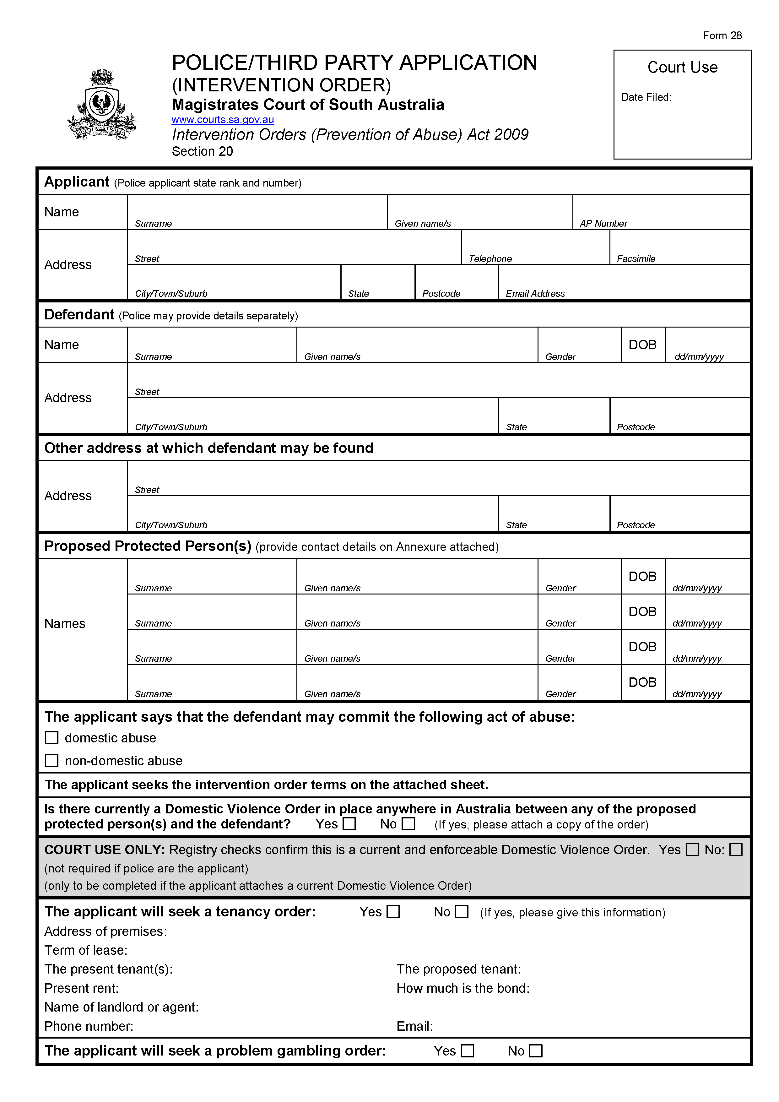
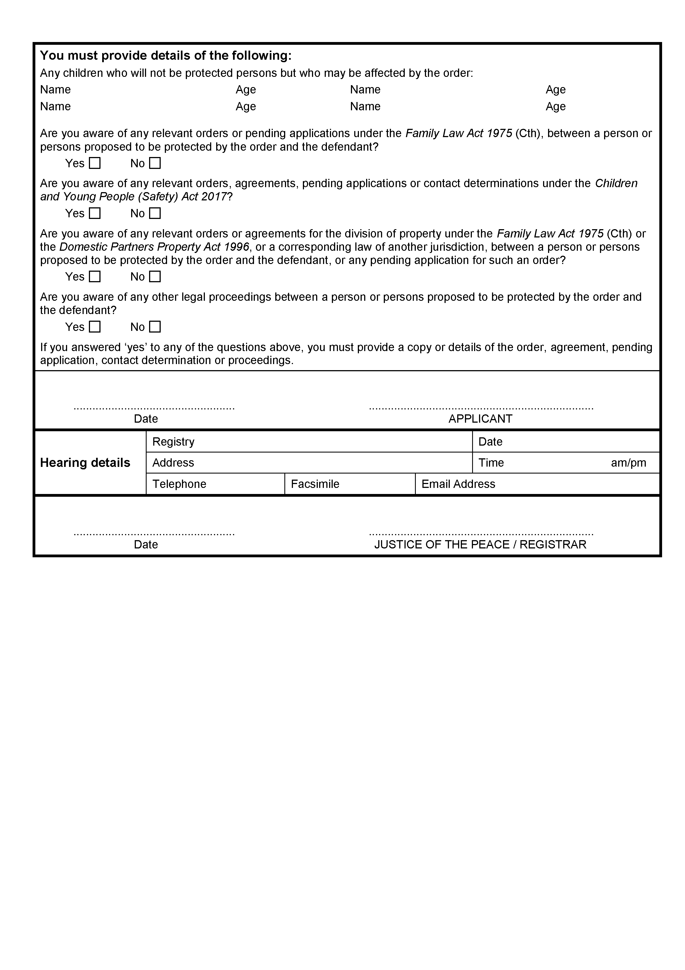
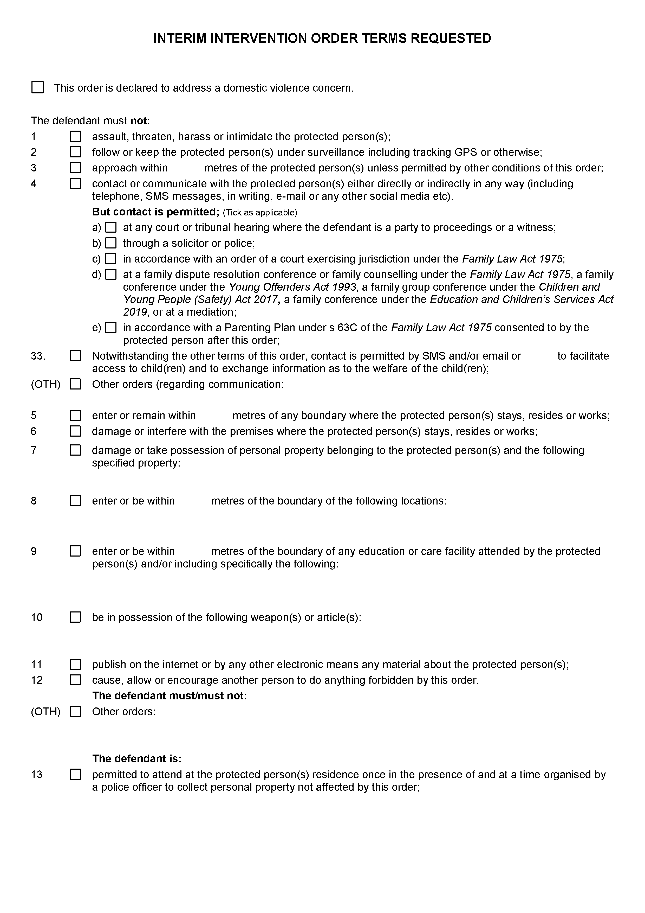
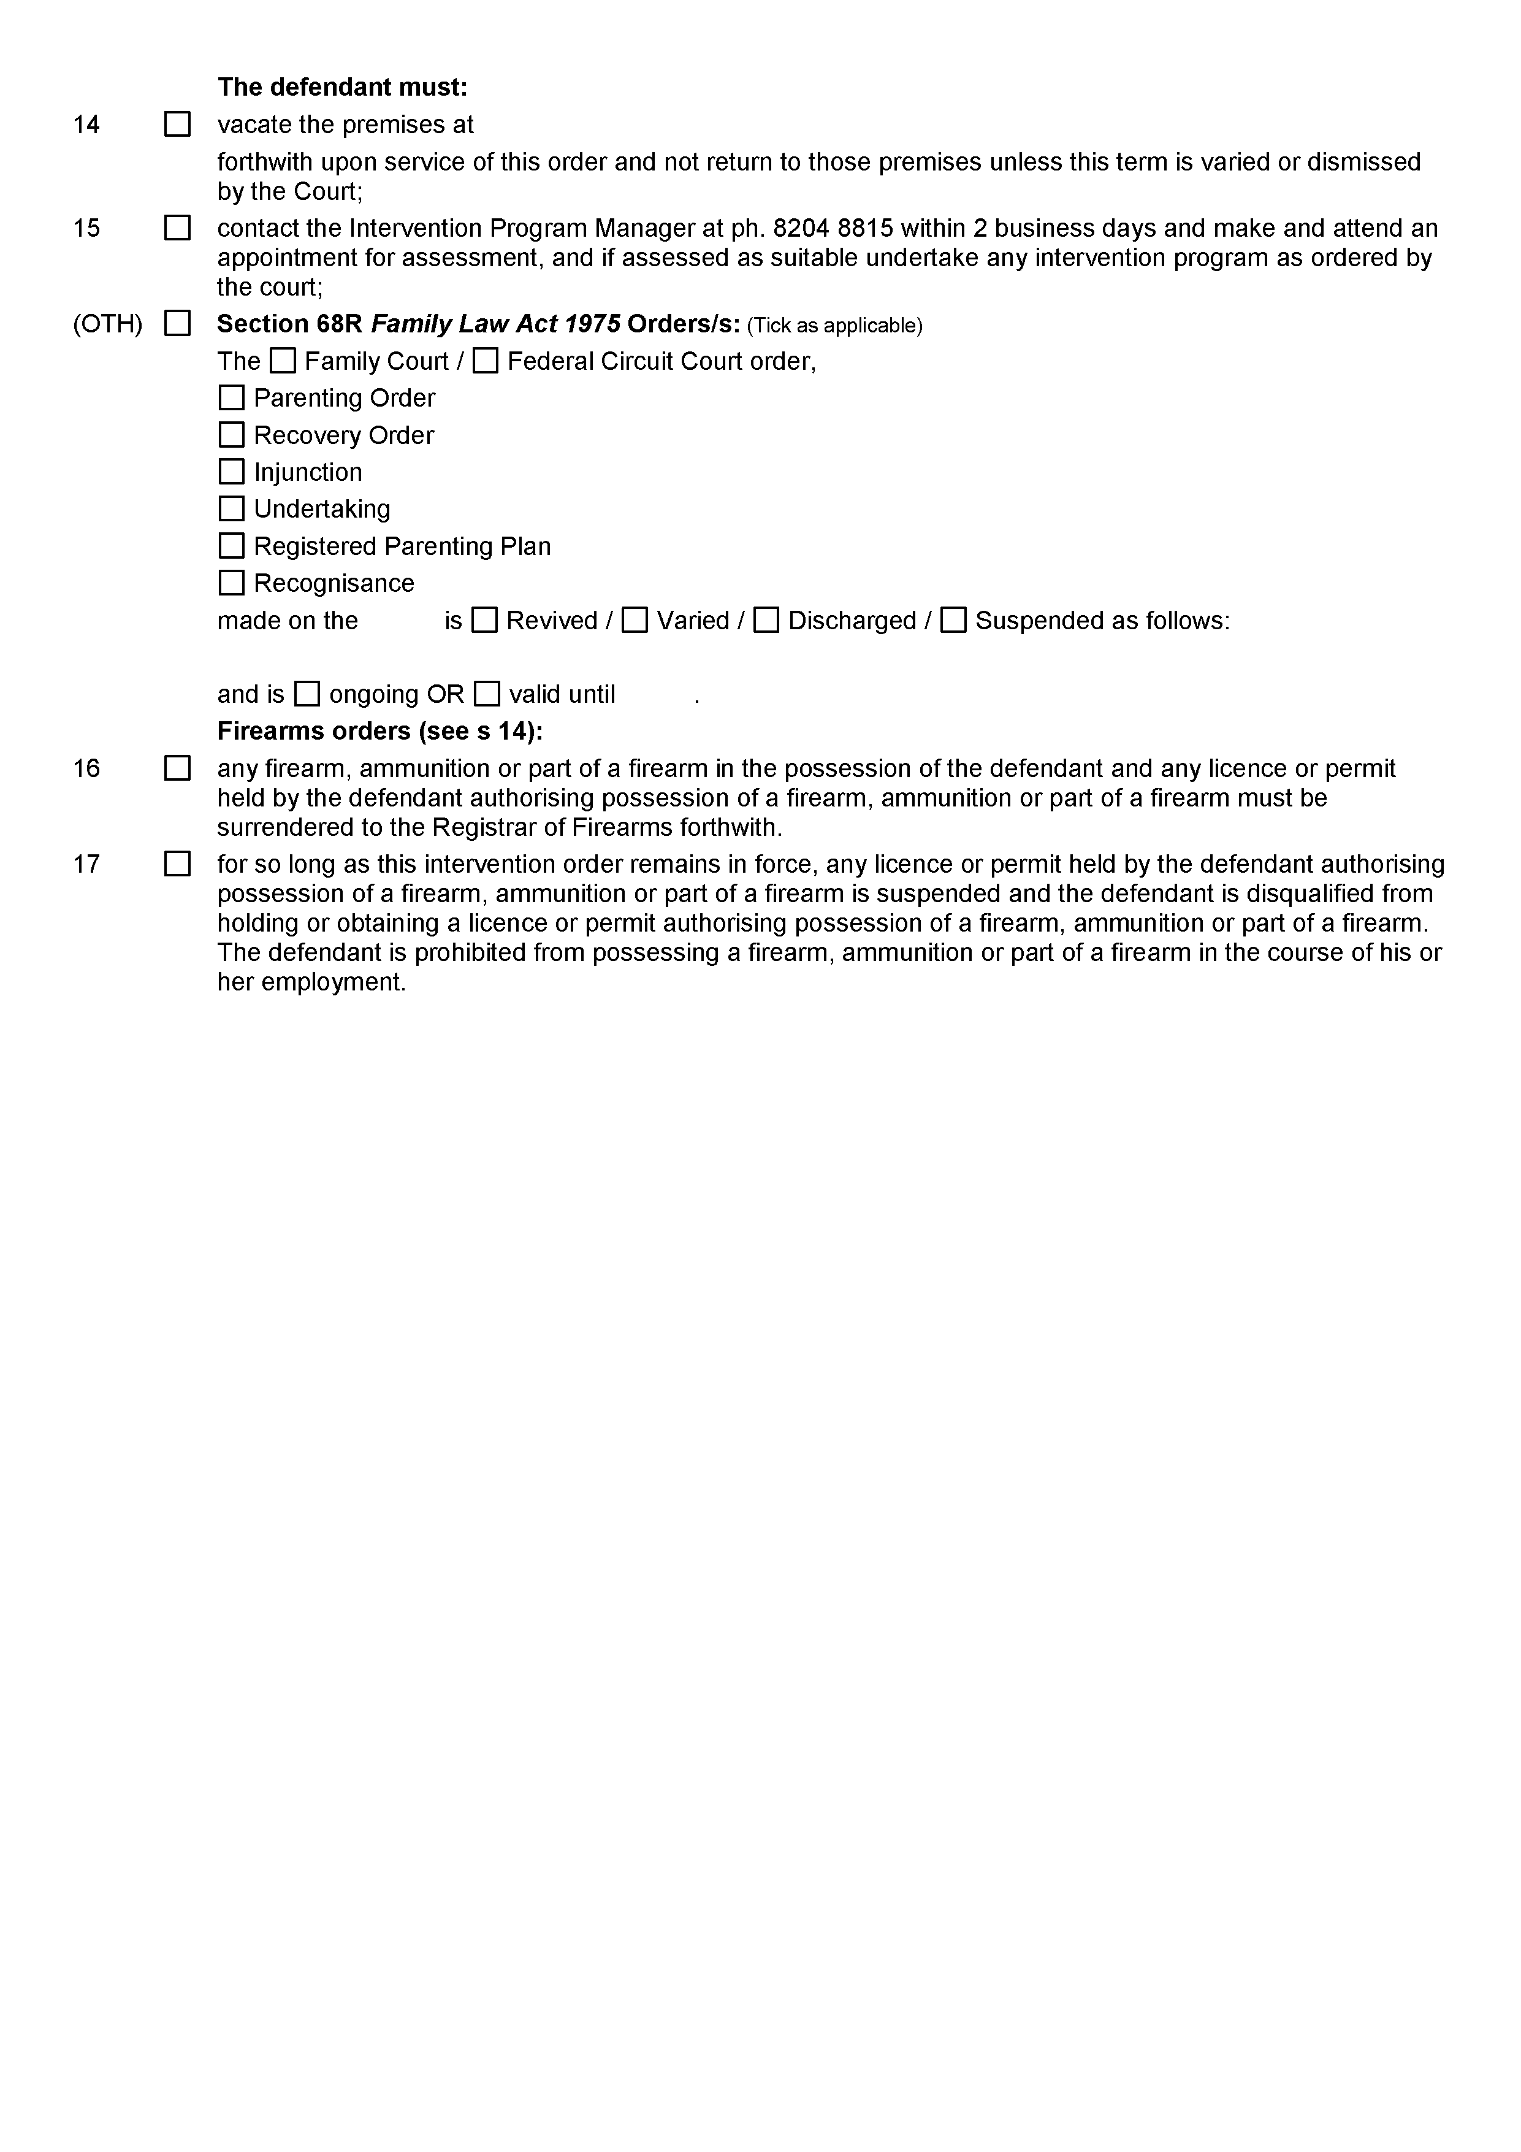
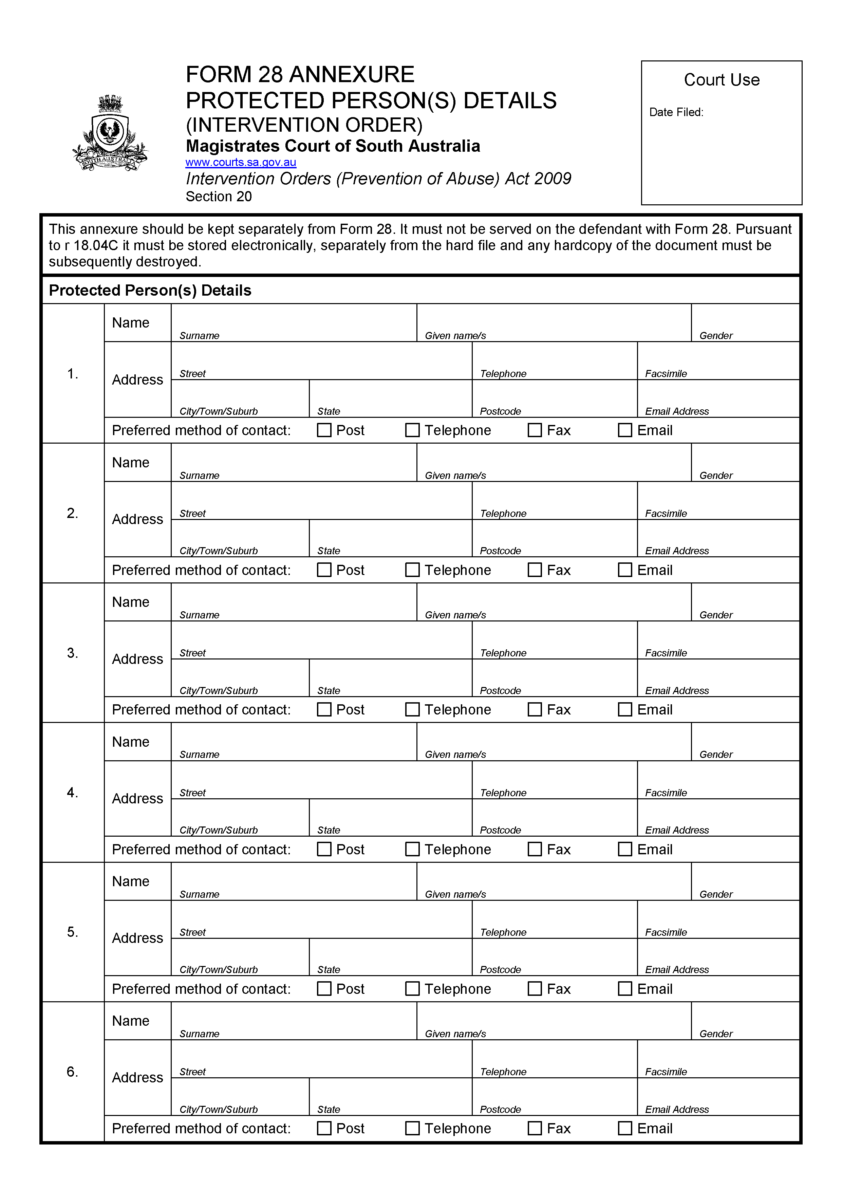
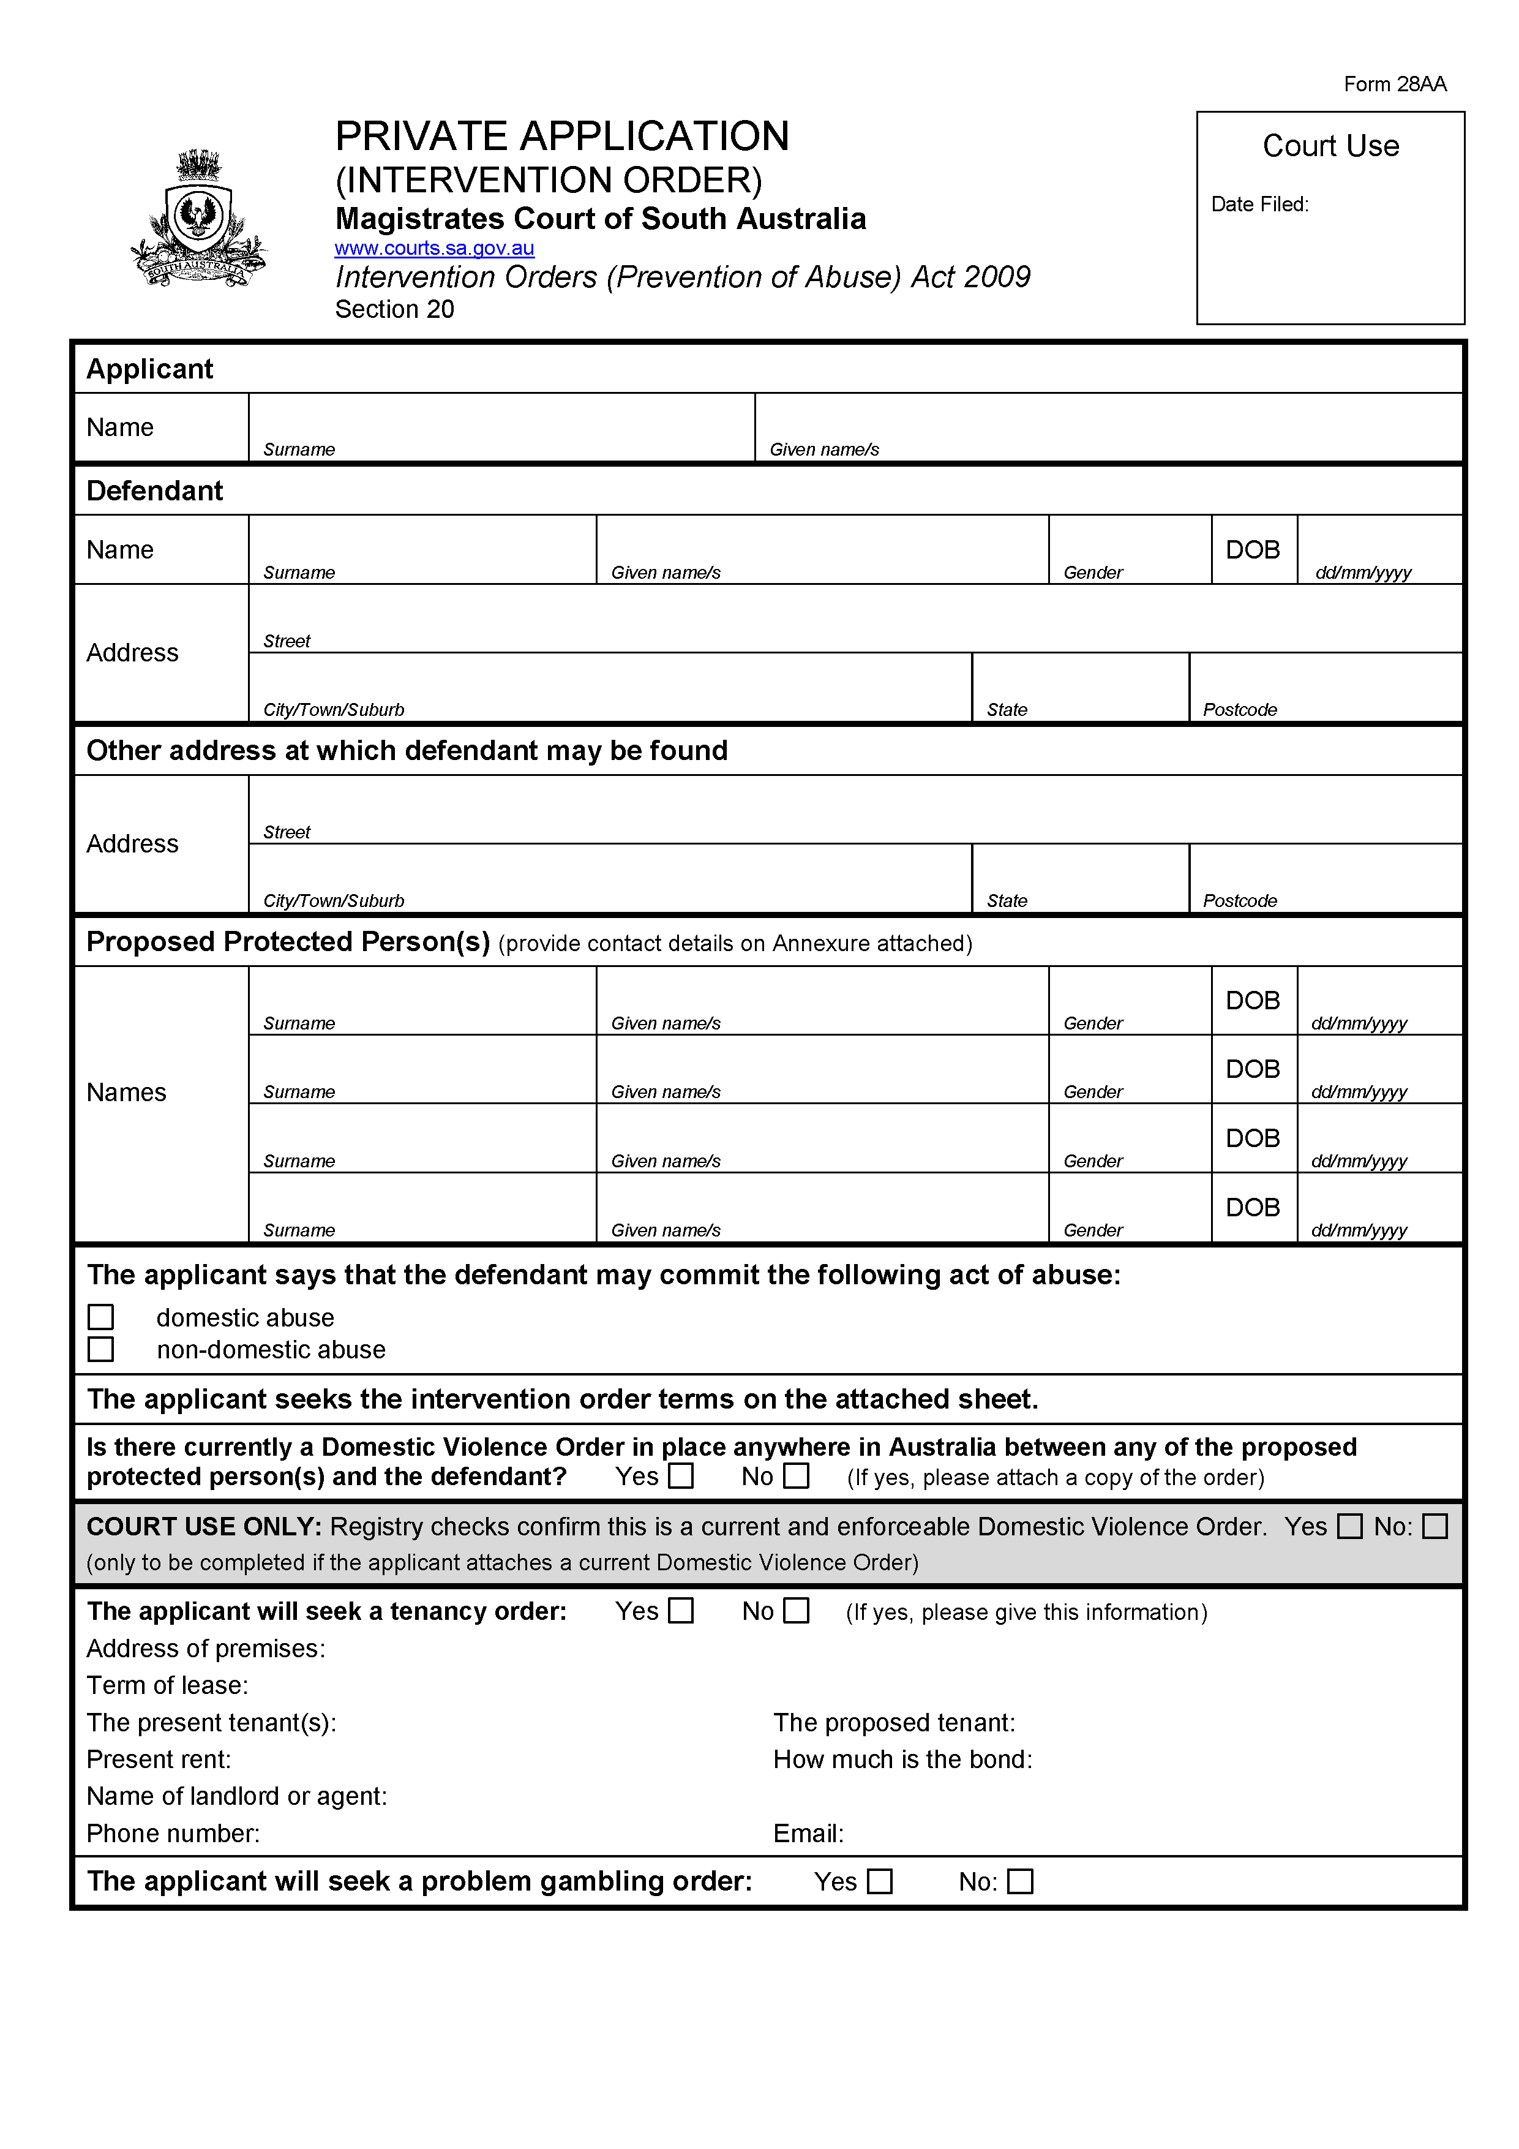
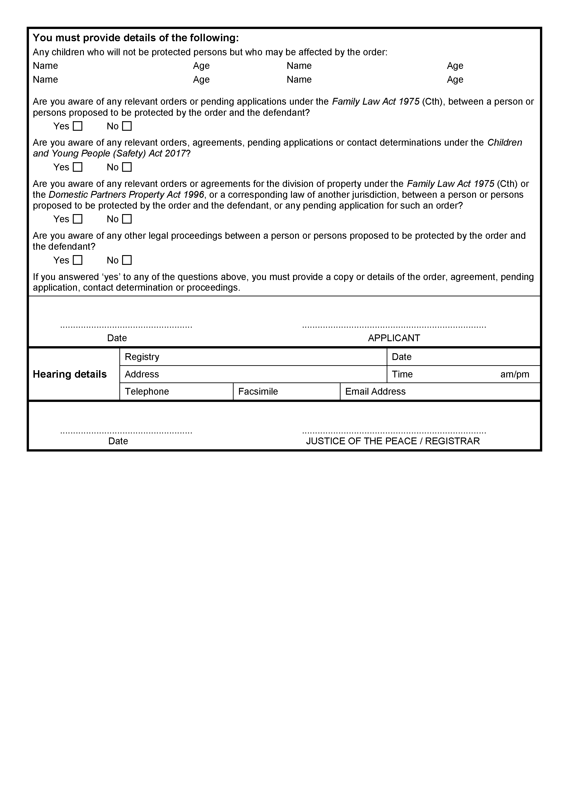
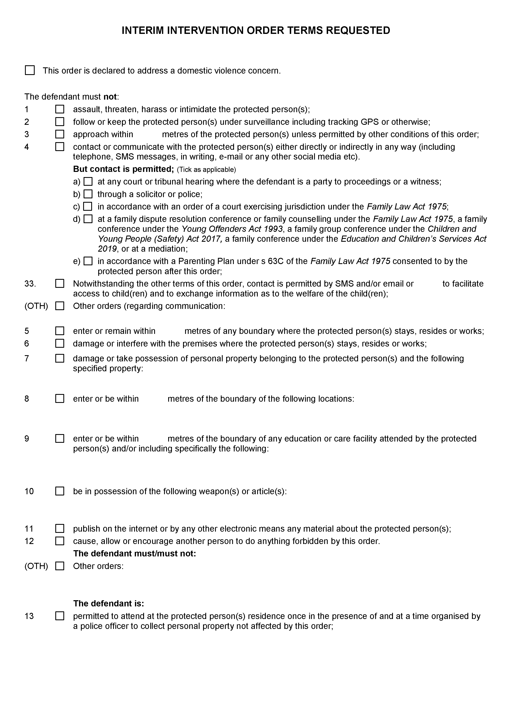
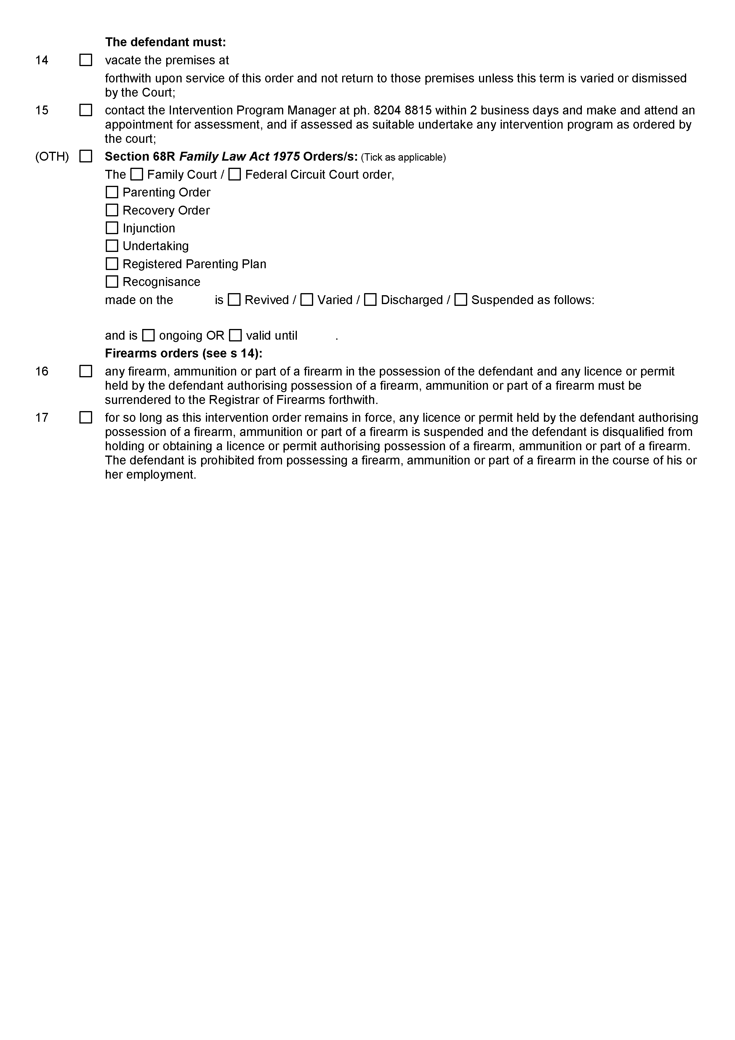
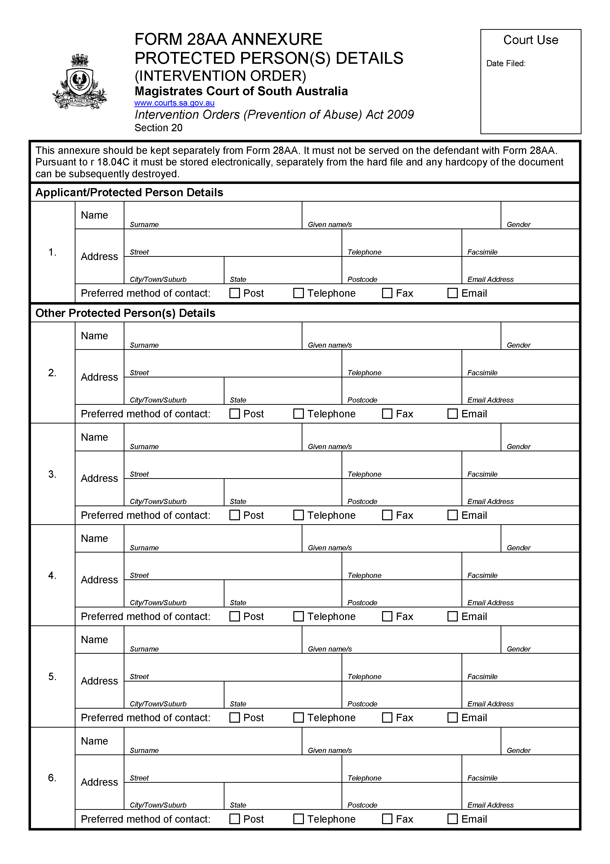
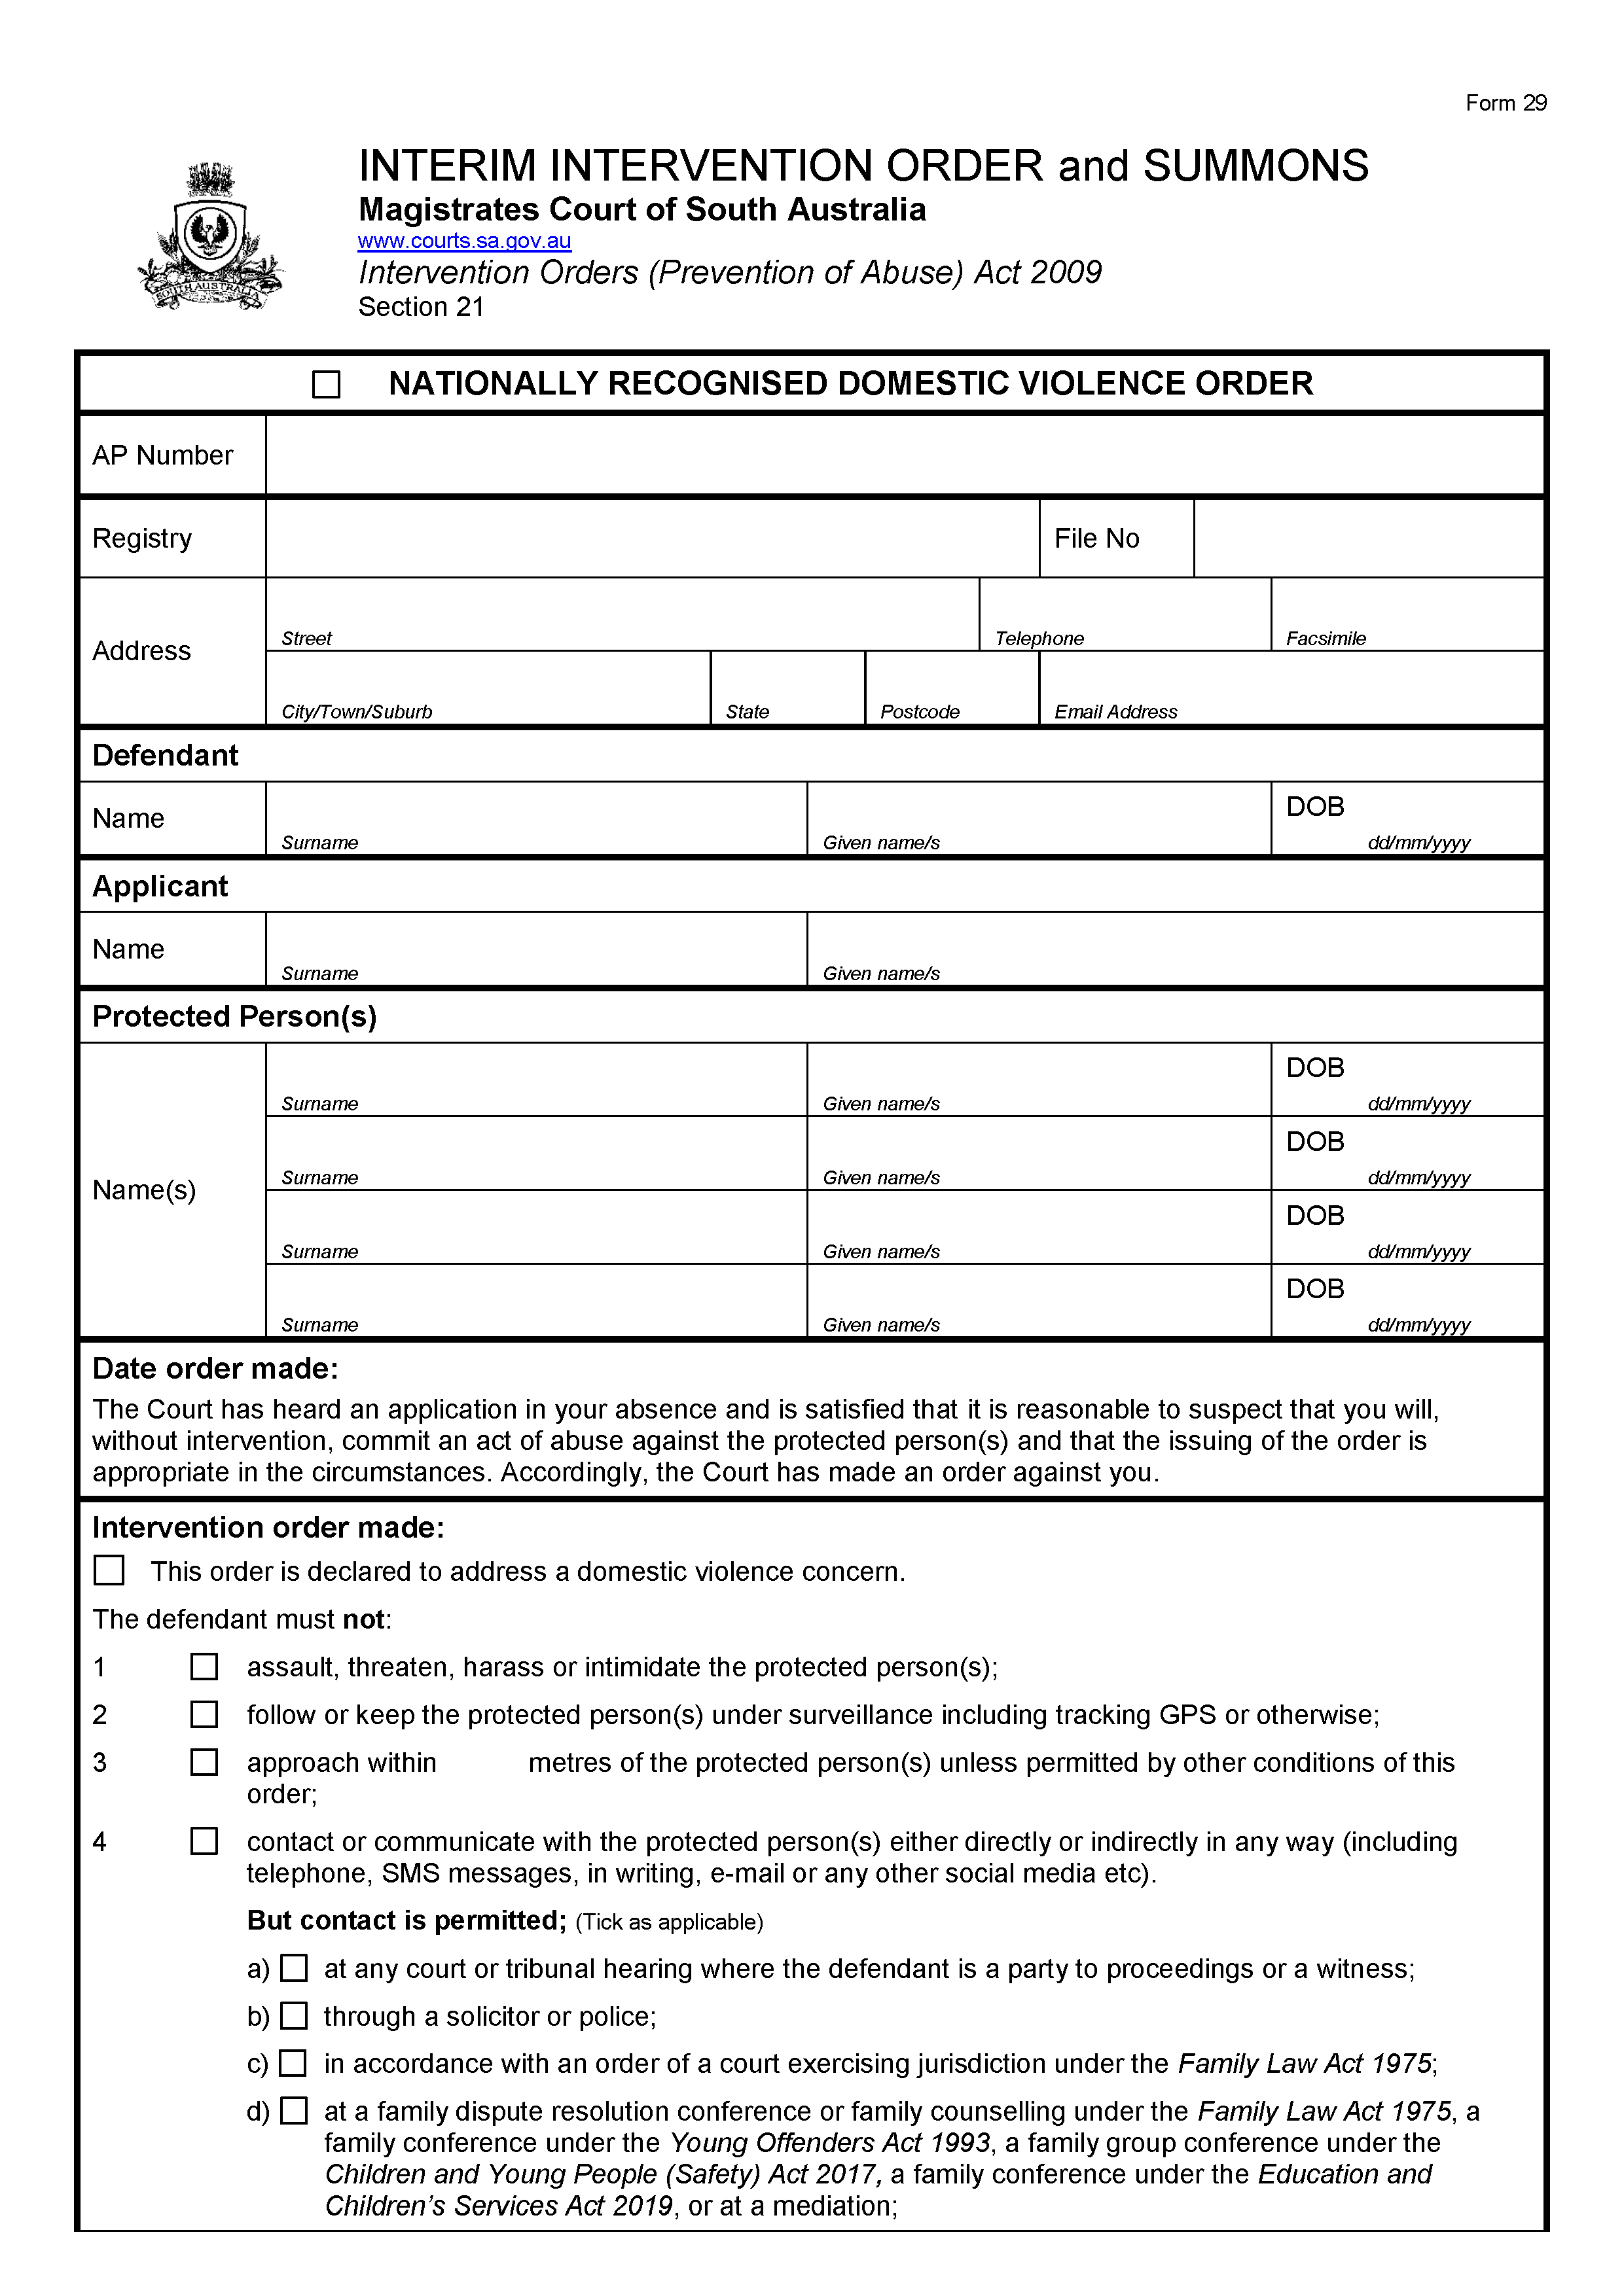
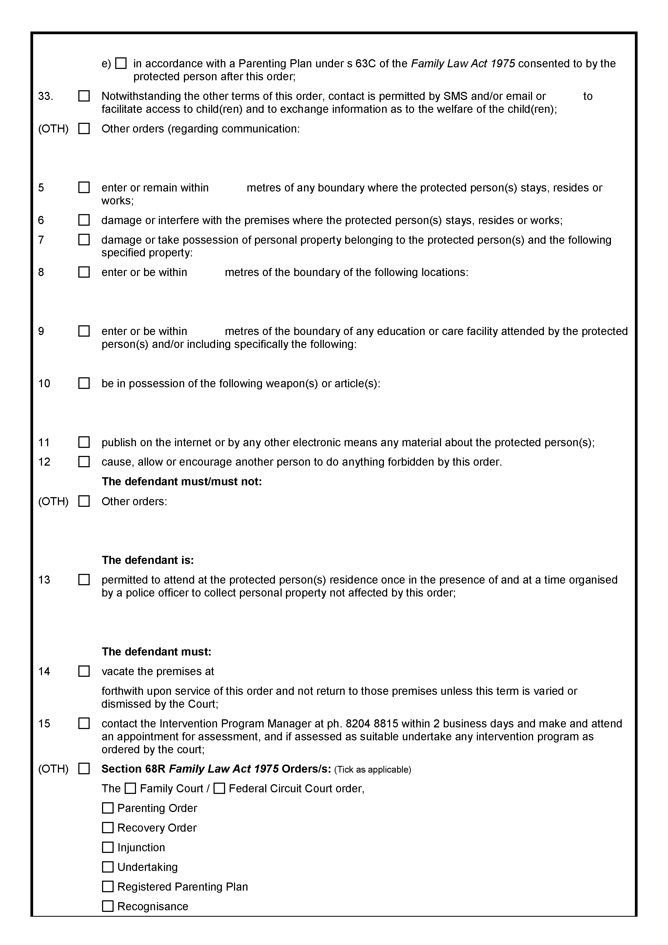
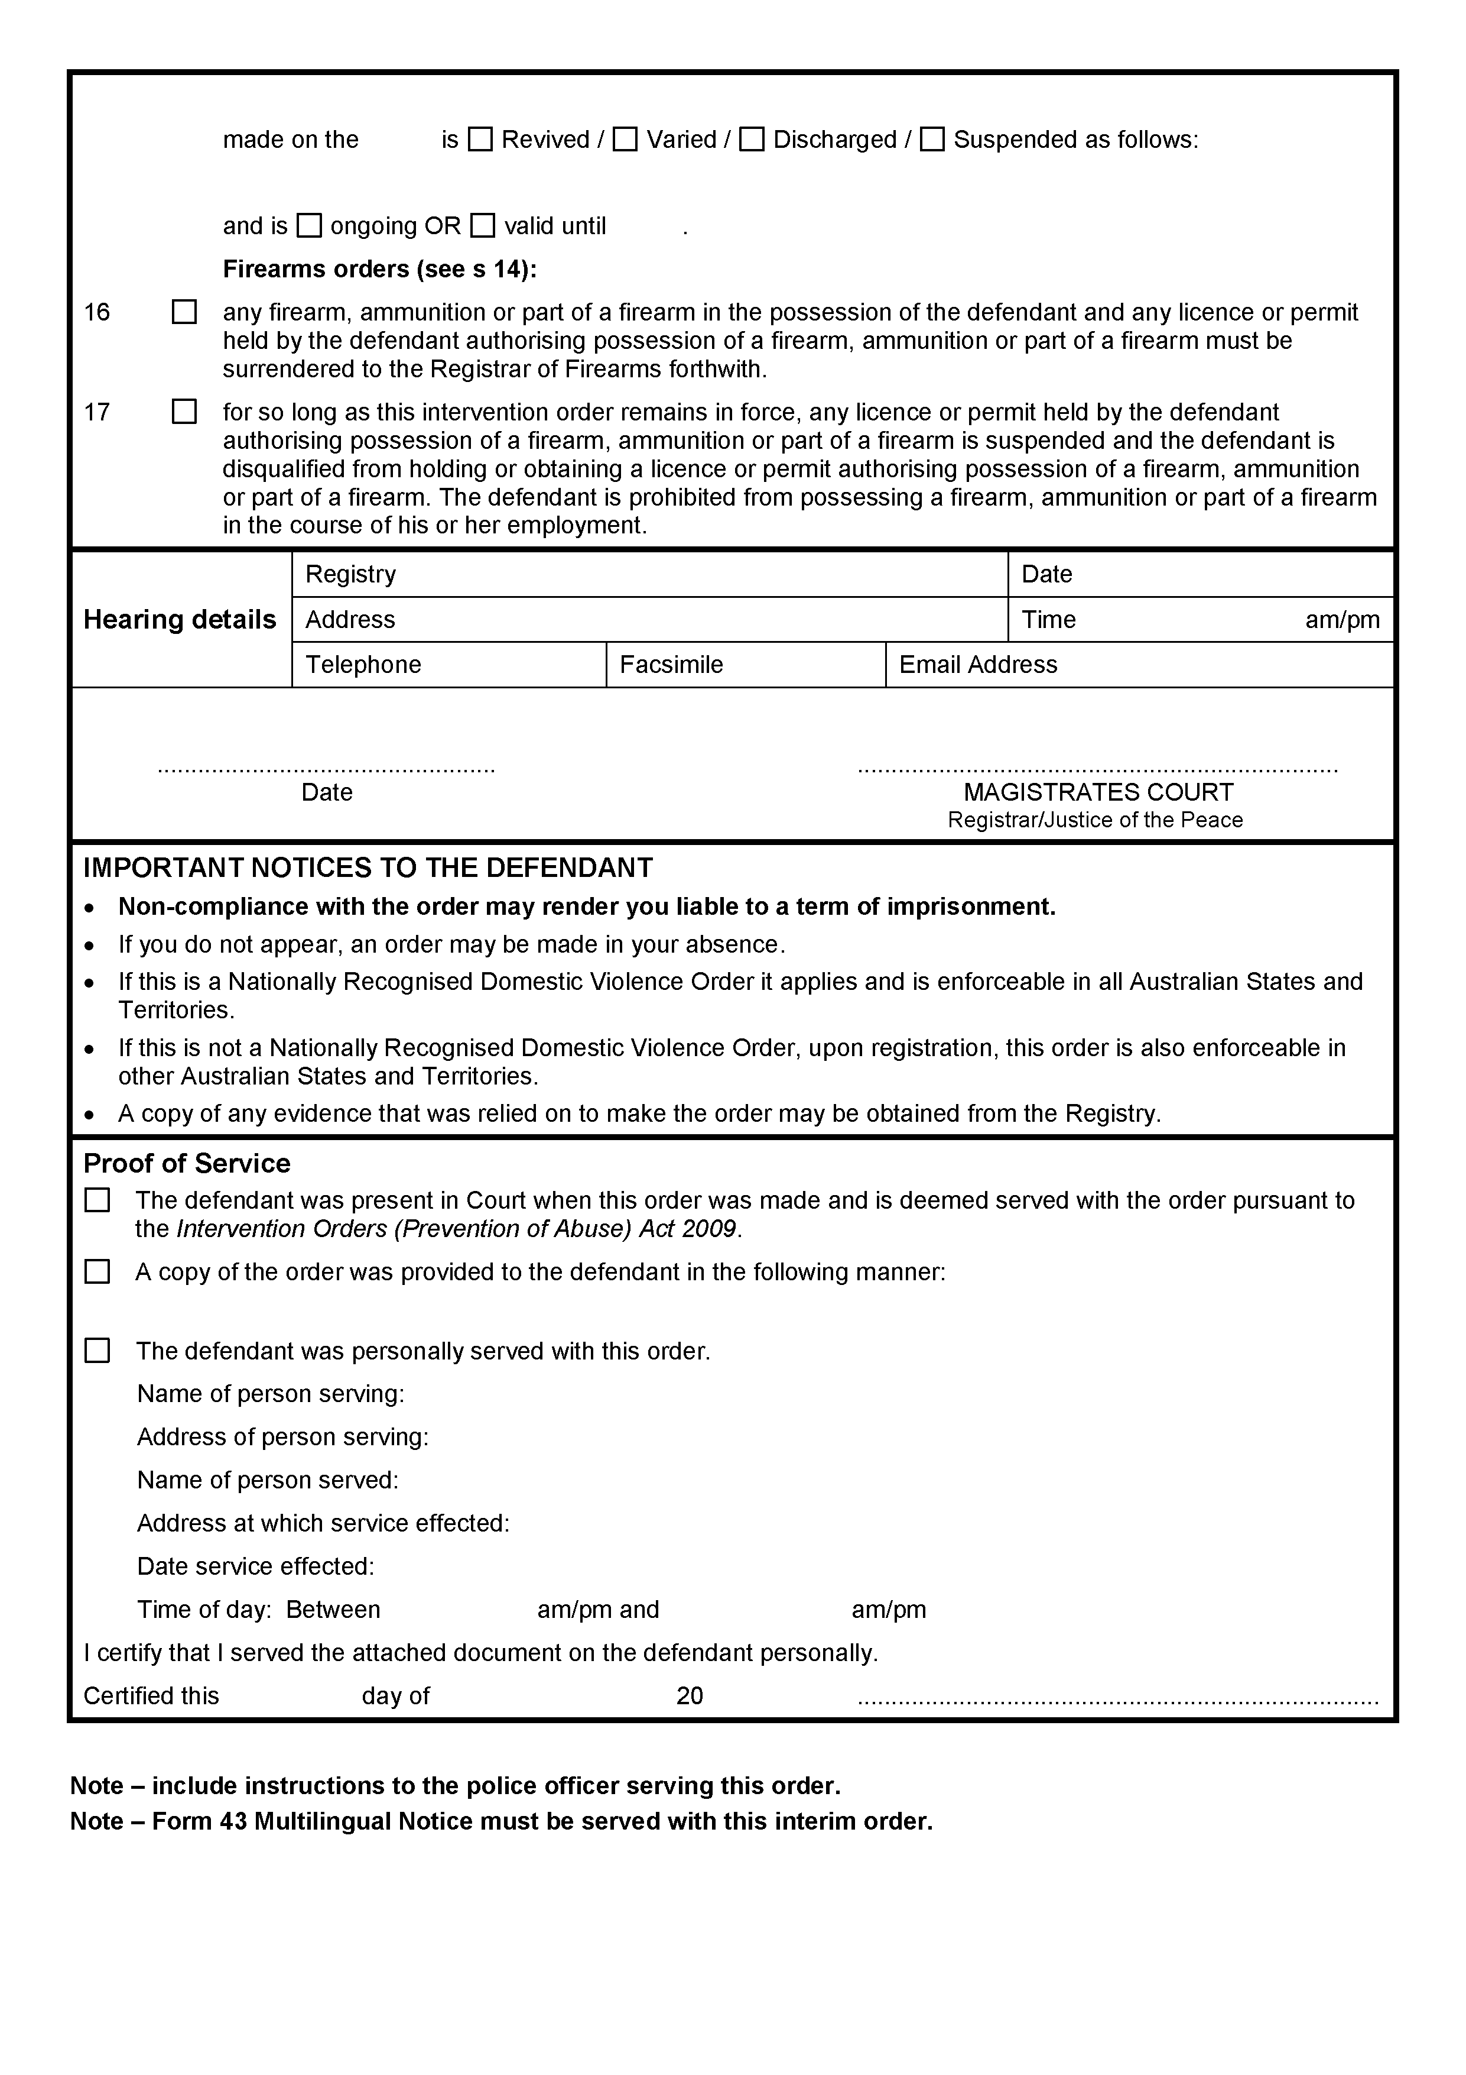
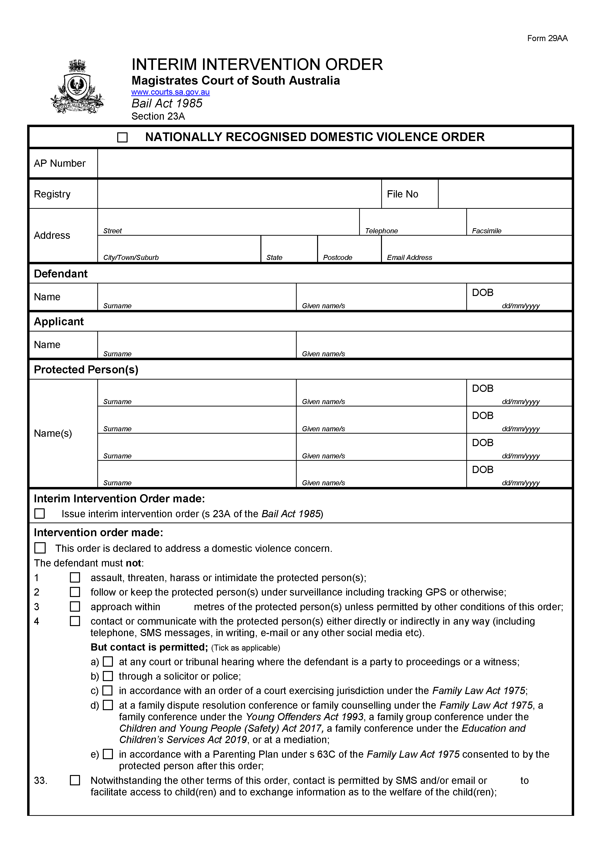
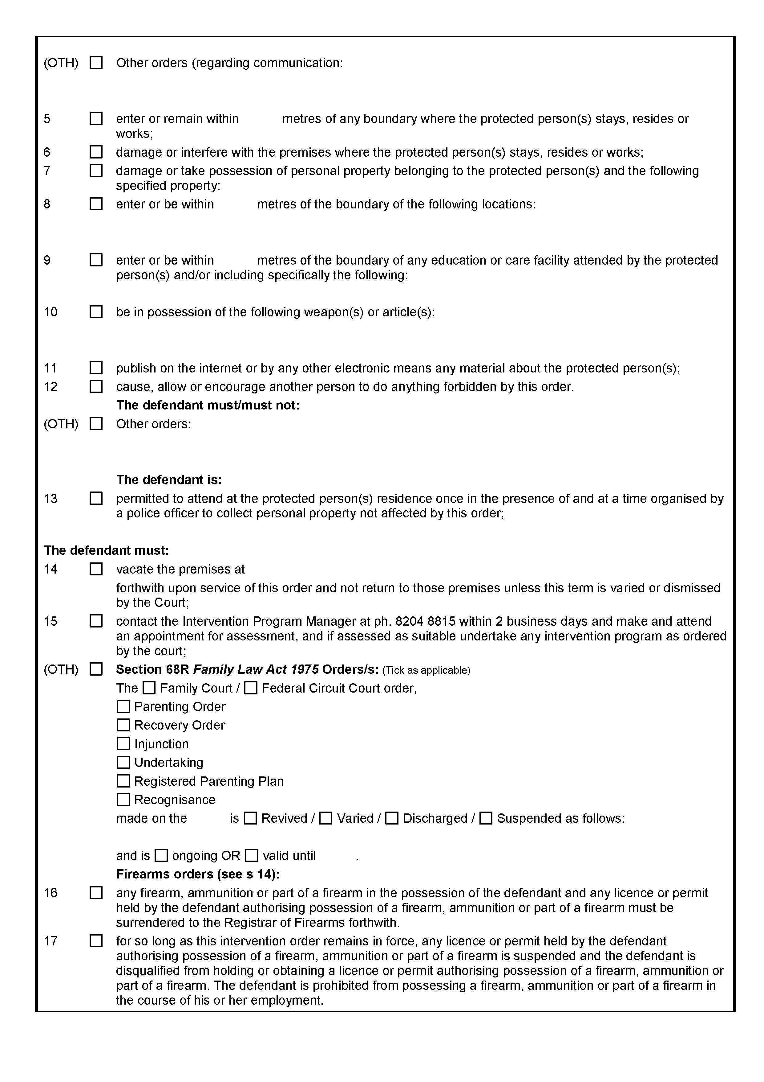
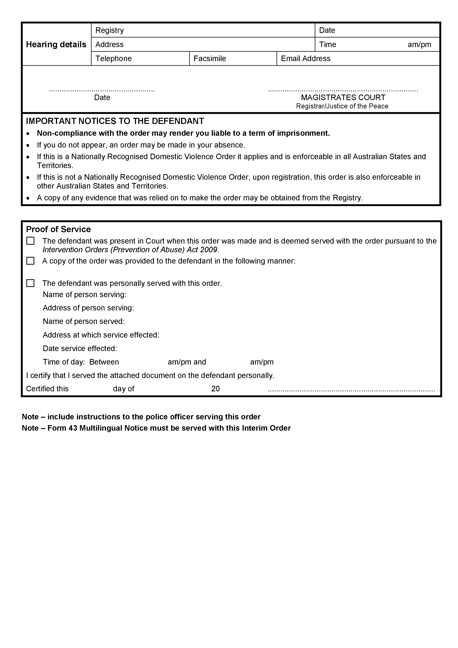
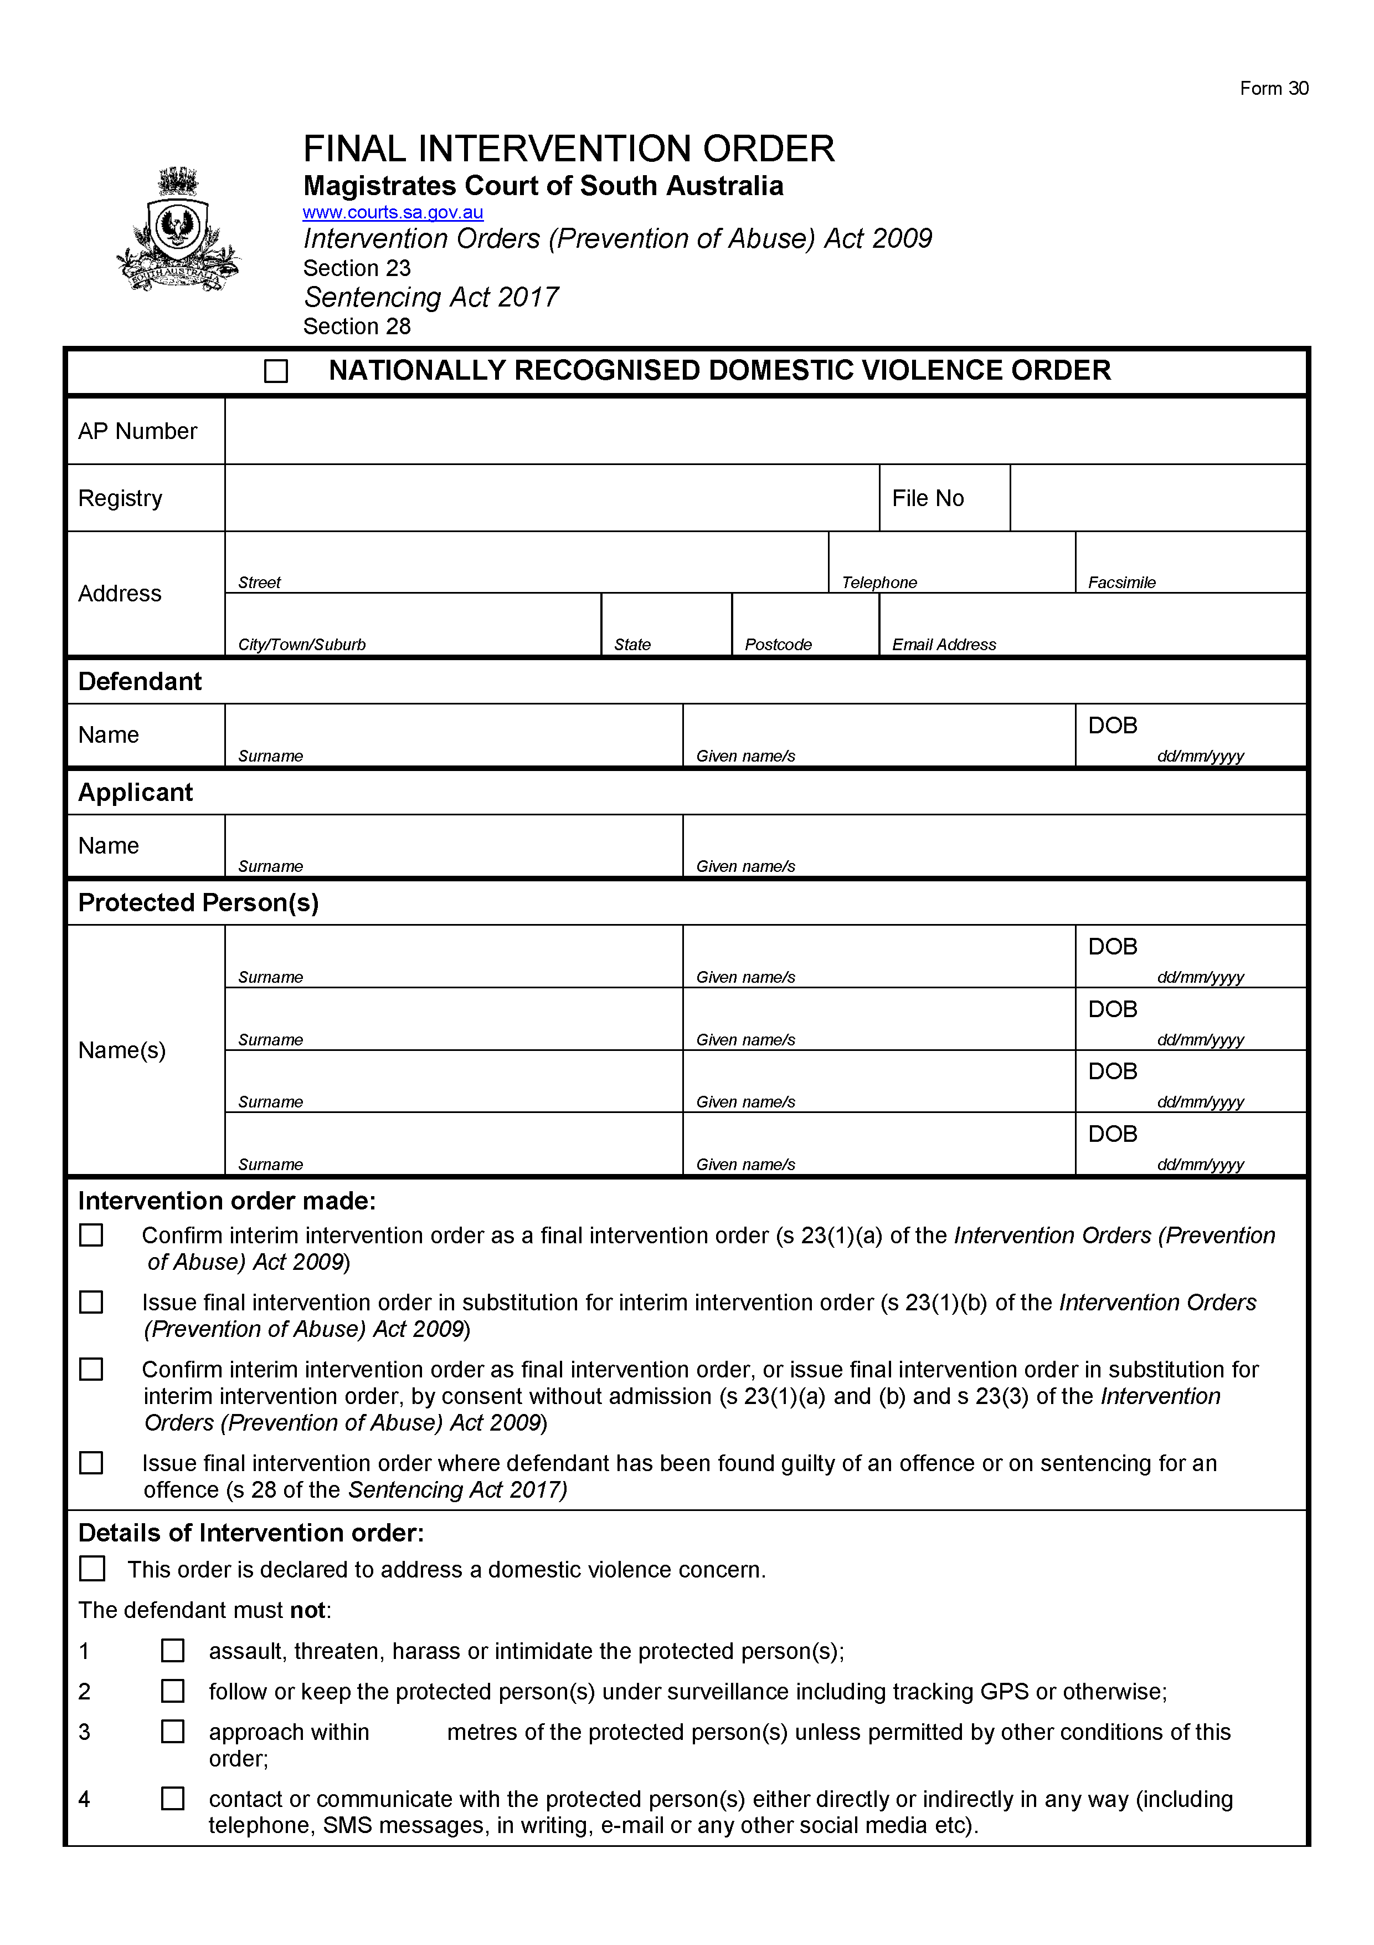
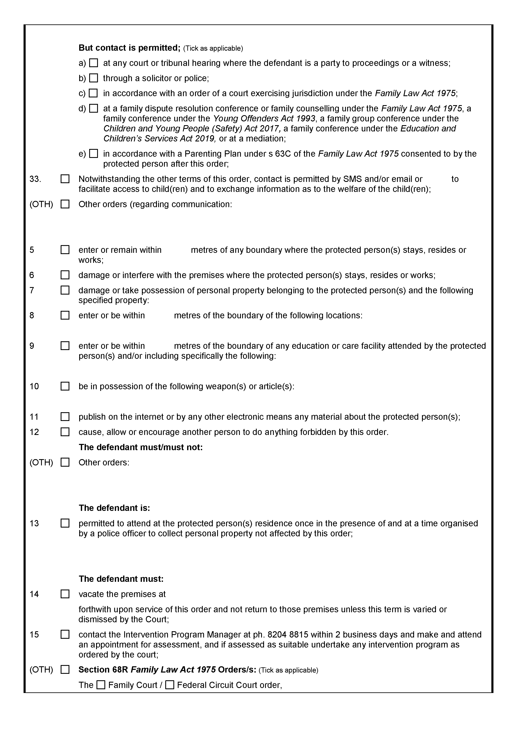
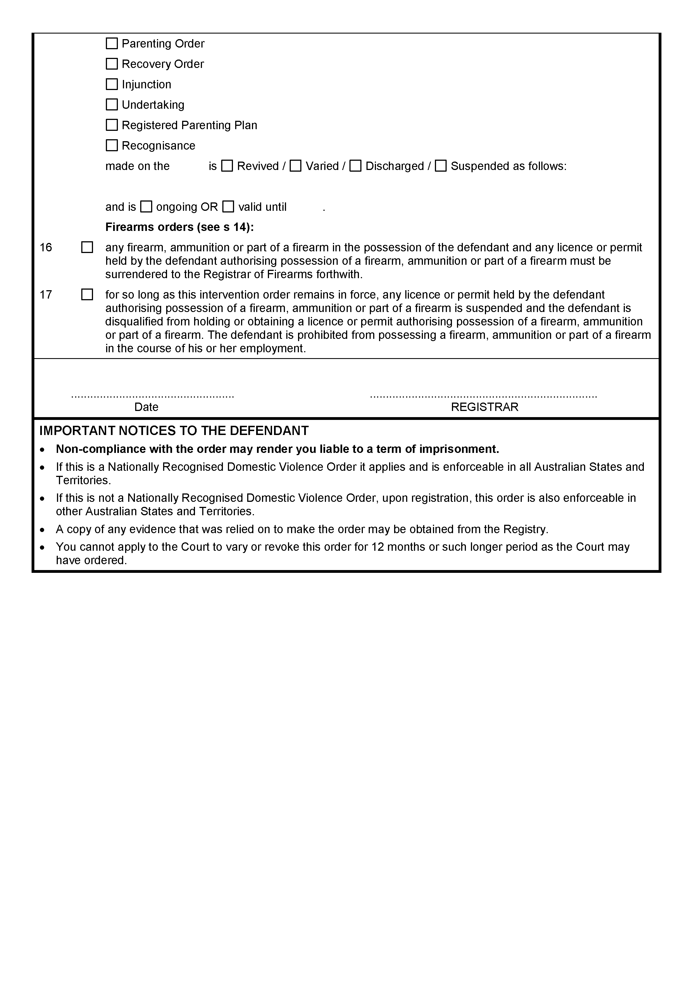
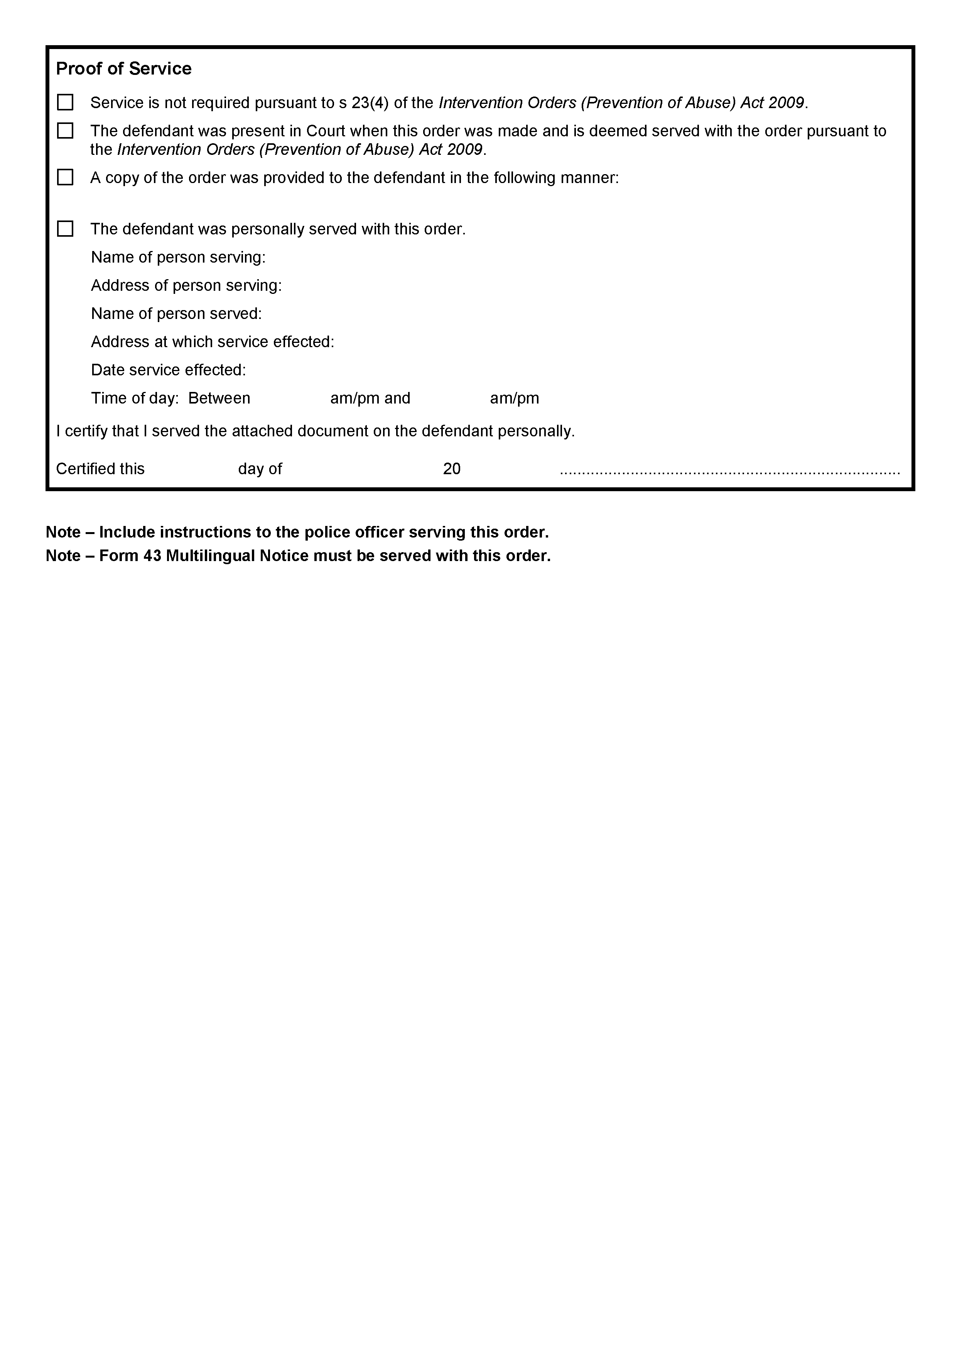
Schedule 1
Magistrates Court Criminal Scale of Costs
Effective from 16 September 2021
Notes:
1. This cost scale is intended for use in making orders as between party and party.
2. The fees set out in item 1 and 2 are intended to cover all necessary attendances and preparatory work for a trial (other than attendance at a pre-trial conference). Where an attendance is unnecessary as a result of default by one or other party, an order should be sought and made at that hearing. The fee set out in item 4 or 5 should be used for that purpose.
No. | Item | Represented by  solicitor | Represented by  non-legally  qualified person
1 | Instructions, including all preparation for trial and attendances up to, but not including attendance at a Pre-Trial Conference | $1133 | $288
2 | All aspects not otherwise specified from Pre-Trial Conference to Trial, including proofing witnesses, advice or evidence and law (solicitor and counsel) and  delivering brief to counsel. | $1133 | $206
3 | Attendance at pre-trial conference | $309 | $77
4 | Attendance at hearing (see note 2 above) | $113 | $36
5 | Attendance where detailed argument is necessary (see note 2 above) | $206 | $46
6 | Arranging attendance of witnesses (including issue and service of summons  if necessary) - per witness | $103
 | Counsel fees
7 | Fee on brief, to include attendance for plea or withdrawal (if separate counsel briefed) | $1030 | $258
8 | Each day | $1545 | $386

Witness fees
Professional scientific or other expert witnesses per day | $1030 or such amount ordered by the Court
Other adult person per day | $371
Persons under 18 years of age per day | $155
Travel expenses | Where the witness is normally resident more than 50 km from the trial Court at the rate of 88 cents per km or the least expensive return air fare whichever is the lesser or the cheapest combination of both.
Accommodation expenses | In the discretion of the taxing officer where the witness is required to be absent from his or her normal place of residence overnight for accommodation and sustenance per night $299 or such larger amounts allowed by the Court at the time of or before judgment.
Photocopying | 67 cents per page
ISD calls | The actual cost.
Expert Reports | $1030 or such other amount ordered by the Court
Other | All Court fees, search fees, and other fees and payments to the extent to which they have been properly and reasonably incurred and paid; but excluding the usual and incidental expenses and overheads of a legal practice and in particular excluding postage, telephone charges (non STD) and courier expenses.
NOTE:
A. If a witness is released before or is required to first attend after the luncheon break on any day, half a day will be allowed.
B. Fees for non-legally qualified people are for attendances only.
C. The costs allowed in this scale do not include Goods and Services Tax (GST) which is to be added except in the following circumstances:
The GST should not be included in a claim for costs in a party/party Bill of Costs if the receiving party is able to obtain an input tax credit for a proportion of GST only, only the portion which is not eligible for credit should be claimed in the party/party bill.

State Government Instruments

Electoral Act 1985
Part 6—Registration of Political Parties
Notice is hereby given that the following application for registration as a registered political party under the provisions of Part 6 of the Electoral Act 1985, has been received:
Name of Party Australian Family Party
Abbreviation of Party Name Aust Family Party
Name of Applicant Robert John Day
Any elector who believes that the application is not in accordance with the Electoral Act 1985 can formally object in writing to the Electoral Commissioner, Level 6, 60 Light Square, Adelaide SA 5000 by 5pm (ACDT) on Monday, 18 October 2021. Objections must contain the postal address and signature of the objector and detail the grounds upon which the objection is made.
Dated: 16 September 2021
Mick Sherry
Electoral Commissioner

Electoral Act 1985
Part 6—Registration of Political Parties
Notice is hereby given, pursuant to Section 42 of the Electoral Act 1985, that I have this day registered the following political party:
Name of Party Pauline Hanson’s One Nation
Dated: 16 September 2021
Mick Sherry
Electoral Commissioner

Fisheries Management Act 2007
Undersized fish in the Southern Zone Abalone Fishery
Take notice that for the purposes of clause 5(2)(a) of part 2 of schedule 2 of the Fisheries Management (General) Regulations 2017
I hereby revoke all prior notices published in the South Australian Government Gazette declaring undersized lengths of Blacklip Abalone in the Southern Zone Abalone Fishery and hereby declare that Blacklip Abalone (Haliotis rubra) taken in an abalone fishing area of the Southern Zone Abalone Fishery is undersized if its length is less than that specified below:
Abalone Fishing Area* | Location | Minimum Legal  Length (mm)
1 | Cape Jaffa | 125
2 | Nora Creina | 125
3 | Beachport | 125
4 | Rivoli Bay | 110
5 | South End | 125
6 | Number 2 Rocks | 125
7 | Admella | 125
8 | Carpenters Rocks | 125
9 | Gerloff Bay | 112
10 | Blackfellows Caves | 125
11 | Middle Point | 120
12 | Port MacDonnell | 122
13 | East Port MacDonnell | 100
*As defined in regulation 11(1) and schedule 1 of the Fisheries Management (Abalone Fisheries) Regulations 2017.
Dated: 10 September 2021
Professor Gavin Begg
Executive Director
Fisheries and Aquaculture
Delegate of the Minister for Primary Industries and Regional Development

Housing Improvement Act 2016
Rent Control
The Minister for Human Services Delegate in the exercise of the powers conferred by the Housing Improvement Act 2016, does hereby fix the maximum rental per week which shall be payable subject to Section 55 of the Residential Tenancies Act 1995, in respect of each house described in the following table. The amount shown in the said table shall come into force on the date of this publication in the Gazette.
Address of Premises | Allotment Section | Certificate of Title Volume/Folio | Maximum Rental  per week payable
21 Goodall Avenue, Kilkenny SA 5009 | Allotment 4 Deposited Plan 4111 Hundred of Yatala | CT5326/505 | $0.00  (Unfit for human habitation)
Dated: 16 September 2021
Craig Thompson
Housing Regulator and Registrar
Housing Safety Authority, SAHA
Delegate of Minister for Human Services

Housing Improvement Act 2016
Rent Control Revocations
Whereas the Minister for Human Services Delegate is satisfied that each of the houses described hereunder has ceased to be unsafe or unsuitable for human habitation for the purposes of the Housing Improvement Act 2016, notice is hereby given that, in exercise of the powers conferred by the said Act, the Minister for Human Services Delegate does hereby revoke the said Rent Control in respect of each property.
Address of Premises | Allotment Section | Certificate of Title  Volume/Folio
8A Glover Road, Two Wells SA 5501 | Allotment 11 Deposited Plan 117565 Hundred of Port Gawler | CT2860/65,  CT5627/584,  CT6203/476
121 Spring Street, Queenstown SA 5014 | Allotment 201 Deposited Plan 47470 Hundred of Yatala | CT5444/40
794 Verran Terrace, Moonta Mines SA 5558 | Section 2848 Hundred Plan 211100 Hundred of Wallaroo | CT4401/442,  CT5439/902
134 May Terrace, Ottoway SA 5013  (Rear Unit) | Allotment 12 Deposited Plan 2204 Hundred of Port Adelaide | CT5778/654
575 Graham Road, Petersville SA 5571 | QP 1 Filed Plan 147641 Hundred of Cunningham | CT5268/514
64 Mead Street, Birkenhead SA 5015 | Allotment 1 Filed Plan 3729 Hundred of Port Adelaide | CT5181/759
7 Queen Street, Solomontown SA 5540  (AKA Port Pirie) | Allotment 363 Filed Plan 184445 Hundred of Pirie | CT5548/617
18 Pritchard Road, Windsor SA 5501  (AKA Lot 2 Long Plains Road, Dublin) | Allotment 2 Filed Plan 137767 Hundred of Dublin | CT5251/151
3 Brigalow Avenue, Kensington Gardens SA 5068 | Allotment 94 Filed Plan 140155 Hundred of Adelaide | CT5406/67
Dated: 16 September 2021
Craig Thompson
Housing Regulator and Registrar
Housing Safety Authority, SAHA
Delegate of Minister for Human Services

Local Government Act 1999
South Australia
Local Government (Application for Review Fee) Notice 2021
under the Local Government Act 1999
1—Short title
This notice may be cited as the Local Government (Application for Review Fee) Notice 2021.
Note—
This is a fee notice made in accordance with the Legislation (Fees) Act 2019.
2—Commencement
This notice has effect on 10 November 2021.
3—Interpretation
In this notice, unless the contrary intention appears—
Act means the Local Government Act 1999.
4—Fee payable to relevant council
The fee set out in Schedule 1 is—
(a) prescribed for the purposes of the Act; and
(b) payable to the relevant council.
Schedule 1—Prescribed Fee

Fee for an application for review under section 270 of the Act | $20.00
Made by the Minister for Planning and Local Government
On 13 September 2021

Roads (Opening and Closing) Act 1991
Section 24
NOTICE OF CONFIRMATION OF
ROAD PROCESS ORDER
Road Closure—Donaldson Road, Two Wells
By Road Process Order made on 26 February 2021, the Adelaide Plains Council ordered that:
1. Portion of Donaldson Road, Two Wells, situated adjacent to Gawler Road and adjoining Filed Plan 218508, Hundred of Port Gawler, more particularly delineated and lettered ‘A’ in Preliminary Plan 20/0039 be closed.
2. Issue a Certificate of Title to the Adelaide Plains Council for the whole of the land subject to closure in accordance with the Application for Document of Title dated 26 February 2021.
On 9 September 2021 that order was confirmed by the Attorney-General conditionally upon the deposit by the Registrar-General of Deposited Plan 127169 being the authority for the new boundaries.
Pursuant to section 24(5) of the Roads (Opening and Closing) Act 1991, NOTICE of the Order referred to above and its confirmation is hereby given.
Dated: 16 September 2021
M. P. BURDETT
Surveyor-General
DPTI: 2020/16540/01

South Australian Skills Act 2008
Part 4—Apprenticeships, Traineeships and Training Contracts
Pursuant to the provision of the South Australian Skills Act 2008, the South Australian Skills Commission (SASC) gives notice that determines the following Trades or Declared Vocations in addition to the Gazette notices of:
1. 25 September 2008 | 2. 23 October 2008 | 3. 13 November 2008 | 4. 4 December 2008
5. 18 December 2008 | 6. 29 January 2009 | 7. 12 February 2009 | 8. 5 March 2009
9. 12 March 2009 | 10. 26 March 2009 | 11. 30 April 2009 | 12. 18 June 2009
13. 25 June 2009 | 14. 27 August 2009 | 15. 17 September 2009 | 16. 24 September 2009
17. 9 October 2009 | 18. 22 October 2009 | 19. 3 December 2009 | 20. 17 December 2009
21. 4 February 2010 | 22. 11 February 2010 | 23. 18 February 2010 | 24. 18 March 2010
25. 8 April 2010 | 26. 6 May 2010 | 27. 20 May 2010 | 28. 3 June 2010
29. 17 June 2010 | 30. 24 June 2010 | 31. 8 July 2010 | 32. 9 September 2010
33. 23 September 2010 | 34. 4 November 2010 | 35. 25 November 2010 | 36. 16 December 2010
37. 23 December 2010 | 38. 17 March 2011 | 39. 7 April 2011 | 40. 21 April 2011
41. 19 May 2011 | 42. 30 June 2011 | 43. 21 July 2011 | 44. 8 September 2011
45. 10 November 2011 | 46. 24 November 2011 | 47. 1 December 2011 | 48. 8 December 2011
49. 16 December 2011 | 50. 22 December 2011 | 51. 5 January 2012 | 52. 19 January 2012
53. 1 March 2012 | 54. 29 March 2012 | 55. 24 May 2012 | 56. 31 May 2012
57. 7 June 2012 | 58. 14 June 2012 | 59. 21 June 2012 | 60. 28 June 2012
61. 5 July 2012 | 62. 12 July 2012 | 63. 19 July 2012 | 64. 2 August 2012
65. 9 August 2012 | 66. 30 August 2012 | 67. 13 September 2012 | 68. 4 October 2012
69. 18 October 2012 | 70. 25 October 2012 | 71. 8 November 2012 | 72. 29 November 2012
73. 13 December 2012 | 74. 25 January 2013 | 75. 14 February 2013 | 76. 21 February 2013
77. 28 February 2013 | 78. 7 March 2013 | 79. 14 March 2013 | 80. 21 March 2013
81. 28 March 2013 | 82. 26 April 2013 | 83. 23 May 2013 | 84. 30 May 2013
85. 13 June 2013 | 86. 20 June 2013 | 87. 11 July 2013 | 88. 1 August 2013
89. 8 August 2013 | 90. 15 August 2013 | 91. 29 August 2013 | 92. 6 February 2014
93. 12 June 2014 | 94. 28 August 2014 | 95. 4 September 2014 | 96. 16 October 2014
97. 23 October 2014 | 98. 5 February 2015 | 99. 26 March 2015 | 100. 16 April 2015
101. 27 May 2015 | 102. 18 June 2015 | 103. 3 December 2015 | 104. 7 April 2016
105. 30 June 2016 | 106. 28 July 2016 | 107. 8 September 2016 | 108. 22 September 2016

109. 27 October 2016 | 110. 1 December 2016 | 111. 15 December 2016 | 112. 7 March 2017
113. 21 March 2017 | 114. 23 May 2017 | 115. 13 June 2017 | 116. 18 July 2017
117. 19 September 2017 | 118. 26 September 2017 | 119. 17 October 2017 | 120. 3 January 2018
121. 23 January 2018 | 122. 14 March 2018 | 123. 14 June 2018 | 124. 5 July 2018
125. 2 August 2018 | 126. 9 August 2018 | 127. 16 August 2018 | 128. 30 August 2018
129. 27 September 2018 | 130. 4 October 2018 | 131. 18 October 2018 | 132. 1 November 2018
133. 15 November 2018 | 134. 22 November 2018 | 135. 29 November 2018 | 136. 6 December 2018
137. 20 December 2018 | 138. 24 January 2019 | 139. 14 February 2019 | 140. 30 May 2019
141. 6 June 2019 | 142. 13 June 2019 | 143. 20 June 2019 | 144. 27 June 2019
145. 11 July 2019 | 146. 8 August 2019 | 147. 22 August 2019 | 148. 12 September 2019
149. 19 September 2019 | 150. 14 November 2019 | 151. 28 November 2019 | 152. 12 December 2019
153. 19 December 2019 | 154. 23 January 2020 | 155. 27 February 2020 | 156. 21 April 2020
157. 25 June 2020 | 158. 10 September 2020 | 159. 17 September 2020 | 160. 8 October 2020
161. 29 October 2020 | 162. 5 November 2020 | 163. 10 December 2020 | 164. 17 December 2020
165. 24 December 2020 | 166. 21 January 2021 | 167. 11 February 2021 | 168. 25 February 2021
169. 25 March 2021 | 170. 1 April 2021 | 171. 8 April 2021 | 172. 6 May 2021
173. 10 June 2021 | 174. 1 July 2021 | 175. 12 August 2021 | 176. 16 September 2021
Trades or Declared Vocations and Required Qualifications and Training Contract Conditions
for the CPP, RGR Training Package/s
*Trade/ #Declared Vocation/ Other Occupation | Qualification Code | Qualification Title | Nominal Term of Training Contract | Probationary  Period | Supervision  Level Rating
Customer Servicing  (Real Estate Operations—Sales) # | CPP41419 | Certificate IV in  Real Estate Practice | 12 | 60 | Prescribed in Land Agents Act 1994
Management # | CPP41419 | Certificate IV in  Real Estate Practice | 24 | 60 | M
Racing Operations # | RGR20221 | Certificate II in  Racing Industry | 12 | 60 | M
Racing Operations # | RGR40221 | Certificate IV in  Racing (Jockey) | 48 | 90 | H

Superannuation Act 1988
South Australian Superannuation Board
Election of Two Board Members
Pursuant to Regulation 16 under the Superannuation Act 1988, I hereby declare Alison Kimber and William Griggs elected to fill the two vacancies on the South Australian Superannuation (Super SA) Board.
The number of first preferences received for each candidate was as follows:
KIMBER, Alison 6919 votes
BOLAND, Marie 3507 votes
DAMIN, John 1512 votes
GRIGGS, William 6690 votes
TOTAL 18628 votes
Following the conclusion of the election and distribution of preferences, Alison Kimber was elected with 9112 votes and William Griggs was elected with 8680 votes. 836 votes were unable to be distributed as no further preferences were marked on the ballot papers.
The term of office for the successful candidates commences on 2 October 2021 and expires on 1 October 2024.
Mick Sherry
Electoral Commissioner

Survey Act 1992
Designated Survey Areas
Pursuant to section 49(1)(b) of the Survey Act 1992, I declare, from 16 December 2021, the following areas of the State, numbered 533 to 565 and shaded green on Rack Plan 1506, to be designated survey areas.
Rack Plan 1506 may be viewed on the South Australian Integrated Land Information System (SAILIS).
Dated: 16 September 2021
Michael Burdett
Surveyor-General

Local Government Instruments

City of Holdfast Bay
Supplementary Election of Councillor for Somerton Ward
Nominations to be a candidate for election as a member of City of Holdfast Bay will be received between Thursday, 23 September 2021 and 12 noon Thursday, 7 October 2021. Candidates must submit a profile of not more than 150 words with their nomination form and may also provide a photograph, predominantly head and shoulders, taken within the previous 12 months.
Nomination kits are available from the Council Office, 24 Jetty Road, Brighton. Nomination forms and guides will also be available for download from the Electoral Commission SA website www.ecsa.sa.gov.au.
A briefing session for intending candidates will be held from 6pm to 8pm on Monday, 20 September at the Brighton Civic Centre, 24 Jetty Road, Brighton.
Dated: 16 September 2021
Mick Sherry
Returning Officer

City of Onkaparinga
Notice of Application of Dogs and Foreshore By-laws
Pursuant to section 246(4a) of the Local Government Act 1999 (the Act), notice is hereby given that at its meeting on 17 August 2021, the Council resolved that:
• Clause 10.4 of the Council’s Dogs By-law 2015 (By-law No. 7), applies to all fenced Hooded Plover breeding sites located on the foreshore or on any other Local Government land so that these sites are ‘dog prohibited’ areas;
• Clause 9.8.1 of the Council’s Foreshore By-law 2015 (By-law No. 6) applies to all fenced Hooded Plover breeding sites located on the foreshore so that these sites constitute an area on the foreshore where a vehicle may not be driven or propelled; and
• a ‘Hooded Plover breeding site’ is any land that has been identified by a temporary fenced exclusion zone with a sign at least 20m away from the fence to indicate a Hooded Plover nest is or may be present on the land or in the vicinity.
Further information regarding these by-law controls is available on the Council’s website at www.onkaparingacity.com and can be inspected at the Council’s offices at the Civic Centre, Ramsay Place, Noarlunga Centre during business hours.
Dated: 16 September 2021
Scott Ashby
Chief Executive Officer

City of Port Adelaide Enfield
Supplementary Election of Councillor for Outer Harbor Ward
Close of Nominations
Nominations Received
At the close of nominations at 12 noon on Thursday, 9 September 2021 the following people were accepted as candidates and are listed in the order in which their names will appear on the ballot paper.
Councillor for Outer Harbor Ward—1 Vacancy
WOTTON, Adrian
LE RAYE, John
MOFFATT, Steven Daryl
MERCIERRE, Robyn
ANDERSON, Scott
COOKE, Peter
Postal Voting
The election will be conducted by post. Ballot papers and pre-paid envelopes for each voting entitlement will be posted between Tuesday, 28 September 2021 and Monday, 4 October 2021 to every person, or designated person of a body corporate or group listed on the voters roll at roll close on Friday, 30 July 2021. Voting is voluntary.
A person who has not received voting material by Monday, 4 October 2021 and believes they are entitled to vote should contact the Deputy Returning Officer on 1300 655 232.
Completed voting material must be returned to reach the Returning Officer no later than 12 noon on Monday, 18 October 2021.
A ballot box will be provided at the Council Office, Civic Centre, 163 St Vincent Street, Port Adelaide for electors wishing to hand deliver their completed voting material during office hours.
Vote Counting Location
The scrutiny and counting of votes will take place at the Electoral Commission SA, 60 Light Square, Adelaide at 9am on Tuesday, 19 October 2021. A provisional declaration will be made at the conclusion of the election count.
Campaign Donations Return
All candidates must forward a Campaign Donations Return to the Council Chief Executive Officer within 30 days after the conclusion of the election.
Dated: 16 September 2021
Mick Sherry
Returning Officer

City of Tea Tree Gully
Close of Roll for Supplementary Election
Due to the removal of a member of the council, a supplementary election will be necessary to fill the vacancy of Councillor for Hillcott Ward.
The voters roll for this supplementary election will close at 5pm on Thursday, 30 September 2021.
You are entitled to vote in the election if you are enrolled on the State electoral roll for the council area. If you have recently turned 18 or changed your residential or postal address you must complete an electoral enrolment form available online at www.ecsa.sa.gov.au.
If you are not eligible to enrol on the State electoral roll you may still be entitled to enrol to vote if you own or occupy a property in the council area. Contact the council to find out how.
Nominations to fill the vacancy will open on Thursday, 28 October 2021 and will be received until 12 noon on Thursday, 11 November 2021.
The election will be conducted entirely by post with the return of ballot material to reach the Returning Officer no later than 12 noon on Monday, 13 December 2021.
Dated: 16 September 2021
Mick Sherry
Returning Officer

District Council of Kimba
Adoption of Community Land Management Plans
Notice is hereby given pursuant to Section 197(3) of the Local Government Act 1999 that the District Council of Kimba, at its meeting held on 8 September 2021, adopted the following Community Land Management Plans:
• Lot 230 HD Solomon (Crown)
• Motorcycle Club & Yesteryear Machinery Club
Dated: 16 September 2021
Deb Larwood
Chief Executive Officer

Wattle Range Council
Supplementary Election of Councillor for Riddoch Ward
Call for Nominations
Nominations to be a candidate for election as a member of Wattle Range Council will be received between Thursday, 23 September 2021 and 12 noon Thursday, 7 October 2021. Candidates must submit a profile of not more than 150 words with their nomination form and may also provide a photograph, predominantly head and shoulders, taken within the previous 12 months.
Nomination kits are available from the Council Offices, Civic Centre, George Street, Millicent and Arthur Street, Penola. Nomination forms and guides will also be available for download from the Electoral Commission SA website www.ecsa.sa.gov.au.
A briefing session for intending candidates will be held from 5:30pm to 7:30pm on Tuesday, 28 September 2021 at the Penola Office, John Shaw Nelson Meeting Room, Arthur Street, Penola.
Dated: 16 September 2021
Mick Sherry
Returning Officer

Public Notices

Trustee Act 1936
Public Trustee
Estates of Deceased Persons
In the matter of the estates of the undermentioned deceased persons:
BLUCHER, Christine Anne late of 52 Dunrobin Road Hove of no occupation who died 8 May 2021
BROWN, Valerie Jean late of 6 Ross Avenue Flinders Park Retired Personnel Officer who died 8 July 2021
CHRISTOPHER, Alan James late of 4 Stewart Avenue Vale Park Retired Teacher who died 25 May 2021
GARRETT, Arnold late of 43 Russell Terrace Woodville Park of no occupation who died 20 November 2020
KLEMENKO, Vasily late of 41 Burley Griffin Boulevard Brompton of no occupation who died 5 July 2021
SHORT, Lewis George late of 333 Marion Road North Plympton Retired Forensic Accountant who died 7 May 2021
SIPOS, Judith Gabriella Anna late of 463 Stuart Road Coober Pedy of no occupation who died 5 January 2019
STUTCHBURY, John Edward late of 38 Nairne Road Woodside Retired Research Scientist who died 9 July 2021
Notice is hereby given pursuant to the Trustee Act 1936, the Inheritance (Family Provision) Act 1972 and the Family Relationships Act 1975 that all creditors, beneficiaries, and other persons having claims against the said estates are required to send, in writing, to the office of Public Trustee at GPO Box 1338, Adelaide SA 5001, full particulars and proof of such claims, on or before the 15 October 2021 otherwise they will be excluded from the distribution of the said estate; and notice is also hereby given that all persons indebted to the said estates are required to pay the amount of their debts to the Public Trustee or proceedings will be taken for the recovery thereof; and all persons having any property belonging to the said estates are forthwith to deliver same to the Public Trustee.
Dated: 16 September 2021
N. S. Rantanen
Public Trustee

Trustee Act 1936
Deceased Estate
Notice to Creditors and Claimants
Ruth Esme MacLeod, formerly of 19 Cornhill Road, Victor Harbor, South Australia, Australia but late of Ross Robertson Memorial Care Centre, Victor Harbor, South Australia, Australia, Retired Nurse/Midwife, deceased.
Creditors and other persons having claims (to which Section 29 of the Trustee Act 1936, relates) in respect of the estate of the deceased, who died on 27 August 2020, are required by the executor, Equity Trustees Wealth Services Limited of Level 1, 575 Bourke Street, Melbourne, Victoria 3000 to send particulars of their claims to it, care of Tiziana Reiners, Equity Trustees Wealth Services Limited of Level 1, 575 Bourke Street, Melbourne, Victoria 3000 within two (2) months of the date of publication hereof, after which date the executor may convey or distribute the assets having regard only to the claims of which the executor then has notice.
Dated: 16 September 2021
Equity Trustees Wealth Services Limited
as executor

National Electricity Law
Notice of Draft Determination
The Australian Energy Market Commission (AEMC) gives notice under the National Electricity Law as follows:
Under s 99, the making of a draft determination and related draft rule on the Primary frequency response incentive arrangements proposal (Ref. ERC0263). Submissions must be received by 28 October 2021.
Submissions can be made via the AEMC’s website. Before making a submission, please review the AEMC’s privacy statement on its website. Submissions should be made in accordance with the AEMC’s Guidelines for making written submissions on Rule change proposals. The AEMC publishes all submissions on its website, subject to confidentiality.
Australian Energy Market Commission
Level 15, 60 Castlereagh St
Sydney NSW 2000
Telephone: (02) 8296 7800
www.aemc.gov.au
Dated: 16 September 2021

Notice Submission

The South Australian Government Gazette is compiled and published each Thursday.
Notices must be submitted before 4 p.m. Tuesday, the week of intended publication.
All submissions are formatted per the gazette style and proofs are supplied as soon as possible. Alterations must be returned before 4 p.m. Wednesday.
Requests to withdraw submitted notices must be received before 10 a.m. on the day of publication.

Gazette notices should be emailed as Word files in the following format:
• Title—name of the governing Act/Regulation
• Subtitle—brief description of the notice
• A structured body of text
• Date of authorisation
• Name, position, and government department/organisation of the person authorising the notice

Please provide the following information in your email:
• Date of intended publication
• Contact details of at least two people responsible for the notice content
• Name of the person and organisation to be charged for the publication (Local Council and Public notices)
• Request for a quote, if required
• Purchase order, if required

Email: governmentgazettesa@sa.gov.au
Phone: (08) 7109 7760
Website: www.governmentgazette.sa.gov.au

All instruments appearing in this gazette are to be considered official, and obeyed as such

Printed and published weekly by authority of S. Smith, Government Printer, South Australia
$8.00 per issue (plus postage), $402.00 per annual subscription—GST inclusive
Online publications: www.governmentgazette.sa.gov.au

