SUPPLEMENTARY GAZETTE
THE SOUTH AUSTRALIAN
GOVERNMENT GAZETTE
Published by Authority

Adelaide, Friday, 29 October 2021

Contents

State Government Instruments

Fisheries Management Act 2007 3948

[REPUBLISHED] Liquor Licensing Act 1997 3949

State Government Instruments

Fisheries Management Act 2007
Section 79
Variation
South East Snapper Fishing Arrangements—Recreational Activities
Temporary Prohibition of Fishing Activity
Take note that the notice made under section 79 of the Fisheries Management Act 2007, dated 29 June 2021, and published in the South Australian Government Gazette dated 1 July 2021, on page 2647, being the first notice on that page, referring to South East Snapper Fishing Arrangements for the Recreational sector, is hereby varied such that Schedule 3, the period to which the notice applies is deleted and the following is inserted:
Schedule 3
From 00:01 hrs on 1 July 2021 until 23:59 hrs on 30 June 2022.
Dated: 28 October 2021
Professor Gavin Begg
Executive Director, Fisheries and Aquaculture
Delegate of the Minister for Primary Industries and Regional Development

Fisheries Management Act 2007
Section 79
Variation
South East Snapper Fishing Arrangements—Charter Activities
Temporary Prohibition of Fishing Activity
Take note that the notice made under section 79 of the Fisheries Management Act 2007, dated 29 June 2021, and published in the South Australian Government Gazette dated 1 July 2021, on page 2646, being the first notice on that page, referring to South East Snapper Fishing Arrangements for the Charter sector, is hereby varied such that Schedule 3, the period to which the notice applies is deleted and the following is inserted:
Schedule 3
From 00:01 hrs on 1 July 2021 until 23:59 hrs on 30 June 2022.
Dated: 28 October 2021
Professor Gavin Begg
Executive Director, Fisheries and Aquaculture
Delegate of the Minister for Primary Industries and Regional Development

Fisheries Management Act 2007
Section 115
Exemption Number ME9903181
Variation
South East Snapper Fishing Arrangements—Charter boat Snapper tags
Take note that the Ministerial exemption notice number ME9903181 made under section 115 of the Fisheries Management Act 2007, dated 1 October 2021, and published in the South Australian Government Gazette dated 7 October 2021, on page 3720, being the fourth notice on that page, referring to South East Snapper Fishing arrangements for registered charter vessels tagging snapper, is hereby varied such that Schedule 1 and Schedule 3 are deleted, and the following is inserted:
Schedule 1
Waters of the South East—means the South East Fishing Zone being the waters adjacent the south east coast of South Australia contained within and bounded by a line commencing at Mean High Water Springs closest to 35°38ʹ26.13ʺ South, 138°07ʹ28.73ʺ East (southern Fleurieu Peninsula), then beginning south-easterly following the line of Mean High Water Springs to the location closest to 38°03ʹ39.05ʺ South, 141°00ʹ00.02ʺ East (South Australian-Victorian border), but excluding the Murray Mouth, then southerly to 38°59ʹ59.95ʺ South, 141°00ʹ00.02ʺ East, then westerly to 38°59ʹ59.95ʺ South, 140°00ʹ00.02ʺ East, then northerly to 37°59ʹ59.95ʺ South, 140°00ʹ00.02ʺ East, then westerly to 37°59ʹ59.95ʺ South, 136°00ʹ00.03ʺ East, then northerly to 35°59ʹ59.95ʺ South, 136°00ʹ00.03ʺ East, then easterly to 35°59ʹ59.95ʺ South, 136°41ʹ04.52ʺ East (south-western Kangaroo Island), then beginning south-easterly following the line of Mean High Water Springs to the location closest to 35°48ʹ07.14ʺ South, 138°07ʹ28.73ʺ East (Cape St Albans, Kangaroo Island), then northerly to the point of commencement.
Schedule 3
From 00:01 hrs on 2 October 2021 until 23:59 hrs on 30 June 2022.
Dated: 28 October 2021
Professor Gavin Begg
Executive Director, Fisheries and Aquaculture
Delegate of the Minister for Primary Industries and Regional Development

[REPUBLISHED]
In the South Australian Government Gazette No. 70, dated 28 October 2021, on pages 3911, 3914, 3917 and 3920, under the Liquor Licencing Act 1997, was published with an error and should be replaced with the following:

Liquor Licensing Act 1997
South Australia
Liquor Licensing (Dry Areas) Notice 2021
under section 131(1a) of the Liquor Licensing Act 1997
1—Short title
This notice may be cited as the Liquor Licensing (Dry Areas) Notice 2021.
2—Commencement
This notice comes into operation on 15 November 2021.
3—Interpretation
(1) In this notice—
principal notice means the Liquor Licensing (Dry Areas) Notice 2015 published in the Gazette on 5.1.15, as in force from time to time.
(2) Clause 3 of the principal notice applies to this notice as if it were the principal notice.
4—Consumption etc of liquor prohibited in dry areas
(1) Pursuant to section 131 of the Act, the consumption and possession of liquor in the area described in the Schedule is prohibited in accordance with the provisions of the Schedule.
(2) The prohibition has effect during the periods specified in the Schedule.
(3) The prohibition does not extend to private land in the area described in the Schedule.
(4) Unless the contrary intention appears, the prohibition of the possession of liquor in the area does not extend to—
(a) a person who is genuinely passing through the area if—
(i) the liquor is in the original container in which it was purchased from licensed premises; and
(ii) the container has not been opened; or
(b) a person who has possession of the liquor in the course of carrying on a business or in the course of his or her employment by another person in the course of carrying on a business; or
(c) a person who is permanently or temporarily residing at premises within the area or on the boundary of the area and who enters the area solely for the purpose of passing through it to enter those premises or who enters the area from those premises for the purpose of leaving the area.

Schedule— Victor Harbour Area 2
1—Extent of prohibition
The consumption of liquor is prohibited and the possession of liquor is prohibited.
2—Period of prohibition
From 8 AM on Monday 15 November 2021 to 10 AM on Monday 22 November 2021.
3—Description of area
The whole of Granite Island to low water mark, together with the whole of the causeway linking the mainland and Granite Island apart from the part of the causeway above the low water mark on the mainland as well as any area beneath the causeway. In addition to the causeway, the area also includes the whole of any wharf, jetty, boat ramp, breakwater or other structure extending below low water mark from Granite Island, as well as any area beneath such a structure.

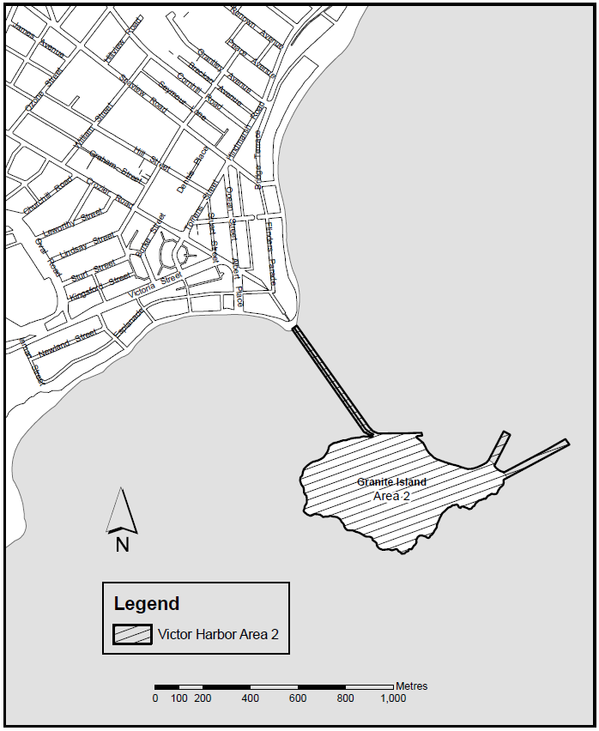
Made by the Liquor and Gambling Commissioner
on 25 October 2021

Liquor Licensing Act 1997
South Australia
Liquor Licensing (Dry Areas) Notice 2021
under section 131(1a) of the Liquor Licensing Act 1997
1—Short title
This notice may be cited as the Liquor Licensing (Dry Areas) Notice 2021.
2—Commencement
This notice comes into operation on 15 November 2021.
3—Interpretation
(1) In this notice—
principal notice means the Liquor Licensing (Dry Areas) Notice 2015 published in the Gazette on 5.1.15, as in force from time to time.
(2) Clause 3 of the principal notice applies to this notice as if it were the principal notice.
4—Consumption etc of liquor prohibited in dry areas
(1) Pursuant to section 131 of the Act, the consumption and possession of liquor in the area described in the Schedule is prohibited in accordance with the provisions of the Schedule.
(2) The prohibition has effect during the periods specified in the Schedule.
(3) The prohibition does not extend to private land in the area described in the Schedule.
(4) Unless the contrary intention appears, the prohibition of the possession of liquor in the area does not extend to—
(a) a person who is genuinely passing through the area if—
(i) the liquor is in the original container in which it was purchased from licensed premises; and
(ii) the container has not been opened; or
(b) a person who has possession of the liquor in the course of carrying on a business or in the course of his or her employment by another person in the course of carrying on a business; or
(c) a person who is permanently or temporarily residing at premises within the area or on the boundary of the area and who enters the area solely for the purpose of passing through it to enter those premises or who enters the area from those premises for the purpose of leaving the area.
Schedule— Victor Harbour Area 4
1—Extent of prohibition
The consumption of liquor is prohibited and the possession of liquor is prohibited.
2—Period of prohibition
From 8 AM on Monday 15 November 2021 to 10 AM on Monday 23 November 2021.
3—Description of area
The area in and adjacent to Victor Harbor bounded as follows: commencing at the point at which the north-western boundary of Hindmarsh Road intersects the southern bank of the Hindmarsh River, then generally westerly, north-easterly and north-westerly along that bank of the Hindmarsh River to the point at which it is intersected by the prolongation in a straight line of the northern boundary of Dinan Road, then easterly along that prolongation and boundary of Dinan Road and the prolongation in a straight line of that boundary to the western boundary of Laxton Street, then generally south-westerly and south-easterly along that boundary of Laxton Street, the south-western boundary of Adare Avenue and the prolongation in a straight line of the south-western boundary of Adare Avenue to the south-eastern boundary of Hindmarsh Road, then generally south-westerly along that boundary of Hindmarsh Road to the point at which it intersects the northern bank of the Hindmarsh River, then along that bank of the Hindmarsh River to the low water mark of Encounter Bay, then generally south-westerly and southerly along the low water mark to the eastern side of the causeway linking Granite Island to the mainland, then in a straight line by the shortest route to the low water mark on the western side of the causeway, then generally westerly, south-westerly, southerly and south-westerly along the low water mark to the point at which it is intersected by the prolongation in a straight line of the south-western boundary of Harbour View Terrace, then north-westerly along that prolongation and boundary of Harbour View Terrace to the point at which it is intersected by the prolongation in a straight line of the north-western boundary of Kent Drive, then generally north-easterly, northerly and north-westerly along that prolongation and boundary of Kent Drive to the point at which it is intersected by the prolongation in a straight line of the south-eastern boundary of a foot bridge across the Inman River (being the foot bridge closest to the mouth of the river), then north-easterly along the line of that south-eastern boundary of the foot bridge across the river to the south-western boundary of the Victor Harbor Beachfront Holiday Park, then generally south-easterly and north-easterly along the boundary of the park to the south-western boundary of Inman Street, then north-westerly along that boundary of Inman Street and the prolongation in a straight line of that boundary to the north-western boundary of Victoria Street, then north-easterly along that boundary of Victoria Street to the south-western boundary of George Main Road, then north-westerly along that boundary of George Main Road to the northern bank of the Inman River, then westerly along that bank of the river to the point at which it is intersected by the prolongation in a straight line of the western boundary of Lot 57 of FP 20694, then north-westerly along that prolongation to the kerb line on the south-eastern side of Bay Road, then generally north-easterly along that kerb line to the kerb line on the south-western side of George Main Road, then in a straight line by the shortest route across George Main Road to the north-eastern boundary of that road, then north-westerly along that boundary of George Main Road to the point at which the north-eastern boundary of George Main Road meets the eastern boundary of Lot 11 DP 14245 (Victor Harbor High School), then north-easterly, north-westerly, north-easterly, north-westerly and south-westerly along that boundary of Lot 11 to the point at which it meets the south-eastern boundary of Kullaroo Road, then north-easterly along the south-eastern boundary of Kullaroo Road and the prolongation in a straight line of that boundary to the north-eastern corner of Lot 333 FP 165581, then in a straight line by the shortest route to the point at which the north-western boundary of Leworthy Street meets the north-eastern boundary of Oval Road, then generally north-easterly along that north-western boundary of Leworthy Street and the prolongation in a straight line of that boundary to the north-eastern boundary of Crozier Road, then south-easterly along that boundary of Crozier Road to the north-western boundary of Acraman Street, then north-easterly along the north-western boundaries of Acraman Street and Carlyle Street to the point at which the north-western boundary of Carlyle Street intersects the north-eastern boundary of Cornhill Road, then south-easterly along that north-eastern boundary of Cornhill Road to the north-western boundary of Hindmarsh Road, then north-easterly along that boundary of Hindmarsh Road to the north-eastern boundary of Peace Avenue, then north-westerly along that boundary of Peace Avenue to the south-eastern boundary of Broadway Terrace, then north-easterly along that boundary of Broadway Terrace to the south-western boundary of Renown Avenue, then south-easterly along that boundary of Renown Avenue to the north-western boundary of Hindmarsh Road, then generally north-easterly along that boundary of Hindmarsh Road to the point of commencement. The area includes the whole of any wharf, jetty, boat ramp, breakwater or other structure that extends below low water mark from within the area (as well as any area beneath such a structure), but does not include that part of the causeway to Granite Island that lies within the area to which the prohibition in Victor Harbor Area 2 applies.
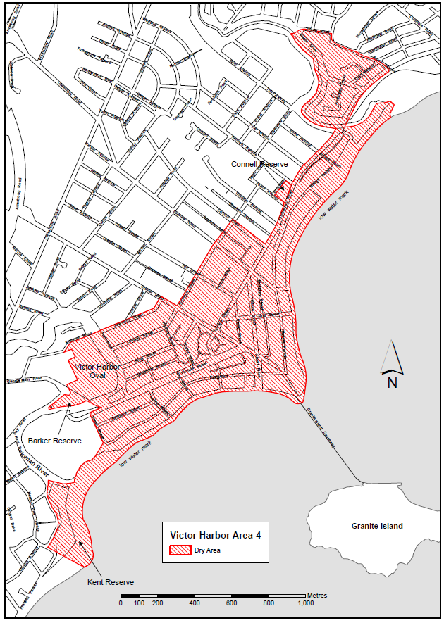
Made by the Liquor and Gambling Commissioner
on 25 October 2021

Liquor Licensing Act 1997
South Australia
Liquor Licensing (Dry Areas) Notice 2021
under section 131(1a) of the Liquor Licensing Act 1997
1—Short title
This notice may be cited as the Liquor Licensing (Dry Areas) Notice 2021.

2—Commencement
This notice comes into operation on 24 December 2021

3—Interpretation
(1) In this notice—
principal notice means the Liquor Licensing (Dry Areas) Notice 2015 published in the Gazette on 5.1.15, as in force from time to time.
(2) Clause 3 of the principal notice applies to this notice as if it were the principal notice.
4—Consumption etc of liquor prohibited in dry areas
(1) Pursuant to section 131 of the Act, the consumption and possession of liquor in the area described in the Schedule is prohibited in accordance with the provisions of the Schedule.
(2) The prohibition has effect during the periods specified in the Schedule.
(3) The prohibition does not extend to private land in the area described in the Schedule.
(4) Unless the contrary intention appears, the prohibition of the possession of liquor in the area does not extend to—
(a) a person who is genuinely passing through the area if—
(i) the liquor is in the original container in which it was purchased from licensed premises; and
(ii) the container has not been opened; or
(b) a person who has possession of the liquor in the course of carrying on a business or in the course of his or her employment by another person in the course of carrying on a business; or
(c) a person who is permanently or temporarily residing at premises within the area or on the boundary of the area and who enters the area solely for the purpose of passing through it to enter those premises or who enters the area from those premises for the purpose of leaving the area.

Schedule— Robe Area 1
1—Extent of prohibition
The consumption of liquor is prohibited and the possession of liquor is prohibited.
2—Periods of prohibition
From 12 PM on Friday 24 December 2021 until 12 PM on Sunday 2 January 2022.
3—Description of area
The area in and adjacent to Robe bounded as follows: commencing at the western end of the northern boundary of Dawson Drive, then in a straight line by the shortest route to the low water mark of Guichen Bay on the eastern side of the entrance to Fox's Lake, then in a straight line by the shortest route (across the entrance) to the low water mark on the western side of the entrance, then generally westerly along the low water mark to the eastern side of the entrance to Lake Butler, then in a straight line by the shortest route (across the entrance) to the eastern boundary of the breakwater on the western side of the entrance to the lake, then northerly, north-easterly, westerly and south-westerly around the outer boundary of the breakwater back to the low water mark on the shore on the western side of the breakwater, then generally north-westerly and southerly along the low water mark to the point at which it is intersected by the prolongation in a straight line of the southern boundary of Evans Cave Road (the northern boundary of Section 363 Hundred of Waterhouse), then generally easterly along that prolongation and boundary of Evans Cave Road, and the prolongation in a straight line of that boundary, to the eastern boundary of Robe Street, then northerly along that boundary of Robe Street to the southern boundary of Beacon Hill Road, then generally easterly along that boundary of Beacon Hill Road to the point at which it meets the north-eastern boundary of Lot 5 of DP 78111, then generally south-easterly and easterly along that boundary of Lot 5 and easterly and north-easterly along the northern boundary of Section 289 Hundred of Waterhouse to the eastern boundary of Section 289, then in a straight line by the shortest route to the south-western corner of Lot 11 of DP 64831, then easterly along the southern boundary of Lot 11 and the prolongation in a straight line of that boundary to the point at which the prolongation intersects the eastern boundary of Nora Creina Road, then northerly along that boundary of Nora Creina Road to the point at which it meets the southern boundary of Wildfield Road, then generally easterly along that boundary of Wildfield Road and the prolongation in a straight line of that boundary to the point at which the prolongation intersects the northern boundary of Southern Ports Highway, then generally north-westerly and south-westerly along that boundary of Southern Ports Highway and the northern boundary of Main Road to the eastern boundary of Dawson Drive, then generally north-westerly and westerly along that boundary of Dawson Drive to the point of commencement. The area includes any wharf, jetty, boat ramp, breakwater or other structure projecting below low water mark from within the area described above (as well as any area beneath such a structure).

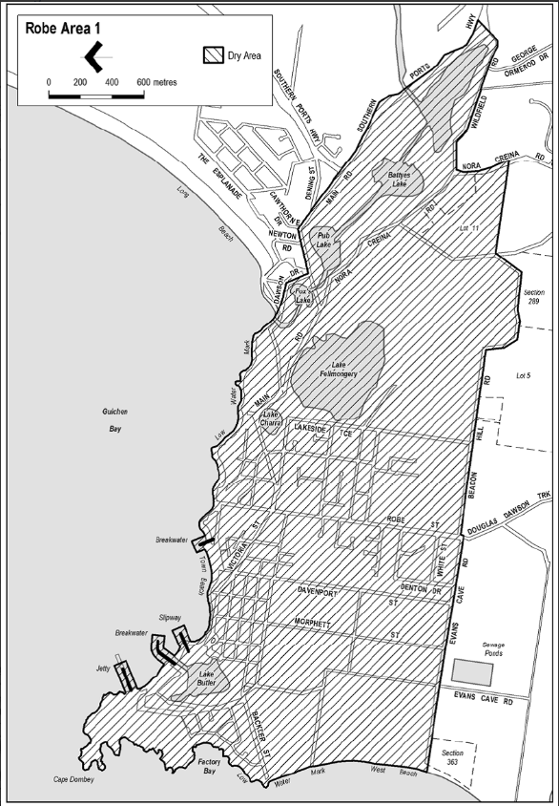
Made on behalf of the Liquor and Gambling Commissioner
On 25 October 2021

Liquor Licensing Act 1997
South Australia
Liquor Licensing (Dry Areas) Notice 2021
under section 131(1a) of the Liquor Licensing Act 1997
1—Short title
This notice may be cited as the Liquor Licensing (Dry Areas) Notice 2021.
2—Commencement
This notice comes into operation on 24 December 2021
3—Interpretation
(1) In this notice—
principal notice means the Liquor Licensing (Dry Areas) Notice 2015 published in the Gazette on 5.1.15, as in force from time to time.
(2) Clause 3 of the principal notice applies to this notice as if it were the principal notice.
4—Consumption etc of liquor prohibited in dry areas
(1) Pursuant to section 131 of the Act, the consumption and possession of liquor in the area described in the Schedule is prohibited in accordance with the provisions of the Schedule.
(2) The prohibition has effect during the periods specified in the Schedule.
(3) The prohibition does not extend to private land in the area described in the Schedule.
(4) Unless the contrary intention appears, the prohibition of the possession of liquor in the area does not extend to—
(a) a person who is genuinely passing through the area if—
(i) the liquor is in the original container in which it was purchased from licensed premises; and
(ii) the container has not been opened; or
(b) a person who has possession of the liquor in the course of carrying on a business or in the course of his or her employment by another person in the course of carrying on a business; or
(c) a person who is permanently or temporarily residing at premises within the area or on the boundary of the area and who enters the area solely for the purpose of passing through it to enter those premises or who enters the area from those premises for the purpose of leaving the area

Schedule— Robe Area 2
1—Extent of prohibition
The consumption of liquor is prohibited and the possession of liquor is prohibited.
2—Periods of prohibition
From 12 PM on Friday 24 December 2021 until 12 PM on Sunday 2 January 2022.
3—Description of area
The area in and adjacent to Robe bounded as follows: commencing at the western end of the northern boundary of Dawson Drive, then in a straight line by the shortest route to the low water mark of Guichen Bay on the eastern side of the entrance to Fox's Lake, then generally north-easterly along the low water mark to the point at which it is intersected by the prolongation in a straight line of the northern boundary of Section 573 Hundred of Waterhouse, then easterly along that prolongation and boundary of Section 573 to the eastern boundary of the Section, then generally southerly and south-westerly along that boundary of Section 573 to the north-eastern boundary of Section 390 Hundred of Waterhouse, then south-easterly along that boundary of Section 390 to the point at which it is intersected by the prolongation in a straight line of the northern boundary of Dennis Avenue, then easterly along that prolongation and boundary of Dennis Avenue, and the prolongation in a straight line of that boundary, to the point at which the prolongation intersects the western boundary of Lot 223 of FP 205569, then generally south-westerly and southerly along that boundary of Lot 223 and the prolongation in a straight line of that boundary to the point at which the prolongation intersects the south-eastern boundary of Southern Ports Highway, then south-westerly along that boundary to the western boundary of Lot 2 of FP 9707, then southerly along that boundary of Lot 2 to the southern boundary of the Lot, then generally north-westerly and south-westerly along the northern boundary of Southern Ports Highway and the northern boundary of Main Road to the eastern boundary of Dawson Drive, then generally north-westerly and westerly along that boundary of Dawson Drive to the point of commencement.

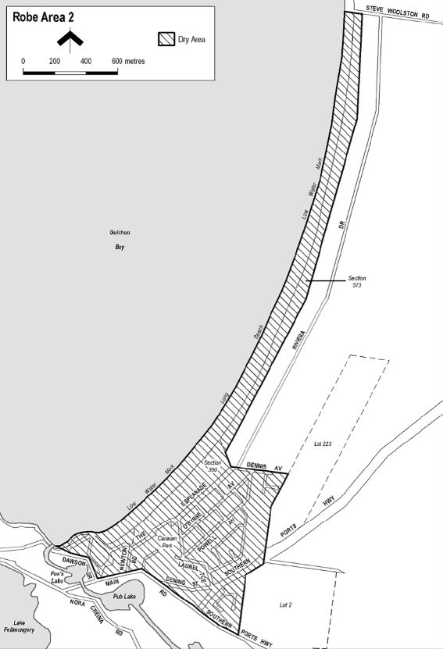
Made on behalf of the Liquor and Gambling Commissioner
On 25 October 2021

All instruments appearing in this gazette are to be considered official, and obeyed as such

Printed and published weekly by authority of S. Smith, Government Printer, South Australia
$8.00 per issue (plus postage), $402.00 per annual subscription—GST inclusive
Online publications: www.governmentgazette.sa.gov.au

