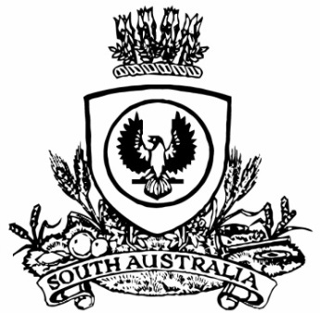
No. 32 p. 1365
SUPPLEMENTARY GAZETTE
THE SOUTH AUSTRALIAN
GOVERNMENT GAZETTE
Published by Authority

Adelaide, Tuesday, 11 May 2021

Contents

State Government Instrument
Aquaculture Act 2001 1366

State Government Instrument

Aquaculture Act 2001
Aquaculture (Zones—Eastern Spencer Gulf) Amendment Policy 2021
The Aquaculture (Zones—Eastern Spencer Gulf) Amendment Policy 2021, as approved by notice published in the Gazette (the Aquaculture (Approval of Eastern Spencer Gulf Zones Amendment Policy) Notice 2021 (Gazette 11.5.2021 p.1363)), is published below.
South Australia
Aquaculture (Zones—Eastern Spencer Gulf) Amendment Policy 2021
under section 12 of the Aquaculture Act 2001

Contents
Part 1—Preliminary
1 Short title
2 Amendment provisions
Part 2—Amendment of Aquaculture (Zones—Eastern Spencer Gulf) Policy 2005
3 Substitution of clause 7
7 Classes of permitted aquaculture
4 Substitution of clause 10
10 Classes of permitted aquaculture
5 Substitution of clause 13
13 Classes of permitted aquaculture

Part 1—Preliminary
1—Short title
This policy may be cited as the Aquaculture (Zones—Eastern Spencer Gulf) Amendment Policy 2021.
2—Amendment provisions
In this policy, a provision under a heading referring to the amendment of a specified policy varies the policy so specified.
Part 2—Amendment of Aquaculture (Zones—Eastern Spencer Gulf) Policy 2005
3—Substitution of clause 7
Clause 7—delete the clause and substitute:
7—Classes of permitted aquaculture
The classes of aquaculture permitted in the Hardwicke Bay (inner) subtidal aquaculture zone are—
(a) the farming of molluscs; and
(b) the farming of algae.
4—Substitution of clause 10
Clause 10—delete the clause and substitute:
10—Classes of permitted aquaculture
The classes of aquaculture permitted in the Hardwicke Bay (middle) subtidal aquaculture zone are—
(a) the farming of molluscs; and
(b) the farming of algae.
5—Substitution of clause 13
Clause 13—delete the clause and substitute:
13—Classes of permitted aquaculture
The classes of aquaculture permitted in the Hardwicke Bay (outer) subtidal aquaculture zone are—
(a) the farming of molluscs; and
(b) the farming of algae.
Minister for Primary Industries and Regional Development
Dated: 22 April 2021

All instruments appearing in this gazette are to be considered official, and obeyed as such

Printed and published weekly by authority of S. Smith, Government Printer, South Australia
$7.85 per issue (plus postage), $395.00 per annual subscription—GST inclusive
Online publications: www.governmentgazette.sa.gov.au

