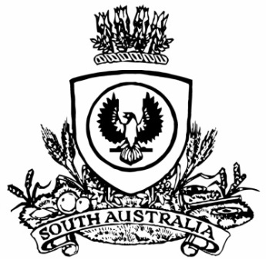
No. 13 p. 817
SUPPLEMENTARY GAZETTE
THE SOUTH AUSTRALIAN
GOVERNMENT GAZETTE
Published by Authority

Adelaide, Friday, 26 February 2021

State Government Instrument
Fisheries Management Act 2007
Section 47
Extension of the Management Plan for the South Australian Commercial Lakes and Coorong Fishery
Take note that pursuant to subsection 47(3) of the Fisheries Management Act 2007, the term of the Management Plan for the South Australian Commercial Lakes and Coorong Fishery that came into effect on 1 March 2016 by notice on page 5304 of the South Australian Government Gazette dated 24 December 2015 is hereby extended to 28 February 2022.
Dated: 25 February 2021
Prof Gavin Begg
Executive Director
Fisheries and Aquaculture
Delegate of the Minister for Primary Industries and Regional Development

