No. 57 p. 3319
THE SOUTH AUSTRALIAN
GOVERNMENT GAZETTE
Published by Authority

Adelaide, Thursday, 26 August 2021

Contents

Governor’s Instruments
Appointments 3320
Constitution Act 1934 3320
Regulations—
Planning, Development and Infrastructure (General)
(Time Periods) Variation Regulations 2021—
No.123 of 2021 3321
State Government Instruments
Environment Protection Act 1993 3323
Essential Services Commission Act 2002 3328
Housing Improvement Act 2016 3329
Justices of the Peace Act 2005 3329
Land Acquisition Act 1969 3330
Landscape South Australia Act 2019 3332
Mining Act 1971 [Republished] 3337
Petroleum and Geothermal Energy Act 2000 3347
Planning, Development and Infrastructure Act 2016 3348
Real Property Act 1886 3370
Roads (Opening and Closing) Act 1991 3370
Local Government Instruments
City of Charles Sturt 3371
City of Marion 3374
City of Whyalla 3394
District Council of Elliston 3418
Flinders Ranges Council, The 3418
District Council of Peterborough, The 3419
Public Notices
Trustee Act 1936 3420
Adelaide Airport Ltd (“AAL”) 3420
Associations Incorporations Act 1985 3421
Corporations Act 2001 3421
National Electricity Law 3422

Governor’s Instruments

Appointments
Department of the Premier and Cabinet
Adelaide, 26 August 2021
His Excellency the Governor in Executive Council has been pleased to appoint the undermentioned to the South Eastern Water Conservation and Drainage Board, pursuant to the provisions of the South Eastern Water Conservation and Drainage Act 1992:
Member: from 26 August 2021 until 25 August 2025
James Stuart Blake Holyman
By command,
Steven Spence Marshall
Premier
21EWDEWSC0026

Department of the Premier and Cabinet
Adelaide, 26 August 2021
His Excellency the Governor in Executive Council has been pleased to appoint the undermentioned to the South Australian Housing Trust Board of Management, pursuant to the provisions of the South Australian Housing Trust Act 1995:
Member: from 1 September 2021 until 31 August 2023
Samuel Montgomery Moore
Member: from 1 November 2021 until 30 October 2024
Linda Rae Matthews
By command,
Steven Spence Marshall
Premier
MHACS21008

Department of the Premier and Cabinet
Adelaide, 26 August 2021
His Excellency the Governor in Executive Council has been pleased to appoint the undermentioned to the State Bushfire Coordination Committee, pursuant to the provisions of the Fire and Emergency Services Act 2005:
Member: from 26 August 2021 until 13 November 2023
Michael James Garrod
Sarah Reachill
Deputy Member: from 26 August 2021 until 13 November 2023
Tessa Nicole Bignell Roberts (Deputy to Ashley)
Jonathan Luke Clark (Deputy to Garrod)
Merridie Shepherd Martin (Deputy to Reachill)
By command,
Steven Spence Marshall
Premier
21EMS0008CS

Department of the Premier and Cabinet
Adelaide, 26 August 2021
His Excellency the Governor in Executive Council has been pleased to appoint Peter George Kassapidis as a full-time Commissioner of the South Australian Employment Tribunal for a term of one year commencing on 13 September 2021 and expiring on 12 September 2022 - pursuant to the provisions of the South Australian Employment Tribunal Act 2014.
By command,
Steven Spence Marshall
Premier
T&F21/066CS

Constitution Act 1934
Section 13(4)
Assembly to Fill Vacancy in Legislative Council
Pursuant to a Proclamation made by His Excellency The Governor on the 12th day of August 2021, an assembly of Members of both Houses of Parliament was held on the 24th day of August 2021, to fill the seat in the Legislative Council which had become vacant by virtue of the resignation of the Honourable John David Wickham Ridgway, MLC.
At that assembly Heidi Margaret Girolamo was duly elected to fill the said vacancy.
C. D. Schwarz
Clerk of the Assembly of Members

Regulations
South Australia

Planning, Development and Infrastructure (General)
(Time Periods) Variation Regulations 2021
under the Planning, Development and Infrastructure Act 2016

Contents
Part 1—Preliminary
1 Short title
2 Commencement
3 Variation provisions
Part 2—Variation of Planning, Development and Infrastructure (General) Regulations 2017
4 Variation of regulation 3A—Application of Act (section 8)
5 Revocation of regulation 53A

Part 1—Preliminary
1—Short title
These regulations may be cited as the Planning, Development and Infrastructure (General) (Time Periods) Variation Regulations 2021.
2—Commencement
These regulations come into operation on 30 August 2021.
3—Variation provisions
In these regulations, a provision under a heading referring to the variation of specified regulations varies the regulations so specified.
Part 2—Variation of Planning, Development and Infrastructure (General) Regulations 2017
4—Variation of regulation 3A—Application of Act (section 8)
Regulation 3A(4), definition of designated day, (b)—delete “30 September 2021” and substitute:
31 January 2022
5—Revocation of regulation 53A
Regulation 53A—delete the regulation
Note—
As required by section 10AA(2) of the Subordinate Legislation Act 1978, the Minister has certified that, in the Minister’s opinion, it is necessary or appropriate that these regulations come into operation as set out in these regulations.
Made by the Governor
with the advice and consent of the Executive Council
on 26 August 2021
No 123 of 2021

State Government Instruments

Environment Protection Act 1993
Section 68
Variation of Approvals of Category B Containers
I, Andrea Kaye Woods, Delegate of the Environment Protection Authority (‘the Authority’) pursuant to section 68(6) of the Environment Protection Act 1993 (SA) hereby vary the approvals of the classes of Category B containers sold in South Australia as identified by reference to the following matters, which are described in the first 4 columns of Schedule 1 of this Notice:
(a) the product which each class of containers contain;
(b) the size of the containers;
(c) the type of containers;
(d) the name of the holders of these approvals.
These approvals are varied as the Authority is satisfied that the containers are no longer manufactured, distributed, or sold by the approval holder in South Australia.
Dated: 26 August 2021
Andrea Kaye Woods
Delegate of the Environment Protection Authority

Schedule 1
Column 1 | Column 2 | Column 3 | Column 4 | Column 5
Product Name | Container Size | Container Type | Approval Holder | Collection Arrangements
Amsterdam Mariner Premium Lager | 500ml | Can—Aluminium | Dan Murphys | Marine Stores Ltd
Asahi | 300ml | Can—Aluminium | Dan Murphys | Marine Stores Ltd
Amsterdam Mariner Premium Lager | 500ml | Can—Aluminium | International Liquor Wholesalers | Marine Stores Ltd
Becks Beer | 330ml | Glass | International Liquor Wholesalers | Marine Stores Ltd
Bitburger Lemon | 330ml | Glass | International Liquor Wholesalers | Marine Stores Ltd
Cerveza Dos Equis Lager Especial | 330ml | Glass | International Liquor Wholesalers | Marine Stores Ltd
Chang Beer | 330ml | Glass | International Liquor Wholesalers | Marine Stores Ltd
Gaymers Original Cider | 330ml | Glass | International Liquor Wholesalers | Marine Stores Ltd
Gaymers Original Cider | 568ml | Glass | International Liquor Wholesalers | Marine Stores Ltd
Grolsch Premium Lager | 250ml | Glass | International Liquor Wholesalers | Marine Stores Ltd
Kopparberg Elderflower & Lime Cider 4.0% | 330ml | Glass | International Liquor Wholesalers | Marine Stores Ltd
Kopparberg Mixed Fruit Cider 4.0% | 330ml | Glass | International Liquor Wholesalers | Marine Stores Ltd
Kopparberg Premium Apple Cider 4.5% | 500ml | Glass | International Liquor Wholesalers | Marine Stores Ltd
Kopparberg Premium Cider With Elderflower And Lime 4.0% | 500ml | Glass | International Liquor Wholesalers | Marine Stores Ltd
Kopparberg Premium Cider With  Mixed Fruits 4.0% | 500ml | Glass | International Liquor Wholesalers | Marine Stores Ltd
Kopparberg Premium Cider With  Strawberry And Lime 4.0% | 500ml | Glass | International Liquor Wholesalers | Marine Stores Ltd
Mishka Guava Tropics Vodka | 275ml | Glass | International Liquor Wholesalers | Marine Stores Ltd
Mishka Hot Pink Vodka | 275ml | Glass | International Liquor Wholesalers | Marine Stores Ltd
Mishka Lemon Twist Vodka | 275ml | Glass | International Liquor Wholesalers | Marine Stores Ltd
Mishka Pineapple Crush Vodka | 275ml | Glass | International Liquor Wholesalers | Marine Stores Ltd
Mishka Raspberry Rush Vodka | 275ml | Glass | International Liquor Wholesalers | Marine Stores Ltd
Nelson County Bourbon & Cola | 375ml | Can—Aluminium | International Liquor Wholesalers | Marine Stores Ltd
Oettinger Beer | 330ml | Glass | International Liquor Wholesalers | Marine Stores Ltd
Oranjeboom | 330ml | Glass | International Liquor Wholesalers | Marine Stores Ltd
Platinum Blonde Premium Low Carb | 375ml | Can—Aluminium | International Liquor Wholesalers | Marine Stores Ltd
Platinum Blonde Premium Low Carb | 330ml | Glass | International Liquor Wholesalers | Marine Stores Ltd
Sail & Anchor Bolt Premium Low Carb 4.6% | 330ml | Glass | International Liquor Wholesalers | Marine Stores Ltd
Sail & Anchor Castaway Cider | 330ml | Glass | International Liquor Wholesalers | Marine Stores Ltd
Sail & Anchor Clipper Light Premium Lager | 330ml | Glass | International Liquor Wholesalers | Marine Stores Ltd
Sail & Anchor Dry Dock Premium Lager | 330ml | Glass | International Liquor Wholesalers | Marine Stores Ltd
San Pellegrino Sparkling Mineral Water | 750ml | Glass | International Liquor Wholesalers | Marine Stores Ltd
Sapporo Beer | 355ml | Glass | International Liquor Wholesalers | Marine Stores Ltd
Sol Beer | 330ml | Glass | International Liquor Wholesalers | Marine Stores Ltd
Sol Cerveza Importada 4.5% | 940ml | Glass | International Liquor Wholesalers | Marine Stores Ltd
VnC Cocktails Mango Daiquiri | 700ml | PET | International Liquor Wholesalers | Marine Stores Ltd
VnC Cocktails Pacific Mai Tai | 700ml | PET | International Liquor Wholesalers | Marine Stores Ltd
VnC Cocktails Passionfruit Caprioska | 700ml | PET | International Liquor Wholesalers | Marine Stores Ltd
VnC Cocktails Pomegranate Cosmopolitan | 700ml | PET | International Liquor Wholesalers | Marine Stores Ltd
VnC Cocktails Vodka Mojito | 700ml | PET | International Liquor Wholesalers | Marine Stores Ltd
Asahi Super Dry | 330ml | Glass | Woolworths Limited | Marine Stores Ltd
Ballast Point Brewing Co Fathom IPA | 355ml | Aluminium | Woolworths Limited | Marine Stores Ltd
Barossa Cider Co Pear Cider | 330ml | Glass | Woolworths Limited | Marine Stores Ltd
Hoegaarden White Beer | 330ml | Glass | Woolworths Limited | Marine Stores Ltd
Langers Cranberry Fruit Drink Cocktail | 1,890ml | PET | Woolworths Limited | Marine Stores Ltd
Langers Cranberry Zero Sugar Added | 1,890ml | PET | Woolworths Limited | Marine Stores Ltd
Macro Organic 100% Pure Coconut Water | 500ml | LPB—Aseptic | Woolworths Limited | Marine Stores Ltd
Macro Organic 100% Pure Coconut Water | 330ml | LPB—Aseptic | Woolworths Limited | Marine Stores Ltd
Stand Together Aussie Spring Water | 600ml | PET | Woolworths Limited | Marine Stores Ltd
Stella Artois | 330ml | Glass | Woolworths Limited | Marine Stores Ltd
1688 Grand Rose Non Alcoholic Sparkling Grape Juice | 750ml | Glass | Woolworths Limited T/as Pinnacle Drinks | Marine Stores Ltd
Ballast Point Brewing Company Big Eye Indian Pale Ale | 355ml | Can—Aluminium | Woolworths Limited T/as Pinnacle Drinks | Marine Stores Ltd
Ballast Point Brewing Company Even Keel Session IPA | 355ml | Can—Aluminium | Woolworths Limited T/as Pinnacle Drinks | Marine Stores Ltd
Ballast Point Brewing Company Grapefruit Sculpin Indian Pale Ale | 355ml | Can—Aluminium | Woolworths Limited T/as Pinnacle Drinks | Marine Stores Ltd
Ballast Point Brewing Company Grunion  Pale Ale | 355ml | Can—Aluminium | Woolworths Limited T/as Pinnacle Drinks | Marine Stores Ltd
Ballast Point Brewing Company Sculpin  Indian Pale Ale | 355ml | Can—Aluminium | Woolworths Limited T/as Pinnacle Drinks | Marine Stores Ltd
Ballast Point Grapefruit Sculpin India  Pale Ale | 355ml | Glass | Woolworths Limited T/as Pinnacle Drinks | Marine Stores Ltd
Ballast Point High West Barrel Aged  Victory at Sea | 355ml | Glass | Woolworths Limited T/as Pinnacle Drinks | Marine Stores Ltd
Ballast Point Sculpin India Pale Ale | 355ml | Glass | Woolworths Limited T/as Pinnacle Drinks | Marine Stores Ltd
Ballast Point Sea Rose Tart Cherry  Wheat Ale | 355ml | Glass | Woolworths Limited T/as Pinnacle Drinks | Marine Stores Ltd
Ballast Point Victory at Sea | 355ml | Glass | Woolworths Limited T/as Pinnacle Drinks | Marine Stores Ltd
Becks | 660ml | Glass | Woolworths Limited T/as Pinnacle Drinks | Marine Stores Ltd
Becks Blue Non Alcoholic Beer | 330ml | Glass | Woolworths Limited T/as Pinnacle Drinks | Marine Stores Ltd
Cerveza Dos Equis XX Lager Especial | 355ml | Can—Aluminium | Woolworths Limited T/as Pinnacle Drinks | Marine Stores Ltd
Crabbies Cloudy Alcoholic Lemon | 330ml | Glass | Woolworths Limited T/as Pinnacle Drinks | Marine Stores Ltd
Dos Equis XX Ambar | 330ml | Glass | Woolworths Limited T/as Pinnacle Drinks | Marine Stores Ltd
Dry Dock Premium Lager | 330ml | Glass | Woolworths Limited T/as Pinnacle Drinks | Marine Stores Ltd
Dry Dock Premium Lager | 440ml | Can—Aluminium | Woolworths Limited T/as Pinnacle Drinks | Marine Stores Ltd
Duff Beer Premium Lager | 355ml | Can—Aluminium | Woolworths Limited T/as Pinnacle Drinks | Marine Stores Ltd
Dutch Windmill | 330ml | Can—Aluminium | Woolworths Limited T/as Pinnacle Drinks | Marine Stores Ltd
Firestone Walker Double Barrel DPA | 355ml | Glass | Woolworths Limited T/as Pinnacle Drinks | Marine Stores Ltd
Firestone Walker Union Jack IPA | 355ml | Glass | Woolworths Limited T/as Pinnacle Drinks | Marine Stores Ltd
Good George Brewing Blackberry Cider  With Blackberry Juice | 946ml | Glass | Woolworths Limited T/as Pinnacle Drinks | Marine Stores Ltd
Good George Brewing Doris Plum Cider  With Black Doris Plum Juice | 946ml | Glass | Woolworths Limited T/as Pinnacle Drinks | Marine Stores Ltd
Good George Brewing IPA Beer | 946ml | Glass | Woolworths Limited T/as Pinnacle Drinks | Marine Stores Ltd
Good George Brewing Pale Ale | 946ml | Glass | Woolworths Limited T/as Pinnacle Drinks | Marine Stores Ltd
Good George Brewing Scarlett Peach Cider With Scarlett OHara Peach Juice | 946ml | Glass | Woolworths Limited T/as Pinnacle Drinks | Marine Stores Ltd
Good George Brewing XPA Beer | 946ml | Glass | Woolworths Limited T/as Pinnacle Drinks | Marine Stores Ltd
Heineken | 330ml | Glass | Woolworths Limited T/as Pinnacle Drinks | Marine Stores Ltd
Heineken | 330ml | Can—Aluminium | Woolworths Limited T/as Pinnacle Drinks | Marine Stores Ltd
Heineken | 650ml | Glass | Woolworths Limited T/as Pinnacle Drinks | Marine Stores Ltd
Herrljunga + 46 Apple Cider | 330ml | Glass | Woolworths Limited T/as Pinnacle Drinks | Marine Stores Ltd
Herrljunga + 46 Pear Cider | 330ml | Glass | Woolworths Limited T/as Pinnacle Drinks | Marine Stores Ltd
Hoegaarden White Beer | 330ml | Glass | Woolworths Limited T/as Pinnacle Drinks | Marine Stores Ltd
Infinite Session American Pale Ale Ultra  Low Alcohol | 330ml | Can—Aluminium | Woolworths Limited T/as Pinnacle Drinks | Marine Stores Ltd
Johanssons Pear Cider | 500ml | Glass | Woolworths Limited T/as Pinnacle Drinks | Marine Stores Ltd
Johanssons Strawberry & Lime  Flavoured Cider | 500ml | Glass | Woolworths Limited T/as Pinnacle Drinks | Marine Stores Ltd
Karl Strauss Brewing Company Pintail  Pale Ale | 355ml | Glass | Woolworths Limited T/as Pinnacle Drinks | Marine Stores Ltd
Karl Strauss Brewing Company Tower 10 IPA | 355ml | Glass | Woolworths Limited T/as Pinnacle Drinks | Marine Stores Ltd
Lech Premium Beer | 500ml | Can—Aluminium | Woolworths Limited T/as Pinnacle Drinks | Marine Stores Ltd
Loafer Pale Ale | 330ml | Glass | Woolworths Limited T/as Pinnacle Drinks | Marine Stores Ltd
Magners Original Irish Apple Cider | 568ml | Glass | Woolworths Limited T/as Pinnacle Drinks | Marine Stores Ltd
Magners Original Irish Pear Cider | 568ml | Glass | Woolworths Limited T/as Pinnacle Drinks | Marine Stores Ltd
Martens Pils | 500ml | Can—Aluminium | Woolworths Limited T/as Pinnacle Drinks | Marine Stores Ltd
McAllister & Cola | 440ml | Can—Aluminium | Woolworths Limited T/as Pinnacle Drinks | Marine Stores Ltd
Mishka Citrus Vodka | 300ml | Can—Aluminium | Woolworths Limited T/as Pinnacle Drinks | Marine Stores Ltd
Mishka Mixed Vodka Lemon Lime & Bitters | 250ml | Can—Aluminium | Woolworths Limited T/as Pinnacle Drinks | Marine Stores Ltd
Mishka Mixed Vodka Ripe Raspberry | 250ml | Can—Aluminium | Woolworths Limited T/as Pinnacle Drinks | Marine Stores Ltd
Mishka Mixed Vodka Sugar Free Guava | 275ml | Glass | Woolworths Limited T/as Pinnacle Drinks | Marine Stores Ltd
Mishka Mixed Vodka Tangy Orange | 275ml | Glass | Woolworths Limited T/as Pinnacle Drinks | Marine Stores Ltd
Mishka Mixed Vodka Tropical Pineapple | 275ml | Glass | Woolworths Limited T/as Pinnacle Drinks | Marine Stores Ltd
Mishka Mixed Vodka Tropical Pineapple | 250ml | Can—Aluminium | Woolworths Limited T/as Pinnacle Drinks | Marine Stores Ltd
Mishka Mixed Vodka Zingy Lemon | 250ml | Can—Aluminium | Woolworths Limited T/as Pinnacle Drinks | Marine Stores Ltd
Mishka Tropical Vodka Sugar Free | 300ml | Can—Aluminium | Woolworths Limited T/as Pinnacle Drinks | Marine Stores Ltd
Oettinger Wheat Beer | 500ml | Can—Aluminium | Woolworths Limited T/as Pinnacle Drinks | Marine Stores Ltd
Oranjeboom Premium Quality Cider | 500ml | Can—Aluminium | Woolworths Limited T/as Pinnacle Drinks | Marine Stores Ltd
Oseberg Crushed Apple Cider | 500ml | Glass | Woolworths Limited T/as Pinnacle Drinks | Marine Stores Ltd
Oseberg Crushed Pear Cider | 500ml | Glass | Woolworths Limited T/as Pinnacle Drinks | Marine Stores Ltd
Oseberg Peach & Vanilla Flavoured Cider | 500ml | Glass | Woolworths Limited T/as Pinnacle Drinks | Marine Stores Ltd
Oseberg Strawberry & Lime Flavoured Cider | 500ml | Glass | Woolworths Limited T/as Pinnacle Drinks | Marine Stores Ltd
Peroni Nastro Azzurro | 330ml | Glass | Woolworths Limited T/as Pinnacle Drinks | Marine Stores Ltd
Peroni Nastro Azzurro | 660ml | Glass | Woolworths Limited T/as Pinnacle Drinks | Marine Stores Ltd
Pistonhead Kustom Lager | 330ml | Can—Aluminium | Woolworths Limited T/as Pinnacle Drinks | Marine Stores Ltd
Sail & Anchor Changing Tides | 640ml | Glass | Woolworths Limited T/as Pinnacle Drinks | Marine Stores Ltd
Sail & Anchor IPA | 345ml | Glass | Woolworths Limited T/as Pinnacle Drinks | Marine Stores Ltd
Sail & Anchor The Bloke Red Ale | 640ml | Glass | Woolworths Limited T/as Pinnacle Drinks | Marine Stores Ltd
Saranac Shandy | 355ml | Glass | Woolworths Limited T/as Pinnacle Drinks | Marine Stores Ltd
Sidra Del Verano Apple & Pear Cider | 500ml | Glass | Woolworths Limited T/as Pinnacle Drinks | Marine Stores Ltd
Sidra Del Verano Apple Blackcurrant & Cranberry Cider | 500ml | Glass | Woolworths Limited T/as Pinnacle Drinks | Marine Stores Ltd
Sidra Del Verano Apple Mango &  Passionfruit Cider | 500ml | Glass | Woolworths Limited T/as Pinnacle Drinks | Marine Stores Ltd
Sidra Del Verano Apple Peach &  Apricot Cider | 500ml | Glass | Woolworths Limited T/as Pinnacle Drinks | Marine Stores Ltd
Sidra Del Verano Spanish Apple Cider | 500ml | Glass | Woolworths Limited T/as Pinnacle Drinks | Marine Stores Ltd
Skinny Brands Lager | 330ml | Glass | Woolworths Limited T/as Pinnacle Drinks | Marine Stores Ltd
Stella Artois | 660ml | Glass | Woolworths Limited T/as Pinnacle Drinks | Marine Stores Ltd
Stella Artois Cidre | 568ml | Glass | Woolworths Limited T/as Pinnacle Drinks | Marine Stores Ltd
Stoke IPA | 330ml | Glass | Woolworths Limited T/as Pinnacle Drinks | Marine Stores Ltd
Stoke NPA | 330ml | Glass | Woolworths Limited T/as Pinnacle Drinks | Marine Stores Ltd
Sub Zero Citrus Vodka Mix | 275ml | Glass | Woolworths Limited T/as Pinnacle Drinks | Marine Stores Ltd
Tecate | 355ml | Glass | Woolworths Limited T/as Pinnacle Drinks | Marine Stores Ltd
The Bronx Pale Ale | 473ml | Can—Aluminium | Woolworths Limited T/as Pinnacle Drinks | Marine Stores Ltd
Tun Original Bitter | 355ml | Can—Aluminium | Woolworths Limited T/as Pinnacle Drinks | Marine Stores Ltd
Tyskie | 500ml | Can—Aluminium | Woolworths Limited T/as Pinnacle Drinks | Marine Stores Ltd
W Wilderen Goud | 330ml | Glass | Woolworths Limited T/as Pinnacle Drinks | Marine Stores Ltd
W Wilderen Kriek | 330ml | Glass | Woolworths Limited T/as Pinnacle Drinks | Marine Stores Ltd
W Wilderen Tripel Kanunnik | 330ml | Glass | Woolworths Limited T/as Pinnacle Drinks | Marine Stores Ltd
Winemakers Cider Co Granny Smith | 750ml | Glass | Woolworths Limited T/as Pinnacle Drinks | Marine Stores Ltd
Winemakers Cider Co Pink Lady | 750ml | Glass | Woolworths Limited T/as Pinnacle Drinks | Marine Stores Ltd
Winemakers Cider Co Red Delicious | 750ml | Glass | Woolworths Limited T/as Pinnacle Drinks | Marine Stores Ltd
Zytho Brewing Zesty Pale Ale | 375ml | Can—Aluminium | Woolworths Limited T/as Pinnacle Drinks | Marine Stores Ltd
Ballast Point Big Eye India Pale Ale | 355ml | Glass | Wow Brands | Marine Stores Ltd
Ballast Point Black Marlin Porter | 650ml | Glass | Wow Brands | Marine Stores Ltd
Becks | 500ml | Can—Aluminium | Wow Brands | Marine Stores Ltd
Castaway Dry Cider | 640ml | Glass | Wow Brands | Marine Stores Ltd
Castaway Original Cider | 640ml | Glass | Wow Brands | Marine Stores Ltd
Castaway Sweet Cider | 330ml | Glass | Wow Brands | Marine Stores Ltd
Castaway Sweet Cider | 640ml | Glass | Wow Brands | Marine Stores Ltd
Chang Beer | 640ml | Glass | Wow Brands | Marine Stores Ltd
Chang Beer | 500ml | Can—Aluminium | Wow Brands | Marine Stores Ltd
Coronada Orange Avenue Wit | 355ml | Glass | Wow Brands | Marine Stores Ltd
Coronita Extra | 210ml | Glass | Wow Brands | Marine Stores Ltd
Crabbies Original Alcoholic Ginger Beer | 500ml | Glass | Wow Brands | Marine Stores Ltd
Crabbies Original Alcoholic Ginger Beer | 330ml | Glass | Wow Brands | Marine Stores Ltd
Crabbies Raspberry Alcoholic Ginger Beer | 500ml | Glass | Wow Brands | Marine Stores Ltd
Crabbies Spiced Orange Alcoholic Ginger Beer | 500ml | Glass | Wow Brands | Marine Stores Ltd
Crabbies Strawberry & Lime Alcoholic  Ginger Beer | 500ml | Glass | Wow Brands | Marine Stores Ltd
Dundee India Pale Ale | 355ml | Glass | Wow Brands | Marine Stores Ltd
Feeneys Irish Cream Liqueur | 50ml | PET | Wow Brands | Marine Stores Ltd
Franks Alcoholic Ginger Beer | 500ml | Glass | Wow Brands | Marine Stores Ltd
Heineken | 500ml | Can—Aluminium | Wow Brands | Marine Stores Ltd
Herrljunga + 46 Apple Cider | 1,500ml | Glass | Wow Brands | Marine Stores Ltd
Herrljunga + 46 Pear Cider | 1,500ml | Glass | Wow Brands | Marine Stores Ltd
Herrljunga Blackcurrant & Lime  Flavoured Cider | 500ml | Glass | Wow Brands | Marine Stores Ltd
Herrljunga Strawberry & Vanilla  Flavoured Cider | 500ml | Glass | Wow Brands | Marine Stores Ltd
Hogs 3 Bourbon & Cola Kentucky  Straight Bourbon Whiskey | 375ml | Can—Aluminium | Wow Brands | Marine Stores Ltd
Karl Strauss Pintail Pale Ale | 355ml | Glass | Wow Brands | Marine Stores Ltd
Karl Strauss Red Trolley Ale | 355ml | Glass | Wow Brands | Marine Stores Ltd
Karl Strauss Tower 10 IPA | 355ml | Glass | Wow Brands | Marine Stores Ltd
Kopparberg Blueberry & Lime | 500ml | Glass | Wow Brands | Marine Stores Ltd
Kopparberg Pear Cider | 330ml | Can—Aluminium | Wow Brands | Marine Stores Ltd
Kopparberg Premium Cider with Raspberry | 500ml | Glass | Wow Brands | Marine Stores Ltd
Kopparberg Premium Cider with Winter Fruits | 500ml | Glass | Wow Brands | Marine Stores Ltd
Kopparberg Strawberry & Lime Cider | 330ml | Can—Aluminium | Wow Brands | Marine Stores Ltd
Kostritzer Schwarzbier | 330ml | Glass | Wow Brands | Marine Stores Ltd
Loic Raison Brut Dry Cider | 750ml | Glass | Wow Brands | Marine Stores Ltd
Loic Raison Doux Sweet Cider | 750ml | Glass | Wow Brands | Marine Stores Ltd
Magic Hat | 355ml | Glass | Wow Brands | Marine Stores Ltd
Maria Ole Sangria Red | 1,500ml | PET | Wow Brands | Marine Stores Ltd
Maria Ole Sangria White | 1,500ml | PET | Wow Brands | Marine Stores Ltd
Miller Genuine Draft | 330ml | Glass | Wow Brands | Marine Stores Ltd
Mionetto il Spriz | 200ml | Glass | Wow Brands | Marine Stores Ltd
Mionetto il Spriz | 750ml | Glass | Wow Brands | Marine Stores Ltd
Mionetto il UGO | 750ml | Glass | Wow Brands | Marine Stores Ltd
Mionetto il UGO | 200ml | Glass | Wow Brands | Marine Stores Ltd
Mishka Apple & Lychee Vodka | 275ml | Glass | Wow Brands | Marine Stores Ltd
Mishka Freeze Citrus Vodka Daiquiri | 220ml | Flexible Pouch—PE/PET | Wow Brands | Marine Stores Ltd
Mishka Freeze Strawberry Daiquiri | 220ml | Flexible Pouch—PE/PET | Wow Brands | Marine Stores Ltd
Mishka Vodka Apple & Cranberry Juice | 2,000ml | Cask—cardboard box & PE/Metal/  Polyester bag | Wow Brands | Marine Stores Ltd
Mishka Vodka Berry Sensation | 250ml | Can—Aluminium | Wow Brands | Marine Stores Ltd
Mishka Vodka Ginger & Lime | 275ml | Glass | Wow Brands | Marine Stores Ltd
Mishka Vodka Lemon Twist | 250ml | Can—Aluminium | Wow Brands | Marine Stores Ltd
Mishka Vodka Pear & Honey | 2,000ml | Cask—cardboard box & PE/Metal/  Polyester bag | Wow Brands | Marine Stores Ltd
Mishka Vodka Raspberry Splash | 250ml | Can—Aluminium | Wow Brands | Marine Stores Ltd
Mishka Vodka Tropical Fruit Juices | 2,000ml | Cask—cardboard box & PE/Metal/  Polyester bag | Wow Brands | Marine Stores Ltd
Mishka Vodka Tropical Tango | 250ml | Can—Aluminium | Wow Brands | Marine Stores Ltd
Nastro Azzurro | 330ml | Glass | Wow Brands | Marine Stores Ltd
Nelson County Bourbon & Cola | 330ml | Glass | Wow Brands | Marine Stores Ltd
Nelson County Bourbon & Cola 6.5% | 375ml | Can—Aluminium | Wow Brands | Marine Stores Ltd
Old Mout Boysen Cider | 750ml | Glass | Wow Brands | Marine Stores Ltd
Old Mout Classic Apple Cider | 750ml | Glass | Wow Brands | Marine Stores Ltd
Old Mout Scrumpy Cider | 750ml | Glass | Wow Brands | Marine Stores Ltd
Pabst Blue Ribbon Beer | 473ml | Can—Aluminium | Wow Brands | Marine Stores Ltd
Rekorderlig Apple Blackcurrant | 500ml | Glass | Wow Brands | Marine Stores Ltd
Rekorderlig Pear | 500ml | Glass | Wow Brands | Marine Stores Ltd
Rekorderlig Strawberry Lime | 500ml | Glass | Wow Brands | Marine Stores Ltd
Rekorderlig Wild Berries | 500ml | Glass | Wow Brands | Marine Stores Ltd
Rose River Just Joey Sauvignon Blanc Semillon Non Alcoholic | 750ml | Glass | Wow Brands | Marine Stores Ltd
Rose River Red Pierre Shiraz Non Alcoholic | 750ml | Glass | Wow Brands | Marine Stores Ltd
Rose River Vol De Nuit Sparkling Cuvee  Non Alcoholic | 750ml | Glass | Wow Brands | Marine Stores Ltd
Sail & Anchor Boas Bind Amber Ale | 345ml | Glass | Wow Brands | Marine Stores Ltd
Sail & Anchor Cats Shank Kolsch | 345ml | Glass | Wow Brands | Marine Stores Ltd
Sail & Anchor Devil Dodger IPA | 640ml | Glass | Wow Brands | Marine Stores Ltd
Sail & Anchor Draught Beer | 330ml | Glass | Wow Brands | Marine Stores Ltd
Sail & Anchor Dry Dock Beer | 640ml | Glass | Wow Brands | Marine Stores Ltd
Sail & Anchor Jack Tar Imperial Stout | 640ml | Glass | Wow Brands | Marine Stores Ltd
Sail & Anchor Larks Foot Golden Ale | 345ml | Glass | Wow Brands | Marine Stores Ltd
Sail & Anchor Monkeys Fist Pale Ale | 345ml | Glass | Wow Brands | Marine Stores Ltd
Sail & Anchor Ol Bluey Ginger Beer | 330ml | Glass | Wow Brands | Marine Stores Ltd
Sail & Anchor Strawberry & Lime Cider | 330ml | Glass | Wow Brands | Marine Stores Ltd
Saranac Pumpkin Ale | 355ml | Glass | Wow Brands | Marine Stores Ltd
Savanna Dry Cider | 330ml | Glass | Wow Brands | Marine Stores Ltd
Saxton Apple Cider | 330ml | Glass | Wow Brands | Marine Stores Ltd
Saxton Pear Cider | 330ml | Glass | Wow Brands | Marine Stores Ltd
Sierro Sparkling Red Grape Drink | 750ml | Glass | Wow Brands | Marine Stores Ltd
Sierro Sparkling White Grape Drink | 750ml | Glass | Wow Brands | Marine Stores Ltd
Stella Artois | 500ml | Can—Aluminium | Wow Brands | Marine Stores Ltd
Stella Artois Premium Lager Beer | 330ml | Glass | Wow Brands | Marine Stores Ltd
Stoke Amber | 330ml | Glass | Wow Brands | Marine Stores Ltd
Stoke Bomber Bohemian Ale | 650ml | Glass | Wow Brands | Marine Stores Ltd
Stoke Bomber Kiwi Pale Ale | 650ml | Glass | Wow Brands | Marine Stores Ltd
Stoke Dark | 330ml | Glass | Wow Brands | Marine Stores Ltd
Stoke Gold | 330ml | Glass | Wow Brands | Marine Stores Ltd
Suntory Magnum Dry | 500ml | Can—Aluminium | Wow Brands | Marine Stores Ltd
Tun Bitter | 355ml | Can—Aluminium | Wow Brands | Marine Stores Ltd
Tun Light | 355ml | Can—Aluminium | Wow Brands | Marine Stores Ltd
Tun Mid | 355ml | Can—Aluminium | Wow Brands | Marine Stores Ltd
Wing Walker American Belgian Style  Wheat Ale | 355ml | Glass | Wow Brands | Marine Stores Ltd
Wing Walker American Pale Ale | 355ml | Glass | Wow Brands | Marine Stores Ltd

Environment Protection Act 1993
Section 69
Variation to Existing Approval of Collection Depot
I, Andrea Kaye Woods, Delegate of the Environment Protection Authority (‘the Authority’), pursuant to section 69 of the Environment Protection Act 1993 (SA) (‘the Act’) hereby:
1. Variation to Existing Approval of Collection Depot:
Vary the approval of the collection depot listed at Schedule 1 of this notice, that was granted under the Act prior to the date of this Notice and impose the conditions of this approval to be as follows:
1.1 Approval of Collection Depot:
The collection depot identified by reference to the following matters is approved:
(a) the name of the collection depot described in Column 1 of Schedule 1 of this Notice;
(b) the name of the proprietor of the depot identified in Column 3 of Schedule 1 of this Notice;
(c) the location of the depot described in columns 4-6 of Schedule 1 of this Notice; and
The collection depot listed at Schedule 1 of this Notice is approved in relation to all classes of containers, which were approved under the Act, at or subsequent to the date of this Notice, as Category B Containers.
1.2 Conditions of approval:
Impose the following conditions on the approval:
1. If the Approval Holder’s name or postal address (or both) changes, then the Approval Holder must inform the Authority in writing, within 28 days of the change occurring.
2. If the collection depot is sold to another party, the Approval Holder must inform the Authority in writing, within 28 days of settlement.
3. The Approval Holder who wishes to cease operation of the depot shall notify the Authority in writing. no less than 14 days from date of closing.
4. The Approval Holder, or a person acting on his or her behalf, must not pay a refund on, or seek reimbursement for, containers that the Approval Holder, or the person acting on his or her behalf, knows were not purchased in South Australia.
5. The Approval Holder must ensure that prominent signage is displayed, detailing the offence and the penalties under Section 69 the Act, for presenting interstate containers for refund.
Dated: 26 August 2021
Andrea Kaye Woods
Delegate of the Environment Protection Authority

Schedule 1
Column 1 | Column 2 | Column 3 | Column 4 | Column 5 | Column 6 | Column 7
Depot Name | Company  Name | Proprietors | Depot Location  Street | Depot Location  Suburb | Certificate of  Title/Volume | Collection  Area
Arno Bay Receival Centre | Eastern Eyre Recycling | Frank Gillings; Gail Gillings | Lot 52 Alexandria Avenue | Arno Bay | 52/051145 | Regional
Cleve Receival Centre | Eastern Eyre Recycling | Frank Gillings; Gail Gillings | Lot 431 Depot Street | Cleve | n/a | Regional
Port Neill Receival Centre | Eastern Eyre Recycling | Frank Gillings; Gail Gillings | 19 Wallis Street | Port Neill | 5370/927 | Regional

Essential Services Commission Act 2002
Subsequent Determination
Notice is hereby given that:
1. Pursuant to section 31(8) and Part 3 of the Essential Services Commission Act 2002 and as authorised by Part 4 of the Water Industry Act 2012, the Essential Services Commission has, by the making of a subsequent determination to take effect on and from 26 August 2021, varied the price determination applying to Robusto Investments Pty Ltd (ACN 117 034 545) made by the Essential Services Commission on 25 May 2021.
2. Copies of that subsequent determination may be inspected or obtained from the Essential Services Commission, Level 1, 151 Pirie Street, Adelaide and are also available at www.escosa.sa.gov.au.
3. Queries in relation to the subsequent determination may be directed to the Essential Services Commission, Level 1, 151 Pirie Street, Adelaide. Telephone (08) 8463 4444, Freecall 1800 633 592 or email escosa@escosa.sa.gov.au.
The seal of the Essential Services Commission was affixed to the subsequent determination with due authority by a Commissioner of the Essential Services Commission.
Dated: 26 August 2021
Dr Lynne Williams AM
Acting Chairperson
Essential Services Commission

Housing Improvement Act 2016
Rent Control Revocations
Whereas the Minister for Human Services Delegate is satisfied that each of the houses described hereunder has ceased to be unsafe or unsuitable for human habitation for the purposes of the Housing Improvement Act 2016, notice is hereby given that, in exercise of the powers conferred by the said Act, the Minister for Human Services Delegate does hereby revoke the said Rent Control in respect of each property.
Address of Premises | Allotment Section | Certificate of Title  Volume/Folio
Unit 1, 452 Portrush Road, Linden Park SA 5065 | Allotment 358 Filed Plan 18505 Hundred of Adelaide | CT5467/897
Unit 3, 452 Portrush Road, Linden Park SA 5065 | Allotment 358 Filed Plan 18505 Hundred of Adelaide | CT5467/897
2143 Main RD45, Waterloo SA 5413 | Allotment 50 Deposited Plan 93098 Hundred of Stanley | CT6170/185
20A Radbone Road, Mount George SA 5155 | Allotment 6 Filed Plan 11259 Hundred of Onkaparinga | CT5066/937,  CT6231/681
Dated: 26 August 2021
Craig Thompson
Housing Regulator And Registrar
Housing Safety Authority, SAHA
Delegate of Minister for Human Services

Justices of the Peace Act 2005
Section 4
Notice of Appointment of Justices of the Peace for South Australia
by the Commissioner for Consumer Affairs
I, Dini Soulio, Commissioner for Consumer Affairs, delegate of the Attorney-General, pursuant to section 4 of the Justices of the Peace Act 2005, do hereby appoint the people listed as Justices of the Peace for South Australia as set out below:
For a period of ten years for a term commencing on 22 September 2021 and expiring on 21 September 2031:
Lyndsay Scott YOUNG
Graham Charles THOMAS
Mark Anthony SURMAN
John James SNELLING
William Andrew SINTON
Mario Nunzio RUSSO
Keith Frank PUYENBROEK
Christopher Ray POLE
Domenic Ramo PATRONI
Lisa Gaye LOADER
Garry Ivan LENNARD
Stephen Noel LANGMAN
Annette Kay HURLEY
Trevor Charles HOLST
Katrina HILL
Robyn Kathryn GERAGHTY
Garry Douglas FIELDHOUSE
Iain Frederick EVANS
Arthur Timothy Heathfield DENDY
John Andrew DARLEY
Terri Lynn CHRISTENSEN
Andrew Paul Stanley CHAMBERS
Cosimo Vincenzo CAVALLARO
Deirdre Clarice BLACKWELL
Tracy Ann BERRY
Phillip John BENTLEY
Frances Ellen BEDFORD
Kevin John BAXTER
Michael John ATKINSON
Ronald Geoffrey ATKIN
John Pellegrino AMOROSO
Dated: 20 August 2021
Dini Soulio
Commissioner for Consumer Affairs
Delegate of the Attorney-General

Land Acquisition Act 1969
Section 16
Form 5—Notice of Acquisition
1. Notice of acquisition
The Commissioner of Highways (the Authority), of 50 Flinders Street, Adelaide SA 5000, acquires the following interests in the following land:
Comprising an unencumbered estate in fee simple in that piece of land being portion of Allotment 100 in Deposited Plan No. 78670 comprised in Certificate of Title Volume 6037 Folio 131, and being the whole of the land identified as Allotment 21 in D127223 lodged in the Lands Titles Office.
This notice is given under section 16 of the Land Acquisition Act 1969.
2. Compensation
A person who has or had an interest consisting of native title or an alienable interest in the land that is divested or diminished by the acquisition or the enjoyment of which is adversely affected by the acquisition who does not receive an offer of compensation from the Authority may apply to the Authority for compensation.
2A. Payment of professional costs relating to acquisition (section 26B)
If you are the owner in fee simple of the land to which this notice relates, you may be entitled to a payment of $10,000 from the Authority for use towards the payment of professional costs in relation to the acquisition of the land.
Professional costs include legal costs, valuation costs and any other costs prescribed by the Land Acquisition Regulations 2019.
3. Inquiries
Inquiries should be directed to:
Carlene Russell
GPO Box 1533
Adelaide SA 5001
Telephone: (08) 8343 2512
Dated: 23 August 2021
The Common Seal of the COMMISSIONER OF HIGHWAYS was hereto affixed by authority of the Commissioner in the presence of:
Rocco Caruso
Manager, Property Acquisition
(Authorised Officer)
Department for Infrastructure and Transport
DIT 2020/18224/01

Land Acquisition Act 1969
Section 16
Form 5—Notice of Acquisition
1. Notice of acquisition
The Commissioner of Highways (the Authority), of 50 Flinders Street, Adelaide SA 5000, acquires the following interests in the following land:
Comprising an unencumbered estate in fee simple in that piece of land being portion of Allotment 4 in Deposited Plan No. 75222 comprised in Certificate of Title Volume 6000 Folio 152, and being the whole of the land identified as Allotment 92 in D127330 lodged in the Lands Titles Office.
This notice is given under section 16 of the Land Acquisition Act 1969.
2. Compensation
A person who has or had an interest consisting of native title or an alienable interest in the land that is divested or diminished by the acquisition or the enjoyment of which is adversely affected by the acquisition who does not receive an offer of compensation from the Authority may apply to the Authority for compensation.
2A. Payment of professional costs relating to acquisition (section 26B)
If you are the owner in fee simple of the land to which this notice relates, you may be entitled to a payment of $10,000 from the Authority for use towards the payment of professional costs in relation to the acquisition of the land.
Professional costs include legal costs, valuation costs and any other costs prescribed by the Land Acquisition Regulations 2019.
3. Inquiries
Inquiries should be directed to:
Petrula Pettas
GPO Box 1533
Adelaide SA 5001
Telephone: (08) 8343 2619
Dated: 23 August 2021
The Common Seal of the COMMISSIONER OF HIGHWAYS was hereto affixed by authority of the Commissioner in the presence of:
Rocco Caruso
Manager, Property Acquisition
(Authorised Officer)
Department for Infrastructure and Transport
DIT2020/20052/01

Land Acquisition Act 1969
Section 16
Form 5—Notice of Acquisition
1. Notice of acquisition
The Commissioner of Highways (the Authority), of 50 Flinders Street, Adelaide SA 5000, acquires the following interests in the following land:
Comprising an unencumbered estate in fee simple in that piece of land being a portion of Section 543S in Hundred of Cameron comprised in Certificate of Title Volume 5607 Folio 149, and being the whole of the land identified as Allotment 90 in D127329 lodged in the Lands Titles Office.
This notice is given under section 16 of the Land Acquisition Act 1969.
2. Compensation
A person who has or had an interest consisting of native title or an alienable interest in the land that is divested or diminished by the acquisition or the enjoyment of which is adversely affected by the acquisition who does not receive an offer of compensation from the Authority may apply to the Authority for compensation.
2A. Payment of professional costs relating to acquisition (section 26B)
If you are the owner in fee simple of the land to which this notice relates, you may be entitled to a payment of $10,000 from the Authority for use towards the payment of professional costs in relation to the acquisition of the land.
Professional costs include legal costs, valuation costs and any other costs prescribed by the Land Acquisition Regulations 2019.
3. Inquiries
Inquiries should be directed to:
Petrula Pettas
GPO Box 1533
Adelaide SA 5001
Telephone: (08) 8343 2619
Dated: 23 August 2021
The Common Seal of the COMMISSIONER OF HIGHWAYS was hereto affixed by authority of the Commissioner in the presence of:
Rocco Caruso
Manager, Property Acquisition
(Authorised Officer)
Department of Planning, Transport and Infrastructure
DIT 2020/20053/01

Land Acquisition Act 1969
Section 16
Form 5—Notice of Acquisition
1. Notice of acquisition
The Commissioner of Highways (the Authority), of 50 Flinders Street, Adelaide SA 5000, acquires the following interests in the following land:
First: Comprising an unencumbered estate in fee simple in that piece of land being portion of Section 482 in Hundred of Goyder comprised in Certificate of Title Volume 5498 Folio 13, and being the whole of the land identified as Allotment 37 in D127161 lodged in the Lands Titles Office.
Secondly: Comprising an unencumbered estate in fee simple in that piece of land being portion of Section 504 in Hundred of Goyder comprised in Certificate of Title Volume 5526 Folio 361, and being the whole of the land identified as Allotment 35 in D127160 lodged in the Lands Titles Office.
This notice is given under section 16 of the Land Acquisition Act 1969.
2. Compensation
A person who has or had an interest consisting of native title or an alienable interest in the land that is divested or diminished by the acquisition or the enjoyment of which is adversely affected by the acquisition who does not receive an offer of compensation from the Authority may apply to the Authority for compensation.
2A. Payment of professional costs relating to acquisition (section 26B)
If you are the owner in fee simple of the land to which this notice relates, you may be entitled to a payment of $10,000 from the Authority for use towards the payment of professional costs in relation to the acquisition of the land.
Professional costs include legal costs, valuation costs and any other costs prescribed by the Land Acquisition Regulations 2019.
3. Inquiries
Inquiries should be directed to:
Petrula Pettas
GPO Box 1533
Adelaide SA 5001
Telephone: (08) 8343 2619
Dated: 23 August 2021
The Common Seal of the COMMISSIONER OF HIGHWAYS was hereto affixed by authority of the Commissioner in the presence of:
Rocco Caruso
Manager, Property Acquisition
(Authorised Officer)
Department for Infrastructure and Transport
DIT: 2020/20067/01

Land Acquisition Act 1969
Section 16
Form 5—Notice of Acquisition
1. Notice of acquisition
The Commissioner of Highways (the Authority), of 50 Flinders Street, Adelaide SA 5000, acquires the following interests in the following land:
Comprising an estate in fee simple in that piece of land being portion of Allotment 103 in Deposited Plan No. 12123 comprised in Certificate of Title Volume 6050 Folio 505, and being the whole of the land identified as Allotment 9 in D126871 lodged in the Lands Titles Office hereto subject to the easement(s) over the land marked J, K and L to Distribution Lessor Corporation (Subject to Lease 8890000) (TG 11219680) and Subject to Easement(s) over the land marked B to Transmission Lessor Corporation of 1 undivided 2nd part (subject to Lease 9061500) and Electranet Pty Ltd of 1 undivided 2nd part (TG8084580).
This notice is given under section 16 of the Land Acquisition Act 1969.
2. Compensation
A person who has or had an interest consisting of native title or an alienable interest in the land that is divested or diminished by the acquisition or the enjoyment of which is adversely affected by the acquisition who does not receive an offer of compensation from the Authority may apply to the Authority for compensation.
2A. Payment of professional costs relating to acquisition (section 26B)
If you are the owner in fee simple of the land to which this notice relates, you may be entitled to a payment of $10,000 from the Authority for use towards the payment of professional costs in relation to the acquisition of the land.
Professional costs include legal costs, valuation costs and any other costs prescribed by the Land Acquisition Regulations 2019.
3. Inquiries
Inquiries should be directed to:
Petrula Pettas
GPO Box 1533
Adelaide SA 5001
Telephone: (08) 8343 2619
Dated: 24 August 2021
The Common Seal of the COMMISSIONER OF HIGHWAYS was hereto affixed by authority of the Commissioner in the presence of:
Rocco Caruso
Manager, Property Acquisition
(Authorised Officer)
Department for Infrastructure and Transport
DIT: 2020/20073/01

Landscape South Australia Act 2019
List of Declared Animals
Pursuant to section 185(1) of the Landscape South Australia Act 2019 (the Act), I, David Speirs MP, Minister for Environment and Water, vary the List of Declared Animals by declaring the provisions of the Act apply to specified animals in specified declared areas as follows:
The List of Declared Animals is amended by the removal of CLASS 24 and the replacement of CLASS 23 and CLASS 25 with the following (by amending “Whole of State (excluding any areas specified in other classes)” to “Whole of State” in CLASS 23; and by updating the class number for CLASS 25, Pig (Domestic form)):
Taxonomic Name | Common Name | Provision of Act  Which are to Apply | Category | Declared Area
CLASS 23 | Feral Pig, Wild Pig | 186(1)(3), 187(1), 188, 189, 190, 192(1) | 3 | Whole of State
MAMMALIA
ARTIODACTYLA
Suidae
Sus scrofa
CLASS 24 | Pig (Domestic form) | 189, 191(1), 192(3) | 3 | Whole of State
MAMMALIA
ARTIODACTYLA
Suidae
Sus scrofa
The List of Declared Animals is amended by the replacement of reference to provision 187(1a) with reference to provision 187(2) for CLASSES 6, 7, 8, 9, 11, 12, 20, 21 and 22, and with reference to provision 187(1) for CLASS 17.
Taxonomic Name | Common Name | Provision of Act  Which are to Apply | Category | Declared Area
CLASS 6 | Fox, Red Fox, European Fox | 186(1)(3), 187(2), 188, 189, 190, 192(1) | 1 | All offshore islands and any vessel adjacent to any such island
MAMMALIA
CARNIVORA
Canidae
Vulpes vulpes
CLASS 7  MAMMALIA  CARNIVORA  Canidae  Canis familiaris | Dingo | 186(1)(2)(3), 187(2), 188, 189, 191(1), 192(1) | 2 | Inside of the Dog Fence
CLASS 8  MAMMALIA  LAGOMORPHA  Leporidae  Lepus europeus  Oryctolagus cuniculus | Hare, European Hare  Rabbit, European Rabbit  (wild & domestic forms) | 186(1)(3), 187(2), 188, 189, 190, 192(1) | 1 | All offshore islands (including Kangaroo Island but excluding Wardang Island) and any vessel adjacent to any such island
CLASS 9  MAMMALIA  LAGOMORPHA  Leporidae  Oryctolagus cuniculus | Rabbit, European Rabbit (wild forms) | 186(1)(3), 187(2), 188, 189, 192(2), 194(1) | 3 | Whole of the State (excluding any areas specified in other classes)
CLASS 11  MAMMALIA  ARTIODACTYLA  Bovidae  Capra hircus | Goat | 187(2), 189, 190, 192(3) | 3 | Whole of the area comprising the Flinders Ranges Development Plan
CLASS 12  MAMMALIA  ARTIODACTYLA  Bovidae  Capra hircus | Goat | 186(1), 187(2), 189, 190, 192(3) | 3 | All offshore islands (excluding Wardang Island and Kangaroo Island)
CLASS 17  MAMMALIA  RODENTIA  Muridae  Mus musculus  Rattus norvegicus  Rattus rattus | Mouse, House Mouse (wild form)  Brown Rat (wild form)  Black Rat (wild form) | 187(1), 189 | 3 | Whole of the State
CLASS 20  MAMMALIA  CARNIVORA  Mustelidae  Mustela putorius furo | Ferret, Domestic Ferret | 186(1)(3), 187(2), 188, 189, 190, 191(1), 192(1) | 3 | Kangaroo Island
CLASS 21 |  | 186(1)(3), 187(2), 188, 189, 190, 191(1), 192(1) | 3 | All offshore islands including Kangaroo Island
MAMMALIA
ARTIODACTYLA
Cervidae
Axis axis | Chital Deer, Axis Deer, Spotted Deer
Axis porcinus | Hog Deer
Cervus elaphus | Red Deer (incl. elk/wapiti)
Cervus nippon | Sika Deer
Dama dama | Fallow Deer (incl. Persian/ Mesopotamian fallow)
Rusa timoriensis | Rusa Deer, Javan Deer, Timor Deer
Rusa unicolor | Sambar, Sambar Deer
CLASS 22  MAMMALIA  ARTIODACTYLA  Bovidae  Capra hircus | Goat | 186(1)(3), 187(2), 188, 189, 190, 191(1), 192(2) | 3 | Kangaroo Island
Dated: 27 July 2021
David Speirs MP
Minister for Environment and Water

Landscape South Australia Act 2019
Section 192(1)
Notice Requiring Action to Destroy Wild Dogs in the Declared Area
For the purposes of section 192(1) of the Landscape South Australia Act 2019 (the Act) and in accordance with Regulation 24 of the Landscape South Australia (General) Regulations 2020 (the Regulations), I, John Schutz, Chief Executive of the Department for Environment and Water, hereby notify that, within the declared area of mainland South Australia, an owner of land in a region designated by this notice must take action to destroy wild dogs in the manner set out in this notice.
Designated Regions:
Region 1 comprises the area of South Australia (the State) that is located inside the dog fence but outside council areas under the Local Government Act 1999.
Region 2 comprises all properties greater than 300 hectares within the boundaries of the Flinders Ranges Council, District Council of Orroroo Carrieton, District Council of Peterborough, Northern Areas Council, Regional Council of Goyder or District Council of Ceduna.
Region 3 comprises the areas of the Southern Mallee Council, Tatiara Council and Coorong Council incorporating Ngarkat Conservation Park and all properties that have a shared boundary with the Ngarkat Conservation Park.
Region 4 comprises all land mainland South Australia inside the dog fence and not within Regions 1, 2 or 3.
In this notice:
dog fence means the dog-proof fence established and maintained in the northern areas of the State in accordance with subsection 18(2) of the Dog Fence Act 1946.
inside the dog fence means land within that portion of the State that is bounded by the dog fence, the eastern border of the State and the coast of the State.
lethal wild dog bait means a wild dog bait containing 0.6mg of Sodium Fluoroacetate (1080) or 1,000mg of Paramino Propriophenome (PAPP).
owner of land means—
(a) if the land is unalienated from the Crown—the Crown; or
(b) if the land is alienated from the Crown by grant in fee simple—the owner (at law or in equity) of the estate in fee simple; or
(c) if the land is held from the Crown by lease or licence—the lessee or licensee, or a person who has entered into an agreement to acquire the interest of the lessee or licensee; or
(d) if the land is held from the Crown under an agreement to purchase—the person who has the right to purchase; or
(e) a person who holds native title in the land; or
(f) a person who has arrogated to themselves (lawfully or unlawfully) the rights of an owner of the land,
and includes an occupier of the land and any other person of a prescribed class included within the ambit of this definition by a regulation made under the Act.
trapping means trapping an animal in a manner that complies with regulation 9(2) of the Animal Welfare Regulations 2012.
wild dog means a dingo; and any dog that is any cross of a dingo; and any feral dog.
1. In all Regions, baits must be laid in a manner that complies with the “Bait label for Wild Dog Control” set out at the PIRSA website.
2. In all Regions, an owner of land must not bait or trap wild dogs on land they do not own, unless they have permission to do so.
3. In Region 1:
All owners of land must, once every autumn and once every spring (and irrespective of evidence of wild dog activity) lay at least one lethal wild dog bait at intervals of one kilometre for the entire length of any established vehicle track or road on that land, or if organically certified, the land owner must provide to the local landscape board a plan that outlines an alternative method for laying the equivalent amount of baits, based on at least one lethal wild dog bait per kilometre for the entire length of all established vehicle tracks and roads on that land and, once approved by the local landscape board, immediately enact the approved plan.
(a) If an owner of land becomes aware of evidence of wild dog activity on that land, they:
(i) must, as soon as practicable, report the evidence to all owners of land adjoining that land and the local landscape board; and
(ii) must take the following measures:
(1) as soon as practicable, within 10 kilometres of such evidence lay at least one lethal wild dog bait along every 200 metres of any established vehicle track or road; or
(2) if the property is organically certified, the land owner must, as soon as practicable, provide to the local landscape board, for approval by that board, a wild dog control plan that outlines an alternative method for laying the equivalent amount of baits, based on baiting within 10 kilometres of such evidence, laying at least one lethal wild dog bait along every 200 metres of any established vehicle track or road and, once approved by the local landscape board, immediately enact the approved plan;
(3) Whether the property is organically certified or not, if wild dog activity is still detected after one month of baits being laid, repeat the baiting or undertake trapping or employ the services of a professional trapper to destroy all wild dogs until no further evidence is detected for a period of at least one month and report the continued wild dog activity and control activities to all adjoining owners of the land and the local landscape board contemporaneously with the further control activities.
4. In Region 2:
(a) If an owner of land becomes aware of evidence of wild dog activity on that land, they:
(i) must, as soon as practicable, report the evidence to all owners of land adjoining that land and the local landscape board; and
(ii) The owner of the land, and the owners of all land adjoining that land, must take the following measures:
(1) as soon as practicable, lay ten lethal wild dog baits per 100 hectares of land, or one bait at minimum intervals of 200 metres along any established vehicle tracks or roads; or

(2) if the property is organically certified, the land owner must, as soon as practicable, provide to the local landscape board, for approval by that board, a wild dog control plan that outlines an alternative method for laying the equivalent amount of baits, based on baiting within 10 kilometres of such evidence, laying at least one lethal wild dog bait along every 200 metres of any established vehicle track or road and, once approved by the local landscape board, immediately enact the approved plan;
(3) Whether the property is organically certified or not, if wild dog activity is still detected after one month of baits being laid, repeat the baiting or undertake trapping or employ the services of a professional trapper to destroy all wild dogs until no further evidence is detected for a period of at least one month and report the continued wild dog activity and control activities to all adjoining owners of the land and the local landscape board contemporaneously with the further control activities.
5. In Region 3:
(a) If an owner of land becomes aware of evidence of wild dog activity on that land, they must, as soon as practicable, report the evidence to all owners of land adjoining that land and the local landscape board.
(b) Within Ngarkat Conservation Park:
(i) The owner of the land must provide to the local landscape board, for approval by that board, a plan which provides for baiting within the Ngarkat Conservation Park and, once approved by the local landscape board, immediately enact the approved plan.
(ii) The plan must include the following requirements:
(1) That periodic baiting is to address the whole of the Ngarkat Conservation Park;
(2) That periodic baiting is to occur four times per year;
(3) That the location of periodic baiting must be identified e.g. through identifying tracks to be baited;
(4) That lethal baits must be laid at minimum intervals of 500 metres along any track identified and every 250 metres along the vehicle track that borders Victoria.
(c) Outside Ngarkat Conservation Park:
(i) If the owner of land becomes aware of wild dog activity on their land, that owner and the owners of all land adjoining that land, must undertake the following measures:
(1) as soon as practicable, lay baits at minimum intervals of 500 metres along established tracks or roads;
(d) Within all of Region 3:
(i) If wild dog activity is still detected after one month of baits being laid, repeat the baiting or undertake trapping or employ the services of a professional trapper to destroy all wild dogs until no further evidence is detected for a period of at least one month and report the continued wild dog activity and control activities to all adjoining owners of the land and the local landscape board contemporaneously with the further control activities.
6. In Region 4:
(a) If an owner of land becomes aware of evidence of wild dog activity on that land, they must, as soon as practicable, report the evidence to the local landscape board and should report that evidence to all owners of land adjoining that land; and
(b) must comply with any instructions of the board to destroy wild dogs on that land.
For noting—REGION 5 is addressed under a separate Notice pursuant to section 192(3)(a) of the Act and regulation 25 of the Regulations.
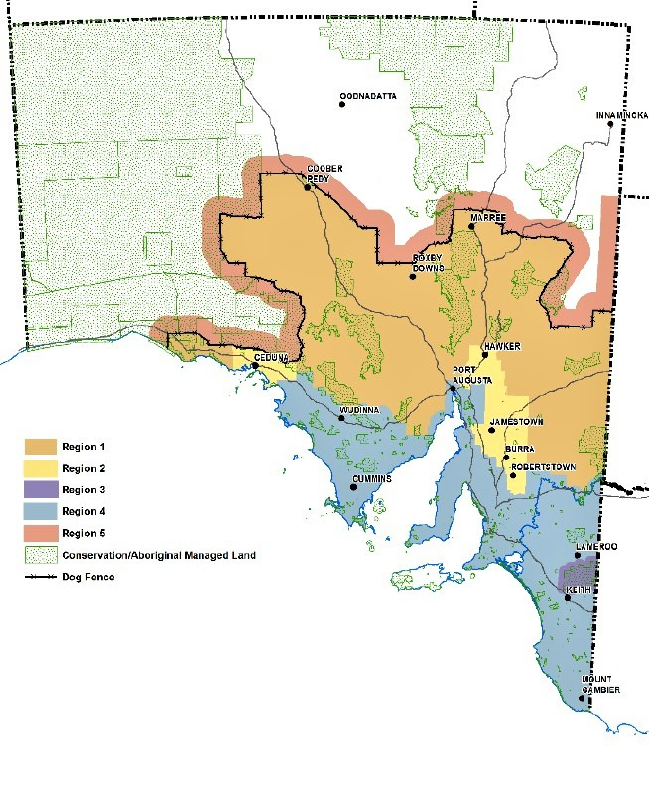Dated: 11 August 2021
John Schultz
Chief Executive
Department for Environment and Water

Landscape South Australia Act 2019
Section 192 (3)(a)
Notice of Control Measures for Declared Animals in Declared Areas
Pursuant to Section 192(3)(a) of the Landscape South Australia Act 2019
Wild Dogs Outside, but within 35 Kilometres of, the Dog Fence in South Australia
For the purposes of section 192(3)(a) of the Landscape South Australia Act 2019 (LSA Act) and in accordance with regulation 25 of the Landscape South Australia (General) Regulations 2020, I, John Schutz, Chief Executive of the Department for Environment and Water, hereby notify that, within the declared area of mainland South Australia, an owner of land within the region designated by this notice must take the following measures to control any wild dogs on their land:
Designated Region:
Region 5, the designated region, comprises the 35-kilometre-wide corridor of land running along the entire outside boundary of the dog fence within South Australia (the State).
In this notice:
dog fence means the dog-proof fence established and maintained in the northern areas of the State in accordance with subsection 18(2) of the Dog Fence Act 1946.
outside the dog fence means the land within the State that is not within the area bounded by the dog fence, the eastern border of the State and the coast of the State (i.e. inside the dog fence).
lethal wild dog bait means a wild dog bait containing 0.6 mg of Sodium Fluoroacetate (1080) or 1000mg of Paramino Propriophenome (PAPP).
owner of land means—
(a) if the land is unalienated from the Crown—the Crown; or
(b) if the land is alienated from the Crown by grant in fee simple—the owner (at law or in equity) of the estate in fee simple; or
(c) if the land is held from the Crown by lease or licence—the lessee or licensee, or a person who has entered into an agreement to acquire the interest of the lessee or licensee; or
(d) if the land is held from the Crown under an agreement to purchase—the person who has the right to purchase; or
(e) a person who holds native title in the land; or
(f) a person who has arrogated to themselves (lawfully or unlawfully) the rights of an owner of the land,
and includes an occupier of the land and any other person of a prescribed class included within the ambit of this definition by a regulation made under the Act.
wild dog means a dingo; and any dog that is any cross of a dingo; and any feral dog.
vehicle track means any track or road on a property that is accessed by a vehicle.
Irrespective of evidence of wild dog activity, all owners of land within Region 5 must, once in autumn and once in spring, lay a minimum of ten lethal wild dog baits within a 10km radius of each man-made water point which is being used by livestock, or if the property is organically certified, the land owner must provide to the local landscape board, for approval by that board, a wild dog control plan that outlines an alternative method for laying the equivalent amount of baits, based on a minimum of ten lethal wild dog baits within a 10km radius of each man-made water point which is being used by livestock and, once approved by the local landscape board, immediately enact the approved plan.
Baits must be laid in a manner that complies with the “Bait label for Wild Dog Control” set out at the PIRSA website.
For noting—REGIONS 1, 2, 3 and 4 are addressed in a separate Notice pursuant to section 192(1) of the LSA Act and Regulation 24 of the Landscape South Australia (General) Regulations 2020.
Dated: 19 August 2021
John Schultz
Chief Executive
Department for Environment and Water

[Republished]
In the South Australian Government Gazette No. 97 dated 17 December 2020, on page 5901 being the second notice on that page, the notice submitted under the Mining Act 1971 was published with numbering errors and should be replaced with the following:

Mining Act 1971
Section 36
Terms of Reference for Extractive Mineral Quarry Lease/Licence Applications
An application for a mining lease (EML) for the recovery of extractive minerals must be accompanied by:
• a proposal that complies with section 36 of the Mining Act 1971, regulations 46 and 47 of the Mining Regulations 2020 and any determinations set out in this Terms of Reference; and
• information that complies with regulation 30 of the Mining Regulations 2020 and any determinations set out in this Terms of Reference; and
• a declaration of accuracy that complies with regulation 84 of the Mining Regulations 2020; and
• the relevant application fee.
An application for a miscellaneous purposes licence (MPL) for the recovery of extractive minerals must be accompanied by:
• a proposal that complies with section 49 of the Mining Act 1971, regulations 46 and 47 of the Mining Regulations 2020 and any determinations set out in this Terms of Reference; and
• information that complies with regulations 37 and 38 of the Mining Regulations 2020 and any determinations set out in this Terms of Reference; and
• a declaration of accuracy that complies with regulation 84 of the Mining Regulations 2020; and
• the relevant application fee.
In accordance with section 36 of the Mining Act 1971 this Terms of Reference will have effect from 1 January 2021.
FORM OF APPLICATION
In accordance with section 36(1)(a) of the Mining Act 1971 an application for a mining lease (EML) for the recovery of extractive minerals must be made in the form and contain such information as set out in this Terms of References, unless otherwise specified by the Director of Mines or an authorised officer.
For the purposes of section 36(1)(a) of the Mining Act 1971, it is determined that an application for an EML must contain the information as follows:
• Applicant name(s) (company and/or individual and/or related body corporate) and each applicants percentage share in the application
• Name of project
• Mineral type
• Mineral(s) to be authorised
• Primary mineral(s) sought
• Other mineral(s) sought
• Proposed lease area details including a detailed map/plan (if required)
• Native title land
• Details of relevant land ownership, notices, consents and agreements
• Declaration of accuracy
• Applicant(s) details including:
◦ Name of Company and/or Individual
◦ ABN (if applicable)
◦ ACN (if applicable)
◦ Registered address
◦ Applicant contact details including:
- Postal Address
- Email
- Website
- Phone number(s)
◦ Contact Person details including:
- Name
- Position Title
- Email
- Phone number(s)
- Consent to receive electronic correspondence (or otherwise)
In accordance with section 49(1)(a) of the Mining Act 1971 an application for a miscellaneous purpose licence (MPL) ancillary to the recovery of extractive minerals must be made in the form and contain such information as set out in this Terms of References, unless otherwise specified by the Director of Mines or an authorised officer.

For the purposes of section 49(1)(a) of the Mining Act 1971, it is determined that an application for a MPL must contain the information as follows:
• Applicant name(s) (company and/or individual and/or related body corporate) and each applicants percentage share in the application
• Name of project
• Related applications/mining operations
• Location of proposed licence including a detailed map/plan (if required)
• Purpose of proposed licence
• Pegging details relating to proposed licence area
• Native title land
• Details of relevant land ownership, notices, consents and agreements
• Declaration of accuracy
• Applicant(s) details including:
◦ Name of Company and/or Individual
◦ ABN (if applicable)
◦ ACN (if applicable)
◦ Registered address
◦ Applicant contact details including:
- Postal Address
- Email
- Website
- Phone number(s)
◦ Contact Person details including:
- Name
- Position Title
- Email
- Phone number(s)
- Consent to receive electronic correspondence (or otherwise)
An application for an EML and/or MPL must in accordance with section 36(1)(a) and 49(1)(a) of the Mining Act 1971 be in the following form, unless otherwise specified by the Director of Mines or an authorised officer:
• an electronic version of the Proposal must be submitted in accordance with regulation 88 of the Mining Regulations 2020; hardcopies must be submitted upon request; the information in all must be identical;
• each page, plan or other separate sheet of the Proposal must include the mineral claim, retention lease or exploration licence number(s), date of the application submission and sequential page numbering; and
• the electronic version of the Proposal must be submitted in one single Acrobat PDF file or if requested by the Director of Mines or an authorised officer, Microsoft WORD compatible files must be submitted.
PROPOSAL
An application for an EML and/or MPL must be accompanied by a proposal that complies with sections 36 and 49 of the Mining Act 1971 and regulations 46 and 47 of the Mining Regulations 2020, and must comply with the following determinations of this Terms of Reference as set out below:
1. DESCRIPTION OF THE EXISTING ENVIRONMENT
In setting out an assessment of the environmental impacts of the proposed authorised operations in accordance with sections 36(1)(c)(ii)(A) and 49(1)(c)(ii)(A) of the Mining Act 1971 and regulation 46(2) of the Mining Regulations 2020, the Minister determines in accordance with regulation 46(7)(e) of the Mining Regulations 2020 that a proposal must include a description and assessment of the environment as set out in this Terms of Reference. Each of the elements of the existing environment (as defined in section 6(4) of the Mining Act 1971) listed in clause 1.1- 1.19 must be described only to the extent that they may need to be considered in assessing the potential impacts of the proposed quarry operations. If the element is not likely to be impacted by the operation, a statement to that effect must be included.
1.1 Topography and landscape
Provide a description and map (as per 5.1.1.1) of the topography and landscape, detailing the:
• application area; and
• general surroundings.
1.2 Climate
Provide a summary from the nearest relevant weather station of:
• annual rainfall and temperature patterns; and
• prevailing wind directions and speed (including maximum wind gusts).
1.3 Topsoil and subsoil
Provide:
• a description of the soil profile (type and depth), and the characteristics and/or productivity of all soils on the application area (show this information on a map as per 5.1.1.2 if there is a variation in soils over the application area); and
• identify any soil characteristics that may be an issue for disturbance or rehabilitation.
1.4 Geological Environment
Provide:
• local geological or site map (as per 5.1.1.2), showing location and dimensions of the deposit and structure (dip and strike where appropriate);
• representative cross sections (as per 5.2.1.1) of the proposed quarry area that identify the extent of the resource and estimate any overlying overburden; and
• a description and results of any geological evaluation work carried out.
1.5 Geohazards
Provide an assessment of the potential for any of the following natural geohazards to be present in the application area:
• structural instability including slips, faults, karst features or geological unit boundaries;
• minerals that may occur in the material to be quarried (including overburden) and are hazardous to human health specifically radioactive minerals, asbestiform minerals or minerals which have the potential to produce respirable silica; and
• minerals that may occur in the material to be quarried (including overburden) that may have the potential to pollute the environment - including but not limited to sulphide minerals that may generate acid.
1.6 Groundwater
Provide:
• a statement describing if the application area is within an area where the water resources are prescribed under the Landscape South Australia Act 2019;
• a map (as per 5.1.1.3) showing groundwater wells in the surrounding area, highlighting those used to determine the seasonally high water table elevation;
• a cross section (as per 5.2.1.2) showing the proposed quarrying and seasonally high water table elevation in metres Australian Height Datum (AHD); and
• evidence to validate the estimated seasonally high water table.
If the proposed quarry has the potential to intersect the seasonally high water table, the following must be provided:
• details of local groundwater systems, including information on water quality and static water level (including seasonal fluctuations), recharge and discharge mechanisms, aquifer hydraulic properties, location of any aquifer and static water level of any other known drill holes; and
• an assessment of any current use of this water by the landowner, adjacent landowners and groundwater dependent ecosystems.
1.7 Surface water
Provide a Topographic Map (as per 5.1.1.1) and description of the current drainage patterns for the application area and water catchment including:
• location of watercourses, drains, dams and wetlands;
• surface water catchment boundaries;
• direction of drainage and discharge from the application area;
• a statement describing if the application area is within an area where the water resources are prescribed under the Landscape South Australia Act 2019, and provide details on the current availability of water resources within the prescribed area;
• a statement describing if the application area is within a water protection area including areas under the River Murray Act 2003; and
• a statement as to whether the application area falls within the Murray Darling Basin.
If there is potential for changing a flow regime (including change in flow volume) or discharge into these watercourses from the proposed quarry operations, an assessment of the use of this water by the landowner, downstream users and water dependent ecosystems must be included.
1.8 Vegetation, weeds and plant pathogens
Provide:
• a description and map (as per 5.1.1.1) of existing flora (native and introduced) in the application area and surroundings;
• the State conservation status and habitat value of native vegetation present in the application area;
• a description of the presence of Commonwealth Environment Protection and Biodiversity Conservation Act 1999 listed species and ecological communities;
• a description of the extent the application area and adjoining land is affected or potentially affected by pathogens and declared weeds, including but not limited to phytophthora and broomrape; and
• if known, a description of the history of land use to identify if the existing vegetation is the result of deliberate cultivation or natural regrowth arising from previous clearance.
1.9 Fauna
Describe the native and feral fauna that may be present in the application area noting State or Commonwealth conservation status of all species.
1.10 Caves
If the application area is within, or near to, known caves or significant limestone formations a survey for the presence of caves must be performed.
Provide a summary of the results of the survey and describe the presence of any caves in karst (limestone) areas within, or near to, the application area and show on a map (as per 5.1.1.5).
1.11 Land use
Provide a description of:
• land use (historical and current) for the application area and the surrounding areas;
• the zoning as defined by the Planning and Design Code or relevant council development plans;
• policies relevant to the application area, including region or council wide, zone specific and sub areas within a zone;
• known plans for potential future land use changes by other parties;
• other interests or restrictions on the application area, including:
◦ public utility easements;
◦ if the application is within land used for defence purposes, including the Woomera Prohibited Area or the Cultana Army Training Area; and
◦ any overlapping or adjacent tenements under the Mining Act 1971 or Petroleum and Geothermal Energy Act 2000;
1.12 Proximity to infrastructure and housing
Provide information and a map (as per 5.1.1.4):
• identifying residences within and near the application area;
• identifying other human infrastructure including but not limited to schools, hospitals, commercial or industrial sites, roads, sheds, bores, dams, ruins, pumps, cemeteries, scenic lookouts, roads, railway lines, fences, transmission lines, gas and water pipelines, telephone and communication lines (both underground and above ground); and
• identifying public roads to be utilised or affected as part of proposed quarrying operations, including an estimate of the existing traffic movements.
1.13 Exempt Land
Provide a description and map (as per 5.1.1.4) of any applicable exempt land under Section 9 of the Mining Act 1971.
1.14 Amenity
Provide a summary description of scenic or aesthetic values for the application area and immediate surrounds.
1.15 Air quality
Provide a description of the existing levels of dust and contributors to air quality (both natural and anthropogenic).
1.16 Noise
Provide a description of existing noise levels and contributors to noise (both natural and anthropogenic).
1.17 Heritage (Aboriginal, European, Geological)
Detail and show on a map (as per 5.1.1.1):
• any registered heritage sites in or adjacent to the application areas that are protected under legislation (in so far as may be permitted under the relevant legislation).
• Include a statement concerning whether or not an Aboriginal cultural heritage survey has been conducted by the proponent and, if so, the results of the survey.
1.18 Proximity to conservation areas
Provide information and a map (as per 5.1.1.1) showing:
• proximity to national parks and reserves, private conservation areas, Commonwealth recognised conservation areas, heritage agreement areas and geological heritage sites.
1.19 Pre-existing site contamination and previous disturbance
Provide information and a map (as per 5.1.1.1) showing:
• any known existing contamination of the site and/or any disturbance by previous mining operations or other activities.
2. DESCRIPTION OF THE PROPOSED OPERATIONS
In specifying the nature and extent of the authorised operations that are proposed in accordance with sections 36(1)(c)(i) and 49(1)(c)(i) of the Mining Act 1971, the Minister determines in accordance with regulation 46(7)(e) of the Mining Regulations 2020 that a proposal must include a description of the proposed operations as set out in this Terms of Reference. Each of the elements listed in clauses 2.1–2.9 must be described only to the extent that they apply to the proposed quarry operation.
2.1 General description and maps/plans of operations
A summary description of all elements of the proposed operation must be included.
2.2 Resource and Products
2.2.1 Resource
Provide a statement of the extractive minerals proposed to be extracted, recovered and sold.
Provide a statement of the current estimated resource or reserve (or both), including:
• details of the basis of this estimate; and
• a declaration that the resource or reserve (or both) has been appropriately identified and estimated.
2.2.2 Production Rate and Products
State:
• the potential end use and products for all extractive minerals proposed to be sold. Provide estimates of the:
• annual production rate (product and overburden);
• life of the quarry; and
• material movement over life of quarry (product and overburden).
2.3 Quarrying Activities
2.3.1 Type or types of proposed quarry operation to be carried out
Provide:
• a summary and map (as per 5.1.2.1) of the proposed site layout;
• a description of the proposed quarrying method; and
• conceptual dimensions and depth of proposed pit(s).
2.3.2 Sequence of quarrying and progressive rehabilitation
Describe conceptually and show on a map (as per 5.1.2.2):
• staging and description of each progressive quarrying stage;
• milestones that will instigate progressive rehabilitation; and
• staging and description of each progressive rehabilitation stage including:
◦ use of overburden;
◦ battering of mining faces and other earthworks;
◦ topsoil management; and
◦ revegetation.
2.3.3 Stockpiles
2.3.3.1 Topsoil and Subsoil Stockpiles
Describe and show on a map (as per 5.1.2.1):
• conceptual location, size, shape and height of topsoil/subsoil stockpiles.
2.3.3.2 Product Stockpile
Describe and show on a map (as per 5.1.2.1):
• conceptual location and height of product stockpiles.
2.3.4 Use of explosives
If explosives are proposed to be used, describe:
• estimated frequency of blasting; and
• whether explosives will be stored onsite.
2.3.5 Modes and hours of operation
State if the proposed quarry operation will be operated on a continuous (24 hour, 7 days a week), regular periodical or campaign basis.
If the proposed quarry operation is to be operated on a regular periodical basis or campaign basis, specify:
• proposed period(s) (daily, weekly and public holidays) to be worked; and
• proposed start and finish hours the site is to be worked per period.
2.4 Crushing, processing and product transport
2.4.1 Fixed plant
Describe the specifications (to at least a conceptual standard) of fixed plant including but not limited to:
• area, size, and location of fixed plant and associated structures including as applicable concrete batching plant, wheel wash facilities, silos, fuel tanks, water tanks, chemical storage proposed to be used for processing the extractive minerals on site;
• a description of rock or sand processing; in particular crushing, washing, drying, screening and separation; and
• the type(s) of processing/value adding used on the raw material and conducted onsite including but not limited to concrete, bitumen, separation and drying.
2.4.2 Hours of operation
Describe the proposed hours of crushing, processing and product transport activities.
2.4.3 Processing wastes
If processing wastes are to be generated provide a conceptual description of:
• management of any proposed chemical additives contained within waste to prevent environmental harm;
• management and disposal of processing wastes;
• construction and geotechnical details of proposed storage facilities; and
• construction details/design of evaporation ponds and proposed use of waste material.
2.4.4 Industrial and domestic wastes
A description of management of any of the following industrial and domestic wastes must be provided:
• putrescible waste;
• oil;
• other onsite waste disposal or recycling; e.g. workshop waste, tyres, drums, oil filters;
• offsite disposal; and
• a description of the type, area and layout of sewage systems installed at the site.
2.5 Supporting surface infrastructure
2.5.1 Access and Roads
Describe:
• access route to the site and show on a map (as per 5.1.2.3);
• indicate if any new roads are to be constructed, or if existing roads or intersections (public and private) are to be upgraded; and
• transport system(s) used to and from the site and the estimated number of vehicle movements per day.
2.5.2 Accommodation and offices
Describe onsite personnel accommodation and offices, including but not limited to:
• number, area, size, type of construction and location of accommodation, office, meals or laboratory buildings, caravans or camp, and associated structures (e.g. car parks, water tanks, etc.) to be used on site; and
• if temporary or permanent.
2.5.3 Public services and utilities used by the operation
Describe:
• sources of services or utilities that are, or are to be supplied to the proposed site, such as power, water, telecommunications etc.;
• if new connections to services and utilities are required, the proposed routes for connection; and
• the effects to any existing services or utilities that have been or may be affected by the mining operations.
2.5.4 Visual screening
Describe the type of screening, including existing or proposed vegetation (i.e. species and density of plantings) and show on a map (as per 5.1.2.1 or 5.1.2.2).
2.5.5 Fuel and chemical storage
For all fuels and chemicals stored on site show the proposed location of storage on a map (as per 5.1.2.1) and provide detail on:
• types of bulk chemicals and the volumes of each; and
• proposed bunding and containment for all chemical and fuel storage vessels.
2.5.6 Site security
Describe infrastructure and measures that will be adopted to prevent unauthorised access by the public, including, but not limited to:
• fencing; and
• signage.
2.5.7 Erosion, Sediment and Silt Control
Describe and show on a map (as per 5.1.2.1):
• location and design of sediment management structures;
• management and disposal of silt;
• strategies to control runoff on disturbed areas and rehabilitated areas; and
• storage, diversion and release of clean water.
2.6 Vegetation clearance
If clearance of native vegetation is proposed, a description of the vegetation type to be cleared and map (as per 5.1.2.2) showing the proposed clearance area must be provided.
State the estimated quantum of significant environmental benefit (SEB) to be gained in exchange for the proposed clearance and describe how the SEB will be provided.
2.7 Site Water Management
Provide an estimate of the quantity of water to be used and the proposed source of that water. If processing water is to be used, provide a water balance including:
• approximate water volumes required for processing; and
• a summary of all water inputs and outputs.
Provide a description of all process water ponds, including:
• size, capacity, layout and location of ponds;
• design and construction methods; and
• minimum freeboard to be maintained.
2.8 Description of Quarry Site at Completion
Provide a map (as per 5.1.2.4), cross-section (as per 5.2.2.2) and a conceptual description of the quarry site as it will be at completion after all rehabilitation and closure activities have been completed, including:
• potential land use options;
• landforms;
• proposed vegetation covers (including native vegetation that will not be disturbed due to proposed quarrying operations);
• any quarrying infrastructure that may remain on site and become the responsibility of the landowner;
• location, description and management of waste disposal areas;
• location of reshaped and rehabilitated areas, proposed surface contours and revegetation; and
• location of surface water infrastructure including ponds and diversions.
Provide a description of the proposed mechanism for transferring responsibility for any potential residual liability (e.g. ongoing maintenance or monitoring) subsequent to surrender of the tenement.
2.9 Description of workforce and local procurement
Describe:
• number of full-time equivalent employee positions that would be directly created by the proposal (not to include existing positions);
• the proportion of the workforce that would likely reside in the local community and the estimated impact on local employment;
• any programs to target and assist Indigenous or local employment at the quarry;
• training to be provided to employees and potential employees;
• approximate timelines for creation of the positions; and
• potential for local business participation, and procurement of local goods and services.
3. CONSULTATION
In setting out the result of the consultation undertaken in connection with the proposed operations in accordance with sections 36(1)(c)(iv) and 49(1)(c)(iv) of the Mining Act 1971 and regulation 47 of the Mining Regulations 2020, the Minister determines in accordance with regulation 46(7)(e) of the Mining Regulations 2020 that a proposal must include:
A description of:
• the process undertaken for identifying stakeholders with an interest in, or stakeholders likely to be directly affected by the proposed quarry operation;
• the process undertaken for the delivery of information to, gathering of feedback from, and responding to those identified stakeholders;
• if any individual or group of similar affected persons were not able to be consulted, the steps taken to consult with them; and
• the extent to which the outcomes proposed in clause 4.2.2 have been developed in consultation with the landowner and any other person who may be directly affected by the proposed quarry operations.
The results of the consultation undertaken with those identified stakeholders, including:
• the persons consulted;
• any concerns/issues raised; and
• the response and steps (if any) taken or proposed to address those concerns.
4. MANAGEMENT OF ENVIRONMENTAL IMPACTS
4.1 Assessment of environmental impacts
In setting out an assessment of the environmental impacts of the proposed authorised operations in accordance with sections 36(1)(c)(ii)(A) and 49(1)(c)(ii)(A) of the Mining Act 1971 and regulation 46(2) of the Mining Regulations 2020, the Minister determines in accordance with regulation 46(7)(e) of the Mining Regulations 2020 that a proposal must include an assessment of the environment as set out in this Terms of Reference.
4.1.1 Elements of the environment
Describe the specific elements of the environment (the environment is defined in Section 6(4) of the Mining Act 1971) that may reasonably be expected to be impacted on by the proposed quarry operation during construction, operation, and indefinitely post completion.
For each element of the environment identified:
• provide a summary of any issues or considerations raised by stakeholders, and any relevant legislated or recognised standards in relation to the element of the environment;
• describe all potential environmental receptors; and
• undertake an impact assessment of how the element could be potentially impacted by proposed quarry operations (during construction, operation and post completion) through the provision of the information listed in the following clause 4.1.2.
4.1.2 Potential impact events
Describe potential impact events associated with each phase of the proposed quarry operations (construction, operation and post completion) and relevant to each element of the environment.
For the purpose of the impact assessment, a potential impact event is the combination of a source, a pathway and an environmental receptor.
The source, pathway and environmental receptor of each potential impact event must be described prior to the implementation of engineering or administrative control measures.
For each potential impact event identified in clause 4.1.2, provide:
4.1.2.1 Source
A description of the source of the potential impact event, which alone or in combination has the potential to cause harm to an environmental receptor.
4.1.2.2 Pathway
A description of the potential pathway (with consideration of any natural barriers) by which an identified environmental receptor can be exposed to, or may reasonably be expected to be impacted by an identified source.
4.1.2.3 Environmental receptor
A description of the environmental receptors that may reasonably be expected to be adversely impacted by the source, taking into account the considerations for the element of the environment described under clause 4.1.1
4.1.2.4 Description of uncertainty
Describe any significant degree of uncertainty pertaining to the evaluation of sources, pathways and environmental receptors, including (but not limited to) lack of site specific information, limitations on modelling and quality of data.
Describe any assumptions connected with the identified uncertainty.
So far as is relevant, identify the sensitivity to change of any assumption that has been made, including whether a change in assumption may result in a new environmental impact.
4.1.2.5 Confirmation of potential impact events
For each potential impact event provide:
• an analysis of whether a source, pathway and receptor does exist (and if not, or if it remains uncertain, provide an explanation for the conclusion); and
• a description of the likely impact from the source on the environmental receptor.
4.2 Control measures, uncertainty assessment, statement of environmental outcomes and criteria
For each impact event confirmed in clause 4.1.2.5, the information listed in clauses 4.2.1—4.2.3 must be provided:
4.2.1 Control measures
In setting out an outline of the measures that the applicant intends to take to manage, limit or remedy environmental impacts as confirmed in clause 4.1.2.5 in accordance with sections 36(1)(c)(ii)(B) and 49(1)(c)(ii)(B) of the Mining Act 1971 and regulation 46(3) of the Mining Regulations 2020, the Minister determines in accordance with regulation 46(7)(e) of the Mining Regulations 2020 that a proposal must:
• Include a description of the measures proposed to manage, limit or remedy each impact event;
• Demonstrate that the measures proposed are commensurate with the potential impacts, achieve compliance with other applicable statutory requirements and promote progressive rehabilitation;
• Include a description of any significant degree of uncertainty pertaining to the likely effectiveness of proposed control measures, including but not limited to lack of site specific information, limitations on modelling and quality of data
• Include a description of any assumptions connected with the identified uncertainty;
• So far as is relevant, identify the sensitivity to change of any assumption that has been made and assess the likelihood of an outcome not being achieved if an assumption is later found to be incorrect.
4.2.2 Statement of proposed environmental outcomes
Statements of the environmental outcomes that are expected to occur are required in accordance with sections 36(1)(c)(ii)(C) and 49(1)(c)(ii)(C) of the Mining Act 1971 and regulation 46(4) of the Mining Regulations 2020 and must be made for each impact event confirmed in clause 4.1.2.5. The Minister determines in accordance with regulation 46(7)(e) of the Mining Regulations 2020 that a proposal must:
• Provide a statement of the proposed environmental outcome(s) (including completion outcomes assessed on a long term basis) for each impact event confirmed in clause 4.1.2.5;
• Ensure that the statement of environmental outcome(s) describe the likely consequence of the expected impact on the environment by the proposed quarry operations subsequent to the implementation of the control measures described in clause 6.2.1; and
• Provide a statement that demonstrates the environmental outcomes would be able to be achieved taking into consideration the effectiveness of the control measures (clause 4.2.1) and description of uncertainty (clause 4.2.1).
4.2.3 Draft measurement criteria
In preparing a draft statement of the criteria to be adopted to measure each of the proposed environmental outcomes in accordance with sections 36(1)(c)(iii) and 49(1)(c)(iii) of the Mining Act 1971 and regulation 46(5) of the Mining Regulations 2020, the Minister determines in accordance with regulation 46(7)(e) of the Mining Regulations 2020 that the draft criteria must:
• As far as practical comply with the five elements set out in regulation 46(5) of the Mining Regulations 2020; and
• Include demonstration of the successful implementation of the significant environmental benefit, if native vegetation is proposed to be cleared and an on-ground off-set proposed.
5 MAPS AND CROSS-SECTIONS
In preparing a proposal in accordance with sections 36(1)(c) and 49(1)(c) of the Mining Act 1971 and regulation 46 of the Mining Regulations 2020, the Minister determines in accordance with regulation 46(7)(e) of the Mining Regulations 2020 that all maps and plans must comply with the following requirements relating to the amount of detail or information to be provided:
• state and show the relevant datum (Australian Height Datum (AHD) is preferred);
• metric units;
• title, north arrow, scale bar, text and legend;
• date prepared and author;
• be of appropriate resolution and scale for represented information; and
• be legible in both the hardcopy and electronic versions of the submission.

All cross-sections must conform to the following standards:
• state and show the relevant datum (Australian Height Datum (AHD) is preferred);
• metric units;
• title, scale bar, text and legend;
• date prepared and author;
• be of appropriate resolution and scale for represented information; and
• be legible in both the hardcopy and electronic versions of the submission.
5.1 List of Maps
5.1.1 Maps required for Description of the Existing Environment (as per clause 2)
5.1.1.1 Topographic Map showing:
• mineral claim boundaries;
• existing surface contours; existing vegetation;
• location of watercourses, including ephemeral and permanent rivers, creeks, swamps, streams, wetlands and any man-made water management structures;
• surface water catchment boundaries;
• direction of drainage and discharge from the application area;
• location and extent of all previously disturbed areas associated with previous mining; and
• location and extent of any adjacent conservation reserves, heritage sites or any other significant areas.
5.1.1.2 Local Geological Map showing:
• mineral claim boundaries;
• location and dimensions of the deposit; and
• topsoil/subsoil variation if there is a variation in soils over the application area.
5.1.1.3 Groundwater Map showing:
• groundwater wells in the surrounding area highlighting those used to determine the groundwater level.
5.1.1.4 Land Access Map showing:
• mineral claim boundaries;
• proposed tenement boundary if an area smaller than the mineral claim is proposed
• any exempt land;
• location of residences within and near the application area; and
• human infrastructure as per clause 1.12.
If relevant:
5.1.1.5 Caves Map showing:
• mineral claim boundaries;
• potential cave hosting geology; and
• location of the cave(s).
5.1.2 Maps required for Description of the Proposed Quarrying Operations (as per clause 3)
5.1.2.1 Proposed Site Layout Map showing all components of the proposed quarry operation including, but not limited to:
• tenement boundaries;
• location of sediment management infrastructure;
• if relevant location of process water dams;
• location of haul roads;
• if relevant location of fixed plant;
• location of mobile plant for stage 1 of quarrying;
• Location of overburden; and
• location and extent of topsoil/subsoil and product stockpiles.
5.1.2.2 Sequence of Quarrying and Progressive Rehabilitation Map showing:
• proposed tenement boundaries;
• conceptual staging of each progressive quarrying stage;
• proposed native vegetation clearance; and
• conceptual staging of each progressive rehabilitation stage.
5.1.2.3 Access Route Map showing:
• proposed access route for heavy vehicles;
• proposed exit route for heavy vehicles; and
• any road upgrades or new roads to be constructed if relevant.

5.1.2.4 Quarry Completion Map showing:
• final landforms (including rehabilitated and non-disturbed areas); and
• proposed topographical contours of the entire site (including rehabilitated and non-disturbed areas).
5.2 Summary of Cross-Sections
Following is a summary of all cross-sections required in the proposal:
5.2.1 Cross-Sections required for Description of the Existing Environment (as per clause 2)
5.2.1.1 Geological Cross-Section(s) showing:
• a representation of the geological profile within the application area; and
• depth of the resource and any overlying overburden.
5.2.1.2 Groundwater Cross-Section(s) showing:
• the proposed depth of mining; and
• the depth to groundwater.
5.2.2 Cross-Sections required for Description of the Proposed Mining Operations (as per clause 3)
5.2.2.1 Proposed Quarry Operation Cross-Section(s) showing:
• proposed pit depth; and
• proposed pit dimensions.
5.2.2.2 Quarry Completion Cross Section(s) showing:
• pre quarrying natural surface; and
• proposed final rehabilitated surface.
ADDITIONAL INFORMATION TO ACCOMPANY APPLICATION
An application for an EML and/or MPL must be accompanied by additional information as set out in regulations 30, 37 and 48 of the Mining Regulations 2020, and must comply with the following determinations of this Terms of Reference:
6 Reasonable prospect of access to land
In preparing a statement under regulation 30(1)(e)(i) of the Mining Regulations 2020 that demonstrates that there is a reasonable prospect that the land in respect of which an EML is sought could be effectively and efficiently mined, the Minister determines in accordance with regulation 30(2) of the Mining Regulations 2020 that this statement must be supported by the following evidence:
• A description of any waivers of exemption obtained, and/or information on the status of waivers of exemption yet to be negotiated/finalised under Section 9AA of the Mining Act 1971; and
• A description of any native title mining agreements obtained under the Mining Act 1971 or Indigenous Land Use Agreements (ILUA) under the Native Act 1993 (Cth).
7 Description of contributions to the economy
For the purposes of regulation 30(1)(g) of the Mining Regulations 2020, the Minister determines that the following information must accompany an application for an EML:
• A description of the economic contributions of the proposed operations, including (but not limited to):
• goods and services used in the local community, state and external to state;
• wages and other employee benefits;
• economic benefits derived from local employment;
• approximate royalty payments and other direct state government taxes; and
• any other potential economic contributions proposed during the development of the quarry, operation of the proposed quarry and post quarry completion.
Dated: 11 December 2020
Hon. Daniel van Holst Pellekaan
Minister for Energy and Mining

Petroleum and Geothermal Energy Act 2000
Application for Grant of Associated Activities Licence—AAL 294
Pursuant to section 65(6) of the Petroleum and Geothermal Energy Act 2000 (the Act) and delegation dated 29 June 2018, notice is hereby given that an application for the grant of an associated activities licence over the area described below has been received from:
Beach Energy Limited
Great Artesian Oil and Gas Pty Ltd
The application will be determined on or after 24 September 2021.
Description of Application Area
All that part of the State of South Australia, bounded as follows:
All coordinates MGA2020, Zone 54:
336200.0768mE 6925249.9671mN
336805.7158mE 6925250.0094mN
336805.4229mE 6924014.2060mN
337318.3099mE 6924014.1481mN
337326.5876mE 6923398.5538mN
337052.9223mE 6923394.8885mN
337059.1087mE 6922933.2845mN
336922.3097mE 6922931.3857mN
336929.9235mE 6922364.4028mN
336506.5743mE 6922365.4061mN
336502.4734mE 6922616.5848mN
336200.1398mE 6922612.4681mN
336200.0768mE 6925249.9671mN
AREA: 2.18 square kilometres approximately.
Dated: 23 August 2021
Barry A. Goldstein
Executive Director
Energy Resources Division
Department for Energy and Mining
Delegate of the Minister for Energy and Mining

Petroleum and Geothermal Energy Act 2000
Suspension of Condition Extension of Licence Term Petroleum Exploration Licence—PEL 512
Extension of Licence Term Associated Activities Licence—AAL 293
Pursuant to section 76A of the Petroleum and Geothermal Energy Act 2000, notice is hereby given that Condition 1 of petroleum exploration licence 512 has been suspended for the period from 29 October 2021 to 28 April 2022 inclusive, pursuant to delegated powers dated 29 June 2018.
The term of petroleum exploration licence PEL 512 has been extended by a period corresponding to the period of suspension, such that PEL 512 will now expire on 28 April 2024.
The effect of this suspension of licence condition 1 would not have altered the outcome of the original competitive tender process.
As a consequence of the suspension and extension of PEL 512, the term of the adjunct associated activities licence AAL 293 is extended, such that AAL 293 will now expire on 15 June 2022.
Dated: 16 August 2021
Barry A. Goldstein
Executive Director
Energy Resources Division
Department for Energy and Mining
Delegate of the Minister for Energy and Mining

Planning, Development and Infrastructure Act 2016
Section 76
Amendment to the Planning and Design Code
Preamble
It is necessary to amend the Planning and Design Code (the Code) in operation at 12 August 2021 (Version 2021.11) in order to make changes of form and correct errors that relate to:
• Misapplication of the Regulated and Significant Tree Overlay within the Adelaide Hills Council and Mount Barker District Council.
Pursuant to section 76 of the Planning, Development and Infrastructure Act 2016, I—
1. Amend the Code as follows:
(a) Amend the spatial application of the Regulated and Significant Tree Overlay in the areas of the Adelaide Hills Council and Mount Barker District Council in accordance with the maps contained in Attachment A;
(b) Update the Table of Planning and Design Code Amendments (Part 13—Table of Amendments), pursuant to this Section 76 Amendment.
2. Declare that the Section 76 Amendment will take effect upon being published on the SA planning portal.
Dated: 20 August 2021
Vickie Chapman MP
Deputy Premier
Minister for Planning and Local Government

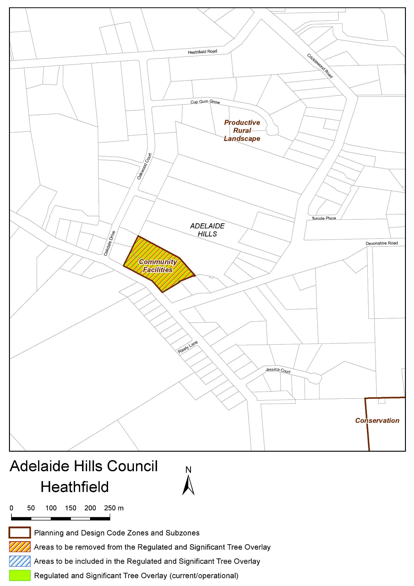
Attachment A

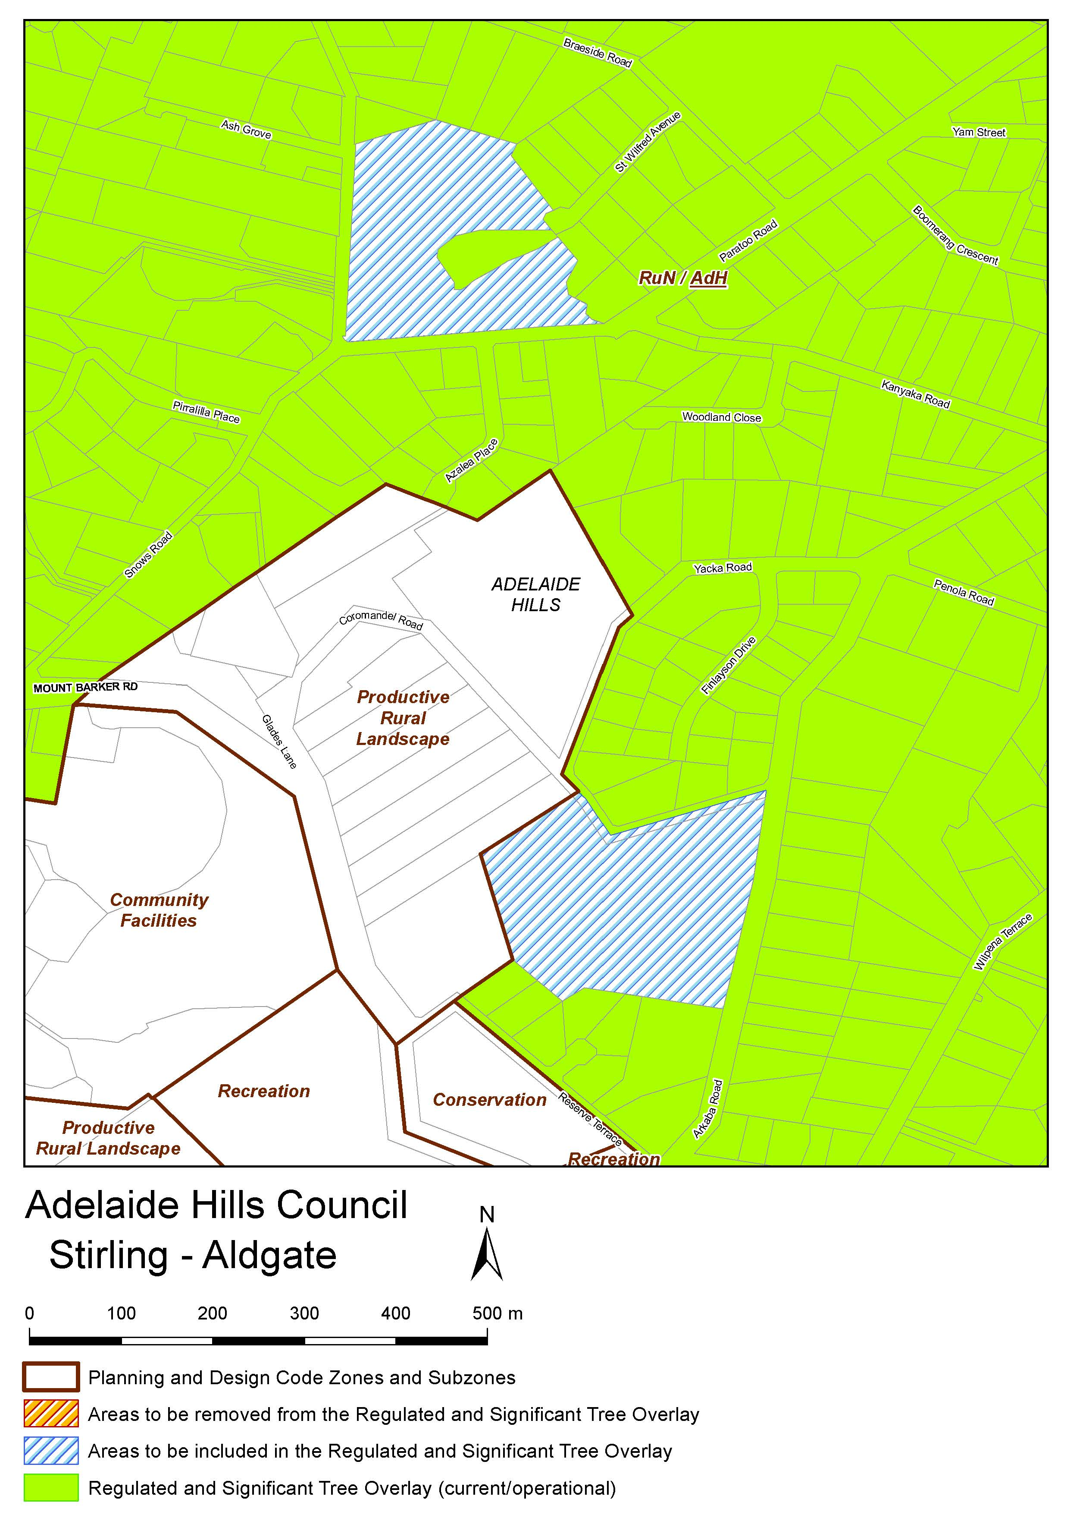
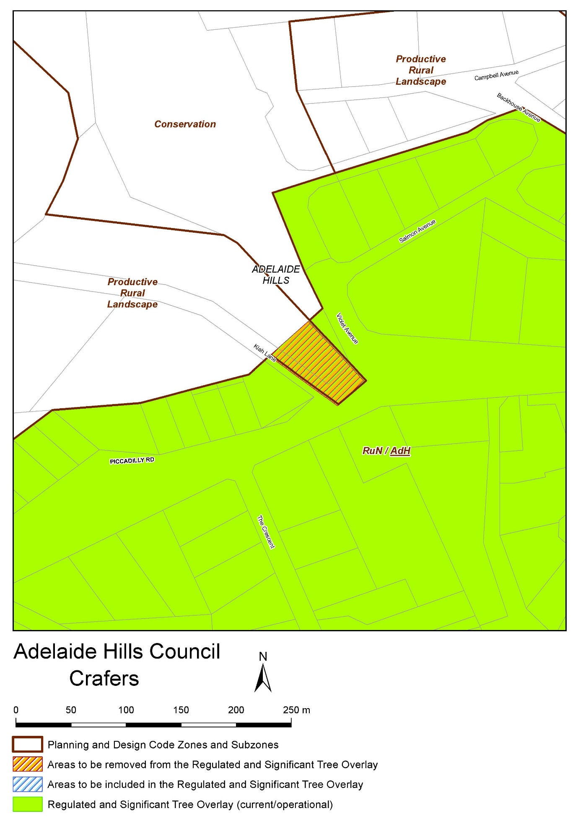
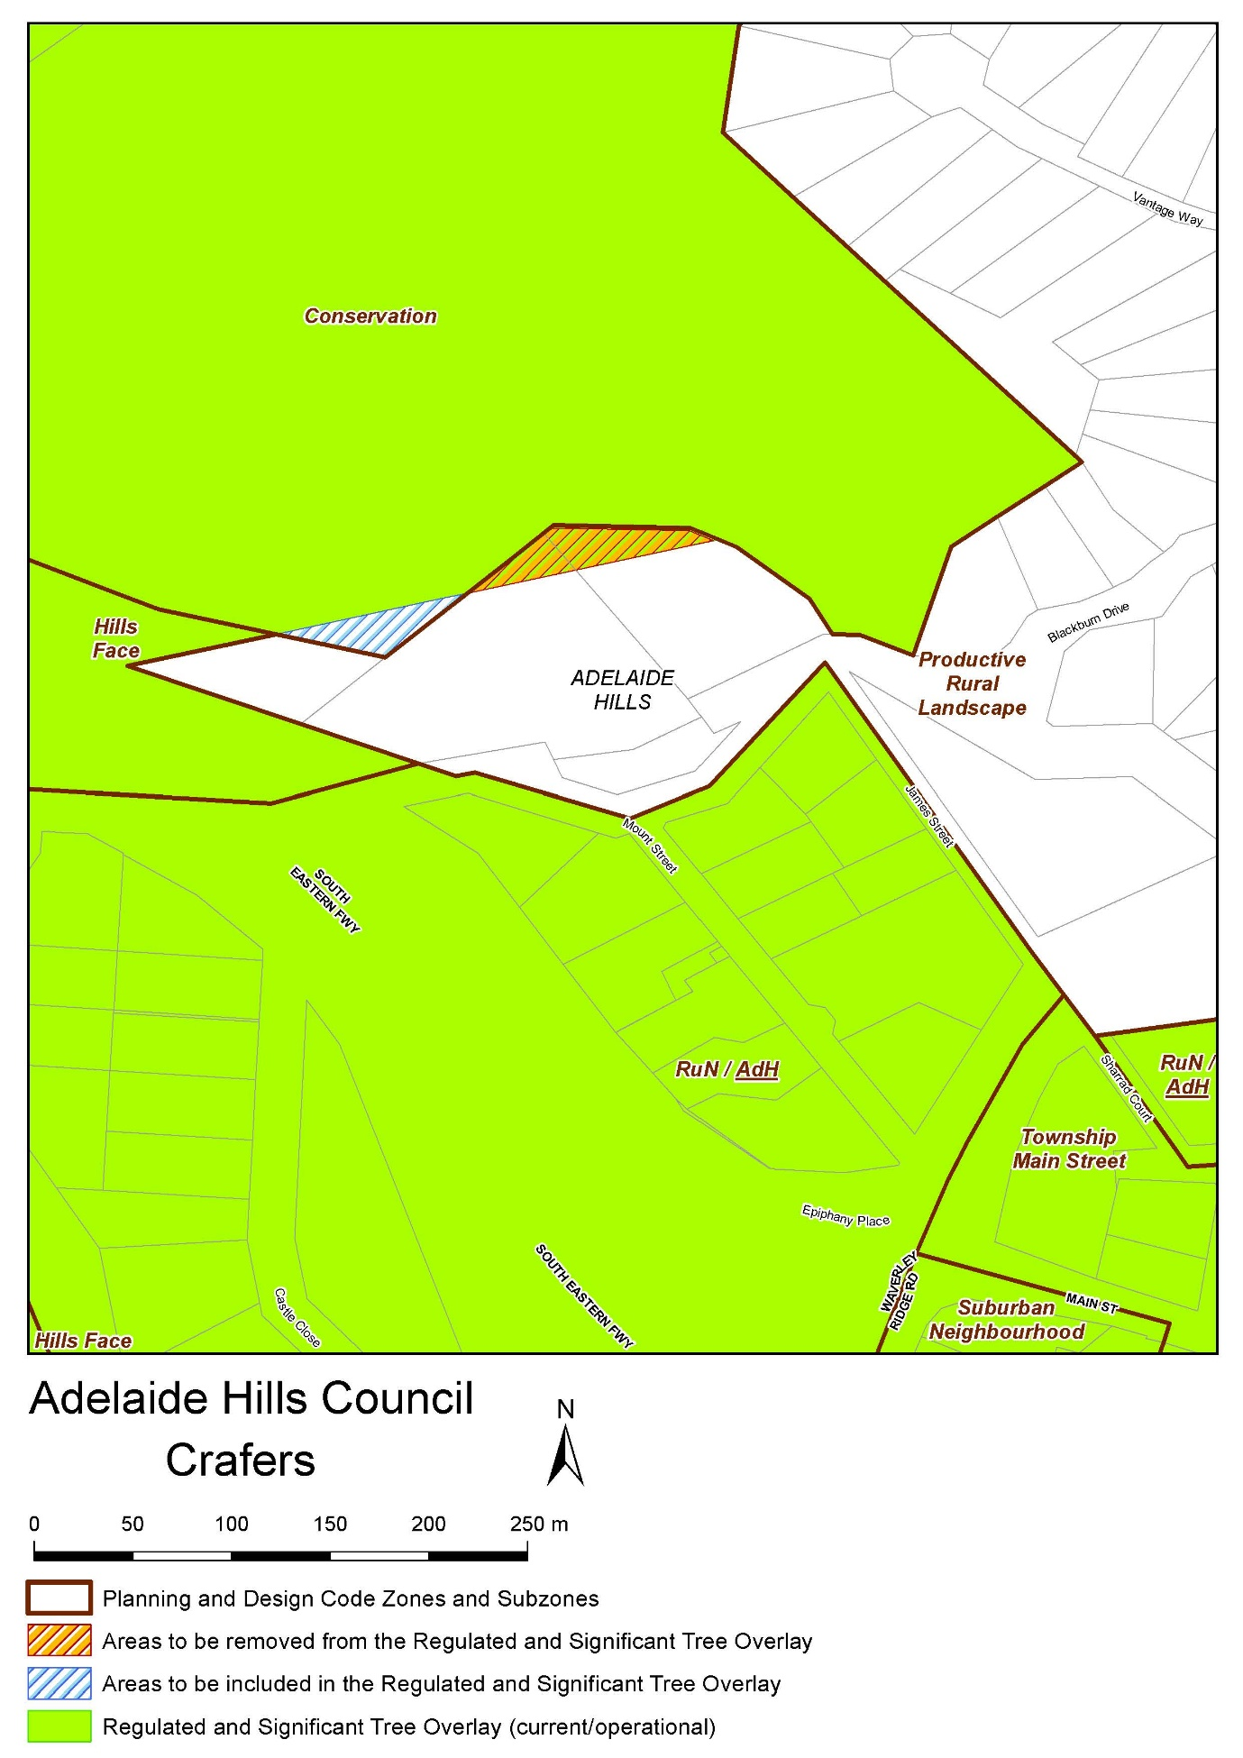
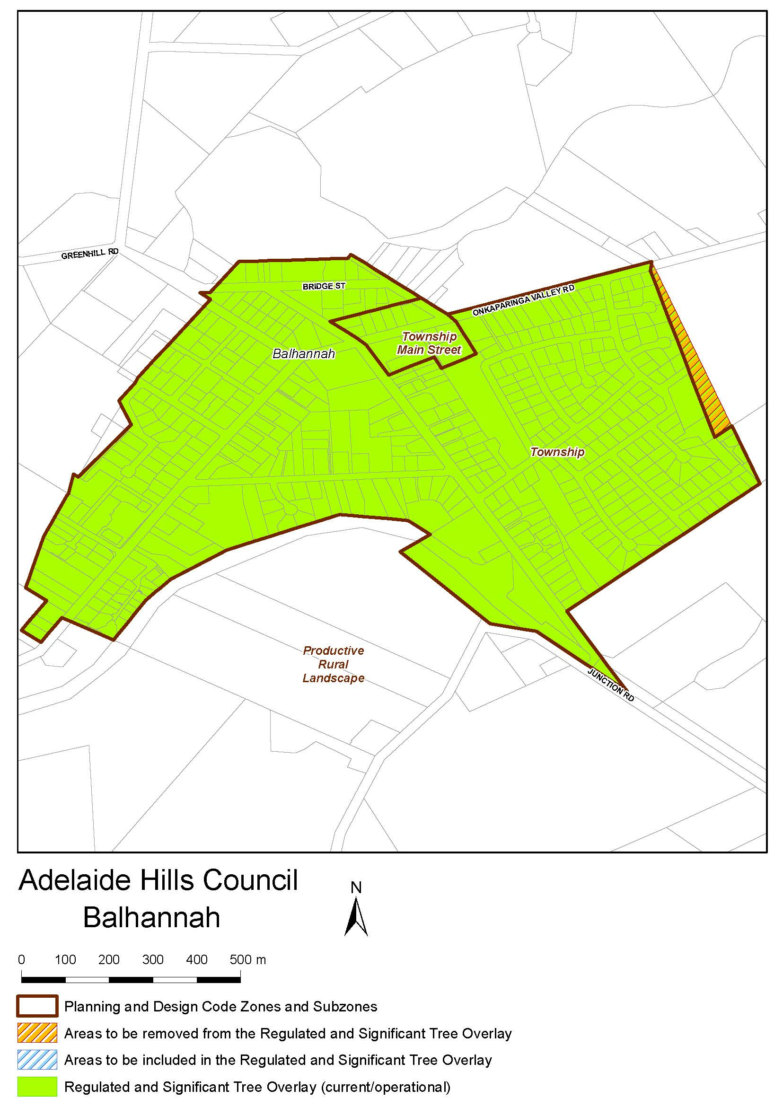
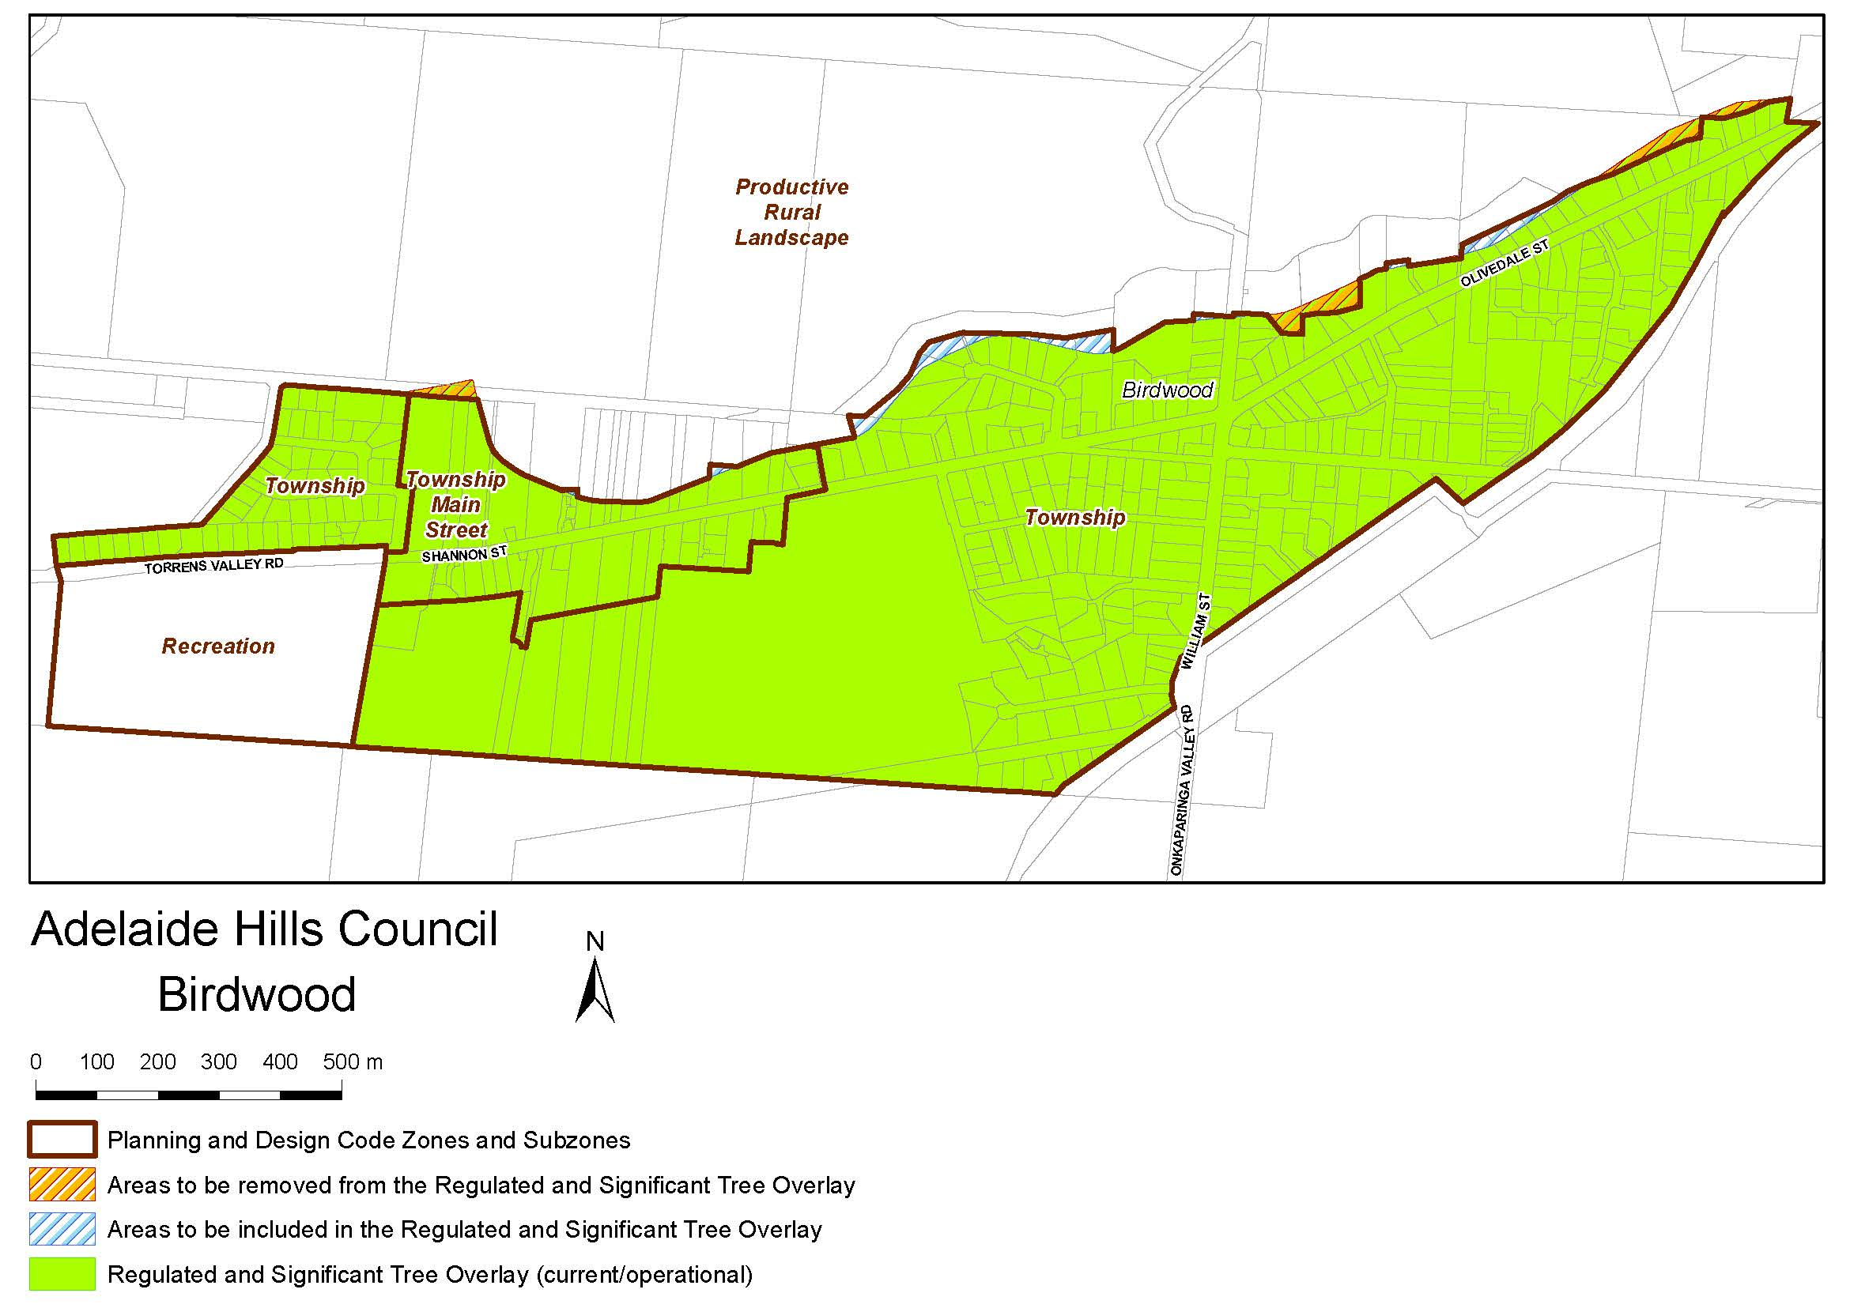
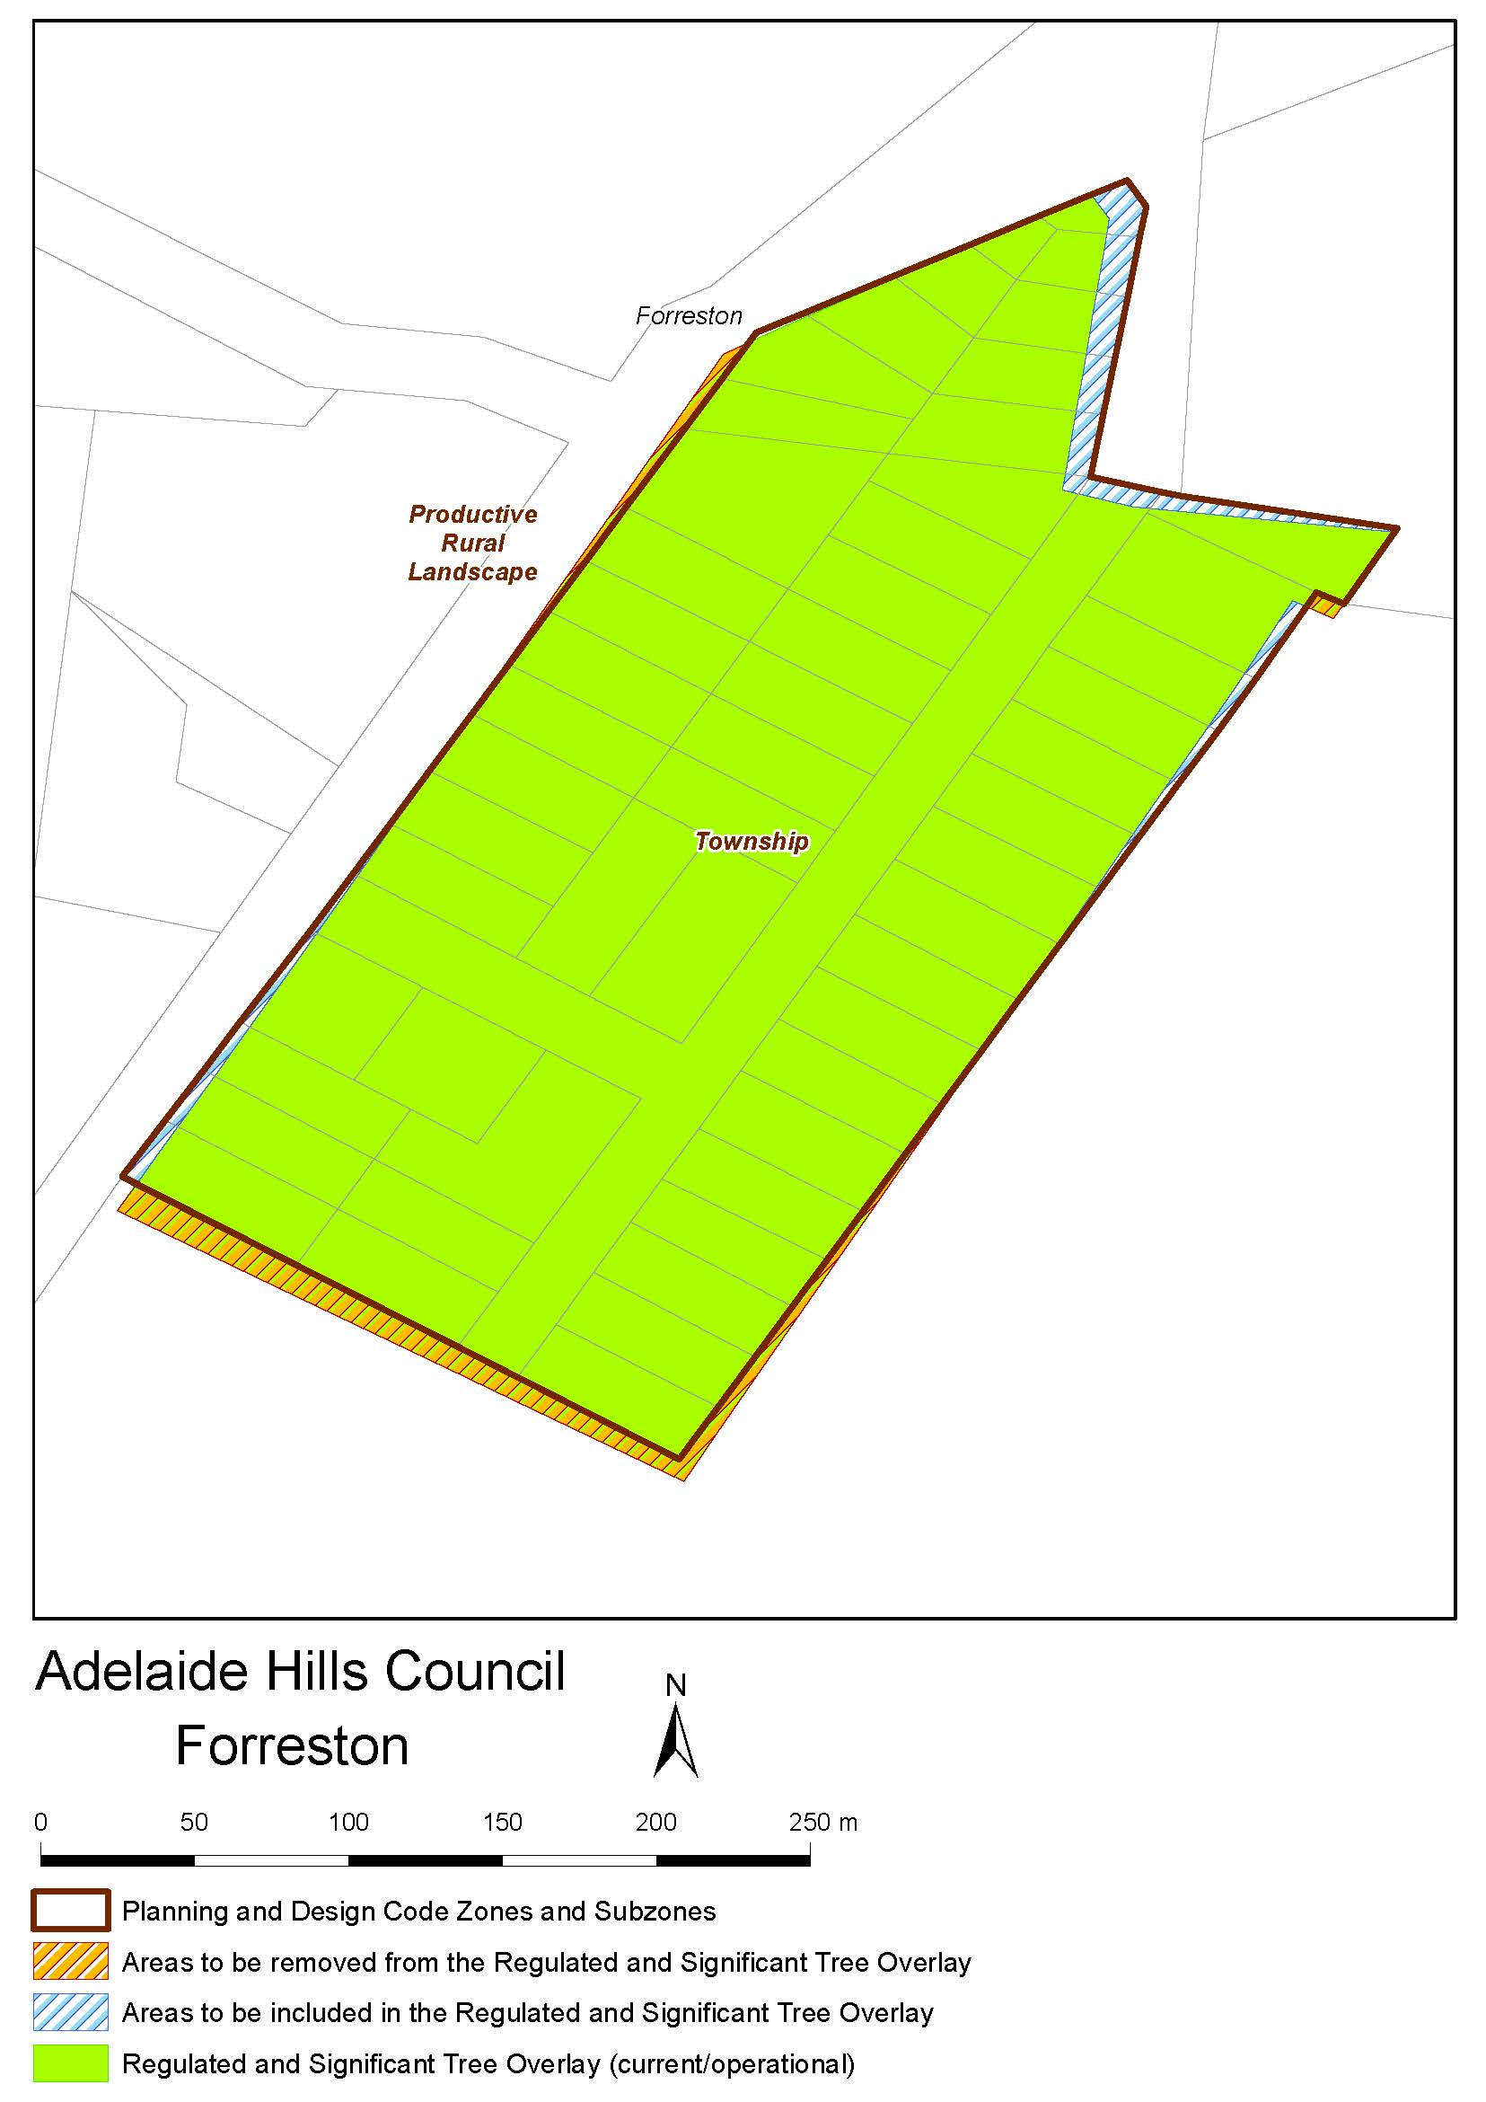
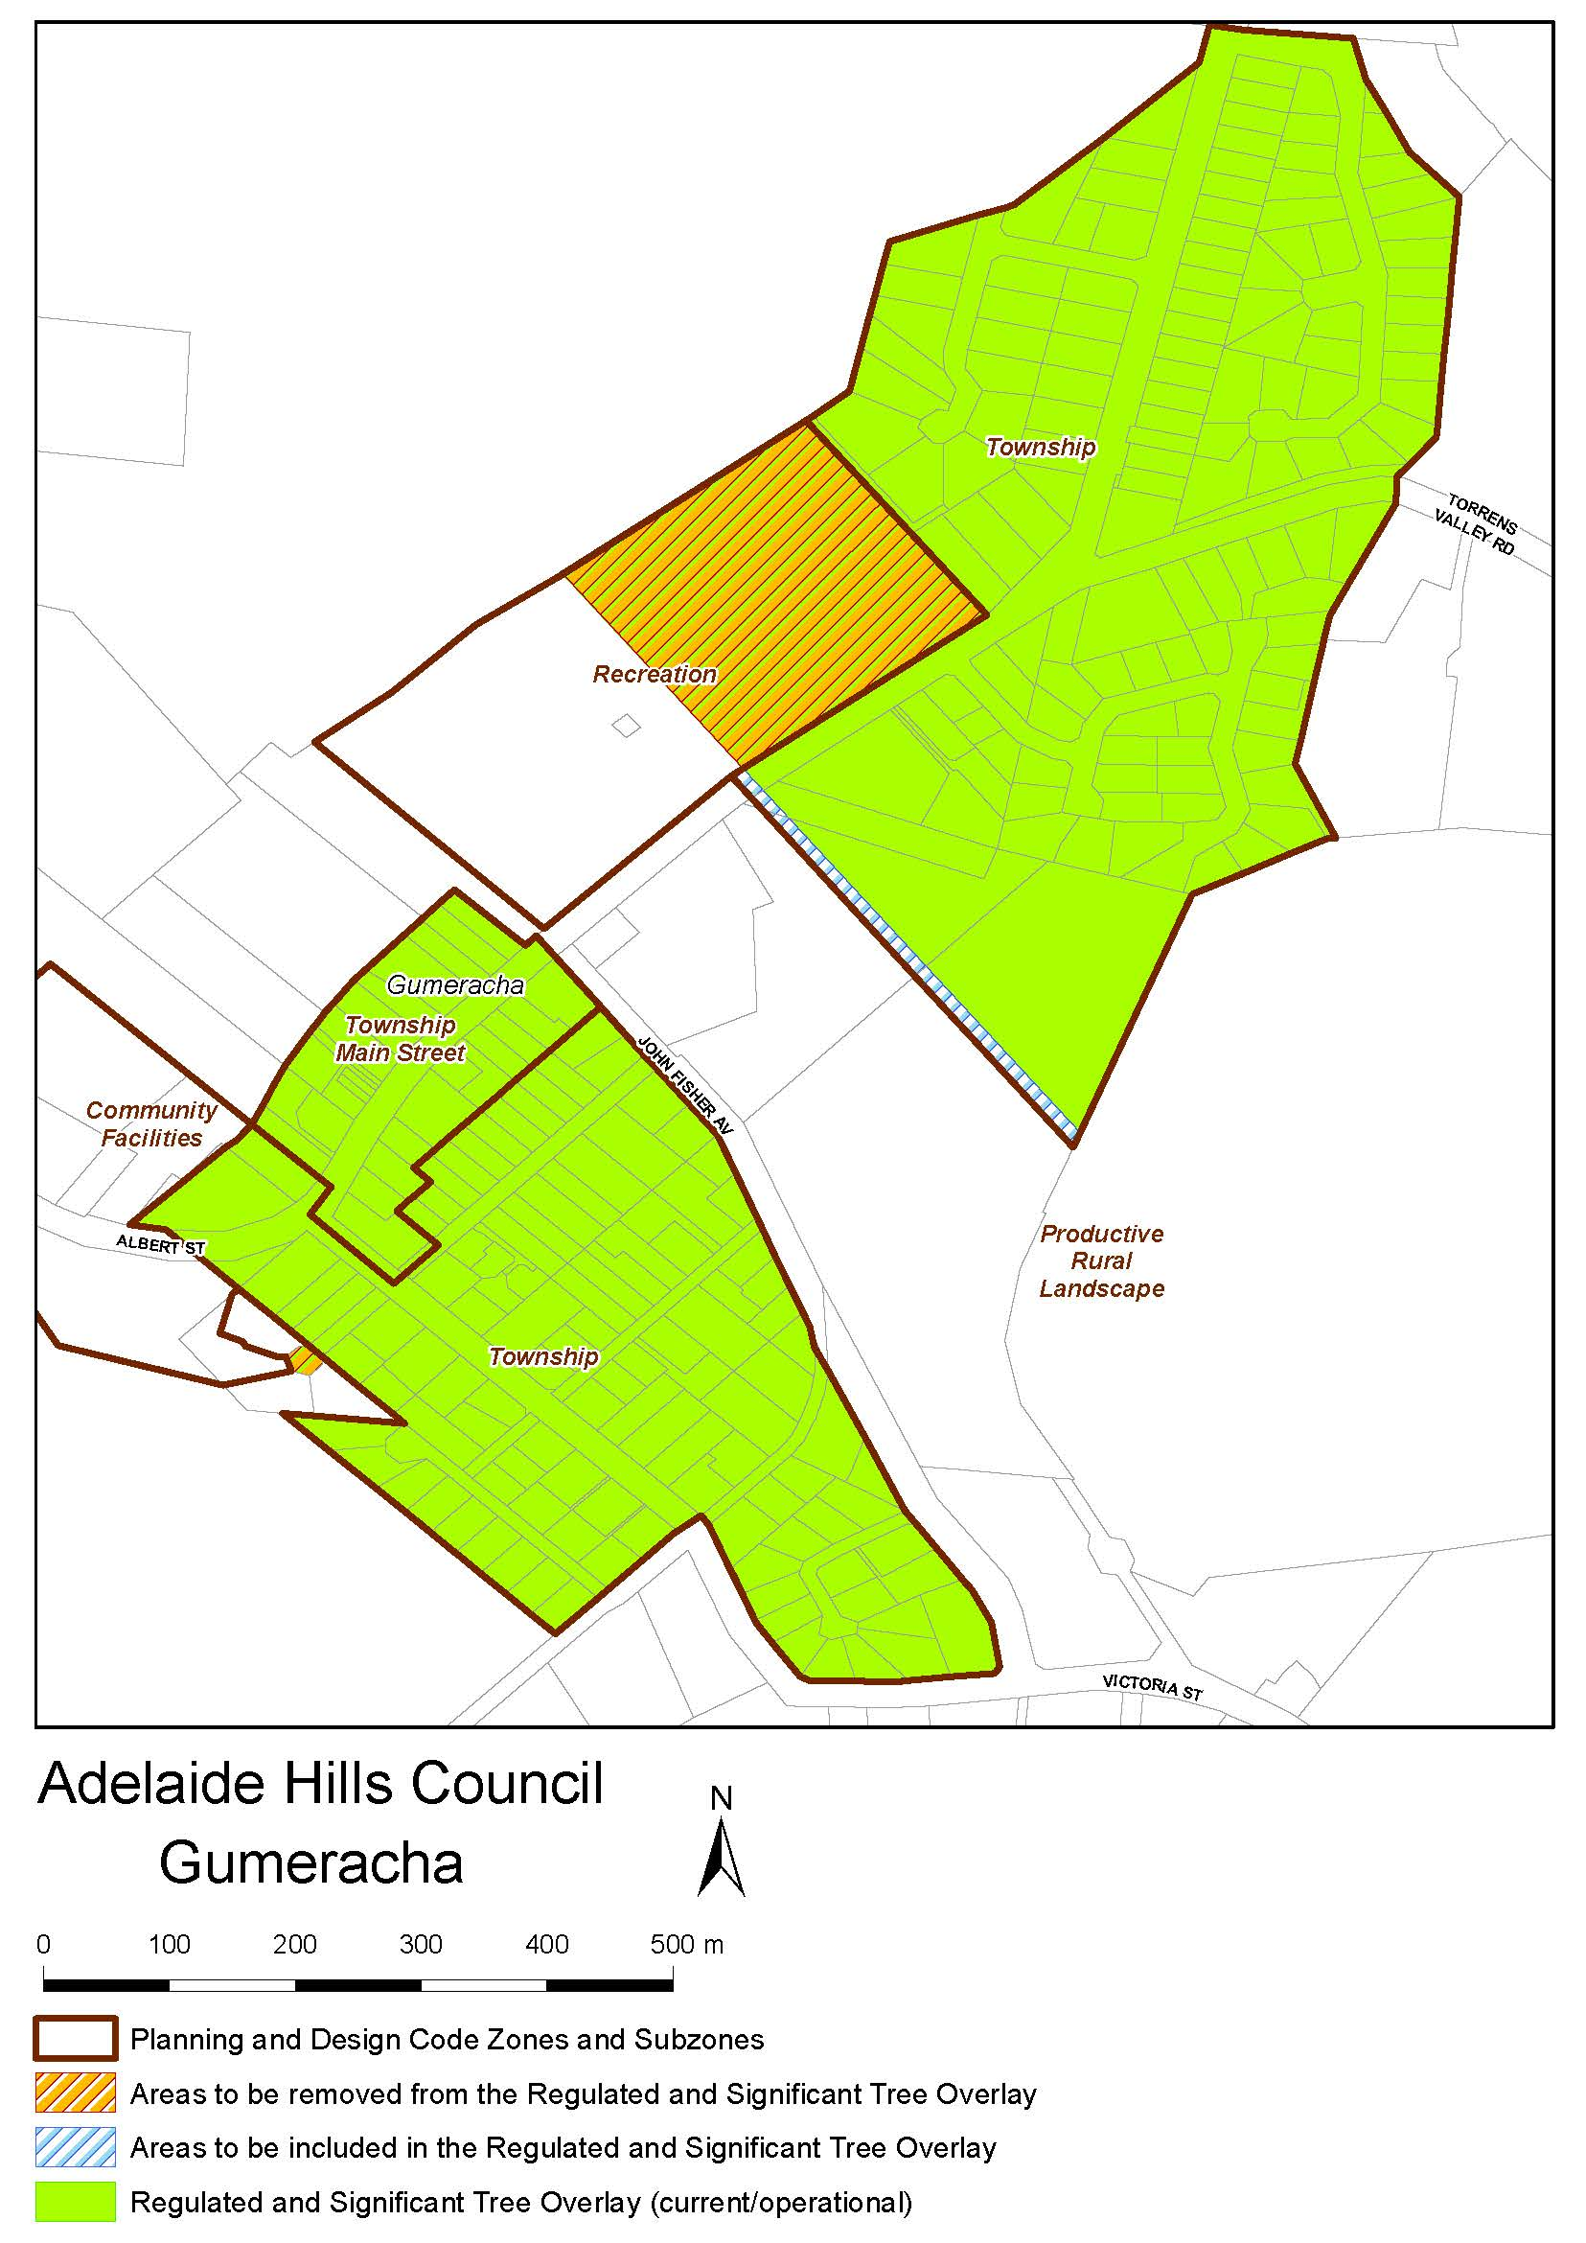
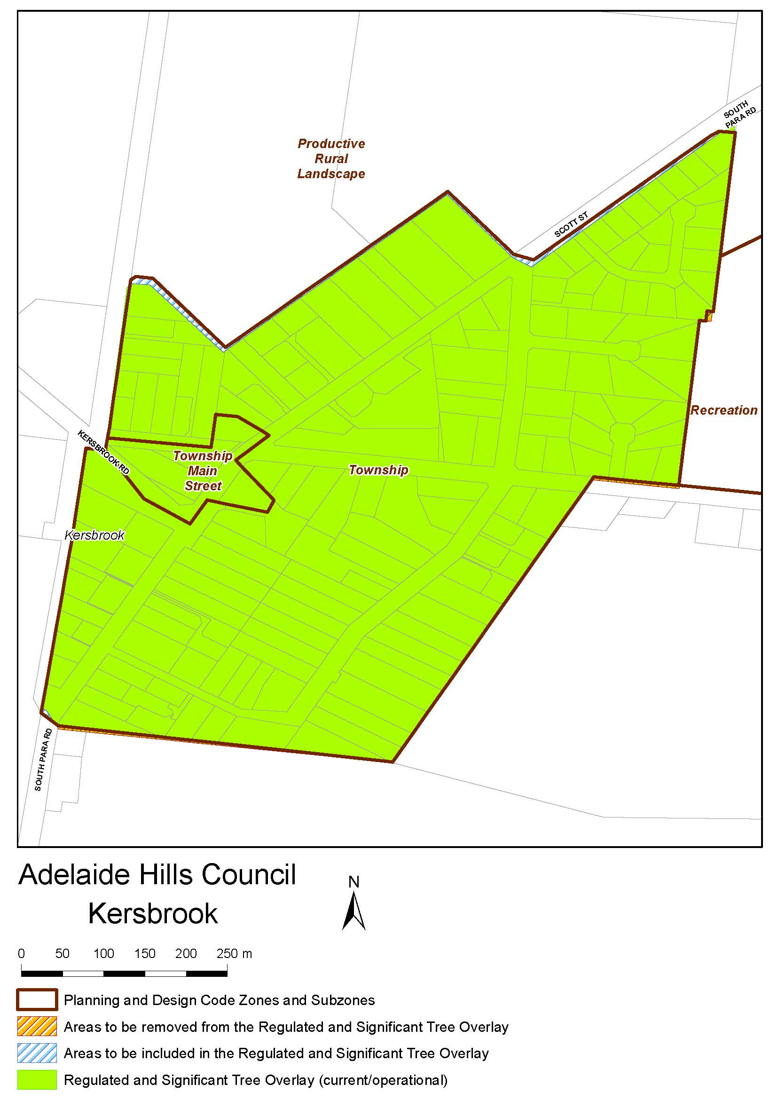
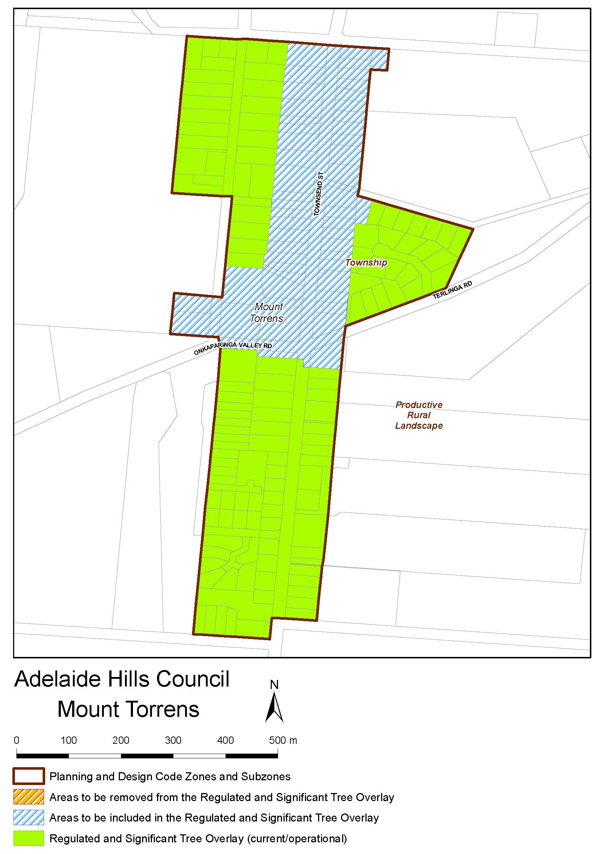
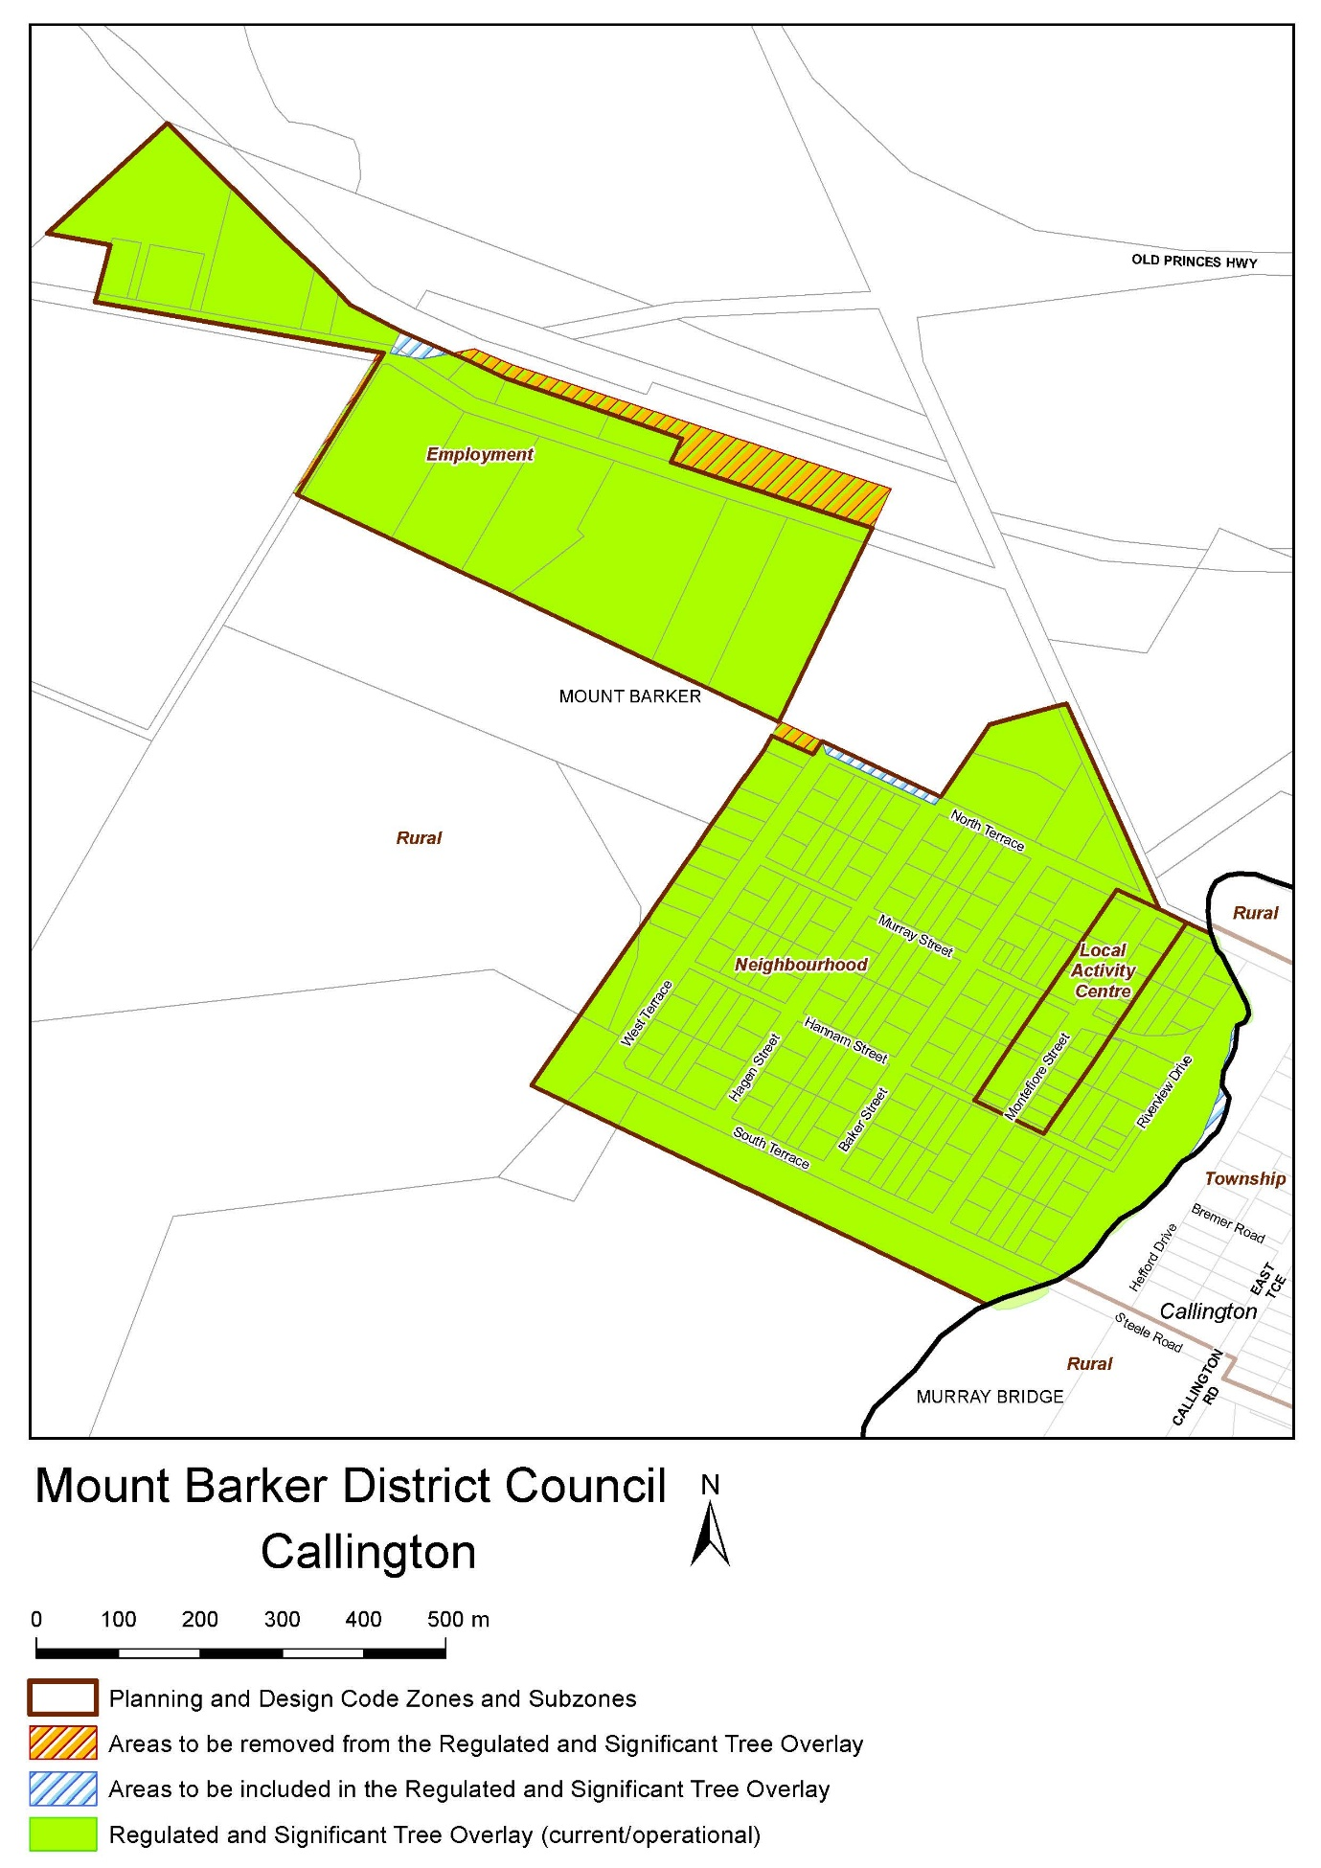
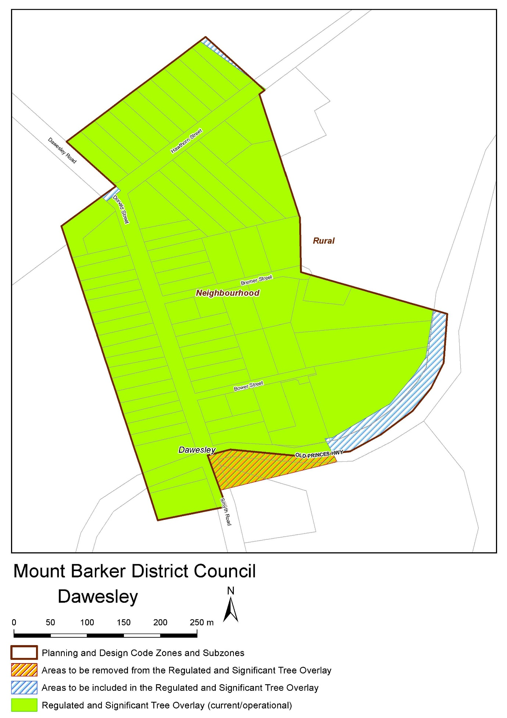
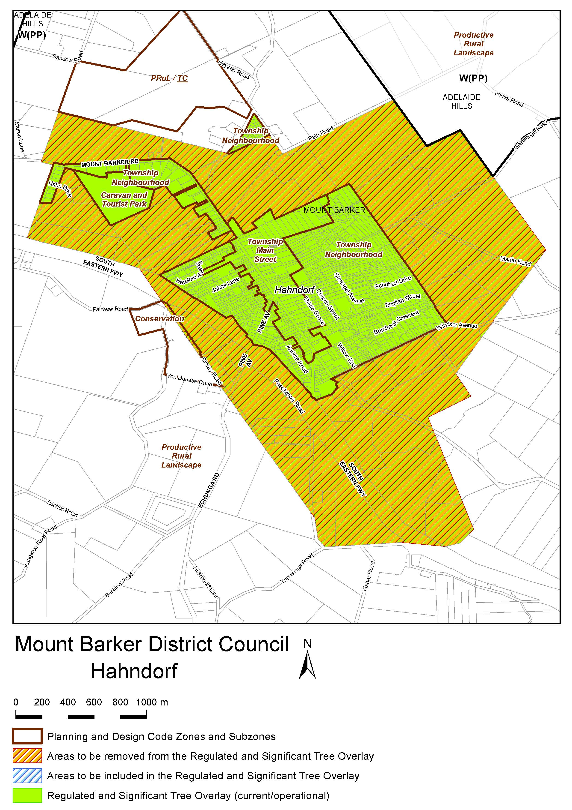
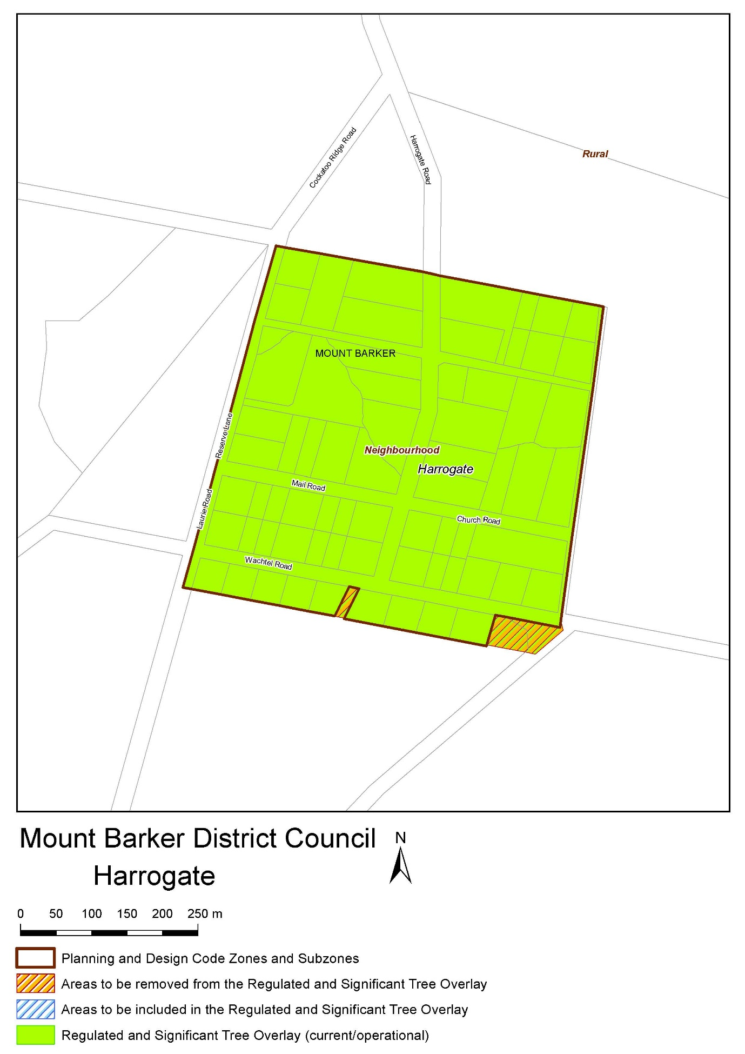
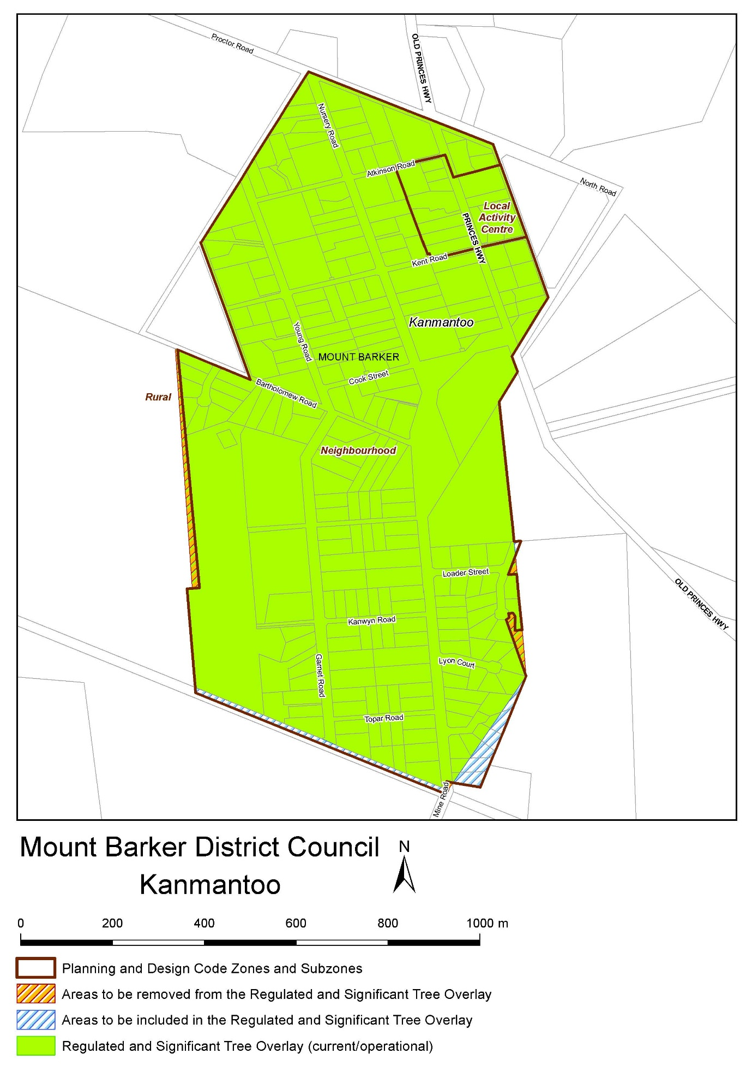
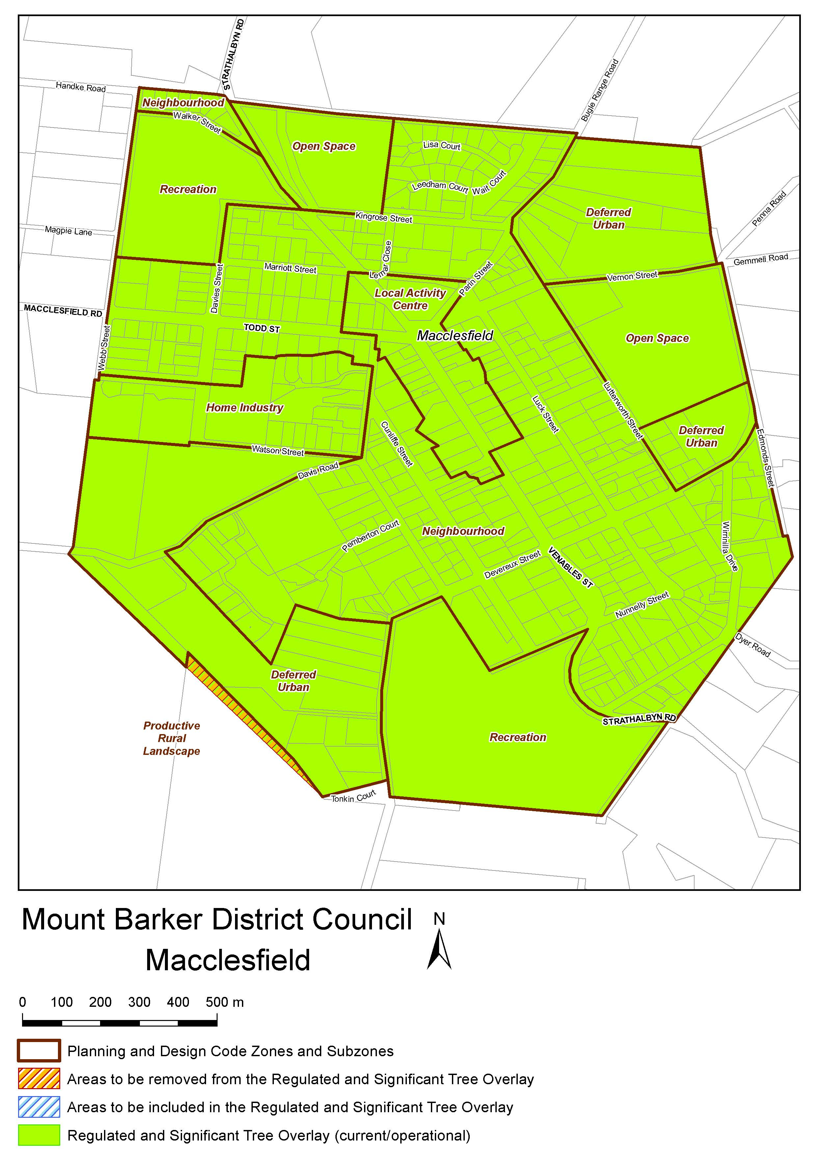
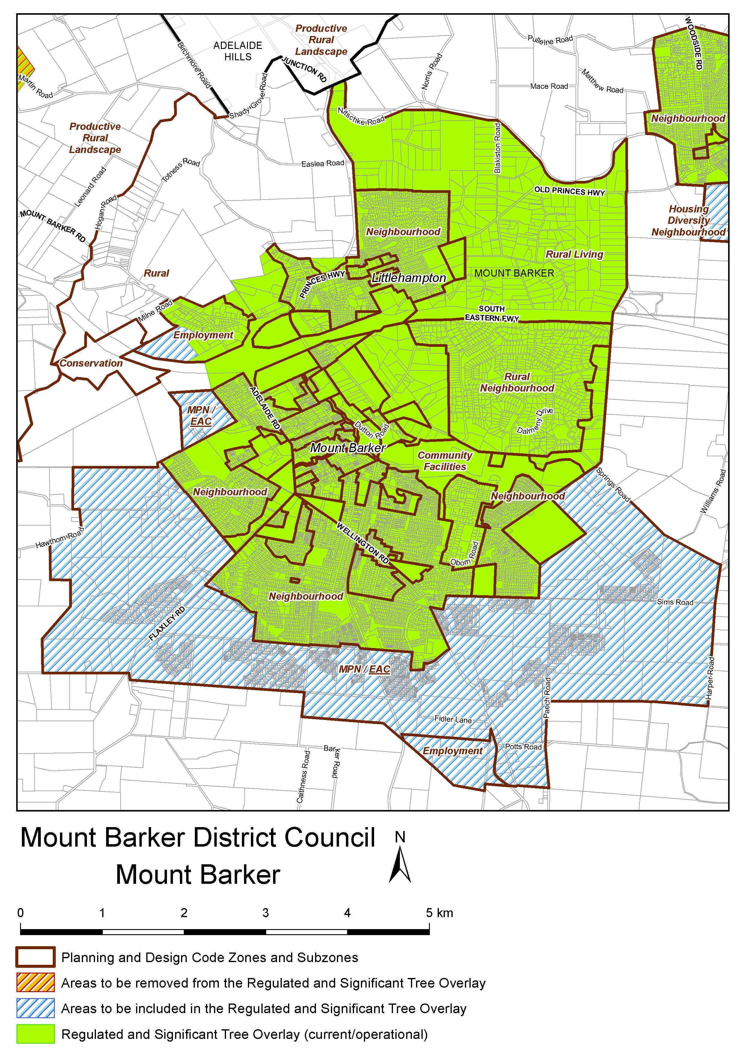
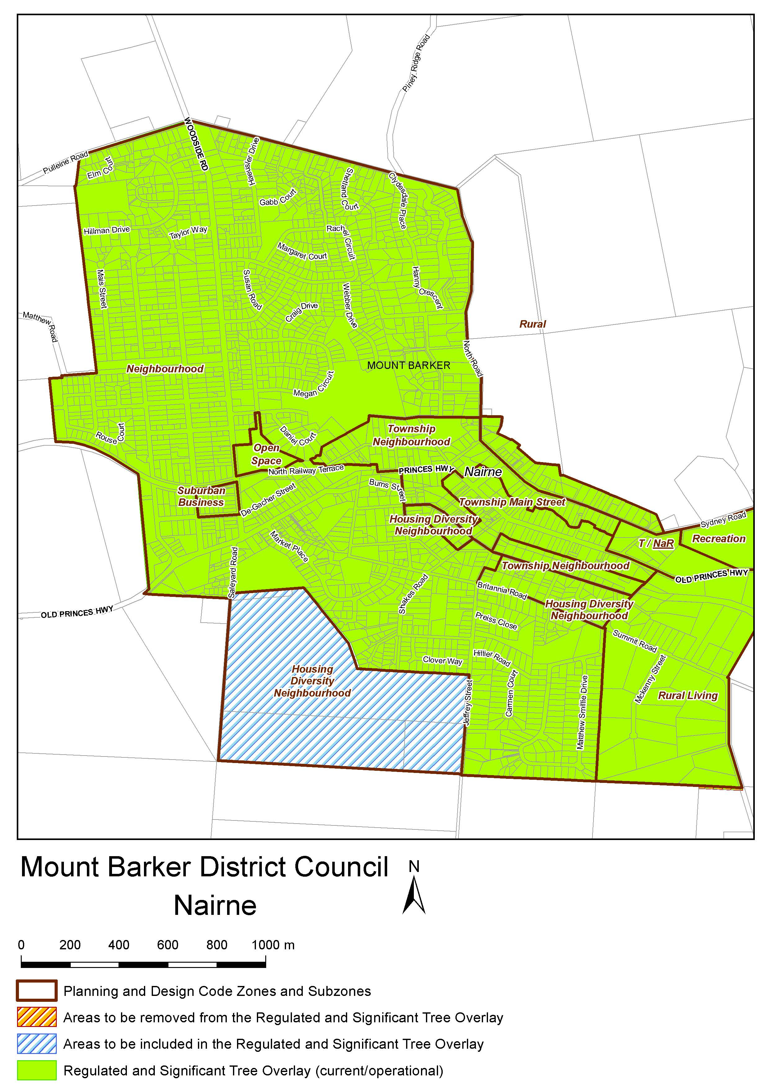
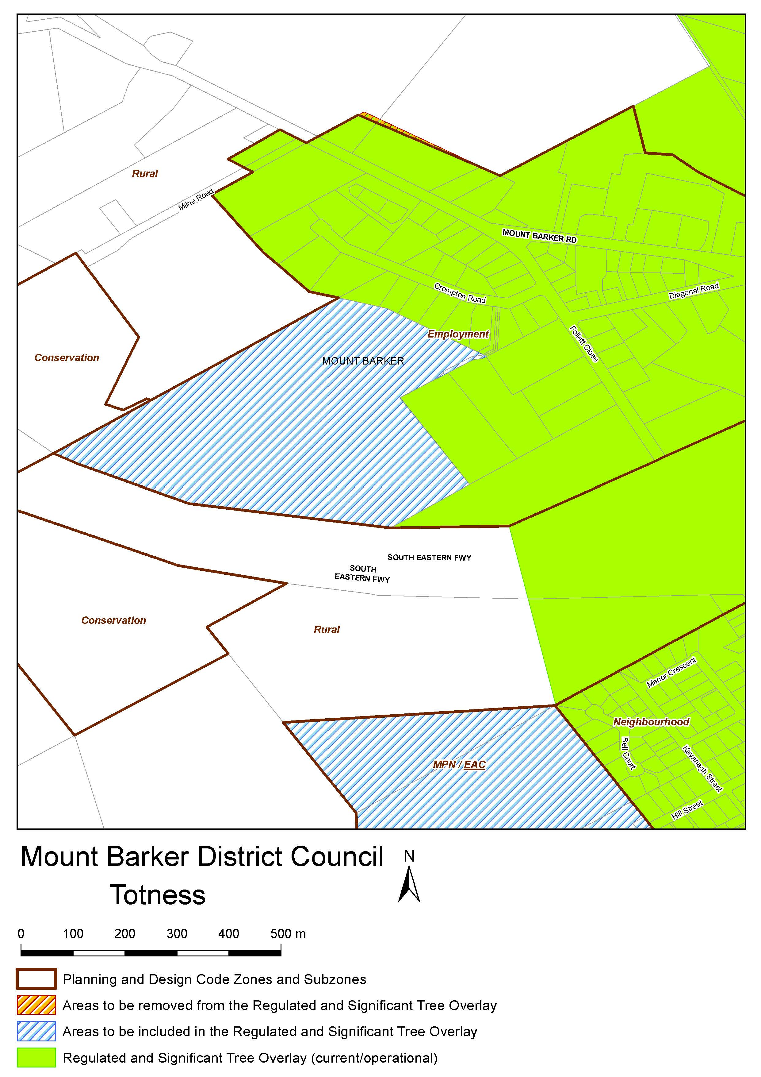

Planning, Development and Infrastructure Act 2016
Section 76
Amendment to the Planning and Design Code
Preamble
It is necessary to amend the Planning and Design Code (the Code) in operation at 12 August 2021 (Version 2021.11) in order to make changes of form, address inconsistency and correct errors that relate to:
• Misapplication of the Established Neighbourhood Zone to a portion of 1-11 Main North Road, Medindie
• Adjusting the Code’s spatial layers to maintain the correct relationship between parcels and Code spatial layers.
Pursuant to section 76 of the Planning, Development and Infrastructure Act 2016, I—
1. Amend the Code as follows:
(a) Amend the geometry of the Established Neighbourhood Zone at Medindie, so that it does not spatially apply to 1-11 Main North Road, Medindie, (and make corresponding spatial adjustments to the Suburban Business Zone so that it is spatially applied to the entirety of this allotment)
(b) Undertake minor alterations to the geometry of the spatial layers and data in the Planning and Design Code to maintain the current relationship between the parcel boundaries and Planning and Design Code data as a result of the following:
• New plans of division deposited in the Land Titles Office between 6 August 2021 and 19 August 2021 affecting the following spatial and data layers in the Planning and Design Code:
A. Zones and subzones
B. Technical and Numeric Variations
• Building Heights (Levels)
• Building Heights (Metres)
• Concept Plan
• Gradient Minimum Site Area
• Gradient Minimum Frontage
• Minimum Frontage
• Minimum Site Area
• Minimum Primary Street Setback
• Minimum Side Boundary Setback
• Future Local Road Widening Setback
C. Overlays
• Affordable Housing
• Airport Building Heights (Regulated)
• Character Preservation Districts
• Coastal Areas
• Future Road Widening
• Future Local Road Widening
• Hazard (Bushfire—High Risk)
• Hazard (Bushfire—Medium Risk)
• Hazard (Bushfire—General Risk)
• Hazard (Bushfire—Urban Interface)
• Hazard (Bushfire—Regional)
• Hazard (Bushfire—Outback)
• Heritage Adjacency
• Historic Area
• Key Outback and Rural Routes
• Limited Land Division
• Local Heritage Place
• Major Urban Transport Routes
• Noise and Air Emissions
• Non-stop Corridors
• Regulated and Significant Tree

• Scenic Quality
• Significant Landscape Protection
• State Heritage Place
• Stormwater Management
• Urban Transport Routes
• Urban Tree Canopy
• Improved spatial data for existing land parcels undertaken between 23 July 2021 and 5 August 2021 in the following locations (Column A) that affect data layers in the Planning and Design Code (Column B):
Location (Column A) | Layers (Column B)
Hindmarsh | Zones and Subzones  Technical and Numeric Variations  - Interface Height  - Building Heights (Metres)  - Building Heights (Levels)  Overlays  - Historic Area  - Heritage Adjacency  - Local Heritage Place  - State Heritage Place
D52958—Carpenter Rocks | Zones and Subzones  Technical and Numeric Variations  - Finished Ground and Floor Levels  Overlays  - Hazards (Acid Sulfate Soils)
D61289—Davoren Park | Zones and Subzones  Overlays  - Affordable Housing  - Future Road Widening  - Stormwater Management  - Urban Tree Canopy
Port Bonython | Zones and Subzones  Technical and Numeric Variations  - Finished Ground and Floor Levels  Overlays  - Coastal Areas  - Hazards (Bushfire—Regional)  - Heritage Adjacency  - Historic Shipwrecks  - Significant Interface Management  - State Heritage Place
Blewitt Springs | Zones and Subzones  Technical and Numeric Variations  - Minimum Site Area  Overlays  - Heritage Adjacency  - Local Heritage Place
• Remedy minor miscellaneous gaps, overlaps and misalignments between parcel boundaries and Planning and Design Code data.
(c) Update the Table of Planning and Design Code Amendments (Part 13—Table of Amendments), pursuant to this Section 76 Amendment.
2. Declare that the Section 76 Amendment will take effect upon being published on the SA planning portal.
Dated: 24 August 2021
Sally Smith
Executive Director
Planning & Land Use Services
Attorney-General’s Department
Delegate of Vickie Chapman MP, Minister for Planning and Local Government

Real Property Act 1886
Section 17
Caveat to be Lodged
Whereas the Applicant named at the foot hereof has for itself made application to have the land set forth and described before its name at the foot hereof brought under the operation of the Real Property Act 1886:
Notice is hereby given that unless caveat be lodged with the Registrar General by some person having estate or interest in the said land on or before the expiration of the period herein below for each case specified, the said land will be brought under the operation of the said Act as by law directed. Diagrams delineating this land may be inspected at the Land Titles Registration Office, Adelaide and in the offices of the several corporations or district councils in which the lands are situated.
The Schedule
No. of Application | Description of Property | Name | Residence | Date up to and inclusive of which caveat may be lodged
32060 | Section 1000,  Hundred of Adelaide  in the area named Montacute | Joseph Meccariello, Filomena Sanche and Vincenzo Meccariello, as executors of Gino Meccariello | 63A Stamden Street, Murray Bridge  204 Montacute Road, Athelstone  15 Athos Place, Paradise | 27 Sept 2021
Dated: 26 August 2021
B. Pike
Chief Executive Officer, Land Services SA
Acting under Delegation of the Registrar-General

Roads (Opening and Closing) Act 1991
Section 24
NOTICE OF CONFIRMATION OF
ROAD PROCESS ORDER
Road Closure—Argent Road, Penfield
By Road Process Order made on 11 April 2017, the City of Playford ordered that:
1. Portion of Argent Road, Penfield, situated adjoining Allotment 26 in Deposited Plan 17993, Hundred of Munno Para, more particularly delineated and lettered ‘A’ in Preliminary Plan 16/0034 be closed.
2. Transfer the whole of the land subject to closure to Commonwealth of Australia in accordance with the Agreement for Transfer dated 17 February 2017 entered into between the City of Playford and Commonwealth of Australia.
On 18 August 2021 that order was confirmed by the Attorney-General conditionally upon the deposit by the Registrar-General of Deposited Plan 115741 being the authority for the new boundaries.
Pursuant to section 24 of the Roads (Opening and Closing) Act 1991, NOTICE of the Order referred to above and its confirmation is hereby given.
Dated: 26 August 2021
M. P. Burdett
Surveyor-General
DPTI: 2016/17726/01

Local Government Instruments

City of Charles Sturt
Representation Review
Final Recommendation
Notice is hereby given that the City of Charles Sturt in accordance with the requirements of section 12(4) of the Local Government Act 1999, has reviewed its composition and elector representation arrangements.
Certification
Pursuant to section 12(13)(a) of the Local Government Act 1999, the Electoral Commissioner has certified that the review undertaken by the Council satisfies the requirements of section 12 and may therefore now be put into effect as from the day of the first periodic election held after the publication of this notice.
The Council proposes to make no change to its representation arrangements, save to alter the boundary between the Semaphore Park and Grange Wards, to increase the number of electors in the Semaphore Park Ward to satisfy the Semaphore Park Ward tolerance quota requirement.
The Council’s representation arrangements are proposed and are as follows:
• the Principal Member of the Council continue to be an elected Mayor;
• the Council area continue to be divided into eight (8) wards, with the existing ward names Beverley, Findon, Grange, Henley, Hindmarsh, Semaphore Park, West Woodville, and Woodville being retained, but subject to the boundary alteration to increase the number of electors in the Semaphore Park Ward;
• each ward to be represented by two (2) Ward Councillors;
• the Council continue to comprise the Mayor and 16 Ward Councillors.

First Schedule
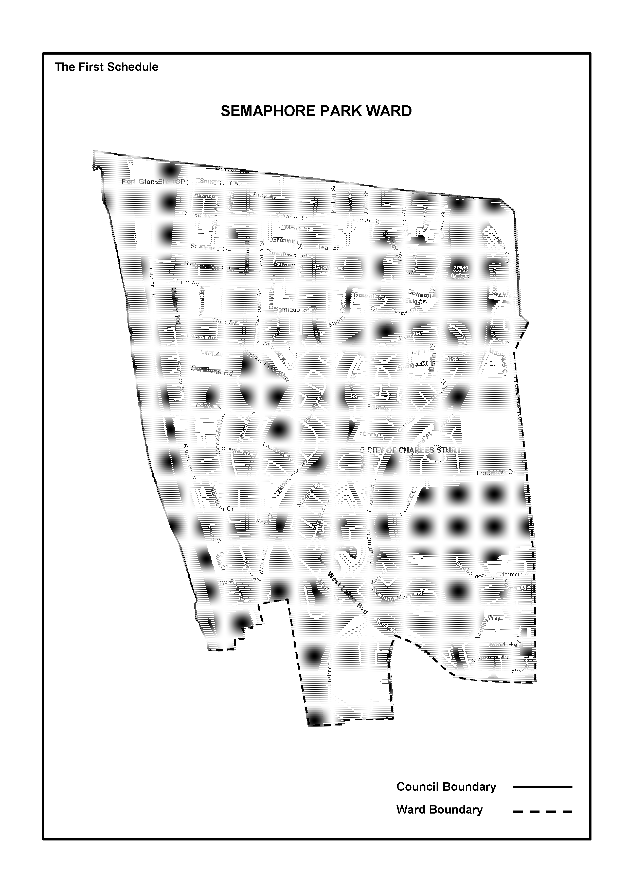Semaphore Park Ward—the existing Semaphore Park Ward, including that portion of Grange Ward, currently bordered by Turner Driver, Brebner Drive, extending along the southern boundary of allotment 82, to be incorporated into the Semaphore Park Ward, delineated on the plan published herewith.

Second Schedule
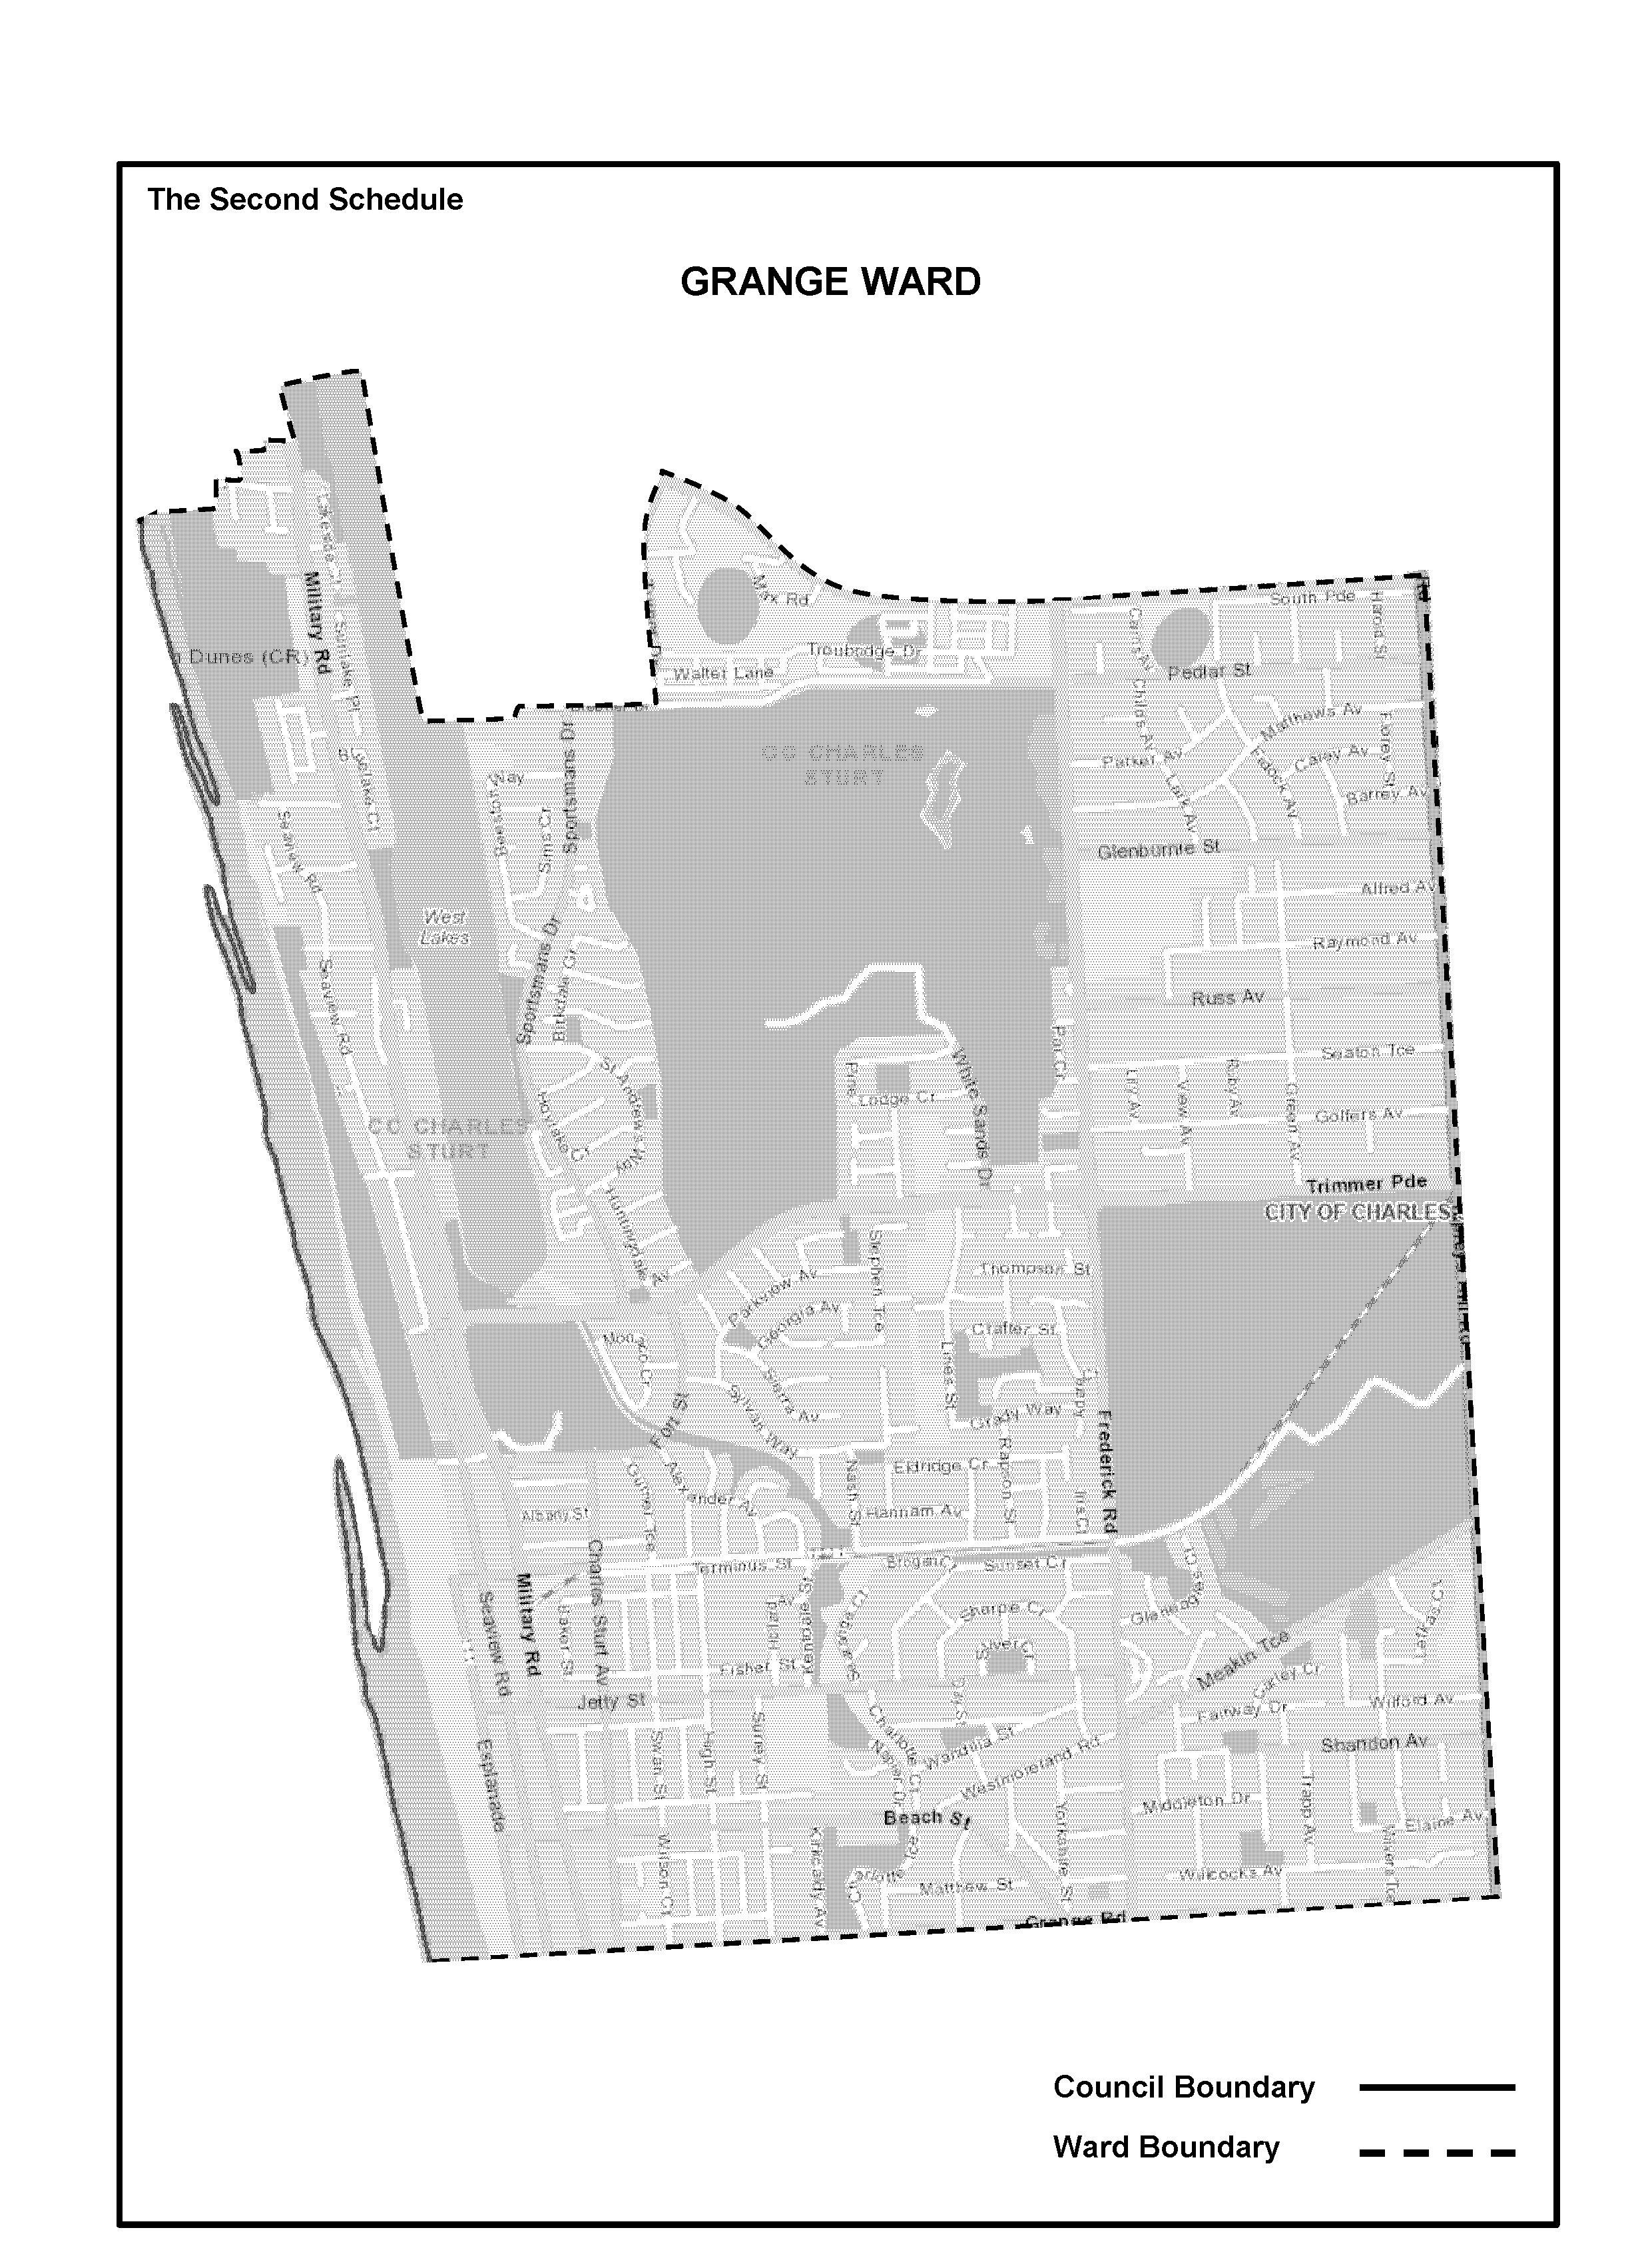Grange Ward—the existing Grange Ward, however that portion of Grange Ward, currently bordered by Turner Driver, Brebner Drive, extending along the southern boundary of allotment 82, is to be incorporated into the Semaphore Park Ward, delineated on the plan published herewith.
Dated: 26 August 2021
Paul Sutton
Chief Executive Officer

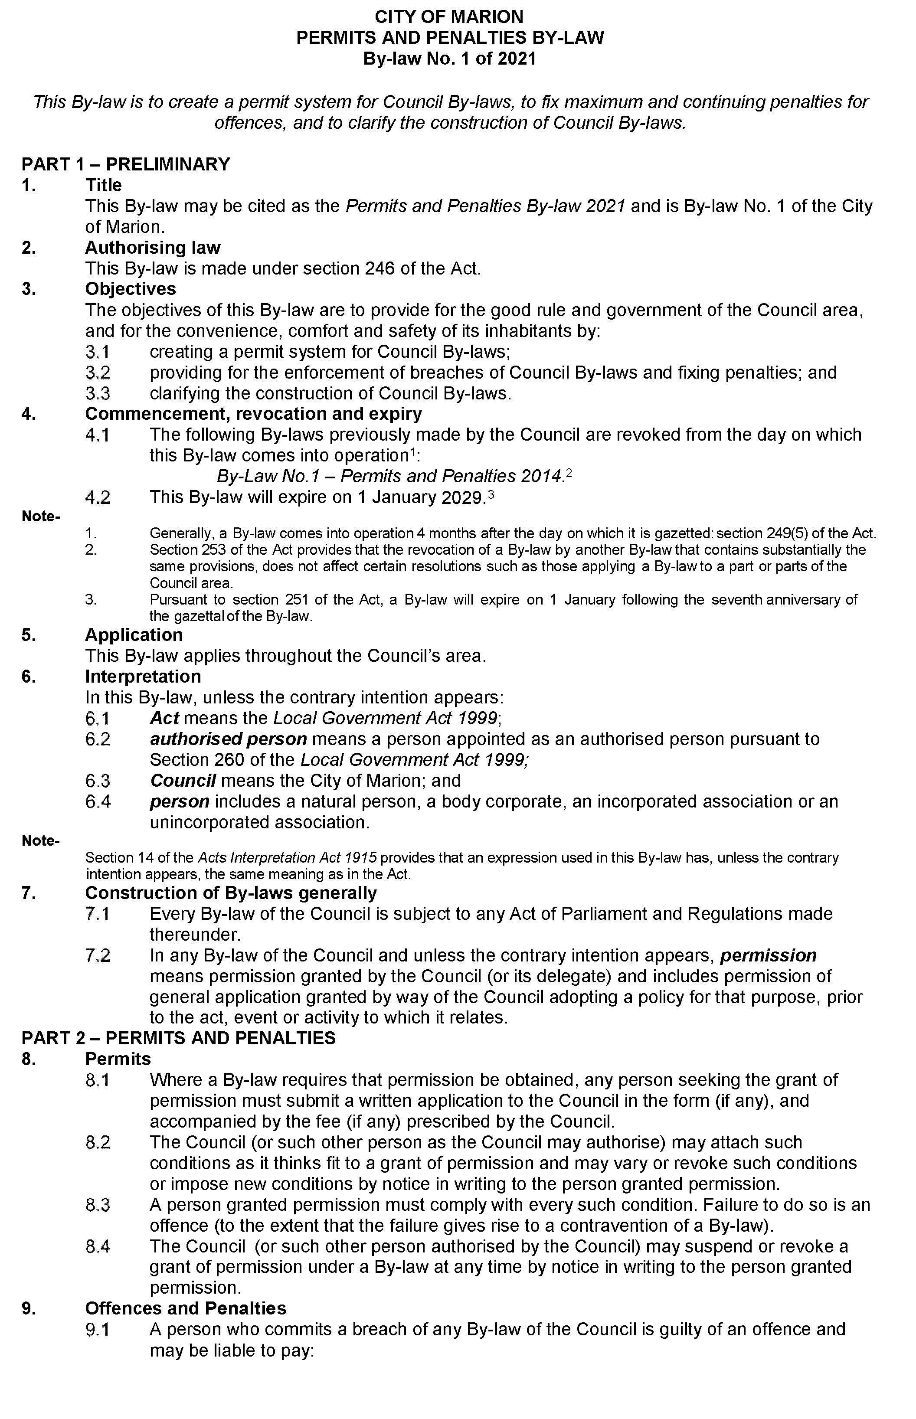
City of Marion

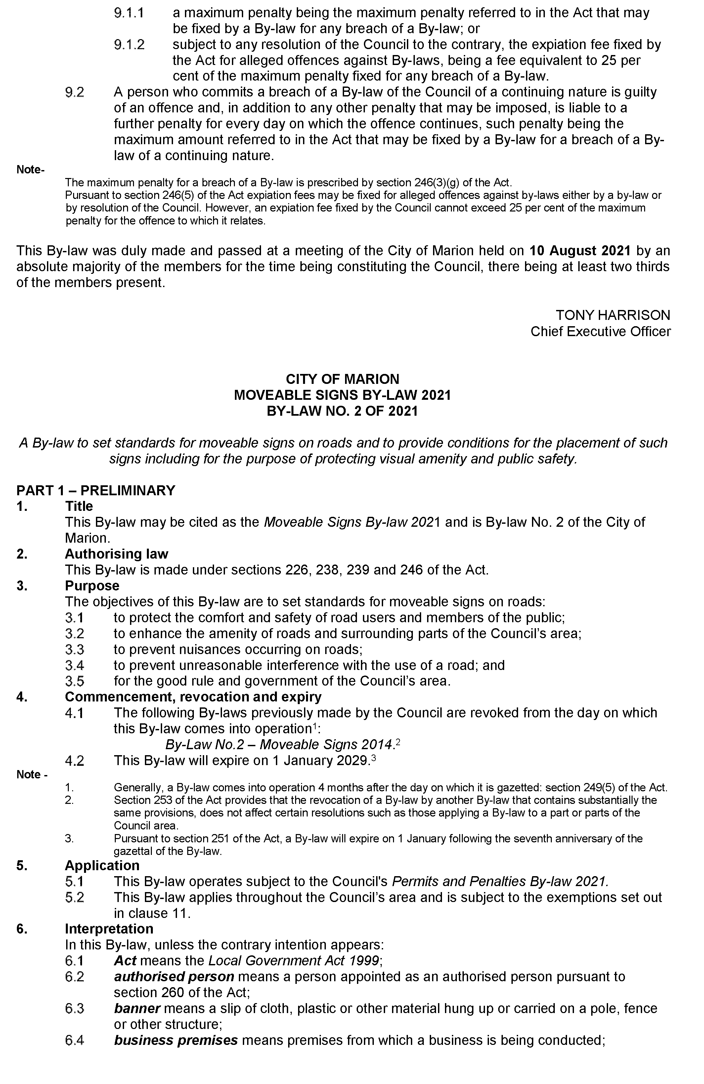
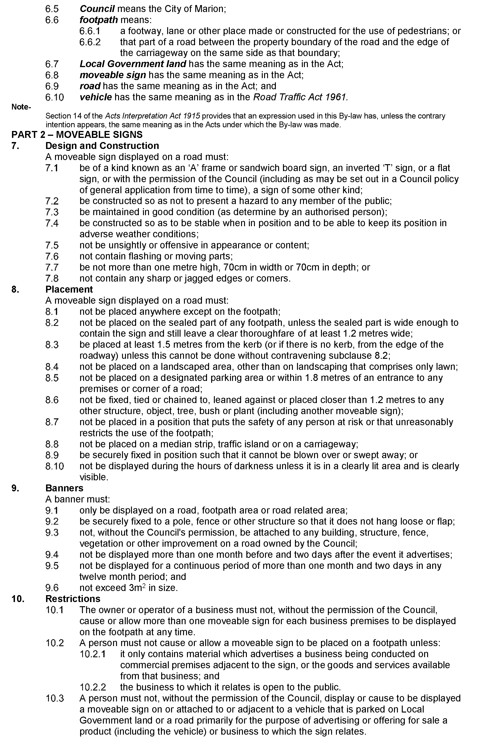
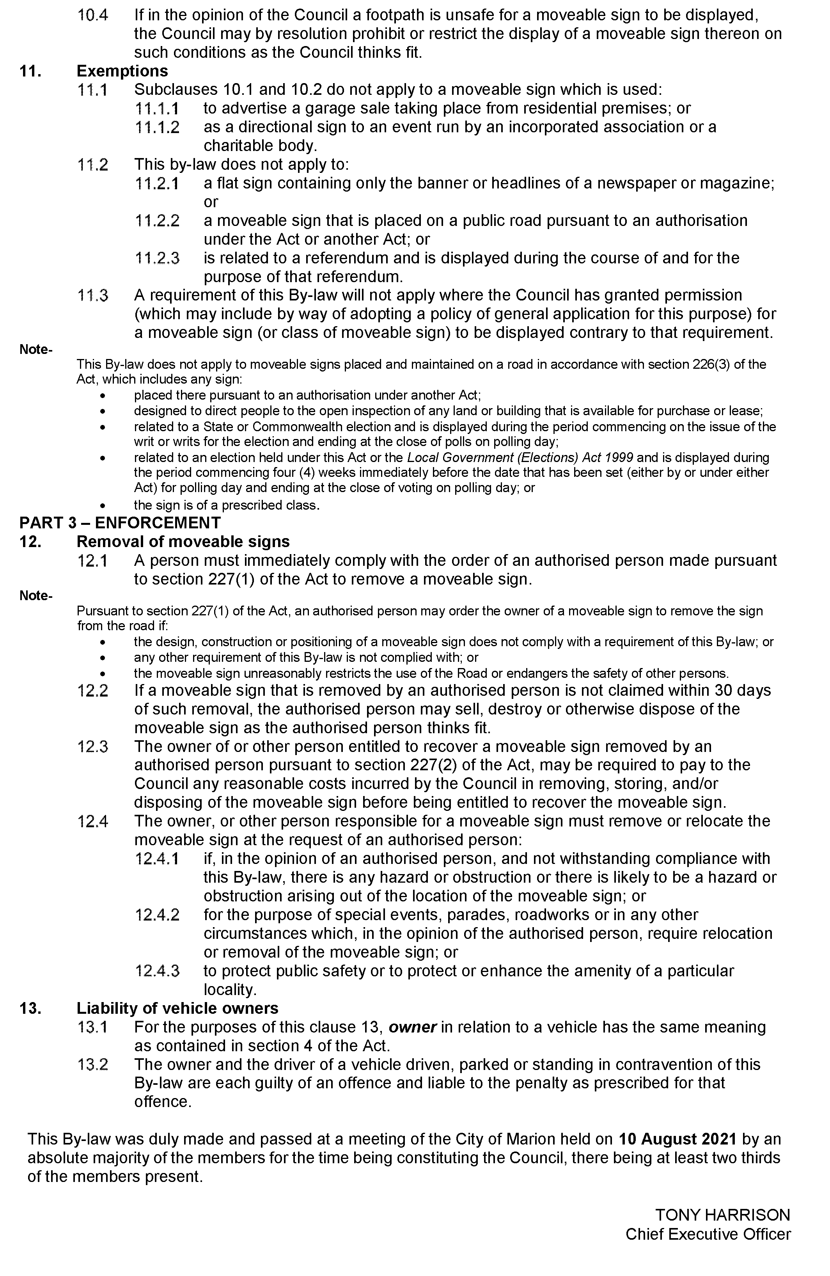
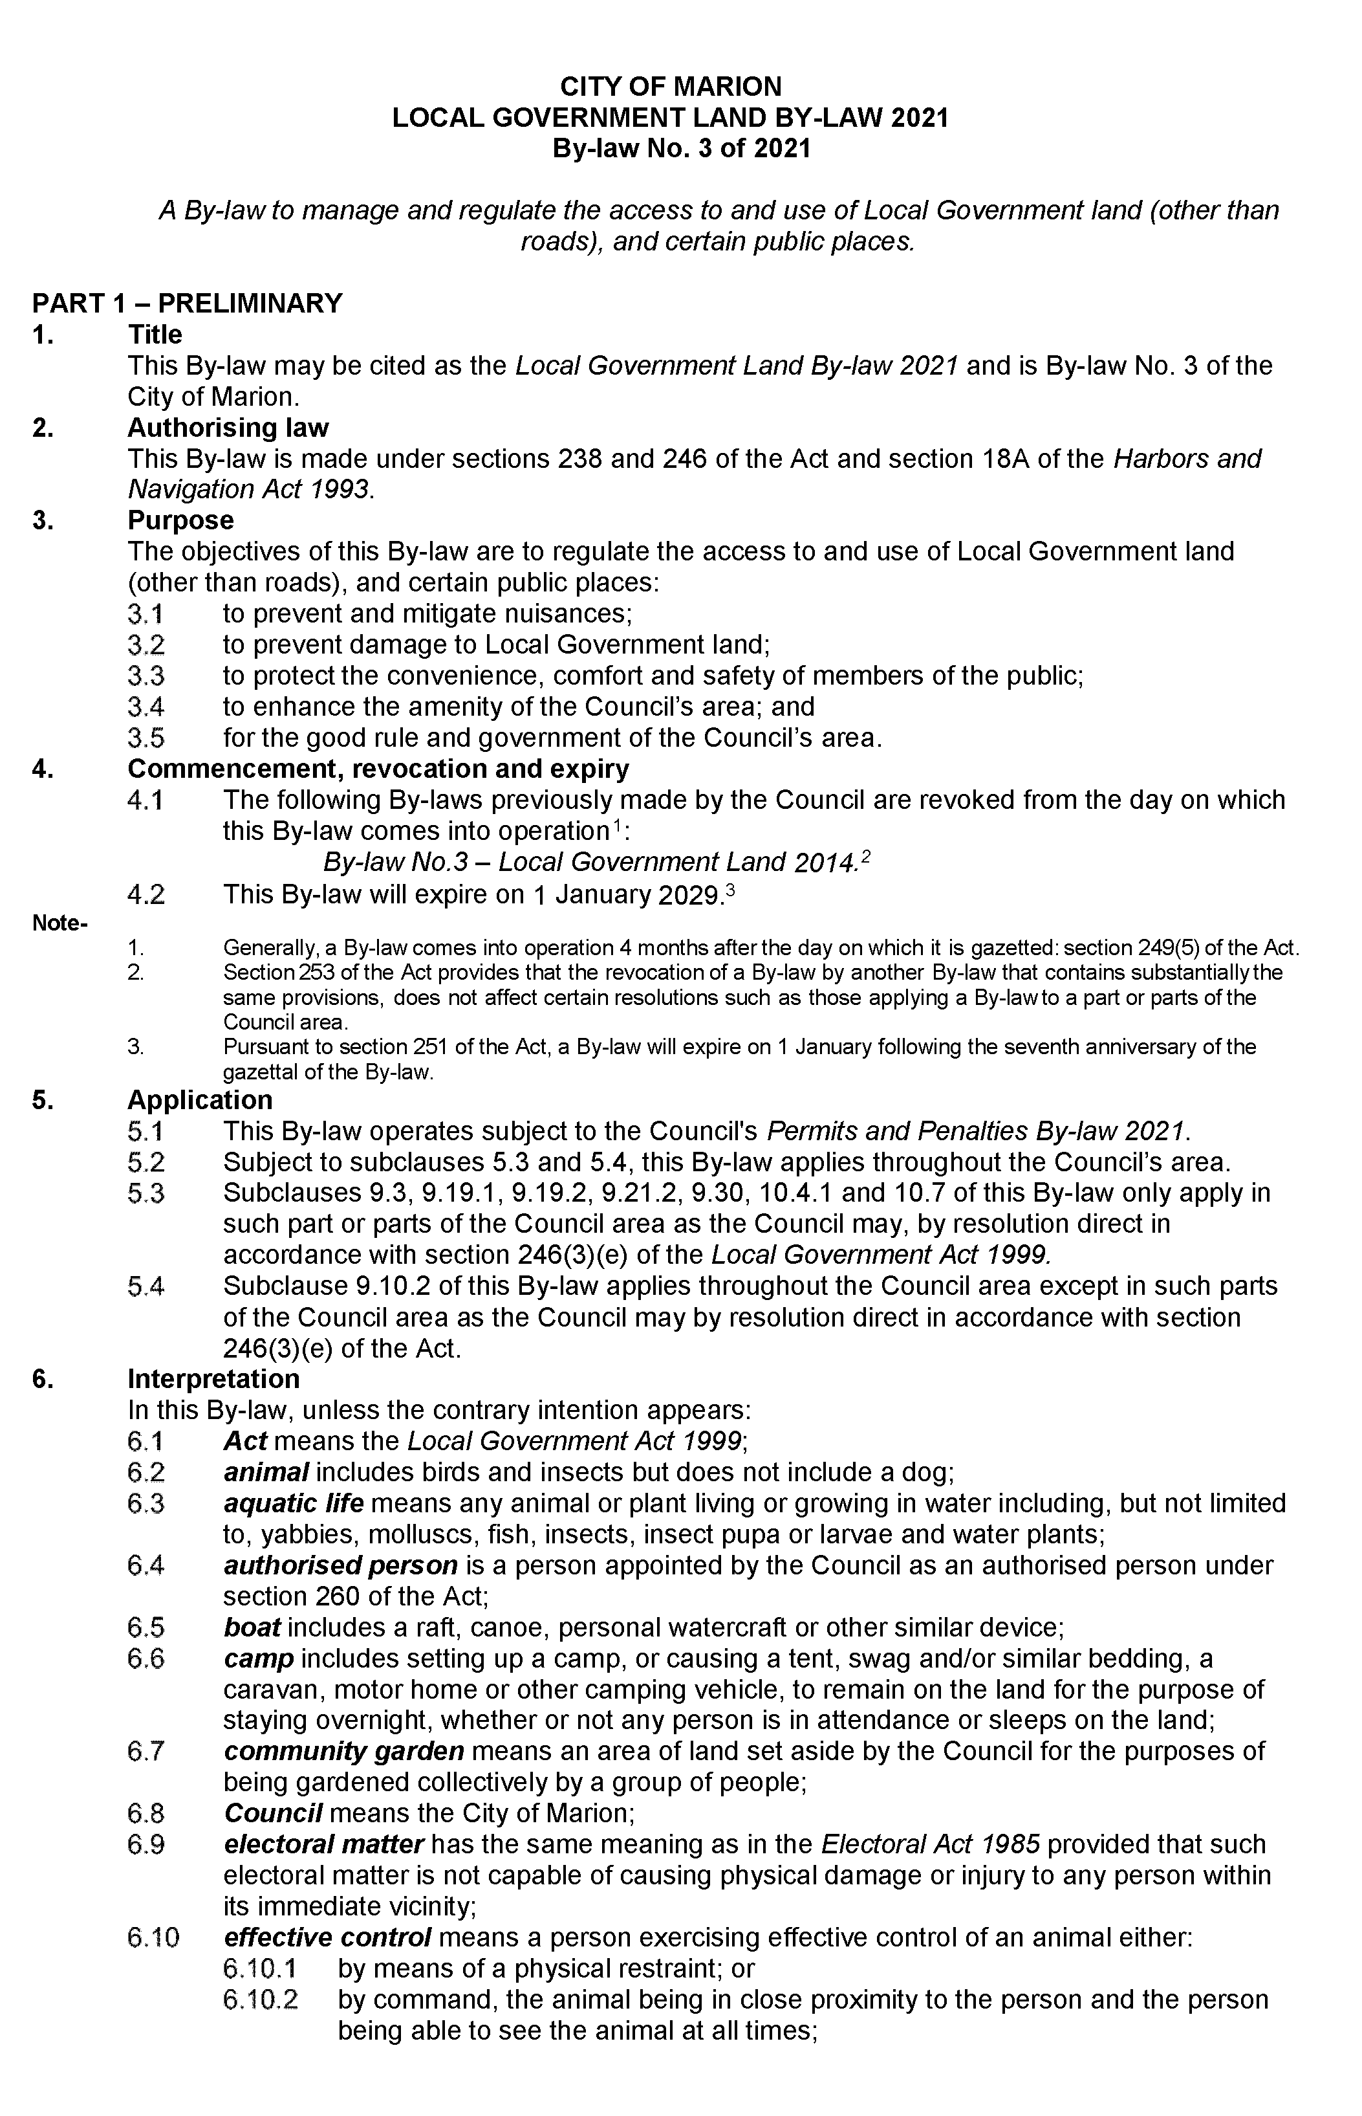
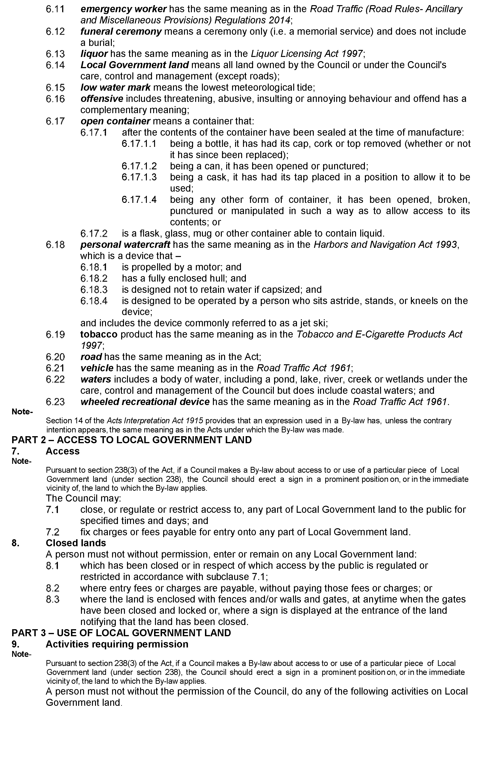
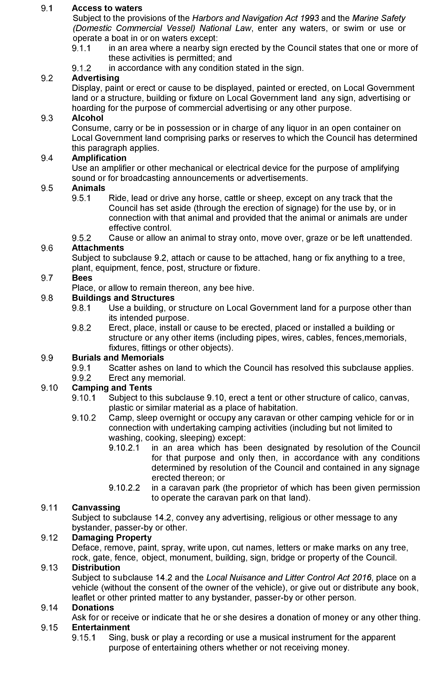
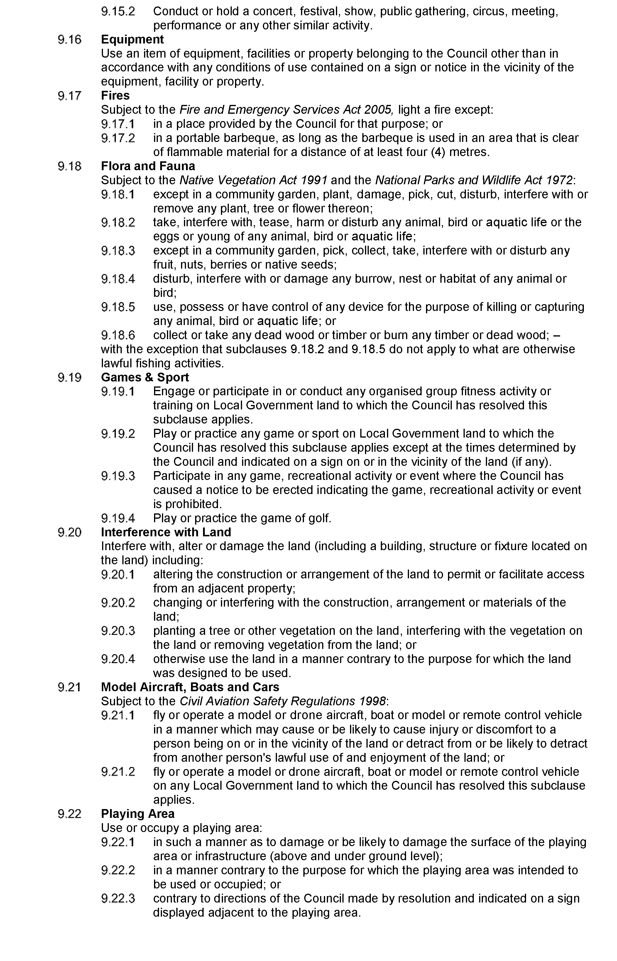
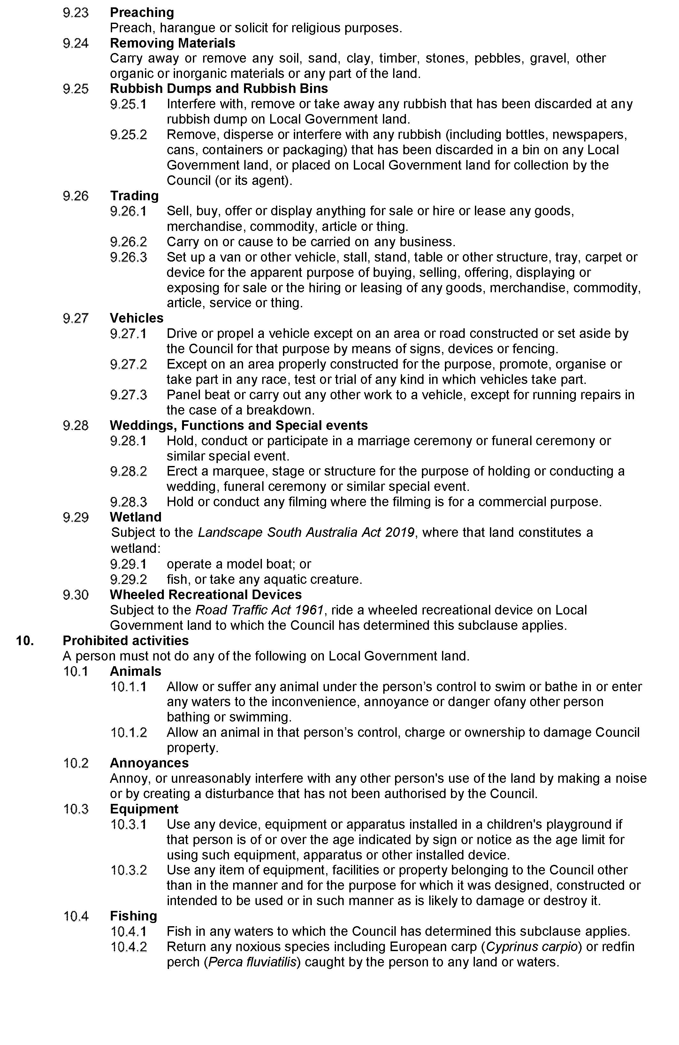
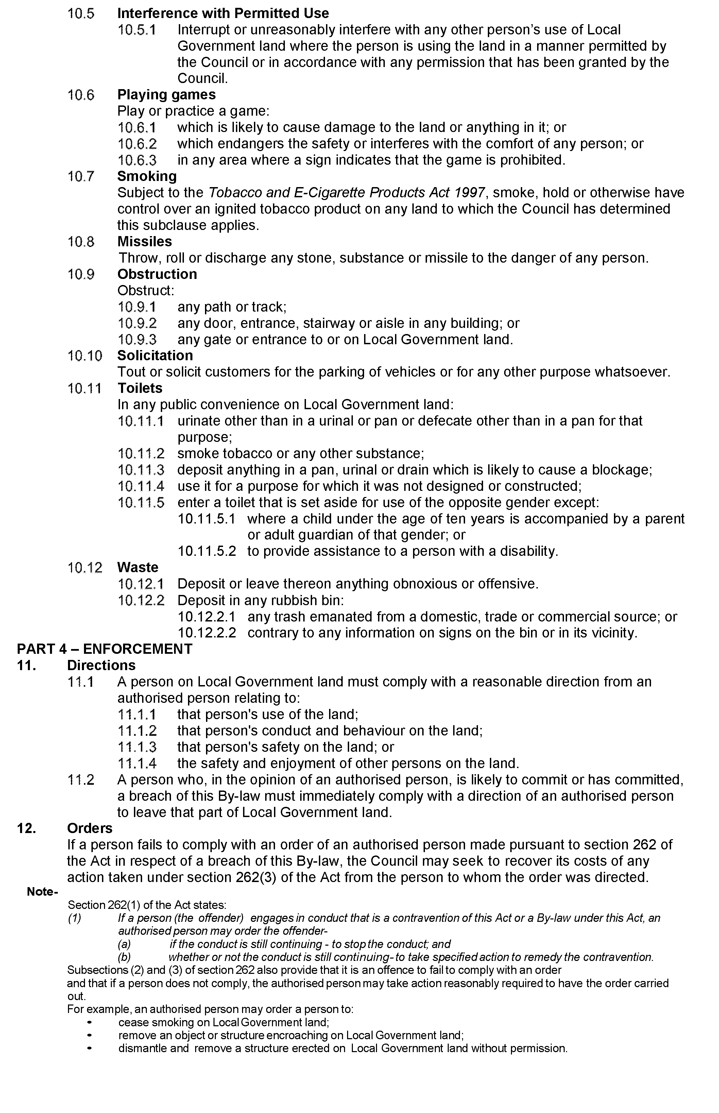
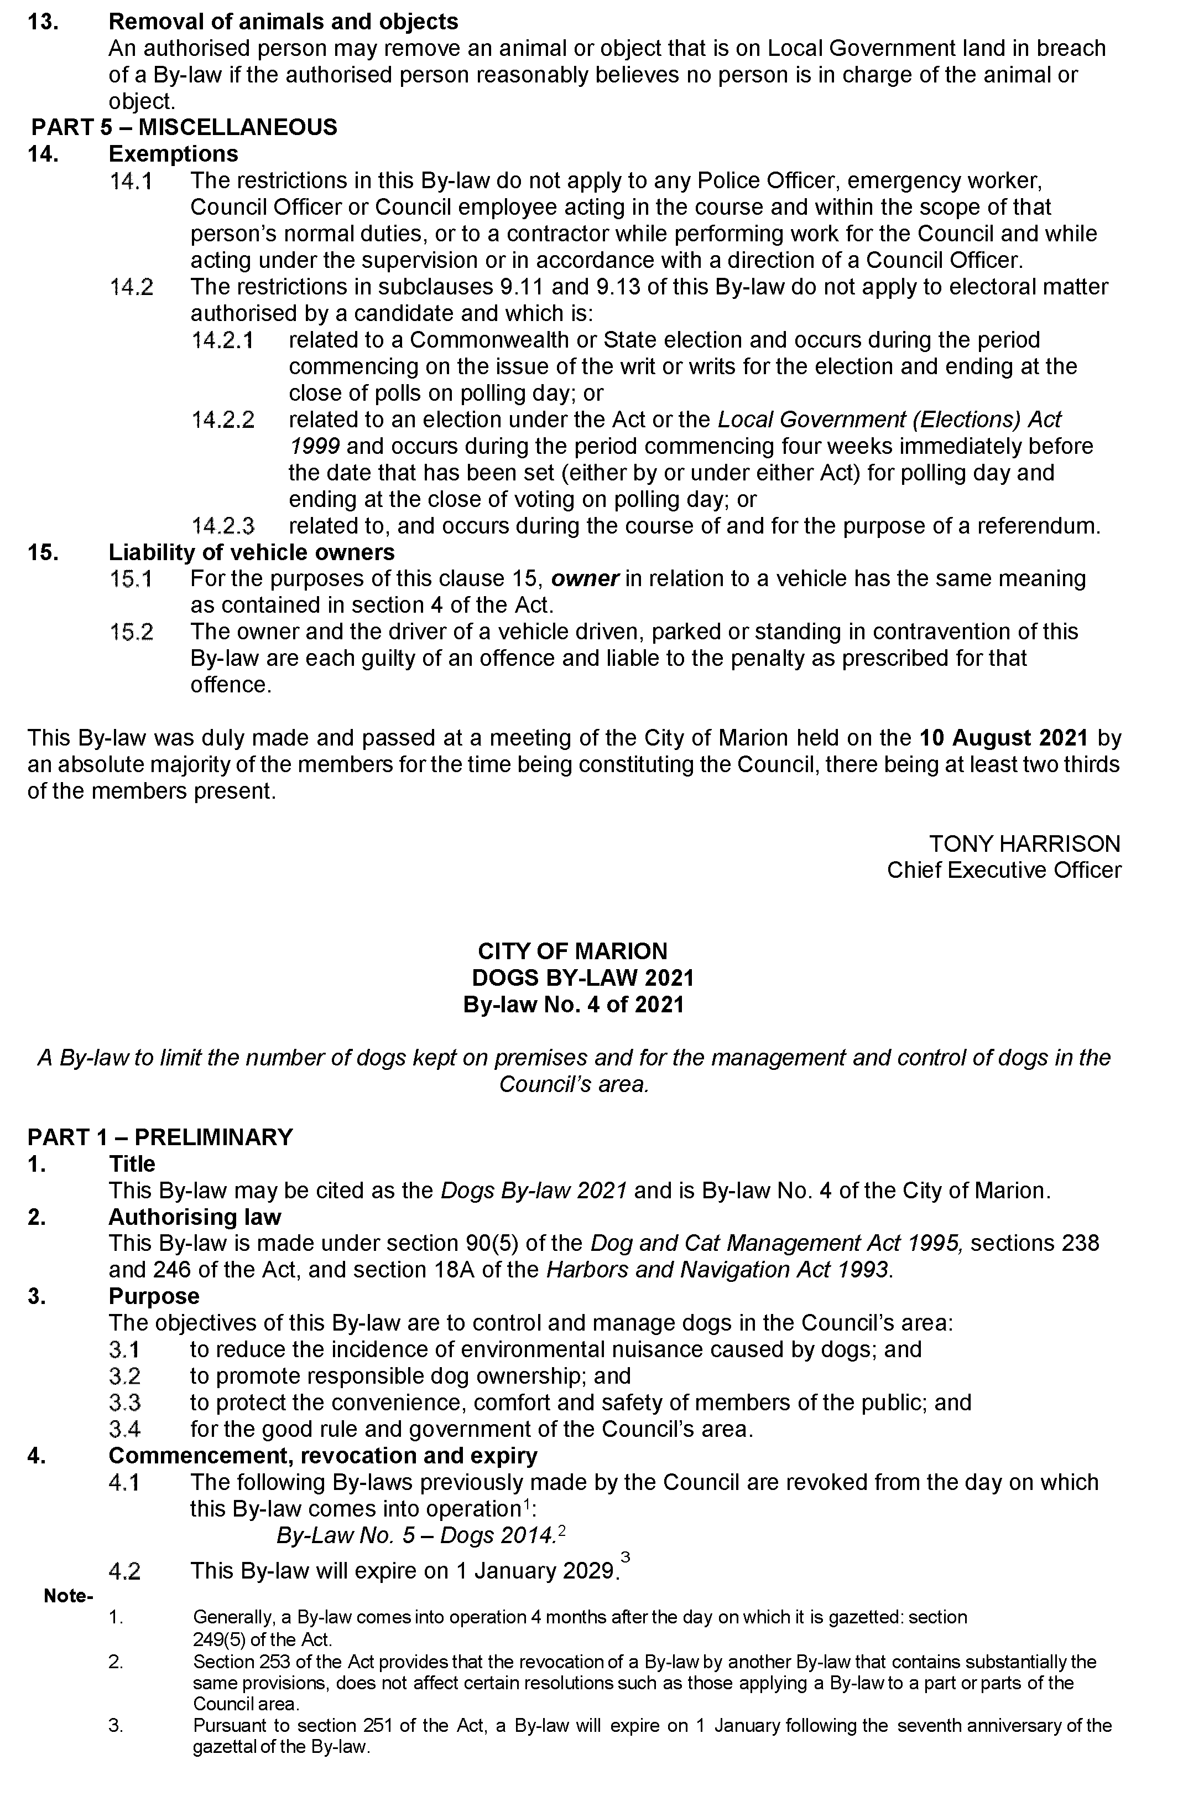
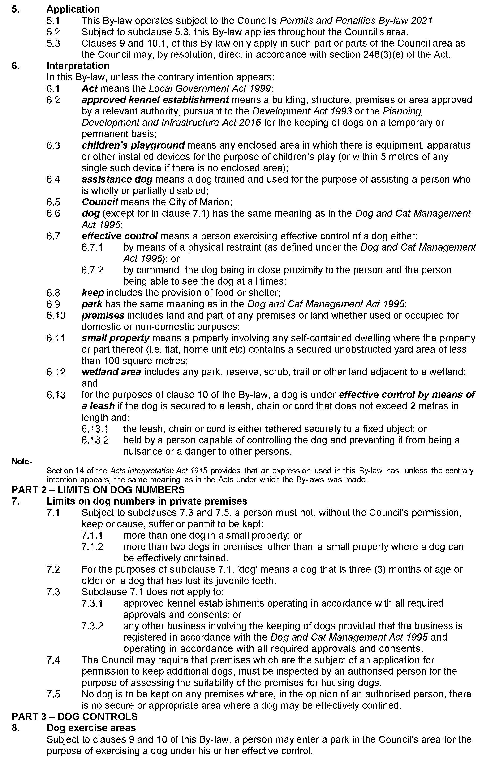
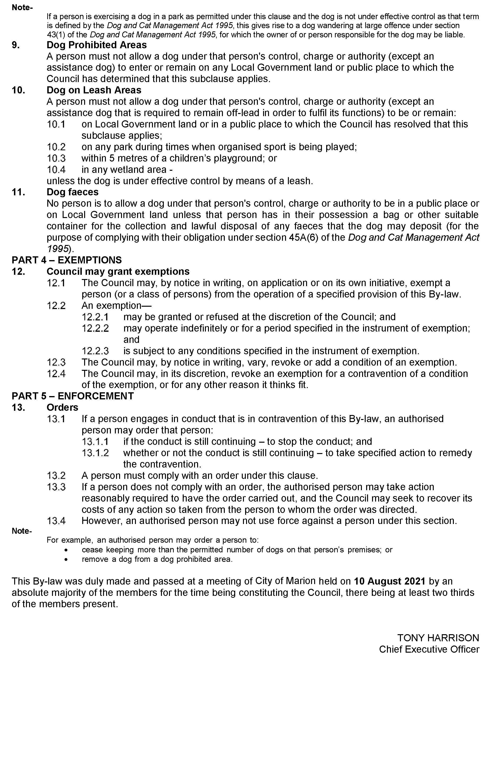
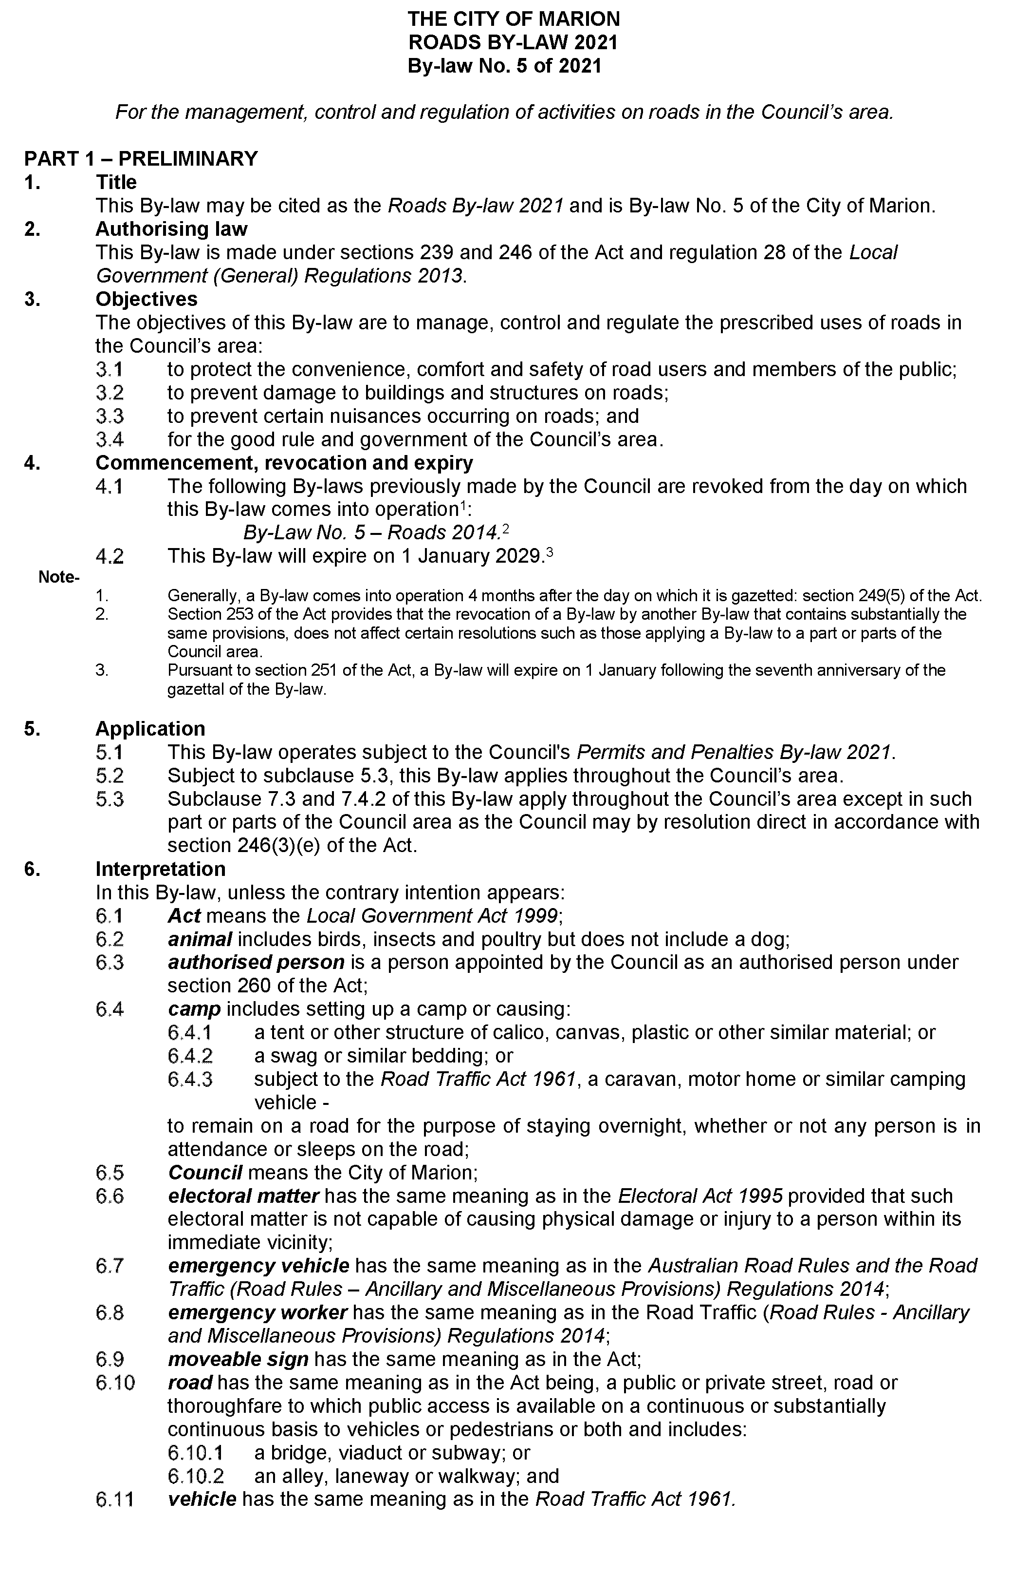
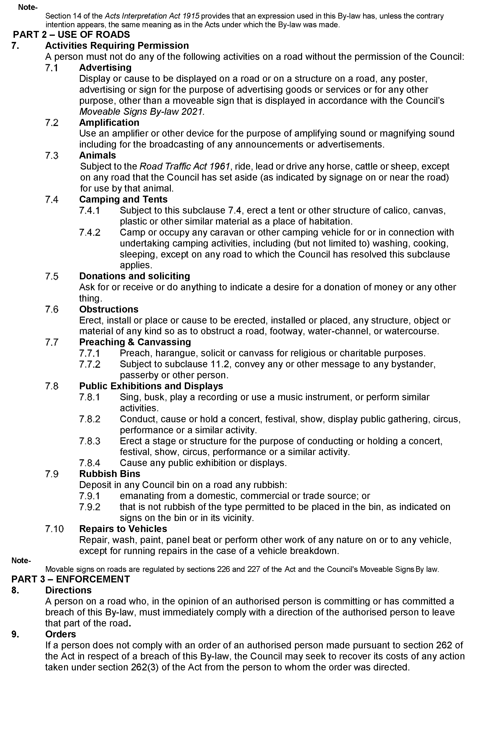
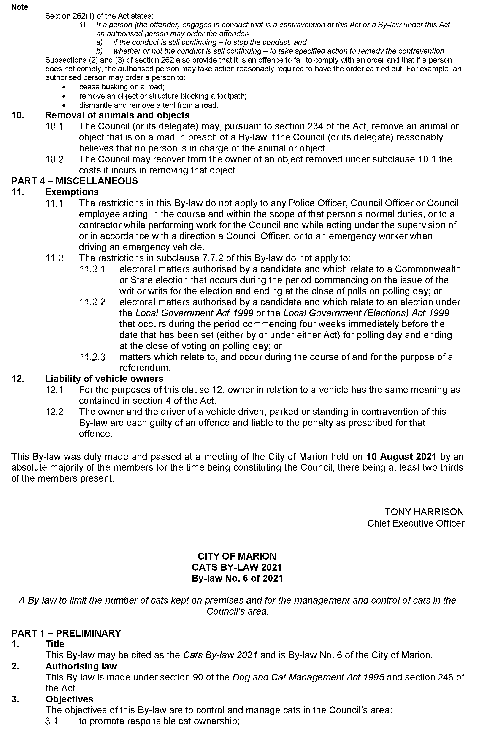
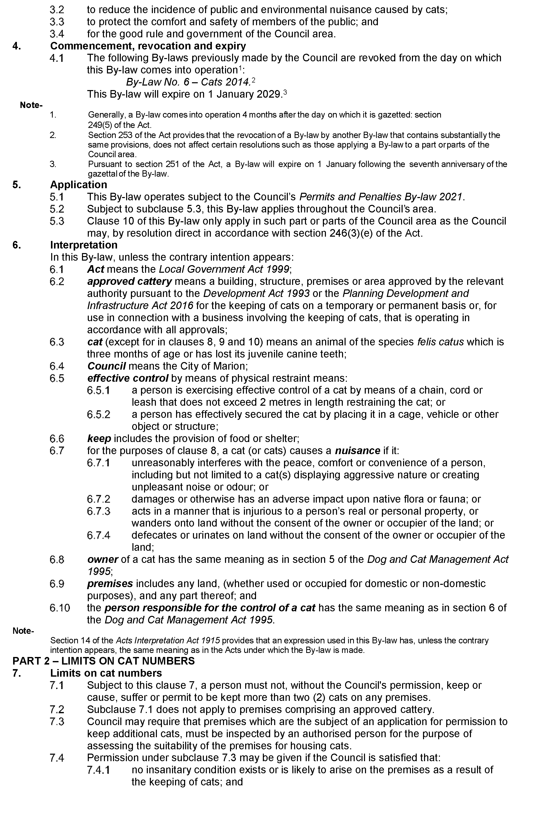
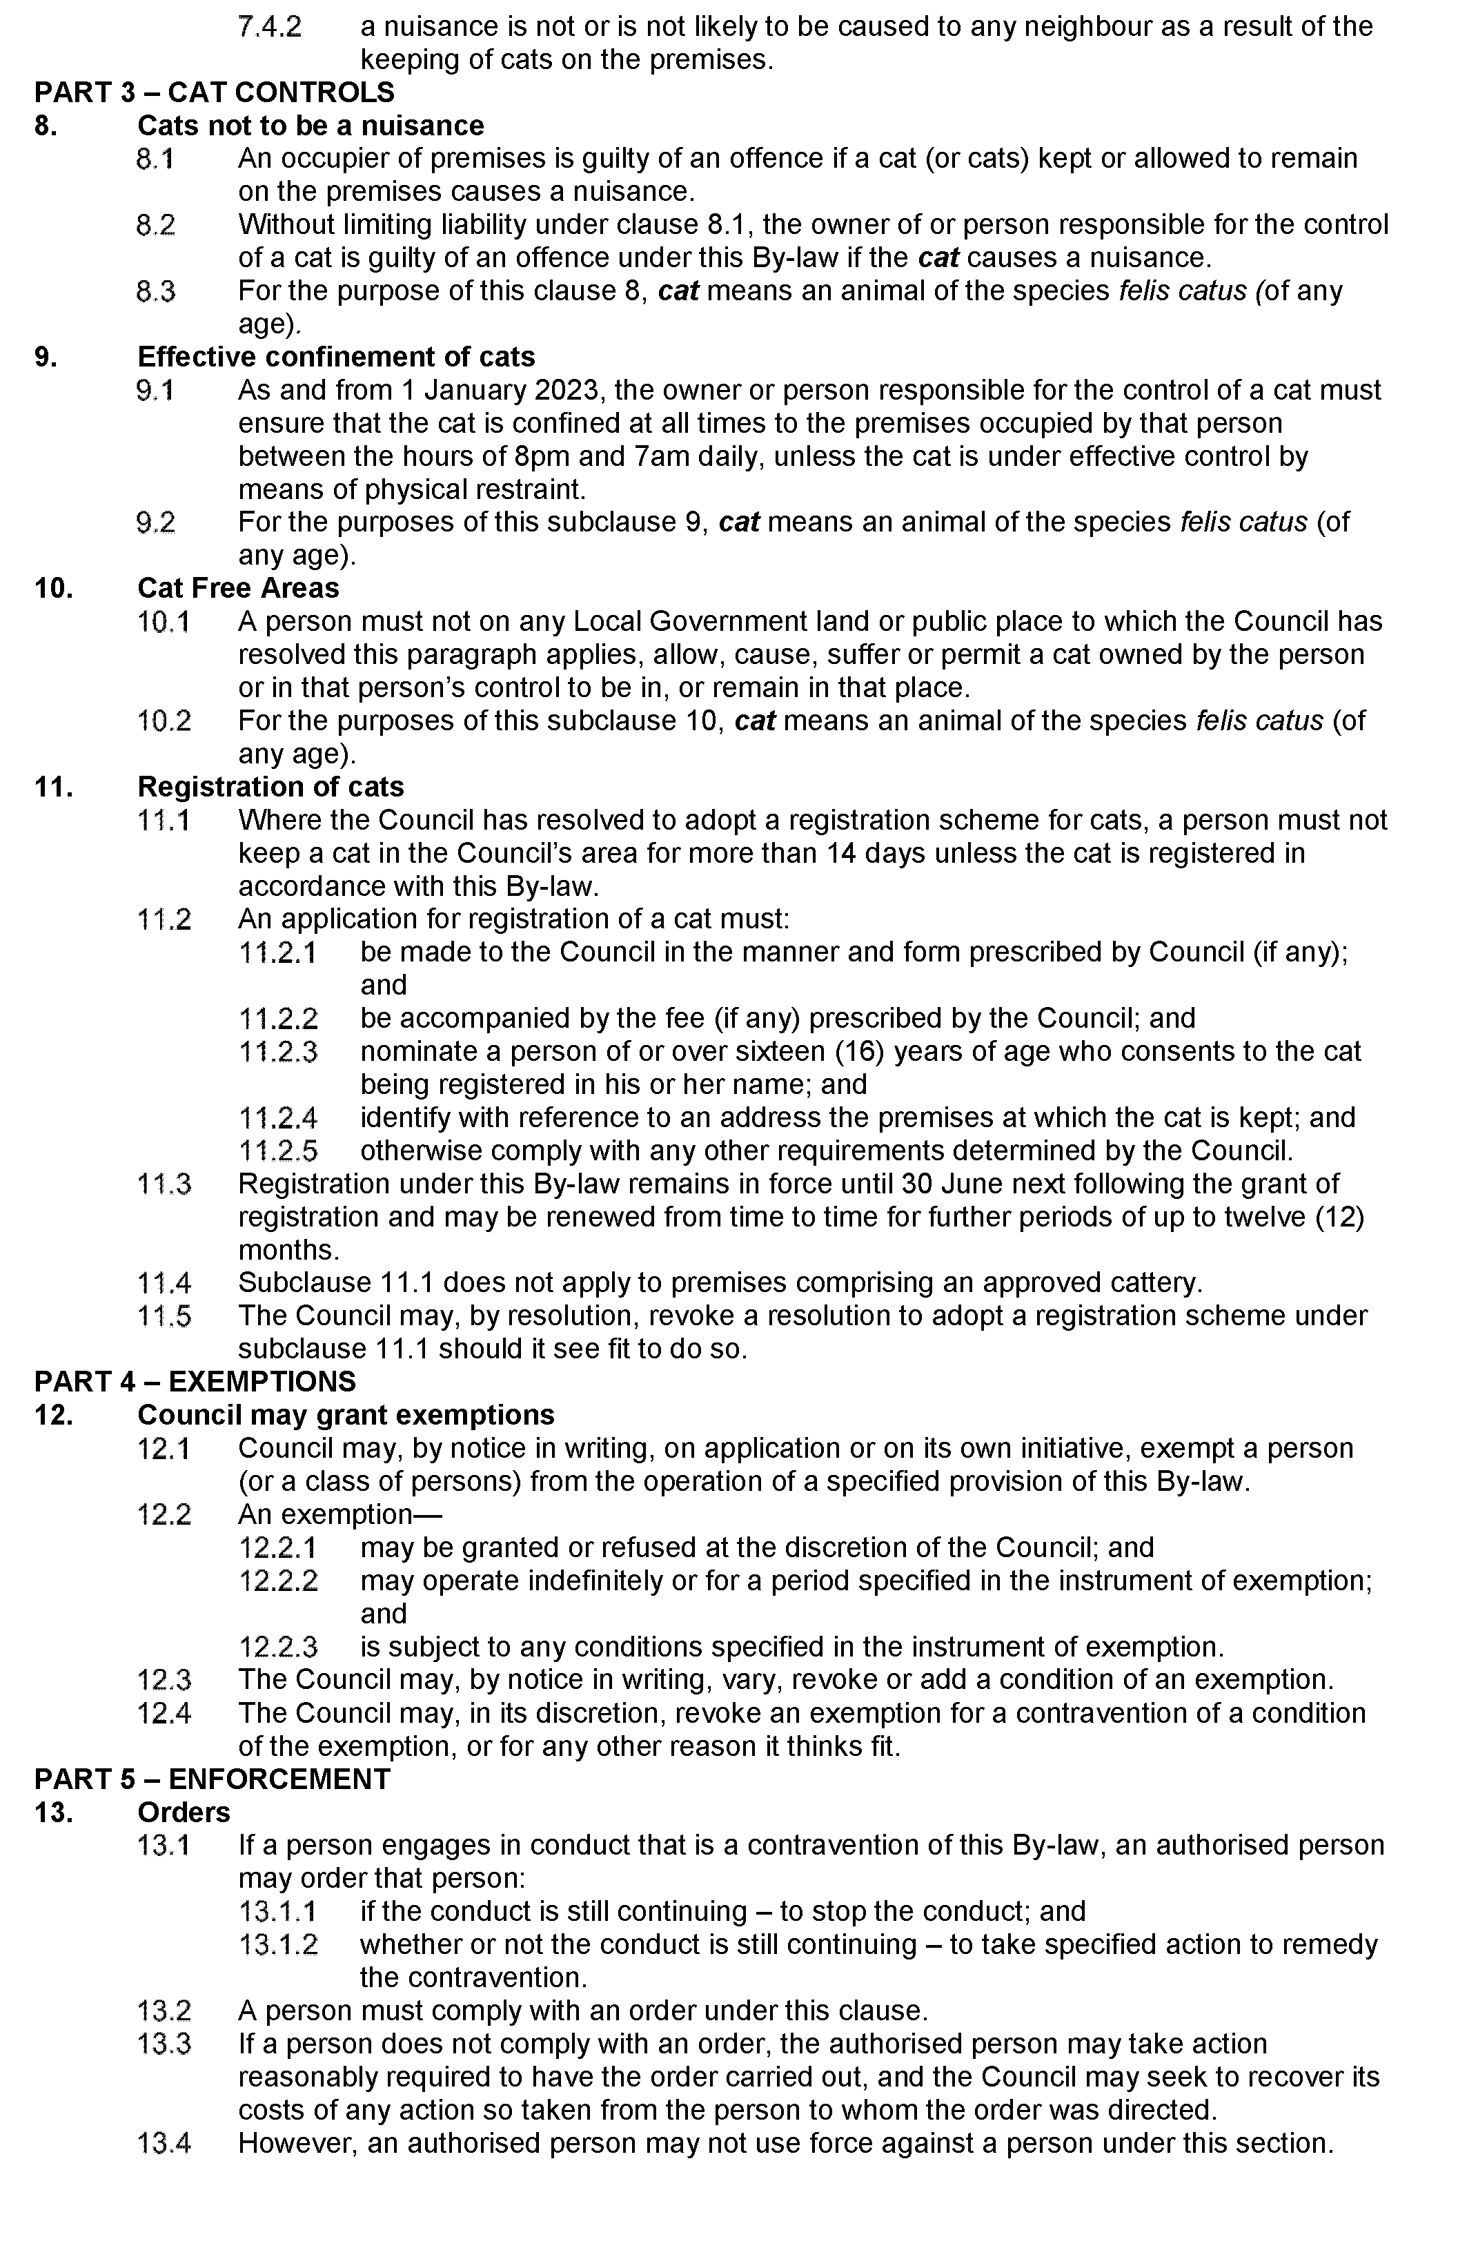
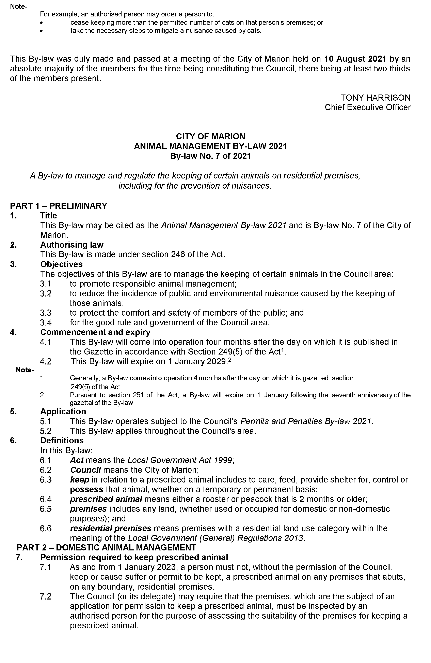
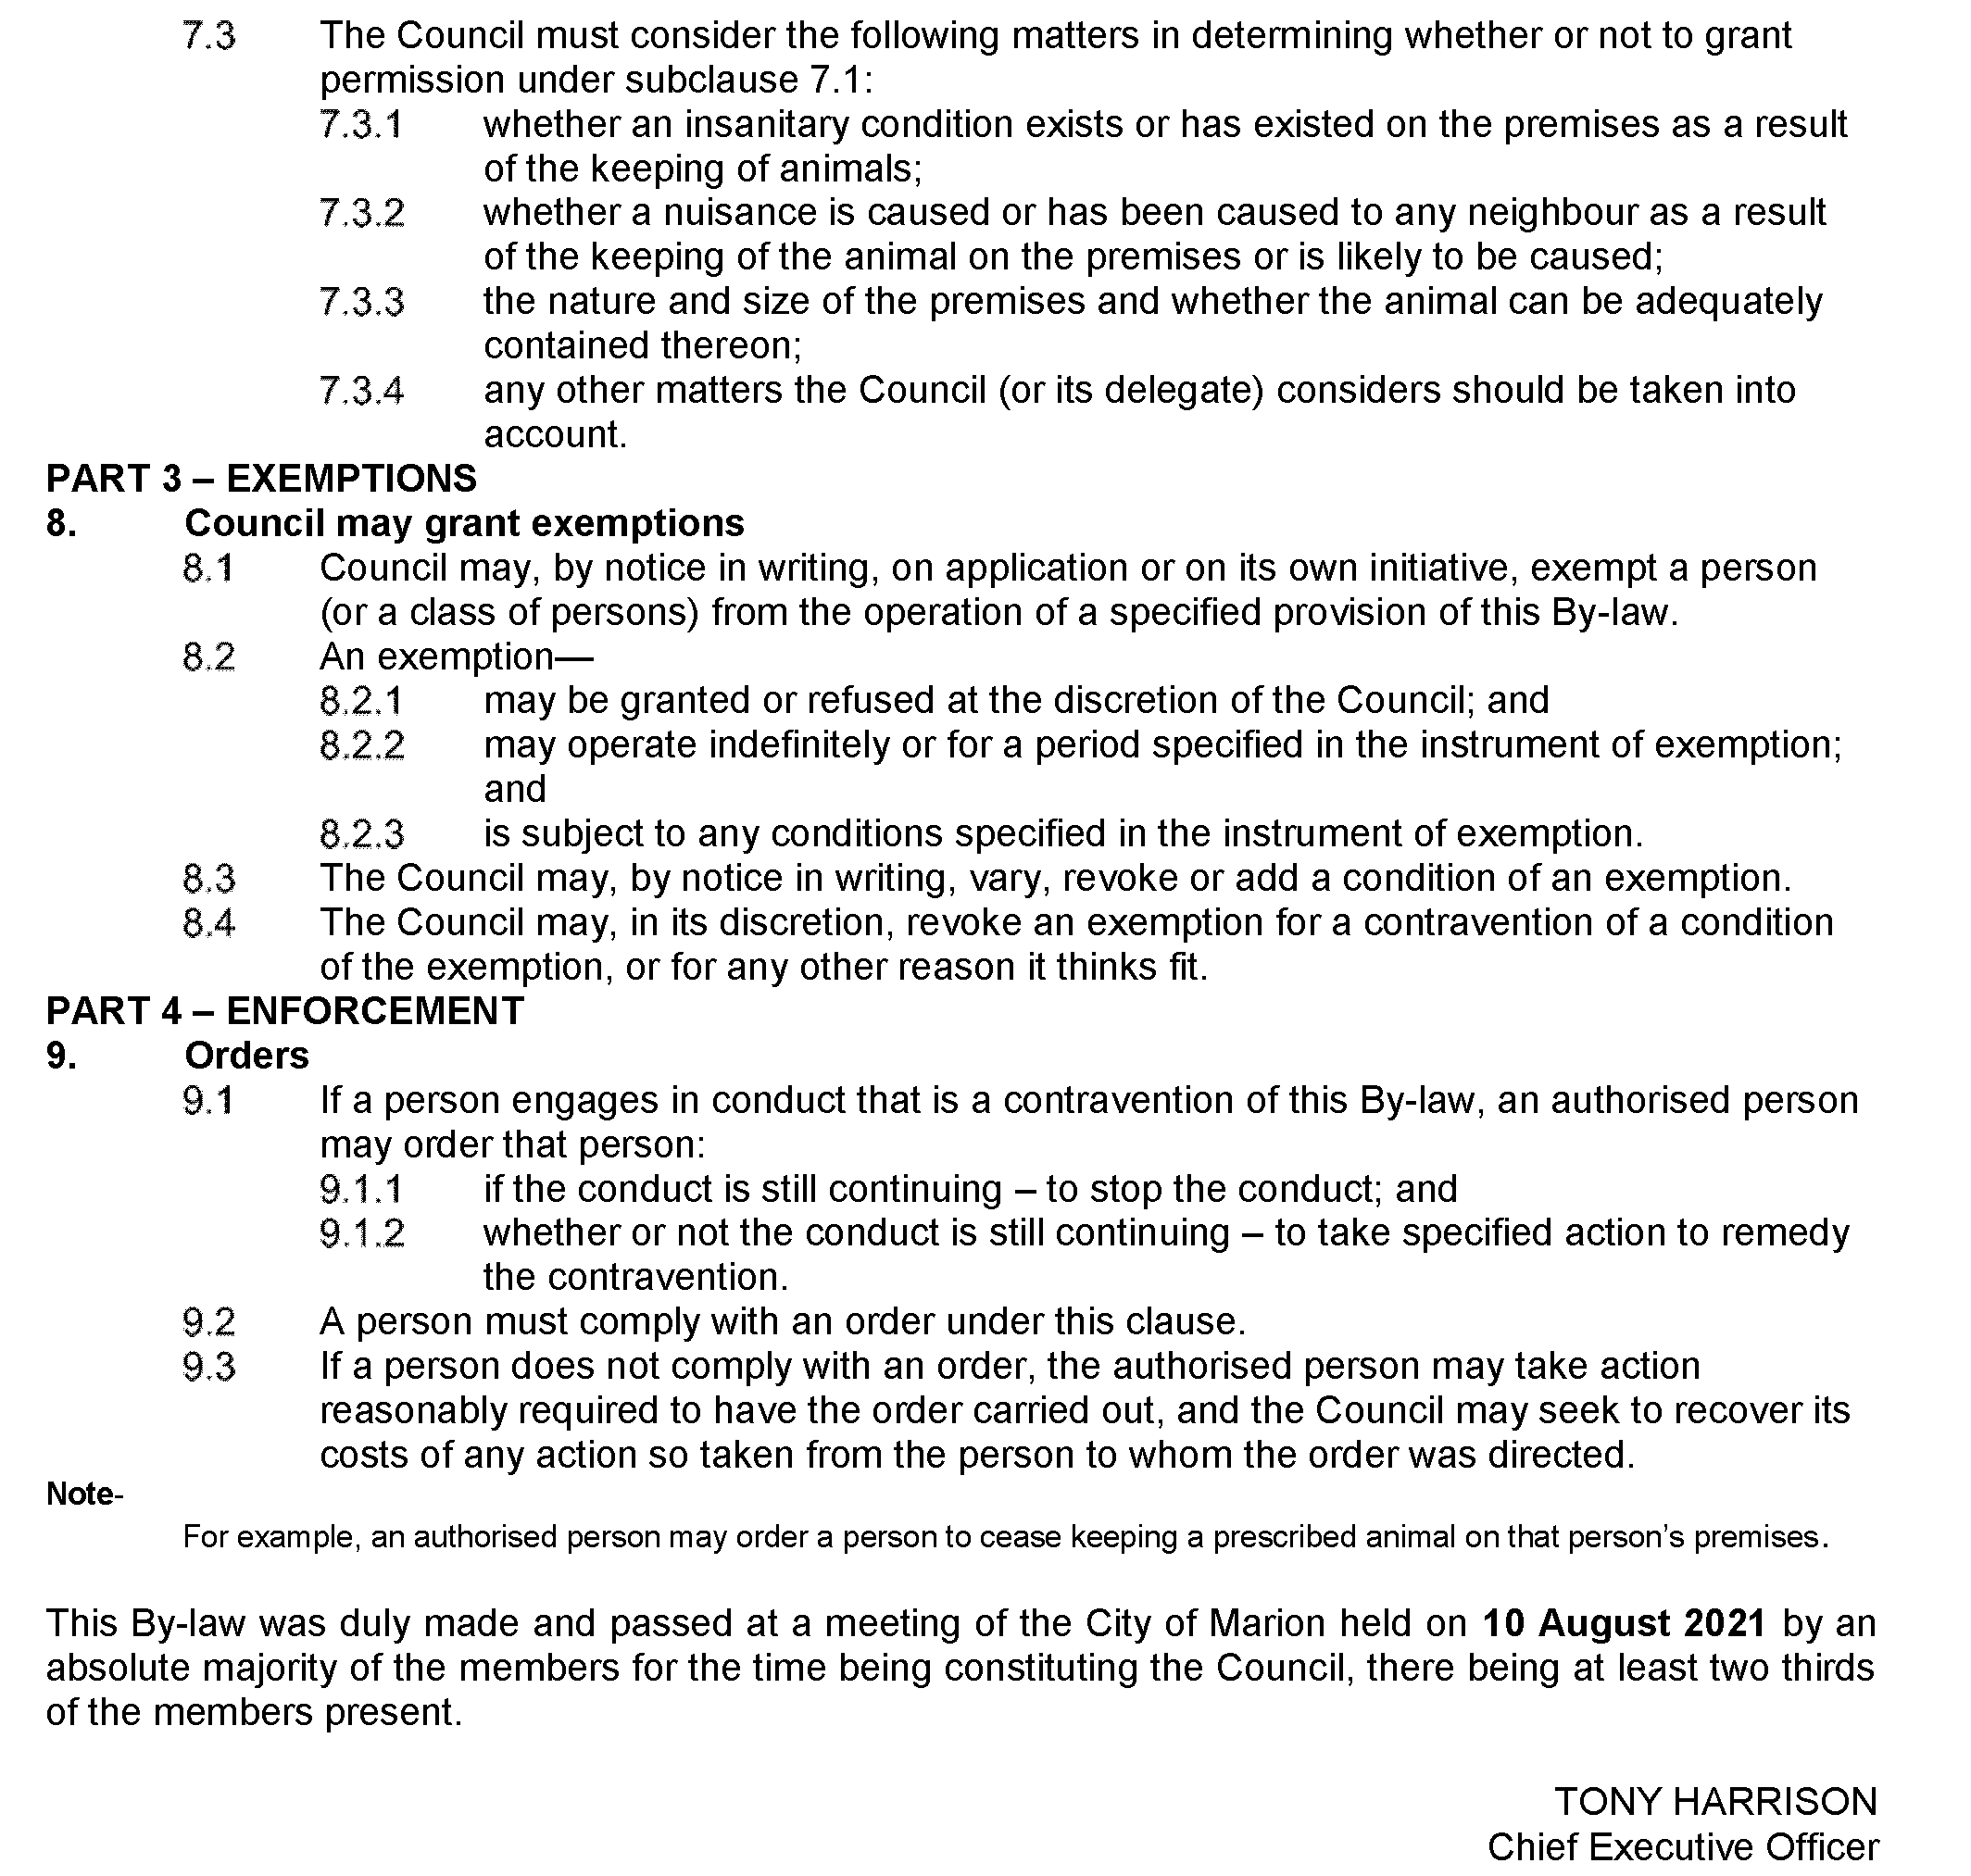

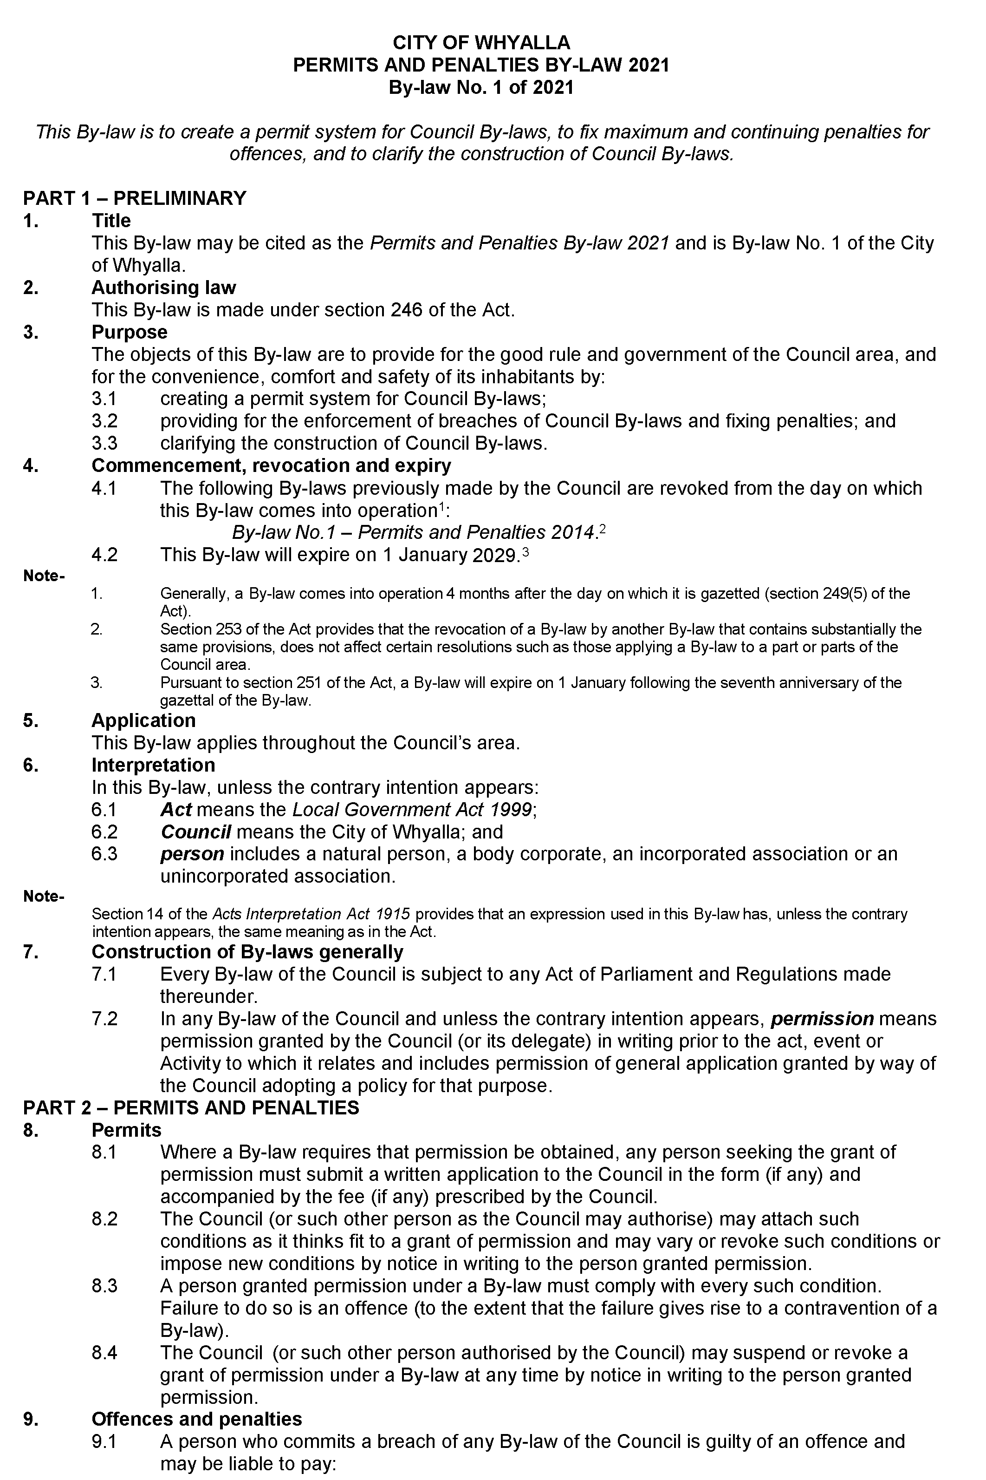
City of Whyalla

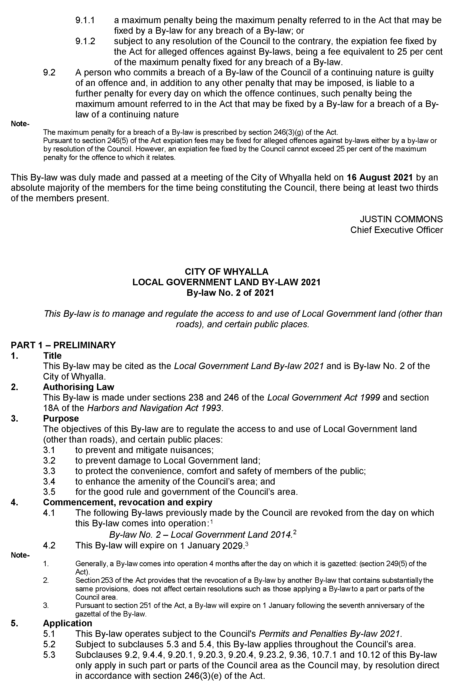
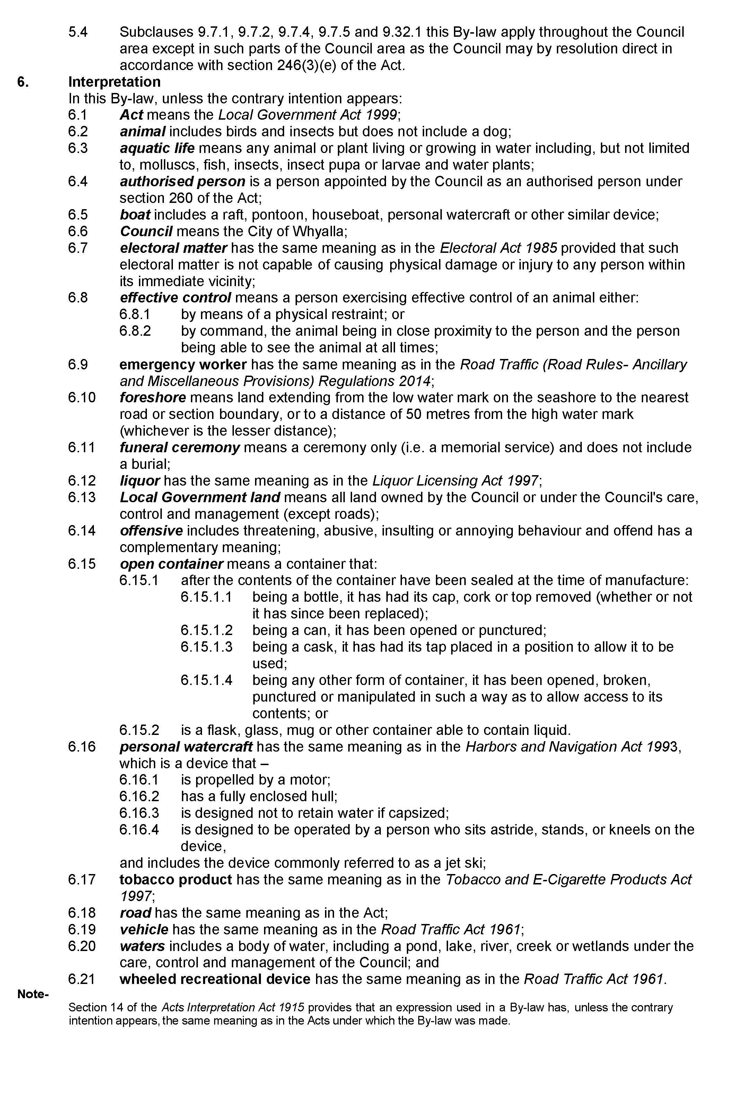
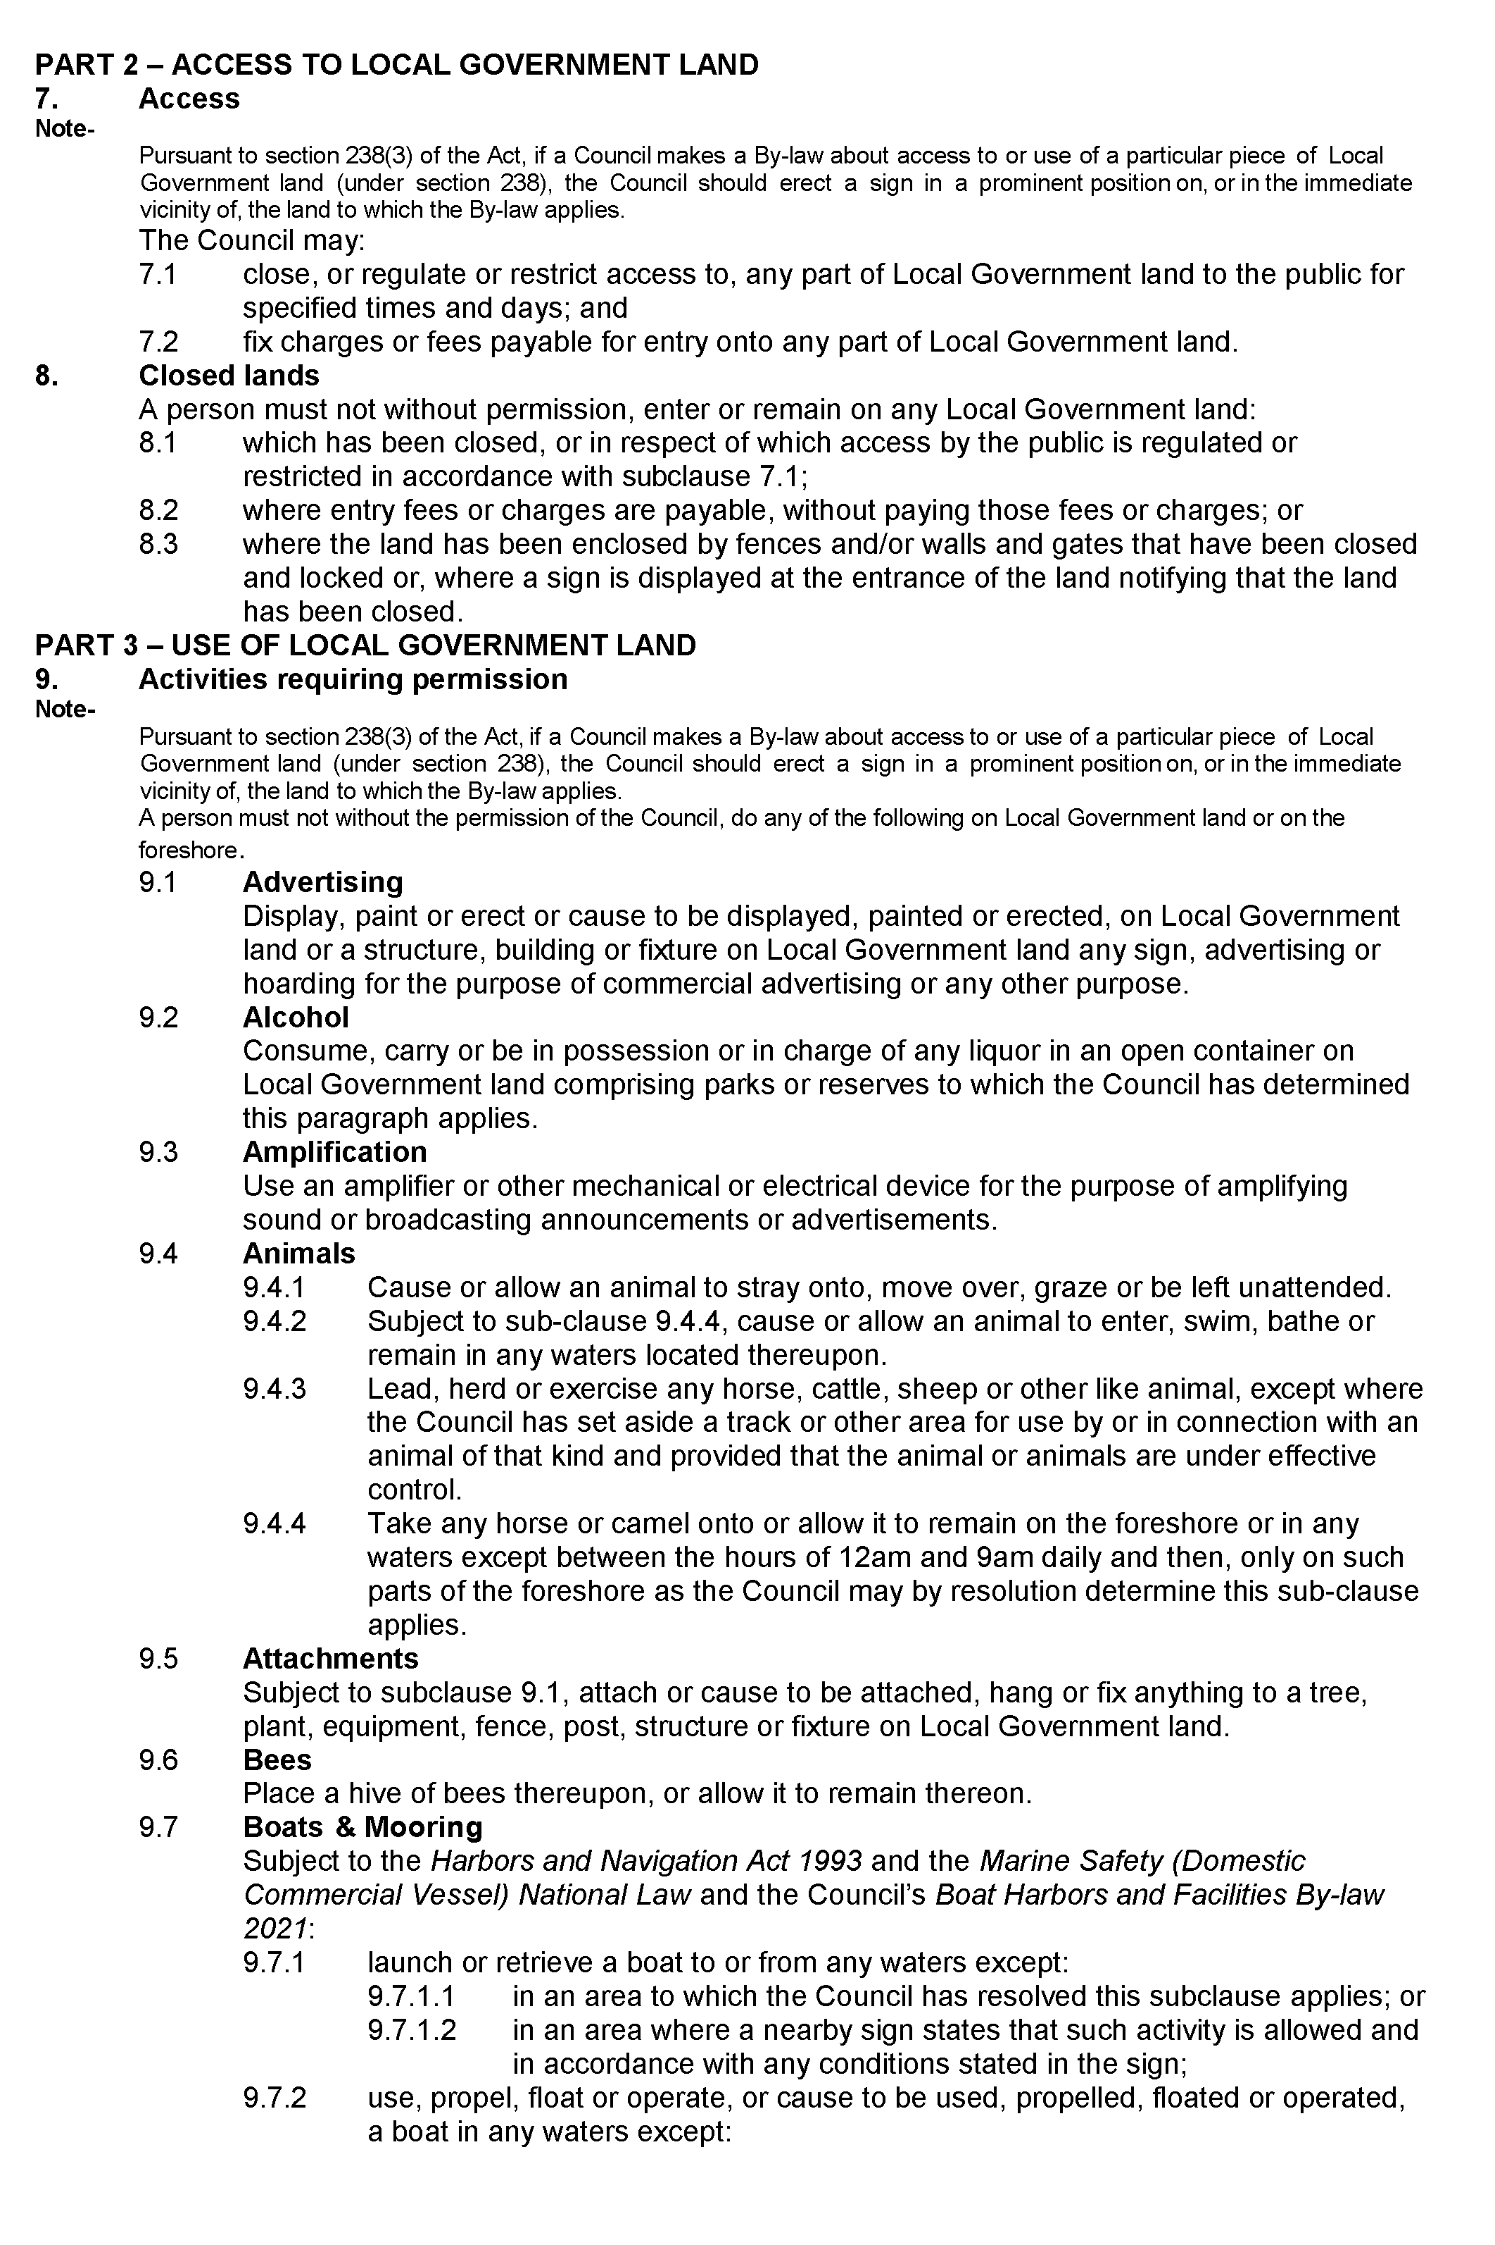
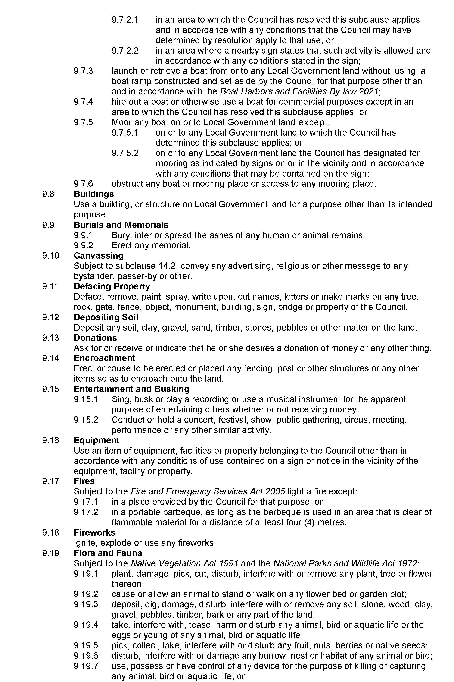
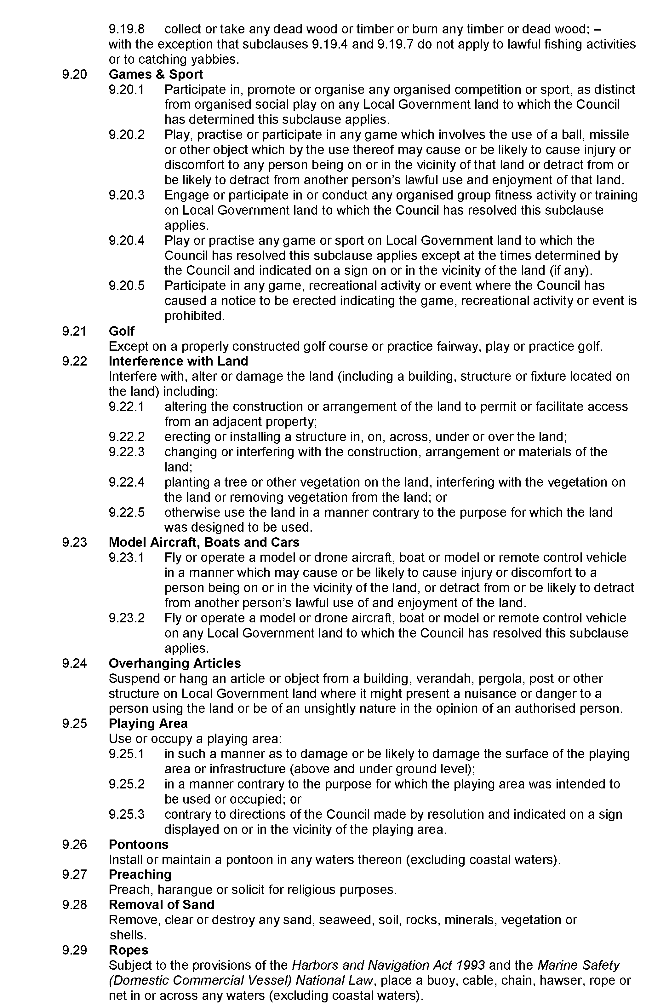
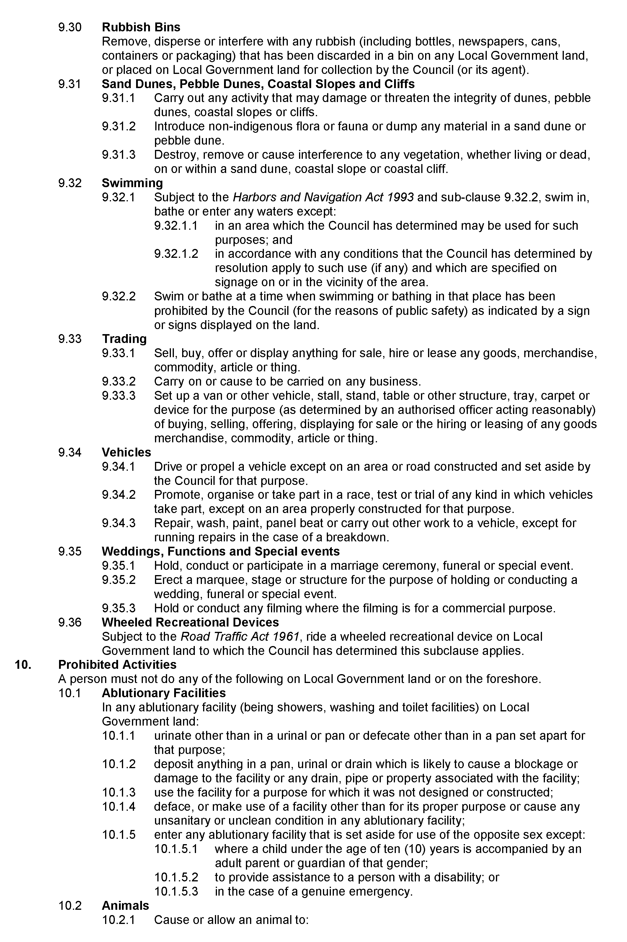
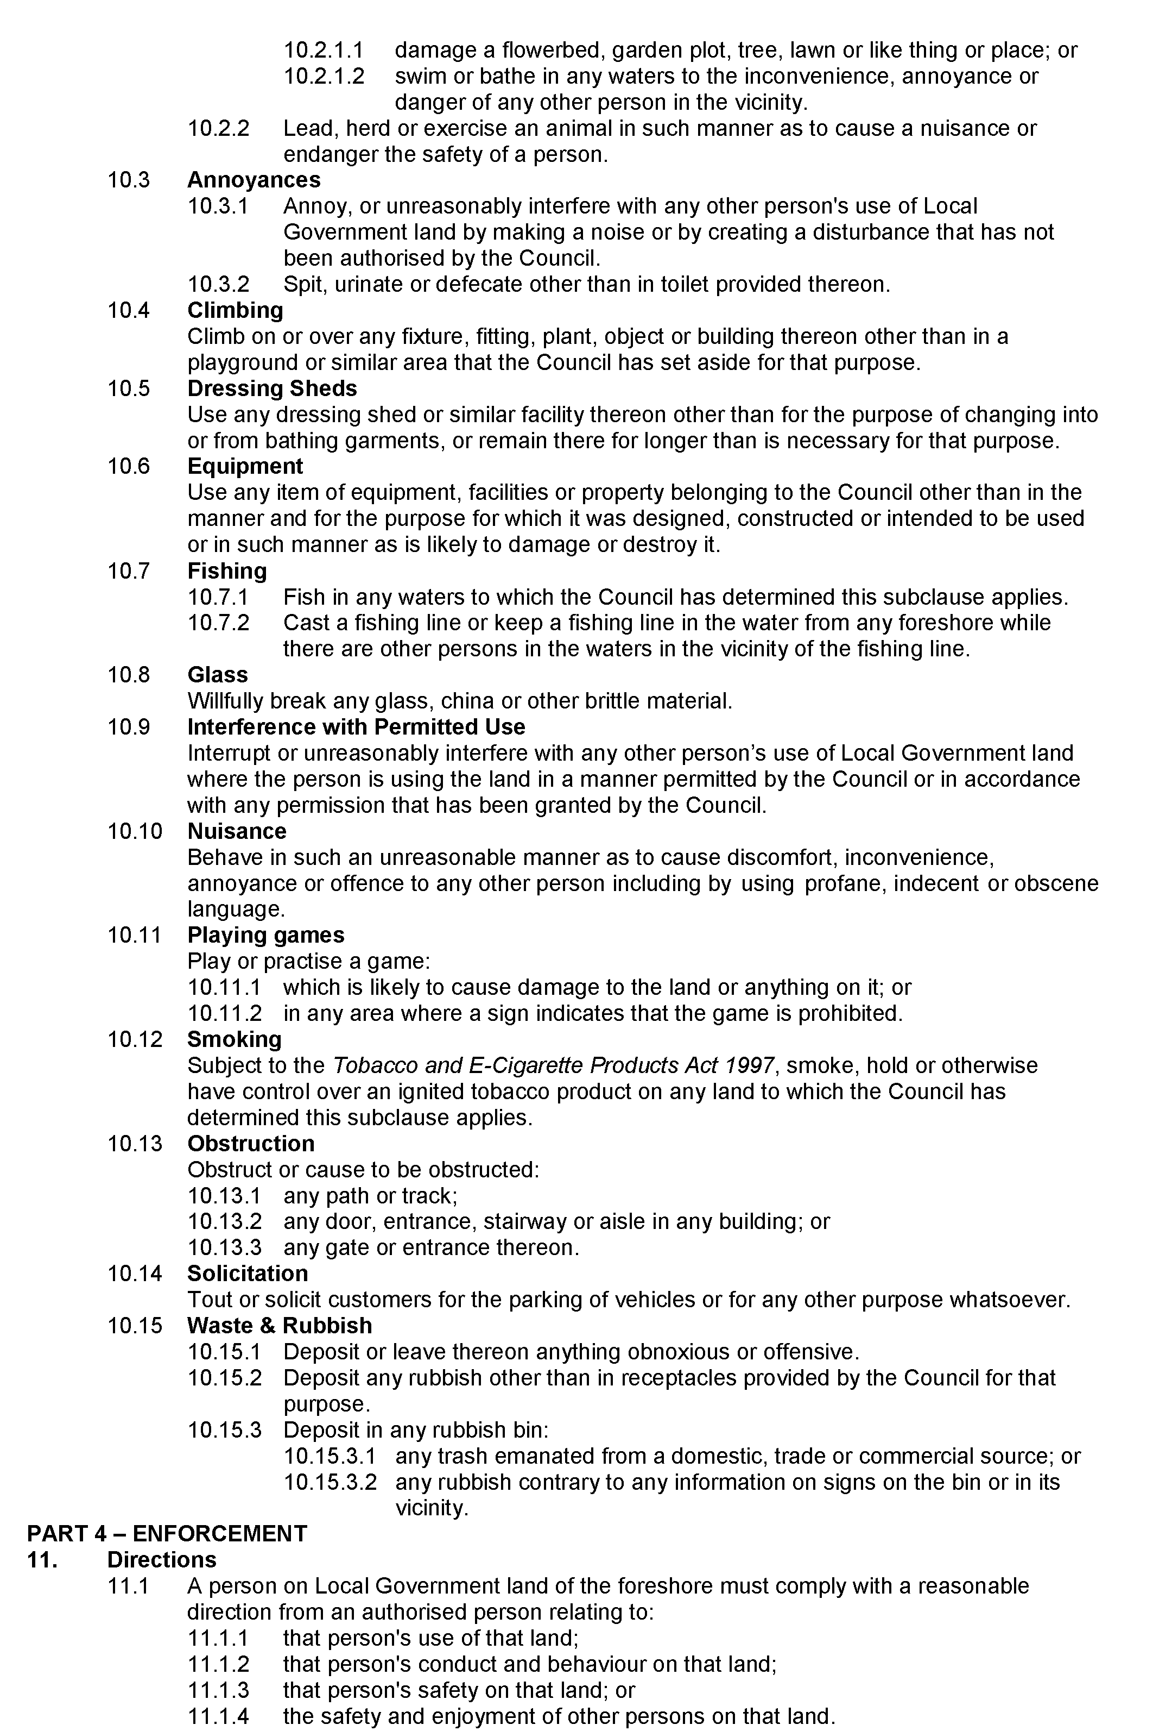
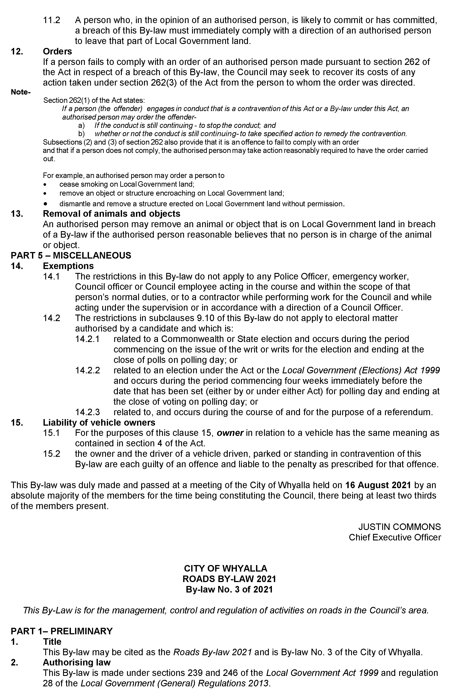
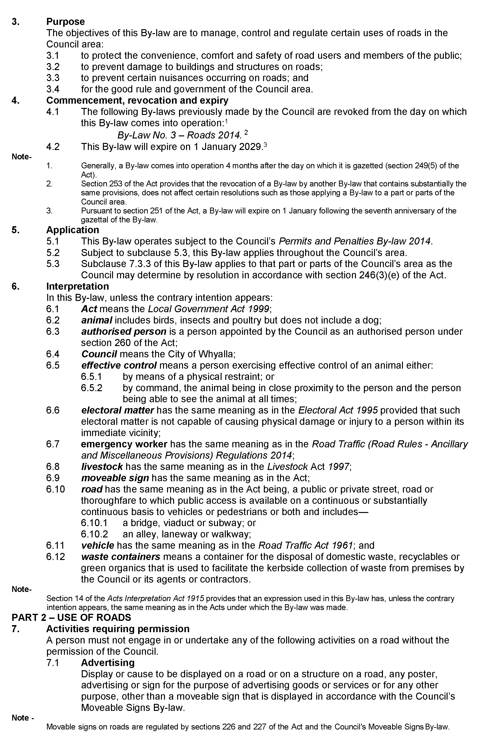
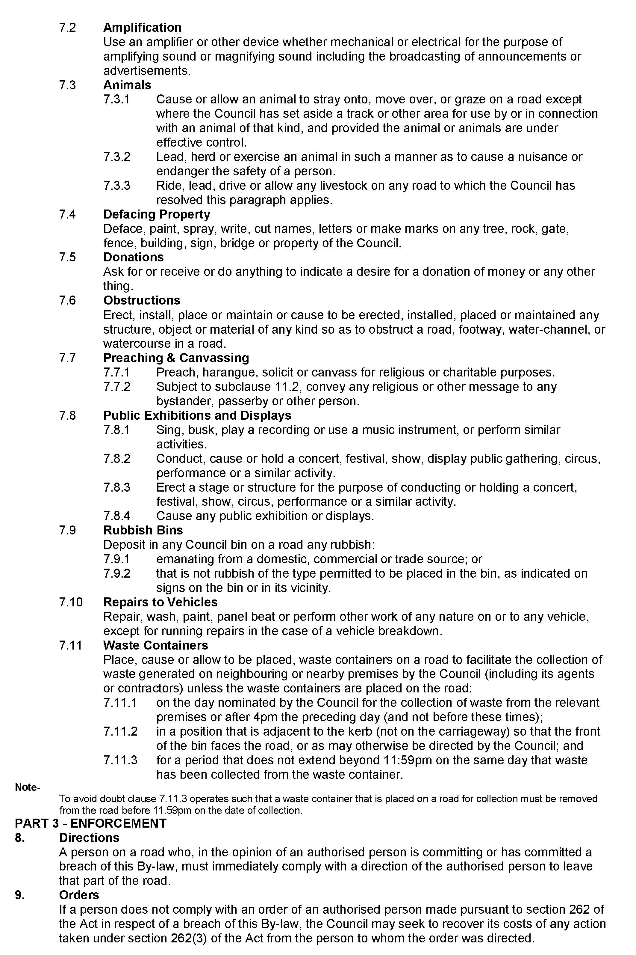
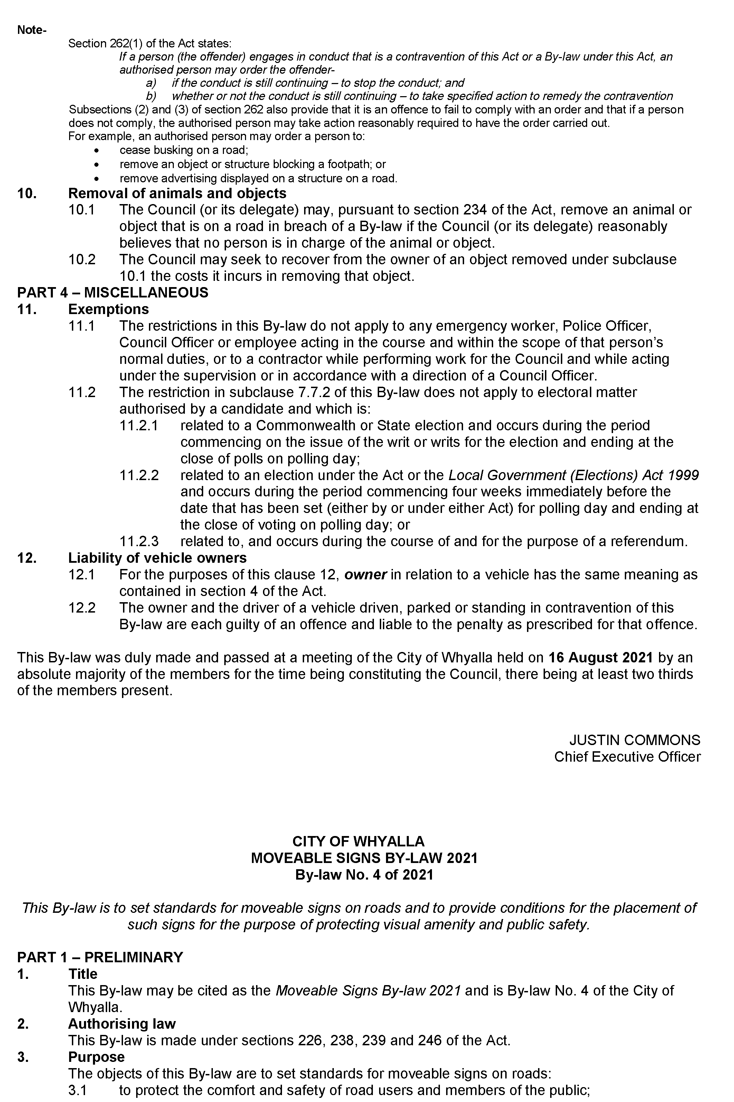
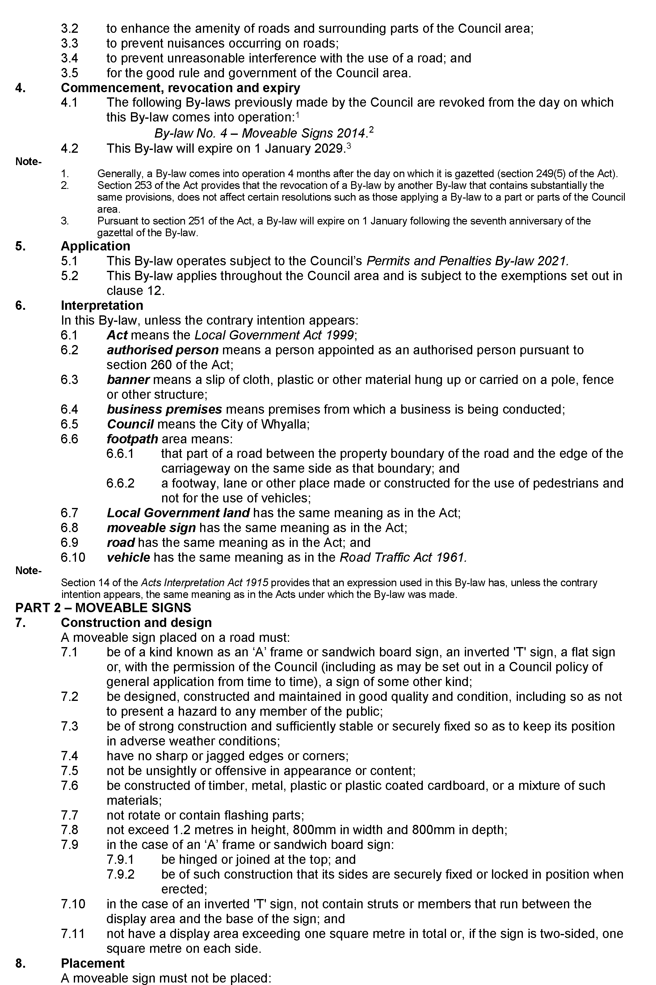
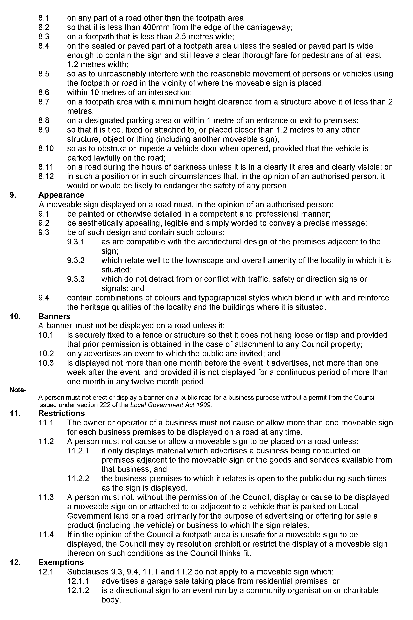
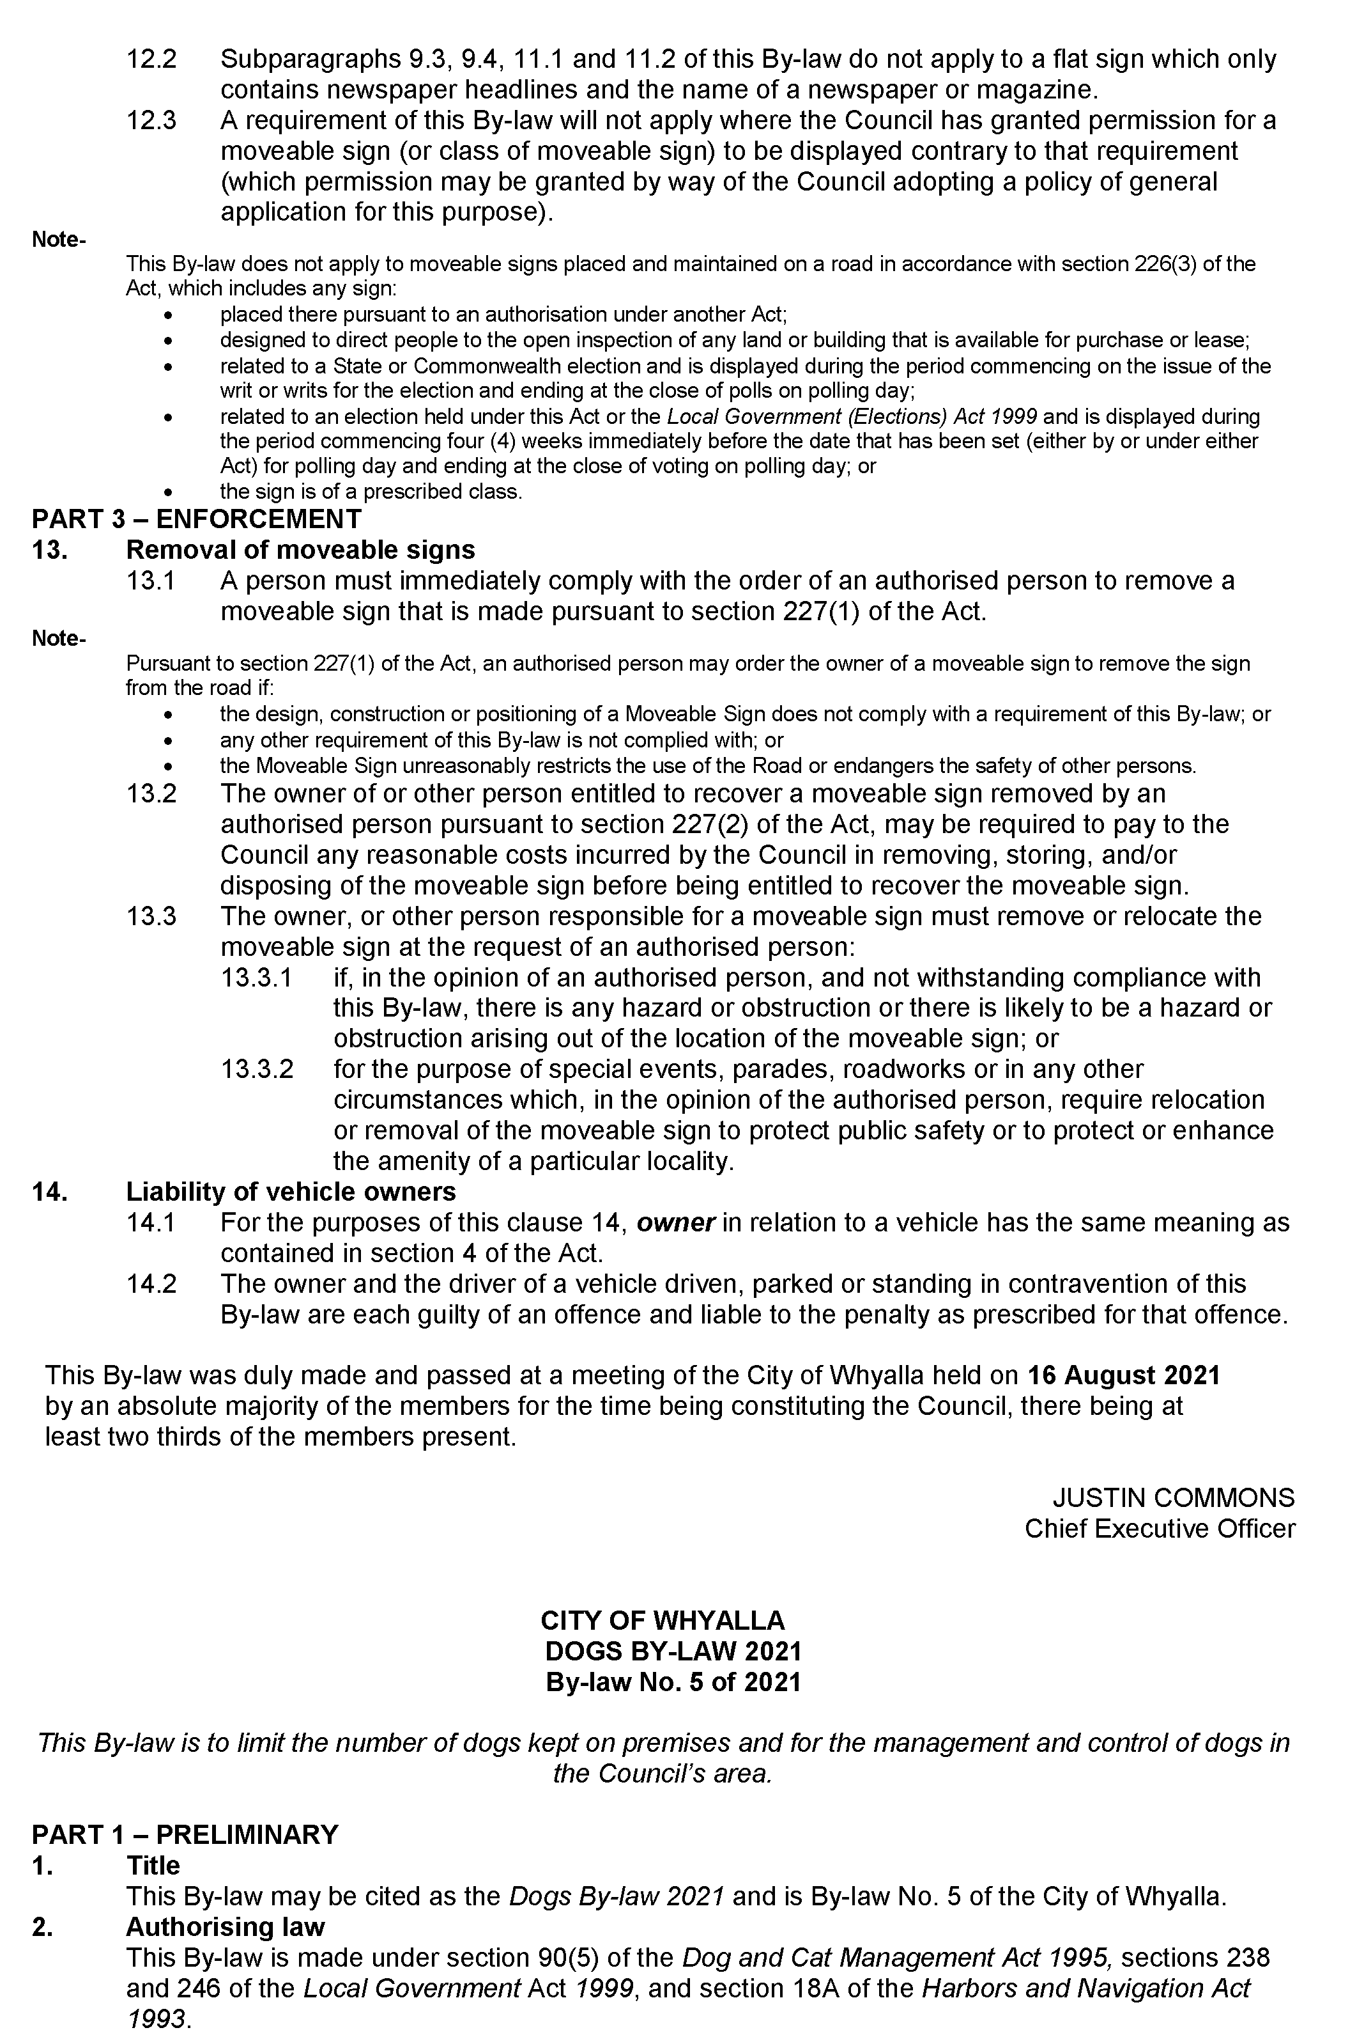
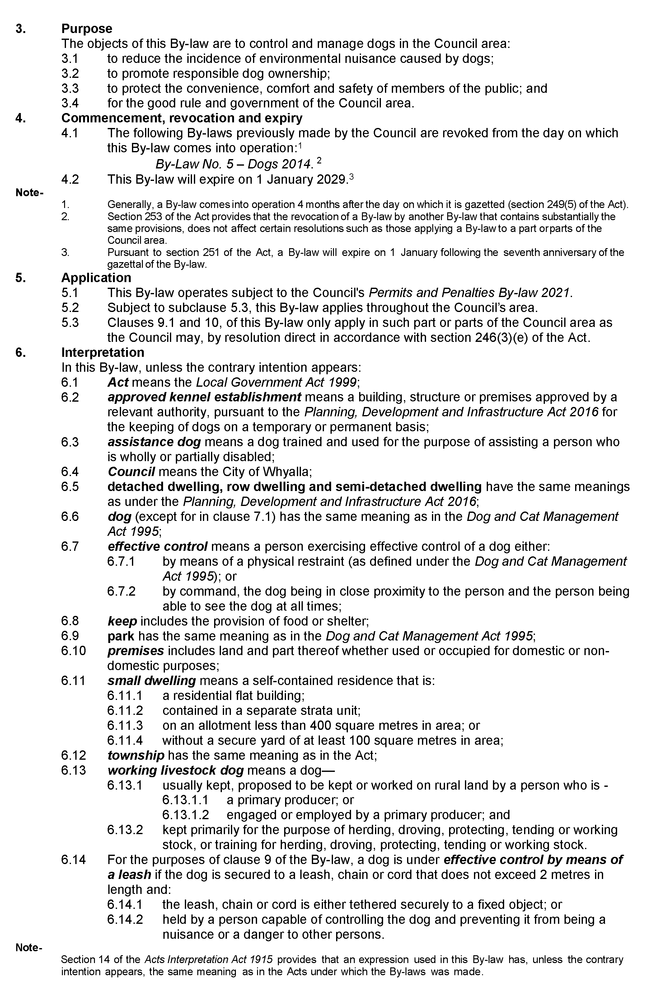
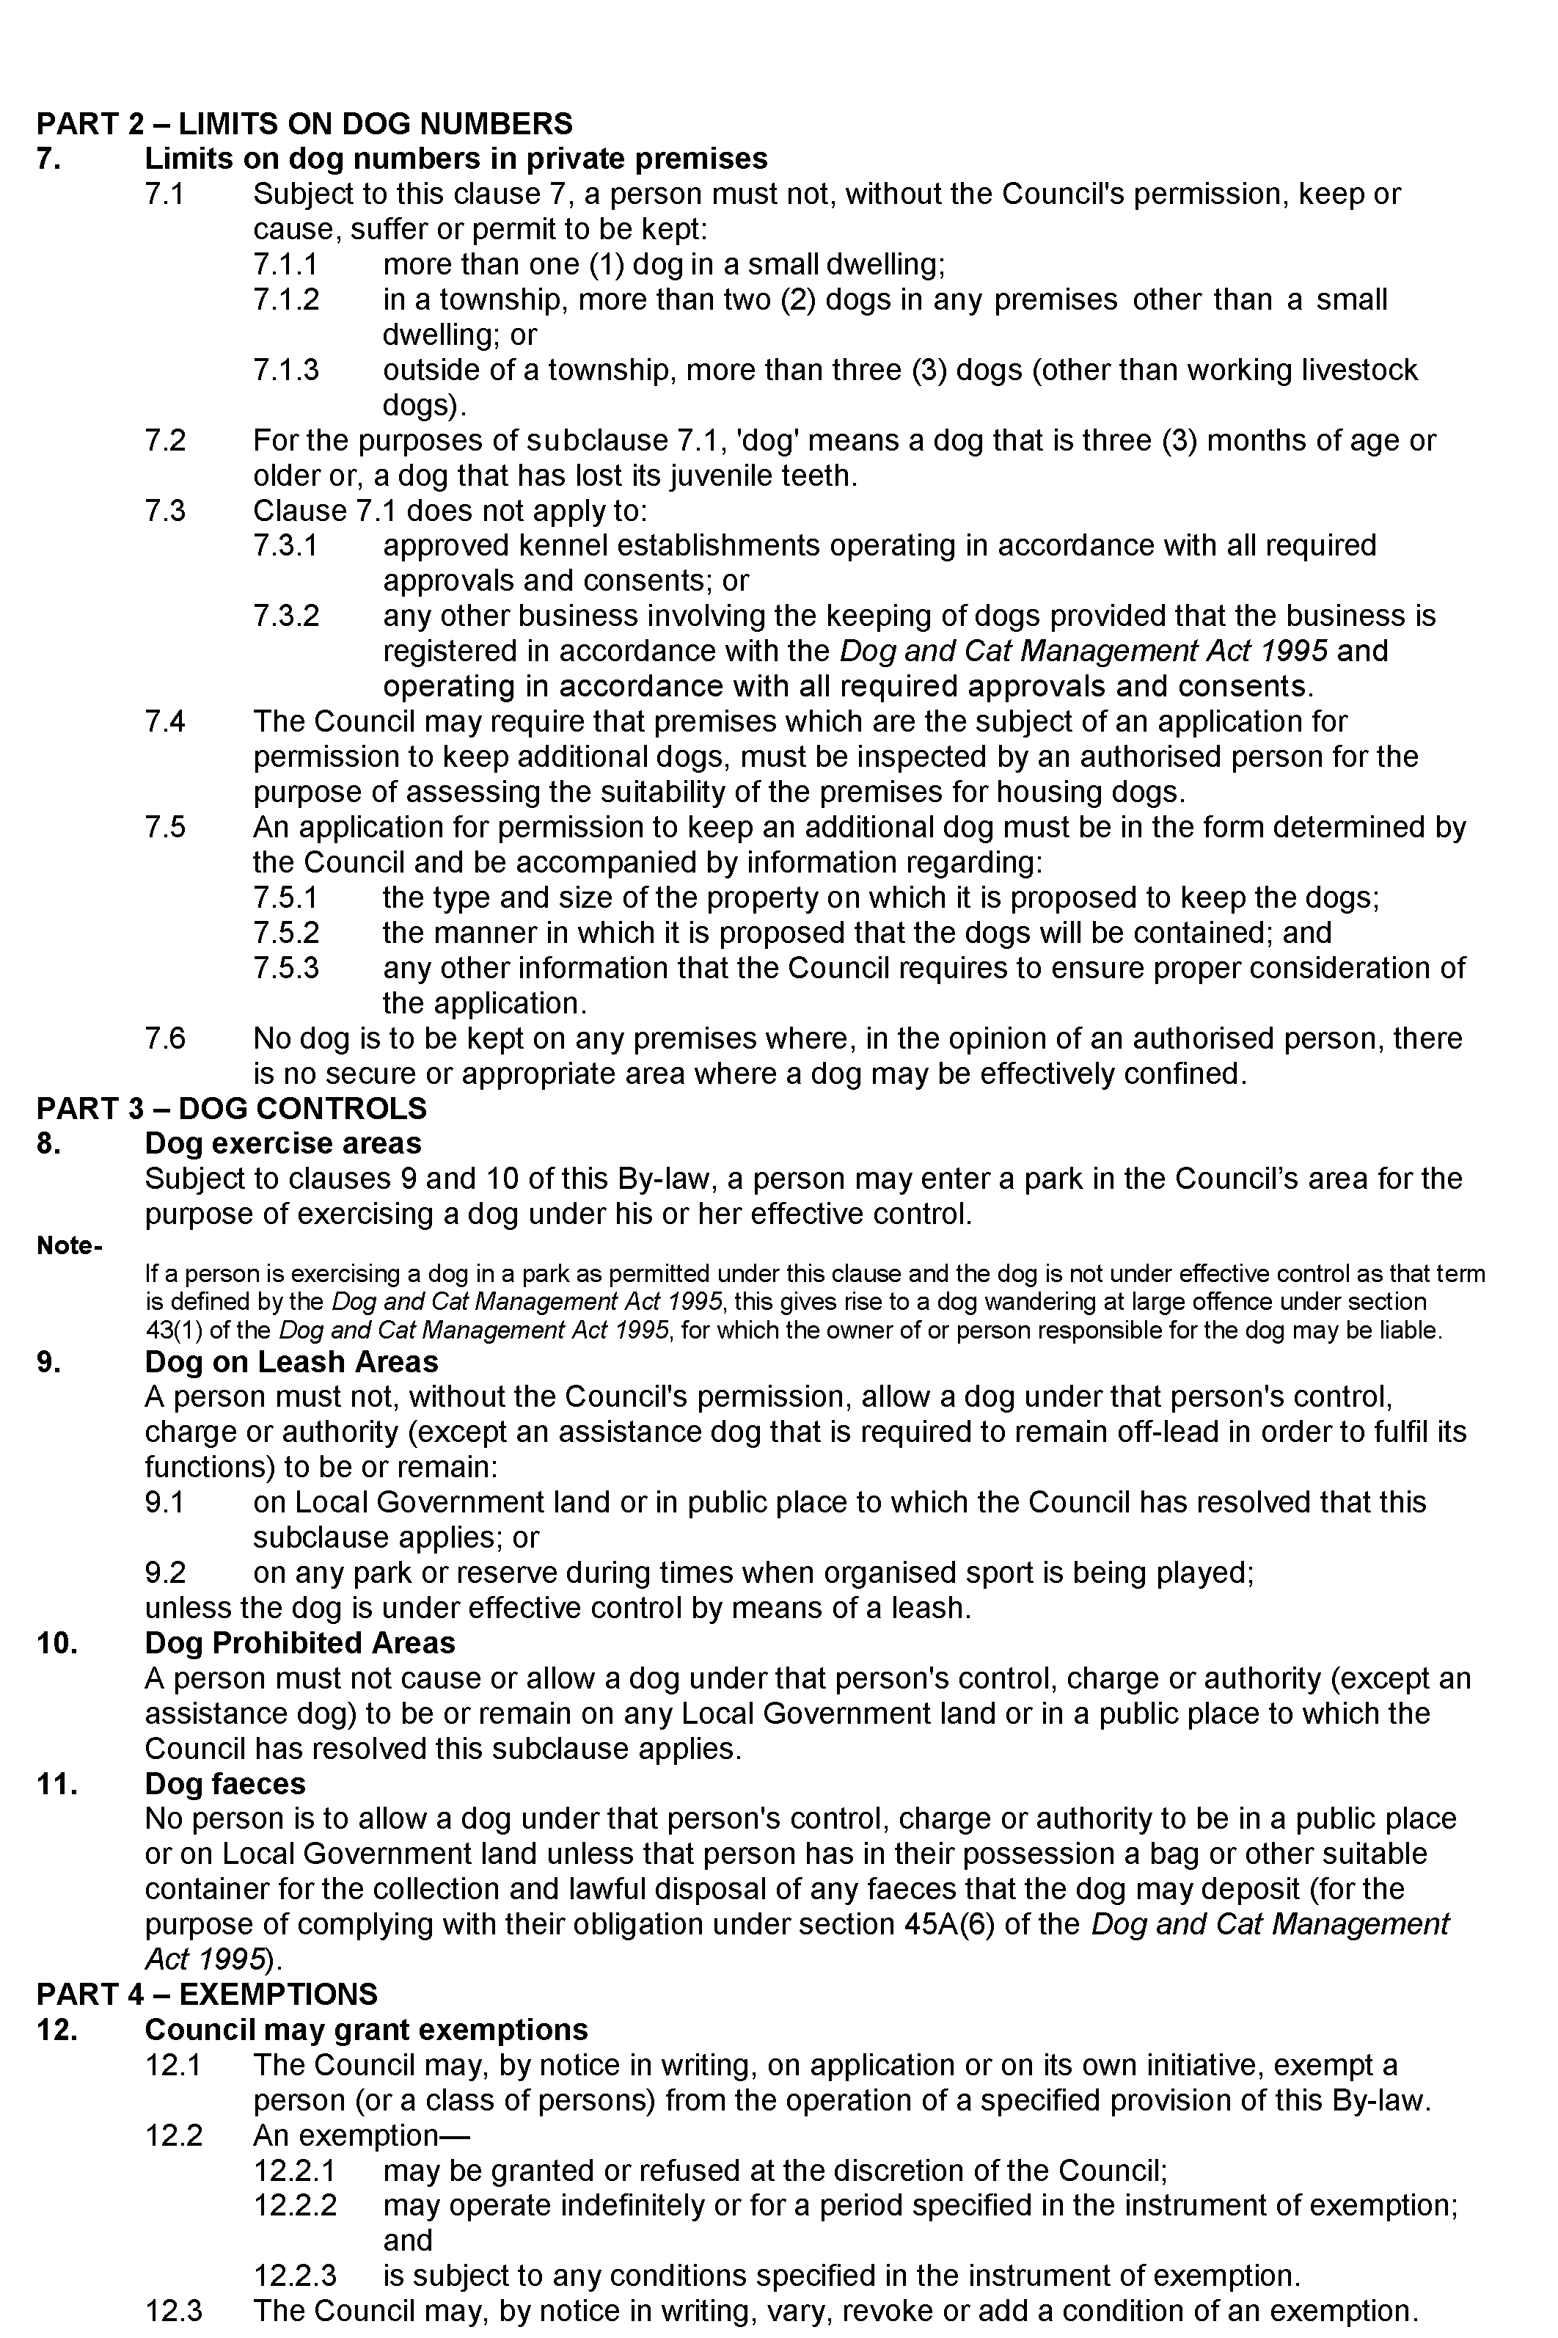
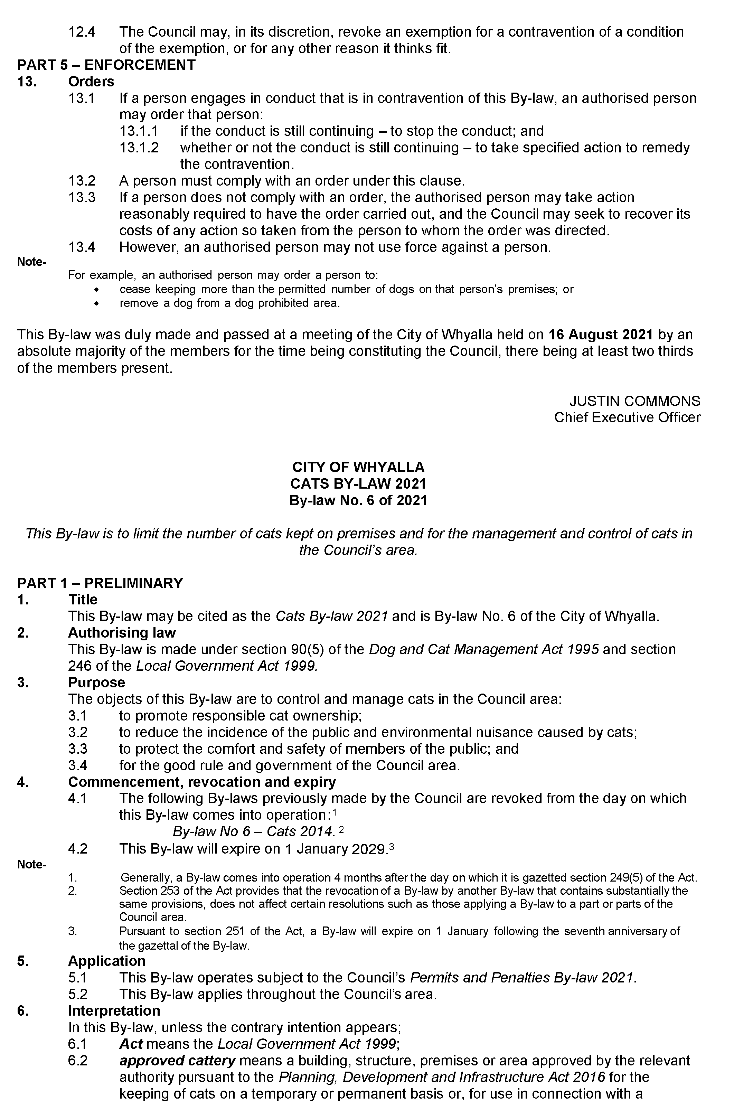
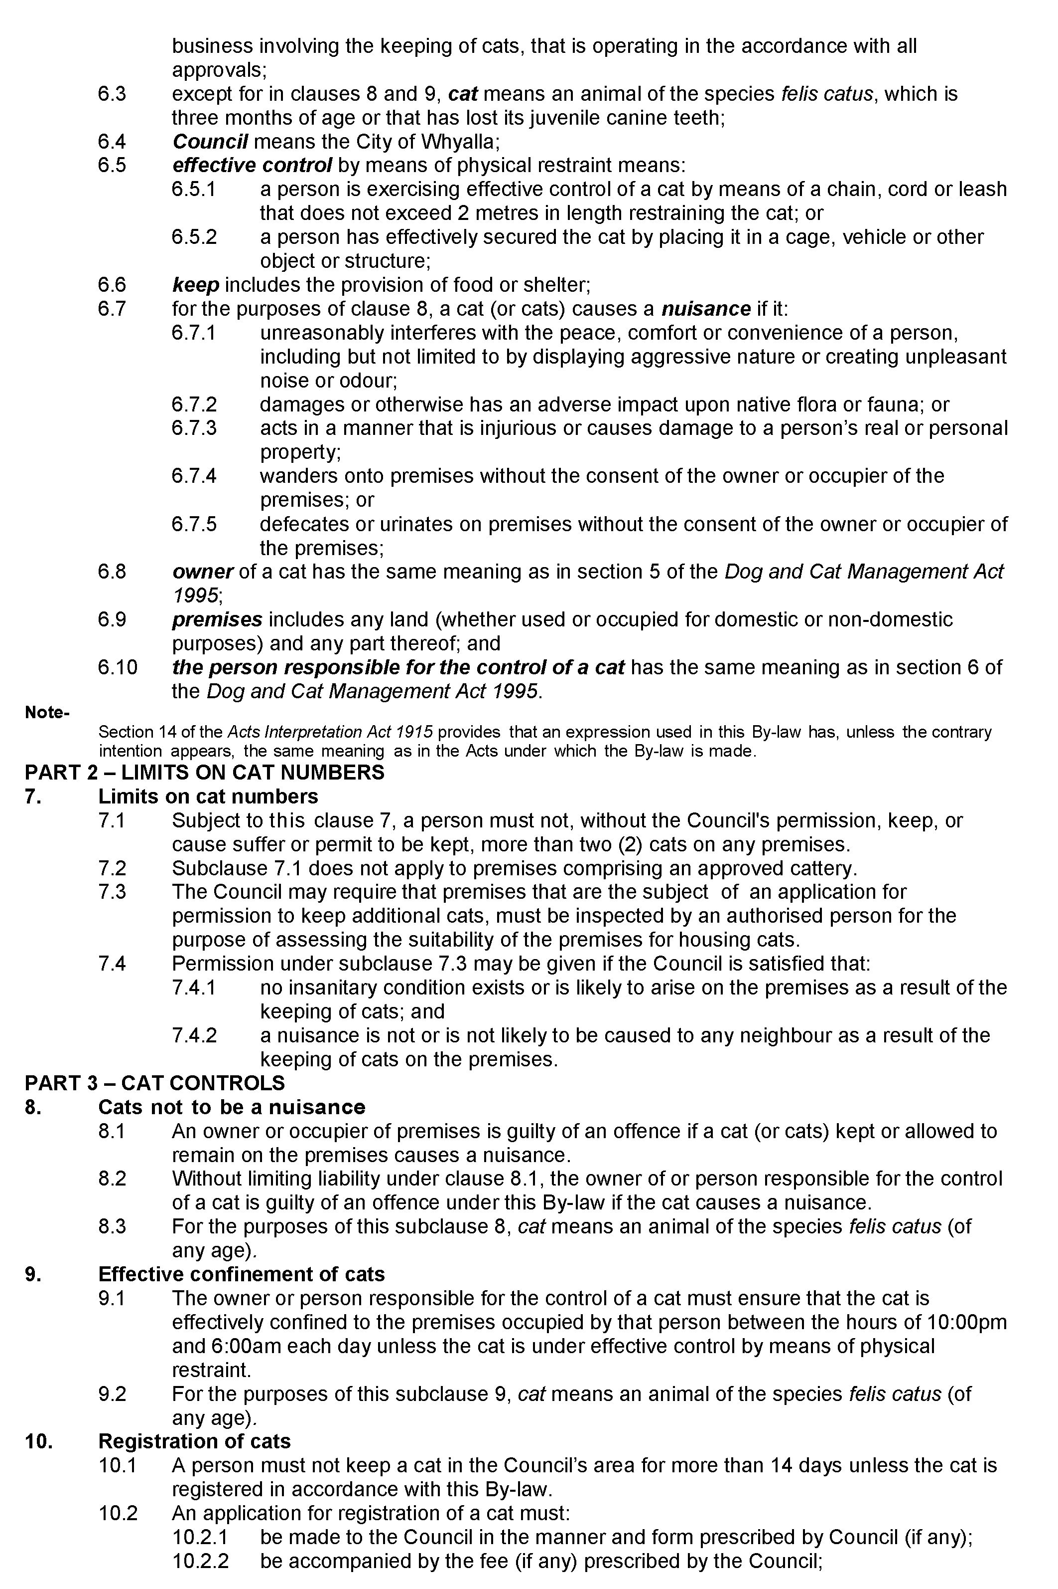
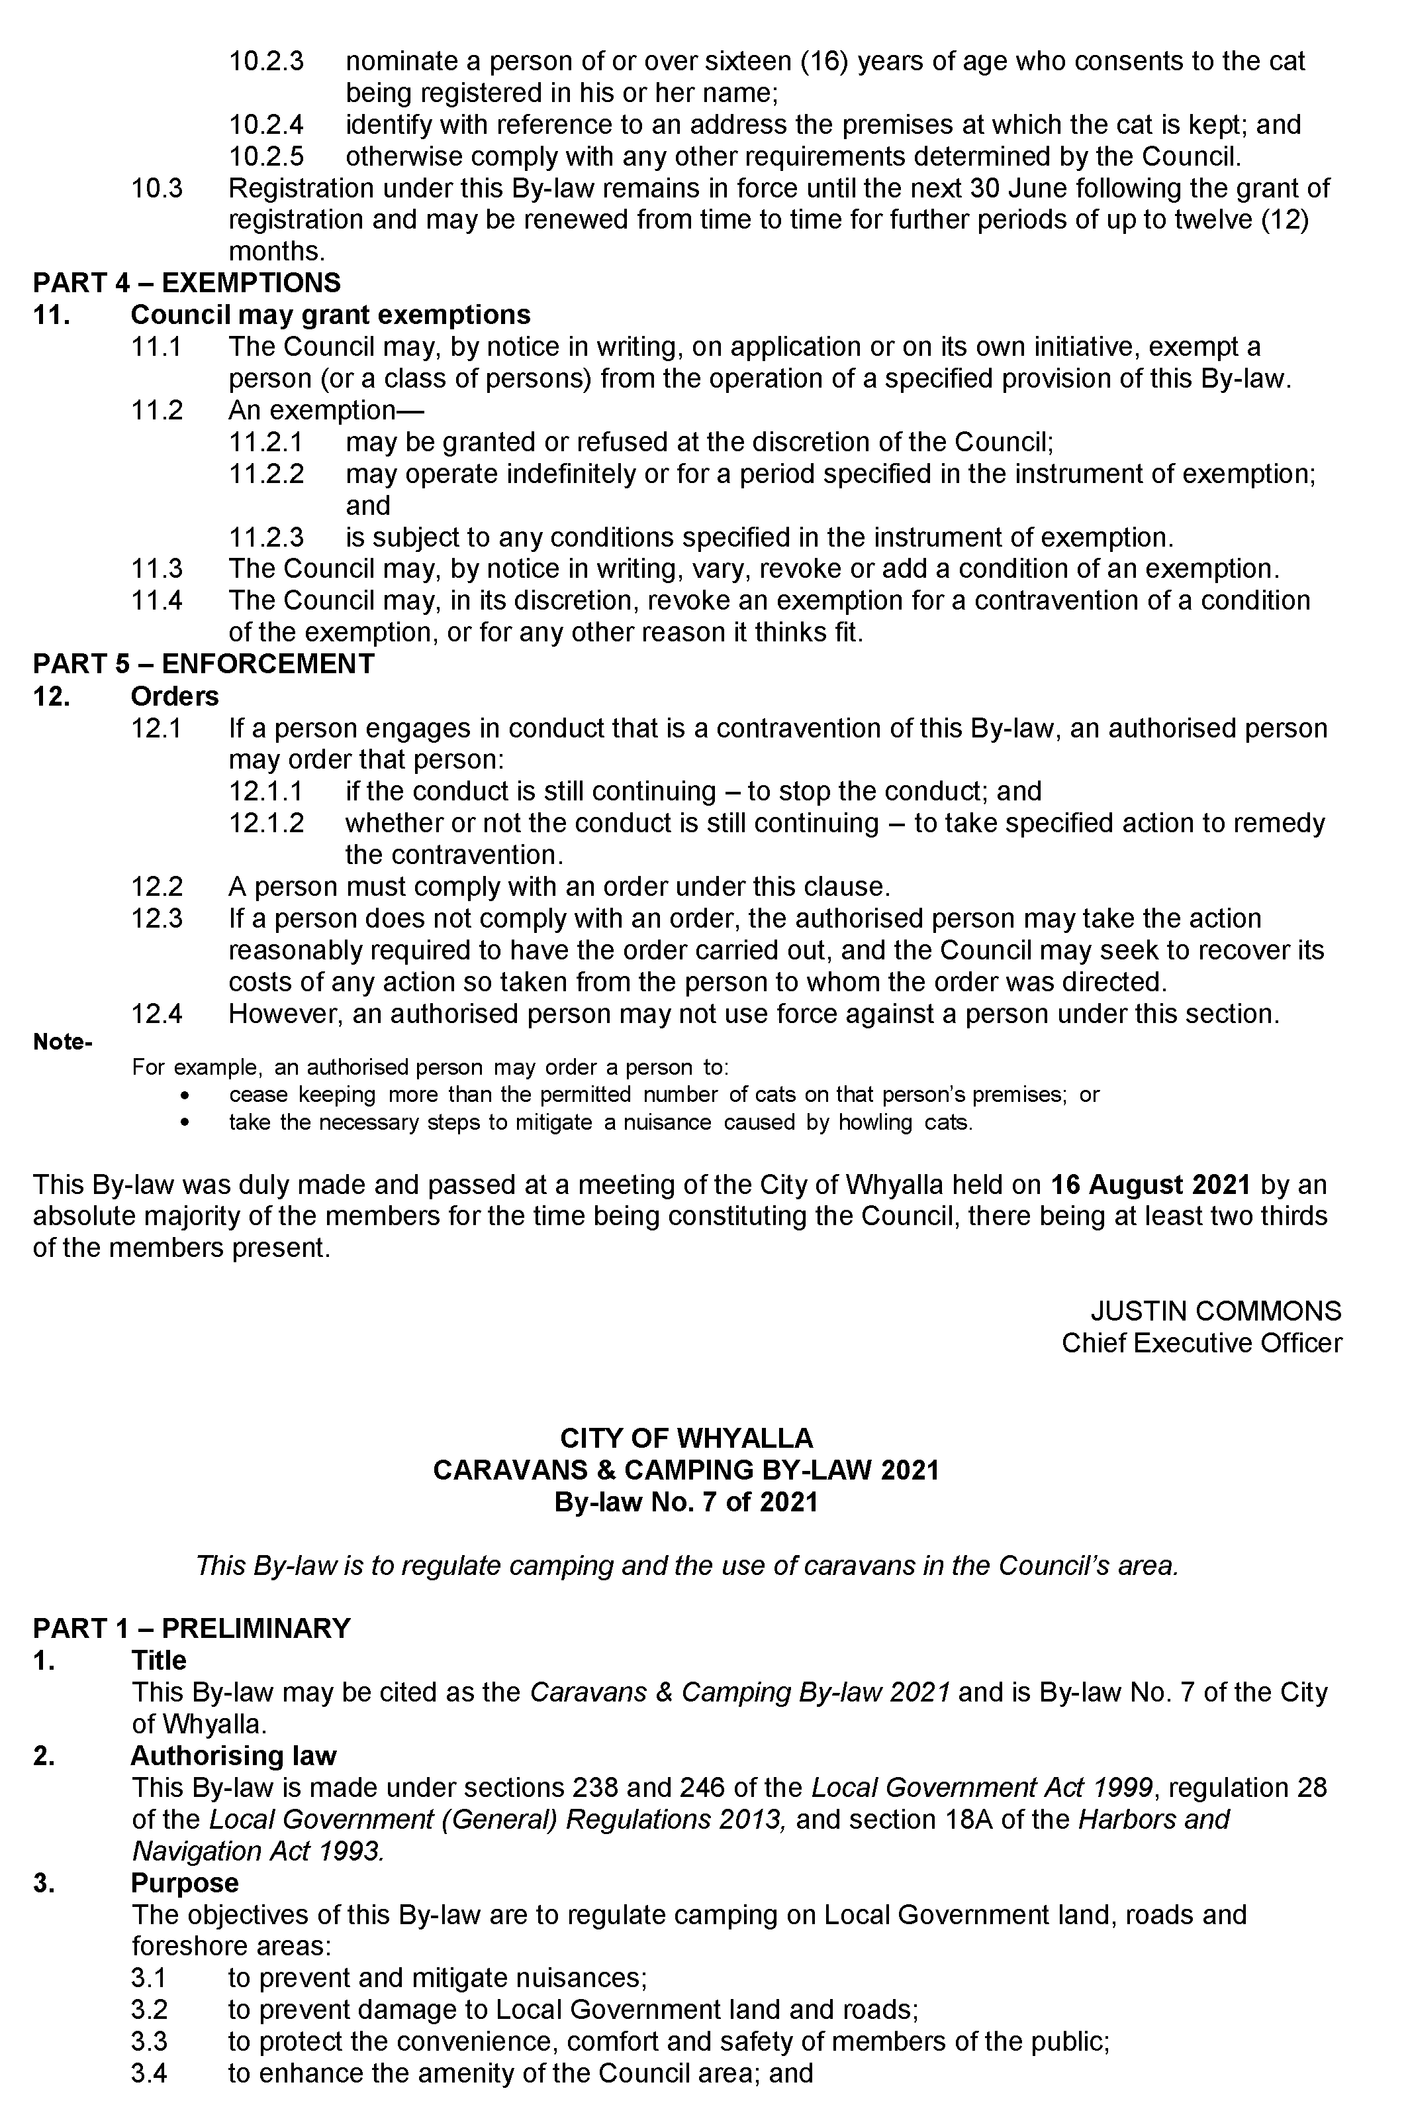
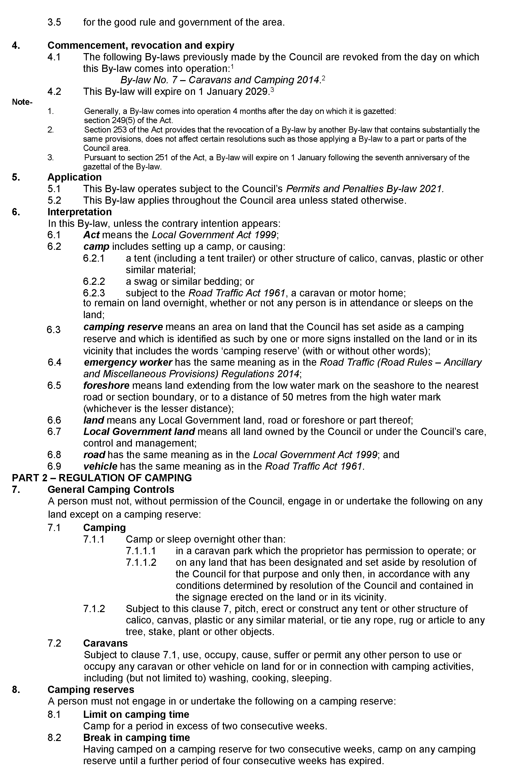
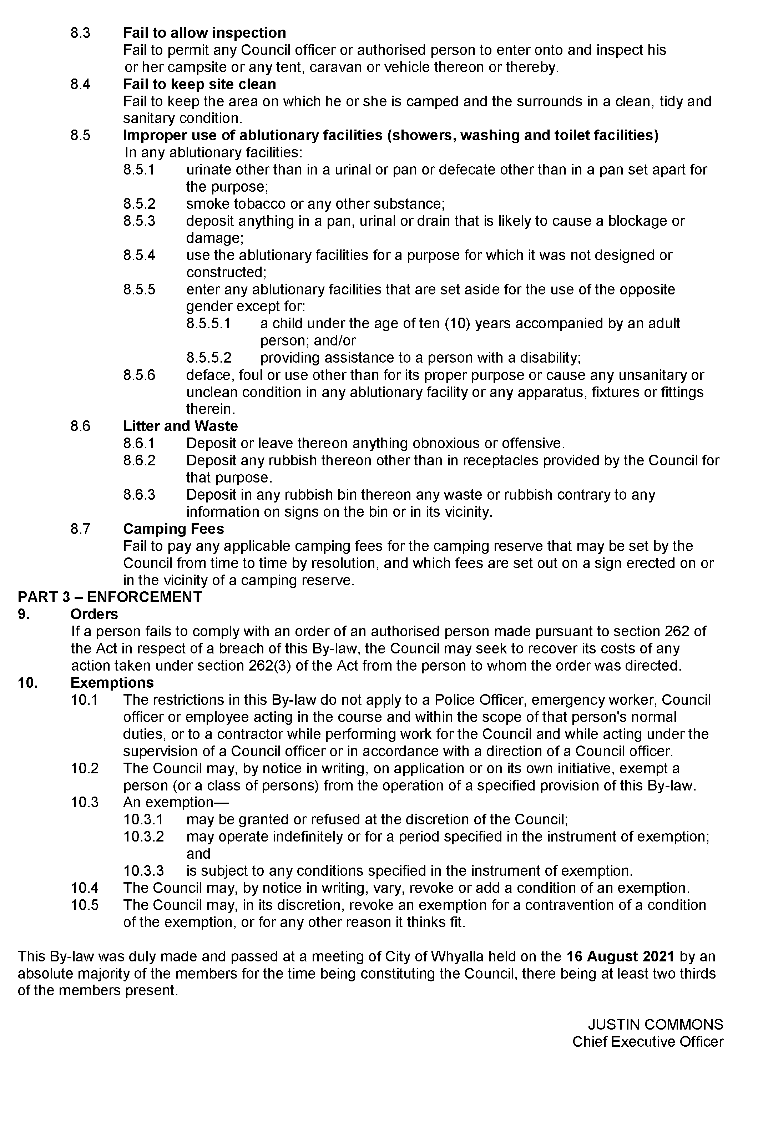
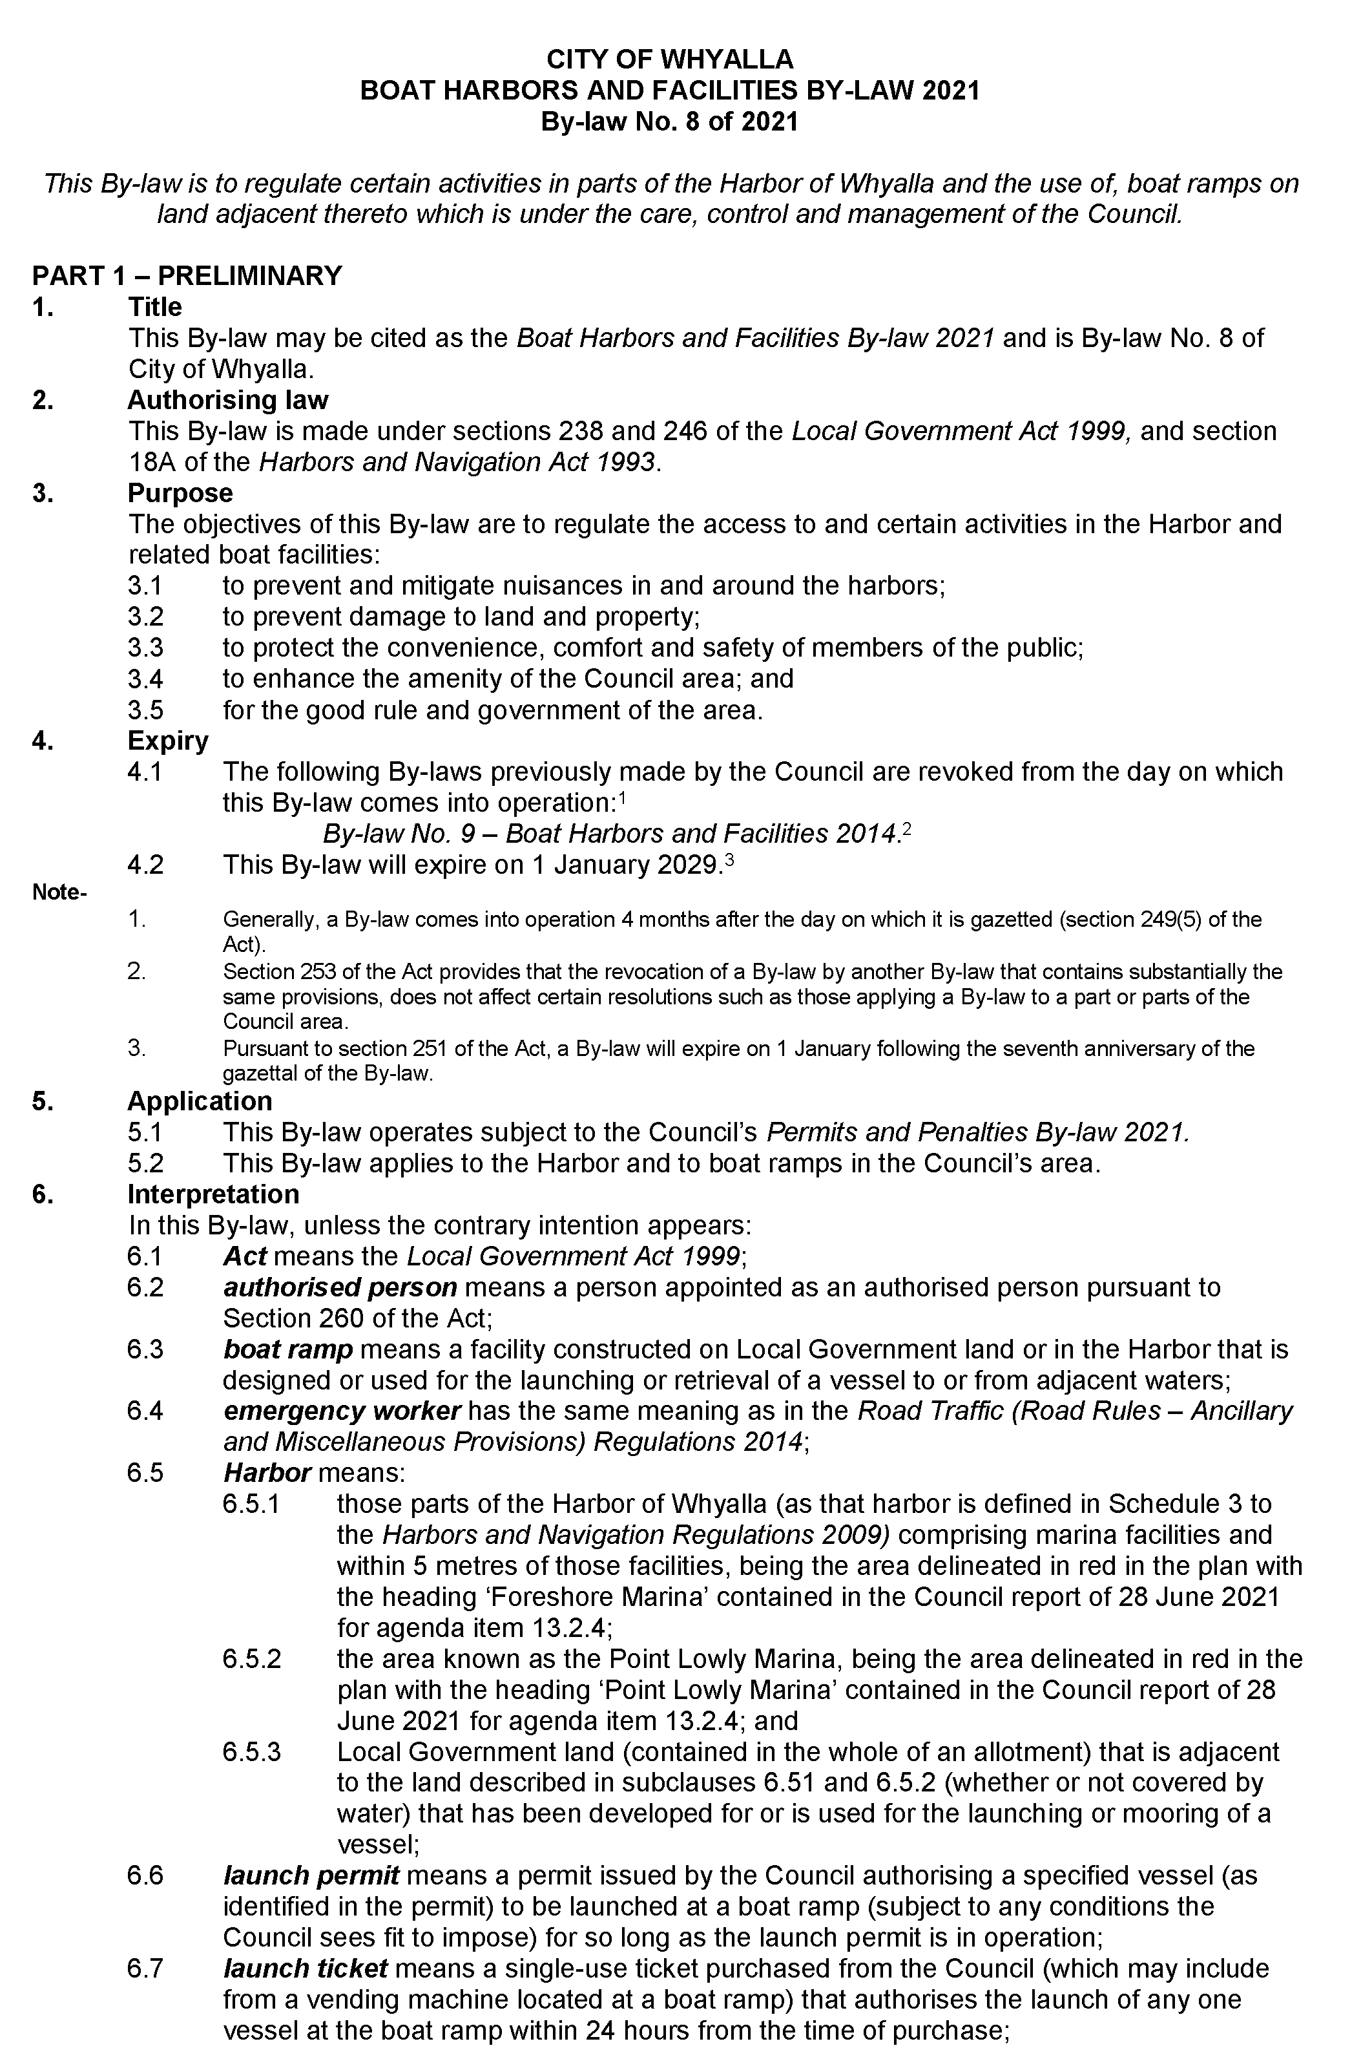
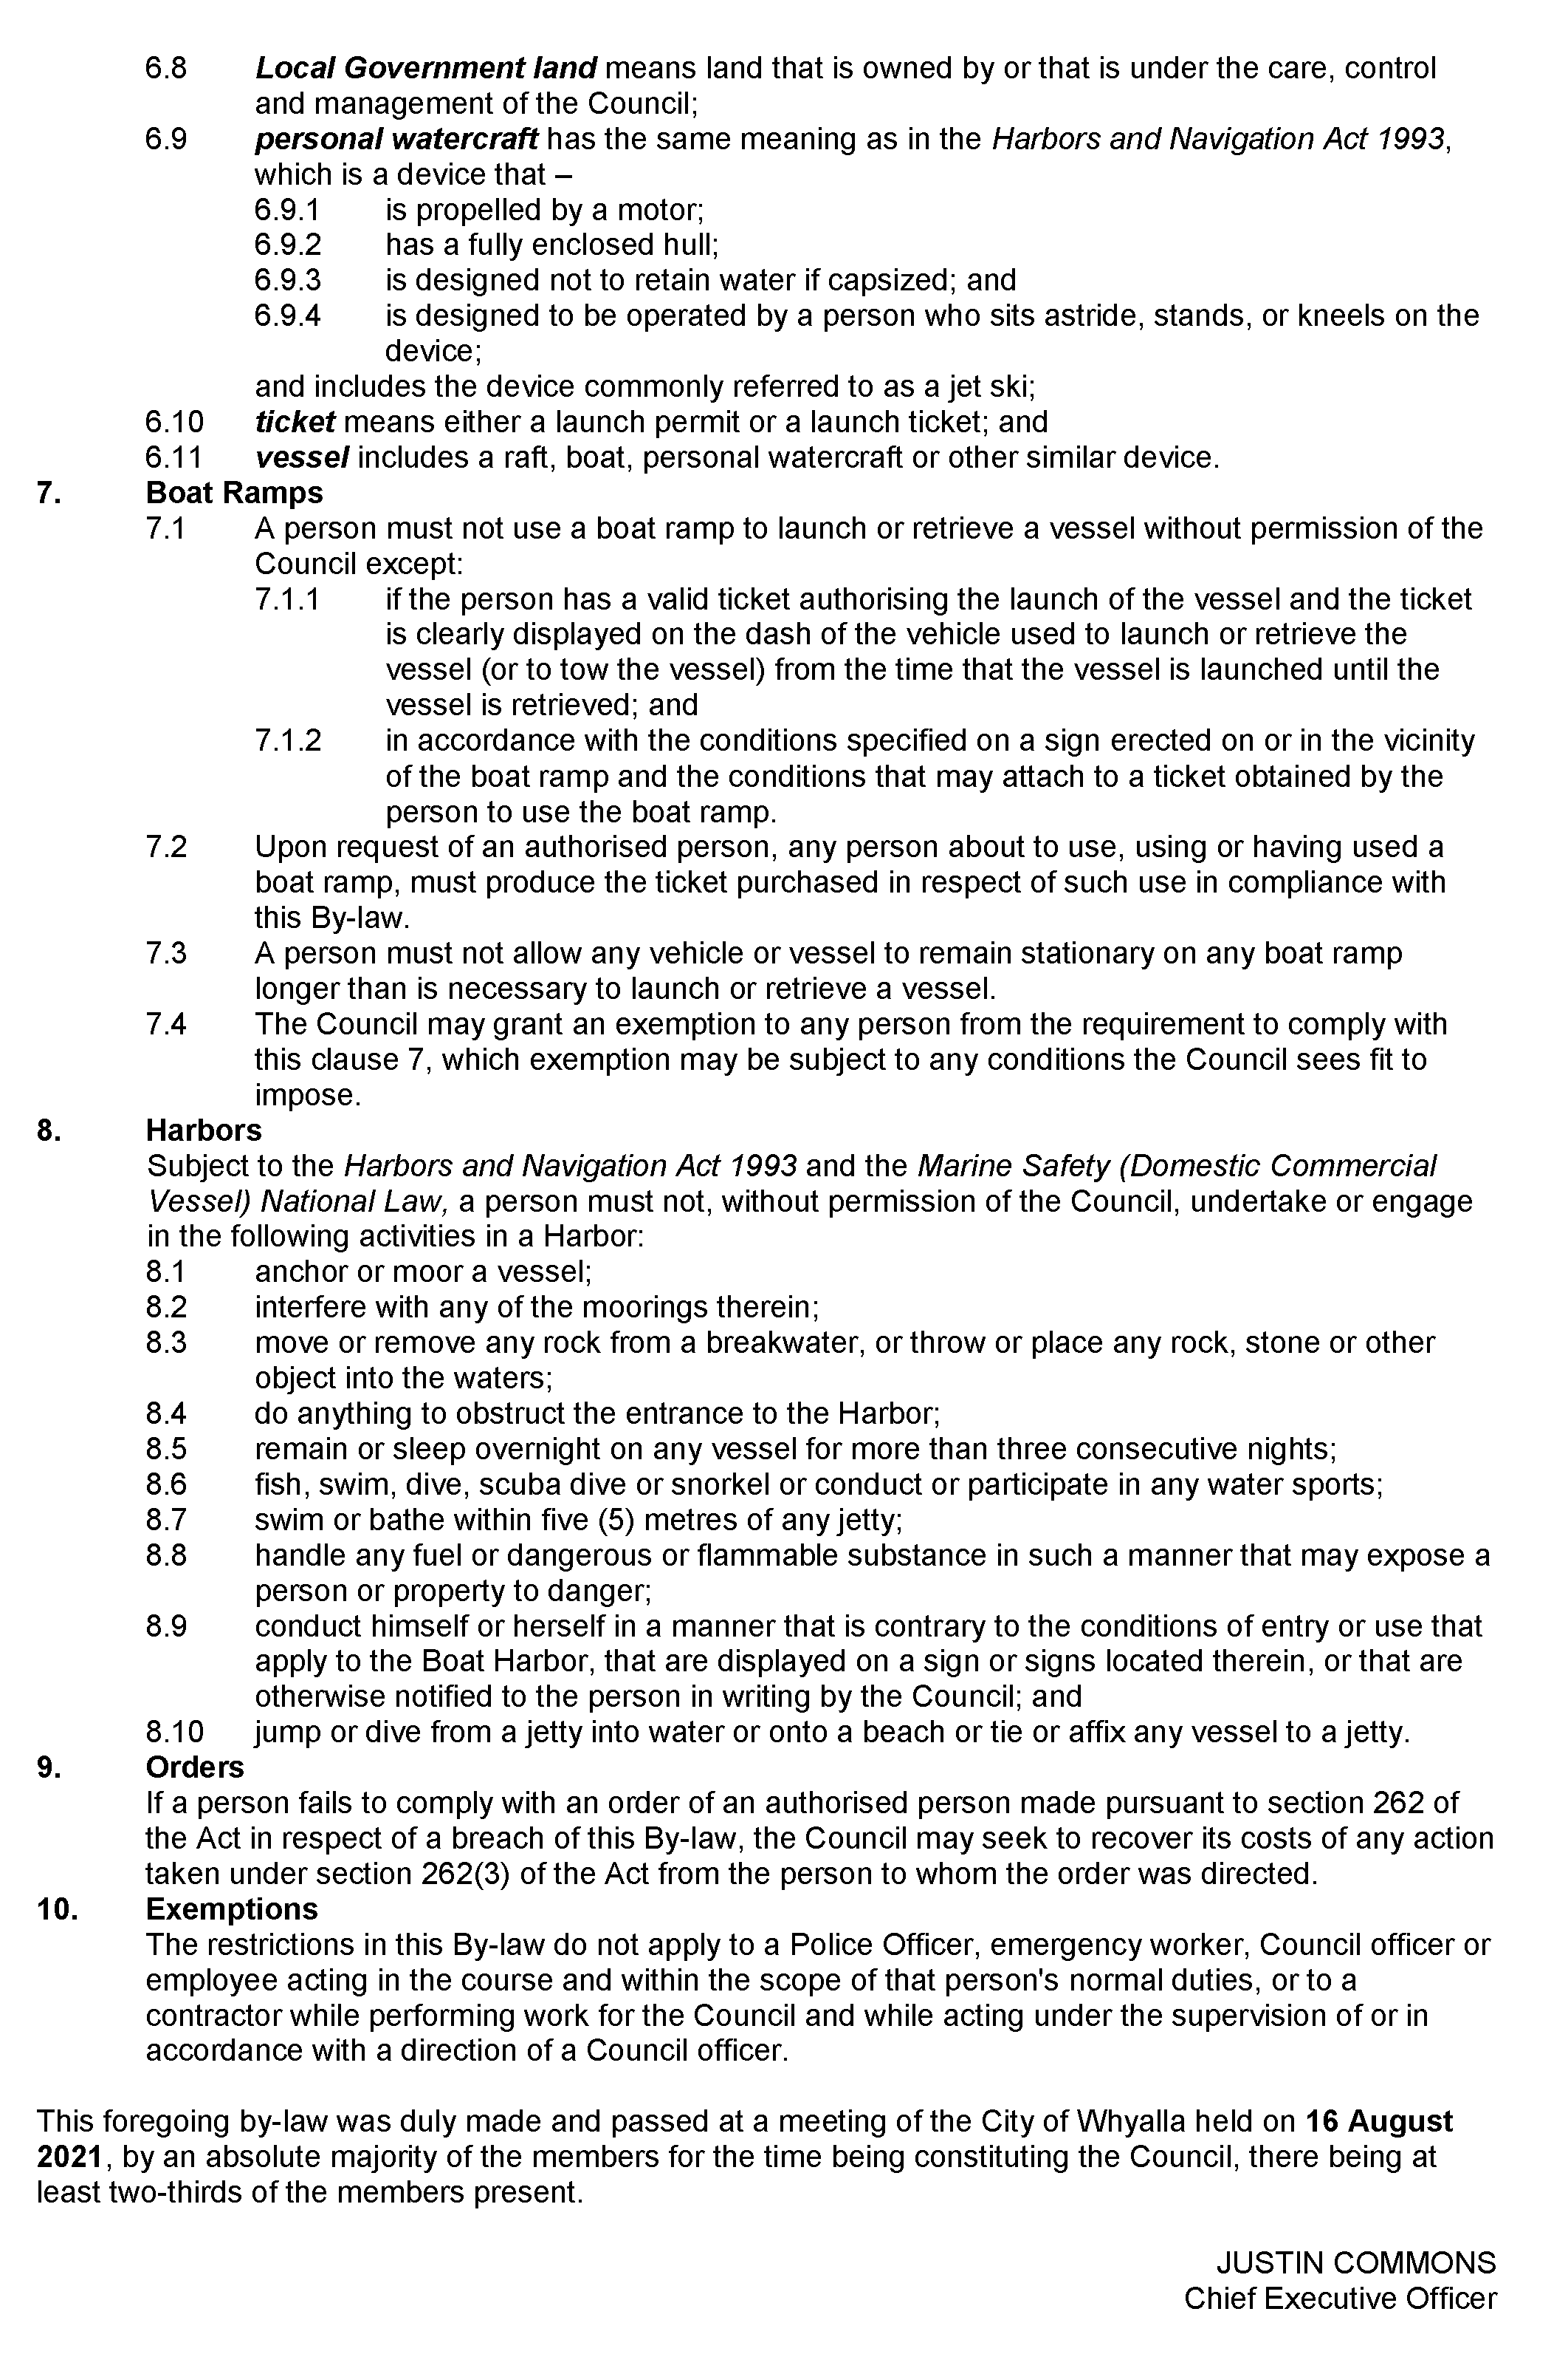

District Council of Elliston
Naming of Public Road
Notice is hereby given that, at its meeting held on 17 August 2021 the District Council of Elliston resolved to name a public road at Elliston as Alto Drive, pursuant to Section 219(1) of the Local Government Act 1999.
Dated: 19 August 2021
Geoff Sheridan
Chief Executive Officer

The Flinders Ranges Council
Adoption of Valuations and Declaration of Rates
Notice is given that at the Council meeting on 29 July 2021, the Council resolved for the year ending 30 June 2022:
1. To adopt, for rating purposes, the most recent valuations made by the Valuer-General in relation to all land in the area of the Council with total valuations being $280,399,280 comprising $271,261,480 of rateable land and $9,137,800 of non-rateable land.
2. Declares differential general rates based on the assessed capital values of all rateable land within the Council area by reference to land use and locality of the land as follows:
The Quorn Township, Quorn Rural Area, Hawker Township, Hawker Rural Area a differential general rate of:
(1) 0.7160 cents in the dollar for residential land use;
(2) 0.7950 cents in the dollar for commercial—shop land use;
(3) 0.9170 cents in the dollar for commercial—office land use;
(4) 0.9170 cents in the dollar for commercial—other land use;
(5) 0.8970 cents in the dollar for industry—light land use;
(6) 1.0000 cents in the dollar for industry—other land use;
(7) 0.6070 cents in the dollar for primary production land use;
(8) 0.7160 cents in the dollar for vacant land use;
(9) 1.0150 cents in the dollar for other land use.
3. Fixed a minimum amount of $812.00 payable by way of general rates.
4. Imposed Annual Service Charges based on the level of usage of the service upon the land to which it provides the prescribed service of the collection and disposal of “wet” and “recyclable” waste as follows:
(1) $190.00 for occupied properties in Quorn, Hawker and Cradock for “wet” waste; and
(2) $130.00 for occupied properties in Quorn, Hawker and Cradock for “recyclable” waste.
5. Imposed Annual Service Charges based on the nature of the service and varying according to whether the land is vacant or occupied upon the land to which it provides or makes available the prescribed service of a Community Wastewater Management System, of:
(a) $415.00 per unit in respect of each piece of occupied land serviced by the Quorn Community Wastewater Management Systems;
(b) $405.00 per unit in respect of each piece of vacant land serviced by the Quorn Community Wastewater Management Systems;
(c) $415.00 per unit in respect of each piece of occupied land serviced by the Hawker Community Wastewater Management Systems; and
(d) $405.00 per unit in respect of each piece of vacant land serviced by the Hawker Community Wastewater Management Systems.
6. In order to reimburse the Council for amounts contributed to the South Australian Arid Lands Landscape Board, being $46,943 declared a Regional Landscape Levy of 0.01760 cents in the dollar, based on the capital value of all rateable properties in the area of the Council.
Dated: 30 July 2021
E. Brown
Chief Executive Officer

The District Council of Peterborough
Adoption of Valuation and Declaration of Rates
Notice is given that the District Council of Peterborough, at the Special Council Meeting held on 23 August 2021, for the financial year ending 30 June 2022 resolved:
Adoption of Capital Valuations
To adopt the most recent capital valuations of the Valuer-General available for rating purposes for its area with total valuations being $213,495,880 comprising $206,013,027 in respect of rateable land and $7,482,853 in respect of non-rateable land.
Fixed Charge/Differential General Rates
To impose a fixed charge of $380.00 on each piece of separate rateable land and to declare the following differential general rates on all rateable land, by reference to the locality of the land:
Peterborough township 0.6700 cents in the dollar
Oodla Wirra township 0.5070 cents in the dollar
Yongala township 0.5019 cents in the dollar
Rural property 0.2835 cents in the dollar
Annual Service Charge (Garbage)
To impose an Annual Service Charge of $102.50 per Mobile Garbage Bin (Wheelie Bin) in respect of all land (rateable and non-rateable) to which it provides or makes available the service of the collection and disposal of domestic and commercial waste.
Separate Rates (State Government Landscape SA Levy)
To declare a separate rate of 0.01655 cents in the dollar to reimburse the Council for the amount of $34,078 contributed to the Northern and Yorke Landscape Region Board.
Annual Service Charge (Community Wastewater Management System)
To impose an Annual Service Charge of $540.00 per Property Unit upon all land (rateable and non-rateable) to which it provides or makes available the service of the Community Wastewater Management System in the Peterborough township, with a declared discretionary rebate of $108.00 to apply.
Dated: 26 August 2021
Stephen Rufus
Chief Executive Officer

Public Notices

Trustee Act 1936
Public Trustee
Estates of Deceased Persons
In the matter of the estates of the undermentioned deceased persons:
ARCHER Thomas late of 3 Grant Avenue Gilles Plains Retired Tram Driver who died 24 April 2021
BALLINGER Ronald Ralph late of 19 Cornhill Road Victor Harbor of no occupation who died 26 March 2021
CULLEN Paul Francis late of 20 Cross Street Enfield of no occupation who died 14 March 2021
FILMER Lindsay John late of 22 Harden Street Waikerie of no occupation who died 21 December 2020
GIBSON Bruce late of 21 Sturt Street Mansfield Park of no occupation who died 28 December 2019
KOHLHAGEN Kym late of 154 Playford Avenue Whyalla of no occupation who died 15 February 2021
LAMBE Janise Elene late of 108 Russell Street Rosewater Retired Secretary who died 20 December 2020
MART Brenton Leigh late of 16 Glyndale Grove Huntfield Heights Retired Police Officer who died 27 March 2021
STRAZDINS Annette Joy late of 494 Fullarton Road Myrtle Bank of no occupation who died 5 November 2020
SUDAR Momcilo late of 3 Watson Street Beverley of no occupation who died on or about 15 January 2020
TKACZUK Lesa late of 2 Duncan Street Findon of no occupation who died 10 January 2021
WHITE Annie Leslie late of 31 Arthur Street Booleroo Centre of no occupation who died 11 March 2021
Notice is hereby given pursuant to the Trustee Act 1936, the Inheritance (Family Provision) Act 1972 and the Family Relationships Act 1975 that all creditors, beneficiaries, and other persons having claims against the said estates are required to send, in writing, to the office of Public Trustee at GPO Box 1338, Adelaide, 5001, full particulars and proof of such claims, on or before the 24 September 2021 otherwise they will be excluded from the distribution of the said estate; and notice is also hereby given that all persons indebted to the said estates are required to pay the amount of their debts to the Public Trustee or proceedings will be taken for the recovery thereof; and all persons having any property belonging to the said estates are forthwith to deliver same to the Public Trustee.
Dated: 26 August 2021
N. S. Rantanen
Public Trustee

Adelaide Airport Ltd (“AAL”)
Schedule of Aeronautical Charges
The prices shown in this schedule are inclusive of GST. Effective 1 October 2021.
SERVICE | CHARGE BASE (see note i)
 | Charge per Passenger | Passenger Charge Applies to  (see Charge Rules) | Charge per 1,000kg MTOW (pro-rata)
INTERNATIONAL RPT SERVICES
Landing Charge | $15.49 | (1)
Passenger Facility Charge (“PFC”)—see note iv | $9.54 | (1)
Government Mandated Charge | $31.98 | (3)
Government Mandated Charge for international transit passengers | $8.42 | (5)
DOMESTIC RPT SERVICES (Aircraft weighing more than 20,000 kg MTOW)
Landing Charge | $5.59 | (2) | $20.63
Passenger Facility Charge (“PFC”)—see note iv | $6.87 | (2)
Government Mandated Charge | $8.26 | (4)
REGIONAL RPT SERVICES (Aircraft weighing less than 20,000 kg MTOW)
Landing Charge | $3.28 | (2) | $9.84
Passenger Facility Charge (“PFC”)—see note iv | $1.65 | (2)
Government Mandated Charge | $8.26 | (4)
LANDING CHARGES FOR DIVERSIONS
International RPT services |  |  | $12.63
Domestic RPT services |  |  | $9.37
GENERAL AVIATION (minimum charges apply, see note ii)
Freight aircraft |  |  | $8.56
Fixed wing aircraft not operating RPT services |  |  | $8.56
Rotary wing aircraft and unpowered aircraft |  |  | $4.29
AIRCRAFT PARKING CHARGES:
General aviation aircraft parked longer than two hours in designated general aviation parking areas will incur a charge of $18.67 per day or any part of a day.
Code “B” or greater—the charges for parking of Aircraft in the category of Code “B” or greater is by arrangement with AAL from time to time.

Definitions
(A) Government Mandated Services means those services which AAL provides to RPT Operators and other users of the Airport which are mandated by the Commonwealth Government (in applicable legislation and ministerial or Commonwealth Department directions) or other lawful authority and includes (but are not limited to) the following services:
(i) Terminal passenger checked bag screening; and
(ii) Terminal passenger screening; and
(iii) airside inspections; and
(iv) other services required by the Commonwealth Government or other lawful authority.
(B) Infant means children less than 2 years old, not occupying a seat.
(C) Landing Charge means the amount from time to time charged by AAL to an aircraft operator in respect of the use by an aircraft of AAL’s runways, taxiways and aprons. The Landing Charge is a single charge made on each arrival (landing) of an aircraft.
(D) MTOW means maximum take-off weight as specified by the manufacturer
(E) Passenger Facility Charge (“PFC”) means the amount from time to time charged by AAL to an RPT Operator in respect of its Passengers using a Terminal for the purpose of recovering costs relating to the Terminals.
(F) RPT (Regular Public Transport) Operation means an operation of an Aircraft for the purposes of the carriage of people, or both people and goods, of an air service that:
(i) is provided for a fee payable by persons using the service; and
(ii) is conducted in accordance with fixed schedules to or from fixed terminals over specific routes; and
(iii) is available to the general public on a regular basis.
Any terms not defined in this schedule of charges have the same definition as the terms defined in Adelaide Airport Terms of Use available on the Adelaide Airport website.
Per Passenger Charge Rules
(1) Applies to all arriving and departing passengers and excludes transit passengers, infants and positioning crew.
(2) Applies to all arriving, departing and transit passengers and excludes infants and positioning crew.
(3) Applies to departing passengers only and excludes infants and positioning crew.
(4) Applies to departing passengers and departing transit passengers and excludes infants and positioning crew.
(5) Applies to all transit passengers excluding infants arriving from a port outside Australia.
Notes
i. Charge Base: An Aircraft Operator may elect, by agreement with AAL, and entirely at AAL’s discretion, to incur Aeronautical Charges on a MTOW or Passenger basis, which basis is then fixed for the ensuing twelve (12) month period.
ii. Minimum charge: a minimum charge applies to all General Aviation customers as follows:
(a) Fixed Wing Aircraft $50.06 per landing
(b) Rotary Wing Aircraft $25.00 per landing
iii. AAL has a growth incentive scheme which provides discount on the landing charges indicated above for airlines which exceed a target growth rate for the year. Details of this scheme are available to airlines on request.
iv. Calculations of GST exclusive amounts should be made to four decimal places.
Dated: 9 August 2021
Adelaide Airport Limited
ABN 78 075 176 653
1 James Schofield Drive, Adelaide Airport SA 5950
www.adelaideairport.com.au

Associations Incorporations Act 1985
Regulation 9

Corporations Act 2001
Subregulation 5.6.65(1)(b)
Form 548—Notice to Creditor or Person Claiming to be a Creditor of Intention to Declare a First and Final Dividend
Association Details
Association: Recreation South Australia Incorporated
ABN: 23 156 877 936
Status: In Liquidation
A first and final dividend is to be declared on 30 September 2021 for the association.
You are required formally to prove your debt or claim on or before 15 September 2021.
If you do not, I will exclude your claim from participation and I will proceed to make a final dividend without having regard to it.
Dated: 23 August 2021
Maris Andris Rudaks
Liquidator, BRI Ferrier
Level 8, 50 Pirie Street
Adelaide SA 5000
Ph: (08) 8233 9900
Email: info@brifsa.com.au

National Electricity Law
Initiation of Rule Change Request
Review of Compensation Guidelines Notice
The Australian Energy Market Commission (AEMC) gives notice under the National Electricity Law as follows:
Under s 95, the Australian Energy Market Operator has requested the Updating Short Term PASA (Ref. ERC0332) proposal. The proposal seeks to introduce a principles-based approach to clause 3.7.3 of the NER. Submissions must be received by 23 September 2021.
Under rule 6A.20 of the National Electricity Rules, the AEMC invites written submissions on the draft amended Compensation Guidelines developed in accordance with clause 3.14.6 of the National Electricity Rules (Review of compensation guidelines to include wholesale demand response, Ref. EPR0088). Submissions are due by 8 October 2021.
Submissions can be made via the AEMC’s website. Before making a submission, please review the AEMC’s privacy statement on its website. The AEMC publishes all submissions on its website, subject to confidentiality.
Documents referred to above are available on the AEMC’s website and are available for inspection at the AEMC’s office.
Australian Energy Market Commission
Level 15, 60 Castlereagh St
Sydney NSW 2000
Telephone: (02) 8296 7800
www.aemc.gov.au
Dated: 26 August 2021

Notice Submission

The South Australian Government Gazette is compiled and published each Thursday.
Notices must be submitted before 4 p.m. Tuesday, the week of intended publication.
All submissions are formatted per the gazette style and proofs are supplied as soon as possible. Alterations must be returned before 4 p.m. Wednesday.
Requests to withdraw submitted notices must be received before 10 a.m. on the day of publication.

Gazette notices should be emailed as Word files in the following format:
• Title—name of the governing Act/Regulation
• Subtitle—brief description of the notice
• A structured body of text
• Date of authorisation
• Name, position, and government department/organisation of the person authorising the notice

Please provide the following information in your email:
• Date of intended publication
• Contact details of at least two people responsible for the notice content
• Name of the person and organisation to be charged for the publication (Local Council and Public notices)
• Request for a quote, if required
• Purchase order, if required

Email: governmentgazettesa@sa.gov.au
Phone: (08) 7109 7760
Website: www.governmentgazette.sa.gov.au

All instruments appearing in this gazette are to be considered official, and obeyed as such

Printed and published weekly by authority of S. Smith, Government Printer, South Australia
$8.00 per issue (plus postage), $402.00 per annual subscription—GST inclusive
Online publications: www.governmentgazette.sa.gov.au

