THE SOUTH AUSTRALIAN
GOVERNMENT GAZETTE
Published by Authority

Adelaide, Thursday, 24 September 2020

Contents

Governor’s Instruments
Appointments 4656
Proclamations—
Criminal Law (Legal Representation) (Reimbursement of Commission) Amendment Act (Commencement) Proclamation 2020 4657
Regulations—
Criminal Law (Legal Representation) Regulations 2020—
No. 270 of 2020 4658
Public Sector (Data Sharing) (Prescribed Purposes)
Variation Regulations 2020—No. 271 of 2020 4659
Native Vegetation (Recreation Tracks) Variation Regulations 2020—No. 272 of 2020 4661
Road Traffic (Miscellaneous) (Technical Matters)
Variation Regulations 2020—No. 273 of 2020 4663
Road Traffic (Road Rules—Ancillary and Miscellaneous Provisions) (Technical Matters) Variation
Regulations 2020—No. 274 of 2020 4665
Road Traffic (Miscellaneous) (GDA2020) Variation Regulations 2020—No. 275 of 2020 4666
Work Health and Safety (GDA2020) Variation Regulations 2020—No. 276 of 2020 4668
Environment Protection (GDA2020) Variation Regulations 2020—No. 277 of 2020 4670
Electricity (General) (Technical Standards) Variation Regulations 2020—No. 278 of 2020 4679
National Energy Retail Law (Local Provisions)
(Tariff Structures) Variation Regulations 2020—
No. 279 of 2020 4688
Planning, Development and Infrastructure (General) (Miscellaneous) (No 3) Variation
Regulations 2020—No. 280 of 2020 4690
Planning, Development and Infrastructure (General) (Planning and Development Fund) Variation
Regulations 2020—No. 281 of 2020 4713
Rules of Court
Supreme Court of South Australia Probate
Rules 2015—Amendment No. 2 4715
State Government Instruments
Aerodrome Fees Act 1998 4716
Crown Land Management Act 2009 4716
Education and Children’s Services Regulations 2020 4717
Electricity Act 1996 4719
Geographical Names Act 1991 4720
Housing Improvement Act 2016 4720
Land Acquisition Act 1969 4720
Livestock Act 1997 4721
Mental Health Act 2009 4723
Mining Act 1971 4724
Petroleum and Geothermal Energy Act 2000 4725
The District Court of South Australia—
Mount Gambier Circuit Court 4725
Local Government Instruments
Rural City of Murray Bridge 4727
Port Augusta City Council 4727
City of Whyalla 4727
Adelaide Hills Council 4728
Adelaide Plains Council 4729
Public Notices
Trustee Act 1936 4730
National Electricity Law 4730
National Energy Retail Law 4731

Governor’s Instruments

Appointments
Department of the Premier and Cabinet
Adelaide, 24 September 2020
His Excellency the Governor in Executive Council has been pleased to appoint the undermentioned to the South Australian Public Health Council, pursuant to the provisions of the South Australian Public Health Act 2011:
Member: from 24 September 2020 until 5 February 2023
Ann Shirley Ferguson
By command,
Steven Spence Marshall
Premier
HEAC-2020-00052

Department of the Premier and Cabinet
Adelaide, 24 September 2020
His Excellency the Governor in Executive Council has been pleased to appoint the undermentioned to the TAFE SA Board of Directors, pursuant to the provisions of the TAFE SA Act 2012:
Chair: from 31 October 2020 until 14 October 2021
Pauline Joanne Denley
By command,
Steven Spence Marshall
Premier
ME20/049

Department of the Premier and Cabinet
Adelaide, 24 September 2020
His Excellency the Governor in Executive Council has been pleased to appoint Professor Brenda Wilson as Governor’s Deputy of South Australia for the period from 2.00pm on Friday, 25 September 2020 until 6.00pm on Saturday, 26 September 2020.
By command,
Steven Spence Marshall
Premier

Department of the Premier and Cabinet
Adelaide, 24 September 2020
His Excellency the Governor in Executive Council has been pleased to appoint Emily Rachel Strickland as the Acting Commissioner for Equal Opportunity on a temporary basis commencing on 26 September 2020 and expiring on 27 November 2020 - pursuant to Section 8 of the Equal Opportunity Act 1984.
By command,
Steven Spence Marshall
Premier
AGO0159-20CS

Proclamations
South Australia

Criminal Law (Legal Representation) (Reimbursement of Commission) Amendment Act (Commencement) Proclamation 2020
1—Short title
This proclamation may be cited as the Criminal Law (Legal Representation) (Reimbursement of Commission) Amendment Act (Commencement) Proclamation 2020.
2—Commencement of Act
The Criminal Law (Legal Representation) (Reimbursement of Commission) Amendment Act 2020 (No 16 of 2020) comes into operation on 1 October 2020.
Made by the Governor
with the advice and consent of the Executive Council
on 24 September 2020

Regulations
South Australia

Criminal Law (Legal Representation) Regulations 2020
under the Criminal Law (Legal Representation) Act 2001

Contents
1 Short title
2 Commencement
3 Interpretation
4 Prescribed legal assistance

1—Short title
These regulations may be cited as the Criminal Law (Legal Representation) Regulations 2020.
2—Commencement
These regulations come into operation on the day on which section 4(3) of the Criminal Law (Legal Representation) (Reimbursement of Commission) Amendment Act 2020 comes into operation.
3—Interpretation
In these regulations, unless the contrary intention appears—
Act means the Criminal Law (Legal Representation) Act 2001.
4—Prescribed legal assistance
For the purposes of paragraph (b) of the definition of prescribed legal assistance in section 4(1) of the Act, the following types of legal assistance are prescribed:
(a) legal assistance provided for the purposes of an appeal against a decision of a court on an issue antecedent to a trial, being an appeal determined before the commencement or completion of the trial;
(b) legal assistance provided to a person for the purposes of proceedings under Part 3 Division 5 of the Sentencing Act 2017 (except where section 57(12) of the Sentencing Act 2017 applies);
(c) legal assistance provided for the purposes of proceedings on application under section 269ND, 269NDA, 269P, 269U or 269UA of the Criminal Law Consolidation Act 1935.
Note—
As required by section 10AA(2) of the Subordinate Legislation Act 1978, the Minister has certified that, in the Minister's opinion, it is necessary or appropriate that these regulations come into operation as set out in these regulations.
Made by the Governor
with the advice and consent of the Executive Council
on 24 September 2020
No 270 of 2020

South Australia

Public Sector (Data Sharing) (Prescribed Purposes) Variation Regulations 2020
under the Public Sector (Data Sharing) Act 2016

Contents
Part 1—Preliminary
1 Short title
2 Commencement
3 Variation provisions
Part 2—Variation of Public Sector (Data Sharing) Regulations 2017
4 Insertion of regulation 5A
5A Trusted access principles (safe data) (section 7(4))
5 Variation of regulation 7—Prescribed data sharing purposes (section 8(1)(c))

Part 1—Preliminary
1—Short title
These regulations may be cited as the Public Sector (Data Sharing) (Prescribed Purposes) Variation Regulations 2020.
2—Commencement
These regulations come into operation on the day on which they are made.
3—Variation provisions
In these regulations, a provision under a heading referring to the variation of specified regulations varies the regulations so specified.
Part 2—Variation of Public Sector (Data Sharing) Regulations 2017
4—Insertion of regulation 5A
After regulation 5 insert:
5A—Trusted access principles (safe data) (section 7(4))
For the purposes of section 7(4)(a)(vii) of the Act, the purposes specified in regulation 7(1)(c) are prescribed.
5—Variation of regulation 7—Prescribed data sharing purposes (section 8(1)(c))
Regulation 7(1)—after paragraph (b) insert:
(c) to include a photograph of a person (being a photograph taken or supplied and held under the Motor Vehicles Act 1959) in a licence, authorisation, accreditation, identity card or other similar document (however described) granted to or issued in respect of the person under, or for the purposes of the administration of, any of the following laws of the State:
(i) the Firearms Act 2015;
(ii) the Harbors and Navigation Act 1993;
(iii) the Passenger Transport Act 1994.
Note—
As required by section 10AA(2) of the Subordinate Legislation Act 1978, the Minister has certified that, in the Minister's opinion, it is necessary or appropriate that these regulations come into operation as set out in these regulations.
Made by the Governor
with the advice and consent of the Executive Council
on 24 September 2020
No 271 of 2020

South Australia

Native Vegetation (Recreation Tracks) Variation Regulations 2020
under the Native Vegetation Act 1991

Contents
Part 1—Preliminary
1 Short title
2 Commencement
3 Variation provisions
Part 2—Variation of Native Vegetation Regulations 2017
4 Variation of Schedule 1—Prescribed circumstances in which native vegetation may be cleared (section 27(1)(b) of Act)

Part 1—Preliminary
1—Short title
These regulations may be cited as the Native Vegetation (Recreation Tracks) Variation Regulations 2020.
2—Commencement
These regulations come into operation on the day on which they are made.
3—Variation provisions
In these regulations, a provision under a heading referring to the variation of specified regulations varies the regulations so specified.
Part 2—Variation of Native Vegetation Regulations 2017
4—Variation of Schedule 1—Prescribed circumstances in which native vegetation may be cleared (section 27(1)(b) of Act)
(1) Schedule 1, Part 6, clause 36(1)—delete "involving the use of non-motorised vehicles" and substitute:
, other than recreational activity involving the use of a motorised vehicle
(2) Schedule 1, Part 6, clause 36—after subclause (3) insert:
(4) In this clause—
motorised vehicle does not include a power-assisted pedal cycle;
power-assisted pedal cycle means a power-assisted pedal cycle within the meaning of vehicle standards determined under the Motor Vehicle Standards Act 1989 of the Commonwealth, but does not include such a pedal cycle if it has an auxiliary propulsion motor comprised (in whole or in part) of an internal combustion engine.
Note—
As required by section 10AA(2) of the Subordinate Legislation Act 1978, the Minister has certified that, in the Minister's opinion, it is necessary or appropriate that these regulations come into operation as set out in these regulations.
Made by the Governor
with the advice and consent of the Executive Council
on 24 September 2020
No 272 of 2020

South Australia

Road Traffic (Miscellaneous) (Technical Matters) Variation Regulations 2020
under the Road Traffic Act 1961

Contents
Part 1—Preliminary
1 Short title
2 Commencement
3 Variation provisions
Part 2—Variation of Road Traffic (Miscellaneous) Regulations 2014
4 Variation of regulation 64—Prohibition of vehicles carrying dangerous substances on certain roads
5 Variation of Schedule 2—Hospitals declared for compulsory blood tests

Part 1—Preliminary
1—Short title
These regulations may be cited as the Road Traffic (Miscellaneous) (Technical Matters) Variation Regulations 2020.
2—Commencement
These regulations come into operation on the day on which they are made.
3—Variation provisions
In these regulations, a provision under a heading referring to the variation of specified regulations varies the regulations so specified.
Part 2—Variation of Road Traffic (Miscellaneous) Regulations 2014
4—Variation of regulation 64—Prohibition of vehicles carrying dangerous substances on certain roads
Regulation 64(5)—after paragraph (c) insert:
(d) any other portion of road specified by the Minister by notice in the Gazette.
5—Variation of Schedule 2—Hospitals declared for compulsory blood tests
(1) Schedule 2—before "The following hospital facilities of Central Adelaide Local Health Network Incorporated" insert:
Calvary Adelaide Hospital.
(2) Schedule 2—delete "Wakefield Hospital." and substitute:
Tullawon Health Service Incorporated.
Note—
As required by section 10AA(2) of the Subordinate Legislation Act 1978, the Minister has certified that, in the Minister's opinion, it is necessary or appropriate that these regulations come into operation as set out in these regulations.
Made by the Governor
with the advice and consent of the Executive Council
on 24 September 2020
No 273 of 2020

South Australia

Road Traffic (Road Rules—Ancillary and Miscellaneous Provisions) (Technical Matters) Variation Regulations 2020
under the Road Traffic Act 1961

Contents
Part 1—Preliminary
1 Short title
2 Commencement
3 Variation provisions
Part 2—Variation of Road Traffic (Road Rules—Ancillary and Miscellaneous Provisions) Regulations 2014
4 Variation of regulation 9——Special provisions relating to no U-turn signs

Part 1—Preliminary
1—Short title
These regulations may be cited as the Road Traffic (Road Rules—Ancillary and Miscellaneous Provisions) (Technical Matters) Variation Regulations 2020.
2—Commencement
These regulations come into operation 4 months after the day on which they are made (see Subordinate Legislation Act 1978 section 10AA).
3—Variation provisions
In these regulations, a provision under a heading referring to the variation of specified regulations varies the regulations so specified.
Part 2—Variation of Road Traffic (Road Rules—Ancillary and Miscellaneous Provisions) Regulations 2014
4—Variation of regulation 9——Special provisions relating to no U-turn signs
Regulation 9(1)—after paragraph (a) insert:
(ab) an unladen heavy vehicle while it is being driven on the South Eastern Freeway for the purpose of providing assistance to a heavy vehicle that is a disabled or other vehicle; or
Made by the Governor
with the advice and consent of the Executive Council
on 24 September 2020
No 274 of 2020

South Australia

Road Traffic (Miscellaneous) (GDA2020) Variation Regulations 2020
under the Road Traffic Act 1961

Contents
Part 1—Preliminary
1 Short title
2 Commencement
3 Variation provisions
Part 2—Variation of Road Traffic (Miscellaneous) Regulations 2014
4 Variation of regulation 3—Interpretation
5 Variation of regulation 38—Average speed evidence (section 175A of Act)—identification of average speed cameras, average speed camera locations etc
6 Variation of regulation 61A—South Eastern Freeway: prescribed road (section 45C of Act)

Part 1—Preliminary
1—Short title
These regulations may be cited as the Road Traffic (Miscellaneous) (GDA2020) Variation Regulations 2020.
2—Commencement
These regulations come into operation on 24 September 2020.
3—Variation provisions
In these regulations, a provision under a heading referring to the variation of specified regulations varies the regulations so specified.
Part 2—Variation of Road Traffic (Miscellaneous) Regulations 2014
4—Variation of regulation 3—Interpretation
Regulation 3(1)—after the definition of fifth wheel coupling insert:
GDA94 means the Geocentric Datum of Australia as defined in Commonwealth of Australia Gazette No 35 of 6 September 1995;
GDA2020 has the same meaning as in the National Measurement (Recognized-Value Standard of Measurement of Position) Determination 2017 made under section 8A of the National Measurement Act 1960 of the Commonwealth;
5—Variation of regulation 38—Average speed evidence (section 175A of Act)—identification of average speed cameras, average speed camera locations etc
Regulation 38(4), definition of coordinates—delete the definition and substitute:
coordinates means coordinates based on either GDA94 or GDA2020;
6—Variation of regulation 61A—South Eastern Freeway: prescribed road (section 45C of Act)
(1) Regulation 61A(b)(i)—delete "coordinates 138° 41′ 54.727″ E 34° 59′ 40.838″ S GDA 94" and substitute:
coordinates 138° 41′ 54.753″ E 34° 59′ 40.790″ S GDA2020
(2) Regulation 61A(b)(ii)—delete "coordinates 138° 38′ 39.136″ E 34° 57′ 48.679″ S GDA 94" and substitute:
coordinates 138° 38′ 39.162″ E 34° 57′ 48.630″ S GDA2020
Note—
As required by section 10AA(2) of the Subordinate Legislation Act 1978, the Minister has certified that, in the Minister's opinion, it is necessary or appropriate that these regulations come into operation as set out in these regulations.
Made by the Governor
with the advice and consent of the Executive Council
on 24 September 2020
No 275 of 2020

South Australia

Work Health and Safety (GDA2020) Variation Regulations 2020
under the Work Health and Safety Act 2012

Contents
Part 1—Preliminary
1 Short title
2 Commencement
3 Variation provisions
Part 2—Variation of Work Health and Safety Regulations 2012
4 Variation of regulation 675S—Survey plan of mine must be prepared

Part 1—Preliminary
1—Short title
These regulations may be cited as the Work Health and Safety (GDA2020) Variation Regulations 2020.
2—Commencement
These regulations come into operation on 24 September 2020.
3—Variation provisions
In these regulations, a provision under a heading referring to the variation of specified regulations varies the regulations so specified.
Part 2—Variation of Work Health and Safety Regulations 2012
4—Variation of regulation 675S—Survey plan of mine must be prepared
(1) Regulation 675S(2)—delete subregulation (2) and substitute:
(2) The plan must (unless it relates to a precious stones field under the Opal Mining Act 1995) reference the mine to—
(a) —
(i) in the case of a plan prepared before 24 September 2022—GDA94 or GDA2020; or
(ii) in any other case—GDA2020; and
(b) the Australian Height Datum.
(2) Regulation 675S(5), definition of Geocentric Datum of Australia—delete the definition and substitute:
Geocentric Datum of Australia 1994 or GDA94 means the Geocentric Datum of Australia as defined in Commonwealth of Australia Gazette No. 35 of 6 September 1995 (GDA94 geocentric data set);
Geocentric Datum of Australia 2020 or GDA2020 has the same meaning as in the National Measurement (Recognized-Value Standard of Measurement of Position) Determination 2017 made under section 8A of the National Measurement Act 1960 of the Commonwealth.
Note—
As required by section 10AA(2) of the Subordinate Legislation Act 1978, the Minister has certified that, in the Minister's opinion, it is necessary or appropriate that these regulations come into operation as set out in these regulations.
Made by the Governor
with the advice and consent of the Executive Council
on 24 September 2020
No 276 of 2020

South Australia

Environment Protection (GDA2020) Variation Regulations 2020
under the Environment Protection Act 1993

Contents
Part 1—Preliminary
1 Short title
2 Commencement
3 Variation provisions
Part 2—Variation of Environment Protection Regulations 2009
4 Variation of Schedule 2—Environmental authorisations—application and authorisation fees
5 Variation of Schedule 3—Site contamination

Part 1—Preliminary
1—Short title
These regulations may be cited as the Environment Protection (GDA2020) Variation Regulations 2020.
2—Commencement
These regulations come into operation on 24 September 2020.
3—Variation provisions
In these regulations, a provision under a heading referring to the variation of specified regulations varies the regulations so specified.
Part 2—Variation of Environment Protection Regulations 2009
4—Variation of Schedule 2—Environmental authorisations—application and authorisation fees
(1) Schedule 2, clause 1(1)—delete subclause (1) and substitute:
(1) In this Schedule—
Geocentric Datum of Australia 2020 or GDA2020 has the same meaning as in the determination under section 8A of the National Measurement Act 1960 of the Commonwealth for the recognised-value standard of measurement of position;
Map Grid of Australia 2020 or MGA2020 means the system of rectangular coordinates derived from a Universal Transverse Mercator projection of latitudes and longitudes based on the Geocentric Datum of Australia 2020.
(1a) For the purposes of the descriptions in this Schedule—
(a) all lines are geodesics based on the Geocentric Datum of Australia 2020; and
(b) all coordinates are given according to the Map Grid of Australia 2020.
(2) Schedule 2, clauses 2 to 7 (inclusive)—delete the clauses and substitute:
2—Adelaide airshed
The Adelaide airshed is comprised of the area contained within and bounded by a line commencing (in zone 54) at East 299122m, North 6173180m (point 1), then southerly to East 299122m, North 6103180m (point 2), then westerly to East 269122m, North 6103180m (point 3), then northerly to East 269122m, North 6173180m (point 4), then easterly to the point of commencement, but excluding that part of the area that is more than 300 metres above sea level.
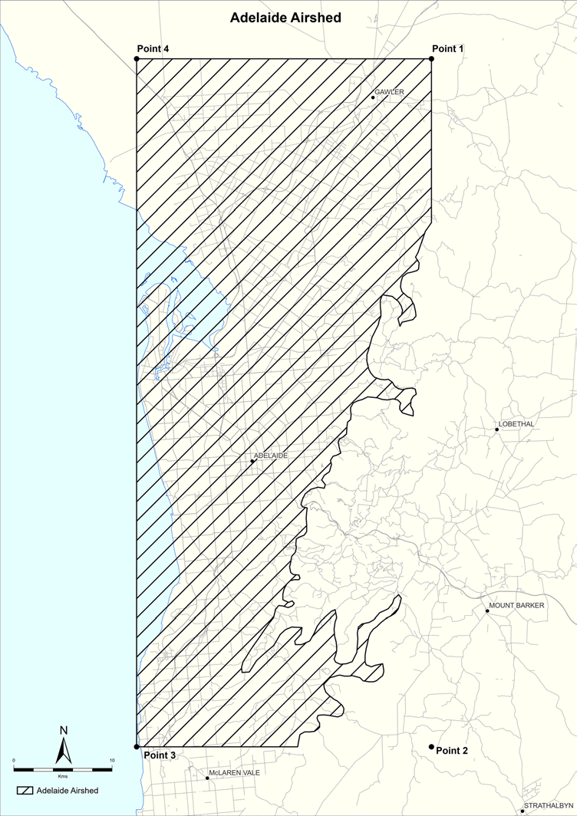
3—Mount Gambier airshed
The Mount Gambier airshed is comprised of the area contained within and bounded by a line commencing (in zone 54) at East 487223m, North 5821478m (point 1), then southerly to East 487223m, North 5806478m (point 2), then westerly to East 472223m, North 5806478m (point 3), then northerly to East 472223m, North 5821478m (point 4), then easterly to the point of commencement.
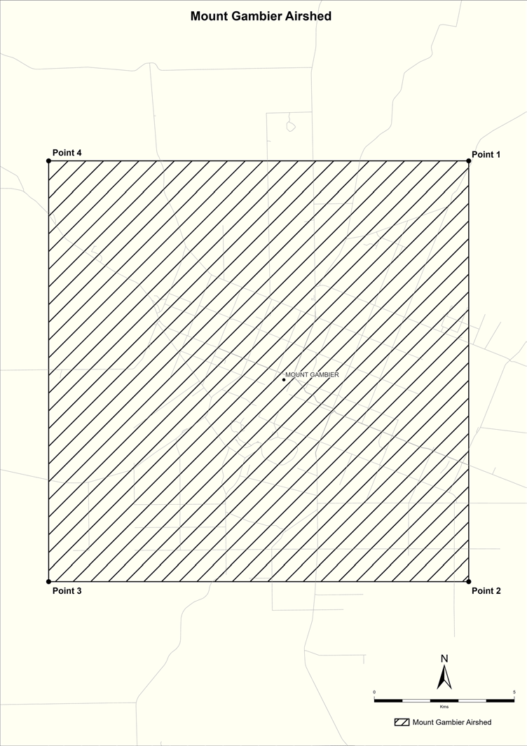
4—Port Pirie airshed
The Port Pirie airshed is comprised of the area contained within and bounded by a line commencing (in zone 54) at East 230703m, North 6331481m (point 1), then southerly to East 231563m, North 6316507m (point 2), then westerly (in zone 53) to East 775530m, North 6315872m (point 3), then northerly to East 775530m, North 6330872m (point 4), then easterly to the point of commencement.
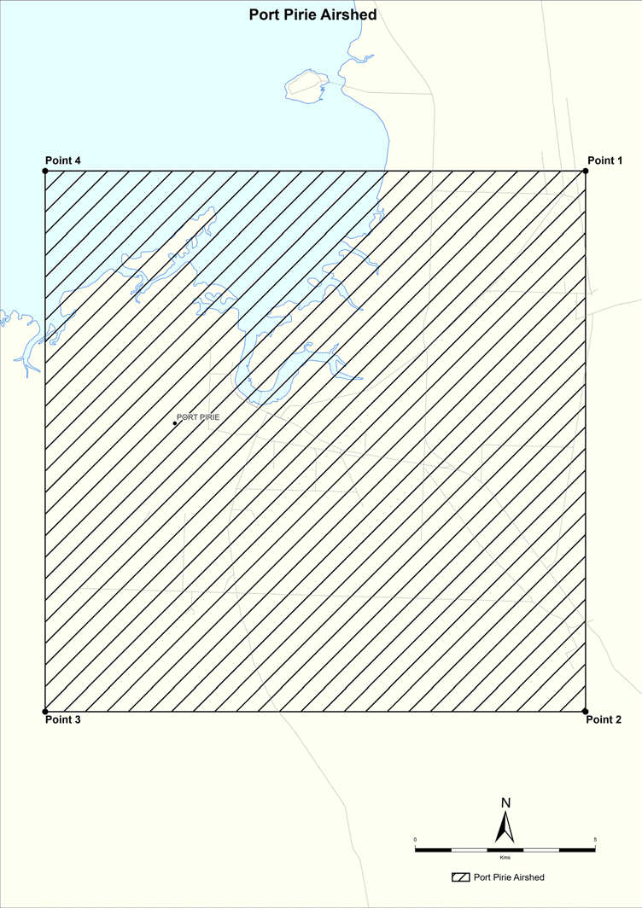
5—Port River region
The Port River region comprises the waters (within the limits of the State and vested in the Crown) of the Adelaide Dolphin Sanctuary established by the Adelaide Dolphin Sanctuary Act 2005 as at 1 July 2008.
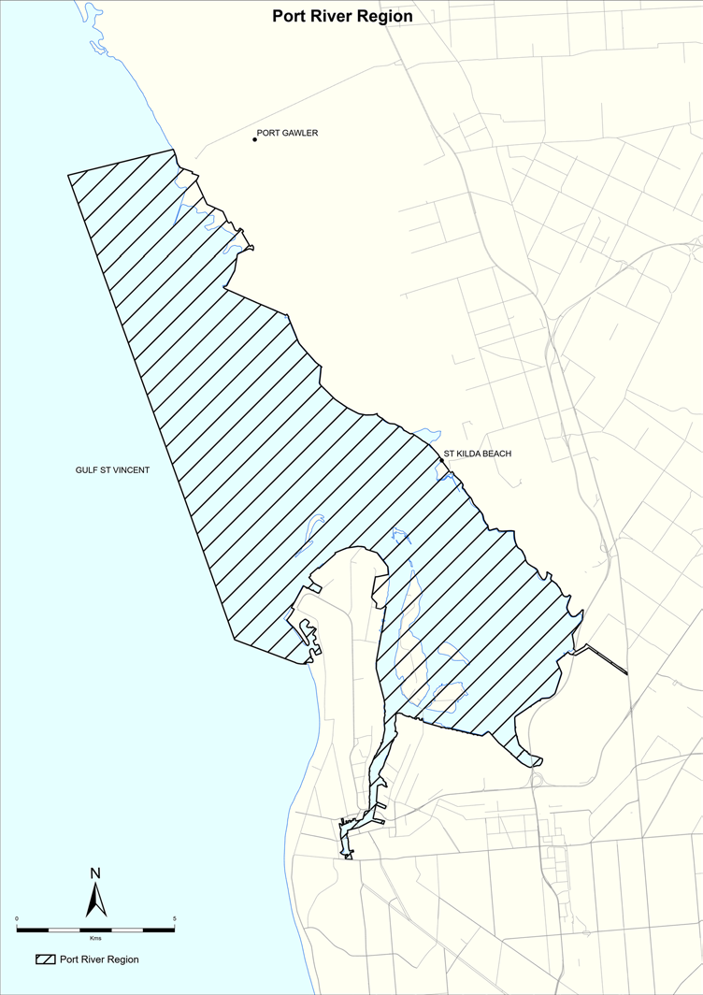
6—Upper Spencer Gulf
The Upper Spencer Gulf is comprised of the waters north of a line (in zone 53) at North 6317894m and bounded by mean high water springs.
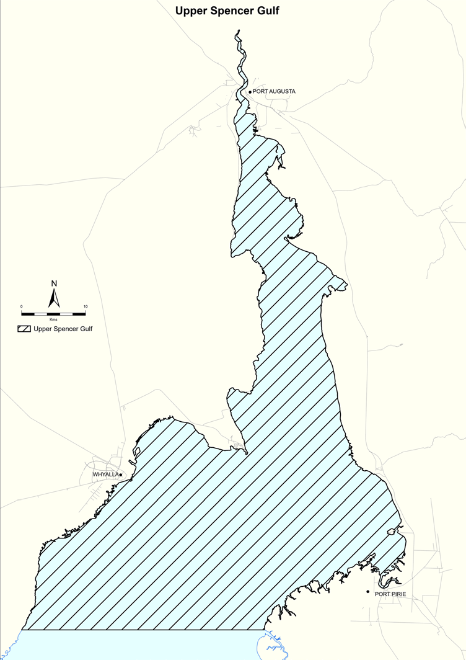
7—Whyalla airshed
The Whyalla airshed is comprised of the area contained within and bounded by a line commencing (in zone 53) at East 745530m, North 6350872m (point 1), then southerly to East 745530m, North 6335872m (point 2), then westerly to East 730530m, North 6335872m (point 3), then northerly to East 730530m, North 6350872m (point 4), then easterly to the point of commencement.
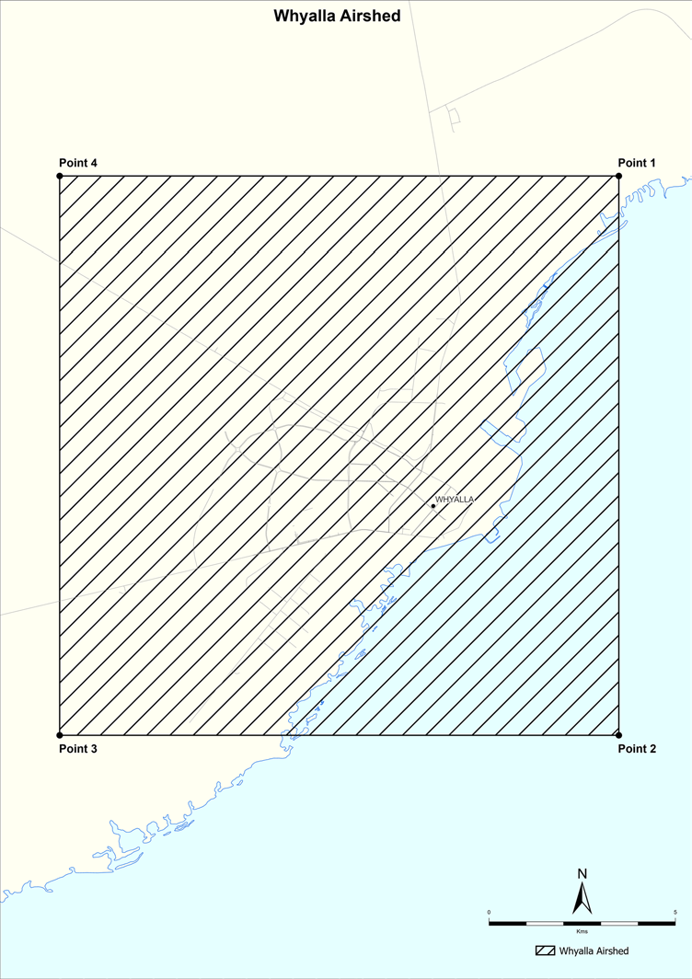
5—Variation of Schedule 3—Site contamination
(1) Schedule 3, clause 6—delete "AMG co-ordinates (GDA 94, UTM 53 and 54)" and substitute:
coordinates (GDA2020/MGA2020 and associated zone (52, 53 or 54))
(2) Schedule 3, clause 8—delete "AMG co-ordinates (GDA 94, UTM 53 and 54)" and substitute:
coordinates (GDA2020/MGA2020 and associated zone (52, 53 or 54))
Note—
As required by section 10AA(2) of the Subordinate Legislation Act 1978, the Minister has certified that, in the Minister's opinion, it is necessary or appropriate that these regulations come into operation as set out in these regulations.
Made by the Governor
with the advice and consent of the Executive Council
on 24 September 2020
No 277 of 2020

South Australia

Electricity (General) (Technical Standards) Variation Regulations 2020
under the Electricity Act 1996

Contents
Part 1—Preliminary
1 Short title
2 Commencement
3 Variation provisions
Part 2—Variation of Electricity (General) Regulations 2012
4 Variation of regulation 11—Compliance with standards that are varied or substituted
5 Insertion of regulations 55B to 55G
55B Remote disconnection and reconnection of electricity generating plant
55C Relevant agents
55D Register of relevant agents
55E Export limits for electricity generating plant
55F Voltage ride through for low voltage inverters of electricity generating plant
55G Meters

Part 1—Preliminary
1—Short title
These regulations may be cited as the Electricity (General) (Technical Standards) Variation Regulations 2020.
2—Commencement
These regulations come into operation on 28 September 2020.
3—Variation provisions
In these regulations, a provision under a heading referring to the variation of specified regulations varies the regulations so specified.
Part 2—Variation of Electricity (General) Regulations 2012
4—Variation of regulation 11—Compliance with standards that are varied or substituted
Regulation 11—after subregulation (4) insert:
(5) This regulation does not apply in relation to regulations 55B to 55G (inclusive).
5—Insertion of regulations 55B to 55G
After regulation 55A insert:
55B—Remote disconnection and reconnection of electricity generating plant
(1) This regulation applies to a designated electricity generating plant that is, or is to be, connected to a relevant distribution network and that—
(a) is installed on or after the relevant day; or
(b) was installed before the relevant day if a declared component of electricity infrastructure or an electrical installation associated with the plant is replaced on or after that day.
(2) From the prescribed day, the owner or operator of a designated electricity generating plant to which this regulation applies must ensure that the following requirements are complied with in relation to the plant:
(a) the plant must be capable of being remotely disconnected from, and reconnected to, the relevant distribution network;
(b) the owner or operator must give a relevant agent written authorisation to remotely disconnect the plant from, and reconnect the plant to, the relevant distribution network in circumstances where the owner or operator of the plant is lawfully directed to disconnect or reconnect the plant.
(3) In addition, from 1 January 2021, the owner or operator of a designated electricity generating plant to which this regulation applies must ensure that the plant is capable of being remotely disconnected from, and reconnected to, the network by the relevant agent of the owner or operator of the plant.
(4) The owner or operator of a designated electricity generating plant to which this regulation applies must notify their relevant agent if there is, or is to be, a change in the owner or operator of the plant as soon as practicable after becoming aware of the change (and in any event within 7 days after the change).
(5) A designated electricity generating plant to which this regulation applies must not be connected to a relevant distribution network unless the requirements under subregulations (2) and (3) (as relevant) are complied with in relation to the plant.
(6) The Technical Regulator may prepare and publish guidelines that set out methods for ensuring that a designated electricity generating plant is capable of being remotely disconnected from, and reconnected to, a relevant distribution network.
(7) Guidelines published under subregulation (6) may indicate that a method is, or is not, appropriate for designated electricity generating plant with particular nameplate capacity.
(8) For the purposes of this regulation, a particular designated electricity generating plant (installed plant) will be taken to be capable of being remotely disconnected from, and reconnected to, a relevant distribution network if the installed plant complies with a method that is appropriate for designated electricity generating plant with nameplate capacity of the installed plant set out in guidelines published under subregulation (6).
(9) The Technical Regulator must maintain an up to date list of declared components for the purposes of subregulation (1)(b) on a website determined by the Technical Regulator.
(10) The Minister may—
(a) by notice in the Gazette, designate an electricity generating plant as a designated electricity generating plant for the purposes of this regulation; and
(b) by subsequent notice in the Gazette, vary or revoke a notice under this subregulation.
(11) The Technical Regulator may—
(a) by notice in the Gazette, declare that a distribution network is an excluded distribution network for the purposes of this regulation; and
(b) by subsequent notice in the Gazette, vary or revoke a notice under this subregulation.
(12) In this regulation and regulations 55C and 55D—
declared component—see subregulation (9);
designated electricity generating plant—see subregulation (10);
excluded distribution network—see subregulation (11);
prescribed day means a day specified by the Minister by notice in the Gazette for the purposes of subregulation (2);
relevant agent means a person who is authorised by the owner or operator of the designated electricity generating plant to be their relevant agent and who meets the requirements set out in regulation 55C;
relevant day, in relation to a designated electricity generating plant, means—
(a) the day on which the Minister publishes the first notice under subregulation (10)(a); or
(b) in the case of an electricity generating plant that is designated as a designated electricity generating plant after the day referred to in paragraph (a)—the day on which the electricity generating plant is so designated;
relevant distribution network means a distribution network other than an excluded distribution network.
55C—Relevant agents
(1) A person may be authorised, on or before 31 December 2020, to be a relevant agent by an owner or operator of a designated electricity generating plant to which regulation 55B applies if the person—
(a) is suitably qualified in accordance with the requirements set out in any guidelines under subregulation (4); and
(b) nominates, in accordance with any guidelines under subregulation (4), the technology they will use to remotely disconnect plant from, and reconnect plant to, the relevant distribution network; and
(c) gives a written undertaking to the Technical Regulator, in the form determined by the Technical Regulator, that the person will—
(i) complete, on or before 31 December 2020, all actions necessary to allow the person to remotely disconnect plant from, and reconnect plant to, the network; and
(ii) demonstrate, on or before 31 December 2020, that the technology nominated by them under paragraph (b) is capable of remotely disconnecting plant from, and reconnecting plant to, a relevant distribution network to the satisfaction of the Technical Regulator.
(2) A person may be authorised, on or after 1 January 2021, to be a relevant agent by an owner or operator of a designated electricity generating plant to which regulation 55B applies if the person—
(a) is suitably qualified in accordance with the requirements set out in any guidelines under subregulation (4); and
(b) has nominated, in accordance with any guidelines under subregulation (4), the technology they will use to remotely disconnect plant from, and reconnect plant to, the relevant distribution network; and
(c) has completed all actions necessary to allow the person to remotely disconnect plant from, and reconnect plant to, the network; and
(d) has demonstrated that the technology nominated by them under paragraph (b) is capable of remotely disconnecting plant from, and reconnecting plant to, a relevant distribution network to the satisfaction of the Technical Regulator.
(3) A person must not act contrary to, or fail to comply with, a written undertaking given under subregulation (1)(c).
(4) The Technical Regulator may prepare and publish guidelines that set out the requirements for, and role and responsibilities of, a relevant agent.
55D—Register of relevant agents
(1) The Technical Regulator must keep and maintain a register of relevant agents for the purposes of regulations 55B and 55C.
(2) The requirement under subregulation (1) will be taken to be satisfied if the Technical Regulator adopts a register maintained by another person or body that the Technical Regulator is satisfied contains the information specified by subregulation (3).
(3) The register must contain the following information:
(a) the location and size of each designated electricity generating plant to which regulation 55B applies;
(b) the name and contact details of the relevant agent for each designated electricity generating plant to which regulation 55B applies.
(4) Information contained in the register may be provided to the following persons:
(a) a person with lawful authority to direct that a designated electricity generating plant be disconnected from, or reconnected to, a relevant distribution network;
(b) the operator of a relevant distribution network.
55E—Export limits for electricity generating plant
(1) This regulation applies to a designated electricity generating plant that is, or is to be, connected to a relevant distribution network and that—
(a) is installed on or after the relevant day; or
(b) was installed before the relevant day if a declared component of electricity infrastructure or an electrical installation associated with the plant is replaced on or after that day.
(2) The owner or operator of a designated electricity generating plant to which this regulation applies must ensure that the following requirements are complied with in relation to the plant:
(a) the plant's inverter is remote communications capable;
(b) on or after the prescribed day—
(i) the plant is capable of being export limited; and
(ii) the export limits of the plant are capable of being updated remotely.
(3) A designated electricity generating plant to which this regulation applies must not be connected to a relevant distribution network unless the requirements under subregulation (2) are complied with in relation to the plant.
(4) The Technical Regulator must prepare and publish guidelines that set out the requirements for ensuring that an inverter is remote communications capable.
(5) The Technical Regulator may prepare and publish guidelines that set out methods for ensuring that—
(a) a designated electricity generating plant is capable of being export limited (export limiting methods); and
(b) the export limits of a designated electricity generating plant are capable of being updated remotely (without a person being required to attend the site of the designated electricity generating plant) (remote updating methods).
(6) Guidelines published under subregulation (5) may indicate that a method is, or is not, appropriate for designated electricity generating plant with particular nameplate capacity.
(7) For the purposes of this regulation—
(a) a designated electricity generating plant (generally) is capable of being export limited if the electricity exported to a relevant distribution network from the plant can be programmed to not exceed thresholds (export limits), which may vary at different times of the day; and
(b) a particular designated electricity generating plant (installed plant) will be taken to be capable of being export limited if the installed plant complies with an export limiting method that is appropriate for designated electricity generating plant with nameplate capacity of the installed plant set out in guidelines published under subregulation (5); and
(c) the export limits of a designated electricity generating plant (installed plant) will be taken to be capable of being updated remotely if the installed plant complies with a remote updating method that is appropriate for designated electricity generating plant with nameplate capacity of the installed plant set out in guidelines published under subregulation (5).
(8) The Technical Regulator must maintain an up to date list of declared components for the purposes of subregulation (1)(b) on a website determined by the Technical Regulator.
(9) The Minister may—
(a) by notice in the Gazette, designate an electricity generating plant as a designated electricity generating plant for the purposes of this regulation; and
(b) by subsequent notice in the Gazette, vary or revoke a notice under this subregulation.
(10) The Technical Regulator may—
(a) by notice in the Gazette, declare that a distribution network is an excluded distribution network for the purposes of this regulation; and
(b) by subsequent notice in the Gazette, vary or revoke a notice under this subregulation.
(11) In this regulation—
declared component—see subregulation (8);
designated electricity generating plant—see subregulation (9);
excluded distribution network—see subregulation (10);
prescribed day means a day specified by the Minister by notice in the Gazette for the purposes of subregulation (2)(b);
relevant day, in relation to a designated electricity generating plant, means—
(a) the day on which these regulations come into operation; or
(b) in the case of an electricity generating plant that is designated as a designated electricity generating plant after the day referred to in paragraph (a)—the day on which the electricity generating plant is so designated;
relevant distribution network means a distribution network other than an excluded distribution network.
55F—Voltage ride through for low voltage inverters of electricity generating plant
(1) Subject to subregulation (2), this regulation applies to an electricity generating plant that is, or is to be, connected to a distribution network through a low voltage inverter and that—
(a) is installed after the commencement of this regulation; or
(b) was installed before the commencement of this regulation if the plant's inverter is replaced after the commencement of this regulation, unless the inverter is replaced under warranty.
(2) Despite subregulation (1)(a), this regulation—
(a) does not apply to an electricity generating plant installed after the commencement of this regulation where a written application to connect the plant to the distribution network was received by the operator of the distribution network on or before 10 August 2020; but
(b) does apply to such an electricity generating plant if the plant's inverter is subsequently replaced, unless the inverter is replaced under warranty.
(3) The owner or operator of an electricity generating plant to which this regulation applies must ensure that the low voltage inverter of the plant—
(a) on or before 31 March 2021—is a designated inverter; or
(b) has been tested in accordance with both of the following procedures relating to voltage ride through:
(i) a procedure published from time to time by AEMO;
(ii) a procedure in Australian Standard AS/NZS4777.2.
(4) An electricity generating plant to which this regulation applies must not be connected to a distribution network unless the requirements under subregulation (3) are complied with in relation to the plant.
(5) The Technical Regulator must, from the commencement of this regulation until 31 March 2021, keep and maintain a publicly available register of designated inverters, being inverters that meet the following requirements:
(a) the manufacturer of the inverter has provided the Technical Regulator with a test report that demonstrates that the inverter meets a procedure published from time to time by AEMO relating to voltage ride through, excluding any requirement in the procedure that the test be conducted at an appropriate testing facility;
(b) the manufacturer of the inverter has given a written undertaking to the Technical Regulator, in the form determined by the Technical Regulator, that—
(i) they will complete the testing referred to in subregulation (3)(b) through an appropriate testing facility on or before 31 March 2021; and
(ii) if the inverter fails to pass a test referred to in subregulation (3)(b) through an appropriate testing facility, they will—
(A) replace any such inverter supplied after the commencement of this regulation with an inverter that passes the tests referred to in subregulation (3)(b) through an appropriate testing facility; or
(B) upgrade any such inverter supplied after the commencement of this regulation so that the inverter passes the tests referred to in subregulation (3)(b) through an appropriate testing facility;
(c) the importer of the inverter (if any) has given a written undertaking to the Technical Regulator, in the form determined by the Technical Regulator, that, if the inverter fails to pass a test referred to in subregulation (3)(b) through an appropriate testing facility, they will—
(i) replace any such inverter supplied after the commencement of this regulation with an inverter that passes the tests referred to in subregulation (3)(b) through an appropriate testing facility; or
(ii) upgrade any such inverter supplied after the commencement of this regulation so that the inverter passes the tests referred to in subregulation (3)(b) through an appropriate testing facility.
(6) A person must not act contrary to, or fail to comply with, a written undertaking given under subregulation (5)(b) or (c).
(7) In this regulation—
appropriate testing facility means a testing facility that meets any requirements set out in a procedure published from time to time by AEMO relating to voltage ride through;
designated inverter—see subregulation (5);
importer means a person who imports an inverter into Australia.
55G—Meters
A meter installed at premises on or after the commencement of this regulation must—
(a) be capable of separately measuring and controlling an electricity generating plant and controllable load from essential load (whether or not there is electricity generating plant or controllable load at the premises); and
(b) be installed in accordance with any guideline prepared and published by the Technical Regulator in respect of wiring, meter configurations and other installation requirements.
Note—
As required by section 10AA(2) of the Subordinate Legislation Act 1978, the Minister has certified that, in the Minister's opinion, it is necessary or appropriate that these regulations come into operation as set out in these regulations.
Made by the Governor
with the advice and consent of the Executive Council
on 24 September 2020
No 278 of 2020

South Australia

National Energy Retail Law (Local Provisions) (Tariff Structures) Variation Regulations 2020
under the National Energy Retail Law (South Australia) Act 2011

Contents
Part 1—Preliminary
1 Short title
2 Commencement
3 Variation provisions
Part 2—Variation of National Energy Retail Law (Local Provisions) Regulations 2013
4 Insertion of regulation 6A
6A Tariff structures

Part 1—Preliminary
1—Short title
These regulations may be cited as the National Energy Retail Law (Local Provisions) (Tariff Structures) Variation Regulations 2020.
2—Commencement
These regulations come into operation on the day on which they are made.
3—Variation provisions
In these regulations, a provision under a heading referring to the variation of specified regulations varies the regulations so specified.
Part 2—Variation of National Energy Retail Law (Local Provisions) Regulations 2013
4—Insertion of regulation 6A
After regulation 6 insert:
6A—Tariff structures
(1) Section 22(1a) of the National Energy Retail Law (South Australia) applies in relation to South Australia.
(2) The following tariff structures are prescribed for the purposes of section 22(1a)(c) of the National Energy Retail Law (South Australia):
(a) in the case of a residential customer—
(i) the time of use tariff structure applying under the residential time of use tariff published by SA Power Networks; and
(ii) the demand tariff structure applying under the residential prosumer tariff published by SA Power Networks;
(b) in the case of a business customer who consumes energy at business premises below the upper consumption threshold—
(i) the small business time of use tariff structure published by SA Power Networks; and
(ii) the small business time of use with demand tariff structure published by SA Power Networks;
(c) in the case of an eligible retailer—a tariff structure determined by the retailer.
(3) A retailer's standing offer need only include 1 of the tariff structures prescribed by subregulation (2)(a) and 1 of the tariff structures prescribed by subregulation (2)(b), as determined by the retailer.
(4) In this regulation—
eligible retailer means a retailer that the Minister is satisfied—
(a) has a generally available market offer that provides efficient signals to customers about when to use energy; and
(b) is using its best endeavours to market that generally available market offer to customers.
Note—
As required by section 10AA(2) of the Subordinate Legislation Act 1978, the Minister has certified that, in the Minister's opinion, it is necessary or appropriate that these regulations come into operation as set out in these regulations.
Made by the Governor
with the advice and consent of the Executive Council
on 24 September 2020
No 279 of 2020

South Australia

Planning, Development and Infrastructure (General) (Miscellaneous) (No 3) Variation Regulations 2020
under the Planning, Development and Infrastructure Act 2016

Contents
Part 1—Preliminary
1 Short title
2 Commencement
3 Variation provisions
Part 2—Variation of Planning, Development and Infrastructure (General) Regulations 2017
4 Variation of regulation 3—Interpretation
5 Variation of regulation 3A—Application of Act (section 8)
6 Variation of regulation 3F—Regulated and significant trees
7 Variation of regulation 19—Incorporation of material (section 71(b))
8 Variation of regulation 21—Minor or operational amendments (section 76)
9 Variation of regulation 22—Prescribed scheme (section 93)
10 Variation of regulation 43—River Murray
11 Variation of regulation 44—Appeals
12 Variation of regulation 47—Performance assessed development and restricted development
13 Variation of regulation 57—Notice of decision (section 126(1))
14 Variation of regulation 64—Building work affecting other land
15 Insertion of regulation 64A
64A Access to neighbouring land
16 Variation of regulation 65—Variation of authorisation (section 128)
17 Variation of regulation 68—Procedural matters (section 111(2))
18 Variation of regulation 93—Notifications during building work
19 Variation of regulation 94—Essential safety provisions
20 Variation of regulation 99—Construction Industry Training Fund
21 Variation of regulation 103—Certificates of occupancy
22 Variation of regulation 104—Statement of Compliance
23 Variation of regulation 112—Authorised officers and inspections
24 Variation of regulation 116—Rights of review and appeal
25 Variation of Schedule 3—Additions to definition of development
26 Variation of Schedule 4—Exclusions from definition of development—general
27 Variation of Schedule 5—Exclusions from definition of development—State heritage areas
28 Variation of Schedule 6—Relevant authority—Commission
29 Variation of Schedule 7—Complying building work
12 Temporary accommodation in area affected by bushfire
30 Variation of Schedule 8—Plans
31 Variation of Schedule 9—Referrals
32 Insertion of Schedules 10A and 10B
Schedule 10A—Building work affecting stability—prescribed form
Schedule 10B—Access to neighbouring land—prescribed form

Part 1—Preliminary
1—Short title
These regulations may be cited as the Planning, Development and Infrastructure (General) (Miscellaneous) (No 3) Variation Regulations 2020.
2—Commencement
These regulations come into operation on the day on which they are made.
3—Variation provisions
In these regulations, a provision under a heading referring to the variation of specified regulations varies the regulations so specified.
Part 2—Variation of Planning, Development and Infrastructure (General) Regulations 2017
4—Variation of regulation 3—Interpretation
(1) Regulation 3(1), definitions of AHD and ARI—delete the definitions
(2) Regulation 3(3)—delete subregulation (3)
5—Variation of regulation 3A—Application of Act (section 8)
(1) Regulation 3A—after subregulation (3) insert:
(3a) Pursuant to section 8(2)(b) of the Act, section 215 of the Act applies with the following prescribed variation during the period from the commencement of this subregulation until the designated day:
Section 215—after subsection (4) insert:
(5) Subsection (4) does not apply to prevent a person who operates a shop used primarily for the sale of foodstuffs by retail from—
(a) loading or unloading goods at the shop at any time; or
(b) opening the shop to the public at any time.
(2) Regulation 3A(4)—before the definition of prescribed separation distance insert:
designated day means the earlier of the following days:
(a) the day designated by the Minister by notice in the Gazette;
(b) 30 September 2020;
6—Variation of regulation 3F—Regulated and significant trees
(1) Regulation 3F(1)—delete "significant tree" and substitute:
regulated tree
(2) Regulation 3F(4)(c)—delete "Chapter 8 Part 1 of the Natural Resources Management Act 2004" and substitute:
Part 9 Division 1 of the Landscape South Australia Act 2019
7—Variation of regulation 19—Incorporation of material (section 71(b))
Regulation 19—after paragraph (a) insert:
(ab) the administrative unit of the Public Service that is responsible for assisting a Minister in the administration of the Heritage Places Act 1993;
8—Variation of regulation 21—Minor or operational amendments (section 76)
Regulation 21(h)—delete "an NRM plan (or a part of any such plan) prepared under Chapter 4 of the Natural Resources Management Act 2004" and substitute:
a regional landscape plan, water allocation plan or landscapes or water affecting activities control policy (or a part of any such plan or policy) under the Landscape South Australia Act 2019
9—Variation of regulation 22—Prescribed scheme (section 93)
Regulation 22—after its present contents (now to be designated as subregulation (1)) insert:
(2) In connection with subregulation (1)(a)(ii), an assessment manager may act as a relevant authority for the purposes of—
(a) making a decision in accordance with a practice direction under section 107(3)(a) of the Act; and
(b) determining whether a proposed development the subject of an application falls within a specified class of development excluded from the operation of section 107(3) and (4) of the Act by the Planning and Design Code.
10—Variation of regulation 43—River Murray
Regulation 43(2)—delete subregulation (2) and substitute:
(2) If an application for the consent or approval of a proposed development must be referred under Schedule 9 to the Minister responsible for the administration of the River Murray Act 2003 (the River Murray Minister), the following provisions apply:
(a) subject to subregulation (3), the River Murray Minister must, in considering the application, take into account any matter that is raised by another Minister or other authority responsible for, or involved in, the administration of a related operational Act that is provided to the River Murray Minister in response to the referral of the application by the River Murray Minister to the other Minister or authority for comment;
(b) the River Murray Minister may, in providing a response to the relevant authority under section 122 of the Act, make that response on the basis of a matter referred to in paragraph (a).
(3) A matter raised by another Minister or authority in response to the referral of an application by the River Murray Minister under subregulation (2)(a) is not required to be taken into account by the River Murray Minister unless it is provided to the River Murray Minister within a period specified by the River Murray Minister.
11—Variation of regulation 44—Appeals
Regulation 44—delete "item 14" wherever occurring and substitute in each case:
item 18
12—Variation of regulation 47—Performance assessed development and restricted development
Regulation 47(4)—delete subregulation (4) and substitute:
(4) If—
(a) the applicant, in accordance with a procedure specified by a practice direction, requests the relevant authority to place a notice on land under subregulation (2); and
(b) the proposed development is to be undertaken within the area of a council; and
(c) the relevant authority is an assessment panel appointed or constituted under section 83 or 84 of the Act; and
(d) the applicant pays the fee determined by the council for the area in which the proposed development is to be undertaken as being appropriate to cover the reasonable costs of placing the notice on the land,
the relevant authority will be responsible for placing the notice on the land.
13—Variation of regulation 57—Notice of decision (section 126(1))
Regulation 57(4)—delete subregulation (4) and substitute:
(4) The relevant authority must—
(a) endorse a set of any approved plans and other relevant documentation with an appropriate form of authentication; and
(b) ensure that the notice provided via the SA planning portal under subregulation (2) includes the endorsed set of approved plans and other relevant documentation.
14—Variation of regulation 64—Building work affecting other land
Regulation 64—after subregulation (2) insert:
(2a) For the purposes of section 139(2)(a) of the Act—
(a) the form set out in Schedule 10A is prescribed; and
(b) the person undertaking the development must serve a completed notice on the owner of the affected site at least 20 business days before the building work is commenced.
(2b) For the purposes of section 139(2)(c) of the Act, before seeking access under section 139(2)(b) of the Act, the person undertaking the development (or a person authorised by that person) must give at least 1 business day's notice of the proposed work and the proposed time of accessing the affected site.
15—Insertion of regulation 64A
After regulation 64 insert:
64A—Access to neighbouring land
For the purposes of section 140(3) of the Act, the form set out in Schedule 10B is prescribed.
16—Variation of regulation 65—Variation of authorisation (section 128)
Regulation 65—after subregulation (2) insert:
(3) Subregulation (1) does not apply to a development authorisation relating to a division of land where certificates of title have been issued by the Registrar-General in respect of the land divided in accordance with the development authorisation.
17—Variation of regulation 68—Procedural matters (section 111(2))
Regulation 68(3)—delete subregulation (3)
18—Variation of regulation 93—Notifications during building work
(1) Regulation 93(1)(c)—delete "or before development approval is granted" and substitute:
the granting of development approval
(2) Regulation 93(1)(f)—before "completion" insert:
the intended
19—Variation of regulation 94—Essential safety provisions
Regulation 94(4)(a)—delete "building rules consent" and substitute:
building consent
20—Variation of regulation 99—Construction Industry Training Fund
(1) Regulation 99(2)—delete "building rules consent" and substitute:
building consent
(2) Regulation 99(3)(b)—delete "building rules consent" and substitute:
building consent
(3) Regulation 99(4)—delete "building rules consent" and substitute:
building consent
21—Variation of regulation 103—Certificates of occupancy
(1) Regulation 103—after subregulation (6) insert:
(6a) If, on receipt of a notification of intended completion of building work under regulation 93(1)(f), a council determines that the building work will be inspected by an authorised officer, the certificate of occupancy must not be granted until the inspection has been carried out and any required building work or other action has been undertaken.
(6b) A council must provide to the relevant authority responsible for assessment of the building work against the provisions of the Building Rules (unless that relevant authority was the council)—
(a) notice of its determination to carry out an inspection of building work in accordance with subregulation (6a); and
(b) notice of the completion of the inspection (after any building work or other action required by the inspection has been undertaken).
(2) Regulation 103(7)—delete "Pursuant" and substitute:
Subject to subregulation (7a), pursuant
(3) Regulation 103—after subregulation (7) insert:
(7a) If the council has determined to carry out an inspection of building work in accordance with subregulation (6a), the period under subregulation (7)(a) or (b) (within which an application for the issue of a certificate of occupancy in respect of the building must be decided) does not commence until the day after the notice of completion of the inspection under subregulation (6b)(b) is provided.
(4) Regulation 103(11)—after "(3)" insert:
, (6a)
22—Variation of regulation 104—Statement of Compliance
(1) Regulation 104(3)—delete subregulation (3) and substitute:
(3) If building work is carried out in a case where this regulation applies—
(a) the licensed building work contractor responsible for carrying out the building work; or
(b) if there is no such person, a registered building work supervisor or a building certifier,
must, when a notice of completion with respect to the building work is given, provide to the relevant authority under subregulation (4) and the person referred to in subregulation (6)(b) via the SA planning portal a duly completed Statement of Compliance in the form determined by the Chief Executive for the purposes of this regulation (being a form published by the Chief Executive on the SA planning portal).
(2) Regulation 104(5)—delete "building rules consent" and substitute:
building consent
(3) Regulation 104(10)—delete subregulation (10)
23—Variation of regulation 112—Authorised officers and inspections
(1) Regulation 112(2)(a)—delete "section 144" and substitute:
sections 144 and 156
(2) Regulation 112—after subregulation (2) insert:
(3) For the purposes of section 155(2) of the Act, the prescribed qualifications are the qualifications that apply for the purposes of gaining accreditation as an accredited professional who is—
(a) an Accredited professional—building level 1; or
(b) an Accredited professional—building level 2.
24—Variation of regulation 116—Rights of review and appeal
Regulation 116—delete "An" and substitute:
For the purposes of section 203(1) of the Act, an
25—Variation of Schedule 3—Additions to definition of development
Schedule 3, clause 7(1)(d)—after "Flood Plain" insert:
Protection Area
26—Variation of Schedule 4—Exclusions from definition of development—general
(1) Schedule 4, clause 4(1)—after paragraph (a) insert:
(ab) a temporary structure on land on which a building, or part of a building, has been destroyed or significantly damaged by a bushfire if—
(i) the structure is for the use of the owner of the land for the storage of goods or materials required to assist in the recovery and redevelopment of an area affected by the bushfire; and
(ii) the structure—
(A) does not exceed 3 m in height (measured from ground level); and
(B) does not exceed 12.5 m in length; and
(C) does not exceed 2.5 m in width; and
(iii) the structure does not remain on the land for a period exceeding 2 years;
(2) Schedule 4, clause 4(1)(b)—delete paragraph (b) and substitute:
(b) a windmill or a flagpole that—
(i) is not attached to a building and is not more than 10 m in height; or
(ii) is attached to a building and is not more than 4 m in height above the topmost point of attachment to the building, exclusive of guy wires,
and, if in a designated airport building heights area, is not more than the height restriction under the Planning and Design Code relating to structures in the location of the proposed development;
(3) Schedule 4, clause 4(1)(d)(i)(A)—after "overlay" insert:
identified under the Planning and Design Code for the purposes of this subsubparagraph
(4) Schedule 4, clause 4(1)(d)(i)(B)—delete "subparagraph" and substitute:
subsubparagraph
(5) Schedule 4, clause 4(1)(d)(ii)—delete "Local Heritage Area Overlay" and substitute:
Historic Area Overlay
(6) Schedule 4, clause 4(1)(e)—after "overlay" insert:
identified under the Planning and Design Code for the purposes of this paragraph
(7) Schedule 4, clause 4(1)(g)(ii)(A)—delete "Hazards (Bushfire Protection) Overlay" and substitute:
Hazards (Bushfire—Outback) Overlay, Hazards (Bushfire—Regional) Overlay, Hazards (Bushfire—General Risk) Overlay, Hazards (Bushfire—Medium Risk) Overlay, Hazards (Bushfire—High Risk) Overlay or Hazards (Bushfire—Urban Interface) Overlay or any other zone or area in which the word "Bushfire" appears in the title of the zone or area
(8) Schedule 4, clause 4(1)(i)—delete "Local Heritage Area Overlay" and substitute:
Historic Area Overlay
(9) Schedule 4, clause 4(2)—delete "Local Heritage Area Overlay" and substitute:
Historic Area Overlay
(10) Schedule 4, clause 4(3)—delete "Local Heritage Area Overlay" and substitute:
Historic Area Overlay
(11) Schedule 4, clause 5(2)—after paragraph (f) insert:
(fa) the parking of a caravan or other vehicle of any weight on land on which a dwelling, or part of a dwelling, has been destroyed or significantly damaged by a bushfire if the vehicle is to be used as accommodation by the owner of the land—
(i) for a period not exceeding 2 years; or
(ii) until a Class 1a building on the land is able to be occupied in accordance with regulation 103,
whichever occurs first;
(fb) the storage of goods or materials for a period not exceeding 2 years on land on which a building, or part of a building, has been destroyed or significantly damaged by a bushfire if the storage is for the use of the owner of the land to assist in the recovery and redevelopment of an area affected by the bushfire;
(12) Schedule 4, clause 9(a)—delete "Local Infrastructure (Airfield) Zone, Settlement Zone" and substitute:
Infrastructure (Airfield) Zone, Rural Settlement Zone
(13) Schedule 4, clause 9(a)—after "Flood Plain" insert:
Protection Area
(14) Schedule 4, clause 9(a)—delete "Specific Use (Tourism Development) Zone" and substitute:
Tourism Development Zone
(15) Schedule 4, clause 9(d)—delete "Settlement Zone or Specific Use (Tourism Development) Zone" and substitute:
Rural Settlement Zone or Tourism Development Zone
(16) Schedule 4, clause 10—after its present contents (now to be designated as subclause (1)) insert:
(2) The partial or total demolition of a building and associated structures if the building, or part of the building, has been destroyed or significantly damaged by a bushfire, other than in respect of a local heritage place or Historic Area Overlay in the Planning and Design Code.
(17) Schedule 4, clause 11(c)(i)—after "overlay" insert:
identified under the Planning and Design Code for the purposes of this subparagraph
(18) Schedule 4, clause 13(1)(b)(i)—delete "Local Heritage Area Overlay" and substitute:
Historic Area Overlay
(19) Schedule 4, clause 13(3)(a)—delete "Local Infrastructure (Airfield) Zone, Settlement Zone" and substitute:
Infrastructure (Airfield) Zone, Rural Settlement Zone
(20) Schedule 4, clause 13(3)(a)—after "Flood Plain" insert:
Protection Area
(21) Schedule 4, clause 13(3)(a)—delete "Specific Use (Tourism Development) Zone" and substitute:
Tourism Development Zone
(22) Schedule 4, clause 13(3)(d)—delete "Settlement Zone or Specific Use (Tourism Development) Zone" and substitute:
Rural Settlement Zone or Tourism Development Zone
(23) Schedule 4, clause 14—after subclause (5) insert:
(5a) Subclauses (1) and (5) do not apply in relation to the construction of a new railway station.
(24) Schedule 4, clause 14(7), definition of infrastructure, (d)—delete "buildings heights area" and substitute:
building heights area where the work exceeds the height restriction under the Planning and Design Code relating to structures in the location of the work
27—Variation of Schedule 5—Exclusions from definition of development—State heritage areas
(1) Schedule 5, clause 4(1)(c)—after "swimming pool" insert:
or spa pool (other than in a designated flood zone, subzone or overlay or in any other zone, subzone or overlay identified under the Planning and Design Code for the purposes of this paragraph) which is
(2) Schedule 5, clause 4(1)(c)—after subparagraph (iii) insert:
and
(iv) in the case of an aboveground or inflatable swimming pool or spa pool, does not incorporate a filtration system;
(3) Schedule 5, clause 4(1)(d) and (e)—delete paragraphs (d) and (e)
28—Variation of Schedule 6—Relevant authority—Commission
(1) Schedule 6, clause 1(1)(a)—after "South Australian Housing Trust" insert:
, either individually or jointly with other persons or bodies, or by a provider registered under the Community Housing National Law participating in a program relating to the renewal of housing endorsed by the South Australian Housing Trust
(2) Schedule 6, clause 1(1)(a)(iii) and (iv)—delete subparagraphs (iii) and (iv)
(3) Schedule 6, clause 1(1)(a)(v)—after "regulated tree" insert:
that is not associated with an application for building work on the relevant land
(4) Schedule 6, clause 1(1)(a)(vi)—delete subparagraph (vi) and substitute:
(vi) development which is classified as deemed-to-satisfy under section 106 of the Act.
(5) Schedule 6—after clause 4 insert:
4A—Morphettville and Camden Park—buildings exceeding 4 storeys
(1) Development that involves the erection or construction of a building that exceeds 4 storeys in height in an Urban Neighbourhood Zone under the Planning and Design Code in the suburb of Morphettville or Camden Park.
(2) Subject to subclause (3), development—
(a) under an application to vary a development authorisation given by the Commission under this clause; or
(b) which, in the opinion of the Commission, is ancillary to or in association with a development the subject of an authorisation given by the Commission under this clause.
(3) Subclause (2) does not apply to development involving a building in relation to which a certificate of occupancy has been issued.
(6) Schedule 6, clause 12—delete "identified as coastal or coastal conservation zones, subzones or overlays under the Planning and Design Code for the purposes of this clause" and substitute:
within the Conservation Zone under the Planning and Design Code
(7) Schedule 6—after clause 12 insert:
12A—Tourist accommodation in reserves
Development for the purposes of tourist accommodation in a reserve constituted under the National Parks and Wildlife Act 1972.
(8) Schedule 6—after clause 13 insert:
14—Osborne maritime area
Development in any part of the area identified as the Osborne Maritime Policy Area by the Development Plan relating to the City of Port Adelaide Enfield, as that Development Plan existed on 1 April 2020.
29—Variation of Schedule 7—Complying building work
Schedule 7—after clause 11 insert:
12—Temporary accommodation in area affected by bushfire
The construction or placement of a building or structure on land on which a dwelling, or part of a dwelling, has been destroyed or significantly damaged by a bushfire if—
(a) the building or structure is to be used as accommodation by the owner of the land; and
(b) the building or structure is a minimum of 20 m from any remaining or regenerating cluster of vegetation (whether that vegetation is on the land or on adjoining land); and
(c) the owner of the land complies with any requirements of the South Australian Country Fire Service relating to the maintenance of a clearance area between the temporary accommodation and any remaining or regenerating cluster of vegetation; and
(d) the building or structure is to be used as accommodation—
(i) for a period not exceeding 2 years; or
(ii) until a Class 1a building on the land is able to be occupied in accordance with regulation 103,
whichever occurs first; and
(e) the building or structure complies with the following requirements:
(i) the requirements in—
(A) the relevant clauses of Part 2.1 of the Housing Provisions of the National Construction Code; and
(B) clause P2.2.2 of the Housing Provisions of the National Construction Code; and
(C) clause P2.4.3 of the Housing Provisions of the National Construction Code;
(ii) —
(A) if the site is connected to mains water—the land on which the building or structure is constructed or placed has a 2 000 L dedicated fire fighting water supply with a tap; or
(B) if the site is not connected to mains water—the land on which the building or structure is constructed or placed has a 5 000 L dedicated fire fighting water supply with a tap;
(iii) waste water is disposed of through, or connected to, an approved wastewater system, SA Water sewer or council community wastewater system;
(iv) all smoke alarms required under clause P2.3.2 of the Housing Provisions of the National Construction Code are installed and tested;
(v) the building or structure is fitted with a fire extinguisher.
30—Variation of Schedule 8—Plans
(1) Schedule 8, clause 1—delete "or pergola" and substitute:
, deck, fence, retaining wall or pergola (or any other development ancillary to a dwelling not within the ambit of clause 3)
(2) Schedule 8, clause 2—delete "relates to 1 or more proposed dwellings, or the alteration of or addition to an existing dwelling," and substitute:
proposes building work not within the ambit Schedule 8 clause 1 or 3
(3) Schedule 8, clause 2(a)—after subparagraph (i) insert:
(ia) the boundaries and dimensions of any proposed sites (after completion of the proposed development) and, if the application provides for an area of common or community land, the boundaries of such land; and
(4) Schedule 8, clause 2(a)(ii)—delete "the minimum front and side setbacks of"
(5) Schedule 8, clause 2(a)(vi)—delete "that are not fully enclosed or covered"
(6) Schedule 8, clause 2(a)—after subparagraph (ix) insert:
(x) the amount and location of private open space that will exist on the site after completion of the development, including details of any fencing around areas of private open space; and
(xi) the location and capacity of any proposed water tank and connection type; and
(xii) if a new or modified driveway or access point is proposed, the width of the vehicle crossover, the driveway width at the front boundary and the minimum and maximum driveway widths.
(7) Schedule 8, clause 2(b)—delete "the location and purpose of rooms and other areas at the completion of the development; and" and substitute:
—
(i) the location and purpose of rooms and other areas at the completion of the development; and
(ii) the internal dimensions of any proposed carport or garage; and
(iii) the roof area, including any eaves and verandahs; and
(8) Schedule 8, clause 2(c)(v)(C)—delete subsubparagraph (C)
(9) Schedule 8, clause 2(c)(viii)—delete subparagraph (viii)
(10) Schedule 8, clause 2(d)—after "new dwellings" insert:
where the previous use or activity on the allotment was not for residential purposes
(11) Schedule 8, clause 2—after paragraph (d) insert:
and
(e) in the case of an application proposing development located in a designated bushfire prone area—a site plan, drawn to scale, including appropriate bar and ratio scales, showing—
(i) the location of an existing or proposed asset protection zone; and
(ii) the surface materials of any existing or proposed driveway; and
(iii) the gradient of the transition area between the public road and any existing or proposed driveway, the gradients of the driveway, and the cross fall of the driveway; and
(f) in the case of an application proposing a deemed-to-satisfy development for a new dwelling that is not connected to an approved common waste water disposal service but which is serviced by an on-site wastewater treatment system—evidence that the wastewater treatment system has been granted a wastewater works approval under the South Australian Public Health (Wastewater) Regulations 2013; and
(g) in the case of an application proposing development located in the Native Vegetation Overlay or State Significant Native Vegetation Overlay in the Planning and Design Code—
(i) if native vegetation is proposed to be cleared—a report prepared in accordance with regulation 18(2)(a) of the Native Vegetation Regulations 2017 that establishes that the clearance is categorised as Level 1 clearance in accordance with guidelines established by the Native Vegetation Council for the purposes of applications to clear native vegetation under the Native Vegetation Act 1991; or
(ii) in any other case—a declaration stating that the proposal will not involve clearance of native vegetation under the Native Vegetation Act 1991; and
(h) in the case of an application proposing development which uses an existing or proposed access point from a road affected by the Key Outback and Rural Routes Overlay, Major Urban Transport Routes Overlay or Urban Transport Routes Overlay under the Planning and Design Code, or within 25 m of such a road—a site plan, drawn to scale, including appropriate bar and ratio scales, showing—
(i) the location and dimensions of all access points (noting whether an access point is located on a section of road affected by double barrier lines between edges of the access points); and
(ii) the expected number of vehicle movements per day; and
(iii) the expected maximum vehicle length for vehicles expected to access the site; and
(iv) in respect of the largest vehicle expected to access the site—
(A) vehicle turning profiles demonstrating entry and exit movements and on-site circulation (if required); and
(B) the angle of vehicle access crossing the property boundary; and
(v) the distance of unobstructed line of sight to and from any new access point for vehicles entering and exiting the access point; and
(vi) the distance between each access point and the nearest—
(A) public road junction or terminating or merging lane on a public road; and
(B) access point to or from a private road; and
(C) internal (on-site) driveway, intersection, car parking space, gate or other internal obstruction to vehicle movement; and
(D) roadside infrastructure or tree.
(12) Schedule 8, clause 10(1)—delete "item 16" and substitute:
item 9
(13) Schedule 8, clause 11(1)—delete "Natural Resources Management Act 2004 under item 7" and substitute:
Landscape South Australia Act 2019 under item 13
(14) Schedule 8, clause 12(1)—delete "item 9 or 10" and substitute:
item 15 or 16
(15) Schedule 8, clause 13(1)—delete "item 11" and substitute:
item 10
Note—
The heading to Schedule 8 clause 1 will be varied to "Plans for development ancillary to dwellings" when this regulation comes into operation.
The heading to Schedule 8 clause 2 will be varied to "Plans for applications seeking planning consent for new buildings or structures or extensions to existing buildings" when this regulation comes into operation.
The heading to Schedule 8 clause 9 will be varied to "Land division certificates or deemed-to-satisfy land division" when this regulation comes into operation.
31—Variation of Schedule 9—Referrals
(1) Schedule 9, clause 1(1)(a)—after "column 1" insert:
, other than such development that is classified as deemed-to-satisfy development,
(2) Schedule 9, clause 1(1)(c)—after "column 3" insert:
in Part A of the table
(3) Schedule 9, clause 1(1)—after paragraph (c) insert:
(ca) the term Direction to impose conditions specified in column 3 in Part A of the table means that the prescribed body may, if the relevant authority decides to consent to or approve the development, direct the relevant authority to impose such conditions as the prescribed body thinks fit (subject to any qualification referred to in the relevant item and any specific limitation under another Act as to the conditions that may be imposed by the prescribed body) and that the relevant authority must comply with any such direction; and
(cb) the term Advice specified in column 3 in Part B of the table means that the relevant authority must not make its decision until it has received a response from the prescribed body in relation to the matter or matters for which the referral was made (provided that the prescribed body complies with section 122 of the Act in relation to the provision of its response); and
(4) Schedule 9, clause 1(2)—delete "items 9 and 10" and substitute:
items 15 and 16
(5) Schedule 9, clause 2(a)—delete "item 14" and substitute:
item 18
(6) Schedule 9, clause 3—delete clause 3 and substitute:
3—Table

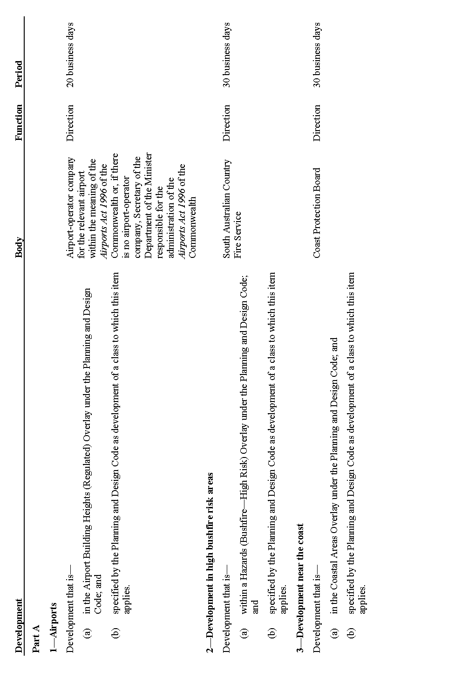
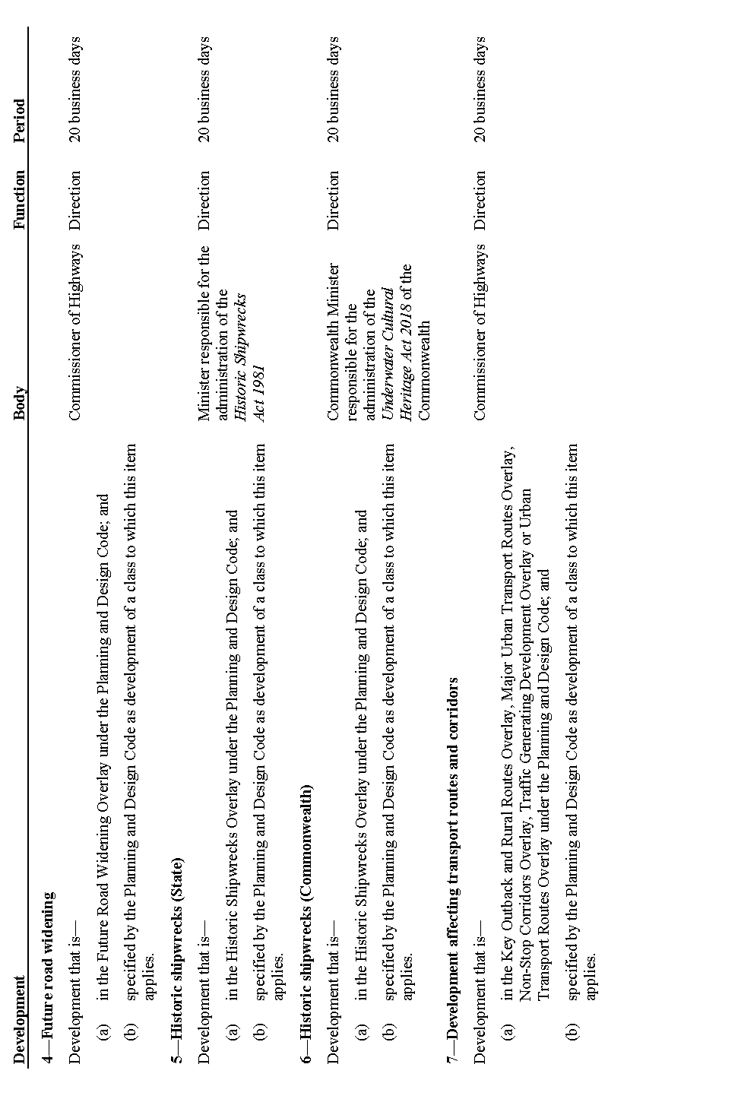
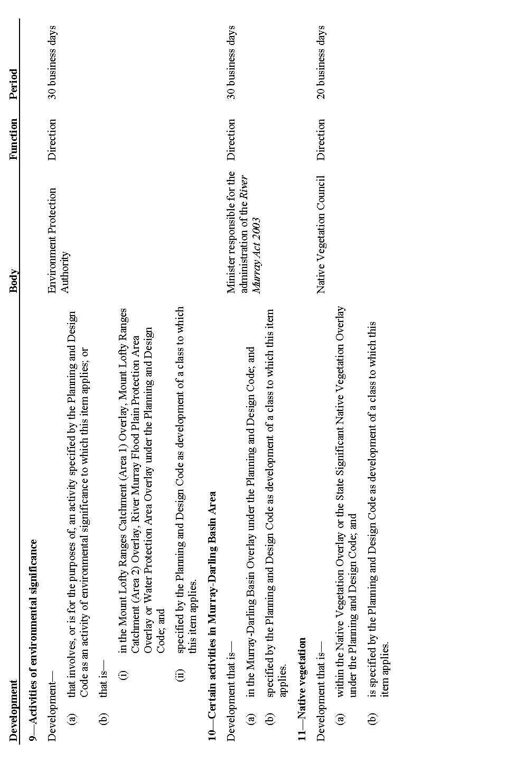
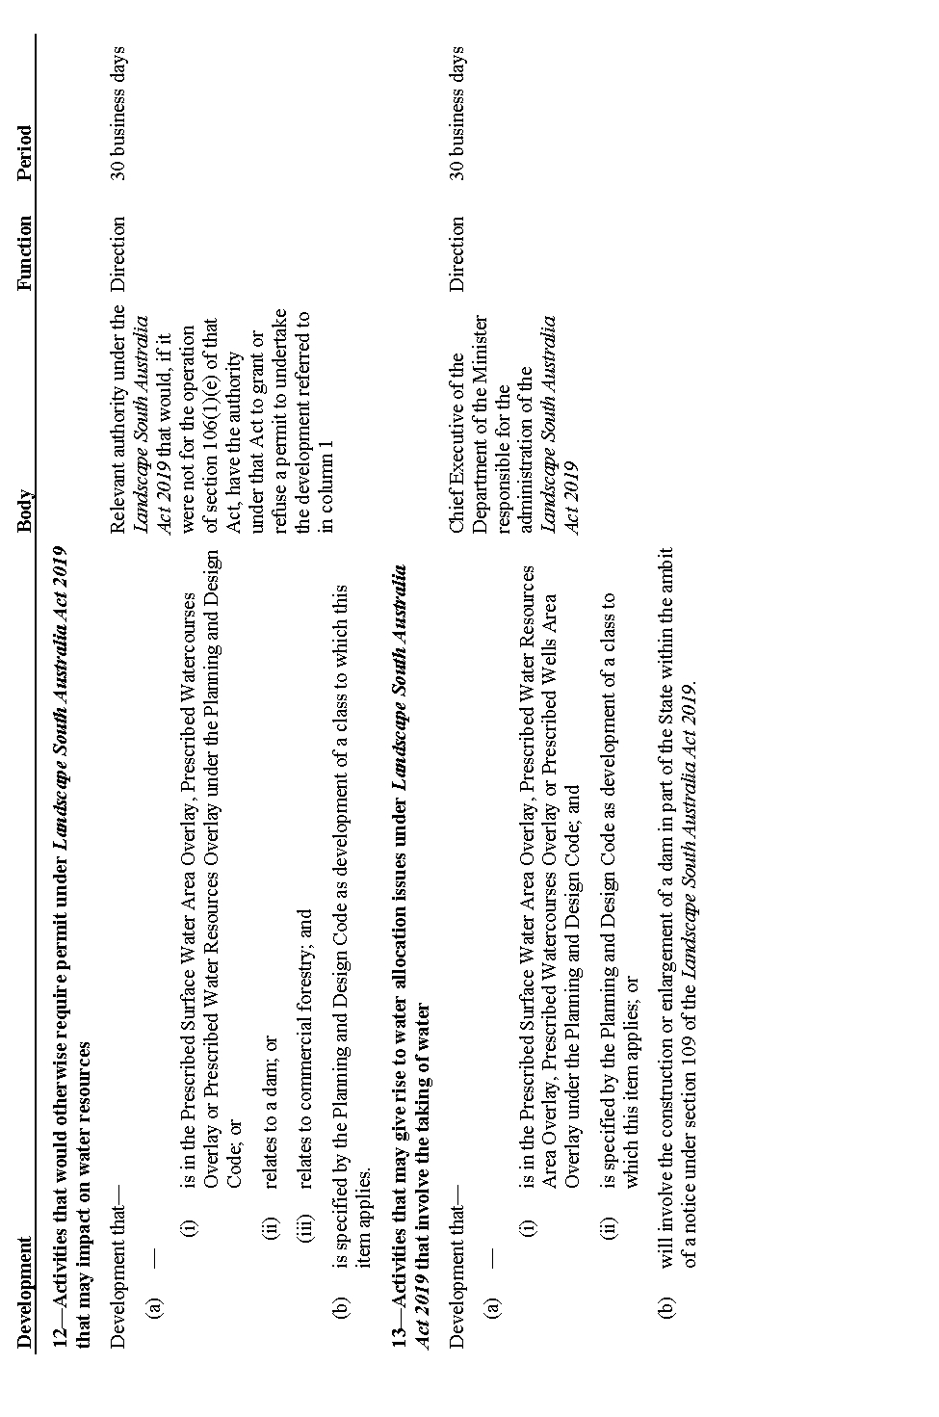
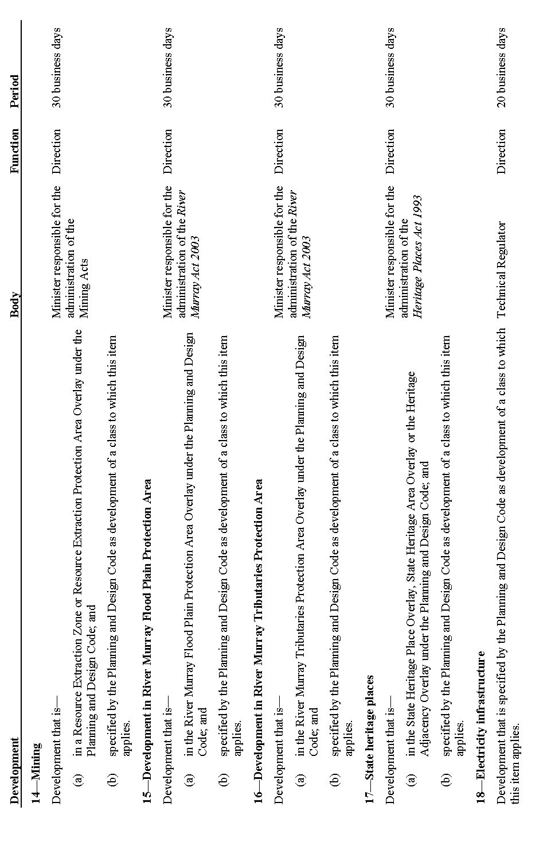
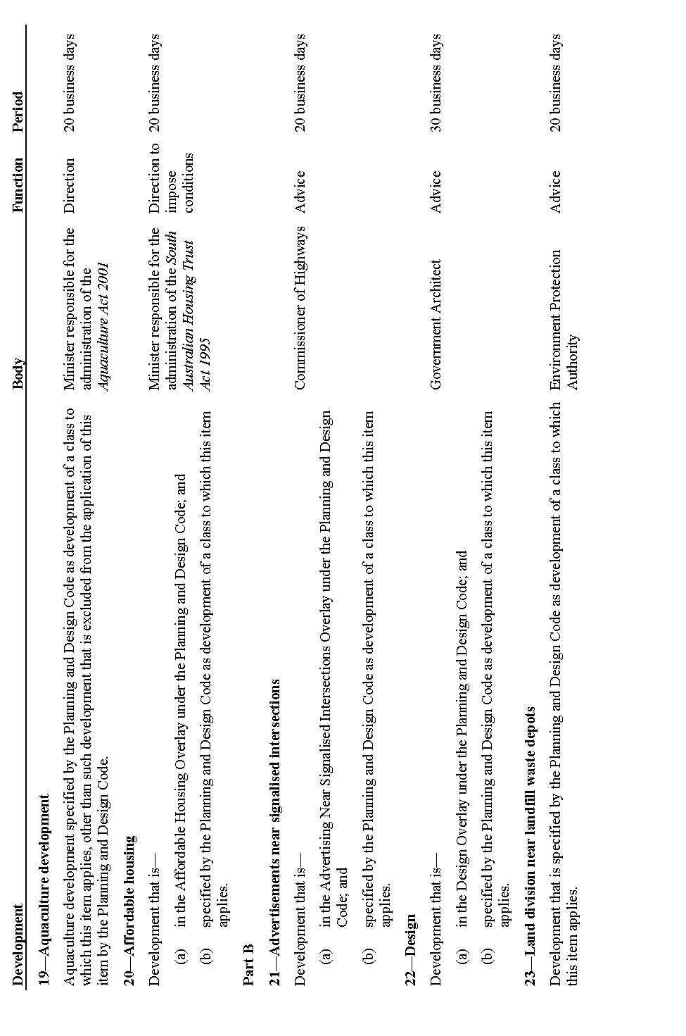
32—Insertion of Schedules 10A and 10B
After Schedule 10 insert:
Schedule 10A—Building work affecting stability—prescribed form
Form 1—Initial notice to owner of affected site
Planning, Development and Infrastructure Act 2016—section 139(2)(a)
To: [Insert details of owner]
The following building work will be to performed on the affected site: [Insert details of building work, including description of the nature of the building work]
The building work is intended to commence on: [Insert date of commencement]
The building work is intended to be completed on: [Insert date of completion]
TAKE NOTICE that access to the affected site may be required in accordance with section 139(2) and (3) of the Planning, Development and Infrastructure Act 2016 [Insert details of section 139(2) and (3)]
Signed:
Date:
Schedule 10B—Access to neighbouring land—prescribed form
Form 1—Access to neighbouring land
Planning, Development and Infrastructure Act 2016—section 140(3)
To: [Insert details of owner of adjoining allotment]
Request for access to adjoining allotment [Insert details required under section 140(3) of the Planning, Development and Infrastructure Act 2016]
Reason for which access is sought:
Time at which, or period for which, access is sought:
Details of—
(a) person proposed to be entering:
(b) what they would bring with them:
(c) what activity or work would be carried out:
Signed:
Date:
Note—
As required by section 10AA(2) of the Subordinate Legislation Act 1978, the Minister has certified that, in the Minister's opinion, it is necessary or appropriate that these regulations come into operation as set out in these regulations.
Made by the Governor
being satisfied that provisions about the policy or policies that each body prescribed for the purposes of section 122 of the Act will seek to apply in connection with the operation of that section have been included in the Planning and Design Code, or that the Minister has provided an indication under section 122(2)(b) of the Act in a relevant case, with the advice and consent of the Executive Council
on 24 September 2020
No 280 of 2020

South Australia

Planning, Development and Infrastructure (General) (Planning and Development Fund) Variation Regulations 2020
under the Planning, Development and Infrastructure Act 2016

Contents
Part 1—Preliminary
1 Short title
2 Commencement
3 Variation provisions
Part 2—Variation of Planning, Development and Infrastructure (General) Regulations 2017
4 Variation of regulation 119—Application of Fund

Part 1—Preliminary
1—Short title
These regulations may be cited as the Planning, Development and Infrastructure (General) (Planning and Development Fund) Variation Regulations 2020.
2—Commencement
These regulations come into operation on the day on which they are made.
3—Variation provisions
In these regulations, a provision under a heading referring to the variation of specified regulations varies the regulations so specified.
Part 2—Variation of Planning, Development and Infrastructure (General) Regulations 2017
4—Variation of regulation 119—Application of Fund
Regulation 119—delete "a public work or public purpose that promotes or complements a policy or strategy contained in a state planning policy is authorised as a purpose for which the Planning and Development Fund may be applied." and substitute:
the Planning and Development Fund may be applied for the following purposes:
(a) a public work or public purpose that promotes or complements a policy or strategy contained in a state planning policy;
(b) the establishment (in connection with the object set out in section 12(2)(b) of the Act) of a system that enables people who use or interact with the planning system to access planning information, and to undertake processes and transactions, by digital means.
Note—
As required by section 10AA(2) of the Subordinate Legislation Act 1978, the Minister has certified that, in the Minister's opinion, it is necessary or appropriate that these regulations come into operation as set out in these regulations.
Made by the Governor
with the advice and consent of the Executive Council
on 24 September 2020
No 281 of 2020

Rules of Court
South Australia

Supreme Court of South Australia Probate Rules 2015
(Amendment No 2)
By virtue and in pursuance of section 72 of the Supreme Court Act 1935, section 122 of the Administration and Probate Act 1919 and all other enabling powers, we, Judges of the Supreme Court make the following Supreme Court of South Australia Probate Rules 2015 (Amendment No 2).
1. These Rules may be cited as the Supreme Court of South Australia Probate Rules (Amendment No 2).
2. The amendments made by these rules come into effect on the later of—
(a) 1 October 2020; or
(b) the date of their publication in the Gazette.
3. The Supreme Court of South Australia Probate Rules 2015 are amended as set out below.
4. In subrule 3(1)(b), the definition of “General Civil Rules” is amended by substituting the words “Uniform Civil Rules 2020” for the words “Supreme Court Civil Rules 2006”.
5. In subrule 3(1)(b), the definition of “General Civil Supplementary Rules” is deleted.
6. In subrule 3(1)(b), the definition of “trust corporation” is amended by inserting the word “special” between the words “other” and “Act”.
7. Subrule 4A(6) is amended by substituting the words “General Civil Rules” for the words “Supreme Court Civil Rules 2006”.
8. Subrule 5(2) is amended by deleting the words “and the General Civil Supplementary Rules”.
9. Subrule 5(3) and subrule 5(4) are amended by deleting the words “or the General Civil Supplementary Rules”.
Dated this 17th day of September 2020
Chief Justice Kourakis
Justice Blue
Justice Doyle

State Government Instruments

Aerodrome Fees Act 1998
Arrival and Departure Fees at the Marla Aerodrome
Outback Communities Authority
NOTICE is hereby given that, pursuant to the Aerodrome Fees Act 1998, the Outback Communities Authority hereby advises that Arrival and Departure Fees at the Marla Aerodrome (YALA) are fixed as follows and are effective from 1 August 2020:
1. Landing Fees
General Aviation Landing Fee - $15.50/tonne for fixed wing aircraft. Minimum charge, $21.00
General Aviation Landing Fee - $21.00 flag fall for all helicopters
Note - all above fees are GST exclusive
Dated: 24 September 2020
Byron Gough
Governance Manager
Outback Communities Authority

Aerodrome Fees Act 1998
Arrival and Departure Fees at the Oodnadatta Aerodrome
Outback Communities Authority
NOTICE is hereby given that, pursuant to the Aerodrome Fees Act 1998, the Outback Communities Authority hereby advises that Arrival and Departure Fees at the Oodnadatta Aerodrome (YOOD) are fixed as follows and are effective from 1 August 2020:
1. Landing Fees
General Aviation Landing Fee - $15.50/tonne for fixed wing aircraft. Minimum charge, $21.00
General Aviation Landing Fee - $21.00 flag fall for all helicopters
Note - all above fees are GST exclusive
Dated: 24 September 2020
Byron Gough
Governance Manager
Outback Communities Authority

Aerodrome Fees Act 1998
Arrival and Departure Fees at the Leigh Creek Aerodrome
Outback Communities Authority
NOTICE is hereby given that, pursuant to the Aerodrome Fees Act 1998, the Outback Communities Authority hereby advises that Arrival and Departure Fees at the Leigh Creek Aerodrome (YLEC) are fixed as follows and are effective from 1 August 2020:
1. Landing Fees
General Aviation Landing Fee - $15.50/tonne for fixed wing aircraft. Minimum charge, $21.00
General Aviation Landing Fee - $21.00 flag fall for all helicopters
Note - all above fees are GST exclusive
Dated: 24 September 2020
Byron Gough
Governance Manager
Outback Communities Authority

Crown Land Management Act 2009
Section 59
Applications to Lease Waterfront Crown Land—Public Notice
Notice is hereby given, pursuant to Section 59 of the Crown Land Management Act 2009 that the Minister for Environment and Water is considering individual applications for long term leases over up to 40 existing shack sites and 6 boat shed sites located along the Glenelg River, near Donovans, South Australia. The leases are being considered for a cumulative period not greater than 50 years. The sites under consideration are listed in the Schedule below.
Schedule
Hundred of Caroline
The whole of the land in Sections 795, 797, 798, 799, 800, 801, 802, 803, 808, 809, 810, 813, 816, 818, 822, 823, 838, 840, 841, 843, 845, 846, 847, 848, 852, 853, 856, 863, 865, 867, 868, 870, 874, 884, 891, 894, 895, 899, 903, 909, 911, 912, 914, 916, 918 and 922.
Written comments regarding the proposed leases are invited and may be submitted for consideration by the Minister for Environment and Water no later than Wednesday 21 October 2020.
Correspondence may be addressed to:
By Post DEW Shacks Team
GPO Box 1047
ADELAIDE SA 5001
By Email DEWshacks@sa.gov.au
Dated 21 September 2020
Michael Williams
Executive Director National Parks and Wildlife Service
as Delegate under the Crown Land Management Act 2009

Education and Children’s Services Regulations 2020
Notice of Policy by the Minister for Education
PURSUANT to Regulation 12(1) of the Education and Children’s Services Regulations 2020, I, the Minister for Education publish a policy for the purposes of the enrolment of a child at Unley High School:
School Zone
Unley High School
A school zone is a defined area from which the school accepts its core intake of students. The school zone for Unley High School, effective for enrolments from 27 January 2021, is within the area bordered by the black line on the map below. Students residing within this zone are eligible to be enrolled at Unley High School and will be given priority enrolment.
An online map of the Unley High School zone and a search tool to indicate if a home address is within the school zone is available at www.education.sa.gov.au/findaschool.
Information on enrolment and placement in school is available from www.education.sa.gov.au/enrolment.
Dated: 22 September 2020
John Gardner
Minister for Education

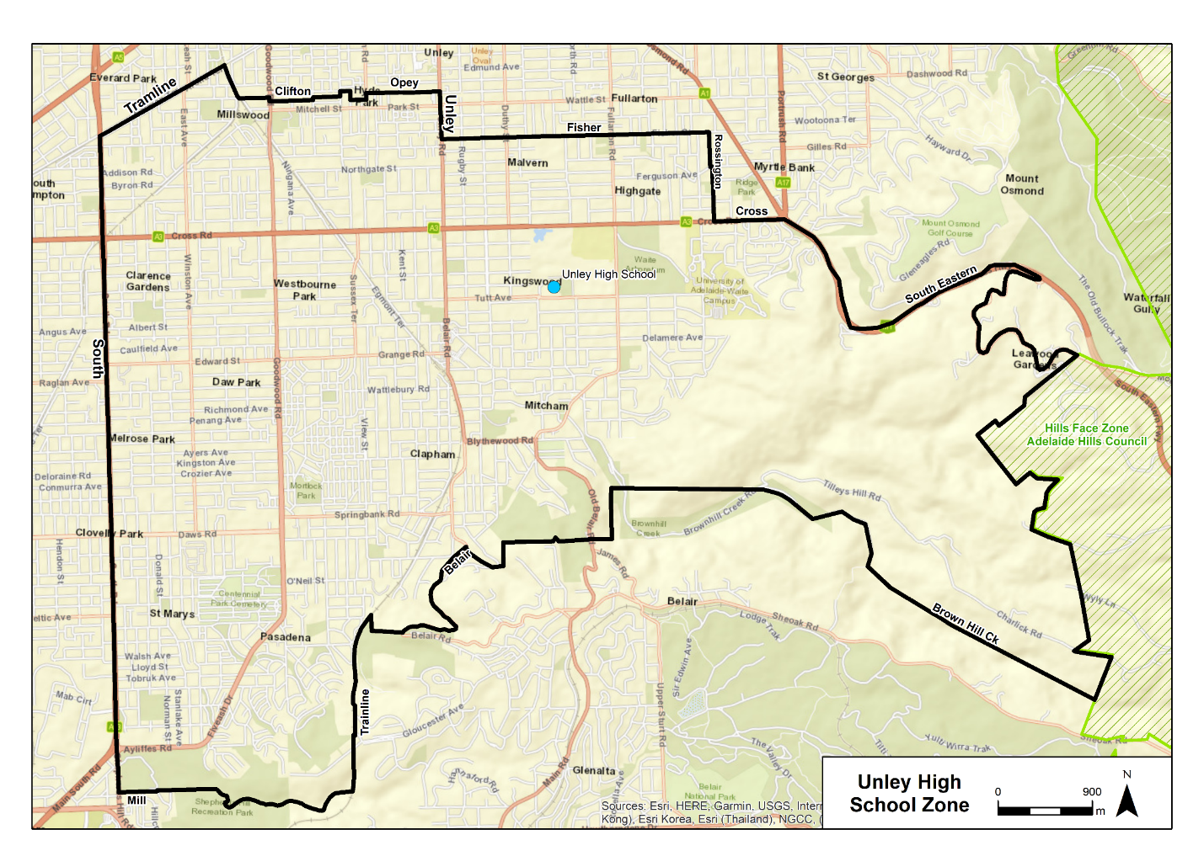

Electricity Act 1996
Export Limits for Electricity Generating Plant
Designated Electricity Generating Plant
Pursuant to regulation 55E(9) of the Electricity (General) Regulations 2012 under the Electricity Act 1996, I hereby designate electricity generating plant that is, or is to be, connected to a relevant distribution network through a low voltage inverter as a designated electricity generating plant for the purposes of regulation 55E.
This notice will take effect on 28 September 2020.
Dan Van Holst Pellekaan
Minister for Energy and Mining

Electricity Act 1996
Export Limits for Electricity Generating Plant
Excluded Distribution Network
Pursuant to regulation 55E(10) of the Electricity (General) Regulations 2012 under the Electricity Act 1996, I hereby declare that a distribution network operated by the named entities in the named locations to be an excluded distribution network for the purposes of regulation 55E:
• Australian Rail Track Corp - Tarcoola
• Cowell Electricity Supply Pty Ltd - Amata, Blinman, Cockburn, Glendambo, Indulkana, Kalka, Kaltjiti, Kanpi, Kingoonya, Mannahill, Marla, Maree, Mimili, Murputja, Nundroo, Nyapari, Oak Valley, Oodnadatta, Parachilna, Pipalyatjara, Pukatja, Umuwa, Watinuma, Yalata, Yunyarinyi, Iron Knob, Pimba, Anangu Pitjantjara Yunkunytjatara, Maralinga Tjarutja, Aboriginal Lands Trust, Umuwa
• Dalfoam Pty Ltd - Yunta
• District Council of Coober Pedy – Coober Pedy
• Enerven Energy Infrastructure Pty Ltd – at and near Woomera and Pimba
• Epic Energy South Australia Pty Ltd – State-wide provided it is related to or in connection with the Moomba to Adelaide gas pipeline operations.
• IBA Wilpena Solar Pty Ltd – Wilpena Pound
• Jeril Enterprises Pty Ltd - Andamooka
• Santos Limited – at or near Moomba
• Transfield Services (Australia) Pty Ltd – Cook and Tarcoola
This notice will take effect on 28 September 2020.
Robert Faunt
Technical Regulator

Electricity Act 1996
Remote Disconnection and Reconnection of Electricity Generating Plant
Excluded Distribution Network
Pursuant to regulation 55B(11) of the Electricity (General) Regulations 2012 under the Electricity Act 1996, I hereby declare that a distribution network operated by the named entities in the named locations to be an excluded distribution network for the purposes of regulation 55B:
• Australian Rail Track Corp - Tarcoola
• Cowell Electricity Supply Pty Ltd - Amata, Blinman, Cockburn, Glendambo, Indulkana, Kalka, Kaltjiti, Kanpi, Kingoonya, Mannahill, Marla, Maree, Mimili, Murputja, Nundroo, Nyapari, Oak Valley, Oodnadatta, Parachilna, Pipalyatjara, Pukatja, Umuwa, Watinuma, Yalata, Yunyarinyi, Iron Knob, Pimba, Anangu Pitjantjara Yunkunytjatara, Maralinga Tjarutja, Aboriginal Lands Trust, Umuwa
• Dalfoam Pty Ltd - Yunta
• District Council of Coober Pedy – Coober Pedy
• Enerven Energy Infrastructure Pty Ltd – at and near Woomera and Pimba
• Epic Energy South Australia Pty Ltd – State-wide provided it is related to or in connection with the Moomba to Adelaide gas pipeline operations.
• IBA Wilpena Solar Pty Ltd – Wilpena Pound
• Jeril Enterprises Pty Ltd - Andamooka
• Santos Limited – at or near Moomba
• Transfield Services (Australia) Pty Ltd – Cook and Tarcoola
This notice will take effect on 28 September 2020.
Robert Faunt
Technical Regulator

Electricity Act 1996
Remote Disconnection and Reconnection of Electricity Generating Plant
Designated Electricity Generating Plant
Pursuant to regulation 55B(10) of the Electricity (General) Regulations 2012 under the Electricity Act 1996, I hereby designate solar photovoltaic systems connected to a relevant distribution network as a designated electricity generating plant for the purposes of regulation 55B.
This notice will take effect on 28 September 2020.
Dan Van Holst Pellekaan
Minister for Energy and Mining

Electricity Act 1996
Remote Disconnection and Reconnection of Electricity Generating Plant
Designated Electricity Generating Plant
Pursuant to regulation 55B(12) of the Electricity (General) Regulations 2012 under the Electricity Act 1996, I hereby specify 28 September 2020 as the prescribed day for the purposes of regulation 55B(2).
This notice will take effect on 28 September 2020.
Dan Van Holst Pellekaan
Minister for Energy and Mining

Geographical Names Act 1991
For Public Consultation
Notice of Intention to Assign a Name to a Building
NOTICE is hereby given pursuant to the provisions of the above Act, that the Attorney-General seeks public comment on a proposal to:-
1. Assign the name of Marnirni-apinthi to the building currently identified as Allied Health Building located within Lot Fourteen, North Terrace, Adelaide.
Submissions in writing regarding this proposal may be lodged with the Surveyor-General, GPO Box 1354, Adelaide SA 5001, within 28 days of the publication of this notice.
Copies of the plan for this naming proposal can be viewed at;
• the Office of the Surveyor-General, 101 Grenfell Street, Adelaide
• the Land Services website at www.sa.gov.au/placenameproposals
Dated: 24 September 2020
Michael Burdett
Surveyor-General
Attorney-General’s Department
DPTI 2020/16166/01

HOUSING IMPROVEMENT ACT 2016
Rent Control Revocations
Whereas the Minister for Human Services Delegate is satisfied that each of the houses described hereunder has ceased to be unsafe or unsuitable for human habitation for the purposes of the Housing Improvement Act 2016, notice is hereby given that, in exercise of the powers conferred by the said Act, the Minister for Human Services Delegate does hereby revoke the said Rent Control in respect of each property.
Address of Premises | Allotment Section | Certificate of Title  Volume/Folio
48 Gosfield Crescent, Hampstead Gardens  SA 5086 | Allotment 299 Deposited Plan 3045 Hundred of Yatala | CT5573/334
2 Moonta Street, Wallaroo SA 5556 | Allotment 60 Filed Plan 38100 Wallaroo | CT 5403/628
Dated: 24 September 2020
Craig Thompson
Acting Housing Regulator and Registrar
Housing Safety Authority, SAHA
Delegate of Minister for Human Services

Land Acquisition Act 1969
(Section 16)
Form 5—Notice of Acquisition
1. Notice of acquisition
The Commissioner of Highways (the Authority), of 50 Flinders Street, Adelaide SA 5000, acquires the following interests in the following land:
Comprising an unencumbered estate in fee simple in that piece of land being the whole of Allotment 14 in Deposited Plan No 3266 comprised in Certificate of Title Volume 5789 Folio 268.
This notice is given under section 16 of the Land Acquisition Act 1969.
2. Compensation
A person who has or had an interest consisting of native title or an alienable interest in the land that is divested or diminished by the acquisition or the enjoyment of which is adversely affected by the acquisition who does not receive an offer of compensation from the Authority may apply to the Authority for compensation.
2A. Payment of professional costs relating to acquisition (section 26B)
If you are the owner in fee simple of the land to which this notice relates, you may be entitled to a payment of $10 000 from the Authority for use towards the payment of professional costs in relation to the acquisition of the land.
Professional costs include legal costs, valuation costs and any other costs prescribed by the Land Acquisition Regulations 2019.
3. Inquiries
Inquiries should be directed to:

Rob Gardner
GPO Box 1533
Adelaide, SA 5001
Phone: (08) 8343 2567
Dated: 21 September 2020
The Common Seal of the COMMISSIONER OF HIGHWAYS was hereto affixed by authority of the Commissioner in the presence of:
Rocco Caruso
Manager, Property Acquisition
Authorised Officer
Department for Infrastructure and Transport
DIT 2019/18686/01

LIVESTOCK ACT 1997
Section 33
Prohibition of Entry into and Movement within South Australia of
Decapod Crustaceans (Order Decapoda) and Polychaete Worms (Class Polychaeta)
PURSUANT to Section 87 of the Livestock Act 1997, I, Mary Ruth Carr, Chief Inspector of Stock, delegate of the Minister for Primary Industries and Regional Development, revoke the notice made by the Minister for Primary Industries and Regional Development pursuant to section 37 of the Livestock Act 1997 on 13 September 2019, published in the Gazette on 19 September 2019 at p.3318.
PURSUANT to Section 33 of the Livestock Act 1997 and for the purposes of controlling and eradicating White Spot Disease, an exotic disease of decapod crustaceans, I, Mary Ruth Carr, Chief Inspector of Stock, delegate of the Minister for Primary Industries and Regional Development, prohibit the entry into, and movement within, South Australia of:
- live or dead decapod crustaceans and/or polychaete worms, whether wild-caught or cultivated, originating from, or which have moved through, the Queensland White Spot Disease movement restriction area as described in Schedule 1 of this Notice; and
- fittings used in connection with cultivation or commercial catch of decapod crustaceans or polychaete worms described in subclause (1); and
- live or dead decapod crustaceans and/or polychaete worms, not being decapod crustaceans or polychaete worms described in subclause (1), that have been in contact with any of the following:
- live or dead decapod crustaceans or polychaete worms described in subclause (1); or
- water that had previously held live or dead decapod crustaceans or polychaete worms described in subclause (1); or
- fittings that had previously been used in connection with decapod crustaceans or polychaete worms described in subclause (1),
except to the extent, and subject to the conditions, set out in Parts A to F below. Except as expressly provided, the exceptions in Parts A to F are independent of one another.
Part A: cooked decapod crustaceans for human consumption
The entry into, and movement within, South Australia of dead decapod crustaceans described in subclause (1) or subclause (3) above is permitted if:
  - they have been processed as cooked product before entering South Australia; and
  - they were securely packaged upon being processed as cooked product and remain so at the time of entering South Australia and thereafter until after they have been delivered to a point of sale in South Australia; and
  - upon entering South Australia they are transported directly to a point of sale in South Australia.
Part B: uncooked decapod crustaceans for human consumption
The entry into, and movement within, South Australia of uncooked dead decapod crustaceans which originated from outside the Queensland White Spot Disease movement restriction area but have moved through the Queensland White Spot Disease movement restriction area is permitted if:
- they were moved through the Queensland White Spot Disease movement restriction area in sealed bins, containers or packaging and remain in the secured bins, containers or packaging at the time of entering South Australia and thereafter until after they have been delivered to a point of sale in South Australia and sold for human consumption; and
- the name, address, postcode and State or Territory of the grower and/or the commercial fisher and the packer are clearly displayed on the outer surface of each individual bin, container or packaging; and
- upon entering South Australia they are transported directly to a point of sale in South Australia for human consumption.
Part C: gamma irradiated product for processing and/or distribution as fishing bait
The entry into, and movement within, South Australia of uncooked dead decapod crustaceans or polychaete worms originating from, or which have moved through, the Queensland White Spot Disease movement restriction area (in Parts C and D, “the product”) is permitted if:
- the product was subject to gamma irradiation treatment within the Queensland White Spot Disease movement restriction area; and
- upon entering South Australia, the product is transported directly to a processing/distribution facility; and
- an inspector is notified no less than 48 business hours prior to the planned time of arrival of the product at the processing/ distribution facility of:
  - the name, address and contact details (telephone and email) of the person importing the product into South Australia; and
  - the description of the product including species, weight, type of packaging and number of packages; and
  - the estimated date and time of arrival of the product; and
- the product did not come into contact with any untreated decapod crustaceans or polychaete worms described in subclause (1) or subclause (3) above after the gamma irradiation treatment; and
- the product is moved into South Australia and transported to the processing/distribution facility:
  - in refrigerated transport; and
  - in sealed containers that only contain individually sealed packets of gamma irradiated product that are labelled with:
    - date of capture, and
    - origin of capture, and
    - the symbols “50kGy” to indicated the product was irradiated with this dose, and
    - the relevant gamma irradiation lot number,
and the outer containers are clearly marked as containing gamma irradiated product; and
  - accompanied by a copy of the relevant Certificate of Irradiation; and
  - as soon as possible after the arrival of the product at the processing/distribution facility, the SA Chief Inspector of Stock is informed in writing via email by the first person receiving the product in South Australia of the date and time of the arrival of the product at its destination (email details of SA Chief Inspector of Stock: pirsa.biosecuritysa@sa.gov.au); and
- unless sold by retail at the processing/distribution facility for use as fishing bait in the individually sealed packets in which it was transported there, or intended for distribution in the individually sealed packets in which it was transported to the processing/distribution facility, the product is processed and/or packaged at the processing/distribution facility for distribution for use as fishing bait in accordance with the requirements of Part D; and
- unless sold by retail at the processing/distribution facility for use as fishing bait, either in the individually sealed packets in which it was transported there or, as applicable, in the individual containers into which it was finally packaged there, the product is transported directly from the processing/distribution facility to a retail point of sale in South Australia for use as fishing bait; and
- the product to which Part C paragraph (g) applies is transported to the point of sale either in the individually sealed packets in which it was transported to the processing/distribution facility, or, as applicable, in the containers into which it was finally packaged there, and in either case remains in the applicable packaging until sold by retail; and
- the product is accompanied at all times by documentation that contains a statement to the effect that the product originated from the Queensland White Spot Disease movement restriction area and as a result, must be dealt with in accordance with the requirements in Part C paragraphs (a) to (i) and Part D paragraphs (a) to (d) of this Notice.
Part D: requirements for processing and packaging
The requirements that apply for the purposes of Part C paragraph (f) are that:
- the product remains identifiable with appropriate marks on containers and boxes with the lot number allocated to the product by the Treatment Facility and with the name of the Treatment Facility; and
- a copy of the Certificate of Irradiation is kept with the product at all times prior to it being finally packaged; and
- (without limiting paragraph (a)) each individual container into which the product is finally packaged is clearly labelled with:
  - the name of the Treatment Facility; and
  - the relevant lot number; and
  - the details of the volume of product that was irradiated in that lot; and
  - the symbols “50kGy” to indicate that the product was irradiated with this dose; and
- any waste product produced during processing or packaging (for example, water or organic matter) is disposed of to either the public sewer (for water) or to a Waste Depot (for waste other than water).
Part E: cleaned and disinfected fittings
The entry into, and movement within, South Australia of fittings used in connection with cultivation or commercial catch of decapod crustaceans or polychaete worms described in subclause (1) is permitted on the condition that:
- the fittings have been cleaned and disinfected to remove all traces of live or dead decapod crustaceans or polychaete worms; and
- a record of the cleaning date is made available to an inspector upon request.
Part F: product previously coming into contact with cleaned and disinfected fittings
The entry into, and movement within, South Australia of live or dead decapod crustaceans or polychaete worms, not being decapod crustaceans or polychaete worms described in subclause (1), (in Part G, “the product”) that have been in contact with fittings that had previously been used in connection with decapod crustaceans or polychaete worms described in subclause (1) is permitted on the condition that:
- the fittings had been cleaned and disinfected to remove all traces of live or dead decapod crustaceans or polychaete worms before the product was in contact with the fittings; and
- a record of the cleaning date is made available to an inspector upon request.
Definitions
In this Notice:
Certificate of Irradiation, in relation to a product, means a certificate that:
- certifies that gamma irradiation treatment was applied to the product at the Treatment Facility on the date stated on the certificate; and
- bears an individual lot number assigned by the Treatment Facility; and
- describes the product that was treated including the species and total weight of the product; and
- is signed by an employee of the Treatment Facility who is authorised to sign the certificate on behalf of the Treatment Facility.
Cleaned and disinfected means to clean and disinfect in accordance with the Queensland Department of Agriculture and Fisheries Recommended procedure for decontaminating fishing apparatus and vessels which can be found at www.daf.qld.gov.au/business-priorities/biosecurity/animal-biosecurity-welfare/animal-health-pests-diseases/a-z-list-of-significant-animal-pests-and-diseases/white-spot-disease/decontamination
Cooked product means product comprising or containing decapod crustaceans that has been cooked, in premises approved by and under the control of the relevant state government agency that regulates food safety, to a minimum time and temperature standard where all the protein in the decapod crustaceans is coagulated and no uncooked meat remains.
Decapod crustacean means any crustacean of the Order Decapoda and includes, but is not limited to school, tiger and banana prawns, yabbies or pink nippers, shrimp, slipper lobsters, crabs and hermit crabs.
Exotic disease has the same meaning as in the Livestock Act 1997.
Gamma irradiation treatment means treatment by irradiation at a gamma irradiation dose of at least 50 kilo Gray (kGy).
Gamma irradiated product means product treated by irradiation at a gamma irradiation dose of at least 50 kilo Gray (kGy).
Inspector means an inspector appointed under the Livestock Act 1997.
Point of sale means a place at which product is processed and/or sold, whether by wholesale or retail, on a commercial basis.
Polychaete worm means any worm of the Class Polychaeta and includes, but is not limited to, bristle worms.
Processing/distribution facility means a facility in South Australia which undertakes the processing and/or on-selling of uncooked decapod crustaceans and/or polychaete worms that have been subject to gamma irradiation treatment within the Queensland White Spot Disease movement restriction area for use as fishing bait.
Public sewer means a sewer operated by a council or any other authority established under the Local Government Act 1999, a water supply authority (within the meaning of the Water Industry Act 2012), a State owned corporation (South Australian Water Corporation Act 1994 or a subsidiary of such a corporation) or any other public or local authority.
Treatment Facility means a treatment facility that applies gamma irradiation treatment to decapod crustaceans and/or polychaete worms.
Waste Depot means a place at which waste may be treated or stored in accordance with an approval under the Local Government Act 1999 or a place approved as a Waste Depot or waste facility under any other Act.
White Spot Disease means the disease that is caused by the virus Whispovirus (Family Nimaviridae), also known as infection with white spot syndrome virus.
A reference to dead animals of a particular kind includes a reference to parts of animals of that kind and to a product consisting of parts of, or which is derived from, animals of that kind.
Schedule 1
- The Queensland White Spot Disease movement restriction area comprises that portion of the State of Queensland, as currently defined in the Queensland Department of Agriculture and Fisheries Notice of Establishment of Biosecurity Areas within the White Spot Biosecurity Zone and Lesser Restrictions for the Biosecurity Areas (Section 94B of the Biosecurity Regulation 2016 and section 129(1)(c) of the Biosecurity Act 2014), made on July 5 2017, as the area within the White Spot Biosecurity Zone outside Biosecurity Area 1.
- The Queensland Department of Agriculture and Fisheries Notice of Establishment of Biosecurity Areas within the White Spot Biosecurity Zone and Lesser Restrictions for the Biosecurity Areas (Section 94B of the Biosecurity Regulation 2016 and section 129(1)(c) of the Biosecurity Act 2014) can be found at www.daf.qld.gov.au/__data/assets/file/0006/1258746/notice-establishment-biosecurity-areas.pdf and published on the Queensland Department of Agriculture and Fisheries website www.daf.qld.gov.au/business-priorities/biosecurity/animal-biosecurity-welfare/animal-health-pests-diseases/a-z-list-of-significant-animal-pests-and-diseases/white-spot-disease
A map of the above-described zones can be found at either www.daf.qld.gov.au/business-priorities/biosecurity/animal-biosecurity-welfare/animal-health-pests-diseases/a-z-list-of-significant-animal-pests-and-diseases/white-spot-disease
or at www.pir.sa.gov.au/biosecurity/aquatics/aquatic_diseases/white_spot_disease
Note: Any decapod crustaceans or polychaete worms originating from, or which have moved through, the Queensland White Spot Disease movement restriction area are likely to be subject to a permit or other regulatory requirement under Queensland law. The requirements in this Notice apply within South Australia and are separate and additional to any regulatory requirements under Queensland law.
This Notice will remain in force (as it may be varied from time to time by subsequent Notice) until revoked by subsequent Notice.
Dated: 21 September 2020
Mary Ruth Carr
Chief Inspector of Stock
Delegate of the Minister for Primary Industries and Regional Development

MENTAL HEALTH ACT 2009
Authorised Mental Health Professional
NOTICE is hereby given in accordance with Section 94(1) of the Mental Health Act 2009, that the Chief Psychiatrist has determined the following persons as an Authorised Mental Health Professional:
Leon Tymko
Ian Bishop
Josephien Rio
Peter Rio
Geevar Paul
Nadia Daminato
Valary Elliott
Elizabeth McHugh
Nick Burt
A person’s determination as an Authorised Mental Health Professional expires three years after the commencement date.
Dated: 24 September 2020
Dr J Brayley
Chief Psychiatrist

Mining Act 1971
Section 28(5)
Exploration Licences
Notice is hereby given in accordance with Section 28(5) of the Mining Act 1971 that the delegate of the Minister for Energy and Mining intends to grant Exploration Licences over the areas described below.
Applicant: Rifle Resources Pty Ltd
Location: Melton Station area - approximately 30km northwest of Yunta
Pastoral Leases: Melton
Term: Two years
Area in km²: 162
Reference number: 2020/00108
Applicant: Renascor Resources Limited
Location: Malbooma Railway Station area - approximately 30km northwest of Tarcoola
Pastoral Leases: Wilgena, Mulgathing
Term: Two years
Area in km²: 32
Reference number: 2020/00110
Applicant: OZ Exploration Pty Ltd
Location: Anna Creek area - approximately 90km east-southeast of Coober Pedy
Pastoral Leases: Anna Creek
Term: Two years
Area in km²: 689
Reference number: 2020/00113
Applicant: Archimedes Consulting Pty Ltd; Antonio Belperio
Location: Stuarts Creek area - approximately 105km west of Marree
Pastoral Leases: Stuart Creek
Term: One year
Area in km²: 197
Reference number: 2020/00114
Applicant: SA Exploration Pty Ltd
Location: Outalpa area - approximately 220km east of Port Augusta
Pastoral Leases: Outalpa, Abminga, Waiwera, Oulnina, Weekeroo, Florina
Term: Two years
Area in km²: 342
Reference number: 2020/00115
Applicant: SA Exploration Pty Ltd
Location: Mount Victor Station area - approximately 170km northeast of Port Pirie
Pastoral Leases: Koonamore, Mount Victor, Florina, Winnininnie, Melton
Term: Two years
Area in km²: 206
Reference number: 2020/00116
Applicant: Rifle Resources Pty Ltd
Location: Melton Station area - approximately 25km northwest of Yunta
Pastoral Leases: Minburra, Koonamore, Winnininnie, Melton
Term: Two years
Area in km²: 444
Reference number: 2020/00118
Applicant: Indiana Resources Limited
Location: Mulgathing area - approximately 65km west of Tarcoola
Pastoral Leases: Wilgena, Mulgathing, Mobellla
Term: Two years
Area in km²: 889
Reference number: 2020/00119
Applicant: Indiana Resources Limited
Location: Bulgunnia area - approximately 50km north of Tarcoola
Pastoral Leases: Wilgena, Bulgunnia, McDouall Peak, Commonwealth Hill
Term: Two years
Area in km²: 992
Reference number: 2020/00120
Applicant: Rifle Resources Pty Ltd
Location: Minburra Plain area - approximately 45km west-northwest of Yunta
Pastoral Leases: Minburra, Melton
Term: Two years
Area in km²: 463
Reference number: 2020/00121
Applicant: SA Exploration Pty Ltd
Location: McDouall Peak area - approximately 90km northeast of Tarcoola
Pastoral Leases: Bulgunnia, Mount Eba, McDouall Peak
Term: Two years
Area in km²: 969
Reference number: 2020/00122
Plans and co-ordinates can be found on the Department for Energy and Mining website:
http://energymining.sa.gov.au/minerals/exploration/public_notices/exploration_licence_applications or by contacting Mineral Tenements on 08 8463 3103.
Community information on mineral exploration licence processes and requirements under the Mining Act 1971 is available from:
http://energymining.sa.gov.au/minerals/exploration/public_notices/exploration_licence_applications or hard copy on request to Mineral Tenements.
Dated: 24 September 2020
J Martin
Mining Registrar as delegate for the Minister for Energy and Mining
Department for Energy and Mining

Petroleum and Geothermal Energy Act 2000
Grant of Associated Activities Licence—AAL 285
(Adjunct to Petroleum Production Licence PPL 207)
Notice is hereby given that the undermentioned Associated Activities Licence has been granted with effect from 17 September 2020, under the provisions of the Petroleum and Geothermal Energy Act 2000, pursuant to delegated powers dated 29 June 2018.
No of Licence | Licensees | Locality | Area in km² | Reference
AAL 285 | Stuart Petroleum Pty Ltd | Cooper Basin | 4.18 | MER-2020/0239
AAL 285 covers an area of approximately 4.18 square kilometres located adjacent to petroleum production licence PPL 207 and situated southwest of Moomba in the South Australian Cooper Basin.
A map and GIS data for the application area is available from the Department for Energy and Mining website at the following location: https://map.sarig.sa.gov.au/ or by contacting the Department for Energy and Mining, Energy Resources Division on telephone (08) 8429 2559.
Dated: 17 September 2020
Barry A. Goldstein
Executive Director
Energy Resources Division
Department for Energy and Mining
Delegate of the Minister for Energy and Mining

Petroleum and Geothermal Energy Act 2000
Suspension of Petroleum Retention Licences—PRLs 78,79 and 80
Pursuant to section 90 of the Petroleum and Geothermal Energy Act 2000, notice is hereby given that the abovementioned Licences have been suspended for the period from 3 September 2020 until 2 September 2021 inclusive, pursuant to delegated powers dated 29 June 2018.
The expiry date of PRLs 78, 79 and 80 is now determined to be 22 April 2024.
Dated: 18 September 2020
Barry A. Goldstein
Executive Director
Energy Resources Division
Department for Energy and Mining
Delegate of the Minister for Energy and Mining

THE DISTRICT COURT OF SOUTH AUSTRALIA
Mount Gambier Circuit Court
Sheriff’s Office, Adelaide, 13 October 2020
IN pursuance of a precept from the District Court to me directed, I do hereby give notice that the said Court will sit as a Court of Oyer and Terminer and General Gaol Delivery at the Courthouse at Mount Gambier on the day and time undermentioned and all parties bound to prosecute and give evidence and all jurors summoned and all others having business at the said Court are required to attend the sittings thereof and the order of such business will be unless a Judge otherwise orders as follows:
Tuesday 13 Oct 2020 at 10 a.m. on the first day of the sittings the only business taken will be the arraignment of prisoners in gaol and the passing of sentences on prisoners in gaol committed for sentence; the surrender of prisoners on bail committed for sentence; the surrender of persons in response to ex officio informations or of persons on bail and committed for trial who have signified their intentions to plead guilty and the passing of sentences for all matters listed for disposition by the District Court.
Juries will be summoned for 13 Oct 2020 and persons will be tried on this and subsequent days of the sittings.
Prisoners in H.M. Gaol and on bail for sentence and for trial
at the sittings of the Mount Gambier Courthouse, commencing 13 Oct 2020.
Allen, John Malcolm |  | Maintaining an unlawful sexual relationship with a child; unlawful sexual intercourse with a person under 12 years; indecent assault | On bail
Barry, Daniel Luke |  | Causing death by dangerous driving; leave accident scene after causing death; aggravated driving without due care | On bail
Bates, Jessica Anne |  | Application for enforcement of a breached bond | On bail
Davies, Jason Scott |  | Trafficking in a controlled drug (19) | On bail
Davies, Trevor John |  | Maintaining an unlawful sexual relationship with a child; aggravated indecent assault | On bail
Dickinson, Robert Richard Peter |  | Commit theft using force; assault; theft | In gaol
F, B A |  | Maintaining an unlawful sexual relationship with a child; assault occasioning actual bodily harm | On bail
Kostera, Bradley John |  | Possess an unregistered firearm (5); contravene a provision of the code of practice – category c (5); possess firearm (not prescribed) without a licence (5) possess prescribed firearm without a licence | In gaol
McGregor, Chad Alexander |  | Assault (2); aggravated assault causing harm (2); aggravated assault (3); rape | In gaol
McIntosh, Emma |  | Application for enforcement of a breached bond | On bail
Melino, Henri Joseph |  | Escape from custody | In gaol
Melino, Henri Joseph |  | Application for enforcement of a breached bond | In gaol
Stewart, Trevor Francis |  | Causing death by dangerous driving (2) | On bail
Prisoners on bail must surrender at 10 a.m. of the day appointed for their respective trials. If they do not appear when called upon their recognizances and those of their bail will be estreated and a bench warrant will be issued forthwith.
By order of the Court,
S. Ferguson
Sheriff

Local Government Instruments

Rural City of Murray Bridge
Public Notice—Representation Review Paper
Notice is hereby given that the Rural City of Murray Bridge is undertaking a review to determine whether a change of arrangements are required in respect to elector representation, including ward boundaries and the composition of Council.
Report
Council has prepared a report which details the review process, public consultation undertaken and a proposal council considers could be carried into effect.
A copy of this report is available from:
- Council’s website http://www.murraybridge.sa.gov.au
- The Rural City of Murray Bridge Local Government Centre, 2 Seventh Street Murray Bridge – via email or in person
- The Library, Level 2 Murray Bridge Market Place 51 South Terrace, Murray Bridge
Written submissions
Written submissions are invited from interested persons from 24 September 2020 and should be provided in writing by no later than 16 October 2020 via:
- Council’s Let’s Talk site – letstalk.murraybridge.sa.gov.au
- email to council@murraybridge.sa.gov.au
- in writing addressed to:
Representation Review 2020
Chief Executive Officer
PO Box 421
MURRAY BRIDGE SA 5253
Any person(s) making a written submission will be invited to appear before a Special Meeting of Council to be held on Monday 12 October 2020 commencing at 5.30 pm to be heard in respect of their submission.
Information regarding the representation review can be obtained by contacting Ros Kruger on 85391407 or email r.kruger@murraybridge.sa.gov.au
Dated: 24 September 2020
Michael Sedgman
Chief Executive Officer

PORT AUGUSTA CITY COUNCIL
Alteration of Street Names Policy
The Port Augusta City Council, pursuant to Section 219 of the Local Government Act 1999 advises that at its meeting held on 12 February 2019 resolved to alter the ‘Street Names’ Policy 1.1.14. A copy of the revised policy is available on Council’s website www.portaugusta.sa.gov.au
Dated: 24 September 2020
J. Banks
Chief Executive Officer

CITY OF WHYALLA
Adoption of Valuations and Declaration of Rates 2020-2021
NOTICE is given that the City of Whyalla at a meeting of Council held on 14 September 2020, resolved for the financial year ending 30 June 2021 as follows:
Adoption of Valuations
Adopted the valuations as at 30 June 2020 of site value made by the Valuer-General for rating purposes for the year ending 30 June 2021. The total valuations for the area aggregate $754,211,100 of which $690,170,100 is the valuation of rateable land.
Declaration of Rates
Declared differential General Rates according to the locality of the land in various zones defined in the Development Plan, established pursuant to the Development Act 1993, and according to the use of the land, pursuant to Regulation 14(1) of the Local Government (General) Regulations 2013, the rate applies as follows:
(a) Locality and use of differentiating factors:
(i) In respect of all rateable land situated in the Commercial, District Centre, Local Centre, Town Centre, Open Space, Recreation and Caravan and Tourist Park Zones ,a differential general rate of 3.2328 cents in the dollar, excluding any land categorised as Residential and for which the general differential rate is declared in paragraph (b) hereunder;
(ii) In respect of all rateable land situated in the Industry, Light Industry and Deferred Industry Zones, a differential general rate of 3.2328 cents in the dollar, excluding any land categorised as Residential and for which the general differential rate is declared in paragraph (b) hereunder;
(iii) In respect of all rateable land situated in the Residential, Residential Character and Community Zones, a differential general rate of 1.2972 cents in the dollar, excluding any land categorised as Commercial-shop, Commercial-office, Commercial-other, Industry-light, Industry-other and Primary Production, and for which the general differential rate is declared in paragraph (b) hereunder;
(iv) In respect of all rateable land situated in the Rural Living Zone, a differential general rate of 0.4183 cents in the dollar, excluding any land categorised as Commercial-shop, Commercial-office, Commercial-other, Industry-light and Industry-other and for which the general differential rate is declared in paragraph (b) hereunder;
(v) In respect of all rateable land situated in the Special Industry (Hydrocarbons), a differential general rate of 22.3993 cents in the dollar, excluding any land categorised as Residential and Commercial-other and for which the general differential rate is declared in paragraph (b) hereunder;
(vi) In respect of all rateable land situated in the Coastal Settlement and Settlement Zones, a differential general rate of 0.2371 cents in the dollar, excluding any land categorised as Commercial-shop, Commercial-office, Commercial-other, Industry-light and Industry-other and for which the general differential rate is declared in paragraph (b) hereunder;
(vii) In respect of all rateable land situated in the Regional Centre Zone, a differential general rate of 4.1501 cents in the dollar, excluding any land categorised as Residential and for which the general differential rate is declared in paragraph (b) hereunder;
(viii) In respect of all rateable land situated in the Remote Area Zone, a differential general rate of 0.0131 cents in the dollar, excluding any land categorised as Residential, Commercial-shop, Commercial-office, Commercial-other, Industry-light and Industry-other and for which the general differential rate is declared in paragraph (b) hereunder;
(b) Land use as a differentiating factor in respect of all land not otherwise falling within paragraph (a) above, as follows:
(i) Residential – a differential general rate of 1.2972 cents in the dollar;
(ii) Commercial-shop – a differential general rate of 3.2328 cents in the dollar;
(iii) Commercial-office – a differential general rate of 3.2328 cents in the dollar;
(iv) Commercial-other – a differential general rate of 3.2328 cents in the dollar;
(v) Industry-light – a differential general rate of 3.2328 cents in the dollar;
(vi) Industry-other – a differential general rate of 3.2328 cents in the dollar;
(vii) Primary Production – a differential general rate of 0.0131 cents in the dollar;
(viii) Vacant Land – a differential general rate of 3.2328 cents in the dollar;
(ix) Other (any other land use not referred to in a previous category) – a differential general rate of 3.2328 cents in the dollar.
Fixed Charge
The Council imposes a fixed charge of $586.00 payable by way of General Rates on rateable land within the area of the Council for the year ending 30 June 2021.
Declaration of Separate Rates – Regional Landscape Levy
A separate rate based on a fixed charge and differentiated according to land use is declared on all rateable land within its area and within the area of the Eyre Peninsula Landscape Board for the purpose of the Regional Landscape Levy.
Residential | $79.15
Commercial | $118.72
Industrial | $118.72
Primary Producer | $158.30
Other/Vacant | $79.15
Note: The Regional Landscape Levy is collected on behalf of, and funds the operations of, the Eyre Peninsula Landscape Board.
Declaration of Service Charges
The Council imposes for the year ending 30 June 2021 an annual service charge of $350.00 on rateable land within its area for the provision of the service of collection, treatment and disposal of hard waste where such a service is provided.
Dated: 21 September 2020
K. Clark
Acting Chief Executive Officer

ADELAIDE HILLS COUNCIL
Roads (Opening and Closing) Act 1991
Road Opening and Closure—Stirling
Notice is hereby given, pursuant to Section 10 of the Roads (Opening and Closing) Act 1991, that, the Adelaide Hills Council proposes to make a Road Process Order to close a portion of Public Road, Pomona Road situated on the north side of Pomona Road approximately 340 metres east from Mount Barker Road and merge portion marked A with adjoining allotment 41 F158387, Hundred of Noarlunga, more particularly delineated “A” on Preliminary Plan 20/0038 and open a portion of allotment 41 F158387 numbered 1 on Preliminary Plan 20/0038 as Public Road, in exchange for the aforementioned road closure.
A copy of the plan and a statement of persons affected are available for public inspection at the Local Government Centre, 63 Mount Barker Road Stirling, and the office of the Surveyor-General 101 Grenfell Street, Adelaide during normal opening hours and from Councils website www.ahc.sa.gov.au.
Any application for easement or objection must be made in writing to the Council at PO Box 44 Woodside SA 5244 WITHIN 28 DAYS OF THIS NOTICE and a copy must be forwarded to the Surveyor General at GPO Box 1354, Adelaide 5001 setting out full details. Where a submission is made, the Council will give notification of a meeting at which the matter will be considered, so that the person making the submission or a representative may attend, if so desired.
Any enquiries regarding the proposal should be directed to Council’s Natalie Westover on 8408 0546 or email nwestover@ahc.sa.gov.au.
Dated: 20 September 2020
Andrew Aitken
Chief Executive Officer

ADELAIDE PLAINS COUNCIL
Assignment of names to new roads
NOTICE is hereby given, in accordance with section 219(4) of the Local Government Act 1999, of Adelaide Plains Council’s decision to assign names to public roads located in the Council area.
Council at its meeting held on 24 February 2020 resolved that:
• Meaney Drive remains the road name between the Mallala Road/Old Port Wakefield Road intersection (future roundabout) and the new Jefferson Boulevard roundabout, on the alignment of the former Port Wakefield Road
• The section of new road between the Jefferson Boulevard roundabout and the Meaney Road roundabout be named Benjamin Franklin Boulevard
Further, Council at its Ordinary Meeting held on 22 June 2020, adopted the following road names to Stages 1-4 within the Liberty residential development:
• Jefferson Boulevard
• Benjamin Franklin Boulevard
• Mary-Lee Street
• Bastiat Avenue
• Locke Avenue
• Shann Street
• Von Mises Place
• Buchanan Avenue
• Hamilton Avenue
• Cobden Court
• Hume Place
• Lilburne Lane
• Mason Avenue
• Wilberforce Lane
• Adam Smith Avenue
• Paterson Place
• Hayek Drive
• Steve Jobs Street
• Pankhurst Place
A copy of the plans delineating the new roads and these assigned names is available for inspection on the Council’s website www.apc.sa.gov.au
Dated: 24 September 2020
James Miller
Chief Executive Officer

Public Notices

Trustee Act 1936
Public Trustee
Estates of Deceased Persons
In the matter of the estates of the undermentioned deceased persons:
BRENNAN Kenneth James late of 29-31 Austral Terrace Morphettville of no occupation who died 20 May 2017
BUCKMAN Caron Louise late of 80 Margaret Street North Adelaide Student who died 26 March 2016
CROUT John Edward late of 22 Lelta Avenue Salisbury North Retired Purchasing Officer who died 06 July 2020
CUNNINGHAM Lucy Margaret late of 90 Valiant Road Holden Hill of no occupation who died 10 June 2020
CUTT Bryan Keith late of 1 Myzantha Street Lockleys Retired Lecturer who died 22 May 2020
ELIX Rosalie Isobel late of 14 Frew Street Fullarton Retired Podiatrist who died 27 January 2020
GUERIN Kerrie Gail late of 56 High Street Grange of no occupation who died 14 April 2020
HAMBROOK Colin Bevan late of 1 Henderson Street Henley Beach of no occupation who died 12 June 2019
HARROLD Malcolm Elliot late of 7 Raymond Grove Glenelg of no occupation who died 31 March 2020
HAYLER Patricia Esther late of 364 Beach Road Hackham West Home Duties who died 15 January 2020
HOOTON James Roger Coultas late of 6C Buna Terrace Nuriootpa of no occupation who died 09 March 2020
HULL Colin Malcolm late of 101 Lake Terrace East Mount Gambier Retired Assistant Accountant who died 16 February 2020
KESSELS Berthold late of 2 Cardigan Street Angle Park of no occupation who died 31 January 2020
LEE Alfred James John late of 80 Moseley Street Glenelg North Retired Property Manager who died 02 March 2020
LIHOU Kathleen Joyce late of 18-20 Cudmore Terrace Marleston of no occupation who died 01 August 2019
PARTINGTON Ronald Oliver late of 151 The Terrace Port Pirie Retired Fire Fighter who died 30 April 2020
PATERSON Ian Ernest late of 342 Marion Road North Plympton of no occupation who died 06 March 2020
RUSSEL Raeleen Fay late of 22 Acacia Avenue Klemzig Home Duties who died 01 June 2020
VAN EEDEN Peter late of 23 Wayford Street Elizabeth Vale of no occupation who died 16 June 2020
WATKINS Ross Douglas late of 25 Newton Street Whyalla Retried Electroplater who died 02 June 2020
WILES Kevin Elliott late of 6 Booth Avenue Linden Park Retired Electrician who died 02 June 2020
ZOKUR Willi Wilfred late of 104 Woodville Road Woodville South of no occupation who died 05 February 2020
Notice is hereby given pursuant to the Trustee Act 1936, the Inheritance (Family Provision) Act 1972 and the Family Relationships Act 1975 that all creditors, beneficiaries, and other persons having claims against the said estates are required to send, in writing, to the office of Public Trustee at GPO Box 1338, Adelaide, 5001, full particulars and proof of such claims, on or before the 23 October 2020 otherwise they will be excluded from the distribution of the said estate; and notice is also hereby given that all persons indebted to the said estates are required to pay the amount of their debts to the Public Trustee or proceedings will be taken for the recovery thereof; and all persons having any property belonging to the said estates are forthwith to deliver same to the Public Trustee.
Dated: 24 September 2020
N S Rantanen
Public Trustee

National Electricity Law
Initiation of Rule Change Request; Publication of Draft
Determinations; and Notice of Extension of Draft Determinations
The Australian Energy Market Commission (AEMC) gives notice under the National Electricity Law as follows:
Under s 95, the Reliability Panel has requested the Transparency of Unserved Energy Calculation (Ref. ERC0279) proposal. The proposal seeks to clarify what counts towards unserved energy for the purposes of the reliability standard and would promote transparency with regard to how unserved energy is calculated after events on the power system that incur involuntary load shedding. The AEMC intends to expedite the proposal under s 96 as it considers the proposed Rule is non-controversial, subject to requests not to do so. Written requests not to expedite the proposal must be received by 8 October 2020. Submissions must be received by 22 October 2020.
Under s 99, the making of a draft determination and related draft rule on the Compensation for market participants affected by intervention events proposal (Ref. ERC0284). Written requests for a pre-determination hearing must be received by 1 October 2020. Submissions must be received by 5 November 2020.
Under s 99, the making of a draft determination and related draft rule on the Compensation following directions for services other than energy and market ancillary services proposal (Ref. ERC0287). Written requests for a pre-determination hearing must be received by 1 October 2020. Submissions must be received by 5 November 2020.
Under s 107, the time for making the draft determination on the Primary frequency response incentive arrangements (Ref. ERC0263) proposal has been extended to 16 September 2021.
Under s 107, the time for making the draft determination on the Synchronous services markets (Ref. ERC0290) proposal has been extended to 25 March 2021.
Under s 107, the time for making the draft determination on the Operating reserve market (Ref. ERC0295) proposal has been extended to 24 June 2021.
Under s 107, the time for making the draft determination on the Fast frequency response market ancillary service (Ref. ERC0296) proposal has been extended to 22 April 2021.
Under s 107, the time for making the draft determination on the Efficient management of system strength on the power system (Ref. ERC0300) proposal has been extended to 24 December 2020.
Under s 107, the time for making the draft determination on the Capacity commitment mechanism for system security and reliability services (Ref. ERC0306) proposal has been extended to 25 March 2021.
Under s 107, the time for making the draft determination on the Introduction of ramping services (Ref. ERC0307) proposal has been extended to 24 June 2021.
Submissions can be made via the AEMC’s website. Before making a submission, please review the AEMC’s privacy statement on its website. Submissions should be made in accordance with the AEMC’s Guidelines for making written submissions on Rule change proposals. The AEMC publishes all submissions on its website, subject to confidentiality.
Written requests should be sent to submissions@aemc.gov.au and cite the reference in the title. Before sending a request, please review the AEMC’s privacy statement on its website.
Documents referred to above are available on the AEMC’s website and are available for inspection at the AEMC’s office.
Australian Energy Market Commission
Level 15, 60 Castlereagh St
Sydney NSW 2000
Telephone: (02) 8296 7800
www.aemc.gov.au
Dated: 24 September 2020

National ENERGY RETAIL Law
Initiation of Rule Change Request
The Australian Energy Market Commission (AEMC) gives notice under the National Energy Retail Law as follows:
Under s 251, the Hon Angus Taylor MP, Minister for Energy and Emissions Reduction has requested the Bill contents and billing requirements (Ref. RRC0036) proposal. The proposal seeks to change energy bill contents and requirements under the rules. Submissions must be received by 22 October 2020.
Submissions can be made via the AEMC’s website. Before making a submission, please review the AEMC’s privacy statement on its website. Submissions should be made in accordance with the AEMC’s Guidelines for making written submissions on Rule change proposals. The AEMC publishes all submissions on its website, subject to confidentiality.
Documents referred to above are available on the AEMC’s website and are available for inspection at the AEMC’s office.
Australian Energy Market Commission
Level 15, 60 Castlereagh St
Sydney NSW 2000
Telephone: (02) 8296 7800
www.aemc.gov.au
Dated: 24 September 2020

Notice Submission

The South Australian Government Gazette is compiled and published each Thursday.
Notices must be submitted before 4 p.m. Tuesday, the week of intended publication.
All submissions are formatted per the gazette style and proofs are supplied as soon as possible. Alterations must be returned before 4 p.m. Wednesday.
Requests to withdraw submitted notices must be received before 10 a.m. on the day of publication.

Gazette notices should be emailed as Word files in the following format:
- Title—name of the governing Act/Regulation
- Subtitle—brief description of the notice
- A structured body of text
- Date of authorisation
- Name, position, and government department/organisation of the person authorising the notice

Please provide the following information in your email:
- Date of intended publication
- Contact details of at least two people responsible for the notice content
- Name of the person and organisation to be charged for the publication (Local Council and Public notices)
- Request for a quote, if required
- Purchase order, if required

Email: governmentgazettesa@sa.gov.au
Phone: (08) 7109 7760
Website: www.governmentgazette.sa.gov.au

All instruments appearing in this gazette are to be considered official, and obeyed as such

Printed and published weekly by authority of S. Smith, Government Printer, South Australia
$7.70 per issue (plus postage), $387.60 per annual subscription—GST inclusive
Online publications: www.governmentgazette.sa.gov.au

