THE SOUTH AUSTRALIAN
GOVERNMENT GAZETTE
Published by Authority

Adelaide, Thursday, 8 October 2020

Contents

Governor’s Instruments
Appointments 4812
Rules of Court
Uniform Civil (No 2) Amending Rules 2020 4813
State Government Instruments
Associations Incorporation Act 1985 4819
Development Act 1993 4819
Education and Children’s Services Act 2019 4826
Environment Protection Act 1993 4826
Firearms Regulations 2017 4832
Geographical Names Act 1991 4832
Harbors and Navigation Act 1993 4832
Housing Improvement Act 2016 4833
Housing Improvement Act 2016 4833
Mental Health Act 2009 4833
Mining Act 1971 4833
National Electricity (South Australia) Act 1996 4834
Petroleum and Geothermal Energy Act 2000 4834
Real Property Act 1886 4835
Training and Skills Development Act 2008 4835
Local Government Instruments
City of Charles Sturt 4837
City of Onkaparinga 4837
Central Local Government Region of South Australia
(Legatus Group) 4837
Adelaide Hills Council 4837
Adelaide Plains Council 4838
Copper Coast Council 4838
The Flinders Ranges Council 4841
Public Notices
Trustee Act 1936 4842
National Electricity Law 4842

Governor’s Instruments

Appointments
Department of the Premier and Cabinet
Adelaide, 8 October 2020
His Excellency the Governor in Executive Council has been pleased to appoint the undermentioned to the South Australian Film Corporation, pursuant to the provisions of the South Australian Film Corporation Act 1972:
Member: from 13 October 2020 until 12 October 2023
Miriam Amena Silva
By command,
Steven Spence Marshall
Premier
20IS/019CS

Department of the Premier and Cabinet
Adelaide, 8 October 2020
His Excellency the Governor in Executive Council has been pleased to appoint the undermentioned to the South Australian Tourism Commission Board, pursuant to the provisions of the South Australian Tourism Commission Act 1993:
Director: from 8 October 2020 until 7 October 2022
John Irving
By command,
Steven Spence Marshall
Premier
DPC20/100CS

Department of the Premier and Cabinet
Adelaide, 8 October 2020
His Excellency the Governor in Executive Council has been pleased to appoint the undermentioned to the South Australian Country Arts Trust, pursuant to the provisions of the South Australian Country Arts Trust Act 1992:
Member: from 8 October 2020 until 7 October 2023
Ella Stephanie Winnall
By command,
Steven Spence Marshall
Premier
DPC20/087CS

Rules of Court
South Australia

Uniform Civil (No 2) Amending Rules 2020
By virtue and in pursuance of the Supreme Court Act 1935, the District Court Act 1991 and the Magistrates Court Act 1991, and all other enabling powers, we, the Chief Justice of the Supreme Court, the Chief Judge of the District Court and the Chief Magistrate of the Magistrates Court, make the following Uniform Civil (No 2) Amending Rules 2020.
1. These Rules may be cited as the Uniform Civil (No 2) Amending Rules 2020.
2. The Uniform Civil Rules 2020 are amended as set out below.
3. The amendments made by these rules come into effect on the later of—
(a) 12 October 2020; or
(b) the date of their publication in the Gazette.
4. Subrule 31.7(9)(e) and subrule 31.7(13) are amended by inserting the words “deponent and” before the words “attesting witness”.
5. The Note in subrule 213.1(2) is amended by inserting the following below the last note:
“Section 50(4)(a)(ii) of the Supreme Court Act 1935 provides that an appeal from a judgment given by a single Judge on appeal from a judgment of the Magistrates Court lies only with the permission of the Court.
Section 50(4)(a)(i) of the Supreme Court Act 1935 provides that an appeal from a judgment given by consent of the parties lies only with the permission of the Court.
Subsections 50(5) and (6) of the Supreme Court Act 1935 provide that the rules cannot require the Court’s permission for an appeal if the judgment under appeal—
(a) denies, or imposes conditions on, a right to defend an action; or
(b) deals with the liberty of the subject or the custody of an infant; or
(c) grants or refuses relief in the nature of an injunction or the appointment of a receiver; or
(d) is a declaration of liability or a final assessment of damages under section 30B of the Supreme Court Act 1935; or
(e) unless the judgment under appeal is given by a single Judge on appeal from some other court or tribunal—makes a final determination of a substantive right.”
6. In subrule 213.6(1), the word “considered” is substituted for the word “determined”, the words “in the first instance” are inserted before the words “by a single Judge”, and the Note is deleted.
7. Subrule 236.3(1) is amended by inserting the words “or multiple orders under a rule in this Part” after the words “more than one rule in this Part”.
8. Subrule 236.4(1) is amended by inserting the words “the same or” before the words “another rule in this Part”.
9. Subrule 236.10(3)(a) and subrule 236.14(3)(a) are amended by substituting the word “and” for the word “or”.
10. Chapter 20 Part 13—Legal Office: Senior Counsel is deleted and substituted as follows:
“Part 13—Legal Office: Senior and Queen’s Counsel
263.1—Introduction
(1) This Part deals with persons appointed as Senior or Queen’s Counsel in South Australia.
(2) In this Part, unless the contrary intention appears—
Queen’s Counsel means a person appointed by the Governor as Queen’s Counsel pursuant to the Prerogative or section 92 of the Legal Practitioners Act 1981.
Senior Counsel means a person appointed by the Court as Senior Counsel pursuant to the former rules of the Supreme Court or section 91 of the Legal Practitioners Act 1981.
263.2—Criteria for appointment
(1) A person admitted by the Court to the office of Senior Counsel in accordance with this Part is a person whom the Court regards as having proven themselves to be an advocate of high skill, integrity, professional judgment, and independence justifying an expectation on the part of the public and the judiciary generally that, as Senior Counsel, they will provide outstanding service in the course of the administration of justice.
(2) Senior Counsel should exhibit—
(a) eminence in the practice of the law, especially in advocacy, where eminence is to be understood as including—
(i) the possession of a high intellectual capacity, comprehensive and up to date knowledge of the law and procedures in his or her chosen field of practice, and of legal method, and a demonstrated commitment to the provision of the highest level of service and the pursuit of excellence;
(ii) the possession of proven skill and judgment in the presentation and testing of litigants’ cases in adversarial proceedings, so as to enhance the likelihood of just outcomes and serve the public interest;
(iii) a perspective and knowledge of legal practice usually acquired over a considerable period derived from a practice that evidences: experience in contested matters, especially trials; experience in arguing cases on appeal; experience in conducting major cases in which the other party is represented by Senior Counsel; considerable practice in giving advice in specialist fields of law and a position of leadership, either generally or in a specialist jurisdiction;

(b) standing and leadership, evidenced by—
(i) contribution to the legal profession, its organisations and institutions and the administration of justice more generally;
(ii) the making of a significant contribution to legal education;
(iii) a practice of mentoring junior members of the profession;
(iv) the making of a significant contribution to the community as a legal practitioner;
(c) integrity evidenced by—
(i) a history of honesty, candour, discretion and plain dealing with the courts, professional colleagues and clients;
(ii) independence of mind and moral courage;
(iii) professional standing, namely having the respect of the judiciary and the profession with respect to observing duties to the courts and to the administration of justice, while preparing and presenting a client’s case with dedication and skill, and having the trust and confidence of professional colleagues;
(iv) maturity of judgment and balance based on many years practice of the law;
(d) independence including objectivity and detachment and the ability and courage to give advice and to make decisions that serve the best interests of the client and the administration of justice;
(e) availability in that they have adopted a mode of practice that ensures that their services are available generally to prospective clients and are not unduly restricted by client or business relationships; where—
(i) this does not preclude the acceptance of a general or special retainer on behalf of a client.
(ii) Senior Counsel must honour the duty to accept briefs to appear within their area of practice and for which they are available, regardless of personal opinions about the parties or about the causes, and subject only to exceptions relating to appropriate fees and conflicting obligations.
(iii) the criterion of availability does not apply to counsel holding a statutory office or in the employment of the Crown or the Legal Services Commission;
(f) a commitment to fairness and equity in the affairs of the legal profession evidenced by—
(i) a practice of advancing the provision of equal opportunities to all members of the legal profession;
(ii) a practice of providing legal assistance on a pro bono or similar basis or other legal related community service.
263.3—Timing of application
(1) An application for appointment to the office of Senior Counsel must, unless the Chief Justice otherwise determines, be filed by 30 June of the year in which the application is to be considered.
(2) An applicant who is unsuccessful in the year of application will be reconsidered in the following year, but not in subsequent years without further application being made.
(3) An applicant may submit a revised application for consideration before 30 June of the following year. An applicant who is unsuccessful in two consecutive years may submit a fresh application in a subsequent year.
263.4—Form and content of application
(1) An application for appointment as Senior Counsel must be in the prescribed form.
Prescribed form—
Form 7C Originating Application Ex Parte—Appointment as Senior Counsel
(2) The application must provide the following information—
Part A: Formal Particulars
(i) title, given name, middle name or names and surname;
(ii) date of birth;
(iii) address (including postcode) and email address;
(iv) academic qualifications;
(v) date, month and year of admission in the first jurisdiction in which the applicant was admitted to practise and in South Australia;
(vi) date of joining the independent bar (if applicable);
(vii) year of first application for Senior Counsel and year(s) of previous applications
Part B: Areas of Practice
A narrative description of the applicant’s practice including main areas of practice and the courts or tribunals in which she or he predominantly practices.

Part C: Details of Recent Cases
(1) Details of the cases involving substantial disputes of fact or law in which the applicant was involved in the 18 month period immediately preceding the due date for the application and in relation to each case:
(a) the name of the parties and, if available, its citation;
(b) the name of the judicial officer, tribunal or arbitrator (or if applicable mediator) before whom the matter was conducted;
(c) the name of any counsel who led the applicant or whom the applicant led;
(d) the name of opposing counsel;
(e) the name of the applicant’s instructing solicitor.
(2) A brief precis of five cases (or if the applicant so chooses not more than 10 cases) in which the applicant was engaged in the last two years that the applicant considers evidence her or his attainment of the standard of Senior Counsel.
Part D: Supporting Submission
A statement of the reasons why the applicant considers that she or he is suitable for appointment to the office of Senior Counsel. Here the applicant should address all the criteria set out in rule 332(2).
In support of the application an applicant may refer to cases falling outside the 18 month period referred to in Part C (1) and should state why the cases referred to in Part C (2) evidence attainment of the standard of Senior Counsel.
Part E: Complaint History
Details of any disciplinary complaints made and upheld, unresolved complaints, convictions for serious offences and any finding of professional negligence against the applicant, any notification to the applicant’s professional indemnity insurer, any costs order made against the applicant personally occasioned by the applicant’s conduct and any bankruptcy (providing details).
If there is any other matter that may disqualify an applicant from appointment to the office of Senior Counsel, even if the applicant contends that it does not, it should be disclosed out of an abundance of caution.
Part F: Referees
(1) The names of three judicial officers before whom the applicant has appeared in any of the matters subject of the cases set out in Part C above whom the advisory committee may consult.
Applicants should not approach the judges whom they propose to name before doing so.
The judges so named may be approached by the advisory committee and asked to give their opinion upon the question whether the applicant has displayed the qualities of Senior Counsel as set out in rule 263.2 and is worthy of consideration for appointment as Senior Counsel.
The advisory committee will explain to judges approached the circumstances and the purpose of the nomination.
Applicants are required to list the cases (with dates and citations) in which they appeared before their nominated judicial referees.
(2) The names of two non-judicial referees, who may be a barrister, solicitor, corporate counsel, arbitrator or mediator, who has direct, recent professional experience of the applicant’s work.
This referee may be approached by the advisory committee and asked to comment on whether the applicant displayed the qualities of Senior Counsel as set out in rule 263.2 and is worthy of consideration for appointment as Senior Counsel.
(3) Applicants should not submit the names of any additional referees or any written references with the application form.
(4) The advisory committee may consult any of the referees identified in Part F or any of the judicial officers involved in the matters to which the applicant refers in the course of complying with Part C.
Part G: Certifications and acknowledgements
The following certifications and acknowledgements:
I certify that the information provided in this application is correct to the best of my knowledge and belief and that there are no other matters of which I am aware that may provide a reason why I should not be appointed Senior Counsel.
I acknowledge that the Chief Justice, the Court, the advisory committee and persons the advisory committee may consult may make enquiries of the persons referred to in the application and such other persons as it or they think fit in relation to my application. I authorise such enquiries to be made and acknowledge that it will be done on a confidential basis and that the information received from such enquiries and provided by such third parties is confidential as against me and I cannot require disclosure of it.
I agree to confidential enquiries being made of the Legal Profession Conduct Commissioner or any other regulatory body about any matter or circumstances, either past or anticipated that may adversely affect my fitness or propriety to hold an appointment as Senior Counsel. I agree that the Legal Profession Conduct Commissioner and any such other regulatory body as may be consulted may provide to the advisory committee and the Chief Justice, on a confidential basis, all information necessary to answer such enquiries.
I undertake to notify the Chief Justice in the event that any new matter arises that would be required to be disclosed in this application.

(3) No other documents may be included, and the application must not exceed 15 pages in length.
(4) The content of an application, the information received during consultation and any report thereon will be treated as confidential by the Court and will only be disclosed to the extent necessary to enable the processes of consultation referred to in this Division to occur. The fact of making the application and the name of the applicant are not confidential.
263.5—Fee
(1) If an application fee is prescribed by regulation or fee notice, the applicant must pay the fee at the same time as filing the application. Failure to pay the fee will result in the applicant’s application being rejected.
(2) The fee is not refundable.
263.6—Procedure
(1) As soon as practicable after 30 June in each year or such other date as the Chief Justice determines, the Chief Justice will—
(a) provide a list of the current year’s applicants and copies of the relevant applications, including revised applications, to—
(i) the Attorney-General;
(ii) Judges and Masters of the Supreme Court;
(iii) the senior resident Judge of the Federal Court of Australia;
(iv) the senior resident Judge of the Family Court of Australia;
(v) the senior resident Judge of the Federal Circuit Court;
(vi) the Chief Judge of the District Court;
(vii) the President of the South Australian Employment Tribunal;
(viii) the Chief Magistrate of the Magistrates Court;
(ix) the Deputy President of the Administrative Appeals Tribunal;
(x) the National President, Australian Association of Women Judges;
(xi) the Solicitor-General;
(xii) the Director of Public Prosecutions;
(xiii) the Chief Counsel of the Legal Services Commission;
(xiv) the President of the South Australian Bar Association;
(xv) the President of the Law Society of South Australia;
(xvi) the President of the Women Lawyers’ Association of SA Inc;
(xvii) the Chair of the Women at the Bar Committee of the South Australian Bar Association;
(b) assemble an advisory committee (the advisory committee) constituted of three justices of the Supreme Court appointed by the Chief Justice at least one of whom must be female;
(c) upon receiving the report referred to in rule 336(2)(iii) from the advisory committee convene a meeting of the Judges and Masters of the Court to consider the report and determine which applicants shall be appointed to the office of Senior Counsel.
(2) The advisory committee—
(a) may reject any applications not received by 5.00pm on 30 June, or or such other date as the Chief Justice determines, in the year in which the application is to be considered;
(b) may reject any applications in respect of which any fee payable as referred to in rule 335 has not been paid by 5.00pm on 30 June, or such other date as the Chief Justice determines, in the year in which the application is to be considered;
(c) will consult with:
(i) the Attorney-General, the Solicitor-General, the Director of Public Prosecutions, the Chief Counsel of the Legal Services Commission, the South Australian nominee of the National President, Australian Association of Women Judges, the President of the Women Lawyers’ Association of SA Inc, the Chair of the Women at the Bar Committee of the South Australian Bar Association;
(ii) the Chief Magistrate, the senior resident Judge of the Federal Circuit Court, the senior resident Judge of the Family Court of Australia, the President of the South Australian Employment Tribunal, the Deputy President of the Administrative Appeals Tribunal;
(iii) the Judges and Masters of the District Court;
(iv) the resident Judges of the Federal Court of Australia;
(v) any other judicial officer referred to by an applicant not included above or with whom, having regard to an applicant’s application, the advisory committee considers it appropriate to consult;
(vi) the President of the South Australian Bar Association and the President of the Law Society of South Australia;
together or separately as the advisory committee sees fit.
(d) must report in writing to the Chief Justice by 30 September, or such other date as the Chief Justice determines, on the outcome of the consultation process and the suitability of all applicants for appointment to office of Senior Counsel;
(e) may seek further information from an applicant but only if it is necessary to an understanding of any part or parts of an application or it is considered necessary to provide the applicant with procedural fairness;
(f) may consult further with any of those referred to in (c) above if the advisory committee thinks it appropriate.
(3) It is expected that the following persons will consult as specified in the following sub-paragraphs:
(a) in the case of each of the Presidents of the South Australian Bar Association, the Law Society of South Australia and the Women Lawyers’ Association of SA Inc, and the Chair of the Women at the Bar Committee of the South Australian Bar Association—his or her council or executive and such other members as he or she considers appropriate;
(b) in the case of each head of another jurisdiction with the exception of the Federal Court of Australia and the District Court—judicial officers of that jurisdiction before whom the applicant has appeared.
(4) All consultations will be undertaken with discretion, respecting as far as possible the privacy of applicants, and will be made for the purpose of answering the question whether, having regard to the criteria set out in rule 263.2, the applicant is a suitable person for appointment to the office of Senior Counsel.
263.7—Appointment
(1) The Chief Justice will inform each applicant in writing of the outcome of her or his application.
(2) Appointments will be made by Chief Justice on behalf of the Supreme Court under the hand of the Chief Justice by an instrument in writing bearing the seal of the Supreme Court and will, if practicable, be announced no later than 31 October, or such other date as the Chief Justice determines, of each year.
(3) The appointment of Senior Counsel will be announced publicly, and will be published in the South Australian Government Gazette.
263.8—Applicants aggrieved
(1) An unsuccessful applicant will not be provided with reasons.
(2) A member of the advisory committee may, upon the request of an unsuccessful applicant, meet with the applicant to discuss the application and the reason for its refusal.
263.9—Seniority
(1) Senior Counsel and Queen’s Counsel rank in seniority according to the date of their first appointment, and in the case of persons appointed on the same date, by the date of their admission and in the case of persons admitted on the same date, by alphabetical order of their surnames.
(2) The reference in subrule (1) to date of appointment is a reference to the earlier of date of appointment as Senior Counsel or Queen’s Counsel.
263.10—Undertaking
A Senior Counsel and Queen’s Counsel is taken to undertake—
(a) to confine the nature of their practice to the type of work usually performed by Senior Counsel and Queen’s Counsel and to do so to the standard expected of Senior Counsel and Queen’s Counsel;
(b) to use the designation only while remaining a practising barrister in sole practice or retained under statute by the Crown, or during temporary appointments in a legal capacity to a court, tribunal or statutory body, or in retirement from legal practice;
(c) that, if they practise in future as a solicitor or in partnership or association with a solicitor, they will not permit partners or associates to attribute to them, in connection with such legal practice, the title SC, Senior Counsel, QC or Queen’s Counsel or any other indicia of the office of Senior Counsel and Queen’s Counsel; and
(d) to disclose in writing to the Chief Justice as soon as practicable—
(i) the bringing and result of any disciplinary proceeding or charge of a serious offence against them; or
(ii) any bankruptcy or entry into a debt agreement or personal insolvency agreement under or governed by the Bankruptcy Act 1966 (Cth).
263.11—Attire
Subject to the requirements of particular courts or tribunals, Senior Counsel and Queen’s Counsel are to wear the court dress generally worn by Senior Counsel and Queen’s Counsel.
Note—
Refer to the Registrar and Principal Registrar information under the Uniform Civil Rules 2020 for further guidance as to attire.
263.12—Title and use of post nominals
(1) A person appointed as Senior Counsel is entitled to the designation of Senior Counsel and to the use of the abbreviation “SC” after their name.
(2) A person holding the office of Queen’s Counsel is entitled to the designation of Queen’s Counsel and to the use of the abbreviation “QC” after their name.
(3) A person holding the office of Queen’s Counsel is entitled to adopt the designation of Senior Counsel and to be recognised as such upon giving notice of such adoption and resignation from the office of Queen’s Counsel to the Chief Justice for transmission to His Excellency the Governor.
263.13—Interstate Senior Counsel
(1) Senior Counsel and Queen’s Counsel appointed elsewhere in Australia are to be accorded in the courts of this State the title under which they practise in the jurisdiction in which they were appointed and the status and privileges of Senior Counsel and Queen’s Counsel in this State.
(2) Such persons rank in seniority according to their date of appointment as Senior Counsel or Queen’s Counsel in the first jurisdiction in which they were so appointed.
263.14—Resignation
A Senior Counsel or Queen’s Counsel may resign from their appointment by writing, signed by counsel and delivered to the Chief Justice.
263.15—Revocation
(1) The Chief Justice may revoke an appointment as Senior Counsel or Queen’s Counsel if—
(a) in a disciplinary proceeding, the Supreme Court, the Legal Practitioners Disciplinary Tribunal or the Legal Profession Conduct Commissioner finds the person guilty of conduct that in the opinion of the Chief Justice is incompatible with the office of Senior Counsel or Queen’s Counsel;
(b) in the opinion of the Chief Justice the person has acted or practised in a manner incompatible with the office of Senior Counsel or Queen’s Counsel; or
(c) in the opinion of the Chief Justice the person is otherwise unfit to hold the office of Senior Counsel or Queen’s Counsel.
(2) Before exercising the power conferred by this rule, the Chief Justice will give the person concerned an opportunity to show cause why their appointment or recognition should not be revoked.
(3) A revocation or resignation of an appointment will be published in the South Australian Government Gazette.”
In accordance with the Supreme Court Act 1935, the District Court Act 1991 and the Magistrates Court Act 1991, and all other enabling powers, the Uniform Civil (No 2) Amending Rules 2020 have been made—
• as rules of the Supreme Court by 3 or more Judges of the Supreme Court; and
• as rules of the District Court by the Chief Judge and 2 or more other Judges of that Court; and
• as rules of the Magistrates Court by the Chief Magistrate and 2 or more other Magistrates,
and such rules will apply to and in relation to the Court in accordance with their terms.
Dated this 29th day of September 2020.
Chief Justice Kourakis
Chief Judge Evans
Chief Magistrate Hribal

State Government Instruments

Associations Incorporation Act 1985
Section 43A
Deregistration of Associations
NOTICE is hereby given that the Corporate Affairs Commission approves the applications for deregistration received from the associations named below pursuant to section 43A of the Associations Incorporation Act, 1985. Deregistration takes effect on the date of publication of this notice.
Sevenoaks Residents Association Incorporated
Martins Well Conservation Society Incorporated
Friends of the Barossa Library Incorporated
North Eastern Community Hospital Auxiliary Incorporated
Native Valley Bible Fellowship Incorporated
Australian Network of Environmental Defenders Offices Incorporated
Southern Urgency Relief Fund Incorporated
Clare Valley Cuisine Incorporated
GIVEN at Adelaide this 8 October 2020.
Bradley Simpson
A Delegate of the Corporate Affairs Commission

Development Act 1993
Section 29
Amendment to the City of Onkaparinga Council Development Plan
Preamble
It is necessary to amend the City of Onkaparinga Council Development Plan (the Plan) dated 2 July 2020.
PURSUANT to section 29 (2)(b)(ii) of the Development Act 1993, I—
1. Amend the Plan as follows:
(a) Replace Zone Map Onka/22 with the contents of ATTACHMENT ‘A’
(b) Replace Zone Map Onka/31 with the contents of ATTACHMENT ‘B’
(c) Replace Policy Area Map Onka/22 with the contents of ATTACHMENT ‘C’
(d) Replace Policy Area Map Onka/31 with the contents of ATTACHMENT ‘D’
2. Fix the day on which this notice is published in the Gazette as the day on which the section 29 amendment will come into operation.
Dated: 29 September 2020
Sally Smith
Executive Director
Planning & Land Use Services
As Delegate of Vickie Chapman, Minister for Planning and Local Government

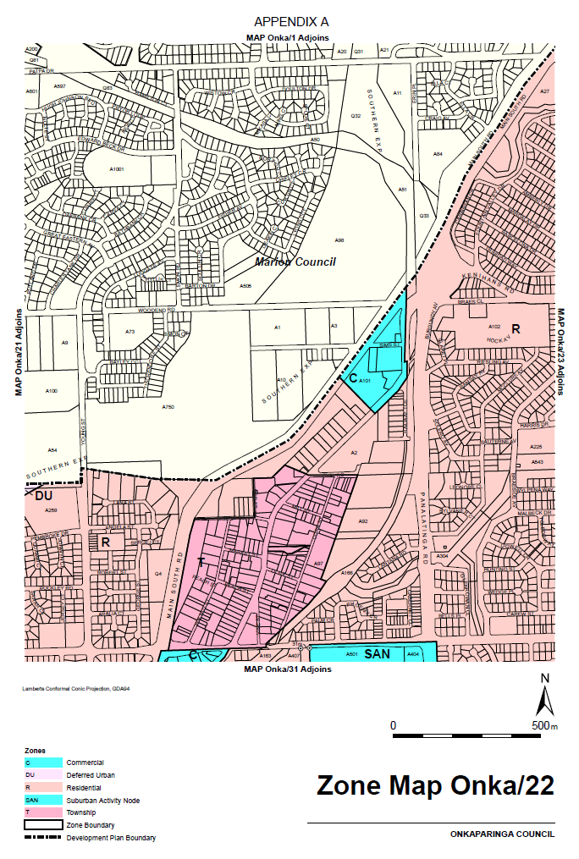
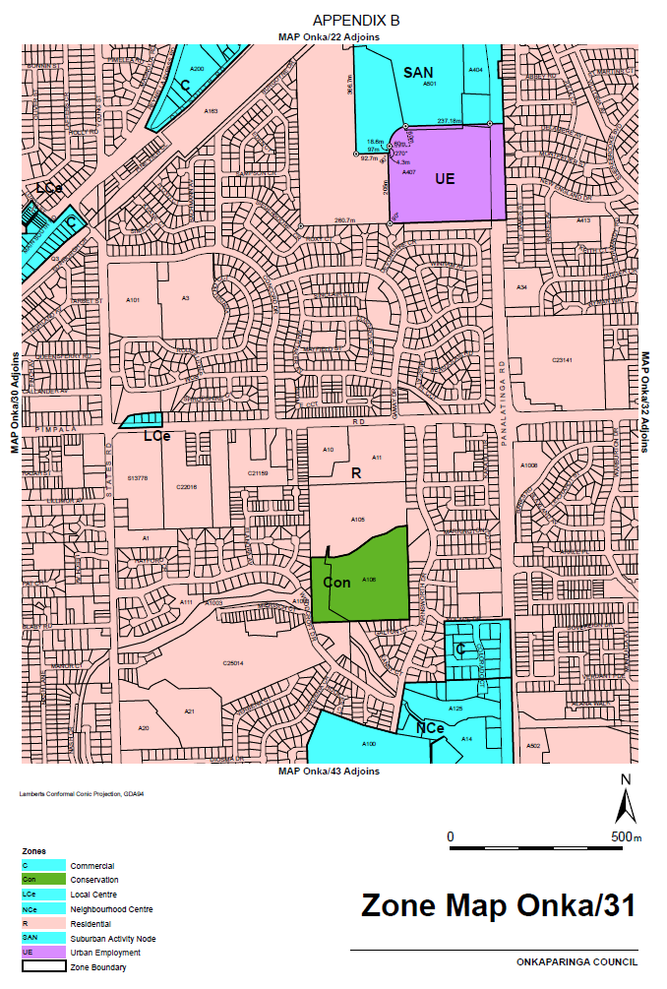
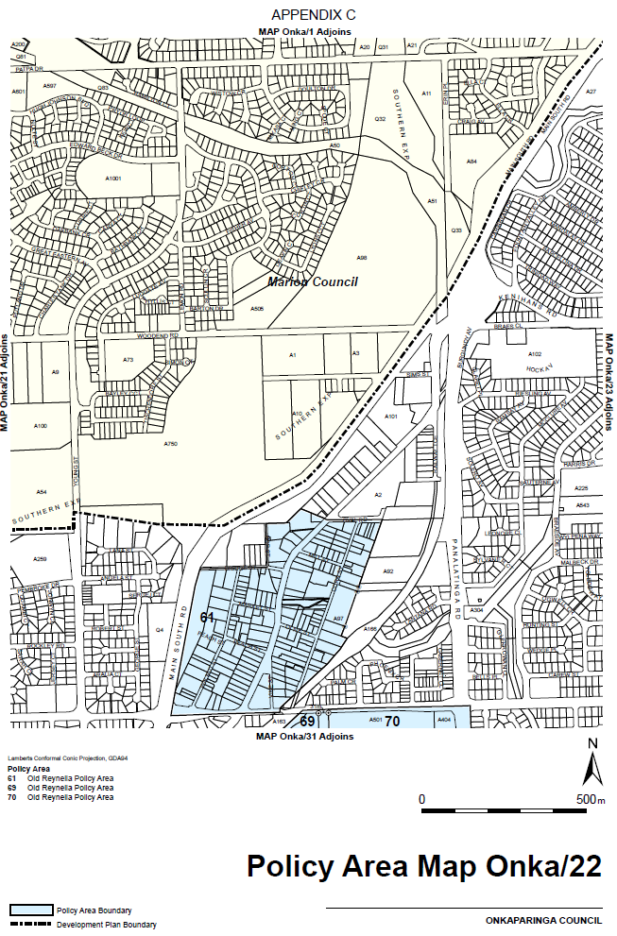
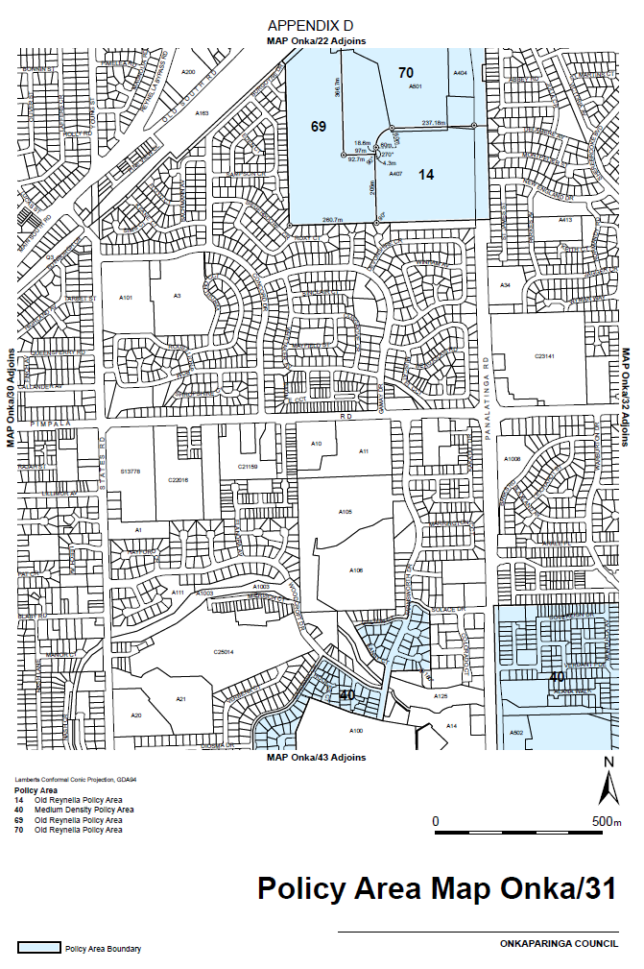

Development Act 1993
Section 29
Amendment to the City of Tea Tree Gully Council Development Plan
Preamble
It is necessary to amend the City of Tea Tree Gully Council Development Plan (the Plan) dated 27 December 2018.
PURSUANT to section 29 (2)(b)(i) of the Development Act 1993, I—
1. Amend the Plan as follows:
(a) Building near Airfields General Section:
1. Delete ‘and the Air Services Australia navigation aid at Modbury’ from Objective 1.
2. Delete ‘and the Air Services Australia navigation aid at Modbury shown on Concept Plan Map TTG/13—Edinburgh Defence Airfield Defence (Area Control) Regulations.’ from Principle of Development Control 1.
3. Delete the heading and Principle of Development Control 8.
(b) Interface Between Land Uses General Section:
1. Delete the heading and Principle of Development Control 19.
(c) Open Space Zone:
1. Delete Principle of Development Control 7
(d) Residential Zone:
1. Delete Principle of Development Control 7
2. After Maximum building height delete ‘(except where located within 150 metres of the Air Services Australia—navigation aid shown on Overlay Map TTG/21 - Development Constraints)’ in Principle of Development Control 8
3. After Maximum building height delete ‘(except where located within 150 metres of the Air Services Australia—navigation aid shown on Overlay Map TTG/21 - Development Constraints)’ in Principle of Development Control 10
4. After Maximum wall height/height of posts delete ‘(except where located within 150 metres of the Air Services Australia—navigation aid shown on Overlay Map TTG/21 - Development Constraints)’ in Principle of Development Control 10
5. Delete the row ‘Development located within 150 metres of the Air Services Australia—navigation aid shown on Overlay Map TTG/21—Development Constraints)’ in the Non Complying Table
6. Delete ‘Development within 150 metres of the Air Services Australia—navigation aid shown on Overlay Map TTG/21—Development Constraints)’ from the Category 2 list.
(e) Urban Core Zone
1. Delete ‘Development within 150 metres of the Air Services Australia—navigation aid shown on Overlay Map TTG/21—Development Constraints)’ from the Category 2 list.
(f) Table TTG/1—Conditions for Complying Development
1. Delete item 5(d).
(g) Replace Overlay Map TTG/21 Development Constraints with the contents of ATTACHMENT ‘A’
2. Fix the day on which this notice is published in the Gazette as the day on which the section 29 amendment will come into operation.
Dated: 1 October 2020
Sally Smith
Executive Director
Planning & Land Use Services
As Delegate of Vickie Chapman, Minister for Planning and Local Government

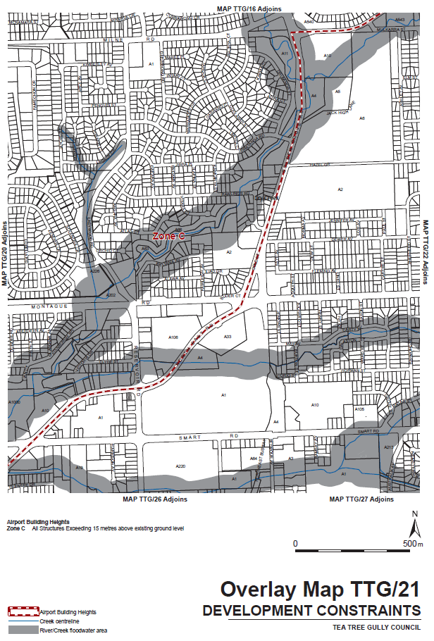
Attachment A

Education and Children’s Services Act 2019
Dissolving the Tantanoola Primary School Governing Council
I, COLLEEN ABBOTT, Director, Conditions for Learning, Partnership, Schools and Preschools, hereby dissolve the Governing Council of Tantanoola Primary School, pursuant to section 43(1)(a) of the Education and Children’s Services Act 2019, due to the school being permanently closed.
Dated: 25 September 2020
Colleen Abbott
Director, Conditions for Learning, Partnerships, Schools and Preschools
Delegate of the Minister of Education

Environment Protection Act 1993
Section 68
Approval of Category B Containers
I, ANDREA KAYE WOODS, Team Leader, Container Deposit Legislation and Delegate of the Environment Protection Authority (‘the Authority’), pursuant to Section 68 of the Environment Protection Act 1993 (SA) (‘the Act’) hereby:
Approve as Category B Containers, subject to the conditions in sub-clauses 1, 2, 3 and 4 below, each of the classes of containers identified by reference to the following matters described in the first 4 Columns of Schedule 1 of this Notice which are sold in South Australia:
(a) the product which each class of containers shall contain;
(b) the size of the containers;
(c) the type of containers;
(d) the name of the holders of these approvals.
1. That containers of the class to which the approval relates must bear the refund marking specified by the Authority for containers of that class.
2. The holder of the approval must have in place an effective and appropriate waste management arrangement in relation to containers of that class. For the purpose of this approval notice the company named in Column 5 of Schedule 1 of this Notice is the nominated super collector.
3. In the case of an approval in relation to Category B containers that the waste management arrangement must require the holder of the approval to provide specified super collectors with a declaration in the form determined by the Authority in relation to each sale of such containers by the holder of the approval as soon as practicable after the sale”;
4. The holder of these approvals must ensure that if a sticker bearing the refund marking has been approved, and is applied to the container, then the sticker must not be placed on any portion of the opening mechanism or in any other place that would require complete or partial removal of the sticker before the contents may be consumed.
Dated: 8 October 2020
Andrea Kaye Woods
Delegate of the Environment Protection Authority

Schedule 1
Column 1 | Column 2 | Column 3 | Column 4 | Column 5
Product Name | Container  Size | Container  Type | Approval Holder | Collection  Arrangements
River Port Olde Style Traditional Flavour Ginger Soda | 330ml | Glass | Australian Pure Fruits Pty Ltd | Marine Stores Ltd
Llanllyr Source Club Soda For Craft Cocktails | 200ml | Glass | Awesome Food and Beverage Pty Ltd | Statewide Recycling
Llanllyr Source Fiery Ginger Beer For Craft Cocktails | 200ml | Glass | Awesome Food and Beverage Pty Ltd | Statewide Recycling
Llanllyr Source Ginger Ale For Craft Cocktails | 200ml | Glass | Awesome Food and Beverage Pty Ltd | Statewide Recycling
Llanllyr Source Sparkling | 330ml | Glass | Awesome Food and Beverage Pty Ltd | Statewide Recycling
Llanllyr Source Sparkling | 750ml | Glass | Awesome Food and Beverage Pty Ltd | Statewide Recycling
Llanllyr Source Sparkling Spring Water | 330ml | Aluminium | Awesome Food and Beverage Pty Ltd | Statewide Recycling
Llanllyr Source Still | 750ml | Glass | Awesome Food and Beverage Pty Ltd | Statewide Recycling
Llanllyr Source Still | 330ml | Glass | Awesome Food and Beverage Pty Ltd | Statewide Recycling
Llanllyr Source Still Spring Water | 330ml | Aluminium | Awesome Food and Beverage Pty Ltd | Statewide Recycling
Llanllyr Source Tonic Water For Craft Cocktails | 200ml | Glass | Awesome Food and Beverage Pty Ltd | Statewide Recycling
Sirma Apple Vitamin Apple Flavored Sparkling Mineral Water | 250ml | Glass | Basfoods International Pty Ltd as Trustee for Basfoods International Trust | Statewide Recycling
Sirma Natural Mineral Water | 250ml | Glass | Basfoods International Pty Ltd as Trustee for Basfoods International Trust | Statewide Recycling
Sirma Orange Vitamin Orange Flavored Sparkling Mineral Water | 250ml | Glass | Basfoods International Pty Ltd as Trustee for Basfoods International Trust | Statewide Recycling
Sirma Pomegranate Vitamin Pomegranate Flavored Sparkling Mineral Water | 250ml | Glass | Basfoods International Pty Ltd as Trustee for Basfoods International Trust | Statewide Recycling
Sirma Sour Cherry Vitamin Sour Cherry Flavored Sparkling Mineral Water | 250ml | Glass | Basfoods International Pty Ltd as Trustee for Basfoods International Trust | Statewide Recycling
Sirma Strawberry Vitamin Strawberry Flavored Sparkling Mineral Water | 250ml | Glass | Basfoods International Pty Ltd as Trustee for Basfoods International Trust | Statewide Recycling
Basic Babe Alcoholic Sparkling Water Every Berry Zero Sugar Zero Carbs | 250ml | Aluminium | Basic Brands & Co Pty Ltd | Statewide Recycling
Basic Babe Alcoholic Sparkling Water Ginger & Lime Zero Sugar Zero Carbs | 250ml | Aluminium | Basic Brands & Co Pty Ltd | Statewide Recycling
Basic Babe Alcoholic Sparkling Water Watermelon Zero Sugar Zero Carbs | 250ml | Aluminium | Basic Brands & Co Pty Ltd | Statewide Recycling
Big Shed Brewing Co Brewers Series 2020 Feelin’ Fine Oat Cream IPA | 375ml | Aluminium | Big Shed Brewing Concern Pty Ltd | Marine Stores Ltd
Big Shed Brewing Co Mega Golden Stout Time Dessert Stout | 330ml | Glass | Big Shed Brewing Concern Pty Ltd | Marine Stores Ltd
Big Shed Brewing Concern Brewers Series 2018 Port Lager | 375ml | Aluminium | Big Shed Brewing Concern Pty Ltd | Marine Stores Ltd
Never Never Fearless Spirit Juneipa Juniper New England IPA | 375ml | Aluminium | Big Shed Brewing Concern Pty Ltd | Marine Stores Ltd
Garage Project Chateau Aro Solera Escarpment Pinot Noir Juice | 750ml | Glass | Brewwell Limited T/AS Garage Project | Statewide Recycling
Garage Project Fresh IPA Oct 2020 | 440ml | Aluminium | Brewwell Limited T/AS Garage Project | Statewide Recycling
Garage Project Fresh IPA Sep 2020 | 440ml | Aluminium | Brewwell Limited T/AS Garage Project | Statewide Recycling
Garage Project Ghost Light | 330ml | Aluminium | Brewwell Limited T/AS Garage Project | Statewide Recycling
Garage Project Green Cheek X Hapi Sessions Vol 7 Just Cause You Feel It | 440ml | Aluminium | Brewwell Limited T/AS Garage Project | Statewide Recycling
Garage Project Hop Haus Alt | 330ml | Aluminium | Brewwell Limited T/AS Garage Project | Statewide Recycling
Garage Project Hyde East Coast IPA | 440ml | Aluminium | Brewwell Limited T/AS Garage Project | Statewide Recycling
Garage Project Jekyll West Coast IPA | 440ml | Aluminium | Brewwell Limited T/AS Garage Project | Statewide Recycling
Garage Project Noo12 Juice | 330ml | Aluminium | Brewwell Limited T/AS Garage Project | Statewide Recycling
Garage Project Party & Bullshit | 330ml | Aluminium | Brewwell Limited T/AS Garage Project | Statewide Recycling
Garage Project Pernicious Yuzu Weed | 440ml | Aluminium | Brewwell Limited T/AS Garage Project | Statewide Recycling
Garage Project Single Fruit Raspberries | 375ml | Glass | Brewwell Limited T/AS Garage Project | Statewide Recycling
Garage Project Single Fruit Raspberries | 750ml | Glass | Brewwell Limited T/AS Garage Project | Statewide Recycling
Garage Project Slay Ride A Lost Cause | 330ml | Aluminium | Brewwell Limited T/AS Garage Project | Statewide Recycling
Garage Project The Veil X New, New, Normal, Normal Hapi Sessions Vol 6 | 440ml | Aluminium | Brewwell Limited T/AS Garage Project | Statewide Recycling
Garage Project Yakima Valley Hazy Double IPA | 440ml | Aluminium | Brewwell Limited T/AS Garage Project | Statewide Recycling
Gekkeikan Junmai Sake | 720ml | Glass | Brown-Forman Australia Pty Limited | Statewide Recycling
Lockdown Release Matilda Bay Alpha Pale Ale | 500ml | Glass | Carlton & United Breweries Pty Ltd | Marine Stores Ltd
Lockdown Release Matilda Bay Dogbolter Dark Ale | 500ml | Glass | Carlton & United Breweries Pty Ltd | Marine Stores Ltd
Lockdown Release Matilda Bay Original Ale | 500ml | Glass | Carlton & United Breweries Pty Ltd | Marine Stores Ltd
Lockdown Release Matilda Bay Redback Original Wheat Beer | 500ml | Glass | Carlton & United Breweries Pty Ltd | Marine Stores Ltd
Mercury Hard Seltzer Crushed Berry & Apple | 375ml | Aluminium | Carlton & United Breweries Pty Ltd | Marine Stores Ltd
Mercury Hard Seltzer Sparkling Apple | 375ml | Aluminium | Carlton & United Breweries Pty Ltd | Marine Stores Ltd
Coopers Dry Low Carb Fine Filtered | 355ml | Glass | Coopers Brewery Limited | Marine Stores Ltd
Kronenbourg 1664 | 330ml | Glass | Coopers Brewery Limited | Marine Stores Ltd
Dainton Beer Glazed & Confused Jam Donut NEIPA | 355ml | Aluminium | Daicom Australia Pty Ltd | Statewide Recycling
Dainton Brewery & Taphouse 4D Imperial Red Eye Rye | 355ml | Aluminium | Daicom Australia Pty Ltd | Statewide Recycling
Dainton Brewery & Taphouse Bloodzilla Double Blood Orange NEIPA | 355ml | Aluminium | Daicom Australia Pty Ltd | Statewide Recycling
Dainton Brewery & Taphouse Sir Spritzalot Snaperol Sour | 355ml | Aluminium | Daicom Australia Pty Ltd | Statewide Recycling
Dainton Brewery Bourbon Barrel-Aged Imperial Stout | 750ml | Glass | Daicom Australia Pty Ltd | Statewide Recycling
Itoen Ice Tea Lemon Decaf Real Brewed | 535ml | PET | Daiso Industries Australia Pty Ltd | Marine Stores Ltd
Itoen Ice Tea Lychee Decaf Real Brewed | 535ml | PET | Daiso Industries Australia Pty Ltd | Marine Stores Ltd
Itoen Ice Tea Peach Decaf Real Brewed | 535ml | PET | Daiso Industries Australia Pty Ltd | Marine Stores Ltd
UCC Black Coffee Cold Brew | 500ml | PET | Daiso Industries Australia Pty Ltd | Marine Stores Ltd
Balter IIPA’20 | 375ml | Aluminium | Emencee Pty Ltd t/as Balter Brewing | Statewide Recycling
Dong Wong Corn Tea Drink | 1 500ml | PET | Griun Pty Ltd t/as Tong Il Trading | Statewide Recycling
Dong Wong Corn Tea Drink | 500ml | PET | Griun Pty Ltd t/as Tong Il Trading | Statewide Recycling
GOOD DAY Lychee | 350ml | Glass | Griun Pty Ltd t/as Tong Il Trading | Statewide Recycling
GOOD DAY Mango | 350ml | Glass | Griun Pty Ltd t/as Tong Il Trading | Statewide Recycling
Gugen Big Yoghurt Carbonated Soft Drink | 750ml | PET | Griun Pty Ltd t/as Tong Il Trading | Statewide Recycling
Haitai Apple Juice | 1 500ml | PET | Griun Pty Ltd t/as Tong Il Trading | Statewide Recycling
Haitai Orange BonBon | 238ml | Aluminium | Griun Pty Ltd t/as Tong Il Trading | Statewide Recycling
Haitai Peach BonBon | 238ml | Aluminium | Griun Pty Ltd t/as Tong Il Trading | Statewide Recycling
Jenog in Soju | 360ml | Glass | Griun Pty Ltd t/as Tong Il Trading | Statewide Recycling
Lotte Milkis Refreshing Milk & Yogurt Flavour | 250ml | Aluminium | Griun Pty Ltd t/as Tong Il Trading | Statewide Recycling
Morning Due Peach | 360ml | Glass | Griun Pty Ltd t/as Tong Il Trading | Statewide Recycling
Soonhari Apple Mango | 360ml | Glass | Griun Pty Ltd t/as Tong Il Trading | Statewide Recycling
Sparkling Lychee | 340ml | PET | Griun Pty Ltd t/as Tong Il Trading | Statewide Recycling
Sparkling Peach | 340ml | PET | Griun Pty Ltd t/as Tong Il Trading | Statewide Recycling
Sparkling Strawberry | 340ml | PET | Griun Pty Ltd t/as Tong Il Trading | Statewide Recycling
Sparkling White Grape | 340ml | PET | Griun Pty Ltd t/as Tong Il Trading | Statewide Recycling
Wongjin Barley Tea | 500ml | PET | Griun Pty Ltd t/as Tong Il Trading | Statewide Recycling
Wongjin Refresh Red Apple Juice | 1 500ml | PET | Griun Pty Ltd t/as Tong Il Trading | Statewide Recycling
Wongjin Sicily Winter Carrot | 1 500ml | PET | Griun Pty Ltd t/as Tong Il Trading | Statewide Recycling
Wongjin Tomato Juice | 1 500ml | PET | Griun Pty Ltd t/as Tong Il Trading | Statewide Recycling
Rare Blends Mocktails Cosmopolitan Non-Alcoholic Juice Blends in Signature Cocktail Flavours | 1 000ml | PET | Grove Fruit Juice Pty Ltd | Statewide Recycling
Rare Blends Mocktails Moscow Mule Non-Alcoholic Juice Blends In Signature Cocktail Flavours | 1 000ml | PET | Grove Fruit Juice Pty Ltd | Statewide Recycling
Hop Brewing Co Ray Hard Seltzer Lemon & Lime Naturally Brewed Alcoholic Sparkling Water | 330ml | Aluminium | Hop Nation Pty Ltd | Statewide Recycling
Hop Brewing Co Seven Clouds Hazy IPA | 375ml | Aluminium | Hop Nation Pty Ltd | Statewide Recycling
Hop Nation Brewing Co Dreamfeed Hazy IPA | 375ml | Aluminium | Hop Nation Pty Ltd | Statewide Recycling
Hop Nation Brewing Co Karma Oatmeal Stout | 375ml | Aluminium | Hop Nation Pty Ltd | Statewide Recycling
Hop Nation Brewing Co Melbourne Fog Hazy Pale | 375ml | Aluminium | Hop Nation Pty Ltd | Statewide Recycling
Hop Nation Brewing Co Organic Lager | 375ml | Aluminium | Hop Nation Pty Ltd | Statewide Recycling
Hop Nation Brewing Co Ray Hard Seltzer Peach Naturally Brewed Alcoholic Sparkling Water | 330ml | Aluminium | Hop Nation Pty Ltd | Statewide Recycling
Hop Nation Brewing Co Ray Hard Seltzer Watermelon & Mint Naturally Brewed Alcoholic Sparkling Water | 330ml | Aluminium | Hop Nation Pty Ltd | Statewide Recycling
Jiva Kombucha Blueberry Refreshing Organic Probiotic Beverage | 750ml | Glass | Jiva Products Pty Ltd | Marine Stores Ltd
Oval Hotel Spring Water | 350ml | PET | Jolt Corporation Australia Pty Ltd | Statewide Recycling
The Sneaky Bucha of Byron Beer & Kombucha Lager Lower Carb | 330ml | Aluminium | Kombucha Brewing Co Pty Ltd t/as The Bucha of Byron | Marine Stores Ltd
The Sneaky Bucha of Byron Beer & Kombucha Summer Lower Carb | 330ml | Aluminium | Kombucha Brewing Co Pty Ltd t/as The Bucha of Byron | Marine Stores Ltd
The Sneaky Bucha of Byron Beer & Kombucha XPA Lower Carb | 330ml | Aluminium | Kombucha Brewing Co Pty Ltd t/as The Bucha of Byron | Marine Stores Ltd
Dare Iced Coffee Vanilla Latte Robusta & Arabica Coffee | 500ml | HDPE | LD&D Australia Pty Ltd | Marine Stores Ltd
Dare Iced Coffee Vanilla Latte Robusta & Arabica Coffee | 750ml | HDPE | LD&D Australia Pty Ltd | Marine Stores Ltd
OAK Thickshake Choc Malt | 425ml | PET | Lactalis Australia Pty Ltd | Statewide Recycling
OAK Thickshake Cookies & Cream | 425ml | PET | Lactalis Australia Pty Ltd | Statewide Recycling
OAK Thickshake Raspberry Spider | 425ml | PET | Lactalis Australia Pty Ltd | Statewide Recycling
Vaalia Probiotics Kids Immunity Boost Strawberry | 100ml | HDPE | Lactalis Australia Pty Ltd | Statewide Recycling
Vaalia Probiotics Kids Immunity Boost Vanilla | 100ml | HDPE | Lactalis Australia Pty Ltd | Statewide Recycling
Merica Energy Red, White & Boom Merica’s Energy Drink Impeachment | 480ml | Aluminium | Menjo Investments Pty Ltd | Statewide Recycling
Merica Energy Red, White & Boom Merica’s Energy Drink Justice | 480ml | Aluminium | Menjo Investments Pty Ltd | Statewide Recycling
Merica Energy Red, White & Boom Merica’s Energy Drink Liberty | 480ml | Aluminium | Menjo Investments Pty Ltd | Statewide Recycling
Merica Energy Red, White & Boom Merica’s Energy Drink Not Your Granny’s Apple | 480ml | Aluminium | Menjo Investments Pty Ltd | Statewide Recycling
Mismatch Brewing Co Bitter Negroni IPA | 375ml | Aluminium | Mismatch Brewing Company Pty Ltd | Marine Stores Ltd
Mismatch Brewing Co Double Dry Hopped Hazy Session | 375ml | Aluminium | Mismatch Brewing Company Pty Ltd | Marine Stores Ltd
Mismatch Brewing Co Double Hazy | 375ml | Aluminium | Mismatch Brewing Company Pty Ltd | Marine Stores Ltd
Mismatch Brewing Co Hazy IPA | 375ml | Aluminium | Mismatch Brewing Company Pty Ltd | Marine Stores Ltd
Nippy’s Apple & Blackcurrant Juice | 215ml | PET | Nippys Fruit Juices Pty Ltd | Statewide Recycling
Nippy’s Orange Juice | 215ml | PET | Nippys Fruit Juices Pty Ltd | Statewide Recycling
Pirate Life Brewing Prison Bar Ale 1870 150 Years | 355ml | Aluminium | Pirate Life Brewery Pty Ltd | Statewide Recycling
Pirate Life Brewing Single Hop IPA Idaho-7 | 355ml | Aluminium | Pirate Life Brewery Pty Ltd | Statewide Recycling
Organic Kombucha Peach Flavour | 750ml | Glass | Remedy Kombucha P/L | Marine Stores Ltd
Remedy Organic Kombucha No Sugar Naturally Passionfruit | 250ml | Aluminium | Remedy Kombucha P/L | Marine Stores Ltd
Remedy Organic Kombucha No Sugar Naturally Passionfruit | 300ml | PET | Remedy Kombucha P/L | Marine Stores Ltd
Remedy Organic Kombucha No Sugar Naturally Wild Berry | 750ml | Glass | Remedy Kombucha P/L | Marine Stores Ltd
Remedy Organic Kombucha No Sugar Naturally Wild Berry | 330ml | Glass | Remedy Kombucha P/L | Marine Stores Ltd
Shapeshifter Brewing Co Zeitgeist Oat Cream IPA | 375ml | Aluminium | Shapeshifter Brewing Company Pty Ltd | Statewide Recycling
Shifty Lizard Brewing Co Brewski Easy Ale | 375ml | Aluminium | Shifty Lizard Brewing Co. Pty Ltd | Statewide Recycling
Shifty Lizard Brewing Co Sesh’n Ale | 375ml | Aluminium | Shifty Lizard Brewing Co. Pty Ltd | Statewide Recycling
Shifty Lizard Brewing Co Stouty McStout Face | 375ml | Aluminium | Shifty Lizard Brewing Co. Pty Ltd | Statewide Recycling
Shifty Lizard Brewing Co Stouty McStout Face | 330ml | Glass | Shifty Lizard Brewing Co. Pty Ltd | Statewide Recycling
Shifty Lizard Bruce Lee-Zard West Coast IPA | 375ml | Aluminium | Shifty Lizard Brewing Co. Pty Ltd | Statewide Recycling
Lo Bros Kombucha Organic Brewed Ginger Beer | 330ml | Glass | Soulfresh Group Pty Ltd | Statewide Recycling
Lo Bros Kombucha Organic Cola | 330ml | Glass | Soulfresh Group Pty Ltd | Statewide Recycling
Lo Bros Kombucha Organic Lemon Lime & Bitters | 330ml | Glass | Soulfresh Group Pty Ltd | Statewide Recycling
Lo Bros Kombucha Organic Passionfruit 330ml | 330ml | Glass | Soulfresh Group Pty Ltd | Statewide Recycling
Lo Bros Kombucha Organic Raspberry & Lemon | 330ml | Glass | Soulfresh Group Pty Ltd | Statewide Recycling
Lo Bros Living Drinks Organic Lemon Lime & Bitters Kombucha Naturally Low in Sugar | 750ml | Glass | Soulfresh Group Pty Ltd | Statewide Recycling
The Milk Thief Organic Blueberry Probiotic Kefir | 1 000g | PET | Soulfresh Group Pty Ltd | Statewide Recycling
The Milk Thief Organic Bush Honey Probiotic Kefir | 1 000g | PET | Soulfresh Group Pty Ltd | Statewide Recycling
The Milk Thief Organic Original Probiotic Kefir | 1 000g | PET | Soulfresh Group Pty Ltd | Statewide Recycling
Frog Dreaming Australia Natural Spring Water | 350ml | PET | Springwater Beverages Pty Ltd | Statewide Recycling
NED Australian Whisky & Cola 4.8% | 375ml | Aluminium | Top Shelf International Pty Ltd | Marine Stores Ltd
NED Australian Whisky & Cola 6% | 375ml | Aluminium | Top Shelf International Pty Ltd | Marine Stores Ltd
NED Australian Whisky & Cola 9% | 250ml | Aluminium | Top Shelf International Pty Ltd | Marine Stores Ltd
NED Australian Whisky & Dry 4.8% | 375ml | Aluminium | Top Shelf International Pty Ltd | Marine Stores Ltd
Mornington Free Non-Alc Pale Ale | 375ml | Aluminium | Tribe Brands Pty Ltd | Statewide Recycling
Glee Sours Blueberry Flavoured Sparkling Fruit Juice | 250ml | Aluminium | Tru Blu Beverages Pty Limited | Flagcan Distributors
Glee Sours Kiwi & Lime Flavoured Sparkling Fruit Juice | 250ml | Aluminium | Tru Blu Beverages Pty Limited | Flagcan Distributors
Glee Sours Watermelon Flavoured Sparkling Fruit Juice | 250ml | Aluminium | Tru Blu Beverages Pty Limited | Flagcan Distributors
UpFlow Brewing Draught Full Flavour Non Alcoholic Beer | 355ml | Aluminium | UpFlow Brewing Australia Pty Ltd | Marine Stores Ltd
UpFlow Brewing Pale Ale Full Flavour Non Alcoholic Beer | 355ml | Aluminium | UpFlow Brewing Australia Pty Ltd | Marine Stores Ltd
UpFlow Brewing Session IPA Full Flavour Non Alcoholic Beer | 355ml | Aluminium | UpFlow Brewing Australia Pty Ltd | Marine Stores Ltd
UpFlow Brewing Stout Full Flavour Non Alcoholic Beer | 355ml | Aluminium | UpFlow Brewing Australia Pty Ltd | Marine Stores Ltd
UpFlow Brewing Wheat Full Flavour Non Alcoholic Beer | 355ml | Aluminium | UpFlow Brewing Australia Pty Ltd | Marine Stores Ltd
Vacay Alcoholic Seltzer Kakadu Plum Premium Spiked Sparkling Water | 330ml | Aluminium | Vacay Seltzer Pty Ltd | Statewide Recycling
Vacay Alcoholic Seltzer Lime Premium Spiked Sparkling Water | 330ml | Aluminium | Vacay Seltzer Pty Ltd | Statewide Recycling
Vacay Alcoholic Seltzer Pure Premium Spiked Sparkling Water | 330ml | Aluminium | Vacay Seltzer Pty Ltd | Statewide Recycling
Vacay Alcoholic Seltzer Raspberry Premium Spiked Sparkling Water | 330ml | Aluminium | Vacay Seltzer Pty Ltd | Statewide Recycling
23 Twenty Third St Distillery Vodka & Soda Riverland Rose Vodka With Soda Water No Sugar | 300ml | Aluminium | Vok Beverages Pty Ltd | Statewide Recycling
Vale Gin Sour Ale | 375ml | Aluminium | Vok Beverages Pty Ltd | Statewide Recycling
Vok Cocktails Cosmopolitan | 2 000ml | LPB—Aseptic | Vok Beverages Pty Ltd | Statewide Recycling
Vok Cocktails Gin & Juice | 2 000ml | LPB—Aseptic | Vok Beverages Pty Ltd | Statewide Recycling
Wild One Natures Finest Alkaline Water pH 9-10 Functional Hydration + 5 Natural Electrolytes | 500ml | PET | Wild One Holdings Pty Ltd | Marine Stores Ltd
Willie Smiths Bone Dry Apple Cider Huon Valley, Tas. | 355ml | Aluminium | William Smith & Sons Pty Ltd | Statewide Recycling
Willie Smiths Frequin Good Apple Cider Huon Valley, Tas. | 355ml | Aluminium | William Smith & Sons Pty Ltd | Statewide Recycling
Willie Smiths Organic Apple Cider Huon Valley, Tas. | 355ml | Aluminium | William Smith & Sons Pty Ltd | Statewide Recycling
Willie Smiths Sour Apple Cider Huon Valley, Tas. | 355ml | Aluminium | William Smith & Sons Pty Ltd | Statewide Recycling
Boom Bira 91 Classic Crisp & Mild Session Beer | 330ml | Glass | Woolworths Limited T/as Pinnacle Drinks | Marine Stores Ltd
Initial Brewing X XPA Smooth Tropical Extra Hoppy | 375ml | Aluminium | Woolworths Limited T/as Pinnacle Drinks | Marine Stores Ltd
John Boston The End Island IPA Dry Hopped | 330ml | Aluminium | Woolworths Limited T/as Pinnacle Drinks | Marine Stores Ltd
John Boston The Shipyard Coastal XPA Dry Hopped | 330ml | Aluminium | Woolworths Limited T/as Pinnacle Drinks | Marine Stores Ltd
Kopparberg Premium Cider Hard Cider Apple | 330ml | Aluminium | Woolworths Limited T/as Pinnacle Drinks | Marine Stores Ltd
Kopparberg Rose Hard Cider | 330ml | Glass | Woolworths Limited T/as Pinnacle Drinks | Marine Stores Ltd
ONE Standard Drink Classic Lager Lower Calorie | 500ml | Aluminium | Woolworths Limited T/as Pinnacle Drinks | Marine Stores Ltd
Palm Belgian Amber Ale | 330ml | Glass | Woolworths Limited T/as Pinnacle Drinks | Marine Stores Ltd
Pals Vodka Watermelon Mint And Soda | 330ml | Aluminium | Woolworths Limited T/as Pinnacle Drinks | Marine Stores Ltd
Zeffer Cider Co Rose Cider With Berry Infusion | 330ml | Aluminium | Woolworths Limited T/as Pinnacle Drinks | Marine Stores Ltd
YF Banana Mango Smoothie Banana, Mango, Pineapple, Apple | 350ml | PET | Youjuice Pty Ltd | Statewide Recycling
YF Berry Superfood Smoothie, Acai, Blueberry, Raspberry, Mulberry Banana, Pear | 350ml | PET | Youjuice Pty Ltd | Statewide Recycling
YF Iced Coffee Shot | 100ml | PET | Youjuice Pty Ltd | Statewide Recycling

Environment Protection Act 1993
Section 69
Revocation of Collection Depot Approval
I, ANDREA KAYE WOODS, Delegate of the Environment Protection Authority (‘the Authority’), pursuant to Section 69 of the Environment Protection Act 1993 (SA) (‘the Act’) hereby:
1. Revocation of collection depot approval:
Revoke the approval of the collection depot identified by reference to the following matters, which previously received all containers belonging to a class of containers that were approved as Category B Containers:
(a) the name of the collection depot described in Column 1 of Schedule 1 of this Notice;
(b) the name of the proprietor of the depot identified in Column 3 of Schedule 1 of this Notice;
(c) the location of the depot described in Columns 4-6 of Schedule 1 of this Notice.
Dated: 8 October 2020
Andrea Kaye Woods
Delegate of the Environment Protection Authority

Schedule 1
Column 1 | Column 2 | Column 3 | Column 4 | Column 5 | Column 6
Depot Name | Company Name | Proprietors | Depot Location | Certificate of Title/Volume | Collection Area
Northern Windmills & Agencies | Northern Windmills & Agencies | D Schultz; D Schultz | 26 Second Street, Orroroo | 3293/123 | Regional

Environment Protection Act 1993
Section 69
Variation to Existing Approval of Collection Depot
I, ANDREA KAYE WOODS, Delegate of the Environment Protection Authority (‘the Authority’), pursuant to Section 69 of the Environment Protection Act, 1993 (SA) (‘the Act’) hereby:
1. Variation to Existing Approval of Collection Depot:
Vary the approval of the collection depot listed at Schedule 1 of this notice, that was granted under the Act prior to the date of this Notice and impose the conditions of this approval to be as follows:
1.1 Approval of Collection Depot:
The collection depot identified by reference to the following matters is approved:
(a) the name of the collection depot described in Column 1 of Schedule 1 of this Notice;
(b) the name of the proprietor of the depot identified in Column 3 of Schedule 1 of this Notice;
(c) the location of the depot described in Columns 4-6 of Schedule 1 of this Notice; and
The collection depot listed at Schedule 1 of this Notice is approved in relation to all classes of containers, which were approved under the Act, at or subsequent to the date of this Notice, as Category B Containers.
1.2 Conditions of approval:
Impose the following conditions on the approval:
1. If the Approval Holder’s name or postal address (or both) changes, then the Approval Holder must inform the Authority in writing, within 28 days of the change occurring.
2. If the collection depot is sold to another party, the Approval Holder must inform the Authority in writing, within 28 days of settlement.
3. The Approval Holder who wishes to cease operation of the depot shall notify the Authority in writing. no less than 14 days from date of closing.
4. The Approval Holder, or a person acting on his or her behalf, must not pay a refund on, or seek reimbursement for, containers that the Approval Holder, or the person acting on his or her behalf, knows were not purchased in South Australia.
5. The Approval Holder must ensure that prominent signage is displayed, detailing the offence and the penalties under Section 69 the Act, for presenting interstate containers for refund.
Dated: 8 October 2020
Andrea Kaye Woods
Delegate of the Environment Protection Authority

Schedule 1
Column 1 | Column 2 | Column 3 | Column 4 | Column 5 | Column 6
Depot Name | Company Name | Proprietors | Depot Location | Cert of Title Volume | Collection Area
Jamestown Recycling | Timothy Mark Box | Tim Box | 42 Mannanarie Road, Jamestown | n/a | Regional
Balhannah Salvage and Trading | Crazy Gujjus Pty Ltd | Paras Doshi | 87 Main Road, Balhannah | n/a | Regional

Firearms Regulations 2017
Regulated Imitation Firearms
Pursuant to Regulation 4(4) of the Firearms Regulations 2017, I, Grantley John Stevens, hereby declare an item of the class specified in Schedule 1 to be a regulated imitation firearm.
Schedule 1
All devices designed to fire or propel hydrated superabsorbent polymer balls or other similar gel-like projectiles by means of compressed air or other compressed gas including, without limitation, those devices commonly known as ‘gel blasters’.
Dated: 8 October 2020
G. J. Stevens
Registrar of Firearms

Geographical Names Act 1991
Notice to Alter Boundaries of a Place
NOTICE is hereby given pursuant to Section 11B of the Geographical Names Act 1991, that I, MICHAEL BURDETT, Surveyor-General and Delegate appointed by the Honourable Vickie Chapman, Attorney-General, Minister of the Crown to whom the administration of the Geographical Names Act 1991 is committed, DO HEREBY:
Alter the locality boundary between Woolundunga and Stirling North to exclude from the bounded locality of WOOLUNDUNGA that area marked (A) shown highlighted in green and include in the locality of STIRLING NORTH.
A copy of the plan showing the extent of the altered boundary can be viewed on the Land Boundaries website at:
www.sa.gov.au/placenameproposals
Dated: 8 October 2020
Michael Burdett
Surveyor-General
Attorney-General’s Department
DPTI: 2020/04319/01

Harbors and Navigation Act 1993
Notice to Mariners No. 25 of 2020
South Australia—Gulf St Vincent—Wirrina Cove—Beacon Light Characteristics Altered
Mariners are advised that the light characteristics of the following two navigation beacons at the entrance to Wirrina Cove have been altered:
• The starboard beacon at the end of the western breakwater in approximate position 35°29′58.90″S, 138°14′19.00″E has been changed to Fl G 3s, range 3 nautical miles.
• The port beacon at the end of the northern breakwater in approximate position 35°30′00.25″S, 138°14′24.15″E has been changed to Fl R 3s, range 3 nautical miles.
Chart affected: AUS 125
Dated: 21 September 2020
Gordon Panton
Manager Marine Safety and Compliance
Department for Infrastructure and Transport
DIT 2017/02277/01
www.dit.sa.gov.au

Housing Improvement Act 2016
Rent Control
The Minister for Human Services Delegate in the exercise of the powers conferred by the Housing Improvement Act 2016, does hereby fix the maximum rental per week which shall be payable subject to Section 55 of the Residential Tenancies Act 1995, in respect of each house described in the following table. The amount shown in the said table shall come into force on the date of this publication in the Gazette.
Address of Premises | Allotment Section | Certificate of Title  Volume/Folio | Maximum Rental per week payable
7 Barnes Road, Glynde SA 5070 | Allotment 31 Deposited Plan 4265 Adelaide | CT 5669/373 | $150.00
Dated: 8 October 2020
David Osborne
Acting Housing Regulator and Registrar
Housing Safety Authority, SAHA
Delegate of Minister for Human Services

Housing Improvement Act 2016
Rent Control Revocations
Whereas the Minister for Human Services Delegate is satisfied that each of the houses described hereunder has ceased to be unsafe or unsuitable for human habitation for the purposes of the Housing Improvement Act 2016, notice is hereby given that, in exercise of the powers conferred by the said Act, the Minister for Human Services Delegate does hereby revoke the said Rent Control in respect of each property.
Address of Premises | Allotment Section | Certificate of Title  Volume/Folio
217 Philip Highway, Elizabeth Vale SA 5112 | Allotment 138 Deposited Plan 7495  Hundred of Munno Para | CT5275/193
2 Emu Street, Semaphore SA 5019 | Allotments 120 and 121 - Allotments 201 and 202 and 203  Deposited Plan 425  Deposited Plan 124347  Hundred of Port Adelaide | CT5700/914  CT6242/123  CT6242/124  CT6242/125
6 Wootton Street, Davoren Park SA 5113 | Allotment 10 Deposited Plan 49400  Hundred of Munno Para | CT 5537/773
Dated: 8 October 2020
David Osborne
Acting Housing Regulator and Registrar
Housing Safety Authority, SAHA
Delegate of Minister for Human Services

Mental Health Act 2009
Authorised Medical Practitioner
NOTICE is hereby given in accordance with Section 93(1) of the Mental Health Act 2009, that the Chief Psychiatrist has determined the following person as an Authorised Medical Practitioner:
Andrew Giam
A determination will be automatically revoked upon the person being registered as a specialist psychiatrist with the Australian Health Practitioner Regulation Agency and as a fellow of the Royal Australian and New Zealand College of Psychiatrists.
Dated: 8 October 2020
Dr J. Brayley
Chief Psychiatrist

Mining Act 1971
Notice pursuant to Section 28(5) of the Mining Act 1971
Notice is hereby given in accordance with Section 28(5) of the Mining Act 1971 that the delegate of the Minister for Energy and Mining intends to grant Exploration Licences over the areas described below.
Applicant: Copper Aura Pty Ltd
Location: Mutooroo Mine area - approximately 55km east of Olary
Pastoral Leases: Pine Creek, Mutooroo
Term: Two years
Area in km²: 23
Reference number: 2020/00092
Applicant: Havilah Resources Limited
Location: Mundi Mundi area - approximately 80km northeast of Olary
Pastoral Leases: Mundi Mundi, Mulyungarie
Term: Two years
Area in km²: 73
Reference number: 2020/00093

Applicant: Copper Aura Pty Ltd
Location: Bonython Hill area - approximately 35km east of Olary
Pastoral Leases: Tikalina, Oulnina, Tepco
Term: Two years
Area in km²: 20
Reference number: 2020/00094
Applicant: Great Southern Kaolin Pty Ltd
Location: Tootla area - approximately 50km east of Streaky Bay
Term: Two years
Area in km²: 372
Reference number: 2020/00096
Applicant: OZ Exploration Pty Ltd
Location: Lake Torrens area - approximately 90km southwest of Leigh Creek
Pastoral Leases: Pernatty, South Gap
Term: Two years
Area in km²: 912
Reference number: 2020/00100
Plans and co-ordinates can be found on the Department for Energy and Mining website:
http://energymining.sa.gov.au/minerals/exploration/public_notices/exploration_licence_applications or by contacting Mineral Tenements on 08 8463 3103.
Community information on mineral exploration licence processes and requirements under the Mining Act 1971 is available from: http://energymining.sa.gov.au/minerals/exploration/public_notices/exploration_licence_applications or hard copy on request to Mineral Tenements.
Dated: 8 October 2020
J. Martin
Mining Registrar as delegate for the Minister for Energy and Mining
Department for Energy and Mining

National Electricity (South Australia) Act 1996
Section 19B
Revocation of a T-3 Reliability Instrument for South Australia
Pursuant to section 19B(6) of the National Electricity (South Australia) Act 1996, I revoke the T-3 Reliability Instrument made on 9 January 2020 under section 19B of the National Electricity (South Australia) Act 1996, for the trading intervals between 3pm and 9pm Eastern Standard Time each working weekday during the period 10 January 2022 to 18 March 2022 inclusive.
This takes effect from the date of publication of this notice in the Gazette.
Dated: 29 September 2020
Hon Daniel Cornelis van Holst Pellekaan MP
Minister for Energy and Mining

Petroleum and Geothermal Energy Act 2000
Statement of Environmental Objectives
PURSUANT to section 104(1) of the Petroleum and Geothermal Energy Act 2000 (the Act) I, Barry Goldstein, Executive Director Energy Resources Division, Department for Energy and Mining do hereby publish the following document as having been approved as a statement of environmental objectives under the Act.
Documents:
• Strike Energy, Multi-well Exploration and Appraisal Production Testing from Deep Coals in PEL 96—Statement of Environmental Objectives, September 2020
This document is available for public inspection on the Environmental Register section of the following webpage -
www.energymining.sa.gov.au/petroleum/legislation_and_compliance/environmental_register
or at the Public Office determined pursuant to section 107 (1) of the Act to be at:
Energy Resources Division
Customer Services
Level 4
11 Waymouth Street
Adelaide SA 5000
Dated: 6 October 2020
Barry Goldstein
Executive Director
Energy Resources Division
Department for Energy and Mining
Delegate of the Minister for Energy and Mining

Real Property Act 1886
Caveat to be lodged
WHEREAS the Council named at the foot hereof has for itself made application to have the land set forth and described before its name at the foot hereof brought under the operation of the Real Property Act 1886:
Notice is hereby given that unless caveat be lodged with the Registrar General by some person having estate or interest in the said land on or before the expiration of the period herein below for the case specified, the said land will be brought under the operation of the said Act as by law directed. Diagrams delineating this land may be inspected at the Land Titles Registration Office, Adelaide and in the offices of the several corporations or district councils in which the lands are situated.
The Schedule
No. of  Application | Description of Property | Name | Residence | Date up to and inclusive of which caveat may be lodged
32053 | Section 801 Hundred of Encounter Bay in the area named Victor Harbor and more particularly defined in Survey Diagram Book Page 25 in the said Hundred | City of Victor Harbor | 1 Bay Road,  Victor Harbor SA 5008 | 9th November 2020
Dated: 8 October 2020
B. Pike
Chief Executive Officer, Land Services SA
Acting under Delegation of the Registrar-General Pursuant to Sec. 17 of the Real Property Act 1886

Training and Skills Development Act 2008
Part 4—Apprenticeships/Traineeships
PURSUANT to the provision of the Training and Skills Development Act 2008, the Training and Skills Commission (TaSC) gives notice that determines the following Trades or Declared Vocations in addition to the Gazette notices of:
- 25 September 2008 | - 23 October 2008 | - 13 November 2008 | - 4 December 2008
- 18 December 2008 | - 29 January 2009 | - 12 February 2009 | - 5 March 2009
- 12 March 2009 | - 26 March 2009 | - 30 April 2009 | - 18 June 2009
- 25 June 2009 | - 27 August 2009 | - 17 September 2009 | - 24 September 2009
- 9 October 2009 | - 22 October 2009 | - 3 December 2009 | - 17 December 2009
- 4 February 2010 | - 11 February 2010 | - 18 February 2010 | - 18 March 2010
- 8 April 2010 | - 6 May 2010 | - 20 May 2010 | - 3 June 2010
- 17 June 2010 | - 24 June 2010 | - 8 July 2010 | - 9 September 2010
- 23 September 2010 | - 4 November 2010 | - 25 November 2010 | - 16 December 2010
- 23 December 2010 | - 17 March 2011 | - 7 April 2011 | - 21 April 2011
- 19 May 2011 | - 30 June 2011 | - 21 July 2011 | - 8 September 2011
- 10 November 2011 | - 24 November 2011 | - 1 December 2011 | - 8 December 2011
- 16 December 2011 | - 22 December 2011 | - 5 January 2012 | - 19 January 2012
- 1 March 2012 | - 29 March 2012 | - 24 May 2012 | - 31 May 2012
- 7 June 2012 | - 14 June 2012 | - 21 June 2012 | - 28 June 2012
- 5 July 2012 | - 12 July 2012 | - 19 July 2012 | - 2 August 2012
- 9 August 2012 | - 30 August 2012 | - 13 September 2012 | - 4 October 2012
- 18 October 2012 | - 25 October 2012 | - 8 November 2012 | - 29 November 2012
- 13 December 2012 | - 25 January 2013 | - 14 February 2013 | - 21 February 2013
- 28 February 2013 | - 7 March 2013 | - 14 March 2013 | - 21 March 2013
- 28 March 2013 | - 26 April 2013 | - 23 May 2013 | - 30 May 2013
- 13 June 2013 | - 20 June 2013 | - 11 July 2013 | - 1 August 2013
- 8 August 2013 | - 15 August 2013 | - 29 August 2013 | - 6 February 2014
- 12 June 2014 | - 28 August 2014 | - 4 September 2014 | - 16 October 2014
- 23 October 2014 | - 5 February 2015 | - 26 March 2015 | - 16 April 2015
101. 27 May 2015 | 102. 18 June 2015 | 103. 3 December 2015 | 104. 7 April 2016
105. 30 June 2016 | 106. 28 July 2016 | 107. 8 September 2016 | 108. 22 September 2016
109. 27 October 2016 | 110. 1 December 2016 | 111. 15 December 2016 | 112. 7 March 2017
113. 21 March 2017 | 114. 23 May 2017 | 115. 13 June 2017 | 116. 18 July 2017
117. 19 September 2017 | 118. 26 September 2017 | 119. 17 October 2017 | 120. 3 January 2018
121. 23 January 2018 | 122. 14 March 2018 | 123. 14 June 2018 | 124. 5 July 2018
125. 2 August 2018 | 126. 9 August 2018 | 127. 16 August 2018 | 128. 30 August 2018
129. 27 September 2018 | 130. 4 October 2018 | 131. 18 October 2018 | 132. 1 November 2018
133. 15 November 2018 | 134. 22 November 2018 | 135. 29 November 2018 | 136. 6 December 2018
137. 20 December 2018 | 138. 24 January 2019 | 139. 14 February 2019 | 140. 30 May 2019
141. 6 June 2019 | 142. 13 June 2019 | 143. 20 June 2019 | 144. 27 June 2019
145. 11 July 2019 | 146. 8 August 2019 | 147. 22 August 2019 | 148. 12 September 2019
149. 19 September 2019 | 150. 14 November 2019 | 151. 28 November 2019 | 152. 12 December 2019
153. 19 December 2019 | 154. 23 January 2020 | 155. 27 February 2020 | 156. 21 April 2020
157. 25 June 2020 | 158. 10 September 2020 | 159. 17 September 2020 | 160. 8 October 2020
Trades or Declared Vocations and Required Qualifications and Training Contract Conditions for
the Agriculture, Horticulture and Conservation and Land Management (AHC), Business Services (BSB), Food, Beverage and Pharmaceutical (FBP), Food, Textiles, Clothing and Footwear (MST), National Water (NWP) and Transport and Logistics Industry (TLI) training packages
*Trade/ #Declared Vocation/ Other Occupation | Qualification  Code | Qualification Title | Nominal Term of Training Contract | Probationary Period
Electrical and Refrigeration/  Air-conditioning Technician * | UEE30811 & UEE32211 | Certificate III in Electrotechnology Electrician & Certificate III in Air-conditioning and Refrigeration (concurrent delivery) | 60 | 90
Farming # | AHC32419 | Certificate III in Irrigation | 36 | 90
Farming # | AHC41119 | Certificate IV in Irrigation | 24 | 60
Farming # | AHC41019 | Certificate IV in Agribusiness | 36 | 90
Farming # | AHC51419 | Diploma of Agribusiness Management | 36 | 90
Farming # | AHC60319 | Advanced Diploma of Agribusiness Management | 48 | 90
Leading Hand—Dry Cleaning # | MST30919 | Certificate III in Dry Cleaning Operations | 36 | 90
Logistics Administration Officer # | TLI20119 | Certificate II in Logistics | 18 | 60
Logistics Administration Officer # | TLI30319 | Certificate III in Supply Chain Operations | 18 | 60
Logistics Administration Officer # | TLI40319 | Certificate IV in Logistics | 36 | 90
Logistics Manager # | TLI50219 | Diploma of Logistics | 48 | 90
Project Manager # | BSB51415 | Diploma in Project Management | 24 | 60
Road Transport Operator # | TLI20219 | Certificate II in Road Transport Terminal Operations | 18 | 60
Road Transport Operator # | TLI30419 | Certificate III in Waste Driving Operations | 24 | 60
Stevedoring Employee # | TLI20319 | Certificate II in Stevedoring | 12 | 60
Stevedoring Employee # | TLI30219 | Certificate III in Stevedoring | 24 | 60
Stevedoring Employee # | TLI40419 | Certificate IV in Stevedoring Operations | 24 | 60
Storeworker # | TLI30319 | Certificate III in Supply Chain Operations | 24 | 60
Storeworker # | TLI40619 | Certificate IV in Warehousing Operations | 36 | 90
Water Industry Operator# | NWP20119 | Certificate II in Water Industry Operations | 12 | 60
Water Industry Operator # | NWP30219 | Certificate III in Water Industry Operations | 24 | 60
Wine Industry Worker # | FBP30920 | Certificate III in Wine Industry Operations | 42 | 90

Local Government Instruments

City of Charles Sturt
Local Government Act 1999
Amended Community Land Management Plan—Bowden Village Reserve (Lot 400 in Deposited Plan 112982)
Notice is hereby given pursuant to Section 197 (3) of the Local Government Act 1999 that the Council of the City of Charles Sturt did, at its meeting of 28 September 2020, resolve to amend the Community Land Management Plan for Bowden Village Reserve (Lot 400 in Deposited Plan 112982—CT Vol. 3183 Fol. 369).
A copy of the Community Land Management Plan may be viewed by visiting Council’s website www.charlessturt.sa.gov.au.
Dated: 8 October 2020
P. Sutton
Chief Executive Officer

City of Onkaparinga
Local Government Act 1999 (SA)
Proposed Declaration under Section 210(1)
The City of Onkaparinga hereby gives notice that it proposes to make a declaration under Section 210(1) of the Local Government Act 1999 (SA) converting the following private road within its Council area into a public road. The declaration will take effect no earlier than 18 January 2021.
The private road is currently described as Allotment 200 in DP 2142 comprised in Certificate of Title Volume 6239 Folio 873. The private road is named and commonly known as Welland Street, Port Noarlunga.
Dated: 8 October 2020
Scott Ashby
Chief Executive Officer

Central Local Government Region of South Australia
(Legatus Group)
Local Government Act 1999
Adoption of Amended Charter
Notice is hereby given of the adoption of an Amended Charter by the Central Local Government Region of South Australia (referred to as Legatus Group) on 4 September 2020.
In accordance with the Local Government Act 1999, Schedule 2 (2) Clause 19 (5) (c), full details of the Amended Charter are available at www.legatus.sa.gov.au.
Dated: 30 September 2020
Simon Millcock
Chief Executive Officer
Legatus Group

Adelaide Hills Council
Roads (Opening and Closing) Act 1991
Road Closure—Public Road, Stirling
NOTICE is hereby given, pursuant to Section 10 of the Roads (Opening and Closing) Act 1991, that the ADELAIDE HILLS COUNCIL proposes to make a Road Process Order to close and merge with 9 Melrose Avenue, Stirling the Public Road adjoining 9 Melrose Avenue, Stirling, more particularly delineated and lettered A on Preliminary Plan 20/0040.
A copy of the plan and a statement of persons affected are available for public inspection at the offices of the Council at 63 Mt Barker Road, Stirling, between the hours of 8.30am and 5.00pm, Monday to Friday, or at the Adelaide office of the Surveyor-General during normal office hours.
The Preliminary Plan can also be viewed at http://www.sa.gov.au/roadsactproposals.
Any application for easement or objection must set out the full name, address and details of the submission and must be fully supported by reasons.
The application for easement or objection must be made in writing to the Council at PO Box 44, Woodside, SA 5244 WITHIN 28 DAYS OF THIS NOTICE and a copy must be forwarded to the Surveyor-General at GPO Box 1354, Adelaide, SA 5001. Where a submission is made, the Council will give notification of a meeting at which the matter will be considered.
Dated: 8 October 2020
A. Aitken
Chief Executive Officer

Adelaide Plains Council
Roads (Opening and Closing) Act 1991
Road Closure—Donaldson Road, Two Wells
Notice is hereby given pursuant to Section 10 of the Act, that the Adelaide Plains Council proposes to make a Road Process Order to close and retain a portion of the Un-Made Public Road (Donaldson Road), adjoining F218508, F174894, D114649, D117831 and D122917 marked ‘A’ on Preliminary Plan No. 20/0039.
A copy of the plan and statement of persons affected are available for public inspection at the Council office, 2A Wasleys Road, Mallala and the office of the Surveyor-General, 101 Grenfell Street Adelaide during normal office hours. The Preliminary Plan can also be viewed at www.sa.gov.au/roadsactproposals.
Any application for easement or objections must set out the full name, address and details of the submission and must be fully supported by reasons.
Any application for easement or objections must be made in writing within 28 days of this notice to the Council, PO Box 18 Mallala SA 5502 and the Surveyor-General, GPO Box 1354 Adelaide 5001, setting out full details. Where a submission is made, council will give notification of a meeting at which the matter will be considered.
Dated: 8 October 2020
J. Miller
Chief Executive Officer

Copper Coast Council
[Republished]
The notice which appeared in the Government Gazette, No. 78, 1 October 2020, on page 4802, being the second notice on that page, was printed in error and should be replaced with the following:
South Australia
Liquor Licensing (Dry Areas) Notice 2020
under section 131(1a) of the Liquor Licensing Act 1997
1—Short title
This notice may be cited as the Liquor Licensing (Dry Areas) Notice 2020.
2—Commencement
This notice comes into operation on 31 December 2020.
3—Interpretation
(1) In this notice—
principal notice means the Liquor Licensing (Dry Areas) Notice 2015 published in the Gazette on 5.1.15, as in force from time to time.
(2) Clause 3 of the principal notice applies to this notice as if it were the principal notice.
4—Consumption etc of liquor prohibited in dry areas
(1) Pursuant to section 131 of the Act, the consumption and possession of liquor in the area described in the Schedule is prohibited in accordance with the provisions of the Schedule.
(2) The prohibition has effect during the periods specified in the Schedule.
(3) The prohibition does not extend to private land in the area described in the Schedule.
(4) Unless the contrary intention appears, the prohibition of the possession of liquor in the area does not extend to—
(a) a person who is genuinely passing through the area if—
(i) the liquor is in the original container in which it was purchased from licensed premises; and
(ii) the container has not been opened; or
(b) a person who has possession of the liquor in the course of carrying on a business or in the course of his or her employment by another person in the course of carrying on a business; or
(c) a person who is permanently or temporarily residing at premises within the area or on the boundary of the area and who enters the area solely for the purpose of passing through it to enter those premises or who enters the area from those premises for the purpose of leaving the area.

Schedule—Moonta Bay and Port Hughes Area 1
1—Extent of prohibition
The consumption of liquor is prohibited and the possession of liquor is prohibited.
2—Period of prohibition
From 12 noon on 31 December 2020 to 7.00 am on 1 January 2021.
3—Description of area
The area in and adjacent to Moonta Bay and Port Hughes bounded as follows: Commencing at the point at which the northern boundary of North Terrace, Moonta Bay intersects the eastern boundary of Coast Road, then generally south-westerly along that eastern boundary of Coast Road and the prolongation in a straight line of that boundary to the point at which the prolongation intersects the southern boundary of Harry’s Point Road, Port Hughes then north-westerly along the southern boundary of Harry’s Point Road to the point at which it meets the eastern boundary of Snell Avenue, Port Hughes then generally south-westerly along that boundary of Snell Avenue and the prolongation in a straight line of that boundary to the point at which it intersects the southern boundary of Minnie Terrace, Port Hughes then generally westerly along that boundary of Minnie Terrace to the eastern boundary of West Terrace, Port Hughes then generally south-westerly and southerly along that boundary of West Terrace and the continuation of West Terrace (past South Terrace) to the northern boundary of Section 2031 Hundred of Wallaroo, then north-westerly along that boundary of Section 2031 and the prolongation in a straight line of that boundary to the low water mark on the eastern side of Spencer Gulf, then generally northerly and north-easterly along the low water mark to the point at which it is intersected by the prolongation in a straight line of the northern boundary of North Terrace, Moonta Bay then south-easterly along that prolongation and boundary of North Terrace to the point of commencement. The area includes any jetty, boat ramp or other structure projecting below low water mark from within the area described above (as well as any area beneath such a structure).
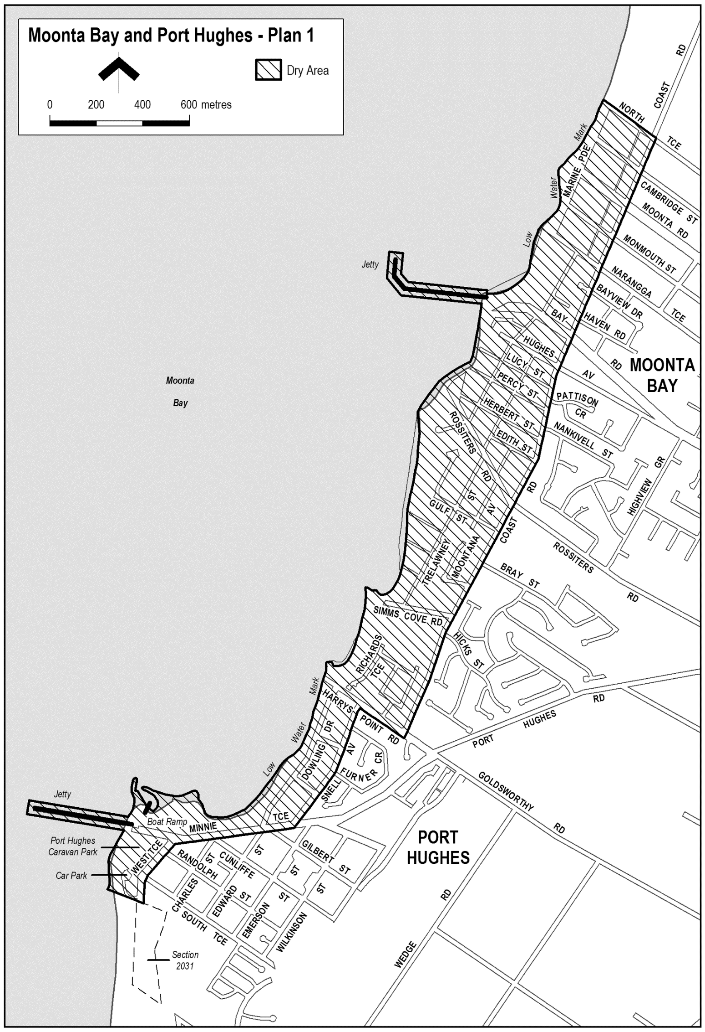

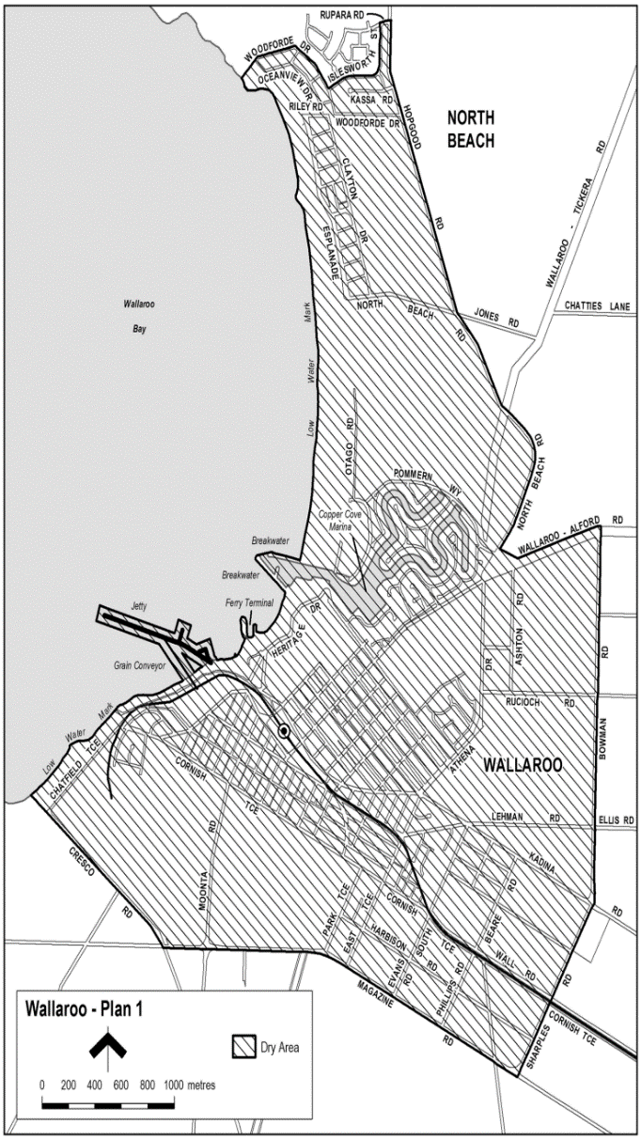
Schedule—Wallaroo Area 4
1—Extent of prohibition
The consumption of liquor is prohibited and the possession of liquor is prohibited.
2—Period of prohibition
From 12 noon on 31 December 2020 to 7.00 am on 1 January 2021.
3—Description of area
The area in and adjacent to Wallaroo and North Beach bounded as follows: Commencing at the point at which the prolongation in a straight line of the northern boundary of Woodforde Drive, North Beach intersects the low water mark on the eastern side of Spencer Gulf, then north-easterly and south-easterly along that prolongation and boundary of Woodforde Drive to the point at which it meets the northern boundary of Islesworth Street, North Beach then generally easterly and northerly along that boundary of Islesworth Street and the prolongation in a straight line of that boundary to the northern boundary of Rupara Road, North Beach then easterly along that boundary of Rupara Road and the prolongation in a straight line of that boundary to the point at which the prolongation intersects the eastern boundary of Hopgood Road, North Beach then generally south-easterly and south-westerly along the eastern boundary of Hopgood Road and the eastern boundary of North Beach Road to the point at which the eastern boundary of North Beach Road meets the northern boundary of the Wallaroo to Alford Road, then north-easterly along that boundary of the Wallaroo to Alford Road to the point at which it is intersected by the prolongation in a straight line of the eastern boundary of Bowman Road, Wallaroo then southerly and south-westerly along that boundary of Bowman Road, the eastern boundary of Sharples Road, Wallaroo and the prolongation in a straight line of the eastern boundary of Sharples Road to the southern boundary of Magazine Road, Wallaroo then generally north-westerly and westerly along that boundary of Magazine Road to the south-western boundary of Cresco Road, Wallaroo then generally north-westerly along that boundary of Cresco Road and the prolongation in a straight line of that boundary to the point at which the prolongation intersects the low water mark on the eastern side of spencer Gulf, then generally north-easterly along the low water mark to the commencement of the southern breakwater at the entrance to the Copper Cove Marina, then north-westerly along the outer boundary of the breakwater to its north-western end, then in a straight line by the shortest route (across the entrance to the marina) to the northern boundary at the western end of the northern breakwater at the entrance to the marina, then easterly along the outer boundary of the breakwater back to the low water mark on the shore on the northern side of the marina, then generally northerly and north-westerly along the low water mark to the point of commencement. The area includes the whole of any wharf, jetty, breakwater, boat ramp or other structure projecting below low water mark from within the area described above (as well as any area beneath such structure).

Dated: 1 October 2020
Russell Peate
Chief Executive Officer

The Flinders Ranges Council
Roads (Opening and Closing) Act 1991
Road Closure—Chace View Terrace/Wilpena Road, Hawker
Notice is hereby given pursuant to Section 10 of the Act; that the Flinders Ranges Council proposes to make a Road Process Order to close and merge with Section 519 a portion of the Public Roads (Chace View Terrace and Wilpena Road), adjoining Section 519 Hundred of Wonoka marked ‘A’ on Preliminary Plan No. 20/0036.
A copy of the plan and statement of persons affected are available for public inspection at the Council office, 1 Seventh Street, Quorn and the office of the Surveyor-General, 101 Grenfell Street Adelaide during normal office hours. The Preliminary Plan can also be viewed at www.sa.gov.au/roadsactproposals.
Any application for easement or objections must set out the full name, address and details of the submission and must be fully supported by reasons.
Any application for easement or objections must be made in writing within 28 days of this notice to the Council, PO Box 43 Quorn SA 5433 and the Surveyor-General, GPO Box 1354 Adelaide 5001, setting out full details. Where a submission is made, council will give notification of a meeting at which the matter will be considered.
Dated: 8 October 2020
E. Brown
Chief Executive Officer

Public Notices

Trustee Act 1936
Public Trustee
Estates of Deceased Persons
In the matter of the estates of the undermentioned deceased persons:
ARNOLD Irene Mary late of 16-24 Penneys Hill Road Hackham Retired Cafeteria Attendant who died 21 June 2020
BANDT Norma Betty late of 578-580 Brighton Road South Brighton of no occupation who died 05 July 2020
BARTLETT Joan Anzac late of 30 Penong Avenue Camden Park Home Duties who died 02 July 2020
CHILDS Eva Maria Auguste late of 5 Luther Road Loxton Retired Nurse who died 19 April 2020
FOX Catherine Dawn late of 7 Clare Avenue Sheidow Park Retired Project Officer who died 02 April 2020
FRANKS Gregory Martin late of 5 Roberts Crescent Port Augusta of no occupation who died 23 February 2020
HALFORD Joan late of 150 Adams Road Craigmore of no occupation who died 16 February 2020
KNIGHT Sherrie Nancy late of 20 Ashbourne Avenue Kingswood Home Duties who died 28 December 2017
LEAUNO Stace late of 45 Cecilia Street Hove Retired Hairdresser who died 05 August 2020
MARTIN Angampa late of 3 Wilkinson Street Alice Springs Northern Territory of no occupation who died 05 July 2019
OVENS Pearl Winifred late of 30 Sussex Terrace Westbourne Park of no occupation who died 05 July 2020
PATERSON Barbara Elaine late of 20 Daisy Street Solomontown of no occupation who died 14 October 2019
RUSSELL Douglas George late of 18-24 Trafford Street Angle Park Retired Carpenter who died 24 June 2020
SPOORS Edwin late of 150 Adams Road Craigmore Retired Surveyor who died 02 March 2020
Notice is hereby given pursuant to the Trustee Act 1936, the Inheritance (Family Provision) Act 1972 and the Family Relationships Act 1975 that all creditors, beneficiaries, and other persons having claims against the said estates are required to send, in writing, to the office of the Public Trustee at GPO Box 1338, Adelaide, 5001, full particulars and proof of such claims, on or before the 6 November 2020, otherwise they will be excluded from the distribution of the said estate; and notice is also hereby given that all persons indebted to the said estates are required to pay the amount of their debts to the Public Trustee or proceedings will be taken for the recovery thereof; and all persons having any property belonging to the said estates are forthwith to deliver same to the Public Trustee.
Dated: 8 October 2020
N. S. Rantanen
Public Trustee

National Electricity Law
Initiation of Rule Change Requests
The Australian Energy Market Commission (AEMC) gives notice under the National Electricity Law as follows:
Under s 95, the Honourable Lily D’Ambrosio MP, Minister for Energy, Environment and Climate Change, Minister for Solar Homes has requested the Prudent discounts in an adoptive jurisdiction (Ref. ERC0317) proposal. The proposal seeks to make amendments to the operation of the prudent discount regime in an adoptive jurisdiction. The AEMC intends to expedite the proposal under s 96 as it considers the proposed Rule is non-controversial, subject to requests not to do so. Written requests not to expedite the proposal must be received by 22 October 2020. Submissions must be received by 5 November 2020.
Under s 95, the Australian Energy Council has requested the Generator registration thresholds (Ref. ERC0256) proposal. The proposal seeks to increase the participation of smaller generators in central dispatch and also proposes changes to the Australian Energy Market Operator’s process for granting exemptions from being registered as a scheduled or semi-scheduled generator. Submissions must be received by 17 December 2020.
Under s 95, Mr Damien Vermeer has requested the Improving connection process for embedded generators (Ref. ERC0318) proposal. The proposal seeks to minimise uncertainty in the registration and connection process for embedded generators which are intending to be exempt from registration. Submissions must be received by 17 December 2020.
Submissions can be made via the AEMC’s website. Before making a submission, please review the AEMC’s privacy statement on its website. Submissions should be made in accordance with the AEMC’s Guidelines for making written submissions on Rule change proposals. The AEMC publishes all submissions on its website, subject to confidentiality.
Written requests should be sent to submissions@aemc.gov.au and cite the reference in the title. Before sending a request, please review the AEMC’s privacy statement on its website.
Documents referred to above are available on the AEMC’s website and are available for inspection at the AEMC’s office.
Australian Energy Market Commission
Level 15, 60 Castlereagh St
Sydney NSW 2000
Telephone: (02) 8296 7800
www.aemc.gov.au
Dated: 8 October 2020

Notice Submission

The South Australian Government Gazette is compiled and published each Thursday.
Notices must be submitted before 4 p.m. Tuesday, the week of intended publication.
All submissions are formatted per the gazette style and proofs are supplied as soon as possible. Alterations must be returned before 4 p.m. Wednesday.
Requests to withdraw submitted notices must be received before 10 a.m. on the day of publication.

Gazette notices should be emailed as Word files in the following format:
- Title—name of the governing Act/Regulation
- Subtitle—brief description of the notice
- A structured body of text
- Date of authorisation
- Name, position, and government department/organisation of the person authorising the notice

Please provide the following information in your email:
- Date of intended publication
- Contact details of at least two people responsible for the notice content
- Name of the person and organisation to be charged for the publication (Local Council and Public notices)
- Request for a quote, if required
- Purchase order, if required

Email: governmentgazettesa@sa.gov.au
Phone: (08) 7109 7760
Website: www.governmentgazette.sa.gov.au

All instruments appearing in this gazette are to be considered official, and obeyed as such

Printed and published weekly by authority of S. Smith, Government Printer, South Australia
$7.70 per issue (plus postage), $387.60 per annual subscription—GST inclusive
Online publications: www.governmentgazette.sa.gov.au

