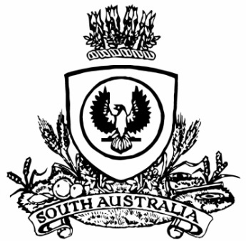No. 43 p. 2491
SUPPLEMENTARY GAZETTE
THE SOUTH AUSTRALIAN
GOVERNMENT GAZETTE
Published by Authority

Adelaide, Thursday, 21 May 2020

Contents

Governor’s Instruments
Regulations—
Summary Offences (Variation of Schedule 2)
Regulations 2020—No. 66 of 2020 [Republished] 2492

Governor’s Instruments
Regulations
[Republished]
In Government Gazette No. 42 dated 21 May 2020, page 2460, Regulation No. 66 of 2020 was published with an error. The Summary Offences (Variation of Schedule 2) Regulations 2020 should be replaced as follows:
South Australia
Summary Offences (Variation of Schedule 2) Regulations 2020
under the Summary Offences Act 1953

Contents
1 Short title
2 Commencement
3 Interpretation
4 Variation of Schedule 2 of Act
24 Prescribed weapons—NSW fisheries officers

1—Short title
These regulations may be cited as the Summary Offences (Variation of Schedule 2) Regulations 2020.
2—Commencement
These regulations come into operation on the day on which they are made.
3—Interpretation
In these regulations, unless the contrary intention appears—
Act means the Summary Offences Act 1953.
4—Variation of Schedule 2 of Act
Pursuant to section 85(2)(a) of the Act, Schedule 2 of the Act is varied by inserting the following clause after clause 23:
24—Prescribed weapons—NSW fisheries officers
A person is an exempt person for the purposes of an offence of use or possession of a prohibited weapon under section 21F(1)(b) of this Act in relation to a baton designed for use as a weapon that can be extended in length by gravity or centrifugal force or by a release button or other device if the person is a fisheries officer (within the meaning of the Fisheries Management Act 1994 of New South Wales) who uses or possesses the weapon in the course of official duties or functions under that Act.
Note—
As required by section 10AA(2) of the Subordinate Legislation Act 1978, the Minister has certified that, in the Minister's opinion, it is necessary or appropriate that these regulations come into operation as set out in these regulations.
Made by the Governor
with the advice and consent of the Executive Council
on 21 May 2020
No 66 of 2020

All instruments appearing in this gazette are to be considered official, and obeyed as such

Printed and published weekly by authority of S. Smith, Government Printer, South Australia
$7.70 per issue (plus postage), $387.60 per annual subscription—GST inclusive
Online publications: www.governmentgazette.sa.gov.au

