No. 39 p. 995
SUPPLEMENTARY GAZETTE
THE SOUTH AUSTRALIAN
GOVERNMENT GAZETTE
Published by Authority

Adelaide, Thursday, 14 May 2020

Contents

Rules of Court
Corporations Rules 2003—Amendment No 10 996
District Court Criminal Supplementary Rules 2014—
Amendment No 7 1046
District Court Special Applications Rules 2014—
Amendment No 2 1047
Environment, Resources and Development Court
(Native Title) Rules 2001—Amendment No 1 1059
Environment, Resources and Development Court
Rules 2003—Amendment No 2 1095
Land and Valuation Division Rules 2014—
Amendment No 2 1164
Supreme Court Criminal Rules 2014—Amendment No 8 1168
Supreme Court Criminal Supplementary Rules 2014—Amendment No 7 1174
Supreme Court Special Applications Rules 2014—
Amendment No 3 1182
Uniform Civil Rules 2020 1200
Youth Court (General) Rules 2016—Amendment No 1 1201
Youth Court (Adoption) Rules 2018—Amendment No 1 1280
Youth Court (Care and Protection) Rules 2018—
Amendment No 1 1341

Rules of Court

Corporations Rules 2003
South Australia

Amendment No 10
By virtue and in pursuance of section 72 of the Supreme Court Act 1935 and all other enabling powers, we, the Judges of the Supreme Court of South Australia, make the following Corporations Rules 2003 (Amendment No 10).
- These Rules may be cited as the Corporations Rules 2003 (Amendment No 10).
- The Corporations Rules 2003 are amended as set out below.
- The Corporations Supplementary Rules 2015 are repealed.
- These rules come into effect—
(a) subject to subrule (b), on the date of their publication in the Gazette;
(b) if these rules are published in the Gazette on a day other than a Monday, these rules come into effect on the date that is the first Monday following that publication.
- In these Rules, the commencement date means the date on which these rules come into effect under rule 4.
- Unless the Court otherwise orders
(a) the Corporations Rules 2003 as amended by these Rules (the current Rules) apply to—
(i) a proceeding commenced; and
(ii) a step in a proceeding taken,
on or after the commencement date; and
(b) the Corporations Rules 2003 before they were amended by these Rules (the former Rules) continue to govern a step in a proceeding taken before the commencement date.
- In respect of a proceeding instituted before the commencement date—
(a) a party who was a plaintiff is now an applicant;
(b) a party who was a defendant is now a respondent; and
(c) a party who was an intervenor is now an interested party.
- Every reference to a form in the Rules is amended by inserting the prefix “CORP” before the form number.
- Subrule 1.3(2) is amended by substituting the words ‘Uniform Civil Rules 2020’ for the words ‘the other rules of the Court’.
- In rule 1.5, the definition of ‘applicant’ is deleted and substituted as follows:
“applicant means a person claiming relief (except interlocutory relief) under the Corporations Act, the ASIC Act, or the Cross-Border Insolvency Act, whether in the originating process or not.”
- In rule 1.5, the definition of ‘defendant’ is deleted.
- In rule 1.5, the definition of ‘interlocutory process’ is deleted and a definition of ‘interlocutory process’ substituted as follows:
“interlocutory process means an interlocutory process in accordance with Form CORP 3.”
- In rule 1.5, the definition of ‘originating process’ is deleted and a definition of ‘originating process’ substituted as follows:
“originating process means an originating process in accordance with Form CORP 2 or 2A.”
- In rule 1.5, the definition of ‘plaintiff’ is deleted.
- In rule 1.5, the definition of ‘respondent’ is deleted and substituted as follows:
“respondent means a person against whom relief (except interlocutory relief) is claimed under the Corporations Act, the ASIC Act, or the Cross-Border Insolvency Act, whether in the originating process or not.”
- Rule 1.6(b) is amended by substituting the words ‘these Rules’ for the words ‘the Corporations Supplementary Rules 2015’.
- Wherever the word “plaintiff” appears in the Rules, the word “applicant” is substituted (including when the word is used in the plural or possessive or any other case).
- Wherever the word “defendant” appears in the Rules, the word “respondent” is substituted (including when the word is used in the plural or possessive or any other case).
- The heading of rule 2.2 is amended by adding ‘,2A’ after ‘2’.
- Subrule 2.2(1)(a) is amended by inserting the words ‘in the prescribed form’ after the words ‘originating process’.
- Subrule 2.2(1)(b) is amended by inserting the words ‘in the prescribed form’ after the words ‘interlocutory process’.
- Subrule 2.2(3)(a) is amended by adding the words ‘or 2A (as the case requires)’ at the end of the subrule.
- Rule 2.6 is deleted and the following rule substituted:
“2.6 Form of affidavits
An affidavit must be in a form that complies with:
(a) the Uniform Civil Rules; or
Prescribed forms—
Form 12 Affidavit
Form 14 Exhibit front sheet to Affidavit
(b) the rules of the Supreme Court of the State (if any) or Territory (if any) where the affidavit was sworn or affirmed; or
(c) the rules of the Federal Court of Australia.”
- Subrule 2.7(2) is amended by substituting the word ‘filing party’ for the word ‘applicant’.
- Subrule 2.7(2)(a) is deleted and the following subrule substituted:
“(a) each party (if any) against whom the application in the interlocutory process is made; and”
- Subrule 3.5(a) is amended by deleting the words ‘[or authenticated]’.
- Rule 9.2A is amended by substituting the words ‘filing party’ for the word ‘applicant’, wherever it occurs.
- Subrule 9.2A(3) is amended by adding the word ‘respectively’ before the words ‘must serve a notice …’.
- The Note in rule 11.11 is amended by substituting the words ‘the filing party’ for the words ‘an applicant’ and the words ‘person against whom the order is sought’ for the words ‘respondent to the proceeding’.
- Rule 15.1 is deleted and the following rule substituted:
“15.1 Reference to Court of question of law arising at hearing of ASIC (s61 of the ASIC Act)
Rules 214.6 and 214.7 of the Uniform Civil Rules 2020 apply, with any necessary adaptations, to a reference of a question of law arising at a hearing by ASIC to the Court under section 61 of the ASIC Act.”
- Rule 15.2 is deleted and the following rule substituted:
“15.2 Reference to Court of question of law arising at hearing of Corporations and Securities Panel (s 196 of the ASIC Act)
Rules 214.6 and 214.7 of the Uniform Civil Rules 2020 apply, with any necessary adaptations, to a reference of a question of law arising at a hearing by the Corporations and Securities Panel to the Court under section 196 of the ASIC Act.”
- A new Schedule 1 – Forms is inserted as follows:

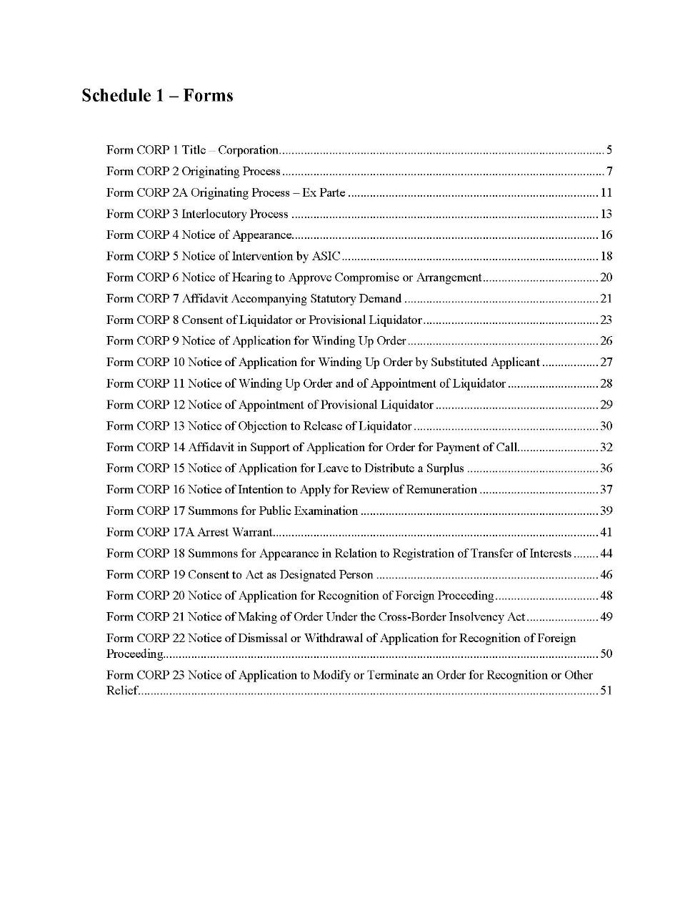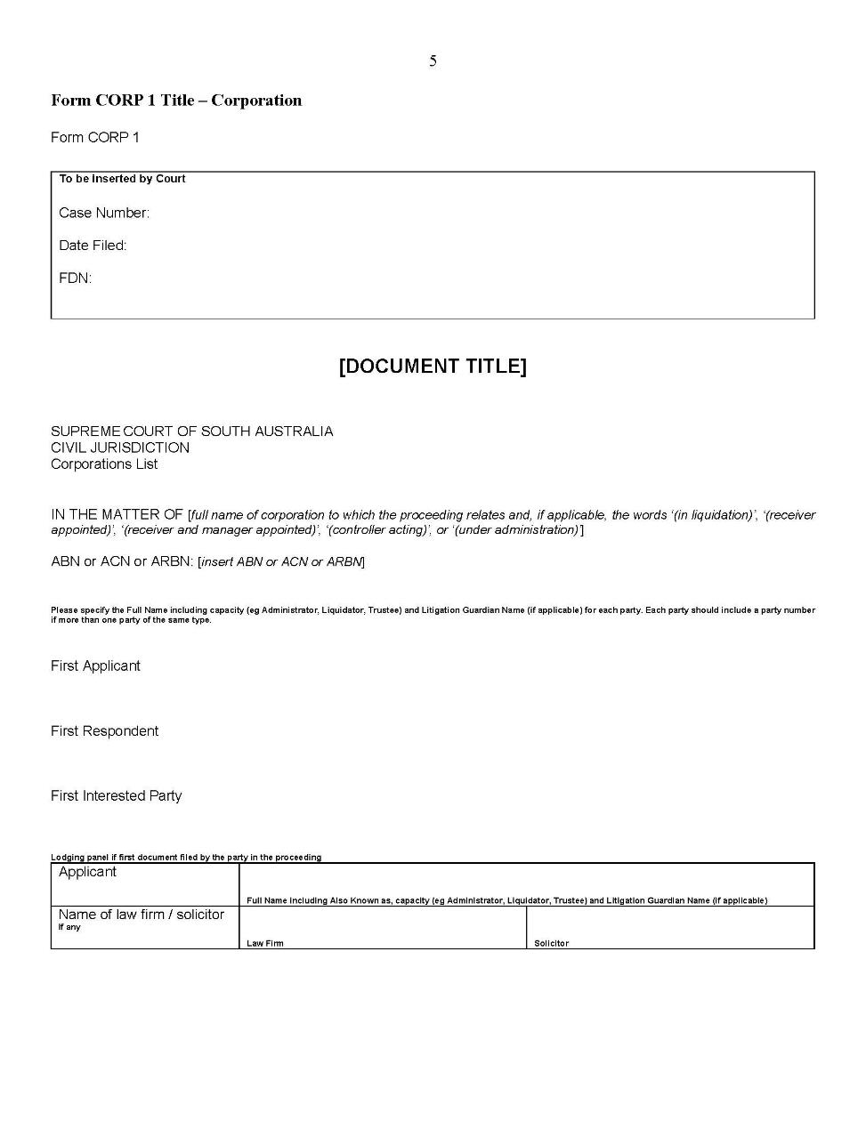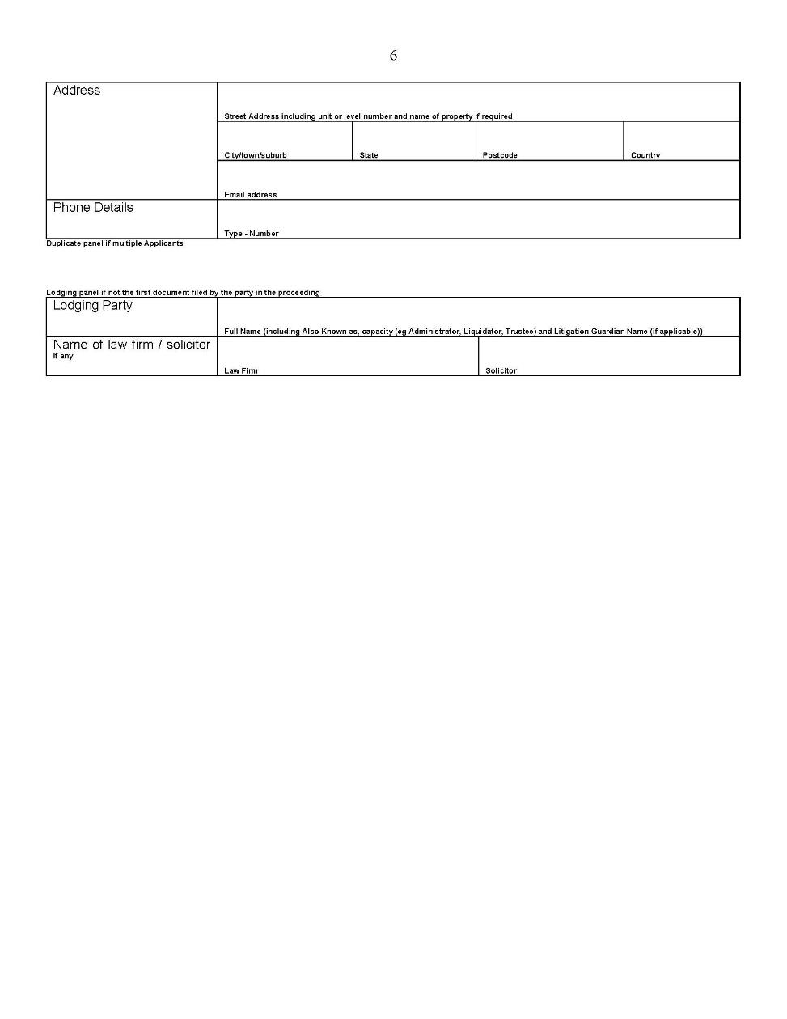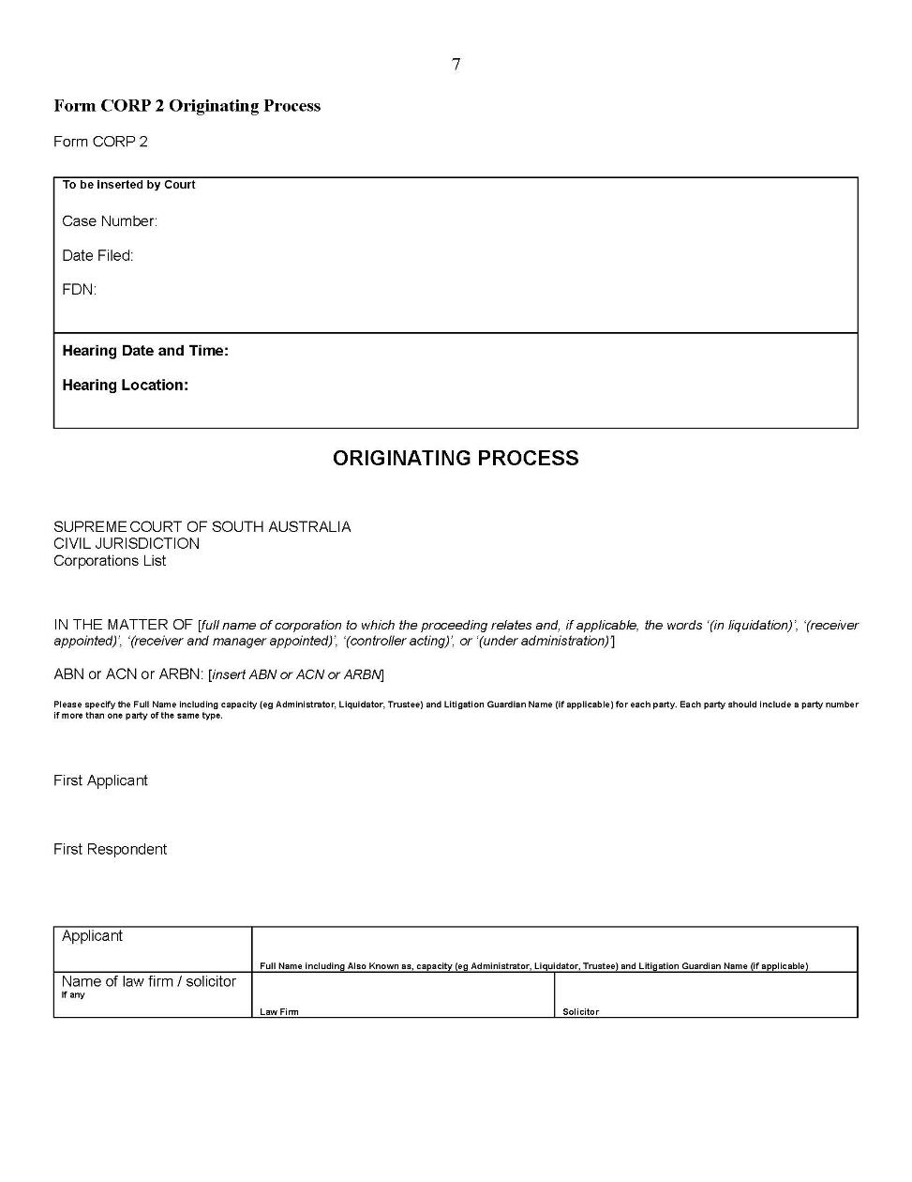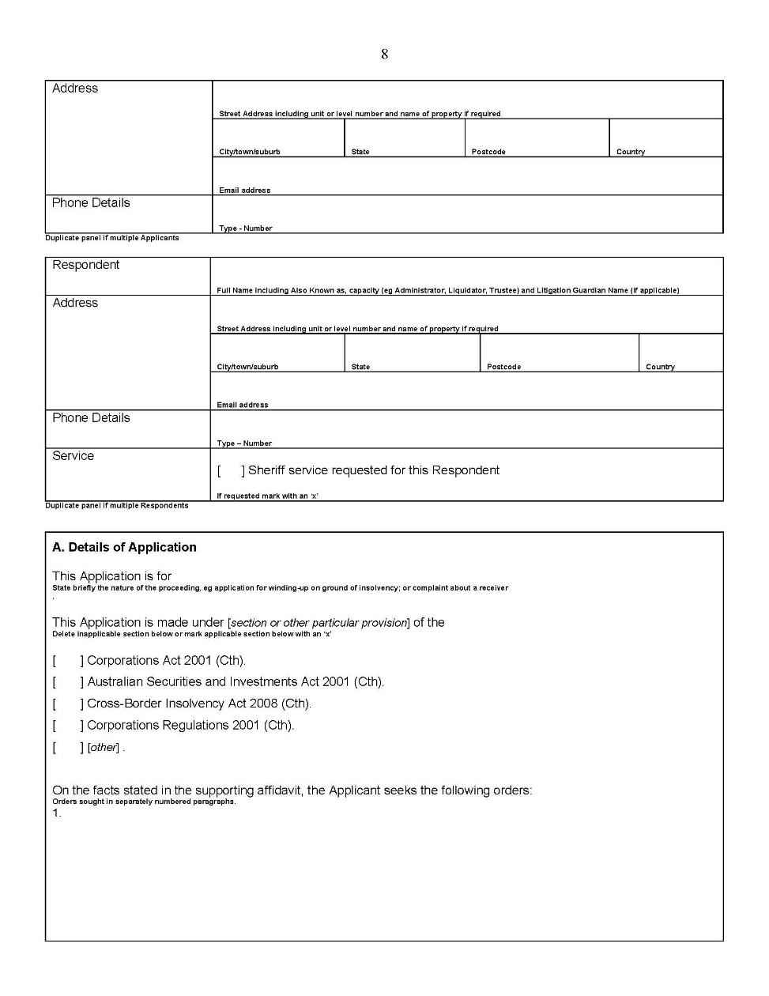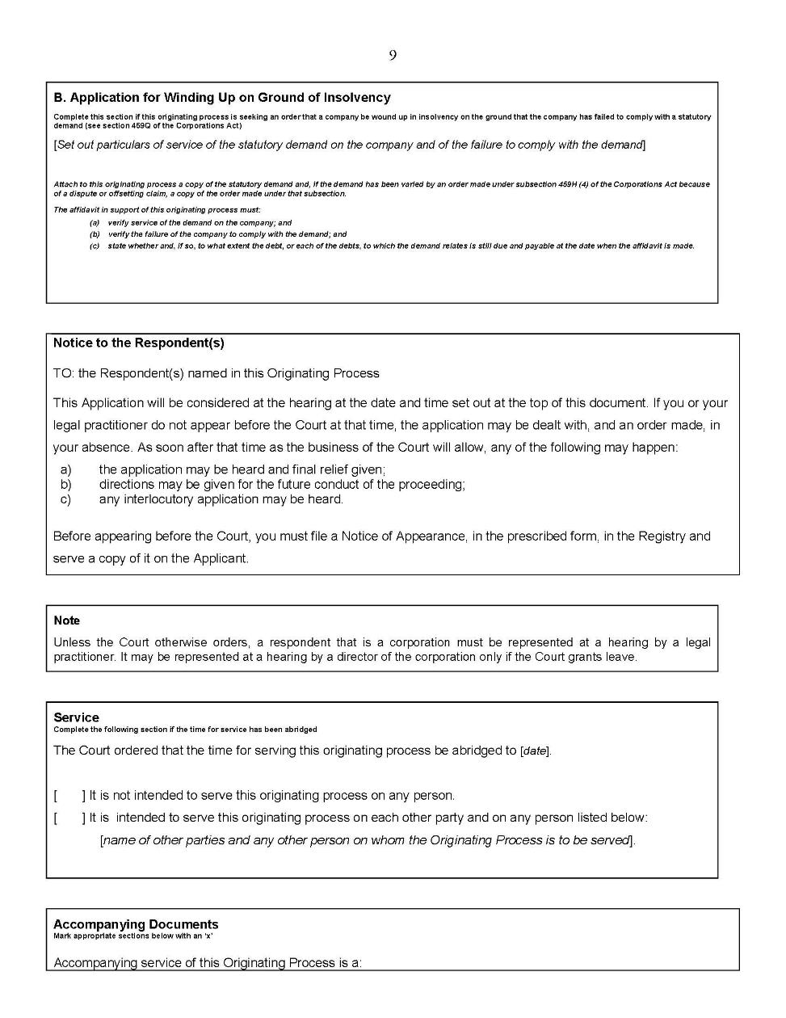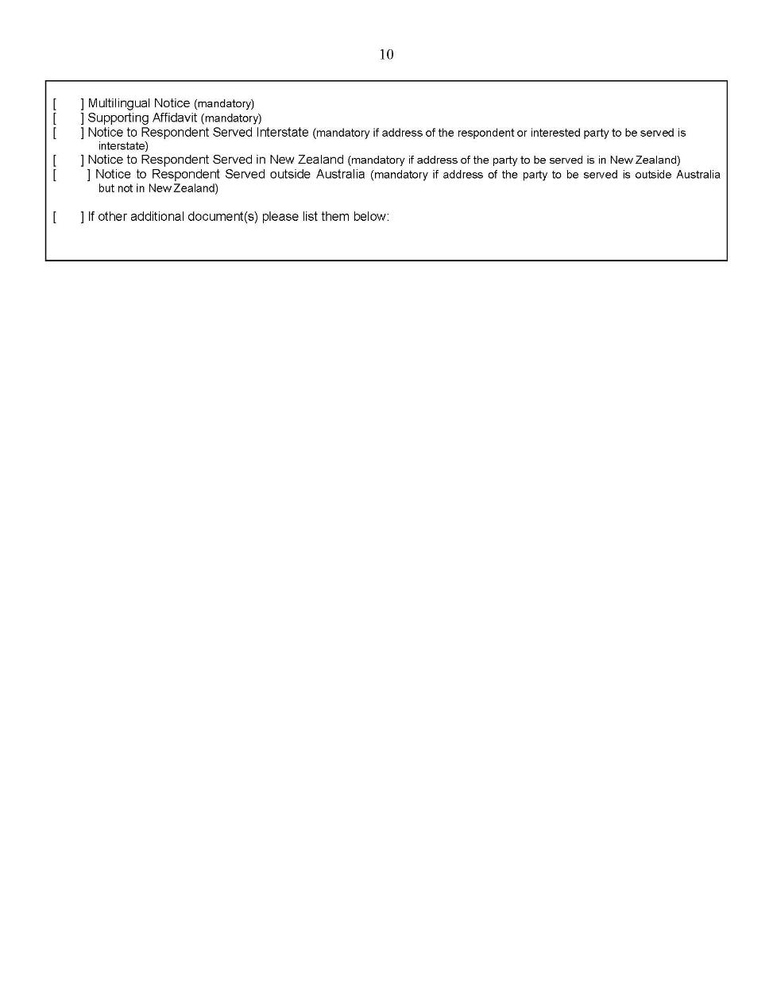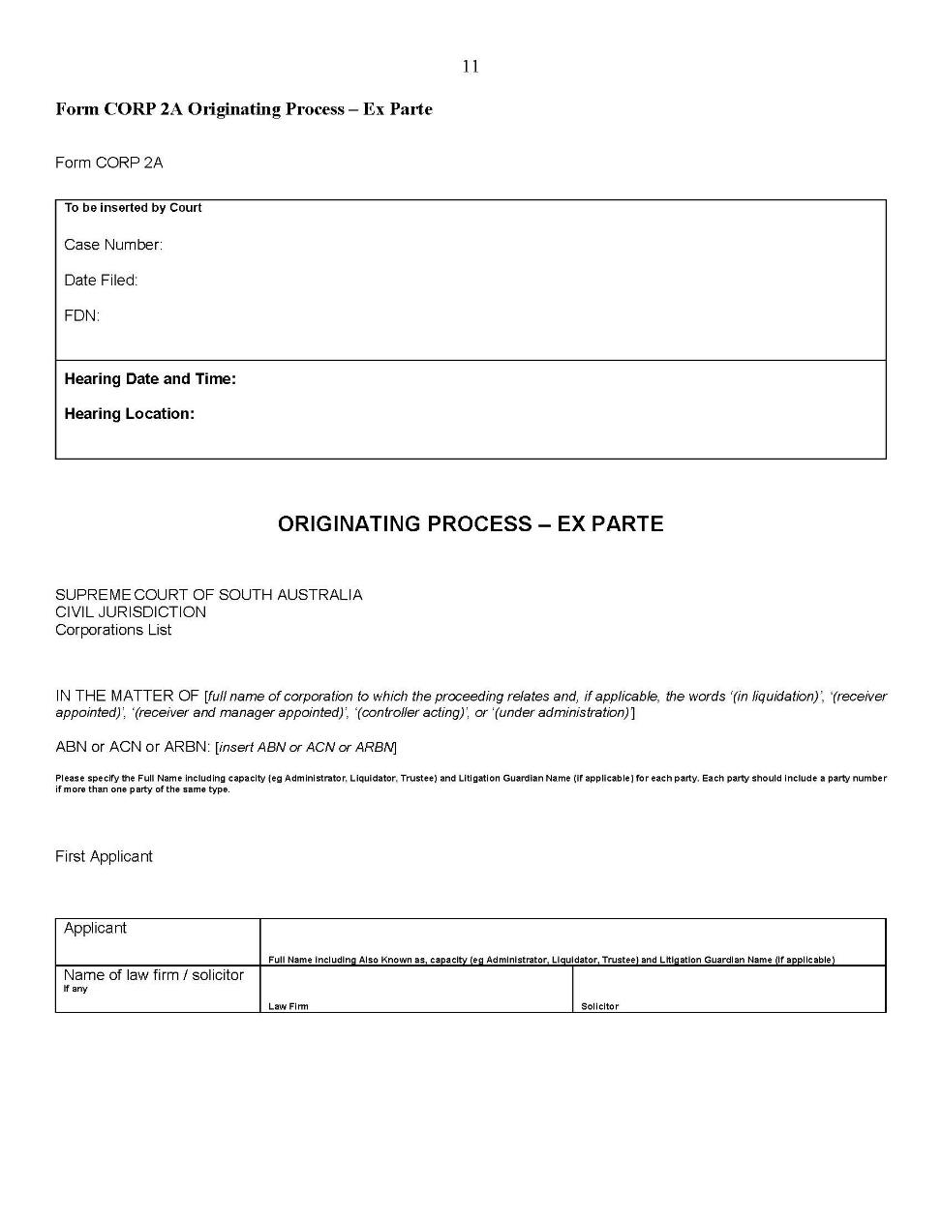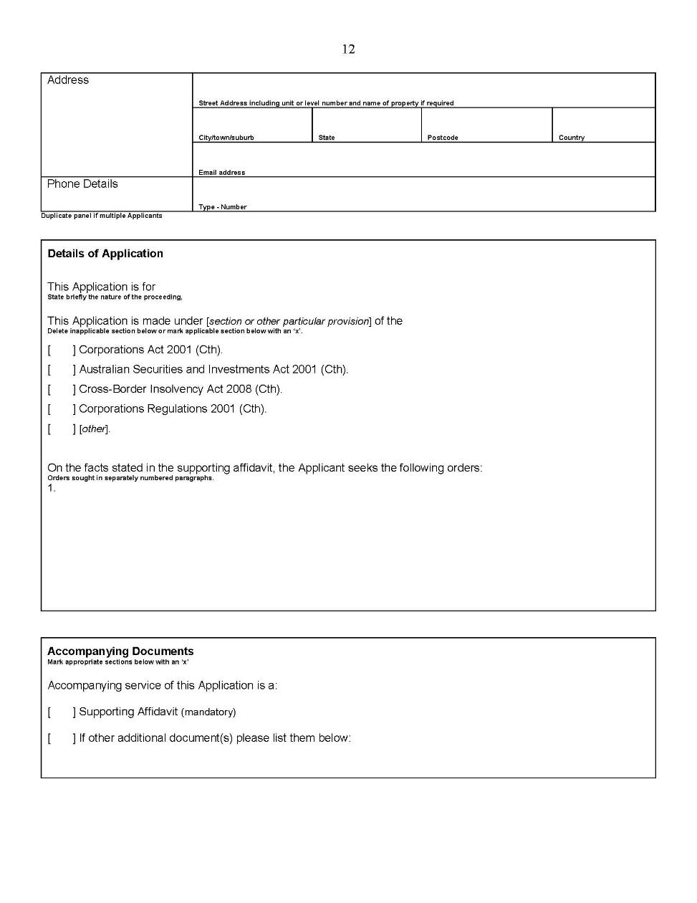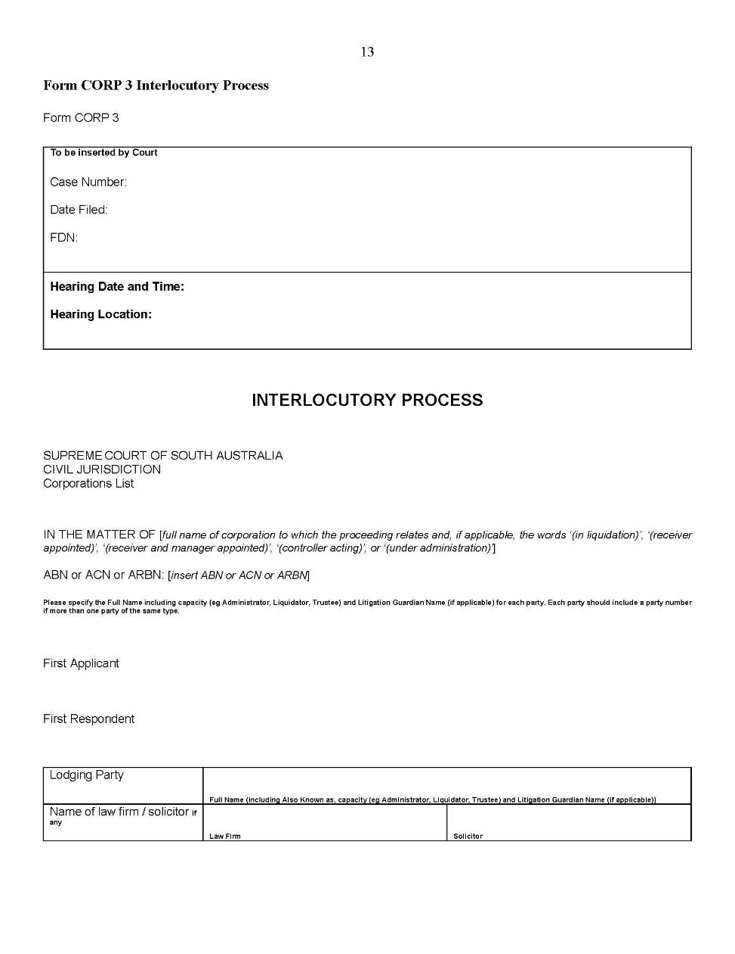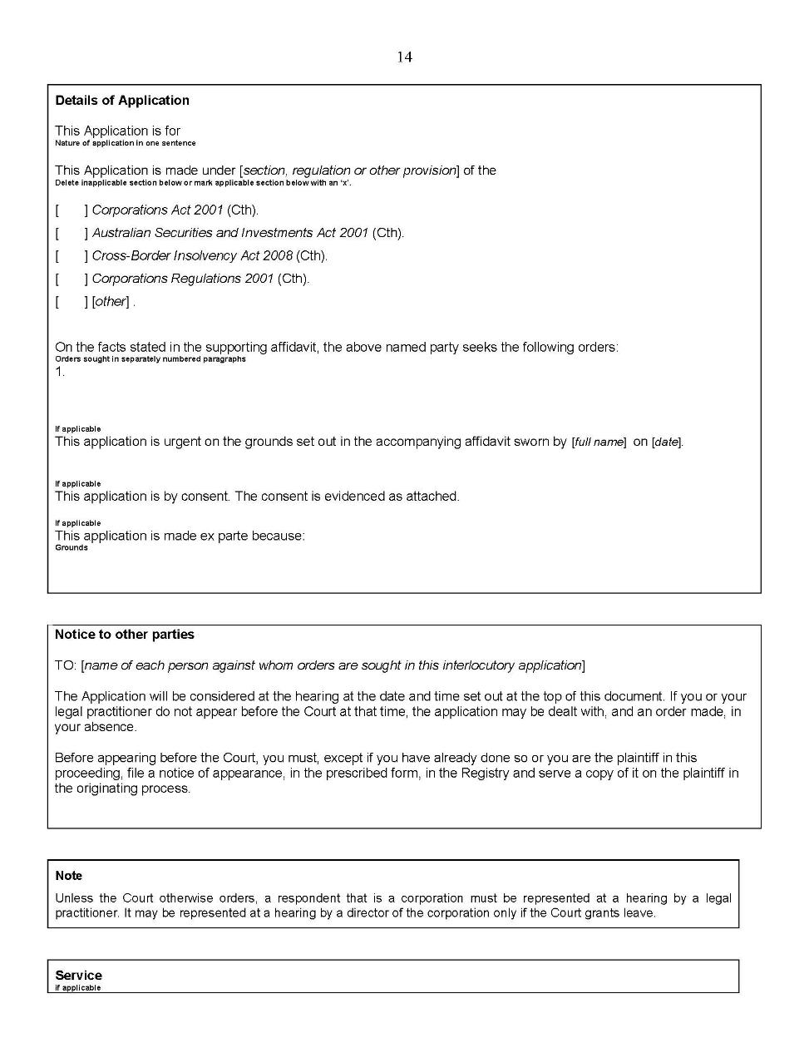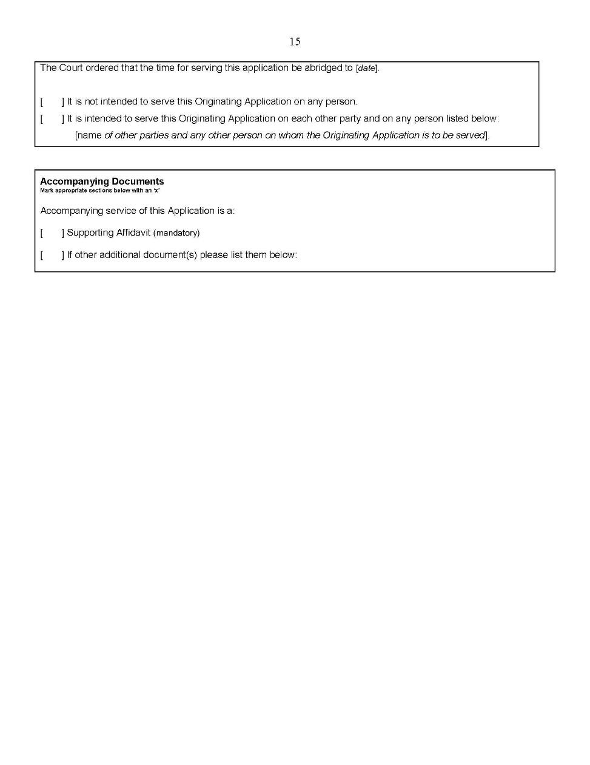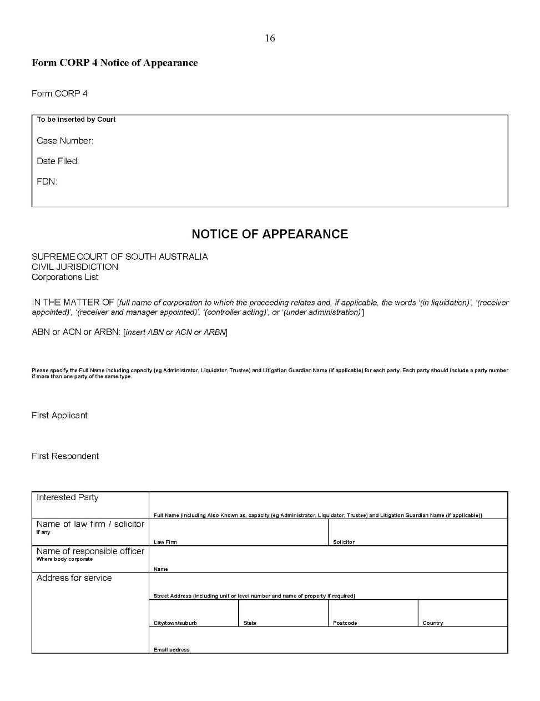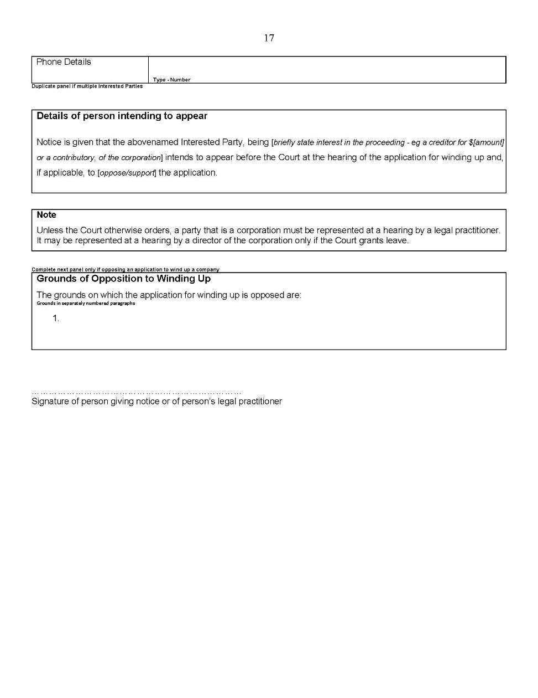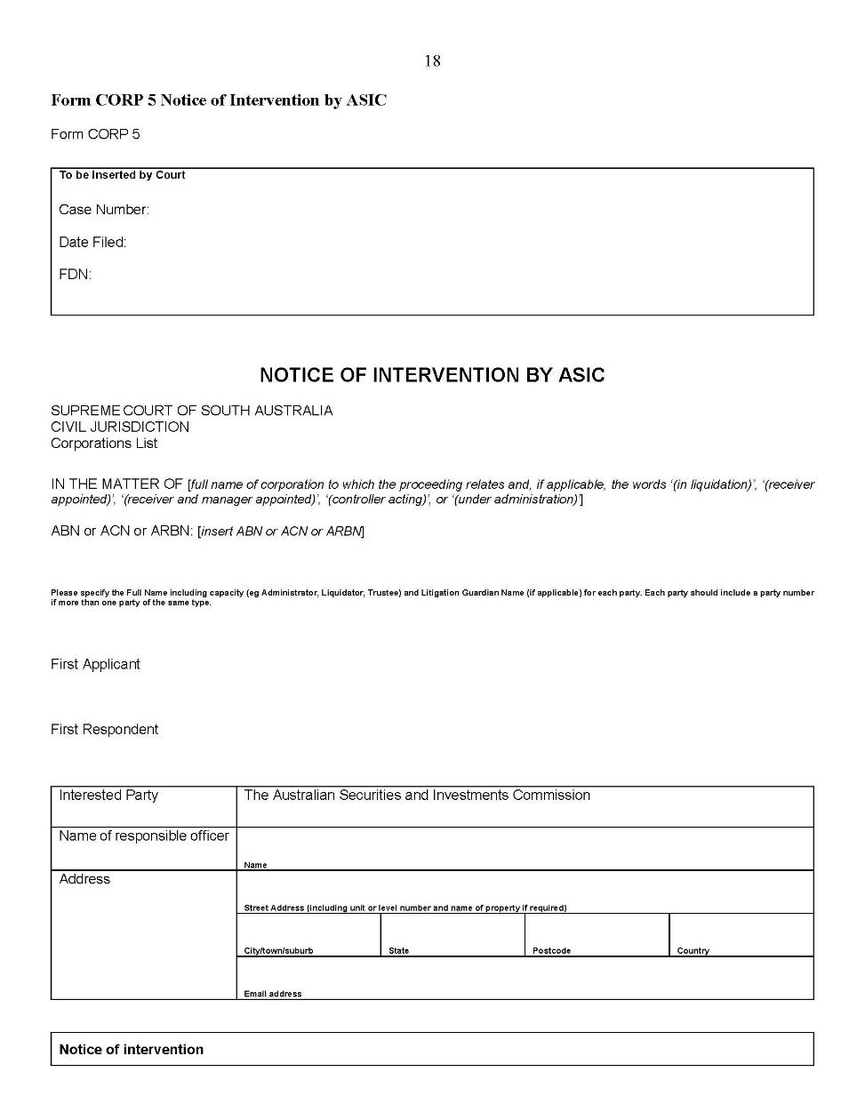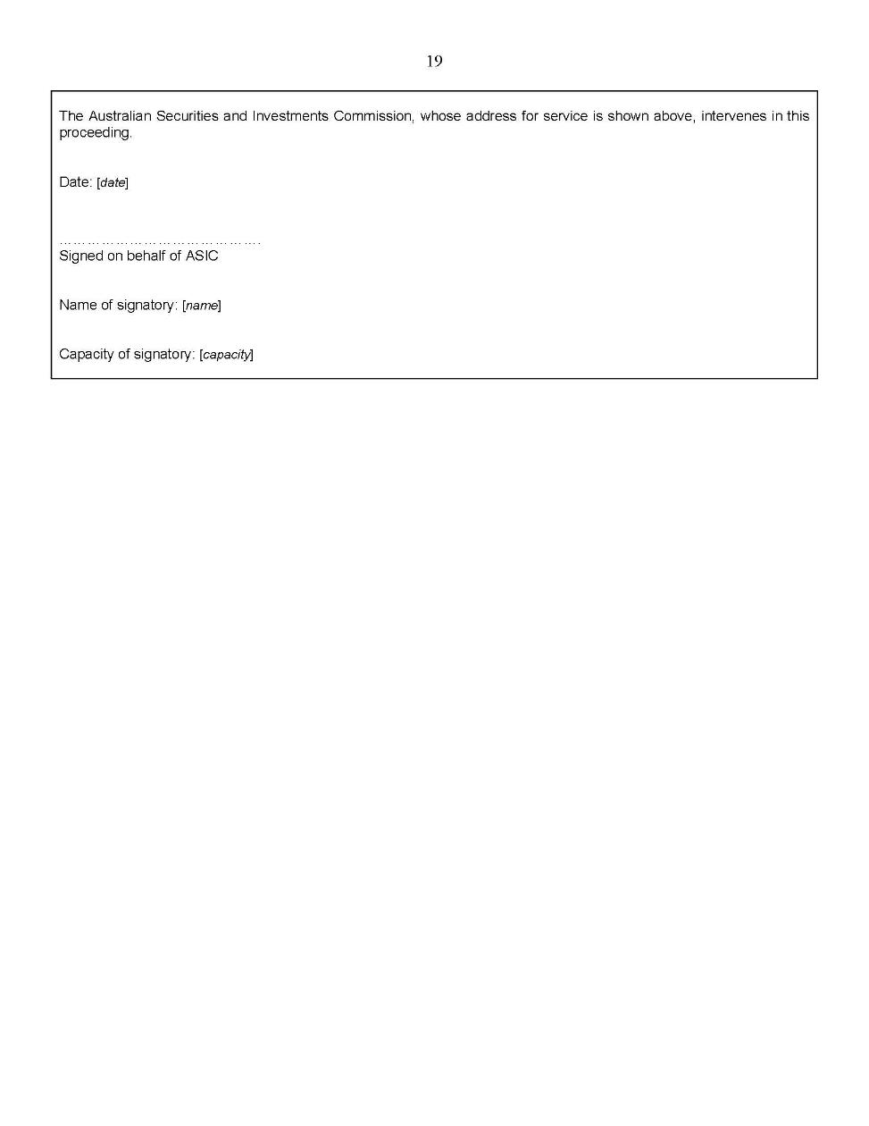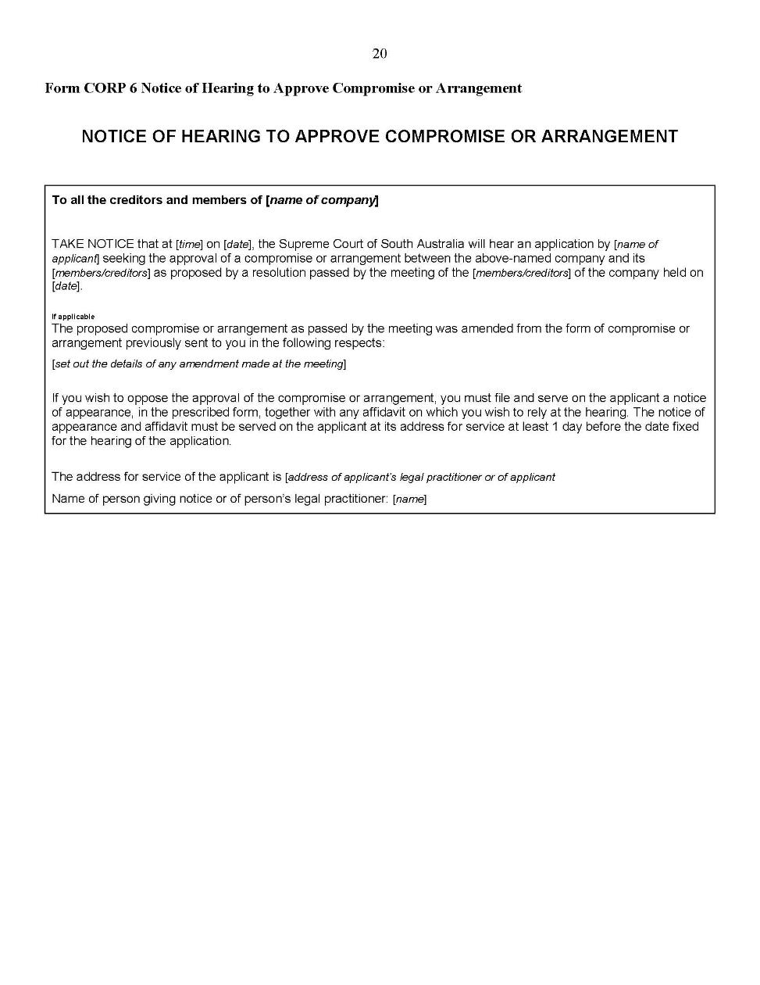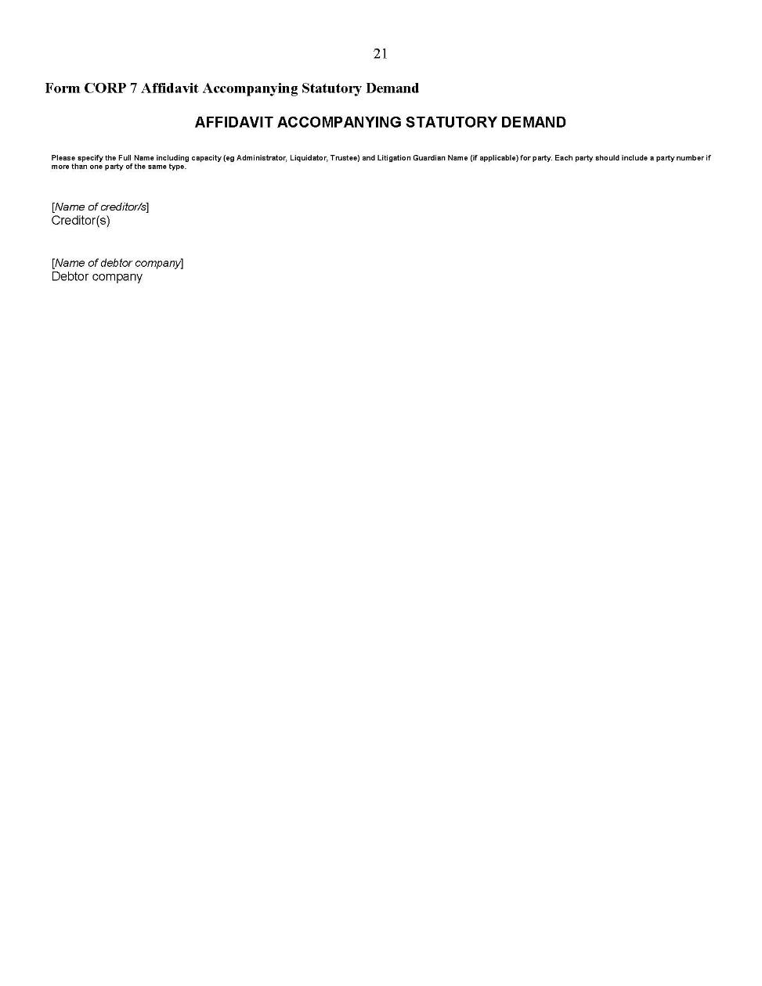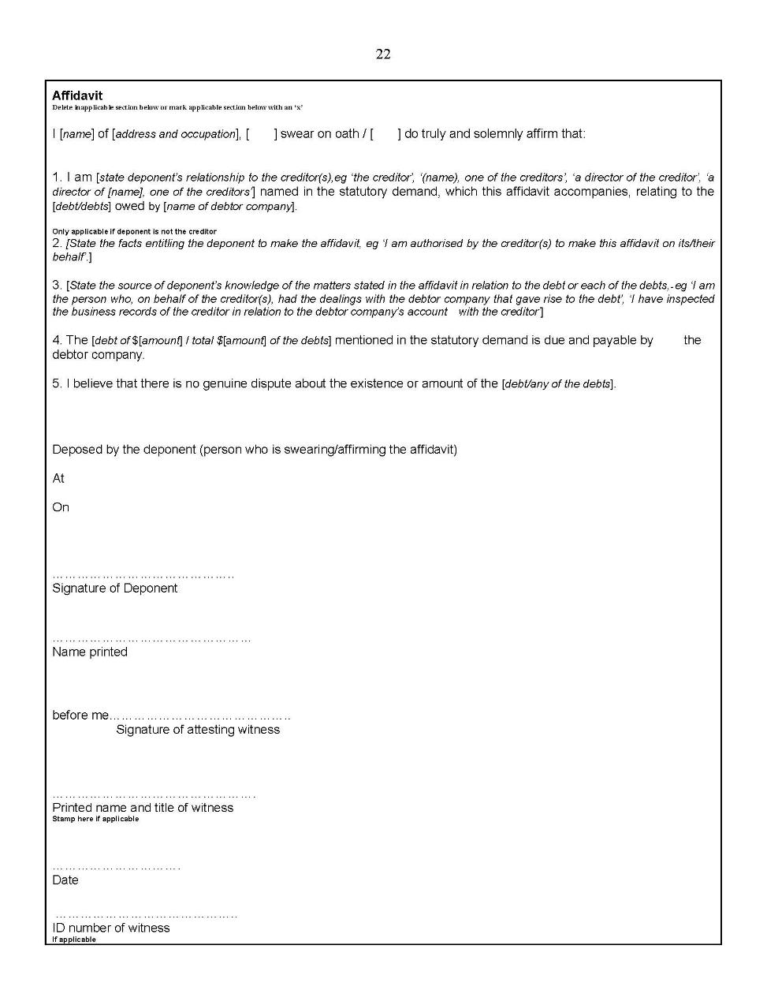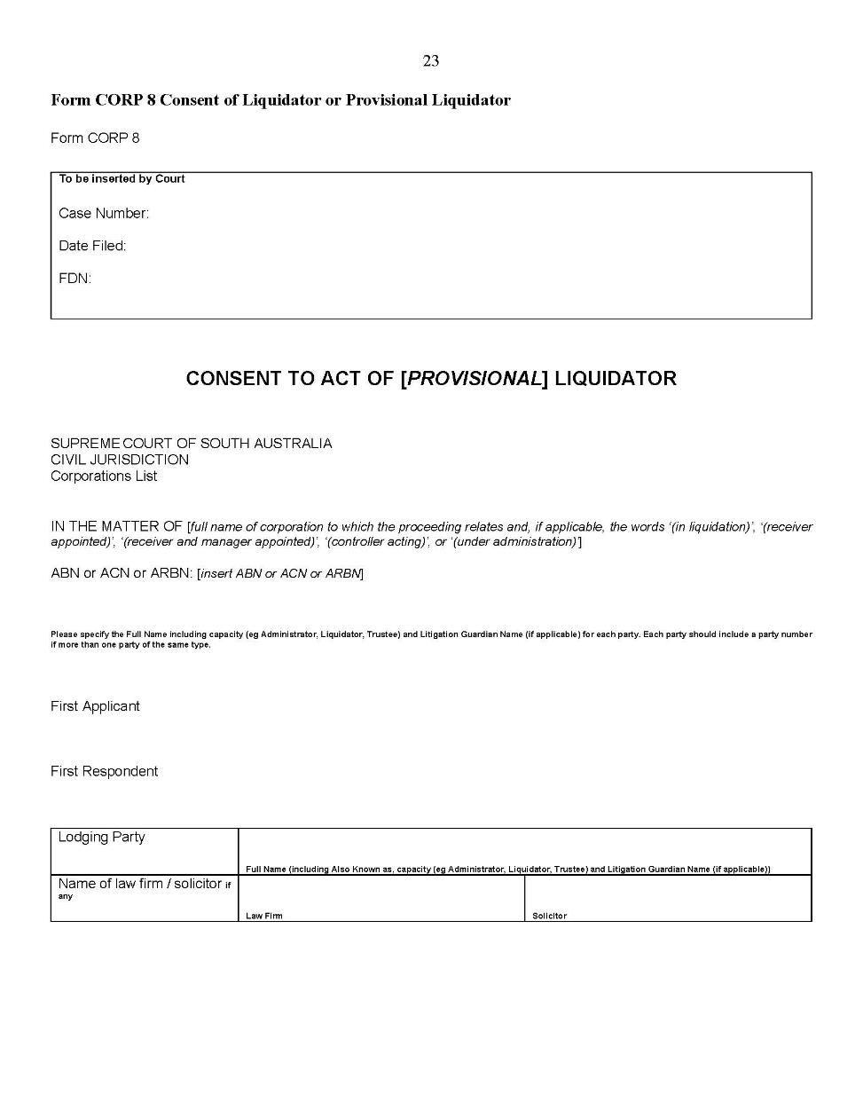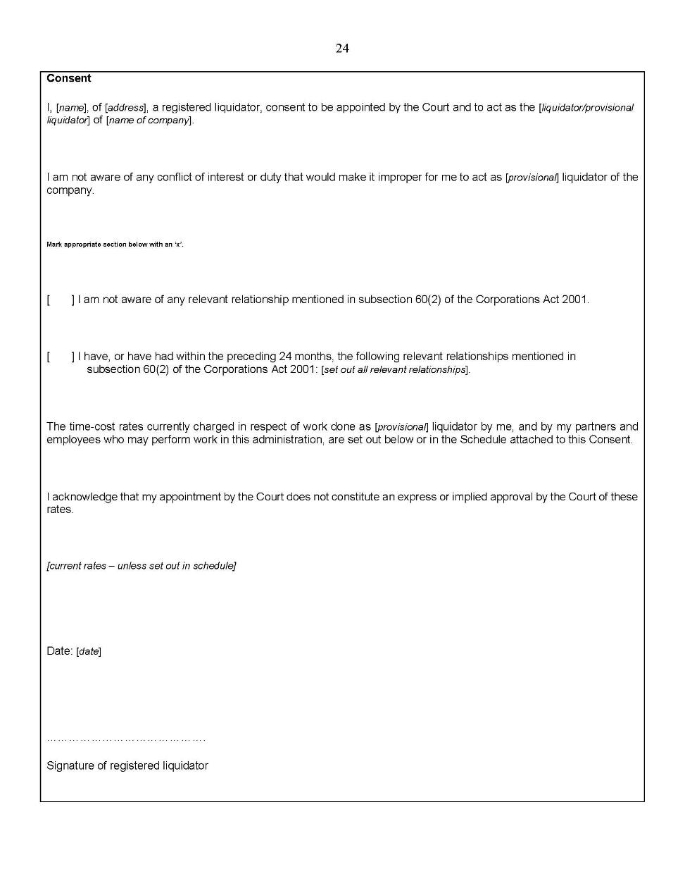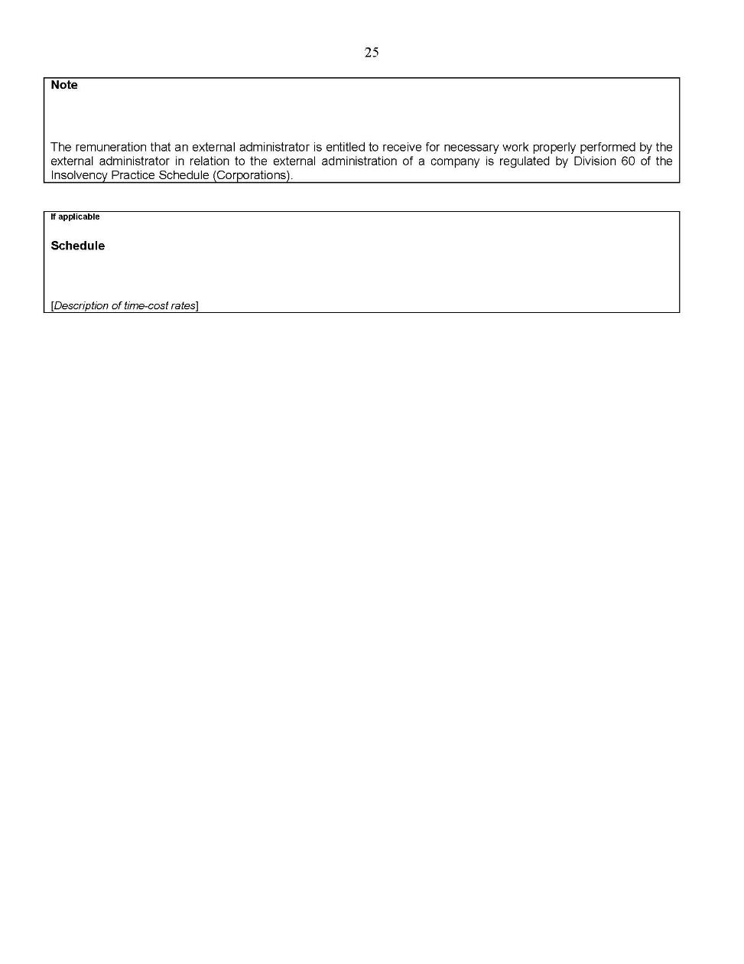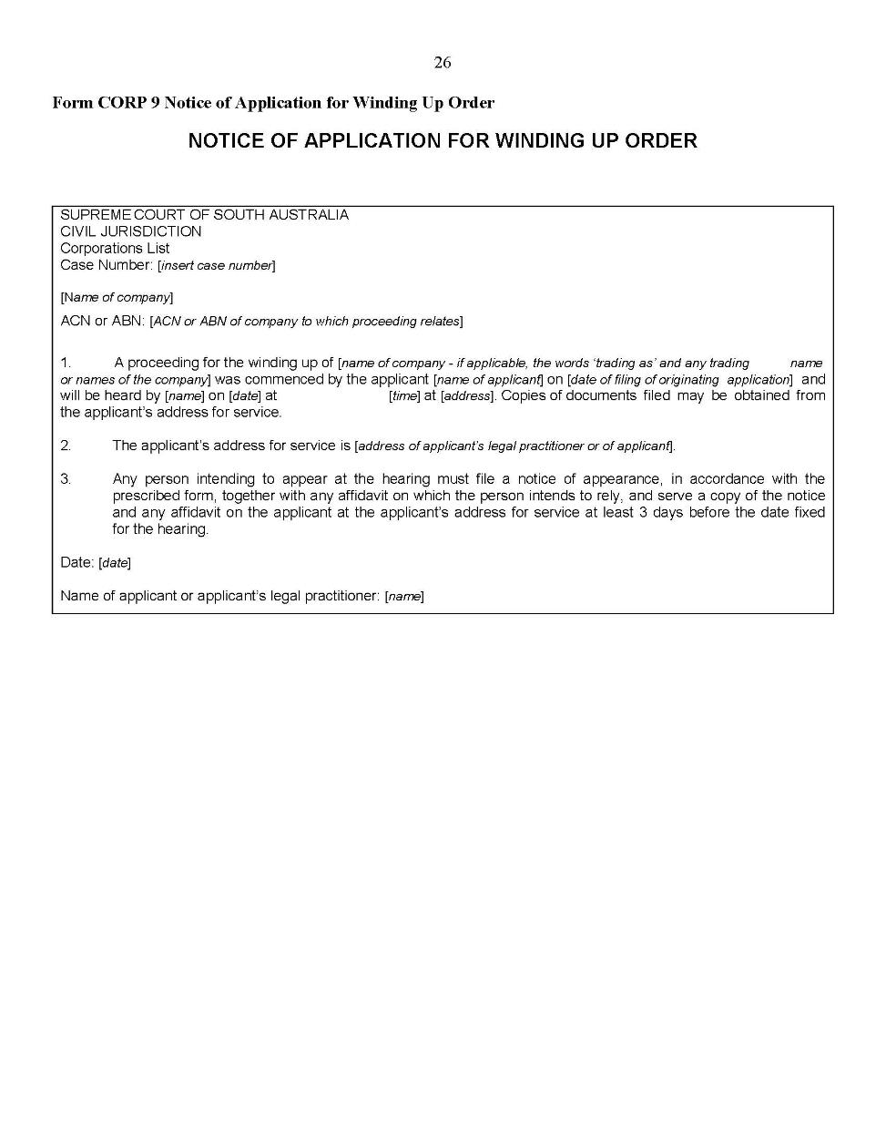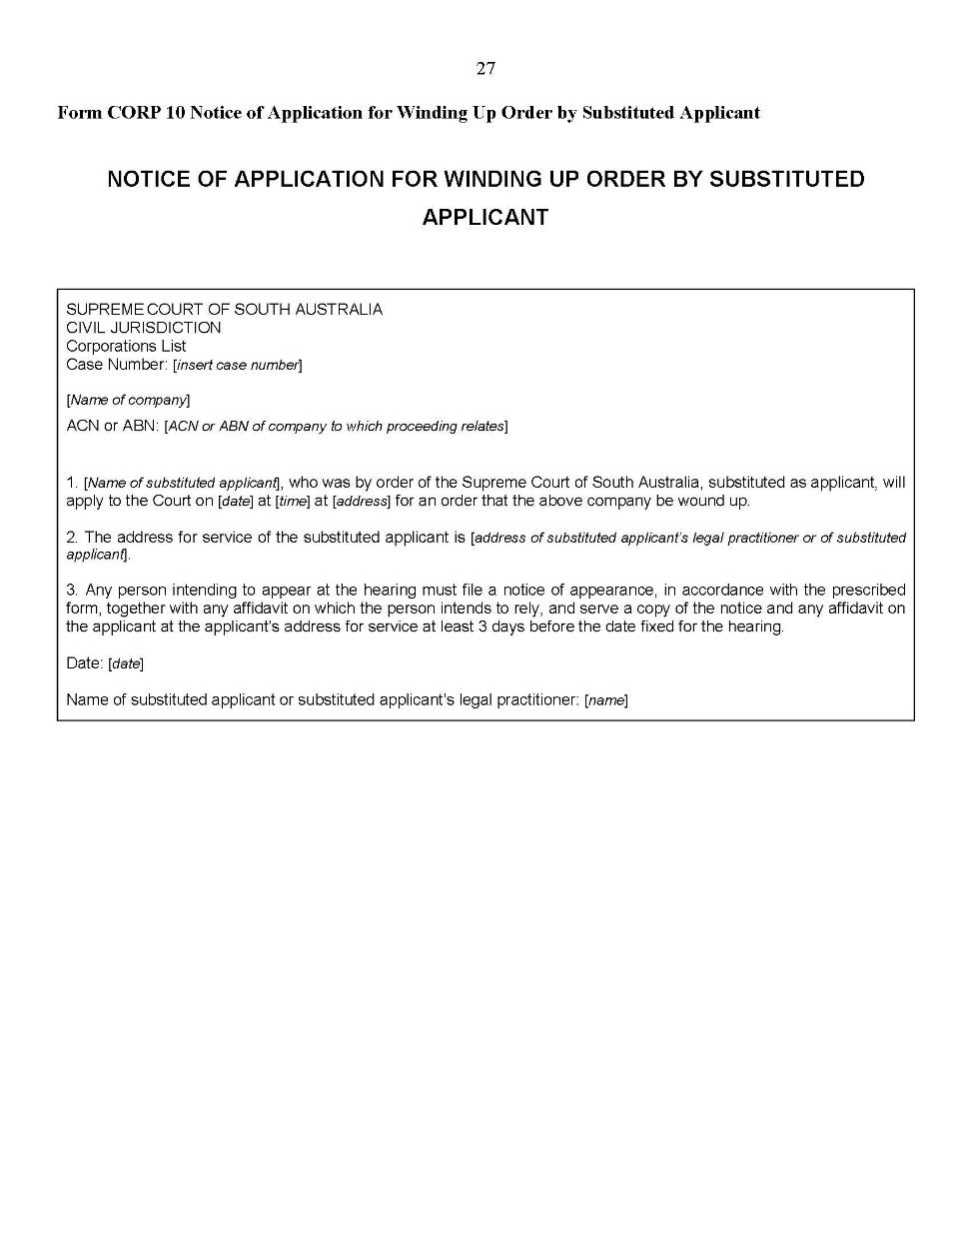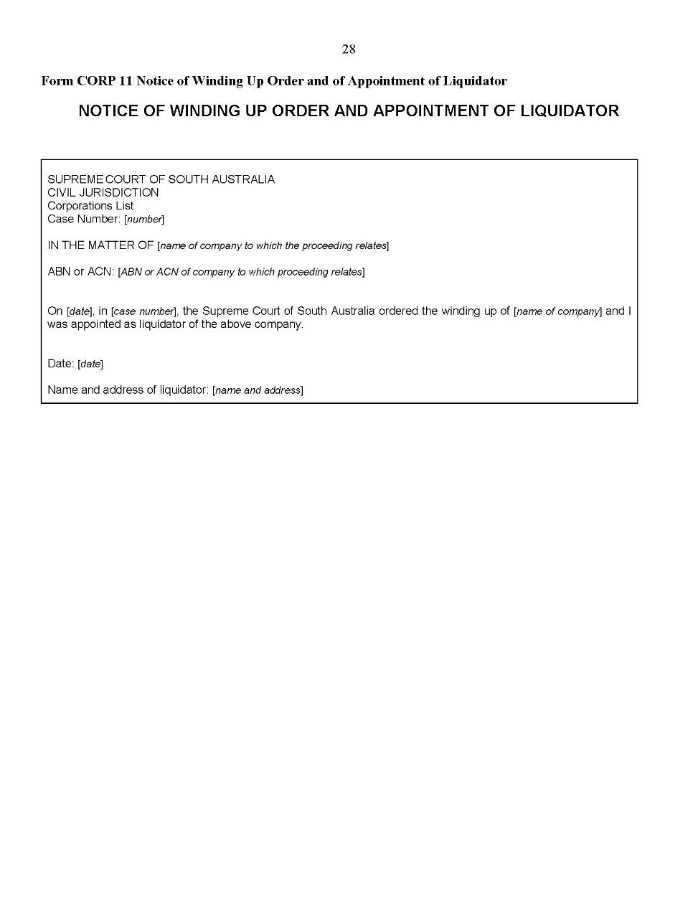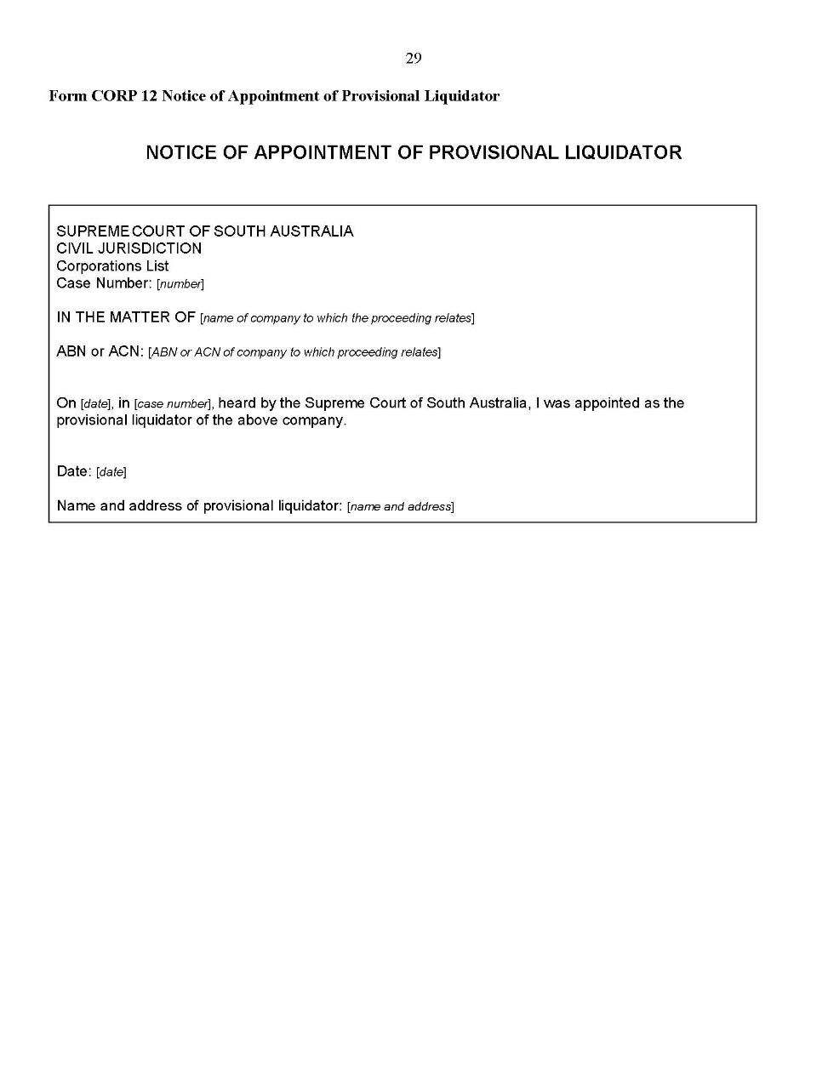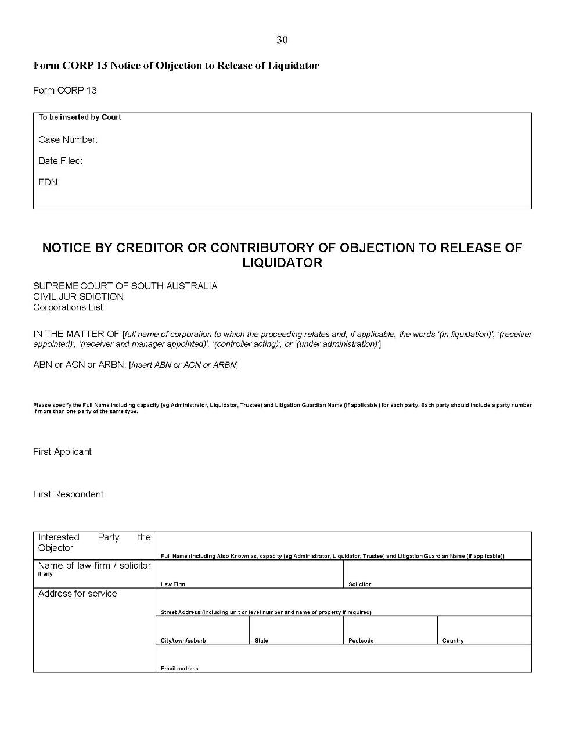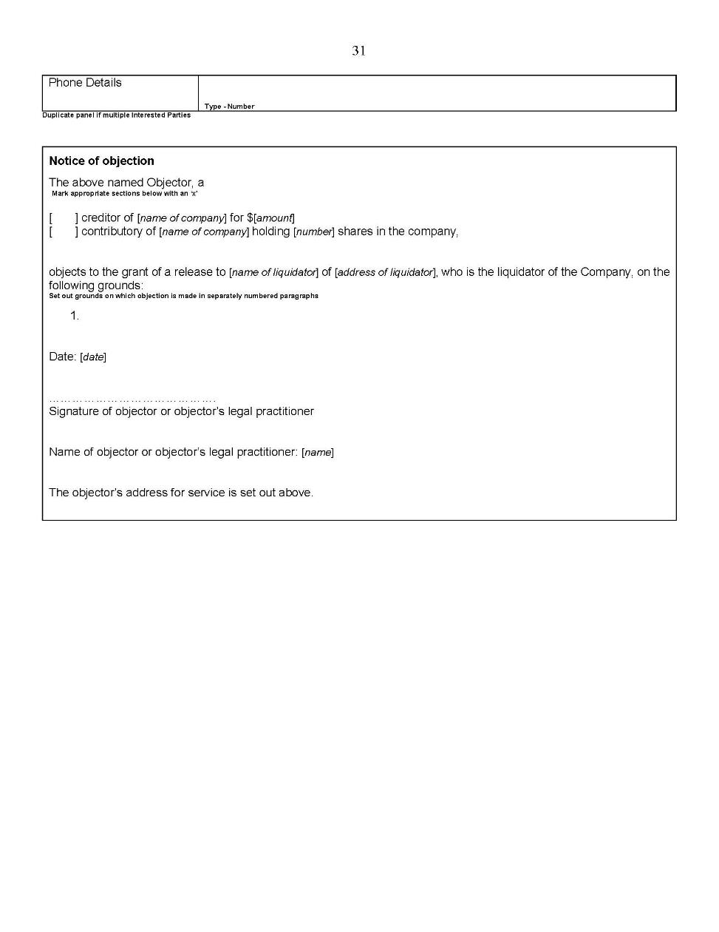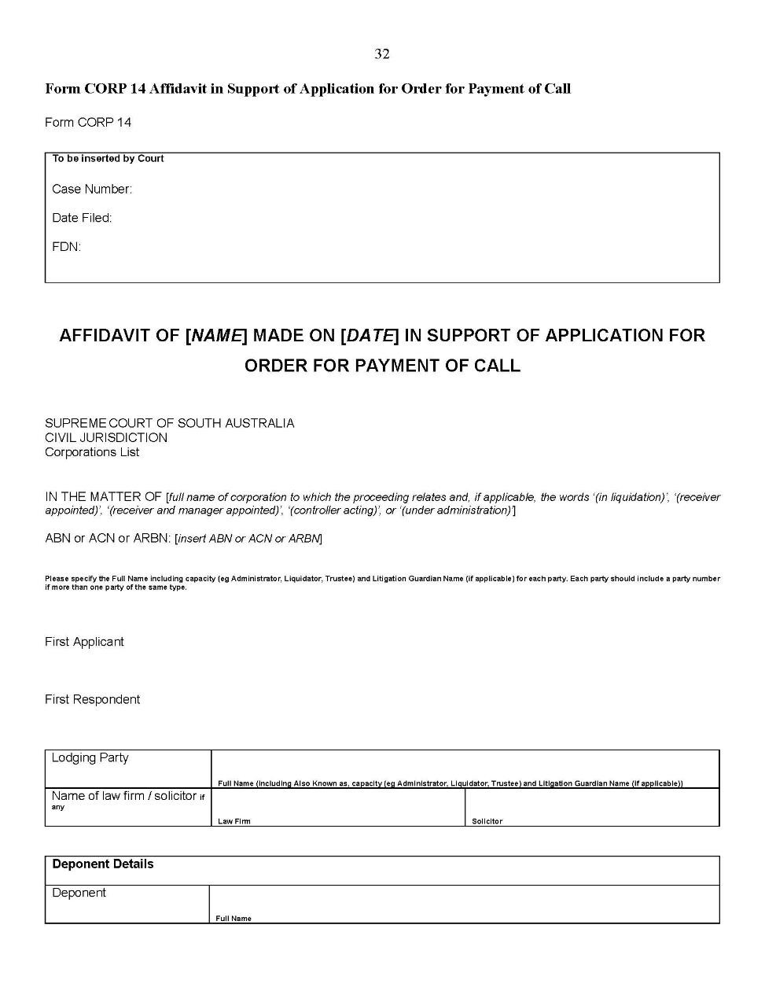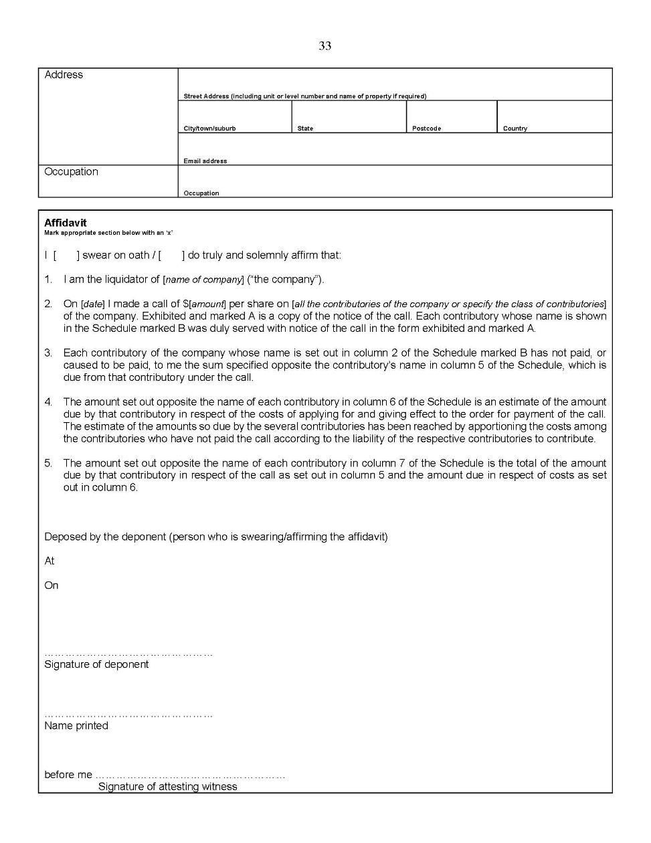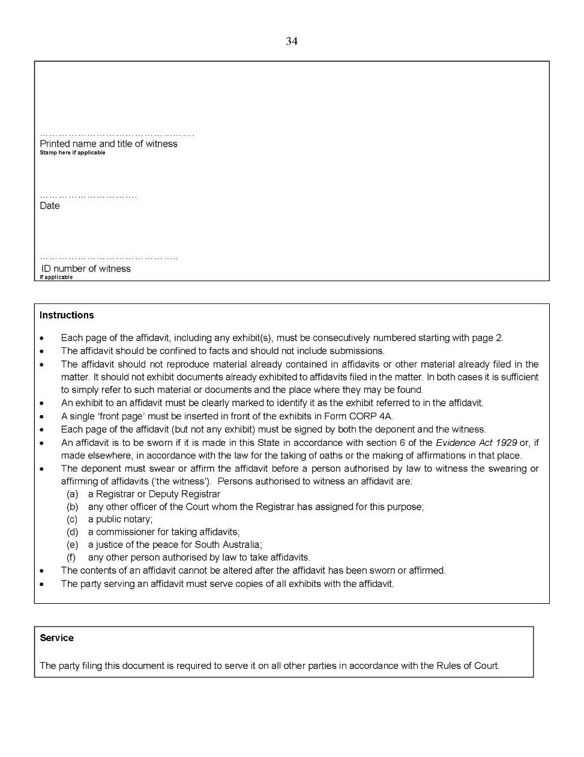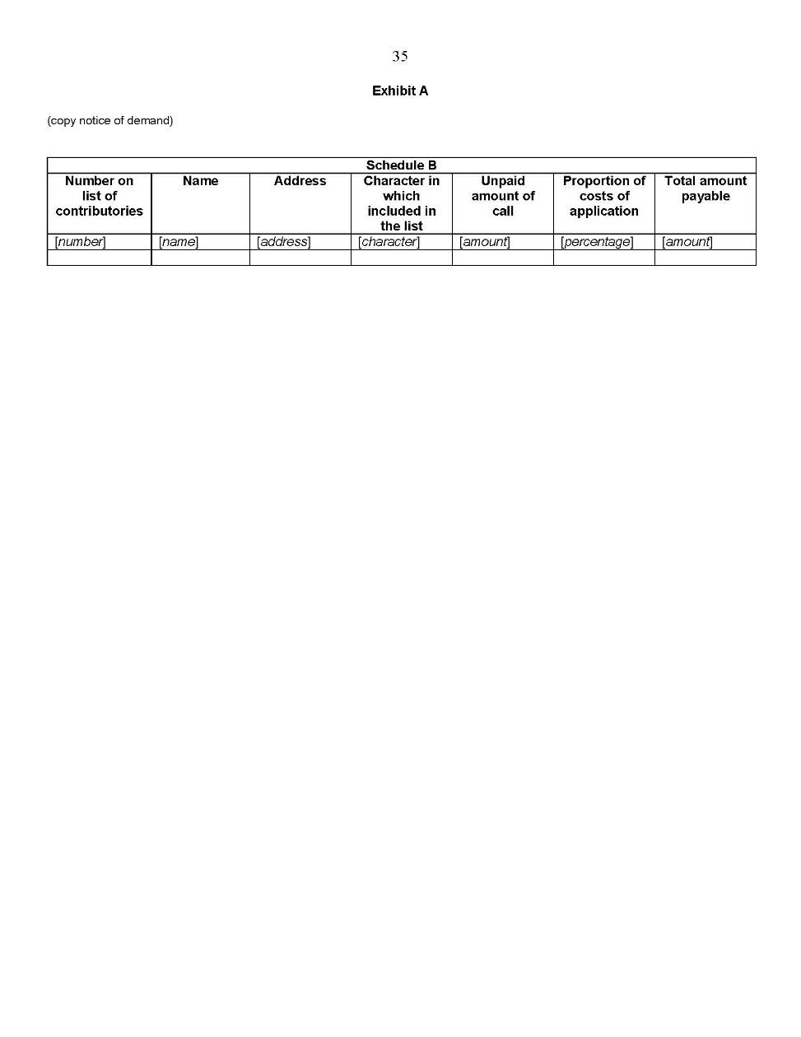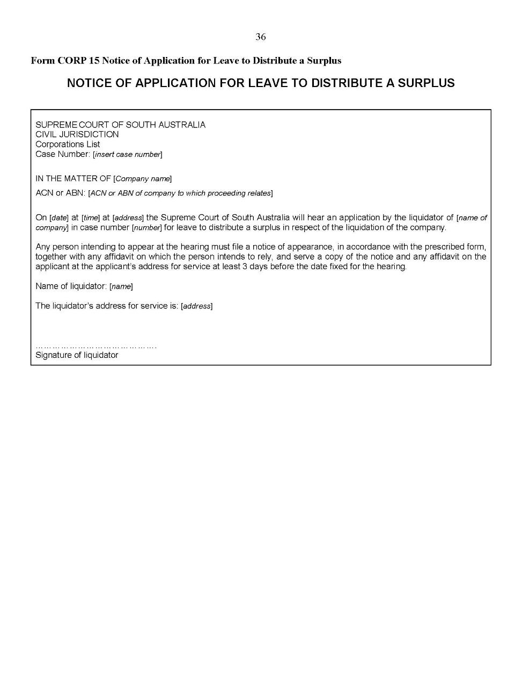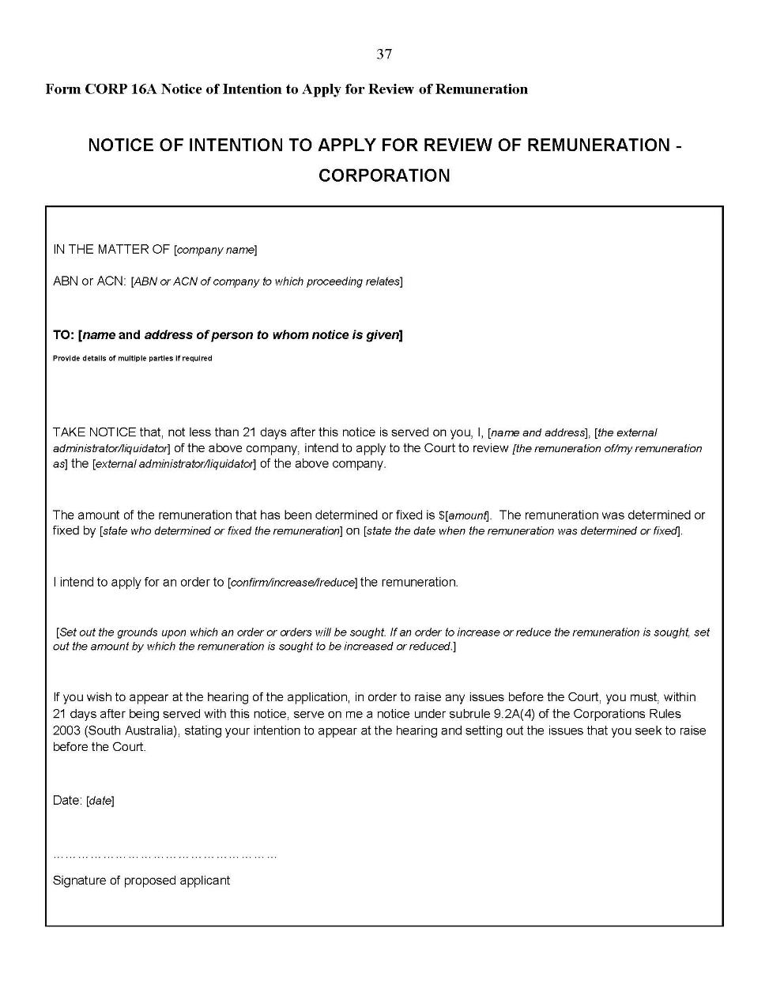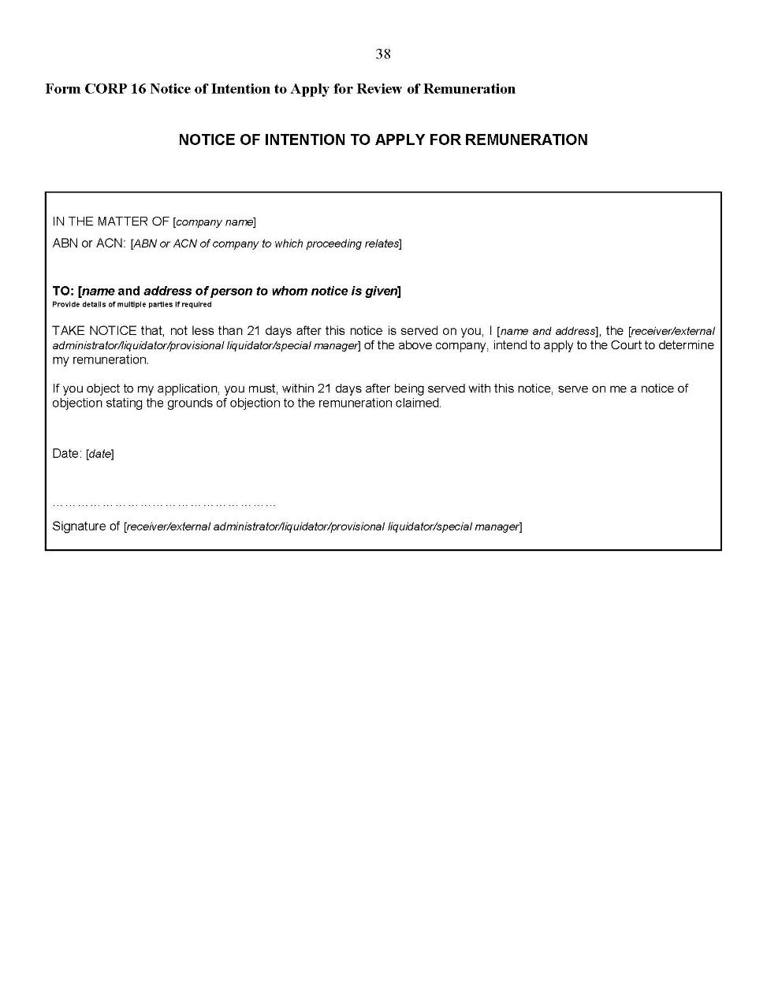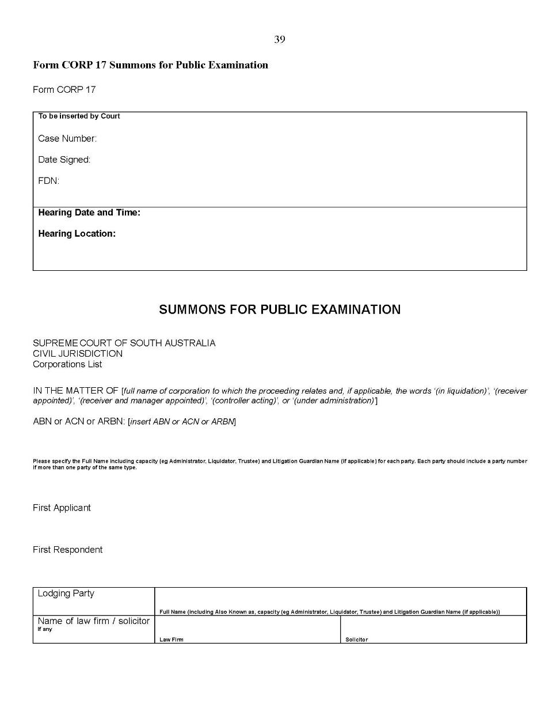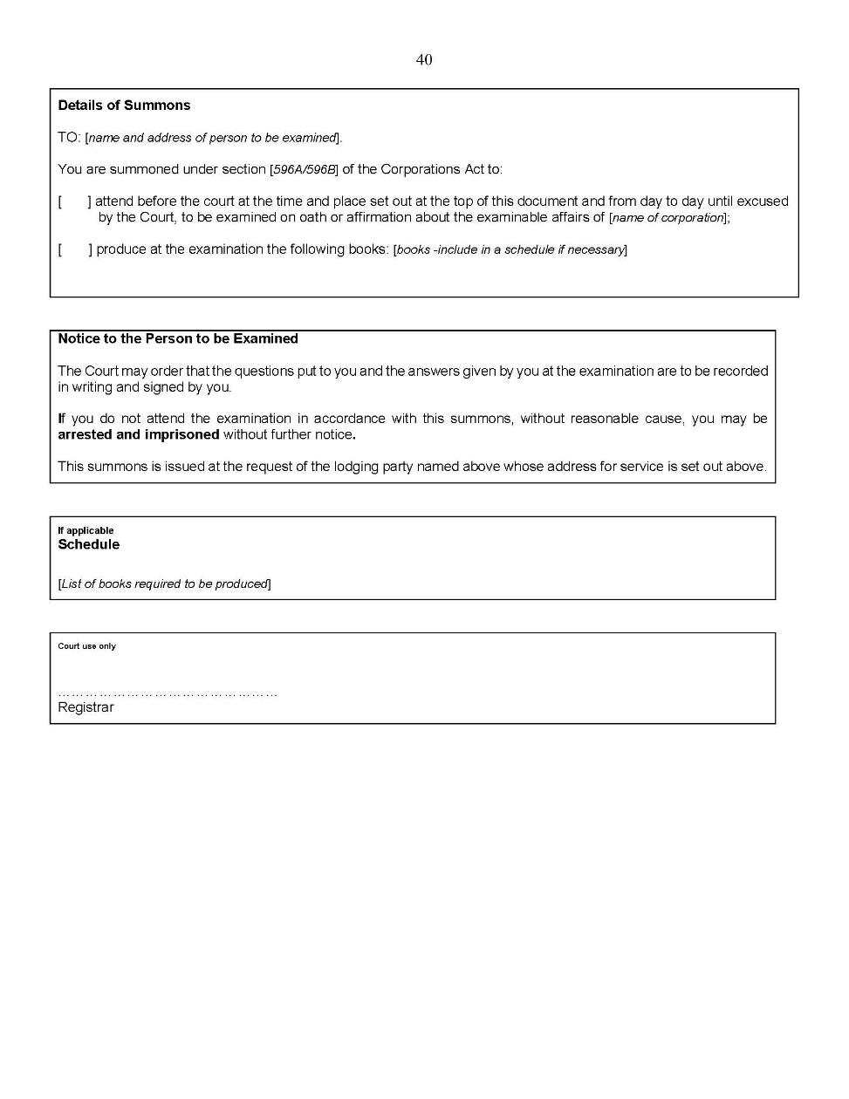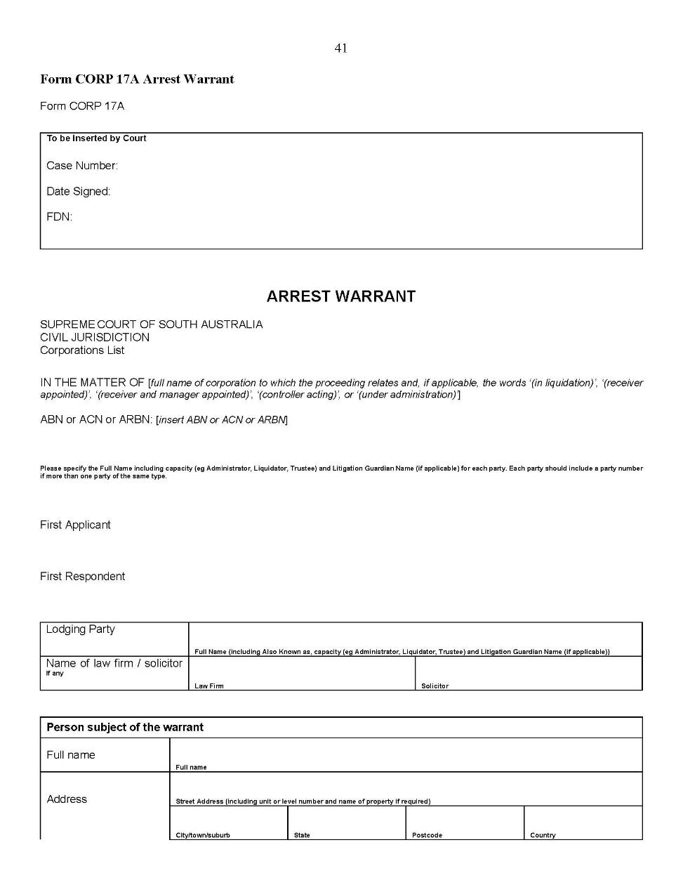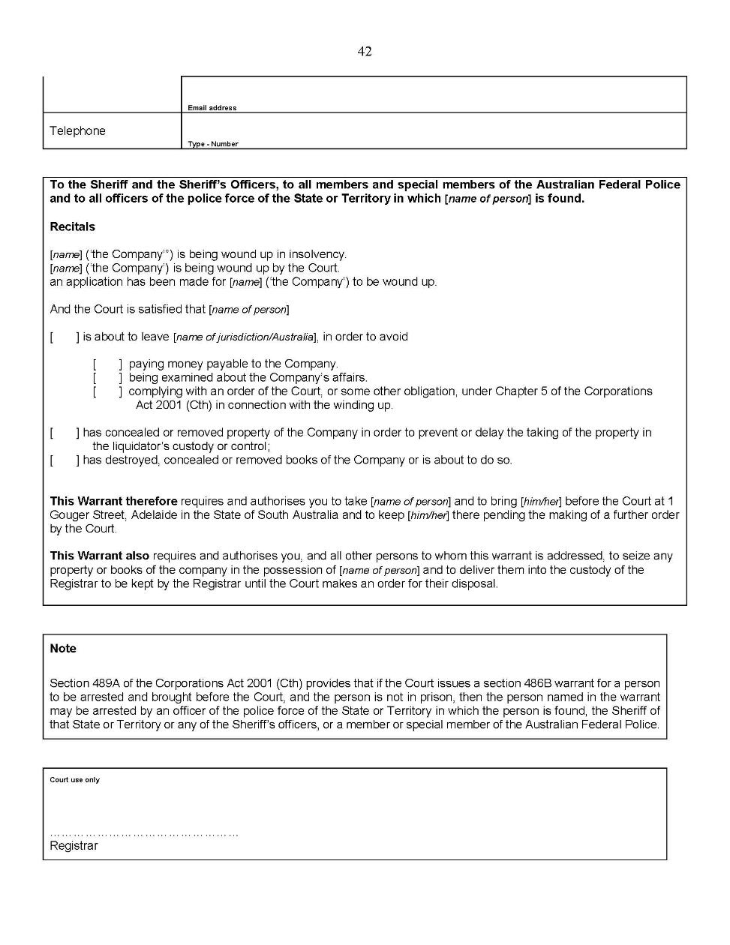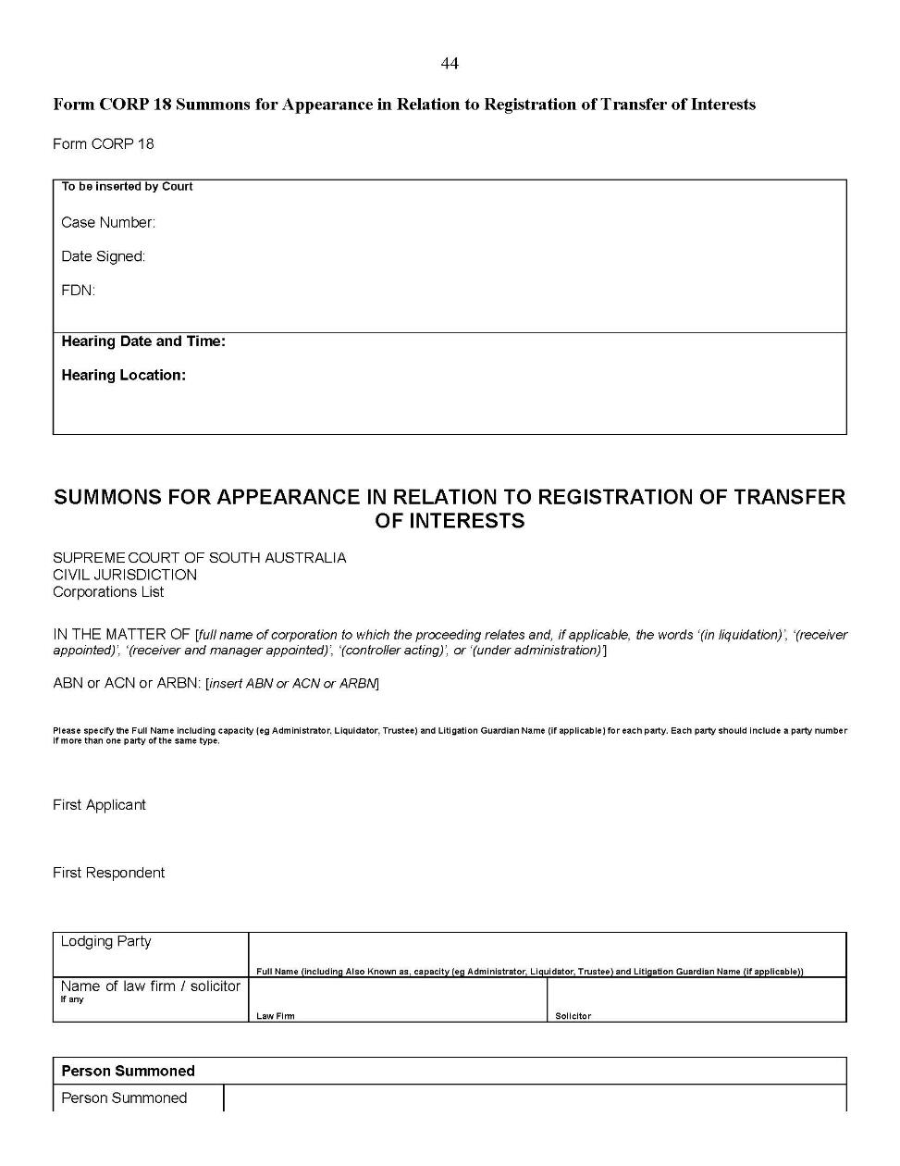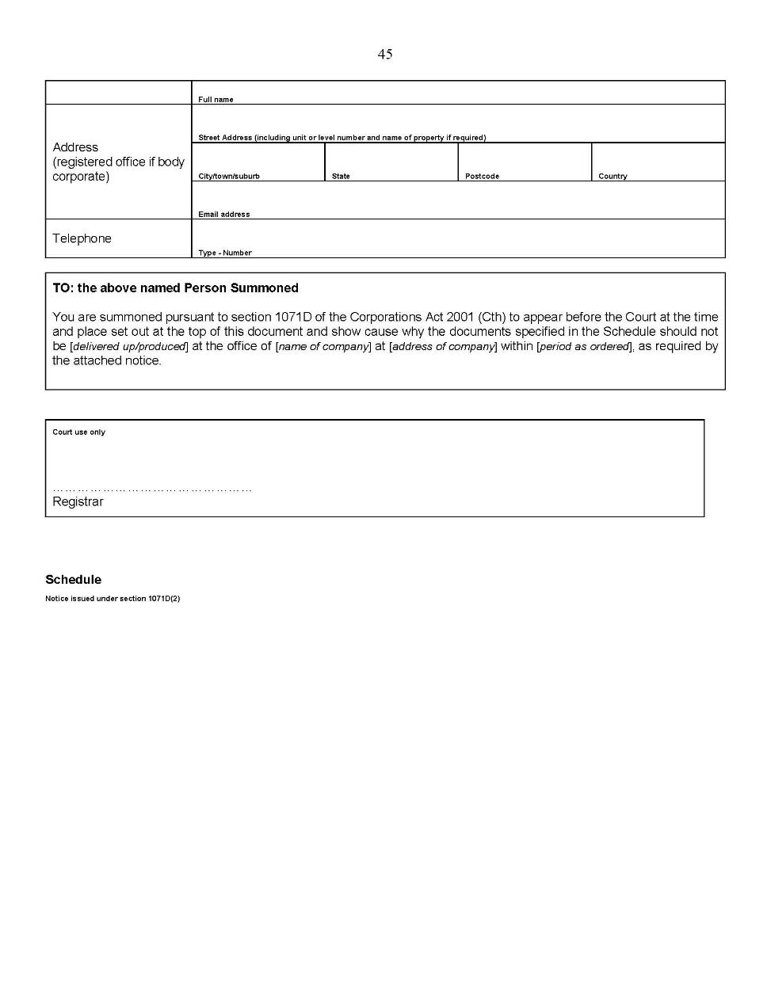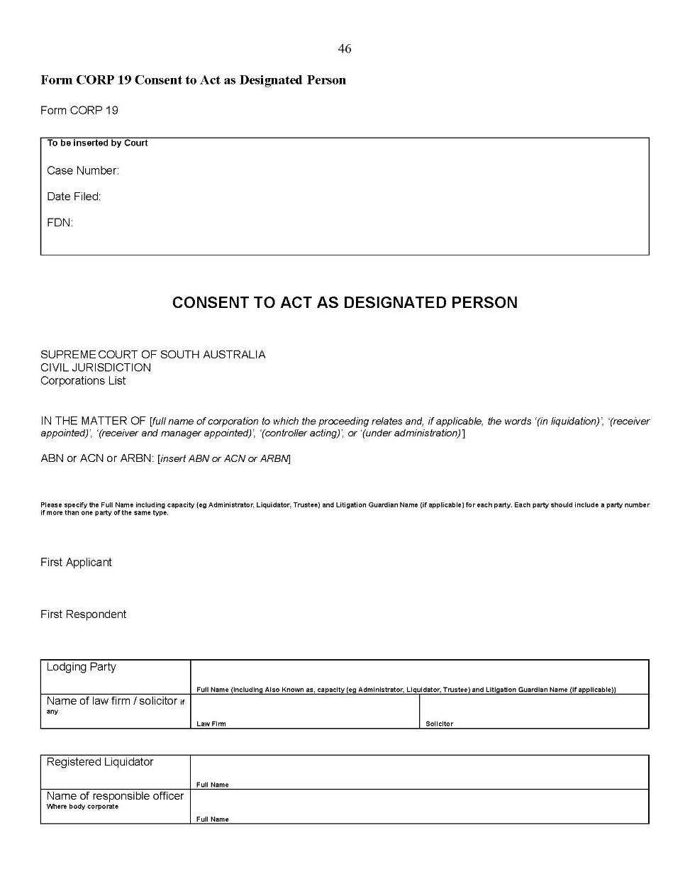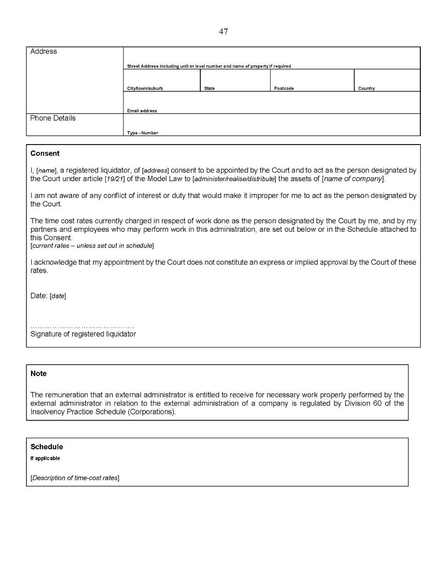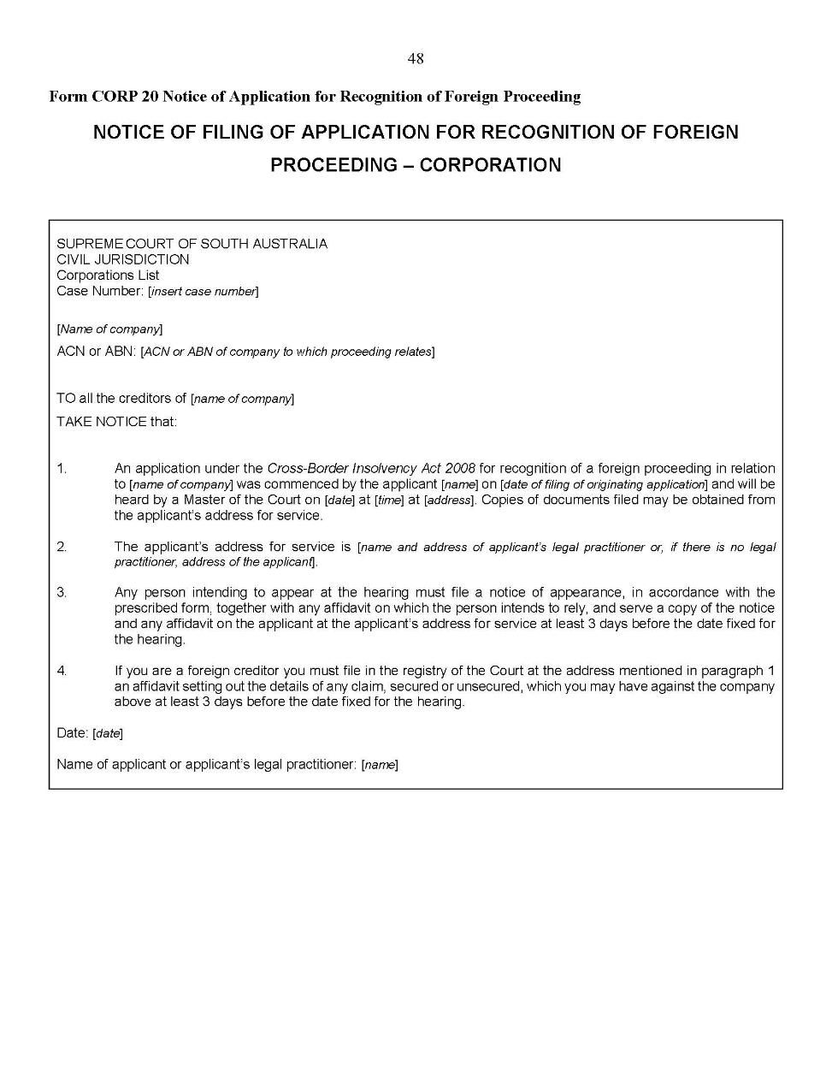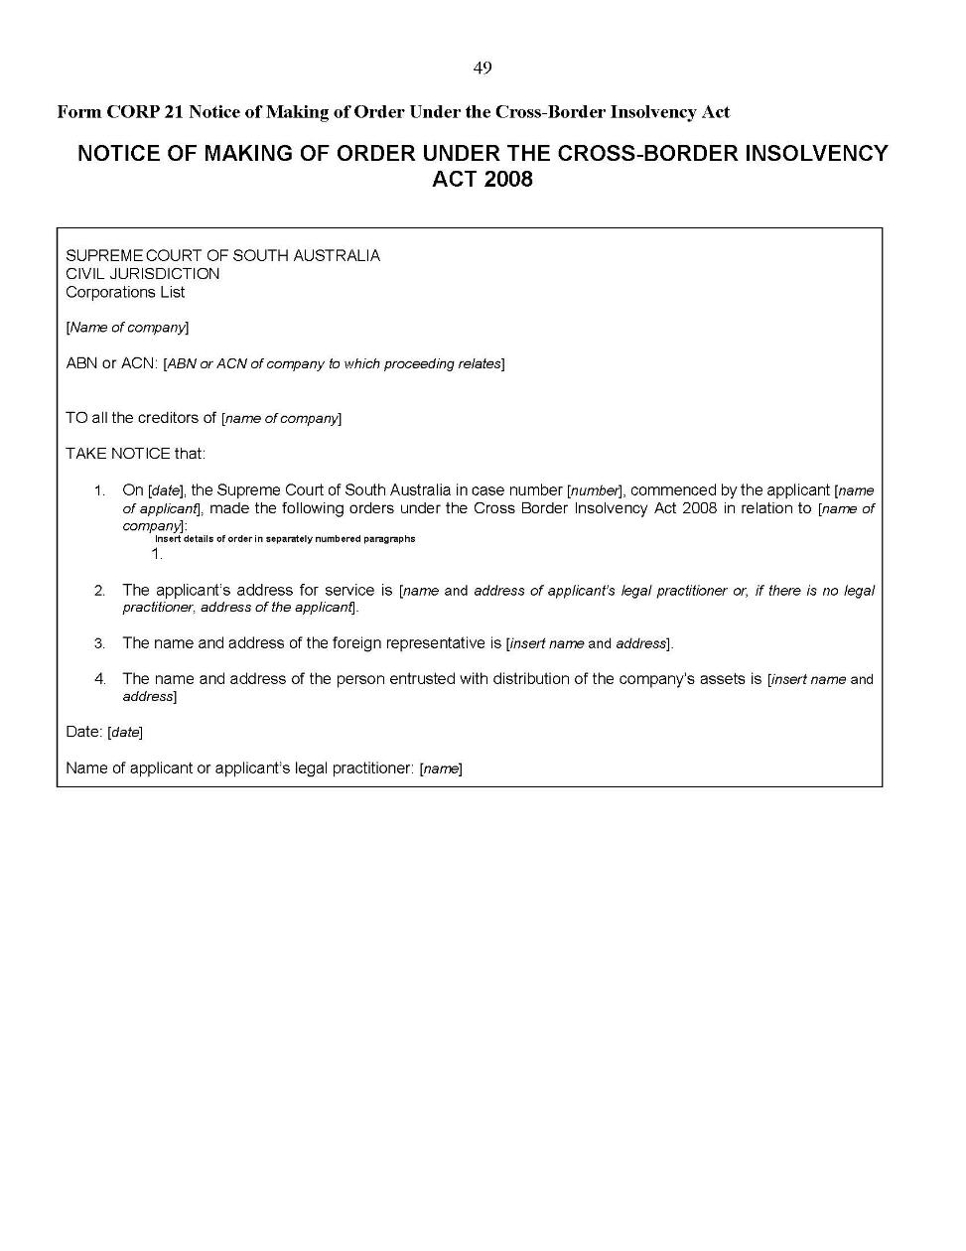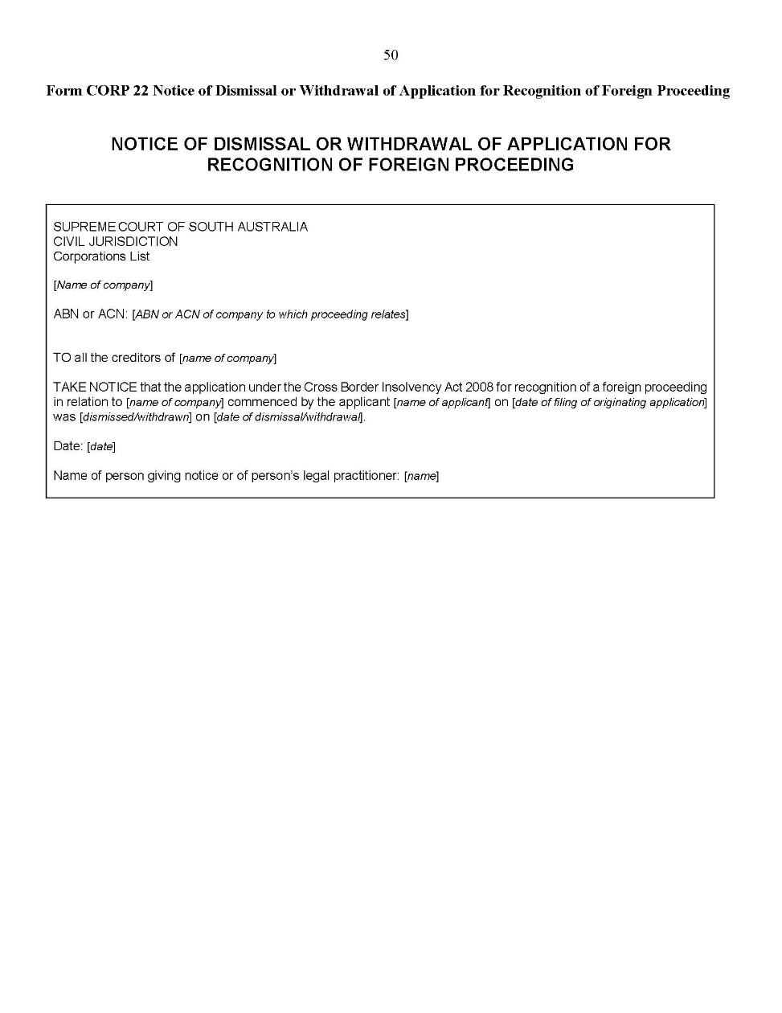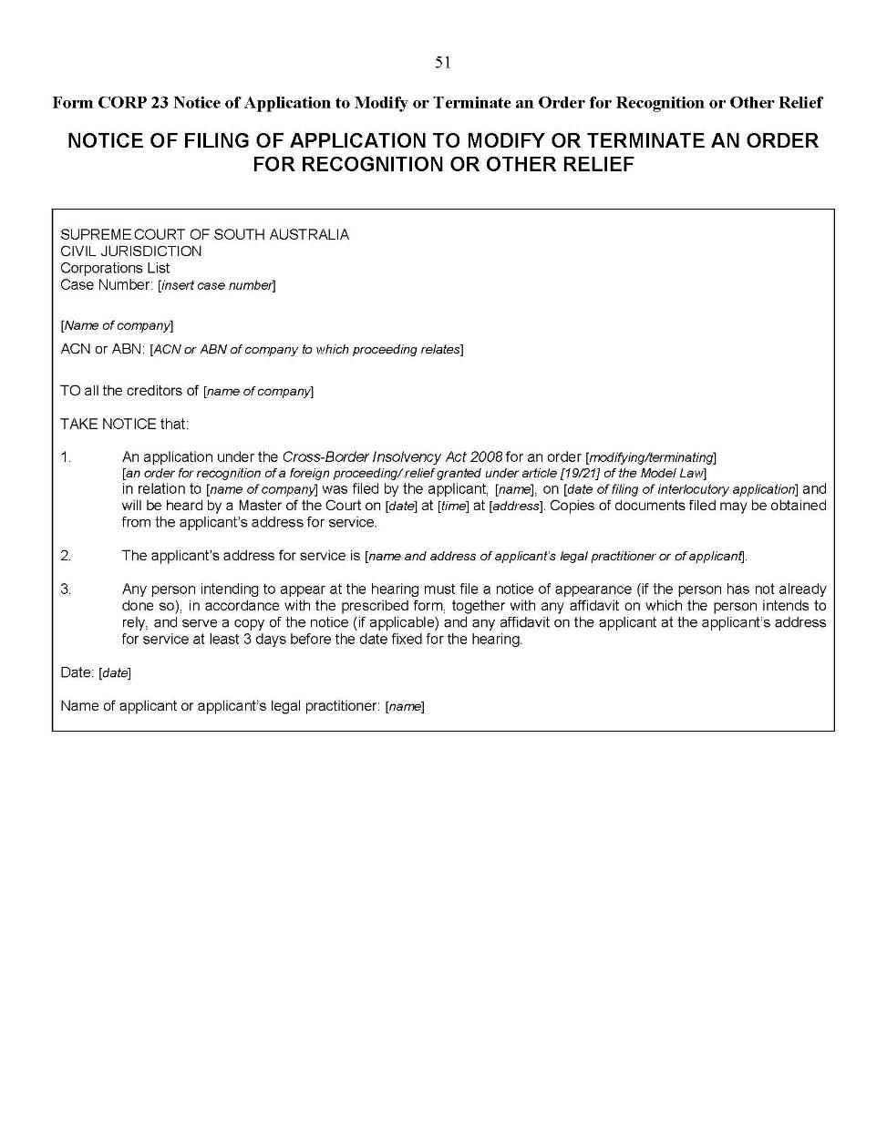
Dated: 5 May 2020
Kourakis CJ
Blue J
Doyle J

District Court Criminal Supplementary Rules 2014
South Australia

Amendment No 7
By virtue and in pursuance of section 51 of the District Court Act 1991 and all other enabling powers, we, Judges of the District Court of South Australia, make the following District Court Criminal Supplementary Rules 2014 (Amendment No 7).
- These Rules may be cited as the District Court Criminal Supplementary Rules 2014 (Amendment No 7).
- The District Court Criminal Supplementary Rules 2014 are amended as set out below.
- The amendments made by these rules come into effect—
(a) subject to subrule (b), on the date of their publication in the Gazette;
(b) if these rules are published in the Gazette on a day other than a Monday, these rules come into effect on the date that is the first Monday following that publication.
- In these Rules, the commencement date means the date on which these rules come into effect under rule 3.
- Rule 49A is deleted.
Dated: 9 April 2020
M G Evans
Chief Judge
R Soulio
Judge
P V Slattery
Judge

District Court Special Applications Rules 2014
South Australia

Amendment No 2
By virtue and in pursuance of section 51 of the District Court Act 1991 and all other enabling powers, we, Judges of the District Court of South Australia, make the following District Court Special Applications Rules 2014 (Amendment No 2).
- These Rules may be cited as the District Court Special Applications Rules 2014 (Amendment No. 2).
- The District Court Special Applications Rules 2014 are amended as set out below.
- The District Court Special Applications Supplementary Rules 2014 are repealed.
- These rules come into effect—
(a) subject to subrule (b), on the date of their publication in the Gazette;
(b) if these rules are published in the Gazette on a day other than a Monday, these rules come into effect on the date that is the first Monday following that publication.
- In the Rules, the commencement date means the date on which these rules come into effect under rule 4.
- Unless the Court otherwise orders—
(a) the District Court Special Applications Rules 2014 as amended by these Rules (the current Rules) apply to—
(i) a proceeding commenced; and
(ii) a step in a proceeding taken,
on or after the commencement date; and
(b) the District Court Special Applications Rules 2014 before they were amended by these Rules (the former Rules) continue to govern a step in a proceeding taken before the commencement date.
- If the time to commence or take a step in a proceeding under the former Rules has not expired as at the commencement date, the time to commence or take a step in the proceeding continues to be governed by the former Rules (unless the current Rules provide for a longer time).
- The definition of ‘General Civil Rules’ in rule 3(2) is deleted.
- In rule 3(2), a new definition is inserted after the definition of ‘Supplementary Rules’ and before the definition of ‘warrant’ as follows:
“Uniform Civil Rules means the Uniform Civil Rules 2020;”
- Rule 4 is amended by inserting the word ‘certain’ before the word ‘proceedings’ and deleting paragraphs (e), (f) and (i).
- Rule 5 is deleted and the following rule is substituted:
“5—Application of Uniform Civil Rules
(1) Unless the Court otherwise directs and subject to subrule (2), Chapters 1 to 4 of the Uniform Civil Rules apply to proceedings in the Court under these Rules.
(2) To the extent of any inconsistency between these Rules and the Uniform Civil Rules, these Rules prevail.”
- Rule 8 is deleted.
- Rule 9 is deleted.
- Subrule 10(1) is amended by substituting the word ‘Chapter’ for the word ‘Chapters’ and deleting the words ‘or 4’ and substituting “Chapter 2 Part 3 and Chapter 4 of the Uniform Civil Rules” for “Chapter 4 of the General Civil Rules”.
- Subrule 14(3) is deleted and the following subrule is substituted:
“(3) Any other application to which this Chapter applies is to be in accordance with the relevant statutory provision.
(3A) An application under section 22 of the Australian Crime Commission Act 2002 (Cth), section 29 of the Australian Crime Commission (South Australia) Act 2004, or section 16 of the Serious and Organised Crime (Unexplained Wealth) Act 2009 for a search warrant is to be in the prescribed form.
- Prescribed form—
Form 7G Originating Application Ex Parte Search Warrant
(3B) An application under section 14 of the Serious and Organised Crime (Unexplained Wealth) Act 2009 for a monitoring order is to be in the prescribed form.
- Prescribed form—
Form 7I Originating Application Ex Parte Monitoring Order
(3C) An application under section 3 or 13 of the Terrorism (Police Powers) Act 2005 to confirm a special powers authorisation or special area declaration is to be in the prescribed form.
- Prescribed form—
Form 7J Originating Application Ex Parte Special Powers Authorisation or Special Area Declaration
- Subrule 17(1) is deleted and the following subrule is substituted:
“(1) An application under rule 14 or 15 is to be accompanied by an affidavit verifying—
(a) the grounds of the application;
(b) any relevant matters required by the relevant legislation or any applicable regulations to be verified by affidavit or to be established to the satisfaction of or taken into account by the Judge;
(c) in the case of a search warrant, the hours during which it is proposed the warrant can be executed;
(d) Note – there is no subrule (d) – see rule 3A;
(e) in the case of an email or facsimile application when permitted by the relevant legislation, the circumstances giving rise to the urgency of the application; and
(f) the period the applicant proposes that the Court retain documents associated with the application before destruction or return.”
- Subrule 17(4) is amended by substituting the words ‘a draft’ for the words ‘minutes of’.
- A new subrule 18(3a) is inserted after subrule 18(3) as follows:
“(3a) A search warrant issued under this Chapter is to be in the prescribed form.
- Prescribed form—
Form 138 Search Warrant”
- Chapter 5 – Serious and organised crime applications is deleted in its entirety.
- Chapter 7 – Enforcement applications is deleted in its entirety.
- A new ‘Schedule 1 – Forms’ is inserted as follows:

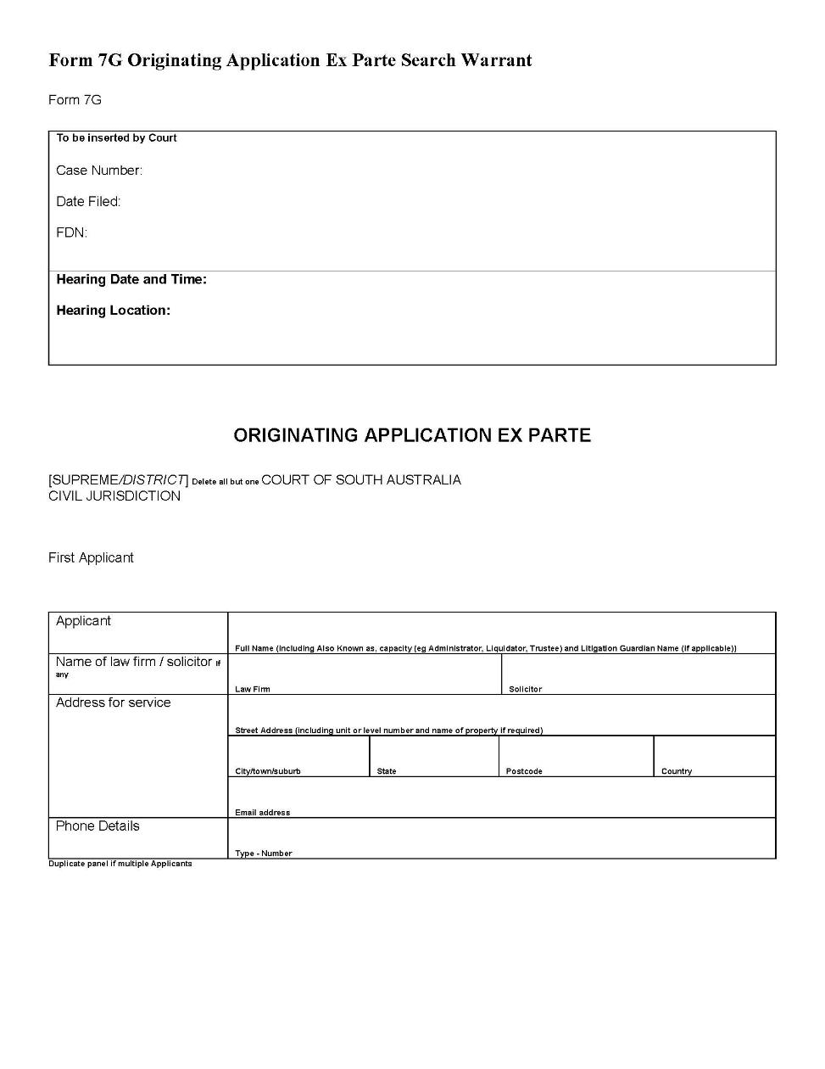
Schedule 1 – Forms

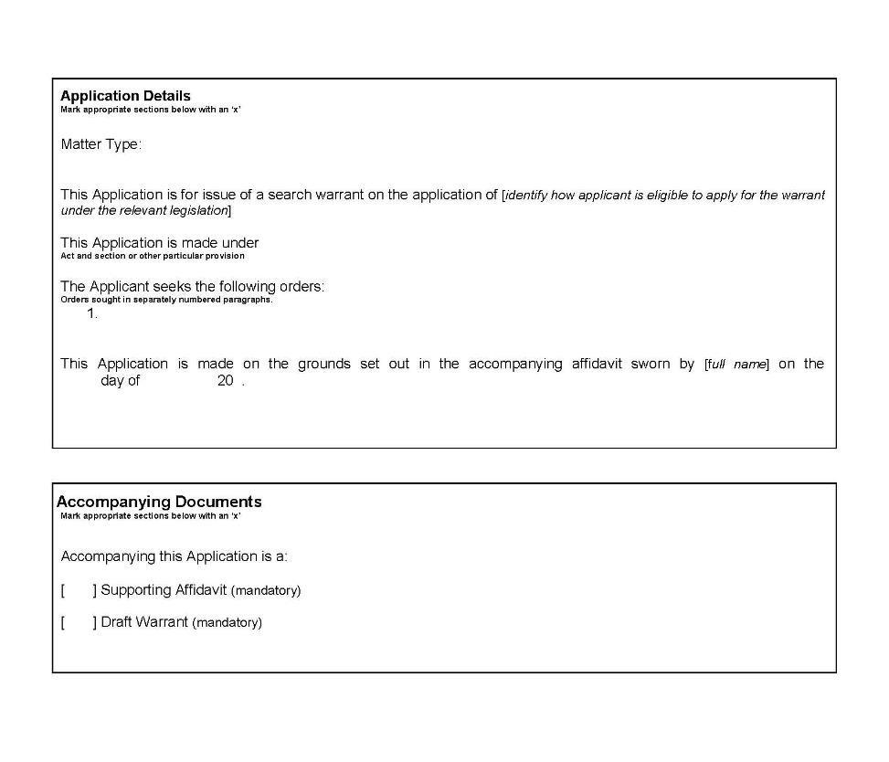

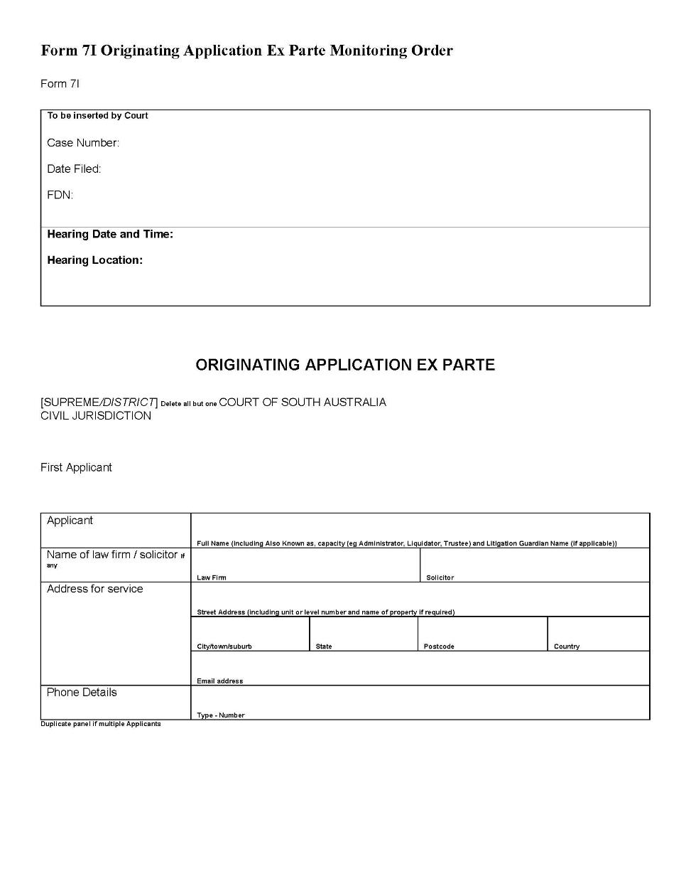

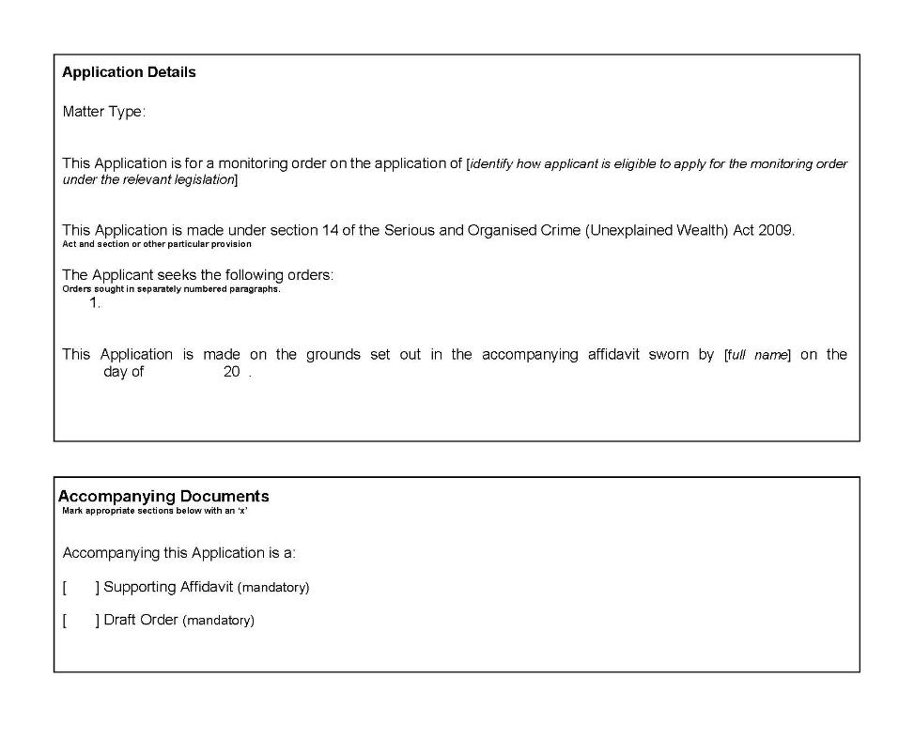

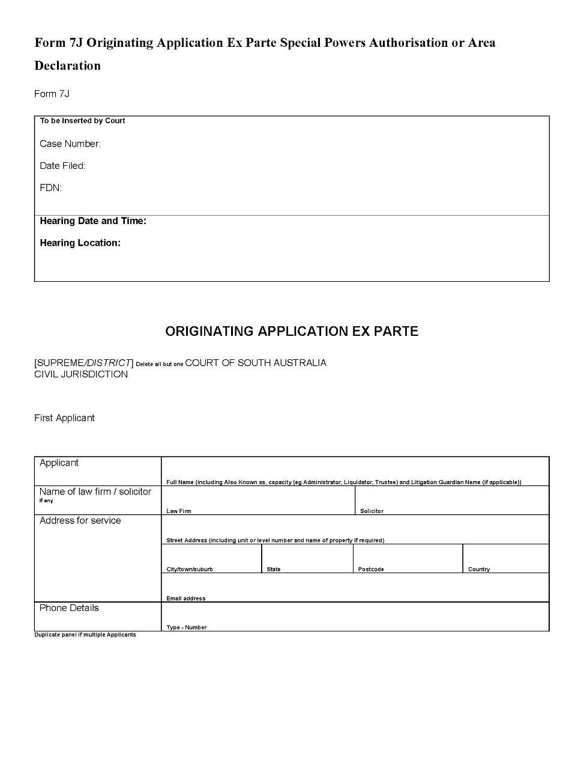

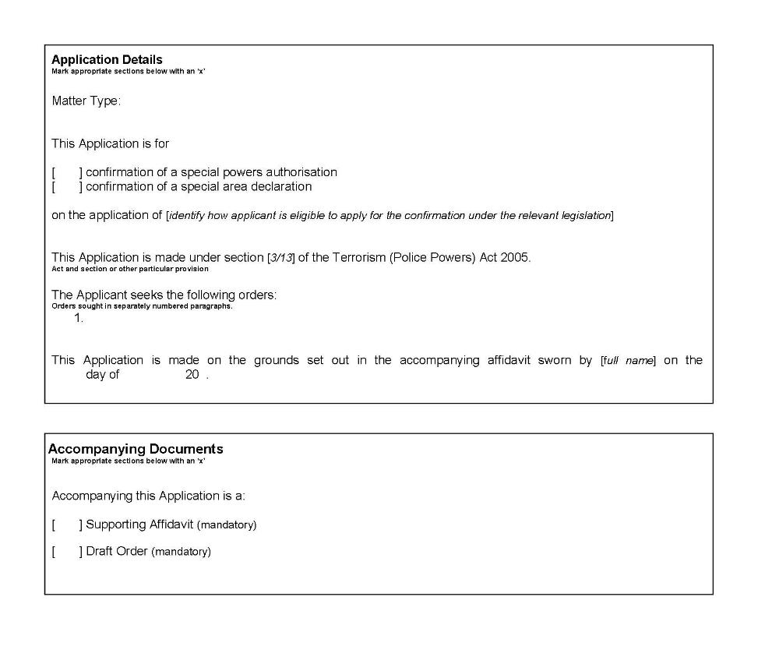

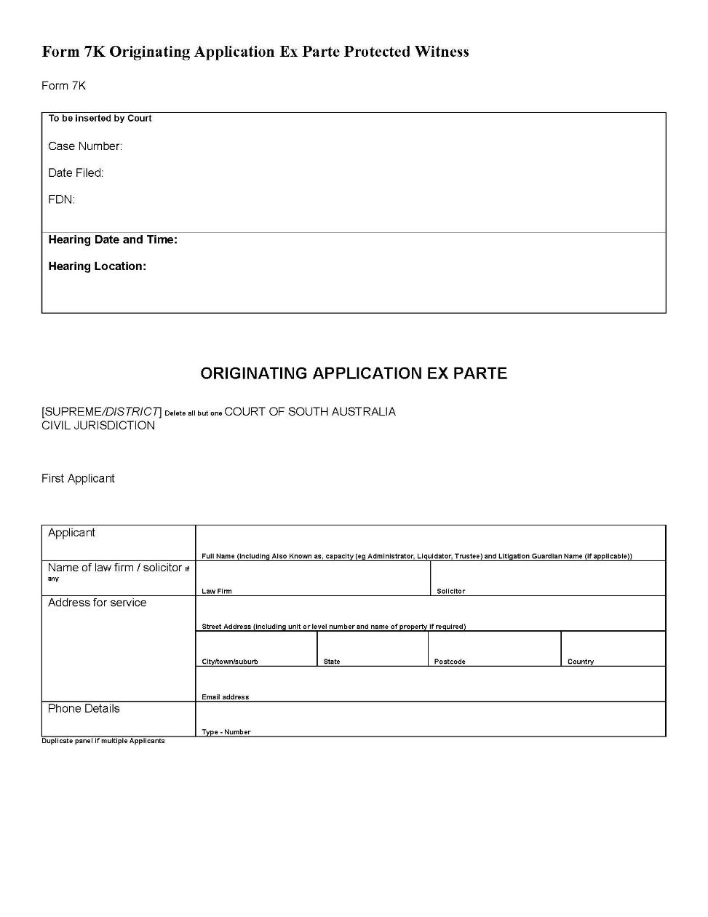

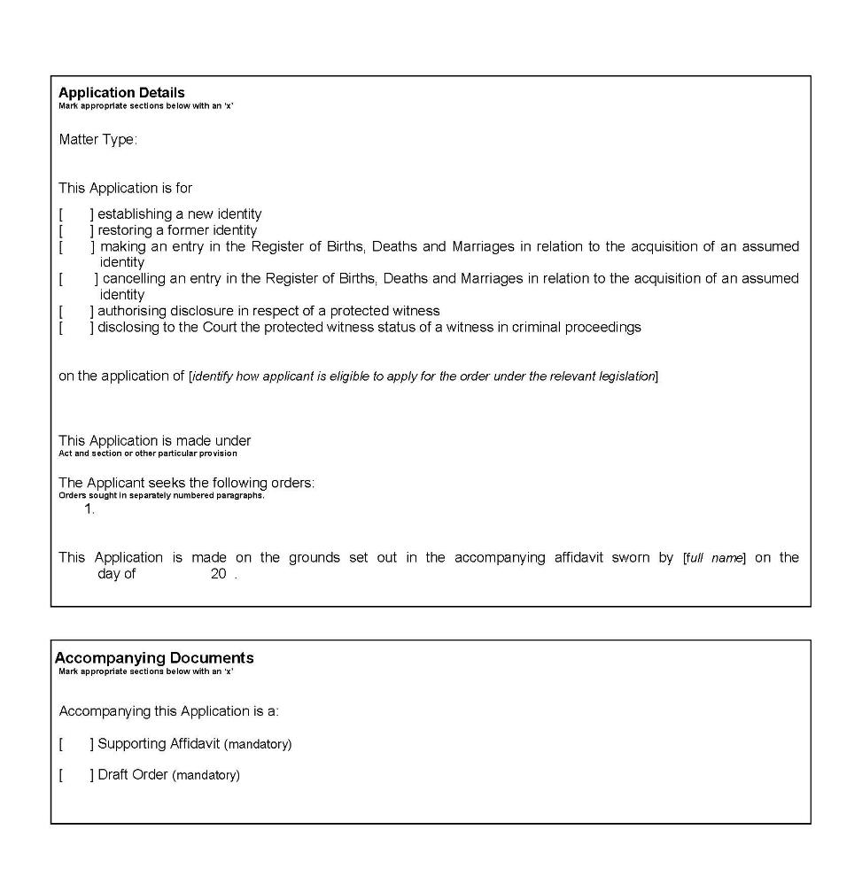

.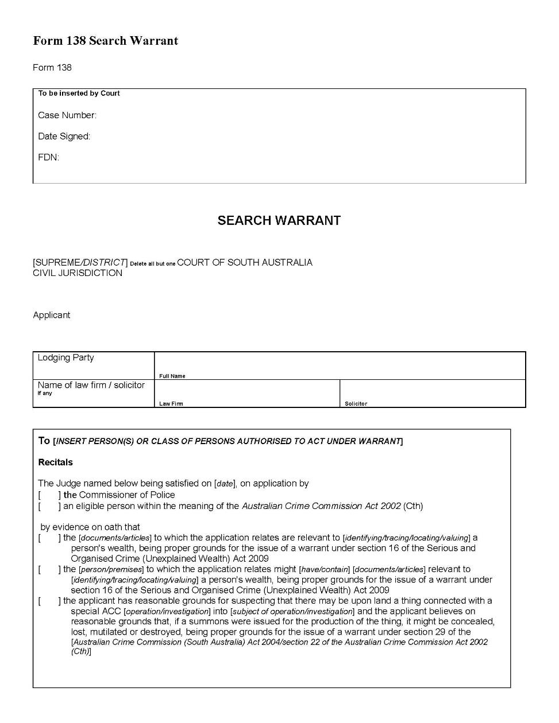

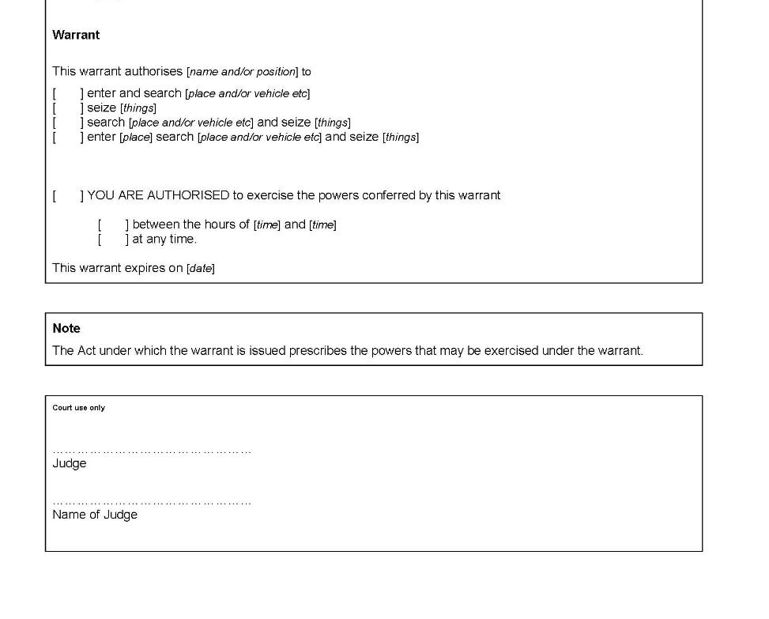

Dated: 27 April 2020
M G Evans
Chief Judge
R Soulio
Judge
P V Slattery
Judge

Environment, Resources and Development Court (Native Title) Rules 2001
South Australia

Amendment No 1
Pursuant to section 48 of the Environment, Resources and Development Court Act 1993, and all other enabling powers, we, Michael Evans, Senior Judge of the Environment, Resources and Development Court, and Michael Durrant, a Judge of that Court, make the following Environment, Resources and Development Court (Native Title) Rules 2001 (Amendment No 1).
- These Rules may be cited as the Environment, Resources and Development Court (Native Title) Rules 2001 (Amendment No 1).
- The Environment, Resources and Development Court (Native Title) Rules 2001 are amended as set out below.
- These rules come into effect—
(a) subject to subrule (b), on the date of their publication in the Gazette;
(b) if these rules are published in the Gazette on a day other than a Monday, these rules come into effect on the date that is the first
Monday following that publication.
- In these Rules, the commencement date means the date on which these rules come into effect under rule 3.
- Unless the Court otherwise orders
(a) the Environment, Resources and Development Court (Native Title) Rules 2001 as amended by these Rules (the current Rules)
apply to—
(i) a proceeding commenced; and
(ii) a step in a proceeding taken,
on or after the commencement date; and
(b) the Environment, Resources and Development Court (Native Title) Rules 2001 before they were amended by these Rules (the former Rules) continue to govern a step in a proceeding taken before the commencement date.
- If the time to commence or take a step in a proceeding under the former Rules has not expired as at the commencement date, the time to commence or take a step in the proceeding continues to be governed by the former Rules (unless the current Rules provide for a longer time).
- Unless the Court otherwise orders, a proceeding instituted before the commencement date—
(a) is to be regarded as a claim if it was progressing on the basis of pleadings;
(b) is to be regarded as an originating application if it was progressing on the basis of affidavits and not pleadings;
(c) subject to paragraphs (a) and (b)—is to be regarded as either a claim or an originating application according to the Environment, Resources and Development Court (Native Title) Rules 2001 as if it had been instituted after the commencement date.
- A new rule 1.4 is inserted after rule 1.3 as follows:
“1.4 Application of ERD Court Rules
Unless the contrary intention appears, the provisions of the Environment, Resources and Development Court Rules 2001 apply to
a native title proceeding governed by these Rules.”
- Rule 1.4 is renumbered as rule 1.5.
- The Note in Rule 1.5 is deleted and replaced with the following:
“Note—
See, for example, the definitions of claimant application, native title question and non-claimant application in section 3 of the State
Native Title Act.”
- Rule 1.5 is renumbered as rule 1.6.
- Subrule 2.4.1 is amended by substituting the word “that” for the word “than” and deleting the word “(sic)”.
- Rule 3.1 is deleted and the following rule substituted:
“ 3.1 Applications (native title and compensation)
    - An applicant for a native title declaration under Part 4 Division 2, or for compensation under Part 4A, of the State Native Title Act must file 2 copies of the application and each map and other accompanying document with the Court.
Prescribed forms—
Form 2AH Originating Application – Native Title Declaration Claimant Application
Form 2AI Originating Application – Native Title Declaration Non-Claimant Application
Form 77N Interlocutory Application – Native Title and Form 77O Schedule to Interlocutory Application – Native Title
Form 1N Claim – Native Title Compensation
Note—
The above prescribed forms reflect the forms prescribed by the Regulations for applications under Part 4A of the State Native Title Act.
    - An application under Parts 4 or 4A of the State Native Title Act must be accompanied by a supporting affidavit or statutory declaration in the prescribed form.
Prescribed forms—
Form 12 Affidavit
Form 13 Statutory Declaration
Form 14 Exhibit to Affidavit or Statutory Declaration
    - If the applicant is an individual, the application must be signed, and the accompanying statutory declaration or affidavit sworn or affirmed, by the applicant.
    - If the applicant is a body corporate, the application must be signed, and the accompanying statutory declaration or affidavit sworn or affirmed, by a director, secretary or other principal officer of the body corporate, or by a person employed by the body corporate who is authorised to sign the application and make the statutory declaration or affidavit.”
- The Note in subrule 3.2.1 is deleted and replaced with the following:
“Note—
An application may be amended under Parts 4 and 4A of the State Native Title Act and the Regulations or in any other way as ordered by the Court.”
- Subrule 3.3.2 is amended by substituting the words “the prescribed form” for the word “writing”.
- Subrule 3.3.4 is deleted and replaced as follows:
“3.3.4 If the relevant period has ended, the person must seek the leave of the Court by applying to the Court in the prescribed form setting out the nature of the person’s interests in the proceeding.
Prescribed form—
Form 77I Interlocutory Application to be Joined”
- Rule 3.4 is deleted and replaced with the following:
“3.4 Applications other than applications (native title and compensation)
    - This Rule applies to an application other than an application (native title and compensation).
    - Unless the Court otherwise orders, an application to the Court for which no form is prescribed under the Regulations must be:
      - in the appropriate form under the Environment, Resources and Development Court Rules 2001 with any variations that the nature of the case requires; and
      - accompanied by an affidavit in the prescribed form setting out the grounds in support of the application.
    - If the applicant is an individual, the accompanying affidavit must be sworn or affirmed by the applicant.
    - If the applicant is a body corporate, the accompanying affidavit must be sworn or affirmed by a director, secretary or other principal officer of the body corporate, or by a person employed by the body corporate who is authorised to sign the application and make the affidavit.
    - Unless the Court otherwise orders, the application must be served on the applicant for native title or compensation and on the State Minister.
    - The Court may order that the application be served on, or notice of the application be given to, other parties to the application for native title or compensation.
Note—
For giving notice, see Rule 9.3.
    - If an applicant, or the State Minister served with an application under this Rule, believes another person has an interest in the application, the applicant, or the State Minister may, within 14 days of receiving the application, notify the Court of the name and address of the person believed to have an interest.
    - The Court may order that the application be served on, or notice be given to, any person that the Court is satisfied has an interest in the application.
    - A person served with, or given notice of, the application may file and serve a notice of acting in the prescribed form and, unless the Court otherwise orders, becomes a respondent to the application on filing the notice of appearance.
Prescribed form—
Form 23 Notice of Acting
    - In this Rule, person may include a group of persons or an organisation.
    - Nothing in this Rule affects any right a person may otherwise have to be joined as a party to a proceeding, or the power of the Court, on its own initiative or at the request of a party, to order that a person be joined as a party to a proceeding.”
- A new subrule 3.5.2 is inserted as follows:
“3.5.2 An application for review of a decision not to accept a claim for registration must be made by filing an Originating Application in the prescribed form.
Prescribed form—
Form 4H Originating Application for Review”
- Subrule 3.5.2 is renumbered as rule 3.5.3.
- Subrule 3.5.3 is renumbered as rule 3.5.4.
- Subrule 3.5.4 is renumbered as rule 3.5.5.
- Rule 4.1 is deleted and replaced with the following:
“4.1 Form of applications and notices of appeal
Unless these Rules or the applicable statute otherwise provides, an application, a proceeding to review an administrative decision or a proceeding to appeal against an administrative decision relating to a native title question must be instituted by filing an Originating Application in the prescribed form.
Prescribed forms—
Form 2AD Originating Application
Form 2AJ Originating Application – Summary Determination Authorising Operations on Native Title Land
Form 2AK Originating Application – Native Title Determination
Form 4H Originating Application for Review
Form 5G Originating Application – Appeal Against Administrative Decision”
- Subrule 4.2.1 is amended by deleting the words “or appellant”.
- The text in square brackets underneath rule 4.3 is deleted and replaced with the following:
“Note—
Certain provisions allow native title parties and others negotiating with native title parties to request the Court to mediate between the parties to assist in obtaining their agreement (see eg section 63P(3) Mining Act 1971, section 58(3) Opal Mining Act 1995, and sections 19(3) and 23(3) Land Acquisition Act 1969).”
- Subrule 4.3.1 is deleted and the following rule substituted:
“4.3.1 An application requesting the Court to mediate between parties to assist in obtaining their agreement about a native title question must be instituted by filing an Originating Application in the prescribed form which–
      - gives the name and address of each other party to the proposed mediation; and
      - includes an outline of the circumstances of the case and the matters in dispute; and
      - is accompanied by a copy of the notice initiating negotiations between the parties and a copy of any other notice or document relating to the matter given to or by the applicant under the Act authorising the request for mediation.
Prescribed form—
Form 2AD Originating Application”
- Rule 4.4 is deleted and the following rule substituted:
“4.4 Application for summary determination authorising operations on native title land
Note—
Certain provisions allow the Court to make a summary determination authorising operations on native title land if no native title parties have come forward following notification of an intention to negotiate with native title parties (see eg section 63N of the Mining Act 1971 and section 56 of the Opal Mining Act 1995) or if the operations are of a kind attracting the expedited procedure (see eg section 63O of the Mining Act 1971 and section 57 of the Opal Mining Act 1995).
    - An application for a summary determination authorising operations on native title land must be instituted by filing an Originating Application in the prescribed form and must –
      - identify and describe the land on which the proposed operations are to be carried out;
      - describe the interest (including any authority or tenement authorising the proposed operations) that the applicant holds or has applied to hold in the land;
      - describe the general nature of the proposed operations that are to be carried out on the land;
      - set out the terms of the determination sought;
      - if the applicant is relying on the expedited procedure –
        - set out the grounds on which the applicant alleges that the expedited procedure applies to the proposed operations; and
        - be accompanied by a supporting affidavit in the prescribed form exhibiting copies of any objections to reliance on the expedited procedure received by the applicant;
      - be accompanied by a supporting affidavit in the prescribed form exhibiting a copy of the notice initiating negotiations with native title parties in relation to the proposed operations given by the applicant; and
      - set out to whom, when and how that notice was given.
Prescribed forms—
Form 2AJ Originating Application – Summary Determination Authorising Operations on Native Title Land
Form 12 Affidavit
Form 14 Exhibit to Affidavit or Statutory Declaration
    - If the applicant is relying on the expedited procedure – the applicant must give a copy of the notice to each person (if any) who has objected to reliance on the expedited procedure.”
- Rule 4.5 is deleted and the following rule substituted:
“4.5 Application for decision on payment to native title parties under native title agreement
Note—
A native title agreement may provide for payment to the native title parties based on profits or income derived from operations on the land or on production from the operations on a basis to be decided by the Court (see eg section 63Q(1) and (2) Mining Act 1971 and section 59(1) and (2) Opal Mining Act 1995. Note that under section 63S(3) Mining Act 1971 and section 61(3) Opal Mining Act 1995 a native title determination cannot impose such an arrangement).
    - An application requesting the Court to determine the basis of payment to native title parties under a native title agreement (as required by the agreement) must be instituted by filing an Originating Application in the prescribed form accompanied by a copy of the native title agreement.
Prescribed form—
Form 2AD Originating Application
    - The applicant must give a copy of the application to –
      - each other party to the agreement; and
      - the Minister responsible for the Act under which the agreement is made.”
- Rule 4.6 is deleted and the following rule substituted:
“4.6 Appeal against Minister’s order prohibiting registration of native title agreement

Note—
Certain provisions allow a Minister, if of the opinion that there is reason to believe that a native title agreement may not have been negotiated in good faith, to make an order prohibiting registration of the agreement (see eg section 63Q(5) Mining Act 1971 and section 59(5) Opal Mining Act 1995). The decision of the Minister is subject to appeal (see eg section 63Q(6) Mining Act 1971) and section 59(6) Opal Mining Act 1995).
4.6.1 An appeal against a decision of a Minister prohibiting registration under an Act of a native title agreement must be instituted by filing an Originating Application in the prescribed form which must–
      - give an outline of the circumstances of the case;
      - give details of the decision appealed against;
      - set out the terms of the order sought;
      - set out the grounds of appeal; and
      - be accompanied by a copy of –
        - the native title agreement; and
        - the order of the Minister prohibiting registration of the agreement.
4.6.2 The appellant must give a copy of the Originating Application to –
      - each other party to the native title agreement; and
      - the Minister.
Prescribed form—
Form 5G Originating Application – Appeal Against Administrative Decision”
- Rule 4.7 is deleted and the following rule substituted:
“4.7 Application for native title determination
Note—
Negotiations with native title parties must occur in relation to various matters including creation of a right to mine (see eg Part 9B Mining Act 1971 and Part 7, Opal Mining Act 1995), the conferral of rights under the Land Acquisition Act 1969. If agreement cannot be reached between the negotiating parties, an application may be made to the Court for a native title determination (see eg section 63S Mining Act 1971, section 61 Opal Mining Act 1995 and section 20 Land Acquisition Act 1969).
4.7.1 An application for a native title determination following the failure of negotiating parties to reach agreement must be instituted by filing an Originating Application in the prescribed form which must–
      - identify the land subject to the negotiations;
      - identify the other parties with whom negotiations have taken place;
      - identify the representative Aboriginal body for the area in which the land is situated;
      - identify any person who holds an interest in the land (including an authority or tenement authorising mining or other operations on the land) but has not been a party to the negotiations and give details of the nature of the interest;
      - include a statement of the effect of the proposed operations on:
        - the enjoyment of native title rights and interests by the native title parties;
        - the way of life, culture and traditions of the native title parties;
        - the development of the social, cultural and economic interests of the native title parties;
        - the freedom of access by any of the native title parties to the land and their freedom to carry out rites, ceremonies or other activities of cultural significance on the land in accordance with their traditions;
        - any area or site on the land of particular significance to the native title parties in accordance with their traditions; and
        - the natural environment of the land;
      - set out the terms of the determination sought;
      - if it is made by a person other than a native title party –
        - describe the interest (including any authority or tenement authorising proposed operations on the land) that the applicant holds or has applied to hold in the land;
        - describe the general nature of the operations proposed to be carried out on the land or the purpose for which the land is to be acquired;
        - be accompanied by a supporting affidavit in the prescribed form exhibiting a copy of the notice initiating the negotiations; and
        - set out to whom, when and how that notice was given; and
      - if it is made by a native title party –
        - give details of the nature of the rights conferred by the native title in the land held or claimed by the applicant and the basis on which native title is held or claimed; and
        - give details of any request for non-monetary compensation.
Prescribed form—
Form 2AK Originating Application – Native Title Determination
Form 12 Affidavit
Form 14 Exhibit to Affidavit or Statutory Declaration
4.7.2 However, if the Court has mediated between the parties to assist in obtaining their agreement, any party to the mediation may apply for a native title determination by written request to the Court setting out the terms of the determination sought (rather than by application in the form referred to above).
4.7.3 The applicant must give a copy of the application or written request to –
      - each other party to the negotiations; and
      - the representative Aboriginal body for the area in which the land is situated; and
      - the Minister responsible for administration of the Act under which the determination is sought.”
- Rule 4.8 is deleted and the following rule substituted:
“4.8 Application for review of compensation under native title determination
Note—
The Court may be asked to review provisions of a native title determination providing for payment of compensation if a native title declaration is made subsequent to the determination (see eg section 63ZB of the Mining Act 1971 and section 70 Opal Mining Act 1995).
An application for review of the provisions of a native title determination providing for the payment of compensation following a native title declaration must be in the prescribed form which must –
- identify the determination and the provisions of the determination sought to be reviewed and set out the terms of the order sought; and
- be accompanied by a supporting affidavit which provides details of the native title declaration, including –
  - the date of the declaration;
  - the land to which the declaration relates;
  - if native title is declared to exist in the land –
    - the persons declared to be the common law holders of native title;
    - the body declared to be the registered representative of the common law holders of native title;
    - the nature and extent of the rights and interests conferred by the native title; and
    - the nature and extent of other interests in the land that may affect the native title rights and interests deriving from the native title;
  - the operations authorised by the determination and the authorities or tenements under which the operations authorised by the determination may be carried out;
  - if the applicant is a person who is liable to pay compensation under the determination – the operations that have been carried out under the determination;
  - any person who holds an interest in the land but who was not a party to the negotiations leading to the determination and give details of the nature of the interest;
  - the reasons for changing the provisions of the determination for payment of compensation.
Prescribed forms—
Form 4H Originating Application for Review
Form 12 Affidavit
Form 14 Exhibit to Affidavit or Statutory Declaration
4.8.1 The applicant must give a copy of the application to –
      - each other party bound by the determination; and
      - the representative Aboriginal body for the area in which the land is situated; and
      - the Minister responsible for administration of the Act under which the determination was made.”
- The text in square brackets under “Part 5 Native title questions referred to Court” is deleted and replaced as follows:
“Note—
Section 6 of the State Native Title Act and section 20A of the Environment, Resources and Development Court Act 1993 empower the Supreme Court, and require other courts, to refer proceedings involving a native title question (as defined in the State Native Title Act) to the Environment, Resources and Development Court.”
- Subrule 5.1.1 is deleted and substituted as follows:
“5.1.1 If a proceeding involving a native title question is referred to the Court for hearing and determination before the pleadings are completed, the parties must, subject to direction by the Court, complete the pleadings in accordance with the rules applicable to the Court in which the proceeding was commenced.”
- Subrule 6.1.2 is amended by substituting the words “a proceeding” for the word “proceedings”.
- The text in square brackets under “Part 8 Native title conferences” is deleted and replaced as follows:
“Note—
Section 8 of the State Native Title Act requires the Court to call a conference of the parties to contested proceedings involving a native title question, unless the Court is of the opinion that no useful purpose would be served by a conference between the parties before the hearing of the matter or there is some other adequate reason for dispensing with a conference.”
- The text in square brackets under Rule 8.1 is deleted and replaced as follows:
“Note—
Section 9 of the State Native Title Act requires the Court to select a mediator from among the native title commissioners to preside at the conference in accordance with the rules.”
- Rule 8.1 is amended by deleting the space in “St ate” and deleting the word “(sic)” after it.
- Subrule 8.4(a)(i) is amended by deleting the space in “i nquiries” and deleting the word “(sic)” after it.
- Subrule 8.4(b) is amended by deleting the space in “t ake” and deleting the word “(sic)” after it.
- Rule 9.1 is deleted and substituted as follows:
“9.1 Change of address for service
A party to a proceeding must inform the Court in writing of any change in address for service or contact details in the prescribed form within 14 days of the change.
Prescribed form—
Form 25 Notice of Change of Address for Service”
- A new “Schedule 1 – Forms” is inserted at the end of the Rules and the following forms are inserted into Schedule 1:

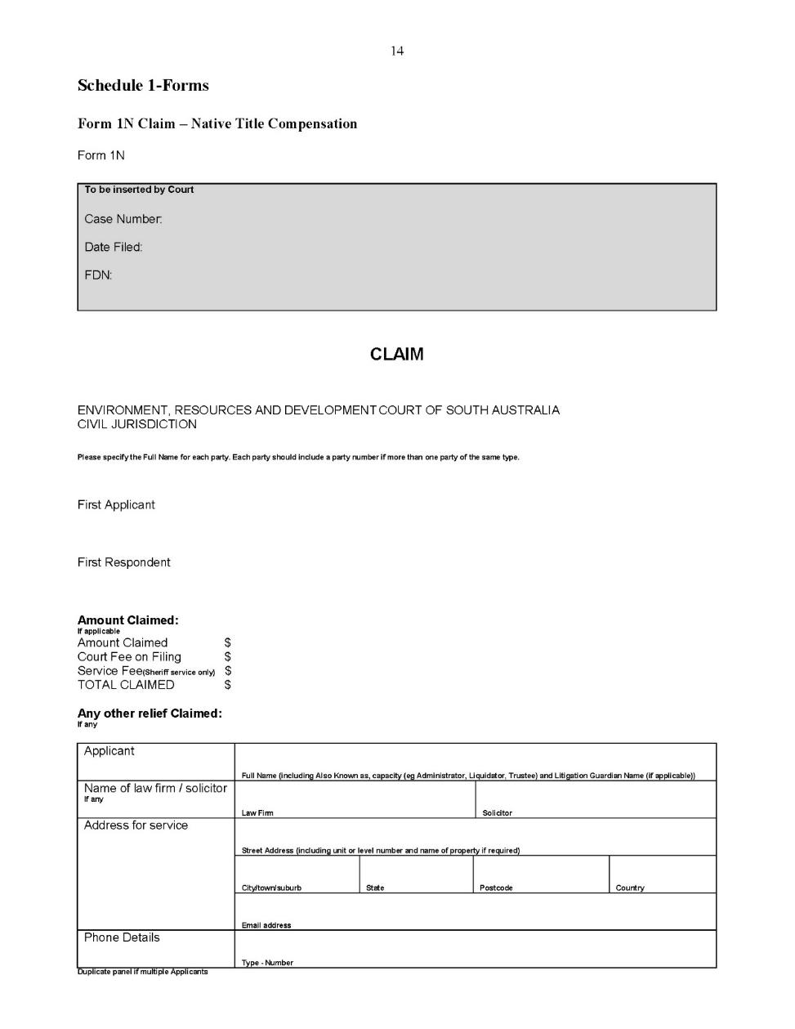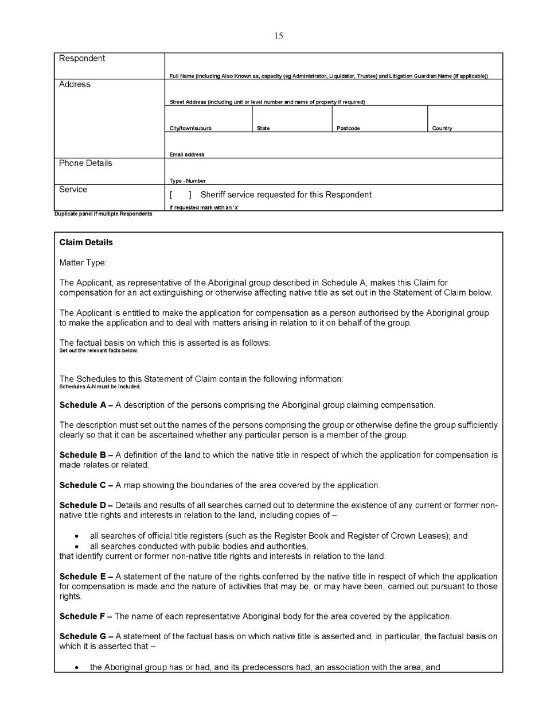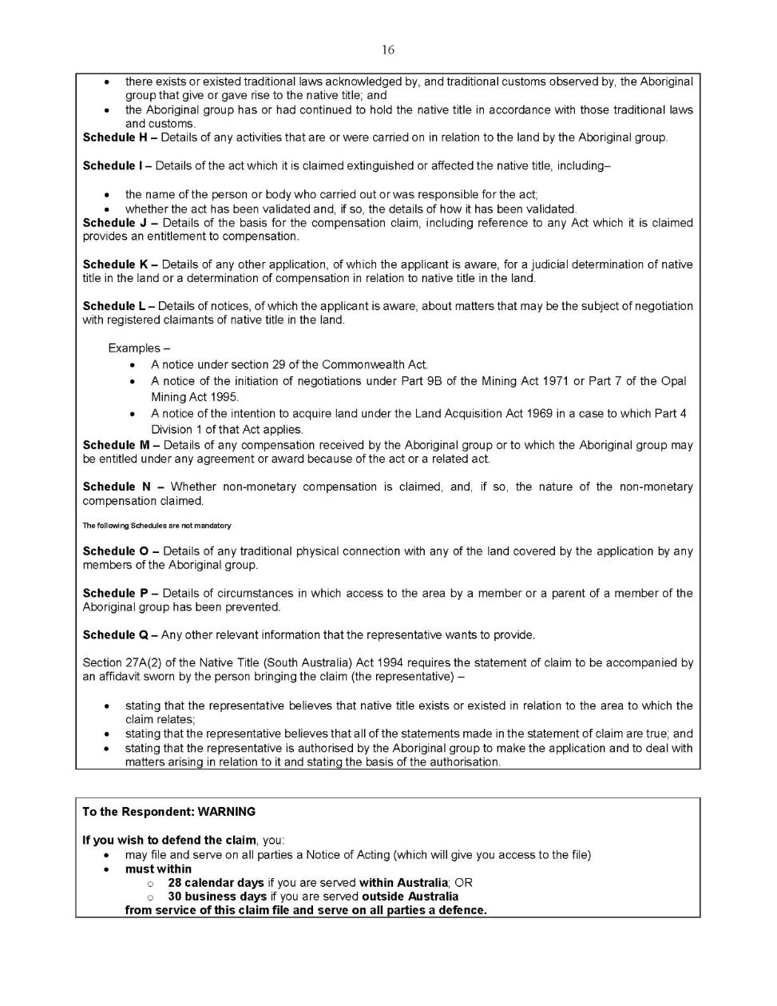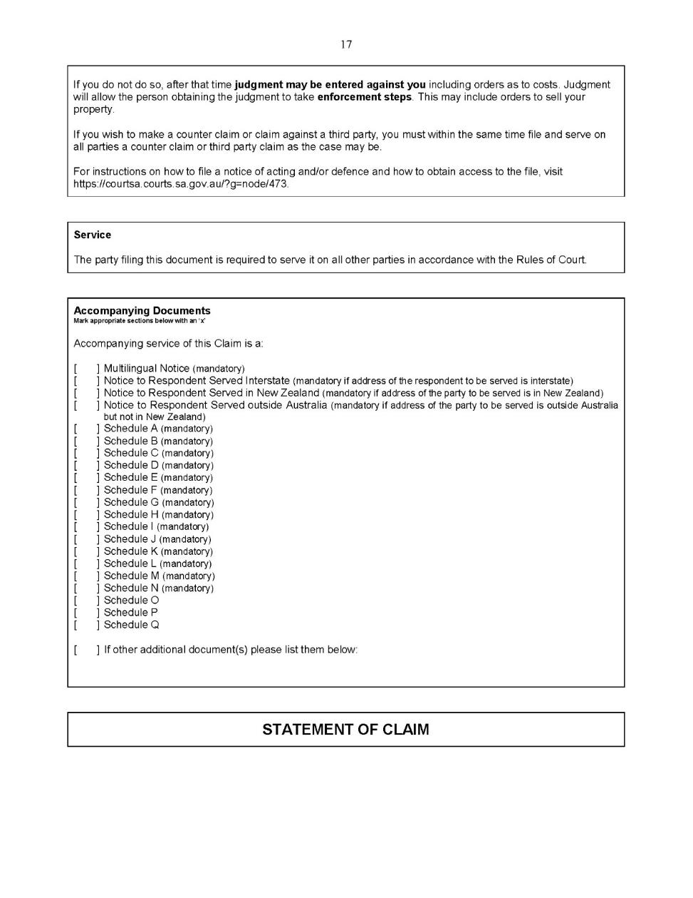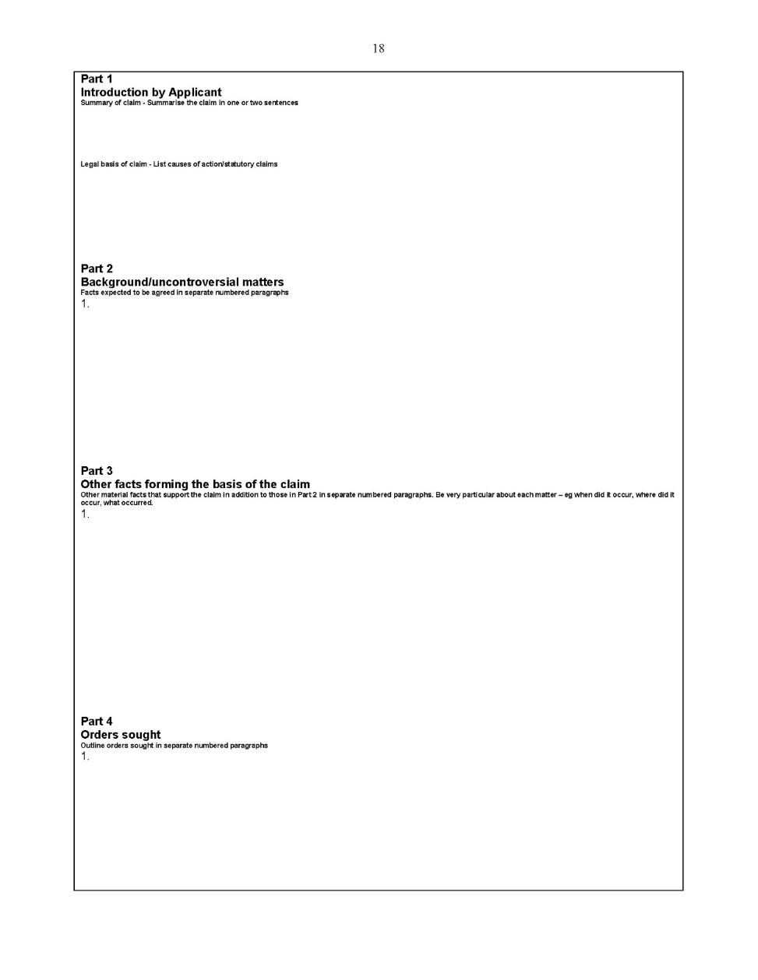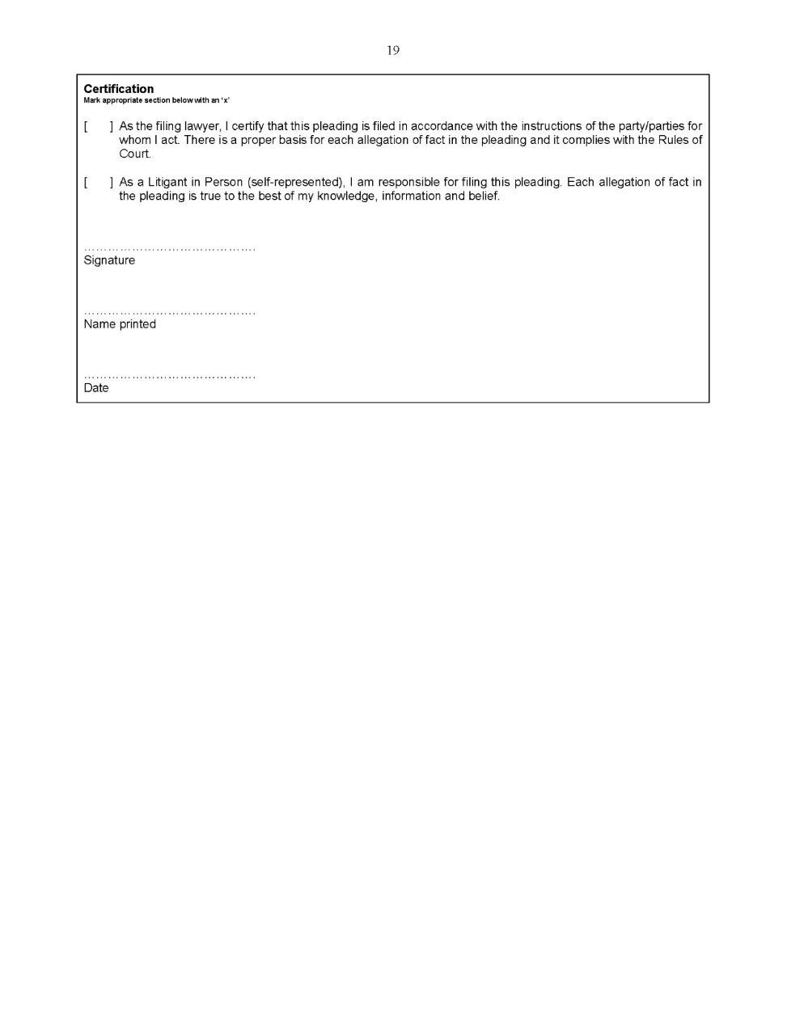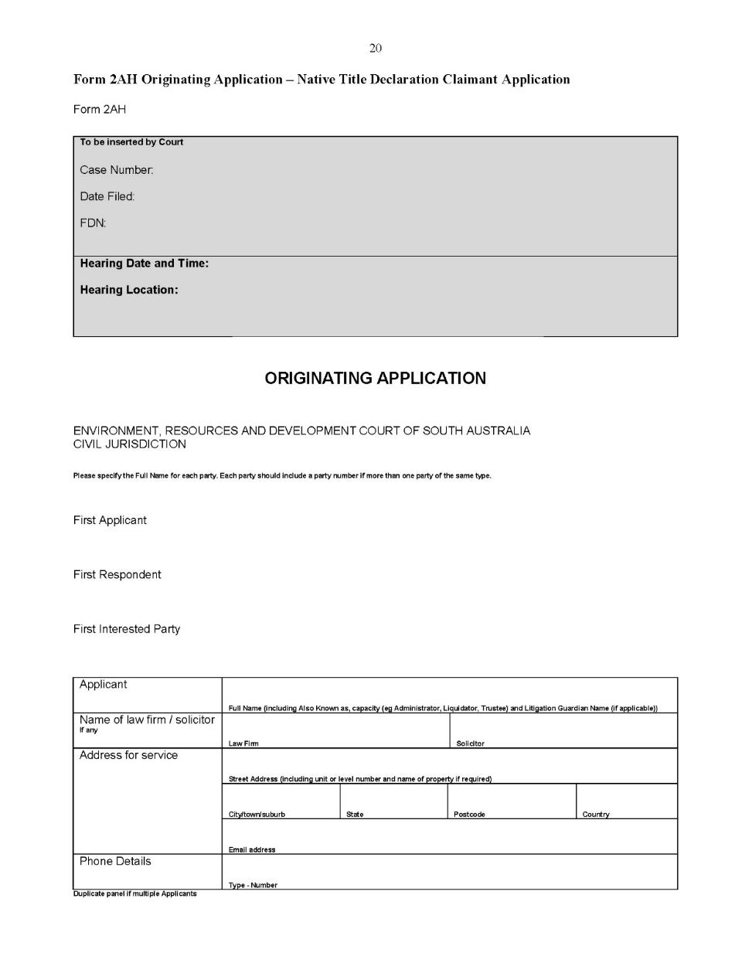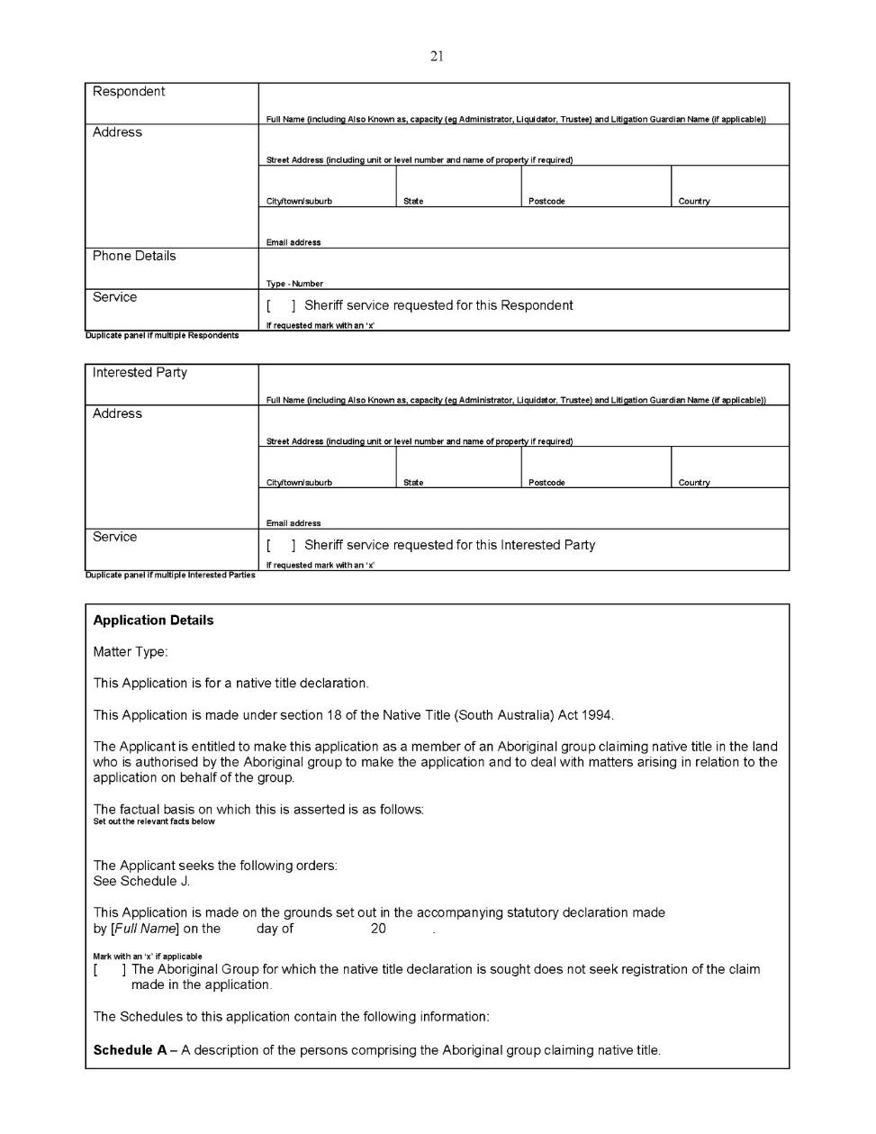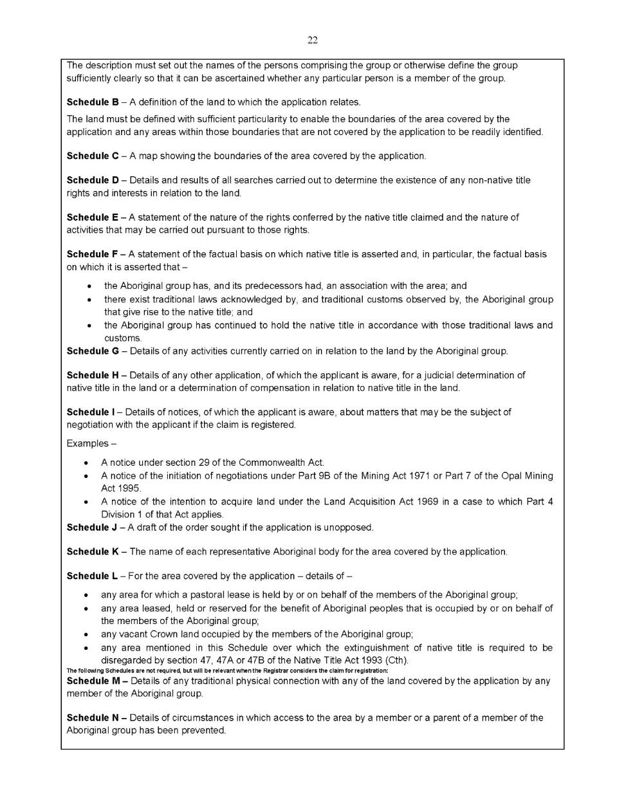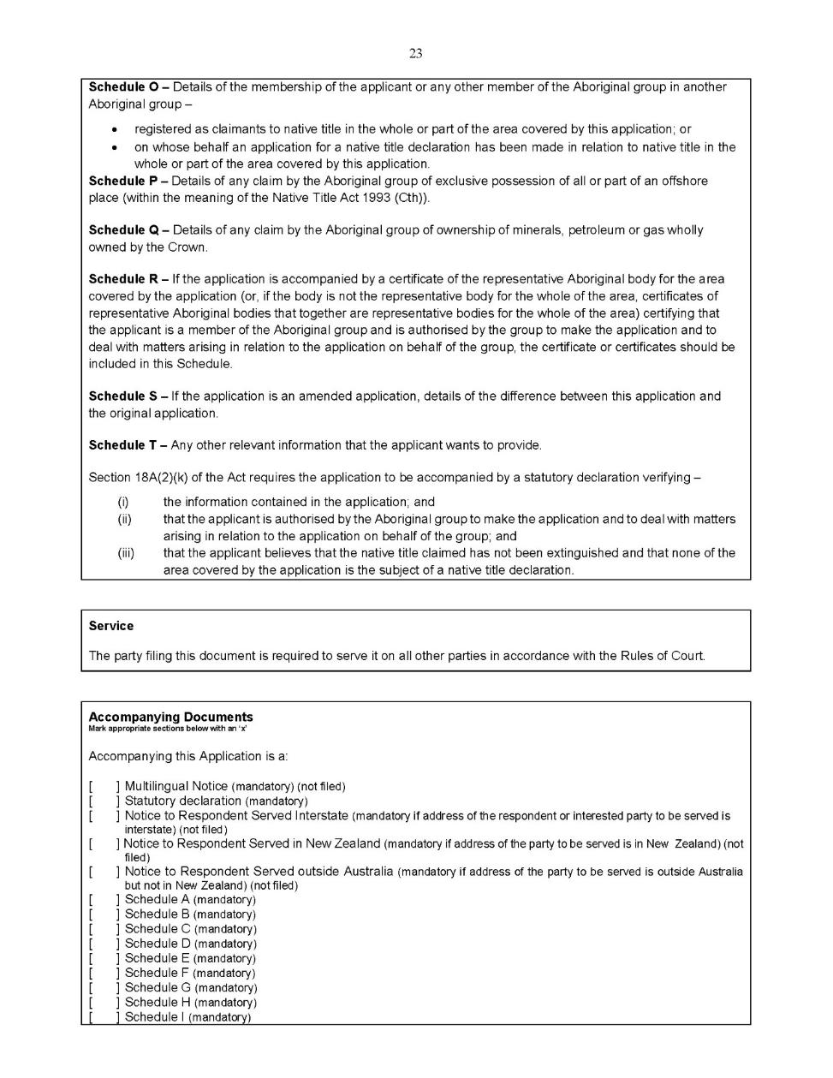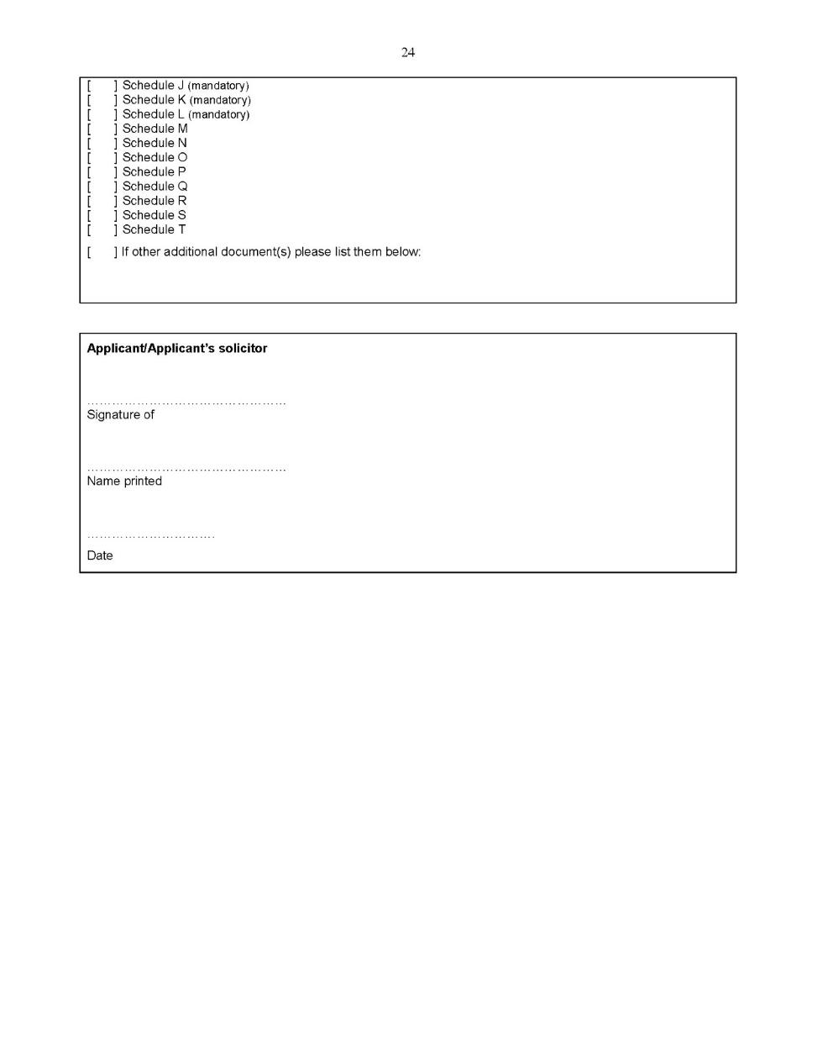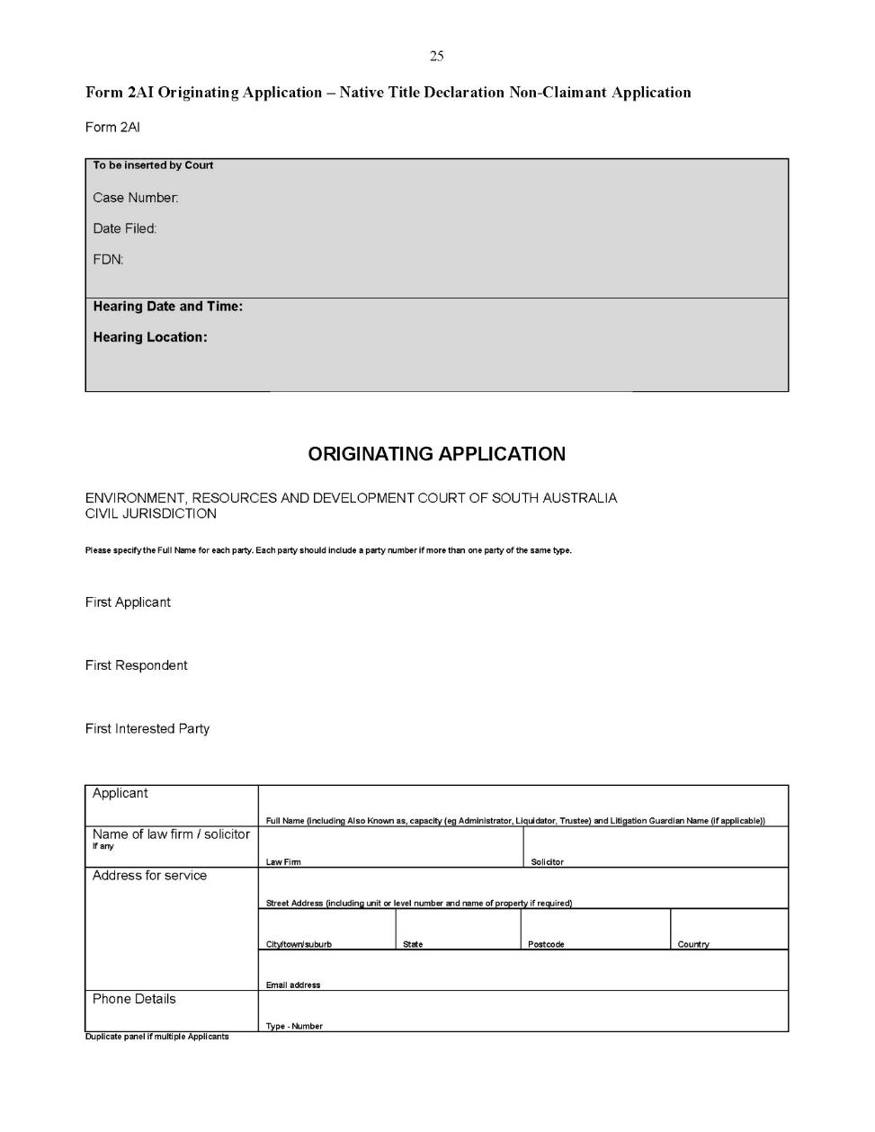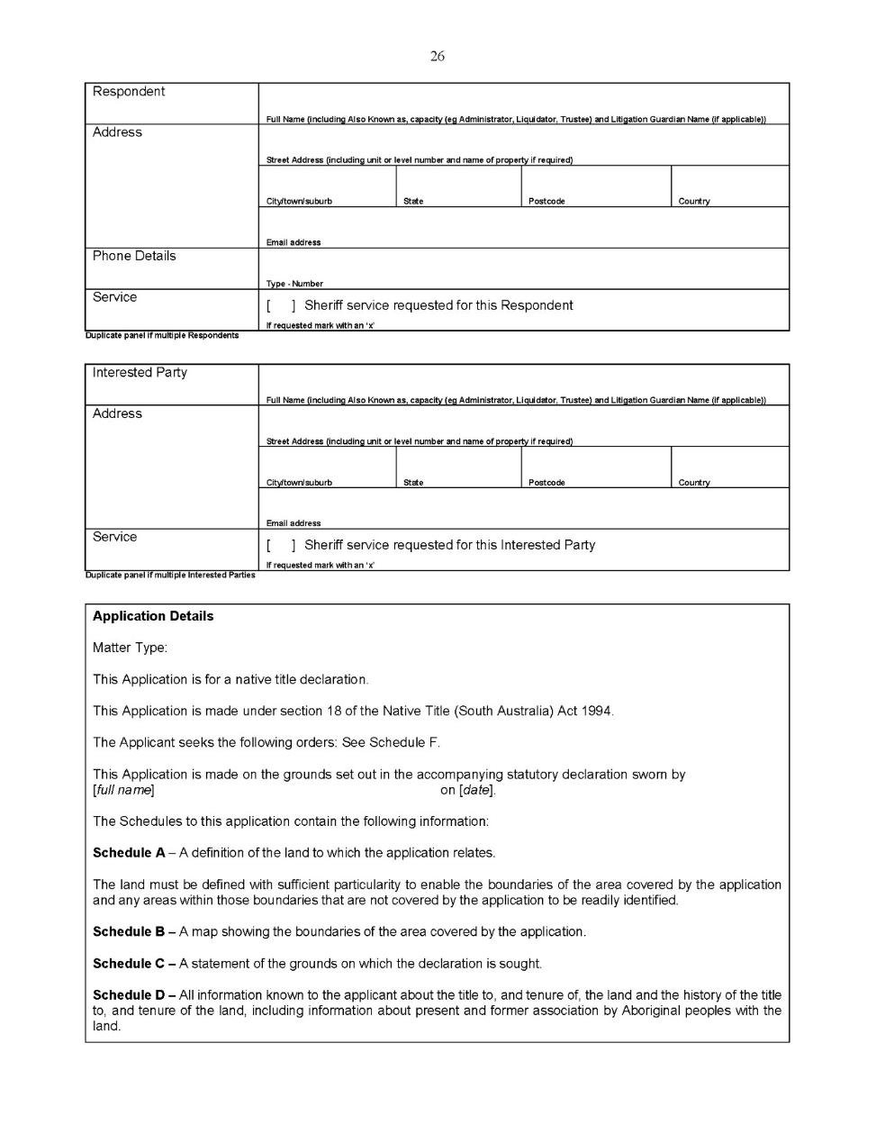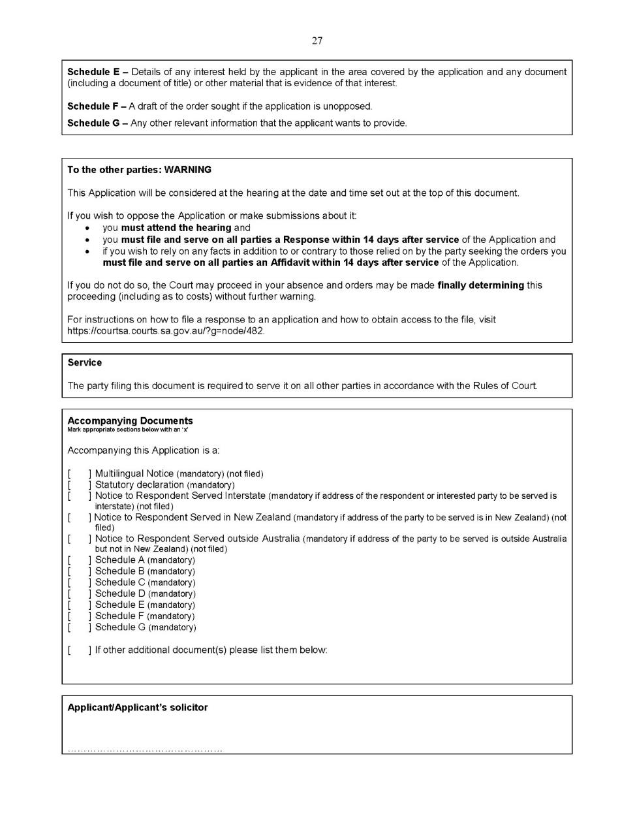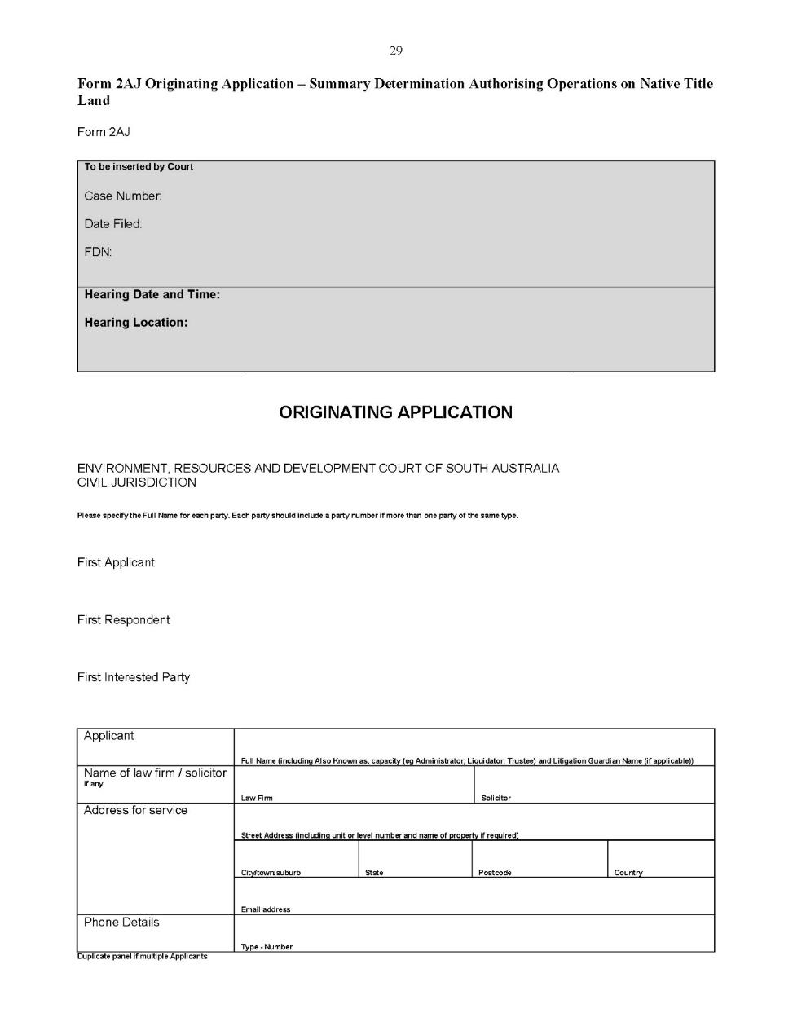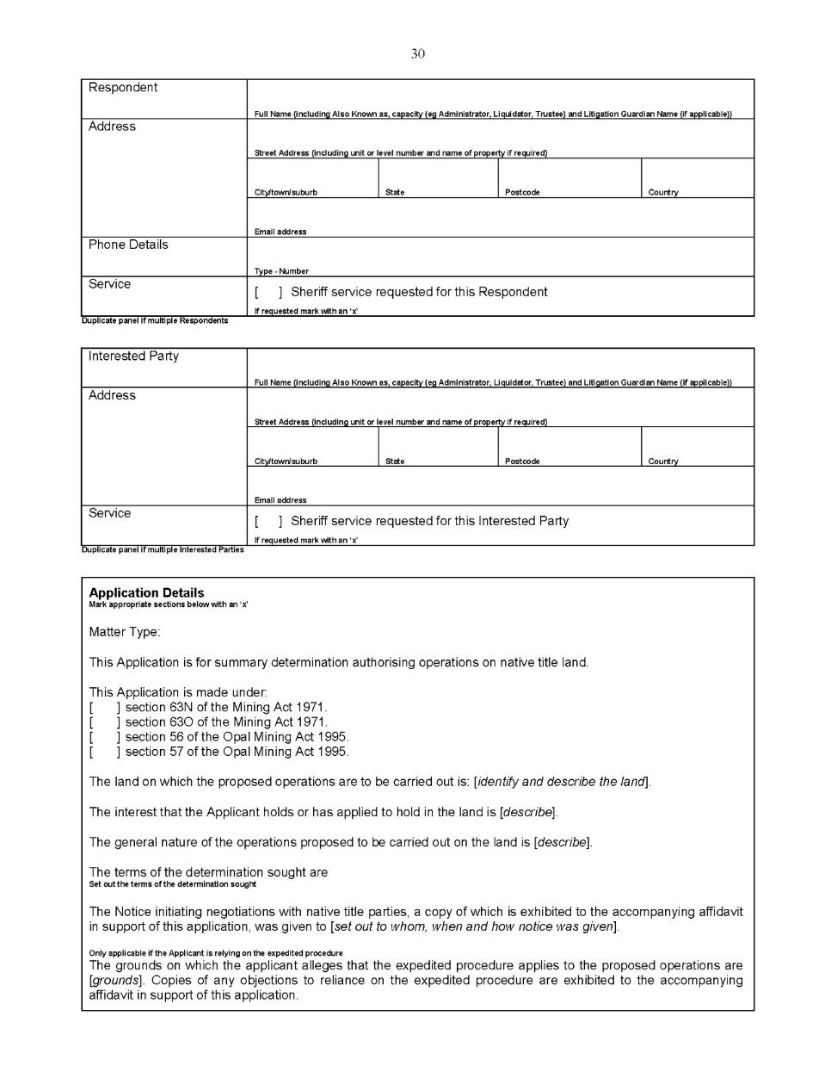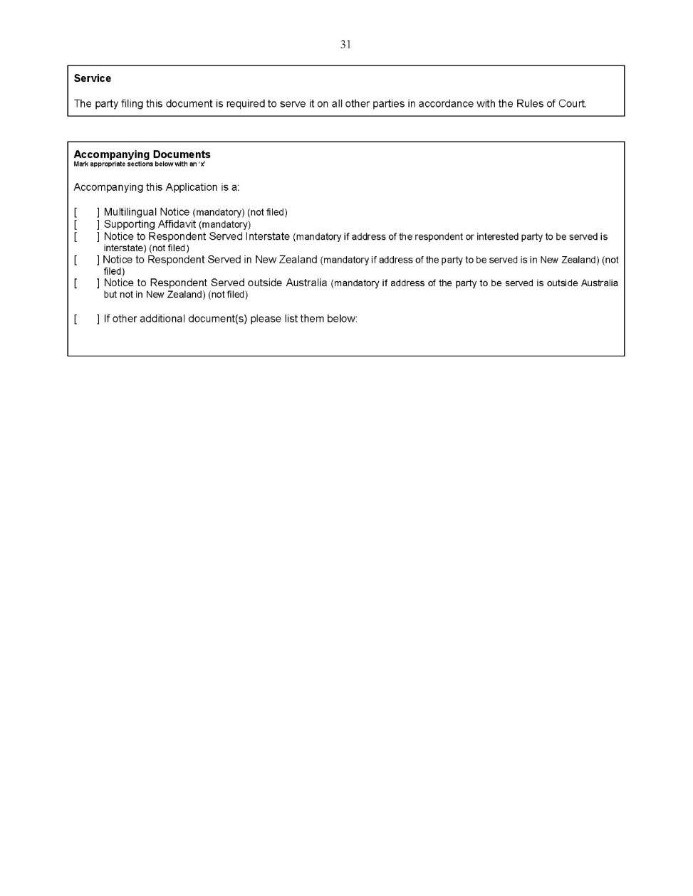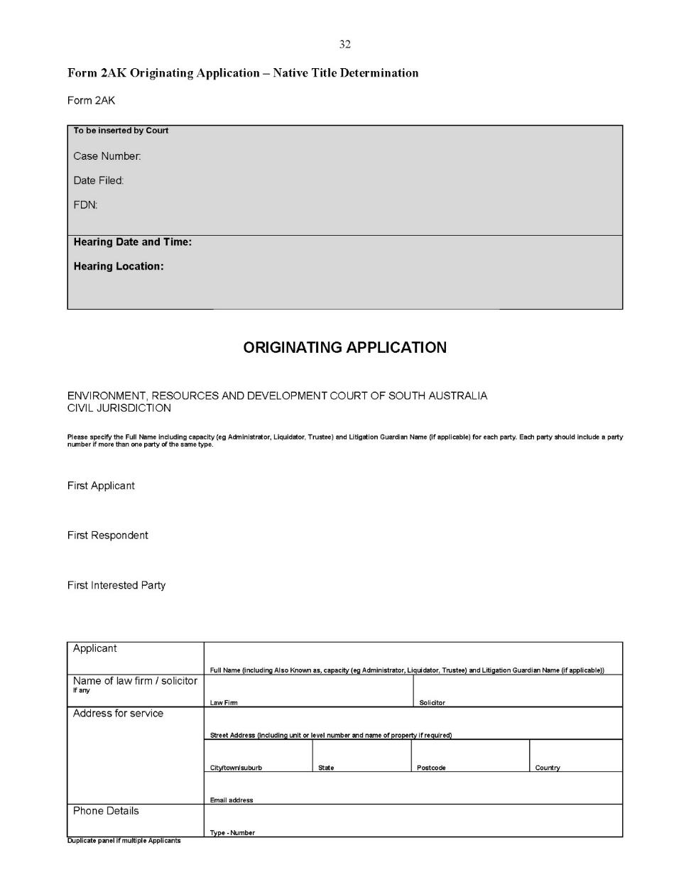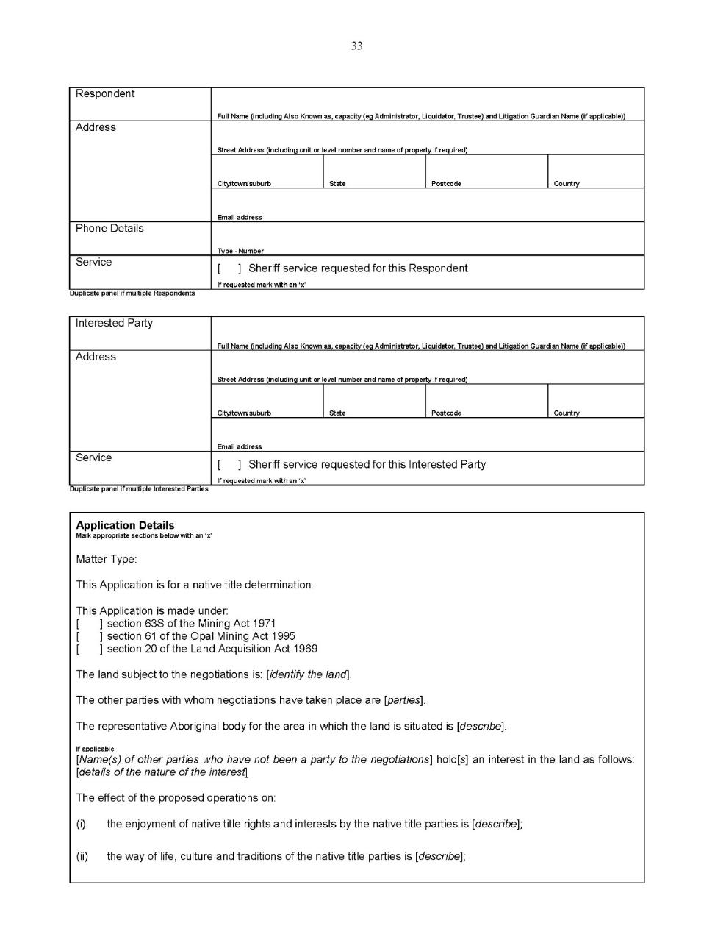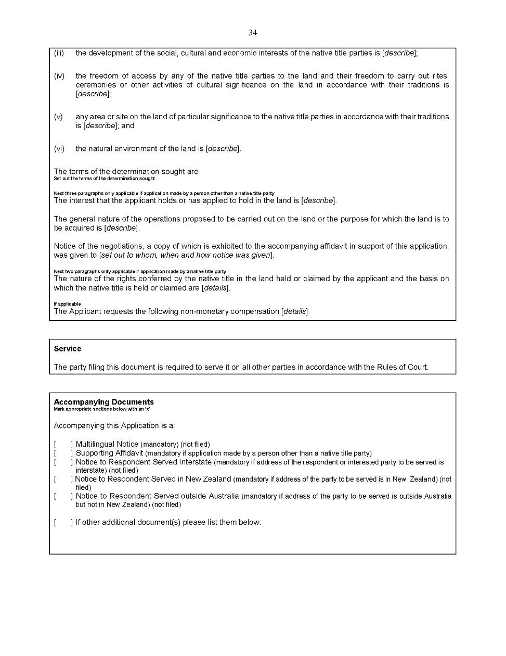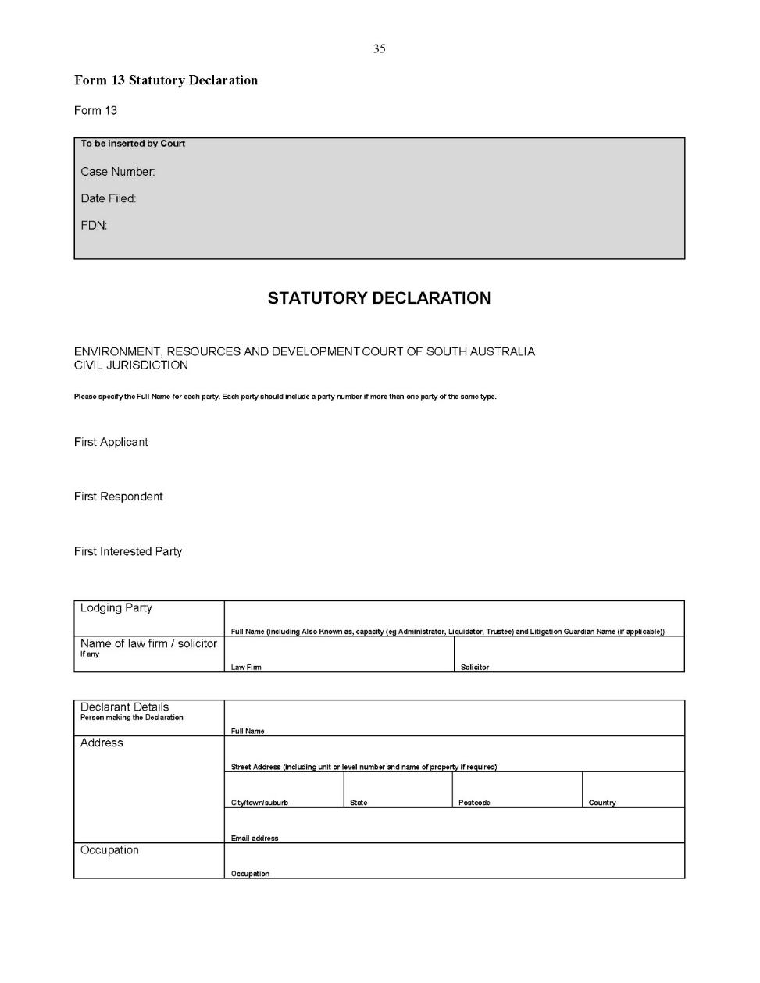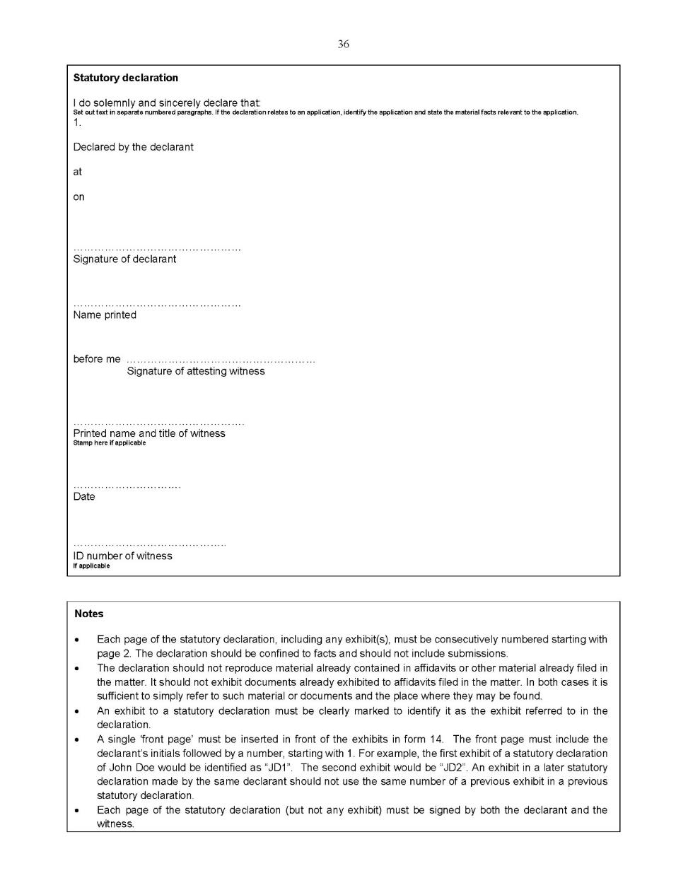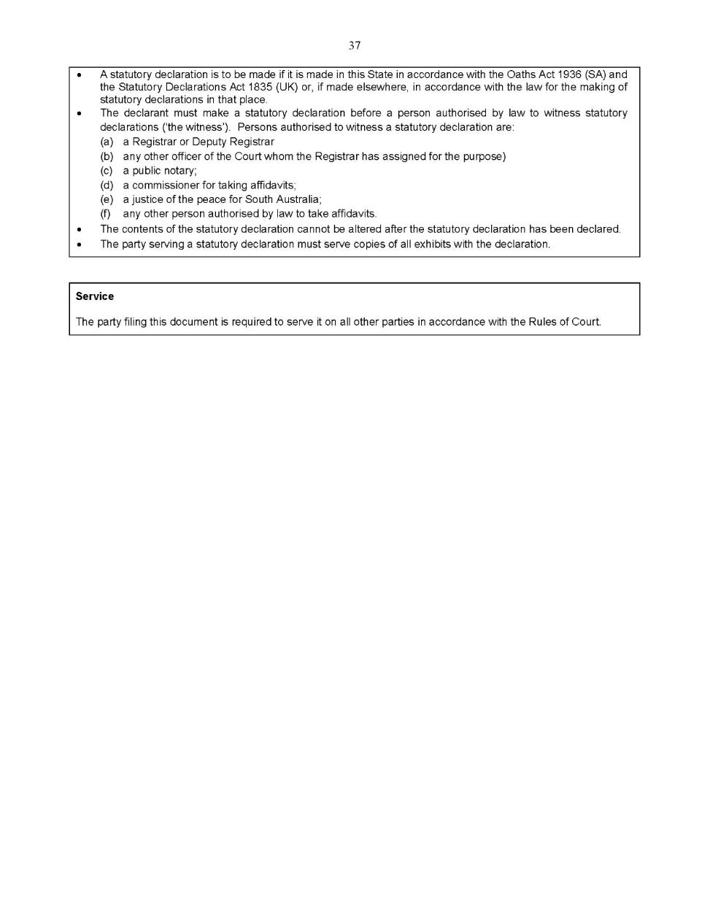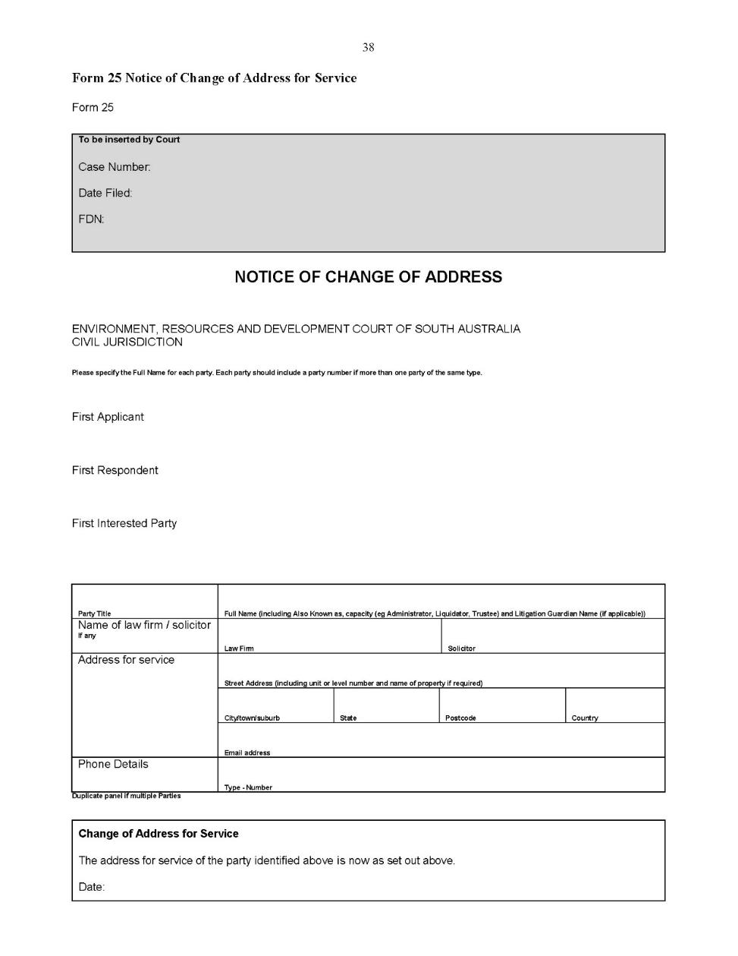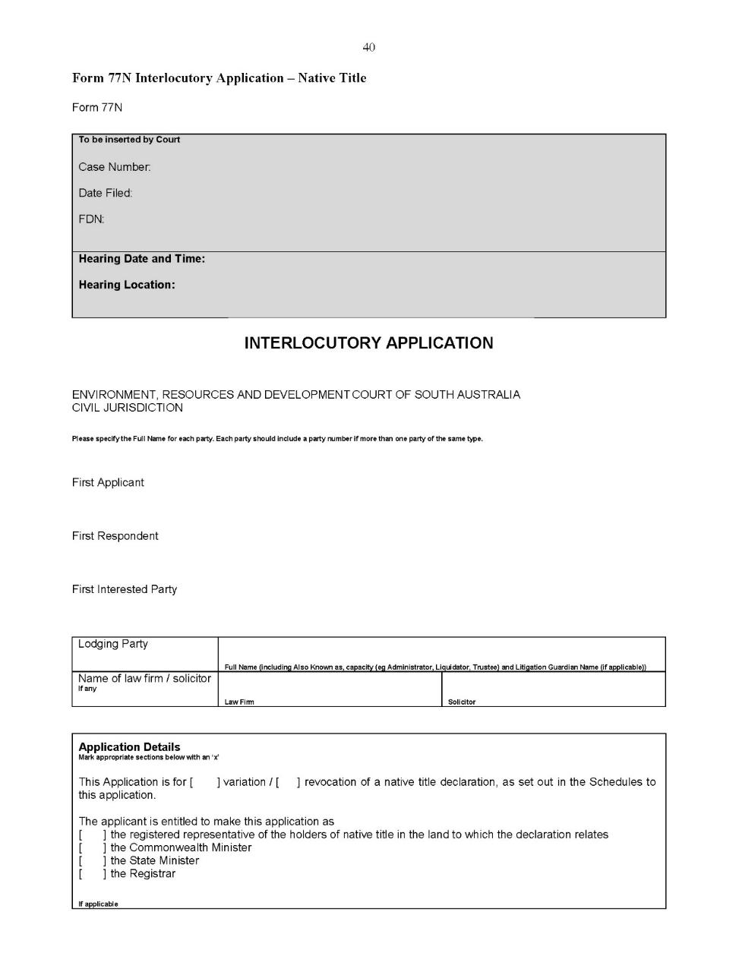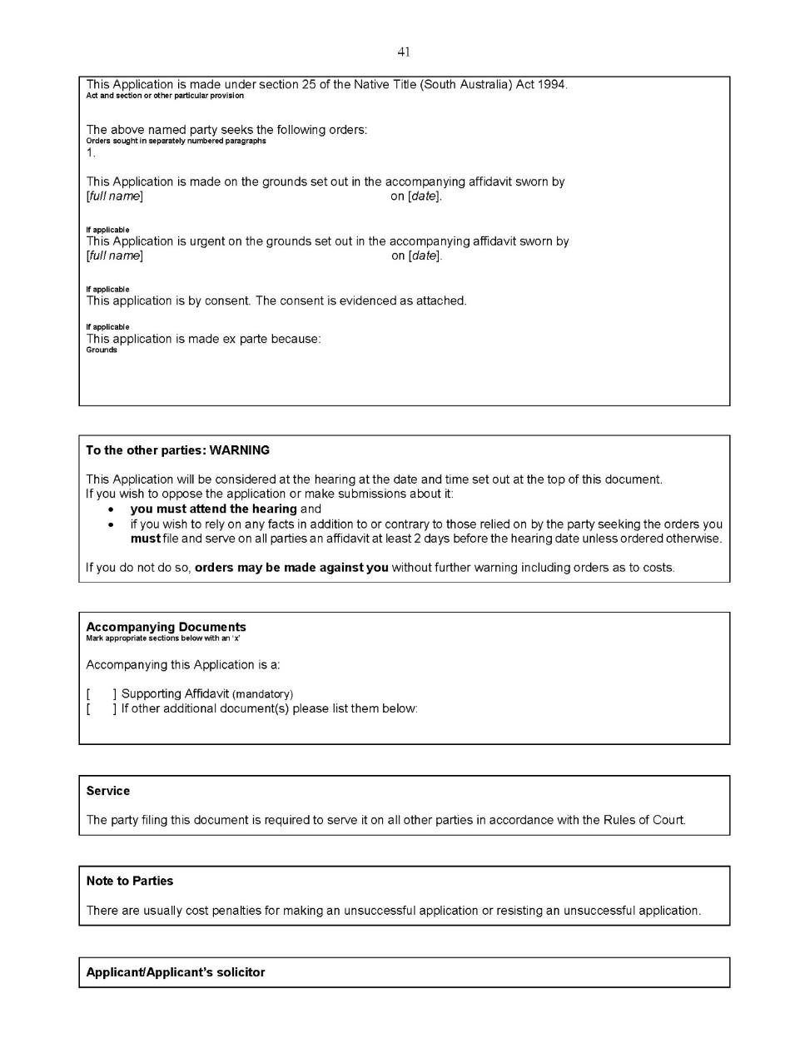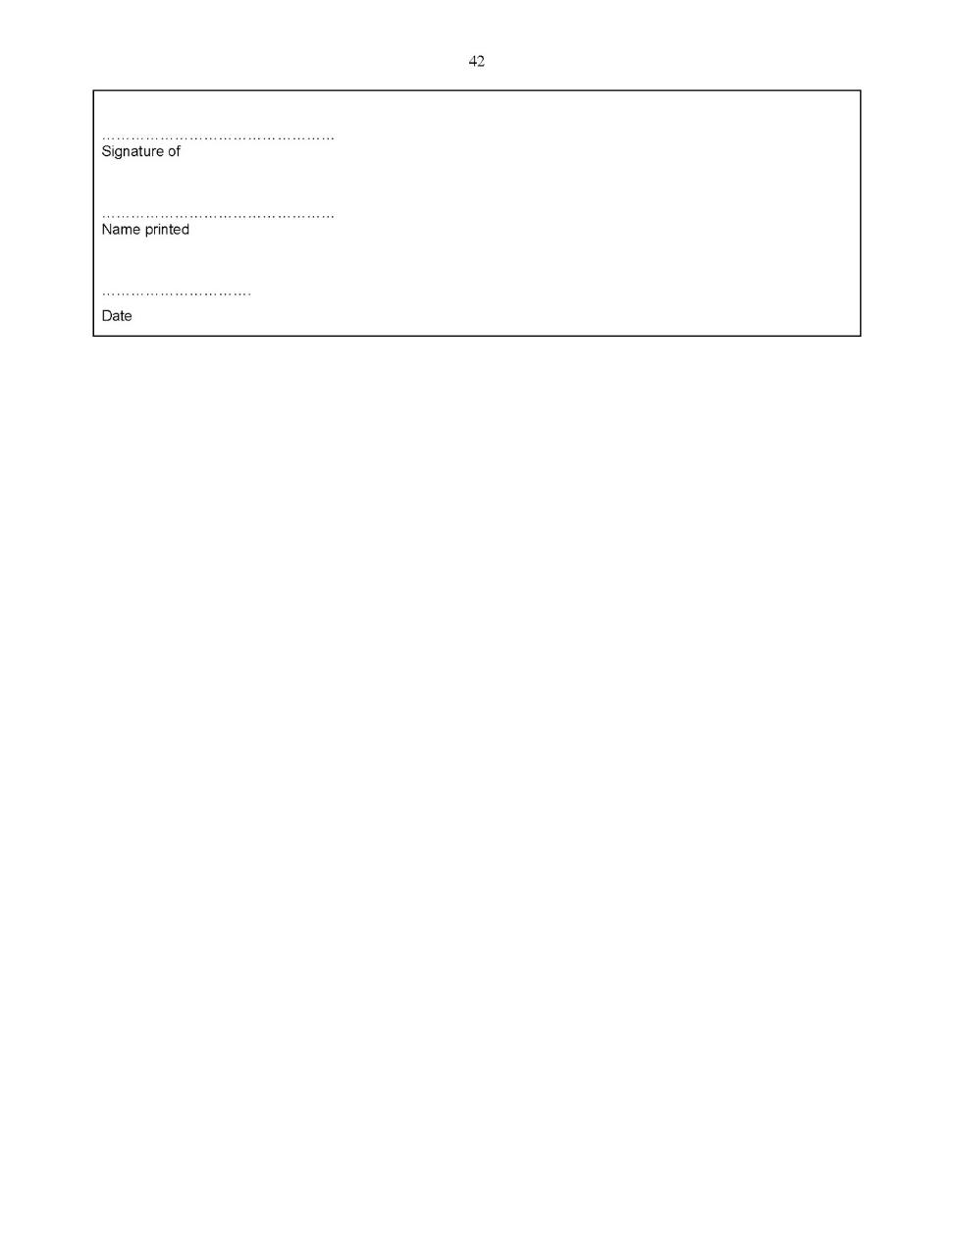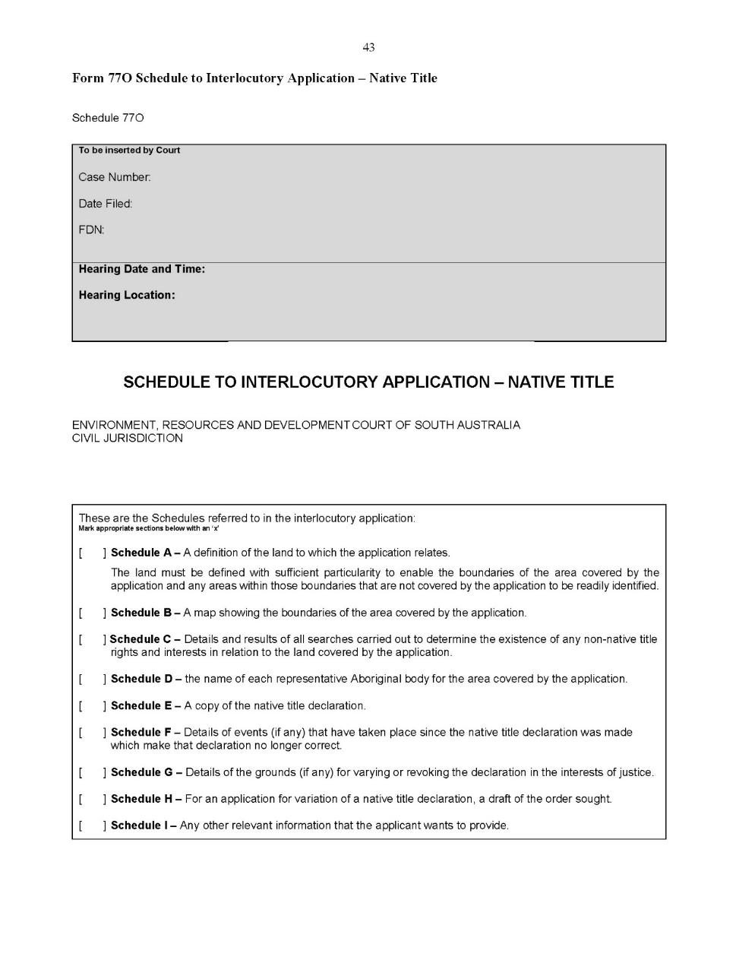
Dated: 8 May 2020
Evans SJ
Durrant J

Environment, Resources and Development Court Rules 2003
South Australia

Amendment No 2
By virtue of the provisions of section 48 of the Environment, Resources and Development Court Act 1993, and of all other enabling powers, we, Michael Evans, Senior Judge of the Environment, Resources and Development Court, and Michael Durrant, a Judge of that Court, make the following Environment, Resources and Development Court Rules 2003 (Amendment No 2).
- These Rules may be cited as the Environment, Resources and Development Court Rules 2003 (Amendment No 2).
- The Environment, Resources and Development Court Rules 2003 are amended as set out below.
- These rules come into effect—
(a) subject to subrule (b), on the date of their publication in the Gazette;
(b) if these rules are published in the Gazette on a day other than a Monday, these rules come into effect on the date that is the first Monday following that publication.
- In these Rules, the commencement date means the date on which these rules come into effect under rule 3.
- Unless the Court otherwise orders—
(a) the Environment, Resources and Development Court Rules 2003 as amended by these Rules (the current Rules) apply to—
(i) a proceeding commenced; and
(ii) a step in a proceeding taken,
on or after the commencement date; and
(b) the Environment, Resources and Development Court Rules 2003 before they were amended by these Rules (the former Rules) continue to govern a step in a proceeding taken before the commencement date.
- If the time to commence or take a step in a proceeding under the former Rules has not expired as at the commencement date, the time to commence or take a step in the proceeding continues to be governed by the former Rules (unless the current Rules provide for a longer time).
- Unless the Court otherwise orders, a proceeding instituted before the commencement date—
(a) is to be regarded as a claim if it was progressing on the basis of pleadings;
(b) is to be regarded as an originating application if it was progressing on the basis of affidavits and not pleadings;
(c) subject to paragraphs (a) and (b)—is to be regarded as either a claim or an originating application according to these Environment, Resources and Development Rules 2003 as if it had been instituted after the commencement date.
- Subrule 1.3.1(g) is deleted and substituted as follows:
“(g) on the hearing of an appeal by a representor under the Development Act 1993 or the Natural Resources Management Act 2004 or Landscape South Australia Act 2019, the applicant for consent must be prepared to inform the Court as to the proposal at the commencement of the hearing.”
- A new rule 1.3.5 is inserted immediately after rule 1.3.4 as follows:
“1.3.5 If these Rules are silent in relation to a particular procedure or other matter, unless the Court otherwise orders, that matter is governed by the Uniform Civil Rules 2020.”
- In rule 2.1, the definition of ‘address for service’ is deleted and substituted as follows:
“ “address for service” means an address of a place at which an application or other document may be sent or left for the party giving such address. Such address must include:
(i) the party title and full name of the party;
(ii) whether the party is represented by a law firm and, if so, the name of the law firm and of the individual responsible solicitor;
(iii) a physical address at which documents in or in relation to the proceeding can be served which must:
(a) if the party does not provide an email address—be in South Australia; or
(b) if the party provides an email address—be in Australia;
(iv) an email address at which documents in, or in relation to, the proceeding can be served, unless the party does not have available and cannot reasonably obtain an email address; and
(v) a telephone number at which the party or, if represented, the party’s law firm can be contacted.”
- In rule 2.1, the definition of ‘appeal’ is deleted and substituted as follows:
“ “appeal against administrative decision” means an appeal to the Court against, or application to the Court for review of, an administrative decision instituted pursuant to:
(i) any of the following provisions of the Development Act 1993, namely:
- subsection 6 (4);
- subsection 74 (6);
- subsection 86 (1) (a) or (b);
- subsection 86 (1) (d) (i), but not being an application for an order pursuant to section 55;
- subsection 86 (1) (d) (ii);
- subsection 86 (1) (d) (iii), being an appeal or a notice issued pursuant to section 71;
- subsection 86(1)(f);
(ii) section 106 of the Environment Protection Act 1993;
(iii) section 20 of the Heritage Places Act 1993;
(iv) subsections 17 (6), 33 (2), 56 (3) of the Mining Act 1971;
(v) section 202 of the Natural Resources Management Act 2004 or section 216 of the Landscape South Australia Act 2019;
(vi) subsections 65 (1) and 67 (1) of the Irrigation Act 1994;
(vii) section 48 of the South Eastern Water Conservation and Drainage Act 1992;
(viii) subsection 35 (2) of the Ground Water (Qualco-Sunlands) Control Act 2000;
(ix) section 33F of the Native Vegetation Act 1991; or
(x) section 31 of the Upper South East Dryland Salinity and Flood Management Act 2002.”
- In rule 2.1, the definition of “application” is deleted and substituted as follows:
“ “application” means any application to the Court instituted pursuant to:
(i) any of the following provisions of the Development Act 1993:
- subsection 41 (2);
- subsection 55 (1);
- subsection 60 (3);
(ii) section 42, or subsections 49(8) or 89(4) of the Environment Protection Act 1993;
(iii) sections 30 or 35 of the Heritage Places Act 1993;
(iv) the power of the Court to make a declaration of right pursuant to section 28 of the Act;
(v) the power of the Court to make a determination contemplated by subsection 49 (2) of the Irrigation Act 1994;
(vi) section 30 of the Native Vegetation Act 1991; or
(vii) the Natural Resources Management Act 2004 or the Landscape South Australia Act 2019,
but does not include an appeal against administrative decision, enforcement application, compliance application or interlocutory application.”
- In rule 2.1, the definition of “authorised electronic communication” is deleted.
- In rule 2.1, the definition of “Authority” is amended by substituting the words “State Planning” for the words “Development Assessment”.
- In rule 2.1, the definition of “enforcement application” is deleted and substituted as follows:
“ “enforcement application” means an application to the Court for an order pursuant to:
(i) section 85 of the Development Act 1993,
(ii) section 104 of the Environment Protection Act 1993;
(iii) section 201 of the Natural Resources Management Act 2004 or section 215 of the Landscape South Australia Act 2019;
(iv) section 31A of the Native Vegetation Act 1991; or
(v) section 29 of the Upper South East Dryland Salinity and Flood Management Act 2002.”
- In rule 2.1, the definition of “interlocutory order” is amended by deleting paragraph (iv).
- In rule 2.1, a new definition of “mining appeal” is inserted immediately after the definition of “interlocutory order” as follows:
“ “mining appeal” means an appeal to the Court instituted pursuant to section 65 of the Mining Act 1971.”
- In rule 2.1, a new definition of “prescribed form” is inserted after the definition of “mining application” as follows:
“ “prescribed form”—see rule 3.4.1 and 3.4.2(b);”
- A new rule 3.4 – Prescribed Forms is inserted immediately after rule 3.3 as follows:
“3.4 Prescribed Forms
3.4.1 The forms contained in Schedule 1 prescribe the form and content of defined types of documents to be filed at court (prescribed forms).
3.4.2 The Senior Judge may—
(a) modify or delete a prescribed form contained in Schedule 1; or
(b) prescribe the form and content of additional defined types of documents to be filed at court (prescribed forms).
3.4.3 When these Rules refer to a prescribed form, that form (as modified under subrule 3.4.2(a) when applicable), or with the leave of the Court a form to similar effect, must be used for that purpose or in those circumstances.”
- Part 3A – E-Business Transactions is deleted in its entirety.
- A new Part 3A – Parties to Proceedings is inserted immediately after rule 3.4 as follows:
“Part 3A—Parties to Proceedings
3A.1 Parties to a proceeding (not being a mining appeal) in the Court are either applicants, respondents or interested parties.
3A.2 An applicant is the party (whenever joined) seeking final relief from the Court in the action.
3A.3 A respondent is a party (whenever joined) —
(a) against whom final relief is sought from the Court in the action; or
(b) whose interests may be directly and adversely affected by the orders sought in the action.
3A.4 An interested party is a party (whenever joined) against whom no relief is sought and whose interest is not directly and adversely affected by the action but who should be given the opportunity to be heard in relation to the proceeding or who must be joined to be bound by the result.”
- A new Part 3B – Parties to Appeals is inserted immediately after Part 3A as follows:
“Part 3B—Parties to Mining Appeals
3B.1 Parties to a mining appeal are either appellants, respondents or interested parties.
3B.2 An appellant is the person appealing against a judgment, order or decision.
3B.3 A respondent to an appeal means a party (whenever joined) —
(a) who was an applicant or respondent in the proceeding at first instance, unless the party has no interest in the appeal; or
(b) against whom orders are sought in or whose interest may be directly and adversely affected by the orders sought in the appeal.
3B.4 An interested party in an appeal means a party (whenever joined)—
(a) who was an interested party in the proceeding at first instance unless the party has no interest in the appellate proceeding; or
(b) against whom no relief is sought in and whose interest is not directly and adversely affected by the appeal but who should be given the opportunity to be heard in relation to the appeal or who must be joined to be bound by the result.”
- A new Part 3C – Electronic Court Management System is inserted immediately after Part 3B as follows:
“Part 3C—Electronic Court Management System
3C.1 The Registrar must establish an electronic court management system (the Electronic System) to perform such of the Registrar’s general functions and for use by judicial and non-judicial officers of the Court and external users as the Registrar determines.
3C.2 For example, the Electronic System may enable –
(a) the creation, filing or service of documents in electronic form;
(b) the use of electronic signatures by parties, lawyers or other persons;
(c) the electronic issue of the Court’s process;
(d) the use of electronic signatures by judicial or non-judicial officers, sheriff’s officers or other persons performing functions on behalf of the Court;
(e) communications between users and the Court in electronic form;
(f) the electronic listing of hearings, directions hearings and trials;
(g) the creation, retention or deletion of electronic records of proceedings in the Court;
(h) the receipt, retention or deletion of electronic documents tendered in proceedings, produced in response to a subpoena or otherwise produced to the Court; or
(i) controlled access by internal or external users to court records.
3C.3 The Registrar may determine that it is mandatory that all or specified classes of documents lodged for filing by all or specified classes of persons be filed electronically via the Electronic System and to that extent the Registry will not accept physical documents for filing.
3C.4 The Electronic System may be established by the Registrar in conjunction with other courts.
3C.5 If it is mandatory for a person to file a document electronically via the Electronic System, the Registrar or the Court may waive that requirement if and to such extent and on such conditions as the Registrar or the Court thinks fit.”
- A new Part 3D – Registered Users is inserted immediately after Part 3C as follows:
“Part 3D—Registered Users
3D.1 The Registrar may only permit a person other than a judicial or non-judicial officer of a court participating in the Electronic System to have access to the Electronic System if the person is a registered user.
3D.2 The Registrar may establish a system for a person to become a registered user and may exercise a general discretion whether to admit a person as a registered user.
3D.3 The Registrar may impose conditions on the use of the Electronic System by registered users, a class of registered users or individual registered users.
3D.4 The Registrar may cancel the registration of a person if, in the opinion of the Registrar, the person—
(a) is not a fit and proper person to be a registered user;
(b) should not have been admitted as a registered user; or
(c) has breached a condition of the terms of use of the Electronic System published by the Registrar on the Electronic System’s portal.”
- A new Part 3E - Originals of Documents Uploaded into Electronic System is inserted immediately after Part 3D as follows:
“Part 3E—Originals of Documents Uploaded into Electronic System
3E.1 A party who uploads a document electronically into the Electronic System (whether self-represented or represented by a law firm) undertakes to the Court that the document uploaded is identical to the original document.
3E.2 A law firm who uploads a document electronically into the Electronic System undertakes to the Court that the document uploaded is identical to the original document.
3E.3 A document comprising or including an affidavit or statutory declaration uploaded electronically into the Electronic System must be the original bearing the original signature of the deponent and attesting witness and not a copy.
3E.4 A registered user who uploads a document comprising or including an affidavit or statutory declaration electronically into the Electronic System undertakes to the Court—
(a) that the document uploaded is the original document bearing the original signature of the deponent and attesting witness and not a copy;
(b) to retain possession of the original document until finalisation of the proceeding and any appeal and expiration of any appeal period; and
(c) to produce the original document upon request by the Court.”
- A new Part 3F – Official Record of the Court is inserted immediately after Part 3E as follows:

“Part 3F—Official Record of the Court
3F.1 If a document is filed with, or issued by, the Court in electronic form or converted by the Court by scanning or otherwise into electronic form, the document in electronic form represents the official record.
3F.2 If no electronic version of a document is created by the Court, the physical document is the official record.”
- A new Part 3G – Manner of Amendment is inserted immediately after Part 3F as follows:
“Part 3G—Manner of Amendment
3G.1 Unless the Court otherwise orders, a filed document must be amended by filing a revised version of the filed document in the relevant prescribed form—
(a) showing a revision number in accordance with the relevant prescribed form such that the first time the document is amended the amended document is shown as “Revision 1”, the second time it is amended the amended document is shown as “Revision 2” and so on;
(b) showing the omission of existing text in a manner (such as striking through) that does not affect the legibility of the text omitted;
(c) showing the addition of text (other than the revision number) in a manner (such as by underlining) that shows what has been added; and
(d) preserving the existing numbering (such as numbering an additional paragraph inserted between existing paragraphs 10 and 11 as paragraph 10A).
3G.2 The Court may give directions about the mode of amendment of a filed document.
3G.3 Unless the Court otherwise orders, a party who files an amended document must serve it on all other parties as soon as practicable.”
- Part 4 – General Powers of the Court is deleted and substituted as follows:
Part 4—General Powers of the Court
4.1 The Court may on its own initiative or on application by any person make any order that it considers appropriate in the interests of justice.
4.2 For example, the Court may—
(a) order that a provision of these rules not apply or apply in a modified way or dispense with compliance (whether before or after compliance is or was required);
(b) make an order that is inconsistent with or in lieu of a provision of these rules;
(c) fix or vary the time fixed by or under a provision of these rules or a court order;
(d) make an order subject to conditions;
(e) specify consequences of an event referred to in, or of non-compliance with, an order;
(f) make or refuse any order sought by a person or make a different order;
(g) make an order on its own initiative;
(h) set aside a step taken in a proceeding in breach of these rules or an order or for other cause;
(i) direct the Registrar to do or not to do a thing;
(j) give a direction when uncertainty is expressed about the effect of these rules;
(k) make an order regarding a proceeding not yet instituted;
(l) make an order regarding the form of a document to be filed including imposing additional requirements about the filing or form of documents;
(m) order the amendment of, or itself amend, a document;
(n) order that a document be uplifted and removed from the file;
(o) order production of a document notwithstanding that a lawyer or other person claims a lien over it;
(p) order the stay of a proceeding, of a step in or order made in a proceeding or of enforcement of a judgment or order; or
(q) make any order as to costs when it has jurisdiction to make a costs order.
4.3 Without affecting the generality of subrule 4.1, the Court may give directions about the procedure to be followed in a proceeding—
(a) when these rules do not address or address fully a procedural matter that arises in a proceeding;
(b) to resolve uncertainty about the correct procedure to be adopted including commencing a proceeding or appellate proceeding); or
(c) in any other case, when the Court thinks fit.
4.4 The conferral by these Rules of specific powers on the Court does not affect the generality of the power conferred by this rule.
4.5 The Court may order that:
(a) two or more actions be consolidated, where such actions concern related decisions;
(b) two or more actions be heard together;
(c) two or more actions be heard one immediately after the other; and
(d) evidence taken in one action be taken as evidence in another.
4.8 Particulars, Discovery and Production of Documents
4.8.1 The Court may, at any time prior to or in the course of the hearing of proceedings, order a party to produce to the Court and to each other party:
(a) further particulars of that party’s case;
(b) full particulars of the reasons for decision of the relevant authority;
(c) a list of documents which are in the possession of that party and are directly relevant to the proceedings;
(d) a specified document in the possession of that party, which is directly relevant to the proceedings.
4.8.2 Where a party is ordered to produce a list of documents, the party must comply with the following:
(a) a list of documents should not describe a document separately where it is:
(i) part of a file which is discovered as a file;
(ii) contained on a computer disc which is discovered as a disc;
(iii) part of a related group of documents where the group is discovered, e.g., the accounting records for a stated financial year;
(iv) a different version of a document already discovered;
(v) of similar type but of different date or content to a document already discovered;
(b) a party’s list of documents must include any claim by that party for privilege for a document and the grounds upon which the claim is based;
(c) a list of documents must identify a place where the documents may be inspected by the other party or parties to the proceedings and that party or those parties are entitled to inspect the documents and obtain copies of such documents as they require, upon payment of a reasonable fee to the party producing the copies.
4.9 Interlocutory Applications
4.9.1 Every application for an order:
(a) pursuant to the provisions of this Part;
(b) for substituted service pursuant to Part 12 of these Rules; or
(c) of an interim or interlocutory nature,
must be made by filing an interlocutory application in the prescribed form.
4.9.2 Subject to rule 4.9.7, every interlocutory application must:
(a) be in writing in the prescribed form;
(b) set out the order sought and the grounds for it;
(c) state whether the application is to be served on any person and, if so, upon whom.
Prescribed form—
Form 77 Interlocutory Application
4.9.3 Where an interlocutory application is for an injunction or restraining order, it must be accompanied by an affidavit setting out the facts and circumstances upon which the applicant relies.
4.9.4 Where the Court is of the opinion that an interlocutory application should be supported by affidavit, it may adjourn such application until such affidavit has been filed.
4.9.5 Any interlocutory application may be included in any document instituting proceedings before the Court or may be made by subsequent interlocutory application.
4.9.6 Where the Court is of the opinion that an interlocutory application should have been served upon a person or party upon whom it has not been served, the Court may:
(a) give such directions as it thinks fit relating to the service of the interlocutory application and adjourn further consideration; or
(b) dismiss the interlocutory application.
4.9.7 In the case of urgency, or in any other circumstances in which the Court considers it appropriate, the Court may:
(a) hear an oral application; and
(b) hear an application and make an order by telephone, radio telephone, computer, email, video conference or television.
4.10 Powers on Application for Restraining Order
4.10.1 Where an interlocutory application is for a restraining order pursuant to section 28A of the Act, and the Court considers it appropriate to exercise its powers under subsection 28A(5) of the Act, the Court may:
(a) direct the Registrar to issue and cause to be served, a summons directing the respondent or defendant, as the case may be, to appear before the Court at a specified time and place to be examined concerning the identification of property the subject of the proposed restraining order; or
(b) issue a warrant for the arrest of the respondent or defendant, as the case may be, under the hand of a Judge, directed to the Sheriff, ordering the Sheriff to take the person into custody and to hold him or her in custody until he or she can be brought before the Court to be examined concerning the identification of property the subject of the proposed restraining order.
4.11 Court May Make Orders Without Application by Party
4.11.1 Where, for any reason, the Court considers it necessary or desirable that an order be made pursuant to this Part, but no interlocutory application has been made, the Court may require the parties to attend before it and may give orders relating to the conduct of the action.
4.12 Failure to Comply with Rules/Orders of Court
4.12.1 Where a party fails to comply with:
(a) these Rules in relation to the production of a statement or other material which the party intends to produce or rely on at the hearing; or

(b) an order pursuant to paragraph 4.8.1 of these Rules,
the Court may direct that any statement (including oral testimony of any expert witness whose statement should have been produced) or document shall not be admitted into evidence at the hearing.
- Part 5 – Appeals is deleted and substituted as follows:
“Part 5—Appeals Against And reviews of Administrative Decisions
5.1 Institution of Appeals Against Administrative Decisions
5.1.1 Every appeal against an administrative decision or notice issued by an Authority must be instituted by filing an Originating Application in the prescribed form identified in rule 5.1.2, 5.1.3 or 5.1.4, which must:
(a) identify the land, watercourse or building to which the appeal or review relates;
(b) name and provide (to the extent the applicant knows) the postal and e-mail addresses and telephone number of the Authority against whose decision the appeal or review is instituted;
(c) specify the decision or notice of the Authority to which the appeal or review relates;
(d) specify the grounds of appeal or review against such decision or notice;
(e) specify the full name of and the address for service of the applicant and, if available, the telephone number and e-mail address of the applicant;
(f) if the appeal or review relates to the issue or refusal of a development authorisation, specify whether the applicant was the applicant for the development authorisation or is a person who made a representation and to whom notice was given pursuant to section 38 of the Development Act 1993.
5.1.2 An application for review of a matter with respect to a decision as to the nature or category of a development under section 86(1)(f) of the Development Act 1993 must be instituted by filing an Originating Application in the prescribed form.
Prescribed form—
Form 4I Originating Application for Review (s 86)
5.1.3 An appeal against a development decision under the Development Act 1993 must be instituted by filing an Originating Application in the prescribed form.
Prescribed form—
Form 5H Originating Application–Appeal Against Development Decision (Development Act)
5.1.4 In any other case:
(a) if the statute calls the proceeding a “review”, the proceeding must be instituted by filing an Originating Application in Form 4H; or
(b) if the statute calls the proceeding an “appeal”, the proceeding must be instituted by filing an Originating Application in Form 5G.
Prescribed forms—
Form 4H Originating Application for Review
Form 5G Originating Application – Appeal Against Administrative Decision
5.1.5 Every Originating Application in respect of an appeal against administrative decision must have affixed to it a copy of the order, notice or notice of decision of the Authority which is the subject of the appeal or review.
5.1.6 No appeal or review shall be duly instituted until:
(a) an Originating Application meeting the requirements of these Rules has been filed in a registry of the Court;
(b) the prescribed fee has been paid; and
(c) the Originating Application has been served on the Authority in the manner prescribed by these Rules.
5.1.5 Notwithstanding that an Originating Application has not been served in accordance with these Rules, the Court may hear and grant any interlocutory application.
5.2 Joint Parties
5.2.1 An Originating Application may be lodged by or on behalf of one or more applicants, provided:
(a) the appeal or review relates to one order, notice or decision or to related decisions; and
(b) the Originating Application specifies one address for service at or to which documents or notices may be served or delivered upon all appellants or may be deemed to have been so served.
5.3 Representors
5.3.1 Where an appeal is instituted pursuant to placitum 86 (1) (b) of the Development Act 1993 or section 136, 162 or 164D of the Natural Resources Management Act 2004 or section 113, 137 or 144 of the Landscape South Australia Act 2019 by a person who is or was entitled to be given notice of a decision under the relevant Act, the Registrar must, as soon as is reasonably practicable, provide a copy of the Originating Application to the applicant for consent in each case, and advise the applicant that he, she or it is a party to the appeal.
5.3.2 Where an appeal is instituted pursuant to placitum 86 (1) (f) of the Development Act 1993 by a person other than the applicant for consent the Registrar must, as soon as is reasonably practicable, provide a copy of the Originating Application to the applicant for consent, and advise the applicant that he, she or it may apply to become a party to the appeal.
5.3.3 If all parties consent to an application by the applicant for consent under rule 5.3.2, the Court or the Registrar may order the joinder of the applicant administratively without a hearing.
5.4 Participation in Hearings
5.4.1 Where an appeal is instituted pursuant to placitum 86 (1) (a) of the Development Act 1993 or section 136, 162 or 164D of the Natural Resources Management Act 2004 or section 113, 137 or 144 of the Landscape South Australia Act 2019 by an applicant for consent in each case, the Registrar must give notice to each person who made a representation to the relevant Authority and whose name and address has been given to the Court pursuant to section 136, 162 or 164D of the Natural Resources Management Act 2004 or section 113, 137 or 144 of the Landscape South Australia Act 2019, of the fact that an appeal has been instituted and that he or she may apply, in accordance with the provisions of this Rule, to be joined as a party to the appeal.
5.4.2 Where a representation has been made by two or more persons, notice shall only be given to the person nominated as the person making the representation, or (where no such nomination has been made), to the first person named in the representation, who shall be deemed to be the person who made the representation.
5.4.3 Any person to whom the Registrar has given notice pursuant to paragraph 5.4.1 of this Rule may, within seven days of the giving of such notice, apply in writing to the Court in the prescribed form to be joined as a party to the appeal to which such notice relates.
Prescribed form—
Form 77I Interlocutory Application to be Joined
5.4.4 The Court may, after hearing such application, join the person to whom such notice has been given.
5.4.5 If all parties consent, the Court or the Registrar may, in any proceeding governed by this Part, upon application join the applicant for consent as a party without hearing such application.
- Rule 5A.1 is deleted and substituted as follows:
“5A.1 Requirements of Notice of Appeal
5A.1.1 An appeal under section 65 of the Mining Act 1971 must be instituted by filing and serving a notice of appeal in the prescribed form which must set out:
(a) a brief statement of the judgment or order appealed from;
(b) the grounds of appeal in sufficient detail to enable the Judge to know what points are being relied on in support of each ground;
(c) whether all or part only, and if so which part, of the decision is complained of;
(d) the order sought by the appellant,
and unless the Judge hearing the appeal otherwise directs an appellant may not rely upon any grounds which are not set out in the notice of appeal.
5A.1.2 A notice of appeal shall be filed in the Registry and served on all parties directly affected by the appeal.
Prescribed form—
Form 181B Notice of Appeal”
- Rule 5A.3 is deleted and substituted as follows:
5A.3 Cross Appeal
5A.3.1 Where a respondent to an appeal wishes to appeal against the whole or any part of the decision appealed, the respondent must file a notice of cross appeal in the prescribed form within fourteen days of service of the notice of appeal on him.
5A.3.2 The provisions of Rule 5A.1.1 relating to notices of appeal shall with all necessary modifications apply to a notice of cross appeal.
Prescribed form—
Form 184B Notice of Cross Appeal
- Subrule 5A.4.1 is amended by substituting the word “revised” for the word “supplementary”.
- Rule 5A.5 is deleted and substituted as follows:
“5A.5 Discontinuance of Appeal
5A.5.1 An appellant may at any time file and serve a notice of discontinuance of appeal in the prescribed form and upon its being filed the appeal shall be abandoned.
5A.5.2 A notice of discontinuance filed under Rule 5A.5.1 by one of several appellants shall not affect any other appellant in the appeal.
5A.5.3 A party filing a notice of discontinuance under Rule 5A.5.1 shall be liable to pay the costs of the other party or parties occasioned by the appeal.
Prescribed form—
Form 125 Notice of Discontinuance”
- Part 6 – Applications is deleted and substituted as follows:
“Part 6—Applications
6.1 Institution of Applications
6.1.1 Subject to rule 6.1.5, every application (not being an interlocutory application, appeal against administrative decision, mining appeal, enforcement application or compliance application) to the Court must be instituted by filing an Originating Application in the prescribed form, which must:
(a) briefly state the facts, circumstances and other relevant matters upon which the application is based;
(b) identify the land, buildings or watercourse to which the application relates;
(c) specify the declaration, order or orders which the applicant seeks from the Court, and the grounds upon which such declaration, order or orders are sought;
(d) identify the Authority or person against whom such declaration, order or orders are sought and set out (to the extent the applicant knows) the postal and e-mail address and telephone number of such Authority or person; and
(e) specify the full name of and the address for service of the applicant.
Prescribed forms—
Form 2AD Originating Application
6.1.2 Where an application seeks an order pursuant to section 55 of the Development Act 1993, the Originating Application must also set out the name and an address for service of the owner and/or occupier of the land to which the application relates and of any other person who (to the best knowledge of the applicant) has a material interest in the application, and must have affixed to it a copy of the certificate of title of the land.
6.1.3 Where an order is sought pursuant to either subsection 30 (3) of the Heritage Places Act 1993 or subsection 30 (1) of the Upper South East Dry-land Salinity and Flood Management Act 2002, the Originating Application must be accompanied by an affidavit in the prescribed form setting out the facts in support thereof.
Prescribed forms—
Form 12 Affidavit
Form 14 Exhibit to Affidavit
6.1.4 No application shall be duly made or instituted until:
(a) an Originating Application meeting the requirements of these Rules has been filed in a registry of the Court;
(b) the prescribed fee has been paid; and
(c) excepting an application pursuant to subsection 30 (3) of the Heritage Places Act 1993 or the Upper South East Dryland Salinity and Flood Management Act 2002, the notice of the application has been served upon the person or Authority against whom the applicant seeks any declaration or order and, in the case of an application for an order pursuant to section 55 of the Development Act 1993, the notice of application has also been so served upon any owner and/or occupier whose name has been set out in the notice pursuant to paragraph 6.1.2 of this Rule.
6.1.5 In the case of urgency, or in any other circumstances in which the Court considers it appropriate, the Court may:
(a) hear an oral application; and
(b) hear an application and make an order by telephone, radio telephone, transmission, computer, e-mail transmission, video link or television.”
- Subrule 6A.1.1 is deleted and the following subrule substituted:
“6A.1 Institution of Mining Applications
6A.1.1 Every mining application to the Court shall be made by filing an Originating Application in the prescribed form which must:
(a) specify the full name and address for service of the applicant;
(b) specify both the body or person against whom any order or declaration is sought by the applicant and any other person or body upon whom it is intended to serve the application and set out (to the extent the applicant knows) the address, telephone number and email address of such people or bodies;
(c) identify the land, buildings or mining tenements which are involved in or to which the application relates;
(d) briefly specify the details and nature of the dispute (if any) between the parties to the application;
(e) specify the declaration or order which the applicant seeks from the Court, and the grounds upon which such declaration or order is sought.
Prescribed form—
Form 2AD Originating Application”
- Rule 7.1 is deleted and the following rule substituted:
7.1 Institution of Application
7.1.1 An enforcement application shall be commenced by filing the following documents:
(a) an Originating Application in the prescribed form seeking leave to serve a summons (and where the applicant requires leave to bring the application, seeking leave to bring the application);
(b) a summons in the prescribed form in respect of which leave is sought;
(c) one or more supporting affidavits; and
(d) where the applicant brings the proceeding in a representative capacity, a memorandum in accordance with paragraph 7.1.5.
Prescribed forms—
Form 2AD Originating Application
Form 84D Summons
7.1.2 A compliance application shall be commenced by filing the following documents:
(a) an Originating Application in the prescribed form seeking leave to serve a summons;
(b) a summons in the prescribed form which the applicant seeks to be issued by the Court;
(c) one or more supporting affidavits setting out briefly the facts upon which the applicant will request Court to make the order set out in the summons.
7.1.3 Every Originating Application must:
(a) be in writing and give the full name of the applicant;
(b) identify the person or persons on whom it is sought to serve the summons; and
(c) specify the address for service of the applicant.
7.1.4 Every accompanying affidavit must be in the prescribed form, and any exhibits to the affidavit(s) must be in the prescribed form and set out:
(a) the facts and circumstances upon which the applicant relies; and
(b) the name (and, as far as is known, the address, email address and telephone number) of any person who, in the opinion of the deponent, either has or might reasonably be expected to have a legal or equitable interest in the land the subject of the application.
Prescribed forms—
Form 12 Affidavit
Form 14 Exhibit to Affidavit
7.1.5 Every memorandum must specify all the people or organisations upon behalf of whom or which the proceedings are brought and signed by all the people or organisations in such manner as shows that all the people or organisations consent to the proceeding being brought on their behalf.”
- Rule 7.2.3 amended by substituting the words “of proof of service” for the words “verifying such service”.
- Rule 7.3 is deleted and the following rule substituted:
“7.3 Notice of Acting
7.3.1 A person served with a summons and wishing to be heard by the Court in response must file a Notice of Acting in the prescribed form within fourteen days of the date of service.
7.3.2 The Notice of Acting must specifically acknowledge service of the summons, set out the name of the person who desires to be heard in response to the summons and specify an address for service.
Prescribed form—
Form 23 Notice of Acting”
- Rule 7.4 is amended by substituting the word “Acting” for the words “Address for Service”.
- Rule 7.5 is deleted and the following rule substituted:
“7.5 Legal or Equitable Interest
7.5.1 Where an affidavit filed pursuant to paragraph 7.1.2 of this Part sets out the name of any person who, in the opinion of the deponent, either has or might reasonably be expected to have a legal or equitable interest in the land the subject of the application, the Court may order that notice of the summons in the prescribed form be given to that person.
7.5.2 Where, in the opinion of the Court, any person has a legal or equitable interest in the land the subject of the application, the Court may order that notice of the summons in the prescribed form be given to that person.
Prescribed form—
Form 47 Notice of Summons
7.5.3 Where an order that notice be given to any person is made pursuant to this Part, an affidavit verifying that such notice has been given must be filed by the applicant as soon as is reasonably practicable after such notice has been given.
7.5.4 Any person to whom notice has been given pursuant to this Rule and who desires to be heard by the Court upon the hearing of the summons, must file a Notice of Interest in the prescribed form, within fourteen days of being served with such notice.
Prescribed form—
Form 59 Notice of Interest
7.5.5 Every Notice of Interest filed pursuant to paragraph 7.5.4 of this Rule must give an address for service and must contain a brief statement of the person’s interest in either the land or the proceedings.
7.5.6 Every notice given to a person in consequence of an order made pursuant to paragraphs 7.5.1 or 7.5.2 of this Rule shall have attached to it a copy of the summons.”
- Subrule 7.6.1 is amended by substituting the word “Acting” for the words “Address for Service”, wherever they appear.
- Subrule 8.2.1 is amended by deleting the words “subsections 141(11) and 142(6) of the Water Resources Act 1997”.
- Subrule 8.3.1 is amended by substituting the word “proceeding” for the word “proceedings”, wherever it occurs, and adding the word “a” before the first instance of “proceeding”.
- Subrule 8.4.1(b) is amended by substituting the word “proceeding” for the word “proceedings”, wherever it occurs.
- Subrules 8.5.1 and 8.5.2 are amended by substituting the word “proceeding” for the word “proceedings”.
- Subrule 10.1 is amended by adding the words “in the prescribed form” after the words "(‘a building reference’)”.
- Subrule 10.3 is deleted and the following rule substituted:
“10.3 Institution of Building Reference
10.3.1 Every building reference must be in writing in the prescribed form and:
(a) identify the building work (current or proposed) to which the reference relates;
(b) specify the decision, direction or dispute the subject of the reference and, if appropriate, have annexed to it or be accompanied by any plans, specifications or other documents (including any order or notice of refusal) either the subject of or relating to the reference;
(c) briefly set out the order, direction or modification which the party seeking the reference is requesting the Court to make or give;
(d) identify and give the address (and, if known) the telephone number and e-mail address of the Council or other party to the reference;
(e) specify the address for service of the party seeking the reference.
Prescribed form—
Form 2AD Originating Application”
- Subrule 10.4.1(b) is amended by substituting the word “proceeding” for the word “proceedings”.
- Rule 11.3 is deleted and the following rule substituted:
“11.3 Documents for the Hearing—Appeals against Administrative Decisions
11.3.1 The applicant for consent, and the Authority whose decision is the subject of an appeal against administrative decision, must each provide to the Court and each other party, those documents specified in the relevant Practice Directions issued by the Court, in the form and within the time required by the Practice Directions.”
- Subrule 11.4.1 is amended by substituting the word “proceeding” for the word “proceedings”, wherever it occurs, and adding the word “a” before the first instance of that word.
- Subrule 12.1.1 is deleted and the following subrule substituted:
“12.1.1 Subject to the provisions of the Electronic Transactions Act 2000 and these Rules, any notice required to be served or given, or anything required to be delivered, by the Act or these Rules may be served upon, given or delivered to:
(a) the State Planning Commission—unless subparagraph (d) applies, by delivering it to the office of the Crown Solicitor, or by posting in an envelope addressed to the Crown Solicitor at his or her office or by sending it to the email address identified by the Crown Solicitor for that purpose;
(b) a Council—unless subparagraph (d) applies, by delivering it to the office of the chief executive officer of the Council or by posting it in an envelope addressed to the chief executive officer, at his or her office or by sending it to the email address identified by the Council for that purpose;
(c) any other person, unless subparagraph (d) applies, by:
(i) delivering it personally either to the person or his or her solicitor, agent, or other representative;
(ii) sending it by express post in an envelope addressed to the person at his or her usual or last known address for service;
(iii) where the person is a body corporate, by delivering it to the registered or principal office of that body, and leaving it with a person apparently over the age of 16 years, or by posting it in an envelope addressed to the body at its registered or principal office; and
(d) where a party to an appeal has filed a notice or other document in the proceeding which contains an address for service, leaving the notice or document to be served at the address for service with some person apparently in charge thereof, or by sending it by pre-paid post or email addressed to the party at the address for service.”
- Subrules 14.2.3 (b) and (c) are amended by substituting the word “proceeding” for the word “proceedings”.
- Rule 14.4 is deleted and the following rule substituted:
“14.4 Order on Issue of Subpoena to Witness
14.4.1 The Court may issue a subpoena in the prescribed form requiring a person to attend before the Court pursuant to section 22 of the Act.
Prescribed forms—
Form 105G Subpoena to Attend to Give Evidence (ERD Court)
Form 106G Subpoena to Produce Evidence (ERD Court)
Form 107G Subpoena to Attend and Produce (ERD Court)
14.4.2 Where the Court, on the application of a party to the proceeding, issues a subpoena requiring a person to appear before the Court, the Court may, either at the time of the issue of the subpoena or at any time before the conclusion of the action, order the party who applied for the issue of the subpoena to pay to the person required to appear the cost of that person attending before the Court.
14.4.3 When determining the amount to be paid pursuant to paragraph 14.3.1, the Court shall have regard to:
• the principles enunciated in subparagraph 3 under the heading ‘Disbursements’ in paragraph 14.1.1 of this Part; and
• any travelling, accommodation or other costs actually incurred or likely to be incurred by the person in attending the Court.
14.4.4 The Court may make an order pursuant to this paragraph either upon an application by the person required to appear or a party to the proceeding, or of its own motion.
14.4.5 Where an order is made pursuant to this paragraph, the amount ordered to be paid shall be a debt payable to the person required to attend by the party against whom the order is made.”
- Rule 15.1 is deleted and the following rule substituted:
“15.1 Contempt of Court
15.1.1 Chapter 17 Part 5 of the Uniform Civil Rules 2020 applies to proceedings for contempt in the Court.”
- A new “Schedule 1 – Forms” is inserted at the end of the Rules and the following forms are inserted into Schedule 1:

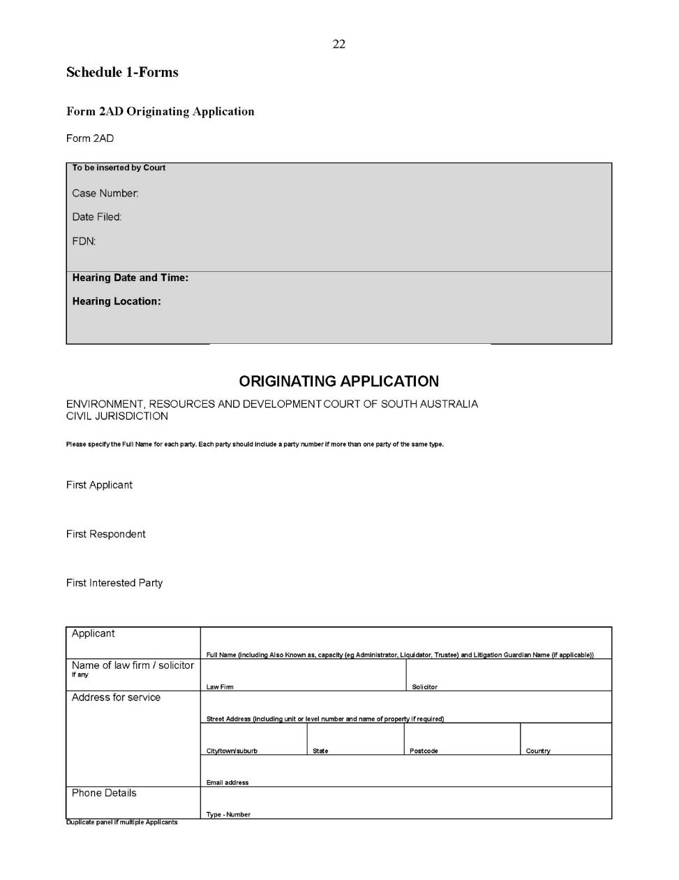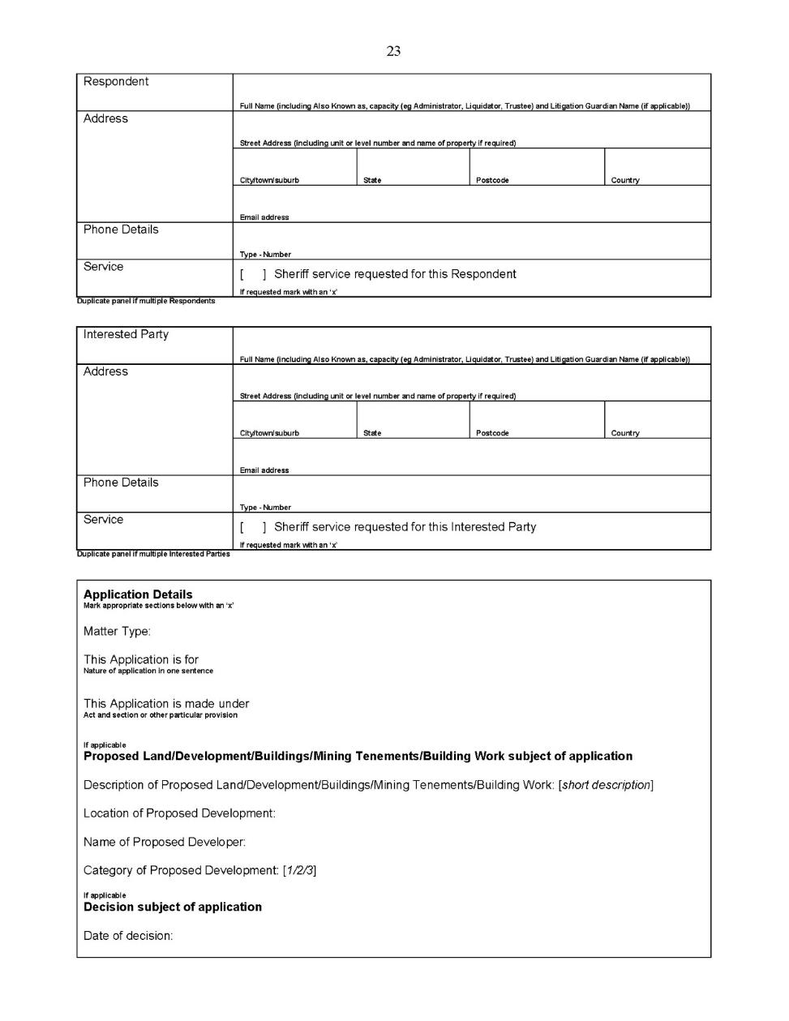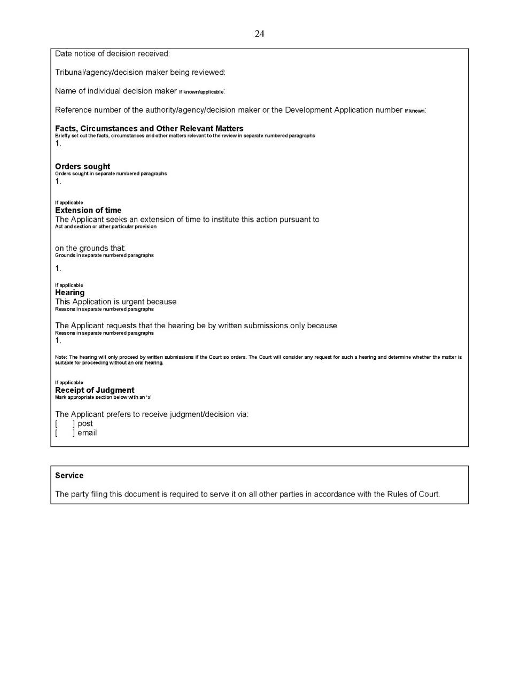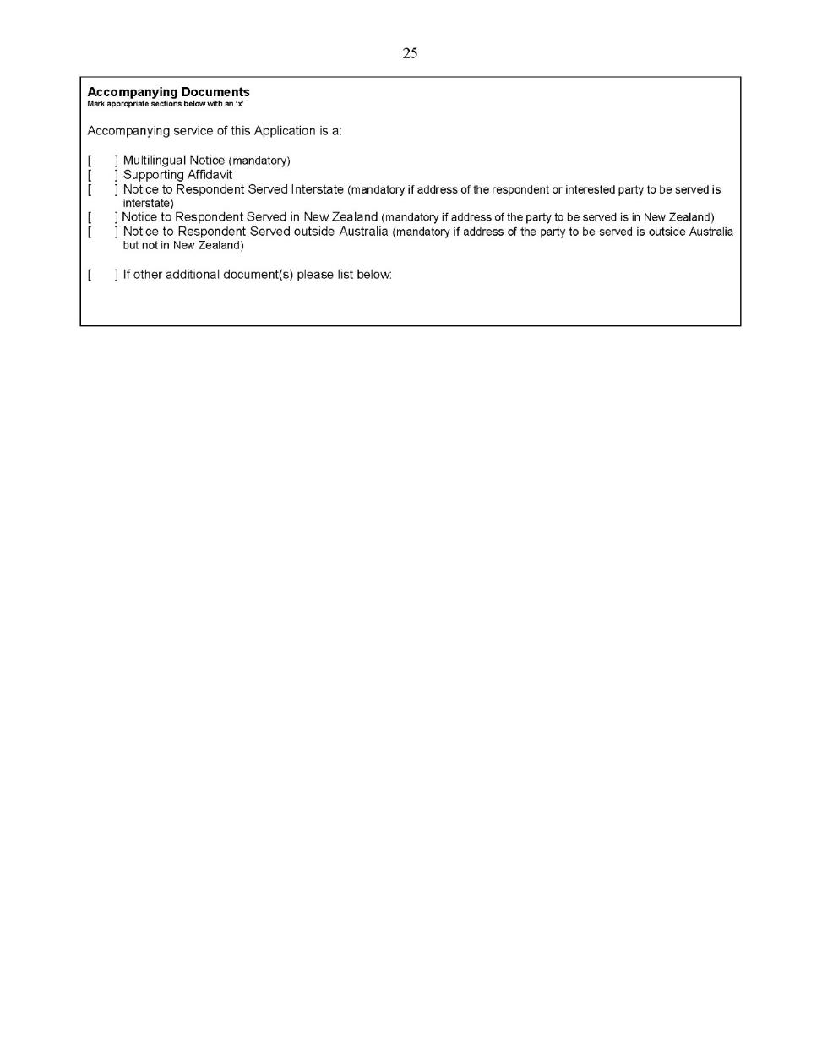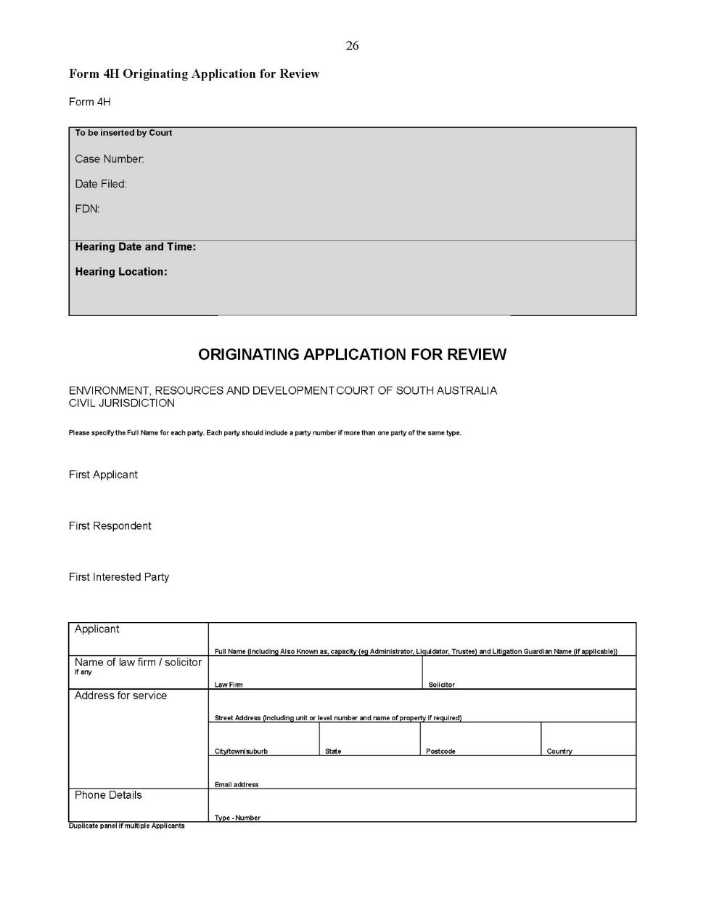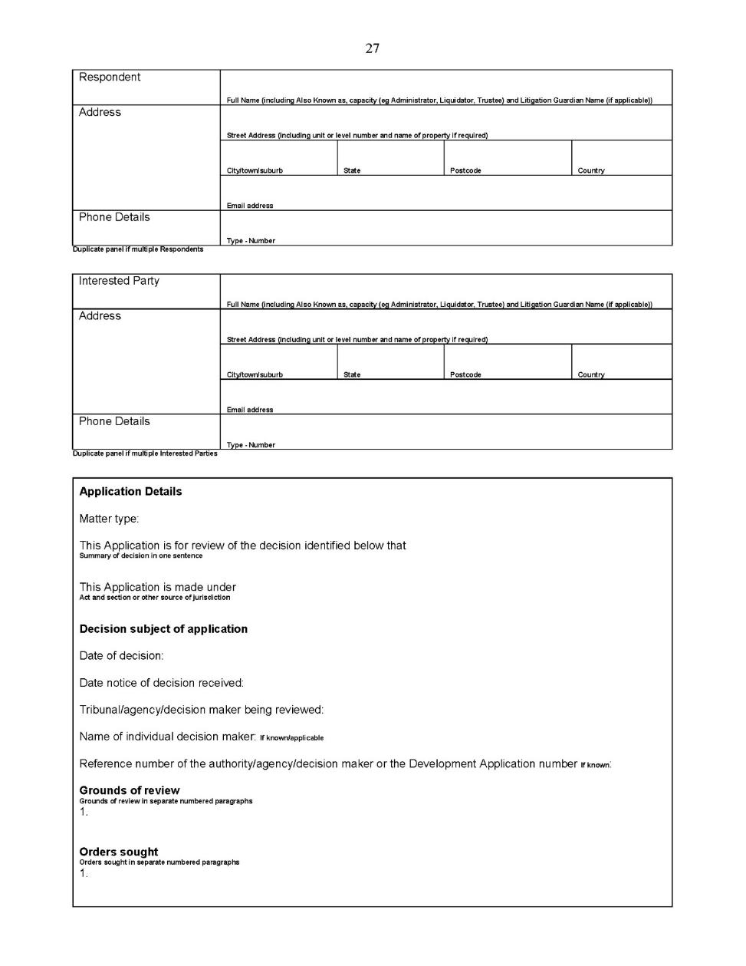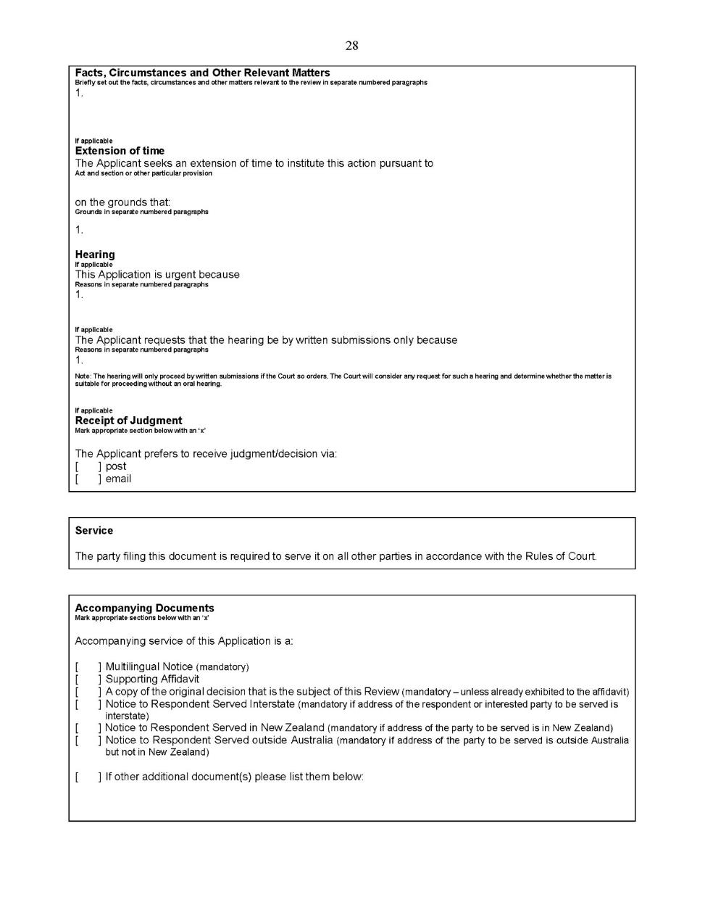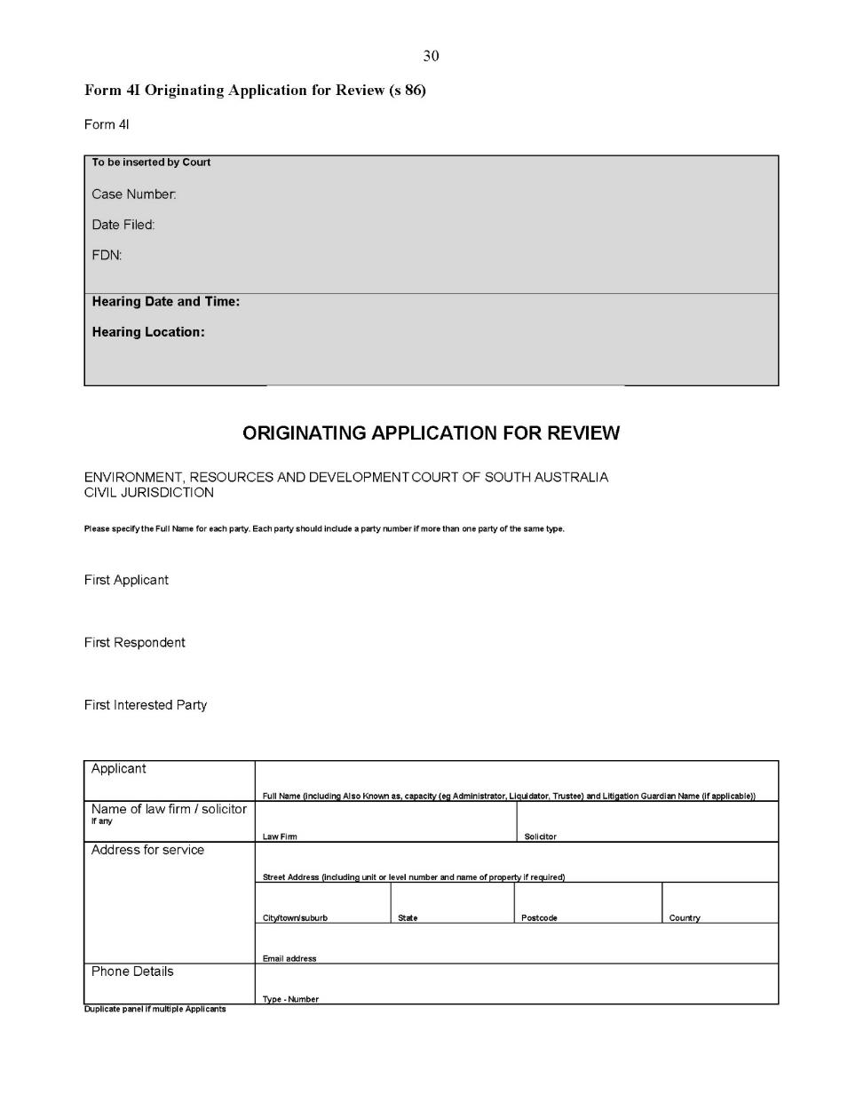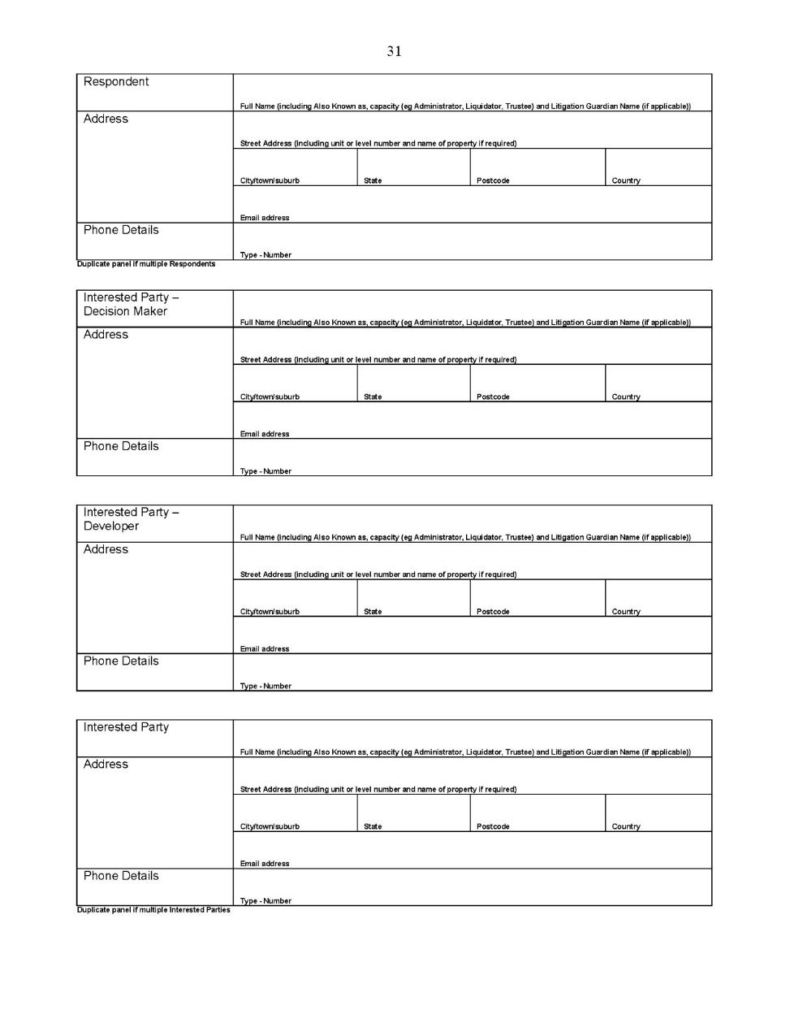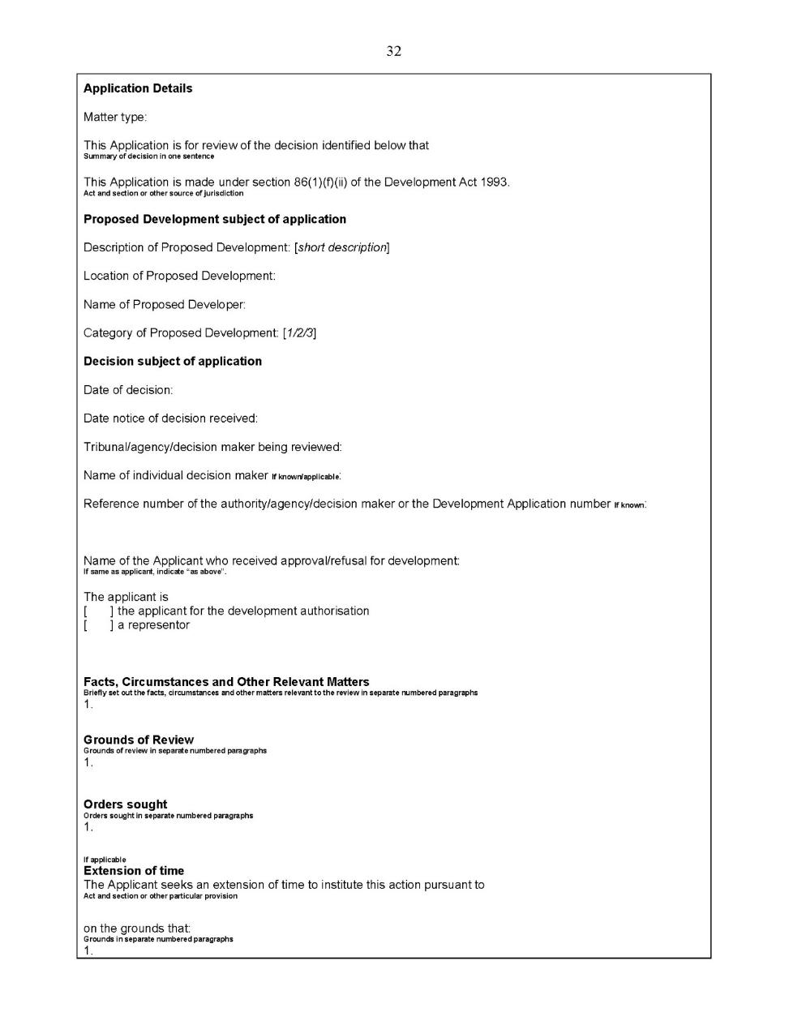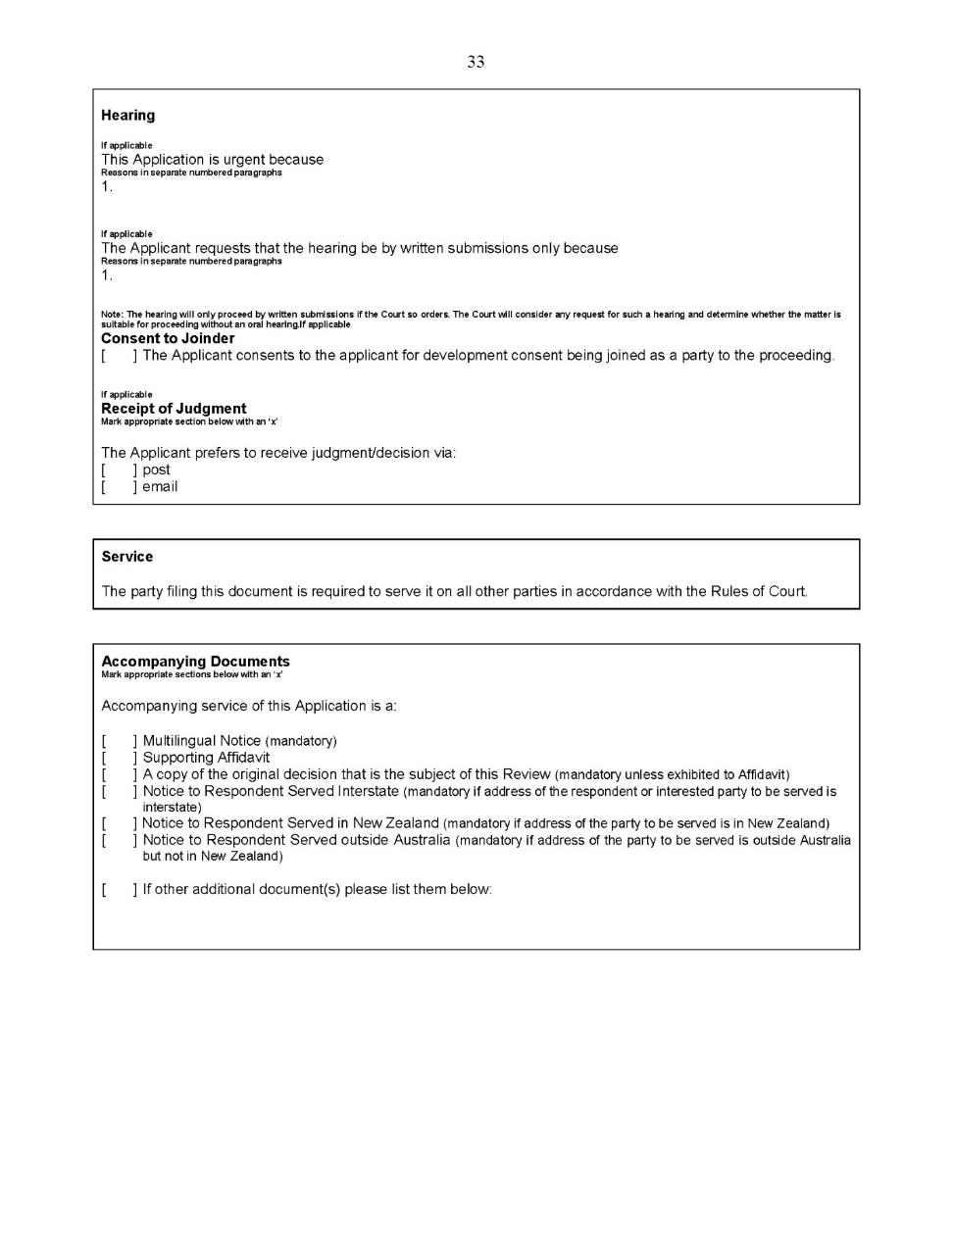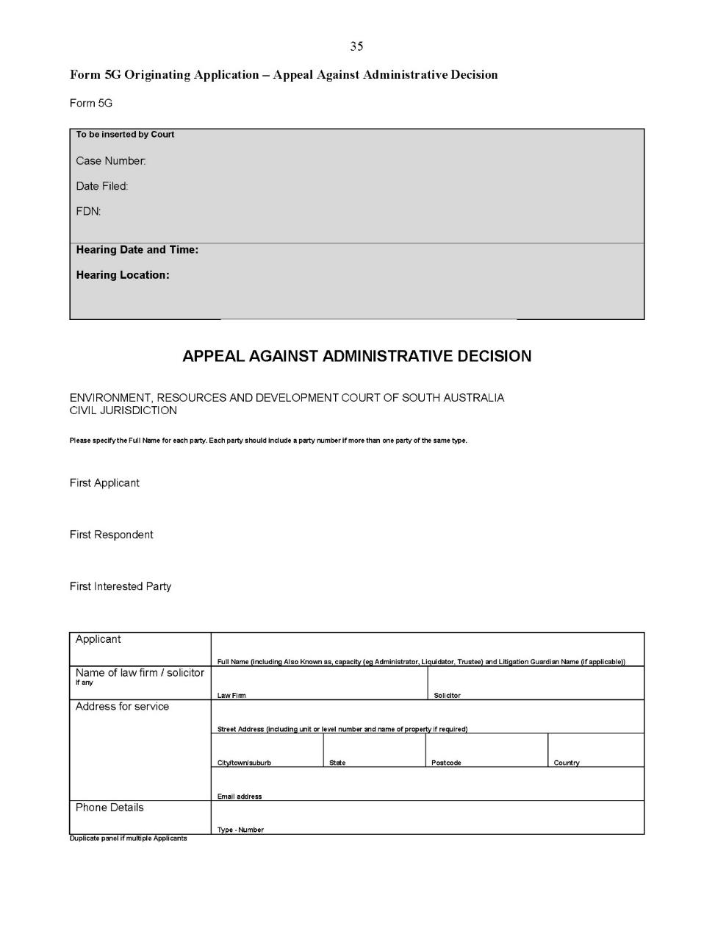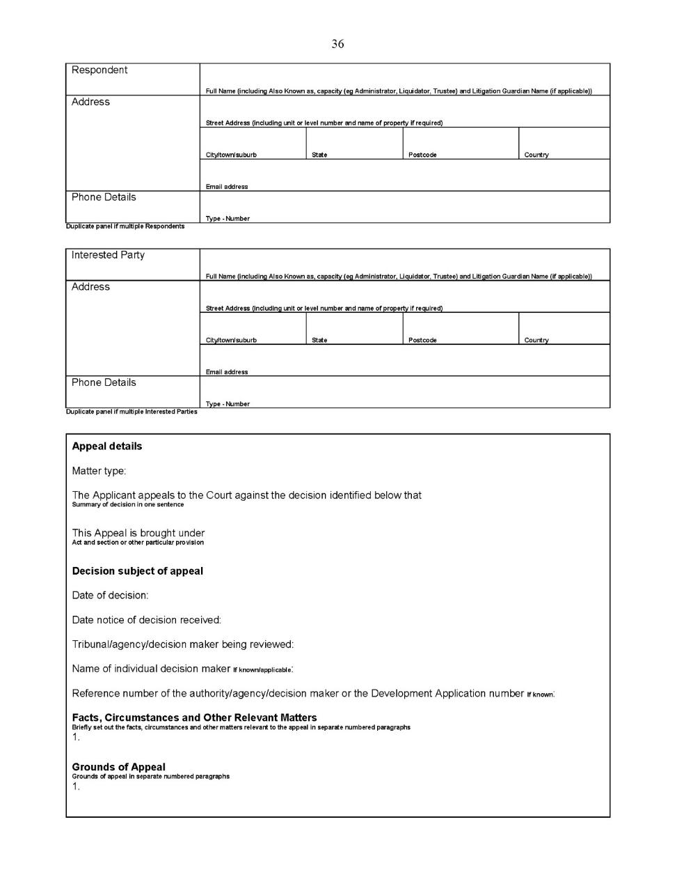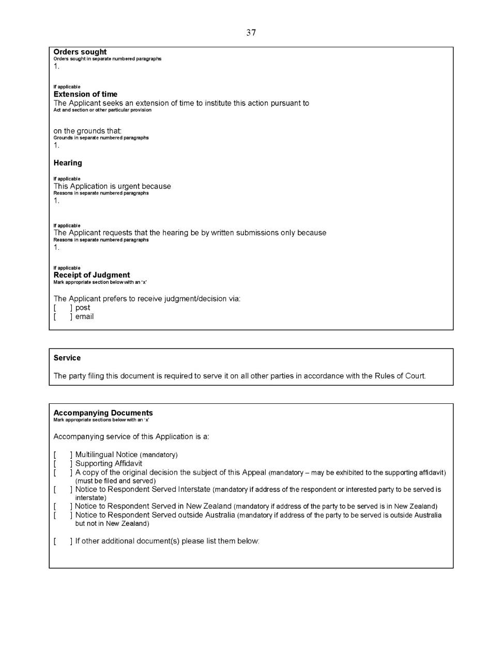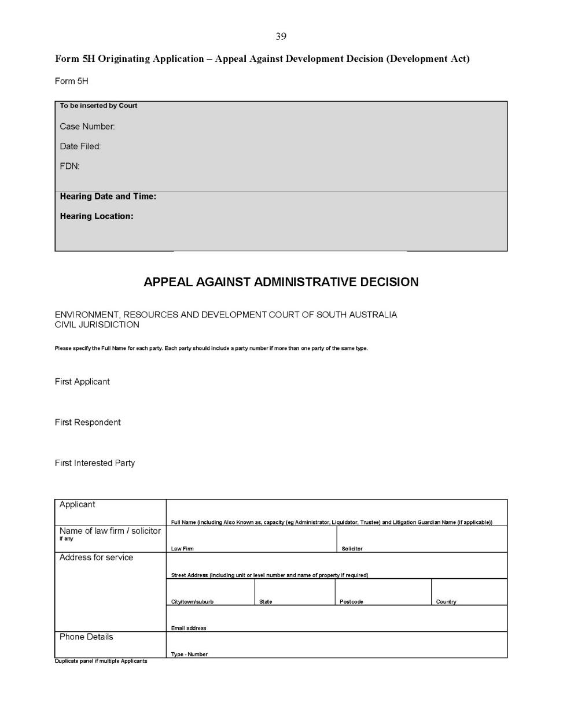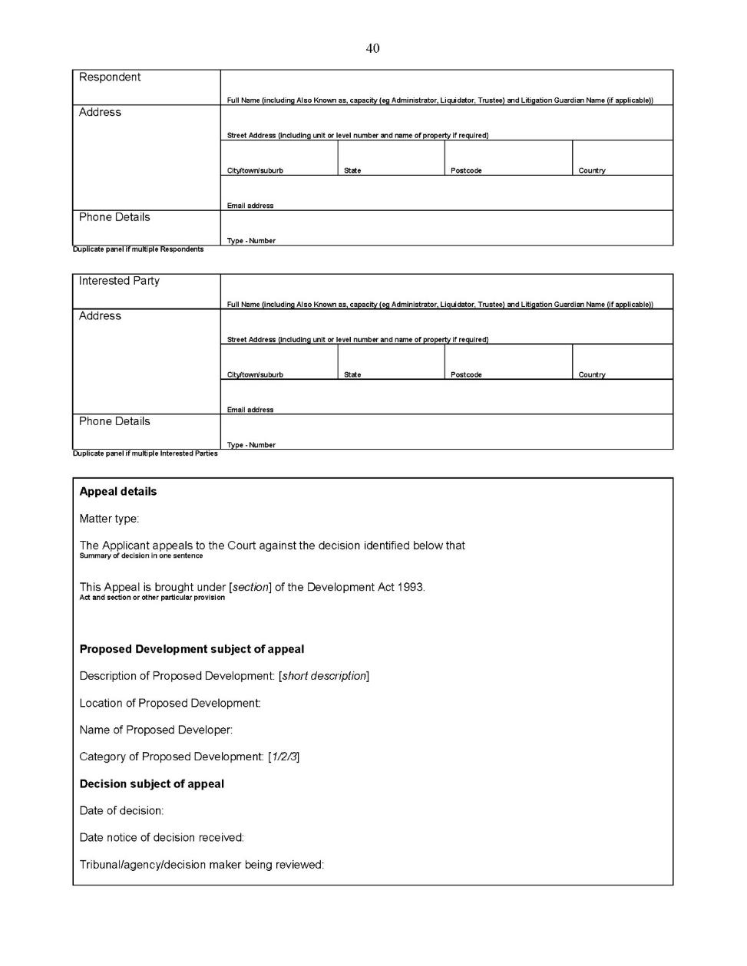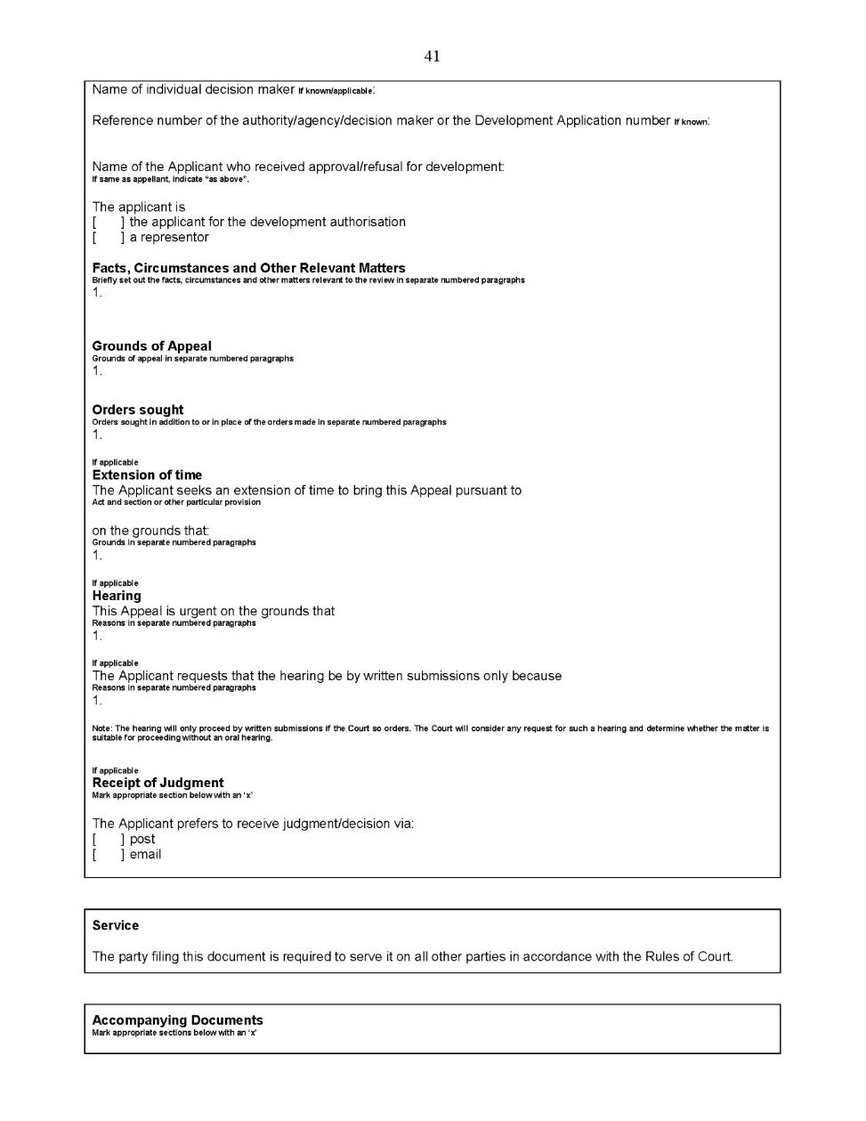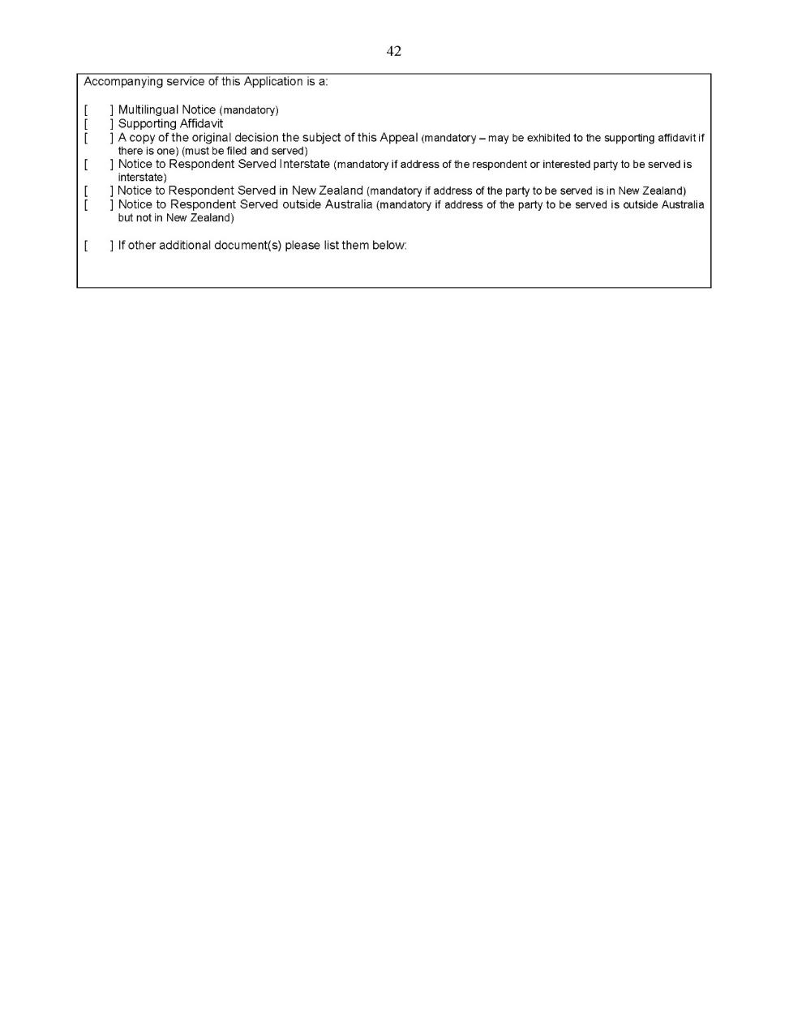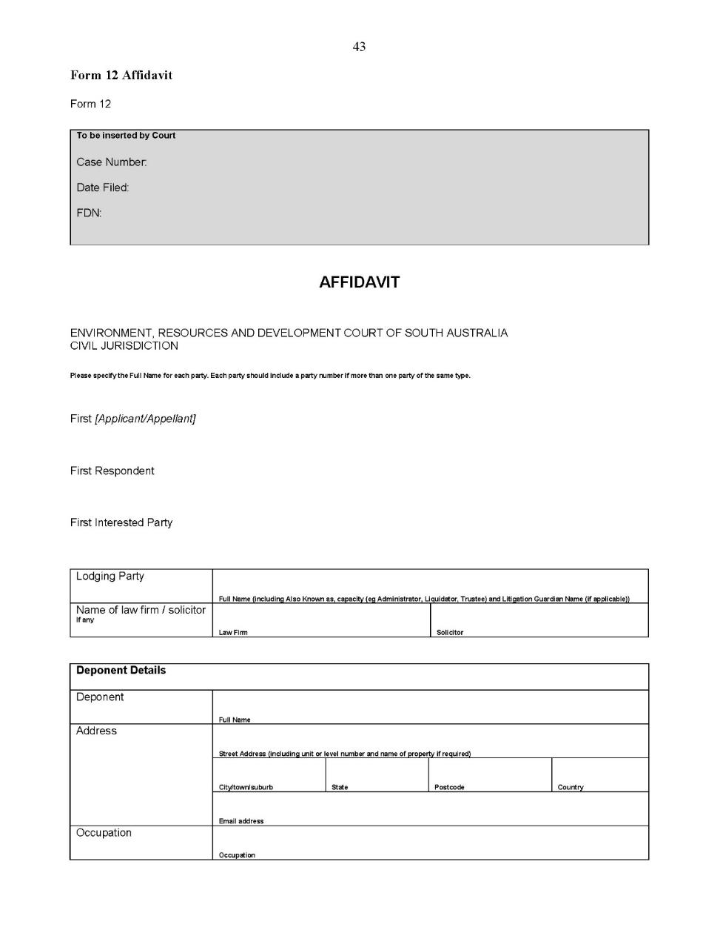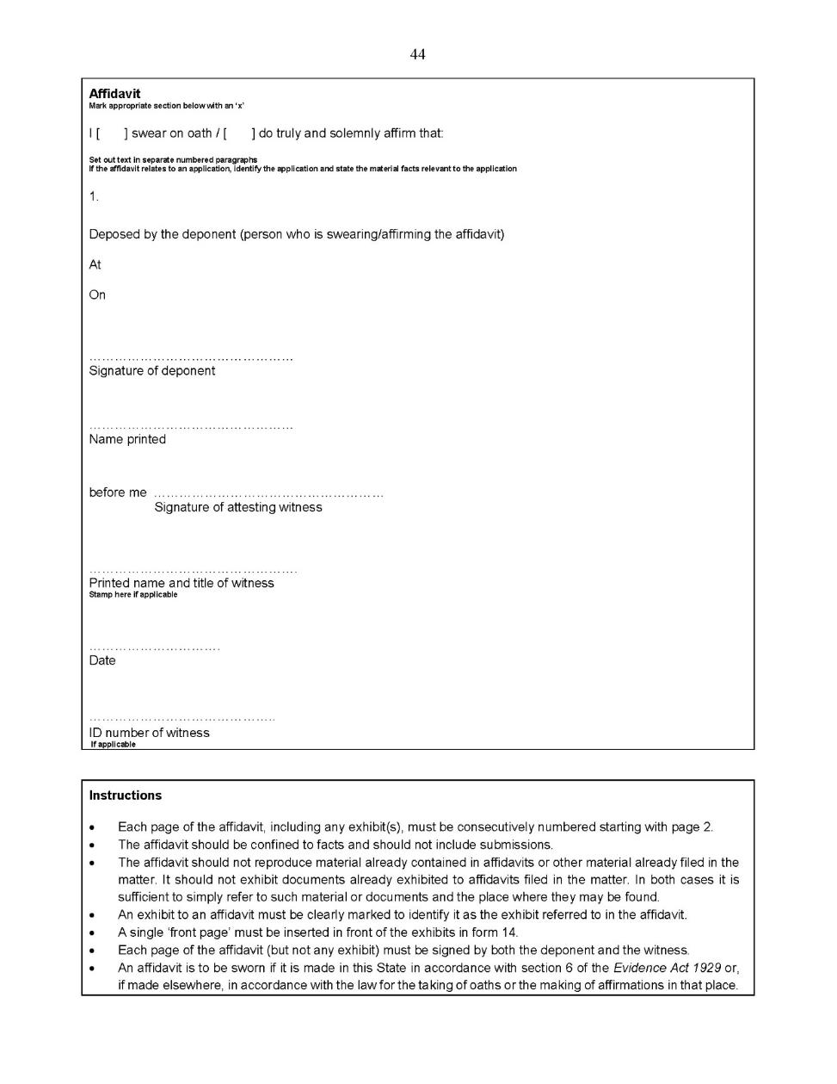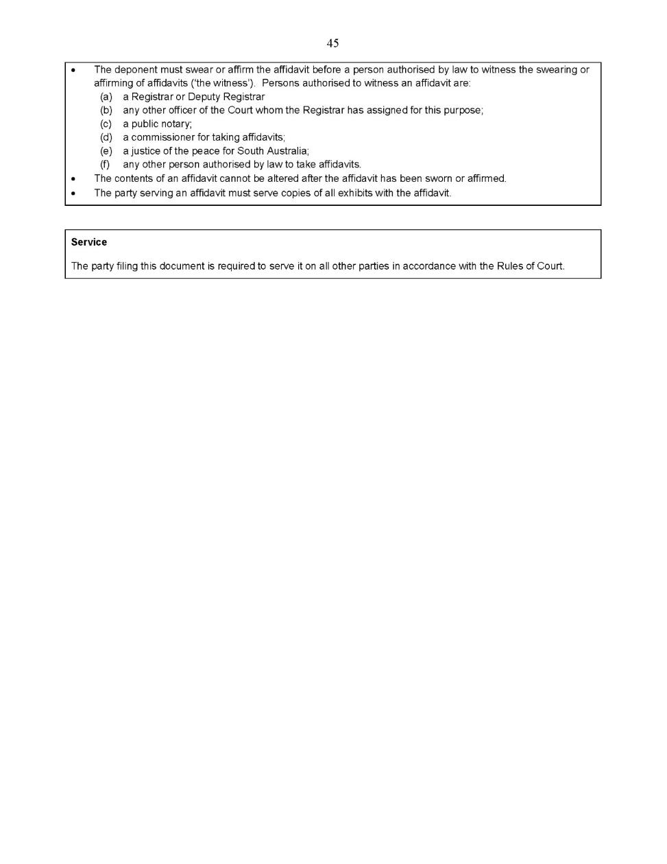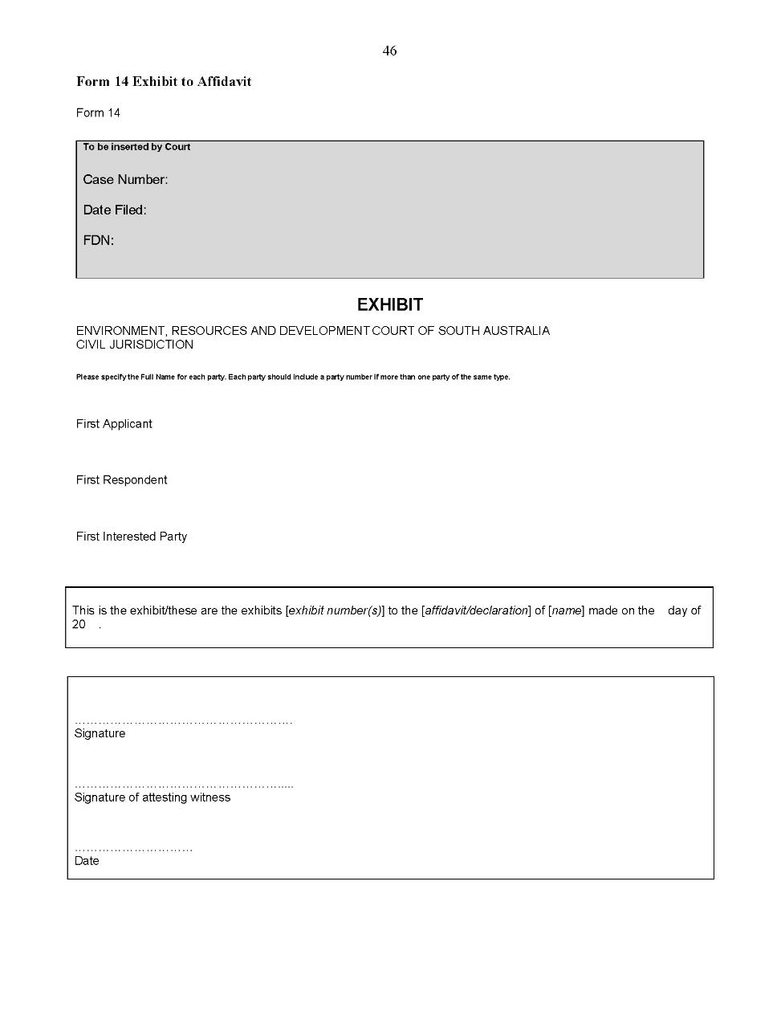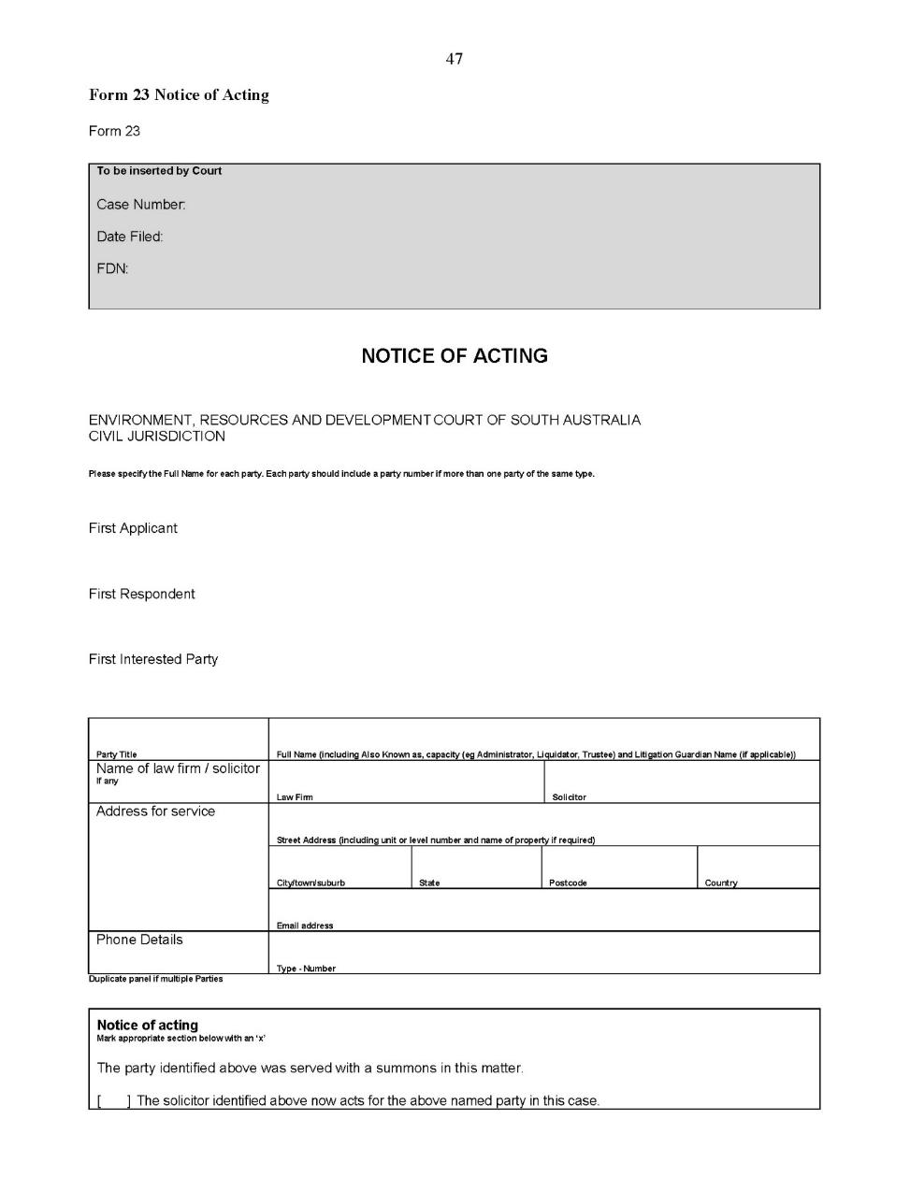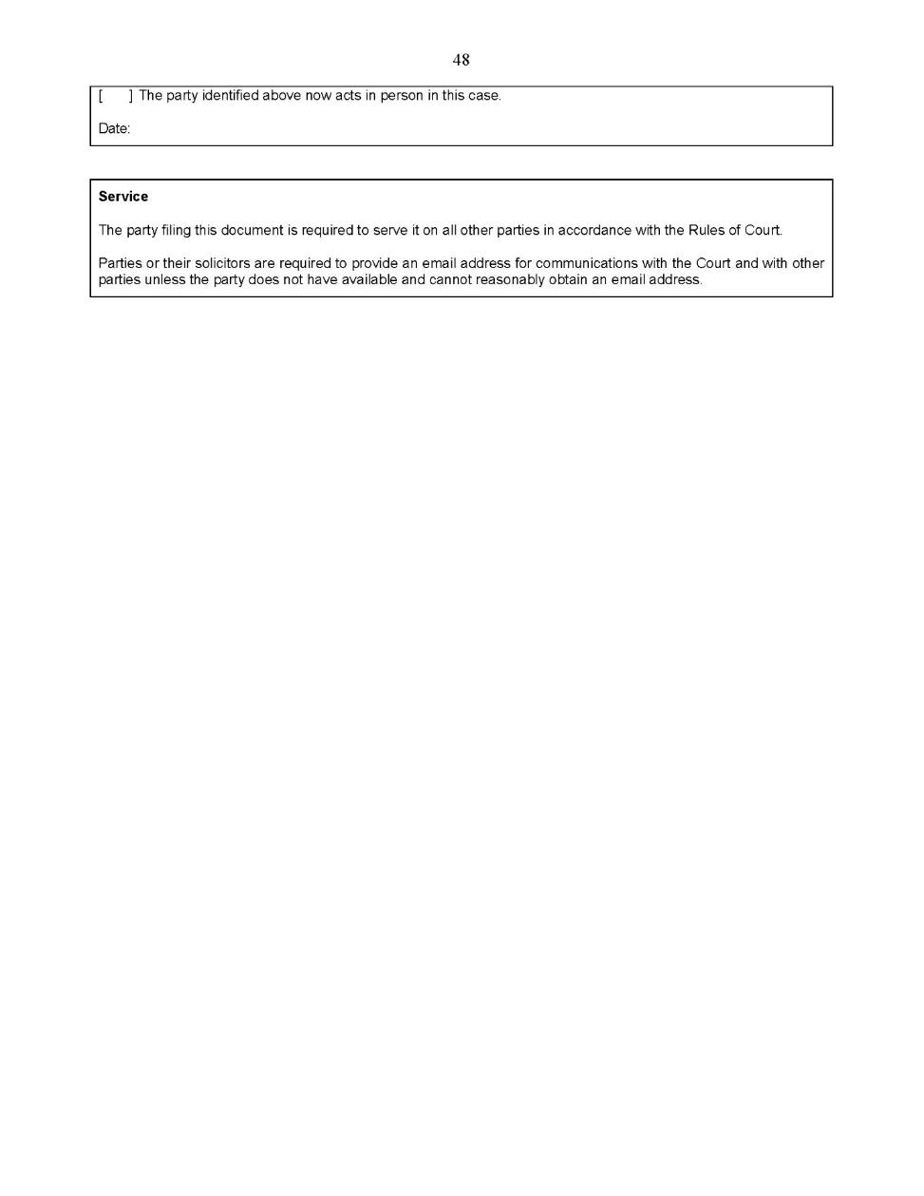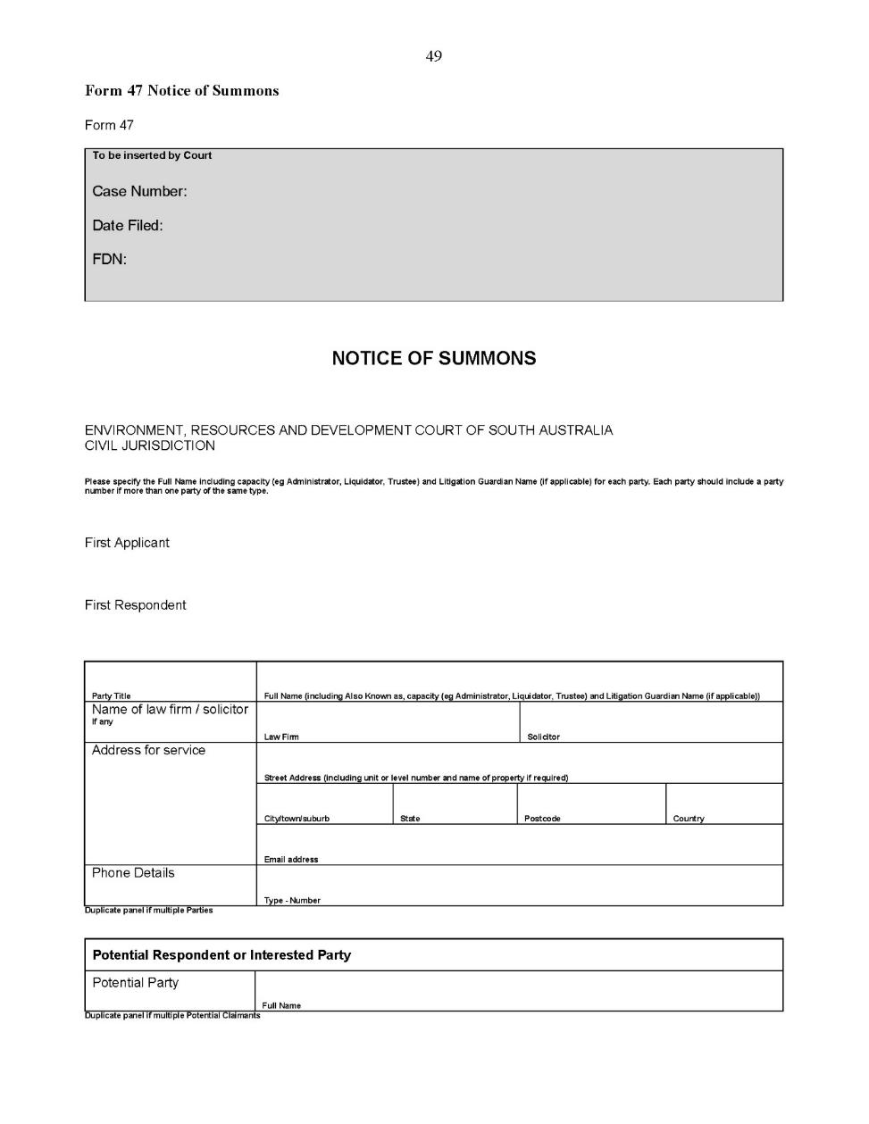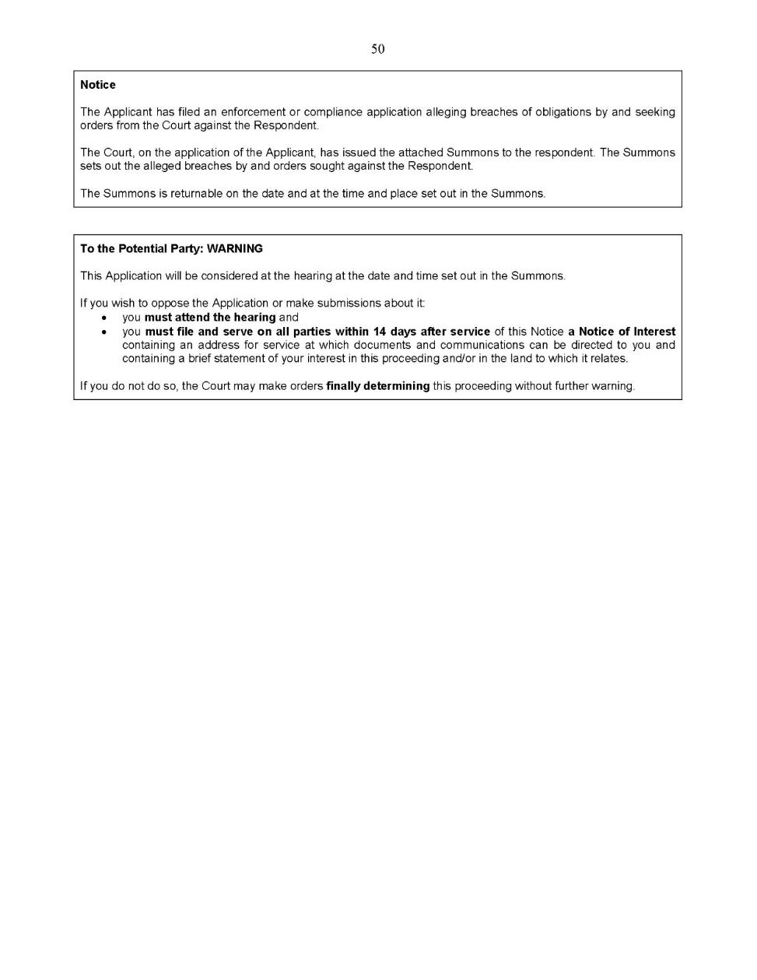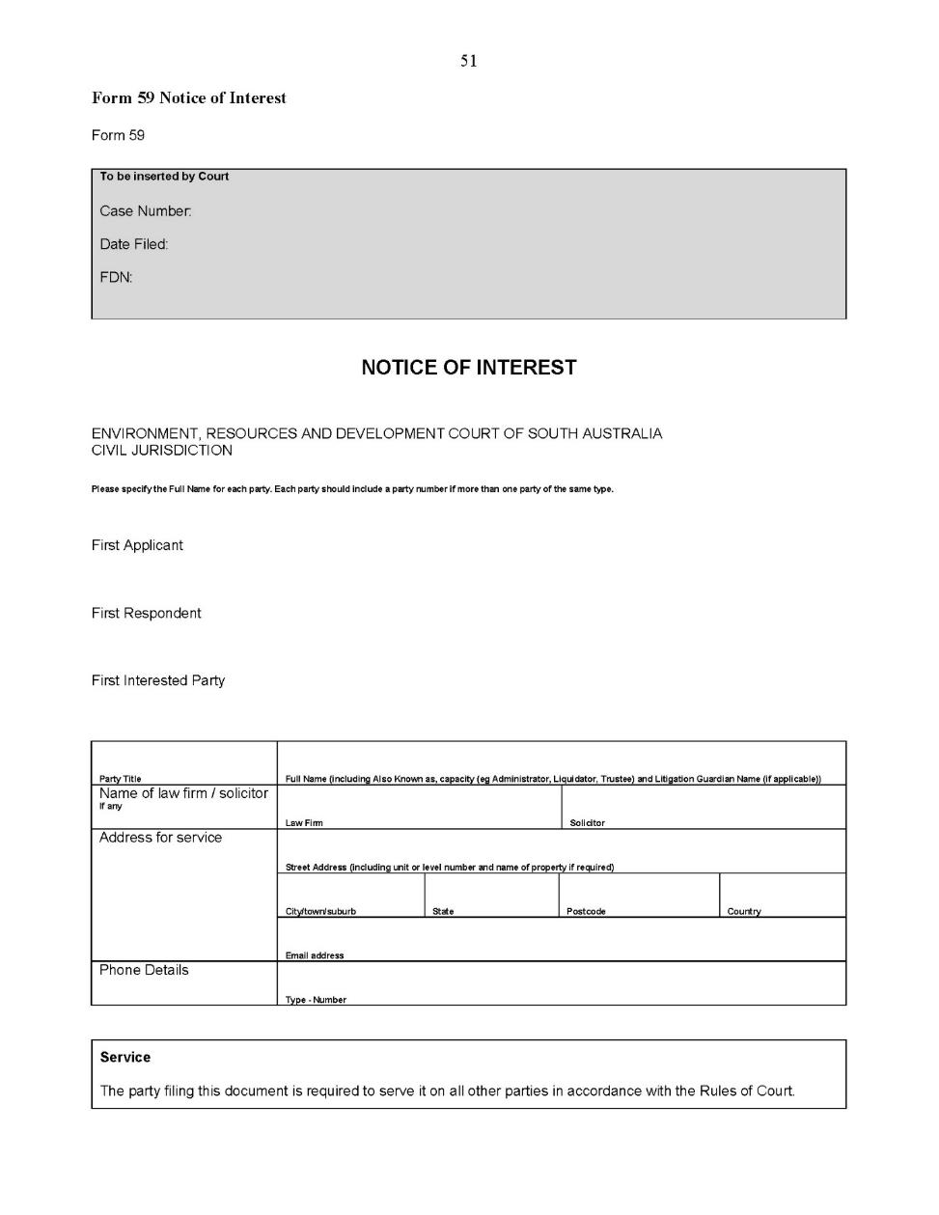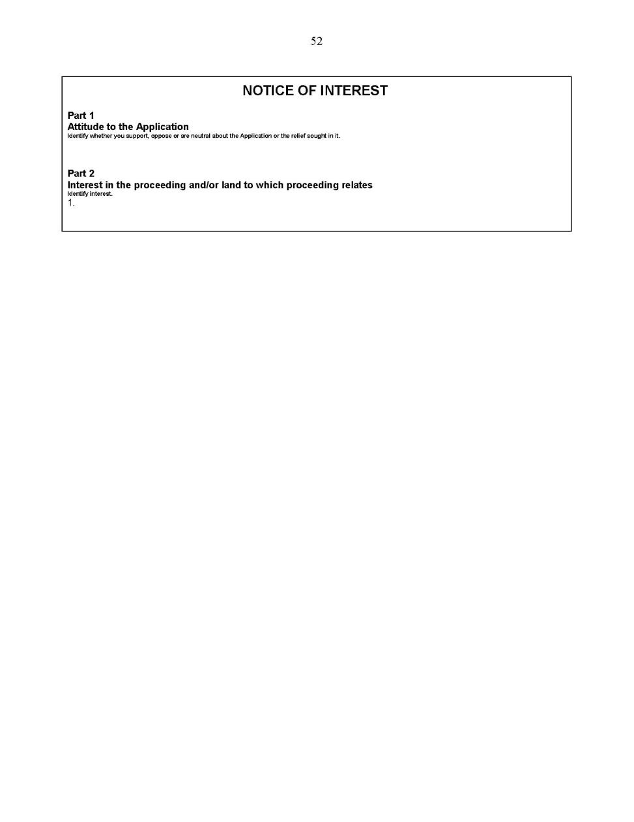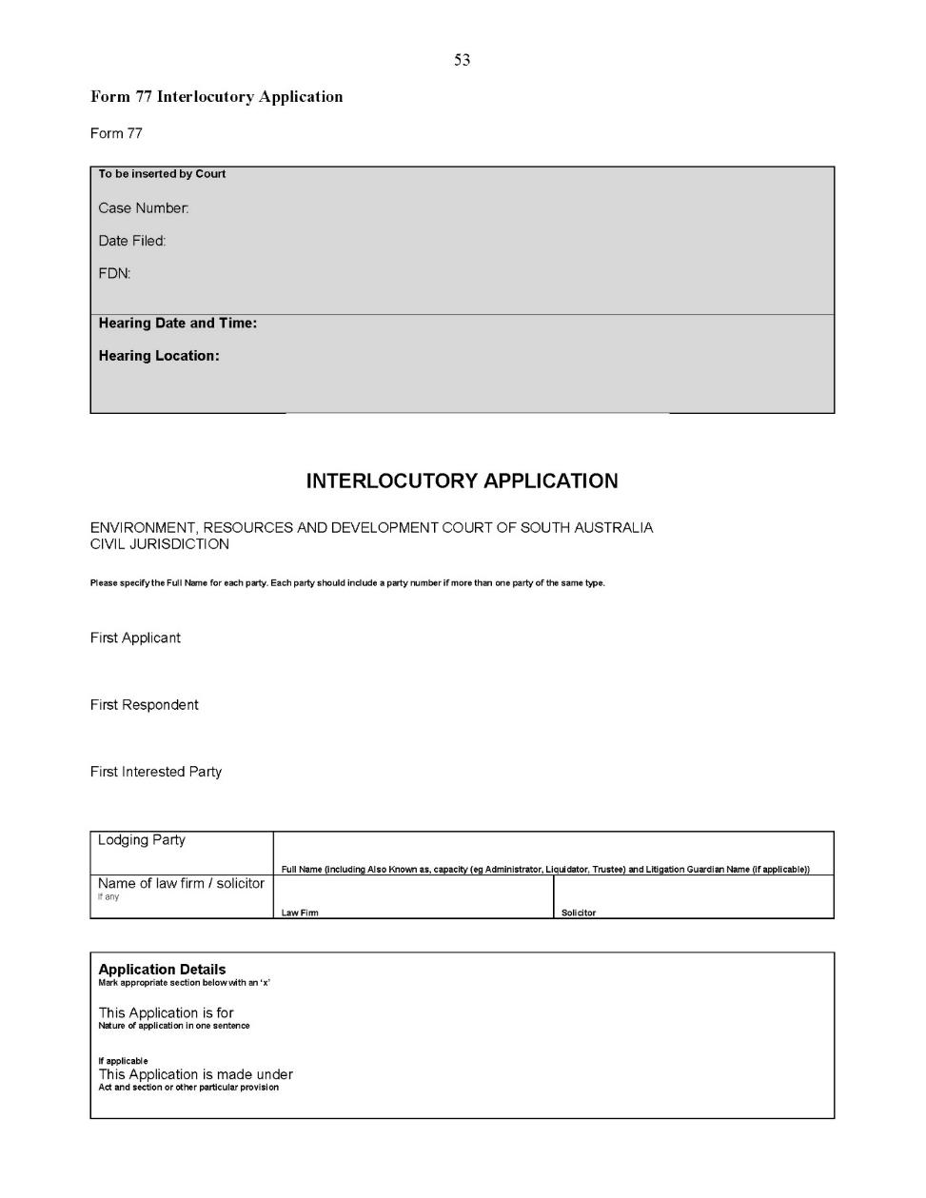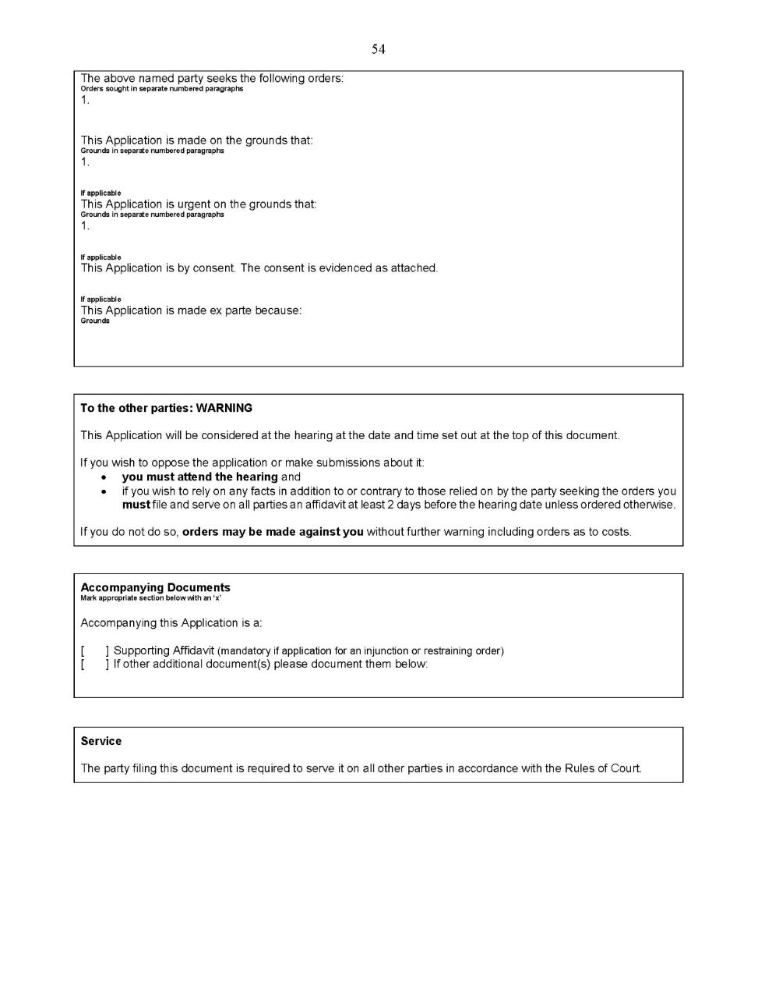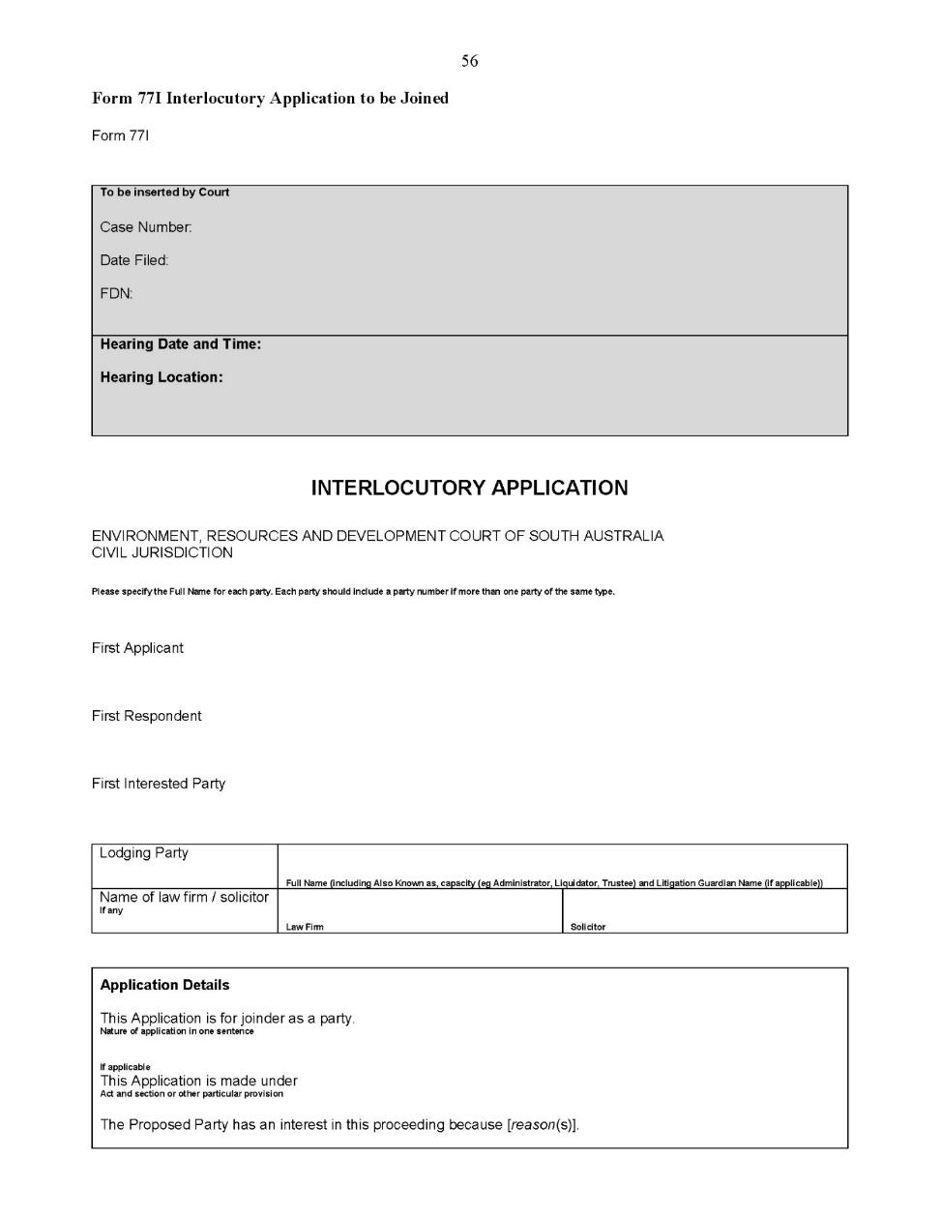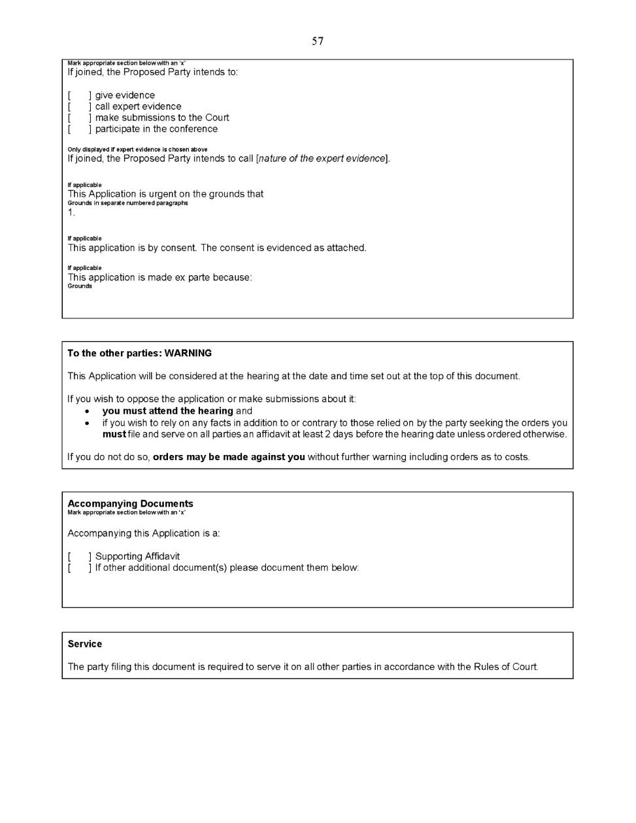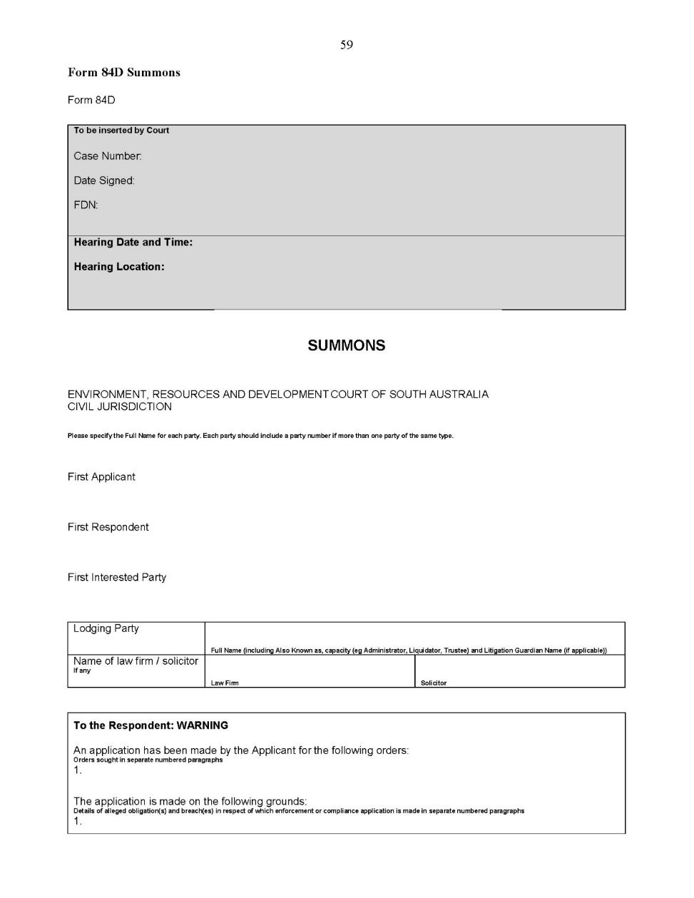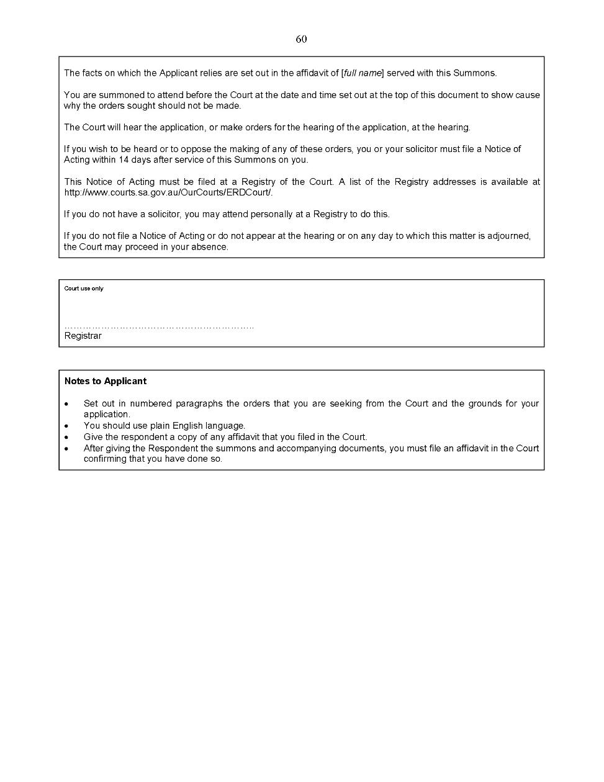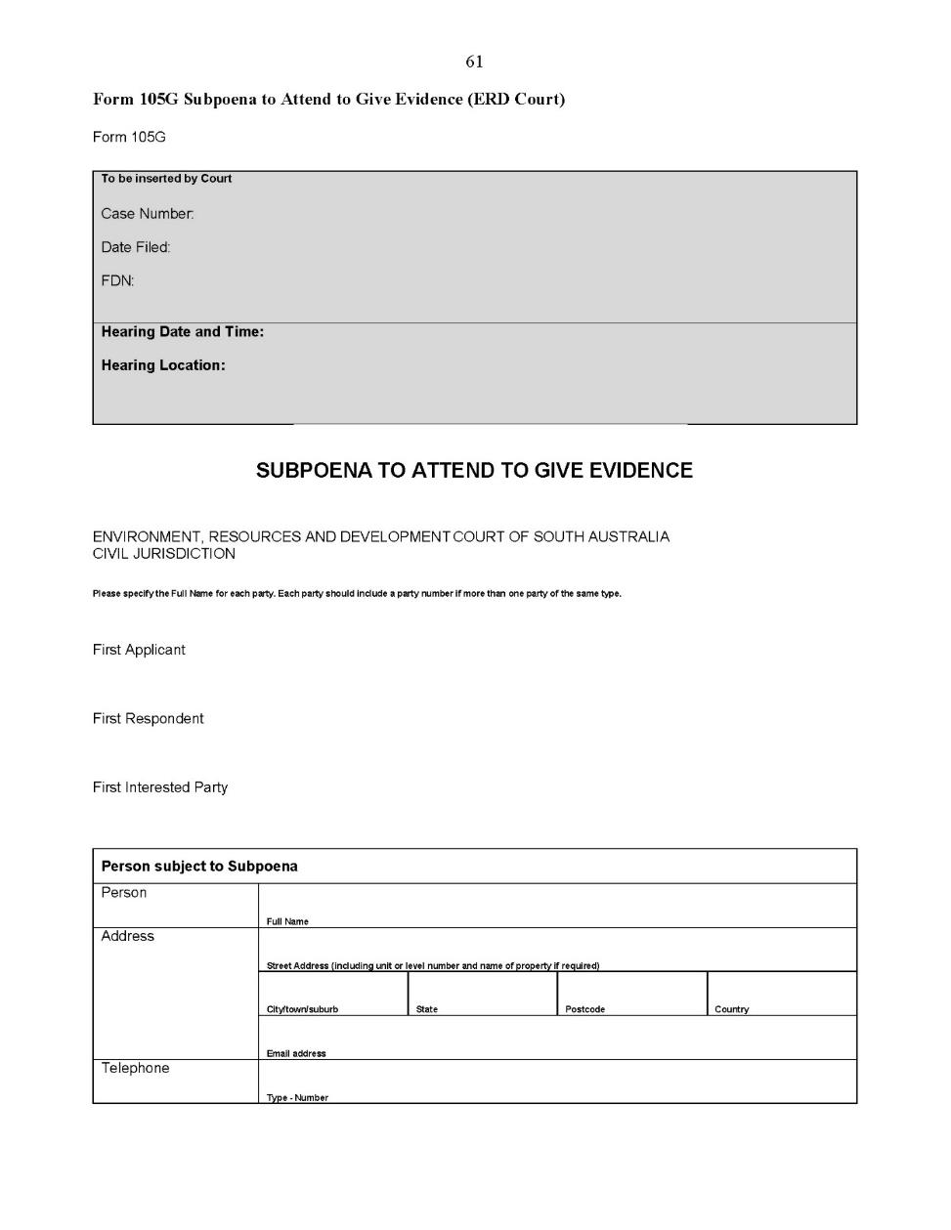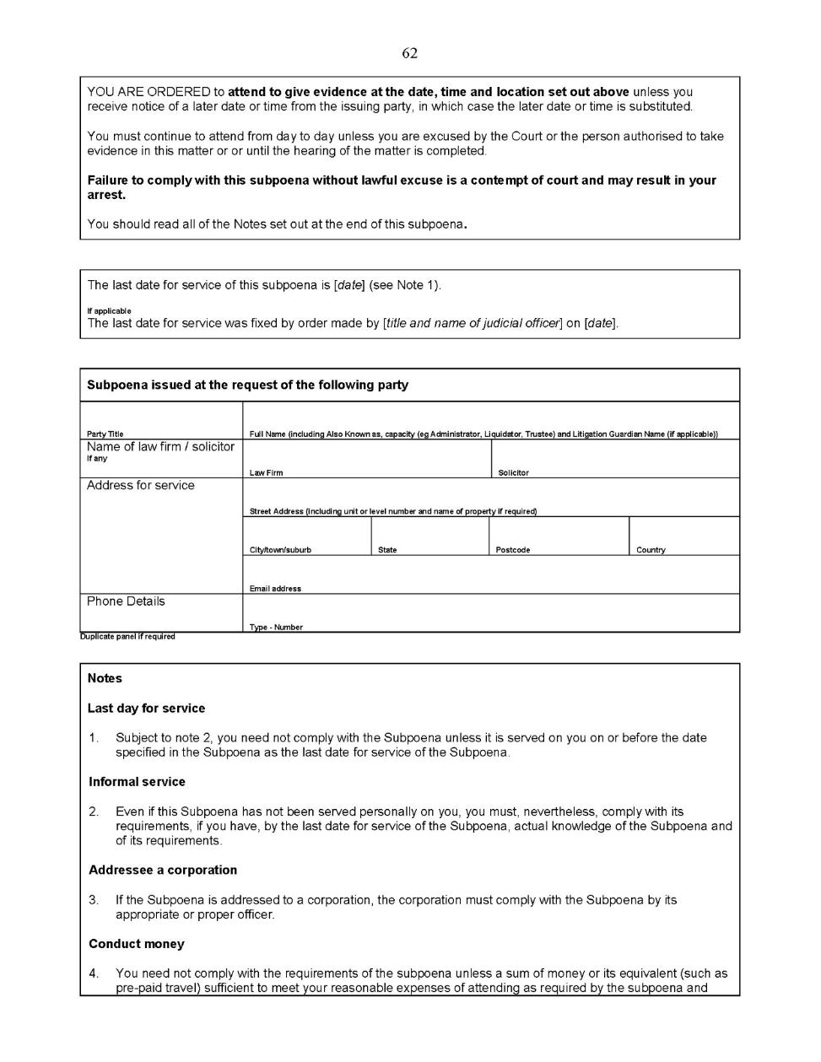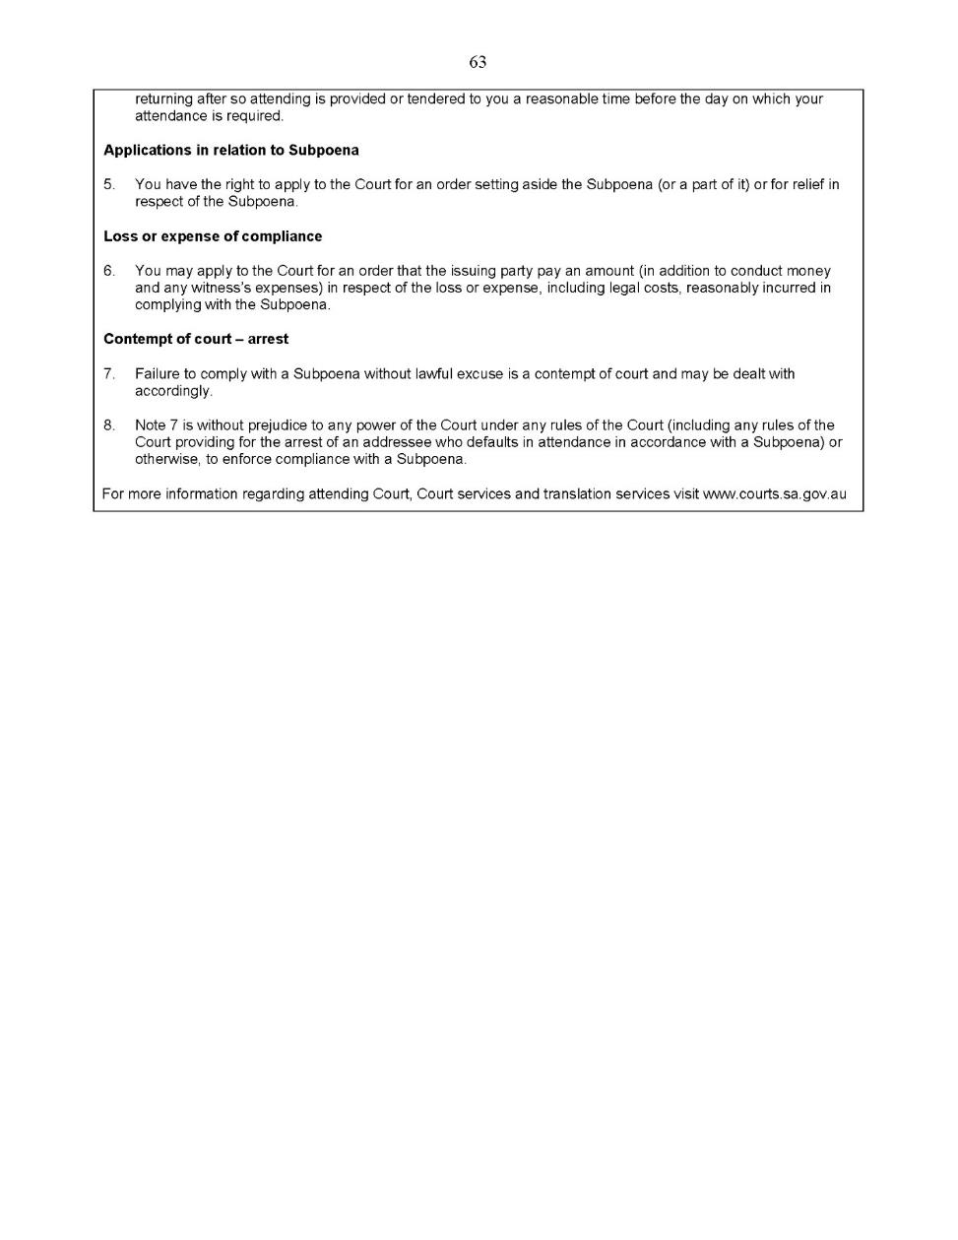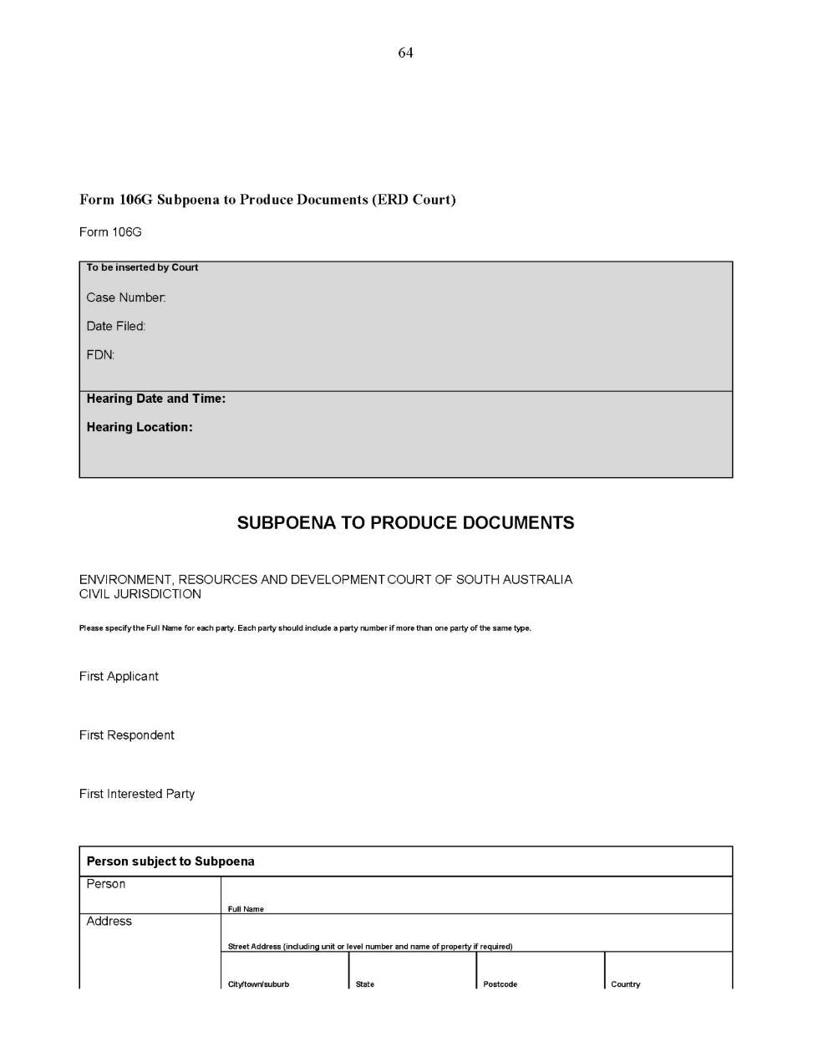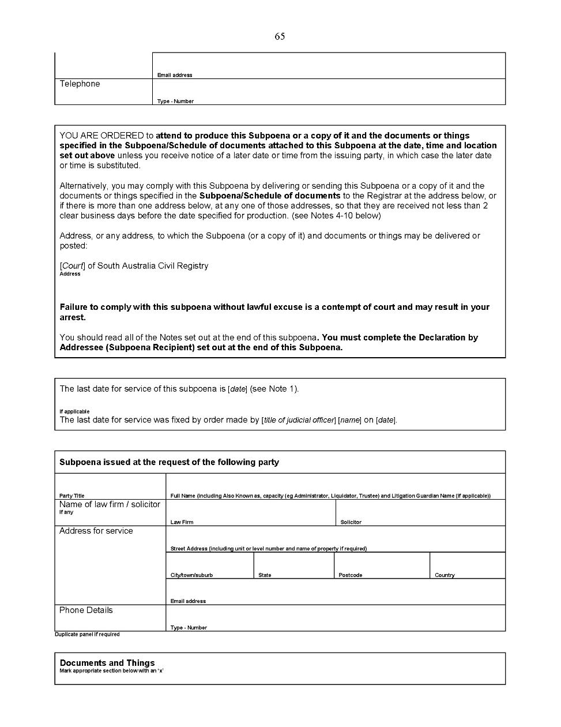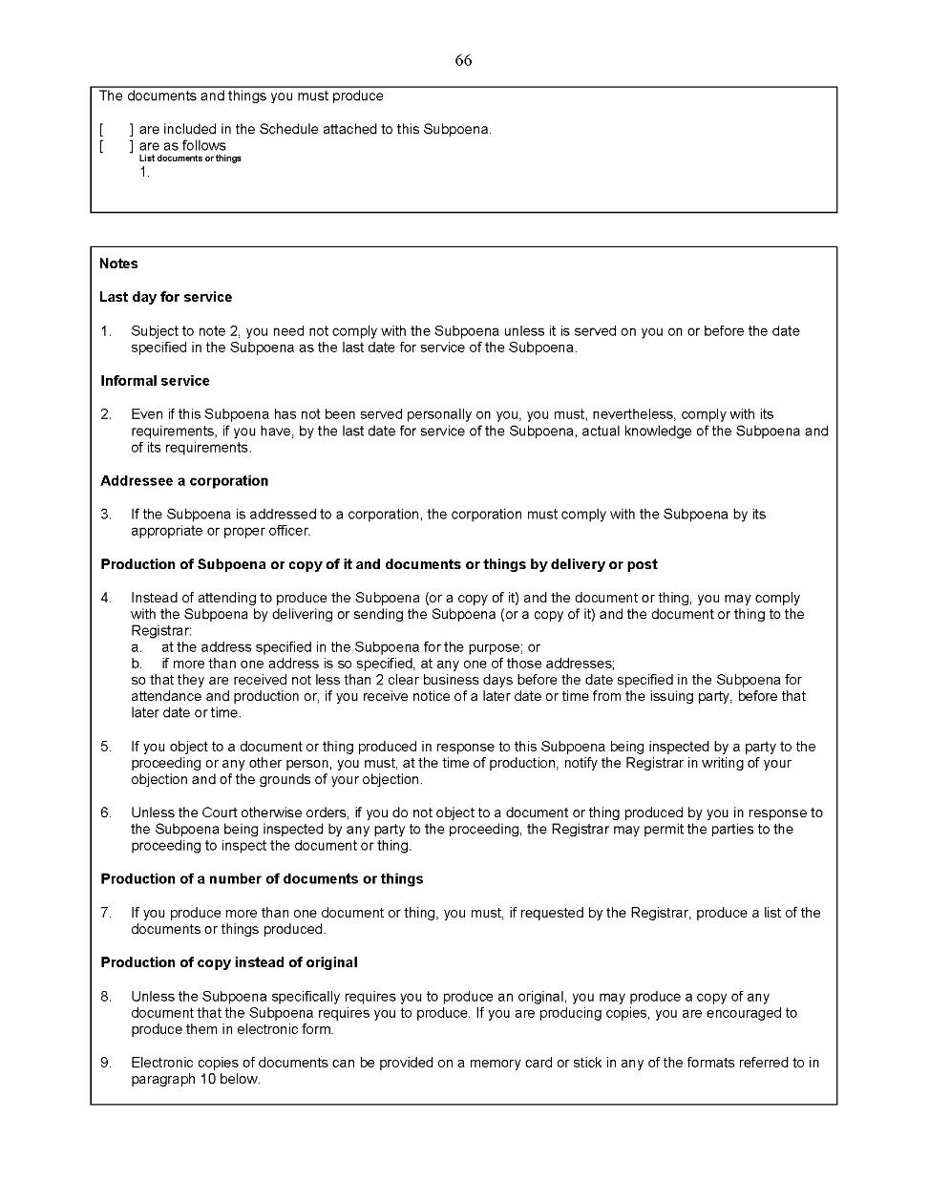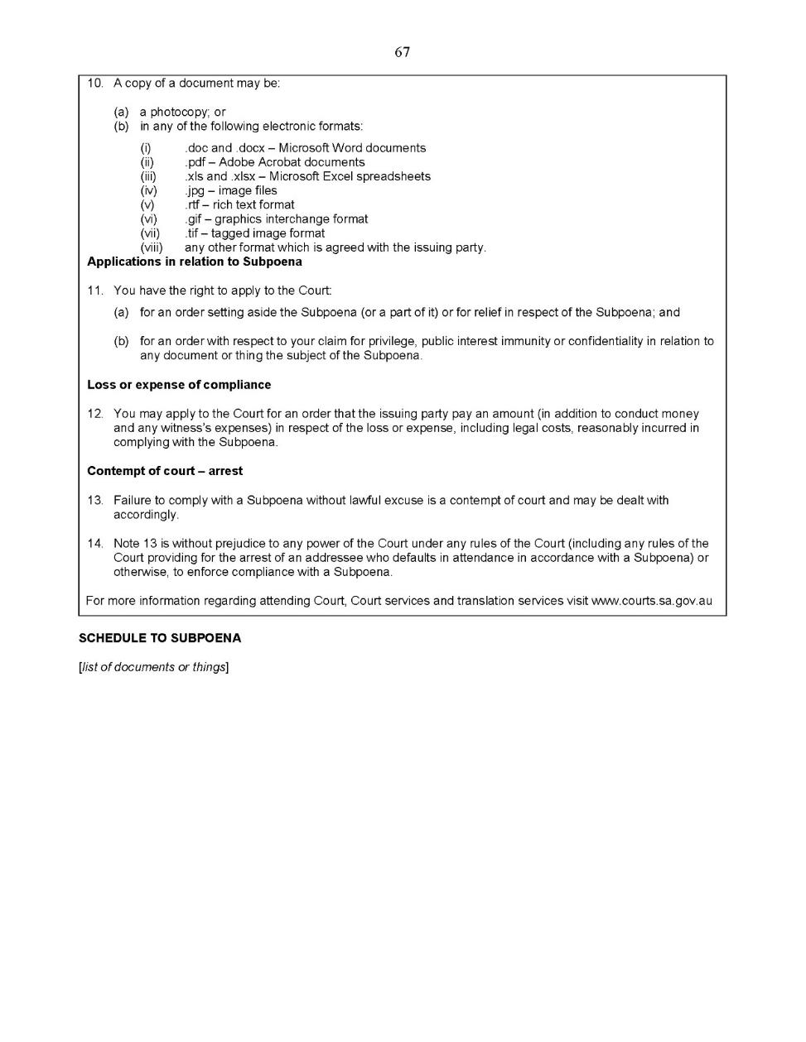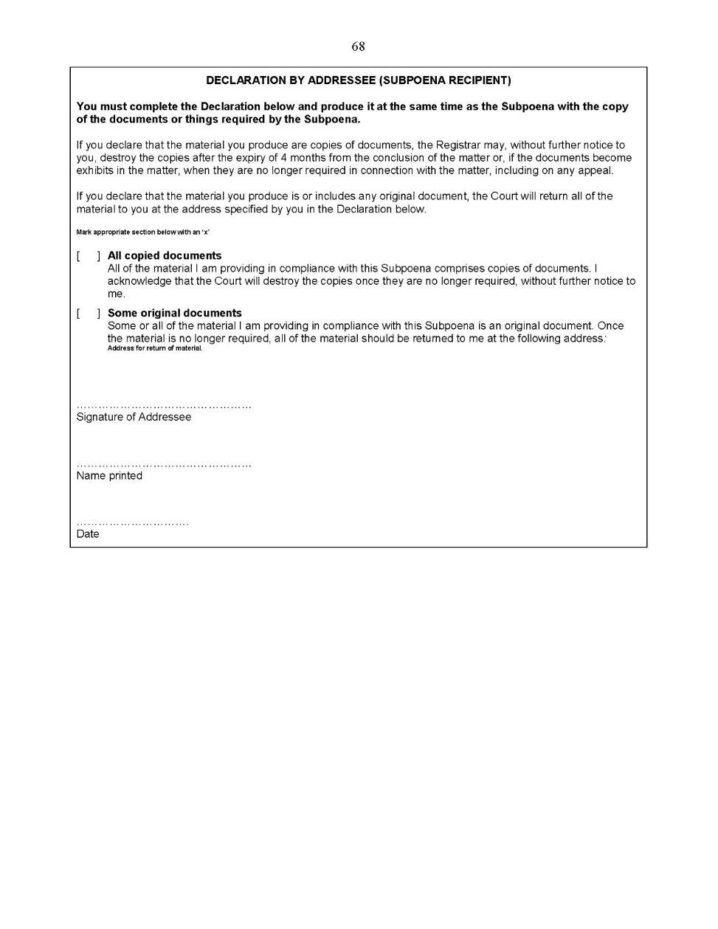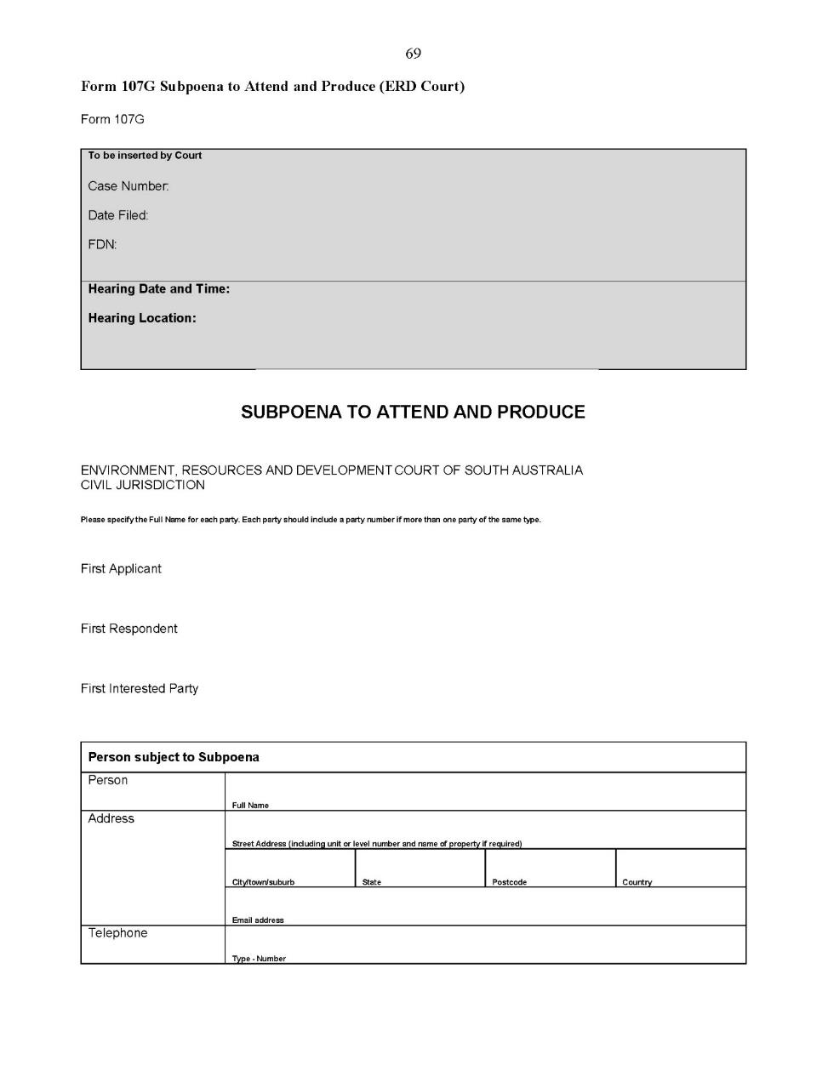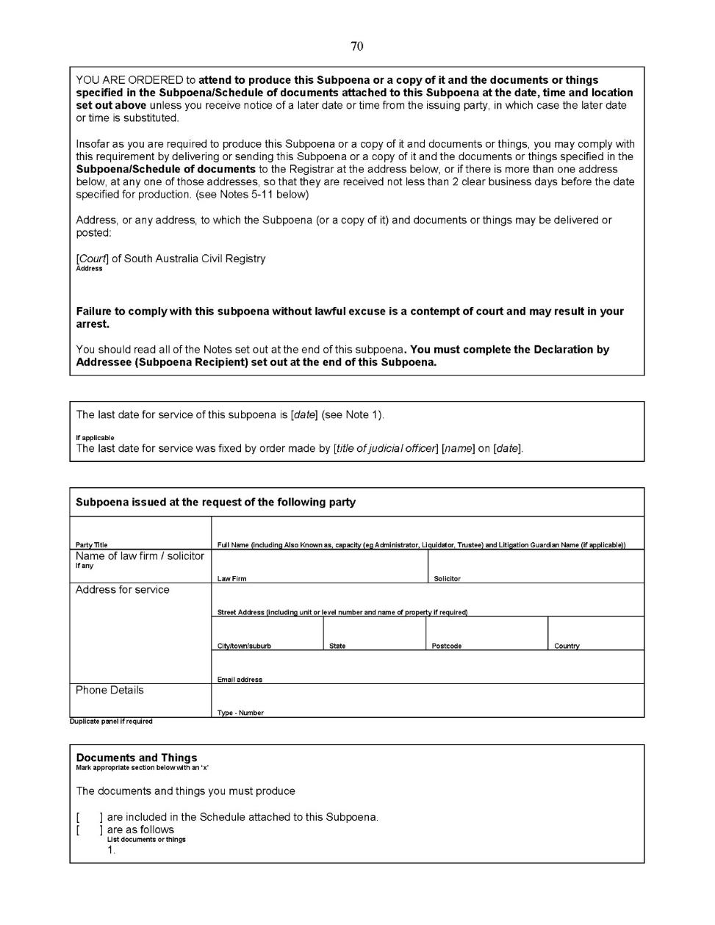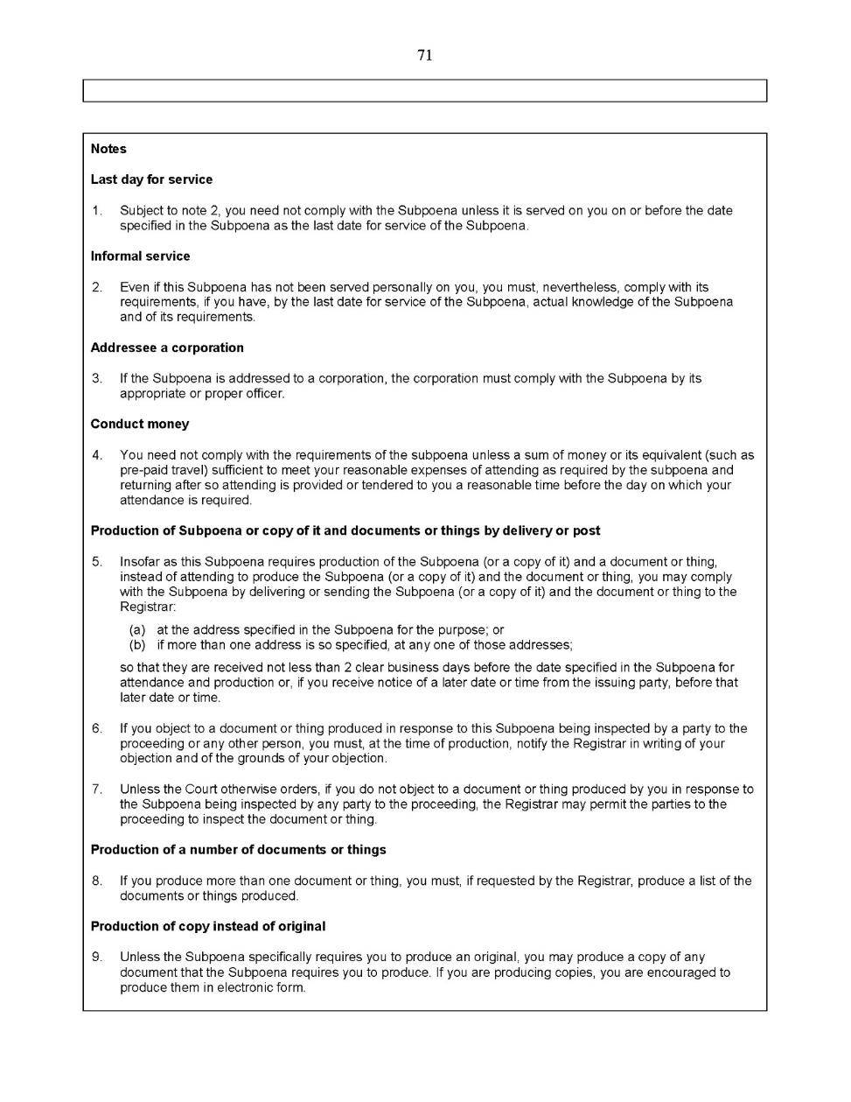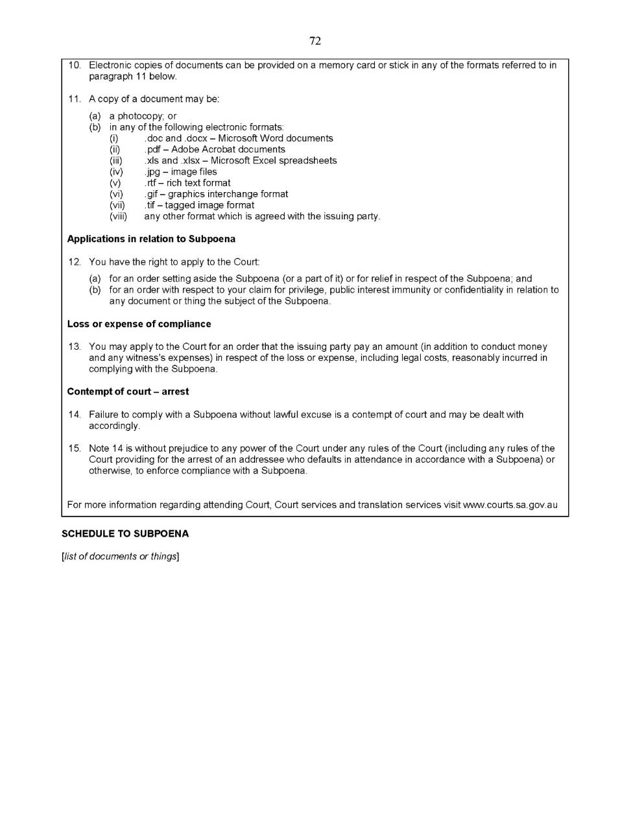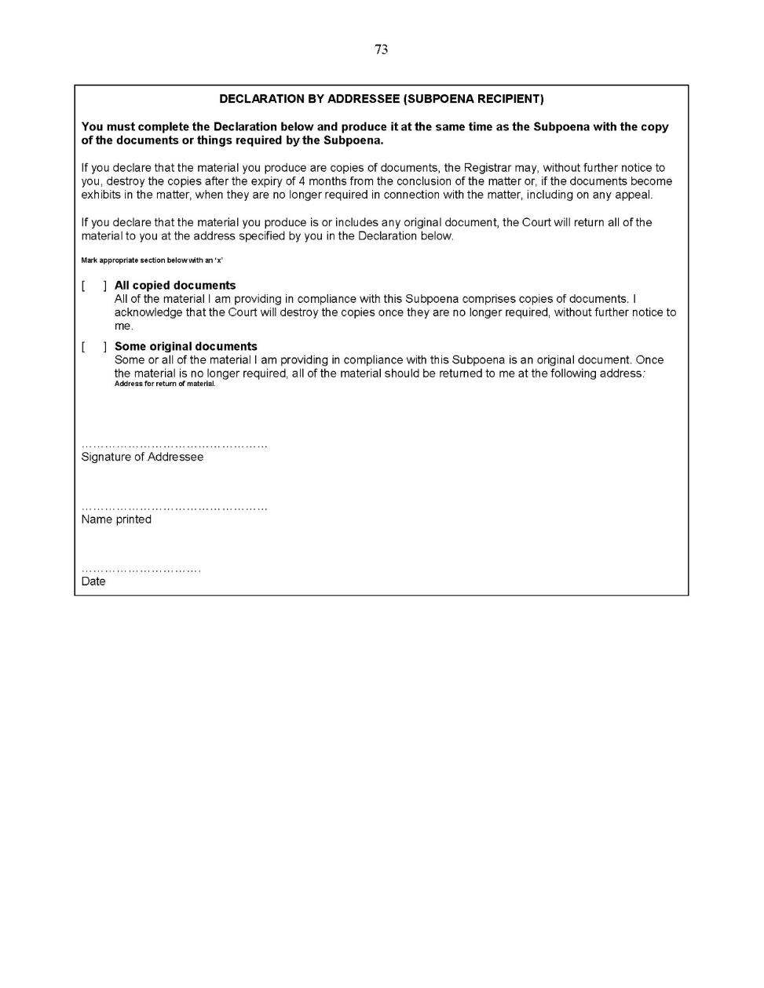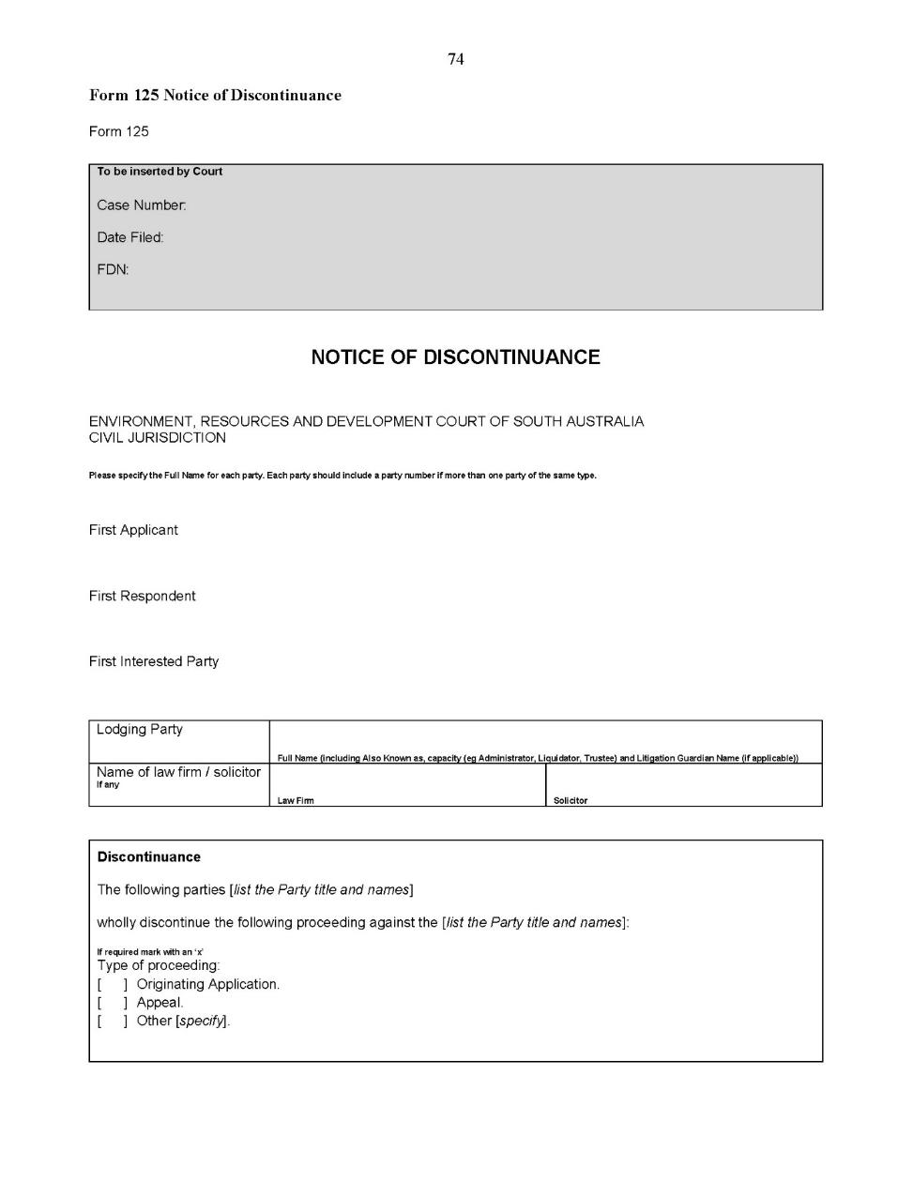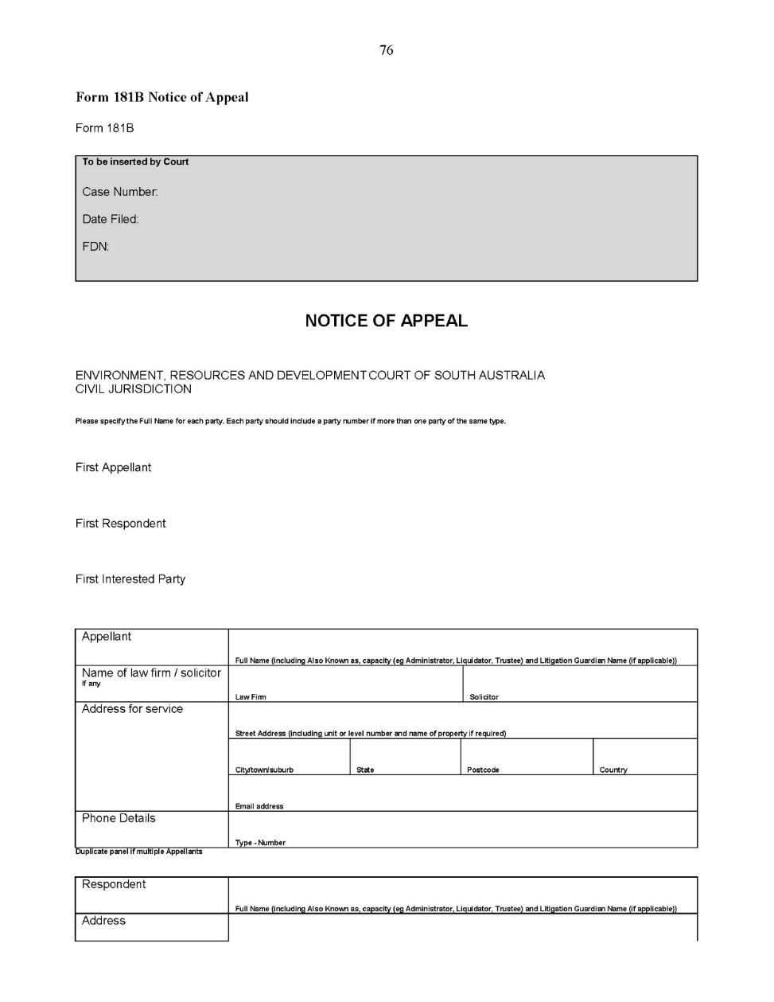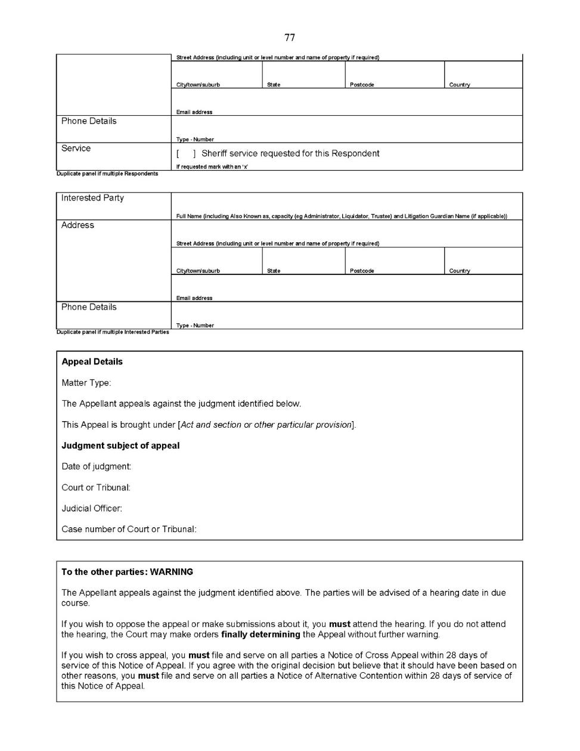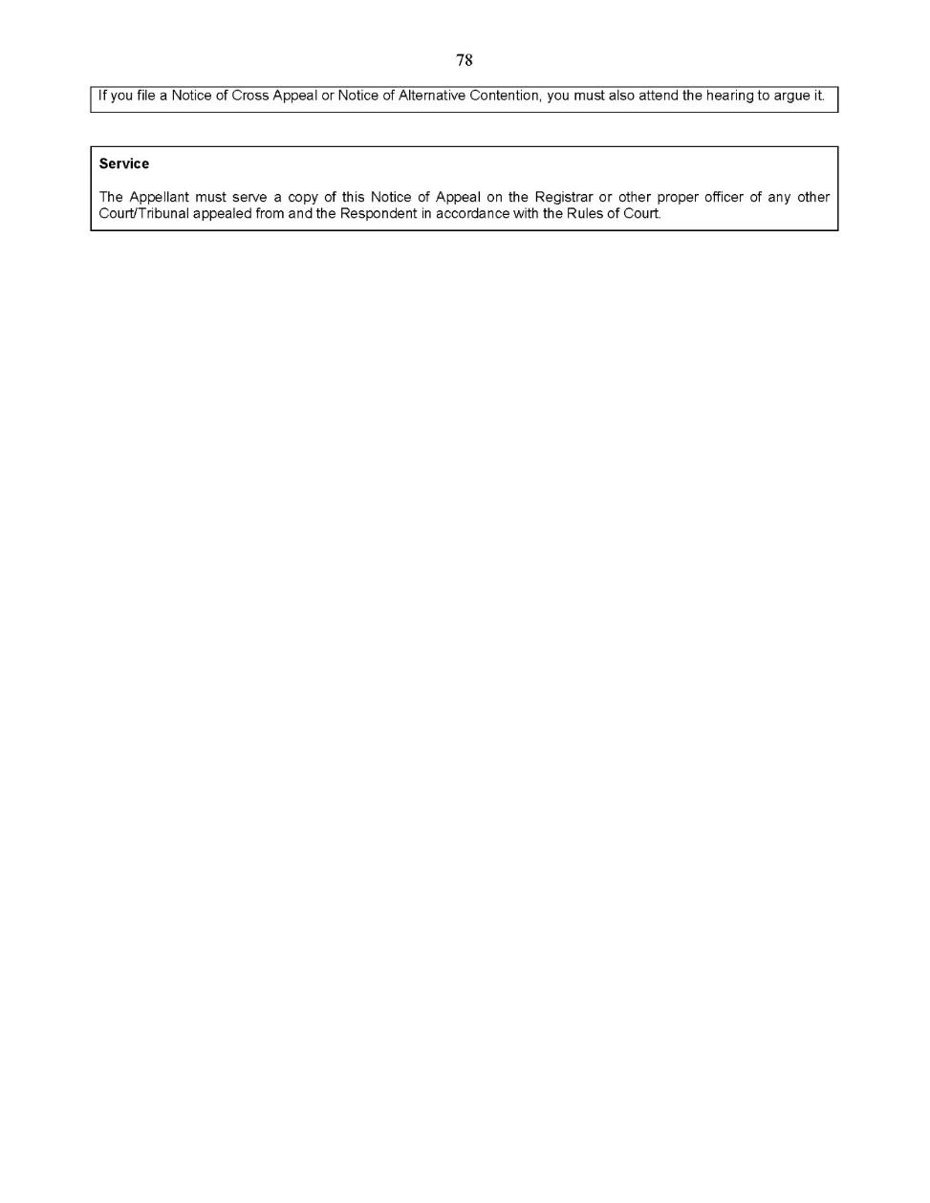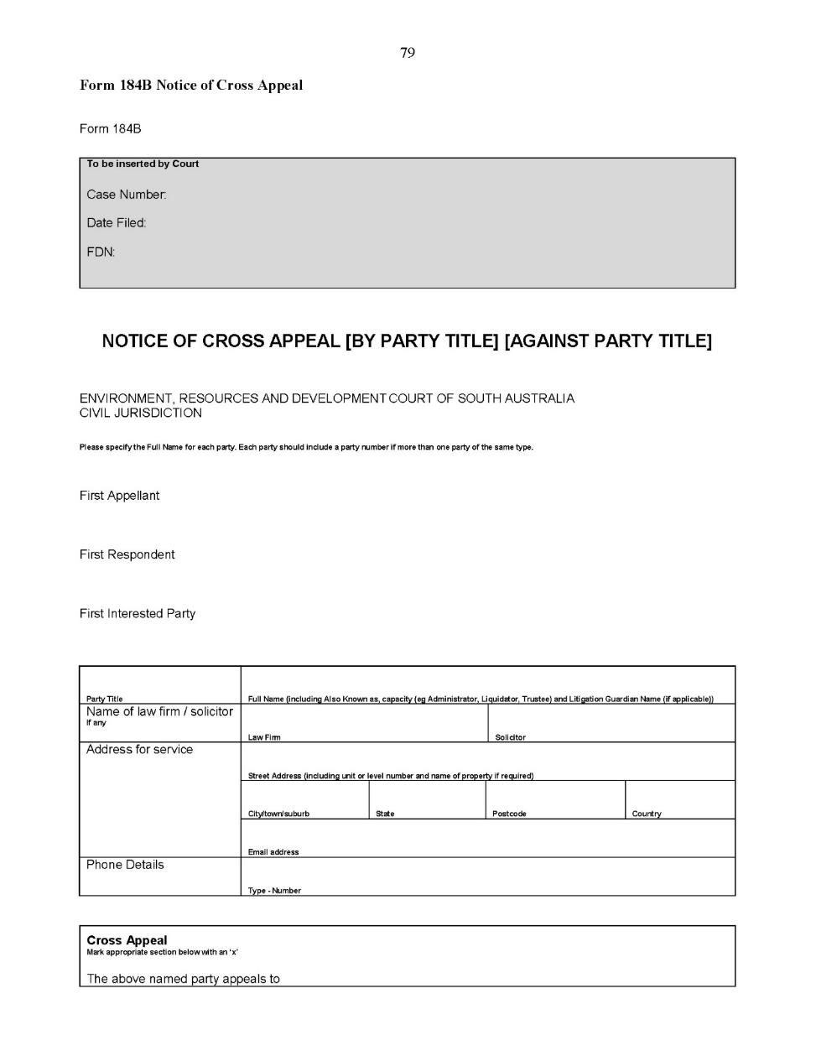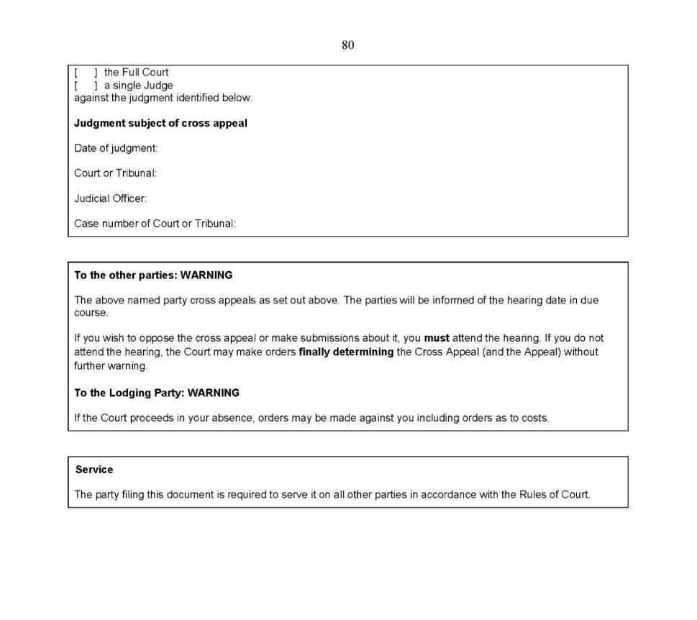

Dated: 8 May 2020
Evans SJ
Durrant J

Land and Valuation Division Rules 2014
South Australia

Amendment No 2
By virtue and in pursuance of Section 62H of the Supreme Court Act 1935 and all other enabling powers, we, the Judges of the Land and Valuation Court being a division of the Supreme Court of South Australia, make the following Land and Valuation Division Rules 2014 (Amendment No 2).
- These Rules may be cited as the Land and Valuation Division Rules 2014 (Amendment No 2).
- The Land and Valuation Division Rules 2014 are amended as set out below.
- The Land and Valuation Division Supplementary Rules 2014 are repealed.
- These rules come into effect—
(a) subject to subrule (b), on the date of their publication in the Gazette;
(b) if these rules are published in the Gazette on a day other than a Monday, these rules come into effect on the date that is the first Monday following that publication.
- In these Rules, the commencement date means the date on which these rules come into effect under rule 3.
- Unless the Court otherwise orders—
- the Land and Valuation Division Rules 2014 as amended by these Rules (the current Rules) apply to—
(i) a proceeding commenced; and
(ii) a step in a proceeding taken,
on or after the commencement date; and
- the Land and Valuation Division Rules 2014 before they were amended, and the Land and Valuation Division Supplementary Rules 2014 before they were repealed, by these Rules (the former Rules) continue to govern a step in a proceeding taken before the commencement date.
- If the time to commence or take a step in a proceeding under the former Rules has not expired as at the commencement date, the time to commence or take a step in the proceeding continues to be governed by the former Rules (unless the current Rules provide for a longer time).
- In respect of a proceeding instituted before the commencement date—
(a) a party who was a plaintiff is now an applicant;
(b) a party who was a defendant is now a respondent; and
(c) a party who was an intervenor is now an interested party.
- Unless the Court otherwise orders, a proceeding instituted before the commencement date—
(a) is to be regarded as a claim if it was progressing on the basis of pleadings;
(b) is to be regarded as an originating application if it was progressing on the basis of affidavits and not pleadings;
(c) subject to paragraphs (a) and (b)—is to be regarded as either a claim or an originating application according to the current Rules as if it had been instituted after the commencement date.
- Rule 4(1) is amended by substituting the words “Uniform Civil Rules 2020” for the words “Supreme Court Civil Rules 2006”.
- The definition of “General Civil Rules” in rule 4(2) is deleted.
- A new definition is inserted after the definition of “lodgment action” and before the definition of “valuation action” as follows:
“Uniform Civil Rules means the Uniform Civil Rules 2020.”
- Subrules 5(2) and (3) are amended by substituting the word “Uniform” for the word “General”.
- Subrule 5(4) is deleted.
- In Chapter 2, the whole of Part 1 – Public Access to Hearings is deleted.
- Rules 8 and 9 are deleted.
- In Chapter 2, the whole of Part 3 – Enforcement of procedural obligations is deleted.
- In Chapter 2, the whole of Part 4, Division 1 – General is deleted.
- Subrule 10(2) is amended by substituting the word “application” for the word “proceeding”.
- Subrule 10(4) is amended by adding the words “or final hearing” after the words “The trial”.
- In Chapter 2, the whole of Part 5 – Representation is deleted.
- In Chapter 3, the whole of Part 1 – Nature of action is deleted.
- The title of Chapter 3, Part 2 is deleted and replaced with “Pre-action steps”.
- In Chapter 3, the whole of Part 2, Division 1 – Investigation and Division 2 – Offers of settlement before action is deleted.
- Rule 11 is deleted and the following rule substituted:
“11—Pre-action steps
(1) Subject to subrule (2), rule 61.7 of the Uniform Civil Rules does not apply to a proceeding in the Court.
(2) Rule 61.7 of the Uniform Civil Rules applies to a boundary action (whether or not based on a monetary claim) other than an action excluded from the application of rule 61.7 of the Uniform Civil Rules by subrule 61.8(1) of the Uniform Civil Rules.”
- Rule 12 is deleted and the following rule substituted:
“12—General
  - Subject to subrule (2), this Subdivision applies to acquisition and boundary actions in the Court.
  - An appeal against an administrative decision of the Surveyor-General approving a plan under section 51(8) of the Survey Act 1992 is governed by Subdivision 3 instead of this Subdivision.
  - Subject to subrule (4), an action governed by this Subdivision must be instituted as a claim by a Claim in the prescribed form set out in Schedule 7 to the Uniform Civil Rules supported by a statement of claim in the prescribed form.
Prescribed forms—
Form 1 Claim
Form 1S Statement of Claim uploaded with Claim
Filing instructions—
If a Claim is filed physically at Registry, a Form 1 incorporating a statement of claim is to be used.
If a Claim is filed using the Electronic System, a Form 1S is to be uploaded with the Claim.
  - An action governed by this Subdivision may, if a proceeding has been started in the Court in relation to the acquisition or boundary the subject of the action, be made—
(a) if the new action is by the Applicant in the proceeding—by amending the existing Claim and statement of claim to introduce the new action; or
(b) if the new action is by any other party in the proceeding—by cross claim by filing a Cross Claim and statement of cross claim in the prescribed form set out in Schedule 7 to the Uniform Civil Rules.
Prescribed forms—
Form 61 Cross Claim
Form 61S Statement of Cross Claim uploaded with Cross Claim
Filing instructions—
If a Cross Claim is filed physically at Registry, a Form 61 is to be used.
If a Cross Claim is filed using the Electronic System, a Form 61S is to be uploaded.”
- Rule 13 is amended by substituting the words “statement of claim” for the word “summons”.
- In subrule 13(f), the word “principal” is deleted.
- Rule 14 is amended by substituting the words “statement of claim” for the word “summons”.
- In subrule 14(f), the word “principal” is deleted.
- Rule 15 is deleted.
- In Chapter 3, Part 3, Division 1, Subdivision 2, a new rule 15 is inserted as follows:
“15—General
(1) This Subdivision applies to lodgment actions in the Court.
(2) An action governed by this Subdivision must be instituted as an originating application.”
- Rule 16 is deleted and the following rule substituted:
“16—Payment in proceeding
(1) A lodgment action involving a payment of monies into court under section 23A(3) of the Land Acquisition Act 1969 must be instituted by an Originating Application in the prescribed form set out in Schedule 7 to the Uniform Civil Rules identifying—
(a) the nature of the proceeding as being a payment of monies into court under section 23A(3) of the Land Acquisition Act 1969;
(b) the land in respect of which the monies are paid into court; and
(c) the amount of monies paid into court.
Prescribed form—
Form 6 Originating Application – Interpleader
(2) A copy of the notice of acquisition published in the Gazette under section 16 of the Land Acquisition Act 1969 must accompany or be filed at the same time as the Originating Application.
(3) The Originating Application is not required to be accompanied by an affidavit.
(4) The applicant must join as an interested party the person whose interest in the land is the subject of the payment into court.
(5) If agreement about compensation is reached by the negotiating parties in respect of the land before payment out, the agreement or the documents evidencing the agreement are to be exhibited to an affidavit filed in the proceeding.
(6) An application for payment out of the monies paid into court under section 26 of the Land Acquisition Act 1969 must be made by interlocutory application in the prescribed form set out in Schedule 7 to the Uniform Civil Rules supported by an affidavit in the prescribed form deposing to and exhibiting such consents as may be required and a search copy of the Certificate of Title immediately before the acquisition.”
Prescribed forms—
Form 77 Interlocutory Application
Form 12 Affidavit”
- Rule 17 is deleted and the following rule substituted:
“17—Compensation agreement proceeding
(1) A lodgment action involving an agreement for compensation under section 23B(1) of the Land Acquisition Act 1969 must be instituted by an Originating Application in the prescribed form set out in Schedule 7 to the Uniform Civil Rules identifying—
(a) the nature of the proceeding as being the lodgment of an agreement for compensation under section 23B(1) of the Land Acquisition Act 1969; and
(b) the land in respect of which the compensation agreement was made.
Prescribed form—
Form 6 Originating Application – Interpleader
(2) A copy of the agreement or the documents evidencing the agreement for compensation must accompany or be filed at the same time as the Originating Application.
(3) The Originating Application is not required to be accompanied by an affidavit.
(4) The applicant must join as an interested party the other party to the compensation agreement.
(5) An application for orders to give effect to the agreement under section 23B(2) of the Land Acquisition Act 1969 must be made by interlocutory application in the prescribed form set out in Schedule 7 to the Uniform Civil Rules supported by an affidavit in the prescribed form.”
Prescribed forms—
Form 77 Interlocutory Application
Form 12 Affidavit
- Subrule 18(1) is deleted and the following subrule substituted:
“18—Valuation appeal
(1) A valuation appeal or appeal under section 51(8) of the Survey Act 1992 must be instituted by a notice of appeal in the prescribed form set out in Schedule 7 to the Uniform Civil Rules.
Prescribed form—
Form 5 Originating Application – Appeal Against Administrative Decision”
- In Chapter 3, the whole of Part 4 – Service of Originating Process (including rule 19) is deleted.
- In Chapter 4, the whole of Part 1, Division 1 – Approved forms (including rule 20) is deleted.
- In Chapter 4, the heading ‘Division 2 – Filing of Documents in Court’ is deleted.
- Rule 21 is deleted and the following rule substituted:
“21. Form of documents for filing in Court
All documents filed in the Court must contain as part of the action heading, immediately below the references to “Supreme Court of South Australia” and “civil jurisdiction”, the words “Land and Valuation List”.”
- In Chapter 4, the whole of Part 2 – Service is deleted.
- Rules 22 and 23 are deleted.
- Subrule 25(2) is amended by substituting the word “applicant” for the word “plaintiff”.
- Subrule 25(3) is amended by substituting the words “a party” for the words “the plaintiff or defendant”.
- Subrule 25(6) is amended by substituting the word “applicant” for the word “plaintiff” and by substituting the word “Claim” for the word “summons”.
- Subrule 26(3) is amended by substituting the words “originating process” for the words “summons and statement of claim”.
- Rule 27 is deleted.
- Rule 28 is deleted and the following rule substituted:
“28. Valuation appeal
(1) This rule applies to a valuation appeal or appeal under section 51(8) of the Survey Act 1992.
(2) The notice of appeal must identify the administrative decision the subject of the appeal.
(3) The notice of appeal must identify the grounds on which it is contended that the administrative decision the subject of the appeal is erroneous.
(4) The appellant must file with the notice of appeal a statement of facts issues and contentions in the prescribed form set out in Schedule 7 to the Uniform Civil Rules.
Prescribed form—
Form 11 Statement of Facts Issues and Contentions Standalone
(5) The statement of facts issues and contentions must set out briefly—
(a) the decision and the subject matter of the decision;
(b) the essential facts, if any, relied on that were not accepted by the decision maker;
(c) the essential issues raised on the appeal;
(d) the appellant’s contention on each issue;
(e) what is contended to be the proper value of the land or thing the subject of the valuation when applicable; and
(f) the grounds for any application for an extension of time.
(6) The statement of facts issues and contentions must be accompanied by an affidavit exhibiting a copy of—
(a) the decision and any reasons given by the decision maker;
(b) any formal submission by the appellant to the decision maker the subject of the decision; and
(c) an expert report by a valuer addressing the valuation of the land or thing the subject of the decision when applicable.”

- Rule 29 is deleted and the following rule substituted:
“29. Response
(1) This rule applies to a valuation appeal or appeal under section 51(8) of the Survey Act 1992.
(2) Within 28 calendar days of service of the notice of appeal, the respondent must file and serve a response to the statement of facts issues and contentions in the prescribed form set out in Schedule 7 to the Uniform Civil Rules.
Prescribed form—
Form 57 Response to Statement of Facts Issues and Contentions
(3) The response to statement of facts issues and contentions must set out briefly—
(a) a response to any contested essential facts on which the appellant relies;
(b) the essential issues raised by the appellant on the appeal and any additional essential issues raised by the respondent on the appeal;
(c) the respondent’s contention on each issue identified by the appellant and respondent;
(d) if an extension of time in which to appeal is sought, the ground of opposition if any.
(4) The response to the statement of facts issues and contention must be accompanied by an affidavit exhibiting a copy of any expert report by a valuer addressing the value of the land or thing obtained by the respondent.”
- In Chapter 6, the whole of Part 1- Duty of parties, Part 2 – Assignment of special classification to action and Part 3 – Court’s powers to manage and control litigation are deleted.
- Subrule 30(4) is deleted and the following subrule substituted:
“(4) If an action will not be ready for trial at the fixed trial date or trial listing date, as the case may be, a party becoming aware of that fact must, as soon as practicable, file and serve an interlocutory application in the prescribed form set out in Schedule 7 to the Uniform Civil Rules seeking appropriate orders from the Court.”
Prescribed form—
Form 77 Interlocutory Application
- In Chapter 7, the whole of Part 1 Initial Steps (including rule 31) is deleted.
- A new rule 31 is inserted immediately below “Part 2 – Interlocutory steps generally” as follows:
“31—Directions hearing
(1) Directions hearings will generally be presided over by a Judge of the Court.
(2) The purpose of directions hearings is to—
(a) ascertain whether the matter can be resolved by settlement;
(b) crystallise the issues in dispute; and
(c) ensure that the matter proceeds as expeditiously and efficiently as possible to trial.”
- In Chapter 7 Part 2, the whole of Division 1 – Litigation Plan (including rule 32) is deleted.
- In Chapter 7 the whole of Part 3 – Disclosure and production of documents, Part 4 Non-party disclosure, Part 5 Gathering of evidentiary material, Part 6 Pre-trial examination by written questions and Part 7 Medical Examinations are deleted.
- Rule 34 is amended by substituting the word “recipient” for the word “respondent”, wherever it occurs.
- Rule 35 is amended by substituting the word “recipient” for the word “respondent”, wherever it occurs.
- In Chapter 7, the whole of Part 9 – Notice of evidence to be introduced at trial, Part 10 – Evidence, Part 11- Offers of settlement, Part 12 – Suitors fund, Part 13 Power to stay or dismiss proceedings and Part 14 Security for costs are deleted.
- Chapters 8, 9, 10, 11, 12, 13, 14, 15, 16 and 17 are deleted in their entirety.
Dated: 5 May 2020
Blue J
Parker J

Supreme Court Criminal Rules 2014
South Australia

Amendment No 8
By virtue and in pursuance of section 72 of the Supreme Court Act 1935 and all other enabling powers, we, Judges of the Supreme Court of South Australia, make the following Supreme Court Criminal Rules 2014 (Amendment No 8).
- These Rules may be cited as the Supreme Court Criminal Rules 2014 (Amendment No 8).
- The Supreme Court Criminal Rules 2014 are amended as set out below.
- The amendments made by these rules come into effect—
(a) subject to subrule (b), on the date of their publication in the Gazette;
(b) if these rules are published in the Gazette on a day other than a Monday, these rules come into effect on the date that is the first Monday following that publication.
- In these Rules, the commencement date means the date on which these rules come into effect under rule 3.
- Unless the Court otherwise orders
(a) the Supreme Court Criminal Rules 2014 as amended by these rules apply to—
(i) an appeal to a single Judge against a judgment, order or decision, or reservation to a single Judge of a question of law, by a court in the exercise of its criminal jurisdiction commenced; and
(ii) a step in such an appeal or reservation of a question of law taken,
on or after the commencement date; and
(b) the Supreme Court Civil Rules 2006 continue to govern a step in an appeal to a single Judge against a judgment, order or decision, or reservation to a single Judge of a question of law, by a court in the exercise of its criminal jurisdiction taken before the commencement date.
- A new Chapter 12A is inserted immediately after Chapter 12 as follows:
“Chapter 12A—Appellate proceedings—single Judge
Part 1—Introduction
104A—Application of Chapter
(1) Subject to subrules (3) and (4), this Chapter applies to all appeals to a single Judge against a judgment, order or decision of a court, and all reservations to a single Judge of a question of law, by a court in the exercise of its criminal jurisdiction.
(2) In particular, these Rules and this Chapter apply to—
(a) appeals under section 42(2)(b) of the Magistrates Court Act 1991 against a judgment, order or decision by a Magistrate in the criminal division of the Magistrates Court;
(b) appeals under section 22(2)(a)(i) or (b)(iii) of the Youth Court Act 1993 against a judgment, sentence or decision by a Magistrate of the Youth Court, or an interlocutory judgment by a Judge of the Youth Court, exercising criminal jurisdiction under the Young Offenders Act 1993;
(c) reservation of a question of law arising in a criminal action under section 43 of the Magistrates Court Act 1991;
(d) reservation of a question of law arising in a criminal proceeding under section 23 of the Youth Court Act 1993; and
(e) any other appeal to a single Judge or reservation of law to a single Judge by a court exercising criminal jurisdiction.
(3) Subject to a statute conferring jurisdiction on a single Judge in absolute terms, a Judge may order that the appellate jurisdiction of the Supreme Court that would otherwise be exercised by a single Judge be exercised by the Full Court.
(4) This Chapter does not apply to bail reviews governed by Chapter 12.
104B—Definitions
In this Chapter, unless the contrary intention appears—
appeal means an appeal against a judgment, order or decision of a court in a proceeding and, unless the context indicates otherwise, includes—
(a) a cross appeal;
(b) an application for leave to appeal (or cross appeal); or
(c) an application for an extension of time to appeal (or cross appeal);
appellant means—
(a) in an appeal—the person appealing against a judgment, order or decision and, unless the context indicates otherwise, includes that person in the capacity of a respondent to a cross appeal; or
(b) in a case stated—the person who files the notice of case stated or otherwise has the carriage of the case stated;
appellate document means—
(a) a notice of appeal;
(b) a notice of cross appeal;
(c) a notice of alternative contention; or
(d) a notice of case stated.
appellate hearing means a hearing of an appeal or an issue relevant to whether a party is or may be entitled to final relief in an appeal;
appellate proceeding means—
(a) an appeal (including cross appeal; or
(b) a case stated;
case stated means a case stated or question reserved for the consideration of a single Judge;
cross appeal means a cross appeal referred to in rule 104J.
104C—Name of party—Police
In an appeal, the South Australian Police, whether as appellant or respondent, is to be referred to as “Police” and not as “South Australian Police” or “SA Police”.
Example—
“Jones v Police” or “Police v Jones”
Part 2—Permission to appeal
Division 1—General
104D—When required
(1) Permission to appeal is required if a statute so requires.
(2) If permission to appeal is granted but it later becomes evident that it ought not to have been granted, the Court may revoke the grant of permission.
Division 2—Seeking permission
104E—Notice of appeal seeking permission to appeal
(1) When permission to appeal is required, the appeal must be instituted in the ordinary way and the notice of appeal must seek the necessary permission.
(2) If a notice of appeal seeking permission to appeal is filed under this Part—
(a) the institution of the appeal is conditional on leave to appeal being granted; and
(b) if leave to appeal is refused, the appeal lapses.
Division 3—Determination of question of permission
104F—Determination timing
(1) A Judge may order that the question of permission to appeal be heard before the hearing of the appeal.
(2) Unless an order is made under subrule (1), an application for permission to appeal and the appeal will be heard at the same time.
Part 3—Institution of appellate proceeding
Division 1—Time to appeal
104G—Time to appeal
(1) Subject to any statute or rule to the contrary, an appeal must be instituted within 21 days after the date of the judgment, order or decision the subject of the appeal.
(2) If an extension of time to appeal is required, the appeal must be instituted in the ordinary way in accordance with rule 104H and the notice of appeal must seek the necessary extension of time.
(3) A Judge may order that the question of an extension of time to appeal be heard before the hearing of the appeal.
(4) Unless an order is made under subrule (3), an application for an extension of time to appeal and the appeal will be heard at the same time.
Division 2—Appeals
104H—Institution
(1) An appeal must be instituted by filing a notice of appeal in an approved form setting out—
(a) the forum of the appellate Court;
(b) the statutory provision under which the appeal is brought;
(c) details of the judgment, order or decision the subject of the appeal;
(d) the grounds of appeal;
(e) the orders sought on appeal;
(f) if permission to appeal is sought—the grounds on which it is sought; and
(g) if an extension of time is sought—the grounds on which it is sought.
(2) The appellant must join as a respondent in the appeal any other party to the first instance proceeding unless that party has no interest in the appeal.
(3) The Court may order the inclusion or removal of a person as a party to an appeal.
(4) The appellant must serve the notice of appeal on the other parties to the appeal as soon as practicable.
(5) The appellant must serve a copy of the notice of appeal on the Registrar or other proper officer of the court of first instance as soon as practicable.
(6) Unless the Court otherwise orders, an appellant may not rely on grounds that are not stated in the notice of appeal.

104I—Documents and information from court of first instance
(1) The Registrar may, and when directed by the Court must, request the court of first instance to transmit to the Court by physical or electronic means (as specified) documents relevant to the appeal.
(2) Unless the Registrar otherwise specifies, documents relevant to the appeal the subject of a request comprise—
(a) all documents lodged with the court;
(b) any transcript of evidence or hearing;
(c) any other evidentiary material; and
(d) the judgment, order or decision subject of the appeal and any reasons given for it.
(3) The Registrar or proper officer of the court of first instance must comply with the request as soon as practicable.
104J—Institution of cross appeal
(1) Another party to an appeal may institute an appeal against the same judgment, order or decision by filing a notice of cross appeal in an approved form within 14 days after service of the notice of appeal on that party.
(2) Subrules (3) to (5) of rule 104H apply, with any necessary changes, in respect of a cross appeal.
(3) If permission to appeal is required, rule 104F applies, with any necessary changes, in respect of a cross appeal.
(4) If an extension of time to appeal is required, rule 104G applies, with any necessary changes, in respect of a cross appeal.
104K—Notice of alternative contention
(1) If another party to the appeal wishes to contend that a decision subject to appeal or cross appeal should be upheld for reasons other than those given by the court of first instance, that party must file a notice of alternative contention in an approved form setting out the grounds on which the party asserts that the decision should be upheld within 14 days after service of the notice of appeal, or notice of cross appeal, on that party.
(2) Subrules (4) and (5) of rule 104H apply, with any necessary changes, in respect of a notice of alternative contention.
(3) If an extension of time to file the notice of alternative contention is required, rule 104G applies, with any necessary changes, in respect of a notice of alternative contention.
Division 3—Case stated
104L—Case stated by court
(1) A court which reserves a question of law for the consideration of a Judge must—
(a) prepare a document containing a statement of the background and relevant facts on the basis of which the question of law is to be determined and a statement of the question to be determined;
(b) designate a party to the proceeding who is to be regarded as the appellant on the case stated before the Supreme Court and have the carriage of it; and
(c) designate who are to be the respondents to the appellate proceeding.
(2) The Court may request that court to forward to the Registrar the whole or part of the file for the proceeding including any transcript of hearings and evidence in the custody of that court.
104M—Institution of case stated
(1) The party designated as the appellant under rule 104L must file in the Court a notice of case stated in an approved form.
(2) Subrules (3) and (4) of rule 104H apply, with any necessary changes, in respect of a case stated.
Part 4—Preparation for and listing of appellate proceeding
Division 1—Introduction
104N—Definition
In this Part—
listed hearing date means the earlier of the listed hearing date referred to in rule 104P(1) and any varied hearing date referred to in rule 104P(3).
Division 2—Transcript
104O—Transcript
(1) This rule applies to appeals where a transcript of evidence was not produced for the proceeding in the court of first instance.
(2) The appellant must file and serve with the notice of appeal a document identifying whether the appellant requests that a transcript of the evidence of any witness be produced and if so identifying what passages of evidence are requested to be produced.
(3) Each other party to the appeal must, within 7 days after service of the notice of appeal on the party, file and serve a document identifying whether they request that a transcript of the evidence of any witness be produced and if so identifying what passages of evidence are requested to be produced.
(4) Unless a Judge otherwise orders, the Court will request the court of first instance to produce transcript in accordance with any requests made under subrules (2) and (3).
Division 3—Listing for hearing
104P—Listing for hearing
(1) An appellate proceeding will be listed for hearing before a Judge on a fixed date in a given month.
(2) The Court will give notice of the listed hearing date to the parties.
(3) If a party seeks a change from the listed hearing date, the party must, within 7 days after the listed hearing date is notified, contact the Judge’s chambers and make a request with details of alternative hearing dates.
Division 4—Appeal book
104Q—Filing and service of appeal book
(1) The appellant must prepare an appeal book in accordance with rule 104R.
(2) The appellant must file a physical copy of the appeal book 7 days before the listed hearing date.
104R—Content of appeal book
(1) An appeal book for an appeal must contain—
(a) a copy of the information or other document that originated the proceeding in the court of first instance;
(b) a copy of the judgment or order the subject of the appeal;
(c) a copy of reasons for judgment or sentencing remarks given in respect of that judgment or order; and
(d) a copy of the notice of appeal, any notice of cross appeal and any notice of alternative contention.
(2) An appeal book is not required for a case stated.
(3) An appeal book must contain a filing which shows the court, jurisdiction, case number, parties, name of the document and details of the law firm representing the party filing the document, or if self-represented, the party.
Division 5—Written submissions, chronologies and lists of authorities
104S—Filing and service
(1) Each party who intends to make submissions on the hearing of the appellate proceeding must prepare written submissions in accordance with rule 104T and a list of authorities in accordance with rule 104U, and may prepare a chronology.
(2) Unless the Court otherwise orders, the appellant must file and serve on the other parties to the appellate proceeding written submissions, a list of authorities and any chronology not less than 7 days before the listed hearing date.
(3) Unless the Court otherwise orders, each other party must file and serve on the other parties to the appellate proceeding written submissions, a list of authorities and any chronology not less than 3 days before the listed hearing date.
(4) The appellant may file and serve on the other parties to the appellate proceeding written submissions in reply not less than 1 day before the listed hearing date.
104T—Content of written submissions
(1) Written submissions must show the anticipated hearing date and name of the Judge listed to hear the matter.
(2) Written submissions must—
(a) in respect of each ground of appeal or issue—set out succinctly each proposition advanced by the party together with supporting references to the reasons for judgment, evidence, legislation or authorities;
(b) to the extent that a party challenges a factual finding—identify the finding that was or was not made, why it is erroneous, the finding that should have been made and the evidence relied on in support of the challenge;
(c) to the extent that a party challenges a statement of law—identify the statement of law, why it is erroneous, the correct statement of law and any authorities relied on in support of the challenge; and
(d) to the extent that a party challenges the reasoning of the judicial officer at first instance—identify the reasoning, why it is erroneous and the correct reasoning.
(3) Written submissions must provide citations to cases in the manner required by rule 104U for a list of authorities.
(4) Written submissions should not, other than in exceptional circumstances, set out passages from the reasons for judgment, evidence, legislation or authorities but should merely identify them.
(5) Written submissions must not, without the leave of the Registrar or the Court, exceed 20 pages for submissions in chief, or 10 pages for submissions in reply.
(6) The Registrar may, on application filed by a party, vary the page limit for written submissions.
104U—Content of list of authorities
(1) A list of authorities must be divided into 2 parts, being authorities expected to be read and authorities not expected to be read.
(2) A list of authorities must show the anticipated hearing date and name of the Judge listed to hear the matter.
(3) A citation to a case must—
(a) if the case is reported in an authorised series of reports—include a citation to the highest ranking available series of authorised reports in which the case is published;
(b) if the case is reported in a published (but not authorised) series of reports—include a citation to an available series of reports in which the case is published; and
(c) if the case postdates 1997 and is published online on austlii or its equivalent elsewhere—include a medium neutral citation to the case.
Part 5—Hearing and determination of appellate proceedings
104V—Hearing of appeals
(1) Subject to any statute to the contrary—
(a) an appeal is to be by way of rehearing;
(b) the Court may draw inferences from evidence adduced in the proceeding at first instance; and
(c) the Court may hear further evidence in its discretion.
(2) The Court may, if it considers that it is in the interests of justice to do so, determine an appeal on the merits notwithstanding a failure of a party to raise or state properly a ground of appeal or alternative contention in a notice of appeal, notice of cross appeal or a notice of alternative contention.
104W—Determination of appeals
(1) Subject to any statute to the contrary, the Court may—
(a) set aside or amend the judgment or order the subject of the appeal;
(b) substitute the Court’s own judgment or order;
(c) remit the matter for rehearing or reconsideration;
(d) dismiss the appeal;
(e) make orders for the costs of the appeal or costs at first instance; or
(f) make such other further orders for the disposition of the appeal as it thinks fit.
(2) When the Court determines an appeal (including refusing leave to appeal), the Registrar must—
(a) give to the Registrar or proper officer of the court of first instance written notice of the Court's decision together with any written reasons given by the Court; and
(b) return any documents or materials transmitted to the Court by the Registrar or proper officer of the court of first instance (other than documents and materials forwarded in electronic form) in connection with the proceeding.
104X—Costs of appeals
(1) Costs in an appeal governed by this Chapter are in the discretion of the Court.
(2) The general rule is that costs follow the event and in the ordinary case costs fixed at $500 plus the appeal filing fee will be awarded in favour of a successful appellant and costs fixed at $500 will be awarded in favour of a successful respondent.
(3) The general rule that costs follow the event is subject to the discretion of the Court.
Examples—
1. When the appellant succeeds on part of, or an issue on, appeal but fails on another.
2. When a party is guilty of misconduct in relation to the original proceeding or the appeal.
3. When one party adopts an unreasonable position on appeal.
(4) If either party intends to apply for costs in an amount other than that reflected in subrule (2), that party must make an application at the outset of the hearing of the appeal; in which event, the Court may fix a different amount for the purpose of paragraph (2) that will generally apply regardless of which party is successful on the appeal or may make any other order that the Court thinks fit.
Examples—
1. An application might be based on the complexity of the appeal requiring especially extensive preparation for the hearing of the appeal.
2. An application might be based on the appeal being listed for an especially lengthy hearing.
3. An application might be based on the reasonable retention of senior counsel to argue the appeal.
(5) The Court may, if it thinks fit, dispense with the requirement in subrule (4) that an application for costs in an amount other than that reflected in subrule (2) must be made at the outset of the hearing of the appeal.”
- The Chapter 13 heading is amended by inserting the words “—Full Court” at the end of the heading as follows:
Chapter 13—Appellate proceedings—Full Court
- Rule 105 is deleted and the following rule substituted:
“105—Application of Chapter
(1) Subject to subrule (3), this Chapter applies to all appeals to or jurisdiction exercised by the Full Court of the Supreme Court in the exercise of its criminal jurisdiction.
(2) In particular, these Rules and this Chapter apply to—
(a) appeals against a judgment, sentence or decision by a Judge of the Supreme Court or District Court exercising criminal jurisdiction;
(b) appeals under section 22(2)(d) of the Youth Court Act 1993 against a judgment, sentence or decision by a Judge of the Youth Court exercising criminal jurisdiction under the Young Offenders Act 1993 other than an interlocutory judgment;
(c) appeals under section 42(2)(ab) of the Magistrates Court Act 1991 or section 22(2)(ba) of the Youth Court Act 1993 against a sentence for a major indictable offence by a Magistrate exercising criminal jurisdiction under section 9(ab) of the Magistrates Court Act 1991 or section 14(2a) of the Youth Court Act 1993;
(d) reservations of questions of law under section 350 of the Consolidation Act;
(e) reservations of questions of law in a criminal proceeding to the Full Court under section 31 of the Environment, Resources and Development Court Act 1993, section 70 of the South Australian Employment Tribunal Act 2014 or any other legislative provision;
(f) references of the whole case or a point on a petition for mercy under section 369 of the Consolidation Act; and
(g) appeals or reservations of questions of law referred by a single Judge to the Full Court under rule 104A(3).”
- In rule 106, the definition of “sentence” is deleted and substituted as follows:
“sentence means—
(a) a sentence within the meaning of, or any other order made under, the Sentencing Act;
(b) a decision whether to make an order for payment of a pecuniary sum within the meaning of the Sentencing Act or for restitution or compensation under Part 6 of the Sentencing Act;
(c) a decision whether to make a recidivist young offender declaration under section 55 of the Sentencing Act or a declaration under section 51(2) or 54(2) of the Sentencing Act;
(d) a decision whether to make a child sex offender registration order under section 9 of the Child Sex Offenders Registration Act 2006;
(e) a decision whether to make an extended supervision order or a continuing detention order under the High Risk Offenders Act; and
(f) a decision whether to make any other order against a person convicted or found guilty of an offence other than a sentencing decision.”
- Rule 119(1) is amended by substituting the words “Unless a Statute otherwise requires, all applications” for the words “All applications”.
Dated: 5 May 2020
Kourakis CJ
Blue J
Doyle J

Supreme Court Criminal Supplementary Rules 2014
South Australia

Amendment No 7
By virtue and in pursuance of section 72 of the Supreme Court Act 1935 and all other enabling powers, we, Judges of the Supreme Court of South Australia, make the following Supreme Court Criminal Supplementary Rules 2014 (Amendment No 7).
- These Rules may be cited as the Supreme Court Criminal Supplementary Rules 2014 (Amendment No 7).
- The Supreme Court Criminal Supplementary Rules 2014 are amended as set out below.
- The amendments made by these rules come into effect—
(a) subject to subrule (b), on the date of their publication in the Gazette;
(b) if these rules are published in the Gazette on a day other than a Monday, these rules come into effect on the date that is the first Monday following that publication.
- In these Rules, the commencement date means the date on which these rules come into effect under rule 3.
- Unless the Court otherwise orders
(a) the Supreme Court Criminal Supplementary Rules 2014 as amended by these rules apply to—
(i) an appeal to a single Judge against a judgment, order or decision, or reservation to a single Judge of a question of law, by a court in the exercise of its criminal jurisdiction commenced; and
(ii) a step in an appeal to a single Judge against a judgment, order or decision, or reservation to a single Judge of a question of law, by a court in the exercise of its criminal jurisdiction taken,
on or after the commencement date; and
(b) the Supreme Court Civil Rules 2006 continue to govern a step in an appeal to a single Judge against a judgment, order or decision, or reservation to a single Judge of a question of law, by a court in the exercise of its criminal jurisdiction taken before the commencement date.
- Rule 49A is deleted.
- A new Chapter 12A is inserted immediately after Chapter 12 as follows:
“Chapter 12A—Appellate proceedings—single Judge
Part 1—Introduction
[no supplementary rules]
Part 2—Permission to appeal
[no supplementary rules]
Part 3—Institution of appeal
Division 1—Time to appeal
[no supplementary rules]
Division 2—Appeals
104H—Institution
A notice of appeal under rule 104H of the Rules is to be in form 37A.
104J—Institution of cross appeal
A notice of cross appeal under rule 104J of the Rules is to be in form 37B.
104K—Notice of alternative contention
A notice of alternative contention under rule 104K of the Rules is to be in form 37C.
104M— Institution of case stated
A notice of case stated to single Judge under rule 104M of the Rules is to be in form 37D.
Part 4—Preparation for and listing of appeal
[no supplementary rules]
Part 5—Hearing and determination of appeals
[no supplementary rules]”
- New forms 37A, 37B, 37C and 37D are inserted in the Schedule to the Supplementary Rules as follows:

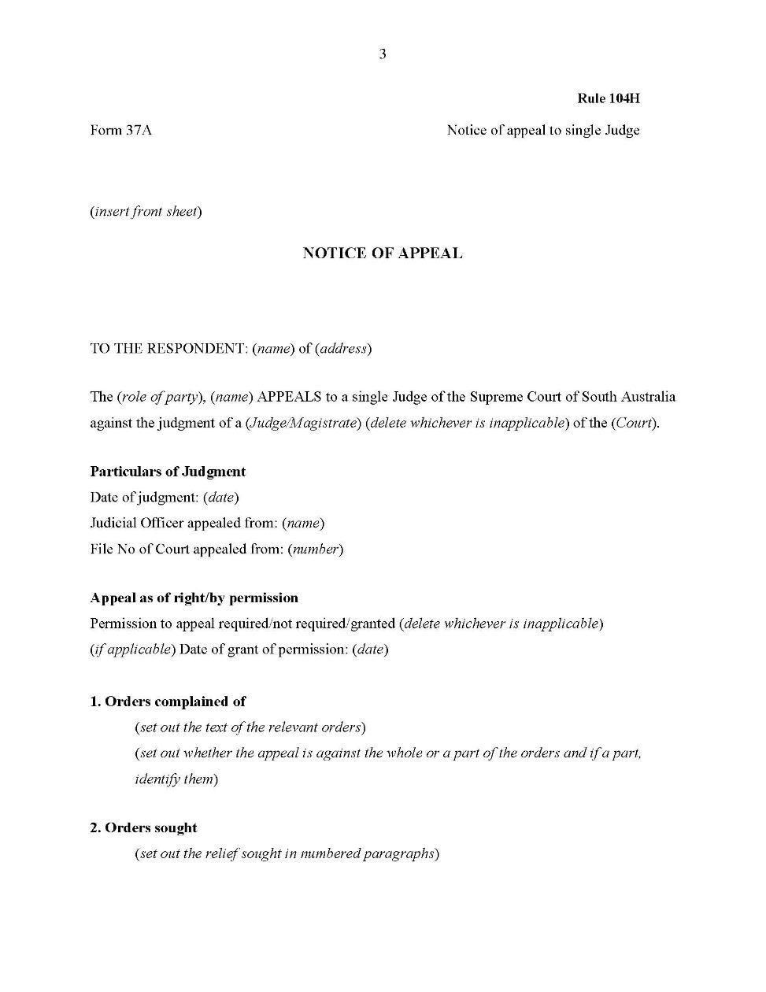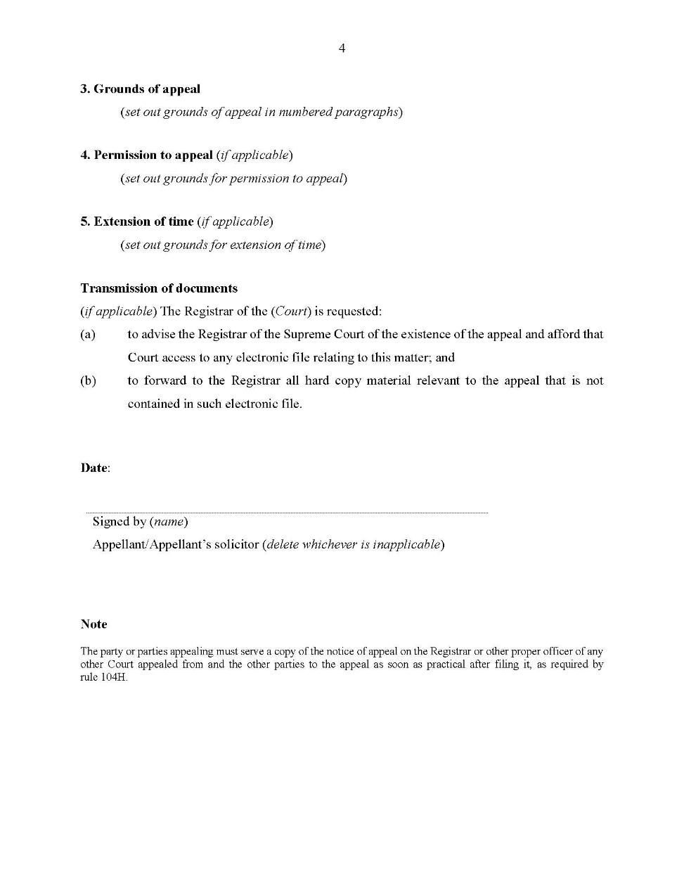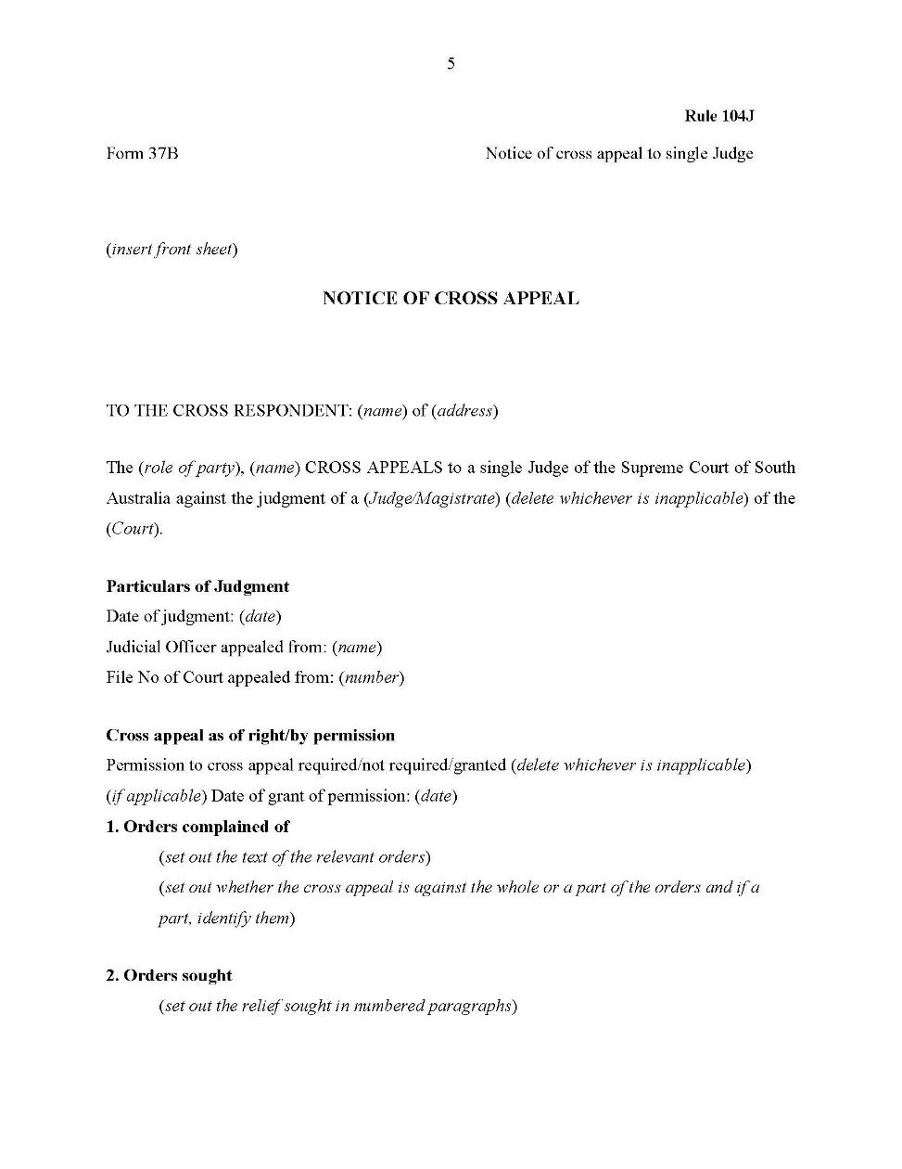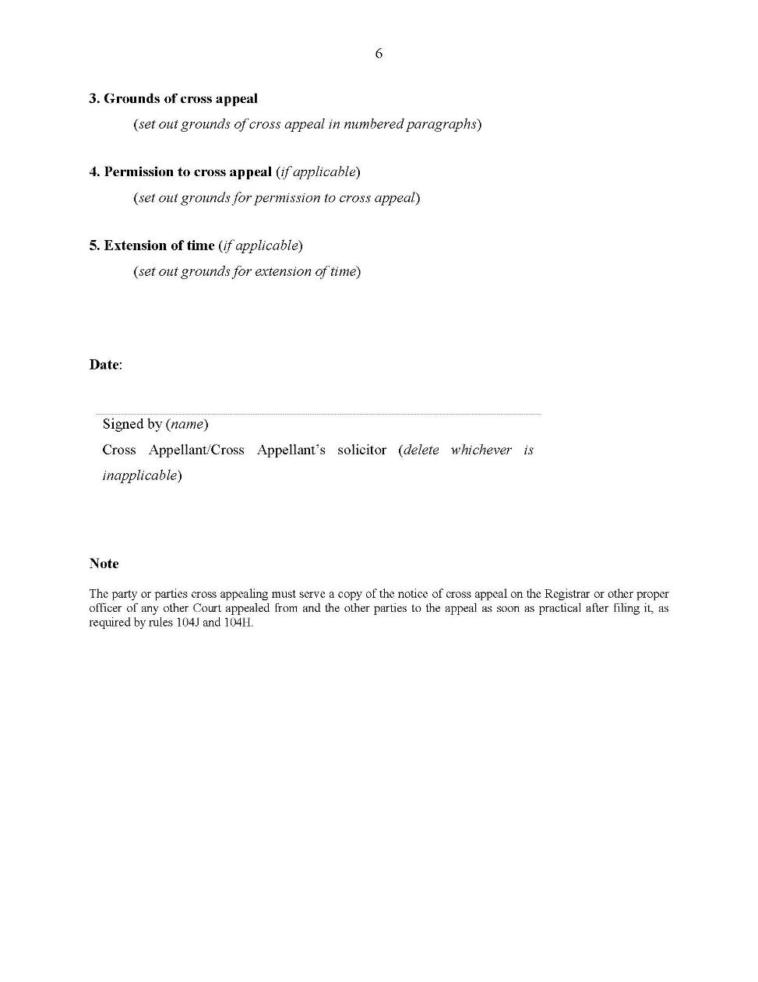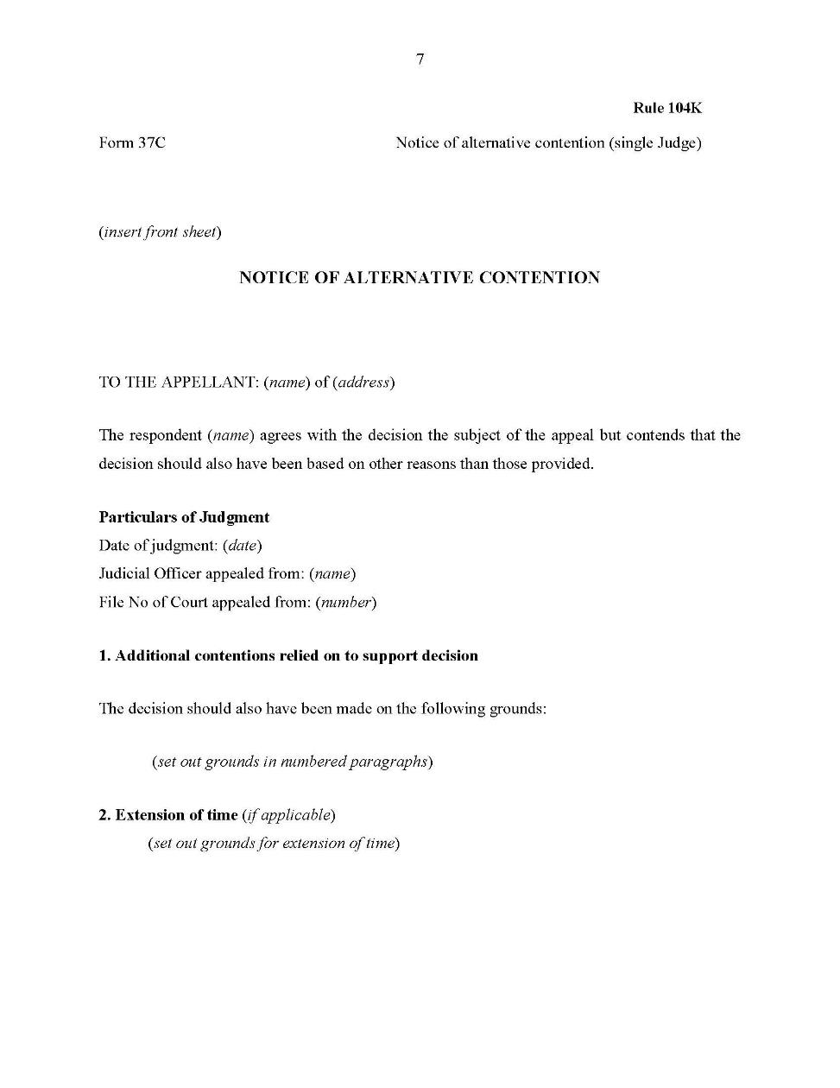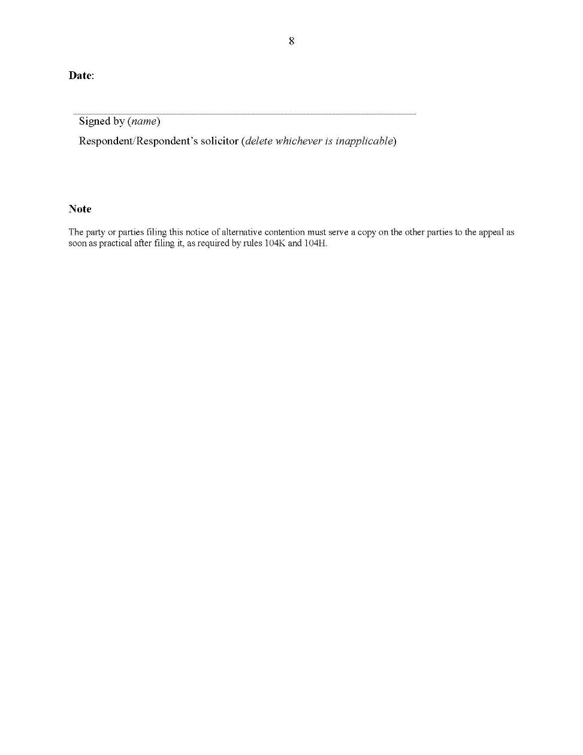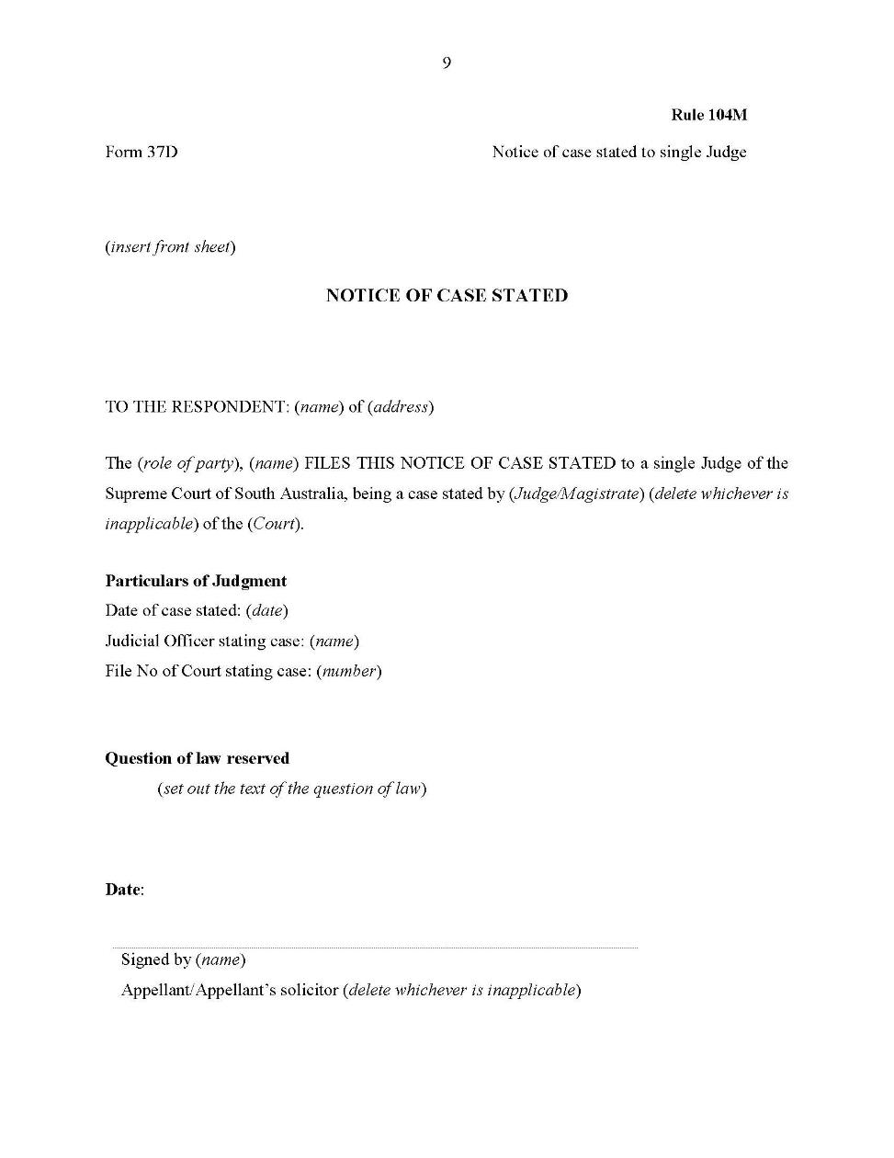
Dated: 9 April 2020
Kourakis CJ
Blue J
Doyle J

SUPREME COURT SPECIAL APPLICATIONS RULES 2014
South Australia

Amendment No 3
By virtue and in pursuance of section 72 of the Supreme Court Act 1935 and all other enabling powers, we, Judges of the Supreme Court of South Australia, make the following Supreme Court Special Applications Rules 2014 (Amendment No 3).
- These Rules may be cited as the Supreme Court Special Applications Rules 2014 (Amendment No 3).
- The Supreme Court Special Applications Rules 2014 are amended as set out below.
- The Supreme Court Special Applications Supplementary Rules 2014 are repealed.
- These rules come into effect—
(a) subject to subrule (b), on the date of their publication in the Gazette;
(b) if these rules are published in the Gazette on a day other than a Monday, these rules come into effect on the date that is the first Monday following that publication.
- In the Rules, the commencement date means the date on which these rules come into effect under rule 4.
- Unless the Court otherwise orders—
(a) the Supreme Court Special Applications Rules 2014 as amended by these Rules (the current Rules) apply to—
(i) a proceeding commenced; and
(ii) a step in a proceeding taken,
on or after the commencement date; and
(b) the Supreme Court Special Applications Rules 2014 before they were amended by these Rules (the former Rules) continue to govern a step in a proceeding taken before the commencement date.
- If the time to commence or take a step in a proceeding under the former Rules has not expired as at the commencement date, the time to commence or take a step in the proceeding continues to be governed by the former Rules (unless the current Rules provide for a longer time).
- Subrule 3(1) is amended by substituting the words “Uniform Civil Rules 2020” for the words “Supreme Court Civil Rules 2006”.
- The definition of “General Civil Rules” in rule 3(2) is deleted.
- The definition of “Supplementary Rules” in rule 3(2) is deleted.
- In rule 3(2), a new definition is inserted after the definition of “surveillance warrant” and before the definition of “warrant” as follows:
“Uniform Civil Rules means the Uniform Civil Rules 2020;”
- Rule 4 is amended by inserting the word “certain” before the word “proceedings” and deleting paragraphs (e), (f) and (i).
- Rule 5 is deleted and the following rule is substituted:
“5—Application of Uniform Civil Rules
(1) Unless the Court otherwise directs and subject to subrule (2), Chapters 1 to 4 of the Uniform Civil Rules apply to proceedings in the Court under these Rules.
(2) To the extent of any inconsistency between these Rules and the Uniform Civil Rules, these Rules prevail.”
- Rule 8 is deleted.
- Rule 9 is deleted.
- Subrule 10(1) is amended by substituting the word “Chapter” for the word “Chapters”, deleting the words “or 4” and substituting “Chapter 2 Part 3 and Chapter 4 of the Uniform Civil Rules” for the words “Chapter 4 of the General Civil Rules”.
- Subrules 14(2), (2A) and (3) are deleted and the following subrules are substituted:
“(2) An application under section 17 or 22 of the Surveillance Devices Act 2016 to issue, renew or vary a surveillance device (general) warrant or confirm a surveillance device (emergency) authority and the exercise of powers thereunder is to be—
(a) in accordance with section 17(4) of the Surveillance Devices Act 2016; and
(b) in the prescribed form.
Prescribed form—
Form 7H Originating Application Ex Parte Surveillance Warrant
(3) Any other application to which this Chapter applies is to be in accordance with the relevant statutory provision.
(3A) An application under section 22 of the Australian Crime Commission Act 2002 (Cth), section 29 of the Australian Crime Commission (South Australia) Act 2004, section 31 of the Independent Commissioner Against Corruption Act 2012 or section 16 of the Serious and Organised Crime (Unexplained Wealth) Act 2009 for a search warrant is to be in the prescribed form.
Prescribed form—
Form 7G Originating Application Ex Parte Search Warrant
(3B) An application under section 14 of the Serious and Organised Crime (Unexplained Wealth) Act 2009 for a monitoring order is to be in the prescribed form.
Prescribed form—
Form 7I Originating Application Ex Parte Monitoring Order
(3C) An application under section 3 or 13 of the Terrorism (Police Powers) Act 2005 to confirm a special powers authorisation or special area declaration is to be in the prescribed form.

Prescribed form—
Form 7J Originating Application Ex Parte Special Powers Authorisation or Special Area Declaration
(3D) An application under section 17, 21 or 24 of the Witness Protection Act 1996 or section 12 or 13 of the Criminal Investigation (Covert Operations) Act 2009 to authorise a new identity or restore a former identity, relating to disclosure of information concerning a witness under a witness protection program or to authorise the making or cancellation of an entry in the Register of Births, Deaths and Marriages is to be in the prescribed form.
Prescribed form—
Form 7K Originating Application Ex Parte Protected Witness
(3E) An application under section 28 or 29A of or clause 4 or 5 of Schedule 2 to the Independent Commissioner Against Corruption Act 2012 for leave to serve a summons or notice outside the State is to be in the prescribed form.
Prescribed form—
Form 7L Originating Application Ex Parte Leave to Serve out of State”
- Subrule 17(1) is deleted and the following subrule is substituted:
“(1) An application under rule 14 or 15 is to be accompanied by an affidavit verifying—
(a) the grounds of the application;
(b) any relevant matters required by the relevant legislation or any applicable regulations to be verified by affidavit or to be established to the satisfaction of or taken into account by the Judge;
(c) in the case of a search warrant, the hours during which it is proposed the warrant can be executed;
(d) in the case of a surveillance warrant, the period for which it is proposed the warrant be in force;
(e) in the case of an email or facsimile application when permitted by the relevant legislation, the circumstances giving rise to the urgency of the application; and
(f) the period the applicant proposes that the Court retain documents associated with the application before destruction or return.”
- Subrule 17(4) is amended by substituting the words “a draft” for the words “minutes of”.
- A new subrule 18(3a) is inserted after subrule 18(3) as follows:
“(3a) A search warrant issued under this Chapter is to be in the prescribed form.
Prescribed form—
Form 138 Search Warrant”
- Subrule 18(4) is deleted and the following subrule is substituted:
“(4) A surveillance warrant issued under this Chapter is to be in the prescribed form with such variations as are appropriate when a remote application is made under section 18 of the Surveillance Devices Act 2016.
Prescribed form—
Form 139 Surveillance Warrant”
- Chapter 4 – Review of preventative detention orders is deleted in its entirety.
- Chapter 5 – Serious and organised crime applications is deleted in its entirety.
- Chapter 6 – Ancillary applications under ICAC Act is deleted in its entirety.
- Chapter 7 – Enforcement applications is deleted in its entirety.
- A new “Schedule 1 – Forms” is inserted as follows:

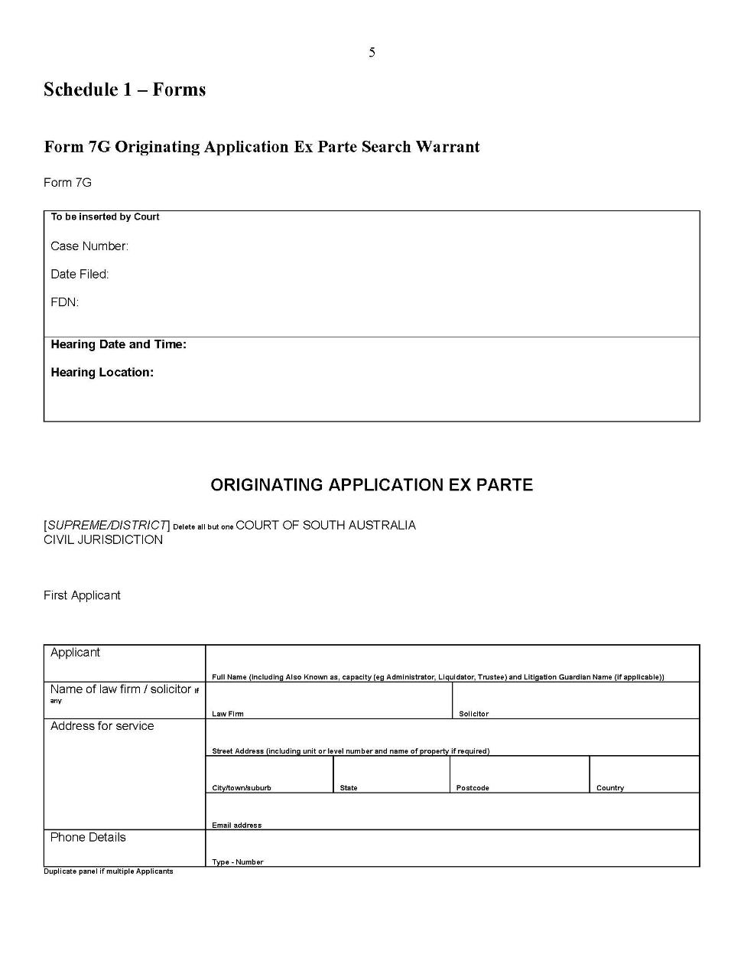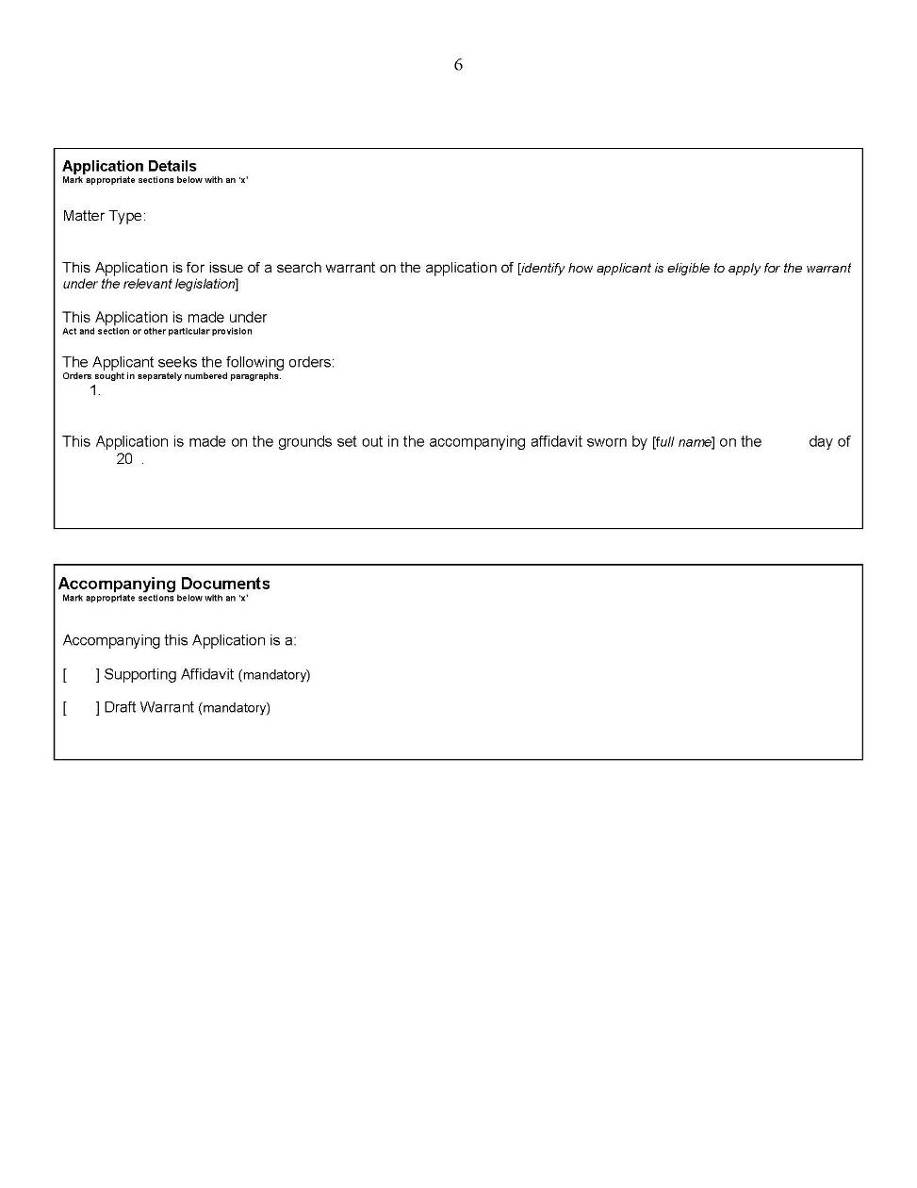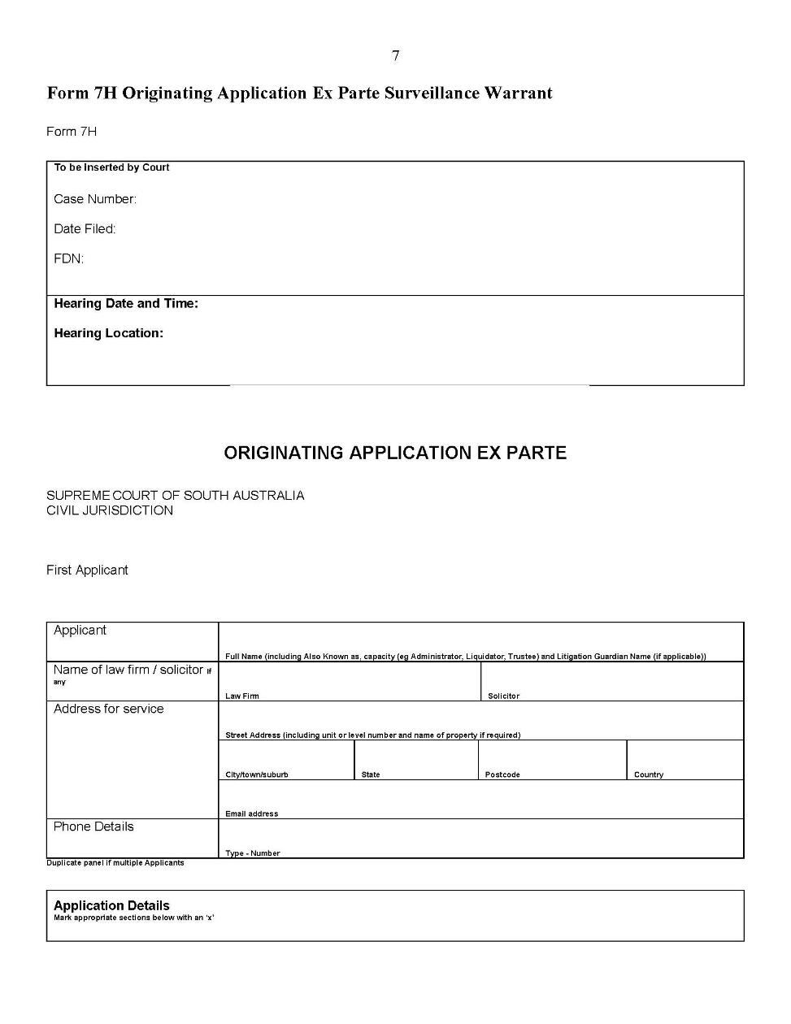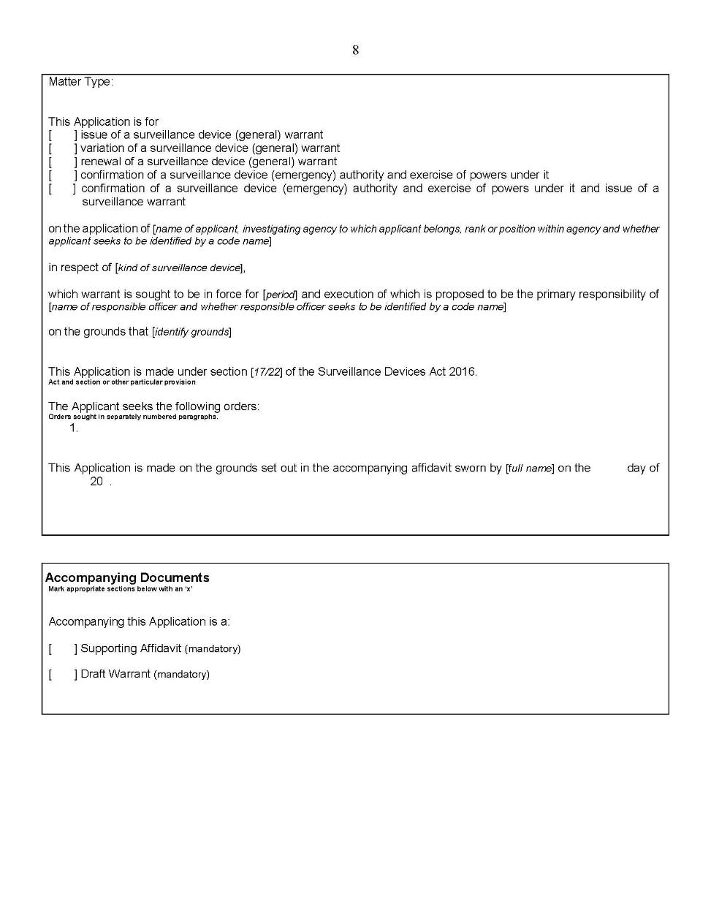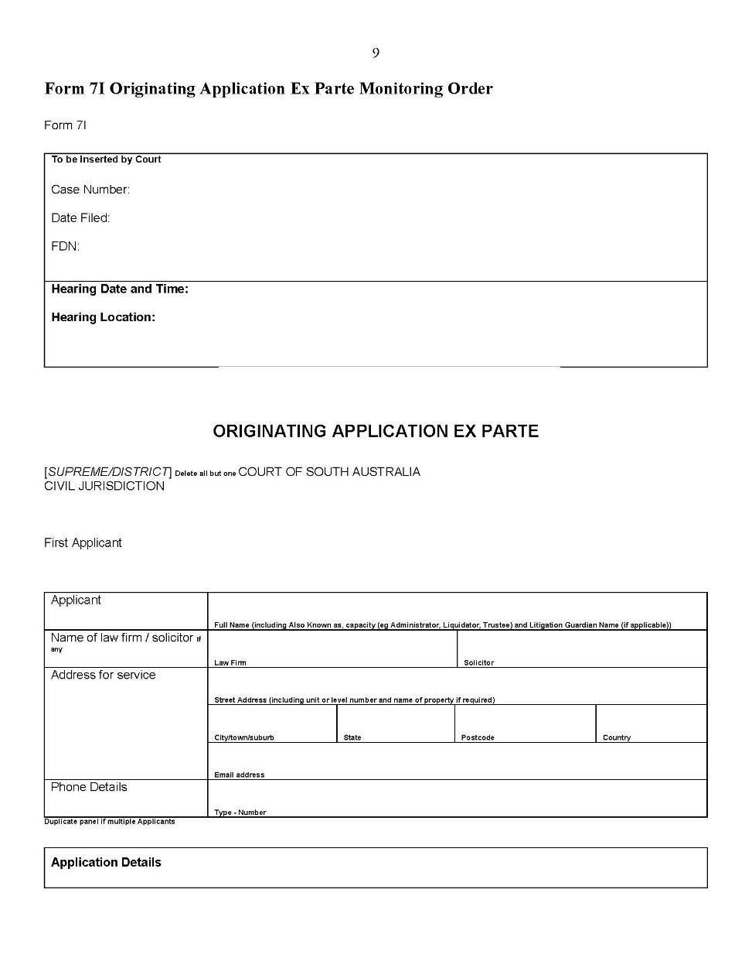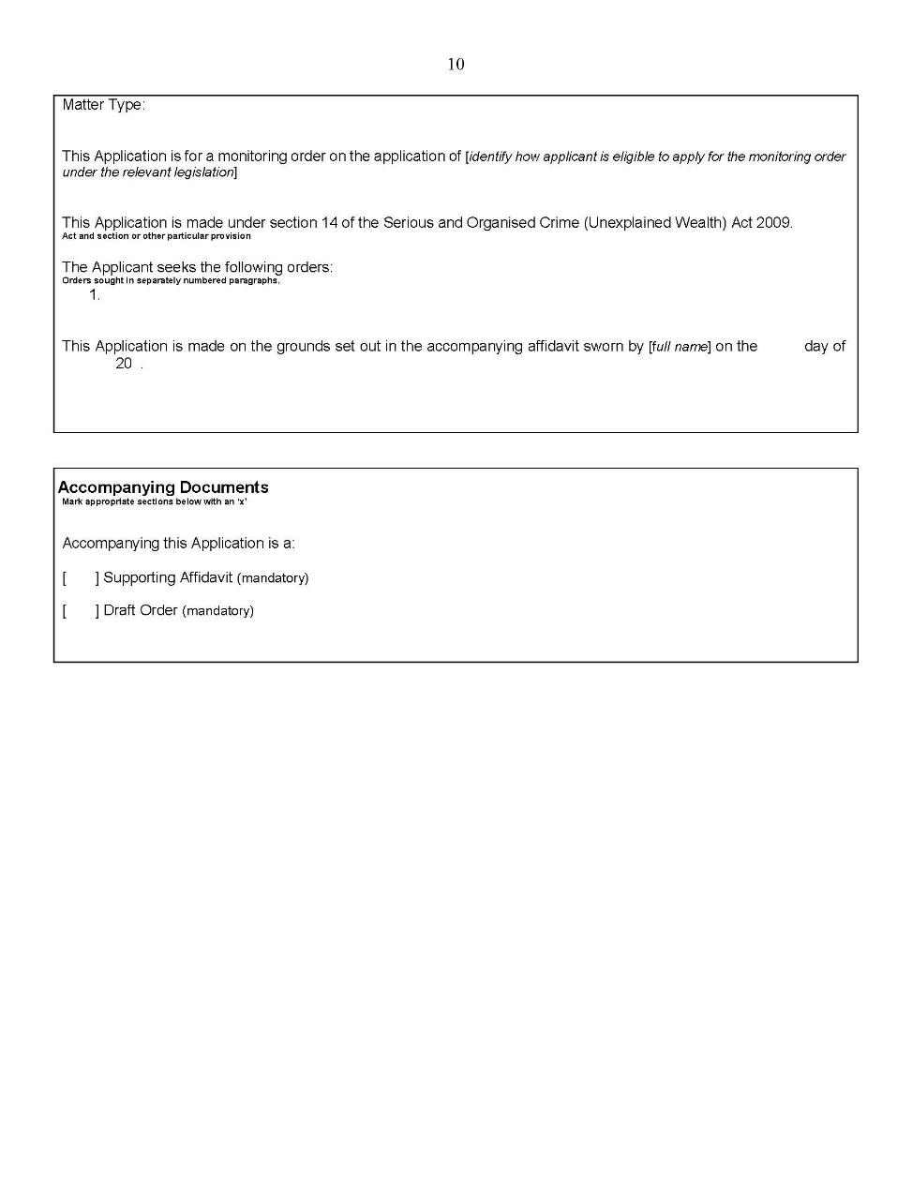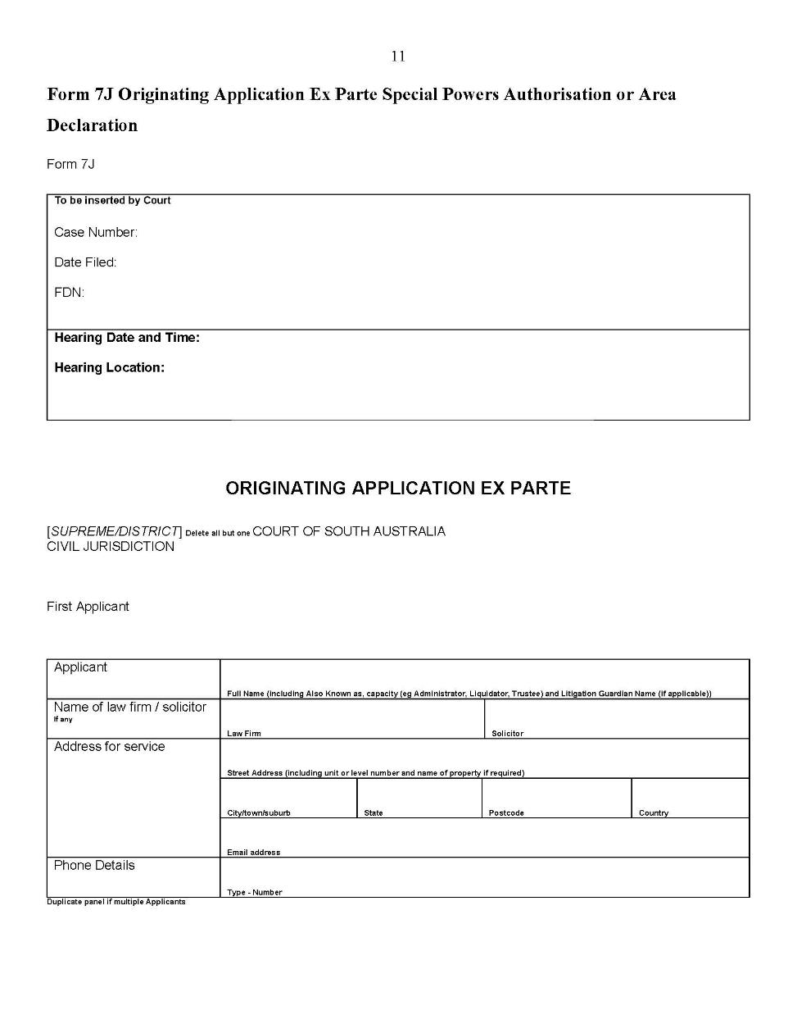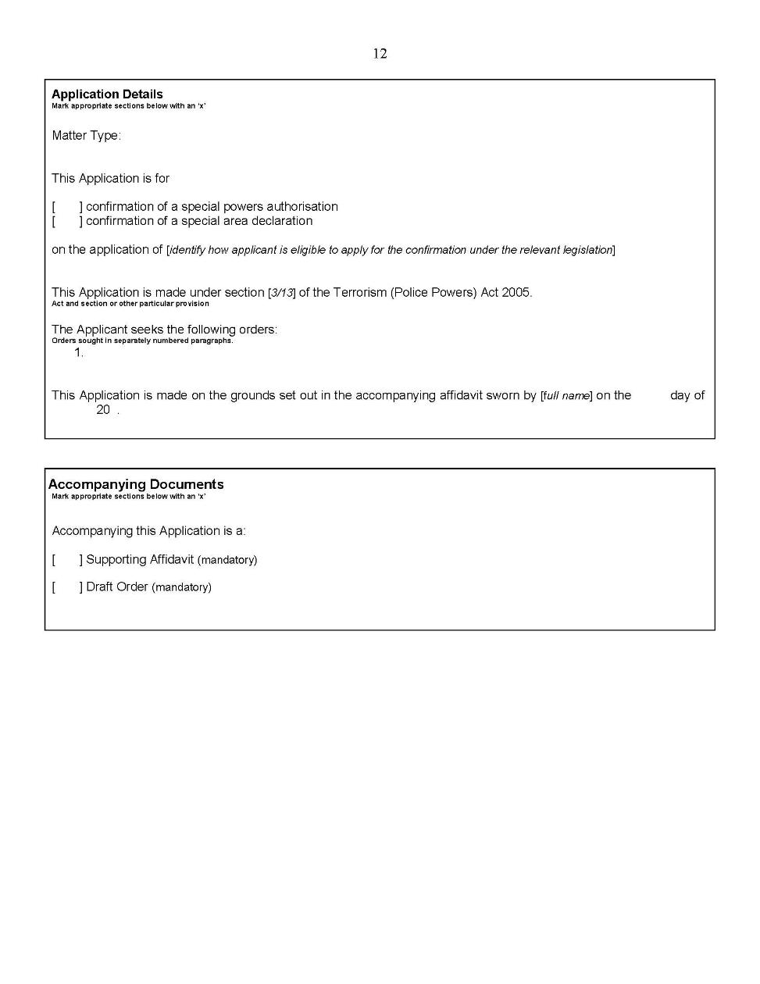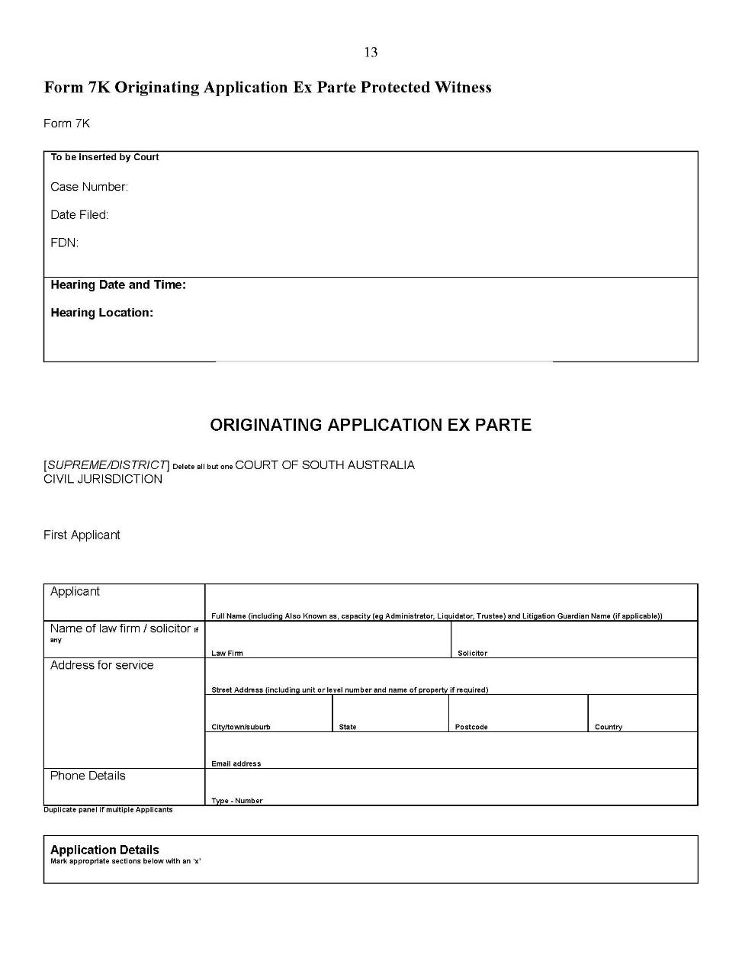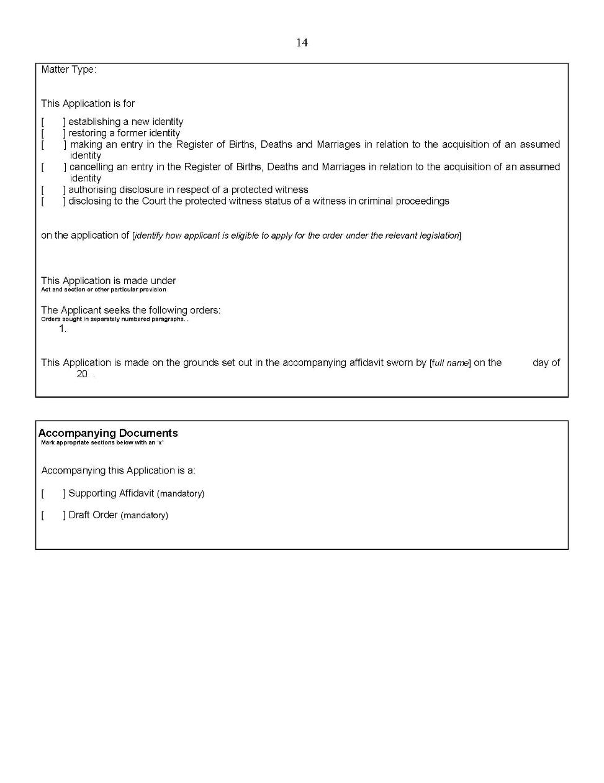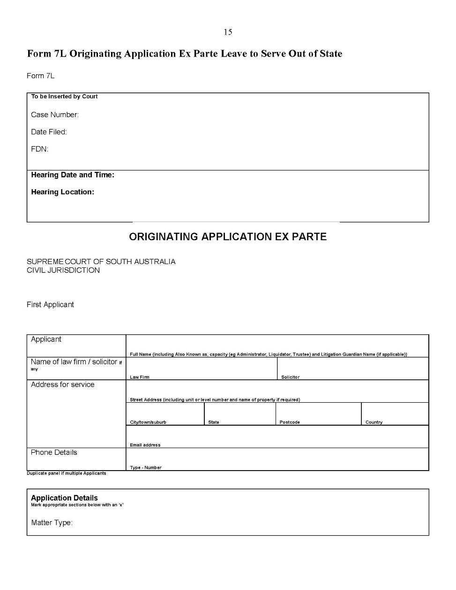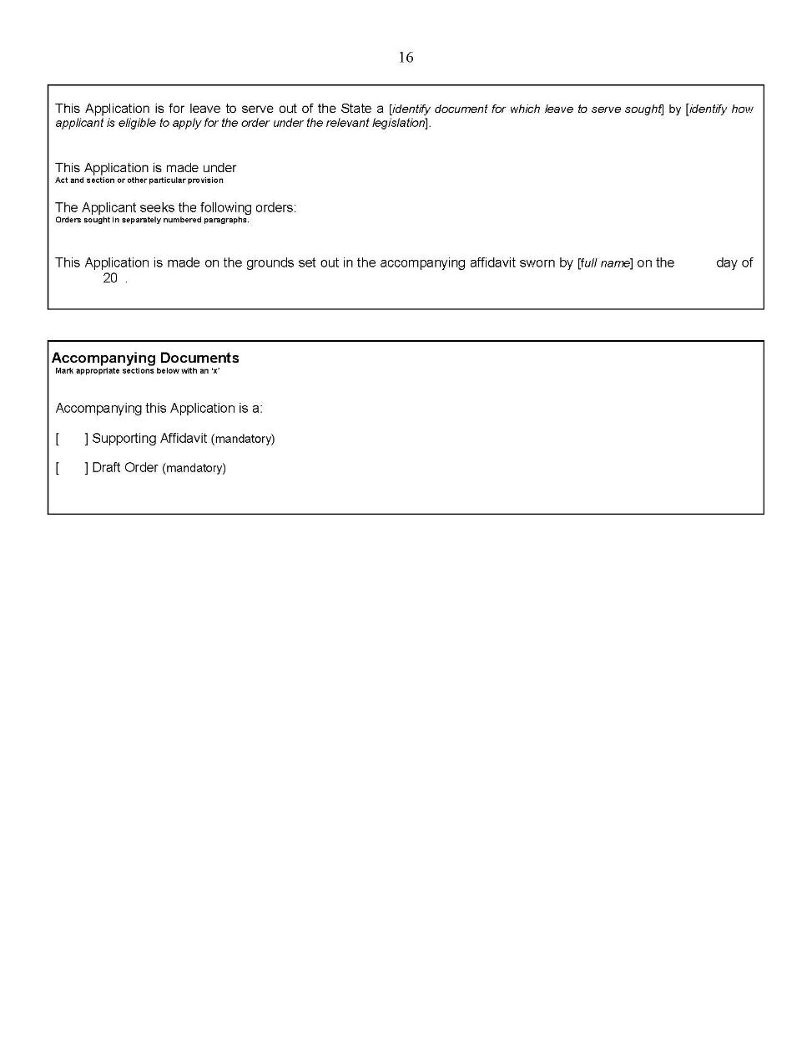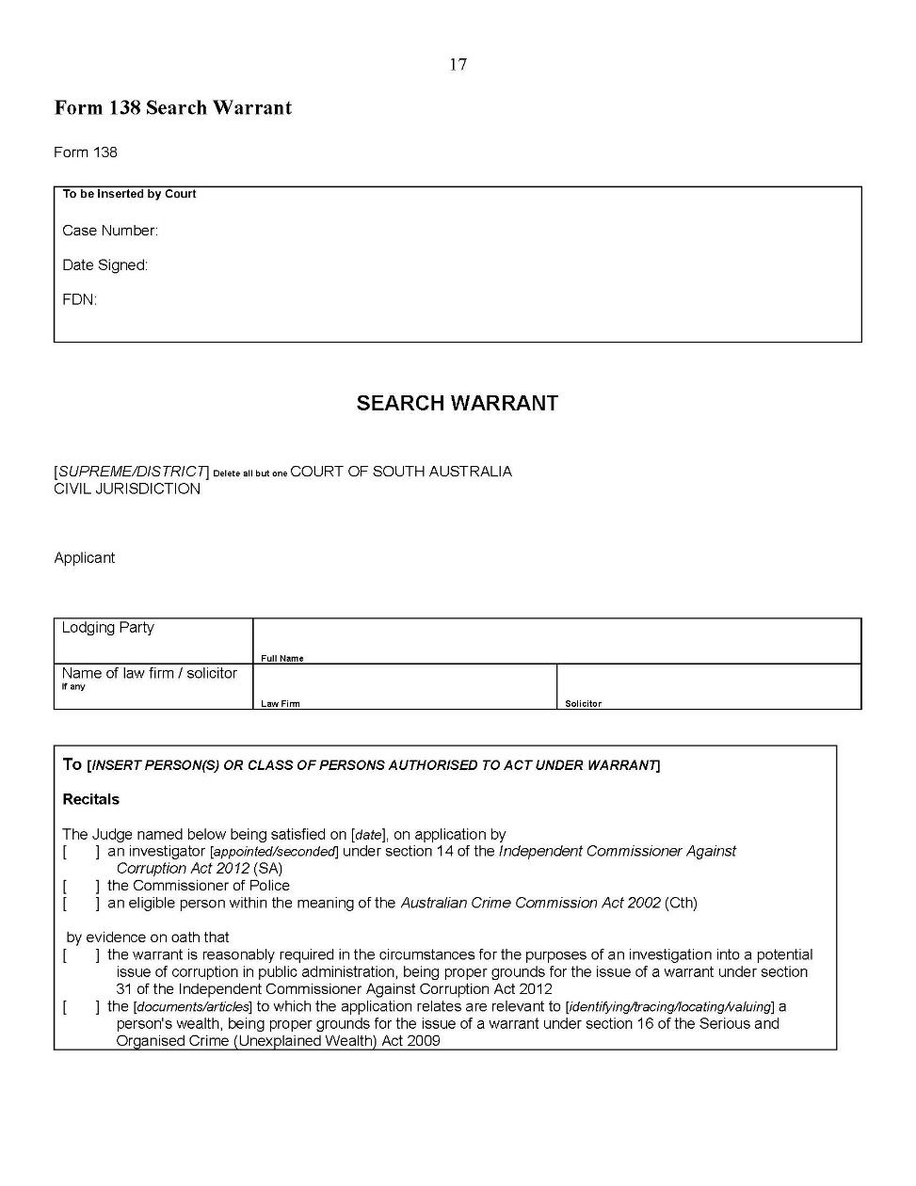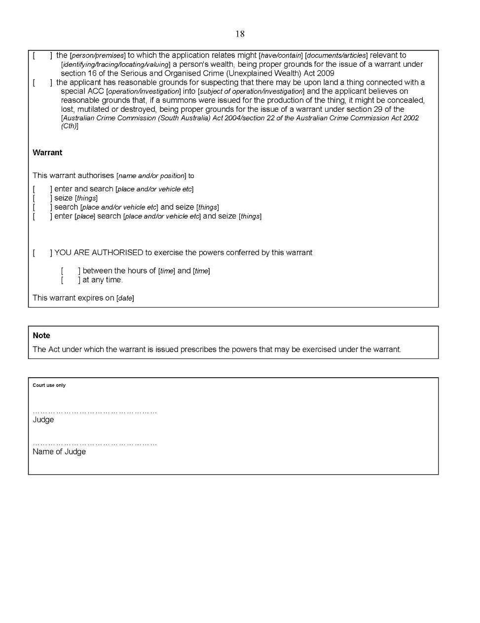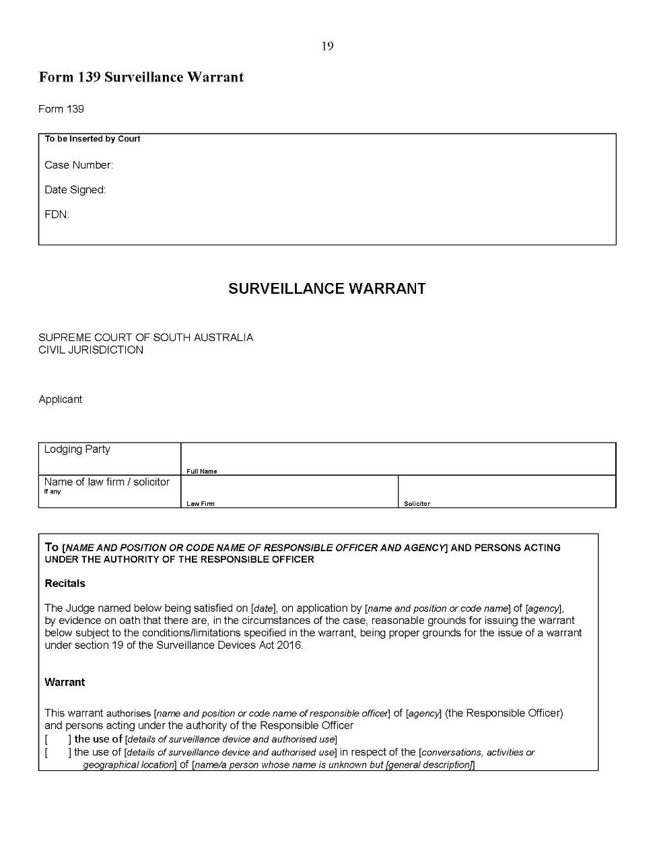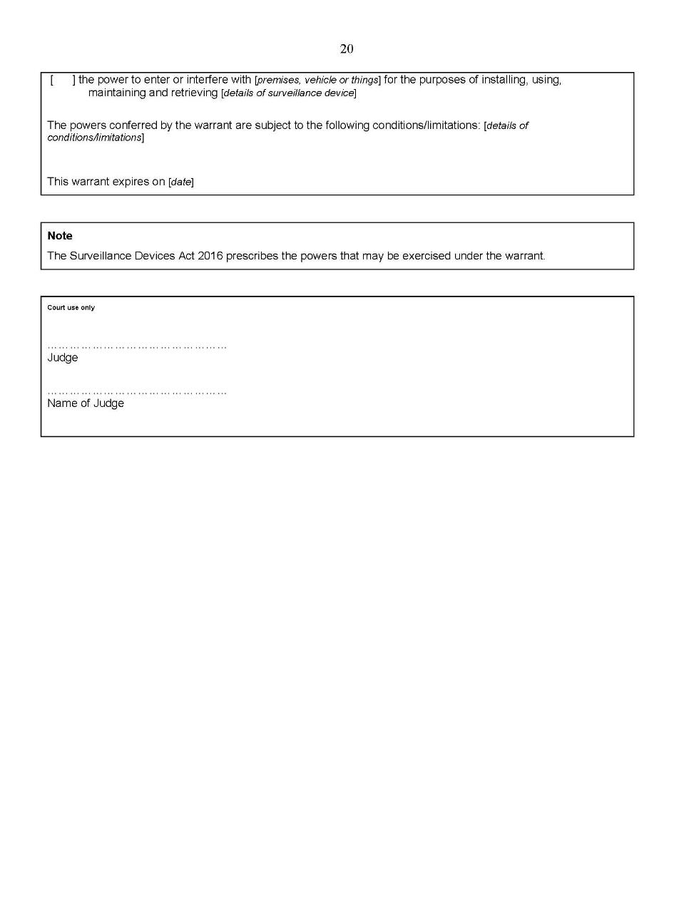
Dated: 5 May 2020
Kourakis CJ
Blue J
Doyle J

Uniform Civil Rules 2020
In accordance with the Supreme Court Act 1935, the District Court Act 1991 and the Magistrates Court Act 1991, and all other enabling powers, the Uniform Civil Rules 2020 set out in the Schedule below have been made –
- as rules of the Supreme Court by 3 or more Judges of the Supreme Court; and
- as rules of the District Court by the Chief Judge and 2 or more other Judges of that Court; and
- as rules of the Magistrates Court by the Chief Magistrate and 2 or more other Magistrates,
and such rules will apply to and in relation to the Court in accordance with their terms.
The Uniform Civil Rules 2020 are accessible on the Courts Administration Authority website:
http://www.courts.sa.gov.au/ForLawyers/Pages/Rules-Forms-and-Fees.aspx
Dated: 1 May 2020
Chief Justice Kourakis
Chief Judge Evans
Chief Magistrate Hribal

Youth Court (General) Rules 2016
South Australia

Amendment No 1
By virtue and in pursuance of section 32 of the Youth Court Act 1993 and all other enabling powers, we, the Judge of the Court and the Magistrates who are members of the principal judiciary of the Court, make the following Youth Court (General) Rules 2016 (Amendment No 1).
- These Rules may be cited as the Youth Court (General) Rules 2016 (Amendment No 1).
- The Youth Court (General) Rules 2016 are amended as set out below.
- These rules come into effect—
(a) subject to subrule (b), on the date of their publication in the Gazette;
(b) if these rules are published in the Gazette on a day other than a Monday, these rules come into effect on the date that is the first Monday following that publication.
- In these Rules, the commencement date means the date on which these rules come into effect under rule 3.
- Unless the Court otherwise orders—
(a) the Youth Court (General) Rules 2016 as amended by these Rules (the current Rules) apply to—
(i) a proceeding commenced; and
(ii) a step in a proceeding taken,
on or after the commencement date; and
(b) the Youth Court (General) Rules 2016 before they were amended by these Rules (the former Rules) continue to govern a step in a proceeding taken before the commencement date.
- If the time to commence or take a step in a proceeding under the former Rules has not expired as at the commencement date, the time to commence or take a step in the proceeding continues to be governed by the former Rules (unless the current Rules provide for a longer time).
- In rule 3.1, a new definition of “adoption jurisdiction” is inserted after the definition of “Act” as follows:
“adoption jurisdiction of the Court means the jurisdiction of the Court under the Adoption Act 1988.”
- Rule 4 is amended by inserting the words “the Youth Court (Adoption) Rules 2018” before the words “and the Youth Court (Young Offenders) Rules 2016”.
- Subrule 8(4) is amended by inserting the words “the Youth Court (Adoption) Rules 2018” before the words “and the Youth Court (Young Offenders) Rules 2016 (as the case requires)”.
- Subrule 9(5)(b) is amended by inserting the words “the Youth Court (Adoption) Rules 2018” before the words “and the Youth Court (Young Offenders) Rules 2016 regarding pre-trial preparation”.
- Subrule 10(2) is amended by inserting the words “the Youth Court (Adoption) Rules 2018” before the words “and the Youth Court (Young Offenders) Rules 2016, be in conformity with the Practice Directions”.
- Rule 11 is deleted and the following rule is substituted:
“11—Power to give directions etc
- The Court may on its own initiative or on application by any person make any order that it considers appropriate in the interests of justice.
- For example, the Court may—
(a) order that a provision of these rules, the Youth Court (Care and Protection) Rules 2018, the Youth Court (Adoption) Rules 2018 or the Youth Court (Young Offenders) Rules 2016 not apply or apply in a modified way or dispense with compliance (whether before or after compliance is or was required);
(b) make an order that is inconsistent with or in lieu of a provision of these rules;
(c) fix or vary the time fixed by or under a provision of these rules or a court order;
(d) make an order subject to conditions;
(e) specify consequences of an event referred to in, or of non-compliance with, an order;
(f) make or refuse any order sought by a person or make a different order;
(g) make an order on its own initiative;
(h) set aside a step taken in a proceeding in breach of these rules or an order or for other cause;
(i) direct the Registrar to do or not to do a thing;
(j) give a direction when uncertainty is expressed about the effect of these rules;
(k) make an order regarding a proceeding not yet instituted;
(l) make an order regarding the form of a document to be filed including imposing additional requirements about the filing or form of documents;
(m) order the amendment of, or itself amend, a document;
(n) order that a document be uplifted and removed from the file;
(o) order production of a document notwithstanding that a lawyer or other person claims a lien over it;
(p) order the stay of a proceeding, of a step in or order made in a proceeding or of enforcement of a judgment or order; or
(q) make any order as to costs.
- Without affecting the generality of subrule (1), the Court may give directions about the procedure to be followed in a proceeding—
(a) when these rules do not address or address fully a procedural matter that arises in a proceeding;
(b) to resolve uncertainty about the correct procedure to be adopted (including commencing a proceeding or appellate proceeding); or
(c) in any other case, when the Court thinks fit.
- The Chief Judicial Officer may –
- modify or delete a prescribed form contained in Schedule 1; or
- prescribe the form and content of additional defined types of documents to be filed at court (prescribed forms).
- The Court may if it thinks fit order that a specified provision of the Uniform Civil Rules 2020 apply to a proceeding in the Court.
- The conferral by these Rules of specific powers on the Court does not affect the generality of the power conferred by this rule.”
- Rule 13 is deleted and the following rule is substituted:
“13—Electronic Court Management System
- The Registrar must establish an electronic court management system (the Electronic System) to perform such of the Registrar’s general functions and for use by judicial and non-judicial officers of the Court and external users as the Registrar determines.
- For example, the Electronic System may enable –
(a) the creation, filing or service of documents in electronic form;
(b) the use of electronic signatures by parties, lawyers or other persons;
(c) the electronic issue of the Court’s process;
(d) the use of electronic signatures by judicial or non-judicial officers, sheriff’s officers or other persons performing functions on behalf of the Court;
(e) communications between users and the Court in electronic form;
(f) the electronic listing of hearings, directions hearings and trials;
(g) the creation, retention or deletion of electronic records of proceedings in the Court;
(h) the receipt, retention or deletion of electronic documents tendered in proceedings, produced in response to a subpoena or otherwise produced to the Court; or
(i) controlled access by internal or external users to court records.
(3) The Registrar may determine that it is mandatory that all or specified classes of documents lodged for filing by all or specified classes of persons be filed electronically via the Electronic System and to that extent the Registry will not accept physical documents for filing.
(4) The Electronic System may be established by the Registrar in conjunction with other courts.
(5) If it is mandatory for a person to file a document electronically via the Electronic System, the Registrar or the Court may waive that requirement if and to such extent and on such conditions as the Registrar or the Court thinks fit.”
- New rules 13A to 13C are inserted as follows:
“13A—Registered Users
(1) The Registrar may only permit a person other than a judicial or non-judicial officer of a court participating in the Electronic System to have access to the Electronic System if the person is a registered user.
(2) The Registrar may establish a system for a person to become a registered user and may exercise a general discretion whether to admit a person as a registered user.
(3) The Registrar may impose conditions on the use of the Electronic System by registered users, a class of registered users or individual registered users.
(4) The Registrar may cancel the registration of a person if, in the opinion of the Registrar, the person—
(a) is not a fit and proper person to be a registered user;
(b) should not have been admitted as a registered user; or
(c) has breached a condition of the terms of use of the Electronic System published by the Registrar on the Electronic System’s portal.
13B – Originals of Documents Uploaded into Electronic System
(1) A party who uploads a document electronically into the Electronic System (whether self-represented or represented by a law firm) undertakes to the Court that the document uploaded is identical to the original document.
(2) A law firm who uploads a document electronically into the Electronic System undertakes to the Court that the document uploaded is identical to the original document.
(3) A document comprising or including an affidavit or statutory declaration uploaded electronically into the Electronic System must be the original bearing the original signature of the deponent and attesting witness and not a copy.
(4) A registered user who uploads a document comprising or including an affidavit or statutory declaration electronically into the Electronic System undertakes to the Court—
(a) that the document uploaded is the original document bearing the original signature of the deponent and attesting witness and not a copy;
(b) to retain possession of the original document until finalisation of the proceeding and any appeal and expiration of any appeal period; and
(c) to produce the original document upon request by the Court.

13C – Official Record of the Court
(1) If a document is filed with, or issued by, the Court in electronic form or converted by the Court by scanning or otherwise into electronic form, the document in electronic form represents the official record.
(2) If no electronic version of a document is created by the Court, the physical document is the official record.”
- Subrule 15(3) is deleted and the following subrule is substituted:
“(3) Service of a summons to a witness may be proved by affidavit or by certificate in the prescribed form.
Prescribed forms—
Form G10A Affidavit of Proof of Service
Form G10B Certificate of Proof of Service”
- Subrule 15(4) is deleted and the following subrule is substituted:
“(4) A warrant under section 18 of the Act to have a person arrested must be in the prescribed form.
Prescribed form—
Form G3 Warrant of Apprehension – Witness”
- Subrule 15(5) is deleted and the following subrule is substituted:
“(5) A summons under section 18 of the Act must be in the prescribed form .
Prescribed forms—
Form G2 Witness Summons Criminal
Form G2A Witness Summons to Attend to Give Evidence
Form G2B Witness Summons to Produce Documents
Form G2C Witness Summons to Attend and Produce”
- A new Rule 15A is inserted as follows:
“15A—Warrant or summons to produce person in custody
(1) A warrant to produce a person held in custody in the State to give evidence or attend at a hearing of a proceeding is to be in the prescribed form.
Prescribed form—
Form G9 Warrant to Bring Person in Custody
(2) A summons to produce a person held in custody in the State to give evidence or attend at a hearing of a proceeding is to be in the prescribed form.
Prescribed form—
Form G5 Summons to Produce Person in Custody
Note—
Section 21 of the Youth Court Act 1993 empowers the Court to order that a prisoner whose evidence is required in a proceeding be brought before the Court for examination.
Section 28(2) of the Correctional Services Act 1982 empowers a court to direct the Chief Executive to cause a prisoner to be brought before the court as a party or a witness.”
- A new Rule 15B is inserted as follows:
“15B—Contempt
(1) This rule applies when the accused admits guilt or the Court finds the accused guilty of contempt.
(2) The Court may punish contempt by a fine or, if the accused is an individual, by imprisonment.
(3) If the Court imposes imprisonment, the Court will issue a warrant of commitment in the prescribed form.
Prescribed form—
Form G7 Warrant of Commitment
(4) If the Court imposes a fine, the Court may—
(a) fix the time for payment of the fine; or
(b) if the accused is an individual—fix a term of imprisonment in default of payment of the fine.
(5) The Court may—
(a) if the accused provides an undertaking to the Court to observe conditions determined by the Court and to appear for the determination of penalty upon a breach of those conditions—release the accused without imposing penalty; or
(b) if the accused provides an undertaking to the Court to observe conditions determined by the Court—suspend the carrying into effect of a penalty for contempt.”
- Rule 16 is deleted and the following rule is substituted:
“16—Application to quash or stay proceedings
(1) An application to quash or stay proceedings (including an application made on the grounds of an abuse of process) must be made by an interlocutory application and be filed 14 days prior to the date set for trial.
(2) An affidavit in the prescribed form must be filed with the application.
Prescribed form—
Form G8 Affidavit
(3) The Registrar must serve a copy of the application and supporting affidavit on the interested parties.”
- The second numbered subrule 21(7) is renumbered as subrule 21(8).
- Rule 22 is deleted and the following rule is substituted:
“22—Electronic communication to and from court
(1) Unless the Court otherwise orders and subject to the following subrules, communication using an electronic device to and from a court during proceedings is not permitted.
(2) This rule does not apply to court staff acting in the course of their office or employment.
(3) Subject to subrules (4) and (5)—
(a) a party to a proceeding being heard by the Court or a lawyer may communicate using an electronic device to and from a court during proceedings; and
(b) a bona fide member of the media may communicate using an electronic device to and from a court during proceedings for the sole purpose of reporting on proceedings.
(4) Any electronic communication permitted by subrule (3) must—
(a) be made in a manner that does not interfere with the proceedings, court decorum or the Court’s sound system or other technology; and
(b) not involve speech or otherwise generate sound.
(5) Any electronic communication of evidence adduced or a submission made in a proceeding by a bona fide member of the media permitted by subrule (3)(b) must not be made until at least 15 minutes have elapsed since the later of—
(a) the evidence or submission being given or made; and
(b) the Court ruling on any application for suppression or objection made in relation to the evidence or submission within that period of 15 minutes.
(6) In this rule, electronic device means any device capable of transmitting or receiving information, audio, video or other matter (including (without limitation) a cellular phone, computer, personal digital assistant or audio or visual camera).”
- Rule 25 is deleted and the following rule is substituted:
“25—Authority to enter and inspect
An authority under section 20(2) of the Act must be issued in the prescribed form at the direction of a Judge or Magistrate of the Court.
Prescribed form—
Form G4 Authorisation to Enter and Inspect (Land/Building)”
- Subrule 26(1) is deleted and the following subrule is substituted:
“(1) A Notice of Appeal under section 22(2)(a) of the Act must be in the prescribed form.
Prescribed form—
Form G6 Appeal from Interlocutory Judgment of Magistrate/Special Justice”
- Rule 28 is deleted and the following rule is substituted:
“28—Surrogacy forms and minutes of orders
- An application to the Court under section 10HB of the Family Relationships Act 1975 must be in the prescribed form .
Prescribed form—
Form S1 Application for an Order as to Parents of a Child Born Under a Recognised Surrogacy Agreement
- An application lodged with the Court under this rule must be accompanied by a Statement of Particulars in the prescribed form and a supporting affidavit in the prescribed form annexing copies of the relevant surrogacy agreement and the child’s birth certificate.
Prescribed forms—
Form S5 Statement of Particulars
Form S4 Affidavit
- The question of the surrogate mother’s agreement as required by section 10HB(7) of the Family Relationships Act 1975 may be proven by affidavit of the surrogate mother in the prescribed form filed in Court with the application in accordance with these rules.
Prescribed form—
Form S4 Affidavit
- An application under section 10HC of the Family Relationships Act 1975 to discharge a surrogacy order made by the Court must be made in the prescribed form and accompanied by a supporting affidavit in the prescribed form.
Prescribed forms—
Form S2 Application to Discharge an Order as to Parents of a Child Born Under a Recognised Surrogacy Agreement
Form S4 Affidavit
- If the Court considers it desirable to do so, the Court may, before or during the hearing of proceedings under Part 2B of the Family Relationships Act 1975, convene a conference between the parties to the proceedings for the purpose of resolving any matters in dispute.
- A judicial officer of the Court will preside over any conference of parties called under subrule (5) and evidence of anything said or done at such a conference is inadmissible in the proceedings except by consent of all parties to the proceedings.
- This rule applies to any interim or final order made by the Court on an application, but does not apply to a purely procedural direction.
- Subject to any direction of the Court to the contrary, the applicant must prepare minutes of the order and provide them to the Court at the hearing at which the order is made, or cause them to be filed in the Court within 2 working days of the making of the order.”

- A new rule 29 is inserted as follows:
“29—Interlocutory Applications
(1) This rule does not apply to an application of a kind excluded from the application of the rule by the Court by practice direction.
(2) An interlocutory application is to be in the prescribed form set out in Schedule 1, accompanied by an affidavit in the prescribed form evidencing the grounds on which the application is being made.
Prescribed forms—
Form S3 Interlocutory Application
Form S4 Affidavit
(3) Nothing prevents an interlocutory application from being combined with an application for a final order of the Court.
(4) The applicant must serve a copy of the application (and accompanying documents) on the other parties as soon as practicable after it is filed in the Court, but not later than 2 business days before the next date for the hearing of the proceedings.
(5) However, service on another party is not required if the application does not affect the interests of the other party.
(6) The Court may, on conditions the Court considers appropriate, dispense with a requirement of this rule—
(a) if the urgency of the case requires; or
(b) by consent of the parties; or
(c) if for any other reason the Court considers it appropriate to do so.
(7) The Court may determine an interlocutory application without hearing oral submissions from the parties if—
(a) the application is not contentious; or
(b) the Court decides on the application of a party to determine the application on the basis of written submissions.
(8) On an interlocutory application, the Court may give directions relating to the proceedings irrespective of whether the applicant has asked for such directions in the application.”
- The current Schedule to the Youth Court (General) Rules 2016 is deleted and the following Schedule is substituted:

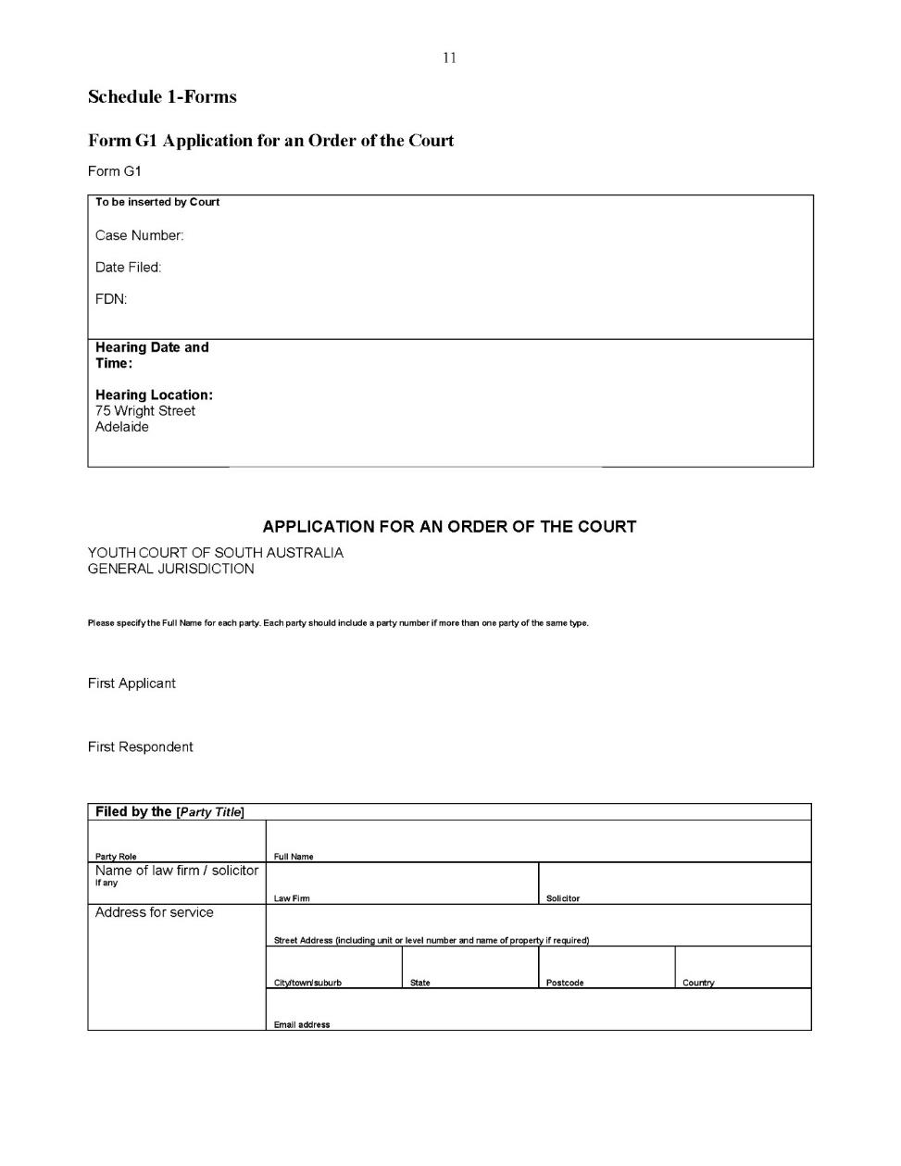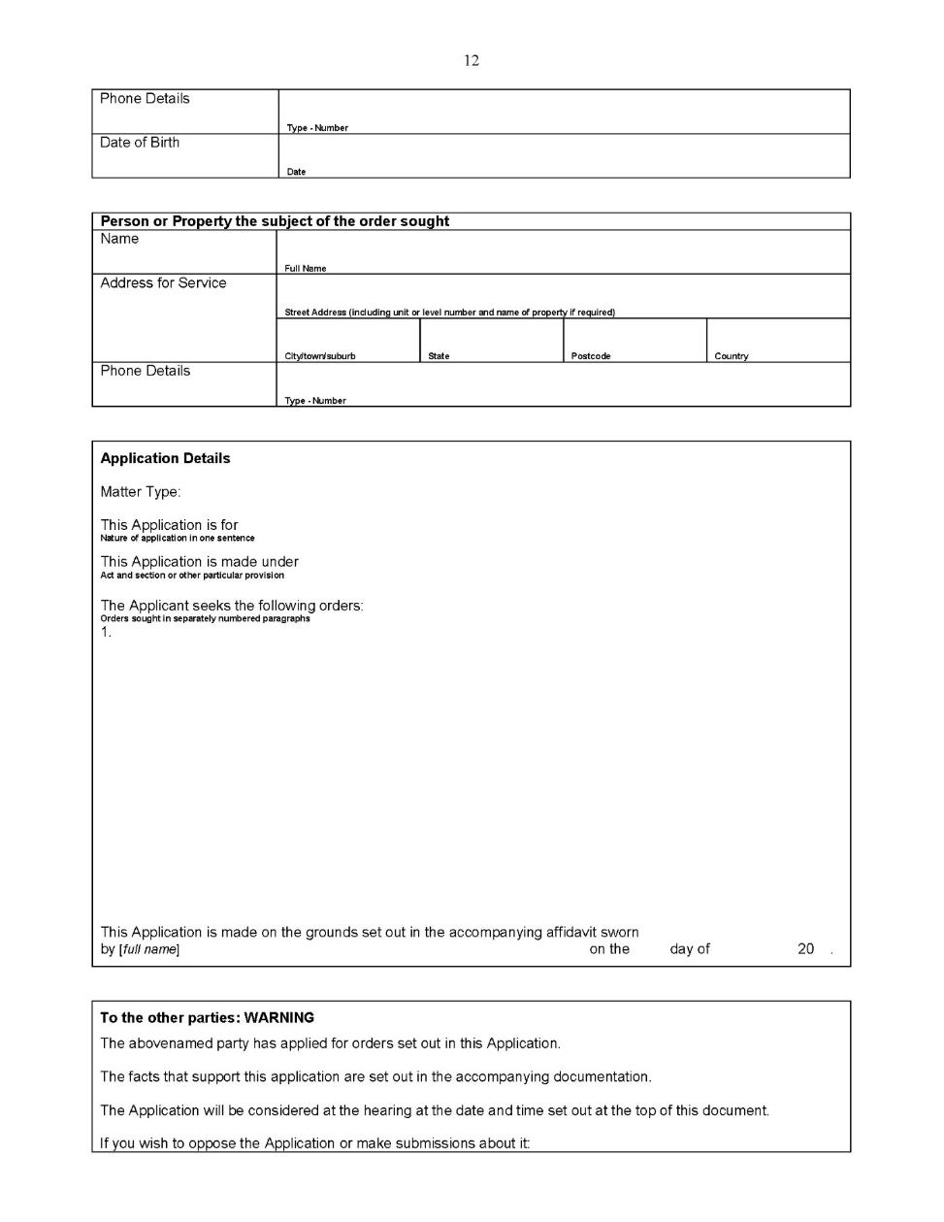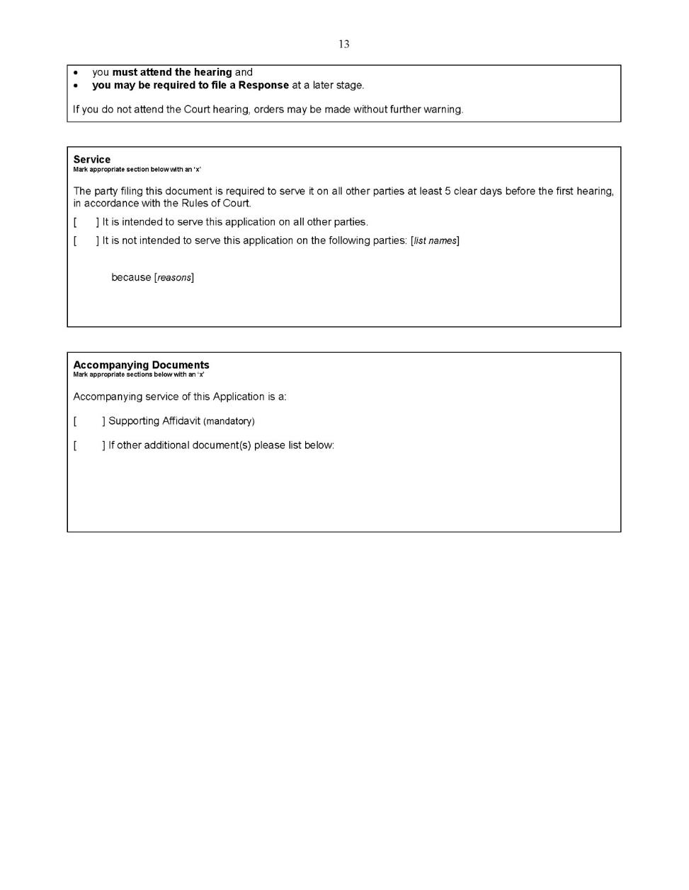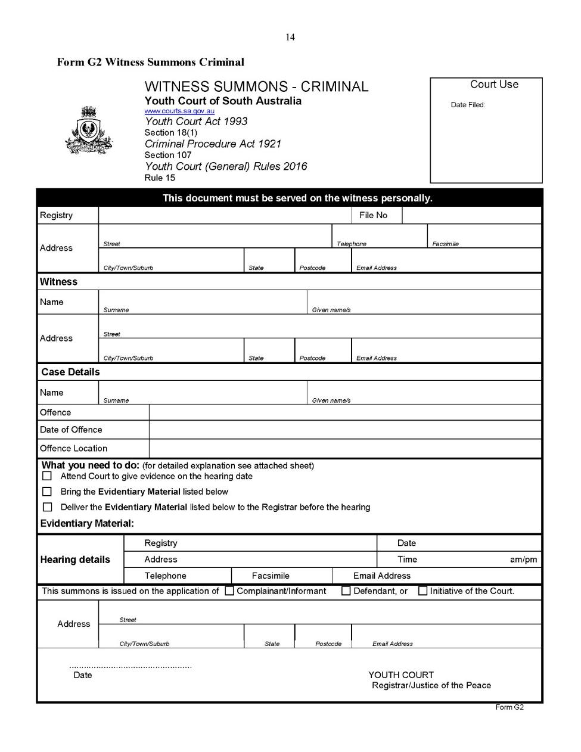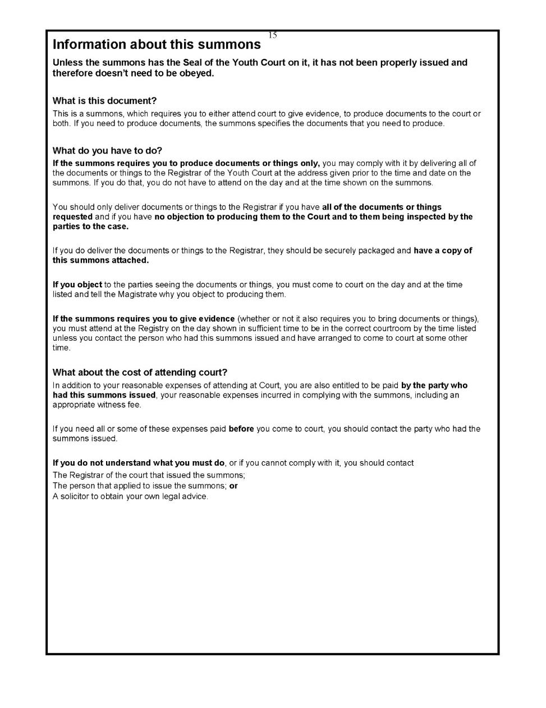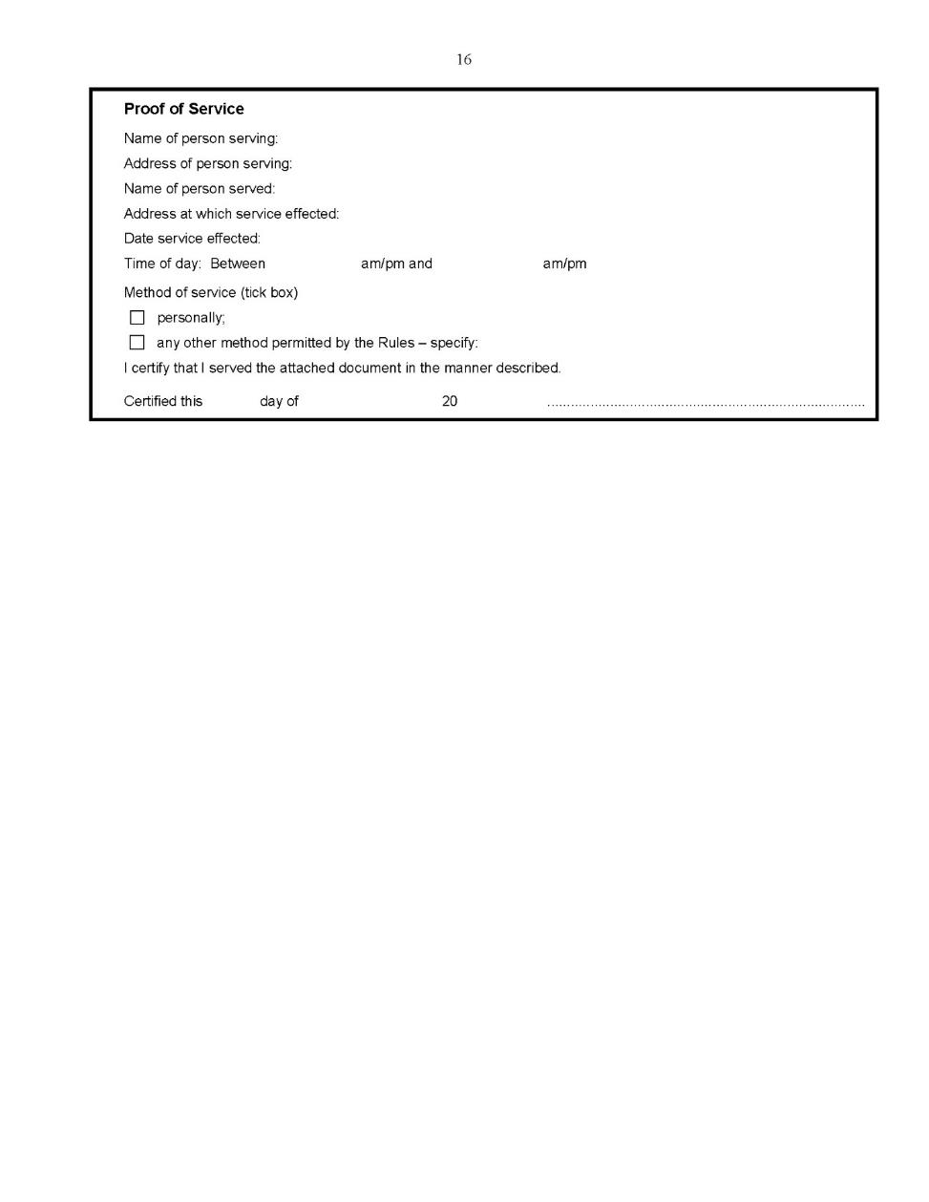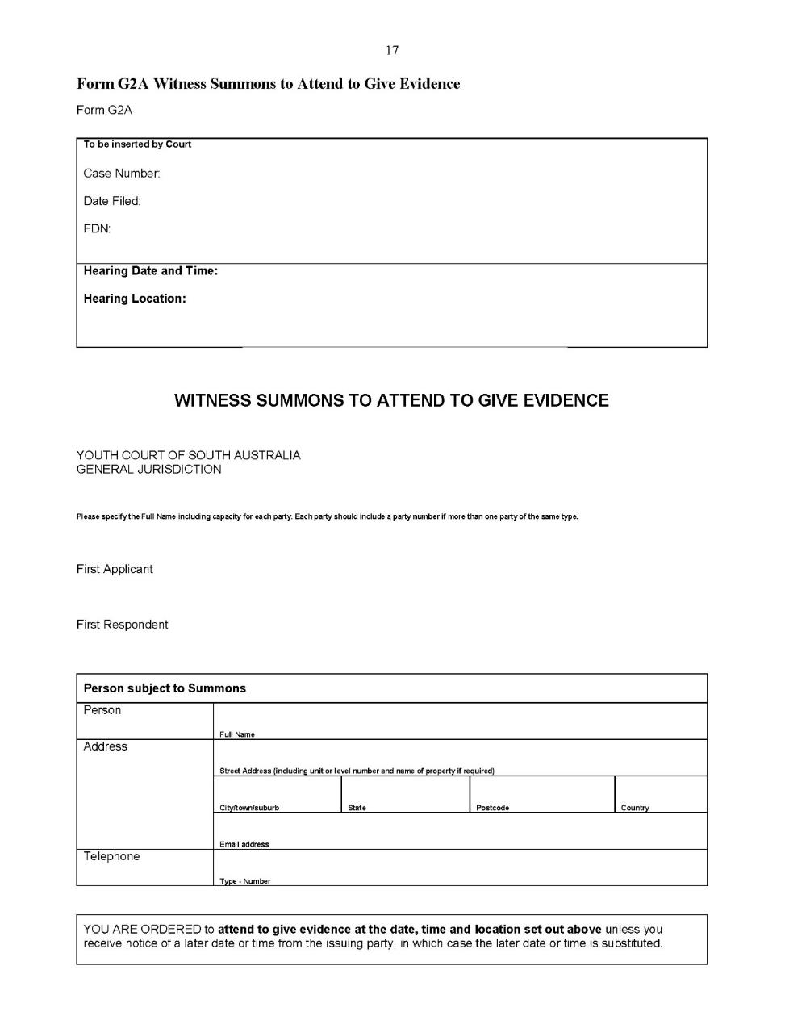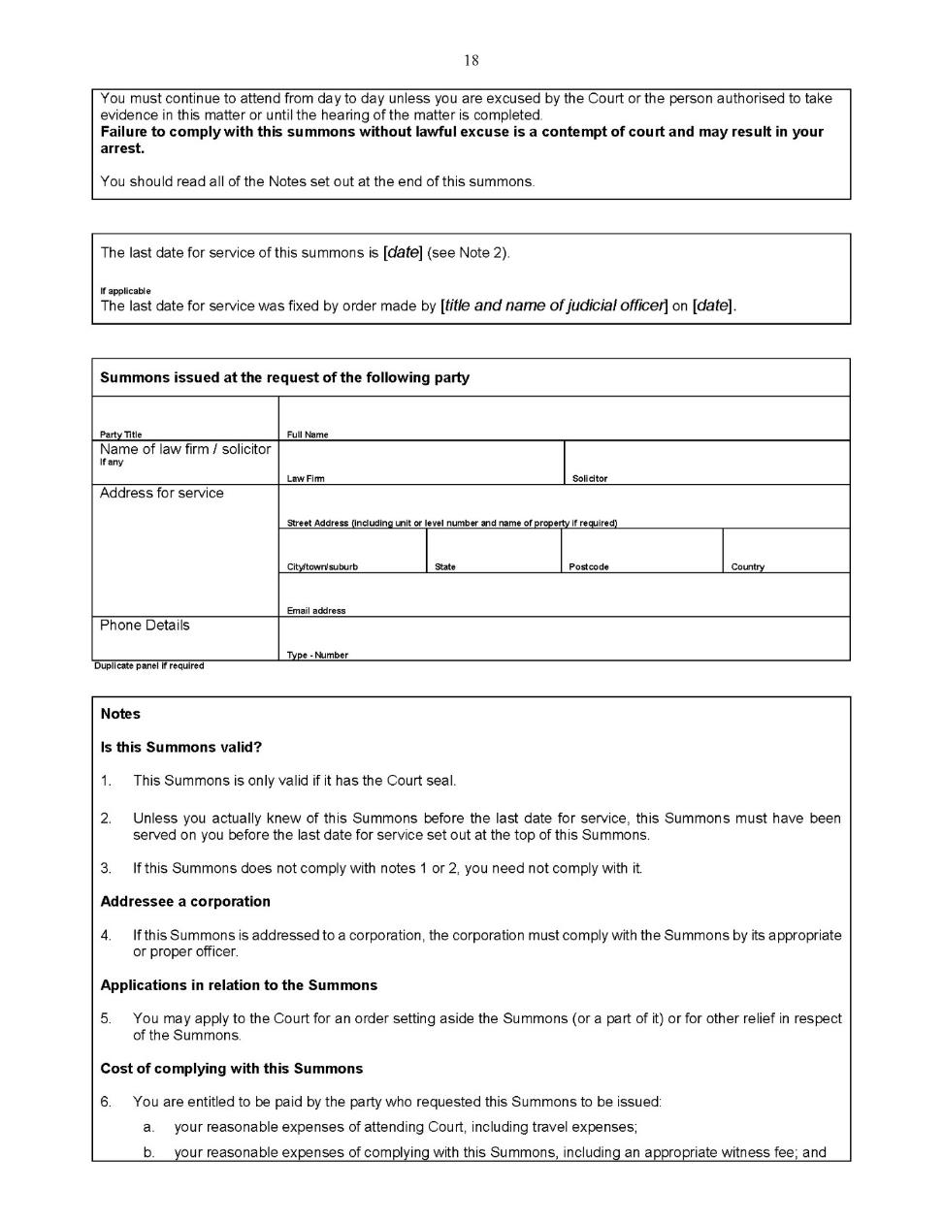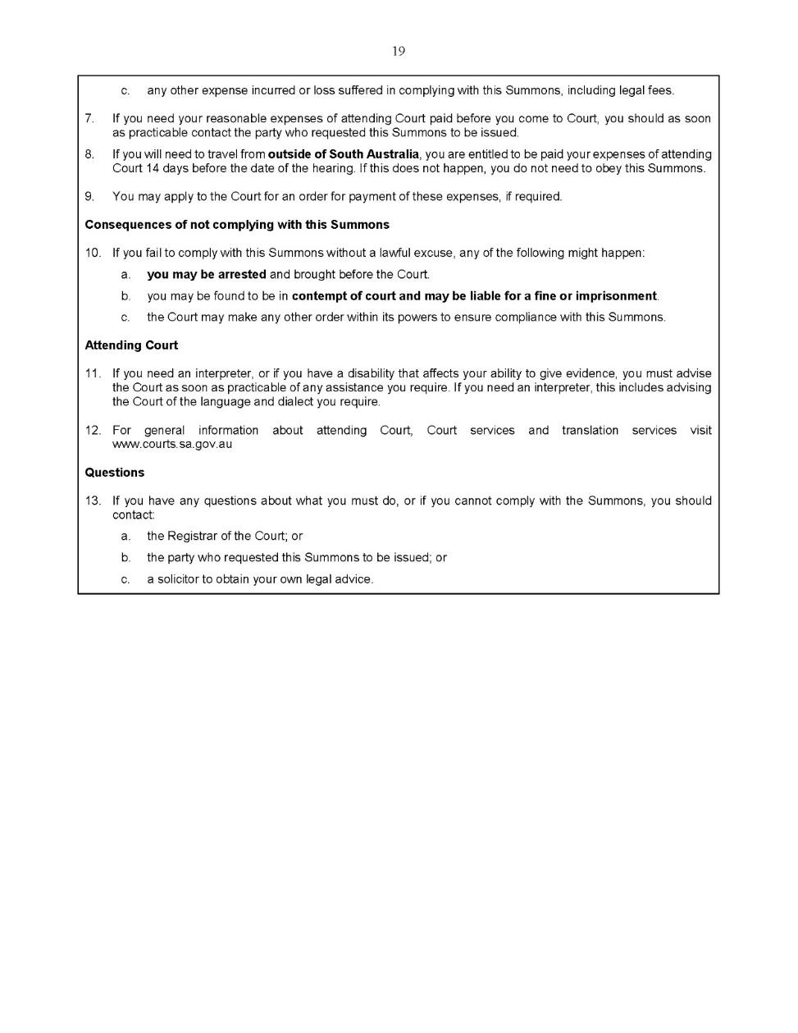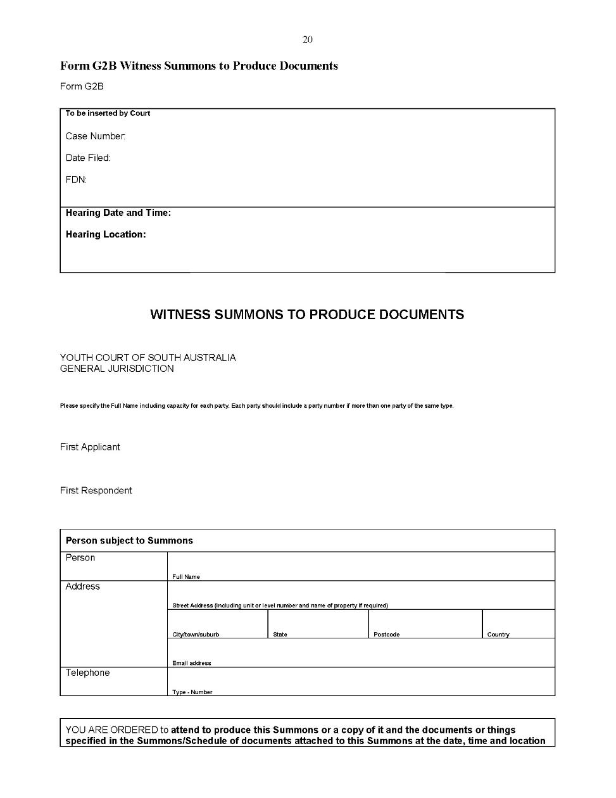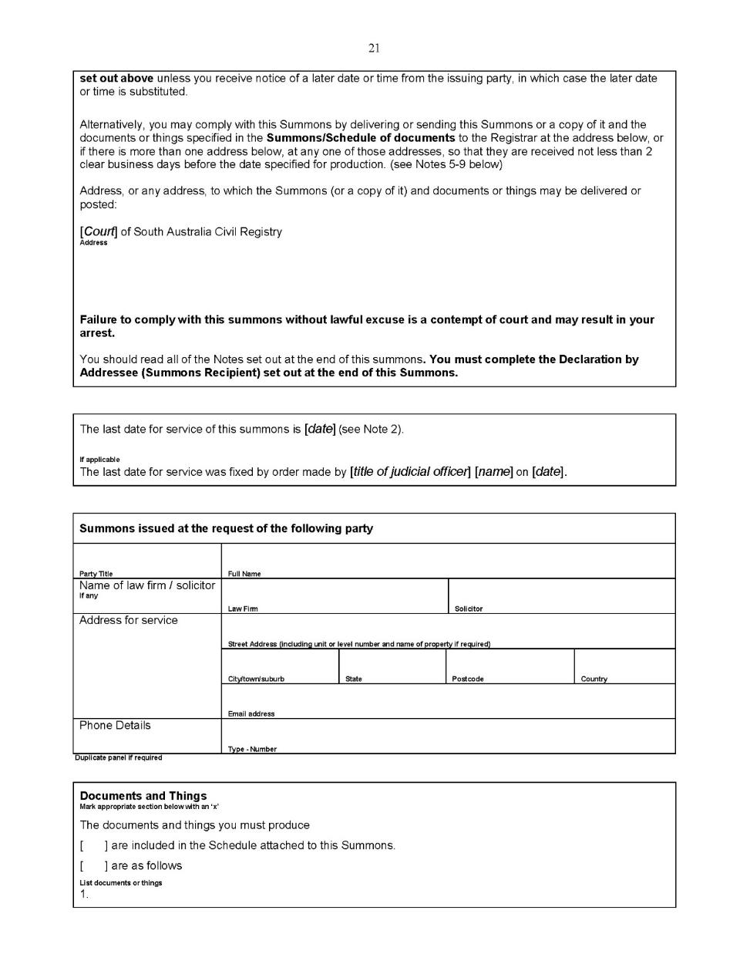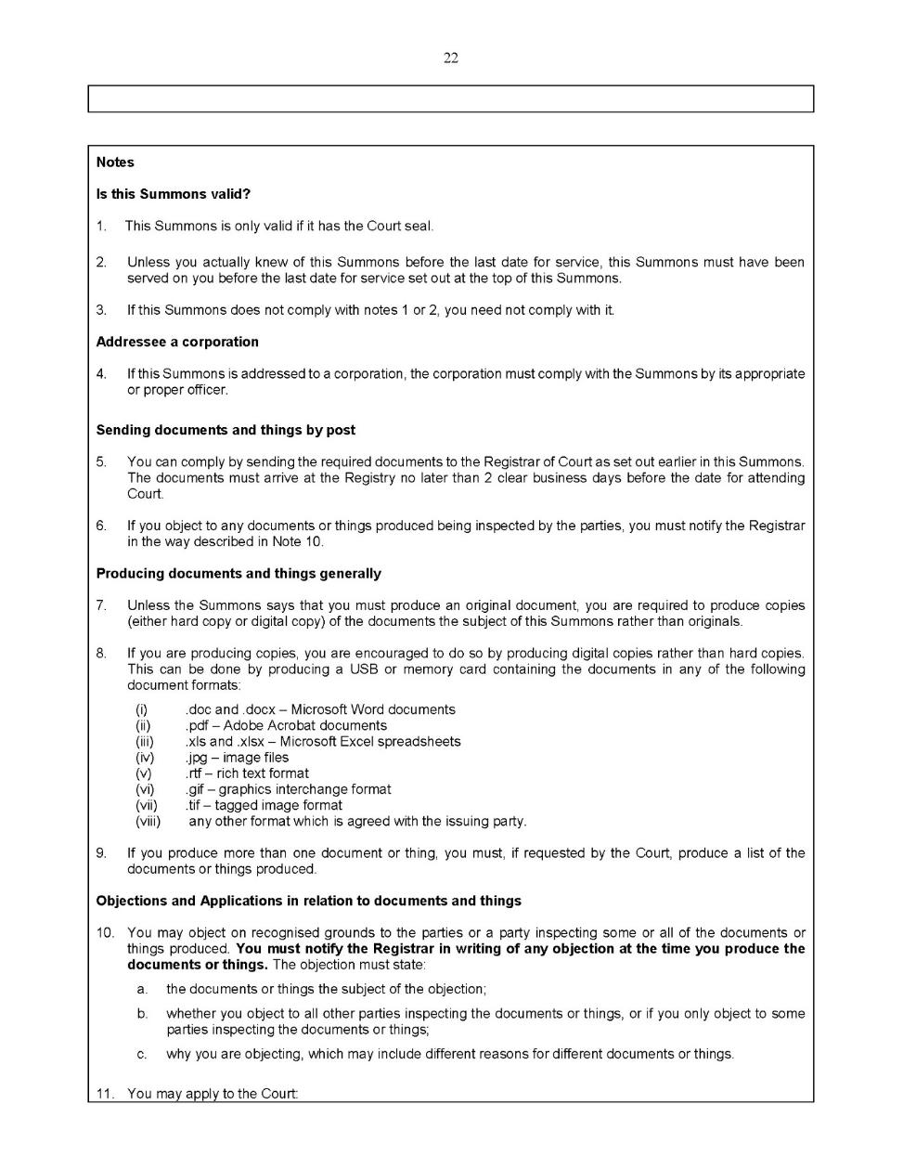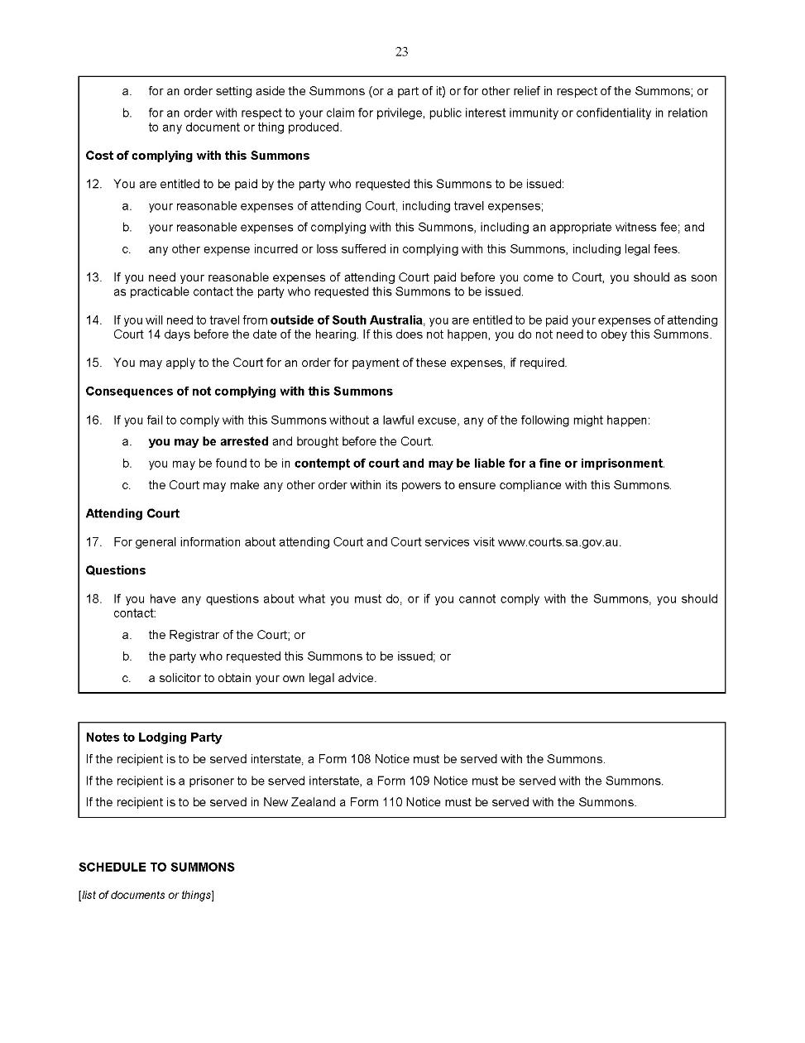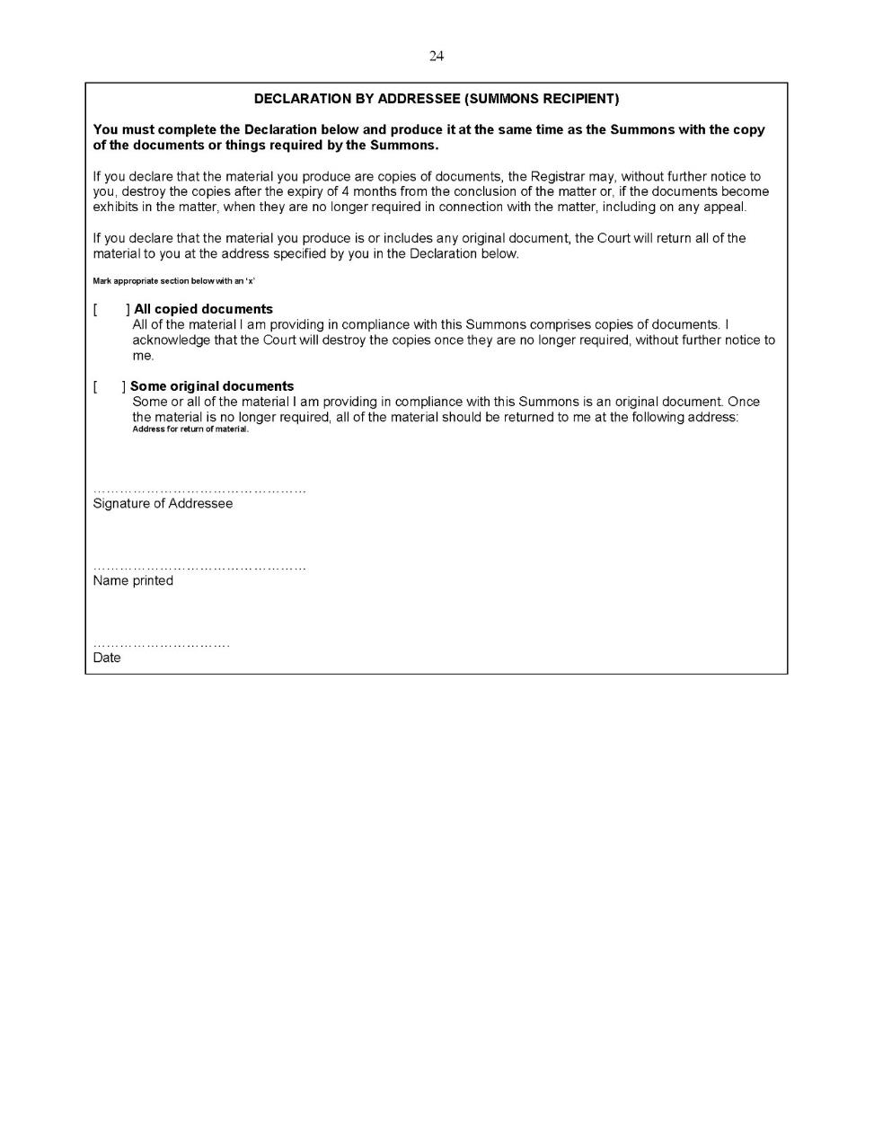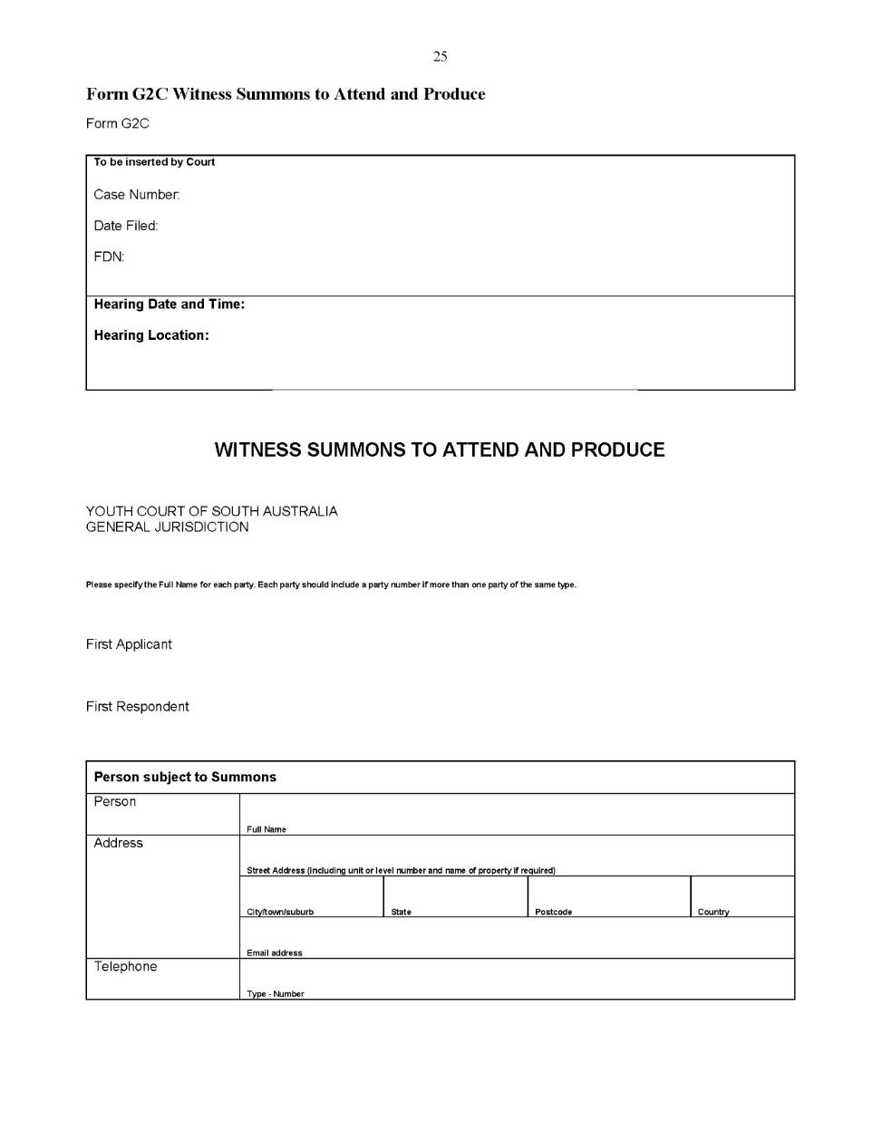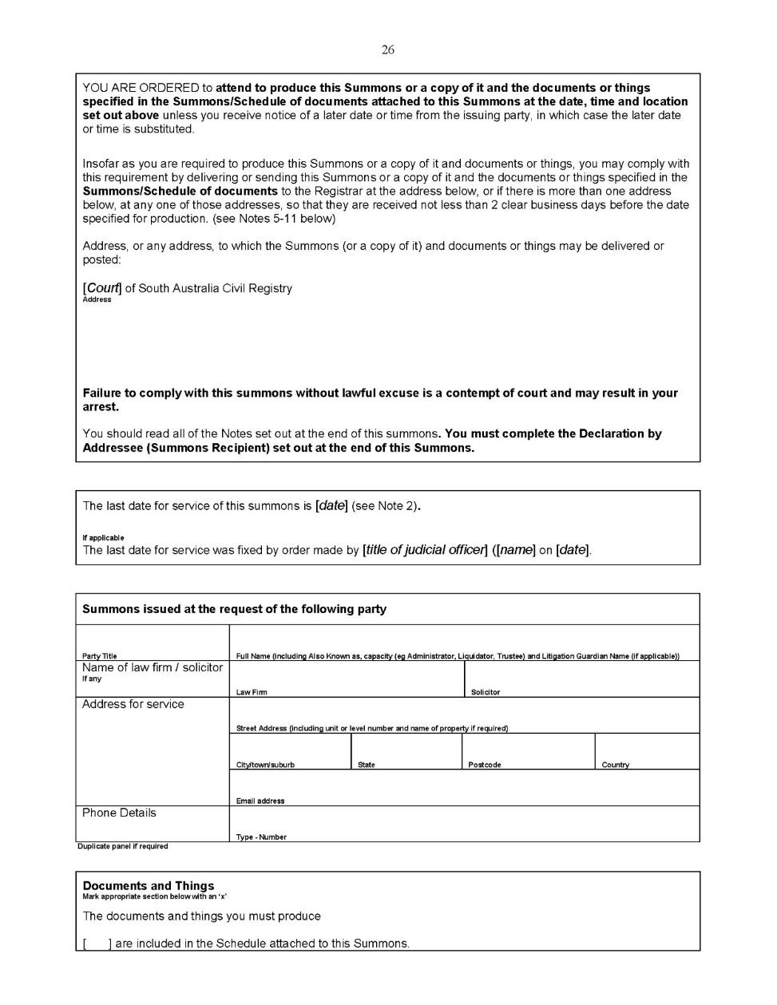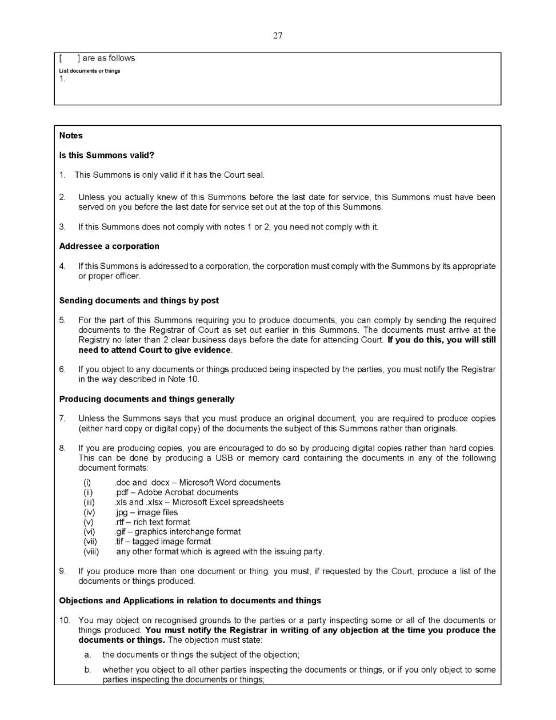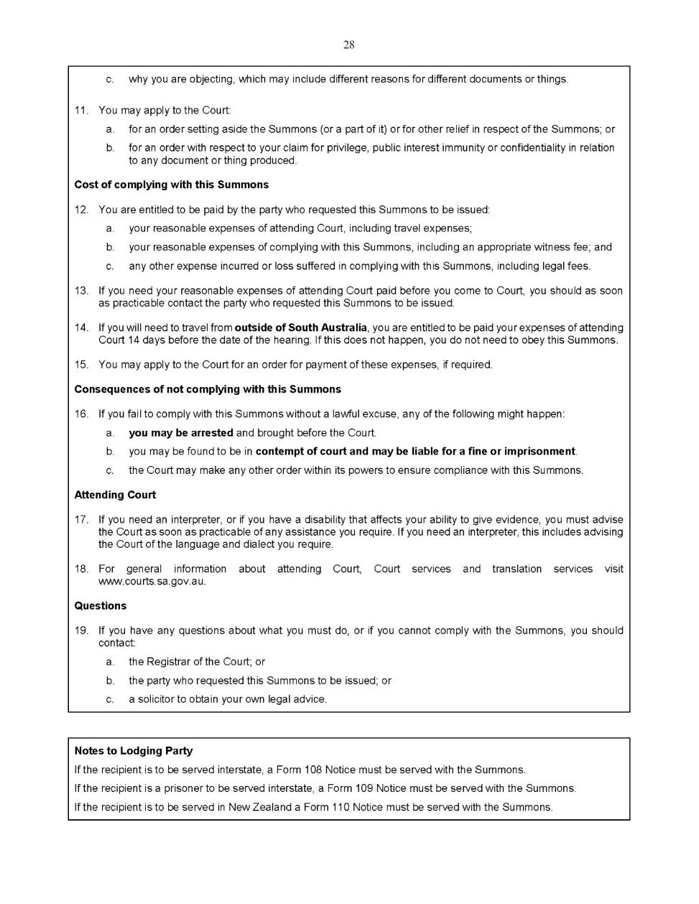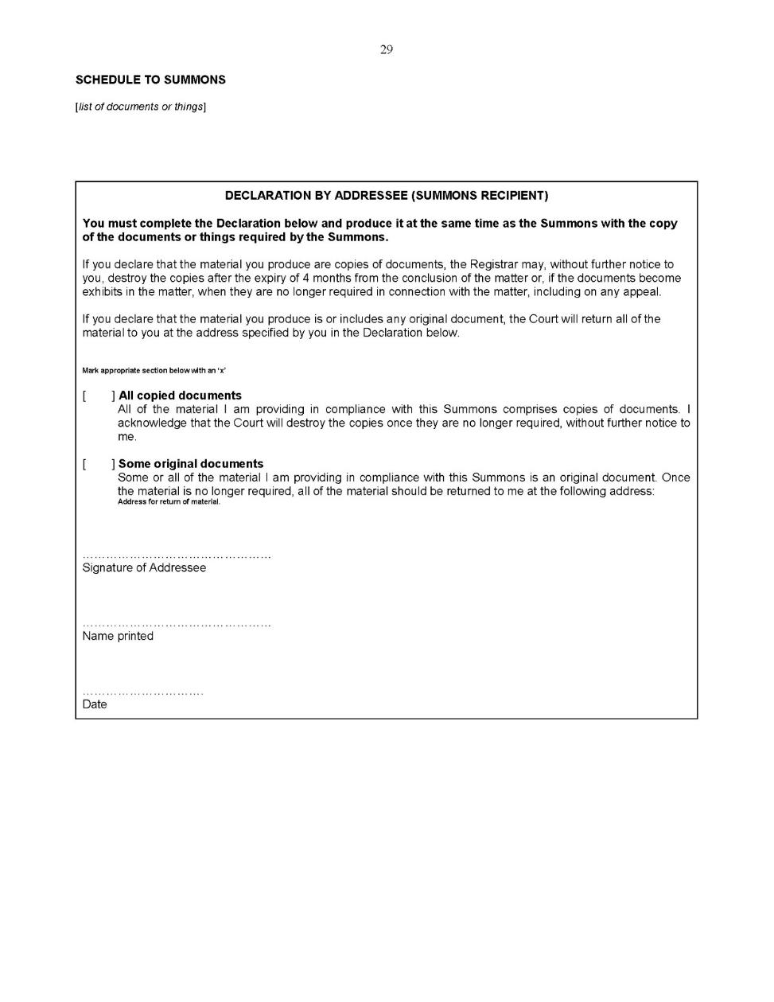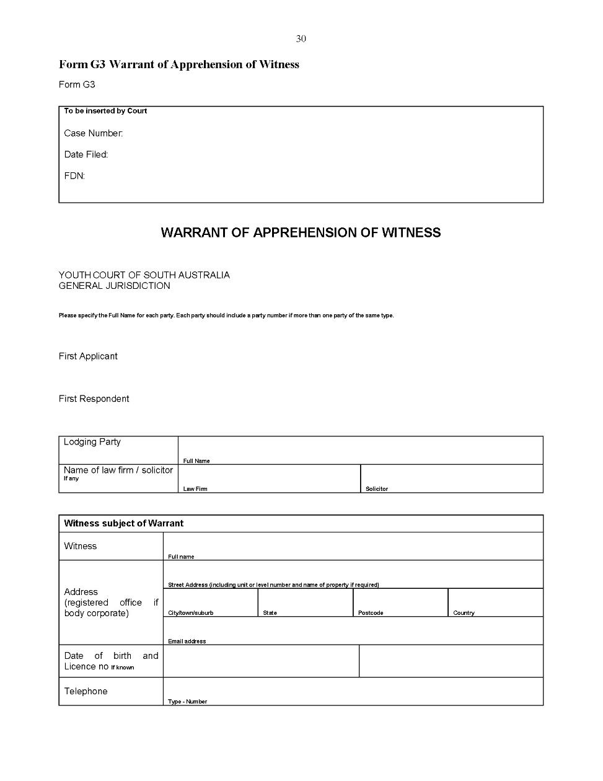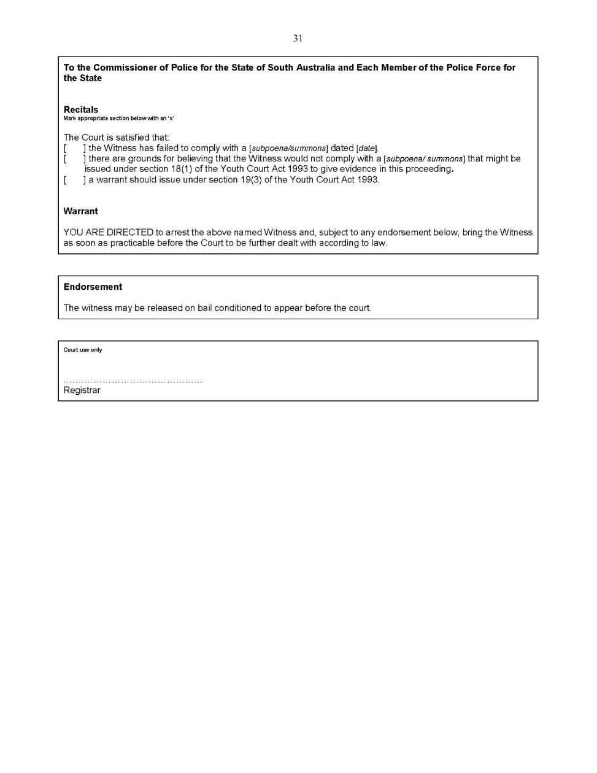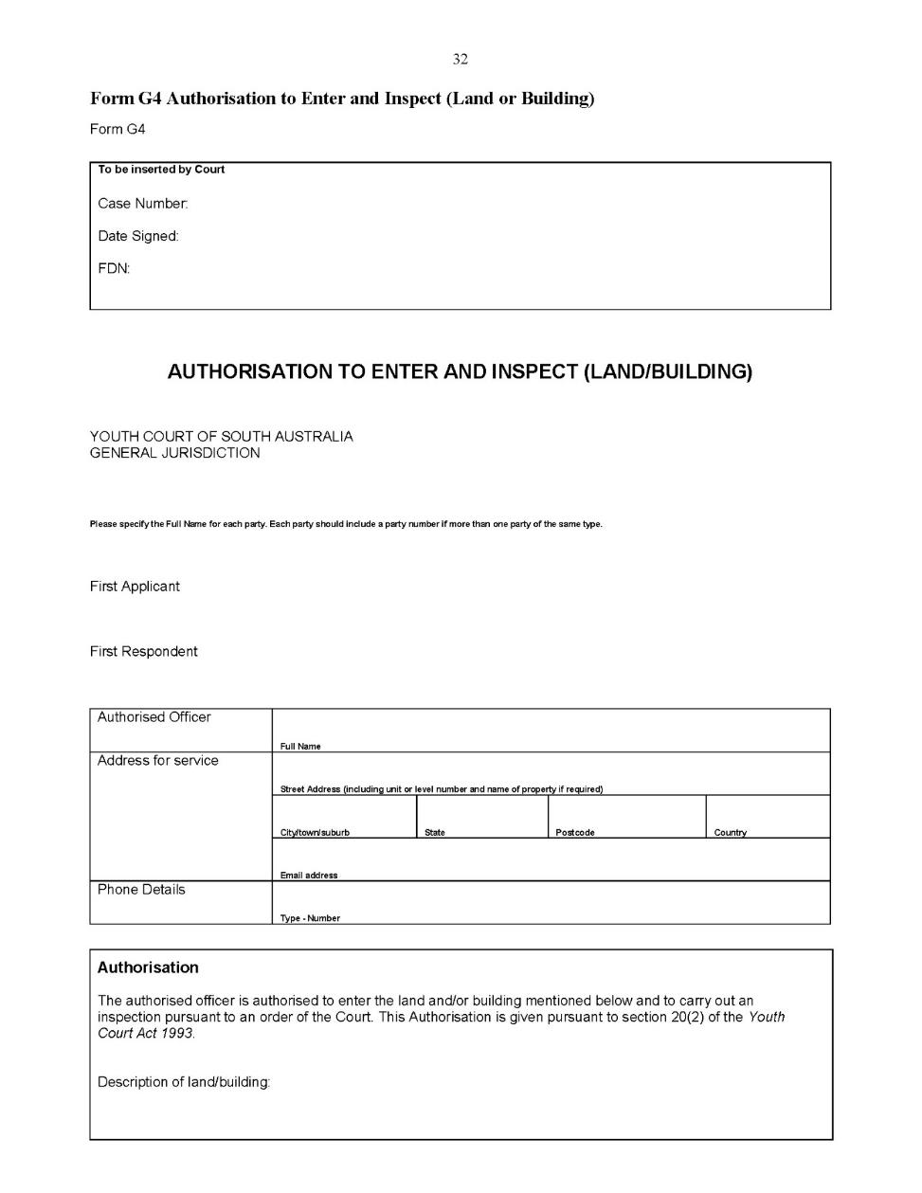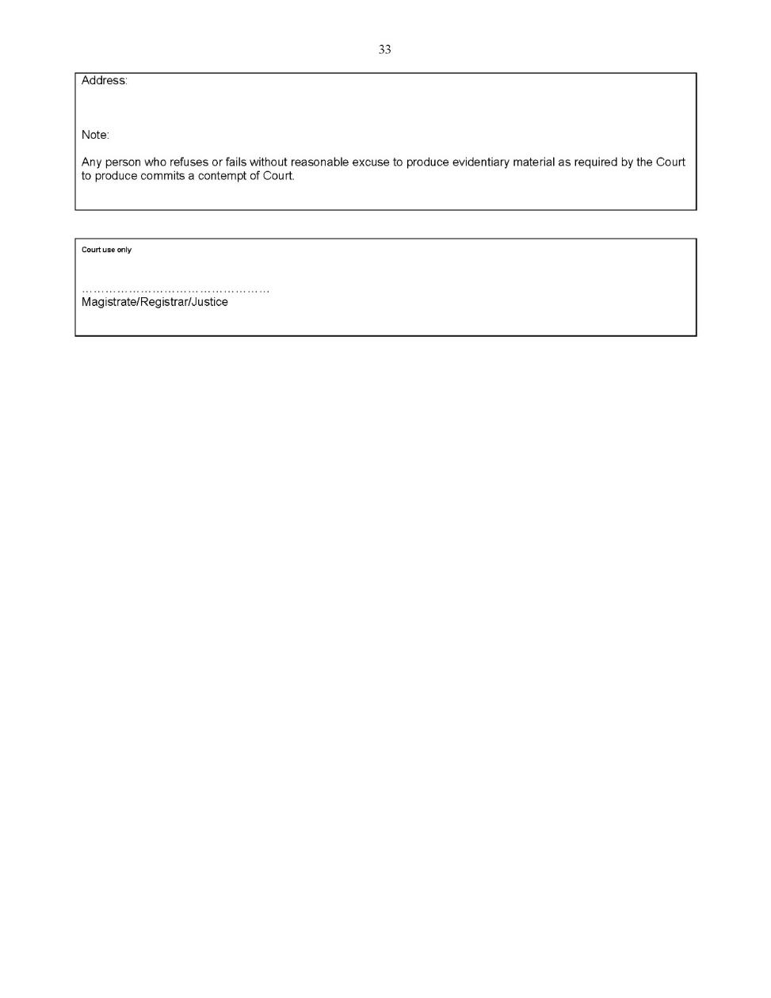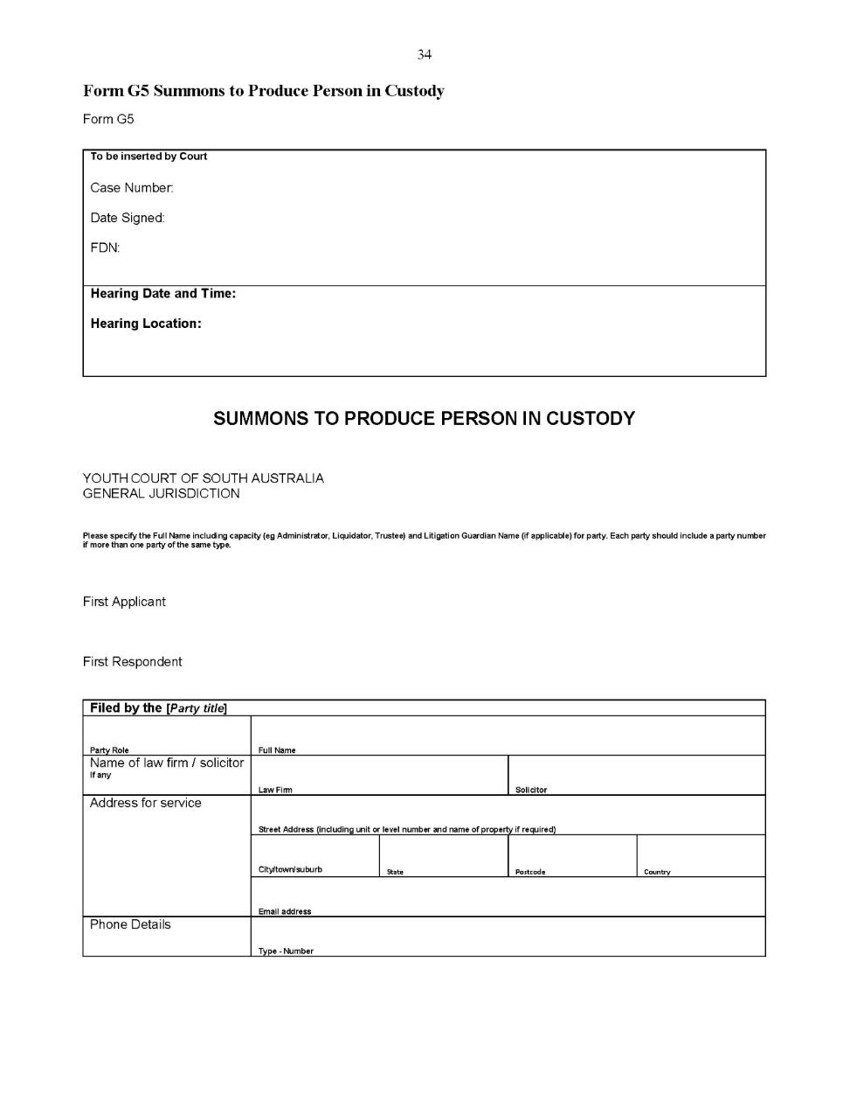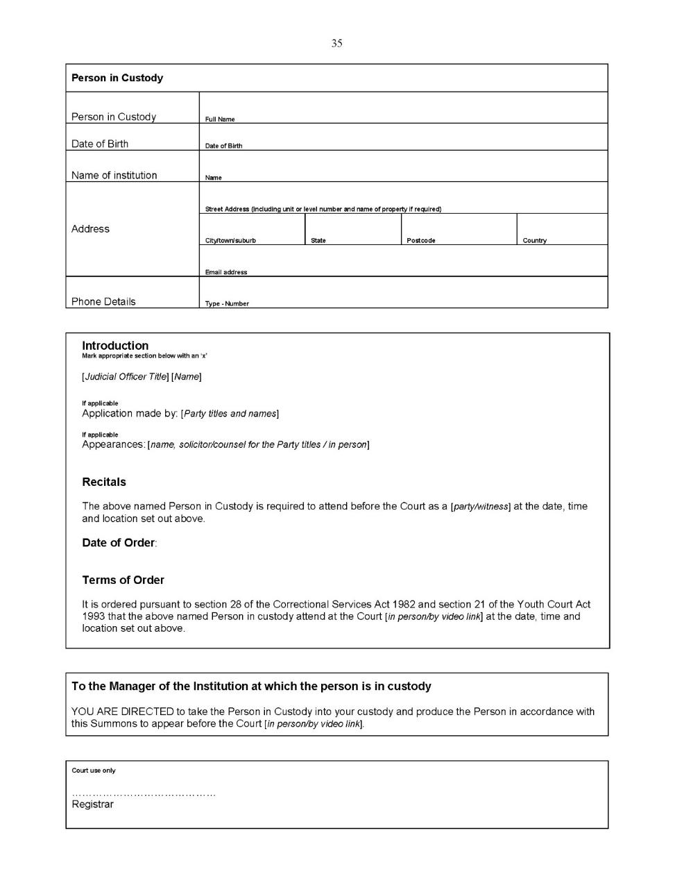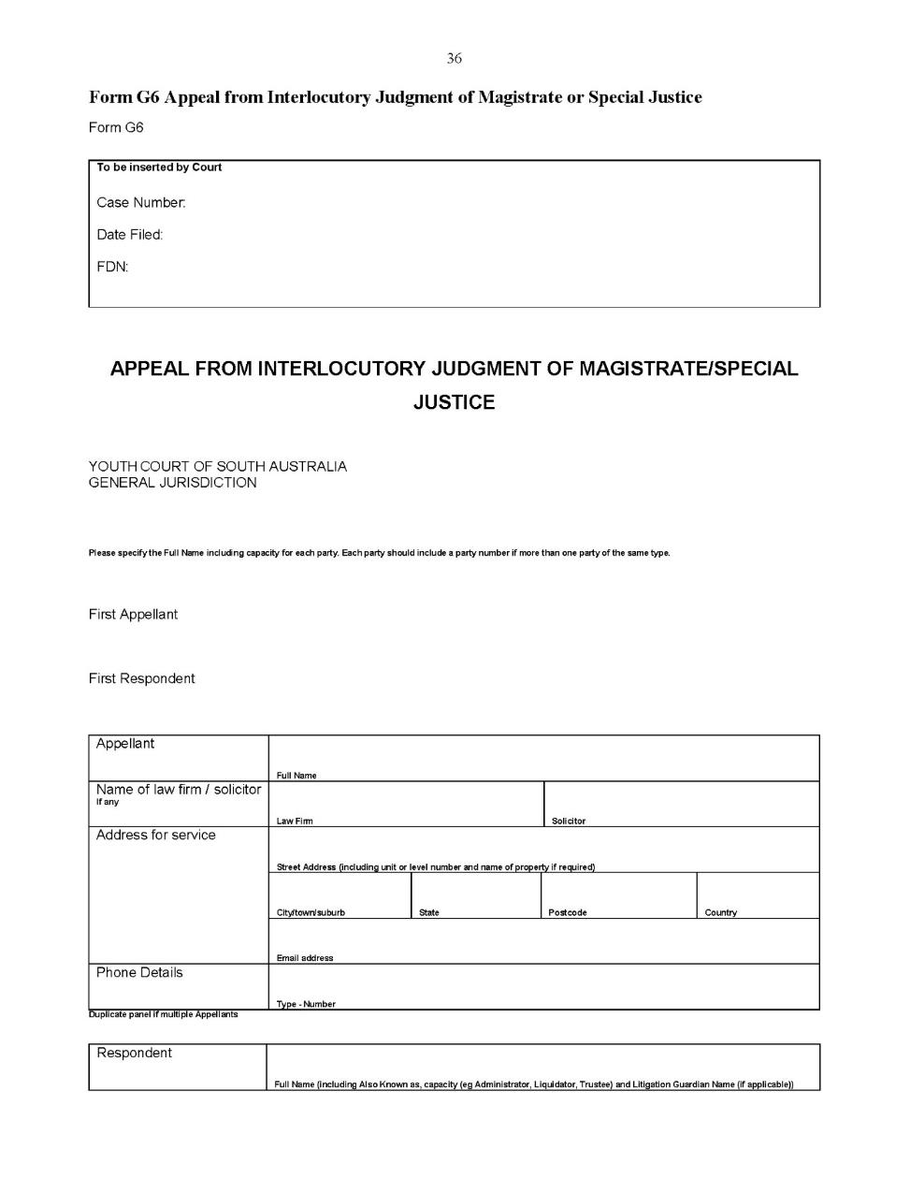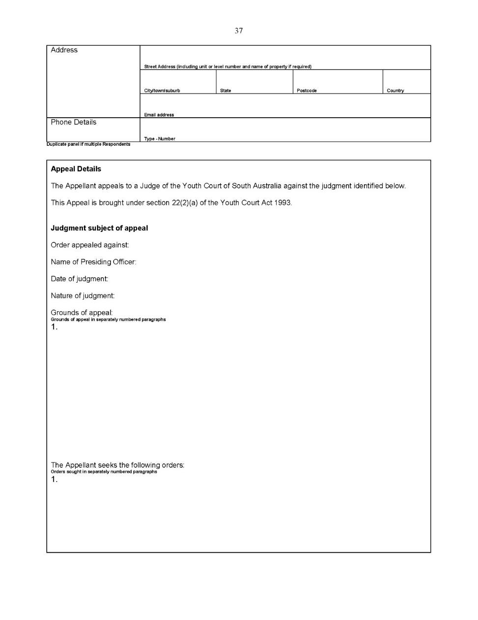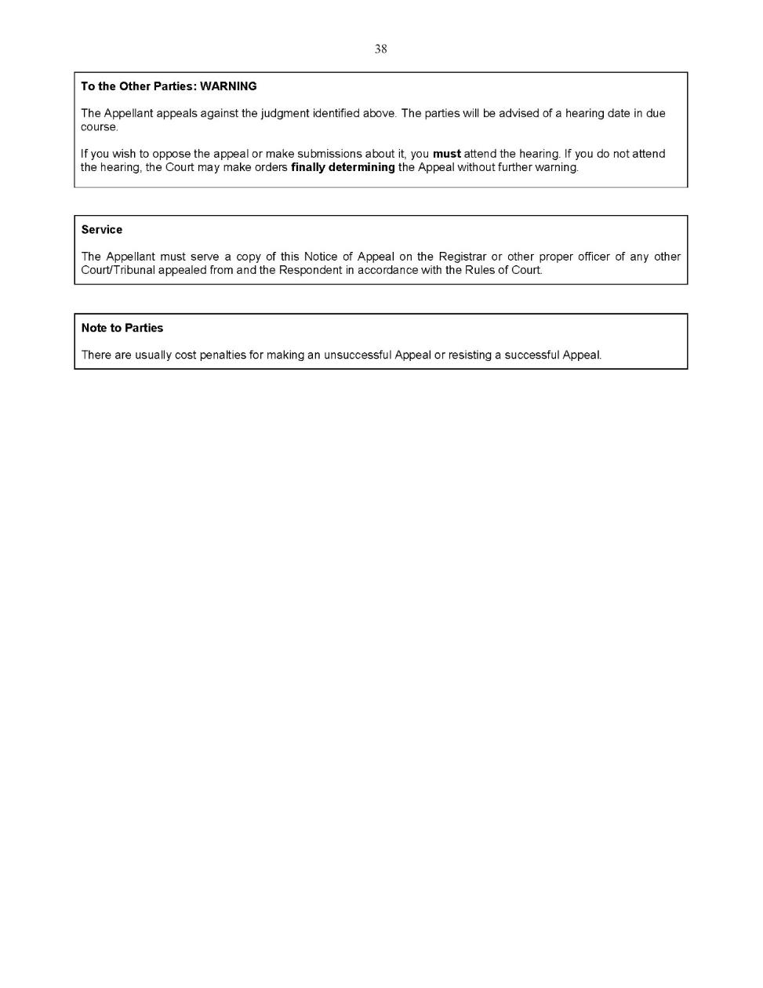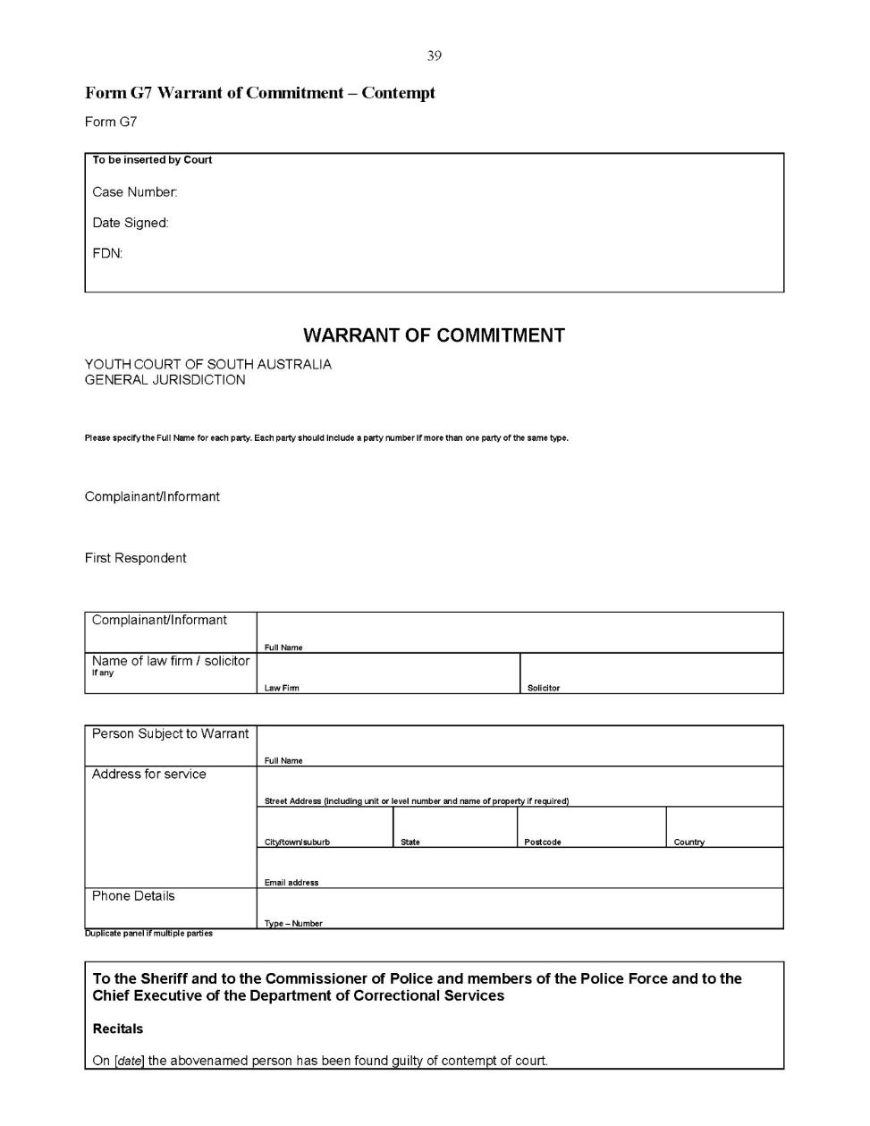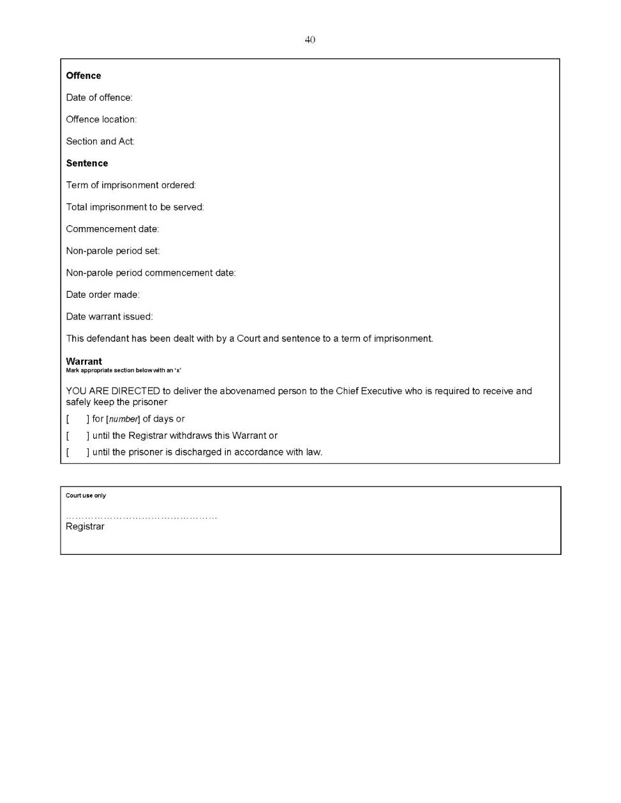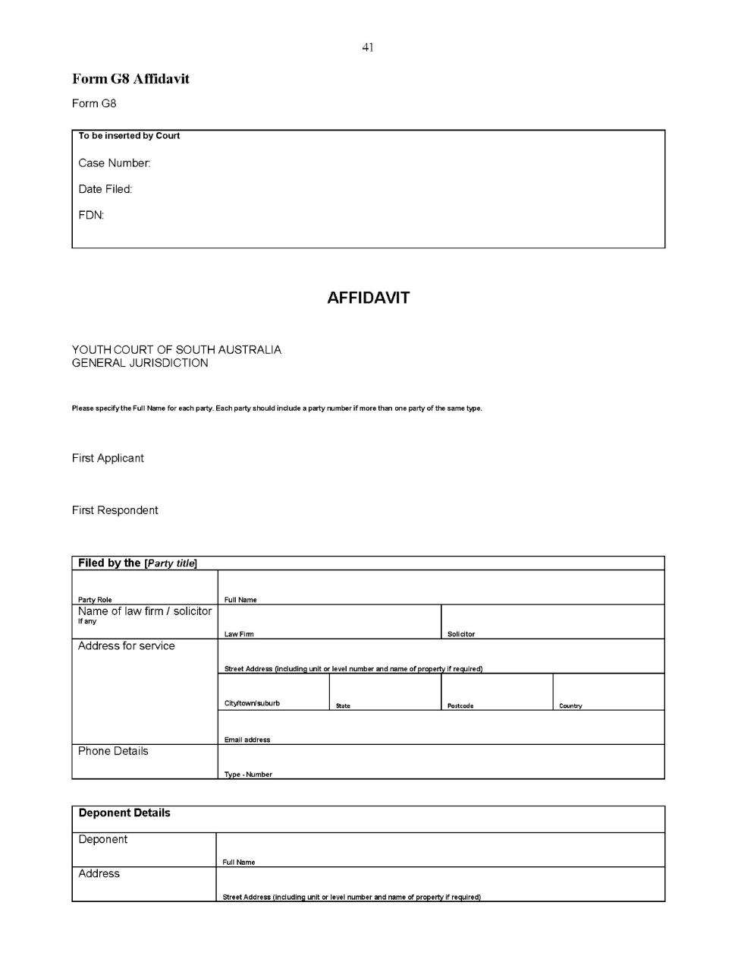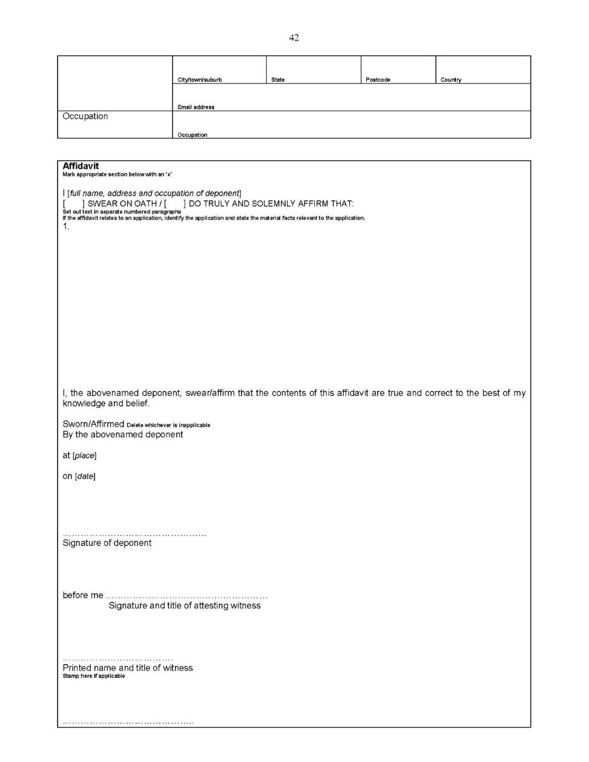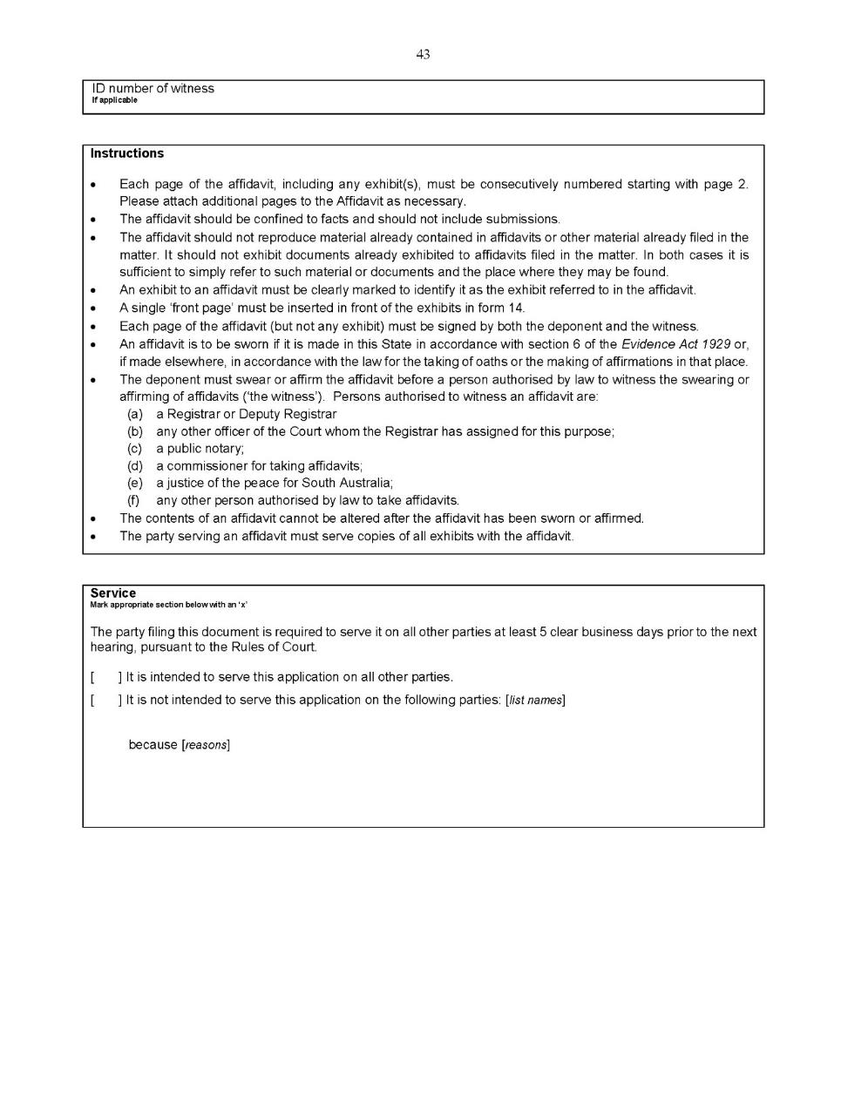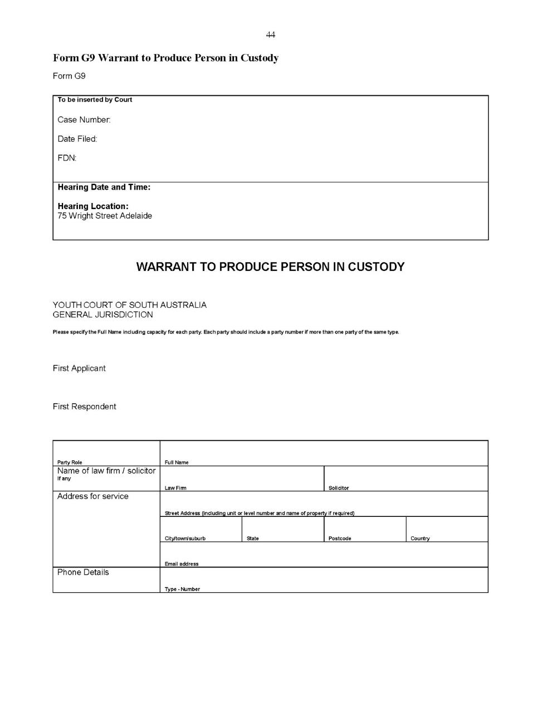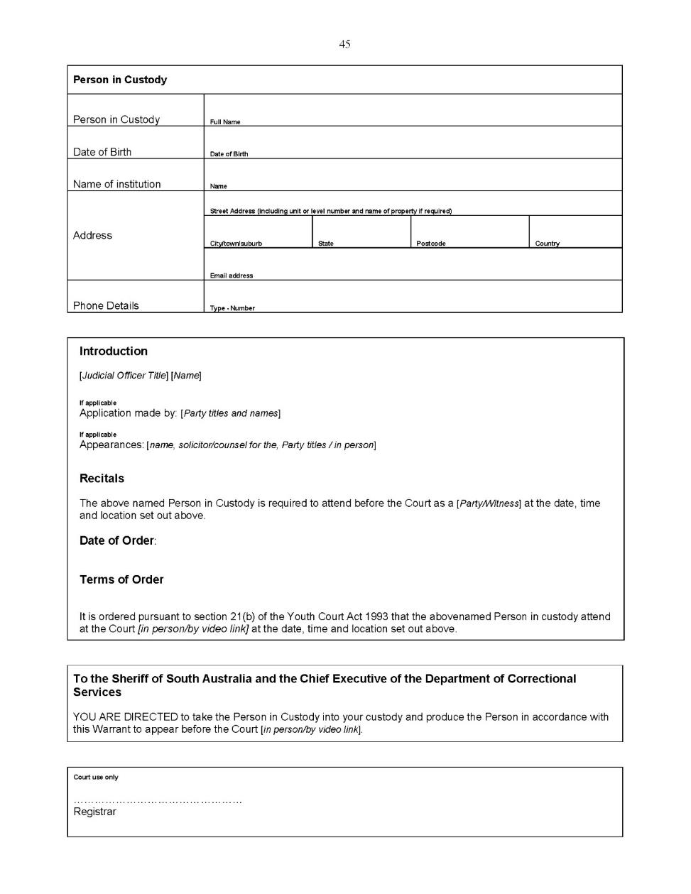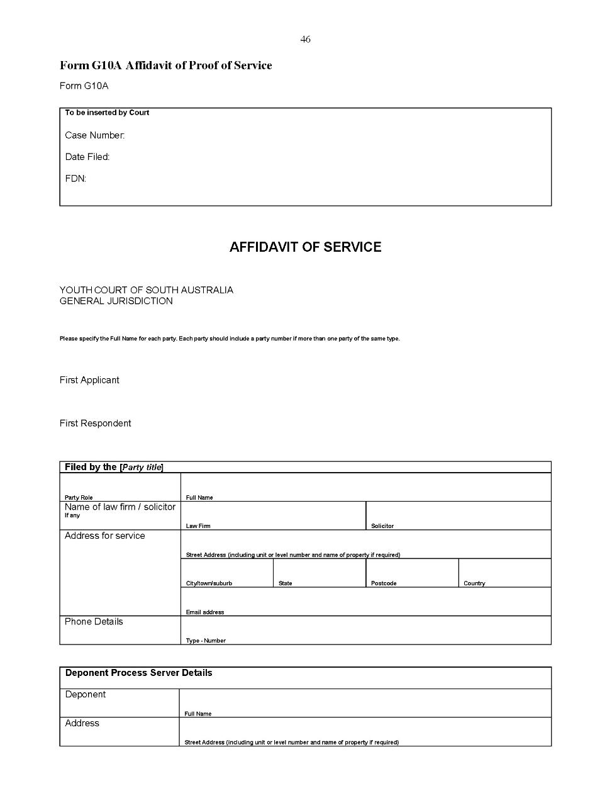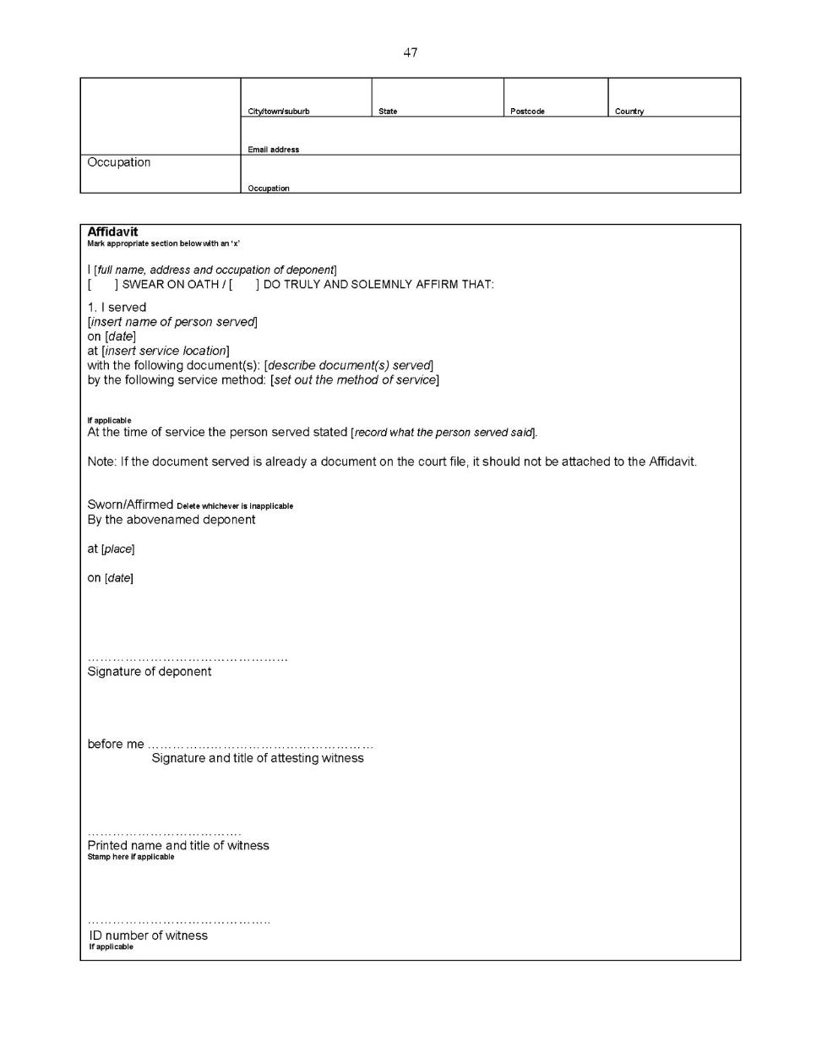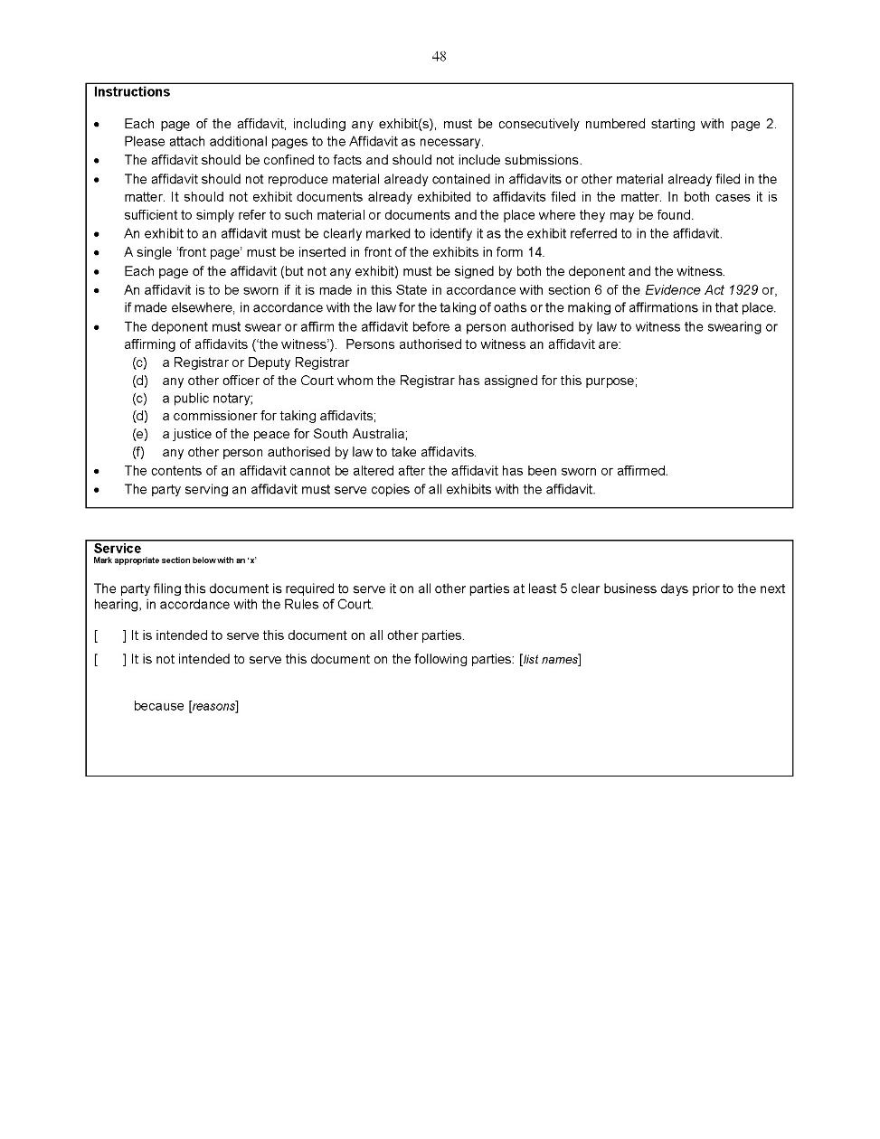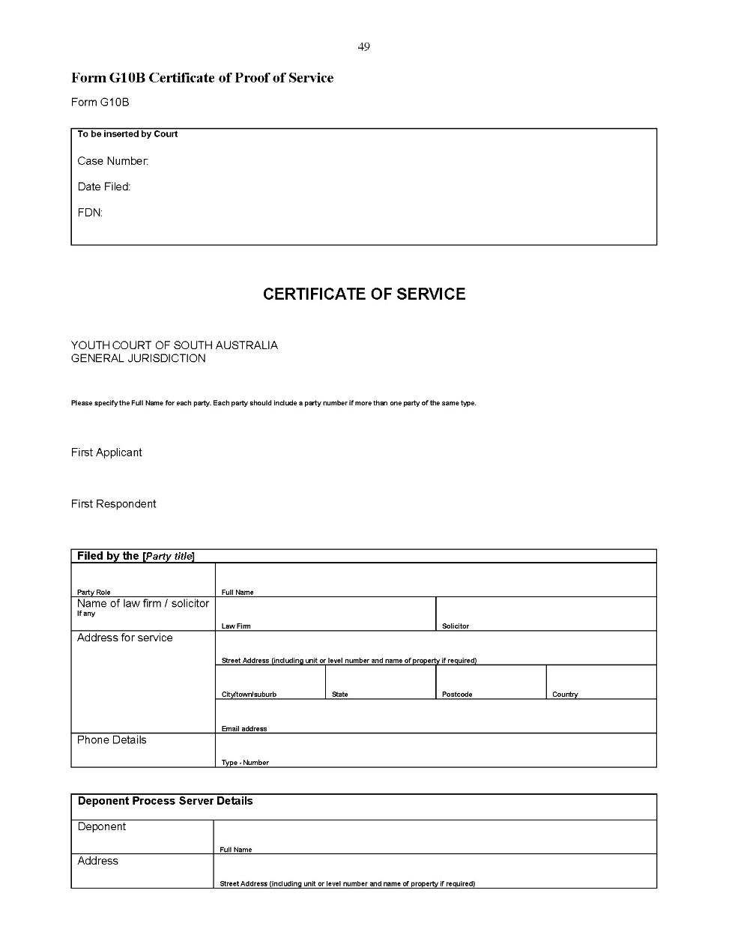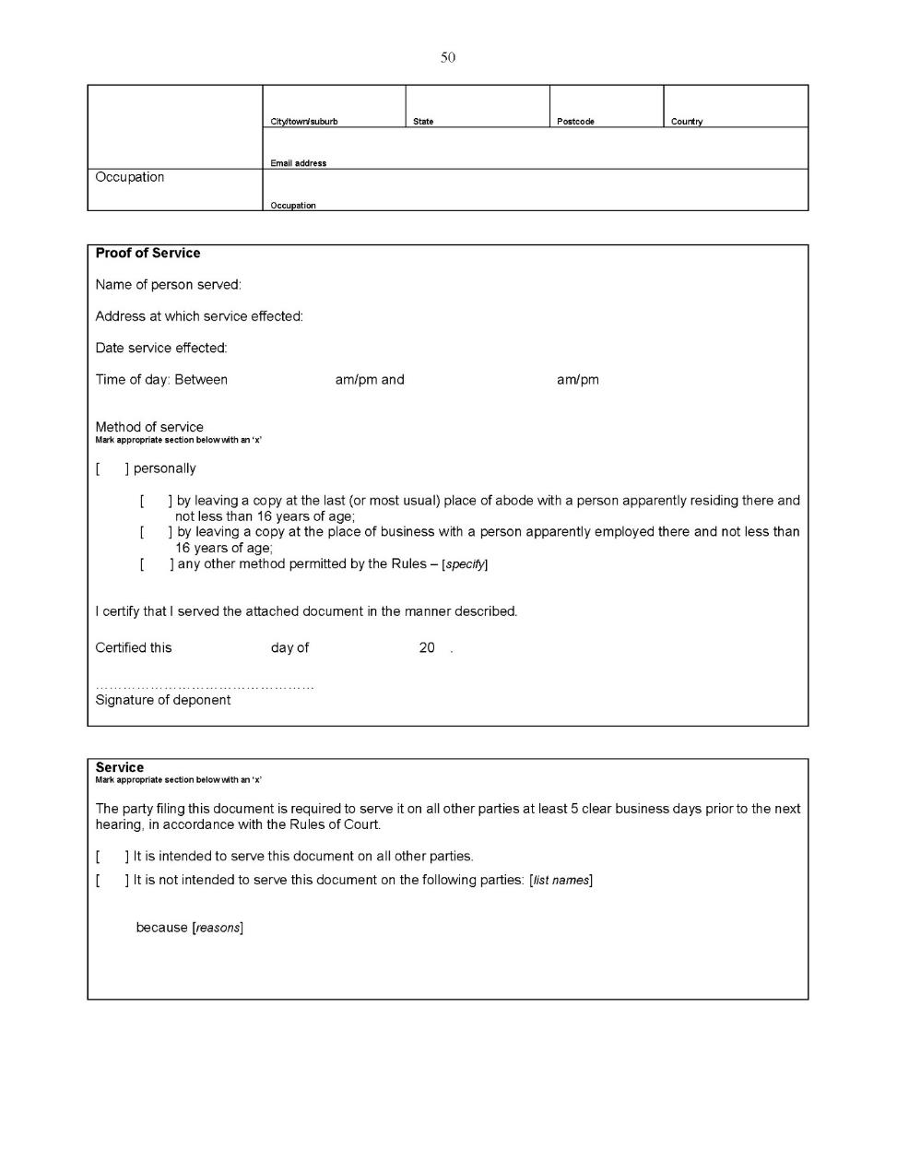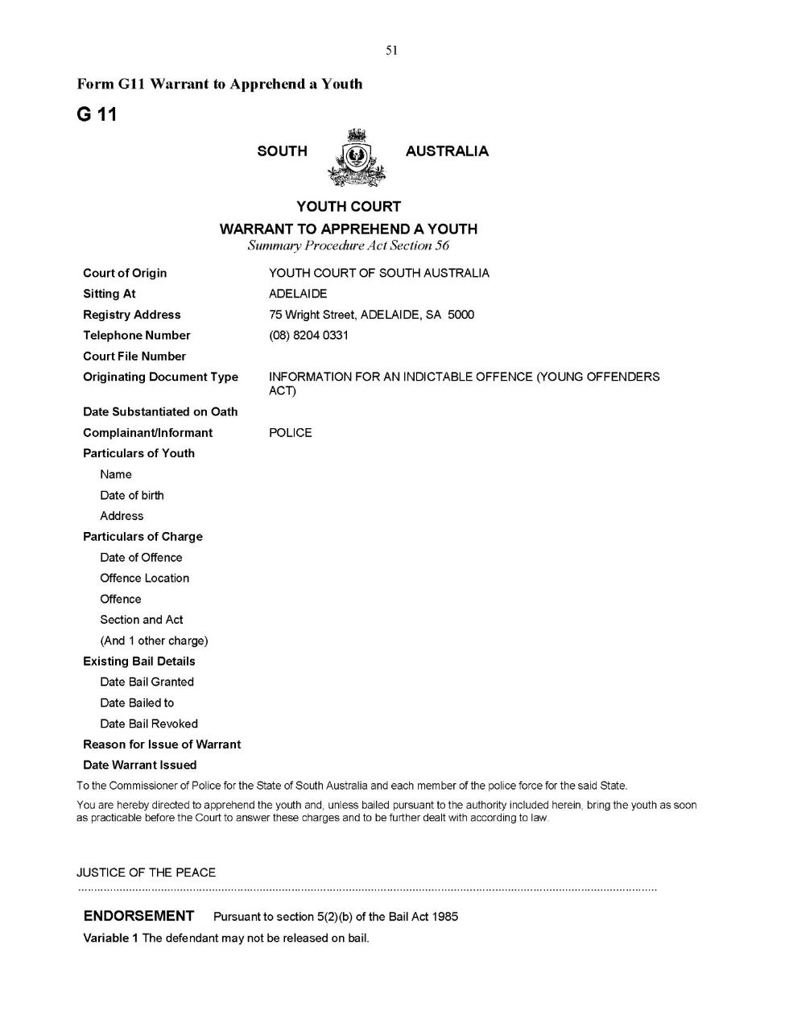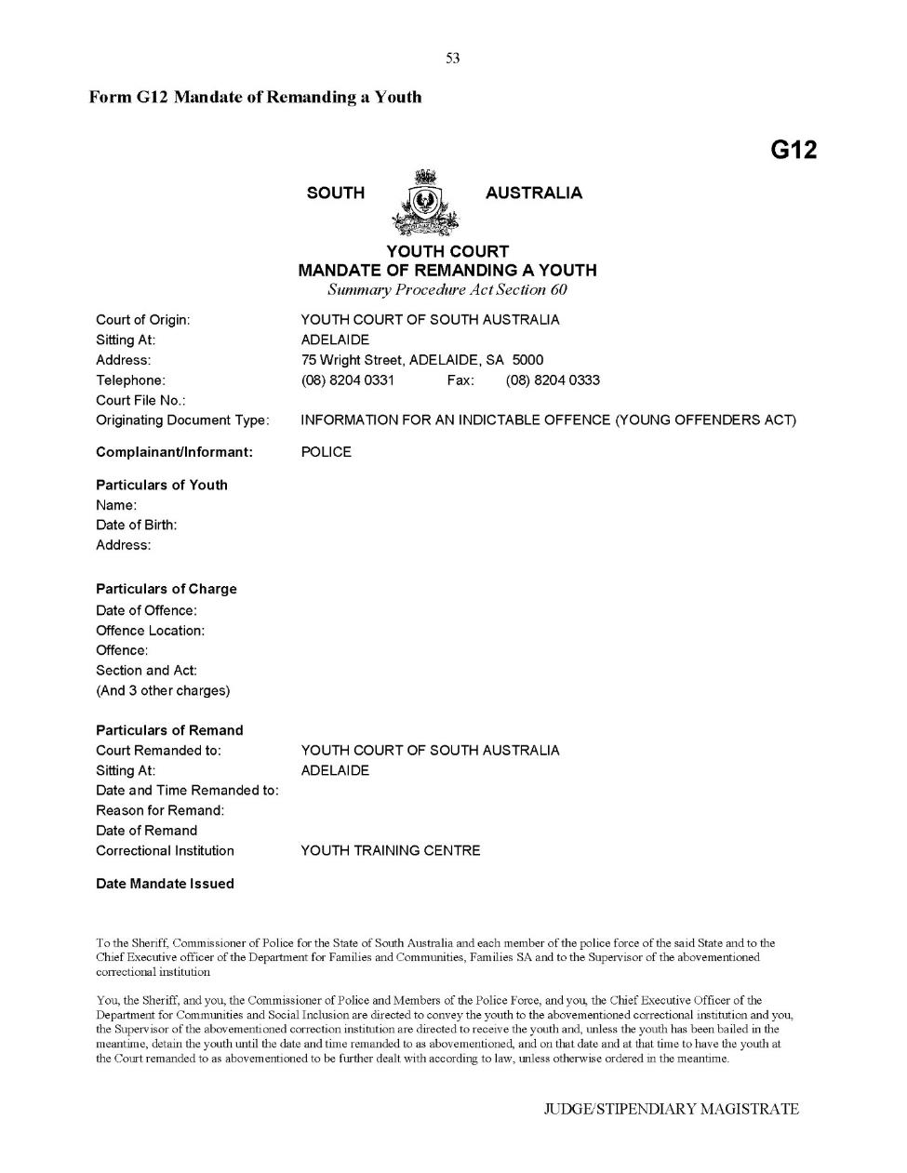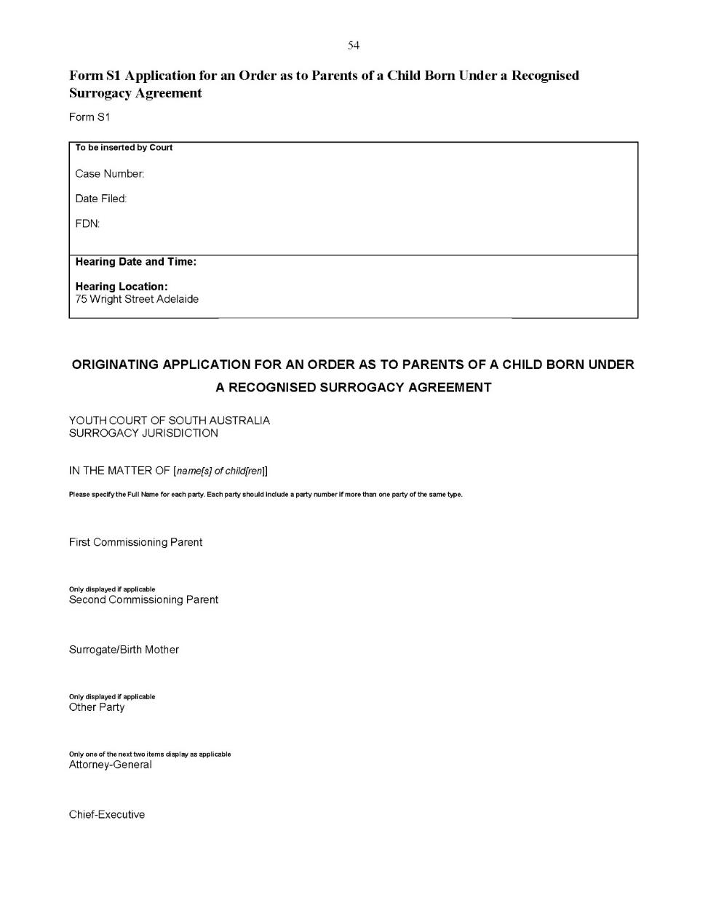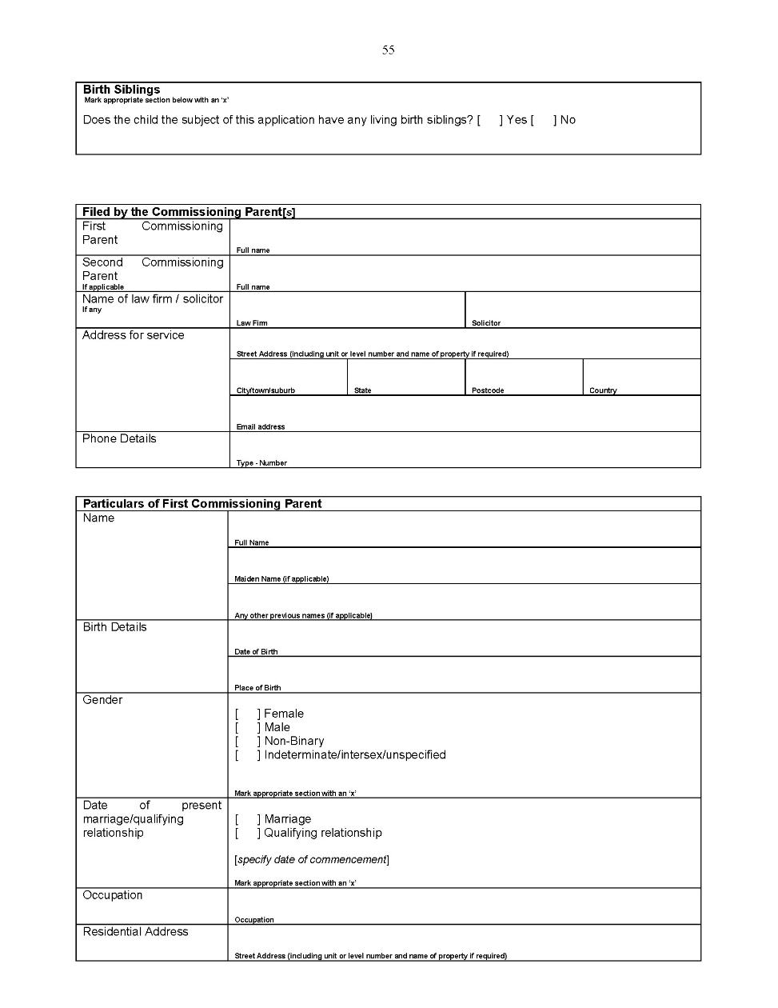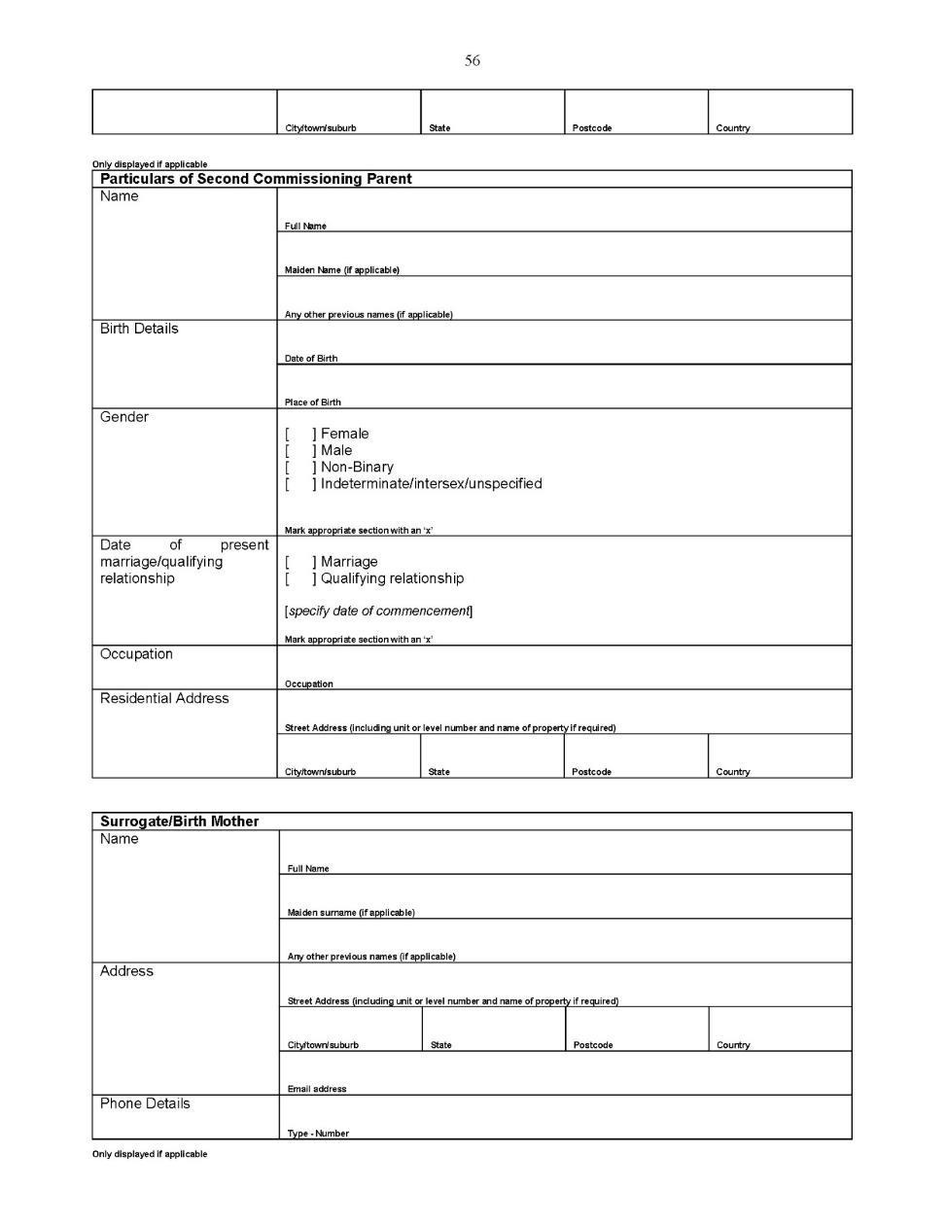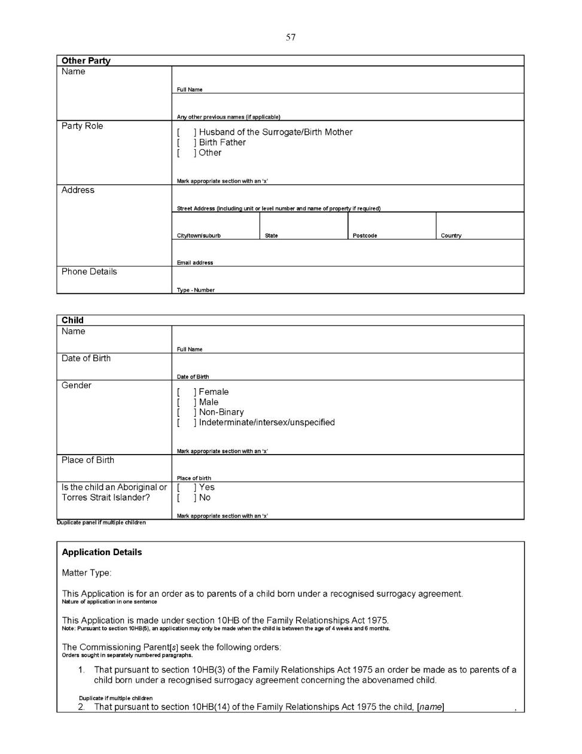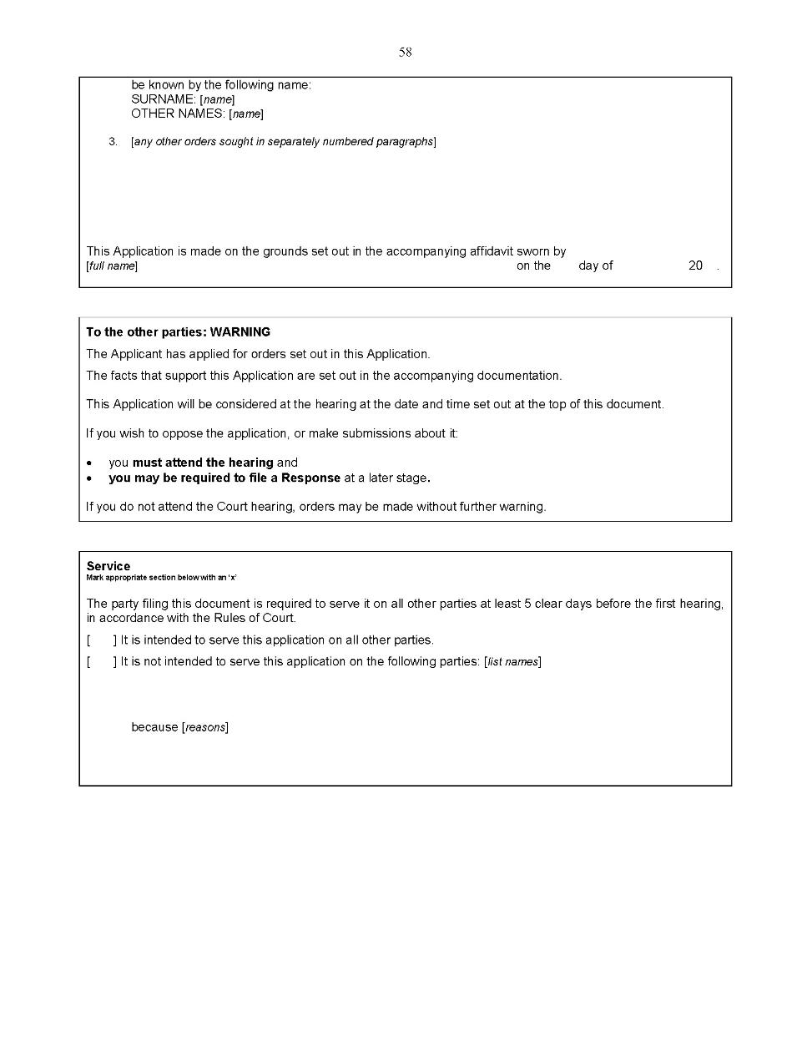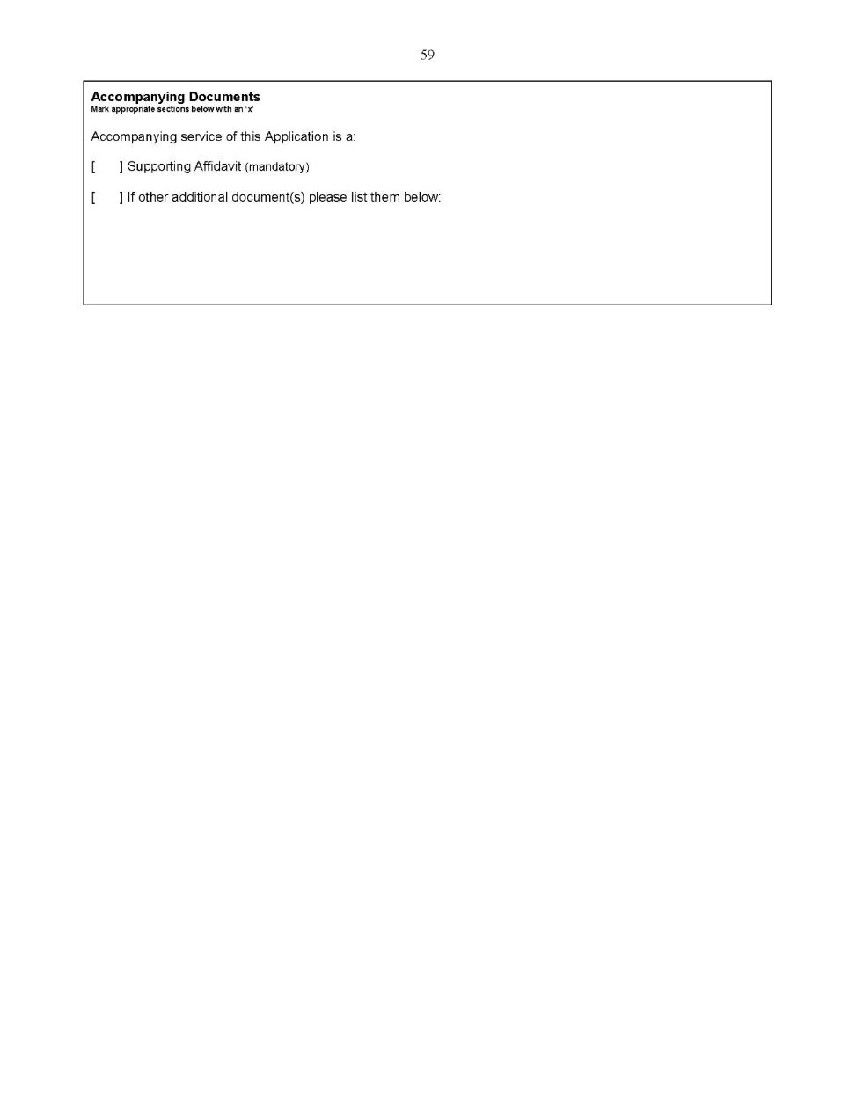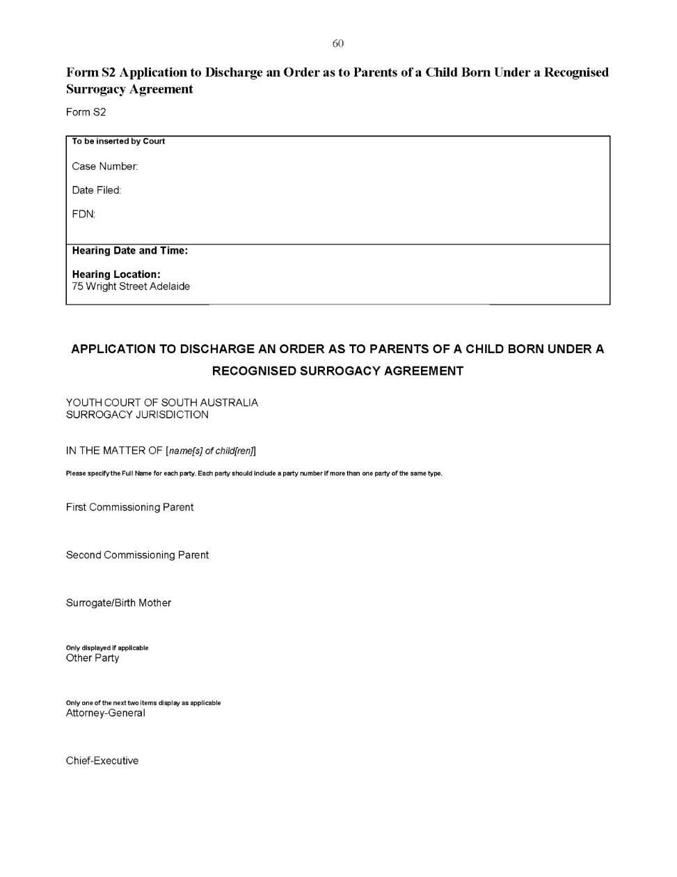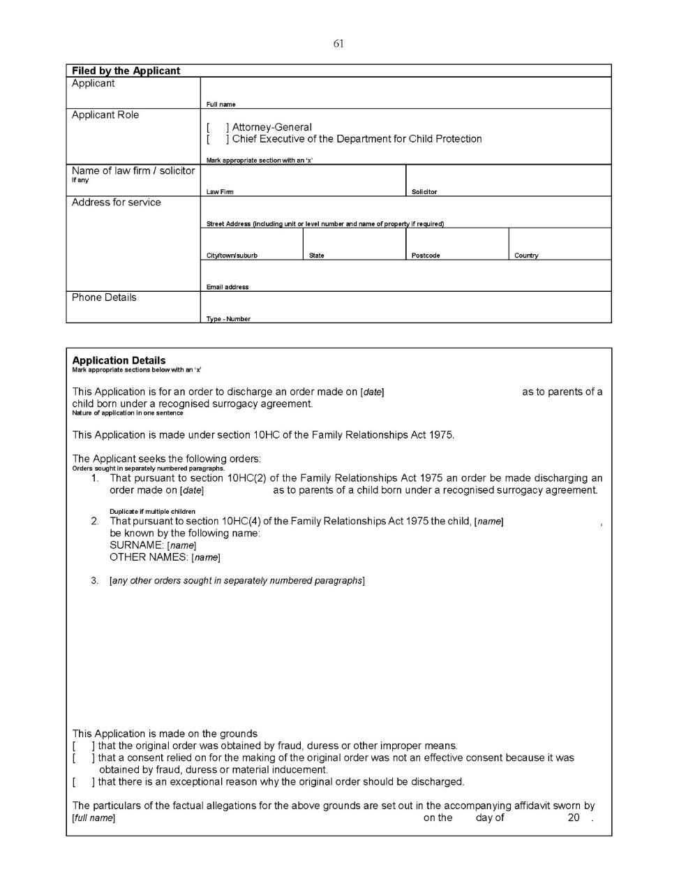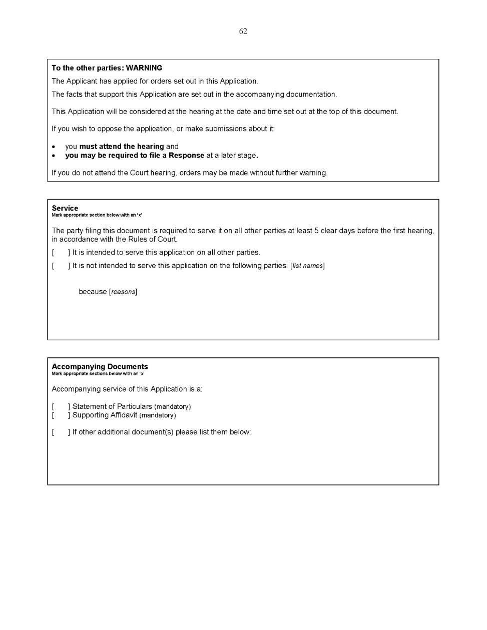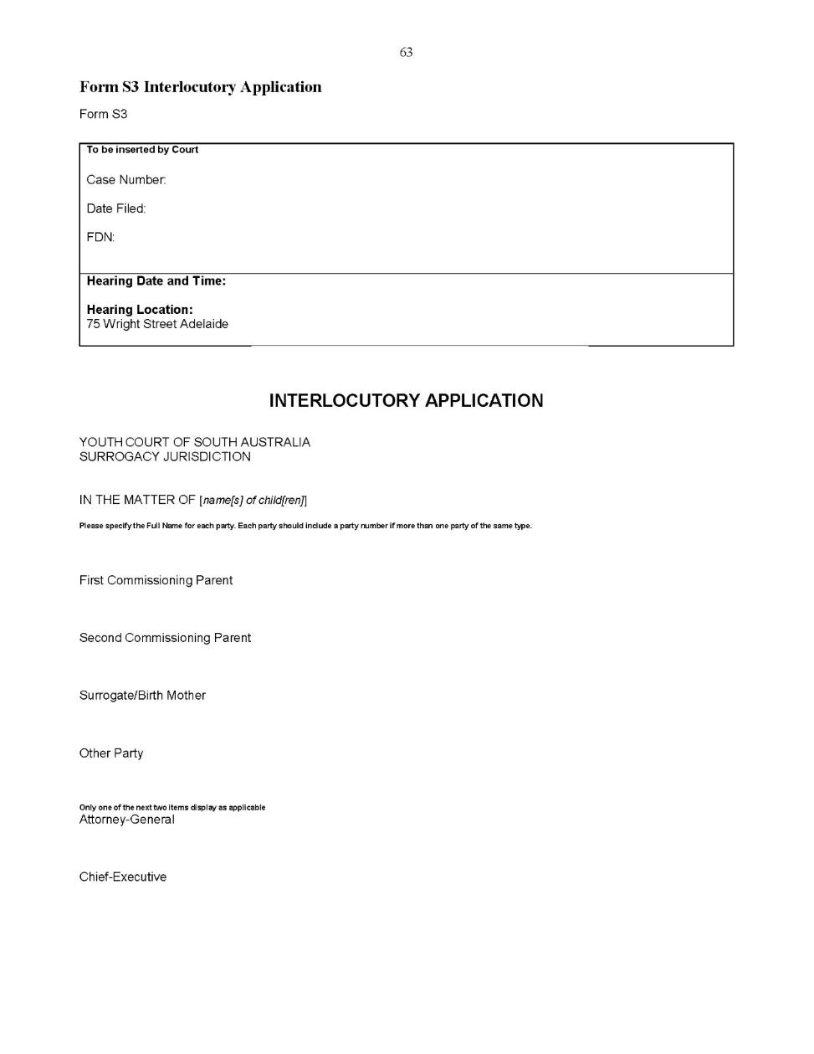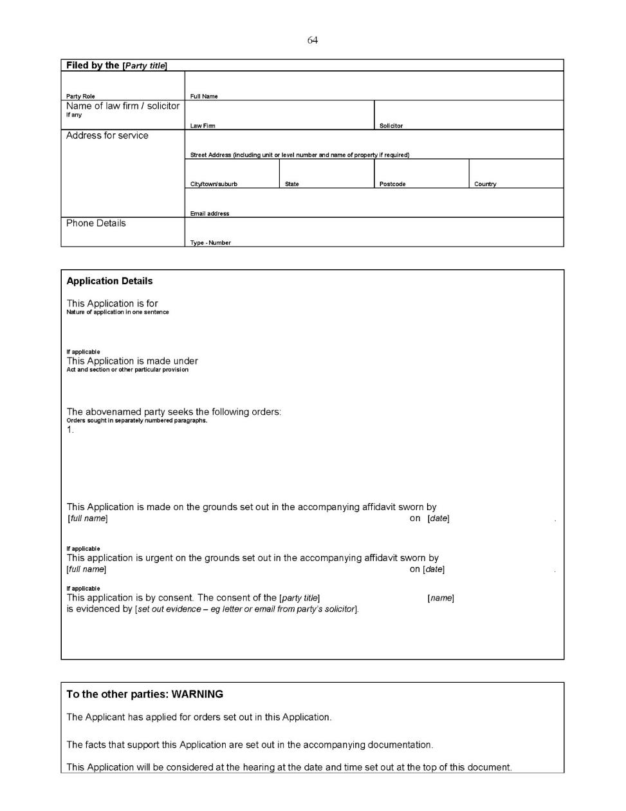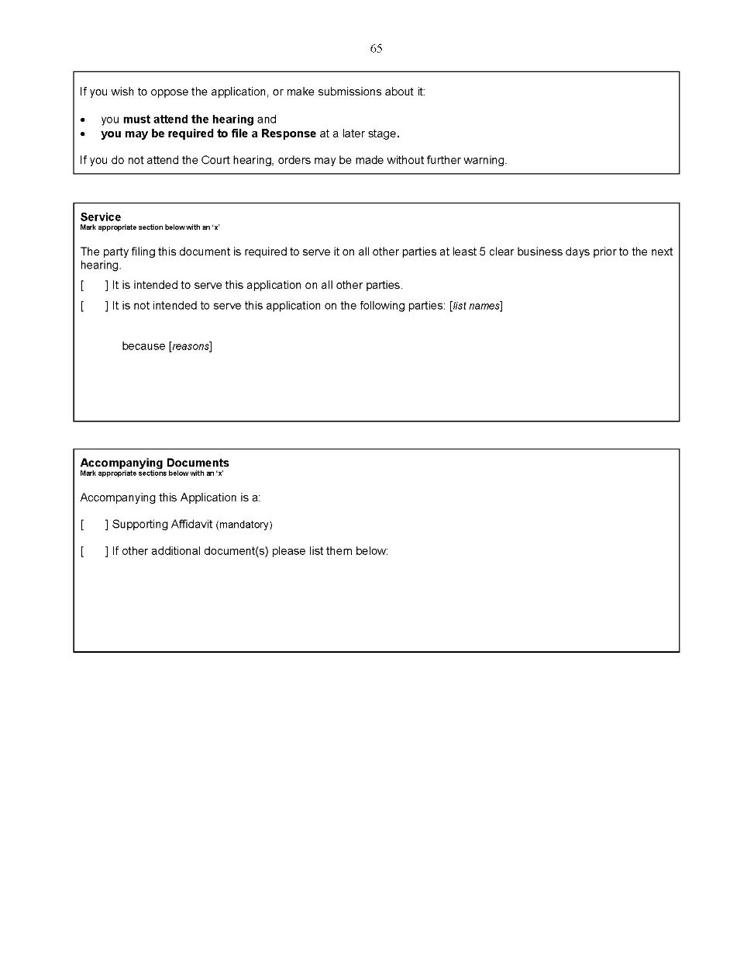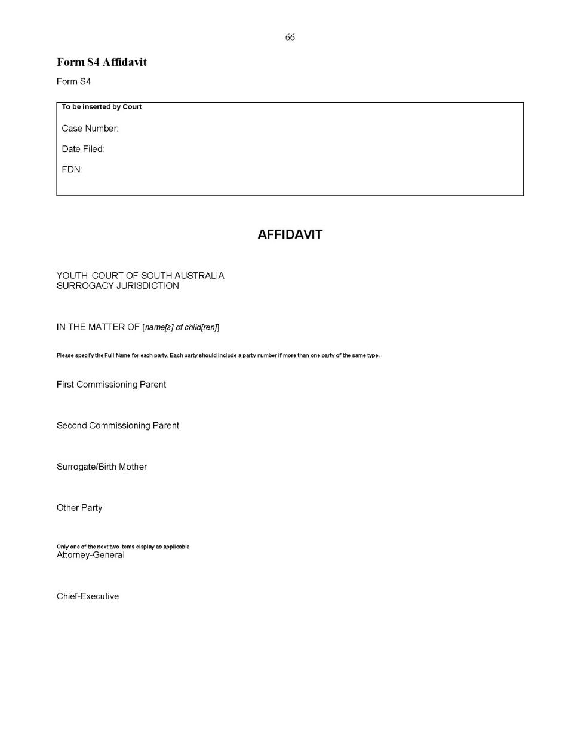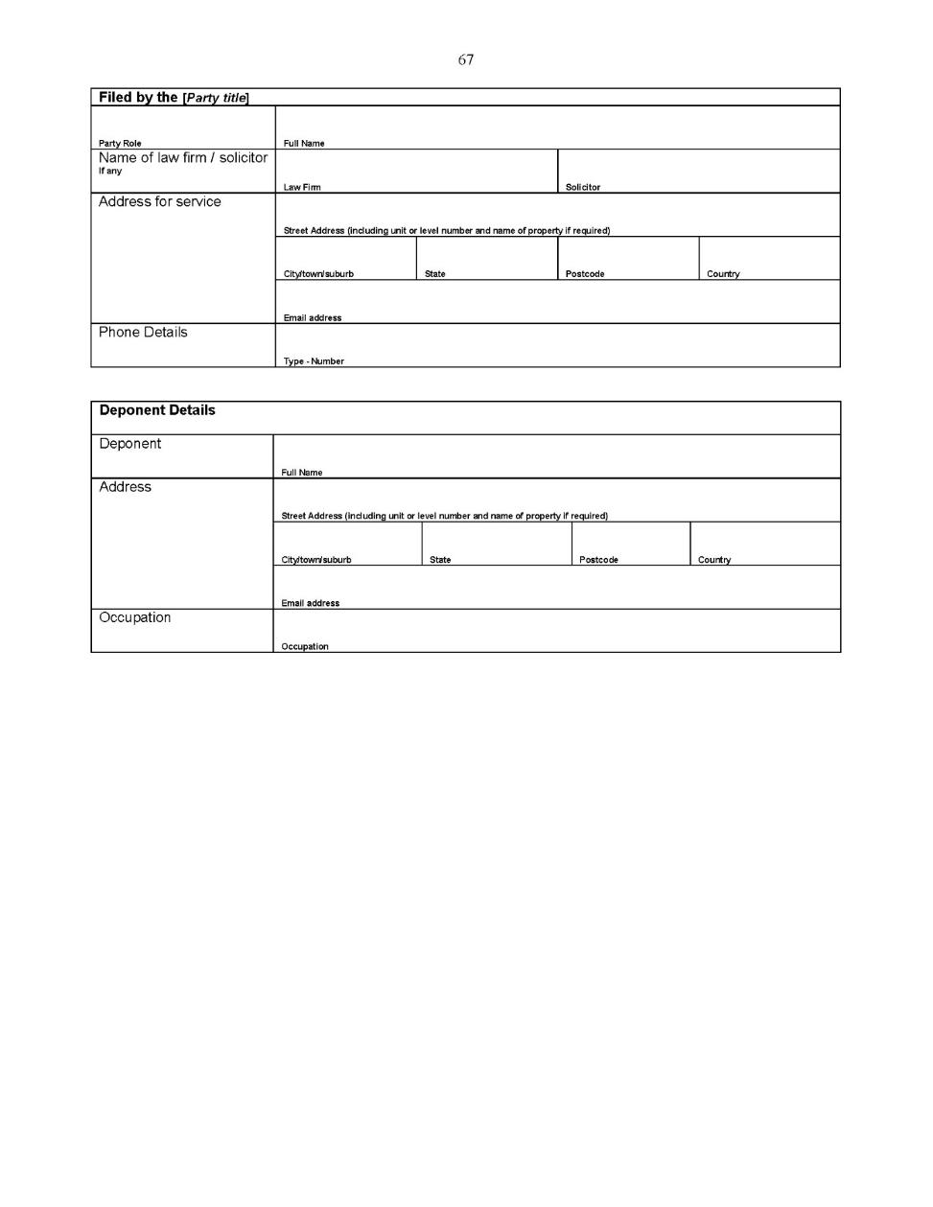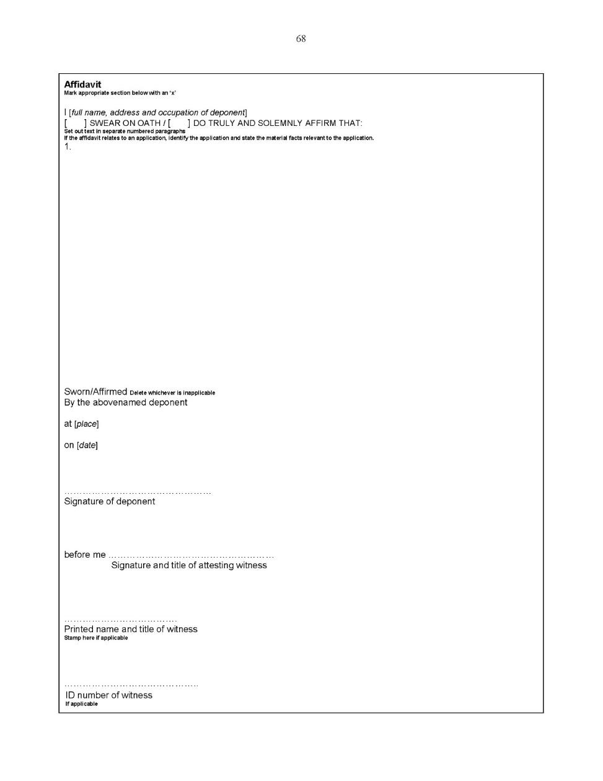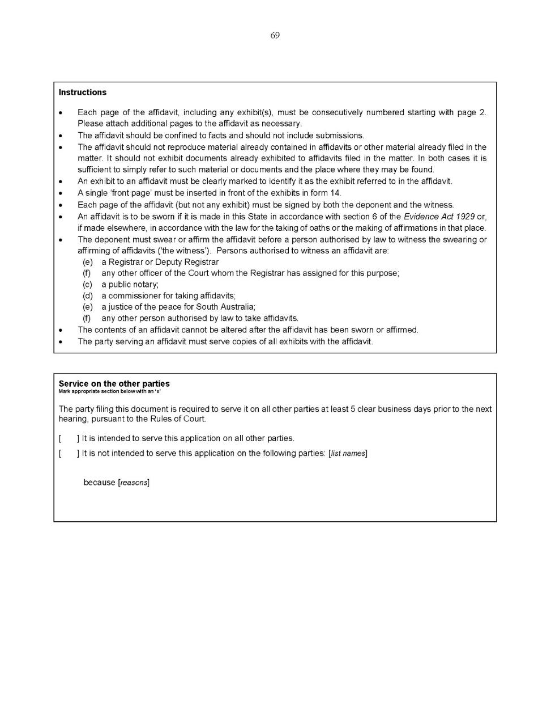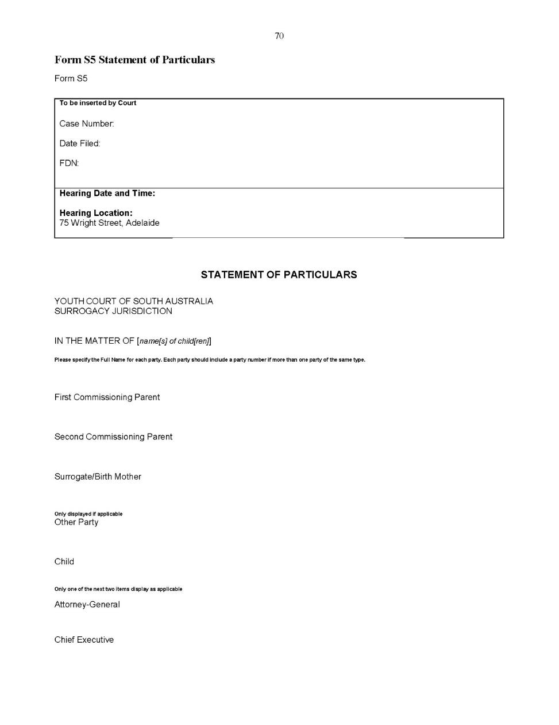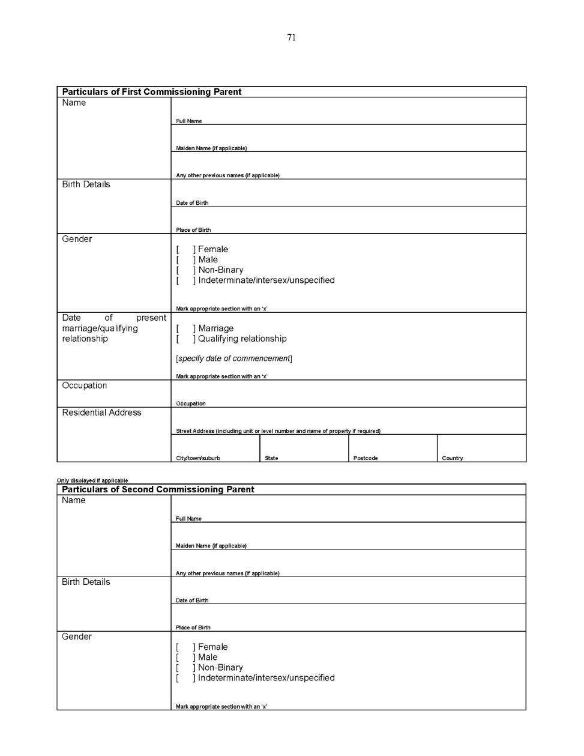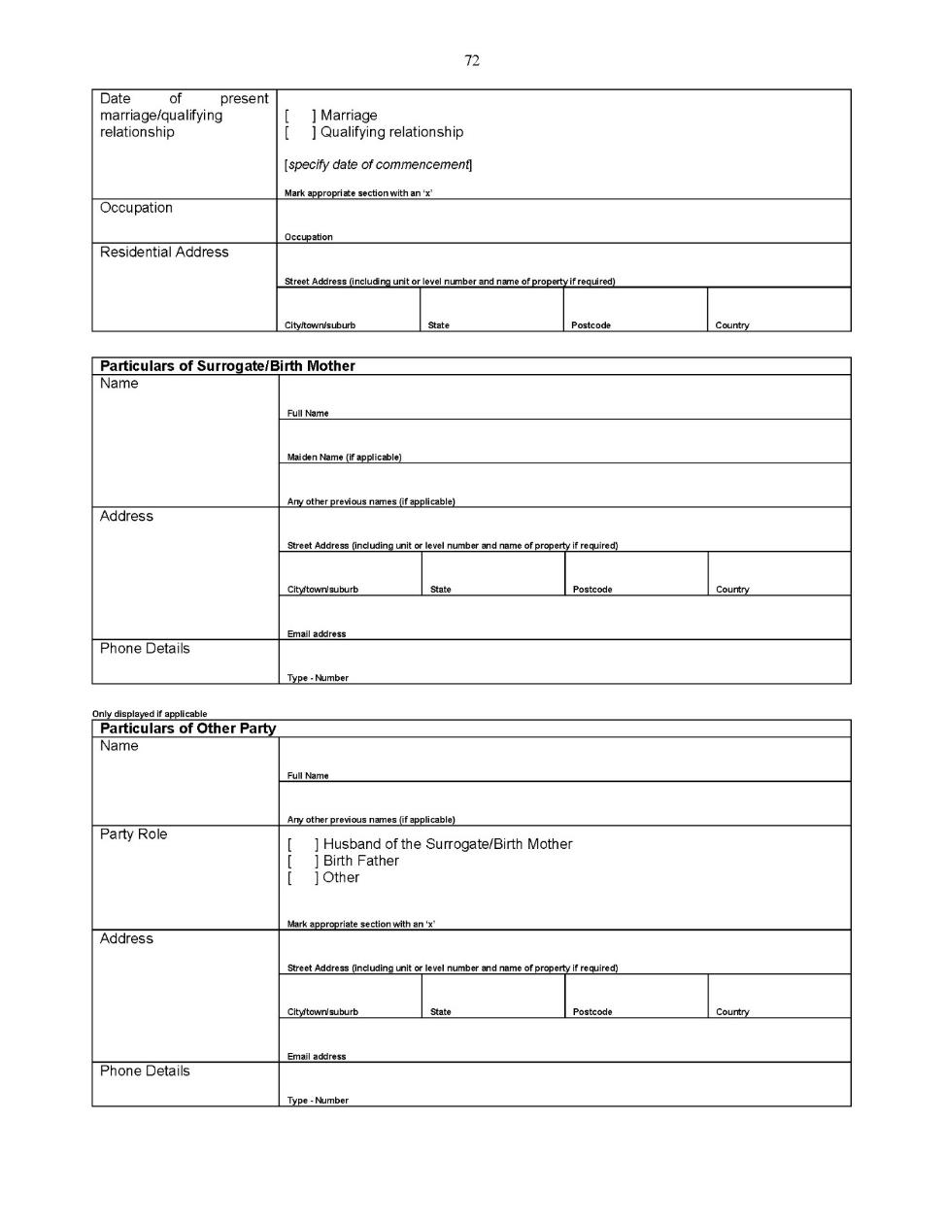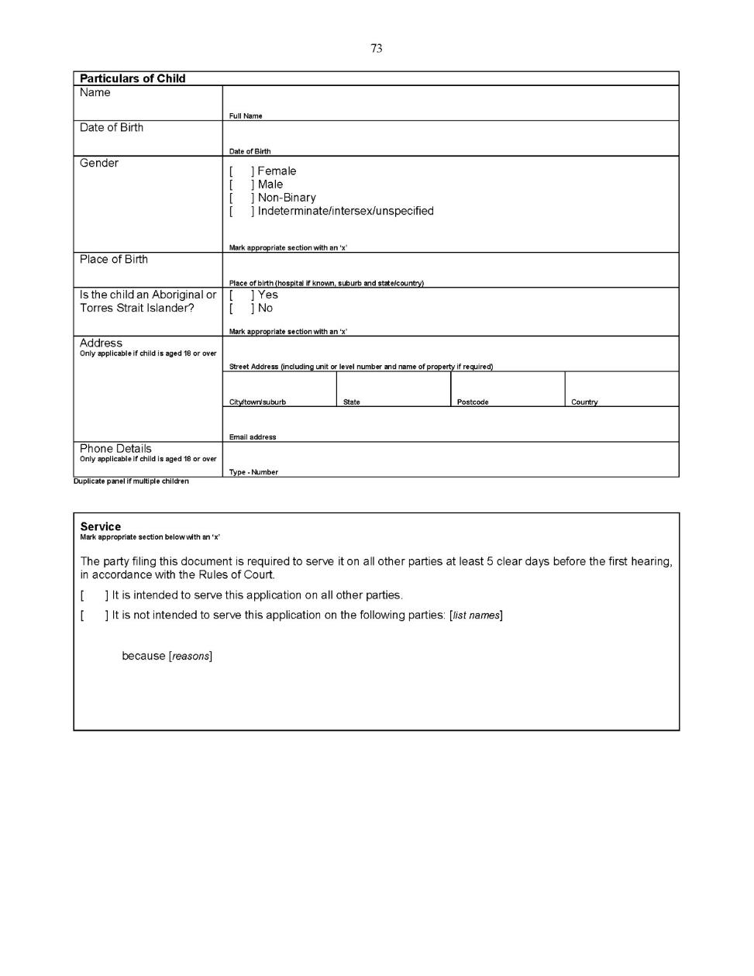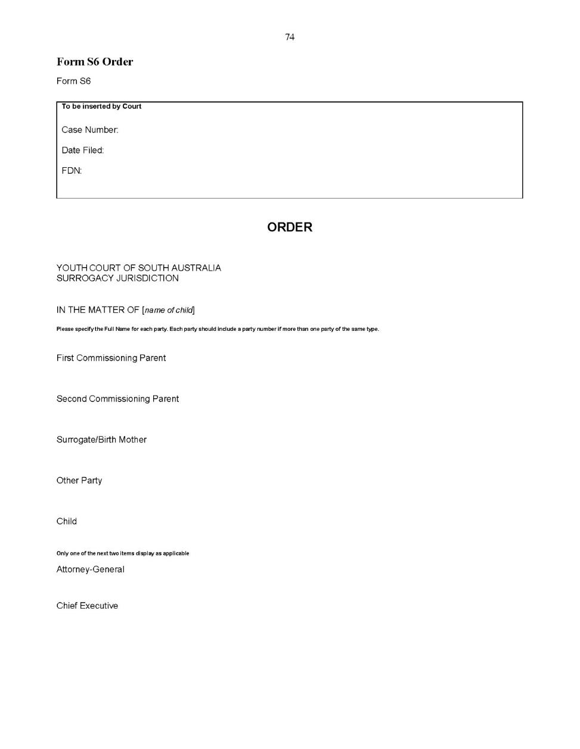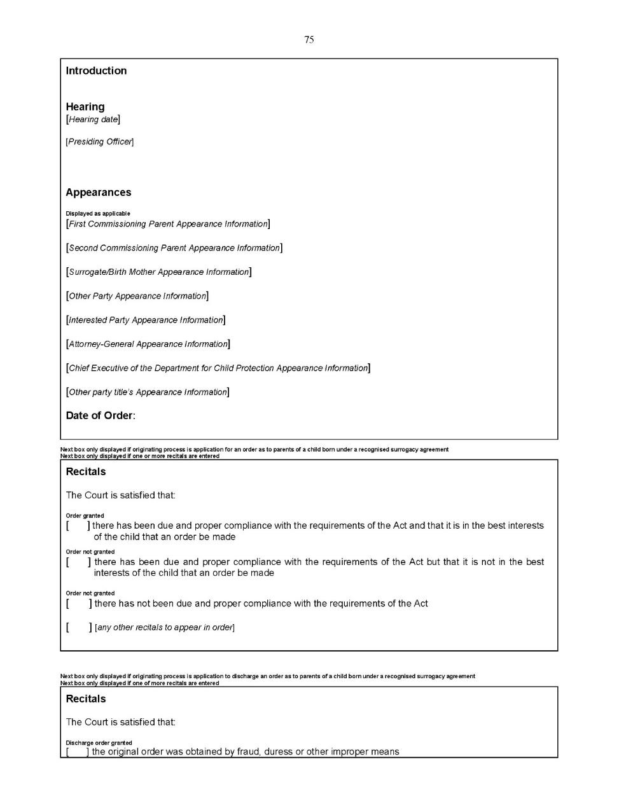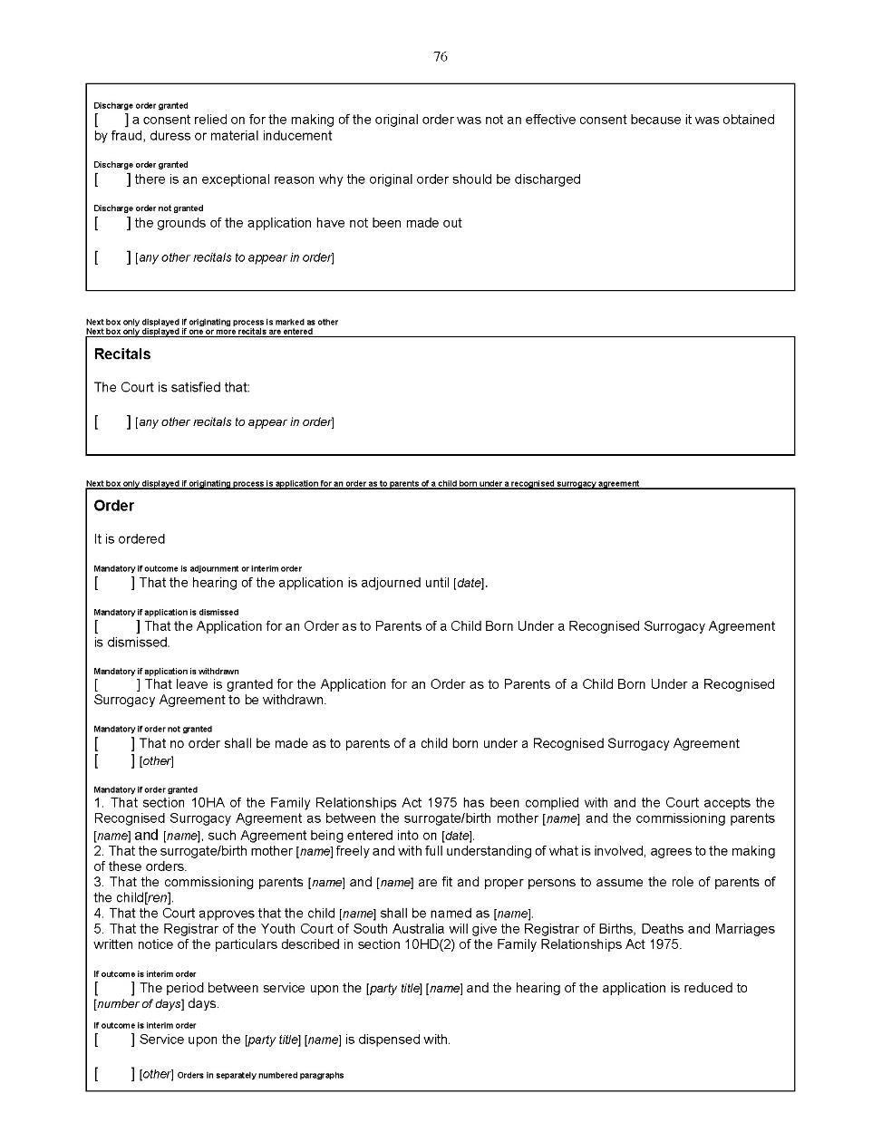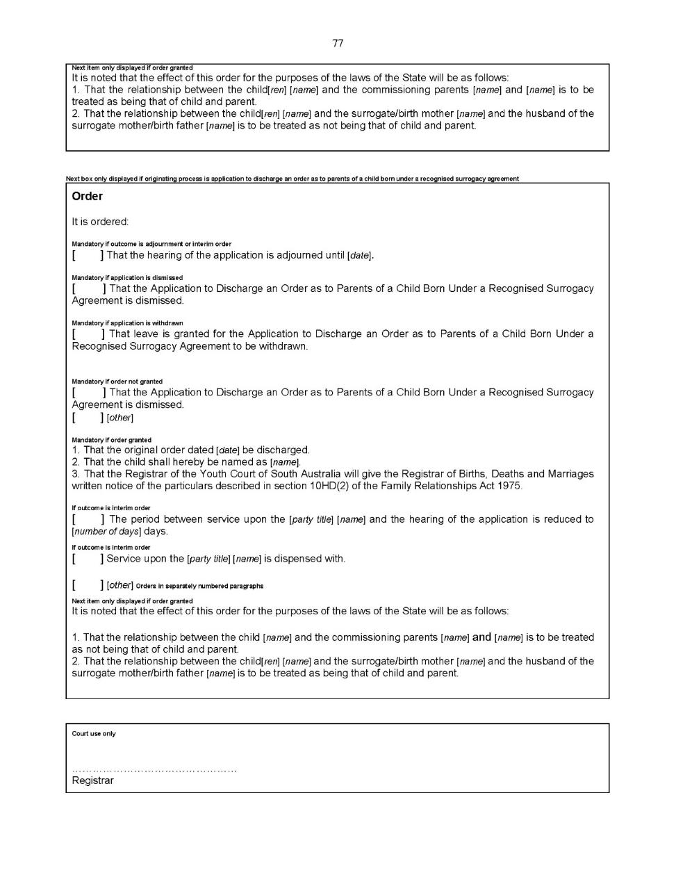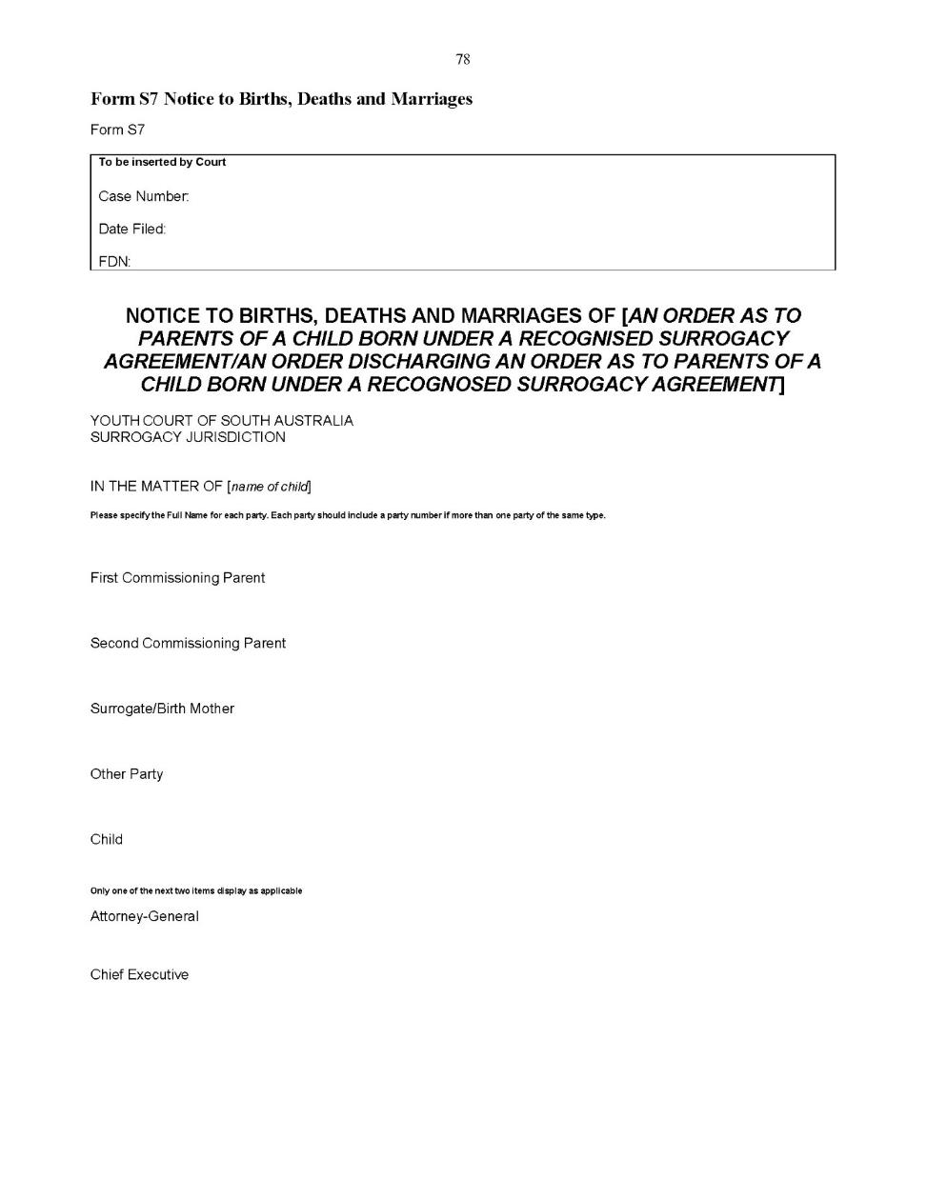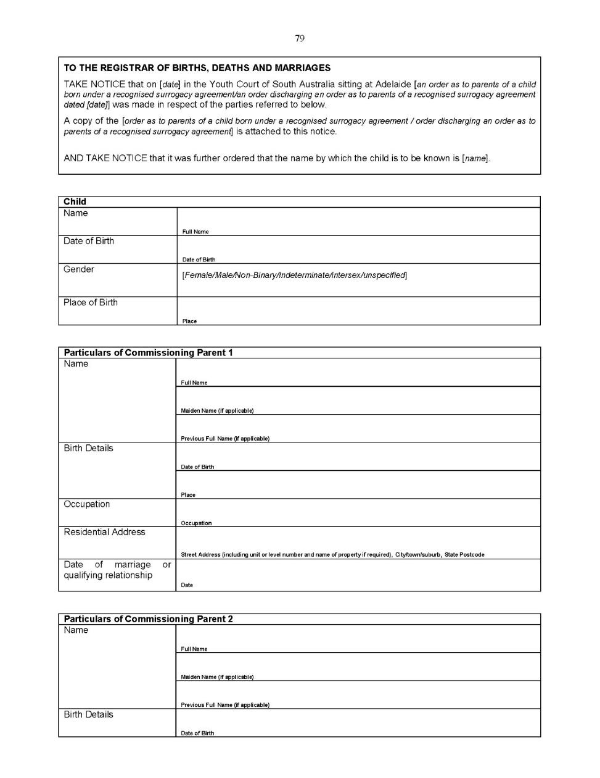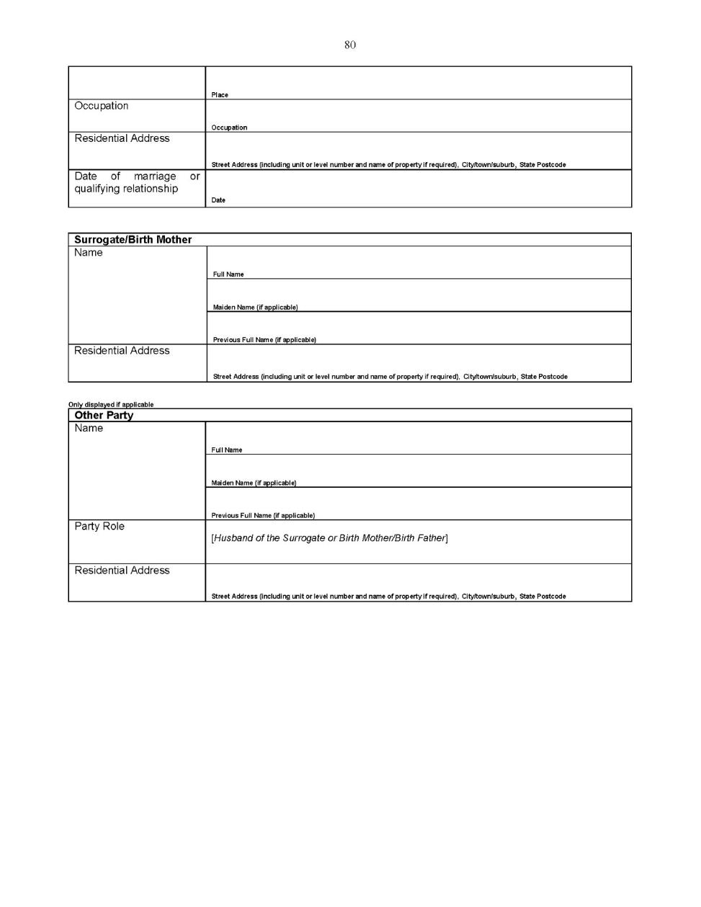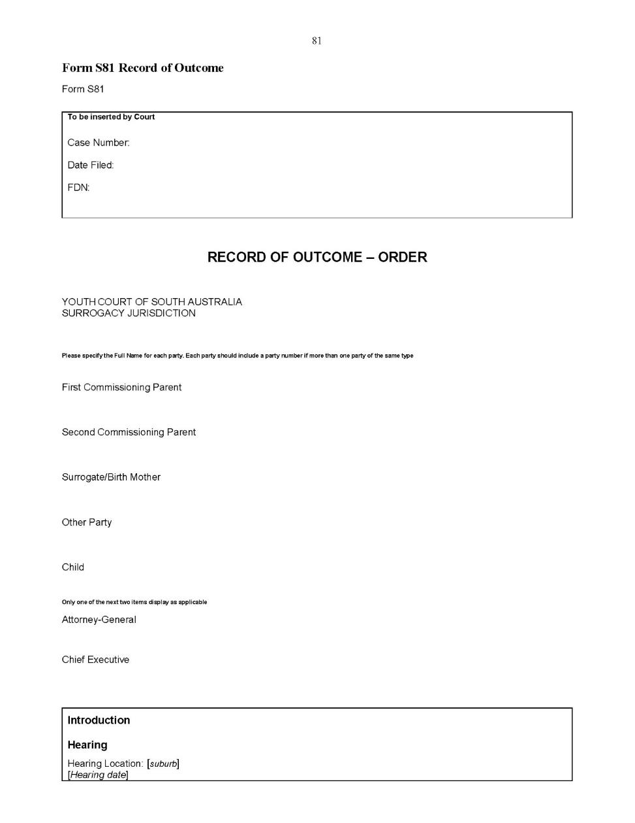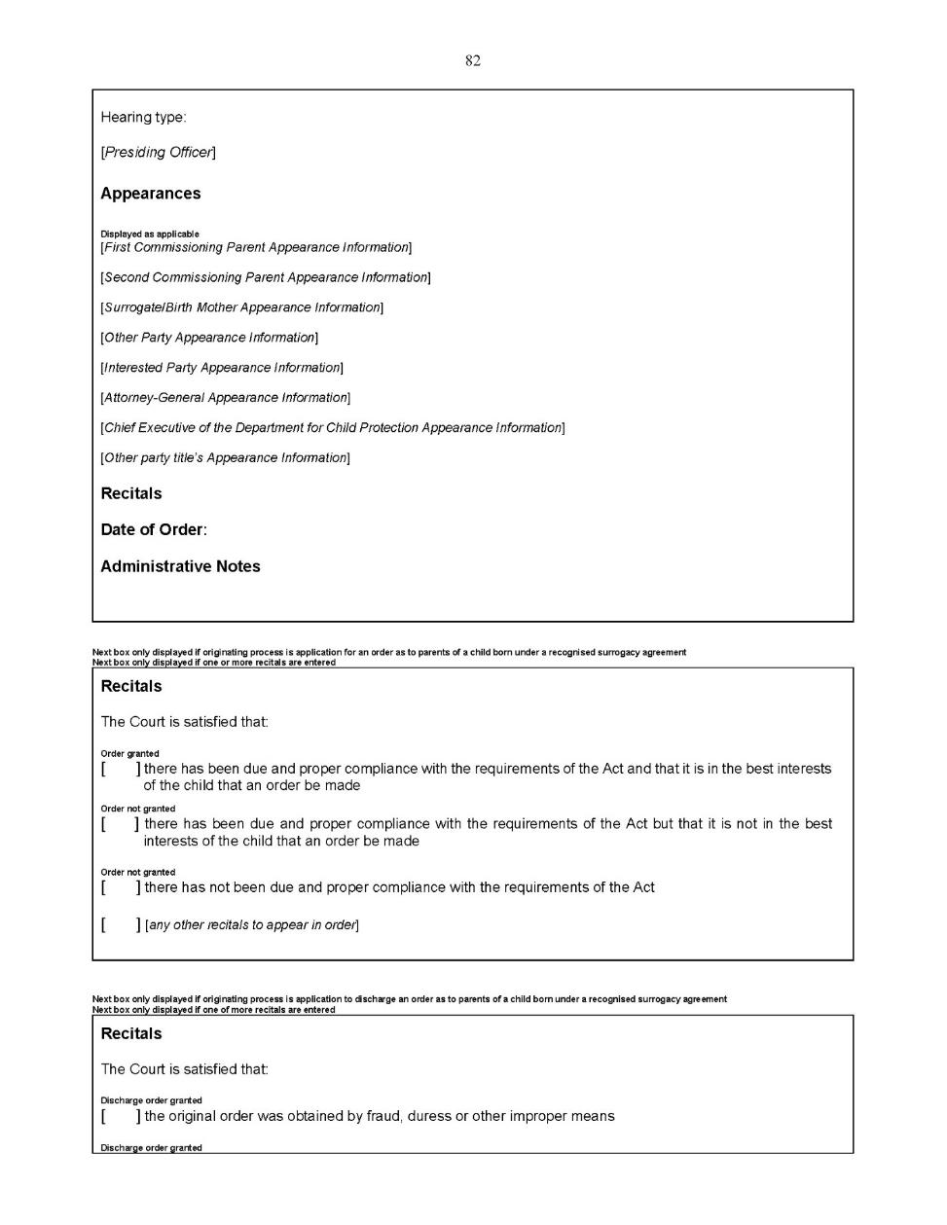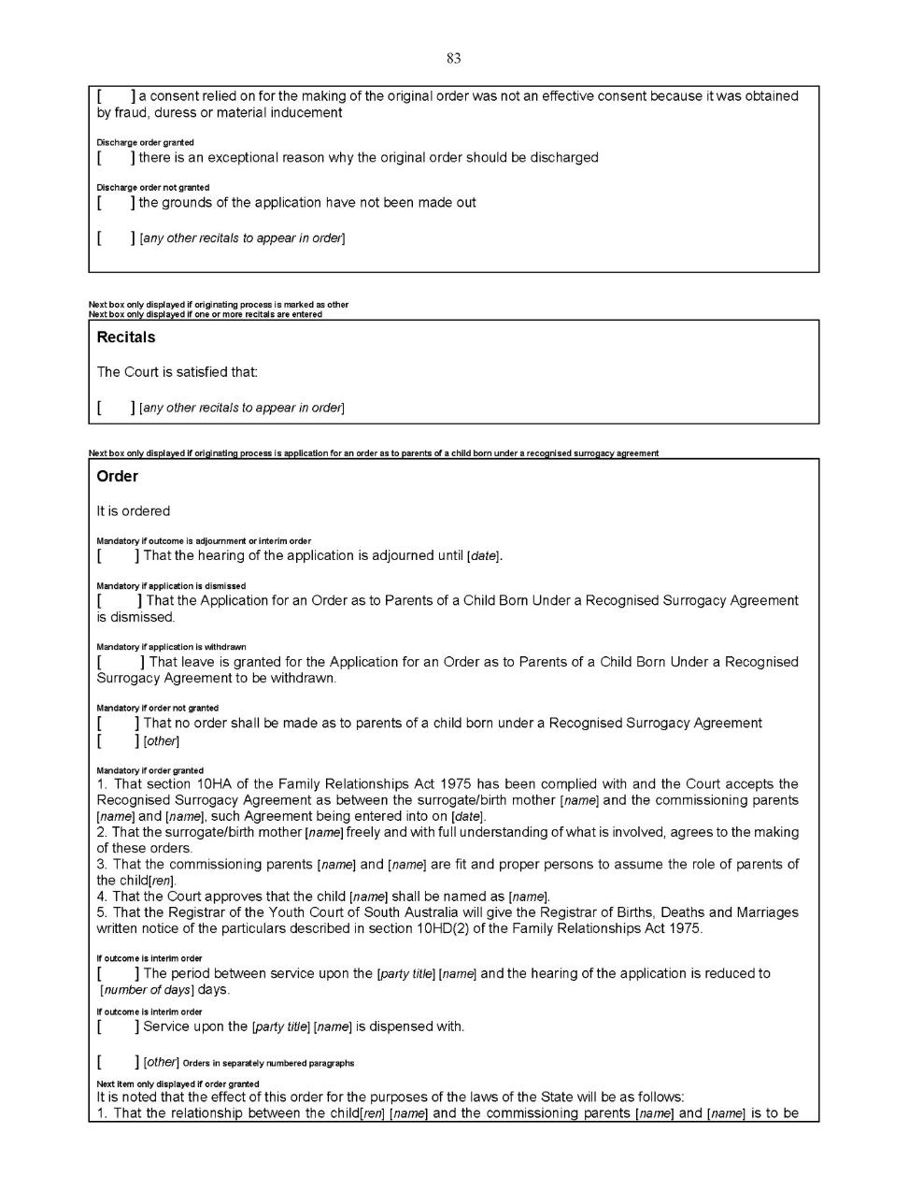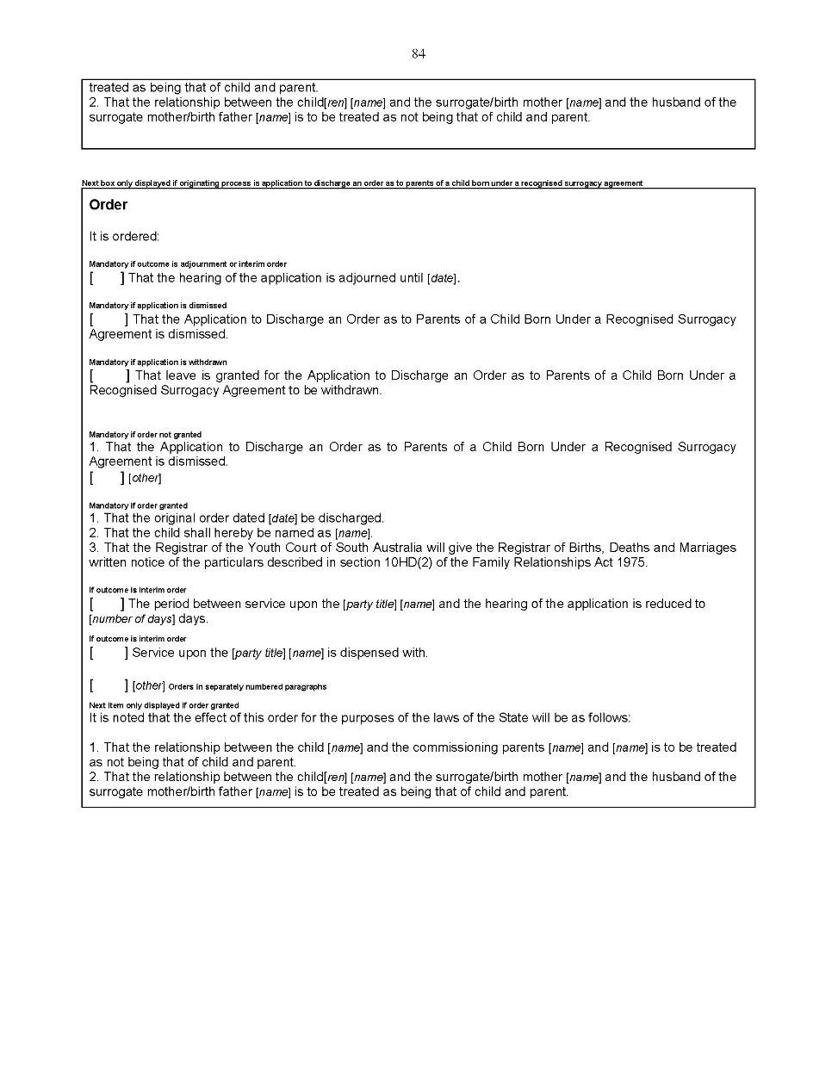

Dated: 8 May 2020
Eldridge P.
Davis L.
White D.
Koehn O.

Youth Court (Adoption) Rules 2018
South Australia

Amendment No 1
By virtue and in pursuance of section 32 of the Youth Court Act 1993 and all other enabling powers, we, the Judge of the Court and the Magistrates who are members of the principal judiciary of the Court, make the following Youth Court (Adoption) Rules 2018 (Amendment No 1).
- These Rules may be cited as the Youth Court (Adoption) Rules 2018 (Amendment No 1).
- The Youth Court (Adoption) Rules 2018 are amended as set out below.
- These rules come into effect—
(a) subject to subrule (b), on the date of their publication in the Gazette;
(b) if these rules are published in the Gazette on a day other than a Monday, these rules come into effect on the date that is the first Monday following that publication.
- In these Rules, the commencement date means the date on which these rules come into effect under rule 3.
- Unless the Court otherwise orders—
(a) the Youth Court (Adoption) Rules 2018 as amended by these Rules (the current Rules) apply to—
(i) a proceeding commenced; and
(ii) a step in a proceeding taken,
on or after the commencement date; and
(b) the Youth Court (Adoption) Rules 2018 before they were amended by these Rules (the former Rules) continue to govern a step in a proceeding taken before the commencement date.
- If the time to commence or take a step in a proceeding under the former Rules has not expired as at the commencement date, the time to commence or take a step in the proceeding continues to be governed by the former Rules (unless the current Rules provide for a longer time).
- Rule 4 is amended by adding the following sentence at the end of the rule:
“The adoption jurisdiction of the Court is also governed by the Youth Court (General) Rules 2016.”
- Rule 6 is deleted.
- ‘Rule 7 – Forms’ is re-numbered ‘Rule 6 – Forms.’
- Rule 8 is re-numbered to ‘Rule 7’, deleted and the following rule is substituted:
“7—Adoption application
An application to the Court under section 8 of the Adoption Act 1988 must be made in the prescribed form set out in Schedule 1.
Prescribed form—
Form A1 Originating Application – Adoption Order”
- ‘Rule 9 – Service’ is re-numbered to ‘Rule 8 – Service.’
- Rule 10 is re-numbered to ‘Rule 9’, deleted and the following rule is substituted:
“9—Application to dispense with consent
An application to the Court under section 18 of the Adoption Act 1988 must be made in the prescribed form set out in Schedule 1, accompanied by a supporting affidavit in the prescribed form.
Prescribed forms—
Form A8 Application for an Order of the Court
Form A5 Affidavit”
- A new rule 9A is inserted immediately after rule 9 as follows:
“9A—Application to dispense with or recognise the validity of consent before application for adoption order made
An application to the Court by the Chief Executive under section 19(1) of the Adoption Act 1988 must be made in the prescribed form set out in Schedule 1, accompanied by a supporting affidavit in the prescribed form.
Prescribed forms—
Form A7 Application to Dispense with or Recognise the Validity of Consent
Form A5 Affidavit”
- ‘Rule 11 – Discharge Application’ is re-numbered to ‘Rule 10 – Discharge Application.’
- Rule 10(1) is deleted and the following rule is substituted:
“10—Discharge application
(1) An application to the Court for the discharge of an adoption order under section 14 of the Adoption Act 1988 must be made in the prescribed form set out in Schedule 1.
Prescribed form—
Form A2 – Application to Discharge an Adoption Order”
- Rule 12 is re-numbered to ‘Rule 11’, deleted and the following rule is substituted:
“11—Material supporting applications—other requirements
(1) An application to the Court as referred to in rule 11 must also be supported by an affidavit in the prescribed form that sufficiently sets out the evidence on which the application is based.
Prescribed form—
Form A5 Affidavit
(2) Leave to file further material may be sought orally and at any stage of the proceedings and, unless the Court allows or directs otherwise, served on the other parties at least 5 business days before the next date for the hearing of the proceedings.”
- ‘Rule 13 – Service’ is re-numbered to ‘Rule 12 – Service.’
- ‘Rule 14 – Investigations’ is re-numbered to ‘Rule 13 – Investigations.’
- Rule 15 is re-numbered to ‘Rule 14’, deleted and the following rule is substituted:
“14—Application for recognition of international adoption order
An application to the Court under section 21(2) of the Adoption Act 1988 for the recognition of an international adoption order must be made in the prescribed form set out in Schedule 1.
Prescribed form—
Form A3 Originating Application – Recognition of an Adoption Order Made Outside Australia”
- A new rule 14A is inserted immediately after rule 15 as follows:
“14A—Other Applications
Any other application, other than an interlocutory application, not specifically addressed by rules 7 to 15 is to be made in the prescribed form set out in Schedule 1.
Prescribed form—
Form A8 Application for an Order of the Court”
- ‘Rule 17 – Representation of party under 18 years’ is re-numbered to ‘Rule 16 – Representation of party under 18 years.’
- A new rule 16A is inserted immediately after rule 16 as follows:
“16A—Responses
(1) This rule applies to any application to the Court other than—
(a) an interlocutory application; or
(b) an application of a kind excluded from the application of this rule by the Court by practice direction.
(2) A party to an application who opposes the application in whole or part must file a response in the Court, and serve the response on the other parties, at least 5 business days before the scheduled date for hearing in relation to the application.
(3) A response to an application must—
(a) be in the prescribed form set out in Schedule 1; and
(b) state clearly the order or orders sought in the application that are opposed and any order that is not opposed; and
(c) if an order is proposed as an alternative to an order sought in the application, indicate that clearly, and specify the proposed order and which order it would replace; and
(d) in relation to each ground of the application, state whether the ground is—
(i) admitted; or
(ii) disputed; or
(iii) not admitted, but not disputed for the purposes of the determination of the application; and
(e) in relation to each separate particular of a factual allegation in the application, state whether the particular is—
(i) admitted; or
(ii) disputed; or
(iii) not admitted, but not disputed for the purposes of the determination of the application; and
(f) if a ground or particular is disputed, state briefly the manner in which the ground or particular is disputed.
Prescribed form—
Form A6 Response
(4) A response should be supported by material that provides evidence of the respondent's version of events or of any matter relevant to the determination of the application.
(5) Material in support of a response may be in the form of—
(a) affidavits (including annexures); or
(b) expert reports; or
(c) chronologies of significant events; or
(d) subject to a direction of the Court, other documentary evidence.
(6) Material in support of a response provided under this rule must be filed in the Court and, unless the Court directs otherwise, served on the other parties, at least 5 business days before the first hearing in relation to the application.
(7) After the expiration of the period that applies under subrule (6), material in support of a response may only be filed in the Court with leave and on such terms or conditions as the Court directs.
(8) Leave to file further material may be sought orally and at any stage of the proceedings and, unless the Court allows or directs otherwise, served on the other parties at least 2 business days before the next date for the hearing of the proceeding.
(9) The Court will make such determinations based on the contents of a response, or the failure to file a response, as the Court considers appropriate, and proceed accordingly, subject to the provisions of the Adoption Act 1998.”

- A new rule 16B is inserted immediately after new rule 16A as follows:
“16B—Interlocutory applications
(1) This rule does not apply to an application of a kind excluded from the application of the rule by the Court by practice direction.
(2) An interlocutory application is to be in the prescribed form set out in Schedule 1, accompanied by an affidavit in the prescribed form evidencing the grounds on which the application is being made.
Prescribed forms—
Form A4 Interlocutory Application
Form A5 Affidavit
(3) Nothing prevents an interlocutory application from being combined with an application for a final order of the Court.
(4) The applicant must serve a copy of the application (and accompanying documents) on the other parties as soon as practicable after it is filed in the Court, but not later than 2 business days before the next date for the hearing of the proceedings.
(5) However, service on another party is not required if the application does not affect the interests of the other party.
(6) The Court may, on conditions the Court considers appropriate, dispense with a requirement of this rule—
(a) if the urgency of the case requires; or
(b) by consent of the parties; or
(c) if for any other reason the Court considers it appropriate to do so.
(7) The Court may determine an interlocutory application without hearing oral submissions from the parties if—
(a) the application is not contentious; or
(b) the Court decides on the application of a party to determine the application on the basis of written submissions.
(8) On an interlocutory application, the Court may give directions relating to the proceedings irrespective of whether the applicant has asked for such directions in the application.”
- ‘Rule 18 – Directions hearings’ is re-numbered to ‘Rule 17 – Directions hearings.’
- ‘Rule 19 – Proof of service’ is re-numbered to ‘Rule 18 – Proof of service.’
- Subrule 18(2) is deleted and the following subrule is substituted:
“(2) Proof of service of an application or document may consist of an affidavit in the prescribed form made by the person who served the application or document setting out—
(a) the date, time and place of service; and
(b) how the person to be served was identified; and
(c) how service was effected.
Prescribed form—
Form A5 Affidavit”
- ‘Rule 20 – Amendment of Youth Court (General) Rules 2016 ‘is re-numbered to ‘Rule 19 - Amendment of Youth Court (General) Rules 2016 .’
- The current Schedule to the Youth Court (Adoption) Rules 2018 is deleted and the following Schedule is substituted:

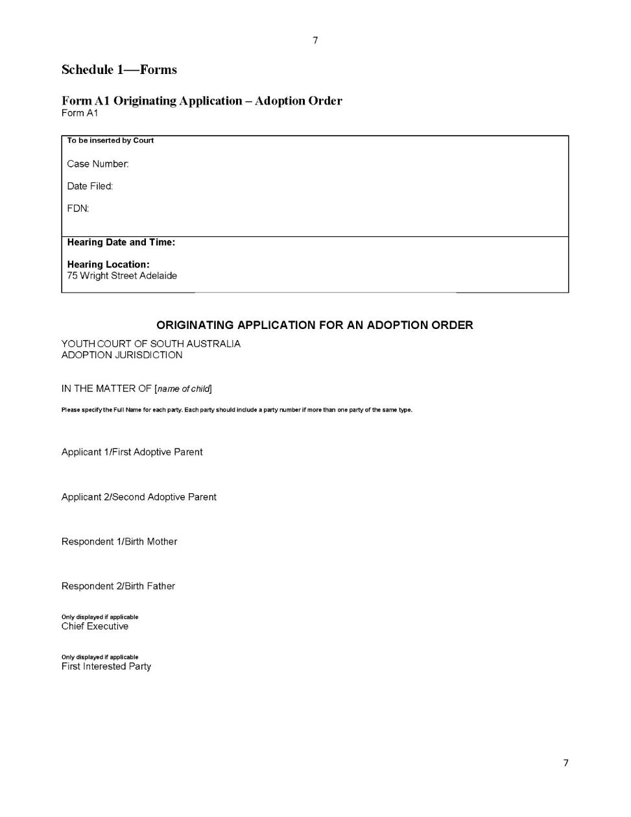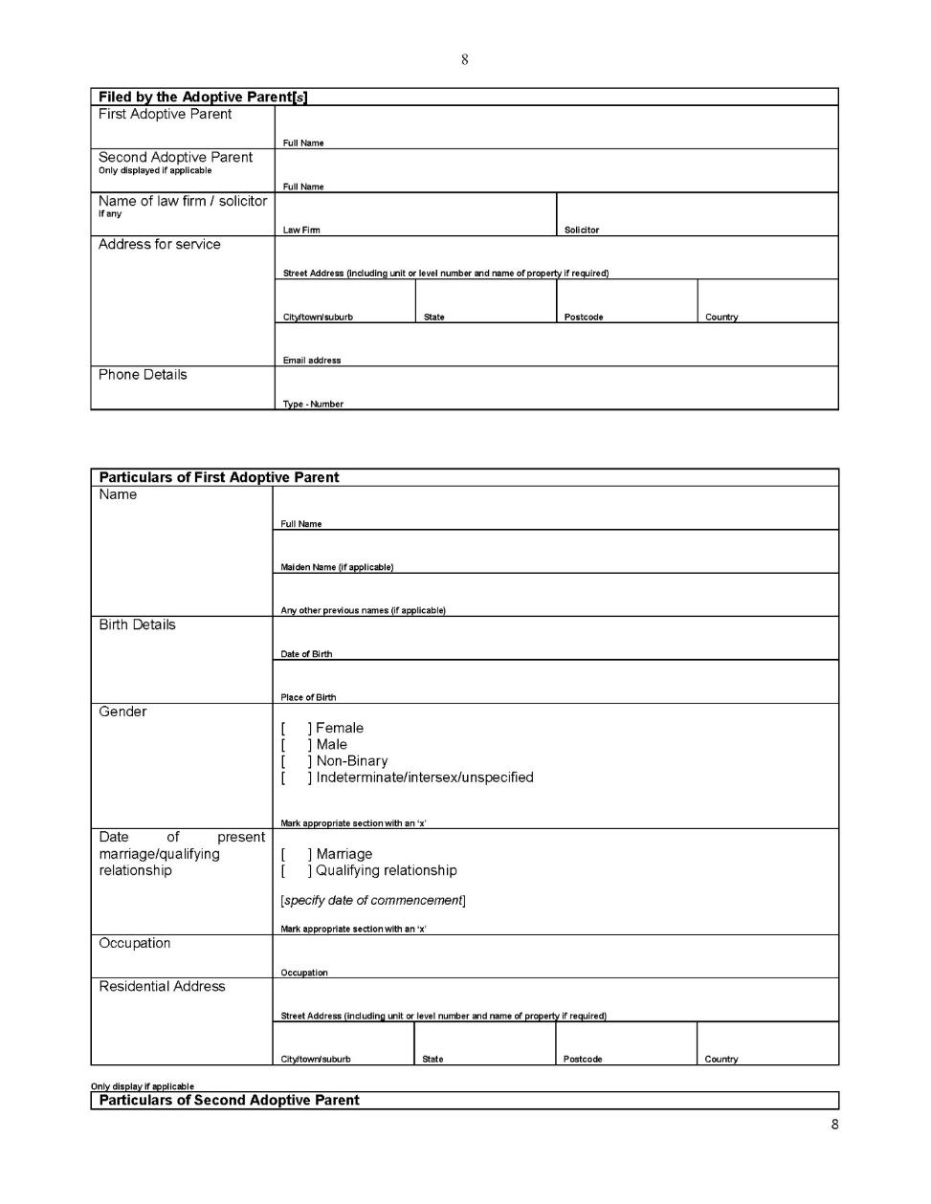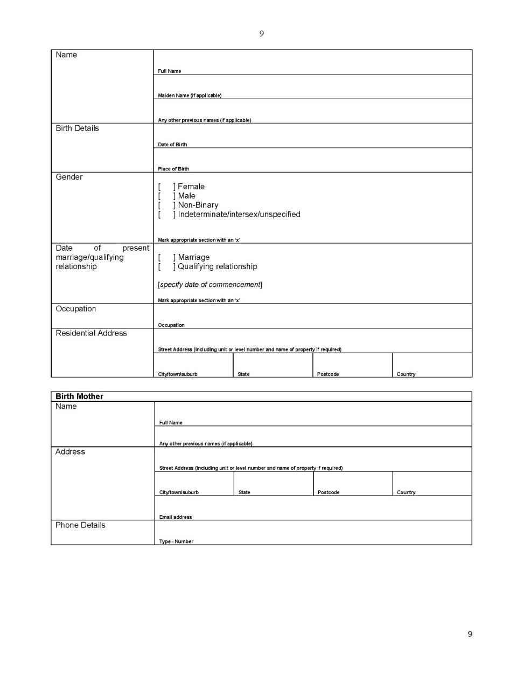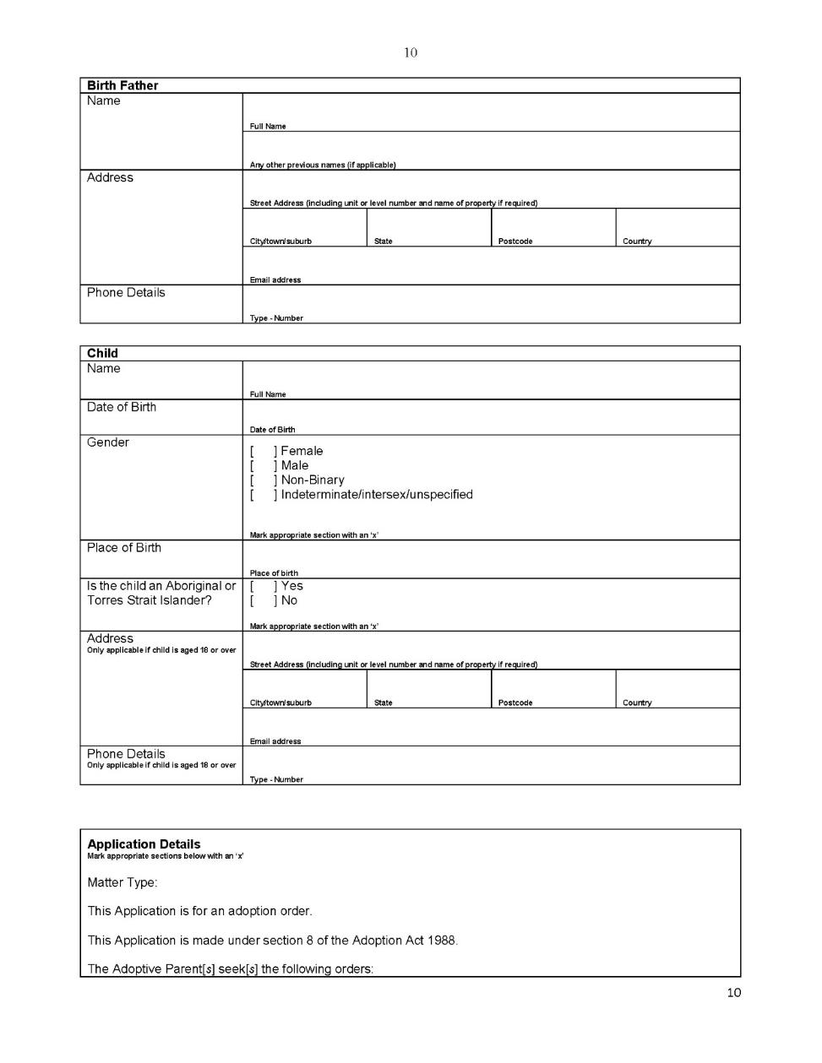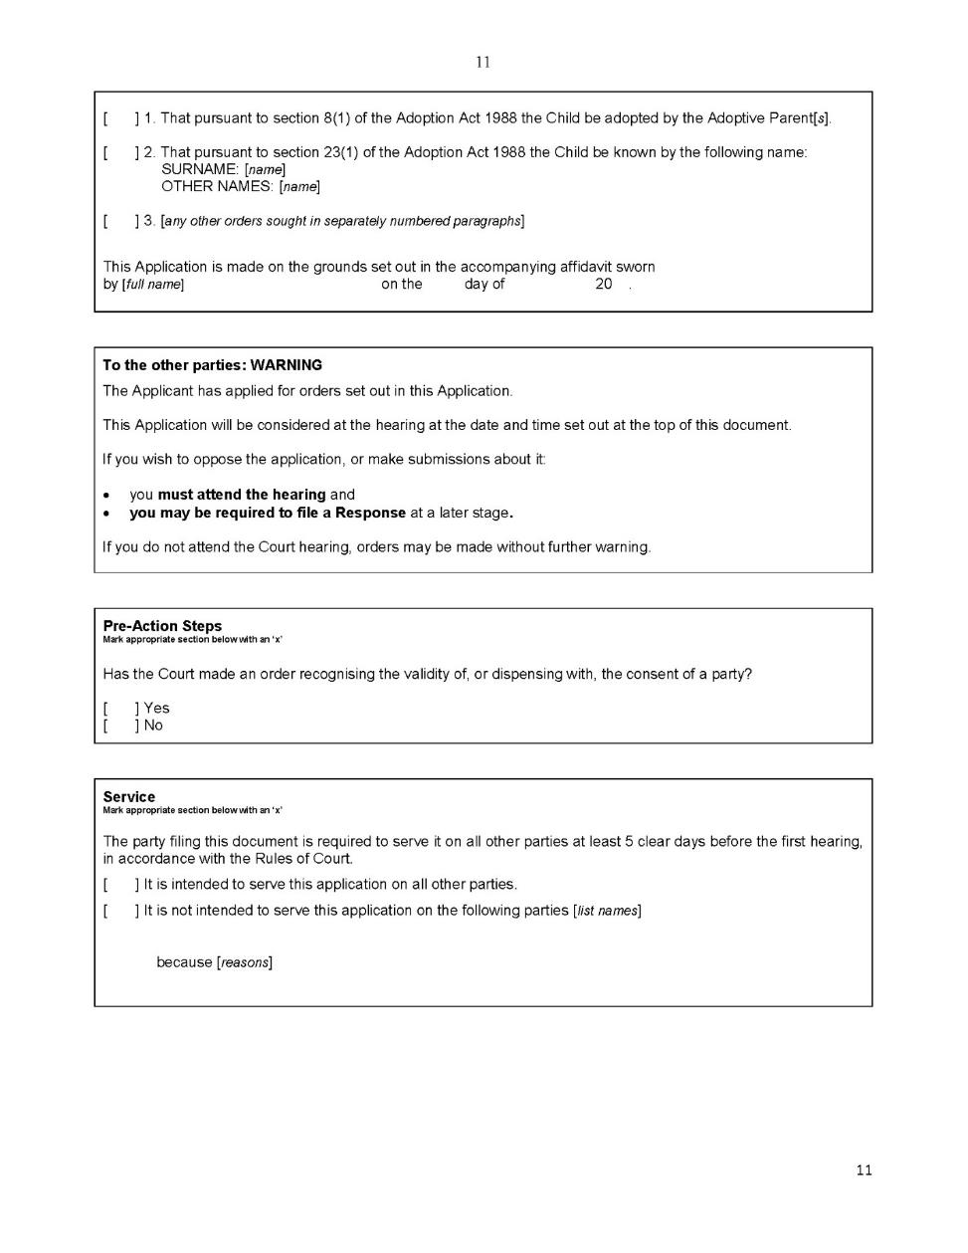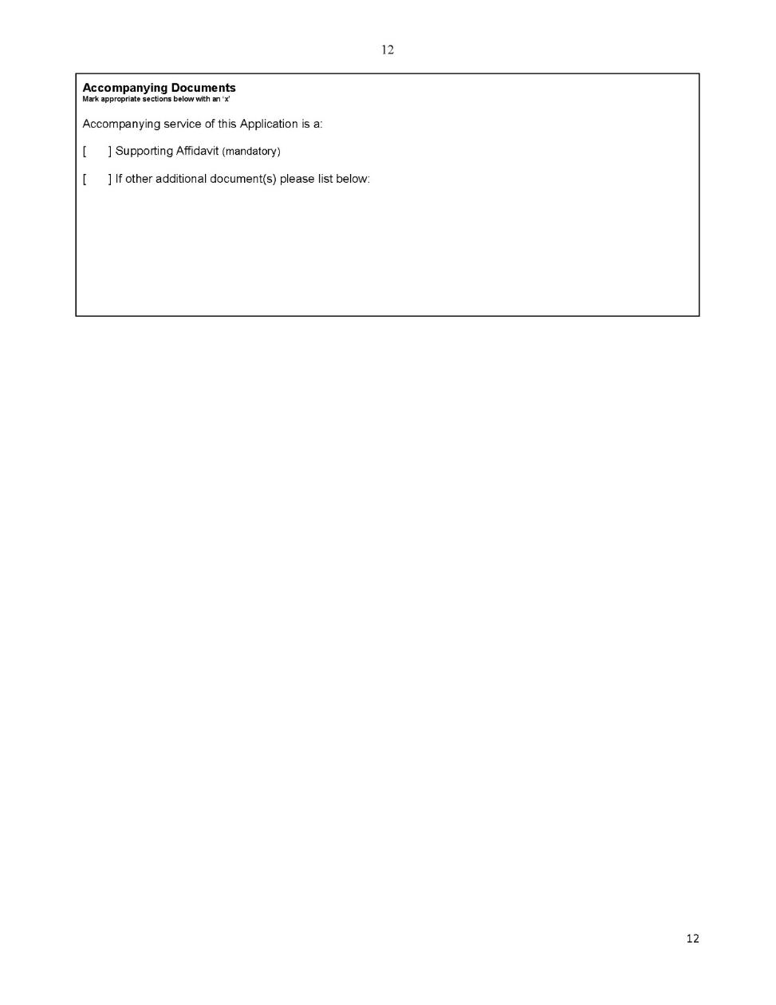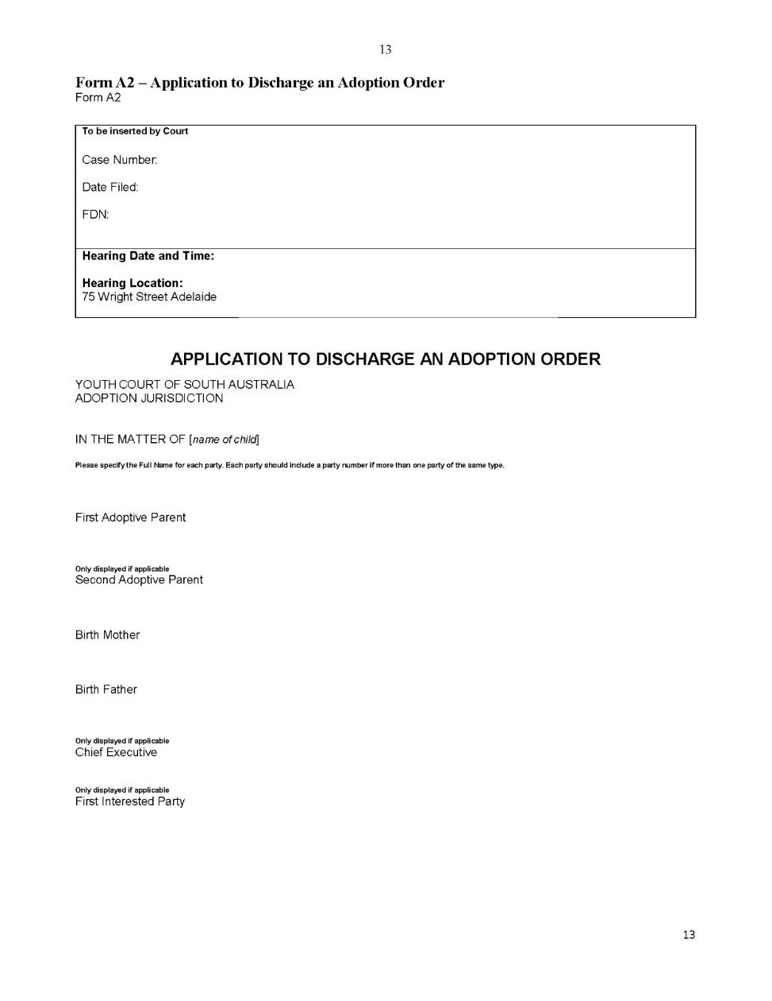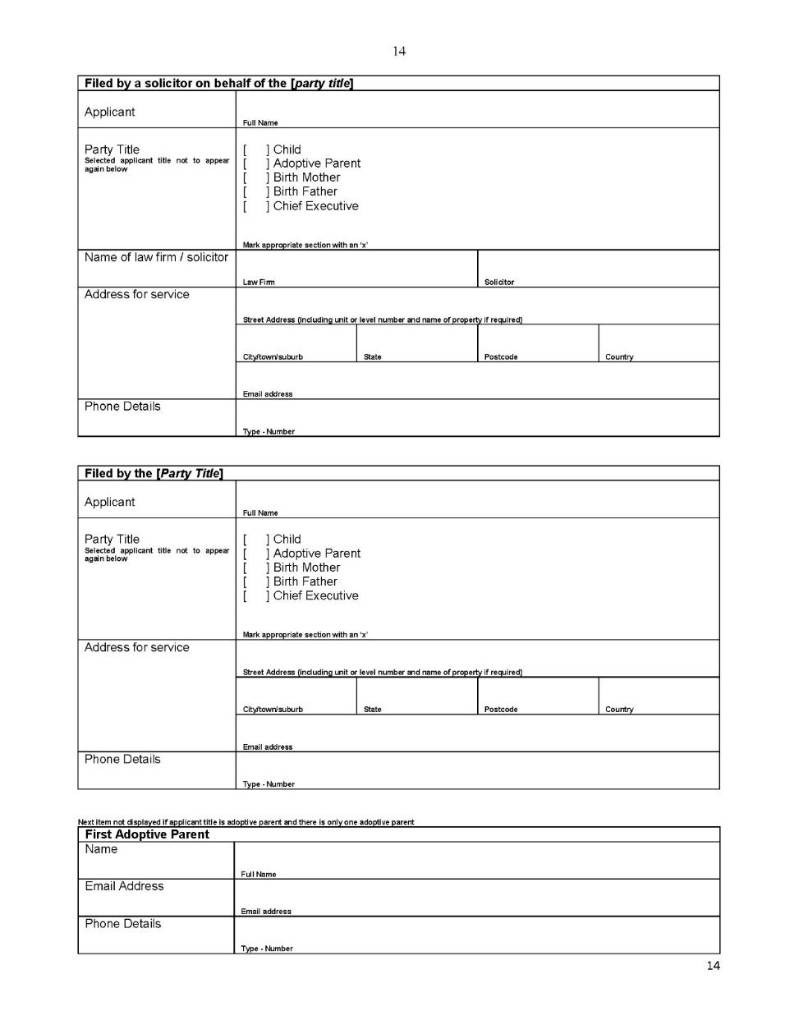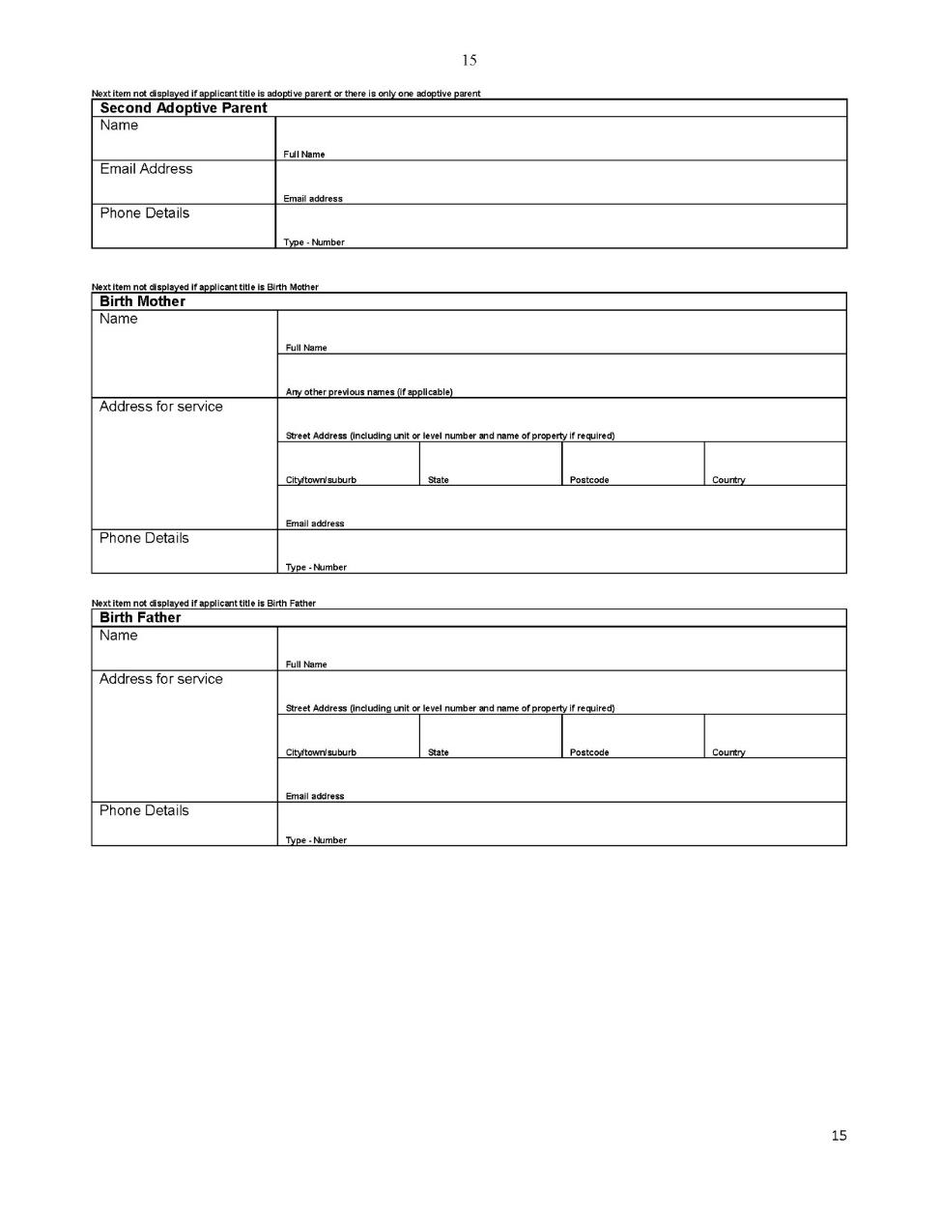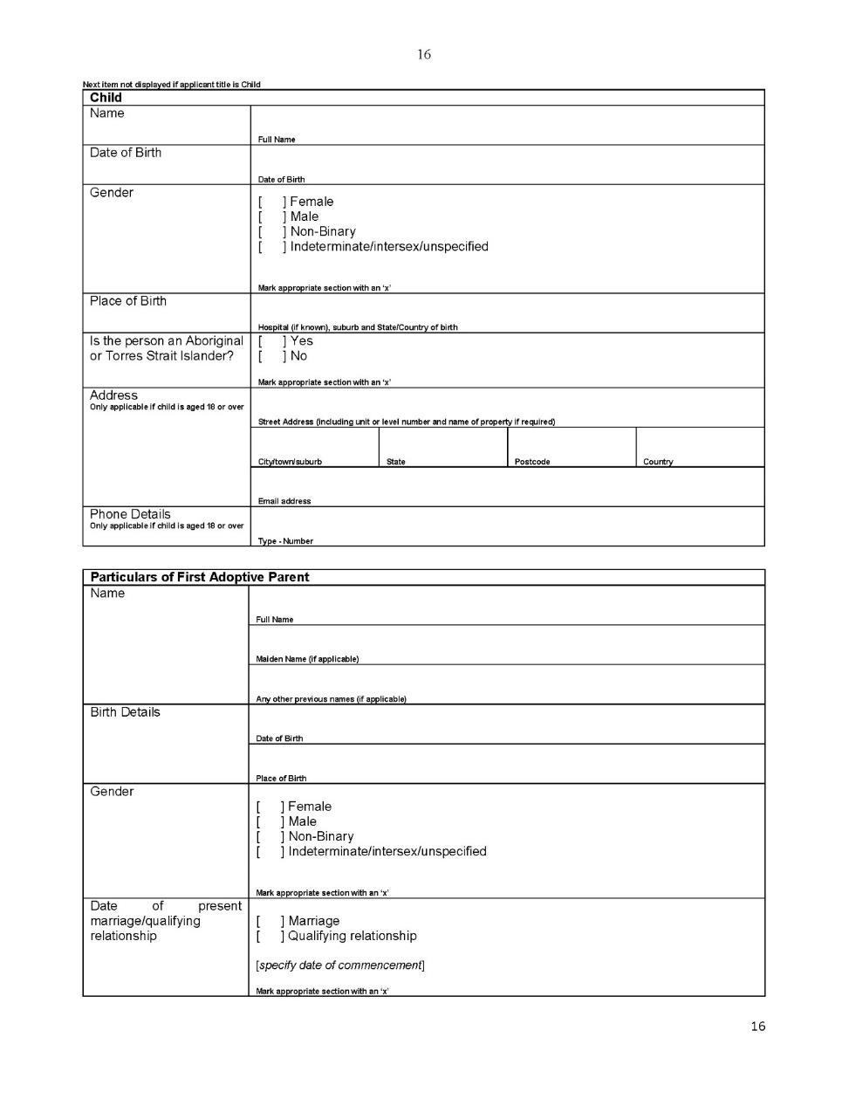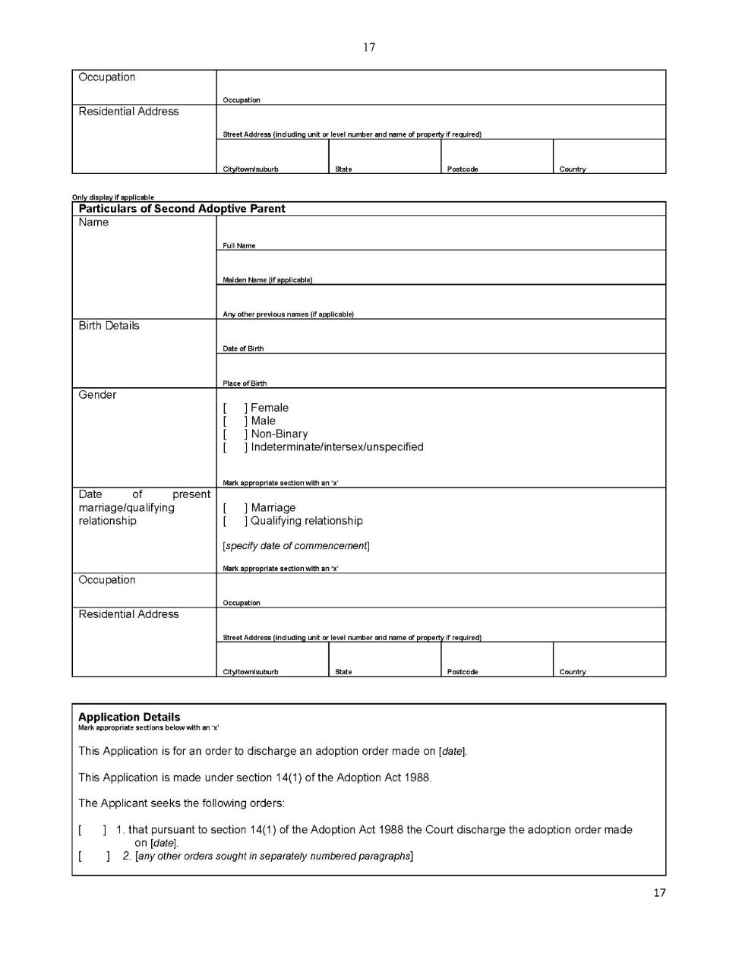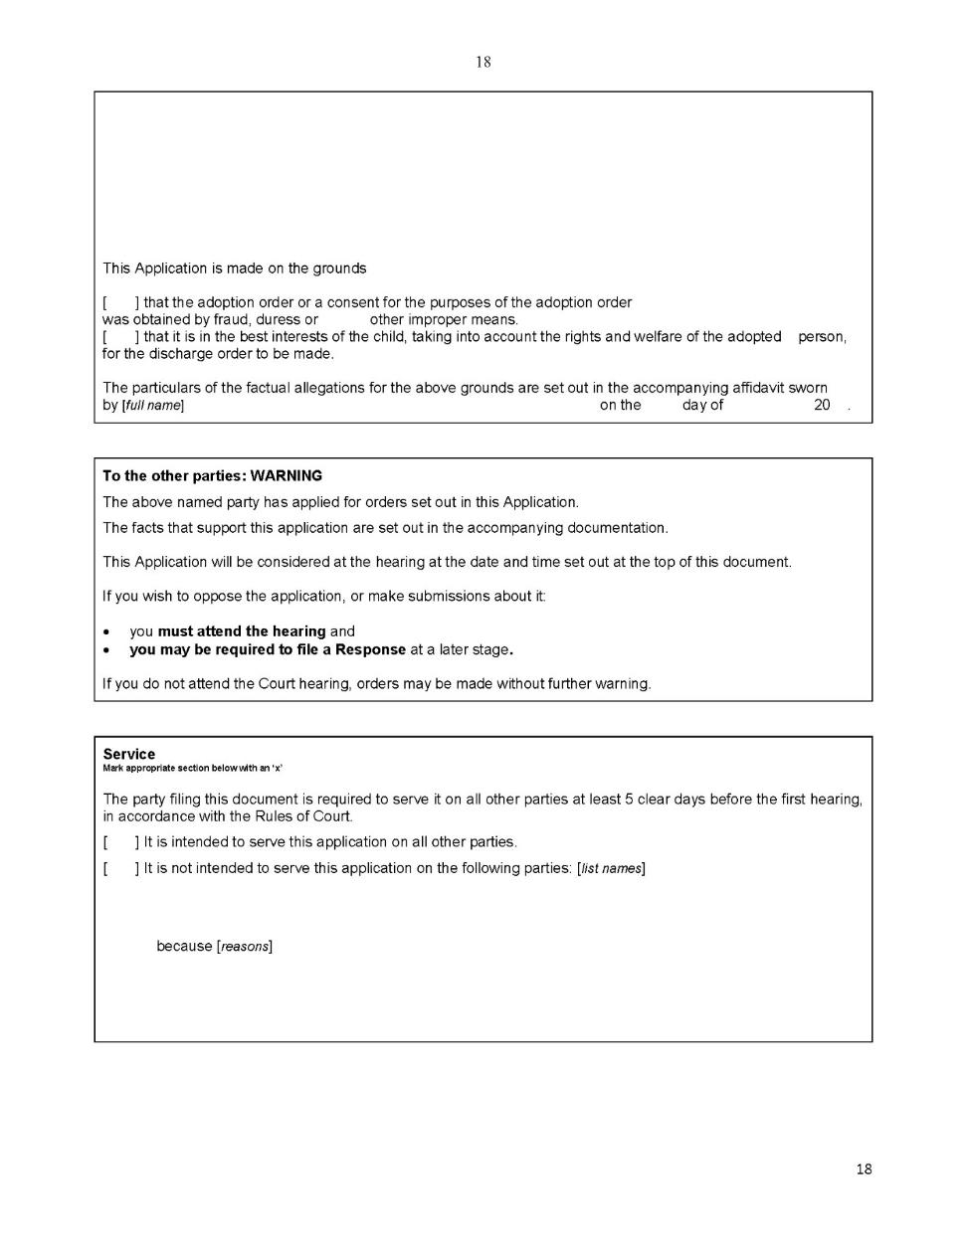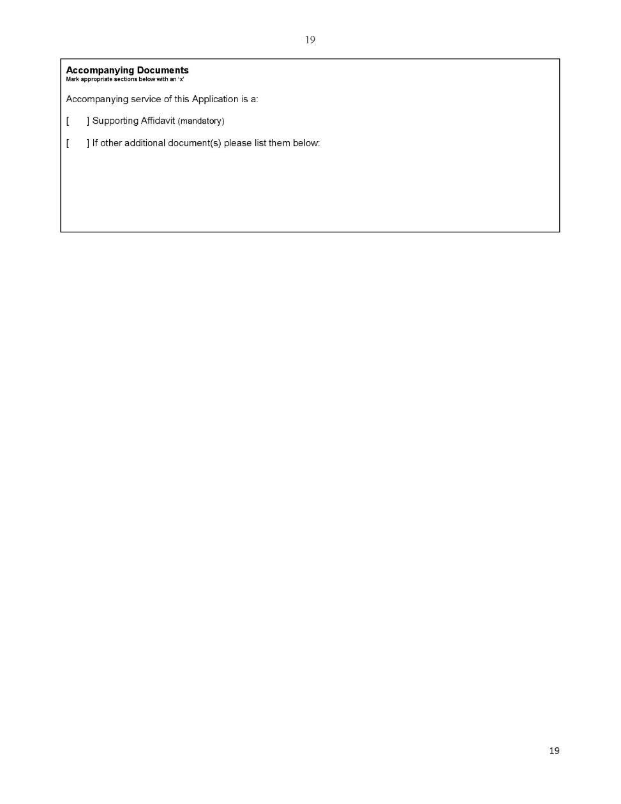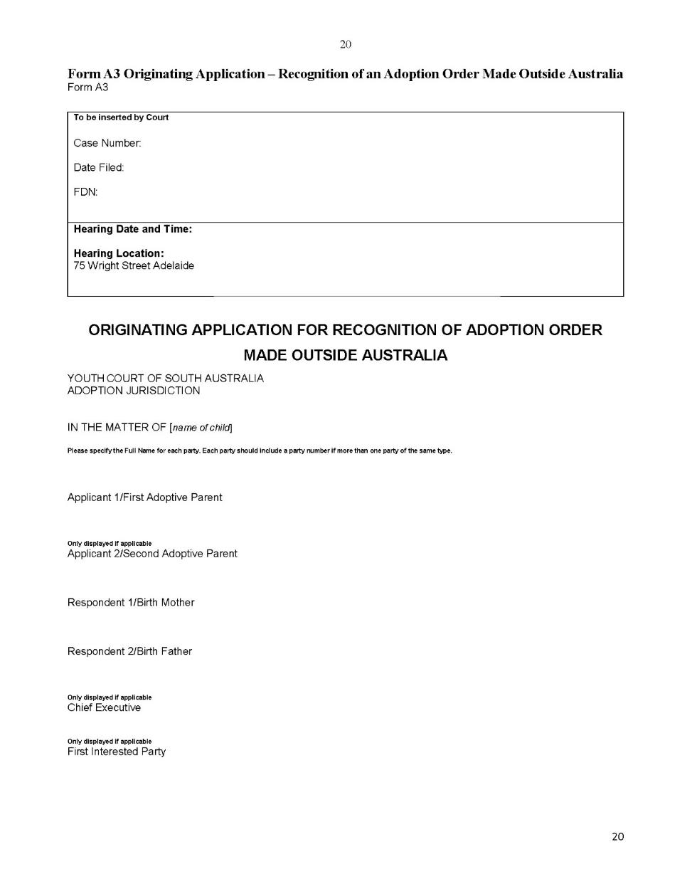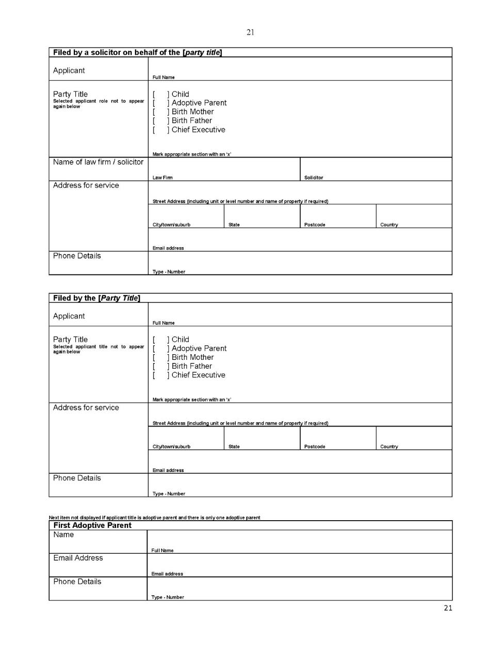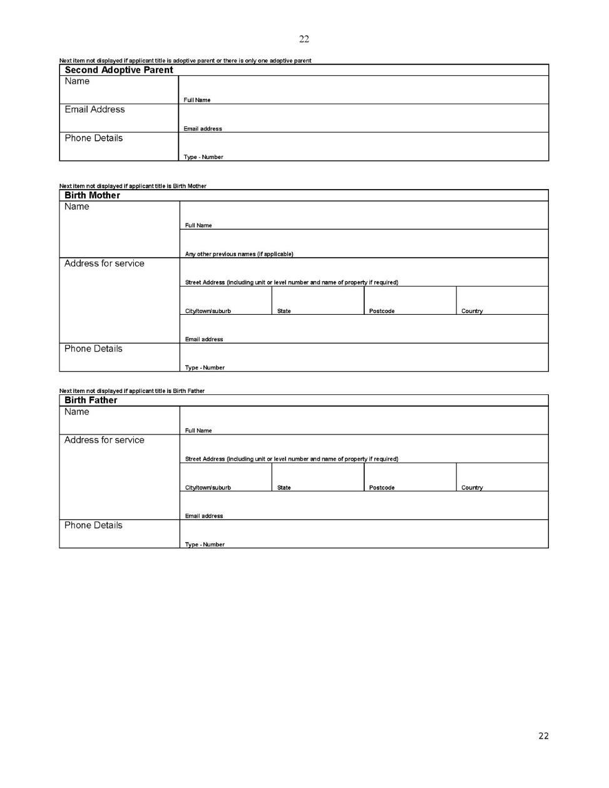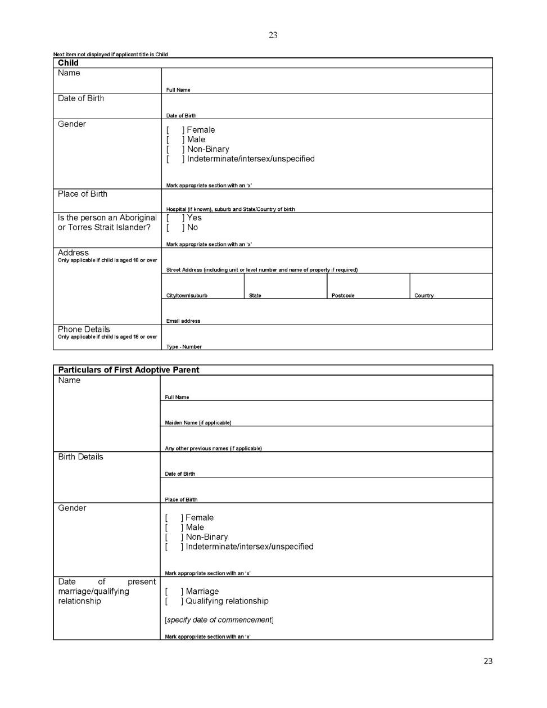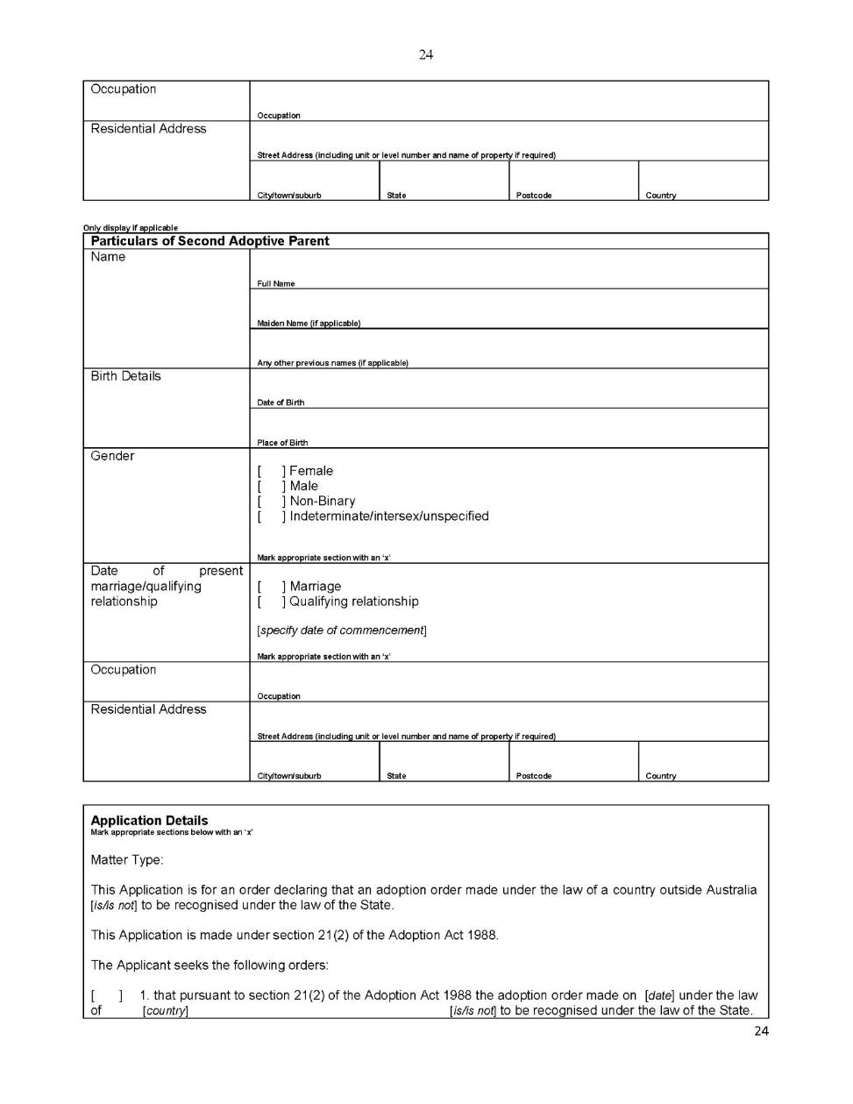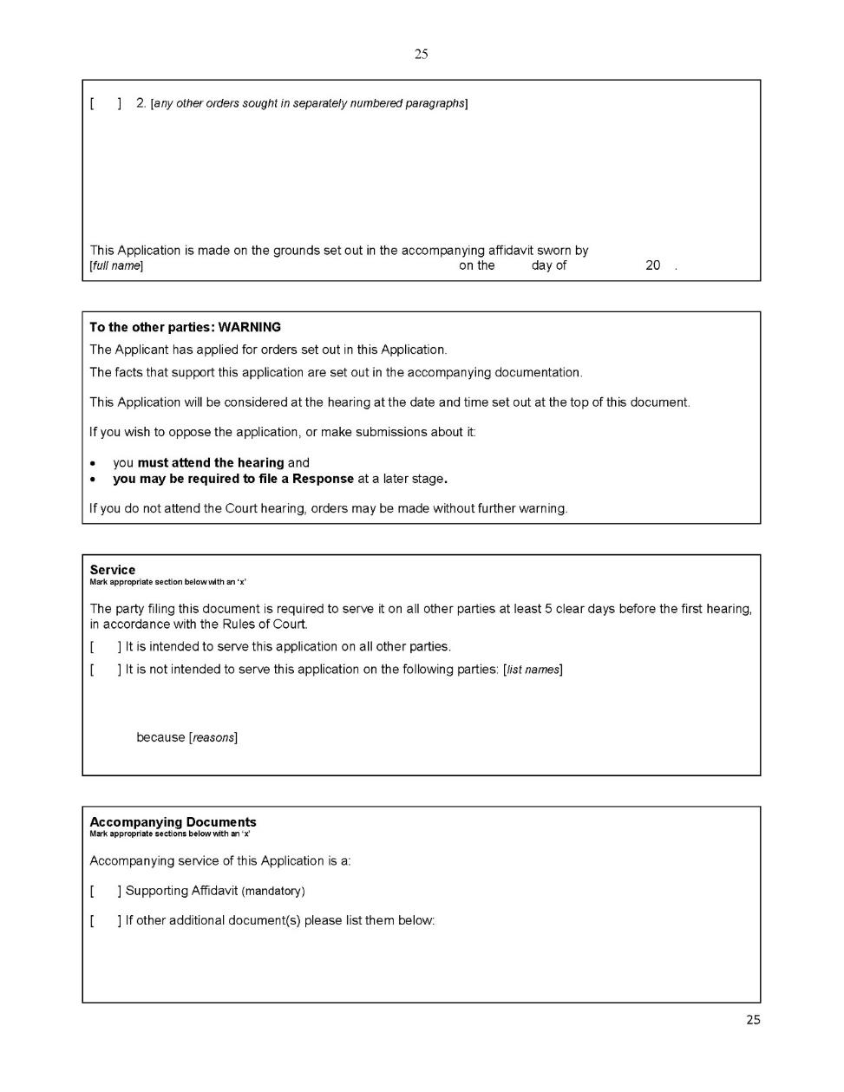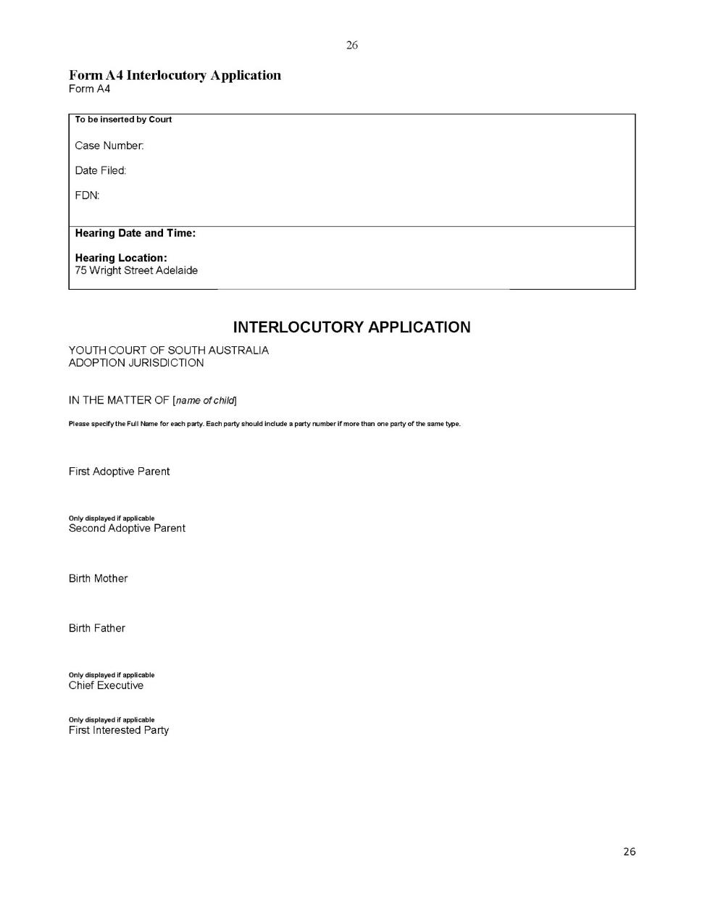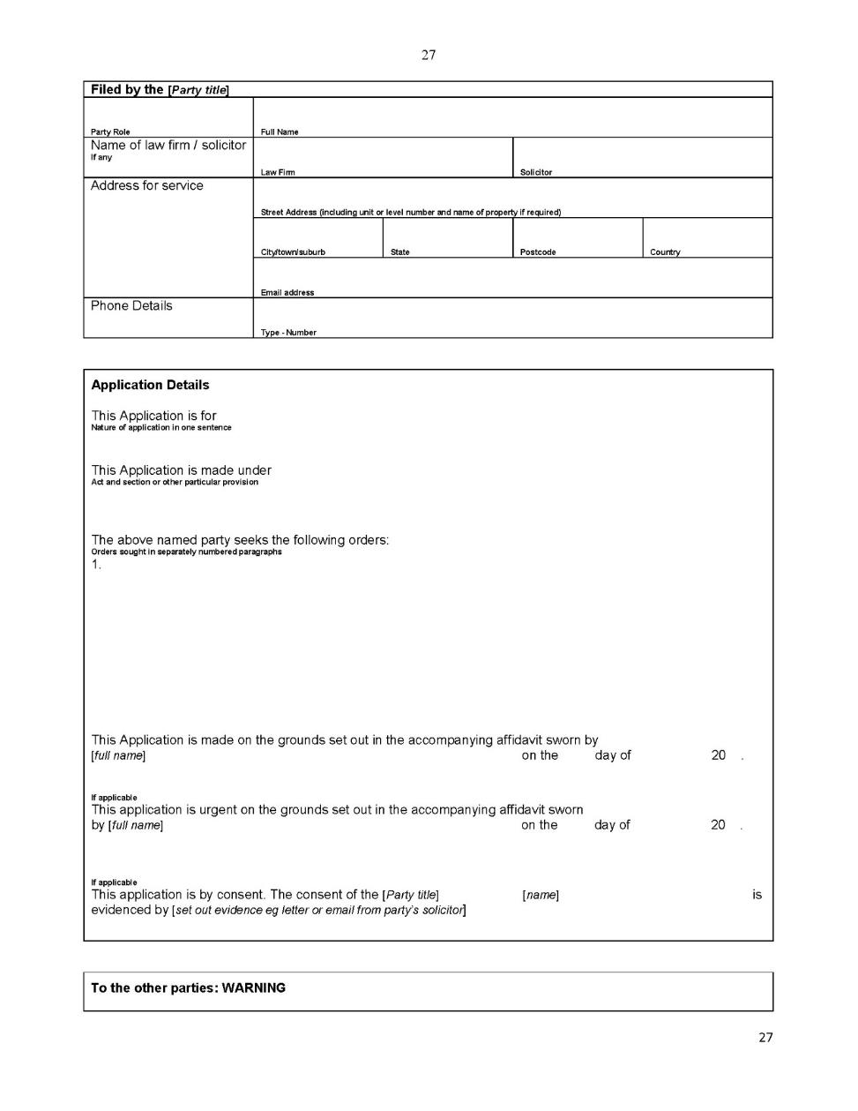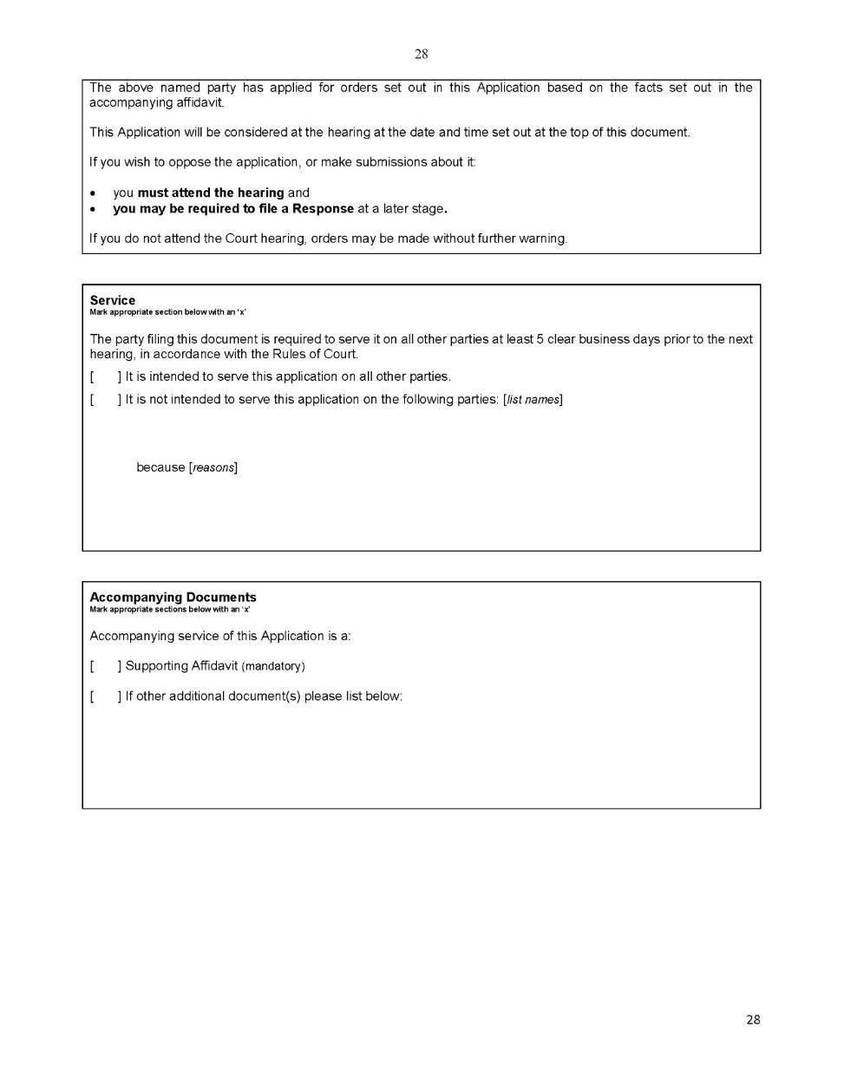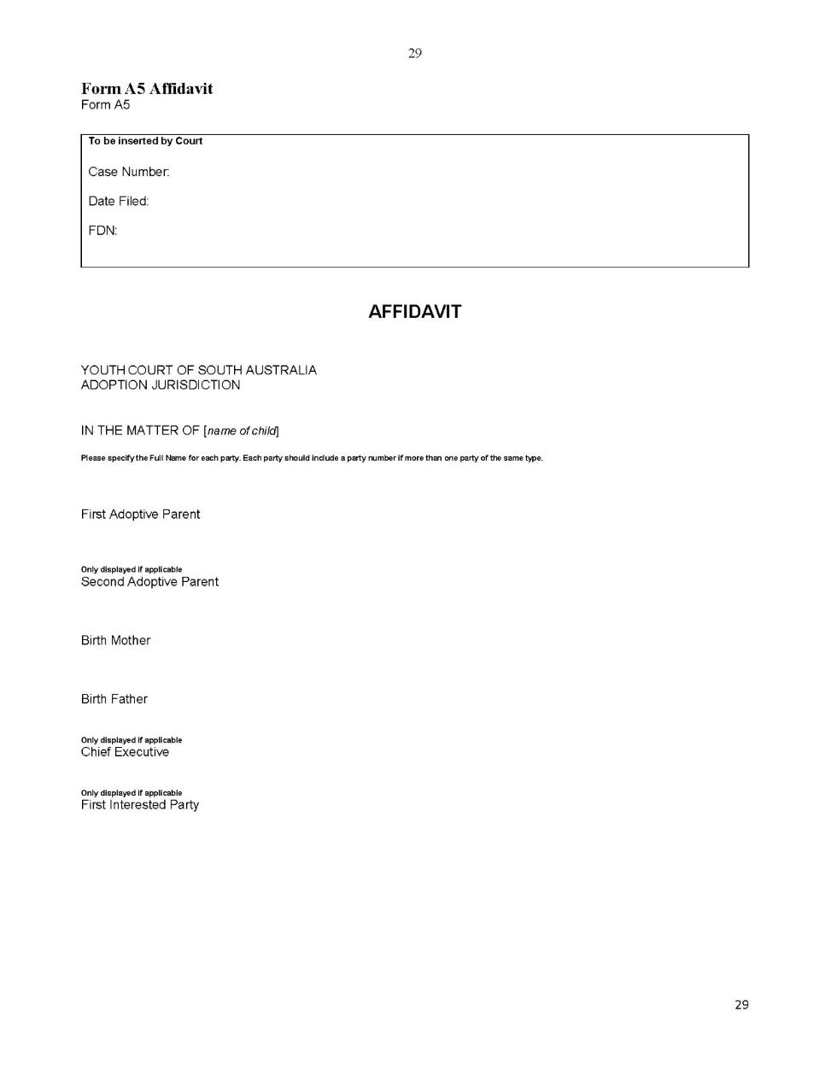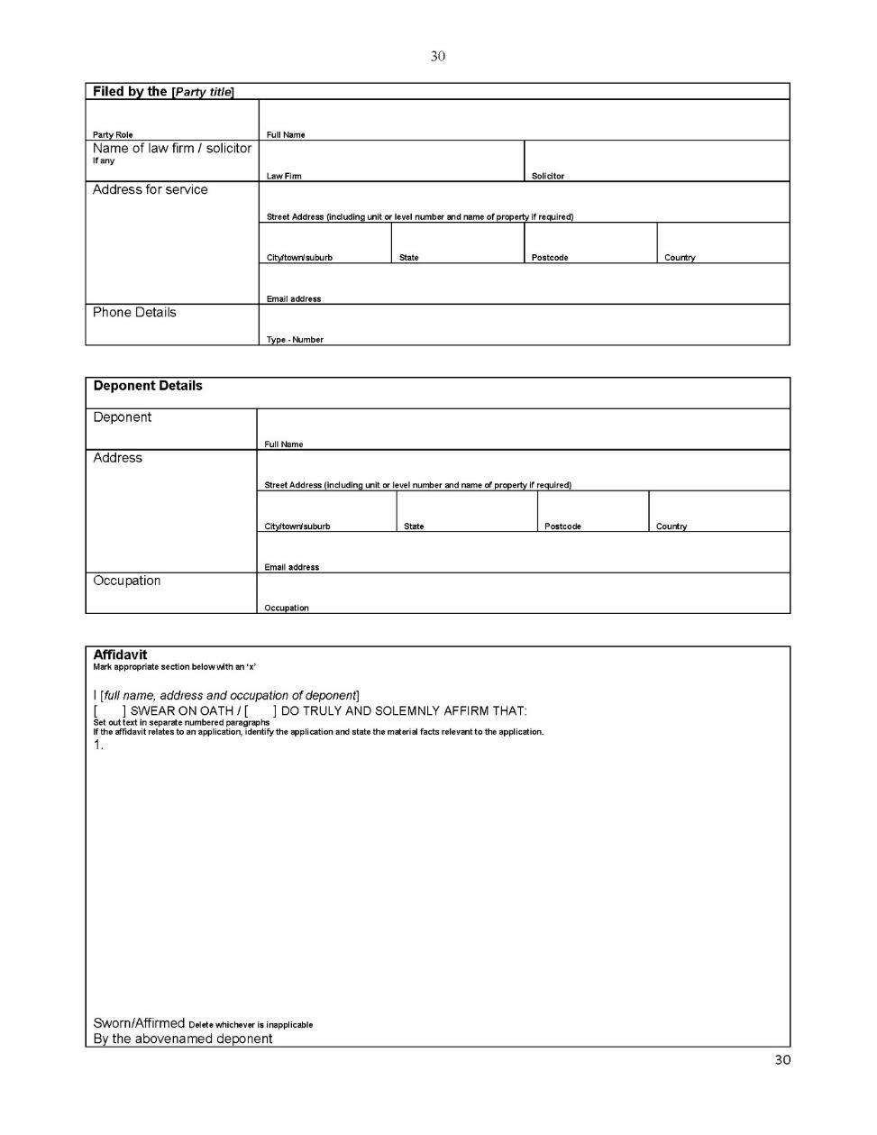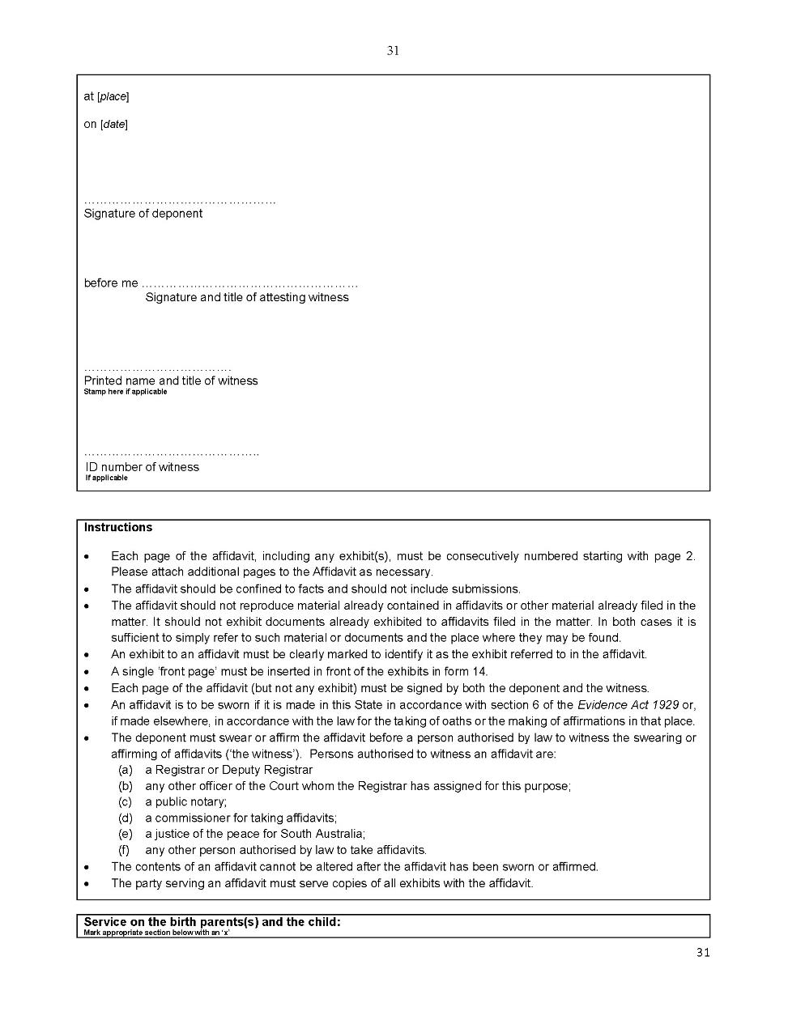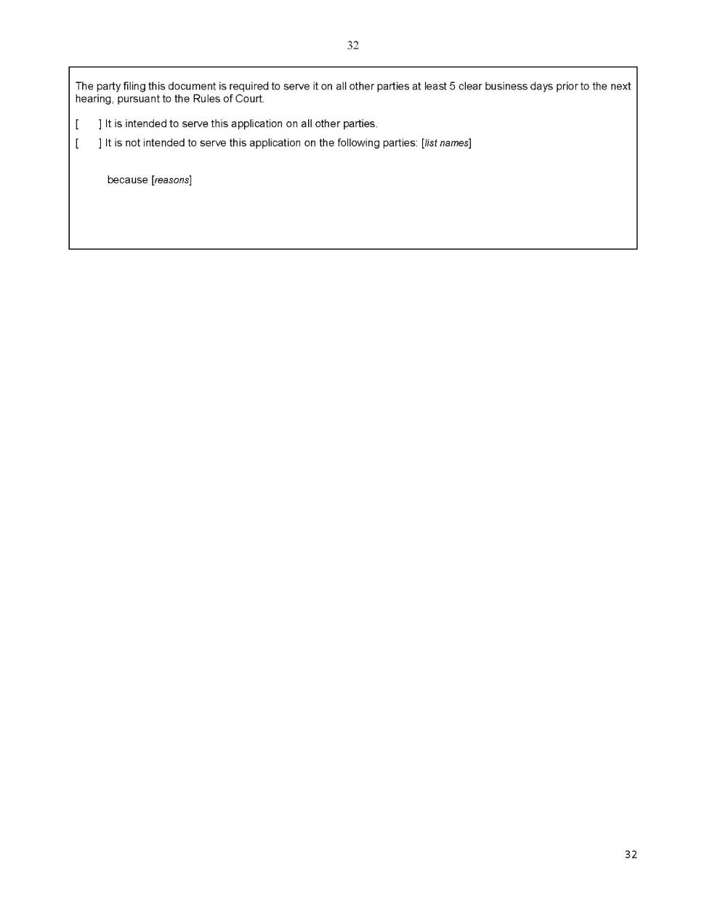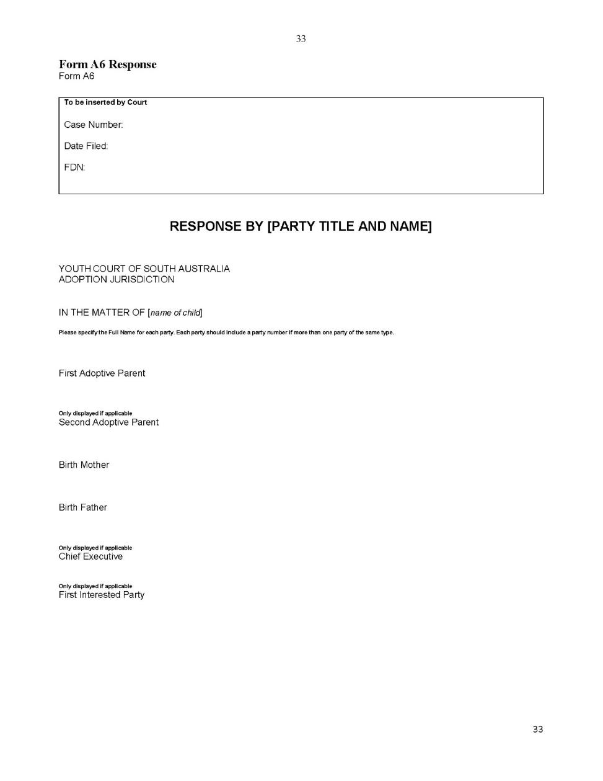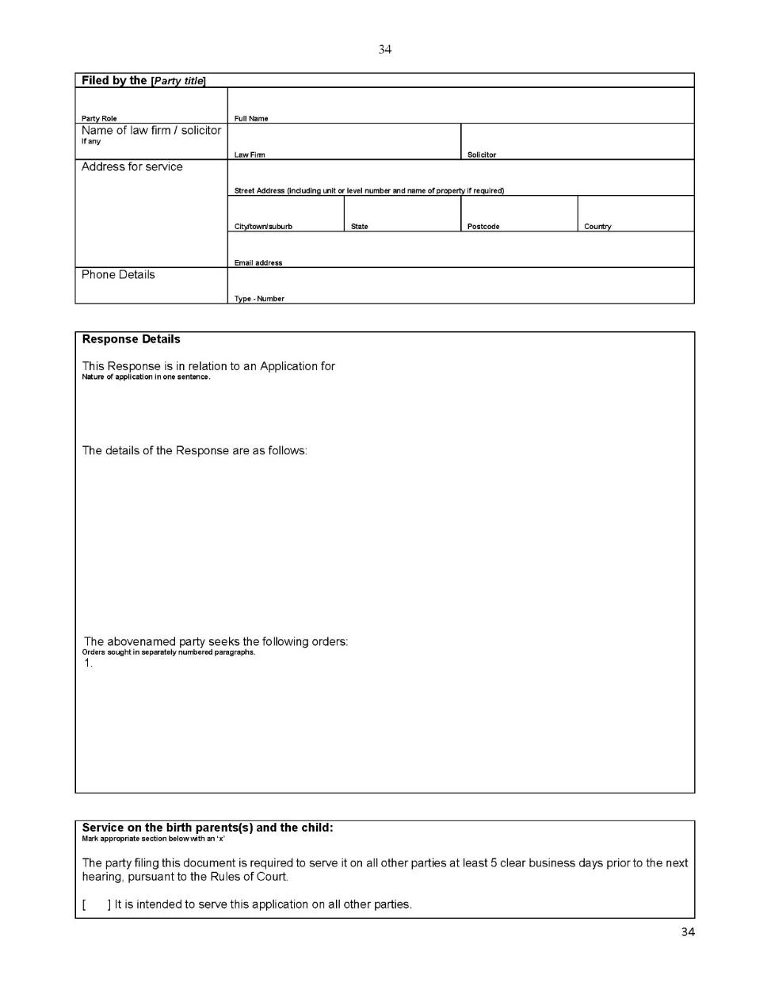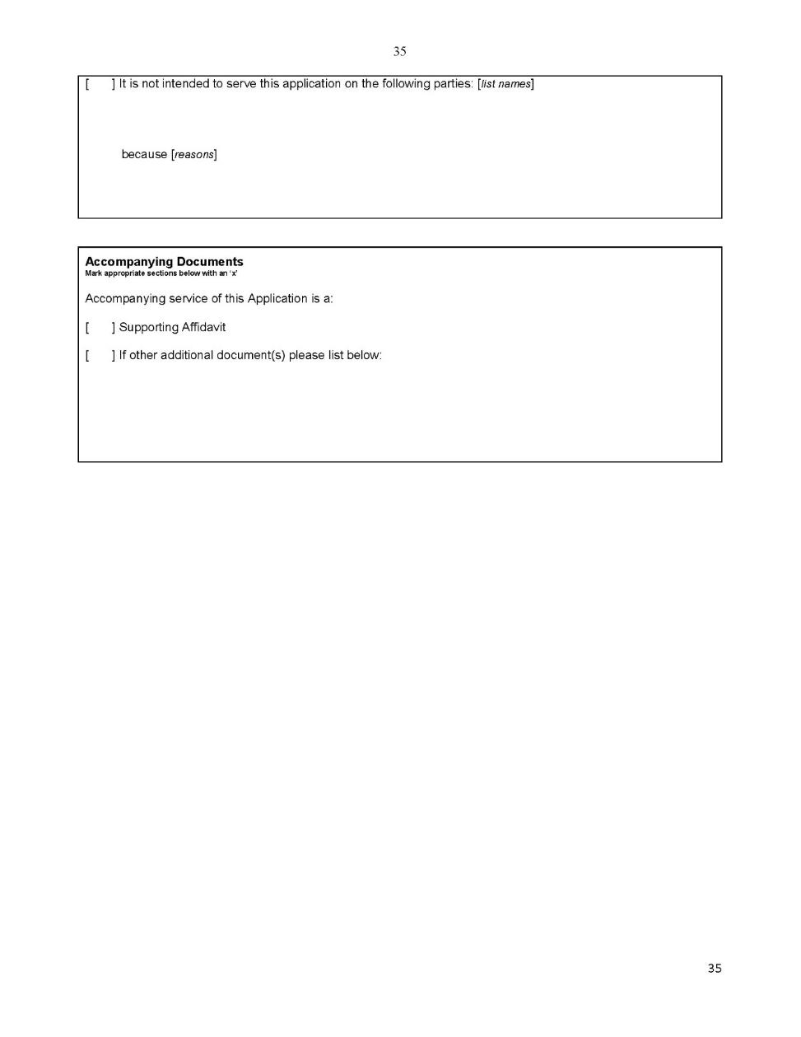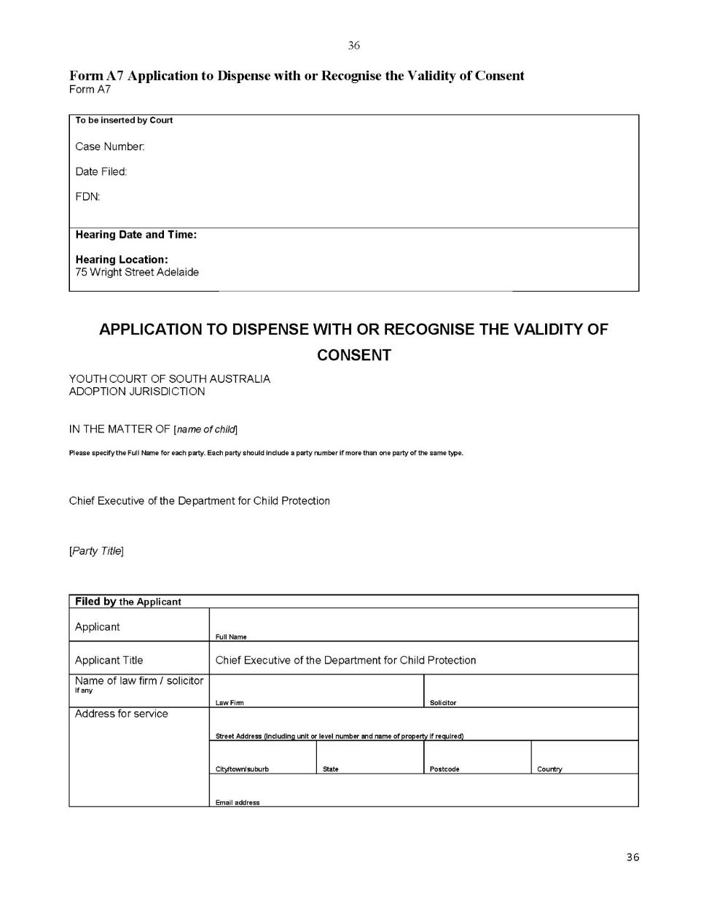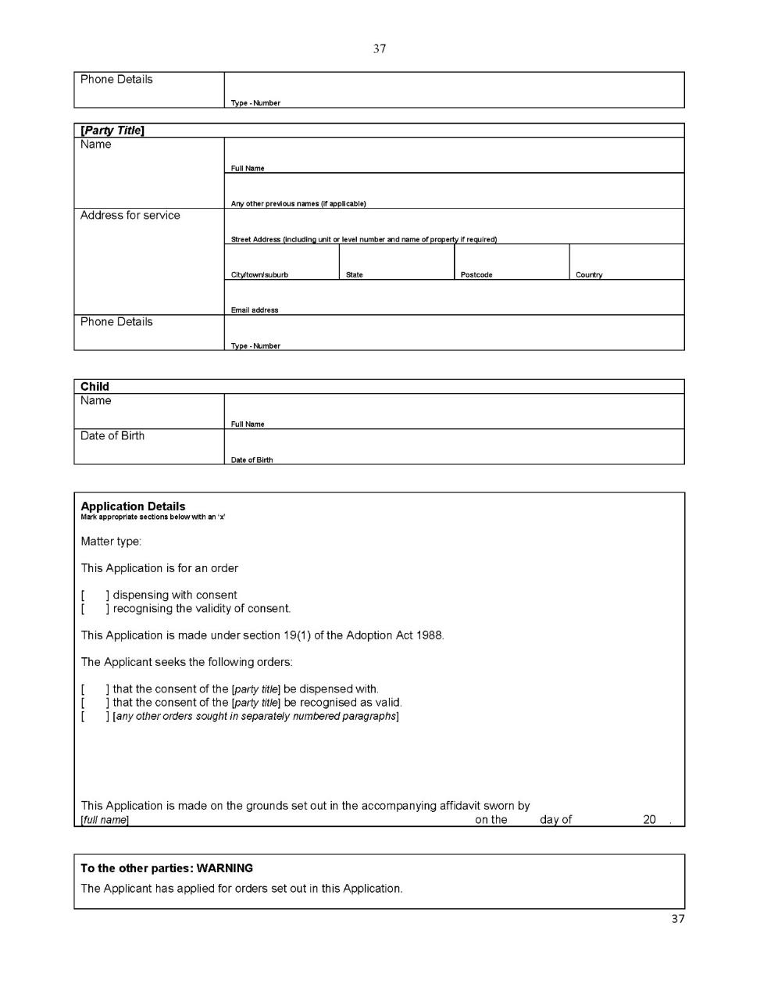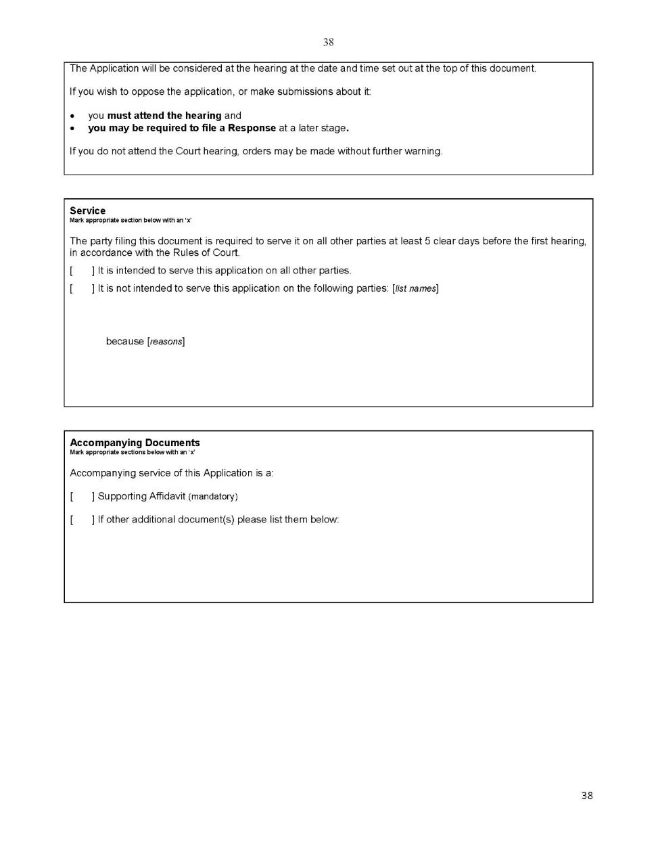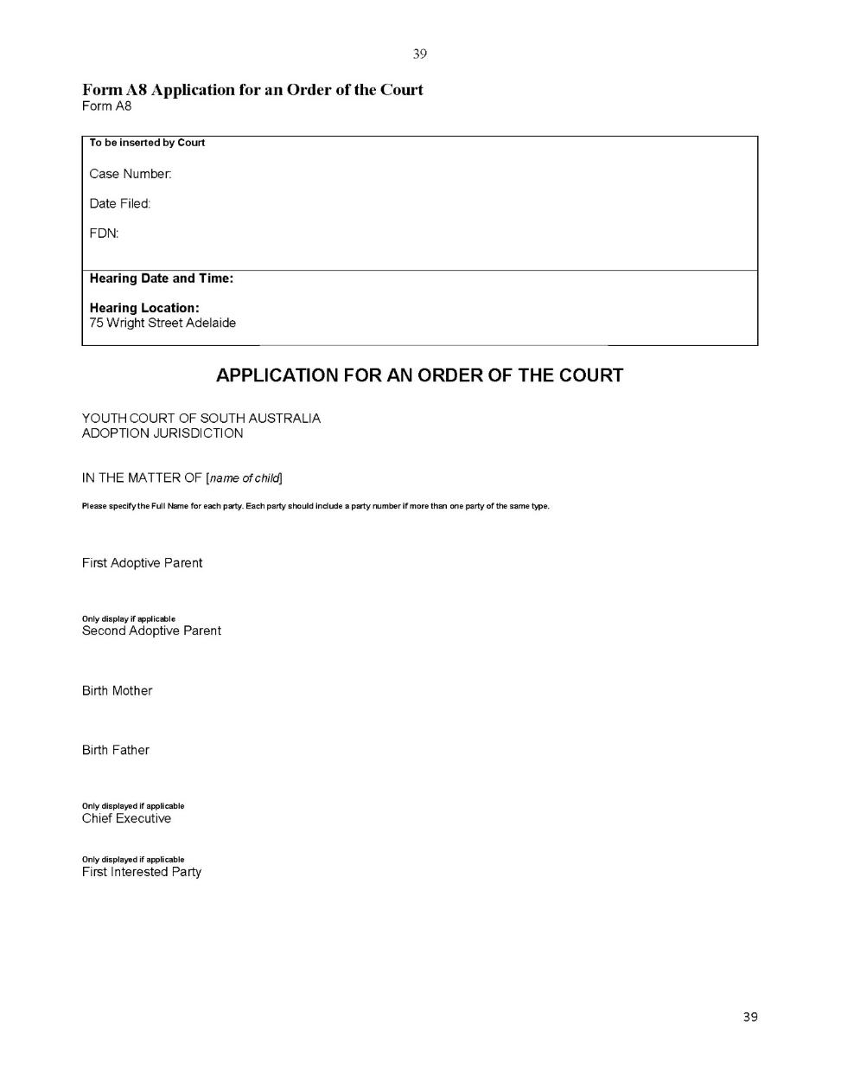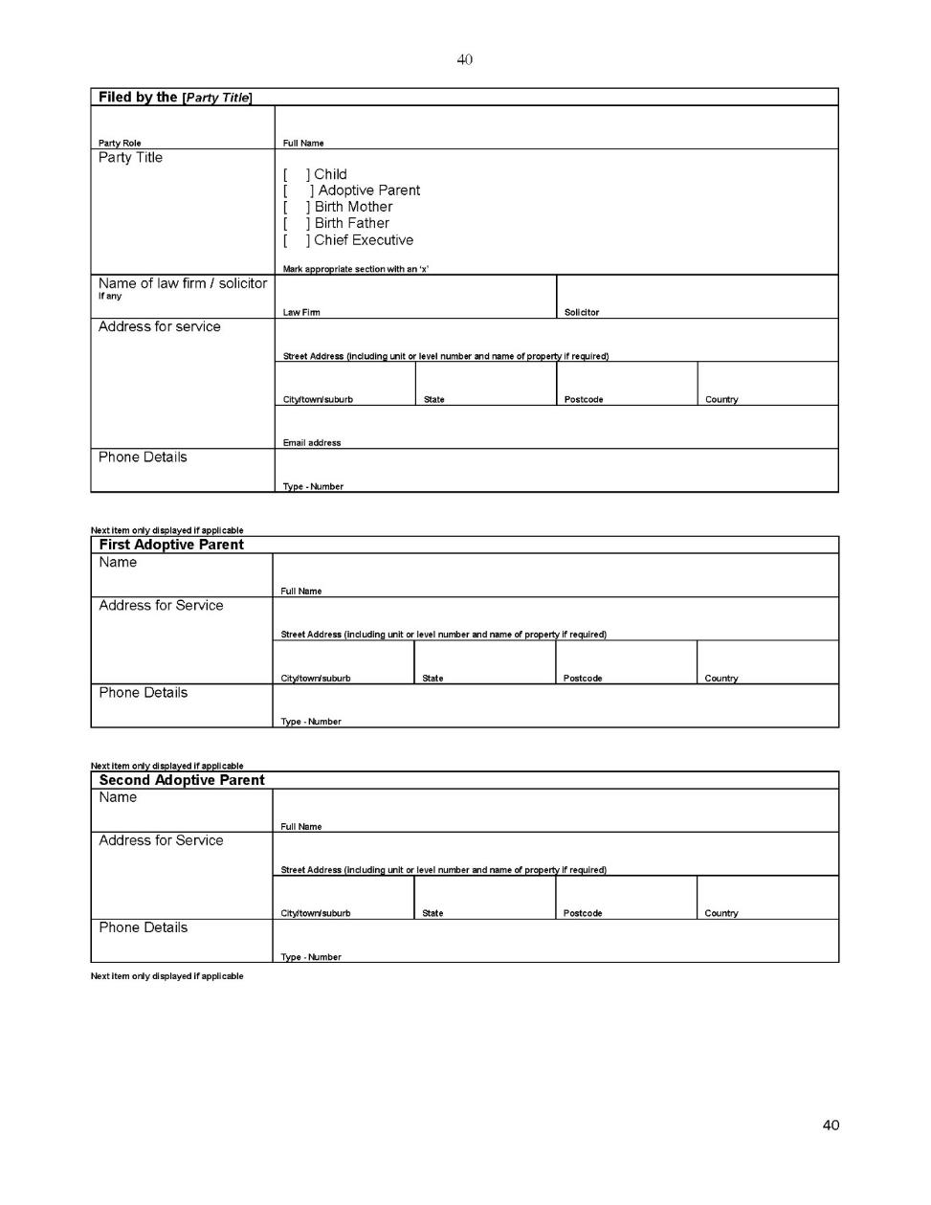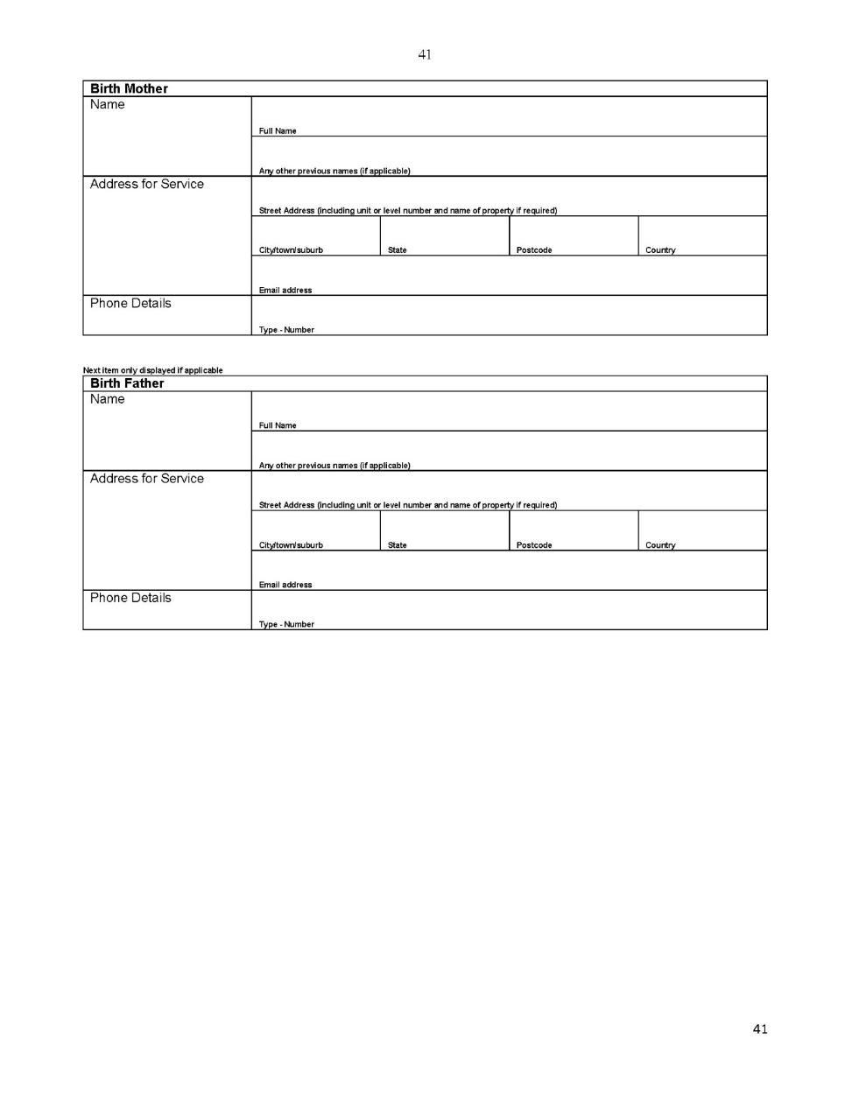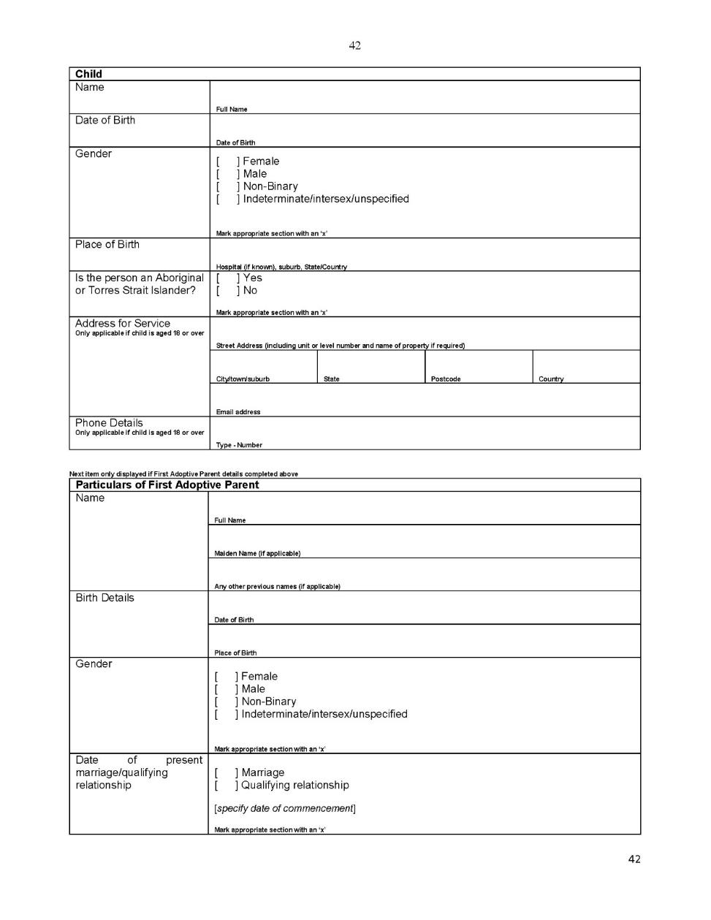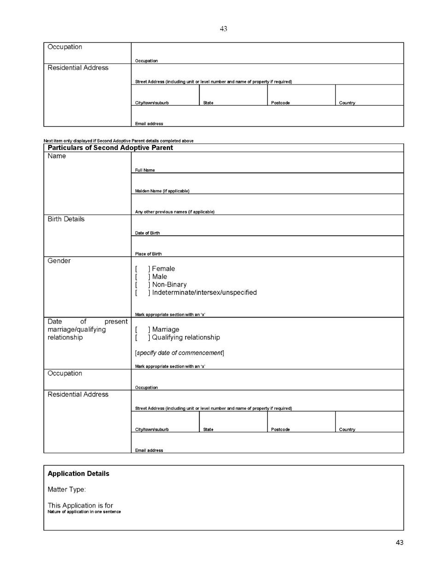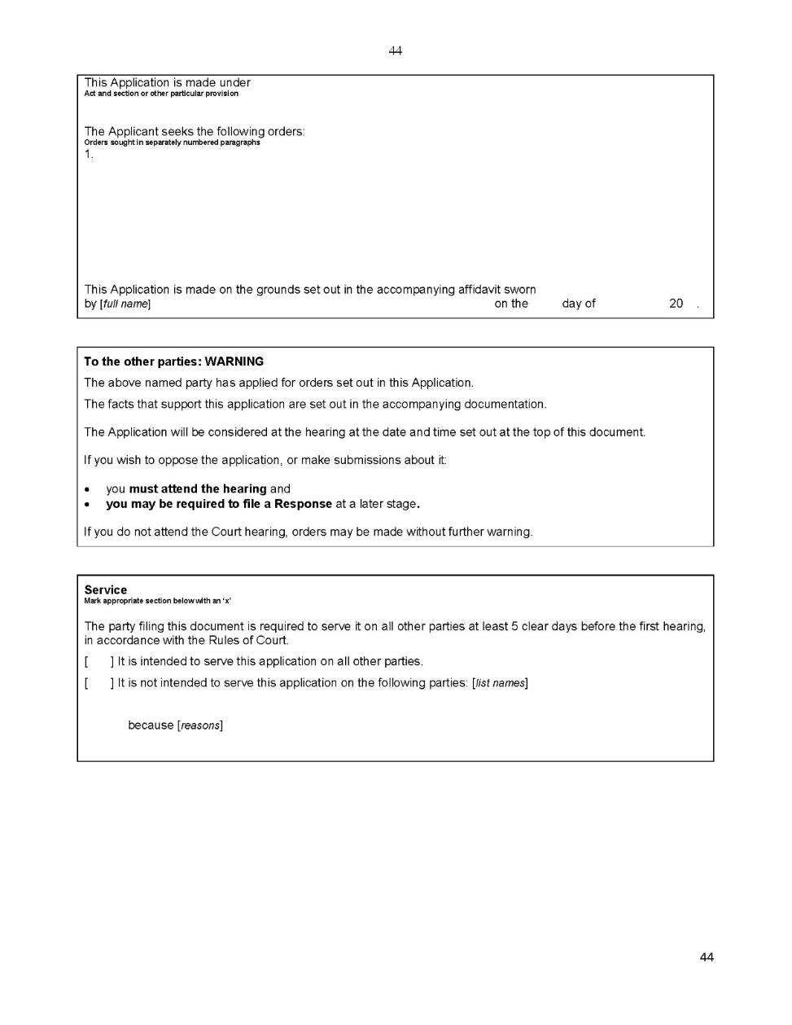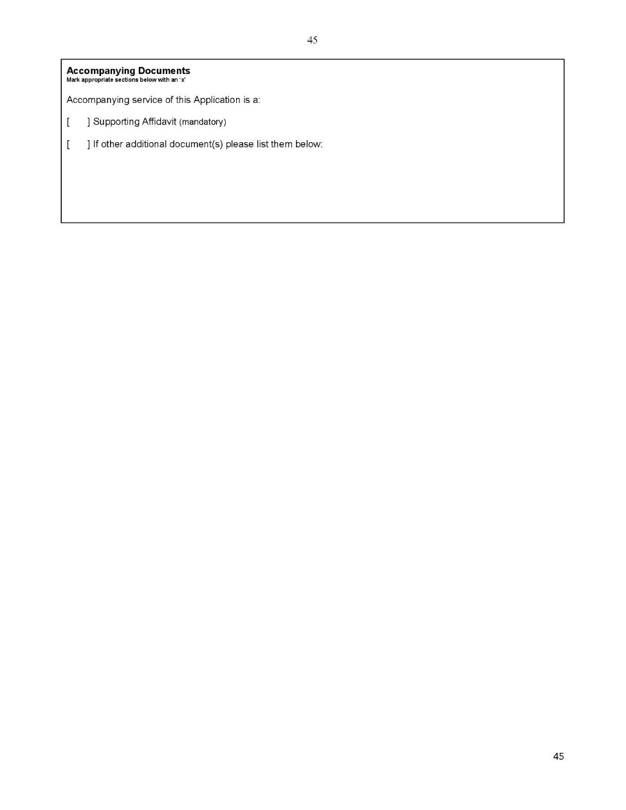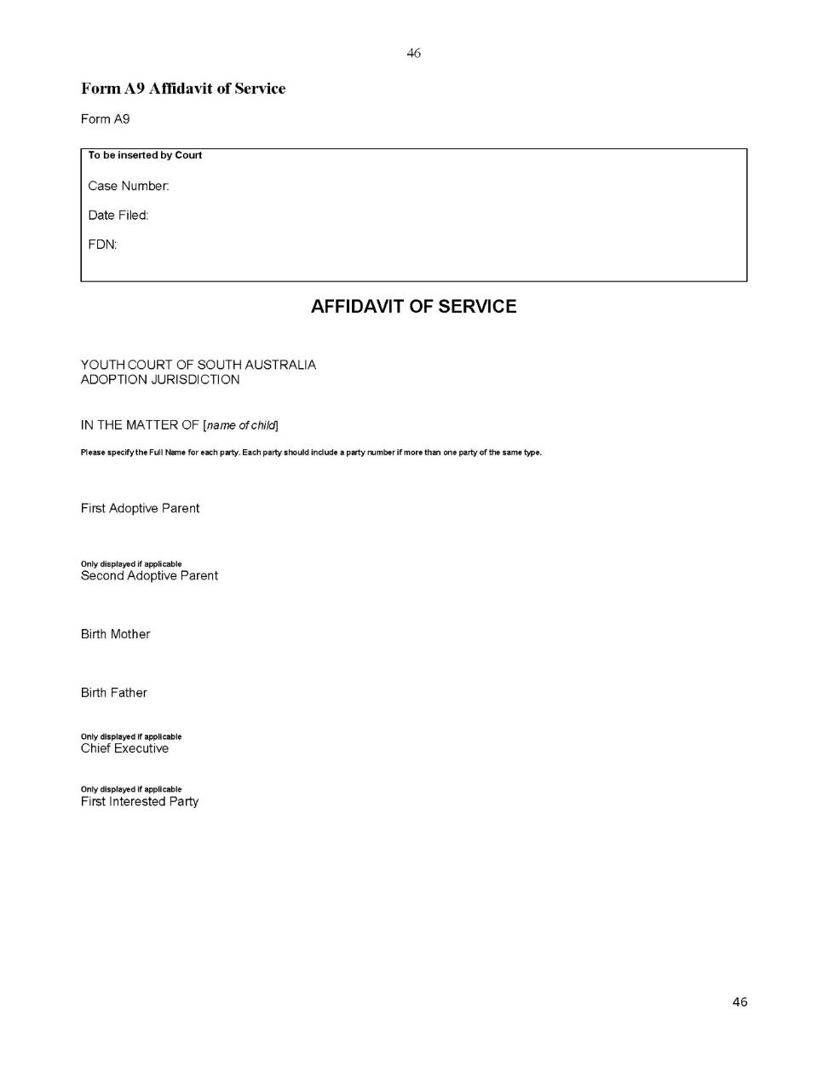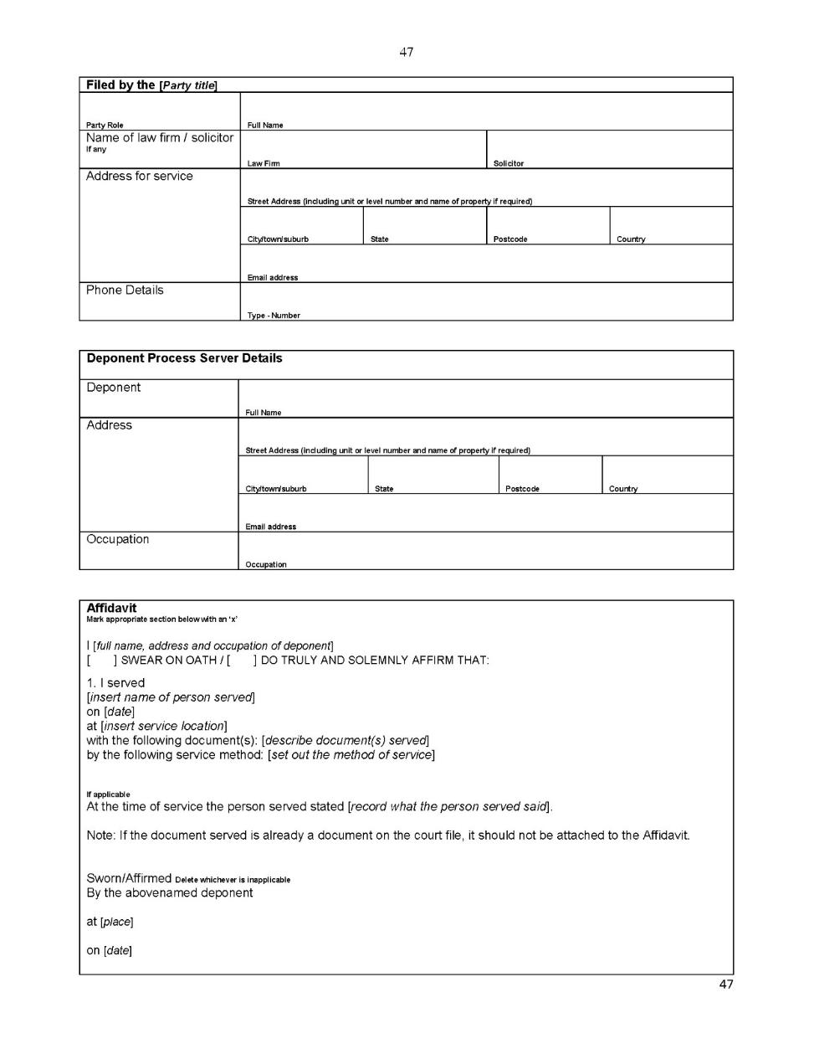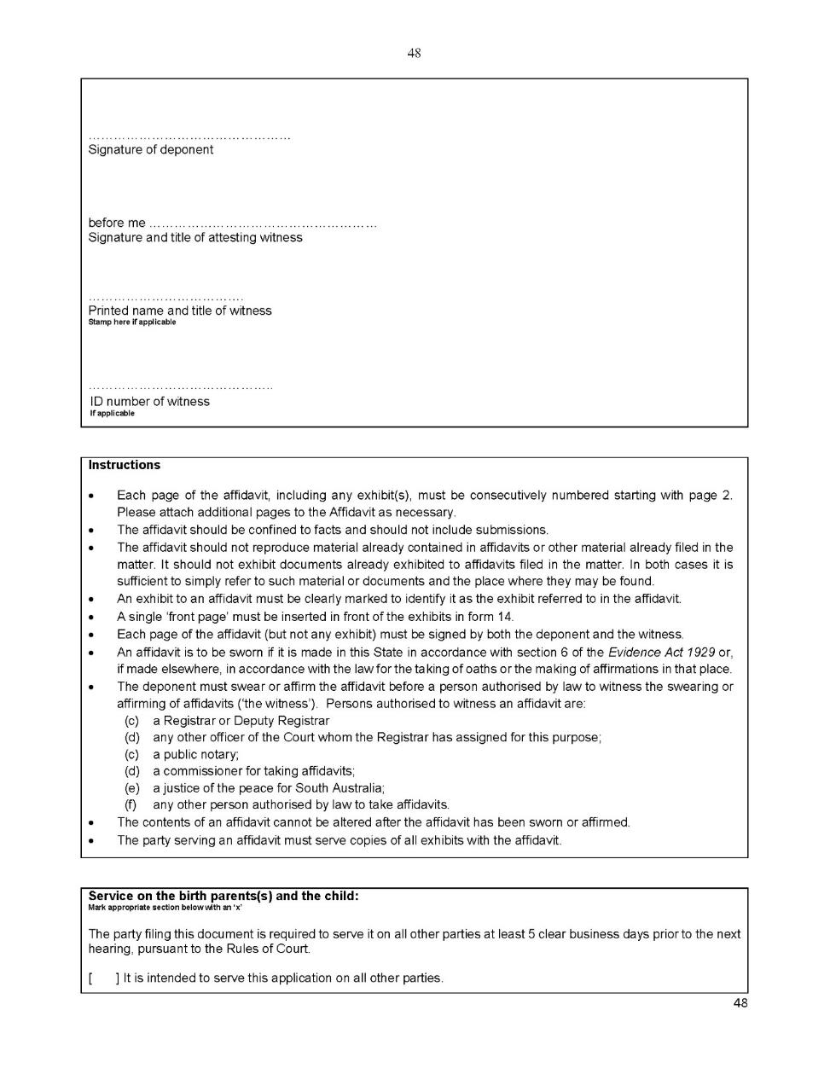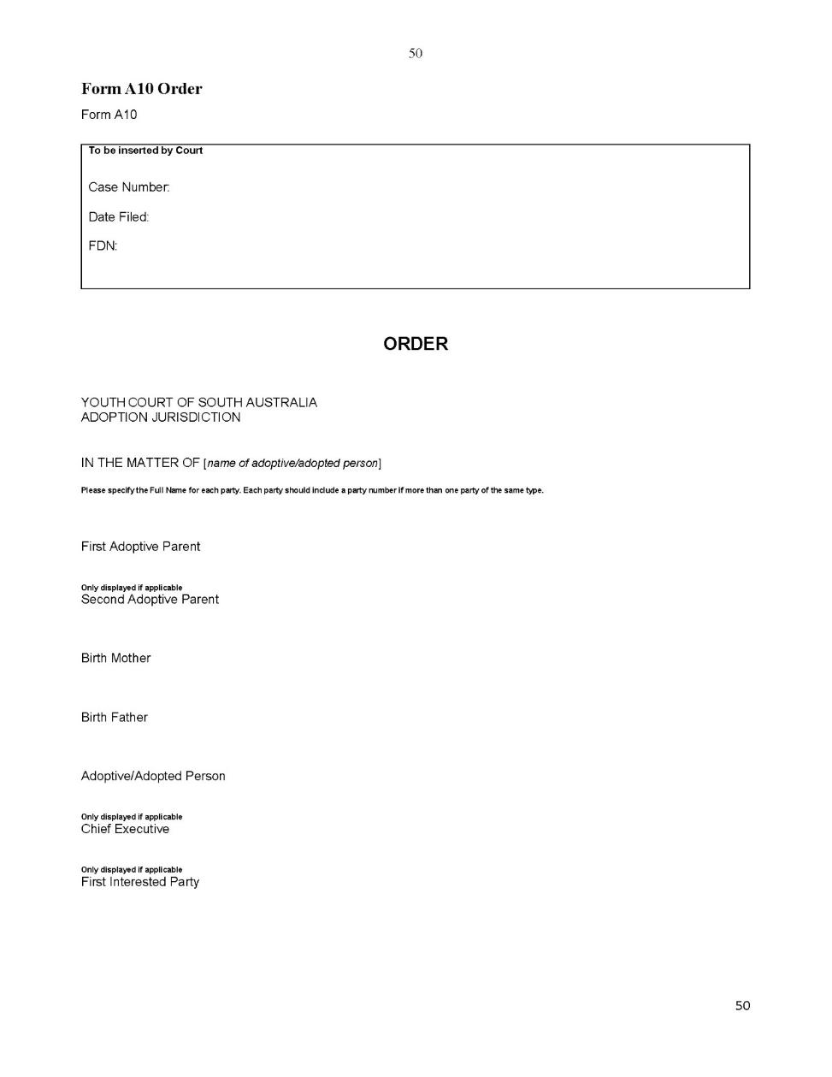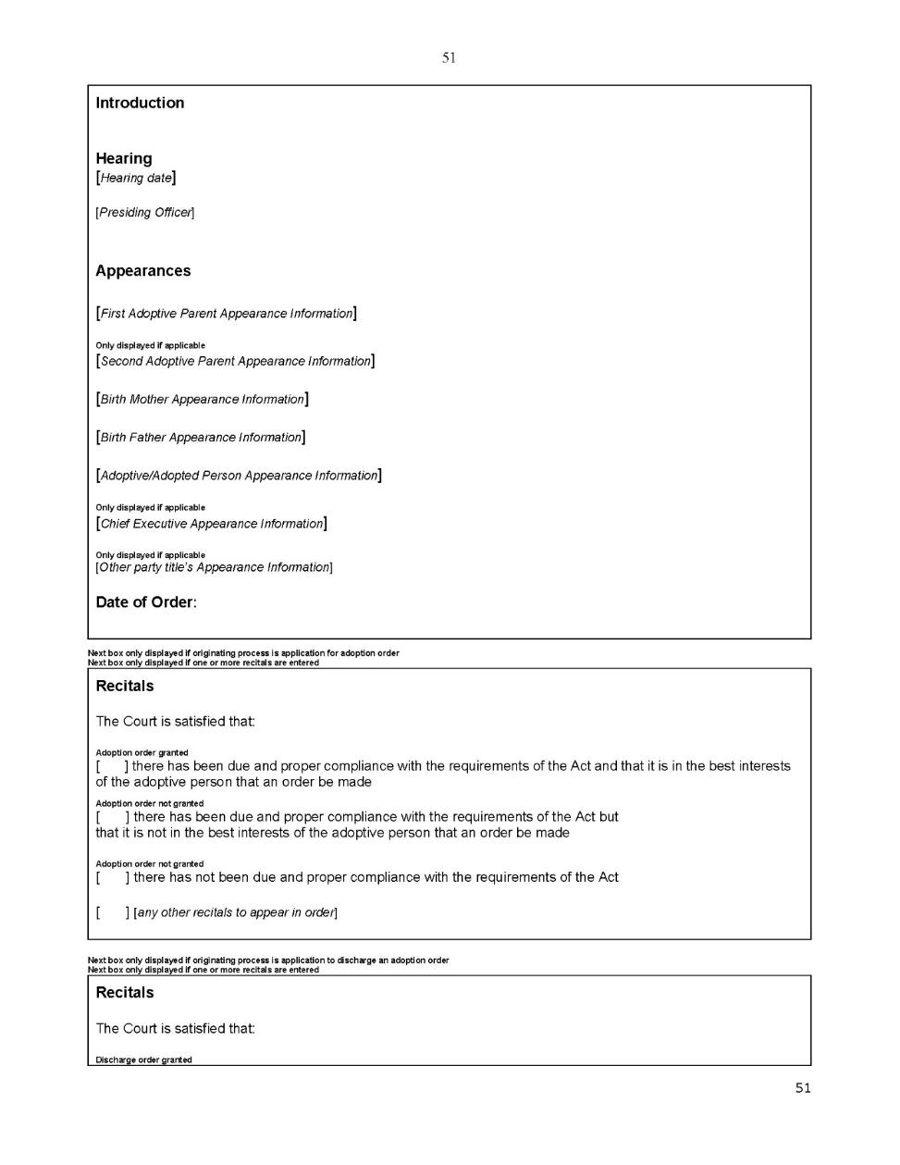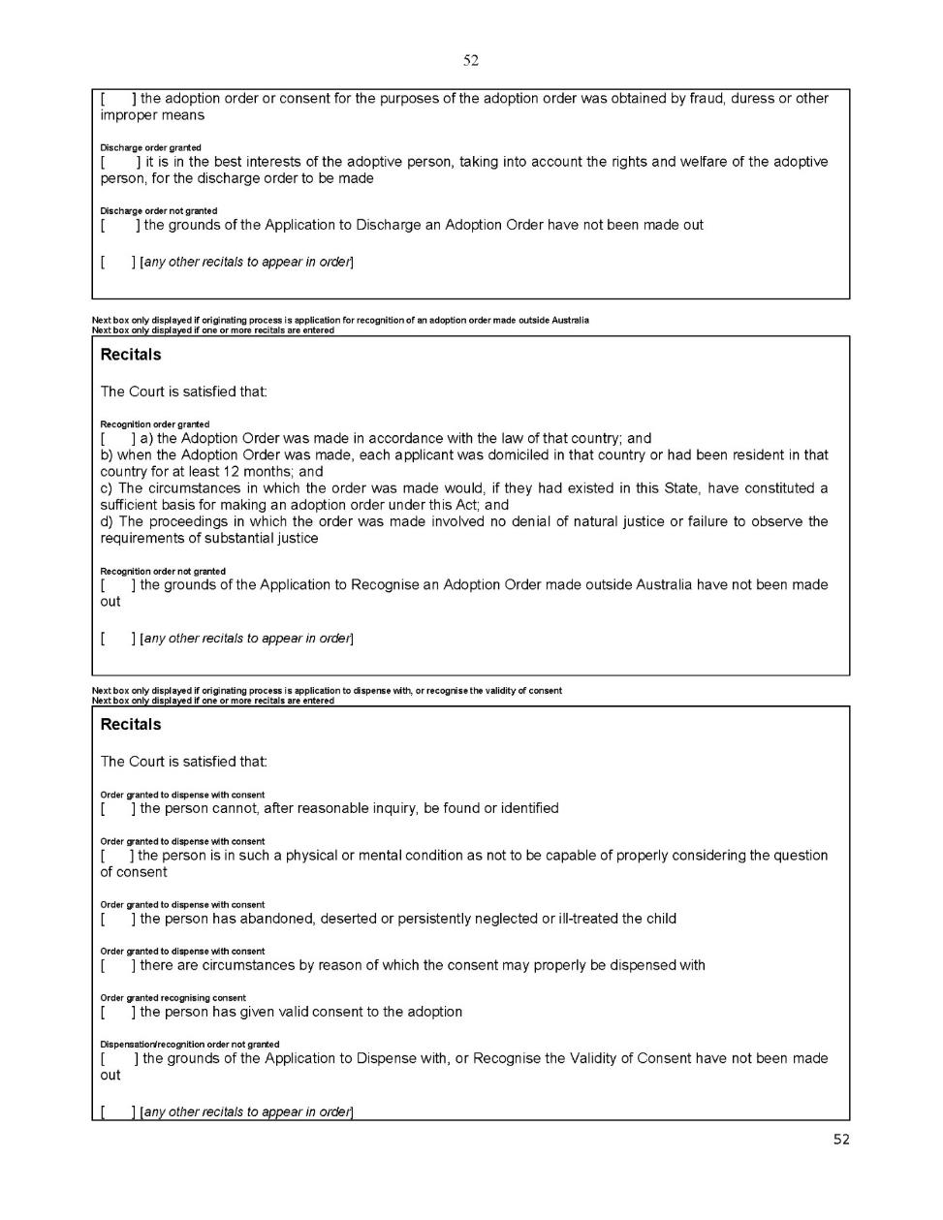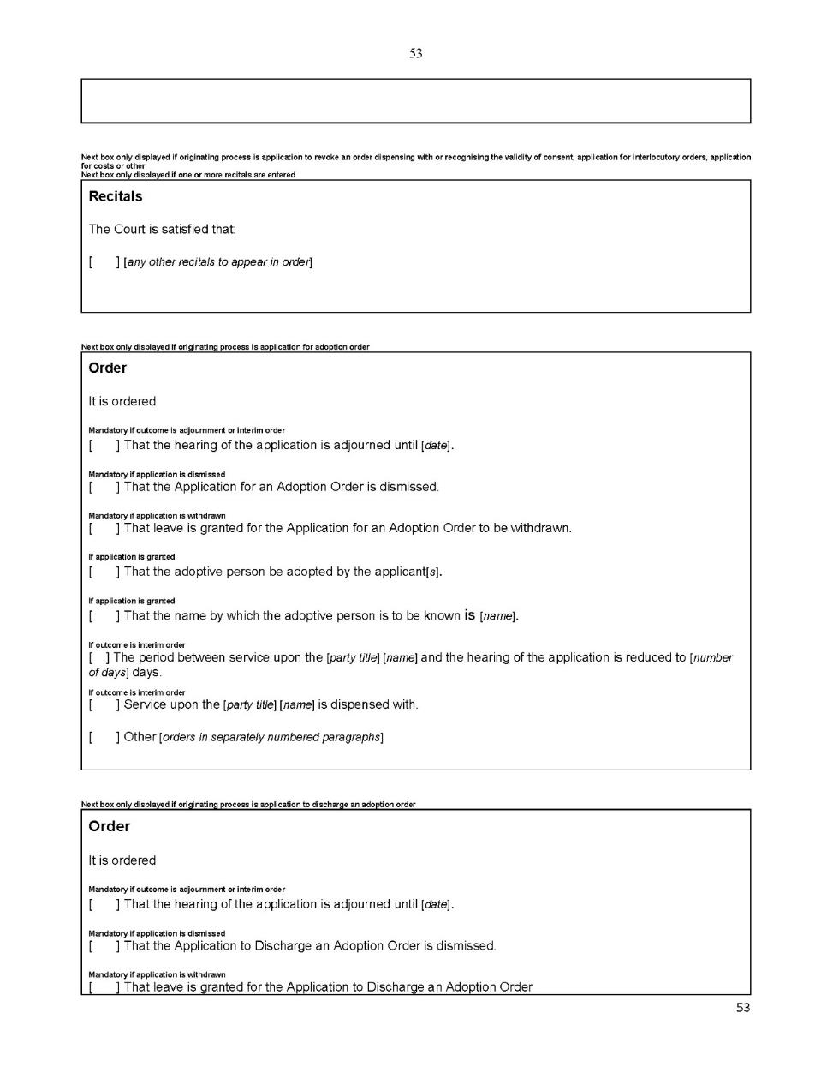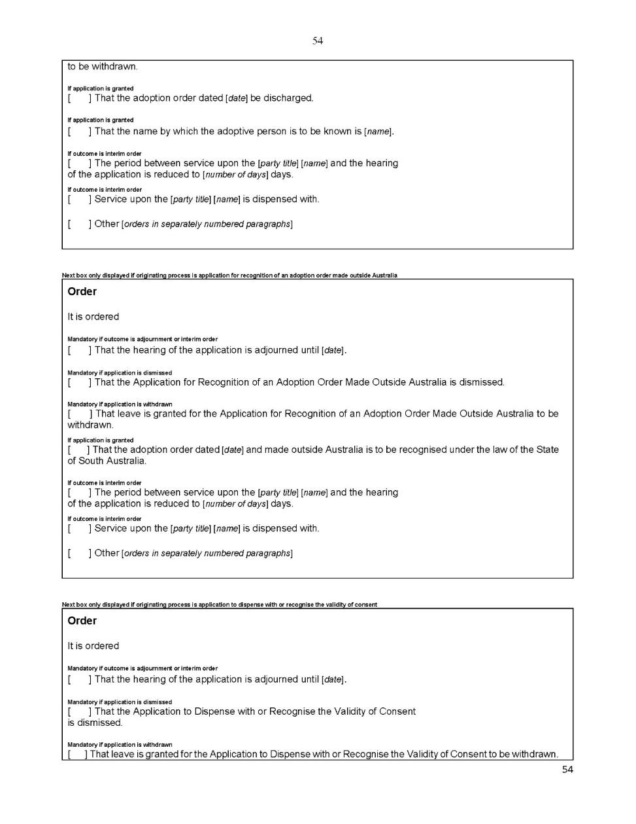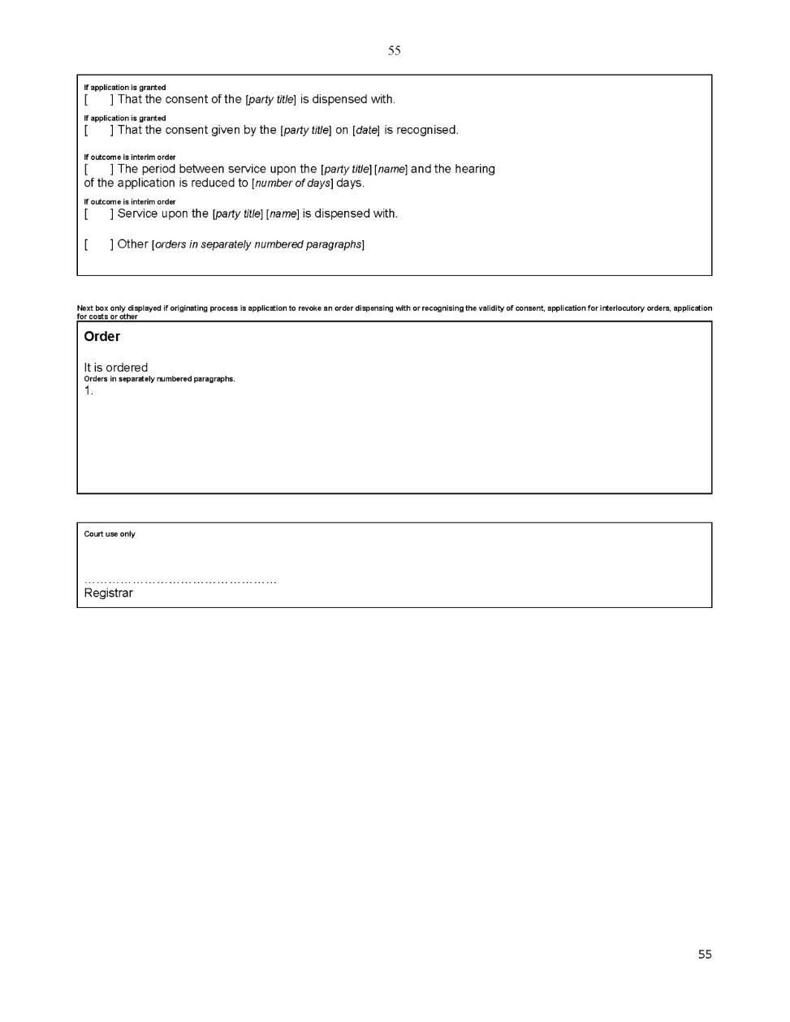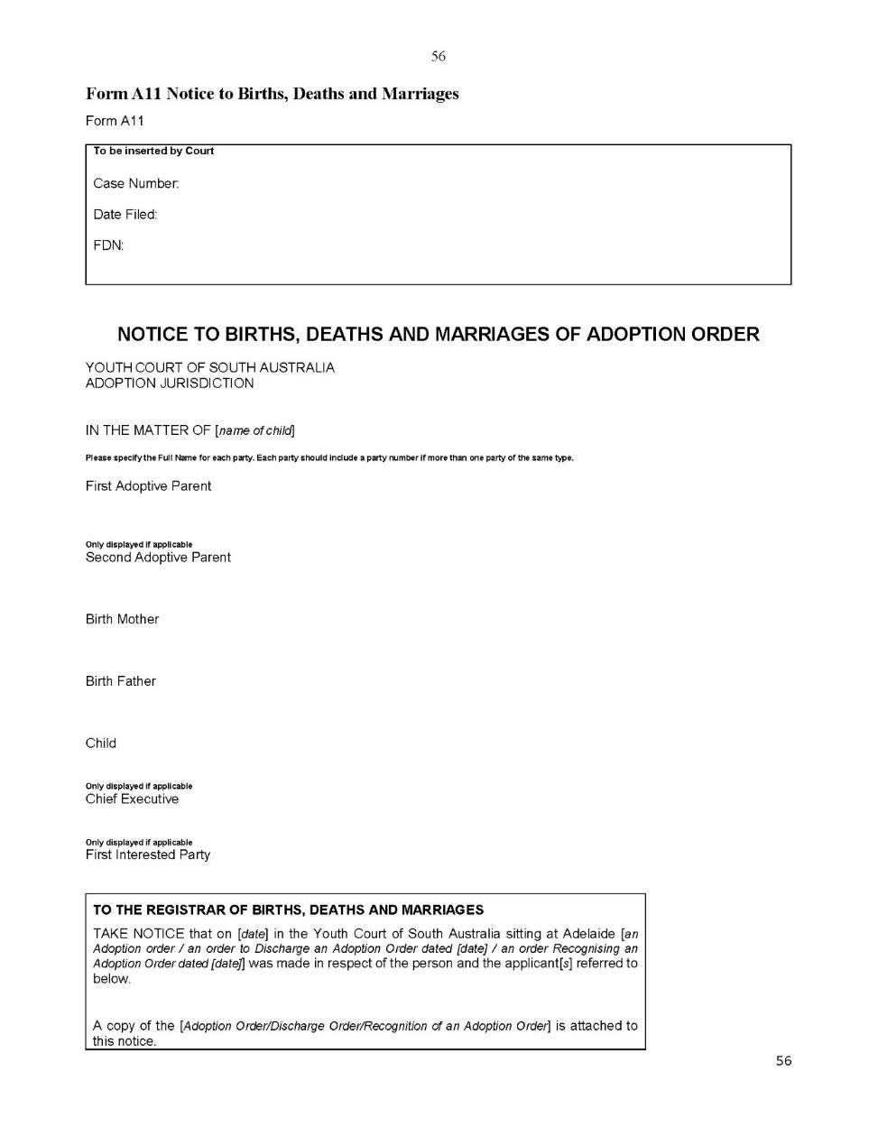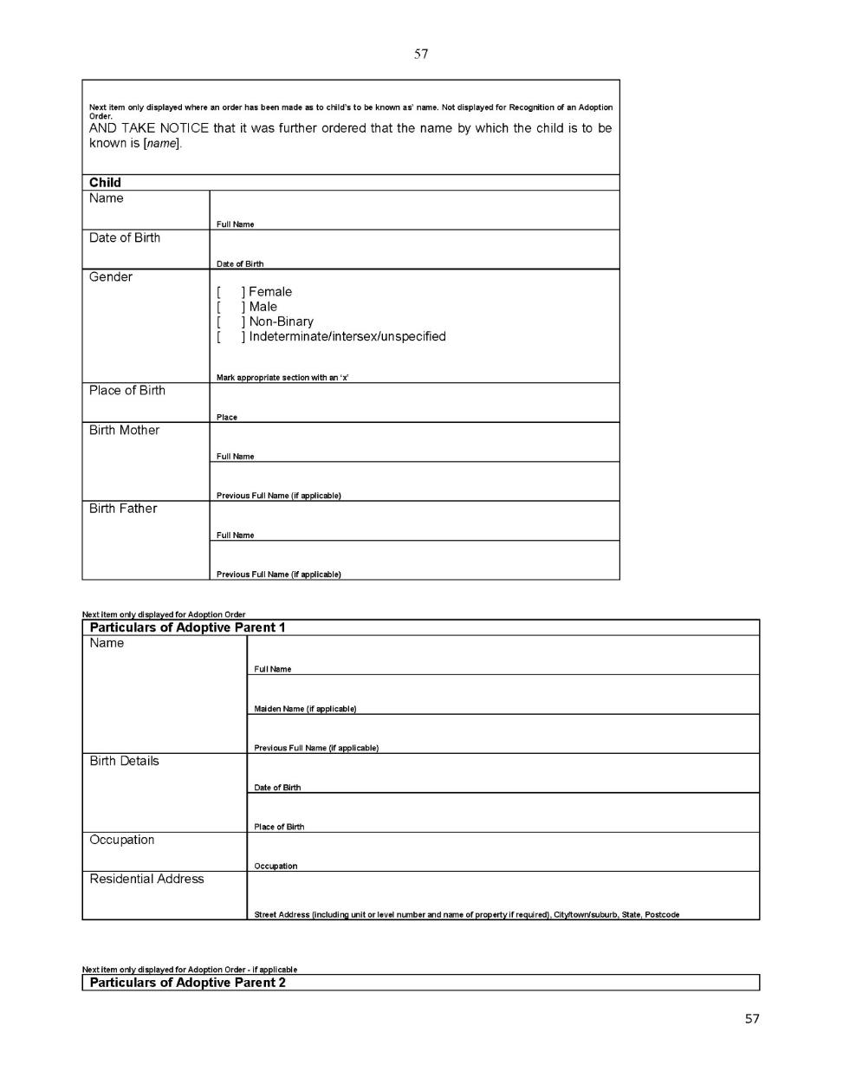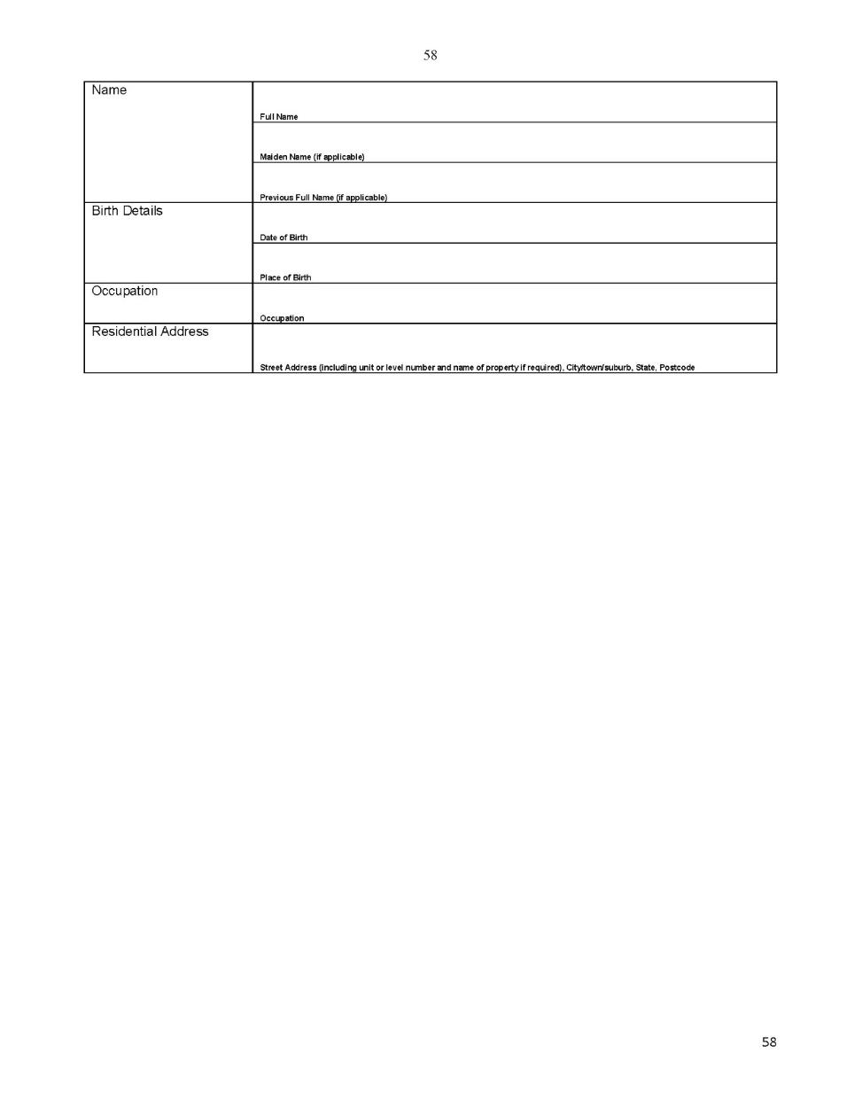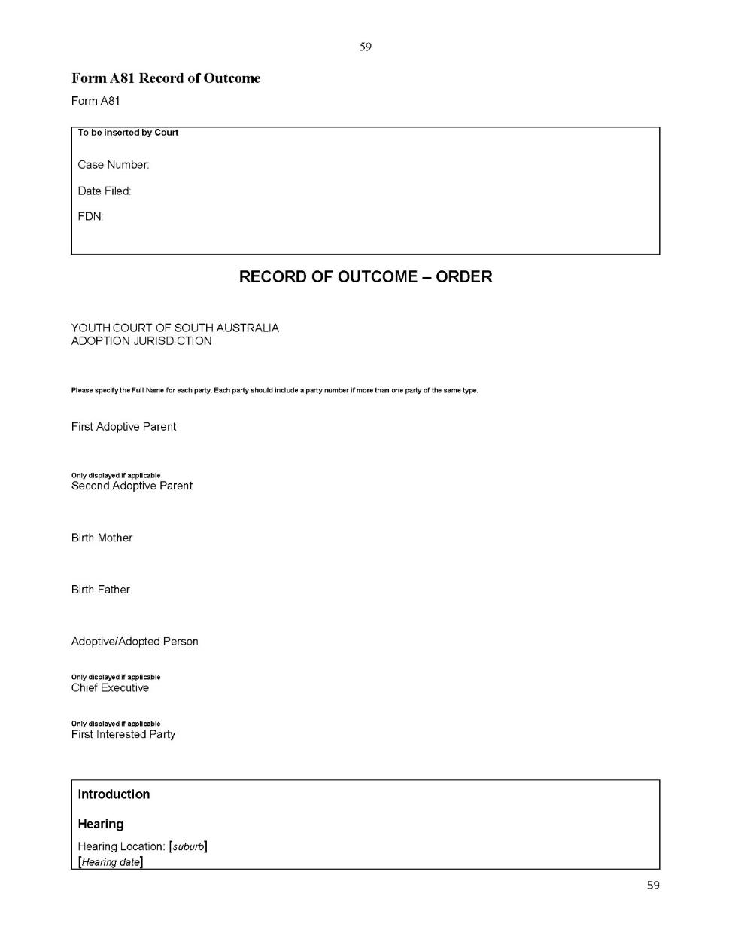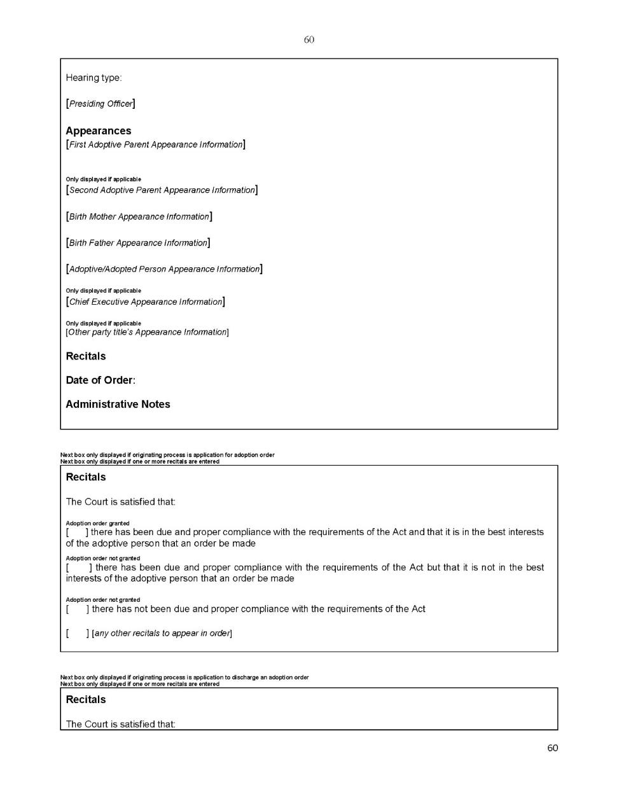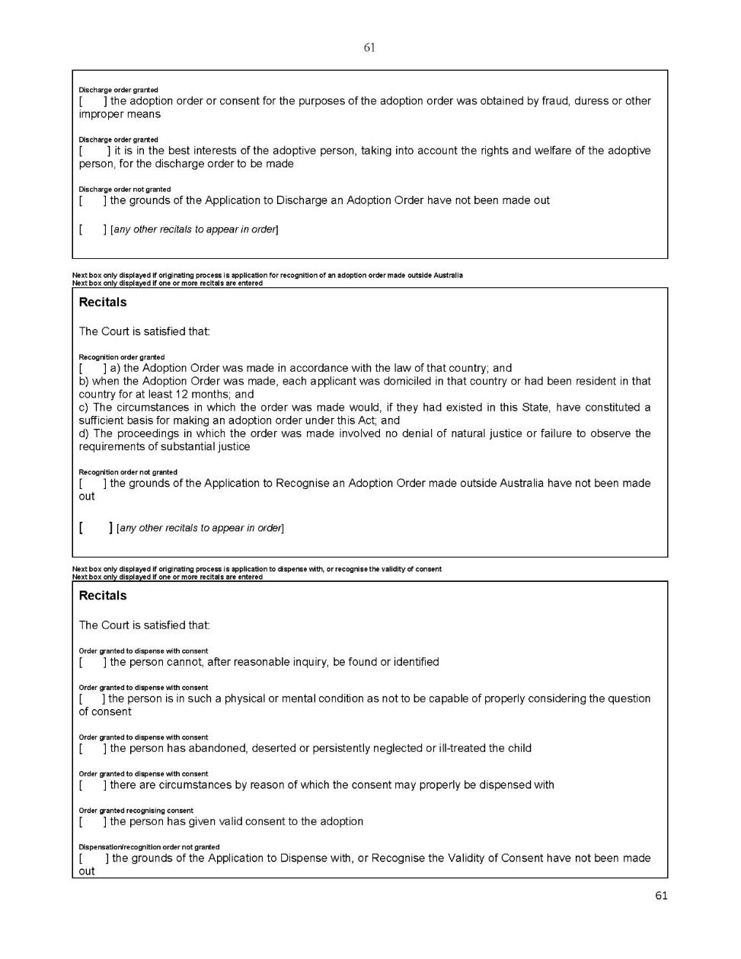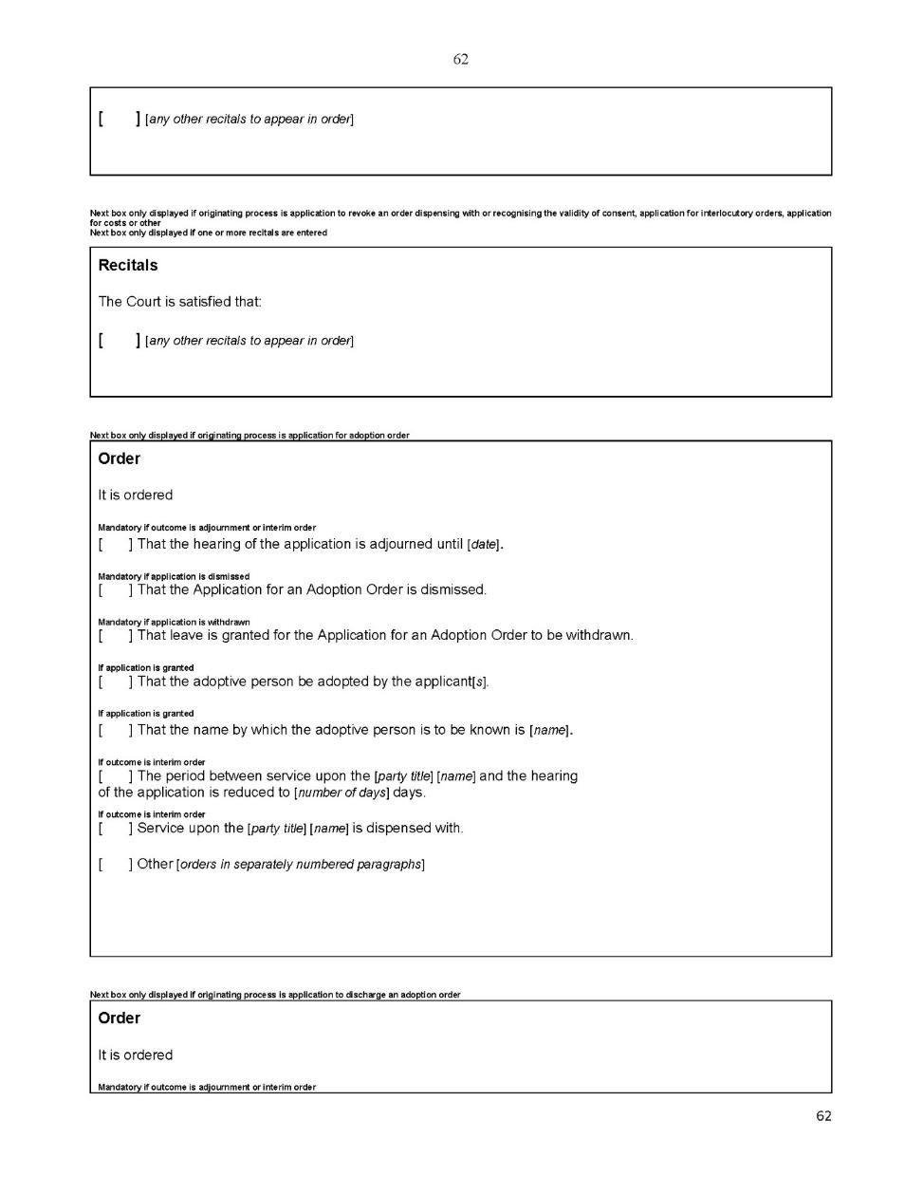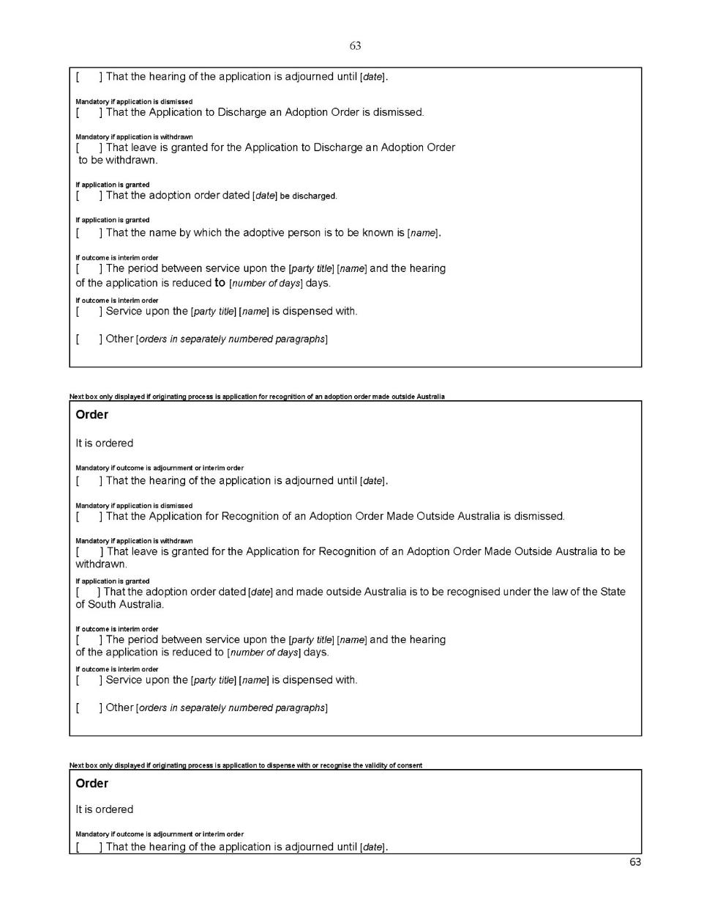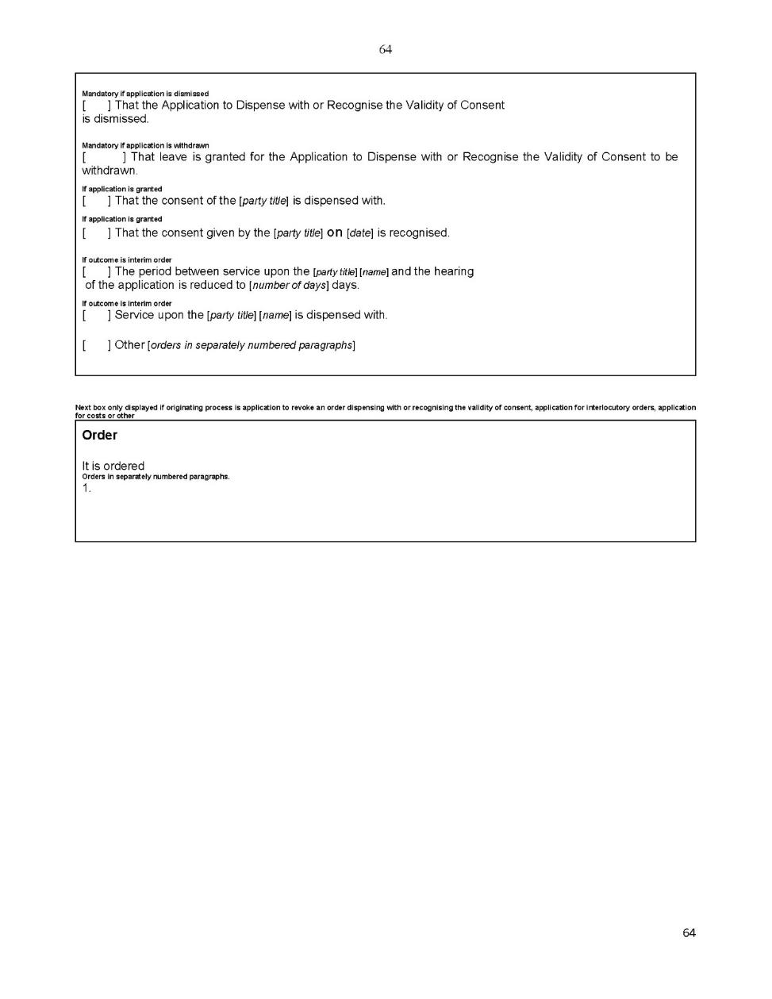

Dated: 8 May 2020
Eldridge P.
Davis L.
White D.
Koehn O.

Youth Court (Care and Protection) Rules 2018
South Australia

Amendment No 1
By virtue and in pursuance of section 32 of the Youth Court Act 1993 and all other enabling powers, we, the Judge of the Court and the Magistrates who are members of the principal judiciary of the Court, make the following Youth Court (Care and Protection) Rules 2018 (Amendment No 1).
- These Rules may be cited as the Youth Court (Care and Protection) Rules 2018 (Amendment No 1).
- The Youth Court (Care and Protection) Rules 2018 are amended as set out below.
- These rules come into effect—
(a) subject to subrule (b), on the date of their publication in the Gazette;
(b) if these rules are published in the Gazette on a day other than a Monday, these rules come into effect on the date that is the first Monday following that publication.
- In these Rules, the commencement date means the date on which these rules come into effect under rule 3.
- Unless the Court otherwise orders—
(a) the Youth Court (Care and Protection) Rules 2018 as amended by these Rules (the current Rules) apply to—
(i) a proceeding commenced; and
(ii) a step in a proceeding taken,
on or after the commencement date; and
(b) the Youth Court (Care and Protection) Rules 2018 before they were amended by these Rules (the former Rules) continue to govern a step in a proceeding taken before the commencement date.
- If the time to commence or take a step in a proceeding under the former Rules has not expired as at the commencement date, the time to commence or take a step in the proceeding continues to be governed by the former Rules (unless the current Rules provide for a longer time).
- Rule 4 is amended by adding the following sentence at the end of the rule:
“The care and protection jurisdiction of the Court is also governed by the Youth Court (General) Rules 2016.”
- Rule 6 is deleted.
- ‘Rule 7 – Forms’ is re-numbered to ‘Rule 6 – Forms.’
- ‘Rule 8 – Notification of urgent removal’ is re-numbered to ‘Rule 7 – Notification of urgent removal.’
- ‘Rule 9 – Applications – general provision’ is re-numbered to ‘Rule 8 – Applications – general provision.’
- A new Rule 8A is inserted as follows:
“8A—Application for Care and Protection Order or for Variation, Revocation or Discharge
(1) An application for a care and protection order is to be made in the prescribed form set out in Schedule 1.
Prescribed form—
Form CP1 Application for Care and Protection Order or to Vary, Extend or Revoke Instrument of Guardianship
(2) An application to vary, revoke or discharge a Care and Protection Order is to be made in the prescribed form set out in Schedule 1.
Prescribed form—
Form CP2 Application to Vary, Revoke or Discharge Care and Protection Orders”
- A new rule 8B is inserted as follows:
“8B—Interested Persons
If an interested person wishes to appear at trial and make submissions in respect of a child or young person pursuant to section 66 of the Children and Young People (Safety) Act 2017, an application must be made in the prescribed form set out in Schedule 1.
Prescribed form—
Form CP5 Application for Interested Person(s) to be Heard”
- A new rule 8C is inserted as follows:
“8C—Undertakings
An undertaking entered into by a party in relation to an Application under this Part must be made in the prescribed form set out in Schedule 1 and signed by the person entering into the undertaking.
Prescribed form—
Form CP8 Undertaking”
- ‘Rule 10 – Case plans’ is re-numbered to ‘Rule 9 – Case plans.’
- ‘Rule 11 – Material supporting applications – other requirements’ is re-numbered to ‘Rule 10 – Material supporting applications – other requirements.;
- ‘Rule 12 – Responses’ is re-numbered to ‘Rule 11 – Responses.’
- Subrule 11(3) is deleted and the following subrule is substituted:
“ (3) A response to an application must—
(a) be in the prescribed form set out in Schedule 1; and
(b) state clearly the order or orders sought in the application that are opposed and any order that is not opposed; and
(c) if an order is proposed as an alternative to an order sought in the application, indicate that clearly, and specify the proposed order and which order it would replace; and
(d) in relation to each ground of the application, state whether the ground is—
(i) admitted; or
(ii) disputed; or
(iii) not admitted, but not disputed for the purposes of the determination of the application; and
(e) in relation to each separate particular of a factual allegation in the application, state whether the particular is—
(i) admitted; or
(ii) disputed; or
(iii) not admitted, but not disputed for the purposes of the determination of the application; and
(f) if a ground or particular is disputed, state briefly the manner in which the ground or particular is disputed.
Prescribed form—
Form CP7 Response”
- ‘Rule 13 – Interlocutory applications’ is re-numbered to ‘Rule 12 – Interlocutory applications.
- Subrule 12(2) is deleted and the following subrule is substituted:
“(2) An interlocutory application is to be in the prescribed form set out in Schedule 1, accompanied by an affidavit in the prescribed form evidencing the grounds on which the application is being made.
Prescribed forms—
Form CP6 Interlocutory Application
Form CP4 Affidavit”
- ‘Rule 14 – Pre-trial conferences’ is re-numbered to ‘Rule 13 – Pre-trial conferences.’
- ‘Rule 15 – Documents required for pre-trial conferences’ is re-numbered to ‘Rule 14 – Documents required for pre-trial conferences.’
- ‘Rule 16 – Status conferences and facilitation of trials’ is re-numbered to ‘Rule 15 – Status conferences and facilitation of trials.’
- ‘Rule 17 – Trial books’ is re-numbered to ‘Rule 16 – Trial books.’
- ‘Rule 18 – Listing of trials’ is re-numbered to ‘Rule 17 – Listing of trials.’
- ‘Rule 19 – Trials’ is re-numbered to ‘Rule 18 – Trials.’
- ‘Rule 20 – Minutes of order’ is re-numbered to ‘Rule 19 – Minutes of order.’
- ‘Rule 21 – Temporary instruments of guardianship and restraining notices’ is re-numbered to ‘Rule 20 – Temporary instruments of guardianship and restraining notices.’
- Rule 20 is deleted and the following rule is substituted:
“21—Temporary instruments of guardianship and restraining notices
(1) For the purposes of sections 45(4)(b) and 46(4)(b) of the Children and Young People (Safety) Act 2017, an instrument of guardianship or restraining notice (as the case may be) must be lodged with the Court in the prescribed form in Schedule 1.
Prescribed form—
Form CP3 Notice of Lodgement of Instrument
(2) An application to the Court to vary arrangements for the care of a child or young person under section 45(6) of the Children and Young People (Safety) Act 2017 must be made in the prescribed form in Schedule 1.
Prescribed form—
Form CP1 Application for Care and Protection Order or to Vary, Extend or Revoke Instrument of Guardianship
(3) An application to the Court to extend the guardianship period or a restraining notice period under section 47 of the Children and Young People (Safety) Act 2017 must be made using the prescribed form in Schedule 1.
Prescribed form—
Form CP1 Application for Care and Protection Order or to Vary, Extend or Revoke Instrument of Guardianship”
- ‘Rule 22 – Video and other links’ is re-numbered to ‘Rule 21 – Video and other links.’
- ‘Rule 23 – Proof of service’ is re-numbered to ‘Rule 22 – Proof of service.’
- Subrule 22(2) is deleted and the following subrule is substituted:
“ (2) Proof of service of an application or document may consist of an affidavit in the prescribed form made by the person who served the application or document setting out—
(a) the date, time and place of service; and
(b) how the person to be served was identified; and
(c) how service was effected.
Prescribed form—
Form CP9 Affidavit of Service”
- ‘Rule 24 – Litigation guardians’ is re-numbered to ‘Rule 23 – Litigation guardians.’
- ‘Rule 25 – Revocation’ is re-numbered to ‘Rule 24 – Revocation.’
- The current Schedule to the Youth Court (Care and Protection) Rules 2018 is deleted and the following Schedule is substituted:

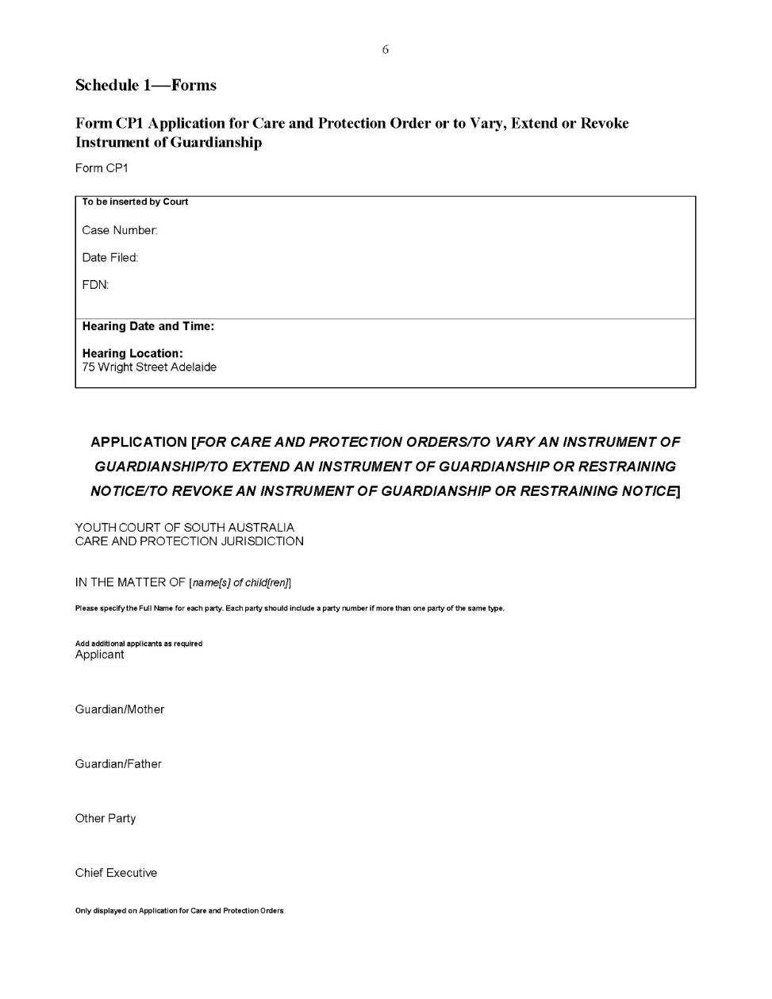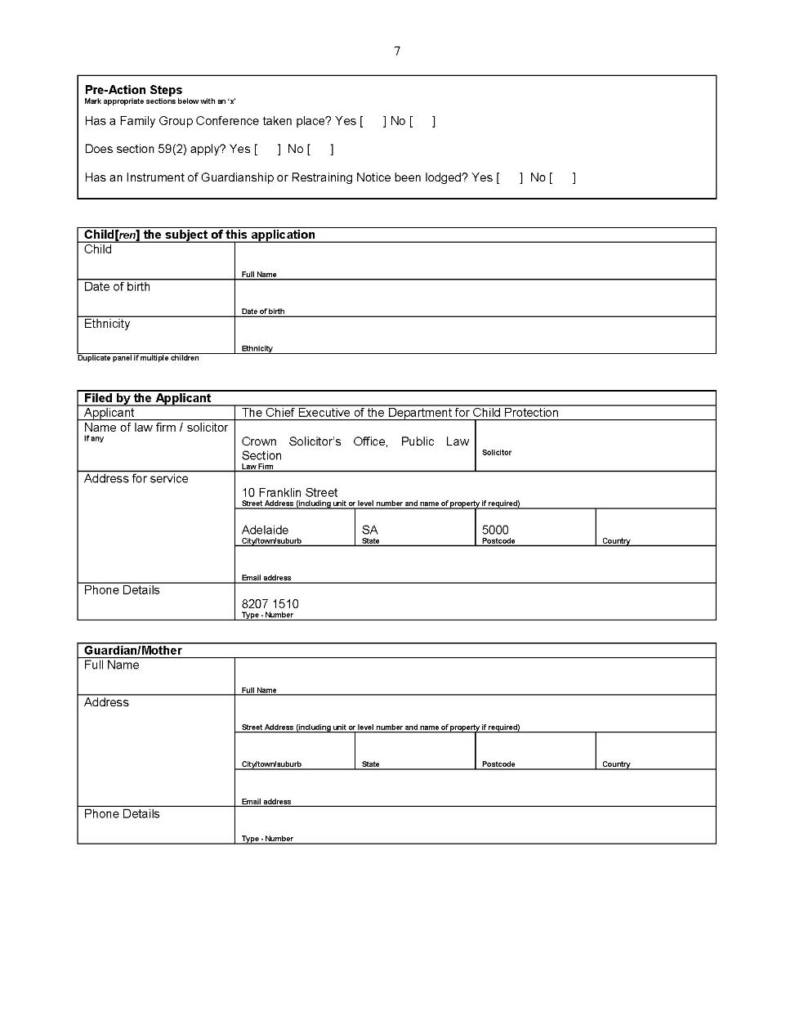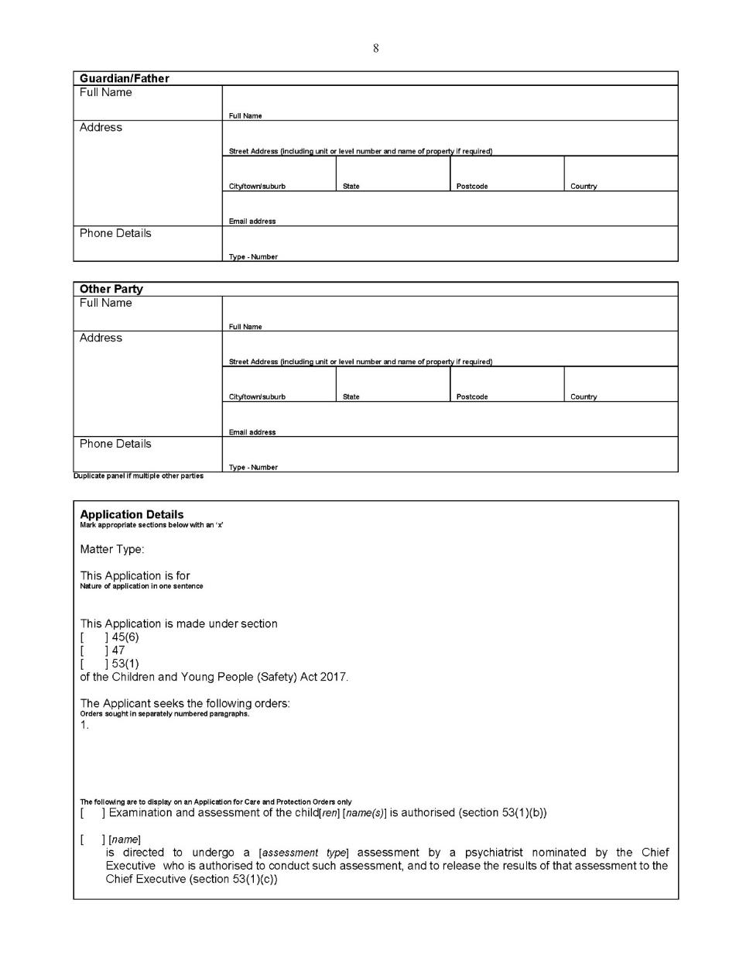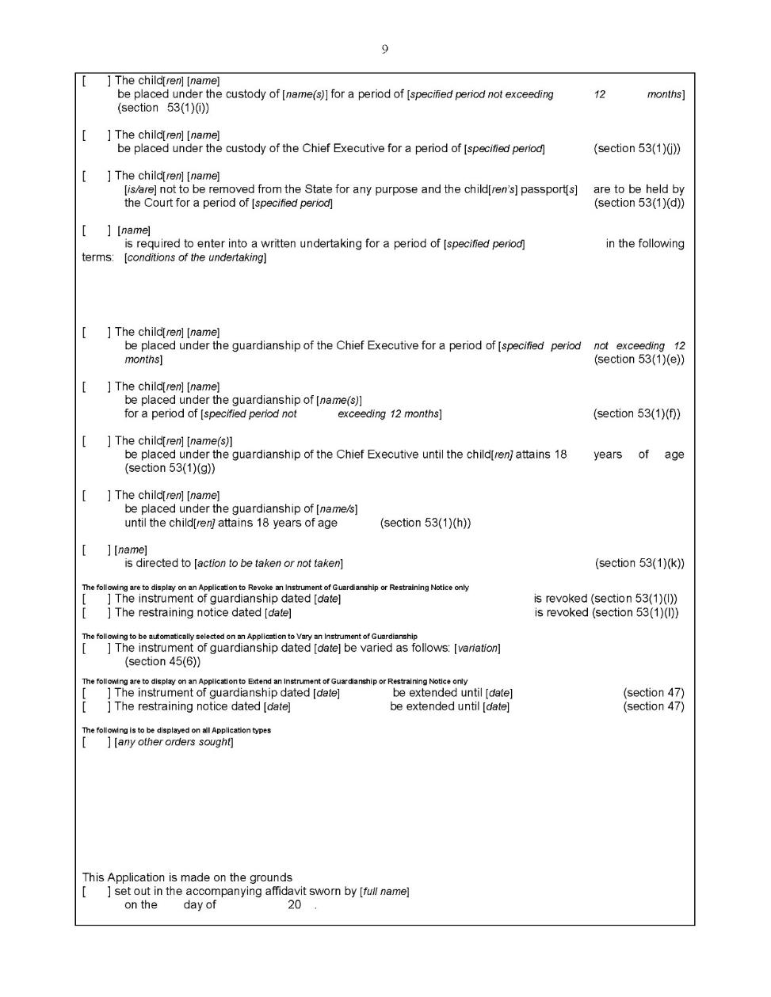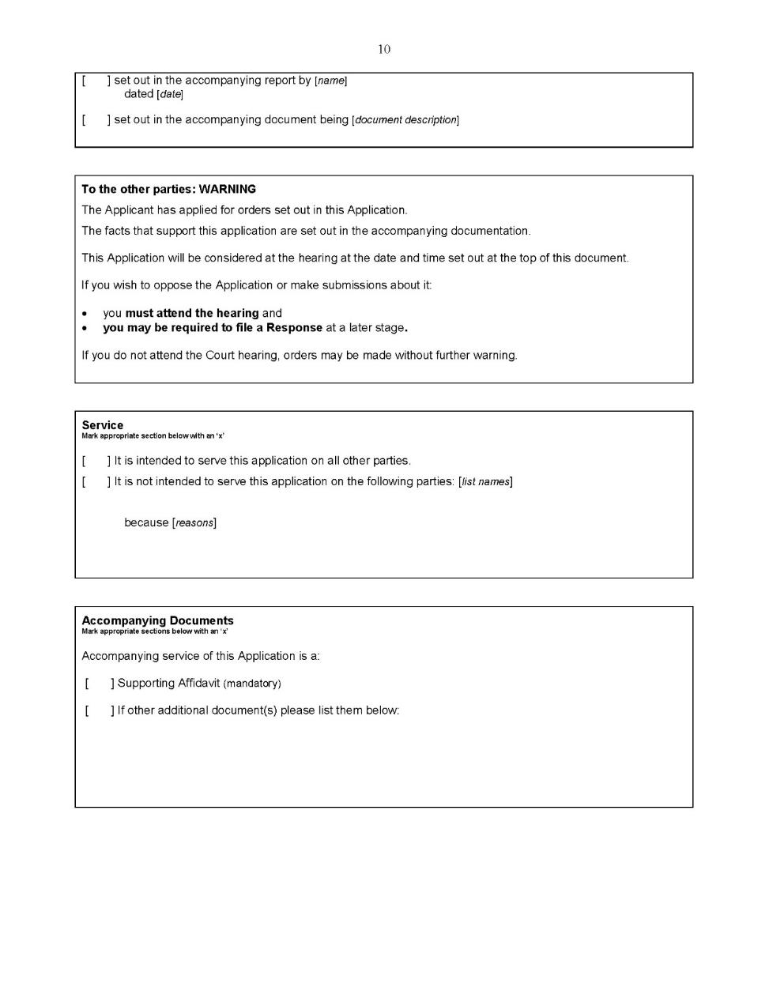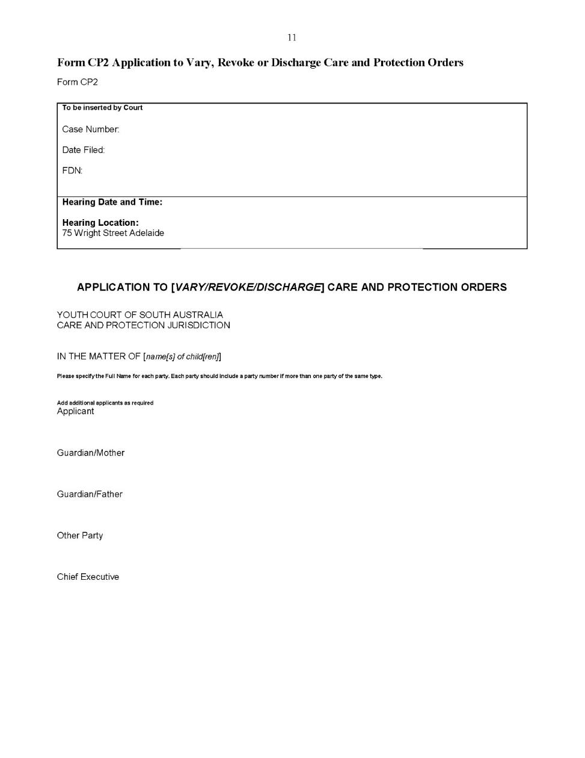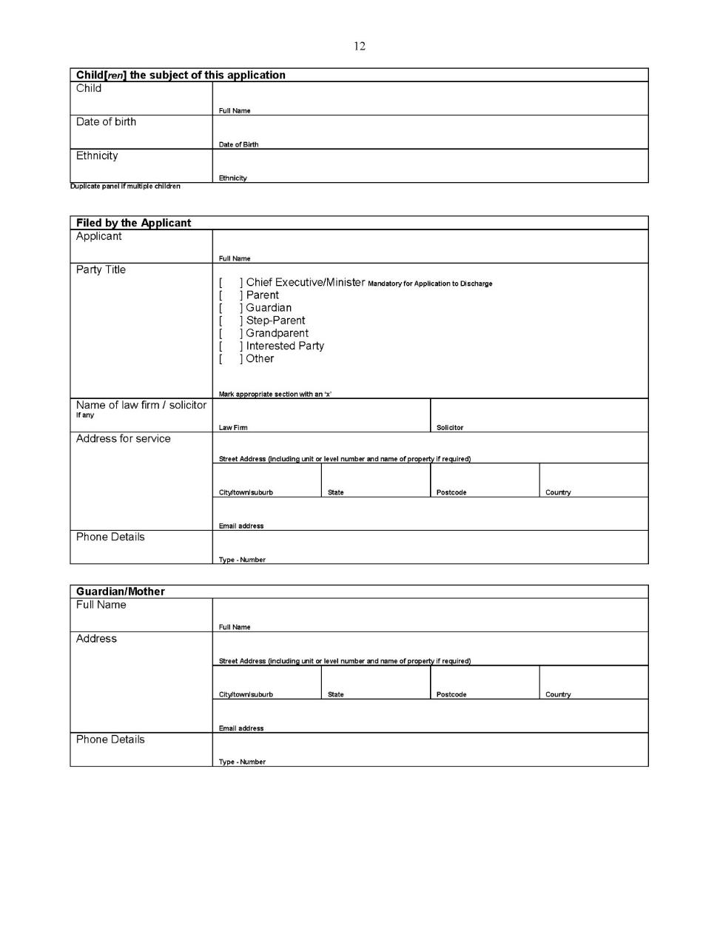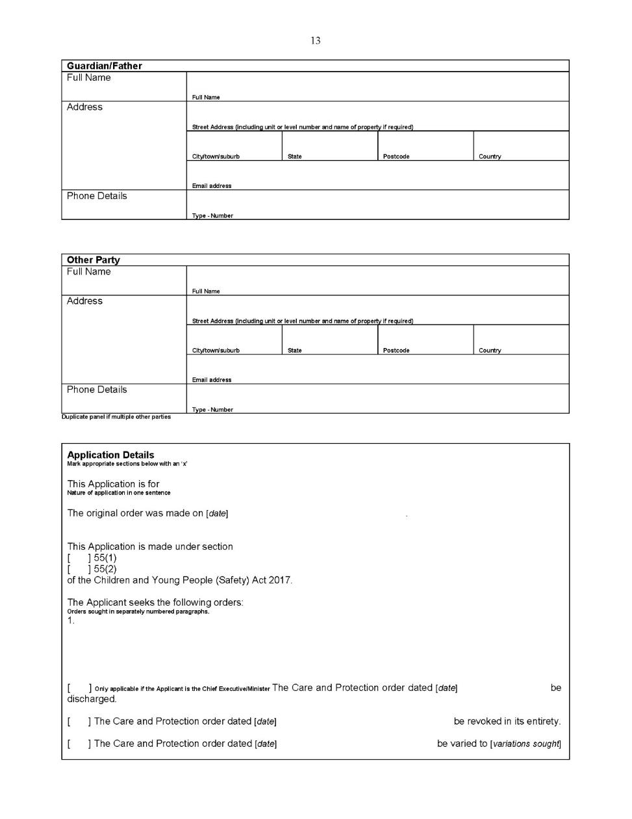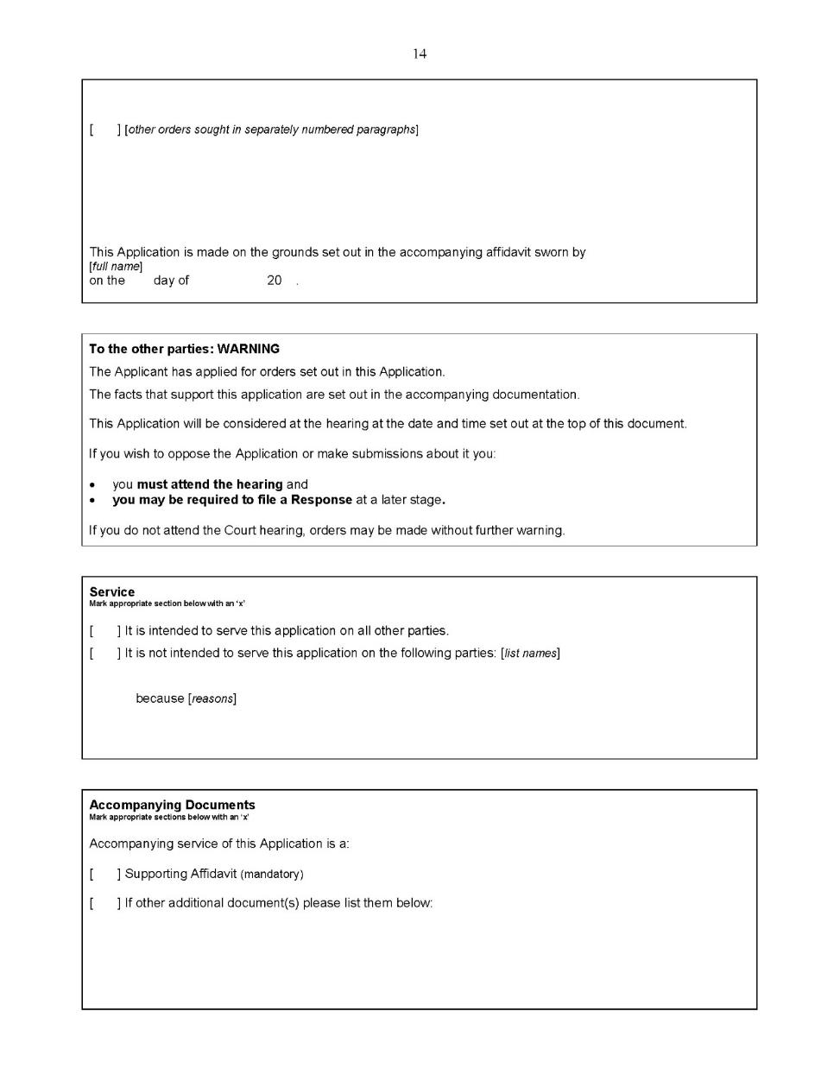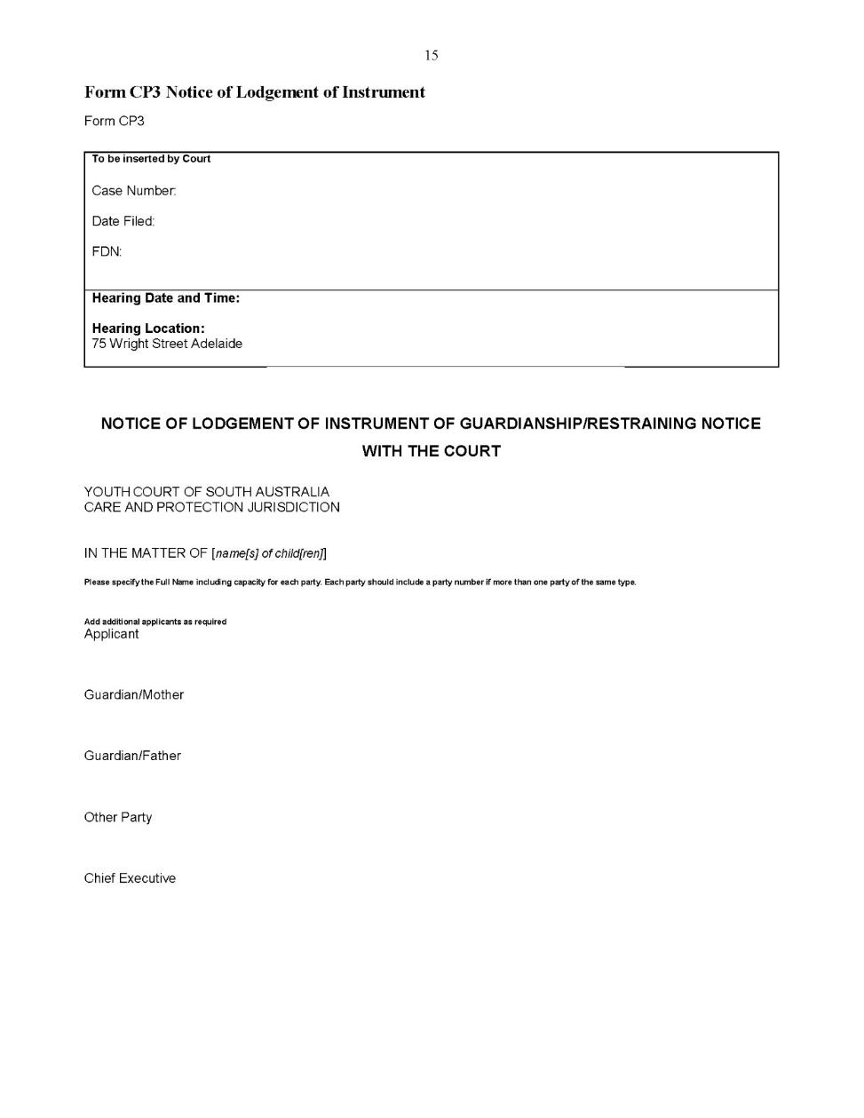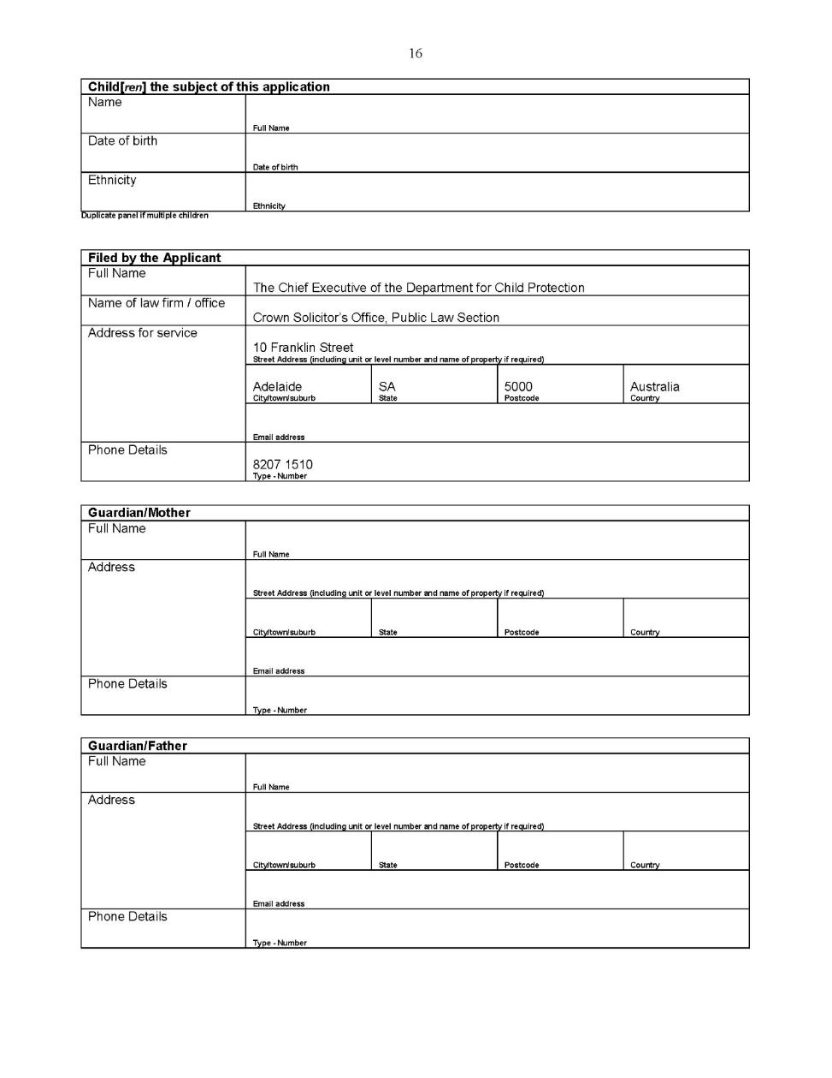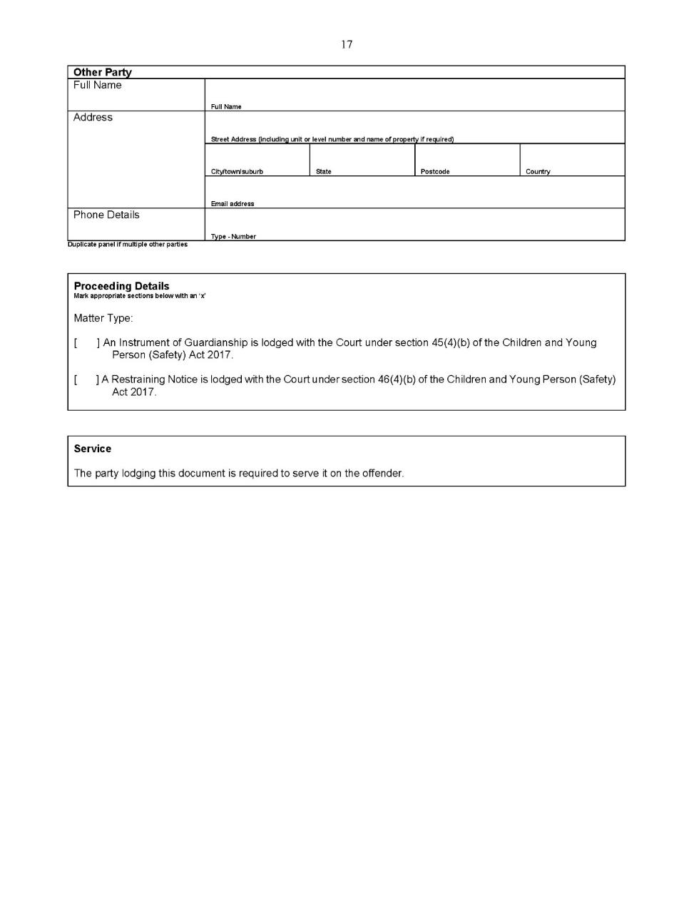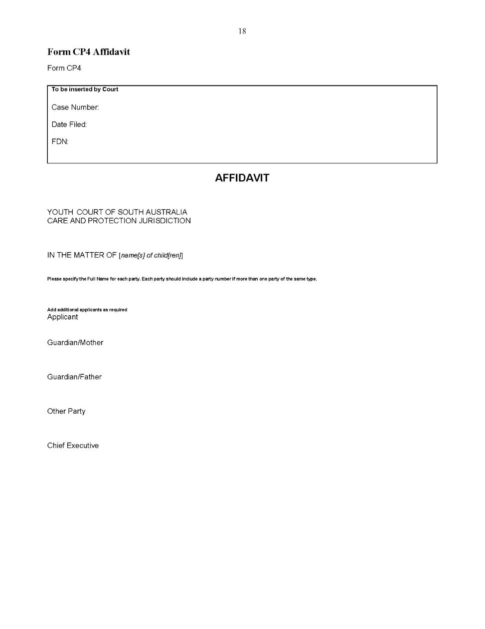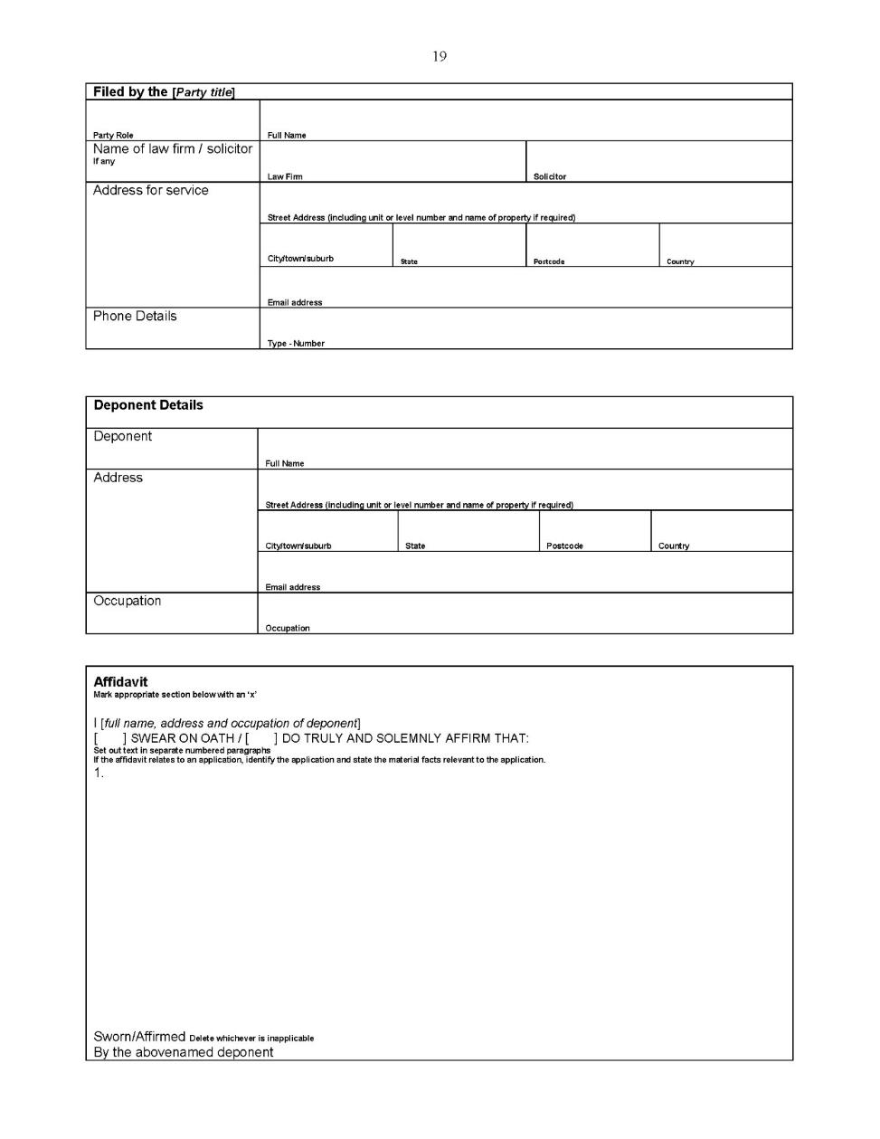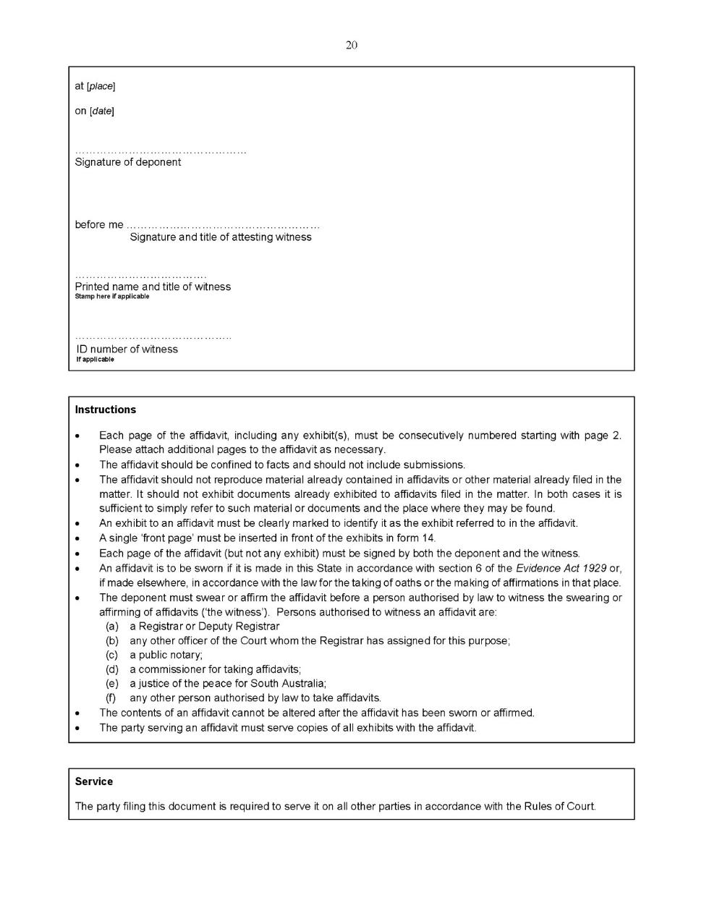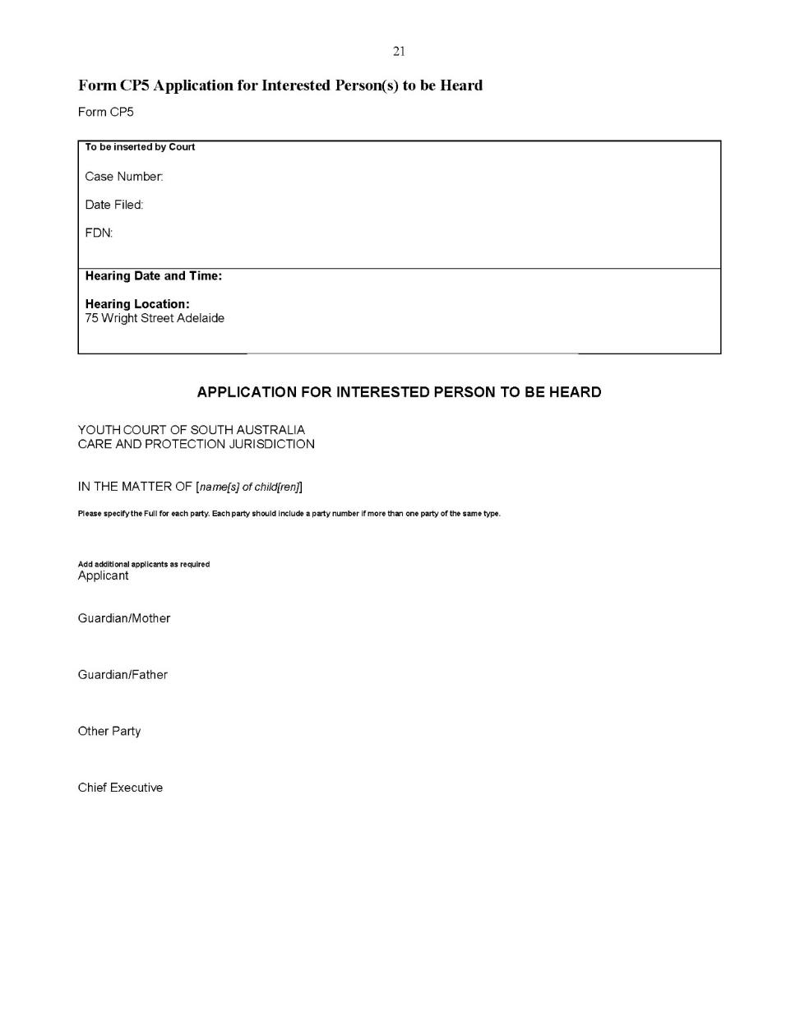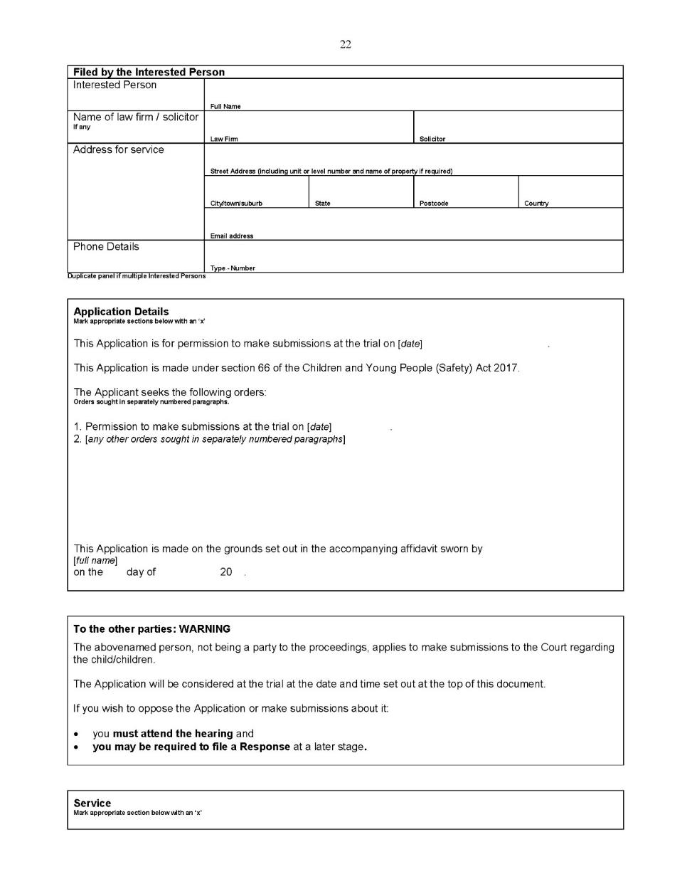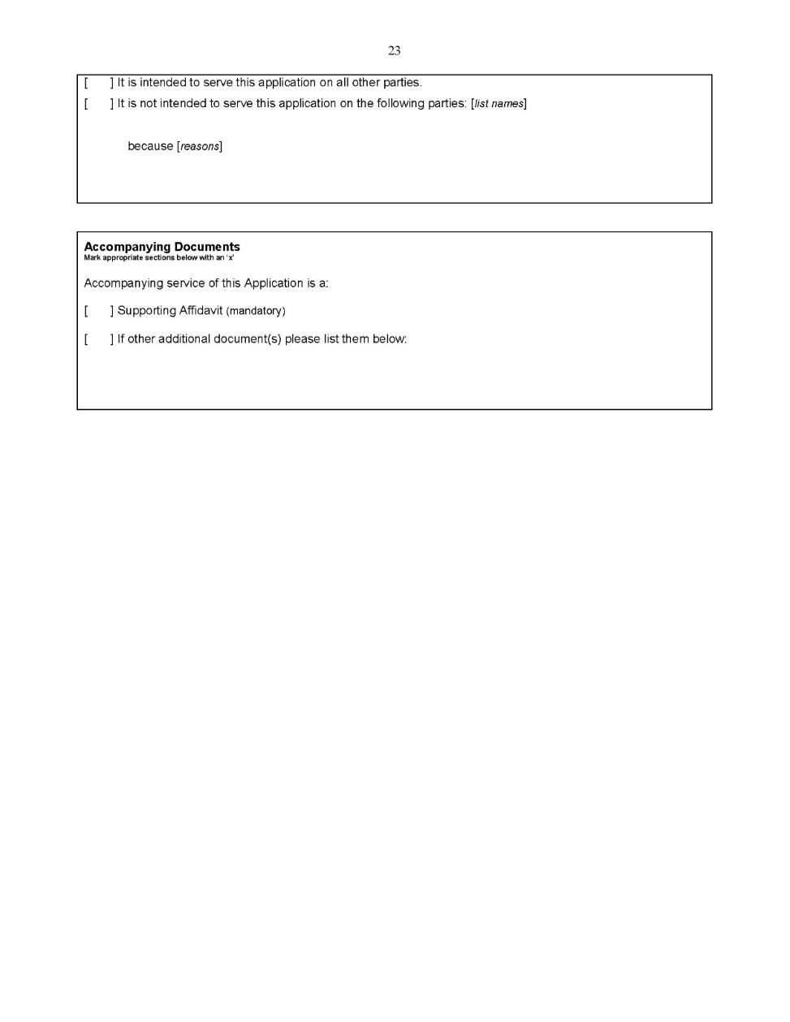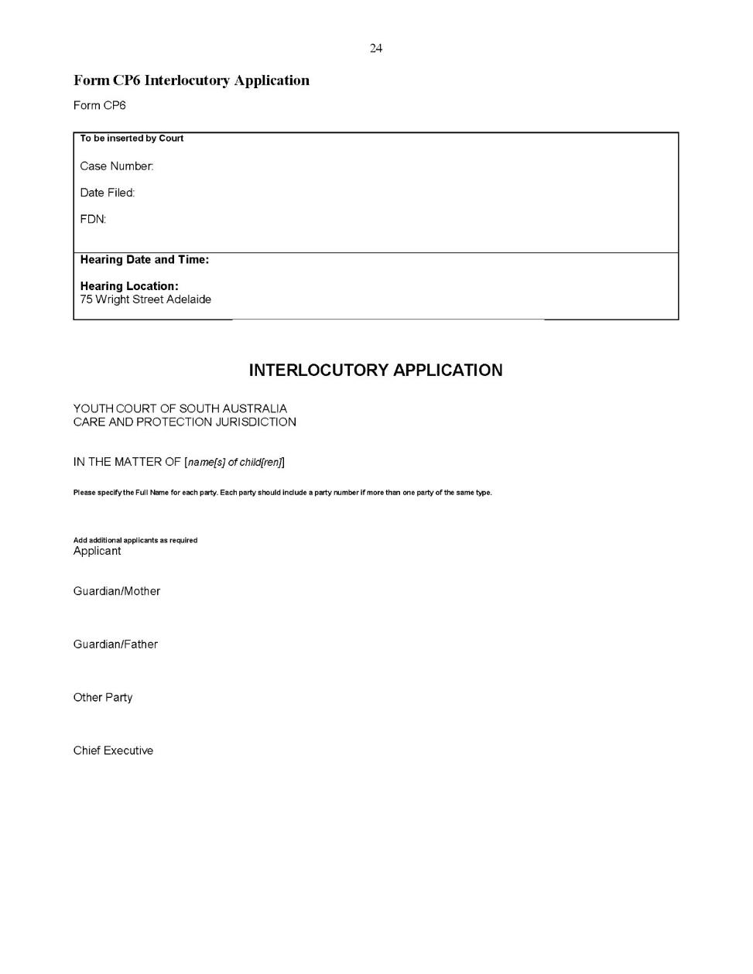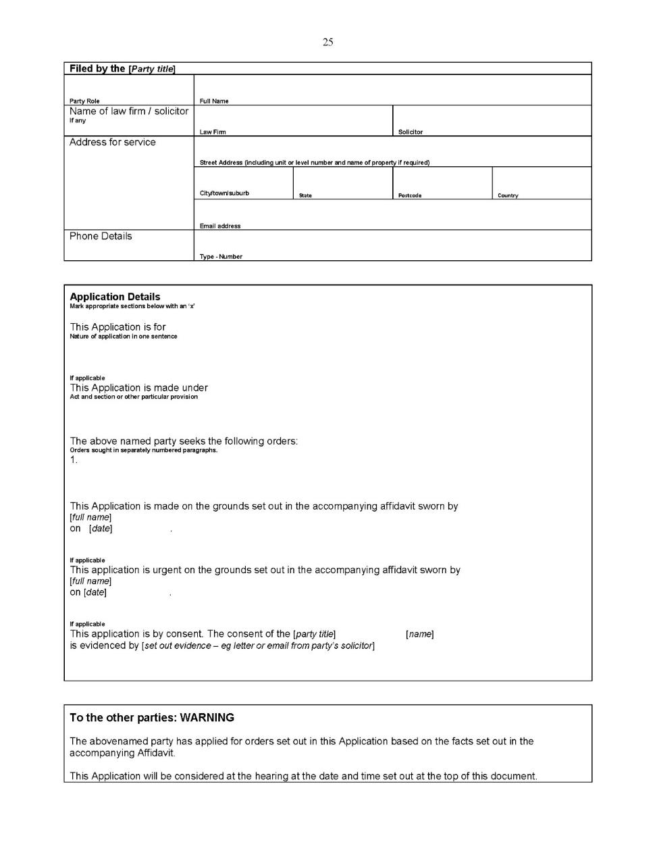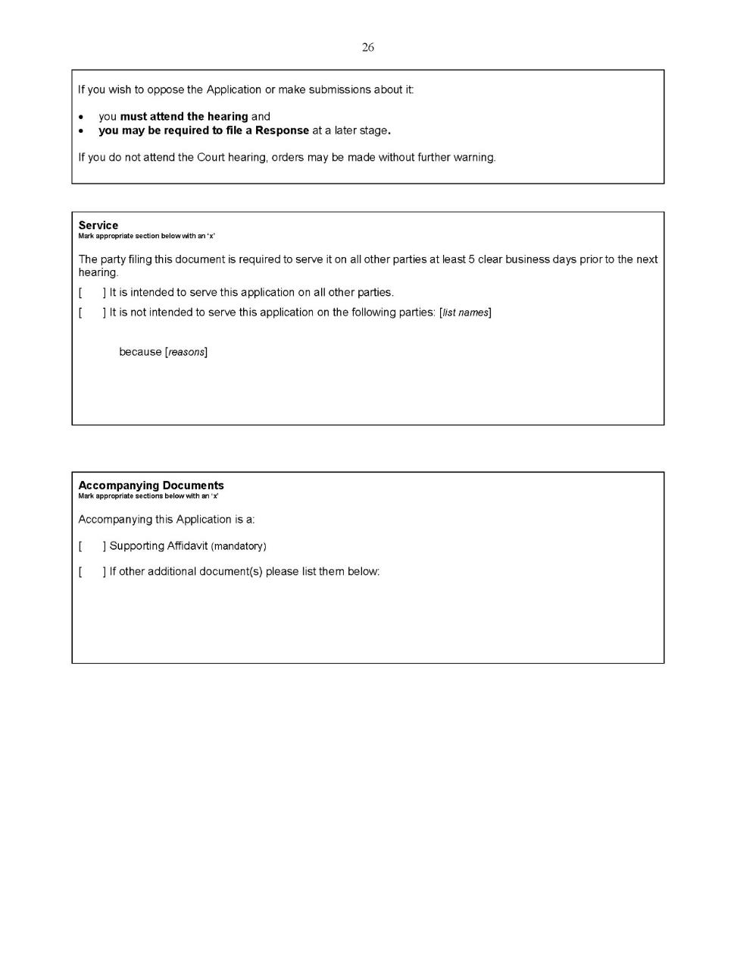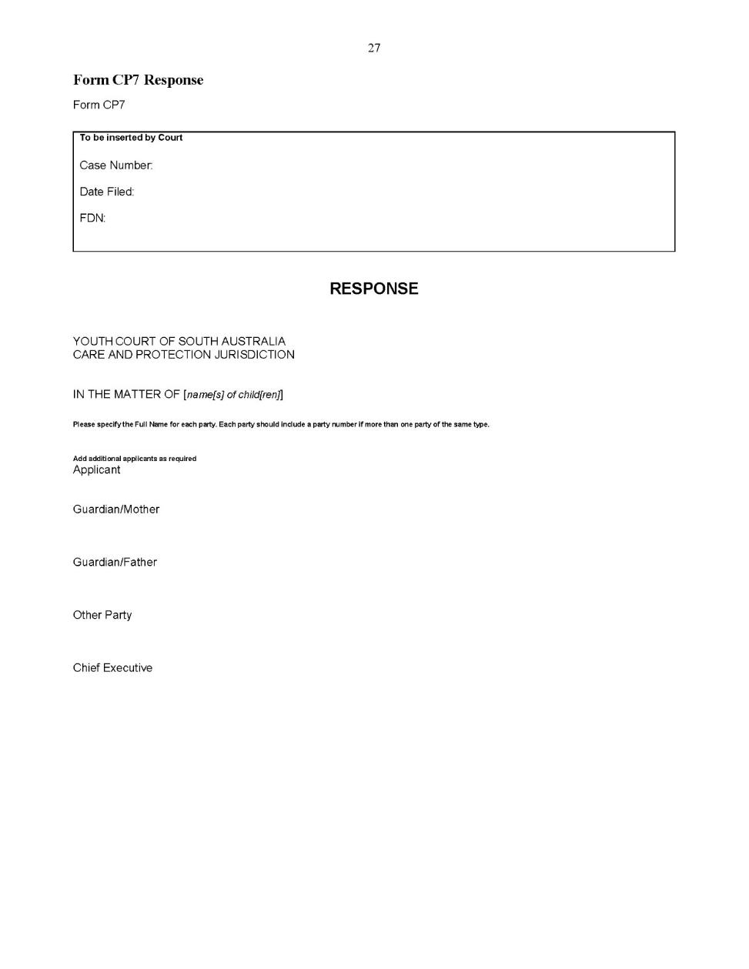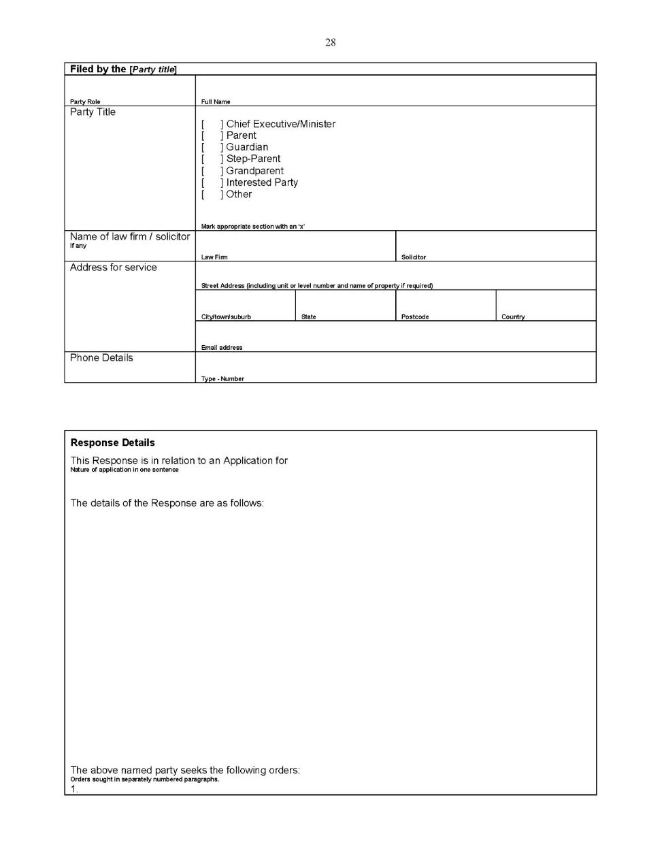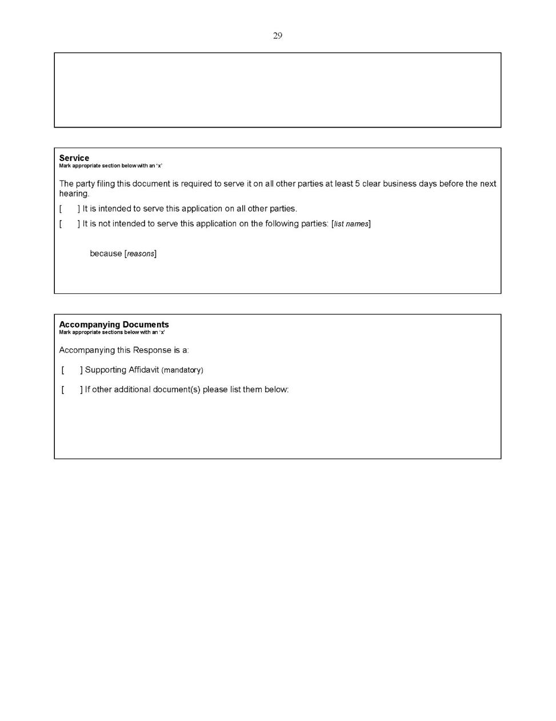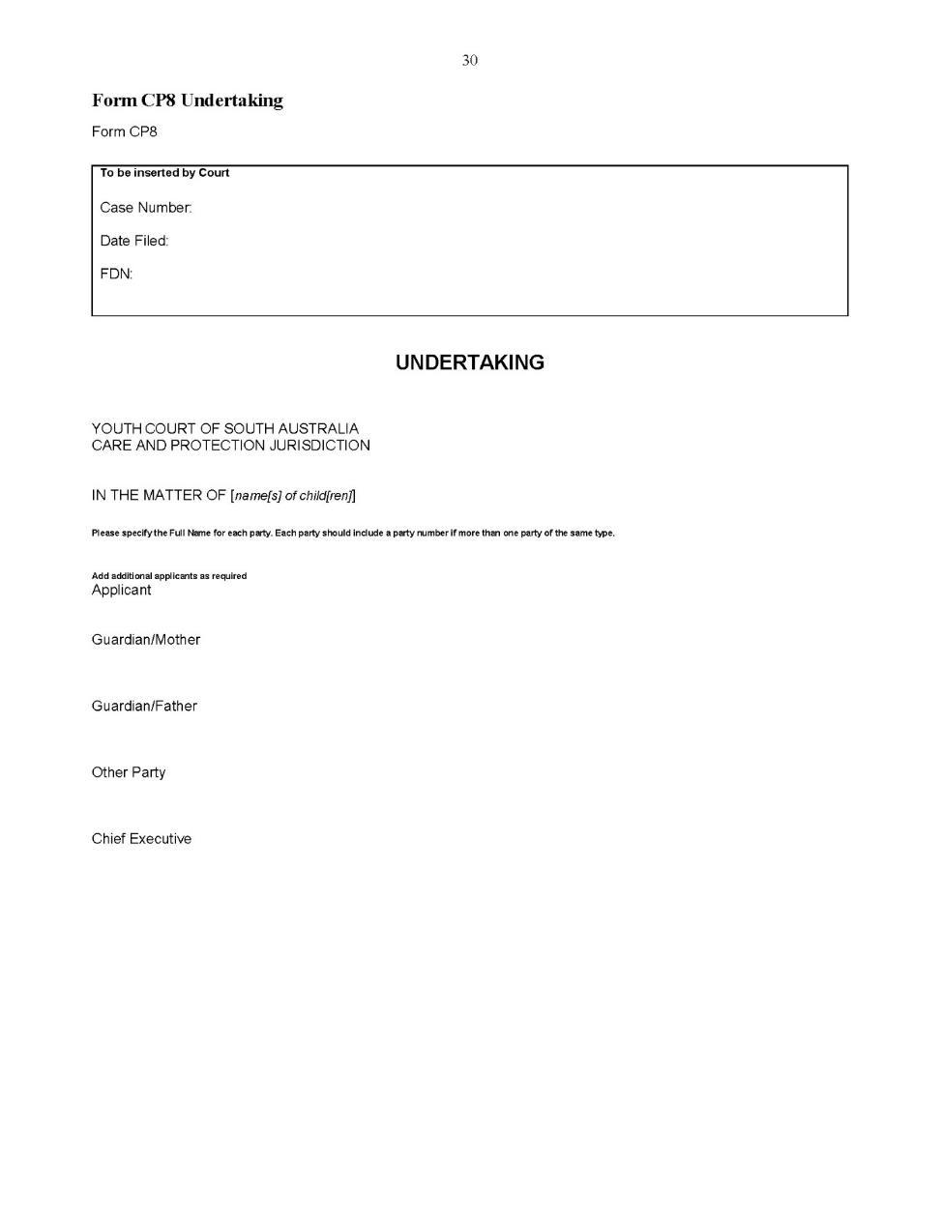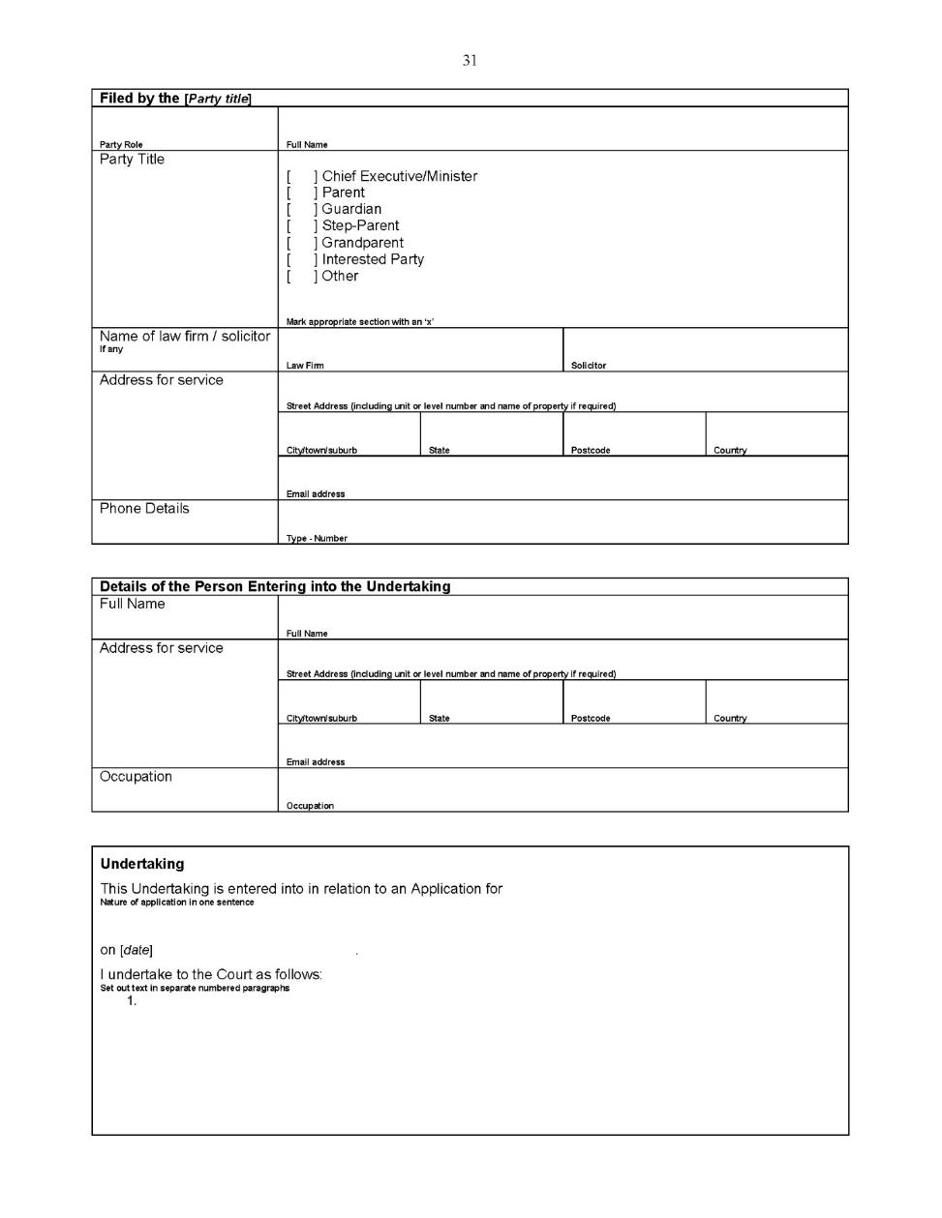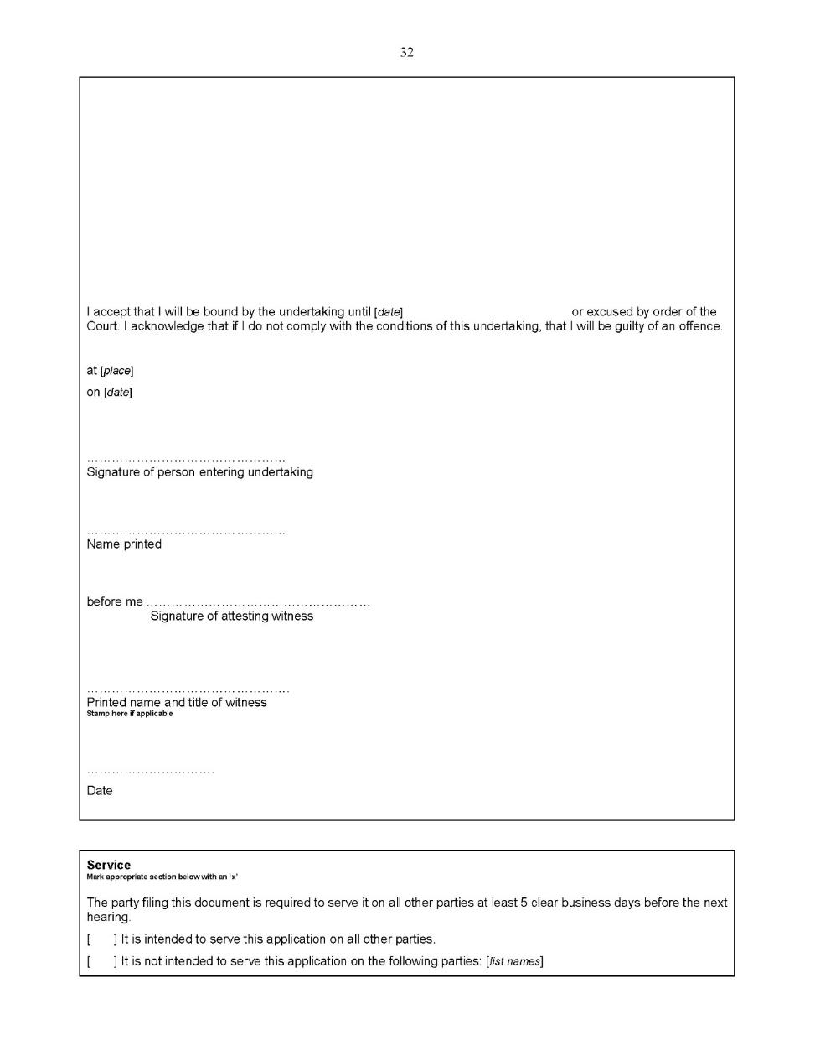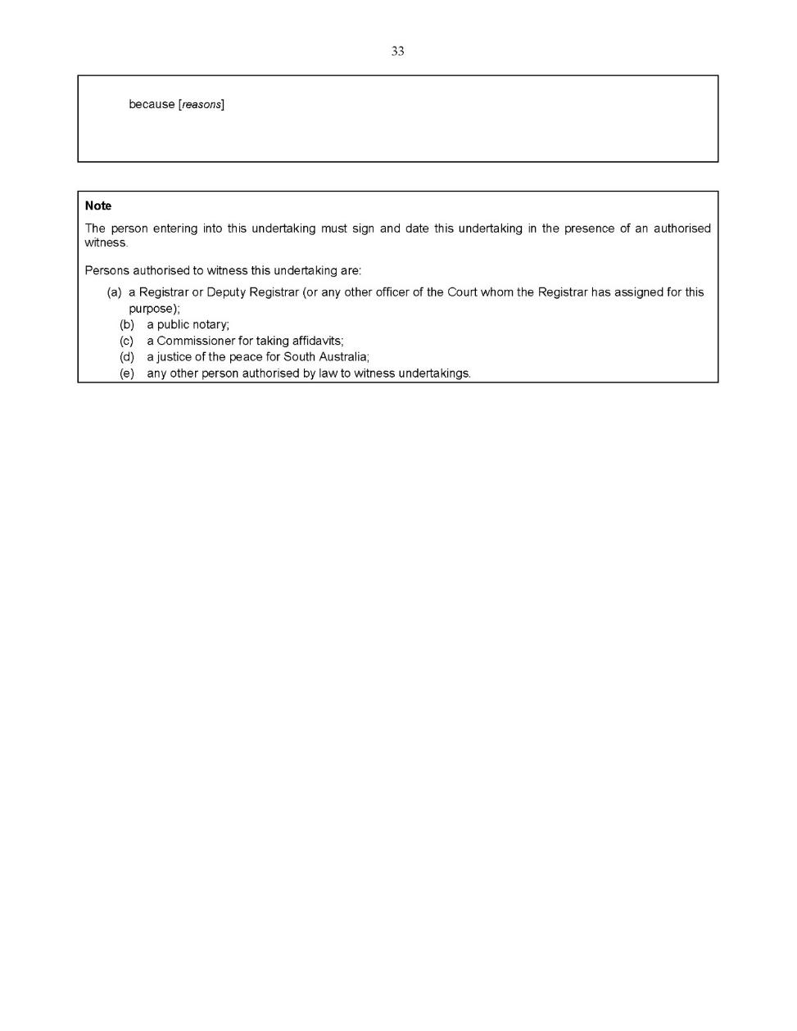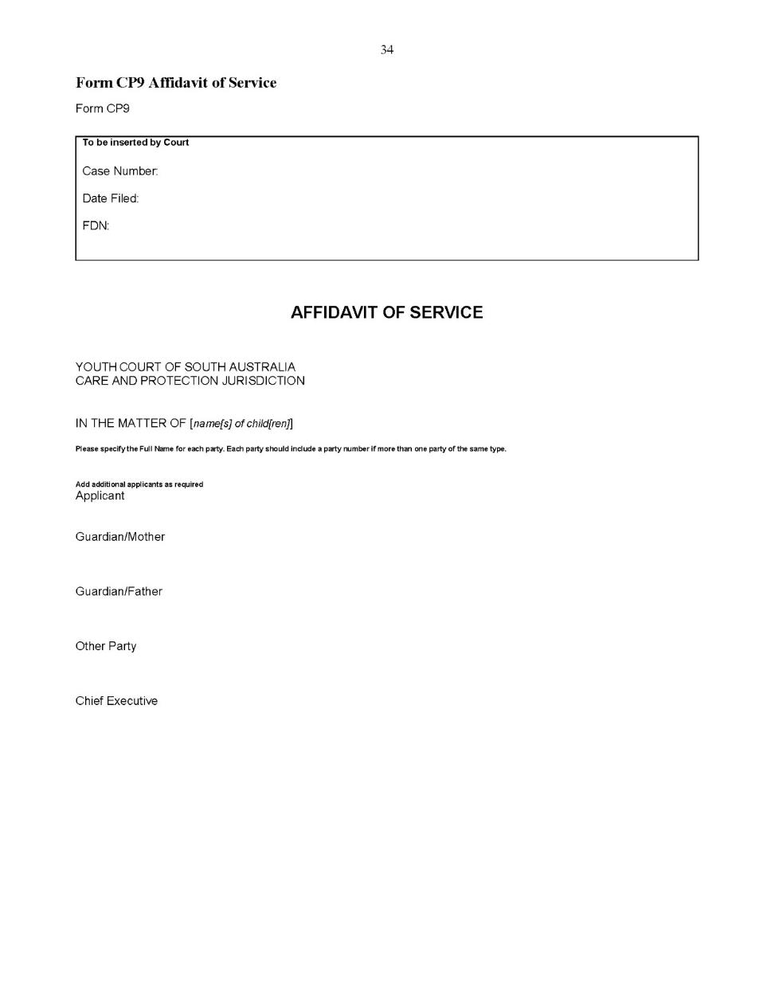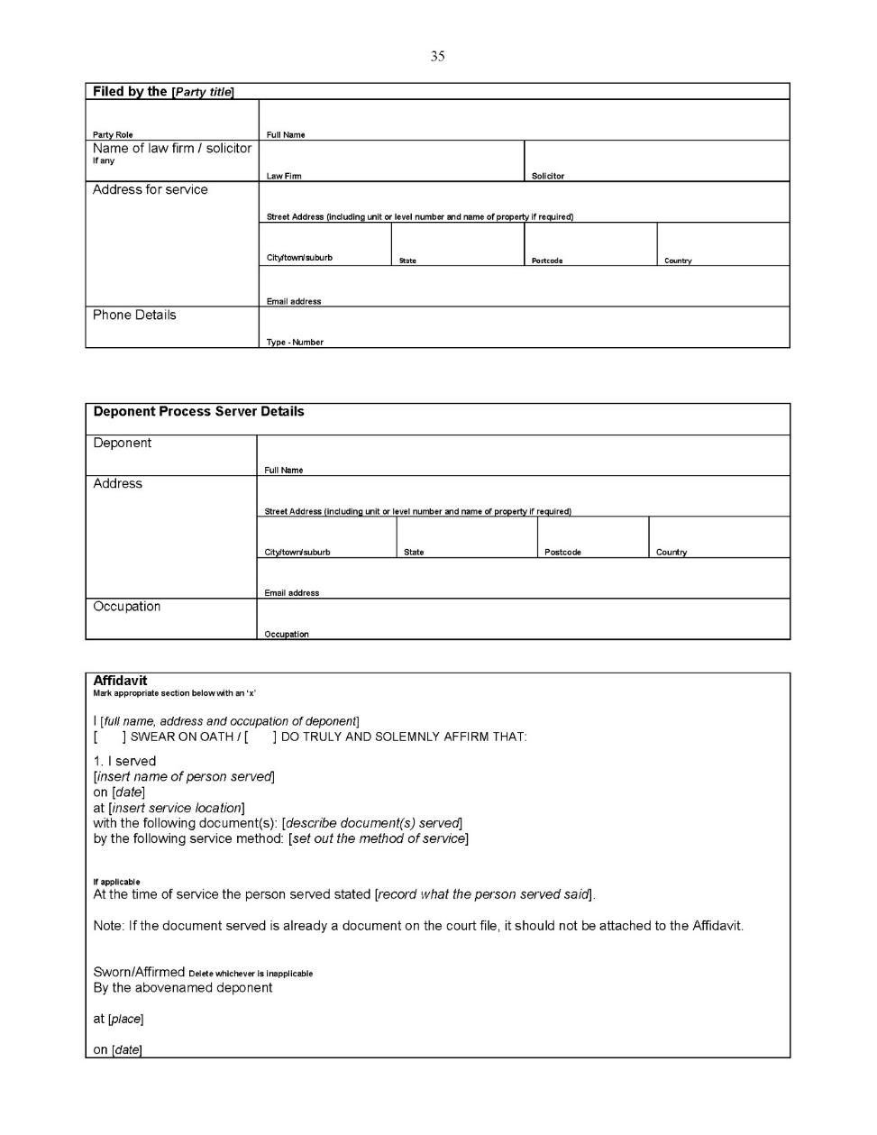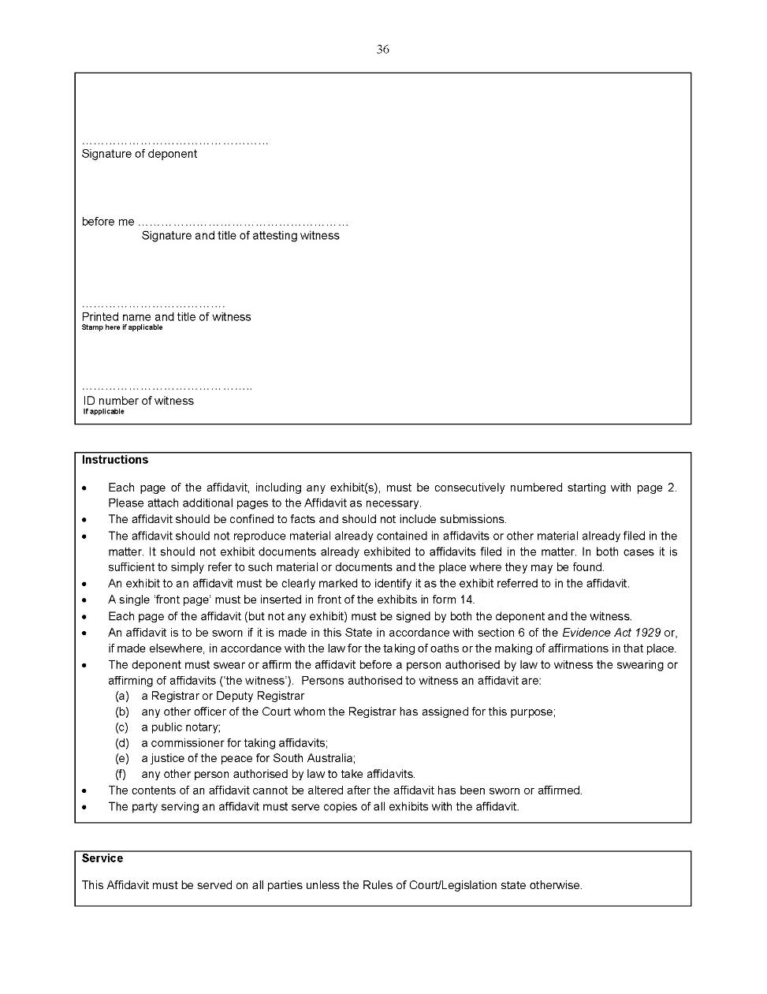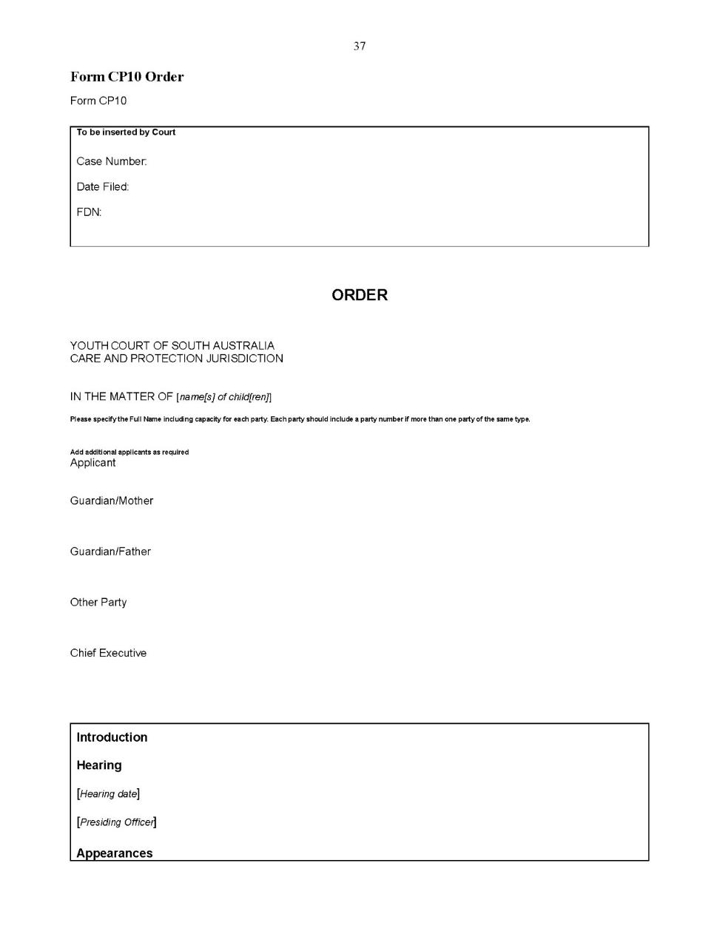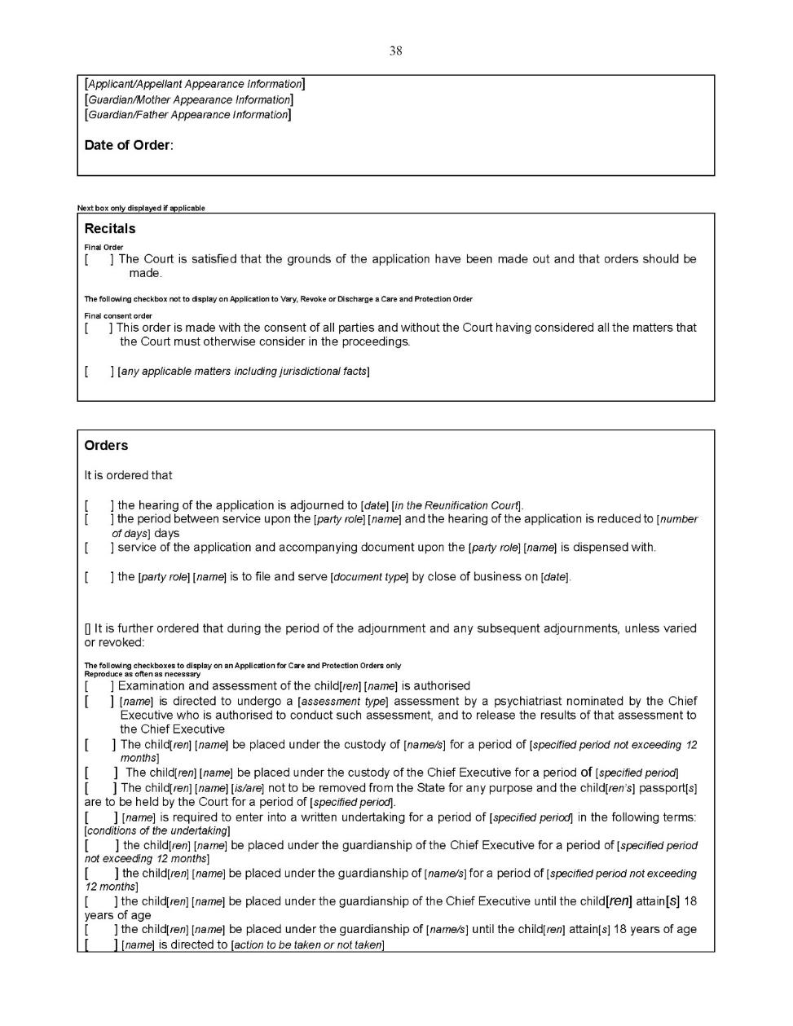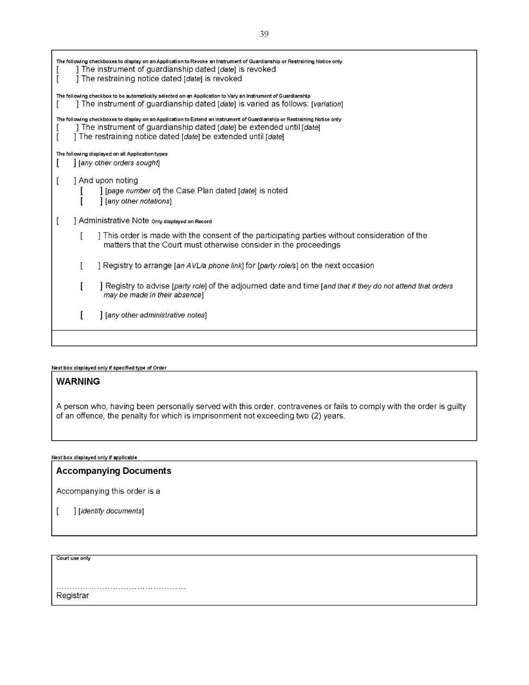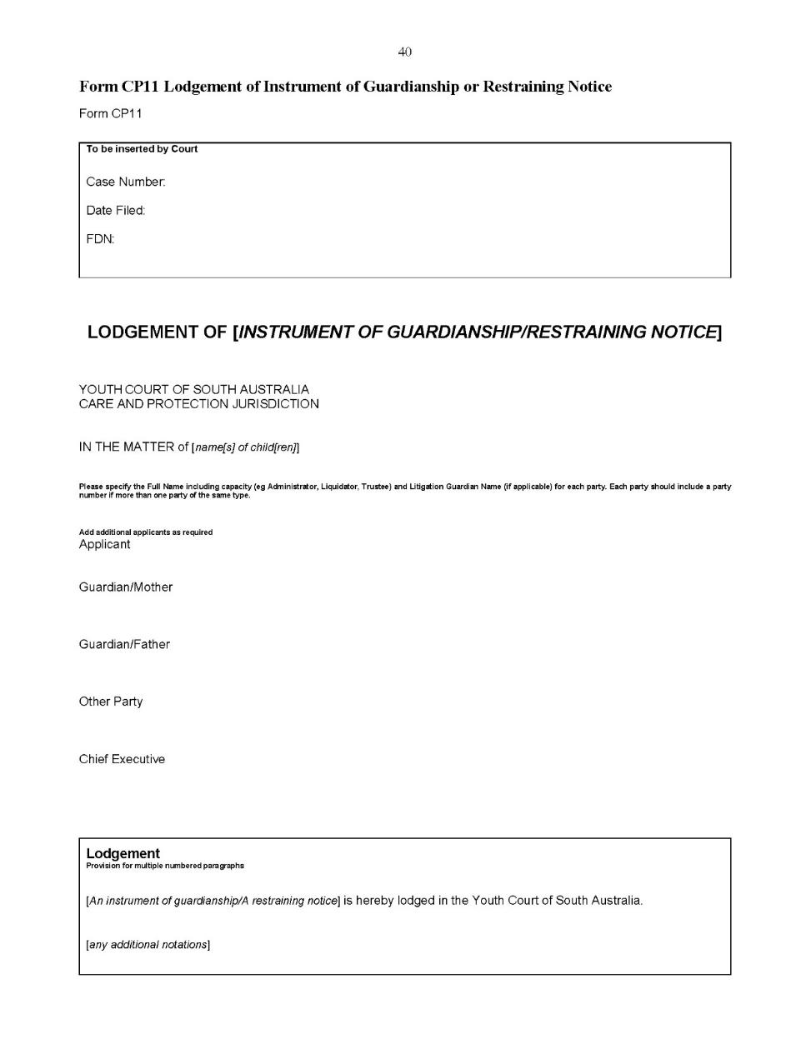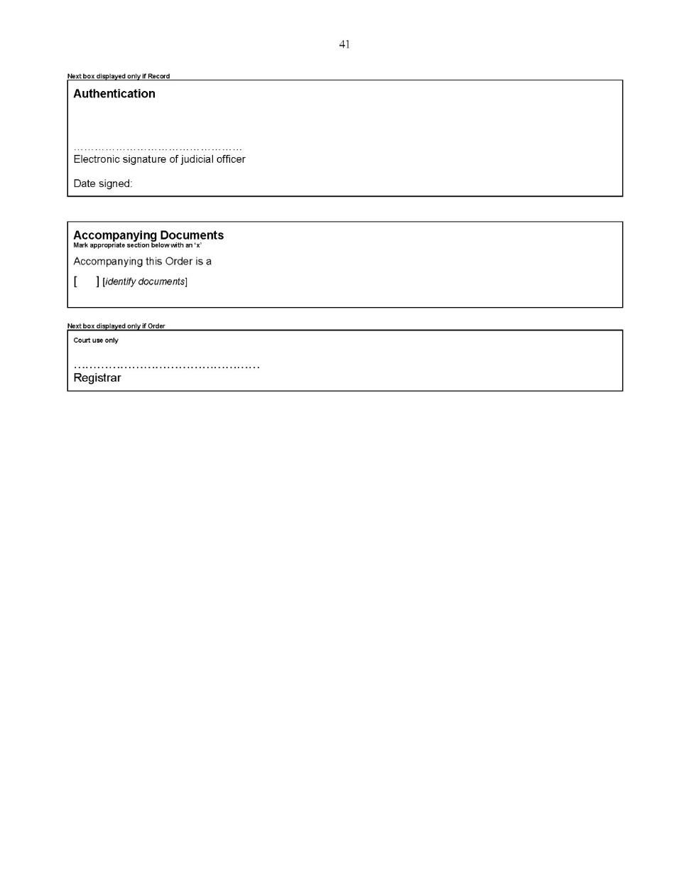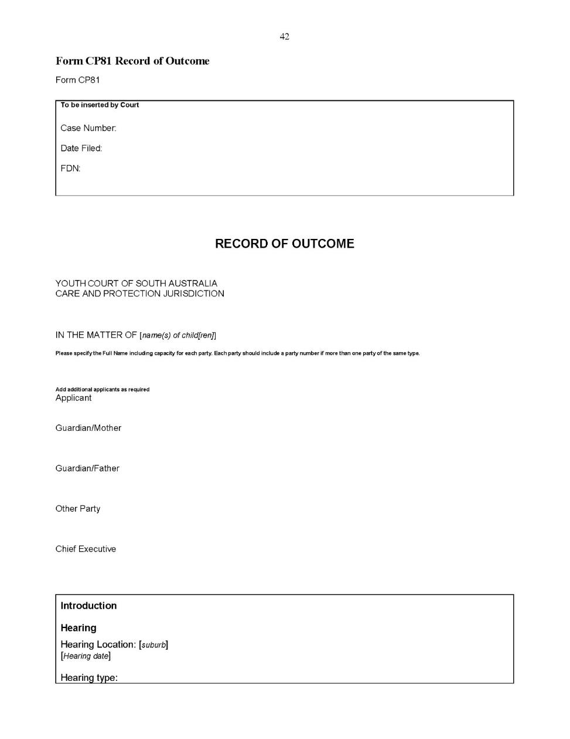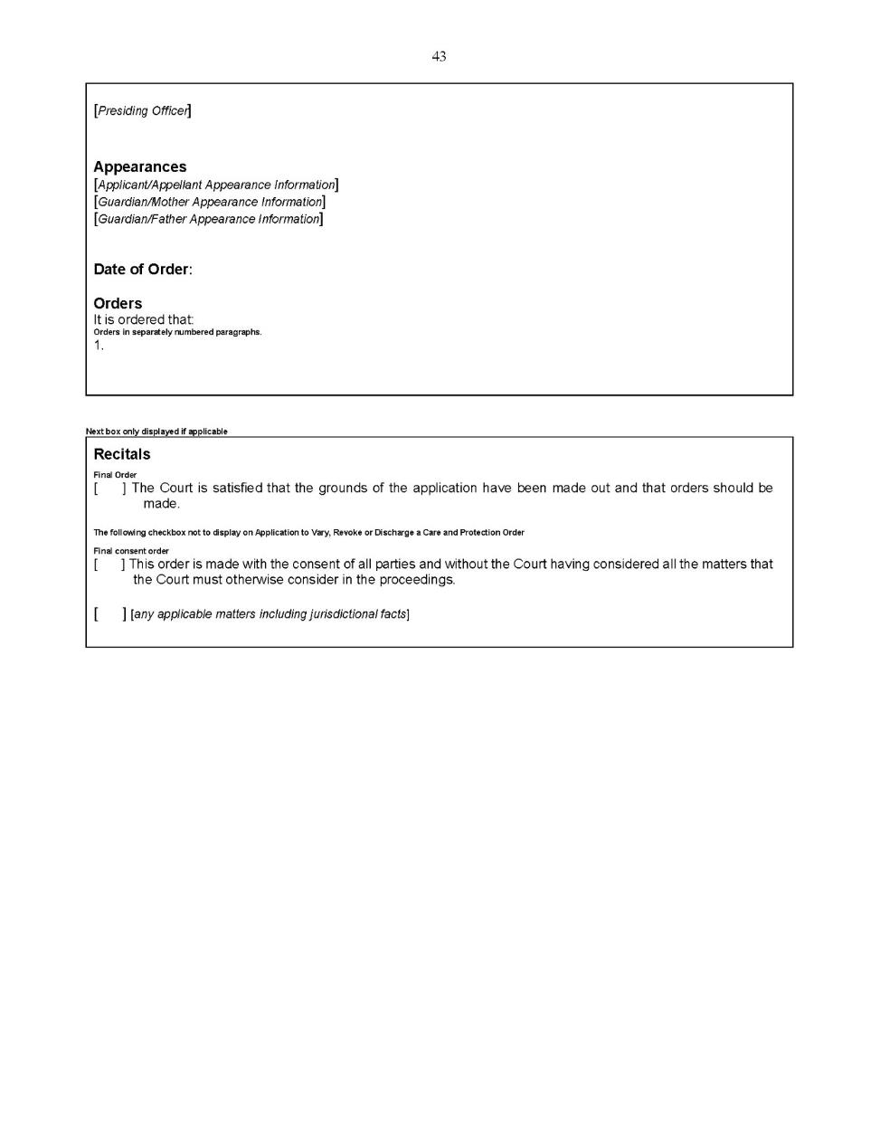
Dated: 8 May 2020
Eldridge P.
Davis L.
White D.
Koehn O.

All instruments appearing in this gazette are to be considered official, and obeyed as such

Printed and published weekly by authority of S. Smith, Government Printer, South Australia
$7.70 per issue (plus postage), $387.60 per annual subscription—GST inclusive
Online publications: www.governmentgazette.sa.gov.au

