THE SOUTH AUSTRALIAN
GOVERNMENT GAZETTE
Published by Authority

Adelaide, Thursday, 14 May 2020

Contents

Governor’s Instruments
Appointments 952
Mutual Recognition Act 1992 952
Mutual Recognition (South Australia) Act 1993 952
Trans-Tasman Mutual Recognition Act 1997 957
Trans-Tasman Mutual Recognition (South Australia)
Act 1999 957
Proclamations—
Retail and Commercial Leases (Miscellaneous)
Amendment Act (Commencement) Proclamation 2020 962
Regulations—
Retail and Commercial Leases (Miscellaneous)
Variation Regulations 2020—No. 57 of 2020 963
Legal Practitioners (Fee Notices) Variation
Regulations 2020—No. 58 of 2020 966
Taxation Administration (Information Disclosure)
Variation Regulations 2020—No. 59 of 2020 967
State Government Instruments
Associations Incorporation Act 1985 969
Crown Land Management Act 2009 969
Development Act 1993 969
Electricity Corporations (Restructuring and Disposal)
Act 1999 974
Environment Protection Act 1993 974
Fisheries Management (Prawn Fisheries) Regulations 2017 978
Gaming Machines Act 1992 979
Housing Improvement Act 2016 979
Land Acquisition Act 1969 980
Legal Practitioners Act 1981 981
Motor Vehicles Act 1959 982
Natural Resources Management Act 2004 984
Petroleum and Geothermal Energy Act 2000 986
Roads (Opening and Closing) Act 1991 987
Shop Trading Hours Act 1977 987
The District Court of South Australia 988
Local Government Instruments
City of Adelaide 990
City of Charles Sturt 990
City of Mitcham 990
City of Port Adelaide Enfield 991
Adelaide Plains Council 991
Mid Murray Council 992
District Council of Yankalilla 992
Public Notices
National Electricity Law 993
Trustee Act 1936 993

Governor’s Instruments

Appointments
Department of the Premier and Cabinet
Adelaide, 14 May 2009
His Excellency the Governor in Executive Council has been pleased to appoint the undermentioned to the Libraries Board of South Australia, pursuant to the provisions of the Libraries Act 1982:
Member: from 15 May 2020 until 14 May 2023
Scott Gordon Hicks
By command,
Steven Spence Marshall
Premier
DPC20/018CS

Department of the Premier and Cabinet
Adelaide, 14 May 2009
His Excellency the Governor in Executive Council has been pleased to appoint the Honourable Robert Ivan Lucas, MLC, Treasurer to be also Acting Minister for Education for the period from 17 May 2020 to 30 May 2020 inclusive, during the absence of the Honourable John Anthony William Gardner, MP.
By command,
Steven Spence Marshall
Premier
ME20/022

Mutual Recognition Act 1992

Mutual Recognition (South Australia) Act 1993
South Australia
Mutual Recognition (WA Container Deposit Scheme) Notice 2020
under section 47 of the Mutual Recognition Act 1992 of the Commonwealth as adopted by section 4 of the Mutual Recognition (South Australia) Act 1993
1—Short title
This notice may be cited as the Mutual Recognition (WA Container Deposit Scheme) Notice 2020.
2—Commencement
This notice comes into operation on the day on which it is made.
3—Request for regulations to be made
For the purposes of section 47 of the Mutual Recognition Act 1992 of the Commonwealth, it is requested that the proposed regulations set out in Schedule 1 be made.
Schedule 1—Proposed regulations
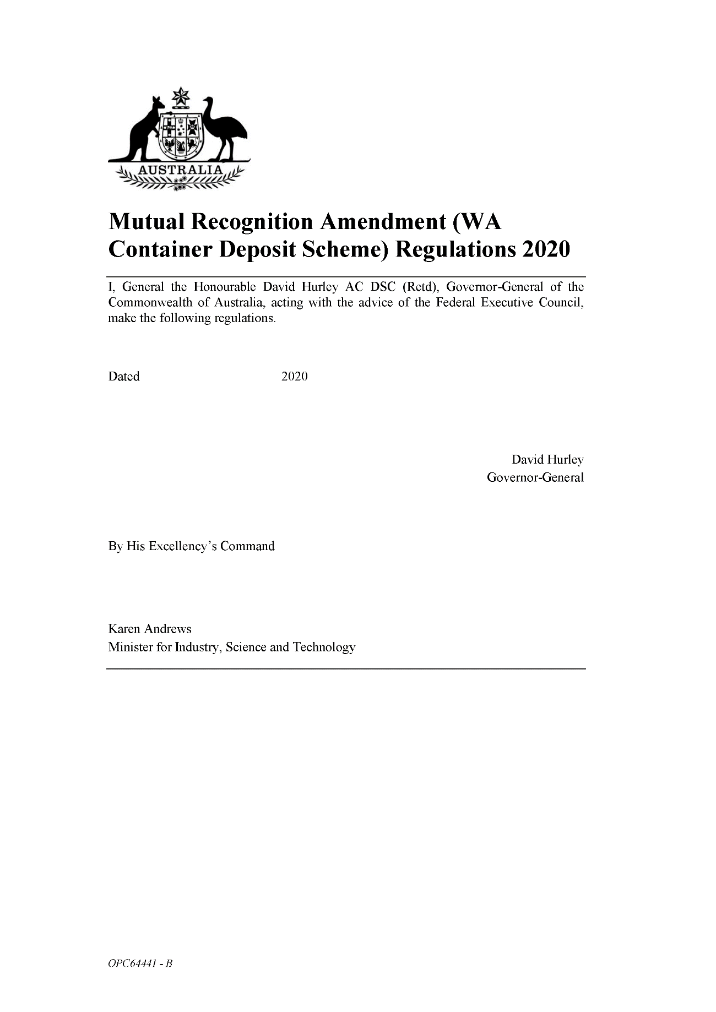
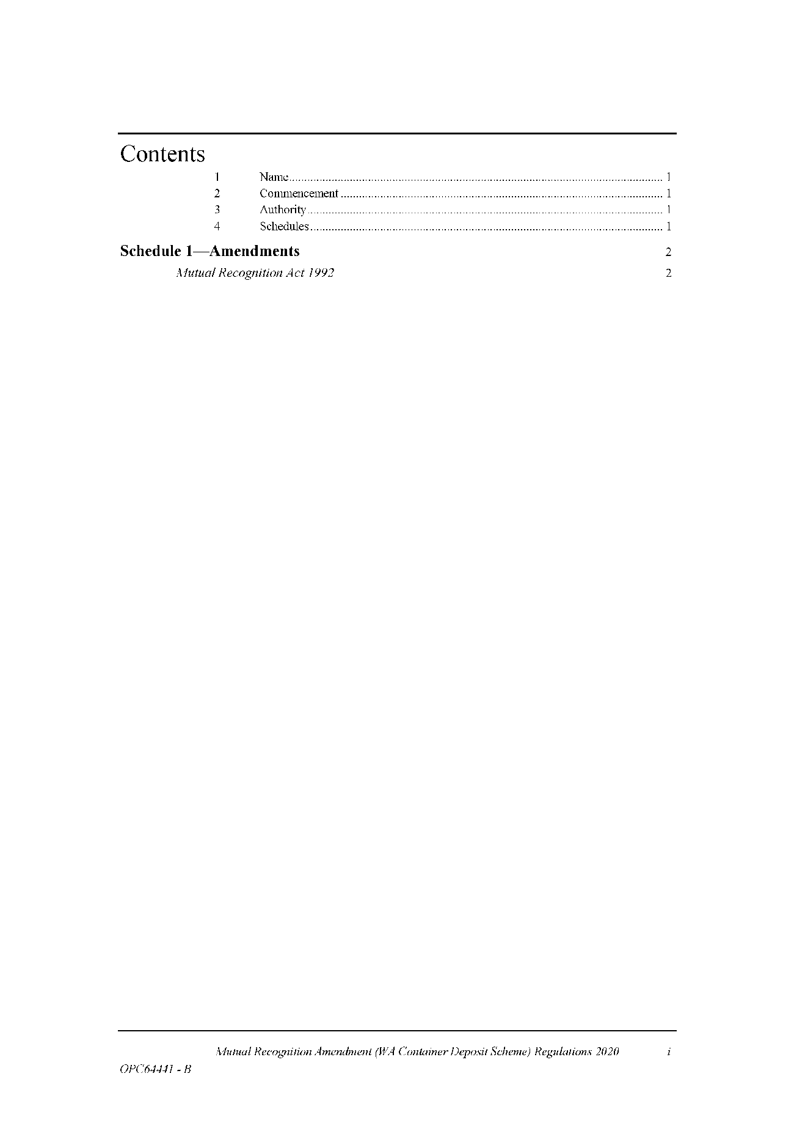
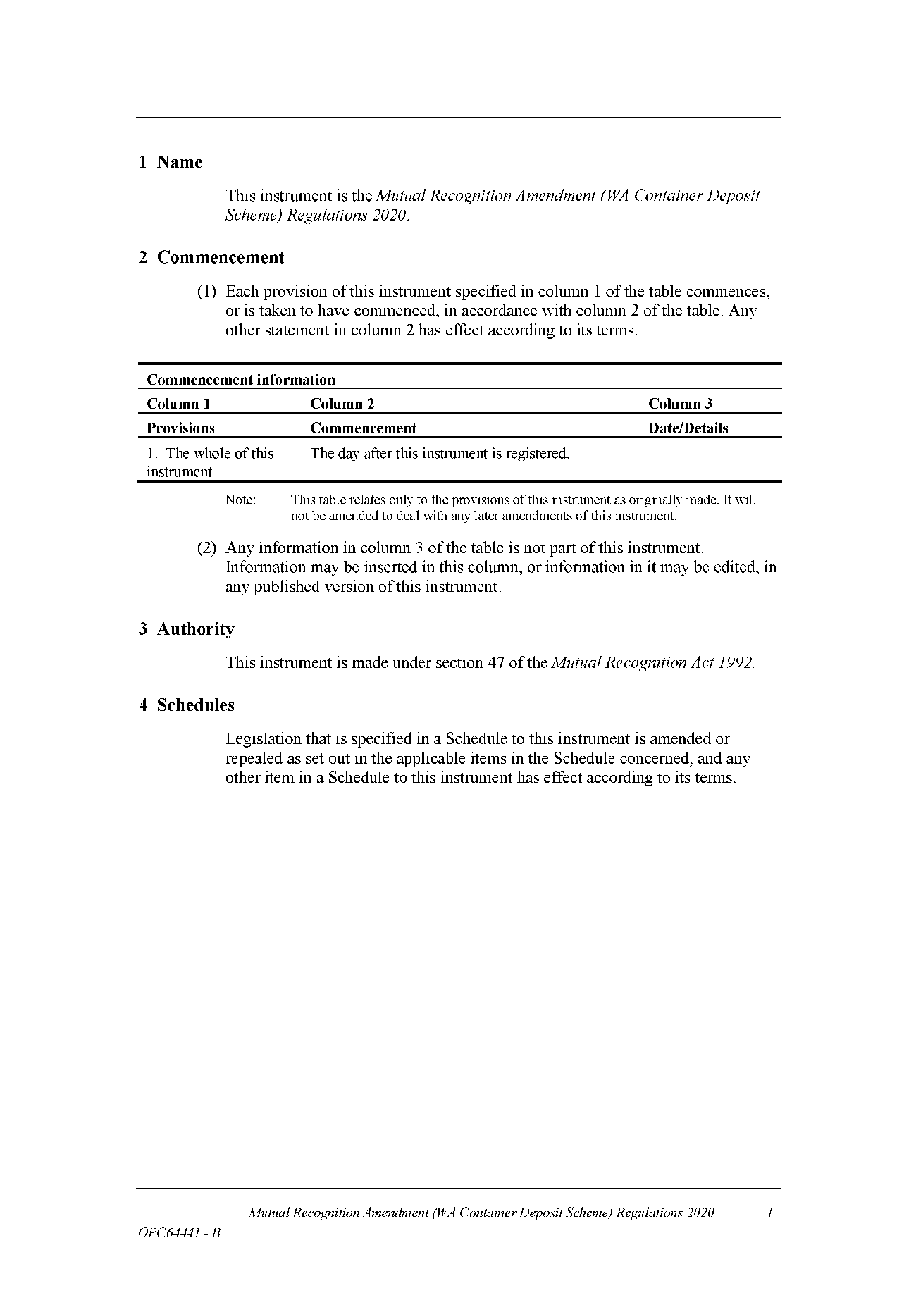
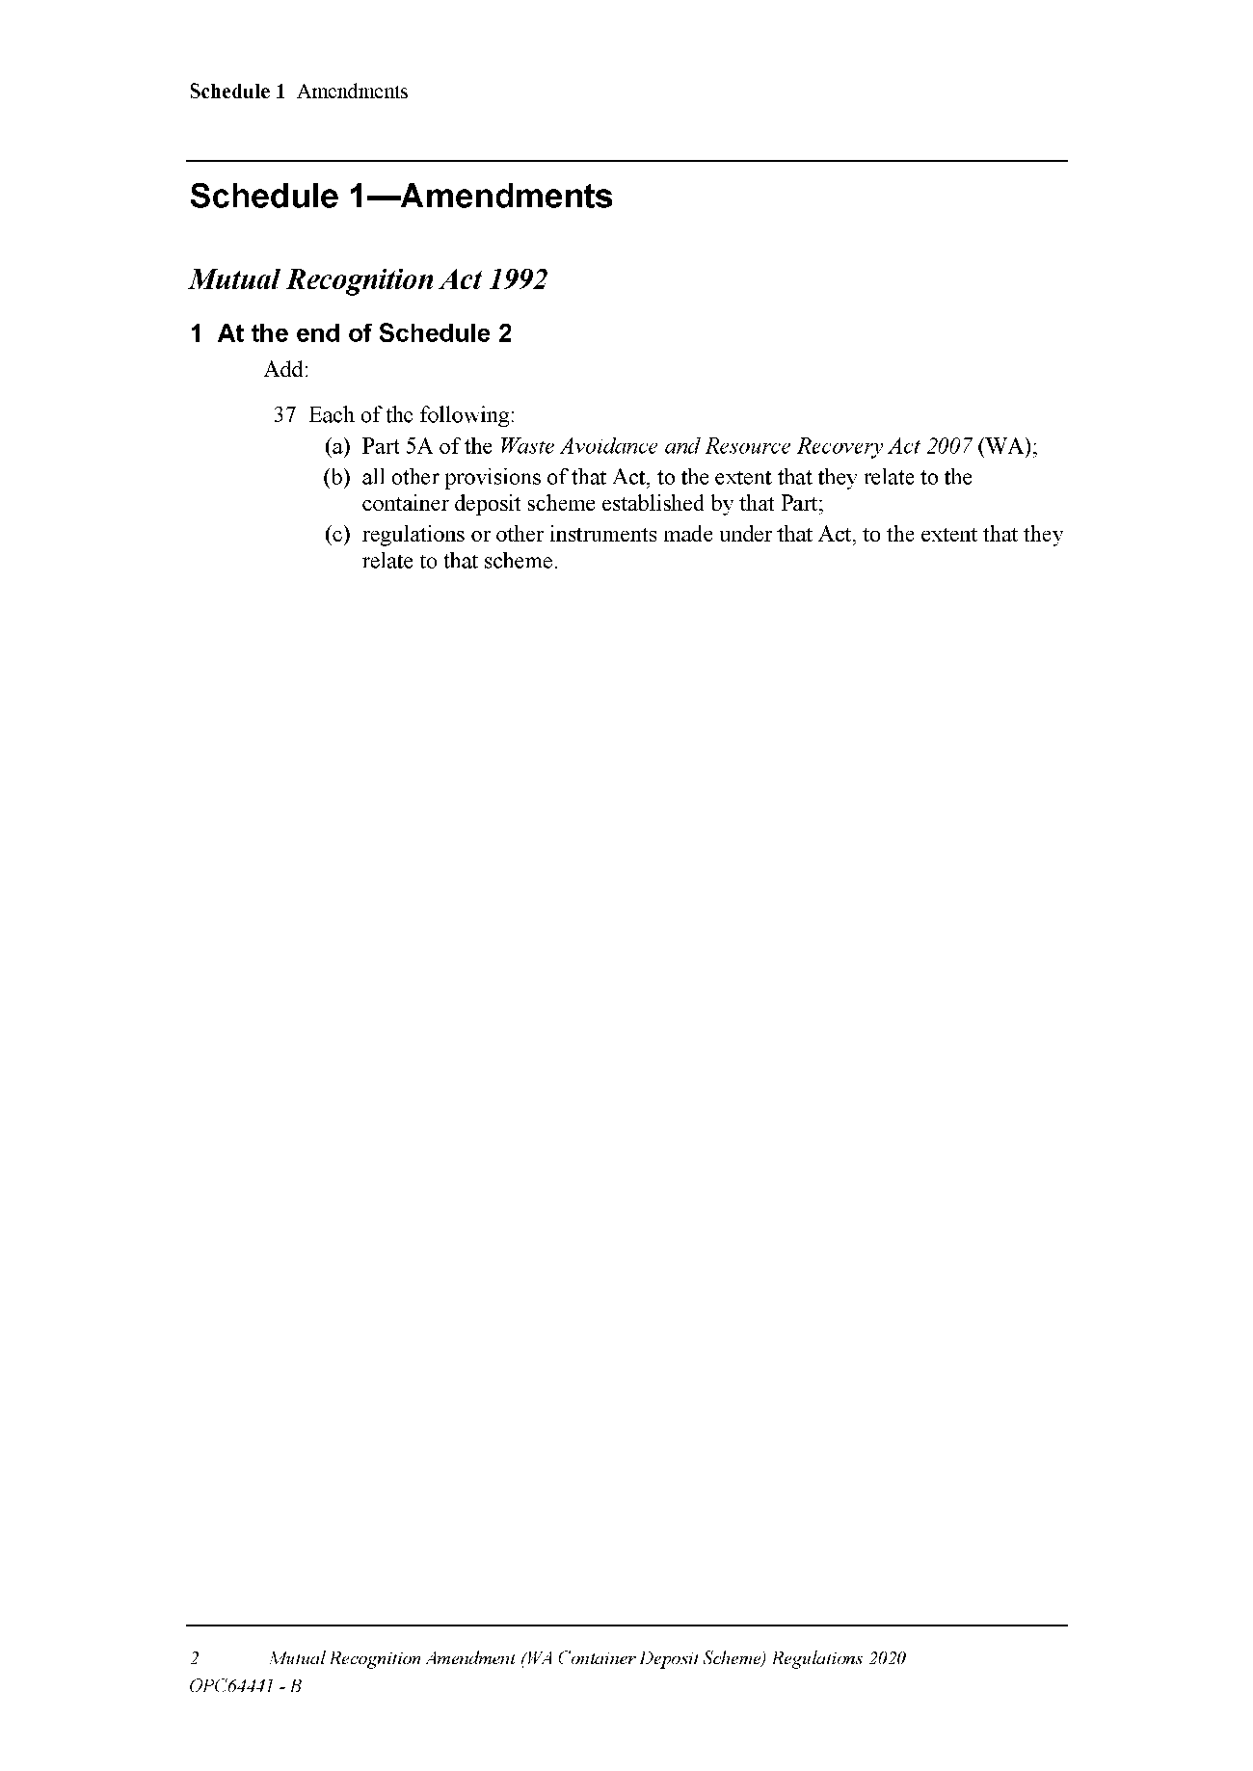
Made by the Governor
with the advice and consent of the Executive Council
on 14 May 2020

Trans-Tasman Mutual Recognition Act 1997

Trans-Tasman Mutual Recognition (South Australia) Act 1999
South Australia
Trans-Tasman Mutual Recognition (WA Container Deposit Scheme) Notice 2020
under section 43 of the Trans-Tasman Mutual Recognition Act 1997 of the Commonwealth as adopted by section 4 of the Trans-Tasman Mutual Recognition (South Australia) Act 1999
1—Short title
This notice may be cited as the Trans-Tasman Mutual Recognition (WA Container Deposit Scheme) Notice 2020.
2—Commencement
This notice comes into operation on the day on which it is made.
3—Endorsement of regulations
The proposed regulations set out in Schedule 1 are endorsed for the purposes of section 45 of the Trans-Tasman Mutual Recognition Act 1997 of the Commonwealth.
Schedule 1—Proposed regulations
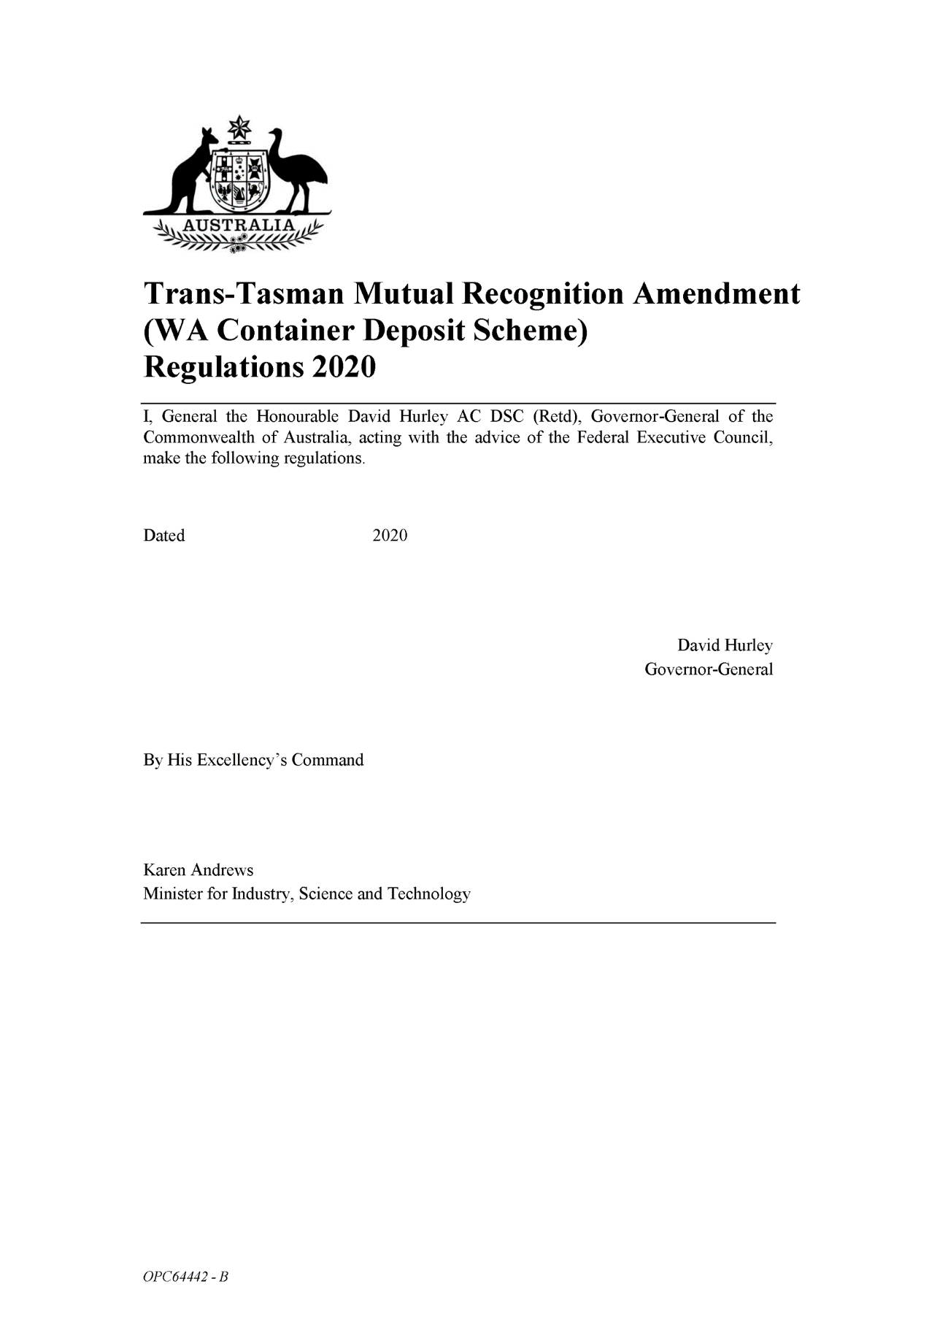
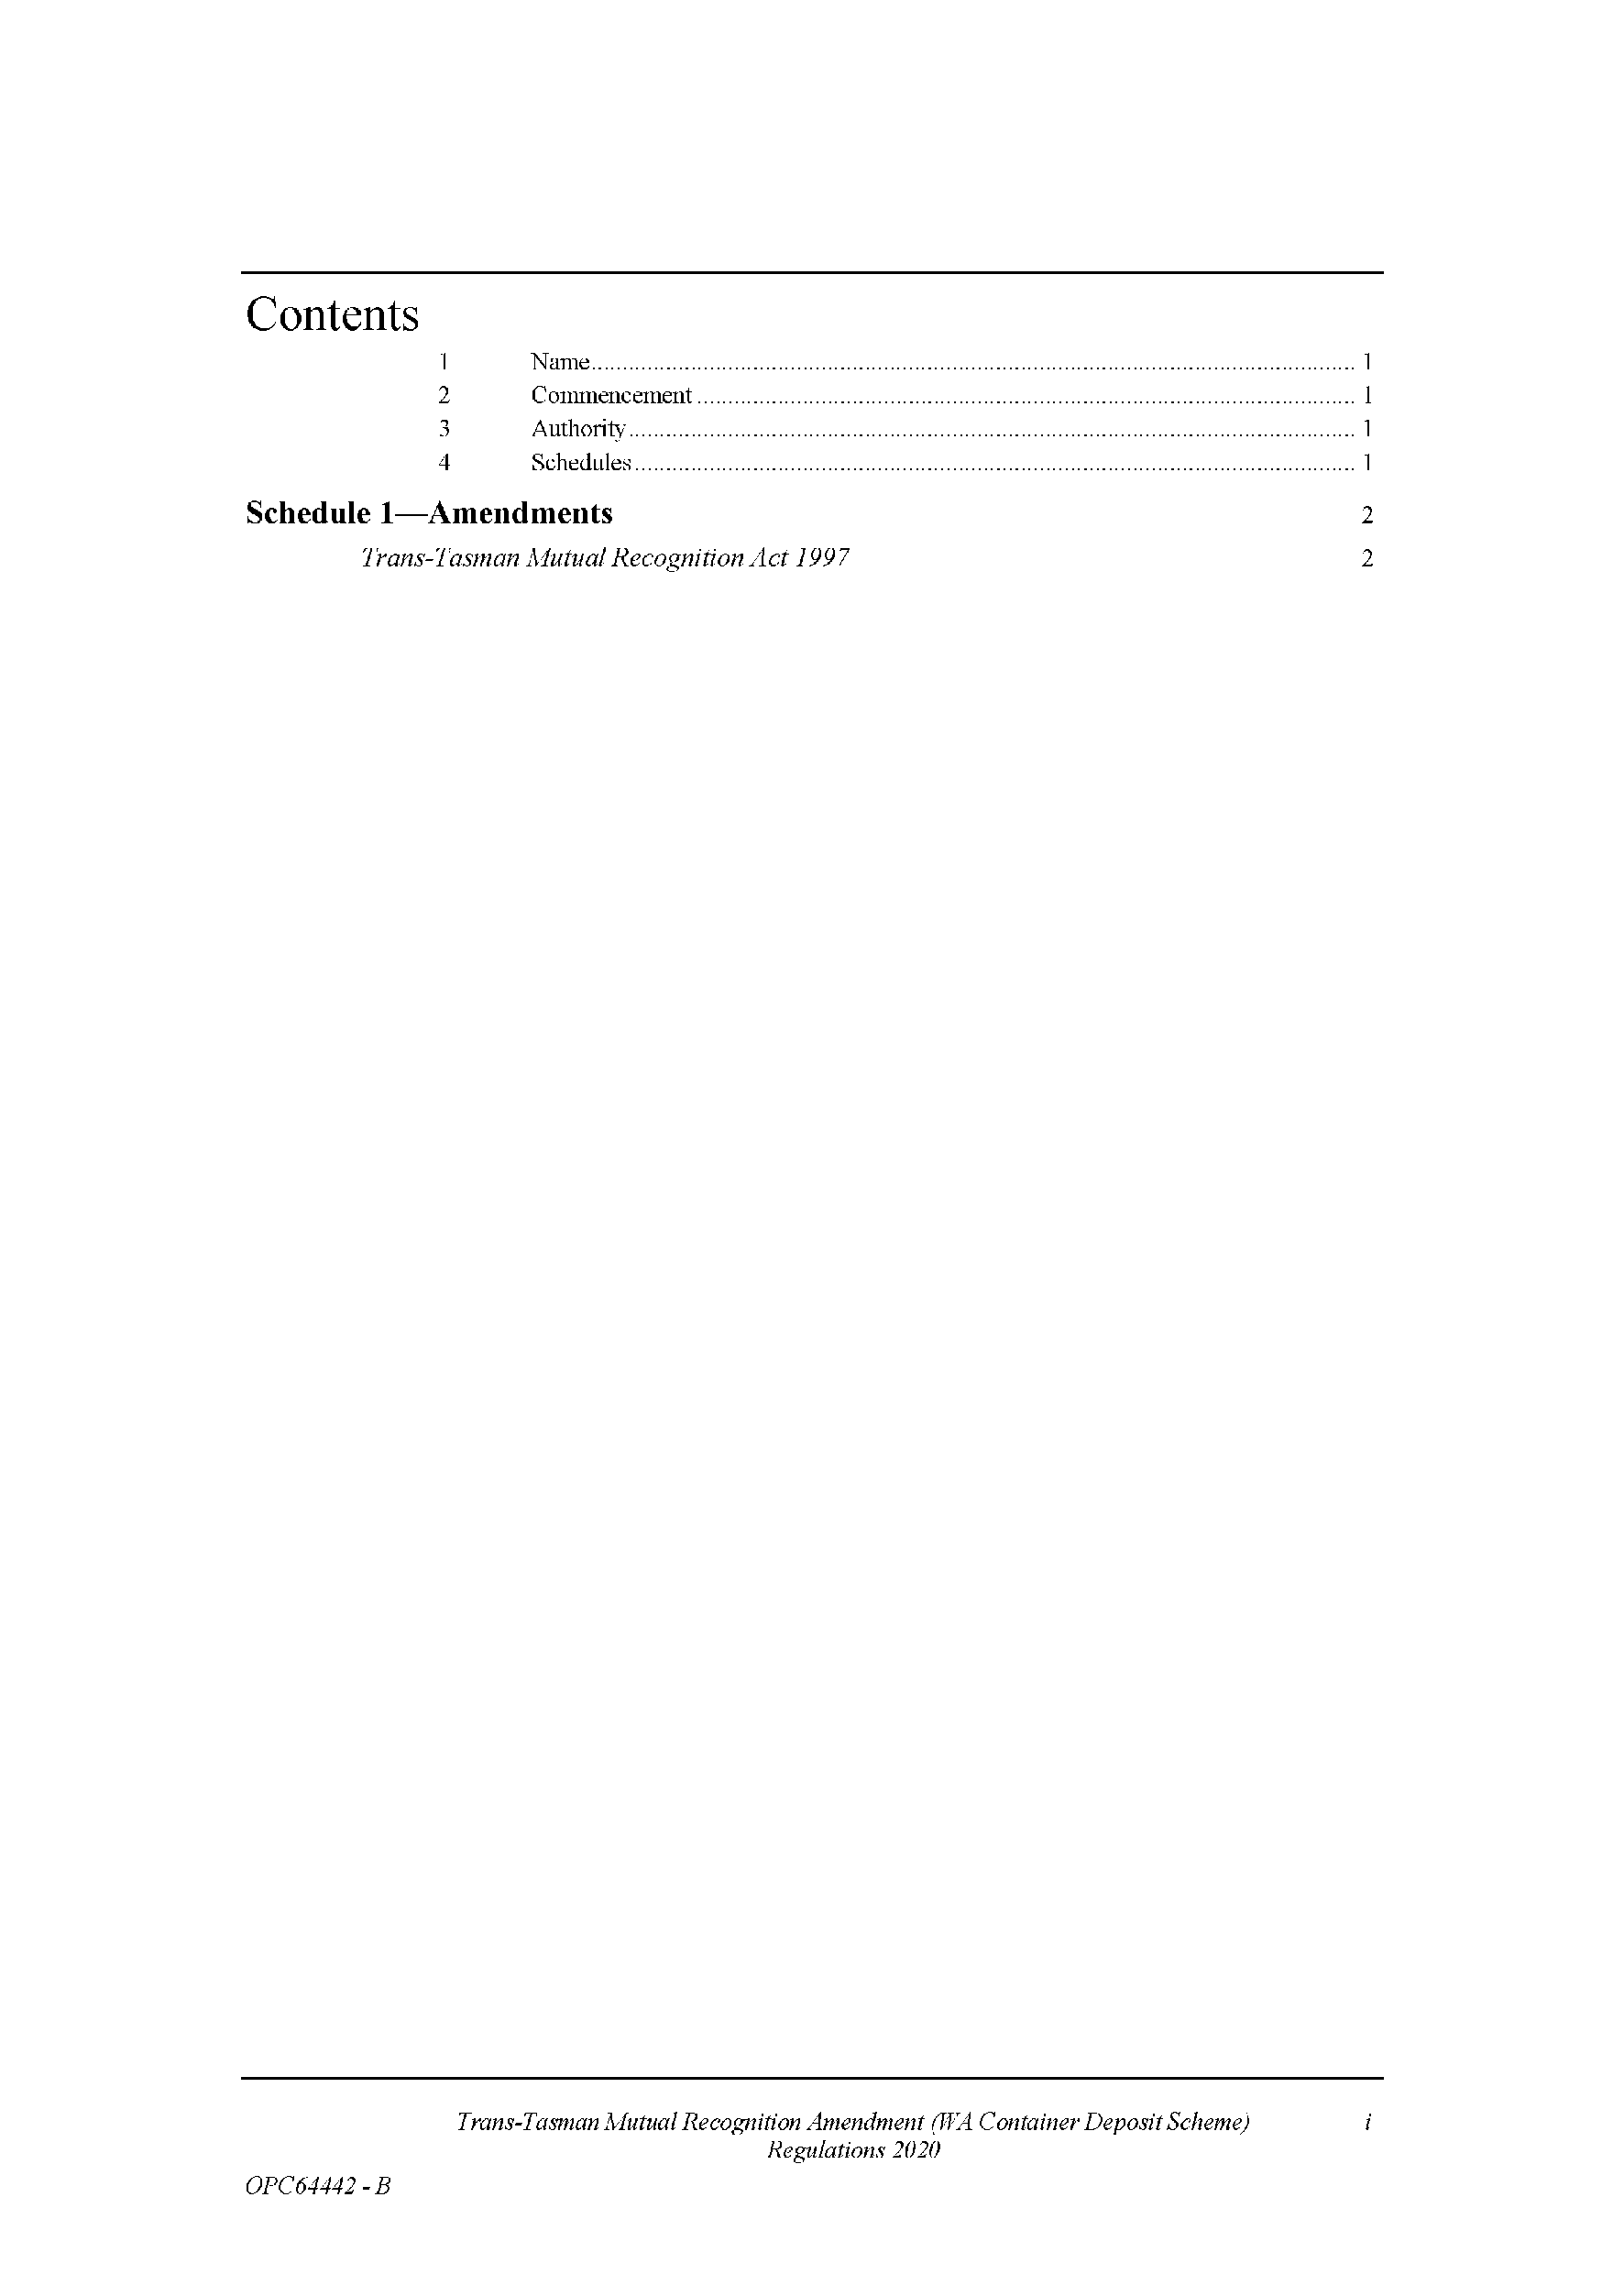
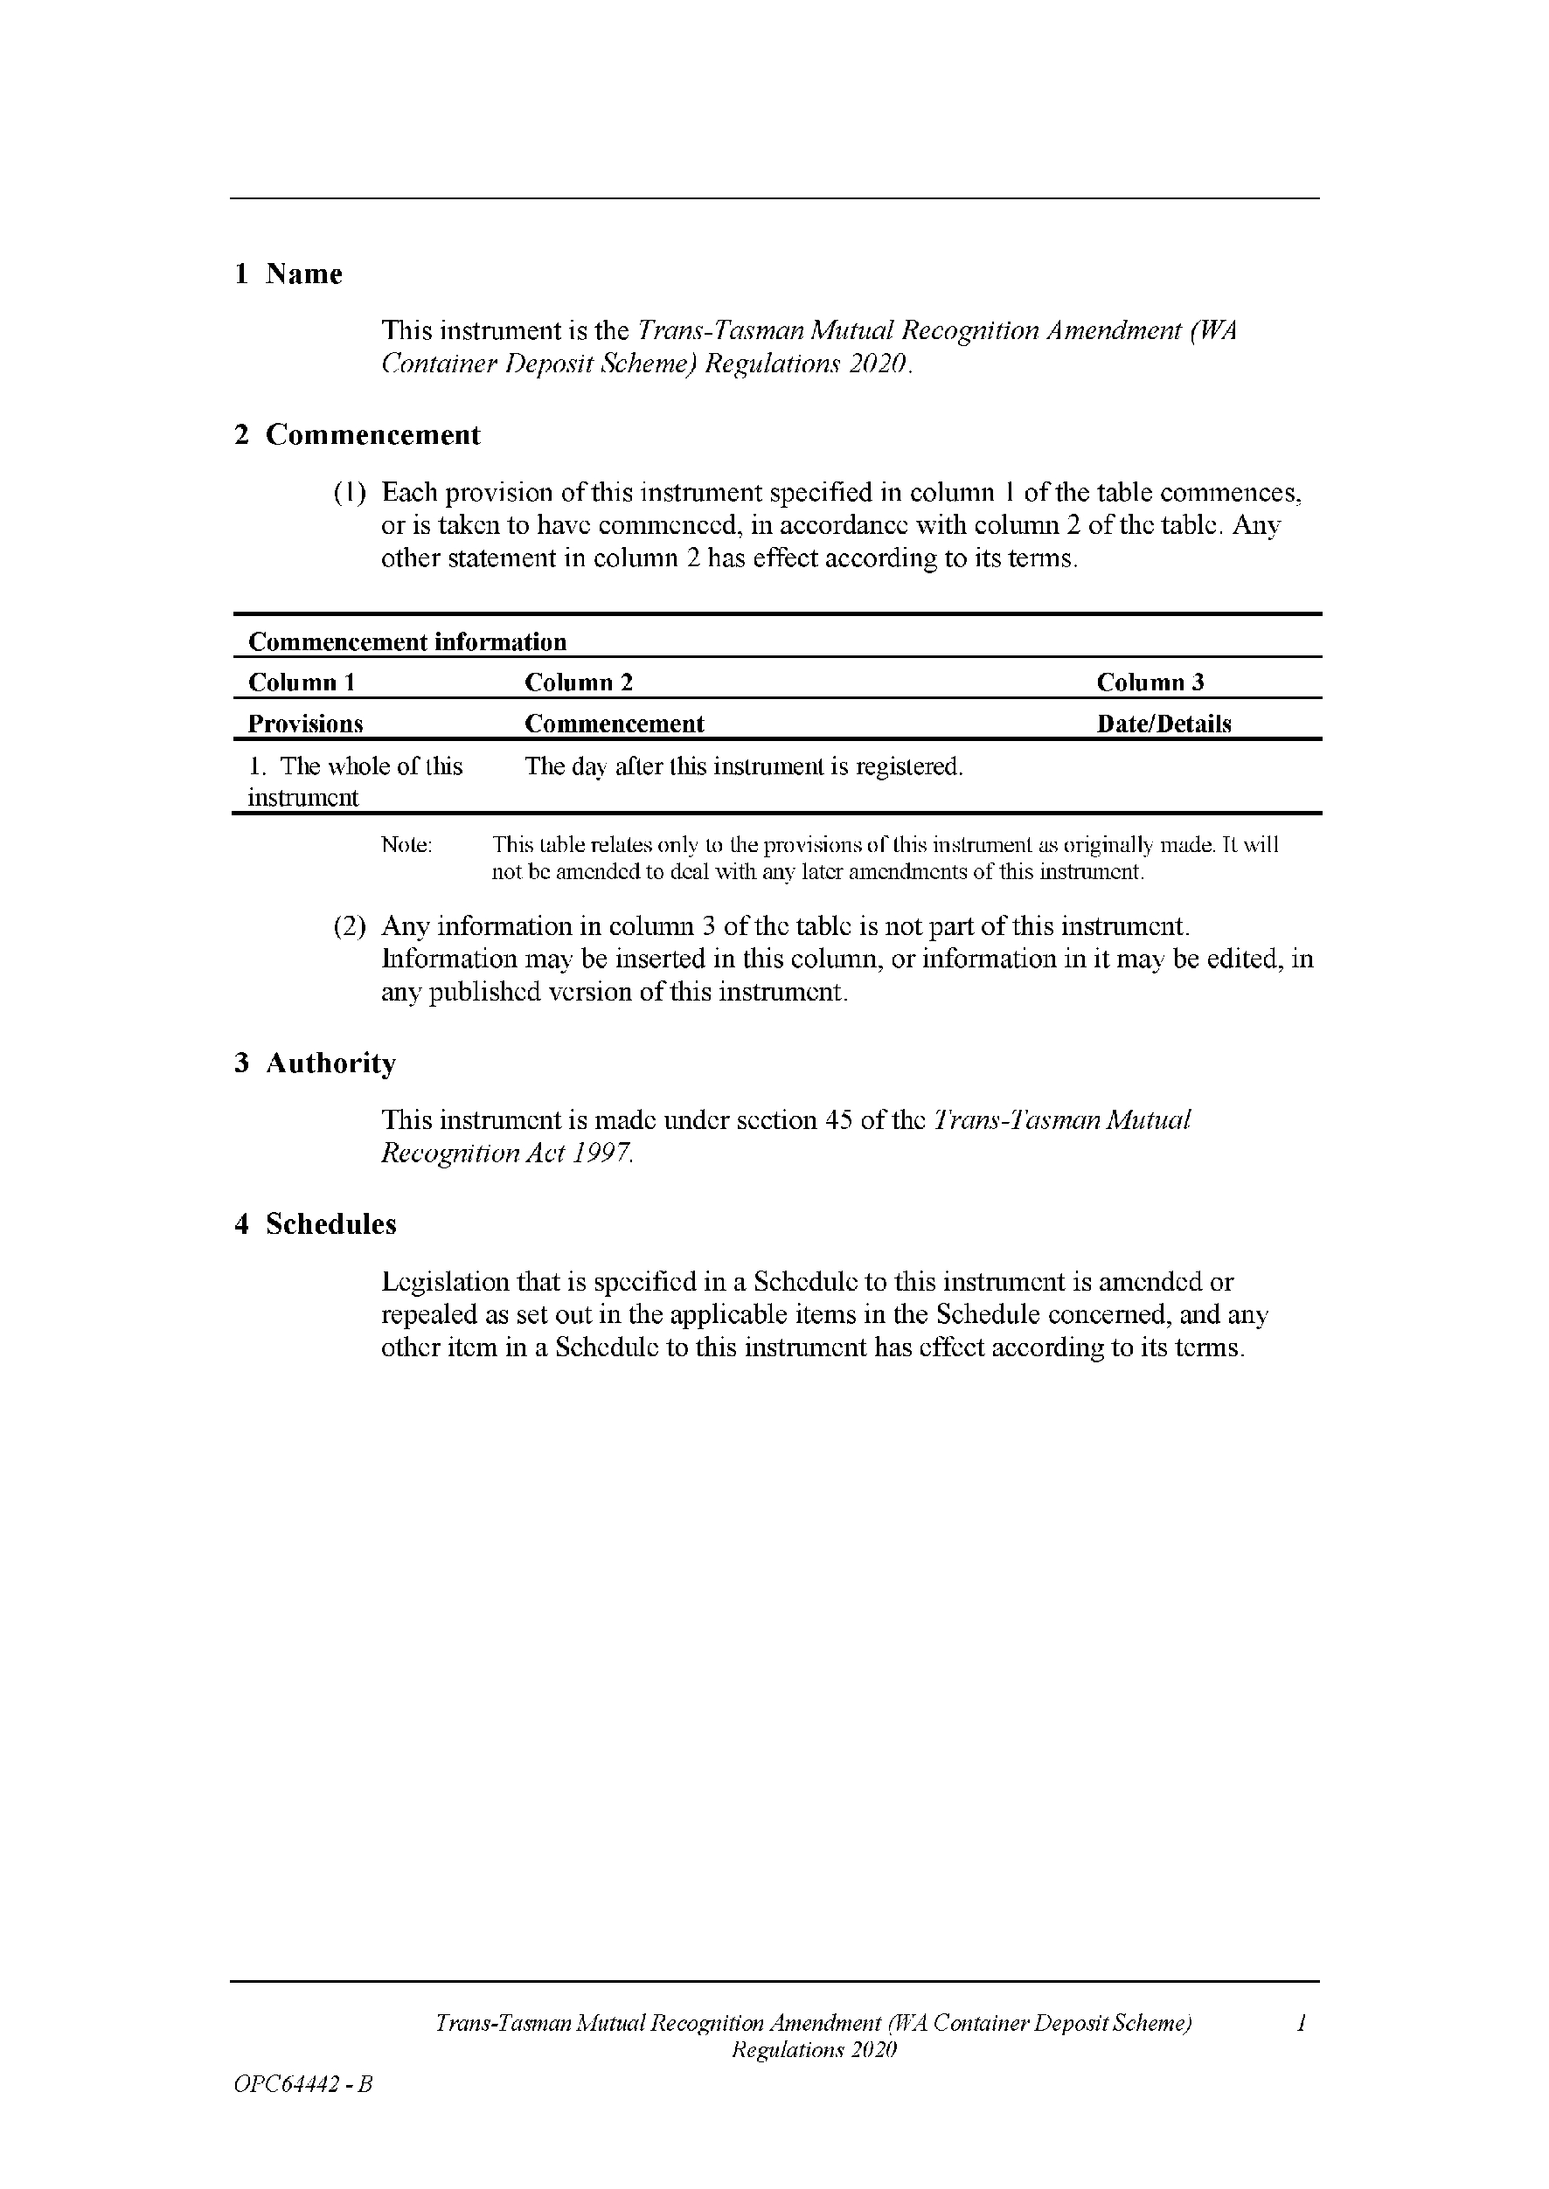
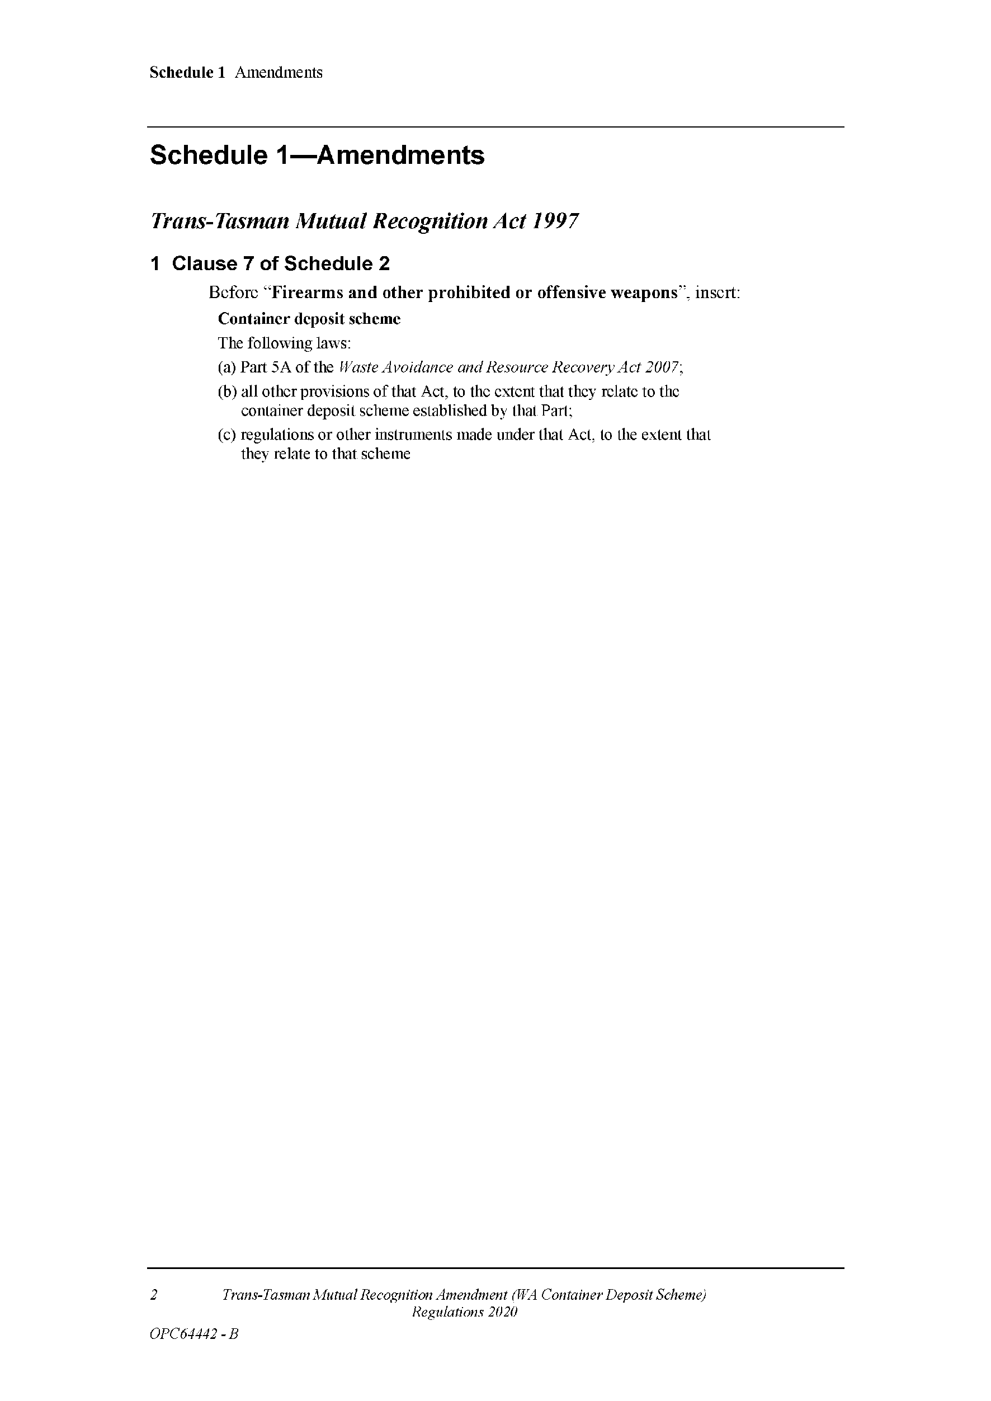
Made by the Governor
with the advice and consent of the Executive Council
on 14 May 2020

Proclamations
South Australia

Retail and Commercial Leases (Miscellaneous) Amendment Act (Commencement) Proclamation 2020
1—Short title
This proclamation may be cited as the Retail and Commercial Leases (Miscellaneous) Amendment Act (Commencement) Proclamation 2020.
2—Commencement of Act
The Retail and Commercial Leases (Miscellaneous) Amendment Act 2019 (No 47 of 2019) comes into operation on 1 July 2020.
Made by the Governor
with the advice and consent of the Executive Council
on 14 May 2020

Regulations
South Australia

Retail and Commercial Leases (Miscellaneous) Variation Regulations 2020
under the Retail and Commercial Leases Act 1995

Contents
Part 1—Preliminary
1 Short title
2 Commencement
3 Variation provisions
Part 2—Variation of Retail and Commercial Leases Regulations 2010
4 Variation of regulation 4—Exclusions from application of Act
5 Insertion of regulation 8A
8A Prescribed fee
6 Variation of regulation 12—Retail Shop Leases Advisory Committee
7 Variation of regulation 14—Modification of Landlord and Tenant Act
8 Variation of Schedule 1—Form of disclosure statements

Part 1—Preliminary
1—Short title
These regulations may be cited as the Retail and Commercial Leases (Miscellaneous) Variation Regulations 2020.
2—Commencement
These regulations come into operation on the day on which the Retail and Commercial Leases (Miscellaneous) Amendment Act 2019 comes into operation.
3—Variation provisions
In these regulations, a provision under a heading referring to the variation of specified regulations varies the regulations so specified.
Part 2—Variation of Retail and Commercial Leases Regulations 2010
4—Variation of regulation 4—Exclusions from application of Act
(1) Regulation 4(1)—delete subregulation (1)
(2) Regulation 4(2)—delete "section 4(3)" and substitute:
section 4(5)
5—Insertion of regulation 8A
After regulation 8 insert:
8A—Prescribed fee
For the purposes of section 20K(4) of the Act, the prescribed fee payable to the Commissioner for a certificate under section 20K(3) of the Act is $200.
6—Variation of regulation 12—Retail Shop Leases Advisory Committee
(1) Regulation 12(1)(b)—delete "- South Australia Division"
(2) Regulation 12(1)(c)—delete paragraph (c)
(3) Regulation 12(1)(e), (f) and (g)—delete paragraphs (e), (f) and (g) and substitute:
(e) AHA SA Hotels;
(f) Australian Lottery and Newsagents Association;
(g) Lease1.com.au Pty Ltd;
(h) the Law Society of South Australia;
(i) the Pharmacy Guild of Australia;
(j) the Real Estate Institute of South Australia Incorporated;
(k) Savills Australia;
(l) Scentre Shopping Centre Management (SA) Pty Ltd;
(m) South Australian Independent Retailers Incorporated;
(n) South Australian Employers' Chamber of Commerce and Industry Incorporated.
7—Variation of regulation 14—Modification of Landlord and Tenant Act
Regulation 14(1)(b), substituted section 56(3) of Landlord and Tenant Act 1936—delete "$40 000" and substitute:
$100 000
8—Variation of Schedule 1—Form of disclosure statements
(1) Schedule 1, Form 1, clause 7—delete clause 7 and substitute:
7—Consequences of breach
The legal consequences of a breach of a term of the lease (including the consequences of early termination of the lease by the lessee) as set out in [insert clause numbers or other identification of relevant components of lease] of the lease are as follows:
[Insert brief description.]
(2) Schedule 1, Form 1, Appendix A, clause 5, table—after "local government rates and charges" insert on next line:
emergency services levy
Note—
As required by section 10AA(2) of the Subordinate Legislation Act 1978, the Minister has certified that, in the Minister's opinion, it is necessary or appropriate that these regulations come into operation as set out in these regulations.
Made by the Governor
with the advice and consent of the Executive Council
on 14 May 2020
No 57 of 2020

South Australia

Legal Practitioners (Fee Notices) Variation Regulations 2020
under the Legal Practitioners Act 1981

Contents
Part 1—Preliminary
1 Short title
2 Commencement
3 Variation provisions
Part 2—Variation of Legal Practitioners Regulations 2014
4 Revocation of regulation 64
5 Revocation of Schedule 2

Part 1—Preliminary
1—Short title
These regulations may be cited as the Legal Practitioners (Fee Notices) Variation Regulations 2020.
2—Commencement
These regulations come into operation on 1 July 2020.
3—Variation provisions
In these regulations, a provision under a heading referring to the variation of specified regulations varies the regulations so specified.
Part 2—Variation of Legal Practitioners Regulations 2014
4—Revocation of regulation 64
Regulation 64—delete the regulation
5—Revocation of Schedule 2
Schedule 2—delete the Schedule
Note—
As required by section 10AA(2) of the Subordinate Legislation Act 1978, the Minister has certified that, in the Minister's opinion, it is necessary or appropriate that these regulations come into operation as set out in these regulations.
Made by the Governor
with the advice and consent of the Executive Council
on 14 May 2020
No 58 of 2020

South Australia

Taxation Administration (Information Disclosure) Variation Regulations 2020
under section 78 of the Taxation Administration Act 1996

Contents
Part 1—Preliminary
1 Short title
2 Commencement
3 Variation provisions
Part 2—Variation of Taxation Administration Regulations 2017
4 Variation of regulation 4—Permitted disclosure of information

Part 1—Preliminary
1—Short title
These regulations may be cited as the Taxation Administration (Information Disclosure) Variation Regulations 2020.
2—Commencement
These regulations come into operation on the day on which they are made.
3—Variation provisions
In these regulations, a provision under a heading referring to the variation of specified regulations varies the regulations so specified.
Part 2—Variation of Taxation Administration Regulations 2017
4—Variation of regulation 4—Permitted disclosure of information
(1) Regulation 4(2)(a)—after subparagraph (v) insert:
(vi) the COVID-19 Small Business Grant Program; or
(2) Regulation 4—after subregulation (2) insert:
(3) In this regulation—
COVID-19 Small Business Grant Program means the small business grant program administered by the Treasurer in respect of small businesses in this State that employ staff and have been subject to closure or otherwise adversely affected by the restrictions imposed by declaration under the Emergency Management Act 2004 relating to the COVID-19 pandemic.
Note—
As required by section 10AA(2) of the Subordinate Legislation Act 1978, the Minister has certified that, in the Minister's opinion, it is necessary or appropriate that these regulations come into operation as set out in these regulations.
Made by the Governor
with the advice and consent of the Executive Council
on 14 May 2020
No 59 of 2020

State Government Instruments

Associations Incorporation Act 1985
Section 42(2)
Dissolution of Association
WHEREAS the CORPORATE AFFAIRS COMMISSION (“the Commission”) pursuant to section 42(1) of the Associations Incorporation Act 1985 (“the Act”) is of the opinion that the undertaking or operations of (the Association) being an incorporated association under the Act are being carried on, or would more appropriately be carried on by a company limited by guarantee incorporated under the Corporations Act 2001 (Cth) AND WHEREAS the Commission was on 29 April 2020 requested by the Association to transfer its undertaking to AUSTRALIAN CRICKET PLAYERS LIMITED (Australian Company Number 639 455 824), the Commission pursuant to section 42(2) of the Act DOES HEREBY ORDER that on 7 May 2020, the Association will be dissolved, the property of the Association becomes the property of AUSTRALIAN CRICKET PLAYERS LIMITED and the rights and liabilities of the Association become the rights and liabilities AUSTRALIAN CRICKET PLAYERS LIMITED.
Given under the seal of the Commission at Adelaide.
Dated: 5 May 2020
Ann-Marie Banfield
A delegate of the Corporate Affairs Commission

Crown Land Management Act 2009
Revocation of Prohibition of Certain Activities on Unalienated Crown Lands
I, David Speirs, Minister for Environment and Water, being the Minister for the Crown to whom the administration of the Crown Land Management Act 2009 is for the time being committed, hereby revoke the prohibition of the occupation or use of unalienated Crown land for the following activities, without lawful authority or excuse, previously published in Government Gazette (pages 739–740) on 9 April 2020:
- camping;
- sleeping or remaining in or with a parked motor vehicle overnight, including but not limited to, cars, motorhomes and caravans.
This revocation comes into operation on Monday 11 May 2020.
Dated: 8 May 2020
David Speirs MP
Minister for Environment and Water

Development Act 1993
Section 48
Decision by the State Commission Assessment Panel as Delegate of the Governor
Preamble
1. On 19 October 1994 the Minister for Housing, Urban Development and Local Government Relations, being of the opinion that a proposed development of a waste management facility in the form of a solid waste landfill (Northern Balefill) near Dublin (‘the development’) was a development of major social, economic or environmental importance, directed the proponent to prepare an Environmental Impact Statement, pursuant to Section 46 of the Development Act 1993.
2. On 22 April 1996 an Environmental Impact Statement for the development was published in accordance with Section 46 of the Development Act 1993. Subsequently, the Minister prepared an Assessment Report in accordance with Section 46 of the Development Act 1993.
3. By notice in the South Australian Government Gazette on 29 January 1998 at p 30 the Governor granted development authorisation to the development, subject to conditions specified in that notice, pursuant to Section 48 of the Development Act 1993.
4. Following an application by the beneficiary of the development authorisation for a variation to the authorisation to allow the receipt and disposal of low level contaminated waste, the proposed development was the subject of an Amended Environmental Impact Statement dated June 1998 and an Amended Assessment Report dated December 1998 under Section 47 of the Development Act 1993 (‘the amended Major Development’).
5. By notice in the Government Gazette on 8 September 2005 at p 3255 the Governor granted provisional development authorisation to the amended Major Development, reserving specific matters for further assessment.
6. Following an application by the beneficiary of the development authorisation for a variation to the authorisation to allow for the establishment of a Multiple Waste Treatment Facility for the treatment and disposal of high level contaminated waste at the existing landfill, the proposed development was the subject of an Amended Environmental Impact Statement dated 24 November 2008 and an Amended Assessment Report under Section 47 of the Development Act 1993 (‘the further amended Major Development’).
7. By notice in the Government Gazette on 27 August 2009 the Governor granted provisional development authorisation to the further amended Major Development, reserving specific matters for further assessment.
8. By notice in the Government Gazette on 2 September 2010 at p 4662 the Minister for Urban Development and Planning, under delegation from the Governor, assessed the matters reserved for further assessment and a variation to the design of the Multiple Waste Treatment Facility and granted development authorisation to the further amended Major Development.
9. By notice in the Government Gazette on 24 January 2013 at p 103 the Development Assessment Commission, as delegate of the Governor, approved a variation of the development authorisation for the implementation of a ‘10 Year Masterplan’ comprising various changes to the landfill operation and the establishment of a Resource Pad, a Bioremediation Pad and a Litter Net System.
10. By letter dated 11 March 2020, Integrated Waste Management Services Pty Ltd, being the beneficiary of the development authorisation sought a variation to the authorisation so as the permit a modification to the design of the landfill module 3.
11. I am satisfied that the Environmental Impact Statement (as amended) and Assessment Report (as amended) in relation to the Major Development are appropriate and have had regard, when considering the proposed variation, to all relevant matters under Section 48 (5) of the Development Act 1993.
12. For ease of reference the conditions attached to the Solid Waste Landfill (Northern Balefill) near Dublin development authorisation are republished in full hereunder.
Decision
PURSUANT to Section 48 (7) (b) (ii) of the Development Act 1993; and having due regard to the matters set out in Section 48 (5) and all other relevant matters; and exercising the power of the Governor, I:
(a) vary the Solid Waste Landfill (Northern Balefill) near Dublin development authorisation dated 24 January 2013, subject to the conditions set out below; and
(b) specify under Section 48 (7) (b) (iii) all matters which are the subject of conditions herein as matters in respect of which the conditions of this authorisation may be varied or revoked, or new conditions attached.
Consolidated Version of Conditions of Authorisation
General Conditions
1. Except where minor amendments may be required by other legislation or by conditions imposed herein, the proposed Major Development shall be undertaken in strict accordance with the following documents:
- Development application dated 30 June 2008;
- Environmental Impact Statement Amendment, Integrated Waste Services Northern Balefill Dublin Multiple Waste Treatment Facility EIS Amendment prepared by Golder Associates, dated 24 November 2008, but in the case of conflict with a specific condition below the specific condition shall apply;
- Proponent’s response to submissions, letter from Connor Holmes to the Department of Planning and Local Government dated 3 April 2009, but in the case of conflict with a specific condition below the specific condition shall apply;
- Correspondence from Connor Holmes to the Department of Planning and Local Government containing additional information on the proposal dated 27 May 2009, but in the case of conflict with a specific condition below the specific condition shall apply;
- Correspondence from Integrated Waste Services to the Department of Planning and Local Government applying for approval of reserved matters and variations related to the Multiple Waste Treatment Facility dated 19 May 2010, but in the case of conflict with a specific condition below the specific condition shall apply;
- Correspondence from Integrated Waste Services to the Department of Planning and Local Government providing additional information to support application dated 11 May 2010, but in the case of conflict with a specific condition below the specific condition shall apply;
- Correspondence from Katnitch Dodd for Stage 1—Civil and Structural Work dated 31 March 2010 and accompanying certified plans;
- Correspondence from Katnitch Dodd for Final Stage—Services and Fitout Works dated 31 March 2010 and accompanying certified plans.
- Application for a variation to the development authorisation from Integrated Waste Services dated 5 October 2012, except as varied by the conditions listed below or to the extent that they are varied by the plans and drawings listed below.
- Application for a variation to the development authorisation from Masterplan (on behalf of Integrated Waste Services P/L) dated 11 March 2020, including plans titled ‘Site Layout’ (prepared by Golder, dated 2020-02-26), ‘Module 3 Cap’ (prepared by Golder, dated 2020-02-26) and ‘Longsection’ (prepared by Golder, dated 2020-02-26).
2. Before any building work is undertaken on the site, the building work is to be certified by a private certifier, or by some person determined by the Minister for Planning, as complying with the provisions of the Building Rules (or the Building Rules as modified according to criteria prescribed by the Regulations).
Multiple Waste Treatment Facility (MWTF)
3. The design of the MWTF shall be amended to include coloured metal cladding on all sides of the building, so as to enclose the whole of the facility.
4. Designs for the effluent treatment and disposal system shall be prepared to the reasonable satisfaction of the District Council of Mallala.
5. Treatment of waste material shall not occur until the construction of the entire MWTF has been completed, to the reasonable satisfaction of the Environment Protection Authority (EPA).
6. High Level Contaminated Waste is not required to be baled or shredded.
7. A truck wash with water sprays shall be installed for the removal of residues from vehicles transporting High Level Contaminated Waste to the site. All transport vehicles shall not leave the site unless they have gone through the truck wash.
8. Treatment of the stored materials shall only commence once the completed MWTF is approved by the EPA to commence operation.
9. Bioremediation and stabilisation are the only treatment processes that shall be used in the MWTF.
10. Pre-remediation trials shall be conducted on all contaminated materials, prior to delivery to the MWTF and the Bioremediation Pad, to determine if treatment methods approved by the EPA would be successful. Trial results shall be submitted to the EPA for assessment, prior to delivery of contaminated materials to the MWTF and the Bioremediation Pad.
11. Post-remediation testing on treated materials shall be undertaken to assess its suitability to be disposed of or reused. Testing results shall be submitted to the EPA for assessment, prior to disposal or reuse.
12. Future treatment options shall undergo pre-trial assessment, to the reasonable satisfaction of the EPA, before they can be adopted.
13. An Environmental Management Plan (EMP) for activities associated with the MWTF, prepared to the reasonable satisfaction of the EPA, must be in place prior to the receival, storage and treatment of contaminated materials.
Solid Waste Balefill
14. The work shall be carried out as shown on the plans (Figures 3.1 to 3.9) in the Development Application Report dated 28 November 1997, included with the Development Application dated 2 December 1997, except as varied by these conditions.
15. Subject to Conditions 16, 17 and 18, all waste received for disposal at the facility shall be shredded and baled.
16. Unbaled commercial/industrial or construction/demolition waste of appropriate particle sizes may by placed and compacted in any voids unavoidably occurring between bales and the inclined surface of the cells in which those bales are placed or within a suitable netting system to the reasonable satisfaction of the EPA and in accordance with any applicable requirements of a relevant environmental authorisation.
17. Waste materials received for disposal at the facility need not be shredded before baling where shredding of those materials is not required for the purpose of producing bales of a density and structural integrity that satisfy the applicable requirements of any relevant environmental authorisation.
18. Non-friable asbestos waste shall not be shredded or baled but shall be disposed of in accordance with the applicable requirements of any relevant environmental authorisation.
19. All perimeter plantings shall be started as early as practicable after the date of this authorisation to achieve maximum amelioration of visual impacts.
20. Screening by suitable plantings where adequate natural screening is not provided, shall be provided for the perimeter fence, all built structures, stockpiles and internal roads (where practicable) using suitable species in accordance with the Vegetation Management and Revegetation Plan proposed as part of the Landfill Environmental Management Plan (LEMP).
21. All firebreaks and external drainage channels shall be located on the inner edge of the vegetation screen and existing stands of native vegetation. In the event that drainage channels are required to be located close to the site boundary, their redesign to form low-lying wetland/saltmarsh communities as part of the vegetation screen shall be undertaken and implemented to the satisfaction of the Environment Protection Authority.
22. A leachate monitoring bore shall be installed within each cell to assist with leachate management, particularly if leachate circulation is incorporated in the Landfill Environmental Management Plan (LEMP).
23. The proponent shall pay all reasonable costs of the detailed design and construction of any public roadworks made necessary by this development. Such works may include the opening and associated left turn deceleration lane from Port Wakefield Road, and the upgrading of the entrance to balefill junction to the satisfaction of the Commissioner of Highways.
24. The proponent shall seal (two coat spray seal) the internal site access road for a minimum of 520 m from the nearest residence.
25. The applicant shall prepare a Vegetation Management and Revegetation Plan (which may be included in the LEMP) to the reasonable satisfaction of the Development Assessment Commission and must implement that Plan once it has been approved by the Development Assessment Commission.
Low Level Contaminated Soil and Liquid Treatment Plant Residues
26. Low level contaminated soil (LLCS) and liquid treatment plant residues (LTPR) are not required to be baled or shredded.
27. The work shall be carried in accordance with the following documents and plans:
- EIS Amendment, Receipt of Low Level Contaminated Soil and Liquid Waste Treatment Plant Residues at the IWS Northern Balefill, dated July 2003.
- Response Document on the EIS Amendment for the Receipt of Low Level Contaminated Soil and Liquid Waste Treatment Plant Residues (Revised), dated 30 April 2004.
- Supplementary Information EIS Amendment Receipt of Low Level Contaminated Soil and Liquid Waste Treatment Plant Residues at the IWS Northern Balefill, dated 26 November 2004.
- Landfill Environmental Management Plan, dated 2001 or as varied by any applicable requirements of a licence from the Environment Protection Authority.
- Drawings
  - 3307DO1, 4/11/2004—cell 31 design plan.
  - 3307DO2, Drawn 25/8/2004 and checked 18/2/2005—Section A, liner and sump design.
  - 3307DO3, 10/8/2004—liner design sections and details.
  - 3307DO4, 14/10/2004—cell 31 interim capping design.
  - 3307DO5, 13/8/2004—landfill staging plan.
  - 3307DO6, 13/8/2004—final surface water control.
  - 3307DO8, Drawn 27/8/2004 and checked 26/11/2004—interim surface water control.
  - 3307DO9 P1, Drawn 4/11/2004 and checked 26/11/2004—cell design plan line 2.
  - 3307DO10, Drawn 29/8/2004 and checked 26/11/2004—Sections D and E, swale drain design.
28. Distance to groundwater requirements shall be as follows:
  - Based on groundwater level monitoring results and interpolated highest groundwater levels for Cell 31, including a 0.1 metre buffer; the base of the sump shall be at 9.1 m AHD;
  - Notwithstanding the above requirement, a minimum separation distance of 2 m between the underside of the lowest portion of the lining system (including the sump area) and the underlying groundwater shall be maintained at all times.
29. Leachate collection and extraction system requirements shall be as follows:
  - Leachate removal shall implement a system which accommodates the installation of the pumps at the leachate riser access point.
  - Following cell completion and until the entire cell base is covered with a minimum of 1.5 metres of waste, a pump with a flow capacity of a minimum of 40 litres per second shall be installed.
  - After it can be demonstrated that leachate production has declined to less than one litre per second, this pump can be replaced by a pump of lesser flow capacity.
  - A back-up pump with the relevant capacity shall be readily available on site at all time.
30. Leachate treatment requirements shall be as follows:
  - Leachate may be managed and treated by means of:
- direct extraction into an on-site leachate evaporation pond which shall meet the minimum design specification as follows:
- composite lining system comprising a one metre low permeability clay liner with k < 1x 10-9m/s compacted to 95% Maximum Dry Density by standard compaction, and a moisture content between 0% and +4% wet of Optimum Moisture Content, overlaid by a 2mm high density polyethylene (HDPE) liner (welded).
- minimum of 600 mm freeboard.
- modelling with HELP or LANDSIM shall consider a one in 25, 24 hour duration storm event.
- a minimum separation distance of two metres between the underside of the lowest portion of the lining system and the underlying groundwater shall be maintained at all times.
- Direct extraction into an onsite tank vehicle suitable for the transport of leachate into an onsite leachate evaporation pond.
- Direct extraction into a licensed vehicle and transported to an off-site Environment Protection Authority licensed Waste Water Treatment Plant.
- Direct extraction into a suitably designed, temporary on-site storage tank prior to off-site disposal by an Environment Protection Authority licensed vehicle at an Environment Protection Authority licensed Waste Water Treatment Plant or prior to on-site transport to an onsite leachate evaporation pond.
31. Leachate management requirements shall be as follows:
  - The head of leachate on the liner shall not exceed 300 mm (excluding the sump) at all times. To facilitate this, the trigger level for leachate extraction out of the leachate sump shall be set at 290 mm.
  - In addition to automatic leachate data readings, a manual monitoring probe shall be installed and calibrated to allow for direct readings of the vertical elevation of leachate in the riser pipe and conversion to the maximum leachate head on top of the liner.
  - Leachate levels shall be read manually daily and recorded in the onsite operations logbook or as specified otherwise in the Environment Protection Authority licence.
32. Distance between LLCS/LTPR cells and Balefill cells (reference drawing 3307D03, 18/8/2004) shall be as follows:
  - The distance between LLCS/LTPR cells and Balefill cells shall be at a minimum of 5 metres, measured between the toe of the LLCS cell structure (that is where the outer surface of the cap of the completed LLCS/LTPR cell joins the outer surface of the underlying clay liner for the same cell) and the cap of the nearest balefill cell (that is where the outer surface of the cap of a completed balefill cell joins the outer surface of the underlying clay liner).
33. Level 1 Supervision requirements shall be as follows:
  - The construction of the clay liner of the cell shall be carried out under Level 1 Supervision in accordance with AS 3798-1996, Appendix B.
  - The construction of the HDPE liner shall be carried out under the full time supervision of a suitably qualified geotechnical consultant with experience in the construction and supervision of the construction of HDPE lining systems, quality control procedures and testing.
34. ‘As Constructed Report’ requirements shall be as follows:
  - An ‘As Constructed Report’ certifying compliance with the approved design for the lining system, including a Construction Quality Assurance Report (CQA) for the HDPE liner and the Level 1 Supervision Report, shall be submitted to the Environment Protection Authority for acceptance prior to the commencement of the receipt and disposal of waste in each cell. No waste shall be received and disposed of prior to written acceptance of the ‘As Constructed Report’ by the Environment Protection Authority.
35. Coverage of waste requirements shall be as follows:
  - All waste shall be covered as soon as reasonable practicable after the receipt of waste and placement in the cell or at close of business on each business day with at least 150 mm of cover material (waste fill or intermediate landfill cover with the restriction to a maximum particle size of 100 mm).
  - If a load of particularly odorous material is received at the LLCS/LTPR cell, it shall be covered immediately with a minimum of 150 mm cover material.
  - During periods when the LLCS/LTPR cell is not operating, routine monitoring for odorous gases shall be carried out as part of the site monitoring program and may trigger the application of additional cover material.
  - Alternative cover materials may be used after the proponent:
- has demonstrated to the Environment Protection Authority that the proposed material and placement method result in an equivalent or better performance compared to the approved material; and
- has received written approval from the EPA prior to the use of alternative materials and placement methods.
36. Groundwater management requirements shall be as follows:
  - An additional groundwater well shall be installed west of cell 30 and the first round of groundwater sampling and testing shall be completed at least two weeks prior to commencement of construction of cell 31
  - Groundwater level monitoring shall commence at least two weeks before commencement of construction of cell 31; groundwater levels shall be taken weekly and reported to the Environment Protection Authority monthly (datasheet and graph) or as specified otherwise in the EPA authorisation.
  - Four monitoring rounds at three monthly intervals in the first 12 months of operation shall be carried out to establish additional background analyte levels around cell 31
  - Six monthly monitoring rounds shall be undertaken following the completion of the initial 12 months of groundwater monitoring or as specified otherwise in the Environment Protection Authority licence
  - Prior to the commencement of construction of any other cell for the receipt of LLCS/LTPR, the groundwater management and monitoring program shall be reviewed and submitted for Environment Protection Authority approval.
37. Surface Water Management requirements shall be as follows:
  - A stormwater management plan shall be developed and submitted for Environment Protection Authority’s approval addressing all issues related to the staged construction of LLCS/LTPR cells on site prior to commencement of construction of cell 31.
  - The stormwater management plan shall provide surface water control and management measures for:
- surface water or stormwater runoff that does not interact with the waste material or other operational areas of the site and is considered to be uncontaminated.
- surface water that comes into contact with waste materials or is collected from landfill areas or other operational areas and is considered to be contaminated.
- surface runoff from the final landfill cap which has to be controlled.
- diversion of surface water runoff from perimeter areas away from the operating cell.
38. Landfill Environmental Management Plan (LEMP) requirements shall be as follows:
  - The new section of the LEMP (‘Section 17’) shall be completed and incorporated in the revised LEMP document.
  - The complete revised LEMP document shall be finalised and submitted to the Environment Protection Authority for approval prior to the receipt and disposal of LLCS/LTPR on the premises.
39. A wheel wash with water sprays shall be installed ensure removal of residues from the wheels and underside of the vehicles transporting low level contaminated soil and liquid treatment plant residues to the site.
Notes to Proponent
Building Rules
- The proponent shall obtain a Building Rules assessment and certification for any building work from either the District Council of Mallala or a private certifier (at the proponent’s option) and forward to the Minister for Urban Development and Planning all relevant certification documents as outlined in Regulation 64 of the Development Regulations 2008.
- Pursuant to Development Regulation 64, the proponent is especially advised that the District Council of Mallala or private certifier conducting a Building Rules assessment must:
  - provide to the Minister for Urban Development and Planning a certification in the form set out in Schedule 12A of the Development Regulations 2008 in relation to the building works in question; and
  - to the extent that may be relevant and appropriate:
(i) issue a Schedule of Essential Safety Provisions under Division 4 of Part 12;
(ii) assign a classification of the building under these regulations; and
(iii) ensure that the appropriate levy has been paid under the Construction Industry Training Fund 1993.
- Regulation 64 of the Development Regulations 2008 provides further information about the type and quantity of all Building Rules certification documentation for Major Developments required for referral to the Minister for Urban Development and Planning. The District Council of Mallala or private certifier undertaking Building Rules assessments must ensure that the assessment and certification are consistent with this provisional development authorisation (including its Conditions and Notes).
Environmental Management Plan for the Multiple Waste Treatment Facility (MWTF)
- An Environmental Management Plan (EMP) covering the operation requirements for the MTWF shall be prepared in consultation with the Environment Protection Authority.
- The EMP shall include an air quality monitoring programme to ensure air emissions from the MWTF do not contain contaminants at levels that may be harmful to nearby residents and land uses.
- The EMP shall include protocols for testing/trialling the suitability and effectiveness of treatment methods for batches of contaminated materials that could potentially be treated at the MWTF, prior to the receival of such material.
- The EMP shall include contingencies for dealing with contaminated materials that cannot meet disposal criteria after treatment.
- The EMP shall include a detailed risk assessment protocol for all contaminated waste types to be treated.
- The EMP shall include a Fire Risk Management Plan.
- The EMP shall include a Hazardous Substances Management Plan.
- The EMP shall include an Occupational Health, Safety and Welfare Plan prepared in consultation with the Department of Health.
- The EMP shall include a financial assurance strategy.
- The EMP shall be amended if new treatment options, that have been approved by the Environment Protection Authority, are adopted in the future.
- The current Landfill Environmental Management Plan (LEMP) shall be amended, to the reasonable satisfaction of the Environment Protection Authority, to address the management of soil erosion and stormwater and the upgrading of existing screens and/or mounds or the establishment of new vegetated screens and/or mounds associated with the MWTF.
- The amendment of the LEMP and the upgrading of the site infrastructure, including but not limited to vegetated screens and/or mounds, shall be undertaken prior to commencement of the MWTF operations.
EPA Licensing and General Environmental Duty of Care
- The applicant is reminded of its general environmental duty, as required by Section 25 of the Environment Protection Act 1993, to take all reasonable and practical measures to ensure that the activities on the whole site, including during both construction and operation, do not pollute the environment in a way which causes or may cause environmental harm.
- Environmental authorisation in the form of an amended licence will be required for the construction and/or operation of this development. The applicant is advised to contact the Environment Protection Authority before acting on this approval to ascertain licensing requirements.
- It is likely that as a condition of such a licence the Environment Protection Authority will require the licensee to carry out specified environmental monitoring of air and water quality and to make reports of the results of such monitoring to it.
General Landfill Operations
- To provide additional screening and wildlife habitat the following options could be investigated by the proponent, council, community and local landowners:
  - revegetation of the road reserve along Prime Beach Road, in conjunction with the District Council of Mallala and the community;
  - revegetation of the road reserve along Port Wakefield Road, in conjunction with the Department of Transport and Urban Planning (Transport SA) to further reduce views from the eastern direction;
  - plantings on private property along fence lines adjoining the site, in conjunction with landowners and the community.
- All sedimentation basins, evaporation ponds, and surface water drainage channels should be suitably located, designed and managed to ensure native vegetation (especially low-lying saltmarsh communities) is not adversely affected by construction activities or groundwater mounding and, if possible, the ecological value enhanced.
- A comprehensive Pest Plant and Animal Management Plan must be implemented prior to landfill operations commencing, to ensure the site is free of as many pest species as possible from the onset and adequate monitoring and follow-up control should occur, as discussed in the Assessment Report.
- Whilst not totally within the control of the proponent, monitoring and control programs to reduce the risk of disease transmission between activities in the area may ideally be prepared by adopting a district approach, in co-ordination with the Adelaide Plains Animal and Plant Control Board, Department of Primary Industries and Resources and landowners.
- To minimise and control any onsite soil erosion (particularly of stockpiled material), a Soil Erosion and Drainage Management Plan (SEDMP) as described in the Environment Protection Agency’s ‘Stormwater Pollution Prevention Codes of Practice’, must be prepared and approved as part of the LEMP, before the site becomes operational.
- As part of the LEMP, a Surface Water Management Plan must be prepared by the proponent to the satisfaction of the EPA prior to receipt of any waste. The plan should address the collection and management of all onsite surface water (including any contaminated runoff originating from roadways, carparks and hardstands, the vehicle workshop or wheel washing facility) and management of all surface water flows entering the site from land external to the site, in particular to ensure their final discharge does not impact adversely on any downstream wetlands.
- A monitoring program must be established to record levels of coastal flooding in the western section of the site and, if results indicate a significant risk, a review process be undertaken (ideally through any relevant local community consultative committee) to determine whether to proceed with Stage 9.
- If blasting is required to remove any of the Ripon Calcrete, explosion vibration characteristics and monitoring requirements must be determined in consultation with the Environment Protection Authority and District Council of Mallala, prior to commencement.
- The Environment Protection Agency must be provided with all additional data concerning the site geology as it becomes available, as this could necessitate minor changes to landfill design or method of operation and the installation of additional groundwater monitoring bores.
- To enable detailed design of the proposed groundwater protection system, to determine the minimum depth at which the landfill cells should be based and to enable detailed design of the surface water management system; further investigation of groundwater levels and behaviour on the site must be undertaken prior to finalisation of the detailed design of the landfill and preparation of management plans.
- As part of the LEMP, a detailed Groundwater and Leachate Management Plan must be prepared by the proponent to the satisfaction of the Environment Protection Authority, prior to receipt of any waste. The Plan must demonstrate how the method of hydraulic containment proposed can be practically achieved. Further hydrogeological investigations must be carried out prior to the commencement of any landfill construction in order to fully define the dewatering and groundwater disposal requirements and to provide details of how the cells can be dewatered and constructed for full hydraulic containment of leachate. In particular, monitoring of watertable levels must commence immediately after the granting of the development authorisation in order that the magnitude of seasonal fluctuations can be fully established prior to construction of the landfill. The Plan may provide for staging of leachate and groundwater management works which may be required as a result of the staging of waste disposal activities upon the site, and should include contingency measures to be implemented in the event of any failure of the leachate management system.
- A more sustainable after-use for the site that will encourage the regeneration and rehabilitation of natural communities must be considered during future post closure planning.
- If appropriate with the desired end use to be determined in more detail at a later stage, the entire landform may be planted with appropriate types of native vegetation cover.
- Determination of interim and post closure land uses of the site, proposed to be undertaken in association with any relevant local community consultative committee, must be undertaken as required by the Environment Protection Authority as part of the LEMP.
Dated: 23 April 2020
Simone Fogarty
Presiding Member
State Commission Assessment Panel

Electricity Corporations (Restructuring and Disposal) Act 1999
Nomination
I, ROB LUCAS, MLC, the Treasurer of South Australia (the ‘Treasurer’) by this notice nominate State Owned Generators Leasing Co Pty Ltd (ACN 638 786 599) as a State-owned company for the purposes of the Electricity Corporations (Restructuring and Disposal) Act 1999.
Dated: 5 May 2020
The Common Seal of the Treasurer was hereunto affixed by authority of the Treasurer in the presence of:
Rob Lucas
Treasurer
Rachael Colgate
Witness

Environment Protection Act 1993
Section 68
Approval of Category B Containers
I, ANDREA KAYE WOODS, Team Leader, Container Deposit Legislation and Delegate of the Environment Protection Authority (‘the Authority’), pursuant to section 68 of the Environment Protection Act, 1993 (SA) (‘the Act’) hereby:
Approve as Category B Containers, subject to the conditions in sub-clauses 1, 2, 3 and 4 below, each of the classes of containers identified by reference to the following matters described in the first 4 columns of Schedule 1 of this Notice which are sold in South Australia:
- the product which each class of containers shall contain;
- the size of the containers;
- the type of containers;
- the name of the holders of these approvals.
- That containers of the class to which the approval relates must bear the refund marking specified by the Authority for containers of that class.
- The holder of the approval must have in place an effective and appropriate waste management arrangement in relation to containers of that class. For the purpose of this approval notice the company named in column 5 of Schedule 1 of this Notice is the nominated super collector.
- In the case of an approval in relation to category B containers that the waste management arrangement must require the holder of the approval to provide specified super collectors with a declaration in the form determined by the Authority in relation to each sale of such containers by the holder of the approval as soon as practicable after the sale”;
- The holder of these approvals must ensure that if a sticker bearing the refund marking has been approved, and is applied to the container, then the sticker must not be placed on any portion of the opening mechanism or in any other place that would require complete or partial removal of the sticker before the contents may be consumed.
Dated: 14 May 2020
Andrea Kaye Woods
Team Leader, Container Deposit Legislation
Delegate of the Environment Protection Authority

Schedule 1
Column 1 | Column 2 | Column 3 | Column 4 | Column 5
Product  Name | Container Size | Container  Type | Approval  Holder | Collection Arrangements
Silver Bark Brewery Belgian Ale | 330 ml | Glass | Anthony Mibus T/as Silver Bark Brewery | Marine Stores Ltd
Silver Bark Brewery Brown Ale | 330 ml | Glass | Anthony Mibus T/as Silver Bark Brewery | Marine Stores Ltd
Silver Bark Brewery India Pale Ale | 330 ml | Glass | Anthony Mibus T/as Silver Bark Brewery | Marine Stores Ltd
Silver Bark Brewery Pale Ale | 330 ml | Glass | Anthony Mibus T/as Silver Bark Brewery | Marine Stores Ltd
Silver Bark Brewery Pilsener | 330 ml | Glass | Anthony Mibus T/as Silver Bark Brewery | Marine Stores Ltd
Silver Bark Brewery Red Ale | 330 ml | Glass | Anthony Mibus T/as Silver Bark Brewery | Marine Stores Ltd
Silver Bark Brewery Stout | 330 ml | Glass | Anthony Mibus T/as Silver Bark Brewery | Marine Stores Ltd
Gatorade No Sugar Orange Natural Flavour |  | PET | Asahi Beverages Pty Ltd | Statewide Recycling
Gatorade No Sugar Glacier Freeze | 600 ml | PET | Asahi Beverages Pty Ltd | Statewide Recycling
Gatorade No Sugar Berry Natural Flavour | 600 ml | PET | Asahi Beverages Pty Ltd | Statewide Recycling
Schweppes Traditional Brown Cream Soda Zero Sugar | 1100 ml | PET | Asahi Beverages Pty Ltd | Statewide Recycling
Somersby Watermelon Flavour Sparkling Cider | 375 ml | Aluminium | Asahi Premium Beverages Pty Ltd | Statewide Recycling
Big Shed Brewing Co NZ Pilsner Brewers Series | 375 ml | Aluminium | Big Shed Brewing Concern Pty Ltd | Marine Stores Ltd
Big Shed Brewing Co Red IPA Brewers Series | 375 ml | Aluminium | Big Shed Brewing Concern Pty Ltd | Marine Stores Ltd
Garage Project A Lost Cause Slay Ride | 440 ml | Aluminium | Brewwell Australia T/AS Garage Project | Statewide Recycling
Garage Project Age Of Aquarius | 440 ml | Aluminium | Brewwell Australia T/AS Garage Project | Statewide Recycling
Garage Project Apr 2020 Fresh IPA | 440 ml | Aluminium | Brewwell Australia T/AS Garage Project | Statewide Recycling
Garage Project Beyond The Pale Off Piste | 330 ml | Aluminium | Brewwell Australia T/AS Garage Project | Statewide Recycling
Garage Project Bright Side Belgian Blonde | 650 ml | Glass | Brewwell Australia T/AS Garage Project | Statewide Recycling
Garage Project Cats Pajamas | 330 ml | Aluminium | Brewwell Australia T/AS Garage Project | Statewide Recycling
Garage Project Cherry Bomb | 650 ml | Glass | Brewwell Australia T/AS Garage Project | Statewide Recycling
Garage Project Crisp Beer Dry Hopped Dry Lager | 330 ml | Aluminium | Brewwell Australia T/AS Garage Project | Statewide Recycling
Garage Project Dinky Pinky | 750 ml | Glass | Brewwell Australia T/AS Garage Project | Statewide Recycling
Garage Project Dry Haze Balter | 440 ml | Aluminium | Brewwell Australia T/AS Garage Project | Statewide Recycling
Garage Project Fresh IPA Vol 3 | 440 ml | Aluminium | Brewwell Australia T/AS Garage Project | Statewide Recycling
Garage Project Fresh IPA Vol 4 | 440 ml | Aluminium | Brewwell Australia T/AS Garage Project | Statewide Recycling
Garage Project Fresh IPA Vol 5 | 440 ml | Aluminium | Brewwell Australia T/AS Garage Project | Statewide Recycling
Garage Project Fresh IPA Vol 6 | 440 ml | Aluminium | Brewwell Australia T/AS Garage Project | Statewide Recycling
Garage Project Fresh IPA Vol 7 | 440 ml | Aluminium | Brewwell Australia T/AS Garage Project | Statewide Recycling
Garage Project Fugazi | 330 ml | Aluminium | Brewwell Australia T/AS Garage Project | Statewide Recycling
Garage Project Garbage Stout | 440 ml | Aluminium | Brewwell Australia T/AS Garage Project | Statewide Recycling
Garage Project Golden Path | 330 ml | Aluminium | Brewwell Australia T/AS Garage Project | Statewide Recycling
Garage Project Hop Bine | 750 ml | Glass | Brewwell Australia T/AS Garage Project | Statewide Recycling
Garage Project Mar 2020 Fresh IPA | 440 ml | Aluminium | Brewwell Australia T/AS Garage Project | Statewide Recycling
Garage Project Marion Street Inner-City Saison | 750 ml | Glass | Brewwell Australia T/AS Garage Project | Statewide Recycling
Garage Project May 2020 Fresh IPA | 440 ml | Aluminium | Brewwell Australia T/AS Garage Project | Statewide Recycling
Garage Project OTP Omne Trium Perfectum Cherry Coffee Bourbon | 750 ml | Glass | Brewwell Australia T/AS Garage Project | Statewide Recycling
Garage Project OTP Omne Trium Perfectum Guava Coconut Makrut Lime | 750 ml | Glass | Brewwell Australia T/AS Garage Project | Statewide Recycling
Garage Project Random Acts of Kindness | 750 ml | Glass | Brewwell Australia T/AS Garage Project | Statewide Recycling
Garage Project Rose De La Vallee | 650 ml | Glass | Brewwell Australia T/AS Garage Project | Statewide Recycling
Garage Project Savoir Fair Sauvignon Blanc 2018 Beer | 750 ml | Glass | Brewwell Australia T/AS Garage Project | Statewide Recycling
Garage Project Savoir Faire Pinot Noir 2018 Beer | 750 ml | Glass | Brewwell Australia T/AS Garage Project | Statewide Recycling
Garage Project Savoir Faire? | 750 ml | Glass | Brewwell Australia T/AS Garage Project | Statewide Recycling
Garage Project Shandy | 330 ml | Aluminium | Brewwell Australia T/AS Garage Project | Statewide Recycling
Garage Project Shinrin Yoku | 750 ml | Glass | Brewwell Australia T/AS Garage Project | Statewide Recycling
Garage Project Silk Road Bhang Thandai Spiced Milk Stout | 650 ml | Glass | Brewwell Australia T/AS Garage Project | Statewide Recycling
Garage Project Single Fruit Cherry | 750 ml | Glass | Brewwell Australia T/AS Garage Project | Statewide Recycling
Garage Project Super Fresh Vol 10 | 440 ml | Aluminium | Brewwell Australia T/AS Garage Project | Statewide Recycling
Garage Project Super Fresh Vol 3 | 440 ml | Aluminium | Brewwell Australia T/AS Garage Project | Statewide Recycling
Garage Project Super Fresh Vol 4 | 440 ml | Aluminium | Brewwell Australia T/AS Garage Project | Statewide Recycling
Garage Project Super Fresh Vol 5 | 440 ml | Aluminium | Brewwell Australia T/AS Garage Project | Statewide Recycling
Garage Project Super Fresh Vol 6 | 440 ml | Aluminium | Brewwell Australia T/AS Garage Project | Statewide Recycling
Garage Project Super Fresh Vol 7 | 440 ml | Aluminium | Brewwell Australia T/AS Garage Project | Statewide Recycling
Garage Project Super Fresh Vol 8 | 440 ml | Aluminium | Brewwell Australia T/AS Garage Project | Statewide Recycling
Garage Project Super Fresh Vol 9 | 440 ml | Aluminium | Brewwell Australia T/AS Garage Project | Statewide Recycling
Garage Project Talk to The Hand | 440 ml | Aluminium | Brewwell Australia T/AS Garage Project | Statewide Recycling
Garage Project The Great Deluge | 750 ml | Glass | Brewwell Australia T/AS Garage Project | Statewide Recycling
Garage Project Thors Cup | 750 ml | Glass | Brewwell Australia T/AS Garage Project | Statewide Recycling
Garage Project Turbine Pale Ale | 330 ml | Glass | Brewwell Australia T/AS Garage Project | Statewide Recycling
Garage Project Turbo Fuzz | 440 ml | Aluminium | Brewwell Australia T/AS Garage Project | Statewide Recycling
Garage Project Twilight of the Gods | 650 ml | Glass | Brewwell Australia T/AS Garage Project | Statewide Recycling
Garage Project VPA Venusian Pale Ale | 650 ml | Glass | Brewwell Australia T/AS Garage Project | Statewide Recycling
Garage Project Verbotene Fruchte Rumfass | 750 ml | Glass | Brewwell Australia T/AS Garage Project | Statewide Recycling
Garage Project Wabi Sabi Sour Yuzu Honeydew | 650 ml | Glass | Brewwell Australia T/AS Garage Project | Statewide Recycling
Garage Project Weird Flex | 330 ml | Aluminium | Brewwell Australia T/AS Garage Project | Statewide Recycling
Garage Project Yuzukosho Green Yuzu Chilli Salted Sour | 650 ml | Glass | Brewwell Australia T/AS Garage Project | Statewide Recycling
Macro Tropical Kombucha Sparkling Organic Live Cultured Drink Low Sugar | 330 ml | Glass | Coca Cola Amatil (Aust) Pty Ltd | Statewide Recycling
Mojo Activated Kombucha Ginger Low Sugar & Organic | 250 ml | Aluminium | Coca Cola Amatil (Aust) Pty Ltd | Statewide Recycling
Mojo Activated Kombucha Passionfruit Low Sugar & Organic | 250 ml | Aluminium | Coca Cola Amatil (Aust) Pty Ltd | Statewide Recycling
Mount Franklin Lightly Sparkling Mango Hint of Natural Flavour | 375 ml | Aluminium | Coca Cola Amatil (Aust) Pty Ltd | Statewide Recycling
Mount Franklin Lightly Sparkling Passionfruit Hint of Natural Flavour | 375 ml | Aluminium | Coca Cola Amatil (Aust) Pty Ltd | Statewide Recycling
Coco Boost Guava Coconut Water Immunity Boost | 330 ml | LiquidPaperBoard | Cocoboost Pty Ltd | Statewide Recycling
Coco Boost Original Coco Water Metabolism Boost | 330 ml | LiquidPaperBoard | Cocoboost Pty Ltd | Statewide Recycling
Coco Boost Pineapple Coconut Water Rejuvenation Boost | 330 ml | LiquidPaperBoard | Cocoboost Pty Ltd | Statewide Recycling
Old Mount Cider Scrumpy & Berry | 1250 ml | PET | DBG Australia Pty Ltd t/a Drinkworks | Marine Stores Ltd
Old Mount Cider Scrumpy & Blackcurrant | 1250 ml | PET | DBG Australia Pty Ltd t/a Drinkworks | Marine Stores Ltd
Old Mount Cider Scrumpy & Tropical | 1250 ml | PET | DBG Australia Pty Ltd t/a Drinkworks | Marine Stores Ltd
Black & Gold Orange & Mango Fruit Drink | 2000 ml | HDPE | Edlyn Foods PTY LTD | Statewide Recycling
Black & Gold Orange Fruit Drink | 2000 ml | HDPE | Edlyn Foods PTY LTD | Statewide Recycling
Bunker Buster Session Ale | 375 ml | Aluminium | Emencee Pty Ltd | Statewide Recycling
Brooklyn Defender India Pale Ale IPA | 355 ml | Aluminium | Lion | Marine Stores Ltd
Panhead Brewery Tyre Fryer Pale Ale | 355 ml | Aluminium | Lion | Marine Stores Ltd
Shine+ Nootropic Drink Blueberry Lemonade Flavour | 400 ml | Glass | Mind Water Pty Ltd | Statewide Recycling
Nudie Beautify Baobab Grapeseed Red Dragon Fruit Apple & More | 400 ml | PET | Monde Nissin Australia Pty Ltd T/As Nudie Foods | Statewide Recycling
Nudie Extra Defence Echinacea Ginger Orange Apple & More | 400 ml | PET | Monde Nissin Australia Pty Ltd T/As Nudie Foods | Statewide Recycling
Nudie Zero Sugar Sparkling Hemp + Blood Orange | 300 ml | Glass | Monde Nissin Australia Pty Ltd T/As Nudie Foods | Statewide Recycling
Nudie Zero Sugar Sparkling Hibiscus Lemonade | 300 ml | Glass | Monde Nissin Australia Pty Ltd T/As Nudie Foods | Statewide Recycling
Tonik Active BCAA Functional Water Lemon Lime Perform | 450 ml | PET | Omni Brands Pty Ltd | Marine Stores Ltd
Tonik Active BCAA Functional Water Mixed Berry Focus | 450 ml | PET | Omni Brands Pty Ltd | Marine Stores Ltd
Tonik Active BCAA Functional Water Strawberry Apple Recover | 450 ml | PET | Omni Brands Pty Ltd | Marine Stores Ltd
Tonik Active BCAA Functional Water Tropical Energise | 450 ml | PET | Omni Brands Pty Ltd | Marine Stores Ltd
Tonik Energise Amino Infused Tropical Flavoured | 450 ml | PET | Omni Brands Pty Ltd | Marine Stores Ltd
Tonik Focus Mixed Berry Flavoured Amino Infused | 450 ml | PET | Omni Brands Pty Ltd | Marine Stores Ltd
Tonik Lemon Lime Flavoured Amino Infused | 450 ml | PET | Omni Brands Pty Ltd | Marine Stores Ltd
Tonik Plant Based Protein Shake Choc Honeycomb Flavoured | 330 ml | PET | Omni Brands Pty Ltd | Marine Stores Ltd
Tonik Plant Based Protein Shake Chocolate Flavoured | 330 ml | PET | Omni Brands Pty Ltd | Marine Stores Ltd
Tonik Plant Based Protein Shake Coffee Flavoured | 330 ml | PET | Omni Brands Pty Ltd | Marine Stores Ltd
Tonik Plant Based Protein Shake Salted Caramel Flavoured | 330 ml | PET | Omni Brands Pty Ltd | Marine Stores Ltd
Tonik Plant Based Protein Shake Vanilla Flavoured | 330 ml | PET | Omni Brands Pty Ltd | Marine Stores Ltd
Tonik Plant Portein Shake Banana Toffee Flavoured | 330 ml | PET | Omni Brands Pty Ltd | Marine Stores Ltd
Tonik Pro Premium Protein Shake Banana Flavoured | 375 ml | PET | Omni Brands Pty Ltd | Marine Stores Ltd
Tonik Pro Premium Protein Shake Choc Honeycomb Flavoured | 375 ml | PET | Omni Brands Pty Ltd | Marine Stores Ltd
Tonik Pro Premium Protein Shake Chocolate Flavoured | 375 ml | PET | Omni Brands Pty Ltd | Marine Stores Ltd
Tonik Pro Premium Protein Shake Coffee Flavoured | 375 ml | PET | Omni Brands Pty Ltd | Marine Stores Ltd
Tonik Pro Premium Protein Shake Strawberry Flavoured | 375 ml | PET | Omni Brands Pty Ltd | Marine Stores Ltd
Tonik Pro Premium Protein Shake Vanilla Flavoured | 375 ml | PET | Omni Brands Pty Ltd | Marine Stores Ltd
Tonik Recover Strawberry Apple Flavoured Amino Infused | 450 ml | PET | Omni Brands Pty Ltd | Marine Stores Ltd
Pirate Life Brewing Kiwifruit & Cherry Sour Ale | 355 ml | Aluminium | Pirate Life Brewery Pty Ltd | Statewide Recycling
Pirate Life Brewing Lemongrass & Ginger Sour Ale | 355 ml | Aluminium | Pirate Life Brewery Pty Ltd | Statewide Recycling
Pirate Life Brewing Lime Fruit Gose | 355 ml | Aluminium | Pirate Life Brewery Pty Ltd | Statewide Recycling
Pirate Life Brewing Red Ale | 500 ml | Aluminium | Pirate Life Brewery Pty Ltd | Statewide Recycling
Pirate Life Brewing South Coast Pale Ale | 355 ml | Aluminium | Pirate Life Brewery Pty Ltd | Statewide Recycling
Pirate Life Brewing Strong Pale Ale | 355 ml | Aluminium | Pirate Life Brewery Pty Ltd | Statewide Recycling
Fever Tree Premium Ginger Beer | 500 ml | Glass | Southtrade International Pty Ltd | Statewide Recycling
Fever Tree Refreshingly Light Elderflower Tonic Water | 150 ml | Aluminium | Southtrade International Pty Ltd | Statewide Recycling
Beerfarm Asam Boi Gose Salted Plum Sour | 375 ml | Aluminium | The Beer Farm PTY LTD | Statewide Recycling
Beerfarm India Pale Ale | 375 ml | Aluminium | The Beer Farm PTY LTD | Statewide Recycling
Beerfarm India Pale Lager | 375 ml | Aluminium | The Beer Farm PTY LTD | Statewide Recycling
Beerfarm Milk Stout | 375 ml | Aluminium | The Beer Farm PTY LTD | Statewide Recycling
Beerfarm Pale Ale | 375 ml | Aluminium | The Beer Farm PTY LTD | Statewide Recycling
Beerfarm Royal Haze Juicy Hazy IPA | 375 ml | Aluminium | The Beer Farm PTY LTD | Statewide Recycling
Core Cider Sparkling Apple Cider | 375 ml | Aluminium | The Trustee for the Stallwood Family Trust | Statewide Recycling
Nail Brewing Gareth Skywalker Golden IPA | 375 ml | Aluminium | The Trustee for the Stallwood Family Trust | Statewide Recycling
Nail Brewing Imperial Stout | 375 ml | Aluminium | The Trustee for the Stallwood Family Trust | Statewide Recycling
Nail Brewing NBT Pale Ale | 375 ml | Aluminium | The Trustee for the Stallwood Family Trust | Statewide Recycling
Nail Brewing Red American Red Ale | 375 ml | Aluminium | The Trustee for the Stallwood Family Trust | Statewide Recycling
Nail Brewing Red Carpet Imperial Red | 375 ml | Aluminium | The Trustee for the Stallwood Family Trust | Statewide Recycling
Nail Brewing Super Supercharged Very Pale Ale | 375 ml | Aluminium | The Trustee for the Stallwood Family Trust | Statewide Recycling
Mornington Peninsula Brewery Mornington Brown | 375 ml | Aluminium | Tribe Brands Pty Ltd | Statewide Recycling
Mornington Peninsula Brewery Mornington Pale | 375 ml | Aluminium | Tribe Brands Pty Ltd | Statewide Recycling
Mornington Peninsula Brewery Mornington XPA | 375 ml | Aluminium | Tribe Brands Pty Ltd | Statewide Recycling

Environment Protection Act 1993
Section 68
Revocation of Approval of Category B Containers
I, ANDREA KAYE WOODS, Delegate of the Environment Protection Authority (‘the Authority’), pursuant to section 68 of the Environment Protection Act, 1993 (SA) (‘the Act’) hereby revoke the approvals of the classes of category B containers sold in South Australia as identified by reference to the following matters, which are described in the first 4 columns of Schedule 1 of this Notice
(a) the product which each class of containers shall contain;
(b) the size of the containers;
(c) the type of containers;
(d) the name of the holders of these approvals
These approvals are revoked as the Authority is satisfied that the waste management arrangement between the approval holder and the party named in column 5 of Schedule 1 of this Notice has been cancelled.
Dated: 14 May 2020
Andrea Kaye Woods
Delegate of the Environment Protection Authority

Schedule 1
Column 1 | Column 2 | Column 3 | Column 4 | Column 5
Product  Name | Container Size | Container Type | Approval  Holder | Collection Arrangements
Dornoosh Blueberry Flavour Basil Drink | 300 ml | Glass | DA International | Marine Stores Ltd
Dornoosh Cardamom Honey & Saffron Flavour Basil Drink | 300 ml | Glass | DA International | Marine Stores Ltd
Dornoosh Grape Flavour Basil Drink | 300 ml | Glass | DA International | Marine Stores Ltd
Dornoosh Lime & Mint Flavour Basil Drink | 300 ml | Glass | DA International | Marine Stores Ltd
Dornoosh Orange Flavour Basil Drink | 300 ml | Glass | DA International | Marine Stores Ltd
Dornoosh Pineapple Flavour Basil Drink | 300 ml | Glass | DA International | Marine Stores Ltd
Hysense Apple Carbonated Juice | 300 ml | Glass | DA International | Marine Stores Ltd
Hysense Classic Non Alcoholic Beer | 300 ml | Glass | DA International | Marine Stores Ltd
Hysense Lemon Non Alcoholic Beer | 300 ml | Glass | DA International | Marine Stores Ltd
Hysense Peach Non Alcoholic Beer | 300 ml | Glass | DA International | Marine Stores Ltd
Hysense Pomegranate Carbonated Juice | 300 ml | Glass | DA International | Marine Stores Ltd
Hysense Red Grape Carbonated Juice | 300 ml | Glass | DA International | Marine Stores Ltd
Mizo Apple Drink | 296 ml | Glass | DA International | Marine Stores Ltd
Mizo Apricot Drink | 296 ml | Glass | DA International | Marine Stores Ltd
Mizo Guava Drink | 296 ml | Glass | DA International | Marine Stores Ltd
Mizo Kiwi Lemon Drink | 296 ml | Glass | DA International | Marine Stores Ltd
Mizo Mango Drink | 296 ml | Glass | DA International | Marine Stores Ltd
Mizo Orange Carrot Drink | 296 ml | Glass | DA International | Marine Stores Ltd
Mizo Orange Drink | 296 ml | Glass | DA International | Marine Stores Ltd
Mizo Strawberry Drink | 296 ml | Glass | DA International | Marine Stores Ltd
Mizo Tamarind Drink | 296 ml | Glass | DA International | Marine Stores Ltd
Saba Dairy Mint Fresh Yogurt Probiotic Drink | 2000 ml | PET | DA International | Marine Stores Ltd
Saba Dairy Mint Fresh Yogurt Probiotic Drink | 250 ml | PET | DA International | Marine Stores Ltd
Saba Dairy Mint Fresh Yogurt Probiotic Drink | 600 ml | PET | DA International | Marine Stores Ltd
Saba Dairy Mint Fresh Yogurt Probiotic Drink | 1250 ml | PET | DA International | Marine Stores Ltd
Saba Dairy Yogurt Probiotic Drink | 600 ml | PET | DA International | Marine Stores Ltd
Saba Dairy Yogurt Probiotic Drink | 2000 ml | PET | DA International | Marine Stores Ltd
Saba Dairy Yogurt Probiotic Drink | 1250 ml | PET | DA International | Marine Stores Ltd
Saba Dairy Yogurt Probiotic Drink | 250 ml | PET | DA International | Marine Stores Ltd
Sunich Lemonade Drinks | 1000 ml | LPB - Aseptic | DA International | Marine Stores Ltd
Sunich Mango Nectar | 1000 ml | LPB - Aseptic | DA International | Marine Stores Ltd
Sunich Mojito Drinks | 1000 ml | LPB - Aseptic | DA International | Marine Stores Ltd
Sunich Orange Nectar | 1000 ml | LPB - Aseptic | DA International | Marine Stores Ltd
Sunich Sour Cherry | 1000 ml | LPB - Aseptic | DA International | Marine Stores Ltd
TuVunu Free With Lemon | 500 ml | Can - Aluminium | Dekka Importers & Wholesalers | Statewide Recycling
TuVunu With Honey & Lemon | 330 ml | Can - Aluminium | Dekka Importers & Wholesalers | Statewide Recycling
TuVunu With Honey & Lemon | 330 ml | Glass | Dekka Importers & Wholesalers | Statewide Recycling
TuVunu With Honey & Lemon | 500 ml | Can - Aluminium | Dekka Importers & Wholesalers | Statewide Recycling

Fisheries Management (Prawn Fisheries) Regulations 2017
Surveying in the Gulf St Vincent Prawn Fishery
TAKE notice that pursuant to regulation 10 of the Fisheries Management (Prawn Fisheries) Regulations 2017, the notice dated 14 March 2020 on page 567 of the South Australian Government Gazette dated 19 March 2020 prohibiting fishing activities in the Gulf St Vincent Prawn Fishery is HEREBY varied such that it will not apply to the holders of a Gulf St Vincent Prawn Fishery licence issued pursuant to the Fisheries Management (Prawn Fisheries) Regulations 2017 listed in Schedule 1 or their registered master insofar as they may use prawn trawl nets in accordance with the conditions of their fishery licence for the purpose of undertaking a prawn survey during the period specified in Schedule 2, subject to the conditions contained in Schedule 3 unless this notice is varied or revoked.
Schedule 1
Licence Number | Licence Holder | Boat Name
V02 | W J Fountain Pty Ltd | Angela K
V03 | Josephine K Fisheries Pty Ltd | Josephine K
V04 | Ledo Pty Ltd | Frank Cori
V06 | Todreel Pty Ltd | Anna Pearl
V14 | W J Fountain Pty Ltd | Zadar
Schedule 2
Commencing at sunset on 14 May 2020 to sunrise on 16 May 2020.
Schedule 3
- For the purposes of this notice the trawl survey areas cannot include any waters of a habitat protection zone or a sanctuary zone of a marine park established under the Marine Parks Act 2007.
- The licence holders listed in Schedule 1 or their registered master must comply with all regulations and conditions that apply to fishing activities undertaken pursuant to their licence, in addition to the conditions imposed by this notice.
- While engaged in fishing activities or unloading the survey catch, the licence holders listed in Schedule 1 or their registered master must have a copy of this notice on board the boat or near his person. This notice must be produced to a Fisheries Officer if requested.
- While engaged in fishing activities, the licence holders listed in Schedule 1 or their registered master must have an observer from the South Australian Research Development Institute (SARDI) aboard the vessel.
- No fishing activity may be undertaken between the prescribed times of sunrise and sunset for Adelaide (as published in the South Australian Government Gazette).
- The licence holders listed in Schedule 1 or their register master must not contravene or fail to comply with the Fisheries Management Act 2007, or any other regulations made under that Act except where specifically exempted by this notice.
This notice does not purport to override the provisions or operation of any other Act including, but not limited to, the Marine Parks Act 2007. The notice holder and his agents must comply with any relevant regulations, permits, requirements and directions from the Department of Environment, Water and Natural Resources when undertaking activities within a marine park.
Dated: 11 May 2020
Steve Shanks
Prawn Fishery Manager
Delegate of the Minister for Primary Industries and Regional Development

FISHERIES MANAGEMENT (PRAWN FISHERIES) REGULATIONS 2017
Temporary Prohibition on Fishing Activities in the Gulf St Vincent Prawn Fishery
TAKE notice that pursuant to regulation 10 of the Fisheries Management (Prawn Fisheries) Regulations 2017, the activities of the class specified in Schedule 1 are prohibited in the waters of the Gulf St Vincent Prawn Fishery during the period specified in Schedule 2 unless this notice is varied or revoked.
Schedule 1
The act of taking or an act preparatory to or involved in the taking of King Prawns (Melicertus latisulcatus) pursuant to a Gulf St Vincent Prawn Fishery Licence.
Schedule 2
From sunset on 12 May 2020 to sunrise on 16 May 2020.
Dated: 11 May 2020
Steve Shanks
Prawn Fishery Manager
Delegate of the Minister for Primary Industries and Regional Development

Gaming Machines Act 1992
GR Notice No. 3 of 2020
Gaming Machines—AHA|SA Further Advanced Training via Zoom video communications platform—Recognition Notice 2020
I, Martha Savva, Delegate of the Liquor and Gambling Commissioner, publish this notice under section 10B of the Gaming Machines Act 1992:
1. Preliminary
(1) This notice may be cited as the Gaming Machines—AHA|SA Further Advanced Training via Zoom video communications platform—Recognition Notice 2020.
(2) This notice is authorised by section 10B(1)(b) of the Gaming Machines Act 1992.
2. Recognised course of training
(1) This notice applies to the further advanced training course via Zoom video communications platform described in an application made by AHA|SA ABN 77 237 576 146 held on File No. GRO 19/0006.
(2) The course of training identified in the table is recognised as further advanced training for provision from the date indicated until a period of time determined by the Commissioner once hotels and clubs are permitted to recommence gaming operations, which is currently not the case, as a result of the coronavirus (COVID-19).
(3) In setting the end date, the Commissioner will take into account whether face-to-face training can practicably and safely occur having regard to social distancing requirements and any directions in place at the time.
Table
Course Documentation Description | Date of First Provision
Letter dated 23 April 2020 | 14 May 2020
Dated: 14 May 2020
Martha Savva
Delegate of the Liquor and Gambling Commissioner

HOUSING IMPROVEMENT ACT 2016
Rent Control Revocations
Whereas the Minister for Human Services Delegate is satisfied that each of the houses described hereunder has ceased to be unsafe or unsuitable for human habitation for the purposes of the Housing Improvement Act 2016, notice is hereby given that, in exercise of the powers conferred by the said Act, the Minister for Human Services Delegate does hereby revoke the said Rent Control in respect of each property.
Address of Premises | Allotment  Section | Certificate of Title  Volume/Folio
2 17th Street, Gawler South SA 5118 | Allotment 9 Filed Plan 27690 Hundred of Mudla Wirra | CT5808/505
22 Livingston Street, Naracoorte SA 5271 | Allotment 61 Town of Naracoorte South Hundred of Naracoorte | CT4015/616, CT5295/650
10A Dudley Avenue, North Plympton SA 5037 | Allotment 1 Deposited Plan 114091 Hundred of Adelaide | CT6184/975
Dated: 14 May 2020
Craig Thompson
Acting Housing Regulator and Registrar
Housing Safety Authority, SAHA
Delegate of Minister for Human Services

LAND ACQUISITION ACT 1969
Section 16
Notice of Acquisition—Form 5
1. Notice of acquisition
The Commissioner of Highways (the Authority), of 50 Flinders Street, Adelaide SA 5000, acquires the following interests in the following land:
Comprising of the right, title, estate or interest of the Unregistered Lessee in that piece of land being:
First: Comprising an estate in fee simple in that piece of land being portion of Allotment 73 in Deposited Plan No 76828 comprised in Certificate of Title Volume 6043 Folio 838, and being the whole of the land identified as R in G 15/2020 lodged in the Lands Titles Office, subject to the service easement(s) over the land marked “D” created under section 223LG RPA.
Secondly: Comprising an estate in fee simple in that piece of land being portion of Allotment 74 in Deposited Plan No 76828 comprised in Certificate of Title Volume 6043 Folio 839, and being the whole of the land identified as S in G 14/2020 lodged in the Lands Titles Office, subject to the easement(s) over the land marked “B” created by TG 9688204, subject to the free and unrestricted right(s) of way over the land marked “L” created by RTC 11156032 and subject to service easement(s) over the land marked “C” created under section 223LG RPA.
This notice is given under section 16 of the Land Acquisition Act 1969.
2. Compensation
A person who has or had an interest in the land that is divested or diminished by the acquisition or the enjoyment of which is adversely affected by the acquisition who does not receive an offer of compensation from the Authority may apply to the Authority for compensation.
3. Inquiries
Inquiries should be directed to:
Carlene Russell
GPO Box 1533
Adelaide SA 5001
Telephone: (08) 8343 2512
Dated: 11 May 2020
The Common Seal of the COMMISSIONER OF HIGHWAYS was hereto affixed by authority of the Commissioner in the presence of:
Rocco Caruso
Manager, Property Acquisition
Authorised Officer
Department of Planning, Transport and Infrastructure
DPTI 2019/01242/01

LAND ACQUISITION ACT 1969
Section 16
Notice of Acquisition—Form 5
1. Notice of acquisition
The Commissioner of Highways (the Authority), of 50 Flinders Street, Adelaide SA 5000, acquires the following interests in the following land:
Comprising an unencumbered estate in fee simple in that piece of land being the whole of Allotment 1 in Deposited Plan No 72317 comprised in Certificate of Title Volume 5978 Folio 276.
This notice is given under section 16 of the Land Acquisition Act 1969.
2. Compensation
A person who has or had an interest in the land that is divested or diminished by the acquisition or the enjoyment of which is adversely affected by the acquisition who does not receive an offer of compensation from the Authority may apply to the Authority for compensation.
3. Inquiries
Inquiries should be directed to:
Rob Gardner
GPO Box 1533
Adelaide SA 5001
Telephone: (08) 8343 2567
Dated: 11 May 2020
The Common Seal of the COMMISSIONER OF HIGHWAYS was hereto affixed by authority of the Commissioner in the presence of:
Rocco Caruso
Manager, Property Acquisition
Authorised Officer
Department of Planning, Transport and Infrastructure
DPTI 2019/11321/01

Legal Practitioners Act 1981
South Australia
Legal Practitioners (Fees) Notice 2020
under the Legal Practitioners Act 1981
1—Short title
This notice may be cited as the Legal Practitioners (Fees) Notice 2020.
Note—
This is a fee notice made in accordance with the Legislation (Fees) Act 2019.
2—Commencement
This notice has effect on the day on which it is made.
3—Interpretation
In these regulations, unless the contrary intention appears—
Act means the Legal Practitioners Act 1981.
4—Fees
The Fees specified in Schedule 1 are prescribed for the purposes of the Act. Schedule 1—Fees

1 | For the issue or renewal of a practising certificate (other than a volunteer practising certificate)—
 | (a) for more than 6 months | $546 fee  $201 levy
 | (b) for 6 months or less | $312 fee  $101 levy
2 | Fee for the issue or renewal of a volunteer practising certificate (see LPEAC rule 3B: category D practising certificate) | $103 fee  $47 levy
3 | Fee to accompany written notice provided under section 23D of the Act | $30
4 | Fee to accompany written notice provided under Schedule 1 clause 4 of the Act | $30
Made by the Attorney-General
on 1 May 2020

Motor Vehicles Act 1959
South Australia
Motor Vehicles (Conditional Registration—Recognition of Motor Vehicle Clubs) Notice 2020 - Wide Five Rollers Incorporated
under the Motor Vehicles Act 1959
1—Short title
This notice may be cited as the Motor Vehicles (Conditional Registration—Recognition of Motor Vehicle Clubs) Notice 2020 - Wide Five Rollers Incorporated
2—Commencement
This notice takes effect from the date it is published in the Gazette.
3—Interpretation
In this notice—

Act means the Motor Vehicles Act 1959;

Code of Practice means the ‘Code of Practice for Club Registration - a 90 day conditional registration scheme for historic, left hand drive and street rod vehicles’ published by the Department of Planning, Transport and Infrastructure;

Conditional Registration Scheme or Scheme means the scheme for conditional registration of historic, prescribed left hand drive and street rod motor vehicles under section 25 of the Act and regulations 15 and 16 of the Motor Vehicles Regulations 2010;

Department means the Department of Planning, Transport and Infrastructure

Federation means the Federation of Historic Motoring Clubs Inc;

MR334 form means an ‘Approval for Registration of Vehicle on the Club Registration Scheme (MR334)’;

Prescribed log book means a log book in a form approved by the Registrar;

Registrar means the Registrar of Motor Vehicles;

Regulations means the Motor Vehicles Regulations 2010.
4—Recognition of motor vehicles clubs
The motor vehicle clubs specified in Schedule 1 are, subject to the conditions set out in clause 5, recognised for the purposes of regulation 16 of the Regulations.
5—Conditions of recognition
A motor vehicle club specified in Schedule 1 must comply with the following conditions:
  - the club must maintain a constitution approved by the Registrar;
(b) the club must nominate and have members authorised by the Registrar (authorised persons). The club’s authorised person(s) are responsible for approving applicants and motor vehicles for registration under the Scheme. This includes confirming that Scheme applicants are financial members of a club; any other details as required by the Registrar on the MR334 form; and to inspect members’ vehicles when requested to do so by the Registrar;
(c) the club must issue a prescribed log book to club members for each of their vehicles to record vehicle use;
(d) the club must cancel a member’s prescribed log book when a member resigns, must ensure that a statutory declaration is provided when a member’s log book is lost or destroyed, must keep details of members’ prescribed log book return sheets and forward copies of the same to the Registrar or Federation annually as required;
(e) the club must create and maintain records detailing all its financial members, its authorised persons, all vehicles for which an MR334 form has been issued, all statutory declarations received and prescribed log books issued and returned to the club;
(f) the club must keep records for a period of 5 years from the date of the document and these records must include all duplicate MR334 forms, all records of motor vehicle inspections undertaken in accordance with paragraph (b), all statutory declarations provided by members for the purposes of paragraphs (d), all prescribed log books issued by reference to their serial number, the member’s name and the vehicle for which it was issued, and to make all such records available for inspection or provide copies of the records at the request of the Registrar for audit purposes;
(g) the club must ensure, as far as practicable, that all members comply with the Code of Practice;
(h) the club, as far as practicable, must report to the Registrar or the Federation details of members and motor vehicles not complying with the conditions and criteria set out in the Code of Practice for the Scheme;
(i) the club must provide to the Registrar, within 2 months after the end of the club’s financial year, an annual report detailing members from that financial year with vehicles registered under the Scheme who are no longer financial members of the club;
(j) the club must notify the Registrar, in writing, within 14 days of resolution to cease operation as a club and must provide the club records specified in paragraph (f) to the Registrar within 14 days of its dissolution.
Note—
Under regulation 16(3)(c) of the Motor Vehicles Regulations 2010, the Registrar may, by notice in the Gazette, withdraw the recognition of a motor vehicle club if satisfied that the club has contravened or failed to comply with a condition applying to its recognition by the Registrar, or if there is other good cause to withdraw the recognition.

Schedule 1—Recognised motor vehicle clubs
Historic, left-hand drive and street rod motor vehicle clubs

Wide Five Rollers Incorporated

Made by the Deputy Registrar of Motor Vehicles

On 8 May 2020

Natural Resources Management Act 2004
Declaration of Penalty in Relation to the Unauthorised or Unlawful Taking of Water
from the River Murray Prescribed Watercourse
I, DAVID SPEIRS, Minister for Environment and Water, to whom administration of the Natural Resources Management Act 2004 (the Act) is committed, hereby declare that pursuant to Section 115 of the Act, the following penalties are payable in relation to the unauthorised or unlawful taking or use of water during the consumption period that corresponds to the accounting period defined in Column 1 of Schedule 1:
- Where a person who is the holder of a water allocation takes water from the River Murray Prescribed Watercourse in excess of the amount available under the allocation, the penalty declared pursuant to Section 115 (1) (a) is:
- the corresponding rate in Column 2 of Schedule 1 to this notice for all water taken in excess of the amount available under the allocation endorsed on the relevant instrument under the terms of the water licence to which the allocation is attributable, up to and including a quantity equal to 10 percent of the amount available under the allocation;
- the corresponding rate in Column 3 of Schedule 1 to this notice for all water taken in excess of the quantity of water referred to in paragraph (a) up to and including a quantity equal to 25 percent; and
- the corresponding rate in Column 4 of Schedule 1 to this notice for all water taken in excess of the quantity of water referred to in paragraph (b).
- Where a person who is authorised under section 128 of the Act takes water from the River Murray Prescribed Watercourse that exceeds the amount authorised under the terms of that authorisation the penalty declared pursuant to Section 115(1)(cb) is:
- the corresponding rate in Column 2 of Schedule 1 to this notice for all water taken in excess of the amount authorised by a notice under Section 128 of the Act, up to and including a quantity equal to 10 percent of the amount authorised by the notice;
- the corresponding rate in Column 3 of Schedule 1 to this notice for all water taken in excess of the quantity referred to in paragraph (a) up to and including a quantity equal to 25 percent of the amount authorised by a notice under Section 128 of the Act; and
- the corresponding rate in Column 4 of Schedule 1 of this notice for all water taken in excess of the quantity of water referred to in paragraph (b).
- Where water is taken from the River Murray Prescribed Watercourse by a person who is not the holder of a water management authorisation or who is not authorised under Section 128 of the Act to take the water, the penalty declared under Section 115(1)(cb) is the corresponding rate in Column 5 of Schedule 1 to this notice per kilolitre of water determined or assessed to have been taken in accordance with Section 106 of the Act.
- Where a person takes water from the River Murray Prescribed Watercourse in excess of the amount authorised for use under Section 132 of the Act the penalty declared pursuant to Section 115(1)(d) is:
- the corresponding rate in Column 2 of Schedule 1 to this notice for all water taken in excess of the amount authorised for use by a notice under Section 132 of the Act, up to and including a quantity equal to 10 percent of the amount authorised by the notice;
- the corresponding rate in Column 3 of Schedule 1 to this notice for all water taken in excess of the quantity referred to in paragraph (a) up to and including a quantity equal to 25 percent of the amount authorised for use by a notice under Section 132 of the Act; and
- the corresponding rate in Column 4 of Schedule 1 of this notice for all water taken in excess of the quantity of water referred to in paragraph (b).
- Where water is taken from the River Murray Prescribed Watercourse subject to a notice under Section 132 of the Act by a person who is not authorised to use the water the penalty declared under Section 115(1)(d) is the corresponding rate in Column 5 of Schedule 1 to this notice per kilolitre of water determined or assessed to have been taken in accordance with Section 106 of the Act.
- Where a person may be subject to more than one penalty under Section 115, the penalty that is the greater shall be imposed.
Schedule 1
Penalties for overuse from the River Murray Prescribed Watercourse 1 April 2020 to 30 June 2020 inclusive:
Column 1 | Column 2 | Column 3 | Column 4 | Column 5
Accounting Period | Penalty for overuse for first 10 per cent | Penalty for overuse above 10 per cent and up to and including 25 per cent | Penalty for overuse above 25 per cent | Penalty for unlawful taking or use of water
1 April 2020 to 30 June 2020 | $1.41 /kL | $3.29 /kL | $5.64 /kL | $7.99 /kL
Unit of measure kL is the abbreviation of kilolitre.
For the purposes of this notice:
‘the River Murray Prescribed Watercourse’ means the watercourses and lakes declared to be the River Murray Proclaimed Watercourse by proclamation under Section 25 of the Water Resources Act 1976 (see Gazette 10 August 1978, p. 467)
‘accounting period’ is part of a financial year, in respect of which a levy (including a penalty charge for water taken in excess of allocation) is payable.
‘consumption period’ means a period of approximately the same length as the accounting period that commences or terminates during the accounting period and in respect of which the quantity of water is measured by meter readings.
Words used in this notice that are defined in the Act shall have the meanings as set out in the Act.
Dated: 11 May 2020
David Speirs MP
Minister for Environment and Water

NATURAL RESOURCES MANAGEMENT ACT 2004
Notice of Authorisation to Take Water from the Central Adelaide Prescribed Wells Area
PURSUANT to Section 128 of the Natural Resources Management Act 2004 (the Act), I, David Speirs, Minister for Environment and Water (the Minister) in the State of South Australia and the Minister to whom the Act is committed, hereby authorise the taking of water from the Central Adelaide Prescribed Wells Area from the prescribed wells specified in Schedule A, for the purpose set out in Schedule B and subject to the conditions specified in Schedule C.
Schedule A
Prescribed Wells
Well unit number 6628-25882 and 6628-26193 located within Allotment 128 of Filed Plan 15596, within the Hundred of Adelaide.
Schedule B
Purpose
For irrigating land used for recreation within the boundary of the City of Unley, in association with the Ridge Park Managed Aquifer Recharge and Recovery Scheme.
Schedule C
Conditions
- Water may only be taken from the date of publication of this notice until 30 June 2021.
- A maximum volume of 40 megalitres of water per water use year may be taken from the prescribed wells specified in Schedule A.
- The water user must not take water except through a meter supplied, installed and maintained in accordance with the South Australian Licensed Water Use Meter Specification approved by the Minister as may be amended from time to time.
- Meter readings must be used to determine the quantity of water taken.
- The water user must measure, record and report, at least once during each month, at the same time during each calendar month:
  - meter readings of
    - injection volumes
    - extraction volumes; and
  - water salinity concentrations.
- The water user must provide the data collected in accordance with Condition 5 to the Minister’s representative prior to the end of each month, in a form to be specified by the Minister’s representative.
- The water user must comply with all measuring, monitoring and recording requirements as specified in the Managed Aquifer Recharge Risk Management and Monitoring Plan (‘the Plan’) as approved by the Minister’s representative and as amended from time to time; and at the times and in the manner required by the Plan.
- The water user must notify the Minister or the Minister’s agent immediately if a meter fails to measure or record any quantity of water taken under this authorisation or if there is any reason to suspect that a meter may be defective.
- The water user must comply with the provisions applying to meters set out in Regulation 14 of the Natural Resources Management (Financial Provisions) Regulations 2005. It is an offence to contravene or fail to comply with those provisions.
- Any additional injection/extraction wells, for the purpose of managed aquifer recharge must be completed in the fractured rock aquifer system only and located on the parcel/s endorsed on this authorisation. Well construction must be in accordance with the General Specifications for Well Construction, Modification and Abandonment in South Australia (or any subsequent or related policy), as provided by the relevant authority. A permit for well construction must be obtained pursuant to section 127 and 135 of the Act, prior to the installation of the well.
For the purposes of this authorisation:
‘Water use year’ means a period of 12 months commencing on 1 July and ending 30 June the following calendar year.
Words used in this authorisation that are defined in the Act shall have the meanings as set out in the Act.
This authorisation will commence on the date below and will remain in effect until 30 June 2021 unless earlier varied or revoked.
Dated: 8 May 2020
David Speirs MP
Minister for Environment and Water

NATURAL RESOURCES MANAGEMENT ACT 2004
Revocation of Notice of Authorisation to Take Water from the Central Adelaide Prescribed Wells Area
Pursuant to section 128 (5) of the Natural Resources Act 2004, I, David Speirs, Minister for Environment and Water, and the Minister to whom the Act is committed, hereby revoke the Notice of Authorisation to Take Water from the Central Adelaide Prescribed Wells Area published pursuant to Section 128 (1) of the Act in the Government Gazette (page 3921) on 21 November 2019.
Dated: 8 May 2020
David Speirs MP
Minister for Environment and Water

Petroleum and Geothermal Energy Act 2000
Grant of Associated Activities Licence AAL 278
(Adjunct to Petroleum Production Licence PPL 220)
Notice is hereby given that the undermentioned Associated Activities Licence has been granted with effect from 11 May 2020, under the provisions of the Petroleum and Geothermal Energy Act 2000, pursuant to delegated powers dated 29 June 2018.
No of Licence | Licensees | Locality | Area in km² | Reference
AAL 278 | Beach Energy Limited  Cooper Energy Limited | Cooper Basin | 2.84 | MER-2019/1767
Description of Area
All that part of the State of South Australia, bounded as follows:
All coordinates MGA94, Zone 54
337067.07mE 6912157.76mN  336525.32mE 6912156.01mN  336524.53mE 6911880.19mN  336506.14mE 6911873.75mN  336484.16mE 6911881.15mN  336449.64mE 6911904.77mN  336431.48mE 6911939.28mN  336415.13mE 6911979.25mN  336400.60mE 6912015.58mN  336386.06mE 6912110.04mN  336371.53mE 6912226.30mN  336364.26mE 6912340.75mN  336362.45mE 6912406.14mN  336380.61mE 6912471.54mN  336435.11mE 6912664.10mN  336440.56mE 6912682.27mN  336443.15mE 6912947.49mN  336447.83mE 6913031.05mN  336455.00mE 6913092.34mN  336495.83mE 6913286.71mN  336493.93mE 6913312.62mN  336335.20mE 6914195.48mN  336080.07mE 6915531.00mN  336033.65mE 6915577.90mN  336031.83mE 6915626.95mN  336017.30mE 6915672.36mN  335999.13mE 6915703.25mN  335957.35mE 6915697.80mN  335935.55mE 6915726.86mN  335913.75mE 6915732.31mN  335886.50mE 6915710.51mN  335813.84mE 6915614.23mN  335790.22mE 6915628.77mN  335746.62mE 6915637.85mN  335728.46mE 6915652.38mN  335728.46mE 6915710.51mN  335717.56mE 6915754.11mN  335677.61mE 6915760.73mN  335637.63mE 6915765.01mN  335626.04mE 6915759.60mN  335610.38mE 6915752.29mN  335577.68mE 6915750.48mN  335563.15mE 6915794.08mN  335577.68mE 6915892.17mN  335534.08mE 6915943.04mN  335517.74mE 6915986.63mN  335501.39mE 6915988.45mN  335490.79mE 6915988.87mN  335455.97mE 6915990.27mN  335430.54mE 6915975.73mN  335421.46mE 6915919.42mN  335426.91mE 6915877.64mN  335406.92mE 6915846.76mN  335397.84mE 6915824.96mN  335392.39mE 6915728.68mN  335401.47mE 6915681.45mN  335390.57mE 6915648.75mN  335385.12mE 6915608.78mN  335401.47mE 6915563.37mN  335406.92mE 6915501.61mN  335454.15mE 6915419.86mN  335463.24mE 6915361.73mN  335463.24mE 6915316.31mN  335483.22mE 6915250.92mN  335479.59mE 6915203.69mN  335468.69mE 6915161.90mN  335479.59mE 6915120.12mN  335497.75mE 6915081.97mN  335528.63mE 6915043.83mN  335543.17mE 6915005.68mN  335534.08mE 6914960.26mN  335541.35mE 6914907.58mN  335615.83mE 6914751.36mN  335632.18mE 6914684.14mN  335669.49mE 6914608.10mN  335702.10mE 6914546.41mN  335743.63mE 6914464.21mN  335765.95mE 6914405.43mN  335844.64mE 6914262.83mN | 335845.82mE 6914260.15mN  335865.30mE 6914216.05mN  335876.25mE 6914192.71mN  335880.54mE 6914151.28mN  335881.97mE 6914106.52mN  335897.68mE 6914055.57mN  335914.35mE 6914019.37mN  335930.54mE 6913984.13mN  335941.49mE 6913943.18mN  335951.90mE 6913893.93mN  335964.61mE 6913850.33mN  335975.51mE 6913814.00mN  335995.50mE 6913763.13mN  336006.40mE 6913723.17mN  336000.95mE 6913666.85mN  336022.75mE 6913588.74mN  336079.06mE 6913485.20mN  336077.24mE 6913430.70mN  336046.36mE 6913359.85mN  335999.13mE 6913292.64mN  335971.88mE 6913259.94mN  335928.28mE 6913229.06mN  335868.34mE 6913212.71mN  335790.22mE 6913180.01mN  335744.81mE 6913127.33mN  335735.73mE 6913054.67mN  335744.81mE 6912956.57mN  335762.97mE 6912853.02mN  335813.84mE 6912773.10mN  335841.09mE 6912687.72mN  335875.60mE 6912551.47mN  335899.22mE 6912458.83mN  335939.18mE 6912355.28mN  335990.05mE 6912288.07mN  336013.66mE 6912224.49mN  336040.91mE 6912130.02mN  336060.89mE 6912070.08mN  336086.33mE 6911993.78mN  336135.37mE 6911850.27mN  336160.81mE 6911712.21mN  336166.26mE 6911595.95mN  336153.54mE 6911552.35mN  336168.07mE 6911486.95mN  336184.42mE 6911408.84mN  336198.95mE 6911365.24mN  336197.14mE 6911281.68mN  336195.32mE 6911236.26mN  336215.30mE 6911178.13mN  336218.94mE 6911116.37mN  336238.92mE 6911052.79mN  336262.53mE 6911011.01mN  336282.52mE 6910960.14mN  336298.87mE 6910911.10mN  336306.13mE 6910845.70mN  336317.03mE 6910793.02mN  336340.65mE 6910747.60mN  336344.28mE 6910700.37mN  336347.91mE 6910656.77mN  336357.00mE 6910614.99mN  336369.71mE 6910582.29mN  336375.16mE 6910547.78mN  336375.16mE 6910513.26mN  336395.15mE 6910469.67mN  336424.21mE 6910415.17mN  336517.73mE 6910458.52mN  336538.66mE 6910531.43mN  336542.00mE 6910546.79mN  337071.23mE 6911849.98mN  337067.07mE 6912157.76mN  336797.82mE 6911846.28mN  337071.23mE 6911849.98mN  336806.16mE 6911230.73mN  336797.82mE 6911846.28mN  336532.76mE 6911227.02mN  336806.16mE 6911230.73mN  336542.00mE 6910546.79mN  336532.76mE 6911227.02mN  337067.07mE 6912157.76mN
AREA: 2.84 square kilometres approximately
Dated: 11 May 2020
Barry A. Goldstein
Executive Director
Energy Resources Division
Department for Energy and Mining
Delegate of the Minister for Energy and Mining

Roads (Opening and Closing) Act 1991
Section 24
Notice of Confirmation of Road Process Order
Road Closure—Public Road, Gawler East
BY Road Process Order made on 25 March 2020, the Town of Gawler ordered that:
- The Public Road situated between Coombe Street and Allwood Drive, Gawler East, dividing Allotments 22 and 23 in Deposited Plan 10405 and dividing Allotment 8 in Deposited Plan 10104 from Allotment 15 in Filed Plan 10294, Hundred of Nuriootpa, more particularly delineated and marked ‘B’, ‘C’ and ‘D’ in Preliminary Plan 19/0029 be closed.
- Transfer portion of the land subject to closure marked ‘B’ to Ian David Willshire and Raelene Thelma Willshire in accordance with the Agreement for Transfer dated 17 January 2020 entered into between the Town of Gawler and Ian David Willshire and Raelene Thelma Willshire.
- Transfer portion of land subject to closure marked ‘C’ to Alan Richard Lagnado and Peti Lagnado in accordance with the Agreement for Transfer dated 21 January 2020 entered into between the Town of Gawler and Alan Richard Lagnado and Peti Lagnado.
- Transfer portion of land subject to closure marked ‘D’ to Joseph Carbone and Jade Emma Carbone in accordance with the Agreement for Transfer dated 24 January 2020 entered into between the Town of Gawler and Joseph Carbone and Jade Emma Carbone.
- The following easements are to be granted over portion of the land subject to closure:
Grant to the South Australian Water Corporation an easement for sewerage purposes over the land marked ‘E’ in Deposited Plan 123652.
Grant to the Town of Gawler an easement for drainage purposes over the land marked ‘E’ in Deposited Plan 123652.
On 12 May 2020 that order was confirmed by the Minister for Transport, Infrastructure and Local Government conditionally upon the deposit by the Registrar-General of Deposited Plan 123652 being the authority for the new boundaries.
Pursuant to section 24 of the Roads (Opening and Closing) Act 1991, NOTICE of the order referred to above and its confirmation is hereby given.
Dated: 14 May 2020
M. P. Burdett
Surveyor-General
DPTI: 2019/11855/01

SHOP TRADING HOURS ACT 1977
Trading Hours—Exemption
NOTICE is hereby given that pursuant to section 5(9)(b) of the Shop Trading Hours Act 1977 (the Act), I, Rob Lucas MLC, Treasurer, on my own initiative, do hereby declare:
- Non-exempt shops, excluding shops the business of which are solely or predominantly the retail sale of motor vehicles or boats, in the Greater Adelaide Shopping District exempt from the provisions of the Act from Wednesday, 20 May 2020 up to and including Thursday, 18 June 2020, between the hours of:
- 9.00 pm and 12 midnight on every weekday (excluding Monday 8 June 2020);
- 5.00 pm and 9.00 pm on a Saturday; and
- 9.00 am and 11.00 am, and 5.00 pm and 9.00 pm on a Sunday.
- Non-exempt shops, excluding shops the business of which are solely or predominantly the retail sale of motor vehicles or boats, in the Central Business District (CBD) Tourist Precinct exempt from the provisions of the Act between the hours of:
- 9.00 am and 11.00 am, and 5.00 pm and 9.00 pm on Monday 8 June 2020 (Queen’s Birthday public holiday).
- Non-exempt shops, excluding shops the business of which are solely or predominantly the retail sale of motor vehicles or boats, in the Metropolitan Shopping District and the Glenelg Tourist Precinct exempt from the provisions of the Act between the hours of:
- 9.00 am and 9.00 pm on Monday 8 June 2020 (Queen’s Birthday public holiday).
This exemption is subject to the following conditions:
- Normal trading hours prescribed by section 13 of the Act shall apply at all other times.
- All employees working during these extended hours will do so on a strictly voluntary basis.
- Any and all relevant industrial instruments are to be complied with.
- All work health and safety issues (in particular those relating to extended trading hours) must be appropriately addressed.
Dated: 11 May 2020
Hon Rob Lucas MLC
Treasurer

The District Court of South Australia
Port Augusta Circuit Court
Sheriff’s Office, Adelaide, 2 June 2020
IN pursuance of a precept from the District Court to me directed, I do hereby give notice that the said Court will sit as a Court of Oyer and Terminer and General Gaol Delivery at the Courthouse at Port Augusta on the day and time undermentioned and all parties bound to prosecute and give evidence and all jurors summoned and all others having business at the said Court are required to attend the sittings thereof and the order of such business will be unless a Judge otherwise orders as follows:
Tuesday 2 June 2020 at 10 a.m. on the first day of the sittings the only business taken will be the arraignment of prisoners in gaol and the passing of sentences on prisoners in gaol committed for sentence; the surrender of prisoners on bail committed for sentence; the surrender of persons in response to ex officio informations or of persons on bail and committed for trial who have signified their intentions to plead guilty and the passing of sentences for all matters listed for disposition by the District Court.
Juries will be summoned for 2 June 2020 and persons will be tried on this and subsequent days of the sittings.
Prisoners in H.M. Gaol and on bail for sentence and for trial at the sittings of the Port Augusta Courthouse, commencing 2 June 2020.
Ackland, Christopher James |  | Trafficking in a controlled drug | On bail
Angus, Corey Dylan |  | Trafficking in a commercial quantity of a controlled drug | On bail
Angus, Corey Dylan |  | Application for enforcement of a breached bond | On bail
Bennier, Leroy |  | Cause death by dangerous driving | On bail
Bull, Gregory |  | Maintaining an unlawful sexual relationship with a child | On bail
Burgoyne, Joseph Oswald |  | Aggravated robbery (2); deception (2) | On bail
Carmody, Steven |  | Maintaining an unlawful sexual relationship with a child | On bail
Cummings, Patrick Francis |  | Aggravated obtain access to child exploitation material | On bail
Dare, Nikita |  | Criminal neglect | On bail
Doak, Jared Leigh |  | Application for enforcement of a breached bond | On bail
Entata, Colin Jungala |  | Aggravated assault (2); aggravated cause harm | In gaol
Fisher, Anthony Jay |  | Trafficking in a controlled drug (5); possess firearm without a licence (2); possess firearm without a licence (2); possess an unregistered firearm (2) | On bail
Fulton, Keith Anthony |  | Aggravated possessing a firearm without a licence (3); possessing a firearm without a licence (2); aggravated possessing a sound moderator; possessing ammunition without a licence | On bail
Gepp, Gordon Michael |  | Aggravated indecent assault | On bail
Gibson, Robert Charles Lachlan |  | Assault occasioning actual bodily harm; gross indecency; common assault (2); unlawful sexual intercourse with a person under 12 years; indecent assault; inciting or procuring an act of gross indecency | On bail
Gibson, Robert Charles Lachlan |  | Aggravated possess a prescribed firearm without a licence; possess an unregistered prescribed firearm; contravene a provision of the code of practice | On bail
Godfrey, Vern |  | Inciting or procuring gross indecency (3); unlawful sexual intercourse | In gaol
Gray, Scott |  | Disseminate child exploitation material (4) | On bail
Hirschausen, Dwayne Andrew |  | Application for enforcement of a breached bond | On bail
Hirschausen, Dwayne Andrew |  | Commit assault that causes harm | On bail
Huth, Jamie Gene |  | Drive dangerously to escape police pursuit; commit theft using force (aggravated); act likely to cause harm; aggravated drive dangerously to escape police pursuit | In gaol
Kellett, Jeffrey Wayne |  | Persistent sexual exploitation of a child; unlawful sexual intercourse with a person under 12 (3) | On bail
Kirkland, Damian Paul |  | Aggravated indecent assault (3) | On bail
McDonald, Brett Anthony |  | Aggravated indecent assault (5); gross indecency (2); indecent assault (2) | On bail
McMahon, Tara Louise |  | Application for enforcement of a breached bond | On bail
McMahon, Tara Louise |  | Application for enforcement of a breached bond | On bail
Mitchell, Karl Edward |  | Unlawfully choking, suffocating or strangling another; aggravated assault; aggravated causing harm with intent to cause harm | In gaol
Nelson, Vincent Roy |  | Application for enforcement of a breached bond | In gaol
Puckridge, Rikki David |  | Application for enforcement of a breached bond | On bail
Richards, Shane |  | Unlawful sexual intercourse with a person under 14 years (4); unlawful sexual intercourse; attempted indecent assault; indecent assault (3) | On bail
Riley, Edward Charles |  | Intentionally cause harm | On bail
Roesch, Andrew Leo |  | Commit theft using force (aggravated offence) | In gaol
Stringer, Drew Scott |  | Aggravated assault (4); unlawfully choking, suffocating or strangling another; damaging property | In gaol
Underwood, Jamie |  | Persistent sexual exploitation of a child | In gaol
Upton, Toby James |  | Aggravated assault (4); aggravated assault causing harm; unlawfully choking, suffocating or strangling another (2) | On bail
Ward, Ashley Balu |  | Aggravated assault (4); aggravated threaten to kill or endanger life; choke, suffocate or strangle a person in a domestic setting | In gaol
Ward, Damien Joseph |  | Aggravated cause death by dangerous driving | On bail
Prisoners on bail must surrender at 10 a.m. of the day appointed for their respective trials. If they do not appear when called upon their recognizances and those of their bail will be estreated and a bench warrant will be issued forthwith.
Dated: 14 May 2020
By order of the Court,
S. Ferguson
Sheriff

Local Government Instruments

City of Adelaide
Adelaide Park Lands Authority (a Subsidiary of the City of Adelaide)
Notice of Appointment
The City of Adelaide, pursuant to section 6 (1) (a) (ii) of the Adelaide Park Lands Act 2005 (the Act) and Council resolution 20113 of 10 March 2020, having undertaken the required consultation with the Minister for Transport, Infrastructure and Local Government, appoints Rob Brookman as a member of the Board of Management of the Adelaide Park Lands Authority.
Pursuant to section 7 (2) (a) of the Act, the City of Adelaide appoints Rob Brookman for the period commencing 1 April 2020 and concluding 31 December 2020.
Dated: 7 May 2020
Mark Goldstone
Chief Executive Officer

City of Charles Sturt
Development Act 1993
Kilkenny Mixed Use (Residential and Commercial) Development Plan Amendment (DPA) (Privately Funded)—Public Meeting
Notice is hereby given regarding changes to the Scheduled Public Meeting Platform for the Kilkenny Mixed Use (Residential and Commercial) Draft Development Plan Amendment (DPA) (Privately Funded) to amend the Charles Sturt Council Development Plan.
Due to the uncertain environment as a result of COVID-19, all Council and Committee meetings for the City of Charles Sturt will now be moving to a virtual platform through Zoom webinars.
The Public Meeting for the Kilkenny Mixed Use (Residential and Commercial) Draft DPA (Privately Funded) which forms part of our City Services Committee meeting will therefore be conducted via a virtual platform.
The Public Meeting can be viewed from home to ensure the safety of our community, our Elected Members and staff. The on-line Public Meeting is still scheduled for Monday 18 May 2020 at 6pm.
The links for the Public Meeting will become available on our website just prior to the event as it is unable to be joined until the official start time. You can choose to watch the Public Meeting through the Zoom browser on your computer, zoom app on your smartphone. You may also phone in and only listen to the meeting. It should be noted that you are unable to request to be heard via this function.
To view the Public Meeting, please visit our Digital Meetings page at www.charlessturt.sa.gov.au and click on the City Services Committee Meeting scheduled for Monday 18 May 2020, at 6pm.
If you still wish to come in person, you can do so at the Civic Centre at 72 Woodville Road, Woodville at 6pm to view the on-line Public Meeting via a screen. Social distancing measures will be in place to ensure the safety of community and staff. If you arrive at the Civic Centre to view the Public Meeting and decide at the meeting that you wish to be heard, staff will assist you in being heard. The Chair of the Committee will provide this opportunity during the proceedings.
Should you have any questions prior to the Public Meeting, please do not hesitate to contact Jim Gronthos, Senior Policy Planner on jgronthos@charlessturt.sa.gov.au or on 8408 1265.
Dated: 14 May 2020
Mr Paul Sutton
Chief Executive Officer

City of Charles Sturt
Reserve Name Change
Notice is hereby given that the Council of the City of Charles Sturt at its meeting held on 27 April 2020 resolved that pursuant to Section 219(1) of the Local Government Act 1999, that Findon reserve, on Reserve Parade, Findon (adjacent Don Klaebe Reserve) be renamed to Mick Harley Reserve, Findon.
A copy of the Council’s resolution is available for inspection at the Council’s Civic Centre, 72 Woodville Road, Woodville SA 5011, during the hours of 9.00am and 5.00pm on week days.
Dated: 27 April 2020
Paul Sutton
Chief Executive Officer

City of Mitcham
Close of Roll for Supplementary Election
Due to the resignation of a member of the council, a supplementary election will be necessary to fill the vacancy of Councillor for Gault Ward.
The voters roll for this supplementary election will close at 5.00pm on Friday 29 May 2020.
You are entitled to vote in the election if you are enrolled on the State electoral roll for the council area. If you have recently turned 18 or changed your residential or postal address you must complete an electoral enrolment form available online at www.ecsa.sa.gov.au
If you are not eligible to enrol on the State electoral roll you may still be entitled to enrol to vote if you own or occupy a property in the council area. Contact the council to find out how.
Nominations to fill the vacancy will open on Thursday 25 June 2020 and will be received until 12 noon on Thursday 9 July 2020.
The election will be conducted entirely by post with the return of ballot material to reach the Returning Officer no later than 12 noon on Monday 10 August 2020.
Dated: 14 May 2020
Matthew Pears
Chief Executive Officer

City of Mitcham
Resignation of Councillor
Notice is hereby given in accordance with section 54(6) of the Local Government Act 1999, that a vacancy has occurred in the office of Councillor for Gault Ward, due to the resignation of Councillor Stephen Fisher, effective 28 April 2020.
Dated: 14 May 2020
Matthew Pears
Chief Executive Officer

City of Port Adelaide Enfield
Development Act 1993
Rezoning of 165-179 and 181-193 Days Road, Regency Park for Residential Development – Development Plan Amendment
Draft for Public Consultation
The City of Port Adelaide Enfield has released the Rezoning of 165-179 and 181-193 Days Road, Regency Park for Residential Development – Development Plan Amendment (DPA) to amend the Port Adelaide Enfield Development Plan. The proposed amendments include:
- Rezoning the affected land from a Community Zone to a Suburban Neighbourhood Zone
- Allowing for the development of residential uses (at various heights and densities), along with small-scale non-residential development
- Inserting new policies with regard to light-sensitive development
- Applying the Council’s default carparking rates for residential development
- Amending the Development Plan’s maps for land use zoning and affordable housing.
Availability of the DPA Document
The Development Plan Amendment will be on public consultation from Thursday 14 May 2020 to Friday 10 July 2020.
With the Council’s Civic Centre and libraries closed for time being, the Council has determined that the DPA will be available for public inspection through its website at www.cityofpae.sa.gov.au/have-your-say. Hard copies of the DPA document can also be mailed (free of charge) to interested persons on request.
Written Submissions
Written submissions regarding the draft Development Plan Amendment will be accepted by the City of Port Adelaide Enfield until 10 July. Postal submissions should be addressed to:
Chief Executive Officer
City of Port Adelaide Enfield
PO Box 110
Port Adelaide SA 5015
Email submissions should be sent to service@cityofpae.sa.gov.au (using the subject of ‘Rezoning of 165-179 and 181-193 Days Road, Regency Park for Residential Development’).
Written submissions should clearly indicate if writers wish to speak on their submission at the Public Meeting.
Copies of submissions received will be available for inspection on the Council’s website from the expiration of the consultation period until the conclusion of the Public Meeting.
Public Meeting
Subject to the status of social distancing restrictions associated with COVID-19, the public meeting will be held on Tuesday 4 August at 7pm. The meeting will be held at the Parks Library, at 46 Trafford Street, Angle Park.
Should social distancing restrictions remain in force, the public meeting will be held electronically. The details of the electronic meeting will be published on Council’s website, following the conclusion of the public consultation period.
The public meeting will not be held if no written submission indicates a desire to speak at the public meeting.
For further information call 8405 6600 or email service@cityofpae.sa.gov.au.
Dated: 14 May 2020
M Withers
Chief Executive Officer

Adelaide Plains Council
Local Government Act 1999—Section 219(7)
Road and Public Places Naming Policy
NOTICE is hereby given pursuant to Section 219(7) of the Local Government Act 1999 that the Adelaide Plains Council, at its meeting held on 28 January 2020, resolved to adopt the Road and Public Places Naming Policy.
Dated: 8 May 2020
James Miller
Chief Executive Officer

Mid Murray Council
Roads (Opening and Closing) Act 1991
Road Closure—Parker Street, Mannum
NOTICE is hereby given, pursuant to section 10 of the Roads (Opening and Closing) Act 1991, that the Mid Murray Council proposes to make a Road Process Order to close portion of the Public Road (Parker Street) adjoining Allotment 13 in DP 1932 and Allotment 91 in FP 212889 in the Hundred of Finniss, shown more particularly delineated and lettered ‘A’ on the Preliminary Plan No. 20/0015.
Closed Road ‘A’ is to be merged with adjoining Allotment 91 in FP 212889.
A copy of the plan and a statement of persons affected are available for public inspection at the offices of the Council at Mid Murray Council, 49 Adelaide Road, Mannum and the Adelaide office of the Surveyor-General during normal office hours.
Any application for easement or objection must set out the full name, address and details of the submission and must be fully supported by reasons.
The application for easement or objection must be made in writing to the Council at Mid Murray Council, PO Box 28, Mannum, 5238 WITHIN 28 DAYS OF THIS NOTICE and a copy must be forwarded to the Surveyor-General at GPO Box 1354, Adelaide 5001. Where a submission is made, the Council will give notification of a meeting at which the matter will be considered.
Dated: 14 May 2020
Ben Scales
Chief Executive Officer

District Council of Yankalilla
Roads (Opening and Closing) Act 1991
Road Closure—Backhouse Road, Delamere
Notice is hereby given, pursuant to section 10 of the Roads (Opening and Closing) Act 1991, that the District Council of Yankalilla proposes to make a Road Process Order to close the whole of Backhouse Road adjoining Allotment 20 in FP 10176 & Section 417 between Range Road and Tapanappa Road, Delamere, more particularly delineated and lettered ‘A’, ‘B’, ‘C’ & ‘D’ on Preliminary Plan No. 20/0018:
Closed Road ‘A’ to be retained as an allotment by the council.
Closed Road ‘B’ to merge with adjacent Allotment 341 in FP 165060.
Closed Road ‘C’ to merge with adjacent Allotment 342 in FP 165061.
Closed Road ‘D’ to merge with adjacent Allotment 10 in FP 17215.
A copy of the plan and a statement of persons affected are available for public inspection at the Council Office at Main Road, Yankalilla and the Adelaide Office of the Surveyor-General during normal office hours.
Any application for easement or objection must set out the full name, address and details of the submission and must be fully supported by reasons.
The application for easement or objection must be made in writing to the Council at PO Box 9, YANKALILLA SA 5203 within 28 days of this notice and a copy must be forwarded to the Surveyor-General at GPO Box 1354 Adelaide 5001. Where a submission is made, the Council will give notification of a meeting at which the matter will be considered.
Dated: 14 May 2020
Nigel Morris
Chief Executive Officer

Public Notices

National Electricity Law
Initiation—Intention to Expedite
The Australian Energy Market Commission (AEMC) gives notice under the National Electricity Law as follows:
Under s 95, Australian Energy Market Operator has requested the Delayed implementation of five minute and global settlement (Ref. ERC0298) proposal. The rule change request proposes the commencement date for the five-minute settlement and global settlement rules be delayed by 12 months. The AEMC intends to expedite the proposal under s 96 as it considers the proposed Rule is urgent, subject to requests not to do so. Written requests not to expedite the proposal must be received by 28 May 2020. Submissions must be received by 11 June 2020.
Submissions can be made via the AEMC’s website. Before making a submission, please review the AEMC’s privacy statement on its website. Submissions should be made in accordance with the AEMC’s Guidelines for making written submissions on Rule change proposals. The AEMC publishes all submissions on its website, subject to confidentiality.
Written requests should be sent to submissions@aemc.gov.au and cite the reference in the title. Before sending a request, please review the AEMC’s privacy statement on its website.
Documents referred to above are available on the AEMC’s website and are available for inspection at the AEMC’s office.
Australian Energy Market Commission
Level 15, 60 Castlereagh St
Sydney NSW 2000
Telephone: (02) 8296 7800
www.aemc.gov.au
Dated: 14 May 2020

Trustee Act 1936
Public Trustee
Estates of Deceased Persons
In the matter of the estates of the undermentioned deceased persons:
BLACK Tina Julie late of 160 OG Road Felixstow of no occupation who died 06 March 2020
CAMPBELL Bradley Martin late of 27 Monterey Pine Drive Aberfoyle Park of no occupation who died 26 November 2019
CHAMPION DE CRESPIGNY June Dorothy late of Gate 3 Hazel Grove Ridgehaven Retired Secretary who died 26 October 2019
COLLINS Betty Dawn late of 2 Malken Way Findon of no occupation who died 21 May 2019
CROSS Peter Colin late of 276 Portrush Road Beulah Park Retired Fireman who died 11 July 2018
GEORGOPOULOS Gregory late of 85 Hindley Street Adelaide of no occupation who died 26 June 2019
HARRIS William late of 122 The Esplanade Semaphore Retired Textile Worker who died 08 December 2019
LEONARD Christopher Charles late of 60-66 States Road Morphett Vale Taxi Driver who died 17 November 2019
ROBINS Kathleen Elaine late of 14-24 King William Road Wayville of no occupation who died 10 December 2019
THOMSON Reginald William late of 30 Sandville Avenue Broadview of no occupation who died 12 December 2019
Notice is hereby given pursuant to the Trustee Act 1936, the Inheritance (Family Provision) Act 1972 and the Family Relationships Act 1975 that all creditors, beneficiaries, and other persons having claims against the said estates are required to send, in writing, to the office of Public Trustee at GPO Box 1338, Adelaide, 5001, full particulars and proof of such claims, on or before the 12 June 2020 otherwise they will be excluded from the distribution of the said estate; and notice is also hereby given that all persons indebted to the said estates are required to pay the amount of their debts to the Public Trustee or proceedings will be taken for the recovery thereof; and all persons having any property belonging to the said estates are forthwith to deliver same to the Public Trustee.
Dated: 14 May 2020
N S Rantanen
Acting Public Trustee

Notice Submission

The South Australian Government Gazette is compiled and published each Thursday.
Notices must be submitted before 4 p.m. Tuesday, the week of intended publication.
All submissions are formatted per the gazette style and proofs are supplied as soon as possible. Alterations must be returned before 4 p.m. Wednesday.
Requests to withdraw submitted notices must be received before 10 a.m. on the day of publication.

Gazette notices should be emailed as Word files in the following format:
- Title—name of the governing Act/Regulation
- Subtitle—brief description of the notice
- A structured body of text
- Date of authorisation
- Name, position, and government department/organisation of the person authorising the notice

Please provide the following information in your email:
- Date of intended publication
- Contact details of at least two people responsible for the notice content
- Name of the person and organisation to be charged for the publication (Local Council and Public notices)
- Request for a quote, if required
- Purchase order, if required

Email: governmentgazettesa@sa.gov.au
Phone: (08) 7109 7760
Website: www.governmentgazette.sa.gov.au

All instruments appearing in this gazette are to be considered official, and obeyed as such

Printed and published weekly by authority of S. Smith, Government Printer, South Australia
$7.70 per issue (plus postage), $387.60 per annual subscription—GST inclusive
Online publications: www.governmentgazette.sa.gov.au

