THE SOUTH AUSTRALIAN
GOVERNMENT GAZETTE
Published by Authority

Adelaide, Thursday, 13 August 2020

Contents

Governor’s Instruments
Appointments 4268
Proclamations—
South Australian Civil and Administrative Tribunal (Designation of Magistrates as Members of
Tribunal) Proclamation 2020 4269
Youth Court (Designation and Classification of
Magistrates) Proclamation 2020 4270
Regulations—
COVID-19 Emergency Response (General)
Regulations 2020—No. 253 of 2020 4271
Australian Energy Market Commission
Establishment Regulations 2020—
No. 254 of 2020 4272
Subordinate Legislation (Postponement of Expiry) Regulations 2020—No. 255 of 2020 4275
Adelaide Dolphin Sanctuary Regulations 2020—
No. 256 of 2020 4279

Rules of Court
Uniform Civil (No 1) Amending Rules 2020 4282

State Government Instruments
COVID-19 Emergency Response Act 2020 4314
Development Act 1993 4314
Dog Fence Act 1946 4319
Environment Protection Act 1993 4320
Fisheries Management Act 2007 4323
Fisheries Management (Prawn Fisheries)
Regulations 2017 4324
Health Care (Governance) Amendment Act 2018 4324
Housing Improvement Act 2016 4324
Land Acquisition Act 1969 4325
Landscape South Australia Act 2019 4326
Livestock Act 1997 4327
Mental Health Act 2009 [Republished] 4330
Migration Act 1957 4331
Mining Act 1971 4331
Motor Vehicles Act 1959 4332
Pastoral Land Management and Conservation
Act 1989 4334
Return to Work Act 2014 4335
Roads (Opening and Closing) Act 1991 4338
South Australian Civil and Administrative Tribunal 4338
South Australian Local Government Grants
Commission Act 1992 4340

Local Government Instruments
City of Adelaide 4341
City of Marion 4341
City of Onkaparinga 4341
City of Port Adelaide Enfield 4342
City of Unley 4342
City of Victor Harbor 4343
City of West Torrens 4343
Adelaide Plains Council 4343
Clare & Gilbert Valleys Council 4344
District Council of Karoonda East Murray 4344
District Council of Kimba—Erratum 4345
Mount Barker District Council 4345
Wudinna District Council 4345
Yorke Peninsula Council 4346

Public Notices
Trustee Act 1936 4347
National Electricity Law 4347

Governor’s Instruments

Appointments
Department of the Premier and Cabinet
Adelaide, 13 August 2020
His Excellency the Governor in Executive Council has been pleased to appoint the Honourable Robert Ivan Lucas MLC, Treasurer to be also Acting Minister for Infrastructure and Transport and Acting Minister for Recreation, Sport and Racing for the period from 14 August 2020 to 21 August 2020 inclusive, during the absence of the Honourable Corey Luke Wingard MP.
By command,
Steven Spence Marshall
Premier
20INF001CS

Department of the Premier and Cabinet
Adelaide, 13 August 2020
His Excellency the Governor in Executive Council has been pleased to appoint Benjamin James Sale and Michelle Louise Sutcliffe as Magistrates commencing on 17 August 2020 - pursuant to the provisions of the Magistrates Act 1983.
By command,
Steven Spence Marshall
Premier
AGO0130-20CS

Department of the Premier and Cabinet
Adelaide, 13 August 2020
His Excellency the Governor in Executive Council has been pleased to appoint Anne McDonald as a full-time Commissioner of the South Australian Employment Tribunal for a term of two years commencing on 21 September 2020 and expiring on 20 September 2022 - pursuant to the provisions of the South Australian Employment Tribunal Act 2014.
By command,
Steven Spence Marshall
Premier
T&F20/065CS

Department of the Premier and Cabinet
Adelaide, 13 August 2020
His Excellency the Governor in Executive Council has been pleased to appoint the undermentioned to the South Australian Museum Board, pursuant to the provisions of the South Australian Museum Act 1976:
Presiding Member: from 18 August 2020 until 31 December 2020
Theresa Anne Whiting
Member: from 25 August 2020 until 24 August 2021
Alan Charles Noble
Deputy Member: from 25 August 2020 until 24 August 2021
Richard Perkins (Deputy to Noble)
By command,
Steven Spence Marshall
Premier
DPC20/0017CS

Department of the Premier and Cabinet
Adelaide, 13 August 2020
His Excellency the Governor in Executive Council has been pleased to appoint the undermentioned to the Police Disciplinary Tribunal, pursuant to the provisions of the Police Complaints and Discipline Act 2016:
Panel Member: from 17 August 2020 until 28 April 2023
Benjamin James Sale
Michelle Louise Sutcliffe
By command,
Steven Spence Marshall
Premier
AGO0130-20CS

Department of the Premier and Cabinet
Adelaide, 13 August 2020
His Excellency the Governor in Executive Council has been pleased to appoint the undermentioned to the Protective Security Officers Disciplinary Tribunal, pursuant to the provisions of the Protective Security Act 2007:
Panel Member: from 17 August 2020 until 28 April 2023
Benjamin James Sale
Michelle Louise Sutcliffe
By command,
Steven Spence Marshall
Premier
AGO0130-20CS

Proclamations
South Australia

South Australian Civil and Administrative Tribunal (Designation of Magistrates as Members of Tribunal) Proclamation 2020
under section 18 of the South Australian Civil and Administrative Tribunal Act 2013
1—Short title
This proclamation may be cited as the South Australian Civil and Administrative Tribunal (Designation of Magistrates as Members of Tribunal) Proclamation 2020.
2—Commencement
This proclamation comes into operation on 17 August 2020.
3—Designation of magistrates as members of Tribunal
The following magistrates holding office under the Magistrates Act 1983 are designated as members of the South Australian Civil and Administrative Tribunal:
Benjamin James Sale
Michelle Louise Sutcliffe
Made by the Governor
on the recommendation of the Attorney-General after consultation by the Attorney-General with the President of the South Australian Civil and Administrative Tribunal and the Chief Magistrate and with the advice and consent of the Executive Council
on 13 August 2020

South Australia

Youth Court (Designation and Classification of Magistrates) Proclamation 2020
under section 9 of the Youth Court Act 1993
1—Short title
This proclamation may be cited as the Youth Court (Designation and Classification of Magistrates) Proclamation 2020.
2—Commencement
This proclamation comes into operation on 17 August 2020.
3—Designation and classification of magistrates
The magistrates named in Schedule 1 are—
(a) designated as magistrates of the Youth Court of South Australia; and
(b) classified as members of the Court's ancillary judiciary.
Schedule 1—Magistrates of the Court
Benjamin James Sale
Michelle Louise Sutcliffe
Made by the Governor
with the advice and consent of the Executive Council
on 13 August 2020

Regulations
South Australia

COVID-19 Emergency Response (General) Regulations 2020
under the COVID-19 Emergency Response Act 2020

Contents
1 Short title
2 Commencement
3 Notice to Minister

1—Short title
These regulations may be cited as the COVID-19 Emergency Response (General) Regulations 2020.
2—Commencement
These regulations come into operation on the day on which they are made.
3—Notice to Minister
The State Co-ordinator must notify the Minister, at the earliest practicable opportunity, if the State Co-ordinator has determined not to seek the approval of the Governor for an extension of a relevant declaration relating to the outbreak of the human disease named COVID-19 within South Australia.
Note—
As required by section 10AA(2) of the Subordinate Legislation Act 1978, the Minister has certified that, in the Minister's opinion, it is necessary or appropriate that these regulations come into operation as set out in these regulations.
Made by the Governor
with the advice and consent of the Executive Council
on 13 August 2020
No 253 of 2020

South Australia

Australian Energy Market Commission Establishment Regulations 2020
under the Australian Energy Market Commission Establishment Act 2004

Contents
1 Short title
2 Commencement
3 Interpretation
4 Confidentiality
5 Annual reports
Schedule 1—Revocation of Australian Energy Market Commission Establishment Regulations 2005

1—Short title
These regulations may be cited as the Australian Energy Market Commission Establishment Regulations 2020.
2—Commencement
These regulations come into operation on 1 September 2020.
3—Interpretation
In these regulations—
Act means the Australian Energy Market Commission Establishment Act 2004.
4—Confidentiality
For the purposes of section 24(3) of the Act, disclosing information to any of the following is authorised use and disclosure of the information:
(a) the Australian Competition and Consumer Commission established by section 6A of the Competition and Consumer Act 2010 of the Commonwealth;
(b) the Australian Energy Regulator established by section 44AE of the Competition and Consumer Act 2010 of the Commonwealth;
(c) AEMO;
(d) the Energy Security Board as defined under section 2(1) of the National Electricity Law;
(e) any staff or consultant assisting a body referred to in a preceding paragraph in performing its functions.

5—Annual reports
(1) A report of the AEMC under section 27 of the Act must include a report on the following in respect of the financial year concerned:
(a) the National Energy Law provisions and other legislative provisions that confer functions on the AEMC;
(b) the AEMC's relationship to other bodies involved in the administration of National Energy Laws;
(c) the membership and organisation of the AEMC;
(d) the AEMC's strategic plans and the relationship of the plans to objectives set out in National Energy Laws;
(e) the AEMC's activities and their efficiency and effectiveness;
(f) the AEMC's financial affairs;
(g) disclosures made by Commissioners under section 22 of the Act;
(h) positions in the employment of the AEMC, including the salary levels for the positions, any positions created or filled and any positions abolished or vacated;
(i) the extent to which external consultants have been engaged by the AEMC, the nature of the work undertaken by the consultants and the total cost to the AEMC of the consultancies;
(j) the occupational health, safety and rehabilitation programs of the AEMC and their effectiveness;
(k) any instances of fraud in the operations of the AEMC and the strategies implemented to prevent and control fraud;
(l) in relation to electricity—
(i) the extent to which the operation of the Rules has met the national electricity objective and the strategic development of the Rules to meet the national electricity objective; and
(ii) any statements of policy principles that have been issued by the MCE in relation to the AEMC and any directions that have been given by the MCE to the AEMC; and
(iii) the Rule making activities of the AEMC under the National Electricity Law, including—
(A) requests for Rules in each of the categories of jurisdictional derogations, participant derogations, non-controversial Rules and urgent Rules; and
(B) the stages at which proposed Rules are in the Rule making procedure; and
(C) decisions of the AEMC not to proceed with requests for Rules; and
(D) Rules made; and
(E) Rules that have come into operation; and

(iv) MCE directed reviews and AEMC initiated reviews under the National Electricity Law; and
(v) market development functions; and
(vi) recommendations made by the AEMC for the MCE to request the making of Rules; and
(vii) the composition and activities of the Reliability Panel and of any other panels or committees that have been established by the AEMC; and
(viii) AEMO's use of powers of direction in relation to power system security under clause 4.8.9(a) of the Rules; and
(ix) the use by Registered Participants of inspection and testing rights under clauses 5.7.1 and 5.7.2 of the Rules; and
(x) the extent and effectiveness of demand side participation in the national electricity market, including measures that could be undertaken to enhance demand side participation in the national electricity market.
(2) The AEMC's report must include its audited financial statements for the financial year and the Auditor-General's report on the financial statements.
(3) In this regulation—
National Electricity Rules or, in relation to electricity, Rules means the National Electricity Rules as defined in section 2(1) of the National Electricity Law.
(4) Terms used in subregulation(1)(l) that are defined in the National Electricity Law or the National Electricity Rules have the same respective meanings as in the National Electricity Law or the National Electricity Rules.
Schedule 1—Revocation of Australian Energy Market Commission Establishment Regulations 2005
The Australian Energy Market Commission Establishment Regulations 2005 are revoked.
Note—
As required by section 10AA(2) of the Subordinate Legislation Act 1978, the Minister has certified that, in the Minister's opinion, it is necessary or appropriate that these regulations come into operation as set out in these regulations.
Made by the Governor
with the advice and consent of the Executive Council
on 13 August 2020
No 254 of 2020

South Australia

Subordinate Legislation (Postponement of Expiry) Regulations 2020
under the Subordinate Legislation Act 1978

Contents
1 Short title
2 Commencement
3 Interpretation
4 Postponement of expiry for 1 year—Regulations made before 1 January 2010
5 Expiry of obsolete regulations
Schedule 1—Postponement of expiry
Schedule 2—Expiry of obsolete regulations
Schedule 3—Revocation of Subordinate Legislation (Postponement of Expiry) Regulations 2019

1—Short title
These regulations may be cited as the Subordinate Legislation (Postponement of Expiry) Regulations 2020.
2—Commencement
These regulations come into operation on the day on which they are made.
3—Interpretation
In these regulations—
Act means the Subordinate Legislation Act 1978.
4—Postponement of expiry for 1 year—Regulations made before 1 January 2010
The expiry under Part 3A of the Act of the regulations listed in Schedule 1 is postponed for a period of 1 year commencing on 1 September 2020.
5—Expiry of obsolete regulations
The regulations listed in Schedule 2 will expire under the Act on 1 September 2020.
Schedule 1—Postponement of expiry
Adelaide Festival Centre Trust Regulations 2007 made under the Adelaide Festival Centre Trust Act 1971

Adelaide Park Lands Regulations 2006 made under the Adelaide Park Lands Act 2005
Administration and Probate Regulations 2009 made under the Administration and Probate Act 1919
Associations Incorporation Regulations 2008 made under the Associations Incorporation Act 1985
Bills of Sale Regulations 2009 made under the Bills of Sale Act 1886
Botanic Gardens and State Herbarium Regulations 2007 made under the Botanic Gardens and State Herbarium Act 1978
Child Sex Offenders Registration Regulations 2007 made under the Child Sex Offenders Registration Act 2006
Construction Industry Training Fund Regulations 2008 made under the Construction Industry Training Fund Act 1993
Cost of Living Concessions Regulations 2009 made under the Cost of Living Concessions Act 1986
Courts Administration Regulations 2008 made under the Courts Administration Act 1993
Criminal Assets Confiscation Regulations 2006 made under the Criminal Assets Confiscation Act 2005
Criminal Law (Clamping, Impounding and Forfeiture of Vehicles) Regulations 2007 made under the Criminal Law (Clamping, Impounding and Forfeiture of Vehicles) Act 2007
Criminal Law (Forensic Procedures) Regulations 2007 made under the Criminal Law (Forensic Procedures) Act 2007
Criminal Law Consolidation (General) Regulations 2006 made under the Criminal Law Consolidation Act 1935
Cross-border Justice Regulations 2009 made under the Cross-border Justice Act 2009
Crown Proceedings Regulations 2008 made under the Crown Proceedings Act 1992
Dangerous Substances (Dangerous Goods Transport) Regulations 2008 made under the Dangerous Substances Act 1979
Daylight Saving Regulations 2009 made under the Daylight Saving Act 1971
Development Regulations 2008 made under the Development Act 1993
Dust Diseases Regulations 2006 made under the Dust Diseases Act 2005
Electoral Regulations 2009 made under the Electoral Act 1985
Emergency Management Regulations 2009 made under the Emergency Management Act 2004
Environment Protection Regulations 2009 made under the Environment Protection Act 1993
Evidence Regulations 2007 made under the Evidence Act 1929
Explosives (Security Sensitive Substances) Regulations 2006 made under the Explosives Act 1936

Fair Trading (Health and Fitness Industry Code) Regulations 2007 made under the Fair Trading Act 1987
Fair Work (Clothing Outworker Code of Practice) Regulations 2007 made under the Fair Work Act 1994
Fair Work (General) Regulations 2009 made under the Fair Work Act 1994
Fair Work (Representation) Regulations 2009 made under the Fair Work Act 1994
Family and Community Services Regulations 2009 made under the Family and Community Services Act 1972
Fisheries Management (Lakes and Coorong Fishery) Regulations 2009 made under the Fisheries Management Act 2007
Freedom of Information (Exempt Agency) Regulations 2008 made under the Freedom of Information Act 1991
Harbors and Navigation Regulations 2009 made under the Harbors and Navigation Act 1993
Harbors and Navigation (Alcohol and Drug Testing) Regulations 2009 made under the Harbors and Navigation Act 1993
Health Care Regulations 2008 made under the Health Care Act 2008
Irrigation Regulations 2009 made under the Irrigation Act 2009
Justices of the Peace Regulations 2006 made under the Justices of the Peace Act 2005
Lottery and Gaming Regulations 2008 made under the Lottery and Gaming Act 1936
Marine Parks Regulations 2008 made under the Marine Parks Act 2007
Members of Parliament (Register of Interests) Regulations 2008 made under the Members of Parliament (Register of Interests) Act 1983
Partnership Regulations 2006 made under the Partnership Act 1891
Passenger Transport Regulations 2009 made under the Passenger Transport Act 1994
Pastoral Land Management and Conservation Regulations 2006 made under the Pastoral Land Management and Conservation Act 1989
Petroleum Products Regulations 2008 made under the Petroleum Products Regulation Act 1995
Plant Health Regulations 2009 made under the Plant Health Act 2009
Plastic Shopping Bags (Waste Avoidance) Regulations 2008 made under the Plastic Shopping Bags (Waste Avoidance) Act 2008
Primary Industry Funding Schemes (Barossa Wine Industry Fund) Regulations 2007 made under the Primary Industry Funding Schemes Act 1998
Primary Industry Funding Schemes (Clare Valley Wine Industry Fund) Regulations 2008 made under the Primary Industry Funding Schemes Act 1998
Primary Industry Funding Schemes (SA Grape Growers Industry Fund) Regulations 2007 made under the Primary Industry Funding Schemes Act 1998

Professional Standards Regulations 2006 made under the Professional Standards Act 2004
Protective Security Regulations 2008 made under the Protective Security Act 2007
Public Corporations (General) Regulations 2008 made under the Public Corporations Act 1993
Real Property Regulations 2009 made under the Real Property Act 1886
Renmark Irrigation Trust Regulations 2009 made under the Renmark Irrigation Trust Act 2009
Residential Parks Regulations 2007 made under the Residential Parks Act 2007
Roads (Opening and Closing) Regulations 2006 made under the Roads (Opening and Closing) Act 1991
SACE Board of South Australia Regulations 2008 made under the SACE Board of South Australia Act 1983
Serious and Organised Crime (Control) Regulations 2008 made under the Serious and Organised Crime (Control) Act 2008
Supported Residential Facilities Regulations 2009 made under the Supported Residential Facilities Act 1992
Terrorism (Police Powers) Regulations 2006 made under the Terrorism (Police Powers) Act 2005
Training and Skills Development Regulations 2008 made under the Training and Skills Development Act 2008
Wilderness Protection Regulations 2006 made under the Wilderness Protection Act 1992
Young Offenders Regulations 2008 made under the Young Offenders Act 1993
Schedule 2—Expiry of obsolete regulations
Health Care (HPC—Appointment of Members) Regulations 2008 made under the Health Care Act 2008
Schedule 3—Revocation of Subordinate Legislation (Postponement of Expiry) Regulations 2019
The Subordinate Legislation (Postponement of Expiry) Regulations 2019 are revoked.
Note—
As required by section 10AA(2) of the Subordinate Legislation Act 1978, the Minister has certified that, in the Minister's opinion, it is necessary or appropriate that these regulations come into operation as set out in these regulations.
Made by the Governor
with the advice and consent of the Executive Council
on 13 August 2020
No 255 of 2020

South Australia

Adelaide Dolphin Sanctuary Regulations 2020
under the Adelaide Dolphin Sanctuary Act 2005

Contents
1 Short title
2 Commencement
3 Interpretation
4 ADS Management Plan—prescribed bodies (section 11(5)(b) and (7)(a) of Act)
5 Applications for warrants (section 29(6) of Act)
6 General duty of care—prescribed circumstances (section 32(3) of Act)
7 Action on non-compliance with order etc—prescribed rate of interest (sections 34, 36 and 37 of Act)
Schedule 1—ADS Management Plan—prescribed bodies
Schedule 2—Revocation of Adelaide Dolphin Sanctuary Regulations 2005

1—Short title
These regulations may be cited as the Adelaide Dolphin Sanctuary Regulations 2020.
2—Commencement
These regulations come into operation on 1 September 2020.
3—Interpretation
In these regulations, unless the contrary intention appears—
Act means the Adelaide Dolphin Sanctuary Act 2005.
4—ADS Management Plan—prescribed bodies (section 11(5)(b) and (7)(a) of Act)
For the purposes of section 11(5)(b) and (7)(a) of the Act, the bodies specified in Schedule 1 are prescribed.
5—Applications for warrants (section 29(6) of Act)
(1) The grounds of an application for a warrant under section 29 of the Act made personally must be verified by affidavit.
(2) If an application for a warrant is made by telephone—
(a) the applicant must inform the magistrate of the applicant's name and identify the position that the applicant holds for the purposes of the Act, and the magistrate, on receiving that information, is entitled to assume, without further inquiry, that the applicant holds that position; and

(b) the applicant must inform the magistrate of the purpose for which the warrant is required and the grounds on which it is sought; and
(c) if it appears to the magistrate from the information given by the applicant that there are proper grounds to issue a warrant, the magistrate must inform the applicant of the facts that justify, in the magistrate's opinion, the issue of the warrant, and must not proceed to issue the warrant unless the applicant undertakes to make an affidavit verifying those facts; and
(d) if the applicant gives such an undertaking, the magistrate may then make out and sign a warrant, noting on the warrant the facts that justify, in the magistrate's opinion, the issue of the warrant; and
(e) the warrant is taken to have been issued, and comes into force, when signed by the magistrate; and
(f) the magistrate must inform the applicant of the terms of the warrant; and
(g) the applicant must, as soon as practicable after the issue of the warrant, forward to the magistrate an affidavit verifying the facts referred to in paragraph (c).
(3) A magistrate by whom a warrant is issued must file the warrant, or a copy of the warrant, and the affidavit verifying the grounds on which the application for the warrant was made, in the Magistrates Court.
6—General duty of care—prescribed circumstances (section 32(3) of Act)
For the purposes of section 32(3) of the Act, any circumstance involving the exercise of a statutory power by a public authority in an emergency situation is prescribed.
7—Action on non-compliance with order etc—prescribed rate of interest (sections 34, 36 and 37 of Act)
(1) For the purposes of sections 34(5)(a), 36(5)(a) and 37(8)(a) of the Act, the prescribed rate of interest per annum on an unpaid amount will be the prime bank rate for any financial year for which the amount remains unpaid.
(2) In this regulation—
prime bank rate for a particular financial year means the corporate loan reference rate applied by the Commonwealth Bank of Australia for corporate lending on the first trading day of the Bank in that financial year.
Schedule 1—ADS Management Plan—prescribed bodies
Aboriginal Legal Rights Movement Incorporated
Boating Industry Association of South Australia Incorporated
City of Port Adelaide Enfield
City of Salisbury
Conservation Council of South Australia Incorporated
Flinders Ports Pty Limited
Green Adelaide Board
South Australian Employers' Chamber of Commerce and Industry Incorporated
The Minister's Recreational Fishing Advisory Council established by the Minister responsible for the administration of the Fisheries Management Act 2007
Wildcatch Fisheries South Australia Incorporated

Schedule 2—Revocation of Adelaide Dolphin Sanctuary Regulations 2005
The Adelaide Dolphin Sanctuary Regulations 2005 are revoked.
Note—
As required by section 10AA(2) of the Subordinate Legislation Act 1978, the Minister has certified that, in the Minister's opinion, it is necessary or appropriate that these regulations come into operation as set out in these regulations.
Made by the Governor
with the advice and consent of the Executive Council
on 13 August 2020
No 256 of 2020

Rules of Court
South Australia

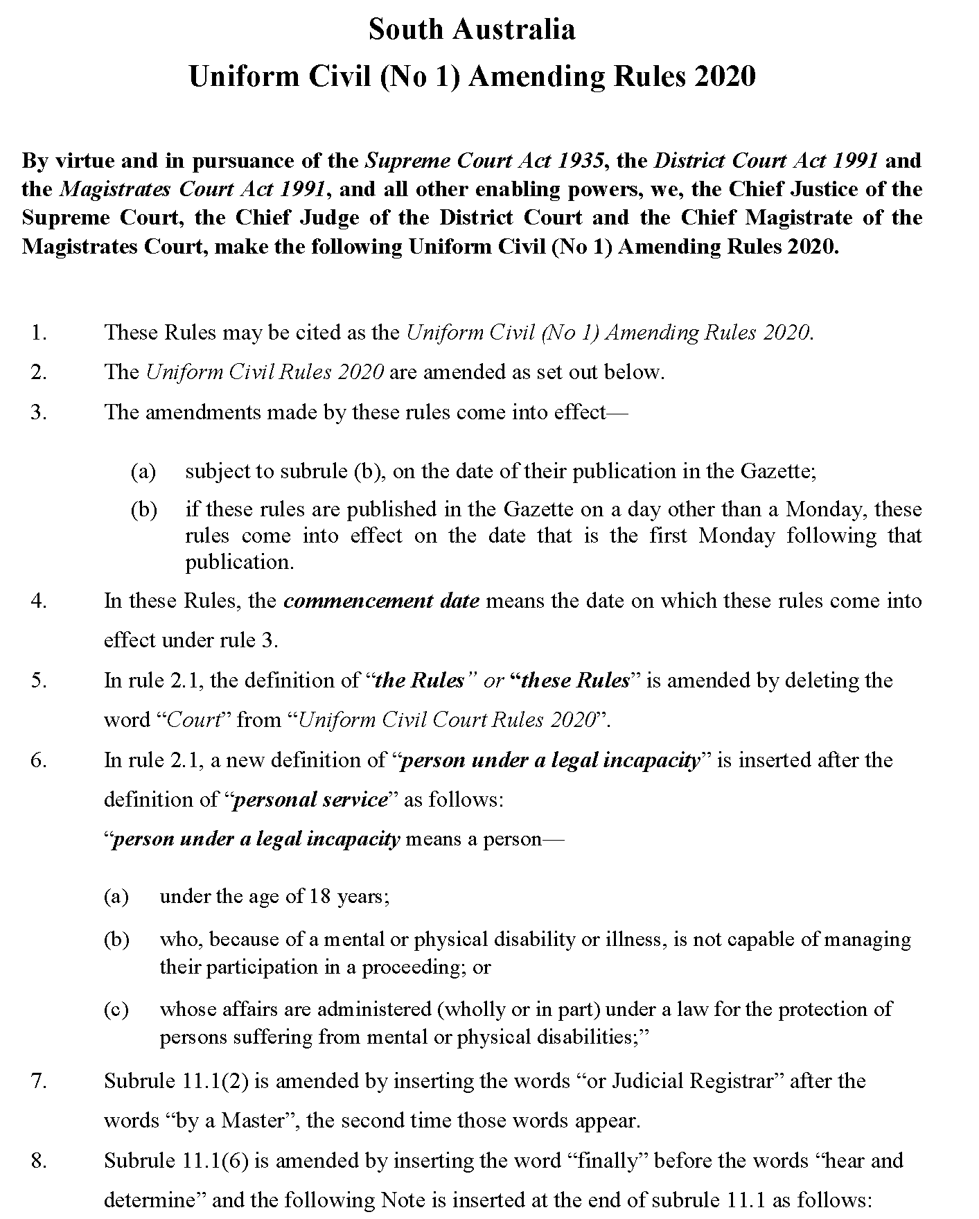
Uniform Civil (No 1) Amending Rules 2020

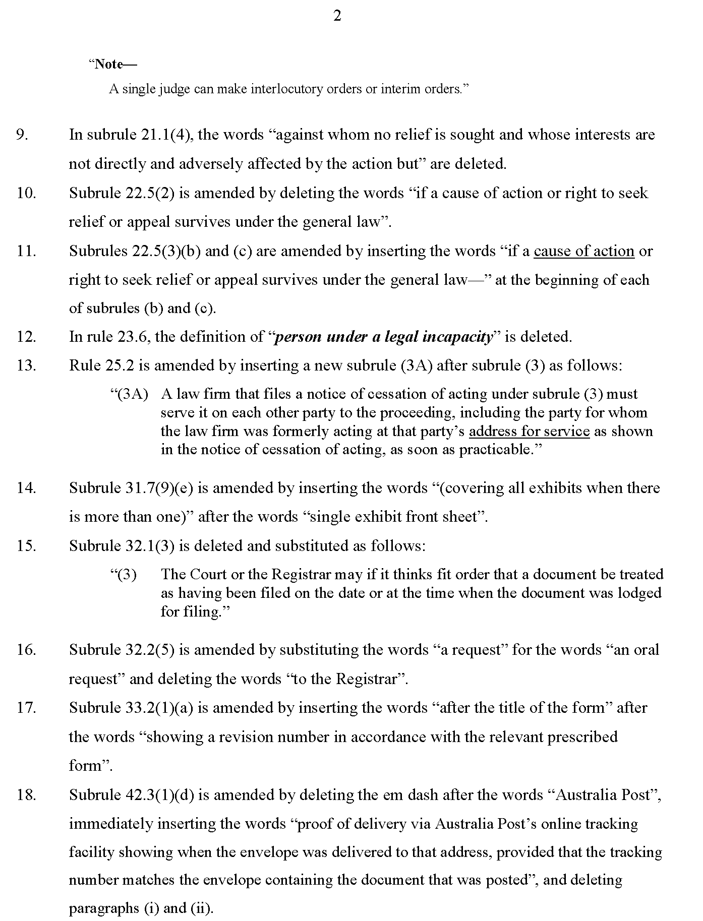

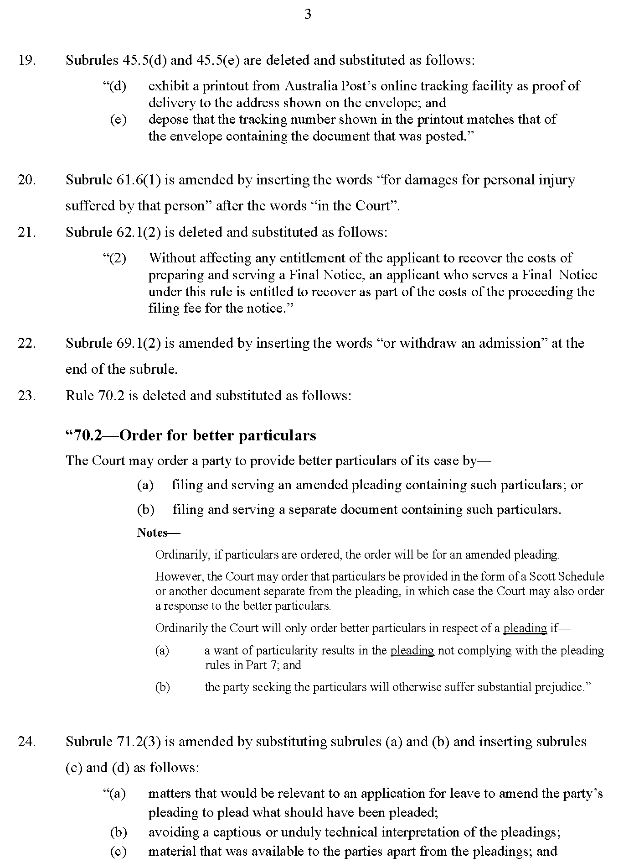

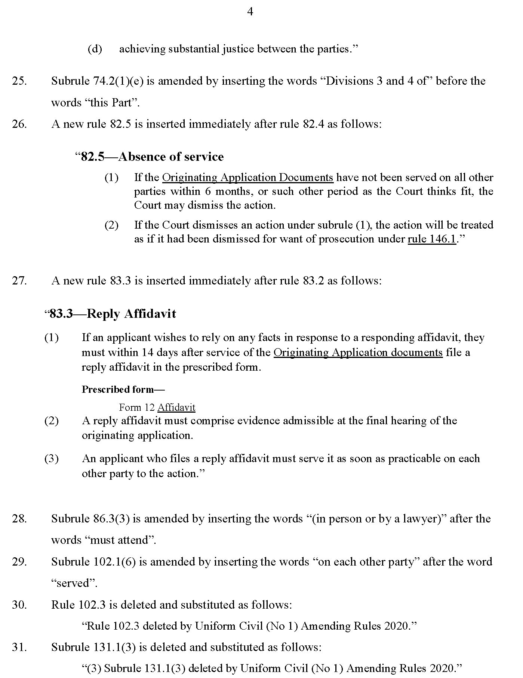

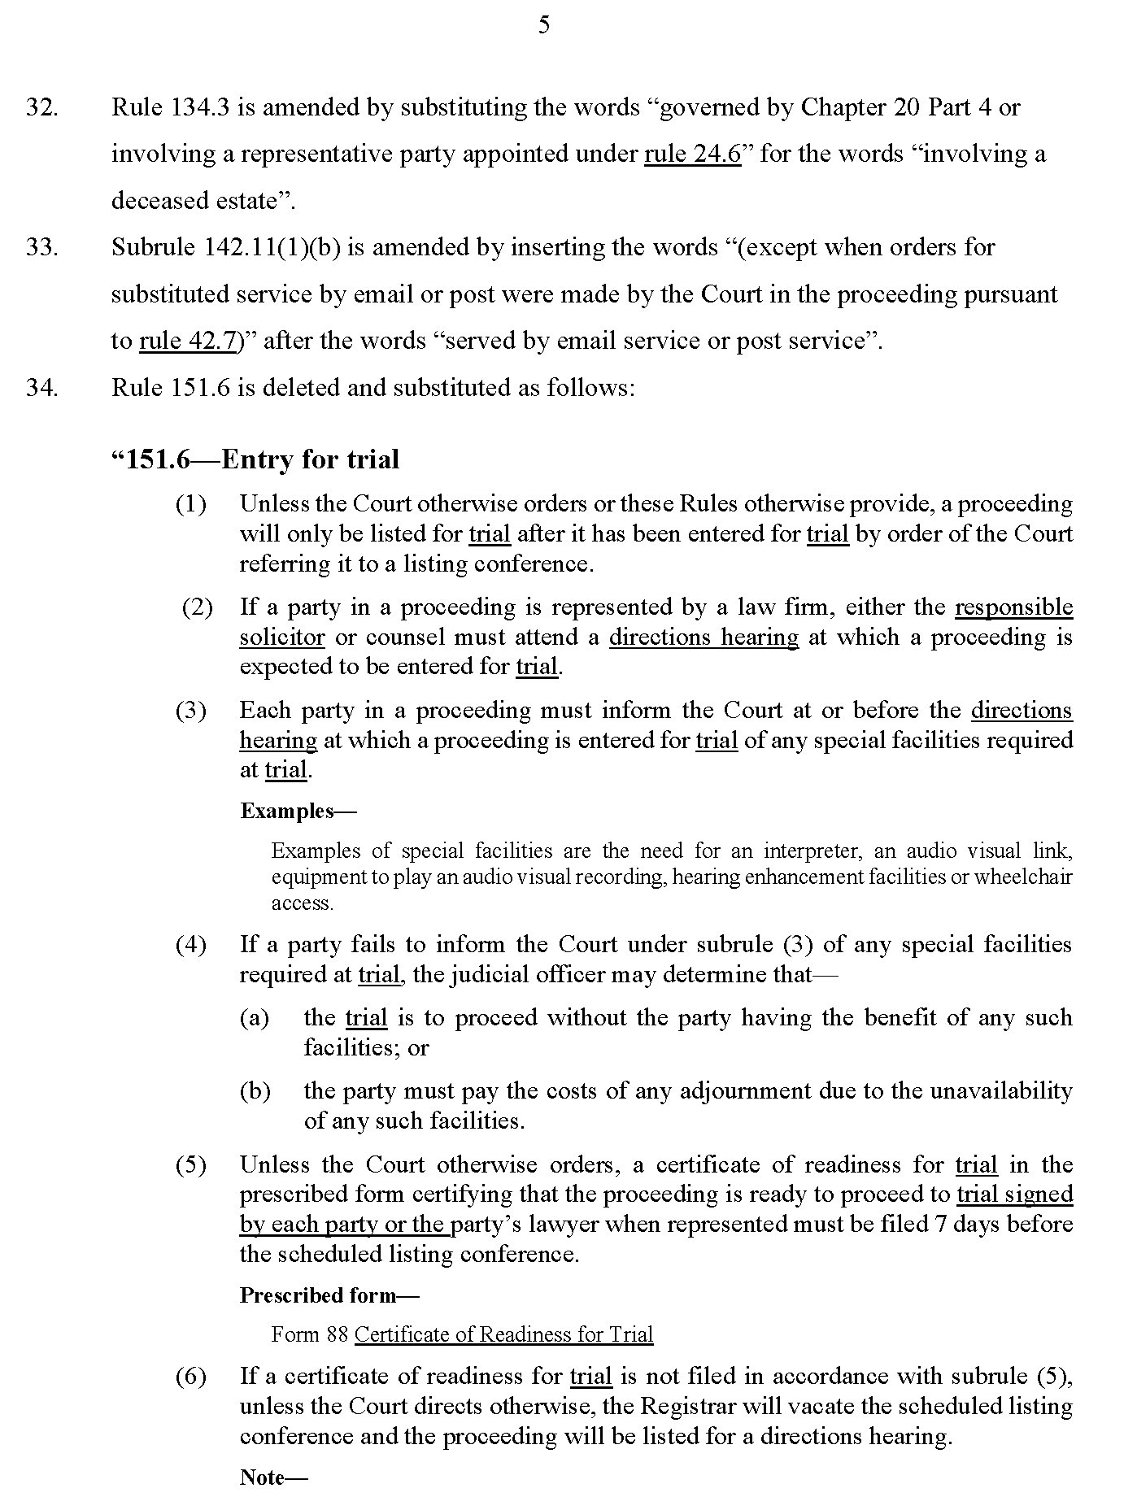

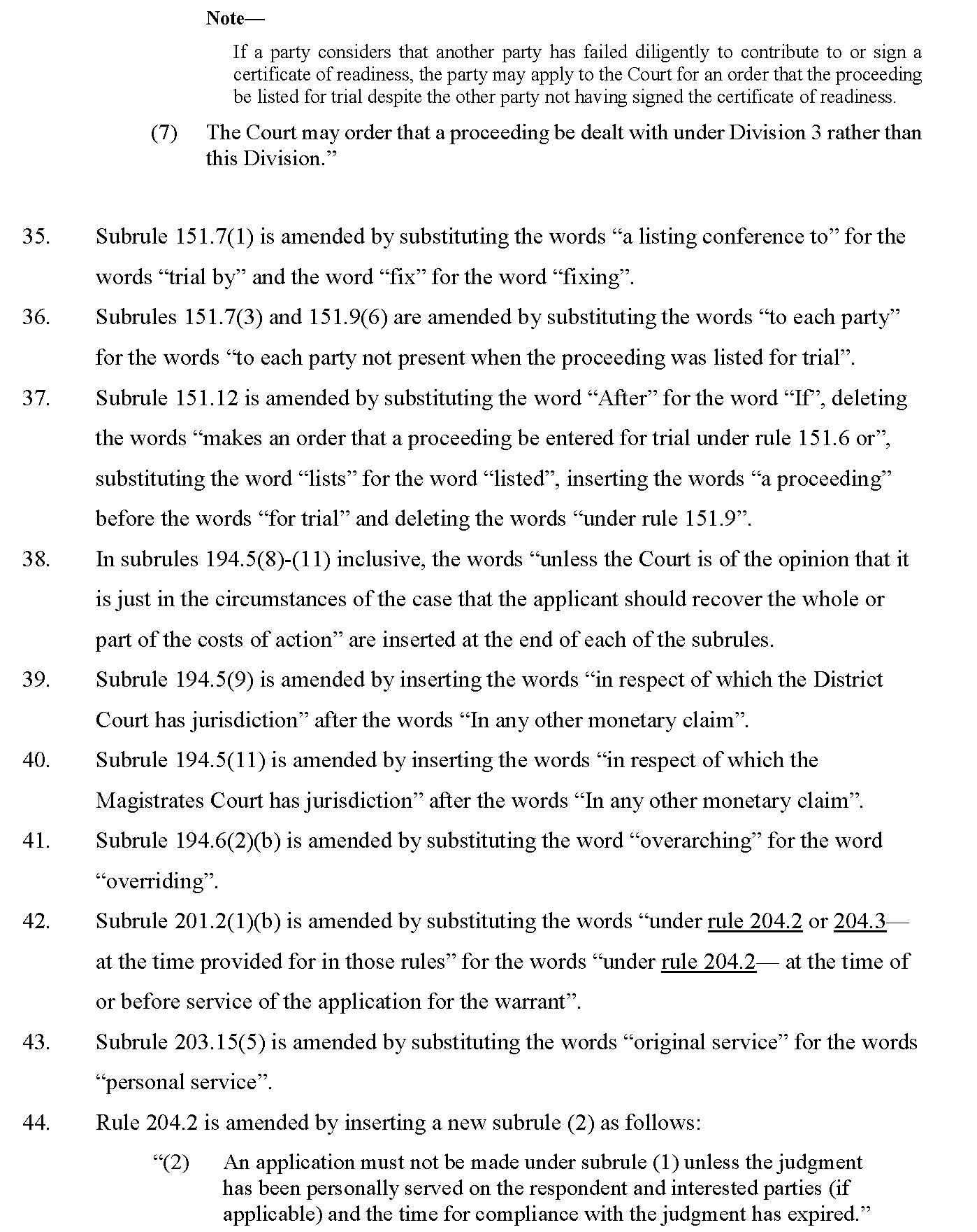

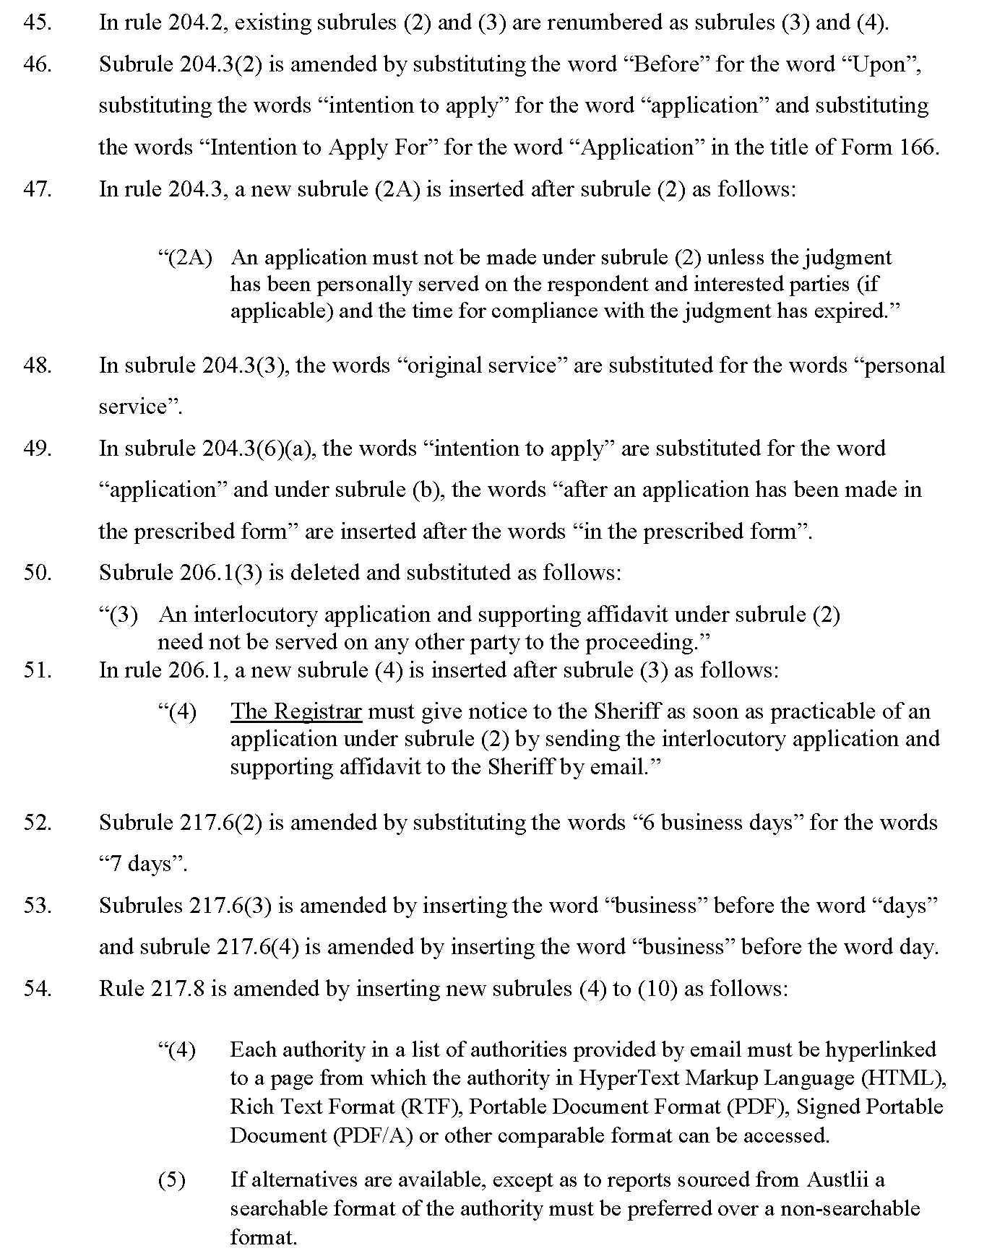

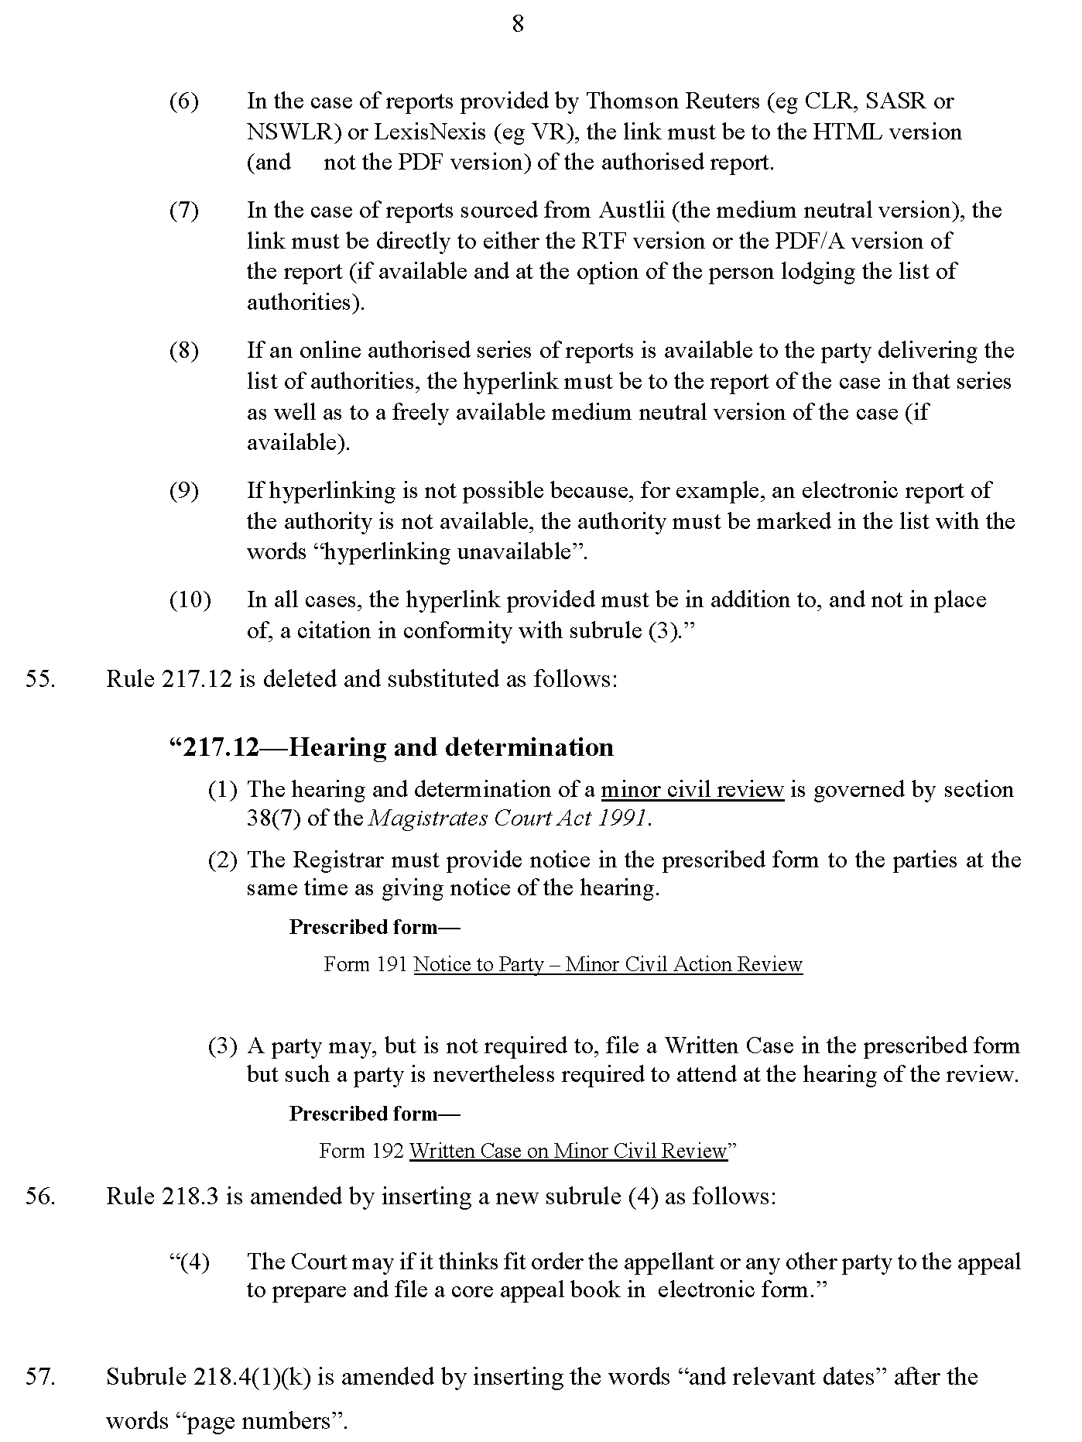
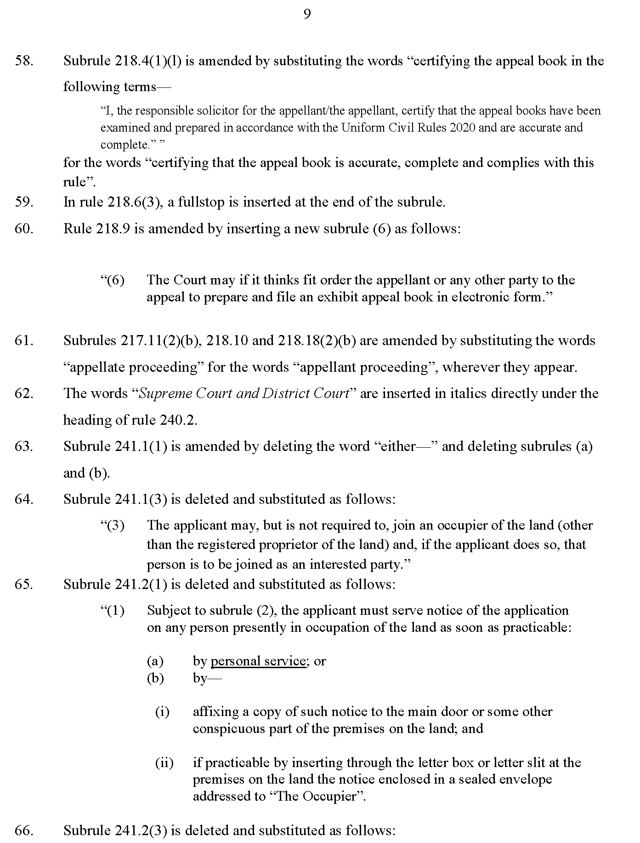

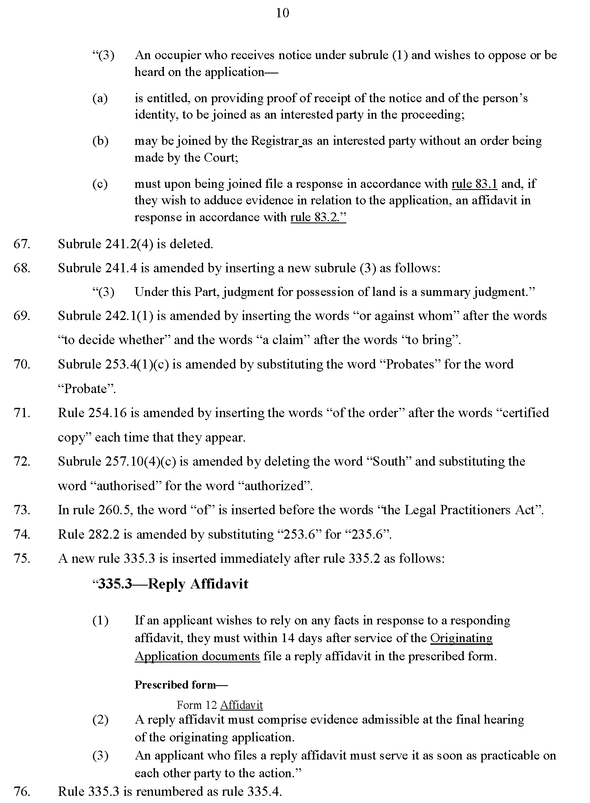

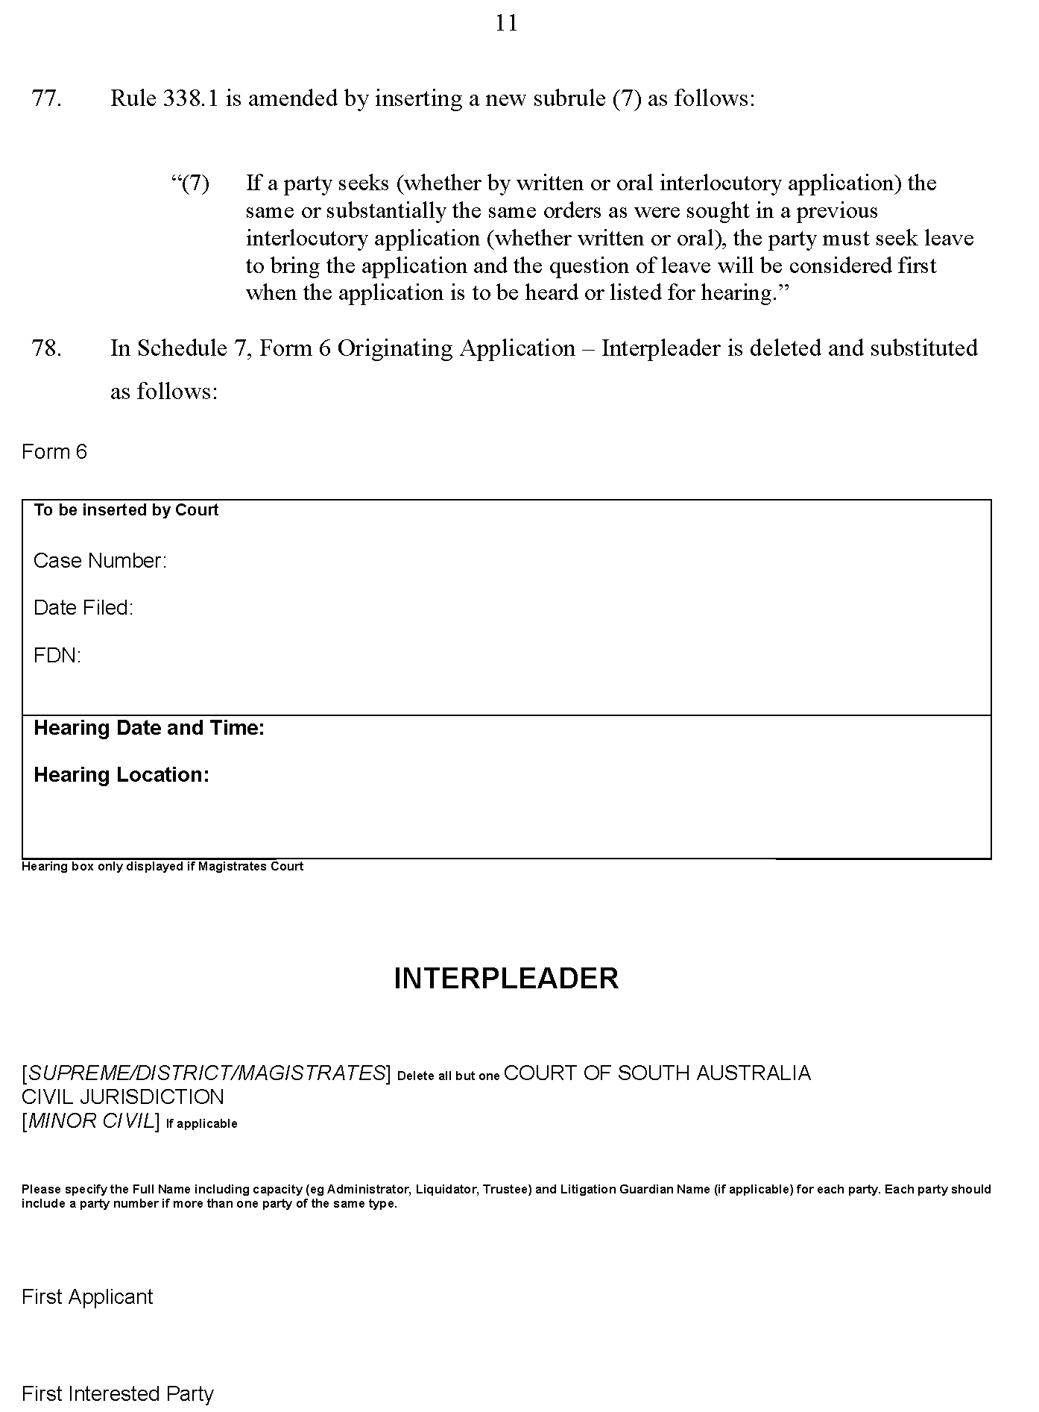
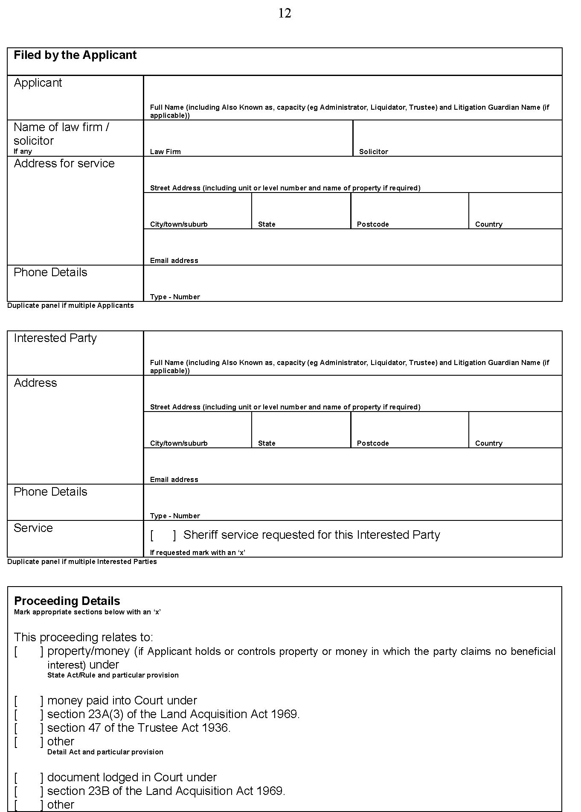

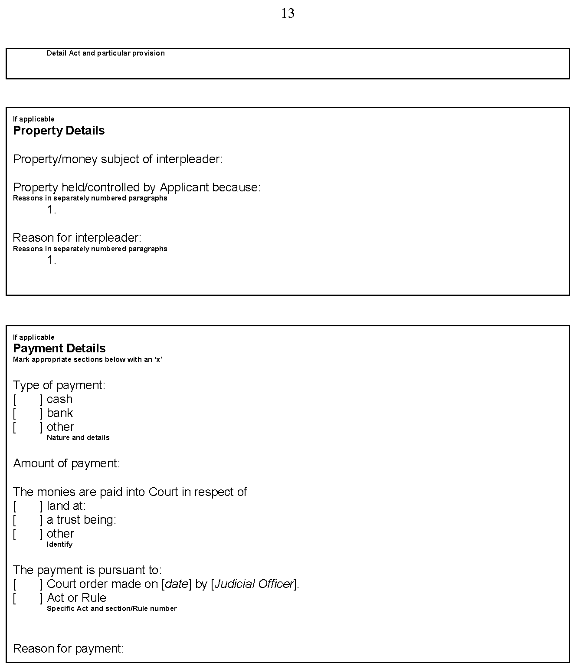
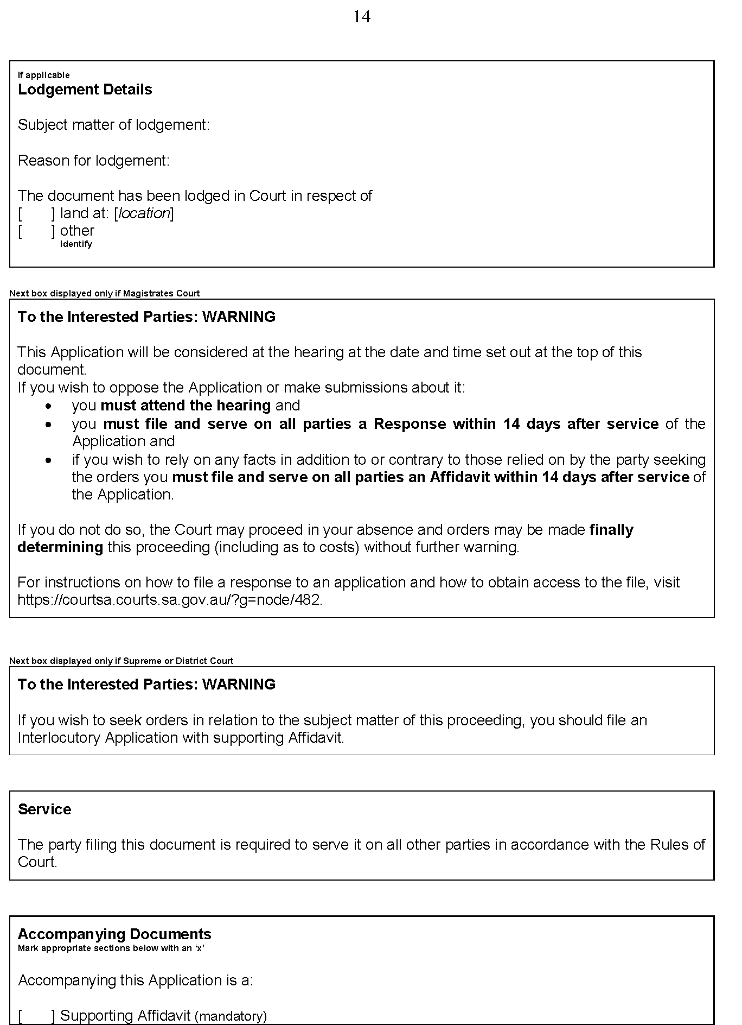

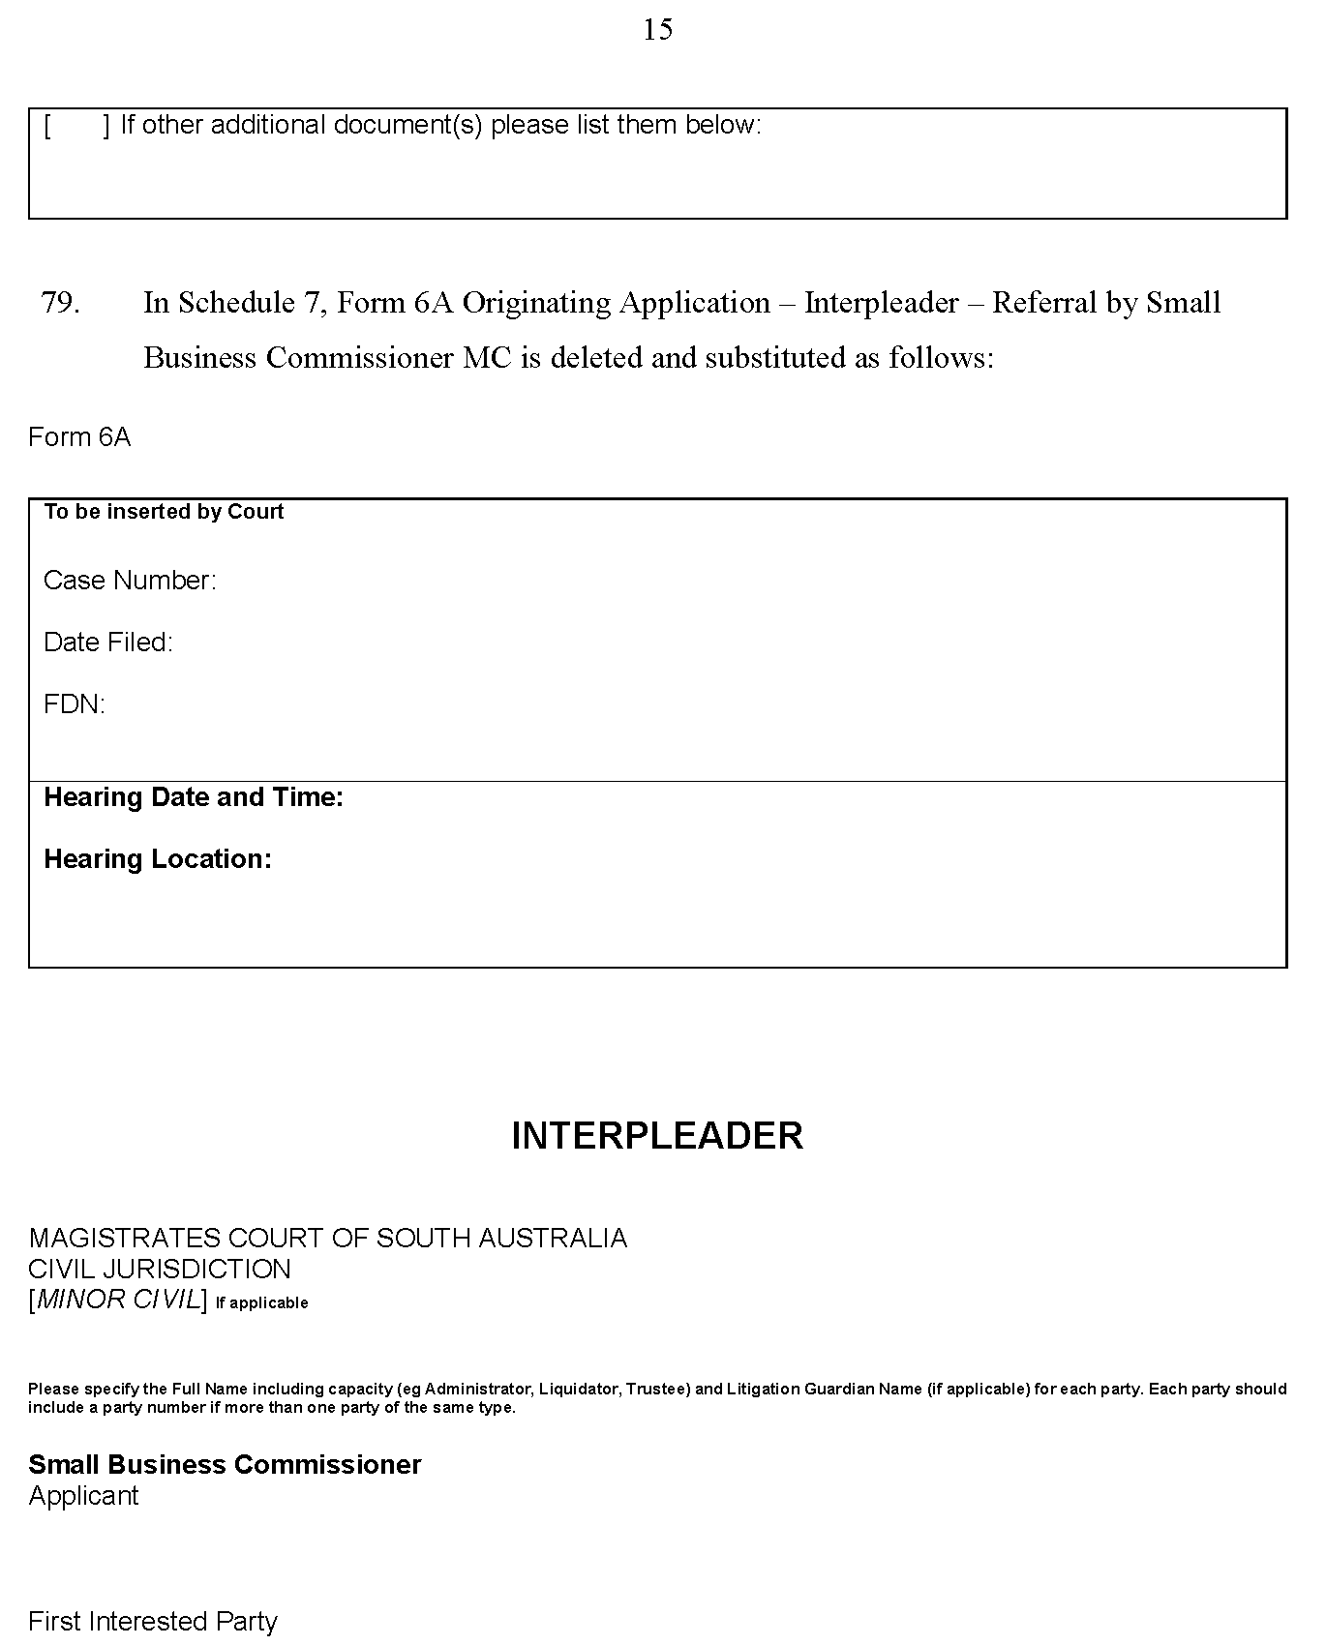

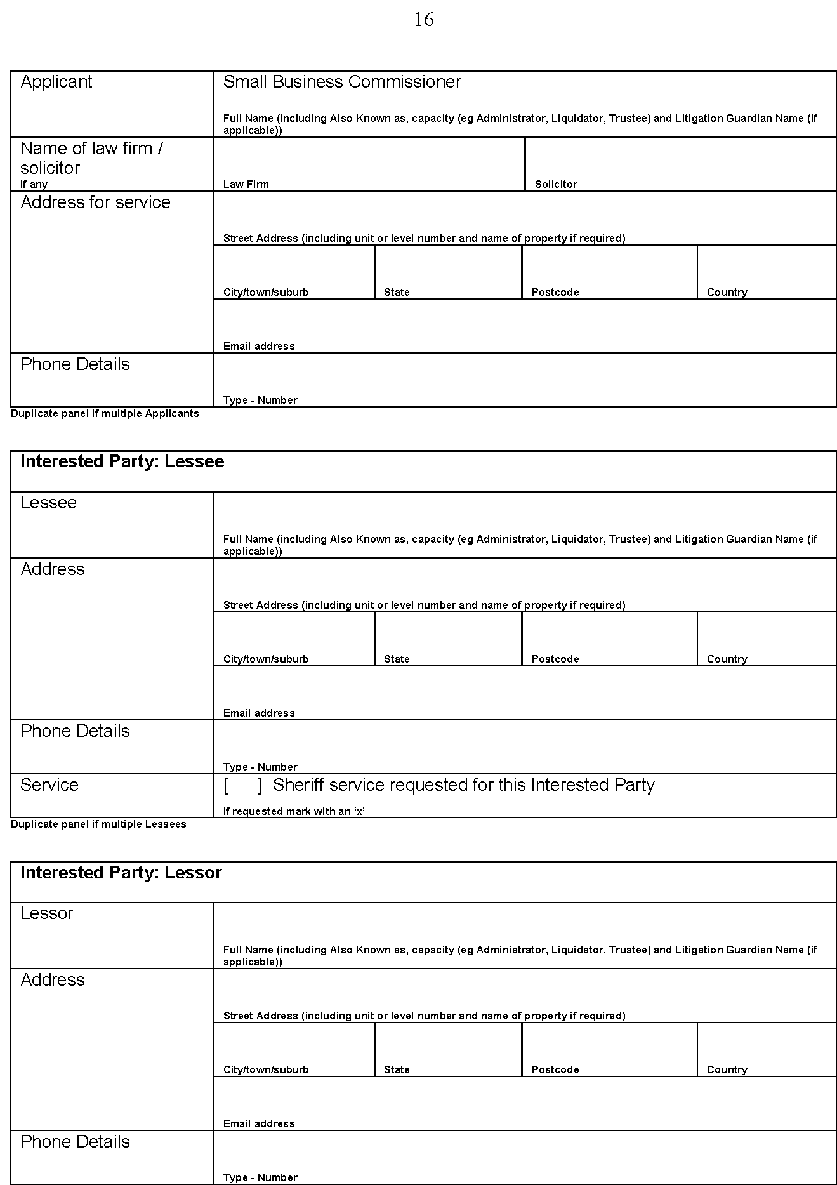

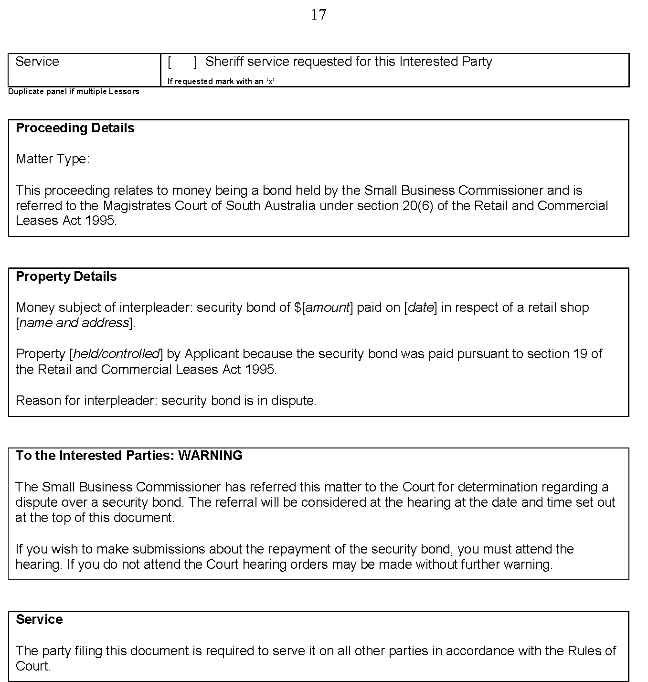
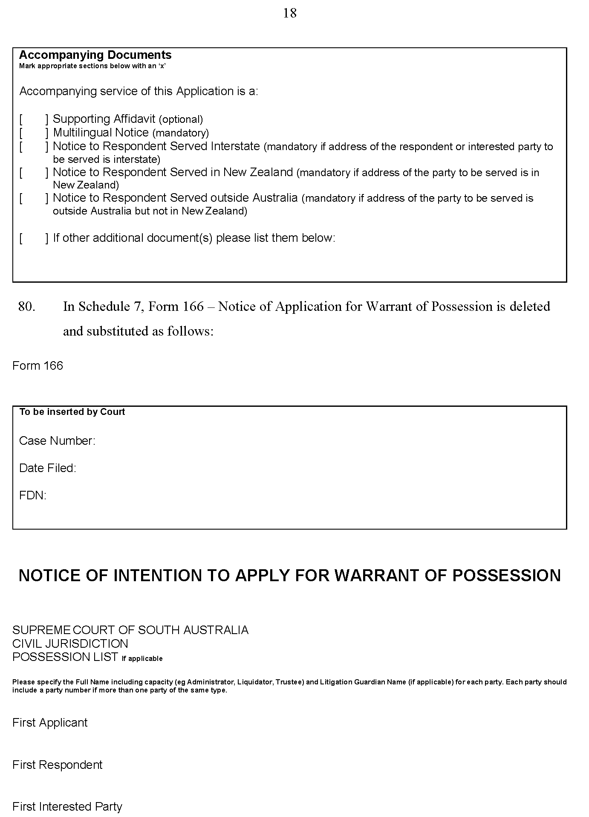

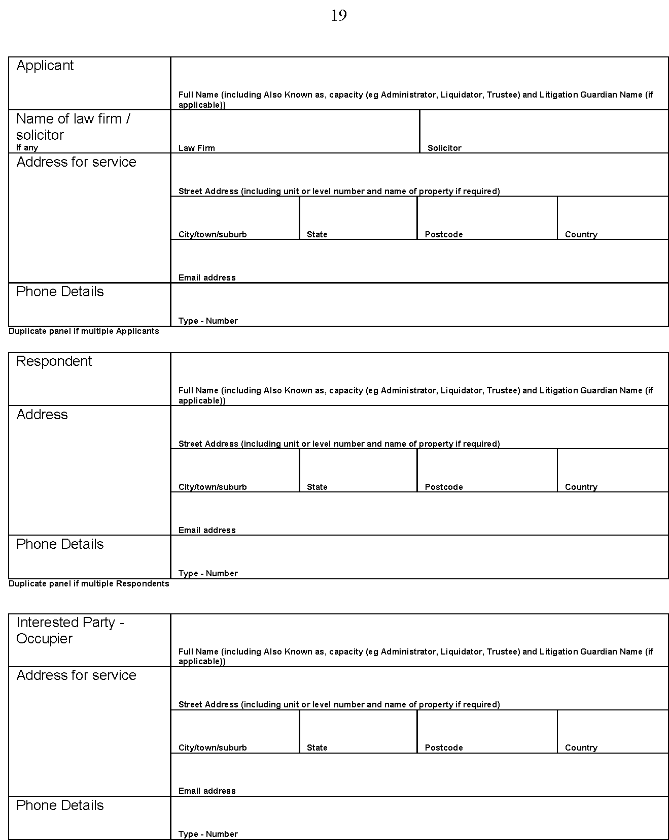

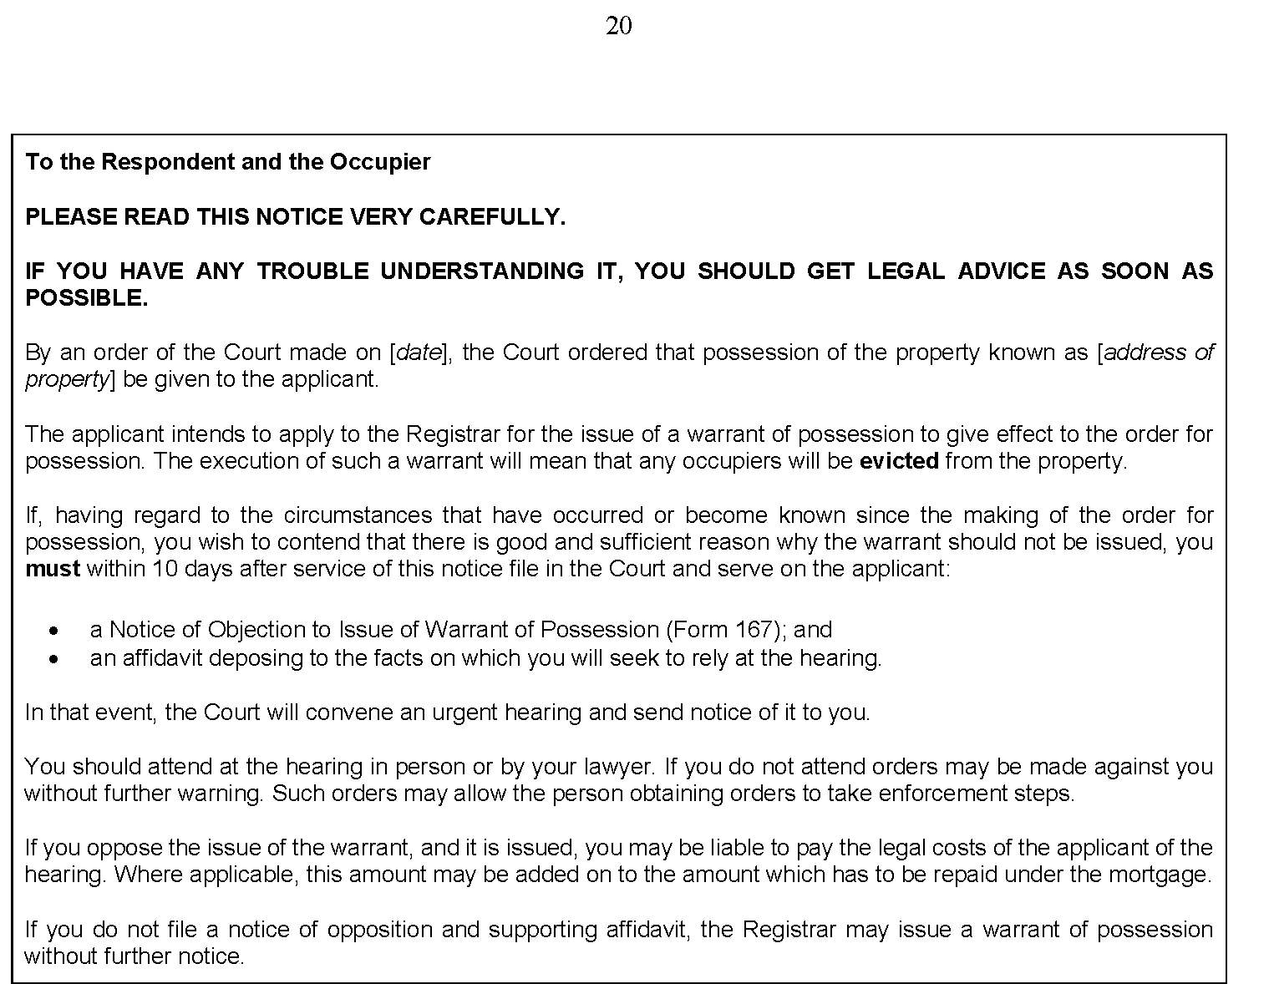

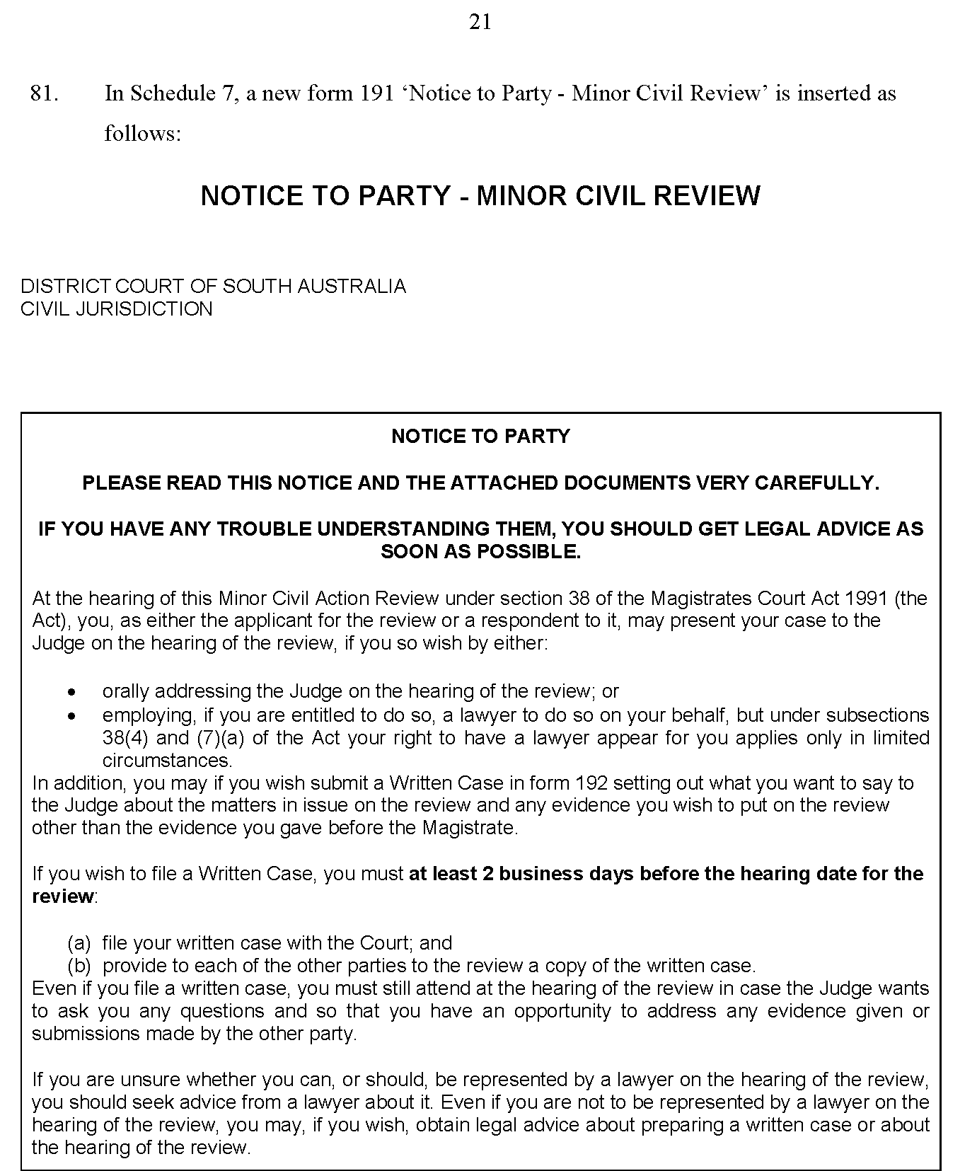
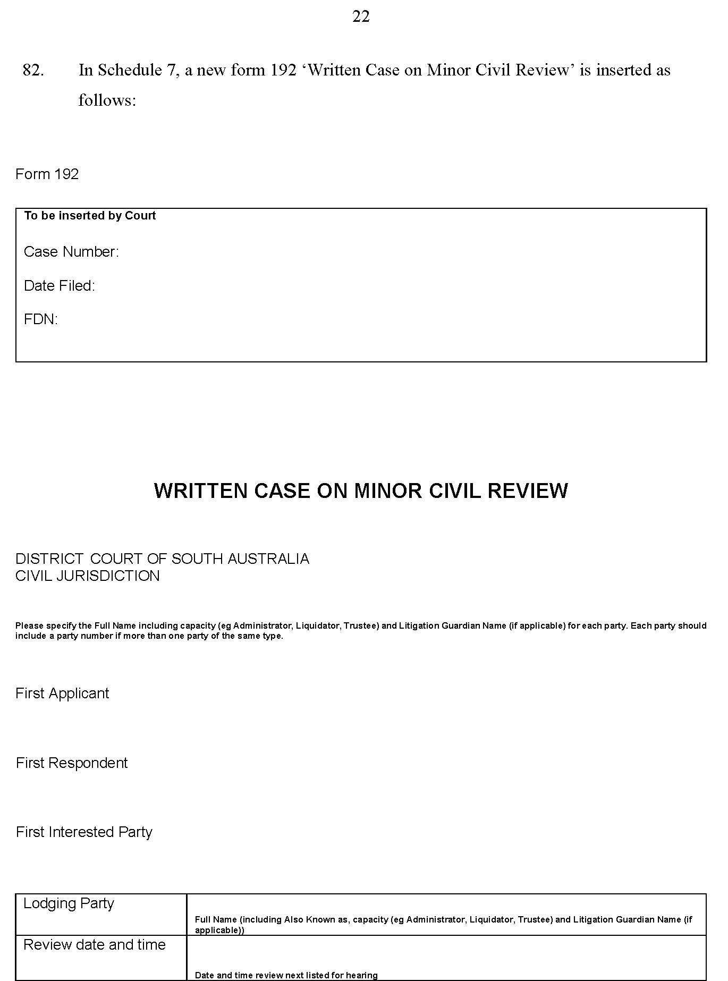

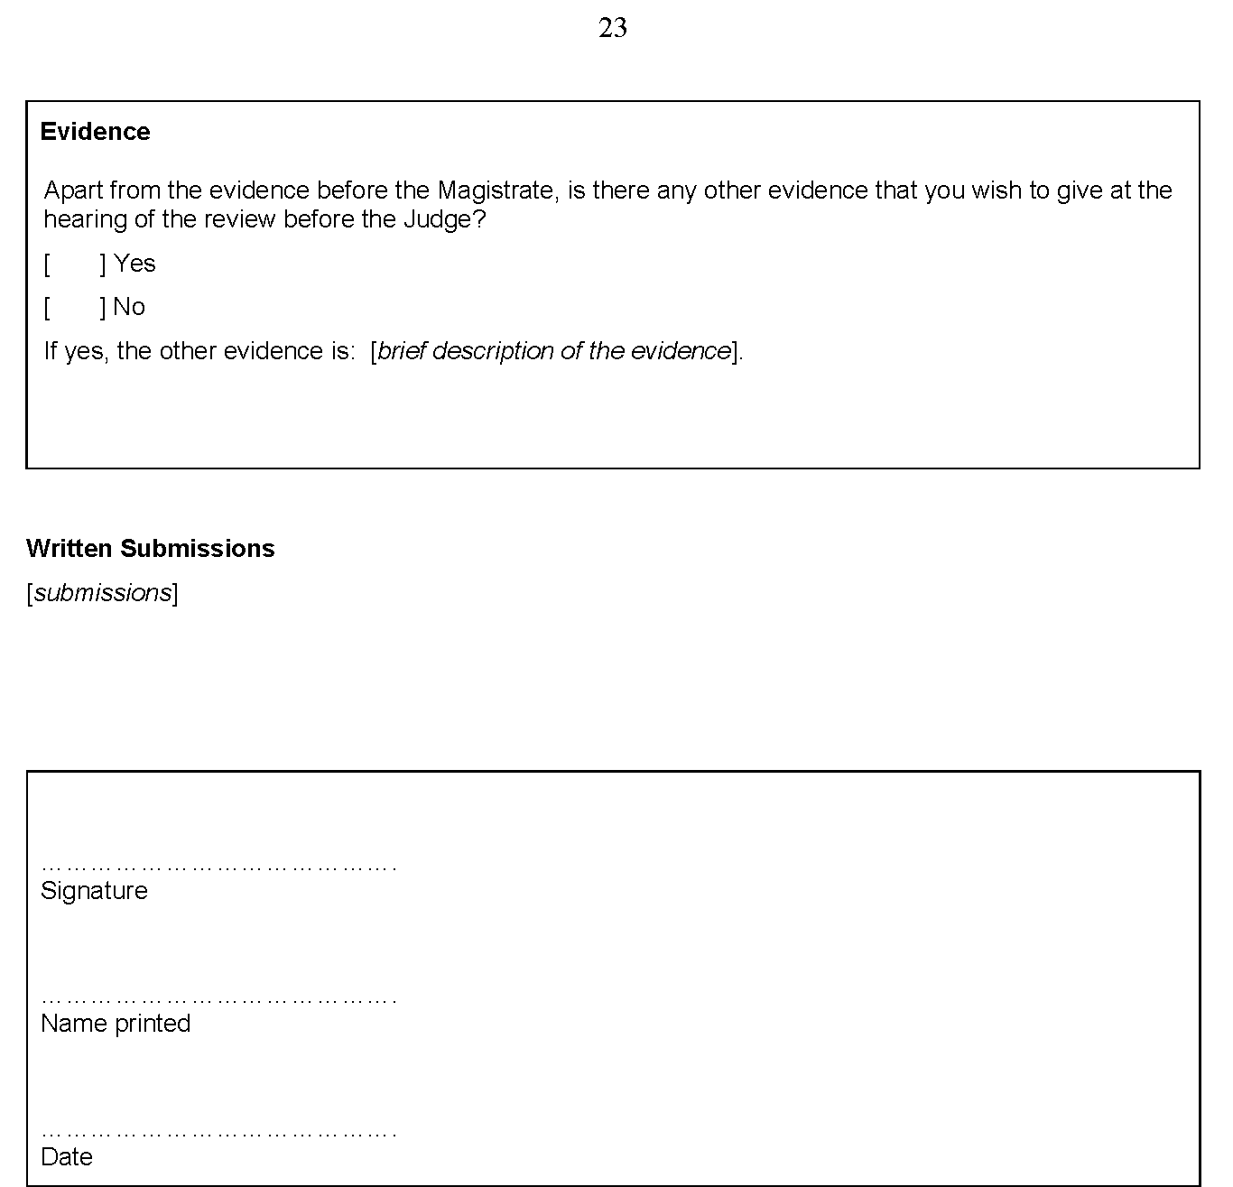

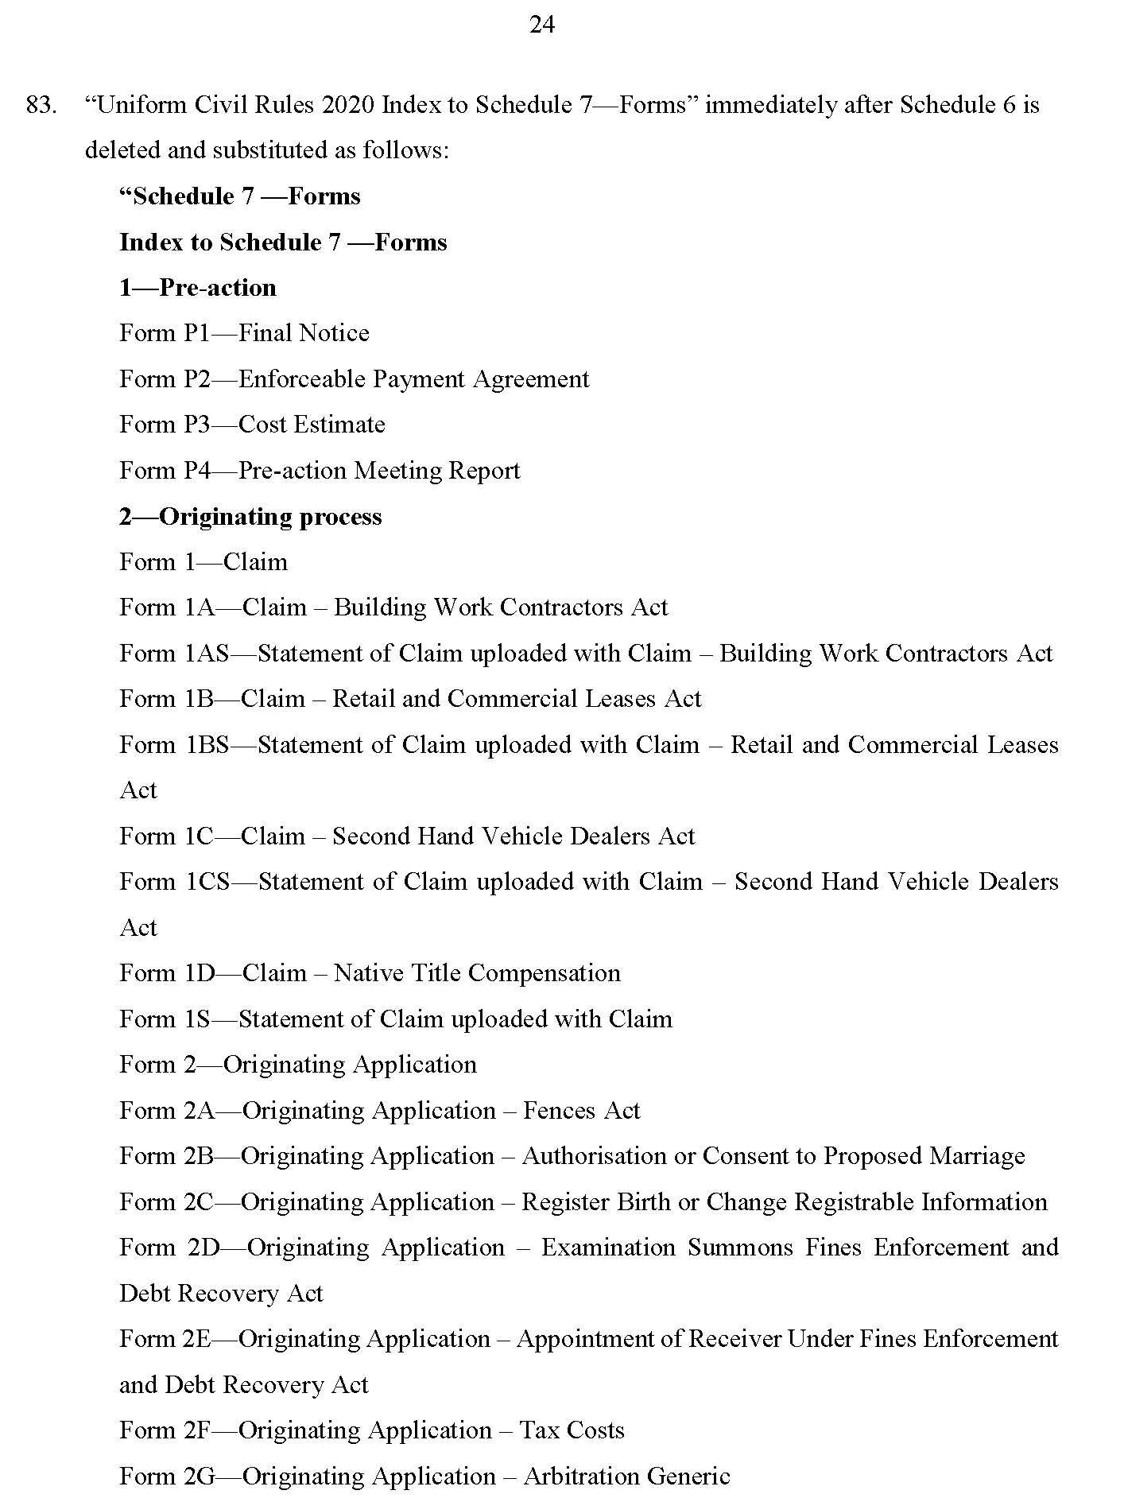

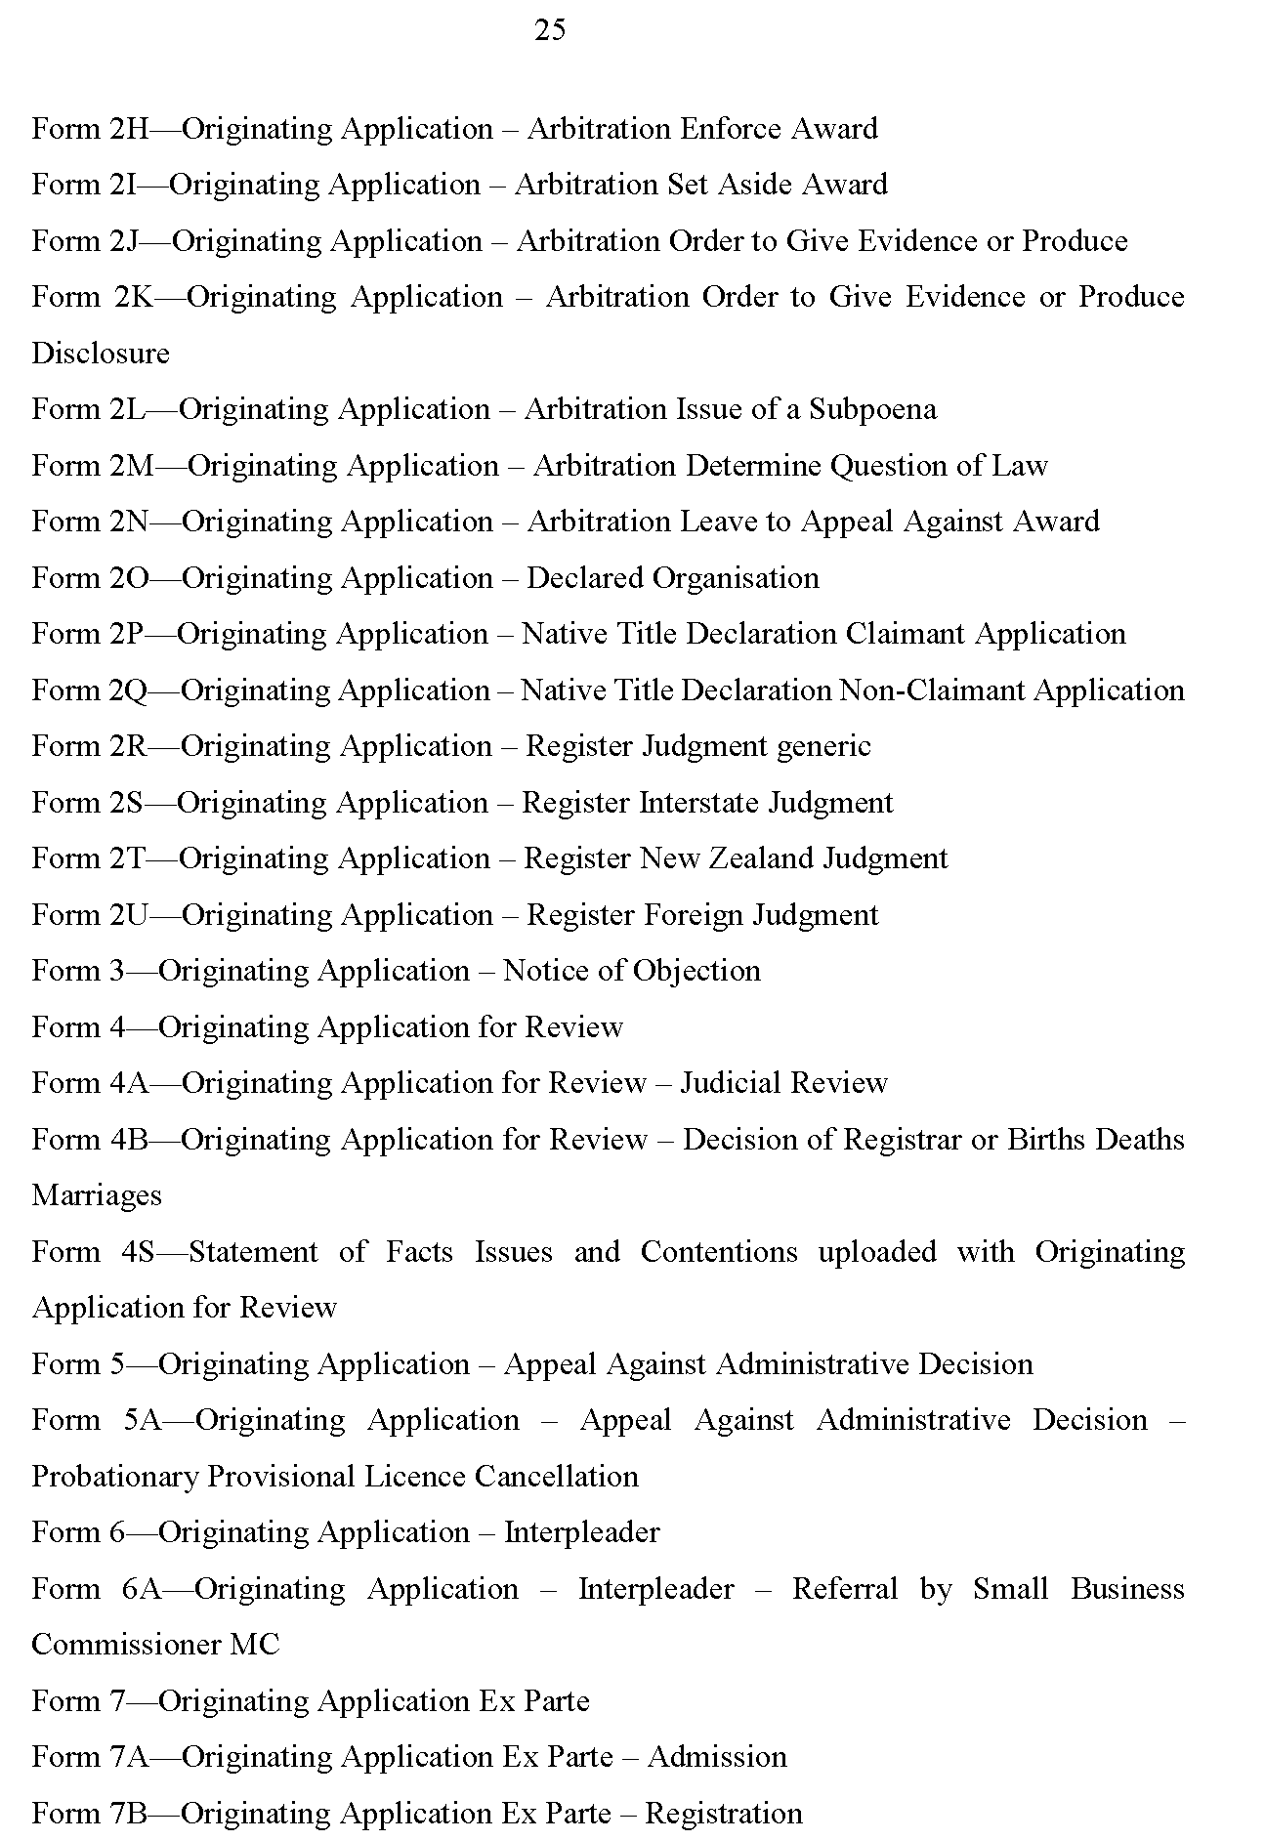
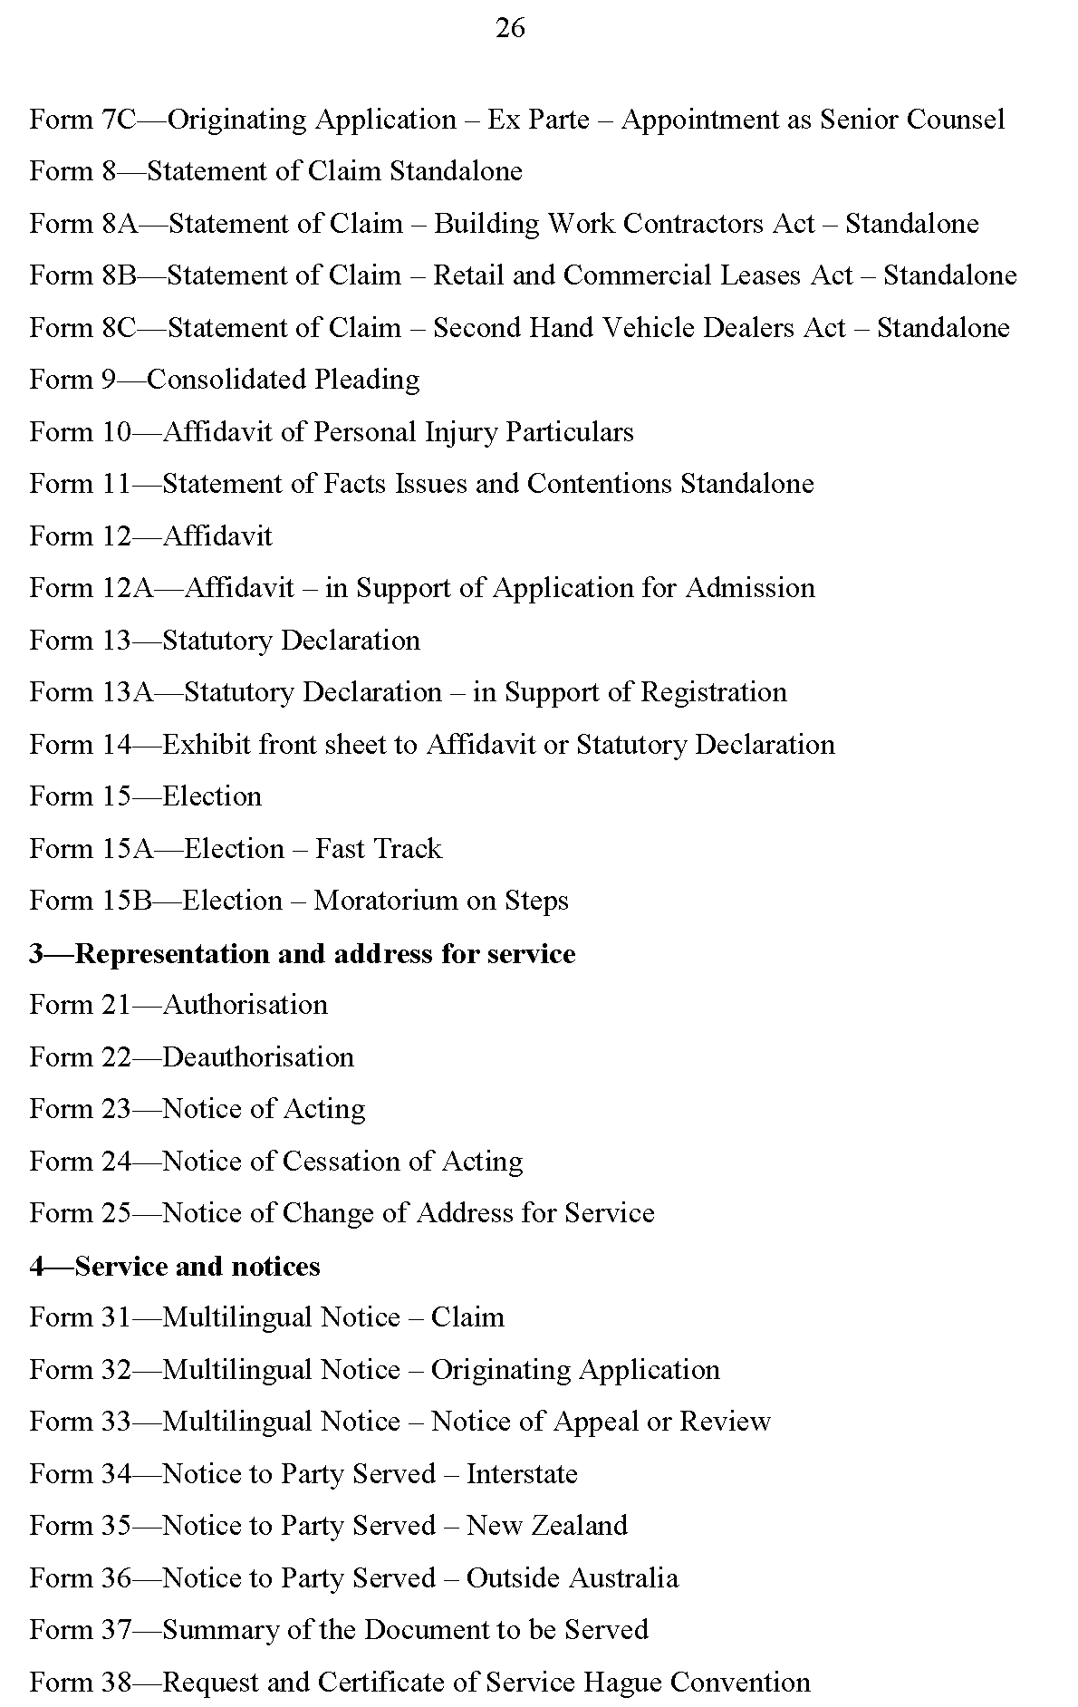

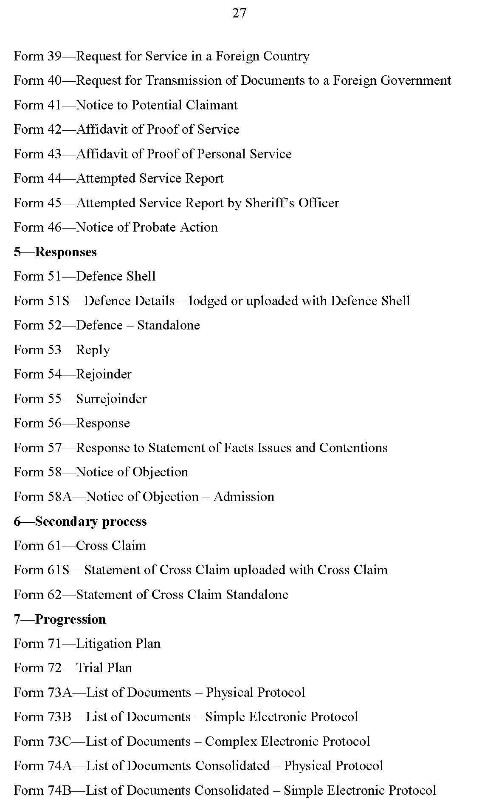
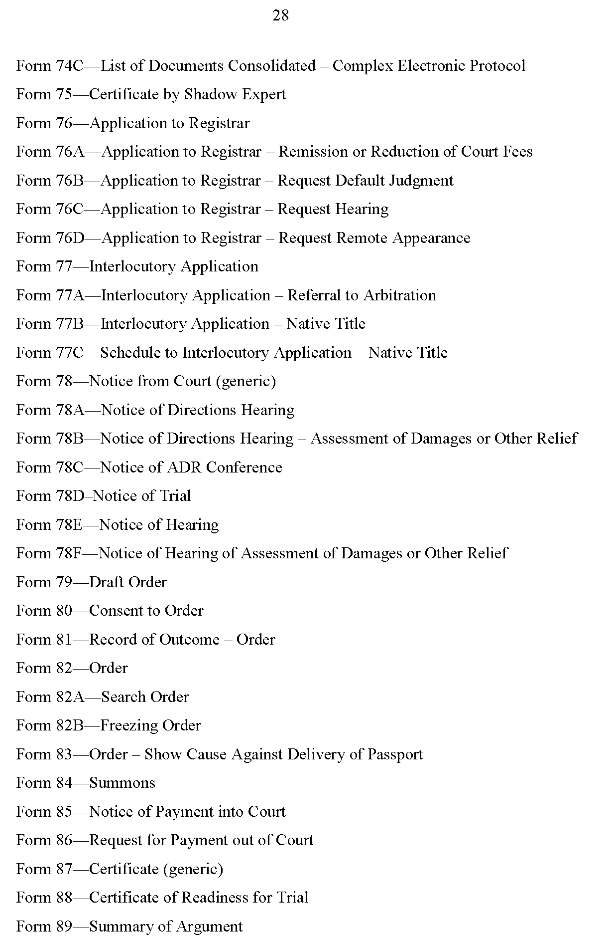

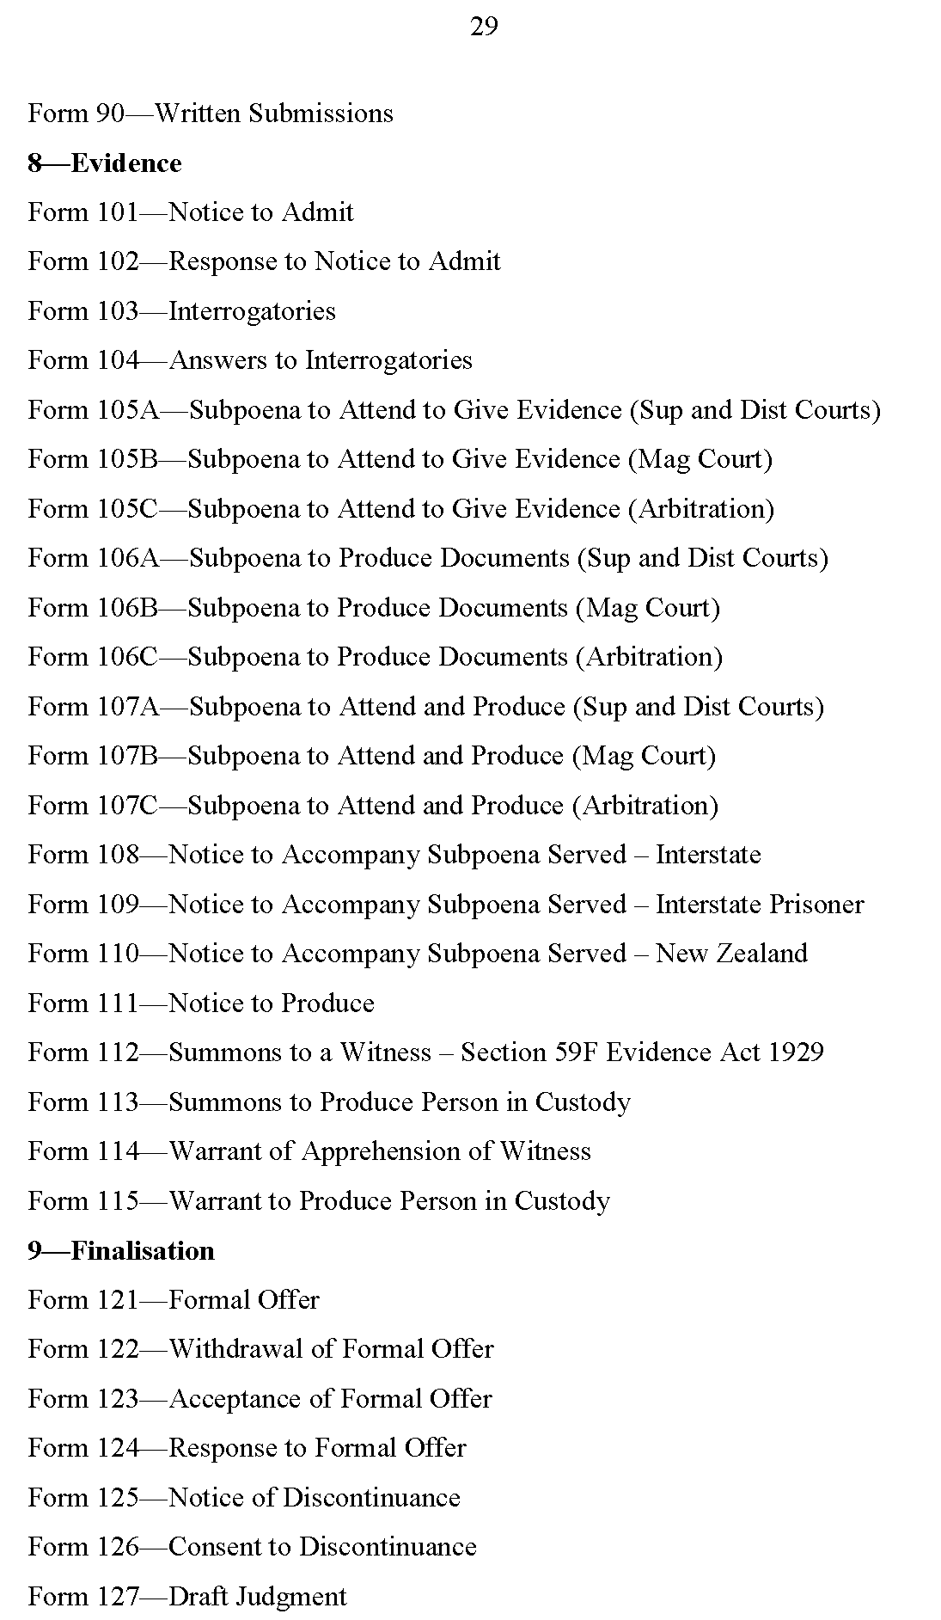
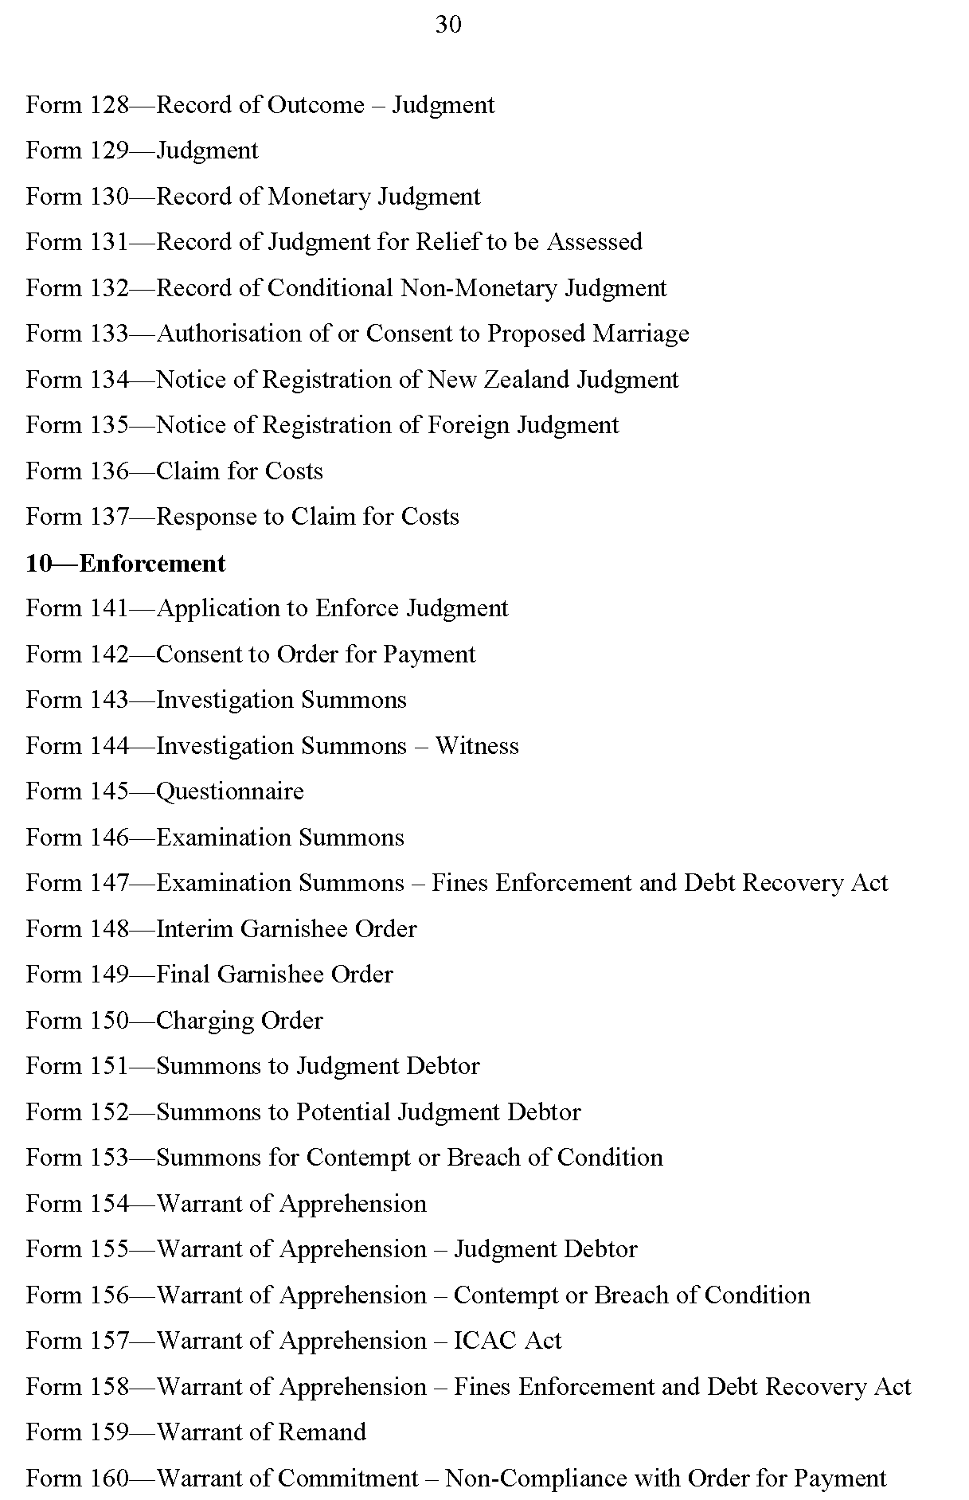

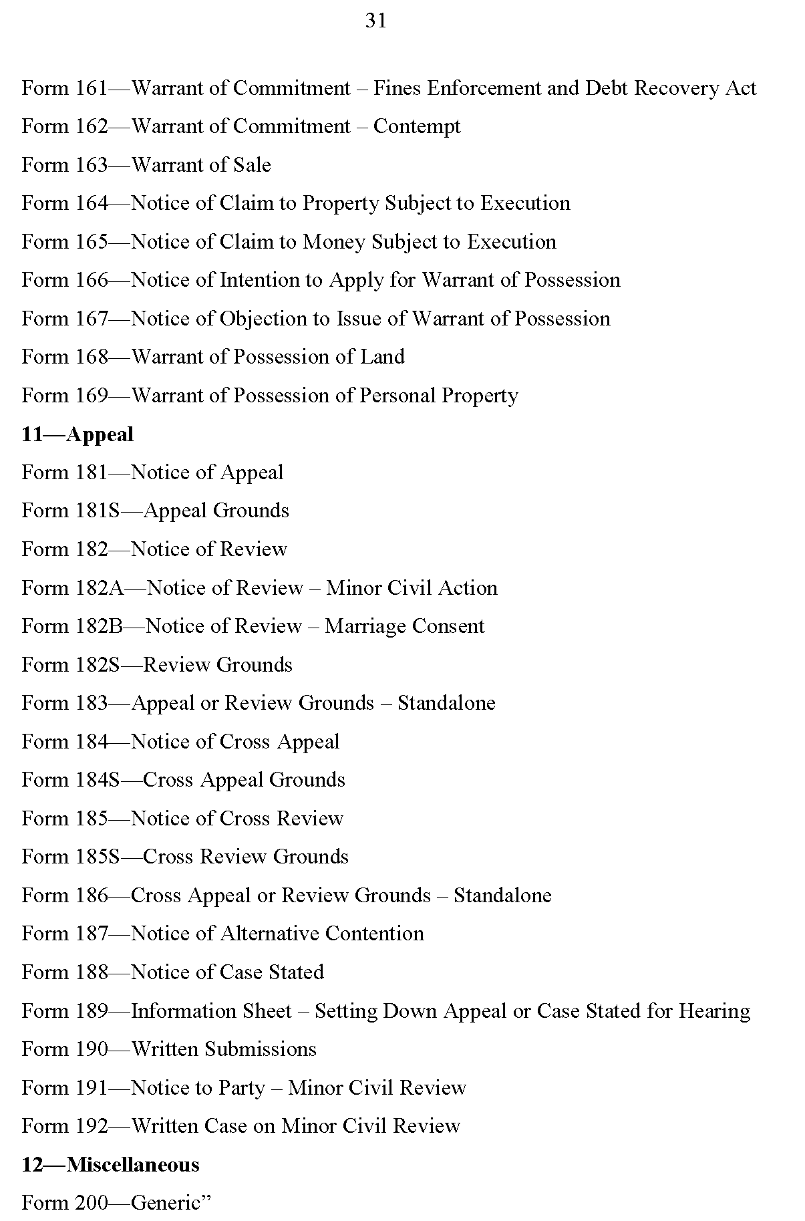

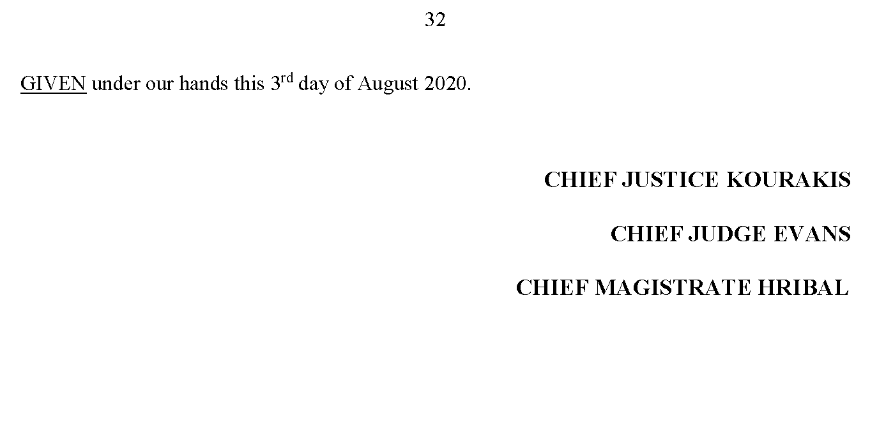

State Government Instruments

COVID-19 Emergency Response Act 2020
South Australia
COVID-19 Emergency Response Modification of requirements relating to laying reports before Parliament Expiry Notice 2020
under section 6(1)(a) of the COVID-19 Emergency Response Act 2020
1—Short title
This notice may be cited as the COVID-19 Emergency Response Modification of requirements relating to laying reports before Parliament Expiry Notice 2020.
2—Commencement
This notice has effect on the day on which it is made.
3—Interpretation
In this notice, unless the contrary intention appears—
Act means the COVID-19 Emergency Response Act 2020.
4—Expiry
Section 15 of Part 2 of the Act will expire on the commencement of this notice.
Signed by the Attorney-General
Dated: 7 August 2020

Development Act 1993
Section 48
Decision by the Minister for Planning and Local Government
Preamble
1. On 20 December 2012 notice of the Governor’s decision to grant a provisional development authorisation under Section 48 of the Development Act 1993, in respect of a proposal to establish and operate the Port Spencer Deep Water Port Facility north of Tumby Bay on the Eyre Peninsula by Centrex Metals Ltd, was published in the South Australian Government Gazette at p 5629.
2. Simultaneously, the Governor delegated his power to grant a variation to the Port Spencer Deep Water Port Facility development authorisation to the Minister for Planning pursuant to Section 48 (8) of the Development Act 1993.
3. A variation to the development authorisation was notified in the South Australian Government Gazette on 18 December 2014 at p 6779 (related to a four year extension of time to commence construction).
4. By letter dated 8 November 2019, Peninsula Ports Pty Ltd, now being the beneficiary of the development authorisation, sought a variation to the authorisation so as to permit modifications to the design and layout of the authorised development. Design modifications have been made to delete facilities for the storage and handling of iron ore, to expand facilities for the storage and handling of grain, to modify the jetty (including the addition of a causeway structure) and to use Lipson Cove Road for site access.
5. The Development Act 1993 applies to the assessment of the proposed modified development except that Section 48 of that Act applies as if a reference to the Governor were a reference to the Minister (and a decision of the Minister in relation to the development will have effect as if it were a decision of the Minister under Section 115 of the Planning Development and Infrastructure Act 2016) in accordance with regulation 11(3)(a) of the Planning, Development and Infrastructure (Transitional Provisions) Regulations 2017.
6. The proposed modified development has been the subject of an amended Public Environmental Report and an amended Assessment Report under Section 47 of the Act.
7. The Minister for Planning and Local Government has, in considering of the application for variation of the development authorisation, had regard to all relevant matters under Section 48 (5) of the Development Act 1993.
8. For ease of reference the varied provisional development authorisation for the Port Spencer Deep Water Port Facility, now known as the Port Spencer Grain Export Facility, is republished in full hereunder.
Decision
PURSUANT to Section 48 (7a) and 48 (7) (b) (ii) of the Development Act 1993; and having due regard to the matters set out in Section 48 (5) and all other relevant matters, I:
(a) vary the Centrex Metals Ltd Port Spencer Deep Water Port Facility development authorisation dated 18 December 2014, subject to the conditions set out below; and
(b) specify under Section 48 (7) (b) (iii) all matters which are the subject of conditions herein as matters in respect of which the conditions of this authorisation may be varied or revoked, or new conditions attached.
Consolidated Version of Conditions of Authorisation
General
1. Except where minor amendments may be required by other legislation or by conditions imposed herein, proposed modified Major Development shall be undertaken generally in accordance with the plans and documents identified below:
(a) Amendment to the Public Environmental Report – Port Spencer Grain Export Facility, prepared by Jacobs Group (Australia) Pty Ltd for Peninsula Ports Pty Ltd, dated November 2019.
(b) Response Document, Amendment to the Public Environmental Report – Port Spencer Grain Export Facility, prepared by ProManage Australia Pty Ltd for Peninsula Ports Pty Ltd, dated 17 June 2020.
2. For the purposes of Section 48 (11) (b) of the Development Act 1993, the proponent shall commence the development by substantial work on the site of the development within two (2) years of the date of this authorisation, failing which the authorisation may be cancelled.
3. The proponent shall have materially completed the development within five (5) years of the date of this authorisation, failing which an extension of time may be sought from the Minister or the authorisation may be cancelled.
4. Should the project cease during the period between the commencement of earthworks and final completion, the proponent shall undertake all necessary steps to reinstate the land and make good to its pre-development condition.
Prior to the Commencement of Construction Works
The following information shall be submitted to the Minister for Planning and Local Government prior to the commencement of construction works at each individual stage:
5. Building Rules compliance, following assessment and certification by a private certifier, the District Council of Tumby Bay or by a person determined by the Minister for Planning and Local Government, as complying with the provisions of the Building Rules (or the Building Rules as modified according to criteria prescribed by the Development Regulations 2008). For the purposes of this condition ‘building work’ does not include plant and equipment or temporary buildings that are not permanently attached to the land (refer to relevant Advisory Notes below).
The following information shall be submitted for further assessment and approval by the Minister for Planning and Local Government, prior to the commencement of construction works at each individual stage:
6. Final detailed plans for all buildings and structures on site and within the marine environment of each component of the development (including site plans, floor plans, elevations, cross-sections, details of any cut and fill, finishes and colours, landscaping and car parking configuration) and other relevant specifications.
7. Final plans, drawings, specifications, financial, construction delivery and maintenance arrangements for road upgrades to the intersection of the Lincoln Highway and Lipson Cove Road (and other associated works), including relevant approvals and Deeds of Agreement with road authorities, prepared to the reasonable satisfaction of the Department of Transport and Infrastructure and the District Council of Tumby Bay.
8. Final plans, drawings, specifications, financial and maintenance arrangements for road upgrades for Lipson Cove Road (and other associated works), including Deeds of Agreement with the road authority, prepared to the reasonable satisfaction of the District Council of Tumby Bay.
9. Detailed engineering designs for the jetty, associated structures and all other structures sought to be constructed on or over land owned by the Crown shall be prepared and independently certified by a registered engineer. A certificate as to the structural soundness of each proposed structure shall be submitted, prior to the commencement of construction of the relevant structure.
10. A Construction Environmental Management Plan (CEMP), prepared in consultation with and to the reasonable satisfaction of the relevant agencies and the District Council of Tumby Bay. The CEMP must identify measures to manage and monitor (at a minimum) the following matters:
(a) sequencing of development (including construction timelines for works on site, as well as periods and hours of construction);
(b) occupational health and safety;
(c) traffic and road maintenance for the duration of any site works and construction activities;
(d) noise and vibration;
(e) air quality, especially the impact of dust on the receiving environment;
(f) soils, sediment and stockpiles (including prevention of soil contamination);
(g) stormwater runoff from structures, roads, hard stand areas, material stockpile areas etc.;
(h) surface water and groundwater (including prevention of groundwater contamination);
(i) impacts on the marine environment (especially turbidity, vibration and noise);
(j) coastal erosion and remediation (where required);
(k) terrestrial and marine native flora and native fauna, in particular the Southern Right Whale;
(l) vegetation clearance (including any Significant Environmental Benefit offset requirements);
(m) pest plants, animals and pathogens (including biosecurity risks)
(n) visual impacts (including lighting);
(o) waste management for all waste streams and overall site clean-up;
(p) use and storage of chemicals, oil, construction-related hazardous substances and other materials that have the potential to contaminate the environment (including proposed emergency responses);
(q) site contamination and remediation (where required);
(r) Aboriginal Heritage sites to ensure compliance with the Aboriginal Heritage Act 1988;
(s) fire risk and emergency planning;
(t) impacts on adjacent landowners;
(u) site security, fencing and safety (including the management of public access); and
(v) public and agency communication, including a community complaints strategy regarding the above matters by way of a community complaints register and management procedure.
During Construction Works
The development shall be constructed in accordance with the following conditions:
11. All works must be undertaken in accordance with the approved plans, drawings, specifications and details required by Conditions 5–10 as listed above.
12. Transport routes for the delivery of construction materials shall be selected to the reasonable satisfaction of the District Council of Tumby Bay and the Department of Transport and Infrastructure.
13. Vegetation screening and landscaping shall be planted and established prior to operation commencing at the site (or during the first favourable growing season), and when established must be maintained in good health and condition at all times.
14. All external lighting, including car parking areas and buildings, shall be designed and constructed to conform with Australian Standards and must be located, directed and shielded, and of such limited intensity, as far as reasonably practicable, that no unreasonable nuisance is caused to any person beyond the boundary of the site.
15. Council, utility or state agency maintained infrastructure that is demolished, altered, removed or damaged during the construction of the development shall be reinstated to Council, utility or state agency specifications as applicable. All costs associated with these works shall be met by the proponent.
16. All stormwater design and construction shall be in accordance with Australian Standards and recognised engineering best practice to ensure that stormwater does not adversely affect any adjoining property, public road or the marine environment. Water-sensitive urban design measures and practices shall be adopted, including stormwater capture and reuse.
17. All liquids or chemical substances that have the ability to cause environmental harm must be stored within a bunded compound that has a capacity of at least 120% of the volume of the largest container, in accordance with the EPA ‘Bunding and Spill Management Guidelines’ (2016).
18. The proponent shall provide appropriate oil spill and firefighting facilities and ensure that contingencies are in place prior to operation of the port, having regard to the South Australian Marne Spill Contingency Action Plan and the Pollution of Waters by Oil and Noxious Substances Act 1987.
19. Appropriate navigational aids shall be erected in prominent locations, in consultation with the Department of Transport and Infrastructure, prior to use of the facility for shipping purposes.
20. The District Council of Tumby Bay shall be given seven days’ notice by the proponent, prior to the commencement of works associated with the construction and operation of the development, and be provided with the contact details for the person responsible for coordinating the works and ongoing operation covered by this approval.
Prior to Operation of the Development
The following information shall be submitted for further assessment and approval by the Minister for Planning and Local Government, prior to the operation of the development:
21. An Operational Environmental Management and Monitoring Plan (OEMMP), prepared in consultation with and to the reasonable satisfaction of relevant agencies and the District Council of Tumby Bay. The OEMMP must identify measures to manage and monitor (at a minimum) the following matters:
(a) traffic management and road maintenance;
(b) operational noise (such as from machinery and ship loading equipment), including a monitoring program to ascertain the effectiveness of noise control measures);
(c) air quality management, in particular dust and fumigants;
(d) cumulative impacts of noise and light spill on the receiving environment;
(e) site contamination;
(f) stormwater run-off for all hard surfaces associated with the development;
(g) surface water management;
(h) waste management (for all waste streams) to ensure compliance with the Environment Protection (Waste to Resources) Policy 2010;
(i) wastewater collection and treatment to comply with the general obligations of the Environment Protection (Water Quality) Policy 2015 and the SA Health On-site Wastewater Systems Code (April 2013);
(j) emergency response and evacuation procedures;
(k) Aboriginal heritage;
(l) chemical, oil, hazardous substances and fuel use and storage (including management/emergency response plans);
(m) safe shipping activities and navigation;
(n) impacts on the terrestrial, coastal and marine environment, including impacts on sea grass and marine fauna (especially Southern Right Whales), pest plant and animal species and nuisance native species;
(o) sand erosion / build-up and seagrass wrack build-up in the nearshore environment;
(p) coastal hazards;
(q) visual impacts (including lighting);
(r) revegetation and landscaping;
(s) ongoing sustainability initiatives;
(t) public safety;
(u) impacts on adjacent land users; and
(v) public and agency communication, including a community complaints strategy regarding the above matters by way of a community complaints register and management procedure.
22. The OEMMP shall be actively monitored by the proponent and the relevant authorities to ensure compliance with predicted impacts and shall be formally reviewed at regular intervals, and updated as necessary, in particular when a significant change in project scope and/or performance is detected. In addition, parts of the OEMMP would need to be revised or superseded by the EPA licencing process or the Department of Transport and Infrastructure port operating agreement process.
23. A Management and Monitoring Plan for Rogers Beach, prepared in consultation with the District Council of Tumby Bay and to the reasonable satisfaction of the Department for Environment and Water.
24. A Beach Profile and Sediment Management Plan, prepared in consultation with and to the reasonable satisfaction of the Department for Environment and Water and the Coast Protection Board.
25. An Air Quality Monitoring and Management Plan for all noise, dust/particulate and fumigant sources, prepared in consultation with and to the reasonable satisfaction of the Environment Protection Authority. The Plan should include revised modelling to verify that final designs comply with relevant environment protection policies.
26. Details of the Road Maintenance Fund Framework for Council roads, prepared in consultation with the Department of Transport and Infrastructure and the Eyre Peninsula Local Government Association.
During Operation of the Development
27. Operations on the site shall be undertaken in accordance with all plans and details submitted as part of the Major Development Application, and where relevant (and endorsed by the Minister for Planning and Local Government where required), in accordance with Conditions 6 - 26 as listed above.
28. The development and the site shall be maintained in a serviceable condition and operated in an orderly and tidy manner at all times.
29. Recycled water (wastewater, greywater and stormwater) must be stored separately from the potable water supply storage.
30. Should operations at the site be temporarily suspended due to unforeseen circumstances for more than six months, an Interim Care and Maintenance Plan shall be developed and relevant government agencies be notified of the nature of the suspension and measures in place to limit impact of the unplanned closure. Should the temporary suspension extend beyond two years, a full Decommissioning and Rehabilitation Plan shall be prepared.
31. Unless otherwise specifically provided for in these conditions or otherwise agreed to in writing, all costs necessary for compliance with these conditions shall be met by the proponent.
Advisory Notes
1. Pursuant to Development Regulation 64, the proponent is advised that the District Council of Tumby Bay or private certifier conducting a Building Rules assessment must:
(a) provide to the Minister a certification in the form set out in Schedule 12A of the Development Regulations 2008 in relation to the building works in questions; and
(b) to the extent that may be relevant and appropriate:
i. issue a Schedule of Essential Safety Provisions under Division 4 of Part 12;
ii. assign a classification of the building under these regulations; and
iii. ensure that the appropriate levy has been paid under the Construction Industry Training Fund Act 1993.
Regulation 64 of the Development Regulations 2008 provides further information about the type and quantity of all Building Rules certification documentation for Major Developments required for referral to the Minister for Planning and Local Government.
2. The District Council of Tumby Bay or private certifier undertaking Building Rules assessments must ensure that the assessment and certification are consistent with this development authorisation (including any Conditions or Advisory Notes that apply in relation to this development authorisation).
3. Construction of each component of the development may commence only after a Building Rules assessment and certification has been undertaken in relation to that component and has been issued by the District Council of Tumby Bay or Accredited Professional, and the Minister for Planning and Local Government has received a copy of the relevant certification documentation.
4. The proponent’s Construction Environmental Management Plan and Operational Environmental Management and Monitoring Plan should be prepared taking into consideration, and with explicit reference to:
(a) Relevant Environment Protection Act 1993 policies and guidance documents, including but not limited to:
i. the Environment Protection (Air Quality) Policy 2016;
ii. the Environment Protection (Noise) Policy 2007;
iii. the Environment Protection (Water Quality) Policy 2015;
iv. the Environment Protection Authority Code of Practice for Materials Handling on Wharves 2007 (updated 2017);
v. the Environment Protection (Waste to Resources) Policy 2010;
vi. the Environment Protection Authority Bunding and Spill Management Guideline 2016;
vii. Environment Protection Authority Handbooks for Pollution Avoidance
viii. the Environment Protection Authority Stormwater Pollution Prevention Code of Practice for the Building and Construction Industry 1999;
ix. the Environment Protection Authority Code of Practice for Vessel and Facility Management (marine and inland waters) 2008 (revised 2019);
x. the Environment Protection Authority guideline ‘Construction environmental management plan (CEMP) 2019’; and
xi. any other legislative requirements, Guidelines and Australian Standards requiring compliance.

(b) In relation to construction of the causeway, the EPA will expect the proponent to:
i. provide hydrodynamic modelling of turbidity/suspended solids generation as a result of the construction of the causeway. This information will then need to be coupled with a review of predicted impacts on benthic communities in the receiving environment. The applicant will need to address potential impacts by identifying effective mitigation measures, including how these will be implemented, when and how their effectiveness will be monitored and managed to reduce risk;
ii. provide a detailed outline of the construction methods and plant and equipment that will be used and how such methods, plant/equipment are linked to the turbidity/sediment modelling; and
iii. design and implement a water quality monitoring program to assess the risk from turbidity generated by the construction of the causeway. This plan will need to take regular turbidity monitoring from multiple locations including up and down current inshore/offshore and areas considered to be background (unaffected by the construction activities). The applicant will need to develop a background turbidity baseline to enable the EPA to provide a turbidity threshold that will need to be followed. This baseline monitoring will need to encompass enough samples from throughout the seasons and weather conditions relevant to the proposed construction period. (This will allow the EPA to understand what is natural turbidity and what is caused by the construction activities.) This would need to be linked to the calibration and use of the hydrodynamic model discussed above.
(c) Address the impacts on the Southern right whale through the implementation of a Southern Right Whale Management and Monitoring Plan, approved by the Australian Government Department of Agriculture, Water and the Environment. In particular, the timing and scheduling of construction activities should be in accordance with the Plan.
5. The proponent’s Construction Environment Management Plan and Operational Environment Management and Monitoring Plan should be prepared taking into consideration, and with explicit reference to the proponent’s sub-plans, including:
• Traffic Management Plan.
• Fire Management Plan.
• Emergency Response Plan.
• Blast Management Plan.
• Construction Noise and Vibration Management Plan.
• Soil, Erosion, Drainage and Water Quality Management Plan (SEDMP).
• Air Quality Management Plan.
• Biosecurity Management sub-Plan.
• Marine Fauna Management Plan.
• Spill Response Plan.
• Waste Management Plan.
• Weed and Pest Management and Monitoring Plan.
6. The following activities in relation to the components of the development hereby approved and/or requiring future approval will require licences under the Environment Protection Act 1993:
• Bulk Shipping Facilities: the conduct of facilities for bulk handling of agricultural crop products, rock, ores, minerals, petroleum products or chemicals to or from any wharf or wharf side facility (including sea-port grain terminals), being facilities handling or capable of handling these materials into or from vessels at a rate exceeding 100 tonnes per day (triggers 7(1) of Schedule 1, Environmental Protection Act 1993).
7. Should any future dredging be required during the operational phase of the development, a licence will be required under the Environment Protection Act 1993 and a separate development application under the Planning, Development and Infrastructure Act 2016 may be required (subject to the volume proposed to be dredged).
8. All works and activities will need to be undertaken in accordance with the General Environmental Duty as defined in Part 4, Section 25 (1) of the Environmental Protection Act 1993 (which requires that a person must not undertake any activity which pollutes, or may pollute the environment, without taking all reasonable and practical measures to prevent or minimise harm to the environment), relevant Environment Protection Policies made under Part 5 of the Environment Protection Act 1993, the Australian New Zealand Environment Conservation Council (ANZECC) Best Practice Guidelines for Waste Reception Facilities at Ports, Marinas and Boat Harbours in Australia and New Zealand and other relevant publications and guidelines.
9. Pursuant to the Harbors and Navigation Act 1993, the proponent will need to enter into a Development Deed incorporating a construction licence and lease over the marine assets with the Minister for Infrastructure and Transport over adjacent and subjacent land on terms acceptable to the Minister prior to the commencement of construction. Such agreement will require completion of the works to the satisfaction of the Minister, at which time the responsibility and control of the area will be transferred so as to minimise the Minister’s ongoing responsibilities. It should be noted a Deed/MOA for tenure requirements will also be required between the proponent, the District Council of Tumby Bay, the Minister for Infrastructure and Transport and the Minister for Environment and Water.
10. Prior to the use of the facility, pursuant to the Harbors and Navigation Act 1993, the proponent would need to apply to the Minister for Infrastructure and Transport to have the harbor defined (and gazetted) as a ‘Port’, and the proponent will be required to enter into a Port Operating Agreement with the Minister. The Port may be a compulsory pilotage area. Pilotage of loaded Cape sized vessels drafts greater than 16m on outward journey will be compulsory. Due to the intention of the Port to be available for use as a multi-user facility, it is likely that the proponent will be subject to the Maritime Services (Access) Act 2000 allowing for third party access.
11. The proponent will need to ensure all Native Title clearances under the South Australian and Commonwealth Native Title Acts have been obtained, prior to any tenure, legislative changes to the Harbors and Navigation Act 1993 (and associated Regulations) or Port Operating Agreement being issued.
12. The proponent is advised that appropriate navigational aids will be required to be erected in appropriate locations, or existing navigation marks may need to be re-located, in consultation with the Department of Transport and Infrastructure, prior to commencement of operations at the new terminal (as required under the Marine and Harbors Act 1993).
13. The proponent is advised that the Commonwealth Navigation Act 2012 and Marine Orders Part 63 makes the provision of position reports mandatory for the following vessels:
• foreign vessels from the arrival at its first port in Australia until its departure from its final port in Australia; and
• all regulated Australian vessels while in a Modernised Australian Ship Tracking and Reporting System (MASTREP) area.
Masters are strongly encouraged to report to MASTREP voluntarily even where it is not mandated.
14. Access and ongoing land tenure arrangements over the Crown land is to be negotiated and approved by the Minister for Environment and Water.
15. In accordance with the National Heavy Vehicle Law (South Australia) Act 2013, the proponent will need to apply to the National Heavy Vehicle regulator for the use of Restricted Access Vehicles on public roads, where access for such vehicle is currently not available. This might include such things as construction equipment and vehicles carrying large indivisible construction materials. This might also include access for vehicles such as Road Trains or Performance Based Standards (PBS) vehicles to transport commodities to and from the Port as part of regular operations.
16. An important initial step, as outlined in the Heavy Vehicle Access Framework, is to have an assessment of the site access route undertaken by an Authorised Route Assessor, at the proponent’s cost. This process will identify any upgrades required for Lipson Cove Road and the Lincoln Highway to make the route safe and suitable for the type of vehicle access requested. As part of the approval/s, the proponent will be required to prepare a list of final transport infrastructure improvement needs upon completion of a full route assessment. If this is necessary, the list should identify the scope, timing and estimated cost of the required improvements.
17. The proponent is reminded of its obligation under the Aboriginal Heritage Act 1988 whereby any “clearance” work, which may require permission to disturb, damage or destroy Aboriginal Sites, must be undertaken with the full authorisation of the Minister for Aboriginal Affairs and reconciliation, according to Section 23 of the Act.
18. The proponent, and all agents, employees and contractors, such as construction crew, is reminded of the need to be conversant with the provisions of the Aboriginal Heritage Act 1988, particularly the requirement to immediately contact the Department of Aboriginal Affairs and Reconciliation in the event that archaeological items (especially skeletal material) are uncovered during earthmoving.
19. The proponent is reminded of its obligations under the Native Vegetation Act 1991 and the Native Vegetation Regulations 2017 whereby any native vegetation clearance must be undertaken in accordance with a management plan that has been approved by the Native Vegetation Council that results in a significant environmental benefit on the property where the development is being undertaken, or a payment is made into the Native Vegetation Fund of an amount considered by the Native Vegetation Council to be sufficient to achieve a significant environmental benefit in the manner contemplated by Section 21 (6) of the Act, prior to any clearance occurring.
20. Prior to any foreign vessels being allowed into the port, the proponent will need to consult with the Department of Transport and Infrastructure (Marine Operations) to address any requirements of the Australian Quarantine Inspection Service (AQIS) and Australian Customs Service.
21. The wastewater treatment system shall be designed by the proponent to ensure that the general obligations of the Environment Protection (Water Quality) Policy 2015 and the SA Health On-site Wastewater Systems Code (April 2013) are met, and to ensure that effluent does not overflow or escape from drains, pipes, sumps, tanks, storage/treatment basins into any watercourse, or into stormwater drains which do not drain into the effluent collections, treatment and disposal system, except where the effluent complies with criteria in the above Policy.
22. Should the proponent wish to vary the Major Development or any of the components of the Major Development, an application to the Minister for Planning and Local Government must be submitted, provided that the development application variation remains within the ambit of the Amendment to the Public Environmental Report and the Amendment to the Assessment Report referred to in this development authorisation. If an application variation involves substantial changes to the proposal, pursuant to Section 47 of the Development Act 1993, the proponent may be required to prepare an amended Public Environmental Report for public inspection and purchase. An amended Assessment Report may also be required to assess any new issues not covered by the amended Assessment Report and the decision made pursuant to Section 48 of the Act.
23. The Minister has a specific power to require testing, monitoring and auditing under Section 48C of the Development Act 1993.
Dated: 6 August 2020
Vickie Chapman MP
Minister for Planning and Local Government

Dog Fence Act 1946
Declaration of Rate
PURSUANT to the provision of Section 25 of the Dog Fence Act 1946, the Dog Fence Board, with the approval of the Minister for Primary Industries and Regional Development, hereby declares that for the financial year ending 30 June 2021 the dog fence rate shall be $2 per square kilometre and the minimum amount payable $475 for all holdings of more than 10 square kilometres of land situated inside the Dog Fence.
Excluding:
1. For all the land in:
(a) The whole of the counties of Musgrave, Flinders, Jervois, Frome, Victoria, Daly, Stanley, Gawler, Fergusson, Light, Eyre, Albert, Alfred, Adelaide, Sturt, Hindmarsh, Russell, Buccleuch, Chandos, Cardwell, Buckingham, MacDonnell, Robe, Grey and Carnarvon.
(b) The whole of the hundreds of Finlayson, Tarlton, Cungena, Kaldoonera, Scott, Murray, Chandada, Karcultaby, Condada, Pildappa, Ripon, Forrest, Campbell, Inkster, Moorkitabie, Carina, Minnipa, Pinbong, Wrenfordsley, Rounsevell, Witera, Addison, Travers, Yaninee, Pygery, Wudinna, Hill, Peella, Pordia, Palabie, Wannamanna, Mamblin, Kongawa, Pinkawillinie, Cortlinye, Moseley, Wright, Downer, Wallis, Cocata, Kappakoola, Warramboo, Cootra, Caralue, Solomon, Kelly, Barna, Yalanda, Panitya, Coomooroo, Walloway, Pekina, Black Rock Plain, Tarcowie, Mannanarie, Yongala, Terowie, Hallett, Kingston, Mongolata, Kooringa, Baldina, Apoinga and Bright.
Where this contribution from holdings in 1(a) and 1(b) is collected via the Sheep Industry Fund and passed on to the Board.
2. Lake Torrens National Park and Lake Gairdner National Park, which are exempted from dog fence rates.
3. All the islands along the seacoast.
Dated: 10 August 2020
Geoff Power
Chair, Dog Fence Board

Environment Protection Act 1993
Section 68
Approval of Category B Containers
I, ANDREA KAYE WOODS, Team Leader, Container Deposit Legislation and Delegate of the Environment Protection Authority (‘the Authority’), pursuant to section 68 of the Environment Protection Act 1993 (SA) (‘the Act’) hereby:
Approve as Category B Containers, subject to the conditions in sub-clauses 1, 2, 3 and 4 below, each of the classes of containers identified by reference to the following matters described in the first 4 columns of Schedule 1 of this Notice which are sold in South Australia:
- the product which each class of containers shall contain;
- the size of the containers;
- the type of containers;
- the name of the holders of these approvals.
- That containers of the class to which the approval relates must bear the refund marking specified by the Authority for containers of that class.
- The holder of the approval must have in place an effective and appropriate waste management arrangement in relation to containers of that class. For the purpose of this approval notice the company named in column 5 of Schedule 1 of this Notice is the nominated super collector.
- In the case of an approval in relation to category B containers that the waste management arrangement must require the holder of the approval to provide specified super collectors with a declaration in the form determined by the Authority in relation to each sale of such containers by the holder of the approval as soon as practicable after the sale”;
- The holder of these approvals must ensure that if a sticker bearing the refund marking has been approved, and is applied to the container, then the sticker must not be placed on any portion of the opening mechanism or in any other place that would require complete or partial removal of the sticker before the contents may be consumed.
Dated: 13 August 2020
Andrea Kaye Woods
Team Leader, Container Deposit Legislation
Delegate of the Environment Protection Authority

Schedule 1
Column 1 | Column 2 | Column 3 | Column 4 | Column 5
Product Name | Container  Size | Container  Type | Approval Holder | Collection  Arrangements
4 Pines Brewing Company Freshy Extra Refreshing Ale | 330 ml | Glass | 4 Pines Brewing Company Wholesale Pty Ltd | Marine Stores Ltd
4 Pines Keller Door Small Batch Nitro Pavlova Ale | 330 ml | Glass | 4 Pines Brewing Company Wholesale Pty Ltd | Marine Stores Ltd
Brookvale Union Juicy Juicy Grapefruit Boozy Seltzer | 330 ml | Aluminium | 4 Pines Brewing Company Wholesale Pty Ltd | Marine Stores Ltd
Brookvale Union Lime & Orange Bitters Boozy Seltzer | 330 ml | Aluminium | 4 Pines Brewing Company Wholesale Pty Ltd | Marine Stores Ltd
Coles Australian Natural Spring Water With Sports Cap | 1000 ml | PET | Asahi Beverages Pty Ltd | Statewide Recycling
Bombay Sapphire Gin & Tonic | 250 ml | Aluminium | Bacardi Martini Australia | Marine Stores Ltd
Bombay Sapphire Gin & Tonic Double Serve | 250 ml | Aluminium | Bacardi Martini Australia | Marine Stores Ltd
Big Shed Brewing Co BruChocs Beer | 375 ml | Aluminium | Big Shed Brewing Concern Pty Ltd | Marine Stores Ltd
Big Shed Brewing Co Double Hazing Hazy DIPA | 375 ml | Aluminium | Big Shed Brewing Concern Pty Ltd | Marine Stores Ltd
Big Shed Brewing Co Erebus Imperial Stout | 375 ml | Aluminium | Big Shed Brewing Concern Pty Ltd | Marine Stores Ltd
Big Shed Brewing Co Indie Single Hop IPA | 375 ml | Aluminium | Big Shed Brewing Concern Pty Ltd | Marine Stores Ltd
Big Shed Brewing Co RIIPA Rye Imperial IPA | 375 ml | Aluminium | Big Shed Brewing Concern Pty Ltd | Marine Stores Ltd
Big Shed Brewing Co Viscosi Raptor Barley Wine | 375 ml | Aluminium | Big Shed Brewing Concern Pty Ltd | Marine Stores Ltd
Brewdog Elvis Juice Grapefruit Infused IPA | 375 ml | Aluminium | BrewDog Brewing Australia Pty Ltd | Statewide Recycling
Brewdog Hazy Jane New England IPA | 375 ml | Aluminium | BrewDog Brewing Australia Pty Ltd | Statewide Recycling
Brewdog Pale Ale West Coast Classic | 375 ml | Aluminium | BrewDog Brewing Australia Pty Ltd | Statewide Recycling
Brewdog Punk IPA Post Modern Classic | 375 ml | Aluminium | BrewDog Brewing Australia Pty Ltd | Statewide Recycling
Garage Project Aug 2020 Fresh IPA | 440 ml | Aluminium | Brewwell Limited T/AS Garage Project | Statewide Recycling
Garage Project Bossa Nova Wild Fermented Tropical Fruit Salad IPA | 440 ml | Aluminium | Brewwell Limited T/AS Garage Project | Statewide Recycling
Garage Project Easy As Is Pretty Sweet Modern Times Beer | 440 ml | Aluminium | Brewwell Limited T/AS Garage Project | Statewide Recycling
Garage Project Engeltjes Pis | 750 ml | Glass | Brewwell Limited T/AS Garage Project | Statewide Recycling
Garage Project Golden Path Hazy India Pale Ale | 330 ml | Aluminium | Brewwell Limited T/AS Garage Project | Statewide Recycling
Garage Project Hazy Daze Simcoe Mosaic Citra Strata | 440 ml | Aluminium | Brewwell Limited T/AS Garage Project | Statewide Recycling
Garage Project Jul 2020 Fresh IPA | 440 ml | Aluminium | Brewwell Limited T/AS Garage Project | Statewide Recycling
Garage Project Jun 2020 Fresh IPA | 440 ml | Aluminium | Brewwell Limited T/AS Garage Project | Statewide Recycling
Garage Project Out of The Woods | 750 ml | Glass | Brewwell Limited T/AS Garage Project | Statewide Recycling
Garage Project Out of The Woods | 375 ml | Glass | Brewwell Limited T/AS Garage Project | Statewide Recycling
Garage Project Sex Death & Figs | 375 ml | Glass | Brewwell Limited T/AS Garage Project | Statewide Recycling
Garage Project Single Fruit Apricot | 750 ml | Glass | Brewwell Limited T/AS Garage Project | Statewide Recycling
Garage Project Single Fruit Apricot | 375 ml | Glass | Brewwell Limited T/AS Garage Project | Statewide Recycling
Garage Project Sunrise Valley Hazy IPA | 440 ml | Aluminium | Brewwell Limited T/AS Garage Project | Statewide Recycling
Garage Project Surrender To The Void Bonoffee & Coffee | 440 ml | Aluminium | Brewwell Limited T/AS Garage Project | Statewide Recycling
Garage Project Surrender To The Void Vanilla Boysenberry Cheesecake | 440 ml | Aluminium | Brewwell Limited T/AS Garage Project | Statewide Recycling
Garage Project Triple Hopped Beer | 440 ml | Aluminium | Brewwell Limited T/AS Garage Project | Statewide Recycling
Burleigh Brewing Burleigh 28 Pale Ale | 375 ml | Aluminium | Burleigh Brewing Company | Statewide Recycling
Burleigh Brewing Burleigh Fig Jam India Pale Ale | 375 ml | Aluminium | Burleigh Brewing Company | Statewide Recycling
Monster Energy Taurine + Zero Sugar + Guarana Ultra Rosa | 500 ml | Aluminium | Coca-Cola Amatil | Statewide Recycling
Bundaberg Rum Original & Sarsaparilla Limited Edition | 375 ml | Aluminium | Diageo Australia Ltd | Statewide Recycling
Captain Morgan Original Spiced Gold & Dry | 375 ml | Aluminium | Diageo Australia Ltd | Statewide Recycling
Gordons London Dry Gin And Tonic With A Hint Of Lemon | 375 ml | Aluminium | Diageo Australia Ltd | Statewide Recycling
UDL Vodka Passionfruit Limited Edition | 375 ml | Aluminium | Diageo Australia Ltd | Statewide Recycling
UDL Vodka Watermelon Limited Edition | 375 ml | Aluminium | Diageo Australia Ltd | Statewide Recycling
Doctor V Energiser Bender Mender Wild Cranberry | 300 ml | Glass | Doctor V Pty Ltd | Marine Stores Ltd
Doctor V Energiser Brain Storm Wild Lingonberry | 300 ml | Glass | Doctor V Pty Ltd | Marine Stores Ltd
Doctor V Energiser Karma Karma Wild Orange | 300 ml | Glass | Doctor V Pty Ltd | Marine Stores Ltd
Doctor V Energiser Siberian Rush Wild Bilberry | 300 ml | Glass | Doctor V Pty Ltd | Marine Stores Ltd
On Pure Pro 50 Banana Flavour | 508 ml | PET | Glanbia Performance Nutrition Australia | Statewide Recycling
On Pure Pro 50 Chocolate Flavour | 508 ml | PET | Glanbia Performance Nutrition Australia | Statewide Recycling
On Pure Pro 50 Vanilla Flavour | 508 ml | PET | Glanbia Performance Nutrition Australia | Statewide Recycling
Mangiatorella Frizzante Sparkling | 750 ml | Glass | Gulli Food Distributors Pty Ltd | Flagcan Distributors
Mangiatorella Natural Mineral Water Low Mineral Content | 1500 ml | PET | Gulli Food Distributors Pty Ltd | Flagcan Distributors
Mangiatorella Naturale Still | 750 ml | Glass | Gulli Food Distributors Pty Ltd | Flagcan Distributors
Heaps Normal Cold Beer Quiet XPA | 355 ml | Aluminium | Heaps Normal Pty Ltd | Statewide Recycling
JR Jetty Road Brewery Infinite 8 IIPA | 375 ml | Aluminium | Jetty Road Brewery | Statewide Recycling
Kombucha Bucha of Byron Acai Berry Low Sugar | 330 ml | Glass | Kombucha Brewing Co Pty Ltd t/as The Bucha of Byron | Marine Stores Ltd
Kombucha Bucha of Byron Ginger Low Sugar | 330 ml | Glass | Kombucha Brewing Co Pty Ltd t/as The Bucha of Byron | Marine Stores Ltd
Kombucha Bucha of Byron Lemon Myrtle Low Sugar | 330 ml | Glass | Kombucha Brewing Co Pty Ltd t/as The Bucha of Byron | Marine Stores Ltd
Kombucha Bucha of Byron Original Low Sugar | 330 ml | Glass | Kombucha Brewing Co Pty Ltd t/as The Bucha of Byron | Marine Stores Ltd
Kombucha Bucha of Byron Tropical Low Sugar | 330 ml | Glass | Kombucha Brewing Co Pty Ltd t/as The Bucha of Byron | Marine Stores Ltd
Mildura Apple & Guava Refreshing Fruit Drink | 2000 ml | HDPE | LD&D Australia Pty Ltd | Marine Stores Ltd
Mildura Orange & Mango Refreshing Fruit Drink | 2000 ml | HDPE | LD&D Australia Pty Ltd | Marine Stores Ltd
Mildura Tropical Refreshing Fruit Drink | 2000 ml | HDPE | LD&D Australia Pty Ltd | Marine Stores Ltd
The Juice Brothers Orange Pulpfree | 500 ml | PET | LD&D Australia Pty Ltd | Marine Stores Ltd
Woolworths Apple Raspberry Fruit Drink 35% Fruit Juice | 250 ml | LPB - Aseptic | LD&D Australia Pty Ltd | Marine Stores Ltd
Adelaide Hills Cider Co Lenswood Cherry Cider | 330 ml | Glass | Lenswood Cider Company | Statewide Recycling
Adelaide Hills Lenswood Cider Co Pear Cider | 330 ml | Glass | Lenswood Cider Company | Statewide Recycling
Adelaide Hills Lenswood Cider Co Sparkling Apple Juice | 330 ml | Glass | Lenswood Cider Company | Statewide Recycling
Adelaide Hills Lenswood Cider Co Strawberry Cider | 330 ml | Glass | Lenswood Cider Company | Statewide Recycling
Cobbs Hill Oakbank Cellar Masters Cider | 330 ml | Glass | Lenswood Cider Company | Statewide Recycling
Arizona Green Tea with Honey & Plum | 500 ml | PET | Level Beverages Pty Ltd | Statewide Recycling
Ginger Riot Alcoholic Ginger Beer | 440 ml | Aluminium | Livingstone Family Trust Trading As Harcourt Valley Vineyards | Marine Stores Ltd
Harcourt Valley Brewing Co Gluten Free Extra Strong Ginger Kid Beer | 330 ml | Glass | Livingstone Family Trust Trading As Harcourt Valley Vineyards | Marine Stores Ltd
Nippys Iced Strawberry No Added Sugar | 250 ml | LPB - Aseptic | Nippys Fruit Juices Pty Ltd | Statewide Recycling
Nippys Iced chocolate No Added Sugar | 250 ml | LPB - Aseptic | Nippys Fruit Juices Pty Ltd | Statewide Recycling
Malibu Passionfruit Flavour | 250 ml | Aluminium | Pernod Ricard Winemakers Pty Ltd | Marine Stores Ltd
Pirate Life Brewing Coffee & Molasses Baltic Porter | 500 ml | Aluminium | Pirate Life Brewery Pty Ltd | Statewide Recycling
Pirate Life Brewing Blueberry Sour | 355 ml | Aluminium | Pirate Life Brewing Pty Ltd | Statewide Recycling
Pirate Life Brewing Cry Baby Dive Beer | 500 ml | Aluminium | Pirate Life Brewing Pty Ltd | Statewide Recycling
Pirate Life Brewing Imperial Red Ale | 500 ml | Aluminium | Pirate Life Brewing Pty Ltd | Statewide Recycling
Pirate Life Brewing Limeburners Whisky Barrel Aged Stout | 500 ml | Aluminium | Pirate Life Brewing Pty Ltd | Statewide Recycling
Paulaner Hefe Weissbier Alcohol Free Beer | 500 ml | Glass | Private Label Liquor Pty Ltd | Statewide Recycling
The Good Stuff Aussie Spring Water | 600 ml | PET | Queensland Bottlers Pty Ltd | Statewide Recycling
The Good Stuff Aussie Spring Water | 1500 ml | PET | Queensland Bottlers Pty Ltd | Statewide Recycling
Famous House Taiwan Lychee Milk Drink | 485 ml | Aluminium | Rockman Australia Pty Ltd | Statewide Recycling
Famous House Taiwan Peach Milk Drink | 485 ml | Aluminium | Rockman Australia Pty Ltd | Statewide Recycling
Madam Hong Lady Boba | 315 ml | Aluminium | Rockman Australia Pty Ltd | Statewide Recycling
SHOJO Red Ginseng Tonic | 100 ml | Glass | Rogue Beverages Pty Limited | Statewide Recycling
SHOJO Turmeric Tonic | 100 ml | Glass | Rogue Beverages Pty Limited | Statewide Recycling
VITONIC Kakadu Plum and Acacia Tonic | 100 ml | Glass | Rogue Beverages Pty Limited | Statewide Recycling
VITONIC NZ Boysenberry & Kawa Tonic | 100 ml | Glass | Rogue Beverages Pty Limited | Statewide Recycling
Sanitarium UP&GO Liquid Breakfast Choc Flavour Dairy Free | 250 ml | LPB - Aseptic | Sanitarium The Health Food Company | Statewide Recycling
Sanitarium UP&GO Liquid Breakfast Vanilla Ice Flavour Dairy Free | 250 ml | LPB - Aseptic | Sanitarium The Health Food Company | Statewide Recycling
Spinifex Brewing Co F88 Premium Lager | 375 ml | Aluminium | Spinifex Brewery Pty Ltd | Marine Stores Ltd
Spinifex Brewing Co Ginger Beer | 375 ml | Aluminium | Spinifex Brewery Pty Ltd | Marine Stores Ltd
Spinifex Brewing Co Myrtle Summer Ale | 375 ml | Aluminium | Spinifex Brewery Pty Ltd | Marine Stores Ltd
Spinifex Brewing Co Spinifex Lager | 375 ml | Aluminium | Spinifex Brewery Pty Ltd | Marine Stores Ltd
Spinifex Brewing Co Wattle Amber Ale | 375 ml | Aluminium | Spinifex Brewery Pty Ltd | Marine Stores Ltd
Spinifex Brewing Co West Australian Pale Ale | 375 ml | Aluminium | Spinifex Brewery Pty Ltd | Marine Stores Ltd
St Andrews Beach Brewery 6 Furlongs Pale Ale | 375 ml | Aluminium | St Andrews Beach Brewery Pty Ltd | Statewide Recycling
St Andrews Beach Brewery Box 54 Golden Ale | 375 ml | Aluminium | St Andrews Beach Brewery Pty Ltd | Statewide Recycling
St Andrews Beach Brewery Race Day Pilsner | 375 ml | Aluminium | St Andrews Beach Brewery Pty Ltd | Statewide Recycling
St Andrews Beach Brewery The Apprentice Session Ale | 375 ml | Aluminium | St Andrews Beach Brewery Pty Ltd | Statewide Recycling
St Andrews Beach Brewery The Farrier India Pale Ale | 375 ml | Aluminium | St Andrews Beach Brewery Pty Ltd | Statewide Recycling
St Andrews Beach Brewery The Strapper Australian Lager | 375 ml | Aluminium | St Andrews Beach Brewery Pty Ltd | Statewide Recycling
Tidal Artesian Seltzer Yuzu Citrus Alcoholic Sparkling Water | 330 ml | Aluminium | St Andrews Beach Brewery Pty Ltd | Statewide Recycling
Tidal Australian Artesian Seltzer Lime Alcoholic Sparkling Water | 330 ml | Aluminium | St Andrews Beach Brewery Pty Ltd | Statewide Recycling
Splash Vodka Lime Zero Sugar | 250 ml | Aluminium | The Trustee For TUS Global Investments Unit Trust T/AS Splash Vodka | Statewide Recycling
Splash Vodka Raspberry Zero Sugar | 250 ml | Aluminium | The Trustee For TUS Global Investments Unit Trust T/AS Splash Vodka | Statewide Recycling
Calypso Grapeberry Lemonade | 473 ml | Glass | Trident Sales & Distribution Australia | Statewide Recycling
Calypso Island Wave Lemonade | 473 ml | Glass | Trident Sales & Distribution Australia | Statewide Recycling
Calypso Kiwi Lemonade | 473 ml | Glass | Trident Sales & Distribution Australia | Statewide Recycling
Calypso Ocean Blue Lemonade | 473 ml | Glass | Trident Sales & Distribution Australia | Statewide Recycling
Calypso Original Lemonade | 473 ml | Glass | Trident Sales & Distribution Australia | Statewide Recycling
Calypso Pineapple Peach Limeade | 473 ml | Glass | Trident Sales & Distribution Australia | Statewide Recycling
Calypso Pink Guava Limeade | 473 ml | Glass | Trident Sales & Distribution Australia | Statewide Recycling
Calypso Strawberry Lemonade | 473 ml | Glass | Trident Sales & Distribution Australia | Statewide Recycling
Calypso Triple Melon Lemonade | 473 ml | Glass | Trident Sales & Distribution Australia | Statewide Recycling
Jarritos Guava | 370 ml | Glass | Trident Sales & Distribution Australia | Statewide Recycling
Jarritos Lime | 370 ml | Glass | Trident Sales & Distribution Australia | Statewide Recycling
Jarritos Mandarin | 370 ml | Glass | Trident Sales & Distribution Australia | Statewide Recycling
Jarritos Mango | 370 ml | Glass | Trident Sales & Distribution Australia | Statewide Recycling
Jarritos Mexican Cola | 370 ml | Glass | Trident Sales & Distribution Australia | Statewide Recycling
Jarritos Pineapple | 370 ml | Glass | Trident Sales & Distribution Australia | Statewide Recycling
Jarritos Watermelon | 370 ml | Glass | Trident Sales & Distribution Australia | Statewide Recycling
Urban Alley Brewery All Nighter Mid Strength Session Ale | 375 ml | Aluminium | Urban Alley Brewery Pty Ltd | Statewide Recycling
Urban Alley Brewery Slapshot Aussie Pale Ale | 375 ml | Aluminium | Urban Alley Brewery Pty Ltd | Statewide Recycling
Urban Alley Brewery Urban Ale Crisp Blonde Ale | 375 ml | Aluminium | Urban Alley Brewery Pty Ltd | Statewide Recycling
Urban Alley Brewery Urban Lager Premium Pale Lager | 375 ml | Aluminium | Urban Alley Brewery Pty Ltd | Statewide Recycling
7up Nimbooz Masala Soda | 600 ml | PET | Usha Food Imports Pty Ltd | Statewide Recycling
Dabur Real Alphonso Mango Fruit Juice Nectar | 1000 ml | LPB - Aseptic | Usha Food Imports Pty Ltd | Statewide Recycling
Dabur Real Green Mango Fruit Juice Drink | 1000 ml | LPB - Aseptic | Usha Food Imports Pty Ltd | Statewide Recycling
Dabur Real Guava Fruit Nectar | 1000 ml | LPB - Aseptic | Usha Food Imports Pty Ltd | Statewide Recycling
Dabur Real Litchi Fruit Nectar | 1000 ml | LPB - Aseptic | Usha Food Imports Pty Ltd | Statewide Recycling
Dabur Real Mango Drink | 200 ml | LPB - Aseptic | Usha Food Imports Pty Ltd | Statewide Recycling
Dabur Real Mango Fruit Nectar | 1000 ml | LPB - Aseptic | Usha Food Imports Pty Ltd | Statewide Recycling
Dabur Real Masala Guava Fruit Juice Drink | 1000 ml | LPB - Aseptic | Usha Food Imports Pty Ltd | Statewide Recycling
Dabur Real Masala Pomegranate Fruit Juice Drink | 1000 ml | LPB - Aseptic | Usha Food Imports Pty Ltd | Statewide Recycling
Dabur Real Pomegranate Fruit Nectar | 1000 ml | LPB - Aseptic | Usha Food Imports Pty Ltd | Statewide Recycling
Fox Hat Bearded Mongrel Bourbon Barrel Aged Stout | 375 ml | Aluminium | Vok Beverages Pty Ltd | Statewide Recycling
Manly Spirits Sydney Australia Gin & Tonic Australian Dry Gin | 275 ml | Glass | Whittaker Distilleries Pty Ltd | Statewide Recycling
Manly Spirits Sydney Australia Pink Gin & Tonic Lilly Pilly Pink Gin | 275 ml | Glass | Whittaker Distilleries Pty Ltd | Statewide Recycling
Woolshed Brewery Bloody Eyed Mary Cocktail Sour | 375 ml | Aluminium | Wilkadene Pty Ltd T/AS Woolshed Brewery | Marine Stores Ltd
Woolshed Brewery Scorched Almond Porter | 375 ml | Aluminium | Wilkadene Pty Ltd T/AS Woolshed Brewery | Marine Stores Ltd
Woolshed Brewery The Bunyip Imperial Stout | 375 ml | Aluminium | Wilkadene Pty Ltd T/AS Woolshed Brewery | Marine Stores Ltd
Woolshed Brewery Utopia Apple Cider | 375 ml | Aluminium | Wilkadene Pty Ltd T/AS Woolshed Brewery | Marine Stores Ltd

Fisheries Management Act 2007
Section 44 (7)
Amendment of the Management Plan for Recreational Fishing in South Australia
TAKE notice that on 10 August 2020 I adopted a management plan to make amendments to the Management Plan for Recreational Fishing in South Australia pursuant to Section 44 (7) of the Fisheries Management Act 2007, and I hereby fix 14 August 2020 as the date of on which the management plan takes effect.
Dated: 10 August 2020
Hon David Basham MP
Minister for Primary Industries and Regional Development

Fisheries Management (Prawn Fisheries) Regulations 2017
Fishing run for the West Coast Prawn Fishery
TAKE notice that pursuant to Regulation 10 of the Fisheries Management (Prawn Fisheries) Regulations 2017, the notice dated 14 March 2020 on page 567 of the South Australian Government Gazette of 19 March 2020, prohibiting fishing activities in the West Coast Prawn Fishery is HEREBY varied such that it will not be unlawful for a person fishing pursuant to a West Coast Prawn Fishery licence to use prawn trawl nets in the areas specified in Schedule 1, during the period specified in Schedule 2, and under the conditions specified in Schedule 3.
Schedule 1
The waters of the West Coast Prawn Fishery.
Schedule 2
Commencing at sunset on 12 August 2020 and ending at sunrise on 26 August 2020.
Schedule 3
1. Each licence holder must ensure that a representative sample of catch (a ‘bucket count’) is taken at least 3 times per night during the fishing activity.
2. Each ‘bucket count’ sample must be accurately weighed to 7 kg where possible and the total number of prawns contained in the bucket must be recorded on the daily catch and effort return.
3. Fishing must cease if one of the following limits is reached:
a. A total of 14 nights of fishing are completed
b. The average catch per vessel, per night (for all 3 vessels) drops below 300 kg for two consecutive nights
c. The average ‘bucket count’ for all vessels exceeds 240 prawns per bucket on any single fishing night in the Coffin Bay area
d. The average ‘bucket count’ for all vessels exceeds 240 prawns per bucket on any single fishing night in the Venus Bay area.
4. The fleet must nominate a person to provide a daily update by telephone or SMS message to the Prawn Fishery Manager on 0477 396 367, to report the average prawn catch and the average prawn ‘bucket count’ for all vessels operating in the fishery.
5. No fishing activity may be undertaken after the expiration of 30 minutes from the prescribed time of sunrise and no fishing activity may be undertaken before the prescribed time of sunset for Adelaide (as published in the South Australian Government Gazette pursuant to the requirements of the Proof of Sunrise and Sunset Act 1923) during the period specified in Schedule 2.
Dated: 11 August 2020
Steve Shanks
Prawn Fisheries Manager
Delegate of the Minister for Primary Industries and Regional Development

Health Care (Governance) Amendment Act 2018
Health Advisory Council Change of Name
On 21 June 2020, the Minister for Health and Wellbeing approved the name change from Port Broughton District Hospital and Health Services Health Advisory Council Inc. to Port Broughton District Health Advisory Council Inc.
Dated: 4 August 2020
Roger Kirchner
Chief Executive Officer
Yorke and Northern Local Health Network

Housing Improvement Act 2016
Rent Control Revocations
Whereas the Minister for Human Services Delegate is satisfied that each of the houses described hereunder has ceased to be unsafe or unsuitable for human habitation for the purposes of the Housing Improvement Act 2016, notice is hereby given that, in exercise of the powers conferred by the said Act, the Minister for Human Services Delegate does hereby revoke the said Rent Control in respect of each property.
Address of Premises | Allotment  Section | Certificate of Title  Volume/Folio
4 Charles Terrace, Wallaroo SA 5556 | Allotment 273 Filed Plan 190025  Hundred of Wallaroo | CT3192/54  CT5874/770
84 Wills Street, Peterhead SA 5016 | Allotment 2 Deposited Plan 2151  Hundred of Port Adelaide | CT5568/564
43 Fuller West Road, Lower Inman Valley SA 5211 | Allotment 10 Deposited Plan 42702  Hundred of Encounter Bay | CT 5277/653
Dated: 13 August 2020
Craig Thompson
Acting Housing Regulator and Registrar
Housing Safety Authority, SAHA
Delegate of Minister for Human Services

Land Acquisition Act 1969
Section 16
Form 5—Notice of Acquisition
1. Notice of acquisition
The Commissioner of Highways (the Authority), of 50 Flinders Street, Adelaide SA 5000, acquires the following interests in the following land:
Comprising an unencumbered estate in fee simple in that piece of land being portion of Allotment 100 in Deposited plan No 50605 comprised in Certificate of Title Volume 5603 Folio 525, and being the whole of the land identified as Allotment 65 and 66 in D123999 lodged in the Lands Titles Office.
This notice is given under Section 16 of the Land Acquisition Act 1969.
2. Compensation
A person who has or had an interest consisting of native title or an alienable interest in the land that is divested or diminished by the acquisition or the enjoyment of which is adversely affected by the acquisition who does not receive an offer of compensation from the Authority may apply to the Authority for compensation.
2A. Payment of professional costs relating to acquisition (Section 26B)
If you are the owner in fee simple of the land to which this notice relates, you may be entitled to a payment of $10 000 from the Authority for use towards the payment of professional costs in relation to the acquisition of the land.
Professional costs include legal costs, valuation costs and any other costs prescribed by the Land Acquisition Regulations 2019.
3. Inquiries
Inquiries should be directed to:
Carlene Russell
GPO Box 1533
Adelaide SA 5001
Telephone: (08) 8343 2512
Dated: 11 August 2020
The Common Seal of the COMMISSIONER OF HIGHWAYS was hereto affixed by authority of the Commissioner in the presence of:
Rocco Caruso
Manager, Property Acquisition
(Authorised Officer)
Department for Infrastructure and Transport
DIT: 2019/18639/01

Land Acquisition Act 1969
Section 16
Form 5—Notice of Acquisition
1. Notice of acquisition
The Commissioner of Highways (the Authority), of 50 Flinders Street, Adelaide SA 5000, acquires the following interests in the following land:
Comprising an unencumbered estate in fee simple in that piece of land being portion of Allotment 23 in Deposited Plan No 5132 comprised in Certificate of Title Volume 5333 Folio 681, and portion of Allotment 24 in Deposited Plan 5132 comprised in Certificate of Title Volume 5359 Folio 607, and being the whole of the land identified as Allotment 60 in D12400 lodged in the Lands Titles Office.
This notice is given under Section 16 of the Land Acquisition Act 1969.
2. Compensation
A person who has or had an interest consisting of native title or an alienable interest in the land that is divested or diminished by the acquisition or the enjoyment of which is adversely affected by the acquisition who does not receive an offer of compensation from the Authority may apply to the Authority for compensation.
2A. Payment of professional costs relating to acquisition (Section 26B)
If you are the owner in fee simple of the land to which this notice relates, you may be entitled to a payment of $10 000 from the Authority for use towards the payment of professional costs in relation to the acquisition of the land.
Professional costs include legal costs, valuation costs and any other costs prescribed by the Land Acquisition Regulations 2019.
3. Inquiries
Inquiries should be directed to:
Carlene Russell
GPO Box 1533
Adelaide SA 5001
Telephone: (08) 8343 2512
Dated: 11 August 2020
The Common Seal of the COMMISSIONER OF HIGHWAYS was hereto affixed by authority of the Commissioner in the presence of:
Rocco Caruso
Manager, Property Acquisition
(Authorised Officer)
Department for Infrastructure and Transport
DIT: 2019/18642/01

Land Acquisition Act 1969
Section 16
Form 5—Notice of Acquisition
1. Notice of acquisition
The Commissioner of Highways (the Authority), of 50 Flinders Street, Adelaide SA 5000, acquires the following interests in the following land:
Comprising an unencumbered estate in fee simple in that piece of land being the whole of Allotment 22 in Deposited Plan No 5132 comprised in Certificate of Title Volume 5123 Folio 662.
This notice is given under Section 16 of the Land Acquisition Act 1969.
2. Compensation
A person who has or had an interest consisting of native title or an alienable interest in the land that is divested or diminished by the acquisition or the enjoyment of which is adversely affected by the acquisition who does not receive an offer of compensation from the Authority may apply to the Authority for compensation.
2A. Payment of professional costs relating to acquisition (Section 26B)
If you are the owner in fee simple of the land to which this notice relates, you may be entitled to a payment of $10 000 from the Authority for use towards the payment of professional costs in relation to the acquisition of the land.
Professional costs include legal costs, valuation costs and any other costs prescribed by the Land Acquisition Regulations 2019.
3. Inquiries
Inquiries should be directed to:
Carlene Russell
GPO Box 1533
Adelaide SA 5001
Telephone: (08) 8343 2512
Dated: 11 August 2020
The Common Seal of the COMMISSIONER OF HIGHWAYS was hereto affixed by authority of the Commissioner in the presence of:
Rocco Caruso
Manager, Property Acquisition
(Authorised Officer)
Department for Infrastructure and Transport
DIT: 2019/18641/01

Landscape South Australia Act 2019
Declaration of Penalty in Relation to the Unauthorised or Unlawful Taking of Water
from the River Murray Prescribed Watercourse
PURSUANT to Section 88 (1) of the Landscape South Australia Act 2019 (‘the Act’), I, Ben Bruce, delegate of the Minister for Environment and Water and Minister to whom the Act is committed, hereby declare that the following penalties are payable in relation to the unauthorised or unlawful taking or use of water during the consumption period that corresponds to the accounting period defined in Column 1 of Schedule 1:
1. Where a person who is the holder of a water allocation takes water from the River Murray Prescribed Watercourse in excess of the amount available under the allocation, the penalty declared pursuant to Section 88 (1) (a) is:
(a) the corresponding rate in Column 2 of Schedule 1 to this notice for all water taken in excess of the amount available under the allocation endorsed on the relevant instrument under the terms of the water licence to which the allocation is attributable, up to and including a quantity equal to 10 percent of the amount available under the allocation;
(b) the corresponding rate in Column 3 of Schedule 1 to this notice for all water taken in excess of the quantity of water referred to in paragraph (a) up to and including a quantity equal to 25 percent; and
(c) the corresponding rate in Column 4 of Schedule 1 to this notice for all water taken in excess of the quantity of water referred to in paragraph (b).
2. Where a person who is authorised under Section 105 of the Act takes water from the River Murray Prescribed Watercourse that exceeds the amount authorised under the terms of that authorisation the penalty declared pursuant to Section 88 (1) (e) is:
(a) the corresponding rate in Column 2 of Schedule 1 to this notice for all water taken in excess of the amount authorised by a notice under Section 105 of the Act, up to and including a quantity equal to 10 percent of the amount authorised by the notice;
(b) the corresponding rate in Column 3 of Schedule 1 to this notice for all water taken in excess of the quantity referred to in paragraph (a) up to and including a quantity equal to 25 percent of the amount authorised by a notice under Section 105 of the Act; and
(c) the corresponding rate in Column 4 of Schedule 1 of this notice for all water taken in excess of the quantity of water referred to in paragraph (b).
3. Where water is taken from the River Murray Prescribed Watercourse by a person who is not the holder of a water management authorisation or who is not authorised under Section 105 of the Act to take the water, the penalty declared under Section 88 (1) (e) is the corresponding rate in Column 5 of Schedule 1 to this notice per kilolitre of water determined or assessed to have been taken in accordance with Section 79 of the Act.

4. Where a person takes water from the River Murray Prescribed Watercourse in excess of the amount authorised for use under Section 109 of the Act the penalty declared pursuant to Section 88 (1) (f) is:
(a) the corresponding rate in Column 2 of Schedule 1 to this notice for all water taken in excess of the amount authorised for use by a notice under Section 109 of the Act, up to and including a quantity equal to 10 percent of the amount authorised by the notice;
(b) the corresponding rate in Column 3 of Schedule 1 to this notice for all water taken in excess of the quantity referred to in paragraph (a) up to and including a quantity equal to 25 percent of the amount authorised for use by a notice under Section 109 of the Act; and
(c) the corresponding rate in Column 4 of Schedule 1 of this notice for all water taken in excess of the quantity of water referred to in paragraph (b).
5. Where water is taken from the River Murray Prescribed Watercourse subject to a notice under Section 109 of the Act by a person who is not authorised to use the water the penalty declared under Section 88 (1) (f) is the corresponding rate in Column 5 of Schedule 1 to this notice per kilolitre of water determined or assessed to have been taken in accordance with Section 79 of the Act.
6. Where a person may be subject to more than one penalty under Section 88, the penalty that is the greater shall be imposed.
Schedule 1
Penalties for overuse from the River Murray Prescribed Watercourse 1 July 2020 to 30 September 2020 inclusive:
Column 1 | Column 2 | Column 3 | Column 4 | Column 5
Accounting Period | Penalty for overuse for first 10 per cent | Penalty for overuse above  10 per cent and up to and including 25 per cent | Penalty for overuse above 25 per cent | Penalty for unlawful taking or use of water
1 July 2020 to  30 September 2020 | $ 1.05/kL | $ 2.45/kL | $ 4.20/kL | $ 5.95/kL
Unit of measure kL is the abbreviation of kilolitre.
For the purposes of this notice:
‘the River Murray Prescribed Watercourse’ means the watercourses and lakes declared to be the River Murray Proclaimed Watercourse by proclamation under Section 25 of the Water Resources Act 1976 (see Gazette 10 August 1978, p. 467)
‘accounting period’ is part of a financial year, in respect of which a levy (including a penalty charge for water taken in excess of allocation) is payable.
‘consumption period’ means a period of approximately the same length as the accounting period that commences or terminates during the accounting period and in respect of which the quantity of water is measured by meter readings.
Words used in this notice that are defined in the Act shall have the meanings as set out in the Act.
Dated: 6 August 2020
Ben Bruce
Executive Director, Water and River Murray
Department for Environment and Water
Delegate of the Minister for Environment and Water

Livestock Act 1997
Notice by the Chief Inspector of Stock
Notifiable Diseases
PURSUANT to Section 87 of the Livestock Act 1997, I, Mary Ruth Carr, Chief Inspector of Stock, delegate of the Minister for Primary Industries and Regional Development, revoke the notice made by the Minister for Primary Industries and Regional Development pursuant to section 4 of the Livestock Act 1997 on 17 August 2018, published 23 August 2018.
PURSUANT to Section 4 of the Livestock Act 1997, I declare to be notifiable diseases those diseases listed as exotic diseases and report only diseases plus the following diseases:
Diseases of bees
American foulbrood (Paenibacillus larvae)
European foulbrood (Melissococcus pluten)
Diseases of aquatic species
Aeromonas salmonicida (atypical strains)
Epizootic haematopoietic necrosis - EHN virus
Infection with Aphanomyces invadans (epizootic ulcerative syndrome)
Infection with Batrachochytrium dendrobatidis
Infection with Bonamia species
Infection with Perkinsus olseni
Viral encephalopathy and retinopathy
Diseases of other species
Aino disease
Akabane disease
Anaplasmosis in tick free areas
Babesiosis (bovines only)
Bluetongue
Buffalo fly
Cattle tick (Rhipicephalus microplus)
Cysticercus bovis (Taenia saginata)
Enzootic bovine leucosis
Ephemeral fever
Equine herpes-virus 1(abortigenic and neurological strains)
Equine infectious anaemia
Equine viral arteritis
Footrot (in sheep and in goats only)
Infection with Brucella suis
Infectious laryngotracheitis
Listeriosis
Melioidosis
Pullorum disease (Salmonella pullorum)
Sporadic bovine encephalomyelitis
Tuberculosis (in all species)
Verotoxigenic Escherichia coli
Exotic Diseases
Diseases of bees
Acariasis tracheal mite (Acarapis woodi)
Acute bee paralysis
Africanised honey bee
Asian honey bee
Bee louse (Braula coeca)
Tropilaelaps mite (Tropilaelaps clareae)
Varroasis (Varroa destructor)
Varroasis (Varroa jacobsoni)
Diseases of aquatic species
Abalone viral ganglioneuritis
Acute hepatopancreatic necrosis disease (AHPND)
Bacterial kidney disease (Renibacterium salmoninarum)
Baculoviral midgut gland necrosis
Channel catfish virus disease
Crayfish plague (Aphanomyces astaci)
Enteric redmouth disease (Yersinia ruckeri – Hagerman strain)
Enteric septicaemia of catfish (Edwardsiella ictaluri)
Enterocytozoon hepatopenaei
European catfish virus / European sheatfish virus
Furunculosis (Aeromonas salmonicida subsp salmonicida)
Gill-associated virus
Grouper iridoviral disease
Gyrodactylosis (Gyrodactylus salaris)
Haplosporidiosis (Haplosporidium costale, H. nelsoni)
Infection with abalone herpes virus
Infection with Batrachochytrium salamandrivorans
Infection with Boccardia knoxi
Infection with Bonamia exitiosa
Infection with Bonamia ostreae
Infection with Decapod iridescent virus 1 – DIV1 virus
Infection with Hepatobacter penaei
Infection with HPR-deleted or HPRO infectious salmon anaemia virus
Infection with Marteilia refringens
Infection with Marteilia sydneyi
Infection with Marteilioides chungmuensis
Infection with Mikrocytos mackini
Infection with Perkinsus marinus
Infection with Perkinsus spp. (exotic)
Infection with ranavirus
Infection with salmonid alphavirus
Infection with Xenohaliotis californiensis
Infection with yellow head virus
Infectious haematopoietic necrosis
Infectious hypodermal and haematopoietic necrosis
Infectious myonecrosis
Infectious pancreatic necrosis
Infectious spleen and kidney necrosis virus-like (ISKNV-like) viruses
Iridoviroses
Koi herpesvirus disease
Monodon slow growth syndrome
Oncorhynchus masou virus disease
Ostreid herpesvirus type 1 microvariant (OsHV-1 microvariant)
Oyster velar disease
Piscirickettsiosis (Piscirickettsia salmonis)
Red sea bream iridoviral disease
Spawner-isolated mortality virus disease
Spring viraemia of carp
Taura syndrome
Tilapia Lake virus (TiLV)
Viral haemorrhagic septicaemia
Whirling disease (Myxobolus cerebralis)
White spot disease
White tail disease
White sturgeon iridoviral disease
Diseases of other species
African horse sickness
African swine fever
Anthrax
Aujeszky’s disease
Australian bat lyssavirus
Avian influenza
Babesiosis (equine only)
Bluetongue (clinical disease)
Borna disease
Bovine virus diarrhoea Type 2
Camelpox
Chagas disease (Trypanosoma cruzi)
Classical swine fever
Contagious agalactia
Contagious bovine pleuropneumonia
Contagious caprine pleuropneumonia
Contagious equine metritis
Cowpox
Crimean Congo haemorrhagic fever
Devil facial tumour disease
Dourine
Duck virus enteritis (duck plague)
Duck virus hepatitis
East coast fever (Theileria parva)
Ehrlichiosis
Encephalitides (tick borne)
Enzootic abortion of ewes (ovine chlamydiosis)
Epizootic haemorrhagic disease (clinical disease)
Epizootic lymphangitis
Equine encephalomyelitis (eastern, western and Venezuelan)
Equine encephalosis
Equine influenza
Foot and mouth disease
Fowl typhoid
Getah virus infection
Glanders
Haemorrhagic septicaemia
Hantaan river virus
Heartwater
Hendra virus infection
Horse pox
Ibaraki disease
Infection with Brucella abortus
Infection with Brucella canis
Infection with Brucella melitensis
Infection with Coenurus cerebralis
Infection with Fasciola gigantica
Infection with Leptospira canicola
Infection with Mycoplasma iowae
Infection with Pseudogymnoascus destructans in bats (White Nose Syndrome)
Infectious bursal disease (hypervirulent and exotic antigenic variant forms)
Infestation with cattle tick (Rhipicephalus microplus)
Infestation with Elaphostrongylus cervi
Japanese encephalitis
Jembrana disease
Leishmaniasis
Louping ill
Lumpy skin disease
Lyme disease
Maedi-visna
Malignant catarrhal fever (wildebeest-associated)
Mediterranean Theilerosis (Theileria annulata)
Menangle virus infection
Nairobi sheep disease
Newcastle disease (virulent)
Nipah virus infection
Peste des petits ruminants
Porcine cysticercosis (Cysticercus cellulosae)
Porcine endemic diarrhoea
Porcine enterovirus encephalomyelitis (Teschen/Talfan disease)
Porcine epidemic diarrhoea
Porcine myocarditis (Bungowannah virus infection)
Porcine reproductive and respiratory syndrome
Potomac fever
Proventricular dilatation syndrome
Pulmonary adenomatosis (Jaagsiekte)
Rabies
Rift Valley fever
Salmonellosis (Salmonella Enteritidis)
Salmonellosis (Salmonella abortus-equi)
Salmonellosis (Salmonella abortus-ovis)
Screw worm fly – New World (Cochliomyia hominivorax)
Screw worm fly – Old World (Chrysomya bezziana)
Senecavirus A (Seneca Valley virus)
Sheep pox and goat pox
Sheep scab
Shope’s fibroma virus
Surra (Trypanosoma evansi)
Swine influenza
Swine plague
Swine vesicular disease
Transmissible gastroenteritis
Transmissible spongiform encephalopathies (bovine spongiform encephalopathy, feline spongiform encephalopathy, chronic wasting disease of deer, scrapie)
Trichinellosis
Trypanosomosis (tsetse fly associated)
Tuberculosis (Mycobacterium bovis)
Tularaemia
Turkey rhinotracheitis (avian metapneumovirus)
Vesicular exanthema
Vesicular stomatitis
Warble-fly myiasis
Wesselsbron disease
West Nile virus infection - clinical
Report Only Diseases
Infection with virulent avian paramyxovirus
Paratuberculosis (Johne’s disease)
Strangles
Dated: 5 August 2020
Mary Ruth Carr
Chief Inspector of Stock
Delegate of the Minister for Primary Industries and Regional Development

[Republished]
In the South Australian Government Gazette No. 66, dated 6 August 2020, on page 4232, being the third notice on that page, the notice under the Mental Health Act 2009 was published incorrectly and the full notice should be replaced with the following:

Mental Health Act 2009
Approved Treatment Centre
NOTICE is hereby given that the Chief Psychiatrist, pursuant to:
1. Section 97 of the Mental Health Act 2009 (‘the Act’) has revoked the determination made on 6 August 2020 that Building 11 of the Repatriation Health Precinct, 216 Daws Road, Daw Park SA 5054, will be a Limited Treatment Centre known as: Specialist Advanced Dementia Unit (SADU), from 12 August 2020.
2. Section 96 of the Act, has determined that Building 11 of the Repatriation Health Precinct, Southern Adelaide Local Health Network, 216 Daws Road, Daw Park SA 5054, will be an Approved Treatment Centre for the purposes of this Act which will be known as: Specialist Advanced Dementia Unit (SADU).
This determination is subject to the following limitation:
(a) The mental health services to be provided at the SADU will primarily be related to, or associated with, the treatment of behavioural and psychological symptoms secondary to dementia.
Dated: 13 August 2020
Dr John Brayley
Chief Psychiatrist

Migration Act 1957
South Australian Migration Fees 2020
Unregulated Fees and Charges—Notice by the Minister
Fees Payable for Services Provided by the Department for Innovation and Skills
The fees set out in the table below are payable for the assessment by the Department for Innovation and Skills of an application made by a prospective migrant to the State seeking nomination or sponsorship relating to the making of an application for the appropriate visa for the purposes of the Migration Act 1957 (Cth).
Class of Migrant | Application to be Assessed | Fee | GST Status
Skilled Migrant | Assessment of an application by a skilled migrant to be nominated for a general skilled migration visa | $330 | Applicable to onshore applicants
Business Migrant | Assessment of an application by a business migrant to be nominated or sponsored for a business skills provisional or temporary visa | $930 | Applicable to onshore applicants
Business Migrant | Assessment of an application by a business migrant to be nominated or sponsored for a business skills permanent visa | $930 | Applicable to onshore applicants
This notice will come into operation on the date of Gazettal.
Dated: 10 August 2020
Hon David Pisoni MP
Minister for Innovation and Skills

Mining Act 1971
Section 28(5)
Exploration Licences
Notice is hereby given in accordance with Section 28(5) of the Mining Act 1971 that the delegate of the Minister for Energy and Mining intends to grant Exploration Licences over the areas described below.
Applicant: Ernies Find Pty Ltd
Location: Glendambo area - approximately 100 km west of Woomera
Pastoral Lease: Coondambo
Term: One year
Area in km²: 261
Reference number: 2020/00038
Applicant: Ernies Find Pty Ltd
Location: Bon Bon area - approximately 35 km northwest of Glendambo
Pastoral Leases: Bon Bon, North Well, Coondambo
Term: One year
Area in km²: 251
Reference number: 2020/00043
Applicant: OZ Minerals Carrapateena Pty Ltd
Location: Bowilia Hill area - approximately 30km southeast of Roxby Downs
Pastoral Lease: Andamooka
Term: Two years
Area in km²: 44
Reference number: 2020/00049
Applicant: OZ Minerals Carrapateena Pty Ltd
Location: Yeltacowie area - approximately 140km north of Port Augusta
Pastoral Leases: Bosworth, Pernatty, Arcoona
Term: Two years
Area in km²: 391
Reference number: 2020/00050
Applicant: Resource Holdings Pty Ltd
Location: Uno area - approximately 100km west-northwest of Whyalla
Pastoral Leases: Uno, Yeltana, Bungeroo
Term: One year
Area in km²: 496
Reference number: 2020/00052
Applicant: Lymex Tenements Pty Ltd
Location: Brimpton Lake area - approximately 120km northwest of Port Lincoln
Pastoral Lease: Hornes Lookout
Term: Two years
Area in km²: 355
Reference number: 2020/00053

Applicant: Neodymium Pty Ltd
Location: Wilgena area - approximately 10km northwest of Tarcoola
Pastoral Leases: Wilgena, Mulgathing
Term: One year
Area in km²: 435
Reference number: 2020/00072
Applicant: Strikeline Resources Pty Ltd
Location: Hawker area - approximately 15km east of Hawker
Pastoral Leases: Worumba, Shaggy Ridge, Black Hill, Willippa, Three Creeks, Wintabatinyana
Term: Two years
Area in km²: 472
Reference number: 2020/00077
Plans and co-ordinates can be found on the Department for Energy and Mining website:
http://energymining.sa.gov.au/minerals/exploration/public_notices/exploration_licence_applications or by contacting Mineral Tenements on 08 8463 3103.
Community information on mineral exploration licence processes and requirements under the Mining Act 1971 is available from:
http://energymining.sa.gov.au/minerals/exploration/public_notices/exploration_licence_applications or hard copy on request to Mineral Tenements.
Dated: 13 August 2020
C. Buttfield
A/Mining Registrar as delegate for the Minister for Energy and Mining
Department for Energy and Mining

Motor Vehicles Act 1959
South Australia
Motor Vehicles (Conditional Registration—Recognition of Motor Vehicle Clubs) Notice 2020 – Aces Rod & Custom Club Incorporated
under the Motor Vehicles Act 1959
1—Short title
This notice may be cited as the Motor Vehicles (Conditional Registration—Recognition of Motor Vehicle Clubs) Notice 2020 – Aces Rod & Custom Club Incorporated
2—Commencement
This notice takes effect from the date it is published in the Gazette.
3—Interpretation
In this notice—

Act means the Motor Vehicles Act 1959;

Code of Practice means the ‘Code of Practice for Club Registration - a 90 day conditional registration scheme for historic, left hand drive and street rod vehicles’ published by the Department for Infrastructure and Transport;

Conditional Registration Scheme or Scheme means the scheme for conditional registration of historic, prescribed left hand drive and street rod motor vehicles under section 25 of the Act and regulations 15 and 16 of the Motor Vehicles Regulations 2010;

Department means the Department for Infrastructure and Transport

Federation means the Federation of Historic Motoring Clubs Inc;
MR334 form means an ‘Approval for Registration of Vehicle on the Club Registration Scheme (MR334)’;

Prescribed log book means a log book in a form approved by the Registrar;

Registrar means the Registrar of Motor Vehicles;

Regulations means the Motor Vehicles Regulations 2010.

4—Recognition of motor vehicles clubs
The motor vehicle clubs specified in Schedule 1 are, subject to the conditions set out in clause 5, recognised for the purposes of regulation 16 of the Regulations.
5—Conditions of recognition
A motor vehicle club specified in Schedule 1 must comply with the following conditions:
  - the club must maintain a constitution approved by the Registrar;
(b) the club must nominate and have members authorised by the Registrar (authorised persons). The club’s authorised person(s) are responsible for approving applicants and motor vehicles for registration under the Scheme. This includes confirming that Scheme applicants are financial members of a club; any other details as required by the Registrar on the MR334 form; and to inspect members’ vehicles when requested to do so by the Registrar;
(c) the club must issue a prescribed log book to club members for each of their vehicles to record vehicle use;
(d) the club must cancel a member’s prescribed log book when a member resigns, must ensure that a statutory declaration is provided when a member’s log book is lost or destroyed, must keep details of members’ prescribed log book return sheets and forward copies of the same to the Registrar or Federation annually as required;
(e) the club must create and maintain records detailing all its financial members, its authorised persons, all vehicles for which an MR334 form has been issued, all statutory declarations received and prescribed log books issued and returned to the club;
(f) the club must keep records for a period of 5 years from the date of the document and these records must include all duplicate MR334 forms, all records of motor vehicle inspections undertaken in accordance with paragraph (b), all statutory declarations provided by members for the purposes of paragraphs (d), all prescribed log books issued by reference to their serial number, the member’s name and the vehicle for which it was issued, and to make all such records available for inspection or provide copies of the records at the request of the Registrar for audit purposes;
(g) the club must ensure, as far as practicable, that all members comply with the Code of Practice;
(h) the club, as far as practicable, must report to the Registrar or the Federation details of members and motor vehicles not complying with the conditions and criteria set out in the Code of Practice for the Scheme;

(i) the club must provide to the Registrar, within 2 months after the end of the club’s financial year, an annual report detailing members from that financial year with vehicles registered under the Scheme who are no longer financial members of the club;
(j) the club must notify the Registrar, in writing, within 14 days of resolution to cease operation as a club and must provide the club records specified in paragraph (f) to the Registrar within 14 days of its dissolution.
Note—
Under regulation 16(3)(c) of the Motor Vehicles Regulations 2010, the Registrar may, by notice in the Gazette, withdraw the recognition of a motor vehicle club if satisfied that the club has contravened or failed to comply with a condition applying to its recognition by the Registrar, or if there is other good cause to withdraw the recognition.

Schedule 1—Recognised motor vehicle clubs
Historic, left-hand drive and street rod motor vehicle clubs

Aces Rod & Custom Club Incorporated

Made by the Deputy Registrar of Motor Vehicles

On 5 August 2020

Pastoral Land Management and Conservation Act 1989
Public Access Route Closures
Notice of Intent to Temporarily Close Public Access Route Number 8, named Pedirka
Notice is hereby given of the intent to temporarily close the Pedirka Public Access Route from Hamilton Homestead to the Witjira National Park boundary, from 7 August 2020 until further notice, pursuant to Section 45 (7) of the Pastoral Land Management and Conservation Act 1989. Notification of the re-opening of the Public Access Route will be provided on the Department of Planning, Transport and Infrastructure’s Outback Road Warnings website at www.dpti.sa.gov.au/OutbackRoads/outback_road_conditions/special_notices.
Notice of Intent to Temporarily Close Public Access Route Number 13, named Lake Eyre (Halligan Bay)
Notice is hereby given of the intent to temporarily close the Lake Eyre (Halligan Bay) Public Access Route from the Oodnadatta Track to the Kati Thanda—Lake Eyre National Park, from 7 August 2020 until further notice, pursuant to Section 45 (7) of the Pastoral Land Management and Conservation Act 1989. Notification of the re-opening of the Public Access Route will be provided on the Department of Planning, Transport and Infrastructure’s Outback Road Warnings website at www.dpti.sa.gov.au/OutbackRoads/outback_road_conditions/special_notices.
Notice of Intent to Temporarily Close Public Access Route Number 15, named K1 Warburton Crossing
Notice is hereby given of the intent to temporarily close the K1 Warburton Crossing Public Access Route from the Birdsville Track to the Simpson Desert Regional Reserve, from 7 August 2020 until further notice, pursuant to Section 45 (7) of the Pastoral Land Management and Conservation Act 1989. Notification of the re-opening of the Public Access Route will be provided on the Department of Planning, Transport and Infrastructure’s Outback Road Warnings website at www.dpti.sa.gov.au/OutbackRoads/outback_road_conditions/special_notices.
Notice of Intent to Temporarily Close Public Access Route Number 16, named Walkers Crossing
Notice is hereby given of the intent to temporarily close the Walkers Crossing Public Access Route from the Birdsville Track to the Innamincka Regional Reserve, from 7 August 2020 until further notice, pursuant to Section 45 (7) of the Pastoral Land Management and Conservation Act 1989. Notification of the re-opening of the Public Access Route will be provided on the Department of Planning, Transport and Infrastructure’s Outback Road Warnings website at www.dpti.sa.gov.au/OutbackRoads/outback_road_conditions/special_notices.
Dated 11 August 2020
Gavin Baird
Pastoral Board delegate of Section 45 (7) of the Pastoral Land Management and Conservation Act 1989
Senior Pastoral Officer
Rural Solutions SA
Department of Primary Industries and Regions SA

Return to Work Act 2014
Publication of Designated Manners and Forms Notice 2020 No. 2
Preamble
Subsection 4 (15) of the Return to Work Act 2014 (“the Act”) provides that the Return to Work Corporation of South Australia (“the Corporation”) may, by notice in the Gazette, designate manners and forms for the purposes of the Act.
In accordance with the power delegated to me by the Corporation under the current Instrument of Delegation of the Corporation, I, Michael Francis, Chief Executive Officer, designate pursuant to the sections of the Act specified herein the forms by which information is to be provided by an employer.
Part 1—Preliminary Matters
1. This notice may be cited as the Publication of Designated Manners and Forms Notice 2020 No. 2.
Part 2—Designated Forms
2. Application to amend employer registration details
Pursuant to Section 132 of the Act, I give notice that the form at Attachment 1 is the designated form for the purpose of that section.
This form will come into effect on 22 August 2020, and supersedes only the forms designated under Section 132 of the Act published in Government Gazette No. 23 dated 23 May 2019 and No. 29 dated 20 June 2019.
3. Employers may supply the information required in the form designated in Part 2 of this Notice in the following designated manners:
3.1. by phone
3.2. by lodging via ReturntoWorkSA’s website.
4. The information shall be deemed to have been provided if one of the designated manners in clause 3 of this Part is used.
5. No signature is required for the purposes of Clause 3.1 and 3.2 of this Part.
I confirm that this is a true and correct record of the decision of the Corporation made in the exercise of my delegated authority.
Dated: 6 August 2020
M. Francis
Chief Executive Officer

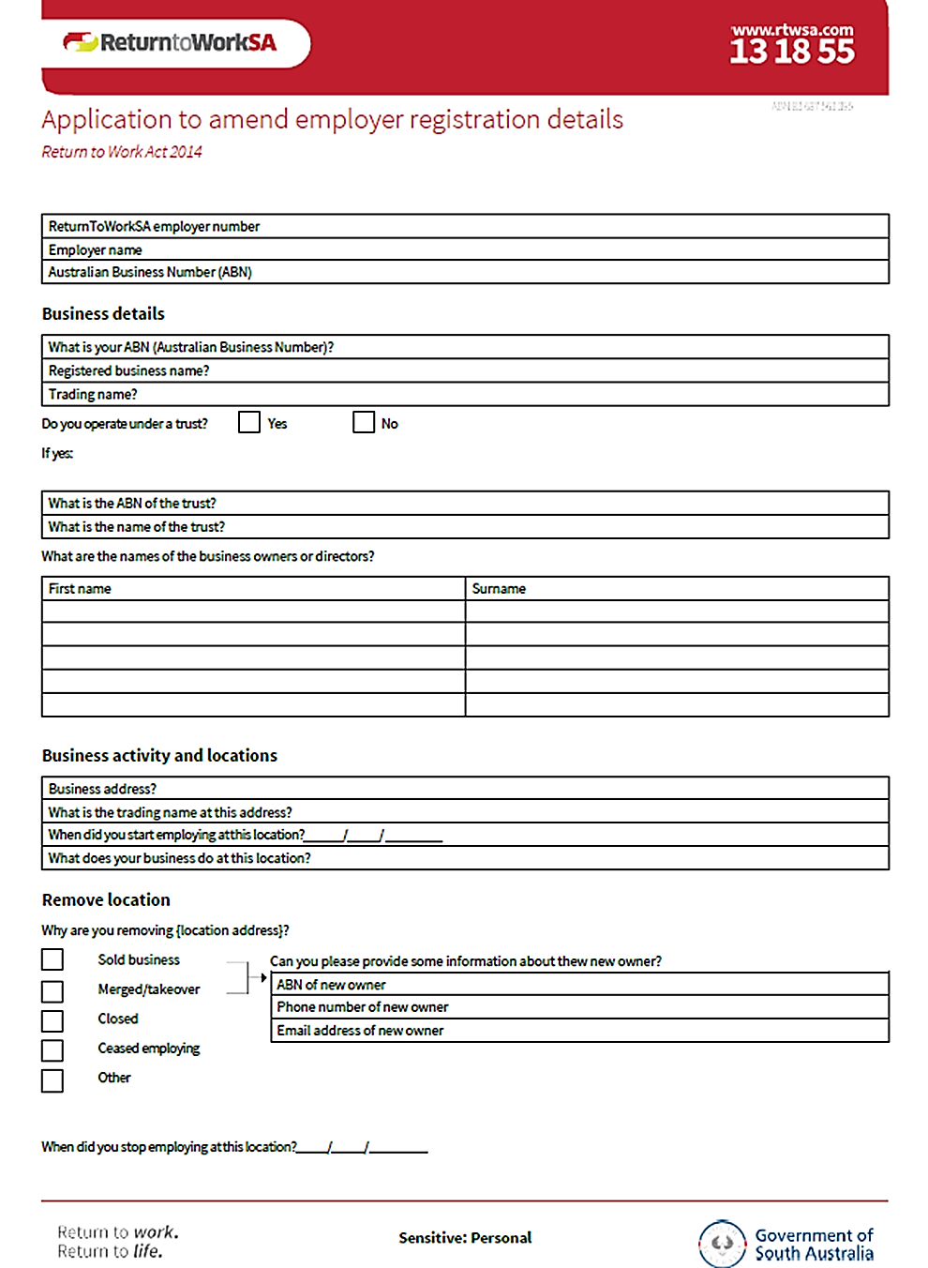
Attachment 1

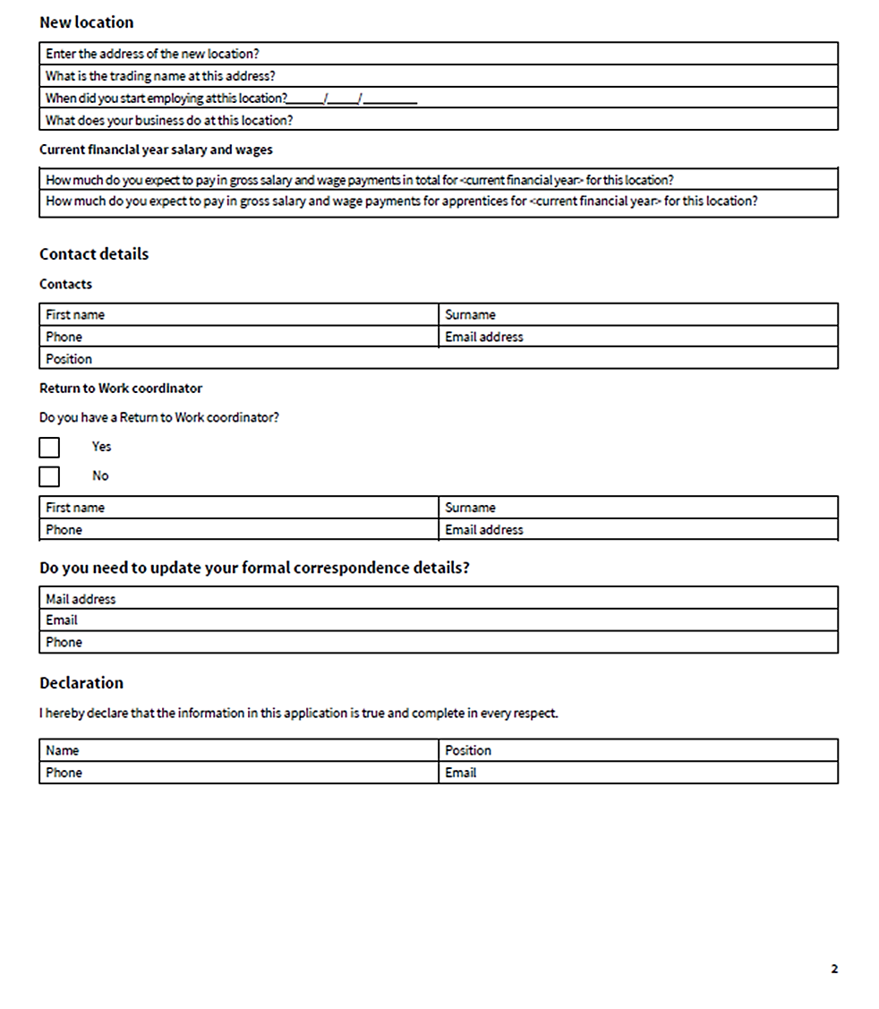

Roads (Opening and Closing) Act 1991
Section 24
Notice of Confirmation of Road Process Order
Road Closure—Public Road, Boconnoc Park
BY Road Process Order made on 7 July 2020, the Clare and Gilbert Valleys Council ordered that:
1. Portion of the Public Road, Boconnoc Park, situated dividing Sections 274 and 275, Hundred of Clare, more particularly delineated and lettered ‘A’ in Preliminary Plan 18/0036 be closed.
2. Transfer the whole of the land subject to closure to Steven Ramsay Sanders and Katrina Joy Jean Sanders in accordance with the Agreement for Transfer dated 21 May 2020 entered into between the Clare and Gilbert Valleys Council and Steven Ramsay Sanders and Katrina Joy Jean Sanders.
On 11 August 2020 that order was confirmed by the Minister for Infrastructure and Transport conditionally upon the deposit by the Registrar-General of Deposited Plan 124563 being the authority for the new boundaries.
Pursuant to Section 24 of the Roads (Opening and Closing) Act 1991, NOTICE of the Order referred to above and its confirmation is hereby given.
Dated: 13 August 2020
M. P. Burdett
Surveyor-General
DPTI: 2018/19621/01

Roads (Opening and Closing) Act 1991
Section 24
Notice of Confirmation of Road Process Order
Road Closure—Webb Road, Coombe Road and Public Road, Tintinara
BY Road Process Order made on 29 May 2020, the Coorong District Council ordered that:
1. Portions of Webb Road, Coombe Road and Public Road, situated adjoining Allotments 10 and 11 in Deposited Plan 15841, Allotment 8 in Deposited Plan 12062, Allotment 100 in Deposited Plan 93487, Allotment comprising Pieces 20, 21, 22 and 23 in Deposited Plan 119322, Allotment comprising Pieces 6 and 7 in Filed Plan 14150 and Allotment 7 in Filed Plan 18002, Hundred of Lewis, more particularly delineated and marked ‘A’, ‘B’, ‘C’ and ‘D’ in Preliminary Plan 20/0002 be closed.
2. Transfer portions of the land subject to closure marked ‘A’, ‘C’ and ‘D’ to Emu Springs Pastoral Co. Pty. Ltd. (ACN: 164 282 302) in accordance with the Agreement for Transfer dated 29 May 2020 entered into between the Coorong District Council and Emu Springs Pastoral Co. Pty. Ltd. (ACN: 164 282 302).
3. Transfer portion of the land subject to closure marked ‘B’ to Stephen John Bainger and Christine Anne Bainger in accordance with the Agreement for Transfer dated 29 May 2020 entered into between the Coorong District Council and Stephen John Bainger and Christine Anne Bainger.
4. The following easement is to be granted over portion of the land subject to that closure:
Grant a free and unrestricted Right of Way over the land marked ‘C’ in Deposited Plan 124522 in favour of Allotment 200 in Deposited Plan 124522.
On 11 August 2020 that order was confirmed by the Minister for Infrastructure and Transport conditionally upon the deposit by the Registrar-General of Deposited Plan 124522 being the authority for the new boundaries.
Pursuant to Section 24 of the Roads (Opening and Closing) Act 1991, NOTICE of the order referred to above and its confirmation is hereby given.
Dated: 13 August 2020
M. P. Burdett
Surveyor-General
DPTI: 2020/02158/01

South Australian Civil and Administrative Tribunal
SACAT Reference Number: 2019/SA003247
Notice of Exemption
Before Tribunal Member Edward Stratton-Smith
I HEREBY certify that on the 26 November 2019, the South Australian Civil and Administrative Tribunal, on application of COBHAM AVIATION SERVICES AUSTRALIA PTY LTD, COBHAM SAR SERVICES PTY LTD, COBHAM NAS PTY LTD, NATIONAL JET SYSTEMS PTY LTD, SURVEILLANCE AUSTRALIA PTY LTD and COBHAM AVIATION SERVICES ENGINEERING PTY LTD, made the following orders for an exemption:
1. Pursuant to section 92(6)(b) of the Equal Opportunity Act 1984, the Applicants are exempted for a period of three years from compliance with the provisions of sections 52 and 54 of the Act to the extent that they may:
a. request information relating to the nationality, country of birth and current and past citizenship from existing and potential employees and contractors;
b. take a person’s nationality, country of birth and current and past citizenship into account in determining who should be offered employment or contract work in areas requiring access to Controlled Defence Articles and when making decisions as to the participation of employees or contractors in such work;
c. maintain records of the nationality, country of birth and current and past citizenship of all employees and contractors who have or may have access to Controlled Defence Articles in the performance of their work;
d. ensure that Controlled Defence Articles are disclosed only to persons who are not prohibited from receiving a disclosure in accordance with applicable United States laws;
e. impose limitations or prohibitions on persons of particular nationalities, countries of origin and current and past citizenship having access to Controlled Defence Articles in the performance of their work;
f. to the extent necessary to comply with their legal obligations to the Commonwealth, disclose to the Commonwealth the nationality, country of birth and current and past citizenship of all employees and contractors who require access to Controlled Defence Articles in the performance of their work;
g. disclose to US Contractors with whom any of the Applicants are party to a US Export Authorisation and to the US Department of State, the nationality, country of birth and current and past citizenship of all employees and contractors who will have access to Controlled Defence Articles in the performance of their work; and
h. establish security systems which will prevent the unauthorised re-export or re-transfer of Controlled Defence Articles.
2. The exemption is granted for a period of three years and is subject to the following conditions:
a. It will only apply only to conduct by the Applicants where:
i. that conduct is necessary to enable the Applicants to enter into and/or perform contractual undertakings requiring access to Controlled Defence Articles; and
ii. the Applicants have taken all steps that are reasonably available (including steps that might be taken in negotiating and performing the terms of their agreements with US Contractors) to avoid the necessity of engaging in conduct that would otherwise be in breach of sections 52, 53, 54 and 103 of the Act.
b. Where, in the exercise of this exemption, an employee or contract worker is moved from a project involving the use of Controlled Defence Articles to any other work controlled by the Applicants or any of their related entities, the Applicants must explain to the person through a duly authorised officer why he or she is being transferred and must otherwise take all reasonable steps to avoid or limit harm or loss to that person.
c. Where the Applicants use a system of security passes to reflect the fact of access to Controlled Defence Articles or levels of access to any security-sensitive material by employees and contract workers, the passes may be coded but not in such a way as to identify the nationality, country of birth and current and past citizenship of the person or the reasons for that person’s level of access.
d. All information relating to nationality, country of birth and current and past citizenship and access to Controlled Defence Articles shall be restricted to technology control officers, export control officers, security officers, legal officers and human resources officers of the Applicants or their properly appointed nominees on a “need to know” basis.
e. The Applicants’ employment policies shall be amended as soon as reasonably possible so as to refer to the terms of this exemption, including all conditions attaching to it, and to make it clear that the purpose of the request for information regarding nationality, country of birth and current and past citizenship is made solely for the purposes of compliance with United States laws.
f. On the twelve month anniversary of the these orders, and every twelve months thereafter, for the duration of this exemption, the First Applicant must report to the Equal Opportunity Commissioner on its and its subsidiaries’ compliance with the exemption requirements and changes in its procedures to reflect amendments to the ITAR, and as to how its employees and contractors are affected.
Dated: 22 May 2020
Anne Lindsay
Principal Registrar
South Australian Civil and Administrative Tribunal

South Australian Civil and Administrative Tribunal
SACAT Reference Number: 2019/SA003830
Notice of Exemption
Before Tribunal Member Edward Stratton-Smith
I HEREBY certify that on the 25 February 2020, the South Australian Civil and Administrative Tribunal, on application of HEN HOUSE CO-OPERATIVE LTD, made the following orders for an exemption:
1. Pursuant to section 92 of the Equal Opportunity Act 1984, Hen House Cooperative Limited is granted an exemption from the provisions of sections 30 (relating to employment), 39 (providing goods and services) and 103 (relating to advertising) of the Equal Opportunity Act 1984 with respect to the provision of its programs.
2. The above exemption is to remain in force for a period of 3 years commencing on 25 February 2020.
Dated: 22 May 2020
Anne Lindsay
Principal Registrar
South Australian Civil and Administrative Tribunal

South Australian Civil and Administrative Tribunal
SACAT Reference Number: 2020/SA000651
Notice of Renewal of Exemption
Before Tribunal Member Edward Stratton-Smith
I HEREBY certify that on the 8th April 2020, the South Australian Civil and Administrative Tribunal, on application of LOCKHEED MARTIN AUSTRALIA PTY LTD and LOCKHEED MARTIN GLOBAL INC, made the following orders for renewal of an exemption:
1. Pursuant to the provisions of section 92 of the Equal Opportunity Act 1984 (“the Act”) the Applicants are granted an exemption from the requirements of the following sections of the Act, in relation to the conduct specified in order 2:
a. section 52—discrimination against applicants and employees;
b. section 53—discrimination against agents and independent contractors;
c. section 54—discrimination against contract workers; and
d. section 103—discriminatory advertisements.

2. The Applicants are permitted to engage in the following forms of conduct in pursuance of the exemption granted by order 1:
a. ask present and future employees and contractors (including contractors’ staff) to disclose their full names;
b. ask present and future employees and contractors (including contractors’ staff) to declare their exact citizenship (including any dual citizenship) and their country of birth;
c. require present and future employees and contractors (including contractors’ staff) to produce a photocopy of their passport(s);
d. require present and future employees and contractors (including contractors’ staff) involved in programs which use ITAR (where “ITAR” refers to the US International Traffic in Arms Regulation 22 CFR § 120 to 130 (2003)) Controlled Material, to notify the Applicants of any change to their citizenship status, to the best of their knowledge and belief;
e. restrict access, by means of transfer if necessary, to controlled technology to particular members of the Applicants’ workforce, based on their citizenship or country of birth;
f. restrict access to areas of its facilities connected with the performance of work on ITAR/EAR programs, based on citizenship or country of birth;
g. reject applications from prospective employees and contractors for positions related to programs which use ITAR Controlled Material, based on the prospective employee or contractor’s (including a contractor’s staff): (i) citizenship, as declared; (ii) country of birth; (iii) nationality; or substantive contacts, where such contacts objectively create an unacceptable risk of diversion of ITAR controlled material or technology; but not on the basis of the prospective employee’s (or contractor’s or contractors’ staff) descent or ethnic or ethnoreligious origin;
h. advertise controlled positions with the Applicants as being subject to the matters set out in the proposed exemption;
i. record and maintain a register of those employees and contractors (including contractors’ staff) that are permitted to access ITAR Controlled Material or work on controlled programs due to citizenship, or country of birth status. Access to the register to be limited to only those employees, contractors (including contractors’ staff), contract workers and agents of the Applicants with a need to know;
j. ask present and future employees and contractors (including contractors’ staff) to execute a nondisclosure agreement in accordance with the licence or TAA (Technical Assistance Agreement) required by the Department of State, in the event they are authorised to have access to ITAR Controlled Material;
k. ask present and future employees and contractors (including contractors’ staff) to disclose their substantive contacts with individuals from restricted or prohibited countries listed in the ITAR;
l. restrict access, by means of transfer if necessary, to controlled technology to particular members of the Applicants’ workforce, based on their substantive contacts, where such contacts objectively create an unacceptable risk of diversion of ITAR Controlled Material or technology;
m. record and maintain a register of those employees and contractors (including contractors’ staff) that are permitted to access ITAR Controlled Material or work on controlled programs due to substantive contacts. Access to the register to be limited to only those employees, contractors (including contractors’ staff), contract workers and agents of the Applicants with a need to know;
n. disclose information about the citizenship of its workforce (including employees, contractors and contractors’ staff) to the US State Department, the Australian Department of Defence or any other organisation or government department for which or on whose behalf the Applicants undertake work that is subject to ITAR/EAR obligations;
o. terminate the employment or engagement of members of the Applicants’ workforce on the basis that:
i. due to their citizenship (including a change to their citizenship), the Applicants may not permit them to participate in the provision of the ITAR/EAR services; and
ii. it is not reasonable in all the circumstances to redeploy or transfer them to another role within the Applicants’ business, or within a business operated by one of the Applicants’ associated entities;
p. advertise positions as being open only to citizens of particular nations who can obtain the necessary clearances for access to perform work on ITAR/EAR programs;
q. impose a condition on any offer of employment or engagement in roles which will require access to ITAR controlled material that the person must, pursuant to ITAR controls, be authorised to access the material whether pursuant to an individual clearance obtained from the US Government or otherwise.
3. The above exemption is to remain in force for a period of 3 years commencing on 8 April 2020.
Dated: 22 May 2020
Anne Lindsay
Principal Registrar
South Australian Civil and Administrative Tribunal

South Australian Local Government Grants Commission Act 1992
Payment of Grants
I, Vickie Chapman, Minister for Planning and Local Government, being the Minister responsible for the administration of the South Australian Local Government Grants Commission Act 1992, hereby state pursuant to Section 6 of the Act that:
(a) the total amount available for payment of grants pursuant to this Act for 2020-21 is $165,234,754;
(b) the amount available for payment of general purpose grants within the total amount for 2020-21 is $121,994,089;
(c) the amount available for payment of identified local road grants within the total amount for 2020-21 is $43,240,665;
(d) an amount of $245,386 relating to the underpayment of grants for 2019-20 will be added from the funds to be paid to councils during 2020-21, using the grant relativities applied in 2019-20; and
(e) an amount of $85,034,470 relating to the payment of grants for 2020-21 brought forward and paid in May 2020 will be deducted from the funds to be paid to councils during 2020-21.
Dated: 4 August 2020
Vickie Chapman MP
Minister for Planning and Local Government

Local Government Instruments

City of Adelaide
Local Government Act 1999—Section 232
Public Consultation—Planting of Trees in Young Street
The City of Adelaide gives notice of its proposal to install trees in Young Street.
Under the Local Government Act 1999, Council is required to undertake public consultation in accordance with its public consultation policy before planting vegetation on a road that may have a significant impact on residents, the proprietors of nearby businesses or advertisers in the area.
The consultation documents on the proposal are available at the Council’s Customer Centre, 25 Pirie Street Adelaide SA 5000 and any of its libraries or community centres.
To view all relevant consultation information and/or to provide feedback on the proposal you can visit: yoursay.cityofadelaide.com.au.
Consultation opens on 13 August 2020.
All submissions must be received by 5pm, Thursday 3 September 2020.
Dated: 13 August 2020
M. Goldstone
Chief Executive Officer

City of Marion
Revocation and Disposal of Community Land
Pursuant to Section 194 of the Local Government Act 1999, the Corporation of the City of Marion proposes to revoke the classification as Community Land of the land located at Lot 88 in Deposited Plan 17901 and situated at 72 Spinnaker Circuit Sheidow Park - commonly known as Spinnaker Circuit Reserve - East - subject to the Minister’s approval.
Council is considering the disposal of 6,158 square metres of the land, subject to the Minister’s approval. The net proceeds from the sale of the land will be paid into the Open Space Reserve Fund for the development of open space facilities or as approved by Council.
Any interested person may request a copy of the plan of the land to be disposed of and the report containing a description of the land, the reasons for the proposal, any Dedication, Reservation or Trust to which the land is subject, the intention of Council once the revocation has occurred and its effect on the community.
Covid-19 Update
Due to Covid-19 social distancing measures, more information is available by:
• A hard copy to be posted or emailed to you
• A hard copy may be collected from City Services, 935 Marion Road Mitchell Park, by arrangement only by contacting Heather Carthew on 0401 686 240 or heather.carthew@marion.sa.gov.au or
• Visit Making Marion website www.makingmarion.com.au/spinnaker-circuit-reserve-revocation
Any representations in relation to this matter must be lodged in writing to the Council at PO Box 21 Oaklands Park SA 5047 or the Making Marion website www.makingmarion.com.au/spinnaker-circuit-reserve-revocation by 3 September 2020.
Council contact: Heather Carthew, Land Asset Officer Phone 0401 686 240.
Dated: 13 August 2020
Adrian Skull
Chief Executive Officer

City of Onkaparinga
Close of Nominations
Supplementary Election of Councillor for Mid Coast Ward
Nominations Received
At the close of nominations at 12 noon on Thursday, 6 August 2020 the following people were accepted as candidates and are listed in the order in which their names will appear on the ballot paper.
Councillor for Mid Coast Ward—1 Vacancy
RAYMOND, Krystal
BROWN, Michael
BHATIA, Shikasta
TONKIN, Sue
DE JONGE, Rob
RHODES, Anne
PILOT, Alema
MUNRO, Luke
COXON, Rebecca Jayne
DEAKIN, Jon
PLATTEN, Dan
FOSSEY, Matthew
MILEN, Rima Anne
REITER, Joshua
MERRITT, Heather
HAMMOND, Alan J
WAGNER, Kristy
DIBDIN, Mark
Postal Voting
The election will be conducted by post. Ballot papers and pre-paid envelopes for each voting entitlement will be posted between Tuesday, 18 August 2020 and Monday, 24 August 2020 to every person, or designated person of a body corporate or group listed on the voters roll at roll close on Tuesday, 30 June 2020. Voting is voluntary.
A person who has not received voting material by Monday, 24 August 2020 and believes they are entitled to vote should contact the Deputy Returning Officer on 1300 655 232.
Completed voting material must be returned to reach the Returning Officer no later than 12 noon on Monday, 7 September 2020.
A ballot box will be provided at the City of Onkaparinga Noarlunga Office, Ramsay Place, Noarlunga Centre for electors wishing to hand deliver their completed voting material during office hours.
Vote Counting Location
The scrutiny and counting of votes will take place at Electoral Commission SA, Ground Floor, 60 Light Square, Adelaide from 9am on Tuesday, 8 September 2020. A provisional declaration will be made at the conclusion of the election count.
Campaign Donations Return
All candidates must forward a Campaign Donations Return to the Council Chief Executive Officer within 30 days after the conclusion of the election.
Dated: 13 August 2020
Mick Sherry
Returning Officer

City of Port Adelaide Enfield
Local Government Act 1999
Proposed Declarations—Conversion of Private Roads to Public Roads
Trinity Street, Ottoway and St John’s Road, Ottoway
Notice is given pursuant to Section 210(2)(b) of the Local Government Act 1999, that the City of Port Adelaide Enfield intends to declare the private roads known as Trinity Street, Ottoway and St John’s Road, Ottoway to be public roads.
Each of these private roads are described in Deposited Plan 544 as Trinity Street and St John’s Road and are contained within partially cancelled Certificate of Title Volume 304 Folio 150, in the name of William Paddock.
If the City of Port Adelaide Enfield resolves to make the declarations, a notice will be published in the South Australian Government Gazette and on publication of the declarations, the private roads are converted to public roads and the land will vest in the Council in fee simple.
A copy of a plan showing the location of these private roads and a copy of this notice are on display in the Civic Centre 163 St Vincent Street, Port Adelaide and on Council’s Website www.cityofpae.sa.gov.au.
If any person has questions or wants to learn more about the proposed declarations, they can telephone 8405 6600 or email service@cityofpae.sa.gov.au.
Dated: 13 August 2020
Mark Withers
Chief Executive Officer

City of Unley
Close of Nominations
Supplementary Election of Councillor for Parkside Ward
Nominations Received
At the close of nominations at 12 noon on Thursday, 6 August 2020 the following people were accepted as candidates and are listed in the order in which they will appear on the ballot paper.
Councillor for Parkside Ward—1 Vacancy
DABROWSKI, Rob
JACOBS, Brent
HARRISON, Ryan
DOYLE, Luke
SMOLUCHA, Luke
BONHAM, Jennifer
Postal Voting
The election will be conducted by post. Ballot papers and pre-paid envelopes for each voting entitlement will be posted between Tuesday, 18 August 2020 and Monday, 24 August 2020 to every person, or designated person of a body corporate or group listed on the voters roll at roll close on Tuesday, 30 June 2020. Voting is voluntary.
A person who has not received voting material by Monday, 24 August 2020 and believes they are entitled to vote should contact the Deputy Returning Officer on 1300 655 232.
Completed voting material must be returned to reach the Returning Officer no later than 12 noon on Monday, 7 September 2020.
A ballot box will be provided at the Council Office, Civic Centre, 181 Unley Road, Unley for electors wishing to hand deliver their completed voting material during office hours.
Vote Counting Location
The scrutiny and counting of votes will take place at Electoral Commission SA, Level 6, 60 Light Square, Adelaide from 9am on Wednesday, 9 September 2020. A provisional declaration will be made at the conclusion of the election count.
Campaign Donations Return
All candidates must forward a Campaign Donations Return to the Council Chief Executive Officer within 30 days after the conclusion of the election.
Dated: 13 August 2020
Mick Sherry
Returning Officer

City of Victor Harbor
Adoption of Valuation and Declaration of Rates
NOTICE is hereby given that at the Special Meeting on Monday, 3 August 2020 the City of Victor Harbor resolved for the financial year ending 30 June 2021:
Adoption of Valuation
To adopt the most recent capital valuations provided by the Valuer-General for land within the Council area, totalling $4,429,236,440 for rating purposes for the year ending 30 June 2020.
Declaration of Differential General Rates
To declare differential general rates as follows:
• 0.4349 cents in the dollar on rateable land of Category (a) (Residential) and Category (i) (Other)
• 0.5654 cents in the dollar on rateable land of Category (b) (Commercial—Shop), Category (c) (Commercial—Office) and Category (d) (Commercial—Other)
• 0.5001 cents in the dollar of rateable land of Category (e) (Industry—Light) and Category (f) (Industry—Other)
• 0.3914 cents in the dollar of rateable land of Category (g) (Primary Production)
• 0.6524 cents in the dollar of rateable land of Category (h) (Vacant Land)
Fixed Charge
To impose a fixed charge of $390 on each separate piece of rateable land within the area of the Council.
Separate Rate—RL Levy
To declare the following separate rates:
• 0.009519 cents in the dollar on all rateable land in the area of the Council and the Hills and Fleurieu Regional Landscape Board and the previous Adelaide and Mount Lofty Ranges Natural Resource Management Board.
• 0.020813 cents in the dollar on all rateable land in the area of the Council and the Hills and Fleurieu Regional Landscape Board and the previous SA Murray Darling Basin Natural Resource Management Board.
Dated: 13 August 2020
Victoria MacKirdy
Chief Executive Officer

City of West Torrens
Adoption of Valuations and Declaration of Rates
Notice is hereby given that the Council in exercise of the powers contained in Chapters 8, 9 and 10 of the Local Government Act 1999 and the Landscape South Australia Act 2019:
1. Adoption of Valuations
At a meeting held on 4 August 2020, adopted for rating purposes, for the year ended 30 June 2021, the capital valuations of the Valuer-General of all property within the Council area, totalling $18,435,104,540.
2. Declaration of Rates
At a meeting held on 4 August 2020:
(i) Declared differential general rates in the dollar based on capital values as follows:
(a) 0.246710 cents in the dollar on rateable land use of the permissible differing category (a);
(b) 0.624800 cents in the dollar on any rateable land of the permissible differing categories (b) to (i) inclusive.
(ii) Declared a minimum amount payable by way of general rates on rateable land in its area of $944.00.
(iii) Declared a separate rate on rateable land within the Council area of 0.009554 cents in the dollar based on capital values, as a contribution to the Green Adelaide Board.
Dated: 13 August 2020
Terry Buss PSM
Chief Executive Officer

Adelaide Plains Council
By-Law Resolutions 2019
By-law No 2—Local Government Land—Designation
NOTICE is hereby provided that the Adelaide Plains Council, at its meeting held on 22 June 2020, resolved to designate the land adjacent to the Mallala Oval, comprised in Certificate of Title Register Book (part) Volume 6163 Folio 218 and (part) Volume 6163 Folio 219 as a camping reserve for the purposes of camping in accordance with Clause 4.12 of Council’s By-law No 2 of 2019—Local Government Land.
Dated: 11 August 2020
James Miller
Chief Executive Officer

Adelaide Plains Council
By-Law Resolutions 2019
By-law No 4—Dogs—Designation
NOTICE is hereby provided that the Adelaide Plains Council, at its meeting held on 22 June 2020, resolved to designate the land adjacent to the Mallala Oval, comprised in Certificate of Title Register Book (part) Volume 6163 Folio 218 and (part) Volume 6163 Folio 219 as a dog on leash area in accordance with Clause 5.2.1 of Council’s By-law No 4 of 2019—Dogs.
Dated: 11 August 2020
James Miller
Chief Executive Officer

Clare & Gilbert Valleys Council
Adoption of Declaration of Landscape Levy
Notice is hereby given that the Clare & Gilbert Valleys Council at Special Council Meeting held on 3 August 2020, resolved as follows for the year ending 30 June 2021:
Declared a separate rate in the dollar of 0.00016863 based on the capital value of the rateable land be declared in respect of all rateable land in the Council area, in order to reimburse the Council the amount contributed to the Northern & Yorke Landscape Board being $496,626.
Dated: 13 August 2020
Dr Helen Macdonald
Chief Executive Officer

District Council of Karoonda East Murray
Adoption of Valuation and Declaration of Rates for 2020/2021
NOTICE is hereby given that the District Council of Karoonda East Murray at its Special Meeting held on 28 July 2020, resolved the following:
Adoption of Valuations
That pursuant to the provisions of Section 167(2)(a) of the Local Government Act 1999, the Council adopts for rating purposes the most recent valuations of the Valuer-General available to the Council, of the capital value of land within the Council’s area totalling $310,465,820 for the 2020/2021 financial year and of which $301,934,920 is the total valuation of rateable land.
Declaration of General Rates
That pursuant to Section 153(1)(a) of the Local Government Act 1999, the Council declare a general rate of 0.4718 cents in the dollar on the capital value of all rateable land within the whole council area for the 2020/2021 financial year.
Minimum Amount Payable
That pursuant to Section 158(1)(a) of the Local Government Act 1999, Council declare a minimum rate of $350.00 to be fixed for rateable land within the whole of the council area for the 2020/2021 financial year.
Service Charges
Community Wastewater Management Scheme (CWMS) Service Charge
That pursuant to Section 155 of the Local Government Act 1999, Council declare a service charge for the Community Wastewater Management System of $455.00 per occupied unit and $430.00 per vacant allotment in Karoonda for properties serviced by the system for the 2020/2021 financial year.
Kerbside Waste Management Collection Charge
That pursuant to Section 155 of the Local Government Act 1999, Council declare a service charge for Kerbside Waste Management Collection of $110.00 per annum, to provide for the collection of one general waste bin collected weekly to each property in the collection zone for the 2020/2021 financial year.
Payment of Rates
That pursuant to Section 181(1) of the Local Government Act 1999, Council approve the quarterly rates payment due dates of 18 September 2020, 18 December 2020, 18 March 2021 and 18 June 2021.
Landscapes Board Levy—Declaration of Separate Rate
That pursuant to Section 72 of the Landscape South Australia Act 2019 and Section 154 of the Local Government Act 1999, in order to reimburse Council, the amount contributed to the Murraylands and Riverland Regional Landscape Board being $68,736 and that Council declares a separate rate of 0.02331 cents in the dollar, based on the capital value of all rateable land in the Council’s area for the 2020/2021 financial year.
Dated: 13 August 2020
Matthew Morgan
Chief Executive Officer

District Council of Kimba
Adoption of Valuation and Declaration of Rates 2020-2021
Corrigendum
Notice is hereby given that the District Council of Kimba at its meetings held on 5 August 2020 for the financial year ending 30 June 2021 resolved to correct the:
1. Declared differential general rates varying according to the locality of the land as:
a. 0.5087 cents in the dollar in respect of rateable land in the Rural Zone; and
b. 3.802 cents in the dollar in respect of all rateable land in all other Zones
as defined in the Council’s Development Plan.
2. Declared a separate rate based on a fixed charge of $79.15 per assessment for residential, other and vacant land, $118.72 per assessment for commercial and industrial properties and $158.30 per assessment for primary production properties in respect of all rateable land in the area of the Eyre Peninsula Landscape Board.
Dated: 11 August 2020
Deb Larwood
Chief Executive Officer

Mount Barker District Council
Exclusion of Land from Classification of Community Land
NOTICE is hereby given that pursuant to Section 193 (6) (a) and Section 193 (4) (a) of the Local Government Act 1999, the Mount Barker District Council at its meeting held on 15 January 2018, resolved that a portion of the following land be excluded from Classification as Community Land:
Lot 103 Deposited Plan 83108 contained within Certificate of Title Volume 6054 Folio 989; which became:
Lot 1 in Deposited Plan 121249 being whole of land in Certificate of Title Volume 6226 Folio 349
Lot 2 in Deposited Plan 121249 being whole of land in Certificate of Title Volume 6226 Folio 350
Dated: 13 August 2020
A. Stuart
Chief Executive Officer

Wudinna District Council
Adoption of Assessment
NOTICE is hereby given that the Wudinna District Council at a meeting held on 4 August 2020 resolved for the 2020-2021 financial year as follows:
Adoption of Valuation
Adopted for rating purposes the capital valuations made by the Valuer-General totalling $352,952,300 for rateable and non-rateable land in the Council area.
Declaration of Rates
Declared differential general rates on rateable land within its area by reference to locality as follows:
(a) The whole of the township of Wudinna, a rate of 0.540 cents in the dollar.
(b) The whole of the township of Minnipa, a rate of 0.540 cents in the dollar.
(c) The whole of the township of Kyancutta, a rate of 0.540 cents in the dollar.
(d) The whole of the township of Warramboo, a rate of 0.540 cents in the dollar.
(e) The whole of the township of Yaninee, a rate of 0.540 cents in the dollar.
(f) The whole of the township of Pygery, a rate of 0.540 cents in the dollar.
(g) In respect of all land within the area of the Council not otherwise included as above, a differential general rate of 0.538 cents in the dollar.
Minimum Rate
Declared a minimum amount payable by way of rates of $470.00 in respect to all rateable land within the area of Council.
Annual Service Charges
(a) Imposed an annual service charge where a septic effluent disposal connection is provided within the Township of Wudinna of $325 per unit for all occupied properties and $290 for all unoccupied properties.
(b) Imposed an annual service charge to properties that have an occupiable dwelling, outbuilding or other class of structure to which the Council provides or makes available the prescribed service of the collection, treatment and disposal of waste via Council’s waste collection service of $220 per mobile garbage bin.
Separate Rate
Declared a separate rate of $176 based on a proportional basis of expenditure incurred in maintaining the area of the cottage home units within portion Section 175, Hd of Pygery—Wudinna Homes for the Aged identified as being assessments:
927026901 | 927027001 | 927027101 | 927027201 | 927027301
927027401 | 927027501 | 927027601 | 927027701 | 927027801
927027811 | 927027821 | 927027831 | 927027841 | 927027861

Regional Landscape (RL) Levy
Declared differential separate rates varying on the basis of land use on all rateable land in the area of the Council in order to reimburse the Council for amounts contributed to the Eyre Peninsula Natural Resource Management Board.
(a) A land use of Primary Production, a Separate Rate of $158.30 per assessment;
(b) A land use of:
i. Commercial
ii. Industrial
A separate rate of $118.72 per assessment;
(c) A land use of:
i. Residential
ii. Vacant Land
iii. Other
A separate rate of $79.15 per assessment.
Dated: 13 August 2020
Alan F. McGuire
Chief Executive Officer

Yorke Peninsula Council
Close of Nominations
Supplementary Election of Councillor for Gum Flat Ward
Nominations Received
At the close of nominations at 12 noon on Thursday, 6 August 2020 the following people were accepted as candidates and are listed in the order in which they will appear on the ballot paper.
Councillor for Gum Flat Ward—1 Vacancy
GUNNING, Richard
CLERKE, Trevor Noel
BROWN, Stephen Keith
HIGGINS, Brian
LAMBERT, Vivienne
HEADON, Alan John
MURDOCK, Michael John
Postal Voting
The election will be conducted by post. Ballot papers and pre-paid envelopes for each voting entitlement will be posted between Tuesday, 18 August 2020 and Monday, 24 August 2020 to every person, or designated person of a body corporate or group listed on the voters roll at roll close on Tuesday, 30 June 2020. Voting is voluntary.
A person who has not received voting material by Monday, 24 August 2020 and believes they are entitled to vote should contact the Deputy Returning Officer on 1300 655 232.
Completed voting material must be returned to reach the Returning Officer no later than 12 noon on Monday, 7 September 2020.
A ballot box will be provided at the Council Offices located at 8 Elizabeth Street, Maitland, 18 Main Street, Minlaton and 15 Edithburgh Road, Yorketown for electors wishing to hand deliver their completed voting material during office hours.
Vote Counting Location
The scrutiny and counting of votes will take place at Electoral Commission SA, Level 6, 60 Light Square, Adelaide as soon as practicable Wednesday, 9 September 2020. A provisional declaration will be made at the conclusion of the election count.
Campaign Donations Return
All candidates must forward a Campaign Donations Return to the Council Chief Executive Officer within 30 days after the conclusion of the election.
Dated: 13 August 2020
Mick Sherry
Returning Officer

Public Notices

Trustee Act 1936
Public Trustee
Estates of Deceased Persons
In the matter of the estates of the undermentioned deceased persons:
CONNOLLY Reginald Clive late of 26 River Road Port Noarlunga Retired Construction Supervisor who died 21 April 2020
DEED Joyce Patricia late of 200-208 Adams Road Craigmore of no occupation who died 3 March 2020
ECKHOLD-SIMPSON, Philip John late of 20 Derrilin Road Ingle Farm Sheet Metal Worker who died 21 January 2020
GEORGOPOULOS Peter late of 7 Salisbury Highway Salisbury of no occupation who died 8 March 2020
GLENN Carl Anthony late of 316 Hampstead Road Clearview of no occupation who died 27 February 2020
KETTER Helmi late of 15 Ralston Street Largs Bay of no occupation who died 10 April 2020
MITTON Audrey late of 42-60 Halsey Road Elizabeth East of no occupation who died 2 May 2019
NELSON Lindsay John late of 72 Hawker Avenue Plympton Park of no occupation who died 30 March 2020
POLKINGHORNE Ernest Albert late of 37 Hospital Road Port Augusta Retired Police Sergeant who died 09 April 2020
SEDUNARY Shirley late of Atze Parade Nuriootpa of no occupation who died 24 December 2019
WALKER Rose Marie late of 14 Rotorua Avenue Park Holme of no occupation who died 18 May 2019
WRZESZCZYNSKI Irene late of 25 Newton Street Whyalla of no occupation who died 30 July 2019
YOUNG Robert Horace late of 28 Ian Street Broadview of no occupation who died 22 January 2020
Notice is hereby given pursuant to the Trustee Act 1936, the Inheritance (Family Provision) Act 1972 and the Family Relationships Act 1975 that all creditors, beneficiaries, and other persons having claims against the said estates are required to send, in writing, to the office of Public Trustee at GPO Box 1338, Adelaide, 5001, full particulars and proof of such claims, on or before the 11 September 2020 otherwise they will be excluded from the distribution of the said estate; and notice is also hereby given that all persons indebted to the said estates are required to pay the amount of their debts to the Public Trustee or proceedings will be taken for the recovery thereof; and all persons having any property belonging to the said estates are forthwith to deliver same to the Public Trustee.
Dated: 13 August 2020
N S Rantanen
Acting Public Trustee

National Electricity Law
Extension of Draft Determination
The Australian Energy Market Commission (AEMC) gives notice under the National Electricity Law as follows:
Under s 107, the time for making the draft determination on the Connection to dedicated connection assets (Ref. ERC0294) proposal has been extended to 26 November 2020.
Australian Energy Market Commission
Level 15, 60 Castlereagh St
Sydney NSW 2000
Telephone: (02) 8296 7800
www.aemc.gov.au
Dated: 13 August 2020

Notice Submission

The South Australian Government Gazette is compiled and published each Thursday.
Notices must be submitted before 4 p.m. Tuesday, the week of intended publication.
All submissions are formatted per the gazette style and proofs are supplied as soon as possible. Alterations must be returned before 4 p.m. Wednesday.
Requests to withdraw submitted notices must be received before 10 a.m. on the day of publication.

Gazette notices should be emailed as Word files in the following format:
- Title—name of the governing Act/Regulation
- Subtitle—brief description of the notice
- A structured body of text
- Date of authorisation
- Name, position, and government department/organisation of the person authorising the notice

Please provide the following information in your email:
- Date of intended publication
- Contact details of at least two people responsible for the notice content
- Name of the person and organisation to be charged for the publication (Local Council and Public notices)
- Request for a quote, if required
- Purchase order, if required

Email: governmentgazettesa@sa.gov.au
Phone: (08) 7109 7760
Website: www.governmentgazette.sa.gov.au

All instruments appearing in this gazette are to be considered official, and obeyed as such

Printed and published weekly by authority of S. Smith, Government Printer, South Australia
$7.70 per issue (plus postage), $387.60 per annual subscription—GST inclusive
Online publications: www.governmentgazette.sa.gov.au

