
THE SOUTH AUSTRALIAN
GOVERNMENT GAZETTE
Published by Authority

Adelaide, Thursday, 21 February 2019

Contents

Acts Assented To 552
Appointments, Resignations, Etc. 552
Corporations and District Councils—Notices 664
Development Act 1993—Notice 553
Electoral Act 1985—Notice 554
Housing Improvement Act 2016—Notices 554
Justices of the Peace Act 2005—Notice 554
Land Acquisition Act 1969—Notices 555
Lifetime Support Scheme Rules—Notice 557
Mining Act 1971—Notice 647
Motor Vehicles Act 1959—Notice 648
National Electricity Law—Notice 665
National Gas Law—Notice 665
Petroleum and Geothermal Energy Act 2000—Notice 653
Professional Standards Act 2004—Republished 653
Regulations
National Electricity (South Australia) Act 1996—
(No. 15 of 2019) 660
National Energy Retail Law and National Energy Retail
Law (South Australia) Act 2011—(No. 16 of 2019) 662
Roads (Opening and Closing) Act 1991—Notices 658
South Australian Public Health Act 2011—Notice 659
Trustee Act 1936—Administration of Estates 666

Department of the Premier and Cabinet
Adelaide, 21 February 2019
His Excellency the Governor directs it to be notified for general information that he has in the name and on behalf of Her Majesty The Queen, this day assented to the undermentioned Acts passed by the Legislative Council and House of Assembly in Parliament assembled, viz.:
No. 1 of 2019—Residential Parks (Miscellaneous) Amendment Act 2019
An Act to amend the Residential Parks Act 2007
By command,
Steven Spence Marshall
Premier

Department of the Premier and Cabinet
Adelaide, 21 February 2019
His Excellency the Governor in Executive Council has been pleased to appoint the undermentioned to the South Australian Country Arts Trust, pursuant to the provisions of the South Australian Country Arts Trust Act 1992:
Member: from 21 February 2019 until 20 February 2022
Michael Velibor Luchich
Presiding Member: from 21 February 2019 until 20 February 2022
Michael Velibor Luchich
By command,
Steven Spence Marshall
Premier
DPC19/013CS

Department of the Premier and Cabinet
Adelaide, 21 February 2019
His Excellency the Governor in Executive Council has been pleased to appoint the undermentioned to Radiation Protection Committee, pursuant to the provisions of the Radiation Protection and Control Act 1982:
Member: from 21 February 2019 until 20 February 2022
Tony Circelli
Sarah Constantine
Cara Miller
Graeme Robert Palmer
Nigel Antony Spooner
Eva Bezak
Wilson Vallat
Gregory George Marshall
Pamela Joy Sykes
Bettina Venner
Deputy Member: from 21 February 2019 until 20 February 2022
Keith Baldry (Deputy to Circelli)
Michelle Nottage (Deputy to Constantine)
Costas Kapsis (Deputy to Miller)
Kent James Gregory (Deputy to Palmer)
Judith Mary Pollard (Deputy to Spooner)
Kathryn Levingstone (Deputy to Bezak)
Ian David Kirkwood (Deputy to Vallat)
Jim Hondros (Deputy to Marshall)
Michael Lardelli (Deputy to Sykes)
Michelle Waters (Deputy to Venner)
Presiding Member: from 21 February 2019 until 20 February 2022
Tony Circelli
By command,
Steven Spence Marshall
Premier
19EWDEWEPACS00010

Department of the Premier and Cabinet
Adelaide, 21 February 2019
His Excellency the Governor in Executive Council has been pleased to appoint Jo-Anne Lee Deuter as a Judge of the District Court of South Australia commencing on 6 May 2019 - pursuant to Section 12 of the District Court Act 1991.
By command,
Steven Spence Marshall
Premier
AGO0019-19CS

Department of the Premier and Cabinet
Adelaide, 21 February 2019
His Excellency the Governor in Executive Council has been pleased to appoint Michael Greig Evans, Chief Judge of the District Court of South Australia, as Senior Judge of the Environment, Resources and Development Court of South Australia from 28 February 2019 - pursuant to Section 8(2) of the Environment, Resources and Development Court Act 1993.
By command,
Steven Spence Marshall
Premier
AGO0019-19CS

Department of the Premier and Cabinet
Adelaide, 21 February 2019
His Excellency the Governor in Executive Council has been pleased to appoint Michael Durrant as a Judge of the District Court of South Australia commencing on 28 February 2019 - pursuant to Section 12 of the District Court Act 1991.
By command,
Steven Spence Marshall
Premier
AGO0019-19CS

Department of the Premier and Cabinet
Adelaide, 21 February 2019
His Excellency the Governor in Executive Council has been pleased to designate Michael Durrant as a Judge of the Environment, Resources and Development Court of South Australia from 28 February 2019 - pursuant to Section 8(6) of the Environment, Resources and Development Court Act 1993.
By command,
Steven Spence Marshall
Premier
AGO0019-19CS

Department of the Premier and Cabinet
Adelaide, 21 February 2019
His Excellency the Governor in Executive Council has been pleased to appoint Emilis Prelgauskas as a part-time sessional Commissioner of the Environment, Resources and Development Court of South Australia, and designate him as a Commissioner for the purposes of the Court's jurisdiction under the Development Act 1993, for a term of three years commencing on 28 February 2019 and expiring on 27 February 2022 - pursuant to Section 10 of the Environment, Resources and Development Court Act 1993.
By command,
Steven Spence Marshall
Premier
AGO0016-19CS

Department of the Premier and Cabinet
Adelaide, 21 February 2019
His Excellency the Governor in Executive Council has been pleased to substitute the Lifetime Support Scheme Rules to include minor changes that are intended to improve the clarity of the Lifetime Support Scheme Rules - pursuant to Section 56 of the Motor Vehicle Accidents (Lifetime Support Scheme) Act 2013 in line with the Lifetime Support Authority’s recommendation, noting that the Rules will come into operation on 21 February 2019.
By command,
Steven Spence Marshall
Premier
HEAC-2019-00006

DEVELOPMENT ACT 1993
Notice under Section 25(17)
Rural City of Murray Bridge—Swanport Development Plan Amendment
Preamble
- The Swanport Development Plan Amendment (the Amendment) by the Rural City of Murray Bridge has been finalised in accordance with the provisions of the Development Act 1993.
- The Minister for Planning has decided to approve the Amendment.
PURSUANT to section 25 of the Development Act 1993, I –
- approve the Amendment; and
- fix the day on which this notice is published in the Gazette as the day on which the Amendment will come into operation.
Dated: 14 February 2019
Hon Stephan Knoll MP
Minister for Planning

ELECTORAL ACT 1985
Part 6 – Registration of Political Parties
NOTICE is hereby given that the following application for change of Party name under the provisions of Part 6 of the Electoral Act, 1985, has been received:
Name of existing Party Nick Xenophon’s SA-BEST Inc
New Name of Party SA-BEST Incorporated
Abbreviation SA-BEST
Name of Applicant Connie Bonaros
Any elector who believes that the new party name should not be registered because:
- the party does not have as a purpose, the promotion of the election to the State Parliament of its endorsed candidate(s); or
- the application does not fulfil the technical requirements specified in the Act; or
- the party’s name is likely to be confused with that of another registered party, parliamentary party or prominent public body,
can formally object in writing to the Electoral Commissioner, Level 6, 60 Light Square Adelaide SA 5000 by 5pm (ACDT) on 21 March 2019. Objections must contain the postal address and signature of the objector and detail the grounds upon which the objection is made.
Dated: 21 February 2019
Mick Sherry
Electoral Commissioner
ECSA 232/18

HOUSING IMPROVEMENT ACT 2016
Rent Control
The Minister for Human Services Delegate in the exercise of the powers conferred by the Housing Improvement Act 2016, does hereby fix the maximum rental per week which shall be payable subject to Section 55 of the Residential Tenancies Act 1995, in respect of each house described in the following table. The amount shown in the said table shall come into force on the date of this publication in the Gazette.
Address of Premises | Allotment  Section | Certificate of Title  Volume/Folio | Maximum Rental  per week payable
42 Matilda Street, Port Lincoln SA 5606 | Allotment 76 Deposited Plan 1677 Hundred of Lincoln | CT 5793/286 | $87.50
Dated: 21 February 2019
Craig Thompson
Acting Housing Regulator and Registrar
Housing Safety Authority, SAHA
Delegate of Minister for Human Services

HOUSING IMPROVEMENT ACT 2016
Rent Control Revocations
Whereas the Minister for Human Services Delegate is satisfied that each of the houses described hereunder has ceased to be unsafe or unsuitable for human habitation for the purposes of the Housing Improvement Act 2016, notice is hereby given that, in exercise of the powers conferred by the said Act, the Minister for Human Services Delegate does hereby revoke the said Rent Control in respect of each property.
Address of Premises | Allotment  Section | Certificate of Title  Volume/Folio
45 Ascot Avenue, Dulwich SA 5065 | Allotment 11 Deposited Plan 2517 Hundred of Adelaide | CT2357/152, CT5678/775
44 Gilbert Street, Tarlee SA 5411  (AKA Lot 111) | Allotment 111 Deposited Plan 251 Hundred of Gilbert | CT5074/521
171 Haby Road, Nildottie SA 5238 (PKA Section 144, Section 3D Hundred of Forster Claypans) | Allotment 721 Filed Plan 209097 Hundred of Forster | CT5671/176, CT5701/539
33 Eighth Street, Bowden SA 5007 | Allotment 200 Filed Plan 15119 Hundred of Yatala | CT5124/829, CT6138/93, CT6140/170, CT6154/118
33 McLaren Street, Adelaide SA 5000 | Allotment 693 Filed Plan 182345 Hundred of Adelaide | CT3181/112, CT5892/364
20 James Street, Adelaide SA 5000 | Allotment 764 Filed Plan 181606 Hundred of Adelaide | CT2197/52, CT5853/911
Dated: 21 February 2019
Craig Thompson
Acting Housing Regulator and Registrar
Housing Safety Authority, SAHA
Delegate of Minister for Human Services

Justices of the Peace Act 2005
Section 4
Appointment of Justices of the Peace for South Australia
Notice by the Commissioner for Consumer Affairs
I, Dini Soulio, Commissioner for Consumer Affairs, delegate of the Attorney-General, pursuant to section 4 of the Justices of the Peace Act 2005, do hereby appoint the people listed as Justices of the Peace for South Australia as set out below:
For a period of ten years for a term commencing on 5 March 2019 and expiring on 4 March 2029:
Peter Thomas FARRELL
Victoria Helen GARDINER
Andrew LEE
Vi MANCE
Helen Jean MIDGLEY
Gregory James MITCHELL
Lynne-Marie POWER
Peter Lindsay VAUGHAN
Tony James VICTOR
For a period of ten years for a term commencing on 12 March 2019 and expiring on 11 March 2029:
Heather Jane HARTLEY
Deborah Anne MCPHERSON
Albert Leslie OATES
Amanda Lee STEFF
Dated: 14 February 2019
Dini Soulio
Commissioner for Consumer Affairs
Delegate of the Attorney-General

LAND ACQUISITION ACT 1969
Section 16
Form 5—Notice of Acquisition
1. Notice of acquisition
The Commissioner of Highways (the Authority), of 50 Flinders Street, Adelaide SA 5000, acquires the following interests in the following land:
Comprising an unencumbered estate in fee simple in that piece of land being the whole of Lot 102 in Primary Community Plan 28470 comprised in Certificate of Title Volume 6148 Folio 609.
This notice is given under section 16 of the Land Acquisition Act 1969.
2. Compensation
A person who has or had an interest in the land that is divested or diminished by the acquisition or the enjoyment of which is adversely affected by the acquisition who does not receive an offer of compensation from the Authority may apply to the Authority for compensation.
3. Inquiries
Inquiries should be directed to:
Ric Lohmeyer
GPO Box 1533
Adelaide SA 5001
Telephone: (08) 8343 2554
Dated: 19 February 2019
The Common Seal of the COMMISSIONER OF HIGHWAYS was hereto affixed by authority of the Commissioner in the presence of:
Stephen McQuillan
Director, Property
(Authorised Officer)
Department of Planning, Transport and Infrastructure
DPTI 2018/16737/01

LAND ACQUISITION ACT 1969
Section 16
Form 5—Notice of Acquisition
1. Notice of acquisition
The Commissioner of Highways (the Authority), of 50 Flinders Street, Adelaide SA 5000, acquires the following interests in the following land:
Comprising an unencumbered estate in fee simple in the whole of the Common Property in Primary Community Plan 28470 being:
First, that piece of land designated C1 in the said plan; and
Secondly, the service infrastructure (if any) situated on the community parcel
Which Common Property is comprised in Certificate of Title Volume 6148 Folio 610.
This notice is given under section 16 of the Land Acquisition Act 1969.
2. Compensation
A person who has or had an interest in the land that is divested or diminished by the acquisition or the enjoyment of which is adversely affected by the acquisition who does not receive an offer of compensation from the Authority may apply to the Authority for compensation.
3. Inquiries
Inquiries should be directed to:
Ric Lohmeyer
GPO Box 1533
Adelaide SA 5001
Telephone: (08) 8343 2554
Dated: 19 February 2019
The Common Seal of the COMMISSIONER OF HIGHWAYS was hereto affixed by authority of the Commissioner in the presence of:
Stephen McQuillan
Director, Property
(Authorised Officer)
Department of Planning, Transport and Infrastructure

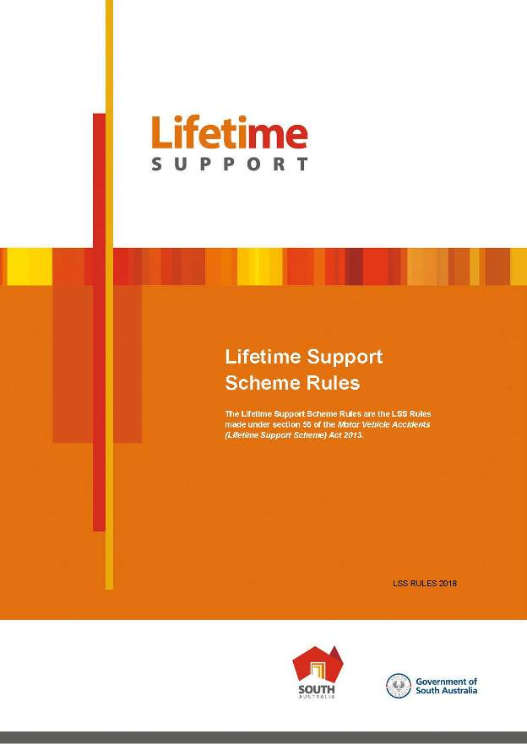

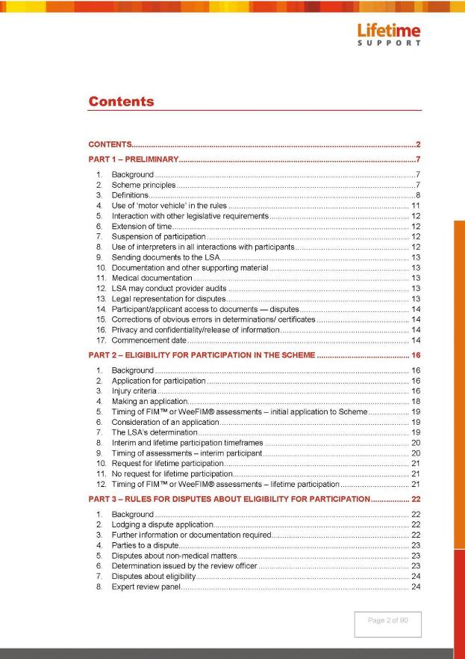

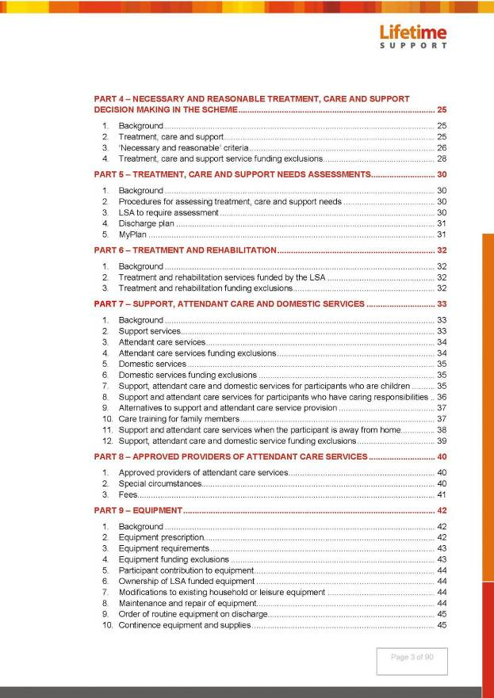

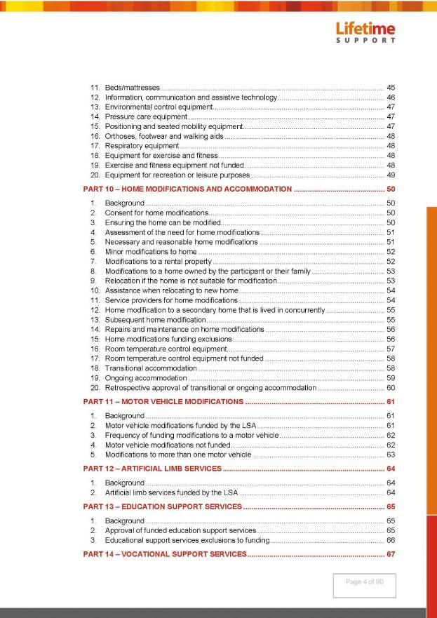

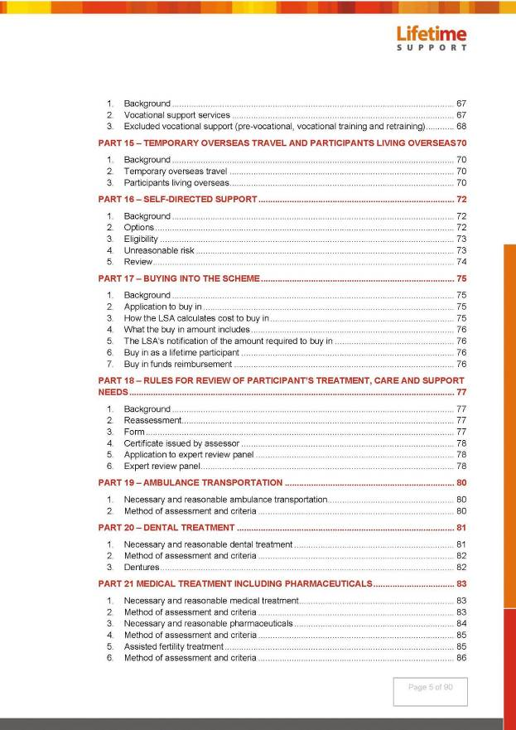

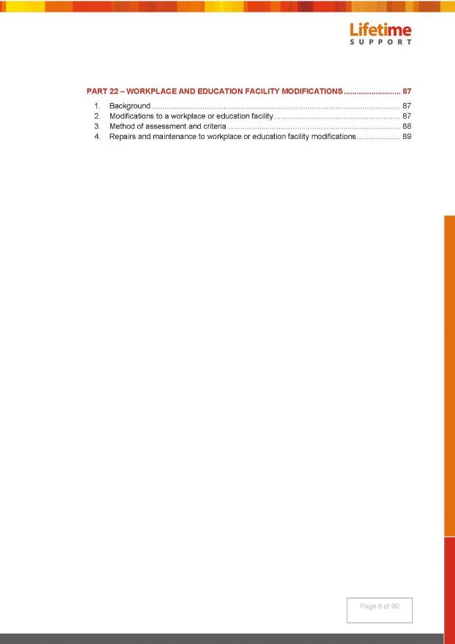

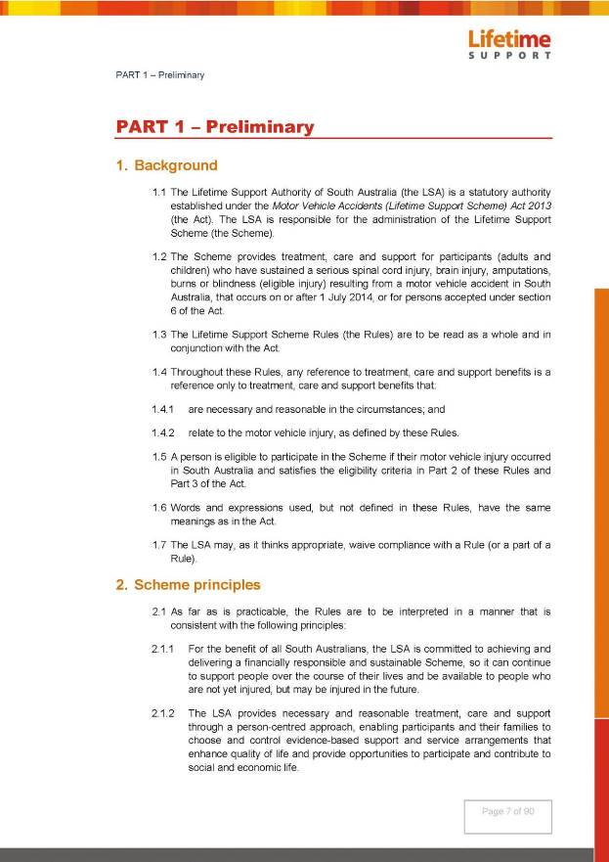

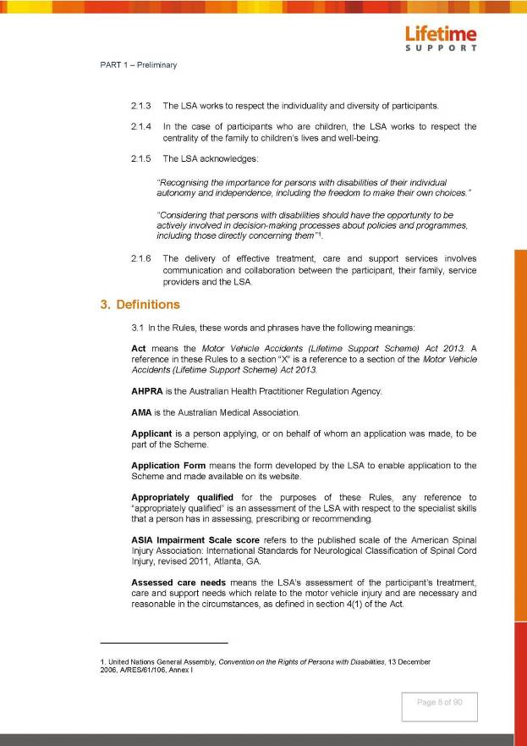

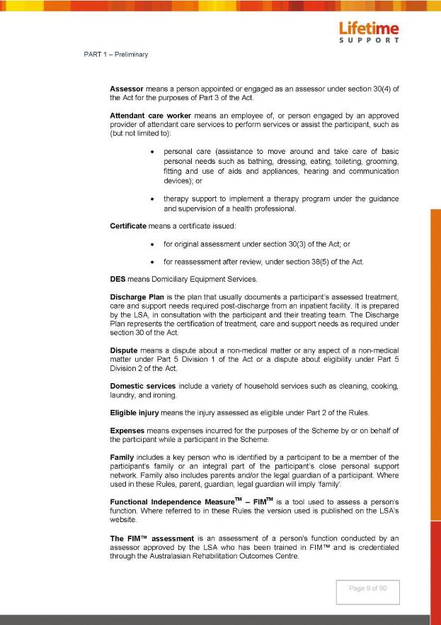

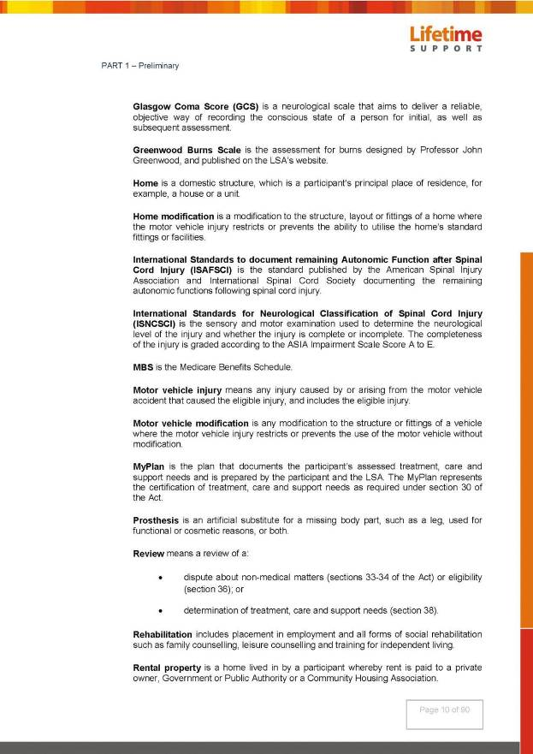

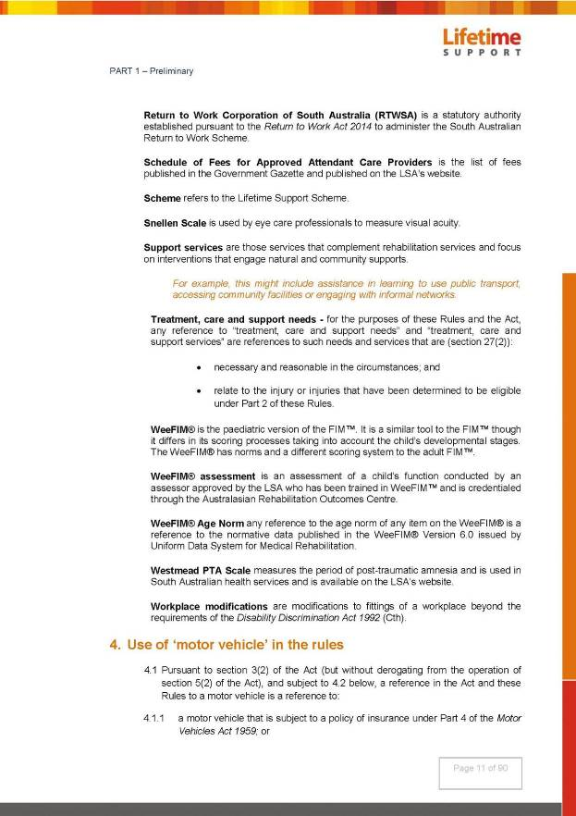

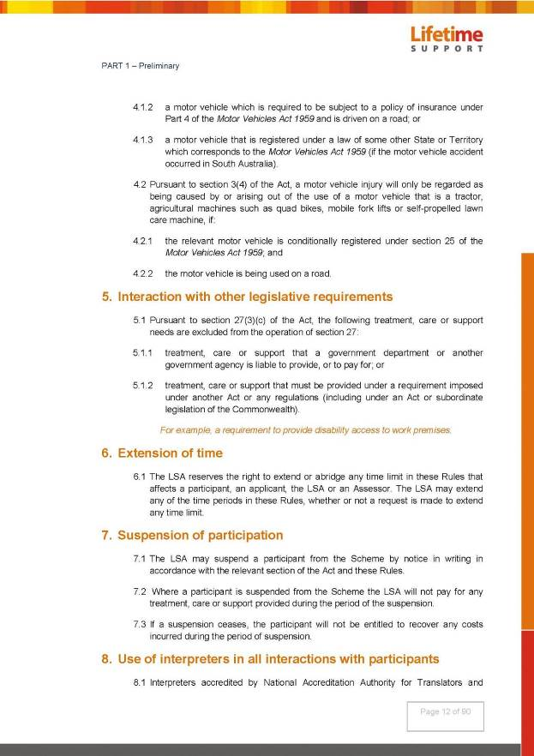

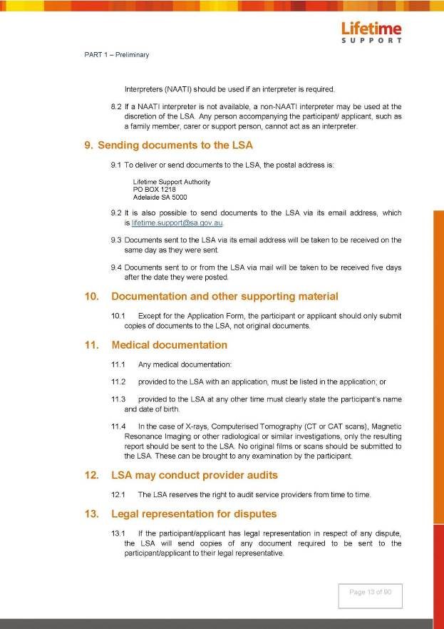

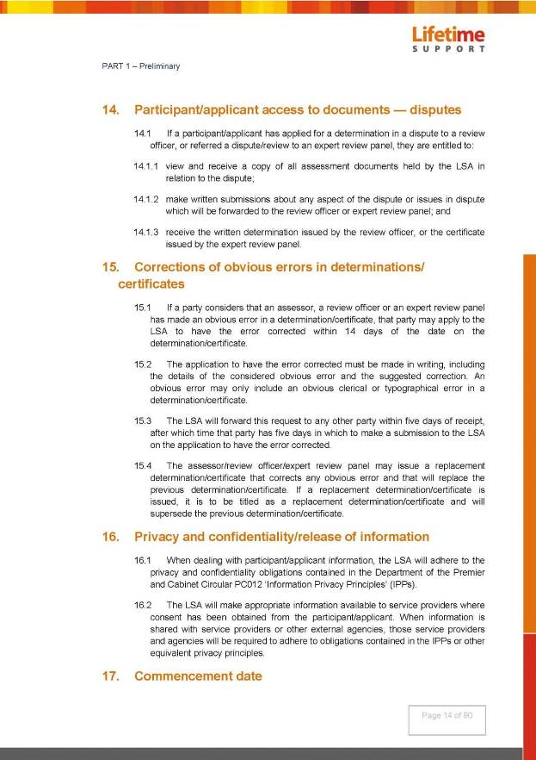



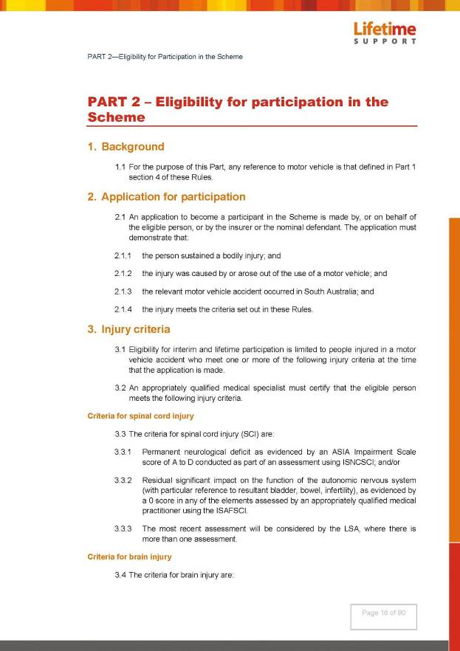

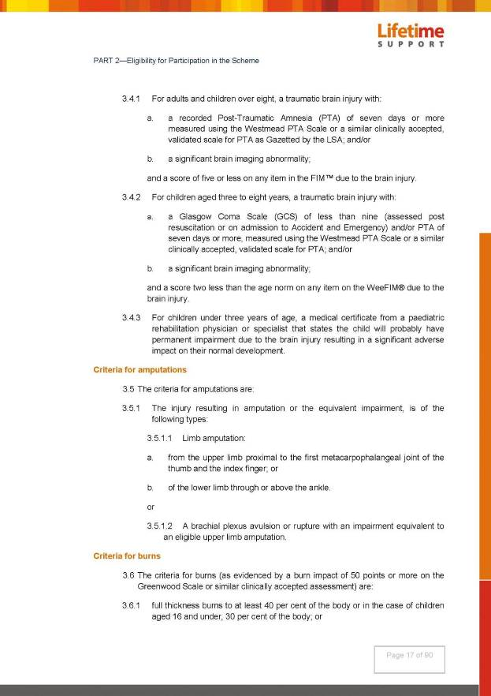

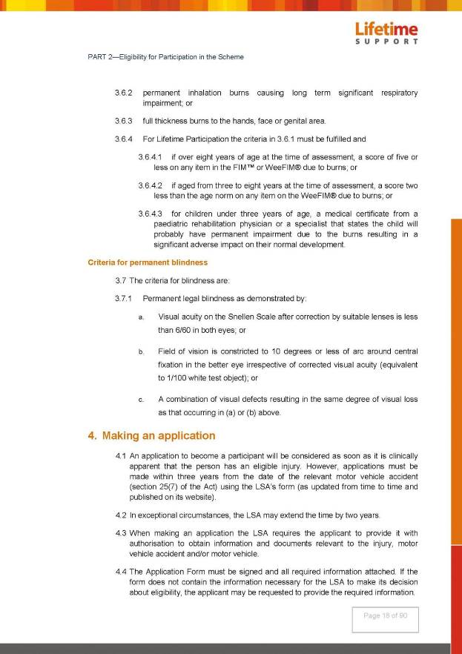

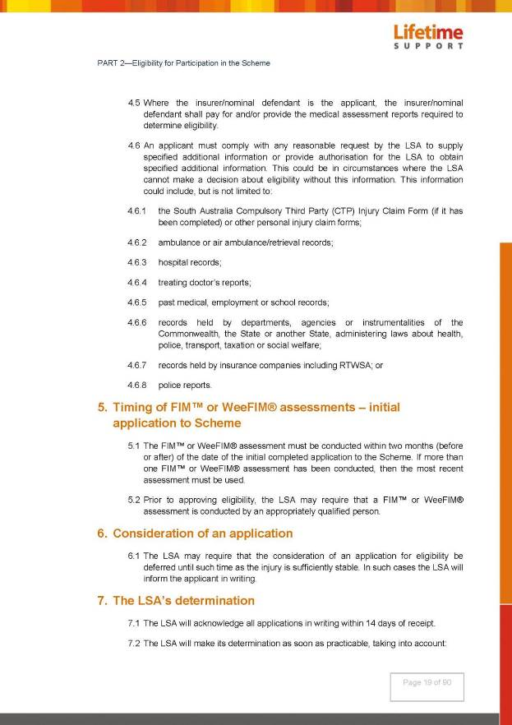

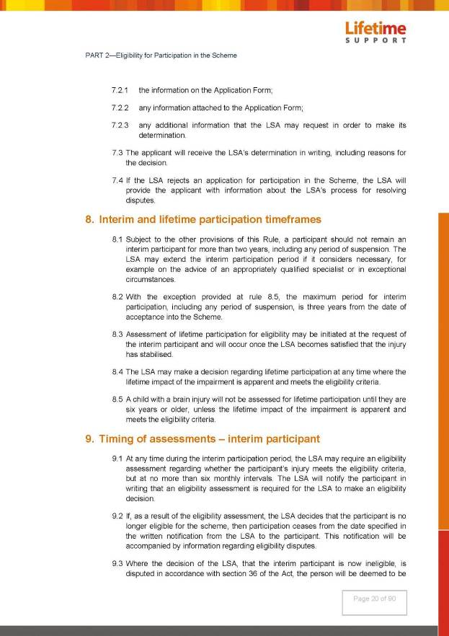

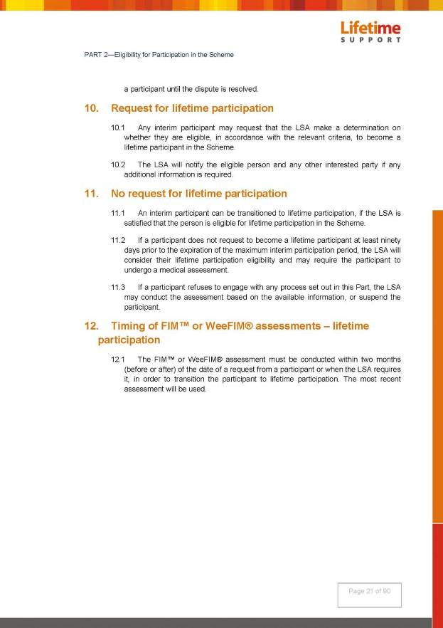

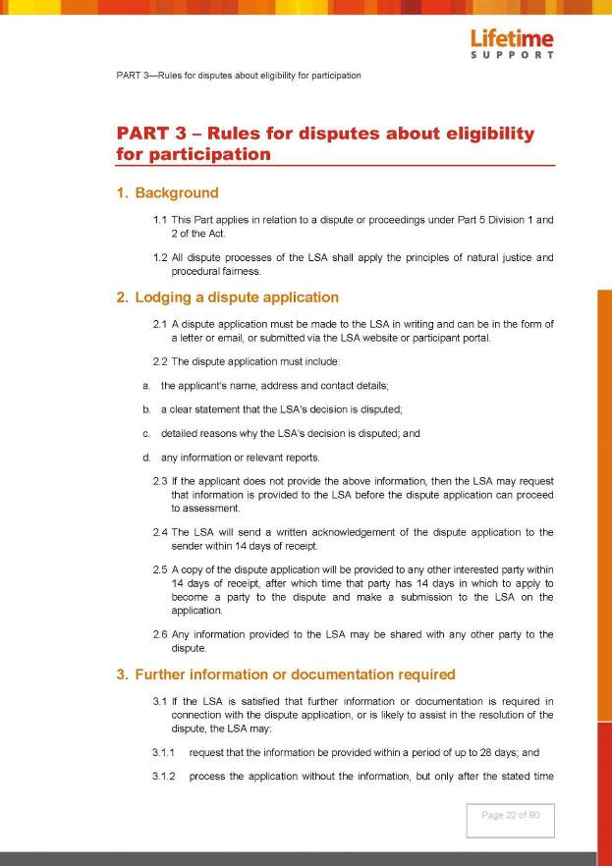

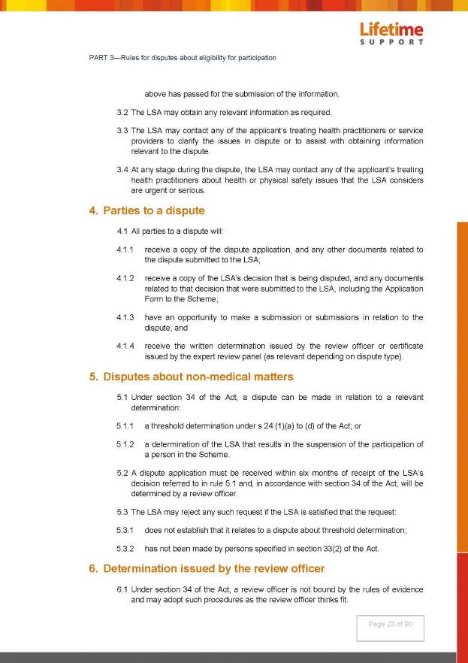

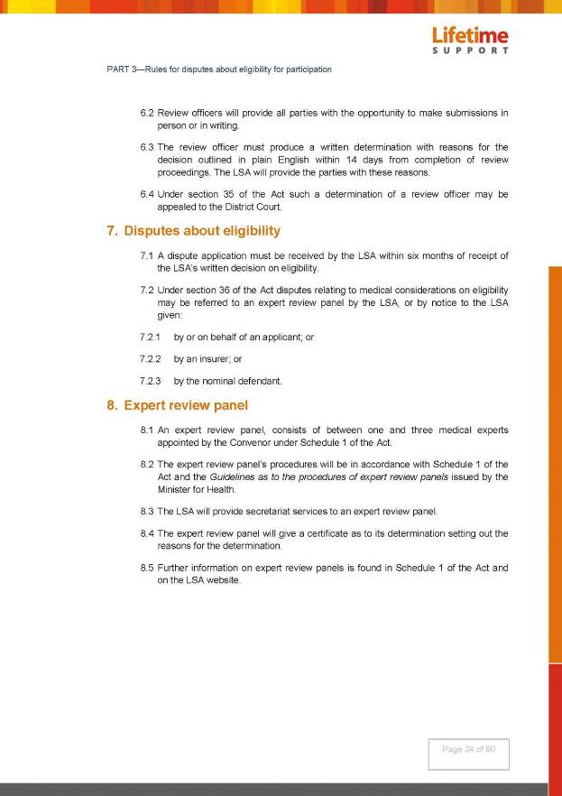

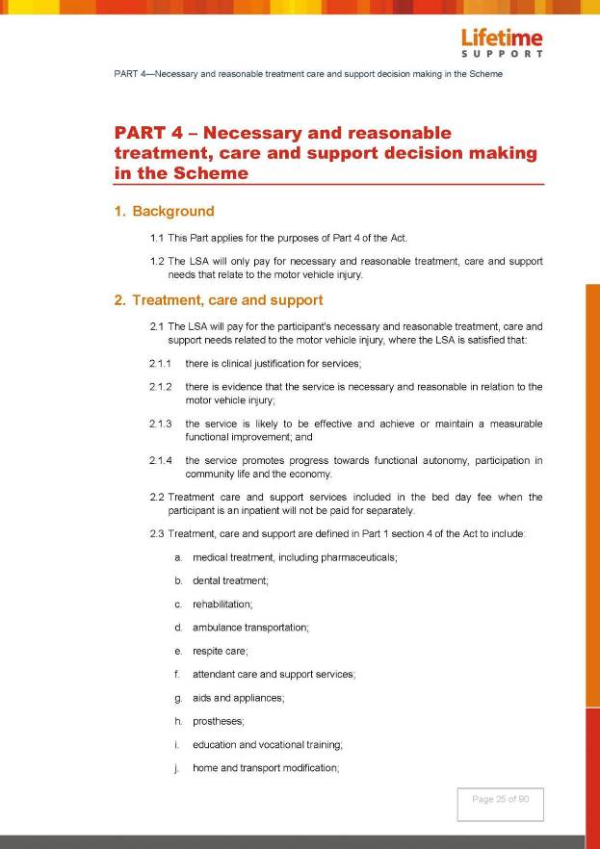
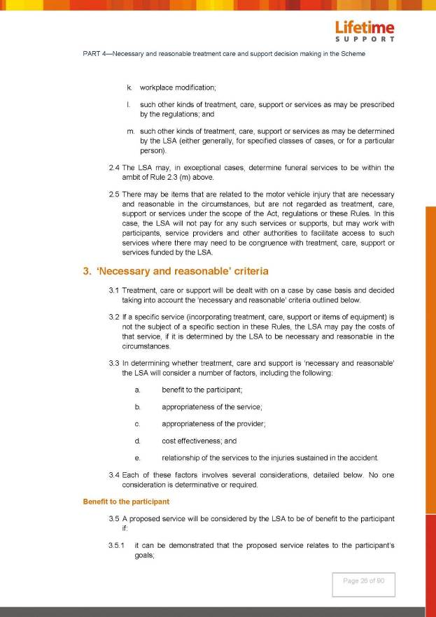

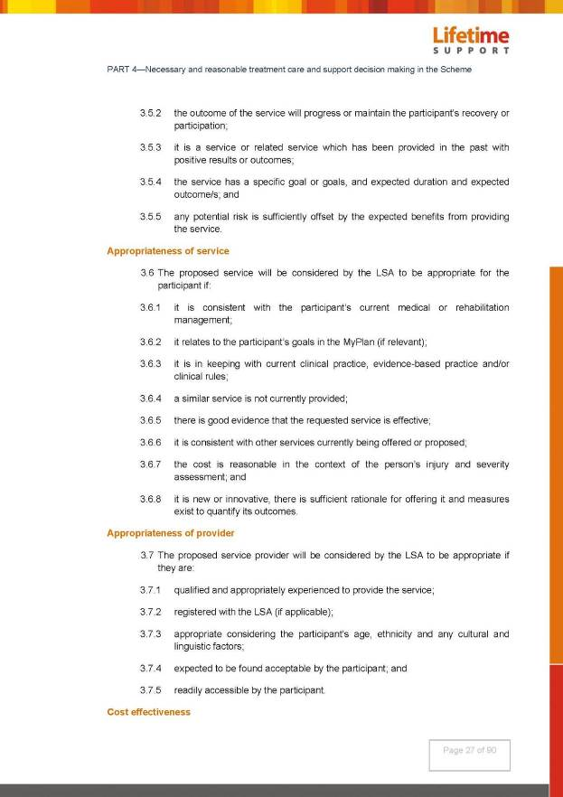

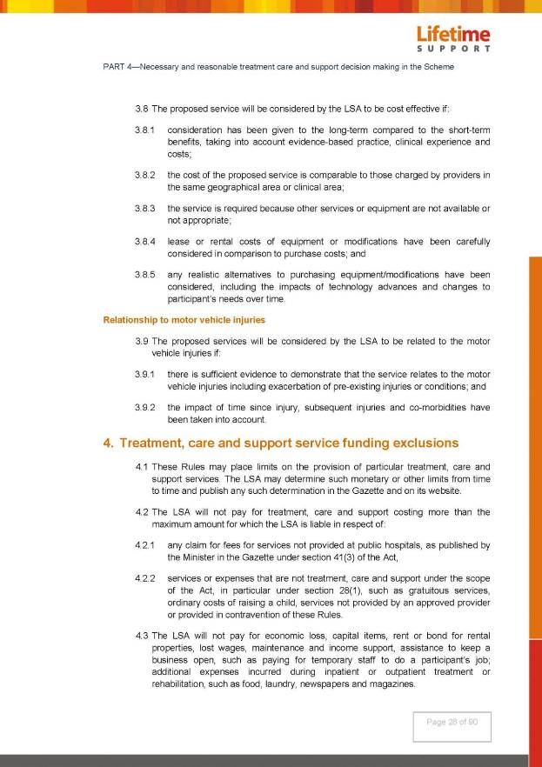

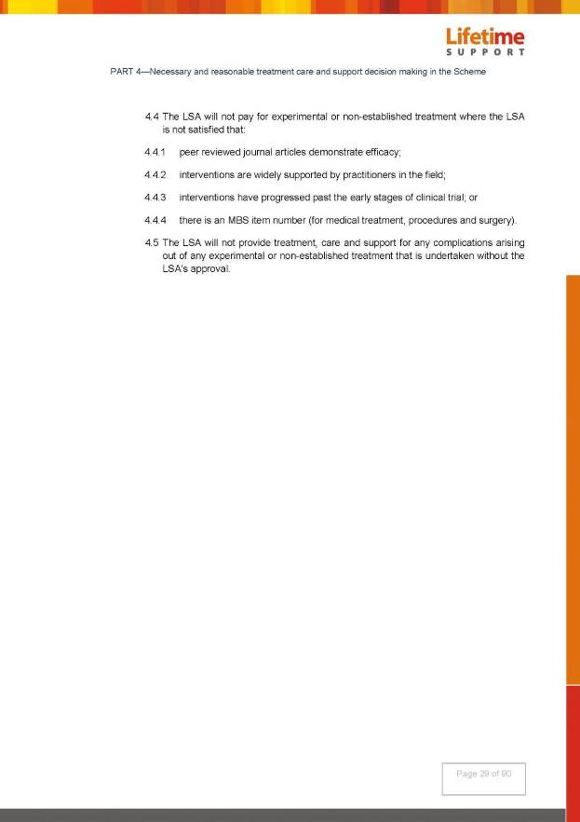

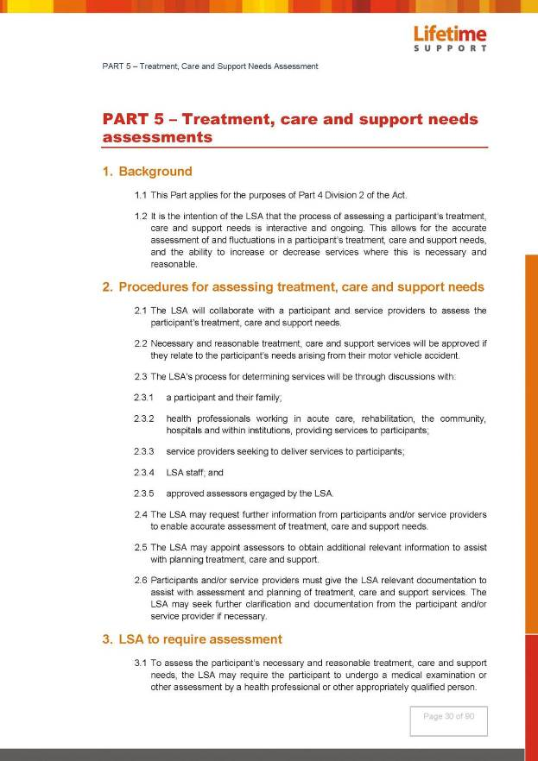

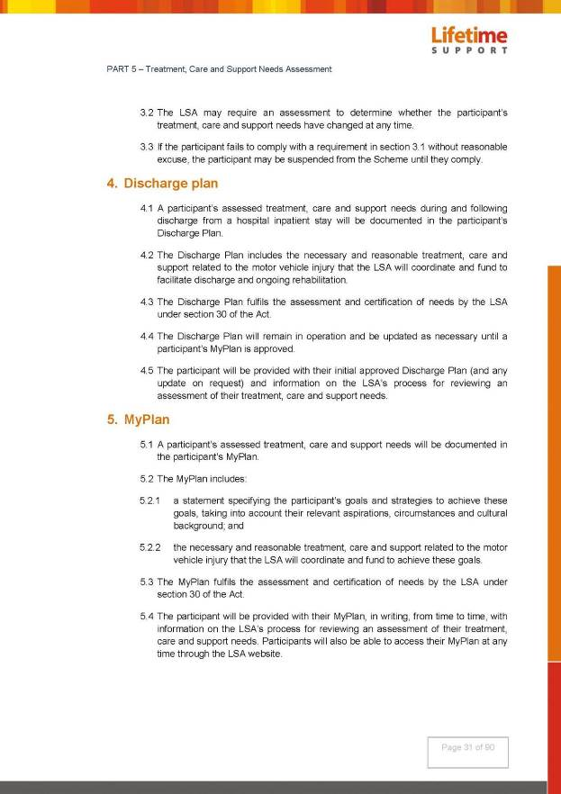

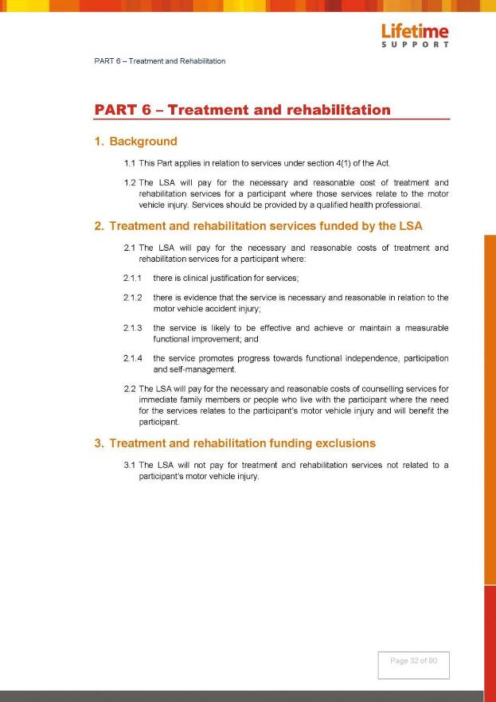

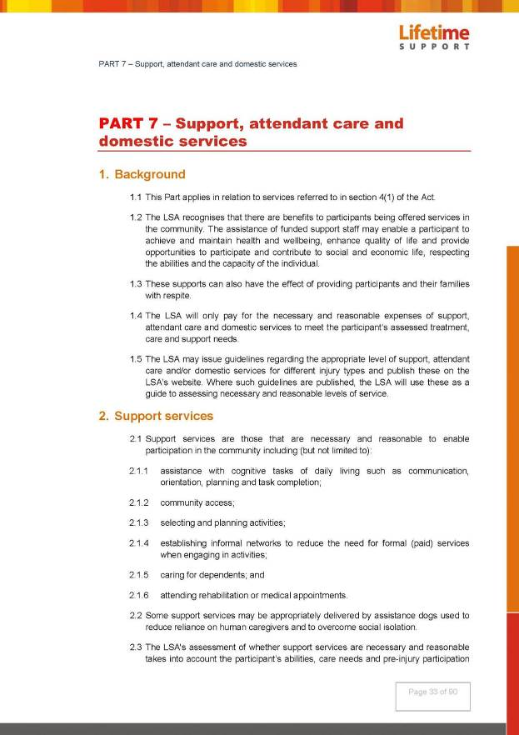

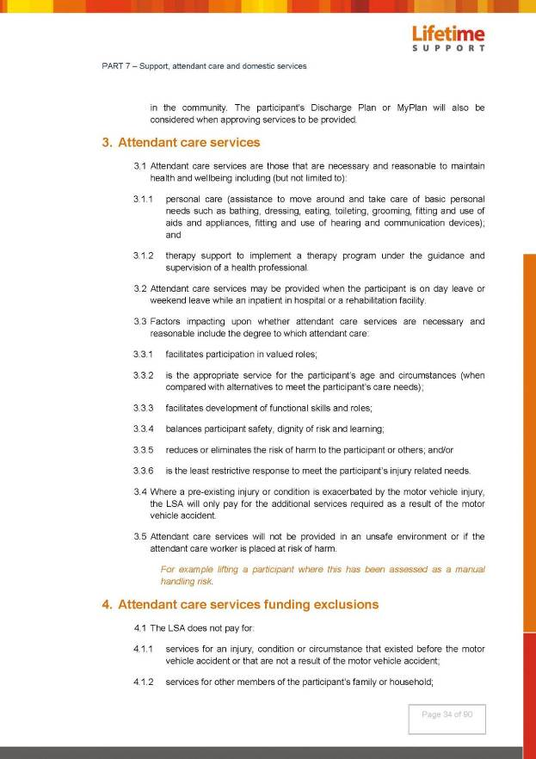

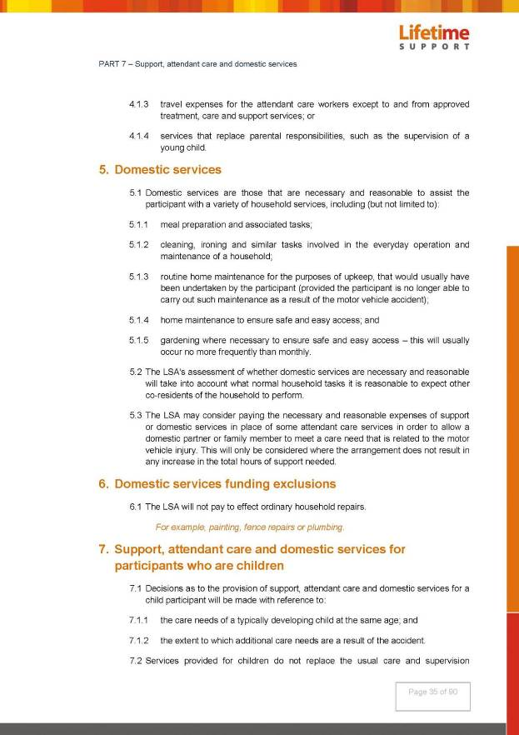

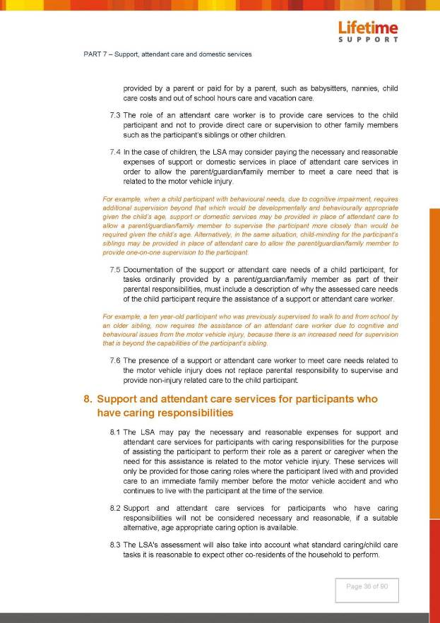

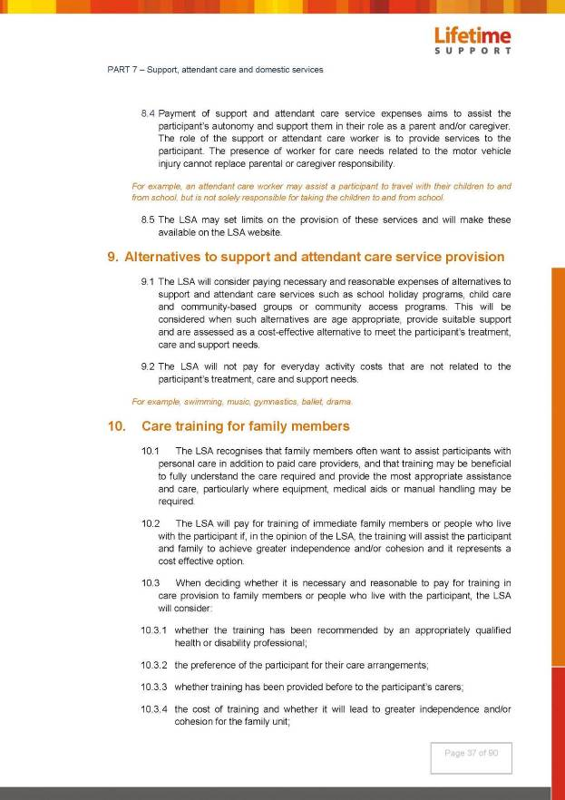

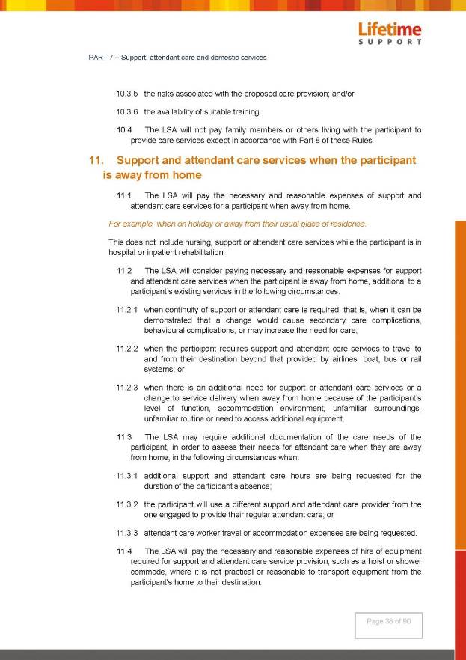

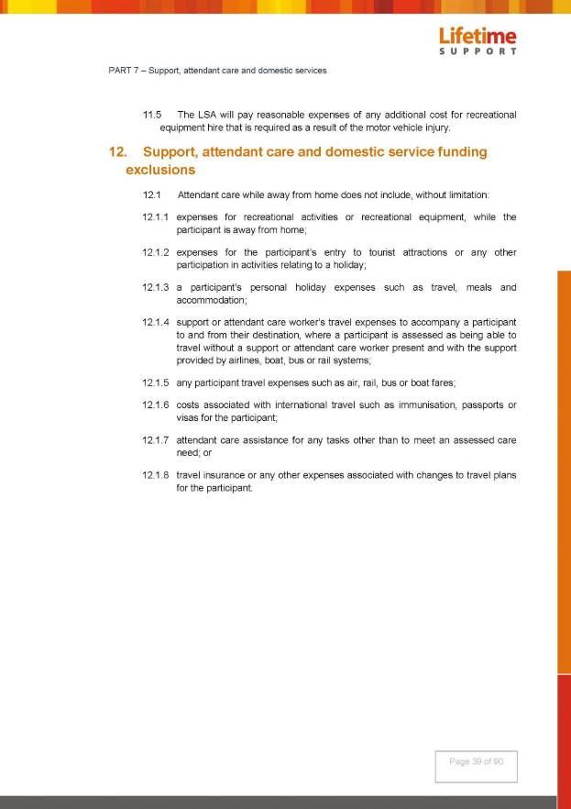

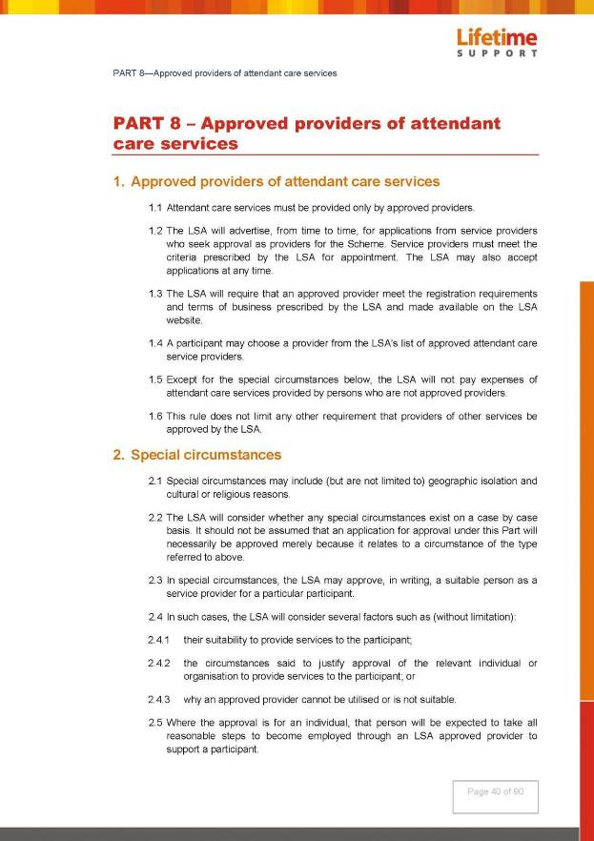

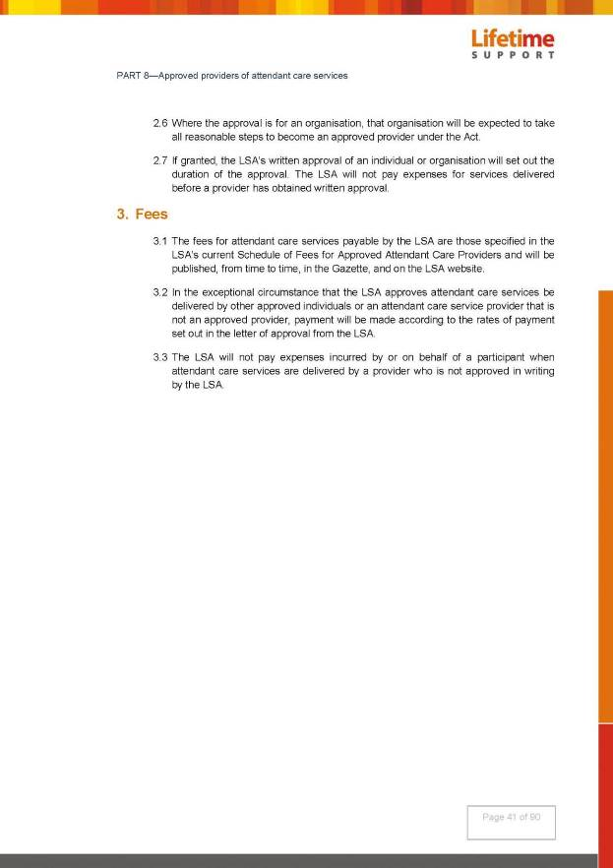

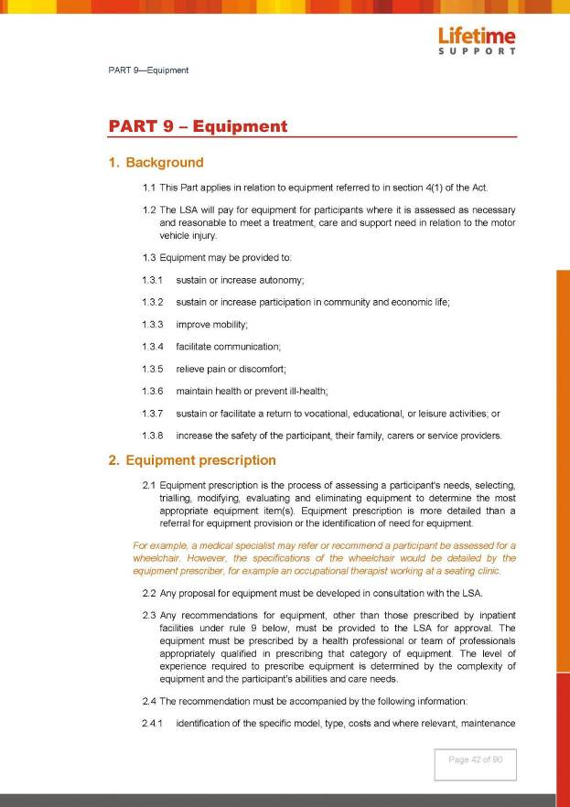

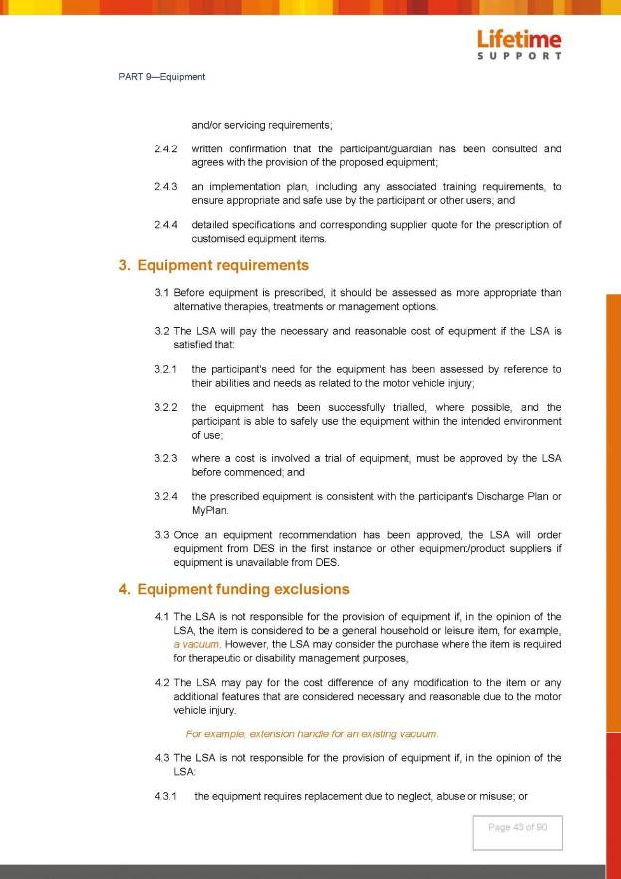

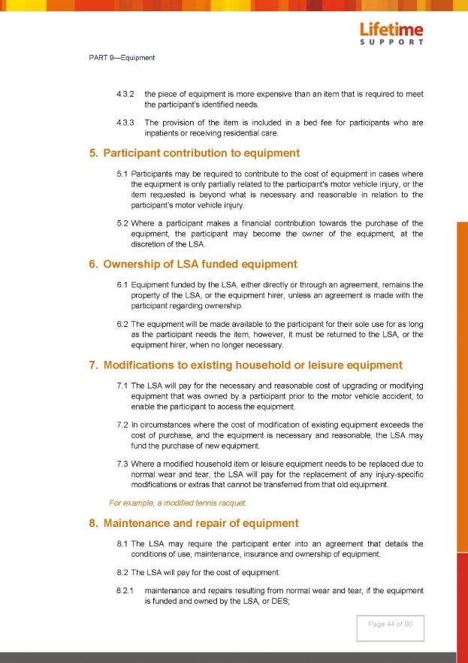

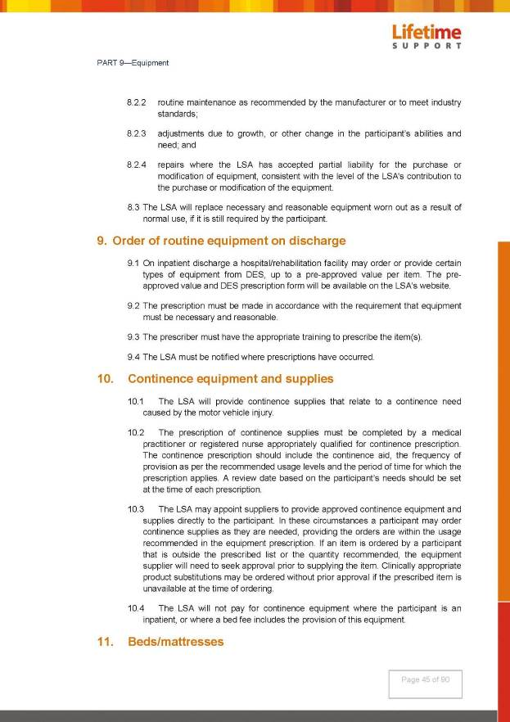

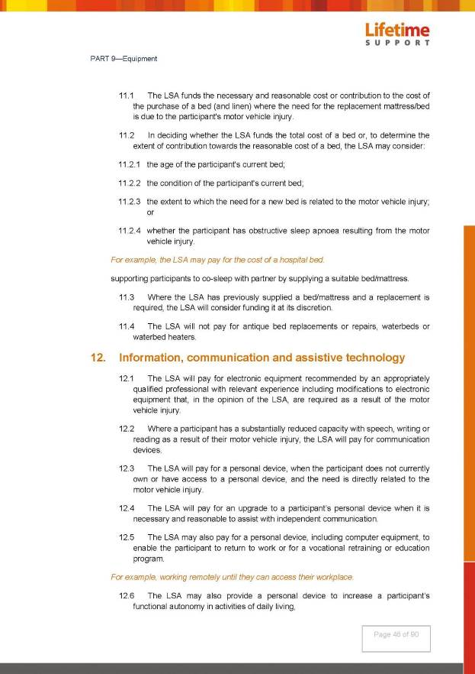
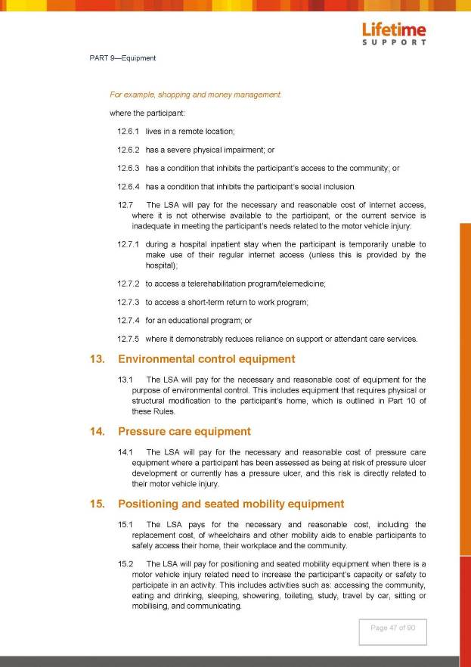

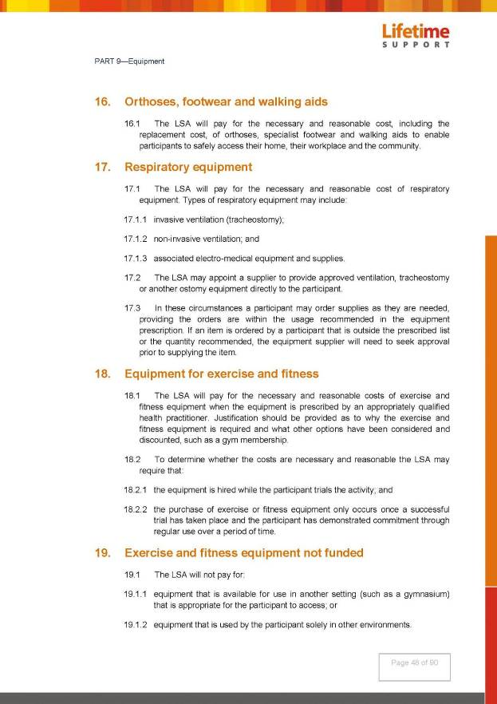

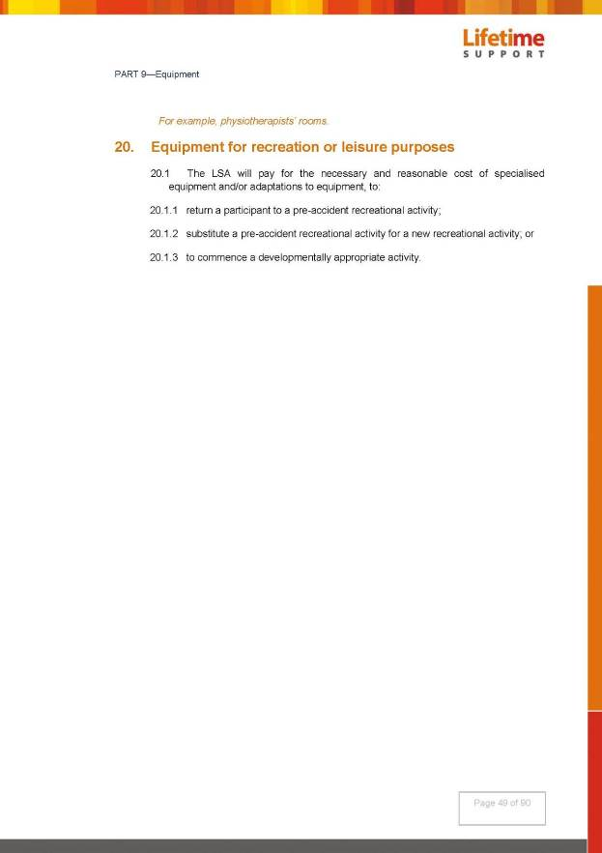

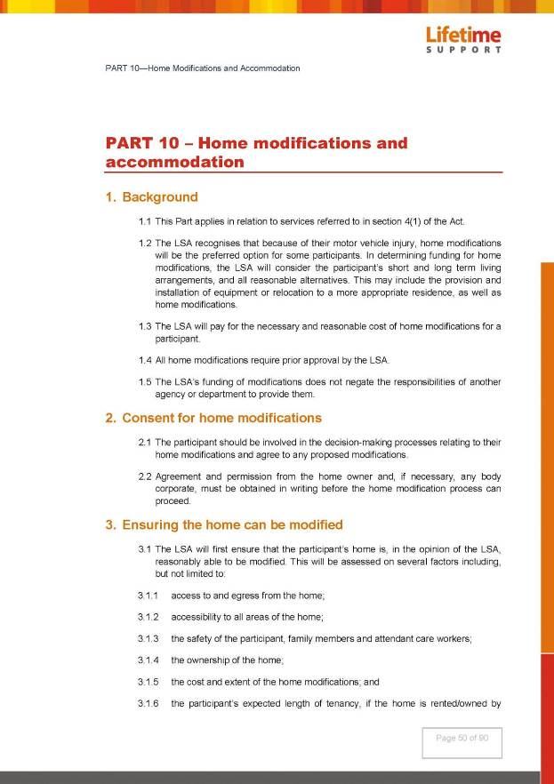

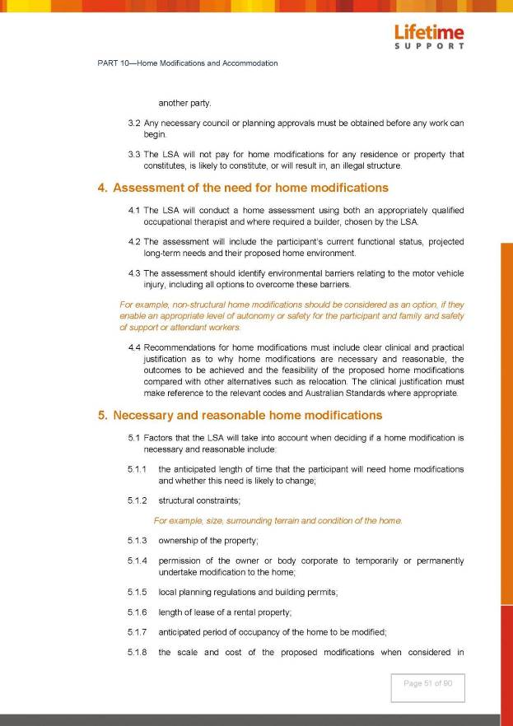

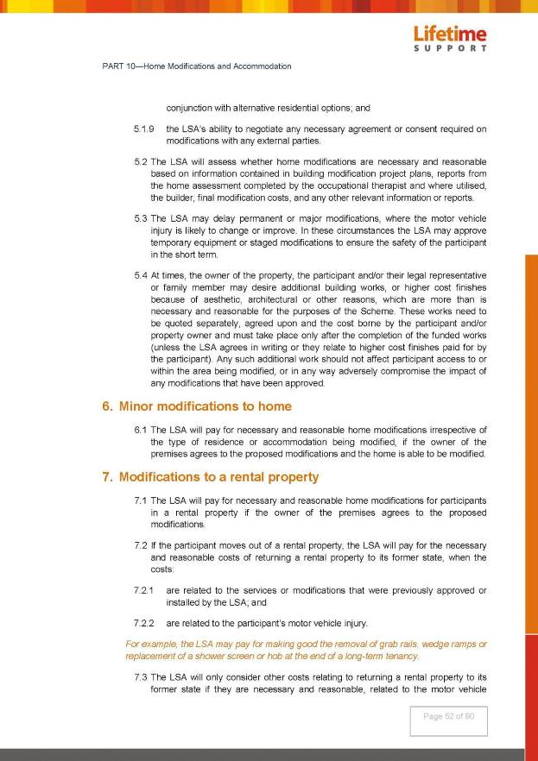

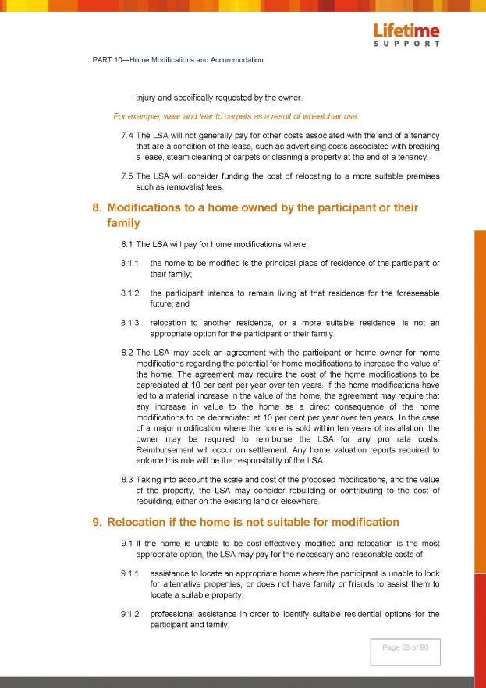

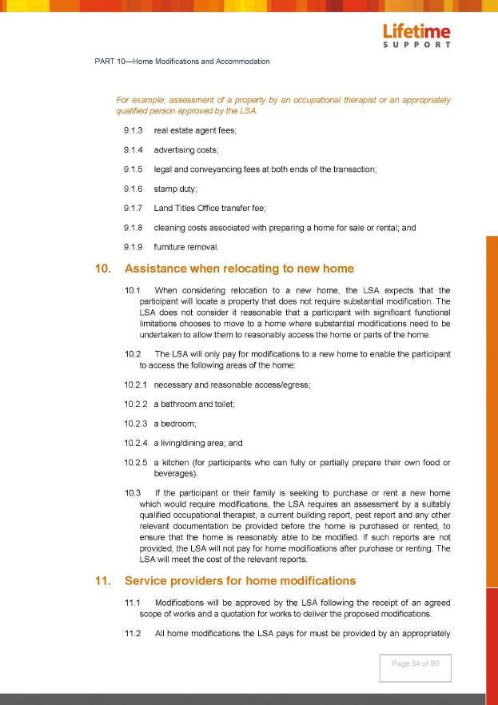
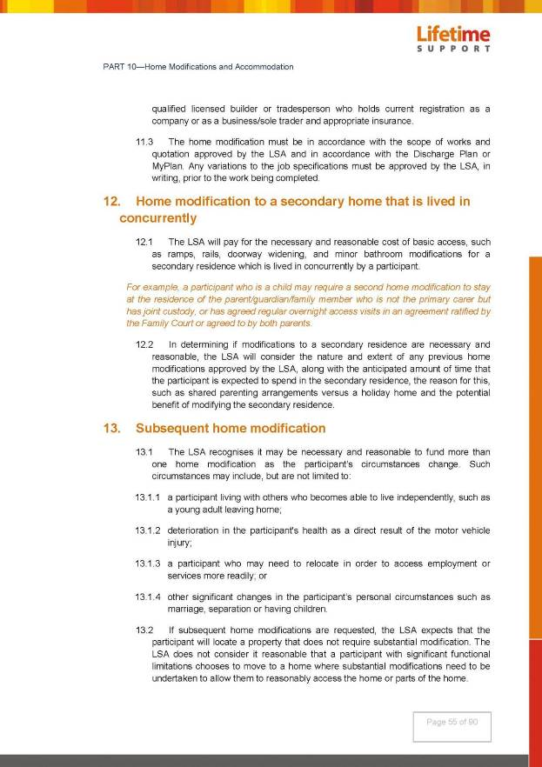

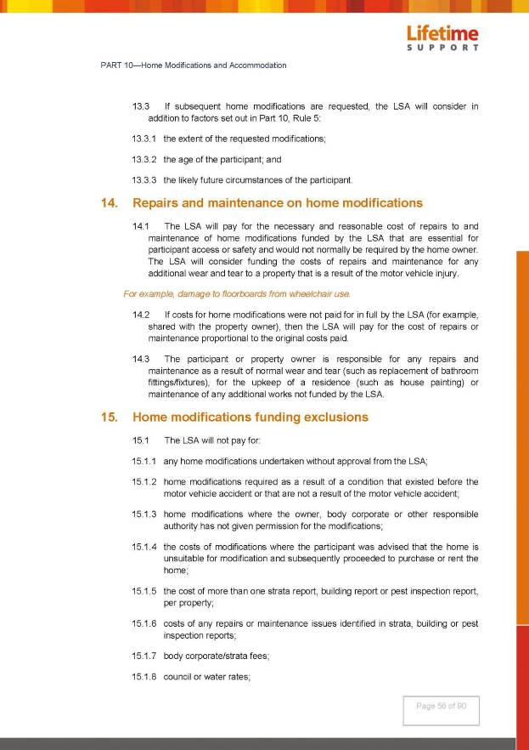

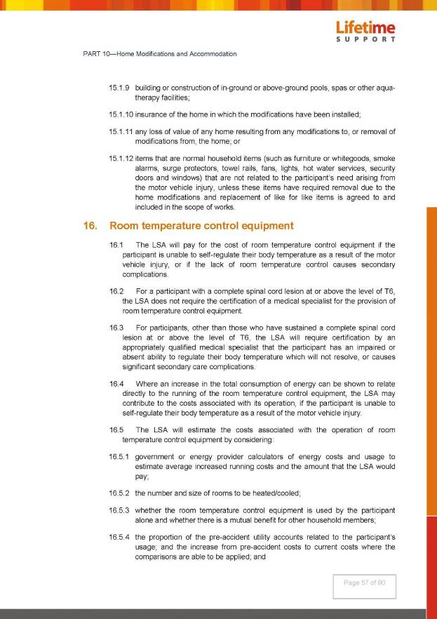

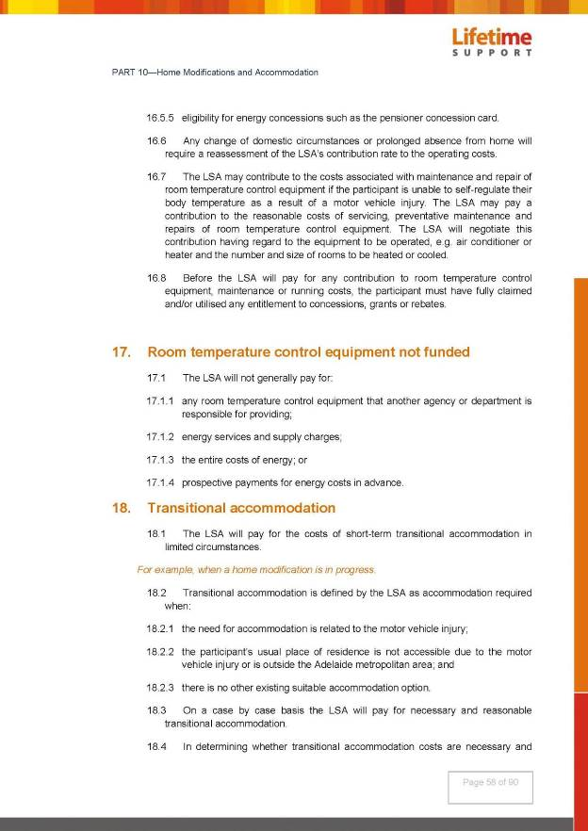
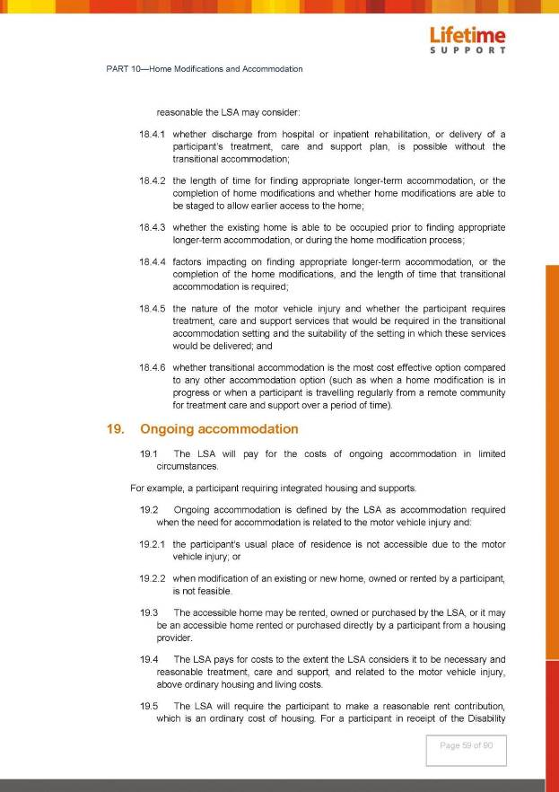

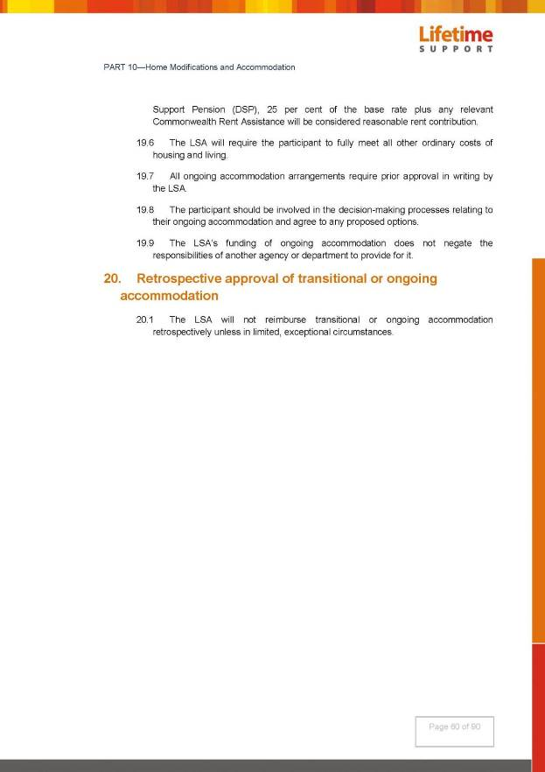

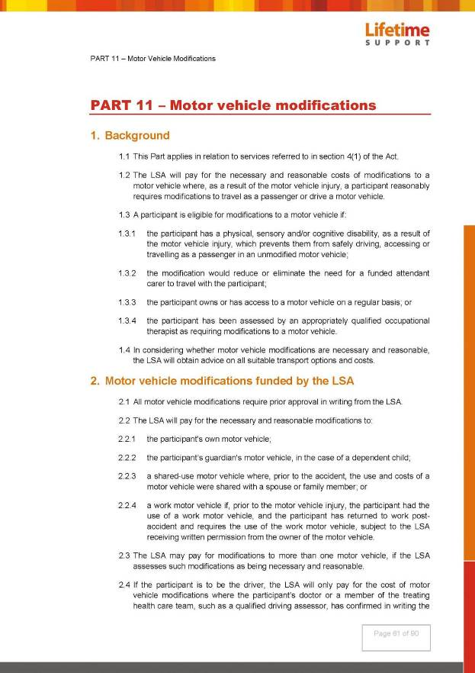

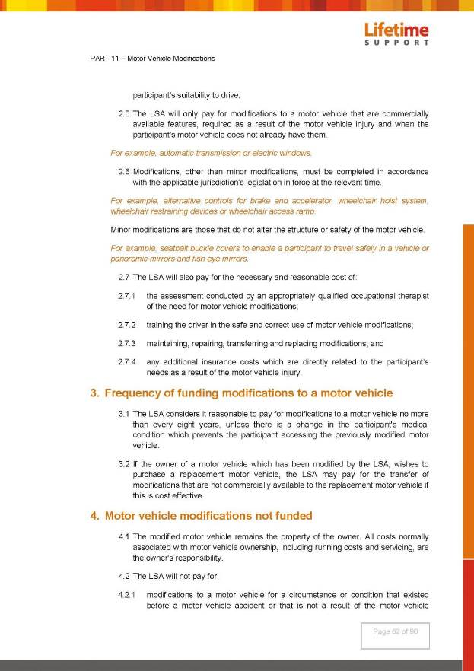
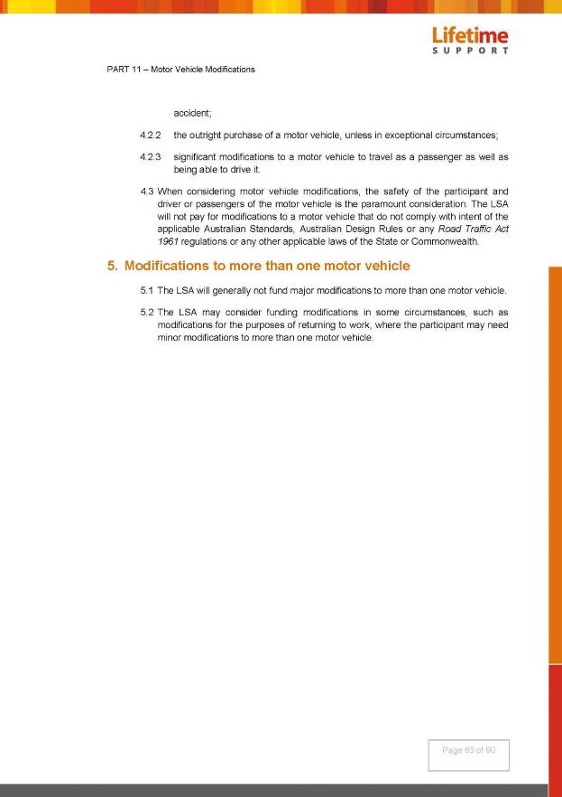

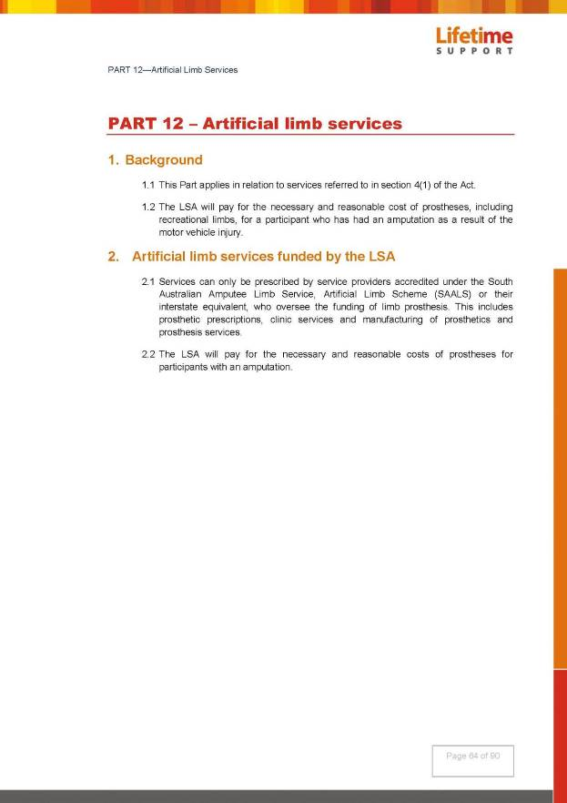

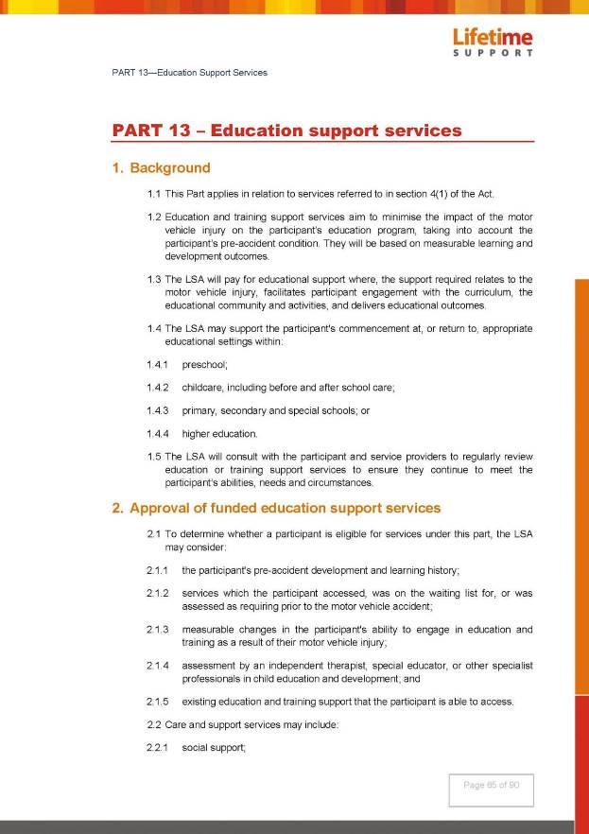

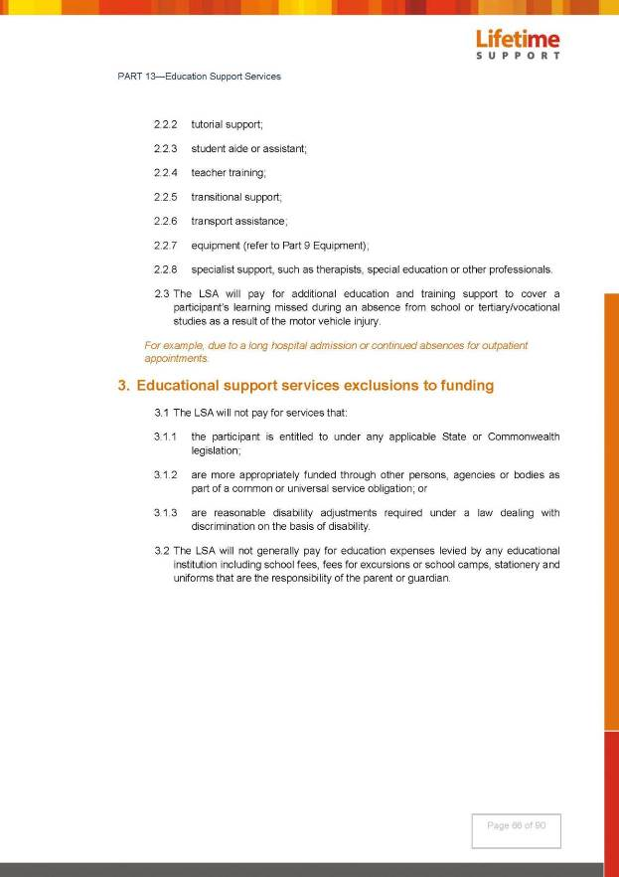

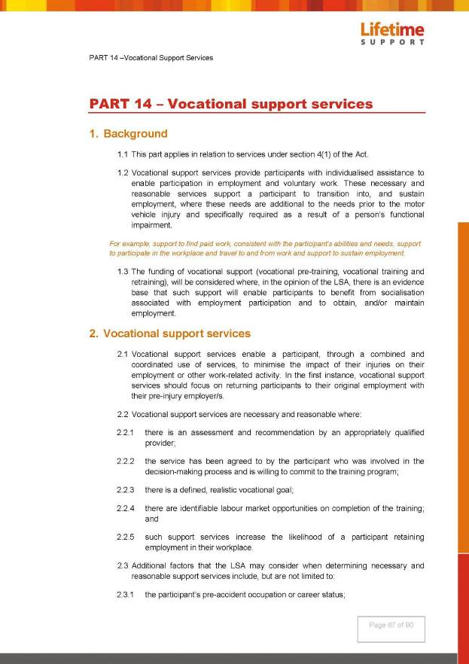

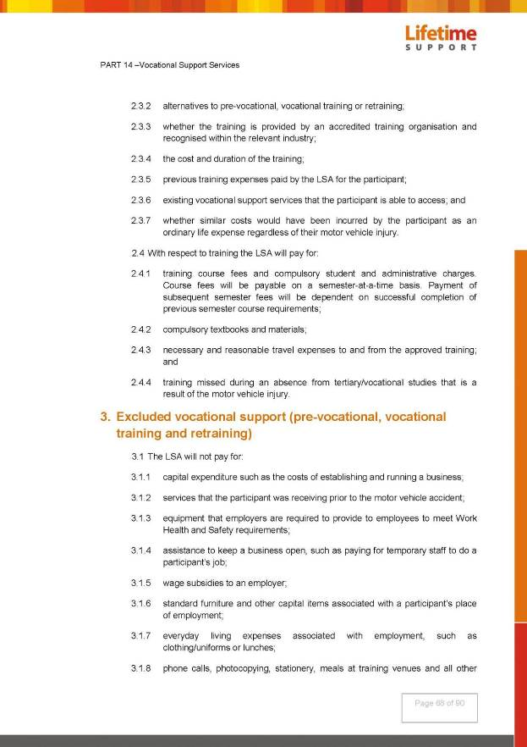

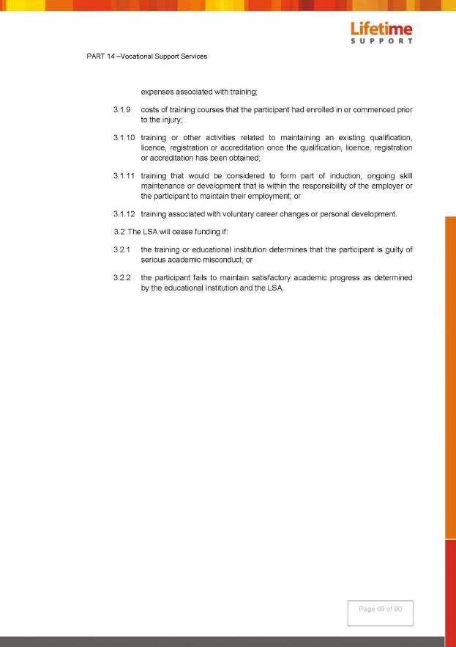
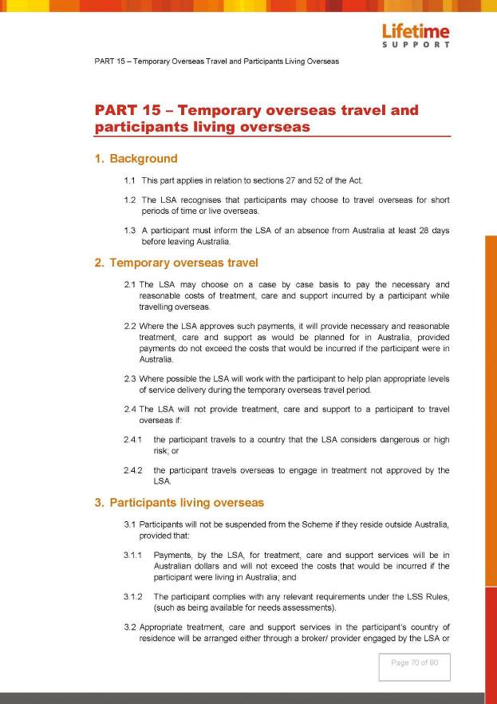


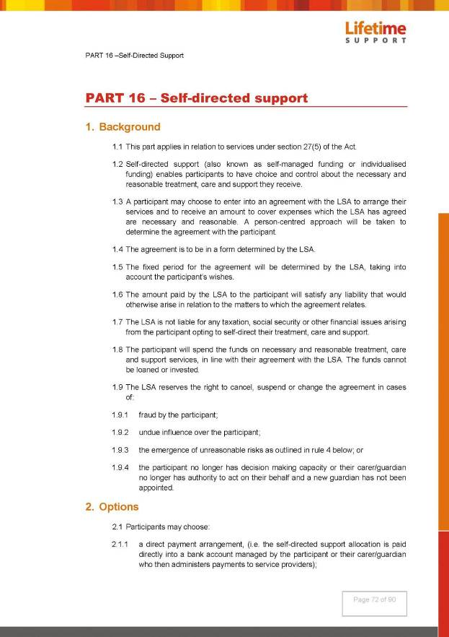

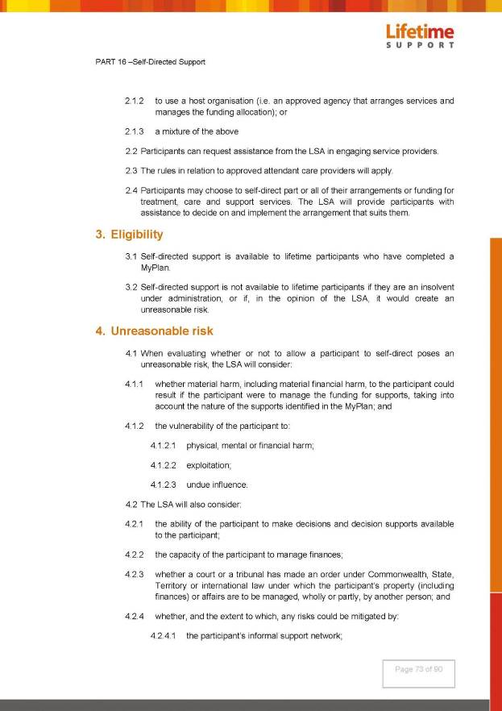
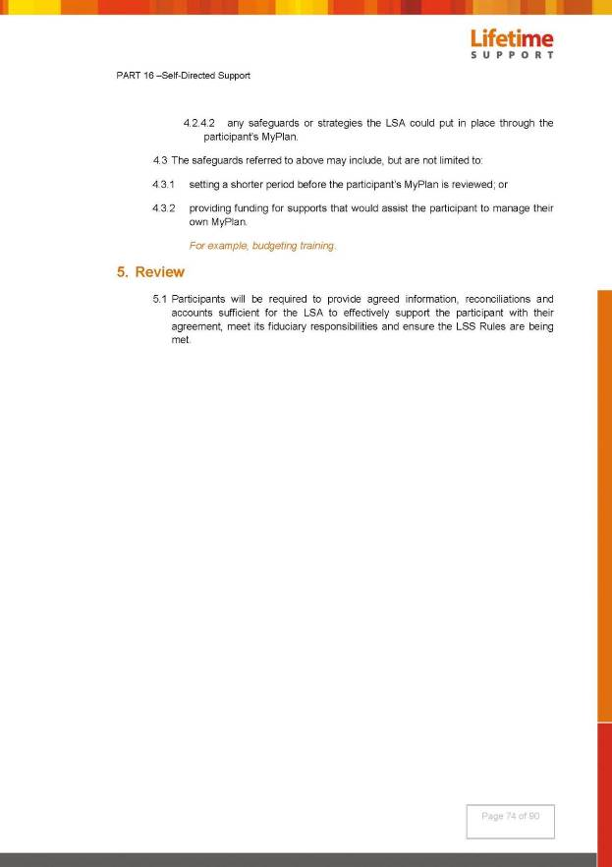
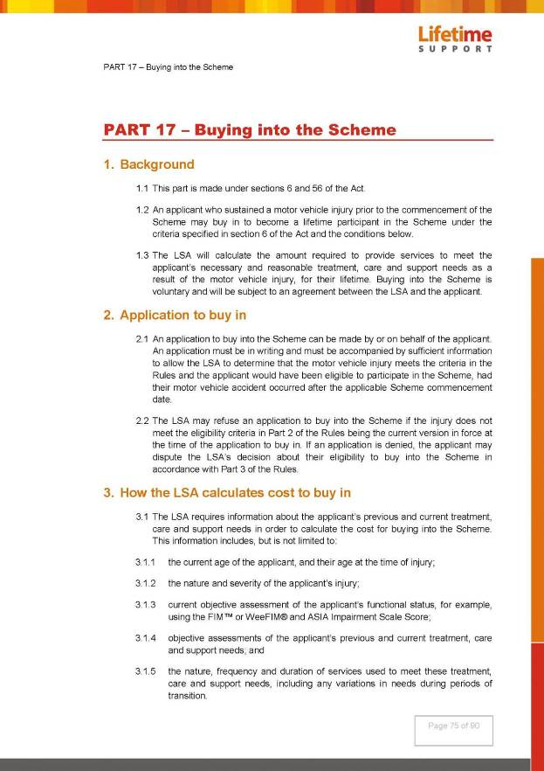

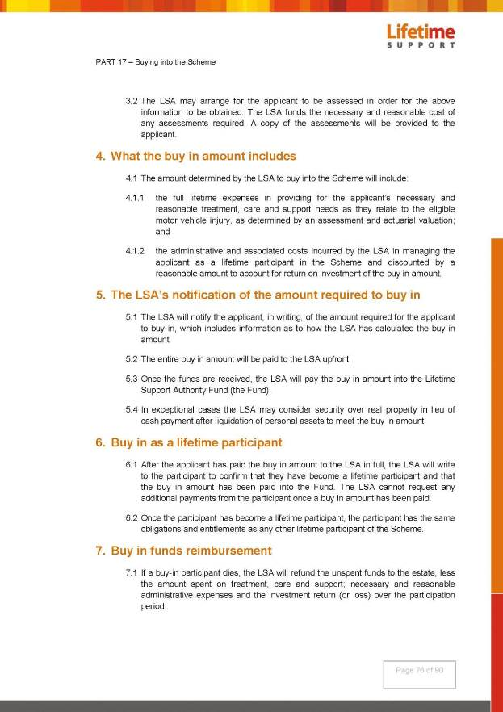

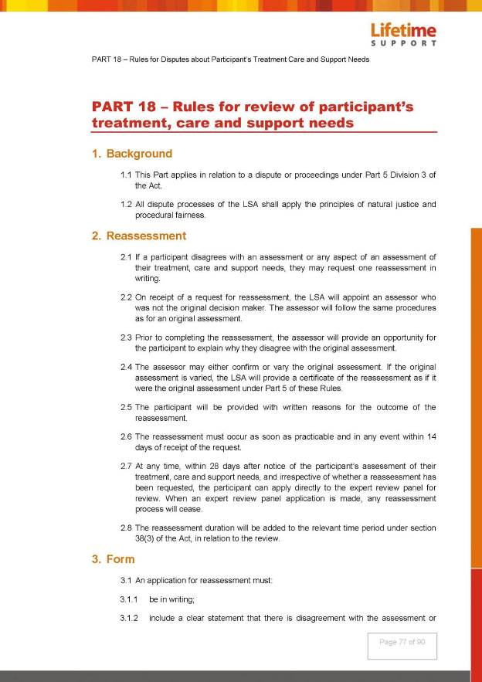
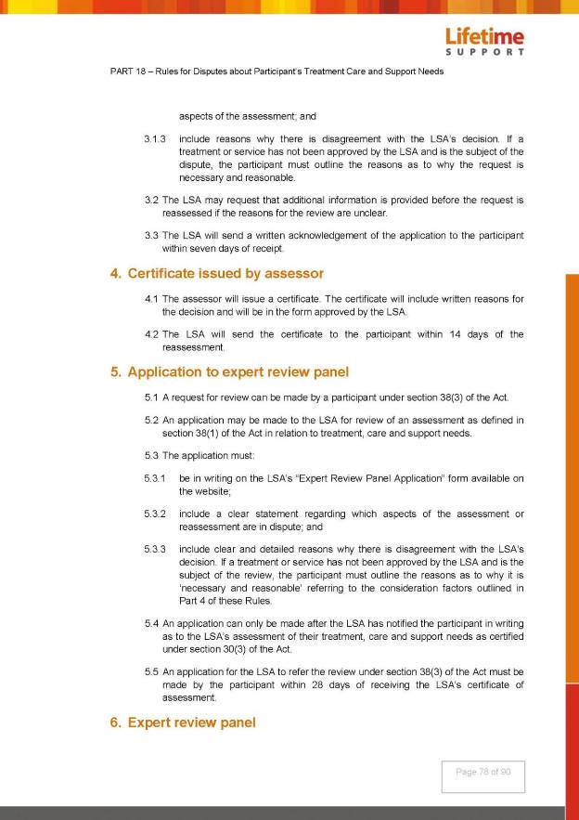



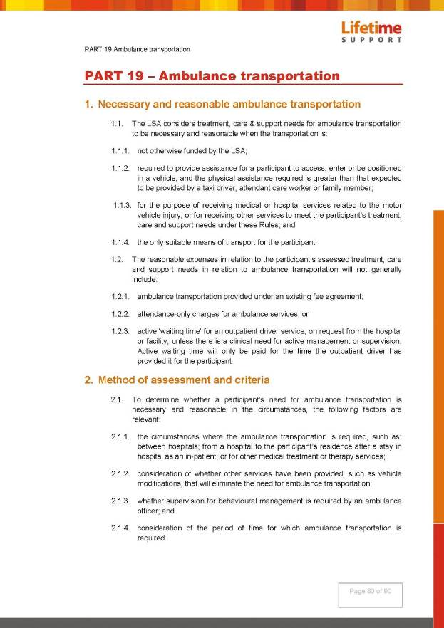

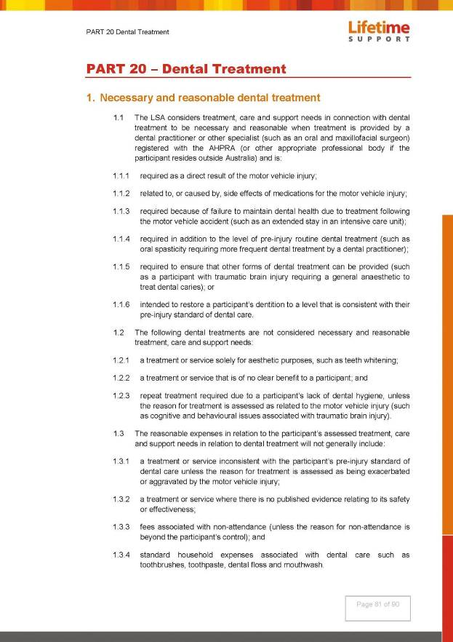

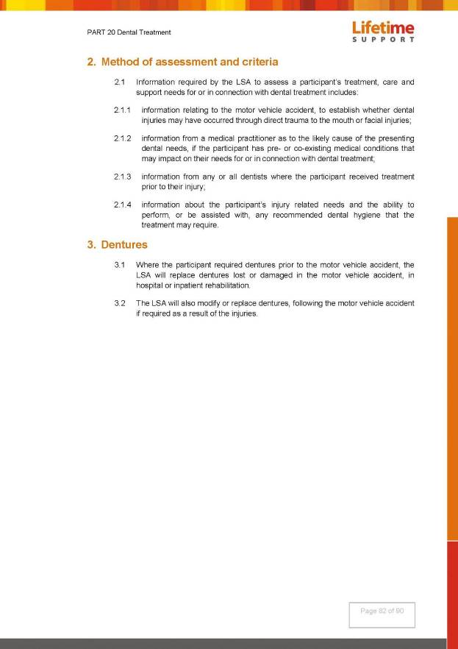

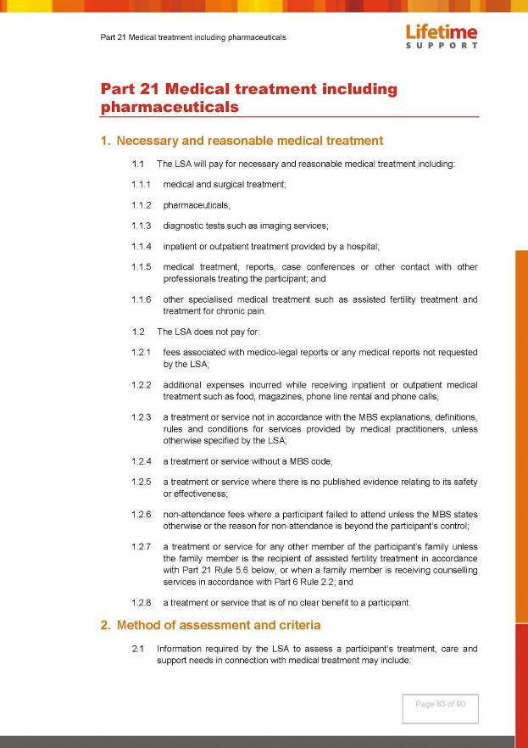

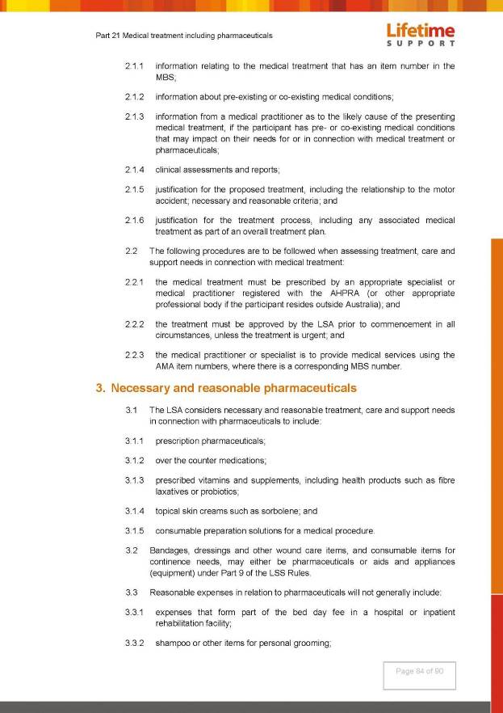

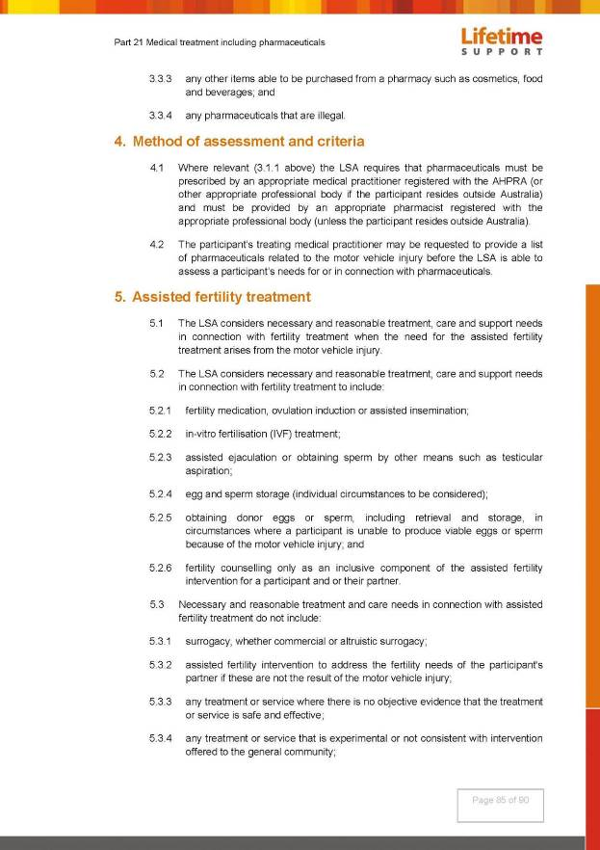

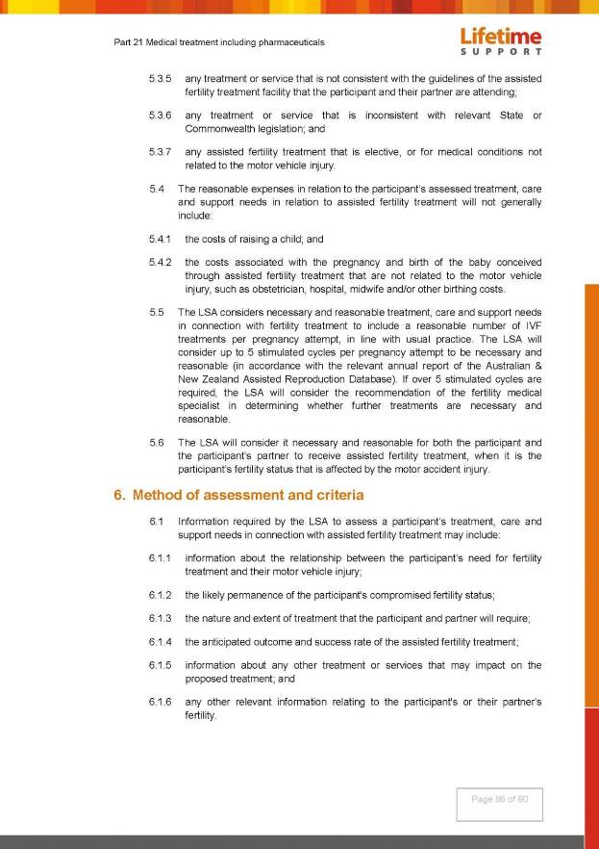

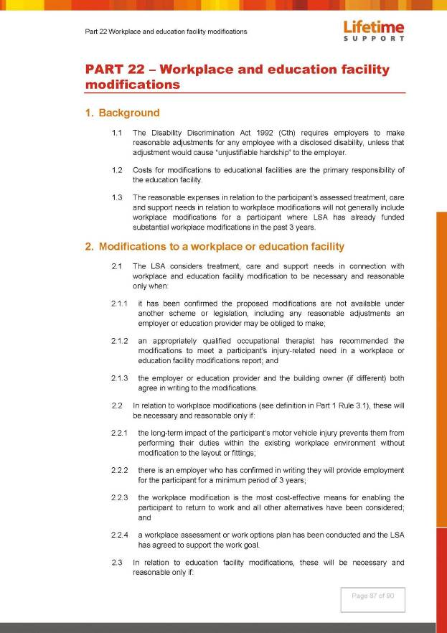
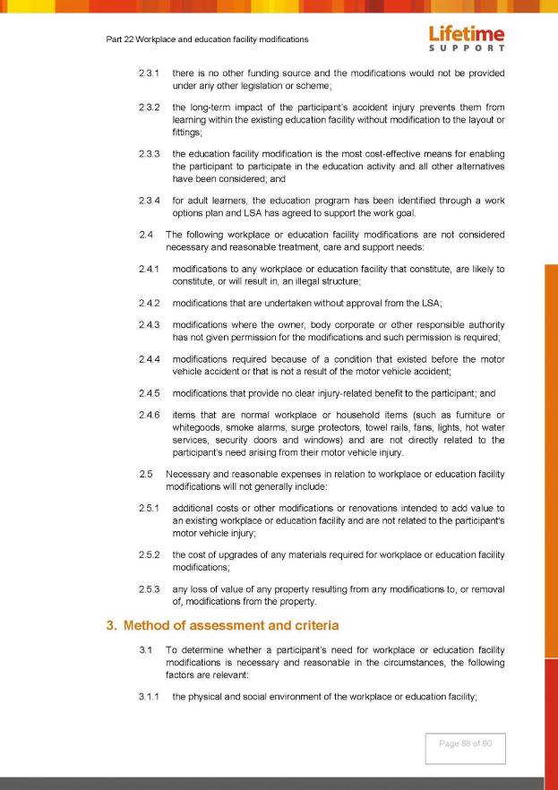

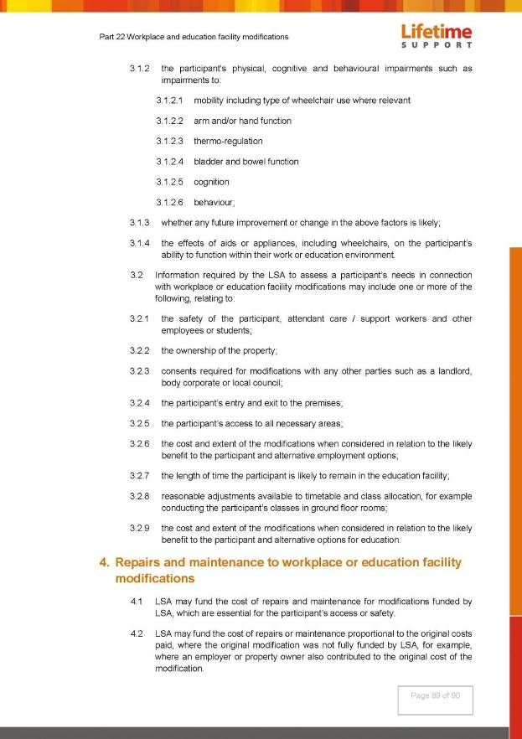



Mining Act 1971
Notice pursuant to Section 28(5) of the Mining Act 1971
Notice is hereby given in accordance with Section 28(5) of the Mining Act 1971 that the delegate of the Minister for Energy and Mining intends to grant Exploration Licences over the areas described below.
Applicant: Strategic Energy Resources Limited
Location: Anna Creek area – approximately 140 km NNW of Roxby Downs
Pastoral Leases: Anna Creek, Billa Kalina
Term: Two years
Area in km²: 526
Reference number: 2018/00185
Applicant: Iluka (Eucla Basin) Pty Ltd
Location: Peake area approximately 65km ESE of Murray Bridge
Term: Two years
Area in km²: 701
Reference number: 2018/000189
Applicant: Cerberus Resources Pty Ltd
Location: Billa Kalina area approximately 120km NNW of Roxby Downs
Pastoral Leases: Billa Kalina
Term: One year
Area in km²: 281
Reference number: 2018/00190
Applicant: Petratherm Ltd
Location: Mount Willoughby area approximately 40km NW of Coober Pedy
Pastoral Leases: Mabel Creek, Mount Barry, Mount Clarence, Mount Willoughby
Term: Two years
Area in km²: 838
Reference number: 2018/00191
Applicant: Iluka (Eucla Basin) Pty Ltd
Location: Ashville area approximately 30km south of Tailem Bend
Term: Two years
Area in km²: 472
Reference number: 2018/00192
Applicant: Cerberus Resources Pty Ltd
Location: Anna Creek area approximately 90km SE of Oodnadatta
Pastoral Leases: Allandale, Nilpinna, The Peake
Term: One year
Area in km²: 946
Reference number: 2018/00193
Applicant: Cerberus Resources Pty Ltd
Location: Anna Creek area approximately 120km SE of Oodnadatta
Pastoral Leases: Anna Creek, The Peake
Term: One year
Area in km²: 669
Reference number: 2018/00194
Applicant: Petratherm Ltd
Location: Mount Barry area approximately 50km NE of Coober Pedy
Pastoral Leases: Anna Creek, Mount Barry, Nilpinna
Term: Two years
Area in km²: 641
Reference number: 2018/00198
Applicant: Cerberus Resources Pty Ltd
Location: Mulgathing area approximately 190km SSW of Coober Pedy
Pastoral Leases: Mulgathing, Wilgena
Term: One year
Area in km²: 351
Reference number: 2018/00206
Applicant: Cristal Mining Australia Limited
Location: Kongal area approximately 40km SSE of Keith
Term: Two years
Area in km²: 927
Reference number: 2019/00005
Plans and co-ordinates can be found on the Department for Energy and Mining website:
http://www.minerals.dpc.sa.gov.au/exploration/public_notices or by contacting Mineral Tenements on 08 8429 2572.
Community information on mineral exploration licence processes and requirements under the Mining Act 1971 is available from: http://energymining.sa.gov.au/minerals/exploration/public_notices/exploration_licence_applications or hard copy on request to Mineral Tenements.
J Martin
Mining Registrar
Department for Energy and Mining
Delegate of the Minister for Energy and Mining

South Australia
Motor Vehicles (Periodic Payment Scheme) Notice 2017
under section 24A of the Motor Vehicles Act 1959

I, Emma Kokar, Registrar of Motor Vehicles, further to section 24A(3) of the Motor Vehicles Act 1959, substitute the ‘Motor Vehicles (Periodic Payment Scheme) Notice 2013’ for the registration of motor vehicles dated 22 November 2013 and published in the Gazette on 28 November 2013 (the “Scheme”), with this notice and the substituted Scheme will come into operation on 3 March 2019.
All participants under the Motor Vehicles (Periodic Payment Scheme) Notice 2013 will continue to be participants under the substituted Scheme established by this Notice.
This Notice may be cited as the Motor Vehicles (Periodic Payment Scheme) Notice 2019.
- DEFINITIONS
In this Notice:
1.1 “ADI Account” means an Authorised Deposit Taking Institution account and includes a reference to a Visa or MasterCard credit card account;
1.2 “Business Day” means any day that is not a Saturday, Sunday or a public holiday;
1.3 “Cessation of Business” means an order made under the Fines Enforcement and Debt Recovery Act 2017;
1.4 “DD Portal” means the website established for the operation of the Scheme found at http://www.sa.gov.au/ezyreg or any other website established by the South Australian Government as a replacement or upgrade of the DD Portal;
1.5 “Direct Debit Request” means the document titled “Direct Debit Request” published on the DD Portal;
1.6 “Direct Debit Request – Service Agreement” means the document titled “Direct Debit Request – Service Agreement” published on the DD Portal;
1.7 “mySA GOV Account” (formerly EzyReg Account) means an internet account established under the DD Portal allowing a person to administer their participation in the Scheme;
1.8 “Fees” means the fees and other charges that apply for the registration renewal of a Nominated Vehicle in accordance with the Scheme;
1.9 “E-Notice” means a notice sent in accordance with this Scheme either to the participant’s nominated e-mail address or to the participant’s nominated Australian mobile phone number by way of SMS;
1.10 “Eligible Vehicle” means a vehicle to which this Scheme may be applied as determined in accordance with clause 3;
1.11 “Motor Vehicle” and “Vehicle” have the meanings attributed to them under the MV Act;
1.12 “MV Act” means the Motor Vehicles Act 1959 (SA);
1.13 “Nominated ADI Account” means the ADI Account that has been nominated for DD payments for a Nominated Vehicle, for which there is a Direct Debit Request and Direct Debit Request – Service Agreement;
1.14 “Nominated Vehicle” means an Eligible Vehicle that the owner has nominated for renewal of its registration in accordance with the Scheme;
1.15 “Public holiday” has the meaning attributed under the Acts Interpretation Act 1915 (SA);
1.16 “Register of Motor Vehicles” means the register kept under section 8 of the MV Act;
1.17 “Registrar” has the meaning attributed under the MV Act;
1.18 “Scheme” means the Periodic Payment Scheme established under section 24A of the MV Act and this Notice; and
1.19 “SMS” means a short messaging service to a mobile telephone device.
- OVERVIEW OF THE SCHEME
2.1 The Scheme enables participants to automatically apply to renew the registration of their Nominated Vehicle and to also make periodic payments by direct debit from their Nominated ADI Account to meet the applicable Fees.
Eligible Vehicles
2.2 A person may only participate in the Scheme with respect to the renewal of a Nominated Vehicle. To be so nominated the relevant vehicle must be an Eligible Vehicle in accordance with the requirements set out in clause 3.
Participation
2.3 The Scheme is governed by an electronic portal and eligible persons may only enrol and participate by accessing the DD Portal.
2.4 To participate, a customer must comply with the requirements set out in clause 4.
2.5 A person’s participation in the Scheme is on-going and starts from when the person successfully completes the enrolment process as set out in the DD Portal and remains in effect until cancelled in accordance with the MV Act or under clause 6 or clause 7.
2.6 A person’s participation in the Scheme cannot be transferred to another person should a participant’s Nominated Vehicle be sold (or its ownership otherwise transferred) to another person.
Communication
2.7 Whilst participating in the Scheme, a person will not be forwarded an Application for Renewal of Registration nor will they receive Registration Details Certificates by post in relation to their Nominated Vehicle(s).
2.8 All notices by the Registrar to persons participating in the Scheme will be by E-Notice sent to the person’s nominated e-mail address and/or via SMS to the person’s nominated Australian mobile phone number.
Renewals
2.9 Registrations under this Scheme are for a period of 1 calendar month or for the nominated registration renewal period as provided in the MV Act.
2.10 Whilst a person is a participant in the Scheme, in respect to their Nominated Vehicle(s):
- they will be taken to apply on a monthly or periodic basis for the renewal of that Nominated Vehicle; and
- the Fees for that Nominated Vehicle will be paid by the automated means of direct debit of their Nominated ADI Account,
(with the payment date falling approximately 1 month prior to the particular vehicle’s registration expiry date).
2.11 Receipt in full by the Registrar of the Fees in advance is a requirement for renewal of a vehicle’s registration under the MV Act. A participant cannot suspend or defer a direct debit payment under the Scheme.
Transaction Process & Notifications
2.12 The participant will be sent an E-Notice approximately 1 month and 7 days prior to the date that the registration payment falls due advising that the debit payment will be attempted in 7 days.
2.13 A direct debit payment from the participant’s Nominated ADI Account will be attempted approximately 1 month prior to the vehicle’s registration expiry date.
2.14 If the direct debit payment is successful the registration of a participant’s Nominated Vehicle will be renewed and the participant will be sent an E-Notice advising that the application for renewal of the Nominated Vehicle has been successful and it will detail the new expiry date for the vehicle’s registration.
2.15 If the direct debit payment is unsuccessful for any reason whatsoever:
- an E Notice will be sent to the participant advising that registration of their Nominated Vehicle was unsuccessful and that a second debit payment attempt will occur in approximately 3 days.
- A second direct debit payment from the participant’s Nominated ADI Account will then be attempted within approximately 3 days of the first attempted direct debit.
- If the second direct debit payment attempt is successful the registration of a participant’s Nominated Vehicle will be renewed and the participant will be sent an E-Notice advising that the application for renewal of the Nominated Vehicle has been successful and it will detail the new expiry date for the vehicle’s registration.
- If the second direct debit payment attempt is unsuccessful for any reason whatsoever, an E-Notice will be sent advising:
- that the Nominated Vehicle concerned has been removed from the Scheme and that the participant will need to make alternative arrangements for the renewal of registration of the vehicle and to contact Service SA for further information.
- This message will be sent at a minimum of approximately 18 days prior to the expiry of the vehicle’s registration.
- An Application for Renewal of Registration will also be generated and sent to the registered owner of the vehicle concerned.
Note: Timeframes set out above are indicated as being approximate to account for months with differing numbers of days and for periods that may fall over a weekend and/or include public holidays (in these cases the timeframe will be extended to fall upon the next available Business Day).
Compliance
2.16 Whilst participating in the Scheme a person must comply with the Scheme, including, but not limited to, the participant responsibilities set out in clause 5. A person failing to comply with the Scheme may give rise to the consequences set out in clause 8.
Cancellation of Participation
2.17 The Registrar may cancel a person’s participation in the Scheme (either entirely or in respect to a particular Nominated Vehicle) in the circumstances outlined in clause 6.
2.18 A person may cancel their participation in this Scheme (either entirely or in respect to a particular Nominated Vehicle) by following the procedure in clause 7.
Fees
2.19 Details of the Fees associated with this Scheme are contained in clause 9.
Registration Concessions
2.20 This Scheme does not affect the application of any concessions for the renewal of registration of motor vehicles and the amount of the Fees charged under this Scheme is open for adjustment if the relevant person meets the criteria for concessional registration.
2.21 If a person is a first time concession applicant, the application of the concession must be verified personally at a Service SA Customer Service Centre or via other methods provided by the Registrar and the person will not be eligible for the reduced fees until the verification has been undertaken.
2.22 As with other forms of registration, a participant in the Scheme is only entitled to a concession on application with verification and a claim for back dating to a date when a person was entitled to the concession is not available.
Discretion to Refund Debits in Exceptional Circumstances
2.23 In cases where there has been a direct debit to an ADI Account as a result of an error, such as, for example, a notice of disposal was not recorded against a registered vehicle and direct debit payments continued to be made, the Registrar may (but is not, in any circumstances, required to) refund the whole or part of the amount so debited (including to avoid doubt cases where a person’s participation in this Scheme has been cancelled after the amount has been so debited).
- ELIGIBLE & INELIGIBLE VEHICLES
3.1 The DD Portal will indicate which vehicles owned by a person are eligible (or ineligible) for the person to nominate for registration under the Scheme.
Eligible Vehicles
3.2 Subject to any applicable exclusion set out in clause 3.3 below, the following vehicles are eligible for nomination by a participant for registration under the Scheme:
- Light motor vehicles (all vehicles with a gross vehicle mass (GVM) of 4.5 tonnes or less for example, 8, 6 & 4 cylinder vehicles, including light commercial vehicles such as utilities, vans and panel vans);
- Heavy vehicles (those with a GVM of more than 4.5 tonnes);
- Motorcycles;
- Trailers, including boat trailers; caravans; heavy trailers (for example semi-trailers).
- Vehicles registered on conditional registration such as Special Purpose vehicle and Historic vehicles;
- Any other vehicles as determined by the Registrar by notice in writing.
Ineligible Vehicles
3.3 The following vehicles are ineligible for nomination by a participant for registration under the Scheme:
- Vehicles which must be inspected before registration; including taxis, buses and chauffeured vehicles;
- Vehicles that are subject to conditions that would prevent the nomination for registration or the renewal of registration of the vehicle in a person’s name, for example, but not limited to the following:
- Vehicles recorded as suspended or cancelled by the Registrar;
- Vehicles with a current Notice of Disposal recorded against them;
- Vehicles recorded as wrecked, written off or defected;
- Vehicles or vehicle identification numbers (VINs) /chassis numbers which are recorded as stolen;
- Vehicles which do not have a current agreement to display their assigned number plates;
- Trailers with an unladen mass greater than or equal to 750 kg and no GVM recorded;
- Vehicles with an interstate address recorded;
- Vehicles with an interstate residential address recorded without a South Australian garaging address recorded;
- Vehicles registered solely in the name of persons who have a “cessation of business” order recorded against them personally.
- APPLYING TO PARTICIPATE
4.1 To participate in the Scheme a person must:
- be eligible to participate in the Scheme as per clause 4.2;
- be the registered owner of the Eligible Vehicle the person wishes to nominate under the Scheme and the vehicle concerned must (at the time of the application) be registered with in excess of one month remaining registration;
- enrol to participate in this Scheme electronically via the DD Portal and comply with clause 4.3 and clause 4.4;
- provide the necessary ADI Account details and establish a direct debit facility in accordance with clause 4.6; and
- establish a mySA GOV Account in accordance with clause 4.9.
Eligibility Requirements to Participate
4.2 To apply to participate in the Scheme a person must:
- be aged 18 years or over;
- have an established e-mail address;
- not be listed as having a “deceased status” in the Registrar’s records.
Enrolment to Participate
4.3 To enrol to participate, each person must provide the information set out below by following the online prompts on the DD Portal:
- e-mail address;
- Australian mobile telephone number (if electing to receive E-Notices via SMS);
- ADI Account name, number and type for direct debits;
- nomination of which of the participant’s Eligible Vehicles is to be registered on a periodic basis under the Scheme and nominate the period of registration;
- any additional information that may affect the amount of the Fees applicable for the renewal of the Nominated Vehicle, for example, being the holder of an appropriate concession.
4.4 For the purposes of on-line security:
- the person’s Licence Card Identification Number (a unique number that is printed on the back of a learner’s permit or driver’s licence) must be provided;
- the “Vehicle Payment Number” of a vehicle registered to the person (located on an Application to Renew Registration for the vehicle concerned) must be provided in order to conclude their enrolment and registration renewal within the Scheme;
- the person’s e-mail address must be verified by the person entering a unique code that the Registrar sends to their e-mail address; and
- if a person elects to be contacted by SMS to an Australian mobile phone number, the mobile telephone number must be verified during the enrolment process by the person sending a unique confirmation code from the nominated mobile telephone via SMS to the Registrar.
4.5 In the event that a person is a body corporate, does not have a Licence Card Identification Number, or does not have a Vehicle Payment Number or chooses to use this confirmation method, then a unique confirmation code will be posted to the person’s address. Alternatively, Service SA can assist in creation of a mySA GOV account.
Direct Debit Facility
4.6 To participate in the Scheme, a person must establish an on-going direct debit authority for direct debit by the Registrar of the renewal of registration Fees.
4.7 To establish a direct debit facility, the person must:
- complete the Direct Debit Request set out in the DD Portal;
- agree to the terms and conditions set out in the Direct Debit Request – Service Agreement published on the DD Portal.
4.8 Any MasterCard and Visa Credit Card account or savings or cheque account can be nominated and used as a Nominated ADI Account under this Scheme.
Note: A person will however need to check with their financial institution to determine whether or not the account they have nominated is suitable for the proposed arrangement as well as in the event that the person wants to be informed of any additional bank fees and charges imposed by their financial institution for direct debit services.
mySA GOV Account (formerly EzyReg Account)
4.9 As part of their enrolment in this Scheme, a person must establish a mySA GOV Account via the DD Portal.
4.10 Once established the mySA GOV Account will operate as the primary channel by which the person may enter and update their personal details, check their vehicle’s registration status, print Registration Details Certificates (Form MR5A) and cancel their participation in the Scheme.
- PARTICIPANT RESPONSIBILITIES
5.1 Whilst participating in the Scheme a person must comply with the Scheme, including but not limited to the participant responsibilities in this section. A person failing to comply with this Scheme and their responsibilities may give rise to the consequences set out in clause 8.
5.2 Participants in the Scheme are responsible for:
- providing correct and accurate information as part of their enrolment to participate;
- notifying the Registrar of any changes in the information provided as part of their enrolment to participate;
- notifying the Registrar of any changes in their circumstances in accordance with clauses 5.3 and 5.4;
- ensuring that their vehicles are registered in accordance with the MV Act;
- ensuring that the Registrar continues to be authorised to make direct debit payments for the registration fees in accordance with the Scheme; and
- ensuring that there are sufficient funds available in their Nominated ADI Account to allow a direct debit payment to be made when falling due.
Obligation to notify the Registrar
5.3 A participant must notify the Registrar within 7 calendar days of the following changes in circumstances:
- if their Nominated ADI Account for direct debit payments under the Scheme is changed, transferred or closed;
- if the direct debit is to a Visa or MasterCard credit card account, and there has been a change in the card details, advise of the new card number and expiry date.
5.4 A participant must notify the Registrar within 14 calendar days of the following changes in circumstances:
- if the participant has changed their nominated e-mail address;
- if the participant has changed their Australian mobile phone number (if nominated under the Scheme for receipt of E-Notices via SMS);
- if there is a change to the participant’s Input Tax Credit entitlement (if applicable);
- if there have been changes in circumstances that may effect the amount of the Fees the participant is liable to pay (for example changes to their vehicle’s garage address resulting in falling into a different District); or
- if the participant is a concession holder, any changes that may affect the Fees payable by the participant.
Means for Notifying the Registrar
5.5 Participants may notify the Registrar of the changes in circumstances for the purposes of this Scheme by any of the following means:
- using the prompts set out in their mySA GOV Account (accessed via the DD Portal) to change their personal details such as ADI details, e-mail address and/or Australian mobile phone number for receipt of SMS messages;
- visiting a Service SA Customer Centre in person or by contacting Service SA by telephone on 13 10 84;
- emailing a Service SA Customer Centre at reginfo@sa.gov.au; or
- in writing by posting to (Service SA GPO Box 1533 ADELAIDE SA 5001).
Other obligations under the MV Act
5.6 The Scheme operates as part of the overall statutory framework established under the MV Act for the registration of vehicles in South Australia.
Each owner of a vehicle (whether a participant in this Scheme or not) is required to notify the Registrar of changes in circumstances for the general purposes of the Act within the time periods provided under the legislation.
For example, these can include (but are not limited to):
- if a person ceases being an authorised signatory of a corporation (section 136 MV Act);
- if a person’s address and/or the garage address of their vehicle changes, (section 136 MV Act);
- if a person’s vehicle is sold and/or the registered ownership of the vehicle is otherwise transferred (section 56/57 MV Act).
- CANCELLATION BY THE REGISTRAR
6.1 The Registrar will cancel a person’s participation in the Scheme (either entirely or for a particular Nominated Vehicle) in the following circumstances:
- the breach or revocation of the participant’s Direct Debit Request and Direct Debit Request – Service Agreement;
- upon being notified of the transfer of the registration of the Nominated Vehicle concerned under section 56(b)(ii) of the MV Act;
- upon being notified of the lodging of a Notice of Disposal for the Nominated Vehicle concerned;
- upon being notified of the Nominated Vehicle concerned being seized under legislation other than the MV Act;
- upon the participant applying to have their participation in the Scheme cancelled;
- upon a participant cancelling their Nominated Vehicle’s registration;
- upon a participant registering their Nominated Vehicle via an alternative payment channel;
- as at the date of renewal of registration, the Nominated Vehicle has become an Ineligible Vehicle (see 3.3);
- if a direct debit attempt by the Registrar to the participant’s Nominated ADI Account (credit card account and/or bank account) fails on the second attempt.
6.2 The Registrar may cancel a person’s participation in the Scheme (either entirely or in respect to a particular Nominated Vehicle):
- if the participant fails to comply with any condition of this Scheme which is not already provided for in clause 6.1.
- CANCELLATION BY THE PARTICIPANT
7.1 A person may cancel their participation in the Scheme (either entirely or for a particular Nominated Vehicle) and their associated direct debit arrangement whenever they wish in accordance with the following steps, provided it is, in the case of (c) or (d) below, at least 7 days before the next direct debit falls due:
- Logging on to their mySA GOV Account and following the prompts provided for cancelling enrolment;
Note: At the conclusion of this process the person will be informed of the expiry of the relevant vehicle’s current registration period and that the person will need to have made alternative arrangements by then to register the vehicle, or
- Visiting a Service SA Customer Centre in person or by contacting Service SA by telephone on 13 10 84;
- Emailing a Service SA Customer Centre at reginfo@sa.gov.au; or
- In writing by posting to Service SA, GPO Box 1533 ADELAIDE SA 5001.
7.2 The cancellation becomes effective immediately on recording on the Register of Motor Vehicles.
- CONSEQUENCES OF NON-COMPLIANCE
Cancellation and the need to re-enrol to participate
8.1 If a person fails to comply with the Scheme their participation in the Scheme in relation to the relevant Nominated Vehicle(s) will be cancelled automatically by the Registrar under clause 6.1 or may be cancelled by the Registrar under clause 6.2. The Registrar will notify the person of the cancellation by E-Notice.
8.2 If participation for a Nominated Vehicle is cancelled, the relevant vehicle is entirely removed from the operation of the Scheme and the person will need to re-enrol if they choose to once again participate in the Scheme with respect to that vehicle.
Registration
8.3 If a person’s participation in the Scheme for a Nominated Vehicle has been cancelled, the vehicle concerned will remain subject to the requirement to be registered under the MV Act and the person will need to register their vehicle in accordance with the MV Act by alternate means outside of the Scheme.
8.4 Monthly renewals in advance and the timeframes for direct debit payments are set to allow for a minimum of (approximately) 18 days prior to the expiration of a vehicle’s registration so as to afford a person the opportunity to renew the registration of their vehicle in the event their participation in the Scheme in respect to that vehicle is cancelled.
8.5 If a person fails to renew the registration of the vehicle concerned prior to the expiry of the vehicle’s registration period then the vehicle will become unregistered. Continued use of the vehicle is a contravention of the MV Act and other State legislation for which penalties may apply.
Penalties for failure to notify Registrar
8.6 Subsection 24A(8) of the MV Act provides:
24A(8) A person who is a participant in the periodic payment scheme in respect of a particular motor vehicle must, in accordance with the scheme, notify the Registrar of any change in—
(a) the person's personal particulars or circumstances that may affect an amount to be paid in respect of the registration of the motor vehicle; or
(b) such other information or circumstances as may be specified under the scheme for the purposes of this subsection.
Maximum penalty: $1 250
8.7 For the purposes of subsection 24A(8)(b) of the MV Act the following information or circumstances are specified (and a person who is a participant in the Scheme must notify the Registrar of any change in):
(i) the person’s contact details (either a participant’s e-mail address or Australian mobile phone number) as nominated for the purposes of an E-Notice within 14 days.
- FEES
9.1 Each direct debit transaction attracts the regulated Administration Fee.
9.2 Failed direct debit transactions may also attract a dishonour fee from the participant’s ADI.
9.3 An amount paid by the use of direct debit is a transaction that is subject to the provisions of section 138B of the MV Act. For the avoidance of doubt if the Registrar is required to repay the amount paid by direct debit, the transaction in relation to the payment that was purportedly made will be taken to be, and to always have been, void and of no effect and the Registrar may, for example, pursuant to s. 138B(7)(b) of the MV Act refuse to enter into any further transaction with the person unless they pay to the Registrar the amount that was payable in respect of the void transaction, or such proportion of that amount as the Registrar thinks fit, and the prescribed charges.
9.4 The registration renewal and administration fees for the Scheme, plus other payments required at the same time, are the fees applicable as at the commencement date of the new period of registration, and are detailed as follows:
Fees (If Applicable) | Method of Calculation
Registration | As set out in the Motor Vehicles Regulations 2010 or Motor Vehicles (National Heavy Vehicles Registration Fees) Regulations 2008
Administration fee | As set out in the Motor Vehicles Regulations 2010
Compulsory Third Party (CTP) Insurance Premium | The Premium application for the registration period as determined by the CTP Regulator  Or for monthly payments:  1/3 rd of the CTP Insurance Premium payable for 3 months
Stamp Duty on CTP | As set out in Schedule 2, Part 1, (3)(aa) of the Stamp Duties Act 1923
Lifetime Support Scheme Fund Levy | As set out in the Lifetime Support Scheme Fund Levy Schedule  Or for monthly payments:  1/3 rd of the amount of the levy for 3 months
Emergency Services Levy | As set out in the Revenue SA Emergency Service Levy Fund  Or for monthly payments:  1/3 rd of the amount of the levy for 3 months registration
- PROCEDURE FOR SUSPECTED DEBIT ERRORS
10.1 If a participant believes there has been an error in debiting their Nominated ADI Account, the participant should notify Service SA directly by telephone on 13 10 84 and confirm that notice by email at reginfo@sa.gov.au as soon as possible.
10.2 A participant may also refer instances of suspected error(s) in debit(s) to their ADI. The ADI may, in turn, obtain details from the participant of the debit(s) in dispute and lodge a claim on the participant’s behalf.
10.3 If the Registrar is satisfied that a participant’s Nominated ADI Account has been incorrectly debited, the Registrar will arrange for the Nominated ADI Account to be reimbursed with the incorrectly debited amount. In such cases the Registrar will notify the participant in writing of the amount by which the Nominated ADI Account has been adjusted.
10.4 If the Registrar concludes that a participant’s Nominated ADI Account has been correctly debited, the Registrar will provide the participant with reasons and any evidence for this finding.
Made by the Registrar of Motor Vehicles
on 28 February 2019

Petroleum and Geothermal Energy Act 2000
Suspension of Condition
Extension of Licence Term
Petroleum Exploration Licence PEL 155
Pursuant to section 76A of the Petroleum and Geothermal Energy Act 2000, notice is hereby given that Condition 1 of Petroleum Exploration Licence 155 has been suspended for the period from 5 September 2020 to 4 May 2021 inclusive, pursuant to delegated powers dated 29 June 2018.
The term of Petroleum Exploration Licence 155 has been extended by a period corresponding to the period of suspension, such that PEL 155 will now expire on 4 May 2021.
Dated: 14 February 2019
Barry A. Goldstein
Executive Director
Energy Resources Division
Department for Energy and Mining
Delegate of the Minister for Energy and Mining

[Republished]
On Friday, 21 December 2018, the PROFESSIONAL STANDARDS ACT 2004 notice published on page 4425 of the South Australian Government Gazette was published without the Scheme attached. The notice should be replaced with the following:
PROFESSIONAL STANDARDS ACT 2004
The Australian Computer Society Professional Standards Scheme
PURSUANT to section 14 of Professional Standards Act 2004, I authorise the publication in the Gazette of The Australian Computer Society Professional Standards Scheme.
Pursuant to section 15 (1) (a) of the Professional Standards Act 2004, I specify 21 February 2019 as the date of commencement of the Professional Standards Scheme.
Dated: 15 February 2019
Vickie Chapman
Attorney-General

The Australian Computer Society Professional Standards Scheme
Professional Standards Act 1994 (NSW)
PREAMBLE
- The Australian Computer Society Inc (ACS) is an occupational association.
- The ACS has made an application to the Professional Standards Council, appointed under the Professional Standards Act 1994 (NSW) (the Act), for the approval of a scheme under the Act as set out in this document.
- The scheme is prepared by the ACS for the purposes of limiting occupational liability to the extent to which such liability may be limited under the Act.
- The scheme propounded by the ACS is to apply to all Certified Professional Members of the ACS.
- The ACS has furnished the Council with a detailed list of the risk management strategies intended to be implemented in respect of its members and the means by which those strategies are intended to be implemented.
- The scheme is intended to commence in New South Wales on 1 January 2019 and remain in force for five (5) years from its commencement unless, prior to that time, it is revoked, its operation ceases, or it is extended pursuant to the applicable legislation of the relevant jurisdiction.
- Unless otherwise defined in this scheme, terms used in the scheme have the meaning given in the Act.
- The scheme is intended to apply in all states and territories of Australia.
THE AUSTRALIAN COMPUTER SOCIETY PROFESSIONAL STANDARDS SCHEME
1 Occupational association
1.1 The Australian Computer Society Professional Standards Scheme (the scheme) is a scheme under the Act prepared by the Australian Computer Society Inc (ACS) whose national office address is Tower One, International Towers, 100 Barangaroo Ave, Sydney, NSW, 2000.
2 Persons to Whom the Scheme Applies
2.1 The scheme will apply to ACS members who are Certified Professional Members. A Certified Professional Member is defined as a member of ACS with a current 'Certified Professional' certification from ACS. A list of Members participating in the ACS Professional Standards Scheme will be published on the ACS web site.
2.2 A person referred to in clause 2.1 may, on application, be exempted from participation in the scheme by the ACS with effect from the date specified by the ACS.
3 Jurisdiction
3.1 The scheme applies in New South Wales in accordance with the Act.
3.2 In addition to New South Wales, the scheme is intended to operate in the Australian Capital Territory, the Northern Territory, Queensland, South Australia, Tasmania, Victoria, and Western Australia, in accordance with the professional standards legislation of those states and territories.
4 Limitation of liability
4.1 This scheme only affects the liability for damages arising from a single cause of action to the extent to which the liability results in damages exceeding $2,000,000.
4.2 This scheme limits the occupational liability in respect of a cause of action founded on an act or omission occurring during the period when the scheme was in force of any person to whom the scheme applied at the time the act or omission occurred.
4.3 If a person, who was at the time of the act or omission giving rise to occupational liability, a person to whom the scheme applied and against whom a proceeding relating to occupational liability is brought, is able to satisfy the court that such person has the benefit of an insurance policy:
(a) of a kind which complies with the standards determined by the ACS;
(b) insuring such person against that occupational liability; and
(c) under which the amount payable in respect of that occupational liability is not less than the monetary ceiling specified in this scheme,
that person is not liable in damages in relation to that cause of action above the monetary ceiling specified in this scheme.
4.4 The monetary ceiling is $2.0 million.
4.5 Clause 4.3 only affects liability for damages arising from a single cause of action to the extent to which the liability results in damages exceeding the amount of damages specified in clause 4.1.
4.6 Notwithstanding anything to the contrary contained in this scheme if, in particular circumstances giving rise to occupational liability, the liability of any person who is subject to this scheme is capped both by this scheme and also by any other scheme under professional standards legislation (whether of this jurisdiction or under the corresponding law of any other Australian state or territory) and, if the amount of such caps should differ, then the cap on the liability of such person arising from such circumstances which is higher shall be the applicable cap.
5 Discretionary authority
5.1 This scheme confers on the ACS a discretionary authority to specify, on application by a person to whom the scheme applies, in relation to that person, a higher maximum amount of liability not exceeding $10 million, in relation to that person either in all cases or in any specified case or class of case.
6 Duration
6.1 This scheme will commence in New South Wales, the Northern Territory, Tasmania, Western Australia, Victoria and Queensland on 1 January 2019.
6.2 In the Australian Capital Territory and in South Australia, the scheme will commence:
(a) on the date provided for in the Minister's notice in relation to the scheme, if a date is provided; or
(b) on the first day two months after the day on which notice was given, in any other case.
6.3 This scheme will be in force in New South Wales for five years from the date of commencement in that jurisdiction.
6.4 For any other jurisdiction, the scheme will be in force for:
(a) 5 years from the date of commencement in that jurisdiction; or
(b) 5 years from the date of commencement in New South Wales;
whichever period ends first.
6.5 Clauses 6.3 and 6.4 are subject to the provisions of each jurisdiction applicable to the revocation, extension or cessation of schemes.

[Republished]
On Thursday, 24 January 2019, the PROFESSIONAL STANDARDS ACT 2004 notice published on page 263 of the South Australian Government Gazette was published without the Scheme attached. The notice should be replaced with the following:
PROFESSIONAL STANDARDS ACT 2004
The Bar Association of Queensland Professional Standards Scheme
PURSUANT to section 14 of Professional Standards Act 2004, I authorise the publication in the Gazette of The Bar Association of Queensland Professional Standards Scheme.
Pursuant to section 15 (1) (a) of the Professional Standards Act 2004, I specify 1 July 2019 as the date of commencement of the Professional Standards Scheme.
Dated: 14 January 2019
Vickie Chapman
Attorney-General

The Bar Association of Queensland
Professional Standards Scheme
Preamble
Occupational Association
A. The Bar Association of Queensland (ACN 009 717 739) (“the Association”) is an occupational association constituted as an Australian Public Company, Limited by Guarantee pursuant to the Corporations Act 2001 (Cth).
B. The occupational group for the purposes of the Scheme represented by the Association consists of barristers practising in or from Queensland who hold a Queensland practising certificate.
C. The objectives of the Association are expressed in clause 3 of its Constitution and include:
(a) to promote the cause of justice;
(b) to maintain the high tradition of the Bar;
(c) to uphold the honour and promote the interests of the Association and members of the Association
(d) to maintain correct and cordial relations with the Bench and the other branches of the profession;
(e) to arrange and promote continuing professional development;
(f) to promote fair and honourable practice amongst barristers; to suppress, discourage and prevent unsatisfactory professional conduct and professional misconduct; to inquire into so far as the law permits and decide questions as to professional conduct and etiquette of barristers; to make rules (including rules for the imposition on members of penalties, including expulsion, suspension or fines), with regard to the foregoing to the extent the law permits and in the absence of other rules and regulations made under the Legal Profession Act 2007 (Qld) (“the LP Act”) for breach of such rules; and if deemed necessary, to report any of such rules or decisions to the Supreme Court of Queensland and to the Members of the Association and to the public as the Council sees fit;
(g) to raise with the appropriate bodies established under the LP Act all such matters as are necessary in respect of the discipline of members;
(h) to be represented in any matter before any Court, tribunal, body or person;
(i) to exercise such powers as may be conferred upon the Association by the LP Act, any other legislation, Rules of Court, or otherwise;
(j) to confer, and when thought fit, to cooperate with bodies in Australia or elsewhere representing the profession of the law or any branch thereof, or with any other bodies in Australia or elsewhere, as to matters directly or indirectly affecting the profession of the law, or which may affect the Association or its members, or may affect the attainment of the objects of Association; and, form and maintain associations with the Australian Bar Association and the Law Council of Australia, or any other body in Australia or elsewhere whether or not connected with the profession of the law;
(k) to make suggestions upon legislation, Rules of Court, the business and procedure of Courts, and the accommodation and condition of Court buildings;
(l) to inquire into and report upon applications for admission as a legal practitioner and to take such action thereon as may be deemed proper;
(m) to promote, conduct or cooperate in the promotion or conduct of activities of a professional, educational, cultural, sporting and social nature amongst Members of the Association.
Nature of the Scheme
D. The Bar Association of Queensland Professional Standards Scheme (“the Scheme”) is a scheme under the Professional Standards Act 2004 (Qld) (“the PS Act”) that applies to the persons referred to below in clause 2.
E. The Scheme does not apply to all members of the Association. Article 4.1 of the Bar Association of Queensland Constitution provides for four types of membership: Ordinary Member - Class A, Class B or Class C; Associate Member; Honorary Member; or Life Member. The Constitution provides that a person, who agrees before admission to membership to undertake to abide by the Constitution and Rules of the Association, may be admitted as an Ordinary Member:
(a) in Class A for any local practising barrister;
(b) in Class B for any person who holds a practising certificate issued by the Association who is not a local practising barrister; or
(c) in Class C, being an interstate practising barrister.
Article 4.8 of the Constitution provides that Life Members are members or former members of the Association appointed for exceptional service to justice, the law or the Association upon nomination by the President, seconded by the Vice-President and approved by no less than three-quarters majority of a general meeting. A Life Member may also belong to another class of membership.
The Scheme will only apply to Class A Ordinary members and Life Members.
F. The approximate number of members of the Association to whom the Scheme might apply at its commencement is 955.
G. The Scheme is intended to operate under the PS Act, which has the purpose of improving the occupational standards of professional persons, and to protect the consumers of their services.
H. The Scheme limits the occupational liability of a person to whom it applies.
I. The occupational liability limited by the Scheme is that provided for by the PS Act, which at present in Queensland is all civil liability for damages (in tort, contract, or otherwise) in relation to a cause of action founded on an act or omission of a person to whom the Scheme applies acting in the performance of the person’s occupation, being barristers’ work as defined in the Barristers’ Conduct Rules issued by the Association pursuant to s 220 of the LP Act, that happens when the Scheme is in force.
J. The Scheme does not apply to any liability to which the PS Act does not apply from time to time, which at present is any liability for damages arising from death or personal injury to a person, any negligence or other fault of a lawyer in acting for a client in a personal injury claim, a breach of trust, fraud or dishonesty or liability that may be the subject of proceedings under the Land Title Act 1994 (Qld), part 9, division 2, subdivision C.
K. The Scheme does not affect any claim for damages below the monetary ceiling specified in the Scheme for each member.
L. The Scheme limits liability for damages above the monetary ceiling specified for a person to whom it applies provided that the person has insurance as required by s 22 of the PS Act.
Risk Management
M. The Association has adopted strategies which cover requirements for professional entry to practice at the Bar in Queensland, and continuing professional development in the areas of ethics and regulation of the profession management, substantive law, court practice and procedure, and evidence, and advocacy, mediation and other barristers’ skills, including making rules about legal practice in this jurisdiction engaged in by an Australian legal practitioner as a barrister. The Association has provided the Professional Standards Councils with a detailed list of the risk management strategies intended to be implemented in respect of its members and the means by which those strategies are intended to be implemented.
N. The Association will report annually on the implementation and monitoring of its risk management strategies, the effect of those strategies and any changes made or proposed to be made to them.
Complaints and discipline
O. Association members are subject to a complaints and discipline system. The system operates pursuant to the requirements of the LP Act.
P. The Association is actively engaged in that system, and has the functions of investigation and of making a recommendation as to whether a discipline application should be started when a complaint is referred to the Association by the Legal Services Commissioner.
Standards of Insurance
Q. Members of the Association are required by the LP Act and regulations made under it, as a condition precedent to the issue of a required annual practising certificate, to have professional indemnity insurance:
(a) for at least $1.5m inclusive of defence costs; and
(b) provided by an insurer approved by the Association.
R. The Association annually approves insurers for that purpose to provide annual insurance cover on the terms of particular standard form policies.
S. The standard form policies cover occupational liability in all Australian States and Territories.
Claims Monitoring
T. As a condition of approval of an insurer each year, the Association requires that the insurer provide claims data to the Association, so that the Association can continue to monitor claims made against its members from time to time.
U. The Association will establish or maintain relationships with approved insurers from time to time.
V. The Association will report annually to the Professional Standards Councils on claims monitoring, tactics, performance measures and monitoring systems.
Scheme Administration
W. Responsibility for administration of the Scheme and ensuring that it complies with the requirements of the PS Act and of the Professional Standards Councils rests with the Association.
Duration
X. The Scheme will remain in force for a period of 5 years from its commencement unless it is revoked, extended or ceases in accordance with section 33 of the PS Act.
Operation as an Interstate Scheme
Y. The Scheme is intended to operate in every Australian State and Territory in accordance with the corresponding law to the PS Act of that jurisdiction and subject to the requirements of the corresponding law, so that references to a provision of the PS Act, the application of the Scheme to a liability, the limit of a liability under the PS Act or what constitutes occupational liability are intended to pick up the relevant provisions of the corresponding law, applied mutatis mutandis, to the extent that is necessary for the application of the Scheme in that jurisdiction as an interstate scheme.
The Bar Association of Queensland Professional Standards Scheme
1. Occupational association
1.1 The Bar Association of Queensland Professional Standards Scheme (“the Scheme”) is a scheme under the PS Act.
1.2 The Scheme was prepared by the Association, whose business address is: Ground Floor, Inns of Court, 107 North Quay, Brisbane, Queensland. 4000.
1.3 A reference in this Scheme to the PS Act or its provisions includes, where the Scheme operates in a jurisdiction other than Queensland, a reference to the corresponding legislation in that jurisdiction and, where applicable, its equivalent provisions.
2. Persons to Whom the Scheme Applies
2.1 The Scheme applies to any barrister who holds a Queensland practising certificate issued under the LP Act, is a Class A Ordinary member or a Life member of the Association and is insured under an approved professional indemnity insurance policy which complies with the requirements under the LP Act and regulations made under it (or any Act replacing those requirements) and clause 3.1 below.
2.2 This Scheme also applies to any person to whom it applies by the operation of ss 20, 21 or 21A of the PS Act.
2.3 The Scheme limits the occupational liability, in relation to a cause of action founded on an act or omission that happens when the Scheme is in force, of any person to whom the Scheme applies when the act or omission happens.
2.4 The Association may, upon application by a person to whom the Scheme applies, exempt that person from participation in the Scheme with effect from a date specified by the Bar on or after the date on which the exemption is granted.
2.5 The Association may, upon application by a person exempted from the Scheme under clause 2.4, revoke such exemption with effect from a date specified by the Bar.
3. Limitation of Liability
3.1 If a person to whom this Scheme applies and against whom a cause of action relating to occupational liability is brought is able to satisfy the Court that:
(a) the person has the benefit of an insurance policy insuring the person against the occupational liability; and
(b) the amount payable under the insurance policy in relation to the occupational liability is at least the amount of the monetary ceiling specified in clause 3.8 in relation to the class of person and the kind of work to which the cause of action relates;
the person is not liable in damages in relation to that cause of action above the amount of that monetary ceiling. For the purposes of s 27 of the PS Act, the Scheme only affects a liability for damages arising from a single cause of action to the extent that the liability results in damages exceeding $1,500,000.
3.2 For the operation of this Scheme in Queensland or in a jurisdiction other than Queensland pursuant to the PS Act, “occupational liability” in this Scheme means any civil liability arising whether in tort, contract or otherwise, directly or vicariously from anything done or omitted by a member of the Association acting in the performance of the member’s occupation, being barristers’ work as defined in the Barristers’ Conduct Rules issued by the Association pursuant to s 220 of the LP Act, and any other liability included in the meaning of “occupational liability” under the PS Act from time to time.
3.3 For the operation of this Scheme in a jurisdiction other than Queensland under a corresponding law of that jurisdiction, “occupational liability” means any liability included in the meaning of “occupational liability” in the corresponding law which is in force in that jurisdiction from time to time.
3.4 The occupational liability for which a person is not liable above the amount of the monetary ceiling is an occupational liability in relation to a cause of action founded on an act or omission that happens when the Scheme is in force in a jurisdiction to which the Scheme applies.
3.5 Notwithstanding clause 3.1, for the operation of this Scheme in Queensland or in a jurisdiction other than Queensland pursuant to the PS Act the occupational liability to which this Scheme applies does not include liability to which the PS Act states, from time to time, that it does not apply.
3.6 Notwithstanding clause 3.1, for the operation of this Scheme in a jurisdiction other than Queensland under a corresponding law of that jurisdiction the occupational liability to which this Scheme applies does not include liability to which the corresponding law states, from time to time, that it does not apply.
3.7 The Scheme is intended to apply in respect of occupational liability of a person to whom the Scheme applies arising in the jurisdictions of Queensland, New South Wales, Victoria, South Australia, Western Australia, the Australian Capital Territory, the Northern Territory and Tasmania.
3.8 The monetary ceiling is $1,500,000.
3.9 The monetary ceiling is in Australian currency.
3.10 Notwithstanding anything to the contrary contained in the Scheme, if in particular circumstances giving rise to occupational liability, the liability of any person who is subject to the Scheme should be capped both by this Scheme and also by any other scheme under Professional Standards Legislation (whether of this jurisdiction or under the law of any other Australian state or territory) and, if the amount of such caps should differ, then the cap on the liability of such person arising from such circumstances which is higher shall be the applicable cap.
4. Conferral of discretionary authority
4.1 The Scheme confers on the Association a discretionary authority, on application by a person to whom the Scheme applies, to specify a higher maximum amount of liability than would otherwise apply under the Scheme in relation to the person, either in all cases or in any specified case or class of case, being a specified monetary ceiling not exceeding $50 million.
5. Duration
5.1 In Queensland the Scheme will commence:
(a) on 1 July 2019, if the Minister gives notice of the approval of the Scheme prior to that date; or
(b) two months after the day the notice is notified, in any other case.
5.2 In New South Wales, the Northern Territory, Tasmania and Western Australia, the Scheme will commence:
(a) on 1 July 2019, if the Scheme is published in the Government Gazette of the jurisdiction prior to that date; or
(b) on the day immediately following the date of the Scheme’s publication in the Government Gazette of the jurisdiction, in any other case.
5.3 In the Australian Capital Territory and in South Australia, the Scheme will commence:
(a) on the date provided for in the Minister’s notice in relation to the Scheme, if a date is provided; or
(b) on the first day two months after the day on which notice was given, in any other case.
5.4 In Victoria, this Scheme will commence:
(a) on 1 July 2019, if the Scheme is published in the Government Gazette at least two months prior; or
(b) on the first day two months after the Scheme is published in the Government Gazette, in any other case.
5.5 The Scheme will remain in force in Queensland for a period of 5 years from its commencement unless it is revoked, extended or ceases in accordance with s 33 of the PS Act.
5.6 Subject to s 33 of the PS Act, the Scheme will remain in force in each other jurisdiction for a period of five years from its commencement unless it is extended, terminated or otherwise ceases in accordance with the corresponding law of the relevant jurisdiction.

ROADS (OPENING AND CLOSING) ACT 1991
Section 24
Notice of Confirmation of Road Process Order
Road Opening and Closing - Beaufort Road (Portions), Whitwarta
BY Road Process Order made on 30 October 2018, the Wakefield Regional Council ordered that:
1. Portions of Sections 14 and 15 Hundred of Stow, more particularly delineated and numbered ‘1’ and ‘2’ on Preliminary Plan 17/0039 be opened as road, forming a realignment of Beaufort Road, Whitwarta.
2. Portion of Beaufort Road situated adjoining the northern boundary of Section 15 Hundred of Stow, more particularly delineated and lettered ‘A’ on Preliminary Plan 17/0039 be closed.
3. Portion of Beaufort Road situated adjoining the western boundary of Section 14 Hundred of Stow, more particularly delineated and lettered ‘B’ on Preliminary Plan 17/0039 be closed.
4. The road being opened in schedule 1 is being exchanged for the land being closed in schedule 2 and 3 in accordance with the Agreement for Exchange dated 25 May 2017 entered into between the Wakefield Regional Council and Andrew Walker Wilson and Leanne Wilson.
5. The following easements are granted over portion of the land subject to that closure:
5.1 Grant an easement for water supply purposes over the land marked A in Deposited Plan 120350 to the South Australian Water Corporation.
On 14 February 2019 that order was confirmed by the Minister for Transport, Infrastructure and Local Government conditionally upon the deposit by the Registrar-General of Deposited Plan 120350 being the authority for the new boundaries
Pursuant to section 24 of the Roads (Opening and Closing) Act 1991, NOTICE of the order referred to above and its confirmation is hereby given.
Dated: 21 February 2019
M. P. Burdett
Surveyor-General
DPTI: 2017/13176/01

ROADS (OPENING AND CLOSING) ACT 1991
Section 24
Notice of Confirmation of Road Process Order
Road Closure – Mersey Road North (Portion), Osborne
BY Order by the Minister to Close Road made on 19 February 2019, the City of Port Adelaide Enfield ordered that:
- Portion of Mersey Road North situated adjoining the western boundaries of Allotments 801 and 802 in Deposited Plan 74381, more particularly delineated and marked ‘A’ in Preliminary Plan 18/0019 be closed.
- Transfer the whole of land subject to closure marked ‘A’ to Australian Naval Infrastructure Pty Ltd in accordance with the Agreement for Transfer dated 1 November 2018.
- The following easements are to be granted over the whole of the land subject to that closure:
- Grant to Distribution Lessor Corporation (subject to Lease 8890000) an easement for the transmission of electricity by overhead cable over the land marked ‘F’ in Deposited Plan 120156.
- Grant to South Australian Water Corporation an easement for sewerage purposes over the land marked ‘H’ in Deposited Plan 120156.
- Grant to South Australian Water Corporation an easement for water supply purposes over the land marked ‘J’ in Deposited Plan 120156.
- Grant to Australian Gas Networks (SA) Ltd an easement over the land marked ‘K’ in Deposited Plan 120156.
- Grant to Distribution Lessor Corporation (subject to Lease 8890000) an easement for the transmission of electricity by underground cable over the land marked ‘G’ in Deposited Plan 120156.
On 19 February 2019 that order was confirmed by the Minister for Transport, Infrastructure and Local Government conditionally upon the deposit by the Registrar-General of Deposited Plan 120156 being the authority for the new boundaries.
Pursuant to section 24 of the Roads (Opening and Closing) Act, 1991, NOTICE of the order referred to above and its confirmation is hereby given.
Dated: 21 February 2019
M. P. Burdett
Surveyor-General
DPTI: 2018/11846/01

ROADS (OPENING AND CLOSING) ACT 1991
Section 34
Order by the Minister to Close Road—Unmade Public Road (Portions), Wirrabara
BY an Order made on 26 September 2018 under Sections 6 and 34 of the Roads (Opening and Closing) Act 1991, the Minister for Transport, Infrastructure and Local Government ordered that:
- Portions of the unmade Public Road situated between Sections 38 and 39, Hundred of Darling, more particularly delineated and lettered ‘A’, ‘B’ and ‘C’ on Preliminary Plan 18/0021 be closed.
- The closed roads described in order (1) will vest in the Crown.
On 14 February 2019 that order was confirmed by the Minister for Transport, Infrastructure and Local Government conditionally upon the deposit by the Registrar-General of Deposited Plan 118198 being the authority for the new boundaries.
Notice of the Order is hereby published in accordance with Section 34(7) of the said Act.
Dated: 21 February 2019
M. P. Burdett
Surveyor-General
DPTI: 2018/14630/01

SOUTH AUSTRALIAN PUBLIC HEALTH ACT 2011
Section 51 (23) (b)—Appointments
Notice by the Minister for Health and Wellbeing
TAKE notice that I, Stephen Wade, Minister for Health and Wellbeing, pursuant to section 51 (23) (b) of the South Australian Public Health Act 2011, do hereby declare the undermentioned entity as a Public Health Partner Authority:
- School of Public Health, The University of Adelaide
Dated: 17 February 2019
Stephen Wade
Minister for Health and Wellbeing

South Australia
National Electricity (South Australia) (Civil Penalties) Variation Regulations 2019
under the National Electricity (South Australia) Act 1996

Contents
Part 1—Preliminary
1 Short title
2 Commencement
3 Variation provisions
Part 2—Variation of National Electricity (South Australia) Regulations
4 Variation of Schedule 1—Civil penalty provisions

Part 1—Preliminary
1—Short title
These regulations may be cited as the National Electricity (South Australia) (Civil Penalties) Variation Regulations 2019.
2—Commencement
These regulations come into operation on the day on which they are made.
3—Variation provisions
In these regulations, a provision under a heading referring to the variation of specified regulations varies the regulations so specified.
Part 2—Variation of National Electricity (South Australia) Regulations
4—Variation of Schedule 1—Civil penalty provisions
(1) Schedule 1—after "clause 2.5.3(e)(1) - (4)" insert:
clause 2.10.1(c1) - (c3)
(2) Schedule 1—after "clause 3.15.8(b)" insert:
clause 3.15.8A(c)
(3) Schedule 1—delete "clause 4.11.2(d)"
(4) Schedule 1—after "clause 5.14.1(d)" insert:
clause 5.15.2(b)
clause 5.15.2(c)
clause 5.16.3(a)
clause 5.16.4(a)
clause 5.17.3(a)
clause 5.17.4(a)
(5) Schedule 1—delete "clause 7.8.10(a), (c) - (d)" and substitute:
clause 7.8.10(a)
clause 7.8.10(aa)
clause 7.8.10(c) - (d)
clause 7.8.10A(a)
clause 7.8.10A(c)
clause 7.8.10B(a)
clause 7.8.10B(c)
clause 7.8.10C(a)
clause 7.8.10C(c)
Made by the Governor
on the unanimous recommendation of the Ministers of the participating jurisdictions and with the advice and consent of the Executive Council
on 21 February 2019
No 15 of 2019
MEM19-001CS

South Australia
National Energy Retail (Civil Penalties) Variation Regulations 2019
under the National Energy Retail Law and section 12 of the National Energy Retail Law (South Australia) Act 2011

Contents
Part 1—Preliminary
1 Short title
2 Commencement
3 Variation provisions
Part 2—Variation of National Energy Retail Regulations
4 Variation of Schedule 1—Civil penalty provisions

Part 1—Preliminary
1—Short title
These regulations may be cited as the National Energy Retail (Civil Penalties) Variation Regulations 2019.
2—Commencement
These regulations come into operation on the day on which they are made.
3—Variation provisions
In these regulations, a provision under a heading referring to the variation of specified regulations varies the regulations so specified.
Part 2—Variation of National Energy Retail Regulations
4—Variation of Schedule 1—Civil penalty provisions
(1) Schedule 1—after the heading to Schedule 1 insert:

Provisions of the Act
Section 24
Section 37
(2) Schedule 1—after "Rule 19(2)(a)—(b)" insert:
Rule 21(1), (2), (3B), (3D) and (3G)
(3) Schedule 1—after "Rule 45(1) and (2)" insert:
Rule 46(4) and (4A)
Rule 46B(1) and (2)
(4) Schedule 1—after "Rule 48(2)" insert:
Rule 48A(1)
(5) Schedule 1—after "Rule 74" insert:
Rule 75B(1) and (2)
(6) Schedule 1—delete "Rule 124(1) and (2)" and substitute:
Rule 124
(7) Schedule 1—delete "Rule 124A(1)" and substitute:
Rule 124A
Rule 124B(1) and (2)
(8) Schedule 1—delete "Rule 125(2)" and substitute:
Rule 125
(9) Schedule 1—delete "Rule 126(1)" and substitute:
Rule 126
Made by the Governor
on the unanimous recommendation of the Ministers of the participating jurisdictions and with the advice and consent of the Executive Council
on 21 February 2019
No 16 of 2019
MEM19-001CS
ADELAIDE HILLS COUNCIL
Opening & Closing of Roads
In accordance with section 10 of the Roads (Opening & Closing) Act, 1991, NOTICE is hereby given that Adelaide Hills Council proposes to make a Road Process Order to CLOSE the following road:
In the Hundred of Adelaide, being a strip of public road in the area named Woodforde generally situate dividing Allotment 10 from Allotment 11 in Deposited Plan 6530 and marked ‘A’ on Preliminary Plan 18/0057.
It is proposed that the portion of road to be closed marked ‘A’ be transferred to RI & SG Walter and merged with said Allotment 11 in Deposited Plan 6530.
A preliminary plan of the proposal, and a statement, are available for public inspection at the Adelaide Hills Council office, 63 Mount Barker Road, Stirling between the hours of 8.30am and 5.00pm, Monday to Friday or at the Adelaide office of the Surveyor-General during normal office hours.
Any person may object to the proposal (and any adjoining landowner or other person substantially affected by the proposed road closure may apply for an easement relative to the closure). Such objection (or application for an easement) must be made in writing to the Adelaide Hills Council WITHIN 28 DAYS OF THE DATE OF THIS NOTICE. If a submission is made, the Adelaide Hills Council is required to give notice of at the time and place at which a meeting will be held to consider the matter, so that the person making the submission (or a representative) may attend to support the submission, if desired. Any submission must set out the full name and address of the person making the submission, and must be fully supported by reasons (and any application for the grant of an easement must give full particulars of the nature and location of the easement and, where made by a person as the owner of adjoining or nearby land, specify the land to which the easement is to be annexed). A copy of the submission must be forwarded to the Surveyor – General at Adelaide.
Dated: 20 February 2019
Andrew Aitken
Chief Executive Officer
PP/18/0057

ADELAIDE HILLS COUNCIL
Opening & Closing of Roads
In accordance with section 10 of the Roads (Opening & Closing) Act, 1991, NOTICE is hereby given that Adelaide Hills Council proposes to make a Road Process Order to CLOSE the following road:
In the Hundred of Onkaparinga, being a strip of public road in the area named Woodside generally situate dividing Section 3961 from Allotment 59 in Filed Plan 156794 and marked ‘A’ on Preliminary Plan 19/0001.
It is proposed that the portion of road to be closed marked ‘A’ be transferred to Deepwater Pty Ltd acn 008 157 935 and merged with said Section 3961.
A preliminary plan of the proposal, and a statement, are available for public inspection at the Adelaide Hills Council office, 63 Mount Barker Road, Stirling between the hours of 8.30am and 5.00pm, Monday to Friday or at the Adelaide office of the Surveyor-General during normal office hours.
Any person may object to the proposal (and any adjoining landowner or other person substantially affected by the proposed road closure may apply for an easement relative to the closure). Such objection (or application for an easement) must be made in writing to the Adelaide Hills Council WITHIN 28 DAYS OF THE DATE OF THIS NOTICE. If a submission is made, the Adelaide Hills Council is required to give notice of at the time and place at which a meeting will be held to consider the matter, so that the person making the submission (or a representative) may attend to support the submission, if desired. Any submission must set out the full name and address of the person making the submission, and must be fully supported by reasons (and any application for the grant of an easement must give full particulars of the nature and location of the easement and, where made by a person as the owner of adjoining or nearby land, specify the land to which the easement is to be annexed). A copy of the submission must be forwarded to the Surveyor – General at Adelaide.
Dated: 20 February 2019
Andrew Aitken
Chief Executive Officer
PP/19/0001

ADELAIDE HILLS COUNCIL
Opening & Closing of Roads
In accordance with section 10 of the Roads (Opening & Closing) Act, 1991, NOTICE is hereby given that Adelaide Hills Council proposes to make a Road Process Order to CLOSE the following road:
In the Hundred of Talunga, being a strip of public road in the area named Birdwood generally situate dividing Section 6286 from Sections 6292 and 6291 and marked ‘A’ on Preliminary Plan 19/0002.
It is proposed that the portion of road to be closed marked ‘A’ be transferred to PJ & MG Edwards and merged with said Section 6286.
A preliminary plan of the proposal, and a statement, are available for public inspection at the Adelaide Hills Council office, 63 Mount Barker Road, Stirling between the hours of 8.30am and 5.00pm, Monday to Friday or at the Adelaide office of the Surveyor-General during normal office hours.
Any person may object to the proposal (and any adjoining landowner or other person substantially affected by the proposed road closure may apply for an easement relative to the closure). Such objection (or application for an easement) must be made in writing to the Adelaide Hills Council WITHIN 28 DAYS OF THE DATE OF THIS NOTICE. If a submission is made, the Adelaide Hills Council is required to give notice of at the time and place at which a meeting will be held to consider the matter, so that the person making the submission (or a representative) may attend to support the submission, if desired. Any submission must set out the full name and address of the person making the submission, and must be fully supported by reasons (and any application for the grant of an easement must give full particulars of the nature and location of the easement and, where made by a person as the owner of adjoining or nearby land, specify the land to which the easement is to be annexed). A copy of the submission must be forwarded to the Surveyor – General at Adelaide.
Dated: 20 February 2019
Andrew Aitken
Chief Executive Officer
PP/19/0002

KANGAROO ISLAND COUNCIL
Local Government Act 1999
Resignation
NOTICE is hereby given in accordance with Section 54(6) of the Local Government Act 1999 that Larry Turner has resigned as Councillor effective 13 February 2019.
Dated: 13 February 2019
G Georgopoulos
Acting Chief Executive Officer

DISTRICT COUNCIL OF PETERBOROUGH
Road Name Changes
NOTICE is hereby given that pursuant to Section 219 of the Local Government Act 1999, Council, at its Ordinary Council meeting held on 21 January 2019, resolved to rename Hodby Road, between Cradock Road and Fuller Road, to Potter Lane.
Dated: 21 January 2019
P McGuinness
Chief Executive Officer

Port Pirie Regional Council
Adoption of Community Land Management Plans
NOTICE is hereby given that pursuant to section 197 (3) of the Local Government Act 1999, the Port Pirie Regional Council resolved, at its meeting held on 23 January 2019, to adopt its Community Land Management Plans, following a comprehensive review, including a public consultation process.
Dated: 23 January 2019
Peter Ackland
Chief Executive Officer

National Electricity Law
The Australian Energy Market Commission (AEMC) gives notice under the National Electricity Law as follows:
Under s 95, Dr Kerry Schott AO has requested the ISP priority projects – SA Energy Transformation (Ref. ERC0264) proposal. The proposal seeks to streamline the regulatory process for the proposed new interconnector between South Australia and New South Wales – Project EnergyConnect. The AEMC intends to expedite the proposal under s 96 as it considers the proposed Rule is non-controversial, subject to requests not to do so. Written requests not to expedite the proposal must be received by 7 March 2019. Submissions must be received by 21 March 2019.
Submissions can be made via the AEMC’s website. Before making a submission, please review the AEMC’s privacy statement on its website. Submissions should be made in accordance with the AEMC’s Guidelines for making written submissions on Rule change proposals. The AEMC publishes all submissions on its website, subject to confidentiality.
Written requests should be sent to submissions@aemc.gov.au and cite the reference in the title. Before sending a request, please review the AEMC’s privacy statement on its website.
Documents referred to above are available on the AEMC’s website and are available for inspection at the AEMC’s office.
Australian Energy Market Commission
Level 6, 201 Elizabeth Street
Sydney NSW 2000
Telephone: (02) 8296 7800
www.aemc.gov.au
Dated: 21 February 2019

National Gas Law
The Australian Energy Market Commission (AEMC) gives notice under the National Gas Law as follows:
Under s 308, the making of a draft determination on the Northern Gas Pipeline – Derogation from Part 23 (Ref. GRC0047) proposal. Requests for a pre-determination hearing must be received by 28 February 2019. Submissions must be received by 4 April 2019.
Submissions can be made via the AEMC’s website. Before making a submission, please review the AEMC’s privacy statement on its website. Submissions should be made in accordance with the AEMC’s Guidelines for making written submissions on Rule change proposals. The AEMC publishes all submissions on its website, subject to confidentiality.
Documents referred to above are available on the AEMC’s website and are available for inspection at the AEMC’s office.
Australian Energy Market Commission
Level 6, 201 Elizabeth Street
Sydney NSW 2000
Telephone: (02) 8296 7800
www.aemc.gov.au
Dated: 21 February 2019

Trustee Act 1936
Public Trustee
Estates of Deceased Persons
In the matter of the estates of the undermentioned deceased persons:
AARON Serge late of 36 Vinrace Street Adelaide of no occupation who died 28 November 2018
BACKLER Antonietta late of 731 Burbridge Road West Beach of no occupation who died 20 August 2017
CALDWELL Desmond Philip late of 4 Stanford Smith Street Klemzig of no occupation who died 19 September 2017
CHANNING Lynlee Anne late of 6 Jarrat Road Ferryden Park Home Duties who died 30 October 2018
CLIFT Betty Joy late of 5 Sandgate Street Reynella Home Duties who died 6 September 2018
DALY Jean Rene late of 2 The Strand Mawson Lakes Retired cleaner who died 3 October 2018
FISHER David Deane late of 254 Bakehouse Road Mypolonga of no occupation who died 19 January 2018
HALL Peter Frank late of 17 Seaview Grove Blair Athol Retired Technicia who died 7 September 2018
HOEY Peter David late of 22 - 24 Hazel Road Salisbury East of no occupation who died 26 June 2018
JOHNSTON Hazel Alice Jean late of Halsey Road Elizabeth East of no occupation who died 3 October 2018
MITCHELL Maxwell James late of 8 Elmgrove Road Salisbury North of no occupation who died 1 August 2018
NELSON Judith late of 50 Kesters Road Para Hills West of no occupation who died 26 September 2018
PARKINSON Max late of 276 Portrush Road Beulah Park of no occupation who died 14 November 2018
SCHMIDT Raymond Joseph late of 6 Mumford Avenue St Agnes of no occupation who died 9 July 2018
TUNNEY Kevin Douglas late of 11 Christie Street Largs Bay Mechanic who died 28 February 2018
Notice is hereby given pursuant to the Trustee Act 1936, the Inheritance (Family Provision) Act 1972 and the Family Relationships Act 1975 that all creditors, beneficiaries, and other persons having claims against the said estates are required to send, in writing, to the office of Public Trustee at GPO Box 1338, Adelaide, 5001, full particulars and proof of such claims, on or before the 22 March 2019 otherwise they will be excluded from the distribution of the said estate; and notice is also hereby given that all persons indebted to the said estates are required to pay the amount of their debts to the Public Trustee or proceedings will be taken for the recovery thereof; and all persons having any property belonging to the said estates are forthwith to deliver same to the Public Trustee.
Dated: 21 February 2019
N S Rantanen
Acting Public Trustee

Notice Submission

Notices for publication must be submitted before 4 p.m. Tuesday, the week of intended gazettal.
Proofs of formatted content are supplied for all notice submissions. Alterations must be returned before 4 p.m. Wednesday.
The SA Government Gazette is compiled and published each Thursday. Requests to withdraw submitted notices must be received before 10 a.m. on the day of publication.

Gazette notices should be emailed as Word files—and signed PDF files if applicable—
in the following format:
- Title (name of the governing legislation/department/organisation)
- Subtitle (description of notice)
- A structured body of text
- Date of authorisation
- Name, position, and department/organisation of the authorising person

Please provide the following information in your email:
- Date of intended gazettal
- Details that may impact on publication of the notice
- Email address and phone number of the person authorising the submission
- Name of the person and organisation to be charged for the notice, if applicable
- Request for a quote, if required
- Purchase order, if required

Email: governmentgazettesa@sa.gov.au
Phone: (08) 8207 1025
Website: www.governmentgazette.sa.gov.au

Printed and published weekly by authority of S. Rodrigues, Government Printer, South Australia
$7.50 per issue (plus postage), $378.15 per annual subscription—GST inclusive
Online publications: www.governmentgazette.sa.gov.au

