
No. 50 p. 2909
THE SOUTH AUSTRALIAN
GOVERNMENT GAZETTE
Published by Authority

Adelaide, Thursday, 3 September 2026

Contents

Governor’s Instruments
Appointments, Resignations and General Matters 2910
Regulations—
Road Traffic (Miscellaneous) (Approved Apparatus)
Amendment Regulations 2026—No. 78 of 2026 2912
State Government Instruments
Associations Incorporation Act 1985 2920
Building Work Contractors Act 1995 2921
Employment Agents Registration Act 1993 2922
Highways Act 1926 2922
Housing Improvement Act 2016 2922
Hydrogen and Renewable Energy Act 2023 2922
Mental Health Act 2009 2923
Mining Act 1971 2923
Outback Communities (Administration and
Management) Act 2009 2924
Pastoral Land Management and Conservation Act 1989 2924
Retail and Commercial Leases Act 1995 2924
South Australian Local Government Grants
Commission Act 1992 2924
Survey Act 1992 2925
Tobacco and E-Cigarette Products Act 1997 2927
Local Government Instruments
City of Salisbury 2928
City of Victor Harbor 2928
Town of Gawler 2928
Adelaide Plains Council 2942
District Council of Peterborough 2956
Public Notices
Sale of Property 2970

Governor’s Instruments

Appointments, Resignations and General Matters
Department of the Premier and Cabinet
Adelaide, 3 September 2026
Her Excellency the Governor in Executive Council has been pleased to appoint the undermentioned to the State Opera of South Australia Board, pursuant to the provisions of the State Opera of South Australia Act 1976:
Member: from 7 September 2026 until 6 September 2029
Ashley Ross Miller
Presiding Member: from 7 September 2026 until 6 September 2029
Ashley Ross Miller
By command,
Peter Bryden Malinauskas, MP
Premier
ART0012-26CS

Department of the Premier and Cabinet
Adelaide, 3 September 2026
Her Excellency the Governor in Executive Council has been pleased to appoint the undermentioned to the Superannuation Funds Management Corporation of South Australia Board, pursuant to the provisions of the Superannuation Funds Management Corporation of South Australia Act 1995:
Director: from 3 September 2026 until 2 September 2029
Elizabeth Dabars
By command,
Peter Bryden Malinauskas, MP
Premier
T&F26-0028CS

Department of the Premier and Cabinet
Adelaide, 3 September 2026
Her Excellency the Governor in Executive Council has been pleased to appoint the undermentioned to the Carrick Hill Trust, pursuant to the provisions of the Carrick Hill Trust Act 1985:
Member: from 3 September 2026 until 2 September 2029 or upon her ceasing to be a member of the City of Mitcham local council, whichever is the earlier
Joanna Margaret Wells
Member: from 3 September 2026 until 2 September 2029
Susan Victoria Nugent
Cain Cooke
Constadina Bonaros
Presiding Member: from 3 September 2026 until 2 September 2029
Cain Cooke
Member: from 21 September 2026 until 20 September 2029
Kathryn Presser
By command,
Peter Bryden Malinauskas, MP
Premier
ART0014-26CS

Department of the Premier and Cabinet
Adelaide, 3 September 2026
Her Excellency the Governor in Executive Council has been pleased to appoint the undermentioned to the Parole Board of South Australia, pursuant to the provisions of the Correctional Services Act 1982:
Member: from 3 September 2026 until 2 September 2029
Trevor Maxwell Lovegrove
Vanessa Swan
Deputy Member: from 3 September 2026 until 2 September 2029
Janina Gipslis
Gregory Mornington May
By command,
Peter Bryden Malinauskas, MP
Premier
26COR0002CS

Department of the Premier and Cabinet
Adelaide, 3 September 2026
Her Excellency the Governor in Executive Council has been pleased to appoint the Honourable Lucy Penelope Hood, MP as Acting Minister for State Development, Acting Minister for Artificial Intelligence and Digital Economy, Acting Minister for Defence and Space Industries and Acting Minister for Veterans' Affairs from 5 September 2026 until 13 September 2026 inclusive, during the absence of the Honourable Christopher James Picton, MP.
By command,
Peter Bryden Malinauskas, MP
Premier
CS26/00004

Regulations
South Australia

Road Traffic (Miscellaneous) (Approved Apparatus) Amendment Regulations 2026
under the Road Traffic Act 1961

Contents
Part 1—Preliminary
1 Short title
2 Commencement
Part 2—Amendment of Road Traffic (Miscellaneous) Regulations 2014
3 Amendment of regulation 27—Apparatus approved as traffic speed analysers (section 53A of Act)
4 Amendment of regulation 29—Apparatus approved as photographic detection devices
5 Amendment of regulation 32—Operation and testing of photographic detection devices referred to in regulation 29(1)(a) for offences committed at intersections, marked foot crossings or level crossings
6 Amendment of regulation 33—Operation and testing of photographic detection devices referred to in regulation 29(1)(a) or (b)(iii) for offences committed other than at intersections, marked foot crossings or level crossings
7 Insertion of regulations 33A and 33B
33A Operation and testing of photographic detection devices referred to in regulation 29(1)(a)(viii) or (ix) for offences committed at intersections, marked foot crossings or level crossings
33B Operation and testing of photographic detection devices referred to in regulation 29(1)(a)(viii) or (ix) for offences committed other than at intersections, marked foot crossings or level crossings

Part 1—Preliminary
1—Short title
These regulations may be cited as the Road Traffic (Miscellaneous) (Approved Apparatus) Amendment Regulations 2026.
2—Commencement
These regulations come into operation on 25 September 2026.
Part 2—Amendment of Road Traffic (Miscellaneous) Regulations 2014
3—Amendment of regulation 27—Apparatus approved as traffic speed analysers (section 53A of Act)
Regulation 27—after paragraph (a) insert:
(ab) a Gatso T-Series RT4 camera system manufactured by Sensys Gatso Group;

(ac) a Gatso T-Series RT4 camera system manufactured by Sensys Gatso Group, linked to and used in conjunction with a device programmed to automatically adjust the speed at which a vehicle will trigger the system during certain periods on certain days;
(ad) a Gatso T-Series camera system manufactured by Sensys Gatso Group, linked to and used in conjunction with an induction loop vehicle detector;
(ae) a Gatso T-Series camera system manufactured by Sensys Gatso Group, linked to and used in conjunction with an induction loop vehicle detector and a device programmed to automatically adjust the speed at which a vehicle will trigger the system during certain periods on certain days;
4—Amendment of regulation 29—Apparatus approved as photographic detection devices
Regulation 29(1)(a)—after subparagraph (v) insert:
(vi) a Gatso T-Series camera system manufactured by Sensys Gatso Group, linked to and used in conjunction with an induction loop vehicle detector;
(vii) a Gatso T-Series camera system manufactured by Sensys Gatso Group, linked to and used in conjunction with an induction loop vehicle detector and a device programmed to automatically adjust the speed at which a vehicle will trigger the system during certain periods on certain days;
(viii) a Gatso T-Series RT4 camera system manufactured by Sensys Gatso Group;
(ix) a Gatso T-Series RT4 camera system manufactured by Sensys Gatso Group, linked to and used in conjunction with a device programmed to automatically adjust the speed at which a vehicle will trigger the system during certain periods on certain days;
5—Amendment of regulation 32—Operation and testing of photographic detection devices referred to in regulation 29(1)(a) for offences committed at intersections, marked foot crossings or level crossings
(1) Regulation 32, heading—after "29(1)(a)" insert:
(i) to (vii)
(2) Regulation 32—after "regulation 29(1)(a)" wherever occurring insert:
(i) to (vii)
6—Amendment of regulation 33—Operation and testing of photographic detection devices referred to in regulation 29(1)(a) or (b)(iii) for offences committed other than at intersections, marked foot crossings or level crossings
(1) Regulation 33, heading—after "29(1)(a)" insert:
(i) to (vii)
(2) Regulation 33—after "regulation 29(1)(a)" wherever occurring insert:
(i) to (vii)

7—Insertion of regulations 33A and 33B
After regulation 33 insert:
33A—Operation and testing of photographic detection devices referred to in regulation 29(1)(a)(viii) or (ix) for offences committed at intersections, marked foot crossings or level crossings
(1) In this regulation—
red traffic light means a red traffic light or red traffic arrow as defined in the Australian Road Rules;
relevant offence means—
(a) a red light offence; or
(b) a speeding or extreme speeding offence; or
(c) a red light offence and a speeding or extreme speeding offence arising out of the same incident,
committed at an intersection, marked foot crossing or level crossing.
(2) Where a photographic detection device referred to in regulation 29(1)(a)(viii) or (ix) is used to provide evidence of relevant offences, the following provisions must be complied with:
(a) the camera or cameras forming part of the device must be positioned and aimed so that when vehicles are proceeding into the intersection, or over the marked foot crossing or level crossing, as the case may be, a photograph or series of photographs may be taken of the vehicles from the rear, at least 1 of which will depict the traffic lights or twin red lights towards which the vehicles are facing when proceeding towards the intersection or crossing;
(b) the radar forming part of the device must be positioned and aimed to detect—
(i) in the case of an intersection or marked foot crossing—vehicles on the intersection or crossing side of the stop line before which vehicles must stop if the traffic lights referred to in paragraph (a) are showing a red traffic light; or
(ii) in the case of a level crossing—vehicles on the crossing side of the entrance to the crossing;
(c) if the device is used to provide evidence of speeding or extreme speeding offences, the device must be programmed and set to operate, and the traffic lights or twin red lights referred to in paragraph (a) must be linked up with the device, so that if a vehicle is detected by the radar forming part of the device at a speed equal to or greater than a speed set on the device, at least 2 electronic records are made of that vehicle from the rear—
(i) at least 1 of which is made following a programmed delay after the first is made; and
(ii) on at least 1 of which is recorded the speed of the vehicle as detected by the device; and
(iii) on each of which is recorded the date, time and code for the location at which the record is made, together with the lane in which the vehicle is travelling;
(d) if the device is used to provide evidence of red light offences, the device must be programmed and set to operate, and the traffic lights or twin red lights referred to in paragraph (a) must be linked up with the device, so that, following a programmed delay after the traffic lights commence showing a red traffic light, or the twin red lights commence operating, as the case may be, if a vehicle is detected by the radar forming part of the device while the red traffic light is showing, or the twin red lights are operating, as the case may be, at least 2 electronic records are made of that vehicle from the rear—
(i) the first of which is made following the detection of the vehicle by the device; and
(ii) at least 1 of which is made following a programmed delay after the first is made; and
(iii) on each of which is recorded the date, time and code for the location at which the record is made, together with the lane in which the vehicle is travelling;
(e) if the device is used to provide evidence of red light offences and speeding or extreme speeding offences arising out of the same incidents, the device must be programmed and set to operate, and the traffic lights or twin red lights referred to in paragraph (a) must be linked up with the device, so that, following a programmed delay after the traffic lights commence showing a red traffic light, or the twin red lights commence operating, as the case may be, if a vehicle is detected by the radar forming part of the device while the red traffic light is showing, or the twin red lights are operating, as the case may be, at least 2 electronic records are made of that vehicle from the rear—
(i) the first of which is made following the detection of the vehicle by the device; and
(ii) at least 1 of which is made following a programmed delay after the first is made; and
(iii) on at least 1 of which is recorded the speed of the vehicle as detected by the device; and
(iv) on each of which is recorded the date, time and code for the location at which the record is made, together with the lane in which the vehicle is travelling;
(f) once in every year while the device is being used to provide evidence of speeding or extreme speeding offences—

(i) a test must be carried out (by reference to a speed not exceeding the speed limit applying to drivers driving vehicles through the intersection or crossing) to ensure that the device—
(A) detects a vehicle travelling through the intersection or crossing and indicates the speed of the vehicle as detected by the device; and
(B) correctly indicates the lane in which the vehicle is travelling; and
(C) makes at least the number of electronic records of the detected vehicle, from the direction and with the recorded information, referred to in paragraph (c) or (e); and
(ii) a check must be carried out to ensure that the device—
(A) indicates the correct date, time and code for the location at which electronic records are made by the device; and
(B) is set to make at least the number of electronic records, from the direction and with any speed set on the device or programmed delay, referred to in paragraph (c) or (e); and
(iii) if a fault is indicated by a test referred to in subparagraph (i), corrective action must be taken and the test must be repeated until no fault is indicated; and
(iv) if a fault is indicated by a check referred to in subparagraph (ii), corrective action must be taken until no fault is indicated;
(g) once in every year while the device is being used to provide evidence of red light offences—
(i) a test must be carried out to ensure that the device—
(A) detects a vehicle travelling on the part of the intersection, marked foot crossing or level crossing referred to in paragraph (b); and
(B) correctly indicates the lane in which the vehicle is travelling; and
(C) makes at least the number of electronic records of the detected vehicle, from the direction and with the recorded information, referred to in paragraph (d) or (e); and
(ii) a check must be carried out to ensure that the device—
(A) indicates the correct date, time and code for the location at which electronic records are made by the device; and

(B) is set to make at least the number of electronic records, from the direction and with any programmed delay, referred to in paragraph (d) or (e); and
(iii) if a fault is indicated by a test referred to in subparagraph (i), corrective action must be taken and the test must be repeated until no fault is indicated; and
(iv) if a fault is indicated by a check referred to in subparagraph (ii), corrective action must be taken until no fault is indicated;
(h) if the length of road in relation to which the device is intended to operate has 2 or more lanes for vehicles travelling in the same direction, a test referred to in paragraph (f)(i) or (g)(i) is required to be carried out in relation to each such lane once in every year;
(i) if—
(i) a test or check; or
(ii) an electronic record referred to in paragraph (c), (d) or (e) made by the device,
indicates a fault that has affected the proper operation of the device as required by these regulations, any electronic record affected by the fault must be rejected for evidentiary purposes;
(j) the accuracy with which the device detects vehicle speeds must be tested on the day on which it is used (or on a day within the period of 1 year immediately preceding that day) with a view to the issuing of a certificate under section 175(3)(ba) of the Act.
(3) Where a photographic detection device referred to in regulation 29(1)(a)(viii) or (ix) is used to provide evidence of reckless, dangerous or careless driving offences or registration offences committed at an intersection, marked foot crossing or level crossing, the provisions of subregulation (2) must be complied with.
33B—Operation and testing of photographic detection devices referred to in regulation 29(1)(a)(viii) or (ix) for offences committed other than at intersections, marked foot crossings or level crossings
(1) Where a photographic detection device referred to in regulation 29(1)(a)(viii) or (ix) is used to provide evidence of speeding or extreme speeding offences committed other than at an intersection, marked foot crossing or level crossing (not being evidence of the average speed of vehicles between 2 average speed camera locations), the following provisions must be complied with:
(a) the radar forming part of the device must be positioned and aimed to detect vehicles travelling along a length of road;

(b) the camera or cameras forming part of the device must be positioned and aimed, and the radar forming part of the device must be linked up, so that when vehicles proceed along or continue past the length of road in relation to which the radar is operating to detect vehicles, a photograph or series of photographs may be taken of the vehicles from the front or from the rear;
(c) the device must be programmed and set to operate so that if a vehicle is detected by the radar forming part of the device travelling along the length of road in relation to which the radar is operating to detect vehicles at a speed equal to or greater than a speed set on the device, at least 2 electronic records are made of that vehicle from the front or from the rear—
(i) at least 1 of which is made following a programmed delay after the first is made; and
(ii) on at least 1 of which is recorded the speed of the vehicle as detected by the device; and
(iii) on each of which is recorded the date, time and code for the location at which the record is made, together with the lane in which the vehicle is travelling;
(d) subject to paragraph (e), once in every year—
(i) a test must be carried out (by reference to a speed not exceeding the speed limit applying to drivers driving vehicles on the length of road in relation to which the radar forming part of the device is operating to detect vehicles) to ensure that the device—
(A) detects a vehicle travelling along the length of road referred to in paragraph (a) and indicates the speed of the vehicle as detected by the device; and
(B) correctly indicates the lane in which the vehicle is travelling; and
(C) makes at least the number of electronic records of the detected vehicle, from a direction and with the recorded information, referred to in paragraph (c); and
(ii) a check must be carried out to ensure that the device—
(A) indicates the correct date, time and code for the location at which electronic records are made by the device; and
(B) is set to make at least the number of electronic records, from a direction and with any speed set on the device or programmed delay, referred to in paragraph (c); and

(iii) if a fault is indicated by a test referred to in subparagraph (i), corrective action must be taken and the test must be repeated until no fault is indicated; and
(iv) if a fault is indicated by a check referred to in subparagraph (ii), corrective action must be taken until no fault is indicated;
(e) if the length of road in relation to which the device is intended to operate has 2 or more lanes for vehicles travelling in the same direction, the test referred to in paragraph (d)(i) is required to be carried out in relation to each such lane once in every year;
(f) if—
(i) a test or check; or
(ii) an electronic record referred to in paragraph (c) made by the device,
indicates a fault that has affected the proper operation of the device as required by these regulations, any electronic record affected by the fault must be rejected for evidentiary purposes;
(g) the accuracy with which the device detects vehicle speeds must be tested on the day on which it is used (or on a day within the period of 1 year immediately preceding that day) with a view to the issuing of a certificate under section 175(3)(ba) of the Act.
(2) Where a photographic detection device referred to in regulation 29(1)(a)(viii) or (ix) is used to provide evidence of reckless, dangerous or careless driving offences or registration offences committed other than at an intersection, marked foot crossing or level crossing, the provisions of subregulation (1) must be complied with.
Editorial note—
As required by section 10AA(2) of the Legislative Instruments Act 1978, the Minister has certified that, in the Minister's opinion, it is necessary or appropriate that these regulations come into operation as set out in these regulations.
Made by the Governor
with the advice and consent of the Executive Council
on 3 September 2026
No 78 of 2026

State Government Instruments

Associations Incorporation Act 1985
Section 43A
Deregistration of Associations
Notice is hereby given that the Corporate Affairs Commission approves the applications for deregistration received from the associations named below pursuant to Section 43A of the Associations Incorporation Act 1985 (SA). Deregistration takes effect on the date of publication of this notice.
ROYAL SOUTH AUSTRALIAN DEAF SOCIETY INCORPORATED (A166)
BAROSSA LOCAL HEALTH CLUSTER INCORPORATED (A42160)
AUSTRALIAN COMMONWEALTH GAMES ASSOCIATION (S.A. DIVISION) INCORPORATED (A12839)
ADELAIDER LIEDERTAFEL 1858/DEUTSCHER VOLKSLIEDER CHOR INCORPORATED (A42529)
SOUTH AUSTRALIAN EXCHANGE TEACHERS LEAGUE INCORPORATED (A9462)
SUSTAINABLE COMMUNITY ORGANISATION AGAINST POVERTY INCORPORATED (A37124)
THE ELLE AND DECLAN FOUNDATION INCORPORATED (A23628)
HOPE PARTNERSHIP INCORPORATED (A41969)
GAWLER BUSINESS DEVELOPMENT GROUP INCORPORATED (A40998)
JUSTUS SOCIAL CLUB INCORPORATED (A42397)
UMEEWARRA MINISTRIES INCORPORATED (A23751)
THE BLACKWOOD/BELAIR AND DISTRICT COMMUNITY ASSOCIATION INCORPORATED (A8418)
Given under the seal of the Commission at Adelaide.
Dated: 3 September 2026
Calem Chandler
Acting Team Leader, Gambling and Associations
A Delegate of the Corporate Affairs Commission

Associations Incorporation Act 1985
Section 44(2)
Defunct Associations
Pursuant to Section 44(2) of the Associations Incorporation Act 1985, the Corporate Affairs Commission is satisfied that the associations named below, associations incorporated under the Act, is defunct and upon publication of this notice is dissolved:
TWINBEE STUDIOS INCORPORATED (A36801)
ATIU ADELAIDE SPORTS ASSOCIATION INCORPORATED (A40010)
SOUTHERN FLINDERS LITTLE ATHLETICS CENTRE INCORPORATED (A40413)
OLARY RANGE INCORPORATED (A19369)
OLARY HOTEL SOCIAL CLUB INC (A19386)
LIONS CLUB OF WOOMERA INCORPORATED (A5525)
LIONS CLUB OF LEIGH CREEK DISTRICT INC (A6603)
WOOMERA COMMUNITY CHILD CARE CENTRE INC (A9544)
PIMBA AMATEUR RACING CLUB INCORPORATED (A10068)
FAR NORTHERN HORSE AND PONY CLUB INCORPORATED (A10138)
BLINMAN TRADERS ASSOCIATION INCORPORATED (A22736)
OPEN TECHNOLOGY FOUNDATION INCORPORATED (A41096)
AUSTRALIAN FUTSAL SUPER 5'S INCORPORATED (A43378)
GLOBALQUEST INTERNATIONAL INCORPORATED (A41148)
KENSHUKAI KARATE CLUB INCORPORATED (A40055)
AUSTRALIAN CHAMBER OF COMMERCE OF GAOYAO INCORPORATED (A43822)
FOUNDATION FIT SA INCORPORATED (A43946)
BAROSSA LIGHT GAWLER TENNIS DEVELOPMENT GROUP INCORPORATED(A41436)
KANGAWARE RESCUE AND REFUGE INCORPORATED (A42341)
MAWSON LAKES SOCCER CLUB INCORPORATED (A41879)
SOUTH COAST TRIATHLONS INCORPORATED (A40291)
SOUTH AUSTRALIAN INDIGENOUS LEGAL PROFESSIONALS ASSOCIATION INCORPORATED (A39959)
AUSTRALIAN INTERNATIONAL MEN'S & MIXED NETBALL ASSOCIATION INCORPORATED (A37107)
MODIFIED FORD CLUB OF SOUTH AUSTRALIA INCORPORATED (A40516)
DELTA MINISTRIES, INCORPORATED (A39821)
THE ARKIE'S ANGELS CHILD EDUCATION NETWORK INCORPORATED (A41958)
COUNTRY TAXIS SOUTH AUSTRALIA INCORPORATED (A39687)
COALITION FOR MEN SUPPORTING NON-VIOLENCE INCORPORATED (A40368)
TEAM DS INCORPORATED (A42074)
RIVERLAND TOURISM ASSOCIATION INCORPORATED (A6820)
THE LEIGH CREEK GARDEN CLUB INCORPORATED (A8575)
LEIGH CREEK TRACK AND FIELD CENTRE INCORPORATED (A12006)
LEIGH CREEK TRACK AND FIELD CENTRE INCORPORATED (A8424)
LEIGH CREEL BADMINTON CLUB INCORPORATED (A9808)
LEIGH CREEK AMATEUR SWIMMING CLUB INCORPORATED (A9883)
LEIGH CREEK BASEBALL ASSOCIATION INCORPORATED (A9986)
THE LEIGH CREEK COMMUNITY SPORTS CLUB INCORPORATED (A10001)
LEIGH CREEK SQUASH CLUB INCORPORATED (A11005)
LEIGH CREEK AND DISTRICT B.M.X. CLUB INCORPORATED (A11317)
LEIGH CREEK NETBALL ASSOCIATION INCORPORATED (A11458)
LEIGH CREEK INDOOR SOCCER CLUB INCORPORATED (A11459)
LEIGH CREEK AND DISTRICT YOUTH CLUB INCORPORATED (A12386)
LEIGH CREEK BASKETBALL ASSOCIATION INCORPORATED (A13006)
LEIGH CREEK TENNIS CLUB INCORPORATED (A19392)
LEIGH CREEK LITTLE ATHLETICS INCORPORATED (A19706)
THE LEIGH CREEK FOOTBALL CLUB INCORPORATED (A20729)
THE LEIGH CREEK BLUE LIGHT YOUTH CLUB INCORPORATED (A21783)
LEIGH CREEK GYMNASTIC CLUB INCORPORATED (A22184)
LEIGH CREEK GYMNASIUM ASSOCIATION INCORPORATED (A23957)
OUTBACK ARCHERS OF LEIGH CREEK INCORPORATED (A39902)
THE SOUTH AUSTRALIAN TENPIN BOWLING ASSOCIATION INCORPORATED (A3936)
BAROSSA VALLEY TENPIN BOWLING ASSOCIATION INCORPORATED (A8906)
WIZARDS TENPIN TRAVEL LEAGUE INCORPORATED (A20617)
FILIPINO TENPIN BOWLING LEAGUE INCORPORATED (A22503)
NOARLUNGA TENPIN BOWLERS ASSOCIATION INCORPORATED (A36753)
AMF CROSS ROAD TENPIN BOWLERS ASSOCIATION INCORPORATED (A38004)
PIRIE CITY TENPIN BOWLING ASSOCIATION INCORPORATED (A39099)
ADELAIDE JUNIOR/YOUTH TENPIN BOWLERS' ASSOCIATION INCORPORATED (A40179)
HAMCNC INCORPORATED (A24390)
HAMCNC INCORPORATED (A24391)
Given under the seal of the Commission at Adelaide.
Dated: 3 September 2026
Calem Chandler
Acting Team Leader, Gambling and Associations
A Delegate of the Corporate Affairs Commission

Building Work Contractors Act 1995
Exemption
Take notice that, pursuant to Section 45 of the Building Work Contractors Act 1995, I, Brett Humphrey as a delegate for the Minister for Consumer and Business Affairs, do hereby exempt the licensee named in Schedule 1 from the application of Division 3 of Part 5 of the above Act in relation to domestic building work described in Schedule 2 and subject to the conditions specified in Schedule 3.
Schedule 1
STEVEN ANDREW FISHER (BLD 283486)
Schedule 2
Construction of a two-storey detached dwelling, habitable outbuilding, swimming pool and safety fence at Allotment 15 Deposited Plan 3531, being a portion of the land described in Certificate of Title Volume 5743 Folio 351, more commonly known as 26 Herbert Road,
West Croydon SA 5008.
Schedule 3
1. This exemption is limited to domestic building work personally performed by the licensee in relation to the building work described in Schedule 2.
2. This exemption does not apply to any domestic building work the licensee contracts to another building work contractor, for which that contractor is required by law to hold building indemnity insurance.
3. That the licensee does not transfer his interest in the land prior to five years from the date of completion of the building work the subject of this exemption, without the prior authorisation of Consumer and Business Services (CBS). Before giving such authorisation, CBS may require the licensee to take any reasonable steps to protect the future purchaser(s) of the property, including but not limited to:
• Providing evidence that an adequate policy of building indemnity insurance is in force to cover the balance of the five-year period from the date of completion of the building work the subject of this exemption;
• Providing evidence of an independent expert inspection of the building work the subject of this exemption;
• Making an independent expert report available to prospective purchasers of the property;
• Giving prospective purchasers of the property notice of the absence of a policy of building indemnity insurance.
Dated: 28 August 2026
Brett Humphrey
Commissioner for Consumer Affairs
Delegate for the Minister for Consumer and Business Affairs

Employment Agents Registration Act 1993
Exemption
Notice is hereby given that, pursuant to Section 4(1) of the Employment Agents Registration Act 1993, I, Kyam Maher MLC, Minister for Industrial Relations, hereby exempt Search4 Pty Ltd of Victoria (Level 48, 600 Bourke Street, Melbourne, VIC 3000) from:
• Section 7(3) of the Employment Agents Registration Act 1993 in relation to the requirement that, in making an application for a licence, the applicant must furnish the name of a natural person, who is a resident of the State and is to act as manager of the business; and
• Section 11(1) of the Employment Agents Registration Act 1993 in relation to the requirement that the business conducted in pursuance of the licence must be managed under the personal supervision of a natural person who is a resident of the State.
Dated: 28 August 2026
Kyam Maher MLC
Deputy Premier
Minister for Industrial Relations

Highways Act 1926
Section 26(4)
Care, Control and Management of Local Roads
This notice varies the Section 26(3) Notice dated 11 December 2024 for the road known as Nottingham Crescent within the boundaries of the City of Marion.
I, Andrew John Excell, delegate of the Commissioner of Highways, with the approval of the Minister for Infrastructure and Transport, and pursuant to my delegated powers under Section 12A of the Highways Act 1926 do hereby give notice that I will undertake the care, control and management of those parts of Nottingham Crescent identified on the attached plan, within the boundaries of the City of Marion, until further notice, in association with the North-South Corridor, River Torrens to Darlington (T2D) Project.
The full extent of the Commissioners care, control and management responsibilities is identified in blue, in the attached plan.
Dated: 28 August 2026
Andrew John Excell
Delegate of the Commissioner of Highways

Housing Improvement Act 2016
Rent Control Revocations
In the exercise of the powers conferred by the Housing Improvement Act 2016, the Delegate of the Minister for Housing and Urban Development hereby revokes the maximum rental amount per week that shall be payable subject to Section 55 of the Residential Tenancies Act 1995, in respect of each premises described in the following table.
Address of Premises | Allotment Section | Certificate of Title  Volume/Folio
Lot 647 Main Street, Terowie SA 5421 | Allotment 647 Filed Plan 187159 Hundred of Terowie | CT5854/555, CT5854/531
3 Fifth Street, Gladstone SA 5473 | Allotment 525 Filed Plan 187847 Hundred of Booyoolie | CT5428/524
266 The Terrace, Port Pirie West SA 5540 | Allotment 861 Filed Plan 184133 Hundred of Pirie | CT2245/184, CT5683/305
11 Branford Street, Solomontown SA 5540 | Allotment 430 Filed Plan 188562 Hundred of Pirie | CT5826/103
8 Caroona Road, Port Augusta West SA 5700 | Allotment 8 Filed Plan 107698 Hundred of Copley | CT5189/131
256 Ferguson Road, Jamestown SA 5491 | Sections 118 Hundred Plan 240500 Hundred of Caltowie | CT5168/666, CT6188/818
Dated: 3 September 2026
David Osborne
Manager
Housing Safety Authority
Delegate of the Minister for Housing and Urban Development

Hydrogen and Renewable Energy Act 2023
Statement of Environmental Objectives—Approval
Pursuant to Section 65(1) of the Hydrogen and Renewable Energy Act 2023 (the Act) I, Paul De Ionno, Executive Director Regulation and Compliance Division, Department for Energy and Mining do hereby publish the following document as having been approved as a statement of environmental objectives under the Act.
Documents:
• Regional Council of Goyder, Temporary Workers Accommodation Facility—Aberdeen Oval Project Statement of Environmental Objectives, 17 August 2026
This document is available for public inspection on the Hydrogen and Renewable Energy Register section of the following webpage:
(https://www.energymining.sa.gov.au/industry/hydrogen-and-renewable-energy/hydrogen-and-renewable-energy-act/hydrogen-and-renewable-energy-register).
Dated: 3 September 2026
Paul De Ionno
Executive Director
Regulation and Compliance Division
Department for Energy and Mining
Delegate of the Minister for Energy and Mining

HYDROGEN AND RENEWABLE ENERGY ACT 2023
Statement of Environmental Objectives—Approval
Pursuant to Section 65(1) of the Hydrogen and Renewable Energy Act 2023 (the Act) I, Paul De Ionno, Executive Director Regulation and Compliance Division, Department for Energy and Mining do hereby publish the following document as having been approved as a statement of environmental objectives under the Act.
Document:
- Utilacor Pty Ltd C/- Flow Power, Port Lincoln BESS Statement of Environmental Objectives, July 2026
This document is available for public inspection on the Hydrogen and Renewable Energy Register section of the following webpage:
(https://www.energymining.sa.gov.au/industry/hydrogen-and-renewable-energy/hydrogen-and-renewable-energy-act/hydrogen-and-renewable-energy-register).
Dated: 3 September 2026
Paul De Ionno
Executive Director
Regulation and Compliance Division
Department for Energy and Mining
Delegate of the Minister for Energy and Mining

Mental Health Act 2009
Authorised Medical Practitioner
Notice is hereby given in accordance with Section 93(1) of the Mental Health Act 2009 that the Chief Psychiatrist has determined the following person as an Authorised Medical Practitioner:
Madeleine Robertson
A determination will be automatically revoked upon the person being registered as a specialist psychiatrist with the Australian Health Practitioner Regulation Agency and as a fellow of the Royal Australian and New Zealand College of Psychiatrists.
The Chief Psychiatrist may vary or revoke this determination at any time.
Dated: 3 September 2026
Associate Professor Melanie Turner
Chief Psychiatrist

MENTAL HEALTH ACT 2009
Authorised Mental Health Professional
Notice is hereby given in accordance with Section 94(1) of the Mental Health Act 2009, that the Chief Psychiatrist has determined the following person as an Authorised Mental Health Professional:
Melanie Gough
The above determinations will expire three years after the commencement date.
The Chief Psychiatrist make vary or revoke these determinations at any time.
Dated: 3 September 2026
Associate Professor Melaine Turner
Chief Psychiatrist

Mining Act 1971
Application for a Mining Lease
Notice is hereby given in accordance with Section 56H of the Mining Act 1971 (SA) that an application has been made for a Mining Lease over the whole area of the Mineral Claim 4580 as follows:
Applicant: Southern Contracting Group Pty Ltd (ACN 143 503 397) as Trustee for MR & BM Ramke Family Trust
Application Number: MLA-01089
Authorising Tenement: Mineral Claim 4580
Land Description: Certificate of Title Volume 5500 Folio 460
Location: Hartley Area, approximately 20km West-Southwest of Murray Bridge
Area: 23.07 hectares approximately
Purpose: Authorised Operations for the recovery of minerals:
CATEGORY: Construction Materials (Extractive Minerals)
Primary Commodity: Limestone
CATEGORY: Industrial Minerals
Secondary Commodity: Limestone
To arrange an inspection of the Mining Lease Applications and Associated Mining Lease Proposals at the Department for Energy and Mining, please call (08) 8463 3103.
An electronic copy can be found on the Department for Energy and Mining website:
https://www.energymining.sa.gov.au/industry/minerals-and-mining/mining/community-engagement-opportunities
Written submissions in relation to these applications are invited to be received at the Department for Energy and Mining, Mining Regulation, Attention to: Business Support Officer, GPO Box 618, Adelaide SA 5001 or dem.miningregrehab@sa.gov.au by no later than 29 September 2026.
The delegate of the Minister for Energy and Mining is required to have regard to these submissions in determining whether to grant or refuse the application and, if granted, the terms and conditions on which it should be granted.
When you make a written submission, that submission becomes a public record. Your submission will be provided to the applicant and may be made available for public inspection.
Dated: 27 August 2026
Caroline Andrews
Mining Registrar as Delegate for the Minister for Energy and Mining
Department for Energy and Mining

Outback Communities (Administration and Management) Act 2009
Outback Communities Authority
Declaration of Community Contribution (Leigh Creek) for 2026-2027
Notice is hereby given that on 19 August 2026, the Outback Communities Authority, for the financial year ending 30 June 2027 and in exercise of the powers contained in Division 2, Part 3 of the Outback Communities (Administration and Management) Act 2009, resolved as follows:
Declaration of the Community Contribution
To declare a community contribution for the rateable land in the township of Leigh Creek.
Purpose of Community Contribution
Declare a fixed charge of $380 per property unit on rateable land for the purposes of raising revenue for the provision of services and support to the community of Leigh Creek.
Payment of Community Contribution
Pursuant to Section 181(2) of the Local Government Act 1999, that the community contribution is payable in four equal or approximately equal instalments as follows:
• first instalment, payable on 15 October 2026;
• second instalment, payable on 17 December 2026;
• third instalment, payable on 18 March 2027; and
• fourth instalment, payable on 17 June 2027.
Fixed charge amount approved by the Minister for Local Government on 31 August 2026.
Dated: 31 August 2026
M. Howard
Director
(A7680088)

Pastoral Land Management and Conservation Act 1989
Public Access Route Cancellation of Closure 2026
Notice of Intent to Cancel the Temporary Closure of Public Access Route Number 13, Named Halligan Point
Notice is hereby given of the intent to cancel the temporary closure of the Halligan Point Public Access Route from the Oodnadatta Track to Lake Eyre National Park, from 1 September 2026 until further notice, pursuant to Section 45(7) of the Pastoral Land Management and Conservation Act 1989. Notification of the re-opening of the Public Access Route will be provided on the Department for Infrastructure and Transport’s Outback Road Warnings website at https://www.dit.sa.gov.au/OutbackRoads/outback_road_warnings/special_notices.
Dated: 1 September 2026
Mark May
Pastoral Board Delegate
Program Leader, Pastoral Operations
Department for Environment and Water

Retail and Commercial Leases Act 1995
Exemption
Pursuant to Section 77(2) of the Retail and Commercial Leases Act 1995 (SA) I, Daniel van Holst Pellekaan, Small Business Commissioner for the State of South Australia, exempt the proposed Lease agreement, which is to commence from the date the existing dedication of the Land for public utility way purposes is revoked, between the Minister for Climate, Environment and Water and Joe Cross Investments Pty Ltd (ACN 122 156 138) and Steve White Investments Pty Ltd (ACN 122 156 165) in relation to Crown Land Volume 5756 Folio 491, being Allotment 285 in the area named Tumby Bay, Hundred of Hutchison, from the entirety of the Retail and Commercial Leases Act 1995.
Dated: 26 August 2026
Hon. Daniel van Holst Pellekaan
Small Business Commissioner

South Australian Local Government Grants Commission Act 1992
Section 6
Financial Assistance Grants 2026-2027
I, Rhiannon Kate Pearce, Minister for Local Government, being the Minister responsible for the administration of the South Australian Local Government Grants Commission Act 1992, hereby state pursuant to Section 6 of the Act that:
(a) the total amount available for payment of grants pursuant to this Act for 2026-2027 is $233,555,416;
(b) the amount available for payment of general purpose grants within the total amount for 2026-2027 is $172,409,578;
(c) the amount available for payment of identified local road grants within the total amount for 2026-2027 is $61,145,838;
(d) an amount of $1,771,968 relating to the underpayment of grants for 2025-2026 will be added from the funds to be paid to councils during 2026-2027, using the grant relativities applied in 2025-2026; and
(e) an amount of $186,945,069 relating to the payment of grants for 2026-2027 brought forward and paid in June 2026 will be deducted from the funds to be paid to councils during 2026-2027.
Dated: 26 August 2026
Hon. Rhiannon Pearce MP
Minister for Local Government

Survey Act 1992
Licensed and Registered Surveyors in South Australia at 31 August 2026
It is hereby notified for general information that the names of the undermentioned persons are duly registered or licensed under the above Act.
List of Licensed Surveyors
Licensed Surveyor’s Name | Licensed Surveyor’s Address | Date of Licence
Afnan, Ruhi | 19 Dunn Street, Bridgewater SA 5155 | 9.4.1992
Allen, Scott Lewis—Non-Practicing | 41 Rose Terrace, Wayville SA 5035 | 8.5.1986
Anderson, Ralph Ian | 26 Evans Street, Renmark SA 5341 | 10.5.1990
Andrew, Robert Lindsay | PO Box 329, Seacliff Park SA 5049 | 23.10.1974
Arnold, Timothy | PO Box 27, Hove SA 5048 | 9.12.2010
Aslanidis, Nicholas Peter | 3/2 Lydia Street, Plympton SA 5038 | 20.9.2012
Bacchus, Scott John | 84 Sawpit Gully Road, Dawesley SA 5252 | 6.8.2003
Baker, Trevor John | PO Box 708, Stirling SA 5152 | 18.5.2017
Barnes, Lyall Bruce—Non-Practicing | 7 Boronia Court, Paradise SA 5075 | 14.4.1994
Barwick, Craig | 62 The Parade, Norwood SA 5067 | 15.11.2001
Bennett, Mark Nicholas | 14 Longview Drive, Windsor Gardens SA 5087 | 18.11.2004
Bested, Antony John | 362 Magill Road, Kensington Park SA 5068 | 1.1.1992
Bevan, Matthew John | 137 Days Road, Regency Park SA 5010 | 21.2.2013
Bleeze, Denis Robert | 130 Range Road South, Houghton SA 5131 | 30.8.1981
Blundell, Marc John Pole | GPO Box 1815, Adelaide SA 5001 | 17.7.2003
Brinkley, Peter James | GPO Box 1815, Adelaide SA 5001 | 19.8.2010
Brogden, Damian John | 176 Prospect Road, Prospect SA 5082 | 13.7.1989
Burgess, Gregory Stephen | 18A Cameron Road, Mount Barker SA 5251 | 6.7.1995
Burgess, Kevin Trevor | 46 Second Avenue, St Peters SA 5069 | 8.7.1982
Cameron, Michael Leigh | 45 Helen Street, Mount Gambier SA 5290 | 20.4.2006
Castelanelli, Carmelo | 25 Hardys Road, Underdale SA 5032 | 11.3.1993
Cavallo, Rocco | GPO Box 416, Adelaide SA 5001 | 19.9.1990
Christie, Brenton Andrew | 23 Sydenham Road, Norwood SA 5067 | 21.7.2005
Ciccarello, Mark Alexander | 2/10 Koonga Avenue, Rostrevor SA 5073 | 16.11.2015
Clarke, Matthew James | 69 Heather Road, Heathfield SA 5153 | 19.11.2009
Cooper, Daniel Charles | 226 Leslie Creek Road, Mylor SA 5153 | 20.6.2013
Crowe, Simon John | GPO Box 1815, Adelaide SA 5001 | 17.3.2012
D’Aloia, Giuseppe | 9 Cassia Crescent, Kidman Park SA 5025 | 20.6.2002
Deane, Harry James | 62 The Parade, Norwood SA 5067 | 20.8.2020
Della Torre, Wade Christopher—Non-Practicing | 9 Belmont Crescent, Mount Barker SA 5251 | 16.5.2002
Eiternick, Paul | 5 Gulfview Road, Blackwood SA 5051 | 17.10.2013
Evans, Jesse Troy | 185 Fairfield Road, Kadina, SA 5554 | 19.3.2020
Ferretti, Damien  Filmer, Scott John | GPO Box 1815, Adelaide SA 5001  1 Railway Place, Mount Barker SA 5251 | 17.4.2025  16.8.2007
Fritsch, Luke Ian | 6 Mercy Court, Compton SA 5291 | 1.12.2022
Fudge, Jeffrey Charles | PO Box 4015, Seaton SA 5023 | 11.8.1978
Gathercole, Dylan Luke | 255 Pulteney Street, Adelaide SA 5000 | 16.2.2012
Gehren, Noel Ralfe | 62 The Parade, Norwood SA 5067 | 13.12.2007
Georgiou, Kristan Michael | 2 Elm Grove, Lobethal SA 5241 | 19.6.2016
Gilbert, Peter Mark | 7 Seaview Avenue, Middleton, SA 5213 | 8.9.1994
Gluis, Joel Mark | PO Box 182, Aldinga Beach SA 5173 | 17.3.2011
Goodwin, Daniel Lee | 62 The Parade, Norwood SA 5067 | 16.11.2023
Grear, Michael Stuart | 24b Willunga Street, Eden Hills SA 5050 | 1.1.1992
Harmer, Michael William | 4 Tay Road, Woodforde SA 5072 | 18.11.2010
Heinrich, Chad Anthony | 9 Woodfield Avenue, Warradale SA 5046 | 16.8.2018
Henley, John Edward | PO Box 2099, Magill North SA 5072 | 12.10.1989
Hillyard, Tyson Peter | 62 The Parade, Norwood SA 5067 | 15.11.2012
Holland, Damian John | 62 The Parade, Norwood SA 5067 | 1.12.2016
Hordacre, Glenn Ian | 62 The Parade, Norwood SA 5067 | 12.11.1992
Hughes, James Edward | 23 Sydenham Road, Norwood SA 5067 | 20.4.2023
Hynes, Matthew David | Level 1, 1 Tonsley Boulevard, Tonsley SA 5042 | 20.5.2004
Janke, Curtis Alexander | 87A Sydney Street, Glenside SA 5064 | 16. 1.2025
Jeffrey, Thomas Samuel | 325 Port Road Hindmarsh SA 5007 | 18.6.2013
Jericho, David Allan | 48 Lawrence Street, Kadina SA 5554 | 11.3.1993
Johnson, Timothy Luke | 62 The Parade, Norwood SA 5067 | 16.11.2023
Keefe, Steven Andrew  Klau, Timothy David | GPO Box 416, Adelaide SA 5001  7 Bunker Court, Port Hughes SA 5558 | 20.11.2025  18.5.2006
Klitscher, Simon Martin | PO Box 226, Brooklyn Park SA 5032 | 15.6.2000
Kruimel, Daniel Nigel | 1323 Elati Street, Denver, Colorado USA | 22.4.2010
Ksiazkiewicz, Joshua Luke  Lambis, Haralambos Michael | 124 South Terrace, Adelaide SA 5000  PO Box 358, Prospect SA 5082 | 20.11.2025  21.4.2005
Langman, James Stephen | 62 The Parade, Norwood SA 5067 | 18.3.2010
Leaker, Martin John | 24 Richardson Avenue, Glenelg North SA 5045 | 11.10.1994
Leith, Grantley David | PO Box 811, St Agnes SA 5097 | 10.5.1990
Liebelt, Michael John | 6 Graves Street, Kadina SA 5554 | 11.6.1992
Light, Brenton Andrew | 51 Bettes Road, Ward Hill SA 5522 | 21.1.2021
Linsell, John Thomas | GPO Box 1815, Adelaide SA 5001 | 20.8.2009
Lock, Michael Grant | 87 Springbank Road, Clapham SA 5062 | 13.2.1986
McIlwraith, Alexander Hamish  Mann, Grant Glenn | 35 King William Road, Unley SA 5061  7 Kirby Street, Encounter Bay SA 5211 | 7.12.2023  11.3.1993
Mattsson, Jeffrey Ian | 10 Braeside Avenue, Seacombe Heights SA 5047 | 10.11.1985
Millett, Christopher John | 124 South Terrace, Adelaide SA 5000 | 1.1.1992
Neale, Graeme Edward | 27 Dover Street, Malvern SA 5061 | 15.5.1980
Nietschke, Michael Dean | 62 The Parade, Norwood SA 5067 | 16.10.1997
North, Ashley Linton | 178 Main Road, McLaren Vale SA 5171 | 20.8.2009
Paull, Gregory John | GPO Box 1815, Adelaide SA 5001 | 21.3.2013
Pennino, Damiano | PO Box 917, Salisbury SA 5108 | 20.6.2013
Petrilli, Kevin John | 64 Gladstone Road, North Brighton SA 5048 | 19.7.1990
Phillips, Jesse Terry | 6 Riverpark Road, Long Flat SA 5253 | 20.8.2026
Phillips, Perry Mark—Non-Practicing | 2/110 Victoria Street, Victor Harbor SA 5211 | 13.12.1984
Pittman, Mark Roger | 62 The Parade, Norwood SA 5067 | 21.8.1997
Pohl, Henry Michael | 23 Sydenham Road, Norwood SA 5067 | 31.3.1983
Rea, Franco | 62 The Parade, Norwood SA 5067 | 15.6.2000
Reddy, Max Charles | 178 Main Road, McLaren Vale SA 5171 | 16.6.2022
Richardson, Brett John | 7 First Avenue, Tanunda SA 5352 | 17.3.2011
Rigon, Dario | 19 Bankside Drive, Old Reynella SA 5161 | 10.3.1998
Ryan, Kane Benjamin | GPO Box 1815, Adelaide SA 5001 | 18.3.2010
Sayer, Max Alfred Michael | 5 Abilene Close, Wynn Vale SA 5127 | 12.10.1989
Seskis, Samuel Thomas | 62 The Parade, Norwood SA 5067 | 16.6.2015
Severns, Neil Robert | 26 Premier Court, Warana QLD 4575 | 23.2.2023
Shepherd, Ben Christopher | 62 The Parade, Norwood SA 5067 | 21.4.2016
Sibly, Timothy Ian Reeves | PO Box 26, Marleston DC SA 5033 | 17.10.2024
Slape, Bradley James | GPO Box 1815, Adelaide SA 5001 | 20.4.2006
Stockley, Nathan James | 62 The Parade, Norwood SA 5067 | 17.2.2021
Struthers, David Barrie | PO Box 1284, Strathalbyn SA 5255 | 16.4.2015
Summers, Clayton Myles | 9 St Georges Street, Willunga SA 5172 | 12.6.1986
Switell, Michael Terrence  Thorley, Beau | 189 Ninth Street, Mildura, VIC 3500  62 The Parade, Norwood SA 5067 | 20.2.2025  17.11.2011
Townsend, Steven James | 8 Beaver Court, Port Lincoln SA 5606 | 18.8.2005
Tripodi, Alfredo | 10 Paula Street, Athelstone SA 5076 | 15.3.2007
Tucker, Nelson Lionel | 62 The Parade, Norwood SA 5067 | 21.3.2024
Tucker, Paul | 58 Park Terrace, Edithburgh SA 5583 | 31.5.1973
Turner, George Joseph | 21 Nish Street, Echuca VIC 3564 | 19.5.2011
Waye, Rowan Samuel | 62 The Parade, Norwood SA 5067 | 19.6.2016
Weston, David Arthur Giles | 78 Castle Street, Parkside SA 5063 | 12.3.1992
Whitford, Mark Kenneth | 4 Wycliff Street, Fullarton SA 5063 | 21.11.2013
Wiggins, Adam Michael | 2 Cardinal Street, St Clair SA 5011 | 16.6.2015
Williams, Mark Antony Peter | 62 The Parade, Norwood SA 5067 | 17.6.2004
Window, Ashley Greg | 362 Magill Road, Kensington Park SA 5068 | 13.3.2008
Wood, Adam Browning | 24 Hakea Avenue, Athelstone SA 5076 | 17.8.2006

List of Registered Surveyors
Registered Surveyor’s Name | Registered Surveyor’s Address | Date of Registration
Chemny, Luke Vasyl | 62 The Parade, Norwood SA 5067 | 19.3.2020
McFarlane, John Alexander | 62 The Parade, Norwood SA 5067 | 19.7.2007
Walker, Graham | Flinders University, Sturt Road, Bedford Park SA 5042 | 5.12.2019
Dated: 31 August 2026
J. M. Oddy
Registrar

Tobacco and E-Cigarette Products Act 1997
Section 51
Declaration that Smoking is Banned in Certain Public Areas
Take notice that I, Hon Blair Boyer, Minister for Health and Wellbeing, pursuant to Section 51 of the Tobacco and E-Cigarette Products Act 1997, do hereby declare that smoking is banned during the 2026 Ceduna Oysterfest from 8:00am on Saturday 3 October until 11:00pm on Sunday 4 October 2026 in the public areas within the O’Loughlin Terrace foreshore park lawns bounded by O’Loughlin Terrace to the east, the southern boundary of the Day Terrace Carpark to the north, the foreshore to the west and the prolongation of the entrance driveway of the Davison Street carpark to the south. To avoid doubt, smoking is banned during this period in all public areas within these boundaries, except where there is a designated “smoking permitted” area that will be clearly signed.
The following map of the area known as the Ceduna Oysterfest 2026 No-Smoking Zone is provided for ease of reference only.
Dated: 26 August 2026
Hon Blair Boyer MP
Minister for Health and Wellbeing

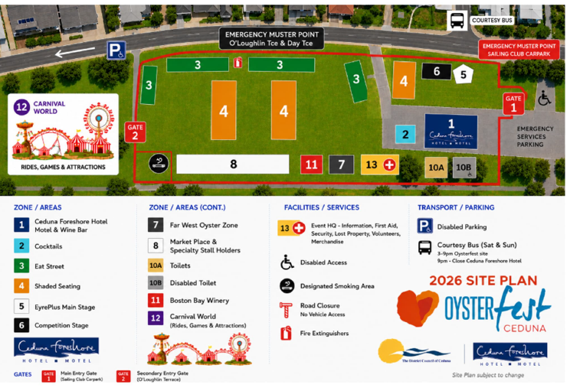
Map

Local Government Instruments

City of Salisbury
Disposal of Abandoned Vehicles
Notice is hereby given that in accordance with the powers contained in Section 237(2) of the Local Government Act 1999, Council has impounded the following vehicle(s):
• Ford Sedan Green WHM773—Gateway Drive, Salisbury Heights.
Unless claimed by the owner(s), and all expenses paid, the vehicle(s) will be disposed of in the manner provided in the above Act, at the expiration of 1 month of the date of this notice.
For further information, please contact the Inspectorate Services Section on 8406 8222.
Dated: 3 September 2026
John Harry
Chief Executive Officer

City of Salisbury
Disposal of Abandoned Vehicles
Notice is hereby given that in accordance with the powers contained in Section 237(2) of the Local Government Act 1999, Council has impounded the following vehicle(s):
• Toyota Silver sedan WTH857—Warwick Court, Paralowie SA
Unless claimed by the owner(s), and all expenses paid, the vehicle(s) will be disposed of in the manner provided in the above Act, at the expiration of 1 month of the date of this notice.
For further information, please contact the Inspectorate Services Section on 8406 8222.
Dated: 3 September 2026
John Harry
Chief Executive Officer

City of Victor Harbor
Local Government Act 1999
Notice of Naming of Road
The City of Victor Harbor hereby gives notice pursuant to Section 219(1) of the Local Government Act 1999, and in accordance with the approval of the Chief Executive Officer on 25 August 2026, that the unnamed roads, as part of Oceane Land Division Stage 4 be named Harrier Way, Bronzewing Way, Lorikeet Road, Moorhen Road, Gannet Road, Currawong Way, Quail Road, Egret Court, Falcon Court.
A copy of this notice and further information can be obtained from the Council’s offices at 1 Bay Road, Victor Harbor SA 5211, during ordinary business hours or on the Council’s website at www.victor.sa.gov.au.
Dated: 3 September 2026
Graham Pathuis
Interim Chief Executive Officer

Town of Gawler
Local Government Act 1999
By-law No. 1 of 2026—Permits and Penalties By-law 2026
To provide for a permit system, set penalties for breaches of by-laws, provide for certain matters pertaining to liability and evidence, set regulatory requirements, clarify the construction of Council’s by-laws and for related purposes.
Part 1—Preliminary
1. Short Title
This by-law may be cited as the Permits and Penalties By-law 2026.
2. Commencement
This by-law will come into operation four months after the day on which it is published in the Gazette in accordance with Section 249(5) of the Local Government Act 1999.
3. Definitions
3.1 In any by-law of the Council, unless the contrary intention is clearly indicated:
3.1.1 authorised person means a person appointed as an authorised person pursuant to Section 260 of the Local Government Act 1999;
3.1.2 Council means the Town of Gawler;
3.1.3 drive a vehicle means to be in control of the steering, movement or propulsion of the vehicle;
3.1.4 driver of a vehicle means the person driving the vehicle;
3.1.5 motor vehicle has the same meaning as in the Road Traffic Act 1961;
3.1.6 person includes a natural person, a body corporate or incorporated association;
3.1.7 road has the same meaning as in the Local Government Act 1999;
3.1.8 vehicle has the same meaning as in the Road Traffic Act 1961 and the Australian Road Rules.
3.2 In this by-law:
3.2.1 owner has the same meaning as in the Road Traffic Act 1961;
3.2.2 prescribed offence means an offence against a by-law of the Council relating to the driving, parking or standing of vehicles.
4. Construction
Every by-law of the Council shall be subject to any Act of Parliament and Regulations made thereunder.
Part 2—Permits
5. Council May Grant Permits
If any by-law of the Council states that a person needs a ‘permit’ or ‘permission’ to do a specified thing, then the following provisions apply:
5.1 The permit must be in writing.
5.2 The Council may:
5.2.1 attach conditions to the permit;
5.2.2 change or revoke a condition, by notice in writing; or
5.2.3 add new conditions, by notice in writing.
5.3 A person who holds a permit must comply with every condition attached to it. Failure to do so constitutes a breach of this by-law.
5.4 The Council may revoke a permit, by notice in writing, if:
5.4.1 the holder of the permit fails to comply with a condition attached to it; or
5.4.2 the permit is of a continuing nature, and the Council has reasonable grounds for revoking it.
5.5 The Council may, by resolution, fix, vary or revoke fees or charges for the granting of a permit to do a specified thing.
Part 3—Enforcement
6. Penalties
6.1 A person who contravenes or fails to comply with any by-law of the Council is guilty of an offence and is liable to a maximum penalty, being the maximum penalty referred to in the Local Government Act 1999, which may be fixed for offences against a by-law.
6.2 A person who is convicted of an offence against any by-law of the Council in respect of a continuing act or omission is liable, in addition to the penalty otherwise applicable, to a further penalty, being the maximum penalty referred to in the Local Government Act 1999 which may be fixed for offences of a continuing nature against a by-law.
7. Liability of Vehicles Owners and Expiation of Certain Offences
7.1 Without derogating from the liability of any other person, but subject to this paragraph, if a vehicle is involved in a prescribed offence, the owner of the vehicle is guilty of an offence and liable to the same penalty as is prescribed for the principal offence and the expiation fee that is fixed for the principal offence applies in relation to an offence against this paragraph.
7.2 The owner and driver of a vehicle are not both liable through the operation of this paragraph to be convicted of an offence arising out of the same circumstances, and consequently conviction of the owner exonerates the driver and conversely conviction of the driver exonerates the owner.
7.3 An expiation notice or expiation reminder notice given under the Expiation of Offences Act 1996 to the owner of a vehicle for an alleged prescribed offence involving the vehicle must be accompanied by a notice inviting the owner, if they were not the driver at the time of the alleged prescribed offence, to provide the Council or officer specified in the notice, within the period specified in the notice, with a statutory declaration:
7.3.1 setting out the name and address of the driver; or
7.3.2 if they had transferred ownership of the vehicle to another prior to the time of the alleged offence and has complied with the Motor Vehicles Act 1959 in respect of the transfer—setting out details of the transfer (including the name and address of the transferee).
7.4 Before proceedings are commenced against the owner of a vehicle for an offence against this section involving the vehicle, the Informant must send the owner a notice:
7.4.1 setting out particulars of the alleged prescribed offence; and
7.4.2 inviting the owner, if he or she was not the driver at the time of the alleged prescribed offence, to provide the Informant, within 21 days of the date of the notice, with a statutory declaration setting out the matters referred to in subparagraph 7.3.
7.5 Subparagraph 7.4 does not apply to:
7.5.1 proceedings commenced where an owner has elected under the Expiation of Offences Act 1996 to be prosecuted for the offence; or
7.5.2 proceedings commenced against an owner of a vehicle who has been named in a statutory declaration under this section as the driver of the vehicle.
7.6 Subject to subparagraph 7.7, in proceedings against the owner of a vehicle for an offence against this paragraph, it is a defence to prove:
7.6.1 that, in consequence of some unlawful act, the vehicle was not in the possession or control of the owner at the time of the alleged prescribed offence; or
7.6.2 that the owner provided the Informant with a statutory declaration in accordance with an invitation under this paragraph.
7.7 The defence in paragraph 7.6.2 does not apply if it is proved that the owner made the declaration knowing it to be false in a material particular.
7.8 If:
7.8.1 an expiation notice is given to a person named as the alleged driver in a statutory declaration under this paragraph; or
7.8.2 proceedings are commenced against a person named as the alleged driver in such a statutory declaration,
the notice or information, as the case may be, must be accompanied by a notice setting out particulars of the statutory declaration that named the person as the alleged driver.
7.9 The particulars of the statutory declaration provided to the person named as the alleged driver must not include the address of the person who provided the statutory declaration.
8. Evidence
In proceedings for a prescribed offence, an allegation in an information that:
8.1 a specified place was a road or local government land; or
8.2 a specified vehicle was driven, parked or left standing in a specified place; or
8.3 a specified vehicle was parked or left standing for the purposes of soliciting business from a person or offering or exposing goods for sale; or
8.4 a specified place was not formed or otherwise set aside by the Council for the purposes of the driving, parking or standing of vehicles; or
8.5 a specified person was an authorised person; or
8.6 a specified provision was a condition of a specified permit granted under paragraph 5 of this by-law; or
8.7 a specified person was the owner or driver of a specified vehicle; or
8.8 a person named in a statutory declaration under paragraph 7 of this by-law for the prescribed offence to which the declaration relates was the driver of the vehicle at the time at which the alleged offence was committed; or
8.9 an owner or driver of a vehicle for a prescribed offence was given notice under paragraph 7 of this by-law on a specified day,
is proof of the matters so alleged in the absence of proof to the contrary.
Part 4—Miscellaneous
9. Revocation
Council’s By-law No. 1—Permits and Penalties, published in the Gazette on 4 July 2019, is revoked on the day on which this by-law comes into operation.
The foregoing by-law was duly made and passed at a meeting of the Town of Gawler held on the 25th day of August 2026 by an absolute majority of the members for the time being constituting the Council, there being at least two thirds of the members present.
Dated: 3 September 2026
Chris Cowley
Chief Executive Officer

Town of Gawler
Local Government Act 1999
By-law No. 2 of 2026—Moveable Signs By-law 2026
To set standards for moveable signs on roads and to provide conditions for the appearance and placement of such signs.
Part 1—Preliminary
1. Short Title
This by-law may be cited as the Moveable Signs By-law 2026.
2. Commencement
This by-law will come into operation four months after the day on which it is published in the Gazette in accordance with
Section 249(5) of the Act.
3. Definitions
In this by-law:
3.1 banner means a moveable sign constituted of a strip of cloth, plastic or other material hung or attached to a pole, fence or other structure;
3.2 business means the business to which a moveable sign relates;
3.3 business premises means the premises from which a business, trade or calling is conducted;
3.4 footpath area means:
3.4.1 that part of the road between the property boundary of the road and the edge of the carriageway on the same side as that boundary; or
3.4.2 a footway, laneway or other place made or constructed for the use of pedestrians and not for the use of vehicles;
3.5 moveable sign has the same meaning as in the Local Government Act 1999;
3.6 road has the same meaning as in the Local Government Act 1999.
Part 2—Provisions Applicable to Moveable Signs
4. Design and Construction
A moveable sign must:
4.1 in the case of an ‘A’ frame or sandwich board sign:
4.1.1 be hinged or joined at the top;
4.1.2 be of such construction that its sides can be and are securely fixed or locked in position when erected;
4.2 in the case of an inverted ‘T’ sign, contain no struts or members than run between the display area of the sign and the base of the sign;
4.3 be designed, constructed and maintained in good condition so as not to present a hazard to any member of the public;
4.4 be of strong construction so as to be stable when in position and to be able to keep its position in adverse weather conditions;
4.5 not contain any sharp or jagged edges or corners;
4.6 not be unsightly or offensive in appearance or content;
4.7 not rotate or contain moving parts;
4.8 be constructed of timber, cloth, metal, plastic or plastic coated cardboard, or a mixture of such materials;
4.9 not contain flashing lights or be illuminated internally;
4.10 not be more than 1 metre high, 600mm wide and 600mm deep;
4.11 not have a display area exceeding 1 square metre in total or, if the sign is two sided, 1 square metre on each side; and
4.12 be stable when in position.
5. Appearance
A moveable sign must, in the reasonable opinion of an authorised person:
5.1 be painted or otherwise detailed in a competent and professional manner;
5.2 be aesthetically appealing, legible and simply worded to convey a precise message;
5.3 be of such design and contain such colours as are compatible with the architectural design of the premises adjacent to the sign, and which relate well to the townscape and overall amenity of the locality in which it is situated and not detract from or conflict with traffic, safety or direction signs or signals; and
5.4 contain combinations of colour and typographical styles which blend in with and reinforce the heritage qualities of the locality and the buildings where it is situated;
5.5 not have attached any balloons, flags, streamers or other things.
6. Placement
A moveable sign must:
6.1 only be placed on the footpath area of a road;
6.2 where there is no kerb to define the footpath area, be set back from the edge of the carriageway by no less than 600mm;
6.3 in the case of a flat sign, the message of which only contains newspaper headlines and the name of a newspaper, be in line with and against the business to which it relates;
6.4 be no less than 2 metres from any structure, fixed object, tree, bush or plant (including another moveable sign);
6.5 be placed directly in front of the business premises to which it relates;
6.6 not be placed on a sealed part of any footpath area unless the sealed part is wide enough to contain the sign and still leave a clear thoroughfare of at least 1.2 metres;
6.7 not be placed within 10 metres of the corner of a road;
6.8 be adjacent to the premises of the business to which it relates;
6.9 not be placed on a landscaped area;
6.10 not be placed on a designated parking area or within 1 metre of an entrance to or exit from premises; and
6.11 not unreasonably restrict the use of the footpath area.
7. Restrictions
A moveable sign must:
7.1 only display material which advertises a business being conducted on commercial premises adjacent to the sign or the products available from that business;
7.2 be limited in number to one moveable sign per business premises;
7.3 only be displayed when the business to which it relates is open to the public;
7.4 be securely fixed in position such that it cannot be blown over or swept away;
7.5 not be placed in such a position or in such circumstances that the safety of any user of the road is at risk;
7.6 not be displayed during the hours of darkness unless it is in a clearly lit area and is clearly visible; and
7.7 not to be displayed on a median strip, traffic island or on a carriageway of a street or road.
8. Banners
A person must not erect or display a banner on a building or structure on a road without the Council’s permission.
Part 3—Enforcement
9. Removal of Non-complying Moveable Signs
9.1 If:
9.1.1 a moveable sign has been placed on any road or footpath in contravention of this by-law or of Sections 226 or 226A of the Local Government Act 1999, an authorised person may order the owner of the sign to remove the moveable sign from the road or footpath;
9.1.2 the authorised person cannot find the owner, or the owner fails to comply immediately with the order, the authorised person may remove and dispose of the sign;
9.1.3 a moveable sign is removed under subparagraph 9.1.2 of this by-law and is not claimed within 30 days of such removal the authorised person may sell, destroy or otherwise dispose of the moveable sign as the authorised person thinks fit.
9.2 Any person who displays an unauthorised moveable sign or who is the owner of an unauthorised moveable sign which has been removed under subparagraph 9.1 of this by-law must pay the Council any reasonable costs incurred in removing, storing or attempting to dispose of the moveable sign before being entitled to recover the moveable sign.
10. Removal of Complying Moveable Signs
10.1 The owner of, or other person responsible for, a moveable sign must remove or relocate the moveable sign at the request of an authorised person if, in the reasonable opinion of that authorised person, and notwithstanding compliance with this by-law, there is any hazard or obstruction or there is likely to be a hazard or obstruction arising out of the location of the moveable sign.
10.2 The owner of, or other person responsible for, a moveable sign must remove or relocate the moveable sign at the request of an authorised person for the purpose of special events, parades, road works or in any other circumstances which, in the reasonable opinion of the authorised person, requires relocation or removal of the moveable sign to protect public safety or to protect or enhance the amenity of a particular locality.
Part 4—Miscellaneous
11. Specified Exemptions
11.1 This by-law does not apply to a moveable sign which:
11.1.1 is a moveable sign that is placed on a public road pursuant to an authorisation under the Local Government Act 1999 or another Act;
11.1.2 directs people to the open inspection of any land or building that is available for purchase or lease;
11.1.3 directs people to a garage sale that is being held on residential premises;
11.1.4 directs people to a charitable function;
11.1.5 is related to a State or Commonwealth election and is otherwise authorised to be exhibited under Sections 226 and 226A of the Local Government Act 1999 or the Electoral Act 1985;
11.1.6 is related to an election held under the Local Government Act 1999 or the Local Government (Elections) Act 1999 and is otherwise authorised to be exhibited under Section 226 of the Local Government Act 1999;
11.1.7 is related to a referendum and is displayed during the course and for the purpose of that referendum;
11.1.8 is displayed with permission of the Council and in accordance with any conditions attached to that permission; or
11.1.9 is a sign of a class prescribed in regulations.
11.2 Clauses 7.1, 7.2 and 7.3 of this By-law do not apply to a flat sign containing only the banner or headlines of a newspaper or magazine.
12. Prohibition
12.1 The Council may, by resolution, prohibit the display of moveable signs on a road or part of road subject to this clause.
12.2 A resolution made by the Council under sub-clause 12.1 may prohibit the display of moveable signs absolutely, or at particular times or on particular days.
12.3 The Council may only make a resolution under sub-clause 12.1 if, in the opinion of the Council, the display of movable signs on the road would endanger the safety of road users, be incompatible with the amenity of a particular locality, or otherwise be unsuitable.
12.4 Notwithstanding any other clause of this by-law, a person must not display a moveable sign on a road or part of a road contrary to a prohibition made by the Council under this clause.
13. Revocation
Council’s By-law No. 2—Moveable Signs, published in the Gazette on 4 July 2019, is revoked on the day on which this by-law comes into operation.
The foregoing by-law was duly made and passed at a meeting of the Town of Gawler held on the 25th day of August 2026 by an absolute majority of the members for the time being constituting the Council, there being at least two thirds of the members present.
Dated: 3 September 2026
Chris Cowley
Chief Executive Officer

Town of Gawler
Local Government Act 1999
By-law No. 3 of 2026—Roads By-law 2026
For the management, control and regulation of activities on roads in the Council’s area.
Part 1—Preliminary
1. Short Title
This by-law may be cited as the Roads By-law 2026
2. Commencement
This by-law will come into operation four months after the day on which it is published in the Gazette in accordance with Section 249(5) of the Act.
3. Interpretation
In this by-law:
3.1 animal includes birds and poultry but does not include a dog;
3.2 camp includes setting up a camp, or causing a tent, caravan or motorhome to remain on the land for the purpose of staying overnight, whether or not any person is in attendance or sleeps on the land;
3.3 effective control means a person exercising effective control of an animal either:
3.3.1 by means of a physical restraint;
3.3.2 by command, the animal being in close proximity to the person, and the person being able to see the animal at all times;
3.4 electoral matter has the same meaning as in the Electoral Act 1985 provided that such electoral matter is not capable of causing physical damage or injury to any person within its immediate vicinity;
3.5 emergency worker has the same meaning as in the Road Traffic (Road Rules—Ancillary and Miscellaneous Provisions) Regulations 2014;
3.6 model aircraft includes a drone;
3.7 moveable sign has the same meaning as in the Local Government Act 1999; and
3.8 township has the same meaning as in the Local Government Act 1999.

Part 2—Management of Roads
4. Activities Requiring Permission
A person must not on any road, without the permission of the Council:
4.1 Advertising
4.1.1 display any sign for the purpose of commercial advertising, other than a moveable sign which is displayed on a public road in accordance with the Council’s Moveable Signs By-law 2026;
4.1.2 place or maintain any goods on the road or park or stand a vehicle on the road for the purpose of:
4.1.2.1 soliciting any business from any person; or
4.1.2.2 offering or exposing goods or services for sale; or
4.1.2.3 conveying any advertising, religious or other message to any bystander, passerby or other person,
provided that this subparagraph 4.1.2 shall not apply to a person who is simply travelling along a road;
4.2 Amplification
use an amplifier or other device whether mechanical or electrical for the purpose of amplifying sound to the public;
4.3 Animals
4.3.1 cause or allow any animal, to stray onto, graze, wander on or be left unattended on any road except where the Council has set aside a track or other area for use by or in connection with an animal of that kind and, then only if under the effective control of a person;
4.3.2 lead, drive or exercise any animal in such a manner as to endanger the safety of any person;
4.4 Annoyance
do anything likely to offend or unreasonably interfere with any other person:
4.4.1 using the road; or
4.4.2 occupying nearby premises,
by making a noise or creating a disturbance;
4.5 Bridge Jumping
jump from or dive from a bridge;
4.6 Camping
4.6.1 erect any tent or other structure of calico, canvas, plastic or similar material as a place of habitation;
4.6.2 camp or remain overnight; or
4.6.3 camp in a motorhome, except where a sign or signs erected by the Council indicates that camping on the road in such a vehicle is permitted;
4.7 Defacing Property
deface, paint, spray, write, cut names, letters or make marks on any tree, rock, gate, fence, building, sign, bridge or other property of the Council;
4.8 Dispose of Dead Animals
dispose of any dead animals or part thereof in any Council rubbish bin;
4.9 Distributing
distribute any handbill, book, notice, leaflet, or other printed matter to any bystander, passer-by or other person;
4.10 Donations
ask for or receive or indicate that they desire a donation of money or any other thing or otherwise solicit for charitable purposes;
4.11 Exhibition or Display
4.11.1 sing, busk or play any recording or musical instrument for the apparent purpose of either entertaining others or receiving money;
4.11.2 conduct or hold any concert, festival, show, public gathering, street party, circus, meeting, performance or other similar activity;
4.11.3 cause any public exhibitions or displays;
4.12 Fires
light any fire except:
4.12.1 in a place provided by the Council for that purpose; or
4.12.2 in a portable barbeque, as long as the barbeque is used in an area that is clear of flammable material for a distance of at least four metres; and
4.12.3 in accordance with the Fire and Emergency Services Act 2005;
4.13 Fireworks
ignite, explode or use any fireworks or rockets;
4.14 Fishing
fish from any bridge or other structure on a road to which the Council has resolved this subparagraph shall apply;
4.15 Flora and Fauna
subject to the Native Vegetation Act 1991 and the National Parks and Wildlife Act 1972:
4.15.1 damage, pick, disturb, interfere with or remove any plant or flower;
4.15.2 lead or drive any animal, or stand or walk, on any flower bed or garden plot;
4.15.3 deposit, dig, damage, disturb, interfere with or remove any soil, stone, wood, clay, gravel, pebbles, timber, bark or other organic material from the road;
4.15.4 take, interfere with, tease, harm or disturb any animal or the eggs or young of any animal;
4.15.5 disturb, interfere with or damage any burrow, nest or habitat of any animal;
4.15.6 use, possess or have control of any device for the purpose of killing or capturing any animal;
4.15.7 burn any timber or dead wood;
4.16 Games
4.16.1 promote, organise or participate in any game, recreation or amusement which involves the use of a ball, missile or other object which by the use thereof may cause or be likely to cause injury or discomfort to any person being on or in the vicinity of that road or detract from or be likely to detract from another person’s lawful use and enjoyment of that road;
4.16.2 fly any model aircraft;
4.16.3 participate in any game, recreation or amusement which is likely to cause damage to lawns, gardens, trees or other property; or
4.16.4 participate in any game, recreation or event where the Council has caused a notice to be erected indicating the playing of such a game, recreation or event is prohibited;
4.17 Overhanging Articles
suspend or hang any article or thing from any building, verandah, pergola, post or other structure where it might present a nuisance or danger to any person using a road;
4.18 Picking Fruit
pick, collect, take, interfere with or disturb any fruit, nuts, berries or native seeds;
4.19 Preaching
preach, harangue or otherwise solicit for religious purposes;
4.20 Repairs to Vehicles
perform the work of repairing, washing, painting, panel beating or other work of any nature on or to any vehicle, except for running repairs in the case of breakdown;
4.21 Rubbish Bins
4.18.1 deposit any domestic or commercial waste or other rubbish emanating from domestic or commercial premises in any Council rubbish bin;
4.18.2 remove, dispense or interfere with any rubbish (including bottles, newspapers, cans, containers or packaging) that has been discarded in a Council rubbish bin;
4.22 Solicitation
tout or solicit customers for the parking of vehicles or for any other purpose;
4.23 Use of Equipment
use any item of equipment and/or facilities or other Council property:
4.23.1 other than in the manner and for the purpose for which it was designed or set aside; and
4.23.2 where any nearby sign states the conditions of use, except in accordance with such conditions.
Part 3—Miscellaneous
5. Directions
A person must comply with any reasonable direction or request from an authorised person relating to:
5.1 that person’s use of the road;
5.2 that person’s conduct and behaviour on the road;
5.3 that person’s safety on the road;
5.4 the safety and enjoyment of other persons on the road; and
5.5 the possible damage to lawn, grass, trees, shrubs, buildings, structures or objects on the road.
6. Removal of Animals and Directions to Persons
6.1 If any animal is found on a road in breach of a by-law any person in charge of the animal shall remove it on the request of an authorised person.
6.2 An authorised person may:
6.2.1 remove the animal if a person fails to comply with the request, or if no person is in charge of the animal;
6.2.2 direct any person who is considered to be committing or has committed a breach of this by-law to leave that part of the road, and failure to comply with that direction forthwith is a breach of this by-law; and
6.2.3 direct any person who is considered to be committing or has committed a breach of this by-law to cease that action and to take specified action to remedy the breach.
7. Exemptions
7.1 The restrictions in this by-law do not apply to any Police Officer, Council Officer or Council employee acting in the course and within the scope of that person’s normal duties, or to a contractor while performing work for the Council and while acting under the supervision of a Council Officer, or to an emergency worker performing emergency duties.
7.2 The restrictions in paragraph 4.1.2.3, 4.2, 4.8, 4.10.2 and 4.10.3 of this by-law do not apply to:
7.2.1 electoral matters authorised by a candidate related to a State or Commonwealth election that are otherwise authorised to be exhibited under Sections 226 or 226A of the Local Government Act 1999 or the Electoral Act 1985;
7.2.2 electoral matters authorised by a candidate related to an election held under the Local Government Act 1999 or the Local Government (Elections) Act 1999 that are otherwise authorised to be exhibited under Section 226 of the Local Government Act 1999; or
7.2.3 matters which relate to and occur during the course of and for the purpose of a referendum.
8. Application
Subparagraph 4.14 of this by-law shall apply only in such portion or portions of the area as the Council may by resolution direct from time to time in accordance with Section 246(3)(e) of the Local Government Act 1999.
9. Revocation
Council’s By-law No. 3—Roads, published in the Gazette on 4 July 2019, is revoked on the day on which this by-law comes into operation.
The foregoing by-law was duly made and passed at a meeting of the Town of Gawler held on the 25th day of August 2026 by an absolute majority of the members for the time being constituting the Council, there being at least two thirds of the members present.
Dated: 3 September 2026
Chris Cowley
Chief Executive Officer

Town of Gawler
Local Government Act 1999
By-law No. 4 of 2026—Local Government Land By-law 2026
For the management and regulation of the use of and access to all land vested in or under the control of Council, including the prohibition and regulation of particular activities on local government land.
Part 1—Preliminary
1. Short Title
This by-law may be cited as the Local Government Land By-law 2026.
2. Commencement
This by-law will come into operation four months after the day on which it is published in the Gazette in accordance with
Section 249(5) of the Act.
3. Interpretation
In this by-law:
3.1 animal includes birds, insects, fish and other aquatic animals, but does not include a dog;
3.2 boat includes a raft, canoe, personal watercraft or any other similar device;
3.3 camp includes setting up a camp, or causing a tent, caravan or motorhome to remain on the land for the purpose of staying overnight, whether or not any person is in attendance or sleeps on the land;
3.4 e-cigarette means:
3.4.1 a device that is designed to generate or release an aerosol or vapour for inhalation by its user in a manner similar to the inhalation of smoke from an ignited tobacco product; or
3.4.2 a device of a kind resolved by the Council and notified by notice in the Gazette to be an e-cigarette;
3.5 electoral matter has the same meaning as in the Electoral Act 1985;
3.6 liquor has the same meaning as in the Liquor Licensing Act 1997;
3.7 local government land has the same meaning as in the Local Government Act 1999, but does not include any road;
3.8 open container means a container which:
3.8.1 after the contents thereof have been sealed at the time of manufacture and:
3.8.1.1 being a bottle, has had its cap, cork or top removed (whether or not it has since been replaced);
3.8.1.2 being a can, has been opened or punctured;
3.8.1.3 being a cask, has had its tap placed in a position to allow it to be used;
3.8.1.4 being any other form of container, has been opened, broken, punctured or manipulated in such a way as to allow access to the contents thereof; or
3.8.2 is a flask, glass, mug or other container used for drinking purposes;
3.9 park has the same meaning as in the Local Government Act 1999;
3.10 public place has the same meaning as in the Local Government Act 1999;
3.11 reserve has the same meaning as in the Local Government Act 1999; and
3.12 smoke means:
3.12.1 in relation to a tobacco product, smoke, hold, or otherwise have control over, an ignited tobacco product; or
3.12.2 in relation to an e-cigarette, to inhale from, hold or otherwise have control over, an e-cigarette that is in use;
3.13 waters means any body of water, including a pond, lake, river, creek or wetland, under the care, control and management of the Council.
Part 2—Management of Local Government Land
4. Activities Requiring Permission
A person must not on any local government land, without the permission of the Council:
4.1 Advertising
display any sign for the purpose of commercial advertising other than a moveable sign which is displayed in accordance with the Moveable Signs By-law 2026;
4.2 Amplification
use an amplifier or other device, whether mechanical or electrical, for the purpose of amplifying sound to the public;
4.3 Animals
4.3.1 cause or allow any animal to stray onto, move over, graze or be left unattended;
4.3.2 cause or allow any animal to enter, swim, bathe or remain in any waters located on local government land to which the Council has resolved this subparagraph shall apply;
4.3.3 lead or drive a horse, cattle or sheep, except where the Council has set aside a track or other area for use by or in connection with an animal of that kind;
4.4 Annoyance
do anything likely to offend or unreasonably interfere with any other person:
4.4.1 using that land; or
4.4.2 occupying nearby premises,
by making a noise or creating a disturbance;
4.5 Aquatic Life
introduce any aquatic life to any waters;
4.6 Athletic and Ball Sports
4.6.1 promote, organise or take part in any organised athletic sport;
4.6.2 play any organised competition sport, as distinct from organised social play;
4.6.3 play or practise the game of golf;
4.7 Attachments to Trees etc.
attach, hang or fix any rug, blanket, sheet, rope or other material to any tree, shrub, plant, tree guard, notice board, seat, fence, post or other item or structure;
4.8 Bees
place, or allow to remain, any bee hive;
4.9 Boats
subject to the provisions of the Harbors and Navigation Act 1993 and the Marine Safety (Domestic Commercial Vessel) National Law and to which the Council has resolved the subparagraph shall apply:
4.9.1 hire, offer for hire or use for commercial purposes a boat, raft, pontoon or other watercraft;
4.9.2 launch or retrieve a boat, raft, pontoon or other watercraft to or from any waters;
4.9.3 propel, float or otherwise use any boat, raft, pontoon or other watercraft on any waters;
4.9.4 tie or affix a boat to any jetty;
4.10 Bridge and Jetty Jumping
4.10.1 jump from or dive from any bridge;
4.10.2 jump or dive from any jetty to which the Council has resolved this subparagraph applies;
4.11 Buildings and Structures
4.11.1 erect or install a building;
4.11.2 use a building or structure other than for its intended purpose;
4.12 Camping and Tents
4.12.1 camp or stay overnight, other than in an area which has been set aside by the Council for camping purposes and, in accordance with any conditions that may be determined by resolution of the Council and contained in any signage erected thereon; or
4.12.2 erect any tent, booth, marquee or other structure for the purpose of habitation; or
4.12.3 camp in a motorhome, except where a sign or signs erected by the Council indicates that camping on the land in such a vehicle is permitted;
4.13 Canvassing and Preaching
preach, canvass, harangue or otherwise solicit for religious purposes except on any land or part thereof where the Council has, by resolution, determined this restriction shall not apply;
4.14 Cemeteries
comprising a cemetery:
4.14.1 bury or inter any human or animal remains;
4.14.2 erect any memorial;
4.15 Closed Lands
enter or remain on any part of local government land:
4.15.1 at any time during which the Council has declared that part to be closed to the public and which closure is indicated by a sign on or adjacent to that land to that effect;
4.15.2 where land is enclosed with fences and/or walls and gates, at any time when the gates have been closed and locked; or
4.15.3 where admission charges are payable to enter without paying those charges;
4.16 Defacing Property
deface, paint, spray, write, cut names, letters or make marks on any tree, rock, gate, fence, building, sign, bridge or other property of the Council;
4.17 Dispose of Dead Animals
dispose of any dead animals or part thereof in any Council rubbish bin;
4.18 Distributing
distribute any handbill, book, notice, leaflet, or other printed matter to any bystander, passer-by or other person;
4.19 Donations
ask for, receive or indicate that they desire, a donation of money or any other thing;
4.20 Encroachment
erect or place any fencing, posts or other structures or any other items or substances so as to encroach onto the land;
4.21 Entertaining
4.21.1 sing, busk or play a recording or musical instrument for the purpose of, or so as to appear to be for the purpose of, entertaining others whether or not receiving money;
4.21.2 conduct or hold any concert, festival, show, public gathering, circus, meeting, performance or other similar activity;
4.22 Filming
conduct or participate in any filming where the filming is for a commercial purpose;
4.23 Fires
light any fire except:
4.23.1 in a place provided by the Council for that purpose; or
4.23.2 in a portable barbecue, as long as the barbecue is used in an area that is clear of flammable material for a distance of at least four metres; and
4.23.3 in accordance with the Fire and Emergency Services Act 2005;
4.24 Fireworks
ignite, explode or use any fireworks or rockets;
4.25 Fishing
4.25.1 fish in any waters on local government land to which the Council has resolved this subparagraph shall apply; or
4.25.2 fish from any bridge or other structure on local government land to which the Council has resolved this subparagraph shall apply;
4.26 Flora and Fauna
subject to the Native Vegetation Act 1991 and the National Parks and Wildlife Act 1972:
4.26.1 damage, pick, disturb, interfere with or remove any plant or flower;
4.26.2 lead or drive any animal, or stand or walk, on any flower bed or garden plot;
4.26.3 deposit, dig, damage, disturb, interfere with or remove any soil, stone, wood, clay, gravel, pebbles, timber, bark or any part of the land;
4.26.4 take, interfere with, tease, harm or disturb any animal or the eggs or young of any animal;
4.26.5 disturb, interfere with or damage any burrow, nest or habitat of any animal;
4.26.6 use, possess or have control of any device for the purpose of killing or capturing any animal;
4.26.7 burn any timber or dead wood;
4.27 Games
4.27.1 promote, organise or participate in any game, recreation or amusement which involves the use of a ball, missile or other object which by the use thereof may cause or be likely to cause injury or discomfort to any person being on or in the vicinity of that land or detract from or be likely to detract from another person’s lawful use and enjoyment of that land;
4.27.2 fly any model aircraft, drone or operate any power model boat;
4.27.3 participate in any game, recreation or amusement which is likely to cause damage to lawns, gardens, trees or other property; or
4.27.4 participate in any game, recreation or event where the Council has caused a notice to be erected indicating the playing of such a game, recreation or event is prohibited,
and, where taking part in any of the activities referred to in subparagraphs 4.22.1, 4.22.2, 4.22.3 or 4.22.4, all persons must cease those activities in favour of other persons making use of the land unless in a designated sporting area identified by goal posts, cricket pitches or similar equipment or improvements;
4.28 Kites
fly a kite in an area that Council has resolved this subparagraph will apply;
4.29 Liquor
excepting sealed containers, consume, carry or be in possession or charge of any liquor in an open container between the hours of 9:00pm on any day and 9:00am on the day immediately following (provided the land constitutes a park or reserve) except on premises in respect of which a licence is in force pursuant to the Liquor Licensing Act 1997;

4.30 Overhanging Articles
suspend or hang any article or thing from any building, verandah, pergola, post or other structure where it might present a nuisance or danger to any person using local government land;
4.31 Picking Fruit
pick fruit, nuts or berries or native seeds from any trees or bushes;
4.32 Removing Soil
carry away or remove any soil, sand, clay, timber, stones, pebbles, gravel, other organic or inorganic materials or any part of the land;
4.33 Repairs to Vehicles
perform the work of repairing, washing, painting, panel beating or other work of any nature on or to any vehicle, except running repairs in the case of breakdown;
4.34 Rubbish Dumps and Rubbish Bins
4.34.1 interfere with, remove or take away any rubbish that has been discarded at any rubbish dump;
4.34.2 remove, dispense or interfere with any rubbish (including bottles, newspapers, cans, containers or packaging) that has been discarded in a Council rubbish bin;
4.35 Smoking
4.35.1 smoke tobacco or any other substance in any building;
4.35.2 smoke tobacco or any other substance on any local government land or part thereof to which the Council has resolved this subparagraph shall apply;
4.36 Structures
erect or allow to remain erected any bouncing castles or other similar inflatable structure, shed, tent, hut or other structure provided that this sub-paragraph does not apply to the erection of any portable shading cover placed on the land for no longer than any eight hour period and not overnight, provided no pegs are used to stabilise such cover;
4.37 Swimming and Aquatic Activity
enter, swim or engage in any aquatic activity in or on any waters except:
4.37.1 waters that the Council has set aside for that purpose; or
4.37.2 in an area where a nearby sign states that such activity is allowed and in accordance with any conditions stated in the sign;
4.38 Trading
4.38.1 carry on the business of buying, selling, offering or exposing for sale or the hiring or leasing of any goods, merchandise, commodity, article, service or thing including, but not limited to, any vehicle, watercraft or aircraft;
4.38.2 set up a van or other vehicle, stall, stand, table or other structure, tray, carpet or device for the apparent purpose of buying, selling, offering, displaying or exposing for sale or the hiring or leasing of any goods, merchandise, commodity, article, service or thing including, but not limited to, any vehicle, watercraft or aircraft;
4.39 Vehicles
4.39.1 drive or propel any vehicle on local government land unless on an area or road that is constructed or set aside by the Council for that purpose;
4.39.2 ride a bicycle in an area where the Council has resolved that this subparagraph shall apply;
4.40 Weddings, Funerals or Special Events
hold, conduct or participate in a marriage ceremony, game, picnic, other event or entertainment on any local government land except where the number of persons attending the event or entertainment does not exceed sixty.
5. Prohibited Activities
A person must not on any local government land:
5.1 Glass
wilfully break any glass, china or other brittle material;
5.2 Interference with Land
5.2.1 interfere with the land such as levelling or flattening land, planting grass, lawn or other vegetation, paving the land, or otherwise use the land in a manner contrary to the purpose for which the land was designed to be used; or
5.2.2 destroy, damage or deface, or cause or permit to be destroyed, damaged or defaced any local government land or any article, structure, building or thing fixed thereto;
5.3 Interference with Permitted Use
interrupt, disrupt or interfere with any person’s use of parks or reserves for which permission has been granted;
5.4 Missiles
throw, roll or discharge any stone, substance or missile to the danger of any person or animal;
5.5 Nuisance
behave in an unreasonable manner so as to cause discomfort, inconvenience, annoyance or offence to any other person including by using profane, indecent or obscene language;
5.6 Obstruction
obstruct:
5.6.1 any footpath or bicycle track;
5.6.2 any door, entrance, stairway or aisle in any building; or
5.6.3 any gate or entrance;
5.7 Public Conveniences
in any public convenience:
5.7.1 urinate other than in a urinal or pan or defecate other than in a pan provided for that purpose;
5.7.2 smoke tobacco or any other substance;
5.7.3 deposit anything in a pan, urinal or drain which is likely to cause a blockage;
5.7.4 use it for a purpose for which it was not designed or constructed;
5.7.5 subject to paragraph 5.7.6, enter the public convenience unless the person is of the gender indicated in writing or on a sign located on the public convenience;
5.7.6 paragraph 5.7.5 does not apply:
5.7.6.1 in a genuine emergency; or
5.7.6.2 to a vulnerable person being assisted by the vulnerable person’s caregiver, parent or guardian; or
5.7.6.3 to a person that is intersex, transgender or gender diverse; or
5.7.6.4 to a person with a disability; or
5.7.6.5 to a person assisting a person with a disability;
5.8 Solicitation
tout or solicit customers for the parking of vehicles or for any other purpose;
5.9 Use of Equipment
use any item of equipment and/or facilities or other Council property:
5.9.1 other than in the manner and for the purpose for which it was designed or set aside; and
5.9.2 where any nearby sign states the conditions of use, except in accordance with such conditions;
5.10 Waste
deposit any domestic or commercial waste or other rubbish emanating from domestic or commercial premises in any Council rubbish bin.
6. Removal of Encroachment or Interference
Any person who encroaches onto or interferes with local government land contrary to this by-law must, at the request of an authorised person, whether verbal or written, cease the encroachment or interference and remove the source of the encroachment or interference and reinstate the land to the same standard as the state of the land prior to the encroachment or interference.
7. Council May Do Work
If a person fails to remove an encroachment or interference on local government land in accordance with a request of an authorised person pursuant to paragraph 6 of this by-law, the Council may:
7.1 undertake the work itself; and
7.2 recover the cost of doing so from that person.
Part 3—Miscellaneous
8. Directions
Any person on local government land must comply with any reasonable direction or request from an authorised person relating to:
8.1 that person’s use of the land;
8.2 that person’s conduct and behaviour on the land;
8.3 that person’s safety on the land;
8.4 the safety of other persons on the land;
8.5 the enjoyment of the land by other persons; and
8.6 the possible damage to lawn, grass, trees, shrubs, buildings, structures or objects on the land.
9. Removal of Animals and Directions to Persons
9.1 If any animal, person or object is found on any local government land in breach of a by-law:
9.1.1 any person in charge of the animal, person or object shall remove it from the local government land on the request of an authorised person; and
9.1.2 an authorised person may remove the animal or object from the land if a person fails to comply with the request, or if no person is in charge of it.
9.2 Any person who is committing or has committed a breach of this by-law must immediately comply with a direction of an authorised person to leave the local government land.
10. Exemptions
10.1 The restrictions in this by-law do not apply to any Police Officer, Council Officer or Council employee acting in the course and within the scope of that person’s normal duties, or to a contractor while performing work for the Council and while acting under the supervision of a Council Officer, or to an emergency worker performing emergency duties.
10.2 The restriction in paragraph 4.22 does not apply to any filming conducted for the purposes of gathering or reporting the news.
10.3 The restrictions in paragraphs 4.2, 4.7, 4.13, 4.18 and 4.21.2 of this by-law do not apply to:
10.3.1 electoral matters authorised by a candidate and which relate to a Commonwealth or State election and are otherwise authorised to be exhibited under Sections 226 and 226A of the Local Government Act 1999 or the Electoral Act 1985; or
10.3.2 electoral matters authorised by a candidate and which relate to an election under the Local Government Act 1999 or the Local Government (Elections) Act 1999 and is otherwise authorised to be exhibited under Section 226 of the Local Government Act 1999; or
10.3.3 matters which relate to and occur during the course of and for the purpose of a referendum.
11. Application
Any of paragraphs 4.3.2, 4.9, 4.10, 4.25, 4.28, 4.35.2 and 4.39.2 of this by-law shall apply only in such portion or portions of the area as the Council may by resolution direct from time to time in accordance with Section 246(3)(e) of the Local Government Act 1999.
Part 4—Miscellaneous
12. Revocation
Council’s By-law No. 4—Local Government Land, published in the Gazette on 4 July 2019, is revoked on the day on which this by-law comes into operation.
The foregoing by-law was duly made and passed at a meeting of the Town of Gawler held on the 25th day of August 2026 by an absolute majority of the members for the time being constituting the Council, there being at least two thirds of the members present.
Dated: 3 September 2026
Chris Cowley
Chief Executive Officer

Town of Gawler
Local Government Act 1999
Dog and Cat Management Act 1995
By-law No. 5 of 2026—Dogs By-law 2026
For the management and control of dogs within the Council’s area.
Part 1—Preliminary
1. Short Title
This by-law may be cited as the Dogs By-law 2026.
2. Commencement
This by-law will come into operation four months after the day on which it is published in the Gazette in accordance with Section 249(5) of the Local Government Act 1999.
3. Definitions
In this by-law:
3.1 approved kennel establishment means a building, structure or area approved by the relevant authority, pursuant to the Planning, Development and Infrastructure Act 2016 for the keeping of dogs on a temporary or permanent basis;
3.2 assistance dog has the same meaning as in the Dog and Cat Management Act 1995 and the Disability Discrimination Act 1992;
3.3 control, in relation to a dog, includes the person having ownership, possession or charge of, or authority over, the dog;
3.4 dog has the same meaning as in the Dog and Cat Management Act 1995;
3.5 effective control means a person exercising effective control of a dog either:
3.5.1 by means of a physical restraint;
3.5.2 by command, the dog being in close proximity to the person, and the person being able to see the dog at all times;
3.6 keep includes the provision of food or shelter;
3.7 leash includes any chain, cord or leash;
3.8 local government land has the same meaning as in the Local Government Act 1999;
3.9 park has the same meaning as in the Dog and Cat Management Act 1995;
3.10 premises includes:
3.10.1 land;
3.10.2 a part of any premises or land;
3.11 public place has the same meaning as in the Dog and Cat Management Act 1995.
3.12 small premises means a self-contained residence that is:
3.12.1 a residential flat building;
3.12.2 contained in a separate strata unit;
3.12.3 on an allotment less than 600 square metres in area; or
3.12.4 without a secure yard of at least 100 square metres in area;
3.13 working livestock dog has the same meaning as in the Dog and Cat Management Act 1995.
Part 2—Dog Management and Control
4. Dog Free Areas
4.1 A person must not allow a dog in that person’s control to be in or remain in a dog free area.
4.2 For the purposes of this paragraph, a dog free area is any local government land or public place to which the Council has resolved this paragraph applies.
4.3 The restrictions in subparagraph 4.1 do not apply to any assistance dog.

5. Dog on Leash Areas
5.1 A person must not allow a dog under that person’s control to be in, or remain in, a dog on leash area unless the dog is secured by a strong leash not exceeding two metres in length which is either:
5.1.1 tethered securely to a fixed object capable of securing the dog; or
5.1.2 held by a person capable of controlling the dog and preventing it from being a nuisance or a danger to other persons.
5.2 For the purposes of this paragraph, a dog on leash area is any local government land or public place to which the Council has resolved that this paragraph applies.
5.3 The restrictions in subparagraph 5.1 do not apply to any assistance dog.
6. Dog Exercise Areas
6.1 Subject to paragraphs 4 and 5, a person may enter any dog exercise area for the purpose of exercising a dog under their control.
6.2 For the purposes of this paragraph, a dog exercise area is any:
6.2.1 park; or
6.2.2 local government land that the Council has resolved is a dog exercise area.
6.3 A person must ensure that any dog under their control remains under effective control while the dog is in a dog exercise area.
7. Events with Dogs
Subject to paragraphs 4, 5 and 6, a person must not, without permission, conduct, promote, organise or participate in any event involving ten or more dogs on local government land to which this paragraph applies.
8. Limit on Dog Numbers
8.1 A person must not, without permission, keep any dog on any premises where the number of dogs on the premises exceeds the prescribed limit.
8.2 Subject to subparagraph 8.3, the prescribed limit on the number of dogs to be kept on premises:
8.2.1 constituting a small premises is one dog;
8.2.2 within a township on premises other than a small premises is two dogs;
8.2.3 outside a township on premises other than a small premises is three dogs.
8.3 For the purposes of calculating the prescribed limit, the following dogs are to be disregarded:
8.3.1 any dog that is under three months of age; and
8.3.2 up to two working livestock dogs kept on premises outside a township.
8.4 The prescribed limit does not apply to:
8.4.1 an approved kennel establishment operating in accordance with all required approvals and consents;
8.4.2 a veterinary practice;
8.4.3 a pet shop;
8.4.4 any premises that the Council has exempted from the requirements of this paragraph; or
8.4.5 any business involving dogs provided that the business is registered in accordance with the Dog and Cat Management Act 1995.
Part 3—Miscellaneous
9. Application
9.1 The Council may from time to time, by resolution, identify local government land as a dog exercise area in accordance with subparagraph 6.2.2 of this by law.
9.2 Any of paragraphs 4.2, 5.2 and 7 of this by-law shall apply only in such portion or portions of the area as the Council may from time to time, by resolution, direct in accordance with Section 246 of the Local Government Act 1999.
9.3 Where the Council makes a resolution under either of subparagraphs 9.1 or 9.2, the Council’s Chief Executive Officer must ensure that:
9.3.1 the area is denoted by signs erected by the Council; and
9.3.2 information is provided to the public on the Council’s website and in any other manner determined by the Council’s Chief Executive Officer.
10. Revocation
Council’s By-law No. 5—Dogs, published in the Gazette on 1 August 2019, is revoked on the day on which this by-law comes into operation.
The foregoing by-law was duly made and passed at a meeting of the Town of Gawler held on the 25th day of August 2026 by an absolute majority of the members for the time being constituting the Council, there being at least two thirds of the members present.
Dated: 3 September 2026
Chris Cowley
Chief Executive Officer

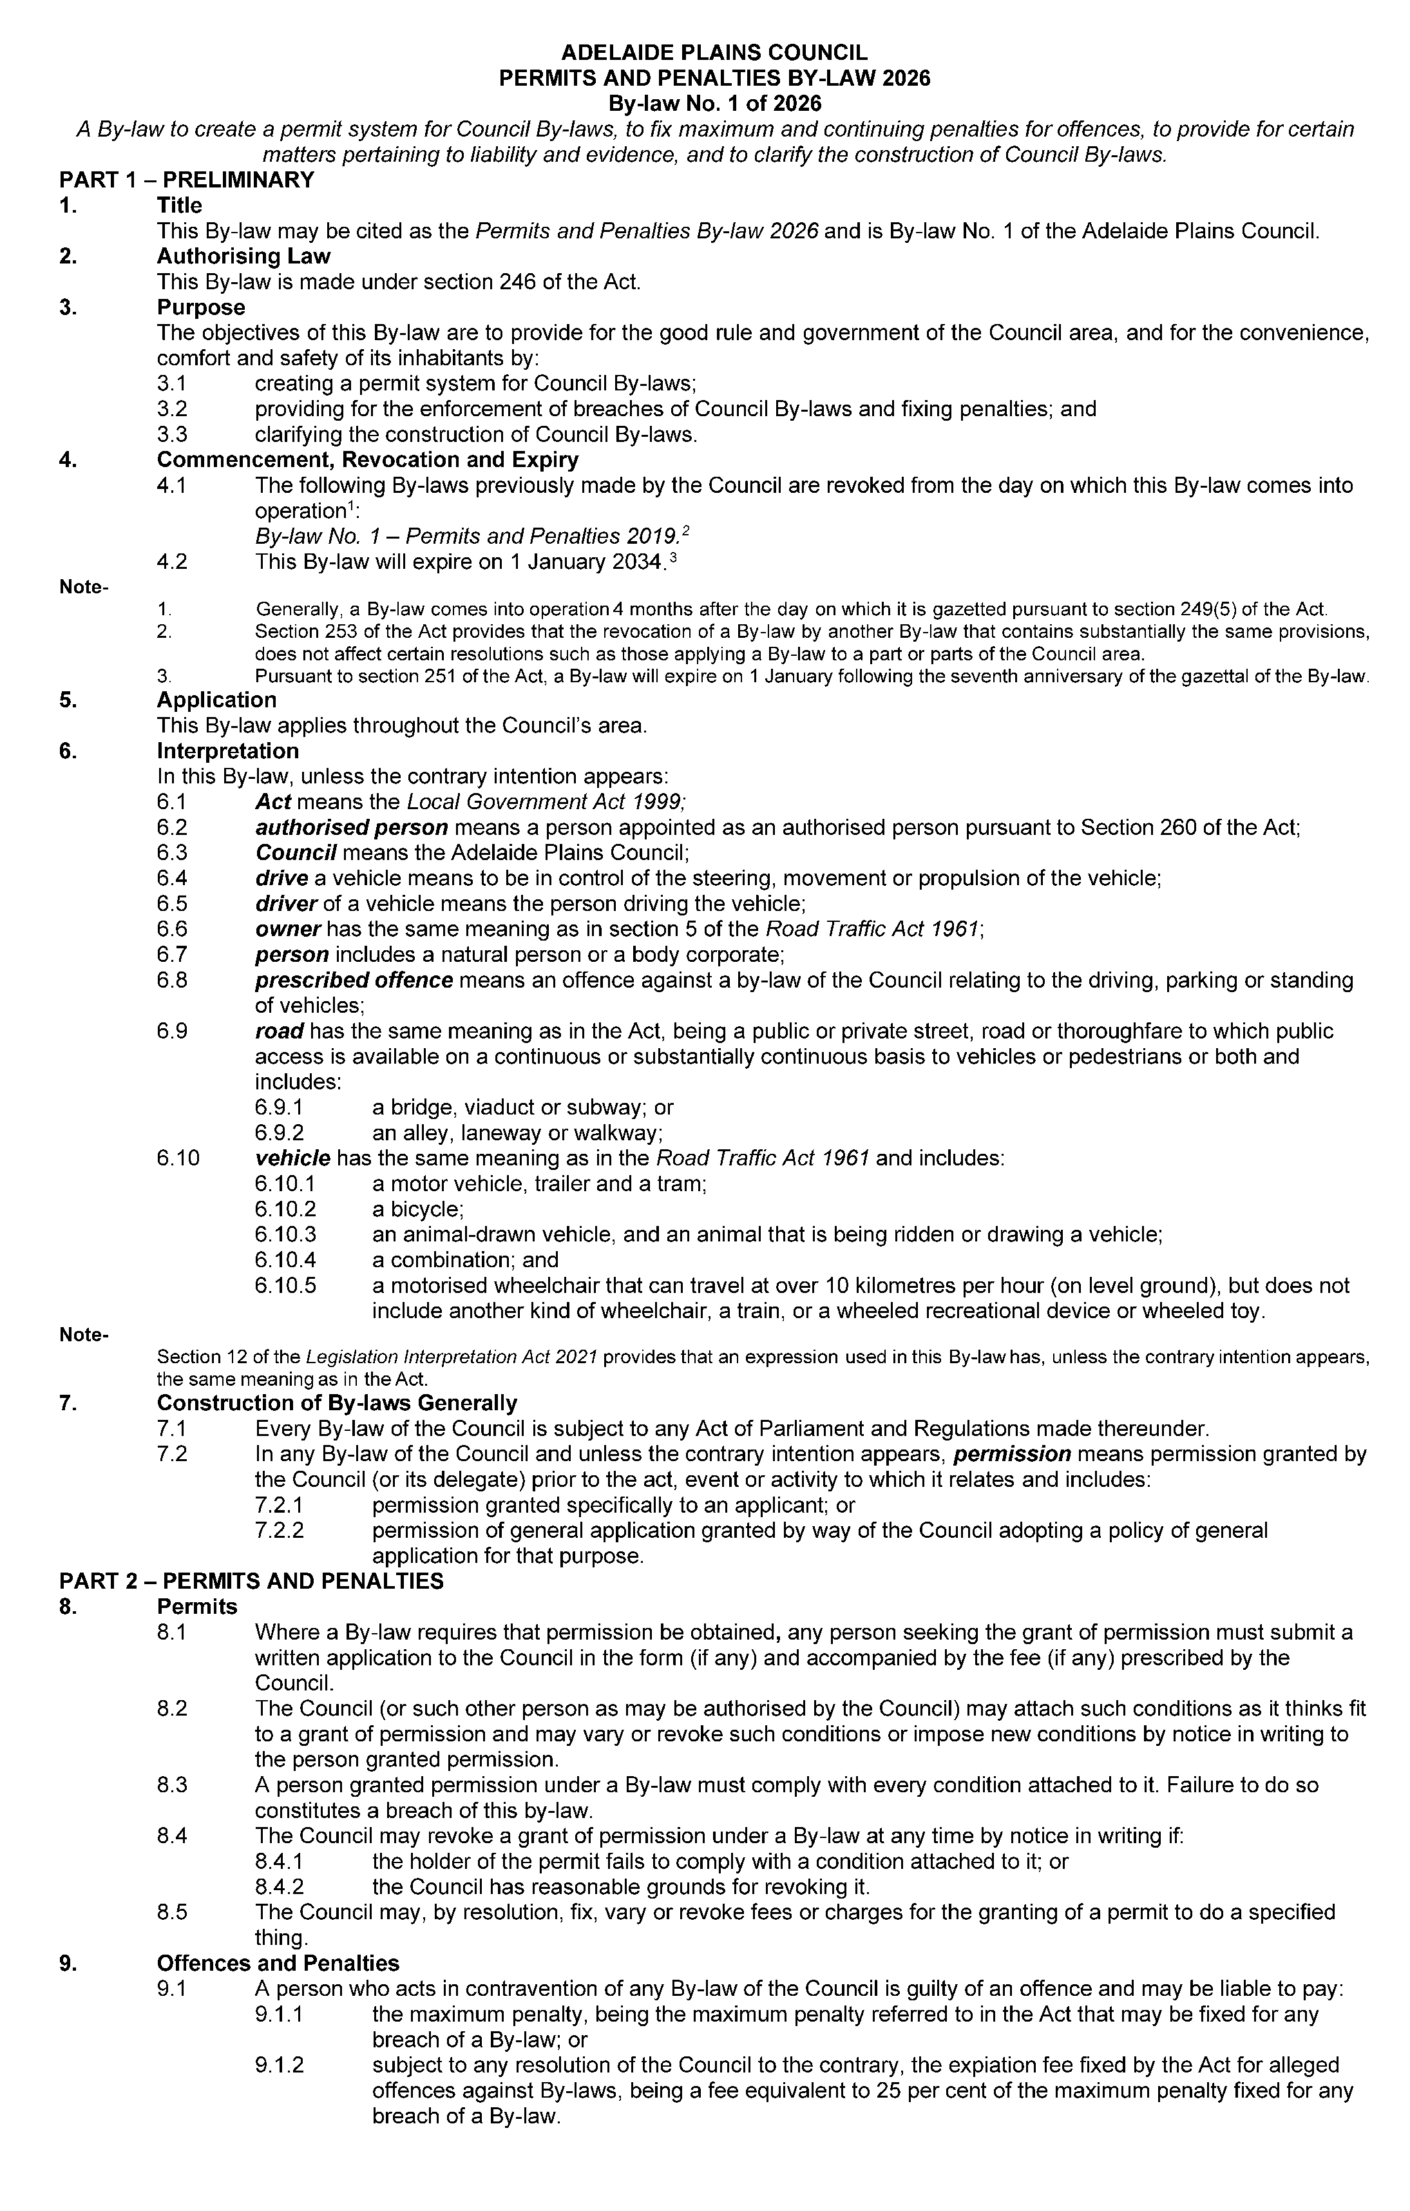
Adelaide Plains Council
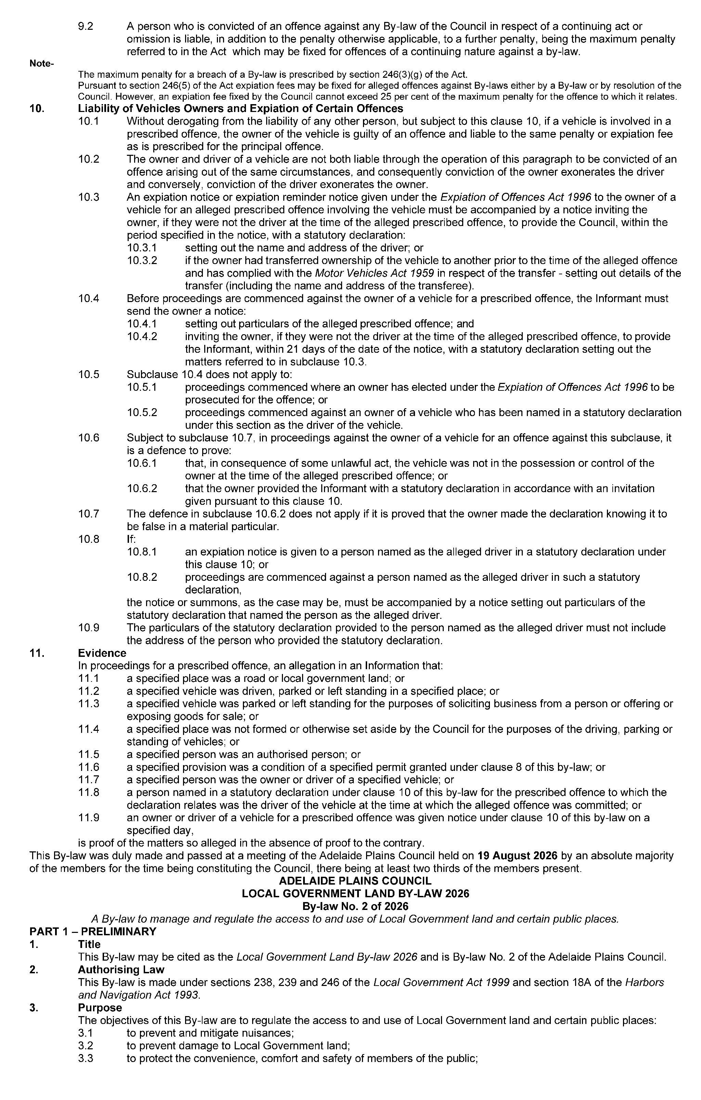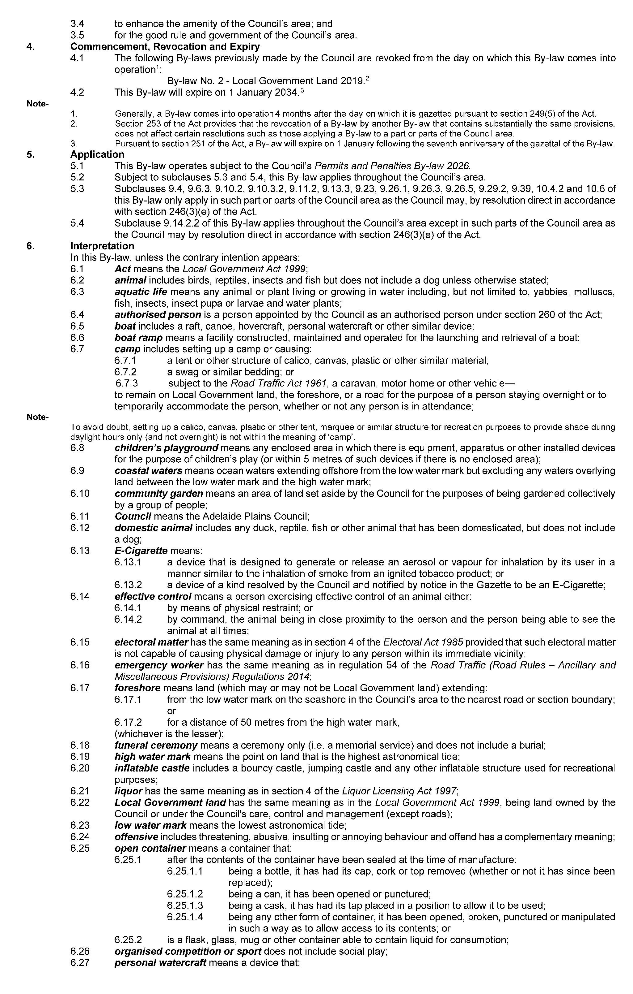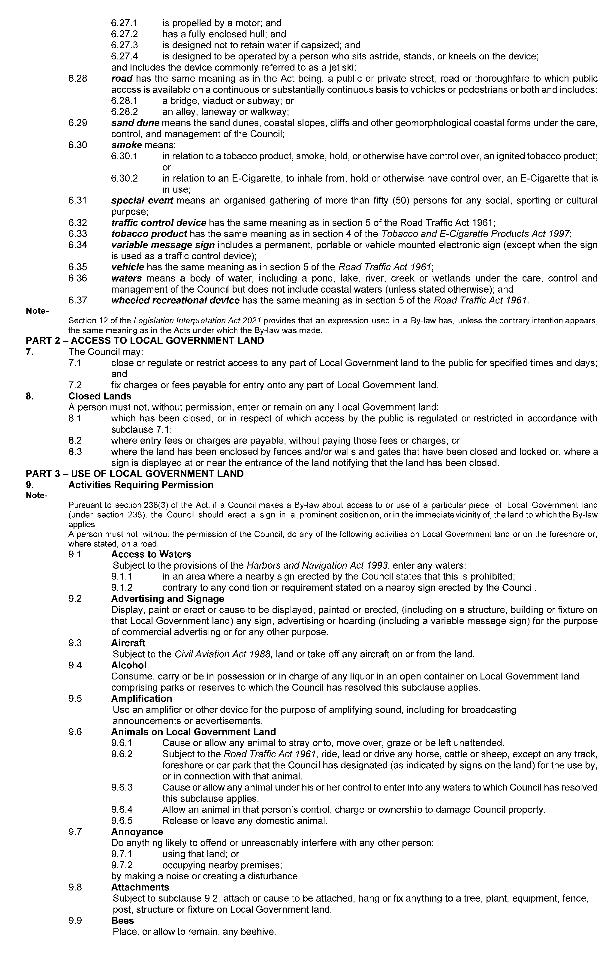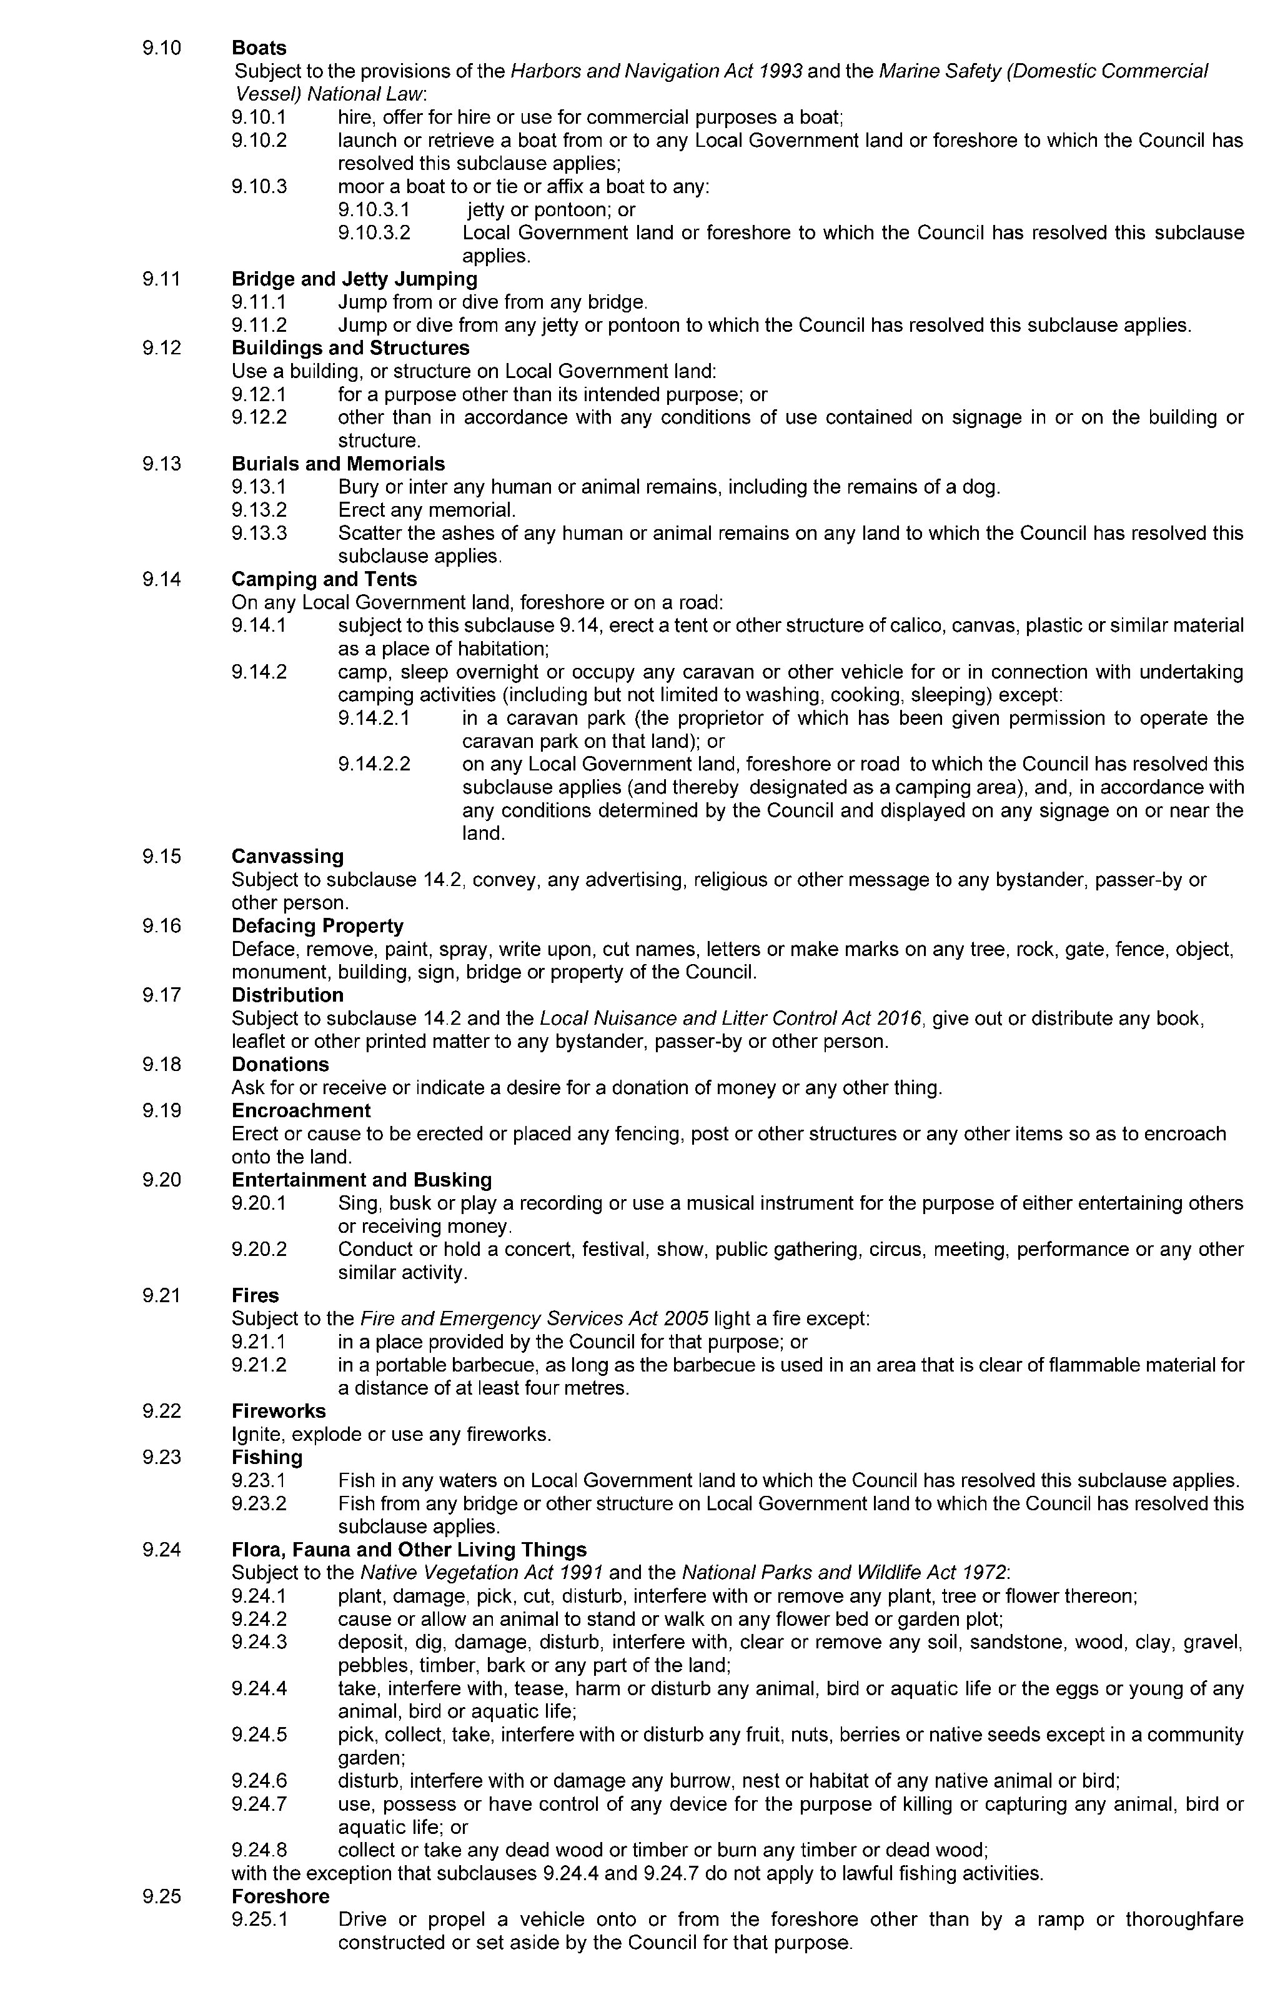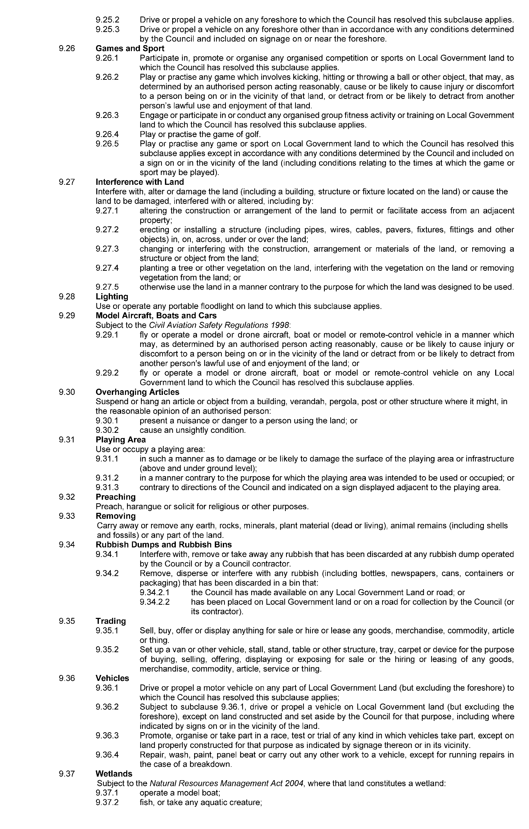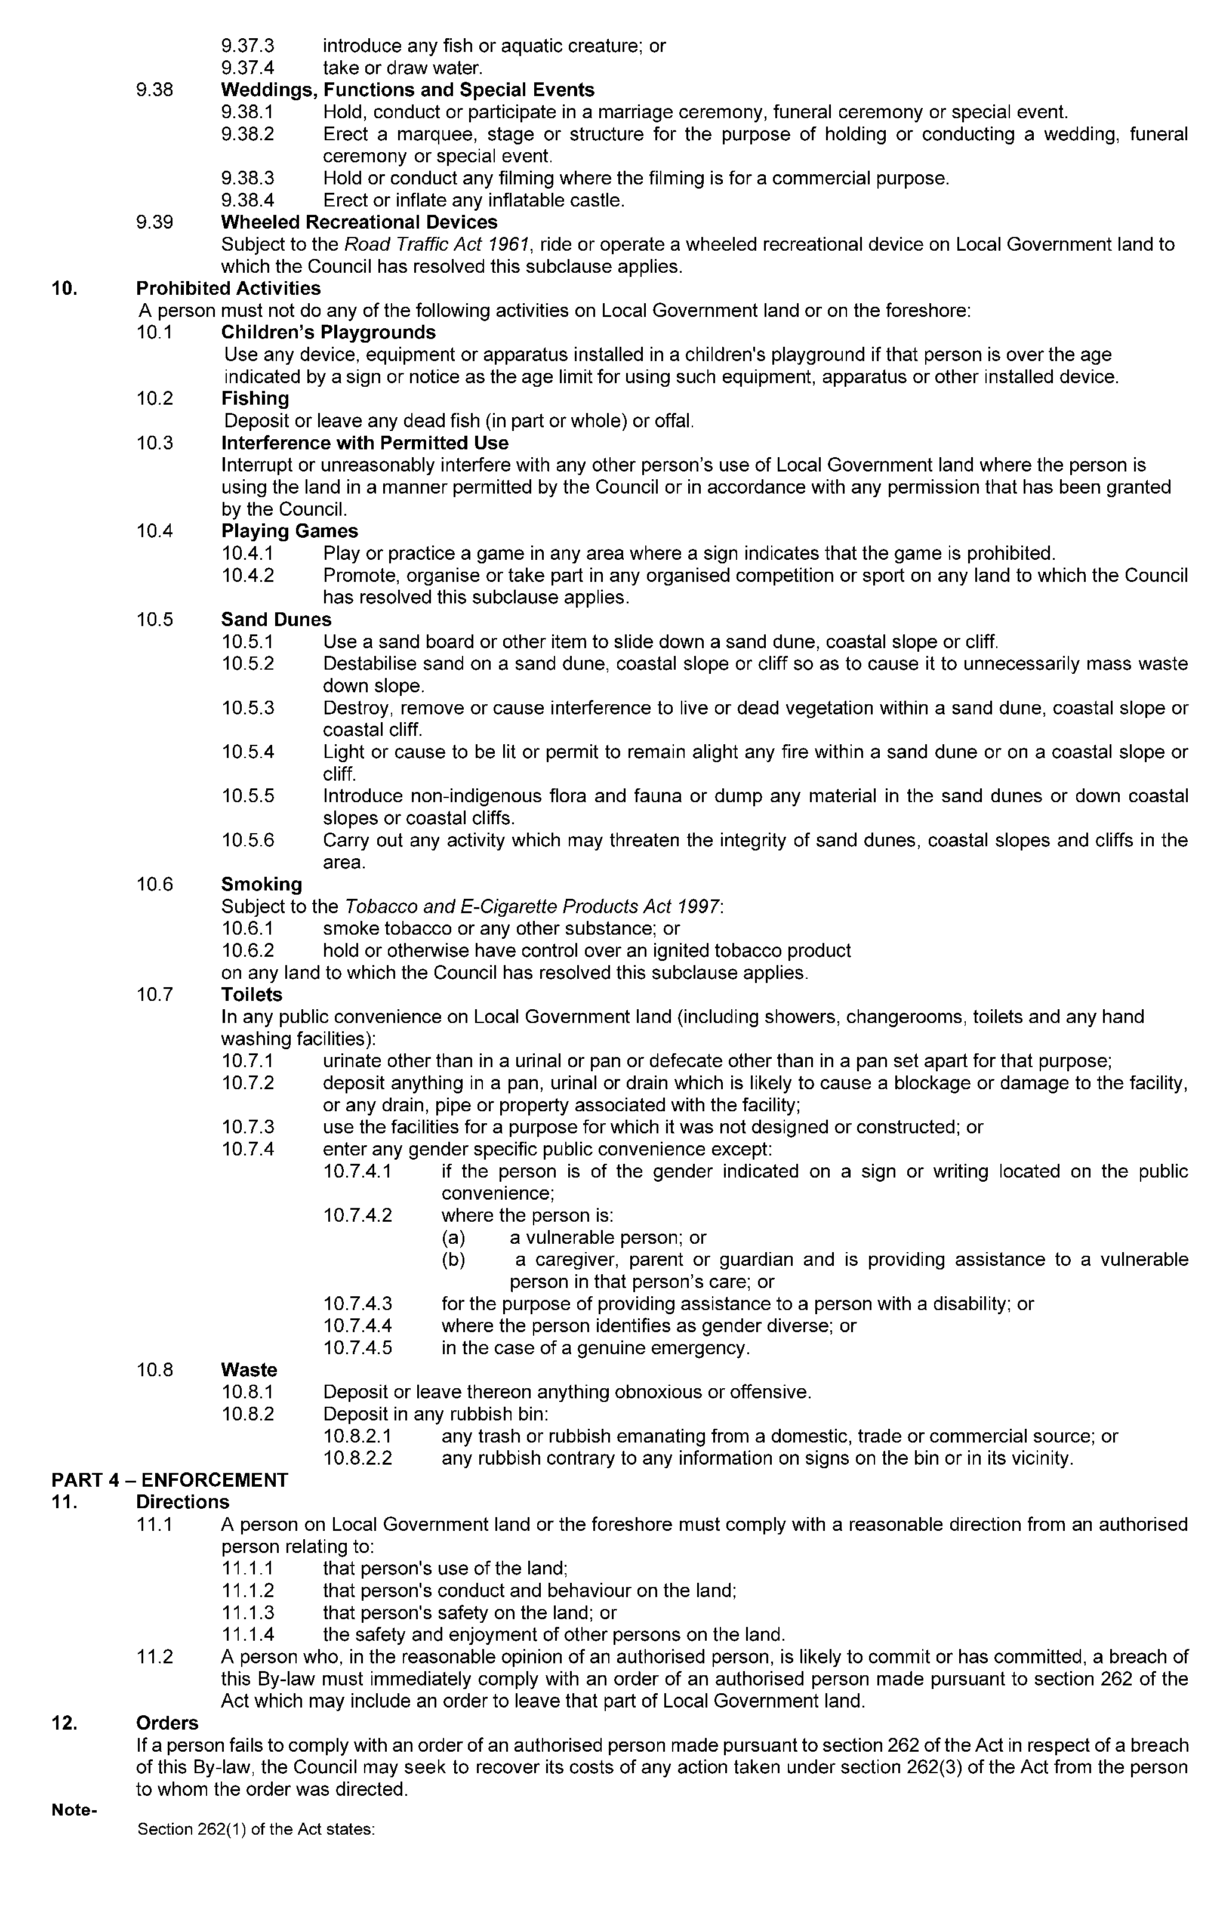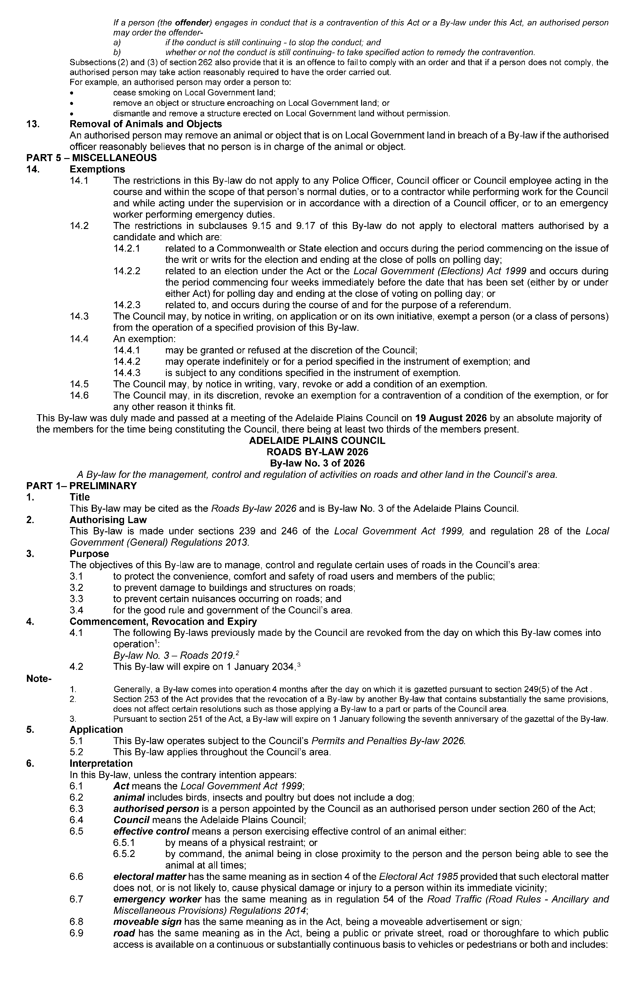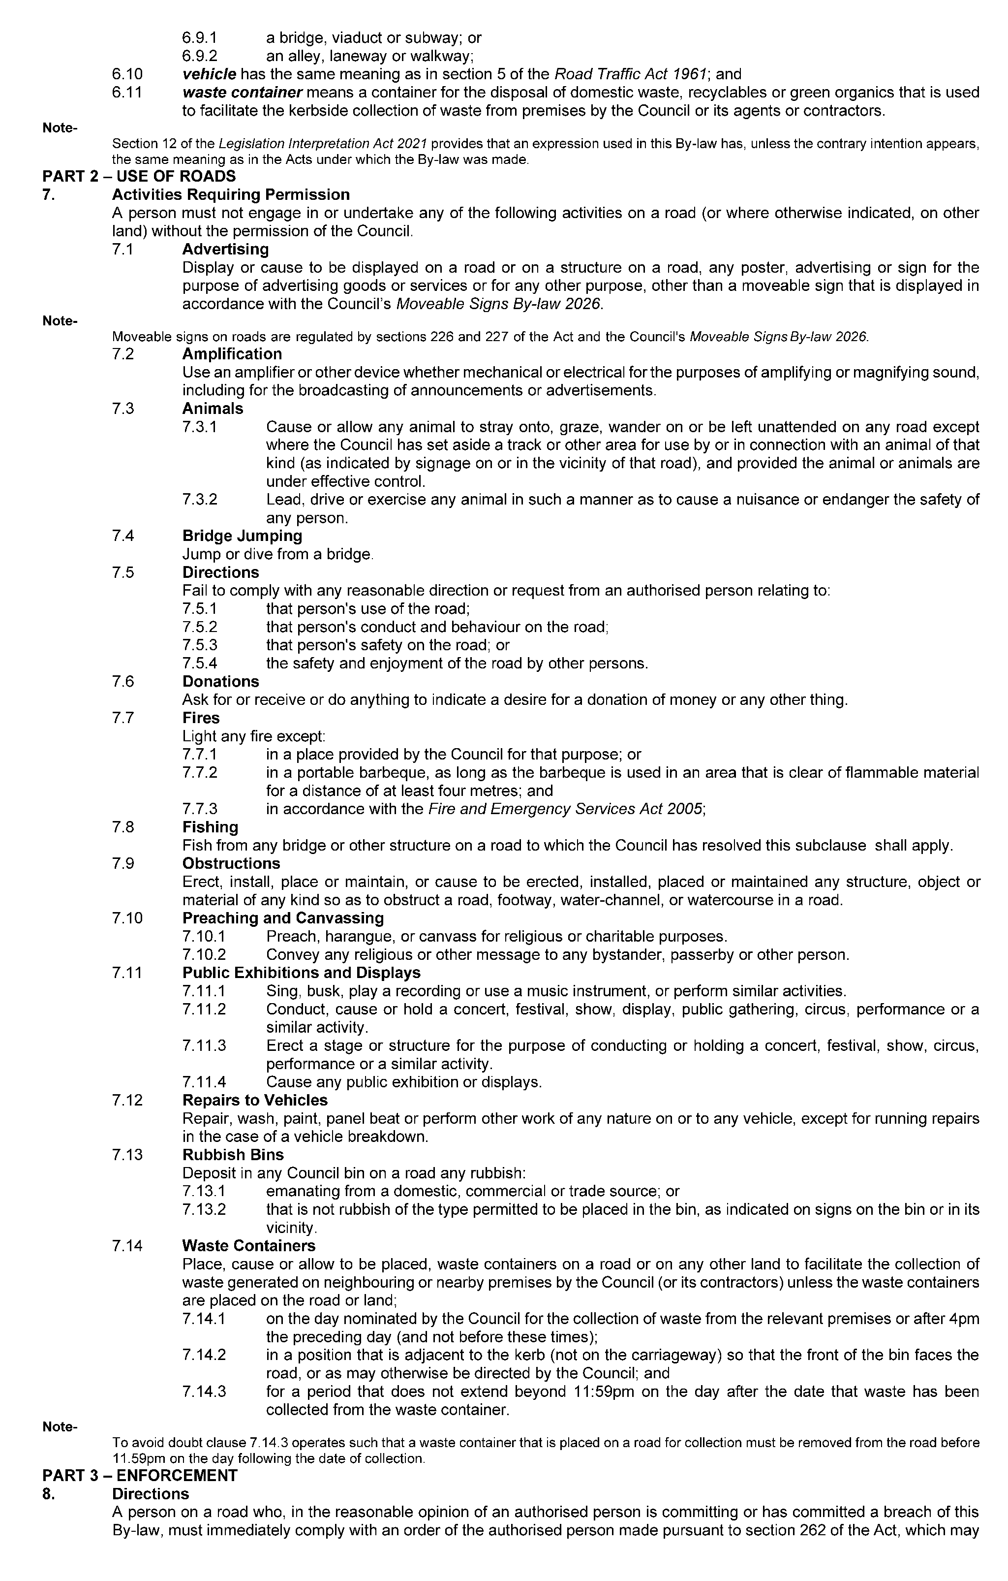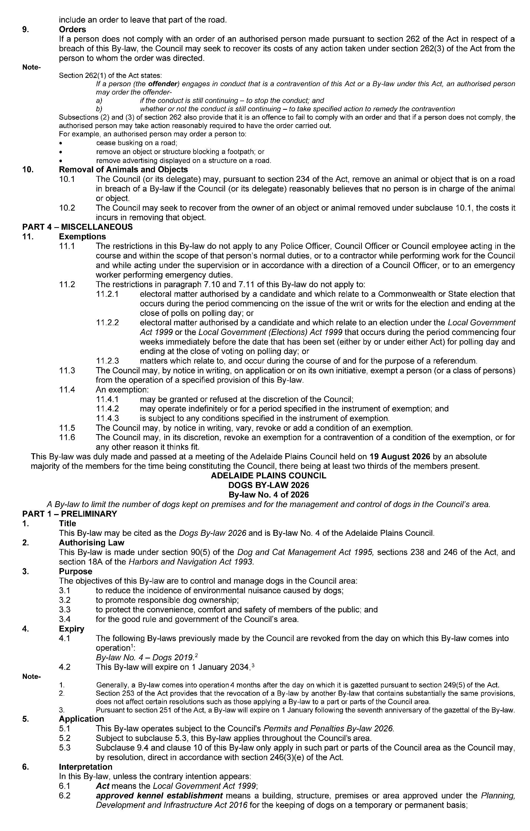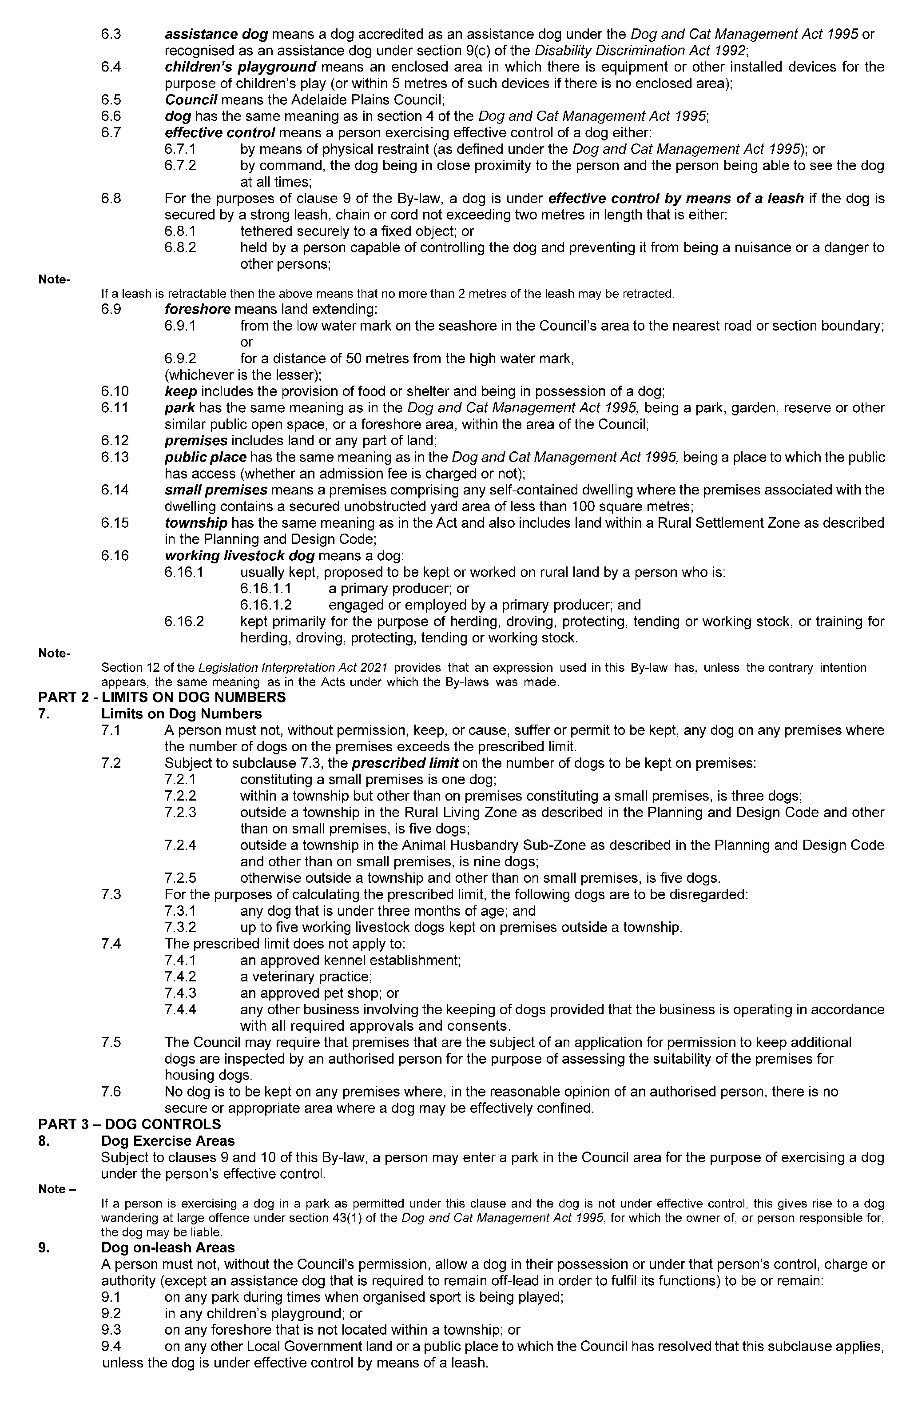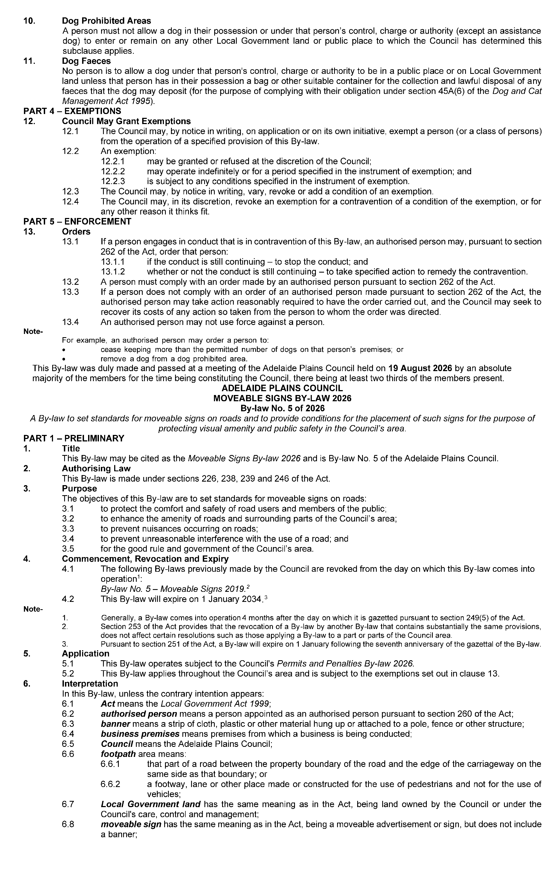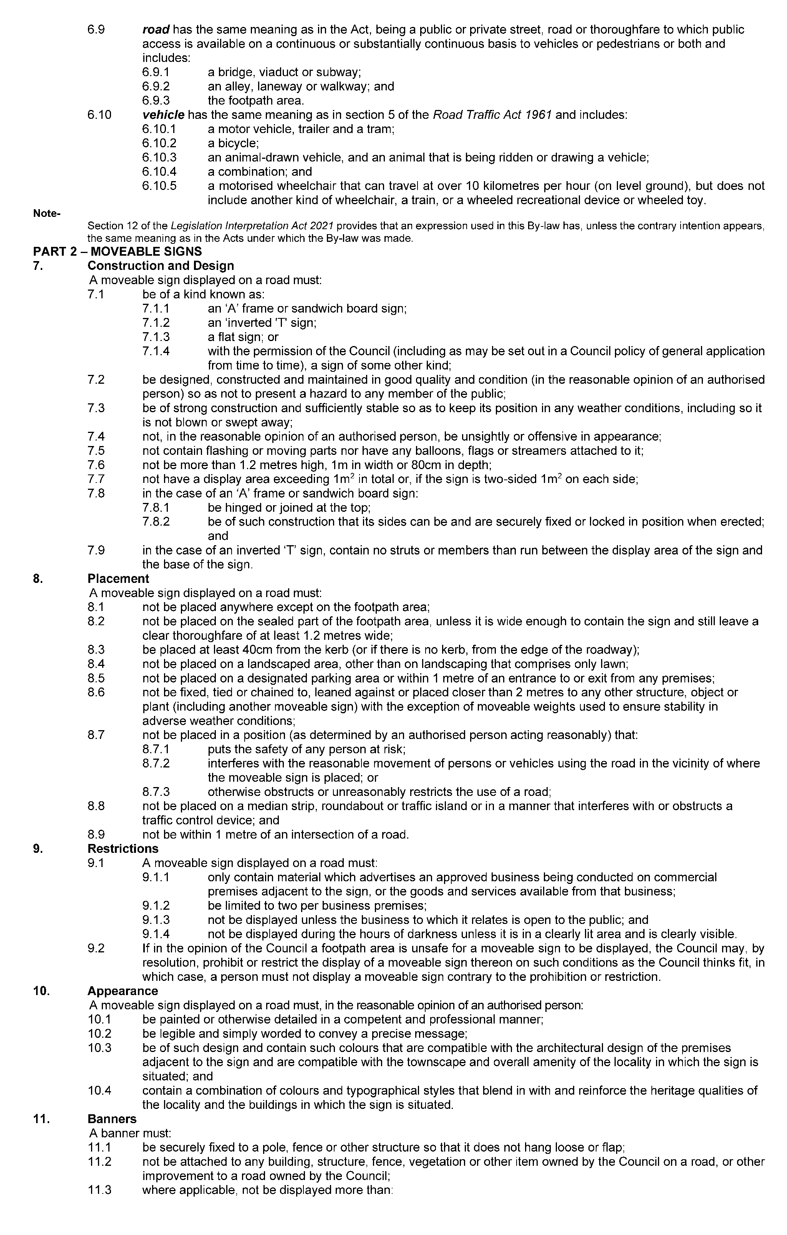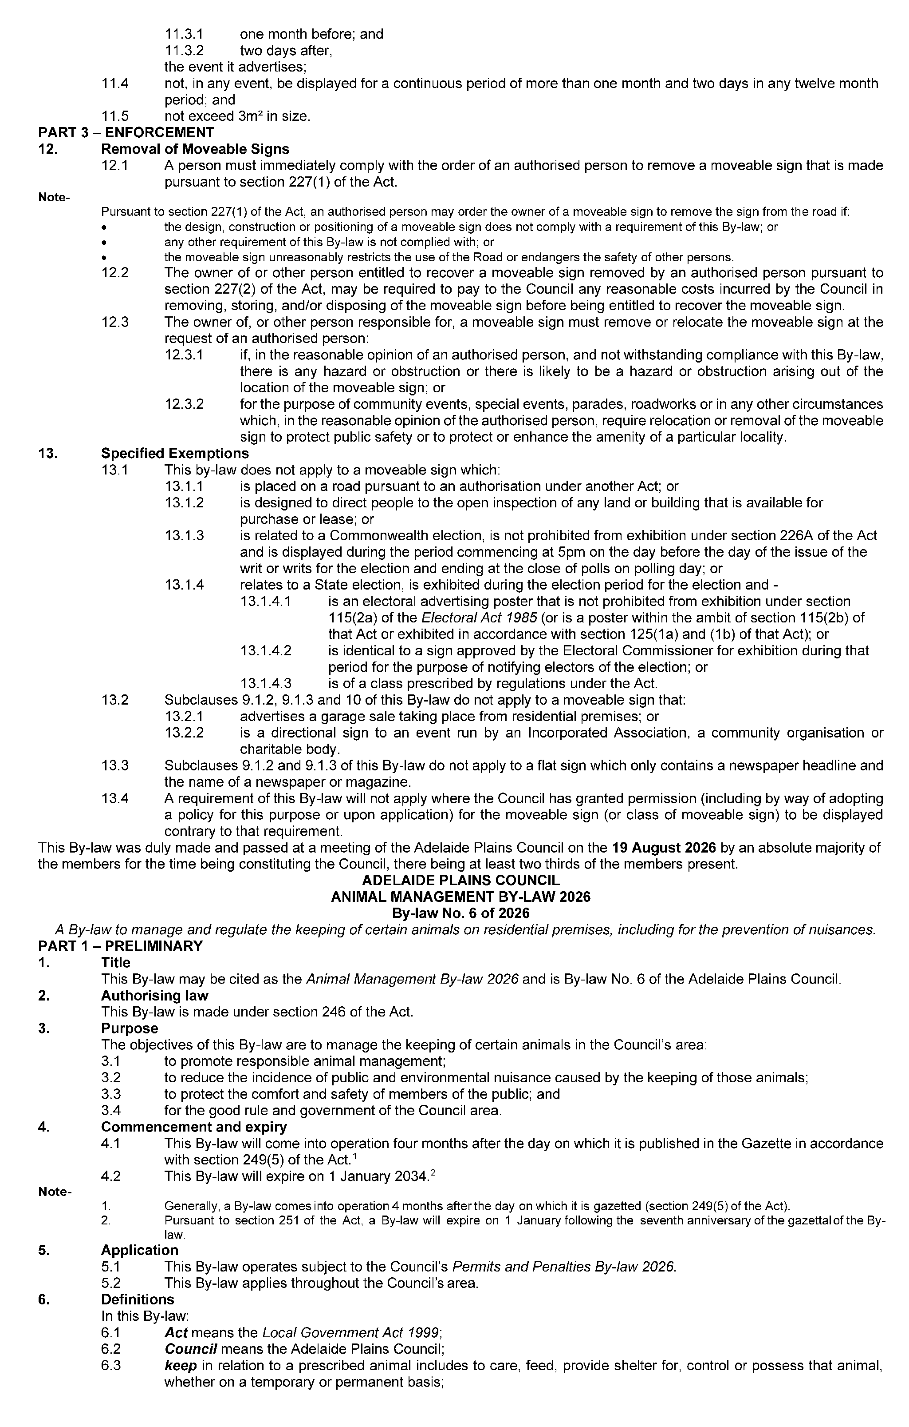
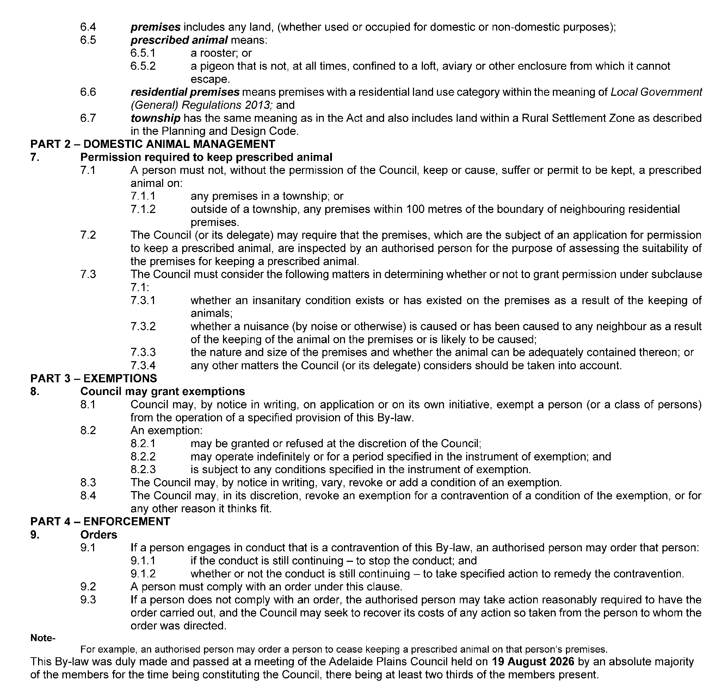
Dated: 3 September 2026
James Miller
Chief Executive Officer

District Council of Peterborough
Local Government Act 1999
By-law No. 1 of 2026—Permits and Penalties By-law 2026
To provide for a permit system, set penalties for breaches of by-laws, provide for certain matters pertaining to liability and evidence, set regulatory requirements, clarify the construction of Council’s by-laws and for related purposes.
Part 1—Preliminary
1. Short Title
This by-law may be cited as the Permits and Penalties By-law 2026.
2. Commencement
This by-law will come into operation four months after the day on which it is published in the Gazette in accordance with Section 249(5) of the Local Government Act 1999.
3. Definitions
3.1 In any by-law of the Council, unless the contrary intention is clearly indicated:
3.1.1 authorised person means a person appointed as an authorised person pursuant to Section 260 of the Local Government Act 1999;
3.1.2 Council means the District Council of Peterborough;
3.1.3 drive a vehicle means to be in control of the steering, movement or propulsion of the vehicle;
3.1.4 driver of a vehicle means the person driving the vehicle;
3.1.5 motor vehicle has the same meaning as in the Road Traffic Act 1961;
3.1.6 person includes a natural person, a body corporate or incorporated association;
3.1.7 road has the same meaning as in the Local Government Act 1999;
3.1.8 vehicle has the same meaning as in the Road Traffic Act 1961 and the Australian Road Rules.
3.2 In this by-law:
3.2.1 owner has the same meaning as in the Road Traffic Act 1961;
3.2.2 prescribed offence means an offence against a by-law of the Council relating to the driving, parking or standing of vehicles.
4. Construction
Every by-law of the Council shall be subject to any Act of Parliament and Regulations made thereunder.
Part 2—Permits
5. Council May Grant Permits
If any by-law of the Council states that a person needs a ‘permit’ or ‘permission’ to do a specified thing, then the following provisions apply:
5.1 The permit must be in writing.
5.2 The Council may:
5.2.1 attach conditions to the permit;
5.2.2 change or revoke a condition, by notice in writing; or
5.2.3 add new conditions, by notice in writing.
5.3 A person who holds a permit must comply with every condition attached to it. Failure to do so constitutes a breach of this by-law.
5.4 The Council may revoke a permit, by notice in writing, if:
5.4.1 the holder of the permit fails to comply with a condition attached to it; or
5.4.2 the permit is of a continuing nature, and the Council has reasonable grounds for revoking it.
5.5 The Council may, by resolution, fix, vary or revoke fees or charges for the granting of a permit to do a specified thing.
Part 3—Enforcement
6. Penalties
6.1 A person who contravenes or fails to comply with any by-law of the Council is guilty of an offence and is liable to a maximum penalty, being the maximum penalty referred to in the Local Government Act 1999, which may be fixed for offences against a by-law.
6.2 A person who is convicted of an offence against any by-law of the Council in respect of a continuing act or omission is liable, in addition to the penalty otherwise applicable, to a further penalty, being the maximum penalty referred to in the Local Government Act 1999 which may be fixed for offences of a continuing nature against a by-law.
7. Liability of Vehicles Owners and Expiation of Certain Offences
7.1 Without derogating from the liability of any other person, but subject to this paragraph, if a vehicle is involved in a prescribed offence, the owner of the vehicle is guilty of an offence and liable to the same penalty as is prescribed for the principal offence and the expiation fee that is fixed for the principal offence applies in relation to an offence against this paragraph.
7.2 The owner and driver of a vehicle are not both liable through the operation of this paragraph to be convicted of an offence arising out of the same circumstances, and consequently conviction of the owner exonerates the driver and conversely conviction of the driver exonerates the owner.
7.3 An expiation notice or expiation reminder notice given under the Expiation of Offences Act 1996 to the owner of a vehicle for an alleged prescribed offence involving the vehicle must be accompanied by a notice inviting the owner, if they were not the driver at the time of the alleged prescribed offence, to provide the Council or officer specified in the notice, within the period specified in the notice, with a statutory declaration:
7.3.1 setting out the name and address of the driver; or
7.3.2 if they had transferred ownership of the vehicle to another prior to the time of the alleged offence and has complied with the Motor Vehicles Act 1959 in respect of the transfer - setting out details of the transfer (including the name and address of the transferee).
7.4 Before proceedings are commenced against the owner of a vehicle for an offence against this section involving the vehicle, the Informant must send the owner a notice:
7.4.1 setting out particulars of the alleged prescribed offence; and
7.4.2 inviting the owner, if he or she was not the driver at the time of the alleged prescribed offence, to provide the Informant, within 21 days of the date of the notice, with a statutory declaration setting out the matters referred to in subparagraph 7.3.
7.5 Subparagraph 7.4 does not apply to:
7.5.1 proceedings commenced where an owner has elected under the Expiation of Offences Act 1996 to be prosecuted for the offence; or
7.5.2 proceedings commenced against an owner of a vehicle who has been named in a statutory declaration under this section as the driver of the vehicle.
7.6 Subject to subparagraph 7.7, in proceedings against the owner of a vehicle for an offence against this paragraph, it is a defence to prove:
7.6.1 that, in consequence of some unlawful act, the vehicle was not in the possession or control of the owner at the time of the alleged prescribed offence; or
7.6.2 that the owner provided the Informant with a statutory declaration in accordance with an invitation under this paragraph.
7.7 The defence in paragraph 7.6.2 does not apply if it is proved that the owner made the declaration knowing it to be false in a material particular.
7.8 If:
7.8.1 an expiation notice is given to a person named as the alleged driver in a statutory declaration under this paragraph; or
7.8.2 proceedings are commenced against a person named as the alleged driver in such a statutory declaration,
the notice or information, as the case may be, must be accompanied by a notice setting out particulars of the statutory declaration that named the person as the alleged driver.
7.9 The particulars of the statutory declaration provided to the person named as the alleged driver must not include the address of the person who provided the statutory declaration.
8. Evidence
In proceedings for a prescribed offence, an allegation in an information that:
8.1 a specified place was a road or local government land; or
8.2 a specified vehicle was driven, parked or left standing in a specified place; or
8.3 a specified vehicle was parked or left standing for the purposes of soliciting business from a person or offering or exposing goods for sale; or
8.4 a specified place was not formed or otherwise set aside by the Council for the purposes of the driving, parking or standing of vehicles; or
8.5 a specified person was an authorised person; or
8.6 a specified provision was a condition of a specified permit granted under paragraph 5 of this by-law; or
8.7 a specified person was the owner or driver of a specified vehicle; or
8.8 a person named in a statutory declaration under paragraph 7 of this by-law for the prescribed offence to which the declaration relates was the driver of the vehicle at the time at which the alleged offence was committed; or
8.9 an owner or driver of a vehicle for a prescribed offence was given notice under paragraph 7 of this by-law on a specified day,
is proof of the matters so alleged in the absence of proof to the contrary.
Part 4—Miscellaneous
The foregoing by-law was duly made and passed at a meeting of the District Council of Peterborough held on the 17th day of August 2026 by an absolute majority of the members for the time being constituting the Council, there being at least two thirds of the members present.
Dated: 3 September 2026
Henry Inat
Acting Chief Executive Officer

District Council of Peterborough
Local Government Act 1999
By-law No. 2 of 2026—Moveable Signs By-law 2026
To set standards for moveable signs on roads and to provide conditions for the appearance and placement of such signs.
Part 1—Preliminary
1. Short Title
This by-law may be cited as the Moveable Signs By-law 2026.
2. Commencement
This by-law will come into operation four months after the day on which it is published in the Gazette in accordance with Section 249(5) of the Act.
3. Definitions
In this by-law:
3.1 banner means a moveable sign constituted of a strip of cloth, plastic or other material hung or attached to a pole, fence or other structure;
3.2 business means the business to which a moveable sign relates;
3.3 business premises means the premises from which a business, trade or calling is conducted;
3.4 footpath area means:
3.4.1 that part of the road between the property boundary of the road and the edge of the carriageway on the same side as that boundary; or
3.4.2 a footway, laneway or other place made or constructed for the use of pedestrians and not for the use of vehicles;
3.5 moveable sign has the same meaning as in the Local Government Act 1999;
3.6 road has the same meaning as in the Local Government Act 1999.
Part 2—Provisions Applicable to Moveable Signs
4. Design and Construction
A moveable sign must:
4.1 in the case of an ‘A’ frame or sandwich board sign:
4.1.1 be hinged or joined at the top;
4.1.2 be of such construction that its sides can be and are securely fixed or locked in position when erected;
4.2 in the case of an inverted ‘T’ sign, contain no struts or members than run between the display area of the sign and the base of the sign;
4.3 be designed, constructed and maintained in good condition so as not to present a hazard to any member of the public;
4.4 be of strong construction so as to be stable when in position and to be able to keep its position in adverse weather conditions;
4.5 not contain any sharp or jagged edges or corners;
4.6 not be unsightly or offensive in appearance or content;
4.7 not rotate or contain moving parts;
4.8 be constructed of timber, cloth, metal, plastic or plastic coated cardboard, or a mixture of such materials;
4.9 not contain flashing lights or be illuminated internally;
4.10 not be more than 1.2 metres high, 800mm wide and 800mm deep;
4.11 not have a display area exceeding 1 square metre in total or, if the sign is two sided, 1 square metre on each side; and
4.12 be stable when in position.
5. Appearance
A moveable sign must, in the reasonable opinion of an authorised person:
5.1 be painted or otherwise detailed in a competent and professional manner;
5.2 be aesthetically appealing, legible and simply worded to convey a precise message;
5.3 be of such design and contain such colours as are compatible with the architectural design of the premises adjacent to the sign, and which relate well to the townscape and overall amenity of the locality in which it is situated and not detract from or conflict with traffic, safety or direction signs or signals; and
5.4 contain combinations of colour and typographical styles which blend in with and reinforce the heritage qualities of the locality and the buildings where it is situated;
5.5 not have attached any balloons, flags, streamers or other things.
6. Placement
A moveable sign must:
6.1 only be placed on the footpath area of a road;
6.2 where there is no kerb to define the footpath area, be set back from the edge of the carriageway by no less than 400mm;
6.3 in the case of a flat sign, the message of which only contains newspaper headlines and the name of a newspaper, be in line with and against the business to which it relates;
6.4 be no less than 2 metres from any structure, fixed object, tree, bush or plant (including another moveable sign);
6.5 be placed directly in front of the business premises to which it relates;
6.6 not be placed on a sealed part of any footpath area unless the sealed part is wide enough to contain the sign and still leave a clear thoroughfare of at least 1.2 metres;
6.7 not be placed within 10 metres of the corner of a road;
6.8 be adjacent to the premises of the business to which it relates;
6.9 not be placed on a landscaped area, other than on landscaping that comprises only lawn;
6.10 not be placed on a designated parking area or within 1 metre of an entrance to or exit from premises; and
6.11 not unreasonably restrict the use of the footpath area.
7. Restrictions
A moveable sign must:
7.1 only display material which advertises a business being conducted on commercial premises adjacent to the sign or the products available from that business;
7.2 be limited in number to one moveable sign per business premises;
7.3 only be displayed when the business to which it relates is open to the public;
7.4 be securely fixed in position such that it cannot be blown over or swept away;
7.5 not be placed in such a position or in such circumstances that the safety of any user of the road is at risk;
7.6 not be displayed during the hours of darkness unless it is in a clearly lit area and is clearly visible; and
not to be displayed on a median strip, traffic island or on a carriageway of a street or road.
8. Banners
A person must not erect or display a banner on a building or structure on a road without the Council’s permission.
Part 3—Enforcement
9. Removal of Non-complying Moveable Signs
9.1 If:
9.1.1 a moveable sign has been placed on any road or footpath in contravention of this by-law or of Sections 226 or 226A of the Local Government Act 1999, an authorised person may order the owner of the sign to remove the moveable sign from the road or footpath;
9.1.2 the authorised person cannot find the owner, or the owner fails to comply immediately with the order, the authorised person may remove and dispose of the sign;
9.1.3 a moveable sign is removed under subparagraph 9.1.2 of this by-law and is not claimed within 30 days of such removal the authorised person may sell, destroy or otherwise dispose of the moveable sign as the authorised person thinks fit.
9.2 Any person who displays an unauthorised moveable sign or who is the owner of an unauthorised moveable sign which has been removed under subparagraph 9.1 of this by-law must pay the Council any reasonable costs incurred in removing, storing or attempting to dispose of the moveable sign before being entitled to recover the moveable sign.
10. Removal of Complying Moveable Signs
10.1 The owner of, or other person responsible for, a moveable sign must remove or relocate the moveable sign at the request of an authorised person if, in the reasonable opinion of that authorised person, and notwithstanding compliance with this by-law, there is any hazard or obstruction or there is likely to be a hazard or obstruction arising out of the location of the moveable sign.
10.2 The owner of, or other person responsible for, a moveable sign must remove or relocate the moveable sign at the request of an authorised person for the purpose of special events, parades, road works or in any other circumstances which, in the reasonable opinion of the authorised person, requires relocation or removal of the moveable sign to protect public safety or to protect or enhance the amenity of a particular locality.
Part 4—Miscellaneous
11. Specified Exemptions
11.1 This by-law does not apply to a moveable sign which:
11.1.1 is a moveable sign that is placed on a public road pursuant to an authorisation under the Local Government Act 1999 or another Act;
11.1.2 directs people to the open inspection of any land or building that is available for purchase or lease;
11.1.3 directs people to a garage sale that is being held on residential premises;
11.1.4 directs people to a charitable function;
11.1.5 is related to a State or Commonwealth election and is otherwise authorised to be exhibited under Sections 226 and 226A of the Local Government Act 1999 or the Electoral Act 1985;
11.1.6 is related to an election held under the Local Government Act 1999 or the Local Government (Elections) Act 1999 and is otherwise authorised to be exhibited under Section 226 of the Local Government Act 1999;
11.1.7 is related to a referendum and is displayed during the course and for the purpose of that referendum;
11.1.8 is displayed with permission of the Council and in accordance with any conditions attached to that permission; or
11.1.9 is a sign of a class prescribed in regulations.
11.2 Clauses 7.1, 7.2 and 7.3 of this by-law do not apply to a flat sign containing only the banner or headlines of a newspaper or magazine.
12. Prohibition
12.1 The Council may, by resolution, prohibit the display of moveable signs on a road or part of road subject to this clause.
12.2 A resolution made by the Council under sub-clause 12.1 may prohibit the display of moveable signs absolutely, or at particular times or on particular days.
12.3 The Council may only make a resolution under sub-clause 12.1 if, in the opinion of the Council, the display of movable signs on the road would endanger the safety of road users, be incompatible with the amenity of a particular locality, or otherwise be unsuitable.
12.4 Notwithstanding any other clause of this by-law, a person must not display a moveable sign on a road or part of a road contrary to a prohibition made by the Council under this clause.
The foregoing by-law was duly made and passed at a meeting of the District Council of Peterborough held on the 17th day of August 2026 by an absolute majority of the members for the time being constituting the Council, there being at least two thirds of the members present.
Dated: 3 September 2026
Henry Inat
Acting Chief Executive Officer

District Council of Peterborough
Local Government Act 1999
By-law No. 3 of 2026—Roads By-law 2026
For the management, control and regulation of activities on roads in the Council’s area.
Part 1—Preliminary
1. Short Title
This by-law may be cited as the Roads By-law 2026.
2. Commencement
This by-law will come into operation four months after the day on which it is published in the Gazette in accordance with Section 249(5) of the Act.
3. Interpretation
In this by-law:
3.1 animal includes birds and poultry but does not include a dog;
3.2 camp includes setting up a camp, or causing a tent, caravan or motorhome to remain on the land for the purpose of staying overnight, whether or not any person is in attendance or sleeps on the land;
3.3 effective control means a person exercising effective control of an animal either:
3.3.1 by means of a physical restraint;
3.3.2 by command, the animal being in close proximity to the person, and the person being able to see the animal at all times;
3.4 electoral matter has the same meaning as in the Electoral Act 1985 provided that such electoral matter is not capable of causing physical damage or injury to any person within its immediate vicinity;
3.5 emergency worker has the same meaning as in the Road Traffic (Road Rules—Ancillary and Miscellaneous Provisions) Regulations 2014;
3.6 model aircraft includes a drone;
3.7 moveable sign has the same meaning as in the Local Government Act 1999; and
3.8 township has the same meaning as in the Local Government Act 1999.
Part 2—Management of Roads
4. Activities Requiring Permission
A person must not on any road, without the permission of the Council:
4.1 Advertising
4.1.1 display any sign for the purpose of commercial advertising, other than a moveable sign which is displayed on a public road in accordance with the Council’s Moveable Signs By-law 2026;
4.1.2 place or maintain any goods on the road or park or stand a vehicle on the road for the purpose of:
4.1.2.1 soliciting any business from any person; or
4.1.2.2 offering or exposing goods or services for sale; or
4.1.2.3 conveying any advertising, religious or other message to any bystander, passerby or other person,
provided that this subparagraph 4.1.2 shall not apply to a person who is simply travelling along a road;
4.2 Amplification
use an amplifier or other device whether mechanical or electrical for the purpose of amplifying sound to the public;
4.3 Animals
4.3.1 within the township of Peterborough:
4.3.1.1 cause or allow any animal, to stray onto, graze, wander on or be left unattended on any road except where the Council has set aside a track or other area for use by or in connection with an animal of that kind and, then only if under the effective control of a person;
4.3.1.2 stand, draw up or allow to remain stationary any horse, cattle, sheep or other like animal, whether attached to a vehicle or not;
4.3.2 lead, drive or exercise any animal in such a manner as to endanger the safety of any person;
4.4 Annoyance
do anything likely to offend or unreasonably interfere with any other person:
4.4.1 using the road; or
4.4.2 occupying nearby premises, by making a noise or creating a disturbance;
4.5 Camping
4.5.1 erect any tent or other structure of calico, canvas, plastic or similar material as a place of habitation;
4.5.2 camp or remain overnight; or
4.5.3 camp in a motorhome, except where a sign or signs erected by the Council indicates that camping on the road in such a vehicle is permitted;
4.6 Defacing Property
deface, paint, spray, write, cut names, letters or make marks on any tree, rock, gate, fence, building, sign, bridge or other property of the Council;
4.7 Dispose of Dead Animals
dispose of any dead animals or part thereof in any Council rubbish bin;
4.8 Distributing
distribute any handbill, book, notice, leaflet, or other printed matter to any bystander, passer-by or other person;
4.9 Donations
ask for or receive or indicate that they desire a donation of money or any other thing or otherwise solicit for charitable purposes;
4.10 Exhibition or Display
4.10.1 sing, busk or play any recording or musical instrument for the apparent purpose of either entertaining others or receiving money;
4.10.2 conduct or hold any concert, festival, show, public gathering, street party, circus, meeting, performance or other similar activity;
4.10.3 cause any public exhibitions or displays;
4.11 Fireworks
ignite, explode or use any fireworks or rockets;
4.12 Flora and Fauna
subject to the Native Vegetation Act 1991 and the National Parks and Wildlife Act 1972:
4.12.1 damage, pick, disturb, interfere with or remove any plant or flower;
4.12.2 lead or drive any animal, or stand or walk, on any flower bed or garden plot;
4.12.3 deposit, dig, damage, disturb, interfere with or remove any soil, stone, wood, clay, gravel, pebbles, timber, bark or other organic material from the road;
4.12.4 take, interfere with, tease, harm or disturb any animal or the eggs or young of any animal;
4.12.5 disturb, interfere with or damage any burrow, nest or habitat of any animal;
4.12.6 use, possess or have control of any device for the purpose of killing or capturing any animal;
4.12.7 burn any timber or dead wood;
4.13 Games
4.13.1 promote, organise or participate in any game, recreation or amusement which involves the use of a ball, missile or other object which by the use thereof may cause or be likely to cause injury or discomfort to any person being on or in the vicinity of that road or detract from or be likely to detract from another person’s lawful use and enjoyment of that road;
4.13.2 fly any model aircraft;
4.13.3 participate in any game, recreation or amusement which is likely to cause damage to lawns, gardens, trees or other property; or
4.13.4 participate in any game, recreation or event where the Council has caused a notice to be erected indicating the playing of such a game, recreation or event is prohibited;
4.14 Overhanging Articles
suspend or hang any article or thing from any building, verandah, pergola, post or other structure where it might present a nuisance or danger to any person using a road;
4.15 Picking Fruit
pick, collect, take, interfere with or disturb any fruit, nuts, berries or native seeds;
4.16 Preaching
preach, harangue or otherwise solicit for religious purposes;
4.17 Repairs to Vehicles
perform the work of repairing, washing, painting, panel beating or other work of any nature on or to any vehicle, except for running repairs in the case of breakdown;
4.18 Rubbish Bins
4.18.1 deposit any domestic or commercial waste or other rubbish emanating from domestic or commercial premises in any Council rubbish bin;
4.18.2 remove, dispense or interfere with any rubbish (including bottles, newspapers, cans, containers or packaging) that has been discarded in a Council rubbish bin;
4.19 Solicitation
tout or solicit customers for the parking of vehicles or for any other purpose;
4.20 Use of Equipment
use any item of equipment and/or facilities or other Council property:
4.20.1 other than in the manner and for the purpose for which it was designed or set aside; and
4.20.2 where any nearby sign states the conditions of use, except in accordance with such conditions.
Part 3—Miscellaneous
5. Directions
A person must comply with any reasonable direction or request from an authorised person relating to:
5.1 that person’s use of the road;
5.2 that person’s conduct and behaviour on the road;
5.3 that person’s safety on the road;
5.4 the safety and enjoyment of other persons on the road; and
5.5 the possible damage to lawn, grass, trees, shrubs, buildings, structures or objects on the road.
6. Removal of Animals and Directions to Persons
6.1 If any animal is found on a road in breach of a by-law any person in charge of the animal shall remove it on the request of an authorised person.
6.2 An authorised person may:
6.2.1 remove the animal if a person fails to comply with the request, or if no person is in charge of the animal;
6.2.2 direct any person who is considered to be committing or has committed a breach of this by-law to leave that part of the road, and failure to comply with that direction forthwith is a breach of this by-law; and
6.2.3 direct any person who is considered to be committing or has committed a breach of this by-law to cease that action and to take specified action to remedy the breach.
7. Exemptions
7.1 The restrictions in this by-law do not apply to any Police Officer, Council Officer or Council employee acting in the course and within the scope of that person’s normal duties, or to a contractor while performing work for the Council and while acting under the supervision of a Council Officer, or to an emergency worker performing emergency duties.
7.2 The restriction in paragraph 4.1.2.3 of this by-law does not apply to:
7.2.1 electoral matters authorised by a candidate related to a State or Commonwealth election that are otherwise authorised to be exhibited under Sections 226 or 226A of the Local Government Act 1999 or the Electoral Act 1985;
7.2.2 electoral matters authorised by a candidate related to an election held under the Local Government Act 1999 or the Local Government (Elections) Act 1999 that are otherwise authorised to be exhibited under Section 226 of the Local Government Act 1999; or
7.2.3 matters which relate to and occur during the course of and for the purpose of a referendum.
7.3 The restrictions in paragraph 4.2, 4.8, 4.10.2 and 4.10.3 of this by-law do not apply to:
7.3.1 electoral matters authorised by a candidate and which relate to a Commonwealth or State election that occurs during the period commencing at 5:00pm on the day before the issue of the writ or writs for the election and ending at the close of polls on polling day;
7.3.2 electoral matters authorised by a candidate and which relate to an election under the Local Government Act 1999 or the Local Government (Elections) Act 1999 that occurs during the period commencing four weeks immediately before the date that has been set (either by or under either Act) for polling day and ending at the close of voting on polling day; or
7.3.3 matters which relate to and occur during the course of and for the purpose of a referendum.
The foregoing by-law was duly made and passed at a meeting of the District Council of Peterborough held on the 17th day of August 2026 by an absolute majority of the members for the time being constituting the Council, there being at least two thirds of the members present.
Dated: 3 September 2026
Henry Inat
Acting Chief Executive Officer

District Council of Peterborough
Local Government Act 1999
By-law No. 4 of 2026—Local Government Land By-law 2026
For the management and regulation of the use of and access to all land vested in or under the control of Council, including the prohibition and regulation of particular activities on local government land.
Part 1—Preliminary
1. Short Title
This by-law may be cited as the Local Government Land By-law 2026.
2. Commencement
This by-law will come into operation four months after the day on which it is published in the Gazette in accordance with Section 249(5) of the Act.
3. Interpretation
In this by-law:
3.1 animal includes birds, insects, fish and other aquatic animals, but does not include a dog;
3.2 boat includes a raft, canoe, personal watercraft or any other similar device;
3.3 camp includes setting up a camp, or causing a tent, caravan or motorhome to remain on the land for the purpose of staying overnight, whether or not any person is in attendance or sleeps on the land;
3.4 e-cigarette means:
3.4.1 a device that is designed to generate or release an aerosol or vapour for inhalation by its user in a manner similar to the inhalation of smoke from an ignited tobacco product; or
3.4.2 a device of a kind resolved by the Council and notified by notice in the Gazette to be an e-cigarette;
3.5 electoral matter has the same meaning as in the Electoral Act 1985;
3.6 liquor has the same meaning as in the Liquor Licensing Act 1997;
3.7 local government land has the same meaning as in the Local Government Act 1999, but does not include any road;
3.8 open container means a container which:
3.8.1 after the contents thereof have been sealed at the time of manufacture and:
3.8.1.1 being a bottle, has had its cap, cork or top removed (whether or not it has since been replaced);
3.8.1.2 being a can, has been opened or punctured;
3.8.1.3 being a cask, has had its tap placed in a position to allow it to be used;
3.8.1.4 being any other form of container, has been opened, broken, punctured or manipulated in such a way as to allow access to the contents thereof; or
3.8.2 is a flask, glass, mug or other container used for drinking purposes;
3.9 park has the same meaning as in the Local Government Act 1999;
3.10 public place has the same meaning as in the Local Government Act 1999;
3.11 reserve has the same meaning as in the Local Government Act 1999;
3.12 smoke means:
3.12.1 in relation to a tobacco product, smoke, hold, or otherwise have control over, an ignited tobacco product; or
3.12.2 in relation to an e-cigarette, to inhale from, hold or otherwise have control over, an e-cigarette that is in use;
3.13 waters means any body of water, including a pond, lake, river, creek or wetland, under the care, control and management of the Council.
Part 2—Management of Local Government Land
4. Activities Requiring Permission
A person must not on any local government land, without the permission of the Council:
4.1 Advertising
display any sign for the purpose of commercial advertising other than a moveable sign which is displayed in accordance with the Moveable Signs By-law 2026;
4.2 Amplification
use an amplifier or other device, whether mechanical or electrical, for the purpose of amplifying sound to the public;
4.3 Animals
4.3.1 cause or allow any animal to stray onto, move over, graze or be left unattended;
4.3.2 cause or allow any animal to enter, swim, bathe or remain in any waters located on local government land to which the Council has resolved this subparagraph shall apply;
4.3.3 lead or drive a horse, cattle or sheep, except where the Council has set aside a track or other area for use by or in connection with an animal of that kind;
4.4 Annoyance
do anything likely to offend or unreasonably interfere with any other person:
4.4.1 using that land; or
4.4.2 occupying nearby premises,
by making a noise or creating a disturbance;
4.5 Aquatic Life
introduce any aquatic life to any waters;
4.6 Athletic and Ball Sports
4.6.1 promote, organise or take part in any organised athletic sport;
4.6.2 play any organised competition sport, as distinct from organised social play;
4.6.3 play or practise the game of golf;
4.7 Attachments to Trees etc.
attach, hang or fix any rug, blanket, sheet, rope or other material to any tree, shrub, plant, tree guard, notice board, seat, fence, post or other item or structure;
4.8 Camping and Tents
4.8.1 camp or stay overnight; or
4.8.2 erect any tent, booth, marquee or other structure for the purpose of habitation; or
4.8.3 camp in a motorhome, except where a sign or signs erected by the Council indicates that camping on the land in such a vehicle is permitted;
4.9 Canvassing and Preaching
preach, canvass, harangue or otherwise solicit for religious purposes except on any land or part thereof where the Council has, by resolution, determined this restriction shall not apply;
4.10 Cemeteries
comprising a cemetery:
4.10.1 bury or inter any human or animal remains;
4.10.2 erect any memorial;
4.11 Closed Lands
enter or remain on any part of local government land:
4.11.1 at any time during which the Council has declared that part to be closed to the public and which closure is indicated by a sign on or adjacent to that land to that effect;
4.11.2 where land is enclosed with fences and/or walls and gates, at any time when the gates have been closed and locked; or
4.11.3 where admission charges are payable to enter without paying those charges;
4.12 Defacing Property
deface, paint, spray, write, cut names, letters or make marks on any tree, rock, gate, fence, building, sign, bridge or other property of the Council;
4.13 Dispose of Dead Animals
dispose of any dead animals or part thereof in any Council rubbish bin;
4.14 Distributing
distribute any handbill, book, notice, leaflet, or other printed matter to any bystander, passer-by or other person;
4.15 Donations
ask for, receive or indicate that they desire, a donation of money or any other thing;
4.16 Encroachment
erect or place any fencing, posts or other structures or any other items or substances so as to encroach onto the land;
4.17 Entertaining
4.17.1 sing, busk or play a recording or musical instrument for the purpose of, or so as to appear to be for the purpose of, entertaining others whether or not receiving money;
4.17.2 conduct or hold any concert, festival, show, public gathering, circus, meeting, performance or other similar activity;
4.18 Filming
conduct or participate in any filming where the filming is for a commercial purpose;
4.19 Fires
light any fire except:
4.19.1 in a place provided by the Council for that purpose; or
4.19.2 in a portable barbecue, as long as the barbecue is used in an area that is clear of flammable material for a distance of at least four metres; and
4.19.3 in accordance with the Fire and Emergency Services Act 2005;
4.20 Fireworks
ignite, explode or use any fireworks or rockets;
4.21 Flora and Fauna
subject to the Native Vegetation Act 1991 and the National Parks and Wildlife Act 1972:
4.21.1 damage, pick, disturb, interfere with or remove any plant or flower;
4.21.2 lead or drive any animal, or stand or walk, on any flower bed or garden plot;
4.21.3 deposit, dig, damage, disturb, interfere with or remove any soil, stone, wood, clay, gravel, pebbles, timber, bark or any part of the land;
4.21.4 take, interfere with, tease, harm or disturb any animal or the eggs or young of any animal;
4.21.5 disturb, interfere with or damage any burrow, nest or habitat of any animal;
4.21.6 use, possess or have control of any device for the purpose of killing or capturing any animal;
4.21.7 burn any timber or dead wood;
4.22 Games
4.22.1 promote, organise or participate in any game, recreation or amusement which involves the use of a ball, missile or other object which by the use thereof may cause or be likely to cause injury or discomfort to any person being on or in the vicinity of that land or detract from or be likely to detract from another person’s lawful use and enjoyment of that land;
4.22.2 fly any model aircraft, drone or operate any power model boat;
4.22.3 participate in any game, recreation or amusement which is likely to cause damage to lawns, gardens, trees or other property; or
4.22.4 participate in any game, recreation or event where the Council has caused a notice to be erected indicating the playing of such a game, recreation or event is prohibited,
and, where taking part in any of the activities referred to in subparagraphs 4.22.1, 4.22.2, 4.22.3 or 4.22.4, all persons must cease those activities in favour of other persons making use of the land unless in a designated sporting area identified by goal posts, cricket pitches or similar equipment or improvements;
4.23 Kites
fly a kite in an area that Council has resolved this subparagraph will apply;
4.24 Liquor
excepting sealed containers, consume, carry or be in possession or charge of any liquor in an open container between the hours of 9:00pm on any day and 9:00am on the day immediately following (provided the land constitutes a park or reserve) except on premises in respect of which a licence is in force pursuant to the Liquor Licensing Act 1997;
4.25 Overhanging Articles
suspend or hang any article or thing from any building, verandah, pergola, post or other structure where it might present a nuisance or danger to any person using local government land;
4.26 Picking Fruit
pick fruit, nuts or berries or native seeds from any trees or bushes;
4.27 Removing Soil
carry away or remove any soil, sand, clay, timber, stones, pebbles, gravel, other organic or inorganic materials or any part of the land;
4.28 Repairs to Vehicles
perform the work of repairing, washing, painting, panel beating or other work of any nature on or to any vehicle, except running repairs in the case of breakdown;
4.29 Rubbish Dumps and Rubbish Bins
4.29.1 interfere with, remove or take away any rubbish that has been discarded at any rubbish dump;
4.29.2 remove, dispense or interfere with any rubbish (including bottles, newspapers, cans, containers or packaging) that has been discarded in a Council rubbish bin;
4.30 Smoking
4.30.1 smoke tobacco or any other substance in any building;
4.30.2 smoke tobacco or any other substance on any local government land or part thereof to which the Council has resolved this subparagraph shall apply;
4.31 Structures
erect or allow to remain erected any bouncing castles or other similar inflatable structure, shed, tent, hut or other structure provided that this sub-paragraph does not apply to the erection of any portable shading cover placed on the land for no longer than any eight-hour period and not overnight, provided no pegs are used to stabilise such cover;
4.32 Swimming and Aquatic Activity
enter, swim or engage in any aquatic activity in or on any waters except:
4.32.1 waters that the Council has set aside for that purpose; or
4.32.2 in an area where a nearby sign states that such activity is allowed and in accordance with any conditions stated in the sign;
4.33 Trading
4.33.1 carry on the business of buying, selling, offering or exposing for sale or the hiring or leasing of any goods, merchandise, commodity, article, service or thing including, but not limited to, any vehicle, watercraft or aircraft;
4.33.2 set up a van or other vehicle, stall, stand, table or other structure, tray, carpet or device for the apparent purpose of buying, selling, offering, displaying or exposing for sale or the hiring or leasing of any goods, merchandise, commodity, article, service or thing including, but not limited to, any vehicle, watercraft or aircraft;
4.34 Vehicles
4.34.1 drive or propel any vehicle on local government land unless on an area or road that is constructed or set aside by the Council for that purpose;
4.34.2 ride a bicycle in an area where the Council has resolved that this subparagraph shall apply;
4.35 Weddings, Funerals or Special Events
hold, conduct or participate in a marriage ceremony, game, picnic, other event or entertainment on any local government land except where the number of persons attending the event or entertainment does not exceed sixty.
5. Prohibited Activities
A person must not on any local government land:
5.1 Glass
wilfully break any glass, china or other brittle material;
5.2 Interference with Land
5.2.1 interfere with the land such as levelling or flattening land, planting grass, lawn or other vegetation, paving the land, or otherwise use the land in a manner contrary to the purpose for which the land was designed to be used; or
5.2.2 destroy, damage or deface, or cause or permit to be destroyed, damaged or defaced any local government land or any article, structure, building or thing fixed thereto;
5.3 Interference with Permitted Use
interrupt, disrupt or interfere with any person’s use of parks or reserves for which permission has been granted;
5.4 Missiles
throw, roll or discharge any stone, substance or missile to the danger of any person or animal;
5.5 Nuisance
behave in an unreasonable manner so as to cause discomfort, inconvenience, annoyance or offence to any other person including by using profane, indecent or obscene language;
5.6 Obstruction
obstruct:
5.6.1 any footpath or bicycle track;
5.6.2 any door, entrance, stairway or aisle in any building; or
5.6.3 any gate or entrance;
5.7 Public Conveniences
in any public convenience:
5.7.1 urinate other than in a urinal or pan or defecate other than in a pan provided for that purpose;
5.7.2 smoke tobacco or any other substance;
5.7.3 deposit anything in a pan, urinal or drain which is likely to cause a blockage;
5.7.4 use it for a purpose for which it was not designed or constructed;
5.7.5 subject to paragraph 5.7.6, enter the public convenience unless the person is of the gender indicated in writing or on a sign located on the public convenience;
5.7.6 paragraph 5.7.5 does not apply:
5.7.6.1 in a genuine emergency; or
5.7.6.2 to a vulnerable person being assisted by the vulnerable person’s caregiver, parent or guardian; or
5.7.6.3 to a person that is intersex, transgender or gender diverse; or
5.7.6.4 to a person with a disability; or
5.7.6.5 to a person assisting a person with a disability;
5.8 Solicitation
tout or solicit customers for the parking of vehicles or for any other purpose;
5.9 Use of Equipment
use any item of equipment and/or facilities or other Council property:
5.9.1 other than in the manner and for the purpose for which it was designed or set aside; and
5.9.2 where any nearby sign states the conditions of use, except in accordance with such conditions;
5.10 Waste
deposit any domestic or commercial waste or other rubbish emanating from domestic or commercial premises in any Council rubbish bin.
6. Removal of Encroachment or Interference
Any person who encroaches onto or interferes with local government land contrary to this by-law must, at the request of an authorised person, whether verbal or written, cease the encroachment or interference and remove the source of the encroachment or interference and reinstate the land to the same standard as the state of the land prior to the encroachment or interference.
7. Council May Do Work
If a person fails to remove an encroachment or interference on local government land in accordance with a request of an authorised person pursuant to paragraph 6 of this by-law, the Council may:
7.1 undertake the work itself; and
7.2 recover the cost of doing so from that person.
Part 3—Miscellaneous
8. Directions
Any person on local government land must comply with any reasonable direction or request from an authorised person relating to:
8.1 that person’s use of the land;
8.2 that person’s conduct and behaviour on the land;
8.3 that person’s safety on the land;
8.4 the safety of other persons on the land;
8.5 the enjoyment of the land by other persons; and
8.6 the possible damage to lawn, grass, trees, shrubs, buildings, structures or objects on the land.
9. Removal of Animals and Directions to Persons
9.1 If any animal, person or object is found on any local government land in breach of a by-law:
9.1.1 any person in charge of the animal, person or object shall remove it from the local government land on the request of an authorised person; and
9.1.2 an authorised person may remove the animal or object from the land if a person fails to comply with the request, or if no person is in charge of it.
9.2 Any person who is committing or has committed a breach of this by-law must immediately comply with a direction of an authorised person to leave the local government land.
10. Exemptions
10.1 The restrictions in this by-law do not apply to any Police Officer, Council Officer or Council employee acting in the course and within the scope of that person’s normal duties, or to a contractor while performing work for the Council and while acting under the supervision of a Council Officer, or to an emergency worker performing emergency duties.
10.2 The restriction in paragraph 4.18 does not apply to any filming conducted for the purposes of gathering or reporting the news.
10.3 The restrictions in paragraph 4.2, 4.7, 4.9, 4.14 and 4.17.2 of this by-law do not apply to:
10.3.1 electoral matters authorised by a candidate and which relate to a Commonwealth or State election and are otherwise authorised to be exhibited under Sections 226 and 226A of the Local Government Act 1999 or the Electoral Act 1985; or
10.3.2 electoral matters authorised by a candidate and which relate to an election under the Local Government Act 1999 or the Local Government (Elections) Act 1999 and is otherwise authorised to be exhibited under Section 226 of the Local Government Act 1999; or
10.3.3 matters which relate to and occur during the course of and for the purpose of a referendum.
11. Application
Any of paragraphs 4.3.2, 4.23, 4.30.2 and 4.34.2 of this by-law shall apply only in such portion or portions of the area as the Council may by resolution direct from time to time in accordance with Section 246(3)(e) of the Local Government Act 1999.
Part 4—Miscellaneous
The foregoing by-law was duly made and passed at a meeting of the District Council of Peterborough held on the 17th day of August 2026 by an absolute majority of the members for the time being constituting the Council, there being at least two thirds of the members present.
Dated: 3 September 2026
Henry Inat
Acting Chief Executive Officer

District Council of Peterborough
Local Government Act 1999
Dog and Cat Management Act 1995
By-law No. 5 of 2026—Dogs By-law 2026
For the management and control of dogs within the Council’s area.
Part 1—Preliminary
1. Short Title
This by-law may be cited as the Dogs By-law 2026.
2. Commencement
This by-law will come into operation four months after the day on which it is published in the Gazette in accordance with Section 249(5) of the Local Government Act 1999.
3. Definitions
In this by-law:
3.1 approved kennel establishment means a building, structure or area approved by the relevant authority, pursuant to the Planning, Development and Infrastructure Act 2016 for the keeping of dogs on a temporary or permanent basis;
3.2 assistance dog has the same meaning as in the Dog and Cat Management Act 1995;
3.3 control, in relation to a dog, includes the person having ownership, possession or charge of, or authority over, the dog;
3.4 dog has the same meaning as in the Dog and Cat Management Act 1995;
3.5 effective control means a person exercising effective control of a dog either:
3.5.1 by means of a physical restraint;
3.5.2 by command, the dog being in close proximity to the person, and the person being able to see the dog at all times;
3.6 keep includes the provision of food or shelter;
3.7 leash includes any chain, cord or leash;
3.8 local government land has the same meaning as in the Local Government Act 1999;
3.9 park has the same meaning as in the Dog and Cat Management Act 1995;
3.10 premises includes:
3.10.1 land;
3.10.2 a part of any premises or land;
3.11 public place has the same meaning as in the Dog and Cat Management Act 1995.
Part 2—Dog Management and Control
4. Dog Free Areas
4.1 A person must not allow a dog in that person’s control to be in or remain in a dog free area.
4.2 For the purposes of this paragraph, a dog free area is any local government land or public place to which the Council has resolved this paragraph applies.
4.3 The restrictions in subparagraph 4.1 do not apply to any assistance dog.
5. Dog on Leash Areas
5.1 A person must not allow a dog under that person’s control to be in, or remain in, a dog on leash area unless the dog is secured by a strong leash not exceeding two metres in length which is either:
5.1.1 tethered securely to a fixed object capable of securing the dog; or
5.1.2 held by a person capable of controlling the dog and preventing it from being a nuisance or a danger to other persons.
5.2 For the purposes of this paragraph, a dog on leash area is any local government land or public place to which the Council has resolved that this paragraph applies.
5.3 The restrictions in subparagraph 5.1 do not apply to any assistance dog.
6. Dog Exercise Areas
6.1 Subject to paragraphs 4 and 5, a person may enter any dog exercise area for the purpose of exercising a dog under their control.
6.2 For the purposes of this paragraph, a dog exercise area is any:
6.2.1 park; or
6.2.2 local government land that the Council has resolved is a dog exercise area.
6.3 A person must ensure that any dog under their control remains under effective control while the dog is in a dog exercise area.
7. Events with Dogs
Subject to paragraphs 4, 5 and 6, a person must not, without permission, conduct, promote, organise or participate in any event involving ten or more dogs on local government land to which this paragraph applies.
8. Limit on Dog Numbers
8.1 A person must not, without permission, keep any dog on any premises where the number of dogs on the premises exceeds the prescribed limit.
8.2 Subject to subparagraph 8.3, the prescribed limit on the number of dogs to be kept on premises is two dogs.
8.3 For the purposes of calculating the prescribed limit, any dog that is under three months of age is to be disregarded.
8.4 The prescribed limit does not apply to:
8.4.1 an approved kennel establishment operating in accordance with all required approvals and consents;
8.4.2 a veterinary practice;
8.4.3 a pet shop;
8.4.4 any premises that the Council has exempted from the requirements of this paragraph; or
8.4.5 any business involving dogs provided that the business is registered in accordance with the Dog and Cat Management Act 1995.
Part 3—Miscellaneous
9. Application
9.1 The Council may from time to time, by resolution, identify local government land as a dog exercise area in accordance with subparagraph 6.2.2 of this by-law.
9.2 Any of paragraphs 4.2, 5.2 and 7 of this by-law shall apply only in such portion or portions of the area as the Council may from time to time, by resolution, direct in accordance with Section 246 of the Local Government Act 1999.
9.3 Where the Council makes a resolution under either of subparagraphs 9.1 or 9.2, the Council’s Chief Executive Officer must ensure that:
9.3.1 the area is denoted by signs erected by the Council; and
9.3.2 information is provided to the public on the Council’s website and in any other manner determined by the Council’s Chief Executive Officer.
The foregoing by-law was duly made and passed at a meeting of the District Council of Peterborough held on the 17th day of August 2026 by an absolute majority of the members for the time being constituting the Council, there being at least two thirds of the members present.
Dated: 3 September 2026
Henry Inat
Acting Chief Executive Officer

District Council of Peterborough
Local Government Act 1999
Dog and Cat Management Act 1995
By-law No. 6 of 2026—Cats By-law 2026
For the management and control of cats within the Council’s area.
Part 1—Preliminary
1. Short Title
This by-law may be cited as the Cats By-law 2026.
2. Commencement
This by-law will come into operation four months after the day on which it is published in the Gazette in accordance with Section 249(5) of the Local Government Act 1999.
3. Definitions
In this by-law:
3.1 authorised person has the same meaning as in the Dog and Cat Management Act 1995;
3.2 cattery means a building, structure, premises or area approved by the relevant authority pursuant to the Planning, Development and Infrastructure Act 2016 for the keeping of cats on a temporary or permanent basis;
3.3 cat means an animal of the species ‘Felis catus’ over four months of age;
3.4 keep includes the provision of food or shelter;
3.5 premises includes:
3.5.1 land;
3.5.2 a part of any premises or land.
Part 2—Cat Management
4. Limit on Cat Numbers
4.1 Subject to Paragraphs 4.3 and 4.4, the limit on the number of cats to be kept on any premises is two.
4.2 A person must not, without permission, keep a cat on any premises where the number of cats being kept on those premises exceeds the limit.
4.3 Permission under Paragraph 4.2 may be given if the Council is satisfied that:
4.3.1 no insanitary condition exists on the premises as a result of the keeping of cats; and
4.3.2 a nuisance is not caused to any neighbour as a result of the keeping of cats on the premises.
4.4 Paragraph 4.1 does not apply to a cattery.
Part 3—Miscellaneous
5. Notices
5.1 The Council may serve notice on the occupier of premises or the owner of a cat requiring action to be taken to ensure compliance with this by-law.
5.2 The person to whom notice is given must comply with the notice.
5.3 If the person to whom notice was given does not comply with the notice, an authorised person of the Council may carry out the terms of the notice and recover the costs of so doing from that person.
The foregoing by-law was duly made and passed at a meeting of the Council of the District Council of Peterborough held on the
17th day of August 2026 by an absolute majority of the members for the time being constituting the Council, there being at least two thirds of the members present.
Dated: 3 September 2026
Henry Inat
Acting Chief Executive Officer

Public Notices

Sale of Property
Warrant of Sale
Auction Date: Wednesday 16 September 2026 at 3.30pm
Location: Unit 36, 6 Arcadia Court, North Haven, South Australia
Notice is hereby given that on the above date at the time and place stated, by virtue of the Warrant of Sale issued out of the Magistrates Court of South Australia, Action No. 010501 of 2025 directed to the Sheriff of South Australia in an action wherein Robert William Naudi as Liquidator of Kenncorp Pty Ltd (in Liquidation) is the Plaintiff and Luke Kennedy is the Defendant, I Leslie Turner, Sheriff of the State of South Australia, will by my auctioneers, Harcourts Real Estate, make sale of the estate, right, title or interest whatsoever it may be of the defendant Luke Kennedy the registered proprietor of an estate in fee simple in the following:
That piece of land situated in the area named North Haven, being Unit 36 Strata Plan 11618, In the area named North Haven, Hundred of Port Adelaide, being the property comprised in Certificate of Title Register Book Volume 5080 Folio 424.
Further particulars from the auctioneers.
Stephen Neal
Harcourts Real Estate
685 Port Road
Woodville Park SA 5011
Telephone: 0432 340 664
Dated: 3 September 2026
Leslie Turner
Sheriff

Notice Submission

The South Australian Government Gazette is published each Thursday afternoon.
Notices must be emailed by 4 p.m. Tuesday, the week of publication.
Submissions are formatted per the gazette style and a proof will be supplied prior to publication, along with a quote if applicable. Please allow one day for processing notices.
Alterations to the proof must be returned by 4 p.m. Wednesday.

Gazette notices must be submitted as Word files, in the following format:
• Title—the governing legislation
• Subtitle—a summary of the notice content
• Body—structured text, which can include numbered lists, tables, and images
• Date—day, month, and year of authorisation
• Signature block—name, role, and department/organisation authorising the notice

Please provide the following information in your email:
• Date of intended publication
• Contact details of the person responsible for the notice content
• Name and organisation to be charged for the publication—Local Council and Public notices only
• Purchase order, if required—Local Council and Public notices only

Email: governmentgazettesa@sa.gov.au
Phone: (08) 7133 3552
Website: www.governmentgazette.sa.gov.au

All instruments appearing in this gazette are to be considered official, and obeyed as such

Printed and published weekly by authority of T. Foresto, Government Printer, South Australia
$10.80 per issue (plus postage), $546.00 per annual subscription—GST inclusive
Online publications: www.governmentgazette.sa.gov.au

