
No. 48 p. 2861
THE SOUTH AUSTRALIAN
GOVERNMENT GAZETTE
Published by Authority

Adelaide, Thursday, 27 August 2026

Contents

Governor’s Instruments
Appointments, Resignations and General Matters 2862
Proclamations—
South Australian Civil and Administrative Tribunal (Designation of Magistrate as Member of Tribunal) Proclamation 2026 2863
Youth Court (Designation and Classification of
Magistrate) Proclamation 2026 2864
Regulations—
Local Government (Elections) (Disclosure and
Prescribed Elector) Amendment
Regulations 2026—No.77 of 2026 2865
State Government Instruments
Building Work Contractors Act 1995 2868
District Court Act 1991 2868
Education and Children’s Service Act 2019 2872
Fisheries Management (General) Regulations 2017 2873
Fisheries Management (Rock Lobster Fisheries)
Regulations 2017 2873
Fisheries Management Act 2007 2873
Housing Improvement Act 2016 2874
Land Acquisition Act 1969 2875
Local Government Act 1999 2875
Mental Health Act 2009 2876
Mining Act 1971 2876
National Parks and Wildlife Act 1972 2876
Pastoral Land Management and Conservation Act 1989 2877
Planning, Development and Infrastructure Act 2016 2877
Retail and Commercial Leases Act 1995 2878
Road Traffic Act 1961 2878
Small Business Commission Act 2011 2878
South Australian Housing Trust Act 1995 2879
Supreme Court Act 1935 2879
Urban Renewal Act 1995 2884
Local Government Instruments
City of Burnside 2885
City of Holdfast Bay 2886
City of Mitcham 2902
City of Onkaparinga 2902
The Flinders Ranges Council 2903
District Council of Streaky Bay 2903
Public Notices
National Gas Law 2904
National Electricity Law 2904
Trustee Act 1936 2904
Unclaimed Goods Act 1987 2905

Governor’s Instruments

Appointments, Resignations and General Matters
Department of the Premier and Cabinet
Adelaide, 27 August 2026
Her Excellency the Governor in Executive Council has been pleased to appoint Darren Phillip Evans to the office of Magistrate, effective from 31 August 2026 - pursuant to the Magistrates Act 1983.
By command,
Blair Ingram Boyer, MP
For Premier
AGO0053-26CS

Department of the Premier and Cabinet
Adelaide, 27 August 2026
Her Excellency the Governor in Executive Council has been pleased to appoint the undermentioned to the Radiation Protection Committee, pursuant to the provisions of the Radiation Protection and Control Act 2021:
Member: from 9 September 2026 until 8 September 2027
Peter James Hondros
Christopher William Minto Lease
Keith Baldry
Nigel Antony Spooner
Michelle Jayne Nottage
Kathryn Heather Liedig-Levingstone
Charlotte Amelia Sale
Kathryn Jane Bellette
Presiding Member: from 9 September 2026 until 8 September 2027
Peter James Hondros
Deputy Presiding Member: from 9 September 2026 until 8 September 2027
Christopher William Minto Lease
Deputy Member: from 9 September 2026 until 8 September 2027
Andrew Lindsay Brown (Deputy to Lease)
Antony Michael Hooker (Deputy to Spooner)
Alice Jagger (Deputy to Hondros)
By command,
Blair Ingram Boyer, MP
For Premier
CABS26/00019

Department of the Premier and Cabinet
Adelaide, 27 August 2026
Her Excellency the Governor in Executive Council has been pleased to appoint the undermentioned to the Police Disciplinary Tribunal, pursuant to the provisions of the Police Complaints and Discipline Act 2016:
Panel Member: from 31 August 2026
Darren Phillip Evans
By command,
Blair Ingram Boyer, MP
For Premier
AGO0053-26CS

Proclamations
South Australia

South Australian Civil and Administrative Tribunal (Designation of Magistrate as Member of Tribunal) Proclamation 2026
under section 18 of the South Australian Civil and Administrative Tribunal Act 2013
1—Short title
This proclamation may be cited as the South Australian Civil and Administrative Tribunal (Designation of Magistrate as Member of Tribunal) Proclamation 2026.
2—Commencement
This proclamation comes into operation on 31 August 2026.
3—Designation of magistrate as member of Tribunal
The following magistrate holding office under the Magistrates Act 1983 is designated as a member of the South Australian Civil and Administrative Tribunal:
Darren Phillip Evans
Made by the Governor
on the recommendation of the Attorney-General after consultation by the Attorney-General with the President of the South Australian Civil and Administrative Tribunal and the Chief Magistrate and with the advice and consent of the Executive Council
on 27 August 2026

South Australia

Youth Court (Designation and Classification of Magistrate) Proclamation 2026
under section 9 of the Youth Court Act 1993
1—Short title
This proclamation may be cited as the Youth Court (Designation and Classification of Magistrate) Proclamation 2026.
2—Commencement
This proclamation comes into operation on 31 August 2026.
3—Designation and classification of magistrate
Magistrate Darren Phillip Evans is—
(a) designated as a magistrate of the Youth Court of South Australia; and
(b) classified as a member of the Court's ancillary judiciary.
Made by the Governor
with the advice and consent of the Executive Council
on 27 August 2026

Regulations
South Australia

Local Government (Elections) (Disclosure and Prescribed Elector) Amendment Regulations 2026
under the Local Government (Elections) Act 1999

Contents
Part 1—Preliminary
1 Short title
2 Commencement
Part 2—Amendment of Local Government (Elections) Regulations 2025
3 Amendment of regulation 6—Manner in which nominations are made
4 Amendment of regulation 11—Assisted voting—preliminary

Part 1—Preliminary
1—Short title
These regulations may be cited as the Local Government (Elections) (Disclosure and Prescribed Elector) Amendment Regulations 2026.
2—Commencement
These regulations come into operation on the day on which they are made.
Part 2—Amendment of Local Government (Elections) Regulations 2025
3—Amendment of regulation 6—Manner in which nominations are made
(1) Regulation 6(2)—after paragraph (e) insert:
(ea) if an adverse finding has been made in respect of the candidate, the profile must contain a statement to that effect that indicates the entity that made the adverse finding;
(2) Regulation 6(3)—after "(e)" insert:
, (ea)

(3) Regulation 6—after subregulation (9) insert:
(10) In this regulation—
adverse finding, in relation to a candidate, means an order, a recommendation or a finding of the following kind made on or after 17 November 2022 in respect of the candidate in connection with their role as a member of a council where that order, recommendation or finding has been made public:
(a) an order made by the Behavioural Standards Panel under section 262W(1) of the Local Government Act 1999;
(b) a recommendation made by the Ombudsman under section 25(2) of the Ombudsman Act 1972, including a recommendation of a kind referred to in section 263B(1) of the Local Government Act 1999;
(c) an order made by SACAT under section 267(1) of the Local Government Act 1999;
(d) a finding of the District Court or Supreme Court that the candidate has committed an offence, or engaged in conduct, referred to in section 5(1) of the Independent Commission Against Corruption Act 2012.
(11) For the purposes of the definition of adverse finding in subregulation (10), an order, a recommendation or a finding will be taken to have been made public if—
(a) in the case of an order made by the Behavioural Standards Panel—
(i) the order, or a report of the Panel setting out the order, has been published by the Panel; or
(ii) the Panel has required a report of the Panel setting out the order to be considered in public at a meeting of a council,
and the order or report states the name of the candidate in respect of whom the order relates; or
(b) in the case of a recommendation made by the Ombudsman—
(i) the recommendation, or a report of the Ombudsman setting out the recommendation, has been published by the Ombudsman; or
(ii) the Ombudsman has recommended that a report of the Ombudsman setting out the recommendation be considered in public at a meeting of a council,
and the recommendation or report states the name of the candidate in respect of whom the recommendation relates; or
(c) in the case of an order made by SACAT—the order, or a decision of SACAT setting out the order, has been published by SACAT, or is able to be requested by a member of the public, and states the name of the candidate in respect of whom the order relates; or

(d) in the case of a finding made by the District Court or Supreme Court—the judgment of the court setting out the finding has been published by the court, or is able to be requested by a member of the public, and states the name of the candidate in respect of whom the finding relates.
4—Amendment of regulation 11—Assisted voting—preliminary
Regulation 11(4)—delete subregulation (4) and substitute:
(4) For the purposes of the definition of prescribed elector in section 41A(8) of the Act, the following electors are prescribed:
(a) an elector—
(i) who is outside South Australia during any part of the period commencing on the day falling 28 days before polling day for an election and ending at the close of voting for the election; and
(ii) who, during that period, calls the telephone number determined under subregulation (2) from outside South Australia;
(b) an elector who otherwise cannot vote without assistance because of a motor impairment.
Editorial note—
As required by section 10AA(2) of the Legislative Instruments Act 1978, the Minister has certified that, in the Minister's opinion, it is necessary or appropriate that these regulations come into operation as set out in these regulations.
Made by the Governor
after consultation with the Local Government Association and with the advice and consent of the Executive Council
on 27 August 2026
No 77 of 2026

State Government Instruments

Building Work Contractors Act 1995
Exemption
Take notice that, pursuant to Section 45 of the Building Work Contractors Act 1995, I, Brett Humphrey as a delegate for the Minister for Consumer and Business Affairs, do hereby exempt the licensee named in Schedule 1 from the application of Division 3 of Part 5 of the above Act in relation to domestic building work described in Schedule 2 and subject to the conditions specified in Schedule 3.
Schedule 1
KRISTIAN RICHARD PAWELSKI (BLD 278511)
Schedule 2
Additions to an existing single storey detached dwelling at Allotment 149 Deposited Plan 4790, being a portion of the land described in Certificate of Title Volume 5660 Folio 457, more commonly known as 13 Astrid Avenue, Warradale SA 5046.
Schedule 3
1. This exemption is limited to domestic building work personally performed by the licensee in relation to the building work described in Schedule 2.
2. This exemption does not apply to any domestic building work the licensee contracts to another building work contractor, for which that contractor is required by law to hold building indemnity insurance.
3. That the licensee does not transfer his interest in the land prior to five years from the date of completion of the building work the subject of this exemption, without the prior authorisation of Consumer and Business Services (CBS). Before giving such authorisation, CBS may require the licensee to take any reasonable steps to protect the future purchaser(s) of the property, including but not limited to:
• Providing evidence that an adequate policy of building indemnity insurance is in force to cover the balance of the five-year period from the date of completion of the building work the subject of this exemption;
• Providing evidence of an independent expert inspection of the building work the subject of this exemption;
• Making an independent expert report available to prospective purchasers of the property;
• Giving prospective purchasers of the property notice of the absence of a policy of building indemnity insurance.
Dated: 24 August 2026
Brett Humphrey
Commissioner for Consumer Affairs
Delegate for the Minister for Consumer and Business Affairs

District Court Act 1991
South Australia
District Court (Fees) (No 2) Notice 2026
under the District Court Act 1991
1—Short title
This notice may be cited as the District Court (Fees) Notice 2026.
Note—
This is a fee notice made in accordance with the Legislation (Fees) Act 2019 and revokes the District Court (Fees) Notice 2026 made on 4 May 2026 as published in the South Australian Government Gazette on 14 May 2026 p 1247.
2—Commencement
This notice has effect on 1 September 2026.
3—Interpretation
In this notice, unless the contrary intention appears—
Act means the District Court Act 1991;
ADD means the Administrative and Disciplinary Division of the Court;
corporation has the same meaning as in the Corporations Act 2001 of the Commonwealth;
National Credit Code means the National Credit Code in Schedule 1 of the National Consumer Credit Protection Act 2009 of the Commonwealth;
not-for-profit organisation means a corporation that is not for the purpose of trading or securing a pecuniary profit for its members from its transactions;
prescribed corporation means a corporation other than—
(a) a small business; or
(b) a not-for-profit organisation;
small business means a corporation that—
(a) has less than 20 full-time equivalent employees; and
(b) is not a subsidiary of a corporation that has 20 or more full-time employees;
subsidiary has the same meaning as in the Corporations Act 2001 of the Commonwealth.
4—Fees
The fees set out in Schedule 1 are prescribed for the purposes of the Act and are payable to the Court in relation to—
(a) in the case of Part 1 of that Schedule—proceedings in the Civil Division; and
(b) in the case of Part 2 of that Schedule—proceedings in the Criminal Injuries Division; and
(c) in the case of Part 3 of that Schedule—proceedings in the Criminal Division; and
(d) in the case of Part 4 of that Schedule—proceedings under the Fair Work Act 2009 of the Commonwealth.
Schedule 1—Fees
Part 1—Fees in Civil Division
1 | On filing a final notice of claim—
 | (a) in the case of a notice of claim filed using the Electronic System | $27.75
 | (b) in any other case | $66.50
2 | On filing an application for discovery of documents before the commencement of a proceeding—
 | (a) for a prescribed corporation | $291.00
 | (b) for any other person | $209.00
3 | On filing a document to commence a proceeding in the District Court—
 | (a) in the case where a fee has previously been paid for filing an application for discovery of documents relating to the subject-matter of the proceeding—
 | (i) for a prescribed corporation | $1,989.00
 | (ii) for any other person | $1,410.00
 | (b) in any other case—
 | (i) for a prescribed corporation | $2,280.00
 | (ii) for any other person | $1,619.00
4 | On transferring a proceeding commenced in the Magistrates Court to the Court—
 | (a) in the case of a prescribed corporation | $2,280.00 less the fees already paid in respect of the proceeding in the Magistrates Court
 | (b) in any other case | $1,619.00 less the fees already paid in respect of the proceeding in the Magistrates Court
5 | On filing an application under the National Credit Code | $319.00
6 | On filing a cross action in the nature of a counter claim or third party claim—
 | (a) for a prescribed corporation | $2,280.00
 | (b) for any other person | $1,619.00
7 | On transferring a cross action in the nature of a counter claim or third party claim commenced in the Magistrates Court to the Court—
 | (a) in the case of a prescribed corporation | $2,280.00 less the fees already paid in respect of the cross action in the Magistrates Court
 | (b) in any other case | $1,619.00 less the fees already paid in respect of the cross action in the Magistrates Court
8 | On setting a date for mediation | $1,500 borne equally between the parties
9 | On setting a date for trial—
 | (a) for a prescribed corporation | $2,280.00
 | (b) for any other person | $1,619.00
10 | On filing a notice of appeal or notice of cross appeal to the Court constituted of a Judge (other than a notice of appeal to the ADD)—
 | (a) for a prescribed corporation | $2,280.00
 | (b) for any other person | $1,619.00
11 | On filing or lodging an application, notice or other document that does not relate to a proceeding for which a fee has been paid under any of the preceding clauses—
 | (a) for a prescribed corporation | $293.00
 | (b) for any other person | $209.00
12 | For sealing a certificate or certifying under seal that a document is a true copy | $96.50
13 | For each request to search and/or inspect a record of the Court | $30.75
14 | For an unsealed copy of the record of the Court | $30.75
15 | For a sealed copy of the record of the Court | $96.50
16 | For copy of evidence—
 | (a) per page in electronic form | $10.40
 | (b) per page in hard-copy form | $13.30
17 | For copy of reasons for judgment—per page  Note—  1 copy will be supplied to a party to the proceeding free of charge. | $10.40
18 | For copy of any other document—per page | $6.20
19 | For production of transcript at request of a party where the Court does not require the transcript—per page | $21.00
20 | Trial fee—for each day or part of a day on which the trial is heard by the Court
 | (a) for a prescribed corporation | $2,280.00
 | (b) for any other person | $1,619.00
21 | Suitors’ Fund—on interest collected on funds in Court or credited to an account, payable on transfer of interest out of the fund or account or at such earlier time or times as required by the Court
 | (a) if the interest is $10.00 or less | no fee
 | (b) in any other case | 3% of amount of interest
22 | Taxation of costs—
 | (a) on filing a claim for costs in an existing proceeding | $96.50
 | (b) on filing an originating application for taxation of legal costs | $96.50
 | (c) for taxing an itemised claim for costs | 5% of amount allowed on taxation (to nearest dollar)
23 | For opening Registry (or Registry remaining open) after hours for urgent execution of process—for each hour or part of an hour | $496.00
24 | For opening Court (or Court remaining open) after hours for urgent hearing—for each hour or part of an hour | $1,493.00
Part 2—Fees in Criminal Injuries Division
1 | On filing a document by which a proceeding is commenced—
 | (a) for a prescribed corporation | $293.00
 | (b) for any other person | $209.00
2 | For each request to search and/or inspect a record of the Court | $30.75
3 | For an unsealed copy of the record of the Court | $30.75
4 | For a sealed copy of the record of the Court | $96.50
Note—
No fee is payable under clauses 2, 3 or 4 for a request made in respect of a record relating to criminal proceedings by or on behalf of the defendant or the victim of the offence that is the subject of those proceedings.
5 | For copy of evidence—
 | (a) per page in electronic form | $10.40
 | (b) per page in hard-copy form | $13.30
6 | For copy of reasons for judgment—per page  Note—  1 copy will be supplied to a party to the proceeding free of charge. | $10.40
7 | For copy of any other document—per page | $6.20
8 | For production of transcript at request of a party where the Court does not require the transcript—per page | $21.00
9 | Taxation of costs—
 | (a) on filing a claim for costs in an existing proceeding | $96.50
 | (b) on filing an originating application for taxation of legal costs | $96.50
 | (c) for taxing an itemised claim for costs | 5% of amount allowed on taxation (to nearest dollar)
10 | For opening Registry (or Registry remaining open) after hours for urgent execution of process—per hour or part of an hour | $496.00
11 | For opening Court (or Court remaining open) after hours for urgent hearing—per hour or part of an hour | $1,493.00
Part 3—Fees in Criminal Division
1 | For each request to search and/or inspect a record of the Court | $30.75
2 | For an unsealed copy of the record of the Court | $30.75
3 | For a sealed copy of the record of the Court | $96.50
Note—
No fee is payable under Clauses 1, 2 or 3 for a request made in respect of a record relating to criminal proceedings by or on behalf of the defendant or the victim of the offence that is the subject of those proceedings.
4 | For sealing a certificate or certifying under seal that a document is a true copy | $96.50
5 | For copy of evidence—
 | (a) per page in electronic form | $10.40
 | (b) per page in hard-copy form | $13.30
6 | For copy of reasons for judgment—per page  Note—  1 copy will be supplied to a party to the proceeding free of charge. | $10.40
7 | For copy of any other document—per page | $6.20
Part 4—Fee in Commonwealth Fair Work Act 2009 jurisdiction
1 | An application in relation to the jurisdiction of the Court under the Fair Work Act 2009 of the Commonwealth | no fee
Made by the Attorney-General
Kyam Joseph Maher MLC
On 25 August 2026

Education and Children’s Service Act 2019
Dissolution of a Governing Council
I, Caroline Fishpool, Lead Director, Conditions for Learning, Schools and Preschools, hereby dissolve the Governing Council of the following schools, pursuant to Section 43(1)(a) of the Education and Children’s Service Act 2019, due to the schools being permanently closed:
- Blanchetown Primary School
- Coonalpyn Primary School
- Geranium Primary School
- Moorook Primary School
- Stuart High School
- Edward John Eyre High School
- Whyalla High School
Dated: 27 August 2026
Caroline Fishpool
Lead Director, Conditions for Learning, Schools and Preschools
Delegate of the Minister for Education

Fisheries Management (General) Regulations 2017
Regulation 23A(1)
Determination—Taking of Bivalve Filter-Feeding Molluscs in Port Adelaide River Estuary
As delegate of the Minister for Primary Industries and Regional Development, I Professor Gavin Begg, Executive Director Fisheries and Aquaculture, make the following determination for the purposes of Regulation 23A(1) of the Fisheries Management (General) Regulations 2017 in regard to the taking of bivalve molluscs in the Port Adelaide River estuary, unless this notice is otherwise varied or revoked:
Mr Ely Woods, Director of East West Dive & Salvage (SA) Pty Ltd and his nominated agents (authorised employees of East West Dive & Salvage (SA) Pty Ltd), may take bivalve filter-feeding molluscs within the waters of the Port Adelaide River Estuary excluding the waters of aquatic reserves (unless otherwise authorised under the Fisheries Management Act 2007) but only to the extent that it is incidental to the trialling and development of an in-water cleaning and capture system, subject to the following conditions in the Port Adelaide River estuary between:
• Latitude—34°50′15.5″ S Longitude—138°30′25.1″ E; and
• Latitude—34°47′10.7″ S Longitude—138°28′09.5″ E
where there is suitable berthing infrastructure.
This determination is made subject to the following conditions:
1. All equipment used in the trialling and development of the in-water cleaning and capture system within the Port Adelaide River must be appropriately decontaminated in accordance with the AQUAVETPLAN Operational Procedures Manual—Decontamination.
2. All bivalve molluscs collected incidentally during the trialling and development of the in-water cleaning and capture system must be disposed of appropriately in accordance with AQUAVETPLAN Operational Procedures Manual—Disposal.
3. The incidental taking of bivalve filter-feeding molluscs as contemplated by this determination may only occur between 21 August 2026 and 20 August 2027 unless this notice is otherwise varied or revoked.
Dated: 20 August 2026
Professor Gavin Begg
Executive Director, Fisheries and Aquaculture
Delegate of the Minister for Primary Industries and Regional Development

Fisheries Management (Rock Lobster Fisheries) Regulations 2017
Regulation 12 and 29
Variation of Restrictions on Fishing Activities during the Closed Season in the Southern Zone Rock Lobster Fishery
Take notice that pursuant to Regulations 12(3), 12(4) and 29(1) of the Fisheries Management (Rock Lobster Fisheries) Regulations 2017 relating to restrictions on fishing activities during the closed season in the Southern Zone Rock Lobster Fishery—I, Professor Gavin Begg, as delegate of the Minister for Primary Industries and Regional Development, hereby make the following determinations:
1. The holder of a licence in respect of the Southern Zone Rock Lobster Fishery may take rock lobster in the waters of the Southern Zone during the period commencing at 0600 hours on 1 September 2026 and ending at 0600 hours on 1 October 2026.
2. The holder of a licence in respect of the Southern Zone Rock Lobster Fishery may set a rock lobster pot in waters of the Southern Zone during the period commencing at 0600 hours on 1 September 2026 and ending at 0600 hours on 1 October 2026.
3. The holder of a licence in respect of the Southern Zone Rock Lobster Fishery may sell live rock lobster during the period commencing at 0600 hours on 1 September 2026 and ending at 0600 hours on 1 October 2026.
Dated: 19 August 2026
Professor Gavin Begg
Executive Director, Fisheries and Aquaculture
Delegate of the Minister for Primary Industries and Regional Development

Fisheries Management Act 2007
Section 115
Ministerial Exemption: ME9903448
Take notice that pursuant to Section 115 of the Fisheries Management Act 2007, Mr Ely Woods of East West Dive & Salvage (SA) Pty Ltd (the ‘exemption holder’) and his nominated agents, are exempt from Clause 115 of Schedule 6 of the Fisheries Management (General) Regulations 2017 but only insofar as the activity described in Schedule 1 may incidentally involve the take of filter-feeding marine molluscan shellfish, in the area specified in Schedule 2, subject to the conditions set out in Schedule 3, from 21 August 2026 until
20 August 2027, unless varied or revoked earlier.
Schedule 1
The trialling of an in-water hull cleaning and capture system.
Schedule 2
The Port Adelaide River estuary, where there is suitable berthing infrastructure, between:
• Latitude: 34°50′15.5″S Longitude: 138°30′25.1″E
and
• Latitude: 34°47′10.7″S Longitude: 138°28′09.5″E
Schedule 2
1. The exemption holder will be deemed responsible for the conduct of all persons conducting the exempted activities under this notice. Any person conducting activities under this exemption must be provided a copy of this notice, which they must have signed as an indication that they have read and understand the conditions under it.

2. The activity outlined in Schedule 1 must be conducted in conjunction with the Ministerial permit MP0310.
3. The nominated agents of the permit holder are employees of East West Dive & Salvage (SA) Pty Ltd.
4. No cleaning is permitted to be undertake in any waters other than the specified waters of this permit.
5. No vessels that have been in international waters are permitted to be cleaned.
6. While engaging in the exempted activity, the exemption holder or his/her nominated agent must be in possession of a copy of this notice. Such notice must be produced to a Fisheries Officer upon request.
7. The exemption holder or agents must not contravene or fail to comply with the Fisheries Management Act 2007 or any regulations made under that Act, except where specifically exempted by this notice.
This notice does not purport to override the provisions or operation of any other Act including, but not limited to, the Adelaide Dolphin Sanctuary 2005. The exemption holder and his agents must comply with any relevant regulations, permits, requirements and directions from the Department for Environment and Water when undertaking activities within the Adelaide Dolphin Sanctuary.
Dated: 20 August 2026
Professor Gavin Begg
Executive Director, Fisheries and Aquaculture
Delegate of the Minister for Primary Industries and Regional Development

Fisheries Management Act 2007
Section 115
Ministerial Exemption: ME9903454
Take notice that pursuant to Section 115 of the Fisheries Management Act 2007, Mr David Bell, of Dulkaninna Fishing Pty Ltd, Miscellaneous Fishery Licence Holder Y067 (the ‘exemption holder’) and persons authorised under the Miscellaneous Fishery licence Y067, are exempt from Section 70 of the Fisheries Management Act 2007 and Regulation 5 and Schedule 7 of the Fisheries Management (General) Regulations 2017 but only insofar as he may use the equipment specified in Schedule 1, in the waters of the State specified in Schedule 2, subject to the conditions set out in Schedule 3, from 1 September 2026 until 31 August 2027, unless varied or revoked earlier.
Schedule 1
30 x Gill nets—having a maximum length of 50 metres, a maximum depth of 5 metres, and a minimum mesh size of 125mm.
Schedule 2
The waters of Lake Hope, Pastoral Lease 2399 (Mulka) and Red Lake, Pastoral Lease 2447 (Lake Hope).
Schedule 3
1. The exemption holder will be deemed responsible for the conduct of all persons conducting the exempted activities under this notice. Any person conducting activities under this exemption must be provided a copy of this notice, which they must have signed as an indication that they have read and understand the conditions under it.
2. The exemption holder and persons authorised under the Miscellaneous Fishery licence Y067 may only engage in the exempted activity when fishing pursuant to Miscellaneous Fishery licence Y067 and may only use a boat to engage in the exempted activity if that boat is registered by endorsement on Miscellaneous Fishery licence Y067.
3. All native fish (excluding species that are permitted under Miscellaneous Fishery licence Y067) taken during the exempted activity must be immediately returned to the water.
4. The exemption holder must ensure that all submerged gill nets are checked, and all fish removed at least once during each 12-hour period.
5. While engaging in the exempted activity, the exemption holder or an authorised person under the Miscellaneous Fishery licence Y067 must be in possession of a copy of this notice. Such notice must be produced to a Fisheries Officer upon request.
6. The exemption holder or agents must not contravene or fail to comply with the Fisheries Management Act 2007 or any regulations made under that Act, except where specifically exempted by this notice.
Dated: 19 August 2026
Professor Gavin Begg
Executive Director, Fisheries and Aquaculture
Delegate of the Minister for Primary Industries and Regional Development

Housing Improvement Act 2016
Rent Control Revocations
In the exercise of the powers conferred by the Housing Improvement Act 2016, the Delegate of the Minister for Housing and Urban Development hereby revokes the maximum rental amount per week that shall be payable subject to Section 55 of the Residential Tenancies Act 1995, in respect of each premises described in the following table.
Address of Premises | Allotment Section | Certificate of Title  Volume/Folio
59 Ellis Road, Two Wells SA 5501 | Allotment 24 Filed Plan 106253 Hundred of Port Gawler | CT5167/818
33 Martin Avenue, Fitzroy SA 5082 | Allotment 65 Deposited Plan 3693 Hundred of Yatala | CT5715/667
Dated: 27 August 2026
David Osborne
Manager
Housing Safety Authority
Delegate of the Minister for Housing and Urban Development

HOUSING IMPROVEMENT ACT 2016
Rent Control Variations
In the exercise of the powers conferred by the Housing Improvement Act 2016, the Delegate of the Minister for Housing and Urban Development hereby varies the maximum rental amount per week that shall be payable subject to Section 55 of the Residential Tenancies Act 1995, in respect of each premises described in the following table. The amount shown in the said table shall come into force on the date of this publication in the Gazette.
Address of Premises | Allotment Section |  | Certificate of Title  Volume/Folio | Reason for Variation | Maximum Rental per week payable
23 New Road, Nuriootpa SA 5355 | Allotment 1 Filed Plan 152751 Hundred of Moorooroo |  | CT5298/722 |  | $0.00
205 Symes Road, Waterloo Corner SA 5110 | Allotments 49 Filed Plan 114510 Hundred of Port Adelaide |  | CT5862/981 |  | $0.00
Dated: 27 August 2026
David Osborne
Manager
Housing Safety Authority
Delegate of the Minister for Housing and Urban Development

Land Acquisition Act 1969
Section 16
Form 5—Notice of Acquisition
1. Notice of acquisition
The Commissioner of Highways (the Authority), of 83 Pirie Street, Adelaide SA 5000, acquires the following interests in the following land:
Comprising an estate in fee simple in that piece of land being the whole of Allotment 64 in Filed Plan 147198 comprised in Certificate of Title Volume 5812 Folio 995, subject only to the existing unregistered periodic Residential Tenancy Agreement dated 17 March 2020 to Jason Foran and Adel Foran, both of 884 Marion Road, Sturt SA 5047.
This notice is given under Section 16 of the Land Acquisition Act 1969.
2. Compensation
A person who has or had an interest consisting of native title or an alienable interest in the land that is divested or diminished by the acquisition or the enjoyment of which is adversely affected by the acquisition who does not receive an offer of compensation from the Authority may apply to the Authority for compensation.
2A. Payment of professional costs relating to acquisition (Section 26B)
If you are the owner in fee simple of the land to which this notice relates, you may be entitled to a payment of up to $10,000 from the Authority for use towards the payment of professional costs in relation to the acquisition of the land.
Professional costs include legal costs, valuation costs and any other costs prescribed by the Land Acquisition Regulations 2019.
3. Inquiries
Inquiries should be directed to: William Ridgway
GPO Box 1533
Adelaide SA 5001
Telephone: 08 7133 2465
Dated: 24 August 2026
The Common Seal of the COMMISSIONER OF HIGHWAYS was hereto affixed by authority of the Commissioner in the presence of:
Rocco Caruso
Director, Property Acquisition
(Authorised Officer)
Department for Infrastructure and Transport
File Reference: 2025/08754/01

Local Government Act 1999
2026 West Torrens Drainage Catchments Stormwater Management Plan
Notice is hereby given in accordance with Clause 19(4) of Schedule 1A of the Local Government Act 1999 that the 2026 West Torrens Drainage Catchments Stormwater Management Plan prepared by the City of West Torrens, the City of Charles Sturt and the City of Adelaide was approved by the Stormwater Management Authority on 11 August 2026.
Dated: 12 August 2026
Executed for and on behalf of the Stormwater Management Authority by its Presiding Member pursuant to a resolution of the Board and in the presence of:
Walter Iasiello
Deputy Presiding Member
Witness:
Belinda Skilton
General Manager

Mental Health Act 2009
Authorised Medical Practitioner
Notice is hereby given in accordance with Section 93(1) of the Mental Health Act 2009 that the Chief Psychiatrist has determined the following person as an Authorised Medical Practitioner:
Swee Ha Grace Ang
A determination will be automatically revoked upon the person being registered as a specialist psychiatrist with the Australian Health Practitioner Regulation Agency and as a fellow of the Royal Australian and New Zealand College of Psychiatrists.
The Chief Psychiatrist may vary or revoke this determination at any time.
Dated: 27 August 2026
Associate Professor Melanie Turner
Chief Psychiatrist

Mining Act 1971
Application for a Mining Lease
Notice is hereby given in accordance with Section 56H of the Mining Act 1971, that an application for a Mining Lease over the undermentioned mineral claim has been received:
Applicant: Central Iron Pty Ltd (ACN 143 503 397)
Claim Number: 4587
Location: CL6304/668 Coondambo area, approximately 2.6km west of Glendambo.
Area: 6.00 hectares approximately
Purpose: Construction Materials (Calcrete, Gravel (Natural), Ironstone)
Reference: MLA-01109; Kultanaby Borrow Pit 1
Applicant: Central Iron Pty Ltd (ACN 143 503 397)
Claim Number: 4588
Location: CL6304/668, Coondambo area, approximately 3km west of Glendambo.
Area: 8.00 hectares approximately
Purpose: Construction Materials (Calcrete, Gravel (Natural), Ironstone)
Reference: MLA-01116; Kultanaby Borrow Pit 2
Applicant: Central Iron Pty Ltd (ACN 143 503 397)
Claim Number: 4589
Location: CL6304/668, Coondambo area, approximately 6km southwest of Glendambo.
Area: 50.03 hectares approximately
Purpose: Construction Materials (Gravel (Natural), Ironstone, Limestone)
Reference: MLA-01117; Kultanaby Borrow Pit 3
Applicant: Central Iron Pty Ltd (ACN 143 503 397)
Claim Number: 4590
Location: CL6304/668, Coondambo area, approximately 11km southwest of Glendambo.
Area: 16.26 hectares approximately
Purpose: Construction Materials (Calcrete, Gravel (Natural), Ironstone)
Reference: MLA-01118; Kultanaby Borrow Pit 4
To arrange an inspection of the proposal at the Department for Energy and Mining, please call the Department on (08) 8463 3103.
An electronic copy of the proposal can be found on the Department for Energy and Mining website:
https://www.energymining.sa.gov.au/industry/minerals-and-mining/mining/community-engagement-opportunities
Written submissions in relation to this application are invited to be received at the Department for Energy and Mining, Mining Regulation, Attn: Business Support Officer, GPO Box 618, Adelaide SA 5001 or dem.miningregrehab@sa.gov.au by no later than 9 September 2026.
The delegate of the Minister for Energy and Mining is required to have regard to these submissions in determining whether to grant or refuse the application and, if granted, the terms and conditions on which it should be granted.
When you make a written submission, that submission becomes a public record. Your submission will be provided to the applicant and may be made available for public inspection.
Dated: 27 August 2026
Gemma-Kate Hammond
Acting Mining Registrar as delegate for the Minister for Energy and Mining
Department for Energy and Mining

National Parks and Wildlife Act 1972
Vulkathunha-Gammon Ranges National Park Management Plan—Draft
I, Michael Joseph Williams, Director of National Parks and Wildlife, hereby give notice under the provisions of Section 38 of the National Parks and Wildlife Act 1972 that the draft Vulkathunha-Gammon Ranges National Park Management Plan has been prepared for Vulkathunha-Gammon Ranges National Park.
Copies of the draft plans may be obtained from:
• Department for Environment and Water Customer Service Centre, Ground Floor, 81-95 Waymouth Street, Adelaide SA 5000
• Port Augusta National Parks and Wildlife Service Office, 9 Mackay Street, Port Augusta 5700
Or online at:
• https://yoursay.sa.gov.au/
• https://www.parks.sa.gov.au/park-management/management-plans
Any person may make representations in connection with the draft plan during the period up to and including 5pm Monday, 30 November 2026.
Written comments should be forwarded to Park Planning and Visitor Experience Branch, Department for Environment and Water, GPO Box 1047, Adelaide SA 5001 or e-mailed to DEWProtectedAreaManagement@sa.gov.au.
Dated: 11 August 2026
M. J. Williams
Director of National Parks and Wildlife
Delegate of the Minister for Climate, Environment and Water

Pastoral Land Management and Conservation Act 1989
Public Access Route Closure 2026
Notice of Intent to Temporarily Close Public Access Route Number 13, Named Halligan Point
Notice is hereby given of the intent to temporarily close the Halligan Point Public Access Route from the Oodnadatta Track to Lake Eyre
National Park, from 21 August 2026 until further notice, pursuant to Section 45(7) of the Pastoral Land Management and Conservation Act 1989. Notification of the re-opening of the Public Access Route will be provided on the Department for Infrastructure and Transport’s Outback Road Warnings website at https://www.dit.sa.gov.au/OutbackRoads/outback_road_warnings/special_notices.
Dated: 21 August 2026
Saravan Peacock
Pastoral Board Delegate
Manager, Pastoral Unit
Department for Environment and Water

Planning, Development and Infrastructure Act 2016
Section 76
Amendment to the Planning and Design Code
Preamble
It is necessary to amend the Planning and Design Code (the Code) in operation at 13 August 2026 (Version 2026.15) in order to make changes of form relating to the Code’s spatial layers and their relationship with land parcels. Note: There are no changes to the application of zone, subzone or overlay boundaries and their relationship with affected parcels or the intent of policy application as a result of this amendment.
1. Pursuant to Section 76 of the Planning, Development and Infrastructure Act 2016 (the Act), I hereby amend the Code in order to make changes of form (without altering the effect of underlying policy), correct errors and make operational amendments as follows:
(a) Undertake minor alterations to the geometry of the spatial layers and data in the Code to maintain the current relationship between the parcel boundaries and Code data as a result of the following:
(i) New plans of division deposited in the Land Titles Office between 5 August 2026 and 18 August 2026 affecting the following spatial and data layers in the Code:
A. Zones and subzones
B. Technical and Numeric Variations
• Building Heights (Levels)
• Building Heights (Metres)
• Concept Plan
• Interface Height
• Minimum Frontage
• Minimum Site Area
• Minimum Primary Street Setback
• Minimum Side Boundary Setback
• Future Local Road Widening Setback
• Site Coverage
C. Overlays
• Affordable Housing
• Co-located Housing
• Design
• Dwelling Excision
• Future Local Road Widening
• Future Road Widening
• Hazards (Bushfire—High Risk)
• Hazards (Bushfire—Medium Risk)
• Hazards (Bushfire—General Risk)
• Hazards (Bushfire—Urban Interface)
• Hazards (Bushfire—Regional)
• Hazards (Bushfire—Outback)
• Heritage Adjacency
• Historic Area
• Interface Management
• Limited Dwelling
• Limited Land Division
• Local Heritage Place
• Noise and Air Emissions

• Significant Landscape Protection
• Significant Retirement Facility and Supported Accommodation Sites
• State Heritage Place
• Stormwater Management
• Urban Tree Canopy
(b) In Part 13 of the Code—Table of Amendments, update the publication date, Code version number, amendment type and summary of amendments within the ‘Table of Planning and Design Code Amendments’ to reflect the amendments to the Code as described in this Notice.
2. Pursuant to Section 76(5)(a) of the Act, I further specify that the amendments to the Code as described in this Notice will take effect upon the date those amendments are published on the SA planning portal.
Dated: 19 August 2026
Greg van Gaans
Director, Geospatial Information Services
Department for Housing and Urban Development
Delegate of the Minister for Planning

Retail and Commercial Leases Act 1995
Exemption
Pursuant to Section 77(2) of the Retail and Commercial Leases Act 1995 (SA) I, Hon. Dan van Holst Pellekaan, Small Business Commissioner for the State of South Australia, exempt the Lease Agreements between The Trust Company (Australia) Limited (ACN 000 000 993) as custodian for CH Pine Pty Ltd (ACN 633 903 867) as trustee for CQE Childcare Trust No.2 (Landlord), EA Happy Valley Pty Ltd (ACN 690 682 672)(Tenant) and Eden Academy Childcare Operations #2 Pty Ltd (ACN 692 777 174) as trustee for the Eden Academy Childcare Operations #2 Trust (Guarantor), from the entirety of the Act, in relation property located at 2 Alabama Road, Happy Valley, SA 5159.
This exemption is granted conditionally on the basis that it may be revoked at any time.
Dated: 21 August 2026
Hon. Dan van Holst Pellekaan
Small Business Commissioner

Road Traffic Act 1961
Authorisation to Operate Breath Analysing Instruments
I, Grant Stevens, Commissioner of Police, do hereby notify that on and from 19 August 2026, the following persons were authorised by the Commissioner of Police to operate breath analysing instruments as defined in and for the purposes of the:
• Road Traffic Act 1961;
• Harbors and Navigation Act 1993;
• Security and Investigation Industry Act 1995; and
• Rail Safety National Law (South Australia) Act 2012.
PD Number | Officer Name
15033 | ARRIOLA, Jazmyne Paige
18210 | BOLT, James Richard
15049 | BURNSIDE, Daniel John
14793 | KEEVERS, Joshua Edward
15445 | MESECKE, Leyla Skye
16676 | MILNES, Oliver Luke
76515 | NICHOLAS, Rowen Leigh
15986 | PACE, Brandon John
14684 | POWELL, Jarrad Michael
15394 | SCHIRMER, Joe Andrew
17528 | WALKER, Joshua Storm Scales
73737 | WARREN, William Walter
Dated: 27 August 2026
Grant Stevens
Commissioner of Police
Reference: 2026-0107

Small Business Commission Act 2011
Mediation Fee
Pursuant to Section 12B(3) of the Small Business Commission Act 2011, the fee charged by the Small Business Commission for mediation is $195 (including GST) per party per day.
Dated: 27 August 2026
Hon Dan van Holst Pellekaan
Small Business Commissioner

South Australian Housing Trust Act 1995
Transfer of Assets of the South Australian Housing Trust
Pursuant to the provisions of Section 23(1)(b)(iii) of the Urban Renewal Act 1995, I, Nick Champion, Minister for Housing and Urban Development, with the concurrence of Tom Koutsantonis, Treasurer, gives notice of the transfer of the properties, with Certificate of Title and Allotment References listed in Schedule 1, from the South Australian Housing Trust to the Urban Renewal Authority on 27 August 2026.
Schedule 1
Address | Certificate of Title |  | Certificate of Title Description
Address | Volume | Folio |  | Plan | Parcel
Lot 529, 12 Cairns Avenue, Seaton | 5562 | 595 |  | D4823 | A529
Lot 530, 14 Cairns Avenue, Seaton | 5562 | 595 |  | D4823 | A530
Lot 6, 3 Barrey Avenue, Seaton | 5693 | 614 |  | D40798 | A6
Lot 416, 10 Glenburnie Street, Seaton | 5563 | 316 |  | D4581 | A416
Lot 415, 12 Glenburnie Street, Seaton | 5563 | 315 |  | D4581 | A415
Lot 414, 14 Glenburnie Street, Seaton | 5563 | 315 |  | D4581 | A414
Lot 413, 16 Glenburnie Street, Seaton | 5563 | 315 |  | D4581 | A413
Dated: 13 August 2026
Hon Nick Champion MP
Minister for Housing and Urban Development
Hon Tom Koutsantonis MP
Treasurer

Supreme Court Act 1935
South Australia
Supreme Court (Fees) Notice (No 2) 2026
under the Supreme Court Act 1935
1—Short title
This notice may be cited as the Supreme Court (Fees) Notice 2026
Note—
This is a fee notice made in accordance with the Legislation (Fees) Act 2019 and revokes the Supreme Court (Fees) Notice 2026 made on 4 May 2026 as published in the South Australian Government Gazette on 14 May 2026 p 1434.
2—Commencement
This notice has effect on 1 September 2026.
3—Interpretation
In this notice, unless the contrary intention appears—
Act means the Supreme Court Act 1935;
corporation has the same meaning as in the Corporations Act 2001 of the Commonwealth;
not-for-profit organisation means a corporation that is not for the purpose of trading or securing a pecuniary profit for its members from its transactions;
prescribed corporation means a corporation other than—
(a) a small business; or
(b) a not-for-profit organisation;
small business means a corporation that—
(a) has less than 20 full-time equivalent employees; and
(b) is not a subsidiary of a corporation that has 20 or more full-time employees;
subsidiary has the same meaning as in the Corporations Act 2001 of the Commonwealth.

4—Fees
The fees set out in Schedule 1 are prescribed for the purposes of the Act and are payable to the Court in relation to—
(a) in the case of Part 1 of that Schedule—proceedings in the general jurisdiction
(b) in the case of Part 2 of that Schedule—proceedings in the probate jurisdiction.
Schedule 1—Fees
Part 1—Fees in general jurisdiction
1—General
1 | On filing a final notice of claim—
 | (a) in the case of a notice of claim filed using the Electronic System |  | $27.75
 | (b) in any other case |  | $66.50
2 | On filing an application for discovery of documents before the commencement of a proceeding—
 | (a) for a prescribed corporation |  | $777.00
 | (b) for any other person |  | $550.00
3 | On filing a document to commence a proceeding in the Supreme Court—
 | (a) in the case where a fee has previously been paid for filing an application for discovery of documents relating to the subject-matter of the proceeding—
 |  | (i) for a prescribed corporation | $3,782.00
 |  | (ii) for any other person | $2,678.00
 | (b) in any other case—
 |  | (i) for a prescribed corporation | $4,559.00
 |  | (ii) for any other person | $3,228.00
4 | On filing a cross action in the nature of a counter claim or third party claim—
 | (a) for a prescribed corporation |  | $4,559.00
 | (b) for any other person |  | $3,228.00
5 | On transferring a proceeding commenced in another court to the Supreme Court—
 | (a) in the case of a prescribed corporation |  | $4,559.00 less the file commencement fees already paid in respect of the proceeding in the other court
 | (b) in any other case |  | $3,228.00 less the file commencement fees already paid in respect of the proceeding in the other court
6 | On filing a notice of appeal or notice of cross appeal for which permission to appeal is required—
 | (a) for a prescribed corporation |  | $776.00
 | (b) for any other person |  | $547.00

7 |  | On the Court granting permission to appeal or cross appeal—
 |  | (a) for a prescribed corporation |  | $3,782.00
 |  | (b) for any other person |  | $2,678.00
8 |  | On filing a notice of appeal or notice of cross appeal in respect of an appeal as of right—
 |  | (a) for a prescribed corporation |  | $4,559.00
 |  | (b) for any other person |  | $3,228.00
9 |  | On filing a notice of appeal to the Supreme Court against a decision of the Magistrates Court pursuant to Section 42 of the Magistrates Court Act 1991 |  | $304.00
10 |  | On transferring a cross action in the nature of a counter claim or third party claim commenced in another court to the Supreme Court—
 |  | (a) in the case of a prescribed corporation |  | $4,559.00 less the fees already paid in respect of the cross action in the other court
 |  | (b) in any other case |  | $3,228.00 less the fees already paid in respect of the cross action in the other court
11. |  | On setting a date for mediation |  | $2,000 borne equally between the parties
12 |  | On setting a date for trial—
 |  | (a) for a prescribed corporation |  | $4,559.00
 |  | (b) for any other person |  | $3,228.00
13 |  | On—
 |  | (a) filing or lodging an application, notice or other document that does not relate to a proceeding for which a fee has been paid under any of the previous clauses |  | $96.50
 |  | (b) sealing a certificate |  | $96.50
 |  | (c) certifying under seal that a document is a true copy |  | $96.50
14 |  | For each request to search and/or inspect a record of the Court, other than a Divorce or Matrimonial Causes record |  | $30.75
15 |  | For an unsealed copy of the record of the Court |  | $30.75
16 |  | For a sealed copy of the record of the Court |  | $96.50
Note—
No fee is payable under Clauses 14, 15 or 16 for a request made in respect of a record relating to criminal proceedings by or on behalf of the defendant or the victim of the offence that is the subject of those proceedings.
17 | For a copy of evidence—
 | (a) per page in electronic form |  | $10.40
 | (b) per page in hard-copy form |  | $13.30
18 | For a copy of the reasons for judgment—per page  Note—  1 copy will be supplied to a party to the proceeding free of charge. |  | $10.40
19 | For a copy of a document (other than a copy of evidence)—per page |  | $6.20
20 | For production of transcript at request of a party where the Court does not require the transcript—per page |  | $21.00
21 | Trial fee—for each day or part of a day on which the trial is heard by the Court—
 | (a) for a prescribed corporation |  | $4,559.00
 | (b) for any other person |  | $3,228.00
22 | Suitors’ Fund—on interest collected on funds in Court or credited to an account, payable from time to time or prior to the payment or transfer of interest out of any fund or money in Court—
 | (a) if the interest is $10.00 or less |  | no fee
 | (b) in any other case |  | 3% of amount of interest
23 | Taxation of costs—
 | (a) on filing a claim for costs in an existing proceeding |  | $96.50
 | (b) on filing an originating application for taxation of legal costs |  | $96.50
 | (c) for taxing an itemised claim for costs |  | 5% of amount allowed on taxation (to nearest dollar)
24 | For opening the Registry (or the Registry remaining open) after hours for urgent execution of process—for each hour or part of an hour |  | $496.00
25 | For opening the Court (or the Court remaining open) after hours for urgent hearing—for each hour or part of an hour |  | $1,493.00
2—Fees payable under rules regulating admission of practitioners
26 | On application for admission or re-admission as a practitioner |  | $765.00
3—Fees to be taken in marshal’s office
27 | Receiving and entering a writ of summons, warrant of release, decree, order, commission or other instrument under the seal of the Court |  | $80.00
28 | For—
 | (a) service of a writ of summons |  | $65.50
 | (b) execution of a warrant of arrest—for each person |  | $136.00
 | but, if a writ is served and a warrant executed on a person at the same time |  | $178.00
29 | For execution of a warrant for the seizure of a ship, cargo or other goods |  | $136.00
30 | For the release of any ship, goods or person from seizure or arrest |  | $65.50
31 | For the execution of a commission of appraisement or sale |  | $136.00
32 | For the execution of any decree, order, commission or instrument other than 1 otherwise specified in this Part |  | $136.00
33 | For delivery of a ship or goods to a purchaser |  | $136.00
34 | For attending the discharge of cargo or removal of a ship or goods—payable per day or part of a day |  | $136.00
35 | For opening office (or office remaining open) after hours for urgent execution of process—payable per hour or part of an hour |  | $496.00

36 | On the gross proceeds of any ship or goods sold—
 | (a) for every $200 or part of $200, up to $20 000 | $27.00
 | (b) for each additional $200 or part of $200 | $16.60
37 | For retaining possession of a ship (with or without cargo) or of a ship’s cargo—for each day or part of a day | $80.00
Note—
No fee is payable under this Part for the custody and possession of property seized if it consists of money with an ADI, or goods stored in a bonded warehouse, or if it is in the custody of a customs officer or other authorised person.
Part 2—Fees in probate jurisdiction
1 | On lodging an application for a grant of probate or administration in respect of a deceased estate the gross value of which—
 | (a) is $200,000 or less | $1,020.00
 | (b) is more than $200,000 but less than or equal to $500,000 | $2,038.00
 | (c) is more than $500,000 but less than or equal to $1 million | $2,715.00
 | (d) is more than $1 million | $4,075.00
2 | On lodging an application for the registering or sealing of a grant under Section 57 of the Succession Act 2023 (SA)in respect of a deceased estate the gross value of which—
 | (a) is $200,000 or less | $1,020.00
 | (b) is more than $200,000 but less than or equal to $500,000 | $2,038.00
 | (c) is more than $500,000 but less than or equal to $1 million | $2,715.00
 | (d) is more than $1 million | $4,075.00
3 | On lodging an application for an order under Section 9 of the Public Trustee Act 1995 (SA) in respect of a deceased estate the gross value of which—
 | (a) is $200,000 or less | $1,020.00
 | (b) is more than $200,000 but less than or equal to $500,000 | $2,038.00
 | (c) is more than $500,000 but less than or equal to $1 million | $2,715.00
 | (d) is more than $1 million | $4,075.00
Note—
The fees under the preceding clauses cover—
(a) photocopies required of the will or other document (if any) for the grant and record or other purposes; and
(b) preparing and sealing any probate or letters of administration, with or without the will annexed, and any order to the Public Trustee to administer; and
(c) registering or sealing any probate or letters of administration, with or without the will annexed, exemplification or other document under Section 57 of the Succession Act 2023.
4 | For the entry or withdrawal of a caveat, or for issuing a warning to a caveat | $45.75
5 | On entering an appearance—for 1 or more persons | $80.00
6 | For issuing a citation | $45.75
7 | Filing a renunciation of probate and/or administration | $45.75
8 | For depositing the will or codicil of a living person for safe custody in the Registry under Section 45 of the Succession Act 2023 (SA) (inclusive fee) | $152.00
9 | On filing an originating application | $385.00
10 | On lodging an application, notice or other document that is subsequent and related to a proceeding for which a fee under Clause 1, 2, 3 or 10 has been paid | $74.50
11 | For an unsealed copy of the record of the Court | $30.75
12 | For a sealed copy of the record of the Court (including an exemplification of a grant) | $96.50
Made by the Attorney-General
Kyam Joseph Maher MLC
On 25 August 2026

Urban Renewal Act 1995
Transfer of Assets of the Urban Renewal Authority
Pursuant to the provisions of Section 23(1)(b)(iii) of the Urban Renewal Act 1995, I, Nick Champion, Minister for Housing and Urban Development, with the concurrence of Tom Koutsantonis, Treasurer, gives notice of the transfer of the properties, with Certificate of Title and Allotment References listed in Schedule 1, from the Urban Renewal Authority to the South Australian Housing Trust on 27 August 2026.
Schedule 1
Address | Certificate of Title |  | Certificate of Title Description
Address | Volume | Folio | Plan | Parcel
Lot 1, Parkana Place, Seaton | 6330 | 747 | D138010 | A1
Lot 2, Parkana Place, Seaton | 6330 | 748 | D138010 | A2
Lot 3, Parkana Place, Seaton | 6330 | 749 | D138010 | A3
Lot 4, Parkana Place, Seaton | 6330 | 750 | D138010 | A4
Lot 5, Parkana Place, Seaton | 6330 | 751 | D138010 | A5
Lot 6, Parkana Place, Seaton | 6330 | 752 | D138010 | A6
Lot 7, Parkana Place, Seaton | 6330 | 753 | D138010 | A7
Lot 8, Parkana Place, Seaton | 6330 | 754 | D138010 | A8
Lot 9, Parkana Place, Seaton | 6330 | 755 | D138010 | A9
Lot 18, Parker Avenue, Seaton | 6330 | 764 | D138010 | A18
Lot 19, Parker Avenue, Seaton | 6330 | 765 | D138010 | A19
Lot 20, Parker Avenue, Seaton | 6330 | 766 | D138010 | A20
Lot 29, Parkana Street, Seaton | 6330 | 775 | D138010 | A29
Lot 30, Parkana Street, Seaton | 6330 | 776 | D138010 | A30
Lot 31, Parkana Street, Seaton | 6330 | 777 | D138010 | A31
Lot 93, Tarnata Avenue, Noarlunga Downs | 6331 | 39 | D139007 | A93
Lot 94, Tarnata Avenue, Noarlunga Downs | 6331 | 40 | D139007 | A94
Lot 95, Tarnata Avenue, Noarlunga Downs | 6331 | 41 | D139007 | A95
Lot 96, Tarnata Avenue, Noarlunga Downs | 6331 | 42 | D139007 | A96
Lot 97, Tarnata Avenue, Noarlunga Downs | 6331 | 43 | D139007 | A97
Lot 98, Tarnata Avenue, Noarlunga Downs | 6331 | 44 | D139007 | A98
Dated: 13 August 2026
Hon Nick Champion MP
Minister for Housing and Urban Development
Hon Tom Koutsantonis MP
Treasurer

Local Government Instruments

City of Burnside
Local Government Act 1999
Notice of Assignment of Name to a Public Place
Notice is hereby given pursuant to Section 219 of the Local Government Act 1999 that the City of Burnside, at its meeting on 18 August 2026, resolved to assign the name Jamie Panelli Nets to the eastern cricket practice nets at Kensington Wama/Kensington Gardens Reserve (C82026/14212). The name takes effect from 18 August 2026.
Dated: 27 August 2026
Julia Grant
Chief Executive Officer

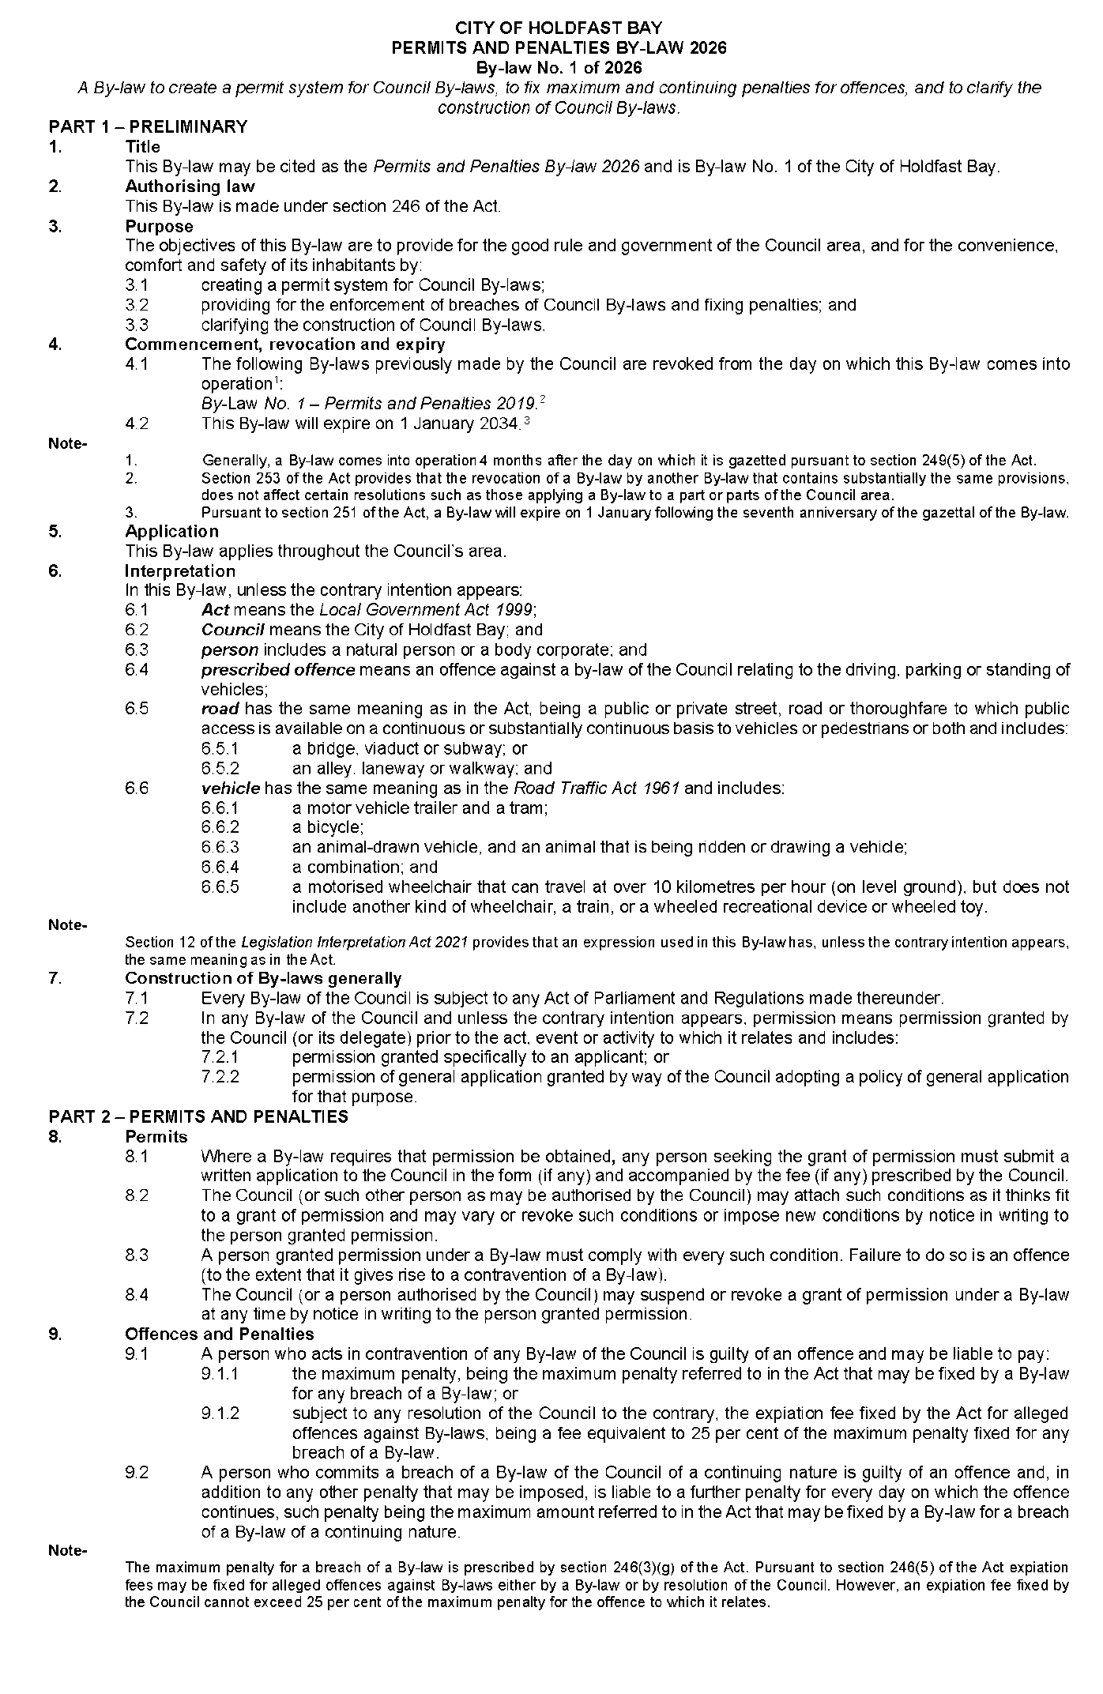
City of Holdfast Bay
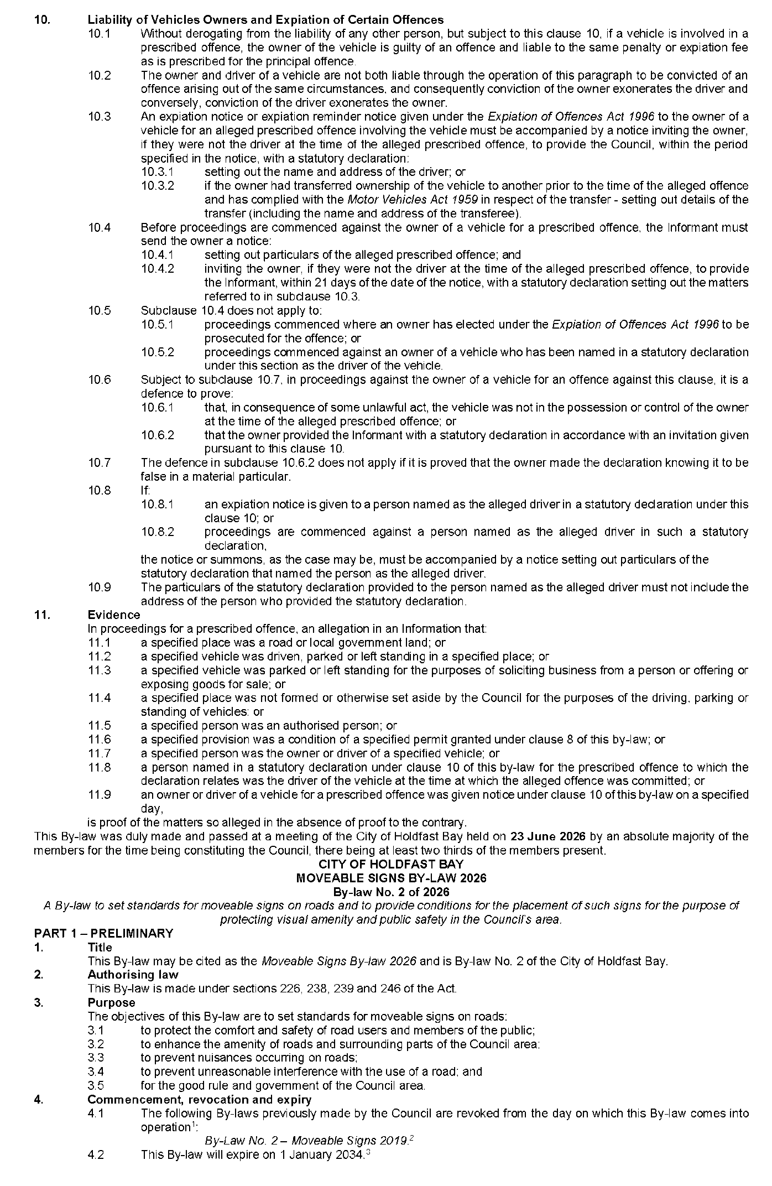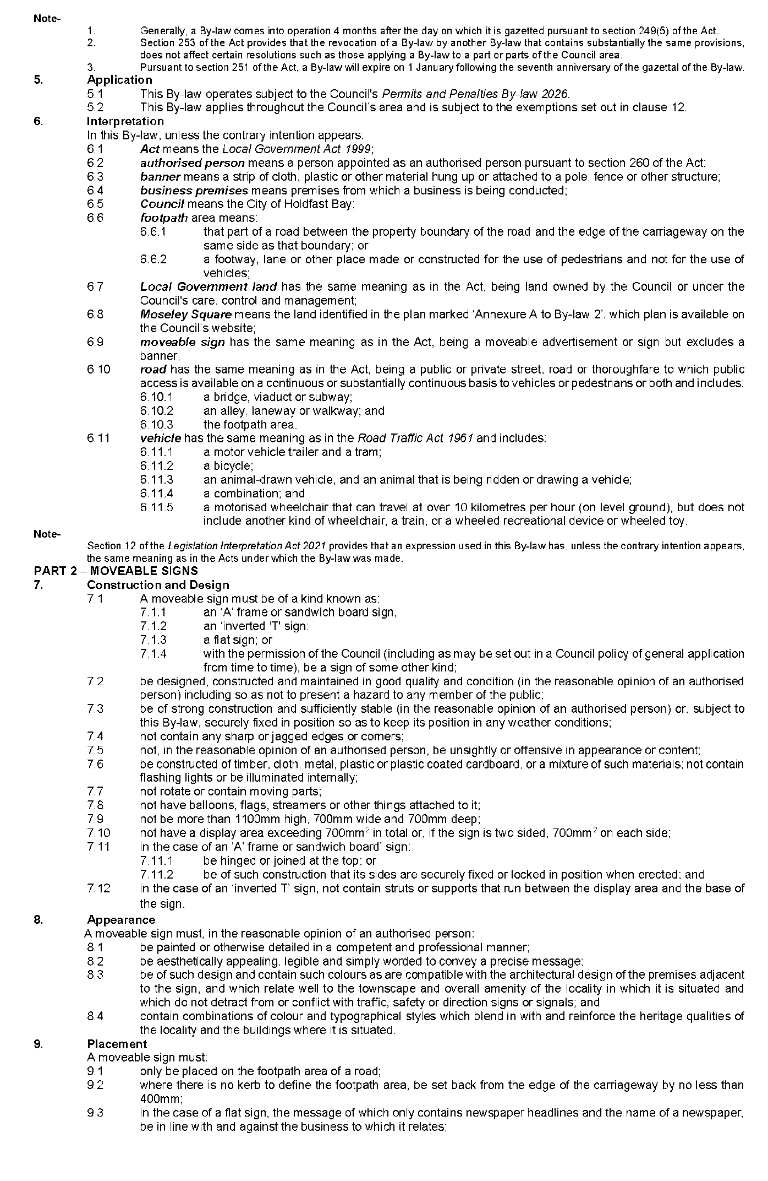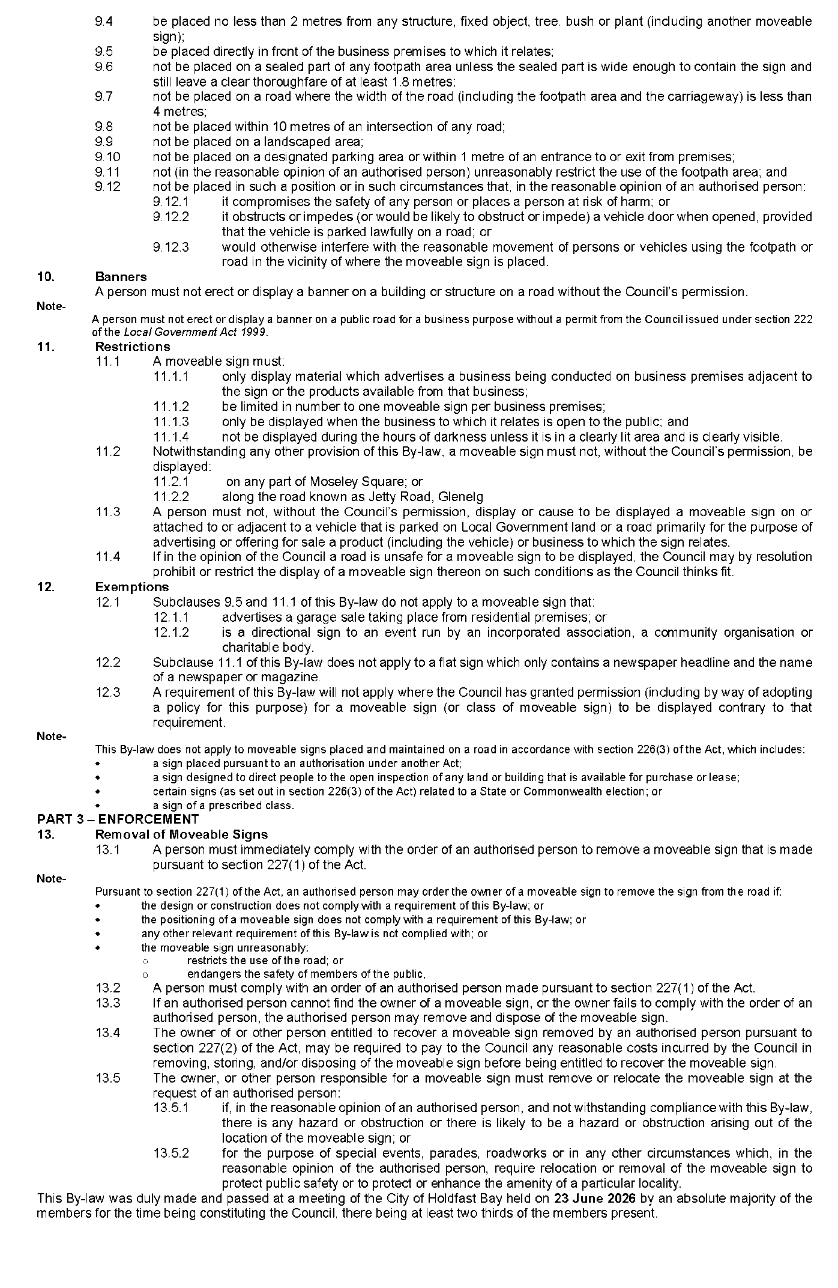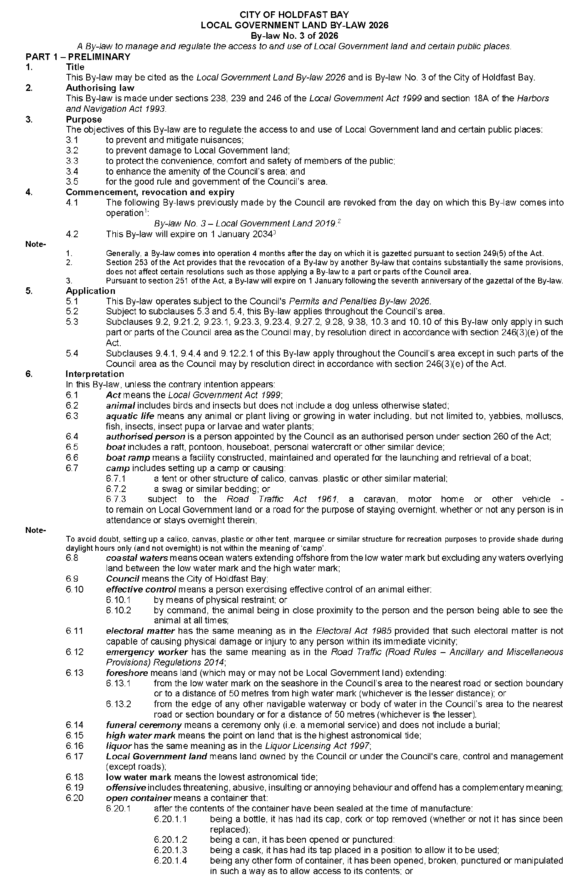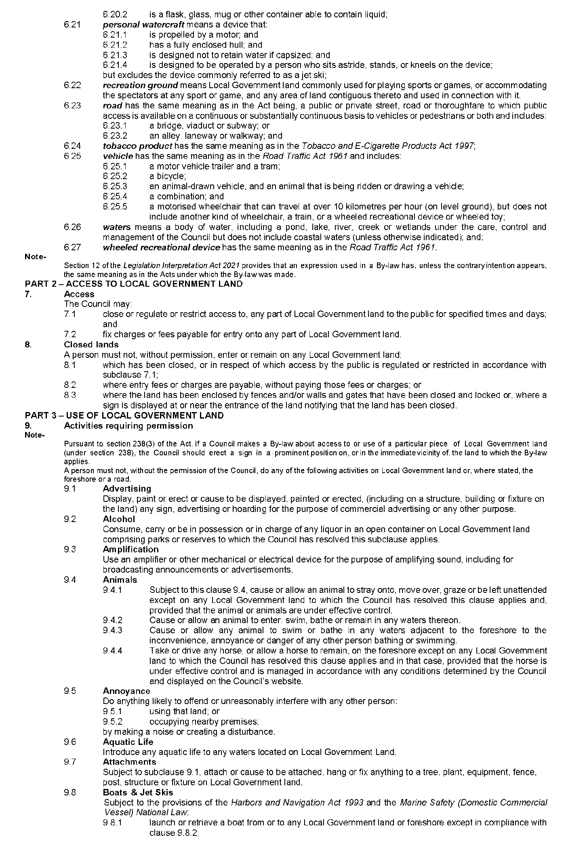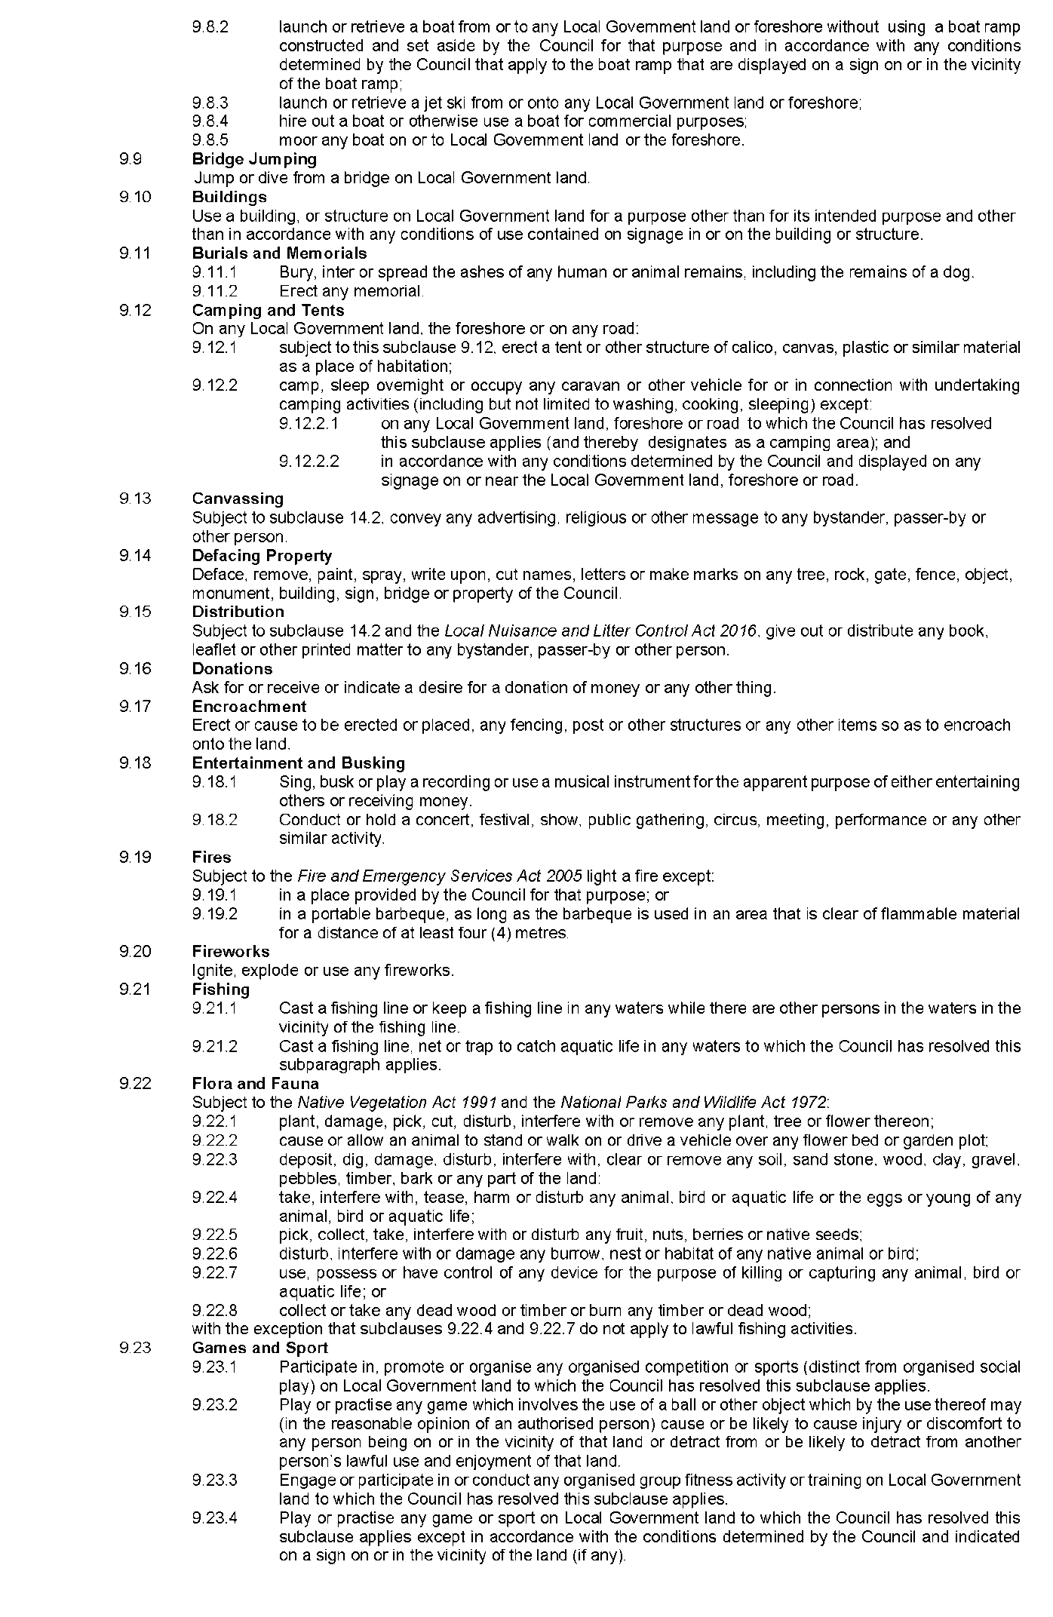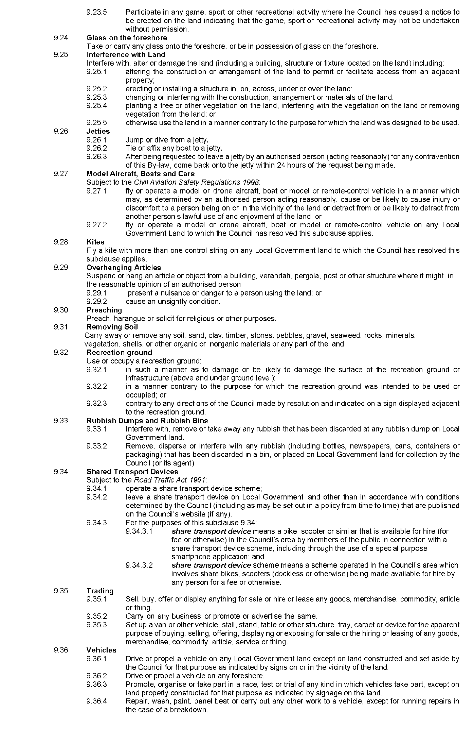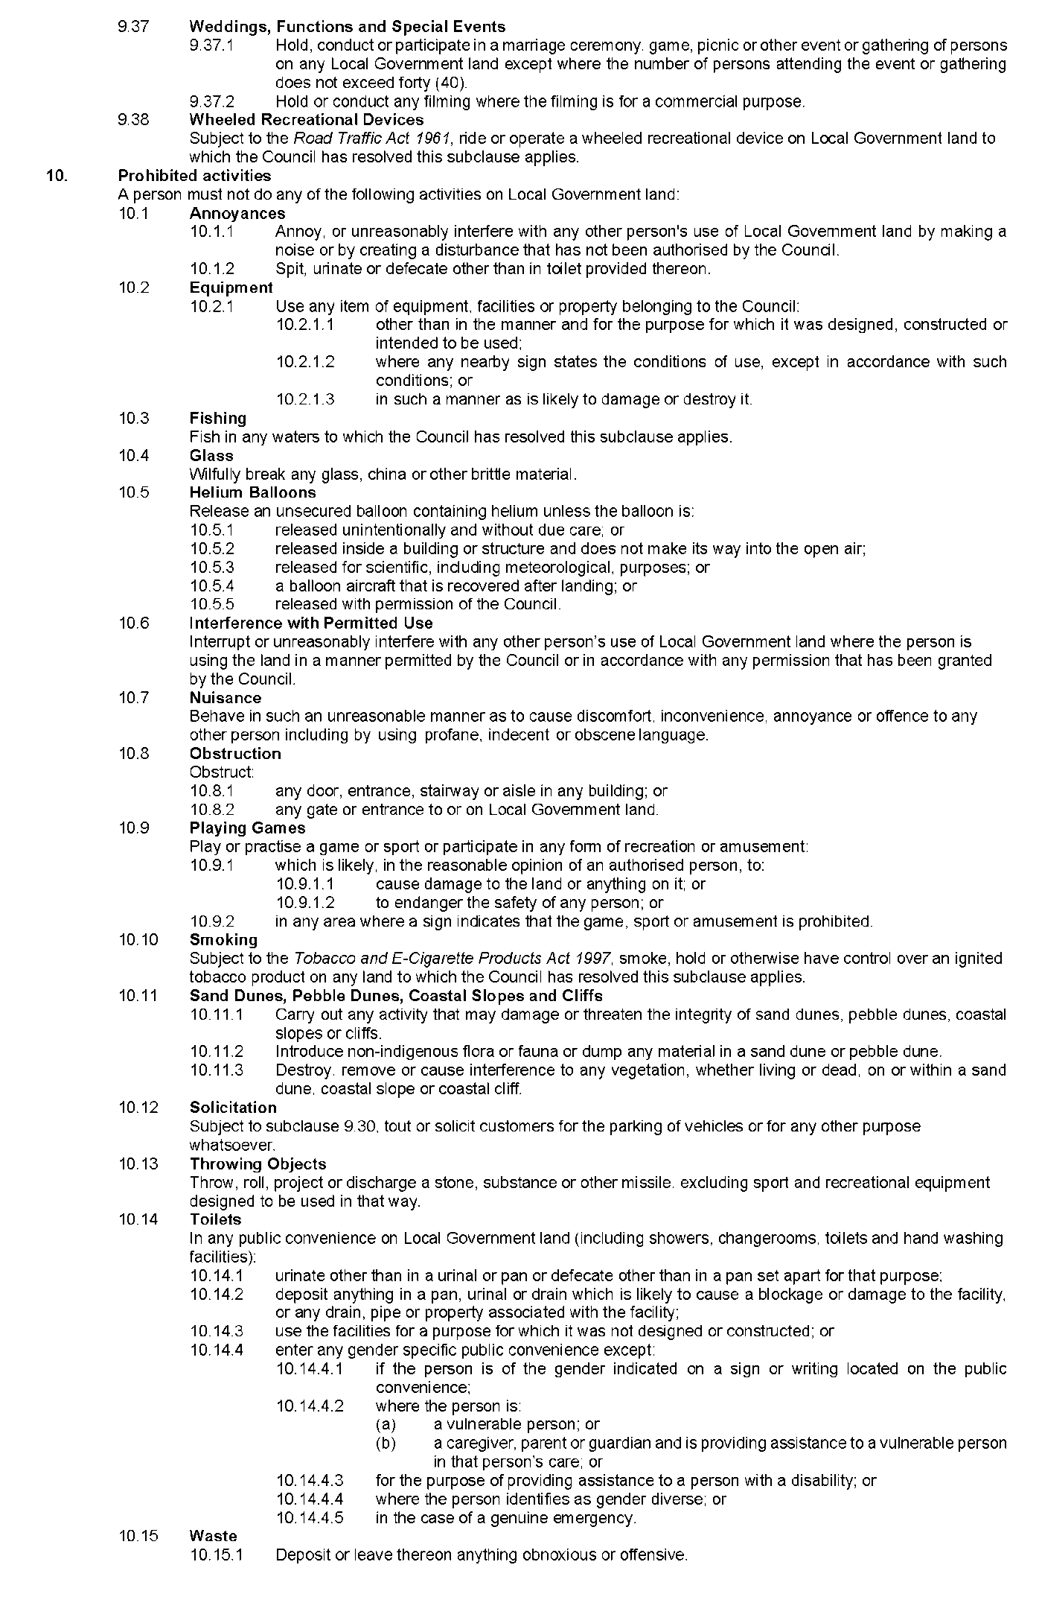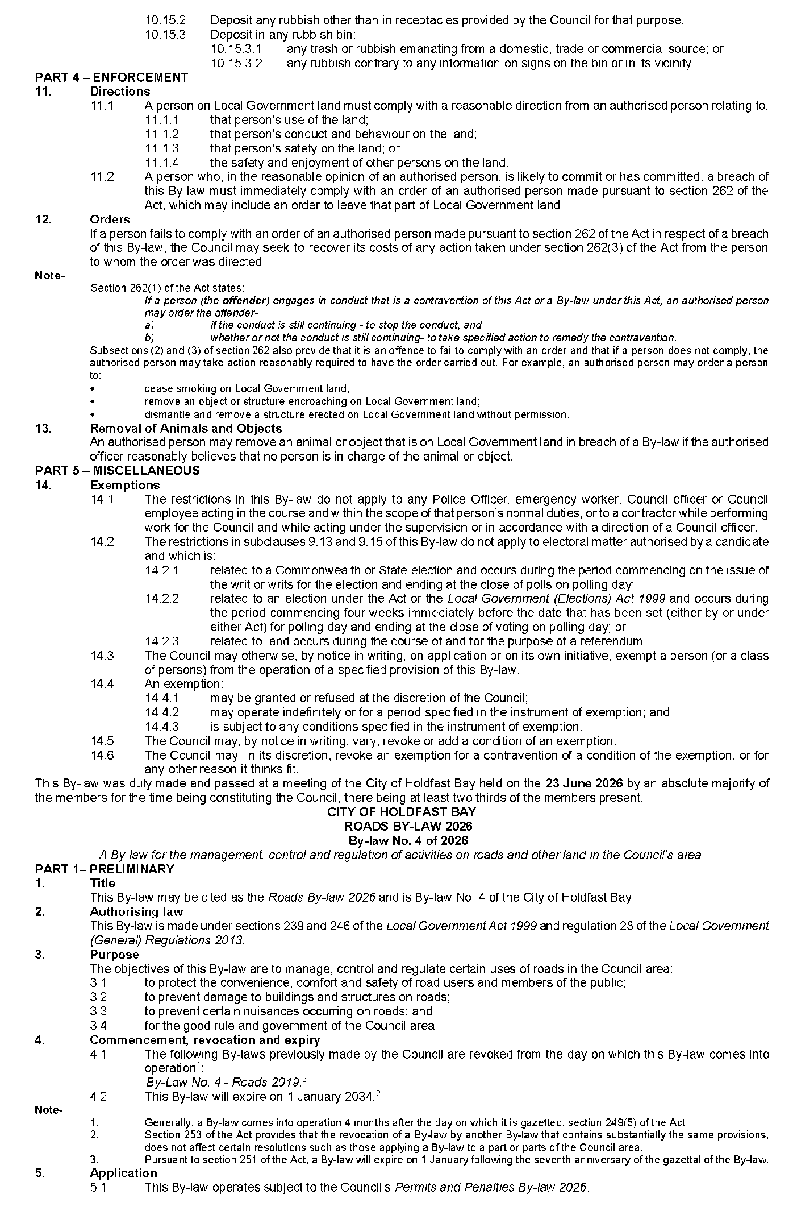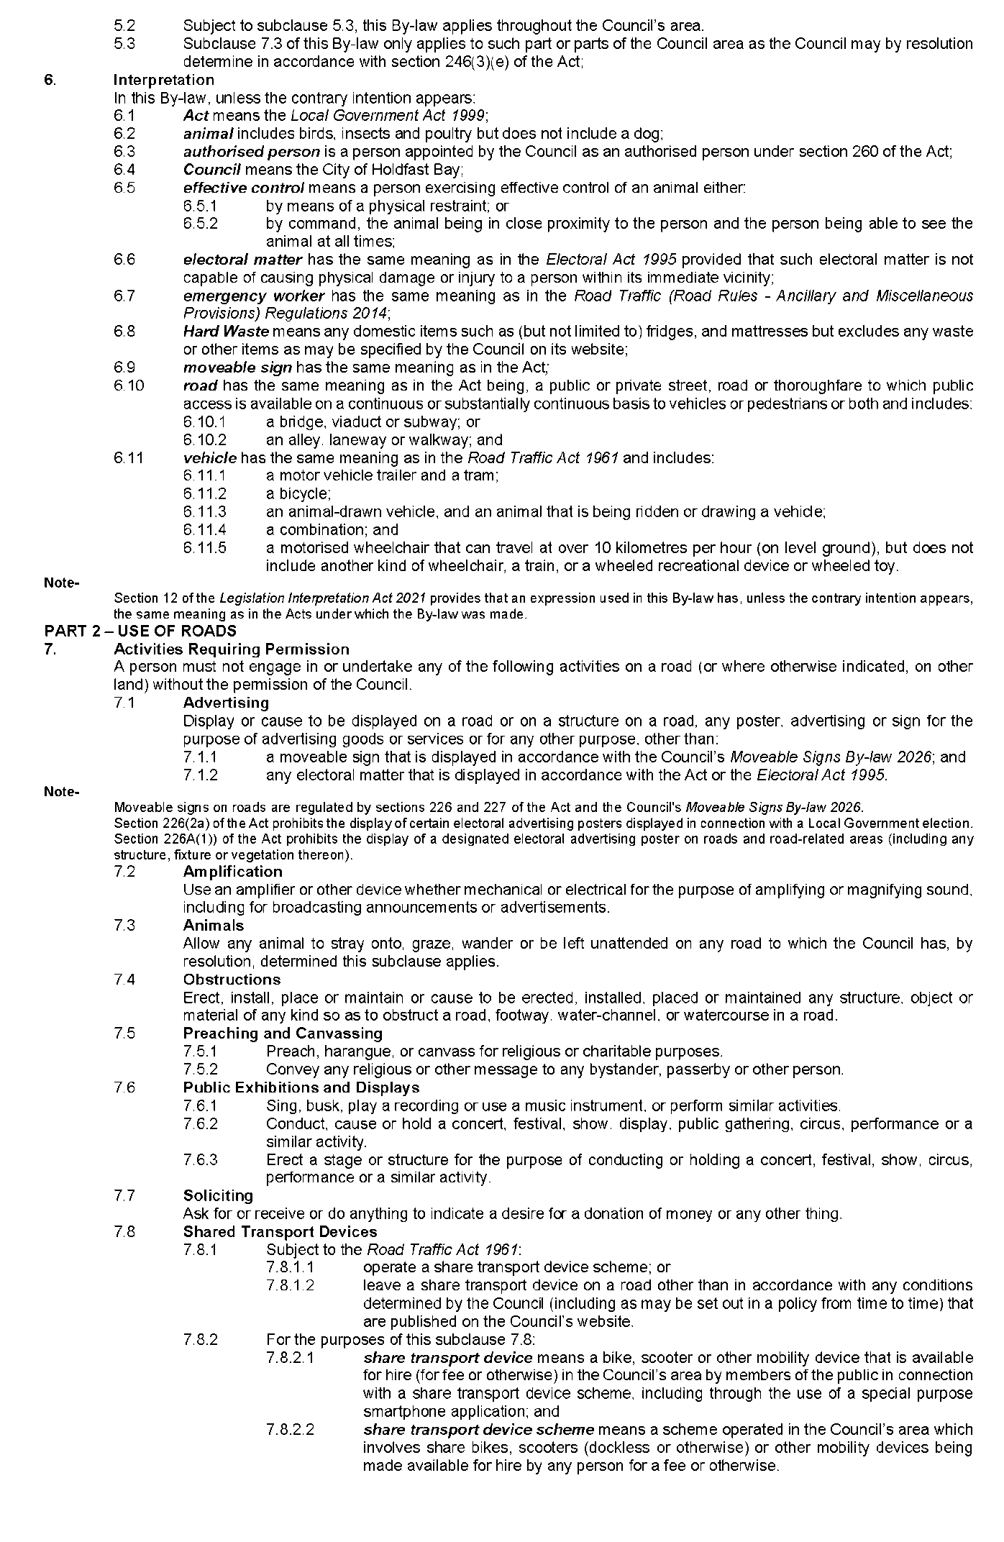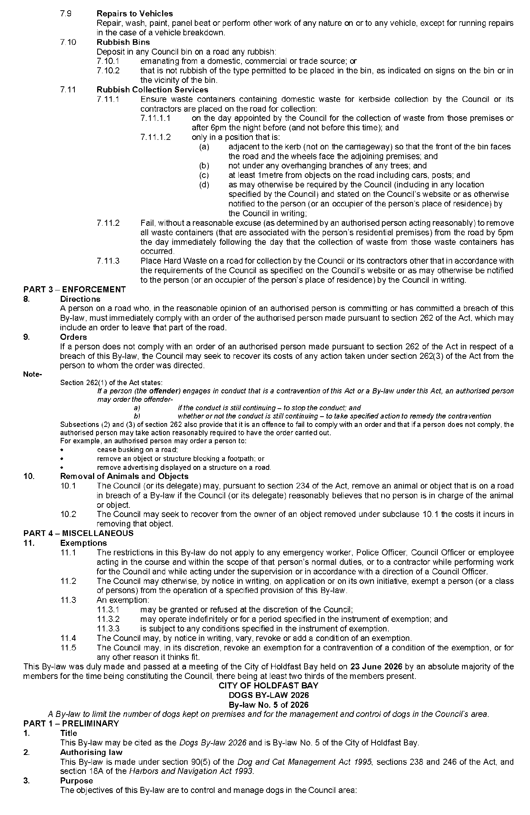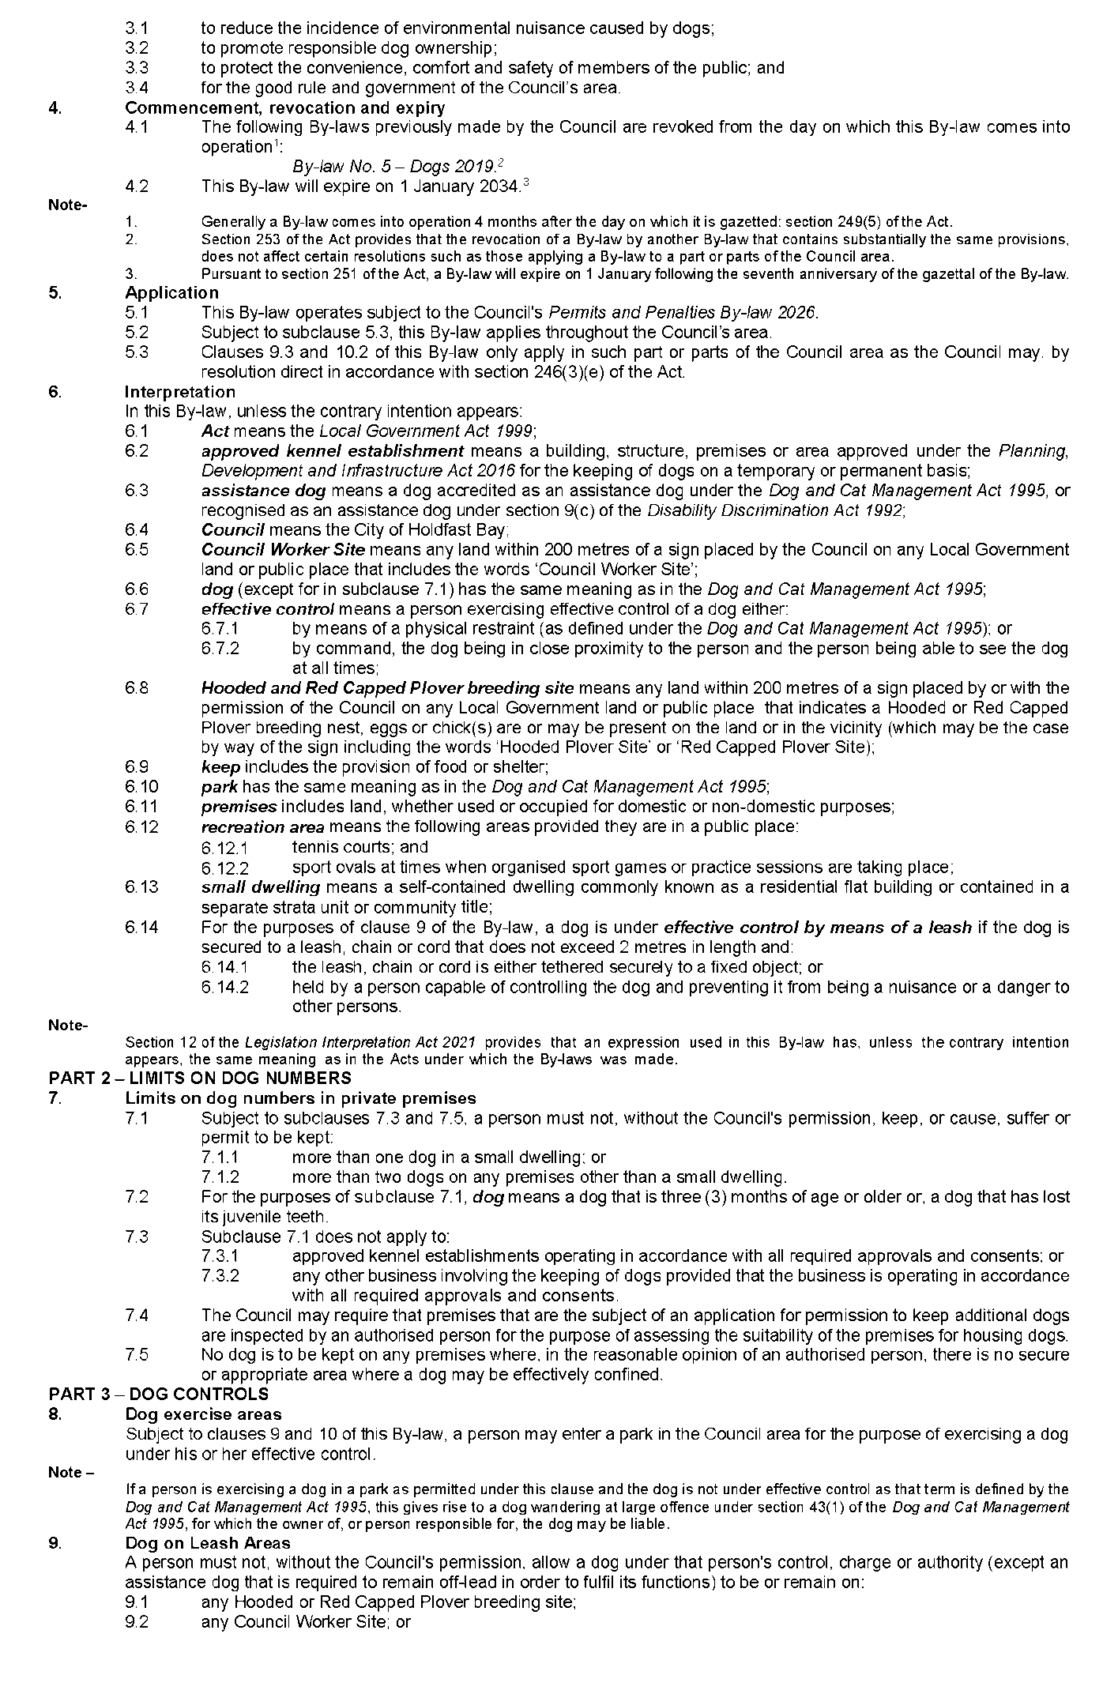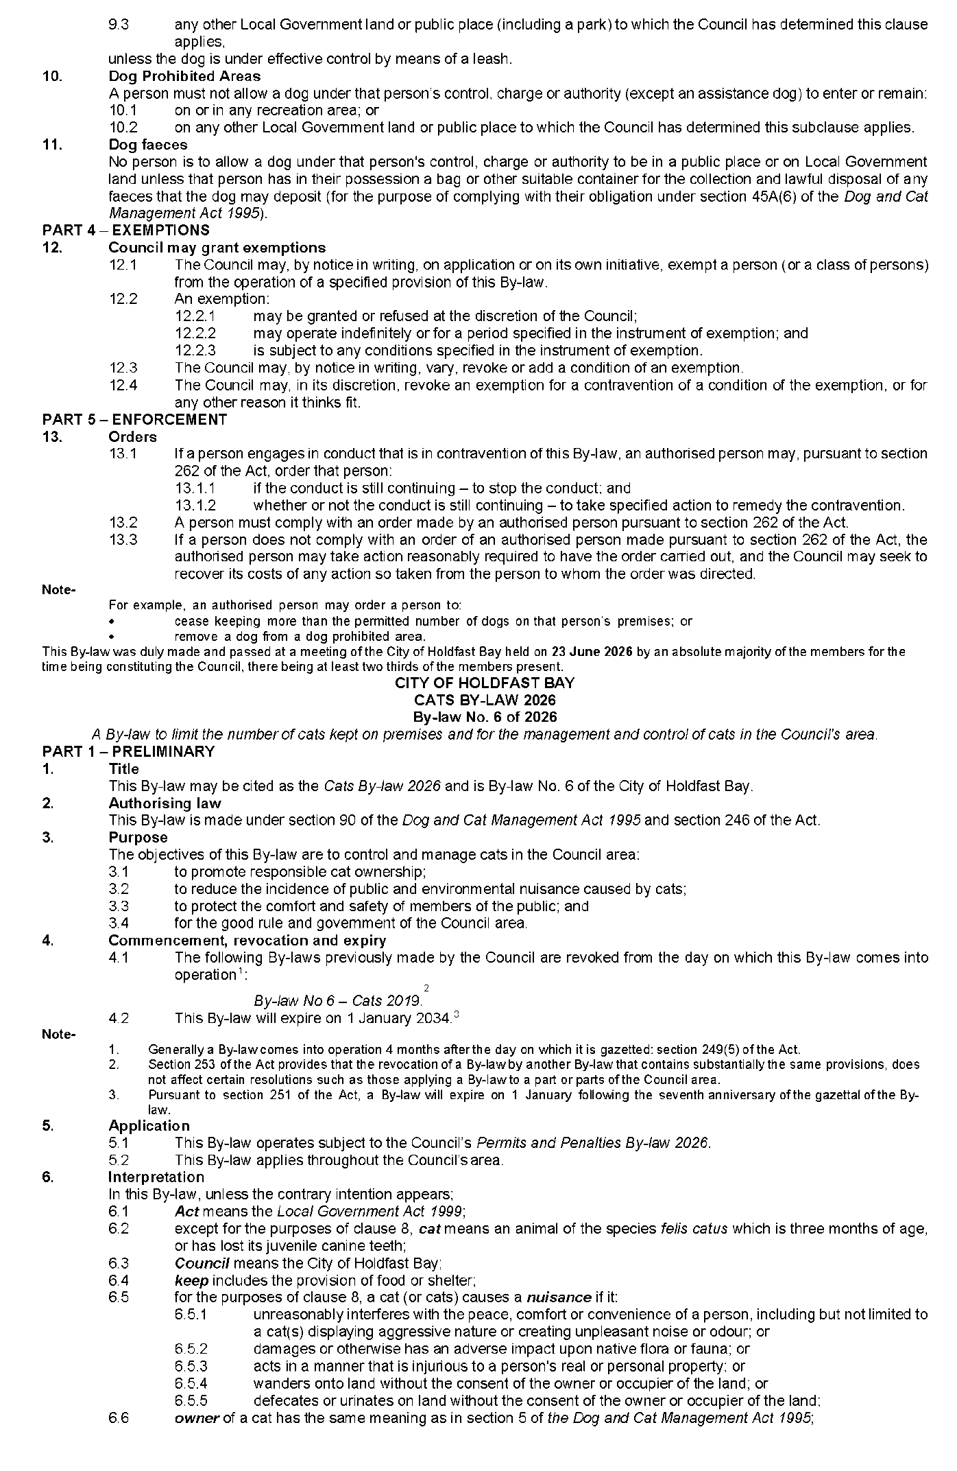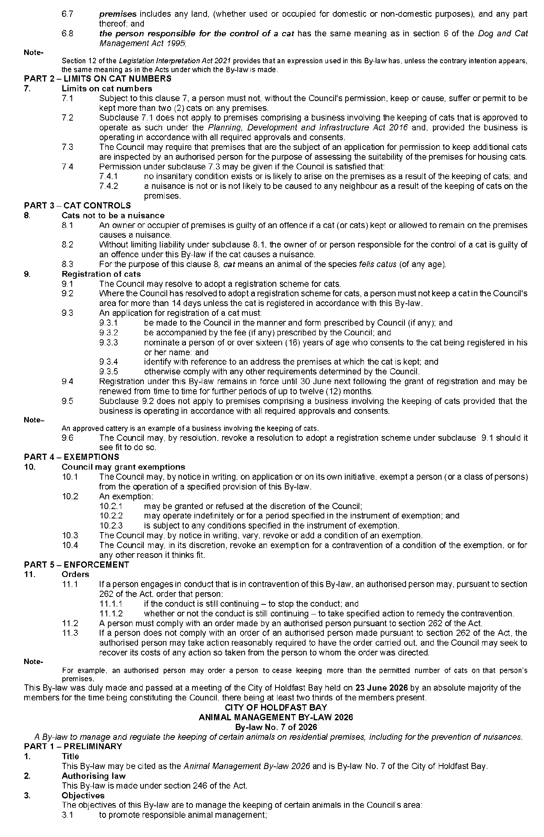
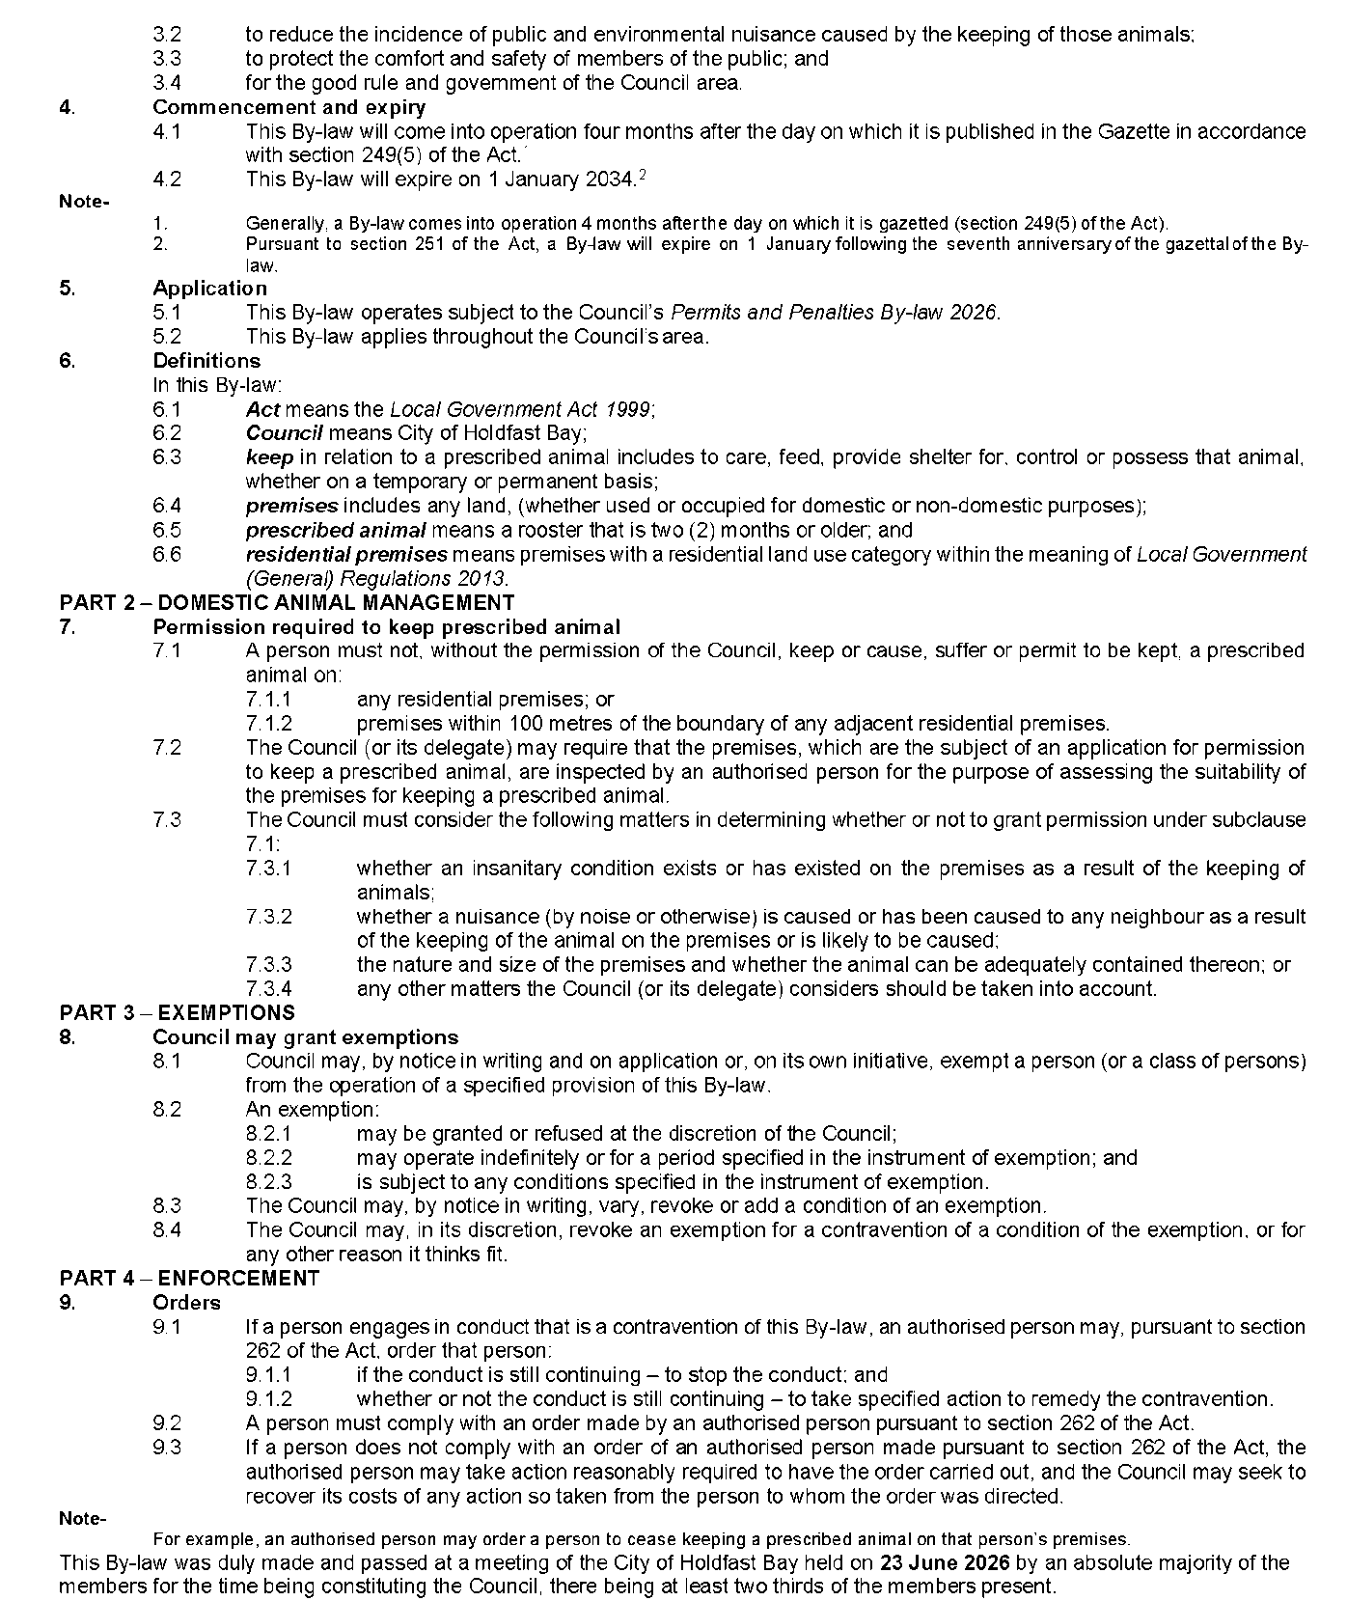
Dated: 27 August 2026
P. Jackson
Chief Executive Officer

City of Mitcham
Local Government Act 1999
Adoption of New and Amended Community Land Management Plans
Notice is hereby given pursuant to Sections 197(3) and 198(4) of the Local Government Act 1999, that the City of Mitcham at its Full Council Meeting on 11 August 2026 resolved to adopt new Community Land Management Plans for:
• Libraries
• Soldiers Memorial Gardens
• Winns Bakehouse and Museum
• Gamble Cottage
• Blackwood War Memorial
And amended Community Land Management Plans for:
• Conservation/Biodiversity Reserves
• Parks (Playgrounds)
• Community Centres and Halls
• Kindergartens
• Passive Recreation Reserves
• Screening Reserves
• Sport and Community Recreation Complexes
The adopted Community Land Management Plans can be viewed at www.mitchamcouncil.sa.gov.au.
Dated: 21 August 2026
Matthew Pears
Chief Executive Officer

CITY OF MITCHAM
Local Government Act 1999
Adoption of New and Amended Community Land Management Plans
Notice is hereby given pursuant to Sections 197(3) and 198(4) of the Local Government Act 1999, that the City of Mitcham at its Full Council Meeting on 11 August 2026 resolved to adopt new Community Land Management Plans for:
• Libraries
• Soldiers Memorial Gardens
• Winns Bakehouse and Museum
• Gamble Cottage
• Blackwood War Memorial
And amended Community Land Management Plans for:
• Conservation/Biodiversity Reserves
• Parks (Playgrounds)
• Community Centres and Halls
• Kindergartens
• Passive Recreation Reserves
• Screening Reserves
• Sport and Community Recreation Complexes
The adopted Community Land Management Plans can be viewed at www.mitchamcouncil.sa.gov.au.
Dated: 21 August 2026
Matthew Pears
Chief Executive Officer

City of Onkaparinga
Notice of Removal of Vehicle
Notice is hereby given that pursuant to Section 237(4)(b) of the Local Government Act 1999 the following vehicles have been removed and impounded by Council.
• White Toyota Landcruiser Victorian Registration 1VS5MG on 24 August 2026 at 13:30.
Take note—
(a) your vehicle has been removed; and
(b) if you do not, within one month after service of this notice—
(i) take possession of the vehicle; and
(ii) pay all expenses in connection with the removal, custody and maintenance of the vehicle and of serving, posting or publishing this notice,
Council will take steps to sell or dispose of the vehicle in accordance with Section 237 of the Local Government Act 1999.
Please contact Council on (08) 8384 0666 during ordinary office hours to arrange collection of your vehicle.
Dated: 27 August 2026
Nicole Moore
Manager Community Safety and Property Acting

The Flinders Ranges Council
Adoption of Valuations and Declaration of Rates
Notice is given that at the Council meeting on 18 August 2026, the Council resolved for the year ending 30 June 2027:
1. To adopt, for rating purposes, the most recent valuations made by the Valuer-General in relation to all land in the area of the Council with total valuations being $510,459,620 comprising $496,523,200 of rateable land and $13,936,420 of non-rateable land.
2. Declares differential general rates based on the assessed capital values of all rateable land within the Council area by reference to land use and locality of the land as follows:
The Quorn Township, Quorn Rural Area, Hawker Township, Hawker Rural Area a differential general rate of:
(1) 0.529 cents in the dollar for residential land use;
(2) 0.730 cents in the dollar for commercial—shop land use;
(3) 0.863 cents in the dollar for commercial—office land use;
(4) 0.863 cents in the dollar for commercial—other land use;
(5) 0.817 cents in the dollar for industry—light land use;
(6) 0.817 cents in the dollar for industry—other land use;
(7) 0.382 cents in the dollar for primary production land use;
(8) 0.529 cents in the dollar for vacant land use;
(9) 0.973 cents in the dollar for other land use.
3. Fixed a minimum amount of $1,021.00 payable by way of general rates.
4. Imposed Annual Service Charges based on the level of usage of the service upon the land to which it provides the prescribed service of the collection and disposal of “wet” and “recyclable” waste as follows:
(1) $280.00 for occupied properties in Quorn, Hawker and Cradock for “wet” waste; and
(2) $190.00 for occupied properties in Quorn, Hawker and Cradock for “recyclable” waste.
5. Imposed Annual Service Charges based on the nature of the service and varying according to whether the land is vacant or occupied upon the land to which it provides or makes available the prescribed service of a Community Wastewater Management System, of:
(a) $455.00 per unit in respect of each piece of occupied land serviced by the Quorn Community Wastewater Management Systems;
(b) $435.00 per unit in respect of each piece of vacant land serviced by the Quorn Community Wastewater Management Systems;
(c) $455.00 per unit in respect of each piece of occupied land serviced by the Hawker Community Wastewater Management Systems; and
(d) $435.00 per unit in respect of each piece of vacant land serviced by the Hawker Community Wastewater Management Systems.
6. In order to reimburse the Council for amounts contributed to the South Australian Arid Lands Landscape Board, being $98,780 declared a Regional Landscape Levy as a differential separate rate on rateable properties in the area of the Council by reference to land use of the land as follows:
(1) $49.06 for residential land use;
(2) $98.12 for commercial—shop land use;
(3) $98.12 for commercial—office land use;
(4) $98.12 for commercial—other land use;
(5) $98.12 for industry—light land use;
(6) $98.12 for industry—other land use;
(7) $245.30 for primary production land use;
(8) $49.06 for vacant land use;
(9) $49.06 for other land use.
Dated: 19 August 2026
K. S. Clark
Acting Chief Executive Officer

District Council of Streaky Bay
Change of Meeting Date
Notice is hereby given that the Ordinary September Council Meeting will now be held on Tuesday, 22 September 2026, commencing at 9:30am in the Council Chambers of 29 Alfred Street, Streaky Bay, in lieu of Tuesday, 15 September 2026.
Dated: 27 August 2026
D. G. Carter
Chief Executive Officer

Public Notices

National Electricity Law
Notice of Final Determination and Final Rule
Notice of Extension of Draft Determination
Notice of Initiation
The Australian Energy Market Commission (AEMC) gives notice under the National Electricity Law as follows:
Under ss 102, 102A and 103, the making of the National Electricity Amendment (Improving contingency FCAS arrangements) Rule 2026 No. 8 (Ref. ERC0359) and related final determination. Provisions commence as follows: Schedules 1 and 3 of this Rule commence on
4 September 2026. Schedule 2 of this Rule commences on 1 October 2027. Schedule 4 of this Rule commences on 31 January 2031.
Under s 107, the time for making the draft determination on the Facilitating electric vehicle charging infrastructure under Commonwealth grants (Ref. ERC0436) proposal has been extended to 24 September 2026.
Under s 95, AEMO has requested the Dispatch limits for inverter-based resources (Ref. ERC0453) proposal. The proposal seeks to expressly enable dispatch instructions to include a limit on the number of inverters online at a connection point. Submissions must be received by 24 September 2026.
Submissions can be made via the AEMC’s website. Before making a submission, please review the AEMC’s privacy statement on its website, and consider the AEMC’s Tips for making a submission. The AEMC publishes submissions on its website, subject to confidentiality and other considerations.
Documents referred to above are available on the AEMC’s website and are available for inspection at the AEMC’s office.
Australian Energy Market Commission
Level 15, 60 Castlereagh St
Sydney NSW 2000
Telephone: (02) 8296 7800
www.aemc.gov.au
Dated: 27 August 2026

National Gas Law
Notice of Draft Determination and Draft Rule
The Australian Energy Market Commission (AEMC) gives notice under the National Gas Law as follows:
Under s 308, the making of a draft determination and related draft rule on the Gas networks in transition (Ref. GRC0082) proposal. Written requests for a pre-determination hearing must be received by 3 September 2026. Submissions must be received by 8 October 2026.
Submissions can be made via the AEMC’s website. Before making a submission, please review the AEMC’s privacy statement on its website, and consider the AEMC’s Tips for making a submission. The AEMC publishes submissions on its website, subject to confidentiality and other considerations.
Written requests should be sent to submissions@aemc.gov.au and cite the reference in the title. Before sending a request, please review the AEMC’s privacy statement on its website.
Documents referred to above are available on the AEMC’s website and are available for inspection at the AEMC’s office.
Australian Energy Market Commission
Level 15, 60 Castlereagh St
Sydney NSW 2000
Telephone: (02) 8296 7800
www.aemc.gov.au
Dated: 27 August 2026

Trustee Act 1936
Deceased Estate
Notice of Intended Application for Probate
After 14 days from publication of this notice, Stephen John Pedley the Administrator of the estate of Raymond Arthur Robinson deceased, will apply to the Probate Registry of the Supreme Court of South Australia for Letters of Administration.
All persons having claims against the estate are required to send particulars of their claims to:
Sonia Petracca Lawyers—0418858399 or PO Box 3040, Rostrevor SA 5073.
Dated: 27 August 2026
Stephen Pedley
pedley1527@gmail.com
0411191187

Trustee Act 1936
Public Trustee
Estates of Deceased Persons
In the matter of the estates of the undermentioned deceased persons:
AHEARN Wayne Edward late of 39 Cumberland Street Warrane Tasmania Of No Occupation who died 12 April 2024
DEUTER Margaret Elma late of 9 Bellevue Court Gawler East Retired Secretary/Nurse who died 12 December 2025
HEDLEY Joan late of 1 Charles Street West Lakes of no occupation who died 26 November 2025
JACKS Alfred Ernest late of 72 Ellis Road Two Wells Retired Machine Operator who died 27 March 2026
MAJOR Jeanette late of 15 Halliday Street Risdon Park Retired Retail Assistant who died 5 June 2026
MANN Dene Courtney late of 59 Alexander Avenue Morphett Vale Of No Occupation who died 29 April 2023
NEILL William late of 25 Newton Street Whyalla Retired Steel Worker who died 23 April 2026
PIKE John Milton late of 86 Kestral Road Humbug Scrub Retired Accountant who died 20 April 2025
SANSOM Ronald Francis late of 2 Malken Way Findon Retired Broadcast Television Cameraman who died 5 January 2026
VERNE Carmen Kay late of 76 Ways Road Manningham Retired Public Servant who died 23 December 2025
Notice is hereby given pursuant to the Trustee Act 1936 (SA), the Succession Act 2023 (SA) and the Family Relationships Act 1975 (SA) that all creditors, beneficiaries, and other persons having claims against the said estates are required to send, in writing, to the office of Public Trustee at GPO Box 1338, Adelaide 5001, full particulars and proof of such claims, on or before the 25 September 2026 otherwise they will be excluded from the distribution of the said estate; and notice is also hereby given that all persons indebted to the said estates are required to pay the amount of their debts to the Public Trustee or proceedings will be taken for the recovery thereof; and all persons having any property belonging to the said estates are forthwith to deliver same to the Public Trustee.
Dated: 27 August 2026
T. Brumfield
Public Trustee

Unclaimed Goods Act 1987
Notice of Intention to Sell
Manheim Pty Ltd of 180 Phillip Hwy, Elizabeth South, South Australia, 5112 intends to sell the following vehicles under the Disposal of Uncollected Goods Act 1987. Owners of the vehicles have been sent notices that state that they are ready for collection. If said owners do not make arrangements for payment within 28 days from now they will be disposed of to settle any outstanding debt.
Make | Model Description | Registration No. | VIN
Yamaha | MT07LA | S02AHJ | JYARM0499GA000213
Dated: 27 August 2026
Rebecca Barry
Cox Automotive Australia & New Zealand
Ph: 1800 326 243

Notice Submission

The South Australian Government Gazette is published each Thursday afternoon.
Notices must be emailed by 4 p.m. Tuesday, the week of publication.
Submissions are formatted per the gazette style and a proof will be supplied prior to publication, along with a quote if applicable. Please allow one day for processing notices.
Alterations to the proof must be returned by 4 p.m. Wednesday.

Gazette notices must be submitted as Word files, in the following format:
• Title—the governing legislation
• Subtitle—a summary of the notice content
• Body—structured text, which can include numbered lists, tables, and images
• Date—day, month, and year of authorisation
• Signature block—name, role, and department/organisation authorising the notice

Please provide the following information in your email:
• Date of intended publication
• Contact details of the person responsible for the notice content
• Name and organisation to be charged for the publication—Local Council and Public notices only
• Purchase order, if required—Local Council and Public notices only

Email: governmentgazettesa@sa.gov.au
Phone: (08) 7133 3552
Website: www.governmentgazette.sa.gov.au

All instruments appearing in this gazette are to be considered official, and obeyed as such

Printed and published weekly by authority of T. Foresto, Government Printer, South Australia
$9.50 per issue (plus postage), $479.00 per annual subscription—GST inclusive
Online publications: www.governmentgazette.sa.gov.au

