
No. 47 p. 2775
THE SOUTH AUSTRALIAN
GOVERNMENT GAZETTE
Published by Authority

Adelaide, Thursday, 20 August 2026

Contents

Governor’s Instruments
Appointments, Resignations and General Matters 2776
Proclamations—
Return to Work (Presumptive Firefighter Injuries)
Amendment Act (Commencement) Proclamation 2026 2777
Regulations—
Fisheries Management (General) (Miscellaneous)
Amendment Regulations 2026—No. 72 of 2026 2778
Fisheries Management (Demerit Points)
(General Regulations) Amendment
Regulations 2026—No. 73 of 2026 2782
Return to Work (Prescribed Injuries) Amendment Regulations 2026—No. 74 of 2026 2784
Community Titles Regulations 2026—No. 75 of 2026 2786
Strata Titles (Miscellaneous) Amendment
Regulations 2026—No. 76 of 2026 2810
State Government Instruments
Building Work Contractors Act 1995 2812
Controlled Substances Act 1984 2812
Fisheries Management (General) Regulations 2017 2813
Fisheries Management Act 2007 2813
Health Care Act 2008 2815
Highways Act 1926 2816
Housing Improvement Act 2016 2816
Mental Health Act 2009 2817
National Parks and Wildlife (National Parks)
Regulations 2016 2817
South Australian Civil and Administrative Tribunal 2818
South Australian Skills Act 2008 2819
Transplantation and Anatomy Act 1983 (SA) 2819
Water Industry Act 2012 2819
Local Government Instruments
City of Onkaparinga 2821
City of Playford 2821
Port Augusta City Council 2822
Town of Gawler 2838
Adelaide Hills Council 2838
District Council of Franklin Harbour 2839
District Council of Karoonda East Murray 2839
Wattle Range Council 2839
Public Notices
Partnership Act 1891 2859

Governor’s Instruments

Appointments, Resignations and General Matters
Department of the Premier and Cabinet
Adelaide, 20 August 2026
Her Excellency the Governor in Executive Council has been pleased to appoint the undermentioned to the Urban Renewal Authority Board of Management, pursuant to the provisions of the Urban Renewal Act 1995:
Member: from 20 August 2026 until 19 August 2029
Bronwyn Kaye Gallacher
By command,
Clare Michele Scriven, MLC
For Premier
26MUDCS10540

Department of the Premier and Cabinet
Adelaide, 20 August 2026
Her Excellency the Governor in Executive Council has been pleased to appoint the Honourable Michael Edison Brown, MP as Acting Minister for Housing and Urban Development, Acting Minister for Housing Infrastructure and Acting Minister for Planning from 22 August 2026 until 29 August 2026 inclusive, during the absence of the Honourable Nicholas David Champion, MP.
By command,
Clare Michele Scriven, MLC
For Premier
26MHCS10407

Proclamations
South Australia

Return to Work (Presumptive Firefighter Injuries) Amendment Act (Commencement) Proclamation 2026
1—Short title
This proclamation may be cited as the Return to Work (Presumptive Firefighter Injuries) Amendment Act (Commencement) Proclamation 2026.
2—Commencement of Act
The Return to Work (Presumptive Firefighter Injuries) Amendment Act 2026 (No 7 of 2026) comes into operation on 20 August 2026.
Made by the Governor
with the advice and consent of the Executive Council
on 20 August 2026

Regulations
South Australia

Fisheries Management (General) (Miscellaneous) Amendment Regulations 2026
under the Fisheries Management Act 2007

Contents
Part 1—Preliminary
1 Short title
2 Commencement
Part 2—Amendment of Fisheries Management (General) Regulations 2017
3 Amendment of regulation 3—Interpretation
4 Amendment of regulation 23—Duty to clip tail fan of rock lobster
5 Amendment of regulation 23D—Taking more than daily bag limit of Razorfish
6 Amendment of regulation 30—Minister's determinations
7 Amendment of Schedule 6—Classes of fishing activities prescribed for purposes of section 70 of Act
8 Amendment of Schedule 11—Expiation fees

Part 1—Preliminary
1—Short title
These regulations may be cited as the Fisheries Management (General) (Miscellaneous) Amendment Regulations 2026.
2—Commencement
These regulations come into operation on the day on which they are made.
Part 2—Amendment of Fisheries Management (General) Regulations 2017
3—Amendment of regulation 3—Interpretation
(1) Regulation 3(1), definition of GDA2020—delete "measurement position" and substitute:
measurement of position
(2) Regulation 3(1), definition of Miscellaneous Broodstock and Seedstock Fishery—delete "Fisheries Management (Miscellaneous Broodstock and Seedstock Fishery) Regulations 2013" and substitute:
Fisheries Management (Miscellaneous Broodstock and Seedstock Fishery) Regulations 2025
4—Amendment of regulation 23—Duty to clip tail fan of rock lobster
(1) Regulation 23, heading—delete "clip" and substitute:
mark
(2) Regulation 23—delete "landed, clip its middle tail fan in half horizontally across the tail and remove it." and substitute:
landed, mark it by—
(a) clipping its middle tail fan in half horizontally across the tail and removing it; or
(b) punching a hole, no less than 10 millimetres in diameter, in the distal end of its middle tail fan.
(3) Regulation 23, diagram—delete the diagram and substitute:
Clipping of middle tail fan
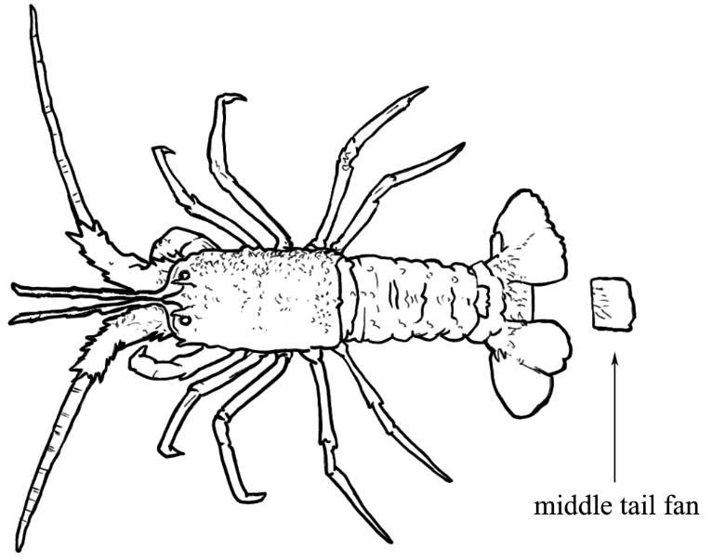
Punching of hole in distal end of middle tail fan
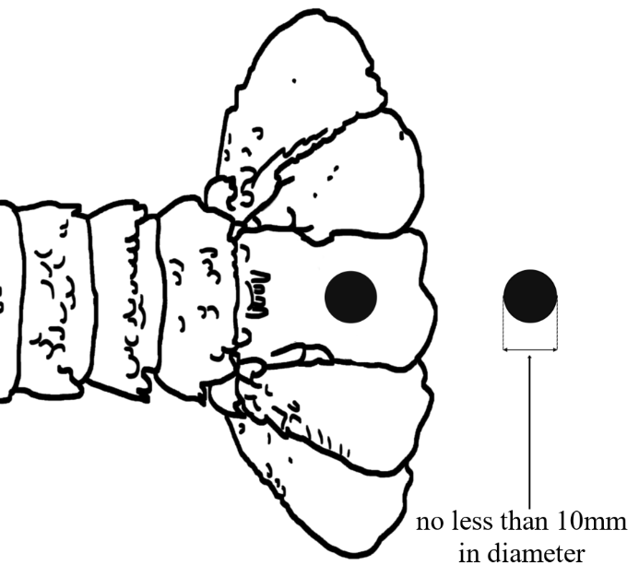
(4) Regulation 23—after its present contents as amended by this regulation (now to be designated as subregulation (1)) insert:
(2) In this regulation—
rock lobster means any spiny rock lobster (Family Palinuridae).
5—Amendment of regulation 23D—Taking more than daily bag limit of Razorfish
Regulation 23D(2)—delete ", if the licensed person takes less than 150 Razorfish over a consecutive period of 3 days" and substitute:
other than Spencer Gulf, if the total number of Razorfish taken under the licence over a period of 3 consecutive days is not more than 150.
6—Amendment of regulation 30—Minister's determinations
Regulation 30(7)—delete ", 23E or 23F" and substitute:
or 23E
7—Amendment of Schedule 6—Classes of fishing activities prescribed for purposes of section 70 of Act
(1) Schedule 6, Part 1, clauses 26, 27 and 28—delete the clauses and substitute:
26—Use of trawl nets and boats in prawn fisheries
(1) The taking of fish by a licenced person under a licence in respect of a prawn fishery—
(a) by use of a boat that has—
(i) an overall length exceeding 24 metres; or
(ii) a main engine the continuous brake power rating of which exceeds 340 kilowatts; or
(b) by use of a single trawl net with a headline length exceeding 29.26 metres; or
(c) by use of 2 trawl nets set up as a double rig with a combined headline length exceeding 29.26 metres; or
(d) subject to subclause (2)—by use of a trawl net or trawl nets other than as a single or double rig.
(2) Subclause (1)(d) does not apply in relation to the taking of fish by a licenced person under a licence in respect of the Gulf St. Vincent Prawn Fishery by use of amalgamated gear where the licensed person is approved by the Minister to use amalgamated gear for the purposes of regulation 9 of the Fisheries Management (Prawn Fisheries) Regulations 2017.
(3) In this clause—
amalgamated gear has the same meaning as in regulation 9(1) of the Fisheries Management (Prawn Fisheries) Regulations 2017;
Gulf St. Vincent Prawn Fishery means the fishery of that name constituted by the Fisheries Management (Prawn Fisheries) Regulations 2017;

prawn fishery has the same meaning as in the Fisheries Management (Prawn Fisheries) Regulations 2017.
(2) Schedule 6, Part 3—after clause 128 insert:
129—Use of baited line or lure trailing from boat in certain waters
The taking of fish by a person in the waters of the River Murray proper or Lakes Albert and Alexandrina (excluding the waters of the Coorong) during the period commencing 1 August in any year and ending on the following 31 December by trailing a baited line or lure through the water from a moving boat.
8—Amendment of Schedule 11—Expiation fees
(1) Schedule 11, table, items relating to clauses 26, 27 and 28 of Schedule 6—delete the items and substitute:

26(1) | Taking fish by licensed person using trawl nets and boats in prawn fishery | $625
(2) Schedule 11, table—after the item relating to clause 128 of Schedule 6 insert:

129 | Taking fish during certain period using baited line or lure trailing from boat in certain waters | $500
Editorial note—
As required by section 10AA(2) of the Legislative Instruments Act 1978, the Minister has certified that, in the Minister's opinion, it is necessary or appropriate that these regulations come into operation as set out in these regulations.
Made by the Governor
with the advice and consent of the Executive Council
on 20 August 2026
No 72 of 2026

South Australia

Fisheries Management (Demerit Points) (General Regulations) Amendment Regulations 2026
under the Fisheries Management Act 2007

Contents
Part 1—Preliminary
1 Short title
2 Commencement
Part 2—Amendment of Fisheries Management (Demerit Points) Regulations 2017
3 Amendment of Schedule 1—Demerit point offences and demerit points

Part 1—Preliminary
1—Short title
These regulations may be cited as the Fisheries Management (Demerit Points) (General Regulations) Amendment Regulations 2026.
2—Commencement
These regulations come into operation on the day on which the Fisheries Management (General) (Miscellaneous) Amendment Regulations 2026 come into operation.
Part 2—Amendment of Fisheries Management (Demerit Points) Regulations 2017
3—Amendment of Schedule 1—Demerit point offences and demerit points
(1) Schedule 1, Part 1, clause 2, table, items relating to clauses 26, 27 and 28 of Schedule 6 of the Fisheries Management (General) Regulations 2017—delete the items and substitute:

26(1) | Taking fish by licensed person using trawl nets and boats in prawn fishery—
 | (a) if the offence is expiated | 20
 | (b) in any other case—
 | (i) first offence | 60
 | (ii) second offence | 80
 | (iii) third or subsequent offence | 100

(2) Schedule 1, Part 1, clause 2, table—after the item relating to clause 128 of Schedule 6 of the Fisheries Management (General) Regulations 2017 insert:

129 | Taking fish by licensed person during certain period using baited line or lure trailing from boat in certain waters—
 | (a) if the offence is expiated | 20
 | (b) in any other case—
 | (i) first offence | 60
 | (ii) second offence | 80
 | (iii) third or subsequent offence | 100
129 | Taking fish by unlicensed person during certain period using baited line or lure trailing from boat in certain waters—
 | (a) if the offence is expiated | 20
 | (b) in any other case—
 | (i) first offence | 45
 | (ii) second offence | 60
 | (iii) third or subsequent offence | 75
(3) Schedule 1, Part 2, clause 8, table, item relating to regulation 23 of the Fisheries Management (General) Regulations 2017—delete the item and substitute:

23(1) | Failing to mark tail fan of rock lobster in prescribed manner—
 | (a) if the offence is expiated | 15
 | (b) in any other case | 75
Editorial note—
As required by section 10AA(2) of the Legislative Instruments Act 1978, the Minister has certified that, in the Minister's opinion, it is necessary or appropriate that these regulations come into operation as set out in these regulations.
Made by the Governor
with the advice and consent of the Executive Council
on 20 August 2026
No 73 of 2026

South Australia

Return to Work (Prescribed Injuries) Amendment Regulations 2026
under the Return to Work Act 2014

Contents
Part 1—Preliminary
1 Short title
2 Commencement
Part 2—Amendment of Return to Work Regulations 2015
3 Amendment of regulation 23—Medical expenses—period of entitlement (section 33(21) of Act)

Part 1—Preliminary
1—Short title
These regulations may be cited as the Return to Work (Prescribed Injuries) Amendment Regulations 2026.
2—Commencement
These regulations come into operation on the day on which the Return to Work (Presumptive Firefighter Injuries) Amendment Act 2026 comes into operation.
Part 2—Amendment of Return to Work Regulations 2015
3—Amendment of regulation 23—Medical expenses—period of entitlement (section 33(21) of Act)
(1) Regulation 23(1)—after paragraph (aaa) insert:
(aaab) asbestos related disease;
(2) Regulation 23(1)—after paragraph (f) insert:
(fa) primary site cervical cancer;
(3) Regulation 23(1)—after paragraph (h) insert:
(ha) primary site liver cancer;
(hb) primary site lung cancer;
(4) Regulation 23(1)—after paragraph (i) insert:
(ia) primary site ovarian cancer;
(ib) primary site pancreatic cancer;
(ic) primary site penile cancer;
(5) Regulation 23(1)—after paragraph (j) insert:
(ja) primary site skin cancer;
(6) Regulation 23(1)—after paragraph (k) insert:
(ka) primary site thyroid cancer;
(7) Regulation 23(1)—after paragraph (l) insert:
(la) primary site uterine cancer;
Editorial note—
As required by section 10AA(2) of the Legislative Instruments Act 1978, the Minister has certified that, in the Minister's opinion, it is necessary or appropriate that these regulations come into operation as set out in these regulations.
Made by the Governor
with the advice and consent of the Executive Council
on 20 August 2026
No 74 of 2026

South Australia

Community Titles Regulations 2026
under the Community Titles Act 1996

Contents
Part 1—Preliminary
1 Short title
2 Commencement
3 Interpretation
Part 2—Requirements relating to plans
4 Plans and maps to comply with guidelines
5 Lot entitlements (section 20(3) of Act)
6 Encroachments
7 Minor amendment of plan
8 Submission of outer boundary survey plan
9 Examination of plans
10 Additional information as to applications
11 Certification of irregular boundaries
12 Notification on deposit of plan
13 Issue of certificates of title on deposit of plan
14 Application to ERD Court to amend or cancel a community plan (sections 59 and 67 of Act)
Part 3—Administration of community schemes
Division 1—General
15 Body corporate managers (section 78B of Act)
16 Return of records and trust money when delegations revoked (section 78D of Act)
17 Matters to be addressed at first statutory general meeting
18 Agenda at annual general meeting (section 81(5)(d) of Act)
19 Procedure at meetings (section 83 of Act)
20 Special resolutions—3 lot schemes (section 88 of Act)
21 Fidelity guarantee insurance (section 104 of Act)
22 Proof of insurance
23 Unanimous or special resolution for acquisition of property
24 Statement of expenditure etc (section 113 of Act)
25 Interest on arrears of contributions by lot owners (section 114(4)(b) of Act)
26 Notice for payment of contribution or instalment (section 114(6)(a) of Act)
27 Resolutions authorising expenditure (section 119 of Act)
28 Register of owners of community lots (section 135(2) of Act)
29 Records (sections 136 and 137 of Act)
30 Audit (section 138(4) of Act)
31 Fee for provision of information
32 Services provided by corporations
33 Functions of secretary and treasurer of corporation
Division 2—Agents' trust accounts
Subdivision 1—Withdrawal of money from trust account and authorised trust accounts
34 Withdrawal of money from trust account
35 Authorised trust accounts
Subdivision 2—Keeping of records
36 Application of Subdivision
37 Electronic records
38 Cash books
39 Trust ledger accounts and transfer journals
40 Reconciliation statements
41 Payments of trust money
42 Receipts
Subdivision 3—Audit of trust accounts
43 Audit of trust accounts
44 Agent's statement
45 Certain persons may not audit accounts and records of agent
Part 4—Miscellaneous
46 By-laws of corporation—penalty notice
47 Holding of deposit and other contract moneys when lot is pre-sold (section 142A of Act)
Schedule 1—Forms
Schedule 2—Repeal of Community Titles Regulations 2011

Part 1—Preliminary
1—Short title
These regulations may be cited as the Community Titles Regulations 2026.
2—Commencement
These regulations come into operation on 1 September 2026.
3—Interpretation
(1) In these regulations—
Act means the Community Titles Act 1996.
(2) For the purposes of paragraph (b)(i) of the definition of special resolution in section 3(1) of the Act, the reasons for the proposed resolution is information that must be served in accordance with that paragraph.
(3) For the purposes of paragraph (a) of the definition of unanimous resolution in section 3(1) of the Act, the reasons for the proposed resolution is information that must be served in accordance with that paragraph.
Part 2—Requirements relating to plans
4—Plans and maps to comply with guidelines
(1) A plan or map lodged with the Registrar-General for the purposes of the Act must comply with any requirements specified in guidelines issued, from time to time, by the Registrar-General or the Surveyor-General.
(2) To the extent of any inconsistency between requirements specified in guidelines issued by the Registrar-General and requirements specified in guidelines issued by the Surveyor-General, the former will prevail.
5—Lot entitlements (section 20(3) of Act)
The aggregate of the lot entitlements of all community lots defined on a plan of community divisions may be any whole number between 2 and 100 000 but must not be a number that exceeds 100 000.
6—Encroachments
For the purposes of section 27(1)(b)(ii) of the Act—
(a) associated structures are all structures (including a roof) that are supported by footings that protrude beyond the boundaries of the community parcel and include all things attached to those structures;
(b) the prescribed distance for the protrusion of footings and associated structures is 200 millimetres or such other distance as the Registrar-General may determine in a particular case.
7—Minor amendment of plan
The minor amendment of the delineation of lots or common property referred to in section 54(3) of the Act is a change in the position of the boundary of a lot or the common property by 200 millimetres or less.
8—Submission of outer boundary survey plan
(1) Subject to subregulation (2), a person who intends on making an application for the division of an allotment or allotments by a primary plan of community division must, before making the application, submit to the Registrar-General—
(a) an outer boundary survey plan of the land to be divided in a form approved by the Registrar-General; and
(b) the appropriate fee prescribed for the purposes of the Act.
(2) Subregulation (1) does not apply in relation to an application for the division of land in respect of which the Registrar-General has determined that subregulation (1) should not apply.
(3) The Registrar-General must examine the outer boundary survey plan and must, if satisfied that the requirements of these regulations have been met and the information on the plan appears to be adequate and accurate, send a copy of the plan to—
(a) the applicant or the applicant's agent; and
(b) the council (if any) for the area in which the land is situated.
9—Examination of plans
The Registrar-General must not deposit a plan under the Act unless the Registrar-General has examined the plan and is satisfied with it.
10—Additional information as to applications
The Registrar-General may require a person who has made an application under the Act to provide the Registrar-General with any information that the Registrar-General requires to consider the application.
11—Certification of irregular boundaries
Where a plan shows land bounded by a watercourse, lake, the sea or some other irregular boundary, the Registrar-General may require the accuracy of the boundary as shown on the plan to be certified by a licensed surveyor.
12—Notification on deposit of plan
(1) After the Registrar-General deposits a plan in the Lands Titles Registration Office under the Act the Registrar-General must—
(a) notify the applicant or the applicant's agent in writing of the deposit; and
(b) notify the council (if any) for the area in which the land is situated in writing of the deposit and send a copy of the deposited plan to the council.
(2) A notification or other document required to be given under this regulation may be sent by electronic means.
13—Issue of certificates of title on deposit of plan
On depositing a plan of community division in the Lands Titles Registration Office the Registrar-General must issue a separate certificate of title for each lot and the common property created by the plan.
14—Application to ERD Court to amend or cancel a community plan (sections 59 and 67 of Act)
For the purposes of sections 59(3b) and 67(1b) of the Act, in determining an application to amend or cancel a community plan, the ERD Court must have regard to the following matters:
(a) whether there is evidence that any owners object to the amendment or cancellation and, if so, how many owners object to it;
(b) whether there are to be any adverse consequences to owners if the application is granted and the extent to which those adverse consequences could be ameliorated or alleviated by court order or other action;
(c) whether there are to be any adverse consequences to owners if the application is refused and the extent to which those adverse consequences could be ameliorated or alleviated by court order or other action;
(d) any other reason why it is in the interests of justice that the application should be granted or refused.
Part 3—Administration of community schemes
Division 1—General
15—Body corporate managers (section 78B of Act)
(1) For the purposes of section 78B(2)(b) of the Act, a body corporate manager must provide the community corporation with a copy of the schedule to the policy of professional indemnity insurance maintained by the body corporate manager that sets out—
(a) the name of the body corporate manager; and
(b) the name of the insurer; and
(c) the nature of the policy; and
(d) the amount for which indemnity is provided under the policy.
(2) For the purposes of section 78B(2)(c) of the Act, a policy of professional indemnity insurance maintained by a body corporate manager must provide an indemnity of at least $1.5 million per claim during a period of 12 months.
(3) For the purposes of section 78B(3)(f) of the Act, a contract between a body corporate manager and a community corporation must contain the following particulars:
(a) a statement verifying that the body corporate manager is insured under a policy of professional indemnity insurance as required by the Act and an undertaking by the body corporate manager that the body corporate manager will maintain that insurance throughout the life of the contract;
(b) an undertaking by the body corporate manager that the body corporate manager will allow any member of the community corporation to inspect, at any time during ordinary business hours, the records of the community corporation in the possession or control of the body corporate manager and specifying how an inspection can be arranged.
(4) For the purposes of section 78B(8) of the Act, the body corporate manager must ensure the availability of a copy of a pamphlet that sets out the role of the body corporate manager and the rights of the community corporation and its members, including—
(a) the right to inspect records held by the manager; and
(b) the right to revoke the delegation of a particular function of the manager; and
(c) the right to appoint the manager as a proxy and revoke that appointment; and
(d) the right to be informed of any payment that the manager receives from another trader for placing the corporation's business; and
(e) the right to terminate the contract; and
(f) the right to apply to the Magistrates Court for a resolution of any dispute.
16—Return of records and trust money when delegations revoked (section 78D of Act)
(1) For the purposes of section 78D(6)(a) of the Act, records—
(a) must be returned to the corporation within 10 business days of the delegations being revoked—
(i) in the case of electronic records—by emailing the records to an email address provided by the corporation for the purpose or by sending a USB or other electronic form of the records by registered post; or
(ii) in any other case—by registered post; or
(b) must be made available for collection by the corporation within 10 business days of the delegations being revoked.
(2) For the purposes of section 78D(6)(b) of the Act, trust money must be—
(a) returned by EFT; or
(b) returned by cheque sent by registered post; or
(c) made available for collection by the corporation,
within 7 business days of the delegations being revoked.
(3) For the purposes of section 78D(7)(b) of the Act, the maximum fee that may be charged for providing a copy of records of the corporation is $1.75 per page.
17—Matters to be addressed at first statutory general meeting
The following are prescribed under section 80(2)(e) of the Act as matters that must be addressed at the first statutory general meeting of a corporation:
(a) whether the policies of insurance taken out by the developer are adequate;
(b) whether the corporation should establish a management committee;
(c) the delegation of functions and powers by the corporation;
(d) whether the by-laws of the scheme need amendment.
18—Agenda at annual general meeting (section 81(5)(d) of Act)
The agenda for each annual general meeting must include—
(a) the appointment of the presiding officer, treasurer and secretary of the corporation; and
(b) other appointments to be made or revoked by the corporation at the meeting; and
(c) the policies of insurance required by the Act to be held by the corporation; and
(d) the number of applications for relief made under Part 14 of the Act and the nature of the claims or disputes the subject of those applications; and
(e) if it is proposed to enter into a contract, or renew or extend a contract, with a body corporate manager under section 78B of the Act—
(i) the text of the resolution to enter into, or renew or extend, the contract; and
(ii) where and when a copy of the contract or proposed contract, and the pamphlet referred to in regulation 15(4), can be viewed or obtained by members of the corporation; and
(f) proposed controls on expenditure by delegates of the corporation.
19—Procedure at meetings (section 83 of Act)
(1) For the purposes of section 83(3a) of the Act, if a member of the corporation has given the body corporate manager or an employee of the body corporate manager a specific proxy or power of attorney to vote on the question of whether the manager or employee of the manager is to preside at a meeting of the corporation, the manager or employee is entitled to vote on that question at the meeting as a proxy or attorney of the member in accordance with the terms of that specific proxy or power of attorney.
(2) For the purposes of section 83(3b) of the Act, the following procedures must be followed at a meeting to which that subsection applies:
(a) the body corporate manager or employee of a body corporate manager must, at the outset of the meeting, inform the persons present and entitled to vote at the meeting of the proxies or powers of attorney that are held by them for the meeting and that those proxies or powers of attorney are available for inspection;
(b) the manager or employee of the manager must, at the outset of the meeting, also inform the persons present and entitled to vote at the meeting—
(i) that they may preside at the meeting only if the majority of persons present and entitled to vote agree to them presiding; and
(ii) that they are not entitled to vote on the question of whether they should preside at the meeting except as a proxy or attorney of a member of the corporation acting in accordance with the terms of a specific proxy or power of attorney given in relation to the question; and
(iii) that they have no right to prevent any person present and entitled to vote at the meeting from moving or voting on any question or motion;
(c) the manager or employee of the manager must make any proxies or powers of attorney held by them available for inspection by persons present and entitled to vote at the meeting.
(3) For the purposes of section 83(6a) of the Act, a member of a community corporation may attend and vote at a meeting by a means of remote communication—
(a) if—
(i) the by-laws of the corporation make provision for attendance and voting at meetings by members by means of remote communication; and
(ii) the member complies with any applicable requirements specified in those by-laws; or
(b) if—
(i) the member makes a request in writing, given to the secretary of the corporation, to attend and vote at the meeting by means of remote communication; and
(ii) the secretary of the corporation makes the necessary arrangements to receive and record the member's attendance and voting at the meeting by remote communication; and
(iii) the member complies with any requirements of the secretary in relation to the request referred to in subparagraph (i).
20—Special resolutions—3 lot schemes (section 88 of Act)
For the purposes of section 88(2)(a) of the Act, a notice setting out the text of a proposed special resolution must also set out the reasons for the proposed resolution.
21—Fidelity guarantee insurance (section 104 of Act)
For the purposes of section 104(3) of the Act—
(a) a policy of fidelity guarantee insurance must insure a community corporation in the amount of—
(i) the maximum total balance of the corporation's bank accounts at any time in the preceding 3 years; or
(ii) $50 000,
whichever is higher;
(b) the following kinds of community corporations are not required to maintain fidelity guarantee insurance:
(i) community corporations that have buildings and other improvements on its common property insured for a sum not exceeding $100 000;
(ii) 2-lot community corporations with no administrative or sinking funds.
22—Proof of insurance
A person who is required by section 106(1) of the Act to insure a building must provide a photocopy of the current certificate of the insurance that they have taken out to satisfy that requirement.
23—Unanimous or special resolution for acquisition of property
(1) A community corporation's acquisition of a freehold or leasehold interest in a lot must be authorised by a unanimous resolution of the corporation (see section 112(3)(a) of the Act).
(2) If the cost of the acquisition by a community corporation of property (other than property referred to in subregulation (1))—
(a) is $5 000 or more the acquisition must be authorised by a unanimous resolution of the corporation; or
(b) is less than $5 000 the acquisition must be authorised by a special resolution of the corporation.
24—Statement of expenditure etc (section 113 of Act)
(1) For the purposes of section 113(1)(aa) of the Act, the prescribed period is—
(a) in the case of a community corporation consisting of at least 7 but not more than 20 community lots—3 years; or
(b) in the case of a community corporation consisting of more than 20 community lots—5 years.
(2) For the purposes of section 113(1a) of the Act, new information must be prepared for the purposes of section 113(1)(aa) of the Act—
(a) if the proposed expenditure (other than recurrent expenditure) is for a period of 3 years—every 3 years; or
(b) if the proposed expenditure (other than recurrent expenditure) is for a period of 5 years—every 5 years.
(3) The following are excluded from the operation of section 113(1)(aa) and (1a) of the Act:
(a) community corporations consisting of 6 or less community lots;
(b) community corporations that have buildings and other improvements on its common property insured for a sum not exceeding $200 000.
25—Interest on arrears of contributions by lot owners (section 114(4)(b) of Act)
A community corporation, when fixing interest payable by the owner of a community lot in respect of a contribution, or an instalment of a contribution, that is in arrears must not—
(a) exceed a rate of 15% per annum; and
(b) must not demand payment of interest on unpaid interest.
26—Notice for payment of contribution or instalment (section 114(6)(a) of Act)
A notice of a contribution or instalment of a contribution served by a community corporation on the owner of a lot must include the following information:
(a) identification of the lot in relation to which the contribution or instalment is payable; and
(b) the amount of the contribution or instalment; and
(c) in the case of a contribution that is payable in instalments—the amount of each instalment and the day on which each instalment is payable; and
(d) the day on or before which the contribution or instalment must be paid (being a day not less than 14 days after the notice is served); and
(e) the total amount that the corporation has decided to raise by way of contributions by the owners of community lots; and
(f) the purpose or purposes for which the money raised will be used; and
(g) the rate of interest payable in respect of a contribution or instalment that is in arrears; and
(h) the name of the person to whom the contribution or instalment should be sent or delivered.
27—Resolutions authorising expenditure (section 119 of Act)
Expenditure by a community corporation—
(a) of less than an amount that is equivalent to $5 000 multiplied by the number of community lots in the scheme must be authorised by an ordinary resolution of the corporation;
(b) of an amount that is equal to, or more than, the amount referred to in paragraph (a) must be authorised by a special resolution if—
(i) the expenditure is reasonably required for completing works that are required by a council (or a body established by 1 or more councils) or a public authority, or for works that are required in connection with or as a consequence of such works; or

(ii) the expenditure is less than an amount that is equivalent to $10 000 multiplied by the number of community lots in the scheme;
(c) of an amount that is equal to or more than the amount referred to in paragraph (b)(ii) (but is not expenditure of a kind referred to in paragraph (b)(i)) must be authorised by a unanimous resolution.
28—Register of owners of community lots (section 135(2) of Act)
A community corporation must keep a record of information used to compile its register of the names and addresses of the owners of the community lots for a period of at least 7 years.
29—Records (sections 136 and 137 of Act)
(1) Documents of the following kinds must be kept by community corporations:
(a) receipts for the expenditure of money;
(b) passbooks, deposit books and all other documents providing evidence of the deposit or investment of money;
(c) ADI statements and all other documents providing evidence of dealing with money invested or on deposit.
(2) All documents and records kept by a corporation must be kept in an orderly manner to enable them to be found easily for the purposes of inspection or copying.
(3) The following periods are prescribed under sections 136 and 137(2) of the Act as the period for which a corporation must keep its records and documents:
(a) minutes of meetings—30 years;
(b) accounting records—7 years;
(c) any statements of account—7 years;
(d) notices or orders served on the corporation—7 years;
(e) correspondence—7 years;
(f) notices of meetings—7 years.
30—Audit (section 138(4) of Act)
(1) For the purposes of section 138(4)(a)(i) of the Act, the prescribed amount of the aggregate of the contributions made or to be made by members of the corporation in respect of that year is an amount not exceeding $30 000.
(2) For the purposes of section 138(4)(a)(ii) of the Act—
(a) the prescribed amount of the balance standing to the credit of the administrative fund at the commencement of the financial year is an amount not exceeding $30 000; and
(b) the prescribed amount of the balance standing to the credit of the sinking fund at the commencement of the financial year is an amount not exceeding $30 000.

31—Fee for provision of information
(1) Subject to subregulation (2), the following fees are prescribed for the purposes of section 139(2) of the Act:
(a) in the case of an application for all or any of the information referred to in section 139(1)(a)—
(i) where the applicant is the owner of a community lot—no fee;
(ii) in any other case—$50 per application;
(b) in the case of an application for the documentary material referred to in section 139(1a)—$50 per application;
(c) in the case of an application for copies of all or any of the documentary material referred to in section 139(1)(b)—
(i) where the applicant is the owner of a community lot—$10 per application;
(ii) in any other case—$50 per application, plus an additional fee of $20 where the application is for, or includes a request for, a copy of current policies of insurance taken out by the corporation;
(d) where an application is made to inspect all or any of the documentary material referred to in section 139(1)(c)—
(i) where the applicant is the owner of a community lot—no fee;
(ii) in any other case—$10 per application.
(2) Where GST is payable in relation to goods, services or other things supplied in response to an application referred to in subregulation (1), the fee prescribed by that subregulation is increased so that, after deduction of the GST, the amount of the fee remaining is equal to the fee prescribed by subregulation (1).
(3) A community corporation may reduce or waive any fees under subregulation (1).
(4) In this regulation—
GST means the tax payable under the GST law;
GST law means—
(a) A New Tax System (Goods and Services Tax) Act 1999 (Commonwealth); and
(b) the related legislation of the Commonwealth dealing with the imposition of a tax on the supply of goods, services and other things.
32—Services provided by corporations
(1) A community corporation may, pursuant to section 143 of the Act, provide to the owner or occupier of a lot any kind of service that relates to the ownership or occupation of the lot.
(2) The provision of a service under subregulation (1) is subject to the following restrictions:
(a) a service must not be provided to a person who has not agreed with the corporation to accept the service;
(b) the cost of the service must be paid for by the persons who have agreed to accept it and must not be subsidised by the corporation.

33—Functions of secretary and treasurer of corporation
(1) The secretary of a community corporation has the following functions:
(a) to prepare and distribute minutes of meetings of the corporation and submit a motion for confirmation of the minutes of any meeting of the corporation at the next such meeting;
(b) to give, on behalf of the members of the corporation and the management committee, the notices required to be given under the Act;
(c) to answer communications addressed to the corporation;
(d) to convene meetings of the management committee;
(e) to attend to matters of an administrative or secretarial nature in connection with the exercise, by the corporation or the management committee, of its functions.
Note—
Meetings can also be convened by members of the corporation and other officers—see sections 81 and 93 of the Act.
(2) The treasurer of a community corporation has the following functions:
(a) to notify owners of community lots of any contributions to be raised from them in accordance with the Act;
(b) to receive, acknowledge, bank and account for any money paid to the corporation;
(c) to keep accounting records and prepare financial statements.
Note—
The offices of secretary and treasurer can be held by the same person in certain circumstances—see section 76 of the Act.
Division 2—Agents' trust accounts
Subdivision 1—Withdrawal of money from trust account and authorised trust accounts
34—Withdrawal of money from trust account
(1) For the purposes of section 123 of the Act, fees, costs or disbursements that the corporation has agreed in writing to pay to the agent are authorised.
(2) An agent who becomes entitled to money held in the agent's trust account in or towards satisfaction of the agent's fees, costs or disbursements must, as soon as practicable and in any event, within 3 months, transfer the money to an account maintained by the agent for receipts other than trust money.
Maximum penalty: $500.
35—Authorised trust accounts
For the purposes of section 124 of the Act, accounts for the time being approved by the Commissioner for Consumer Affairs in relation to the holding of trust money under the Land Agents Act 1994 and the Conveyancers Act 1994 are prescribed.

Subdivision 2—Keeping of records
36—Application of Subdivision
Accounts and records required to be kept under section 126 of the Act must comply with the requirements specified in this subdivision.
37—Electronic records
(1) Accounts and records required to be made under section 126 of the Act may be made in electronic form.
(2) If accounts and records are made in electronic form—
(a) each alteration of the account and record must be recorded electronically within 24 hours of the alteration; and
(b) a back-up version of all electronic accounts and records must be made at least once per week and must be accessible from premises other than those at which the original account and record were made; and
(c) the accounts and records must not be deleted unless a hard copy is made of them; and
(d) a hard copy of the accounts and records must be capable of being produced on request at any time; and
(e) an up-to-date electronic copy of the computer program or application used by the agent to keep the accounts and records must be accessible from premises other than those at which the accounts and records were originally made.
38—Cash books
(1) An agent must keep a cash book containing the following details in relation to each amount of trust money received or paid by the agent:
(a) the date of the receipt or payment;
(b) evidence of the receipt or payment including—
(i) in the case of an EFT—the EFT confirmation; and
(ii) in the case of a cheque—the reference number of the cheque;
(c) the amount received or paid;
(d) the name of the person from whom the money is received or to whom the payment is made;
(e) the name of the community corporation or reference to which the transaction relates;
(f) brief particulars of the purpose of the receipt or payment.
(2) The details required to be recorded under subregulation (1) in relation to a receipt or payment must—
(a) appear together in chronological order of—
(i) in the case of receipt or payment by EFT—the EFT confirmation; or
(ii) in any other case—the date of the receipt or payment; and

(b) be recorded within 2 business days following the receipt or payment or, in the case of an EFT, the EFT confirmation.
39—Trust ledger accounts and transfer journals
(1) An agent must keep a separate trust ledger account in accordance with this regulation—
(a) for each of the agent's clients; and
(b) if the agent performs services for a corporation in respect of a number of transactions between different parties—for each such transaction.
(2) Each trust ledger account—
(a) must specify, in each of the separate accounts—
(i) the name and address of the corporation to which the accounts relate; and
(ii) a brief description of the service provided and the transaction to which the accounts relate; and
(b) must contain the following details in relation to each amount of trust money received or paid:
(i) the date of the receipt or payment;
(ii) evidence of the receipt or payment including—
(A) in the case of an EFT—the EFT confirmation; and
(B) in the case of a cheque—the reference number of the cheque;
(iii) the amount received or paid;
(iv) the name of the person from whom the money is received or to whom the payment is made;
(v) brief particulars of the purpose of the receipt or payment.
(3) The agent must record each transfer of money between any of the agent's separate accounts—
(a) in each account; and
(b) in a transfer journal (which may be in electronic form),
in sufficient detail that the transfer may be clearly understood.
(4) All the details required to be recorded in a trust ledger account or a transfer journal under this regulation must—
(a) appear together in chronological order of—
(i) in the case of receipt or payment by EFT—the EFT confirmation; or
(ii) in any other case—the date of the receipt or payment; and
(b) be recorded within 2 business days following the receipt or payment or, in the case of an EFT, the relevant EFT confirmation.
40—Reconciliation statements
(1) An agent must, at the end of each month, prepare reconciliation statements—

(a) reconciling the balance of the agent's cash books kept under regulation 38 with the balance of the agent's trust account; and
(b) reconciling the balances of the ledgers comprised in the agent's trust ledger accounts with the balance of the agent's trust account.
(2) Reconciliation statements are not required to contain a list of individual balances, or the names of the corporations on whose behalf money is held.
41—Payments of trust money
(1) An agent must not make a payment of trust money in cash.
Maximum penalty: $500.
(2) If an agent makes a payment of trust money by cheque—
(a) the cheque must be marked with the name of the agent and the words "Trust Account"; and
(b) —
(i) the cheque must be crossed and endorsed "Not negotiable"; or
(ii) the agent must obtain from the person receiving the cheque a receipt that is legible and contains the following information:
(A) the date and reference number of the cheque;
(B) particulars identifying the trust account against which the cheque is drawn;
(C) the name of the payee;
(D) brief particulars of the purpose of the payment;
(E) the amount of the cheque.
42—Receipts
For the purposes of section 126(2)(a) of the Act, the following requirements relating to receipts of trust money are specified:
(a) each receipt must contain the following information:
(i) —
(A) in the case of a payment made by EFT into an agent's trust account—the date on which the agent makes out the receipt;
(B) in any other case—the date of the payment;
(ii) the name of the person making the payment;
(iii) whether the payment is by cash, EFT, cheque or bank cheque into the agent's trust account and, if the payment is by cheque or bank cheque, the name of the drawer of the cheque;
(iv) the name of the corporation for which the money is received;
(v) brief particulars of the purpose of the payment;
(vi) the amount of the payment;

(b) a hard copy of each receipt must be produced in duplicate and marked with the name of the agent and the words "Trust Account";
(c) each receipt must show, by means of a pre-numbered referencing system, the chronological order of its production;
(d) the duplicate receipts must be in consecutive order;
(e) receipts must be produced—
(i) in the case of a payment by EFT—immediately after the agent receives official confirmation that the payment has been made (whether by EFT confirmation or some other confirmation, whichever occurs sooner); or
(ii) in any other case—immediately on receipt of the payment.
Subdivision 3—Audit of trust accounts
43—Audit of trust accounts
(1) For the purposes of section 127(1)(a) of the Act, the audit period in respect of which an agent must have the accounts and records audited is each financial year.
(2) In carrying out an audit, the auditor must—
(a) make checks that will enable the auditor to give an opinion as to whether the agent has, during the period covered by the audit, complied with the Act and these regulations relating to the agent's accounts and records; and
(b) ascertain what trust accounts were kept by the agent during that period; and
(c) make a general test examination of any trust account kept by the agent and of the pass books and statements relating to any such account during that period; and
(d) make a comparison as to no fewer than 2 dates (1 to be the last day of the period of the audit and 1 other to be a date within that period selected by the auditor) between—
(i) the liabilities of the agent to the agent's clients as shown by the agent's trust ledger accounts and the records kept under these regulations; and
(ii) the aggregate of the balances standing to the credit of the agent's trust account; and
(e) ask for such information and explanations as the auditor may require for the purposes of this regulation.
(3) For the purposes of section 127(1)(b) of the Act, the statement relating to the audit must be prepared by the auditor and must include all matters relating to the agent's accounts and records that should, in the auditor's opinion, be communicated to the community corporation and, in particular, deal with each of the following matters:
(a) whether the accounts and records appear to have been kept regularly and properly written up at all times;
(b) whether the accounts and records have been ready for examination at the periods appointed by the auditor;

(c) whether the agent has complied with the auditor's requirements;
(d) whether, at any time during the period of the audit, the agent's trust account was overdrawn and, if so, the full explanation for that given by the agent;
(e) whether the agent has, or has had, any debit balances in their trust account and the explanation or reason for such a debit given by the agent;
(f) whether the auditor has received and examined the notice given to the auditor under regulation 44 and the result of that examination;
(g) if the agent's accounts and records are kept electronically, whether the accounts and records are able to be conveniently and properly audited.
(4) The auditor must attach to the auditor's statement a copy of the agent's notice delivered to the auditor under regulation 44(1).
(5) The auditor must verify the statement by statutory declaration and give a signed copy of the statement to the agent.
(6) If the auditor in the course of auditing the agent's accounts and records discovers—
(a) that they are not kept in a manner that enables them to be properly audited; or
(b) a matter that appears to the auditor to involve dishonesty or a breach of the law by the agent; or
(c) a loss or deficiency of trust money or a failure to pay or account for trust money; or
(d) a failure to comply with the Act or these regulations,
the auditor must, as soon as possible, give a report in respect of the discovery to the Minister and the agent concerned.
Maximum penalty: $500.
(7) However, the auditor is not required to give a report to the Minister in respect of the discovery of a loss, deficiency or failure if the auditor is satisfied that—
(a) bringing the discovery to the attention of the agent or community corporation will adequately deal with the matter; and
(b) the loss, deficiency or failure does not involve dishonesty or a breach of the law.
(8) For the purposes of section 127(2)(b) of the Act, an agent must forward an audit statement within 2 months after the end of each audit period.
44—Agent's statement
(1) An agent who is required to have accounts and records audited must, before the completion of the audit, certify—
(a) under the agent's hand; or
(b) in the case of a firm of agents—under the hands of not less than 2 partners of the firm; or
(c) in the case of a body corporate agent—under the hands of not less than 2 directors of the body,
and deliver to the auditor a notice setting out in detail, as of the last day of the period to which the audit relates, particulars of—

(d) the names of all corporations on whose behalf the agent is holding trust money and the amount of the credit of each such corporation; and
(e) all negotiable or bearer securities or deposit receipts in the name of the agent which represent money drawn from the agent's trust account and which were held by the agent on that day; and
(f) —
(i) the names of the trust accounts in which the balance of the agent's trust money is lodged and the balances on that date of those accounts; and
(ii) if the trust account balances are not in agreement with the balances of the agent's ledger accounts—a statement reconciling those balances.
Maximum penalty: $500.
(2) The notice must be verified by statutory declaration—
(a) of the agent; or
(b) in the case of a firm of agents—of not less than 2 of the partners of the firm; or
(c) in the case of a body corporate agent—of not less than 2 directors of the body.
(3) The agent must give the auditor making the next succeeding audit of the agent's accounts and records—
(a) at the request of the auditor, a copy of the notice, together with a signed copy of the auditor's statement of the last preceding audit of the agent's accounts and records; or
(b) if the agent's accounts and records are being audited for the first time or, if for any other reason a copy of the notice cannot be produced for the purpose of the audit—before completion of the audit, a notice containing the same particulars as to money, negotiable or bearer securities and deposit receipts held on the first day of the period to which the audit relates.
Maximum penalty: $500.
45—Certain persons may not audit accounts and records of agent
A person must not audit the accounts and records of an agent if the person—
(a) is, or has been within 2 years, an employee or partner of the agent; or
(b) is an employee of another agent actually carrying on business as an agent; or
(c) is, themself, an agent carrying on business as an agent.
Maximum penalty: $500.
Part 4—Miscellaneous
46—By-laws of corporation—penalty notice
For the purposes of section 34(6)(c)(i) of the Act, Form 11 of Schedule 1 is prescribed.

47—Holding of deposit and other contract moneys when lot is pre-sold (section 142A of Act)
(1) For the purposes of section 142A(1), a provision of a contract of sale that provides for any consideration payable by the purchaser prior to the deposit of the plan to be held on trust by a specified legal practitioner, registered agent or registered conveyancer until the plan is deposited must—
(a) be printed in bold in a font size of not less than 14 points; and
(b) be specifically brought to the attention of the purchaser by the vendor; and
(c) be initialled by, or on behalf of, both the vendor and the purchaser (whether electronically or otherwise).
(2) If a contract for the sale of a lot in a proposed community scheme specifies a period for the purposes of section 142A(4)(a) of the Act, that provision of the contract must—
(a) be printed in bold in a font size of not less than 14 points; and
(b) be specifically brought to the attention of the purchaser by the vendor; and
(c) be initialled by, or on behalf of, both the vendor and the purchaser (whether electronically or otherwise).
Schedule 1—Forms
Form 1
sections 14(4)(h), 52(4)(f)(ii), 58(3)(e) and 60(3)(f) of Act
Certificate of licensed surveyor
I, [insert name], a licensed surveyor under the Survey Act 1992 certify that—
(a) this plan has been made from surveys carried out by me/another licensed surveyor under my personal supervision/a person other than a licensed surveyor under my personal supervision [strike out whichever is not applicable] and correctly prepared in accordance with the Community Titles Act 1996; and
(b) the field work was completed on [insert date]; and
(c) where parcel boundaries, subsidiaries, common property or encroachments are defined by monuments, every monument required to define those parcel boundaries, subsidiaries, common property or encroachments is correct and was physically in place on the date the field work was completed [strike out if not applicable]; and
(d) service infrastructure exists as shown on the plan/service infrastructure exists as shown on the plan, however I am uncertain about the location of that part of the service infrastructure shown between the points marked > and < on the plan [strike out whichever is not applicable].
Date:
Signed:

Form 2
sections 14(4)(i), 21(2)(b), 52(4)(g), 58(3)(f), 60(3)(g), 65(d)(ii) and 67(2)(f)(ii) of Act
Certificate of land valuer
I, [insert name and address], being a land valuer within the meaning of the Land Valuers Act 1994 certify that this Schedule is correct for the purposes of the Community Titles Act 1996.
Date:
Signed:
Note—
The certificate must be endorsed on the Schedule of lot entitlements.
Form 3
section 52(4)(h) of Act
Certificate of land valuer
I, [insert name and address], being a land valuer within the meaning of the Land Valuers Act 1994 certify that the application [insert details identifying the application] for the amendment of deposited community plan No [insert number of community plan] does not affect the relative value of the lots into which the plan as amended divides the community parcel.
Date:
Signed:
Form 4
section 31(2) of Act
Certification of scheme description as amended
I, [insert name and address], being an officer of Community Corporation No [insert number of corporation] Incorporated certify that—
(a) in accordance with section 31 of the Community Titles Act 1996, Community Corporation No [insert number of corporation] has by unanimous resolution at a duly convened meeting of the corporation held at [insert address of location of meeting] on [insert date of meeting] amended Scheme Description No [insert number of scheme description] and a true copy of the scheme description as amended is attached to this certificate; and
(b) the persons whose consents are required by section 32 of the Community Titles Act 1996 have consented to the amendment.
Date:
Signed:
Note—
The copy of the scheme description attached to the certificate must be endorsed "This is the copy of the scheme description referred to in the attached certificate." and signed by the officer certifying the copy.

Form 5
section 39(5) of Act
Certification of copy of by-laws as varied and resolution
I, [insert name and address], being an officer of Community Corporation No [insert number of corporation] Incorporated certify that—
(a) the copy of the by-laws attached to this certificate is a true copy of the by-laws as varied by special/unanimous [strike out whichever is not applicable] resolution of the corporation on [insert date of resolution]; and
(b) the copy of the resolution attached to this certificate is a true copy of the resolution referred to in paragraph (a).
Date:
Signed:
Note—
The copy of the by-laws attached to a certificate must be endorsed "This is the copy of the by-laws referred to in the attached certificate." and signed by the officer certifying the copy.
The copy of the resolution attached to the certificate must be endorsed "This is the copy of the resolution of the corporation referred to in the attached certificate." and signed by the officer certifying the copy.
Form 6
section 50(10) of Act
Certification of copy of development contract as varied
I, [insert name and address], being an officer of Community Corporation No [insert number of corporation] Incorporated certify that the copy of the development contract attached to this certificate is a true copy of the contract as varied pursuant to section 50 of the Community Titles Act 1996 by agreement made on [insert date of resolution] between the developer and the corporation.
Date:
Signed:
Note—
The copy of the contract attached to the certificate must be endorsed "This is the copy of the development contract referred to in the attached certificate." and signed by the officer certifying the copy.
Form 7
section 50(10) of Act
Certification of copy of agreement to terminate development contract
I, [insert name and address], being an officer of Community Corporation No [insert number of corporation] Incorporated certify that the copy of the agreement to terminate a development contract attached to this certificate is a true copy of the agreement entered into pursuant to section 50 of the Community Titles Act 1996 on [insert date of resolution] between the developer and the corporation.
Date:
Signed:

Note—
The copy of the agreement attached to the certificate must be endorsed "This is the copy of the agreement to terminate a development contract referred to in the attached certificate." and signed by the officer certifying the copy.
Form 8
clause 2(2) of Schedule of Act
Certification of copy of resolution of strata corporation that the Community Titles Act 1996 will apply to, and in relation to, the strata scheme
I, [insert name and address], being an officer of Community Corporation No [insert number of corporation] Incorporated certify that the copy of the resolution attached to this certificate is a true copy of the resolution by which the corporation decided that the Community Titles Act 1996 and not the Strata Titles Act 1988 will apply to, and in relation to, the corporation and the strata scheme.
Date:
Signed:
Note—
The copy of the resolution attached to the certificate must be endorsed "This is the copy of the resolution of the corporation referred to in the attached certificate." and signed by the officer certifying the copy.
Form 9
section 154(2) of Act
Notice if whereabouts of certain persons unknown
To [insert name and last address known to the Registrar-General of each person to whom notice is given]
I/We, [insert name and address of each person giving notice], give you notice that I/we intend to make/have made [strike out whichever is not applicable] an application to the Registrar-General under [insert reference to provision of Act] of the Community Titles Act 1996 [insert description of subject matter of application] in respect of the land comprised in Certificate of Title Register Book Volume [insert Volume number] Folio [insert Folio number].
If you do not consent to the Registrar-General granting the application, you must lodge a written objection with the Registrar-General.
I/We are required by section 154(2) of the Community Titles Act 1996 to—
(a) post this notice to you; and
(b) publish a copy of this notice in a newspaper circulating generally throughout the State; and
(c) if the subject matter of the application relates to or involves an encroachment—leave a copy of this notice in a conspicuous place on or near the land over which the encroachment has occurred.

If 28 days have passed since I/we complied with paragraphs (a), (b) and (c) and you have not lodged an objection to the application with the Registrar-General before they grant the application, the Registrar-General may grant the application without your consent. After consent has been granted it will be too late for you to lodge an objection.
Date:
Signed: [signature of each person giving notice]
Form 10
sections 30(1)(ia), 31(3)(ab), 34(2)(e), 39(5a), 47(2)(ka), 50(7)(a) of Act
Certificate as to preparation of scheme description, by-laws or development contracts
Certified correctly prepared in accordance with the requirements of the Community Titles Act 1996 by the person who prepared the document/an officer of the community corporation [strike out whichever is not applicable].
Date:
Name:
Address:
Signed:
Note—
The certificate must be endorsed on the relevant document.
Form 11
section 34(6)(c)(i) of Act
Penalty notice
To [insert name and unit number of the person to whom notice is given]
The [insert name of the community corporation giving notice] gives you notice that you have contravened or failed to comply with [specify the by-law or article that has been contravened or not complied with] by [set out the details of the contravention or non-compliance].
The penalty of [specify the amount of the penalty] is payable to the corporation by you not later than [specify the date for payment].
If you do not pay the penalty as required by this notice, the penalty is recoverable from you by the corporation as a debt. If this notice is served on you as the owner of a community lot, the penalty may be recovered by the corporation under section 114 of the Community Titles Act 1996 (and interest will be payable on the penalty amount in the same way as if it were such a contribution).
Under section 34(6) of the Act you are entitled to apply to the Magistrates Court for revocation of this notice. The application must be made within 60 days after service of this notice. If you make such an application, the penalty specified in this notice is not payable unless the application is withdrawn or otherwise discontinued by you, or is dismissed or refused by the Court (and, in such a case, the penalty will be payable on the date on which the application is so withdrawn, discontinued, dismissed or refused or on the date for payment specified in the notice, whichever occurs later).

Schedule 2—Repeal of Community Titles Regulations 2011
The Community Titles Regulations 2011 are repealed.
Editorial note—
As required by section 10AA(2) of the Legislative Instruments Act 1978, the Minister has certified that, in the Minister's opinion, it is necessary or appropriate that these regulations come into operation as set out in these regulations.
Made by the Governor
with the advice and consent of the Executive Council
on 20 August 2026
No 75 of 2026

South Australia

Strata Titles (Miscellaneous) Amendment Regulations 2026
under the Strata Titles Act 1988

Contents
Part 1—Preliminary
1 Short title
2 Commencement
Part 2—Amendment of Strata Titles Regulations 2018
3 Amendment of regulation 13—Offences
4 Amendment of regulation 16—Statement of expenditure etc
5 Amendment of regulation 31—Information to be furnished

Part 1—Preliminary
1—Short title
These regulations may be cited as the Strata Titles (Miscellaneous) Amendment Regulations 2026.
2—Commencement
These regulations come into operation on 1 September 2026.
Part 2—Amendment of Strata Titles Regulations 2018
3—Amendment of regulation 13—Offences
Regulation 13(3)—delete "$1.40" and substitute:
$1.75
4—Amendment of regulation 16—Statement of expenditure etc
Regulation 16(3)(b)—delete "$100 000" and substitute:
$200 000
5—Amendment of regulation 31—Information to be furnished
(1) Regulation 31(2)(a)(ii)—delete "$40" and substitute:
$50
(2) Regulation 31(2)(b)(i)—delete "$8" and substitute:
$10
(3) Regulation 31(2)(b)(ii)—delete "$40" and substitute:
$50

(4) Regulation 31(2)(b)(ii)—delete "$16" and substitute:
$20
(5) Regulation 31(2)(c)(ii)—delete "$8" and substitute:
$10
Editorial note—
As required by section 10AA(2) of the Legislative Instruments Act 1978, the Minister has certified that, in the Minister's opinion, it is necessary or appropriate that these regulations come into operation as set out in these regulations.
Made by the Governor
with the advice and consent of the Executive Council
on 20 August 2026
No 76 of 2026

State Government Instruments

Building Work Contractors Act 1995
Exemption
Take notice that, pursuant to Section 45 of the Building Work Contractors Act 1995, I, Brett Humphrey as a delegate for the Minister for Consumer and Business Affairs, do hereby exempt the licensee named in Schedule 1 from the application of Division 3 of Part 5 of the above Act in relation to domestic building work described in Schedule 2 and subject to the conditions specified in Schedule 3.
Schedule 1
KAI FORSYTH (BLD 305406)
Schedule 2
Construction of a pergola, deck and swimming pool at Allotment 171 in Deposited Plan 7583 being a portion of the land described in Certificate of Title Volume 5735 Folio 219, more commonly known as 90 Eyre Street, Seaview Downs, SA 5049.
Schedule 3
1. This exemption is limited to domestic building work personally performed by the licensee in relation to the building work described in Schedule 2.
2. This exemption does not apply to any domestic building work the licensee contracts to another building work contractor, for which that contractor is required by law to hold building indemnity insurance.
3. That the licensee does not transfer his interest in the land prior to five years from the date of completion of the building work the subject of this exemption, without the prior authorisation of Consumer and Business Services (CBS). Before giving such authorisation, CBS may require the licensee to take any reasonable steps to protect the future purchaser(s) of the property, including but not limited to:
• Providing evidence that an adequate policy of building indemnity insurance is in force to cover the balance of the five-year period from the date of completion of the building work the subject of this exemption;
• Providing evidence of an independent expert inspection of the building work the subject of this exemption;
• Making an independent expert report available to prospective purchasers of the property;
• Giving prospective purchasers of the property notice of the absence of a policy of building indemnity insurance.
Dated: 14 August 2026
Brett Humphrey
Commissioner for Consumer Affairs
Delegate for the Minister for Consumer and Business Affairs

Controlled Substances Act 1984
Section 57 (1)(c)
Prohibition Order
Take notice that on 13 August 2026, I, Kerin Montgomerie, Director, Clinical Regulation Branch, Health Protection and Regulation, Department for Health and Wellbeing, SA Health exercising the power of the Minister under Section 57 (1)(c) of the Controlled Substances Act 1984 (the Act) as delegated pursuant to Section 62A of the Act, have formed the opinion that Edward Athyr (Art) Bravery has prescribed, sold, supplied or administered a prescription drug/prescription drugs in an irresponsible manner and made an order that;
Edward Athyr (Art) Bravery (Date of Birth 05/02/1998)
is prohibited from manufacturing, producing, packaging, selling, supplying, prescribing, administering, using or having possession of;
• any drug of dependence as declared by Regulation 7 of the Controlled Substances (Poisons) Regulations 2011, pursuant to Section12(3) of the Controlled Substances Act 1984, namely any poison listed in Schedule 8 of the Standard for the Uniform Scheduling of Medicines and Poisons as published and amended by the Secretary to the Department of Health and Ageing under the Commonwealth’s Therapeutic Goods Act 1989.
• any Schedule 4 drug as declared by Regulation 6 of the Controlled Substances (Poisons) Regulations 2011, pursuant to Section 12(2) of the Controlled Substances Act 1984 namely any poison listed in Schedule 4 of the Standard for the Uniform Scheduling of Medicines and Poisons as published and amended by the Secretary to the Department of Health and Ageing under the Commonwealth’s Therapeutic Goods Act 1989 that is a benzodiazepine.
• any Schedule 4 drug as declared by Regulation 6 of the Controlled Substances (Poisons) Regulations 2011, pursuant to Section 12(2) of the Controlled Substances Act 1984 namely any poison listed in Schedule 4 of the Standard for the Uniform Scheduling of Medicines and Poisons as published and amended by the Secretary to the Department of Health and Ageing under the Commonwealth’s Therapeutic Goods Act 1989 that contains tramadol hydrochloride.
Subject to the following conditions:
1. This Order:
(a) Operates from its execution date; and
(b) May be varied or revoked at any time.
Dated: 20 August 2026
Kerin Montgomerie
Director, Clinical Regulation Branch
Health Protection and Regulation
Department for Health and Wellbeing
SA Health

Fisheries Management (General) Regulations 2017
Regulation 23A(1)
Variation of Determination
For the purposes of Regulation 23A(1) of the Fisheries Management (General) Regulations 2017 the determination titled “Determination -Taking of bivalve filter-feeding molluscs in Port Adelaide River Estuary” issued to Mr Simon Spencer of MC Dredging and Port Development Pty Ltd, authorising the incidental taking of bivalve molluscs in the Port Adelaide River estuary, dated 16 July 2026, being the first notice published on page 2357 of the South Australian Government Gazette of 23 July 2026, is hereby varied by deleting condition 3 of the notice and inserting the following:
“(3) The incidental taking of bivalve filter feeding molluscs as contemplated by this determination may only occur between 18 August 2026 and 17 August 2027 unless this notice is otherwise varied or revoked.”
Dated: 17 August 2026
Professor Gavin Begg
Executive Director
Fisheries and Aquaculture
Delegate of the Minister for Primary Industries and Regional Development

Fisheries Management Act 2007
Section 115
Ministerial Exemption: ME9903432
Take notice that pursuant to Section 115 of the Fisheries Management Act 2007, I Professor Gavin Begg, as delegate for the Minister of Primary Industries and Regional Development, hereby exempt Ms Claire Harding of National Parks and Wildlife Service Limestone Coast, 152 Jubilee Highway East, Mount Gambier, South Australia 5290 (the ‘exemption holder’) and her nominated agents, from Section 70 and 71(2) of the Fisheries Management Act 2007 and Regulation 5, specifically Clauses 42, 44, 56, 61, 63, 74, 75, 90 and 95 of Schedule 6 of the Fisheries Management (General) Regulations 2017 but only insofar as the exemption holder may engage in the surveying of aquatic resources from waters specified in Schedule 1, using the gear specified in Schedule 2 (the ‘exempted activity’), subject to the conditions specified in Schedule 3, from 18 August 2026 until 17 August 2027, unless varied or revoked earlier.
Schedule 1
• Inland waters of the State within the Limestone Coast region south of the township of Padthaway excluding Aquatic Reserves, Marine Park sanctuary zones and restricted access zones (unless authorised under the Marine Parks Act 2007).
Schedule 2
• 15 × Fyke nets being any combination of single 3m wing, 4mm mesh, 3m funnel, 0.6m high fyke nets or double 5m wing, 4mm mesh,
3m funnel, 0.6m high fyke nets
• 30 × Fish traps being 400mm in length with square ends (250 × 250mm), 1mm mesh and 40 or 60mm inlets at both ends
• 20 × Pyramid nets (base: 600 × 600mm, entry: 205 × 205mm, height: 140mm).
Schedule 3
1. The exemption holder will be deemed responsible for the conduct of all persons conducting the exempted activities under this notice. Any person conducting activities under this exemption must be provided a copy of this notice, which they must have signed as an indication that they have read and understand the conditions under it.
2. Fish surveyed pursuant to this notice must be returned to the water as soon as reasonably practicable on completion of scientific evaluation.
3. All noxious fish collected during the exempted activity must be destroyed and disposed of appropriately.
4. The devices listed in Schedule 2 must be checked daily following their initial deployment and, any aquatic animals captured (other than fish subject of condition 2 and 3) must be released immediately.
5. Each fyke net must be deployed with at least one float >10cm diameter in the cod end (final chamber).
6. All fyke nets, fish traps and pyramid nets left unattended must be clearly marked with name of the exemption holder and Ministerial exemption number on a tag, and if set away from the shore, a 2L buoy which floats on the surface must also be attached.
7. The following persons are authorised to act as agents under this Ministerial exemption (ME9903432):
• Bradley Clarke-Wood C/- DEW NPWS, Limestone Coast
• Ross Anderson C/- DEW NPWS, Limestone Coast
• Cath Bell C/- DEW NPWS, Limestone Coast
• Anthony Cresp C/- DEW NPWS, Limestone Coast
• Graeme Doyle Friends of Little Dip Conservation P, C/- DEW NPWS, Limestone Coast
8. Before undertaking the exemption activity, the exemption holder or a person acting as his agent must contact PIRSA FISHWATCH on 1800 065 522 and answer a series of questions about the exemption activity. The exemption holder or nominated agent will need to have a copy of the exemption at the time of making the call and be able to provide information about the area and time of the exempted activity, the vehicles and/or boats involved, the number of agents undertaking the exemption activity and other related questions.
9. The exemption holder must provide a written report detailing the outcomes of the research and the collection of organisms pursuant to this notice to the Executive Director PIRSA Fisheries and Aquaculture (PIRSA.Ministerialexemptionsandpermits@sa.gov.au), within 2 weeks of completion of the last activity to occur under this notice or within 2 weeks of the expiry of this notice, whichever occurs first, giving the following details:
• the date and location of sampling
• the number of and types of nets used
• a description of all species collected (fish, invertebrates, turtles) for purposes of identification
• the number of each species collected.
10. While engaging in the exempted activity, the exemption holder or his/her nominated agent must be in possession of a copy of this notice. Such notice must be produced to a Fisheries Officer upon request.
11. The exemption holder or agents must not contravene or fail to comply with the Fisheries Management Act 2007 or any regulations made under that Act, except where specifically exempted by this notice.
This notice does not purport to override the provisions or operation of any other Act.
Dated: 17 August 2026
Professor Gavin Begg
Executive Director
Fisheries and Aquaculture
Delegate of the Minister for Primary Industries and Regional Development

Fisheries Management Act 2007
Section 115
Ministerial Exemption: ME9903444
Take notice that pursuant to Section 115 of the Fisheries Management Act 2007, Dr Bradley Moore of the Commonwealth Scientific and Industrial Research Organisation (CSIRO), 3 Castray Esplanade, Hobart TAS 7004 (the ‘exemption holder’) and his nominated agents, are exempt from Section 71 of the Fisheries Management Act, within the waters specified in Schedule 1, but only insofar as the exemption holder may conduct the activity described in Schedule 2 (the ‘exempted activity’), subject to the conditions set out in Schedule 3, from 18 August 2026 until 17 August 2027, unless varied or revoked earlier.
Schedule 1
Waters of South Australia, excluding the Adelaide Dolphin Sanctuary, Sanctuary and Restricted Access zones of any marine park unless authorised under the Marine Parks Act 2007 and aquatic reserves unless otherwise authorised under the Fisheries Management Act 2007.
Schedule 2
Tagging and biopsy tissue sampling of up to a maximum of 50 White Sharks (Carcharodon carcharias).
Schedule 3
1. The exemption holder will be deemed responsible for the conduct of all persons conducting the exempted activities under this notice. Any person conducting activities under this exemption must be provided a copy of this notice, which they must have signed as an indication that they have read and understand the conditions under it.
2. The exemption holder or the nominated agents may take tissue samples and/or tag up to a maximum of 50 White Sharks during the term of this notice.
3. No shark species may be taken from the water.
4. No sharks are to be restrained during the exempted activity.
5. For the purposes of this notice, the following persons are nominated agents of the exemption holder.
• Mr Richard Pillans, CSIRO, 41 Boggo Road, Dutton Park QLD 4102
• Dr Paul Rogers, Southern Fishery and Ecosystem Solutions, The Causeway, O’Halloran Hill SA 5158.
6. Activities undertaken pursuant to this permit must be conducted in conjunction with the Ministerial permits MP0314.
7. Before undertaking the exempted activity, the exemption holder or a person acting as his agent must contact PIRSA FISHWATCH on 1800 065 522 and answer a series of questions about the exemption activity. The exemption holder or nominated agent will need to have a copy of the exemption at the time of making the call and be able to provide information about the area and time of the exempted activity, the vehicles and/or boats involved, the number of agents undertaking the exemption activity and other related questions.
8. The exemption holder must provide a report in writing detailing the outcomes when he or his agents were in possession of White Sharks to PIRSA Fisheries and Aquaculture (PIRSA.MinisterialExemptionsandPermits@sa.gov.au) within 30 days of the final tagging/biopsy of the exempted activity with the following details:
• The date, time and location of the exempted activity;
• The number of samples retained;
• Any other information deemed relevant or of interest that is able to be volunteered.
9. While engaging in the exempted activity, the exemption holder or his/her nominated agent must be in possession of a copy of this notice. Such notice must be produced to a Fisheries Officer upon request.
10. The exemption holder or agents must not contravene or fail to comply with the Fisheries Management Act 2007 or any regulations made under that Act, except where specifically exempted by this notice.
This notice does not purport to override the provisions or operation of any other Act including, but not limited to, the Marine Parks Act 2007. The exemption holder and his agents must comply with any relevant regulations, permits, requirements and directions from the Department for Environment and Water when undertaking activities within a marine park.
Dated: 17 August 2026
Professor Gavin Begg
Executive Director
Fisheries and Aquaculture
Delegate of the Minister for Primary Industries and Regional Development

FISHERIES MANAGEMENT ACT 2007
Section 115
Ministerial Exemption: ME9903445
Take notice that pursuant to Section 115 of the Fisheries Management Act 2007, persons appointed under Section 80 of the Fisheries Management Act 2007 acting under the direction of persons listed in Schedule 1 are exempt from Section 70 and 71 of the Fisheries Management Act 2007 and Regulations 5, 10 and 22 Clauses 54, 55, 60, 62, 75, and 123 of Schedule 6 of the Fisheries Management (General) Regulations 2017, insofar as they may use unregistered rock lobster pots and may take southern rock lobster (Jasus edwardsii) using the rock lobster pots in the waters described in Schedule 2 (‘the exempt activity’) subject to the conditions specified in Schedule 3, from 18 August 2026 until 17 August 2027, unless otherwise varied or revoked.
Schedule 1
The person occupying or acting in the following positions:
• Director Fisheries and Aquaculture Operations,
• General Manager Operations Support,
• Manager Offshore Patrol Operations, or
• Regional Manager.
Schedule 2
All Waters of the State, excluding waters within Sanctuary and Restricted Access zones of Marine Parks, aquatic reserves and the Adelaide Dolphin Sanctuary.
Schedule 3
1. The exemption holder must not carry out the exempted activity unless it is for the purposes of undertaking a surveillance or investigation consistent with an Operation Plan, approved by the Director Fisheries and Aquaculture Operations or General Manager Operations Support.
2. The exemption holder must not use more than two pots at any one time, for each Fisheries Officer on board any boat from which the exempted activity is being carried out.
3. Any rock lobster caught in the rock lobster pots set under this exemption must be retained and disposed of in accordance with the Operational Plan, unless they are to be returned to the water as soon as practicable after the pot is pulled.
4. The exemption holder must not contravene or fail to comply with the Fisheries Management Act 2007 or any regulations made under that Act, except where specifically exempted by this notice.
This notice does not purport to override the provisions or operation of any other Act including, but not limited to, the Marine Parks Act 2007. The exemption holder and his agents must comply with any relevant regulations, permits, requirements and directions from the Department for Environment and Water when undertaking activities within a marine park.
Dated: 17 August 2026
Professor Gavin Begg
Executive Director Fisheries and Aquaculture
Delegate of the Minister for Primary Industries and Regional Development

FISHERIES MANAGEMENT ACT 2007
Section 115
Ministerial Exemption: ME9903446
Take notice that pursuant to Section 115 of the Fisheries Management Act 2007, Ministerial exemption ME9903446 dated 16 July 2026, being the first notice published on page 2358 of the South Australian Government Gazette of 23 July 2026, is hereby varied as follows:
The date range “from 1 September 2026 until 31 August 2027” contained in the first paragraph of the notice is deleted and substituted by “from 18 August 2026 until 17 August 2027”.
Dated: 17 August 2026
Professor Gavin Begg
Executive Director
Fisheries and Aquaculture
Delegate of the Minister for Primary Industries and Regional Development

Health Care Act 2008
Section 64
Declaration of Authorised Research Activity and Authorised Person—Notice by the Minister
On 13 February 2025, pursuant to Section 64(1)(a)(i) and (b)(i) the Minister for Health and Wellbeing declared the Activity of population-based collection of information on birth defects and the South Australian Birth Defects Register, Women’s and Children’s Hospital to be a declared Authorised Research Activity and Authorised Person under Section 64 of the Health Care Act 2008 (the Act).
Now, I, Blair Ingram Boyer, pursuant to Section 64(8) of the Act, Revoke this declaration effective 10 August 2026.
Take notice that I, Blair Ingram Boyer, Minister for Health and Wellbeing, pursuant to Section 64(1)(a)(ii) and (b)(ii) of the Health Care Act 2008 (the Act) do hereby:
Declare that the population-based collection of information on congenital conditions maintained in the South Australian Register of Congenital Conditions (previously known as the South Australian Birth Defects Register), is an authorised research activity for the purposes of Part 7 of the Act, being a research activity that relates to the causes of mortality or mobility; and
Declare the person holding or acting in the position of Manager, South Australian Register of Congenital Conditions, Women’s and Children’s Health Network to be an authorised entity for the purposes of carrying out the authorised research activity of the collection of population-based congenital conditions to which Part 7 of the Act applies;

being satisfied:
(a) that the performance of the activity within the ambit of this declaration and the functions or activities of the person or group of persons within the ambit of this declaration would be facilitated by the making of the declaration; and
(b) that the making of the declaration is in the public interest.
Dated: 10 August 2026
Hon Blair Boyer MP
Minister for Health and Wellbeing

Highways Act 1926
Section 26(4)
Care, Control and Management of Local Road
This notice varies the Section 26(3) Notice dated 30 July 2025 for the roads known as Everard Avenue, Barwell Avenue, Hare Street and Marleston Avenue within the boundaries of the City West Torrens.
I, Andrew John Excell, delegate of the Commissioner of Highways, with the approval of the Minister for Infrastructure and Transport, and pursuant to my delegated powers under Section 12A of the Highways Act 1926 do hereby give notice that I will undertake the care, control and management of those parts of Everard Avenue, Keswick, Marleston Avenue, Ashford, Hare Street, Kurralta Park, Barwell Avenue and Harvey Street, Marleston identified on the attached plan, within the boundaries of the City of West Torrens, until further notice, in association with the North-South Corridor, River Torrens to Darlington (T2D) Project.
The full extent of the Commissioners care, control and management responsibilities is identified in blue, in the attached plan.
Dated: 13 August 2026
Andrew John Excell
Delegate of the Commissioner of Highways

Housing Improvement Act 2016
Rent Control
In the exercise of the powers conferred by the Housing Improvement Act 2016, the Delegate of the Minister for Housing and Urban Development hereby fixes the maximum rental amount per week that shall be payable subject to Section 55 of the Residential Tenancies Act 1995, in respect of each premises described in the following table. The amount shown in the said table shall come into force on the date of this publication in the Gazette.
Address of Premises | Allotment Section | Certificate of Title  Volume/Folio | Maximum Rental per week payable
45 Barry Street, Risdon Park South SA 5540 | Allotment 34 Deposited Plan 47883  Hundred of Pirie | CT5485/251 | $175.00
Dated: 20 August 2026
Craig Thompson
Registrar, Housing Regulation
Housing Safety Authority
Delegate of the Minister for Housing and Urban Development

HOUSING IMPROVEMENT ACT 2016
Rent Control Revocations
In the exercise of the powers conferred by the Housing Improvement Act 2016, the Delegate of the Minister for Housing and Urban Development hereby revokes the maximum rental amount per week that shall be payable subject to Section 55 of the Residential Tenancies Act 1995, in respect of each premises described in the following table.
Address of Premises | Allotment Section | Certificate of Title  Volume/Folio
25 Augusta Street, Hillcrest SA 5086 | Allotment 53 Deposited Plan 7715 Hundred of Yatala | CT5514/916
Dated: 20 August 2026
David Osborne
Manager
Housing Safety Authority
Delegate of the Minister for Housing and Urban Development

Mental Health Act 2009
Authorised Community Mental Health Facility
Notice is hereby given, in accordance with Section 97A of the Mental Health Act 2009, that the Chief Psychiatrist has determined the following facility as an Authorised Community Mental Health Facility from 24 August 2026:
• Northern Adelaide Medicare Mental Health Centre: Crisis Stabilisation Centre; First Floor, 7 Oldham Road, Elizabeth South SA 5112.
This determination is subject to the following conditions or limitations:
• The Crisis Stabilisation Centre may receive patients under the Mental Health Act 2009—Section 56 or 57 to facilitate mental health assessment and if required safe transfer of a patient. Any ongoing care within the Crisis Stabilisation Centre may only be provided voluntarily.
• The Crisis Stabilisation Centre will be able to support voluntary patients for stays of up to 72 hours duration
• During the commissioning and early operation phase, the Crisis Stabilisation Centre may operate subject to monitoring and reporting according to a plan agreed with the Office of the Chief Psychiatrist.
Dated: 20 August 2026
Associate Professor Melanie Turner
Chief Psychiatrist

MENTAL HEALTH ACT 2009
Authorised Community Mental Health Facility
Notice is hereby given, in accordance with Section 97A of the Mental Health Act 2009, that the Chief Psychiatrist has determined the following facility as an Authorised Community Mental Health Facility from 24 August 2026:
• Northern Adelaide Medicare Mental Health Centre: Immediate Access Care service; Ground Floor, 7 Oldham Road, Elizabeth South SA 5112.
This determination is subject to the following conditions or limitations:
• The Centre may receive patients under the Mental Health Act 2009—Section 56 or 57 to facilitate mental health assessment and if required safe transfer of a patient to a higher level of care.
Dated: 20 August 2026
Associate Professor Melanie Turner
Chief Psychiatrist

Mental Health Act 2009
Authorised Medical Practitioner
Notice is hereby given in accordance with Section 93(1) of the Mental Health Act 2009 that the Chief Psychiatrist has determined the following person as an Authorised Medical Practitioner:
Max Peters
A determination will be automatically revoked upon the person being registered as a specialist psychiatrist with the Australian Health Practitioner Regulation Agency and as a fellow of the Royal Australian and New Zealand College of Psychiatrists.
The Chief Psychiatrist may vary or revoke this determination at any time.
Dated: 20 August 2026
Associate Professor Melanie Turner
Chief Psychiatrist

National Parks and Wildlife (National Parks) Regulations 2016
Flinders Chase National Park
Pursuant to Regulation 7(3)(a) and 7(3)(d) of the National Parks and Wildlife (National Parks) Regulations 2016 I, Michael Joseph Williams, Director of National Parks and Wildlife, close to the public, part of Flinders Chase National Park from:
5:00am on Sunday, 23 August 2026 until 2:00pm on Sunday, 23 August 2026.
The purpose of the closure is to ensure the safety of the public during the Kangaroo Island Marathon which will take place within the reserve during the period indicated.
Dated: 18 August 2026
M. J. Williams
Director of National Parks and Wildlife

National Parks and Wildlife (National Parks) Regulations 2016
Flinders Chase National Park—Permission to Enter Closed Reserve
Pursuant to Regulation 7(4) and 40 of the National Parks and Wildlife (National Parks) Regulations 2016 I, Michael Joseph Williams, Director of National Parks and Wildlife, grant permission to those persons identified in the Hire Agreement between the Minister for Climate, Environment and Water and Destination Sport Group Pty Ltd to enter the closed portions of Flinders Chase National Park from 5:00am until 2:00pm on Sunday, 23 August 2026 in accordance with the purposes and conditions as outlined in the said Hire Agreement.
Dated: 18 August 2026

M. J. Williams
Director of National Parks and Wildlife

South Australian Civil and Administrative Tribunal
SACAT Reference Number: 2026/SA001395
Renewal and Granting of Exemption before Tribunal Member Alex Reilly
I hereby certify that on the 17 June 2026, the South Australian Civil and Administrative Tribunal, on application of ASC Pty Ltd, ASC AWD Shipbuilder Pty Ltd, and ASC OPV Shipbuilder Pty Ltd made the following orders for renewal of an exemption:
1. Pursuant to Section 92 of the Equal Opportunity Act 1984 (SA) (the Act), the Applicants are exempted from compliance with the provisions of Sections 52, 53, 54 and 103(1) of the Act to the extent that they may:
(a) request nationality and place of birth information from existing and potential employees and contractors;
(b) take a person’s nationality and place of birth into account in determining who should be offered employment or contract work in areas requiring access to material controlled under the International Traffic in Arms Regulations (ITAR) 22 CFR § 120 (2003) (USA), the Export Administration Regulations (EAR) and the Defence Trade Controls 2012 (Cth) when making decisions as to the participation of employees or contractors in such work;
(c) maintain records of the nationalities and places of birth of all employees and contractors who have or may have access to USA export controlled materials, and Australian export controlled materials;
(d) understand if permits need to be sought from Defence Expert Controls (DEC) or authorisation needs to be obtained from the US Department of State
(e) ensure that USA export controlled materials are disclosed only to persons who are authorised by ITAR controls or EAR controls to receive it;
(f) ensure that Defence and Strategic Goods List (DSGL) Technology is only accessed by persons authorised to access it under the Defence Trade Controls Act 2012 (Cth)
(g) impose limitations or prohibitions on persons of particular nationalities or places of birth having access to USA export controlled materials and DSGL Technology;
(h) disclose to the Australian Department of Defence the nationalities and places of birth of all employees and contractors who will have access to USA and Australian export controlled materials in the performance of their work;
(i) disclose to USA-based contractors for whom the Applicants perform work under subcontract and to the USA government, the nationalities and places of birth of all employees and contractors who will have access to USA export controlled materials in the performance of their work; and
(j) establish security systems which will prevent the unauthorised re-export or re-transfer of USA and Australian export controlled materials.
2. This order does not permit the Applicants to terminate any employee’s employment on the grounds of nationality or place of birth.
3. The exemption is granted for a period of three years and will be subject to the following conditions:
(a) It will apply only to conduct by the Applicants where:
(i) that conduct is necessary to enable it to enter into and/or perform contractual undertakings requiring access to USA export-controlled materials; and
(ii) it has taken all steps that are reasonably available (including steps which might be taken in negotiating and performing the terms of its agreements with contractors in the USA) to avoid the necessity for engaging in conduct which would otherwise be in breach of Sections 52, 53 54 and 103(1) of the Act.
(b) Where, in the exercise of this exemption, an employee or contract worker is moved from a project involving the use of USA export controlled materials to any other work controlled by the Applicants or any of their related entities, the Applicants must through a duly authorised officer explain to the person why he or she is being transferred and must otherwise take all reasonable steps to avoid or limit harm or loss to that person.
(c) Where the Applicants use systems of security passes to reflect the fact of access to USA export controlled materials or levels of access to any security sensitive material by employees and contract workers, the passes may be coded but not in such a way as to identify the nationality or place of birth of the person or the reasons for that person’s level of access.
(d) All information relating to security passes, security clearance levels and access to USA export controlled materials shall be restricted to the Applicants’ Chief Legal Counsel, Director of Export Controls, Director of Security, Chief People Officer (or such other equivalent positions as are in place from time to time) and to their properly appointed nominees on a “need to know” basis.
(e) The Applicants’ employment policies shall refer to the terms of this exemption, including all conditions attaching to it, and to make it clear that the purpose of the request for information regarding nationality and place of birth is made solely for the purposes of compliance with the laws of the USA.
(f) The Applicants will report to the Commissioner for Equal Opportunity on an annual basis on the following matters.
(i) The training and education provided to new and existing employees on these Orders and their implementation.
(ii) The steps taken by the Applicants to implement these Orders.
(iii) How the Applicants monitor compliance with these Orders.
(iv) The number of persons affected by these Orders and the nature of those effects.
(v) The steps taken by the Applicants to address any adverse effects on existing employees as a result of these Orders.
(vi) The steps taken by the Applicants to minimise the impact of these orders on current and future employees.
4. The order commences on 10 June 2026 and expires on 9 June 2029.
5. In these orders, Applicants mean each of:
(a) ASC Pty Limited (ACN 008 605 034)
(b) ASC AWD Shipbuilder Pty Ltd (ACN 112 123 181)
(c) ASC OPV Shipbuilder Pty Ltd (ACN 628 088 817).
Dated: 17 August 2026
Anne Lindsay
Principal Registrar
South Australian Civil and Administrative Tribunal

South Australian Skills Act 2008
Part 4—Apprenticeships, Traineeships and Training Contracts
Pursuant to the provision of the South Australian Skills Act 2008, the South Australian Skills Commission (SASC) gives notice that determines the following qualification and training contract conditions for Trades or Declared Vocations, in addition to those published in past Gazette notices.
*Trade/ #Declared Vocation/ Other Occupation | Qualification Code | Qualification Title | Nominal Term of Training Contract | Probationary Period | Supervision Level Rating
Electrician/Instrumentation and Control Technician  (dual trade) * | UEE30820 &UEE31225 | Certificate III in Electrotechnology Electrician and Certificate III in Instrumentation and Control | 60 months | 90 days | H
Condition/s | Licensed electrical work will be supervised by a qualified and licensed electrician.  Instrumentation and control work will be supervised by a qualified instrumentation and control tradesperson.
Dated: 20 August 2026
Commissioner Cameron Baker
Chair of the South Australian Skills Commission

Transplantation and Anatomy Act 1983 (SA)
Section 33, Part 6
Instrument of Authorisation
Pursuant to Section 33(2) of the Transplantation and Anatomy Act 1983 (“the Act”), I, Blair Boyer, Minister for Health and Wellbeing, hereby authorise the establishment of a school of anatomy for the teaching and study of anatomy and for the carrying on of the practice of anatomy, within Flinders University, being a prescribed institution pursuant to Section 33(1) of the Act.
This authorisation establishes:
• A school of anatomy for the teaching and study of anatomy using pre-prepared human cadaveric material (potted prosected anatomy and pathology specimens, and skeletal specimens) at the Flinders University, College of Health and Enablement site located at the Healthcare Sim Hub, Sturt Precinct, Bedford Park, South Australia.
This authorisation operates from the date of signing and has effect until 31 July 2030.
This authorisation may be varied or revoked by the Minister for Health and Wellbeing at any time.
Dated: 13 August 2026
Hon Blair Boyer MP
Minister for Health and Wellbeing

Water Industry Act 2012
Plumbing Standard Published by the Technical Regulator
The Plumbing Standard published on 1 May 2023 is revoked.
This Standard is published by the Technical Regulator pursuant to Sections 66 and 67 of the Water Industry Act 2012 (the Act).
This Standard comes into effect on the date on which it is gazetted.
This Standard relates to plumbing, including plumbing work or any equipment, products or materials used in connection with plumbing.
1. For the purposes of Section 67(3)(b) of the Act, the persons to whom Section 67(2) of the Act applies are:
(1) licensed plumbing contractors (under the Plumbers, Gas Fitters and Electricians Act 1995) contracting for plumbing work;
(2) licensed building work contractors (under the Building Work Contractors Act 1995) contracting for plumbing work; and
(3) registered plumbing workers (under the Plumbers, Gas Fitters and Electricians Act 1995) carrying out plumbing work.
2. The above-mentioned persons must comply with the following requirements:
(a) Relevant components of the National Construction Code Volume 3 (Plumbing Code of Australia) (including any standards referred to therein) as amended from time to time, as follows:
(1) Preface;
(2) Section A Governing Requirements, Section A, Parts A1, A2, A3, A4, A5, A6 and A7;
(3) Section B Water Services, Parts B1, B2, B3, B4, B5 and B6;
(4) Section C Sanitary Plumbing and Drainage Systems, Parts C1, C2 and C3;
(5) Section D Excessive Noise, Part D1;
(6) Section E Facilities, Part E1;
(7) Schedule 1 Definitions;
(8) Schedule 2 Referenced documents; and
(9) Schedule 8 South Australia

(b) In an established Class 1 building connected to a reticulated gas supply or a new Class 1 or Class 10 building, a water heater must be one of the following types:
(1) A natural gas or LPG water heater, either instantaneous, continuous flow or storage, that has an energy rating of 5 stars or more;
(2) A natural gas or LPG boosted solar water heater, with a total tank volume of not more than 700 litres, that is eligible for any number (one or more) small-scale technology certificates (STCs);
(3) An electric boosted solar water heater or electric heat pump water heater (air source or solar boosted), with a single tank, that is eligible small-scale technology certificates;
(4) A wood combustion water heater, with no additional heating mechanisms, with a total tank volume of not more than 700 litres;
(5) A wood combustion boosted solar water heater, with no additional heating mechanisms, with a total tank volume of not more than 700 litres; and
(6) A demand response capable water heater that complies with AS/NZS 4755.2.
(c) In an established Class 1 building that is not connected to a reticulated gas supply, a water heater must be one of the following types:
(1) A water heater complying with the requirements set out in 2(b);
(2) An electric water heater with a rated hot water delivery of no greater than 250 litres; and
(3) An electric instantaneous water heater, having a water storage capacity no greater than one litre and total electrical input no greater than 15.0kW.
(d) The requirements of 2(b) and 2(c) do not apply to any of the following:
(1) Water heaters serving buildings other than Class 1;
(2) Secondary electric water heaters of up to 55 litres rated delivery, which do not serve a shower or bath;
(3) Temporary electric water heaters of up to 55 litres rated delivery, for a period not exceeding 60 days, pending installation of a complying water heater;
(4) An electric or gas vented (gravity fed) water heater, located in a roof space of an established Class 1 building, of no greater than 250 litres rated hot water delivery; and
(5) A gas water heater installed entirely within a fully enclosed roof space, room or attached garage of an established Class 1 building, providing the water heater has an energy rating of 3 stars or more.
(e) Persons Constructing, installing, replacing, repairing, altering and maintaining pipes or any other equipment, products or materials used in connection with plumbing are required to book the following plumbing categories for audit with the Office of the Technical Regulator:
(1) Sanitary plumbing and drainage systems;
(2) Fire-fighting water services (in-ground pipework and testable backflow prevention devices only);
(3) FPAA101D automatic fire sprinkler system installations;
(4) Greywater plumbing and drainage systems;
(5) Non-drinking water services;
(6) Drinking water services in parks and recreational areas;
(7) Final inspections of completed commercial plumbing installations; and
(8) Such other plumbing categories as determined by the Technical Regulator.
3. The persons referred to in paragraph 1, (1) and (3) above must comply with the following requirements:
(1) Testable backflow prevention devices on the customer’s side of any water connection point must be commissioned and tested after installation in compliance with AS/NZS 2845.3.
4. The Technical Regulator may grant an exemption from this Standard, or specified provisions of this Standard, with or without conditions as the Technical Regulator considers appropriate.
Dated: 14 May 2026
R. Faunt
Technical Regulator

Local Government Instruments

City of Onkaparinga
Notice of Removal of Vehicle
Notice is hereby given that pursuant to Section 237(4)(b) of the Local Government Act 1999 the following vehicles have been removed and impounded by Council.
- Grey Jeep Station Wagon, SA registration S558BVB
Take note—
(a) your vehicle has been removed; and
(b) if you do not, within one month after service of this notice—
(i) take possession of the vehicle; and
(ii) pay all expenses in connection with the removal, custody and maintenance of the vehicle and of serving, posting or publishing this notice,
Council will take steps to sell or dispose of the vehicle in accordance with Section 237 of the Local Government Act 1999.
Please contact Council on (08) 8384 0666 during ordinary office hours to arrange collection of your vehicle.
Dated: 20 August 2026
Nicole Moore
Acting Manager, Community Safety and Property

City of Playford
Change of Road Name
Pursuant to Section 219 of the Local Government Act 1999 and under delegation, notice is hereby given to correct a road description in the Hillsview Green Estate Stage 1 in Deposited Plan 130565. Road Segment 2008 is currently recorded as Daffodil Court. This is hereby amended to reflect that Road Segment 2008 is named Daffodil Way.
This amendment takes effect immediately.
Dated: 20 August 2026
Matt Dineen
Senior Manager, Development Services

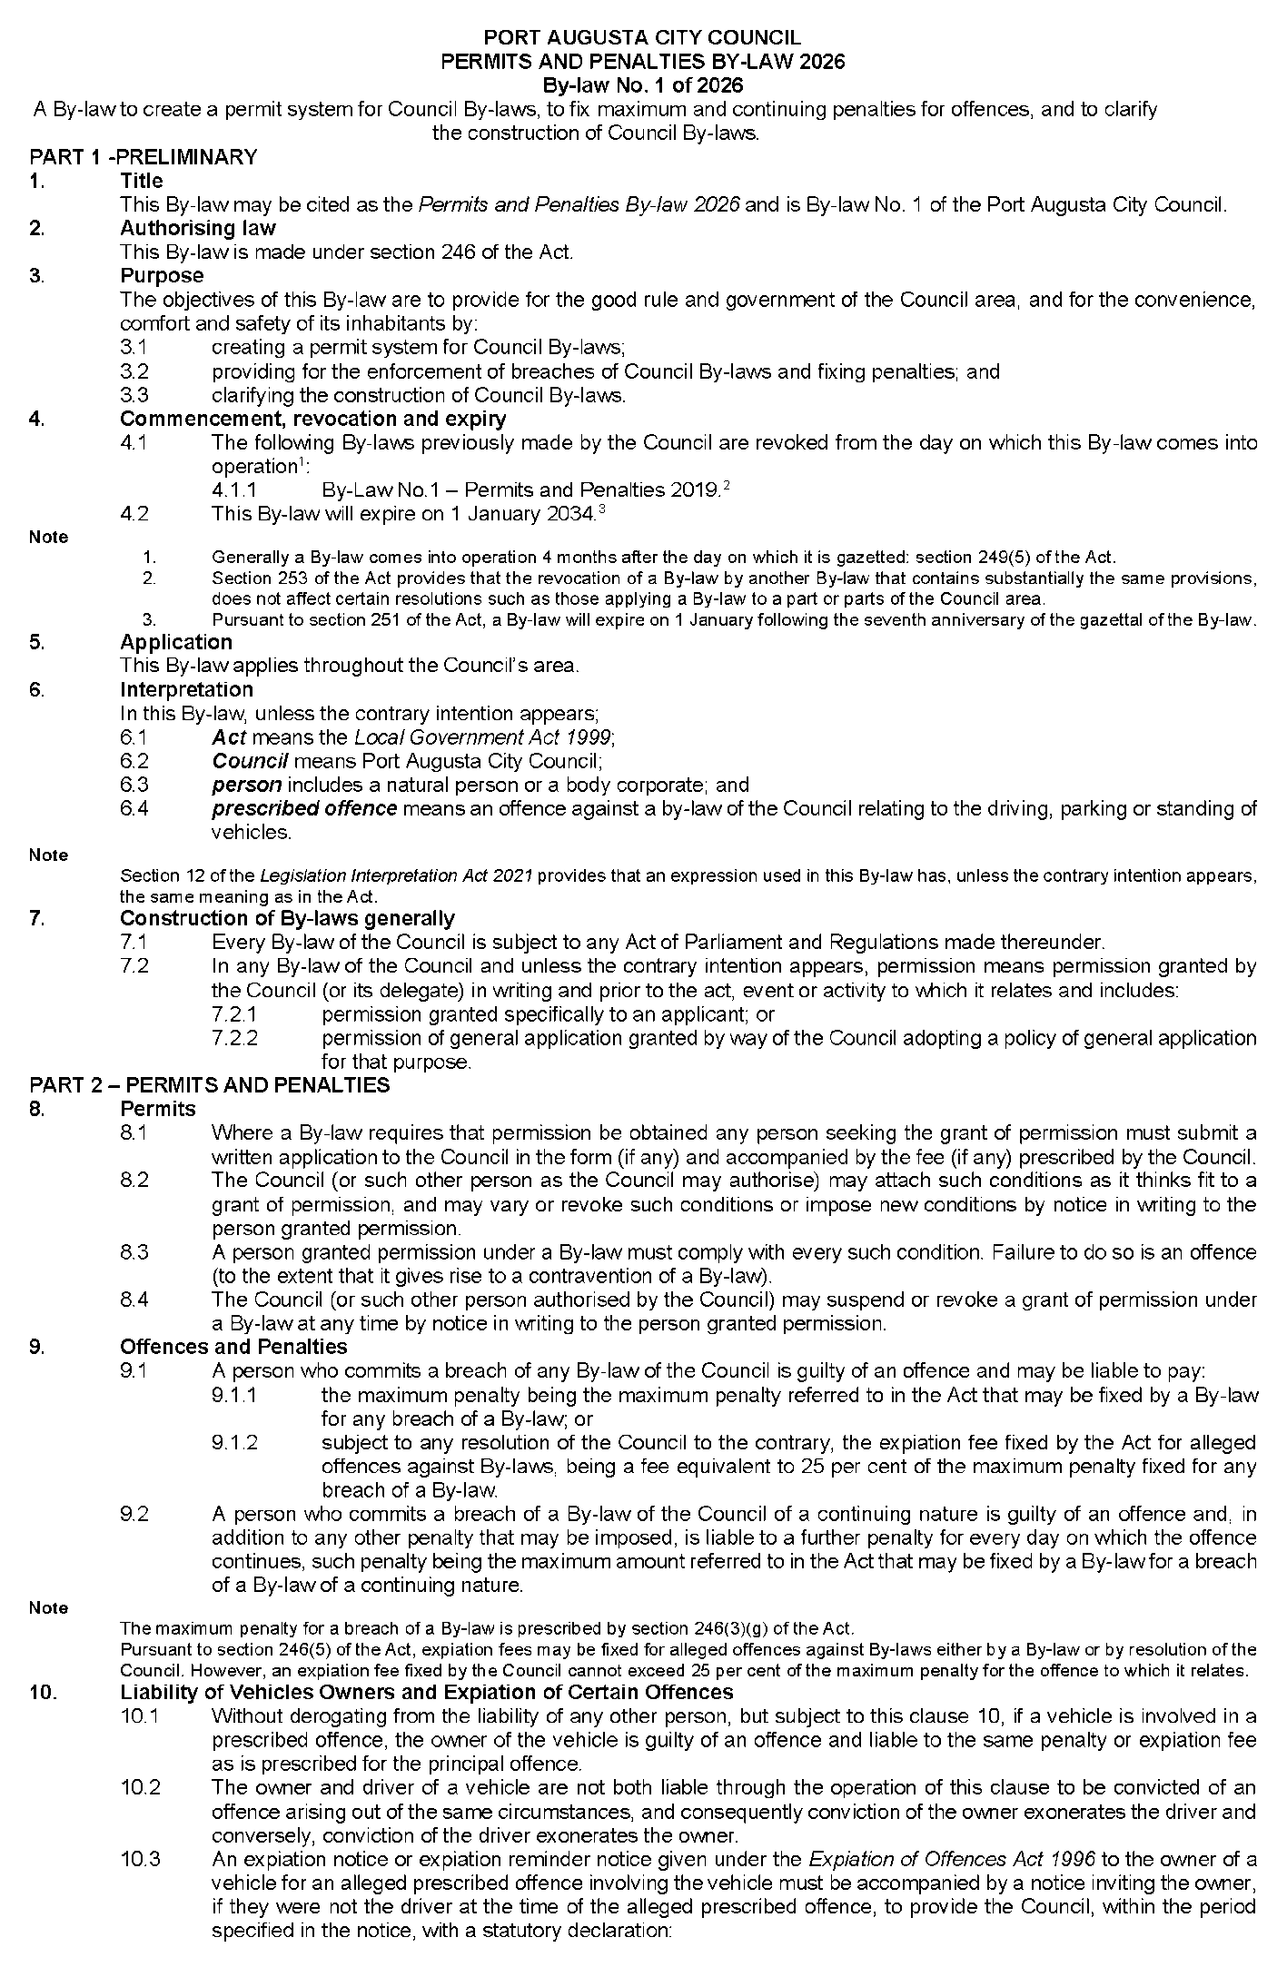
Port Augusta City Council
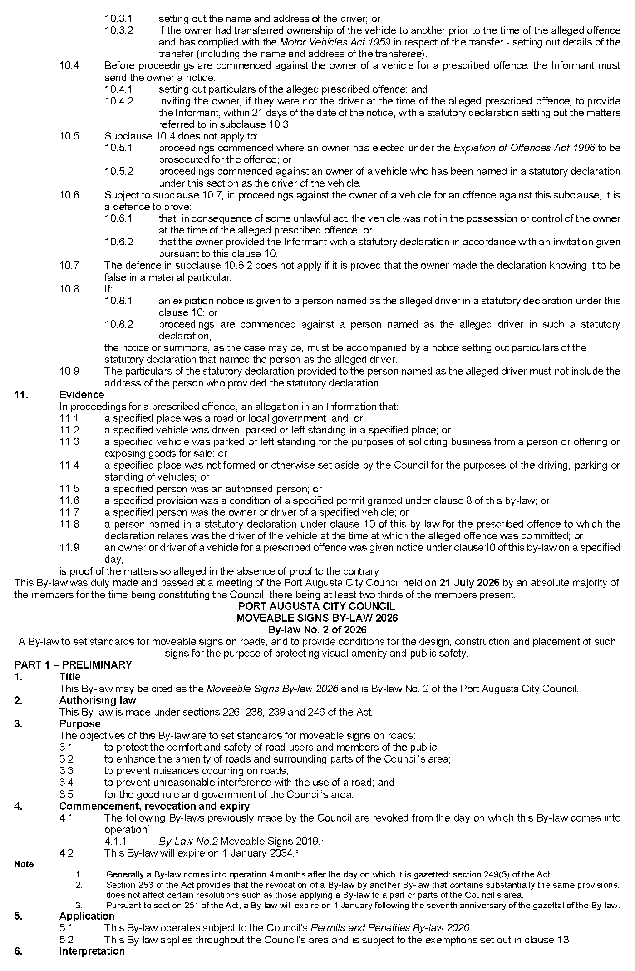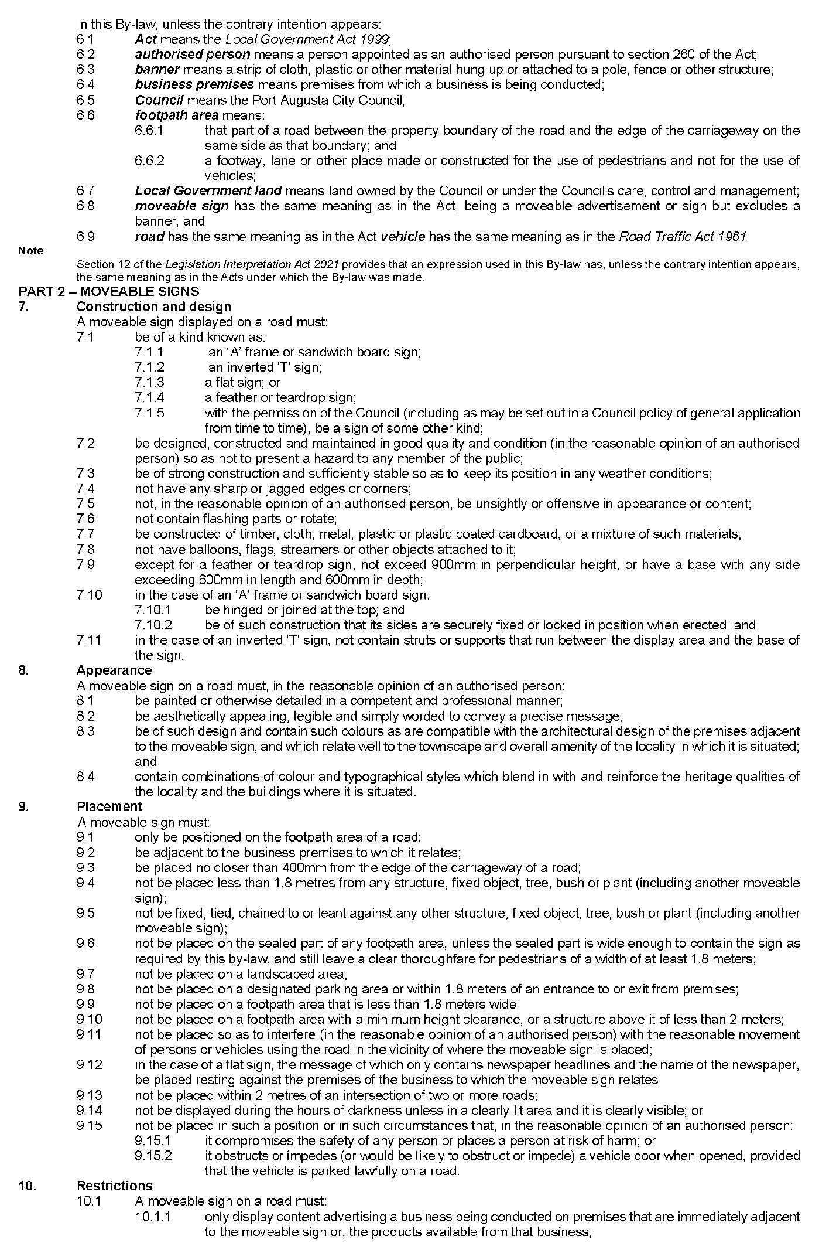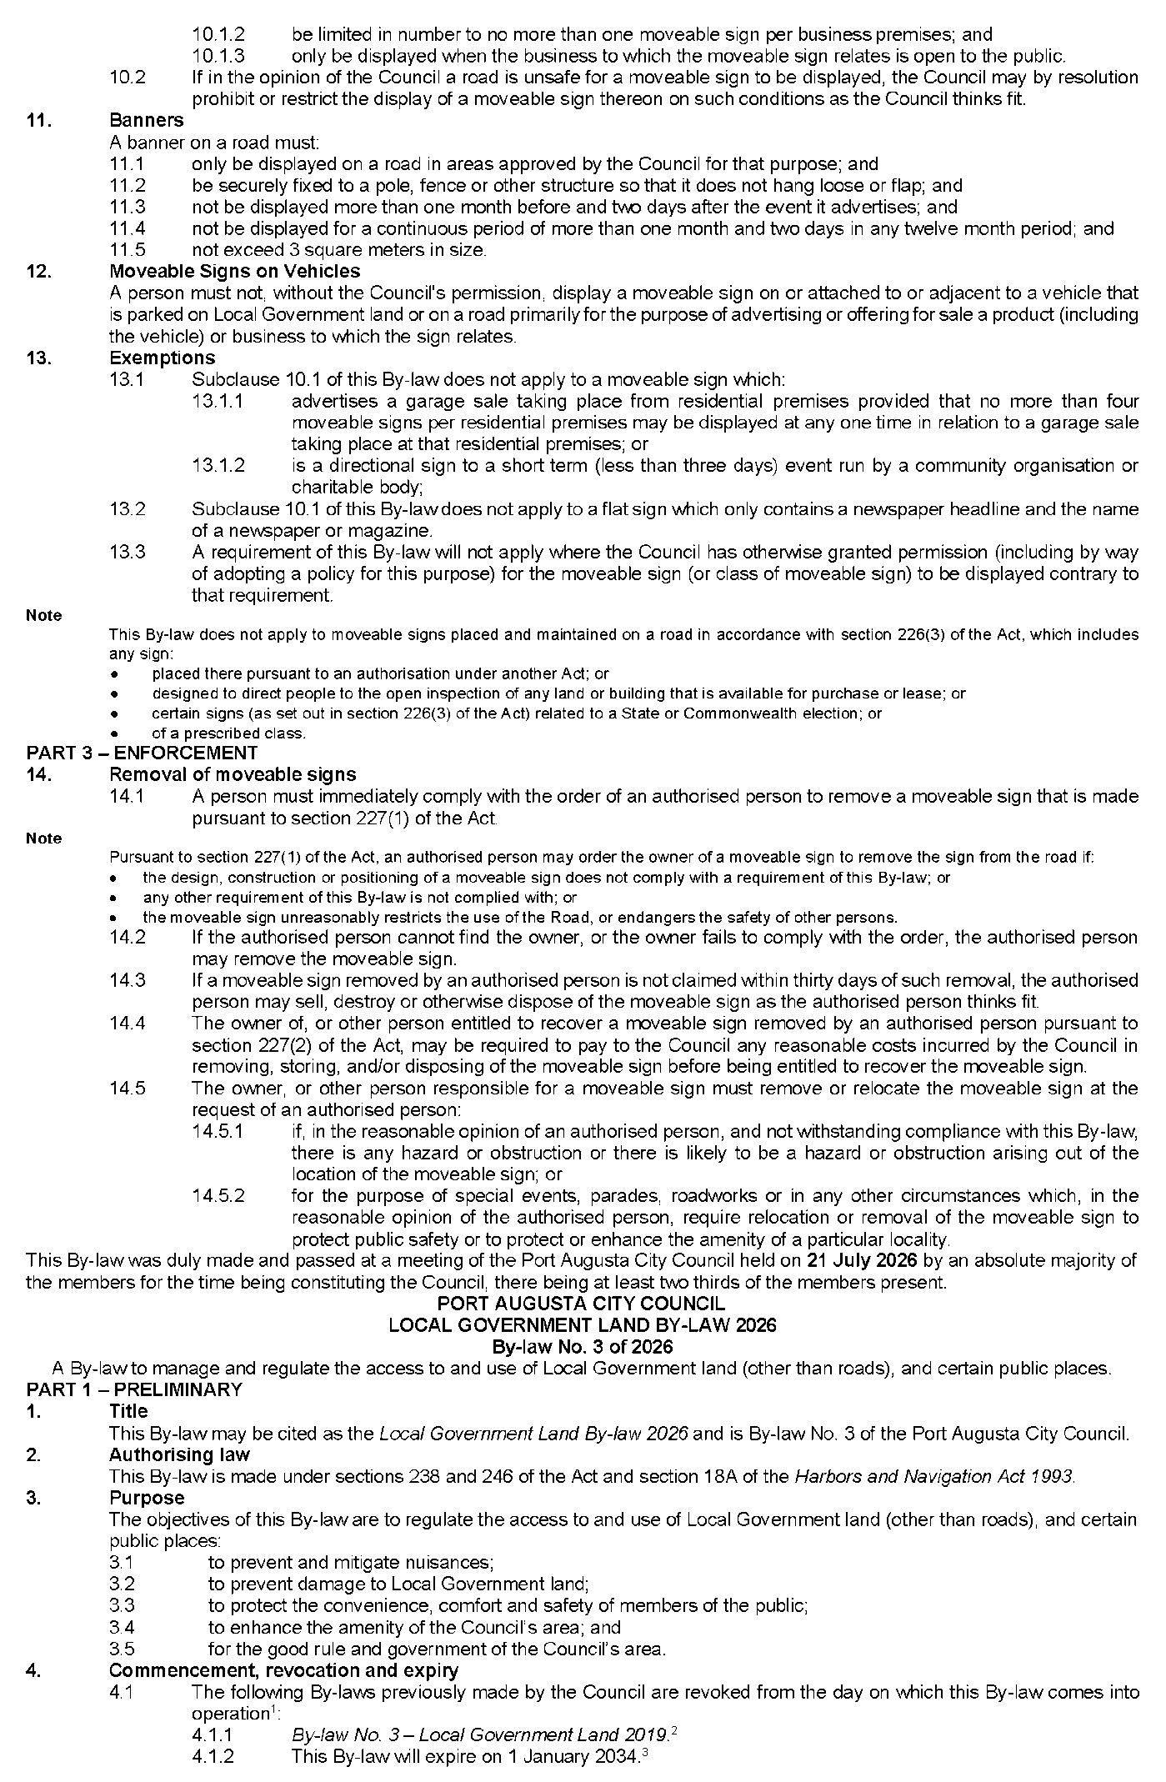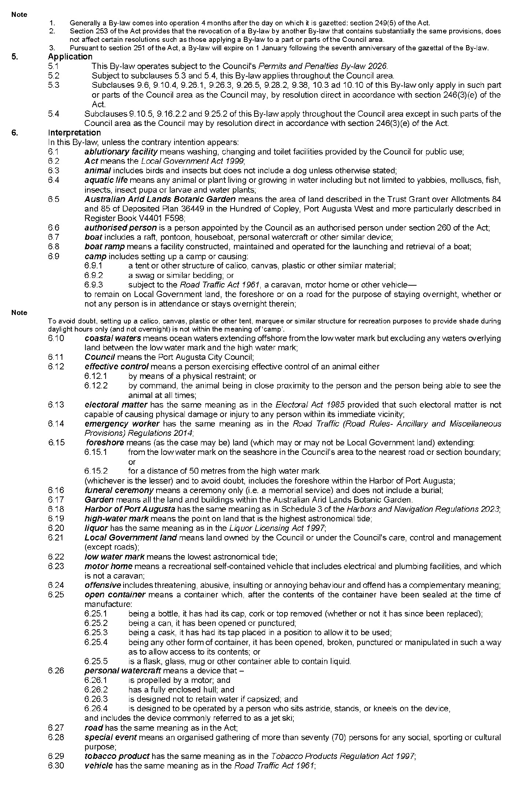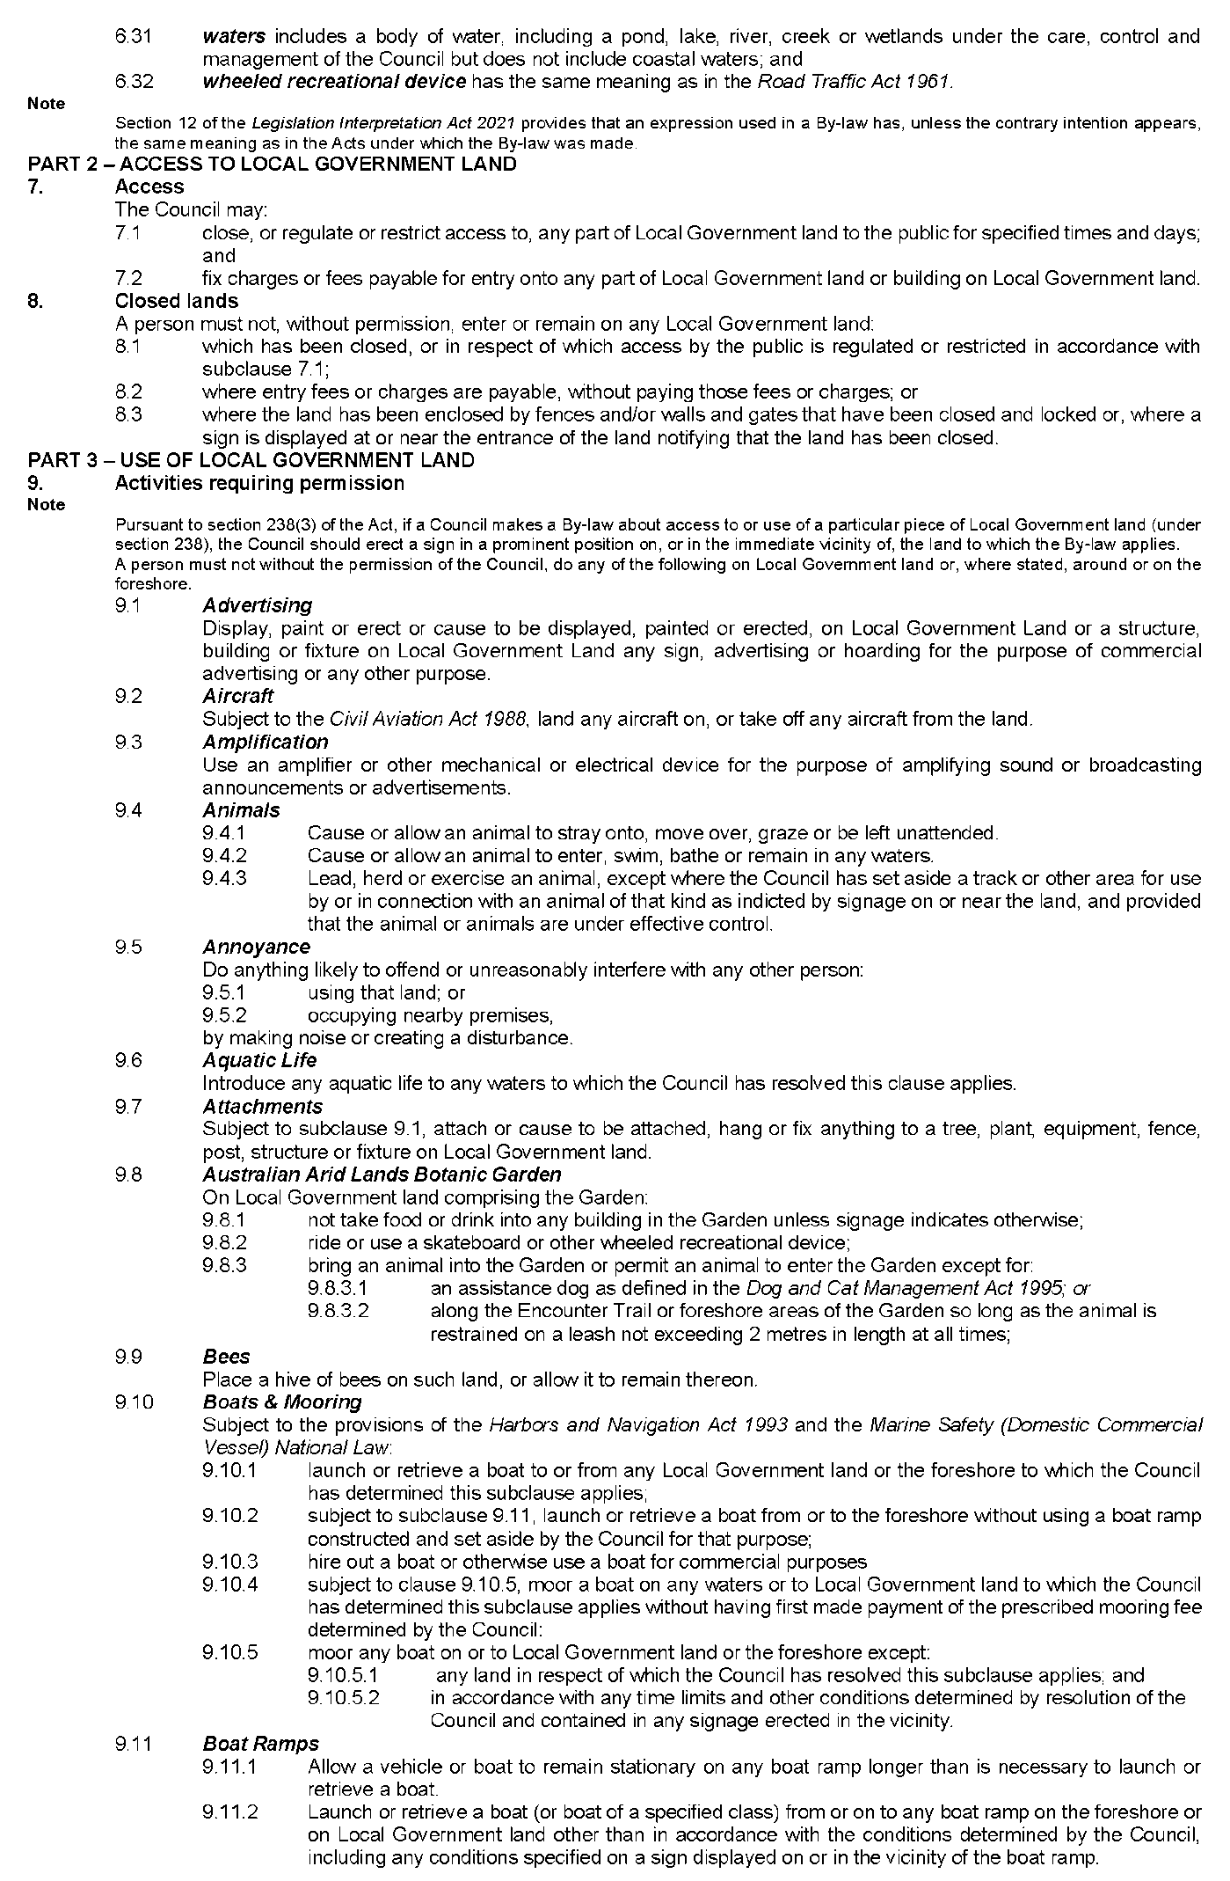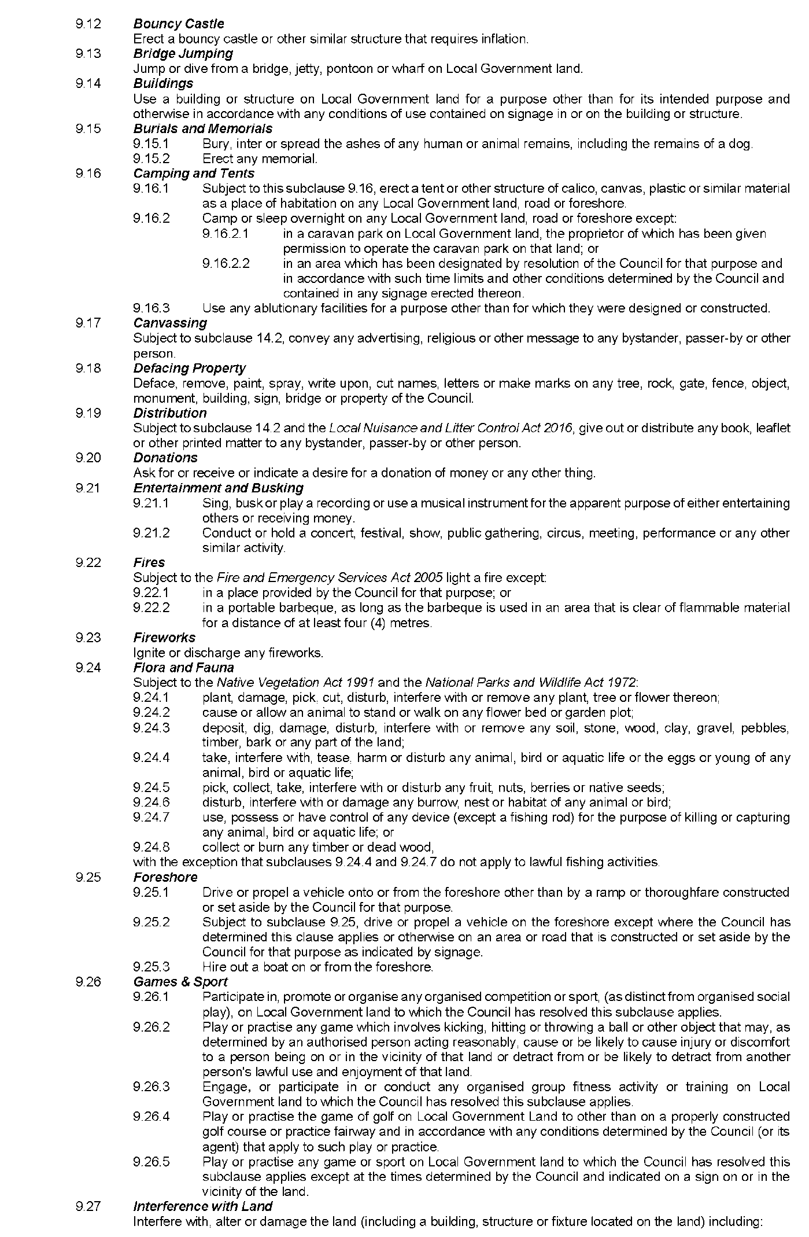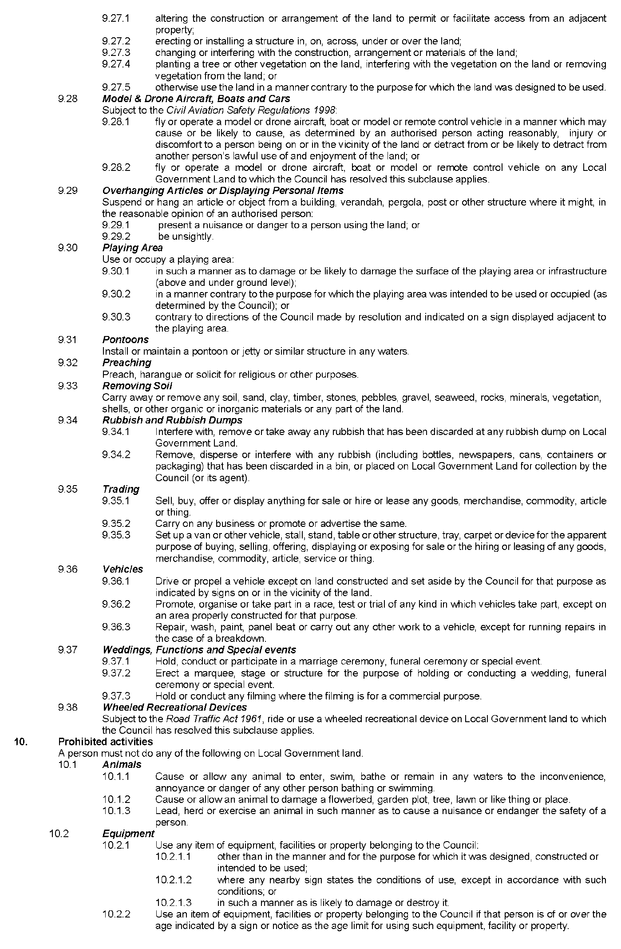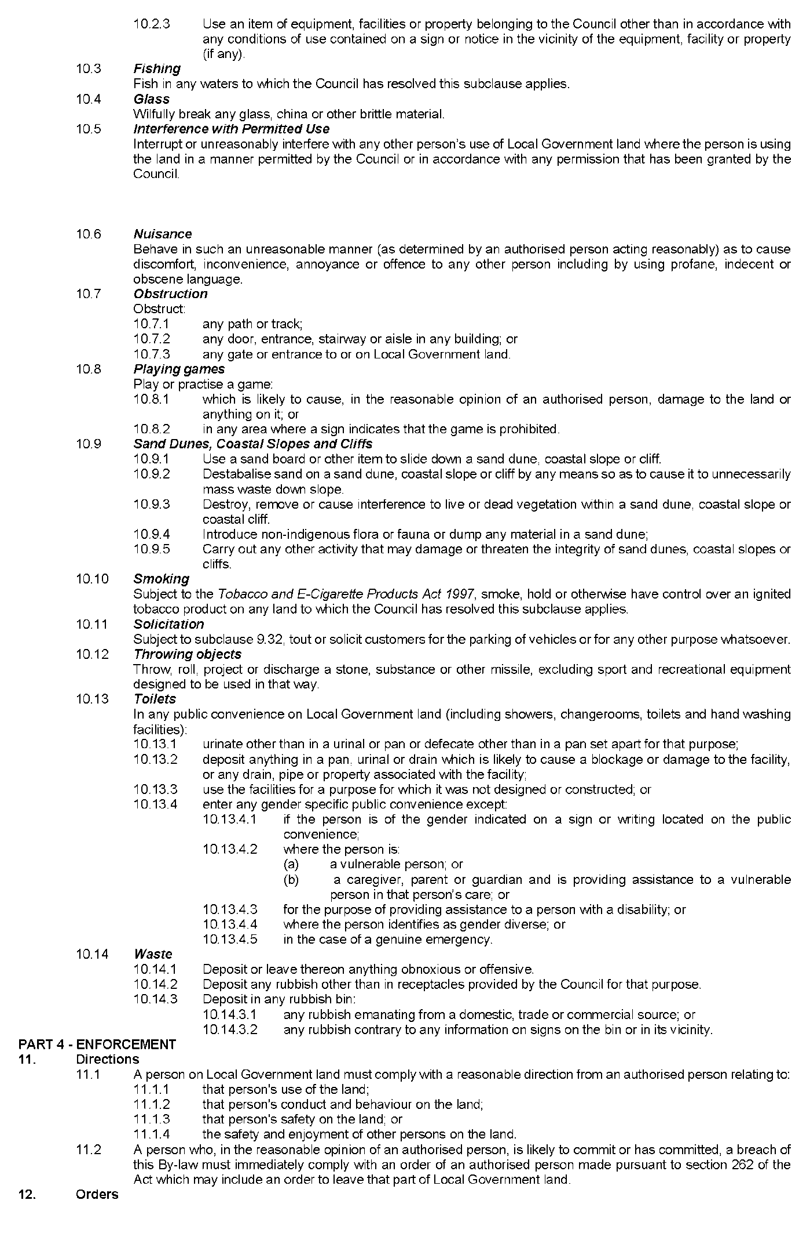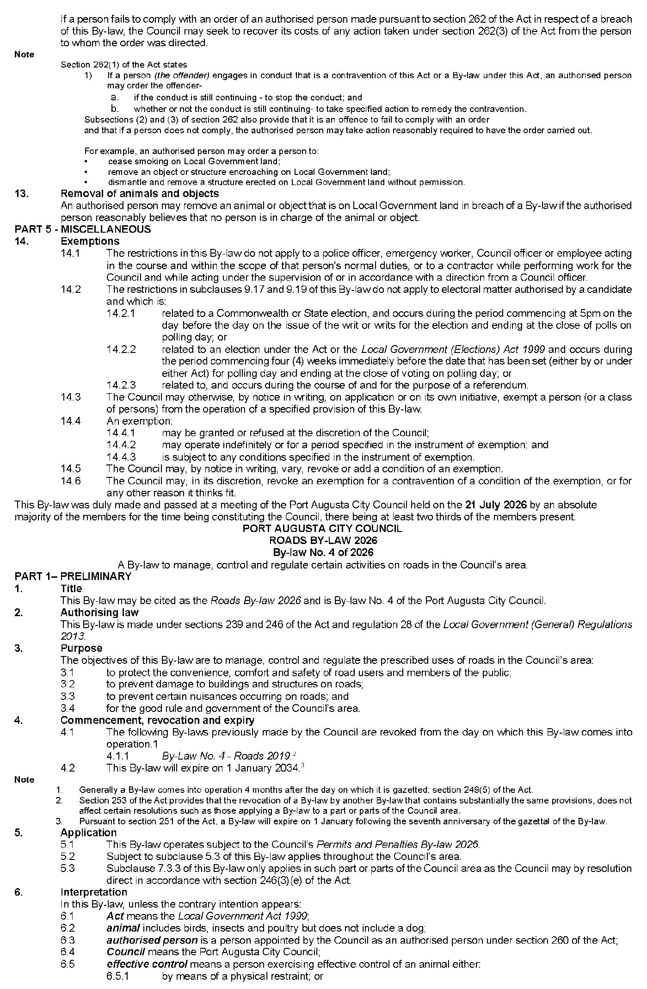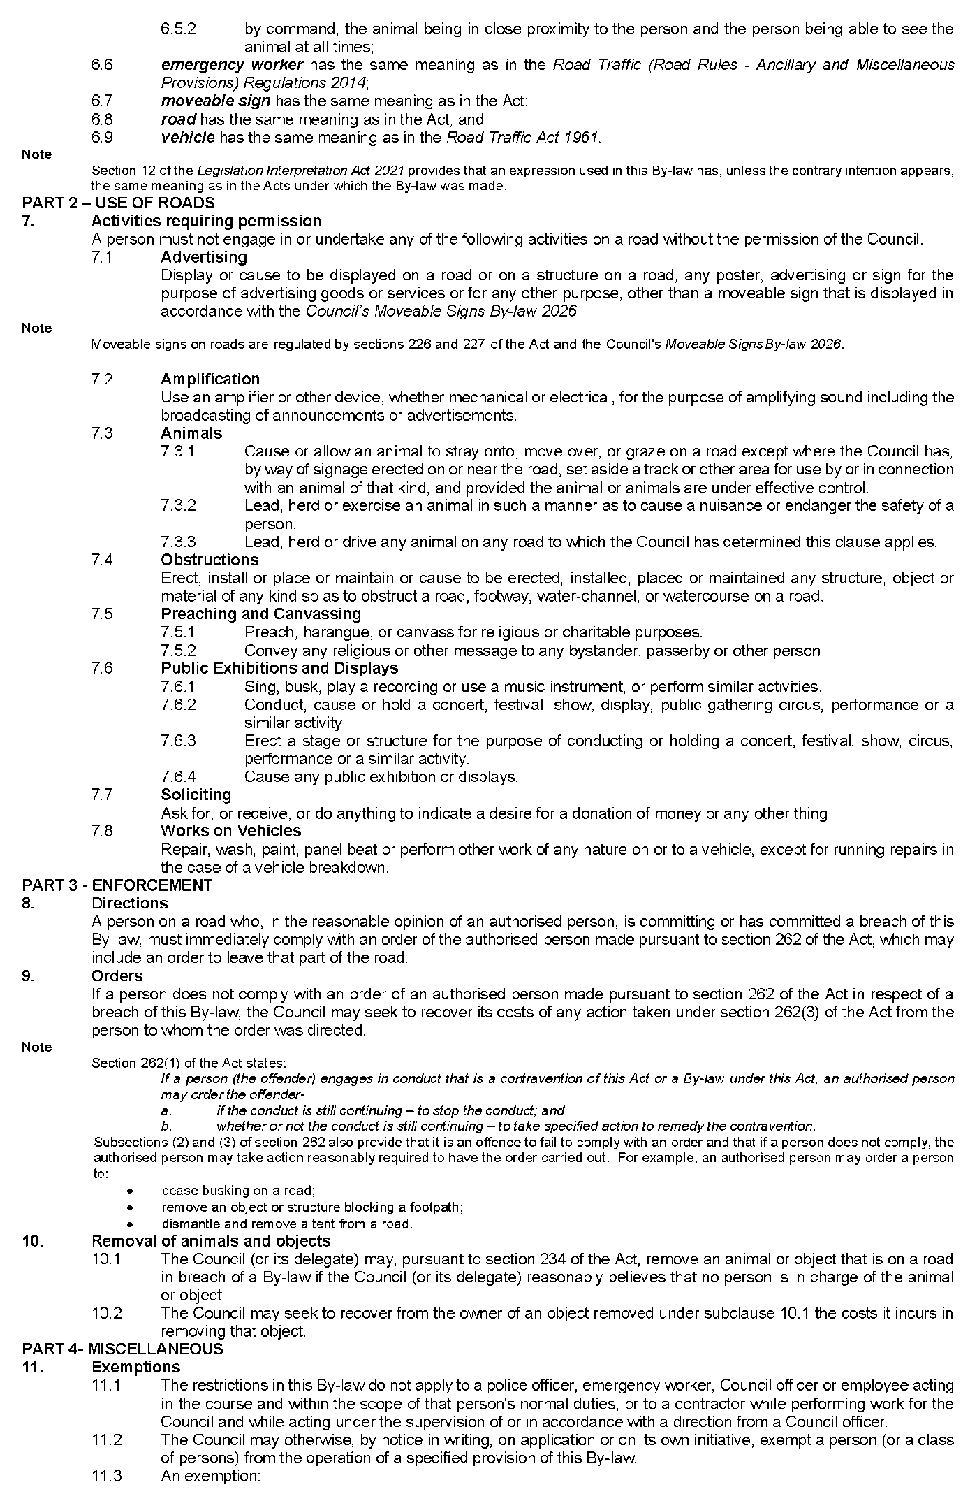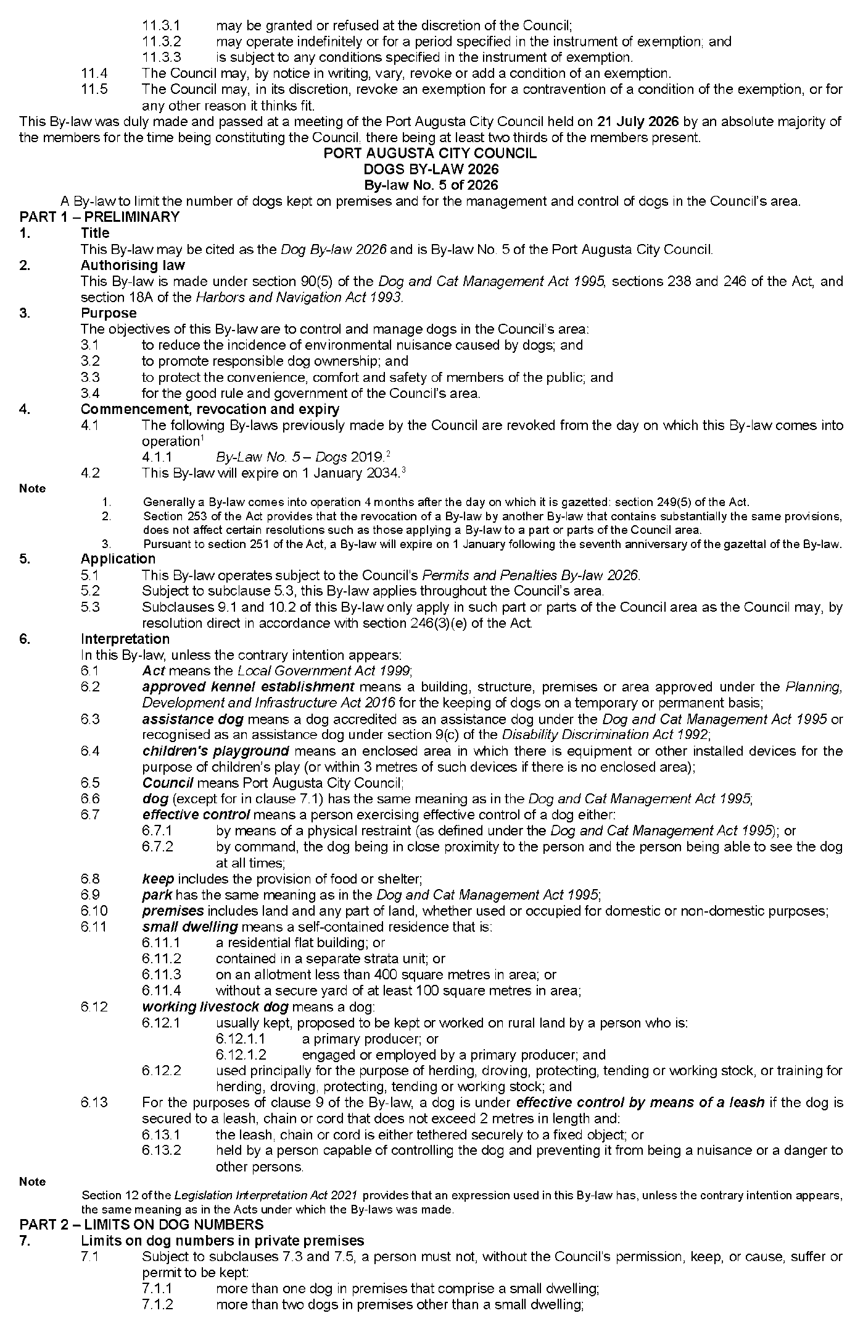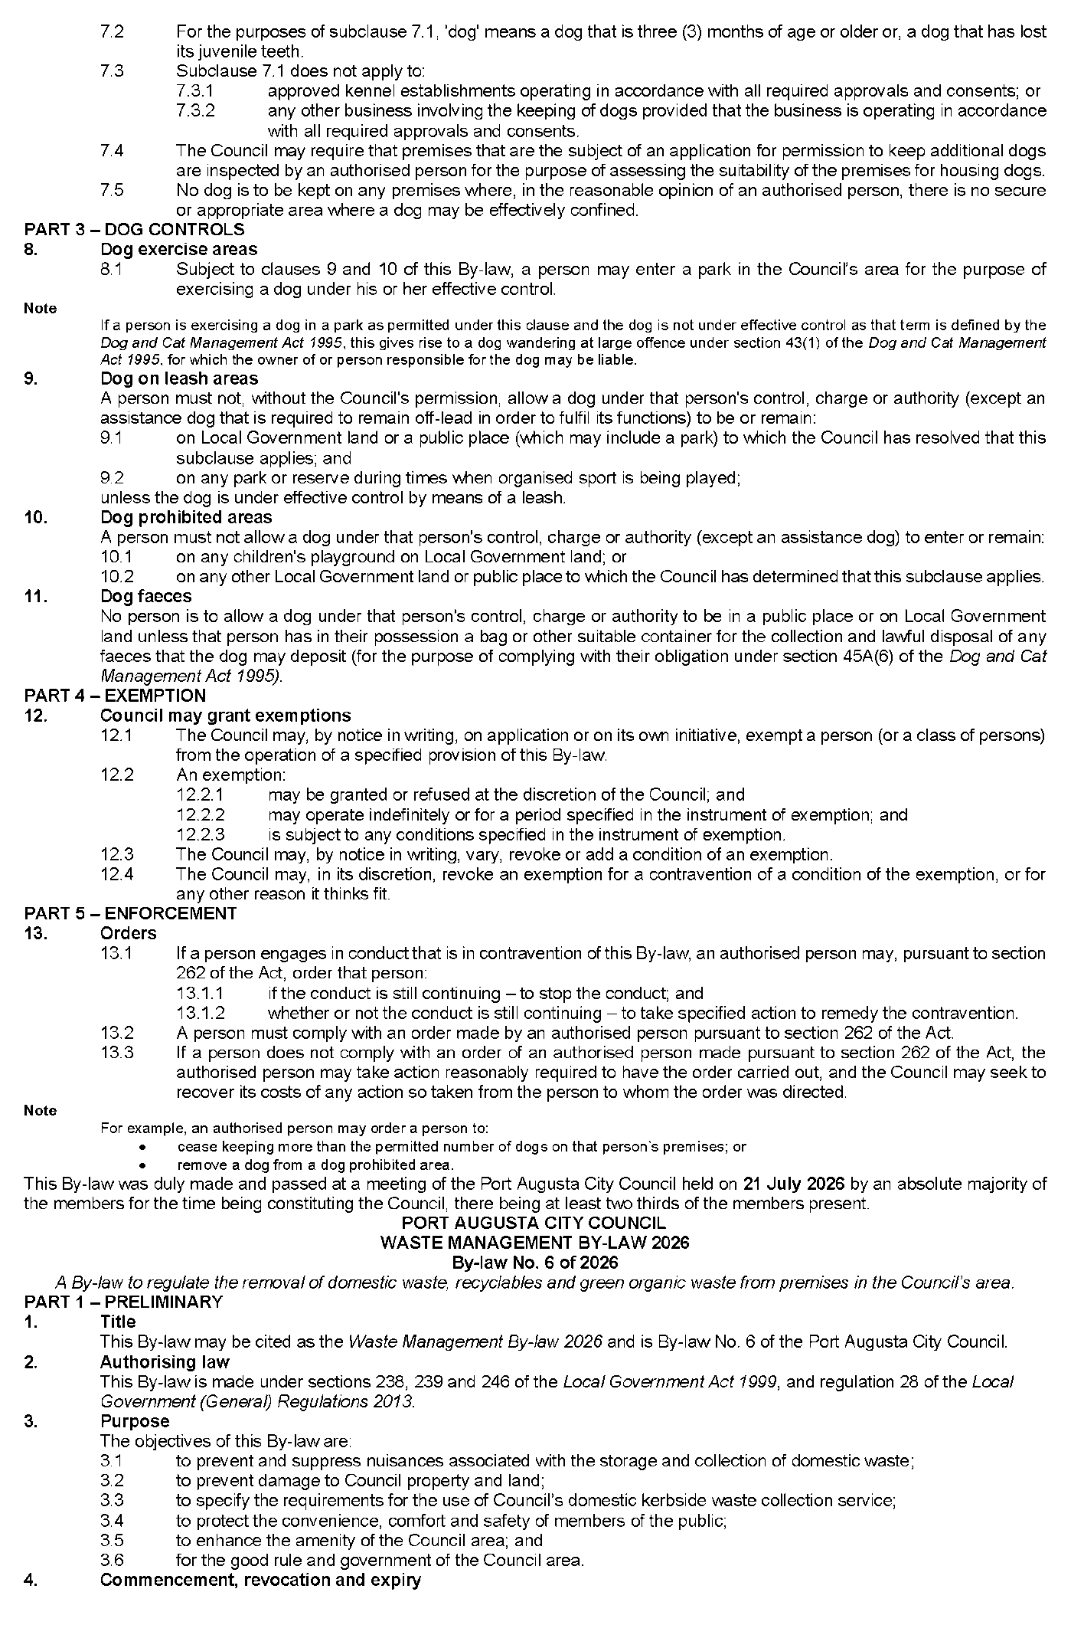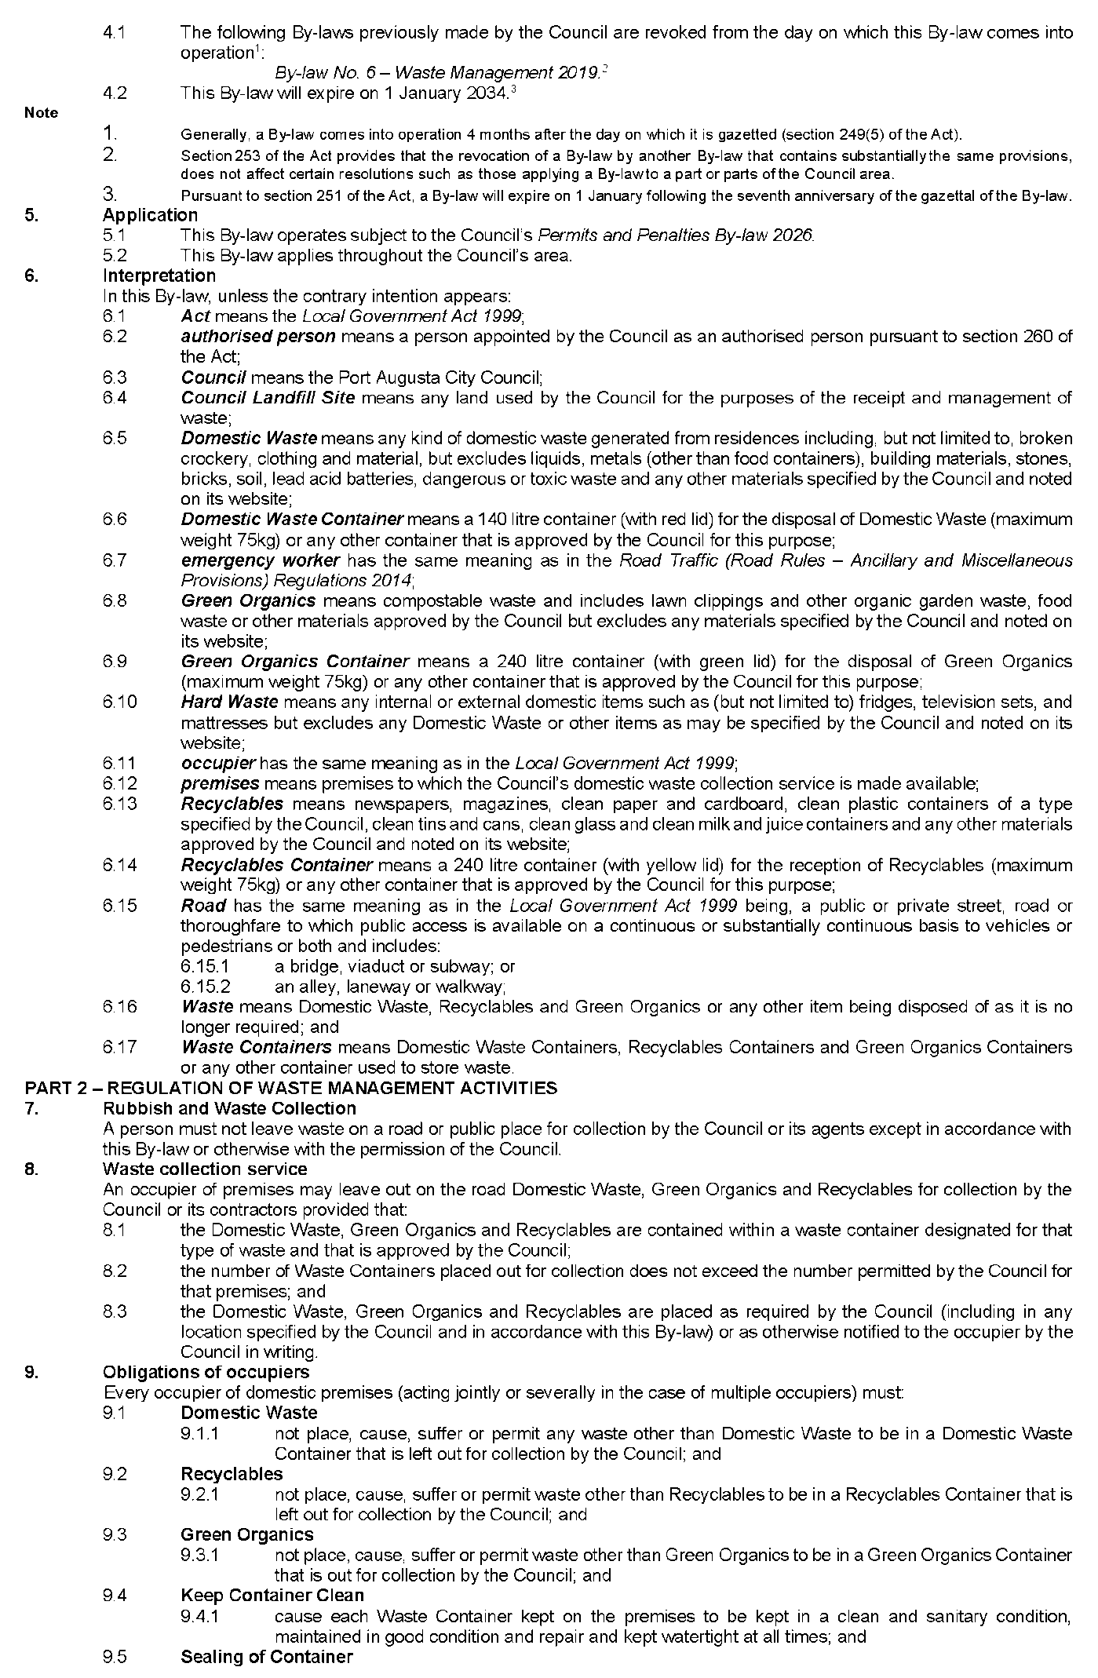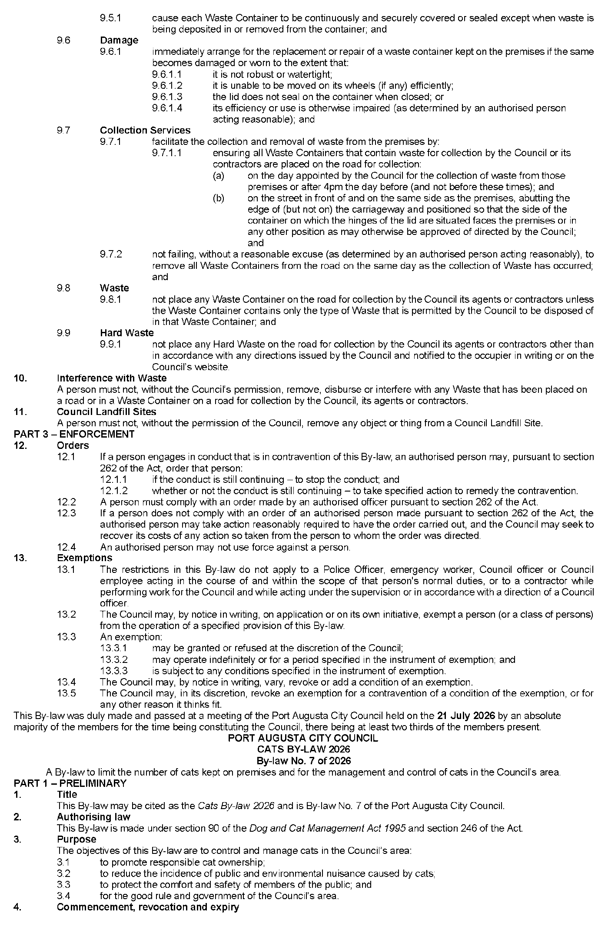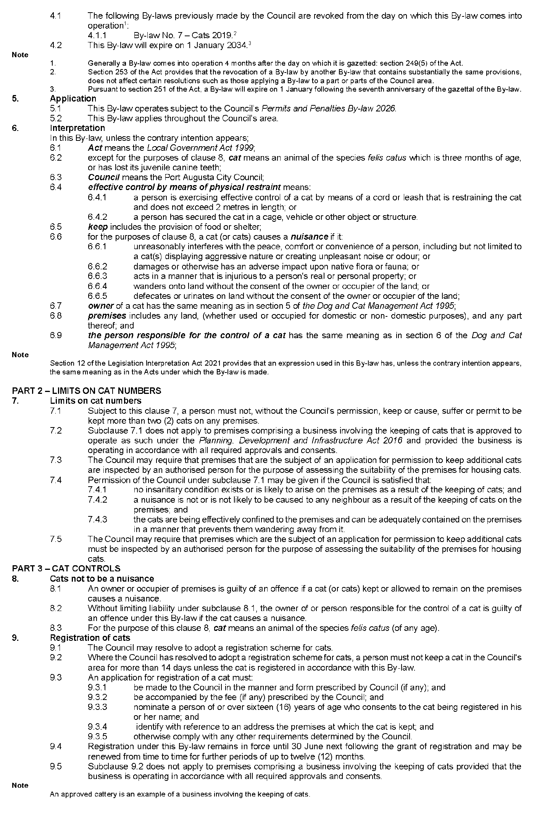

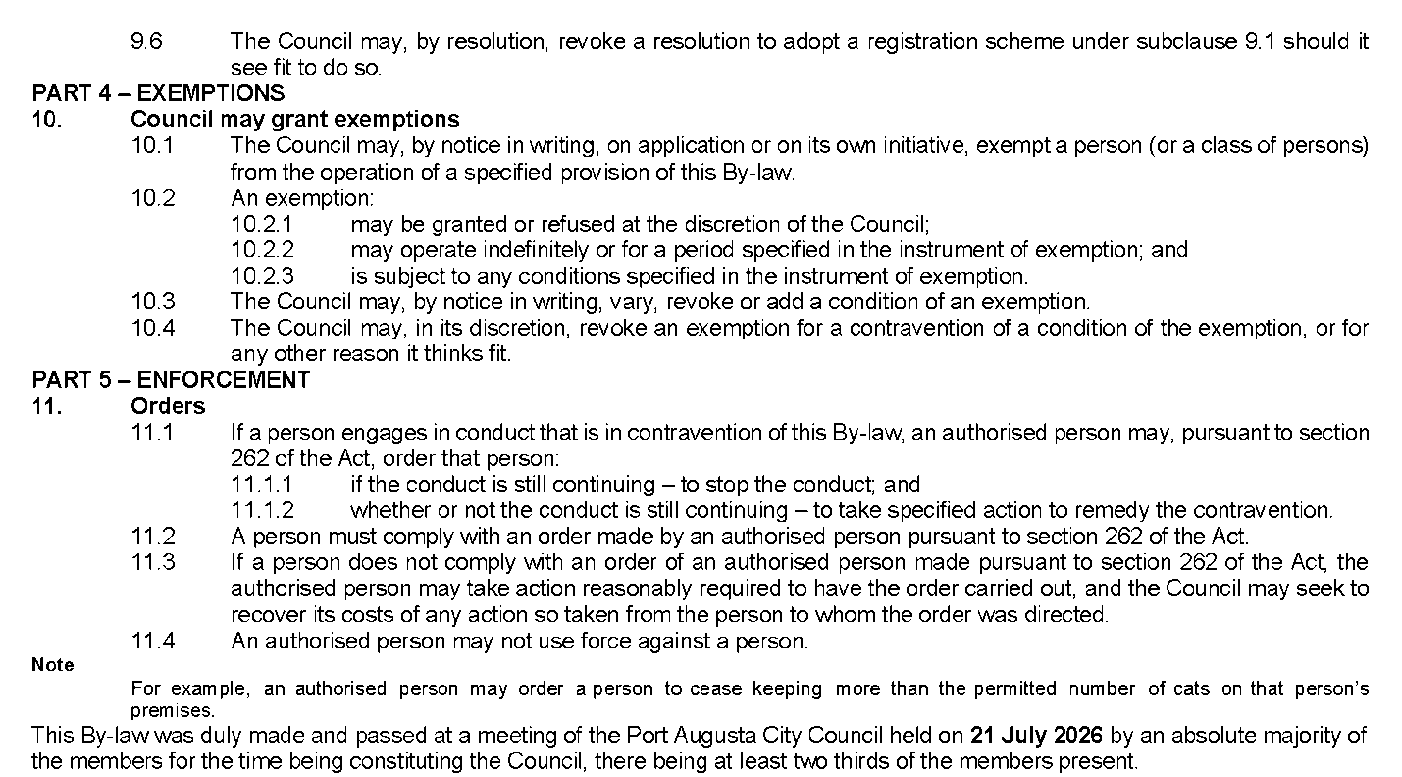
Dated: 20 August 2026
John Banks
Chief Executive Officer

Town of Gawler
Roads (Opening and Closing) Act 1991
Road Closing—Turner Street, Gawler East
Notice is hereby given, pursuant to Section 10 of the Roads (Opening and Closing) Act 1991 that the Town of Gawler proposes to make a Road Process Order to close and merge with the adjoining land a portion of Turner Street adjoining lot 51 in C25092, more particularly delineated and lettered ‘A’ on Preliminary Plan 26/0028.
The Preliminary Plan is available for public inspection at the offices of the Town of Gawler, 43 High Street Gawler East, and the Adelaide Office of the Surveyor-General located at Level 10, 83 Pirie Street Adelaide, during normal office hours. The Preliminary Plan can also be viewed at www.sa.gov.au/roadsactproposals.
Any application for easement or objection must set out the full name, address and details of the submission and must be fully supported by reasons. The application for easement or objection must be made in writing to the Town of Gawler, PO Box 130 Gawler SA 5118, within 28 days of this notice and a copy must be forwarded to the Surveyor-General at GPO Box 1815, Adelaide 5001. Where a submission is made, the applicant must be prepared to support their submission in person upon council giving notification of a meeting at which the matter will be considered.
Dated: 20 August 2026
Chris Cowley
Chief Executive Officer

Adelaide Hills Council
Roads (Opening and Closing) Act 1991
Road Closing—Portion Pomona Road, Stirling
Notice is hereby given, pursuant to Section 10 of the Roads (Opening and Closing) Act 1991, that, the Adelaide Hills Council proposes to make a Road Process Order to close and merge with Allotment 10 in D135124 a portion of Pomona Road, Stirling adjoining allotment 10 in D135124, more particularly and lettered “A” on Preliminary Plan 26/0016.
The Preliminary Plan is available for public inspection at the office of the Adelaide Hills Council (Stirling Library, 63 Mount Barker Road, Stirling) and the Adelaide Office of the Surveyor-General located at Level 10, 83 Pirie Street, Adelaide during normal office hours. The Preliminary Plan can also be viewed at www.sa.gov.au/roadsactproposals or www.engage.ahc.sa.gov.au
Any application for easement or objection must set out the full name, address and details of the submission and must be fully supported by reasons. The application for easement or objection must be made in writing to the Adelaide Hills Council, 63 Mount Barker Road, Stirling SA 5152 within 28 days of this notice and a copy must be forwarded to the Surveyor-General at PO Box 1815, Adelaide 5001. Where a submission is made, the applicant must be prepared to support this submission in person upon Council giving notification of a meeting at which the matter will be considered.
Dated: 20 August 2026
Jade Ballantine
Acting Chief Executive Officer

District Council of Franklin Harbour
Change of Meeting Date
Notice is hereby given that the Ordinary September Council Meeting will now be held on Thursday, 10 September 2026, commencing at 9:00am in the Council Chambers of Main Street, Cowell, in lieu of Wednesday, 9 September 2026.
Dated: 18 August 2026
S. A. Gill
Chief Executive Officer

District Council of Karoonda East Murray
Adoption of Valuation and Declaration of Rates—Imposition of Service Charges for 2026/27
Notice is hereby given that the District Council of Karoonda East Murray at its Special Meeting of Council held on 11 August 2026, for the financial year ending 30 June 2027, resolved:
Valuations
To adopt the most recent valuations of the Valuer-General available to the Council of Capital Values for rating purposes with total valuations of $612,621,400 (including non-rateable land of $13,914,600).
General Rates
To declare a general rate of 0.3667 cents in the dollar of the capital value of rateable land.
Minimum Amount Payable
To impose a minimum amount payable by way of general rates in respect of any one piece of rateable land of $502.00.
Annual Service Charges
Community Wastewater Management Scheme (CWMS)
To imposes an annual service charge on all land to which the prescribed Community Wastewater Management System service is provided of:
• Occupied land—$662.00 per property unit
• Unoccupied land—$630.00 per property
Kerbside Waste Management Collection
To impose an annual service charge for waste collection of:
• of $191.00 for kerbside collection within the collection zone, and
• for the supply and collection of additional mobile garbage bin/s—$297.00 per bin within the collection zone.
Separate Rate—Landscapes Board Levy
To declare a separate rate of 0.0001543 cents in the dollar on the capital value of rateable land within the area of the Murraylands and Riverland Landscape Board.
Dated: 18 August 2026
Scott Reardon
Chief Executive Officer

Wattle Range Council
Local Government Act 1999
By-law No. 1 of 2026—Permits and Penalties By-law 2026
To provide for a permit system, set penalties for breaches of by-laws, provide for certain matters pertaining to liability and evidence, set regulatory requirements, clarify the construction of Council’s by-laws and for related purposes.
Part 1—Preliminary
1. Short Title
This by-law may be cited as the Permits and Penalties By-law 2026.
2. Commencement
This by-law will come into operation four months after the day on which it is published in the Gazette in accordance with Section 249(5) of the Local Government Act 1999.
3. Definitions
3.1 In any by-law of the Council, unless the contrary intention is clearly indicated:
3.1.1 authorised person means a person appointed as an authorised person pursuant to Section 260 of the Local Government Act 1999;
3.1.2 boat includes a raft, pontoon, jet ski, personal watercraft or any other similar device;
3.1.3 Council means the Wattle Range Council;
3.1.4 camp includes setting up a camp, or causing or allowing a tent, sleeping bag, caravan or motor home to remain on land for the purpose of staying overnight whether or not any person is in attendance or sleeps on the land;
3.1.5 cat has the same meaning as in the Dog and Cat Management Act 1995;
3.1.6 dog has the same meaning as in the Dog and Cat Management Act 1995;
3.1.7 drive a vehicle means to be in control of the steering, movement or propulsion of the vehicle;
3.1.8 driver of a vehicle means the person driving the vehicle;

3.1.9 electoral matter has the same meaning as in the Electoral Act 1985 provided that such electoral matter is not capable of causing physical damage or injury to any person within its immediate vicinity;
3.1.10 emergency worker has the same meaning as in the Australian Road Rules and the Road Traffic (Road Rules—Ancillary and Miscellaneous Provisions) Regulations 2014;
3.1.11 footpath means:
3.1.11.1 a footway, lane or other place made or constructed for the use of pedestrians; or
3.1.11.2 that part of road between the property boundary of the road and the edge of the carriageway on the same side as that boundary;
3.1.12 liquor has the same meaning as defined in the Liquor Licensing Act 1997;
3.1.13 motor vehicle has the same meaning as in the Road Traffic Act 1961;
3.1.14 park, in relation to a vehicle, includes where the driver stops and allows the vehicle to stay (whether or not the driver leaves the vehicle);
3.1.15 person includes a natural person, a body corporate or incorporated association;
3.1.16 road has the same meaning as in the Local Government Act 1999;
3.1.17 road related area has the same meaning as in the Road Traffic Act 1961;
3.1.18 vehicle has the same meaning as in the Road Traffic Act 1961 and the Australian Road Rules;
3.1.19 wheeled recreational device has the same meaning as in the Road Traffic Act 1961 but also includes any vehicle that is an electric personal transporter for the purposes of that Act.
3.2 In this by-law:
3.2.1 owner has the same meaning as in the Road Traffic Act 1961;
3.2.2 prescribed offence means an offence against a by-law of the Council relating to the driving, parking or standing of vehicles.
4. Construction
Every by-law of the Council shall be subject to any Act of Parliament and Regulations made thereunder.
Part 2—Permits
5. Council May Grant Permits
If any by-law of the Council states that a person needs a ‘permit’ or ‘permission’ to do a specified thing, then the following provisions apply:
5.1 The permit must be in writing.
5.2 A person may apply for permission by:
5.2.1 making a written application for permission to the Council or its duly authorised agent;
5.2.2 making application by way of a website or mobile application established or designated by the Council for the purpose of issuing a permit of a particular kind;
5.2.3 obtaining a permit from a permit vending-machine installed and maintained by the Council that has been designated by the Council for the purposes of issuing a permit of a particular kind.
5.3 The Council may:
5.3.1 provide that the permit applies for a particular term;
5.3.2 attach conditions to the permit the Council considers appropriate;
5.3.3 change or revoke a condition, by notice in writing; or
5.3.4 add new conditions, by notice in writing.
5.4 A person who holds a permit must:
5.4.1 comply with every condition attached to it; and
5.4.2 produce the permit on request of an authorised person.
5.5 The Council may revoke a permit, by notice in writing, if:
5.5.1 the holder of the permit fails to comply with a condition attached to it; or
5.5.2 the permit is of a continuing nature, and the Council has reasonable grounds for revoking it.
5.6 The Council may, by resolution, fix, vary or revoke fees or charges for the granting of a permit to do a specified thing.
5.7 The Council may, with or without condition:
5.7.1 exempt a person or a class of persons from the requirement to obtain a permit; or
5.7.2 grant general permission to a person or class of persons.
5.8 A person who applies for permission by way of subparagraph 5.2.2 or 5.2.3 is taken to have been granted permission when the following steps have been completed:
5.8.1 the person pays the permit fee (if any) by (as the case may be):
5.8.1.1 credit or debit card; or
5.8.1.2 such other method of payment that may be approved by the Council by resolution;
5.8.2 the person receives a notice identifying itself as a permit from the Council to undertake the activity specified in the permit.

Part 3—Enforcement
6. Penalties
6.1 A person who contravenes or fails to comply with any by-law of the Council is guilty of an offence and is liable to a maximum penalty, being the maximum penalty referred to in the Local Government Act 1999, which may be fixed for offences against a by-law.
6.2 A person who is convicted of an offence against any by-law of the Council in respect of a continuing act or omission is liable, in addition to the penalty otherwise applicable, to a further penalty, being the maximum penalty referred to in the Local Government Act 1999 which may be fixed for offences of a continuing nature against a by-law.
7. Liability of Vehicles Owners and Expiation of Certain Offences
7.1 Without derogating from the liability of any other person, but subject to this paragraph, if a vehicle is involved in a prescribed offence, the owner of the vehicle is guilty of an offence and liable to the same penalty as is prescribed for the principal offence and the expiation fee that is fixed for the principal offence applies in relation to an offence against this paragraph.
7.2 The owner and driver of a vehicle are not both liable through the operation of this paragraph to be convicted of an offence arising out of the same circumstances, and consequently conviction of the owner exonerates the driver and conversely conviction of the driver exonerates the owner.
7.3 An expiation notice or expiation reminder notice given under the Expiation of Offences Act 1996 to the owner of a vehicle for an alleged prescribed offence involving the vehicle must be accompanied by a notice inviting the owner, if they were not the driver at the time of the alleged prescribed offence, to provide the Council or officer specified in the notice, within the period specified in the notice, with a statutory declaration:
7.3.1 setting out the name and address of the driver; or
7.3.2 if they had transferred ownership of the vehicle to another prior to the time of the alleged offence and has complied with the Motor Vehicles Act 1959 in respect of the transfer - setting out details of the transfer (including the name and address of the transferee).
7.4 Before proceedings are commenced against the owner of a vehicle for an offence against this section involving the vehicle, the Informant must send the owner a notice:
7.4.1 setting out particulars of the alleged prescribed offence; and
7.4.2 inviting the owner, if he or she was not the driver at the time of the alleged prescribed offence, to provide the Informant, within 21 days of the date of the notice, with a statutory declaration setting out the matters referred to in subparagraph 7.3.
7.5 Subparagraph 7.4 does not apply to:
7.5.1 proceedings commenced where an owner has elected under the Expiation of Offences Act 1996 to be prosecuted for the offence; or
7.5.2 proceedings commenced against an owner of a vehicle who has been named in a statutory declaration under this section as the driver of the vehicle.
7.6 Subject to subparagraph 7.7, in proceedings against the owner of a vehicle for an offence against this paragraph, it is a defence to prove:
7.6.1 that, in consequence of some unlawful act, the vehicle was not in the possession or control of the owner at the time of the alleged prescribed offence; or
7.6.2 that the owner provided the Informant with a statutory declaration in accordance with an invitation under this paragraph.
7.7 The defence in paragraph 7.6.2 does not apply if it is proved that the owner made the declaration knowing it to be false in a material particular.
7.8 If:
7.8.1 an expiation notice is given to a person named as the alleged driver in a statutory declaration under this paragraph; or
7.8.2 proceedings are commenced against a person named as the alleged driver in such a statutory declaration, the notice or information, as the case may be, must be accompanied by a notice setting out particulars of the statutory declaration that named the person as the alleged driver.
7.9 The particulars of the statutory declaration provided to the person named as the alleged driver must not include the address of the person who provided the statutory declaration.
8. Evidence
In proceedings for a prescribed offence, an allegation in an information that:
8.1 a specified place was a road or local government land; or
8.2 a specified vehicle was driven, parked or left standing in a specified place; or
8.3 a specified vehicle was parked or left standing for the purposes of soliciting business from a person or offering or exposing goods for sale; or
8.4 a specified place was not formed or otherwise set aside by the Council for the purposes of the driving, parking or standing of vehicles; or
8.5 a specified person was an authorised person; or
8.6 a specified provision was a condition of a specified permit granted under paragraph 5 of this by-law; or
8.7 a specified person was the owner or driver of a specified vehicle; or
8.8 a person named in a statutory declaration under paragraph 7 of this by-law for the prescribed offence to which the declaration relates was the driver of the vehicle at the time at which the alleged offence was committed; or
8.9 an owner or driver of a vehicle for a prescribed offence was given notice under paragraph 7 of this by-law on a specified day, is proof of the matters so alleged in the absence of proof to the contrary.

Part 4—Miscellaneous
9. Revocation
Council’s By-law No. 1—Permits and Penalties, published in the Gazette on 5 September 2019, is revoked on the day on which this by-law comes into operation.
The foregoing by-law was duly made and passed at a meeting of the Wattle Range Council held on the 11th day of August 2026 by an absolute majority of the members for the time being constituting the Council, there being at least two thirds of the members present.
Dated: 20 August 2026
Ben Gower
Chief Executive Officer

Wattle range council
Local Government Act 1999
By-law No. 2 of 2026—Moveable Signs By-law 2026
To set standards for moveable signs on roads, to provide conditions for and the placement of such signs, to protect public safety and to protect or enhance the amenity of the area of the Council.
Part 1—Preliminary
1. Short Title
This by-law may be cited as the Moveable Signs By-law 2026.
2. Commencement
This by-law will come into operation four months after the day on which it is published in the Gazette in accordance with Section 249(5) of the Local Government Act 1999.
3. Definitions
In this by-law:
3.1 banner means a moveable sign constituted of a strip of cloth, plastic or other material hung or attached to a pole, fence or other structure;
3.2 moveable sign has the same meaning as the Local Government Act 1999.
Part 2—Provisions Applicable to Moveable Signs
4. Design and Construction
A moveable sign displayed on a road must:
4.1 be of a kind known as an ‘A’ frame or sandwich board sign, an inverted ‘T’ sign, or a flat sign, or, with the permission of the Council, a sign of some other kind;
4.2 be designed, constructed and maintained in good condition so as not to present a hazard to any member of the public;
4.3 be constructed so as to be stable when in position and to be able to keep its position in adverse weather conditions;
4.4 not contain sharp or jagged edges or corners;
4.5 not be unsightly or offensive in appearance;
4.6 not contain flashing or moving parts, be illuminated internally or rotate;
4.7 be constructed of timber, cloth, metal, plastic or plastic coated cardboard, or a mixture of such materials;
4.8 be not more than 90cm high, 60cm in width or 60cm in depth;
4.9 not have a display area exceeding 1m² in total or, if the sign is two-sided 1m² on each side;
4.10 in the case of an ‘A’ frame or sandwich board sign:
4.10.1 be hinged or joined at the top;
4.10.2 be of such construction that its sides can be and are securely fixed or locked in position when erected;
4.11 in the case of an inverted ‘T’ sign, contain no struts or members than run between the display area of the sign and the base of the sign.
5. Placement
A moveable sign displayed on a road must:
5.1 not be placed anywhere except on the footpath;
5.2 be adjacent to the business premises to which it relates;
5.3 in the case of a flat sign, be in line with and against the property boundary of the road;
5.4 not be placed on a sealed footpath, unless the sealed part is wide enough to contain the sign and still leave a clear thoroughfare at least 1.2 metres wide;
5.5 be placed at least 50cm from the kerb (or if there is no kerb, from the edge of the roadway);
5.6 not be placed on a landscaped area, other than on landscaping that comprises only lawn;
5.7 not be placed on a designated parking area or within 1 metre of an entrance to any premises;
5.8 not be fixed, tied or chained to, leaned against or placed closer than 1.2 metres to any other structure, object or plant (including another moveable sign);
5.9 not be placed in a position that puts the safety of any person at risk;
5.10 not be placed on a median strip, roundabout, traffic island or on a carriageway;
5.11 not be within 6 metres of an intersection of a road;
5.12 not be placed so as to obstruct or impede a vehicle door when opened.

6. Restrictions
A moveable sign displayed on a road must:
6.1 only contain material which advertises a business being conducted on commercial premises adjacent to the sign or the goods and services available from that business;
6.2 be limited to one per business premises;
6.3 not be displayed unless the business to which it relates is open to the public;
6.4 not be displayed during the hours of darkness unless it is clearly visible.
7. Appearance
A moveable sign displayed on a road must, in the reasonable opinion of an authorised person:
7.1 be painted or otherwise detailed in a competent and professional manner;
7.2 be legible and simply worded to convey a precise message;
7.3 be of such design and contain such colours:
7.3.1 that are compatible with the architectural design of the premises adjacent to the sign;
7.3.2 are compatible with the townscape and overall amenity of the locality in which the sign is situated;
7.3.3 which do not detract from or conflict with traffic, safety or direction signs or signals;
7.4 contain a combination of colours and typographical styles that blend in with and reinforce the heritage qualities of the locality and the buildings in which the sign is situated; and
7.5 not have any balloons, flags, streamers or other things attached to it.
8. Banners
A banner must:
8.1 only be displayed on a road, footpath or road related area;
8.2 be securely fixed to a pole, fence or other structure so that it does not hang loose or flap;
8.3 not be attached to any building, structure, fence, vegetation or other item owned by the Council on a road, or other improvement to a road owned by the Council;
8.4 not be displayed more than one month before and two days after the event it advertises;
8.5 not be displayed for a continuous period of more than one month and two days in any twelve month period;
8.6 not exceed 3m² in size.
Part 3—Enforcement
9. Removal of Unauthorised Moveable Signs
If:
9.1 a moveable sign has been placed on any road or footpath in contravention of this by-law or of Section 226 of the Local Government Act 1999, an authorised person may order the owner of the sign to remove the moveable sign from the road or footpath;
9.2 the authorised person cannot find the owner, or the owner fails to comply immediately with the order, the authorised person may remove the sign.
10. Removal of Authorised Moveable Signs
10.1 A moveable sign must be removed or relocated by the person who placed the moveable sign on a road or footpath or the owner of the sign, at the request of an authorised person if:
10.1.1 in the reasonable opinion of the authorised person, and notwithstanding compliance with this by-law, there is any hazard or obstruction or there is likely to be a hazard or obstruction arising out of the location of the moveable sign; or
10.1.2 so required by the authorised person for the purpose of special events, parades, road or footpath works or any other circumstances which, in the reasonable opinion of the authorised person, requires relocation or removal of the moveable sign.
10.2 If the person who placed the moveable sign on a road or footpath or the owner of the sign fails to comply immediately with the request, the authorised person may remove the sign.
11. Recovery and Disposal of Moveable Signs
11.1 If a moveable sign removed under subparagraphs 9.2 or 10.2 of this by-law is not claimed within 30 days of such removal, an authorised person may sell, destroy or otherwise dispose of the moveable sign as the authorised person thinks fit.
11.2 Any person who is the owner of a moveable sign which has been removed under subparagraphs 9.2 or 10.2 of this by-law must pay the Council any reasonable costs incurred in removing, storing or attempting to dispose of the moveable sign before being entitled to recover the moveable sign.
Part 4—Miscellaneous
12. Specified Exemptions
12.1 This by-law does not apply to a moveable sign which:
12.1.1 is a moveable sign that is placed on a public road pursuant to an authorisation or permit under the Local Government Act 1999 or another Act;
12.1.2 directs people to the open inspection of any land or building that is available for purchase or lease;
12.1.3 directs people to a garage sale that is being held on residential premises;
12.1.4 directs people to a charitable function;
12.1.5 is related to a State or Commonwealth election and is otherwise authorised to be exhibited under Sections 226 and 226A of the Local Government Act 1999 or the Electoral Act 1985;
12.1.6 is a local electoral poster exhibited in accordance with Section 226 of the Local Government Act 1999;
12.1.7 is related to a referendum and is displayed during the course and for the purpose of that referendum;
12.1.8 is displayed with permission of the Council and in accordance with any conditions attached to that permission; or
12.1.9 is a sign of a class prescribed in regulations.
12.2 Paragraphs 6.2 and 6.3 of this by-law do not apply to a flat sign containing only the banner or headlines of a newspaper or magazine.
12.3 Paragraphs 5.2, 6.2, 6.3, 7.3.1, 7.3.2 and 7.4 of this by-law do not apply to a directional sign to an event run by a charitable body.
12.4 Paragraphs 4.1, 4.8, 4.9, 4.10, 4.11, 5.1-5.3, 5.8, 6, 7.3.1, 7.3.2 and 7.4 do not apply to a banner displayed in accordance with paragraph 8.
13. Prohibition
13.1 The Council may, by resolution, prohibit the display of moveable signs on a road or part of road subject to this paragraph.
13.2 A resolution made by the Council under subparagraph 13.1 may prohibit the display of moveable signs absolutely, or at particular times or on particular days.
13.3 The Council may only make a resolution under subparagraph 13.1 if, in the reasonable opinion of the Council, the display of movable signs on the road would endanger the safety of road users.
13.4 Notwithstanding any other paragraph of this by-law, a person must not display a moveable sign on a road or part of a road contrary to a prohibition made by the Council under this paragraph.
14. Revocation
Council’s By-law No. 2—Moveable Signs, published in the Gazette on 5 September 2019, is revoked on the day on which this by-law comes into operation.
The foregoing by-law was duly made and passed at a meeting of the Wattle Range Council held on the 11th day of August 2026 by an absolute majority of the members for the time being constituting the Council, there being at least two thirds of the members present.
Dated: 20 August 2026
Ben Gower
Chief Executive Officer

Wattle range council
Local Government Act 1999
By-law No. 3 of 2026—Roads By-law 2026
For the management of public roads.
Part 1—Preliminary
1. Short Title
This by-law may be cited as the Roads By-law 2026.
2. Commencement
This by-law will come into operation four months after the day on which it is published in the Gazette in accordance with Section 249(5) of the Local Government Act 1999.
3. Definitions
In this by-law, unless the contrary intention appears:
3.1 adjacent land has the same meaning as in the Australian Road Rules;
3.2 animal includes birds, insects and poultry but does not include a dog or cat;
3.3 effective control means a person exercising effective control of an animal either:
3.3.1 by means of a physical restraint; or
3.3.2 by command, the animal being in close proximity to the person and the person being able to see the animal at all times.
Part 2—Management of Roads
4. Activities Requiring Permission
A person must not on any road, without the permission of the Council:
4.1 Advertising
4.1.1 display any sign for the purpose of commercial advertising, other than a moveable sign which is displayed on a public road in accordance with the Council’s Moveable Signs By-law 2026;
4.1.2 place or maintain any goods on the road or park or stand a vehicle on the road for the purpose of:
4.1.2.1 soliciting any business from any person; or
4.1.2.2 offering or exposing goods or services for sale provided that this subparagraph 4.1.2 shall not apply to a person who is simply travelling along a road.
4.2 Amplification
use an amplifier or other device for the purposes of amplifying sound to the public;
4.3 Animals
4.3.1 cause or allow any animal, to stray onto, graze, wander on or be left unattended on any road except where the Council has set aside a track or other area for use by or in connection with an animal of that kind and, then only if under the effective control of a person;
4.3.2 lead, drive or exercise any animal in such a manner as to endanger the safety of any person;
4.4 Boat Ramps
subject to the provisions of the Harbors and Navigation Act 1993 and the Marine Safety (Domestic Commercial Vessel) National Law:
4.4.1 use or launch a boat or other object from any boat ramp or in any area, where the Council has resolved this subparagraph applies and a sign or signs are displayed by the Council requiring the purchase of a permit prior to launch;
4.4.2 allow any vehicle, boat or other seagoing craft to remain stationary on any boat ramp longer than is necessary to launch or retrieve a boat;
4.4.3 use or launch a boat or other object from any boat ramp or other area where the Council has resolved this subparagraph applies contrary to the terms indicated on a sign or signs adjacent to the ramp or area:
4.4.3.1 restricting the use of the boat ramp or other area to either commercial or recreational use;
4.4.3.2 prohibiting the use of the boat ramp or other area;
4.5 Bridge Jumping
jump from or dive from any bridge;
4.6 Camping
4.6.1 erect any tent or other structure of calico, canvas, plastic or similar material as a place of habitation;
4.6.2 camp or remain overnight, provided that this subclause does not apply to a person where the person camps:
4.6.2.1 in a caravan or motorhome; and
4.6.2.2 within 200m of a sign displayed by the Council indicating that camping in a caravan or motorhome is permitted on that road;
4.6.3 camp or remain overnight, contrary to the conditions displayed on a sign on or adjacent to the place or area where the person camps;
4.7 Donations
ask for or receive or indicate that he or she desires a donation of money or any other thing;
4.8 Driving on Formed Surface
drive a motor vehicle other than on a portion of the road that has been formed or otherwise set aside by the Council for the driving of motor vehicles, unless it is not reasonably practical to do so;
4.9 Fauna
4.9.1 take, interfere with or disturb any animal or the eggs or young of any animal; or
4.9.2 disturb, interfere with or damage any burrow, nest or habitat of any animal;
4.10 Fires
subject to the Fire and Emergency Services Act 2005; light any fire except:
4.10.1 in a place provided by the Council for that purpose; or
4.10.2 in a portable barbeque;
4.11 Fishing
fish from any bridge or other structure on a road to which the Council has resolved this subparagraph shall apply;
4.12 Flora
subject to the Biodiversity Act 2025, Native Vegetation Act 1991 and the National Parks and Wildlife Act 1972:
4.12.1 remove, take or disturb any soil, stone, wood, timber or bark;
4.12.2 collect or take any dead wood or timber for the purpose of using the same to make or maintain a fire; or
4.12.3 ride or drive any vehicle or allow an animal to run, stand or walk on any flowerbed or garden plot;
4.13 Obstructions
4.13.1 erect, install or place or cause to be erected, installed or placed any structure, object or material of any kind so as to obstruct a road or footway, water-channel, or watercourse in a road;
4.13.2 lock, affix, place or park a bicycle or other personal mobility device on a road or road related area, where the bicycle or device may cause an obstruction or unreasonable hazard, other than on a structure or space specifically designed and set aside by the Council for that purpose;
4.14 Preaching and Canvassing
preach, canvass, harangue or solicit except on any road or part thereof where the Council has, by resolution, determined this restriction shall not apply;
4.15 Public Exhibitions and Displays
4.15.1 sing, busk or play a musical instrument for the apparent purpose of either entertaining others or receiving money;
4.15.2 conduct or hold any concert, festival, show, public gathering, street party, circus, performance or any other similar activity;
4.15.3 cause any public exhibitions or displays, except on any road or part thereof where the Council has, by resolution, determined this restriction shall not apply;
4.16 Waste
deposit any domestic or commercial waste or other rubbish emanating from domestic or commercial premises in any Council rubbish bin unless permitted by a sign or signs installed by the Council;
4.17 Wheeled Recreational Devices
use a wheeled recreational device on a footpath;

4.18 Working on Vehicles
perform the work of repairing, washing, painting, panel beating or other work of any nature on or to any vehicle, except for running repairs in the case of breakdown.
5. Prohibited Activities
A person must not on any road:
5.1 Toilets
in any public convenience:
5.1.1 urinate other than in a urinal or pan or defecate other than in a pan set apart for that purpose;
5.1.2 smoke tobacco or any other substance;
5.1.3 deposit anything in a pan, urinal or drain that is likely to cause a blockage;
5.1.4 use it for a purpose for which it was not designed or constructed;
5.1.5 subject to Clause 5.1.6, enter the public convenience unless the person is of the gender indicated in writing or on a sign located on the public convenience;
5.1.6 Clause 5.1.5 does not apply:
5.1.6.1 in a genuine emergency; or
5.1.6.2 to a vulnerable person being assisted by the vulnerable person’s caregiver, parent or guardian;
5.1.6.3 to a person that is intersex, transgender or gender diverse;
5.1.6.4 to a person with a disability;
5.1.6.5 to a person assisting a person with a disability;
Part 3—Miscellaneous
6. Directions
A person must comply with any reasonable direction or request from an authorised person relating to:
6.1 that person's use of the road;
6.2 that person's conduct and behaviour on the road;
6.3 that person's safety on the road;
6.4 the safety and enjoyment of the road by other persons.
7. Removal of Animals and Objects
If any animal, goods, materials or object is found on a road in breach of this by-law:
7.1 any person in charge of the animal, goods, materials or object shall forthwith remove it from that road on the request of an authorised person; and
7.2 any authorised person may remove any animal, goods, materials or object from the road if the person fails to comply with the request, or if no person is apparently in charge of the animal, goods, materials or object and may recover the costs of so doing from the person responsible as a debt.
8. Exemptions
8.1 The restrictions in this by-law do not apply to any Police Officer, Council Officer or Council employee acting in the course and within the scope of that person’s normal duties, or to a contractor while performing work for the Council and while acting under the supervision of a Council Officer, or to an emergency worker performing emergency duties.
8.2 The restrictions in subparagraphs 4.2, 4.14 and 4.15.3 of this by-law do not apply to:
8.2.1 electoral matters authorised by a candidate and which are related to a State or Commonwealth election during the period commencing at 5:00pm on the day before the day of the issue of writ or writs for the election and ending at the close of polls on polling day;
8.2.2 electoral matters authorised by a candidate and which are related to an election under the Local Government Act 1999 or the Local Government (Elections) Act 1999 that occurs during the period commencing four weeks immediately before the date that has been set (either by or under either Act) for polling day and ending at the close of voting on polling day; or
8.2.3 matters which relate to, and occur during the course of and for the purpose of a referendum.
8.3 Subparagraph 4.8 of this by-law does not apply to a motor vehicle being driven to or from adjacent land by the shortest practical route.
8.4 Subparagraph 4.9 of this by-law does not apply to lawful fishing activities.
9. Application
Subparagraphs 4.4.1, 4.4.3 and 4.11 of this by-law shall apply only in such portion or portions of the area as the Council may by resolution direct from time to time in accordance with Section 246(3)(e) of the Local Government Act 1999.
10. Revocation
Council’s By-law No. 3—Roads, published in the Gazette on 5 September 2019, is revoked on the day on which this by-law comes into operation.
The foregoing by-law was duly made and passed at a meeting of the Wattle Range Council held on the 11th day of August 2026 by an absolute majority of the members for the time being constituting the Council, there being at least two thirds of the members present.
Dated: 20 August 2026
Ben Gower
Chief Executive Officer

Wattle range council
Local Government Act 1999
By-law No. 4 of 2026—Local Government Land By-law 2026
For the management and regulation of the use of and access to all land vested in or under the control of the Council including the prohibition and regulation of particular activities on local government land.
Part 1—Preliminary
1. Short Title
This by-law may be cited as the Local Government Land By-law 2026.
2. Commencement
This by-law will come into operation four months after the day on which it is published in the Gazette in accordance with Section 249(5) of the Local Government Act 1999.
3. Definitions
In this by-law, unless the contrary intention appears:
3.1 animal includes birds, insects and poultry but does not include a dog or cat unless expressly stated;
3.2 e-cigarette means:
3.2.1 a device that is designed to generate or release an aerosol or vapour for inhalation by its user in a manner similar to the inhalation of smoke from an ignited tobacco product; or
3.2.2 a device of a kind resolved by the Council and notified by notice in the Gazette to be an e-cigarette;
3.3 effective control means a person exercising effective control of an animal either:
3.3.1 by means of a physical restraint; or
3.3.2 by command, the animal being in close proximity to the person and the person being able to see the animal at all times;
3.4 foreshore means the area between the low water mark on the seashore and the nearest boundary of:
3.4.1 a road;
3.4.2 a section;
3.4.3 a public reserve; or
3.4.4 land comprised in a land grant, Crown Land or Crown License;
3.5 golf does not include disc golf;
3.6 local government land:
3.6.1 means all land vested in or owned by the Council or under the care, control and management of the Council (except roads); and
3.6.2 includes, unless stated otherwise, the foreshore;
3.7 open container means a container which:
3.7.1 after the contents thereof have been sealed at the time of manufacture and:
3.7.1.1 being a bottle, has had its cap, cork or seal removed (whether or not it has since been replaced);
3.7.1.2 being a can, it has been opened or punctured;
3.7.1.3 being a cask, has had its tap placed in a position to allow it to be used;
3.7.1.4 being any form of container, it has been opened, broken, punctured or manipulated in such a way as to allow access to the contents thereof; or
3.7.2 is a flask, glass or mug or other container used for drinking purposes;
3.8 tobacco product has the same meaning as in the Tobacco and E-Cigarette Products Act 1997;
3.9 smoke means:
3.9.1 in relation to a tobacco product, smoke, hold, or otherwise have control over, an ignited tobacco product; or
3.9.2 in relation to an e-cigarette, to inhale from, hold or otherwise have control over, an e-cigarette that is in use;
3.10 waters includes a body of water, including a pond, lake, river, creek or wetlands under the care, control and management of the Council.
Part 2—Management of Local Government Land
4. Activities Requiring Permission
A person must not on any local government land, without the permission of the Council:
4.1 Advertising
display, paint or erect any sign or hoarding for the purpose of commercial advertising or any other purpose;
4.2 Aircraft
Subject to the Civil Aviation Act 1988, land any aircraft on, or take off any aircraft from the land;

4.3 Alteration of Local Government Land
make an alteration to the land, including:
4.3.1 altering the construction or arrangement of the land to permit or facilitate access from an adjacent property; or
4.3.2 erecting or installing a structure (including pipes, wires, cables, fixtures, fittings and other objects) in, on, across, under or over the land; or
4.3.3 changing or interfering with the construction, arrangement or materials of the land; or
4.3.4 changing, interfering with or removing a structure (including pipes, wires, cables, fixtures, fittings or other objects) associated with the land; or
4.3.5 planting a tree or other vegetation on the land, interfering with the vegetation on the land or removing vegetation from the land;
4.4 Amplification
use an amplifier or other device for the purposes of amplifying sound to the public;
4.5 Animals
4.5.1 cause or allow any animal to stray into or depasture thereon;
4.5.2 cause or allow an animal to enter, swim, bathe or remain in any waters located on the land to the inconvenience, annoyance or danger of any other person;
4.5.3 take, drive or ride any horse, or allow it to remain, on the foreshore or to bathe in any waters except between the hours of midnight and 9:00am, and then only if the horse remains under effective control, on any land to which the Council has resolved this subparagraph applies;
4.5.4 allow any animal (including a dog or cat) to damage any flower bed, garden plot, tree, lawn or other item or place;
4.6 Bees
place a hive of bees on such land, or allow it to remain thereon;
4.7 Boat Ramps
subject to the provisions of the Harbors and Navigation Act 1993 and the Marine Safety (Domestic Commercial Vessel) National Law:
4.7.1 use or launch a boat or other object from any boat ramp or in any area, where the Council has resolved this subparagraph applies and a sign or signs are displayed by the Council requiring the purchase of a permit prior to launch;
4.7.2 allow any vehicle, boat or other object to remain stationary on any boat ramp longer than is necessary to launch or retrieve a boat or other object;
4.7.3 use or launch a boat or other object from any boat ramp or other area where the Council has resolved this subparagraph applies contrary to the terms indicated on a sign or signs adjacent to the ramp or area:
4.7.3.1 restricting the use of the boat ramp or other area to either commercial or recreational use;
4.7.3.2 prohibiting the use of the boat ramp or other area;
4.8 Bridge Jumping
jump or dive from any bridge;
4.9 Burials and Memorials
4.9.1 bury or inter any human or animal remains;
4.9.2 erect any memorial;
4.10 Camping
4.10.1 camp or remain overnight, provided that this subclause does not apply to a person where the person camps:
4.10.1.1 in a caravan or motorhome; and
4.10.1.2 within 200m of a sign displayed by the Council indicating that camping in a caravan or motorhome is permitted on that land;
4.10.2 camp or remain overnight, contrary to the conditions displayed on a sign on or adjacent to the place or area where the person camps;
4.11 Closed Lands
enter or remain on any part of the land:
4.11.1 at any time during which the Council has declared that the part shall be closed to the public, and which is indicated by a sign adjacent to the entrance to that part;
4.11.2 where the land is enclosed with fences and/or walls, and gates have been closed and locked; or
4.11.3 where admission charges are payable, without paying those charges;
4.12 Depositing Materials
deposit any soil, clay, gravel, sand, timber, stones, pebbles or any other matter on the land;
4.13 Distribution
give out or distribute any hand bill, book, notice, leaflet, or other printed matter to any bystander, passer-by or other person;
4.14 Donations
ask for or receive or indicate that he or she desires a donation of money or any other thing;
4.15 Fauna
4.15.1 take, interfere with or disturb any animal or the eggs or young of any animal;
4.15.2 disturb, interfere with or damage any burrow, nest or habitat of any animal; or
4.15.3 use, possess or have control of any device for the purpose of killing or capturing any animal;
4.16 Filming
conduct or participate in any filming where the filming is for a commercial purpose;
4.17 Fires
subject to the Fire and Emergency Services Act 2005:
4.17.1 light any fire on the foreshore, unless the Council has resolved this subclause does not apply to that part of the foreshore;
4.17.2 light any fire on any other local government land except:
4.17.2.1 in a place provided by the Council for that purpose; or
4.17.2.2 in a portable barbeque;
4.18 Fishing
cast or keep in the water any fishing line, net or trap to catch fish or other water creatures on any land, bridge, pontoon or jetty to which the Council has resolved this subparagraph applies;
4.19 Fireworks
use, discharge or explode any fireworks;
4.20 Flora
subject to the Biodiversity Act 2025, Native Vegetation Act 1991 and the National Parks and Wildlife Act 1972:
4.20.1 remove, take or disturb any soil, sand, stone, wood, timber or bark;
4.20.2 collect or take any dead wood or timber for the purpose of using the same to make or maintain a fire; or
4.20.3 ride or drive any vehicle or allow an animal to run, stand or walk on any flowerbed or garden plot;
4.21 Games
4.21.1 participate in any game recreation or amusement which involves the use of a ball, missile or other object which by the use thereof may cause injury or discomfort to any person being on or in the vicinity of that land or detract from or be likely to detract from another person’s lawful use and enjoyment of that land;
4.21.2 to which this sub-paragraph applies, promote, organise or take part in any organised competition sport, as distinct from organised social play;
4.22 Golf
play or practice the game of golf, other than land designated or set aside by the Council for that purpose;
4.23 Marine Life
introduce any marine life to any waters;
4.24 Model Aircraft, Boats and Cars
subject to the Civil Aviation Act 1988, fly or operate a model aircraft or drone aircraft, boat or remote control vehicle on any local government land to which the Council has resolved this subparagraph applies;
4.25 Mooring
4.25.1 moor any boat on or to local government land or in any area that the Council has not set aside for the mooring of any boat; or
4.25.2 obstruct any boat or any mooring place, or any access to any boat (either floating or sunk);
4.26 No Liquor
4.26.1 comprising a park or reserve, consume, carry or be in possession or charge of any liquor on land to which the Council has resolved this subparagraph applies;
4.26.2 comprising a park or reserve, consume, carry, be in possession or charge of any liquor in an open container on land to which the Council has resolved this subparagraph applies;
4.26.3 comprising the foreshore, consume, carry, be in possession or charge of any liquor on any part of the foreshore to which the Council has resolved this subparagraph applies;
4.27 Obstructions
4.27.1 erect, install or place or cause to be erected, installed or placed any structure, object or material of any kind so as to obstruct a thoroughfare on the land or footpath, water-channel, or watercourse in the land;
4.27.2 lock, affix, place or park a bicycle or other personal mobility device on the land where the bicycle or device may cause an obstruction or unreasonable hazard, other than on a structure or space specifically designed and set aside by the Council for that purpose;
4.28 Overhanging Articles
suspend or hang any article or thing from any building, verandah, pergola, post or other structure where it might present a nuisance or danger to any person using local government land;
4.29 Playing Area
use or occupy a playing area:
4.29.1 in such a manner as to damage or be likely to damage the surface of the playing area or infrastructure (above and under ground level);
4.29.2 in a manner contrary to the purpose for which the playing area was intended to be used or occupied; or
4.29.3 contrary to directions of the Council made by resolution and indicated on a sign displayed adjacent to the playing area;
4.30 Pontoons
install or maintain a pontoon or jetty in any waters;
4.31 Preaching and Canvassing
preach, canvass, harangue or solicit except on any land or part thereof where the Council has, by resolution, determined this restriction shall not apply;
4.32 Public Exhibitions and Displays
4.32.1 sing, busk or play a musical instrument for the apparent purpose of either entertaining others or receiving money;
4.32.2 conduct or hold any concert, festival, show, public gathering, street party, circus, performance or any other similar activity;
4.32.3 hold, conduct or participate in a marriage ceremony or funeral;
4.32.4 cause any public exhibitions or displays, except on any land or part thereof where the Council has, by resolution, determined this restriction shall not apply;
4.33 Swimming
4.33.1 swim or bathe in any waters on land to which to which the Council has resolved this subparagraph applies, as indicated by a sign or signs displayed on or near the waters;
4.33.2 swim or bathe in any waters which have been closed by the Council for reasons of public health or safety, as indicated by a sign or signs displayed on or near the waters;
4.34 Tents
erect any tent or other structure of calico, canvass, plastic or similar material as a place of habitation;
4.35 Trading
4.35.1 carry on the business of selling or offering or exposing for sale any goods, merchandise, commodity, article or thing;
4.35.2 set up a van or other vehicle or stall or other structure, tray, carpet or device for the purpose of buying or selling any goods, merchandise, commodity, article or thing;
4.35.3 charge admission or seek payment for entering any part of the land;
4.36 Use of Boats
subject to the provisions of the Harbors and Navigation Act 1993 and the Marine Safety (Domestic Commercial Vessel) National Law, hire out a boat or otherwise use a boat for commercial purposes;
4.37 Vehicles
4.37.1 drive or propel a motor vehicle except on an area or road constructed and/or identified by the Council for that purpose, by means of signs, devices or fencing and the like;
4.37.2 promote, organise or take part in a race, test or trial of any kind in which vehicles take part, except on an area properly constructed for that purpose;
4.38 Waste and Waste Facilities
4.38.1 interfere with, remove or take away any litter, rubbish or waste that has been discarded at any waste facility on local government land;
4.38.2 remove, disperse or interfere with any litter, rubbish or waste that has been discarded in a Council waste bin on local government land;
4.39 Wheeled Recreational Devices
use a wheeled recreational device on land to which the Council has resolved this subparagraph applies;
4.40 Working on Vehicles
perform the work of repairing, washing, painting, panel beating or other work of any nature on or to any vehicle, except for running repairs in the case of breakdown.
5. Prohibited Activities
A person must not on any local government land:
5.1 Animals
5.1.1 send, drive, lead, ride or take any animal or permit any animal to be sent, driven, led, ridden or taken on any land which the Council has, by resolution, declared to be prohibited for such purpose;
5.1.2 allow any animal to be let loose or left unattended on any land which the Council has, by resolution, declared to be prohibited for such purpose;
5.2 Annoyances
annoy or unreasonably interfere with any other person’s use of the land by making a noise or creating a disturbance that has not been authorised by the Council;
5.3 Defacing Property
deface, paint, write, cut names or make marks on any tree, rock, gate, fence, building, sign or other property of the Council therein;
5.4 Glass
wilfully break any glass, china or other brittle material;
5.5 Missiles
throw, roll or discharge any stone, substance or missile to the danger of any person or animal;
5.6 Model Aircraft, Boats and Cars
subject to the Civil Aviation Act 1988, fly or operate a model aircraft or drone aircraft, boat or remote control vehicle in a manner which may cause injury or discomfort to a person on or in the vicinity of local government land or detract from or be likely to detract from another person’s lawful use of and enjoyment of the land;
5.7 Sand Dunes, Pebble Dunes, Coastal Slopes and Cliffs
5.7.1 carry out any activity that may damage or threaten the integrity of sand dunes, pebble dunes, coastal slopes or cliffs; or
5.7.2 introduce non-indigenous flora or fauna or dump any material in a sand dune or pebble dune; or
5.7.3 destroy, remove or cause interference to any vegetation, whether living or dead, on or within a sand dune, coastal slope or coastal cliff;
5.8 Smoking
smoke tobacco or any other substance:
5.8.1 in any building or part of any building; or
5.8.2 on any land to which this subparagraph applies;
5.9 Toilets
in any public convenience:
5.9.1 urinate other than in a urinal or pan or defecate other than in a pan set apart for that purpose;
5.9.2 deposit anything in a pan, urinal or drain that is likely to cause a blockage;
5.9.3 use it for a purpose for which it was not designed or constructed;
5.9.4 subject to Clause 5.9.5, enter the public convenience unless the person is of the gender indicated in writing or on a sign located on the public convenience;
5.9.5 Clause 5.9.4 does not apply:
5.9.5.1 in a genuine emergency; or
5.9.5.2 to a vulnerable person being assisted by the vulnerable person’s caregiver, parent or guardian;
5.9.5.3 to a person that is intersex, transgender or gender diverse;
5.9.5.4 to a person with a disability;
5.9.5.5 to a person assisting a person with a disability;
5.10 Use of Equipment
use any equipment, facilities or other Council property:
5.10.1 other than for the purpose and in the manner for which it was designed or set aside; and
5.10.2 where any nearby sign states the conditions of use, except in accordance with those conditions;
5.11 Waste
deposit any domestic or commercial waste or other rubbish emanating from domestic or commercial premises in any Council rubbish bin unless permitted by a sign or signs installed by the Council.
Part 3—Miscellaneous
6. Removal of Animals and Directions to Persons
6.1 Animals and Objects
6.1.1 If any animal or object is found on part of local government land in breach of a by-law any person in charge of the animal or object shall forthwith remove it from that part on the request of any authorised person.
6.1.2 An authorised person may remove the animal or object if a person fails to comply with the request, or if no person is apparently in charge of the animal or object.
6.2 Directions
6.2.1 A person on local government land must comply with a reasonable direction from an authorised person relating to:
6.2.1.1 that persons use of the land;
6.2.1.2 that persons conduct and behaviour on the land;
6.2.1.3 that persons safety on the land; or
6.2.1.4 the safety and enjoyment of other persons on the land.
6.2.2 a person who, in the reasonable opinion of an authorised person, is likely to commit or has committed, a breach of this by-law must immediately comply with a reasonable direction of an authorised person to leave that part of local government land.
6.3 Recovery
If a person fails to comply with an order of an authorised person made pursuant to Section 262 of the Local Government Act 1999 in respect of a breach of this by-law, the Council may recover its costs and expenses of any action taken under Section 262(3) of the Local Government Act 1999 from the person to whom the order was directed as a debt.
7. Removal of Encroachment or Interference
Any person who encroaches onto, interferes with or alters local government land contrary to this by-law must at the request in writing of an authorised person, cease the encroachment, interference or alteration and remove the source of the encroachment, interference or alteration and reinstate the land to the same standard as the state of the land prior to the encroachment, interference or alteration.
8. Council May Do Work
If a person fails to remove an encroachment, interference or alteration on local government land in accordance with a request of an authorised person pursuant to Clause 7 of this by-law, then the Council may:
8.1 undertake the work itself; and
8.2 recover the cost of doing so from that person as a debt.

9. Exemptions
9.1 The restrictions in this by-law do not apply to any Police Officer, Council Officer or employee acting in the course and within the scope of that person’s normal duties, or to a contractor while performing work for the Council and while acting under the supervision of a Council Officer, or an emergency worker when performing emergency duties.
9.2 Subparagraph 4.15 does not apply to lawful fishing activities.
9.3 Subparagraph 4.16 does not apply to any filming conducted for the purposes of gathering or reporting the news.
9.4 Subparagraph 4.26 does not apply to premises in respect of which a licence is in force pursuant to the Liquor Licensing Act 1997.
9.5 The restrictions in Clause 4.1, 4.3, 4.4, 4.13, 4.14, 4.31 and 4.32.4 of this by-law do not apply to:
9.5.1 electoral matters authorised by a candidate and which are related to a State or Commonwealth election during the period commencing at 5:00pm on the day before the day of the issue of writ or writs for the election and ending at the close of polls on polling day; or
9.5.2 electoral matters authorised by a candidate and which are related to an election under the Local Government Act 1999 or the Local Government (Elections) Act 1999 that occurs during the period commencing four weeks immediately before the date that has been set (either by or under either Act) for polling day and ending at the close of voting on polling day; or
9.5.3 related to, and occurs during the course of and for the purpose of a referendum.
10. Application of Paragraphs
Any of sub-paragraphs 4.5.3, 4.7.1, 4.7.3, 4.18, 4.21.2, 4.24, 4.26.1, 4.26.2, 4.26.3, 4.33.1, 4.39, 5.1 and 5.8.2 of this by-law shall apply only in such portion or portions of the area and at such times as the Council may by resolution direct in accordance with Section 246(3)(e) of the Local Government Act 1999.
11. Revocation
Council’s By-law No. 4—Local Government Land, published in the Gazette on 5 September 2019, is revoked on the day on which this by-law comes into operation.
The foregoing by-law was duly made and passed at a meeting of the Wattle Range Council held on the 11th day of August 2026 by an absolute majority of the members for the time being constituting the Council, there being at least two thirds of the members present.
Dated: 20 August 2026
Ben Gower
Chief Executive Officer

Wattle range council
Local Government Act 1999
Dog and Cat Management Act 1995
By-law No. 5 of 2026—Dogs By-law 2026
For the management and control of dogs within the Council’s area.
Part 1—Preliminary
1. Short Title
This by-law may be cited as the Dogs By-law 2026.
2. Commencement
This by-law will come into operation four months after the day on which it is published in the Gazette in accordance with Section 249(5) of the Local Government Act 1999.
3. Definitions
In this by-law:
3.1 approved kennel establishment means a building, structure or area approved by the relevant authority, pursuant to the Planning, Development and Infrastructure Act 2016 for the keeping of dogs on a temporary or permanent basis;
3.2 assistance dog has the same meaning as in the Dog and Cat Management Act 1995;
3.3 authorised person means a person appointed as an authorised person under the Dog and Cat Management Act 1995;
3.4 children’s playground means any enclosed area in which there is equipment, apparatus or other installed devices for the purpose of children’s play (or within 3 metres of such devices if there is no enclosed area);
3.5 control, in relation to a dog, includes the person having ownership, possession or charge of, or authority over, the dog;
3.6 dog has the same meaning as in the Dog and Cat Management Act 1995;
3.7 effective control by means of physical restraint has the same meaning as in the Dog and Cat Management Act 1995;
3.8 keep includes the provision of food or shelter;
3.9 leash includes any chain, cord or leash;
3.10 local government land has the same meaning as in the Local Government Act 1999;
3.11 park has the same meaning as in the Dog and Cat Management Act 1995;
3.12 premises includes:
3.12.1 land;
3.12.2 a part of any premises or land;
3.13 public place has the same meaning as in the Dog and Cat Management Act 1995;
3.14 wetland area includes any park, reserve, scrub, trail or other land adjacent to a wetland;
3.15 working livestock dog has the same meaning as in the Dog and Cat Management Act 1995.

Part 2—Dog Management and Control
4. Dog Free Areas
4.1 A person must not allow a dog in that person’s control to be in, or remain in a dog free area.
4.2 A person must not allow a dog in that person’s control to be in, or remain in a children’s playground.
4.3 For the purposes of this paragraph, a dog free area is
4.3.1 any local government land or public place to which the Council has resolved subparagraph 4.1 applies; or
4.3.2 the local government land or public place upon which any event that the Council has resolved subparagraph 4.1 applies to is held.
4.4 The restrictions in subparagraphs 4.1 and 4.2 do not apply to any assistance dog.
5. Dog on Leash Areas
5.1 A person must not allow a dog under that person’s control to be in, or remain in, a dog on leash area unless the dog is under effective control by means of physical restraint.
5.2 For the purposes of this paragraph, a dog on leash area is any:
5.2.1 local government land or public place to which the Council has resolved that this paragraph applies;
5.2.2 park when organised sport is being played; or
5.2.3 wetland area.
6. Dog Exercise Areas
6.1 Subject to paragraphs 4 and 5, a person may enter any dog exercise area for the purpose of exercising a dog under their control.
6.2 For the purposes of this paragraph, a dog exercise area is any:
6.2.1 park; or
6.2.2 local government land that the Council has resolved is a dog exercise area.
6.3 A person must ensure that any dog under their control remains either:
6.3.1 under effective control by means of physical restraint; or
6.3.2 under effective control by command, the dog being in close proximity to the person and the person being able to see the dog at all times.
7. Limit on Dog Numbers
7.1 A person must not, without permission, keep any dog on any premises where the number of dogs on the premises exceeds the prescribed limit.
7.2 Subject to subparagraph 7.3, the prescribed limit on the number of dogs to be kept on premises is three dogs.
7.3 For the purposes of calculating the prescribed limit, the following dogs are to be disregarded:
7.3.1 any dog that is under three months of age; and
7.3.2 any working livestock dog kept on premises outside a township.
7.4 The prescribed limit does not apply to:
7.4.1 an approved kennel establishment;
7.4.2 a veterinary practice;
7.4.3 a pet shop;
7.4.4 any business involving dogs provided that the business is registered in accordance with the Dog and Cat Management Act 1995.
8. Dog Faeces
A person in control of a dog that is in a public place must carry a sufficient and suitable bag or device for the collection of any faeces from that animal.
Part 3—Miscellaneous
9. Application
9.1 The Council may from time to time, by resolution, identify local government land as a dog exercise area in accordance with subparagraph 6.2.2 of this by law.
9.2 Any of subparagraphs 4.1 and 5.2.1 of this by-law shall apply only in such portion or portions of the area as the Council may from time to time, by resolution, direct in accordance with Section 246 of the Local Government Act 1999.
9.3 Where the Council makes a resolution under either of subparagraphs 9.1 or 9.2, the Council’s Chief Executive Officer must ensure that:
9.3.1 the area is denoted by signs erected by the Council; and
9.3.2 information is provided to the public on the Council’s website and in any other manner determined by the Council’s Chief Executive Officer.
10. Exemptions
10.1 The Council may, by notice in writing, exempt a person or persons of a specified class from the operation of a specific provision of this by-law.
10.2 An exemption:
10.2.1 may be granted or refused on application, or granted on the Council’s own initiative;
10.2.2 may operate indefinitely or for a period specified in the instrument of exemption;
10.2.3 is subject to the conditions specified therein.

10.3 The Council may, by notice in writing, vary, revoke or amend the conditions of an exemption.
10.4 The Council may revoke an exemption:
10.4.1 for contravention of a condition of an exemption; or
10.4.2 for any other reason it thinks fit.
11. Orders
11.1 If a person engages in conduct that is in contravention of this By-law, an authorised person may order that person:
11.1.1 if the conduct is still continuing—to stop the conduct; and
11.1.2 whether or not the conduct is still continuing—to take specified action to remedy the contravention.
11.2 A person must comply with an order under this clause.
11.3 If a person does not comply with an order, the authorised person may take action reasonably required to have the order carried out, and the Council may recover its costs of any action so taken from the person to whom the order was directed.
11.4 However, an authorised person may not use force against a person under this clause.
12. Revocation
Council’s By-law No. 5—Dogs, published in the Gazette on 5 September 2019, is revoked on the day on which this by-law comes into operation.
The foregoing by-law was duly made and passed at a meeting of the Wattle Range Council held on the 11th day of August 2026 by an absolute majority of the members for the time being constituting the Council, there being at least two thirds of the members present.
Dated: 20 August 2026
Ben Gower
Chief Executive Officer

Wattle range council
Local Government Act 1999
Dog and Cat Management Act 1995
By-law No. 6 of 2026—Cats By-law 2026
For the management and control of cats within the Council’s area.
Part 1—Preliminary
1. Short Title
This by-law may be cited as the Cats By-law 2026.
2. Commencement
This by-law will come into operation on 1 July 2027.
3. Definitions
3.1 In this by-law:
3.1.1 authorised person has the same meaning as in the Dog and Cat Management Act 1995;
3.1.2 cattery means a building, structure, premises or area approved by the relevant authority pursuant to the Planning, Development and Infrastructure Act 2016 for the keeping of cats on a temporary or permanent basis;
3.1.3 effective control by means of physical restraint, with respect to a cat, means:
3.1.3.1 the person is exercising effective control of the cat by means of a chain, cord or leash that does not exceed two metres in length restraining the cat;
3.1.3.2 the person has effectively secured the cat by placing it in a cage, vehicle or other object or structure;
3.1.4 keep includes the provision of food or shelter;
3.1.5 premises includes:
3.1.5.1 land;
3.1.5.2 a part of any premises or land;
3.1.6 prescribed premises means:
3.1.6.1 a cattery;
3.1.6.2 a veterinary practice;
3.1.6.3 a pet shop; or
3.1.6.4 any premises for which the Council has granted an exemption;
3.1.7 public notice has the same meaning as in Section 4(1aa) of the Local Government Act 1999;
3.1.8 responsible for the control means a person who has possession or control of the cat;
3.1.9 wander at large means, with respect to a cat, the cat is in a public place or a private place without the consent of the occupier, and no person is exercising effective control by means of physical restraint.
3.2 For the purposes of this by-law:
3.2.1 the prescribed limit, in respect of the number of cats to be kept on premises, is three cats;
3.2.2 the prescribed manner in which a cat is to be identified at all times while the cat is not effectively confined to premises of which the owner of the cat is the occupier is by means of a collar around its neck to which a tag is attached legibly setting out:
3.2.2.1 the name of the owner of the cat, or of a person entitled to possession of the cat; and
3.2.2.2 either:
(a) the address of the owner or other person; or
(b) the telephone number of the owner or other person.
Part 2—Registration and Identification of Cats
4. Cats Must be Registered
4.1 Every cat must be registered under this by-law.
4.2 If a cat is unregistered, any person who owns or is responsible for the control of the cat is guilty of an offence.
4.3 If a person is guilty of an offence by reason of a cat being unregistered, the person is guilty of a continuing offence for each day that the cat remains unregistered.
4.4 A person is not guilty of an offence by reason of the fact that the cat is unregistered if:
4.4.1 less than 14 days has elapsed since the person first owned or became responsible for the control of the cat; or
4.4.2 the cat:
4.4.2.1 is travelling with the person; and
4.4.2.2 is not usually kept within the area of the Council; or
4.4.3 the person is responsible for the control of the cat only by reason of the cat being kept for business purposes at prescribed premises.
5. Registration Procedure for Cats
5.1 An application for registration of a cat must:
5.1.1 be made to the Council in the manner and form approved by the Council; and
5.1.2 nominate a person of or over 16 years of age who consents to the cat being registered in their own name; and
5.1.3 nominate, with reference to an address of premises, the place at which the cat will usually be kept; and
5.1.4 include the unique identification number assigned to the microchip implanted in the cat; and
5.1.5 be accompanied by the registration fee and, if applicable, any late payment fee set by resolution of the Council for the cat.
5.2 Subject to subparagraph 5.3, on application and payment of the registration fee and any fee for late payment of the registration fee, the Council must register the cat in the name of the person nominated and issue to that person a certificate of registration in the form approved by Council.
5.3 The Council may refuse to register a cat under this by-law if:
5.3.1 the number of cats kept or proposed to be kept at premises exceeds the prescribed limit;
5.3.2 keeping a cat at the proposed premises would be contrary to any Act, Regulation or By-law.
5.4 A cat registered in the name of a particular person must, on application to the Council, be registered in the name of some other person who is of or over 16 years of age and consents to the cat being registered in their name.
6. Duration and Renewal of Registration
6.1 Registration under this by-law remains in force until 30 June next ensuing after registration was granted and may be renewed from time to time for further periods of 12 months.
6.2 If an application for renewal of registration is made before 31 August of the year in which the registration expired, the renewal operates retrospectively from the date of expiry.
7. Accuracy of Records
7.1 The person in whose name a cat is individually registered must inform the Council as soon as practicable after any of the following occurs:
7.1.1 the cat is removed from the place recorded in the register as the place at which the cat is usually kept with the intention that it will be usually kept at some other place (whether in the area of the Council, in a different Council area or outside the State);
7.1.2 the cat dies;
7.1.3 the cat has been missing for more than 72 hours;
7.1.4 the residential address or telephone number of the owner of the cat change;
7.1.5 the ownership of the cat is transferred to another person.
7.2 Information given to the Council under this paragraph must include such details as may be reasonably required for the purposes of ensuring the accuracy of records kept under the Dog and Cat Management Act 1995 and this by-law.
7.3 If ownership of a cat is transferred from the person in whose name the cat is individually registered, the person must give to the new owner the certificate of registration last issued in respect of the cat.
8. Identification of Cats
8.1 Every cat must be identified in the prescribed manner at all times while the cat is not effectively confined to premises of which the owner of the cat is the occupier.
8.2 If a cat is not identified in the prescribed manner required by paragraph 8.1, any person who owns or is responsible for the control of the cat is guilty of an offence.
8.3 A person is not guilty of an offence by reason of the fact that the cat is not identified in the prescribed manner if:
8.3.1 the cat:
8.3.1.1 is travelling with the person; and
8.3.1.2 is not usually kept within the area of the Council; or
8.3.2 the person is responsible for the control of the cat only by reason of the cat being kept, for business purposes, at prescribed premises; or
8.3.3 the Council has granted the owner of the cat an exemption from the requirements of this paragraph or an extension of time within which to comply with the requirements.
Part 3—Cat Management and Control
9. Cats Not to Wander at Large
9.1 A person who owns or is responsible for the control of a cat must not allow the cat to wander at large.
9.2 A person is not guilty of an offence by reason of the fact that a cat is wandering at large if the cat is wandering at large before the designated day.
9.3 In this paragraph designated day, means a date no earlier than 12 months after the commencement of this by-law determined by the Council and for which public notice is given.
10. Cats Not to be a Nuisance
10.1 A person who owns or is responsible for the control of a cat must not allow the cat to cause a nuisance.
10.2 A person must not actively encourage, by feeding, feral or stray cats to gather in a particular area.
10.3 In this paragraph, a cat causes a nuisance if the cat, alone or together with other cats:
10.3.1 creates or is responsible for noise;
10.3.2 creates or is responsible for odour, or
10.3.3 defecates or urinates on premises without consent of the owner or occupier of the premises, which persistently occurs or continues to such a degree that it unreasonably interferes with the peace, comfort and convenience of a person.
11. Limit on Cat Numbers
11.1 A person must not, without permission, keep any cat on any premises where the number of cats on the premises exceeds the prescribed limit.
11.2 Permission under this paragraph may be given if the Council is satisfied that:
11.2.1 no insanitary condition exists on the premises as a result of the keeping of cats;
11.2.2 a nuisance is not caused to any neighbour as a result of the keeping of cats on the premises; and
11.2.3 all cats kept on the premises are desexed in accordance with any requirements of the Dog and Cat Management Act 1995.
11.3 The prescribed limit does not apply to prescribed premises.
The foregoing by-law was duly made and passed at a meeting of the Wattle Range Council on the 11th day of August 2026 by an absolute majority of the members for the time being constituting the Council, there being at least two thirds of the members present.
Dated: 20 August 2026
Ben Gower
Chief Executive Officer

Wattle range council
Local Government Act 1999
By-Law No. 7 of 2026—Domestic Livestock Management By-Law 2026
For the management, control and regulation of the keeping of livestock on residential and vacant premises, and for related purposes.
Part 1—Preliminary
1. Short Title
This by-law may be cited as the Domestic Livestock Management By-law 2026.
2. Commencement
This by-law will come into operation on 1 July 2027.
3. Definitions
In this by‐law:
3.1 keep includes care, feed, control or possess, whether temporary or permanent;
3.2 livestock means animals kept or usually kept in a domestic or captive state, including cattle, goats, camels, horses, sheep, alpacas, donkeys, swine, birds, poultry, pigeons, bees and fish kept or usually kept in a commercial aquarium or fish farm, but does not include a dog or cat;
3.3 poultry includes chickens, roosters, turkeys, ducks and geese;
3.4 prescribed livestock means bees, birds, pigeons and fish;
3.5 residential premises means premises that fall within the scope of the residential land use category within the meaning of Local Government (General) Regulations 2013; and
3.6 small premises means residential premises where the property, or part thereof, contains a secured unobstructed yard area of less than 2,000 square metres; and
3.7 township has the same meaning as in the Local Government Act 1999;
3.8 vacant premises means premises that fall within the scope of the vacant land use category within the meaning of the Local Government (General) Regulations 2013.

Part 2—Livestock Management
4. Permission to be Obtained to Keep Livestock in Excess of the Limit
A person must not, without permission, keep or permit to be kept any livestock on residential or vacant premises within a township where the number of livestock on the premises exceeds the limit prescribed for any kind of livestock under this by-law.
Note: In addition to requiring permission under this by-law, a person may also require approval under the Planning, Development and Infrastructure Act 2016 to keep certain livestock on residential premises.
5. Limit on Livestock Numbers
The limit on the number of livestock (other than prescribed livestock and poultry) kept:
5.1 on any vacant premises is zero animals;
5.2 on a small premises is zero animals;
5.3 on residential premises other than a small premises is one animal per 1,000 square metres of unobstructed yard area.
6. Compliance with Prescribed Standards
6.1 The owner of livestock kept on residential premises within a township must ensure that the livestock is kept in a place that complies with the prescribed place standards provided for in Part 4.
6.2 The owner of livestock kept on residential premises within a township in a structure constructed on or after 1 July 2027 must ensure that the structure complies with the prescribed structure standards provided for in Part 4.
7. Feed Storage
The owner of livestock kept on residential premises within a township must ensure that any food for the livestock is stored in an air-tight, rodent proof container when not in use.
Part 3—Specific Requirements for Poultry and Pigeons
8. Keeping Poultry
8.1 The limit on the number of poultry kept is one bird per 2 square metres of unobstructed yard area, up to a maximum of 10 birds per residential premises.
8.2 A person must not, without permission, keep a rooster on residential premises within a township.
9. Keeping Pigeons
9.1 The limit on the number of pigeons kept on residential premises is 15.
9.2 The owner of a pigeon kept on residential premises within a township must ensure that the pigeon is kept in an enclosure that complies with the prescribed enclosure standards provided for in Part 4.
9.3 The owner of a pigeon kept on residential premises within a township must not feed or permit a person to feed the pigeon unless it is inside the enclosure specified in sub-paragraph 9.2.
Part 4—Prescribed Standards
10. Place Standards
A place complies with the ‘prescribed place standards’ if:
10.1 the livestock may extend its legs, wings or body to their full natural extent;
10.2 the livestock may stand, sit or perch, or the place is otherwise adequate for the needs of the animal;
10.3 the place is in a clean and sanitary condition; and
10.4 the livestock can be adequately contained to the premises.
11. Structure Standards
A structure complies with the ‘prescribed structure standards’ if it is:
11.1 located in the rear yard of the premises;
11.2 located not less than one metre from the boundary line between the owner’s premises and any abutting premises;
11.3 soundly constructed of durable materials;
11.4 impervious to water;
11.5 constructed of materials that may be readily sanitised;
11.6 maintained in a good state of repair free from cracks, holes, rust and other damage;
11.7 kept in a way that minimises the transfer of pathogenic agents; and
11.8 adequately ventilated for the health and comfort of the livestock.
12. Enclosure Standards
An enclosure complies with the ‘prescribed enclosure standards’ if it:
12.1 is adequate for the size and breed of pigeon;
12.2 has its inside walls and ceilings (except walls and ceilings constructed of wire) painted or disinfected at least twice yearly;
12.3 otherwise complies with the prescribed place and shelter standards provided for in paragraphs 10 and 11 of this by-law.

Part 5—Miscellaneous
13. Granting of Permits
Prior to the Council granting permission under paragraph 4 or 8.2 the Council must (in addition to any other relevant matters) consider whether:
13.1 an insanitary condition exists or has existed on the premises as a result of the keeping of animals;
13.2 a nuisance is caused or has been caused to any neighbour as a result of the keeping of animals on the premises or is likely to be caused by the keeping of the livestock;
13.3 there exists sufficient space, shelter on the premises for the keeping of the livestock;
13.4 the livestock can be adequately contained to the premises;
13.5 any other animals are kept or proposed to be kept on the premises;
13.6 any notice pursuant to Section 30 of the Local Nuisance and Litter Control Act 2016 has been issued in respect of the premises or the applicant for permission.
14. Exemptions
14.1 The restrictions in this by-law do not apply to livestock for which the Council has granted a specific exemption from the restriction.
14.2 An exemption:
14.2.1 may be granted or refused on application, or granted on the Council’s own initiative;
14.2.2 may operate indefinitely or for a period specified in the instrument of exemption;
14.2.3 is subject to the conditions specified therein.
14.3 The Council may, by notice in writing, vary, revoke or amend the conditions of an exemption.
14.4 The Council may revoke an exemption:
14.4.1 for contravention of a condition of an exemption; or
14.4.2 for any other reason it thinks fit.
14.5 The limit prescribed in paragraphs 5, 8.1 and 9.1 does not include any livestock under three months of age.
The foregoing by-law was duly made and passed at a meeting of the Wattle Range Council held on the 11th day of August 2026 by an absolute majority of the members for the time being constituting the Council, there being at least two thirds of the members present.
Dated: 20 August 2026
Ben Gower
Chief Executive Officer

Public Notices

Partnership Act 1891
Notice of Dissolution of Partnership
Notice is given that the partnership formerly carried on by Elena Allen (also known as Elena McShane) and Geoffrey Allen under the name Robbers Run (ABN 20 597 241 816), and trading under the business names Solstice Kangaroo Island, Sanctuary Kangaroo Island and A-maze-ing Kangaroo Island, from 270 Emu Bay Road, Wisanger SA 5223, was dissolved with effect from 15 August 2026 following the retirement of Elena Allen.
From that date, Elena Allen ceased to be a partner and is not associated with any new business carried on by Geoffrey Allen or under any of the former partnership's trading names. The authority of the former partners continues only so far as is necessary to wind up the affairs of the former partnership and to complete transactions begun but unfinished at dissolution.
Dated: 15 August 2026
Elena Allen
Former Partner

Notice Submission

The South Australian Government Gazette is published each Thursday afternoon.
Notices must be emailed by 4 p.m. Tuesday, the week of publication.
Submissions are formatted per the gazette style and a proof will be supplied prior to publication, along with a quote if applicable. Please allow one day for processing notices.
Alterations to the proof must be returned by 4 p.m. Wednesday.

Gazette notices must be submitted as Word files, in the following format:
• Title—the governing legislation
• Subtitle—a summary of the notice content
• Body—structured text, which can include numbered lists, tables, and images
• Date—day, month, and year of authorisation
• Signature block—name, role, and department/organisation authorising the notice

Please provide the following information in your email:
• Date of intended publication
• Contact details of the person responsible for the notice content
• Name and organisation to be charged for the publication—Local Council and Public notices only
• Purchase order, if required—Local Council and Public notices only

Email: governmentgazettesa@sa.gov.au
Phone: (08) 7133 3552
Website: www.governmentgazette.sa.gov.au

All instruments appearing in this gazette are to be considered official, and obeyed as such

Printed and published weekly by authority of T. Foresto, Government Printer, South Australia
$10.80 per issue (plus postage), $546.00 per annual subscription—GST inclusive
Online publications: www.governmentgazette.sa.gov.au

