
No. 46 p. 2579
THE SOUTH AUSTRALIAN
GOVERNMENT GAZETTE
Published by Authority

Adelaide, Thursday, 13 August 2026

Contents

Governor’s Instruments
Appointments, Resignations and General Matters 2580
Regulations—
Planning, Development and Infrastructure (General)
(Data Centres) Amendment Regulations 2026
—No. 63 of 2026 2581
Expiation of Offences Regulations 2026—No. 64 of 2026 2583
Spent Convictions Regulations 2026
—No. 65 of 2026 2591
Trustee Regulations 2026—No. 66 of 2026 2598
Criminal Procedure (Restraining Orders)
Regulations 2026—No. 67 of 2026 2602
Intervention Orders (Prevention of Abuse)
Regulations 2026—No. 68 of 2026 2604
Legislative Instruments (Postponement of Expiry) Regulations 2026—No. 69 of 2026 2611
Recreation Grounds Regulations 2026—No. 70 of 2026 2616
Explosives Regulations 2026—No. 71 of 2026 2627
State Government Instruments
Boxing and Martial Arts Act 2000 2733
Building Work Contractors Act 1995 2733
Education and Children’s Services Act 2019 2733
Energy Resources Act 2000 2742
Fisheries Management (Prawn Fisheries)
Regulations 2017 2743
Housing Improvement Act 2016 2744
Justices of the Peace Act 2005 2745
Landscape South Australia Act 2019 2745
Liquor Licensing Act 1997 2746
Mental Health Act 2009 2746
Planning, Development and Infrastructure
Act 2016 2747
Remuneration Tribunal, The 2748
Residential Tenancies Act 1995 2770
Local Government Instruments
City of Burnside 2771
City of Port Augusta 2771
City of Salisbury 2771
Southern Mallee District Council 2772
Yorke Peninsula Council 2772

Governor’s Instruments

Appointments, Resignations and General Matters
Department of the Premier and Cabinet
Adelaide, 13 August 2026
Her Excellency the Governor in Executive Council has been pleased to appoint the undermentioned to the Controlled Substances Advisory Council, pursuant to the provisions of the Controlled Substances Act 1984:
Member: from 19 October 2026 until 18 October 2029
Mark Hubbard
Member: from 31 August 2026 until 30 August 2029
Gregory John Abroe
By command,
Kyam Joseph Maher, MLC
For Premier
HEAC-2026-00011

Department of the Premier and Cabinet
Adelaide, 13 August 2026
Her Excellency the Governor in Executive Council has been pleased to appoint the Honourable Justice Mark Christopher Livesey as Governor's Deputy of South Australia from 11.15am on Thursday, 20 August 2026 until 10.30am on Friday, 21 August 2026, or, if the Governor has not returned to Adelaide by the specified time and date, until the Governor's return.
By command,
Kyam Joseph Maher, MLC
For Premier

Department of the Premier and Cabinet
Adelaide, 13 August 2026
Her Excellency the Governor in Executive Council has been pleased to appoint the Honourable Justice John Cameron Vaughan to the office of Justice of the Court of Appeal Division of the Supreme Court of South Australia on an auxiliary basis for a term commencing on 7 September 2026 and expiring on 17 September 2026, it being a condition of appointment that the powers and jurisdictions of office should be exercised only during the time or times the actual duties are being undertaken, but at no other time throughout the period of appointment - pursuant to section 3(1) of the Judicial Administration (Auxiliary Appointments and Powers) Act 1988.
By command,
Kyam Joseph Maher, MLC
For Premier
AGO0052-26CS

Department of the Premier and Cabinet
Adelaide, 13 August 2026
Her Excellency the Governor in Executive Council has been pleased to appoint the Honourable Justice Susan Brown to the office of Justice of the Court of Appeal Division of the Supreme Court of South Australia on an auxiliary basis for a term commencing on 2 November 2026 and expiring on 13 November 2026, it being a condition of appointment that the powers and jurisdictions of office should be exercised only during the time or times the actual duties are being undertaken, but at no other time throughout the period of appointment - pursuant to section 3(1) of the Judicial Administration (Auxiliary Appointments and Powers) Act 1988.
By command,
Kyam Joseph Maher, MLC
For Premier
AGO0052-26CS

Department of the Premier and Cabinet
Adelaide, 13 August 2026
Her Excellency the Governor in Executive Council has amended the terms and conditions of appointment for Jocelyn Veronica Redden, Deputy Inspector, effective from 13 August 2026 - pursuant to the Independent Commission Against Corruption Act 2012.
By command,
Kyam Joseph Maher, MLC
For Premier
AGO0042-26CS

Regulations
South Australia

Planning, Development and Infrastructure (General) (Data Centres) Amendment Regulations 2026
under the Planning, Development and Infrastructure Act 2016

Contents
Part 1—Preliminary
1 Short title
2 Commencement
Part 2—Amendment of Planning, Development and Infrastructure (General) Regulations 2017
3 Insertion of regulation 3CB
3CB Exclusions from definition of development—works etc preparatory to development relating to data centres

Part 1—Preliminary
1—Short title
These regulations may be cited as the Planning, Development and Infrastructure (General) (Data Centres) Amendment Regulations 2026.
2—Commencement
These regulations come into operation on the day on which they are made.
Part 2—Amendment of Planning, Development and Infrastructure (General) Regulations 2017
3—Insertion of regulation 3CB
After regulation 3CA insert:
3CB—Exclusions from definition of development—works etc preparatory to development relating to data centres
(1) Subject to this regulation, the following acts or activities are, when carried on by an authorised entity, declared not to constitute development for the purposes of the Act:
(a) siting, levelling, excavation or filling works, other than on coastal land or in a designated flood zone, subzone or overlay;
(b) works to construct a road or access point;
(c) installation of fencing.

(2) If an authorised entity proposes to undertake works of a kind referred to in subregulation (1), the entity must, before commencing those works—
(a) give notice of the proposed works to the council for the area in which the works are to be undertaken; and
(b) furnish the council with—
(i) a description of the nature of the proposed works; and
(ii) so far as may be relevant, details of the location, siting, layout and appearance of the proposed works.
(3) Subregulation (2) does not apply if the works are within the ambit of Schedule 4, Schedule 5 or Schedule 7.
(4) This regulation does not apply in respect of a State heritage place.
(5) Nothing in this regulation affects the operation of Schedule 4, Schedule 4A, Schedule 5, Schedule 7 or Schedule 13.
(6) A State agency (within the meaning of section 131 of the Act) may, by notice in writing—
(a) give an entity that intends to undertake development for the purposes of a data centre an authorisation for the purposes of this regulation; and
(b) impose conditions or limitations on the authorisation.
(7) In this regulation—
authorised entity—see subregulation (6).
Editorial note—
As required by section 10AA(2) of the Legislative Instruments Act 1978, the Minister has certified that, in the Minister's opinion, it is necessary or appropriate that these regulations come into operation as set out in these regulations.
Made by the Governor
with the advice and consent of the Executive Council
on 13 August 2026
No 63 of 2026

South Australia

Expiation of Offences Regulations 2026
under the Expiation of Offences Act 1996

Contents
1 Short title
2 Commencement
3 Interpretation
4 Reminder notices
5 Expiation enforcement warning notices
6 Notices relating to more than 1 offence
Schedule 1—Forms
1 Expiation notice
2 Expiation reminder notice
3 Expiation enforcement warning notice
4 Election to be prosecuted
Schedule 2—Repeal of Expiation of Offences Regulations 2011

1—Short title
These regulations may be cited as the Expiation of Offences Regulations 2026.
2—Commencement
These regulations come into operation on the day on which they are made.
3—Interpretation
In these regulations—
Act means the Expiation of Offences Act 1996;
levy means the levy payable under the Victims of Crime Act 2001;
relevant motor vehicle register means—
(a) in the case of a vehicle registered in this State—the register kept under the Motor Vehicles Act 1959; or
(b) in the case of a vehicle registered in another State or a Territory of the Commonwealth—the corresponding register in that State or Territory.
4—Reminder notices
For the purposes of section 11(3) of the Act, the reminder notice fee is—
(a) $77.00; plus
(b) if a vehicle was involved in the alleged offence to which the expiation notice relates and a fee incurred for searching the relevant motor vehicle register—the fee for 1 such search.

5—Expiation enforcement warning notices
For the purposes of section 11A(4) of the Act, the warning notice fee is—
(a) $70.00; plus
(b) if—
(i) a vehicle was involved in the alleged offence to which the expiation notice relates and a fee incurred for searching the relevant motor vehicle register; and
(ii) an expiation reminder notice has not been issued to the alleged offender,
the fee for 1 such search.
6—Notices relating to more than 1 offence
(1) If an expiation reminder notice relates to more than 1 offence, the issuing authority must not accept payment unless it comprises the reminder notice fee (except if it is waived) plus the expiation fees and levies (if any) for all offences except any for which the alleged offender elects to be prosecuted.
(2) If an expiation enforcement warning notice relates to more than 1 offence, the issuing authority must not accept payment unless it comprises the warning notice fee (except if it is waived) plus, if a reminder notice fee is payable, the reminder notice fee (except if it is waived) plus the expiation fees and levies (if any) for all offences except any for which the alleged offender elects to be prosecuted.
(3) However, failure to comply with subregulation (1) or (2) does not affect the authority's right under the Act to enforce the notice in relation to any offence remaining unexpiated.
Schedule 1—Forms
1—Expiation notice
(1) The prescribed form for an expiation notice is a form that complies with the following requirements:
(a) the form must include a heading identifying it as an expiation notice under the Expiation of Offences Act 1996;
(b) the form must specify—
(i) the expiation notice number; and
(ii) the date of issue of the expiation notice; and
(iii) the name of the issuing officer or a code enabling the issuing authority to identify the issuing officer;
(c) the form must contain an allegation that a person committed an offence or offences and specify—
(i) —
(A) if the notice is to be addressed to the person as the owner or driver of a vehicle without naming or otherwise identifying the person—the vehicle registration number;
(B) in any other case—the name and address of the person; and
(ii) the general nature of the alleged offence or offences; and
(iii) the time or times and date or dates of the alleged offence or offences (but if the time or date is the same as that of the notice, the time and date need not be separately identified); and
(iv) the place or places at which the alleged offence or offences were committed;
(d) the form must inform the person that the offence or offences may be expiated and specify—
(i) the amount of the expiation fee for each offence; and
(ii) if a levy is payable, the amount of the levy for each offence; and
(iii) the total amount payable; and
(iv) to whom the amount must be paid; and
(v) the date by which the amount must be paid;
(e) the form must include a statement of the choices available to the alleged offender, for example—

YOUR CHOICES:
You may on or before the due date for payment—
• | Dispute the allegation that you committed the offence(s) (or any of them) and elect to be prosecuted for that offence (or offences).
 |  | If you elect to be prosecuted, you may get a summons. The summons will set out when and where to attend court.
• | Pay the total amount due for the offence(s) not disputed (including levies).
• | Enter into a payment arrangement with the Chief Recovery Officer which may include payment of the amount of the fee(s) in instalments, an extension of time in which to pay or other options by agreement with the Chief Recovery Officer. A fee will apply to enter into an arrangement.
• | If you think the offence(s) (or any of them) was trifling—apply to the [issuing authority] for a review of the expiation notice (for special meaning of trifling see section 4(2) Expiation of Offences Act 1996).
If applicable:
• | If you were not the person who committed the alleged offence to which the expiation notice relates, the relevant legislation may enable you to provide a nomination or statutory declaration to that effect.
(f) the form must include a statement of the outcome if no choice is made by the alleged offender, for example—

If no choice is made for an offence within the expiation period 1 reminder notice will be sent and a reminder fee will apply. After that, the outstanding amount may be referred to the Chief Recovery Officer who may make an enforcement determination and take certain actions under the Fines Enforcement and Debt Recovery Act 2017 in the recovery of the debt.

(2) The notice may include payment details, a payment slip for use if the alleged offender wishes to expiate the offence, instructions for completion, contact details for the obtaining of further information, or other information considered relevant by the issuing authority (and the information may be interspersed with the statements required to be included in the notice).
Note—
Under section 6(1)(k) of the Act, the expiation notice is required to be accompanied by a notice in the prescribed form by which the alleged offender may elect to be prosecuted for the offence or any of the offences to which the notice relates—see clause 4.
Certain Acts require—
(a) that an expiation notice given to the registered owner of a motor vehicle must be accompanied by a notice relating to the question of whether the owner was the driver at the time of the alleged offence; and
(b) that an expiation notice given to a person named as the alleged driver in a nomination or statutory declaration must be accompanied by a notice setting out particulars of the nomination or statutory declaration that named the person as the alleged driver (excluding the address of the person who provided the nomination or statutory declaration).
2—Expiation reminder notice
(1) The prescribed form for an expiation reminder notice is a form that complies with the following requirements:
(a) the form must include a heading identifying it as an expiation reminder notice under the Expiation of Offences Act 1996;
(b) the form must specify—
(i) the expiation notice number; and
(ii) the date of issue of the expiation notice; and
(iii) the date of the reminder notice;
(c) the form must contain an allegation that a person committed an offence or offences and specify—
(i) the name and address of the person; and
(ii) if the expiation notice was addressed to the person as the owner or driver of a vehicle without naming or otherwise identifying the person—the vehicle registration number; and
(iii) the general nature of the alleged offence or offences; and
(iv) the time or times and date or dates of the alleged offence or offences; and
(v) the place or places at which the alleged offence or offences were committed;
(d) the form must inform the person that the offence or offences may be expiated and specify—
(i) the amount of the expiation fee for each offence; and
(ii) if a levy is payable, the amount of the levy for each offence; and
(iii) the amount of the reminder notice fee; and
(iv) the total amount payable; and
(v) to whom the amount must be paid; and
(vi) the date by which the amount must be paid;
(e) the form must include a statement of the choices available to the alleged offender, for example—

YOUR CHOICES:
You may on or before the due date for payment—
• | Dispute the allegation that you committed the offence(s) (or any of them) and elect to be prosecuted for that offence (or offences).
 |  | If you elect to be prosecuted, you may get a summons. The summons will set out when and where to attend court.
• | Pay the total amount due for the offence(s) not disputed (including levies and reminder notice fees).
• | Enter into a payment arrangement with the Chief Recovery Officer which may include payment of the amount of the fee(s) in instalments, an extension of time in which to pay or other options by agreement with the Chief Recovery Officer. A fee will apply to enter into an arrangement.
• | If you think the offence(s) (or any of them) was trifling—apply to the [issuing authority] for a review of the expiation notice (for special meaning of trifling see section 4(2) Expiation of Offences Act 1996).
If applicable:
• | If you were not the person who committed the alleged offence to which the expiation notice relates, the relevant legislation may enable you to provide a nomination or statutory declaration to that effect.
(f) the form must include a statement of the outcome if no choice is made by the alleged offender, for example—

If no choice is made the outstanding amount may be referred to the Chief Recovery Officer who may make an enforcement determination and take certain actions under the Fines Enforcement and Debt Recovery Act 2017 in the recovery of the debt.
(2) The notice may include payment details, a payment slip for use if the alleged offender wishes to expiate the offence, instructions for completion, contact details for the obtaining of further information, or other information considered relevant by the issuing authority (and the information may be interspersed with the statements required to be included in the notice).
Note—
Under section 11(1a)(b) of the Act, the expiation reminder notice is required to be accompanied by—
(a) a notice in the prescribed form by which the alleged offender may elect to be prosecuted for the offence or any of the offences to which the notice relates—see clause 4; and
(b) if the notice is issued to the owner of a motor vehicle involved in the alleged offence and the expiation reminder notice is required to be accompanied by a notice relating to the owner sending the issuing authority a nomination, statutory declaration or other document—a form suitable for use as a nomination, statutory declaration or other document (as the case may require).
3—Expiation enforcement warning notice
(1) The prescribed form for an expiation enforcement warning notice is a form that complies with the following requirements:
(a) the form must include a heading identifying it as an expiation enforcement warning notice under the Expiation of Offences Act 1996;
(b) the form must specify—
(i) the expiation notice number; and
(ii) the date of issue of the expiation notice; and
(iii) the date of the expiation enforcement warning notice;
(c) the form must contain an allegation that a person committed an offence or offences and specify—
(i) the name and address of the person; and
(ii) if the expiation notice was addressed to the person as the owner or driver of a vehicle without naming or otherwise identifying the person—the vehicle registration number; and
(iii) the general nature of the alleged offence or offences; and
(iv) the time or times and date or dates of the alleged offence or offences; and
(v) the place or places at which the alleged offence or offences were committed;
(d) the form must inform the person that the offence or offences may be expiated and specify—
(i) the amount of the expiation fee for each offence; and
(ii) if a levy is payable, the amount of the levy for each offence; and
(iii) if a reminder notice has been issued, the amount of the reminder notice fee; and
(iv) the amount of the warning notice fee; and
(v) the total amount payable; and
(vi) to whom the amount must be paid; and
(vii) the date by which the amount must be paid;
(e) the form must include a statement that the nomination, statutory declaration or other document is not accepted by the authority as a defence to the alleged offence or offences, for example—

A nomination, statutory declaration or other document has been received from you in accordance with a notice that accompanied the expiation notice or expiation reminder notice for the specified offence(s).
However, the nomination, declaration or other document is not accepted as a defence to the alleged offence(s).

(f) the form must include a statement of the choices available to the alleged offender, for example—

YOUR CHOICES:
You may on or before the due date for payment—
• | Dispute the allegation that you committed the offence(s) (or any of them) and elect to be prosecuted for that offence (or offences).
 |  | If you elect to be prosecuted, you may get a summons. The summons will set out when and where to attend court.
• | Pay the total amount due for all offence(s) not disputed (including levies, warning notice fees and reminder notice fees).
• | Enter into a payment arrangement with the Chief Recovery Officer which may include payment of the amount of the fee(s) in instalments, an extension of time in which to pay or other options by agreement with the Chief Recovery Officer. A fee will apply to enter into an arrangement.
• | If you think the offence(s) (or any of them) was trifling—apply to the [issuing authority] for a review of the expiation notice (for special meaning of trifling see section 4(2) Expiation of Offences Act 1996).
(g) the form must include a statement of the outcome if no choice is made by the alleged offender, for example—

If no choice is made for an offence within the expiation period the outstanding amount may be referred to the Chief Recovery Officer who may make an enforcement determination and take certain actions under the Fines Enforcement and Debt Recovery Act 2017 in the recovery of the debt.
(2) The notice may include payment details, a payment slip for use if the alleged offender wishes to expiate the offence, instructions for completion, a statement of the reasons for non-acceptance of the nomination, statutory declaration or other document, contact details for the obtaining of further information, or other information considered relevant by the issuing authority (and the information may be interspersed with the statements required to be included in the notice).
Note—
Under section 11A(2)(c) of the Act, the expiation enforcement warning notice is required to be accompanied by a notice in the prescribed form by which the alleged offender may elect to be prosecuted for the offence or any of the offences to which the notice relates—see clause 4.
4—Election to be prosecuted
(1) The prescribed form for a notice by which an alleged offender may elect to be prosecuted for the offence or any of the offences to which an expiation notice relates is a form that provides for:
(a) the inclusion of—
(i) the name and address of the alleged offender; and
(ii) the number of the expiation notice; and
(b) a means of identifying the offence or offences for which the alleged offender elects to be prosecuted; and
(c) the signing and dating of the notice by the alleged offender.
(2) The notice—
(a) may be combined with a payment slip for use if the person wishes to expiate the offence; and
(b) may include an invitation to provide reasons for disputing the offence, instructions for completion, or other information considered relevant by the issuing authority.
(3) For the purposes of section 8 of the Act, the prescribed form is a completed form of the kind referred to in subclause (1).
Schedule 2—Repeal of Expiation of Offences Regulations 2011
The Expiation of Offences Regulations 2011 are repealed.
Editorial note—
As required by section 10AA(2) of the Legislative Instruments Act 1978, the Minister has certified that, in the Minister's opinion, it is necessary or appropriate that these regulations come into operation as set out in these regulations.
Made by the Governor
with the advice and consent of the Executive Council
on 13 August 2026
No 64 of 2026

South Australia

Spent Convictions Regulations 2026
under the Spent Convictions Act 2009

Contents
1 Short title
2 Commencement
3 Interpretation
4 Declaration of corresponding laws (section 3 of Act)
5 Definition of designated sex-related offence (section 3 of Act)
6 Definition of justice agency (section 3 of Act)
7 Definition of sex offence (section 3 of Act)
8 Applications to qualified magistrates
9 Prescribed exclusions (Schedule 1 clause a1 of Act)
10 Prescribed exclusions (Schedule 1 clause 9A of Act)
11 Prescribed exclusions (Schedule 1 clause 14 of Act)
Schedule 1—Repeal of Spent Convictions Regulations 2011

1—Short title
These regulations may be cited as the Spent Convictions Regulations 2026.
2—Commencement
These regulations come into operation on the day on which they are made.
3—Interpretation
In these regulations—
Act means the Spent Convictions Act 2009.
4—Declaration of corresponding laws (section 3 of Act)
For the purposes of the definition of corresponding law in section 3(1) of the Act, the following laws are declared to be corresponding laws:
Annulled Convictions Act 2003 of Tasmania
Crimes Act 1914 of the Commonwealth
Criminal Law (Historical Homosexual Convictions Expungement) Act 2017 of Queensland
Criminal Law (Rehabilitation of Offenders) Act 1986 of Queensland
Criminal Records Act 1991 of New South Wales
Criminal Records (Spent Convictions) Act 1992 of the Northern Territory
Expungement of Historical Homosexual Offence Records Act 2018 of the Northern Territory
Expungement of Historical Offences Act 2017 of Tasmania
Historical Homosexual Convictions Expungement Act 2018 of Western Australia
Sentencing Act 1991 of Victoria (Part 8)
Spent Convictions Act 1988 of Western Australia
Spent Convictions Act 2000 of the Australian Capital Territory
Spent Convictions Act 2021 of Victoria.
5—Definition of designated sex-related offence (section 3 of Act)
For the purposes of paragraph (c)(iii) of the definition of designated sex-related offence in section 3(1) of the Act, an offence against section 23(2) (gross indecency) of the Summary Offences Act 1953 is prescribed.
6—Definition of justice agency (section 3 of Act)
For the purposes of the definition of justice agency in section 3(1) of the Act, the following persons and bodies are brought within the ambit of that definition:
(a) the Registrar of Firearms;
(b) the Licensing Court of South Australia;
(c) the Liquor and Gambling Commissioner;
(d) the Commissioner for Consumer Affairs.
7—Definition of sex offence (section 3 of Act)
For the purposes of the definition of sex offence in section 3(1) of the Act, the following are prescribed as sex offences:
(a) an offence against—
(i) Part 3 Division 11 (rape and other sexual offences); or
(ii) Part 3 Division 11A (child exploitation material and related offences); or
(iii) Part 3 Division 12 (sexual servitude and related offences); or
(iv) Part 3 Division 13 (miscellaneous sexual offences),
of the Criminal Law Consolidation Act 1935;
(b) an offence against section 23(2) (gross indecency) of the Summary Offences Act 1953;
(c) an offence that is substantially similar to an offence referred to in paragraph (a) or (b), being an offence against a corresponding previous enactment;
(d) an offence constituted of aiding, abetting, counselling or procuring an offence referred to in a preceding paragraph.
8—Applications to qualified magistrates
(1) This regulation applies in relation to—
(a) an application under section 8A of the Act; and
(b) an application under section 8B of the Act; and
(c) an application under section 8C of the Act; and
(d) an application under section 13A of the Act.
(2) An application under section 8A of the Act must set out or include—
(a) the applicant's full name, date of birth, address and contact details; and
(b) details about the eligible sex offence to which the application relates, including—
(i) the statutory provision that constitutes the offence; and
(ii) the name of the court where the conviction for the offence was recorded; and
(iii) the date on which the conviction was recorded; and
(c) a copy of any transcript or sentencing remarks made in connection with the conviction that are in the possession of the applicant; and
(d) any information that the applicant would like to submit in support of the application with respect to—
(i) the circumstances and seriousness of the offence; and
(ii) the circumstances of the applicant; and
(iii) any other matter that the applicant considers relevant under section 8A(5) of the Act; and
(e) where an application under section 8A of the Act in respect of the conviction has been previously refused—
(i) the date on which the application was made; and
(ii) the date on which the application was refused; and
(iii) any information that the applicant considers is relevant in the circumstances.
(3) An application under section 8B of the Act must set out or include—
(a) the applicant's full name, date of birth, address and contact details; and
(b) if the applicant is not the convicted person—
(i) the convicted person's full name, date of birth and address (if applicable); and
(ii) the applicant's entitlement under section 8B(2)(b) of the Act to make the application; and
(c) details about the designated sex-related offence to which the application relates, including—
(i) identification of the offence (such as the statutory provision, the common law offence or other description); and
(ii) the name of the court where the conviction for the offence was recorded; and
(iii) the date on which the conviction was recorded; and
(d) a copy of any transcript or sentencing remarks made in connection with the conviction that are in the possession of the applicant; and
(e) any information that the applicant would like to submit in support of the application with respect to—

(i) the conduct engaged in by the convicted person; and
(ii) any grounds on which the applicant contends that the conduct engaged in by the convicted person or constituting the offence would not, at the time the application is considered, constitute an offence under the law of the State; and
(iii) any other matter that the applicant considers relevant under section 8B(5) of the Act.
(4) An application under section 8C of the Act must set out or include—
(a) the applicant's full name, date of birth, address and contact details; and
(b) if the applicant is not the convicted person—
(i) the convicted person's full name, date of birth and address (if applicable); and
(ii) the applicant's entitlement under section 8C(2)(b) of the Act to make the application; and
(c) details about the prescribed public decency offence to which the application relates, including—
(i) identification of the offence (such as the statutory provision, the common law offence or other description); and
(ii) the name of the court where the conviction for the offence was recorded; and
(iii) the date on which the conviction was recorded; and
(d) a copy of any transcript or sentencing remarks made in connection with the conviction that are in the possession of the applicant; and
(e) any information that the applicant would like to submit in support of the application with respect to—
(i) the conduct engaged in by the convicted person; and
(ii) whether the convicted person would not have been charged with the offence but for the fact that the conduct engaged in, or constituting the offence, was suspected of being, or being connected to, homosexual activity; and
(iii) whether the conduct of the convicted person or constituting the offence would not, at the time the application is considered, constitute an offence under the law of the State; and
(iv) any other matter that the applicant considers relevant under section 8C(6) of the Act.
(5) An application under section 13A of the Act must set out or include—
(a) the applicant's full name, date of birth, address and contact details; and
(b) details about the offence to which the application relates, including—
(i) the statutory provision that constitutes the offence; and
(ii) the name of the court where the conviction for the offence was recorded; and
(iii) the date on which the conviction was recorded; and
(iv) the date on which the conviction for the offence became spent; and
(c) a copy of any transcript or sentencing remarks made in connection with the conviction that are in the possession of the applicant; and
(d) any information that the applicant would like to submit in support of the application with respect to—
(i) the circumstances and seriousness of the offence; and
(ii) the circumstances of the applicant; and
(iii) any other matter that the applicant considers relevant under section 13A(6) of the Act; and
(e) where an application under section 13A of the Act in respect of the offence has been previously refused—
(i) the date on which the application was made; and
(ii) the date on which the application was refused; and
(iii) any information that the applicant considers is relevant in the circumstances.
(6) An application to which this regulation relates must comply with any other requirement as to the form of the application specified by the Chief Magistrate.
9—Prescribed exclusions (Schedule 1 clause a1 of Act)
For the purposes of Schedule 1 clause a1(4) of the Act, the exclusions set out in the following clauses of Schedule 1 of the Act do not apply in relation to a finding (as constituting a conviction for the purposes of the Act) that is taken to be immediately spent under section 4(1a) of the Act:
(a) clauses 2, 5 and 9;
(b) clauses 10 to 13 (inclusive).
10—Prescribed exclusions (Schedule 1 clause 9A of Act)
(1) For the purposes of Schedule 1 clause 9A(1)(a) of the Act, the following circumstances are prescribed:
(a) in relation to the performance of a function or the exercise of a power by the central assessment unit—
(i) conducting a working with children check under the Child Safety (Prohibited Persons) Act 2016; or
(ii) conducting a screening check, or an NDIS worker check clearance or exclusion, under the Disability Inclusion Act 2018;
(b) in relation to the performance of a function or the exercise of a power by a prescribed screening unit that is an interstate screening unit—undertaking an assessment of information (as authorised or required under a law of another State or Territory, or of the Commonwealth) about a person for the purpose of determining whether the person may, if appointed to, or engaged to act in, a position, pose a risk to the safety of children or persons with disability;
(c) in relation to the assessment of a person's criminal record check conducted by the Teachers Registration Board under Part 5 of the Teachers Registration and Standards Act 2004 for the purpose of determining whether the person is eligible for registration as a teacher under that Part;
(d) in relation to the assessment of a person's criminal record check conducted by the Teachers Registration Board under Part 6 of the Teachers Registration and Standards Act 2004 for the purpose of determining whether the person is to be granted a special authority under that Part;
(e) in relation to investigations or inquiries conducted by the Teachers Registration Board under Part 7 of the Teachers Registration and Standards Act 2004 into a teacher's conduct or capacity to teach for the purpose of determining whether action should be taken in relation to the teacher under that Part.
(2) For the purposes of Schedule 1 clause 9A(1)(b) of the Act, the following circumstances are prescribed:
(a) circumstances related to a working with children check of a person under the Child Safety (Prohibited Persons) Act 2016;
(b) circumstances related to a screening check, or NDIS worker check clearance or exclusion, of a person under the Disability Inclusion Act 2018.
(3) For the purposes of the definition of prescribed screening unit in Schedule 1 clause 9A(4) of the Act, the following entities are prescribed:
(a) the central assessment unit;
(b) an interstate screening unit;
(c) the Teachers Registration Board established under the Teachers Registration and Standards Act 2004.
(4) In this regulation—
central assessment unit means the central assessment unit established under the Child Safety (Prohibited Persons) Act 2016;
interstate screening unit means a person or body performing functions under a law of the Commonwealth, or another State or Territory, corresponding to the functions of the central assessment unit under the Child Safety (Prohibited Persons) Act 2016 or the Disability Inclusion Act 2018.
11—Prescribed exclusions (Schedule 1 clause 14 of Act)
(1) Sections 10, 11 and 12 of the Act do not apply in relation to a person employed, or seeking employment, as a police security officer under the Police Act 1998 (except in relation to a person in respect of whom a finding or conviction has been taken to be an immediately spent conviction).
(2) If conduct that was the subject of a person's immediately spent conviction constituted a breach of the person's employment conditions, section 10 of the Act does not, for the prescribed period, operate to prevent—
(a) where the employer with whom the person was employed at the time the conduct occurred is still the employer of the person—the employer from having regard to the immediately spent conviction—
(i) for the purposes described in section 10(c); or
(ii) as a proper ground for the taking of an action described in section 10(d); or
(b) the employer with whom the person was employed at the time the conduct occurred (whether still the employer of the person or not) from disclosing the immediately spent conviction to a prospective employer of the person in the context of providing a reference (however described); or
(c) a prospective employer of the person from regarding the immediately spent conviction as a proper ground for the taking of an action described in section 10(d).
(3) A reference in subregulation (2) to a person being employed will be taken to include a reference to a person who—
(a) carries out work under a contract for services; and
(b) undertakes practical training as part of an educational or vocational course,
and a reference to employer and employment is to be construed accordingly.
(4) In this regulation—
employment condition includes any condition or requirement breach of which would constitute grounds for the taking of an action described in section 10(d) of the Act (including, to avoid doubt, a requirement to observe a code of conduct);
immediately spent conviction means—
(a) a finding (constituting a conviction for the purposes of the Act) that is taken to be immediately spent under section 4(1a) of the Act; or
(b) a conviction for an offence that is taken to be immediately spent under section 6(4) of the Act;
prescribed period, in relation to an immediately spent conviction referred to in this regulation, means—
(a) if the relevant finding or conviction is in relation to an eligible juvenile offence other than where the person was dealt with as an adult—5 consecutive years; or
(b) in any other case—10 consecutive years,
from the day on which the finding or conviction is taken to be immediately spent.
Schedule 1—Repeal of Spent Convictions Regulations 2011
The Spent Convictions Regulations 2011 are repealed.
Editorial note—
As required by section 10AA(2) of the Legislative Instruments Act 1978, the Minister has certified that, in the Minister's opinion, it is necessary or appropriate that these regulations come into operation as set out in these regulations.
Made by the Governor
with the advice and consent of the Executive Council
on 13 August 2026
No 65 of 2026

South Australia

Trustee Regulations 2026
under the Trustee Act 1936

Contents
1 Short title
2 Commencement
3 Interpretation
4 Prescribed insurers
5 Records to be kept by trustee
6 Prescribed qualifications for inspectors
Schedule 1—Repeal of Trustee Regulations 2011

1—Short title
These regulations may be cited as the Trustee Regulations 2026.
2—Commencement
These regulations come into operation on the day on which they are made.
3—Interpretation
In these regulations—
Act means the Trustee Act 1936.
4—Prescribed insurers
For the purposes of section 13A(1)(b) of the Act, a body that is authorised under the Insurance Act 1973 of the Commonwealth to carry on insurance business in relation to lender's mortgage insurance is a prescribed body.
5—Records to be kept by trustee
(1) For the purposes of section 84B(1) of the Act, the records that a trustee must keep relating to administration of the trust property are as follows:
(a) the deed establishing the trust and all deeds, resolutions or instruments amending the terms of the establishing deed;
(b) each document authorising the trustee to act as trustee;
(c) all written communications received by the trustee and a copy of each written communication sent by the trustee;
(d) a copy of each statutory declaration and each affidavit made in the course of the administration of the trust;
(e) each deed, agreement or other instrument varying distribution of the trust property or a stamped duplicate of any such deed, agreement or instrument;
(f) a copy of all returns made as to any form of duty, charge or tax imposed on the trust by the Commonwealth or any State or Territory of the Commonwealth (including trust income tax returns and personal tax returns for beneficiaries where applicable);
(g) all written instructions for the sale or transfer of any trust property or any asset which forms or formed part of the trust property and any independent valuations obtained in relation to those assets;
(h) minutes, notices and all other relevant records of the proceedings of all meetings relating to administration of the trust at which the trustee was or was entitled to be present;
(i) a record of any insurance cover in respect of the assets which form or formed part of the trust property;
(j) any report received from an investment adviser and a record of all decisions made in relation to such report;
(k) a record of all reviews of investments;
(l) other records that would enable the receipt and disposition of trust property to be conveniently and properly audited, including the following:
(i) a register of securities recording the following information in respect of all securities received and disposed of:
(A) the date of receipt or disposition;
(B) a description of the securities;
(C) the consideration passing for receipt or disposition;
(D) brief particulars of the purpose of the transaction;
(ii) a property register recording the following information in respect of all other property received and disposed of:
(A) the date of receipt or disposition;
(B) a description of the property;
(C) the consideration passing for receipt or disposition;
(D) brief particulars of the purpose of the transaction;
(iii) a register of all investments of income and capital funds (including redemptions and income accretions) recording the following information in respect of each investment:
(A) the date of investment;
(B) the amount of the funds invested;
(C) brief particulars of the investment;
(iv) records of the following information in respect of each receipt of trust money:
(A) the date and reference number (where applicable) of each receipt;
(B) the name of the person from whom the money is received;
(C) the trust name or reference to which the transaction relates;
(D) brief particulars of the purpose of the receipt;
(E) the amount of the receipt;
(F) if the amount receipted is in cash, the date the cash receipted is deposited in an ADI account (where applicable);
(v) records of the following information in respect of each payment of trust money:
(A) the date of the payment;
(B) if the payment was made by cheque—the cheque number;
(C) the name of the payee;
(D) the trust name or reference to which the transaction relates;
(E) brief particulars of the purpose of the payment;
(F) the amount of the payment;
(vi) each ADI statement and passbook (if applicable) issued in relation to trust ADI accounts;
(vii) trust statements, prepared not less than annually, showing the following for the period from the end of the last period for which a statement was prepared:
(A) monetary receipts and payments;
(B) other property received or transferred;
(C) assets and liabilities as at the last day of the statement period.
(2) Where the trustee administers more than 1 trust, separate records must be kept, in accordance with this regulation, in relation to each trust administered by the trustee.
(3) All records referred to in this regulation must be retained by the trustee, in a legible written form or so as to be readily convertible into such a form, for at least 5 years after the termination of the trust.
6—Prescribed qualifications for inspectors
For the purposes of section 84C of the Act, the prescribed qualifications for an inspector under that section are that the inspector be—
(a) an auditor registered under Division 2 of Part 9.2 of the Corporations Act 2001 of the Commonwealth; or
(b) a legal practitioner within the meaning of the Legal Practitioners Act 1981; or
(c) a person who is certified as CA Forensic Accounting Specialist by Chartered Accountants Australia and New Zealand; or
(d) a registered liquidator within the meaning of Part 2 of Schedule 2 of the Corporations Act 2001 other than a registered liquidator who is registered to practise only as—
(i) a restructuring practitioner; or
(ii) a receiver, and receiver and manager.
Schedule 1—Repeal of Trustee Regulations 2011
The Trustee Regulations 2011 are repealed.
Editorial note—
As required by section 10AA(2) of the Legislative Instruments Act 1978, the Minister has certified that, in the Minister's opinion, it is necessary or appropriate that these regulations come into operation as set out in these regulations.
Made by the Governor
with the advice and consent of the Executive Council
on 13 August 2026
No 66 of 2026

South Australia

Criminal Procedure (Restraining Orders) Regulations 2026
under the Criminal Procedure Act 1921

Contents
1 Short title
2 Commencement
3 Interpretation
4 Foreign restraining orders
Schedule 1—Repeal of Summary Procedure (Restraining Orders) Regulations 2011

1—Short title
These regulations may be cited as the Criminal Procedure (Restraining Orders) Regulations 2026.
2—Commencement
These regulations come into operation on the day on which they are made.
3—Interpretation
In these regulations—
Act means the Criminal Procedure Act 1921.
4—Foreign restraining orders
For the purposes of the definition of foreign restraining order in section 4(1) of the Act, the following laws are declared to be laws corresponding to Part 4 Division 7 of the Act:
(a) Child Protection (Offenders Prohibition Orders) Act 2004 of New South Wales;
(b) Part 5 of the Child Protection (Offender Reporting and Registration) Act 2004 of the Northern Territory;
(c) Part 4A of the Sex Offenders Registration Act 2004 of Victoria;
(d) Child Protection (Offender Reporting and Offender Prohibition Order) Act 2004 of Queensland;
(e) Community Protection (Offender Reporting) Act 2005 of Tasmania;
(f) Crimes (Child Sex Offenders) Act 2005 of the Australian Capital Territory;
(g) Part 5 of the Community Protection (Offender Reporting) Act 2004 of Western Australia.
Schedule 1—Repeal of Summary Procedure (Restraining Orders) Regulations 2011
The Summary Procedure (Restraining Orders) Regulations 2011 are repealed.
Editorial note—
As required by section 10AA(2) of the Legislative Instruments Act 1978, the Minister has certified that, in the Minister's opinion, it is necessary or appropriate that these regulations come into operation as set out in these regulations.
Made by the Governor
with the advice and consent of the Executive Council
on 13 August 2026
No 67 of 2026

South Australia

Intervention Orders (Prevention of Abuse) Regulations 2026
under the Intervention Orders (Prevention of Abuse) Act 2009

Contents
1 Short title
2 Commencement
3 Interpretation
4 Foreign intervention order
5 Prescribed amount
6 Prescribed details
7 Translation of recorded evidence (section 28A of Act)
8 Access to recorded evidence (section 28A of Act)
9 Allowing access to recorded evidence (section 28A of Act)
10 Corresponding laws (section 29A of Act)
11 Foreign intervention orders (section 29A of Act)
12 General violence orders (section 29A of Act)
13 Interstate DVOs (section 29A of Act)
14 Registered foreign orders (section 29B of Act)
15 Transitional—foreign restraining orders registered under the Summary Procedure Act 1921
Schedule 1—Repeal of Intervention Orders (Prevention of Abuse) Regulations 2011

1—Short title
These regulations may be cited as the Intervention Orders (Prevention of Abuse) Regulations 2026.
2—Commencement
These regulations come into operation on the day on which they are made.
3—Interpretation
In these regulations—
access—a person gives another person access to recorded evidence if the person—
(a) retains possession of the recorded evidence but allows the other to listen to or view the recorded evidence; or
(b) gives the other a physical or digital copy of the recorded evidence; or
(c) provides the other with rights to access a digital copy of the recorded evidence;
Act means the Intervention Orders (Prevention of Abuse) Act 2009;
recorded evidence means a recording containing evidence of a relevant person (within the meaning of section 28A of the Act) made by a police officer that is, or may be, admissible in evidence in accordance with section 28A of the Act.
4—Foreign intervention order
(1) For the purposes of the definition of foreign intervention order in section 3 of the Act, each of the following is declared to be a foreign intervention order:
(a) a protection order under the Personal Violence Act 2016 of the Australian Capital Territory;
(b) an apprehended personal violence order under the Crimes (Domestic and Personal Violence) Act 2007 of New South Wales;
(c) an order under section 87 of the Children's and Young People's Well-being Act 1989 of New Zealand;
(d) a protection order under the Family Violence Act 2018 of New Zealand;
(e) a restraining order under the Harassment Act 1997 of New Zealand;
(f) a personal violence restraining order under the Personal Violence Restraining Orders Act 2016 of the Northern Territory;
(g) a restraining order under section 359F of the Criminal Code of Queensland;
(h) the following orders under Part XA of the Justices Act 1959 of Tasmania:
(i) a restraint order;
(ii) an interim restraint order;
(iii) a telephone interim restraint order;
(i) a personal safety intervention order under the Personal Safety Intervention Orders Act 2010 of Victoria;
(j) a violence restraining order under the Restraining Orders Act 1997 of Western Australia.
(2) In this regulation, a reference to an order or notice of a particular type under the law of another State, a Territory of the Commonwealth or New Zealand is a reference to the orders, notices or other types of requirements encompassed by the equivalent reference in that law.
5—Prescribed amount
For the purposes of sections 13(4)(b) and 31(2a)(a) of the Act, the prescribed amount is $1 300.
6—Prescribed details
(1) For the purposes of sections 18(6)(b)(i), 18(9), 21(10)(b)(i), 21(11), 23(7)(b)(i), 23(8), 26(9)(b)(i), 26(10)(a), 26A(9)(b)(i), 26A(10) and 30(6) of the Act, the prescribed details of an order issued against a defendant are such of the following details as are specified in the order:
(a) the name of the defendant;
(b) the date of birth of the defendant;
(c) the address of the defendant or the most recent address of the defendant;
(d) the case file number and court file number;
(e) the name of the protected person;
(f) the date of birth of the protected person;
(g) the prohibitions and requirements imposed by the order;
(h) if the order was issued in relation to an act of domestic abuse—that fact;
(i) if the order addresses a domestic violence concern—that fact;
(j) if the order is an interim order—that fact;
(k) the date on which—
(i) in the case of prescribed details for the purposes of sections 26(9)(b)(i), 26(10)(a), 26A(9)(b)(i) or 26A(10) of the Act—the variation of the order was made; or
(ii) in any other case—the order was made;
(l) whether the order has been served on the defendant.
(2) For the purposes of section 24(5)(b)(i) of the Act, the prescribed details of an order issued against a defendant are such of the following details as are specified in the order:
(a) the name of the defendant;
(b) the date of birth of the defendant;
(c) the address of the defendant or the most recent address of the defendant;
(d) the prohibitions and requirements imposed by the order (including, if the order bars the defendant from attending at particular premises, the address of those premises);
(e) if the order includes an attachment order—that fact and the terms of the attachment order;
(f) the date on which the order was made;
(g) whether the order has been served on the defendant.
7—Translation of recorded evidence (section 28A of Act)
(1) If a statement in recorded evidence is in a language other than English, that statement must be translated into English, either in the recording or in a transcript made at a later time.
(2) If a transcript is made in accordance with subregulation (1), the transcript must accompany the recorded evidence to which it relates if—
(a) the defendant elects to listen to or view the recorded evidence before it is admitted into evidence in proceedings; or
(b) the recorded evidence is admitted into evidence in proceedings.
(3) If a person translates a statement in recorded evidence in accordance with subregulation (1)—
(a) the person must state, in the form of an affidavit, that the statement was accurately translated into English; and
(b) if the recorded evidence is admitted into evidence in proceedings—the affidavit must accompany the recorded evidence.
(4) The Court may require that a translation made in accordance with subregulation (1) be verified (in such manner as the Court may direct) as an accurate translation of the relevant statement.
8—Access to recorded evidence (section 28A of Act)
(1) A police officer who intends to ask the Court to admit recorded evidence in proceedings for the making, or variation, of an intervention order may give the defendant unrestricted or restricted access to the recorded evidence.
(2) If a police officer decides to give the defendant restricted access, the police officer must give the defendant a notice (a recorded evidence access notice) that complies with this section.
(3) The recorded evidence access notice must—
(a) indicate that the police officer has determined to give the defendant restricted access to the recorded evidence; and
(b) state that the defendant's access to the recorded evidence is subject to the following conditions:
(i) the condition that the recorded evidence will be available for the defendant to listen to or view (as the case may require) under the supervision of a police officer at a place specified in the notice and at a time to be arranged at the request of the defendant;
(ii) any other conditions the police officer considers necessary or desirable to protect the relevant person who is the subject of the recorded evidence and to prevent unauthorised reproduction or dissemination; and
(c) set out the manner in which the defendant may request access to the recorded evidence, including the name and contact details of the person who is responsible for arranging access to the recorded evidence on behalf of the police officer.
(4) A person who is given restricted access to recorded evidence by a police officer under this regulation must not contravene a condition of access.
Maximum penalty: $5 000.
(5) In this regulation—
restricted access to recorded evidence means access subject to conditions imposed under this regulation;
unrestricted access to recorded evidence means access that is not subject to conditions imposed under this regulation.
9—Allowing access to recorded evidence (section 28A of Act)
(1) A person who has possession of, or access to, recorded evidence must not publish the recorded evidence or allow access to the recorded evidence by another person except—
(a) for the legitimate purposes of any proceedings in which the recorded evidence has been admitted into evidence or to which the recorded evidence relates; or
(b) for use by a public official for purposes connected with their official functions; or
(c) as may be authorised by the police officer who made the application for the making, or variation, of an intervention order.
Maximum penalty: $5 000.
(2) In this regulation—
public official means—
(a) a police officer; or
(b) a person who holds an office or position in the employment of the State or an instrumentality or agency of the State;
publish means publish by newspaper, radio or television, or on the Internet, or by any other means (whether to the public generally or to a section of the public).
10—Corresponding laws (section 29A of Act)
Pursuant to the definition of corresponding law in section 29A of the Act, the following are declared to be corresponding laws for the purposes of Part 3A of the Act:
(a) the Domestic Violence and Protection Orders Act 2008 of the Australian Capital Territory;
(b) the Family Violence Act 2016 of the Australian Capital Territory;
(c) the Crimes (Domestic and Personal Violence) Act 2007 of New South Wales;
(d) the Domestic and Family Violence Act 2007 of the Northern Territory;
(e) the Domestic and Family Violence Protection Act 2012 of Queensland;
(f) the Family Violence Act 2004 of Tasmania;
(g) the Family Violence Protection Act 2008 of Victoria;
(h) the Restraining Orders Act 1997 of Western Australia.
11—Foreign intervention orders (section 29A of Act)
Pursuant to the definition of foreign intervention order in section 29A of the Act, the following are declared not to be foreign intervention orders for the purposes of Part 3A of the Act:
(a) a protection order under the Personal Violence Act 2016 of the Australian Capital Territory;
(b) an apprehended personal violence order under the Crimes (Domestic and Personal Violence) Act 2007 of New South Wales;
(c) an order under section 87 of the Children's and Young People's Well-being Act 1989 of New Zealand;
(d) a restraining order under the Harassment Act 1997 of New Zealand;
(e) a personal violence restraining order under the Personal Violence Restraining Orders Act 2016 of the Northern Territory;
(f) a restraining order under section 359F of the Criminal Code of Queensland;
(g) the following orders under Part XA of the Justices Act 1959 of Tasmania:
(i) a restraint order;
(ii) an interim restraint order;
(iii) a telephone interim restraint order;
(h) a personal safety intervention order under the Personal Safety Intervention Orders Act 2010 of Victoria;
(i) a violence restraining order under the Restraining Orders Act 1997 of Western Australia.
12—General violence orders (section 29A of Act)
For the purposes of paragraph (b) of the definition of general violence order in section 29A of the Act, a violence restraining order made under the Restraining Orders Act 1997 of Western Australia after 1 July 2017 is declared not to be a general violence order.
13—Interstate DVOs (section 29A of Act)
Pursuant to the definition of interstate DVO in section 29A of the Act, the following are declared to be interstate DVOs for the purposes of Part 3A of the Act:
(a) a domestic violence order under the Domestic Violence and Protection Orders Act 2008 of the Australian Capital Territory (repealed);
(b) the following orders under the Family Violence Act 2016 of the Australian Capital Territory:
(i) a protection order;
(ii) an after-hours order;
(c) the following orders under the Crimes (Domestic and Personal Violence) Act 2007 of New South Wales:
(i) an apprehended domestic violence order;
(ii) an interim apprehended domestic violence order;
(d) a domestic violence order under the Domestic and Family Violence Act 2007 of the Northern Territory;
(e) the following under the Domestic and Family Violence Protection Act 2012 of Queensland:
(i) a domestic violence order;
(ii) a police protection notice;
(iii) a police protection direction;
(iv) release conditions;
(f) the following orders under the Family Violence Act 2004 of Tasmania:
(i) an FVO (a family violence order);
(ii) an interim FVO;
(iii) a PVFO (a police family violence order);
(g) the following under the Family Violence Protection Act 2008 of Victoria:
(i) a family violence intervention order;
(ii) a family violence safety notice;
(h) the following orders under the Restraining Orders Act 1997 of Western Australia:
(i) a family violence restraining order;
(ii) a violence restraining order that addresses a domestic violence concern made before 1 July 2017;
(iii) a police order.
14—Registered foreign orders (section 29B of Act)
Pursuant to section 29B(1)(b) of the Act, the following are declared to be registered foreign orders for the purposes of Part 3A of the Act:
(a) a New Zealand FVO that is a foreign order registered under Part 9 of the Family Violence Act 2016 of the Australian Capital Territory;
(b) an external protection order made by a court of New Zealand and registered under Part 13 of the Crimes (Domestic and Personal Violence) Act 2007 of New South Wales;
(c) an external order made by a court of New Zealand and registered under the Domestic and Family Violence Act 2007 of the Northern Territory;
(d) a registered New Zealand order under Part 6 of the Domestic and Family Violence Protection Act 2012 of Queensland;
(e) an external family violence order made by a court of New Zealand and registered under section 27 of the Family Violence Act 2004 of Tasmania;
(f) a corresponding New Zealand order registered under Part 10 of the Family Violence Protection Act 2008 of Victoria;
(g) a foreign restraining order made by a court of New Zealand and registered under Part 7A of the Restraining Orders Act 1997 of Western Australia.
15—Transitional—foreign restraining orders registered under the Summary Procedure Act 1921
A foreign restraining order registered under the Summary Procedure Act 1921 immediately before the commencement of Schedule 1 clause 38 of the Act other than an order that was made under a provision of the law of another State or a Territory of the Commonwealth or New Zealand corresponding to section 99AA (Paedophile restraining orders) or section 99AAC (Child protection restraining orders) of the Summary Procedure Act 1921 is declared to be an order to which Schedule 1 clause 38(2) of the Act applies.
Schedule 1—Repeal of Intervention Orders (Prevention of Abuse) Regulations 2011
The Intervention Orders (Prevention of Abuse) Regulations 2011 are repealed.
Editorial note—
As required by section 10AA(2) of the Legislative Instruments Act 1978, the Minister has certified that, in the Minister's opinion, it is necessary or appropriate that these regulations come into operation as set out in these regulations.
Made by the Governor
with the advice and consent of the Executive Council
on 13 August 2026
No 68 of 2026

South Australia

Legislative Instruments (Postponement of Expiry) Regulations 2026
under the Legislative Instruments Act 1978

Contents
1 Short title
2 Commencement
3 Interpretation
4 Postponement of expiry for 1 year—regulations made before 1 January 2016
5 Expiry of obsolete regulations
Schedule 1—Postponement of expiry
Schedule 2—Expiry of obsolete regulations
Schedule 3—Repeal of Legislative Instruments (Postponement of Expiry) Regulations 2025

1—Short title
These regulations may be cited as the Legislative Instruments (Postponement of Expiry) Regulations 2026.
2—Commencement
These regulations come into operation on the day on which they are made.
3—Interpretation
In these regulations—
Act means the Legislative Instruments Act 1978.
4—Postponement of expiry for 1 year—regulations made before 1 January 2016
The expiry under Part 3A of the Act of the regulations listed in Schedule 1 is postponed for a period of 1 year commencing on 1 September 2026.
5—Expiry of obsolete regulations
The regulations listed in Schedule 2 will expire under the Act on 1 September 2026.
Schedule 1—Postponement of expiry
Aboriginal Lands Trust Regulations 2014
Advance Care Directives Regulations 2014
Air Transport (Route Licensing—Passenger Services) Regulations 2014
Animal Welfare Regulations 2012
ASER (Restructure) Regulations 2013
Bail Regulations 2015
Boxing and Martial Arts Regulations 2015
Burial and Cremation Regulations 2014
Carrick Hill Trust Regulations 2012
Casino Regulations 2013
Civil Liability Regulations 2013
Coast Protection Regulations 2015
Commonwealth Places (Mirror Taxes Administration) (Modification of State Taxing Laws) Regulations 2014
Community Housing Providers (National Law) (South Australia) Regulations 2014
Consent to Medical Treatment and Palliative Care Regulations 2014
Controlled Substances (Controlled Drugs, Precursors and Plants) Regulations 2014
Criminal Investigation (Covert Operations) Regulations 2014
Criminal Law (High Risk Offenders) Regulations 2015
Director of Public Prosecutions Regulations 2014
Electricity (General) Regulations 2012
Emergency Services Funding (Remissions—Land) Regulations 2014
Emergency Services Funding (Remissions—Motor Vehicles and Vessels) Regulations 2014
Energy Products (Safety and Efficiency) Regulations 2012
Energy Resources Regulations 2013
Fair Trading (Farming Industry Dispute Resolution Code) Regulations 2013
Fair Trading (Franchising Industry Dispute Resolution Code) Regulations 2015
Fair Trading (Fuel Industry Code) Regulations 2013
Fair Trading (Motor Vehicle Industry Dispute Resolution Code) Regulations 2014
Fair Trading (Newsagency Industry Dispute Resolution Code) Regulations 2014
First Home and Housing Construction Grants Regulations 2015
Fisheries Management (Blue Crab Fishery) Regulations 2013
Fisheries Management (Miscellaneous Fishery) Regulations 2015
Forestry Regulations 2013
Gas Regulations 2012
Graffiti Control Regulations 2013
Guardianship and Administration Regulations 2015
Heavy Vehicle National Law (South Australia) (Savings, Transitional and Declaratory) Regulations 2013
Independent Commission Against Corruption Regulations 2013
Juries (General) Regulations 2013
Late Payment of Government Debts (Interest) Regulations 2014
Legal Practitioners Regulations 2014
Libraries Regulations 2013
Liquor Licensing (General) Regulations 2012
Livestock Regulations 2013
Local Government (General) Regulations 2013
Local Government (Procedures at Meetings) Regulations 2013
Marine Parks (Zoning) Regulations 2012
Metropolitan Adelaide Road Widening Plan Regulations 2014
Mines and Works Inspection Regulations 2013
Motor Vehicle Accidents (Lifetime Support Scheme) Regulations 2014
Motor Vehicles (Accident Towing Roster Scheme) Regulations 2015
Motor Vehicles (Third Party Insurance) Regulations 2013
Mutual Recognition (South Australia) (Controlled Substances) Regulations 2015
Mutual Recognition (South Australia) (Environment Protection) Regulations 2015
National Parks and Wildlife (Kanku-Breakaways Conservation Park) Regulations 2013
National Parks and Wildlife (Parking) Regulations 2012
Native Vegetation (Credit for Environmental Benefits) Regulations 2015
Opal Mining Regulations 2012
Parliament (Joint Services) (Retention Entitlement) Regulations 2012
Police Regulations 2014
Prices Regulations 2014
Primary Industry Funding Schemes (Cattle Industry Fund) Regulations 2015
Primary Industry Funding Schemes (Sheep Industry Fund) Regulations 2014
Primary Produce (Food Safety Schemes) (Egg) Regulations 2012
Private Parking Areas Regulations 2014
Protection of Marine Waters (Prevention of Pollution from Ships) Regulations 2013
Public Corporations (Adelaide Festival Centre Trust) Regulations 2013
Public Corporations (Adelaide Venue Management Corporation) Regulations 2013
Public Corporations (Lifetime Support Authority) Regulations 2013
Public Corporations (Southern Select Super Corporation) Regulations 2012
Public Finance and Audit Regulations 2014
Rail Safety National Law (South Australia) (Drug and Alcohol Testing) Regulations 2012
Rail Safety National Law (South Australia) (Transitional Arrangements) Regulations 2012
Return to Work (Transitional Arrangements) (Administration) Regulations 2015
Return to Work (Transitional Arrangements) (General) Regulations 2015
Return to Work Regulations 2015
Road Traffic (Light Vehicle Mass and Loading Requirements) Regulations 2013
Road Traffic (Miscellaneous) Regulations 2014
Road Traffic (Road Rules—Ancillary and Miscellaneous Provisions) Regulations 2014
Roxby Downs (Local Government Arrangement) Regulations 2012
Safe Drinking Water Regulations 2012
Second-hand Dealers and Pawnbrokers Regulations 2013
South Australian Civil and Administrative Tribunal Regulations 2015
South Australian Employment Tribunal Regulations 2015
South Australian Motor Sport Regulations 2014
South Australian Ports (Disposal of Maritime Assets) Regulations 2012
South Australian Public Health (General) Regulations 2013
South Australian Public Health (Legionella) Regulations 2013
South Australian Public Health (Wastewater) Regulations 2013
Stamp Duties Regulations 2013
State Records Regulations 2013
Trans-Tasman Mutual Recognition (South Australia) Regulations 2015
Urban Renewal Regulations 2014
Water Industry Regulations 2012
Witness Protection Regulations 2012
Work Health and Safety Regulations 2012
Schedule 2—Expiry of obsolete regulations
Classification (Publications, Films and Computer Games) Regulations 2011
Electricity Corporations (Restructuring and Disposal) Regulations 2014
Marine Parks (Statutory Authorisation Compensation) Regulations 2015
Marine Safety (Domestic Commercial Vessel) National Law (Application) Regulations 2013
Public Corporations (Lotteries Commission—Tax and Other Liabilities) Regulations 2012
Small Business Commissioner Regulations 2012
Schedule 3—Repeal of Legislative Instruments (Postponement of Expiry) Regulations 2025
The Legislative Instruments (Postponement of Expiry) Regulations 2025 are repealed.
Editorial note—
As required by section 10AA(2) of the Legislative Instruments Act 1978, the Minister has certified that, in the Minister's opinion, it is necessary or appropriate that these regulations come into operation as set out in these regulations.
Made by the Governor
with the advice and consent of the Executive Council
on 13 August 2026
No 69 of 2026

South Australia

Recreation Grounds Regulations 2026
under the Recreation Grounds (Regulations) Act 1931

Contents
Part 1—Preliminary
1 Short title
2 Commencement
3 Interpretation
4 Delegation
Part 2—Use of recreation grounds
5 Entry to and exit from grounds
6 Entrance fees
7 Behaviour of persons on grounds
8 Removal of person from grounds
9 Powers of authorised persons
10 Disclosure and use of information
Schedule 1—Recreation grounds
Schedule 2—Repeals and transitional provisions
Part 1—Repeal of Recreation Grounds Regulations 2011
1 Repeal of regulations
Part 2—Transitional provisions
2 Transitional provisions

Part 1—Preliminary
1—Short title
These regulations may be cited as the Recreation Grounds Regulations 2026.
2—Commencement
These regulations come into operation on 1 September 2026.
3—Interpretation
(1) In these regulations—
assistance dog has the same meaning as in the Dog and Cat Management Act 1995;
authorised person, in relation to a recreation ground, means—
(a) a person authorised by the controlling body of that recreation ground for the purposes of these regulations; or
(b) if the controlling body of that recreation ground is a council constituted under the Local Government Act 1999, an authorised person appointed by the council under that Act; or
(c) a police officer or a special constable;
controlling body, in relation to a recreation ground, means the body listed in Schedule 1 against the name of the recreation ground;
special constable has the same meaning as in the Police Act 1998.
(2) A reference in these regulations to a recreation ground is a reference to a recreation ground specified in Schedule 1.
4—Delegation
(1) The controlling body of a recreation ground may delegate any function of the controlling body under these regulations to a particular person or body or to the person for the time being performing particular duties or holding or acting in a particular position.
(2) A delegation under this regulation—
(a) must be by instrument in writing; and
(b) may be absolute or conditional; and
(c) does not derogate from the power of the controlling body to act in a matter; and
(d) is revocable at will by the controlling body.
(3) A function delegated under this regulation may, if the instrument of delegation so provides, be further delegated.
Part 2—Use of recreation grounds
5—Entry to and exit from grounds
(1) A person must not enter a recreation ground except by an entrance provided by the controlling body.
Maximum penalty: $380.
(2) A person must not leave a recreation ground except by an exit provided by the controlling body.
Maximum penalty: $380.
6—Entrance fees
A person must not enter a recreation ground, or a part of a recreation ground to which access is restricted by the controlling body, unless the person—
(a) pays the entrance fee (if any); or
(b) is otherwise authorised by the controlling body to enter.
Maximum penalty: $750.
7—Behaviour of persons on grounds
(1) A person must not, while on a recreation ground, remain in a walkway or on stairs after having been requested to move from that position by an authorised person.
Maximum penalty: $380.
(2) A person must not—
(a) deposit litter, refuse or waste matter in any place (other than a receptacle provided for that purpose); or
(b) distribute any printed matter; or
(c) erect a sign; or
(d) offer any article for sale; or
(e) take up a collection; or
(f) drive or ride any vehicle; or
(g) bring a dog or, if the owner or person in charge of a dog, allow the dog to remain; or
(h) climb or be on a fence, tree, building, wall or other structure,
on a recreation ground except as authorised by the controlling body or these regulations.
Maximum penalty: $380.
(3) Subregulation (2)(g) does not apply in relation to an assistance dog accompanying a person with a disability if it is restrained on a lead not exceeding 3 metres in length at all times.
(4) A person must not, except as authorised by the controlling body—
(a) bring alcohol onto a recreation ground; or
(b) consume alcohol on a recreation ground.
Maximum penalty: $380.
(5) A person must not, while on a recreation ground, smoke in an area where smoking is prohibited by the controlling body by signs erected with the authority of the controlling body.
Maximum penalty: $380.
(6) A person must not—
(a) obstruct or interfere with the conduct of a sporting or other event on a recreation ground or the reasonable enjoyment of a spectator of such an event; or
(b) enter onto, or be on, an oval or playing field or other area within a recreation ground used for the staging of sporting or other events on a day on which such an event is scheduled to occur unless—
(i) the person is a player, competitor, umpire, official, medical attendant, performer or technician or is otherwise officially involved in the event or in the preparations for the event; or
(ii) the person has been authorised by the controlling body so to enter.
Maximum penalty: $5 000.
(7) A person must not, while on or in the vicinity of a recreation ground, misuse or damage any property of—
(a) the controlling body of the recreation ground; or
(b) a person or body that has been granted a right to occupy the recreation ground or part of the recreation ground (whether under a lease, licence, contract for hire or any other agreement for the occupancy of land).
Maximum penalty: $5 000.
(8) A person must not, while on or in the vicinity of a recreation ground, carry or be in possession of a flare, firework, explosive device or missile without lawful excuse (proof of which lies on the person).
Maximum penalty: $5 000.
(9) In this regulation—
smoke has the same meaning as in the Tobacco and E-Cigarette Products Act 1997.
8—Removal of person from grounds
(1) A police officer or special constable may remove from a recreation ground any person reasonably suspected of having committed an offence while on the recreation ground.
(2) A person who has been removed from a recreation ground under subregulation (1) must not re-enter the recreation ground within 24 hours of their removal.
Maximum penalty: $2 000.
9—Powers of authorised persons
(1) If an authorised person reasonably suspects that a vehicle or dog (other than an assistance dog)—
(a) has been brought onto a recreation ground or a part of a recreation ground in breach of these regulations; or
(b) is obstructing or interfering with, or is likely to obstruct or interfere with, the conduct of a sporting or other event on the recreation ground or the reasonable enjoyment of a spectator of such an event,
the authorised person may require the owner or person in charge of the vehicle or dog to remove the vehicle or dog from the recreation ground (or from a part of it) or, if the owner or person in charge of the vehicle or dog cannot be located in the vicinity, may remove the vehicle or dog from the recreation ground (or part of it).
(2) An authorised person may require a person who the authorised person reasonably suspects of having breached these regulations to state truthfully the person's full name and usual place of residence.
(3) A person must not, without reasonable excuse, refuse or fail to comply with a requirement of an authorised person under this regulation.
Maximum penalty: $2 000.
10—Disclosure and use of information
(1) The controlling body and each authorised person for a recreation ground is authorised to use or to disclose to another person information (including personal information) obtained in the course of performing functions under these regulations if the use or disclosure is reasonably necessary for restricting the entry into the recreation ground of a person who is reasonably suspected of breaching these regulations or committing an offence while on the recreation ground.
(2) Information that has been disclosed under subregulation (1) for the purposes set out in that subregulation must not be used or disclosed for any other purpose by—
(a) the person to whom the information was disclosed; or
(b) any other person who gains access to the information (whether properly or improperly and whether directly or indirectly) as a result of that disclosure.
Maximum penalty: $2 000.
(3) In this regulation—
personal information means information (including an individual's name) or an opinion, whether true or not, about an individual whose identity is apparent, or can reasonably be ascertained, from the information or opinion.
Schedule 1—Recreation grounds

Name of recreation ground | Description of land | Controlling body
Adelaide Aquatic Centre | The Adelaide Aquatic Centre located within Denise Norton Park, North Adelaide, being a portion of the land described in Crown Record Register Book Volume 6102 Folio 710, including associated car parking and vehicle access areas. | Minister for Recreation, Sport and Racing
Adelaide Oval | The Adelaide Oval Core Area (within the meaning of the Adelaide Oval Redevelopment and Management Act 2011). | Adelaide Oval SMA Limited
Adelaide Showground | The whole of the land described in Certificate of Title Register Book Volume 6083 Folio 257. | Royal Agricultural and Horticultural Society of South Australia Incorporated
Alberton Oval | The whole of the land described in Certificates of Title Register Book Volume 5553 Folio 489, Volume 5553 Folio 490, Volume 5831 Folio 45, Volume 6320 Folio 142 and Volume 6320 Folio 143. | Port Adelaide Football Club Ltd
A.M. Ramsay Regatta Course | The whole of the land described in Certificate of Title Register Book Volume 5749 Folio 881. | Minister for Recreation, Sport and Racing
Angle Vale Community Sports Centre | The whole of the land described in Certificate of Title Register Book Volume 6297 Folio 56. | City of Playford
Balaklava Racecourse | The whole of the land described in Certificate of Title Register Book Volume 6036 Folio 650. | Balaklava Racing Club Incorporated
Central Oval | Crown Record Volume 6157 Folio 988. | The Corporation of the City of Port Augusta
Chinnery Oval | Crown Record Volume 6089 Folio 334. | The Corporation of the City of Port Augusta
Clare Racecourse | The whole of the land described in Certificates of Title Register Book Volume 5647 Folio 465 and Volume 5836 Folio 302. | Clare Valley Racing Club Inc
Copper Coast recreation grounds— |  | Copper Coast Council
(a) Kadina Oval | Crown Record Volume 5939 Folio 645.

Name of recreation ground | Description of land | Controlling body
(b) Copper Coast Recreation Centre | Crown Record Volume 5939 Folio 645.
(c) Moonta Oval | The whole of the land described in Certificate of Title Register Book Volume 5429 Folio 547.
(d) Paskeville Recreation Ground | Crown Record Volume 5755 Folio 947.
(e) Wallaroo Recreation Ground | Crown Record Volume 5756 Folio 457 and Crown Record Volume 6095 Folio 584.
Eagle Mountain Bike Park | The whole of the land described in Certificates of Title Register Book Volume 5949 Folio 563, Volume 5960 Folio 614. | Minister for Recreation, Sport and Racing
Elizabeth Oval | The whole of the land described in Crown Record Register Book Volume 5752 Folio 704. | City of Playford
ETSA Oval | The whole of the land described in Certificate of Title Register Book Volume 6058 Folio 101. | The Corporation of the City of Port Augusta
Football Park Oval | The whole of the land described in Certificate of Title Register Book Volume 6306 Folio 167. | City of Charles Sturt
Gawler Racecourse | The whole of the land described in Certificate of Title Register Book Volume 6079 Folio 738. | Gawler & Barossa Jockey Club Incorporated
Glenelg Oval | The whole of the land described in Certificate of Title Register Book Volume 5869 Folio 949. | City of Holdfast Bay
Happy Home Reserve | The whole of the land described in Certificate of Title Register Book Volume 6297 Folio 145. | Minister for Recreation, Sport and Racing
Heini Becker Motorcycle Sports Park | The whole of the land described in Certificates of Title Register Book Volume 5191 Folio 911, Volume 5440 Folio 192. | Minister for Recreation, Sport and Racing
Hindmarsh Stadium Precinct | The whole of the land described in Certificates of Title Register Book Volume 6005 Folios 628, 629, 630 and 631. | Minister for Recreation, Sport and Racing
Kilburn Sports Complex | The whole of the land described in Certificate of Title Register Book Volume 6208 Folio 627. | Minister for Recreation, Sport and Racing
The Drive – Centre Court Precinct; The Drive – Sunken Court Precinct; Tennis SA Clay Court Facility | That part of the Park Lands at Adelaide leased by the Corporation of the City of Adelaide to Tennis SA Incorporated under and by virtue of the Park Lands Lease Agreement dated 7 December 2017 and described in Certificates of Title Register Book Volume 6144 Folio 507 and Volume 6102 Folio 703. | Tennis SA Incorporated

Name of recreation ground | Description of land | Controlling body
Mile End Sports Precinct— |  | Minister for Recreation, Sport and Racing
(a) Australian Centre for Sport Aerodynamics | The Australian Centre for Sport Aerodynamics located within the Mile End Sports Precinct at 145A Railway Terrace, Mile End, being a portion of the land described in Certificate of Title Register Book Volume 5983 Folio 203, including associated car parking and vehicle access areas.
(b) Mile End Sporting Complex | The whole of the land described in Certificate of Title Register Book Volume 5744 Folio 144.
(c) SA Athletics Stadium | The SA Athletics Stadium located within the Mile End Sports Precinct at Marjorie Jackson-Nelson Drive, Mile End, being a portion of the land described in Certificate of Title Register Book Volume 5983 Folio 203, including associated car parking and vehicle access areas.
(d) South Australian Sports Institute | The South Australian Sports Institute located within the Mile End Sports Precinct at 145B Railway Terrace, Mile End, being a portion of the land described in Certificate of Title Register Book Volume 5983 Folio 203, including associated car parking and vehicle access areas.
Mindarie-Halidon Racecourse | The whole of the land described in Certificates of Title Register Book Volume 5441 Folio 25 and Volume 5567 Folio 895. | Mindarie-Halidon Racing Club Incorporated
Monarto Shooting Complex | The whole of the land described in Certificates of Title Register Book Volume 5475 Folio 272, Volume 5475 Folio 273, Volume 5483 Folio 490. | Monarto Shooting Complex Incorporated and the Minister for Recreation, Sport and Racing
Morphettville Racecourse | The whole of the land described in Certificate of Title Register Book Volume 6325 Folio 278. | South Australian Jockey Club Incorporated
Mount Gambier Racecourse | The whole of the land described in Certificates of Title Register Book Volume 5969 Folio 43 and Volume 6080 Folio 207. | Mount Gambier Racing Club Incorporated
Munno Para Sportsground | The whole of the land described in Certificate of Title Register Book Volume 6314 Folio 204.  Note—  This land is Allotment (Reserve) 8061 on Deposited Plan 133680. | City of Playford

Name of recreation ground | Description of land | Controlling body
Murray Bridge Racecourse | Allotment 103 of Deposited Plan 133204, in the area named Gifford Hill, Hundred of Mobilong, being the whole of the land described in Certificate of Title Volume 6294 Folio 856. | Murray Bridge Racing Club Incorporated
Noarlunga Downs Oval | The whole of the land described in Certificates of Title Register Book Volume 5333 Folio 159, Volume 5411 Folio 719 and Volume 5411 Folio 720. | The South Adelaide Football Club Incorporated
North Adelaide Golf Course | The North Adelaide Golf Course located within the Adelaide Park Lands at North Adelaide between Strangways Terrace, War Memorial Drive, Montefiore Road and the River Torrens (Karrawirra Parri), being the whole of the land described in Certificate of Title Register Book Volume 5320 Folio 362 and the whole of the land described in Crown Record Register Book Volume 6102 Folio 711, Volume 5766 Folio 849, Volume 5373 Folio 132 and Volume 5260 Folio 214 and a portion the land described in Crown Record Register Book Volume 6102 Folio 710 and Volume 6144 Folio 507, including associated car parking and vehicle access areas. | Minister for Recreation, Sport and Racing
Parks Football Centre | The Parks Football Centre located at 2/46 Cowan Street, Angle Park, being a portion of the land described in Certificate of Title Register Book Volume 6167 Folio 239, including associated car parking and vehicle access areas. | Minister for Recreation, Sport and Racing
Parks Recreation and Sports Centre | The Parks Recreation and Sports Centre located at 46 Cowan Street, Angle Park, being a portion of the land described in Certificate of Title Register Book Volume 6167 Folio 239, including associated car parking and vehicle access areas. | Minister for Recreation, Sport and Racing
Port Lincoln Racecourse | The whole of the land described in Certificates of Title Register Book Volume 5931 Folio 262 and Volume 5931 Folio 263. | Port Lincoln Racing Club Incorporated
Prospect Oval/Payinthi yarta | The whole of the land described in Certificate of Title Register Book Volume 5204 Folio 868. | City of Prospect
Racing SA Ltd | The whole of the land described in Certificate of Title Register Book Volume 6327 Folio 842. | Racing SA Ltd
Ramsay Park | The whole of the land described in Certificates of Title Register Book Volume 5570 Folio 631 and Volume 6051 Folio 358. | City of Playford

Name of recreation ground | Description of land | Controlling body
Richmond Oval | The whole of the land described in Certificates of Title Register Book Volume 5667 Folio 295, Volume 6311 Folio 453 and Volume 5686 Folio 485. | The City of West Torrens
SA Aquatic & Leisure Centre | The whole of the land described in Certificates of Title Register Book Volume 6171 Folio 269 and Volume 6171 Folio 268. | Minister for Recreation, Sport and Racing
Southern Sports Complex | The whole of the land described in Certificates of Title Register Book Volume 5333 Folio 159, Volume 5411 Folio 720, and Volume 5411 Folio 721. | Minister for Recreation, Sport and Racing
State Shooting Park | The whole of the land described in Certificates of Title Register Book Volume 6255 Folio 537 and Volume 5845 Folio 68. | Minister for Recreation, Sport and Racing
State Sports Park— |  | Minister for Recreation, Sport and Racing
(a) Adelaide Super Drome | The whole of the land described in Certificate of Title Register Book Volume 6095 Folio 717.
(b) State Centre of Archery | The State Centre of Archery located at 10 Anna Meares Way, Gepps Cross, being a portion of the land described in Certificate of Title Register Book Volume 5810 Folio 405, including associated car parking and vehicle access areas.
(c) State Centre of Football | The State Centre of Football located at Matildas Drive, Gepps Cross, being a portion of the land described in Certificate of Title Register Book Volume 6095 Folio 719, including associated car parking and vehicle access areas.
(d) State Hockey Centre | The State Hockey Centre located at Main North Road, Gepps Cross, being a portion of the land described in Certificate of Title Register Book Volume 5810 Folio 405, including associated car parking and vehicle access areas.
(e) State Sports Park open space & trails | The State Sports Park open space & trails, being the whole of the land described in Certificates of Title Register Book Volume 5810 Folio 406, Volume 6282 Folio 519 and Volume 6095 Folio 714, and a portion of the land described in Certificates of Title Register Book Volume 5810 Folio 405 and Volume 6095 Folio 717, including associated car parking and vehicle access areas.

Name of recreation ground | Description of land | Controlling body
Strathalbyn Racecourse | The whole of the land described in Certificate of Title Register Book Volume 5825 Folio 206. | Strathalbyn Racing Club Incorporated
Thebarton Oval | The whole of the land described in Certificate of Title Register Book Volume 6302 Folio 733, Volume 6302 Folio 731 and Volume 5092 Folio 344. | The City of West Torrens
Unley Oval | The whole of the land described in Certificate of Title Register Book Volume 5831 Folio 139. | The City of Unley
Virginia Oval | The whole of the land described in Certificate of Title Register Book Volume 5916 Folio 58. | City of Playford
Whyalla recreation grounds— |  | The Corporation of the City of Whyalla
(a) Bennett Oval | Crown Record Volume 6155 Folio 267.
(b) Bradford Street Reserve | Crown Record Volume 5759 Folio 686.
(c) Centrals Oval | Crown Record Volume 6155 Folio 267.
(d) Civic Park | Crown Record Volume 5646 Folio 894.
(e) Jubilee Park | Crown Record Volume 5754 Folio 342.
(f) Lawn Bowls | Crown Record Volume 5440 Folio 570.
(g) Magill Park | Crown Record Volume 6299 Folio 183.
(h) Memorial Oval | Crown Record Volume 5752 Folio 626.
(i) Ryan Reserve | Crown Record Volume 5752 Folio 734.
(j) Schultz Reserve | Crown Record Volume 5646 Folio 894.
(k) Stuart Park | Crown Record Volume 5754 Folio 342.
(l) Swandel Park | Crown Record Volume 6164 Folio 810.
(m) Tennis Courts | Crown Record Volume 6321 Folio 598.
(n) Velodrome | Crown Record Volume 5975 Folio 392.
(o) Worsnop Park | Crown Record Volume 6166 Folio 850.
Women's Memorial Playing Fields | The whole of the land described in Certificate of Title Register Book Volume 5247 Folio 595. | Minister for Recreation, Sport and Racing
Womma Park Rugby Oval | The whole of the land described in Certificate of Title Register Book Volume 5752 Folio 702. | City of Playford
Woodville recreation grounds— |  | City of Charles Sturt
(a) Frank Mitchell Park | The whole of the land described in Certificate of Title Register Book Volume 5690 Folio 340.
(b) Woodville Oval | The whole of the land described in Certificate of Title Register Book Volume 5218 Folio 142.

Schedule 2—Repeals and transitional provisions
Part 1—Repeal of Recreation Grounds Regulations 2011
1—Repeal of regulations
The Recreation Grounds Regulations 2011 are repealed.
Part 2—Transitional provisions
2—Transitional provisions
(1) This clause applies to a controlling body of a recreation ground that—
(a) immediately before the commencement of this clause, was listed as the controlling body in relation to the recreation ground under the Recreation Grounds Regulations 2011; and
(b) on the commencement of this clause, is listed as the controlling body in relation to the recreation ground under these regulations.
(2) An authorisation of a person as an authorised person in relation to a recreation ground by a controlling body to which this clause applies under paragraph (a) of the definition of authorised person in regulation 3(1) of the Recreation Grounds Regulations 2011 in force immediately before the commencement of this clause continues in accordance with its terms as an authorisation under paragraph (a) of the definition of authorised person in regulation 3(1) of these regulations.
(3) A delegation by a controlling body to which this clause applies under regulation 4 of the Recreation Grounds Regulations 2011 in force immediately before the commencement of this clause continues in accordance with its terms as a delegation by the controlling body under regulation 4 of these regulations.
(4) An authorisation by a controlling body to which this clause applies under regulation 7 of the Recreation Grounds Regulations 2011 in force immediately before the commencement of this clause continues in accordance with its terms as an authorisation by the controlling body under regulation 7 of these regulations.
Editorial note—
As required by section 10AA(2) of the Legislative Instruments Act 1978, the Minister has certified that, in the Minister's opinion, it is necessary or appropriate that these regulations come into operation as set out in these regulations.
Made by the Governor
with the advice and consent of the Executive Council
on 13 August 2026
No 70 of 2026
South Australia

Explosives Regulations 2026
under the Explosives Act 1936

Contents
Part 1—Preliminary
1.01 Short title
1.02 Commencement
1.05 Interpretation
1.06 Duties and responsibilities
1.07 Expiation of alleged offences
Part 2—Classification of explosives
2.01 Explosives to be classified or unclassified
2.02 Possession etc of unclassified explosive
2.03 Classified explosives
2.04 Categories of explosive
2.05 Publication of list of classified explosives
Part 3—Licensing of factories and manufacture of explosives
3.001 Application of Part
3.01 Application for licence of factory for manufacture of explosives
3.02 Licence application
3.03 Chief Inspector to report to Minister on application
3.04 Action by Minister on consideration of application
3.05 Authorisation by Minister to grant licence
3.06 Terms and conditions of licence
3.07 Factory to be used in accordance with licence conditions
3.08 Maintenance of licensed factory
3.09 Quantity of explosive kept in factory
3.10 Use of factory magazine
3.11 Manufacture and keeping of explosives to comply with directions of inspector
3.12 Danger buildings
3.13 Repairs to danger building
3.14 Information to be affixed to danger building
3.15 Requirement for lightning conductors
3.16 Use of tools or implements in danger building
3.17 Clothing of persons working in danger building
3.18 Removal of foreign matter in manufacture of explosives
3.19 Prohibition on smoking
3.20 Prohibition on certain articles in factory and danger building
3.21 Supervision of persons under 16 years
3.22 Transportation of explosives within or outside factory
3.23 Removal of ingredients with explosive properties
3.24 Packing and marking of explosives before removal from factory
3.25 Magazine not to contain broken or defective cases etc
3.26 Locking of magazine doors
3.27 Keys to danger building

3.28 Action required on approach of thunderstorm
3.29 Precautions to be taken by persons working in factory
3.30 Reporting of theft, loss or unauthorised interference with explosives
3.31 Revocation of licence by Chief Inspector
3.32 Penalty provision
Part 4—Mixing and using of Ammonium Nitrate mixtures of Classification Code 1.1D
4.01 Interpretation
4.02 Requirement for licence for mixing of Ammonium Nitrate mixture
4.03 Licence application
4.04 Consideration of licence application by Chief Inspector
4.05 Terms and conditions of licence
4.06 Application of regulations to persons acting under licence granted under this Part
4.07 Mixing Ammonium Nitrate mixture at point of use
4.08 Mixing of Ammonium Nitrate by person who is not licensee
4.09 Quantity of Ammonium Nitrate mixture required for immediate use
4.10 Overnight storage of Ammonium Nitrate mixture
4.11 Storage of detonators, priming cartridges and fuses
4.12 Prohibition on smoking
4.13 Requirements for mixing appliances
4.14 Approval of Chief Inspector to mount mixing appliance on vehicle
4.15 Naked flame prohibited near Ammonium Nitrate mixture
4.16 Application of regulations where Ammonium Nitrate mixture not for immediate use
4.17 Requirements of a site for preparation of Ammonium Nitrate mixture
4.18 Requirements for structures used for mixing Ammonium Nitrate mixture
4.19 Prohibition on quantity of mineral oil within seven metres of site
4.20 Prohibition on quantity of mineral oil within 45 metres of site
4.21 Spillage of ammonium nitrate or Ammonium Nitrate mixture
4.22 Combustible material prohibited near a site
4.23 Attendance of a site containing Ammonium Nitrate mixture
4.24 Nighttime storage of Ammonium Nitrate mixture
4.25 Storage containers for Ammonium Nitrate mixture
4.26 Water access requirements
4.27 Additional water access requirements
4.28 Revocation of licence by Chief Inspector
4.29 Penalty provision
Part 5—Filling for sale of cartridges for small arms with any explosive
5.01 Interpretation
5.02 Requirement for licence for filling cartridges for small arms
5.03 Filling room requirements
5.04 Protective measures in respect of filling cartridges
5.05 Supervision of persons under 16 years
5.06 Storage of inflammable articles prohibited near filling room
5.07 Inspector may issue notices
5.08 Penalty provision
Part 6—Packing and labelling of explosives
6.001 Application of Part
6.01 Interpretation
6.02 Package of explosives to be free of foreign matter
6.03 Package used for explosives not to contain exposed iron or steel
6.04 No re-use of packaging etc
6.05 Maximum quantities permitted to be packed in inner and outer packages
6.06 Additional packaging permitted
6.07 Packaging and marking of unclassified explosive to be in accordance with a special authority
6.08 Marking of detonators and blasting caps
6.09 Marking of detonating relay
6.10 Marking of outer package of explosive
6.11 Exemptions from this Part granted by special authority
6.12 Penalty provision
Part 7—Carriage of explosives
7.001 Application of Part
7.01 Interpretation
7.02 Requirement for licence for carriage of certain quantities of explosives
7.03 Application for licence to carry explosives in vehicle
7.04 Terms and conditions of licence to carry explosives in vehicle
7.05 False or misleading statements
7.06 Approval to carry certain explosives with passengers in vehicle or boat
7.07 Vehicle or boat used to carry explosives to be in good repair
7.08 Driver of vehicle to be licensed
7.09 Vehicle or boat carrying explosives to comply with regulations
7.10 Carriage of explosives of different Compatibility Groups and detonators
7.11 Carriage of explosives in vehicle between sunset and sunrise
7.12 Special provisions relating to Classification Codes 1.3G, 1.4G and 1.4S
7.13 Further requirements with respect to carriage of explosives in vehicle or boat
7.14 Special provisions in respect of areas to which Mines and Works Inspection Act 1920 applies
7.15 Receiving consignment of explosives
7.16 Explosives not to be carried with refuse
7.17 Fuel requirements of diesel engine used to carry explosives
7.18 Special provisions relating to carriage of explosives on railway or tramway
7.19 Keeper of Government magazine to be given prior notice of carriage of explosives
7.20 Removal of explosives from Government magazine
7.21 Loading, unloading, removal etc of explosives
7.22 Reporting of theft, loss or unauthorised interference with explosives from vehicle, boat or ship
7.23 Penalty provision
Part 8—Explosives in ships and boats
8.01 Interpretation
8.02 Application of Part
8.03 Ship or boat carrying explosives not to be in prohibited area
8.04 Permit for ship or boat carrying explosives within a port
8.05 Loading and unloading of explosives
8.06 Competent person to be in charge of boat carrying explosives
8.07 Certain persons to be available in emergency
8.08 Further provisions applicable to landing, shipping and transhipment of explosives
8.09 Carriage of explosives on ship with other substances
8.10 Working on ship or boat near explosives
8.11 Prohibition on use of instruments on ship or boat carrying explosives
8.12 No handling of fuel during handling of explosives
8.13 Mechanical plant for handling explosives to be tested
8.14 Nocturnal handling of explosives in prohibited area
8.15 Requirements of ship carrying explosives in port
8.16 Safety of passengers governed by Harbors and Navigation Act 1993
8.17 Orders of Harbormaster to be complied with
8.18 Practicable precautions to be taken in handling explosives
8.20 Penalty provision
Part 9—Storage of explosives otherwise than in licensed premises or magazines
9.01 Interpretation
9.02 Storage of explosives
9.03 Theft or loss etc of explosives to be reported
9.04 Penalty provision
Part 10—Licensing of premises for storage and storage in those premises
10.001 Application of Part
10.01 Interpretation
10.02 Application for licence to store explosives on premises
10.03 Occupier of premises to make licence application
10.04 Determination of licence application
10.05 Form of licence
10.06 Provisions applying to licence
10.07 False or misleading statement
10.08 Explosives to be kept in store or receptacle
10.09 Limits on amounts of explosives kept
10.10 Division I premises
10.11 Division II premises
10.12 Requirements for stores or receptacles used to store explosives
10.13 Fire etc prohibited near store for explosives
10.14 Movement of explosives prohibited by intoxicated persons
10.15 Removal of explosives from store for opening
10.16 Tools used for opening package of explosives
10.17 Removal of explosives before repair of store
10.18 Condition of packaging
10.19 Security of store or receptacle
10.20 Action by inspectors
10.21 Provisions relating to keeping of different explosive compatibility groups
10.22 Information to be affixed to stores, receptacles and buildings containing explosives
10.23 Precautions to be taken in respect of explosives
10.24 Reporting of theft or loss of explosives etc
10.25 Revocation of licence
10.26 Issue of licence by council
Part 11—Licensing of magazines and storage therein
11.001 Application of Part
11.01 Interpretation
11.02 Application for magazine licence
11.03 Form of application
11.04 Terms and conditions of licence etc
11.05 Distances between magazine and protected works
11.06 Portable magazine licence
11.07 Determination of minimum distances
11.08 False or misleading statements
11.09 Structural requirements of magazine
11.10 Information to be affixed to licensed magazine
11.11 Licensed magazine to have lightning conductor
11.12 Licensed magazine to be maintained etc
11.13 Licensed magazine to be kept clean
11.14 Removal of explosives before repair of magazine or annexe
11.15 Use of licensed magazine
11.16 Removal of explosives from magazine for opening
11.17 Tools used for opening package of explosives
11.18 Prohibition on smoking
11.19 No fire, matches etc in or near magazine or annexe
11.20 Intoxicated persons prohibited in magazine or annexe etc
11.21 Damaged or defective packaging
11.22 Labelling requirements of explosives kept in magazine
11.23 Requirements of keeping explosives and detonators etc
11.24 Supervision of persons under 16 years
11.25 Precautions to be taken by employees
11.26 Reporting of theft or loss etc of explosive in magazine
11.27 Issue of licence by council
Part 12—Management of government magazines
12.01 General rules
12.02 Special rules
12.03 Penalty provision
Part 13—Importation of explosives
13.001 Application of Part
13.01 Interpretation
13.02 Importing explosives into South Australia
13.03 Inspection, examination and analysis of explosives entering South Australia
13.04 Imported explosives to be classified
13.05 Application for licence to import explosives
13.06 Refusal or grant of licence
13.07 Detonators etc to be marked
13.08 Form of licence
13.09 Terms and conditions of licence
13.10 False or misleading statements
13.11 Explosives to be packaged and labelled
13.12 Penalty provision
Part 14—Sale of explosives other than fireworks
14.001 Application of Part
14.01 Permit for sale and custody etc of explosives
14.02 Issue of permit
14.03 Application for permit
14.04 Terms of permit to be complied with
14.05 Period of permit
14.06 Permit holder to be fit and proper person
14.07 Form of permit
14.08 Quantity of explosives not to exceed licensed storage available
14.09 Records to be kept
14.09A Terms of model rocket engine permits issued to incorporated associations
14.09B Terms of model rocket engine permits for specified educational programs
14.10 Application of this Part
14.11 Exposure and display of explosives for sale
14.11A Sale of safety ammunition etc to persons under 15 years
14.12 Packaging and labelling of explosives for sale
14.35 Penalty provision
Part 14A—Mining—blasters' licences
Division 1—Preliminary
14A.01 Interpretation
Division 2—Blasters' licences
14A.02 Requirement to hold licence to conduct blasting operation
14A.03 Grant or renewal of licence
14A.04 Duration and conditions of blaster's licence
14A.05 Acquisition of explosives under licence
14A.06 Cancellation or suspension of licence
14A.07 Return of licence
14A.08 Retention of licence while explosives remain in possession
14A.09 Transitional provision
Division 3—Mining
14A.10 Application of Division
14A.11 Responsibilities of shotfirer and employer or contractor
14A.12 Attendance of shotfirer at blasting operation and supervision of others
14A.13 Hazard identification and risk control etc
14A.14 Storage of blasting explosives
14A.15 Action in event of thunderstorm or dust storm
14A.16 No other work in vicinity of blasting explosives
14A.17 Ensuring explosives are not damaged or defective
14A.18 Reduction of ground vibration and airblast
14A.19 Use of explosives in darkness
14A.20 Capping of fuses and preparation of primer cartridges
14A.21 Charging of shotholes
14A.22 Safety fuse firing
14A.23 Electrical firing
14A.24 Blasting in hot material
14A.25 Exclusion of people from area
14A.26 Butts and misfires
14A.27 Disposal of blasting explosives
Division 4—Opal mining
14A.28 Application of Division
14A.29 Responsibilities of holder of blaster's licence
14A.30 Responsibility of other persons involved in blasting operations
Part 15—Miscellaneous
15.01 Payment rates for attendance of inspector or magazine employee
15.02 Liability for charges for holding of explosives while ship in port
15.03 Expenses payable for attendance of Inspector or Magazine Keeper
15.05 Fees and charges for examination of explosives
15.06 Fees and expenses payable in relation to destruction or disposal of explosives
15.07 Explosives not to be abandoned
15.07A Prohibited model rocket engines and distress signals
15.07B Disposal of out of date distress signals
15.07C Production of licence, permit or other authorisation
15.08 Inspection etc of explosives stored in Government magazine
15.10 Prohibition of unclassified explosives unless authorised by Chief Inspector
15.11 Loading and unloading from Government lighter
15.12 Storage and carriage of explosives by certain persons without complying with regulations
15.13 Penalty provision
15.14 Fees
Schedule AA—Duties and responsibilities
Schedule A—Notice of intention to import explosives
Schedule B—Application for licence to import explosives
Schedule C—Licence to import explosives
Schedule D—Application for permit to purchase explosives
Schedule E—Permit to purchase explosives
Schedule H—Application for licence for factory to manufacture explosives
Schedule I—Factory licence to manufacture explosives
Schedule J—Application for licence to mix and use ammonium nitrate mixture
Schedule K—Licence to mix and use ammonium nitrate mixture
Schedule L—Table showing quantity of explosive equivalent to 1 000 detonators
Schedule M—Application for licence to carry explosives
Schedule N—Licence to carry explosives
Schedule O—Permission for ship to enter prohibited area
Schedule P—Application for licence for keeping explosives on premises
Schedule Q—Licence for keeping explosives on premises
Schedule R—Application for licence for keeping explosives in magazine
Schedule R1—Details of magazine
Schedule S—Licence for keeping explosives in magazine
Schedule T—Tables of safety distance for magazines
Schedule U—Box for carriage of explosives
Schedule V—Repeal of regulations and transitional provision
1 Repeal of Explosives Regulations 2011
2 Transitional provision

Part 1—Preliminary
1.01—Short title
These regulations may be cited as the Explosives Regulations 2026.
1.02—Commencement
These regulations come into operation on 1 September 2026.
1.05—Interpretation
In these regulations, unless a contrary intention appears—
the Act means the Explosives Act 1936;
the Chief Inspector means the Director under the Act;
classify means classify pursuant to section 6(1) of the Act and derivatives of the word "classify" (whether in the form of words or in the form of phrases) shall be construed accordingly;
define means define pursuant to section 6(1) of the Act and derivatives of the word "define" (whether in the form of words or in the form of phrases) shall be construed accordingly;
distress signal means a pyrotechnic device intended for signalling or warning or similar purposes and includes a marine flare or signal, landing flare, highway flare, highway fusee, line-carrying rocket, anti-hail rocket, cloud seeding rocket, avalanche rocket, railway fog signal or smoke generator;
firework has the same meaning as in the Explosives (Fireworks) Regulations 2016;
general use firework has the same meaning as in the Explosives (Fireworks) Regulations 2016;
indoor firework has the same meaning as in the Explosives (Fireworks) Regulations 2016;
prescribed fee means the fee prescribed for the purposes of the Act;
Schedule means Schedule to these regulations;
security sensitive substance has the same meaning as in the Explosives (Security Sensitive Substances) Regulations 2021.
1.06—Duties and responsibilities
(1) The duties and responsibilities created and defined by the regulations, subregulations and other provisions thereof set forth in column 1 of Schedule AA shall be performed and discharged according to their tenor by the persons prescribed by this regulation.
(2) The persons whose respective titles or descriptions appear in column 2 of Schedule AA shall perform and discharge, or (as the case may require) ensure the performance and discharge of, all duties and responsibilities created and defined by those regulations, subregulations or other provisions thereof opposite which the titles or descriptions respectively appear, in all respects according to their tenor.
(3) Where the titles or descriptions of two or more persons appear opposite any regulation, subregulation or other provision thereof in column 1 of Schedule AA, subregulation (2) of this regulation shall apply to those persons jointly and severally.
(4) Where the performance or discharge, or (as the case may require) the ensuring of the performance or discharge, of a duty or responsibility created and defined by these regulations is, in any particular case, delegated by a person or the persons specified in column 2 of Schedule AA, such delegation shall not in any respect excuse non-compliance with the provisions of these regulations.
(5) Where there has been a contravention of, or a failure to observe, perform or comply with, any regulation, subregulation or other provision thereof set forth in column 1 of Schedule AA, the person or persons required to perform or discharge, or to ensure the performance or discharge of the duty or responsibility created and defined by the regulation, subregulation or other provision thereof, shall be guilty, or (as the case may be) jointly and severally guilty, of an offence.
(6) Where an act or default committed by some person other than a person described in Schedule AA constitutes a contravention of, or failure to observe, perform or comply with any provision of any regulation, the first mentioned person shall be guilty of an offence against that regulation, whether or not a person described in Schedule AA is also guilty of an offence against the same regulation.
(7) Nothing in these regulations shall take away or restrict any liability of any person whether under the Criminal Procedure Act 1921 or at common law, for aiding, abetting, counselling, procuring or otherwise being a party to the commission or attempted commission of an offence.
(8) The words appearing in the text of these regulations in brackets after the regulations or parts of such regulations are placed there for the purpose of convenient reference only and do not form part of these regulations.
1.07—Expiation of alleged offences
An alleged offence against regulation 1.06(5) or (6) constituted of an alleged contravention or failure to comply with a requirement of Part 6, Part 14 or Part 15 may be expiated in accordance with the Expiation of Offences Act 1996 and for that purpose the expiation fee is $100.
Part 2—Classification of explosives
2.01—Explosives to be classified or unclassified
For the purposes of these regulations, explosives shall be either classified or unclassified. An explosive that is not a classified explosive is deemed to be an unclassified explosive.
2.02—Possession etc of unclassified explosive
(1) A person shall not have in his possession or custody keep or store in any place, transport or carry by land, sea or air, or use in any way, an unclassified explosive unless he does so in accordance with a written authorisation from and signed by the Chief Inspector. A written authorisation under this subregulation may include such reasonable conditions with respect to the safety of the public or any part or member of the public as the Chief Inspector thinks necessary or expedient and are in accordance with the objects of the Act and these regulations.
(2) Subject to the proviso to subsection (1) of section 12 of the Act, a person shall not prepare an unclassified explosive or, with intent to prepare an unclassified explosive, have in his custody or possession some of or all the ingredients necessary for that purpose, unless he does so in accordance with a written authorisation from and signed by the Chief Inspector. A written authorisation under this subregulation may include conditions of the kind referred to in subregulation (1) of this regulation.
2.03—Classified explosives
For the purposes of these regulations, an explosive is and shall be referred to as a classified explosive by virtue of its having pursuant to section 6(1) of the Act, been placed by the Chief Inspector in one of the divisions of Class 1 Dangerous Goods and one of the compatibility groups of the International Maritime Dangerous Goods Code of the Inter-governmental Maritime Consultative Organisation adopted by him and named in the tables at the foot of this regulation.
The figures representing the Class and division together with the letter representing the compatibility group shall together form the Classification Code of an explosive. An explosive may be referred to by the Classification Code assigned to it.

Table I—Divisions of Class 1 Dangerous Goods adopted by the Chief Inspector
Description of Explosives to be Classified | Class and Division
Substances and articles which have a mass explosion hazard | 1.1
Substances and articles which have a projection hazard but not a mass explosion hazard | 1.2
Substances and articles which have a fire hazard and either a minor blast hazard or a minor projection hazard or both, but not a mass explosion hazard | 1.3
Substances and articles which present no significant hazard | 1.4
Very insensitive substances | 1.5

Table II—Compatibility groups adopted by the Chief Inspector
Description of Substance or Article to be Classified | Compatibility Group
Primary explosive substance | A
Article containing a primary explosive substance | B
Propellant explosive or other secondary deflagrating explosive substance or article containing such explosive substance | C
Secondary detonating explosive substance or black powder or article containing a secondary detonating explosive substance in each instance without means of initiation and without a propelling charge | D
Article containing a secondary detonating explosive substance, without means of initiation, with a propelling charge | E
Article containing a secondary detonating explosive substance, with means of initiation, with or without a propelling charge | F
Pyrotechnic substance or article containing a pyrotechnic substance or article containing both an explosive and illuminating, incendiary, lachrymatory or smoke-producing substance (other than a water-activated article or one containing white phosphorus phosphide or flammable liquid or gel) | G

Description of Substance or Article to be Classified | Compatibility Group
Article containing both an explosive substance and white phosphorus | H
Article containing both an explosive substance and a flammable liquid or gel | J
Article containing both an explosive substance and a toxic chemical agent | K
Article containing an explosive substance and presenting a special risk needing isolation of each type | L
Substance or article so packed or designed that any hazardous effects arising from accidental functioning are confined within the package unless the package has been degraded by fire, in which event all blast or projection effects are limited to the extent that they do not significantly hinder fire fighting or other emergency response efforts | S
2.04—Categories of explosive
For the purpose of these regulations an explosive shall have been assigned to a category or categories of explosive by virtue of its having, pursuant to section 6(1) of the Act, been placed by the Chief Inspector in one or more of the categories of explosives created by him and named in the category table at the foot of this regulation. An explosive may be referred to by the category in which it has been placed and a reference to a category of explosive followed by the letter or letters X, Y, Z, ZZ or V, and cognates of the word category shall be construed accordingly.
Table—Categories
Category X—Explosives classified by the Chief Inspector as having fire or slight explosion risk or both, with only local effect.
Category Y—Explosives classified by the Chief Inspector as having mass fire risk or moderate explosion risk but not mass explosion risk.
Category Z—Explosives classified by the Chief Inspector as having a mass explosion risk with serious missile effect.
Category V—Explosives classified by the Chief Inspector as having slight fire or explosion risk but producing toxic gases.
Category ZZ—Explosives classified by the Chief Inspector as having mass explosion risk with minor missile effect.
2.05—Publication of list of classified explosives
A list of the explosives classified by the Chief Inspector by virtue of section 6 of the Act shall be published in the Government Gazette at least once in each period of 12 months.
Part 3—Licensing of factories and manufacture of explosives
3.001—Application of Part
This Part does not apply in relation to a security sensitive substance.
3.01—Application for licence of factory for manufacture of explosives
Application for a licence of a factory for the manufacture of explosives shall be made to the Chief Inspector in the form set out in Schedule H and shall be accompanied by the prescribed fee. The application may be made—
(a) where the factory is about to be built or is being built but is not completed, by the person on whose behalf the factory is being built; or
(b) where the factory has been completed, by the occupier of the factory to be licensed.
3.02—Licence application
There shall be furnished in and with the application, with reasonable particularity, all the information, plans and documents required by the form in Schedule H to be furnished for the purpose of the application.
3.03—Chief Inspector to report to Minister on application
The Chief Inspector shall after examination of the application, submit a report for the Minister.
3.04—Action by Minister on consideration of application
The Minister may, after considering the application and the report, refuse the application, or may, by instrument in writing, inform the applicant that, subject to regulation 3.05, he is prepared to grant a licence in such form and upon such conditions as are specified in the instrument.
3.05—Authorisation by Minister to grant licence
On receipt of an instrument pursuant to regulation 3.04 the applicant may construct, alter or add to the factory, and, if he does so to the satisfaction of the Chief Inspector and in accordance with the conditions referred to in that instrument, the Minister shall authorise the Chief Inspector to grant a licence.
3.06—Terms and conditions of licence
A licence granted under this Part shall—
(a) be granted to the occupier of the factory and shall be valid only for that occupier and only in respect of the site specified in the licence; and
(b) be in the form of Schedule I; and
(c) not be transferable; and
(d) be subject to these regulations (compliance with which shall be a condition of the licence) and any further conditions of the kind referred to in regulation 3.04 and stated in the licence; and
(e) remain in force for a period of 12 months commencing on the first day of the month in which it is issued, but may be renewed by payment of the prescribed fee before the expiration of the period of 12 months.
3.07—Factory to be used in accordance with licence conditions
A licensed factory shall not be used for a purpose or in a manner not in accordance with the conditions of the licence granted pursuant to this Part.
(Occupier)
3.08—Maintenance of licensed factory
A licensed factory shall be kept and maintained in all respects in accordance with the requirements of the licence, and no material alteration shall be made to any part of the factory without the prior written approval of the Chief Inspector. For the purposes of this regulation every alteration that is other than trifling is a material alteration.
(Occupier)
3.09—Quantity of explosive kept in factory
The quantity of an explosive, or of the ingredients of an explosive, that may be placed or stored at any one time in a factory or in a specified part of a factory which part is referred to in the licence shall not exceed the quantity specified in the licence.
(Occupier)
3.10—Use of factory magazine
The magazine of a factory shall not be used except for the purpose of keeping explosives in it, or the ingredients of explosives, or the tools or implements used for work connected with that keeping, as and in the manner specified in the licence.
(Occupier)
3.11—Manufacture and keeping of explosives to comply with directions of inspector
A person shall not manufacture or keep, or perform any process or work connected with the manufacture or keeping of, an explosive or the ingredient of an explosive except under conditions approved by and in accordance with the written directions of an inspector.
(Occupier)
3.12—Danger buildings
(1) Every building that is part of a factory in which—
(a) an explosive; or
(b) any ingredient of an explosive, that by itself has explosive properties or, when mixed with any other ingredient or article also present in that building is capable of forming an explosive mixture or an explosive compound,
is kept or is present, or in the course of manufacture may be kept or may be present, shall, unless specially exempted by the terms of a licence issued under this Part or by the written order of an inspector (which may be revoked by further written order), for the purposes of this Part be, and be referred to as, a danger building.
(2) The interior of every danger building and the fittings and equipment in it shall be so constructed or assembled as to avoid unnecessary risks and shall, so far as is reasonably practicable, be kept clean and free from grit.
(Occupier)
3.13—Repairs to danger building
Subject to the operation of section 15 of the Act, before any repairs are effected to any part of a danger building that part and the immediate vicinity of that part shall, as far as is reasonably practicable, be cleaned by removing all explosives and all ingredients of explosives and by washing that part or by any other adequate process; and that part of the building and the immediate vicinity of that part, after being so cleaned, shall cease to be a danger building within the meaning of these regulations until an explosive or an ingredient of an explosive is again brought into it.
(Occupier)
3.14—Information to be affixed to danger building
There shall be kept constantly affixed to every danger building, in a prominent position and in such a form as to be easily read, a statement showing the maximum number of persons and the maximum quantities of explosives or the ingredients of explosives permitted by these regulations or by the licence to be in the building at any one time, the distinguishing number of the building as shown in the licence and a copy of such conditions and regulations applicable to the building as may be required by an inspector to be included in the statement.
(Occupier)
3.15—Requirement for lightning conductors
There shall be maintained on or about the factory efficient lightning conductors, in places and for periods which an inspector may, by an instrument in writing served on the occupier, require.
(Occupier)
3.16—Use of tools or implements in danger building
(1) All tools and other implements used in a danger building shall be made only of wood, copper, brass or some soft metal or material, or shall be wholly covered with material rendering them safe for use in that building.
(Occupier)
(2) A tool or implement shall not be placed or left in any room in a danger building if it is not required for actual working in that room.
(Occupier)
3.17—Clothing of persons working in danger building
The outer clothing of all persons working in a danger building shall, unless special provision is made in the licence, be of woollen or other flame resistant material and that clothing and shoes of those persons shall be so made or constructed that they do not create the possibility of explosion or fire in that building.
(Occupier)
3.18—Removal of foreign matter in manufacture of explosives
Wherever in a factory or in a danger building danger may arise from the possibility of foreign matter being present with an explosive or any ingredient of an explosive, all ingredients to be made or mixed into explosives shall, before being made or mixed, be carefully examined, sifted and otherwise treated and, as far as is practicable, all dangerous foreign matter shall be removed or excluded from the explosive or ingredient.
(Occupier)
3.19—Prohibition on smoking
A person shall not smoke in any part of a factory except in such part as may be allowed by the special rules made pursuant to section 11 of the Act.
(Occupier)
3.20—Prohibition on certain articles in factory and danger building
(1) All persons, before entering a factory, shall examine their clothes for the purpose of ensuring, and shall ensure, that they have no matches or other potentially dangerous articles in their pockets or about their persons, and all persons employed in the factory shall be regularly searched in order to ensure as far as is practicable that the precaution laid down by this subregulation is observed.
(Occupier)
(2) Iron, steel, grit or other articles that may cause an explosion or fire shall not be introduced into a danger building.
(Occupier)
3.21—Supervision of persons under 16 years
A person under the age of 16 years shall not be employed in, or enter, a danger building except in the presence, or under the supervision, of a person approved by the occupier as a responsible person.
(Occupier)
3.22—Transportation of explosives within or outside factory
(1) A vehicle, boat or other receptacle for carrying or conveying of any explosive or any explosive ingredient from one part of a factory to any other part of that factory or to a place outside that factory shall, unless specially exempted by the terms of the licence of that factory issued under this Part or by the written order of an inspector (which may be revoked by further written order) be constructed and maintained without any exposed iron or steel in the interior of the vehicle, boat or receptacle and shall, while the carrying or conveying is in progress, be closed or otherwise thoroughly covered over.
(Occupier)
(2) A person shall, while carrying or conveying any explosive or explosive ingredient in a vehicle, boat or other receptacle from one part of a factory to any other part of that factory or to a place outside that factory, use all due diligence and exercise all practicable precautions for the purpose of guarding against fire or explosion.
(Occupier)
(3) In subregulations (1) and (2) of this regulation, explosive ingredient means an ingredient of an explosive that, by itself, is possessed of explosive properties or that, when mixed with any other ingredient, article or substance also present in the vehicle, boat or receptacle is capable of forming an explosive mixture or an explosive compound.
(4) The provisions of subregulation (1) of this regulation shall not have effect where the only explosives or explosive ingredients being carried or conveyed are safety ammunition.
3.23—Removal of ingredients with explosive properties
Where in a building that is part of a factory an ingredient is in the course of being manufactured into explosive and that ingredient by itself has explosive properties or, when mixed with any other ingredient, article or substance also present in that building is capable of forming an explosive mixture or an explosive compound, that ingredient shall be removed as soon as the process of manufacture connected with it is completed, and all explosives that have been manufactured by that process shall, with all practicable expedition, be removed either to a magazine or from the factory.
(Occupier)
3.24—Packing and marking of explosives before removal from factory
All explosives intended or ready for conveyance from a factory shall, before being removed from a factory, be packed and marked in accordance with the provisions of Part 6 of these regulations.
(Occupier)
3.25—Magazine not to contain broken or defective cases etc
There shall not be in a magazine that is part of a factory any broken or defective case, box or other receptacle containing explosives.
(Occupier)
3.26—Locking of magazine doors
The doors of every magazine that is part of a factory shall be kept securely locked, except at such times as explosives are being placed into or removed from the magazine.
(Occupier)
3.27—Keys to danger building
The keys of all danger buildings shall remain in charge of a responsible person duly authorised in writing by the occupier and shall at all times be available to an inspector if required by him.
(Occupier)
3.28—Action required on approach of thunderstorm
On the approach of a thunderstorm to a factory, all magazines and danger buildings shall be immediately closed and every person in or near those magazines and buildings shall withdraw to a place of safety.
(Occupier)
3.29—Precautions to be taken by persons working in factory
(1) All persons working, engaged or employed in a factory shall take all precautions reasonably practicable for the purpose of preventing—
(a) accidents from fire or explosion in or about the factory; and
(b) unauthorised persons from having access to any part of the factory or any explosives, ingredients or other things in the factory.
(Occupier)

(2) All persons shall abstain from doing anything that—
(a) tends to cause fire or explosion; and
(b) is not reasonably necessary for the purpose of the work in the factory.
(Occupier)
3.30—Reporting of theft, loss or unauthorised interference with explosives
All theft or loss of, or apparently unauthorised interference with, any explosive or any ingredient of an explosive at a factory shall immediately be reported to a member of the police force and to the Chief Inspector.
(Occupier)
3.31—Revocation of licence by Chief Inspector
The Chief Inspector may, at any time, by notice in writing served on the licensee, revoke a licence if he is satisfied that the holder has failed to comply with these regulations or with a condition of his licence. Upon revocation, the holder shall immediately surrender his licence to the Chief Inspector or to a person nominated in writing by him.
3.32—Penalty provision
The penalty for any contravention of or any failure to observe any provision of any regulation contained in this Part shall be a fine not exceeding $500.
Part 4—Mixing and using of Ammonium Nitrate mixtures of Classification Code 1.1D
4.01—Interpretation
In this Part—
Ammonium Nitrate mixture means an explosive of Classification Code 1.1D consisting of—
(a) Ammonium Nitrate; or
(b) a non-explosive mixture of Ammonium Nitrate with other substances,
and any other materials none of which is itself an explosive;
licensee means a person to whom a licence has been granted under this Part;
mineral oil means liquid derivatives of petroleum, shale or coal with a flash point of not less than 61°C (For the purposes of this definition "flash point" shall be determined by the closed cup method.);
person in charge means a person appointed by the licensee and authorised to mix and use an Ammonium Nitrate mixture or to be in immediate charge of the mixing or using of an Ammonium Nitrate mixture.
4.02—Requirement for licence for mixing of Ammonium Nitrate mixture
A person shall not in any place, mix for use at that place or assist in mixing for use at that place an Ammonium Nitrate mixture unless—
(a) the mixing and using is authorised by a licence under this Part; and
(b) all conditions of the licence have been complied with.
An occupier of a place shall not be guilty of an offence against this regulation if he proves that the mixing and/or using took place contrary to his directions or orders or notwithstanding the exercise by him of reasonable diligence.
(Person mixing or using) (Occupier of the place)
4.03—Licence application
(1) Application for a licence to mix and use an Ammonium Nitrate mixture shall be made to the Chief Inspector, in the form of Schedule J by the person intending to mix that mixture and shall be accompanied by the prescribed fee.
(2) There shall be furnished in and with the application, with reasonable particularity, all the information that is shown by the form in Schedule J to be required to be furnished for the purposes of the application.
(3) A person who, in or in connection with an application under this Part, furnishes information that is false in a material particular shall be guilty of an offence and may be refused a licence.
(Licensee, applicant for licence)
4.04—Consideration of licence application by Chief Inspector
The Chief Inspector may refuse a licence or may grant a licence subject to this Part and to such reasonable conditions (if any) as he includes in the licence. The Chief Inspector, upon consideration of an application, shall, in addition to taking into account all matters that the scope and object of the Act and these regulations indicate to be relevant, consider whether the applicant is a fit and proper person to be granted a licence and whether the licence should contain any conditions.
4.05—Terms and conditions of licence
A licence granted under this Part shall—
(a) be in the form of Schedule K; and
(b) be valid only for the person to whom it is issued; and
(c) not be transferable; and
(d) be subject to this Part (compliance with which by all concerned shall be a condition of the licence); and
(e) be valid for the place or places and for the particular Ammonium Nitrate mixture specified in the licence; and
(f) have effect subject to such conditions as the Chief Inspector includes; and
(g) continue in force, according to its tenor, (unless previously cancelled) for a period of 12 months commencing on the first day of the month in which it is granted, but may be renewed by payment of the prescribed fee before the expiration of that period.
4.06—Application of regulations to persons acting under licence granted under this Part
Regulations 4.07 to 4.27 inclusive shall apply where a person is acting, or purports to be acting, in pursuance of a licence granted under this Part.
4.07—Mixing Ammonium Nitrate mixture at point of use
A person shall not mix an Ammonium Nitrate mixture at any point other than the point where the explosive is to be used, unless the mixing is effected in accordance in all respects with regulations 4.17 to 4.27 inclusive, of this Part. Regulations 4.17 to 4.27 inclusive shall not apply to the mixing of an Ammonium Nitrate mixture at the point where it is to be used.
(Licensee, person in charge)
4.08—Mixing of Ammonium Nitrate by person who is not licensee
A person other than the licensee shall not mix an Ammonium Nitrate mixture unless he is a person in charge or is under the immediate supervision of a person in charge who is competent and thoroughly conversant with this Part.
(Licensee, person in charge)
4.09—Quantity of Ammonium Nitrate mixture required for immediate use
A person shall not mix a greater quantity of Ammonium Nitrate mixture at any one time than the quantity required for immediate use, unless the mixing takes place in accordance with regulations 4.17 to 4.27 inclusive, of this Part.
(Licensee, person in charge)
4.10—Overnight storage of Ammonium Nitrate mixture
A person shall not store overnight any Ammonium Nitrate mixture unless the storing is done in all respects in accordance with regulations 4.24 and 4.25 of this Part.
(Licensee, person in charge)
4.11—Storage of detonators, priming cartridges and fuses
Any person using Ammonium Nitrate mixture shall keep all detonators, priming cartridges and detonating fuses in strong and secure receptacles and, until they are used, no closer than seven metres from the mixture.
(Licensee, person in charge)
4.12—Prohibition on smoking
A person shall not smoke when mixing, carrying, handling or using Ammonium Nitrate mixture, or at any time when he is within seven metres of a person engaged in that work.
(Licensee, person in charge)
4.13—Requirements for mixing appliances
A mixing appliance must not be used for the mixing of an Ammonium Nitrate mixture unless it is maintained in a clean condition and—
(a) if the mixing appliance is hand operated only—the appliance does not include in its construction any copper, copper alloy, zinc, or galvanised iron that is likely to come into contact with Ammonium Nitrate in its mixed or unmixed form;
(b) if the mixing appliance is mechanically operated—the appliance has been approved in writing by the Chief Inspector.
(Licensee)
4.14—Approval of Chief Inspector to mount mixing appliance on vehicle
A mixing appliance shall not be mounted on or attached to any vehicle unless approval in writing has been received from the Chief Inspector.
(Licensee)
4.15—Naked flame prohibited near Ammonium Nitrate mixture
While a person is mixing, charging or handling Ammonium Nitrate mixture a naked flame shall not be brought within seven metres of the explosive or of the hole being charged.
(Licensee, person in charge)
4.16—Application of regulations where Ammonium Nitrate mixture not for immediate use
Regulations 4.17 to 4.27 inclusive of this Part shall apply where the mixing of an Ammonium Nitrate mixture is carried out at a point that is not the actual point where the mixture is to be used.
4.17—Requirements of a site for preparation of Ammonium Nitrate mixture
Ammonium Nitrate mixture shall be prepared on or near the central part of a concrete floor (hereinafter in this Part referred to as a site) of at least five square metres in area and approximately square in shape. A site shall be so situated that every part of it is not less than—
(a) 45 metres from any protected work of Class I as defined in Part 10 (other than the store for the ammonium nitrate used in the mixing or a licensed magazine or licensed store used for the storage of mixed Ammonium Nitrate mixture); and
(b) 180 metres from any protected work of Class II as defined in Part 10.
(Licensee)
4.18—Requirements for structures used for mixing Ammonium Nitrate mixture
Any structure in which Ammonium Nitrate mixture is mixed shall—
(a) be open on at least one side; and
(b) have in its construction the least practicable quantity of timber or other combustible material; and
(c) have walls the lower edges of which are at least 15 centimetres above floor level.
(Licensee)
4.19—Prohibition on quantity of mineral oil within seven metres of site
A quantity of mineral oil in excess of 25 litres shall not any time be within seven metres of any part of a site when Ammonium Nitrate mixture is being prepared.
(Licensee, person in charge)
4.20—Prohibition on quantity of mineral oil within 45 metres of site
A quantity of mineral oil in excess of 250 litres shall not at any time be within 45 metres of a site when Ammonium Nitrate mixture is being prepared.
(Licensee, person in charge)
4.21—Spillage of ammonium nitrate or Ammonium Nitrate mixture
Any spillage of ammonium nitrate or Ammonium Nitrate mixture shall be immediately swept up and disposed of in such a way as to avoid the risk of fire.
(Licensee, person in charge)
4.22—Combustible material prohibited near a site
Subject to regulation 4.23, combustible material (other than that essential for the preparation of Ammonium Nitrate mixture) shall not be within 15 metres of a site, but standing timber shall not be within 30 metres of a site.
(Licensee, person in charge)
4.23—Attendance of a site containing Ammonium Nitrate mixture
A site shall not be unattended while Ammonium Nitrate mixture, other than that stored in a nearby locked magazine, is present.
(Licensee, person in charge)
4.24—Nighttime storage of Ammonium Nitrate mixture
Ammonium Nitrate mixture shall not be stored at night other than in a store or magazine properly licensed under Part 10 or Part 11.
(Licensee, person in charge)
4.25—Storage containers for Ammonium Nitrate mixture
Ammonium Nitrate mixture shall be stored or kept, and conveyed, in closed containers of plastics, black iron, black steel or other safe material approved in writing by the Chief Inspector, and those containers shall be clearly labelled so as to indicate their contents.
(Licensee, person in charge)
4.26—Water access requirements
Two fire buckets constructed of plastics each of at least 10 litres capacity and kept full of water, and at least 180 litres of water kept in an open or loosely lidded container, shall be readily available within 15 metres of a site.
(Licensee, person in charge)
4.27—Additional water access requirements
In addition to the requirements set out in regulation 4.26, where the quantity of Ammonium Nitrate mixture accumulating at a site during mixing exceeds 1 000 kilograms, a reticulated water service of not less than 75 millimetres internal diameter shall be available, fitted with at least two hydrants with wheel-valves and hoses of at least 25 millimetres internal diameter sufficient to reach the furthest risk and maintained in efficient working order; if not connected to service mains this reticulated service shall be served by a static water supply of not less than 22 kilolitres.
(Licensee)
4.28—Revocation of licence by Chief Inspector
The Chief Inspector may, if he is satisfied that—
(a) any provisions of the Act or any regulation made under the Act or any condition of a licence has not been observed; or
(b) the licensee is no longer a fit and proper person to hold a licence; or
(c) in or in connection with the application for the licence, the applicant furnished information that was false or misleading in a material particular,
revoke a licence at any time by notice in writing given to or served by post on the licensee.
4.29—Penalty provision
The penalty for any contravention of or any failure to observe any provision of any regulation contained in this Part shall be a fine not exceeding $500.
Part 5—Filling for sale of cartridges for small arms with any explosive
5.01—Interpretation
In this Part—
filling room means a room used for the filling of cartridges for small arms with an explosive;
licensee means a person to whom a licence has been issued under Part 2 or Part 4 of the Act.
5.02—Requirement for licence for filling cartridges for small arms
A person shall not fill or cause to be filled cartridges for small arms with an explosive unless he holds a licence under Part 2 of the Act, or he holds a licence to store explosives issued by the Chief Inspector under Part 4 of the Act or by a municipal council or unless he is, pursuant to section 8 of the Act, filling safety cartridges for private use only.
5.03—Filling room requirements
Small arms cartridges shall not be filled with an explosive except—
(a) in a filling room so designed and constructed that, to the reasonable satisfaction of an inspector (whose satisfaction shall be certified in writing), all practicable precautions have been taken in its design, materials and construction against explosion and the consequences of explosion; and
(b) in accordance with the following conditions:
(i) not more than three kilograms of propellant shall be in any one filling room at any one time unless contained in safety cartridges;
(ii) in a filling room, exposed iron or steel shall not be near any explosive, or on any bench or table at or near which the filling of cartridges is or is about to be carried out;
(iii) the floor, shelves and fittings of a filling room shall be kept clean and free from grit, and, immediately before the filling of cartridges is begun, the bench or table at which the filling is to be carried out shall be carefully swept.
(Licensee, person in charge)
5.04—Protective measures in respect of filling cartridges
While filling of cartridges is in progress in a filling room—
(a) work unconnected with the filling shall not be carried out;
(b) a fire or artificial light (other than a light of such construction, position and character as not to create any risk of fire or explosion) shall not be in the filling room;
(c) matches or any substance or article which may cause any fire or explosion shall not be in the filling room;
(d) every person engaged in filling cartridges with an explosive shall wear outer clothing, without pockets, of woollen or other flame resistant material. The wearing of ordinary outer clothes of woollen or other flame resistant material, with all pockets removed or sewn up, shall be in compliance with this paragraph;
(e) shoes, in which there are no iron nails, shall be worn by every person in the filling room;
(f) any process carried out in the course of filling cartridges with an explosive shall be conducted with great care and in a manner which avoids jerking or concussion;
(g) filled cartridges or unfilled cartridges beyond the quantity at hand in the immediate course of preparation shall not be allowed to remain on or close to any bench, table or other place.
(Licensee, person in charge)
5.05—Supervision of persons under 16 years
A person under the age of 16 years shall not be in the filling room unless he is in the presence of and under the supervision of some responsible person.
(Licensee, person in charge)
5.06—Storage of inflammable articles prohibited near filling room
Articles of a highly flammable nature, or which may cause fire or explosion, shall not be stored close to a filling room.
(Licensee, person in charge)
5.07—Inspector may issue notices
An inspector, at any time that he reasonably considers it in the interests of public safety for him to do so may, by notice, in writing, given to or served by post on the licensee—
(a) prohibit the filling of small arms cartridges in any place or places specified in the notice; or
(b) direct that the process of filling small arms cartridges that is carried out in any place or places specified in the notice be varied in such manner as is specified in the notice.
If a notice pursuant to this regulation has been given to or served by post on a licensee, the filling of small arms cartridges in the place or places specified in that notice shall thereupon cease or, as the case may be, be varied to accord with the requirements of the notice. A notice so given or served shall be obeyed until the inspector, by a further notice, in writing, given to or served by post on that licensee, withdraws the first mentioned notice.
(Licensee)
5.08—Penalty provision
The penalty for any contravention of or any failure to observe any provision of any regulation contained in this Part shall be a fine not exceeding $500.
Part 6—Packing and labelling of explosives
6.001—Application of Part
This Part does not apply in relation to a security sensitive substance.
6.01—Interpretation
In this Part—
authorised explosive means an explosive defined and classified under section 6 of the Act;
inner package means a substantial case, bag, canister or other receptacle whatsoever that is inside an outer package and is made and closed so as to prevent any explosive within that case, bag, canister or receptacle from escaping in the ordinary course of its being stored conveyed or carried;
manufacturer in relation to manufactured explosives that are being packed in a factory includes the occupier of that factory;
outer package means a box, barrel, case or cylinder of wood or metal or other material approved in writing by the Chief Inspector of such strength, construction and character that it cannot be broken or become accidentally opened or become defective or insecure in the ordinary course of being stored, carried or conveyed and, when closed and secured, will not allow any explosive within the box, barrel, case or cylinder to escape;
owner in relation to any specific quantity of explosive includes the possessor or possessors, for the time being, of that explosive;
propellant means an authorised explosive other than gunpowder or black powder adapted and intended exclusively for use as a propelling charge in cannon or small arms;
special authority means a written authority given by an inspector and may contain any condition which, in the opinion of the inspector, is necessary in the interests of safety and such written authority may be an authority to do or forbear from doing something that would, if that authority were not given, constitute an offence against this Part.
6.02—Package of explosives to be free of foreign matter
A person packing an explosive shall keep any package of that explosive free of grit or other foreign matter.
(Owner, manufacturer)
6.03—Package used for explosives not to contain exposed iron or steel
Subject to regulation 6.05 of this Part, iron or steel shall not be used in the construction of any package holding or containing, or intended to hold or contain, an explosive, unless that package is covered with material that effectively prevents the exposure of the iron or steel.
(Owner, manufacturer)
6.04—No re-use of packaging etc
(1) Subject to subregulations (2) and (3) of this regulation, if a package has been used for the packing of an explosive, that package shall not thereafter be used for the packing of any other explosive or of any other article or substance.
(Owner, manufacturer)
(2) Inner packages containing a propellant may be packed in an outer package together with other inner packages containing other propellants or gunpowder.
(3) An article that is not of a flammable nature or liable to cause fire or explosion may be packed in the same package as an explosive of Classification Code 1.4S.
(Owner, manufacturer)
6.05—Maximum quantities permitted to be packed in inner and outer packages
(1) Explosives shall be packed as prescribed by the International Maritime Dangerous Goods Code or as otherwise approved in writing by the Chief Inspector.
(Owner)
(2) The maximum quantities of explosives permitted to be packed in inner and in outer packages shall be as specified in the Table at the foot of this regulation, unless otherwise approved in writing by the Chief Inspector.
(Owner)

Table—Maximum quantities of explosives of various classification codes permitted to be packed in inner and outer packages
Classification Code | Maximum Quantity in an Inner Package | Maximum Quantity in an Outer Package
1.1A | 12.5 kg | 100 kg
1.1B
Detonators, non-electric not exceeding 1 000 | 100 in number | 1 000 in number
Detonators, non-electric exceeding 1 000 | 100 in number | 10 000 in number
Electric detonators | 100 in number | 5 000 in number providing gross weight shall not exceed 50 kg
1.1C | 25 kg | 25 kg
1.1D | 25 kg | 25 kg
1.1E | 25 kg | 25 kg
1.1F | 25 kg | 25 kg
1.1G | 25 kg | 25 kg
1.1L | 25 kg | 25 kg
1.2B | 25 kg | 25 kg
1.2C | 25 kg | 25 kg
1.2D | 25 kg | 25 kg
1.2E | 25 kg | 25 kg
1.2F | 25 kg | 25 kg
1.2G | 50 kg | 50 kg
1.2L | 25 kg | 25 kg
1.3C | 25 kg | 25 kg
1.3G | 50 kg | 50 kg
1.3L | 25 kg | 25 kg

Classification Code | Maximum Quantity in an Inner Package | Maximum Quantity in an Outer Package
1.4D | 25 kg | 25 kg
1.4F | 50 kg | 50 kg
1.4G | 50 kg | 50 kg
1.4S | unlimited | unlimited
6.06—Additional packaging permitted
Nothing in these regulations shall be construed as prohibiting the use of an additional package, whether inner or outer, unless that additional package is one or one of a type the use of which has been prohibited, in writing, by an inspector.
(Owner, manufacturer)
6.07—Packaging and marking of unclassified explosive to be in accordance with a special authority
A person shall not pack an explosive that is not a classified explosive, nor mark a package which contains an explosive that is not a classified explosive, unless that packing or that marking as the case may be is in accordance with a special authority referring to that explosive.
(Owner, manufacturer)
6.08—Marking of detonators and blasting caps
Except for detonators or blasting caps which have been brought into South Australia before 31 December 1971 or the importation of which into South Australia has been approved in writing by the Chief Inspector, no person shall pack or cause or permit to be packed any detonator or blasting cap whether plain or electric or otherwise adapted unless the outside of the capsule or case of the detonator or blasting cap is clearly and durably marked with the words "DETONATOR EXPLOSIVE DANGER" or the words "BLASTING CAP EXPLOSIVE DANGER" in capital letters not less than three millimetres high.
(Owner, manufacturer)
6.09—Marking of detonating relay
Unless approval shall have been given in writing by the Chief Inspector, a person shall not pack or cause or permit to be packed any detonating relay unless the outside of the capsule or case of the detonating relay is clearly and durably marked with the words "EXPLOSIVE DANGER" in capital letters not less than three millimetres high.
(Owner, manufacturer)
6.10—Marking of outer package of explosive
(1) A person who packs an explosive shall mark the outside of the outer package or cause it to be marked with the word "EXPLOSIVE" in the label prescribed by the International Maritime Dangerous Goods Code, the name of the explosives, the Classification Code of the explosive and the name of the manufacturer or consignor of the explosive; this information may be imprinted on the outer package or may appear on a label securely attached or affixed to the package or by some other permanent mark.
(Owner, manufacturer)
(2) A person who packs an explosive shall, in addition to complying with the requirements of subregulation (1) of this regulation, comply with the requirements (if any) of the National Measurement Act 1960 of the Commonwealth and with the following requirements wherever applicable:
(a) opposite ends of the outside of an outer package containing an explosive of Classification Code 1.1C or 1.1D shall be marked in conspicuous characters not less than 18 millimetres high, with—
(i) the name of the explosive; and
(ii) the date of manufacture or issue from the factory; and
(iii) the batch number of the particular batch or mix of the explosive or such sign or signs indicating that date and that batch or mix as may be approved in writing by the Chief Inspector;
(b) where the package contains an explosive in cartridges or charges for cannon, shells, mines, blasting or other like purposes which do not contain their own means of ignition, the marking shall be as for the explosive when not so made up;
(c) the words "Reloaded Ammunition" shall appear on each outer package and on each inner package which contains reloaded ammunition;
(d) on the outside of a package containing Pin Fire Cartridges there shall appear in conspicuous characters not less than 18 millimetres high the words "Pin Fire Cartridges";
(e) the word "EXPLOSIVE" and the name of the explosive, each in capital letters, shall appear conspicuously on individual packages, bags, cartridges and canisters containing blasting explosives;
(f) on ships' rockets, distress flares and similar explosives there shall appear conspicuously the month and year of manufacture in such a manner and place as not to be obscured by tape or any other portion of the article or by any envelope in which it is packed.
(Owner, manufacturer)
(3) If an outer package contains more than one explosive, the marking required by this regulation for each explosive shall be imprinted on or affixed to that outer package.
(Owner, manufacturer)
6.11—Exemptions from this Part granted by special authority
Where reasonable cause exists an exemption from the whole or any provision of this Part may be granted by special authority.
6.12—Penalty provision
The penalty for any contravention of or any failure to observe any provision of any regulation contained in this Part shall be a fine not exceeding $500.
Expiation fee: $100.
Part 7—Carriage of explosives
7.001—Application of Part
(1) Subject to this regulation, this Part does not apply in relation to a security sensitive substance.
(2) If a security sensitive substance is transported together with explosives of any other kind, the security sensitive substance must be taken into account under this Part (see especially regulation 7.10, 7.13 and 7.18) on the basis—
(a) in the case of ammonium nitrate blasting intermediate, that it is an explosive of Division 1.1D; and
(b) in any other case, that it is an explosive of Division 1.1D with a mass that is half its actual mass.
(3) In this regulation—
ammonium nitrate blasting intermediate means security sensitive ammonium nitrate comprised of an emulsion, suspension or gel, primarily made up of ammonium nitrate (with or without other inorganic nitrates) and containing other substances such as oxidisers and fuels, and intended for use as a blasting explosive following modification prior to use.
7.01—Interpretation
In this Part—
licensee means—
(a) the owner of a vehicle to whom a licence has been granted for the carriage of explosives in that vehicle; or
(b) a person to whom the Chief Inspector has, pursuant to section 39 of the Act, given his approval for the carriage of explosives in a boat;
manager of a railway or tramway includes the State Transport Authority;
owner in relation to a vehicle includes—
(a) the person in possession of a vehicle pursuant to a valid and subsisting consumer contract or hire purchase agreement or the assignee of the right to that possession; and
(b) the person recorded in the register of motor vehicles pursuant to the Motor Vehicles Act 1959 as the owner of a vehicle; and
(c) the person in possession of a motor vehicle which is subject to a valid and subsisting Bill of Sale.
7.02—Requirement for licence for carriage of certain quantities of explosives
(1) Subject to this regulation a person shall not carry in or on a vehicle, by land, a quantity of gunpowder exceeding 15 kilograms, or a quantity of any other explosive exceeding three kilograms, unless the owner of the vehicle in which the explosives are conveyed holds a licence, issued to him by the Chief Inspector pursuant to the provisions of this Part, in respect of the carriage of that explosive in that vehicle.
(Owner, driver)
(2) For the purposes of this Part the equivalent mass of any detonators being carried shall be determined in accordance with Schedule L and the mass of explosives such as detonating cord, shaped charges, boosters and primers shall be calculated as the mass of the contained explosive compositions.
(3) A licence shall not be required for the carriage in a vehicle by land of any quantity of explosives of Classification Code 1.3G, 1.4G or 1.4S.
(4) The Chief Inspector may exempt a person from the requirement to hold a licence under this Part in respect of conveying explosives in the circumstances, and subject to the conditions, specified in the instrument of exemption.
7.03—Application for licence to carry explosives in vehicle
An application for a licence for the carriage of explosives in a vehicle shall be—
(a) made in writing to the Chief Inspector by the owner of that vehicle; and
(b) in the form prescribed in Schedule M to these regulations; and
(c) accompanied by the prescribed fee.
7.04—Terms and conditions of licence to carry explosives in vehicle
(1) The Chief Inspector may refuse a licence for the carriage of explosives or may require the applicant to fulfil conditions specified by the Chief Inspector prior to the grant of a licence or may grant the licence subject to conditions inserted therein by the Chief Inspector. Those inserted conditions shall be complied with in all respects by the licensee.
(2) A licence may be granted only to the owner of the vehicle in which explosives are to be carried, and shall be valid only for the owner to whom it is issued, for the vehicle specified and for the quantity of explosive stated. A licence shall not be transferable and shall be subject to these regulations, the due performance of which by all concerned shall be deemed a condition upon which the licence is issued.
(3) A licence shall be in the form prescribed by Schedule N.
(4) The Chief Inspector may include in a licence any condition that he deems necessary or desirable in the interests or for the purpose of the safety of the community.
(5) A licence shall continue in force for a period of 12 months commencing on the first day of the month in which the licence is issued but may be renewed for a period of 12 months by payment of the prescribed fee whilst the licence is current.
(6) The Chief Inspector may, at any time by notice in writing served on the licensee, revoke the licence if he is satisfied that the holder has failed to comply with these regulations or with a condition inserted in the licence or that in, or in connection with, an application for a licence, a statement was made that was false or misleading in a material particular. Upon revocation of the licence the holder shall immediately surrender his licence to the Chief Inspector or to a person nominated in writing by the Chief Inspector.
7.05—False or misleading statements
A person shall not in, or in connection with, an application for a licence, make a statement that is false or misleading in a material particular.
(Licensee, applicant for licence)
7.06—Approval to carry certain explosives with passengers in vehicle or boat
A person shall not, without the approval of an inspector, carry an explosive, other than an explosive of Classification Code 1.4G or 1.4S in a vehicle or boat whilst that vehicle or boat is carrying or plying for passengers.
(Licensee, person in charge of vehicle or boat)
7.07—Vehicle or boat used to carry explosives to be in good repair
A person shall not carry an explosive in a vehicle or boat unless that vehicle or boat is sound and roadworthy or (as the case may be) seaworthy and all mechanical and electrical components and accessories are in good order.
(Licensee, person in charge of vehicle or boat)
7.08—Driver of vehicle to be licensed
A person shall not drive a motor vehicle in which explosives are being carried unless he is in possession of a current licence to drive a motor vehicle issued pursuant to the Motor Vehicles Act 1959 nor unless the classification of his licence is appropriate to the type of vehicle that he is driving.
(Licensee, person in charge of vehicle)
7.09—Vehicle or boat carrying explosives to comply with regulations
A person shall not, without the approval of an inspector, carry in a vehicle or boat any explosive that is not packed and branded, labelled or marked in accordance with these regulations.
(Licensee, person in charge of vehicle or boat)
7.10—Carriage of explosives of different Compatibility Groups and detonators
(1) A person shall not carry any explosives of different Compatibility Groups in a vehicle or boat unless the explosives are separated, one Compatibility Group from another, by sufficient means or distance to prevent explosion or fire in an explosive of one Compatibility Group being communicated to an explosive of another Compatibility Group.
(Licensee, person in charge of vehicle or boat)
(2) Detonators shall not be carried in a vehicle that is carrying more than 260 kilograms of other explosives unless approved by an inspector.
(Licensee, person in charge of vehicle)
(3) Up to 500 detonators may be carried in a vehicle at the same time as a quantity of other explosives not exceeding 260 kilograms under such conditions as are approved by an inspector.
(Licensee, person in charge of vehicle)
7.11—Carriage of explosives in vehicle between sunset and sunrise
A person shall not after sunset on one day and before sunrise on the succeeding day carry an explosive in a vehicle on land, except with the approval in writing of an inspector and subject to such conditions as are contained in that approval.
(Licensee, person in charge of vehicle)
7.12—Special provisions relating to Classification Codes 1.3G, 1.4G and 1.4S
(1) The provisions of regulation 7.13 of this Part shall not apply to the carriage in a vehicle or boat of explosives of Classification Codes 1.3G, 1.4G or 1.4S.
(2) If an explosive of Classification Code 1.3G and/or an explosive of Classification Code 1.4G and/or an explosive of Classification Code 1.4S is or are carried in a vehicle or boat all reasonable and practicable precautions shall be taken against fire, explosion or other accident.
(Licensee, person in charge of vehicle or boat)
(3) Notwithstanding subregulation (1) of this regulation, a vehicle or boat in which manufactured fireworks of Classification Codes 1.3G and/or 1.4G and/or 1.4S, in a total quantity greater than 25 kilograms are being carried, shall be equipped with an efficient fire extinguisher, readily available for immediate use.
(Licensee, person in charge of vehicle or boat)
7.13—Further requirements with respect to carriage of explosives in vehicle or boat
(A1) A person shall not, without the approval of an inspector, carry an explosive in a vehicle or boat unless such of the provisions set out in this regulation as are applicable are strictly complied with.
(1) A vehicle in which explosives are being carried on land shall bear in conspicuous places at the front and rear notice boards on which the word "EXPLOSIVES" is printed in red capital Roman letters, not less than 125 millimetres high on a white background; alternatively, one such notice board may be mounted above the cabin of the vehicle displaying the word "EXPLOSIVES" so that the word is clearly visible from both the front and the rear of the vehicle. If the quantity of explosives being carried exceeds 60 kilograms the vehicle shall, in addition, bear similar notices on each side.
(Licensee, person in charge of vehicle)
(1a) Notices in conformity with subregulation (1), or notices bearing a general similarity to those notices, shall not be exhibited on any vehicle unless explosives are being carried in that vehicle.
(Licensee, person in charge of vehicle)
(2) A boat in which explosives are being carried shall fly in a conspicuous position a red flag at least one metre square.
(Person in charge of boat)
(3) A quantity of explosives not exceeding 60 kilograms may be carried in a vehicle or boat if the explosives are carried in one or more securely closed boxes constructed in accordance with the principles stated in Schedule U or are completely covered with painted cloth, tarpaulin or other similar material and are effectively protected against dampness, undue movement and rapid communication of fire.
(Licensee, person in charge of vehicle or boat)
(4) A quantity of explosives not exceeding 265 kilograms may be carried in a vehicle if—
(a) the vehicle is fitted with two exterior rear vision mirrors, one on each side, giving a clear view to the rear from the driver's and the front passenger's seat respectively; and
(b) the explosives are carried in one or more securely closed boxes constructed in accordance with the principles stated in Schedule U and used exclusively for the conveyance of explosives; and
(c) the receptacles are firmly secured in the vehicle.
(Licensee, person in charge of vehicle)
(5) A quantity of explosives not exceeding 1 000 kilograms may be carried in a vehicle specially constructed for the carriage of such a quantity of explosives or suitably adapted and equipped with one or more closed boxes as described in Schedule U. When explosives are being carried, no other article or substance shall be conveyed as merchandise in or on the vehicle except with the approval of an inspector. Unless otherwise approved in writing by the Chief Inspector such a vehicle shall be so constructed or adapted that—
(a) it has two exterior rear vision mirrors, one on each side, so as to give effective view to the rear to both the driver and the other person in attendance on the vehicle;
(b) the whole of the under side of the tray is covered with a substantial sheet metal fire screen which shall also extend vertically the full width of the vehicle between the tray and the cab to the height of the cab (a suitable all-steel tray may be regarded as complying with this requirement) and at least to the level of the bottom of the fuel tanks, and which shall be separated from the cab by an air space of at least 75 millimetres;
(c) the exhaust and muffler system is free from leaks, with the exhaust pipe discharging to the front or to one side of the vehicle and in front of the fire screen and below the level of the tray;
(d) the batteries and fuel tanks are located in front of the fire screen, provided that if the fuel used has a Flash Point (closed cup) not lower than 61°C, the fuel tanks may be located elsewhere if protected in a manner approved by an inspector;
(e) it has a quick-action cut-off fitted to the fuel line in an accessible position near the fuel tank.
(Licensee, person in charge of vehicle)
(6) A quantity of explosives not exceeding 1 000 kilograms may be carried in a suitable boat which if not the property of the Minister for Transport has been approved for carriage of explosives by the Chief Inspector and—
(a) is specially constructed for the carriage of explosives; or
(b) has firmly attached in it one or more securely closed boxes constructed as described in Schedule U; or
(c) is otherwise equipped in a manner approved by an inspector,
provided that when a quantity of explosives greater than 265 kilograms is being carried in a boat, no other article or substance shall be carried as merchandise except with the approval of an inspector.
(Person in charge of boat)
(7) A quantity of explosives exceeding 1 000 kilograms shall not be carried in a vehicle or boat without the written authority of an inspector and in accordance with any conditions contained in that authority.
(Licensee, person in charge of vehicle or boat)
(8) Any iron or steel in the interior of the portion of the vehicle or boat where explosive is placed for carriage or conveyance shall be effectively covered with leather, wood, cloth or other material.
(Licensee, person in charge of vehicle or boat)
(9) A vehicle or boat in which an explosive is being carried shall be in the exclusive charge of, and constantly attended by, some competent person who is thoroughly acquainted with this Part of these regulations, and that person shall not have in his charge at any one time more than one vehicle or boat.
(Licensee, person in charge of vehicle or boat)
(9a) Where the quantity of explosives being carried in a vehicle does not exceed 60 kilograms, a second person may accompany the driver in order to assist, and where the quantity of explosives being carried in a vehicle exceeds 60 kilograms a second person shall be carried in the vehicle in order to assist the person in charge.
(Licensee, person in charge of vehicle)
(9b) No person (except the person in charge of or accompanying a vehicle being used in conformity with subregulation (9) or (9a)), may travel in the vehicle.
(Licensee, person in charge of vehicle)
(9c) If the vehicle in which an explosive is being carried forms part of a continuous train on a railway or tramway subregulation (9), (9a) and (9b) are sufficiently complied with, if, and so long as, that train is in charge of, and constantly attended by, some competent person.
(10) A person in charge of a vehicle or boat in which explosives are being carried shall not drive or manage the vehicle or boat negligently or in a reckless or dangerous manner.
(Person in charge of vehicle or boat)
(10a) A person who is under the influence of intoxicating liquor or a drug shall not be in charge of any vehicle or boat in which explosives are being carried.
(Licensee, person in charge of vehicle or boat)
(11) The driver of a vehicle in on or by which explosives are being transported shall observe all relevant speed limits and shall not, except when such vehicle is on a railway, exceed a speed of 60 kilometres per hour in a municipality, town or township or a speed of 80 kilometres per hour elsewhere.
(Licensee, person in charge of vehicle)
(12) An efficient fire extinguisher, capable of dealing with any petroleum spirit or diesel fuel or lubricating oil fire that may break out in that vehicle or boat, shall be carried in a readily accessible position in a vehicle or boat in which explosives are being carried.
(Licensee, person in charge of vehicle or boat)
(13) A person shall not refuel a vehicle or boat in which explosives are being carried except in case of emergency or necessity, in which case the refuelling shall be carried out in as isolated a place as is reasonably practicable with the engine of the vehicle or boat switched off and the engine of any vehicle or boat in attendance with the fuel supplies switched off.
(Licensee, person in charge of vehicle or boat)
(14) A person shall not smoke whilst he is on, in, near or attending, any vehicle or boat carrying or containing any explosive.
(Licensee, person in charge of vehicle or boat)
(15) A person shall not carry an explosive in a vehicle or boat that contains any article or substance (other than flammable liquid contained in the fuel tank of the vehicle or boat) that may cause fire or explosion or communicate fire.
(Licensee, person in charge of vehicle or boat)
(16) A substance or article that may cause fire or explosion shall not be introduced into a vehicle or boat in which explosives are being carried.
(Licensee, person in charge of vehicle or boat)
(16a) Iron, steel or grit shall not be permitted to come into contact with packages of explosives being carried in a vehicle or boat.
(Licensee, person in charge of vehicle or boat)
(16b) All practicable steps shall be taken to prevent water from coming into contact with packages of explosives being carried in a vehicle or boat.
(Licensee, person in charge of vehicle or boat)
(17) A radio transmitter shall not knowingly be operated in, near to, or in the vicinity of—
(a) a vehicle or boat in which electric detonators are being carried; or
(b) any place where electric detonators are kept.
(Licensee, person in charge of vehicle or boat)
(18) Where two or more vehicles or boats carrying explosives are travelling together, a distance of at least 50 metres shall be kept between each vehicle or boat, and every other such vehicle or boat, unless circumstances render it impracticable.
(Person in charge of vehicle or boat)
(19) Explosives being carried in a vehicle or boat shall be carried with all due diligence, and without unnecessary delay, to their proper destination.
(Licensee, person in charge of vehicle or boat)
(20) Explosives shall not be loaded into, or unloaded from, any vehicle that is in, or upon, any public highway, street, road, thoroughfare or public place, except with the written consent of an inspector, and in accordance with any conditions contained in that consent.
(Licensee, person in charge of vehicle)
(20a) Explosives shall not be loaded or unloaded into or from any boat at any public wharf or landing place, except with the written consent of the Minister for Transport and in accordance with any conditions contained in that consent.
(Licensee, person in charge of boat)
(21) The loading or unloading of explosives into, or from, a vehicle or boat shall be carried out with the engine of that vehicle or boat switched off, and when once begun shall be continued with all practicable speed until completed.
(Licensee, person in charge of vehicle or boat)
(22) While the loading, unloading or carriage of explosives is in progress, all persons engaged in the loading, unloading or carriage shall—
(a) take all necessary precautions for the prevention of fire or explosion, and for preventing unauthorised persons from having access to the explosives being loaded, unloaded or carried; and
(b) abstain from any act whatever that may cause fire or explosion and that is not reasonably necessary for the purpose of the loading, unloading or carriage of the explosive or of any other article lawfully carried with the explosive and as far as reasonably practicable prevent any other person from committing such act.
(Licensee, person in charge of vehicle or boat)
(23) All persons engaged in the loading, unloading or carriage of explosives shall be thoroughly acquainted with the regulations which are applicable to that loading, unloading or carriage.
(Licensee, person in charge of vehicle or boat)
7.14—Special provisions in respect of areas to which Mines and Works Inspection Act 1920 applies
Notwithstanding the provisions of subregulations (4) and (5) of regulation 7.13, explosives may be carried within an area to which the Mines and Works Inspection Act 1920 applies without the use of carrying boxes or a specially constructed body provided that—
(a) explosives packed as prescribed in Part 6 of these regulations are protected from any exposed iron or steel in the vehicle by clean tarpaulins or wooden separators which contain no exposed iron or steel; and
(b) such tarpaulins or wooden separators shall not come into contact with ammonium nitrate, Ammonium Nitrate mixture or containers in which Ammonium Nitrate mixtures of Classification Code 1.1D are conveyed in accordance with regulation 4.25.
(Licensee, person in charge of vehicle)
7.15—Receiving consignment of explosives
(1) A person shall not forward a consignment of explosives unless he has given notice to the consignee, and has received from the consignee a statement of the time at which the consignee will be ready to receive the consignment.
(Consignor)
(2) A consignee shall not give an intimation of his readiness to receive a consignment of explosives, or receive such a consignment, unless he is ready, upon receipt, forthwith either to use or to dispatch the consignment, or to deposit the consignment in conformity with the requirements of section 23 of the Act.
(Consignee)
7.16—Explosives not to be carried with refuse
A person shall not—
(a) have or carry an explosive in a vehicle or boat appropriated or used for the removal of refuse; or
(b) hand or forward an explosive to any person employed in the removal of refuse while he is carrying out his duties in that employment.
(Person in charge of vehicle or boat)
7.17—Fuel requirements of diesel engine used to carry explosives
The fuel of a diesel engine propelling a vehicle or boat in which explosives are carried shall not have a Flash Point (closed cup) less than 61°C.
(Licensee, person in charge of vehicle or boat)
7.18—Special provisions relating to carriage of explosives on railway or tramway
Without derogating from or affecting the operation of regulation 7.13 of this Part, the following provisions shall apply to the carriage of explosives on a railway or tramway:
(a) Explosives, with the exception of Classification Code 1.1A, if packed in outer packages which fulfil all of the requirements of these regulations and are of a pattern approved by the State Transport Authority or the manager of a railway or tramway, may be carried with ordinary goods in a vehicle or vehicles not containing any article or substance liable to cause or communicate fire or explosion, provided that—
(i) no explosive of Classification Code 1.4S other than safety fuse, or of Classification Code 1.1B shall be carried in a truck with any explosive of any other Classification Code;
(ii) not more than 1 000 kilograms of explosives other than detonators, and not a greater number than 60 000 detonators, are so carried in one goods train;
(iii) not more than 500 kilograms of explosives (other than detonators) and not a greater number than 30 000 detonators are so carried in any one mixed (passenger and goods) train;
(iv) except as provided in regulation 7.06 of this Part, explosives must not be conveyed on passenger trains, but explosives may, except where special instructions are given to the contrary, be carried on mixed trains, but then only to a point of supervision where the vehicles containing the explosives can be placed at intervals which are in conformity with these regulations on a conveniently scheduled goods train for which the estimated time of departure will not result in undue delay.
(b) A quantity of explosives exceeding 1 000 kilograms, or if the explosives are detonators, exceeding 60 000 in number, shall be carried only in vehicles suitably constructed and exclusively used for the carriage of explosives and in a train not carrying passengers, provided that—
(i) not more than 10 000 kilograms of explosives shall be carried in any one such vehicle; and
(ii) no other explosives shall be carried in a vehicle in which detonators are being carried.
(c) The number of vehicles (not containing explosives or flammable material) which shall intervene between the engine or a passenger vehicle or brake van and each vehicle containing explosives shall be as follows:
(i) when a vehicle is carrying not more than 150 kilograms of explosives (other than detonators) or not more than 10 000 detonators—one or more;
(ii) when a vehicle is carrying more than 150 kilograms of explosives (other than detonators) or more than 10 000 detonators—not less than three vehicles of the four wheel type or such other number of vehicles as will give an equivalent separating distance between the two closest points of vehicles carrying explosives.
(d) —
(i) Not more than 90 000 kilograms of explosives shall be carried simultaneously in a train.
(ii) Not less than three vehicles of the four wheel type or the number of other vehicles necessary to give at least an equivalent separating distance shall intervene between each 10 000 kilograms of explosives.
(iii) Vehicles separating parcels of explosives shall not contain flammable materials.
(Manager of tramway or railway)
7.19—Keeper of Government magazine to be given prior notice of carriage of explosives
A person shall not carry any explosive for storage in a Government magazine unless he has given to the Magazine Keeper reasonable prior notice of such carriage.
(Consignor, person in charge of vehicle)
7.20—Removal of explosives from Government magazine
Every person desiring to remove an explosive from a Government magazine shall—
(a) give to the Magazine Keeper at least one working day notice of his intention to do so accompanied, if required by the Magazine Keeper, by a housing certificate containing particulars of the explosive, the quantity of it required, the name of the consignee, the place to which the explosives are to be consigned and the method of their proposed carriage; and
(b) shall depute a trustworthy and sober person, who shall be subject to and shall obey the orders of the Magazine Keeper, to assist in the delivery of and give the necessary receipt for the explosives removed. That person shall also produce the necessary waybills, bills of lading, consignment note or other similar document relating to the explosives to be removed from the magazine. If those documents are not produced the explosives may be returned to the magazine and their return treated as a new deposit and be subject to the prescribed fee for a new deposit of those explosives.
7.21—Loading, unloading, removal etc of explosives
A person shall not load, unload, remove or stow any explosives except—
(a) by passing each package carefully by hand; or
(b) by using handling equipment which has been approved in writing by an inspector for use with that explosive and which is used in accordance with any conditions contained in that approval.
(Licensee, master, person in charge)
7.22—Reporting of theft, loss or unauthorised interference with explosives from vehicle, boat or ship
All theft or loss of, or apparently unauthorised interference with, an explosive from or at a vehicle, boat or ship shall immediately be reported to a member of the police force and to the Chief Inspector.
(Licensee, master, person in charge of vehicle or boat)
7.23—Penalty provision
Subject to the Act the penalty for any contravention of or any failure to observe any provision of any regulation contained in this Part shall be a fine not exceeding $200.
Part 8—Explosives in ships and boats
8.01—Interpretation
In this Part—
agent in relation to any ship or boat means any person, firm or corporation who or which performs for or on behalf of the owner of the ship or boat any function or duty under or for the purposes of the Harbors and Navigation Act 1993 or the Act, and includes any person, firm or corporation who or which, within the State, on behalf of the owner of the ship or boat undertakes or performs the functions of ships' husbandry or makes any arrangements for or in connection with the berthing of any ship or boat or the carriage, loading or unloading of cargo thereon or therefrom;
Harbormaster includes the person for the time being in charge of the administration of the port concerned;
owner in relation to any ship or boat includes any person who is owner jointly or in common with any other person; and also includes a corporate body; and when used in relation to goods includes any consignor, consignee, shipper or agent for the sale or custody, importing or exporting, loading or unloading of goods;
stevedore means a stevedore who is for the time being in charge of loading or unloading of any cargo which contains explosives into or from ships or boats.
8.02—Application of Part
(1) The provisions of this Part shall not apply to explosives carried on a ship or boat as part of the lifesaving or signalling equipment of that ship or boat.
(2) The provisions of—
(a) regulations 8.03, 8.04 and 8.05; and
(b) (1), (8) and (11) of regulation 8.08; and
(c) regulation 8.14 of this Part,
shall not apply to any ship or boat having on board not more than 15 kilograms of gunpowder or three kilograms of other explosives or a combined quantity of gunpowder and other explosives not exceeding 15 kilograms when one kilogram of other explosives is calculated as equivalent to five kilograms of gunpowder and detonators are calculated as set out in Schedule L.
(3) The provisions of—
(a) regulation 8.05; and
(b) subregulations (1), (3)(a), (4), (5), (8) and (11) of regulation 8.08; and
(c) regulations 8.12 and 8.14 of this Part,
shall not apply to explosives of Classification Code 1.2G, 1.3G, 1.4G or 1.4S.
8.03—Ship or boat carrying explosives not to be in prohibited area
A ship or boat with explosive on board shall not be within a prohibited area unless the master, person in charge, owner or agent of that ship or boat has given at least two clear working days' notice in writing to the Minister for Transport in the form prescribed in Schedule O to these regulations and unless such master, person in charge, owner or agent shall have received from the Minister for Transport permission for the ship or boat to be within such prohibited area. The person signing the notice shall furnish such information regarding the explosive as the Minister for Transport may, from time to time, require.
Upon the granting of permission the Harbormaster may allot a berth at which the explosive may be landed, shipped or transhipped. Immediately upon completion of the landing, shipping or transhipping of the explosive the ship or boat if it still has any explosive on board shall, unless permission in writing to remain therein has been obtained from the Minister for Transport, depart from the prohibited area.
(Master, person in charge, owner, agent)
8.04—Permit for ship or boat carrying explosives within a port
A person shall not have on board, land, ship or tranship on or from any ship or boat, within any port any explosive unless two clear working days' notice has been given to the Chief Inspector and a permit has been received from the Chief Inspector for the retaining on board, landing, shipping or transhipping of the explosive specified in that permit. The request for a permit to retain on board, land, ship or tranship shall be in the form prescribed in Schedule L to these regulations. The permit granted to any person shall, when required or demanded, be produced by that person to an inspector, Magazine Keeper, Harbormaster, Pilot, or a master, owner, or agent of any ship in which the explosive mentioned in that permit is conveyed or is being or is about to be conveyed from or to South Australia.
(Master, owner, agent, stevedore)
8.05—Loading and unloading of explosives
Except with the express permission, in writing, of the Minister for Transport a person shall not bring or navigate a ship to, or take up, a berth for the purpose of landing, shipping or transhipping any explosive unless and until that ship is ready to commence loading or unloading that explosive and unless effective arrangements have been made to commence loading or unloading that explosive immediately the ship is berthed.
(Master)
8.06—Competent person to be in charge of boat carrying explosives
There shall be a competent person in charge of a boat at all times when there is any explosive on board.
(Owner, person in charge of boat)
8.07—Certain persons to be available in emergency
As long as there is any explosive on or in a ship there shall be on duty a responsible deck officer and an engineer officer and sufficient crew immediately available, to operate the fire pumps, fire extinguishing appliances, machinery and other equipment and appliances in an emergency involving the risk of fire or likely to involve an explosion.
(Master, owner, agent)
8.08—Further provisions applicable to landing, shipping and transhipment of explosives
An explosive (other than an explosive specially exempted, in writing, by the Chief Inspector from the operation of this regulation) shall not be landed, shipped or transhipped from any ship or boat unless all of the following provisions which are applicable to the circumstances of the landing, shipment or transhipment are strictly complied with during that landing, shipment or transhipment as the case may be:
(1) Unless special exemption, in writing, is granted by the Chief Inspector, the landing, shipment or transhipment of an explosive shall take place, and the door of a hatch or ship magazine shall be opened, only in the presence of and under the supervision of an inspector or Magazine Keeper.
(Master)
(2) The master or another competent officer of the ship shall be constantly and exclusively in charge of the ship and its equipment and crew during landing, shipment, stowage or transhipment of explosives and one or other shall assist the inspector or Magazine Keeper when either the inspector or Magazine Keeper are present in enforcing the observance of these regulations.
(Master)
(3)
(a) Before any hatch of a ship or boat or any door of a ship or boat magazine is opened, and during any operation, for landing, shipping or transhipping an explosive, all fires and lights in the ship shall be completely put out (except such fires or lights as are approved by the inspector or Magazine Keeper).
(b) A person shall not smoke on board a ship or boat, a hatch or magazine of which has been opened for landing, shipping or transhipping an explosive, or on board a ship or boat alongside or attached to any such ship or boat.
(Master, stevedore)
(4) Any person working in the magazine of a ship or boat shall not have in or on his apparel or about his person any matches, fusees, knives, iron or steel, nor shall he wear boots, shoes or other footwear with any iron, steel or grit on or in them.
(Master, stevedore)
(5) All exposed iron or steel in or near the place where any explosive is being passed or handled shall be completely and effectively covered over by a material which efficiently insulates any iron or steel from the risk of creating sparks by percussion with any other material.
(Master, stevedore)
(6) All explosives shall be passed or handed from man to man and shall not be moved by being pitched, rolled, thrown, slid or by any method during the course of which they may be jarred, but they may with the prior approval of an inspector given by instrument in writing and in conformity with any conditions specified in that instrument, be moved by cargo net slings, cargo parachutes or pallets with nets provided that such instrument shall not be required for explosives of Classification Codes 1.2G, 1.3G, 1.4G or 1.4S.
(Stevedore)
(7) Any person engaged in the operation of landing, shipping or transhipping explosives shall be a fit and proper person for the purpose and shall be perfectly sober throughout the operation.
(Stevedore)
(8) If at any time the landing, shipping, transhipping or handling of any explosive ceases for any reason whatever, the hatches shall be immediately recovered with their regular coverings and the doors of the ship or boat magazine shall be securely closed, and while the cessation continues no person shall be in a magazine or hold which contains or is about to contain an explosive.
(Master, person in charge)
(9) Special care shall be exercised by the master, officers of the ship, members of the crew or other persons engaged in the operation of lifting or replacing hatches, fore-and-afters, and hatch beams from or on any hatch, hold or magazine containing any explosive.
(Master, stevedore)
(10) All practicable precautions shall be taken by the master, officers of the ship, its crew and all persons assisting in the operation to ensure that during the landing, shipping, transhipping or handling of any explosive, the explosive is handled with care and any act or omission tending to cause fire or explosion is avoided.
(Master, stevedore)
(11) Where any ship or boat passes near a ship or boat where an explosive is being landed, shipped, transhipped or handled, the first mentioned ship or boat shall not pass within 30 metres of the second mentioned ship or boat and shall not exceed a speed of four nautical miles per hour when so passing.
(Master of ship or person in charge of boat navigating in vicinity)
8.09—Carriage of explosives on ship with other substances
A person shall not convey or carry any explosive, except ships' signal rockets, in any ship or boat that is carrying or contains as cargo any substance, liquid or article that may cause or communicate fire or explosion unless that substance, liquid or article is—
(a) securely packed and stowed; and
(b) stowed as far away as reasonably possible from the explosive; and
(c) stowed in such a position, and at such distance, from the explosive as not to endanger the explosive by communication of fire or otherwise.
Without affecting the generality of the foregoing, the substances, liquids or articles of the kind above described include petroleum, naphtha, benzine, bisulphide of carbon, methylated spirit, mineral acids, ethers, compressed gases and matches.
(Master, person in charge)
8.10—Working on ship or boat near explosives
A person shall not work aloft on any part of a ship or boat over or near any place where an explosive is being landed, shipped, transhipped or handled.
(Master, person in charge)
8.11—Prohibition on use of instruments on ship or boat carrying explosives
A person shall not use an iron or steel hammer, or any other instrument capable, in the circumstances, of causing a spark, for the purpose of opening or closing any hatch or magazine on a ship or boat carrying an explosive. Chipping, scraping and hammering of iron or steel while any explosive is on board shall not be permitted without the prior written approval of and in conformity with any conditions specified by the Harbormaster.
(Master, person in charge)
8.12—No handling of fuel during handling of explosives
While an explosive is being landed, shipped, transhipped or handled into, on or from any ship or boat, a person shall not land, ship, tranship or handle any cargo, bunkers or oil fuel into, on or from that ship or boat.
(Master, person in charge, stevedore)
8.13—Mechanical plant for handling explosives to be tested
A person shall not in, on or near a ship or boat use any mechanical plant or any gear for hoisting or lowering an explosive unless that mechanical plant or gear has, immediately prior to its use for that purpose, been thoroughly examined and tested by a competent officer of the ship.
(Master, person in charge, stevedore)
8.14—Nocturnal handling of explosives in prohibited area
Subject to the provisions of section 31 of the Act a person shall not within a prohibited area at any time between sunset of one day and sunrise of the following day—
(a) navigate a ship or boat with any explosive on board;
(Master, person in charge)
(b) open any magazine, hold or other compartment of a ship or boat containing any explosive;
(Master, person in charge, stevedore)
(c) land, ship, tranship or handle any explosive;
(Master, person in charge, stevedore)
(d) navigate, sail, tow, any ship or boat containing any explosive,
(Master, person in charge)
except with the approval in writing of the Minister for Transport and subject to such conditions as he specifies in that approval.
8.15—Requirements of ship carrying explosives in port
The master of any ship during the time the ship is within any port and any explosives exceeding 15 kilograms of gunpowder or three kilograms of any other explosives or a combined quantity of gunpowder and other explosives exceeding 15 kilograms when one kilogram of other explosives is calculated as equivalent to five kilograms of gunpowder and detonators are calculated as set out in Schedule L are—
(a) on board the ship; or
(b) on board any boat alongside the ship,
shall exhibit from the mast head or some other conspicuous position on the ship, by day, flag B of the international code, and by night, a red light.
(Master)
Maximum penalty: $40.
8.16—Safety of passengers governed by Harbors and Navigation Act 1993
If any ship carrying passengers carries any explosives the carriage of such explosives shall be governed by any regulations relating to the safety of passengers for the time being in force under the Harbors and Navigation Act 1993.
(Master, owner)
8.17—Orders of Harbormaster to be complied with
The master, or where that person is not the master, the person in charge of any ship or boat containing any explosive shall at any time obey any reasonable order or instruction issued or given by a Harbormaster or an officer under the direction and on behalf of the Harbormaster.
(Master, person in charge)
8.18—Practicable precautions to be taken in handling explosives
While any explosive is being landed, shipped, transhipped or handled in, on or from any boat or ship, notwithstanding any other provision in this Part, all practicable precautions shall be taken for the prevention of any fire or explosion, and no act shall be done by any person which may cause fire, explosion or danger unless that act is reasonably necessary for that landing, shipping or transhipping.
(Master, person in charge, owner, agent)
8.20—Penalty provision
Subject to the Act the penalty for any contravention of or any failure to observe any provision of any regulation contained in this Part shall be a fine not exceeding $500.
Part 9—Storage of explosives otherwise than in licensed premises or magazines
9.01—Interpretation
In this regulation—
owner of explosives includes a person having the possession, custody or control of explosives.
9.02—Storage of explosives
A person who keeps explosives for his own use in quantities not exceeding those prescribed by section 23(2) of the Act shall keep them in accordance with the following provisions:
(a) Gunpowder (blasting powder) and nitro-compound explosives including propellants shall be stored in a container or containers inside which there is no exposed iron or steel, securely locked, conspicuously marked with the word "EXPLOSIVES" and placed out of reach of children in a building (other than a dwelling or an office) which is locked in the absence of a responsible adult. Fuse lighters shall not be stored in the same container as other explosives.
(b) Detonators shall be stored in a container or containers inside which there is no exposed iron or steel, securely locked, conspicuously marked with the words "EXPLOSIVES" and "DETONATORS", exclusively used for the storage of detonators and firmly fixed or secured, away from other explosives and out of reach of children and in a building (other than a dwelling or an office) which is locked in the absence of a responsible adult.
(c) Articles or commodities which constitute a fire risk shall be kept at a safe distance from the explosives.
(d) A person who is under the influence of intoxicating liquor or a drug shall not place explosives in or remove explosives from a container.
(Owner of explosives)
9.03—Theft or loss etc of explosives to be reported
All theft or loss of, or apparently unauthorised interference with, an explosive shall immediately be reported to a member of the police force and to the Chief Inspector.
(Owner of explosives)
9.04—Penalty provision
The penalty for any contravention of or any failure to observe any provision of any regulation contained in this Part shall be a fine not exceeding $500.
Part 10—Licensing of premises for storage and storage in those premises
10.001—Application of Part
This Part does not apply in relation to a security sensitive substance.
10.01—Interpretation
In this Part, unless the contrary intention appears—
licensee means
(a) a person to whom a licence has been granted under section 22 of the Act; or
(b) a person who has been granted by a municipal council a certificate for the storing or keeping of explosives;
premises means any house, storehouse, warehouse, shop, cellar, yard, building, or fenced or enclosed land or space occupied by any one person, firm, partnership, association or company; and all houses, storehouses, warehouses, shops, cellars, yards, buildings, lands and spaces adjoining each other and occupied together shall be deemed to be the same premises;
protected work of Class I means any shop, room, workshop, railway, magazine or store or receptacle for explosives, depot for flammable liquids, furnace, kiln or fire, occupied by or used by the occupier of licensed premises, or if the occupier or user thereof gives his consent in writing to the same being considered as included in the protected works of Class I; or any highway, street, public road, public thoroughfare, or open place of resort for the public or for persons carrying on any trade or business or any canal, navigable water, dock, wharf, pier, jetty or reservoir;
protected work of Class II means any dwelling, shop, room, workshop, railway, magazine or store or receptacle for explosives, depot for flammable liquids, furnace, kiln or fire, which is not included in protected works of Class I or any factory, church, chapel, university, college, school, hospital, public institution, town hall, court of justice, theatre, covered market, or building wherein persons are accustomed to assemble or public building;
protection distance means the distance that shall separate a protected work from a store or a receptacle for explosives. (In computing the least distance which can be regarded as a "protection distance" in connection with any store or receptacle for explosives, one metre in length shall be allowed for each kilogram of explosives permitted by the licence to be kept in such store or receptacle, and, except for propellant powders, safety ammunition and distress signals, a minimum distance of 15 metres shall be required. Provided that as regards a protected work of Class I, the distance may be reduced to half: and provided further that where a hill, mound, wall, or other obstacle efficient in the opinion of the Chief Inspector intervenes between such store or receptacle and the protected work, the distance may be half that which would otherwise be required);
receptacle means a receptacle that is—
(a) exclusively appropriated for the keeping of explosives; and
(b) substantially constructed of wood or other approved material and has no exposed iron or steel inside; and
(c) provided with strong handles; and
(d) provided with a closely fitting lid secured by a lock, the hinges and fastenings being constructed of copper, brass or other approved material; and
(e) housed so as to prevent unauthorised persons having access to the receptacle and so as to provide protection from damage from fire and other causes; and
(f) situated at protection distances from—
(i) dwellings or shops or other places frequented by the public on the same premises as the receptacle; and
(ii) protected works which are not on the same premises as the receptacle;
store means a store which is—
(a) exclusively used for keeping explosives; and
(b) substantially built of brick, stone, iron, concrete or other approved material or excavated in solid rock, earth or mine refuse not liable to ignition; and
(c) so made, closed and locked as to prevent unauthorised persons from having access to the store and to secure it from danger from without; and
(d) situated at protection distances from protected works.
10.02—Application for licence to store explosives on premises
A person may apply to the Chief Inspector for a licence under section 22 of the Act to store explosives upon any premises.
10.03—Occupier of premises to make licence application
Every application for a licence shall be made by the occupier of the premises in respect of which the licence is sought. An application shall be in the form prescribed in Schedule P and shall be accompanied by the prescribed fee.
10.04—Determination of licence application
The Chief Inspector may refuse a licence or may grant a licence subject to such conditions, if any, as he includes in the licence. For the purpose of determining whether to grant or refuse a licence the Chief Inspector shall have regard to all relevant matters but principally to the situation, construction and use of the premises and the nature of the explosives intended to be stored.
10.05—Form of licence
A licence under this Part shall be in the form prescribed in Schedule Q to these regulations.
10.06—Provisions applying to licence
The following provisions shall apply to a licence granted under this Part:
(a) The licence shall be issued to the occupier of the premises therein mentioned and shall be valid only for the person to whom and the premises in respect of which it is issued. It shall not be transferable.
(b) The licence shall when issued be subject to these regulations. Due compliance with these regulations by the licensee is a condition upon which the licence is issued.
(c) The licence shall continue in force for a period of 12 months commencing on the first day of the month in which the licence is issued but may be renewed before the expiration of the period of 12 months next ensuing by payment of the prescribed fee.
(d) The licence may be revoked at any time by the Chief Inspector if the holder has failed to comply with the conditions of the licence or if in or in connection with an application for a licence a statement was made or information was furnished that was false or misleading in a material particular.
10.07—False or misleading statement
A person shall not in, or in connection with, an application for a licence under this Part make a statement or furnish information that is false or misleading in a material particular.
(Licensee, applicant for licence)
10.08—Explosives to be kept in store or receptacle
A person shall not keep explosives on licensed premises except in a store or receptacle.
(Licensee)
10.09—Limits on amounts of explosives kept
A person shall not keep or cause or permit to be kept on any premises an amount of explosives exceeding the amount specified in the table below or any lesser amount specified in the licence issued in respect of those premises.

On premises qualified to belong to Division I | 60 kg
On premises qualified to belong to Division II | 30 kg
In calculating the amount of explosives which may be stored—
(a) two kilograms of gunpowder or of propellant powder, or of distress signals or fireworks (except those of Division 1.1) shall be regarded as equivalent to one kilogram of explosives;
(d) the quantities of explosives such as ammunition, shaped charges, detonating cord, boosters and similar contrivances which may be stored on licensed premises shall be determined by the Chief Inspector on the quantity and nature of the explosive compositions contained therein;
(e) 1 000 detonators shall be taken as equivalent to the quantity of explosives shown in Schedule L of these regulations, and the equivalents of other numbers of detonators shall be calculated in the same proportion.
(Licensee)
10.10—Division I premises
Premises belong to Division I where they comprise or contain a store or stores, whether or not that store is or these stores are situated within or attached to another building (other than a dwelling).
10.11—Division II premises
Premises belong to Division II where they comprise or contain any building (other than a dwelling) which is not itself qualified to belong to Division I but in which is placed a receptacle.
10.12—Requirements for stores or receptacles used to store explosives
(1) A person shall not use a store or receptacle for the storage of explosives unless—
(a) the interior, the shelves and the fittings are so constructed or so lined and covered as to prevent the exposure of any iron or steel or the detaching of any grit, iron, steel, or similar substance; and
(b) the interior, the shelves and the fittings are kept free from grit and otherwise clean; and
(c) all practicable precautions are taken to ensure that dampness is excluded from the store or receptacle.
(Licensee)
(2) Where explosives are kept in a receptacle or receptacles placed in a store, then the interior of the store need not be lined and covered as required by subregulation (1) of this regulation.
10.13—Fire etc prohibited near store for explosives
A person shall not have or bring or cause or permit any person to have or to bring any fire, naked light or any substance liable to cause fire or explosion within seven metres of a store or receptacle for explosives.
(Licensee)
10.14—Movement of explosives prohibited by intoxicated persons
A person shall not, while under the influence of intoxicating liquor or a drug, place explosives in or remove explosives from any store or receptacle.
(Licensee)
10.15—Removal of explosives from store for opening
A person shall not open or cause or permit any person to open any package containing any explosive while such explosive is in any store or receptacle, but the package shall be removed to a safe distance from the store or receptacle before it is opened or any attempt to open it is made.
(Licensee)
10.16—Tools used for opening package of explosives
A person shall not use or cause or permit any person to use any tool or implement in opening any package containing explosive unless that tool or implement is made only of wood, copper, brass or some soft metal or material or unless that tool or implement is covered with a safe and suitable material.
(Licensee)
10.17—Removal of explosives before repair of store
A person shall not repair any part of any store or receptacle unless all explosives have been removed.
(Licensee)
10.18—Condition of packaging
(1) There shall not be in any store or receptacle for explosives any damaged or defective package containing explosives; upon damage becoming apparent such packages shall be repaired or other undamaged packages obtained and the explosive repacked.
(Licensee)
(2) There shall not be in any store or receptacle for explosives any explosive that is not packed in accordance with these regulations.
(Licensee)
(3) Any explosive which is spilt in a store or receptacle shall at once be carefully collected and destroyed.
(Licensee)
10.19—Security of store or receptacle
A person in charge of, attendant upon or occupying a store or having possession or custody of a receptacle containing explosives shall keep every door of that store, or the lid or cover of that receptacle securely locked at all times except during inspection or while any explosive is being brought into or removed from the store or receptacle.
(Licensee)
10.20—Action by inspectors
Notwithstanding anything contained in this Part, where an inspector finds in or in connection with any store or receptacle for explosives any thing or practice which, in his opinion, tends to endanger the public safety or the safety of any person or property, that inspector may, by direction in writing, or if that is not practicable in the circumstances, by oral direction, require the licensee, occupier, attendant or person in charge to remedy the need or matter with all practicable expedition; if that person fails or neglects to comply with that direction he shall be guilty of an offence and in addition to any other penalty the licence for the premises may be forthwith revoked pursuant to section 22(4)(b) of the Act.
10.21—Provisions relating to keeping of different explosive compatibility groups
(1) Subject to subregulations (2) and (3) of this regulation a person shall not keep explosives of different compatibility groups in any one store or receptacle at any one time.
(Licensee)
(2) Blasting accessories which contain no exposed iron or steel and are not explosives of Compatibility Group B may be kept with blasting explosives of Classification Code 1.1D.
(Licensee)
(3) Detonators shall be kept in a separate store or receptacle or other place approved in writing by an inspector and exclusively appropriated for that purpose and situated at a safe distance from any other explosive.
(Licensee)
10.22—Information to be affixed to stores, receptacles and buildings containing explosives
There shall be kept constantly affixed—
(a) on either the outside or the inside of every store or receptacle for explosives in a legible form, the current licence or a statement of the quantities of explosives permitted to be in that store or receptacle, by or pursuant to these regulations together with a copy of these regulations; and
(b) on the outside of every receptacle for explosives and on the outside of or within one metre of the door of every store for explosives in conspicuous letters the word "EXPLOSIVES" or where detonators are kept in the receptacle or store the words "EXPLOSIVES" and "DETONATORS"; and
(c) at each entrance to any building in which a store or receptacle is situated the word "EXPLOSIVES" so as to appear conspicuously to every person approaching that entrance from the outside.
(Licensee)
10.23—Precautions to be taken in respect of explosives
Where there is any explosive in any premises or place all persons shall at all times take all practicable precautions whether specified by these regulations or not—
(a) for the prevention of accidents by fire or explosion; and
(b) for preventing persons from smoking near any such explosive; and
(c) for preventing unauthorised persons from having access to those premises or any explosive in those premises; and
(d) for preventing any act whatever which may cause fire or explosion and is not reasonably necessary for the purpose of handling or keeping the explosive.
(Licensee, person in charge)
10.24—Reporting of theft or loss of explosives etc
All theft or loss of or apparently unauthorised interference with any explosive from or in any store or receptacle for explosives shall immediately be reported to a member of the police force and to the Chief Inspector.
(Licensee)
10.25—Revocation of licence
Where a licensee commits a breach of these regulations the Chief Inspector may forthwith revoke the licence.
10.26—Issue of licence by council
Nothing in these regulations shall compel or be held to compel the holding of a licence issued by the Chief Inspector when a licence for the same purpose and covering the same period has already been issued by a municipal council.
Part 11—Licensing of magazines and storage therein
11.001—Application of Part
(1) If—
(a) ammonium nitrate blasting intermediate; or
(b) a quantity of security sensitive substance other than ammonium nitrate blasting intermediate exceeding 100 tonnes,
is stored together with or in the vicinity of other explosives, the security sensitive substance must be taken into account under this Part (see especially regulations 11.05 and 11.06) on the basis that it is an explosive of category ZZ.
(2) If a quantity of security sensitive substance other than ammonium nitrate blasting intermediate not exceeding 100 tonnes is stored together with or in the vicinity of other explosives, the security sensitive substance must be taken into account under this Part (see especially regulations 11.05 and 11.06) on the basis that it is an explosive of category ZZ with a mass that is half its actual mass.
(3) In this regulation—
ammonium nitrate blasting intermediate means security sensitive ammonium nitrate comprised of an emulsion, suspension or gel, primarily made up of ammonium nitrate (with or without other inorganic nitrates) and containing other substances such as oxidisers and fuels, and intended for use as a blasting explosive following modification prior to use.
11.01—Interpretation
In this Part, unless the contrary intention appears—
protected works shall include the places, structures, buildings and works listed in the headings of the columns appearing in Schedule T of these regulations.
11.02—Application for magazine licence
An application for a licence for a magazine for storage of explosives shall be made in the form prescribed in Schedule R and Schedule R1 by the owner or the person having charge for the time being of the magazine, and be directed to the Chief Inspector and be accompanied by the prescribed fee.
11.03—Form of application
The applicant shall furnish—
(a) an application in the forms prescribed in Schedule R and Schedule R1;
(b) all information indicated by those forms as being required.
11.04—Terms and conditions of licence etc
(1) The Chief Inspector may refuse an application, or defer granting a licence until the applicant complies with all conditions specified by the Chief Inspector in writing.
(2) A licence, if granted, shall be in the form prescribed in Schedule S.
(3) A licence granted under this Part shall be issued to the applicant and shall not be transferable.
(4) Subject to the provisions of regulation 11.06 of this Part a licence granted under this Part shall be valid only in respect of the location and for the nature and quantity of explosives specified in the licence.
(5) A licence shall be subject to these regulations, due compliance with which by the licensee shall be deemed to be a condition upon which the licence is issued.
(6) The Chief Inspector may include in a licence any condition which he may think fit to add.
(7) A licence shall continue in force for a period of 12 months commencing on the first day of the month in which the licence was issued, and may be renewed by payment of the prescribed fee before the expiration of the period of 12 months.
(8) The Chief Inspector may revoke the licence at any time if the holder has failed to comply with a condition of the licence or if in or in connection with the application for the licence a statement was made or information was furnished that was false or misleading in a material particular.
11.05—Distances between magazine and protected works
A licence shall not be issued where the distance between the magazine the subject of the application and any protected works is less than the appropriate distance indicated by Schedule T, unless in the opinion of the Chief Inspector special circumstances exist by virtue of which any given distance should be increased or reduced, in which case the distance determined by the Chief Inspector shall apply in place of the distance indicated as appropriate by Schedule T.
11.06—Portable magazine licence
The Chief Inspector may grant a licence for a portable magazine for the storage of explosives used or to be used in connection with seismic exploration, prospecting, well boring, fencing or similar activities. The licence may confine the use of the magazine to specified locations and shall have effect subject to the following conditions:
(a) The magazine when used for storing explosives shall be fixed in a position which is in accordance with the safety distances set out in Schedule T of these regulations.
(b) Each location of the magazine shall be advised in writing to the Chief Inspector within a period of seven days commencing immediately after the establishment of the location.
(c) The annual licence fee for a magazine licensed pursuant to this regulation and in which the quantity of explosives to be kept exceeds 60 kilograms shall be twice that which would be applicable to a fixed magazine licensed for a similar quantity of explosives.
(Licensee)
11.07—Determination of minimum distances
In determining the minimum distances required under regulation 11.05 or regulation 11.06 of these regulations for a magazine for the storage of detonators or for an annexe to a magazine, 1 000 detonators shall be taken as equivalent to the quantity of explosive shown in Schedule L of these regulations.
11.08—False or misleading statements
A person shall not in, or in connection with, an application for a licence under this Part make a statement that is false or misleading in a material particular.
(Licensee, applicant for licence)
11.09—Structural requirements of magazine
A person shall not use a magazine or any annexe to a magazine unless it is well and substantially built to afford protection from dampness and to afford reasonable security against unlawful entry and (except in the case of a magazine to be used exclusively for the storage of Ammonium Nitrate mixture or explosive packed in cans) is close lined throughout with wood or other suitable material, has a close joined wooden floor or a floor of other material approved by an inspector and is free of exposed iron or steel in the interior. A substantial close fitting door opening outwards and having hinges as far as may be practicable inaccessible from outside shall be securely fixed to each magazine or annexe thereto. The door shall be faced with iron on the outside and be provided with a substantial lock or locks. The word "EXPLOSIVES" or the words "EXPLOSIVES" and "DETONATORS" or the words "EXPLOSIVES" and "FIREWORKS" as the case may require shall be painted or marked conspicuously either on the outside of the door or within one metre of the door of any magazine and of any annexe.
(Licensee)
11.10—Information to be affixed to licensed magazine
There shall be kept constantly affixed either on the outside or on the inside of a licensed magazine, in such a form as to be easily read, the current licence or a copy thereof or a statement of the quantities of explosives permitted to be stored in the magazine together with a copy of these regulations.
(Licensee)
11.11—Licensed magazine to have lightning conductor
A licensed magazine shall not be used for the storage of any explosive unless either it is protected by an efficient lightning conductor or the Chief Inspector considers that a lightning conductor is unnecessary.
(Licensee)
11.12—Licensed magazine to be maintained etc
Every part of a licensed magazine shall be at all times maintained and used in accordance with the licence and the conditions of that licence, and no material alteration whatsoever shall be made to the magazine or any part of the magazine without the prior written approval of an inspector and subject to the conditions contained in that approval.
(Licensee)
11.13—Licensed magazine to be kept clean
A licensed magazine shall not be used for the storage of any explosive unless the interior of the magazine, any annexe to that magazine and the shelves and fittings of the magazine and annexe are kept clean and free from grit.
(Licensee)
11.14—Removal of explosives before repair of magazine or annexe
A person shall not repair any part of any magazine or annexe, or any article in any magazine or annexe, unless all explosives shall have been removed.
(Licensee)
11.15—Use of licensed magazine
A person shall not use a licensed magazine or an annexe to a licensed magazine for any purpose but the keeping of explosives and tools or implements approved for the work in connection with the keeping of the explosives.
(Licensee)
11.16—Removal of explosives from magazine for opening
A person shall not open or cause or permit any person to open any package containing any explosive while such explosive is in any magazine, but the package shall be removed to a safe distance from the magazine before it is opened or any attempt to open it is made.
(Licensee)
11.17—Tools used for opening package of explosives
A person shall not use or cause or permit any person to use any tool or implement in opening any package containing explosive unless that tool or implement is made only of wood, copper, brass or some soft metal or material, or unless that tool or implement is covered with a safe and suitable material.
(Licensee)
11.18—Prohibition on smoking
A person shall not smoke in any part of a magazine or in any annexe to a magazine or in the vicinity of either.
(Licensee)
11.19—No fire, matches etc in or near magazine or annexe
Fire, matches or any substance or article that is burning or likely to cause fire or explosion shall not at any time be introduced into or kept in a magazine or any annexe to a magazine or in the vicinity thereof.
(Licensee)
11.20—Intoxicated persons prohibited in magazine or annexe etc
A person while under the influence of intoxicating liquor or a drug shall not enter into or remain within a magazine, the annexe to a magazine or the vicinity of either. No intoxicating liquor or drug shall be in a magazine, an annexe to a magazine or the vicinity of either.
(Licensee)
11.21—Damaged or defective packaging
(1) There shall not be in any magazine or annexe to a magazine any damaged or defective package containing explosives; upon damage becoming apparent such packages shall be repaired or other undamaged packages obtained and the explosive repacked.
(Licensee)
(2) There shall not be in any magazine or annexe to a magazine any explosive that is not packed in accordance with these regulations.
(Licensee)
(3) All practicable precautions shall be taken in a magazine or an annexe to a magazine to prevent the spilling of explosives, and any explosive which is spilt shall at once be carefully collected and destroyed.
(Licensee)
11.22—Labelling requirements of explosives kept in magazine
There shall not be received into a magazine or the annexe to a magazine any explosive on the outer package or covering of which do not appear the words or characters required by these regulations to be legible thereon.
(Licensee)
11.23—Requirements of keeping explosives and detonators etc
(1) A person shall not keep explosives of different Compatibility Groups in a magazine at any one time except that blasting accessories that contain no exposed iron or steel and are not explosives of Compatibility Group B may be kept with blasting explosives of Classification Code 1.1D.
(Licensee)
(2) Ammonium Nitrate Mixtures of Classification Code 1.1D, if kept otherwise than in accordance with Part 4 of these regulations, shall be packed as required by Part 6.
(Licensee)
(3) Detonators shall be kept in a separate magazine annexe, store or receptacle exclusively appropriated for the purpose, and situated at a safe distance from any other explosive. A structure of a kind that is in accordance with the definition of a store in regulation 10.01 of Part 10 used exclusively for the keeping of detonators not exceeding in number 20 000 and situated at a site approved by an inspector and within 30 metres of a magazine may be considered as an annexe to that magazine.
(Licensee)
11.24—Supervision of persons under 16 years
A person under the age of 16 years shall not enter any magazine or the annexe to a magazine unless in the presence of and under the supervision of some responsible person.
(Licensee)
11.25—Precautions to be taken by employees
All persons employed in and about any magazine or the annexe to a magazine shall at all times take all practicable precautions whether specified by these regulations or not—
(a) for the prevention of accidents by fire or explosion; and
(b) for preventing persons from smoking near or in the vicinity of the magazine or annexe; and
(c) for preventing unauthorised persons from having access to the magazine or the annexe to the magazine or to any explosive in that magazine or annexe; and
(d) for preventing any act whatever which may tend to cause fire or explosion and is not reasonably necessary for the performance of the work in the magazine or annexe.
(Licensee)
11.26—Reporting of theft or loss etc of explosive in magazine
All theft or loss of, or apparently unauthorised interference with, an explosive in a magazine or the annexe to a magazine shall immediately be reported to a member of the police force and to the Chief Inspector.
(Licensee)
11.27—Issue of licence by council
Nothing in these regulations shall compel or be held to compel the holding of a licence issued by the Chief Inspector when a licence for the same purpose and covering the same period has already been issued by a municipal council.
Part 12—Management of government magazines
12.01—General rules
The following general rules shall be observed in the management of Government magazines:
(a) In any Government magazine, every building, cabin or hold in which any explosive is kept or liable to be kept shall be deemed to be a danger building.
(b) Every danger building shall be used only for—
(i) the keeping of explosives in a manner sanctioned by these regulations; and
(ii) the keeping of receptacles for tools and implements for work connected with keeping of explosives.
(c) The interior of every danger building, and the benches, shelves, and fittings in a danger building shall be so constructed, or so lined or covered, as to prevent—
(i) the exposure of any iron or steel; and
(ii) the detaching of any grit, iron, steel or similar substance which may come into contact with the explosive in a danger building; and the interior, benches, shelves, and fittings in every danger building shall, so far as is reasonably practicable be kept clean and free from grit.
(d) Every magazine shall have attached thereto a sufficient lightning conductor, unless by reason of the situation of such magazine or for any other reason the Chief Inspector considers a conductor unnecessary.
(e) Charcoal, whether ground or otherwise, and oiled cotton, oiled rags, and oiled waste, and any article whatever liable to spontaneous ignition, shall not be taken into a magazine, except for the purpose of immediate supply for work or immediate use in a magazine, and upon the cessation of such work or use shall be removed forthwith.
(f) Before repairs are done to any danger building, it shall, so far as practicable, be cleaned by the removal of all explosives, and by a thorough washing out. After that cleaning that danger building shall not be deemed a danger building within the meaning of these rules until explosive is again taken into it.
(g) All tools and implements used in or in any repairs to or in a danger building, or used in the opening, securing, or removal of any packages containing explosives, whether in a danger building or not, shall be made only of copper, bronze, brass, gunmetal, or wood, or other material approved by the Chief Inspector.
(h) No fires, lights, matches, or any substance or article likely to cause explosion or fire shall be introduced into or be permitted to be at any time in a magazine, except in accordance with the provisions of Special Rules in that behalf set out in regulation 12.02.
(i) Provision shall be made by—
(i) the use of suitable working clothes, without pockets; and
(ii) suitable shoes; and
(iii) searching; and
(iv) any other effective means,
for preventing the introduction into any danger building of any fire, matches, or any substance or article likely to cause explosion or fire, and for preventing the introduction of any iron, steel or grit into any part of a danger building where it would be likely to come into contact with explosive; and in any magazine in which any explosive is kept which is liable to be dangerously affected by water adequate precautions shall be taken to exclude water from such magazine; but this rule shall not prevent the introduction of an artificial light of such construction, position and character as not to cause any danger of fire or explosion.
(j) No person shall smoke in any part of a magazine, or in any annexe thereto.
(k) Any vehicle, boat or other receptacle in which explosives are conveyed in, to or from a magazine or any part thereof shall, unless specially exempted by the Chief Inspector, be constructed without any exposed iron or steel in the interior thereof, and shall contain only the explosive, and shall be closed or otherwise properly covered over; and the explosive shall be unloaded, loaded and conveyed with all due diligence, and with such precautions and in such manner as will sufficiently guard against any accidental ignition or explosion.
(l) While any explosive is being received into or delivered out of a magazine, or while the hatches or doors of any danger building or the hatches or coverings of any vehicle, ship or boat which contains any such explosive are open, no fire or unprotected light shall be allowed within seven metres of that magazine; and when any vehicle, ship or boat having on board a fire, other than engine fires properly banked-up, or unprotected lights, is alongside a magazine containing any explosive, or in its vicinity no receipt or delivery of explosive shall be carried on, and the hatches or doors of any danger building shall not be open.
(m) No explosive of classification code 1.1A shall be kept in any Government magazine, except in a magazine used solely for the purpose.
(n) Explosives of different Compatibility Groups shall not be in a magazine at any time except that blasting accessories which contain no exposed iron or steel and are not explosives of Compatibility Group B may be kept with blasting explosives of Classification Code 1.1D.
12.02—Special rules
The following special rules shall be observed in the management of Government magazines:
(a) Every Government magazine shall be under the control and management of the Chief Inspector, but in immediate charge of an officer-in-charge or other person duly authorised by the Chief Inspector.
(b) It shall be the duty of an officer-in-charge to be present when a magazine is opened; to superintend the receipt, issue and stowage of explosives, and all operations connected with the examination and overhaul of explosives; to keep a daily journal of all such transactions, and a ledger showing particulars of all explosives stored in the magazine, and the receipt and issue thereof; to see that all buildings, vessels, tools, plant under his care are kept in proper order; to remain at the magazine during working hours, and on no account to absent himself except when on duty and with the permission of the Chief Inspector; to see that all doors, windows, ports, shutters, hatches of the magazine or boats are well secured on leaving off work, and to receive into his charge all keys to locks on any opening; to exercise a diligent and careful supervision of the duties and conduct of all persons under him; to see that the provisions of the Act, and any regulations thereunder in so far as they apply, are strictly enforced; and to report generally to the Chief Inspector on all matters relating to his office and the conduct of those persons under him.
(c) A person shall not be admitted within 20 metres of a Government magazine, except with the authority of the Chief Inspector, and when so admitted shall be attended by an Inspector of Explosives, Magazine Keeper or Assistant Magazine Keeper, who shall be responsible to ensure that all necessary precautions are adopted.
(d) Except with the permission of the Chief Inspector, Government boats or vehicles kept for the carriage or transport of explosives shall not be used for any other purpose than work connected with the conduct of the work of the magazines or incidental thereto, and when not in use shall be well secured.
(e) On the approach of a thunderstorm, the receipt, delivery, examination, loading or unloading of explosive shall cease at once and all magazines, danger buildings and boats shall be immediately closed and made secure.
(f) Should any extraordinary or unusual circumstance come under the notice of any person employed in or in connection with a magazine he shall at once bring the same under the notice of the officer-in-charge.
(g) No dry undergrowth or dry grass shall be allowed to accumulate within the precincts of any magazine.
(h) Lightning conductors shall always be kept in proper repair, and shall be tested annually. When lightning conductors are supplied with wells, such shall be kept constantly full of water.
(i) If a magazine be supplied with a hydrant service, fire-engine or other appliance, that appliance shall be kept in thorough working order, and shall be so placed as to be always ready and fit for immediate use.
(j) Magazines shall be regularly aired, but with due regard to the weather and the state of the atmosphere. Generally speaking, the conditions are favourable for ventilating a magazine when the temperature of the inside is higher than that of the outside air; but when the latter is very dry, a magazine may be ventilated with advantage when its temperature is below that of the outside air. Magazines must not be aired or kept open longer than absolutely necessary in very wet or damp weather.
(k) The floors or decks of every building or vessel forming part of a Government magazine shall be frequently swept. In the case of a floating magazine, the upper deck shall be scrubbed down, and the vessel pumped out at least once a week and oftener if necessary.
(l) The keys of every Government magazine shall remain in the care of the officer-in-charge, and in his absence shall be transferred to the care of a deputy.
(m) All gates, hatches, windows, and doors of a magazine shall be kept securely locked except during inspection, or except when explosives are being received into or issued therefrom, or except when a magazine is open for some other necessary purpose in connection with the management thereof.
(n) No fires, smoking or unprotected lights shall be permitted within the magazine precincts, or in or near any magazine, danger building or landing place.
(o) A person under the influence of intoxicating liquor or a drug shall not be permitted to enter or remain within a magazine or its precincts, and no intoxicating liquor shall be taken into a magazine or any boat or vessel connected with or in the vicinity thereof.
(p) A person shall not enter a magazine or danger building whilst carrying or having about his person any fire, lights, matches, grit, iron, steel or other article liable to cause explosion or fire. A person about to enter a magazine shall either himself examine his clothing or, if required, shall submit himself to examination to ensure the strict observance of this rule.
(q) A person shall not enter a magazine or danger building unless he is wearing the special magazine shoes provided for the purpose.
(r) A sufficient supply of magazine shoes without any iron or steel about them, and over-shoes or galoshes, shall be provided at every Government magazine.
(s) The officer-in-charge shall take special precautions to ensure the observance of the three last preceding rules, and shall, himself, occasionally search employees, or cause them to be searched, with a view to preventing the introduction into any danger building or magazine of any article or substance liable to cause explosion or fire.
(t) All explosives kept in a Government magazine shall be packed in the manner directed by these regulations for the packing of explosives.
(u) Every broken or defective package containing any explosive received at a Government magazine shall be repaired as soon as possible, and no insecure or defectively-constructed package shall be issued therefrom.
(v) All explosives conveyed to or from a Government magazine shall be conveyed in accordance with the regulations relating to conveyance.
(w) No package of explosive shall be opened or remain open in any magazine or danger building where explosives are stored therein. When any package of explosive has to be opened or closed, or its contents overhauled, it shall be taken to a special building or boat, or on to the upper deck of a floating magazine, the floor or deck of which shall be covered with canvas or other suitable material.
(x) Except in cases of extreme urgency which will not admit of the observance of the conditions prescribed by paragraphs (f) and (g) of regulation 12.01, no tool or implement of any description shall be taken into a magazine or danger building for any purpose whatever, unless that tool or implement is made of copper, bronze, brass, gunmetal or wood.
(y) Every package of explosives shall be carried or passed from man to man unless otherwise conveyed; on no account shall any package be pitched, thrown, slung, slid or rolled.
(z) When stacking packages of explosives in a magazine, space shall be left between packages and between the packages and the wall to allow free circulation of air.
(aa) No delivery of explosives from a Government magazine shall be made without a written order from the officer-in-charge or his deputy, duly signed by either of them, and such delivery shall be made only in the presence of the officer-in-charge or his deputy.
(ab) The officer-in-charge and every person employed in and about a magazine shall take all due precautions for the prevention of accidents by fire or explosion in the same, and for preventing unauthorised persons having access to the magazine, or any part thereof, or to the explosives therein, and shall abstain from any act whatever which may tend to cause fire or explosion, and is not reasonably necessary for the purpose of the work in such magazine.
12.03—Penalty provision
The penalty for any contravention of or any failure to observe any provision of any regulation contained in this Part shall be a fine not exceeding $500.
Part 13—Importation of explosives
13.001—Application of Part
This Part does not apply in relation to a security sensitive substance.
13.01—Interpretation
In this Part—
owner, consignee and consignor include persons acting as agents for an owner, consignee and consignor, respectively.
13.02—Importing explosives into South Australia
No lot, parcel or consignment of explosive exceeding 15 kilograms of gunpowder or three kilograms of any other explosive shall be brought into the State of South Australia unless the owner, consignee, consignor or carrier—
(a) holds a licence to import explosives; and
(b) has first given at least two clear working days notice in writing (in the form of Schedule A) to the Chief Inspector and, if the explosives are to be landed at a port, to the Harbormaster at Port Adelaide.
Provided that a licence shall not be required where a person imports safety cartridges not exceeding 2 000 in number for his own use and not for sale.
(Owner, consignee, consignor, carrier)
13.03—Inspection, examination and analysis of explosives entering South Australia
Every lot, parcel or consignment of explosive exceeding the limits specified in regulation 13.02 of this Part shall, as soon as practicable after entering South Australia be deposited in a Government magazine or such other place as may be directed by the Chief Inspector for the purposes of inspection, examination and analysis as may be required by the Chief Inspector and shall not be removed therefrom without the authority of the Chief Inspector. All costs of storage, inspection, examination and analysis shall be borne by the owner or the consignee of the explosives.
(Owner, consignee, consignor, carrier)
13.04—Imported explosives to be classified
A person shall not import or cause or permit any person to import any explosive into the State of South Australia unless that explosive has been classified and defined by the Chief Inspector, with the consent of the Governor pursuant to section 6 of the Act, except in such quantity and under such conditions as may be permitted by the Chief Inspector.
(Owner, consignee, consignor, carrier)
13.05—Application for licence to import explosives
Application for a licence to import explosives shall be made to the Chief Inspector either by the owner, consignee, consignor or carrier of the explosive or by an agent for the owner, consignee, consignor or carrier resident in South Australia. The application shall be in the form prescribed in Schedule B and shall be accompanied by the prescribed fee.
13.06—Refusal or grant of licence
The Chief Inspector may refuse a licence, or may grant a licence subject to such reasonable conditions as he includes in the licence.
13.07—Detonators etc to be marked
A person shall not, without the approval of the Chief Inspector in writing, carry or bring or cause or permit any person to carry or bring into the State of South Australia any detonator, blasting cap or detonating relay which is not marked in accordance with the provisions of Part 6.
13.08—Form of licence
A licence issued under this Part shall be in the form prescribed in Schedule C.
13.09—Terms and conditions of licence
The following provisions shall apply to a licence granted under this Part:
(a) the licence shall be issued to the owner, consignee, consignor or carrier and shall not be transferable;
(b) the licence shall be subject to these regulations, the due performance of which by all concerned shall be a condition upon which a licence has been issued;
(c) the licence shall continue in force for a period of 12 months commencing on the first day of the month in which the licence was issued but may be renewed before the expiration of a period of 12 months by payment of the prescribed fee;
(d) a licence may be revoked by the Chief Inspector at any time if the holder has failed to comply with the conditions of the licence.
13.10—False or misleading statements
A person shall not in or in connection with an application for a licence under this Part make a statement that is false or misleading in a material particular.
13.11—Explosives to be packaged and labelled
A person shall not carry or bring into the State of South Australia any explosive which is not packed and labelled in accordance with the provisions of Part 6.
(Owner, consignee, consignor, carrier)
13.12—Penalty provision
The penalty for any contravention of or any failure to observe any provision of any regulation contained in this Part shall be a fine not exceeding $500.
Part 14—Sale of explosives other than fireworks
14.001—Application of Part
This Part applies to explosives other than fireworks or security sensitive substances.
14.01—Permit for sale and custody etc of explosives
Subject to this Part and Part 14A a person shall not—
(a) sell, give, exchange or supply explosives to a person who is not the holder of a current permit to purchase explosives; or
(b) receive into his custody, possession or control any explosives unless he is the holder of a current permit to purchase explosives:
Provided that this regulation shall not apply to a person who receives explosives only for the purpose of transporting them for delivery to a person to whom has been issued a current permit to purchase explosives.
14.02—Issue of permit
(1) A permit shall be issued by an Inspector of Explosives, by an Inspector of Mines or by a member of the police force stationed at a police station near either the place of residence or the place of business of the applicant.
(2) A permit shall not be issued pursuant to subregulation (1) of this regulation where the Inspector of Explosives, the Inspector of Mines or the member of the police force, as the case may be, to whom an application for a permit is made, is satisfied upon reasonable grounds that such permit should not be issued to the applicant.
14.03—Application for permit
An application for a permit to purchase explosives shall be in the form set out in Schedule D. A person shall not in or in connection with an application for a permit under this regulation make a statement that is false or misleading in a material particular.
14.04—Terms of permit to be complied with
A person to whom a permit has been granted shall comply with the terms of the permit and with these regulations.
14.05—Period of permit
(1) A permit to purchase explosives shall continue in force for a period of 12 months from the date of issue or for such shorter period as is stated in the permit.
(2) A permit may be revoked by the Chief Inspector at any time if the holder has failed to comply with the terms of the permit or with these regulations.
14.06—Permit holder to be fit and proper person
A natural person is not entitled to the grant of a permit unless he or she is a fit and proper person to hold the permit and has attained the age of 18 years.
14.07—Form of permit
A permit to purchase explosives shall be in the form set out in Schedule E.
14.08—Quantity of explosives not to exceed licensed storage available
A person shall not at any one time receive a quantity of explosives in excess of the licensed storage available to him unless the excess explosive is used immediately and not stored and the record of the sale is endorsed by the purchaser with a statement to that effect.
14.09—Records to be kept
Every sale of explosives shall be recorded by the seller and the records shall, for a period of at least two years commencing on the day of the sale, be available for inspection by any Inspector of Explosives, Inspector of Mines or member of the police force. The records shall show with reasonable particularity, the name of the vendor, the name and address of the purchaser, the serial number of the permit under which the explosives are purchased, and the date and the quantity and description of the explosives sold and the signature of the purchaser.
(Vendor)
14.09A—Terms of model rocket engine permits issued to incorporated associations
(1) A permit to purchase model rocket engines (as defined by the Director under section 6 of the Act) issued under this Division to an association incorporated under the Associations Incorporation Act 1985 is subject to the following terms:
(a) the association is not authorised to receive model rocket engines except through a member of the association who—
(i) has attained at least 15 years of age; and
(ii) is authorised in writing by the association to receive model rocket engines under the permit; and
(iii) complies with any conditions to which the authorisation is subject; and
(b) the association must record (and make the record available for inspection and copying at the request of an inspector)—
(i) the name and address of each member authorised to receive model rocket engines; and
(ii) a description of the kind and quantity of model rocket engines the member is authorised to receive; and
(iii) any conditions to which the authorisation is subject; and
(c) any other terms specified in the permit.1
(2) Nothing in this Division requires a member of an incorporated association that holds a current permit under the Division to himself or herself hold a permit in relation to model rocket engines received by the member in accordance with an authorisation given to the member by the association under the terms of its permit.
(3) For the purposes of this Division a sale of model rocket engines to a member of an incorporated association that holds a current permit under this Division in accordance with an authorisation given to the member by the association under the terms of its permit will be taken to be a sale made under the association's permit.
Note—
1 The permit will specify the kind and quantity of explosives that may be received under the permit.
14.09B—Terms of model rocket engine permits for specified educational programs
(1) A permit to purchase model rocket engines (as defined by the Director under section 6 of the Act) issued under this Division in connection with an educational program specified in the permit is subject to the following terms:
(a) model rocket engines may only be received and used for the purposes of the specified program; and
(b) the permit holder may only sell or otherwise supply model rocket engines received under the permit to participants in the specified program who have attained 15 years of age; and
(c) the permit holder must record (and make the records available for inspection and copying at the request of an inspector)—
(i) the name and address of each person to whom the model rocket engines are sold or otherwise supplied; and
(ii) the quantity and description of the model rocket engines supplied; and
(iii) the date of supply; and
(d) any other terms specified in the permit.1
(2) Nothing in this Division requires the participants in an educational program in connection with which a permit has been issued under this Division to themselves hold a permit under this Division in relation to model rocket engines received from the holder of the permit for use in the program.
Note—
1 The permit will specify the kind and quantity of explosives that may be received under the permit.
14.10—Application of this Part
None of the foregoing regulations of this Part shall apply to the following:
(a) propellant powders and black powder other than blasting powder in quantities not greater than three kilograms;
(b) safety ammunition, safety fuse, railway fog signals and percussion caps;
(c) Very signal cartridges;
(d) rockets or other distress or signalling devices bona fide required for equipping any boat, vessel or aircraft.
14.11—Exposure and display of explosives for sale
(1) Subject to subregulations (2) and (3) of this regulation, an explosive shall not be exposed for sale or displayed in any shop or shop window, or hawked or exposed for sale on or in any highway, street, road, public thoroughfare or public place.
(Vendor)
(2) A quantity of propellant powder of 0.5 kilogram or less packed as required by Part 6 may be displayed in a shop in a position not ordinarily accessible to the public.
(Vendor)
(3) Safety ammunition may be displayed in a shop in a position not ordinarily accessible to the public.
(Vendor)
14.11A—Sale of safety ammunition etc to persons under 15 years
A person shall not sell safety ammunition, percussion caps, gunpowder, smokeless powder or other propellant powder to any person under the age of 15 years.
(Vendor)
14.12—Packaging and labelling of explosives for sale
All explosives when sold shall be in a substantial case, bag, canister or other package in accordance with the requirements of Part 6 made and closed so as to prevent the explosives from escaping and labelled in accordance with the requirements of Part 6.
(Vendor)
14.35—Penalty provision
The penalty for any contravention of or any failure to observe any provision of any regulation contained in this Part shall be a fine not exceeding $500.
Expiation fee: $100.
Part 14A—Mining—blasters' licences
Division 1—Preliminary
14A.01—Interpretation
(1) In this Part—
blaster's licence means a licence authorising the conduct of a blasting operation;
blasting explosive means an explosive that is used to provide the majority of the force when blasting rock or similar material, and includes the components for the initiation of the explosive such as a booster, detonator, fuse, shock tube or ignitor;
blasting operation means an operation or that part of an operation consisting of the use of blasting explosives conducted in the course of mining operations;
butt means any portion of a shothole that remains in the ground or other material being blasted after a charge has been fired;
charge means blasting explosives that are placed in a shothole or other place for firing;
detonator means a plain, electric, electronic or non-electric type detonator, detonating relay, connector or bunch block or other device with detonators;
high temperature blasting and hot material have the same meaning as in AS 2187.2 Explosives - Storage and use - Part 2 - Use of explosives;
licensee means the holder of a blaster's licence under this Part;
mine has the same meaning as in Chapter 10 of the Work Health and Safety Regulations 2012;
mining operations has the same meaning as in Chapter 10 of the Work Health and Safety Regulations 2012;
mine operator has the same meaning as in Chapter 10 of the Work Health and Safety Regulations 2012;
opal mining or opal mining operations means mining operations carried out in the course of prospecting or mining for precious stones;
precious stones means opal and other minerals declared to be precious stones under the Opal Mining Act 1995;
shotfirer means a natural person responsible for the conduct of a blasting operation;
shothole means a hole made for the purposes of placing in position explosives which are to be fired;
site means the site of a mine and includes the area in the vicinity of a mine;
use, in relation to explosives, means the preparation, assembling, charging or firing of explosives.
(2) In this Part, a reference to a quantity of explosives is, in the case of an explosive article that contains explosive and non-explosive components, a reference to the mass (in kilograms) of the explosive components exclusive of any non-explosive components (ie the net explosive quantity).
(3) However, if the net explosive quantity cannot be readily determined, the quantity of explosives in the article will be taken to be the mass of the article (in kilograms).
Division 2—Blasters' licences
14A.02—Requirement to hold licence to conduct blasting operation
(1) Subject to subregulation (2), a person must not conduct a blasting operation unless the person holds a licence (a blaster's licence) authorising the conduct of the operation.
Maximum penalty: $5 000.
(2) A person must not conduct a blasting operation in the course of opal mining operations unless the person holds a blaster's licence specifically endorsed for opal mining and authorising the conduct of the operations.
Maximum penalty: $5 000.
(3) Despite subregulations (1) and (2), a person is not required to hold a licence authorising the conduct of the blasting operation if the person holds a current permit, licence or other authority granted under the law of another State or a Territory of the Commonwealth authorising the person to conduct a blasting operation of the same kind and the person complies with any conditions of that permit, licence or other authority.
(4) Subregulation (3) does not apply to a person conducting a blasting operation in the course of opal mining operations if—
(a) the person has been residing in the State for at least 6 months; or
(b) the person has relied on the permit, licence or other authority to conduct a blasting operation in the State within the last 6 months; or
(c) the Chief Inspector determines, by notice in writing to the person, that it is inappropriate for the person to rely on the permit, licence or other authority for the purposes of this regulation.
(5) A person who assists the holder of a blaster's licence to conduct a blasting operation in the course of opal mining operations need not hold a blaster's licence.
14A.03—Grant or renewal of licence
(1) The Chief Inspector may, on application by a person, grant or renew, or refuse to grant or renew, a blaster's licence.
(2) A body corporate is not entitled to apply for (or to be issued) a blaster's licence.
(3) An application for the grant or renewal of a blaster's licence must—
(a) be made to the Chief Inspector in a manner and form approved by the Chief Inspector; and
(b) contain the information required by the Chief Inspector; and
(c) be accompanied by the prescribed fee.
(4) An applicant must provide further information, or cause assessments or investigations to be carried out (at his or her expense), reasonably required by the Chief Inspector for the purposes of determining the application.
(5) A natural person is not entitled to be granted a blaster's licence unless the person—
(a) has attained the age of 18 years; and
(b) has qualifications and experience considered appropriate by the Chief Inspector.
(6) The Chief Inspector may refuse to grant or renew a blaster's licence on 1 or more of the following grounds:
(a) the protection of the safety or health of persons or the safety of property;
(b) that the applicant is not a fit and proper person to hold the licence having regard, in particular, to—
(i) the applicant's record of non-compliance with these regulations, the Act or other relevant laws (including the Work Health and Safety Act 2012); and
(ii) any mental illness or incapacity suffered or previously suffered by the applicant;
(c) that there is no genuine reason for the applicant to be engaged in the activity authorised or proposed to be authorised by the licence or to acquire explosives authorised or proposed to be authorised by the licence;
(d) any other relevant ground.
14A.04—Duration and conditions of blaster's licence
(1) Subject to this Division, a blaster's licence takes effect on the day it is granted and, unless cancelled earlier, expires 3 years after that day.
(2) A blaster's licence is subject to the condition that the licensee—
(a) must only use or dispose of blasting explosives of a kind specified in the licence; and
(b) must only use an initiation method of a type specified in the licence; and
(c) must only conduct types of blasting operations specified in the licence.
(3) The Chief Inspector may fix other conditions that will apply to a blaster's licence.
(4) The Chief Inspector may, on application or at the Chief Inspector's own initiative, substitute, add, remove or vary a condition of a blaster's licence.
(5) Without limiting subregulation (4), the Chief Inspector may vary a condition on the Chief Inspector's own initiative if satisfied that the licensee has contravened or failed to comply with the Act or these regulations or another relevant law or that other sufficient cause exists.
14A.05—Acquisition of explosives under licence
(1) Subject to conditions of the licence to the contrary, a blaster's licence authorises the licensee, and any person over the age of 18 years authorised by the licensee to act on his or her behalf, to acquire explosives of a kind that may be used in blasting operations under the licence.
(2) Despite regulation 14.01, a person may sell, give or supply explosives to a person who is not the holder of a current permit to purchase explosives if the person is a licensee authorised by his or her licence to acquire the explosives or a person acting on behalf of such a licensee in accordance with subregulation (1).
14A.06—Cancellation or suspension of licence
The Chief Inspector may suspend or cancel a blaster's licence if satisfied that—
(a) the licensee has contravened or failed to comply with these regulations, the Act or another relevant law; or
(b) the licensee has contravened or failed to comply with a condition of the licence; or
(c) events have occurred such that the licensee would not now be granted the licence; or
(d) other sufficient cause exists.
14A.07—Return of licence
If a blaster's licence granted to a person is suspended or cancelled, that person must, at the direction of the Chief Inspector, return the licence to the Chief Inspector.
Maximum penalty: $5 000.
14A.08—Retention of licence while explosives remain in possession
(1) A licensee or former licensee must retain his or her blaster's licence (even after it has expired) for so long as explosives acquired under the licence remain in the person's custody, possession or control.
Maximum penalty: $5 000.
(2) If an original or replacement licence is lost, stolen or destroyed, it is sufficient for the purposes of subregulation (1) if a replacement licence is retained.
14A.09—Transitional provision
(1) A blaster's licence in force under Chapter 10 of the Work Health and Safety Regulations 2012 immediately before 1 January 2014 will be taken to be a blaster's licence under this Division.
(2) The licence under this Division—
(a) will expire 3 years after the day on which it was granted; and
(b) is subject to the same conditions to which the licence was subject immediately before the commencement of this clause.
(3) An application for the grant or renewal of a blaster's licence made under regulation 636 or 675G of the Work Health and Safety Regulations 2012 but not finally determined before 1 January 2014 is to be taken to be an application to the Chief Inspector for the grant or renewal of the equivalent licence under regulation 14A.03 and is to be dealt with accordingly.
Division 3—Mining
14A.10—Application of Division
This Division does not apply in relation to opal mining operations.
14A.11—Responsibilities of shotfirer and employer or contractor
(1) If a following requirement of this Division is not complied with in respect of a blasting operation, the following persons are each guilty of an offence:
(a) the shotfirer who conducted the operation;
(b) any person who employed the shotfirer to conduct the operation;
(c) if the blasting operation was conducted at a mine—the mine operator of the mine.
Maximum penalty: $5 000.
(2) A person who employs or engages a shotfirer in connection with blasting operations must comply with all reasonable requests of the shotfirer in regard to matters necessary to enable the shotfirer to comply with these regulations and to observe safe practices.
Maximum penalty: $5 000.
14A.12—Attendance of shotfirer at blasting operation and supervision of others
The shotfirer must personally supervise the blasting operation and in particular—
(a) the shotfirer must be present at the immediate site of the operation while—
(i) explosives are placed in a shothole; or
(ii) a charge is fired; or
(iii) the area is inspected for misfires after a charge is fired; and
(b) the shotfirer must, at all times while work is being undertaken in connection with the operation, be readily available to attend the immediate site of the operation to provide direction or deal with any accident or emergency.
14A.13—Hazard identification and risk control etc
(1) The shotfirer who is supervising a blasting operation is responsible for the safety of all persons who could be endangered by the blasting operation and must ensure—
(a) that he or she has sufficient knowledge about the explosives and their safe handling for the proper performance of his or her responsibilities (including the responsibility of taking action in an emergency); and
(b) that appropriate steps are taken (before the blasting operation is commenced and as reasonably required during the blasting operation)—
(i) to identify all reasonably foreseeable hazards arising from the blasting operation; and
(ii) to assess the risks associated with each hazard identified; and
(iii) to eliminate, or where that is not reasonably practicable, minimise those risks; and
(iv) to ensure that each other person engaged in the blasting operation receives—
(A) sufficient information, instruction and training for the proper performance of his or her responsibilities in relation to the explosives; and
(B) where reasonably necessary—suitable and adequate assistance and supervision.
(2) If a blasting operation involves use of explosives, risk assessment and control must take place under subregulation (1)(b)(ii) and (iii) immediately before each occasion on which the explosives are used.
(3) For the purposes of eliminating or minimising risks associated with hazards involved in the blasting operation (identified in accordance with this regulation), consideration must be given to limiting the size or number of the explosive charges used and using blasting mats or other means to provide protection against debris resulting from the blast.
(4) A shotfirer who is supervising a blasting operation must, immediately on becoming aware of a dangerous situation or potentially dangerous situation arising from the blasting operation, ensure that appropriate action is taken, so far as is reasonably practicable—
(a) to protect the safety or health of any person or the safety of property immediately endangered; and
(b) to eliminate or minimise any risk associated with the situation.
14A.14—Storage of blasting explosives
Blasting explosives being used or awaiting use in a blasting operation must be stored in suitable, robust containers conspicuously marked to indicate their contents under the supervision of a competent person responsible for the explosives.
14A.15—Action in event of thunderstorm or dust storm
On the approach of a thunderstorm or dust storm to the site of a blasting operation—
(a) all explosives not loaded into shotholes must be safely and securely stored; and
(b) all persons must withdraw from the vicinity of the blasting operation until the storm has passed; and
(c) if explosives have been loaded into shotholes, the area must be kept under observation by a person responsible for the explosives who has acquired through training, qualification or experience the knowledge and skills to carry out the task, or made reasonably secure against unauthorised access, until the operation is resumed.
14A.16—No other work in vicinity of blasting explosives
Work not connected with a blasting operation must not be carried out in the immediate vicinity of a place at which blasting explosives are awaiting use or being used in the blasting operation.
14A.17—Ensuring explosives are not damaged or defective
Explosives that are damaged or defective must not be used in a blasting operation.
14A.18—Reduction of ground vibration and airblast
Appropriate steps must be taken to reduce ground vibration and airblast from the blasting operation (see AS 2187.2 Explosives - Storage and use - Part 2 - Use of explosives).
14A.19—Use of explosives in darkness
If blasting explosives are used or disposed of in a blasting operation between sunset and sunrise, an adequate level of artificial light must be provided to ensure that the operations can be conducted safely and in accordance with these regulations.
14A.20—Capping of fuses and preparation of primer cartridges
(1) Fuses must not be capped nor primer cartridges prepared within 10 metres of any explosives.
(2) No person not directly engaged in the work of capping fuses or preparing primer cartridges may come within 7 metres of the place where the work is being carried out.
14A.21—Charging of shotholes
(1) Metal tools, bars or rods or implements with exposed metal must not be used for the purpose of placing blasting explosives into shotholes.
(2) Blasting explosives must not be rammed or forced into a shothole.
(3) Each detonator used in connection with blasting explosives in a shothole must be protected from impact.
14A.22—Safety fuse firing
(1) Before a roll or coil of safety fuse is first used, the burning rate of the fuse must be determined by burning a 1 metre sample of the fuse.
(2) The fuse must not be used unless the burning rate of the sample is between 90 and 120 seconds per metre.
(3) The length of safety fuse used to fire explosives must be sufficient to allow a person to unhurriedly withdraw to a safe place after igniting the fuse and, in any event, must not be less than 1 metre.
(4) If more than 1 fuse but not more than 8 fuses are to be ignited at the 1 firing, 1 of the following means of ignition must be used:
(a) a 2-minute fuse igniter;
(b) a non-electric multiple fuse igniter;
(c) plastic igniter cord;
(d) electric igniters of a kind approved by the Chief Inspector.
(5) If more than 8 fuses are to be ignited at the 1 firing, 1 of the following means of ignition must be used:
(a) if each fuse is at least 2 metres in length and not more than 15 fuses are to be ignited at the 1 firing—
(i) a 2-minute fuse igniter;
(ii) a non-electric multiple fuse igniter;
(b) in any case—
(i) plastic igniter cord;
(ii) electric igniters of a kind approved by the Chief Inspector.
(6) If more than 8 fuses are to be ignited at the 1 firing, a person (in addition to the shotfirer) must be present and readily available to provide assistance in case of accident or emergency.
14A.23—Electrical firing
(1) Storage or dry cell batteries must not be used to fire explosives unless the batteries are part of an exploder.
(2) Exploders, circuit testers and firing cables used in a blasting operation must be constructed, tested and maintained in accordance with Appendix B of AS 2187.2 Explosives - Storage and use - Part 2 - Use of explosives (although exploders and circuit testers do not require approval of the Chief Inspector).
14A.24—Blasting in hot material
Any blasting in hot material or high temperature blasting must be conducted in accordance with clauses 12.6 and 12.7 of AS 2187.2 Explosives - Storage and use - Part 2 - Use of explosives.
14A.25—Exclusion of people from area
(1) Before a charge is fired, steps must be taken to ensure that no person is in a position where he or she could be injured or killed by the blast or affected by dust or gases generated by the blast.
(2) After firing a charge, steps must be taken to ensure that—
(a) no person enters the area until fumes and toxic gases generated by the blast are no longer present; and
(b) no person (other than the shotfirer or a person authorised by the shotfirer) enters the area until the area has been thoroughly inspected for butts, unexploded charges or parts of charges and any butts and unexploded charges or parts of charges dealt with in accordance with this Division.
14A.26—Butts and misfires
(1) If a butt is found after a charge has been fired, no work (except work necessary to make the butt and surrounding area safe) may be performed in the vicinity of the butt until the shotfirer is satisfied that it is safe to do so and, in particular, no holes may be drilled into, or within 150 millimetres of, the butt.
(2) If an unexploded charge is found after firing or there is reason to suspect all or part of a charge failed to explode (ie a misfire occurred), the requirements of clause 10 of AS 2187.2 Explosives - Storage and use - Part 2 - Use of explosives must be complied with.
14A.27—Disposal of blasting explosives
Blasting explosives must not be disposed of except by a method allowed by clause 11 of AS 2187.2 Explosives - Storage and use - Part 2 - Use of explosives.
Division 4—Opal mining
14A.28—Application of Division
This Division applies in relation to opal mining operations.
14A.29—Responsibilities of holder of blaster's licence
(1) A person who is responsible for the conduct of a blasting operation is responsible for the safety of all persons who could be endangered by the blasting operation.
(2) A person who is responsible for the conduct of a blasting operation must, before the blasting operation is commenced, conduct a risk assessment of the blasting operation and ensure that appropriate steps are taken to eliminate, or where that is not reasonably practicable, to minimise any risk that is identified by that risk assessment.
(3) A risk assessment under subregulation (2) must include consideration of the following matters:
(a) static electricity, lightning, electrical activity and dust storms;
(b) naked flames;
(c) fly rock;
(d) fumes;
(e) dust;
(f) the location of plant and equipment;
(g) possible effects on neighbouring mines;
(h) the possibility of a person entering the area;
(i) the means for leaving the blasting site;
(j) the need to check after the blast for—
(i) loose rocks in roofs and walls; and
(ii) misfires, or unexploded charges; and
(iii) blasting fumes.
(4) Explosives must be disposed of in a safe manner in accordance with AS 2187.2 Explosives - Storage and use - Part 2 - Use of explosives.
(5) If a requirement of this regulation is not complied with, the holder of the relevant blaster's licence is guilty of an offence.
Maximum penalty: $5 000.
14A.30—Responsibility of other persons involved in blasting operations
A person who assists the holder of a blaster's licence in the conduct of a blasting operation must comply with all reasonable instructions or directions of the licence holder in regard to the matters necessary to enable compliance with these regulations and to observe safe practices.
Maximum penalty: $5 000.
Part 15—Miscellaneous
15.01—Payment rates for attendance of inspector or magazine employee
The owner, master or agent of any ship or boat, and the owner of any explosive being loaded on or unloaded from any road or railway vehicle, or his agent, shall pay for the attendance of any inspector or magazine employee during the loading or unloading of any explosive at the following rates relative to the weekly wages of such inspector or magazine employee at that time:
(a) between the hours of 5.00 p.m. any weekday and 8.00 a.m. on the following day, or at any time in the forenoon of any Saturday, at the rate of time and one half;
(b) at any time after noon on any Saturday, or at any time on any Sunday or public holiday, at the rate of double time.
15.02—Liability for charges for holding of explosives while ship in port
All charges incurred in the holding of interstate or overseas cargoes of explosives during a vessel's stay in port shall be paid by the owner, master or agent of the ship.
15.03—Expenses payable for attendance of Inspector or Magazine Keeper
The actual amount incurred for labour and other necessary expenses shall be payable for the attendance of every Inspector, Magazine Keeper or Assistant Magazine Keeper during handling of interstate or through cargo or when a vessel containing explosives is working general cargo.
15.05—Fees and charges for examination of explosives
Subject to the Act there shall be payable the following fees or charges in respect of every examination of explosives, namely:
The actual sum incurred for labour, travelling time, travelling expenses and other necessary expenses in procuring samples of explosives for testing purposes and in transmitting those samples to such place as the Chief Inspector may require.
15.06—Fees and expenses payable in relation to destruction or disposal of explosives
Subject to the Act if at any time explosives are, in the opinion of an inspector, in any way damaged or defective or likely to become a source of danger during transport, storage or use, the importer, owner or agent, shall, in the presence of an inspector, and in a manner approved by him, destroy or otherwise dispose of such explosives, the fee and expenses of such inspector being paid by the owner; if the importer, owner or agent refuses or neglects to destroy or dispose of such explosive immediately in the manner approved by the inspector then the Chief Inspector may proceed to remove and destroy the said explosive at the cost and expense of the owner.
15.07—Explosives not to be abandoned
A person shall not abandon any explosive.
15.07A—Prohibited model rocket engines and distress signals
A person must not manufacture, keep, convey, sell or use—
(a) a model rocket engine or distress signal that is constructed in a manner that may allow the escape of an explosive substance from its casing; or
(b) a distress signal that contains a mixture of a chlorate with sulphur, a sulphide or phosphorus other than for the purpose of its means of ignition; or
(c) a distress signal that explodes wholly or in part and contains a mixture of a chlorate with aluminium or magnesium.
15.07B—Disposal of out of date distress signals
The owner of a distress signal that becomes outdated must deliver it for disposal—
(a) to a police station; or
(b) to a person approved by the Director.
15.07C—Production of licence, permit or other authorisation
An inspector may direct a person to produce for inspection a licence, permit or other authorisation held by the person under the Act or regulations made under the Act.
15.08—Inspection etc of explosives stored in Government magazine
Explosives presented for storage in a Government magazine shall be subjected to such inspection, examination and analysis as the Chief Inspector may require, and explosives stored in a Government magazine shall be subjected to such periodical inspection, examination and analysis as the Chief Inspector may require; all fees, charges and costs shall be borne by the owner of the explosives.
15.10—Prohibition of unclassified explosives unless authorised by Chief Inspector
A person shall not bring or carry into or manufacture, mix, sell, store or carry in the State of South Australia or cause or permit any person to bring or carry into, manufacture, mix, sell, store or carry in the State of South Australia any explosive which has not been classified and defined by the Chief Inspector with the consent of the Governor pursuant to section 6 of the Act, except in such quantity and under such conditions as may be permitted by the Chief Inspector.
15.11—Loading and unloading from Government lighter
During the loading of any explosive from a ship or boat into a Government lighter, or the unloading of any explosive into a ship or boat from a Government lighter, the explosive shall be received or delivered only by officers of the Department of Transport or of the Chief Inspector at the lighter's rails.
15.12—Storage and carriage of explosives by certain persons without complying with regulations
When a reasonable cause exists, Inspectors of Explosives, Inspectors of Mines and members of the police force may store or carry explosives or cause or permit explosives to be stored or carried otherwise than in accordance with these regulations.
15.13—Penalty provision
The penalty for any contravention of or any failure to observe any provision of any regulation contained in this Part shall be a fine not exceeding $500.
Expiation fee: $100.
15.14—Fees
(1) The Chief Inspector may waive a fee or particular class of fee prescribed for the purposes of the Act (or part of such a fee or class of fee) if the Chief Inspector considers it appropriate to do so.
Example—
If an applicant for the grant or renewal of a licence or permit holds an authorisation under the law of another State or a Territory of the Commonwealth authorising activities that are substantially the same as those sought to be authorised by the licence or permit (whether or not this result is achieved by means of the imposition of conditions), the Chief Inspector may waive the application fee or part of the application fee.
(2) Departments and instrumentalities of the South Australian Government are exempt from the payment of fees prescribed for the purposes of the Act in relation to these regulations.
Schedule AA—Duties and responsibilities
(regulation 1.06)

Number of Regulation, Subregulation or other Provision | Title or description of Person or Persons
3.07—3.11 (inclusive) | Occupier
3.12(2) | Occupier

Number of Regulation, Subregulation or other Provision | Title or description of Person or Persons
3.13—3.15 (inclusive) | Occupier
3.16(1) (2) | Occupier
3.17—3.19 | Occupier
3.20(1) (2) | Occupier
3.21 | Occupier
3.22(1) (2) | Occupier
3.23—3.28 (inclusive) | Occupier
3.29(1) (2) | Occupier
3.30 | Occupier
4.02 | Person mixing or using, occupier of the place
4.03(3) | Licensee, applicant for licence
4.07—4.12 (inclusive) | Licensee, person in charge
4.13—4.14 (inclusive) | Licensee
4.15 | Licensee, person in charge
4.17—4.18 (inclusive) | Licensee
4.19—4.26 (inclusive) | Licensee, person in charge
4.27 | Licensee
5.03—5.06 (inclusive) | Licensee, person in charge
5.07 | Licensee
6.02—6.03 (inclusive) | Owner, manufacturer
6.04(1) (3) | Owner, manufacturer
6.05(1) (2) | Owner
6.06—6.09 | Owner, manufacturer
6.10(1) (2) (3) | Owner, manufacturer
7.02(1) | Owner, driver
7.05 | Licensee, applicant for licence
7.06—7.09 (inclusive) | Licensee, person in charge of vehicle or boat (as case requires)
7.10(1) (2) (3) | Licensee, person in charge of vehicle or boat (as case requires)
7.11 | Licensee, person in charge of vehicle
7.12(2) (3) | Licensee, person in charge of vehicle or boat
7.13(1) | Licensee, person in charge of vehicle
7.13(2) | Person in charge of boat
7.13(3) (4) (5) | Licensee, person in charge of vehicle or boat (as case requires)
7.13(6) | Person in charge of boat
7.13(7) (8) (9)(a) | Licensee, person in charge of vehicle or boat
7.13(9)(b)(c) | Licensee, person in charge of vehicle
7.13(10)(a) | Person in charge of vehicle or boat

Number of Regulation, Subregulation or other Provision | Title or description of Person or Persons
7.13(10)(b) | Licensee, person in charge of vehicle or boat
7.13(11) | Licensee, person in charge of vehicle
7.13(12) (13) (14) (15) (16) (17) | Licensee, person in charge of vehicle or boat
7.13(18) | Person in charge of vehicle or boat
7.13(19) | Licensee, person in charge of vehicle or boat
7.13(20)(a) | Licensee, person in charge of vehicle
7.13(20)(b) | Licensee, person in charge of boat
7.13(21) (22) (23) | Licensee, person in charge of vehicle or boat
7.14 | Licensee, person in charge of vehicle
7.15(1) | Consignor
7.15(2) | Consignee
7.16 | Person in charge of vehicle or boat
7.17 | Licensee, person in charge of vehicle or boat
7.18 | Manager of tramway or railway
7.19 | Consignor, person in charge of vehicle
7.21 | Licensee, master, person in charge
7.22 | Licensee, master, person in charge of vehicle or boat
8.03 | Master, person in charge, owner, agent
8.04 | Master, owner, agent, stevedore
8.05 | Master
8.06 | Owner, person in charge of boat
8.07 | Master, owner, agent
8.08(1) (2) | Master
8.08(3) (4) (5) | Master, stevedore
8.08(6) (7) | Stevedore
8.08(8) | Master, person in charge
8.08(9) (10) | Master, stevedore
8.08(11) | Master of ship or person in charge of boat navigating in vicinity
8.09—8.11 (inclusive) | Master, person in charge
8.12—8.13 (inclusive) | Master, person in charge, stevedore
8.14(a) | Master, person in charge
8.14(b)(c) | Master, person in charge, stevedore
8.14(d) | Master, person in charge
8.15 | Master
8.16 | Master, owner
8.17 | Master, person in charge
8.18 | Master, person in charge, owner, agent
9.02—9.03 (inclusive) | Owner of explosives

Number of Regulation, Subregulation or other Provision | Title or description of Person or Persons
10.07 | Licensee, applicant for licence
10.08—10.09 (inclusive) | Licensee
10.12(1) | Licensee
10.13—10.17 (inclusive) | Licensee
10.18(1) (2) (3) | Licensee
10.19 | Licensee
10.21(1) (2) (3) | Licensee
10.22 | Licensee
10.23 | Licensee, person in charge
10.24 | Licensee
11.06 | Licensee
11.08 | Licensee, applicant for licence
11.09—11.20 (inclusive) | Licensee
11.21(1) (2) (3) | Licensee
11.22 | Licensee
11.23(1) (2) (3) | Licensee
11.24—11.26 (inclusive) | Licensee
13.02—13.04 (inclusive) | Owner, consignee, consignor, carrier
13.11 | Owner, consignee, consignor, carrier
14.09 | Vendor
14.11(1) (2) (3) (4) | Vendor
14.11A | Vendor
14.12 | Vendor
15.07A | Any person
15.07B | Owner

Schedule A—Notice of intention to import explosives
(Regulation 13.02(b))
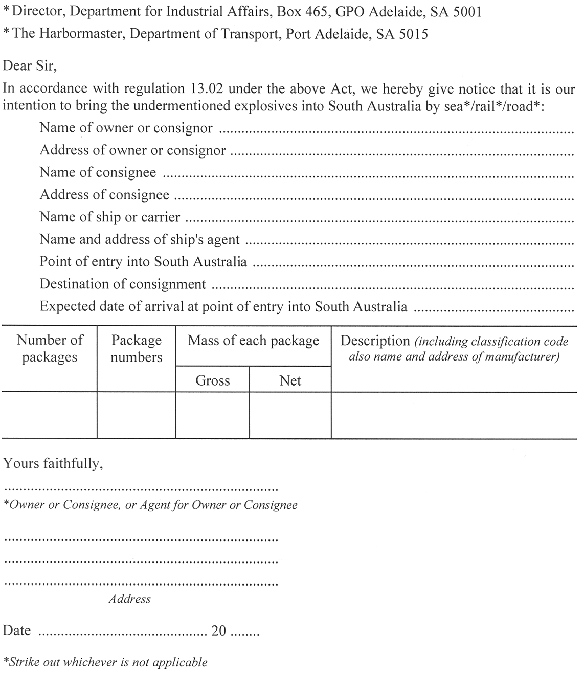

Schedule B—Application for licence to import explosives
(Regulation 13.05)
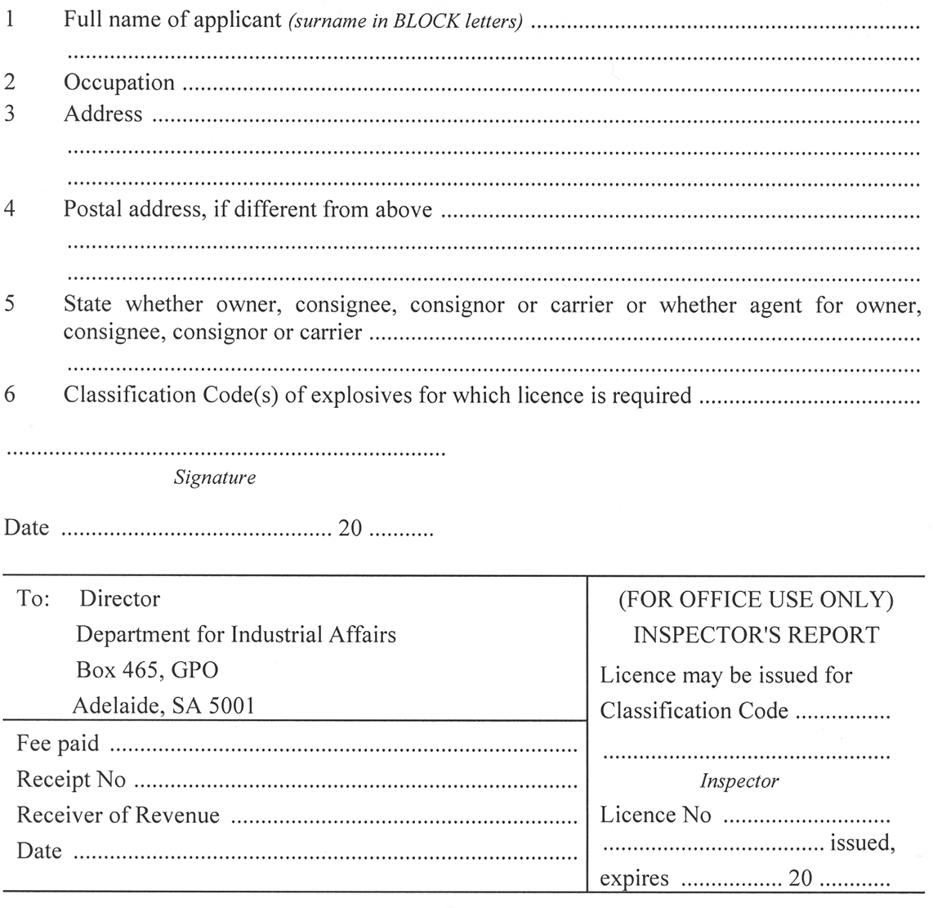
Schedule C—Licence to import explosives
(Regulation 13.08)
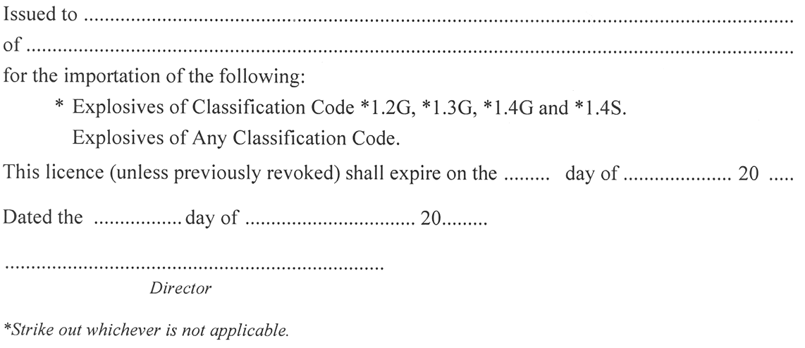

Schedule D—Application for permit to purchase explosives
(Regulation 14.03)


Schedule E—Permit to purchase explosives
(Regulation 14.07)
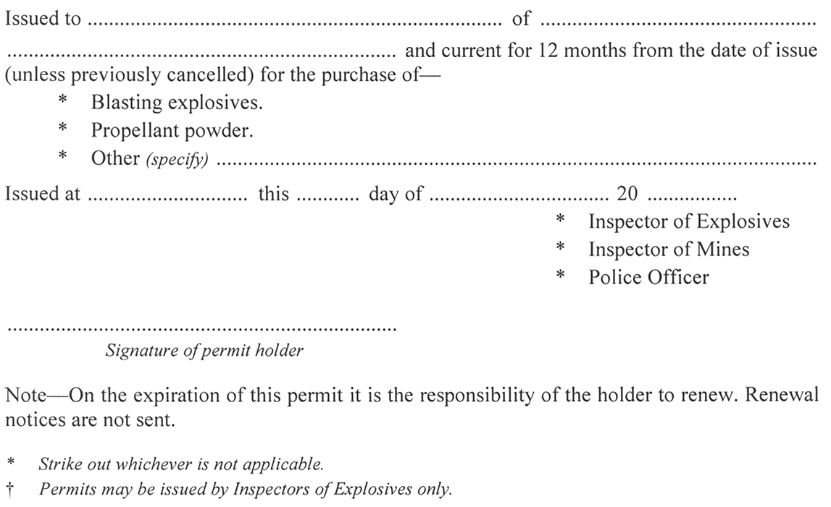
Schedule H—Application for licence for factory to manufacture explosives
(Regulation 3.01)
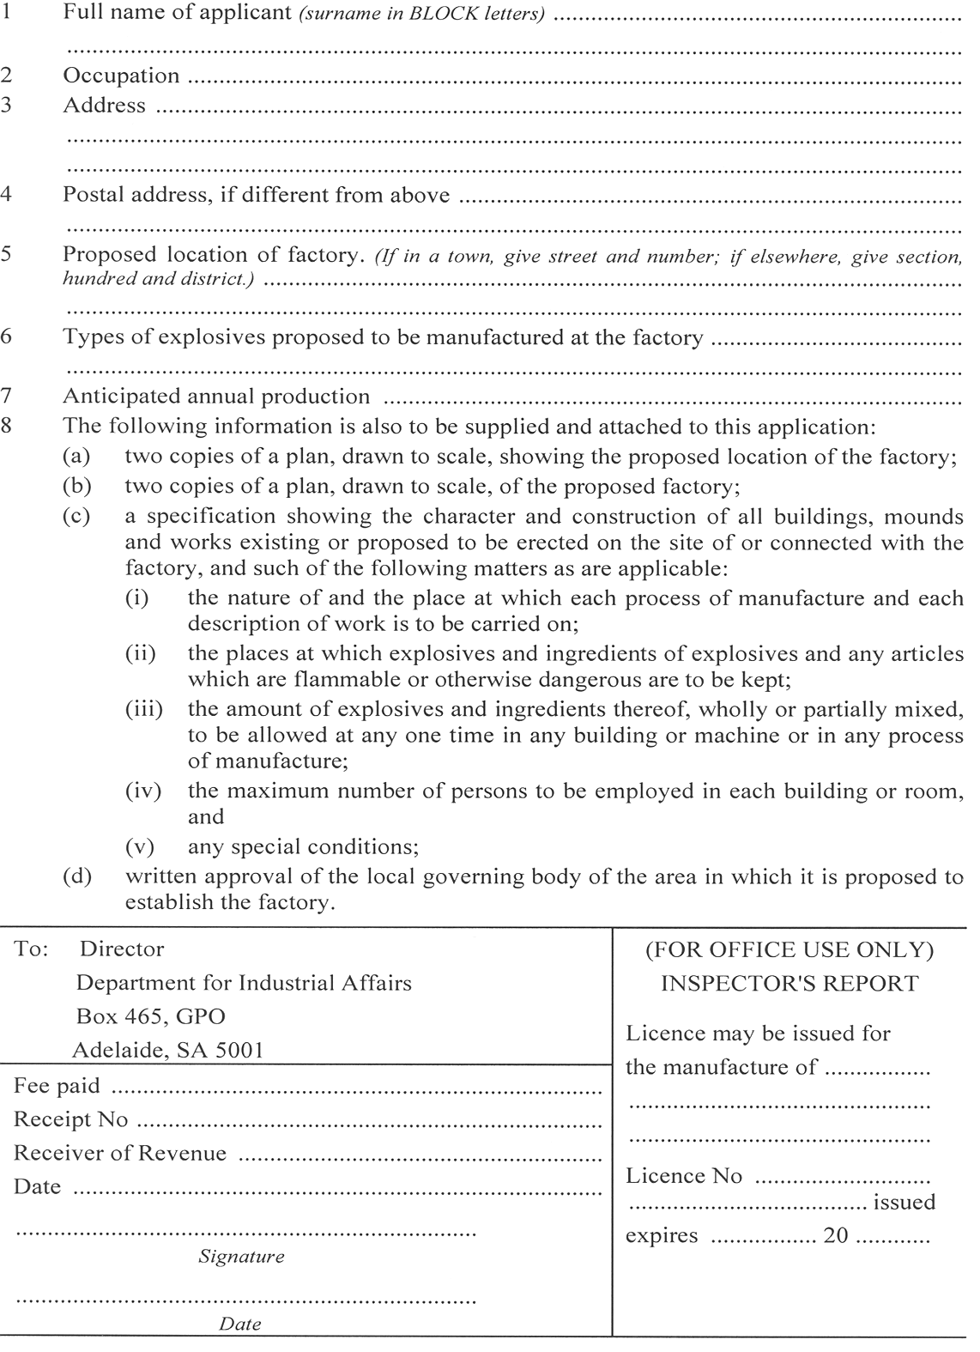

Schedule I—Factory licence to manufacture explosives
(Regulation 3.06(b))
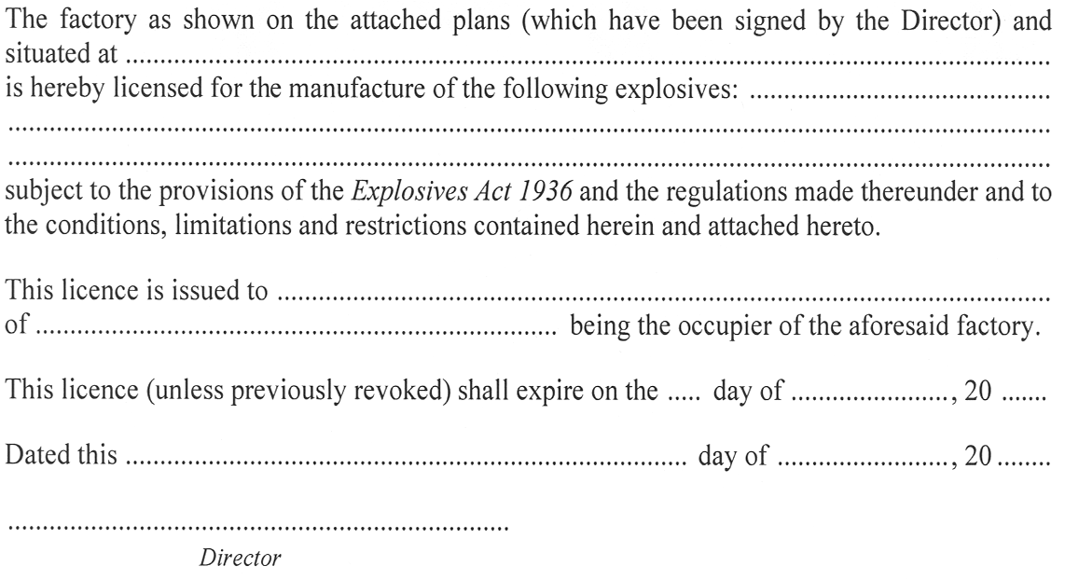
Schedule J—Application for licence to mix and use ammonium nitrate mixture
(Regulation 4.03(1))
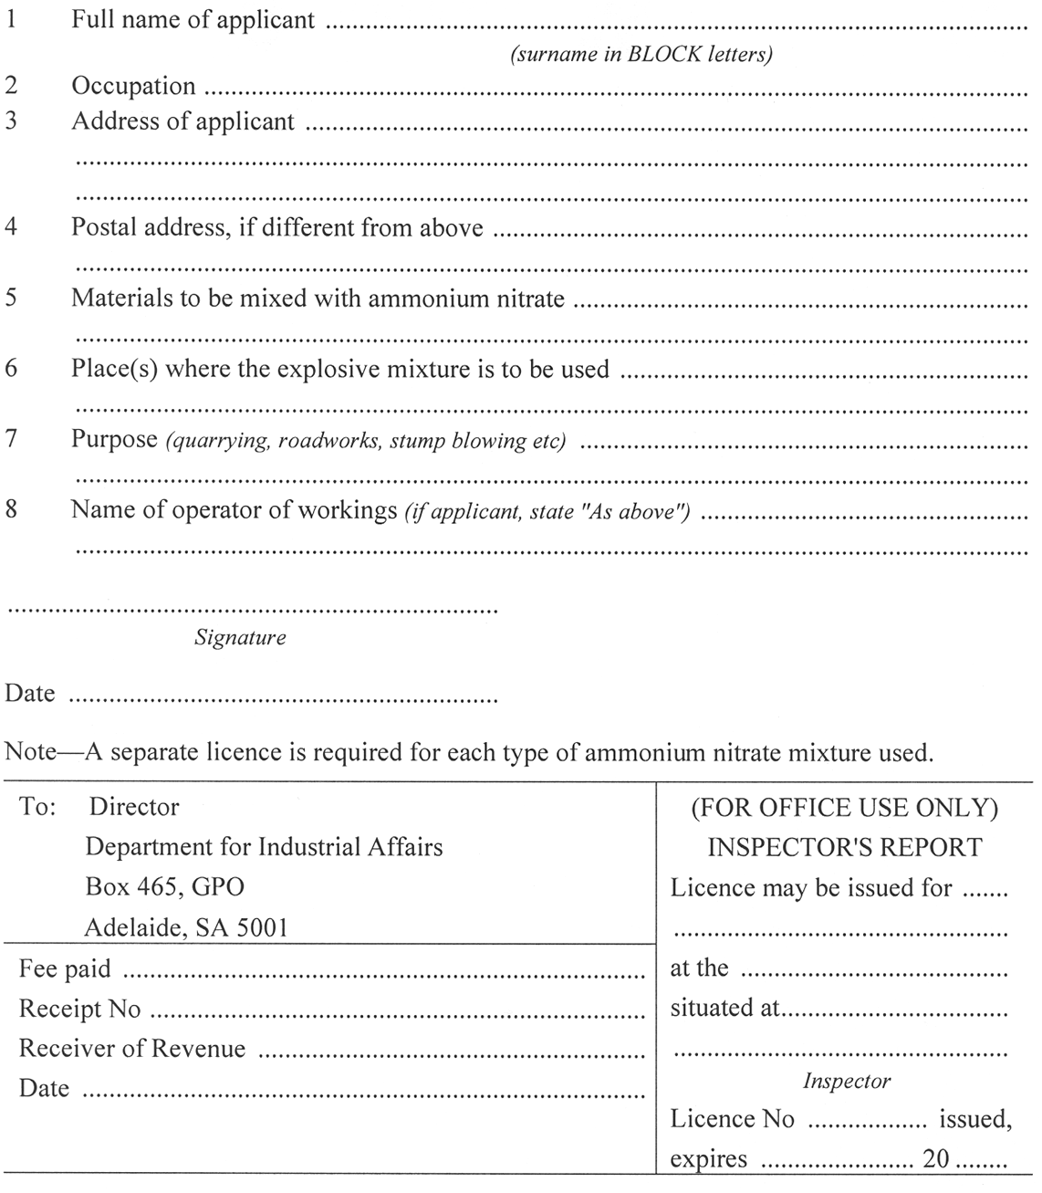
Schedule K—Licence to mix and use ammonium nitrate mixture
(Regulation 4.05(a))

Schedule L—Table showing quantity of explosive equivalent to 1 000 detonators
(Regulation 7.02(2), 10.09(e) and 11.07)
For the purposes of section 23(2) of the Act and of the Regulations for the carriage and for the storage of explosives, 1 000 detonators shall be taken as equivalent to quantities of explosives shown in the following table, and the equivalents of other numbers of detonators shall be calculated in proportion.

Table showing Quantity of Explosive Equivalent to 1 000 detonators
Size of Detonator | Equivalent of Explosive  (kg) | Size of Detonator | Equivalent of Explosive  (kg)
No. 3 | 6 | No. 7 | 13
No. 4 | 7 | No. 8 | 16
No. 5 | 8 | No. 9 | 18
No. 6 | 9 | No. 10 | 20

Schedule M—Application for licence to carry explosives
(Regulation 7.03(b))
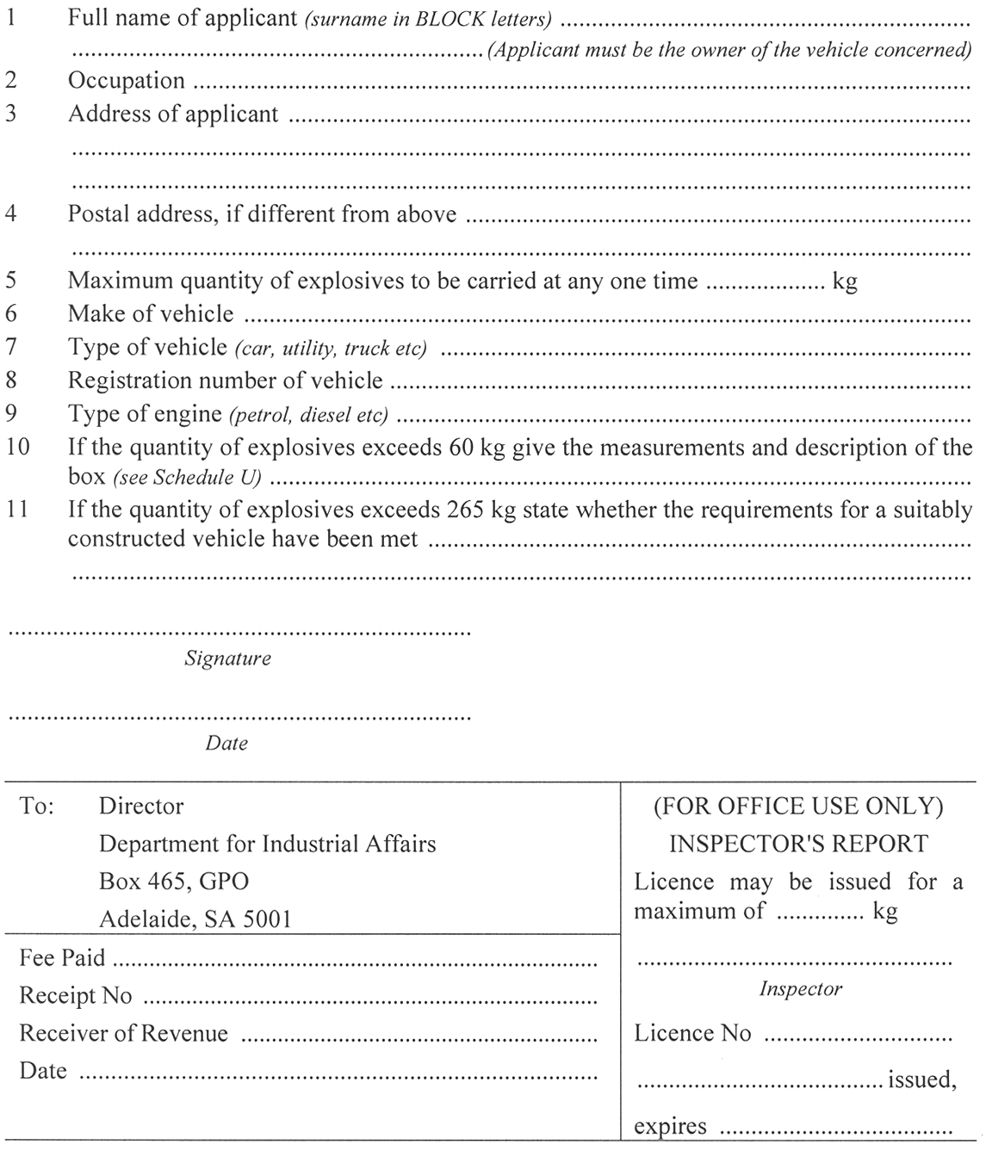
Schedule N—Licence to carry explosives
(Regulation 7.04(3))
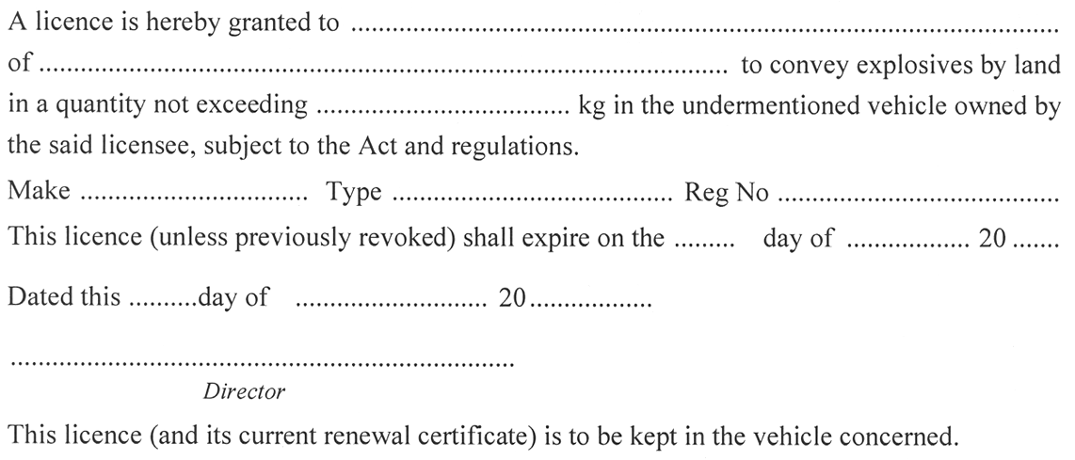
Schedule O—Permission for ship to enter prohibited area
(Section 31 of Act)
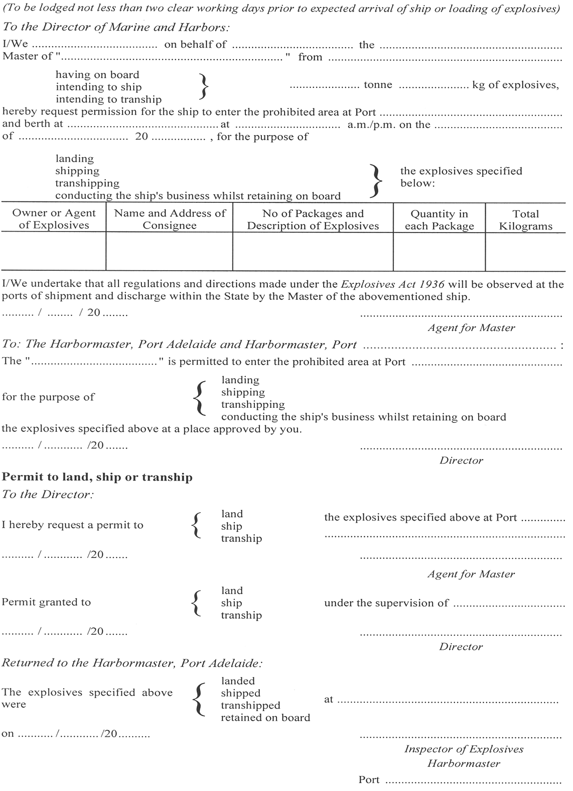
Schedule P—Application for licence for keeping explosives on premises
(Regulation 10.03)
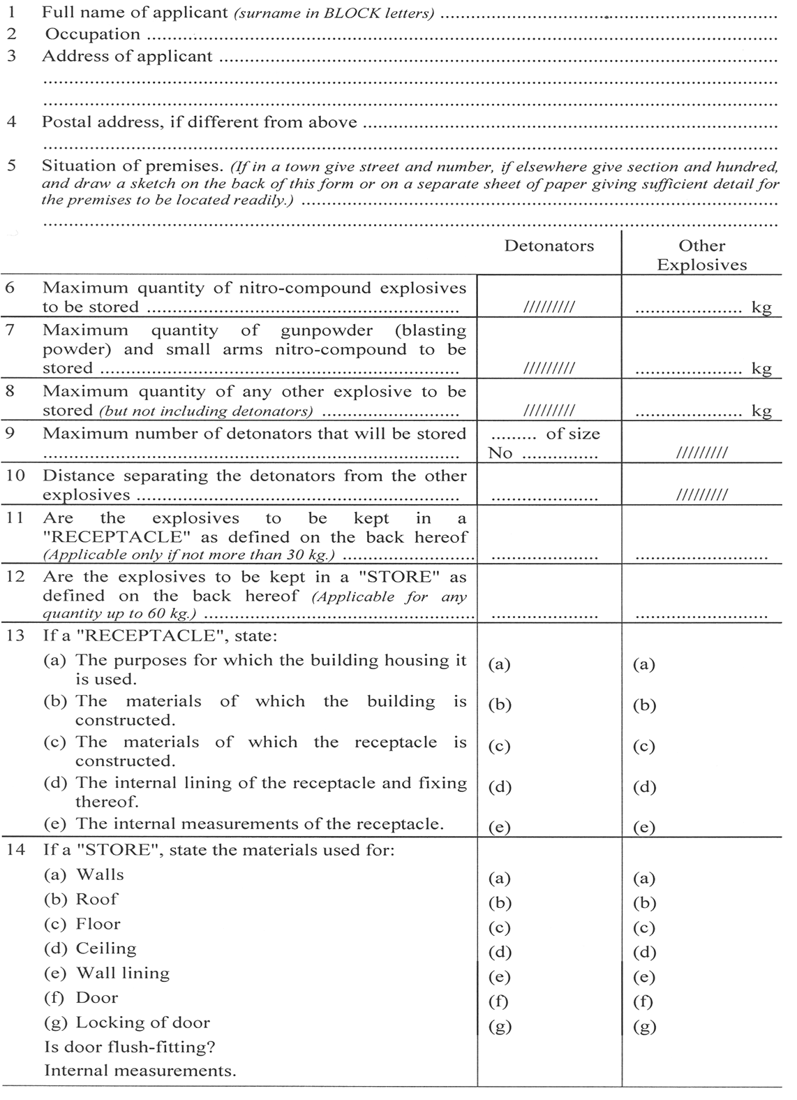
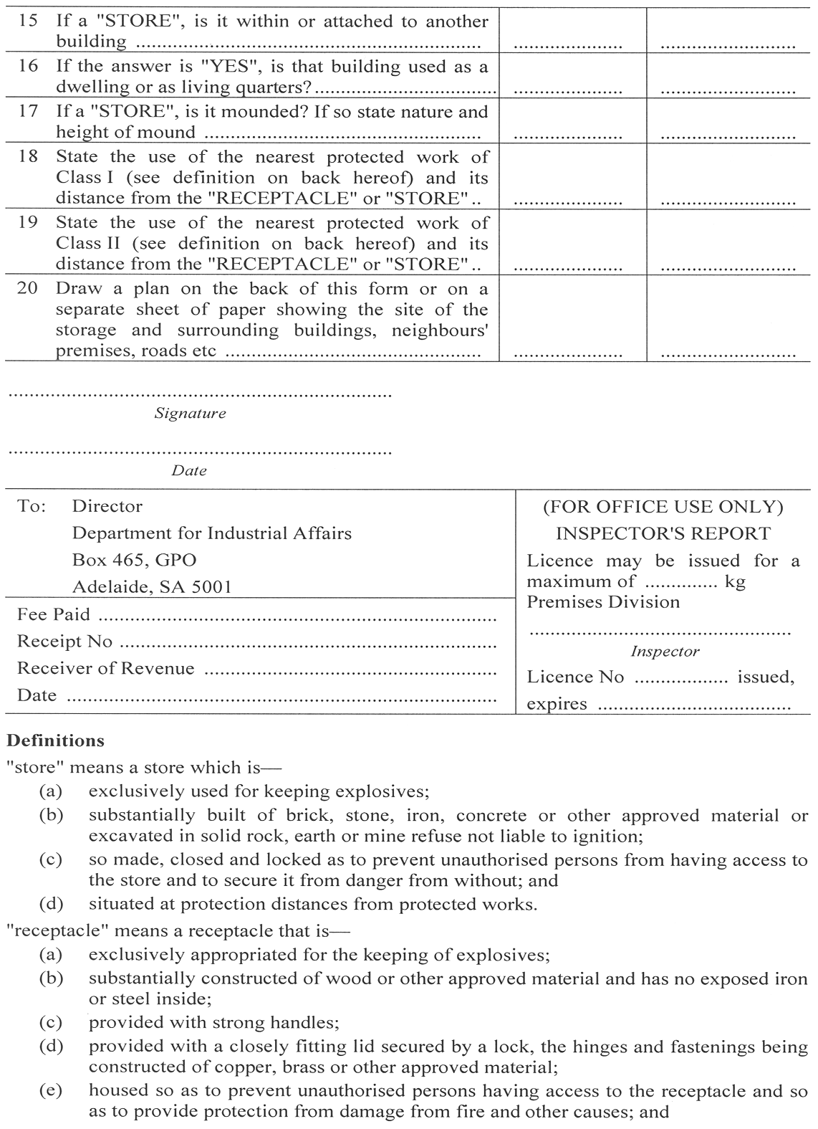
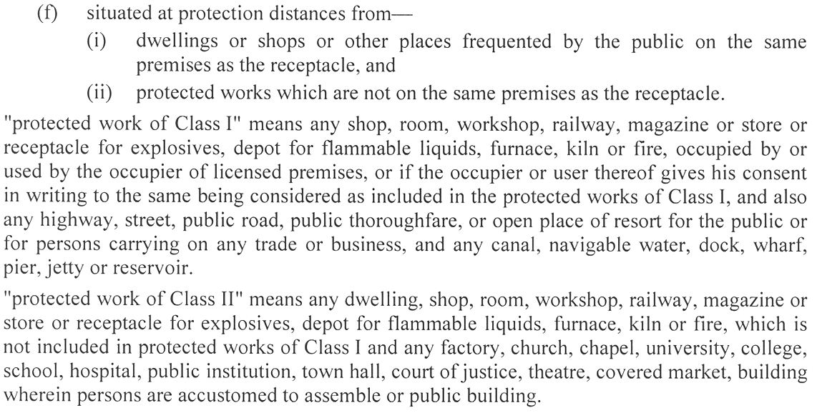
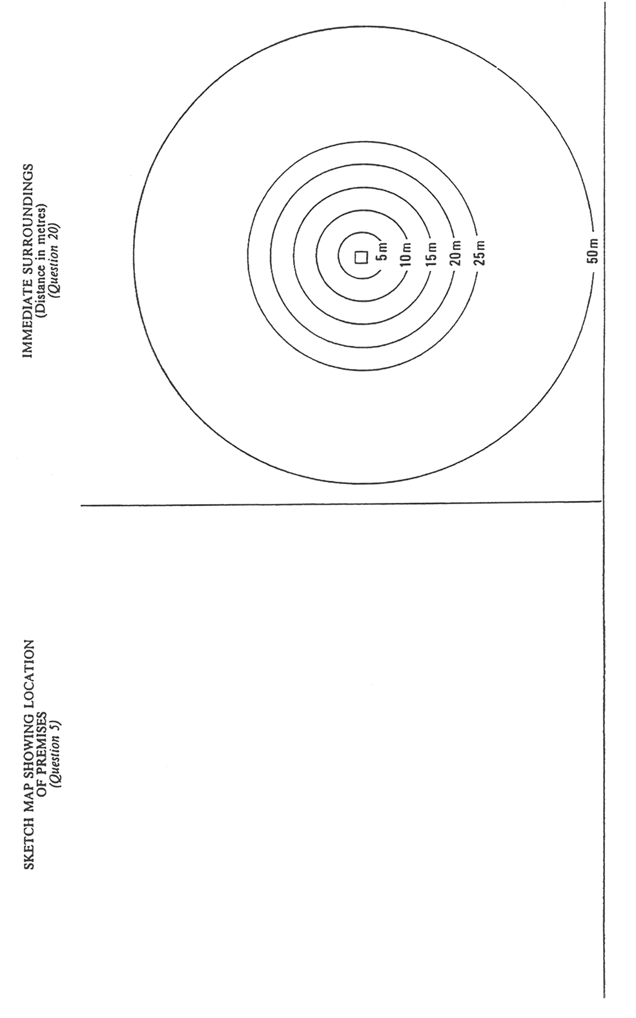
Schedule Q—Licence for keeping explosives on premises
(Regulation 10.05)
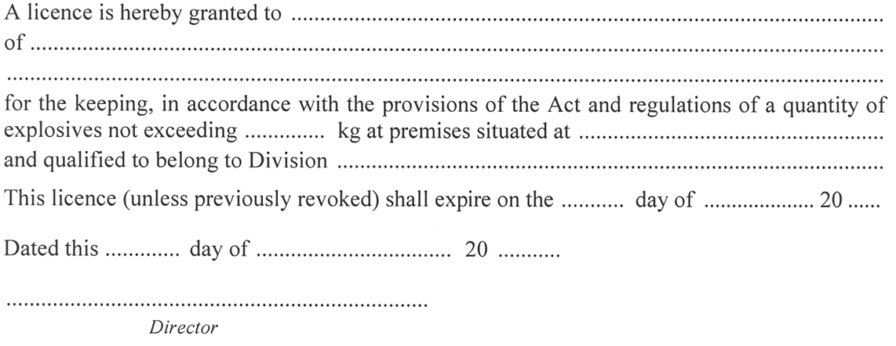
Schedule R—Application for licence for keeping explosives in magazine
(Regulation 11.02)
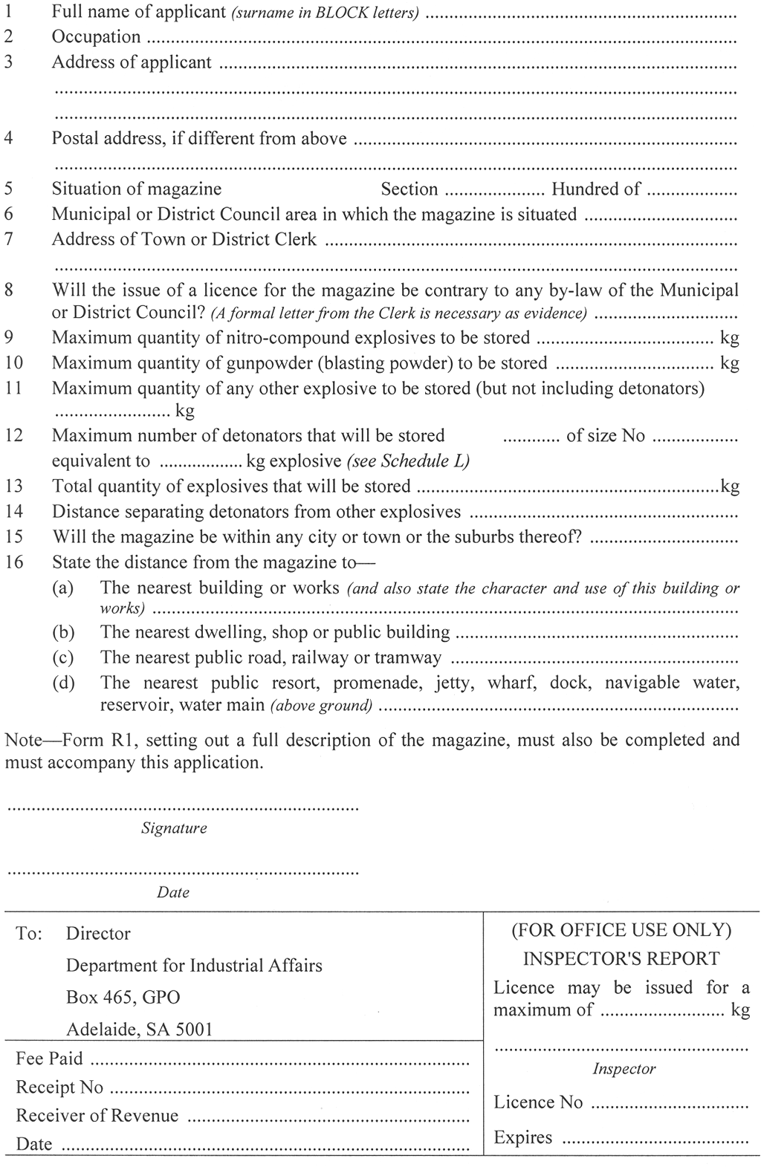
Schedule R1—Details of magazine
(Regulation 11.02)
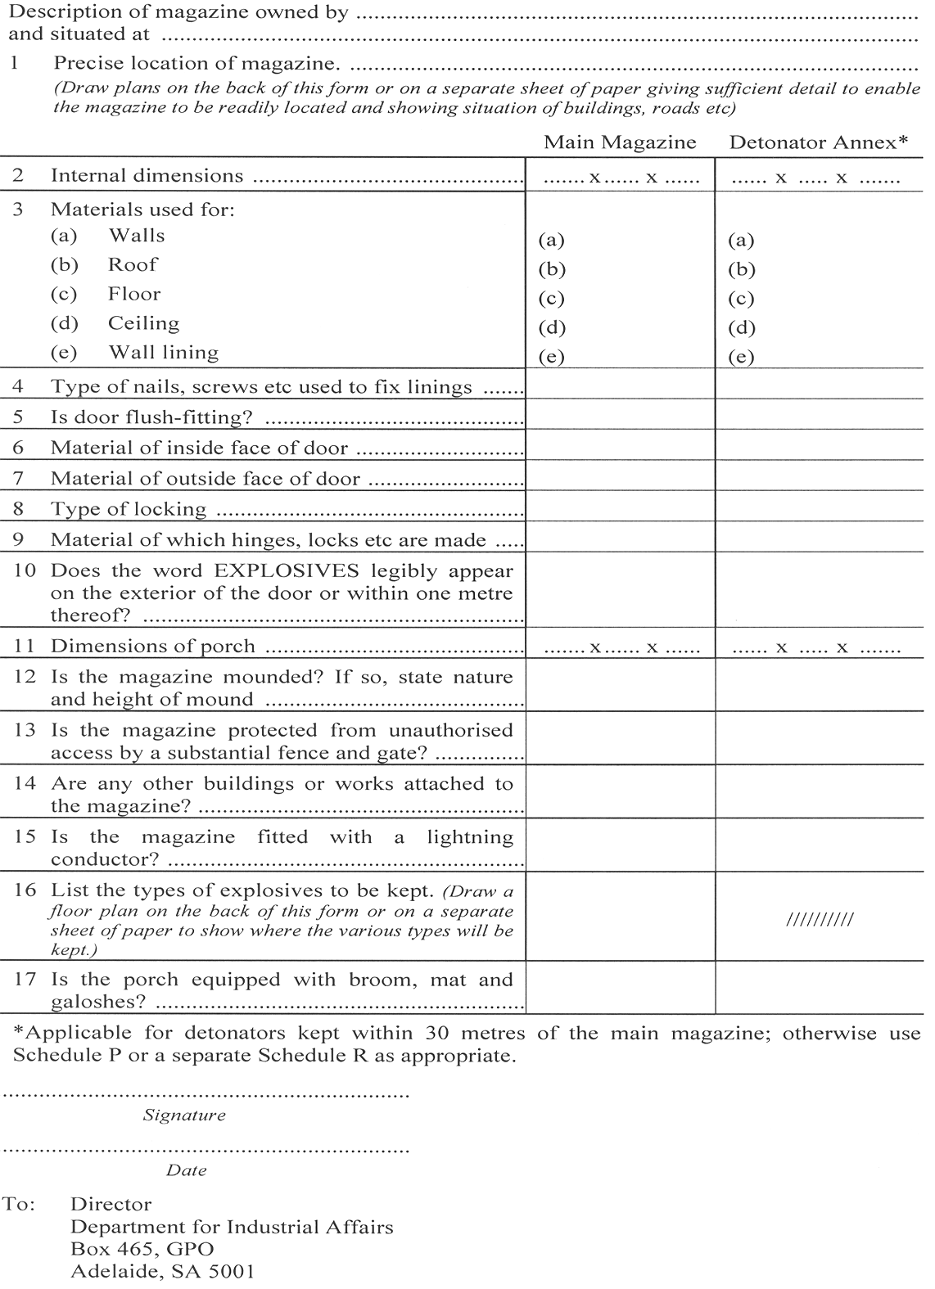
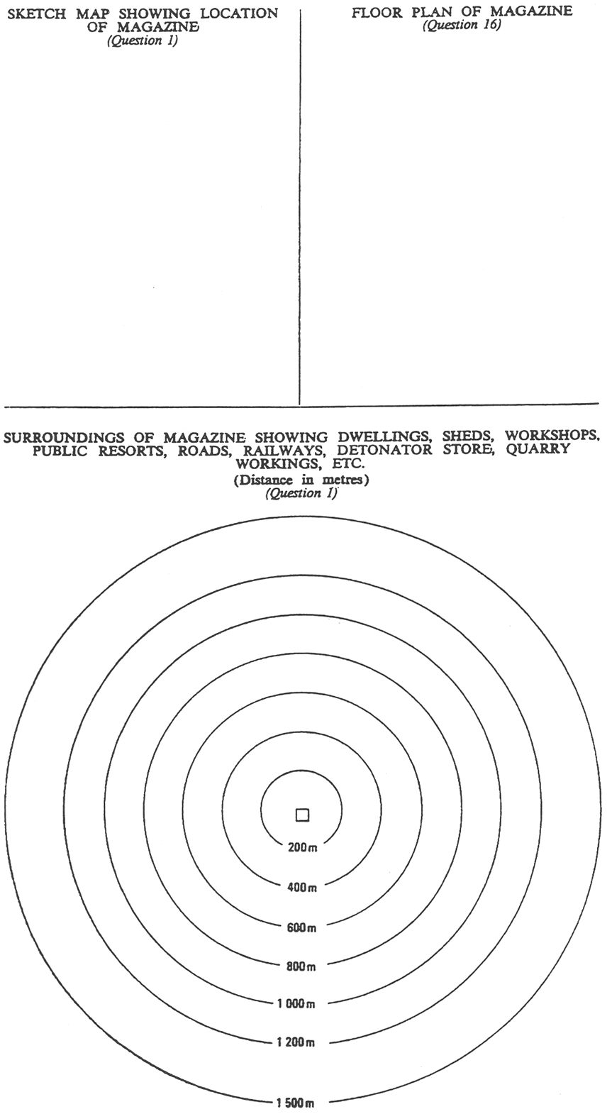
Schedule S—Licence for keeping explosives in magazine
(Regulation 11.04(2))

Schedule T—Tables of safety distance for magazines
(Regulation 11.01, 11.05, 11.06(a))
In this Schedule, the term Inside Safety Distance means the distance to be observed between a magazine and other magazines or buildings in the same occupancy not being protected works, and the term Outside Safety Distance means the distance to be observed between a magazine and a protected work.
The Safety Distance required for buildings containing explosives to achieve the necessary degree of safety depends upon the following three factors:
(a) The type of risk appropriate to the explosive; and
(b) The weight of explosive in the building; and
(c) Whether effective mounds or screens are provided.
In regard to (a) all authorised explosives are given a category by the Director which is dependent on their potential risks. The categories are—
Category X—Explosives having fire or slight explosion risk or both with only local effect.
Category Y—Explosives having mass fire risk, or moderate explosion risk, but not mass explosion risk.
Category Z—Explosives having a mass explosion risk with serious missile effect.
Category ZZ—Explosives having a mass explosion risk with minor missile effect.
In regard to (c), a protected work may be considered mounded if a mound or screen exists such that straight lines drawn from all points of the protected work to all points of the magazine will pass through the mound or screen. A natural hill may serve as a mound or screen.
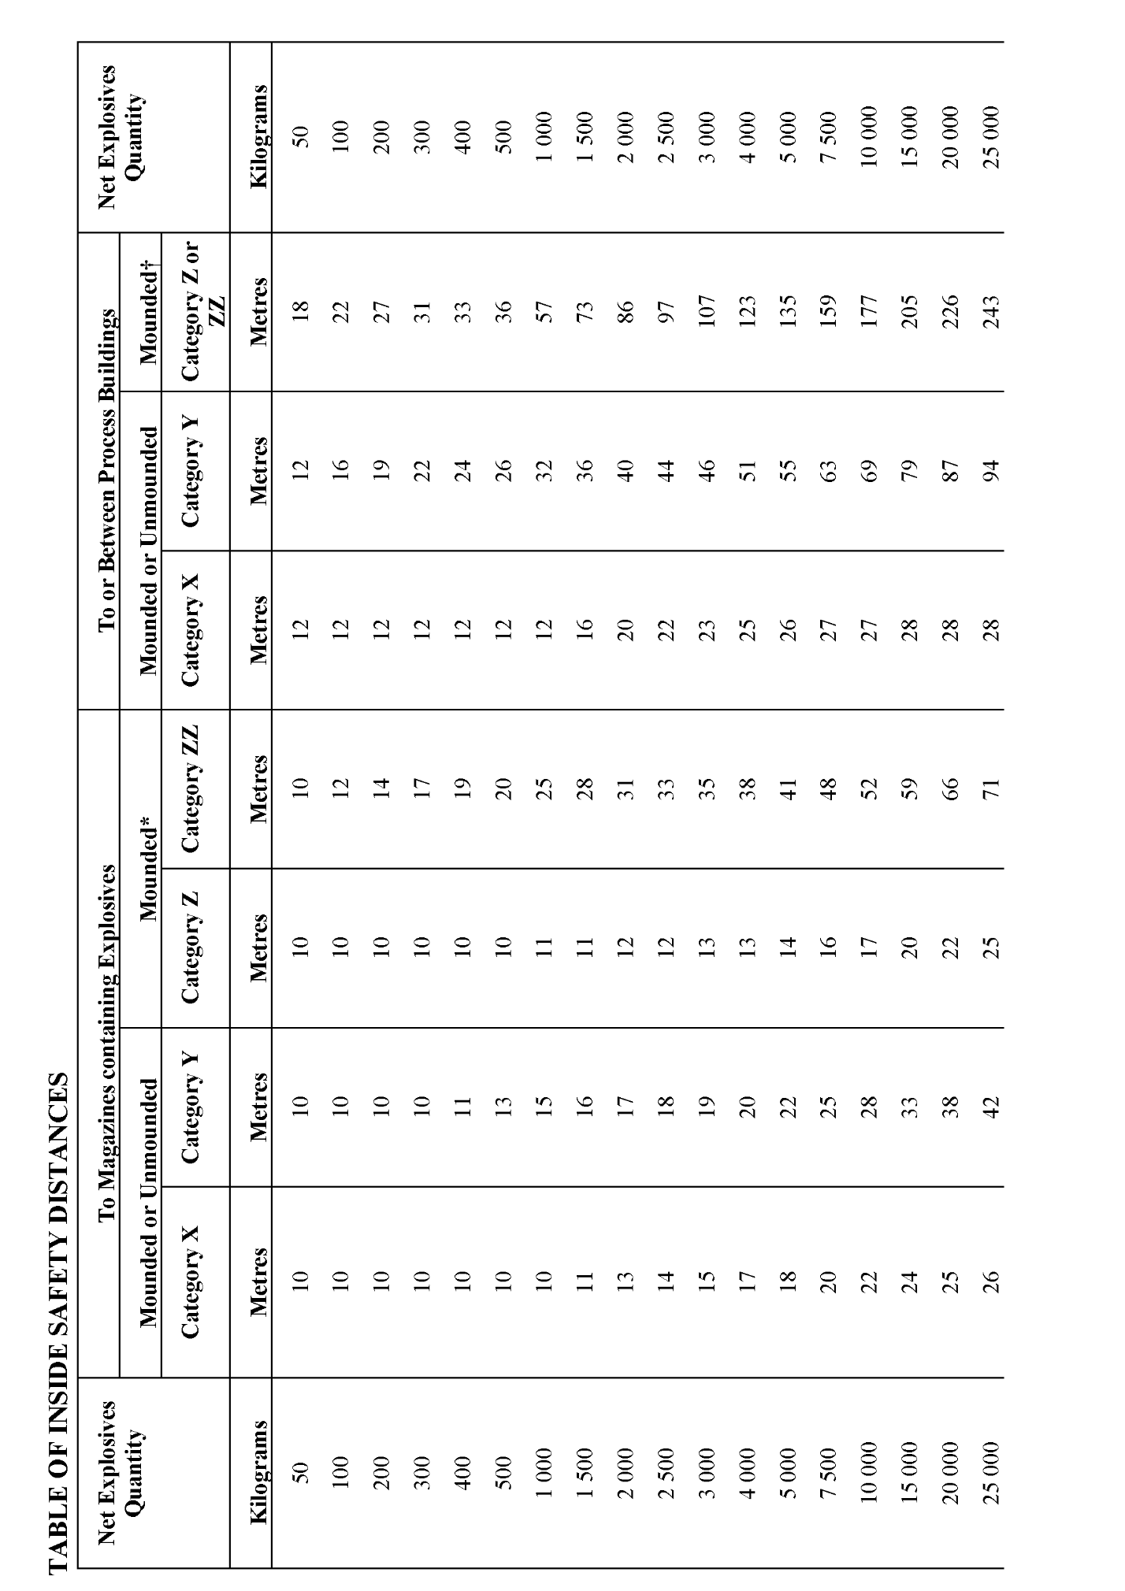

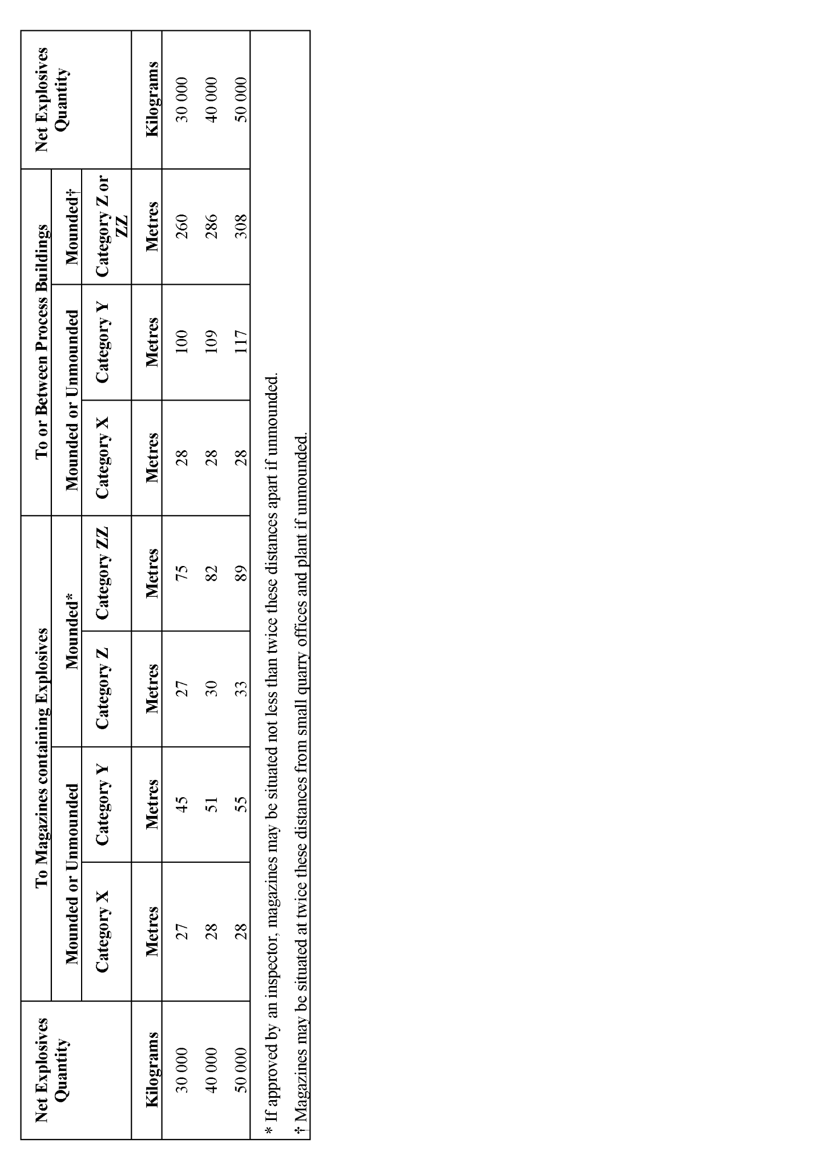

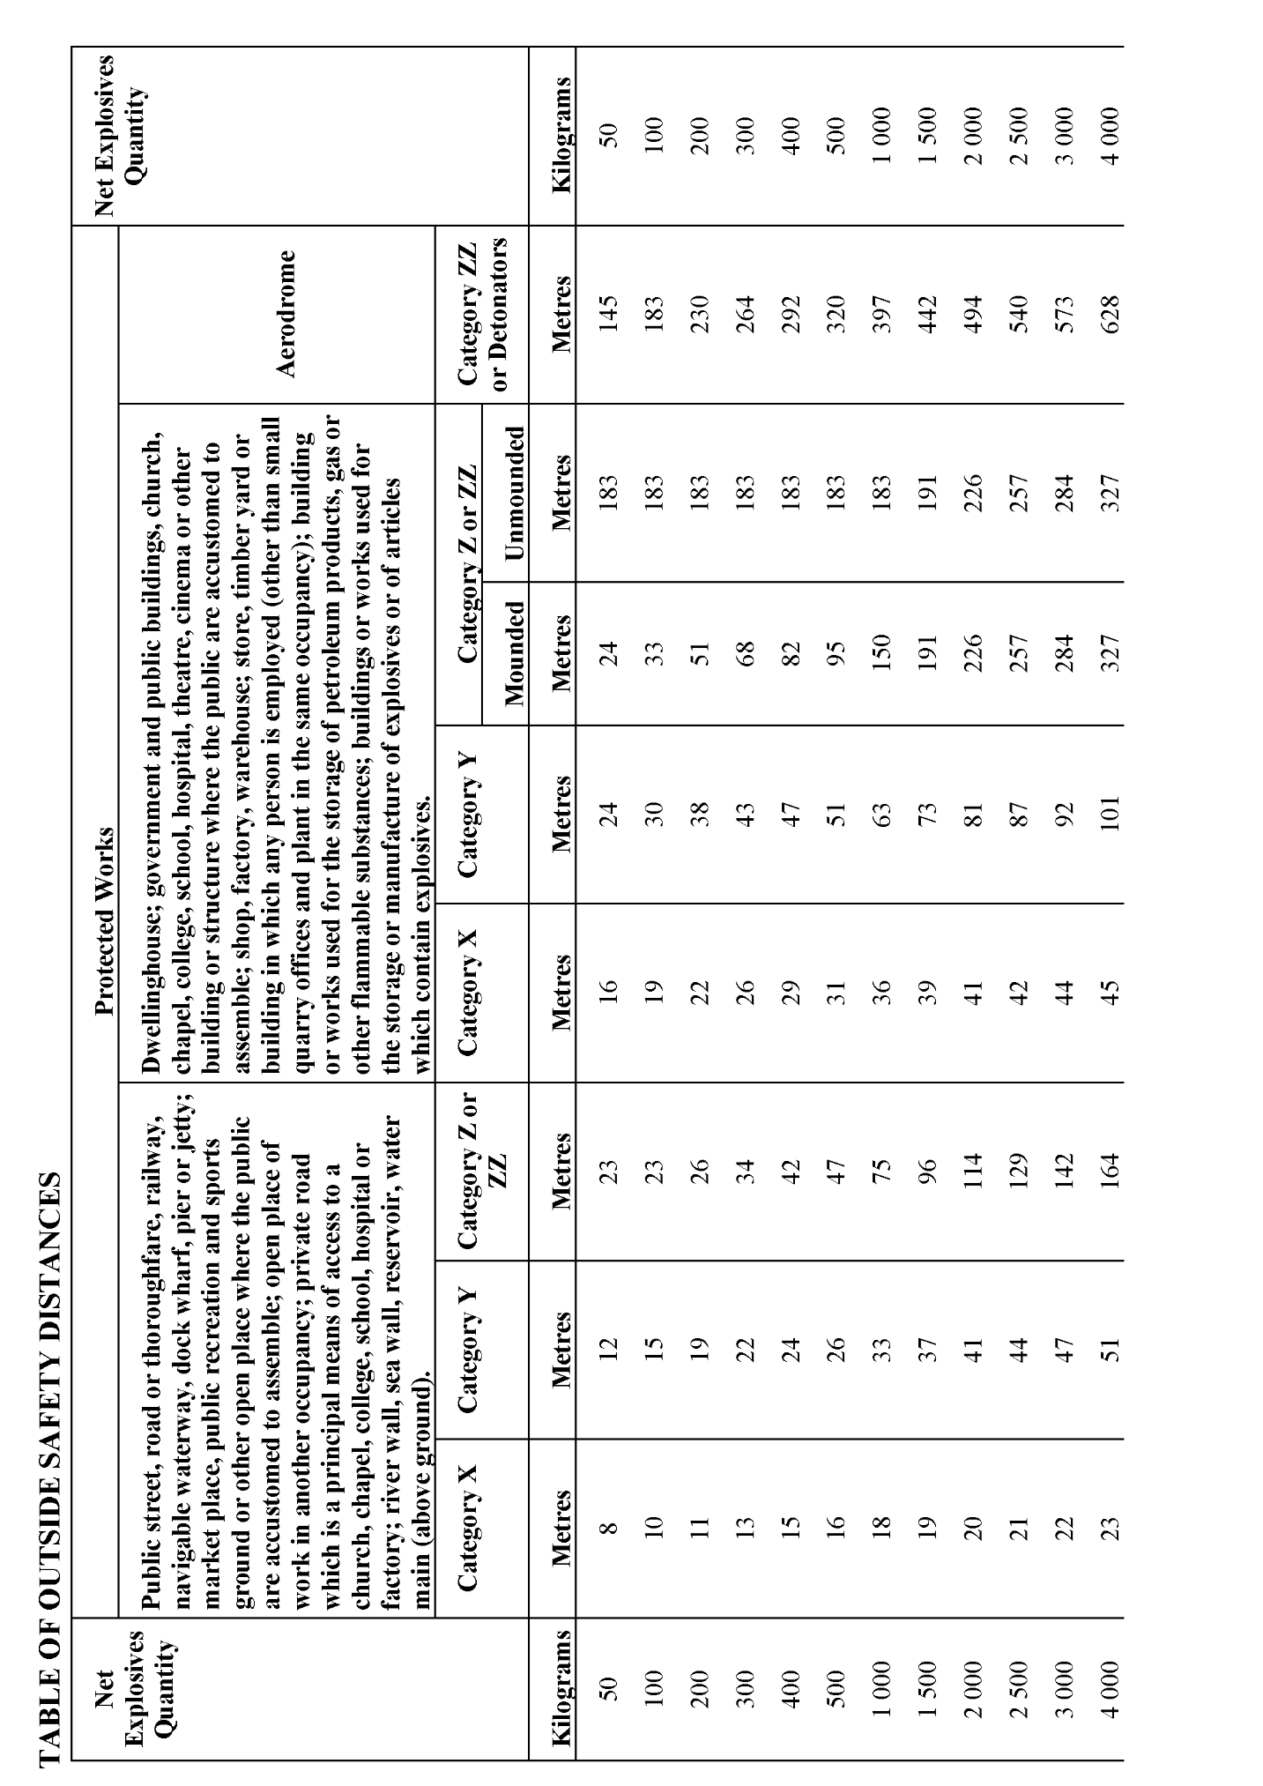

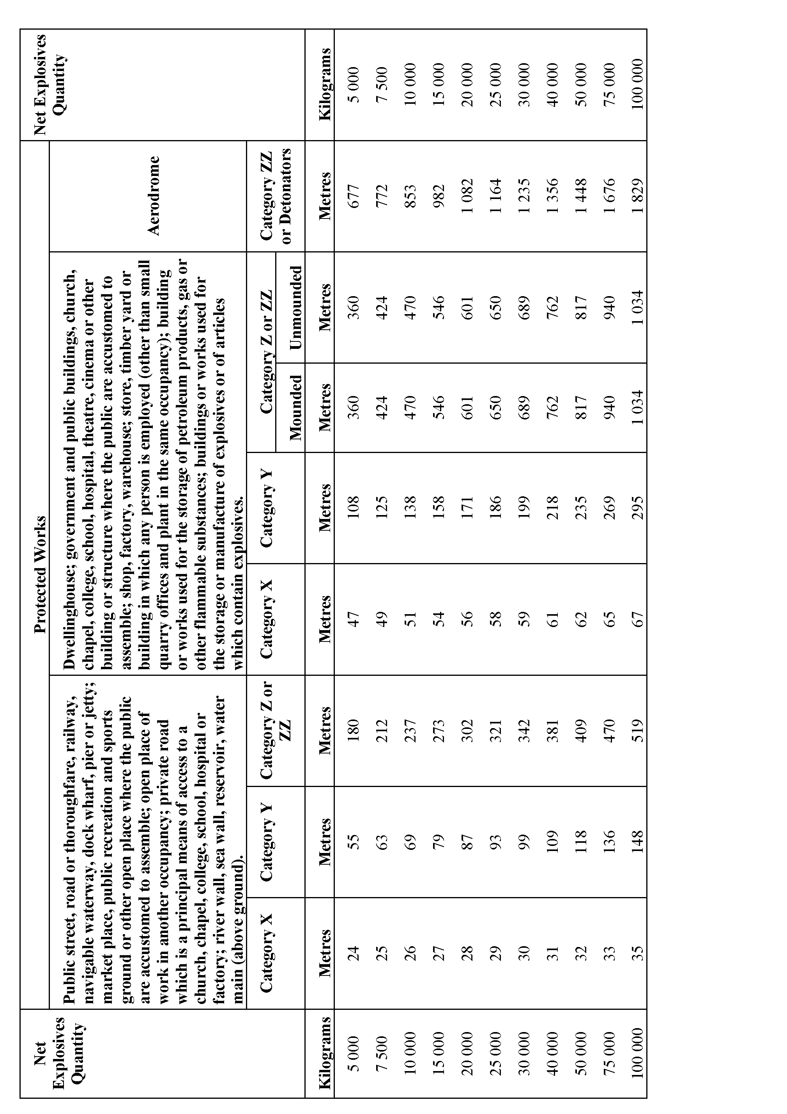

Schedule U—Box for carriage of explosives
(Regulation 7.13(3), 7.13(4)(b), 7.13(5), 7.13(6)(b))
A box for the carriage of explosives in a vehicle or a boat shall be—
1 Strongly constructed of tongue and groove timber at least 20 mm thick or of wooden sheets at least 12 mm thick (see sketches below);
2 Sheathed outside with flat galvanised iron;
3 Fitted with one or more locks;
4 Marked with the word "EXPLOSIVES" painted conspicuously in red on a white background;
5 Secured firmly in the vehicle when being used for the carriage of explosives;
6 Fitted with lugs or rings if ropes are to be used to secure it in the vehicle;
7 Used only for the carriage of explosives.
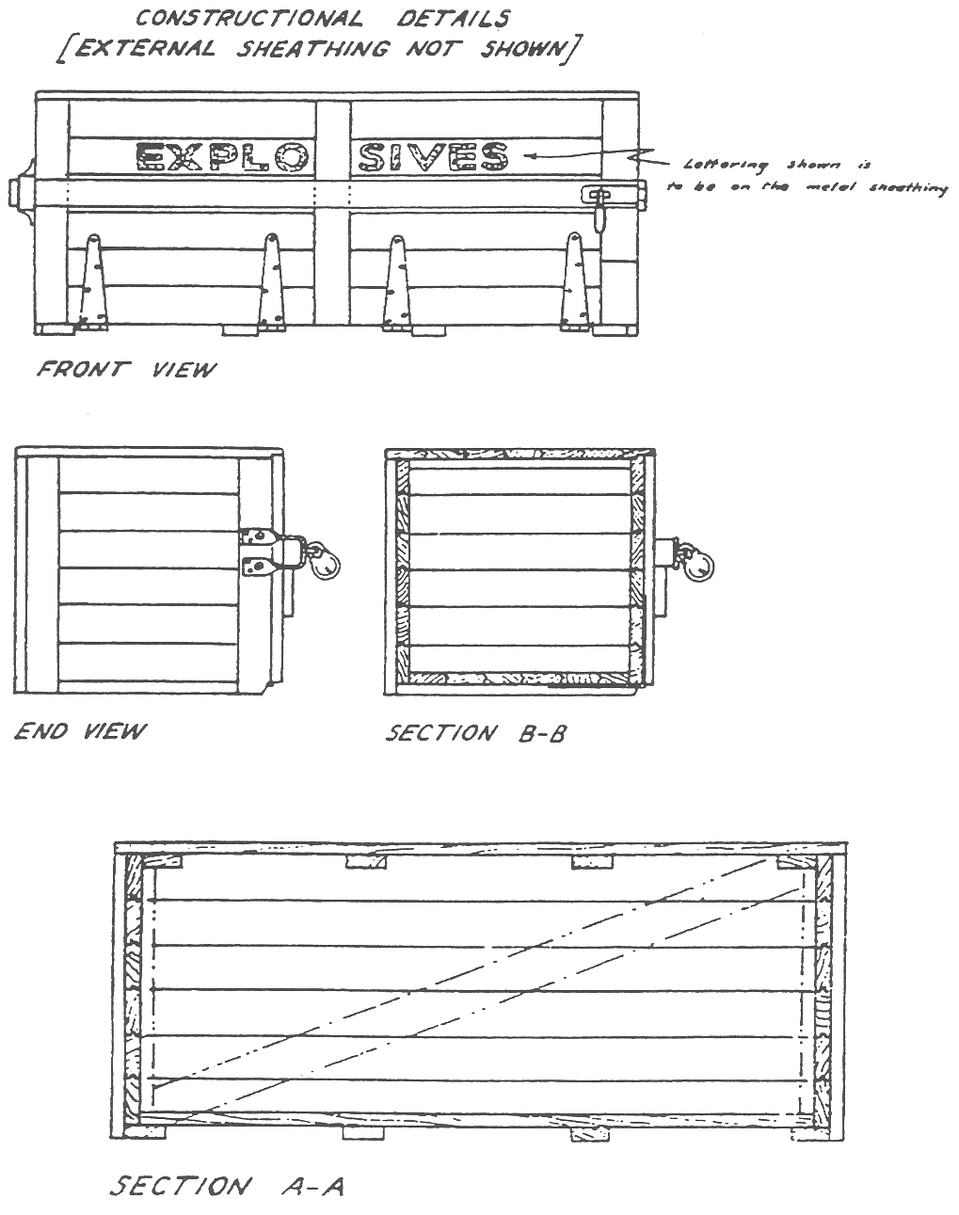
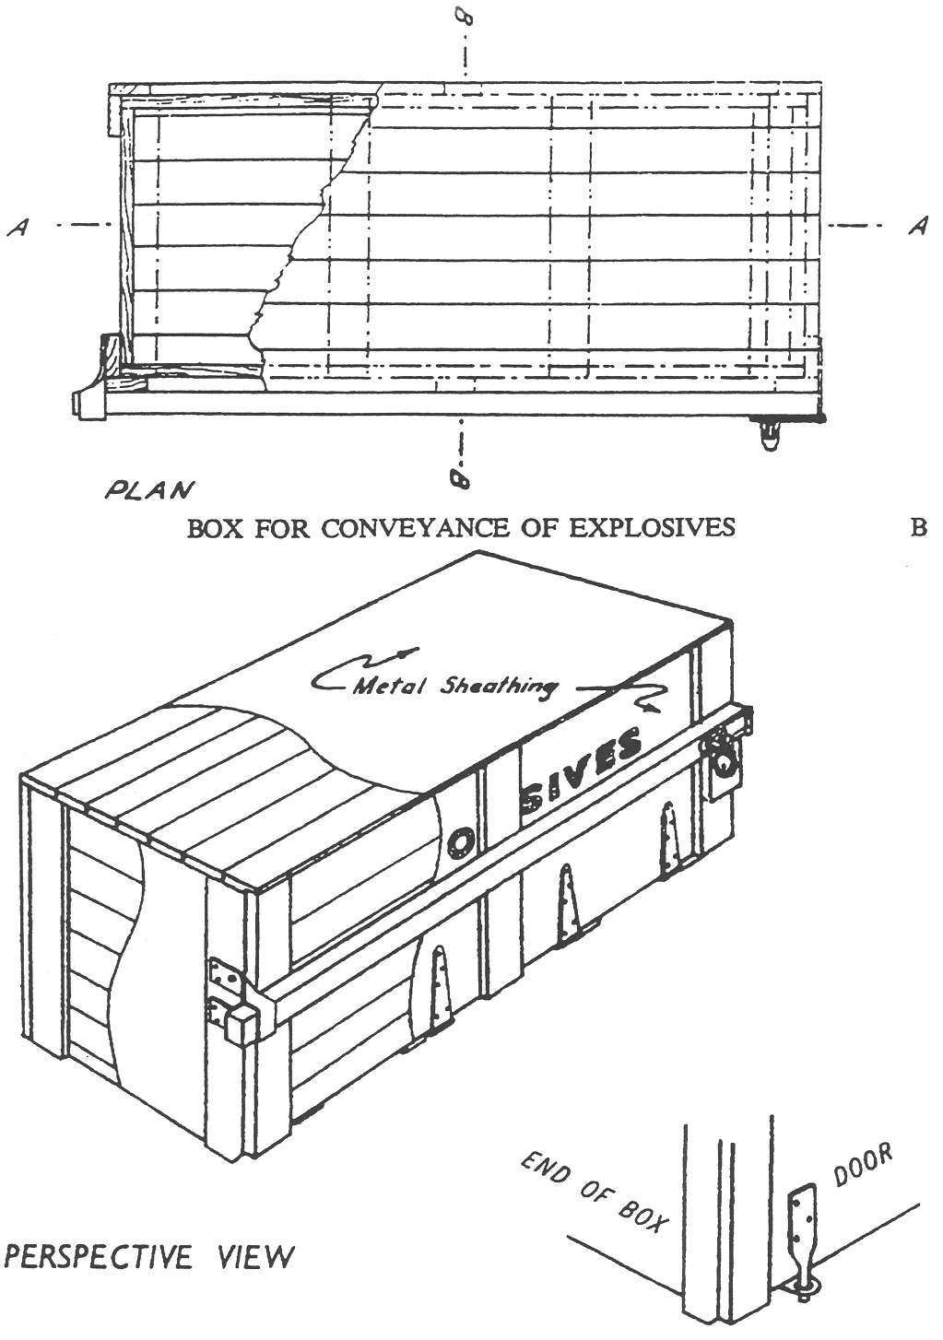
Instead of using hinges, the door may be held in place by two metal pegs attached to the bottom of the door and fitting into corresponding holes in metal plates fastened to the base of the box as shown above.
Notes—
1 The actual size of the box will depend on the number and size of cases to be conveyed.
2 The box is to be completely covered on the outside with plain galvanised iron or approved non-ferrous metal. Hinges, catches and other fittings to be of approved non-ferrous metal.
3 The interior is to be free from exposed iron or steel. All nails, screws and other fastenings used inside are to be countersunk and puttied over.
4 Door may be a lid instead of on side, if desired.
5 Close stowage to avoid undue movement of cases within the box is essential. If necessary, suitable wooden wedges or other approved means should be used for this purpose.
Schedule V—Repeal of regulations and transitional provision
1—Repeal of Explosives Regulations 2011
The Explosives Regulations 2011 are repealed.
2—Transitional provision
A licence or permit in force under a provision of the Explosives Regulations 2011 immediately before the commencement of this clause will be taken to be a licence or permit in force under the corresponding provision of these regulations.
Editorial note—
As required by section 10AA(2) of the Legislative Instruments Act 1978, the Minister has certified that, in the Minister's opinion, it is necessary or appropriate that these regulations come into operation as set out in these regulations.
Made by the Governor
with the advice and consent of the Executive Council
on 13 August 2026
No 71 of 2026

State Government Instruments

Boxing and Martial Arts Act 2000
Notice of Rules
Take notice that pursuant to Section 10 of the Boxing and Martial Arts Act 2000, I Kylie Taylor, Chief Executive of the Office for Recreation, Sport and Racing, as delegate for the Minister for Recreation, Sport and Racing to whom the administration of the Boxing and Martial Arts Act 2000 is committed, have approved the rules applicable to the conduct of boxing events to commence operation on this date of publication.
The approved rules are set out below.
Dated: 6 August 2026
Kylie Taylor
Chief Executive, Office for Recreation, Sport and Racing
As delegate for the Minister for Recreation, Sport and Racing

International Boxing Association Technical and Competition Rules—3 March 2024

Building Work Contractors Act 1995
Exemption
Take notice that, pursuant to Section 45 of the Building Work Contractors Act 1995, I, Brett Humphrey as a delegate for the Minister for Consumer and Business Affairs, do hereby exempt the licensee named in Schedule 1 from the application of Division 3 of Part 5 of the above Act in relation to domestic building work described in Schedule 2 and subject to the conditions specified in Schedule 3.
Schedule 1
BELLA HOMES PTY LTD (BLD 336202)
Schedule 2
Construction of a single storey detached dwelling at Allotment 3 Deposited Plan 64698, being a portion of the land described in Certificate of Title Volume 5918 Folio 744, more commonly known as 6 Camporeale Drive, Risdon Park SA 5540.
Schedule 3
1. This exemption is limited to domestic building work personally performed by the licensee in relation to the building work described
in Schedule 2.
2. This exemption does not apply to any domestic building work the licensee contracts to another building work contractor, for which that contractor is required by law to hold building indemnity insurance.
3. That the licensee does not transfer its interest in the land prior to five years from the date of completion of the building work the subject of this exemption, without the prior authorisation of Consumer and Business Services (CBS). Before giving such authorisation, CBS may require the licensee to take any reasonable steps to protect the future purchaser(s) of the property, including but not limited to:
• Providing evidence that an adequate policy of building indemnity insurance is in force to cover the balance of the five-year period from the date of completion of the building work the subject of this exemption;
• Providing evidence of an independent expert inspection of the building work the subject of this exemption;
• Making an independent expert report available to prospective purchasers of the property;
• Giving prospective purchasers of the property notice of the absence of a policy of building indemnity insurance.
Dated: 4 August 2026
Brett Humphrey
Commissioner for Consumer Affairs
Delegate for the Minister for Consumer and Business Affairs

Education and Children’s Services Act 2019
Amending the Constitution of a Governing Council for a Government Preschool
I, Lynne Rutherford, Director, Quality Preschools, consider it necessary to amend the constitution of Keith War Memorial Community Centre Kindergarten to ensure that it takes the form of the proposed model constitution for children’s services centres. Therefore, in accordance with Section 22(1) and (2) of the Education and Children’s Services Act 2019, I amend the governing councils’ constitution such that it now reads as follows:
Keith War Memorial Community Centre Kindergarten Incorporated
Constitution
Table of Contents
1. Name
2. Interpretation
3. Object and Establishment
4. Powers of the Centre
5. Membership of the Centre
6. Meetings of the Centre
7. The Governing Council
8. Voting
9. Minutes
10. Finances and Accounts
11. Audit
12. Reporting
13. Seal
15. Amendment of Constitution and Rules
16. Dissolution
17. Liability
Children’s Services Centre Constitution
(Under Education and Children’s Services Act 2019)
1. Name
The name of the Children’s Services Centre is the Keith War Memorial Community Centre Kindergarten Incorporated (hereinafter called ‘the Centre’).
2. Interpretation
In this constitution, unless the contrary intention appears:
‘the Act’ means the Education and Children’s Services Act 2019
‘administrative instruction’ means an administrative instruction issued by the Chief Executive (or delegate) pursuant to Section 9 of the Act
‘Centre Staff’ means persons employed to work at the Centre who are employed by the Chief Executive or who are employed by the Centre on terms and conditions approved by the Chief Executive
‘Chairperson’ means the presiding member of the Council
‘Chief Executive’ means the Chief Executive of the administrative unit of the Public Service responsible for assisting the Minister with the administration of the Act
‘Children’s Services Centre’ means a stand-alone children’s services centre continuing in existence under Section 26 of the Act at which one or more children’s services are provided
‘children’s service provided by the Centre’ means a children’s service run by the Centre and funded by the department. To avoid doubt, this does not include children’s services offered by external agencies co-hosted at the Centre
‘Council’ means the Governing Council of the Centre
‘Council member’ means member of the Council
‘department’ means the Department for Education
‘Director’ means the person for the time being designated by the Chief Executive as the Director of the Centre
‘Governing Council’ of the Centre means the Governing Council of the Centre continued under Section 26 of the Act
‘meeting’ means an Annual General Meeting or a General Meeting or Special General Meeting of members of the Centre convened in accordance with this constitution
‘member’ means a member of the Centre and whose name appears in the register referred to in Clause 5.2 of this constitution
‘Minister’ means the person to whom the administration of the Act is committed pursuant to the Administrative Arrangements Act 1994
‘parent’—the Act uses the term “person responsible for a child or student”. In this constitution, the term “parent” will be used instead. This term includes parents, guardians, and persons standing in loco parentis to a child, but excludes any person whose custody or guardianship of a child, or whose responsibility for a child, has been excluded under any Act or law (for example, the Family Law Act 1975 (Cth)).
‘preschool’ means a place at which education services are provided to children who have not yet attained the compulsory school age (and preschool education will be taken to have a corresponding meaning) but a reference to a preschool, or to preschool education, will be taken not to include a reference to the provision of primary education to such children at a school.
‘Quality Improvement Plan’ means a document created by the Centre for the purposes of assessing its performance in delivering quality education and care and to plan future improvements
‘Regulations’ means the Education and Children’s Services Regulations 2020
‘special resolution’ of the Council means a resolution for the purposes of removing an office holder from office, passed by a duly convened meeting of the Council if—
(1) at least 14 days written notice has been given to all Council members specifying the intention to propose the resolution as a special resolution; and
(2) it is passed by a majority of not less than three quarters of Council members who vote in person or by proxy at that meeting.
3. Object and Establishment
3.1 The objects and purposes of the Centre are to provide preschool education and other services and activities to further the development, education, care and wellbeing of young children in the community. In provision of these services the Centre shall:
(i) ensure that the children’s services provided to children by the Centre are of a high quality
(ii) ensure the development of an accessible range of education and children's services that meet the needs of all groups in the community
(iii) promote the involvement of and consultation with persons responsible for children attending, or who are to attend, the Centre and other members of the community in the provision of children's services to children

(iv) evaluate and monitor the nature of these services to ensure that the highest standards are attained
(v) ensure, as far as possible, that special needs of individual groups of children are addressed by the provision of services from the Centre
(vi) ensure that the Centre, in providing services, does not unlawfully discriminate against a child on the ground of their, or their parents’, gender, mental or physical impairment, religion or race
(vii) do all other such things as may be incidental to the attainment of the objects of the Centre.
3.2 The Centre:
(i) is an incorporated body with perpetual succession and a common seal in accordance with Section 26 of the Act;
(ii) has the powers and functions set out in Section 23 of the Act; and
(iii) has such other powers and functions as may be conferred on it by or under the Act, by the Minister or the Chief Executive, or by this constitution.
4. Powers of the Centre
4.1 For the purposes of carrying out its objectives the Centre may, subject to the Act, to any other law, to this constitution and to any administrative instructions issued by the Chief Executive:
(i) with the written consent of the Minister, acquire, hold, deal with and dispose of any real property
(ii) acquire, hold, deal with and dispose of any personal property
(iii) administer any property on trust
(iv) open and operate bank accounts
(v) manage its finances in line with the administrative instruction issued by the Chief Executive under Section 9 of the Act
(vi) with the written consent of the Minister, borrow money
(vii) give such security for the discharge of liabilities incurred as it thinks fit
(viii) appoint agents to transact any business on its behalf
(ix) employ staff, except as teachers (in addition to those members of the Centre Staff who are employed by the Chief Executive), on such terms and conditions as are approved by the Chief Executive
(x) enter into any contract it considers necessary or desirable in accordance with the objects of the Centre in Clause 3 of this constitution.
4.2 The Centre will appoint a Governing Council to manage the Centre in accordance with this constitution, the provisions of the Act, other relevant legislation, and any administrative instruction issued by the Chief Executive.
5. Membership of the Centre
5.1 The following persons who have agreed to support the objects are eligible to be members:
(i) parents of children
(a) attending the Centre;
(b) who are to attend the Centre and are enrolled;
(c) who commenced attending the Centre as part of a mid-year intake, and who have completed their preschool program —in which case the parents retain membership for the remainder of the year in which the child completes their program and until the next Annual General Meeting;
(ii) Centre Staff;
(iii) persons who have applied in writing for membership and who are accepted as members by a majority vote at a General Meeting, and who retain membership until the next Annual General Meeting.
5.2 The Secretary of the Council must ensure that a register of the names and addresses of all members is kept and maintained.
5.3 The Council must ensure that persons who are eligible to be members pursuant to Clause 5.1(i) and (ii) of this constitution are notified of that eligibility as soon as practicable after the eligibility arises.
5.4 Membership of the Centre does not confer on members any right, title or interest in any real or personal property of the Centre.
5.5 Membership ceases when a member:
(i) dies
(ii) resigns from membership of the Centre by giving written notice delivered to the Centre
(iii) ceases to be a parent of a child attending, or who is to attend, the Centre, except where the child has completed a preschool program as part of a mid-year intake, as provided for in Clause 5.1(i)(c)
(iv) ceases to be employed as Centre Staff.
5.6 A member whose membership has ceased under 5.5(iii) or (iv) may reapply for membership under Clause 5.1(iii).
5.7 Each member is eligible to vote at annual, special and general meetings of the Centre and for nomination to the Governing Council.
6. Meetings of the Centre
6.1 Annual General Meeting
6.1.1 The Annual General Meeting must be held at least once in each calendar year and the period between each Annual General Meeting must not exceed 16 months.
6.1.2 Members are each entitled to one vote at any Annual General Meeting at which they are present.
6.1.3 The quorum is not less than ten (10) percent of the total members.

6.1.4 If at any Annual General Meeting there is no quorum within thirty (30) minutes of the time appointed for the meeting, the meeting will stand adjourned to a time and place determined by those members present.
6.1.5 The business of the Annual General Meeting will be:
(i) to confirm the minutes of the preceding Annual General Meeting
(ii) to receive the Chairperson’s report for the previous year. The Chairperson must report on:
• strategic and operational plans
• the proceedings and operations of the Council and Centre for the period since the date of the previous Annual General Meeting
• the outcomes of those proceedings in relation to the functions of the Council and the operation of the Centre.
(iii) to receive the Treasurer’s report including an up-to-date statement of receipts and expenditure with respect to all accounts of the Centre, which shall be prepared in accordance with the requirements of this constitution, the Minister, funding agreements in place and administrative instruction published by the Chief Executive.
(iv) where any statement has been subject to an audit, to determine when the audited statement is to be subsequently made available for inspection, at the Centre.
(v) to receive the Director’s report
(vi) to elect or re-elect the Council members, who must consent in writing or in person, and to announce the commencement of the term of nominated and representative members
(vii) to conduct any other business placed on the agenda before the commencement of the meeting.
6.1.6 The Centre must give notice and call for agenda items for the Annual General Meeting no less than fourteen (14) days before the meeting.
6.1.7 Written notice of the Annual General Meeting must be displayed at the premises of the Centre and distributed to all members and to users of the Centre who do not visit the premises regularly.
6.2 General Meeting
6.2.1 General Meetings of the Centre will be held at intervals determined at the Annual General Meeting.
6.2.2 A general meeting must be held:
(i) at least once annually (the Annual General Meeting) to present reports, to elect members to the Council and/or declare election results, as set out in Clause 6.1
(ii) for any other reason relating to the affairs, functions or membership of the Centre, determined by agreement between the Council Chairperson and the Director.
6.2.3 A conference by telephone or other electronic means will be taken to be a general meeting of the Centre community provided that all procedures in this constitution relating to general meetings are complied with and each participating member can communicate with every other participating member during the conference.
6.2.4 The Centre must give notice and call for agenda items for a General Meeting no less than fourteen (14) days prior to the meeting.
6.2.5 The Centre must display written notice of the meeting at the Centre and distribute it to all members and to users of the Centre who do not visit the premises regularly.
6.2.6 Members are each entitled to one vote at any General Meeting at which they are present.
6.2.7 A quorum at any General Meeting is ten (10) percent of members.
6.2.8 If at any General Meeting there is no quorum within thirty (30) minutes of the time appointed for the meeting, the meeting will stand adjourned to a time and place determined by those members present.
6.3 Special General Meeting
6.3.1 A Special General Meeting must be called by the Secretary within twenty-eight (28) days of receiving:
(i) a directive of the Council; or
(ii) a written request of three (3) Council members; or
(iii) a written request of six (6) Centre members;
to call a Special General Meeting that specifies the business to be conducted at that meeting.
7. The Governing Council
7.1 Membership
7.1.1 The Council must comprise no less than 5 Council members and no more than 12 Council members, all of whom must be members of the Centre.
7.1.2 The Council members must include:
(i) a majority of members who are parents of the Centre
(ii) the Director of the Centre
(iii) a staff representative for the preschool service, elected by the Centre Staff who are employed for the provision of the preschool service
(iv) one representative nominated by any other children’s service provided by the Centre.
7.1.3 The Council members may include up to three individuals:
(i) representing services provided at the Centre that are not children’s services provided by the Centre; and/or
(ii) appointed by the Council from the local community who have specific skills and expertise or perspectives that will contribute to the effectiveness of the Council and the Centre.

7.1.4 All Council members will have one vote each.
7.2 Functions of the Governing Council
7.2.1 The Council is responsible for involving the Centre community in the governance of the Centre by:
(i) providing a focus and forum for the involvement of parents and the Centre community
(ii) ensuring that the cultural and social diversity of the community is considered and particular needs are appropriately identified.
7.2.2 The Council is responsible for setting the broad direction and vision of the Centre and strategic planning for the Centre including:
(i) developing, monitoring and reviewing the objectives and targets of the Centre’s Quality Improvement Plan
(ii) determining the application of the total financial resources available to the Centre including the regular review of the budget
(iii) reporting to the Centre community and the Minister on:
(a) the finances of the Centre
(b) operational plans and the Council's operations.
7.2.3 The Council is responsible for determining policies for the Centre.
7.2.4 The Council may appoint such officers and employees as are required to carry out the objects of the Centre.
7.2.5 The Council may, in accordance with Clause 7.15 of this constitution, establish sub committees as required from time to time to further the objectives of the Centre.
7.2.6 The Council may raise money for Centre-related purposes, in accordance with administrative instructions.
7.2.7 The Council may perform such functions as necessary to further and attain the objects of the Centre.
7.2.8 The Council may do all those acts and things incidental to the exercise of these functions.
7.3 Functions of the Director on the Governing Council
7.3.1 The functions of the Director on Council are undertaken in the context of the Director’s joint responsibility with the Council for the governance of the Centre.
7.3.2 The Director is answerable to the Chief Executive for providing educational leadership in the Centre and for other general responsibilities prescribed in the Act and Regulations.
7.3.3 The Director must also:
(i) implement the Centre’s Quality Improvement Plan and Centre policies
(ii) provide accurate and timely reports, information and advice relevant to the Council’s functions
(iii) report on learning and care outcomes
(iv) supervise and promote the development of Centre Staff
(v) be responsible for the financial, physical and human resource management of the Centre
(vi) be an ex-officio member of Council with full voting rights
(vii) be the returning officer for the election, nomination and appointment of councillors if called upon to do so
(viii) contribute to the formulation of the agenda of Council meetings.
7.4 Election of Council Members
7.4.1 The Secretary must call for nominations for membership of the Council no less than fourteen (14) days prior to the Annual General Meeting, by notice displayed on the premises occupied by the Centre.
7.4.2 Subject to Clause 7.4.3, any parent is eligible to nominate for election as a Council member.
7.4.3 A person is not eligible for election, appointment or nomination to the Council if the person:
(i) is an undischarged bankrupt or is receiving the benefit of a law for the relief of insolvent debtors; or
(ii) has been convicted of:
(a) any offence of dishonesty
(b) any offence of a sexual nature involving a minor or
(c) any offence of violence against a person; or
(iii) has been issued with a barring notice in accordance with Part 8 of the Act;
(iv) has had an intervention order has been issued against them in accordance with the Intervention Orders (Prevention of Abuse) Act 2009, or had a foreign intervention order as defined in that Act issued against them;
(v) is a prohibited person in accordance with the Child Safety (Prohibited Persons) Act 2016;
(vi) is not compliant with, or states that they will not comply with, directions issued under the Emergency Management Act 2004 or the South Australian Public Health Act 2011;
(vii) is serving a sentence of imprisonment (whether or not the sentence is suspended, or being served in the community on home detention or under an intensive correction order); or
(viii) has been removed from a governing council pursuant to Section 27 or Section 44 of the Act.
7.4.4 If at any election there are fewer nominations than vacancies to be filled, additional nominations will be called for and accepted at the meeting at which the election is to take place.

7.4.5 In the event of there being a greater number of nominations than required for a particular office, a ballot for election must be conducted.
7.4.6 All Council members must be elected by a majority vote of all those Centre members present and voting.
7.4.7 The new Council comes into operation at the declaration of the election.
7.5 Term of Office
7.5.1 Elected and appointed Council members will hold office for a term not exceeding two years.
7.5.2 Nominated staff representatives will hold office for a term not exceeding one year subject to being a member of the Centre Staff.
7.5.3 Upon expiry of the term of office, each Council member will remain incumbent until the position is declared vacant at the Annual General Meeting.
7.5.4 All Council members are eligible for subsequent re-election or appointment, unless they cease to be a member of the Centre or are not re-nominated as a representative of an eligible group as per Clause 7.1.2(iv).
7.5.5 The Council may appoint a person to temporarily fill a casual vacancy in its membership until a Council member can be elected, nominated or appointed in accordance with this constitution.
7.6 Removal of a Council Member
7.6.1 A Council member ceases to be a Council member if they:
(i) die
(ii) complete their term of office and they are not reelected, re-nominated or re-appointed
(iii) resign in writing
(iv) are removed as a Council member of the Centre in accordance with Clause 7.6.2
(v) in circumstances where they are a staff representative for the preschool service or a representative nominated by any other children’s service provided by the Centre, they are no longer a member of the Centre Staff or part of the other service
(vi) during their term as a Council member, are sentenced to or are serving a term of imprisonment (whether or not the sentence is suspended, or being served in the community on home detention or under an intensive correction order)
(vii) are a parent member and:
(a) they are no longer a parent of a child enrolled at or attending the preschool, except where the child has completed a preschool program as part of a mid-year intake, in which case the Council member may continue as a Council member for the remainder of the year of completion and until the next Annual General Meeting; or
(b) their guardianship or custody of, or responsibility for, a child enrolled at or attending the preschool is, during their term as a Council member, excluded under any Act or law
(viii) let their working with children check issued under the Child Safety (Prohibited Persons) Act 2016 lapse
(ix) become a prohibited person in accordance with the Child Safety (Prohibited Persons) Act 2016
(x) are issued with a barring notice under Part 8 of the Act
(xi) are removed from the Council by the Minister in accordance with Section 27 of the Act
(xii) have an intervention order issued against them in accordance with the Intervention Orders (Prevention of Abuse) Act 2009, or with a foreign intervention order as defined in that Act.
7.6.2 A Council member’s position will be vacated after absence for three consecutive Council meetings without leave. Acceptance of an apology at the Council meeting will be deemed a grant of such leave.
7.6.3 The Council may resolve to expel a Council member upon a charge of conduct detrimental to the interests of the Centre, subject to giving a Council member an opportunity to be heard or to make a written submission. Reasons for expulsion include, but are not limited to:
(i) being undischarged bankrupt or receiving the benefit of a law for the relief of insolvent debtors
(ii) conviction of:
(a) any offence of dishonesty
(b) any offence of a sexual nature involving a minor or
(c) any offence of violence against a person.
7.6.4 If there is a motion to expel a Council member, the Council must provide written particulars of the charge to the Council member concerned at least fourteen (14) days prior to the Council meeting at which the motion is to be considered.
7.6.5 Expulsion may only occur where the resolution is carried by a not less than two-thirds majority vote at a Council meeting.
7.6.6 Voting on expulsion must be by secret ballot.
7.6.7 Notice of any expulsion must be given in writing to the last known address of the Council member and will be deemed to have been received on the third business day following the posting of such notice. In addition, the Council member will be provided a written notice by electronic mail to the person’s last known electronic mail address.
7.6.8 A Council member may be expelled for such period as the Council may decide.
7.6.9 Any expelled Council member may require the expulsion to be reconsidered at a Special General Meeting called for that purpose. The Council member’s request for reconsideration at a Special General Meeting must be received no more

than two weeks after the expelled Council member receives written notification of their expulsion.
7.6.10 An affirmative vote of at least two thirds of the members present at the Special General Meeting convened for the purposes of reconsidering the proposed expulsion must be recorded to rescind the expulsion.
7.6.11 A Council member may be removed from the Council, but not from membership of the Centre.
7.6.12 The Director of the Centre may not cease to be a member of the Council without the prior written approval of the Chief Executive.
7.7 Council Office Holders
7.7.1 The office holders of the Council are the Chairperson, Deputy Chairperson (if required), Secretary and Treasurer who must be elected by the Council from amongst its councillors within one month of the Annual General Meeting.
7.7.2 The Council may appoint an Executive Committee comprising the office holders and the Director to meet to carry out business delegated or referred by the Council and to report to subsequent Council meetings.
7.8 Chairperson
The Chairperson:
(i) must not be a member of the Centre Staff or a person employed in an administrative unit for which the Minister is responsible
(ii) must call and preside at the meetings of the Council and the Executive Committee. If the Chairperson and deputy Chairperson of the Council are absent or unable to preside at a meeting, a Council member elected by the Council must preside
(iii) must, in consultation with the Director and Secretary, prepare the agenda for all Council and general meetings
(iv) must include on the agenda any item requested by the Director
(v) must facilitate full and balanced participation in meetings by all Council members and decide on the manner in which meetings are conducted and matters of order
(vi) must report at the Annual General Meeting on the proceedings and operations of the Council for the period since the date of the previous Annual General Meeting
(vii) must act as spokesperson on behalf of the Council, unless an alternative spokesperson has been appointed by the Council, and may only comment on Council matters
(viii) at any meeting has a deliberative vote and does not have a casting vote if votes are equal.
7.9 Secretary
The Secretary must:
(i) ensure that notices of meetings are given in accordance with the provisions of this constitution
(ii) ensure, prior to each meeting, that a copy of the meeting agenda is forwarded to each Council member
(iii) ensure that the minutes of meetings are recorded and forwarded to each Council member prior to the next meeting
(iv) conduct the official correspondence of the Council
(v) be responsible for ensuring the maintenance and safekeeping of:
• the constitution and the code of practice of the Council
• official records of the business of the Council and a register of minutes of meetings
• copies of notices and a file of correspondence and records of submissions or reports made by or on behalf of the Council
• the register of members of the Centre and Council members
• contracts or agreements entered into by the Centre
• copies of policies of the Centre
• the Common Seal, and must record of every use of the Common Seal.
7.10 Treasurer
The Treasurer must:
(i) not be a member of the Centre Staff
(ii) be the Chairperson of, and preside at the meetings of, the Finance Advisory Committee of the Council (if the Centre has such a committee)
(iii) be aware of the bank accounts held by the Centre
(iv) ensure that the Centre’s financial budgets and statements are prepared
(v) submit a financial management report to each Council meeting
(vi) must at the Annual General Meeting provide a report including an up-to-date statement of receipts and expenditure with respect to all of the Centre’s accounts
(vii) ensure that, where the Centre has been subject to an audit, the most recent audited accounts are presented to the Annual General Meeting.
7.11 Removal of an Office Holder
7.11.1 The position of any office holder absent for three (3) consecutive executive committee meetings without leave automatically becomes vacant. Acceptance of an apology will be deemed a grant of such leave.
7.11.2 An office holder of the Council may be removed from office, but not from membership of the Council, by special resolution of the Council provided that:
(i) at least 14 days written notice is given to all Council members and to the office holder concerned, of any proposed resolution, giving reasons for the proposed removal

(ii) the office holder is given the right to be heard at the Council meeting
(iii) voting on the special resolution is by secret ballot.
7.12 Proceedings of the Council
7.12.1 The Council will meet as often as may be required to conduct the business of the Centre but not less than eight (8) times each calendar year at intervals not exceeding ninety (90) days.
7.12.2 Notice of meetings must be provided at the previous Council meeting or by at least seven (7) days written notice distributed to all Council members, or in an emergency by such other notice as shall be ratified by the Council. Notice of meetings must be posted in a prominent place on a noticeboard at the premises of the Centre.
7.12.3 A conference by telephone or other electronic means between the Council members will be taken to be a meeting of the Council provided that all procedures in this constitution relating to Council meetings are complied with and each participating member can communicate with every other participating member during the conference.
7.12.4 Where there are one or more vacancies in the membership of the Council, the Council is not prevented from acting.
7.12.5 The Council may from time to time determine procedures to facilitate and expedite its business.
7.12.6 All acts done or performed by the Council or a sub-committee or an officer or employee of the Centre will, notwithstanding that it is afterwards discovered that there was some defect in the appointment, be as valid as if the Council, sub-committee, officer or employee has been duly appointed and was properly qualified.
7.12.7 At Council meetings:
(i) a quorum will be the majority of the filled positions. If at the expiration of thirty (30) minutes after the appointed time for the meeting there is not a quorum present, the meeting will stand adjourned to a time and place determined by those members present
(ii) resolutions must be passed by a majority of the Council members present and voting
(iii) the Chairperson will have a deliberative vote only. In the event of a tied vote, the Chairperson does not have a second or casting vote and the motion must be taken to be defeated
(iv) any member of the Centre may attend any Council meeting as an observer without voting rights; however the Council has the right to determine that a particular meeting or part of it is closed to observers in order to deal with confidential business of the Centre.
7.13 Extraordinary Council Meetings
7.13.1 The Chairperson or two (2) other members of the Council, by written request, have the power to call an extraordinary meeting of the Council.
7.13.2 Written notice of the meeting must be given to all Council members within a reasonable time, setting out the time, date, place and object of the meeting.
7.13.3 The business of any extraordinary meeting must be confined to the object for which it is convened.
7.14 Conflict of Interest
7.14.1 Council members who are also employed at the Centre must not take part in decisions relating to their employment and, at the request of a majority of the Council, must absent themselves from any relevant deliberations.
7.14.2 A Council member who has a direct or indirect pecuniary interest in a contract or proposed contract with the Centre must:
(i) disclose the nature of the interest to the Council as soon as the Council member becomes aware of the interest
(ii) not take part in deliberations or decisions of the Council with respect to that contract
(iii) not vote in relation to that contract and
(iv) be absent from the meeting room when any such discussion or voting is taking place.
7.14.3 A disclosure of such interest must be recorded in the minutes of the Council.
7.14.4 If a Council member discloses an interest in a contract or proposed contract:
(i) the contract is not liable to be avoided by the Council on any ground arising from the fiduciary relationship between the Council member and the Council
(ii) the Council member is not liable to account for the profits derived from the contract.
7.14.5 This Clause does not apply in relation to a contract in which a Council member has an interest while the Council member remains unaware that they have an interest in the contract, but in any proceedings against the Council member the burden will lie on the Council member to prove that they were not, at the material time, aware of the interest.
7.15 Sub-committees
7.15.1 The Council may appoint sub-committees comprising Council members and non-Council members for specific purposes who shall meet as directed by the Council, and who shall report to the Council as required by the Council.
7.15.2 Any sub-committee must consist of at least three (3) people and at least one of those must be a Council member.
7.15.3 The Council must specify terms of reference for its sub-committees.
8. Voting
8.1 Members of the Centre and appointed Council members only are eligible to vote at any meeting of the Centre.
8.2 At the discretion of the Chairperson, persons with special interests or knowledge relevant to the Centre may be invited to attend any meeting and to speak, but such persons may not vote.
8.3 Voting at all meetings must be by a show of hands except when the majority of the meeting supports a secret ballot and in the case of:
(i) a contested election at an Annual General Meeting
(ii) a motion to remove a Council member or office holder
(iii) where the Centre is voting to close or amalgamate.
9. Minutes
9.1 Proper minutes of all meetings of the Centre and of the Council must be kept in a location created for that purpose. A copy of any reports presented must be kept with the minutes.
9.2 The minutes must be confirmed by members at the subsequent meeting, and signed by the Chairperson of the meeting at which the proceedings took place or by the Chairperson of the subsequent meeting.
9.3 Upon reasonable notice, the minutes of any meetings must be made available for inspection by any member.
9.4 A copy of any minutes required by the Chief Executive must be forwarded to the Chief Executive by the Council.
10. Finances and Accounts
10.1 Revenue additional to grants from the Minister must be derived from contributions by parents, donations from others, fundraising and any other arrangements allowed by the administrative instructions issued by the Chief Executive. The Centre may set the level of contribution for parents, as determined by the Council, in relation to the children’s services at the Centre.
10.2 No child will be excluded from the department-funded preschool service operated at the Centre because of the inability of the child’s parents to contribute financially or for non-payment.
10.3 The Centre may only borrow money with the Minister’s written consent.
10.4 The Centre is not able to hold and invest funds outside of banking arrangements outlined in this constitution without the approval of the Chief Executive.
10.5 The property and funds of the Centre must only be used towards the promotion of its objects and must not be paid or transferred to the members or relatives of members. Centre Staff and Council members and their associates must not personally benefit from purchases. This does not prevent any payment in good faith to any person in return for services actually rendered or to any person in the promotion of the objects of the Centre and without undue preference.
10.6 All accounts must be operated on the basis of the designated financial year as specified in Clause 11.1.
10.7 Accounts must be kept in accordance with the provisions of the Act, the Regulations, this constitution and administrative instructions issued by the Chief Executive.
10.8 The Chief Executive may mandate that the Centre maintains appropriate financial records using accounting systems approved by the Chief Executive.
11. Audit
11.1 The financial year for the Centre is 1 January to 31 December.
11.2 The Centre must make available to the Chief Executive or the Auditor-General any accounts under its control, including all relevant records and papers connected with an account, for inspection or audit at any time.
11.3 The Centre may arrange for accounts to be audited at such other intervals as the Council determines, by a person appointed by the Centre.
11.4 The audit of any of the Centre’s accounts must be in accordance with the provisions of the Act, the Regulations, administrative instructions and this constitution.
12. Reporting
12.1 The Council must report to the Centre members at least once a year, at the Annual General Meeting.
12.2 The Council must report to the Minister at least once a year, in accordance with administrative instructions.
13. Seal
13.1 The Council, through the Secretary, must provide for the safe custody of the Common Seal of the Centre.
13.2 The Seal must not be affixed other than pursuant to a resolution of the Council. The Seal must be affixed in the presence of at least two (2) members of the Council, one of whom must be an office bearer.
14. Records and Access
14.1 Staff of the department and any other person authorised by the Chief Executive must be given access to the records, environs and property of the Centre when requested.
14.2 The Council must provide any information concerning the operations of the Centre that may be required from time to time by the Chief Executive or his/her nominee.
15. Amendment of Constitution and Rules
15.1 This constitution may be amended by the Council subject to a resolution of two-thirds of Centre members present and voting at a general meeting of the Centre, provided that not less than fourteen (14) days written notice of the meeting, including notice of the proposed amendment, has been distributed to all members.
15.2 An amendment by the Council in accordance with 15.1 has no effect until approved by the Minister in accordance with Section 22 of the Act.
15.3 The Minister may, in accordance with Section 22 of the Act, amend this constitution or direct that it be amended.
15.4 Rules for the proper administration of meetings or business may be made, repealed or amended by a General Meeting, or by a Council Meeting subject to subsequent disallowance at a General Meeting, provided that not less than fourteen (14) days written notice of the meeting, including notice of the proposed new rule, repeal or amendment, has been distributed to all members.
16. Dissolution
16.1 The Centre cannot be dissolved except by:
16.1.1 approval of not less than two-thirds members present and voting at a Special General Meeting called for that purpose, for which at least one (1) month’s written notice, including notice of the proposed dissolution, has been given to all members; or

16.1.2 the Chief Executive who may, by one (1) month’s written notice, direct that the Centre be dissolved in the following circumstances:
(i) the Minister has withdrawn funding for the Centre
(ii) the Council has acted beyond the powers conferred by this constitution
(iii) the Centre has failed to comply with a notice to amend this constitution pursuant to a direction of the Minister in accordance with Section 22(3) of the Act
(iv) any other proper reason exists; or
16.1.3 the Minister in accordance with:
(i) Section 29(5) of the Act
(ii) a written notice published in the Gazette pursuant to Section 26A declaring the Centre to be established under Division 2 of the Act.
16.2 On dissolution, all property, rights and liabilities vested in or attached to the Centre will vest in the Minister.
16.3 The Council may provide recommendations to the Minister concerning the transfer and/or dispersal of all or part of the Centre’s assets to another children’s services centre or other entity having similar objectives to those of the Centre.
17. Liability
17.1 No member of the Centre will be liable for the debts and liabilities of the Centre.
17.2 Membership of the Centre does not confer on members any right, title or interest in any real or personal property of the Centre.
17.3 Persons who, by authority, accept or incur any pecuniary liability on behalf of the Centre will be held indemnified against any personal loss in respect of such liability.
17.4 Members of the Council, Council Office holders and subcommittees appointed pursuant to 7.2.5 will be indemnified against any civil liability which attaches for a bona fide act or omission in the exercise or purported exercise of their powers or functions under this constitution.
18. Code of Practice
Members of the Council must comply with the code of practice approved by the Minister.
19. Dispute Resolution
The Council must participate in a scheme for the resolution of disputes between the Council and the Director, as set out in Appendix 1 to this Constitution.
20. Public Access to the Constitution and Code of Practice
The Council must keep available for public inspection a copy of its constitution (as in force from time to time) and the code of practice, at the Centre, during the normal operating hours of the Centre.
Appendix 1
Scheme for the Resolution of Disputes Between the Council and the Director
Where the governing council considers it is in dispute with the Director, the chairperson will ensure the dispute is recorded appropriately in the minutes at a formal meeting of the council.
The governing council must be operating within the scope of its designated role and function, that is, the dispute must be in relation to the powers and functions of council.
At its next meeting, the governing council must move and pass a formal resolution by a majority of the council members present and eligible to vote that independent mediation is required.
The chairperson must then write to the Education Director with line management of the relevant Director detailing the nature of the and issues in dispute. The chairperson and Education Director will then jointly agree on the appointment of an independent mediator.
Once appointed, the independent mediator, in accordance with their professional conduct rules, will convene a meeting of representatives of both the governing council and the department to help them identify the issues, explore options, and, if possible, agree to a quick resolution of the dispute.

These amendments take effect from the date of the Gazette notice.
Dated: 4 August 2026
Lynne Rutherford
Director, Quality Preschools
Delegate of the Minister for Education, Training and Skills

Energy Resources Act 2000
Grant of Associated Activities Licence—AAL 339
Adjunct to Petroleum Retention Licence—PRL 200
Notice is hereby given that the undermentioned Associated Activities Licence has been granted with effect from 10 August 2026, under the provisions of the Energy Resources Act 2000, pursuant to delegated powers.
Licence Number | Licensees | Locality | Area in km2 | Reference
AAL 339 | Santos QNT Pty Ltd  Drillsearch (513) Pty Limited | Cooper Basin | 0.10 | MER-2026/0003

Description of Area
All that part of the State of South Australia, bounded as follows:
All coordinates GDA2020, Zone 54
Easting Northing
387525.65mE 6909736.38mN
389454.79mE 6910356.59mN
389510.80mE 6910006.32mN
389339.03mE 6909971.14mN
389301.28mE 6910287.97mN
387525.94mE 6909704.68mN
387525.65mE 6909736.38mN
AREA: 0.10 square kilometres approximately
Dated: 10 August 2026
Paul De Ionno
Executive Director
Regulation and Compliance Division
Department for Energy and Mining
Delegate of the Minister for Energy and Mining

Energy Resources Act 2000
Grant of Associated Activities Licence—AAL 340
Adjunct to Petroleum Retention Licence—PRL 200
Notice is hereby given that the undermentioned Associated Activities Licence has been granted with effect from 10 August 2026, under the provisions of the Energy Resources Act 2000, pursuant to delegated powers.
Licence Number | Licensees | Locality | Area in km² | Reference
AAL 340 | Santos QNT Pty Ltd  Drillsearch (513) Pty Limited | Cooper Basin | 1.06 | MER-2026/0004
Description of Area
All that part of the State of South Australia, bounded as follows:
All coordinates GDA2020, Zone 54
Easting Northing
383608.10mE 6909435.26mN
384708.08mE 6909445.85mN
384717.34mE 6908479.78mN
383617.44mE 6908469.18mN
383608.10mE 6909435.26mN
AREA: 1.06 square kilometres approximately
Dated: 10 August 2026
Paul De Ionno
Executive Director
Regulation and Compliance Division
Department for Energy and Mining
Delegate of the Minister for Energy and Mining

Fisheries Management (Prawn Fisheries) Regulations 2017
August 2026 Fishing for the West Coast Prawn Fishery
Take notice that pursuant to Regulation 10 of the Fisheries Management (Prawn Fisheries) Regulations 2017, the notice dated 8 September 2025 on page 3811 of the South Australian Government Gazette of 11 September 2025, prohibiting fishing activities in the West Coast Prawn Fishery is hereby varied such that it will not be unlawful for a person fishing pursuant to a West Coast Prawn Fishery licence to use prawn trawl nets in the areas specified in Schedule 1, during the period specified in Schedule 2, and under the conditions specified in Schedule 3.
Schedule 1
The waters of the West Coast Prawn Fishery as defined in the West Coast Prawn Fishery Harvest Strategy.
Schedule 2
Commencing at sunset on 6 August 2026 and ending at sunrise on 23 August 2026.
Schedule 3
1. Each license holder of a fishing licence undertaking fishing activities pursuant to this notice must ensure that a representative sample of catch (a ‘bucket count’) is taken at least 3 times per night during the fishing activity.
2. Each ‘bucket count’ sample must be accurately weighed to 7kg where possible and the total number of prawns contained in the bucket must be recorded on the daily catch and effort return.
3. Fishing must cease if a total of 14 nights of fishing are completed.

4. Fishing must cease in a fishing area if one of the following limits is reached:
(a) The average catch per vessel, per night (for all 3 vessels) drops below 300kg for two consecutive nights in a fishing area.
(b) The average ‘bucket count’ for all vessels exceeds 270 prawns per 7kg bucket for two consecutive nights in the Ceduna area.
(c) The average ‘bucket count’ for all vessels exceeds 240 prawns per 7kg bucket for two consecutive nights in the Coffin Bay area.
(d) The average ‘bucket count’ for all vessels exceeds 240 prawns per 7kg bucket for two consecutive nights in the Venus Bay area.
(e) The average ‘bucket count’ for all vessels exceeds 270 prawns per 7kg bucket for two consecutive nights in the Corvisart Bay area.
(f) The average catch for all three vessels exceeds the 6 tonne catch cap in the Corvisart Bay area.
(g) The average ‘bucket count’ for all vessels exceeds 260 prawns per 7kg bucket for two consecutive nights in each of the outer fishing regions as defined in the Harvest Strategy (Outer Ceduna, Outer Venus Bay and Outer Coffin), where those waters are part of the defined waters of the West Coast Prawn Fishery.
5. Each licence holder, or registered master of a fishing license undertaking fishing activities must provide a daily report by telephone or SMS message, via a nominated representative, to the Department of Primary Industries and Regions, Prawn Fishery Manager, providing the following information for all vessels operating in the fishery from the previous nights fishing:
(a) average prawn catch; and
(b) the average prawn ‘bucket count’.
6. Each licence holder, or registered master of a fishing licence undertaking fishing activities must provide a 4-hour prior to unload report to PIRSA compliance at pirsa.fisherieswest@sa.gov.au, with the following details:
1. Date of Unload
2. Time of Unload
3. Name of Vessel
4. Licence
5. Port of Unload
6. Name of Master
7. Phone Number
8. Unload Type (Mid/End Trip)
9. Weight of Prawns Unloaded (kg)
10. Weight of Bugs Unloaded (kg)
11. Weight of Squid Unloaded (kg)
12. Weight of Octopus Unloaded (kg).
7. No fishing activity may be undertaken after the expiration of 30 minutes from the prescribed time of sunrise and no fishing activity may be undertaken before the prescribed time of sunset for Adelaide (as published in the South Australian Government Gazette pursuant to the requirements of the Proof of Sunrise and Sunset Act 1923) during the period specified in Schedule 2.
Dated: 5 August 2026
Jade Fredericks
Prawn Fishery Manager
Delegate of the Minister for Primary Industries and Regional Development
Objective ID: A7648289

Housing Improvement Act 2016
Rent Control
In the exercise of the powers conferred by the Housing Improvement Act 2016, the Delegate of the Minister for Housing and Urban Development hereby fixes the maximum rental amount per week that shall be payable subject to Section 55 of the Residential Tenancies Act 1995, in respect of each premises described in the following table. The amount shown in the said table shall come into force on the date of this publication in the Gazette.
Address of Premises | Allotment Section | Certificate of Title  Volume/Folio | Maximum Rental per week payable
5A Tipperary Court, Salisbury Downs SA 5108 | Allotment 1 Primary Community Plan 40963  Hundred Yatala | CT6194/686 | $0.00
39 Balranald Avenue, Largs Bay SA 5016 | Allotment 131 Deposited Plan 3186  Hundred of Port Adelaide | CT5559/397 | $402.00
91 Days Road, Croydon Park SA 5008 | Allotment 400 Deposited Plan 3421  Hundred Yatala | CT5138/116 | $0.00
19 Murtho Street, Renmark SA 5341 | Allotment 100 Filed Plan 199425 Out of  Hundreds (Renmark) | CT5782/840 | $0.00
Dated: 13 August 2026
Craig Thompson
Housing Regulator and Registrar
Housing Safety Authority
Delegate of the Minister for Housing and Urban Development

HOUSING IMPROVEMENT ACT 2016
Rent Control Revocations
In the exercise of the powers conferred by the Housing Improvement Act 2016, the Delegate of the Minister for Housing and Urban Development hereby revokes the maximum rental amount per week that shall be payable subject to Section 55 of the Residential Tenancies Act 1995, in respect of each premises described in the following table.
Address of Premises | Allotment Section | Certificate of Title  Volume/Folio
2 Larkhill Road, Elizabeth North SA 5113 | Allotment 602 Deposited Plan 6445 Hundred of Munno Para | CT5608/321
Dated: 13 August 2026
David Osborne
Manager
Housing Safety Authority
Delegate of the Minister for Housing and Urban Development

Justices of the Peace Act 2005
Section 4
Notice of Appointment of Justices of the Peace for South Australia
by the Commissioner for Consumer Affairs
I, Brett Humphrey, Commissioner for Consumer Affairs, delegate of the Attorney-General, pursuant to Section 4 of the Justices of the Peace Act 2005, do hereby appoint the people listed as Justices of the Peace for South Australia as set out below. It being a condition of appointment that the Justices of the Peace must take the oaths required of a justice under the Oaths Act 1936 and return the oaths of office form to Justice of the Peace Services within three months after the date of appointment:
For a period of ten years for a term commencing on 28 August 2026 and expiring on 27 August 2036:
Destiny Vanbawisung ZAHAU
Sharon SIBENALER
Rustam SANDHU
Marcus RICHARDSON
Jasmin Sonya PARASIERS
Debra Ann O'CONNOR
William Alexander MENCEL
Belinda Anne MCGREEHAN
Vasiliki KOUTSOUKOS
Sungsik JUNG
Echezona Neraiah ILUNO
Daryl John HARPER
Daniel Ashley CARTER
Katie Lauren CAMPBELL
Francis John ALLAN
Zubaida
Dated: 11 August 2026
Brett Humphrey
Commissioner for Consumer Affairs
Delegate of the Attorney-General

Landscape South Australia Act 2019
Declaration of Penalty in Relation to the Unauthorised or Unlawful Taking of Water
from the River Murray Prescribed Watercourse
Pursuant to Section 88(1) of the Landscape South Australia Act 2019 (the Act), I, Dan Jordan, delegate of the Minister for Climate, Environment and Water and Minister to whom the Act is committed, hereby declare that the following penalties are payable in relation to the unauthorised or unlawful taking or use of water during the consumption period that corresponds to the accounting period defined in Column 1 of Schedule 1:
1. Where a person who is the holder of a water allocation takes water from the River Murray Prescribed Watercourse in excess of the amount available under the allocation, the penalty declared pursuant to Section 88(1)(a) is:
(a) the corresponding rate in Column 2 of Schedule 1 to this notice for all water taken in excess of the amount available under the allocation endorsed on the relevant instrument under the terms of the water licence to which the allocation is attributable, up to and including 500,000 kilolitres; and
(b) the corresponding rate in Column 3 of Schedule 1 to this notice for all water taken in excess of the quantity of water referred to in paragraph (a) above 500,000 kilolitres.
2. Where a person who is authorised under Section 105 of the Act takes water from the River Murray Prescribed Watercourse that exceeds the amount authorised under the terms of that authorisation the penalty declared pursuant to Section 88(1)(e) is:
(a) the corresponding rate in Column 2 of Schedule 1 to this notice for all water taken in excess of the amount authorised by a notice under Section 105 of the Act, up to and including 500,000 kilolitres; and
(b) the corresponding rate in Column 3 of Schedule 1 to this notice for all water taken in excess of the quantity referred to in paragraph (a) above 500,000 kilolitres.
3. Where water is taken from the River Murray Prescribed Watercourse by a person who is not the holder of a water management authorisation or who is not authorised under Section 105 of the Act to take the water, the penalty declared under Section 88(1)(e) is the corresponding rate in Column 4 of Schedule 1 to this notice per kilolitre of water determined or assessed to have been taken in accordance with Section 79 of the Act.
4. Where a person takes water from the River Murray Prescribed Watercourse in excess of the amount authorised for use under Section 109 of the Act the penalty declared pursuant to Section 88(1)(f) is:
(a) the corresponding rate in Column 2 of Schedule 1 to this notice for all water taken in excess of the amount authorised for use by a notice under Section 109 of the Act, up to and including 500,000 kilolitres; and
(b) the corresponding rate in Column 3 of Schedule 1 to this notice for all water taken in excess of the quantity referred to in paragraph (a) above 500,000 kilolitres.
5. Where water is taken from the River Murray Prescribed Watercourse subject to a notice under Section 109 of the Act by a person who is not authorised to use the water the penalty declared under Section 88(1)(f) is the corresponding rate in Column 4 of Schedule 1 to this notice per kilolitre of water determined or assessed to have been taken in accordance with Section 79 of the Act.
6. Where a person may be subject to more than one penalty under Section 88, the penalty that is the greater shall be imposed.
Schedule 1
Penalties for overuse from the River Murray Prescribed Watercourse between 1 July 2026 and 30 September 2026 inclusive:
Column 1 | Column 2 | Column 3 | Column 4
Accounting Period | Penalty for overuse up to and including 500,000 kL (per kL) | Penalty for overuse above 500,000 kL (per kL) | Penalty for unlawful taking or use of water (per kL)
1 July 2026 to 30 September 2026 | $1.650 | $2.200 | $2.200
Unit of measure kL is the abbreviation of kilolitre.
For the purposes of this notice:
‘the River Murray Prescribed Watercourse’ means the watercourses and lakes declared to be the River Murray Proclaimed Watercourse by proclamation under Section 25 of the Water Resources Act 1976 (see Gazette 10 August 1978, p. 467)
‘accounting period’ means the period determined by the Minister from time to time by notice in the Gazette (with the period not necessarily being the same period as the accounting period under Division 2).
‘consumption period’ in relation to an accounting period means a period of approximately the same length as the accounting period that commences or terminates during the accounting period and during which water is taken or used.
Words used in this notice that are defined in the Act shall have the meanings as set out in the Act.
Dated: 10 August 2026
Dan Jordan
Executive Director, Water and River Murray
Department for Environment and Water
Delegate of the Minister for Climate, Environment and Water

Liquor Licensing Act 1997
Section 131AA(2)
Declaration
I, Michael Brown MP, Minister for Consumer and Business Affairs, pursuant to Section 131AA(2) of the Liquor Licensing Act 1997 declare that the liquor product known as ‘Boozicles’ is prohibited.
I am satisfied under Subsection 131AA(3)(a) of the Liquor Licensing Act 1997 that the liquor is likely to have a special appeal to minors.
The effect of this Notice is the prohibition of the manufacture, sale or supply of Boozicles for a period of 42 days.
This Notice commences with immediate effect on 13 August 2026.
Dated: 11 August 2026
Michael Brown MP
Minister for Consumer and Business Affairs

Mental Health Act 2009
Authorised Medical Practitioner
Notice is hereby given in accordance with Section 93(1) of the Mental Health Act 2009 that the Chief Psychiatrist has determined the following persons as Authorised Medical Practitioners:
Daniel Ring
Elyse Seal
A determination will be automatically revoked upon the person being registered as a specialist psychiatrist with the Australian Health Practitioner Regulation Agency and as a fellow of the Royal Australian and New Zealand College of Psychiatrists.
The Chief Psychiatrist may vary or revoke this determination at any time.
Dated: 13 August 2026
Associate Professor Melanie Turner
Chief Psychiatrist

Mental Health Act 2009
Authorised Mental Health Professional
Notice is hereby given in accordance with Section 94(1) of the Mental Health Act 2009, that the Chief Psychiatrist has determined the following person as an Authorised Mental Health Professional:
Kathryn Beharrie
The above determination will expire 31 December 2026.
The Chief Psychiatrist make vary or revoke these determinations at any time.
Dated: 13 August 2026
Associate Professor Melaine Turner
Chief Psychiatrist

Planning, Development and Infrastructure Act 2016
Section 76
Amendment to the Planning and Design Code
Preamble
It is necessary to amend the Planning and Design Code (the Code) in operation at 30 July 2026 (Version 2026.14) in order to make changes of form relating to the Code’s spatial layers and their relationship with land parcels. Note: There are no changes to the application of zone, subzone or overlay boundaries and their relationship with affected parcels or the intent of policy application as a result of this amendment.
1. Pursuant to Section 76 of the Planning, Development and Infrastructure Act 2016 (the Act), I hereby amend the Code in order to make changes of form (without altering the effect of underlying policy), correct errors and make operational amendments as follows:
(a) Undertake minor alterations to the geometry of the spatial layers and data in the Code to maintain the current relationship between the parcel boundaries and Code data as a result of the following:
(i) New plans of division deposited in the Land Titles Office between 22 July 2026 and 4 August 2026 affecting the following spatial and data layers in the Code:
A. Zones and subzones
B. Technical and Numeric Variations
• Building Heights (Levels)
• Building Heights (Metres)
• Interface Height
• Minimum Frontage
• Minimum Site Area
• Minimum Primary Street Setback
• Minimum Side Boundary Setback
• Future Local Road Widening Setback
C. Overlays
• Affordable Housing
• Co-located Housing
• Environment and Food Production Area
• Future Local Road Widening
• Future Road Widening
• Heritage Adjacency
• Historic Area
• Local Heritage Place
• Significant Retirement Facility and Supported Accommodation Sites
• State Heritage Place
• Stormwater Management
• Urban Tree Canopy
(b) In Part 13 of the Code—Table of Amendments, update the publication date, Code version number, amendment type and summary of amendments within the ‘Table of Planning and Design Code Amendments’ to reflect the amendments to the Code as described in this Notice.
2. Pursuant to Section 76(5)(a) of the Act, I further specify that the amendments to the Code as described in this Notice will take effect upon the date those amendments are published on the SA planning portal.
Dated: 6 August 2026
Greg van Gaans
Director, Geospatial Information Services,
Department for Housing and Urban Development
Delegate of the Minister for Planning

Planning, Development and Infrastructure Act 2016
Section 76
Amendment to the Planning and Design Code
Preamble
It is necessary to amend the Planning and Design Code (the Code) in order to make the following minor or operational amendments:
• To remove the Local Heritage Place Overlay from a Local Heritage Place that has been demolished in Mount Barker.
1. Pursuant to Section 76 of the Planning, Development and Infrastructure Act 2016 (the Act), I hereby amend the Code in order to make the following minor or operational amendments:
(a) Spatially remove the Local Heritage Place Overlay from Lot 100 Adelaide Road, Mount Barker (CT6323/779), and update the Heritage Adjacency Overlay to reflect this change.
(b) In Part 11, in the section applying to ‘Mount Barker’, delete the following row from the Table of Local Heritage Places:
46 Adelaide Road Mount Barker | Cottage; All facades, verandah, roof and walls supporting the roof. | a b | 16124
(c) In Part 13—Table of Amendments, update the publication date, Code version number, amendment type and summary of amendments within the ‘Table of Planning and Design Code Amendments’ to reflect the amendments to the Code as described in this Notice.
2. Pursuant to Section 76(5)(a) of the Act, I further specify that the amendments to the Code as described in this Notice will take effect upon the date those amendments are published on the SA planning portal.
Dated: 7 August 2026
Amy Barratt
Acting Manager Code Amendments
Department for Housing and Urban Development
Delegate of the Minister for Planning

The Remuneration Tribunal
Report No. 4 of 2026
2026 Review of Minimum and Maximum Remuneration for
Local Government Chief Executive Officers
Executive Summary
1. The Remuneration Tribunal (Tribunal) has reviewed Report and Determination 3 of 2025 which provides for the minimum and maximum remuneration payable to Chief Executive Officers (CEOs) of Local Government Councils.
2. As explained in this Report, the Tribunal has reviewed the Remuneration Framework set out in Report 3 of 2025 and which underpins Determination 3 of 2025.
3. This Review follows submissions made to the Tribunal after it decided to make available the Mercer Report, which was prepared by Mercer Consulting (Australia) Pty Ltd (Mercer). This Report is referenced in Report & Determination 3 of 2025 (Mercer Report). It is a review of a separate nature from the annual review of minimum and maximum remuneration amounts foreshadowed in Report 3 of 2025 (2026 Annual Review).
4. The 2026 Annual Review includes consideration of Report and Determination 4 of 2024 relating to the CEO of the District Council of Coober Pedy.
5. Notwithstanding, and to remove any confusion, the Tribunal has contemporaneously undertaken the 2026 Annual Review in conjunction with this Review and published its reasons in this Report.
6. The Tribunal has not determined that changes to Determination 3 of 2025 with respect to either Council Bands or the placement of Councils within the Council Bands are required. However, the Tribunal has expanded the bandwidth of the Remuneration Ranges by increasing the maximum Remuneration amount of each Remuneration Range applicable to each of the Council Bands by 4%. This is a one-off adjustment to the Remuneration Framework established by the Tribunal and does not apply to the District Council of Coober Pedy.
7. Following a separate consideration, the Tribunal has also undertaken the 2026 Annual Review. To reflect inflationary movements over the past 12 months, it has applied a 4% increase to the maximum amounts for each of the Remuneration Ranges and to the maximum amount applicable to the District Council of Coober Pedy.
8. Neither increase can be regarded as justification for remuneration increases for CEOs. They simply provide scope for Councils to consider increases within the revised maximum amounts applicable to the Remuneration Ranges.
9. The Tribunal has issued an accompanying Determination which applies from 1 July 2026.
Background
10. The Remuneration Act 1990 (SA) (Act) provides the Tribunal with the jurisdiction to determine the remuneration, or a specified part of the remuneration payable in respect of certain offices, if such jurisdiction is conferred on the Tribunal by any other legislation.
11. Section 99A of the Local Government Act 1991 (SA) (LG Act) provides that the Tribunal will, from time to time, determine the minimum and maximum remuneration that may be paid or provided to the CEOs of Local Government Councils.
12. As the Tribunal has noted at Paragraph 2 of this Report, this Review comprises of a review of the Remuneration Framework which the Tribunal established in Report 3 of 2025 and which underpins Determination 3 of 2025.
13. The Remuneration Framework is comprised of multiple parts. The Tribunal has determined to set out those parts here to improve the readability of this Report.
14. The Remuneration Framework is comprised of the following components as discussed in Report 3 of 2025:
(a) The Council Grouping Model, which provides the mechanism to group comparable Councils;
(b) The Council Bands represent the distribution of Councils after the application of the Grouping Model (being the Adelaide City Council and Council Bands 1 to 8 in Determination 3 of 2025);
(c) The Remuneration Ranges are the minimum and maximum remuneration amounts applicable to each Council Band; and
(d) Remuneration as defined by the Tribunal in Report & Determination 3 of 2025.
The Review Process
15. On 23 February 2026 the Tribunal provided to Councils, and published, the Mercer Report which was referenced in Report 3 of 2025. On
23 February 2026, in accordance with Sections 10(2) and 10(4) of the Act, the Tribunal invited submissions by 20 April 2026 in respect of this Review from:
(a) the Local Government Association of South Australia (LGA); and
(b) the Elected Members and CEOs of each South Australian Local Government Council.
16. The Tribunal requested that the notice be published in the LGA Circular inviting submissions by 20 April 2026.
17. The Tribunal also placed a notice on its website from 23 February 2026 inviting submissions from affected persons by 20 April 2026.
18. As this Review commenced during the caretaker period before the 2026 State Election, the Tribunal deferred inviting submissions from the Premier, Minister for Local Government and Minister for the City of Adelaide until the election had concluded and after they had been sworn in.
19. Accordingly, on 27 March 2026, in accordance with Sections 10(2) and 10(4) of the Act, the Tribunal wrote to and invited submissions by 20 April 2026 in respect of this review from:
(a) the Honourable Premier of South Australia—as the Minister responsible for the Act who may make submissions or introduce evidence in the public interest;
(b) the Minister for Local Government, as Minister responsible for the LG Act; and
(c) the Minister for the City of Adelaide, as Minister responsible for the City of Adelaide Act 1998 (SA).
20. The invitations also included a copy of the Mercer Report, which accompanied the Determination under review. The invitation for submissions expressly invited any affected party to make submissions on the Mercer Report by 20 April 2026.
21. On 8 April 2026 the City of Mount Gambier sought an extension of time for submissions to 22 April 2026. On 8 April 2026 the Tribunal granted a sector wide extension of time for the receipt of submissions until 30 April 2026 and informed the sector of the extension by letter and by updating the notice on its website.
22. On 23 April 2026 the Berri Barmera Council sought an extension of time for submissions to 28 April. The Tribunal advised the
Berri Barmera Council that an extension of time had been granted for all submissions until 30 April 2026.
23. Kelledy Jones, the lawyers representing the LGA, the Regional Council of Goyder and the City of West Torrens made two requests for extensions of time when they made the requests for further information from the Tribunal as detailed below:
(a) 10 April 2026 (on behalf of the LGA and two Councils) for a further 4 weeks from the provision of further information from the Tribunal. While further information was provided in response to this request, the Tribunal noted that a sector wide extension of time had been provided to 30 April 2026; and
(b) 27 April 2026 on behalf of the Regional Council of Goyder and City of West Torrens, a further four weeks from 30 April 2026. This request for an extension of time was declined by the Tribunal. The Tribunal’s decision in this respect took into account that the Councils had been able to consider this issue since February 2026. The Tribunal also set out in its letter to Kelledy Jones of 29 April 2026 the following reasons for declining to grant the extension of time:
• your clients have been in receipt of the Report of the Tribunal since May 2025, and the Mercer Report since 23 February 2026;
• the majority of the information used by Mercer was and is publicly available;
• the Report of the Tribunal otherwise refers to publicly available information;
• there is nothing new in the documents produced on 20 April 2026 in response to Ms Riddle’s letters, which is not summarised in the Mercer Report, Report of the Tribunal, or otherwise available to your clients;
• your clients, or at least you were on notice that there was a possibility that the current Determination would be reviewed after it was published in May 2025 because you threatened judicial review throughout the review process which culminated in the current Determination, and have had nearly a year to engage consultants to benchmark the relevant CEOs;
• Other councils have engaged consultants to benchmark their own CEOs between the time of the current Determination being published and the 2026 Review. There is nothing which has inhibited your clients from engaging consultants during this time; and
• Any further delay is likely to impact on the Annual Review and potentially disadvantage other CEOs and councils.
The Tribunal was also concerned that further extensive delays had the potential to cause unfairness to the majority of Councils who had provided submissions.
24. The Tribunal received 19 submissions. Kelledy Jones Lawyers lodged submissions on behalf of the LGA, the City of West Torrens and the Regional Council of Goyder and sought to make oral submissions for each of these entities. A Tribunal Hearing was held on 2 June 2026 to consider submissions from Kelledy Jones on behalf of the LGA, the City of West Torrens and the Regional Council of Goyder. At the hearing the LGA, Mayor of the Regional Council of Goyder, the CEO of the Regional Council of Goyder and the Mayor of the City of West Torrens also made submissions in their own right.

Consideration
Relevant Determinations of the Tribunal
25. Section 99A of the LG Act came into effect in September 2021. This section requires the Remuneration Tribunal to determine the minimum and maximum remuneration payable to CEOs of Councils.
26. On 16 June 2023, the Tribunal issued Report 4 of 2023 and Determination 4 of 2024, its inaugural Determination and Report (Inaugural Determination & Report). The Inaugural Determination & Report detailed the issues considered by the Tribunal in determining its position. Whilst it is not necessary that the Tribunal repeat that background, it is relevant to note that the Tribunal identified different approaches adopted by Councils to the quantification of remuneration. Additionally, the Tribunal identified substantial differences in the remuneration paid to Council CEOs in Councils which had significant common characteristics. The Inaugural Determination & Report utilised groupings of Councils which were founded on the then current remuneration of CEOs to define minimum and maximum remuneration amounts. The Tribunal noted that it did not consider this represented a sustainable long-term approach because it did not address inconsistencies in Council approaches. The approach adopted by the Tribunal in the Inaugural Determination & Report reflected the divergencies in Council approaches and the limited information and assistance provided to the Tribunal.
27. The Tribunal subsequently issued a consultation paper in January 2024 (Consultation Paper) and invited Councils to express views about matters to be considered to develop a more sustainable approach to setting minimum and maximum remuneration levels. Around half of the Councils responded to the Consultation Paper. The Councils were divided about the best approach to setting minimum and maximum remuneration amounts.
28. Having considered the broad range of Council views about the most appropriate approach, the Tribunal resolved to obtain assistance from a remuneration consultant to assist in the development of a sustainable future approach.
29. On 28 June 2024, in Report and Determination 1 of 2024 (Report & Determination 1 of 2024), the Tribunal applied a 2% increase to the minimum and maximum remuneration amounts in the Inaugural Determination & Report. The Tribunal advised that it was undertaking a substantial review of the Inaugural Determination & Report.
30. On 20 January 2025, the Tribunal issued the draft Determination and Report (Draft Determination & Report). Councils and CEOs were invited to respond to the Draft Determination & Report. Report 3 of 2025 records that 29 entities responded to this invitation.
31. These responses were considered by the Tribunal in reaching its final conclusions.
32. Report 3 and Determination 3 of 2025 were the culmination of substantial deliberations on the part of the Tribunal. This included a second survey of Councils to determine remuneration levels, interviews with Mayors, Councillors and CEOs, and consideration of the publicly available data relative to each Council’s characteristics.
33. In Report 3 of 2025, the Tribunal noted the substantial number of submissions put to it. These submissions suggested a wide diversity of approaches.
34. Some of the submissions put to the Tribunal included position descriptions for Council CEOs. While the Tribunal considered all the information provided to it, Report 3 of 2025 notes that the Tribunal reached its conclusions based on the definition of the role of a Council CEO in Section 99 of the LG Act.
35. The Tribunal’s considerations recognised the relevant provisions of Section 99A of the LG Act which state:
(1) Subject to this section, the remuneration of the chief executive officer of a council will be determined by the council.
(2) The Remuneration Tribunal will determine (from time to time) the minimum and maximum remuneration that may be paid or provided to chief executive officers of councils.
(3) In making a determination under subsection (2), the Remuneration Tribunal must have regard to any matter prescribed by the regulations.
(4) A determination under subsection (2)—
(a) may differ based on any factor including, for example, the geographical location of a council or group of councils (such that different minimum and maximum remuneration may be paid or provided to chief executive officers from different councils); and
(b) may provide for minimum and maximum remuneration that may be paid or provided to chief executive officers to be indexed in accordance with the determination.
(5) The regulations—
(a) may make further provision in relation to a determination of the Remuneration Tribunal for the purposes of this section; and
(b) may modify the application of Section 10 of the Remuneration Act 1990 in relation to a determination under this section.
(6) Sections 17 and 19 of the Remuneration Act 1990 do not apply in relation to a determination under this section.
(7) A reference in the Remuneration Act 1990 to determining remuneration payable in respect of an office will, for the purposes of this section, be taken to include a reference to determining the minimum and maximum remuneration payable in respect of the office.
(8) Despite any other Act or law, the reasonable costs of the Remuneration Tribunal in making a determination under this section are to be paid by the LGA under an arrangement determined by the Minister from time to time after consultation with the LGA and the President of the Tribunal.
(9) The LGA may recover the reasonable costs incurred by the Remuneration Tribunal in making a determination under this section as a debt from the councils to which the determination relates.
(10) A council must ensure that the remuneration of its chief executive officer is within the relevant minimum and maximum remuneration determined by the Remuneration Tribunal for the purposes of this section.
36. As it recorded in Report 3 of 2025 the Tribunal obtained advice from Mercer, a remuneration advisory firm, about common approaches to the definition of remuneration. These were explained in Report 3 of 2025 at paragraphs 64 to 87 and broadly reflected the conclusions reached in the Inaugural Determination & Report. Having conferred with Mercer, the Tribunal determined to include housing costs within the concept of remuneration as they represent an employment cost to the Council and to the ratepayers. This conclusion was also explained in Report 3 of 2025. The Tribunal noted this issue primarily impacts more remote Councils and contributed to its recognition of distance as a consideration in the setting of minimum and maximum remuneration amounts. In Report 3 of 2025 the Tribunal noted that it had adopted a different position in respect to housing costs than Mercer. Mercer also noted this difference in the Mercer Report.
37. Prior to its engagement with Mercer, the Tribunal considered a broad range of factors and data which described Council characteristics and concluded that no single factor could be relied on to determine minimum and maximum CEO remuneration levels. In conjunction with Mercer, the Tribunal identified the key characteristics of Councils that impacted on CEO remuneration considerations. Its primary consideration was total operating income as an indicator of CEO complexity. The components of total operating income were detailed in Report 3 of 2025 at paragraphs 91 to 96. That conclusion was arrived at collaboratively with Mercer rather than reflecting a finding in the Mercer Report. As part of that collaborative approach, the Tribunal benefited from Mercer’s experience in considering collective remuneration approaches. At the commencement of its engagement of Mercer the Tribunal and Mercer agreed on the key principles that underpinned the approach ultimately adopted by the Tribunal.
38. Additionally, and again in consultation with Mercer, the Tribunal endorsed four other modifying criteria which were accorded reduced weighting but were nevertheless identified as significant considerations relevant to the demands and expectations of Council CEOs. These were projected population growth, population dispersion within a Council area, distance from Adelaide, and socio-economic advantage/disadvantage. In each case, the Tribunal used the most recent publicly available data. This formed the basis for the Council Grouping Model. All these factors were developed through a series of discussions involving the Tribunal and Mercer. Mercer provided the Tribunal with statistical expertise to demonstrate the outcome of concepts being considered by the Tribunal.
39. As the Tribunal recorded in Report 3 of 2025, the Tribunal then grouped Councils using that criteria. Multiple grouping approaches were developed, trialled and tested against the information available to the Tribunal.
40. Finally, the Tribunal then applied the information about remuneration provided by Councils and the LGA to its Grouping Model. While the Tribunal undertook this task through a collaborative approach with Mercer, the Tribunal determined that the Remuneration Ranges, being the range between the lowest rate and the highest rate should be fundamentally based on the South Australian local government sector. That decision reflected the Tribunal’s assessment of the Remuneration Ranges and the submissions put to the Tribunal that, apart from requests that the Tribunal adopt the West Australian approach there were minimal arguments put for a lower rate than the lowest already paid and minimal argument put for a rate higher than the highest rate being paid. The establishment of the Remuneration Ranges involved numerous discussions with Mercer and the assessment of various minimum and maximum models to test the most sustainable approach. The Tribunal adopted the position that extremely broad ranges between the lowest and the highest remuneration rates for Council Bands meant that the process was of little benefit to Councils and the community at large. Within this constraint, the Tribunal made extensive use of Mercer’s information technology expertise but was, at every stage of the process, the decision-maker.
41. The Council Bands ultimately adopted by the Tribunal cannot be usefully compared with the bands adopted in the Inaugural Determination & Report as they were developed on an entirely different basis. While Mercer made some preliminary suggestions about the number of Remuneration Ranges and Council Bands, the Tribunal decided to increase the number of Remuneration Ranges and Council Bands to make the Remuneration Ranges a more useful guide for CEOs, Councils and the community at large. That decision reflected the extent to which many Councils were unable to articulate a robust process to set and increase CEO remuneration amounts.
42. Mercer’s involvement assisted the Tribunal in the development and testing of grouping approaches, but Mercer did not provide an expert report in the sense that they unilaterally developed a model which the Tribunal then implemented without modification.
The Mercer Report
43. Because of the extent to which some submissions put to the Tribunal since the release of Report and Determination 3 of 2025, have asserted that Mercer was either given instructions that have not been disclosed or, conversely, provided the Tribunal with information which has not been disclosed, the Tribunal has decided to set out its engagement with Mercer.
44. Mercer provides expert remuneration advice to a broad range of public and private sector entities. Before contracting with Mercer, the Tribunal engaged a probity advisor to ensure that both the contracting process was commercially appropriate and provided adequate differentiation from any association Mercer may have with local government in South Australia.
45. Mercer was commissioned by the Tribunal to assist it in two key aspects:
(a) In the Inaugural Determination & Report the Tribunal defined the components of remuneration to which it had regard. The Tribunal noted that Councils applied a broad range of remuneration approaches. In undertaking the comprehensive review which led to Report 3 of 2025 the Tribunal sought expert advice on the recommended approach to a common definition of what should be included in remuneration. The components suggested by Mercer were consistent with the Tribunal’s position apart from the inclusion of housing costs, where the Tribunal determined that these should be included because they represented a cost to the relevant Councils. The Tribunal’s conclusion in this respect is explained in paragraphs 78 to 82 of Report 3 of 2025.
(b) The Mercer advice involved assisting the Tribunal’s consideration of the key factors that were to be considered in differentiating between Councils for the purpose of establishing minimum and maximum remuneration amounts, together with the weighting to be attached to those characteristics. The diversity of remuneration arrangements was so significant that no one single Council characteristic could be fairly relied on to compare Councils. Indeed, the diversity of Council views about the Tribunal’s ultimate conclusions demonstrates the extent to which a series of characteristics required consideration, with differing weighting attached. For instance, had the Tribunal accepted the submissions made by some Councils to rely on the eight groups historically used as the basis for allowances for Councillors (Councillor Groups), the discrepancy between CEO remuneration for Councils with similar characteristics would have either been so substantial that the process would be discredited or made useless because of the diversity in remuneration arrangements. The objectives adopted by the Tribunal required that the base data used to compare Councils be publicly accessible and demonstrably robust. These objectives provided the basis for the guiding principles set out in the Mercer Report (see Table 3: Guiding Principles) (Guiding Principles) and extracted below:

Table 3: Guiding Principles
Principle | Descriptor
Legislative Compliance | The framework must comply with the legislation in terms of setting only minimum and maximum levels of remuneration.
Logical Criteria | The criteria must provide a useful proxy to determine the complexity and demands required of CEOs, and therefore enable a fair and equitable categorisation. Each criterion should be assessing a specific element. While some criteria may be inter-related, they should not assess the same or similar element, so as to avoid double counting.
Measurable Criteria | The criteria must be clearly defined and easy to measure, assess and explain, and be predominantly quantitative measures.
Easy to Assess Measures | Evidence-based data from authoritative sources must be available and easily accessible to enable fair and objective assessments against each criterion.
Transparent, Fair and Equitable | The framework must be constructed in a way that is easy to understand/explain and enables the criteria to be applied to all councils in a consistent, fair and equitable manner, and therefore result in a defensible categorisation outcome.
Flexible and Future Proof | The framework should provide sufficient flexibility for the Tribunal to consider and implement variations to the framework to cater for changed circumstances.
46. The Tribunal participated in the development of the Guiding Principles with Mercer and accepted them. The Tribunal utilised Mercer’s expertise to assist its consideration of the most appropriate criteria and the weighting of each characteristic. In each instance the Tribunal’s considerations and conclusions in Report 3 of 2025 were arrived at in accordance with the Guiding Principles. Mercer also provided information technology-based expertise to take the weightings adopted by the Tribunal into account. In applying those weightings, the Tribunal considered the impact of its conclusions on each of the individual Councils.
47. The Mercer Report reflects these allocated tasks.
48. The Tribunal was responsible for the development of the Remuneration Framework, and it did so with Mercer’s technical assistance. The work undertaken with Mercer was primarily achieved through a series of workshops and discussions. Documents and spreadsheets developed through this process reflected draft approaches being considered by the Tribunal as it developed its report. The Tribunal has not and does not intend to make public, drafts of its decisions or its working papers.
49. The minimal areas of disagreement between Mercer and the Tribunal are identified in Report 3 of 2025 and the Tribunal went to great lengths to explain its position with respect to those differences in that 2025 Report, and, again, in this Review.
50. The Tribunal had substantially completed drafting Report 3 of 2025 when it received the Mercer Report so that the Mercer Report itself was not relied on and simply confirms the collaborative approach within the parameters set by the Tribunal. As the Tribunal utilised Mercer’s remuneration expertise, it considered it was appropriate to note in Report 3 of 2025, the matters where Mercer and the Tribunal disagreed.
51. The Mercer Report was not initially provided because the Tribunal endeavoured to comprehensively explain its decision-making process and Mercer had requested that the report not be published.
Requests for Additional Information
52. The Mercer Report was provided to the LGA and to all Councils on 23 February 2026. Submissions in response to the Mercer Report were initially invited by 20 April 2026 and extended by the Tribunal to 30 April 2026. A detailed timeline on the extensions of time for submissions has been provided earlier in this Report.
53. On 10 April 2026, Kelledy Jones, representing the LGA, the City of West Torrens and the Regional Council of Goyder forwarded to the Tribunal letters in similar terms requesting an extension of time for submissions and substantial additional materials including:
(1) all drafts, working copies, notes, emails, and other documentation relating to the preparation of the Mercer Report, including any letters or emails of instruction and meeting notes with respect to the same, inclusive of any information received and considered by Mercer in the preparation of the report;
(2) all drafts, working copies, notes, emails and other documentation received and considered by the Tribunal in making its Determination with respect to the Determination of the Remuneration Tribunal Minimum and Maximum Chief Executive Officer Remuneration No. 3 2025, that have otherwise not been uploaded to the Tribunal’s website and referred to in the Determination.
54. In its response to Kelledy Jones on 20 April 2026 the Tribunal refused the extension of time request and drew Kelledy Jones’ attention to the Mercer Report which identified the critical information reviewed and analysed by Mercer, as well as additional information and documents obtained or produced by the Tribunal for Mercer’s consideration. Report 3 of 2025 also addressed the Draft Determination & Report which was provided for comment and specified the critical information received and considered by the Tribunal.
55. In its response to Kelledy Jones of 20 April 2026, the Tribunal provided the instructions given to Mercer in the form of correspondence dated 27 August 2024 (Letter of Instruction), together with a document titled Master Spreadsheet which summarised the information collected from Councils and other sources (Master Spreadsheet). The Tribunal also identified the extent to which the documents requested by Kelledy Jones were either publicly available or were available from the parties that Kelledy Jones represented. Information not released by the Tribunal consisted of records of confidential discussions between the Tribunal and interested persons such as Mayors. This information was regarded by the Tribunal as useful context in arriving at the conclusions in Report 3 of 2025.
56. On 21 April 2026 the Tribunal advised the LGA and all Councils of its response to Kelledy Jones and offered the same materials to them.
57. On 27 April 2026, the Tribunal received further correspondences from Kelledy Jones, representing the Regional Council of Goyder and the City of West Torrens. In these similar letters Kelledy Jones expressed disappointment at the Tribunal’s response and repeated its request with reference to the following:
Specifically, we reiterate our request that the Tribunal supply our office with the following:
• provision of notes of instruction, and other information used in the commission, by the Tribunal, for the Mercer Report, including any terms of reference; and
• data and statistical information relied upon in the preparation of the Mercer Report that have not been referenced in the Mercer Report, or which are otherwise not publicly available; and
• working copies of the Mercer Report, documents that are not referenced in the released Mercer Report and not currently, publicly available on the website of the Tribunal.
58. Kelledy Jones requested this information by the close of business 29 April 2026. Kelledy Jones advised that both the Regional Council of Goyder and the City of West Torrens had decided to engage suitably qualified consultants to undertake benchmarking reviews of CEO remuneration to inform their submissions and requested an extension of time of a further four weeks for their submissions.
59. The Tribunal responded to Kelledy Jones on 29 April 2026. It confirmed that it had again reviewed the requests and recorded its response in the following terms:
Provision of notes of instruction, and other information used in the commission, by the Tribunal, for the Mercer Report, including any terms of reference. | The Tribunal considers that this request has been satisfied for the following reasons:  - The Tribunal’s instructions to Mercer are contained in the Tribunal’s letter to Mercer of 27 August 2024 (Letter of Instruction) which was provided to you on 20 April 2026.  - The terms of reference provided by the Tribunal to Mercer are also contained in Letter of Instruction which you have received.
Data and statistical information relied upon in the preparation of the Mercer Report that have not been referenced in the Mercer Report, or which are otherwise not publicly available. | The Tribunal has provided you with the data and statistical information relied upon in the preparation of the Mercer Report as an attachment to its letter of 20 April 2026.
Working copies of the Mercer Report, documents that are not referenced in the released Mercer Report and not currently, publicly available on the website of the Tribunal. | The Tribunal has determined that there is no basis to release working copies of the Mercer Report.  The Tribunal is unclear about what documents you refer to. It is satisfied that the documents you have been provided allow for a fair consideration of the matter.
60. The Tribunal recommended that the City of West Torrens and the Regional Council of Goyder consider all the information available to them since May 2025. The Tribunal noted that it was unfortunate that these Councils had only resolved to undertake benchmarking studies just before the extended deadline for submissions. This further request for an extension of time was refused.
61. The requests for documents by Kelledy Jones on 10 April 2026 and 27 April 2026 appear to be made on a premise that misunderstands the task before the Tribunal. The requests appear to contemplate the provision of documents akin to that of discovery of the kind ordered in inter partes disputes before a court or tribunal or, in the case of the documents sought in relation to the engagement of Mercer, expert witness discovery. The Tribunal’s deliberations are not of this nature, but a process of administrative decision making with respect to which the Tribunal must afford affected parties a reasonable opportunity to be heard. It is in this proper context that the Tribunal considered the requests made by Kelledy Jones.
62. Much of the Tribunal’s deliberations were conducted through a series of iterative workshops. Draft documents were generally prepared at the request of the Tribunal and represented draft considerations of the Tribunal. The Tribunal considers that Report 3 of 2025 records the key principles it adopted and its reliance on publicly available information.
63. Given the comprehensive nature of the Report 3 of 2025, the Tribunal was not satisfied that all the information requested by Kelledy Jones was necessary or appropriate to be provided. The Tribunal confirmed that many of the documents referenced in the Mercer Report and Report 3 of 2025 were publicly available, and that both Reports comprehensively set out the factual assumptions and methodology adopted by Mercer and the Tribunal. Accordingly, the Tribunal considered that the LGA and Councils had been provided with sufficient information to understand and respond to the conclusions reached by Mercer and the Tribunal. The LGA and Councils were also afforded reasonable opportunity to make submissions in response to the Mercer Report and the Tribunal’s Determination.
Submissions in response to the provision of the Mercer Report
64. The Tribunal has received a submission from Kelledy Jones representing the LGA. Kelledy Jones has also made separate submissions representing the positions adopted by the City of West Torrens and Regional Council of Goyder. The submissions made by the City of Mount Gambier and the Mid Murray Council appear to adopt, at least in part, some of the Kelledy Jones submissions.
65. Additionally, the Tribunal has received a further 16 submissions from either Councils or CEOs, representing their own positions. These express a range of views. The Tribunal notes that the position adopted in these responses varies from general support of Report and Determination 3 of 2025, to requests for further information and opposition to all, or elements of the Report and Determination.
66. Because of the range of issues raised, the Tribunal has initially considered the Kelledy Jones submissions made on behalf of the LGA. In addressing these submissions, the Tribunal has detailed its position with respect to the components of those submissions to facilitate references to these topics in its consideration of other submissions. The Tribunal met with the LGA on 2 June 2026. In addition, the Tribunal received correspondence from the LGA on 5 and 10 June 2026.
The LGA Submissions
Term of Office
67. The Tribunal notes that some of the matters raised by the LGA reflect different positions to those put to the Tribunal whilst it was consulting prior to the publication of Report 3 of 2025. Notwithstanding this, the Tribunal has considered these latter positions.
68. The LGA asserts that Section 99A(2) of the LG Act must be read such that holding office includes any uninterrupted extension of a contract to renew the term of office (Term of Office Submission).
69. Section 99A(2) relevantly states
The Remuneration Tribunal will determine (from time to time) the minimum and maximum remuneration that may be paid or provided to chief executive officers of councils.
70. In Report 3 of 2025 the Tribunal addressed the position put by the LGA, the City of West Torrens, the Regional Council of Goyder and two other Councils, to the effect that a grandfathering provision should be used instead of the phased in approach adopted by the Tribunal. This submission was made on the basis that the Tribunal determined that a term of office is singular, with reappointment representing a new term of office. The Tribunal considered that a CEO holding office on 20 September 2021 (being the date of commencement of s 99A of the LG Act) was excluded from the Tribunal’s Determination for that term of office only. The Tribunal determined that it did not have the jurisdiction to establish a grandfathering arrangement that extended over multiple terms of office, but it suggested that this was a matter that individual Councils may wish to take advice on.
71. The LGA has again argued the Term of Office Submission to this review. However, information to lead the Tribunal to a different conclusion has not been provided by the LGA. In Report 3 of 2025 the Tribunal advised that, even if it had that jurisdiction, it would not adopt a grandfathering approach. This is because the adoption of such an approach would support the continuation of remuneration arrangements which are inconsistent with the Remuneration Framework set by the Tribunal. The Tribunal is also concerned that by adopting the Term of Office Submission, it would create a situation where some Councils would be able to avoid the operation of the Determination and Remuneration Framework by continuing to renew existing CEOs with remuneration outside the Remuneration Ranges in Determination 3 of 2025.
72. The LGA asserts that it would be appropriate for the Tribunal to incorporate a yearly Consumer Price Index increase to grandfathered arrangements. That submission appears to be inconsistent with the essence of the grandfathering position. In addition, the Tribunal notes that in Report 3 of 2025 it declined to establish a direct link between Consumer Price Index movements and minimum and maximum remuneration amounts and proposed to review those amounts in July 2026. The Tribunal has considered responses to the invitations for submissions in that respect, being the 2026 Annual Review, and has addressed these later in this Report.
73. The Tribunal has noted the further oral submissions put by the LGA representative on 2 June 2026, which stressed that CEO arrangements entered into before Determination 3 of 2025 took effect, should be recognised. The LGA asserted that a significant proportion of Council CEOs were approaching or had exceeded the maximum remuneration levels and that this had significantly contributed to 17 CEOs resigning over the past year. The Tribunal understood that the LGA was committed to providing evidence of this, but instead, the LGA provided only information which contrasted Council groupings under the Inaugural Determination & Report with those that applied under Determination 3 of 2025. In its letter of 10 June 2026, the LGA advised that since January 2025, 17 CEOs have left the local government sector. The LGA advised that it was aware anecdotally that remuneration was a contributing factor and that it was concerned that remuneration disadvantages would increase the rate of resignations.
74. The Tribunal has not received any substantive evidence linking Council CEO resignations to Determination 3 of 2025.
75. The LGA’s submission was to the effect that, if the Tribunal did not agree to permit the proposed version of grandfathering, a Judicial Review of its decision would be sought. The LGA advised that it understood this would occur within six months, but that it anticipated this could take two years to be determined by the Supreme Court. That timeframe broadly corresponded with the Tribunal’s proposed review of the Remuneration Framework. This submission does not appear to represent a valid basis for the Tribunal to exceed its jurisdiction, and in any event, would create an inherently inequitable remuneration hierarchy as it would be unfair to those CEOs who were more recently appointed.
76. Further, during the hearing of 2 June, there was discussion regarding the LGA’s previous and alternative submission on grandfathering that the Tribunal should extend the phase-in period for another 2 years to the conclusion of the last known contract made under the Tribunal’s previous Determinations.
77. The Tribunal has determined not to adopt this approach because the 29 December 2027 date for the conclusion of the phase-in period for Determination 3 of 2025 was adopted by the Tribunal after considering the submissions put to it on the Draft Determination & Report and consulting with the LGA about this issue. The Tribunal is not satisfied that a basis for an extension beyond that date has been made.
Procedural Fairness
78. The LGA submissions modify the earlier Kelledy Jones request for all “drafts, notes and emails exchanged between Mercer and the Tribunal” so that it now seeks “’substantive correspondence’ exchanged between Mercer and the Tribunal.” The correspondence sought related to matters of substance concerning the commissioning, consideration, and finalisation of the Mercer Report, including any drafts of the Mercer Report. The LGA referred to these as the “requested documents.” The LGA seek these documents on the basis that it asserts that Mercer was engaged to produce an expert report.
79. The LGA asserts that the engagement of Mercer by the Tribunal represents an acknowledgment by the Tribunal that it was not equipped to reach its own conclusions about the matters covered in Report 3 of 2025 without the expert opinions of Mercer. Accordingly, the LGA asserts that information provided by Mercer is relevant to any consideration of Report 3 of 2025.
80. The LGA submission misinterprets Mercer’s function and the way the Tribunal and Mercer operated to develop the Remuneration Framework, each of its components and Report 3 of 2025 where the Tribunal determined the key aspects of the approach. In Report 3 of 2025 the Tribunal stated at paragraph 60:
Mercer was engaged to assist the Tribunal in ensuring the integrity and consistency of the component parts of remuneration considerations, and to facilitate a process by which the Tribunal could assess and weight the characteristics of Councils considered relevant to remuneration.
81. The Tribunal engaged Mercer to assist the Tribunal to assess the data it had obtained, assist in the establishment of appropriate groupings and address definitional issues relating to remuneration. Mercer was provided with the information which has been provided to the LGA and Councils. Mercer was required to review that information, to review the Inaugural Determination & Report and participate in workshops with the Tribunal to consider the key issues. While the Tribunal initially anticipated that Mercer would then develop criteria to group Councils and appropriate remuneration levels for consideration by the Tribunal, these tasks were agreed to be undertaken on an iterative, and shared basis. The Tribunal specified key parameters such as restricting the remuneration considerations to the local South Australian market and not undertaking a very expensive Council by Council work value assessment because of the limited proportion of Councils who supported that position and doubts about the viability and usefulness of such an approach.
82. The Tribunal had numerous discussions and workshops with Mercer and progressively tested the approach and criteria adopted in accordance with the Guiding Principles. To a significant extent, that testing process used spreadsheets that were progressively updated as the Tribunal considered different approaches before fixing on the conclusions set out in Report 3 of 2025. These conclusions, detailed in Report 3 of 2025, were not simply adopted from an expert report in the way asserted by the LGA. They represent positions adopted by the Tribunal which utilised Mercer’s expertise with respect to remuneration descriptors and the application of weightings adopted by the Tribunal through this series of discussions. In each instance, the issues considered by the Tribunal are set out in Report 3 of 2025.
83. The submission that the Mercer Report must be made available to be tested in a process akin to cross-examination is a submission that is based on the same misapprehension of the Tribunal’s role as discussed with respect to the requests for documents. Further, it overlooks the extent to which those conclusions were reached in a collaborative process with the Tribunal, except for the difference in the recognition of housing as a component of Remuneration.
84. Because the Tribunal was actively involved in the development of the Mercer Report as has been discussed above, the Tribunal disagrees with the LGA’s submission that the Mercer Report should be regarded as an expert report unilaterally prepared for consideration by the Tribunal.
85. The LGA asserts that Determination 3 of 2025 reduces the remuneration of more than half of the CEOs in the local government sector. This assertion is inconsistent with the information provided by the LGA in its submissions in response to the Draft Determination & Report. This submission was further developed in the hearing of 2 June 2026.
86. The table below was prepared for the Tribunal by the LGA on 28 March 2025 in response to the Tribunal’s Draft Determination & Report and during the development of Report 3 of 2025. The Tribunal was advised by the LGA that it was based on the information provided by Councils and the definition of Remuneration adopted by the Tribunal. The Tribunal elected not to include it in Report 3 of 2025 because at that time it added little in terms of explanatory value.
Above Band | 18
Within Band & <$5,000 below Maximum | 4
Within Band & >$5k below Maximum | 42
Below Band | 3
TOTAL | 67
87. The LGA has not provided any evidence to substantiate the assertion that the remuneration of more than half of the CEOs in the local government sector has been reduced.
88. As detailed in the table above, on 28 March 2025, there were 18 CEOs whose Remuneration was above the proposed maximum and 42 CEOs whose Remuneration was more than $5,000 below the maximum of the respective Remuneration Range. If it is the case that most CEOs are now directly impacted by the maximum remuneration amount of the relevant Remuneration Ranges, this would be indicative of substantial remuneration increases over the past year and/or changes to remuneration made after the Draft Determination & Report was issued but before Determination 3 of 2025 was issued.
89. Notwithstanding its expressed concerns at grandfathering proposals and its concern at the potential that significant wage increases for CEOs may have been applied after the Draft Determination & Report was issued, the Tribunal recognises that it is possible that CEOs are remunerated at levels above or near the maximum for a given Remuneration Range may have concerns about limits on their remuneration.
90. The LGA refers to concerns about the placement of Councils in “different bands” but as Report 3 of 2025 confirms, the Council Bands that have been established within the Remuneration Framework have an entirely different foundation to those established by the Inaugural Determination & Report. The Inaugural Determination & Report highlighted a concern because it preserved perceived inequities in CEO remuneration between inherently similar Councils.
91. To the extent that a Council considers that it has exceptional circumstances, that Council is at liberty to make an application to the Tribunal for consideration of those circumstances. The Tribunal’s consideration of the District Council of Coober Pedy’s circumstances demonstrates the approach of the Tribunal in this respect. The LGA’s general assertions of concern do not represent a basis for a revision of Determination 3 of 2025.
92. The LGA submission appears to assert that the Tribunal should have accepted that higher levels of remuneration were appropriately set and hence incorporated those higher levels in its Determination. The Tribunal has adopted the position that if the Parliament had intended that the Tribunal base its considerations solely on the remuneration being paid to CEOs, it would have expressed the legislation differently.
93. The LGA assert that Determination 3 of 2025 should be revised because the Mercer Report confirms that the Remuneration Ranges were set by the Tribunal and hence the Tribunal predetermined the expert position that may have been adopted by Mercer. Again, this submission misconstrues the process undertaken. The Tribunal determined the Remuneration Ranges. It did not request Mercer to undertake work value-based assessments and then reach conclusions based on predetermined percentages of a general market. Had Mercer been reviewing individual Councils it may have adopted that approach, but the Tribunal did not request Mercer to do that. The Tribunal then worked with Mercer to consider the minimum and maximum remuneration amounts. It utilised Mercer’s expertise and its capacity to test and review the approach adopted. There is no basis upon which the LGA can assert that the Tribunal fettered Mercer’s expertise as Mercer was required to assist the Tribunal’s consideration of an overall grouping approach with minimum and maximum remuneration amounts.
94. Further, the LGA submission then asserts that as the Remuneration Ranges and bandwidths were determined by the Tribunal, this detracted from Mercer’s capacity to assist and advise about these issues in accordance with the Mercer Letter of Instruction. Again, this submission overlooks the fact that the Tribunal has the responsibility to determine these issues. The Tribunal exercised this responsibility in that it established parameters it considered sustainable. Had Mercer disagreed with those parameters or considered that they created an unfair outcome it was open to Mercer to confirm a position in that regard, as was the case when Mercer recommended that housing not be in the definition of Remuneration.
95. The Tribunal is uncertain about the LGA’s position with respect to the delay between the Inaugural Determination & Report in 2023 and Report and & Determination 3 of 2025, and comments that, had the LGA adopted a more cooperative approach to the Tribunal since the LG Act amendments took effect, the setting of minimum and maximum remuneration levels could have been expedited. If this submission is to the effect that a higher maximum amount should have been specified to take wage movements into account, the Tribunal addressed this in Report 3 of 2025 at paragraph 123.
96. The LGA asserted that the Tribunal’s Determination 3 of 2025 effectively froze CEO salaries over the period mid-2024 to mid-2025. However, this submission appears to ignore the Tribunal’s interim adjustment in Report and Determination 1 of 2024, and the inclusion of a further adjustment referenced at paragraph 110 of Report 3 of 2025. Additionally, the Tribunal took the unusual step of issuing the Draft Determination & Report to be considered by the LGA, Councils, the Premier and the Minister for Local Government. Comments on the Draft Determination & Report were invited and considered by the Tribunal.
97. The LGA submitted that the Tribunal was in error in adopting an eight-band structure (i.e. eight Council Bands and Remuneration Ranges excluding the City of Adelaide) as distinct from the initial six-band structure (Band Structure Submission). The Tribunal acknowledges the LGA’s preference for fewer remuneration ranges with wider bandwidth. The Tribunal preferred the eight Remuneration Ranges and Council Bands over the initial Mercer recommendation for six and consulted with Mercer about this. This preference was directed at ensuring that the minimum and maximum amounts in each Remuneration Range provided a useful guide to CEOs, Councillors and the public. The fact that Mercer initially proposed six does not constitute an error or deficiency in the approach finally adopted and explained in Report 3 of 2025.
Complaints about the Determination
98. The LGA’s written submissions repeat the submissions it put to the Tribunal in March 2025. The LGA seeks the adoption of a measure of organisational complexity and asserts that reliance on total operating income does not properly reflect that recognition. Additionally, the LGA asserts that the Tribunal should have articulated a distinction between its preference for recognition of skill and competence differences in the Inaugural Determination & Report as distinct from the criteria adopted in Report & Determination 3 of 2025.
99. These assertions do not appear to have any link with the Mercer Report. However, the Tribunal has reviewed Report & Determination 3 of 2025 considering these repeated concerns.
100. The Tribunal’s decision to use total operating income as the primary distinguishing characteristic for its Council Grouping Model reflects its conclusion that this measure best and most transparently reflects the overall complexity of the CEO role. Total operating income indicia was then modified by projected population growth, population dispersion, distance from Adelaide and socio/economic advantage/disadvantage, which were determined to represent the most significant other factors. The Tribunal could have referenced additional criteria, but this would have further increased the complexity of the Council Grouping Model which was inconsistent with the Guiding Principles. In any event, the Tribunal was aware that a diversity of measures was proposed to it and considered it was necessary to arrive at the most appropriate modifying criteria rather than an approach that was too complicated.
101. In selecting total operating income derived from the Local Government Grants Commission Data, the Tribunal utilised source information which has been consistently developed and is readily and publicly accessible. This measure is consistent with the Tribunal’s objectives and the Guiding Principles. The 2022/2023 data was, at that time, the most recent data available to the Tribunal. The Tribunal as presently constituted determined to review changes to that data in its 2028 review as discussed at paragraph 131 of Report 3 of 2025. This position addressed a concern expressed by the LGA and some Councils that the Remuneration Framework should not be subject to frequent changes.
102. The LGA submissions also take issue with the definition of Remuneration adopted by the Tribunal. The submissions support a standardised approach but dispute the Tribunal’s inclusion of housing and private use of a motor vehicle for regional CEOs. The Tribunal set out the basis for its position on the inclusion of housing in some detail at paragraphs 78 – 82 of Report 3 of 2025. The approach now requested by the LGA does not appear to take all the costs to Councils and hence ratepayers, into account. Additionally, it does not appear to consider the advice provided by some regional Councils to the effect that they cannot afford to provide accommodation to their CEO.
103. In terms of motor vehicles, the Tribunal has recognised distance factors in its modifying criteria but included motor vehicle costs within Remuneration to again recognise costs that are incurred by ratepayers. This was discussed at paragraphs 72 to 77 of Report 3 of 2025.
Implementation Concerns
104. In Report 3 of 2025 the Tribunal acknowledged implementation issues and provided a phase-in period of up to 31 December 2027. This reflected a request made by the LGA in response to the Draft Determination & Report. In those consultations the Tribunal understood that the LGA acknowledged this resolved most of its concerns over implementation.
105. The LGA’s submission is now put based on anecdotal complaints and is not articulated with sufficient clarity to enable the Tribunal to comment. The LGA letter of 10 June 2026, welcome as it is, does not substantiate the asserted magnitude of the impact of Determination 3 of 2025. However, as the Tribunal has already observed, any Council may seek recognition of extraordinary circumstances.
106. The Tribunal’s role is to apply the relevant legislative requirements. It would be inappropriate for the Tribunal to provide Council specific advice on the implementation of Determination 3 of 2025, and the Tribunal has recognised that Councils may need to seek further advice about their implementation of the Remuneration Framework. A common misunderstanding relates to the nature of the jurisdiction. The Tribunal’s role is to set minimum and maximum remuneration amounts. It is the prerogative of each Council to determine a position within that range to best reflect their collective view about their CEO, together with the challenges and expectations relating to their Council.
107. The LGA asserts that s99A of the LG Act requires the Tribunal to take a consistent approach to CEO contracts reached after September 2021. The Tribunal considers such an approach is not available to the Tribunal under the LG Act.
Labour Market Considerations
108. The LGA asserts that the Tribunal failed to take proper account of other local government jurisdictions, of State government agencies and statutory authorities, and the private sector. The Tribunal considered that the information before it substantially established an internal South Australian market for CEOs and accordingly. the Tribunal only required Mercer to review the range of remuneration within the South Australian local government sector.
109. While the LGA has continued to argue that the market is not an internal South Australian one, it has not provided sufficient evidence to substantiate that claim. For example, the Tribunal has not received any evidence showing that Councils have been unable to hire CEOs from interstate due to the Remuneration Framework.
110. In fact, it is appropriate to note that at least two Councils foreshadowed major concern with the approach proposed in the Draft Determination & Report, but the Tribunal is aware that they had subsequently successfully recruited CEOs within the range provided for by Determination 3 of 2025.
111. In its oral submissions on 2 June 2026 the LGA asserted that a significant number of Councils had their maximum remuneration amount reduced from the level set in the Inaugural Determination & Report and that this reflected an inequity. That submission overlooks the extent to which the Tribunal put the Councils on notice that a banding framework based on current remuneration was not sustainable and would be reviewed. Additionally, the conclusions reached in Report 3 of 2025 and Determination 3 of 2025 took account of current remuneration levels. To the extent that this assertion is to the effect that the Tribunal could not or should not change an earlier grouping arrangement, this is contrary to the jurisdiction within which the Tribunal operates.
LGA Proposals
112. The LGA submissions requested the Tribunal:
(a) Review the weighting of total operating income within the Council Grouping Model on the basis that it disadvantages regional CEOs who face different challenges;
(b) Consider incorporating additional indicators of organisational complexity including infrastructure scale, regional service delivery responsibilities, and economic development roles;
(c) Review the number of bands and consider broader band width or fewer bands;
(d) Maintain the flexibility for councils to structure remuneration packages within a defined total remuneration package;
(e) Take undefined measures to recognise the differences between Councils;
(f) Review motor vehicle costing approaches for regional Councils; and
(g) Exclude housing costs for regional Councils.
113. The Tribunal has summarised its position with respect to these issues later in this Report.
114. The LGA correspondence to the Tribunal of 10 June 2026 is not easily reconciled with its written submissions. The Tribunal notes and appreciates the LGA’s wish to work more collaboratively with the Tribunal in the future. It is not, however, prepared to jettison the approach which has been developed and articulated in Report 3 of 2025 simply because the LGA now wishes to work more constructively with the Tribunal.
115. The Tribunal acknowledges the LGA’s recognition of the importance of an independent, transparent and objective process by which to determine CEO remuneration. This is consistent with the position adopted by the Tribunal. However, the LGA’s general assertion that the primary criteria used in the Council Grouping Model to determine Council categorisation should be broadened to include factors such as growth and population appears to overlook the fact that growth is a criterion adopted by the Tribunal. The Tribunal considers that it has used criteria that provide appropriate proxies for growth and population and no sustainable and easily measurable alternative approaches have been proposed by the LGA within the context of the Guiding Principles as was requested by the Tribunal.
116. In terms of the asserted failings associated with Determination 3 of 2025, the LGA has not demonstrated that 17 CEOs have left their positions because of the Tribunal’s Determination. Nor has it provided evidence to support its assertion that over 60% of CEOs have been adversely affected by the Determination.
City of West Torrens
117. Kelledy Jones lodged submissions on behalf of the City of West Torrens. The Tribunal met with the City of West Torrens on 2 June 2026.
118. These submissions commenced with concerns about what was described as a “two band” demotion for the City of West Torrens. As the Tribunal has explained, the Remuneration Framework adopted by the Tribunal in Determination 3 of 2025 is based on a fundamentally different premise to the one adopted in the Inaugural Determination & Report. Consequently, there is no demotion as such but simply a different remuneration banding structure has been applied.
119. As was the case with the LGA, the City of West Torrens made submissions which go substantially beyond the Mercer Report. Nevertheless, the Tribunal has addressed each of them.
120. The City of West Torrens also made a Term of Office Submission. It had made this submission previously and it was also made by the LGA. The Tribunal has set out its position in that respect in dealing with the LGA’s submission.
121. The City of West Torrens asserts that the application of Determination 3 of 2025 requires a reduction in the remuneration of its CEO of between $50,000 and $90,000, presumably, per annum.
122. Determination 3 of 2025 grouped the City of West Torrens in Council Band 3 which has a minimum level of remuneration of $271,062 and a maximum of $351,283. In March 2025 the LGA advised the Tribunal that the base salary of the CEO of the City of West Torrens was $361,863 per annum, and total Remuneration of $401,715. In its submission the City of West Torrens advises that on 25 December 2025 its CEO receives total Remuneration of $416,715.
123. The methodology adopted by the Tribunal did not commence with consideration of remuneration amounts, but with an assessment of the criteria detailed in Report 3 of 2025. The application of those criteria and the weightings detailed in Report 3 of 2025 resulted in the City of West Torrens being allocated to Council Band 3.
124. The City of West Torrens submissions repeat the LGA position with respect to the role that Mercer undertook in this process. The Tribunal has detailed its position in this regard earlier in this Report.
125. The City of West Torrens submissions also reflect the LGA submission that further consideration of this matter should be suspended pending the release of additional documentation. Given the detail in Report 3 of 2025 and the extent to which Mercer’s role cannot be characterised in the manner claimed, the Tribunal is not prepared to agree to this request for the reasons previously outlined in this Report.
126. The City of West Torrens takes issue with the Tribunal’s use of the SA Local Government Grants Commission 2022/2023 total operating income data and asserts that the Tribunal should have used later data and relied on a “snapshot in time” which did not account for later developments. In this respect the Tribunal is unclear about the position being put by the City of West Torrens. The Tribunal is satisfied that reliance on the most recent information available to it at the time it made Determination 3 of 2025 was appropriate. Without pre-empting conclusions that might be reached by the Tribunal in the future, it may be the case that future reviews of the Remuneration Framework will consider the latest data available to it at that time to reach its conclusions. Future reviews may also consider the advantages and disadvantages of taking an average of a few years of information to mitigate any distortions created by a “snapshot”. However, this may alter the relevant Council Bands and Remuneration Range allocation. To the extent that the City of West Torrens appears to be urging the Tribunal to adopt an approach which means that these are continually updated, the Tribunal considers that approach would create confusion and inequities.
127. The City of West Torrens submissions recognise that total operating income is an important consideration. However, it asserts total operating income should not be the primary consideration. It refers to “significant and large-scale changes” which will increase total operating income, both in the past and in the future. As an example of a large-scale change in the past, the City of West Torrens refers to the 2015 sale of its nursing home facility which was used to fund its now $1 billion community assets portfolio. As examples of future developments, the City of West Torrens refers to its flood mitigation project and advises that the grants for this project have not been included in in total operating income. It also refers to its operation of a wastewater transfer station. It asserts that the Tribunal’s primary reliance on total operating income means that planned future developments or past changes were not properly considered.
128. In addition to the oral submissions on 2 June 2026, the Mayor of the City of West Torrens tabled written submissions which proposed an alternative remuneration framework model based on measurements of Total Assets and Infrastructure Value Under Management, Strategic and Intergovernmental Risk Profile, Regulatory and Planning Complexity, Operational Scale and Core Revenue. It is possible that future Tribunals may consider such inputs in future reviews. However, the City of West Torrens has not been able to demonstrate where these measurements might be able to be obtained in accordance with the Guiding Principles established by the Tribunal.
129. The Tribunal has noted the characteristics of the City of West Torrens and notes that many of the submissions put to it during this process by Councils have been founded on advice that all Councils are unique for a variety of different reasons. In the hearing on 2 June 2026 the City of West Torrens requested that the Tribunal regard its submissions as the basis for an application for it to be considered as having exceptional circumstances.
130. As the Tribunal has indicated, it is open to considering any application for a Council to be considered as having exceptional circumstances. However, it is very difficult to reconcile that oral submission with the written submissions which primarily seek to challenge the very basis of the Remuneration Framework adopted by the Tribunal.
131. The City of West Torrens asserts that the Tribunal’s focus on total operating income could unintentionally influence the commercial decisions of a CEO. In this respect the Tribunal regards oversight of its CEO as a natural function of the Councillors which acts as a safeguard from this being a driving factor in the CEO’s decisions.
132. The Tribunal has considered these concerns. It has concluded that the total operating income remains the most practical and transparent indicator of Council complexity, particularly when moderated by the other four criteria detailed in Report 3 of 2025.
133. The Tribunal is not inclined to have regard to Council’s future projections because it is concerned that these suggested measures cannot be consistently applied across the sector in accordance with the Guiding Principles. However, that does not detract from the Tribunal’s commitment to consider an exceptional circumstances argument that is framed in those terms.
134. The City of West Torrens advised that it was undertaking its own benchmarking study and requested a further 4 weeks to complete this. In this respect the Tribunal notes that, the City of West Torrens has consistently engaged with it in relation to CEO remuneration. However, the Council did not provide any information to explain why it only resolved to commence a benchmarking exercise toward the close of submissions. It may be that the benchmarking exercise identifies relevant factors that are applicable to an application for exceptional circumstances, but the fact of a higher level of remuneration applies is, of itself, unlikely to represent an exceptional circumstance.
135. The City of West Torrens submission repeats the LGA’s Band Structure Submission. In the same vein it seeks information on the Mercer instructions. The Tribunal has addressed these issues when dealing with the LGA’s submissions.
136. The City of West Torrens advises that prior to the Tribunal’s Determination it was open to the Council to take differing approaches to defining remuneration and the way in which it sought to treat certain benefits. The Tribunal acknowledges those past practices and maintains that a standardised approach to how remuneration is defined is an essential element of a fair implementation of s99A of the LG Act.
137. The City of West Torrens details its concern about the impact of the reduction in the salary of its CEO because of its Band 3 categorisation. It asserts that the Tribunal has failed to have regard to the personal detriment of its CEO. The Tribunal is acutely aware of its obligations pursuant to s99A of the LG Act and has sought to mitigate the impact, by implementing a phasing-in period.
138. The City of West Torrens submissions assert that the Council faces uncertainties relative to compliance and recruitment. As the Tribunal noted in Report 3 of 2025, Councils are urged to obtain advice about their obligations. The provision of advice of that nature is outside of the jurisdiction of the Tribunal.
139. The City of West Torrens also refers to what it describes as consequences of the required reduction in its CEO’s remuneration. These include the potential loss of the CEO, staff disruption, and recruitment costs. While the Tribunal acknowledges the Council’s position, it is not prepared, on the information before it, to make an exceptional circumstances determination for the City of West Torrens.
140. The Tribunal notes that on 28 July 2026 it received an application for an Exceptional Circumstances Determination for the City of West Torrens. The Tribunal will consider this application in due course and separately from this Review.
141. As the Tribunal confirms later in this Report, it will apply an increase in the maximum of the Remuneration Ranges. However, the Tribunal acknowledges this is unlikely to fully address the City of West Torrens’ concerns.
Regional Council of Goyder
142. The Regional Council of Goyder submissions were lodged by Kelledy Jones. The Tribunal met with the Regional Council of Goyder on 2 June 2026.
143. The Regional Council of Goyder submissions commence with concerns that it was demoted in terms of its Council Band allocation. As the Tribunal has already commented the Inaugural Determination & Report was based on existing remuneration comparisons, whereas Determination 3 of 2025 is predicated on the criteria explained in Report 3 of 2025. Again, there is no demotion, because the Tribunal applied a new Remuneration Framework.
144. The Regional Council of Goyder asserts that the effect of Determination 3 of 2025 is that its CEO suffers a remuneration reduction of $60,000 with no scope for further increases.
145. The Draft Determination & Report was issued on 20 January 2025. The information provided to the Tribunal by the LGA about the remuneration paid to the CEO of the Regional Council of Goyder as of 28 March 2025 was that this amounted to $295,919. This was consistent with the other information available to the Tribunal. The Tribunal met with the Regional Council of Goyder on 19 March 2025. The Tribunal is aware from the Council’s publicly available meeting minutes that the Regional Council of Goyder held a meeting on 18 March 2025 where it considered a contract extension for its CEO. The Tribunal is not aware of whether this confidential consideration altered the remuneration of its CEO.
146. As the Tribunal explained with respect to the City of West Torrens, the Tribunal commenced its consideration by assessing Councils against the criteria in Report 3 of 2025. The application of those criteria resulted in the Regional Council of Goyder being allocated to Council Band 7.
147. The Regional Council of Goyder submissions reiterate the Term of Office Submission. The Tribunal has already indicated that it does not consider that it has the jurisdiction to provide for grandfathering. Irrespective of that jurisdictional concern, the Regional Council of Goyder’s consideration of an extension to its CEO’s contract the day prior to meeting with the Tribunal in March 2025 confirms the Tribunal’s concerns over potential inequities associated with the suggested grandfathering approach.
148. The Regional Council of Goyder’s requests for asserted additional materials associated with the Mercer Report also repeats the submissions made by the LGA. The Tribunal has addressed this matter and explained how the request fundamentally misconstrues the iterative role Mercer had in assisting the Tribunal develop and test the approach it adopted.
149. The Regional Council of Goyder repeats the LGA position to the effect that the Tribunal should not have interfered with the contract it had negotiated with its CEO. The Tribunal has addressed that issue in dealing with the LGA position.
150. The Regional Council of Goyder repeats the LGA submissions with respect to Mercer’s role in the determination process, including the potential for significant remuneration increases since 2022/2024 and as well as the Band Structure Submission. The Tribunal addressed these issues in dealing with the LGA submissions and reiterates that the Tribunal was concerned that a six-band structure created a bandwidth which undermined the usefulness of the Remuneration Framework for Councils and the community.
151. The Regional Council of Goyder asserts that the criteria applied by Report 3 of 2025 as part of the Grouping Model do not adequately consider the strong financial position of the Council. In this regard the Tribunal reiterates that it adopted an approach which it considered maximised the fair comparison of Councils. For instance, as was suggested by the Regional Council of Goyder in the hearing on 2 June 2026, had the Tribunal used the debt level of a Council as an indicator of CEO complexity, Councils which have heavy infrastructure related debt would likely express concern that they were adversely affected by such an approach. The Tribunal does not consider a comparator based on debt levels or a subjective assessment of fiscal competence to be a sustainable basis for considering remuneration levels in accordance with the Guiding Principles.
152. The Regional Council of Goyder asserts that the inclusion of Council provided housing and motor vehicle costs disproportionately disadvantages regional CEOs. However, the Regional Council of Goyder did not indicate that it provided a house to its CEO. Instead, its submissions referred to a house bought by the CEO. A basis for the Tribunal to change its position on these issues has not been established.
153. The Regional Council of Goyder submission, to the effect that the Tribunal should have greater regard to the contractual arrangements reached between Councils and their CEOs broadly reflects the LGA position. The Tribunal’s position in this respect has been outlined previously. In a practical sense, had there been greater consistency and/or more transparent logic underpinning the disparate remuneration arrangements for CEOs, Report 3 of 2025 may have taken on a different character.
154. The Regional Council of Goyder also asserts that the extent to which the Tribunal considered remuneration levels outside of the South Australian local government sector is unclear. Again, the Tribunal has addressed this submission while considering the LGA submissions. The Regional Council of Goyder asserts that regional Councils may need additional flexibility to address geographic isolation, travel requirements, cost of living impacts and recruitment and retention issues. In these respects, the Tribunal recognised regional considerations with the Grouping Model’s modifying factors, such as distance from Adelaide, population dispersion, and socio-economic advantage/disadvantage. The Tribunal recognises that regional Councils may experience recruitment challenges but does not accept that this represents a basis for endorsing a higher remuneration amount for some Councils in contrast to others. The Tribunal is also aware that numerous regional Councils have expressed concern at the potential for escalating employment costs.
155. The Regional Council of Goyder seeks changes to Determination 3 of 2025 consistent with those sought by the LGA. The Tribunal has set out its position in that respect in dealing with the LGA’s submission.
156. The Regional Council of Goyder also submits that the specific circumstances of the Council and its CEO should be taken into account. These include the performance, skills, and competency of its CEO. They include the tentative listing of Burra for World Heritage status and negotiations with international renewable energy companies. It asserts that, due at least in part to the efforts of its CEO, the Council is “batting above its average.” In the oral submissions on 2 June 2026 the Regional Council of Goyder requested that the Tribunal regard its submissions as an application for differentiation from the Remuneration Framework on the basis that its circumstances were unique. In this respect, the Tribunal acknowledges these arguments and notes that in undertaking this Review, most Councils have relied on their asserted unique characteristics.
157. On the information currently before it, the Tribunal cannot grant the Regional Council of Goyder an exceptional circumstances determination.
158. As was the case with the City of West Torrens, the Tribunal has taken the position that most of the Regional Council of Goyder’s submissions seek a change in the Remuneration Framework.
159. The Tribunal will consider a separate submission to the effect that the Regional Council of Goyder has exceptional circumstances to warrant differentiation from the Remuneration Framework but anticipates that such a submission would go substantially beyond the advice provided at present. To the extent that the Regional Council of Goyder may assert that its absence of debt and the location of renewable power infrastructure, as factors of material differentiation, the Tribunal will require substantially more detail about the Council’s circumstances and their impact on the CEO to conclude that the Council should be regarded as exceptional.
160. The Regional Council of Goyder advised that it was undertaking its own benchmarking study and requested a further 4 weeks to complete this. In this respect the Tribunal notes that, over the last three years it has consistently invited Councils to engage with it in relation to CEO remuneration. The Regional Council of Goyder did not make a submission in response to the Consultation Paper. The Council and its CEO responded to the Draft Determination & Report but has not provided a reason why a further 17 months have elapsed before the benchmarking exercise was commenced.
161. As is the case with any Council, the Regional Council of Goyder is as at liberty to request a review of its potentially exceptional circumstances at any time. Its benchmarking report may identify relevant factors in this respect but that the fact of a higher level of remuneration applies is, of itself, unlikely to represent an exceptional circumstance.
Mid Murray Council
162. The Mid Murray Council submission adopts many similar aspects of the LGA submission. The Tribunal has addressed it in that context. The Mid Murray Council did not request a meeting with the Tribunal.
163. The Mid Murray Council submissions express concern that the impact of its allocation to Council Band 5 is that the remuneration paid to their CEO is $28,000 above the maximum established by Determination 3 of 2025. While the Tribunal understands from media reports that the CEO of the Mid Murray Council has resigned, it has nevertheless considered this submission having had regard to the time when the submission was made.
164. The Mid Murray Council makes the following submissions:
(a) That the CEO provisions be grandfathered so that the contract can be honoured;
(b) Procedural fairness assertions consistent with the LGA position;
(c) The Tribunal should disclose additional information about the Mercer Report;
(d) The Tribunal did not properly recognise the remuneration amounts being paid or market movements;
(e) The Band Structure Submission;
(f) The criteria adopted by the Tribunal do not accurately reflect the complexity of the CEO role and expresses particular concern about the reliance on operating income with respect to smaller and financially limited councils;
(g) The data relied on by the Tribunal was out of date and, additionally, should have included consideration of the Commonwealth Financial Assistance Grants as of 30 June each year; and
(h) Housing and motor vehicle costs should be excluded from the definition of remuneration. The Tribunal noted that the Mid Murray Council was not a Council that provided housing in any event.
165. The Tribunal considered each of these issues when addressing the LGA submissions.
166. The Mid Murray Council also requested the Tribunal consider the following and amend the Remuneration Framework accordingly:
(a) Incorporate additional indicators of organisational complexity;
(b) Reduce the number of bands and increase bandwidth; and
(c) Provide clearer guidance regarding transitional arrangements for councils where their remuneration was above the maximum set by the Tribunal.
167. Similarly, the Tribunal has addressed each of these matters in dealing with the LGA submissions.
City of Mount Gambier
168. The City of Mount Gambier’s submission also adopts many of the LGA submissions and the Tribunal has addressed them in that context. The City of Mount Gambier did not request a meeting with the Tribunal.
169. Each of the following assertions were put by the City of Mount Gambier but dealt with by the Tribunal in its consideration of the LGA submissions:
(a) The information provided to it does not establish that the Tribunal provided the necessary instructions to Mercer to underpin its report and fell short of a proper letter of instruction and that there may have been multiple letters or other forms of instruction to Mercer and requested further documentation from the Tribunal to establish the instructions given to Mercer;
(b) The total operating income used by the Tribunal was outdated and inadequate to properly indicate the characteristics of a Council; and
(c) The Band Structure Submission.
170. The City of Mount Gambier seeks that the Tribunal review the Council Bands and Remuneration Ranges in Determination 3 of 2025 and provide the capacity for Councils to seek reviews based on specified local factors. The City of Mount Gambier submission expresses concern about the impact of Determination 3 of 2025 and requests further information on why the Tribunal decided to place primary reliance on total operating income. The City of Mount Gambier also requests that the Tribunal reopen discussions about the approach to be adopted and suggests further consideration of the West Australian approach be given. In these respects, the Tribunal notes that the City of Mount Gambier responded to the Consultation Paper by suggesting that the Tribunal utilise a combination of the Councillor Groups (based on population numbers), and the West Australian band approach. The Tribunal addressed each of these approaches in Report 3 of 2025 at paragraphs 54 to 56 and has further commented on them in this Report.
171. The City of Mount Gambier also asserts that the Tribunal should have given more attention to remuneration of South Australian Public Sector CEOs (Public Sector CEOs), asserted to be paid between $304,840 and $746,347. In addressing this concern, the Tribunal has noted that the City of Mount Gambier did not make a submission in response to the Draft Determination & Report. Additionally, the information available to the Tribunal indicates that its CEO was, when Determination 3 of 2025 was issued, within the Remuneration Range for its specified Council Band.
172. The Tribunal does not agree with the City of Mount Gambier’s assertion of links with Public Sector CEO remuneration ranges, nor with the extent of comparability. Like some of the other submissions, the City of Mount Gambier makes an unfounded assertion that more than half of the Local Government CEOs in South Australia face a remuneration reduction. Based on the Tribunal’s information and information supplied by the LGA, CEOs of only 18 of the 67 Councils were above the Remuneration Range maximums as of March 2025. Whether Councils have made decisions since then to increase remuneration for CEOs above the foreshadowed maximum amounts is not a matter that the Tribunal can comment on. The Tribunal notes that the submissions in this respect may be referring to those Councils who were previously placed in a band determined by their current remuneration amounts in the Inaugural Determination & Report. If that is the case, the Tribunal put the entire local government sector on notice that this structure was not sustainable and would be reviewed and submissions of this nature appear to disregard the basis of the approach set out in Report 3 of 2025.
173. The City of Mount Gambier also requests that the Tribunal review the weighting of the criteria for the Grouping Model used to determine the distribution of Councils to Council Bands, the number of Council Bands and Remuneration Ranges, use updated data, provide transitional guidance, and review motor vehicle cost arrangements. The Tribunal has further commented in these respects later in this Report.
District Council of Coober Pedy
174. The Principal Administrator of the District Council of Coober Pedy lodged a submission which requested that the Exception Determination 4 of 2024 should continue to apply but that the amounts involved should be increased by the Consumer Price Index since that Determination was issued.
175. Report 3 of 2025 considered the Exemption for the District Council of Coober Pedy at paragraphs 124 to 125 and resolved that this should be maintained. The Tribunal does not intend to change this position and notes that at paragraph 24 of Report 4 of 2024 the Tribunal stated:
Whilst the submission put to the Tribunal did not address annual remuneration adjustment issues the Tribunal has noted that employment contracts often include such provisions. […] It is therefore a matter for the Administrators to consider within the maximum amount that will be set by the Tribunal. Consequently, the Tribunal requests the Principal Administrator’s advice about the nature of any annual adjustment provisions in the contract(s) that are applicable, before determining this request.
Campbelltown City Council
176. The Campbelltown City Council submission was that Report 3 of 2025 was deficient because it did not explain the Council Bands, Remuneration Ranges or the modifying criteria for the Grouping Model and that the Tribunal’s approach did not sufficiently reward or encourage high CEO performance.
177. The Campbelltown City Council asserted that as total operating income was derived primarily from rates it did not accurately describe the importance of executive responsibility and was at odds with the Council’s desire to minimise expenditure. The submissions asserted the approach did not properly take CEO experience into account. The submissions requested clarification of the weighting approach used in the Council Grouping Model and asserted that the effect of the modifying criteria favoured some Councils and reflected fixed criteria.
178. The Campbelltown City Council suggested replacing the socio-economic advantage/disadvantage factor with the ESCOSA Local Government Review of Past and Present Financial Performance (ESCOSA Indicator).
179. The Campbelltown City Council advised that Mercer had separately undertaken a review of its CEO’s salary and that the maximum remuneration applicable to Council Band 3 to which the City was allocated, was below the mid-point of this review.
180. The Campbelltown City Council submission was that Determination 3 of 2025 was flawed in that it required CEOs to accept substantial salary reductions which would adversely affect those CEOs. The City’s submission was that the changes required of it to comply with Determination 3 of 2025 were unfair, and that changes should be phased-in over 5 years and there should be greater certainty about annual reviews.
181. The Campbelltown City Council was, in March 2025 paying its CEO above the proposed maximum amount for Council Band 3. In February 2024, the Campbelltown City Council advocated for the Tribunal to engage an external reviewer to undertake a review of each Council’s circumstances. The Campbelltown City Council submissions are broadly consistent with the position it put to the Tribunal in response to the Draft Determination & Report.
182. In Report 3 of 2025 the Tribunal summarised the conclusions it reached about the most appropriate form of review, including, but not limited to its concerns about arranging for an external assessment of each Council. For the avoidance of doubt, the Tribunal was concerned about the costs of such an exercise given the limited number of Councils advocating for that approach and the extent to which the costs would be borne by all Councils. Additionally, such an approach would also quickly become outdated. The Tribunal set out the principles it considered appropriate for the establishment of a sustainable grouping of Councils so that Councillors can determine remuneration between the minimum and maximum amounts, to reflect the Council’s assessment of their CEO’s performance and experience. Assessing CEO performance or experience is not a function of the Tribunal.
183. As part of the extensive process of developing and testing appropriate criteria to group Councils, the Tribunal considered the ESCOSA Indicator. This was discounted as the Tribunal considered it did not provide a suitable indicator of the challenges confronting Councils with differing socio-economic circumstances. The Tribunal concluded that the ESCOSA process, which is a rolling review of only certain aspects of specified Council operations, would create time-based inequities if it was used as a factor in determining remuneration.
184. In response to concerns about the remuneration assessment undertaken for Campbelltown City Council, the Tribunal notes that Mercer’s contract included safeguards to ensure a clear separation of personnel, functions and information within Mercer. This separation meant that staff involved in assessing local government roles in South Australia were not simultaneously assisting the Tribunal and were not privy to the Tribunal’s information.
185. Accordingly, it is quite possible that an external assessment by Mercer of the Campbelltown City Council’s CEO, based on information and instructions not currently before the Tribunal, may have specified an amount outside of the Remuneration Range adopted by the Tribunal.
186. If the Tribunal were to reassess the minimum and maximum amounts each time a Council commissioned a review based on criteria not disclosed to the Tribunal, the requirement for stability could not be met.
187. The Tribunal established the Council Bands based on what it determined to be comparable Councils with the assistance of the Council Grouping Model before it then determined the minimum and maximum remuneration amounts for each Remuneration Range applicable to the Council Bands. A subsequent reassessment of the Remuneration Framework is proposed in 2028 and as is addressed later in this Report, the Tribunal has reviewed the minimum and maximum Remuneration amounts as part of its annual adjustment of those amounts.
188. The Campbelltown City Councill requested further information on how the limits for the Council Bands were determined. The Council Grouping Model delineates the Council Bands using the combined weighted average of the criteria. The cutoff point of 2.2 recognised a prudent buffer above the midpoint score of 2, as outlined in Report 3 of 2025.
189. The Draft Determination & Report proposed a two-year phase-in period. After considering the submissions put to it and consulting with the LGA about this matter, the Tribunal extended the phase-in period to 31 December 2027. The Tribunal is not satisfied that a basis for an extension beyond that date has been made.
190. The Campbelltown City Council expressed concern about the certainty of planned annual reviews. While the Tribunal did not establish an automatic link between the Remuneration Ranges and Consumer Price Index movements, Report 3 of 2025 confirmed that the monetary minimums and maximums of the Remuneration Ranges will be reviewed annually. These annual reviews are not intended to change Council Band or Remuneration Range allocations. It would generally be the case that the Tribunal would provide Councils between 1 to 2 months to make submissions regarding the planned annual review, before the Determination is made and announced.
191. The Tribunal was concerned about the potential for a delay to the 2026 Annual Review because of this Review. Such a delay could disadvantage Councils generally, including the majority of Councils who have not made submissions to this Review. Consequently, the Tribunal has incorporated the 2026 Annual Review considerations into this Report.
Town of Gawler
192. The Town of Gawler submissions went to a complaint that Mercer and hence the Tribunal, did not undertake an independent salary bench-making exercise. Further, that the minimum and maximum amounts of the Remuneration Ranges were derived using parameters determined by the Tribunal based on existing remuneration spans with a 2% increase. In doing so, the Town of Gawler asserts that Mercer did not consider market competitiveness, fairness of remuneration levels or alignment with national executive labour markets. It disputed that the relevant market was an internal South Australian market and asserted that at least 5 recent recruits to CEO roles were from interstate.
193. The Town of Gawler asserted the Remuneration Framework adopted by the Tribunal was flawed in that operating income changes did not equate with added complexity. It asserted that operating income did not recognise governance complexity, leadership responsibilities, financial stewardship, long term sustainability, asset ownership and management obligations, political and organisational complexity associated with working with an elected body. Further, the Remuneration Framework did not consider acute workforce attraction and retention issues and heightened service expectations faced by medium outer-metro and regional Councils.
194. The Town of Gawler submission asserted that there was an essential need for comprehensive benchmarking of CEO remuneration.
195. The Town of Gawler was, in March 2025, paying its CEO well above the proposed maximum amount for Council Band 3. The Town of Gawler made a submission in response to the Consultation paper. Its Executive Manager submitted in response to the Draft Determination & Report in January 2025 that the proposed remuneration bands were likely to prompt its CEO to resign and were inconsistent with the contracts agreed between CEOs and Councils.
196. In Report 3 of 2025 the Tribunal summarised the conclusions it reached about the most appropriate form of review, including, but not limited to its concerns about arranging for an external assessment of each Council. The Tribunal set out the principles it considered appropriate for the establishment of sustainable groupings of Councils so that Councillors can determine remuneration between the minimum and maximum amounts for the respective Remuneration Ranges. As the Tribunal has discussed with respect to the submissions made by the Campbelltown City Council, assessing CEO performance or experience is not a function of the Tribunal and is the responsibility of each Council.
197. The Tribunal has concluded that the Town of Gawler is primarily concerned that the maximum rate of remuneration for its CEO established by Determination 3 of 2025 is inconsistent with the existing CEO’s remuneration and is hence, inadequate. The factors relied upon in this submission are generally subjective and difficult to measure and compare. Accordingly, the Tribunal has determined that no basis exists to modify the approach it adopted in Report & Determination 3 of 2025.
City of Playford
198. The City of Playford submission supported the Tribunal’s approach. For fairness, the Tribunal notes that the remuneration of the CEO of the City of Playford is well inside of the Remuneration Range maximum established for it.
City of Tea Tree Gully
199. The City of Tea Tree Gully submission observed that CEOs have management and budgetary responsibilities to ensure appropriate financial performance and that a substantial portion of the budget is linked to staff costs. The submission confirmed that overall income and expenditure can assist in guiding remuneration ranges but that some care should be exercised to not limit the CEO’s incentive to develop more efficient and effective service delivery methods.
200. The City of Tea Tree Gully supported the use of the structured methodology which recognised differences between Councils.
201. The Tribunal notes that in February 2025 the City of Tea Tree Gully CEO’s remuneration was within the appropriate Remuneration Range.
Adelaide Hills Council
202. The Adelaide Hills Council submission was that total operating income placed smaller and regional Councils at structural disadvantages in that it does not provide a fair and equitable standalone measure for determining remuneration. The submission was that operating income did not recognise the unique characteristics of Councils. In this regard, residential expansion for the Adelaide Hills Council is limited by 60% of Adelaide’s watershed being in the Council, as well as environmental, native vegetation and bushfire restraints. The Adelaide Hills Council asserts that the modifying criteria did not appropriately recognise these constraints. The submission asserted that there should be higher weightings applied to the modifying criteria and that SEIFA scores are an inadequate measure in some respects.
203. The Adelaide Hills Council suggested that the Tribunal could adopt additional modifying criteria being: service delivery breadth and complexity, tourist destination, peri-urban environment, workforce size and organisational complexity, subsidiaries, commercial entities, committees and working groups, region specific risks and responsibilities, bushfire management, watershed protection, Native Vegetation management, coastal management, market competition, recruitment difficulties, remuneration of adjacent Councils, and pressure from industry sectors.
204. The Adelaide Hills Council argued that the definition of Remuneration adopted by the Tribunal constrained the Council’s capacity to attract and retain staff and that Councils should be able to offer accommodation, leave and other incentives to attract CEOs. The Adelaide Hills Council argued for adoption of the West Australian and/or private sector approach.
205. The Adelaide Hills Council also argued that there were too many Council Bands and Remuneration Ranges, that the minimums for Council Bands 7 and 8 were too low, that the approach adopted by the Tribunal limited the Council’s capacity to engage and retain other specialist staff and that Council CEOs should be compared to Public Sector CEOs.
206. The Tribunal notes that the Adelaide Hills Council did not make a submission in response to either the Consultation Paper, or the Draft Determination & Report. As of February 2025, the Adelaide Hills Council CEO was remunerated within the applicable Remuneration Range established by the Tribunal.
207. The Guiding Principles adopted by the Tribunal dictated that the indicators of CEO job complexity must be measurable and easily understood. In this context The Tribunal considers the modifying criteria proposed by the Adelaide Hills Council cannot be easily measured in objective terms in accordance with the Guiding Principles. The Tribunal considers that if these were adopted as modifying criteria, many other Councils would have a legitimate basis to argue for other factors that reflect their particular circumstances.
208. As the Tribunal has explained, it adopted the Remuneration Framework in Determination 3 of 2025 to balance the interests of CEOs, Councils, and the community generally. Substantially greater bandwidth within the Remuneration Ranges was considered and discounted because it did not provide a relevant guide to all these groups.
209. As discussed earlier, the Tribunal has been aware of Public Sector CEO remuneration arrangements throughout each of the reviews. but decided that consideration of the local government sector was most appropriate. The submissions put to the Tribunal did not demonstrate that Councils were appointing CEOs from interstate or overseas at higher remuneration rates than the Remuneration Ranges determined by the Tribunal.
City of Burnside
210. The City of Burnside submission was that if operating income was to be applied as the primary indicator of complexity, it should be considered over multiple years. The City’s decisions to minimise rate increases during the COVID pandemic were particularly noted. Further, that population growth does not account for complexity in largely built-up Council areas, whereas a grouping approach grounded primarily in current population and realised growth would be more appropriate.
211. The City of Burnside argued that population dispersion and distance from Adelaide do not apply to complexities associated with managing its infrastructure, regulatory diversity, and neighbour impacts.
212. The City of Burnside argued that the relationship between socio-economic profile and CEO complexity was not linear and that socio-economic advantage does not produce lower governance requirements.
213. The City of Burnside advocated for the inclusion of a modifying factor linked to the level of public scrutiny of the CEO role.
214. The City of Burnside did not make a submission in response to the Discussion Paper. It did respond to the Draft Determination & Report and requested an increase to its Council Band allocation because of operating income increases since the Draft Determination & Report was released. The City of Burnside argued that this reclassification was essential to meet its contractual arrangements. It argued that the Tribunal should consider its highly engaged and affluent population, its media scrutiny, and ongoing political challenges. The City of Burnside argued that its four subsidiaries should be considered and that it should be reclassified from Council Band 4 to Council Band 3.
215. The City of Burnside advised that its CEO was engaged in December 2024 with a Total Employment Cost package of $320,000 and that after an external performance assessment an appropriate increase could not be applied because of the proximity to the Remuneration Range maximum.
216. In developing the indicators of CEO complexity, the Tribunal was committed to measures that were capable of application across the local government sector. Total operating income was identified as the most appropriate indicator and its significance was confirmed by Mercer. The Tribunal determined to use the most current data available at the time of the assessment with the expectation that when the Remuneration Framework is reconsidered in 2028, that review will consider relevant changes. Future Tribunals may also consider advantages and disadvantages associated with taking an average of a few years of information to mitigate any distortions created by a “snapshot”.
217. In relation to the City of Burnside submission with regards to population growth, the Tribunal has used a modifying criterion of annualised population growth from 2021 to 2031 sourced from the SA Department for Trade and Investment (as it then was). This provides a metric that is both a retrospective and projected view of population growth over a ten-year period as outlined at paragraph 90 of Report 3 of 2025.
218. To the extent that the City of Burnside asserts that its more affluent population requires positive recognition as an added element of complexity, the Tribunal does not agree. Further, the measure of socio-economic advantage/disadvantage has not been applied to disadvantage more affluent Councils. It simply seeks to recognise added CEO complexity associated with having fewer financial resources to meet population expectations. Further, the use of distance from Adelaide has not been applied to disadvantage metropolitan Councils but to recognise the particular issues facing Councils that are substantial distances from Adelaide.
219. In adopting the Guiding Principles, the Tribunal considered multiple Council characteristics and determined that criteria of CEO complexity that could not be simply measured or easily understood should not be considered for those reasons.
220. In accordance with the Guiding Principles, the Tribunal has relied on the total operating income as published by the SA Local Government Grants Commission which accounts for Councils’ interests in joint ventures and associates, prepared in accordance with the LGA’s Model Financial Statements. The Tribunal notes that the City of Burnside has not provided a data source which better represents the relative position of all Councils, in accordance with the Guiding Principles.
District Council of Streaky Bay
221. The District Council of Streaky Bay submitted that the Tribunal was too reliant on total operating income as a measure of role complexity. It argued that this measure did not take proper account of the complexities of regional local government across large and dispersed areas where the CEO was required to operate across multiple functions. The District Council of Streaky Bay did not support the approach adopted by the Tribunal in as much as it assumed metropolitan Council CEO roles are inherently more complex because of their size. As the CEO role is defined in the LG Act, the District Council of Streaky Bay argued that there should be greater consistency between metropolitan and Country Councils.
222. The District Council of Streaky Bay argued that housing and motor vehicle costs should be excluded from Remuneration. It also argued that the Tribunal should adopt what it described as the Mercer position to allow an extra week of leave to take account of travel time from remote locations.
223. The District Council of Streaky Bay argued that remuneration settings should reflect community expectations and adopt a conservative approach to remuneration growth and that the Remuneration Framework should recognise reputational, personal, and professional risks. It asserted that the Tribunal should consider a remuneration framework for all Council staff and/or abolition of enterprise bargaining agreements. It expressed concern about the compression of rates applicable to CEOs and other staff as well as seeking CEO remuneration be capped at a relatively low level with the Tribunal to take on a more active role to address problem issues.
224. The Tribunal notes that in February 2025 the CEO of the District Council of Streaky Bay was paid below the minimum Remuneration level and that the Council is not recorded as providing its CEO with a house.
225. The Tribunal acknowledges that the role of the CEO is defined in the LG Act and hence has common characteristics across every Council. However, the Tribunal considers that the level of complexity of the role increases with the magnitude of the Council. Hence it has determined to use total operating income as an indicator. The use of modifying factors is intended to account for characteristics which are not recognised within the total operating income consideration, but which indicate added complexities for CEOs including the challenges faced with remoteness and high population dispersion
226. The Tribunal notes that relevant Councils have an exemption for additional leave where this is provided to allow remotely based CEOs to travel to their hometown or capital city to commence or return from leave. However, the Tribunal included motor vehicle and housing costs as part of Remuneration because these are expenditures that must be funded by Councils.
City of Victor Harbor
227. The City of Victor Harbor submission was to the effect that while it generally supported the Mercer Report it did not agree with the Tribunal’s adoption of eight Council Bands and Remuneration Ranges as distinct from the six recommended by Mercer.
228. The City of Victor Harbor did not make a submission in response to the Consultation Paper or the Draft Determination & Report. As of February 2025, the City of Victor Harbor CEO was remunerated within the allocated Remuneration Range.
Eyre Peninsular Local Government Association
229. The Eyre Peninsula Local Government Association (EPLGA) comprises 11 Councils on the Eyre Peninsula. Its position was that the Tribunal relied too heavily on operating income as an indicator of CEO complexity. It asserted that revenue did not reflect geographic size, travel requirements, workforce limitations, skill scarcities, service delivery in low density areas, governance challenges, and leadership expectations in small communities.
230. The EPLGA advised that regional CEOs operated under the same legislative and governance framework as metropolitan Councils. The EPLGA sought an increased weighting be given to distance and dispersion as factors to be considered.
231. The EPLGA argued that motor vehicle and housing costs should be excluded from Remuneration as they indicated that regional CEO roles were more highly paid that was really the case. Further, that Eyre Peninsula CEOs were leaving their Councils for more financially lucrative roles in other parts of Australia, and that there should be greater financial differences between CEOs and senior managers to support career progression given survey-based indications of future resignations.
232. The Tribunal has noted that the EPLGA made a submission in response to the Draft Determination & Report in which it identified some of these issues and sought distinct recognition of regional CEO remuneration arrangements.
233. The Tribunal has also noted that two of the Eyre Peninsular Councils were above the allocated Remuneration Range maximums, one was below the minimum, and the remainder were within the allocated Remuneration Range.
234. The other aspects of the EPLGA submission have been addressed earlier in this Report.
City of Unley
235. The City of Unley requested that the Tribunal adopt the Mercer Report definition of total operating income as defined by the Local Government Grants Commission to include income from Council owned subsidiaries which sell services to the community rather than other Councils.
236. The City of Unley requested that the Tribunal provide an exemption to enable its CEO contract, which was renegotiated in August 2024 and due to expire in July 2028, to run its course.
237. The City of Unley did not make a submission in response to the Consultation Paper and its response to the Draft Determination & Report was that the Draft did not adequately consider market rates, performance-based adjustments and did not adequately consider inflation. The City of Unley supported the grandfathering approach.
238. The Tribunal position with respect to grandfathering has been explained earlier in this Report.
239. To the extent that the City of Unley is asserting that the definition of total operating income proposed by Mercer was different to that which was adopted by the Tribunal in Report 3 of 2025, the submission is incorrect.
240. In paragraph 90 of Report 3 of 2025 the Tribunal confirmed the source for that information was the total operating income defined by the SA Local Government Grants Commission.
241. The Tribunal has determined the concern about the duration of existing contracts inherent in the request for an exemption until mid to late 2028 would be inconsistent with the approach applied generally by the Tribunal and discussed above.
CEO of the Northern Areas Council
242. The CEO of the Northern Areas Council made a submission to the Tribunal in which he asserted that the Mercer Report and the process adopted by the Tribunal had failed to properly recognise the scope and complexity of the CEO function, particularly in a regional context given the experience and skill set required to fulfill the role properly. He advised that the CEO in smaller Councils needed to undertake a broader range of tasks.
243. This submission advised that the CEO had entered a 3-year contract expiring in 2028. At that time, the revised contract remuneration amount was within the limit then applicable but as Determination 3 of 2025 reduced the maximum amount applicable to the Northern Areas Council the remuneration was now $14,000 per annum above the Remuneration Range maximum. The submission also asserted that there was no scope for the recognition of CEO performance.
244. The submission sought that the current contract be grandfathered to cover the duration of employment contracts entered into during the application of Determination 1 of 2024 to minimise the effect on existing CEOs.
245. The Northern Areas Council has not put a submission to the Tribunal in this process. Its CEO was marginally above the Remuneration Range maximum in February 2025.
246. Council Band 7 currently has a minimum Remuneration amount of $190,000 and a maximum of $246,230. The Tribunal assessed this maximum amount consistent with the approach detailed in Report 3 of 2025 at paragraphs 110-123. The Tribunal recognises the Northern Areas Council CEO’s concern, but it is not satisfied that this remuneration arrangement was set on criteria which can be consistently applied across the local government sector.
247. The proposition that an existing contractual arrangement should be exempted represents a type of grandfathering and would create further inconsistencies between Councils.
The District Council of Mount Remarkable
248. A Councillor from the District Council of Mount Remarkable made a submission in his own right in which he asserts that the maximum remuneration levels were too high and represented a major element of the costs of running a Council. This submission stressed the importance of flexibility and the need for regular review to ensure that the Remuneration Framework was consistent with labour market trends.
249. The then Acting CEO of the District Council of Mount Remarkable made a submission to the Tribunal in response to the Draft Determination & Report. This was to the effect that the Draft Determination & Report denied him procedural fairness and interfered with his right to negotiate an arrangement with the Council. This submission reported that the Council sought an exemption to maintain its current remuneration arrangement and requested the Tribunal review the Draft Determination & Report. The Tribunal notes that in February 2025 the CEO of the District Council of Mount Remarkable was remunerated significantly below its allocated Remuneration Range minimum.
The District Council of Kimba
250. The District Council of Kimba submission supported the Mercer framework as an important advancement in local government CEO regulation. The submission advised that the Mercer Report recognised that CEO roles could not be assessed only on organisational size but had to take other factors into account. The submission sought that there should be recognition that smaller regional Council CEOs were required to undertake a broader set of functions than (presumably) larger Councils. Those additional requirements should be recognised along with the difficulty that regional Councils faced in recruiting CEOs.
251. The District Council of Kimba made a consistent submission to the Tribunal following the release of the Draft Determination & Report.
252. In February 2025, its CEO was remunerated within the allocated Remuneration Range.
253. The Tribunal increased the bandwidth for the Remuneration Ranges applicable to Council Bands 7 and 8 from the amounts specified in the Draft Determination & Report, to recognise that some regional Councils may have difficulty paying higher remuneration rates. That change was consistent with a request from the LGA. That added flexibility gives regional Councils more scope to reach remuneration arrangements best suited to them and their CEO. The Tribunal notes that in the consultations about this issue there was common recognition that some smaller regional CEOs were likely to seek employment at larger Councils as part of a career progression.
Conclusions Regarding Complaints about the Mercer Report and Report and Determination 3 of 2025
254. The Tribunal has considered all the submissions and materials put to it. The Tribunal has addressed these matters in response to the individual submissions. It has also considered those submissions collectively. This collective consideration requires some general observations about this Review.
255. The Tribunal has considered whether, based on the submissions it should:
(a) Revise Determination 3 of 2025 in whole or in part, including updating the data used when the Determination was prepared in January 2025; or
(b) Invite further submissions about aspects of Determination 3 of 2025; or
(c) Confirm Determination 3 of 2025.
256. With one exception, the Tribunal is not persuaded that it should revise Determination 3 of 2025, or that further submissions about that Determination should be invited. It has adopted that position for the following reasons:
(a) The Tribunal made the Inaugural Determination & Report based on inadequate information from the local government sector. In the Inaugural Determination & Report the Tribunal set out its expectation that the system of grouping Councils based on the remuneration amounts they were paying CEOs at that time was not sustainable and would be changed. The Tribunal then set about collecting data to assess alternative approaches. It invited a more cooperative approach from the local government sector but noted vast diversity of approaches which were substantially based on assertions that either a Council and/or its CEO were unique.
(b) The Tribunal detailed the Guiding Principles in Report 3 of 2025 and in this Report the Tribunal has again explained the way in which it developed the criteria for the Council Grouping Model. The Tribunal considered the extent to which a single, or a combination of criteria could be used for this purpose. It noted that the application of one criterion only did not adequately explain the substantial diversity in remuneration arrangements and could not be regarded as a sustainable basis for grouping Councils.
257. In the Inaugural Determination & Report the Tribunal set out its approach to defining the components of Remuneration.
258. Mercer’s involvement was directed at two issues.
(a) The Tribunal engaged Mercer, as an expert remuneration advisor, to provide advice on the appropriate definition of what should be considered as Remuneration. In Report 3 of 2025 the Tribunal recorded that it disagreed with Mercer in one key respect, being the provision of housing costs. The Tribunal’s decision to include housing simply reflects the extent to which it is a cost borne by Councils and their ratepayers.
(b) The second element of the Mercer function involved consideration of the optimum way of grouping Councils. This was achieved through a series of workshops underpinned by agreement on objectives and Guiding Principles. These workshops drew on Mercer’s statistical expertise to ensure that calculations based on the policies adopted by the Tribunal were properly applied. In this respect the Mercer Report simply reflects a position iteratively developed with the Tribunal. As an example, Mercer initially suggested 6 Council Bands and Remuneration Ranges. The Tribunal determined that six bands created an excessively wide bandwidth which would not assist either Councils or their ratepayers to understand the rationale for remuneration amounts. This led to consideration of other options. The rationale for the Remuneration Framework is detailed in Report 3 of 2025.
259. The Tribunal has noted that there remains some confusion about the Tribunal’s function in setting minimum and maximum remuneration amounts and its assessment of what constitutes remuneration. In this latter respect, the Tribunal has fundamentally adopted the position that components of remuneration that represent a cost to ratepayers should be considered Remuneration. The Tribunal again suggests that Councils who are unsure in this respect should seek expert advice as that is not the role of the Tribunal. To the extent to which a Council disagrees with the position adopted by the Tribunal or decides that its contractual arrangements take precedence, this is a matter for that Council to consider. The Tribunal does not have an enforcement function.
260. Secondly, in establishing the Remuneration Framework in Report 3 of 2025 the Tribunal was aware of some Councils which were remunerating their CEOs at levels which it considered to be inconsistent with the characteristics of Councils which it considered comparable. The Tribunal released its Draft Determination & Report to provide an opportunity for Councils to comment on that approach. It took those comments into account in determining a final position in Report & Determination 3 of 2025.
261. At the time the Draft Determination & Report was issued there were 18 Councils from a total of 67 who were, on the information available to the Tribunal and on the information provided by the LGA, remunerating their CEOs at levels above the proposed maximum amounts. Information to that effect was provided by the LGA in February 2025 and again in March 2025. The LGA now asserts that over half of the Councils are remunerating their CEOs at levels above the designated maximums. While evidence to support this assertion has not been provided, if it is indeed that case, it suggests that remuneration increases to exceed those maximums were knowingly applied. The Tribunal is now being asked to sanction those higher remuneration amounts irrespective of how they were arrived at.
262. The Tribunal is now being asked to authorise remuneration arrangements that exceed the current maximums and (in some cases) to do so beyond the December 2027 phase-in period. The basis for these requests varies. The majority position is that the Tribunal should grandfather existing arrangements and effectively recognise that repeated contracts with a CEO mean that the term of office is not broken. In Report 3 of 2025 the Tribunal advised that it had concluded that it did not have the jurisdiction to adopt grandfathering in the manner sought by various Councils. The Tribunal has reviewed that position considering the different types of grandfathering now asked of it. Some Councils have argued for grandfathering in the context that they submitted that those successive contracts had the effect of extending the term of office referred to in s 147(5) of the Statutes Amendment (Local Government Review) Act 2021 (SA). That section states:
The remuneration of a [C]hief [E]xecutive [O]fficer holding office on the commencement of Section 99A of the principal Act (as inserted by this Act) is not affected during the term of that office by a determination under Section 99A.
263. In Report 3 of 2025 the Tribunal concluded that a term of office was singular, with re-appointment representing a new term of office commencing with re-appointment under a new contract. The Tribunal maintains that view. It also reaffirms that, even if that jurisdiction existed, the potential for fundamentally iniquitous CEO arrangements would prompt the Tribunal to reject such a position.
264. A second version of grandfathering has been proposed by some Councils. This is based on contracts in operation at the time when Determination 3 of 2025 came into effect. Assuming these contracts were not negotiated to potentially avoid the effects of Determination 3 of 2025, some Councils argue that the Tribunal should and is obliged to recognise those contracts and allow them to run their course. The Tribunal has considered this position. The Tribunal has decided that this too is beyond jurisdiction, and in any event, and on balance, such an approach maintains and exacerbates the extent to which remuneration arrangements for some Councils cannot be reconciled with inherently similar Councils.
265. There is a caveat to this conclusion in that the Tribunal repeats its advice that it is open to any Council to argue that its circumstances are unable to be taken into proper account through the framework approach adopted by the Tribunal and an exemption may be issued.
266. The City of West Torrens and Regional Council of Goyder have both requested that their submissions to this Review be taken as requesting that they are regarded as representing exceptional circumstances. As the Tribunal has explained, it is unable to properly differentiate these submissions from the primary criticisms of the Remuneration Framework adopted by the Tribunal and is concerned that the primary basis of these requests appears heavily influenced by the extent their CEO salaries are so far above the designated maximums. Consequently, the Tribunal has advised it will consider specific applications to this effect if they are made.
267. Accordingly, the Tribunal will consider the City of West Torrens’ application for an Exceptional Circumstances Determination of 28 July 2026 in due course.
268. A third version of grandfathering goes simply to the duration of the phase-in period. In the Draft Determination the Tribunal proposed January 2027. In March 2025 the LGA advised the Tribunal of the existing CEO contracts, their Remuneration and expiration dates. The Tribunal then undertook a projection of Remuneration Range maximums and observed that by applying a notional 3% year on year increase to the maximum for each Remuneration Range, the Councils which were above the Remuneration Range maximums were reduced substantially by December 2027. The submissions of some Councils to this Review indicate this may not be the case.
269. The common assertion that there should be fewer Council Bands with broader Remuneration Ranges is addressed by Report 3 of 2025. For clarity, the Tribunal adopted this number of Council Bands to ensure what it considered to be a reasonable bandwidth. The very broad bandwidth inherent in a six-band structure would have established such a wide discretion available to Councils, that the Tribunal considered it undermined the integrity of the Remuneration Framework. The bandwidth increases progressively so that the higher the ranked Council, the broader the discretion.
270. Some submissions to the Tribunal expressed concern that the imposition of the maximum remuneration levels in Determination 3 of 2025 would adversely affect retention and recruitment within that Council. The Tribunal acknowledges this may be the case. Conversely it notes that at least two Councils, initially asserted this was the case but appear to have recruited CEOs within their allocated Remuneration Ranges. To the extent to which an effect of Determination 3 of 2025 is that it adversely effects the remuneration of senior managers who report to the CEO, the Tribunal has no definite information that enables comment.
271. The Tribunal has considered extending the duration of the phase-in period. In this respect the Tribunal is aware that it has indicated an intention that the Remuneration Framework will next be reviewed in 2028. Whilst that review is clearly at the discretion of the Tribunal as it is constituted in the future, it reflects the many calls for stability in the remuneration system. An extension of the phase-in period until an unspecified time in 2028 to coincide with at least one CEO contract will prolong the unexplained and quite substantial differences in CEO remuneration for some Councils in contrast to others with inherently similar attributes. Such an extension would mean that substantial remuneration differences could be maintained up to the time when the Remuneration Framework is scheduled for reassessment. Accordingly, the Tribunal has determined that 31 December 2027 represents an appropriate phase-in period.
Applications for Exceptional Circumstances Determinations
272. Any Council that applies for the Tribunal to regard its circumstances as exceptional, should provide the Tribunal with comprehensive information relative to the role or employment circumstances of its CEO to enable the Tribunal to enable full consideration of the application.
Once-off Adjustment to Remuneration Range Maximums
273. The Tribunal has determined that one element of the Determination should be reviewed following consideration of the submissions put to it. This relates to the maximum amounts applicable to each of the Remuneration Ranges. It appears to the Tribunal that a small number of CEOs were engaged under contracts negotiated before the Draft Determination & Report was issued that provided for remuneration below the maximum but had the capacity for performance-based increases that would put them above the maximum amounts.
274. The Tribunal recognises that an inability to honour those arrangements may create unnecessary angst.
275. The Tribunal has determined to apply a one-off 4% increase to the maximum amounts for each Remuneration Range (Once-Off Adjustment) before it considers the 2026 Annual Review to facilitate those circumstances.
276. For clarity, the District Council of Coober Pedy is excluded from the Once-Off Adjustment.
277. The Tribunal acknowledges that the Once-Off Adjustment may not appease the small number of Councils who are remunerating their CEOs at levels significantly above the designated maximums.
278. Again, the Tribunal stresses that this does not amount to an automatic remuneration increase for CEOs. That is at the discretion of respective Councils.
2026 Annual Review
279. As the Tribunal has noted, Report 3 of 2025 foreshadowed an annual review of the minimum and maximum remuneration levels for each Remuneration Range, to occur in July 2026. On 27 May 2026 the Tribunal issued invitations for submissions on this topic to all the parties set out at paragraphs 15 to 19 of this Report and invited submissions by Friday, 26 June 2026.
280. On 15 June 2026, the Minister for the City of Adelaide noted that no submission would be made.
281. On 17 June 2026, the Premier’s representative advised that no submission would be made.
282. The Tribunal notes that the Local Government Association did not make a submission in relation to the 2026 Annual Review.
283. At the close of submissions, 4 submissions were received from the following:
(a) The City of Burnside;
(b) The Town of Walkerville;
(c) The Administration of the City of Adelaide; and
(d) The City of Onkaparinga.
284. The Mayor of the City of Burnside referred to the City’s earlier submissions and confirmed that the CEO was near the maximum of the designated range, having been appointed in December 2024 under the framework applicable at that time. The submission was that this limited the City’s capacity to recognise performance. The Tribunal has considered this aspect of the submission in the context of the general submissions about the Remuneration Framework.
285. Additionally, the City of Burnside advised that in undertaking annual reviews it considered multiple factors, including the Tribunal’s determinations, performance against agreed performance measures, CPI changes, applicable enterprise agreement increases and comparable organisations and Councils. The City of Burnside advised that the current maximum limited its capacity to undertake such a review.
286. The Corporation of the Town of Walkerville submission confirmed that it had no concern with its current Council Band and Remuneration Range assignment within the Remuneration Framework. It submitted that the Tribunal should increase the limits of the Remuneration Ranges by Consumer Price Index movements.
287. The City of Onkaparinga did not propose any change to its Council Band or Remuneration Range allocation and considered the Remuneration Framework to be appropriate. The City of Onkaparinga provided information about its population and particularly noted cost of living pressures on that population. The City submitted that the Tribunal should maintain alignment with community wage movements and broader economic conditions when considering adjustments to the Remuneration Range limits.
288. The City of Adelaide advised that its remuneration agreements do not commonly include CPI indexation and that its remuneration adjustments consider its capacity to pay, Wage Price Index changes, Consumer Price Index movements, national increases for Heads of Organisations and Executives, and other management roles, and increases experienced across all job families. It did not recommend a Consumer Price Index linked increase at present.
289. The Tribunal has also had regard to the submission made by the Principal Administrator of the District Council of Coober Pedy to the Review of the Remuneration Framework as set out earlier in this Report. Particularly, that the amounts in the Exception Determination 4 of 2024 be increased by the Consumer Price Index since that Determination was issued.
290. In considering these submissions the Tribunal has had regard to the following economic data:
(a) Consumer Price Index (All Groups Adelaide) shows the following percentage changes from the corresponding quarters of the previous year:
(i) 1.8% for June 2025
(ii) 2.4% for September 2025
(iii) 3.3% for December 2025
(iv) 4.2% for March 2026
(v) 4.4% for June 2026
(b) The Australian Bureau of Statistics Wage Price Index (Public Sector in South Australia) shows the following percentage changes from the corresponding quarters of previous years:
(i) 2.6% for June 2025
(ii) 2.7% for September 2025
(iii) 2.7% for December 2025
(iv) 2.2% for March 2026
291. The Tribunal maintains its view that the minimum and maximum amounts for each Remuneration Range should not be automatically linked to Consumer Price Index movements for the future.
292. Having considered the submissions to the 2026 Annual Review, the Tribunal has determined to apply a 4% increase to the maximum remuneration amounts applicable to each Remuneration Range, as they stand after having applied the Once-Off Adjustment, as well as the maximum amount applicable to the District Council of Coober Pedy.
293. The Tribunal has not increased the minimum Remuneration Range levels because of the paucity of submissions on this issue and concern about the potential capacity of some Councils to afford remuneration increases.
294. These revised maximums for each Remuneration Range and the District Council of Coober Pedy will apply from 1 July 2026.
Conclusion
Once-Off Adjustment to Remuneration Range Maximums
295. The Tribunal has determined to alter the Remuneration Framework by increasing the Remuneration Range maximums by 4% to recognise that the Remuneration Ranges in Determination 3 of 2025, may limit the capacity of Councils to meet established performance recognition arrangements within the Remuneration Framework.
296. The Once-Off Adjustment will apply from 1 July 2026.
297. The Tribunal acknowledges that there remain a small number of Councils who are remunerating their CEOs well above the specified Remuneration Range maximums. This is a matter for those Councils to consider.
298. The Tribunal has not otherwise changed the Remuneration Framework established in Report and Determination 3 of 2025.
299. The Tribunal’s present intention is to review the Remuneration Framework in 2028.
2026 Annual Review
300. As a result of the 2026 Annual Review, the Tribunal has determined to apply a 4% increase to the maximums applicable to each Remuneration Range after the Once-Off Adjustment has been applied, and the District Council of Coober Pedy to reflect inflationary movements. This increase will also operate from 1 July 2026.
301. The Tribunal will undertake a further review of the minimum and maximum Remuneration Range amounts within the Remuneration Framework in June 2027.
302. The Determination giving effect to this Report will operate from 1 July 2026 and supersedes Determination 3 of 2025 and Determination 4 of 2024.
Dated: 30 July 2026
Matthew O’Callaghan
President
Donny Walford
Member
Mark Young
Member

THE REMUNERATION TRIBUNAL
Determination No. 4 of 2026
2026 Review of Minimum and Maximum Remuneration for
Local Government Chief Executive Officers
Scope of Determination
1. This Determination applies to Chief Executive Officers of Local Government Councils to whom Section 99A of the Local Government Act 1999 (SA) (LG Act) applies.
2. This Determination does not apply to the Roxby Downs Council for the reasons provided in Report 3 of 2025.
3. This Determination applies to the District Council of Coober Pedy, while preserving the effect of the Exceptional Circumstances Determination made for that Council for the reasons in Report 4 of 2024.
Minimum and Maximum Remuneration
4. In accordance with Section 99A of the LG Act the Remuneration Tribunal hereby determines the following rates of minimum and maximum remuneration for Chief Executive Officers of Local Government Councils in South Australia:
Band | Total Remuneration Package
Adelaide City Council | $386,710 - $495,975
1 | $323,763 - $453,818
2 | $296,243 - $415,244
3 | $271,062 - $379,948
4 | $248,022 - $347,652
5 | $226,940 - $318,102
6 | $207,650 - $291,063
7 | $190,000 - $266,322
8 | $190,000 - $243,686
Exceptional Circumstances Determination | Total Remuneration Package
District Council of Coober Pedy | $197,600 - $285,414
5. Remuneration figures are expressed on a total remuneration package basis as is detailed below:
Component | Definition
Monetary remuneration | Base salary (cash component).
Superannuation | Includes employer superannuation contributions,  any salary sacrifice component, and any additional payments made by a Council.
Annual Leave Loading | As defined in the relevant employment contract.
Additional Leave Entitlements | Dollar value of additional leave provided over and above statutory entitlement, except where this is provided to allow remotely based CEOs to travel to their hometown or capital city to commence/return from leave.
Bonuses | Dollar value of any bonuses or performance incentives, whether received in cash or kind.
Motor Vehicle | The value of the cash allowance or the private benefit value of the motor vehicle to the CEO using either the Prime Cost (depreciation), Operating Cost, or Statutory Formula in accordance with the ATO rules.  Must include FBT payable by the CEO.  Refer to:  https://www.ato.gov.au/calculators-and-tools/fringe-benefits-tax-car-calculator
Housing Allowance | The dollar value of any housing allowance or rental subsidy and associated FBT. Consistent with the ATO remote area fringe benefit tax requirements.  Note, designated remote areas are exempt from FBT—refer to:  https://www.ato.gov.au/businesses-and-organisations/hiring-and-paying-your-workers/fringe-benefits-tax/types-of-fringe-benefits/accommodation-and-location-related-fringe-benefits/remote-area-fbt-concessions/fringe-benefits-tax-remote-areas.
Other Fees and Allowances | Includes, but not limited to, any or all of the following:  • School or childcare fees, including school uniforms;  • Newspaper/magazine/online subscriptions;  • Value of perquisites provided to the CEO i.e. memberships;  • Personal travel or any other benefit taken in lieu of salary by the CEO (and immediate family at the discretion of the Council);  • Health insurance;  • Any and all other allowances;  • Any other form of payment—cash or otherwise; and  • Any Fringe Benefits Tax paid by Council in respect of any of the above.
Total Remuneration Package (TRP) | The total of all the above components
6. For the avoidance of doubt, mobile telephones, and portable computing equipment, fundamentally for work purposes, professional development costs directly related to the performance of CEO duties, membership of professional associations and relocation expenses are not included in the total remuneration package.
7. Council Groupings are detailed in Attachment 1.
8. Any decision in relation to an annual increase for CEO remuneration within the bands set by the Tribunal remains a matter for each Council in accordance with Section 99A(1) of the LG Act.
9. Councils have until 31 December 2027 to comply with the minimum and maximum remuneration amounts.
Date of Operation
10. This Determination operates from 1 July 2026.
11. It supersedes Determination 3 of 2025 and Determination 4 of 2024.
Dated: 30 July 2026
Matthew O’Callaghan
President
Donny Walford
Member
Mark Young
Member

Attachment 1
Council | Band
City of Onkaparinga | 1
City of Charles Sturt | 1
City of Salisbury | 1
City of Port Adelaide Enfield | 1
City of Playford | 1
City of Marion | 2
City of Tea Tree Gully | 2
City of Holdfast Bay | 2
Alexandrina Council | 2
City of West Torrens | 3
City of Mitcham | 3
Mount Barker District Council | 3
City of Campbelltown | 3
The Rural City of Murray Bridge | 3
The Barossa Council | 3
City of Unley | 3
Copper Coast Council | 3
City of Burnside | 4
Adelaide Hills Council | 4
City of Norwood Payneham & St Peters | 4
City of Mount Gambier | 4
Yorke Peninsula Council | 4
City of Whyalla | 4
Town of Gawler | 4
City of Victor Harbor | 4
Light Regional Council | 4
Kangaroo Island Council | 4
Corporation of the City of Port Augusta | 5
Wattle Range Council | 5
Port Pirie Regional Council | 5
Mid Murray Council | 5
City of Prospect | 5
District Council of Loxton Waikerie | 5
City of Port Lincoln | 5
Berri Barmera Council | 5
Renmark Paringa Council | 5
Naracoorte Lucindale Council | 5
Adelaide Plains Council | 5
District Council of Yankalilla | 5
Tatiara District Council | 6
Clare and Gilbert Valleys Council | 6
Coorong District Council | 6
Wakefield Regional Council | 6
District Council of Grant | 6
Lower Eyre Peninsula Council | 6
Northern Areas Council | 7
Regional Council of Goyder | 7
District Council of Streaky Bay | 7
District Council of Ceduna | 7
Corporation of the Town of Walkerville | 7
District Council of Franklin Harbour | 7
District Council of Mount Remarkable | 7
Southern Mallee District Council | 7
Kingston District Council | 7
District Council of Robe | 7
Barunga West Council | 7
District Council of Tumby Bay | 7
District Council of Cleve | 7
Wudinna District Council | 7
District Council of Kimba | 7
The Flinders Ranges Council | 7
District Council of Peterborough | 7
District Council of Elliston | 7
District Council of Karoonda East Murray | 8
District Council of Orroroo Carrieton | 8

Residential Tenancies Act 1995
Exemption
Pursuant to Section 118 of the Residential Tenancies Act 1995 (‘the Act’), I, Michael Brown MP, Minister for Consumer and Business Affairs for the State of South Australia, do hereby grant the following exemption from the provisions of the Residential Tenancies Regulations 2025.
This exemption applies only to residential tenancy agreements where the landlord is a registered community housing provider, as defined in the Act, and where the tenant is not a member of the registered community housing provider.
- For the purposes of Regulations 24 and 25 of the Residential Tenancies Regulations 2025, a registered community housing provider is taken to be a charitable organisation despite Regulations 24(2) and 25(4) of the Residential Tenancies Regulations 2025.
Dated: 6 August 2026
Michael Brown MP
Minister for Consumer and Business Affairs

Local Government Instruments

City of Burnside
Local Government Act 1999
Notice of Vacancy in the Office of a Member of a Council
Notice is hereby given in accordance with Section 54(6) of the Local Government Act 1999 that the office of ward councillor for the Kensington Park Ward of the City of Burnside, formerly occupied by Jane Davey, became vacant by operation of Section 54(1)(b) of the Local Government Act 1999 (resignation by notice in writing to the Chief Executive Officer) effective as of 10 August 2026.
Dated: 13 August 2026.
Julia Grant
Chief Executive Officer

City of Port Augusta
Disposal of Abandoned Vehicles
Notice is hereby given that in accordance with the powers contained in Section 237(2) of the Local Government Act 1999, Council has impounded the following vehicle(s):
• Volkswagan van 1HZQ 476 El Alamein Road, Port Augusta.
• Nissan station wagon CG 34 IL Mackay Street Port Augusta.
Unless claimed by the owner(s), and all expenses paid, the vehicle(s) will be disposed of in the manner provided in the above Act, at the expiration of 1 month of the date of this notice.
For further information, please contact the General Inspectors on 8641 9100.
Dated: 13 August 2026
J. Banks
Chief Executive Officer

City of Salisbury
Disposal of Abandoned Vehicles
Notice is hereby given that in accordance with the powers contained in Section 237(2) of the Local Government Act 1999, Council has impounded the following vehicle(s):
• BMW S/W No plates, Grey Burnt—Arcadia Avenue, Para Hills.
• Kia Sedan S757CCP, Red—Metro Parade, Mawson Lakes.
• Holden S/W No plates—Kylie Crescent, Ingle Farm.
Unless claimed by the owner(s), and all expenses paid, the vehicle(s) will be disposed of in the manner provided in the above Act, at the expiration of 1 month of the date of this notice.
For further information, please contact the Inspectorate Services Section on 8406 8222.
Dated: 13 August 2026
J. Harry
Chief Executive Officer

CITY OF SALISBURY
Notice of Exclusion of Land from Classification as Community Land
Notice is hereby given that pursuant to Section 193(4) of the Local Government Act 1999, the City of Salisbury resolved, at its meeting held on 24 November 2025, that the property known as McLean Reserve, Desmond Avenue, Pooraka, SA 5095, described in Certificate of Title Volume 5519, Folio 651 be excluded from classification as community land.
Pursuant to Section 193(6) of the Local Government Act 1999, the council hereby gives notice of its resolution.
Dated: 13 August 2026
J. Harry
Chief Executive Officer

CITY OF SALISBURY
Notice of Exclusion of Land from Classification as Community Land
Notice is hereby given that pursuant to Section 193(4) of the Local Government Act 1999, the City of Salisbury resolved at its meeting held on 27 July 2026, that portion of the property known as Port Wakefield Road (Central) Reserve, Port Wakefield Road Parafield Gardens, S.A. 5107, Described in Certificate of Titles volume 5847, folio 178 be excluded from classification as community land.
Pursuant to Section 193(6) of the Local Government Act 1999 the council hereby gives notice of its resolution.
Dated: 13 August 2026
J. Harry
Chief Executive Officer

Southern Mallee District Council
Adoption of Valuation and Declaration of Rates
Notice is hereby given that the Southern Mallee District Council at its special council meeting held on Tuesday, 4 August 2026, resolved for the year ending 30 June 2027 as follows;
Adoption of Valuation
In accordance with Section 167(2)(a) of the Local Government Act 1999, adopt for the financial year ended 30 June 2027, the most recent valuations of the Valuer-General available to the Council of Capital Values which are to apply to land in the area of the Council for rating purposes with the total of valuations as specified below:
Rateable Capital Value $1,591,032,500.00
Non-Rateable Capital Value $21,605,400.00
Total Capital Value $1,612,637,900.00
Declaration of Differential General Rate
Differential rates be declared for the financial year ending 30 June 2027 on the assessed capital value of all rateable land and according to its land use classification within the area of the Council as follows:
26/27 New Rating System  Land Use Description | RID  2026/2027
Residential | 0.00340419
Commercial—Shop | 0.00340419
Commercial—Office | 0.00340419
Commercial—other | 0.00340419
Industry—Light | 0.00340419
Industry—Other | 0.00340419
Primary Production | 0.00340419
Vacant Land | 0.00680838
Other | 0.00340419
Employment Bulk Handling | 0.01361676
Minimum Rate
Pursuant to Section 158 of the Local Government Act 1999, the Council declares a minimum amount payable by way of general rates of $695.00 in respect of all rateable properties within its area.
Regional Landscape Levy
That pursuant to Part 5 of the Landscape South Australia Act 2019 and Section 154 of the Local Government Act 1999, the Council declares, in respect of the year ending 30 June 2027, a separate rate of 0.00014467 in the dollar, based on the capital value of rateable land within the Council’s area and within the area of the Murraylands and Riverland Landscape Board in order to recover the amount payable to the Board.
Community Wastewater Management Scheme Service Charge
Community Wastewater Management Scheme as set out in Section 155 of the Local Government Act 1999, the Council imposes an annual service charge on each piece of occupied dwelling of $775.00 and on each piece of unoccupied dwelling of $375.00 to which the prescribed service (Community Wastewater Management Scheme) is available.
Mobile Garbage Bin Collection Service Charge
As set out in Section 155 of the Local Government Act 1999, the Council imposes an annual service charge against each rateable and non-rateable piece of land within the collection area of $400.00 per annum and $290.00 per annum for each additional Mobile Garbage Bin Collection.
Dated: 6 August 2026
Jason Beaton
Chief Executive Officer

Yorke Peninsula Council
Adoption of Valuations and Declaration of Rates 2026/2027
Notice is given that at the meeting of the Yorke Peninsula Council held on 5 August 2026, the Council resolved for the financial year ending 30 June 2027, as follows:
To adopt for rating purposes, the most recent valuations of the Valuer-General available to the Council of the capital value of land within the Council’s area, totalling $15,559,495,520 comprising $226,173,331 in respect of non-rateable land and $15,333,322,189 in respect of rateable land.
To declare differential general rates on the capital value of land in the Council area based on land use and locality and with a fixed charge as follows:
(a) Locality and land use differentiating factors:
(i) Employment (Bulk Handling) Zone with the Land Use ‘Commercial Other’ a differential general rate of 0.962360 cents
in the dollar
(ii) Resource Extraction Zone with the land Uses of ‘Commercial Other’ and ‘Industry Other’ a differential general rate of 0.962360 cents in the dollar;

(b) Land use differentiating factor in respect of all land not otherwise falling within paragraph (a) above, as follows:
(i) Residential—a differential general rate of 0.206583 cents in the dollar
(ii) Commercial—Shop—a differential general rate of 0.206583 cents in the dollar
(iii) Commercial—Office—a differential general rate of 0.206583 cents in the dollar
(iv) Commercial—Other—a differential general rate of 0.206583 cents in the dollar
(v) Industry—Light—a differential general rate of 0.206583 cents in the dollar
(vi) Industry—Other—a differential general rate of 0.206583 cents in the dollar
(vii) Primary Production—a differential general rate of 0.106350 cents in the dollar
(viii) Vacant Land—a differential general rate of 0.320151 cents in the dollar
(ix) Other—a differential general rate of 0.206583 cents in the dollar
(x) Marina Berth—a differential general rate of 0.206583 cents in the dollar; and
(c) a fixed charge of $410.00.
Imposed an annual service charge on rateable and non-rateable land in the Maitland, Tiddy Widdy Beach, Ardrossan, Balgowan, Black Point, Edithburgh, Point Turton, Port Vincent, Port Victoria, Stansbury, Sultana Point, Yorketown, Bluff Beach, Chinaman Wells, Foul Bay, Port Julia, Hardwicke Bay & Rogues Point areas to which land the Council provides or makes available a Community Wastewater Management System, as follows:
Occupied Land $752.00 per property unit
Vacant Land $557.00 per allotment
Imposed an annual service charge of $273 on rateable and non-rateable land in the Balgowan, Black Point and Hardwicke Bay areas to which land the Council provides or makes available a water supply service.
Imposed an annual service charge on rateable and non-rateable land to which it provides or makes available the prescribed service, being the Waste Collection and Recycling Service as follows:
• $236.00 for a two (2) bin service; and
• $277.00 for a three (3) bin service.
Declared a separate rate of 0.008580 cents in the dollar of the capital value of all rateable land in the area of the Council for the Regional Landscape Levy in the catchment area of the Northern and Yorke Landscape Board.
Dated: 11 August 2026
A. Cameron
Chief Executive Officer

Notice Submission

The South Australian Government Gazette is published each Thursday afternoon.
Notices must be emailed by 4 p.m. Tuesday, the week of publication.
Submissions are formatted per the gazette style and a proof will be supplied prior to publication, along with a quote if applicable. Please allow one day for processing notices.
Alterations to the proof must be returned by 4 p.m. Wednesday.

Gazette notices must be submitted as Word files, in the following format:
• Title—the governing legislation
• Subtitle—a summary of the notice content
• Body—structured text, which can include numbered lists, tables, and images
• Date—day, month, and year of authorisation
• Signature block—name, role, and department/organisation authorising the notice

Please provide the following information in your email:
• Date of intended publication
• Contact details of the person responsible for the notice content
• Name and organisation to be charged for the publication—Local Council and Public notices only
• Purchase order, if required—Local Council and Public notices only

Email: governmentgazettesa@sa.gov.au
Phone: (08) 7133 3552
Website: www.governmentgazette.sa.gov.au

All instruments appearing in this gazette are to be considered official, and obeyed as such

Printed and published weekly by authority of T. Foresto, Government Printer, South Australia
$10.80 per issue (plus postage), $546.00 per annual subscription—GST inclusive
Online publications: www.governmentgazette.sa.gov.au

Remuneration Tribunal—Report Relating to Determination 3 of 2025 [64] – [125] and [14] of this Report.
Remuneration Tribunal—Report Relating to Determination 3 of 2025 [130].
Remuneration Tribunal—Report Relating to Determination 3 of 2025 [90] – [109].
Remuneration Tribunal—Report Relating to Determination 3 of 2025 [108] and Determination 3 of 2025 [3], [6].
Remuneration Tribunal—Report Relating to Determination 3 of 2025 [110] – [123] and Determination 3 of 2025 [3], [6].
Remuneration Tribunal—Report Relating to Determination 3 of 2025 [64] – [87] and Determination 3 of 2025 [4], [5].
Remuneration Tribunal—Report Relating to Determination 3 of 2025 [78] – [82].
Remuneration Tribunal—Report Relating to Determination 3 of 2025 [100] – [101].
Remuneration Tribunal—Report Relating to Determination 3 of 2025 [100] – [105].
Remuneration Tribunal—Report Relating to Determination 3 of 2025 [110] – [116].
Remuneration Tribunal – Report Relating to Determination 3 of 2025 [64] – [87].
Mercer Consulting (Australia) Pty Ltd, CEO Remuneration Framework Review SA Local Government Councils (Report, January 2025) 8.
Remuneration Tribunal—Report Relating to Determination 3 of 2025 [126] – [129].
Remuneration Tribunal—Report Relating to Determination 3 of 2025 [130].
Remuneration Tribunal—Report Relating to Determination 3 of 2025 [132].
Remuneration Tribunal—Report Relating to Determination 3 of 2025 [102] – [105].
Remuneration Tribunal—Report Relating to Determination 3 of 2025 [130].
Remuneration Tribunal—Report Relating to Determination 3 of 2025 [126] – [129].

