
No. 16 p. 297
THE SOUTH AUSTRALIAN
GOVERNMENT GAZETTE
Published by Authority

Adelaide, Thursday, 13 March 2025

Contents

State Government Instruments
Associations Incorporation Act 1985 298
Building Work Contractors Act 1995 298
Energy Resources Act 2000 299
Explosives Act 1936 300
Fisheries Management Act 2007 300
Housing Improvement Act 2016 301
Mining Act 1971 301
Passenger Transport Act 1994 302
Passenger Transport Regulations 2024 302
Planning, Development and Infrastructure Act 2016 302
Return to Work Act 2014 306
Road Traffic Act 1961 471
South Australian Housing Trust Regulations 2010 471
Local Government Instruments
City of Playford 473
City of Tea Tree Gully 473
City of Unley 473
City of West Torrens 473
Light Regional Council 474
Northern Areas Council 474
Wudinna District Council 475
Public Notices
National Electricity Law 476
Sale of Property 476

State Government Instruments

Associations Incorporation Act 1985
Section 42(2)
Dissolution of Association
Whereas the Corporate Affairs Commission (the Commission) pursuant to Section 42(1) of the Associations Incorporation Act 1985 (the Act) is of the opinion that the undertaking or operations of LIVESTOCK SA INCORPORATED (the Association) being an incorporated association under the Act are being carried on, or would more appropriately be carried on by a Company Limited by Guarantee incorporated under the Corporations Act 2001 (Cth) And Whereas the Commission was on 28 October 2024 requested by the Association to transfer its undertaking to LIVESTOCK SA LIMITED (Australian Company Number 681 162 667), the Commission pursuant to Section 42(2) of the Act does hereby order that on 13 March 2025, the Association will be dissolved, the property of the Association becomes the property of LIVESTOCK SA LIMITED and the rights and liabilities of the Association become the rights and liabilities of LIVESTOCK SA LIMITED.
Given under the seal of the Commission at Adelaide.
Dated: 7 March 2025
Kirsty Lawrence
Delegate of the Corporate Affairs Commission

Building Work Contractors Act 1995
Exemption
Take notice that, pursuant to Section 45 of the Building Work Contractors Act 1995, I, Emily Sims as a delegate for the Minister for Consumer and Business Affairs, do hereby exempt the licensee named in Schedule 1 from the application of Division 3 of Part 5 of the above Act in relation to domestic building work described in Schedule 2 and subject to the conditions specified in Schedule 3.
Schedule 1
DANIEL KALAN KURTZER (BLD 320478)
Schedule 2
Construction of a two storey semi-detached dwelling at Allotment 2051, Deposited Plan 134862, being a portion of the land described in Certificate of Title Volume 6304, Folio 841, more commonly known as 4A Nevis Street, West Beach SA 5024.
Schedule 3
1. This exemption is limited to domestic building work personally performed by the licensee in relation to the building work described in Schedule 2.
2. This exemption does not apply to any domestic building work the licensee contracts to another building work contractor, for which that contractor is required by law to hold building indemnity insurance.
3. That the licensee does not transfer his interest in the land prior to five years from the date of completion of the building work the subject of this exemption, without the prior authorisation of Consumer and Business Services (CBS). Before giving such authorisation, CBS may require the licensee to take any reasonable steps to protect the future purchaser(s) of the property, including but not limited to:
• Providing evidence that an adequate policy of building indemnity insurance is in force to cover the balance of the five-year period from the date of completion of the building work the subject of this exemption;
• Providing evidence of an independent expert inspection of the building work the subject of this exemption;
• Making an independent expert report available to prospective purchasers of the property;
• Giving prospective purchasers of the property notice of the absence of a policy of building indemnity insurance.
Dated: 8 March 2025
Emily Sims
Delegate for the Minister for Consumer and Business Affairs

Building Work Contractors Act 1995
Exemption
Take notice that, pursuant to Section 45 of the Building Work Contractors Act 1995, I, Emily Sims as a delegate for the Minister for Consumer and Business Affairs, do hereby exempt the licensee named in Schedule 1 from the application of Division 3 of Part 5 of the above Act in relation to domestic building work described in Schedule 2 and subject to the conditions specified in Schedule 3.
Schedule 1
GOOLWA JETTY BUILDERS PTY LTD (BLD 262904)
Schedule 2
Construction of a jetty at Allotment 8049 Deposited Plan 126636 being a portion of the land described in Certificate of Title Volume 6252 Folio 242, more commonly known as 89 Victoria Parade, Hindmarsh Island SA 5214.
Schedule 3
1. This exemption is limited to domestic building work personally performed by the licensee in relation to the building work described in Schedule 2.
2. This exemption does not apply to any domestic building work the licensee contracts to another building work contractor, for which that contractor is required by law to hold building indemnity insurance.
3. That the owners do not transfer their interest in the land prior to five years from the date of completion of the building work the subject of this exemption, without the prior authorisation of Consumer and Business Services (CBS). Before giving such authorisation, CBS may require the owners to take any reasonable steps to protect the future purchaser(s) of the property, including but not limited to:
• Providing evidence that an adequate policy of building indemnity insurance is in force to cover the balance of the five-year period from the date of completion of the building work the subject of this exemption;
• Providing evidence of an independent expert inspection of the building work the subject of this exemption;
• Making an independent expert report available to prospective purchasers of the property;
• Giving prospective purchasers of the property notice of the absence of a policy of building indemnity insurance.
Dated: 8 March 2025
Emily Sims
Delegate for the Minister for Consumer and Business Affairs

Building Work Contractors Act 1995
Exemption
Take notice that, pursuant to Section 45 of the Building Work Contractors Act 1995, I, Emily Sims as a delegate for the Minister for Consumer and Business Affairs, do hereby exempt the licensee named in Schedule 1 from the application of Division 3 of Part 5 of the above Act in relation to domestic building work described in Schedule 2 and subject to the conditions specified in Schedule 3.
Schedule 1
STEVEN JAMES BUCHECKER (BLD 148442)
Schedule 2
Construction of a single gable steel shed at Allotment Comprising Pieces 23 and 24, Deposited Plan 91565, being a portion of the land described in Certificate of Title Volume 6122, Folio 127, more commonly known as 513 Warmington Run, Mount Torrens SA 5244.
Schedule 3
1. This exemption is limited to domestic building work personally performed by the licensee in relation to the building work described in Schedule 2.
2. This exemption does not apply to any domestic building work the licensee contracts to another building work contractor, for which that contractor is required by law to hold building indemnity insurance.
3. That the licensee does not transfer his interest in the land prior to five years from the date of completion of the building work the subject of this exemption, without the prior authorisation of Consumer and Business Services (CBS). Before giving such authorisation, CBS may require the licensee to take any reasonable steps to protect the future purchaser(s) of the property, including but not limited to:
• Providing evidence that an adequate policy of building indemnity insurance is in force to cover the balance of the five-year period from the date of completion of the building work the subject of this exemption;
• Providing evidence of an independent expert inspection of the building work the subject of this exemption;
• Making an independent expert report available to prospective purchasers of the property;
• Giving prospective purchasers of the property notice of the absence of a policy of building indemnity insurance.
Dated: 8 March 2025
Emily Sims
Delegate for the Minister for Consumer and Business Affairs

Energy Resources Act 2000
Statement of Environmental Objectives—5 Year Review
Pursuant to Section 101(3) of the Energy Resources Act 2000 (the Act) I, Benjamin Zammit, Executive Director, Regulation and Compliance Division, Department for Energy and Mining do hereby publish the following document as having been approved as a statement of environmental objectives under the Act.
Documents:
• South Australia Cooper Basin Production and Processing Operations—Statement of Environmental Objectives, Santos, December 2024
This document is available for public inspection on the Environmental Register section of the following webpage:
https://www.energymining.sa.gov.au/industry/energy-resources/regulation/environmental-register
or at the Public Office determined pursuant to Section 107 (1) of the Act to be at:
Energy Resources Division
Customer Services
Level 4
11 Waymouth Street
Adelaide SA 5000
Dated: 13 March 2025
Benjamin Zammit
Executive Director
Regulation and Compliance Division
Department for Energy and Mining
Delegate of the Minister for Energy and Mining

Energy Resources Act 2000
Suspension of Gas Storage Exploration Licence—GSEL 662
Pursuant to Section 90 of the Energy Resources Act 2000, notice is hereby given that the abovementioned Gas Storage Exploration Licence has been suspended for the period from 18 October 2024 to 17 April 2025 inclusive, pursuant to delegated powers dated 19 August 2024.
The expiry date of GSEL 662 is now determined to be 5 August 2026.
Dated: 5 March 2025
Benjamin Zammit
Executive Director
Regulation and Compliance Division
Department for Energy and Mining
Delegate of the Minister for Energy and Mining

Energy Resources Act 2000
Suspension of Petroleum Retention Licence—PRL 247
Pursuant to Section 90 of the Energy Resources Act 2000, notice is hereby given that the abovementioned Petroleum Retention Licence has been suspended for the period from 18 October 2024 to 17 April 2025 inclusive, pursuant to delegated powers dated 19 August 2024.
The expiry date of PRL 247 is now determined to be 3 December 2025.
Dated: 5 March 2025
Benjamin Zammit
Executive Director
Regulation and Compliance Division
Department for Energy and Mining
Delegate of the Minister for Energy and Mining

Energy Resources Act 2000
Suspension of Petroleum Exploration Licence—PEL 650
In accordance with Section 90 of the Energy Resources Act 2000, notice is hereby given that the abovementioned Petroleum Exploration Licence has been suspended for the period from 18 October 2024 to 17 April 2025 inclusive, pursuant to delegated powers dated 19 August 2024.
Dated: 5 March 2025
Benjamin Zammit
Executive Director
Regulation and Compliance Division
Department for Energy and Mining
Delegate of the Minister for Energy and Mining

Explosives Act 1936
Appointment of Inspectors of Explosives
I, Kyam Joseph Maher, Minister for Industrial Relations and Public Sector in and for the State of South Australia, hereby appoint the following persons as an inspector of explosives for the purposes of the Explosives Act 1936 pursuant to Section 9(1) of that Act:
• Michael Stewart PATERSON
• Eugene ENGELBRECHT
• Nilofer Renish SATANI
• Kamna TIWARI
• Simone Ebony MARKS
• Donna ZEVERONA
• Corey Jason TAYLOR
• Marie Antoinette LIDDLE
• Gail Ruth MORGAN
• Gavin John LEHMANN
• Stuart Stanley BRUGGEMANN
• Peter SAKOULIDIS
• Sue-Ann NORTON
• Olivia Kay HARRISON
• Martin Michael SCHOENFISCH
Dated: 13 March 2025
Hon Kyam Maher MLC
Minister for Industrial Relations and Public Sector

Fisheries Management Act 2007
Section 115
Exemption Number ME9903363
Take notice that pursuant to Section 115 of the Fisheries Management Act 2007, the class of persons listed in Schedule 1 (the ‘exemption holders') are exempt from Section 71(2) of the Fisheries Management Act 2007 and Regulation 14 of the Fisheries Management (General) Regulations 2017, but only insofar as they may use the device described in Schedule 2 to deter Long-nosed Fur Seals from interacting with fishing gear that is being lawfully used under their fishery licences (the ‘exempted activity’), during the period specified in Schedule 3 (unless varied or revoked earlier), subject to the conditions specified in Schedule 4.
Schedule 1
The holder of a Lakes and Coorong Fishery licence that is subject to a net endorsement or their registered masters or agents, who also hold a current permit from the Department for Environment and Water to use non-lethal seal deterrents within the commercial Lakes and Coorong Fishery.
Schedule 2
Underwater percussion device comprising of a wound kraft paper tube 83mm long and 16mm in diameter which contains a maximum of 2.5g of flash powder and Visco fuse (2mm) with maximum length of 102mm inserted within the tube with 70mm extending out of the paper tube, and which conforms with the classification of United Nations number 0428, CLASS 1.1G.
Schedule 3
From 12:01am on 7 March 2025 until 11:59pm on 6 March 2026.

Schedule 4
1. This exemption may only be used in conjunction with a current permit issued by the Department for Environment and Water authorising the use of Seal Control Units.
2. The device as described in Schedule 2 may only be used in the waters of the Lakes and Coorong Fishery as defined in the Fisheries Management (Lakes and Coorong Fishery) Regulations 2024, subject to any existing restrictions under the Fisheries Management Act 2007, the National Parks and Wildlife Act 1972 or other applicable legislation.
3. While engaging in the exempted activity, the exemption holder, registered masters and/or agents must be in possession of a copy of this notice and a copy of a current permit issued by the Department for Environment and Water authorising the use of Seal Control Units. This notice and the permit must be produced to a Fisheries Officer or Warden appointed under the National Parks and Wildlife Act 1972 if requested.
4. The exemption holders must record details of the use of the device listed in Schedule 2, including rate of use, its effectiveness, and any mortality or injury to the target animal or any other fauna, as specified in the Non-Lethal Seal Deterrent Reporting Form provided by the Department of Primary Industries and Regions (PIRSA). The completed form/s must be submitted to PIRSA prior to the expiry of this exemption notice.
5. At the time of activation of the device, the device must be directed towards the rear of the target animal and must not be activated within two metres of the target animal.
6. The exemption holder must not contravene or fail to comply with the Fisheries Management Act 2007, licence conditions or any Regulations made under that Act, except where specifically exempted by this notice.
This notice does not purport to override the provisions or operation of any other Act. The exemption holder and his/her agents are therefore obliged to comply with any relevant regulations, permits, requirements and directions from the Department for Environment and Water when undertaking the exempted activity.
Dated: 6 March 2025
Professor. Gavin Begg
Executive Director, Fisheries and Aquaculture
Delegate of The Minister for Primary Industries and Regional Development

Housing Improvement Act 2016
Rent Control Revocations
In the exercise of the powers conferred by the Housing Improvement Act 2016, the Delegate of the Minister for Housing and Urban Development hereby revokes the maximum rental amount per week that shall be payable subject to Section 55 of the Residential Tenancies Act 1995, in respect of each premises described in the following table.
Address of Premises | Allotment Section | Certificate of Title  Volume/Folio
5 Graham Avenue, Hackham SA 5163 | Allotment 27 Deposited Plan 7999 Hundred of Noarlunga | CT 5548/532
Dated: 13 March 2025
Craig Thompson
Housing Regulator and Registrar
Housing Safety Authority
Delegate of the Minister for Housing and Urban Development

Mining Act 1971
Application for Miscellaneous Purposes Licence
Notice is hereby given in accordance with Section 56H of the Mining Act 1971, that an application for a Miscellaneous Purposes Licence over the undermentioned area was received on 28 November 2023 for which the circulation period ended on 21 August 2024.
Notice is hereby given that administrative variations to the application have been made and a re-circulation period is now commenced.
Applicant: Adbri Concrete and Quarries SA Pty Ltd (ACN 007 726 909)
Location: CT6244/136—Sellicks Hill area, approximately 48km south of Adelaide
Area: 1.11 hectares approximately
Purpose: Stockpiling of overburden. Extension of an existing bund along the western boundary of the tenements to improve visual screening of the quarry from external receptors using Main South Road. No infrastructure is proposed to be located within the MPL area during construction or upon the completion of these works.
Reference: 2023/000341
To arrange an inspection of the proposal at the Department for Energy and Mining, please call the Department on (08) 8463 3103.
An electronic copy of the proposal can be found on the Department for Energy and Mining website:
https://www.energymining.sa.gov.au/industry/minerals-and-mining/mining/community-engagement-opportunities
Written submissions in relation to this application are invited to be received at the Department for Energy and Mining, Mining Regulation, Attn: Business Support Officer, GPO Box 618, Adelaide SA 5001 or dem.miningregrehab@sa.gov.au by no later than 27 March 2025.
The delegate of the Minister for Energy and Mining is required to have regard to these submissions in determining whether to grant or refuse the application and, if granted, the terms and conditions on which it should be granted.
When you make a written submission, that submission becomes a public record. Your submission will be provided to the applicant and may be made available for public inspection.
Dated: 13 March 2025
C. Andrews
Mining Registrar
Delegate for the Minister for Energy and Mining
Department for Energy and Mining

Passenger Transport Act 1994

Passenger Transport Regulations 2024
Section 5
Exemption—Small Passenger Vehicle (Special Purpose)
I, the Hon Anastasios Koutsantonis MP, Minister for Infrastructure and Transport in the State of South Australia:
1. pursuant to Section 5(2) of Passenger Transport Act 1994 (the Act), hereby EXEMPT the vehicle attached to number plate 1381SV and bearing the Vehicle Identification Number (VIN): JTMGV09J804182633 from the requirement under Regulation 13(1)(q)(iii) of the Passenger Transport Regulations 2024 (the Regulations), for accreditation under Part 4 Division 1 of the Act (accreditation of operators), subject to the condition in 2 below;
2. pursuant to Section 5(3) of the Act, this exemption is granted on the condition that it only applies to the vehicle bearing the
VIN: JTMGV09J804182633.
Interpretation
Any terms defined in the Act and the Regulations have the same meaning in this instrument.
Commencement and Operation
This exemption will take effect from the date it is published in the South Australian Government Gazette and will remain in force for 6 months from its execution.
This exemption may be varied or revoked by a subsequent notice issued pursuant to Section 5(4) of the Act.
Dated: 10 March 2025
Hon Anastasios Koutsantonis MP
Minister for Infrastructure and Transport

Planning, Development and Infrastructure Act 2016
Section 76
Amendment to the Planning and Design Code
Preamble
It is necessary to amend the Planning and Design Code (the Code) in operation at 27 February 2025 (Version 2025.4) in order to make changes of form relating to the Code’s spatial layers and their relationship with land parcels. Note: There are no changes to the application of zone, subzone or overlay boundaries and their relationship with affected parcels or the intent of policy application as a result of this amendment.
1. Pursuant to Section 76 of the Planning, Development and Infrastructure Act 2016 (the Act), I hereby amend the Code in order to make changes of form (without altering the effect of underlying policy), correct errors and make operational amendments as follows:
(a) Undertake minor alterations to the geometry of the spatial layers and data in the Code to maintain the current relationship between the parcel boundaries and Code data as a result of the following:
(i) New plans of division deposited in the Land Titles Office between 19 February 2025 and 4 March 2025 affecting the following spatial and data layers in the Code:
A. Zones and subzones
B. Technical and Numeric Variations
• Building Heights (Levels)
• Building Heights (Metres)
• Concept Plan
• Finished Ground Floor Levels
• Interface Height
• Minimum Dwelling Allotment Size
• Minimum Frontage
• Minimum Site Area
• Minimum Primary Street Setback
• Minimum Side Boundary Setback
• Future Local Road Widening Setback
• Site Coverage
C. Overlays
• Affordable Housing
• Defence Aviation Area
• Design
• Environment and Food Production Area
• Future Local Road Widening
• Future Road Widening
• Hazards (Bushfire—High Risk)
• Hazards (Bushfire—Medium Risk)
• Hazards (Bushfire—General Risk)
• Hazards (Bushfire—Urban Interface)
• Hazards (Bushfire—Regional)
• Hazards (Bushfire—Outback)
• Heritage Adjacency
• Historic Area
• Interface Management
• Limited Dwelling
• Limited Land Division
• Local Heritage Place
• Noise and Air Emissions
• Regulated and Significant Tree
• Scenic Quality
• Significant Interface Management
• State Heritage Place
• Stormwater Management
• Urban Tree Canopy
(b) In Part 13 of the Code—Table of Amendments, update the publication date, Code version number, amendment type and summary of amendments within the ‘Table of Planning and Design Code Amendments’ to reflect the amendments to the Code as described in this Notice.
2. Pursuant to Section 76(5)(a) of the Act, I further specify that the amendments to the Code as described in this Notice will take effect upon the date those amendments are published on the SA planning portal.
Dated: 6 March 2025
Greg Van Gaans
Director, Geospatial, Data Science and Analytics
Department for Housing and Urban Development
Delegate of the Minister for Planning

Planning, Development and Infrastructure Act 2016
Section 76
Amendment to the Planning and Design Code
Preamble
It is necessary to amend the Planning and Design Code (the Code) in operation at 27 February 2025 (Version 2025.4) in order to make the following minor or operational amendments:
• to correct errors and inconsistencies relating to:
◦ the misapplication of the Future Local Road Widening Overlay over land at Salisbury, Salisbury North and Edinburgh
◦ accepted development classification criteria for outbuildings in several zones
◦ missing applicable policy linkages for performance assessed land division in the Master Planned Township Zone and Master Planned Neighbourhood Zone
◦ missing minimum dimension for soft landscaping in the Design in Urban Areas General Development Policies
◦ incorrect applicable policy linkages for performance assessed residential flat building in the Urban Neighbourhood Zone.
1. Pursuant to Section 76 of the Planning, Development and Infrastructure Act 2016 (the Act), I hereby amend the Code in order to make the following minor or operational amendments:
(a) Amend the spatial layer of the Future Local Road Widening Overlay (and associated Minimum Future Local Road Widening Setback Technical and Numeric Variation) so that it does not apply to land marked in ‘orange’ in accordance with the map contained in Attachment A.
(b) In Part 2—Zones and Subzones, in ‘Table 1—Accepted Development’, for class of development ‘Outbuilding’, replace Accepted Development Classification Criteria in accordance with the following table:
Affected Zones | Current Criteria wording | Replace with
Caravan and Tourist Park Zone  Commonwealth Facilities Zone  Deferred Urban Zone  Employment (Bulk Handling) Zone  Infrastructure (Airfield) Zone  Open Space Zone  Recreation Zone  Remote Areas Zone  Residential Park Zone  Tourism Development Zone  Township Zone  Urban Corridor (Business) Zone | - If the outbuilding is a garage door opening for vehicle access facing a street frontage does not exceed, in total, 7m in width or 50% of the width of the allotment frontage (whichever lesser) | - If the outbuilding is a garage – door opening for vehicle access facing a street frontage – does not exceed, in total, 7m in width or 50% of the width of the allotment frontage (whichever lesser)
Business Neighbourhood Zone  Suburban Neighbourhood Zone  Township Neighbourhood Zone  Waterfront Neighbourhood Zone | - Door opening for vehicle access facing a street frontage - does not exceed, in total, 7m in width or 50% of the width of the allotment frontage (whichever lesser) | - If the outbuilding is a garage – door opening for vehicle access facing a street frontage – does not exceed, in total, 7m in width or 50% of the width of the allotment frontage (whichever lesser)
General Neighbourhood Zone  Urban Renewal Neighbourhood Zone | - Door opening for vehicle access facing a street frontage - does not exceed, in total, 7m in width or 50% of the width of the allotment frontage (whichever lesser) | - If the outbuilding is a garage – door opening for vehicle access facing a street frontage – does not exceed, in total, 7m in width or 50% of the width of the allotment frontage (whichever lesser)
Housing Diversity Neighbourhood Zone | - Door opening for vehicle access facing a street frontage - does not exceed, in total, 7m in width or 50% of the width of the allotment frontage (whichever lesser) | - If the outbuilding is a garage – door opening for vehicle access facing a street frontage – does not exceed, in total, 7m in width or 50% of the width of the allotment frontage (whichever lesser)
(c) In Part 2—Zones and Subzones, in the Master Planned Township Zone, amend ‘Table 3—Applicable Policies for Performance Assessed Development’ by inserting Master Planned Township Zone ‘Land Division Pattern PO 12.2’ as an applicable ‘Zone’ policy for Class of Development ‘Land division’.
(d) In Part 2—Zones and Subzones, in the Master Planned Neighbourhood Zone, amend ‘Table 3—Applicable Policies for Performance Assessed Development’ by inserting Hills Subzone ‘Built Form and Character PO 3.1 and 3.2’ as applicable ‘Subzone’ policy for Class of Development ‘Land division’.
(e) In Part 4—General Development Policies, in the Design in Uban Areas module, replace DTS/DPF 19.1(k) with the following:
(k) retains a total area of soft landscaping for the entire development site, including any common property, with a minimum dimension of 700mm in accordance with (i) or (ii), whichever is less:
(i) a total area as determined by the following table:
Site area (or in the case of residential flat  building or group dwelling(s), average site area) (m²) | Minimum percentage of site
<150 | 10%
150-200 | 15%
>200-450 | 20%
>450 | 25%
(ii) the amount of existing soft landscaping prior to the development occurring.
(f) In Part 4—General Development Policies, in the Design in Uban Areas module, replace DTS/DPF 19.5(j) with the following:
(l) retains a total area of soft landscaping for the entire development site, including any common property, with a minimum dimension of 700mm in accordance with (i) or (ii), whichever is less:
(i) a total area as determined by the following table:
Site area (or in the case of residential flat  building or group dwelling(s), average site area) (m²) | Minimum percentage of site
<150 | 10%
150-200 | 15%
>200-450 | 20%
>450 | 25%
(ii) the amount of existing soft landscaping prior to the development occurring.
(g) In Part 2—Zones and Subzones, in the Urban Neighbourhood Zone, amend ‘Table 3—Applicable Policies for Performance Assessed Development’ by:
(i) inserting Urban Neighbourhood Zone ‘Land Use and Intensity PO 1.2’ as an applicable ‘Zone’ policy for Class of Development ‘Residential flat building’
(ii) deleting Urban Neighbourhood Zone ‘Land Use and Intensity PO 1.3’ from being an applicable ‘Zone’ policy for Class of Development ‘Residential flat building’.
(h) In Part 13—Table of Amendments, update the publication date, Code version number, amendment type and summary of amendments within the ‘Table of Planning and Design Code Amendments’ to reflect the amendments to the Code as described in this Notice.
2. Pursuant to Section 76(5)(a) of the Act, I further specify that the amendments to the Code as described in this Notice will take effect upon the date those amendments are published on the SA planning portal.
Dated: 6 March 2025
Nadia Gencarelli
Manager, Code Amendments
Department for Housing and Urban Development
Delegate of the Minister for Planning

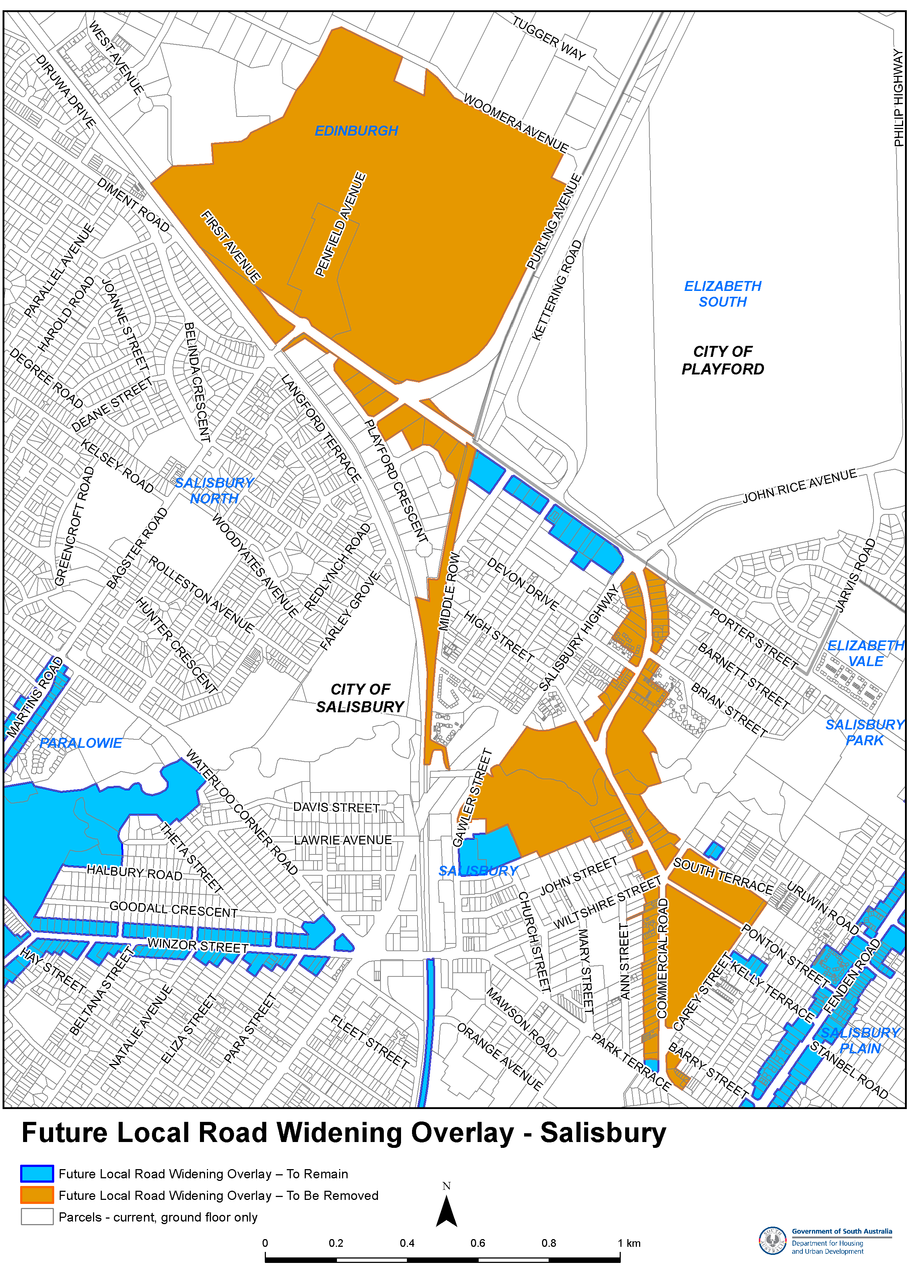
Attachment A
Note: colour version available once published https://governmentgazette.sa.gov.au/2025/March/2025_015.pdf

Return to Work Act 2014
Notice of Amendments to the Impairment Assessment Guidelines
Preamble
Pursuant to Section 22(3) of the Return to Work Act 2014 (the Act), the Minister will publish guidelines (herein referred to as the Impairment Assessment Guidelines) for the purposes of the assessment of permanent impairment (being whole person impairment).
Section 22(4)(f) of the Act provides that the Impairment Assessment Guidelines may be amended or substituted by the Minister from time to time.
Section 22(5) of the Act, provides that before publishing or amending the Impairment Assessment Guidelines, the Minister must consult with professional associations representing the class or classes of medical practitioners who hold accreditation under Section 22 of the Act.
Section 22(6) of the Act provides that an amendment or substitution in relation to the Impairment Assessment Guidelines under Section 22(4)(f) will take effect from a date specified by the Minister as part of the amendment, or in the substituted guidelines, as the case may be (the commencement date).
Notice
Having undertaken the consultation prescribed by Section 22(5) of the Act, I hereby substitute pursuant to Section 22(4)(f) of the Act, the existing Impairment Assessment Guidelines with the version of the Impairment Assessment Guidelines as set out in Attachment A which is to be referred to as the Impairment Assessment Guidelines Third Edition. As specified in the substituted Impairment Assessment Guidelines, they will have a commencement date of 1 October 2025.
Dated: 12 March 2025
Hon Kyam Maher MLC
Minister for Industrial Relations and Public Sector

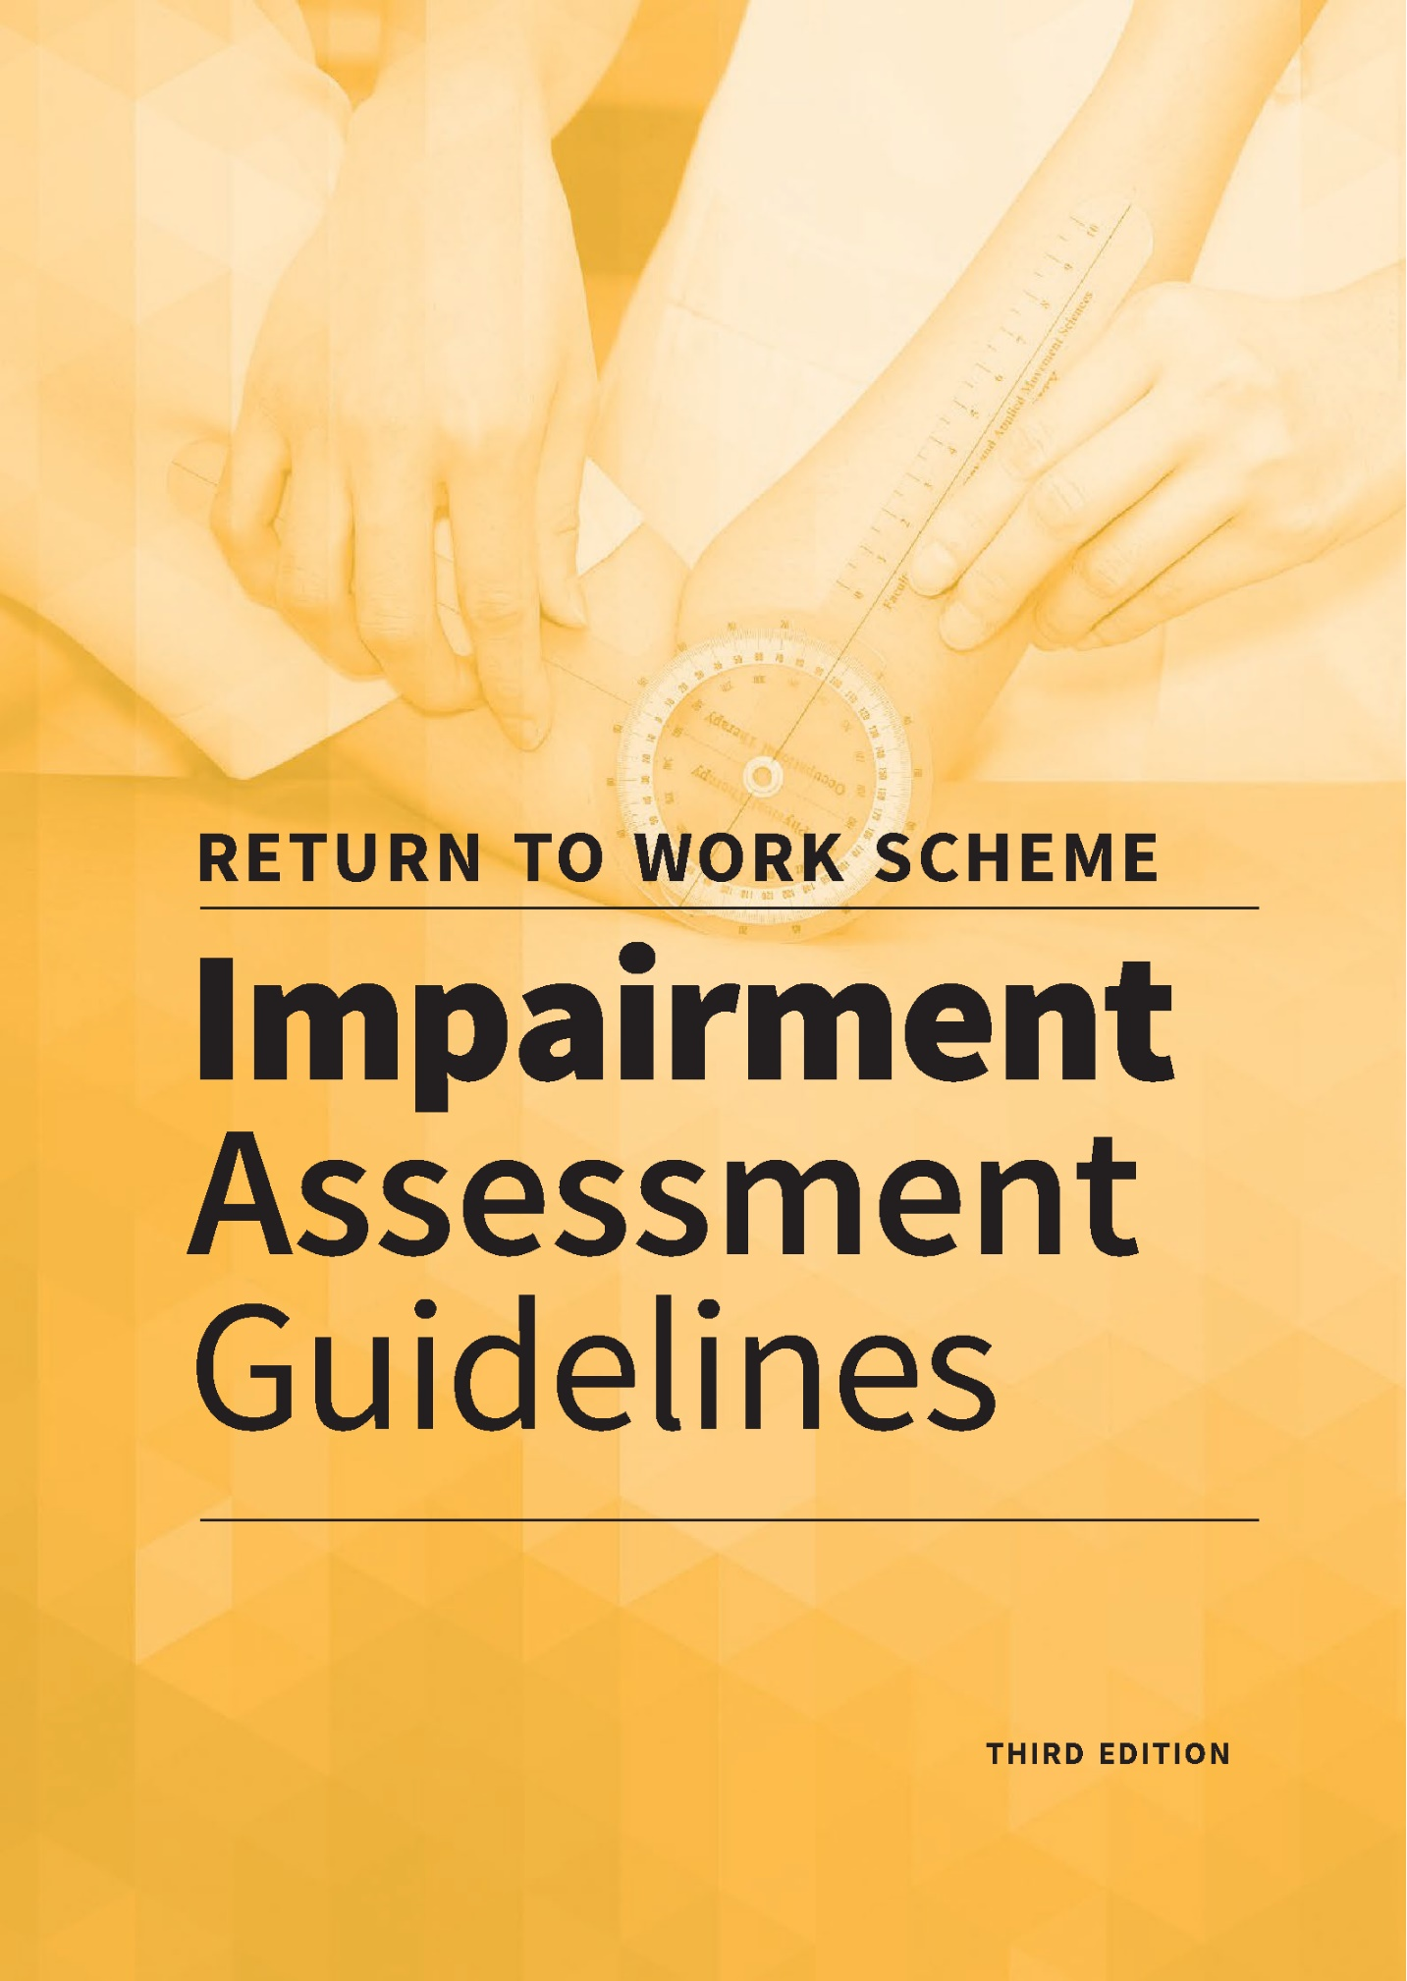
Attachment A
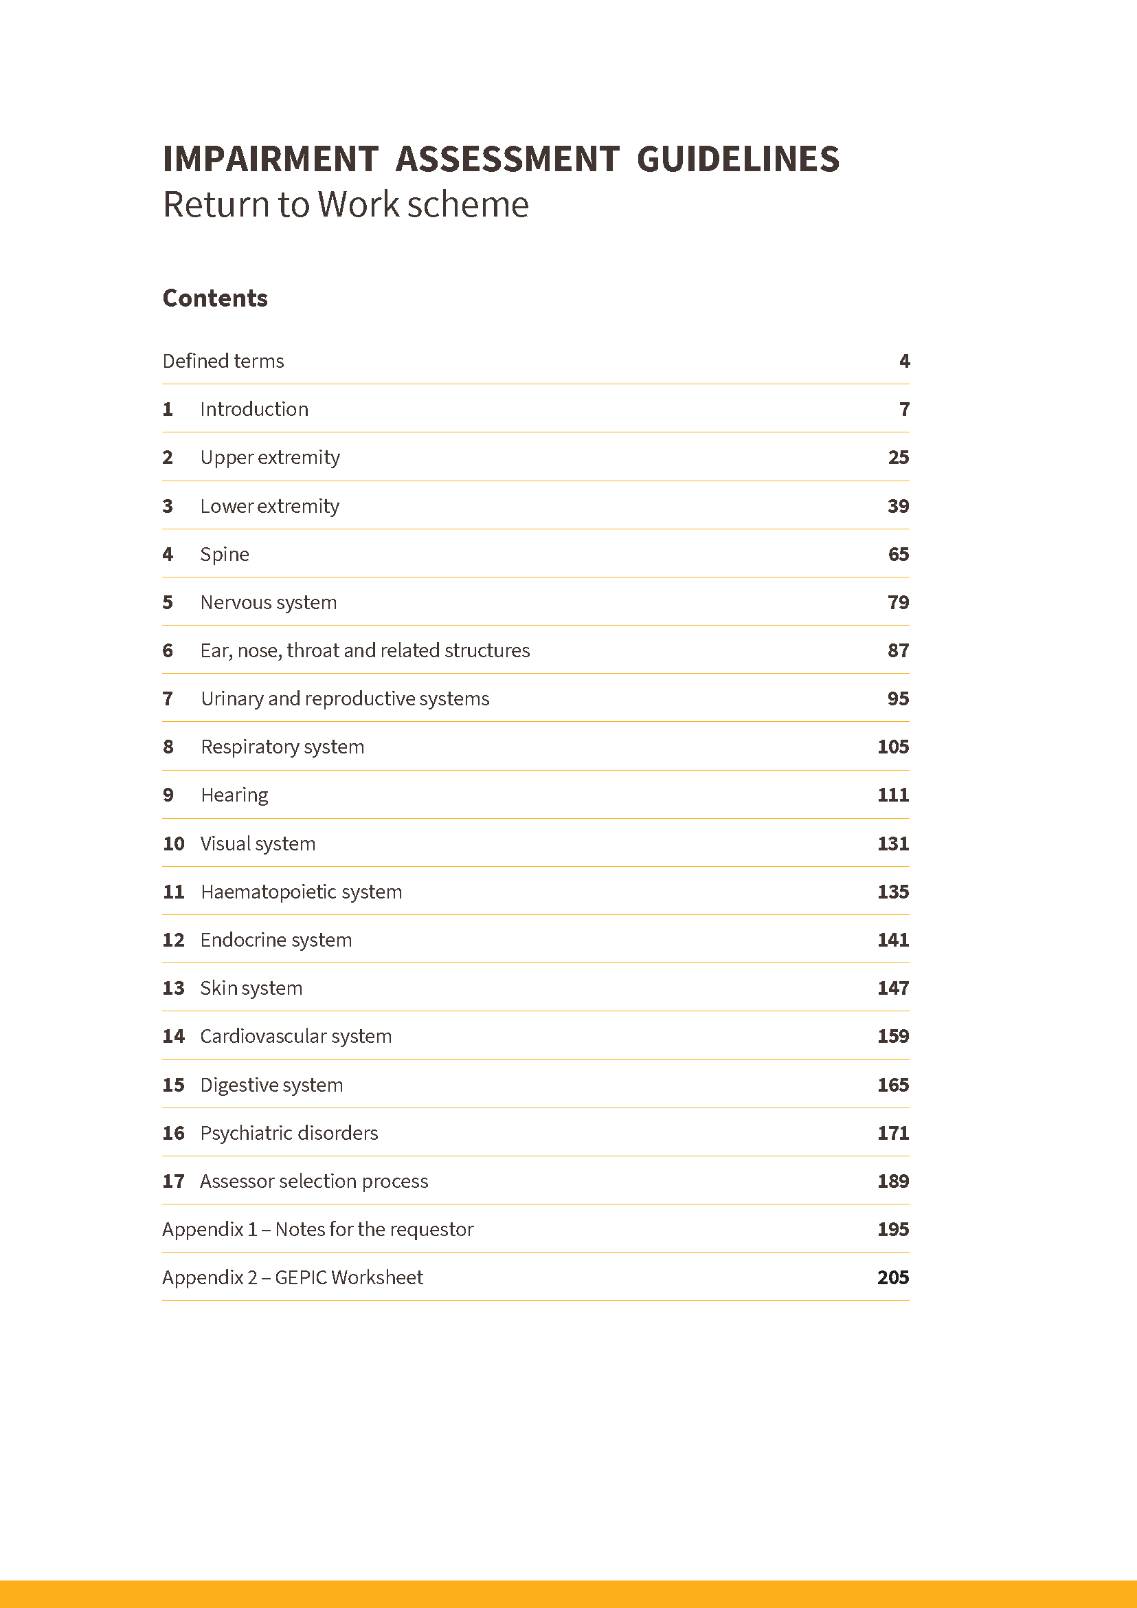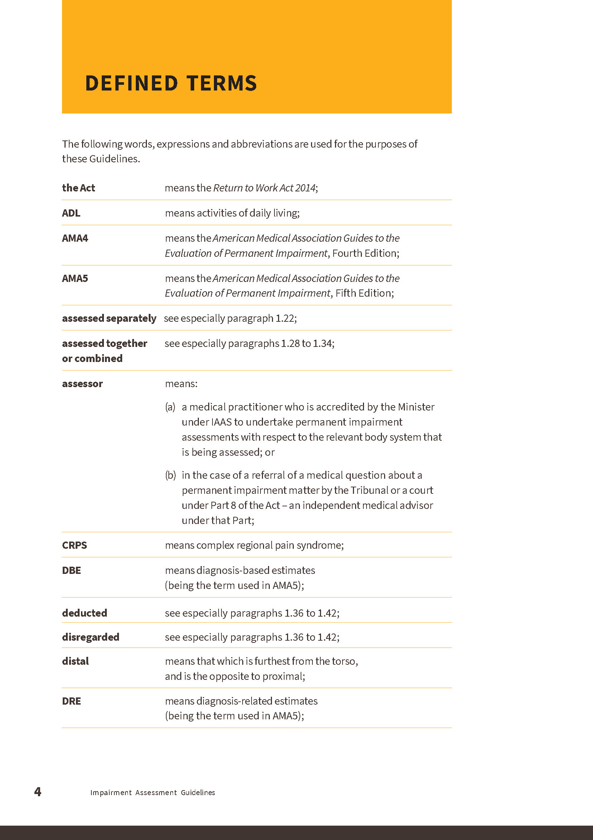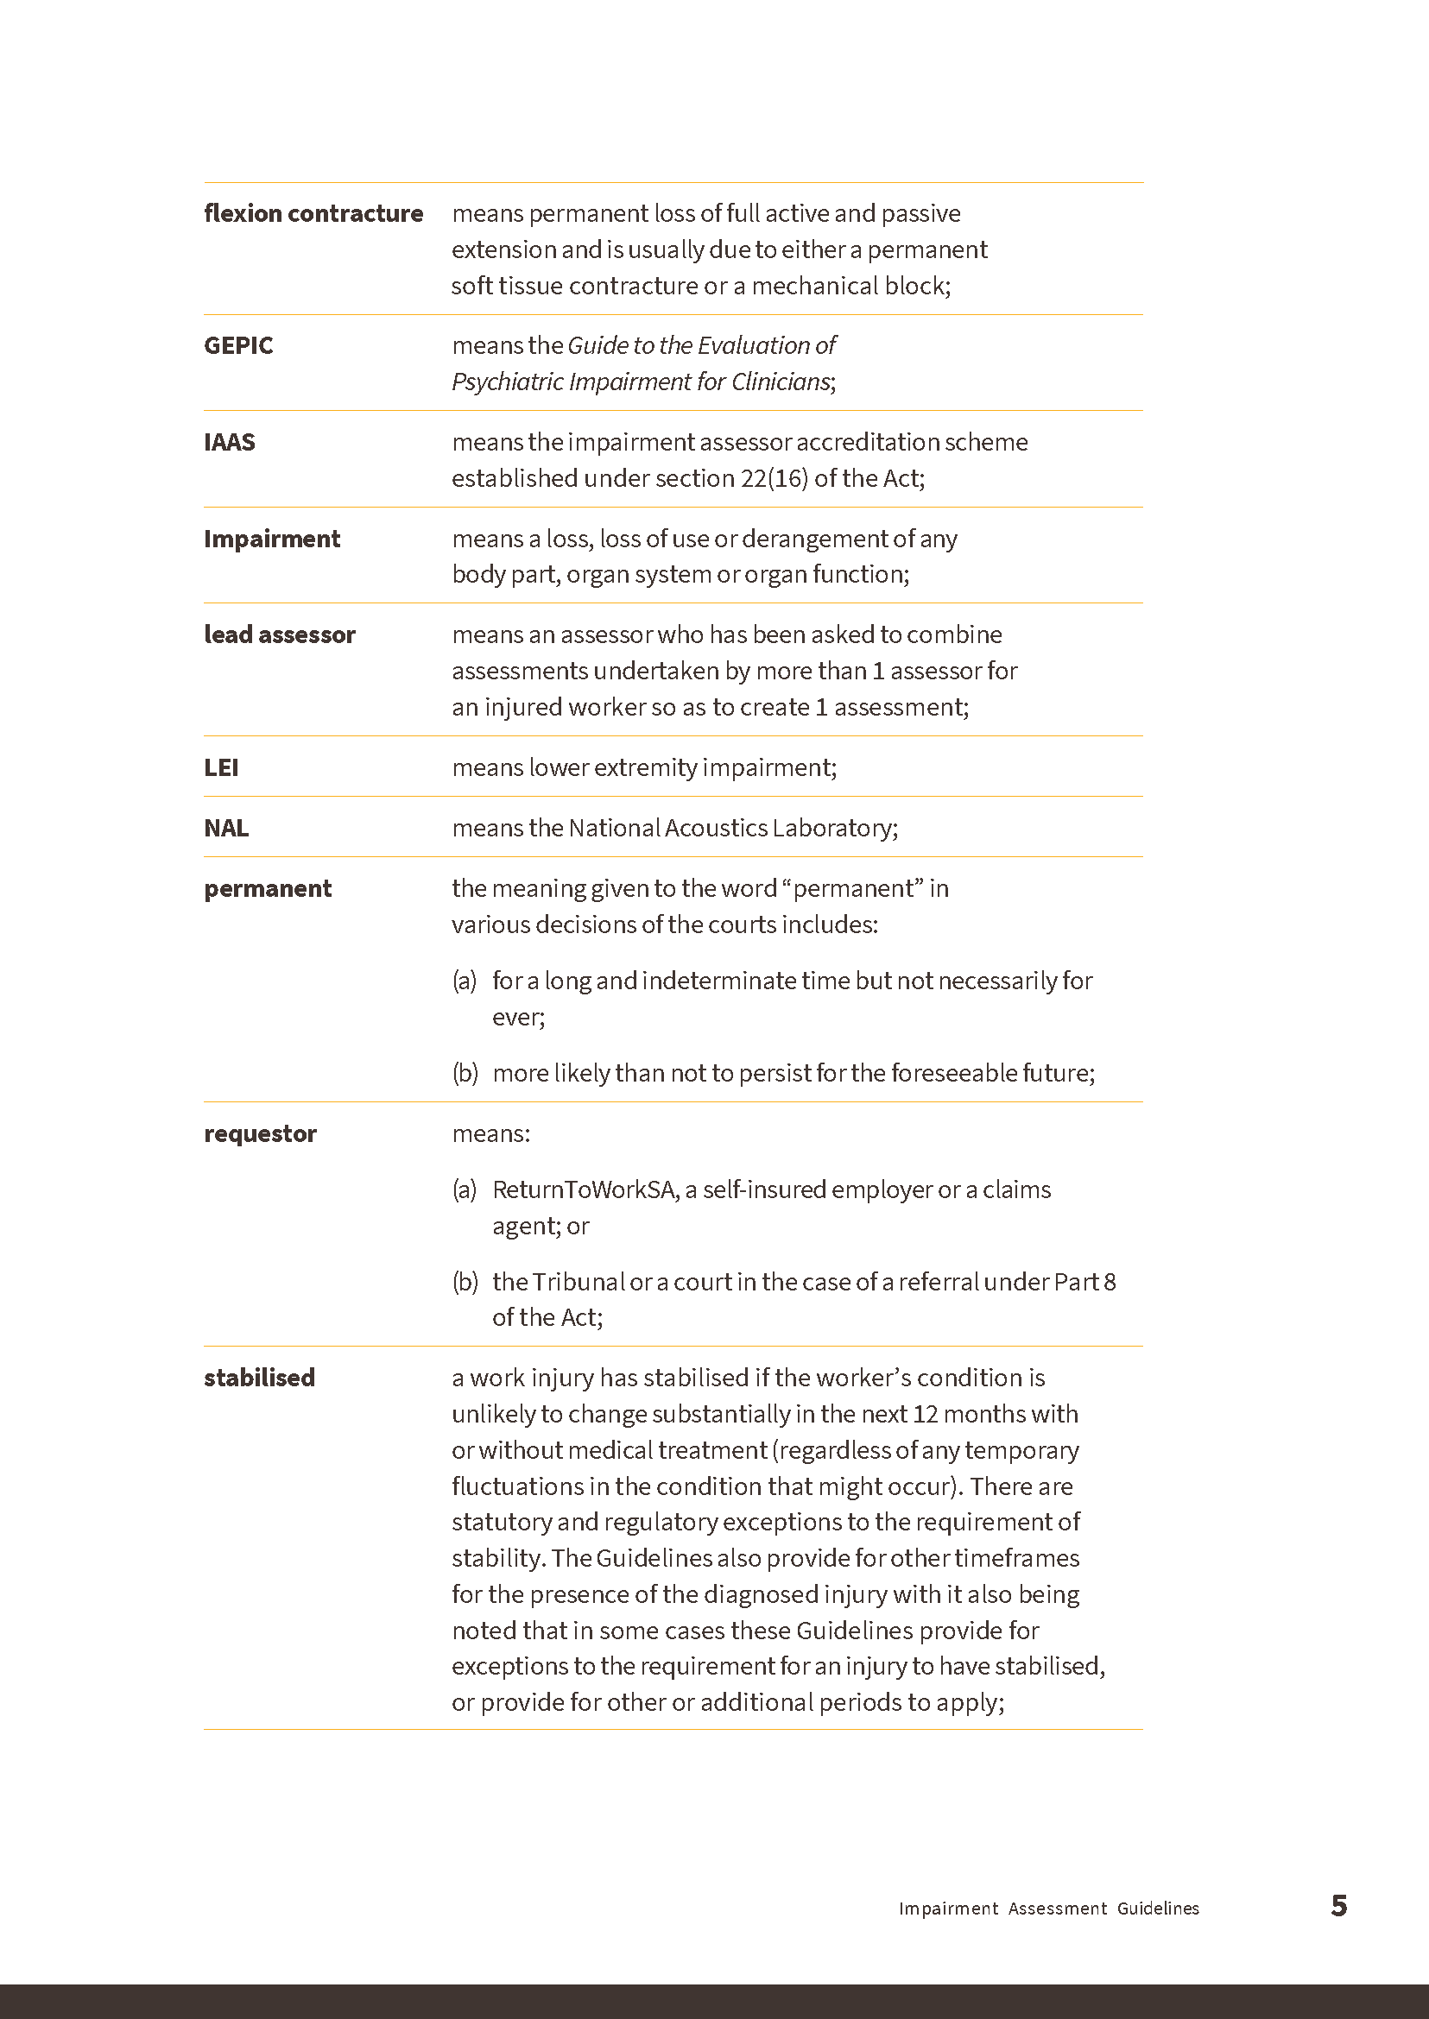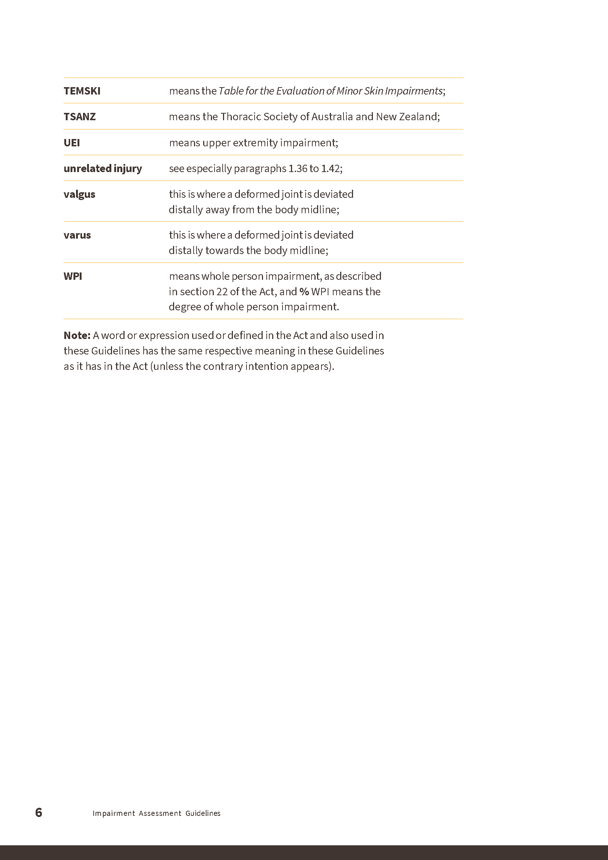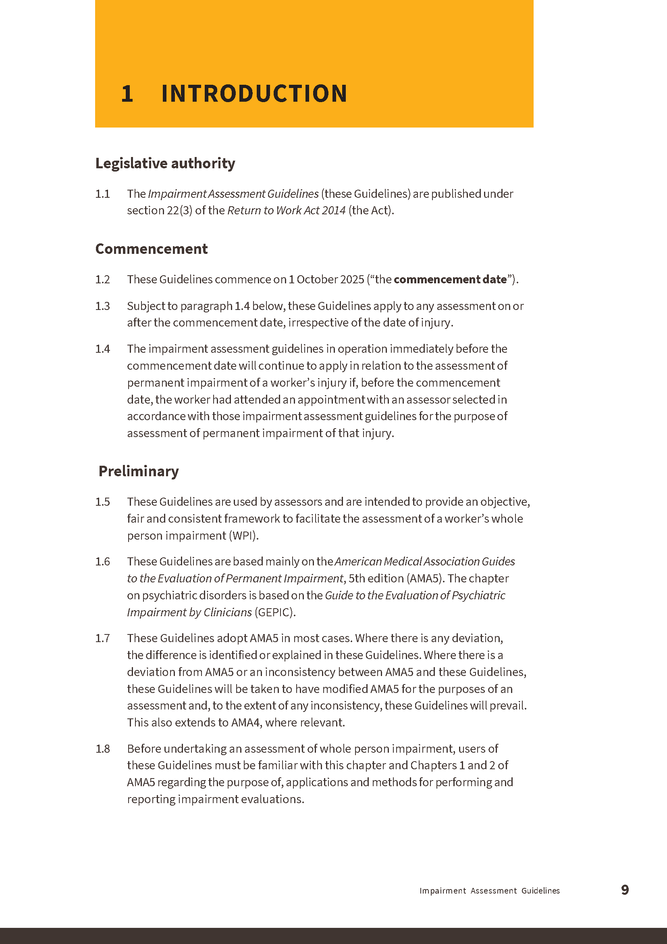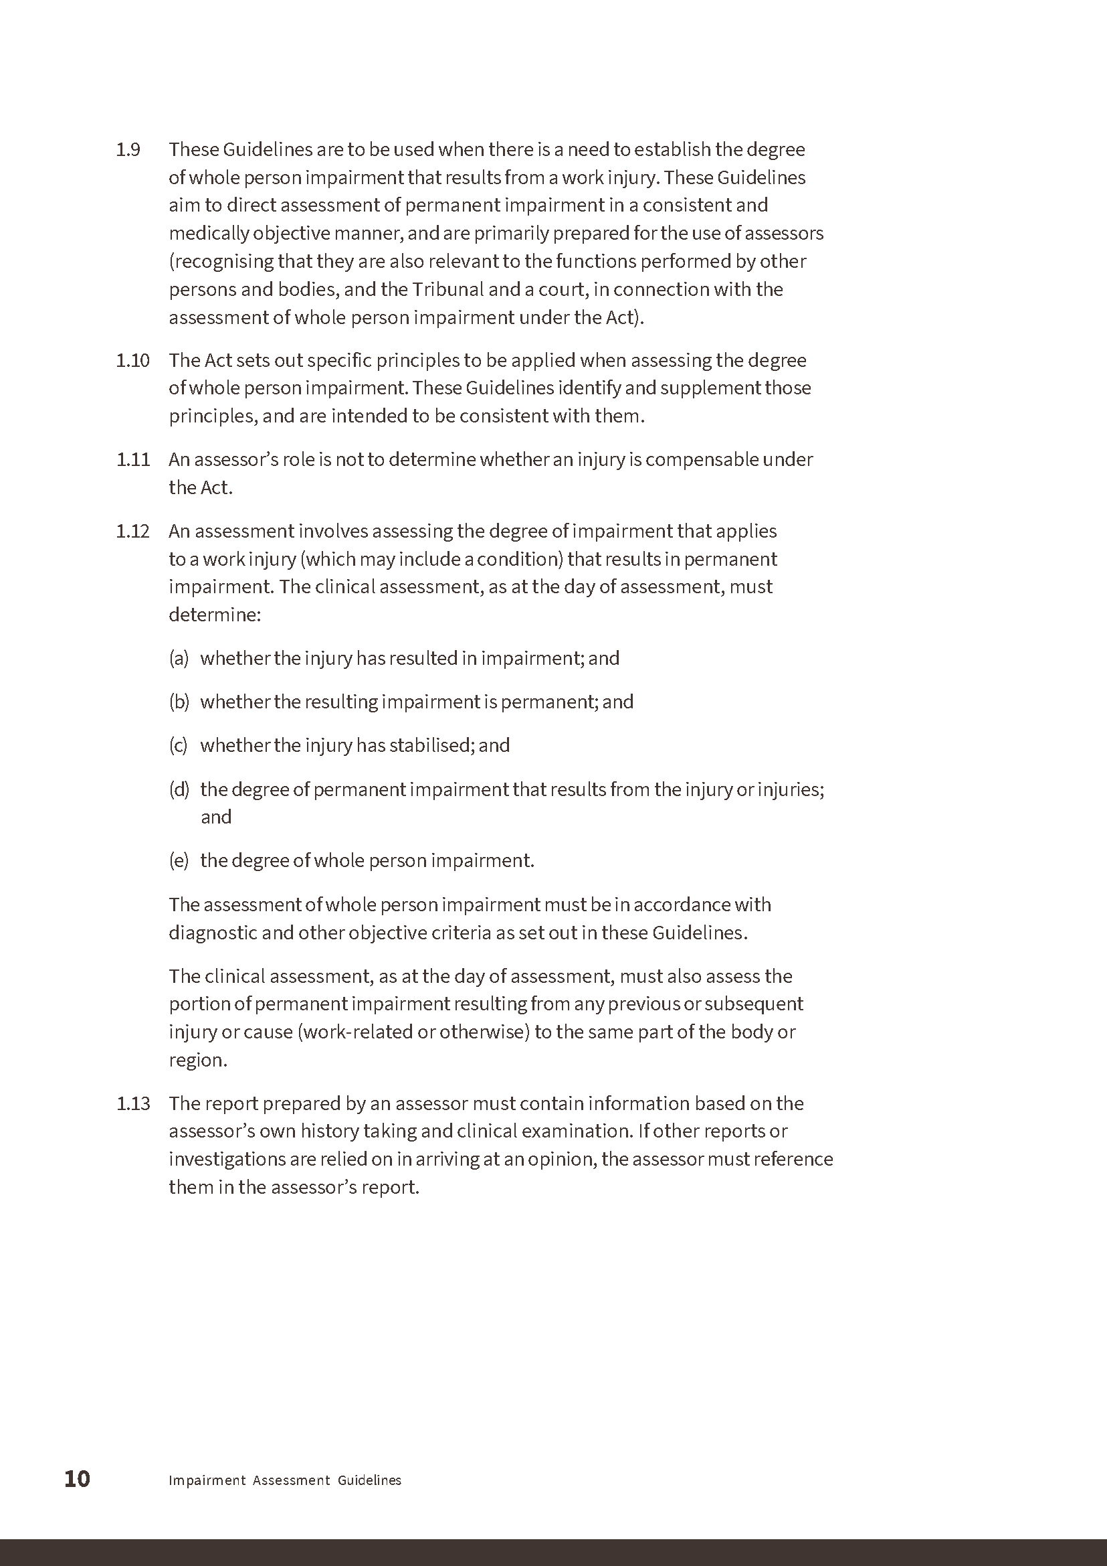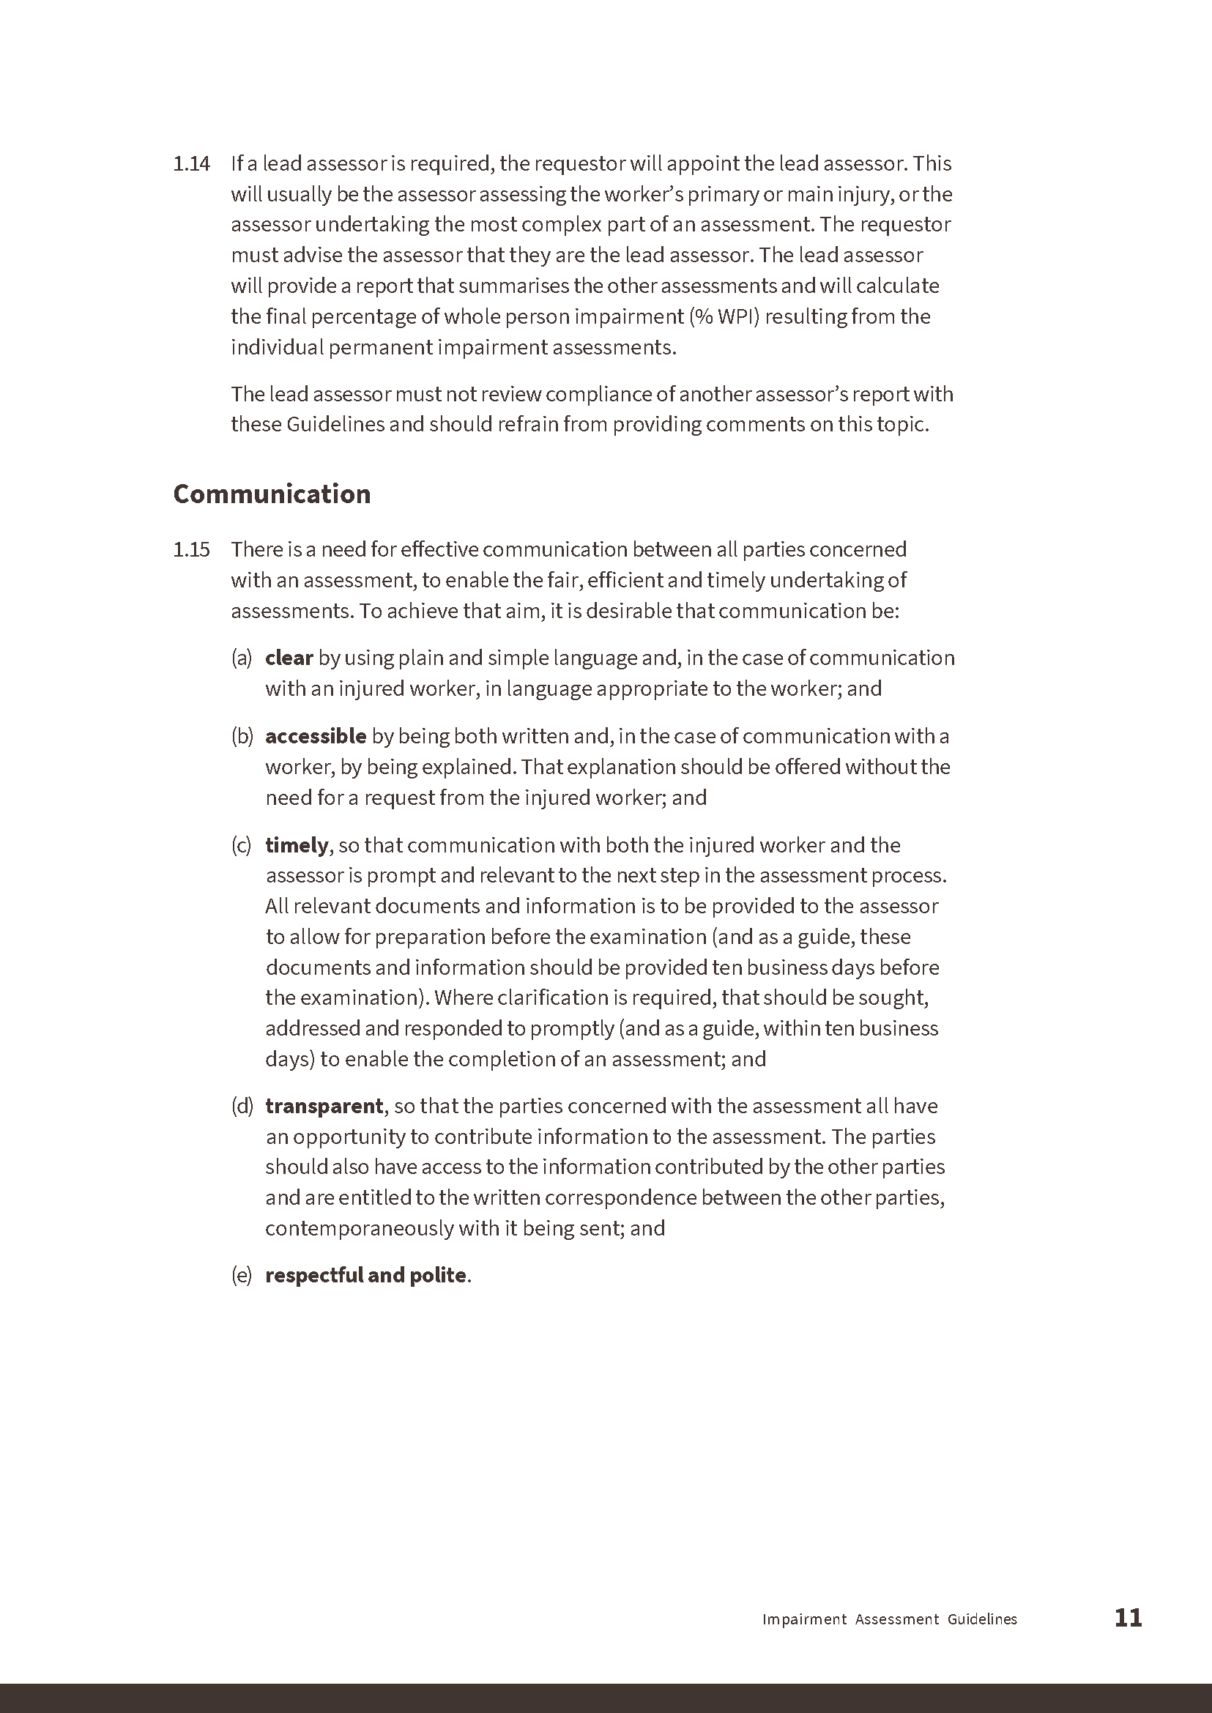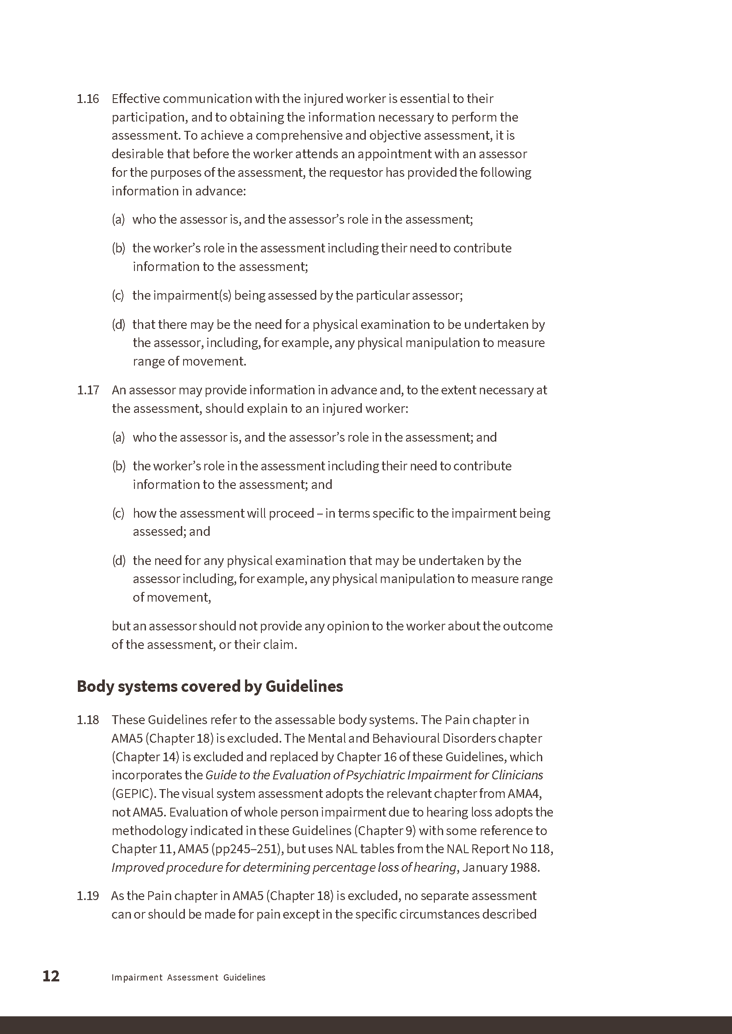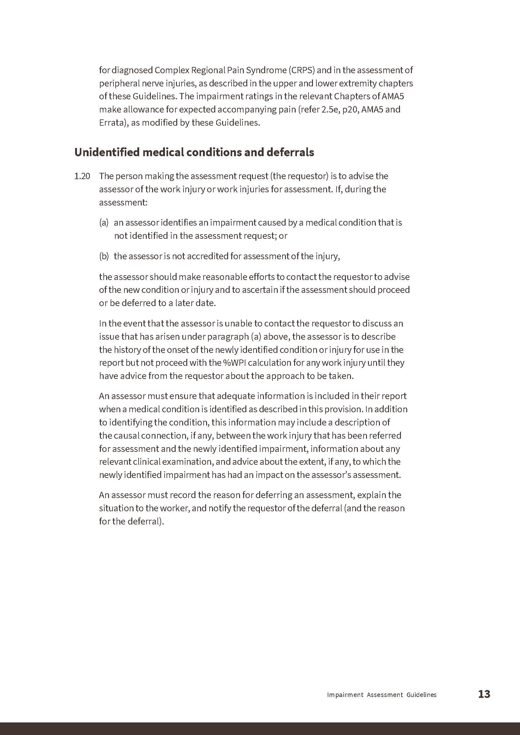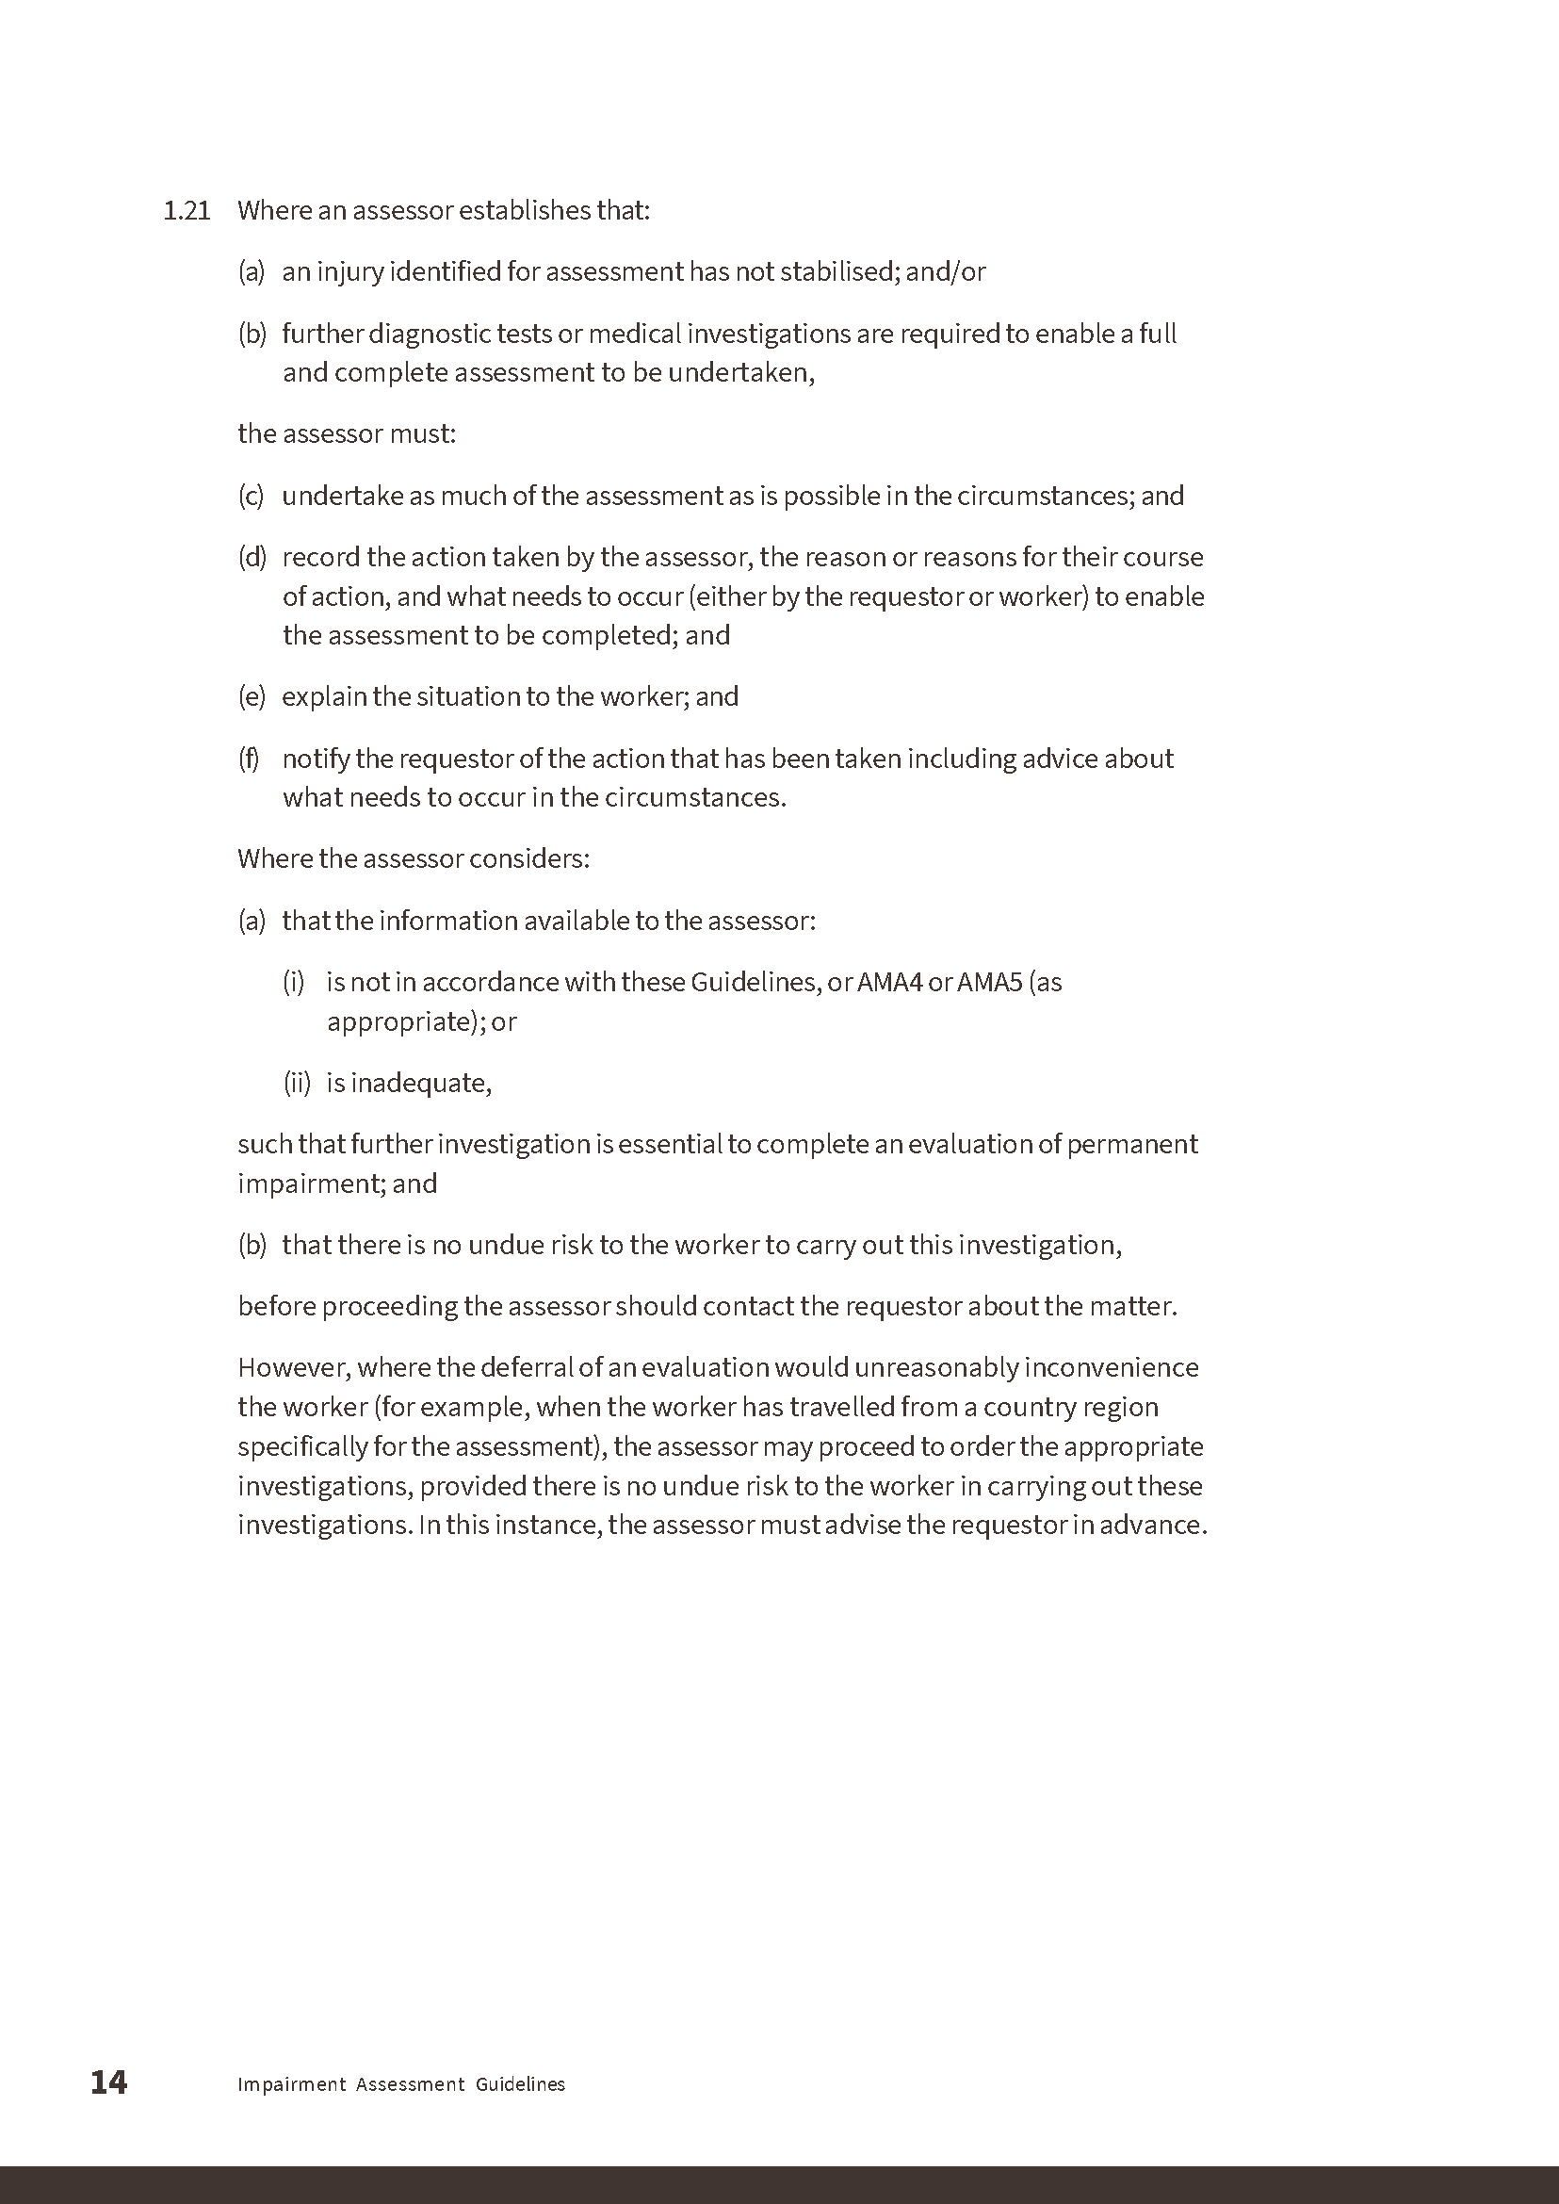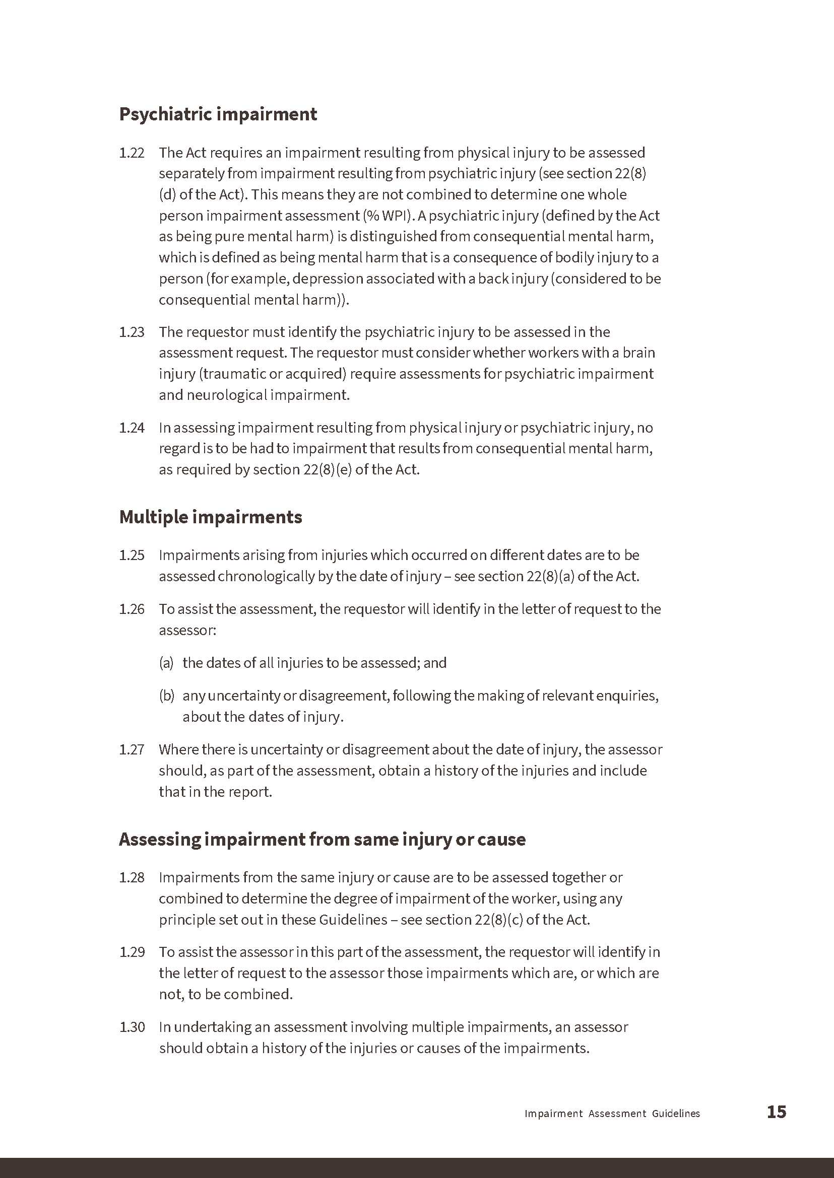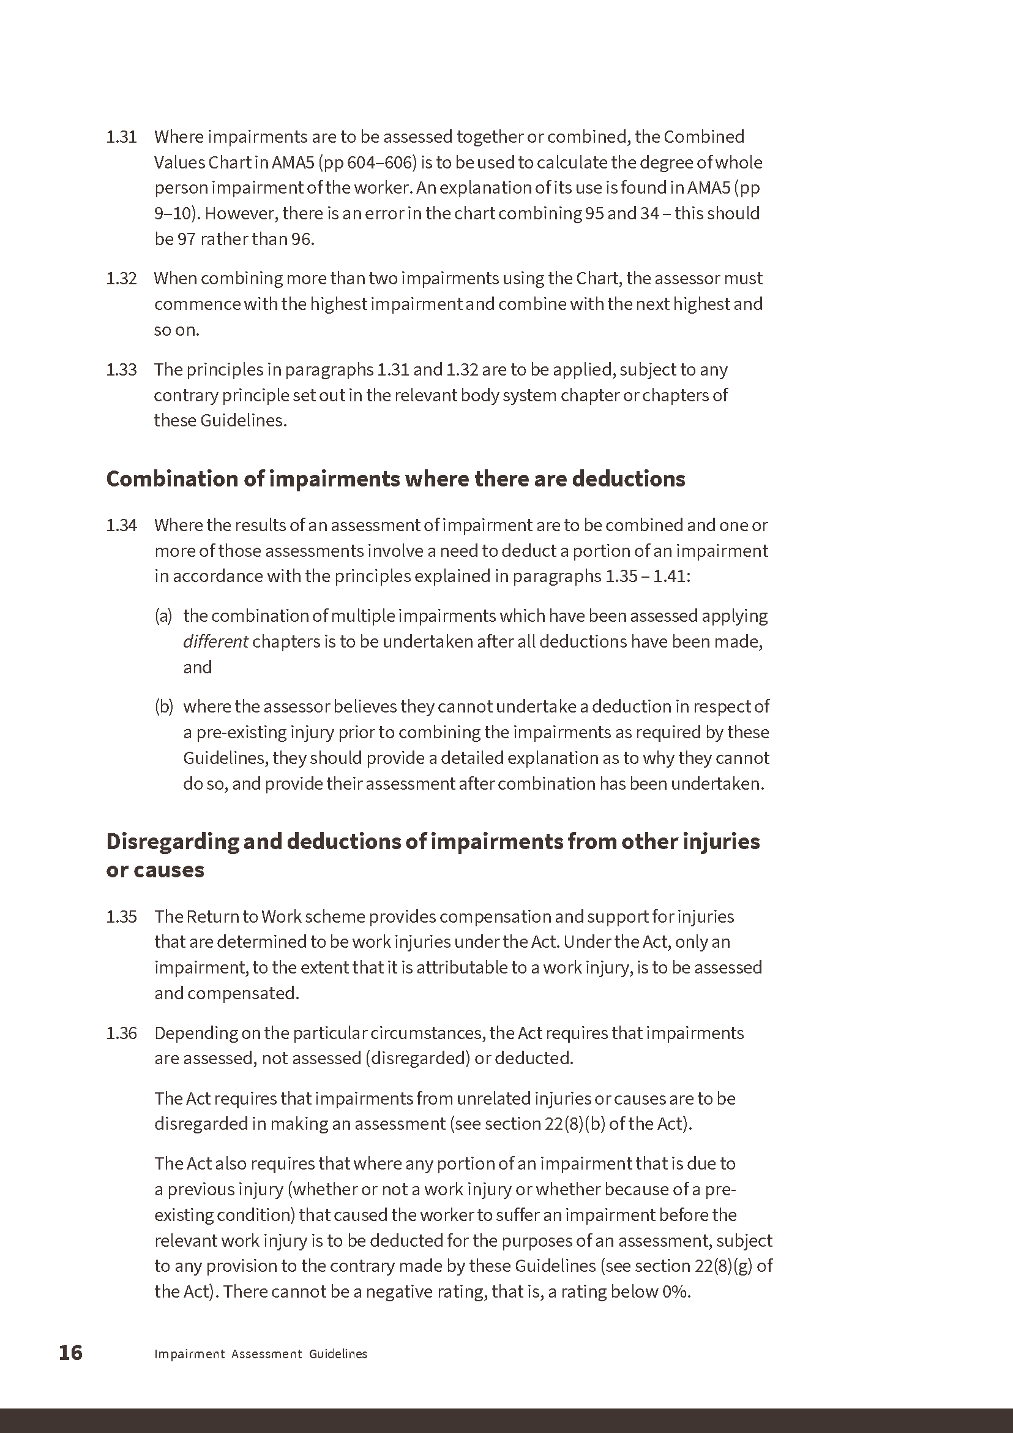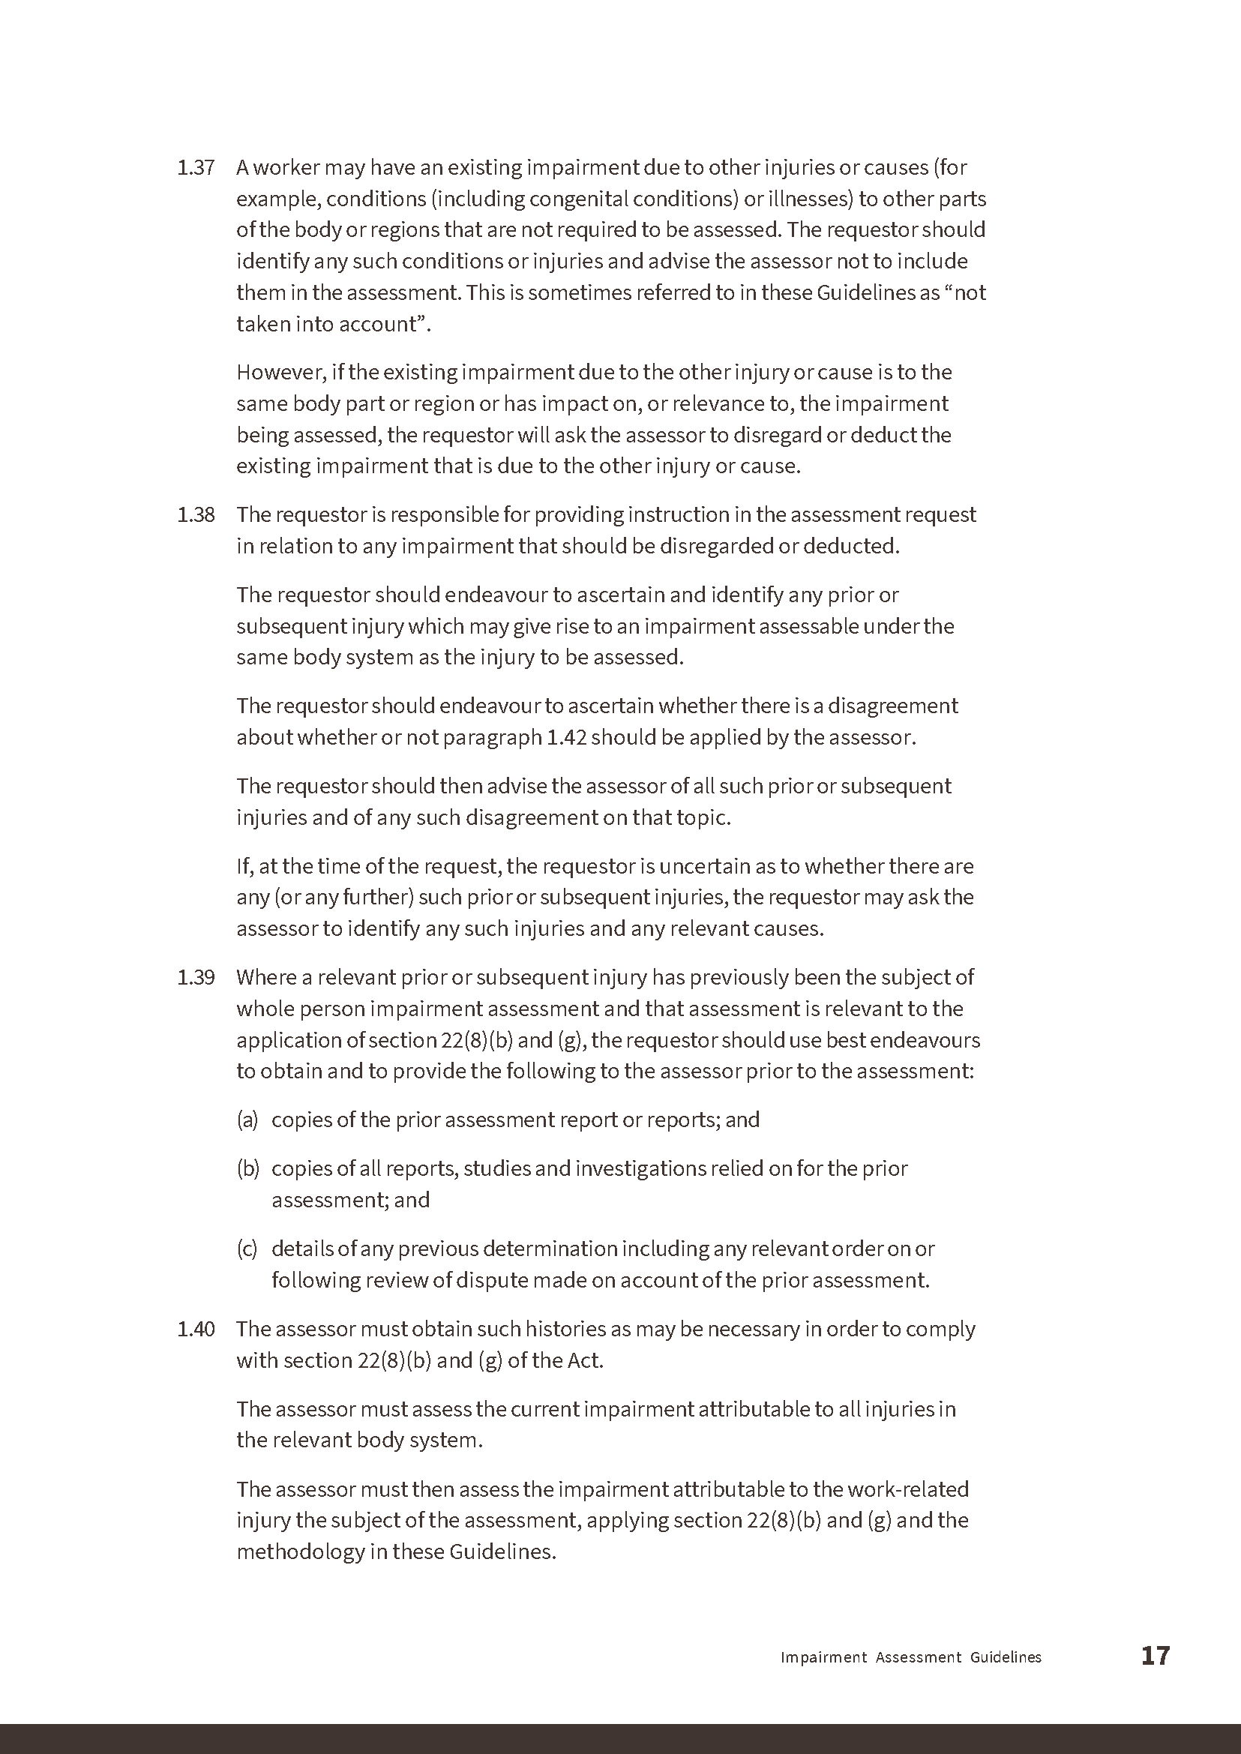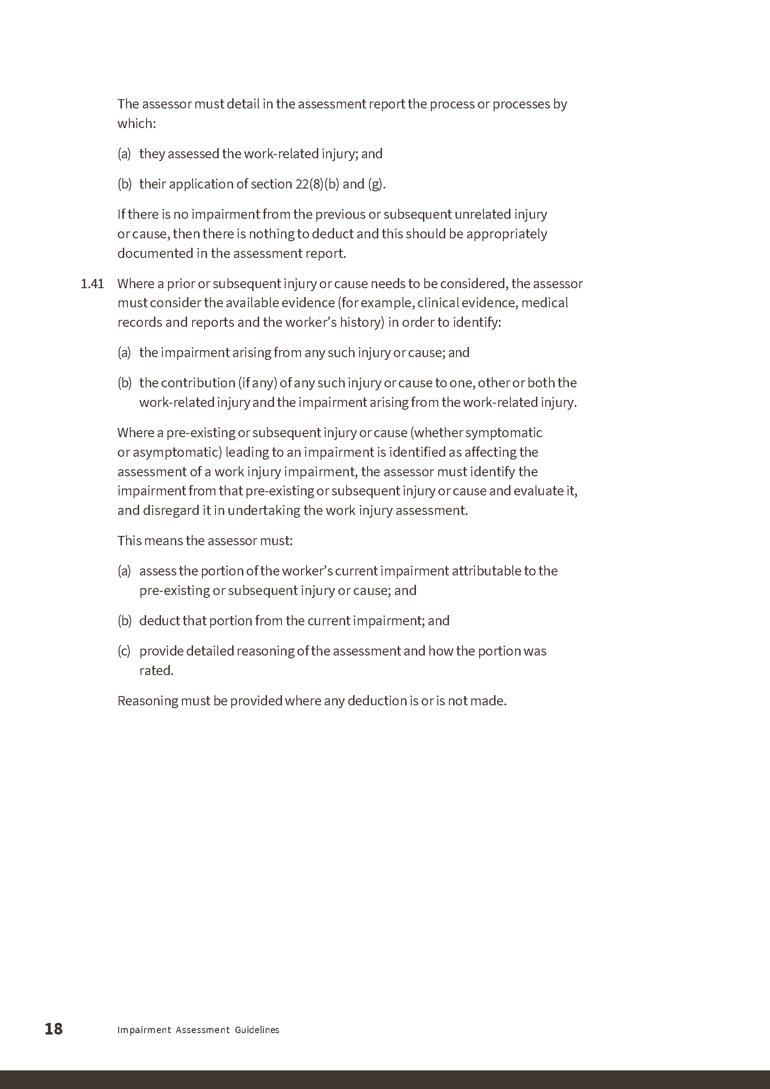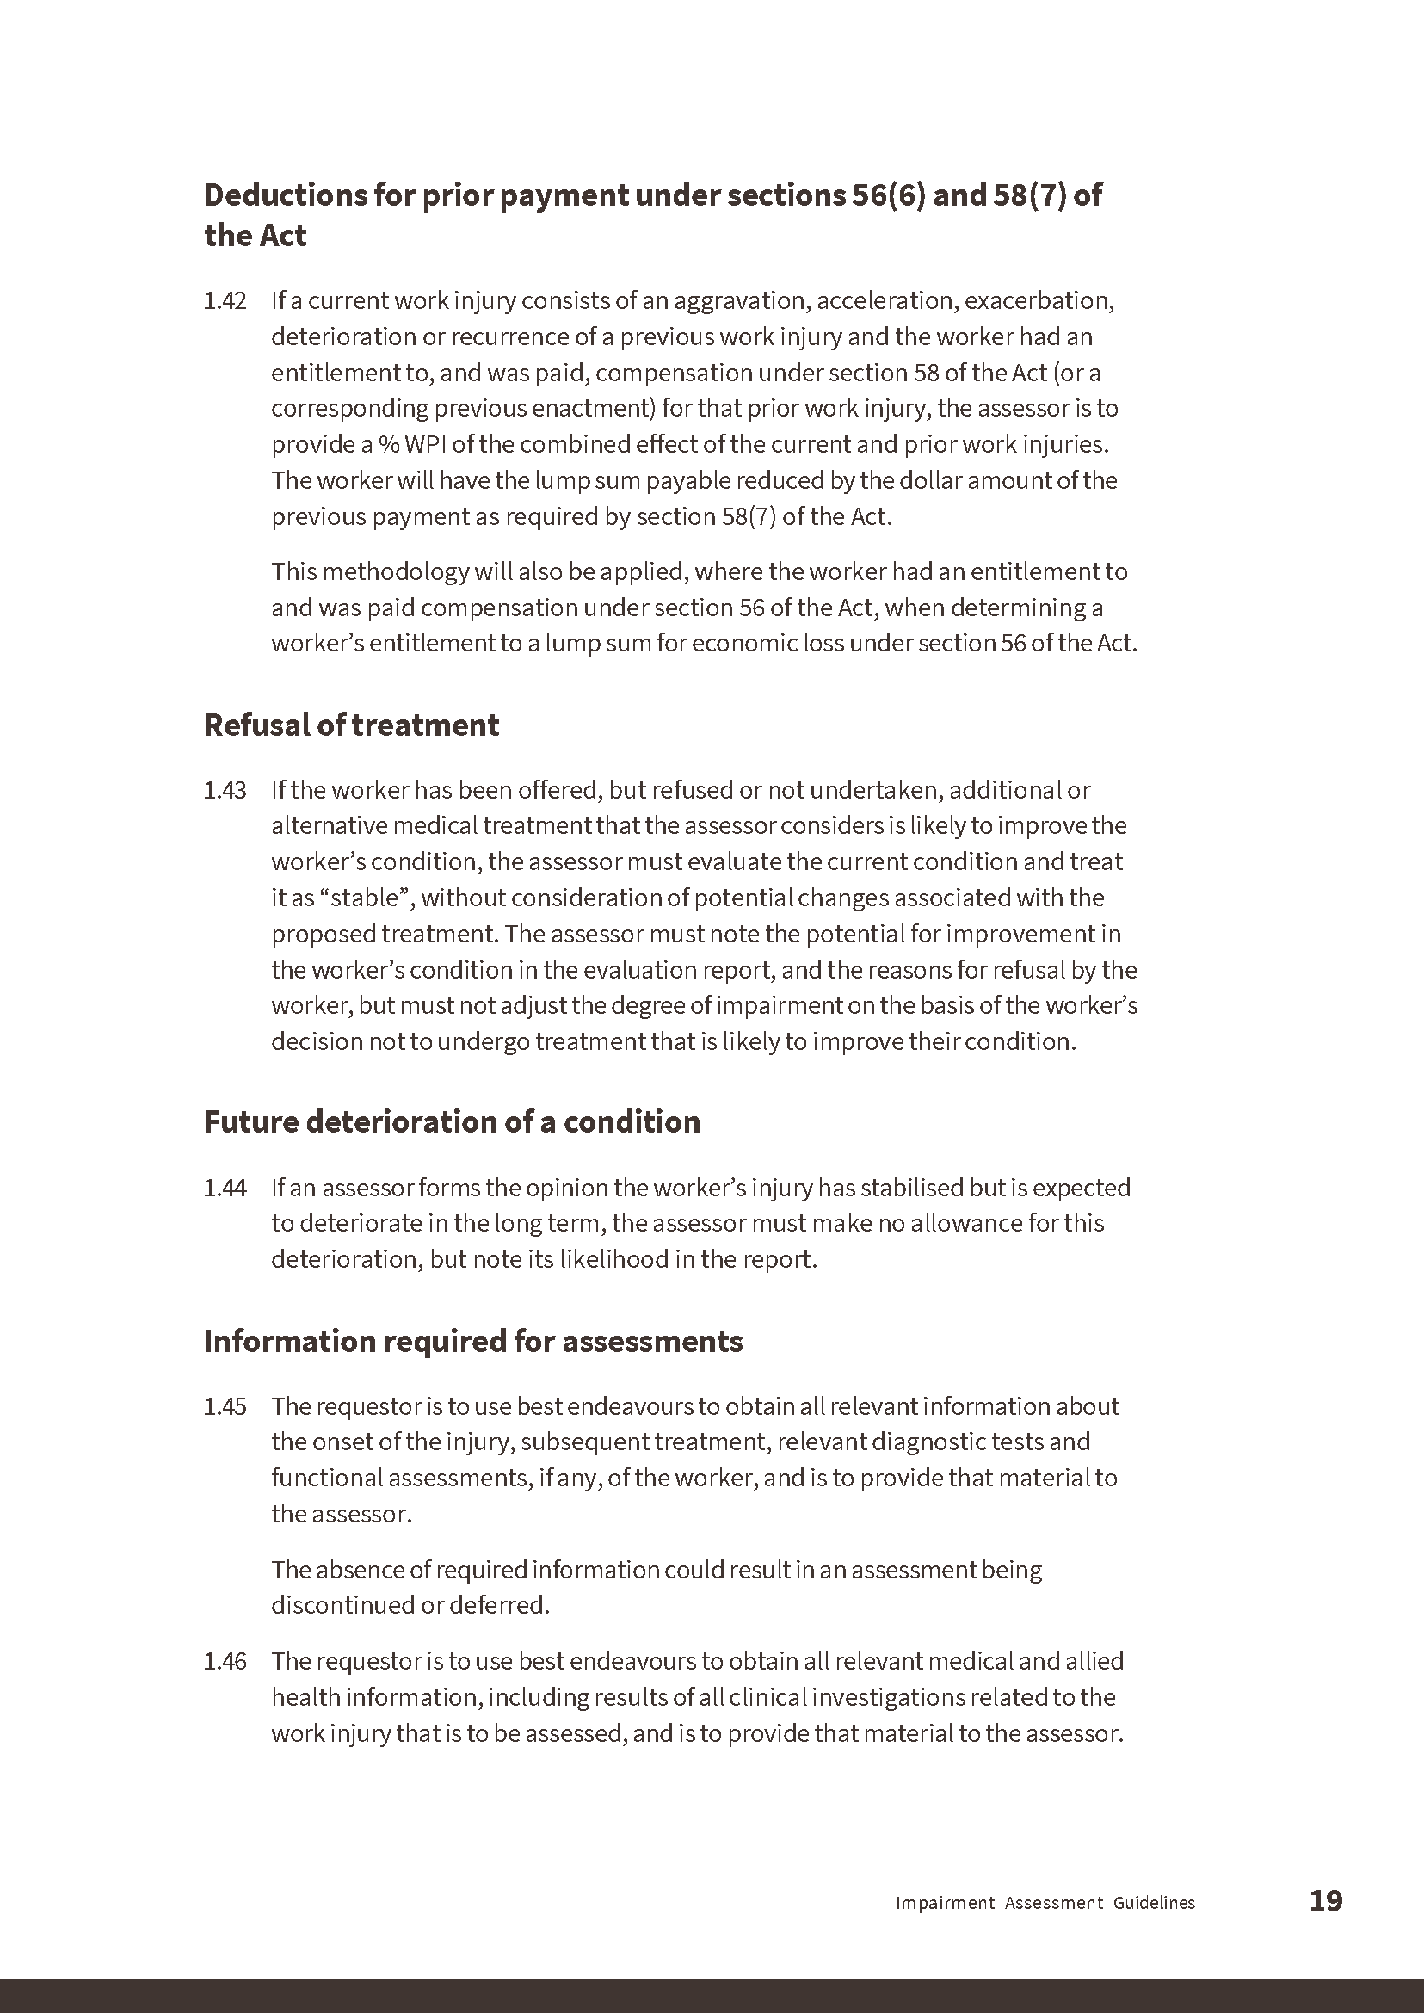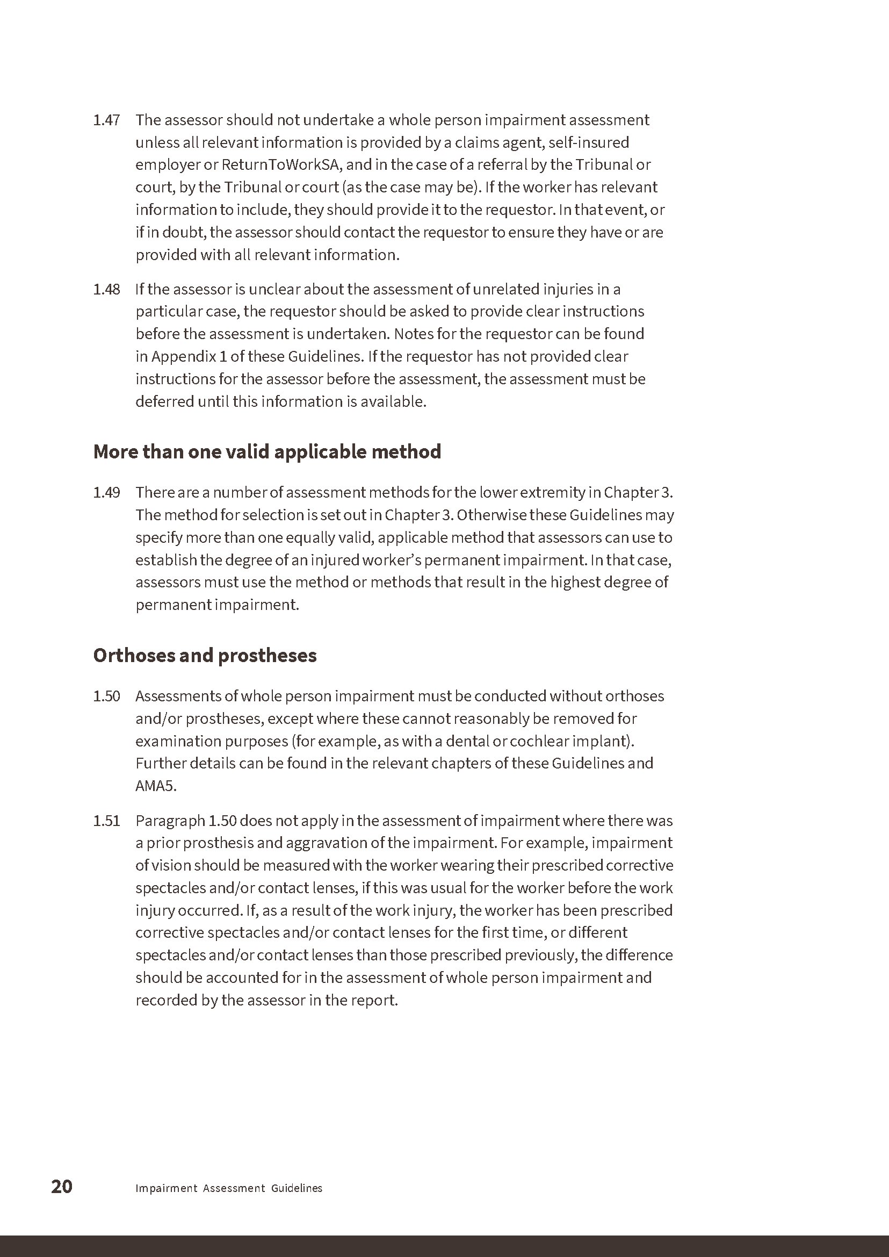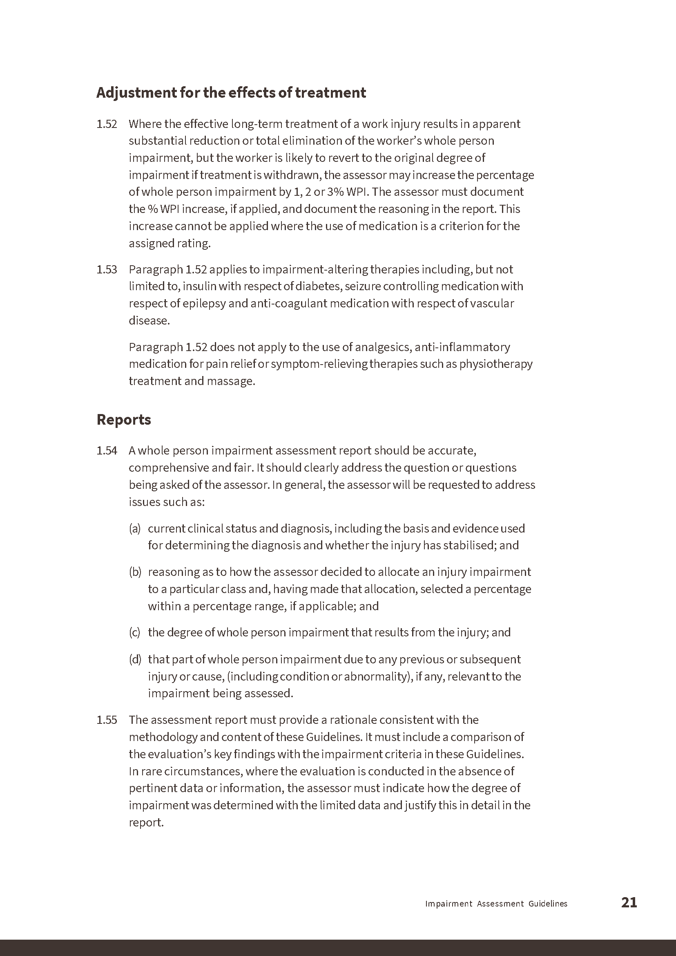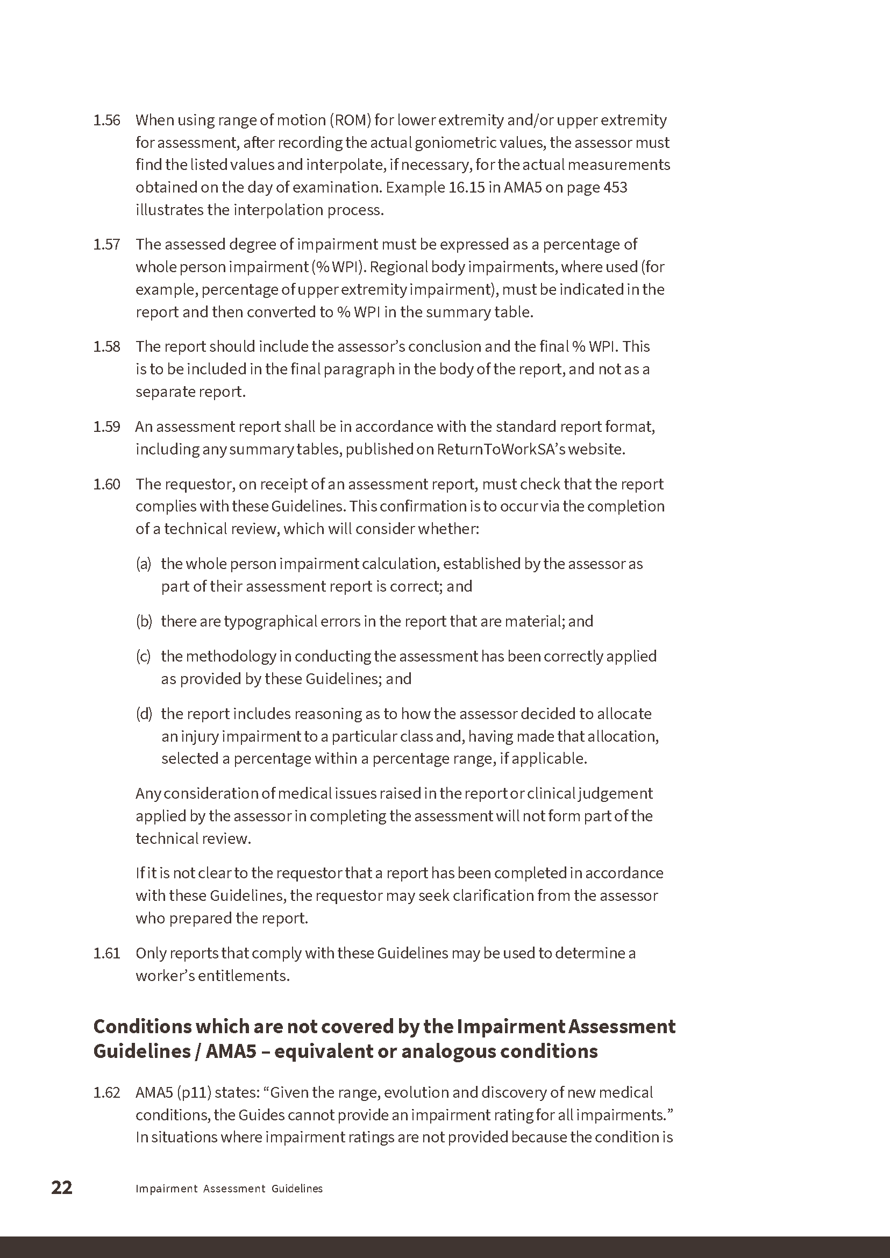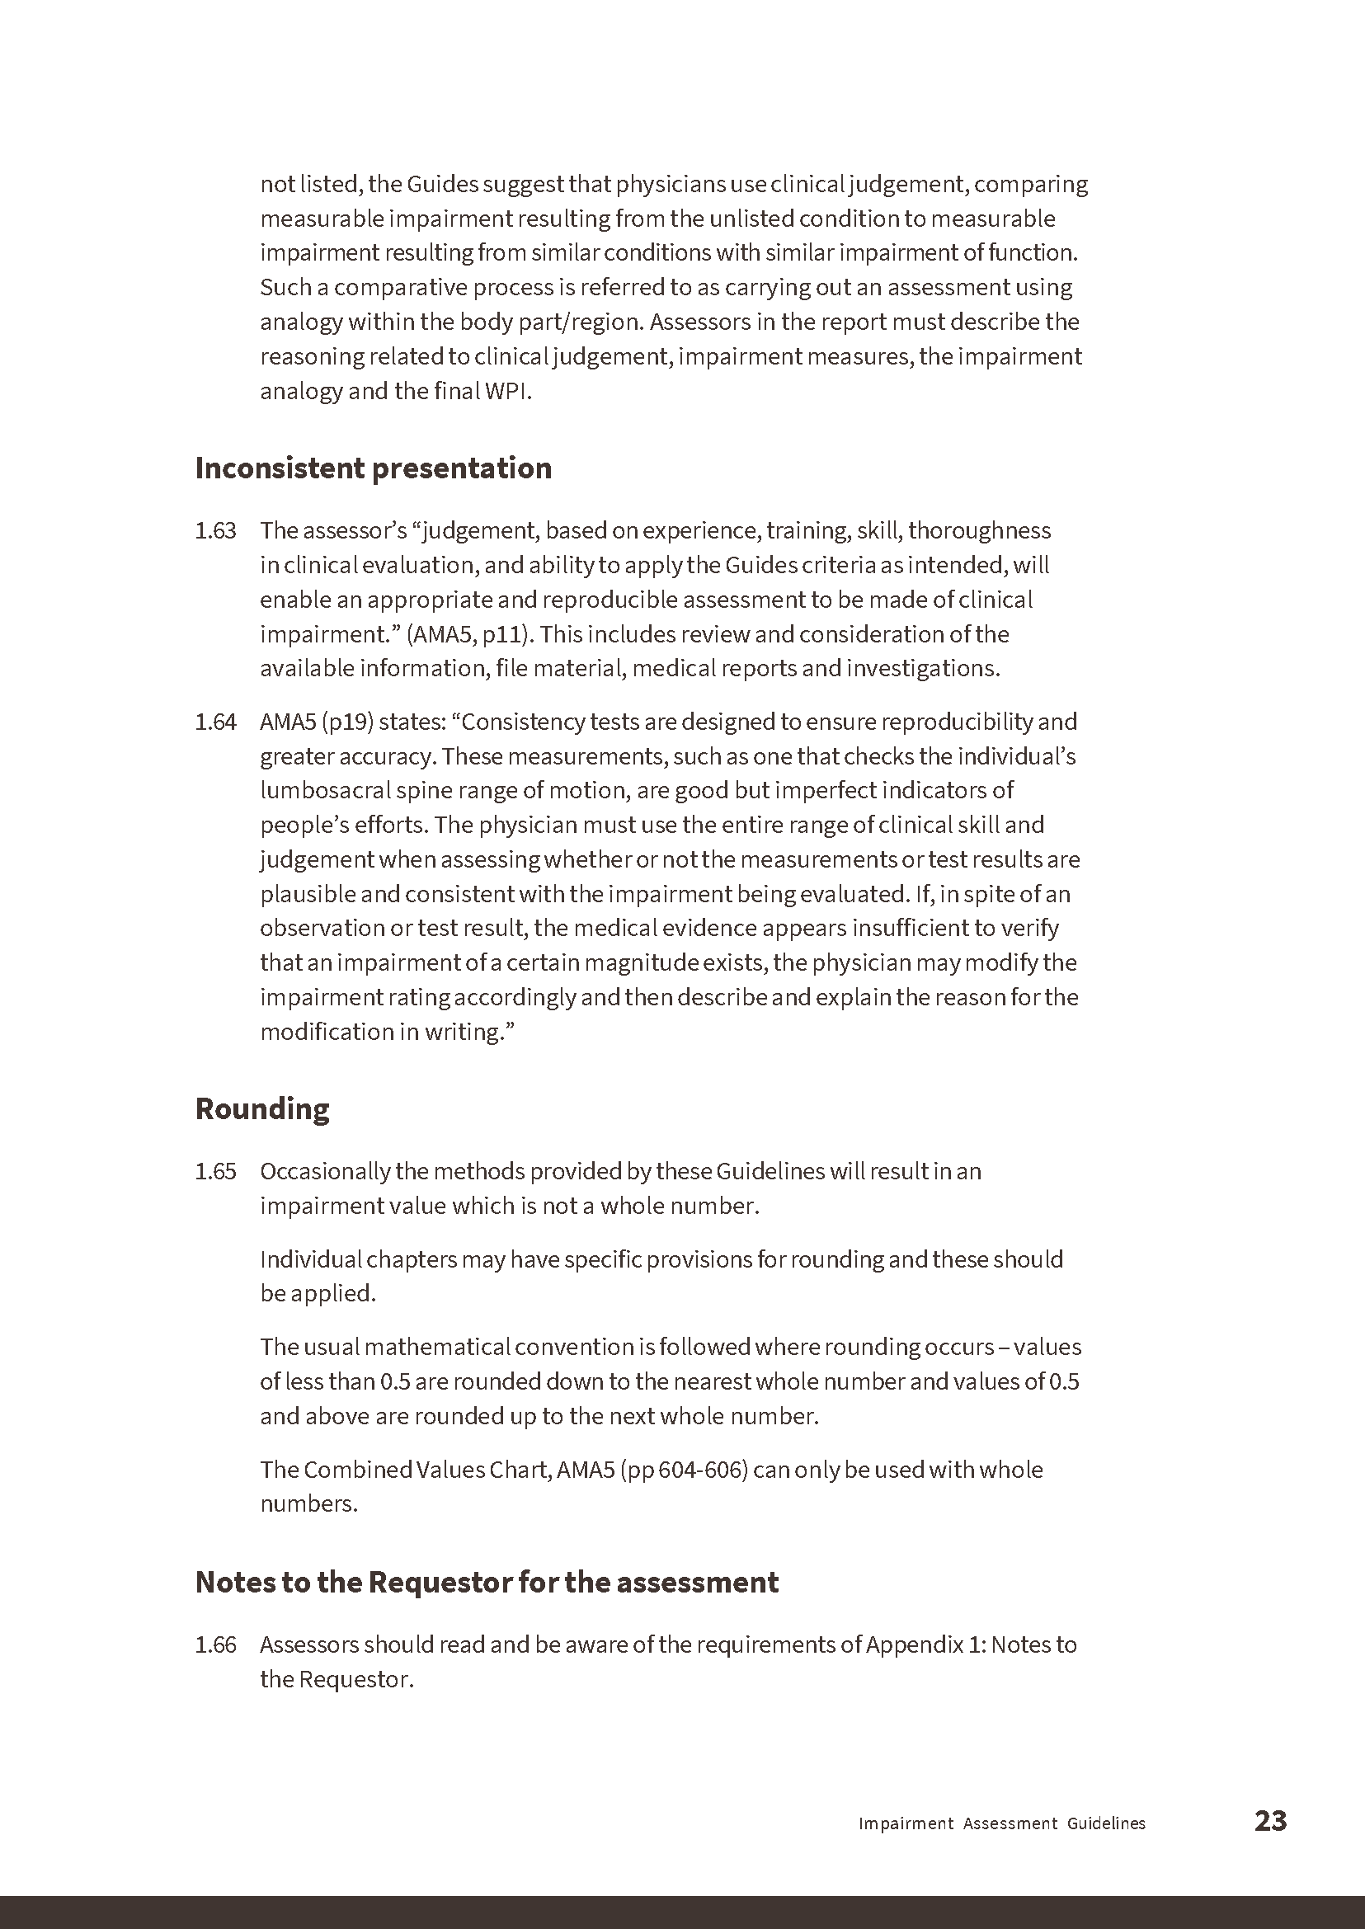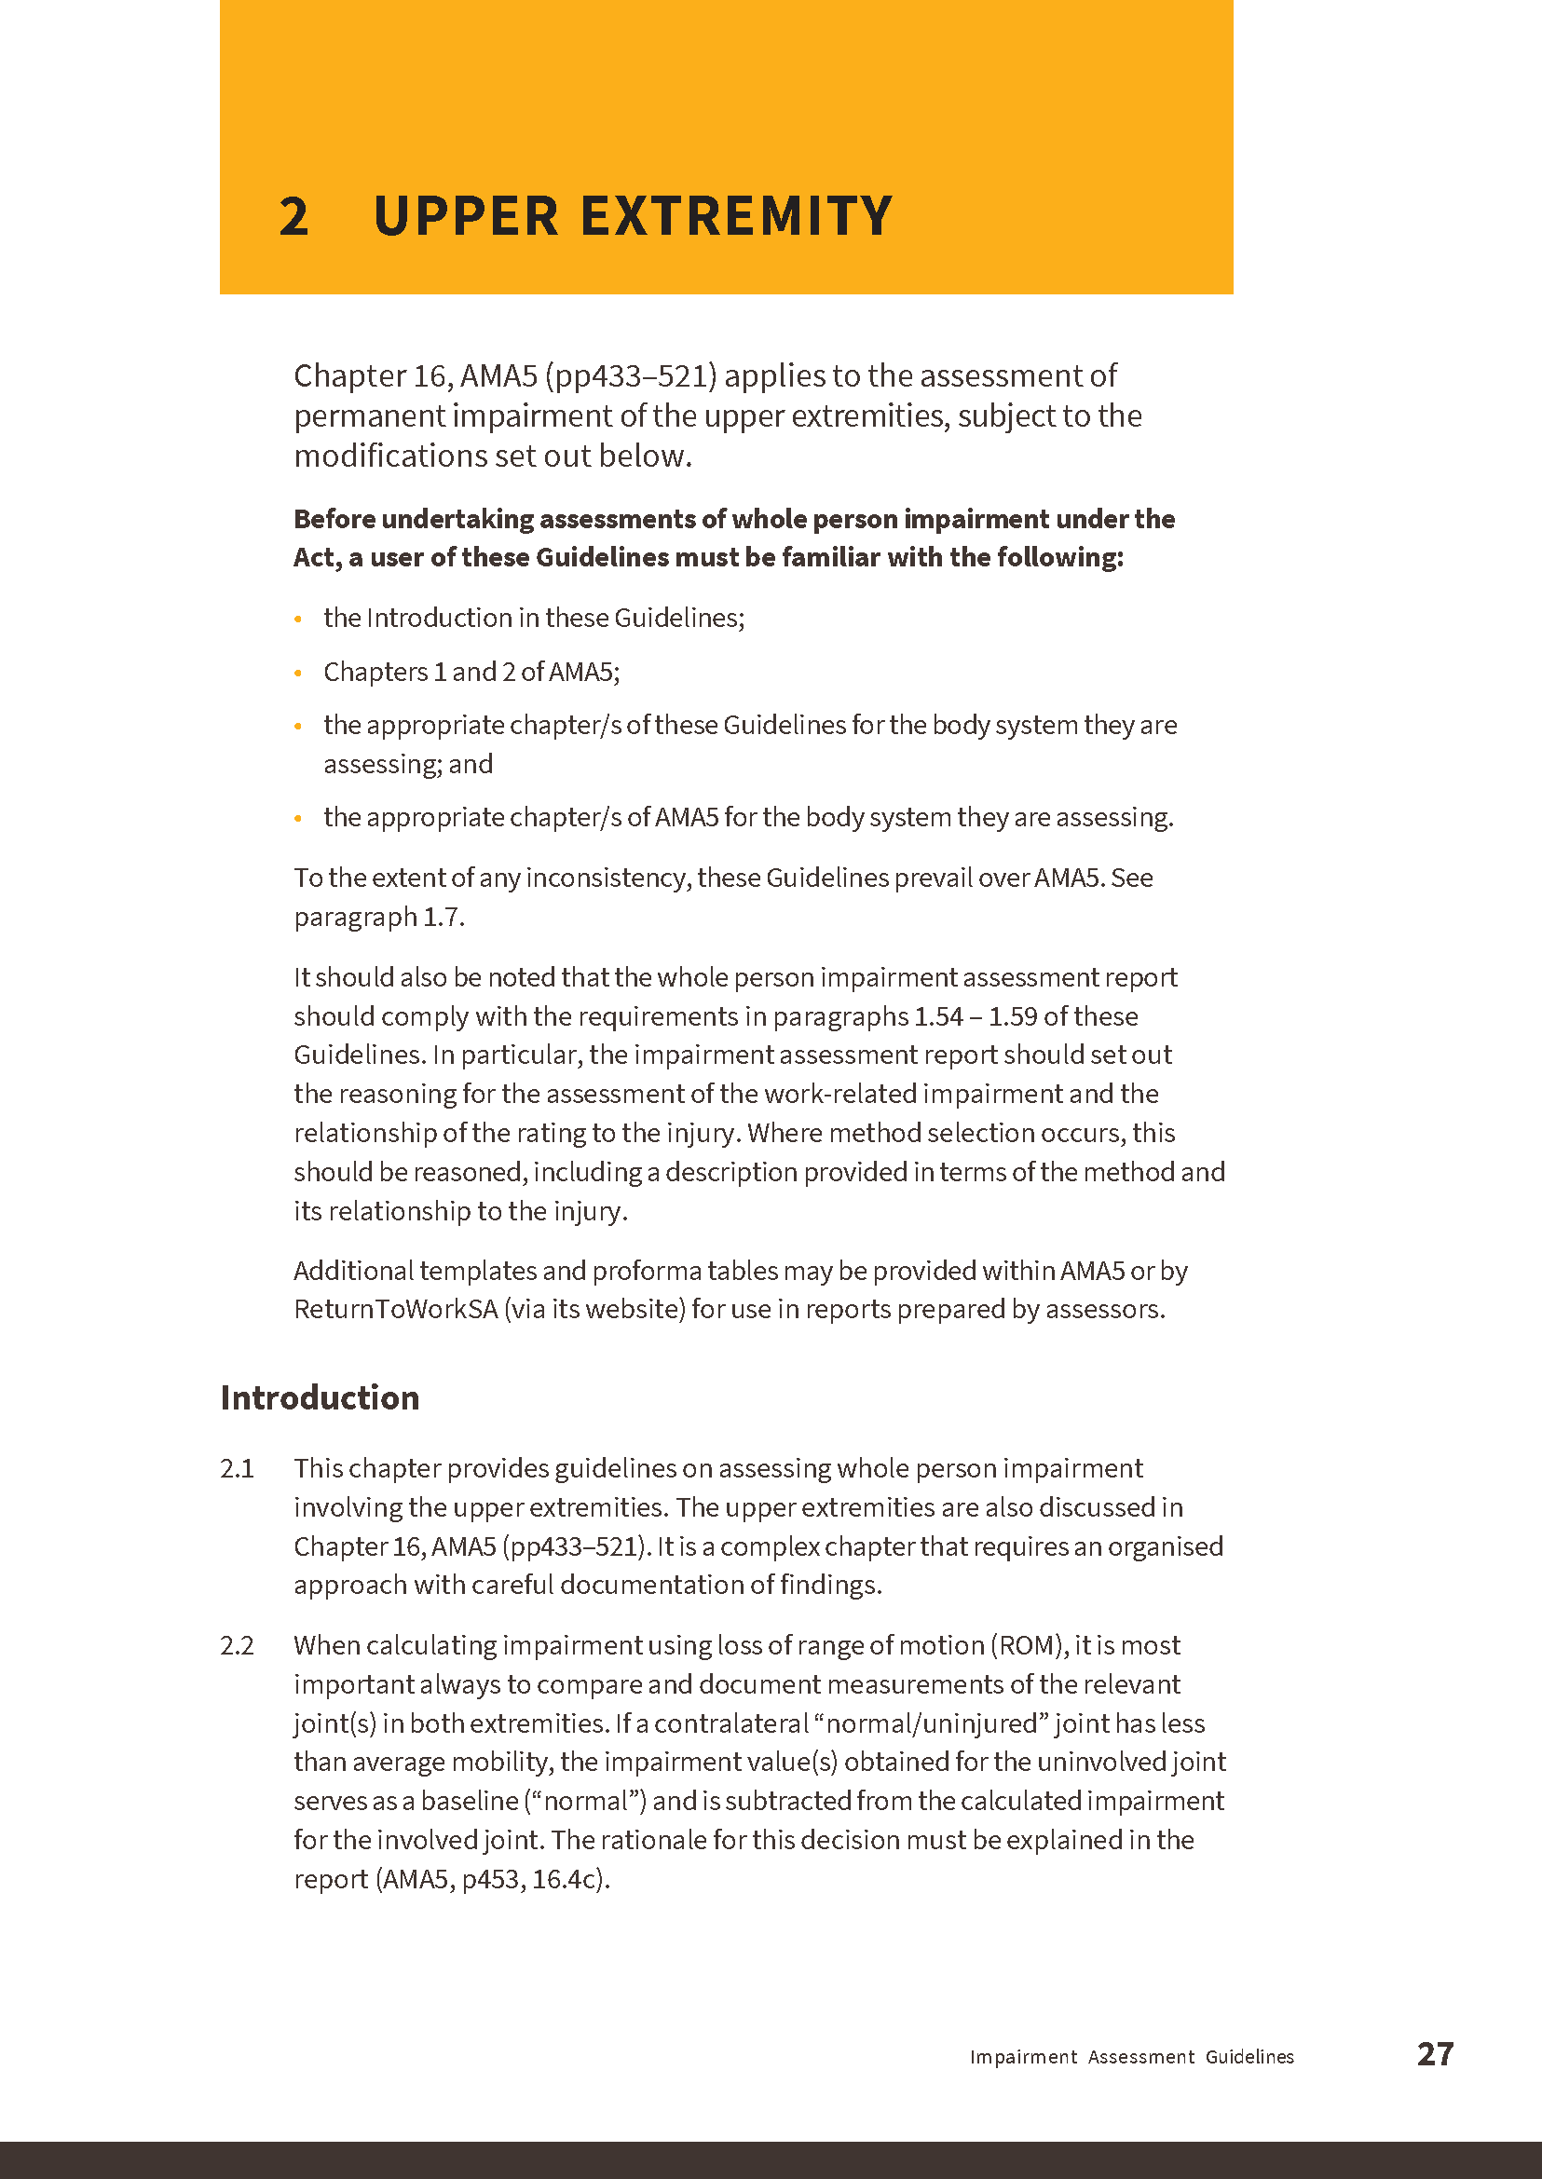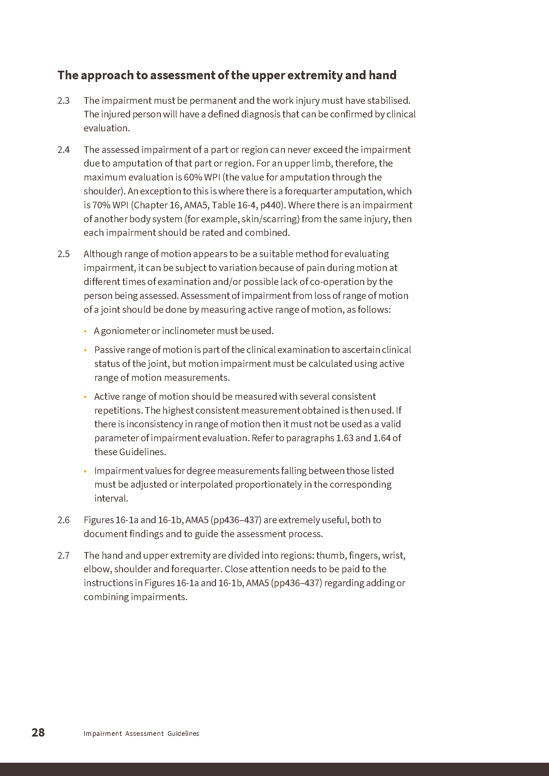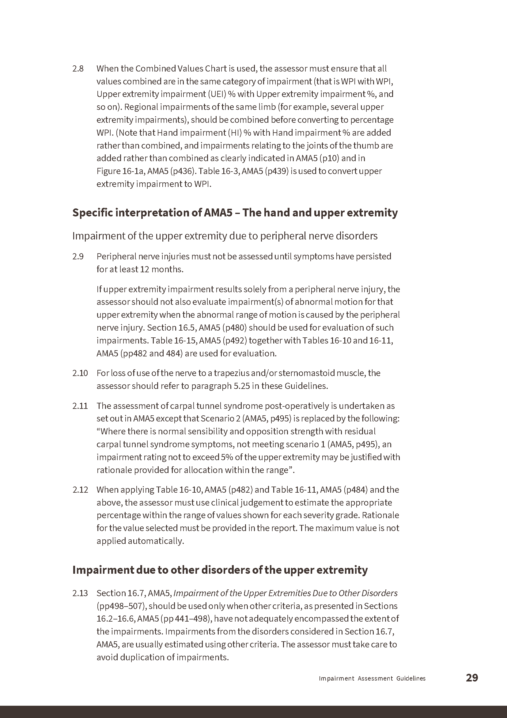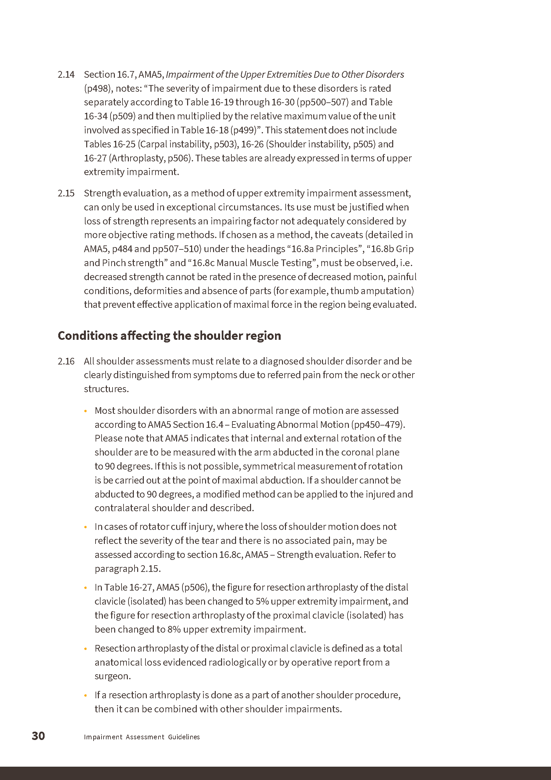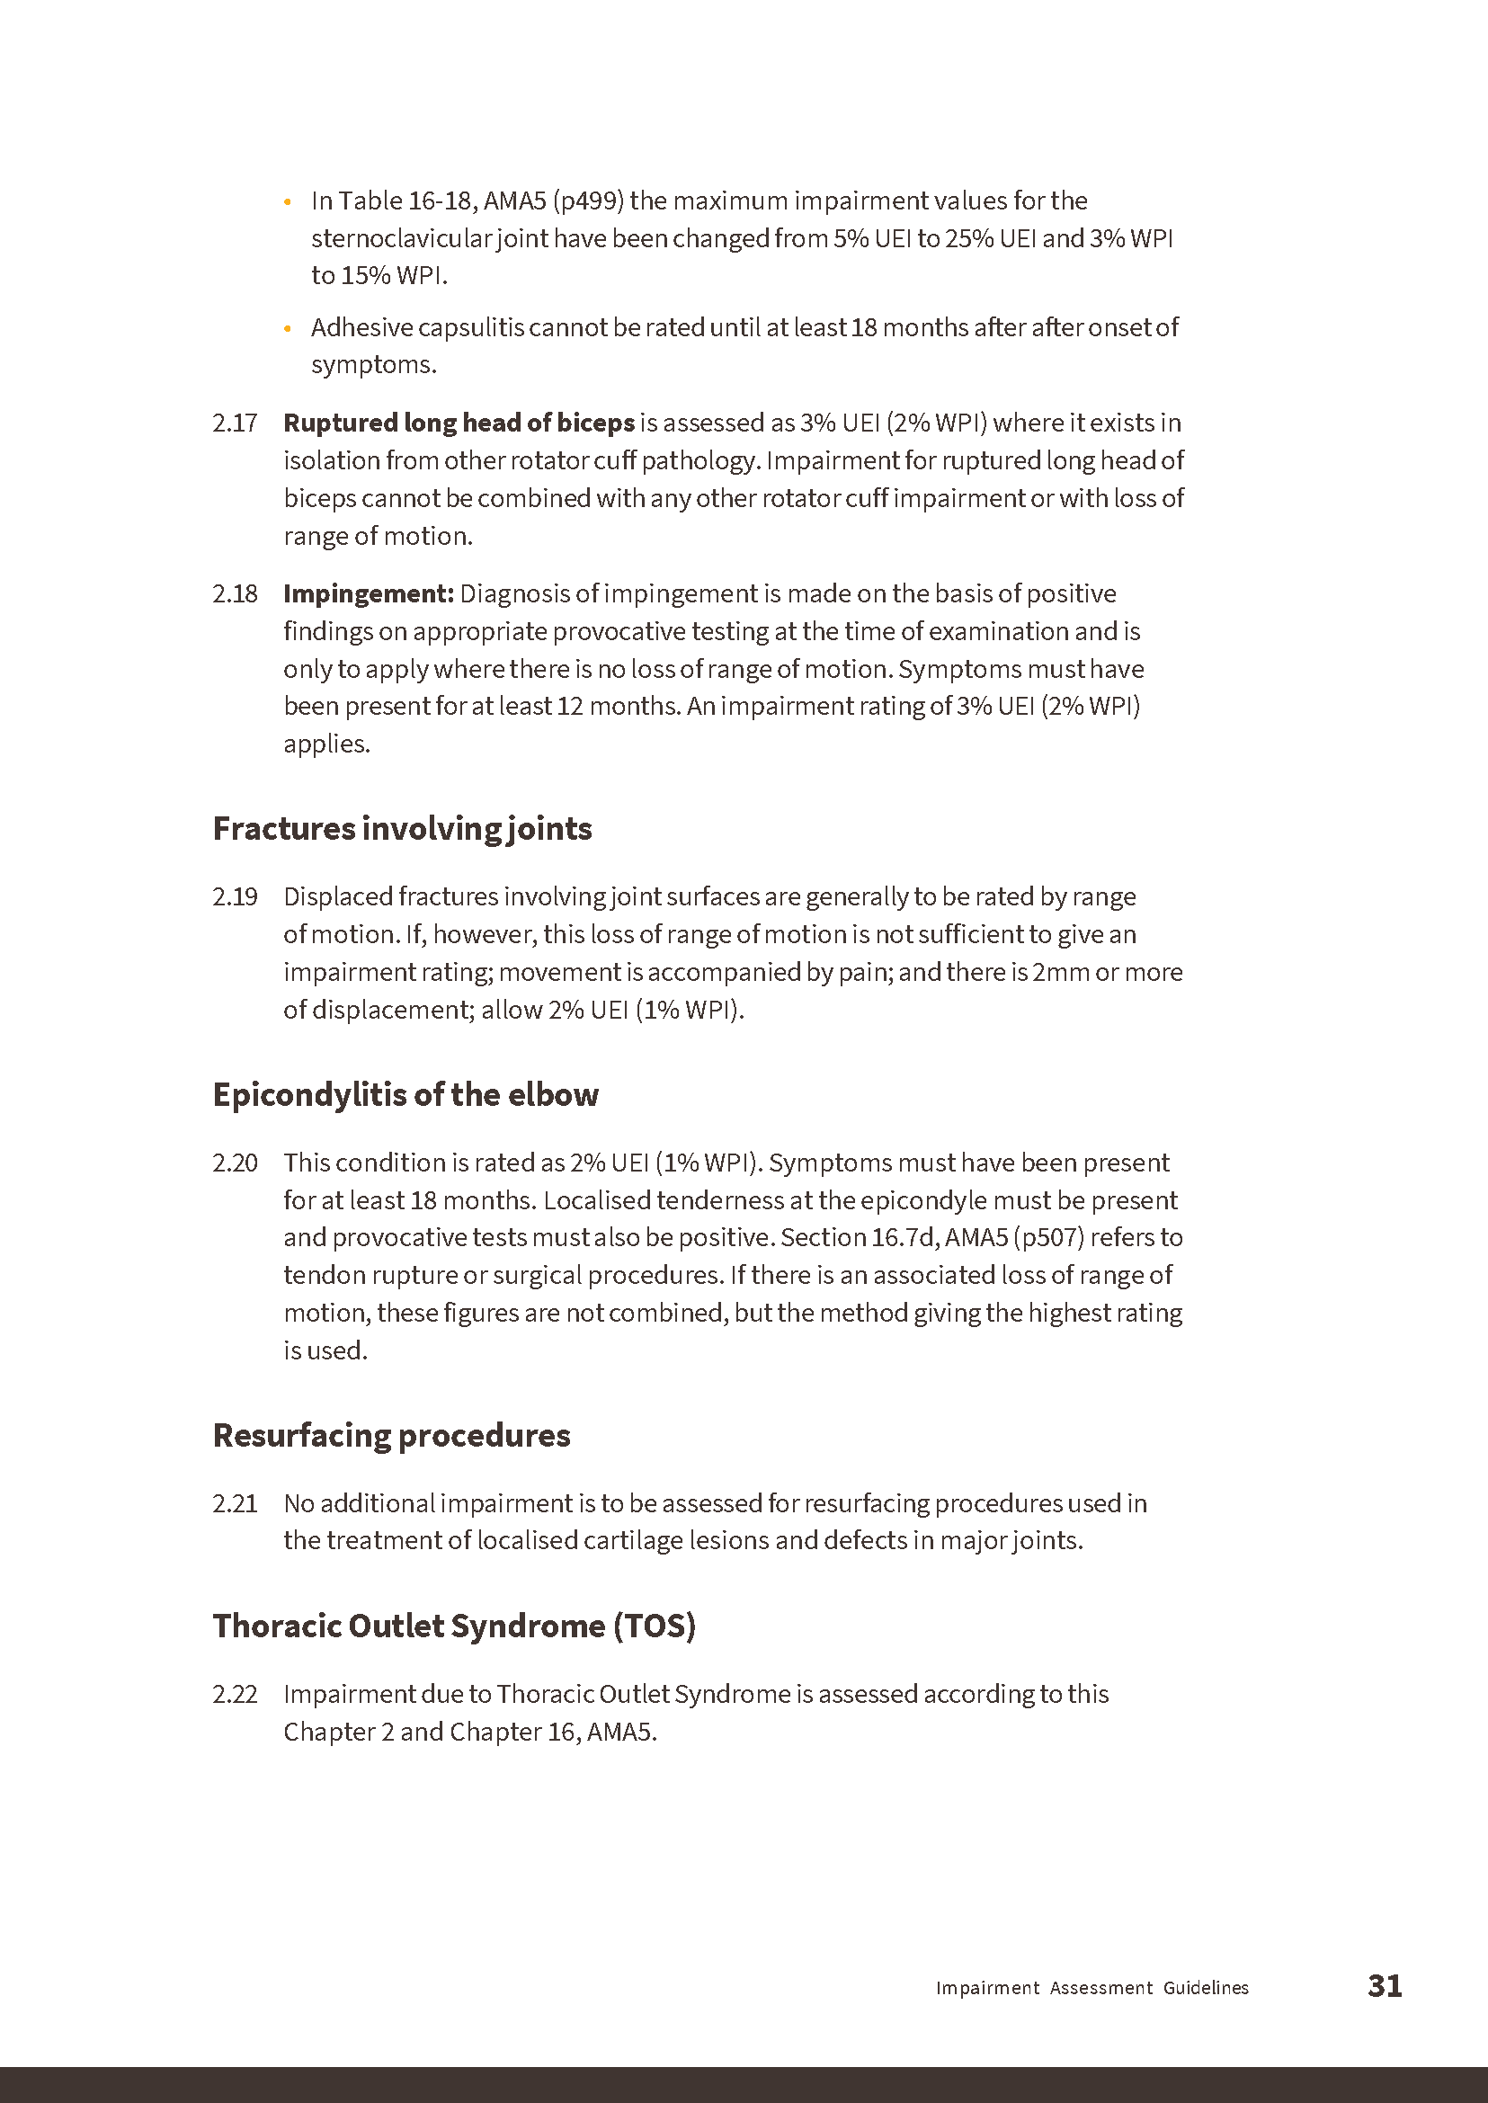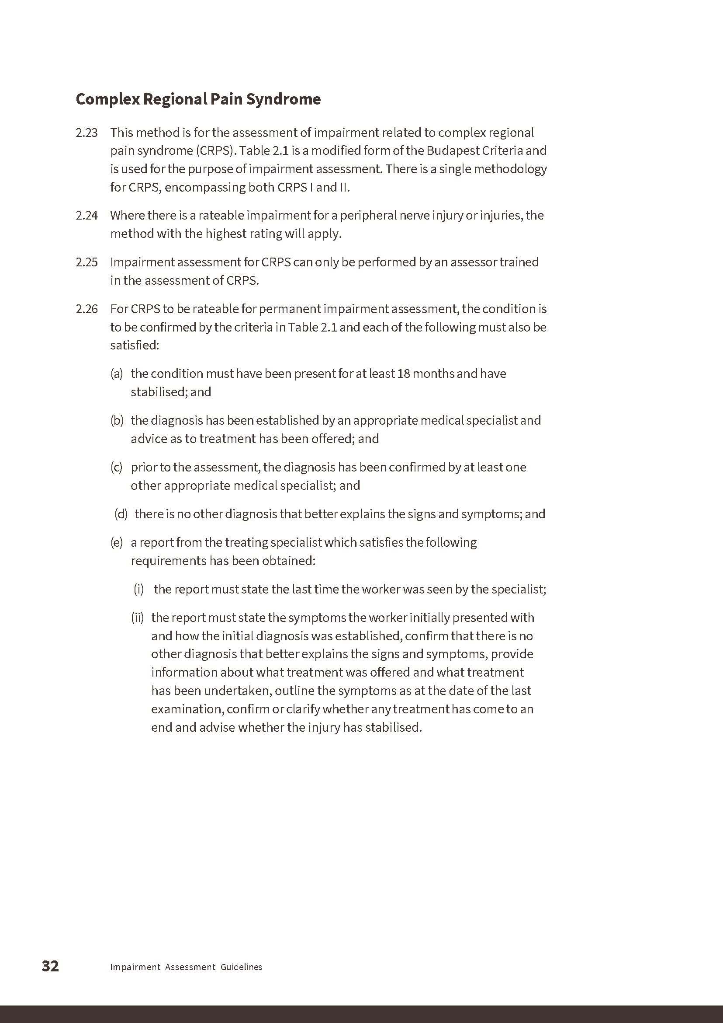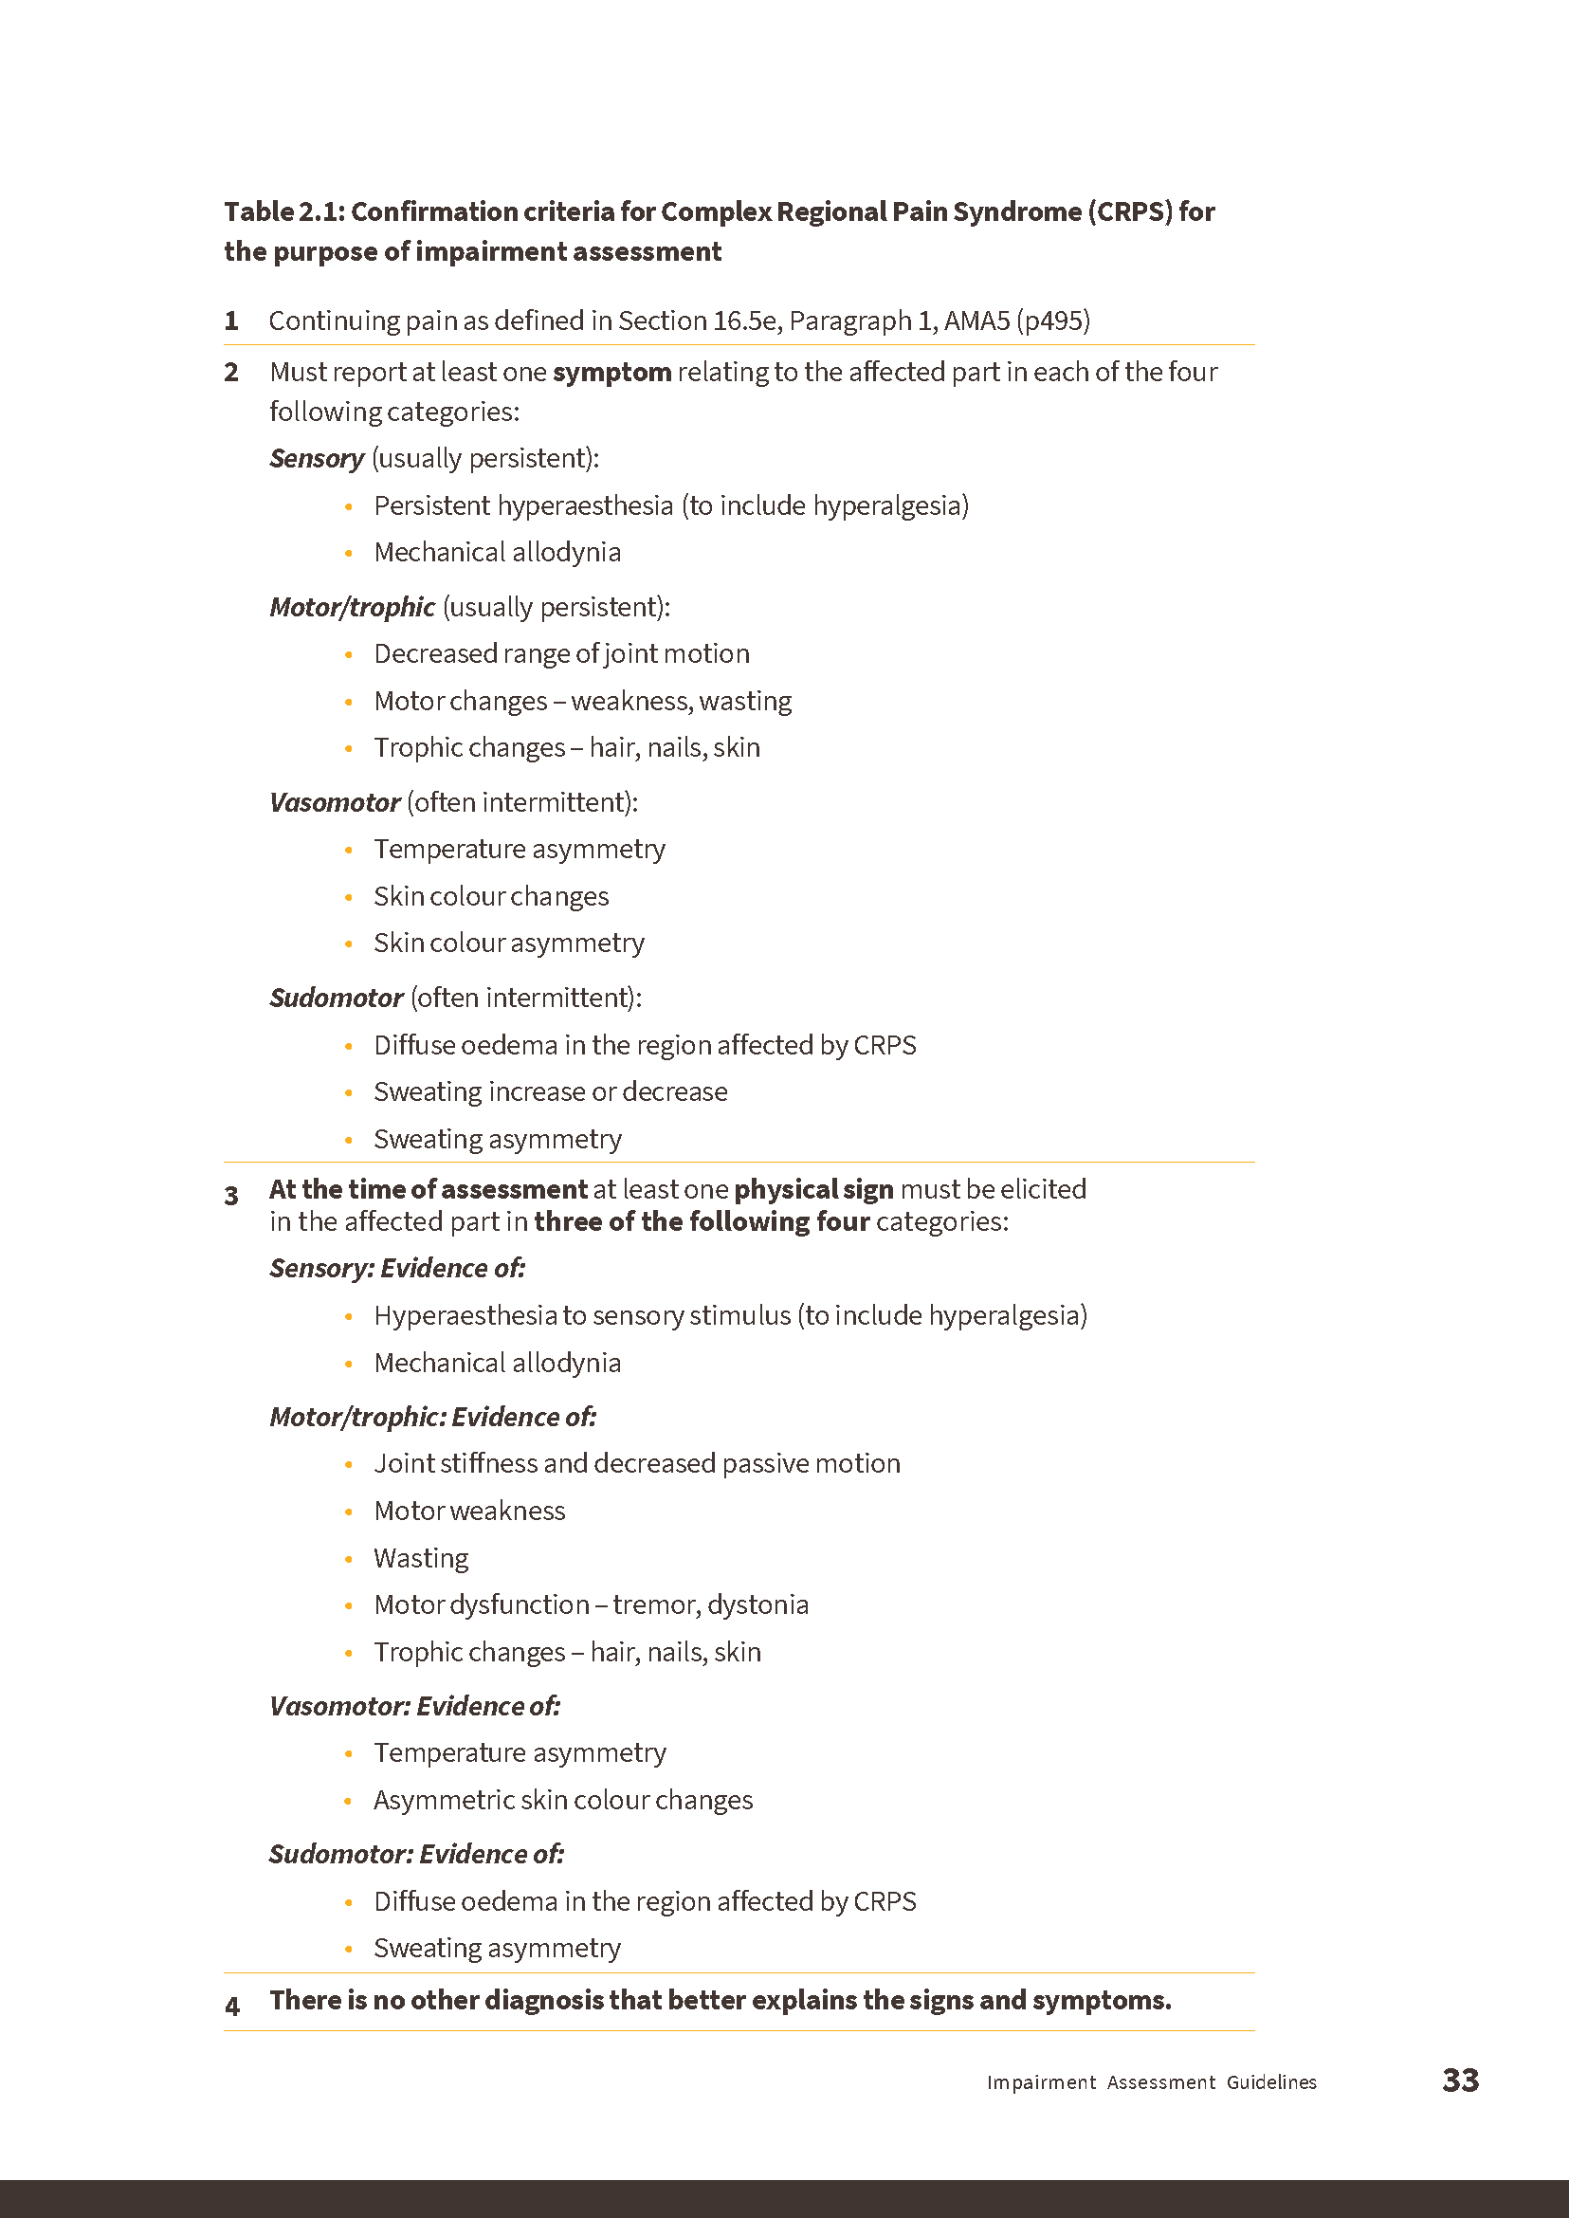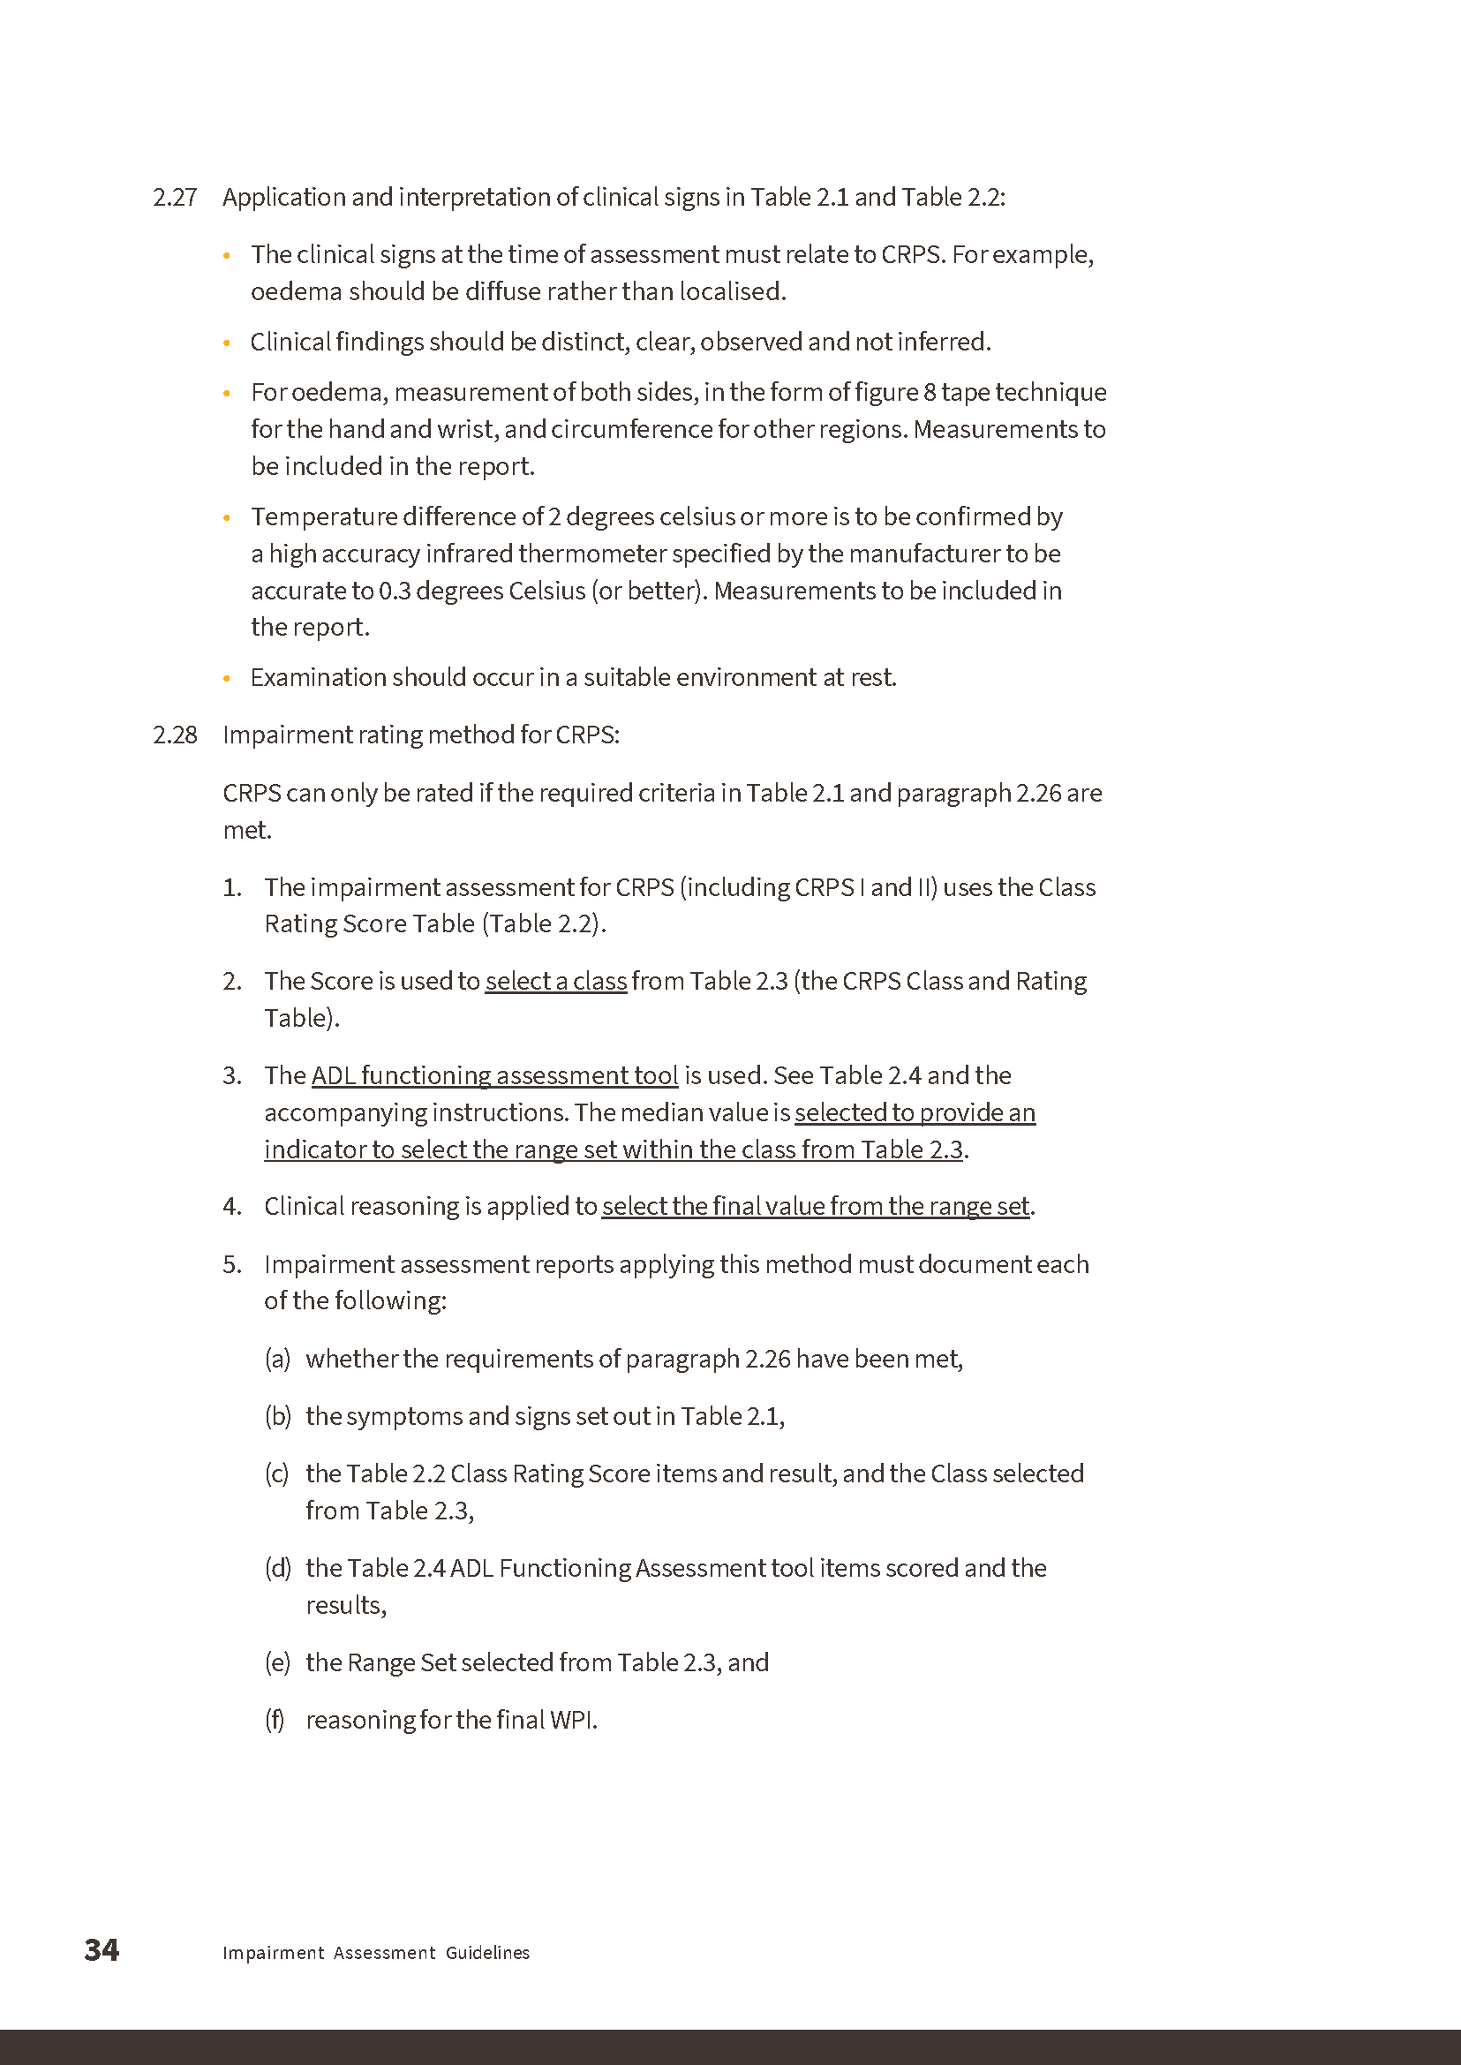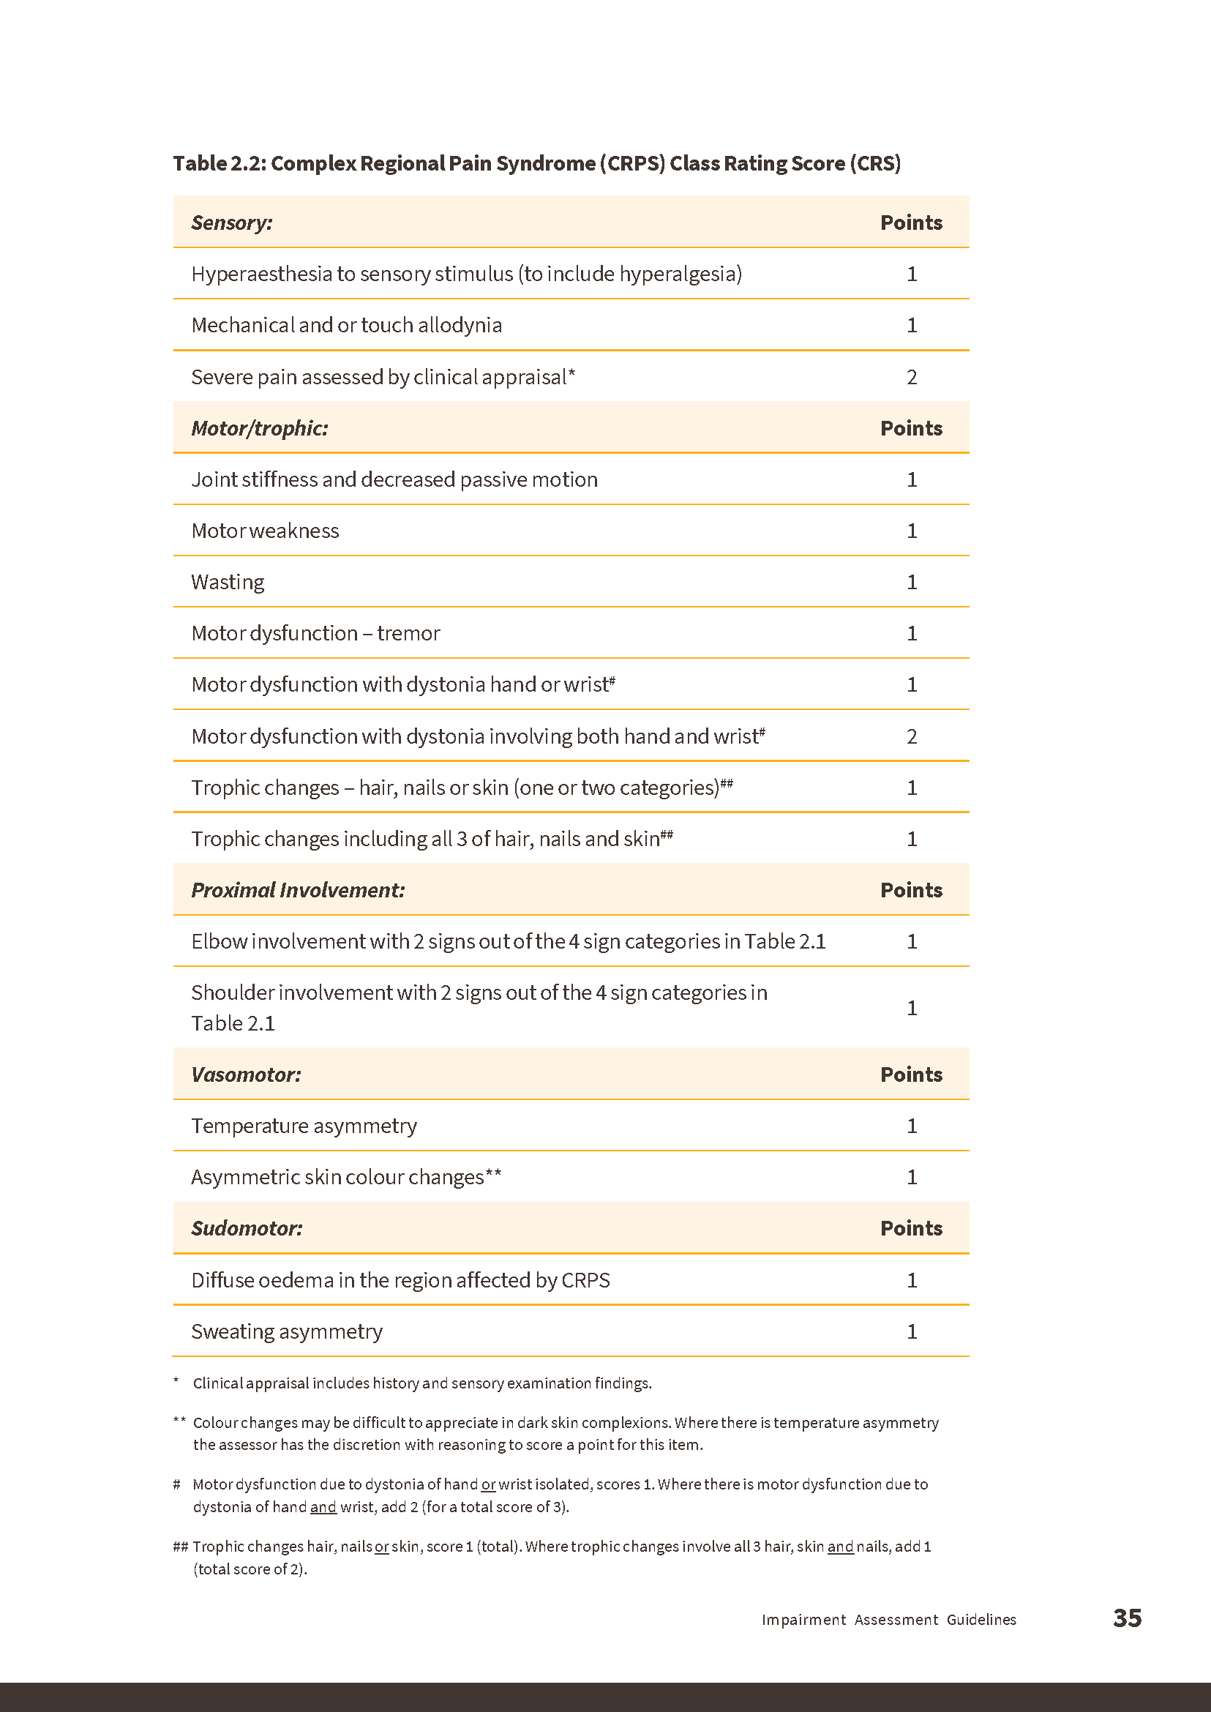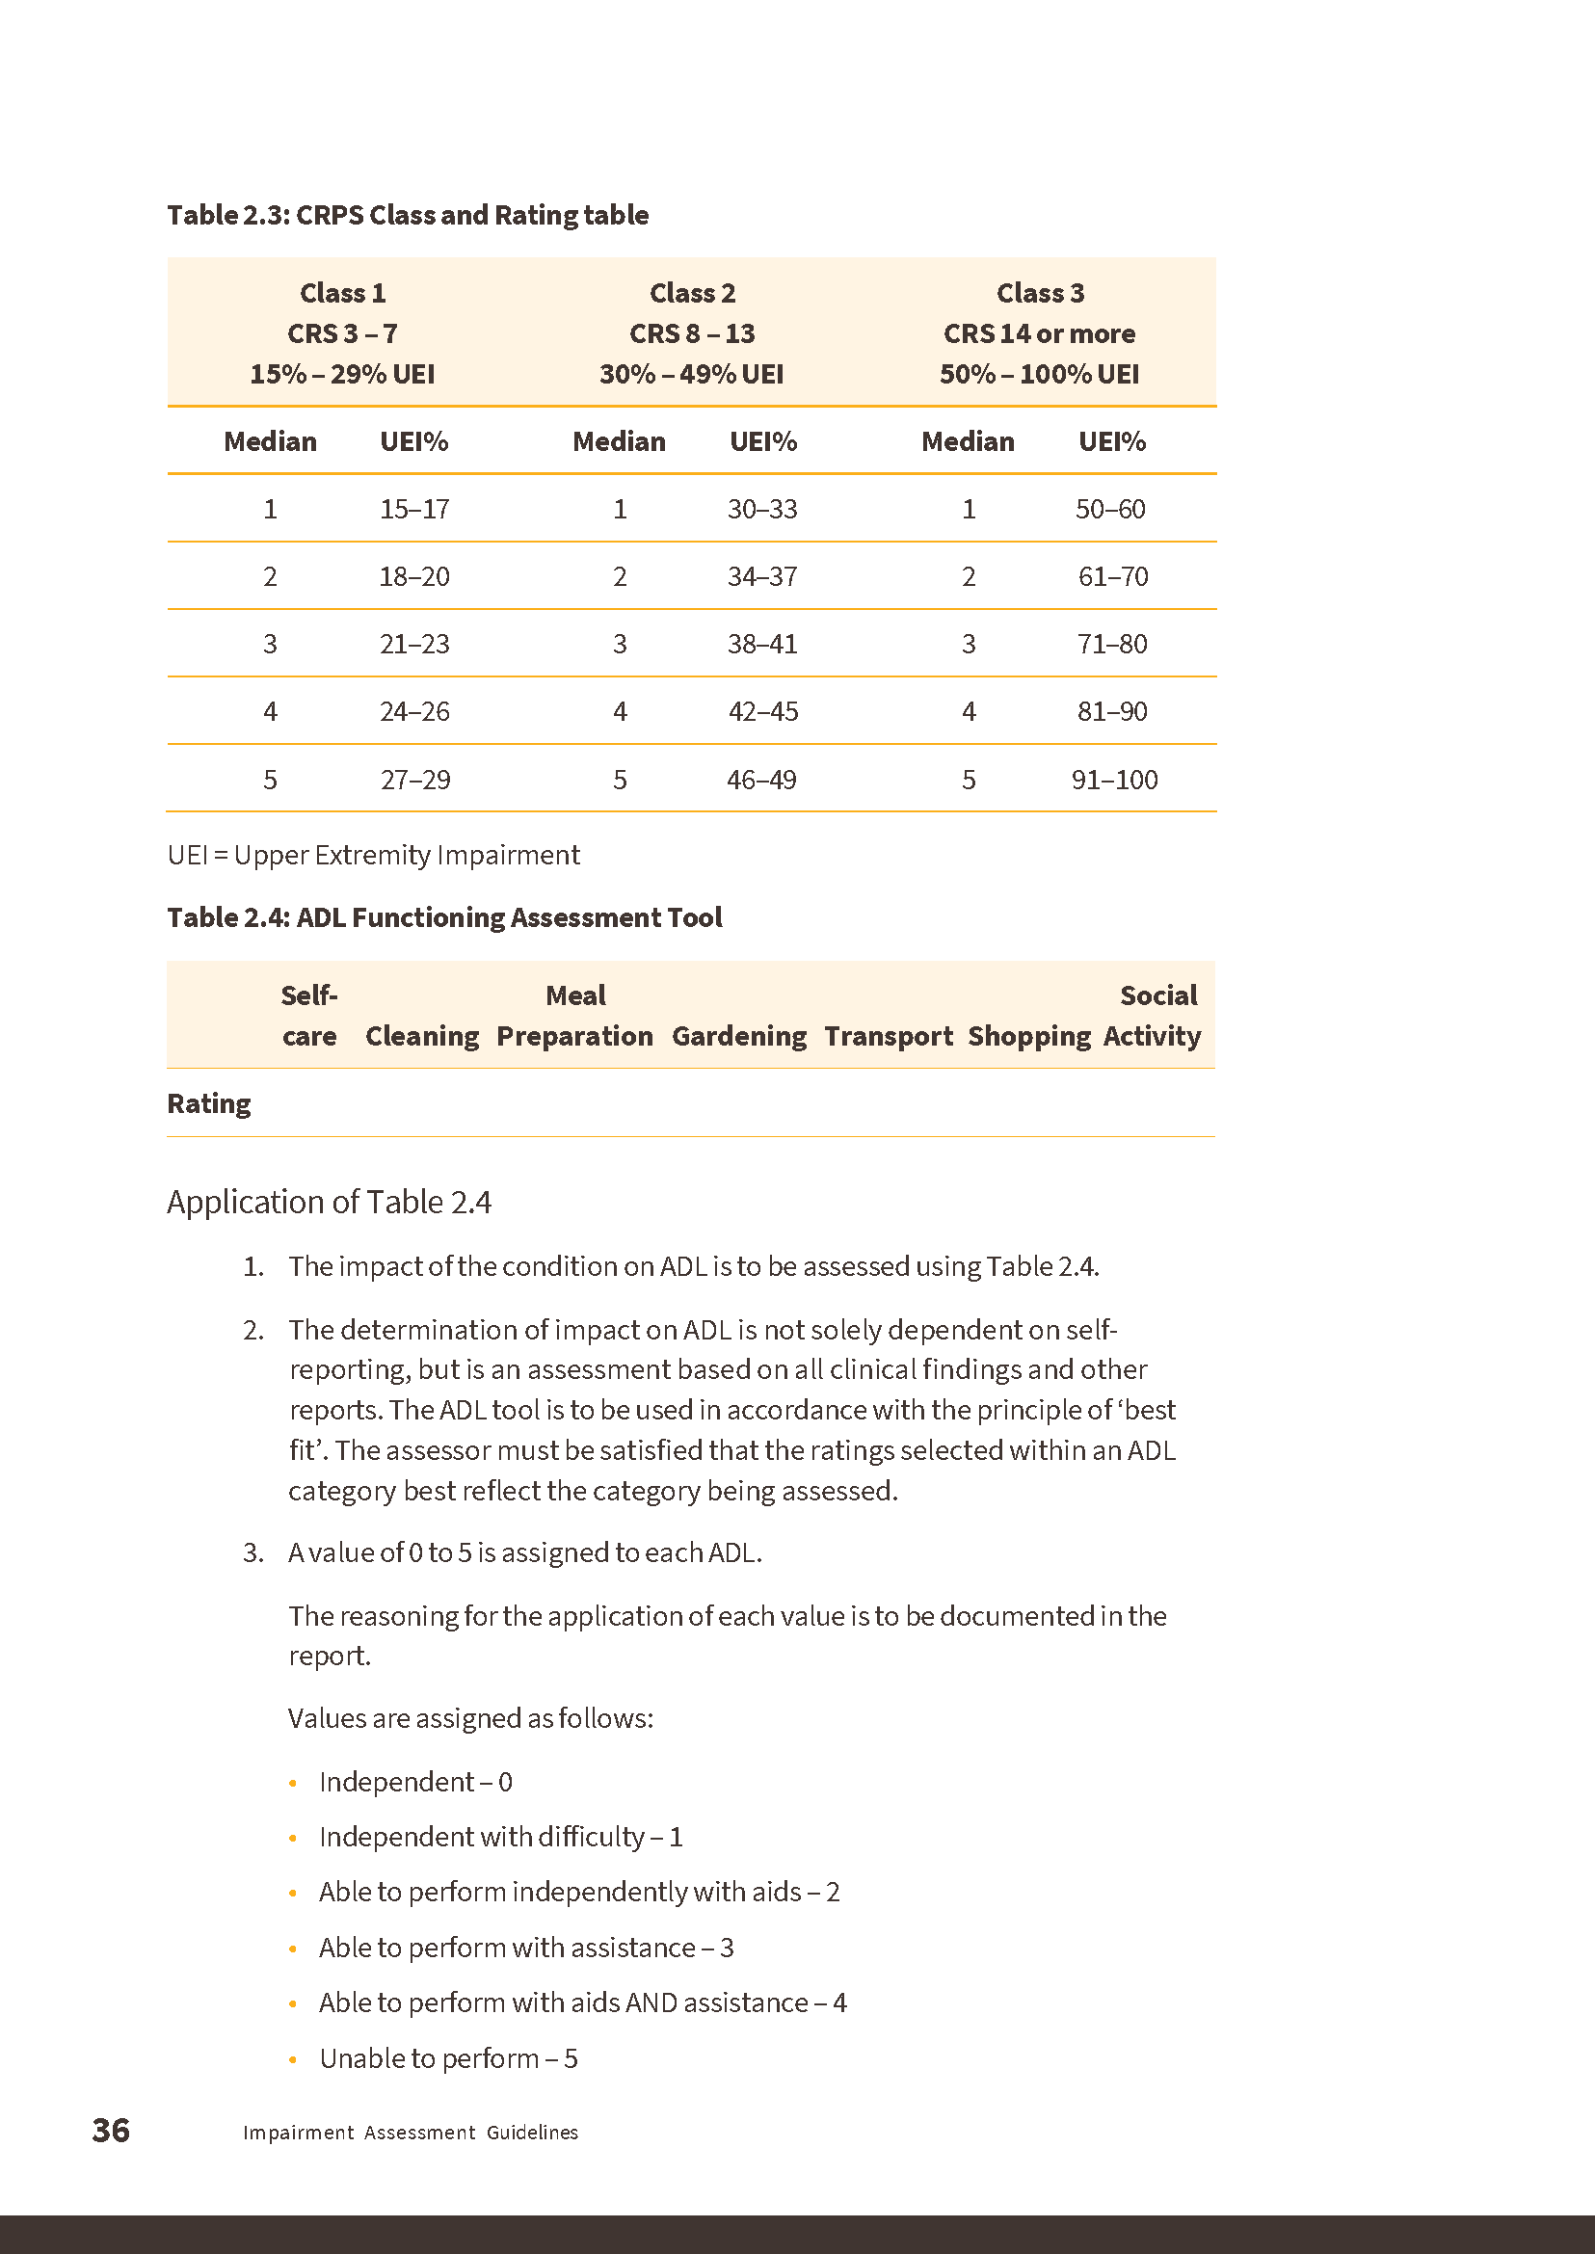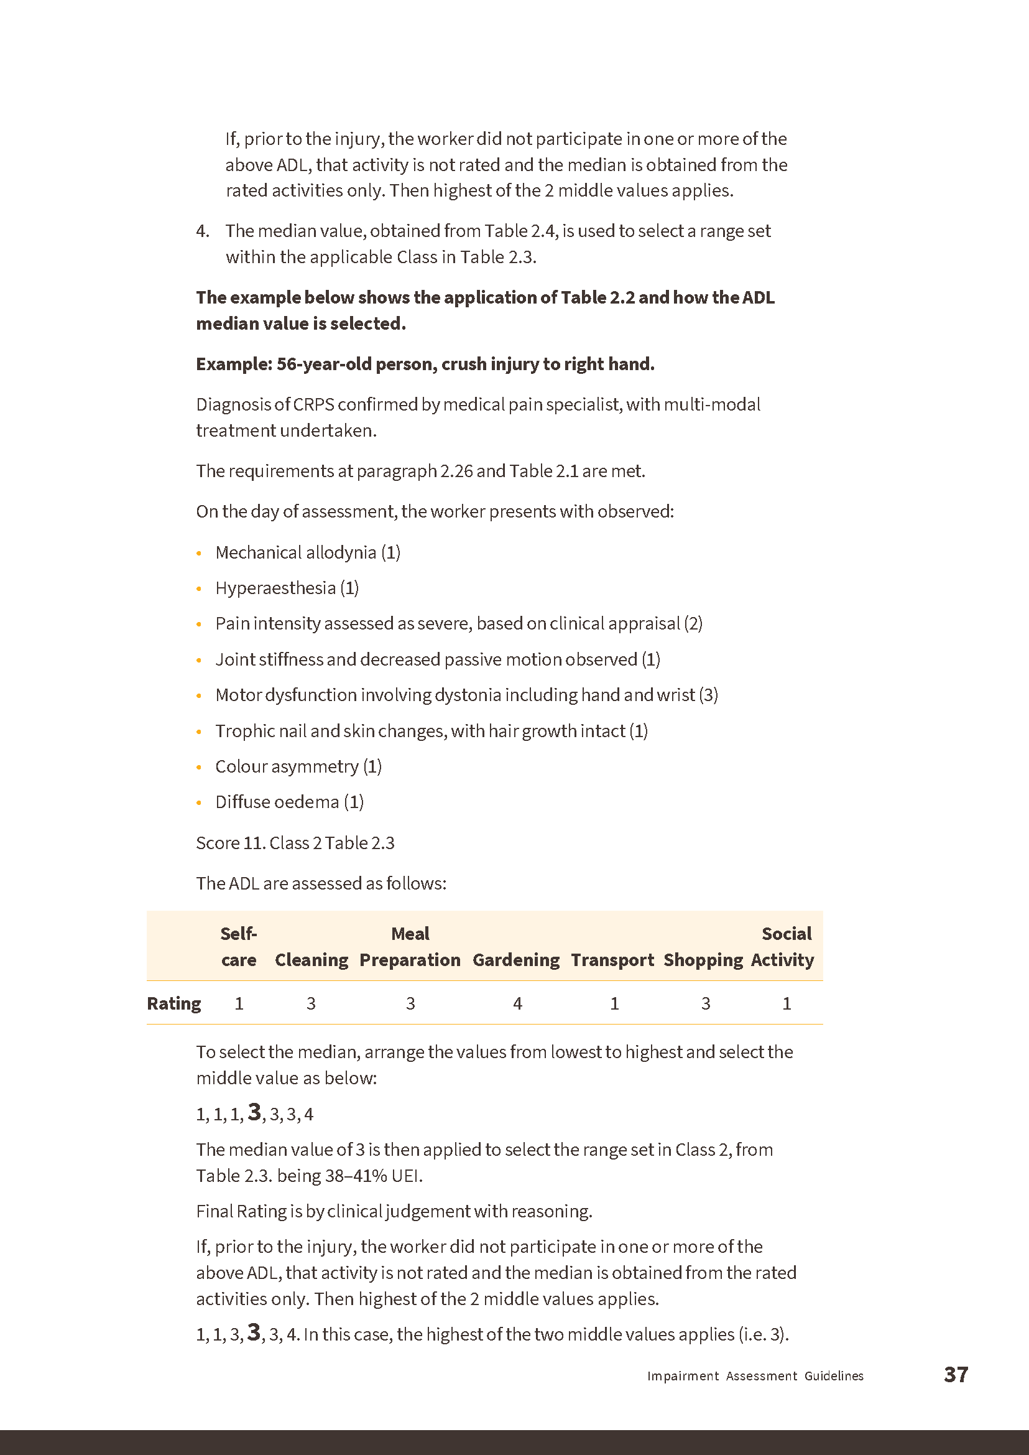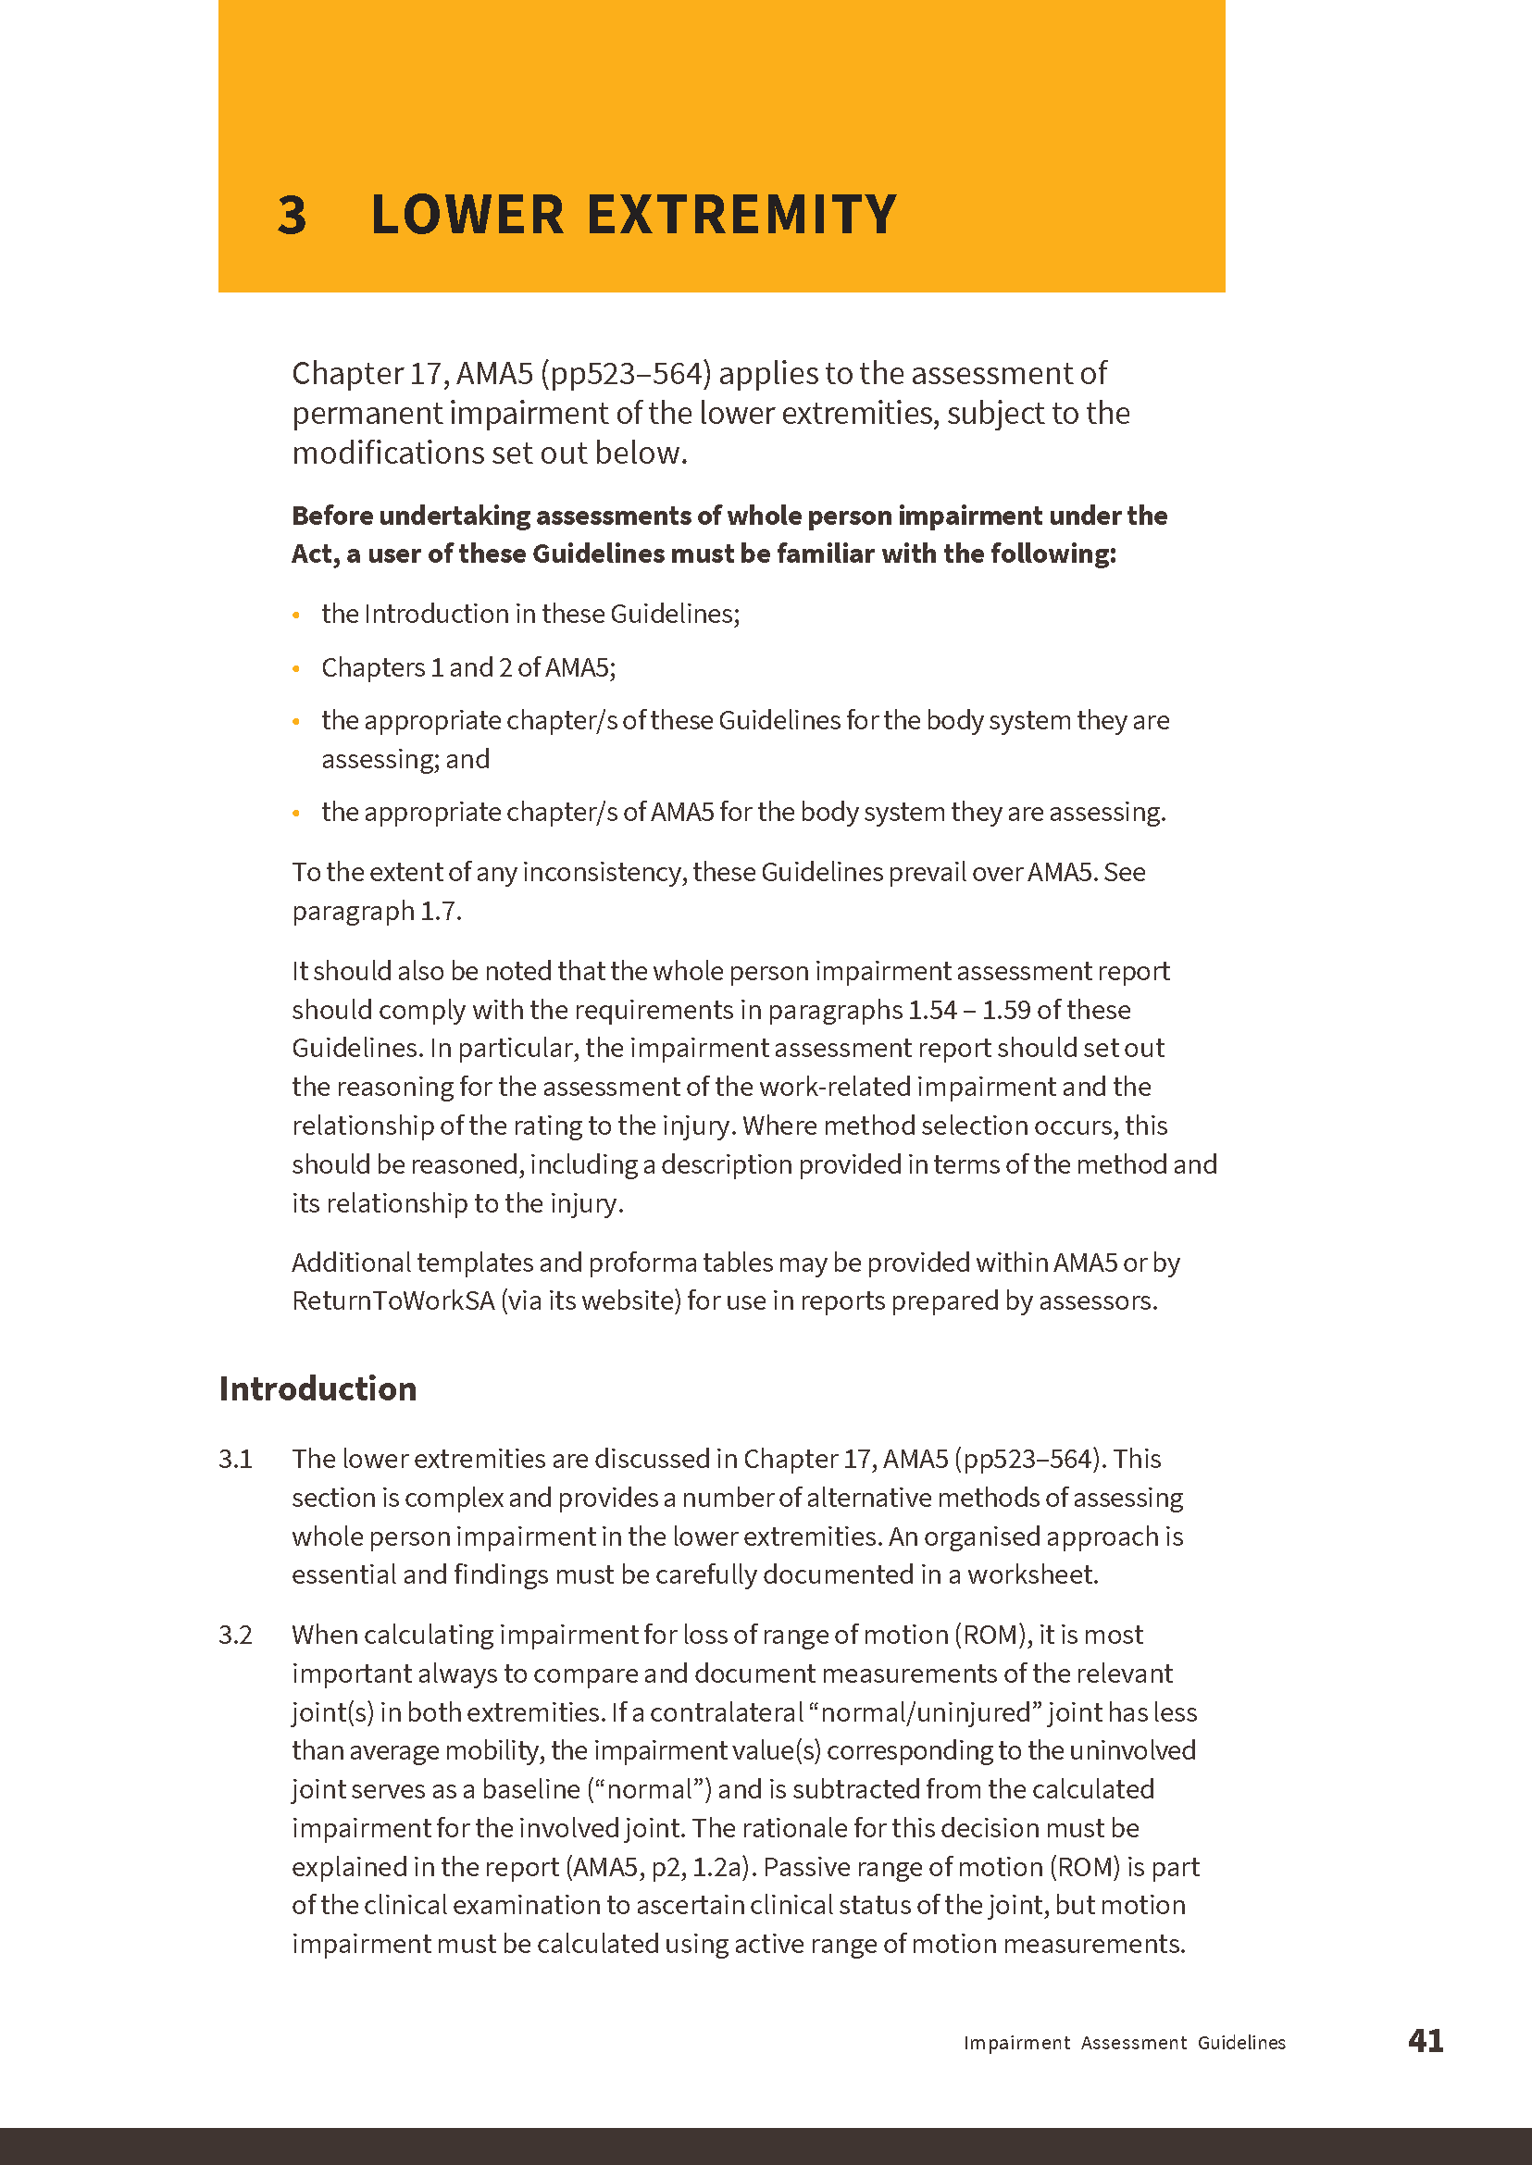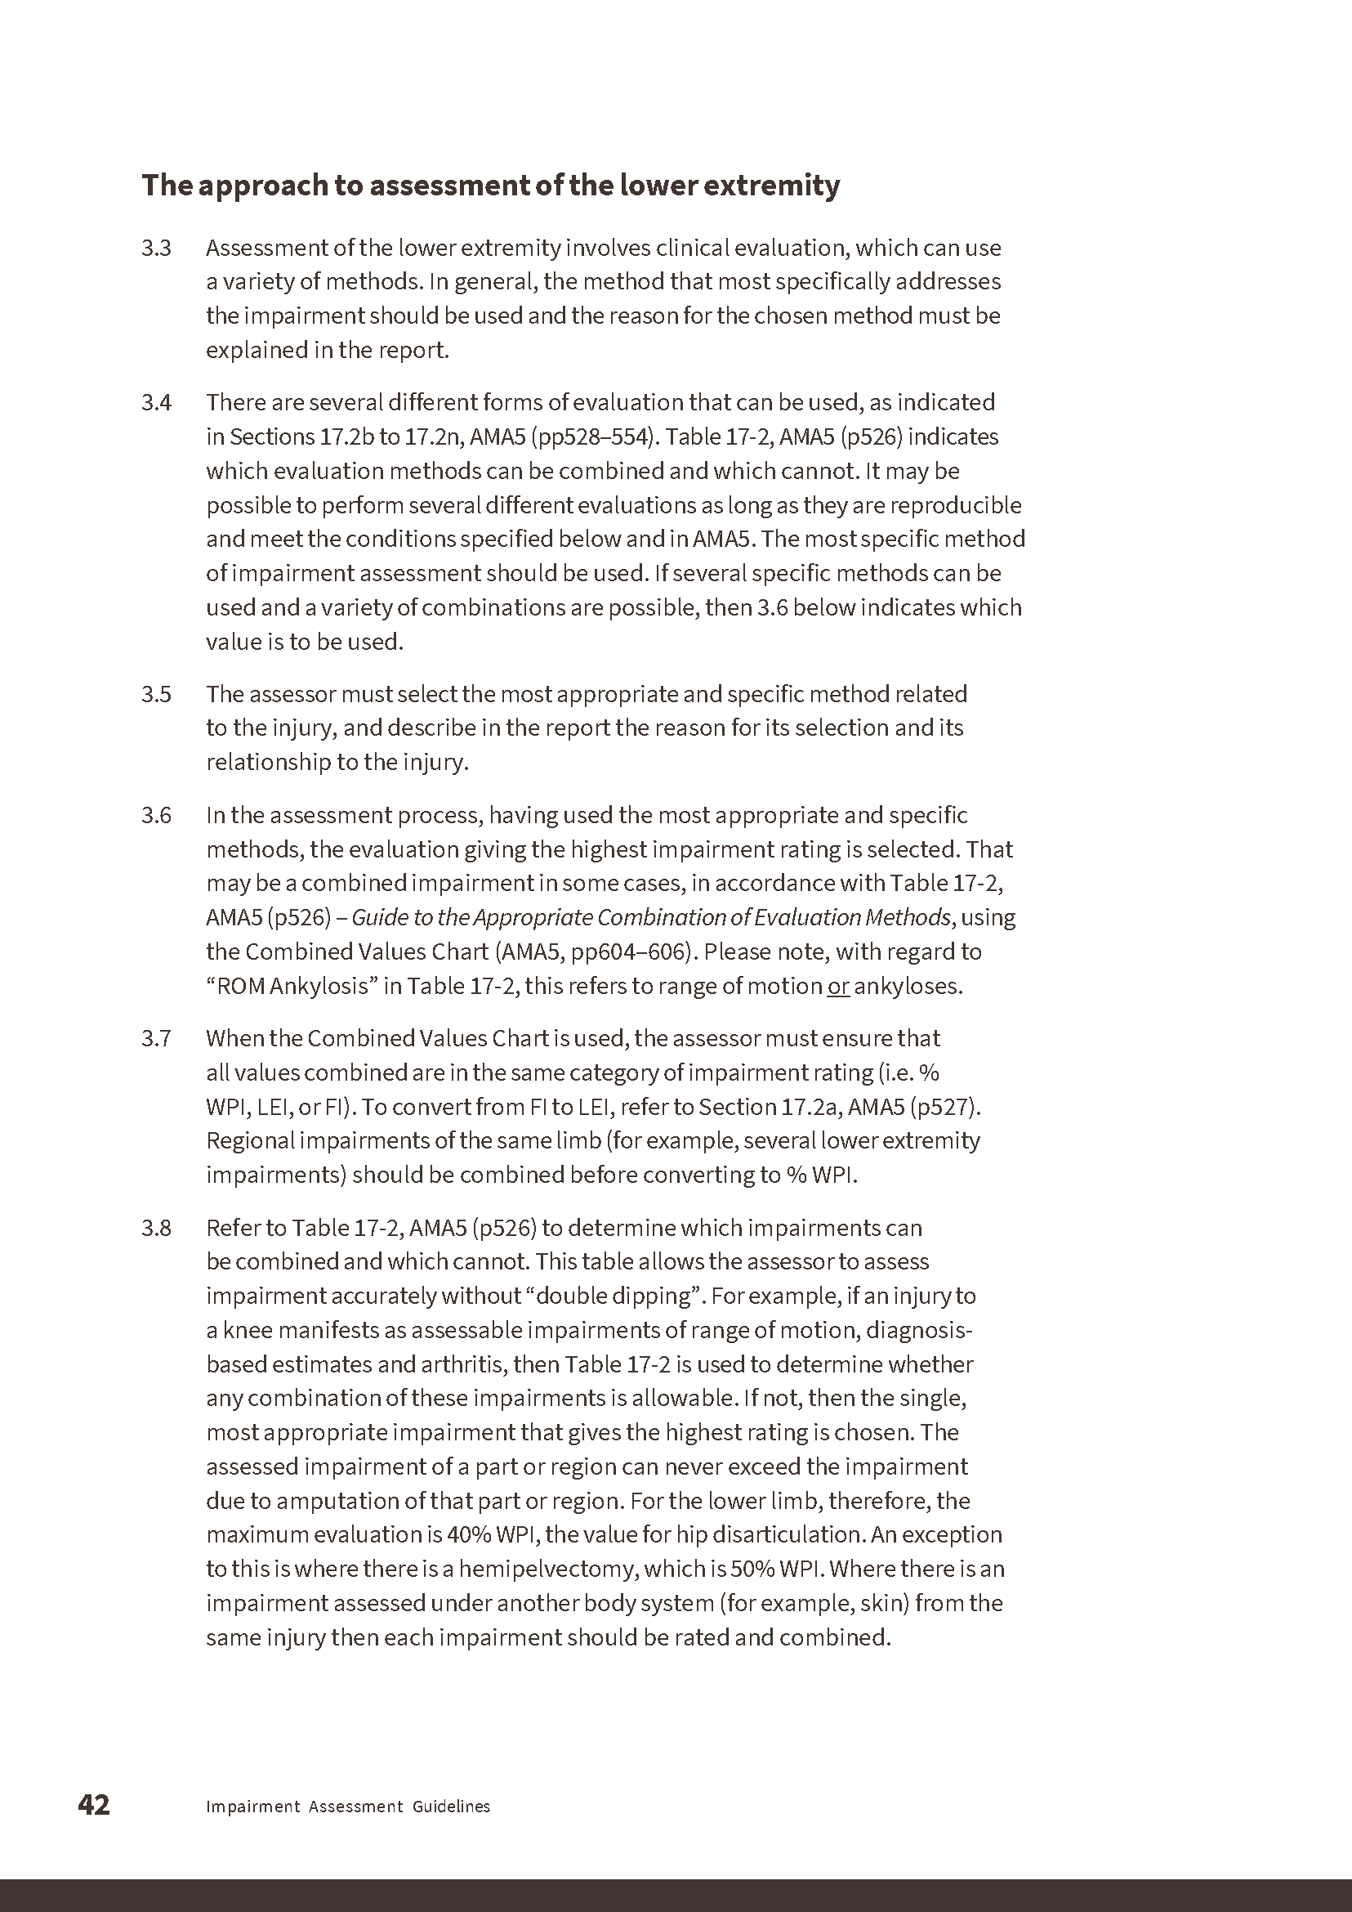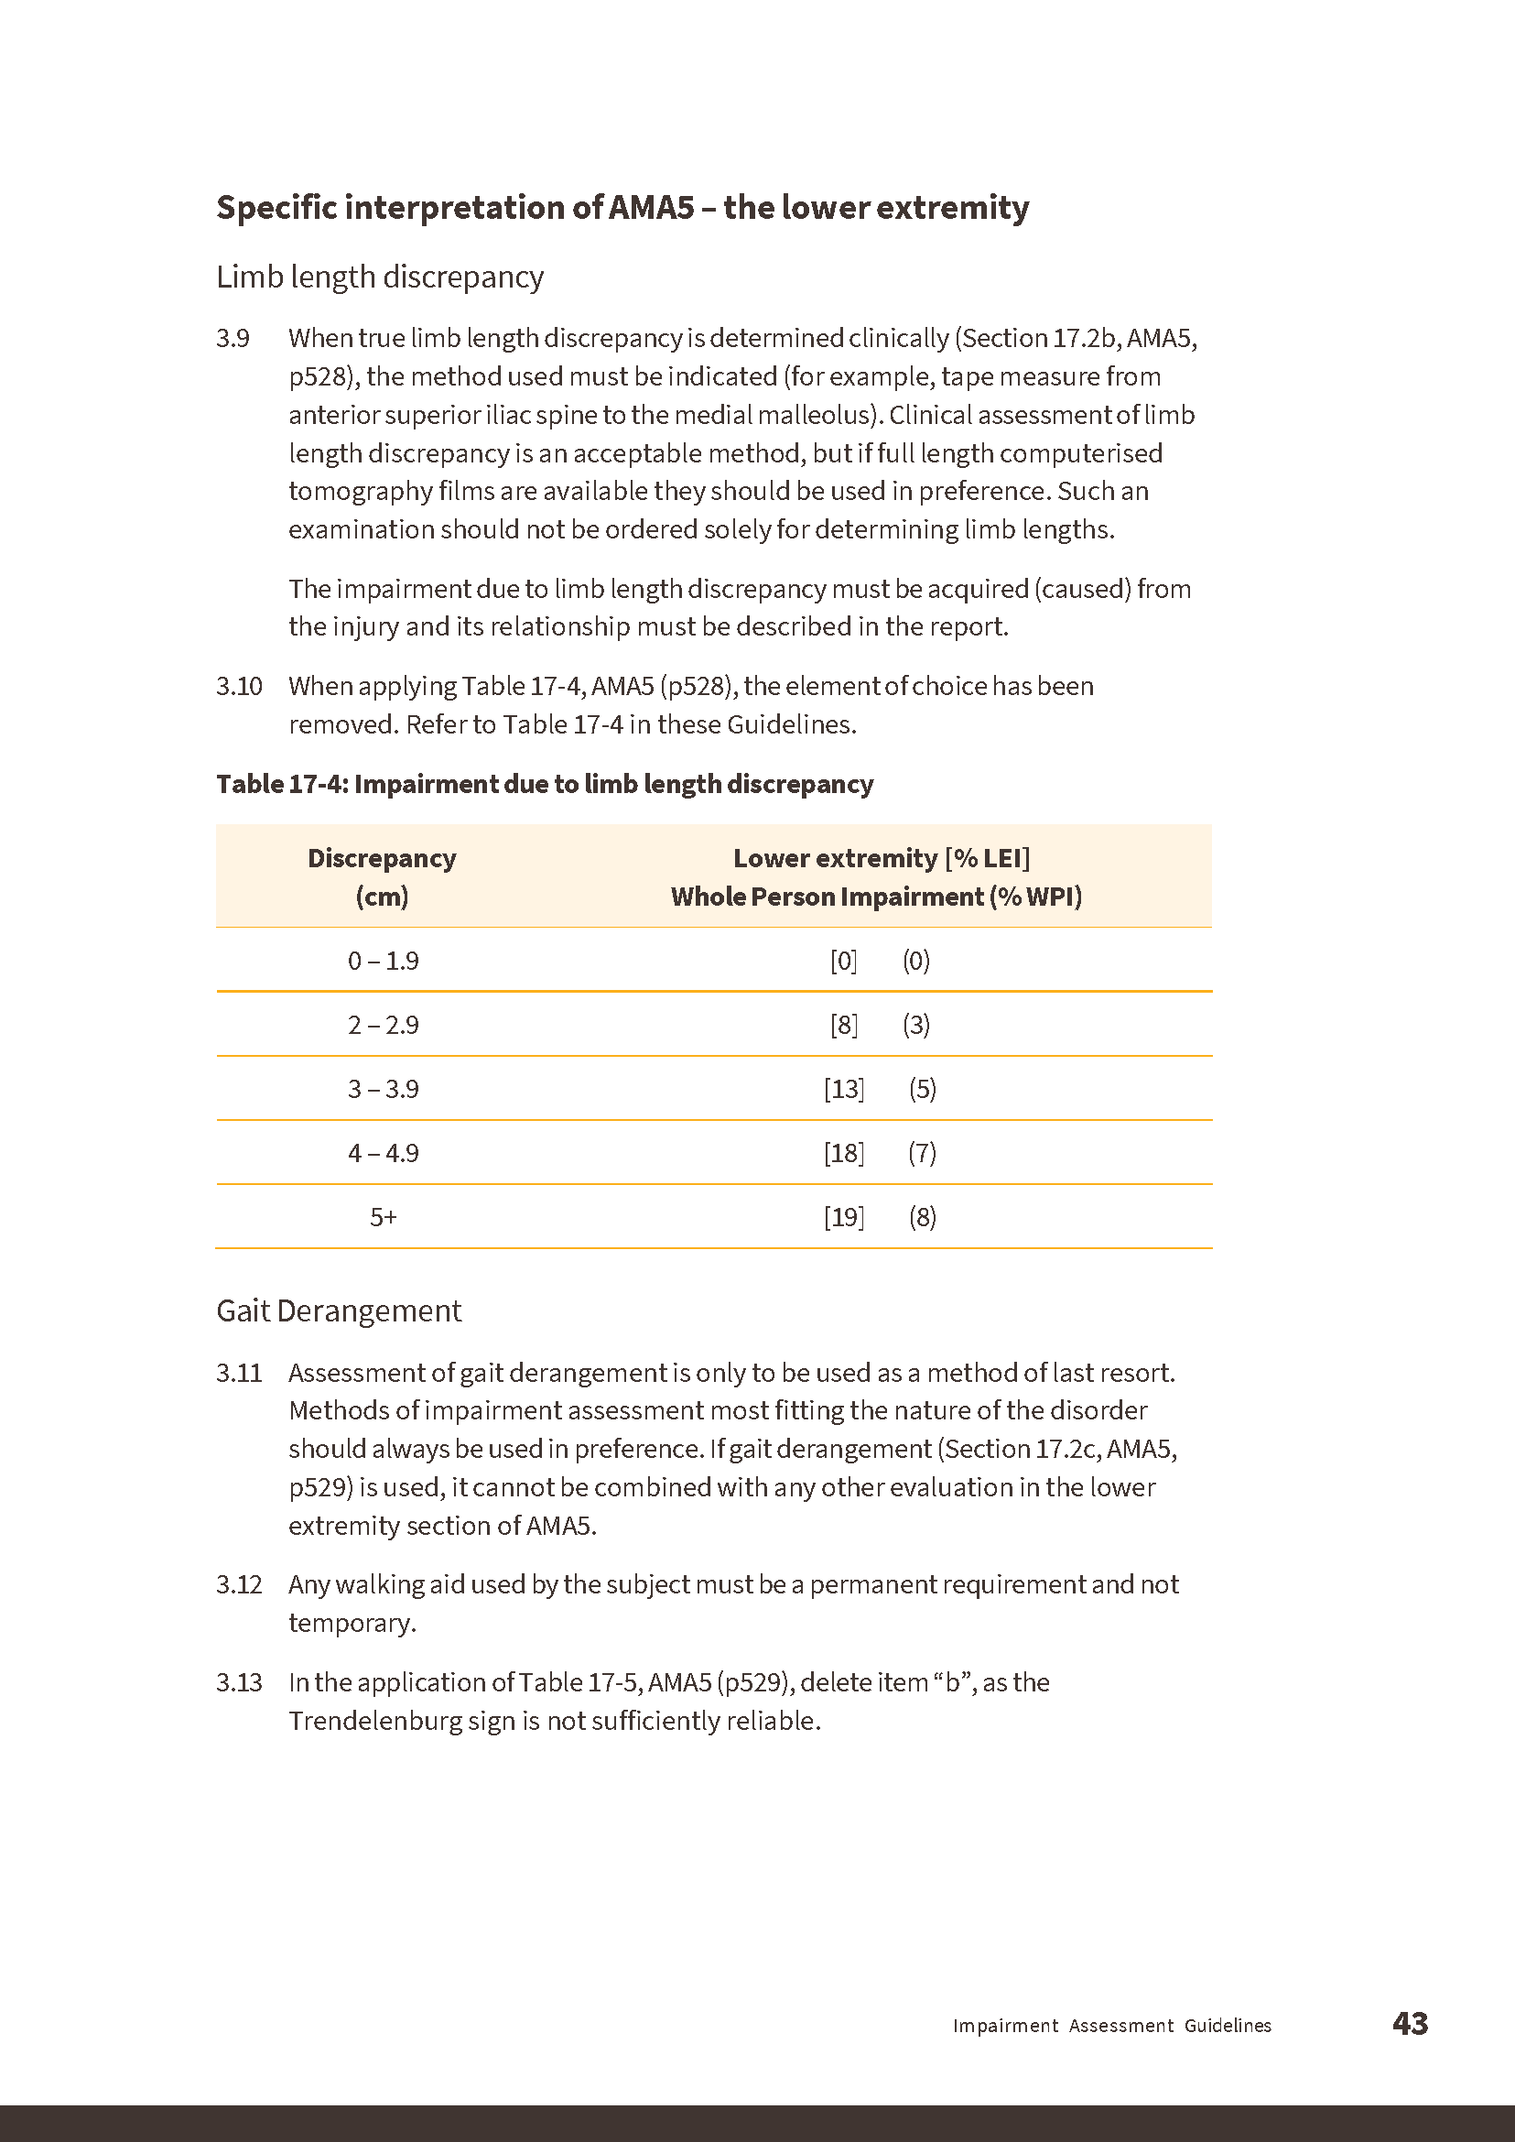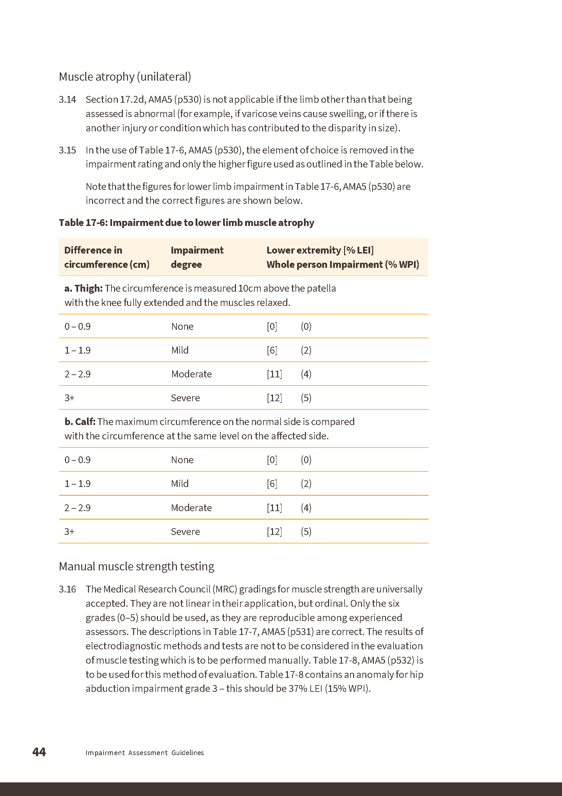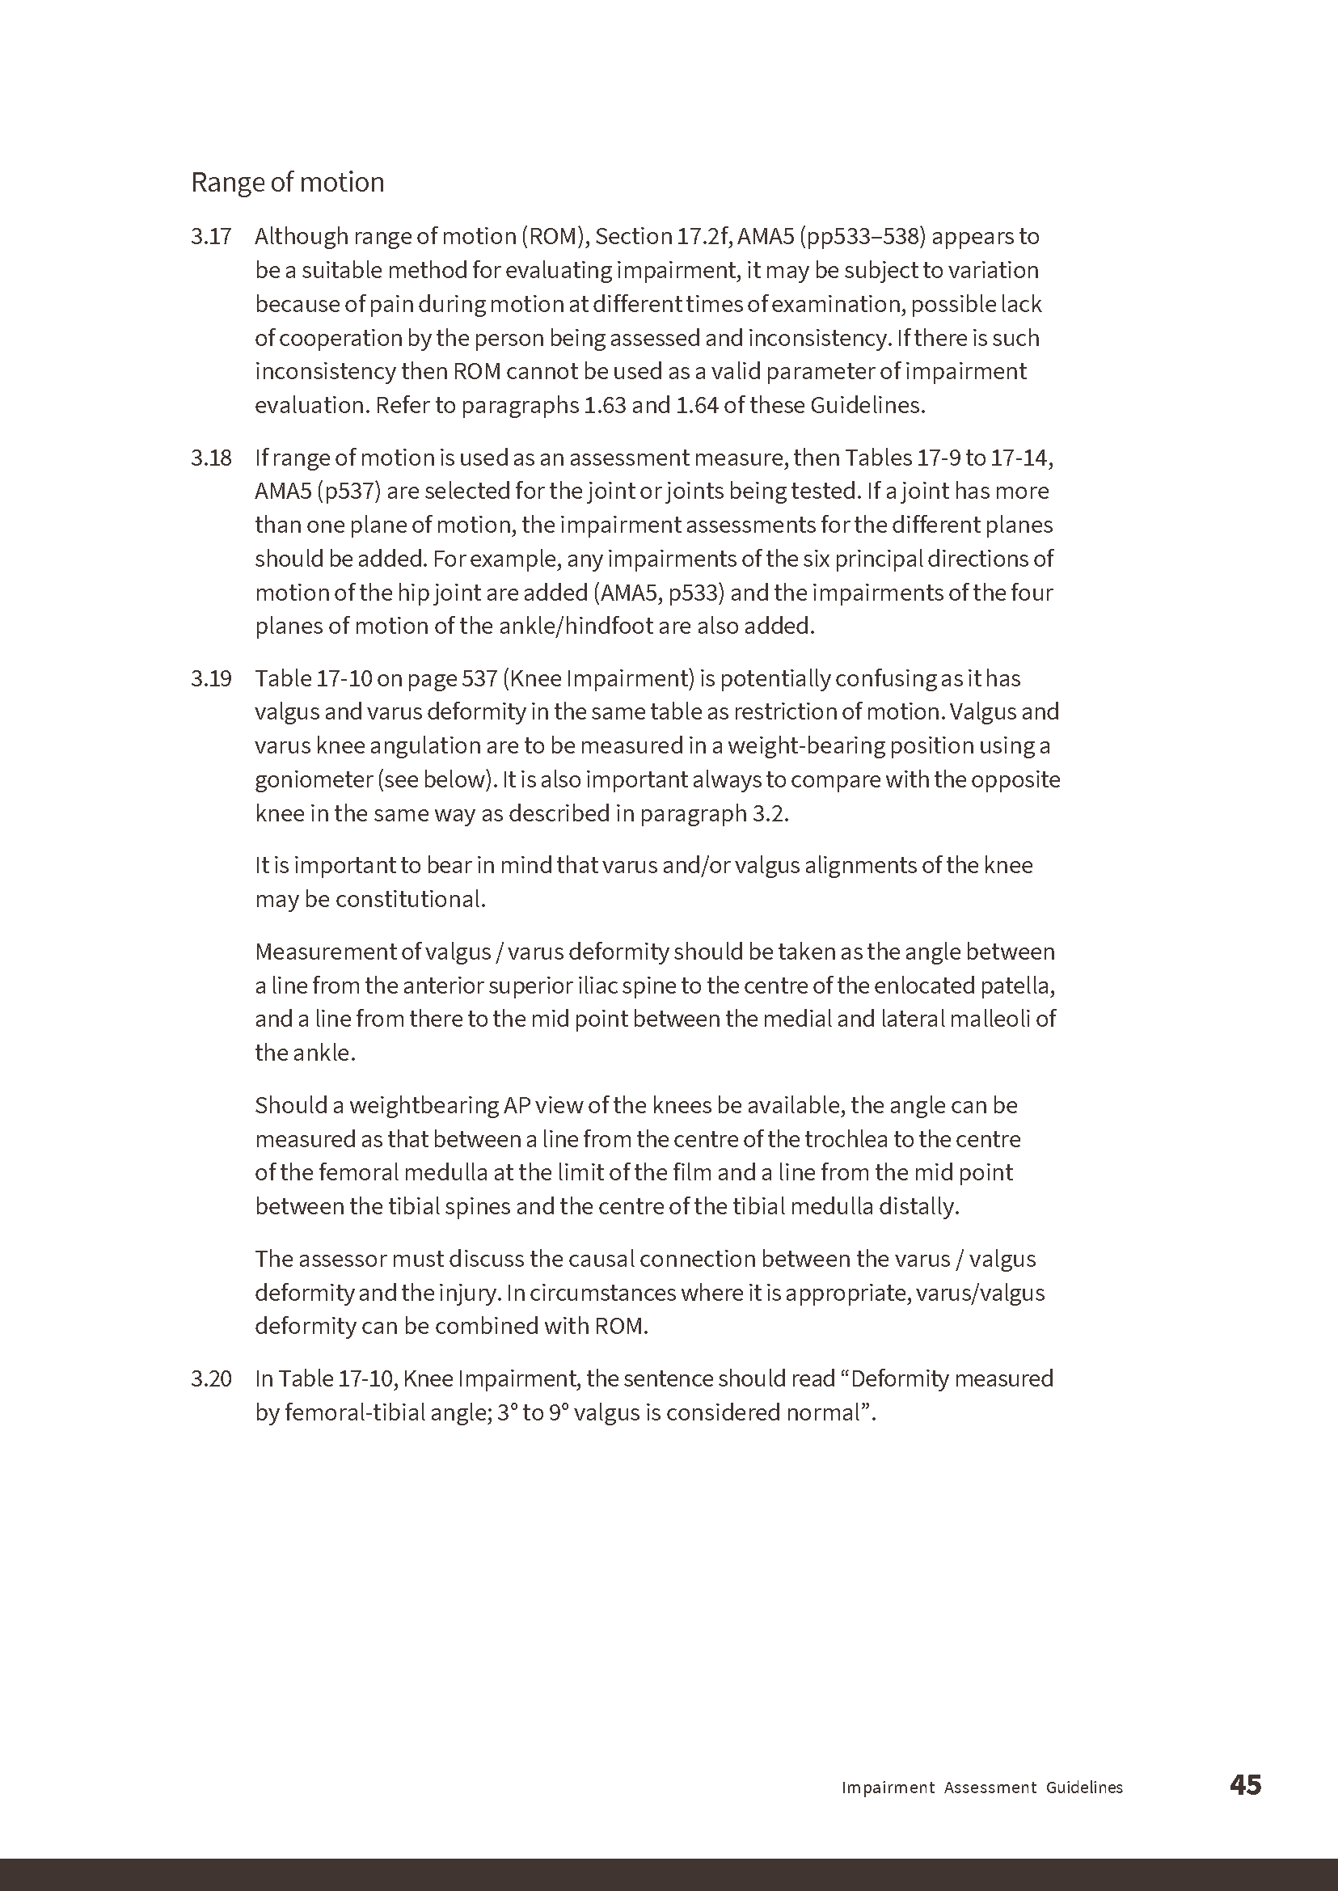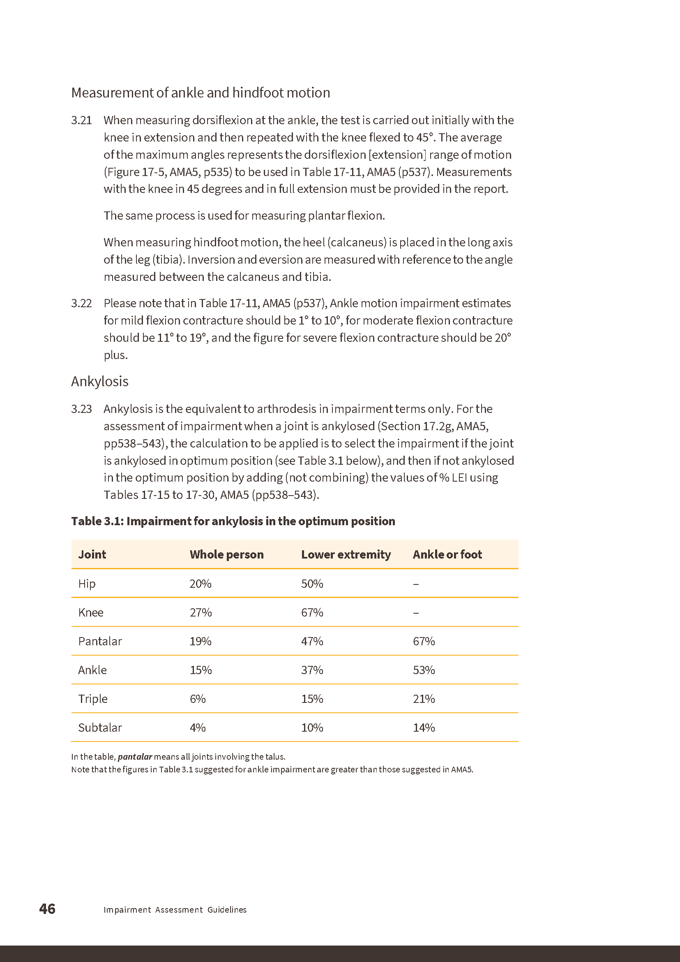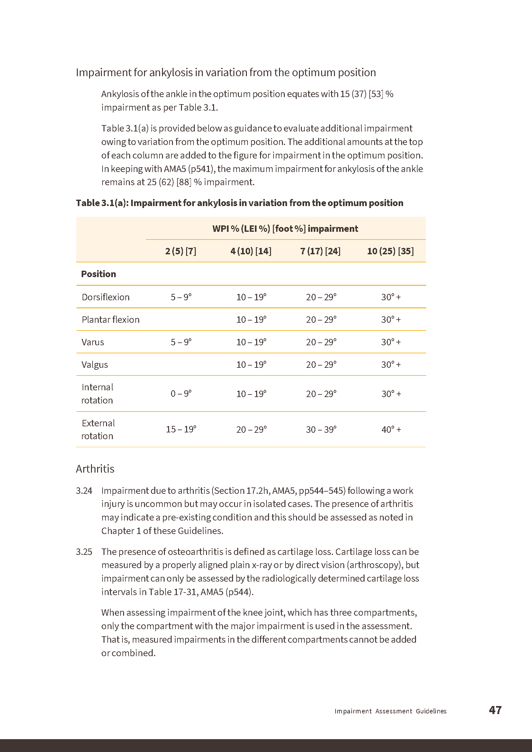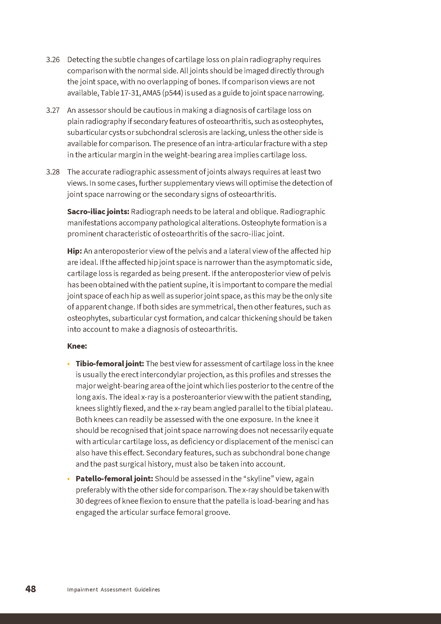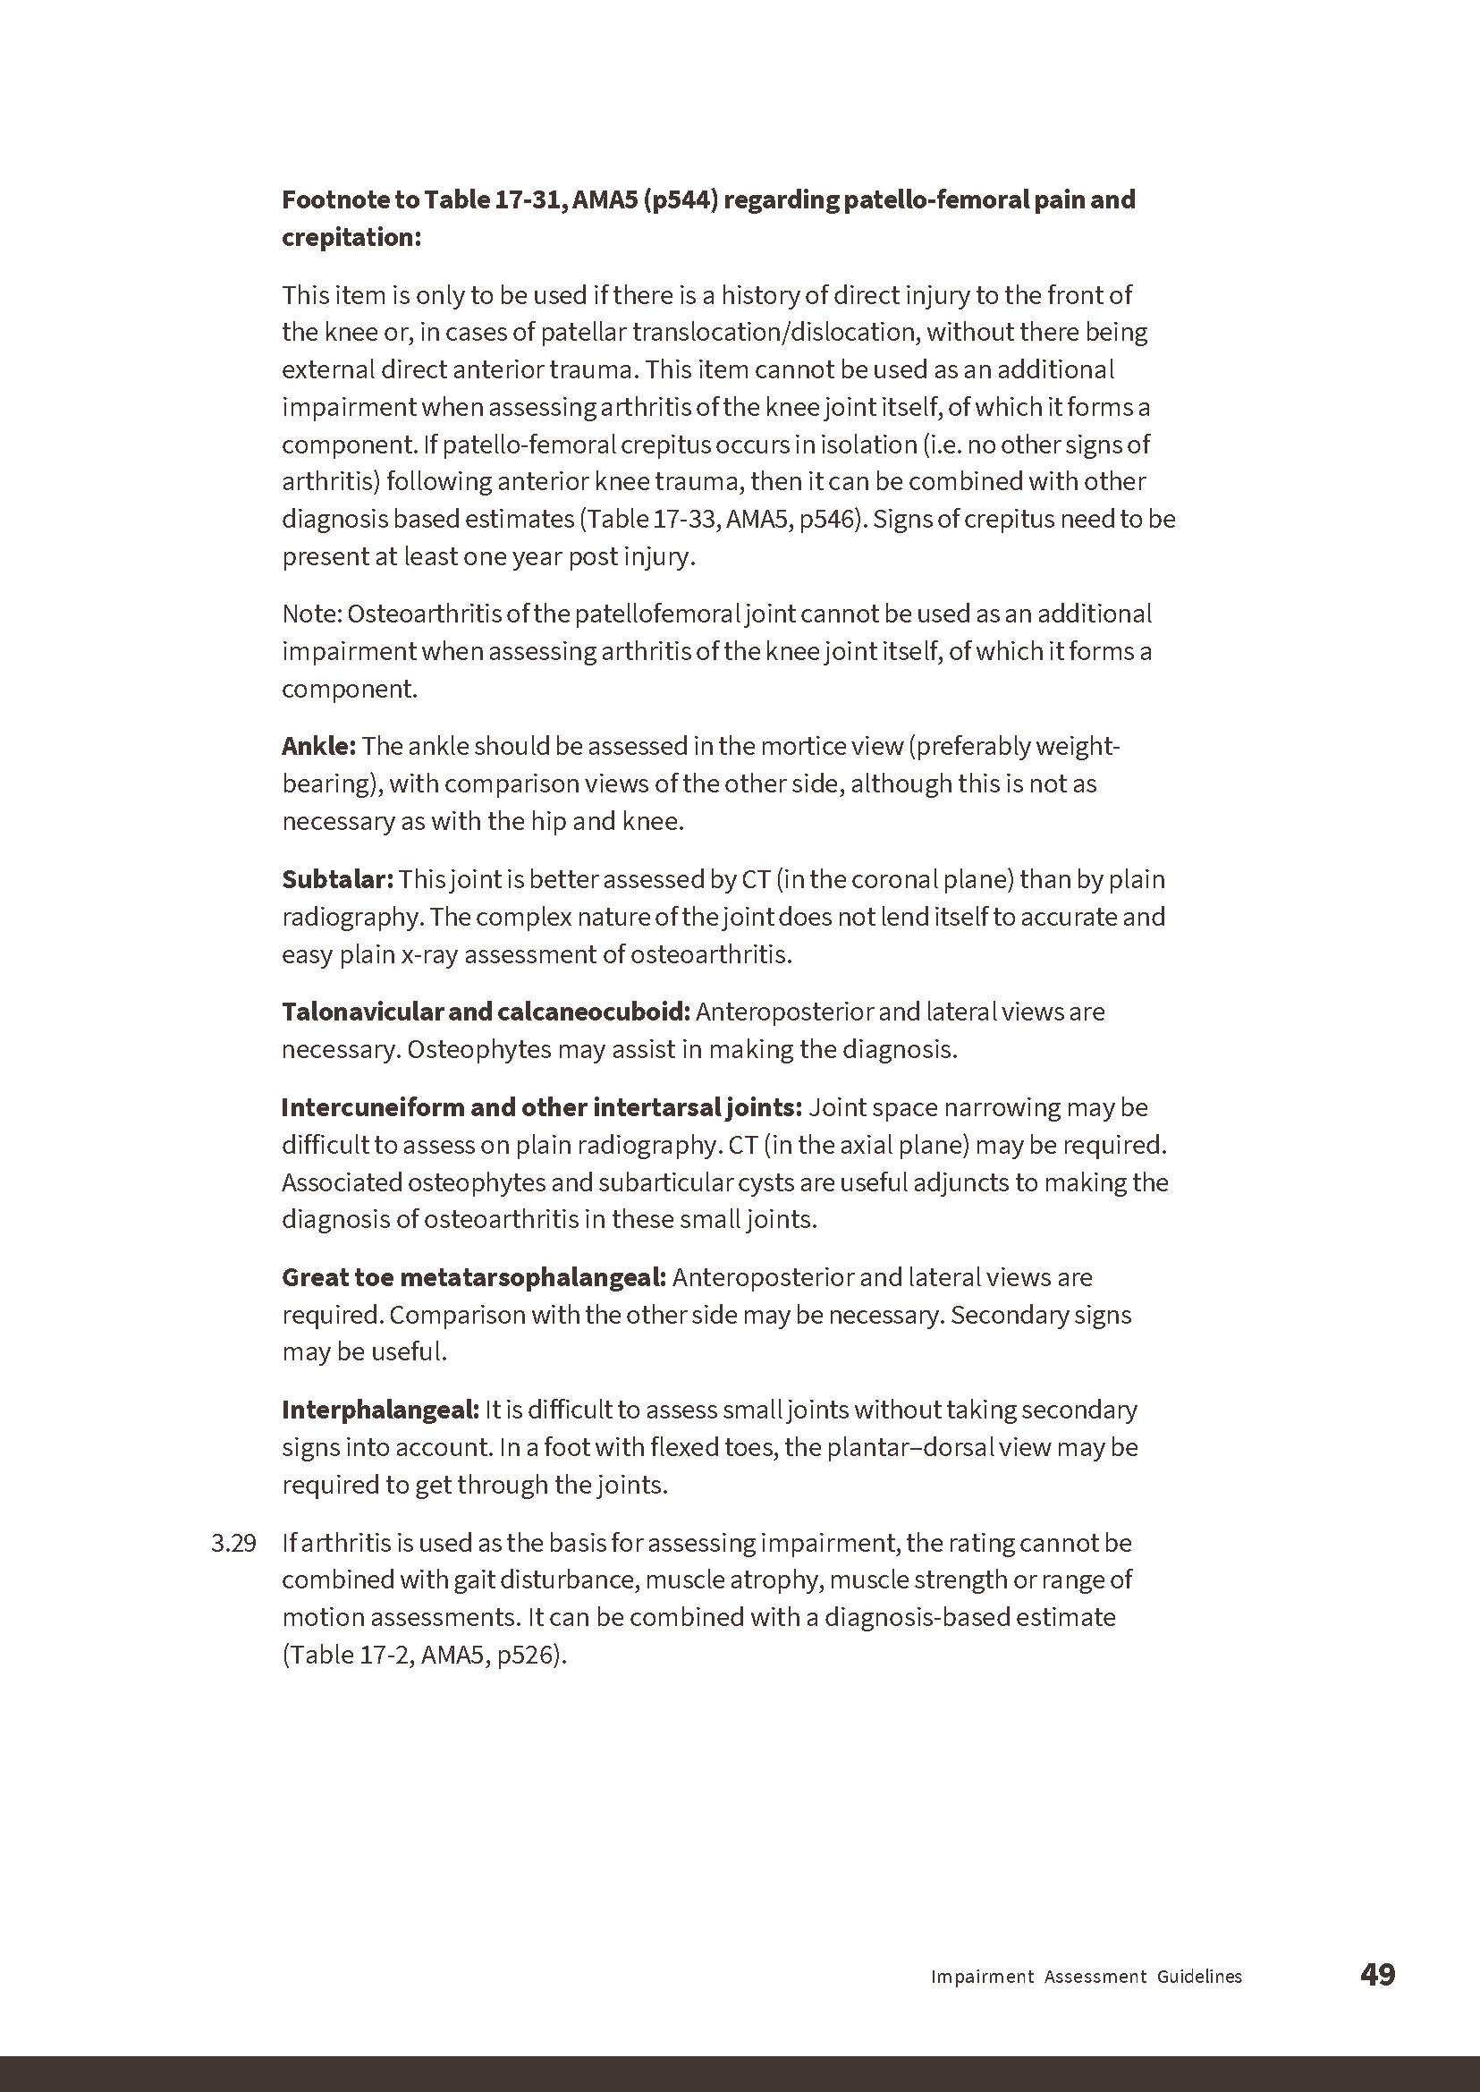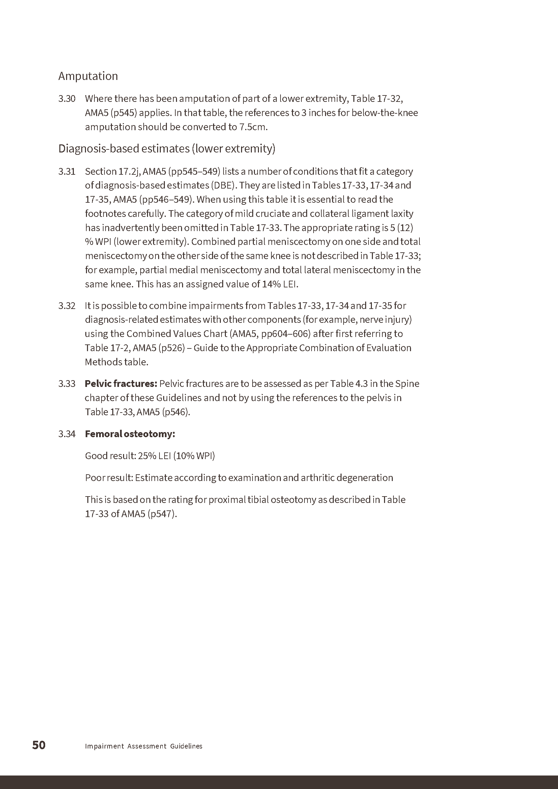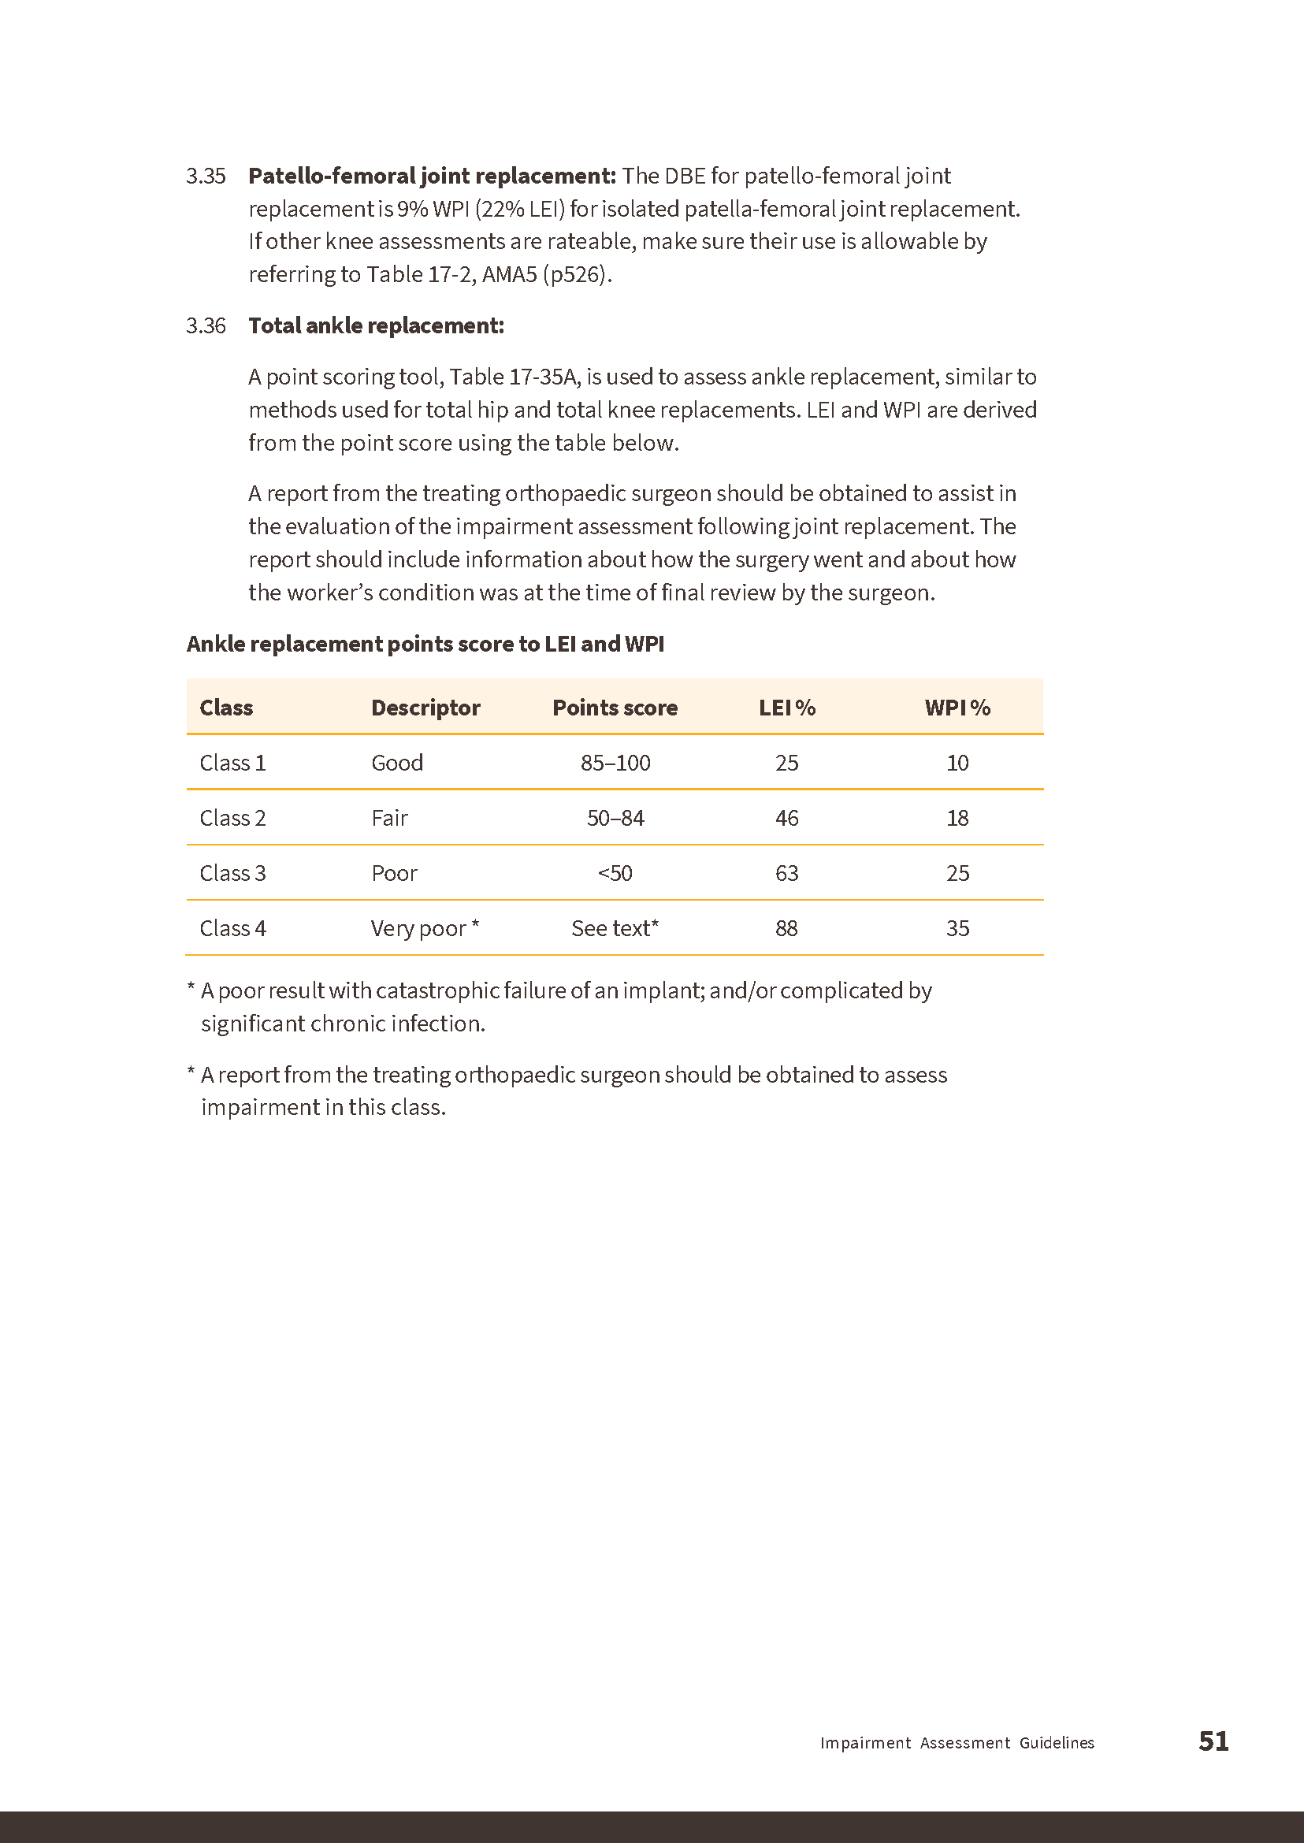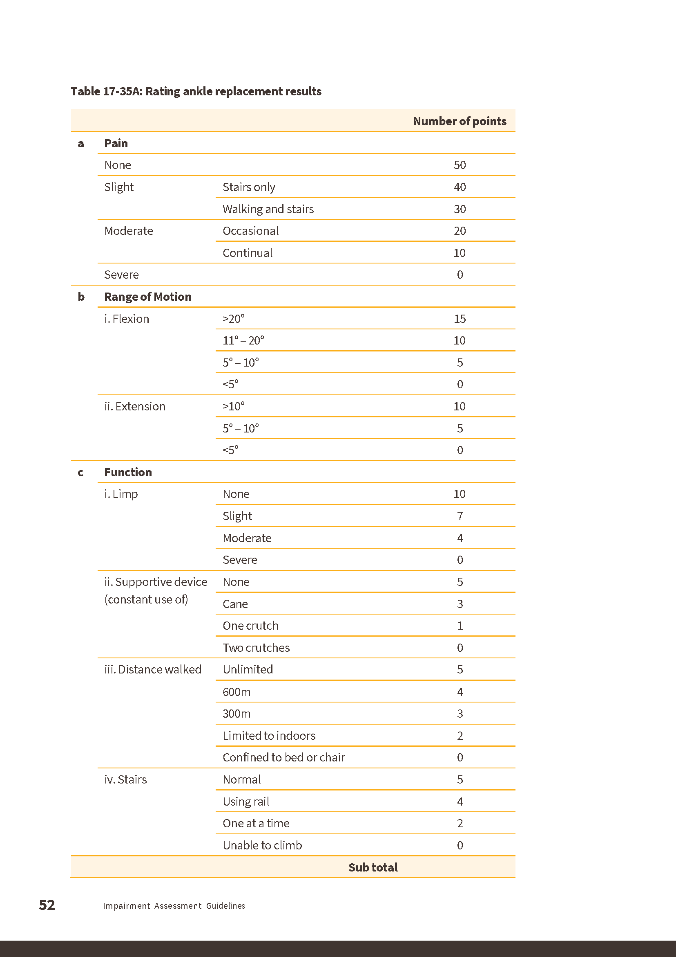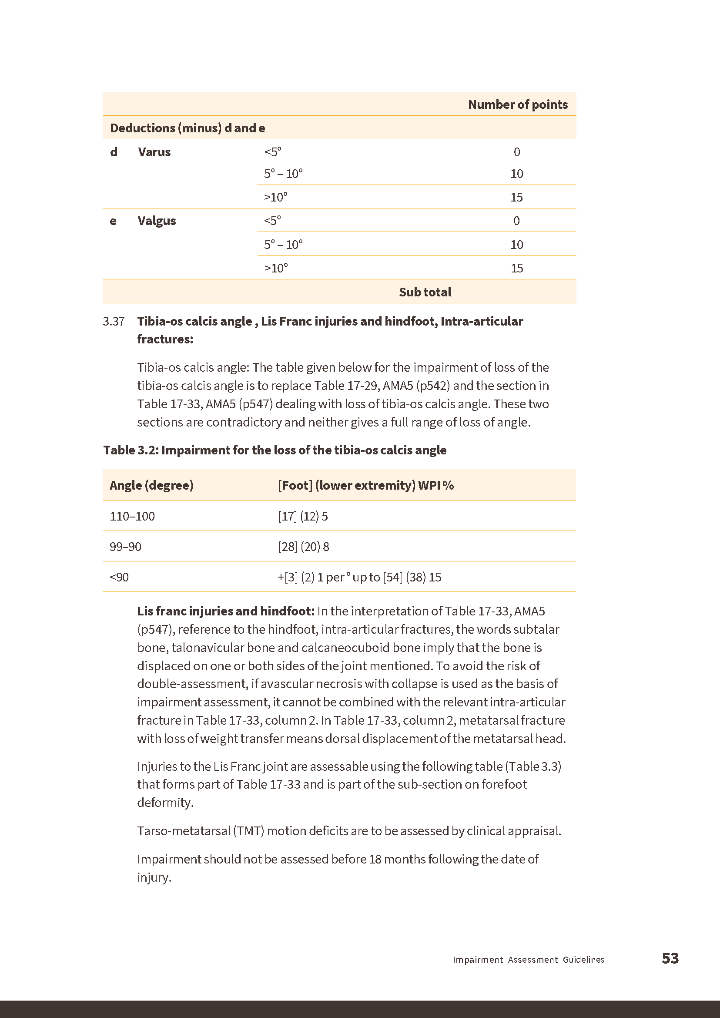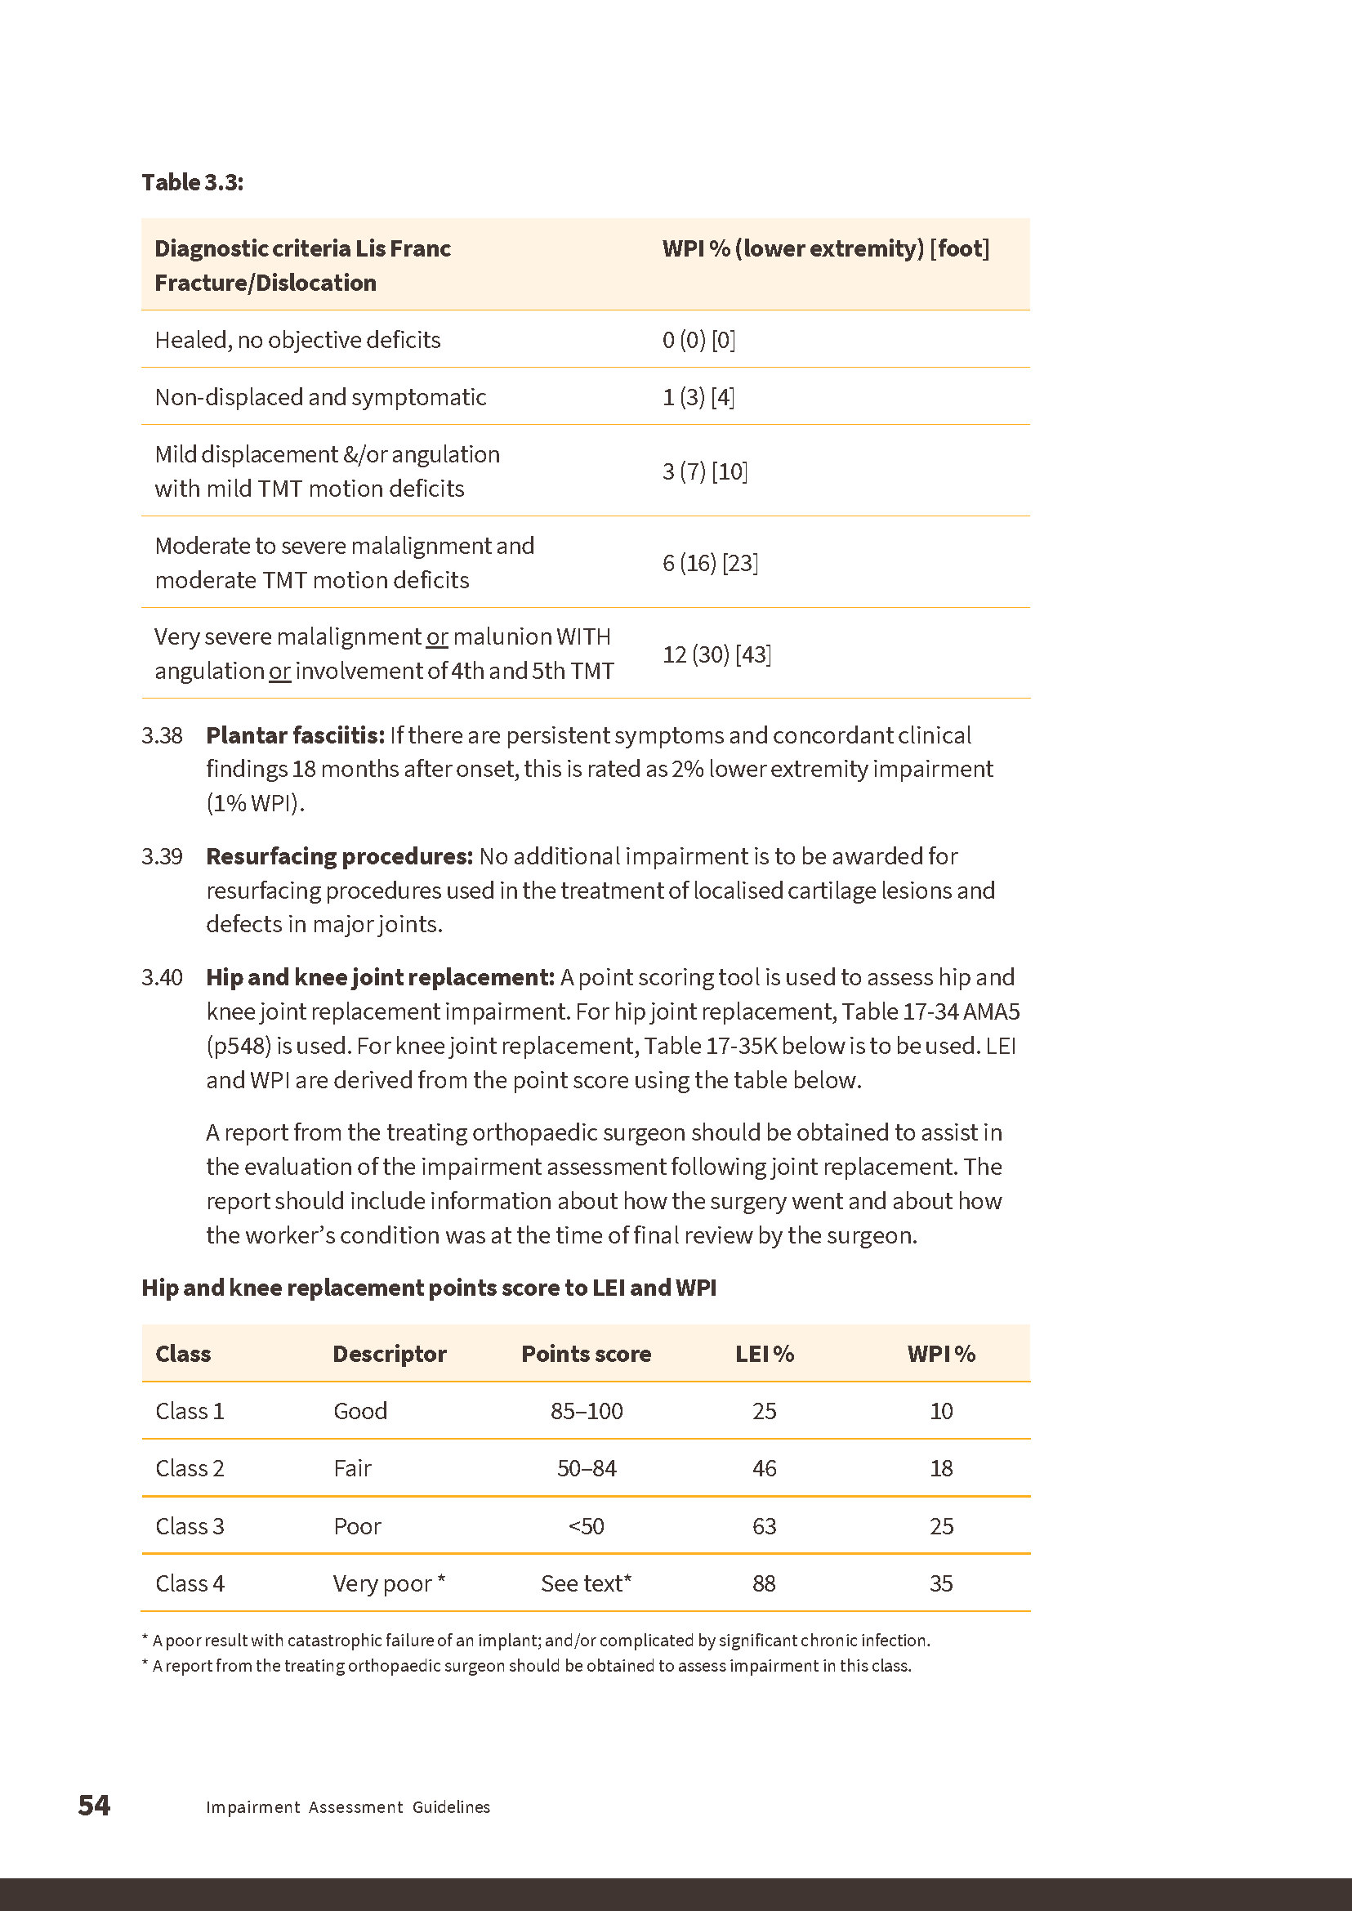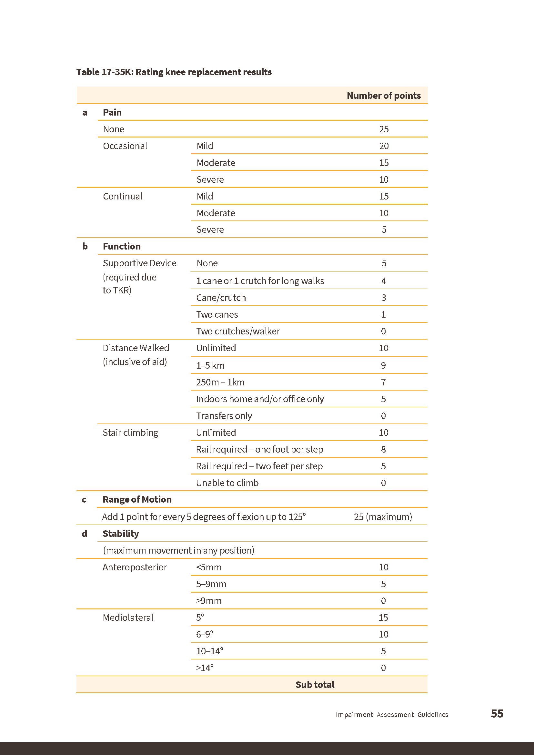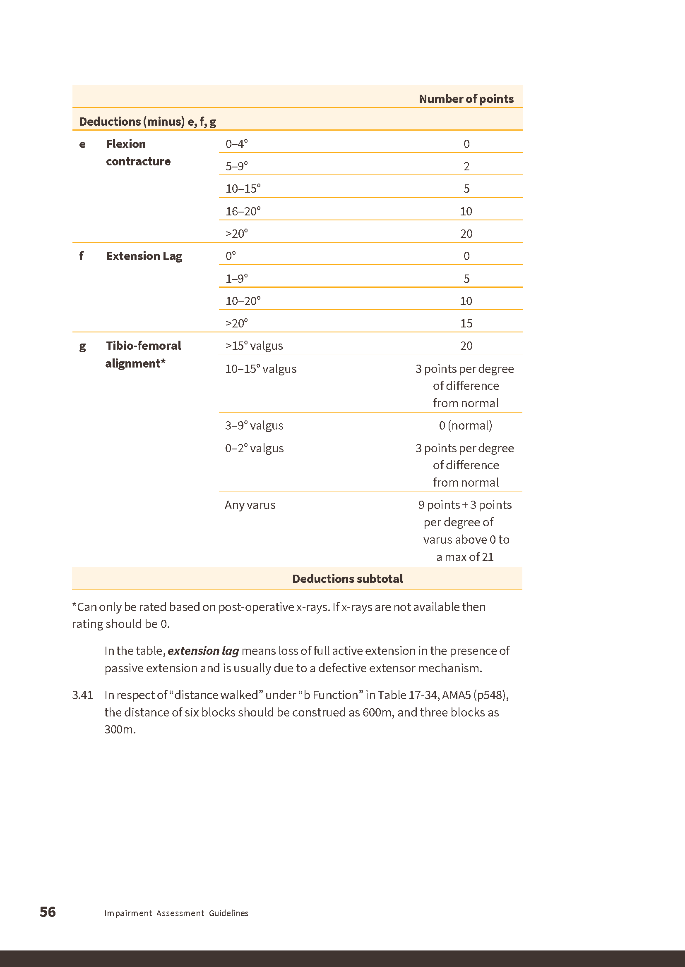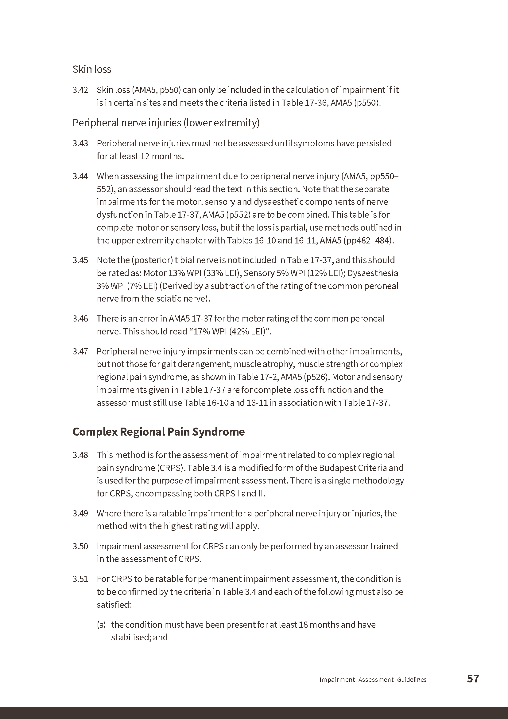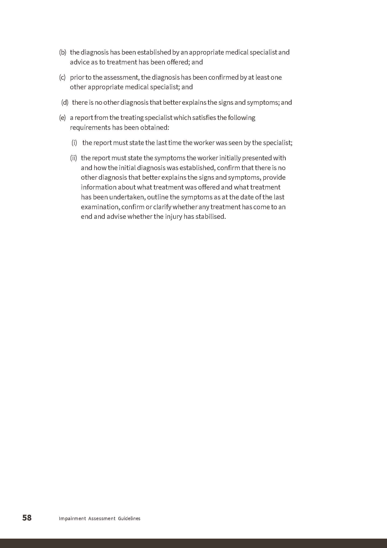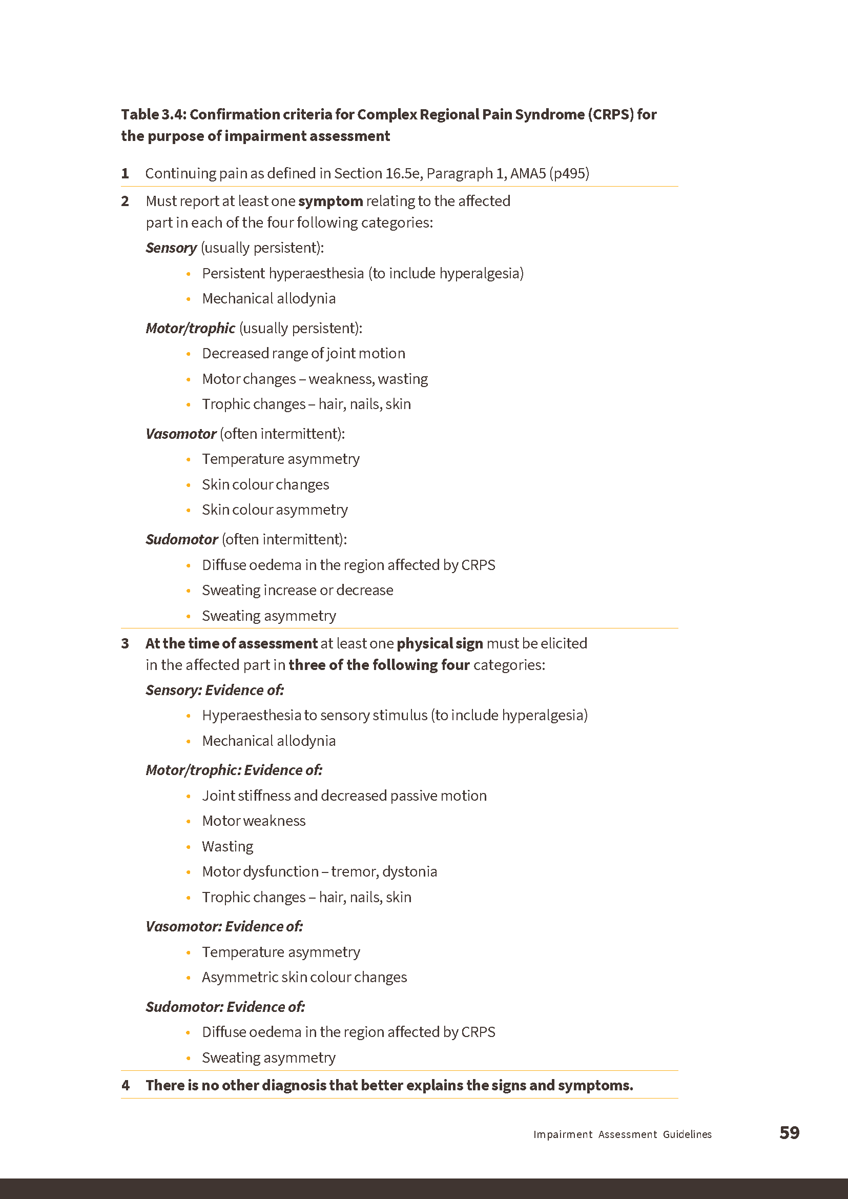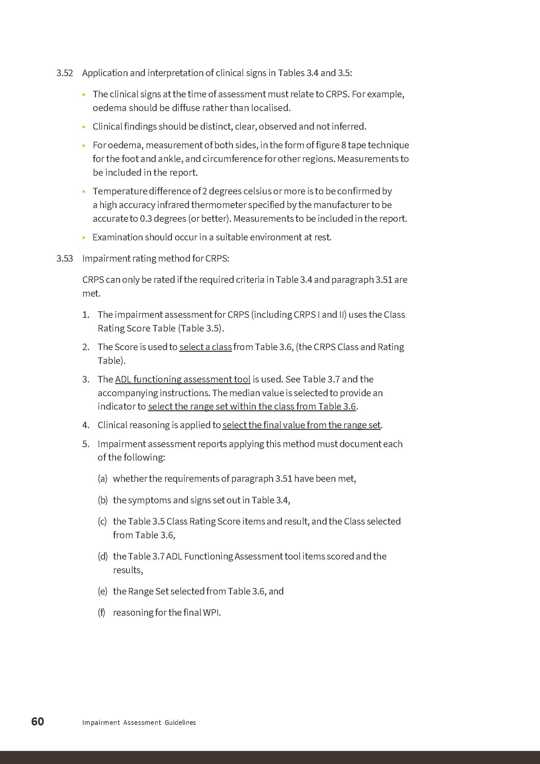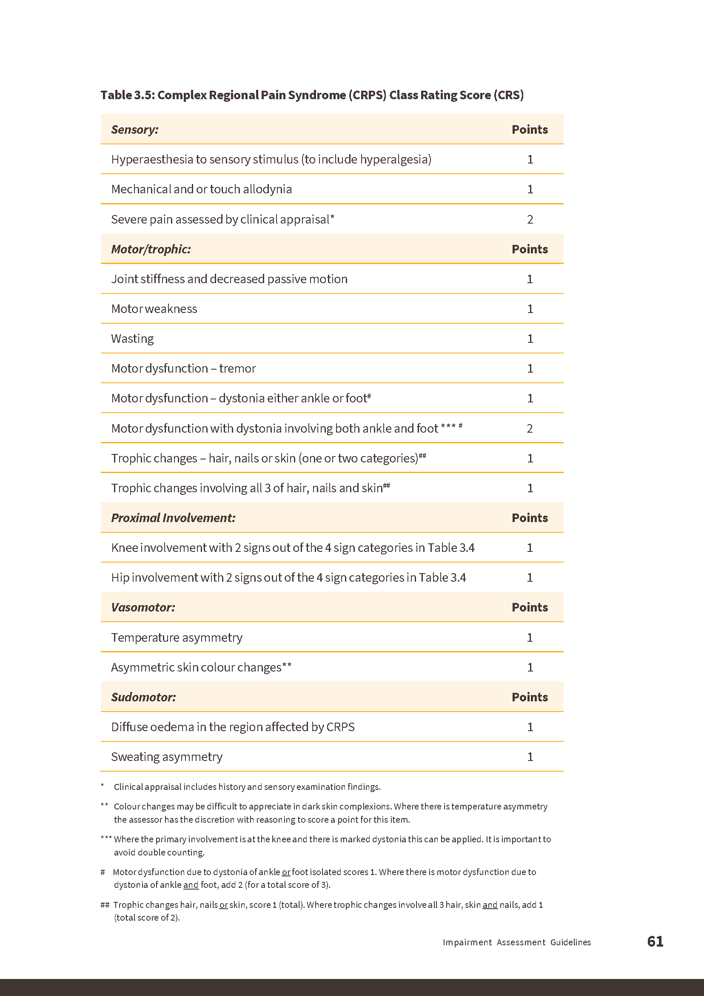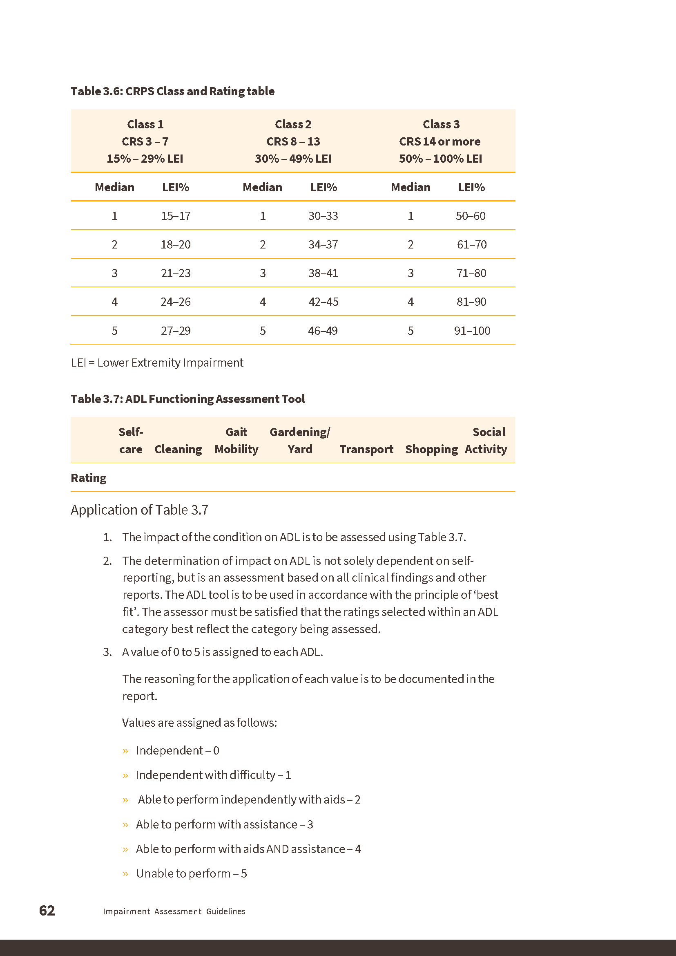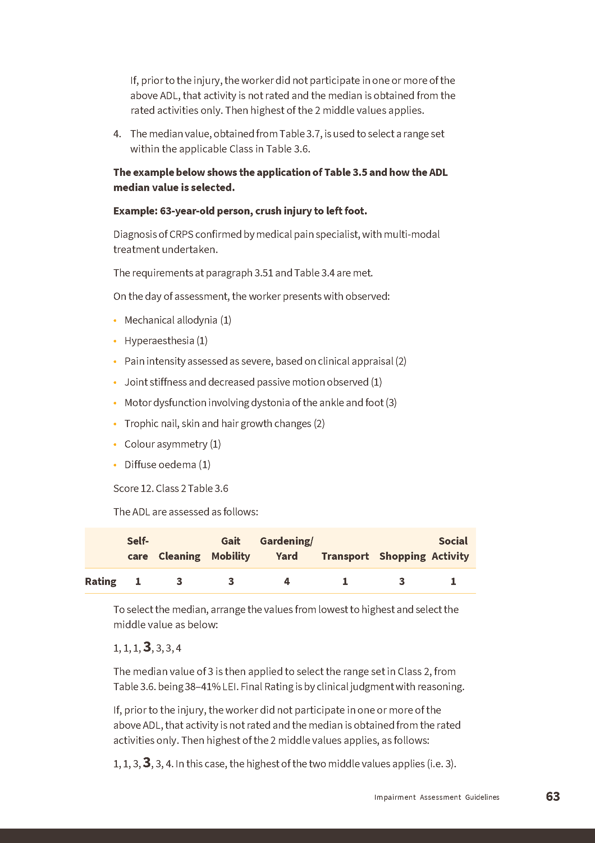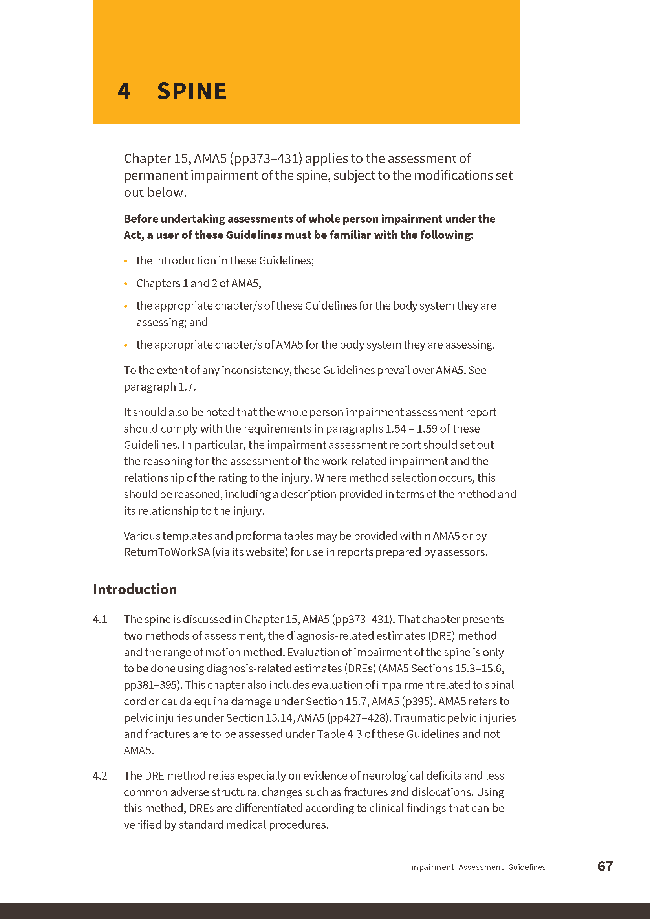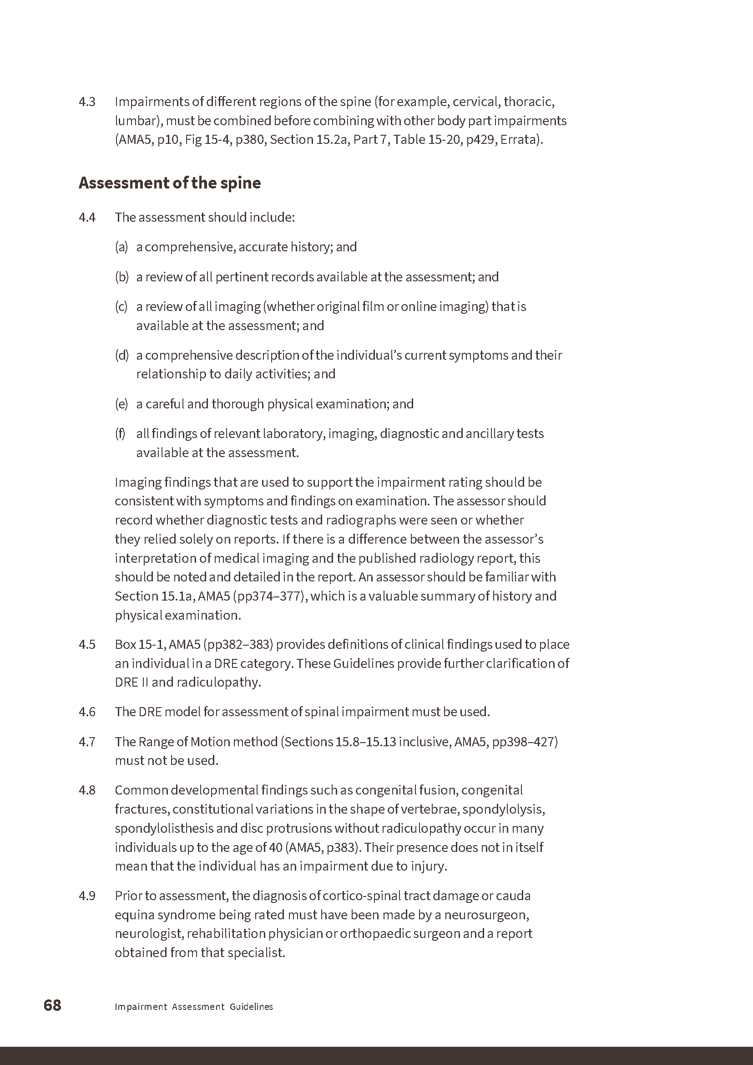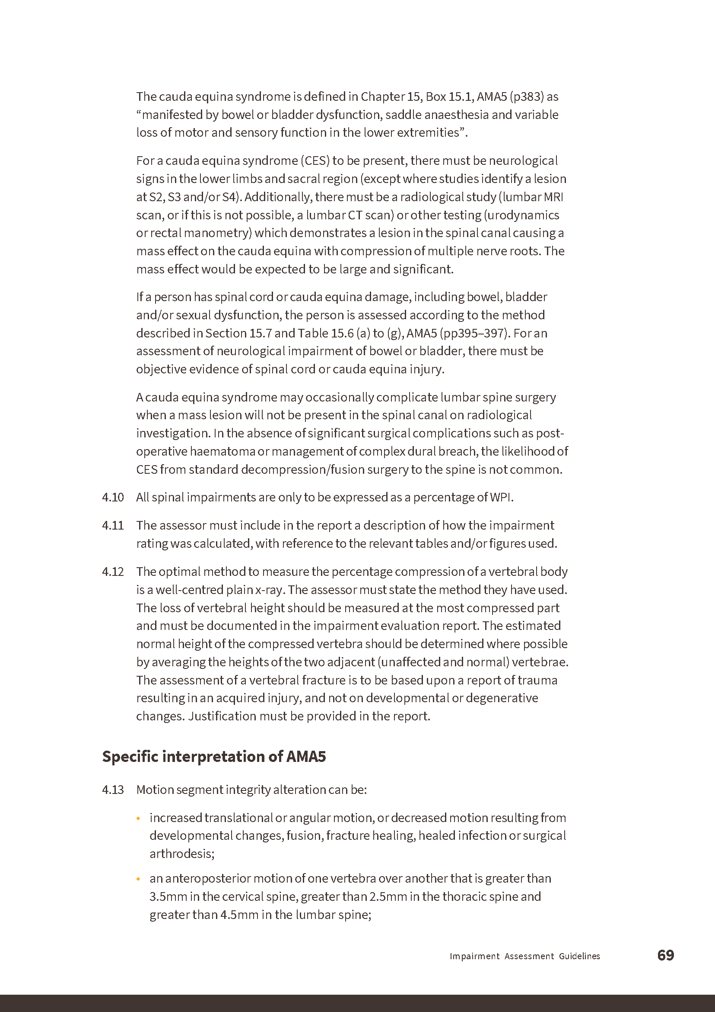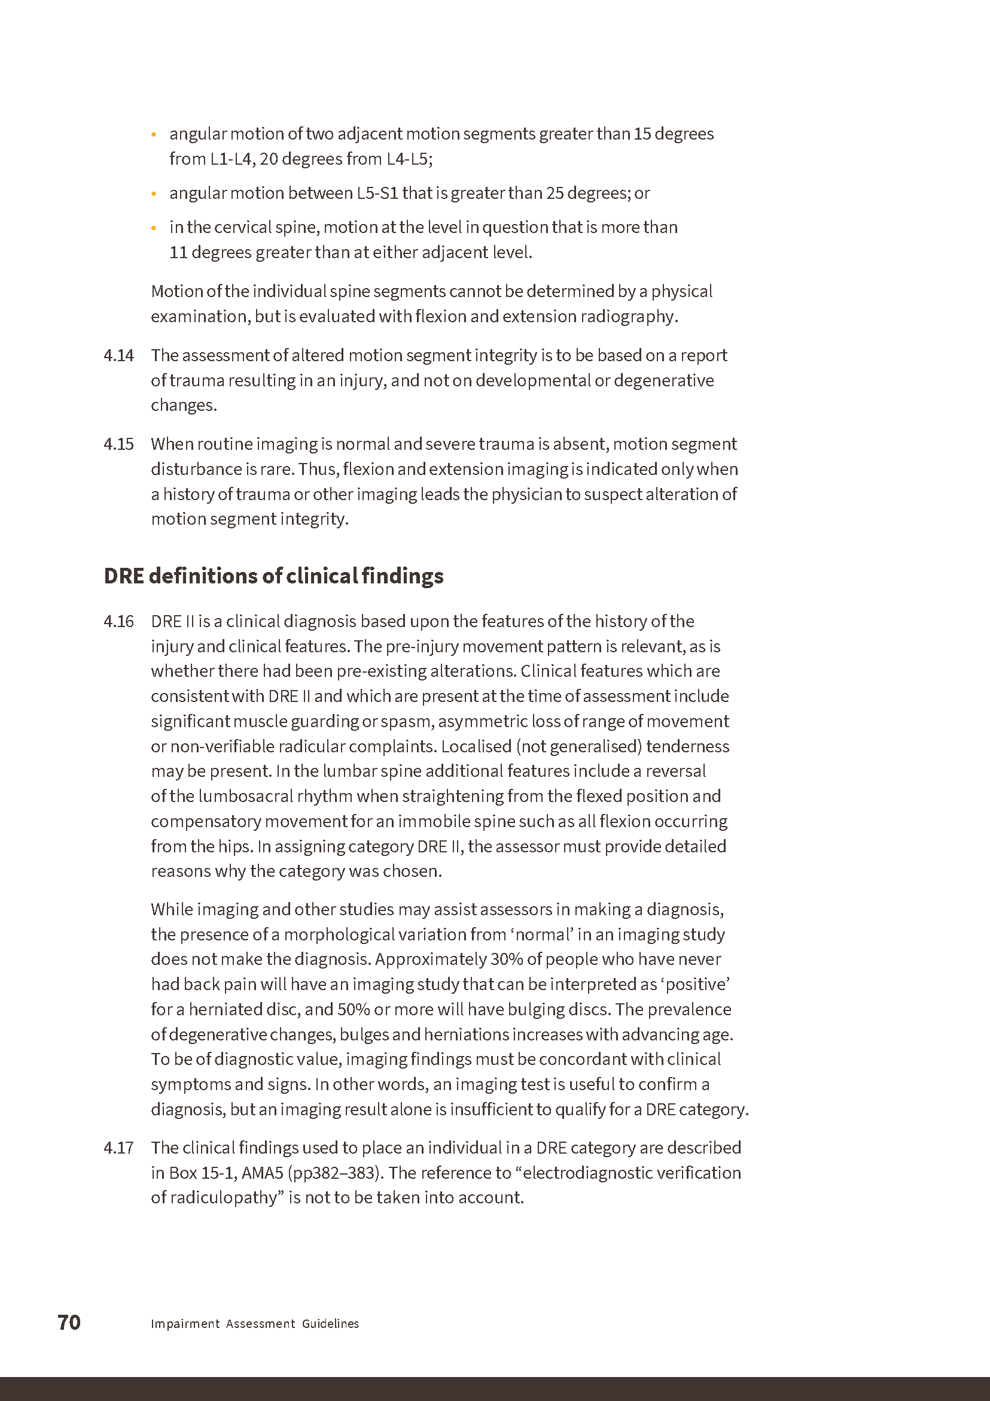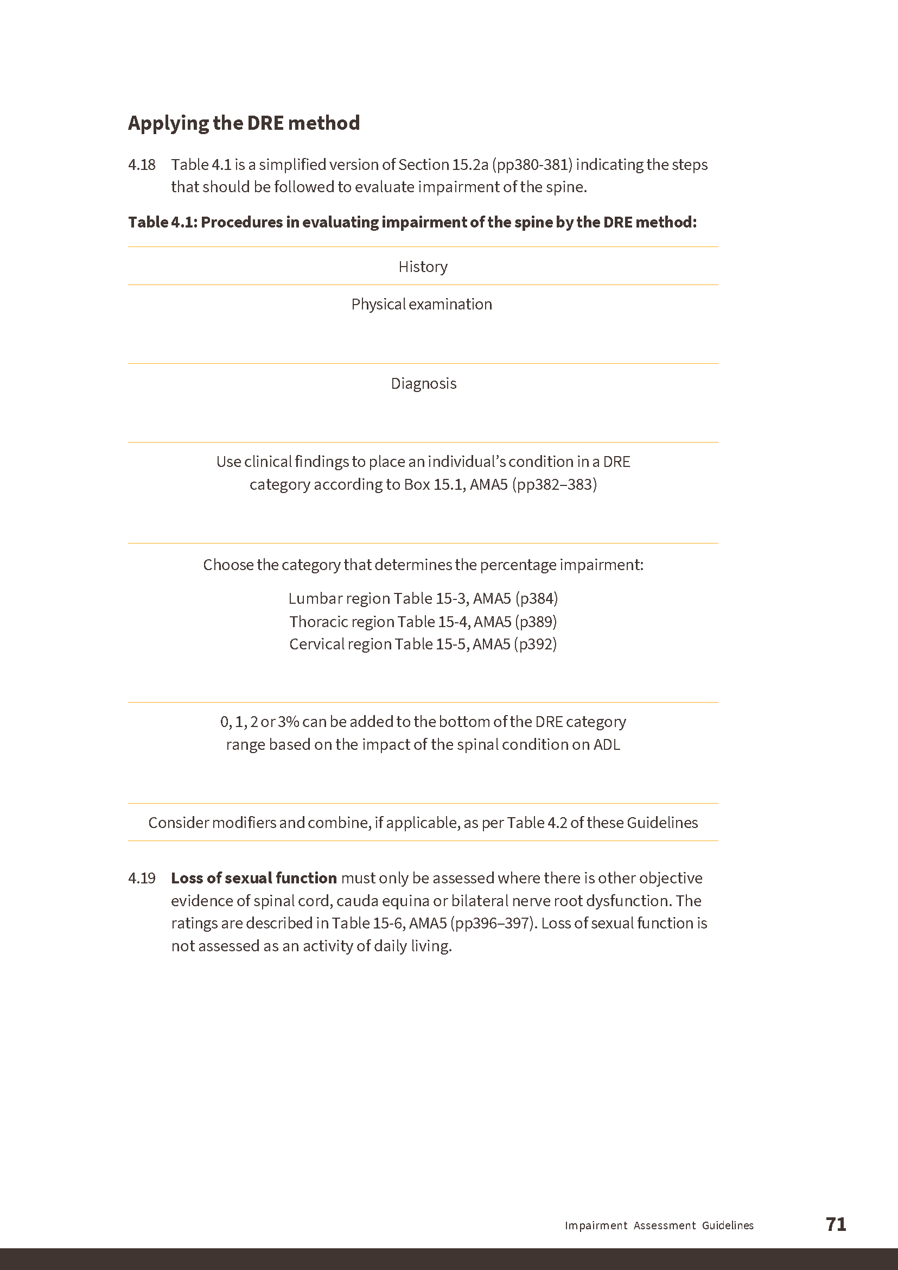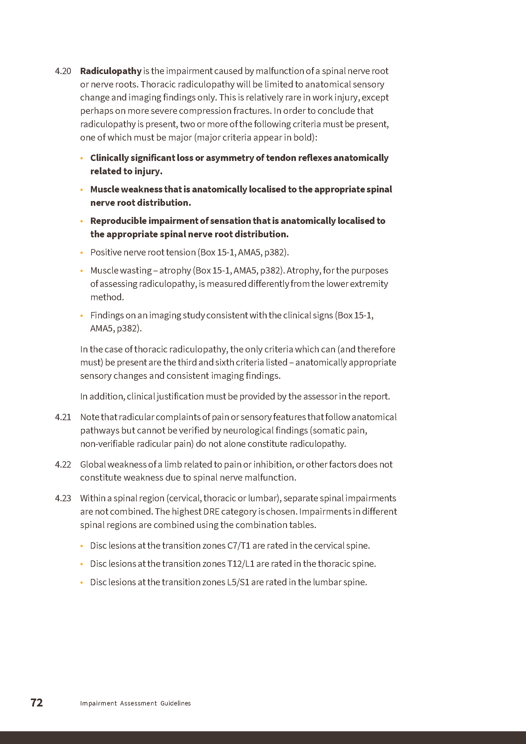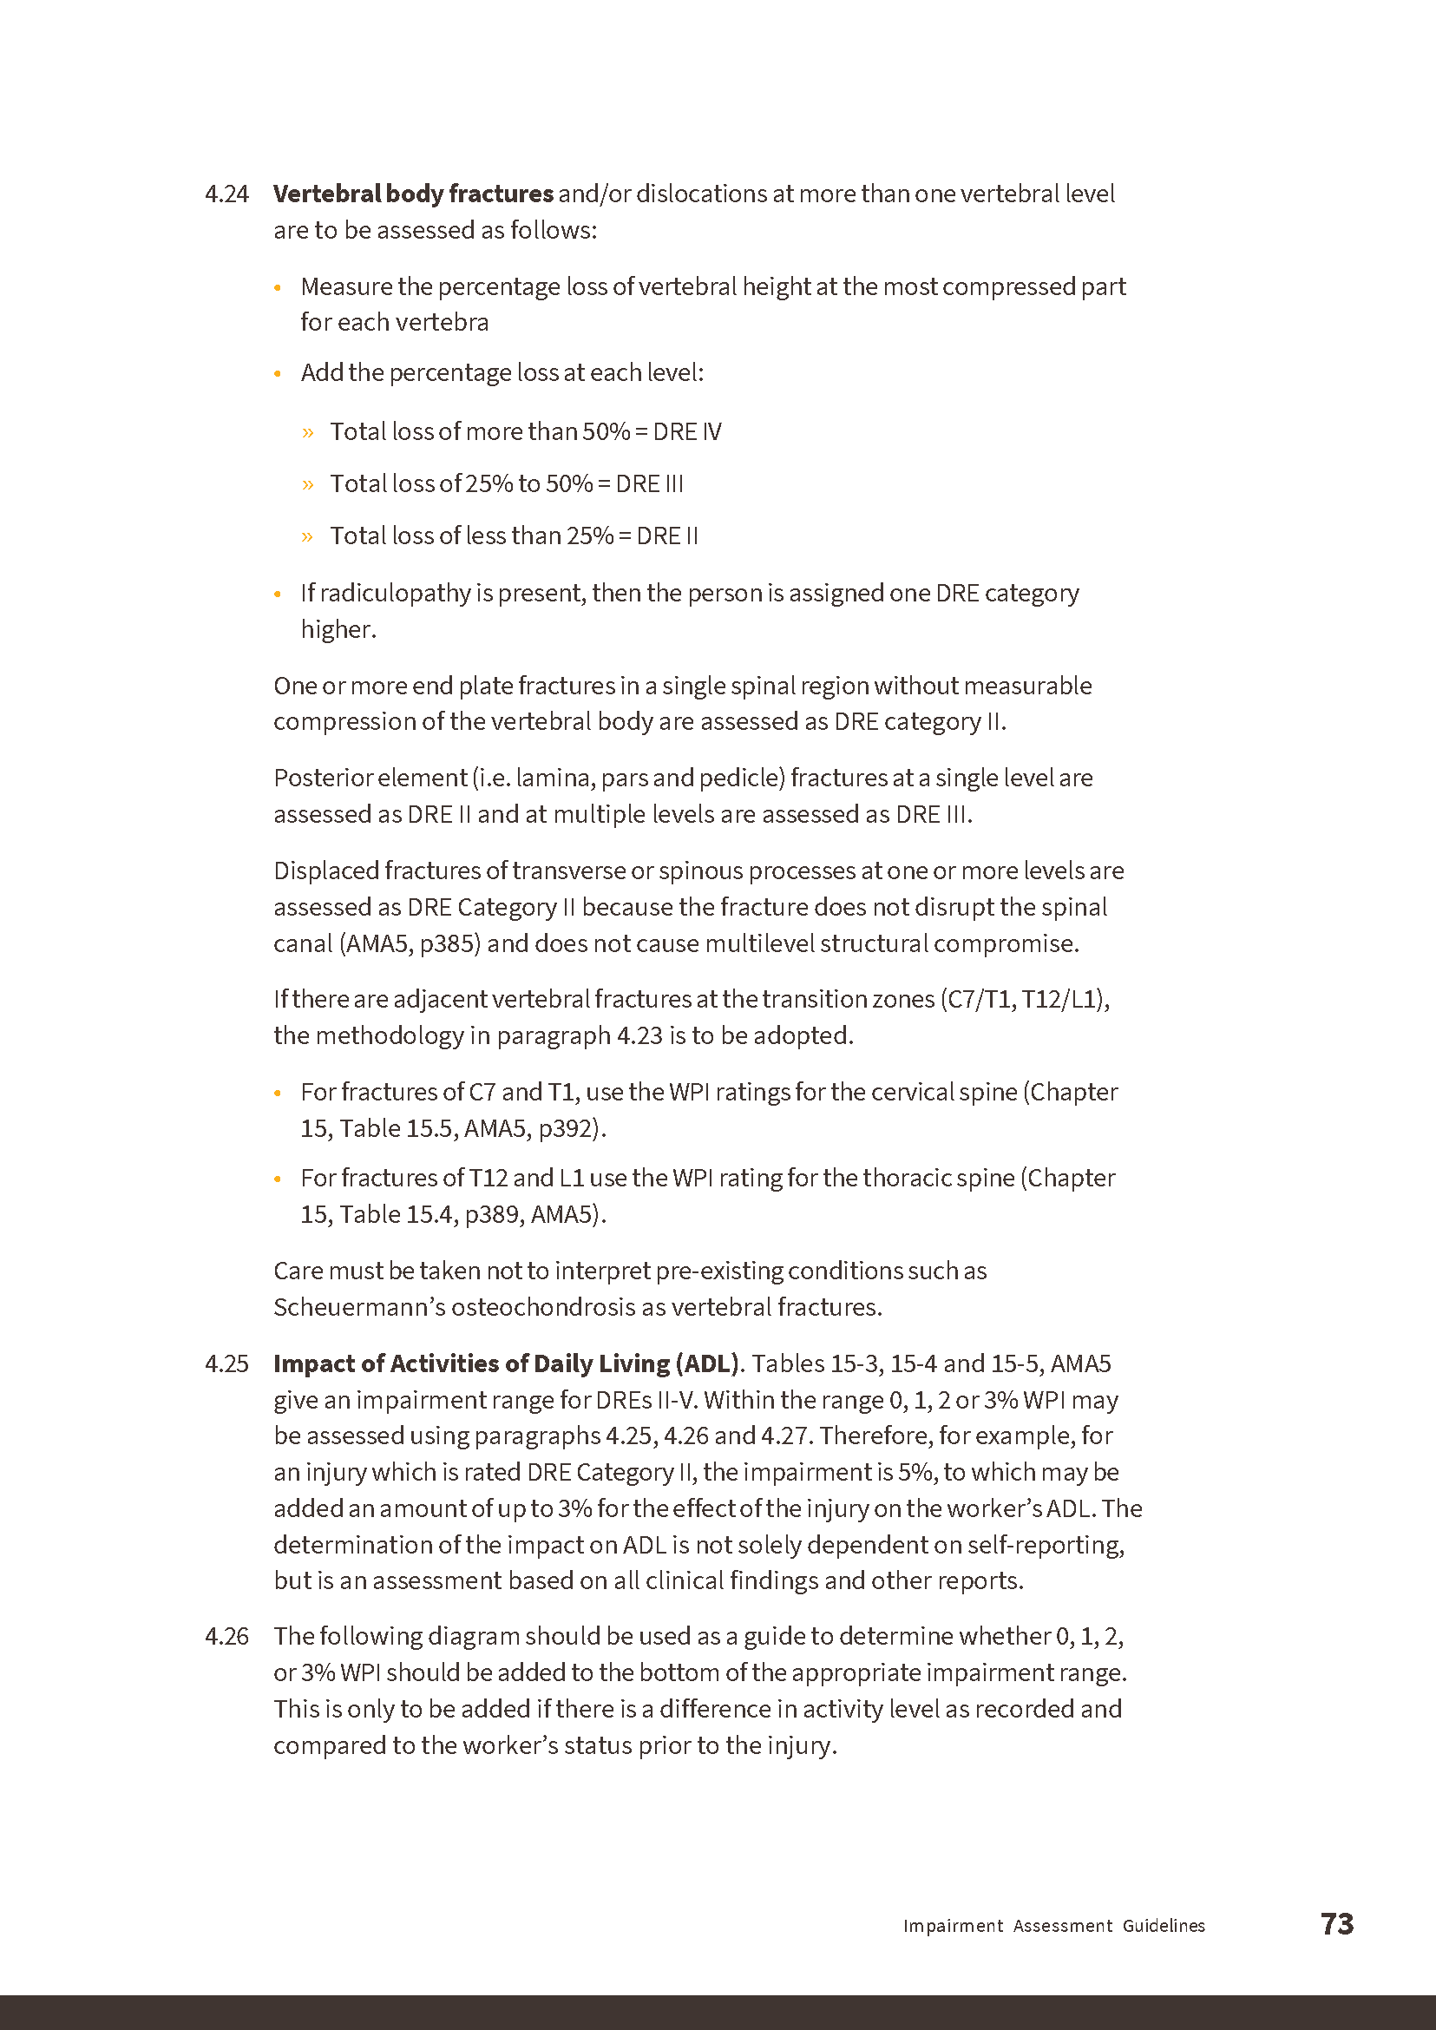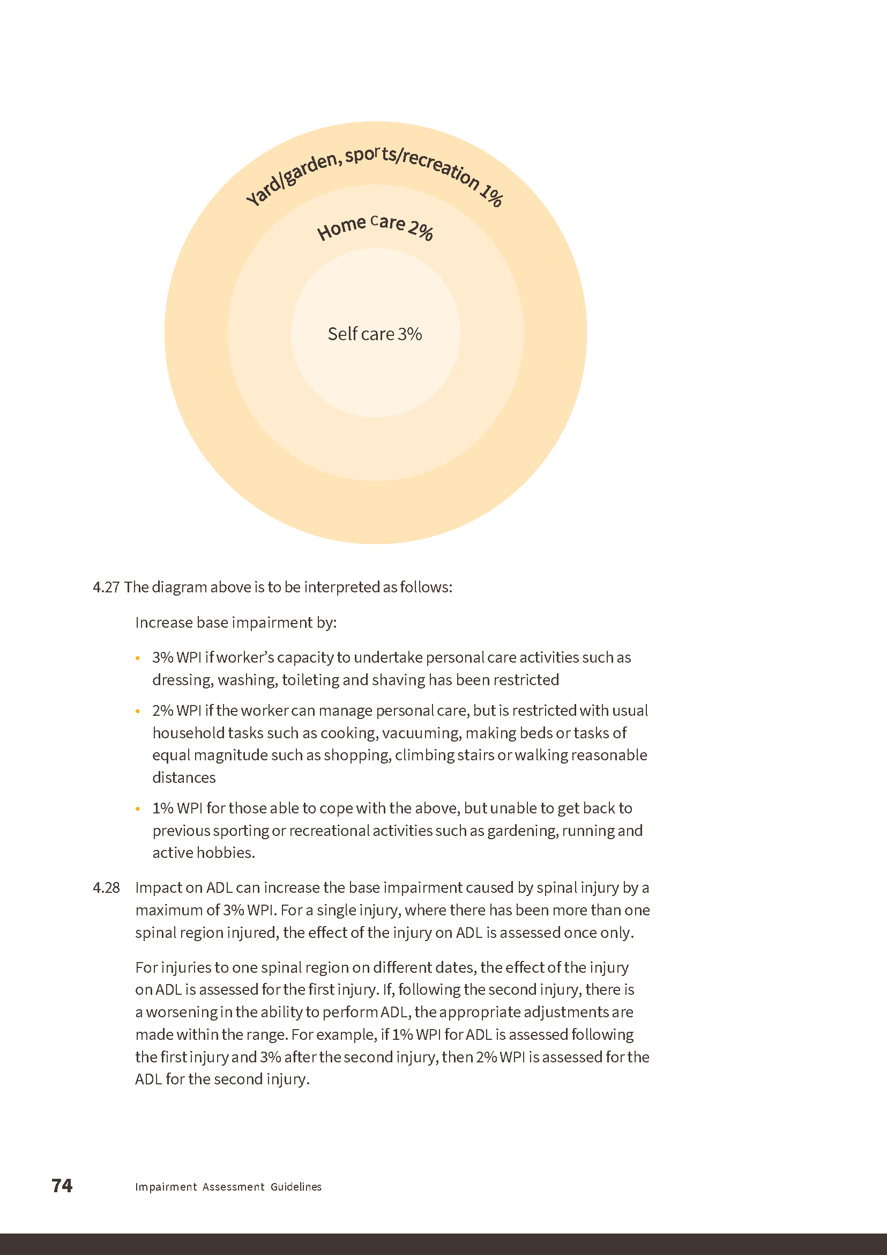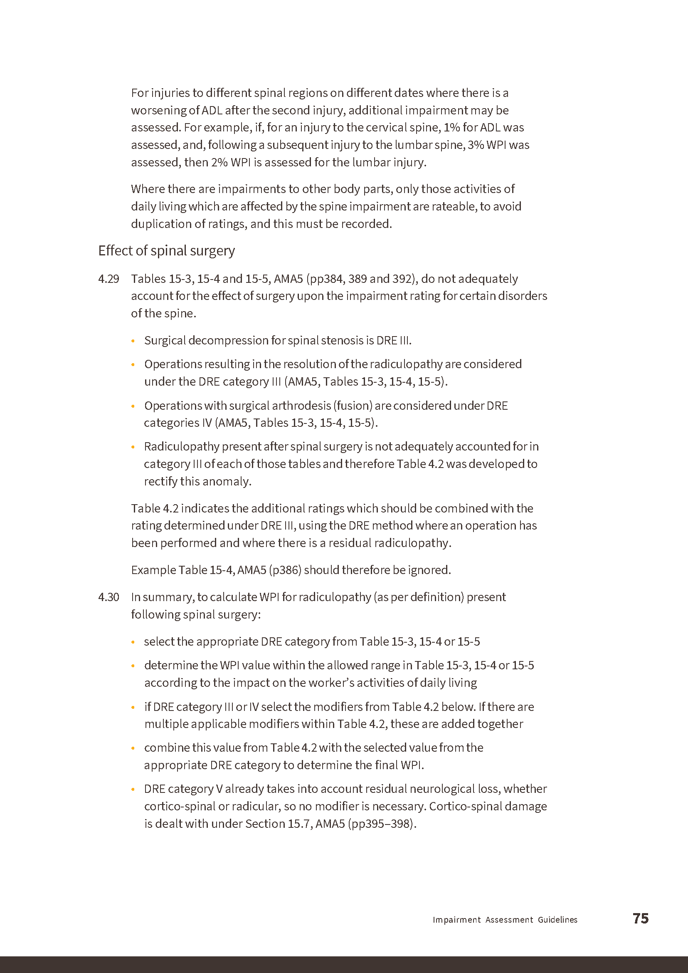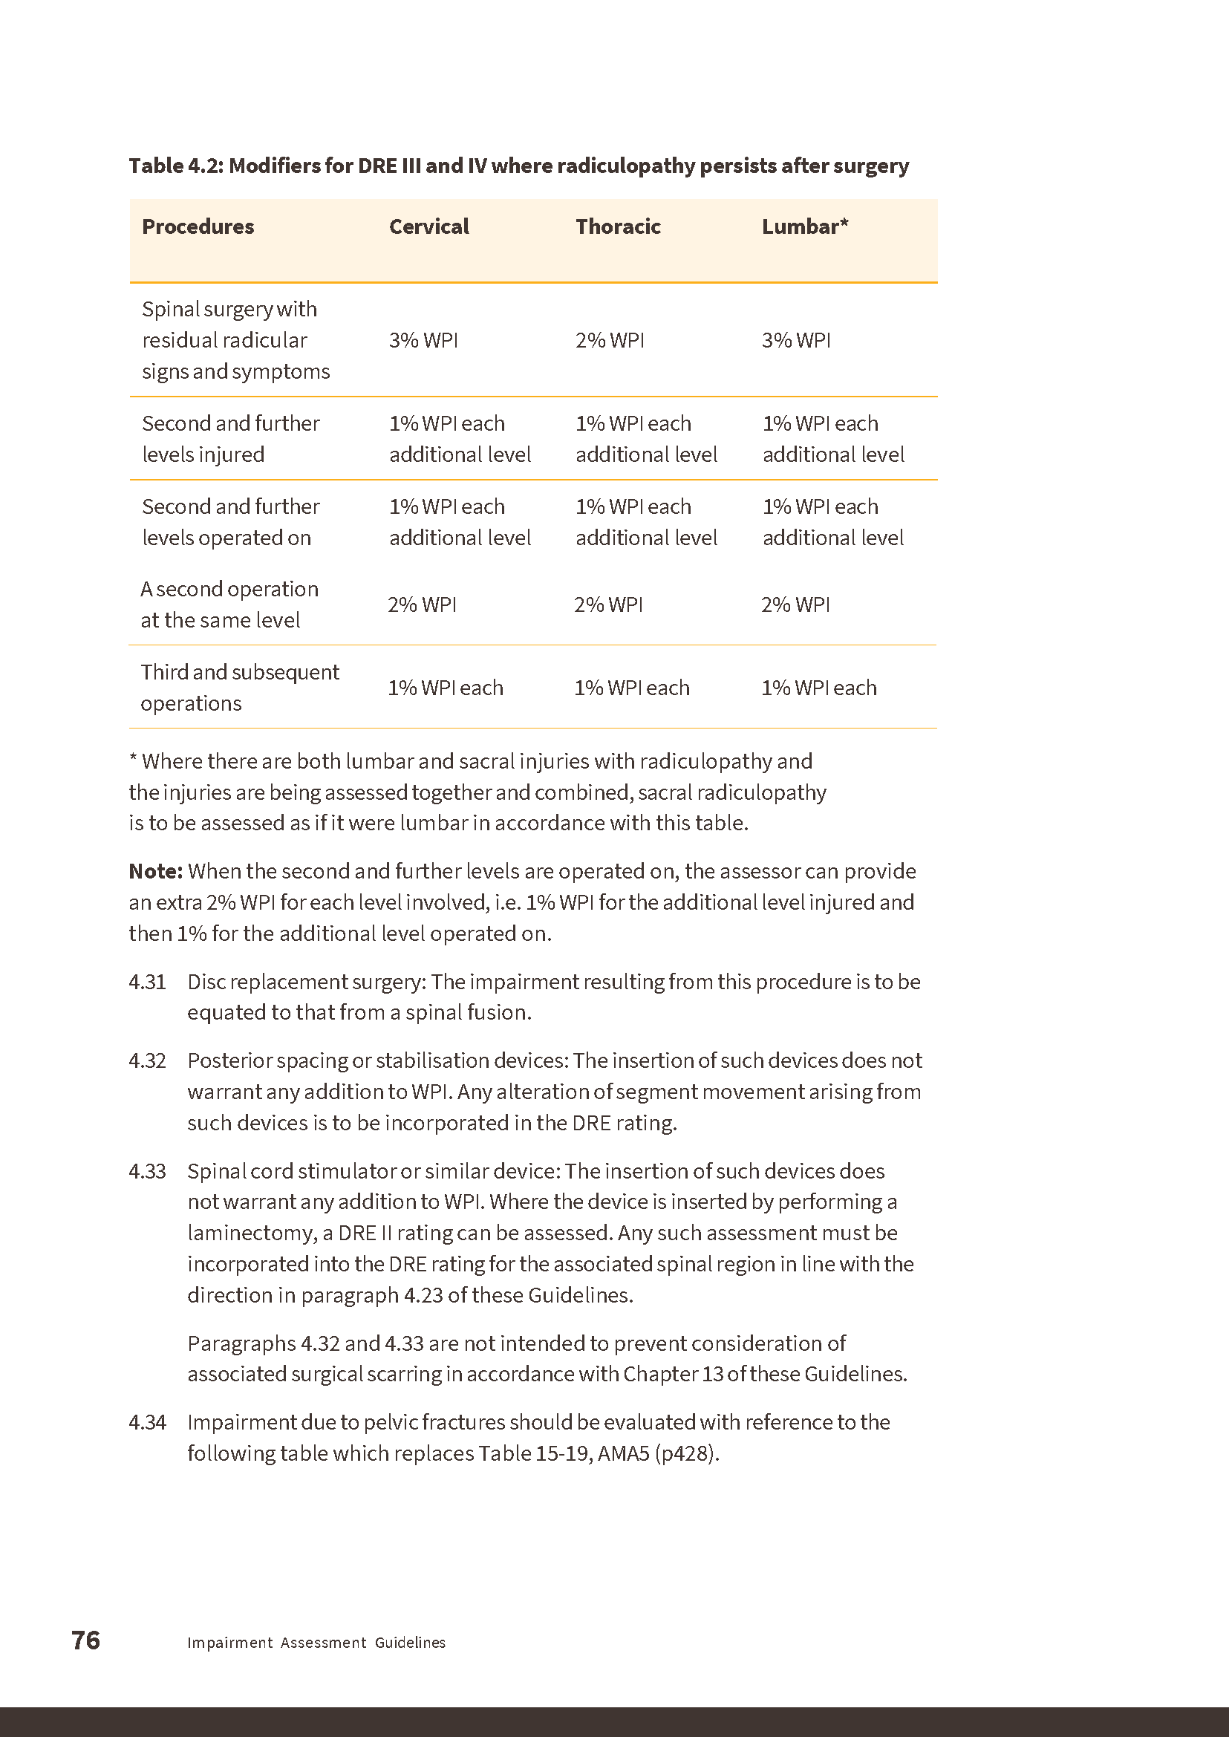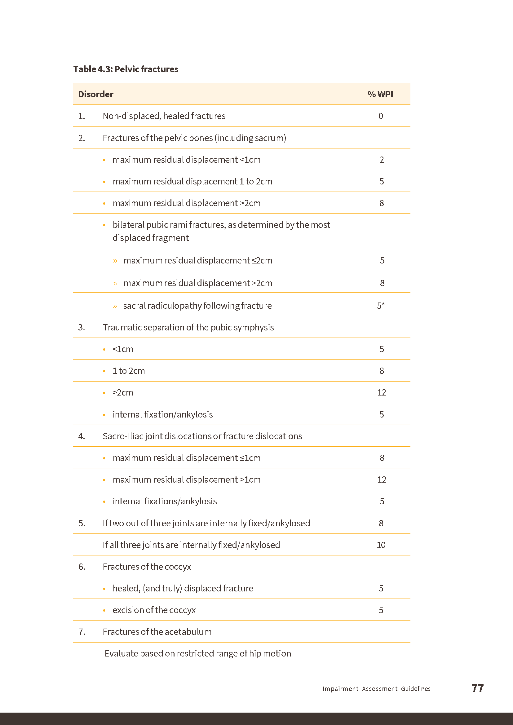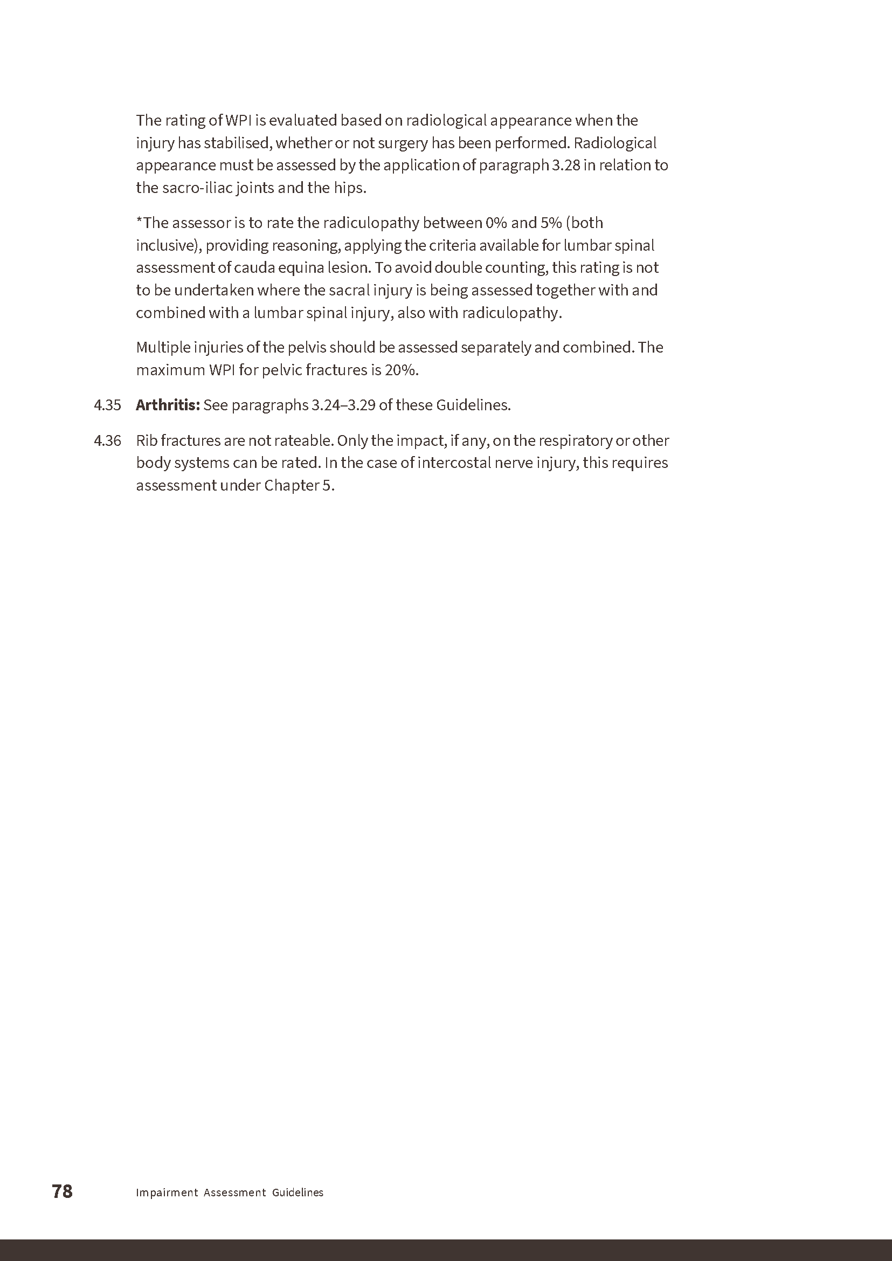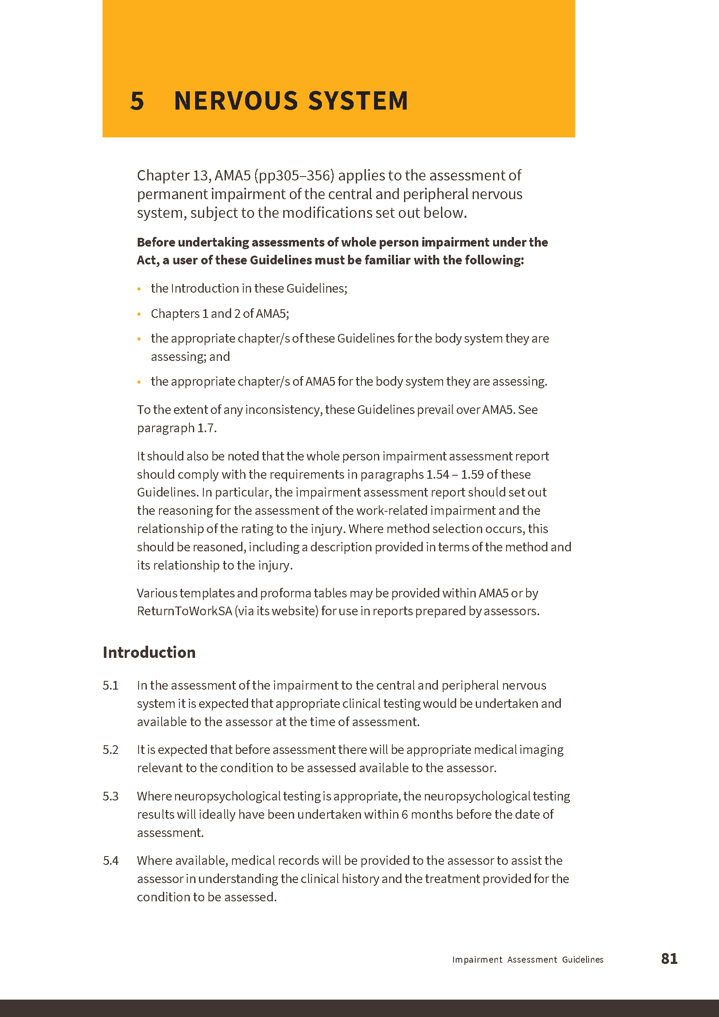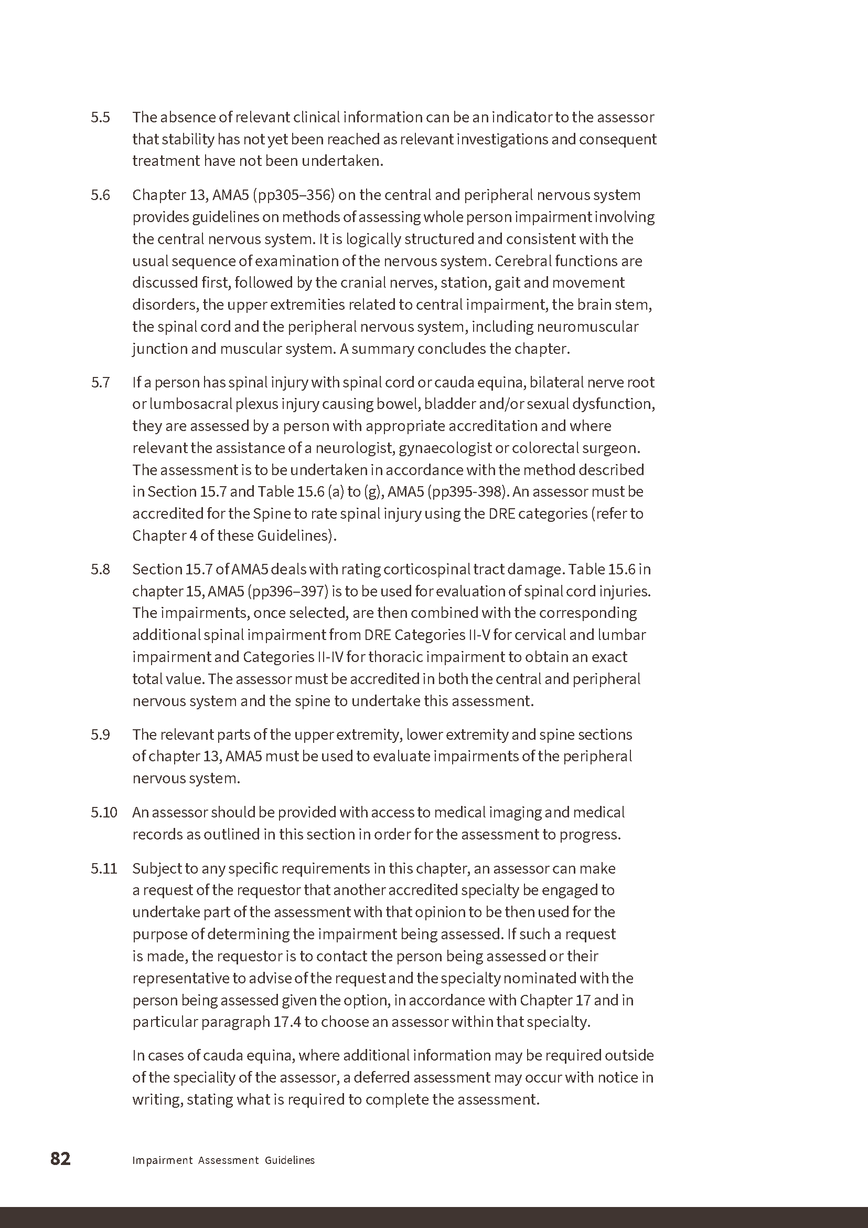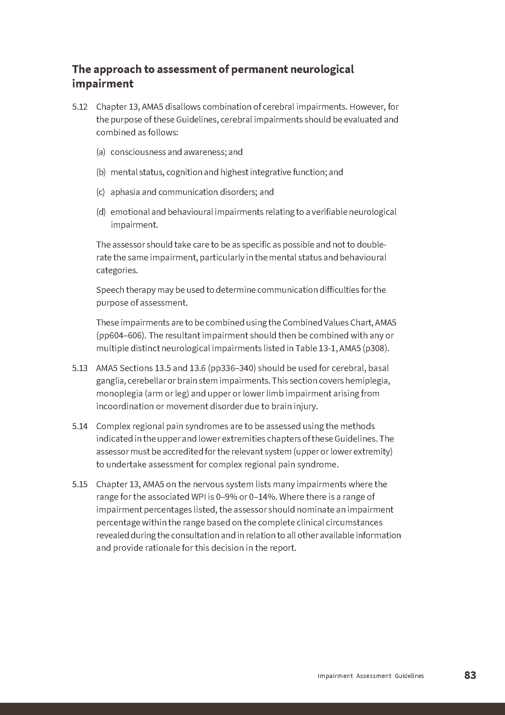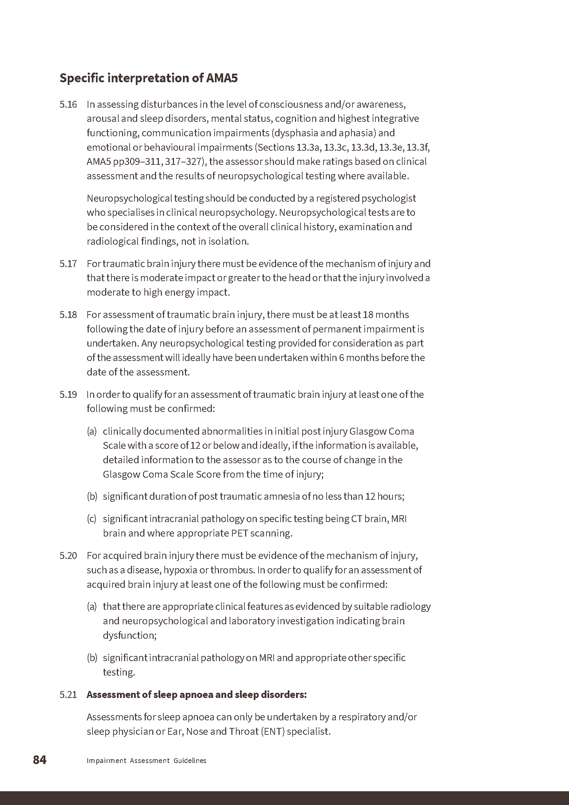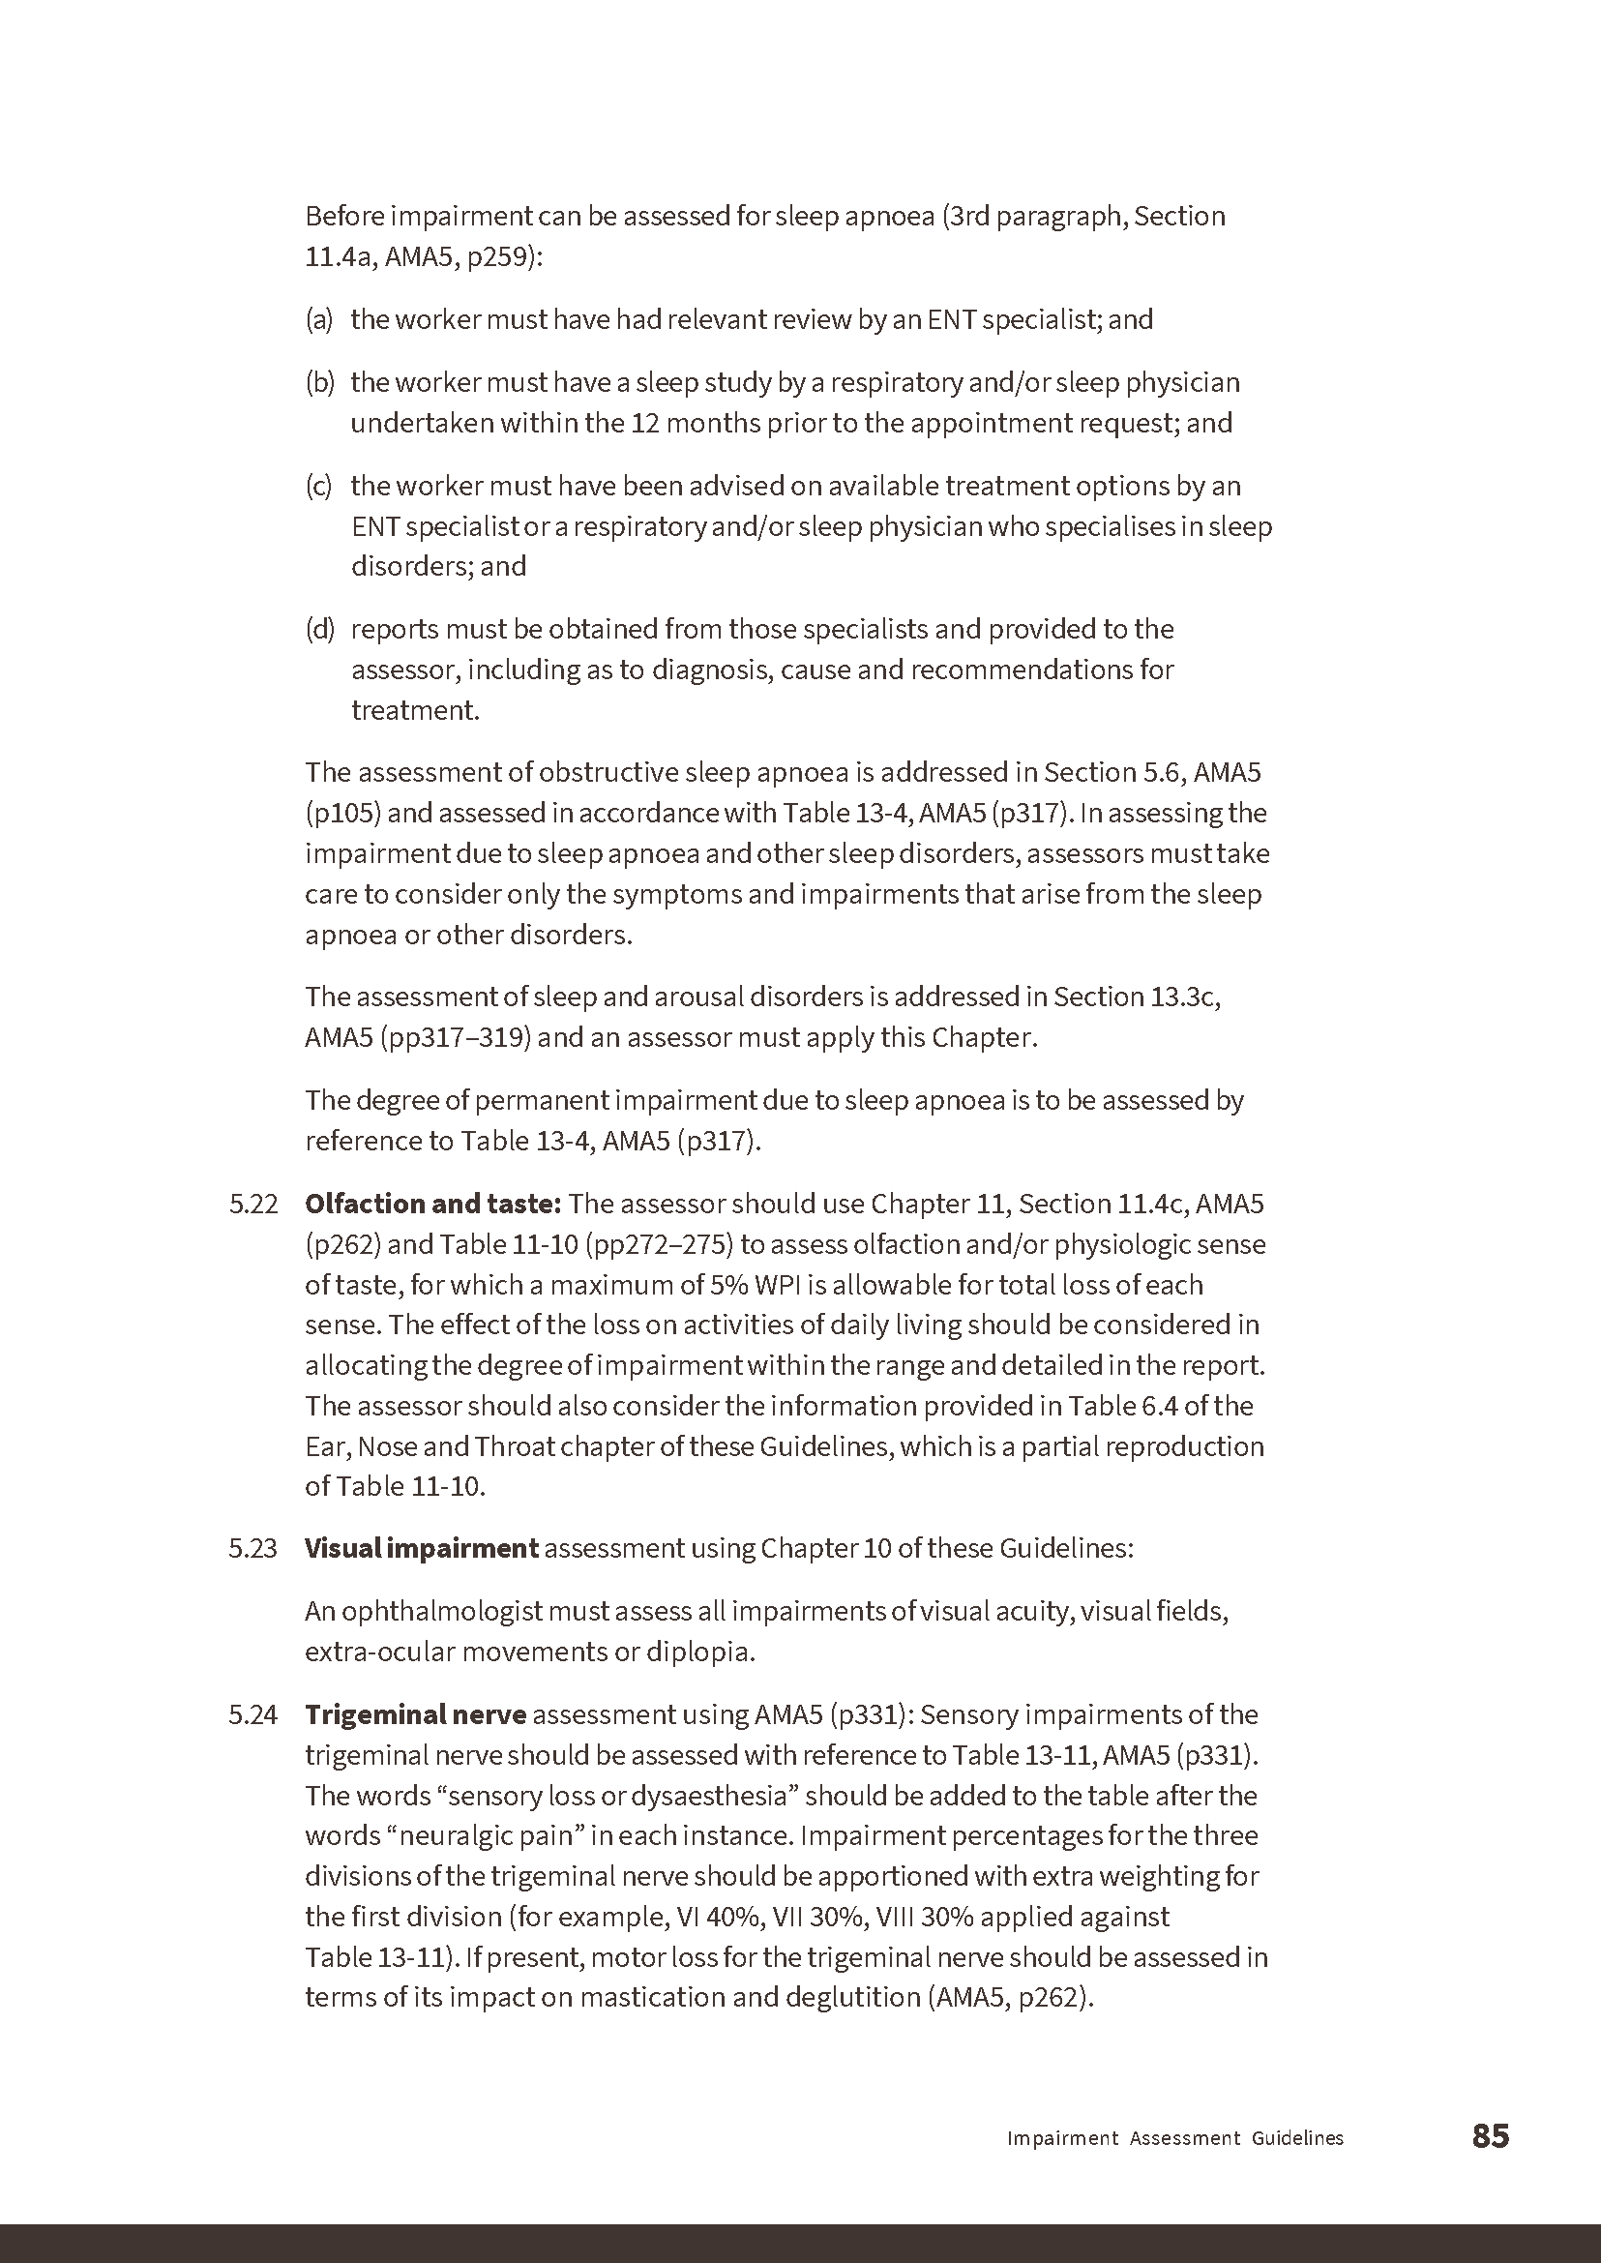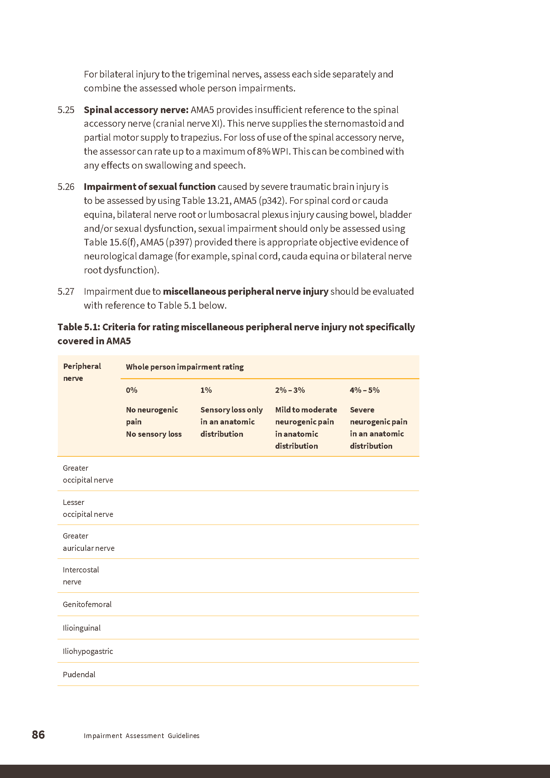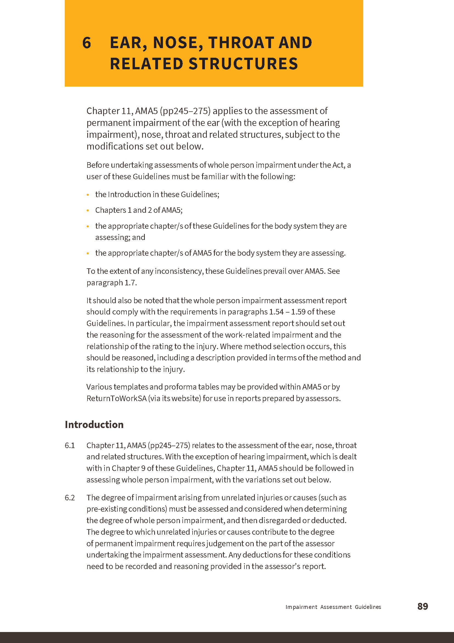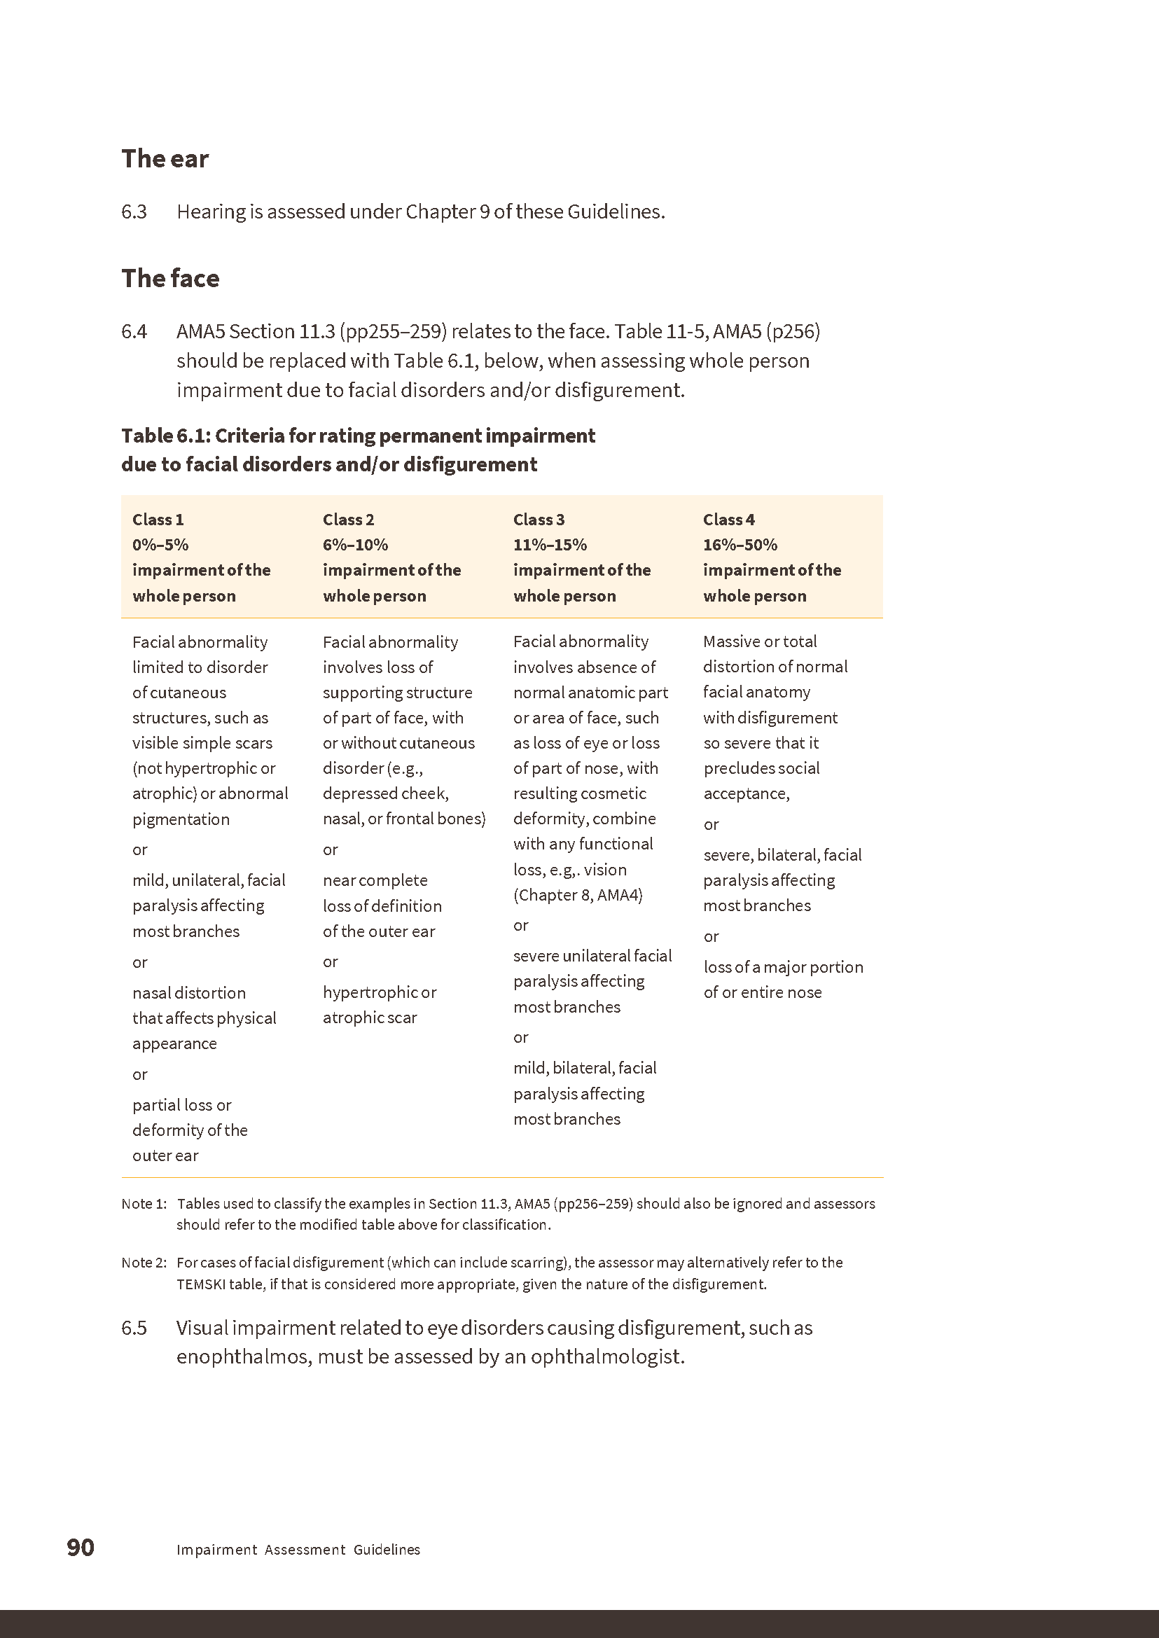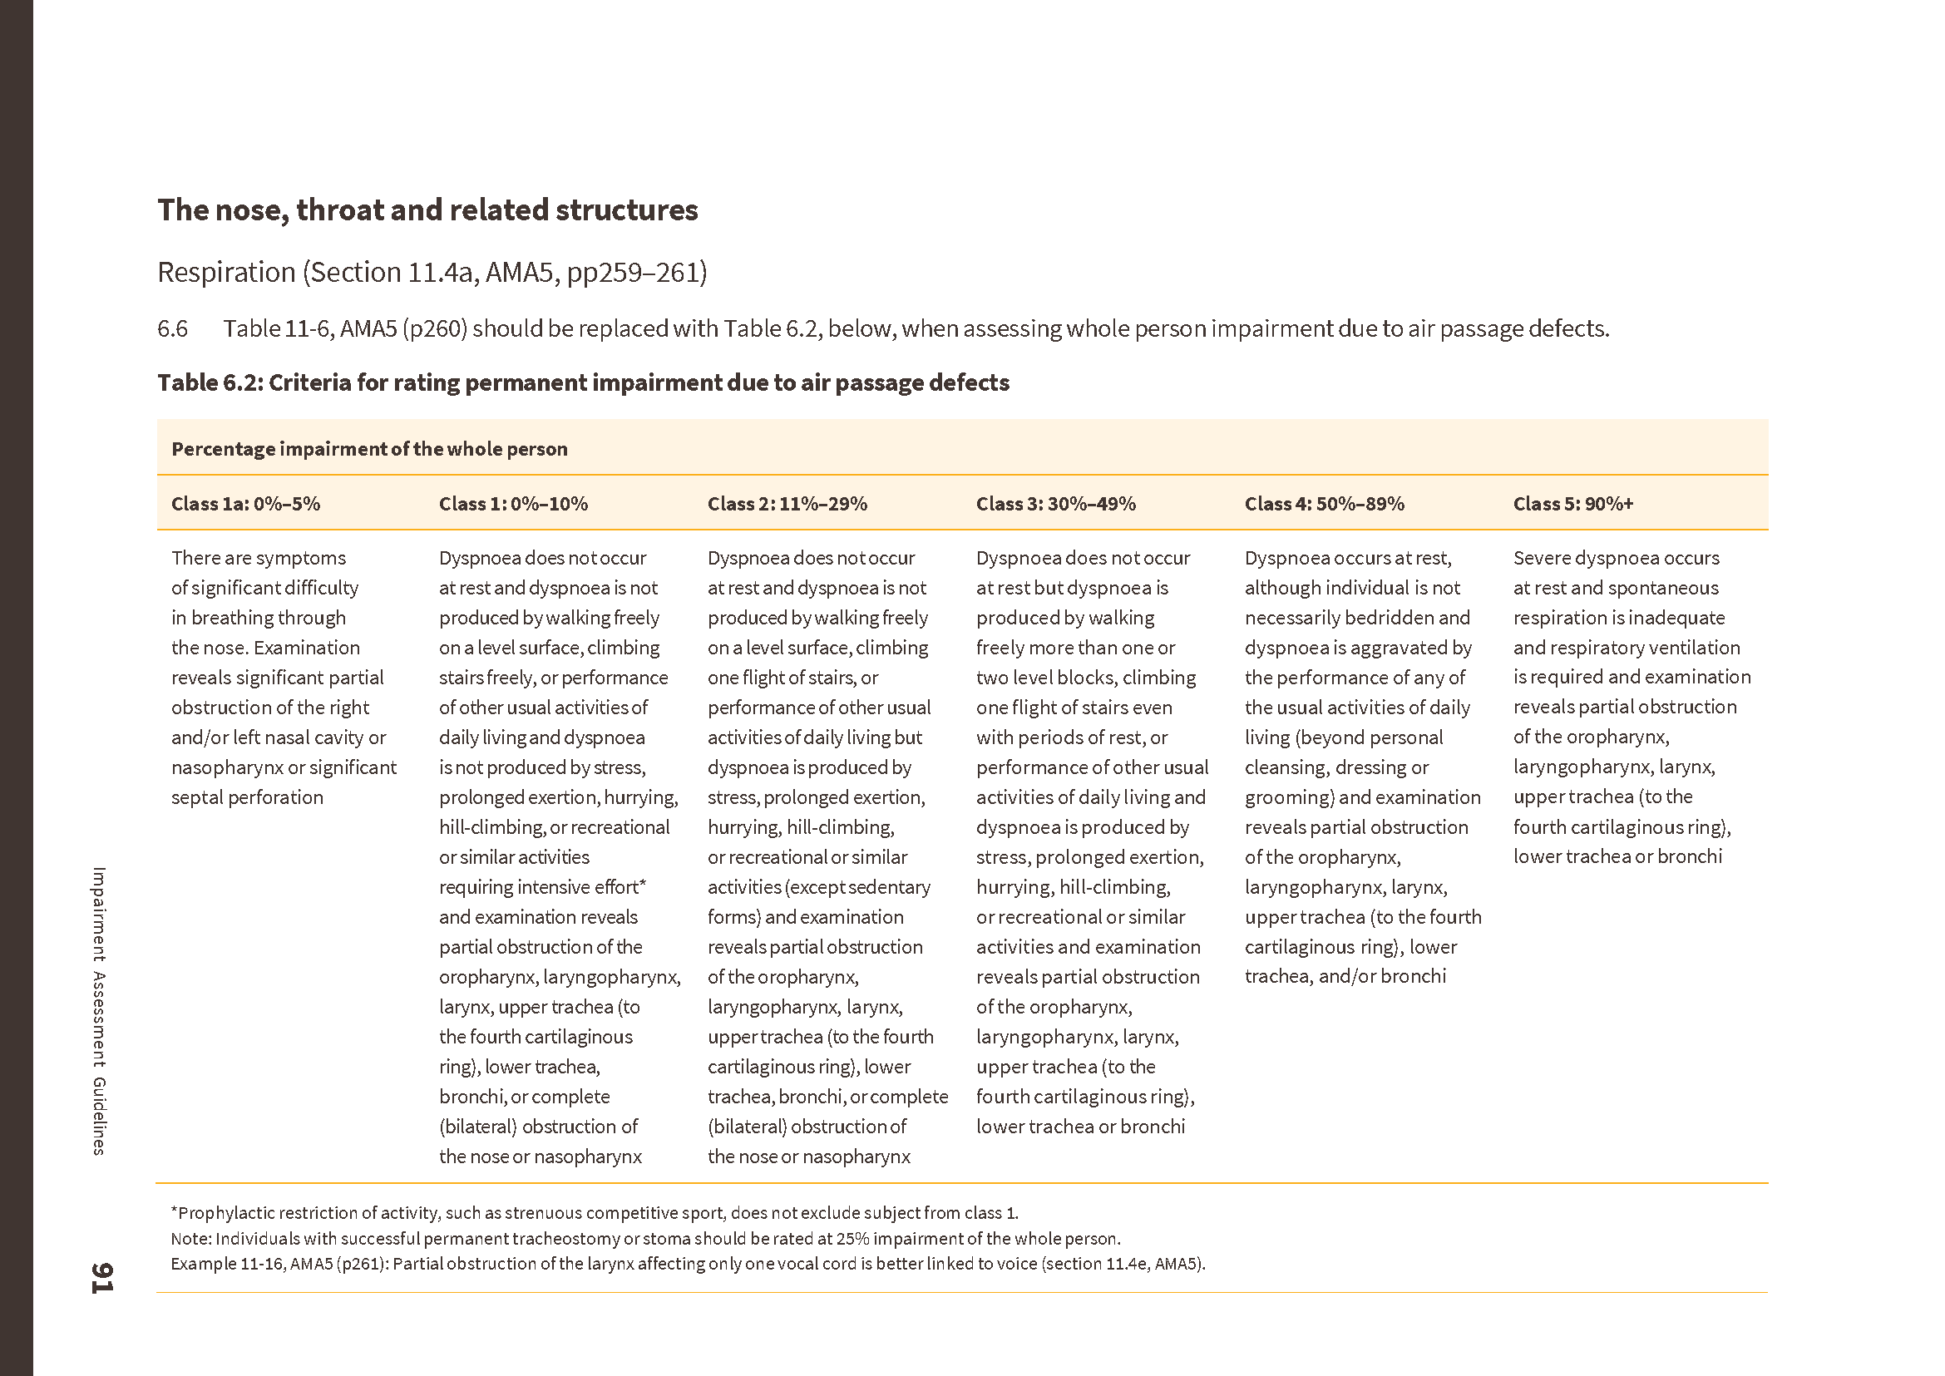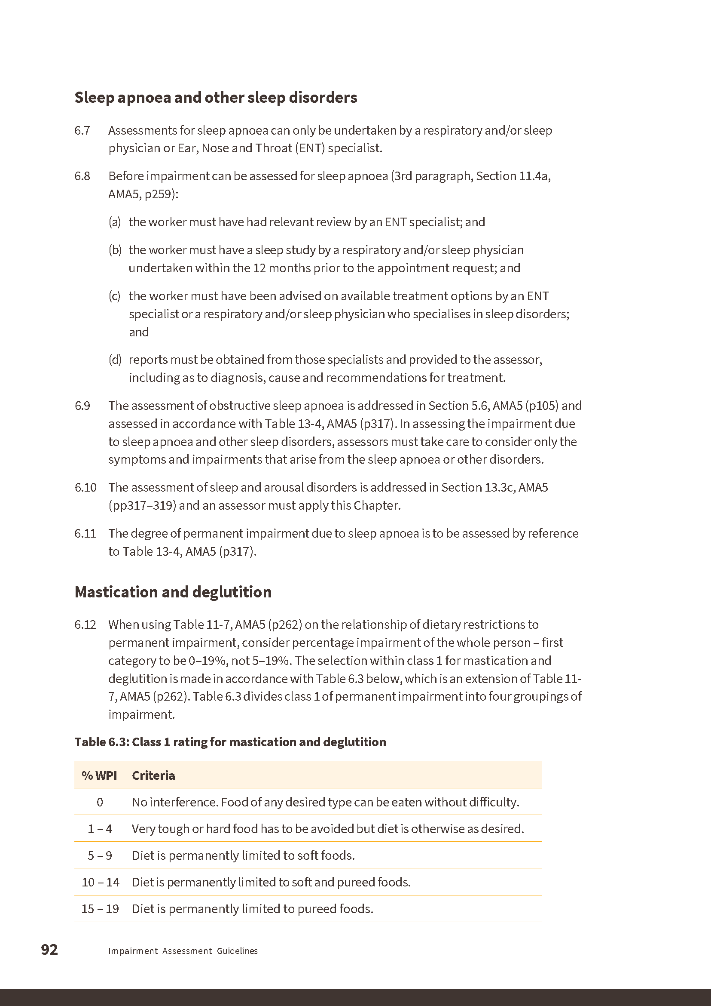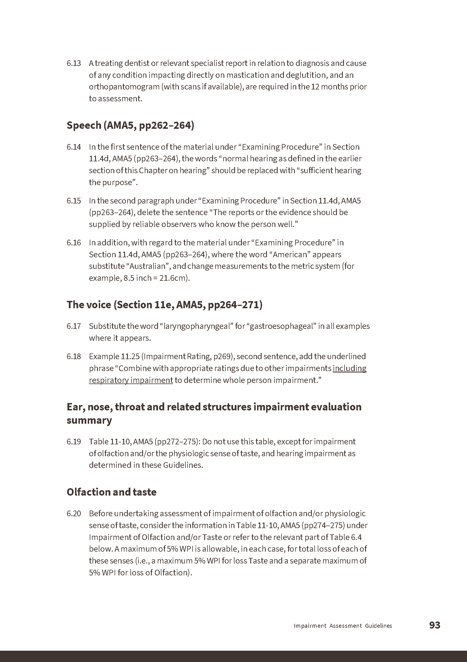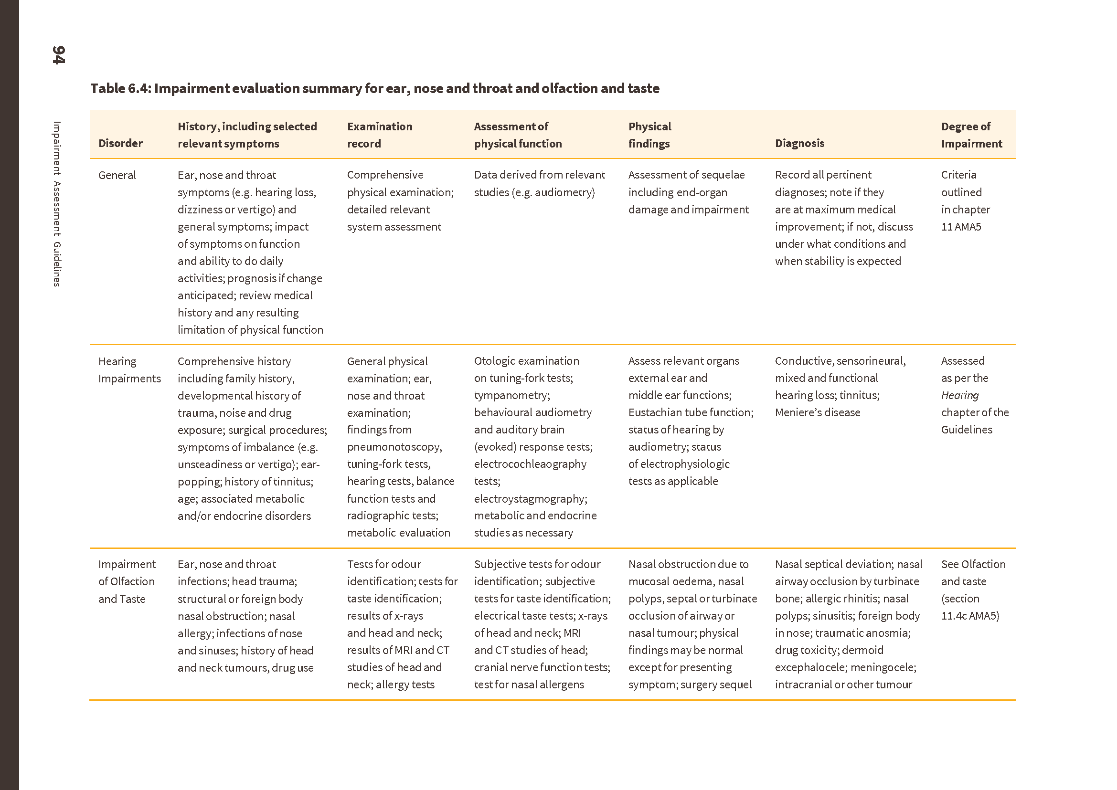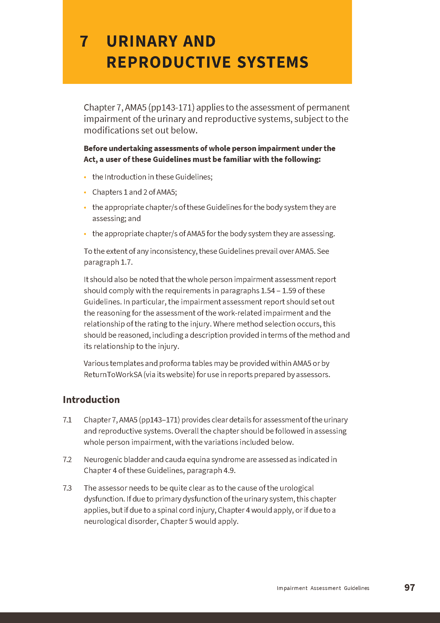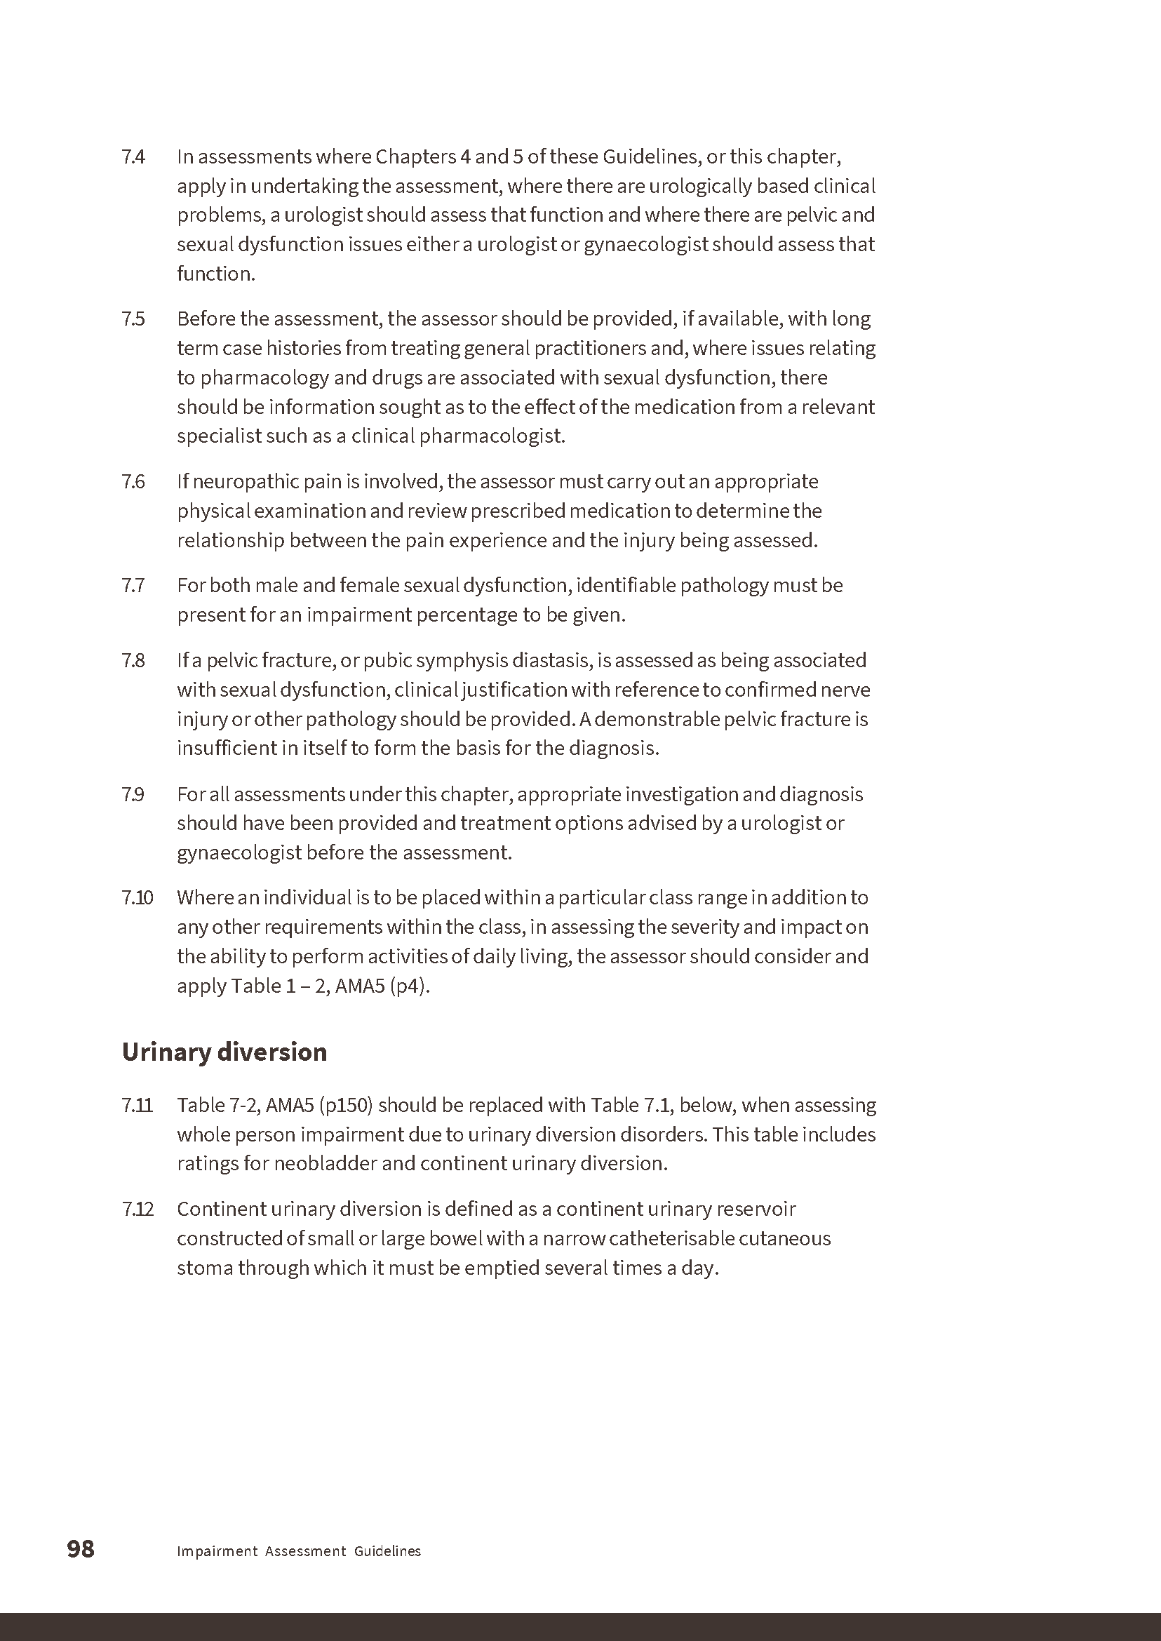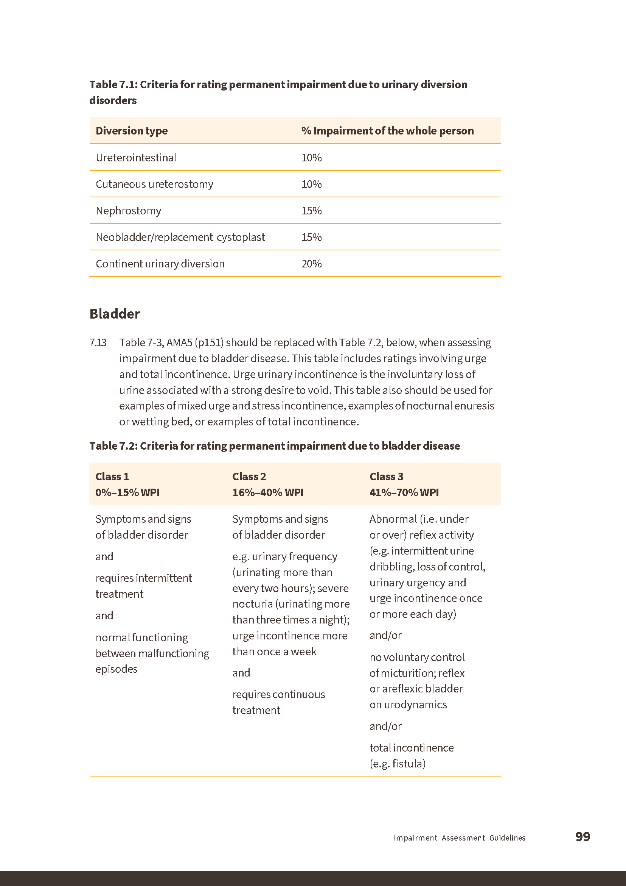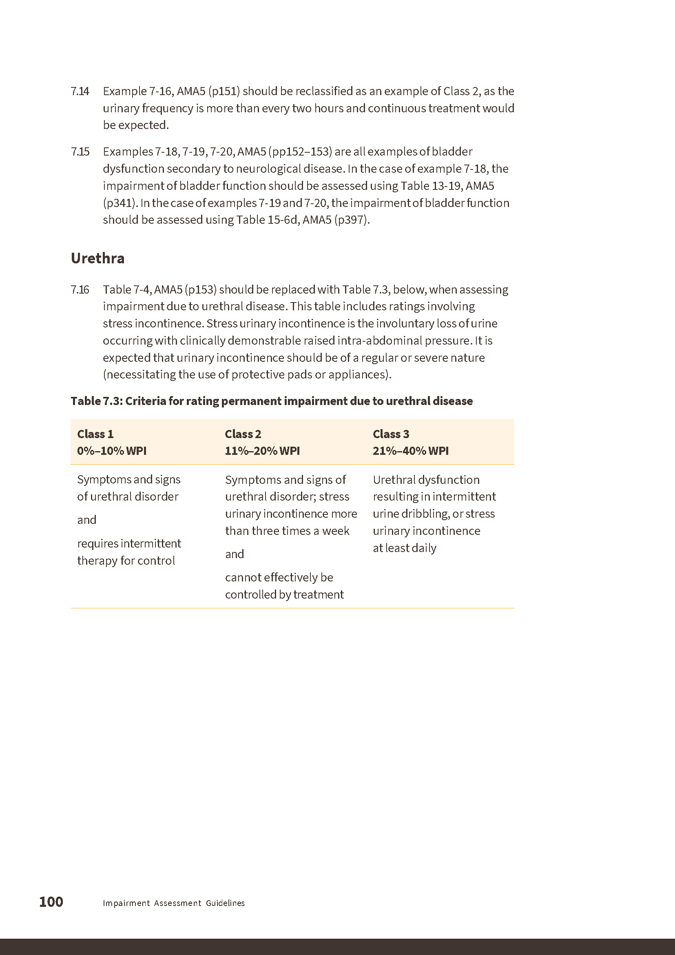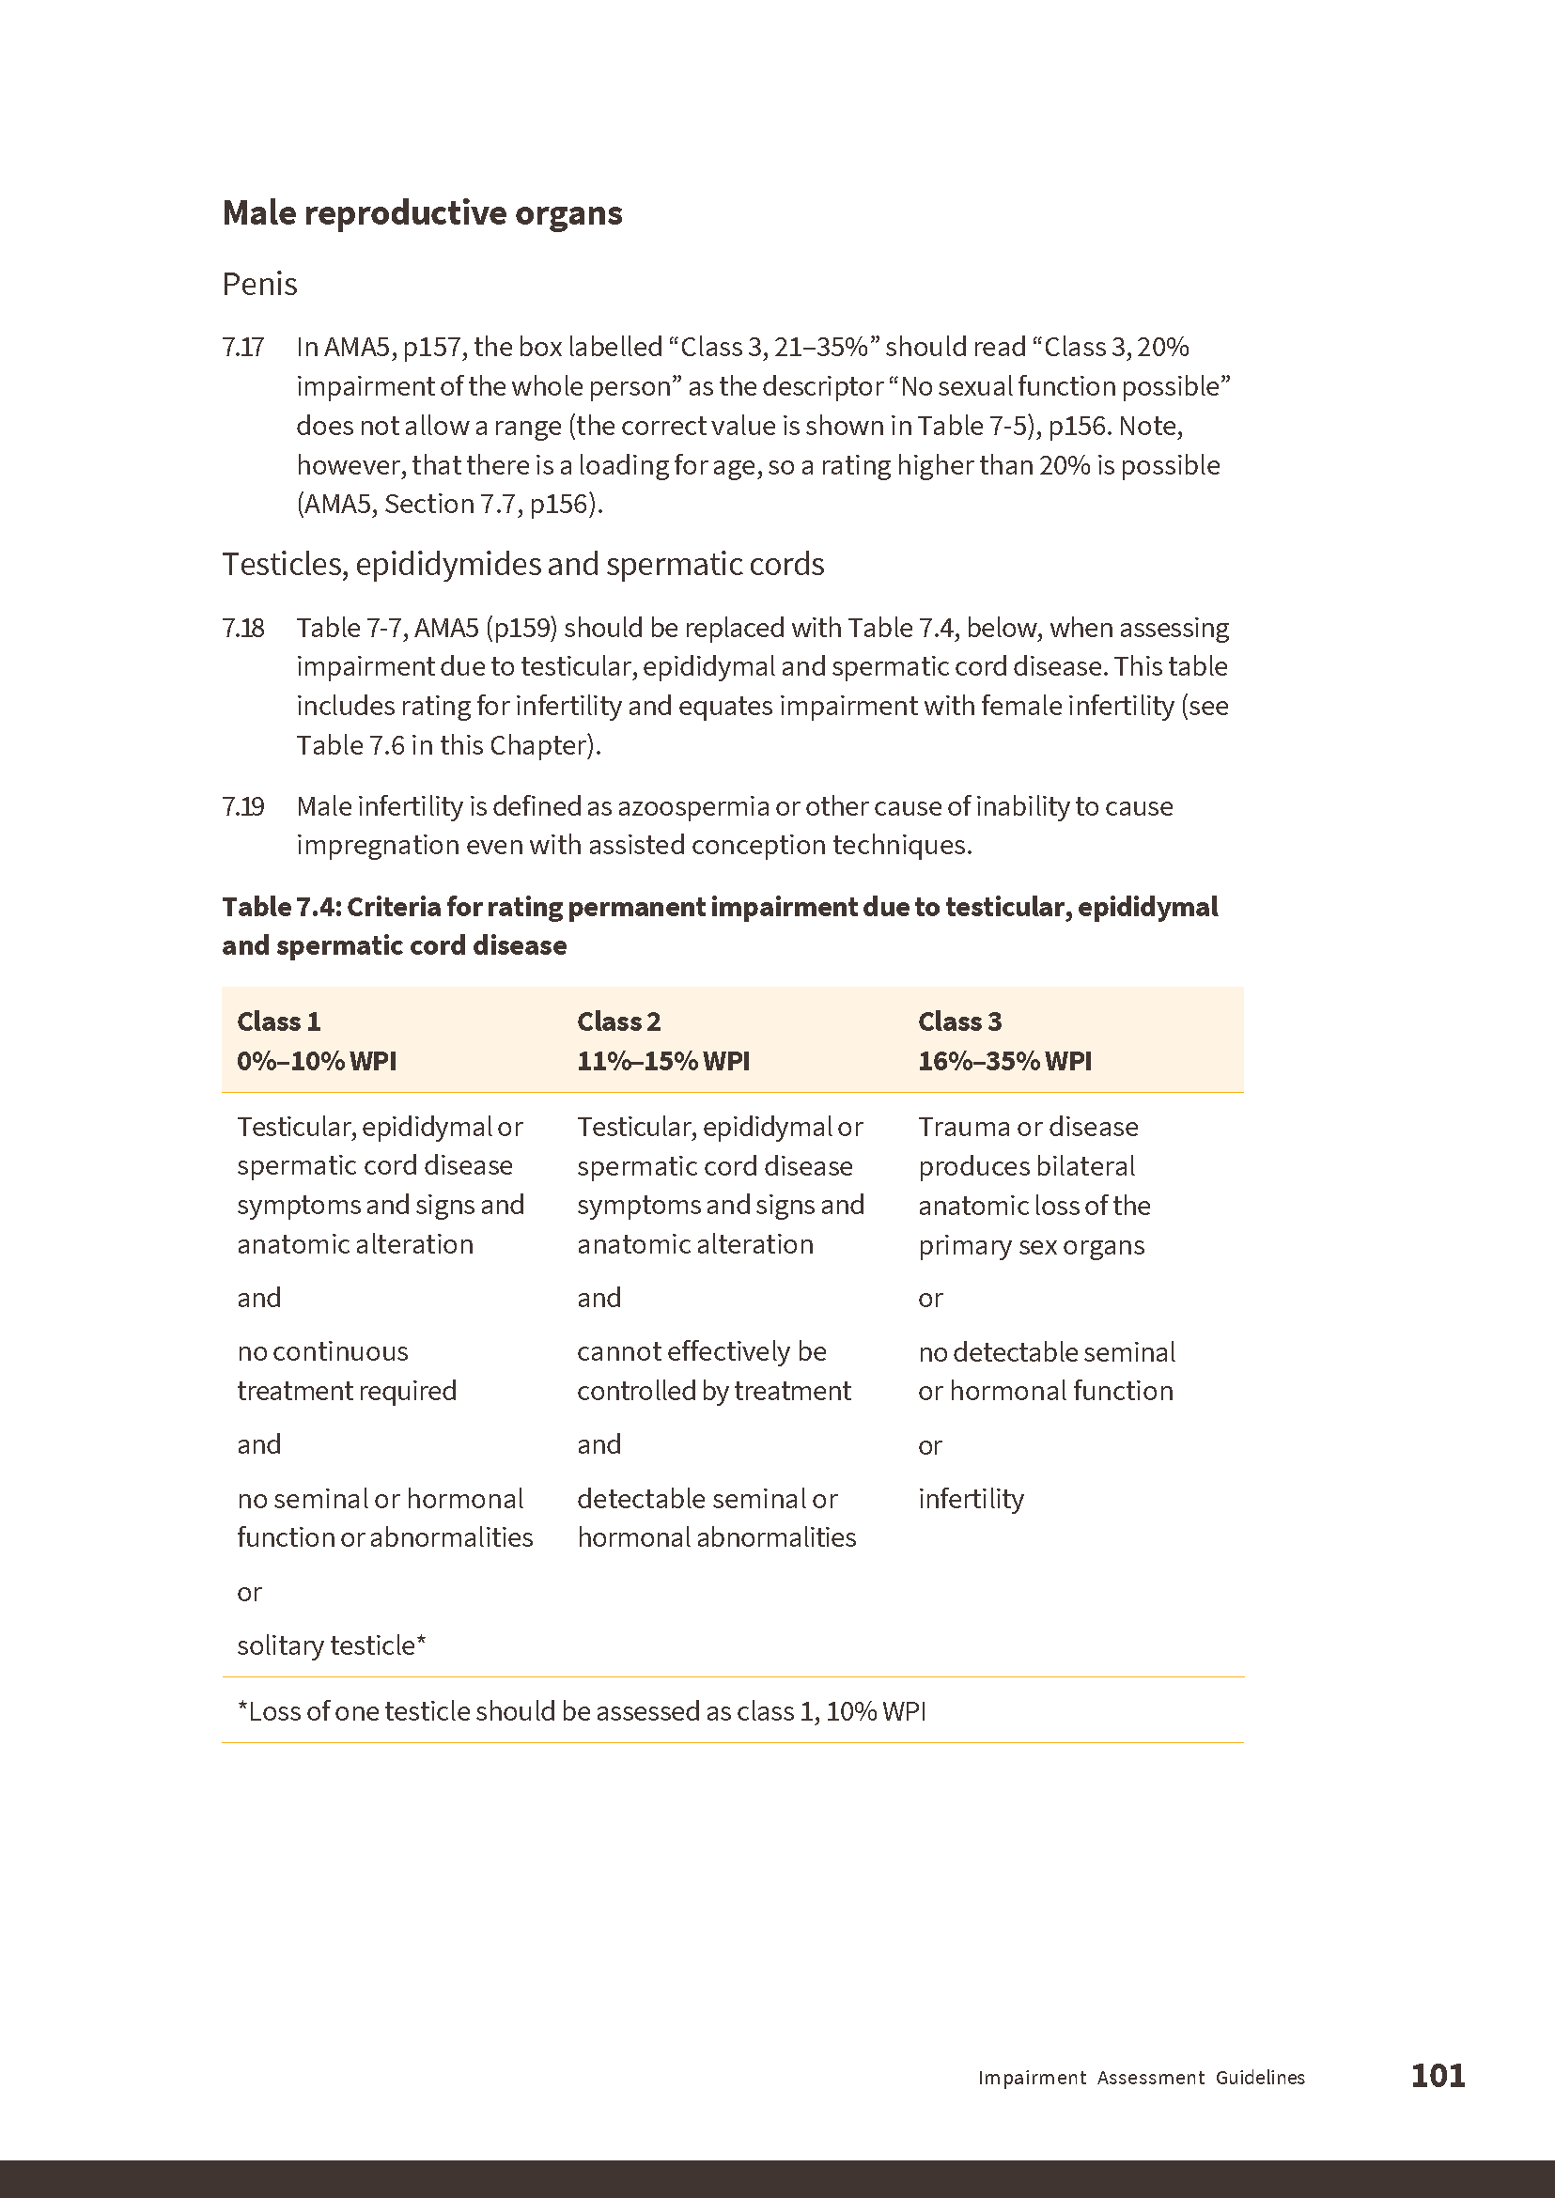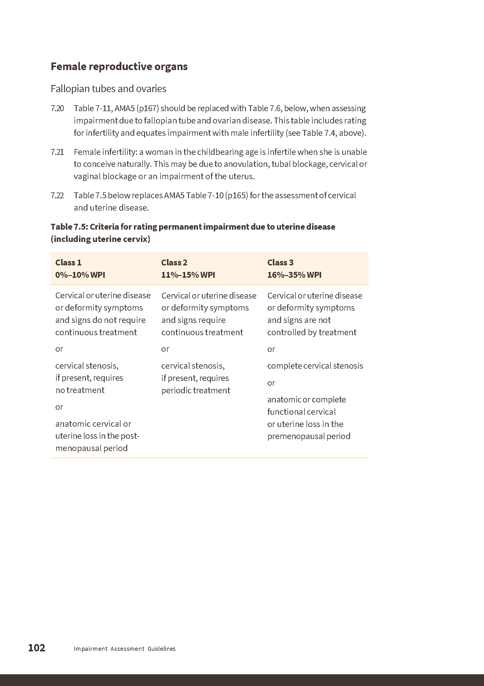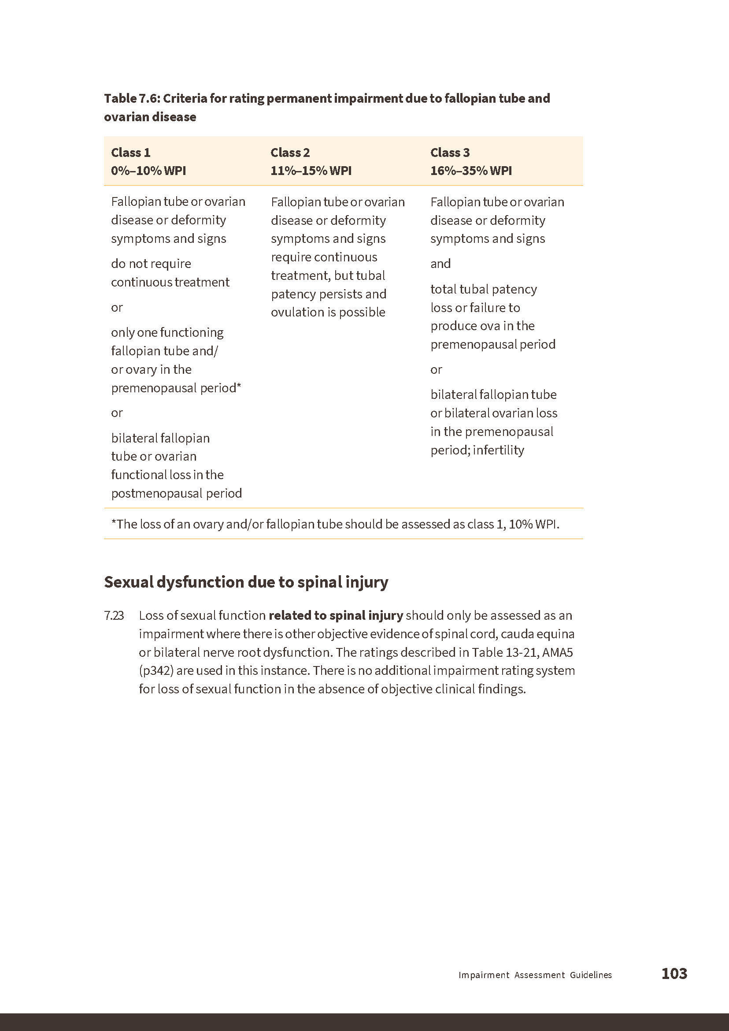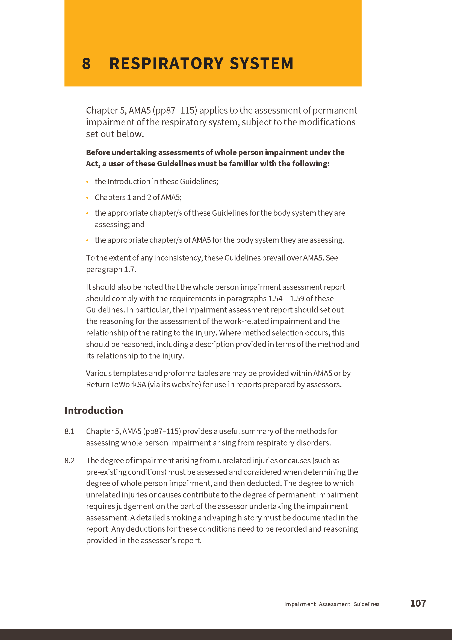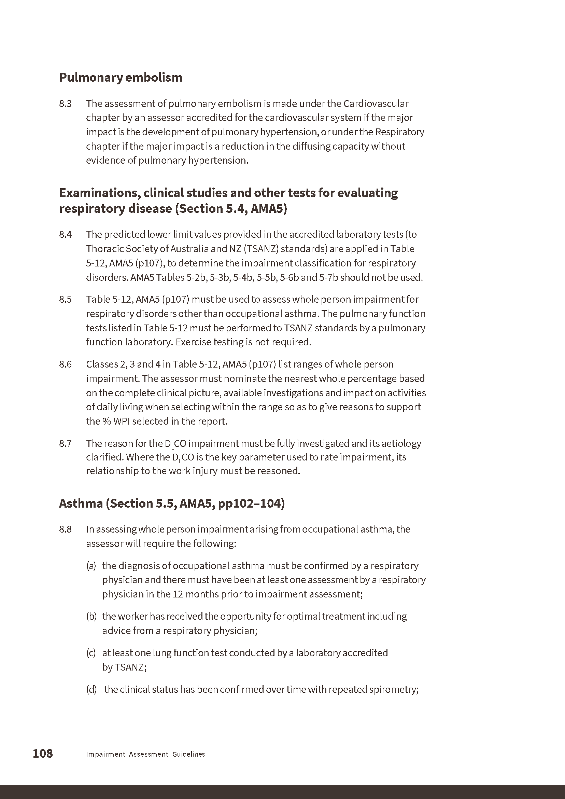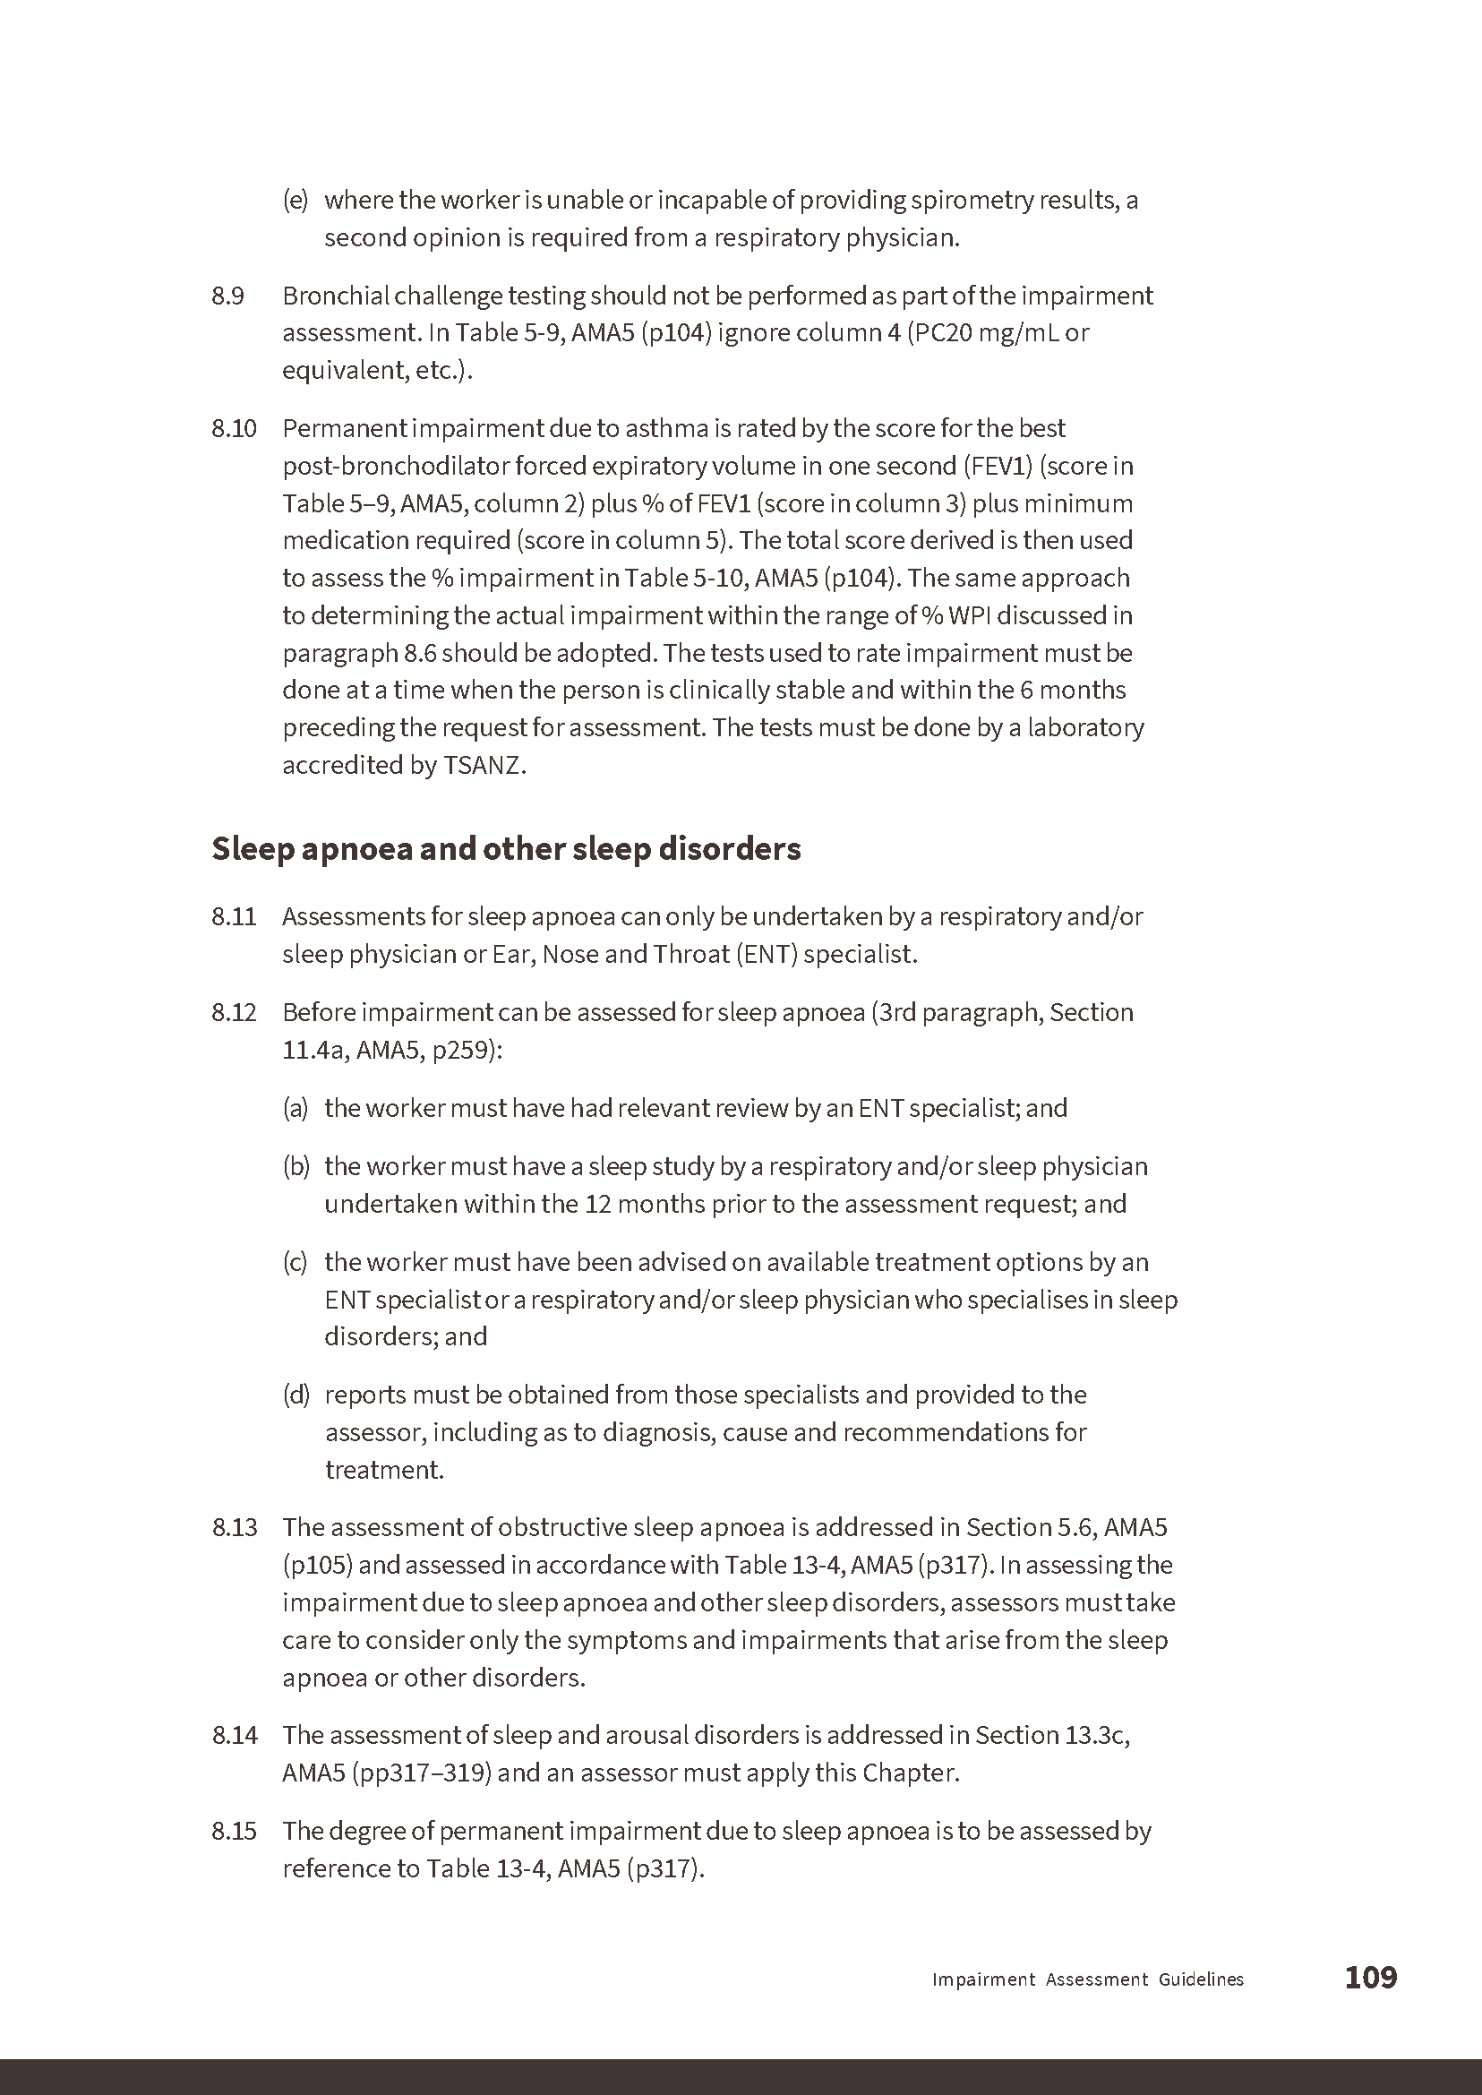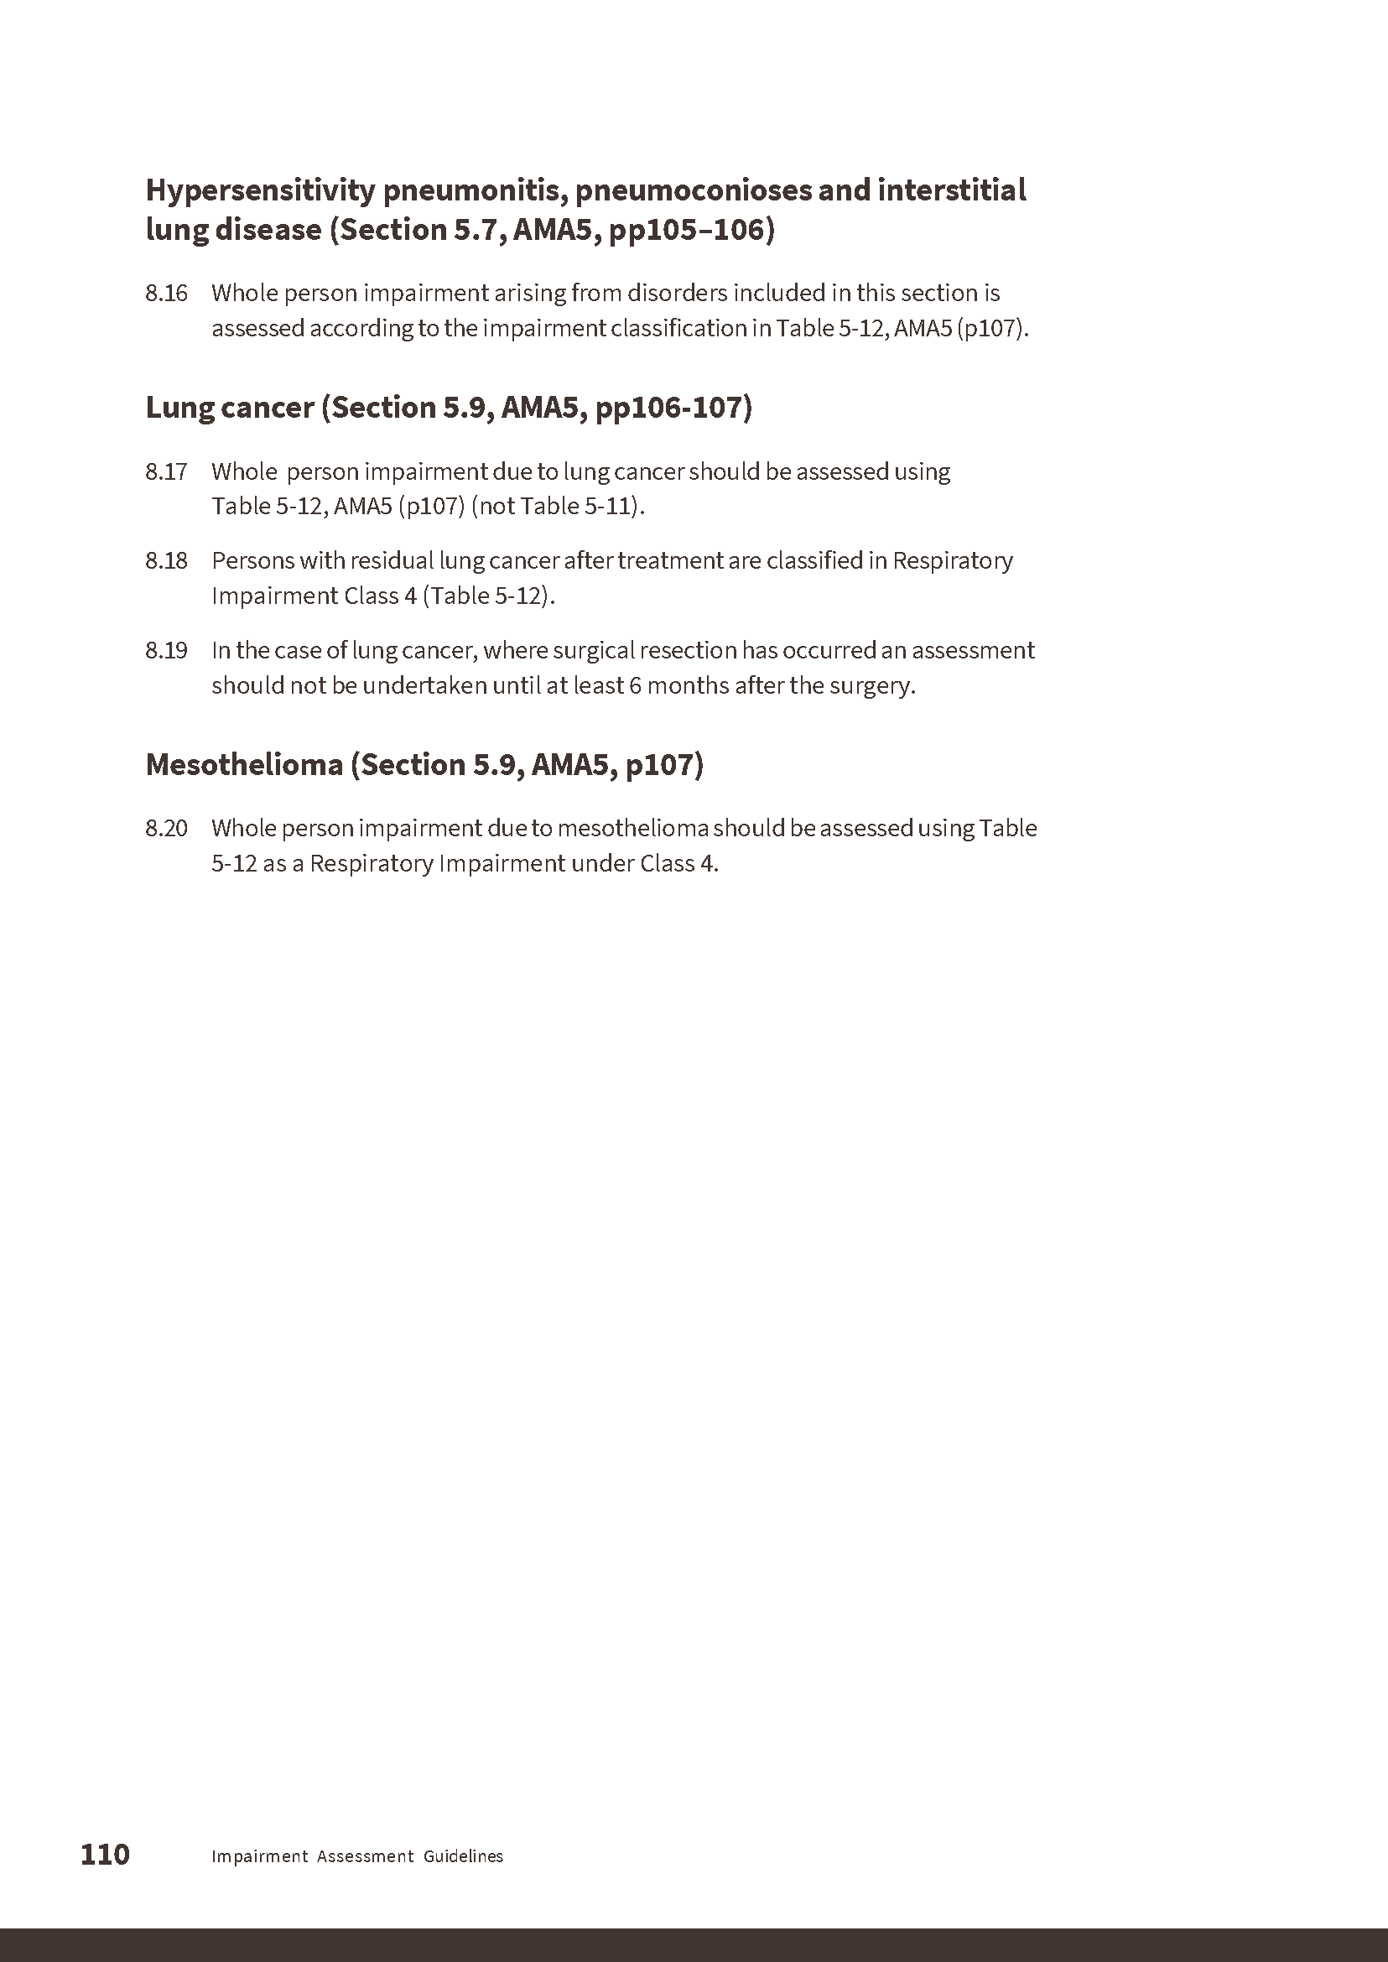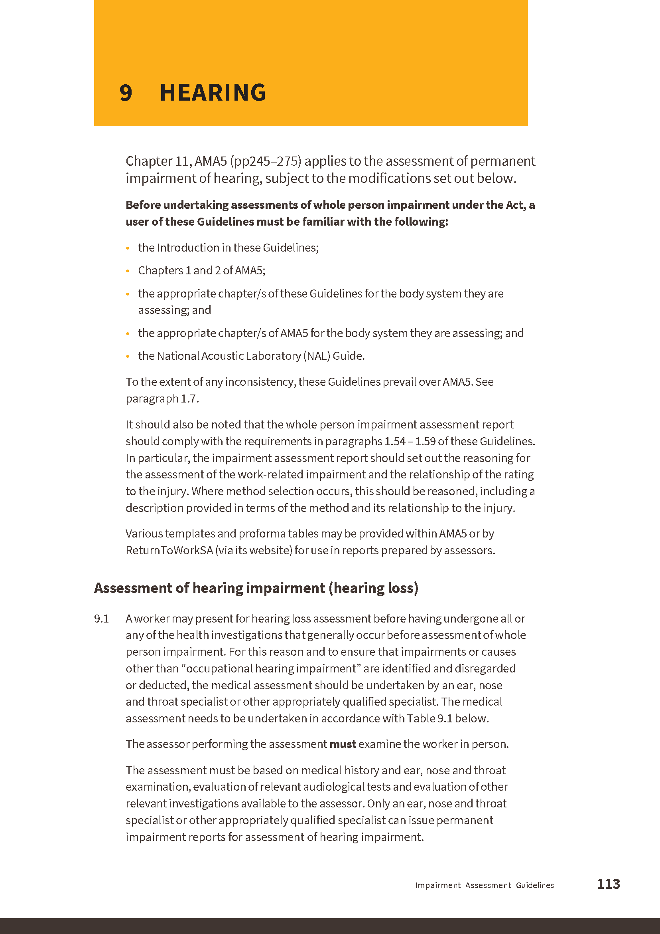
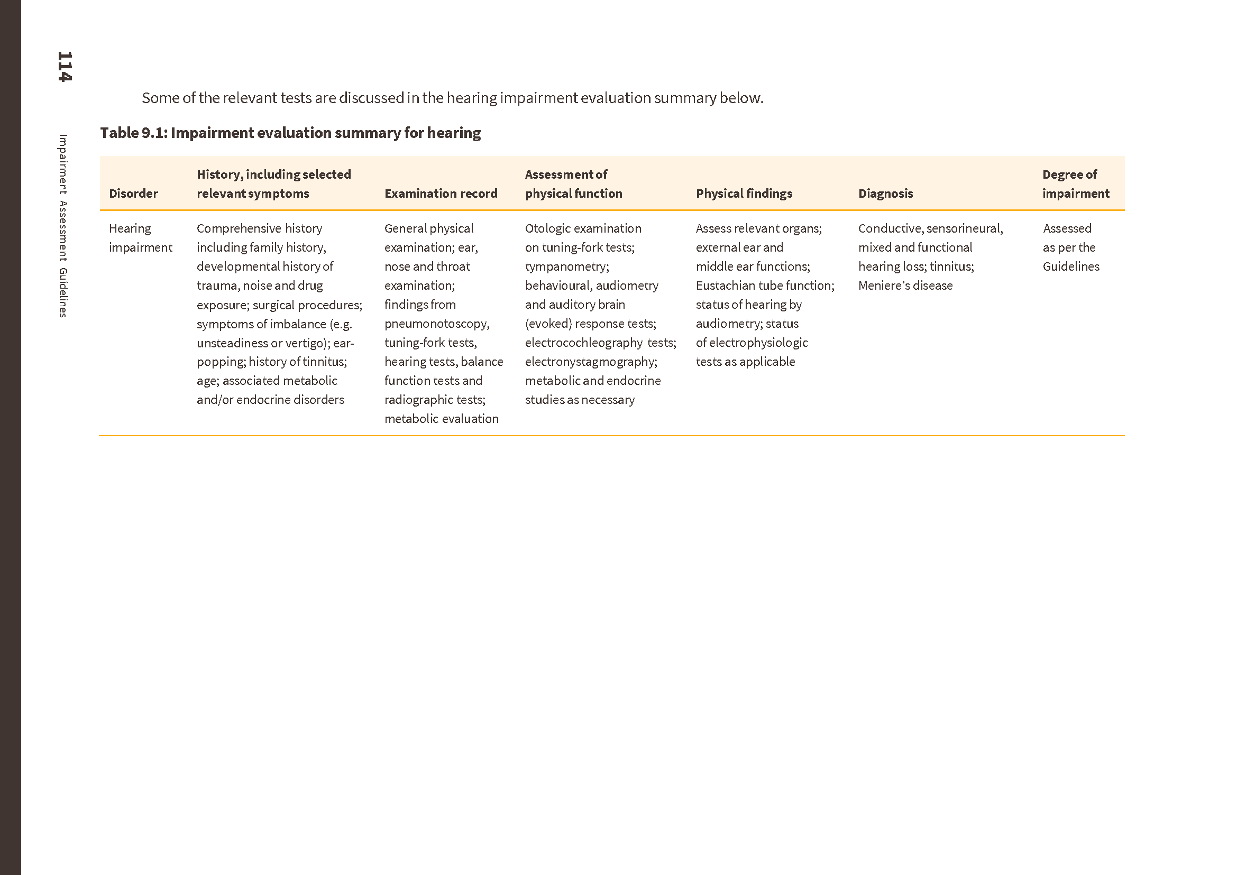

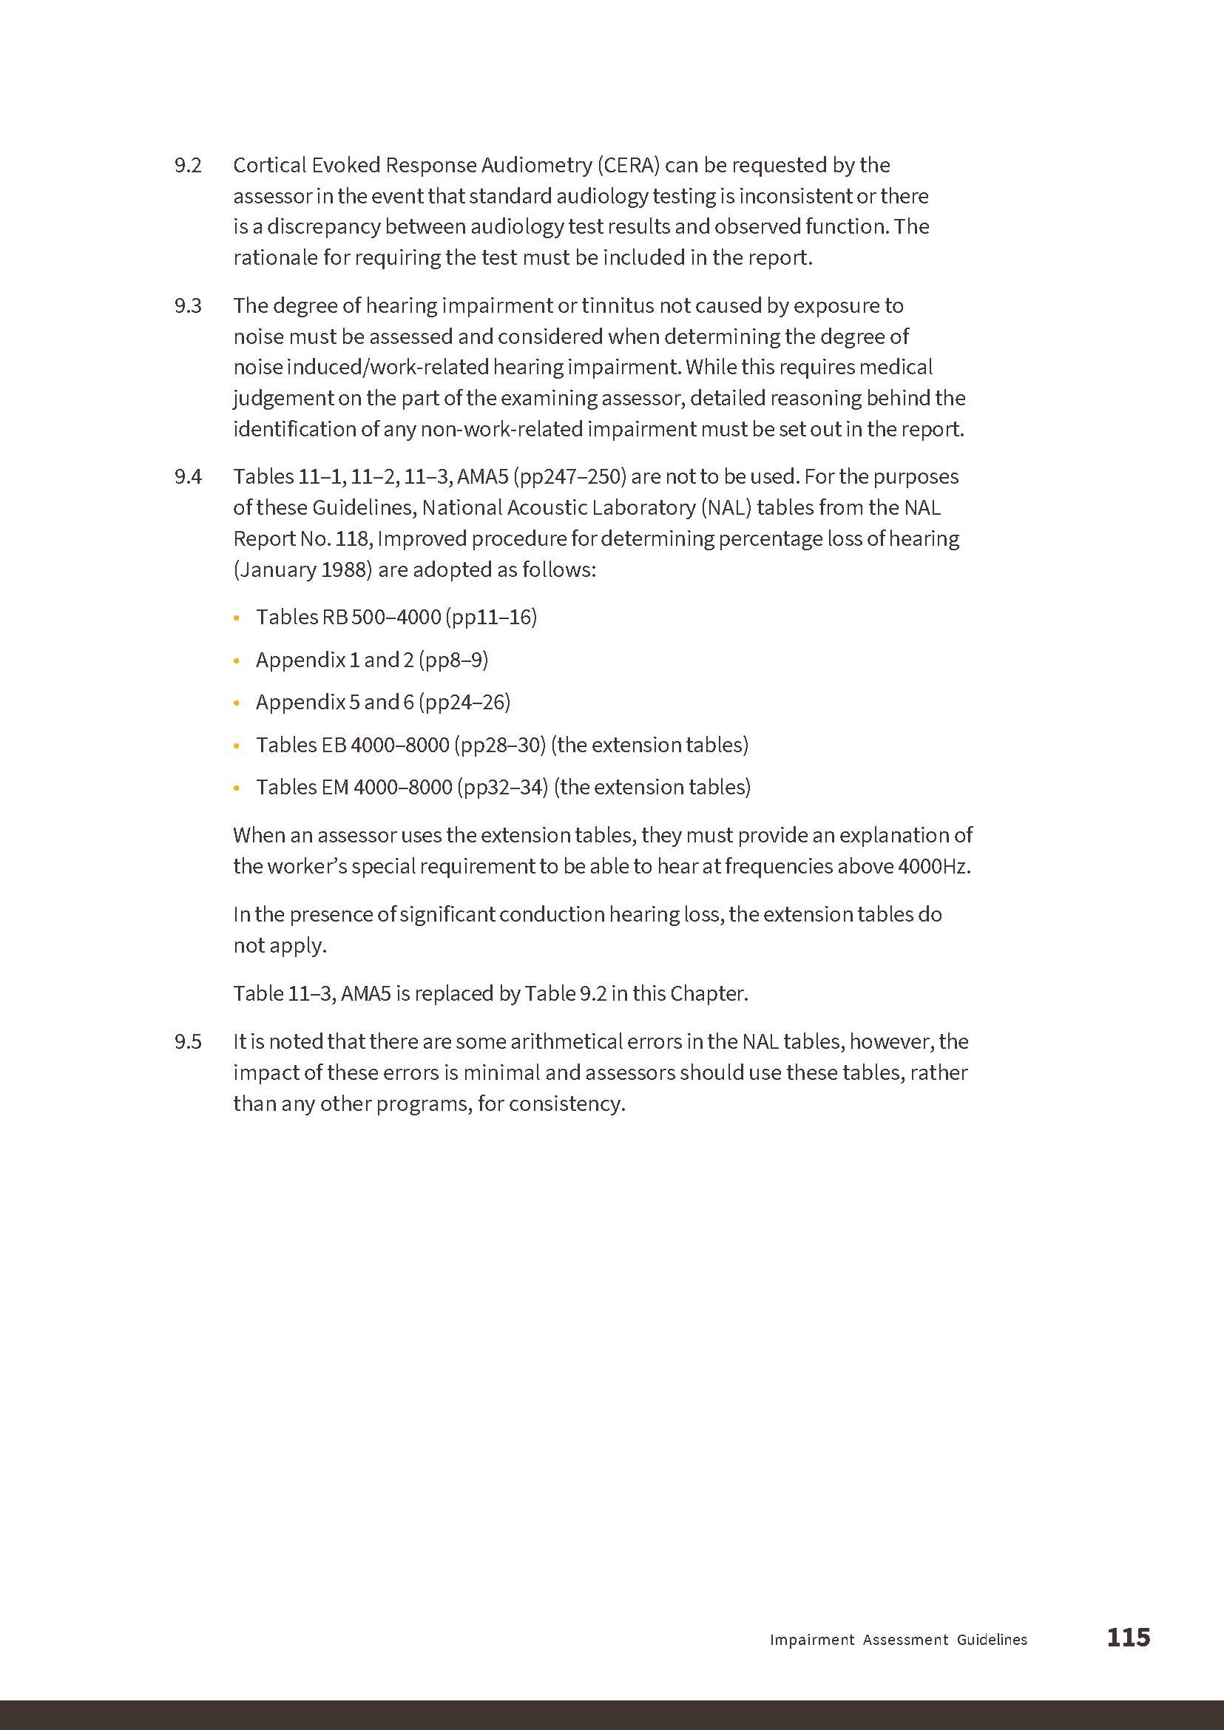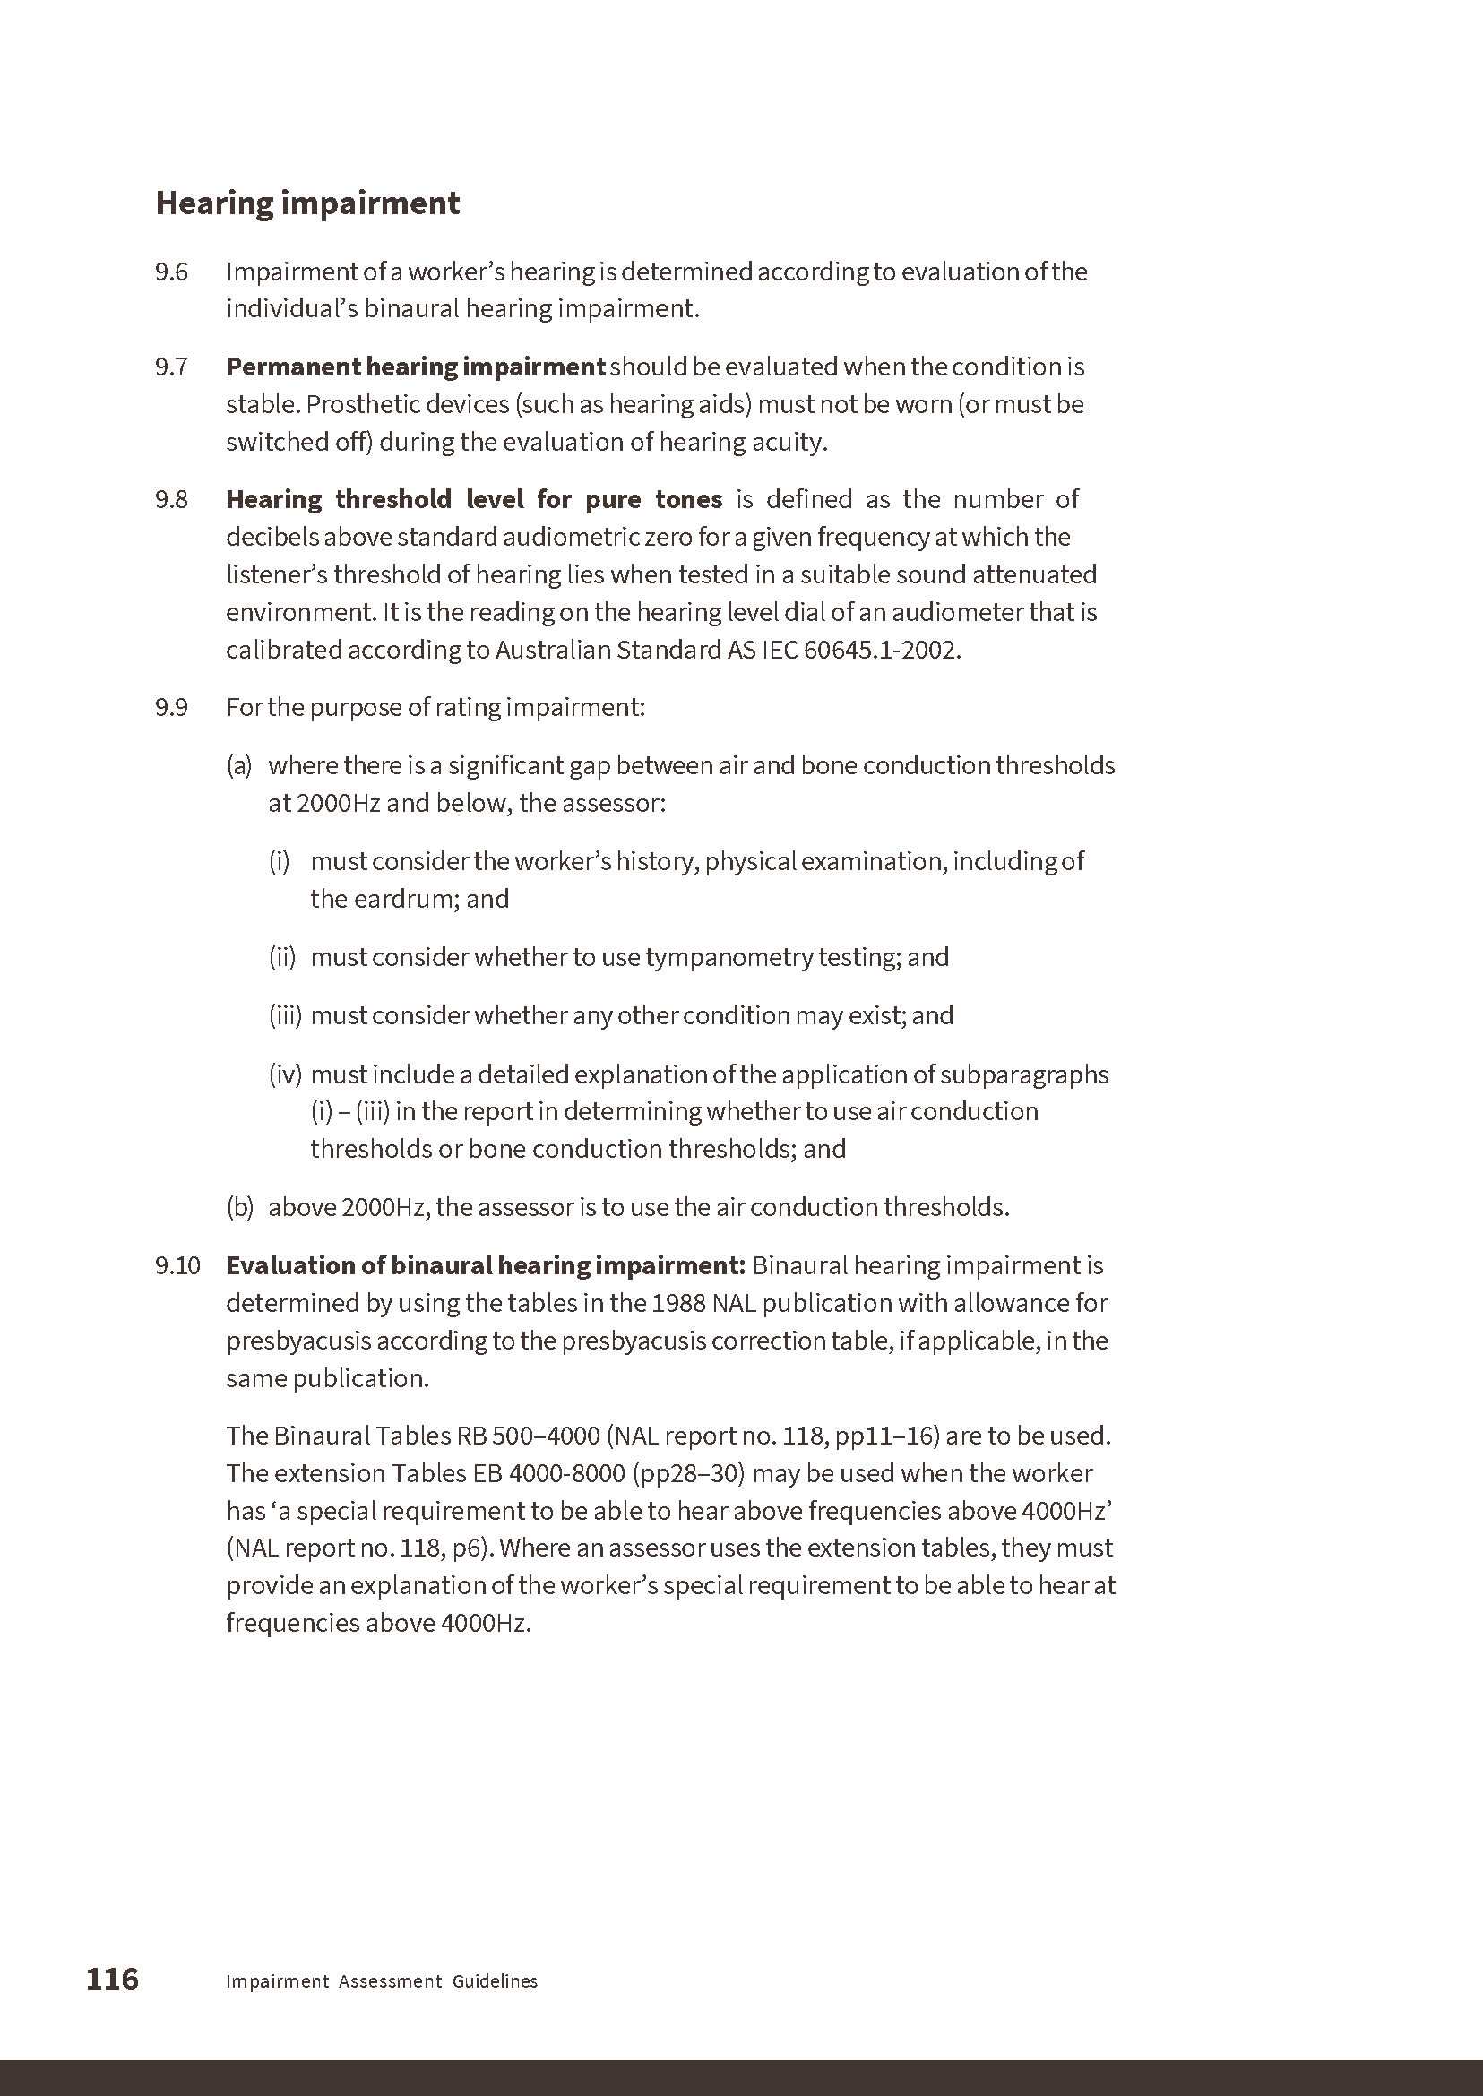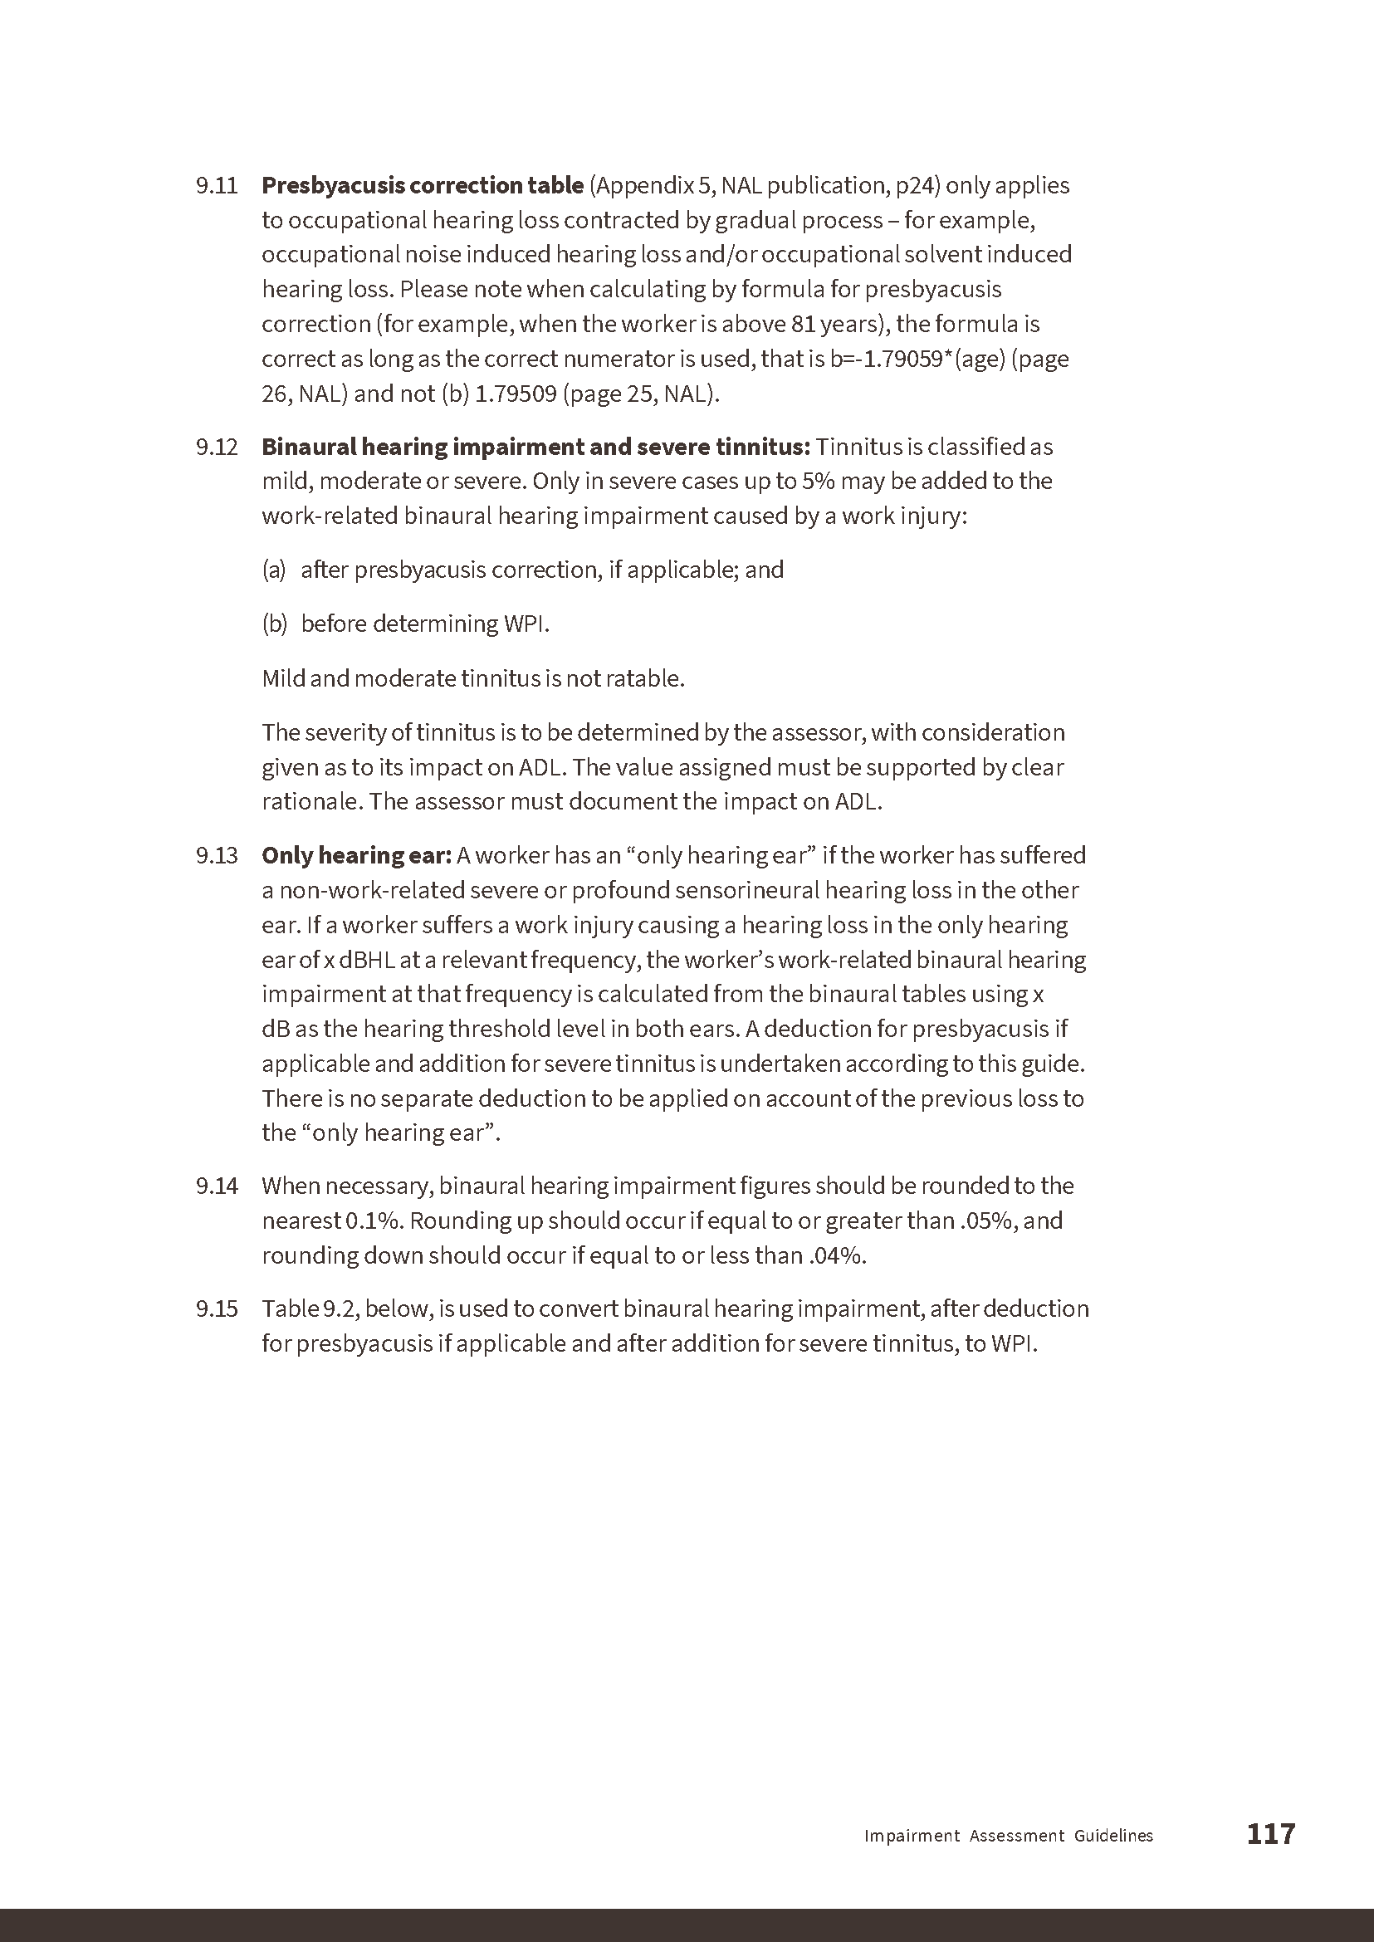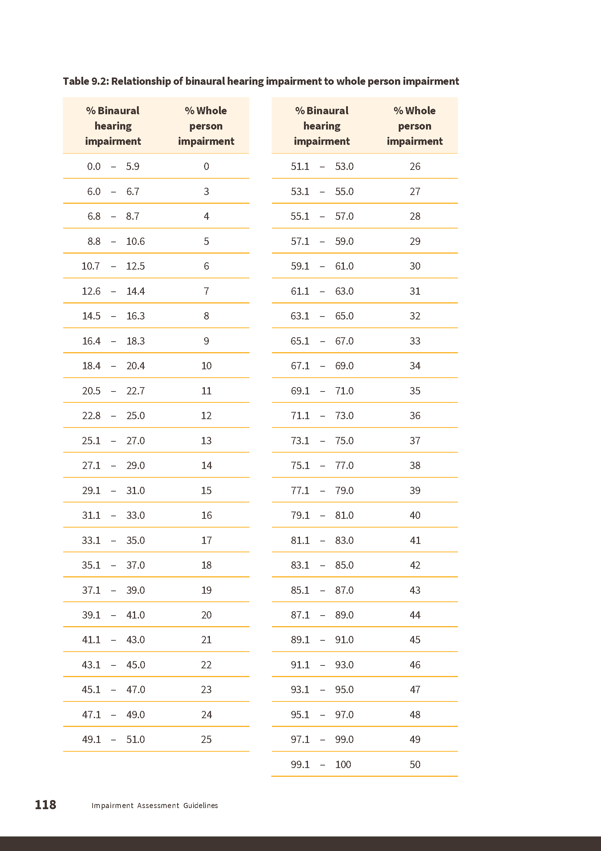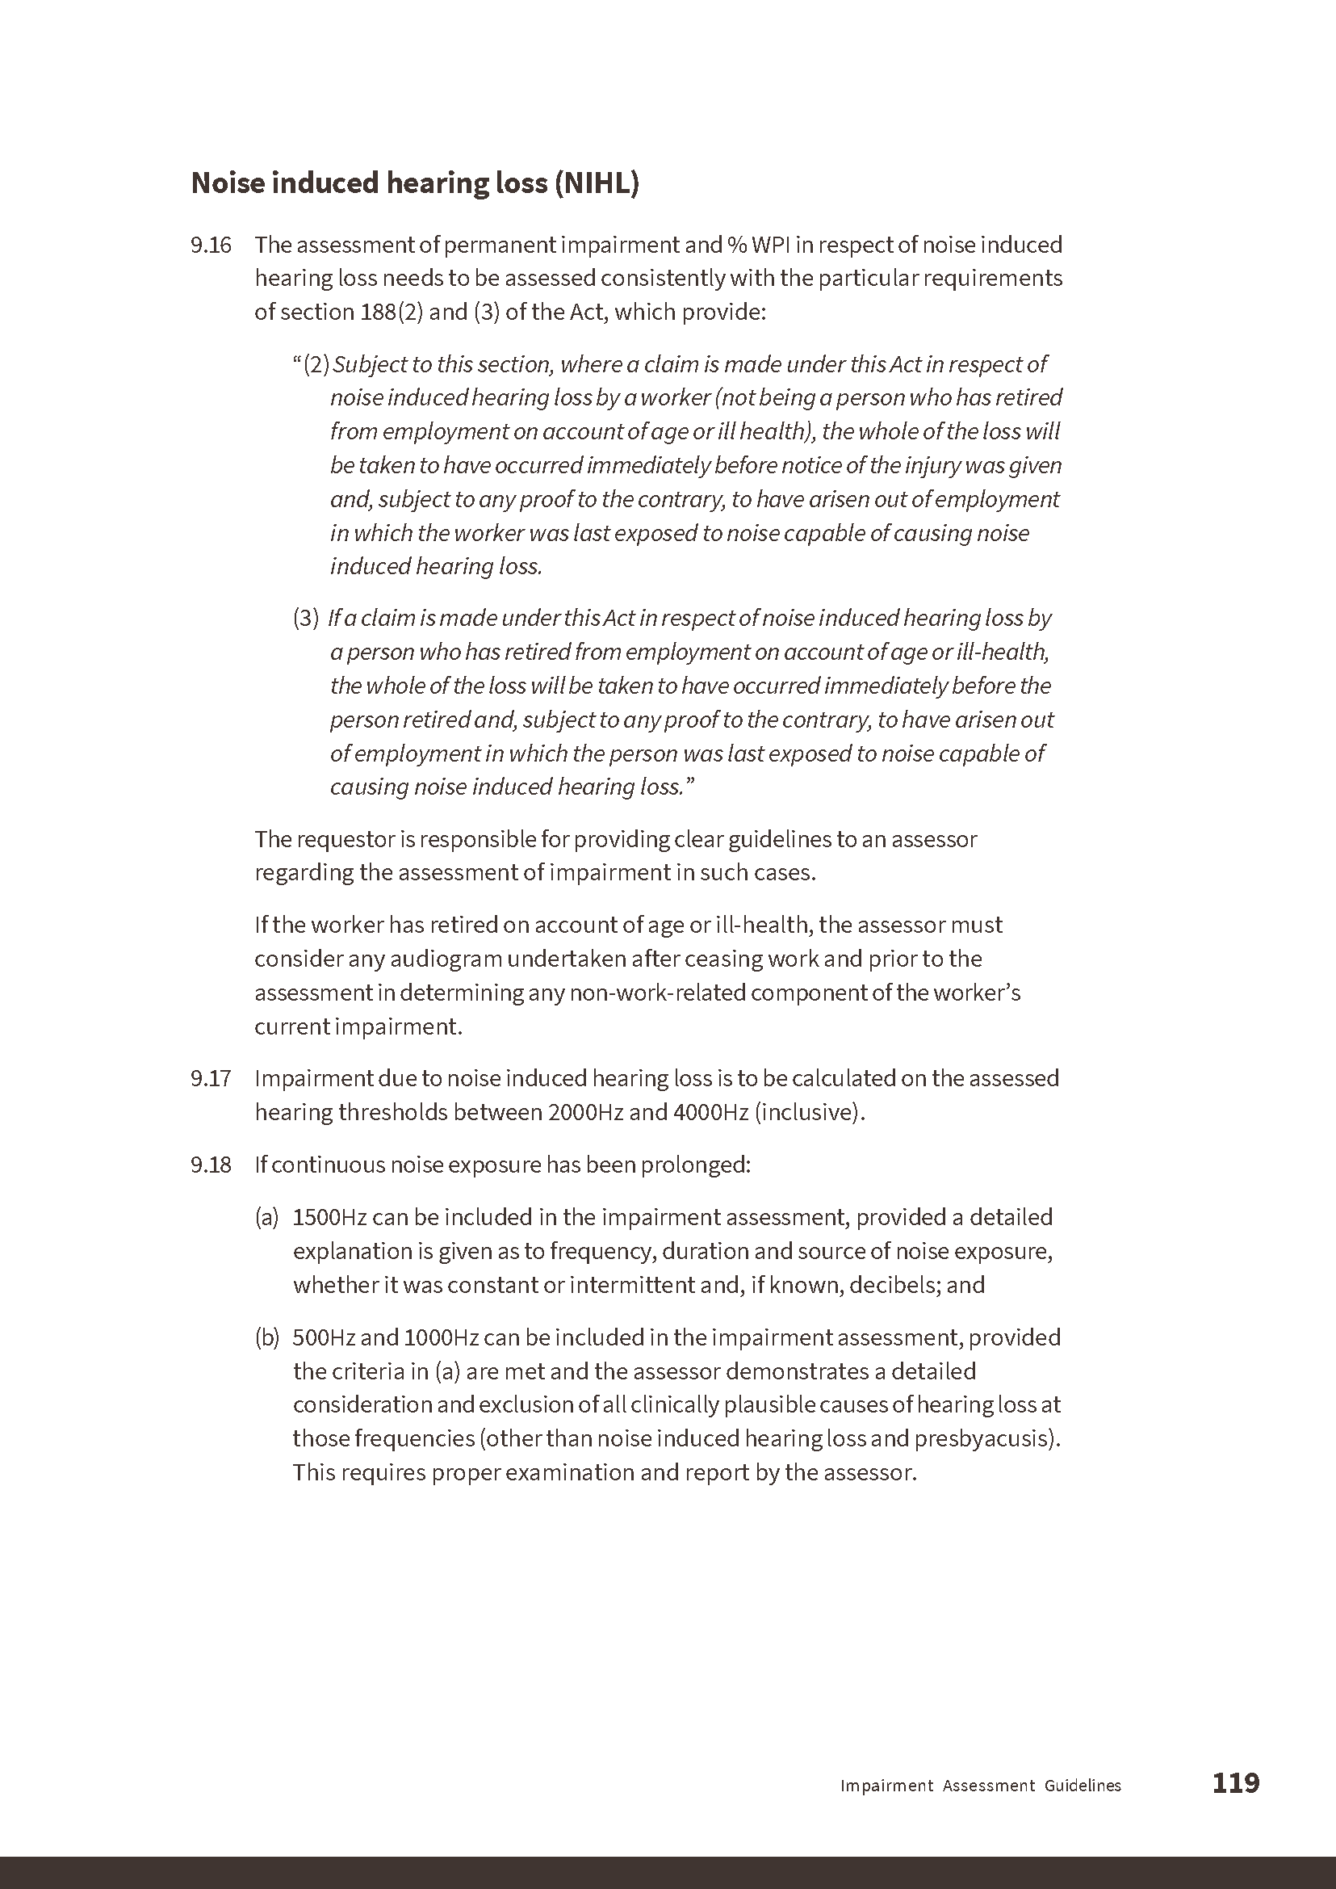

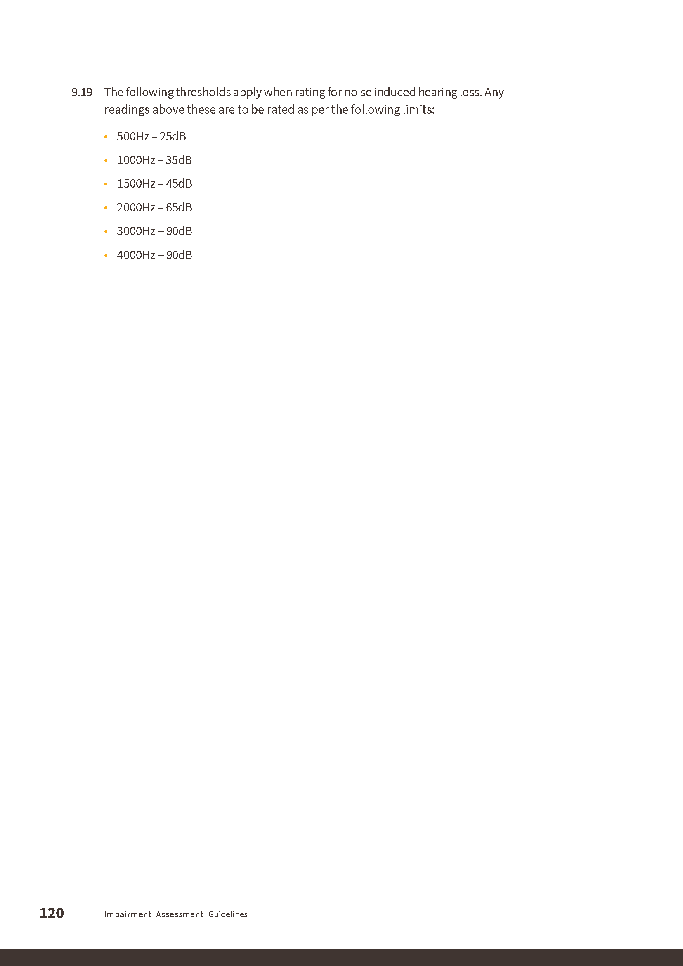

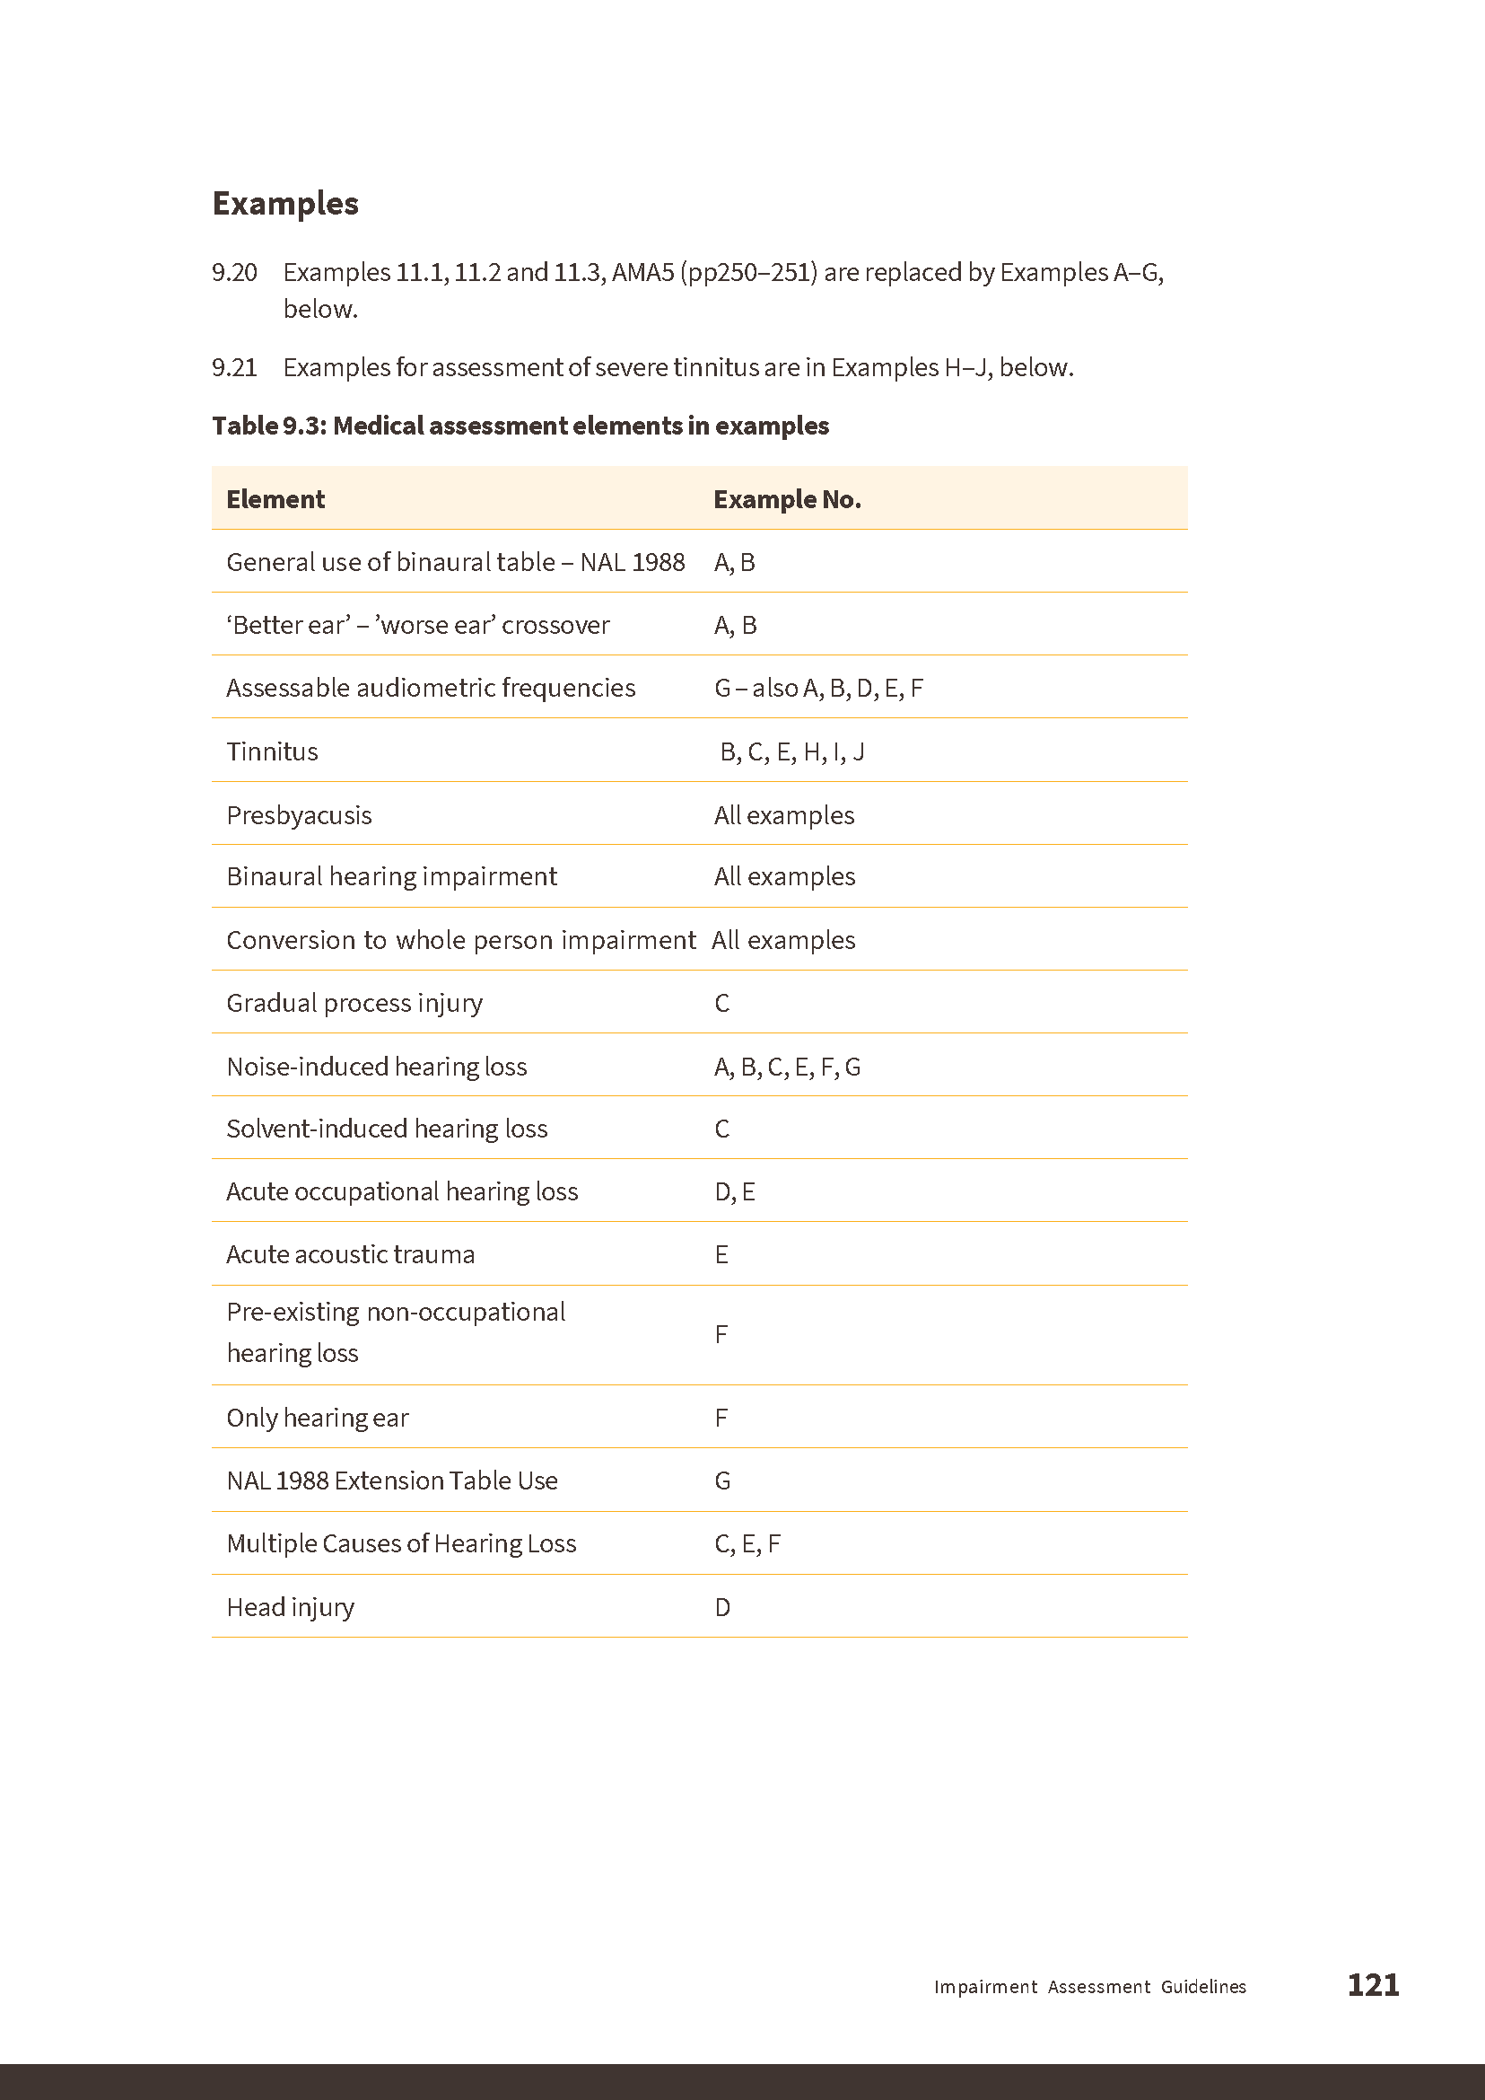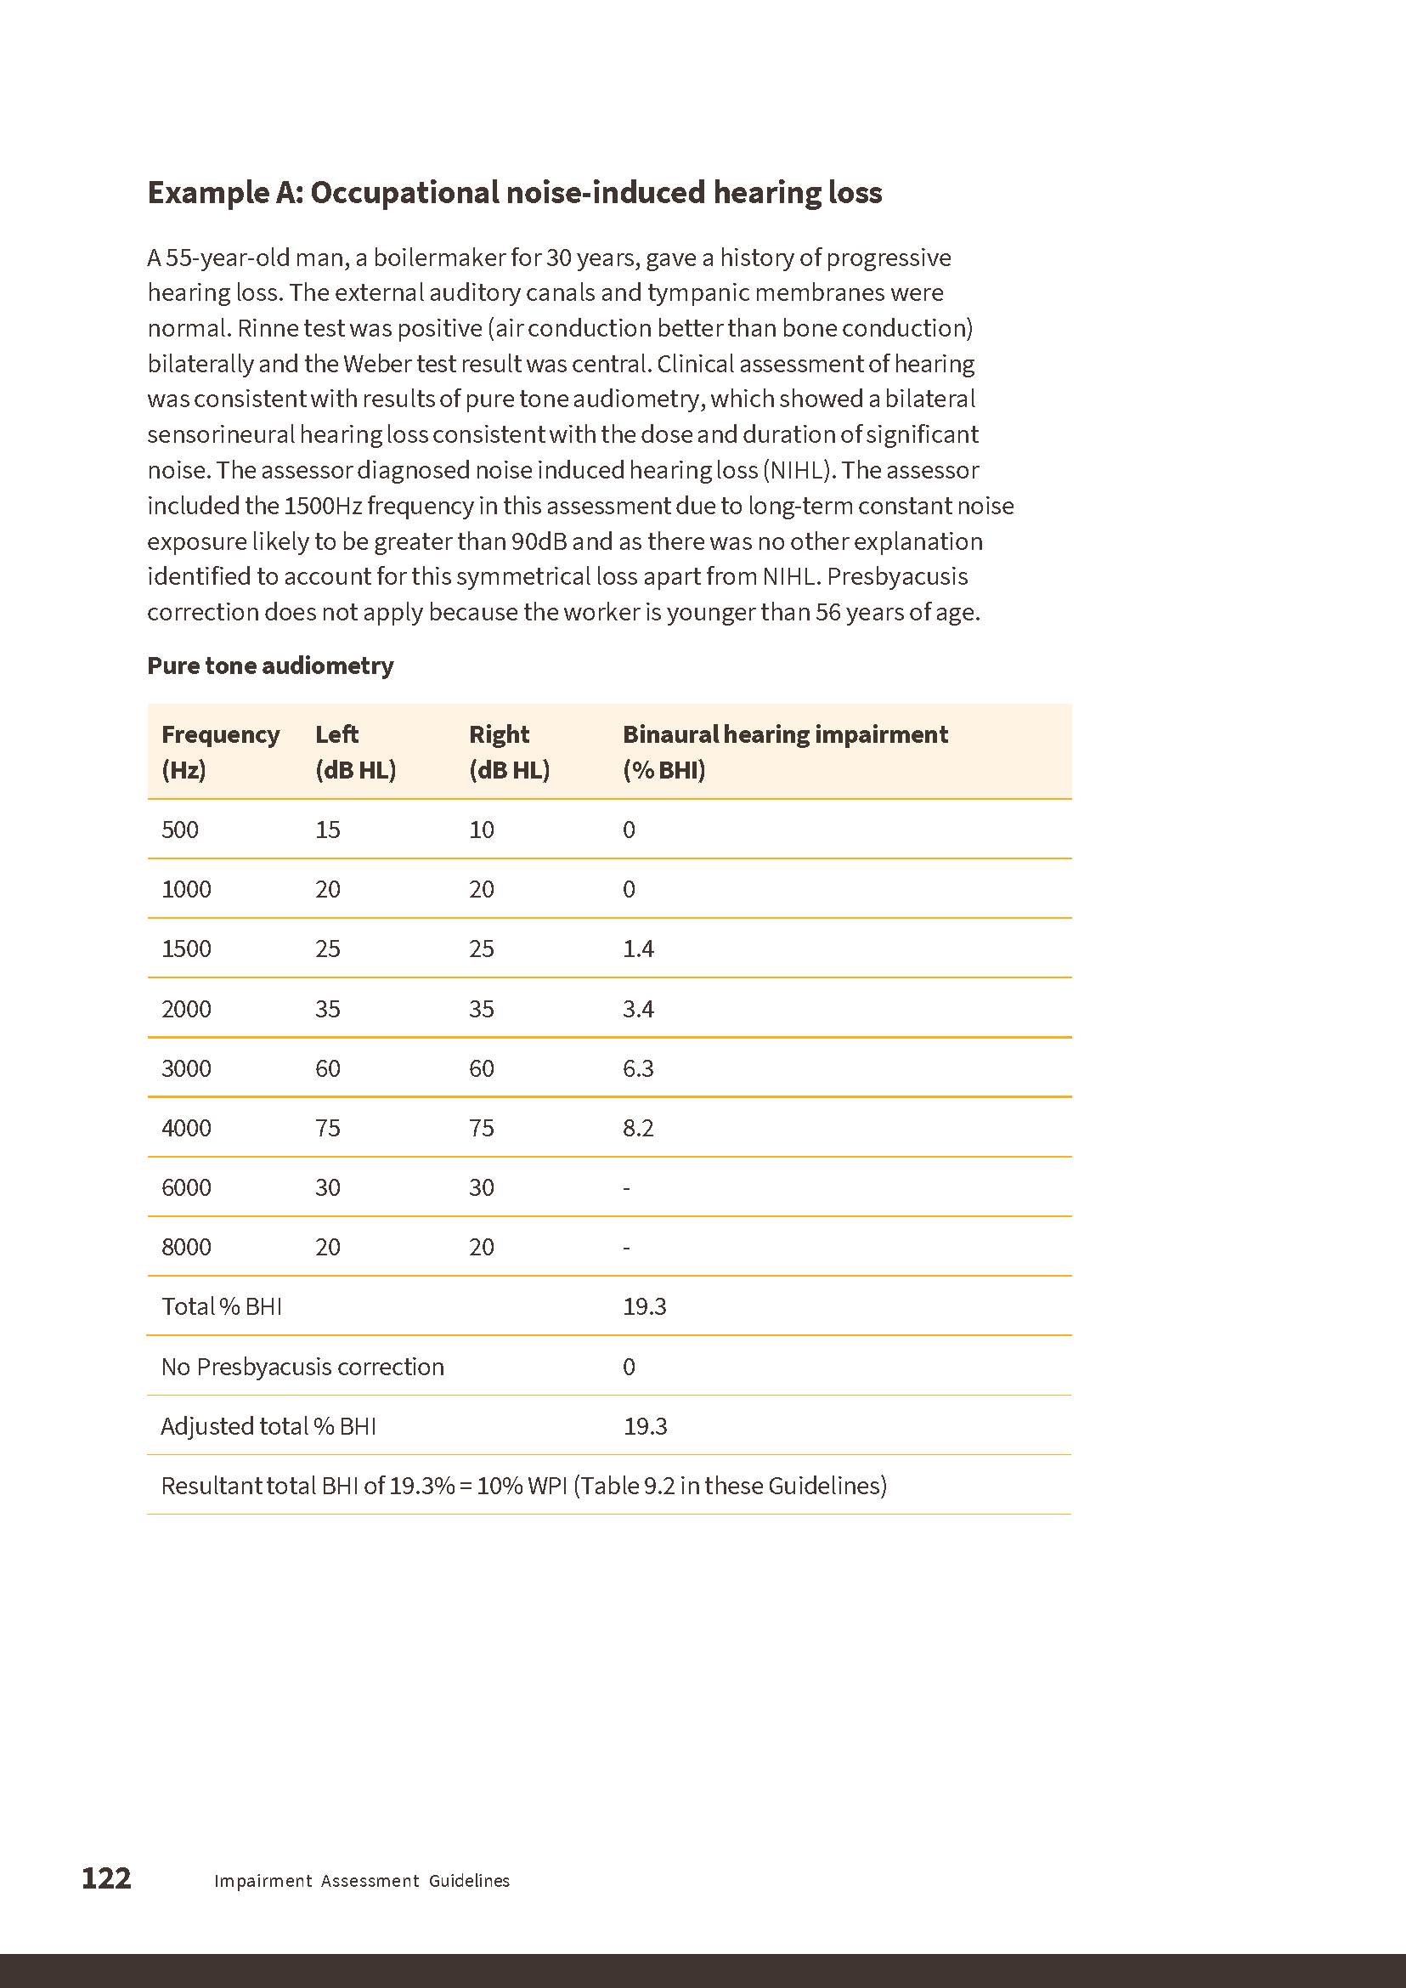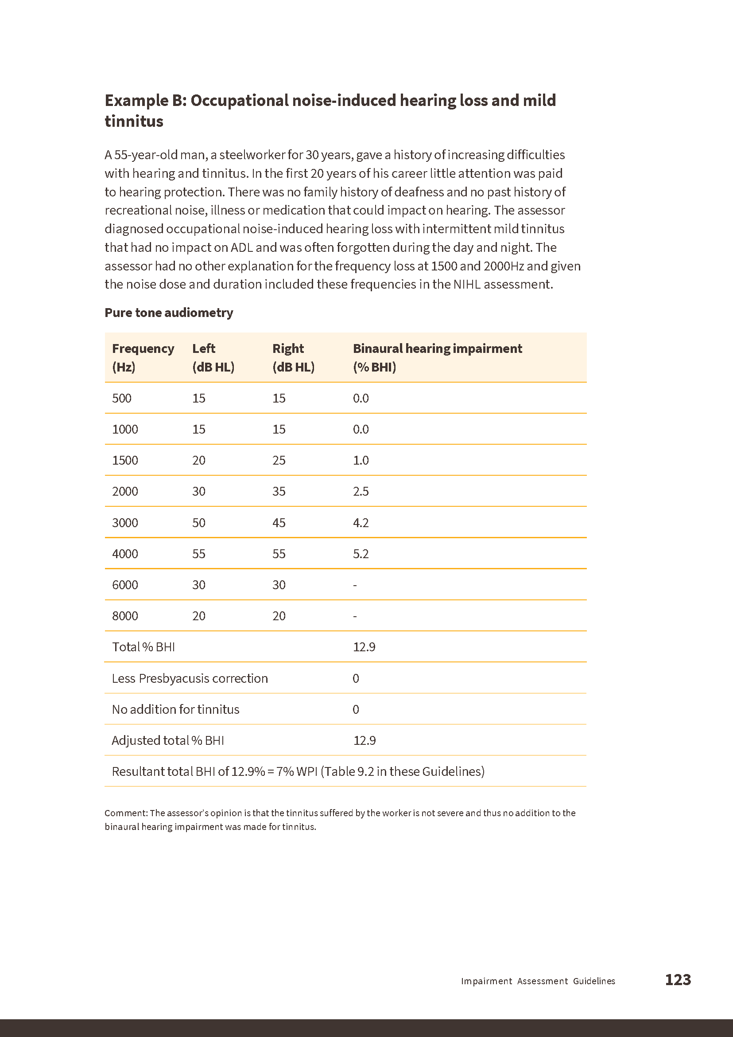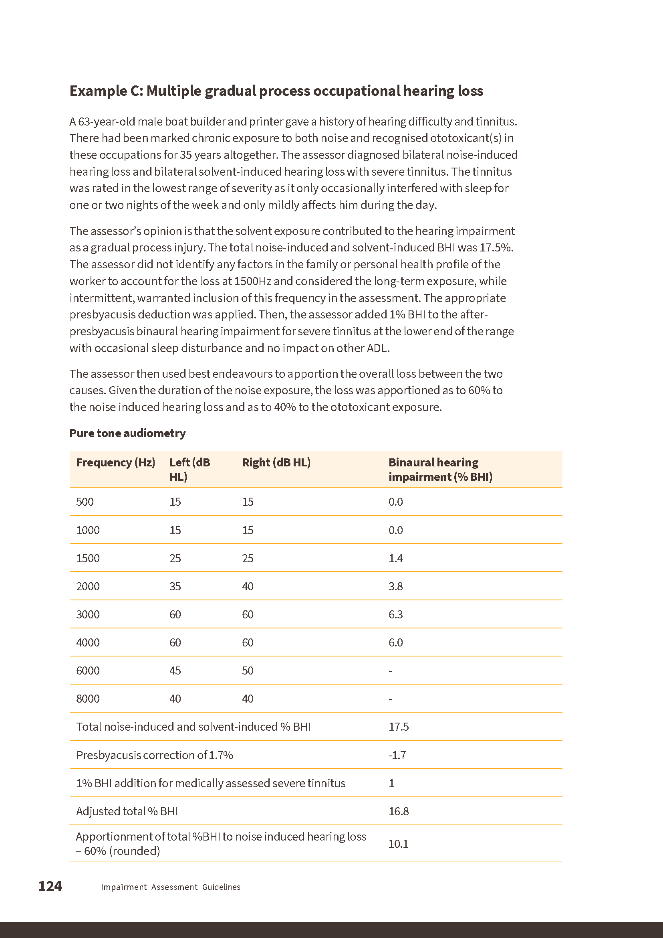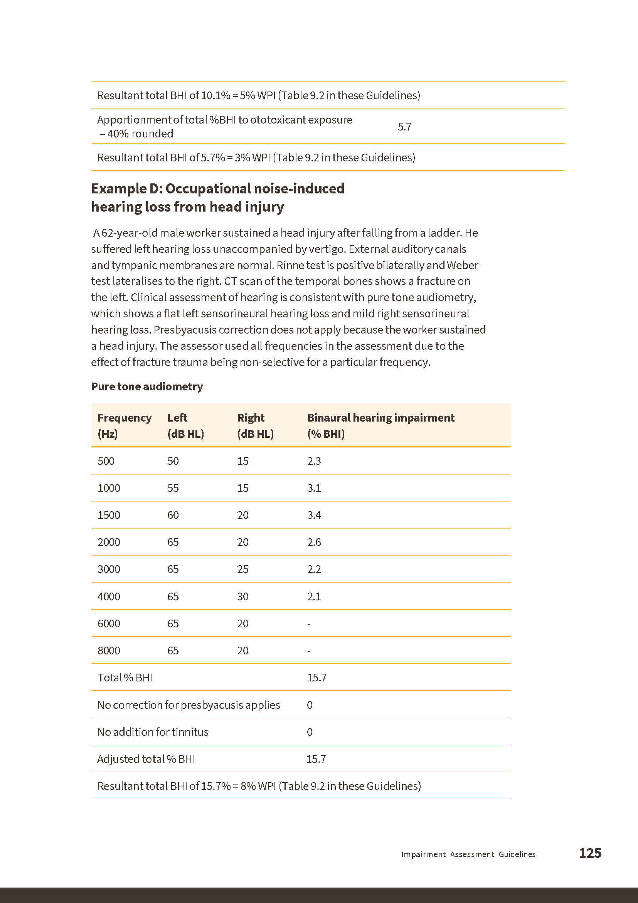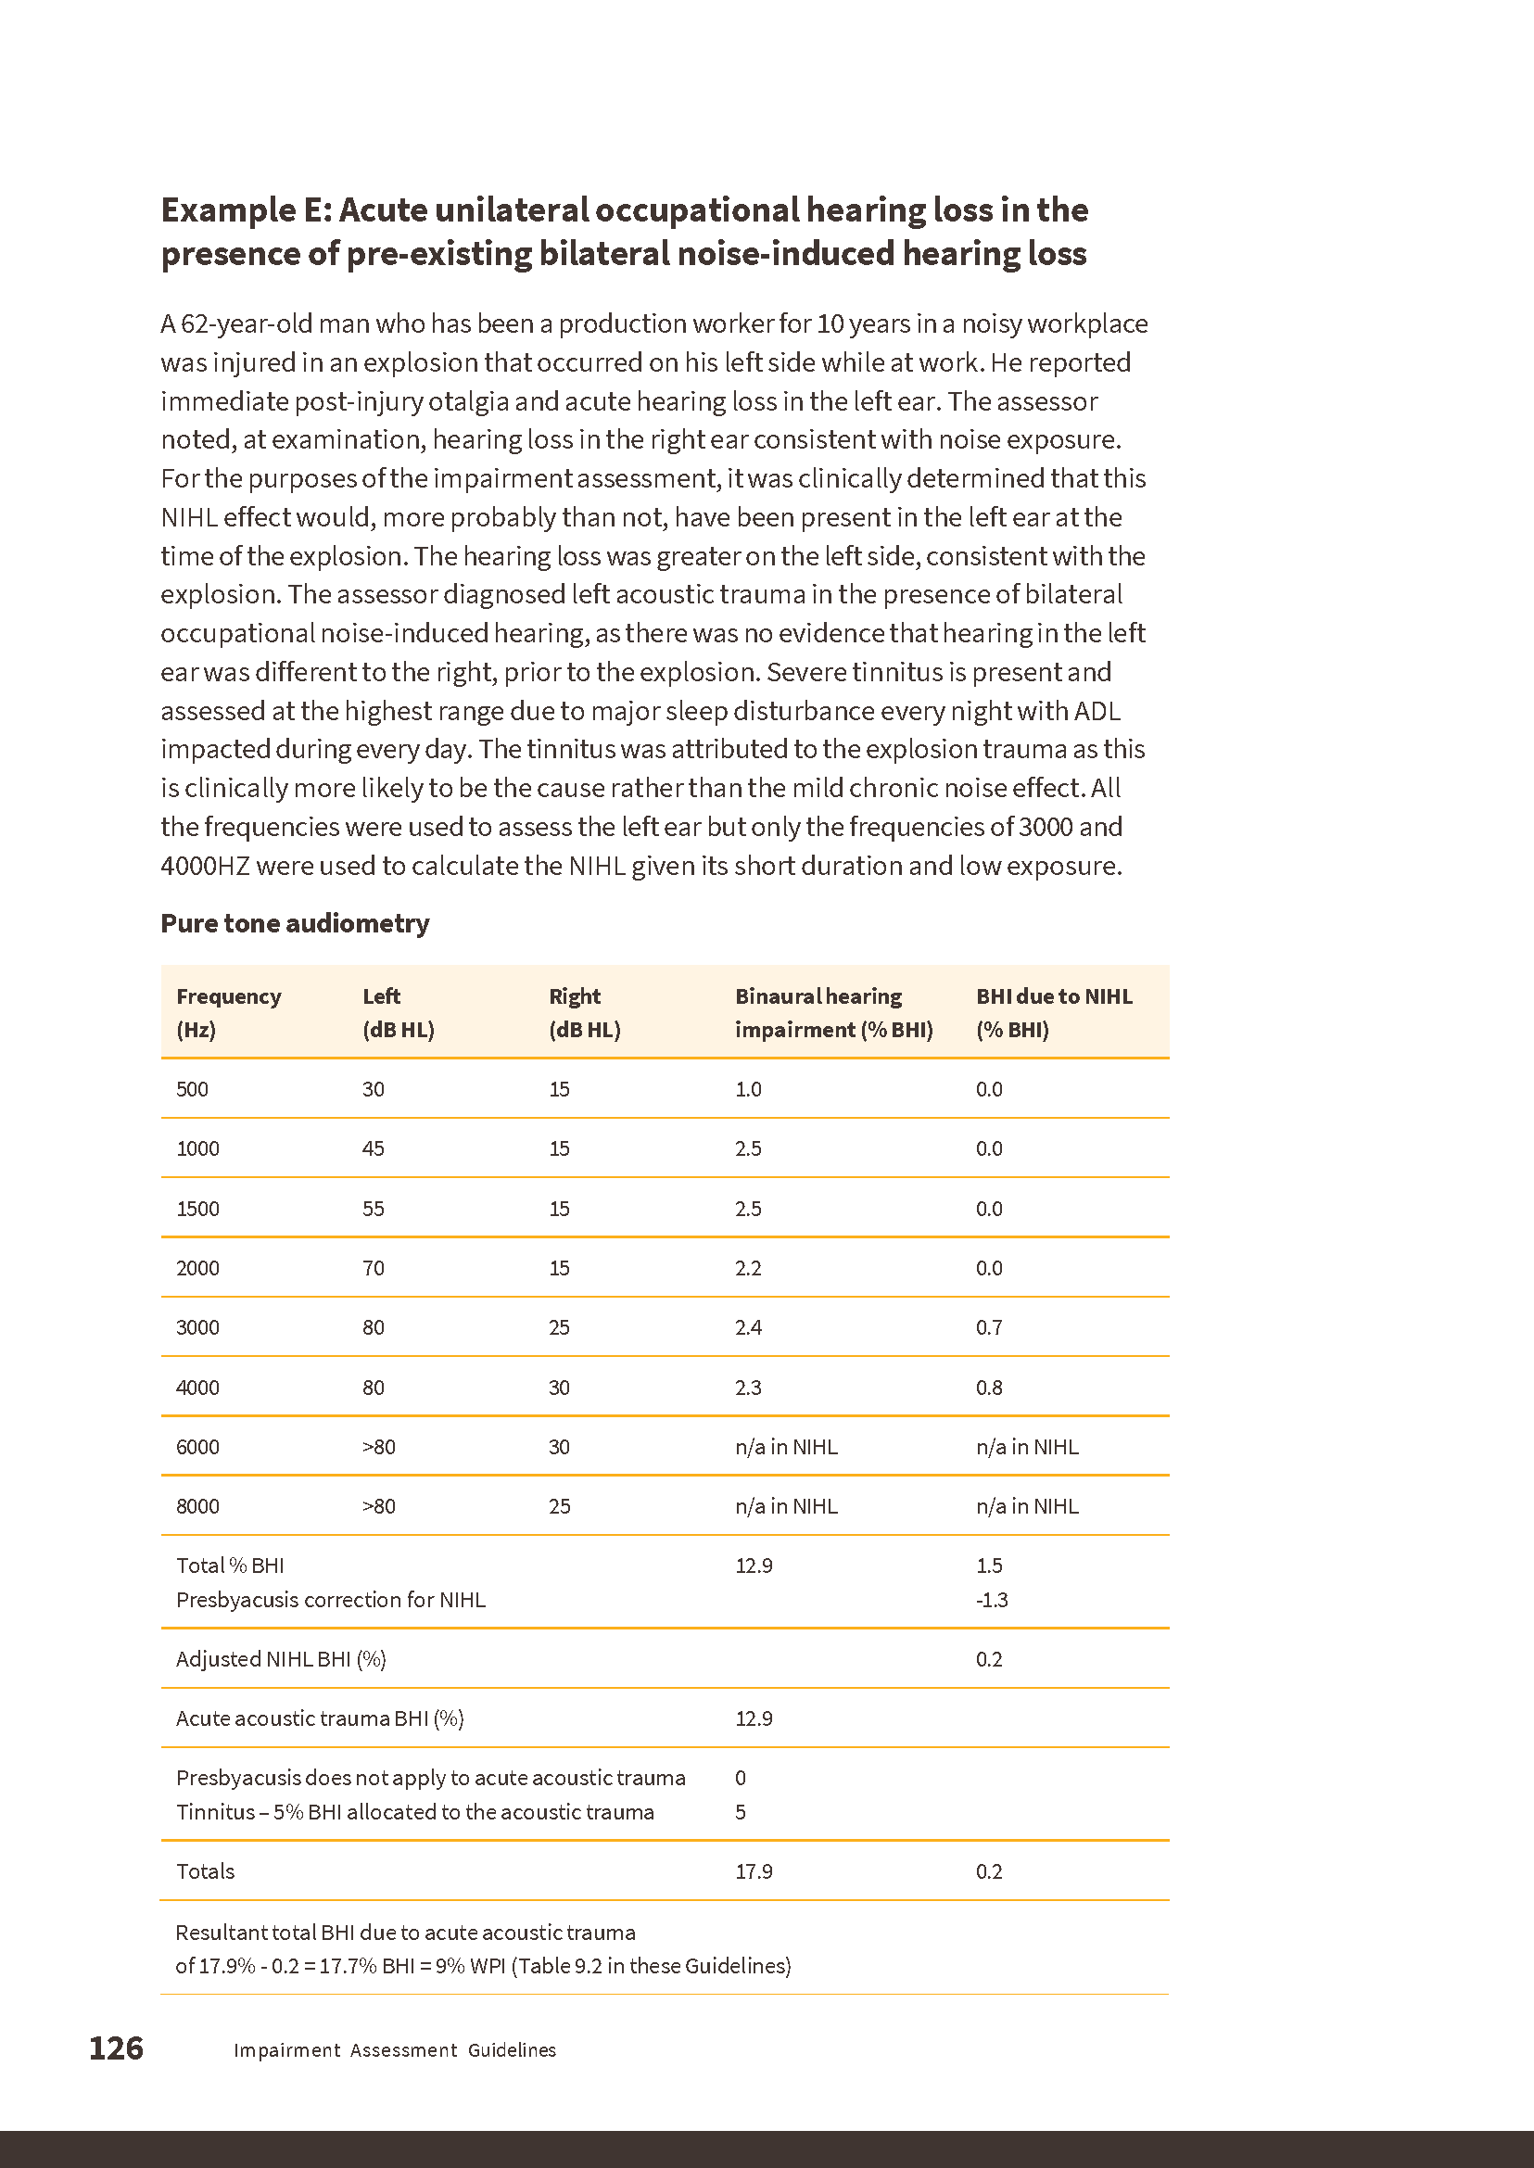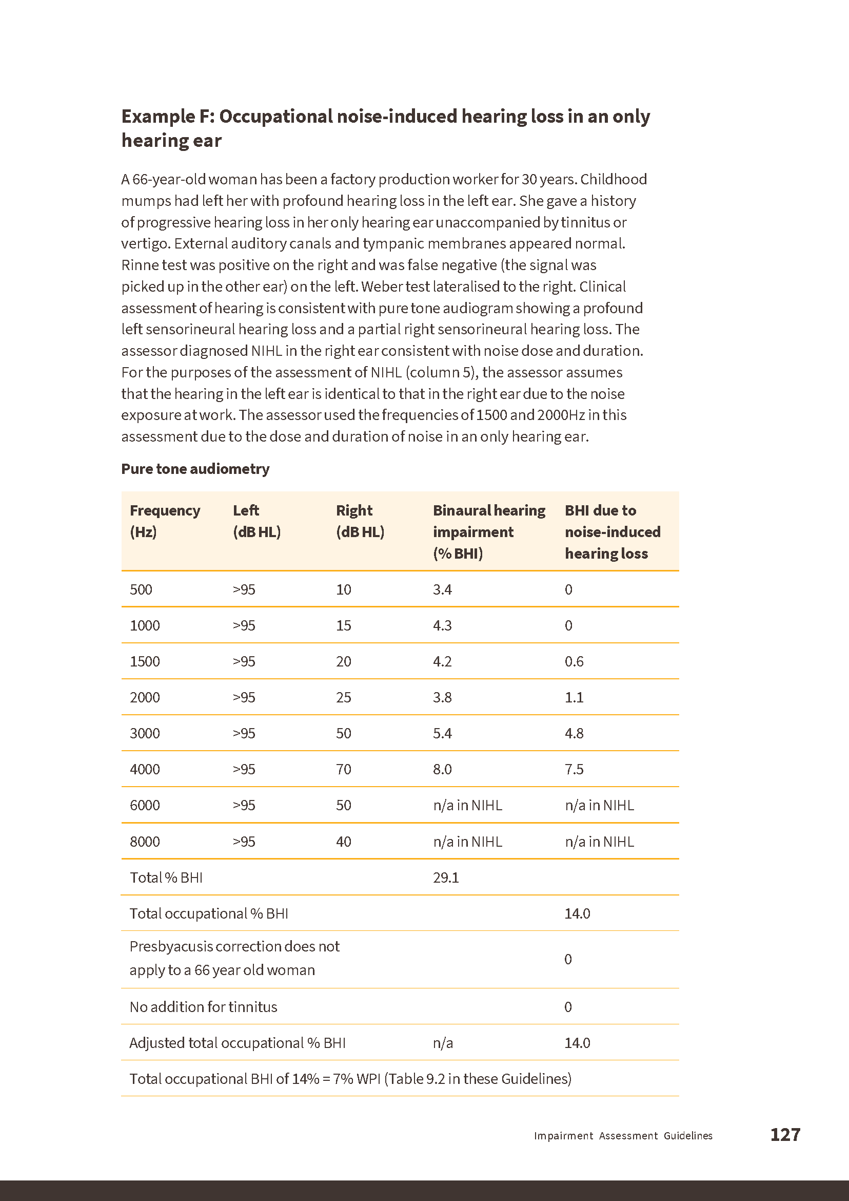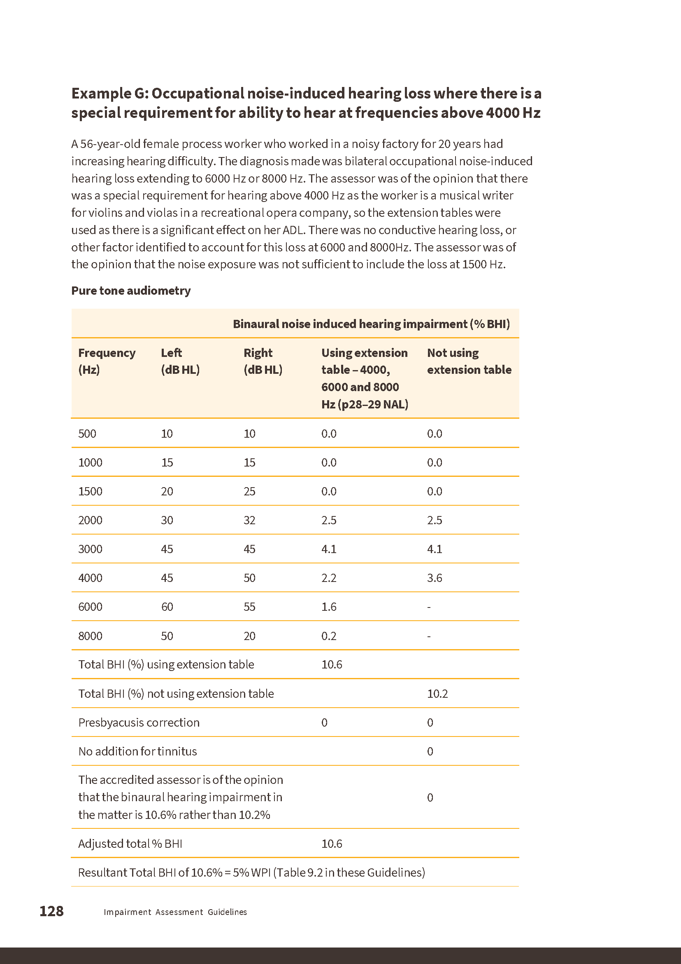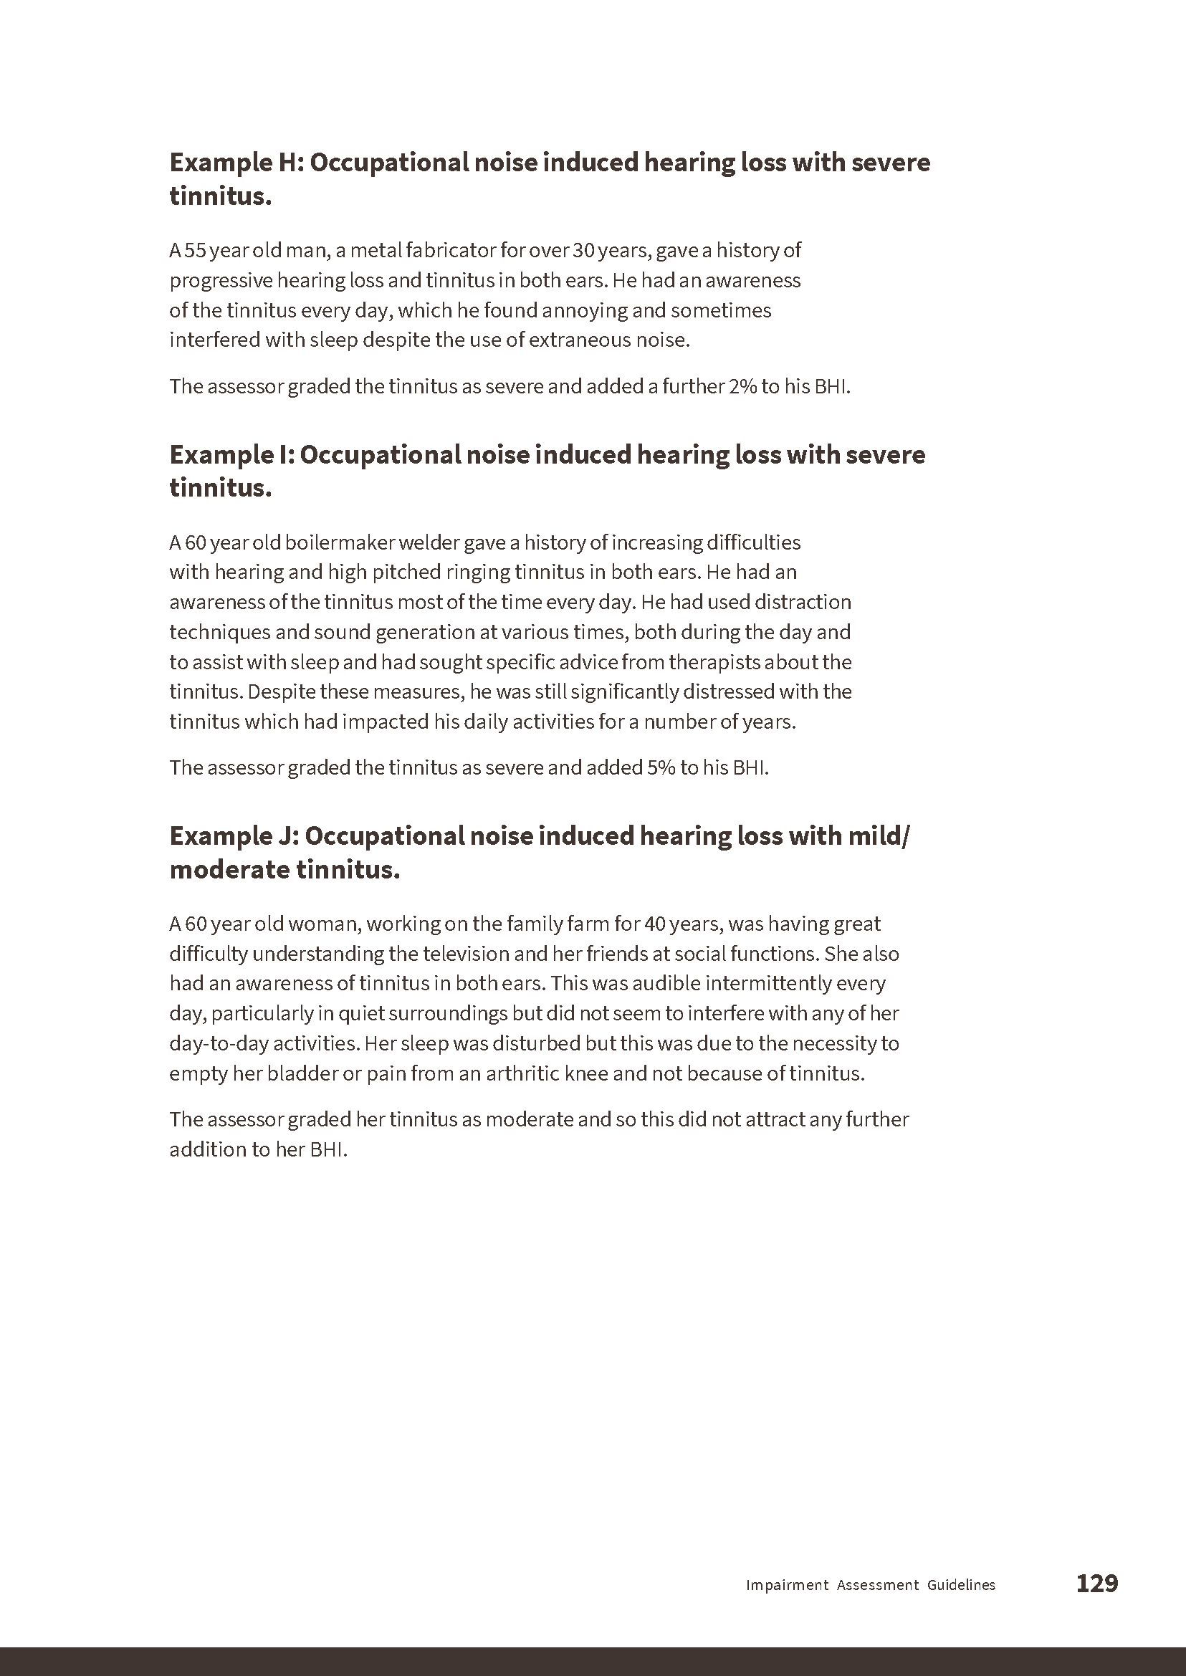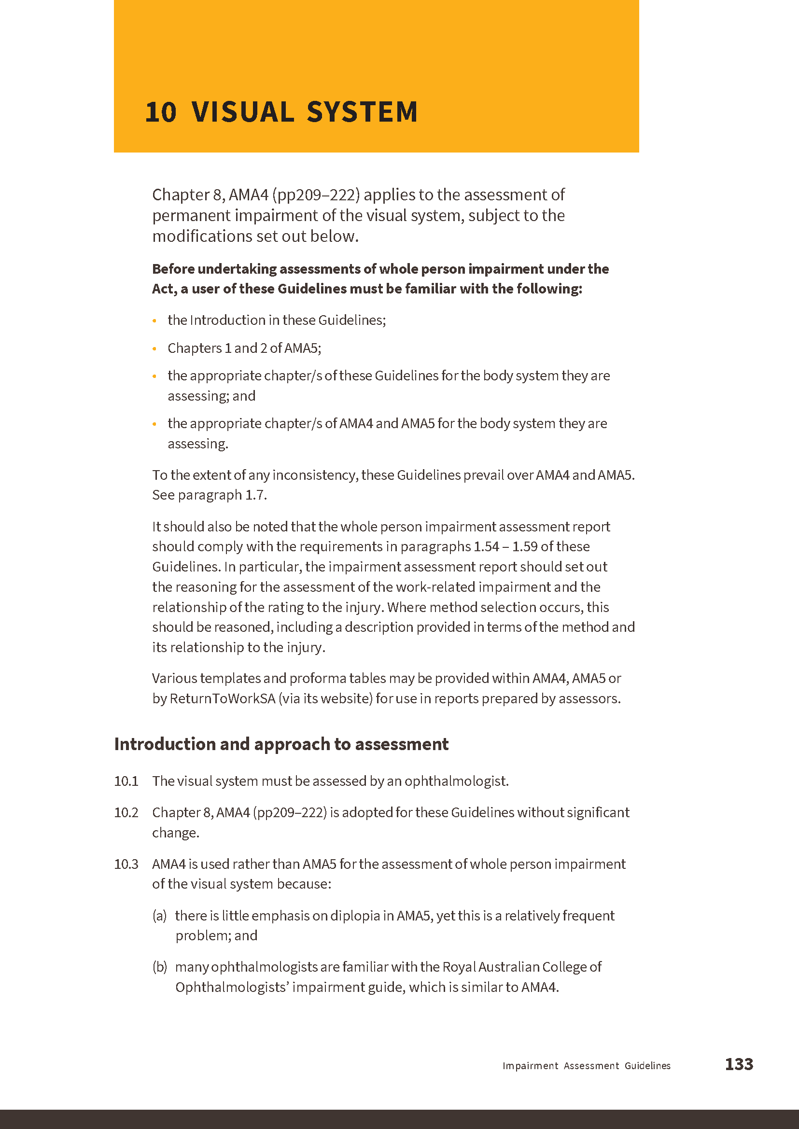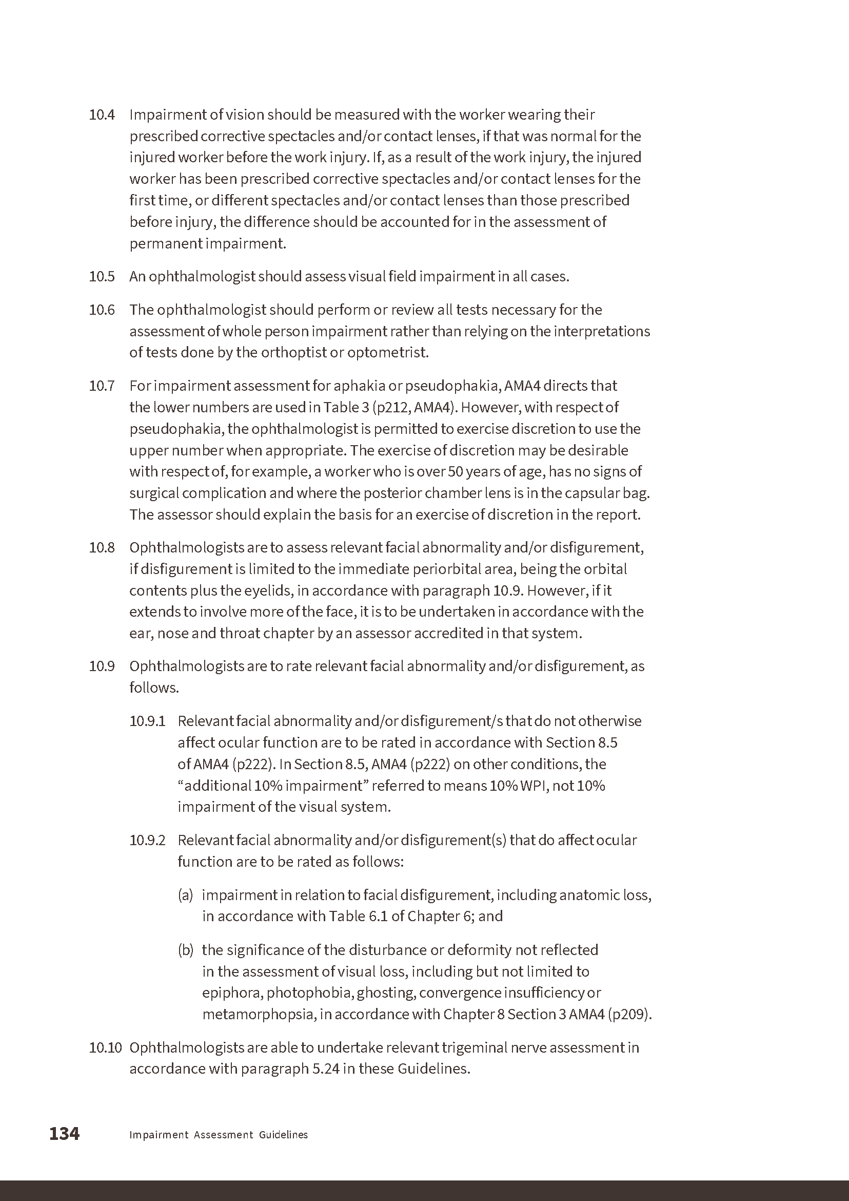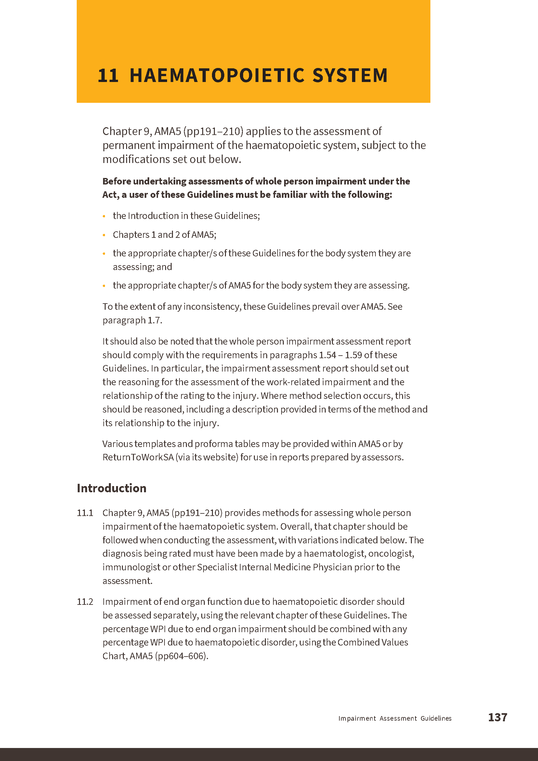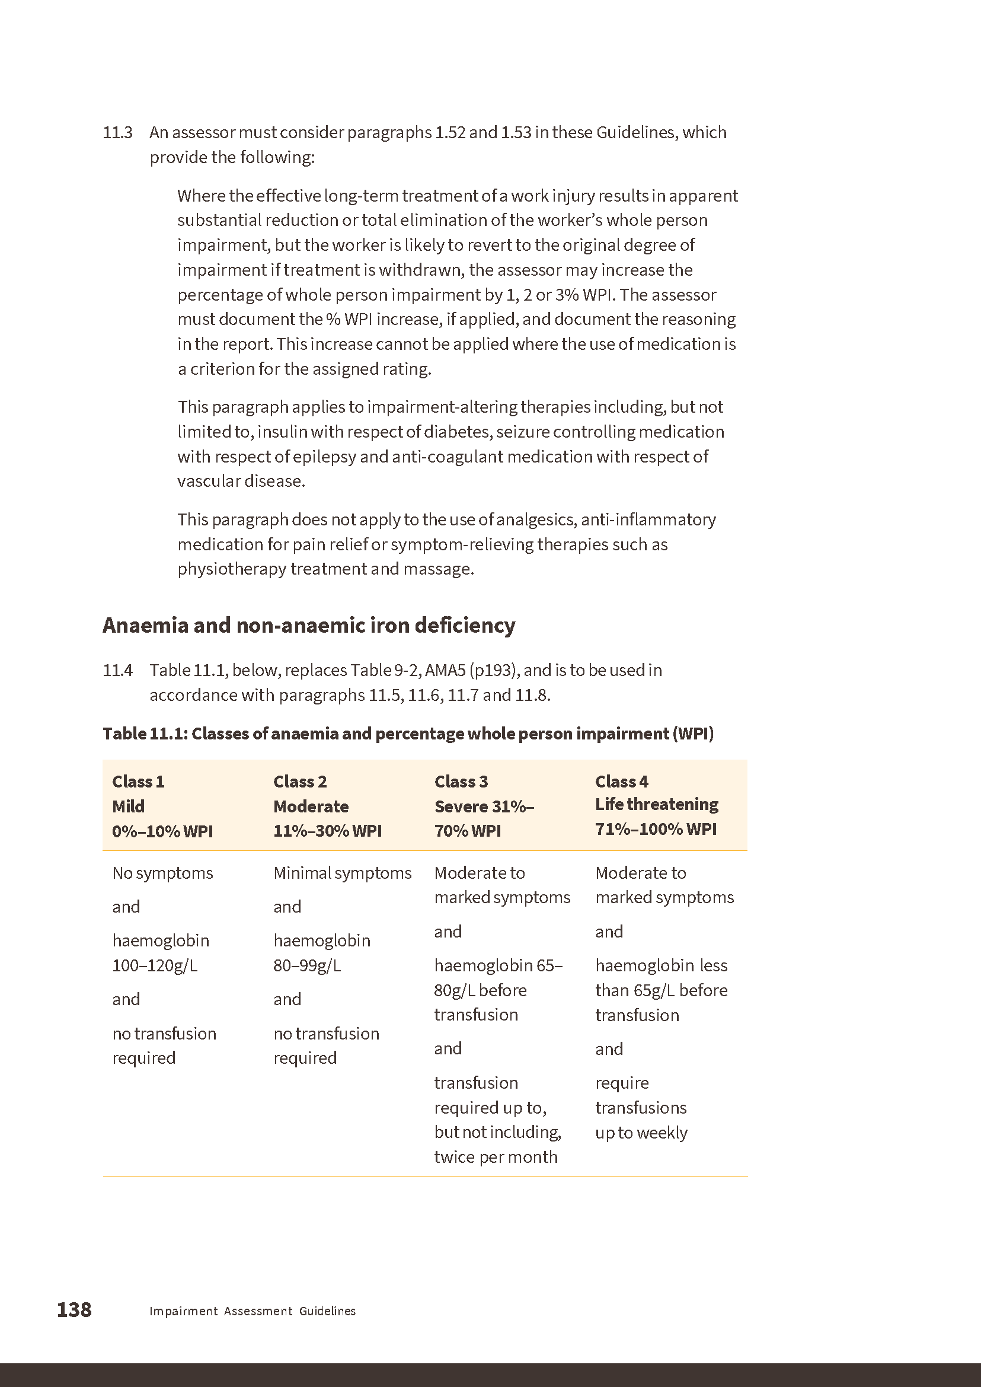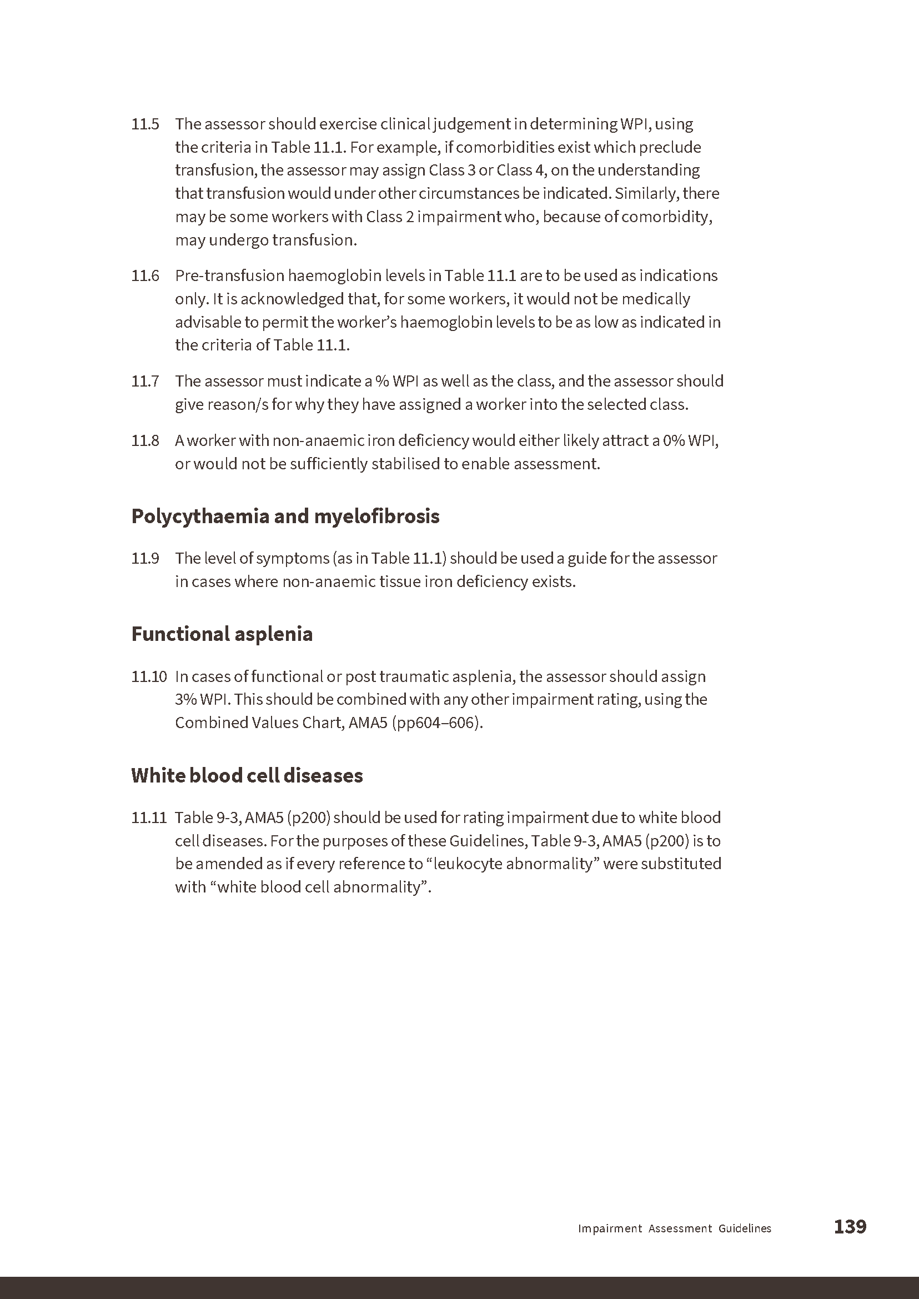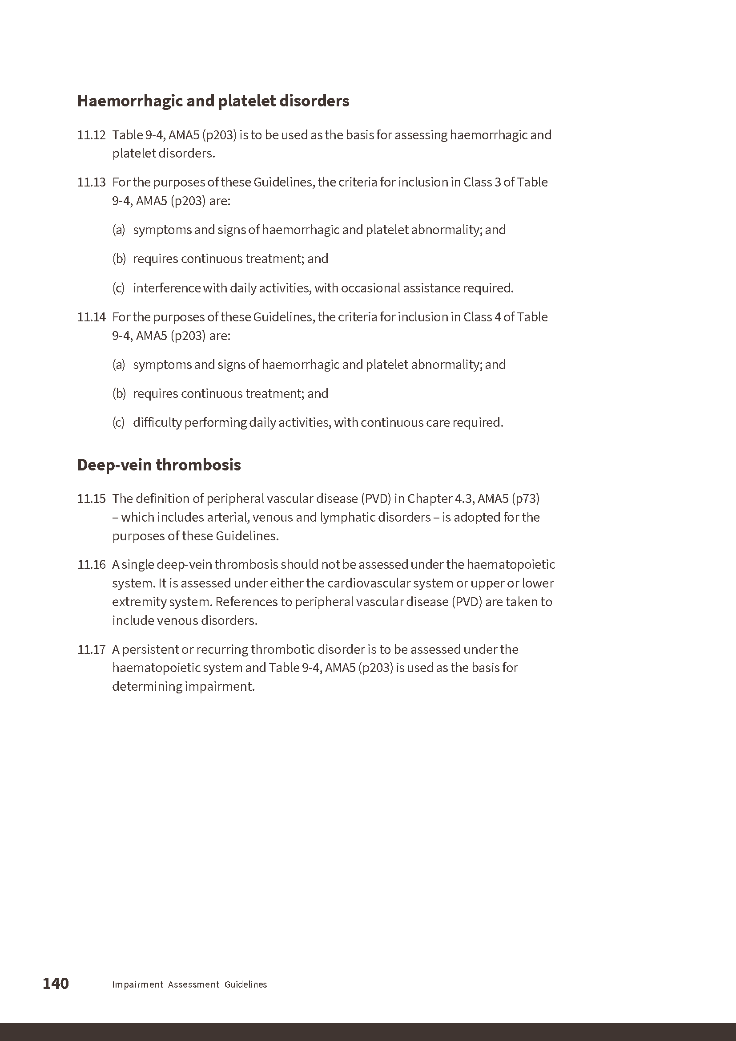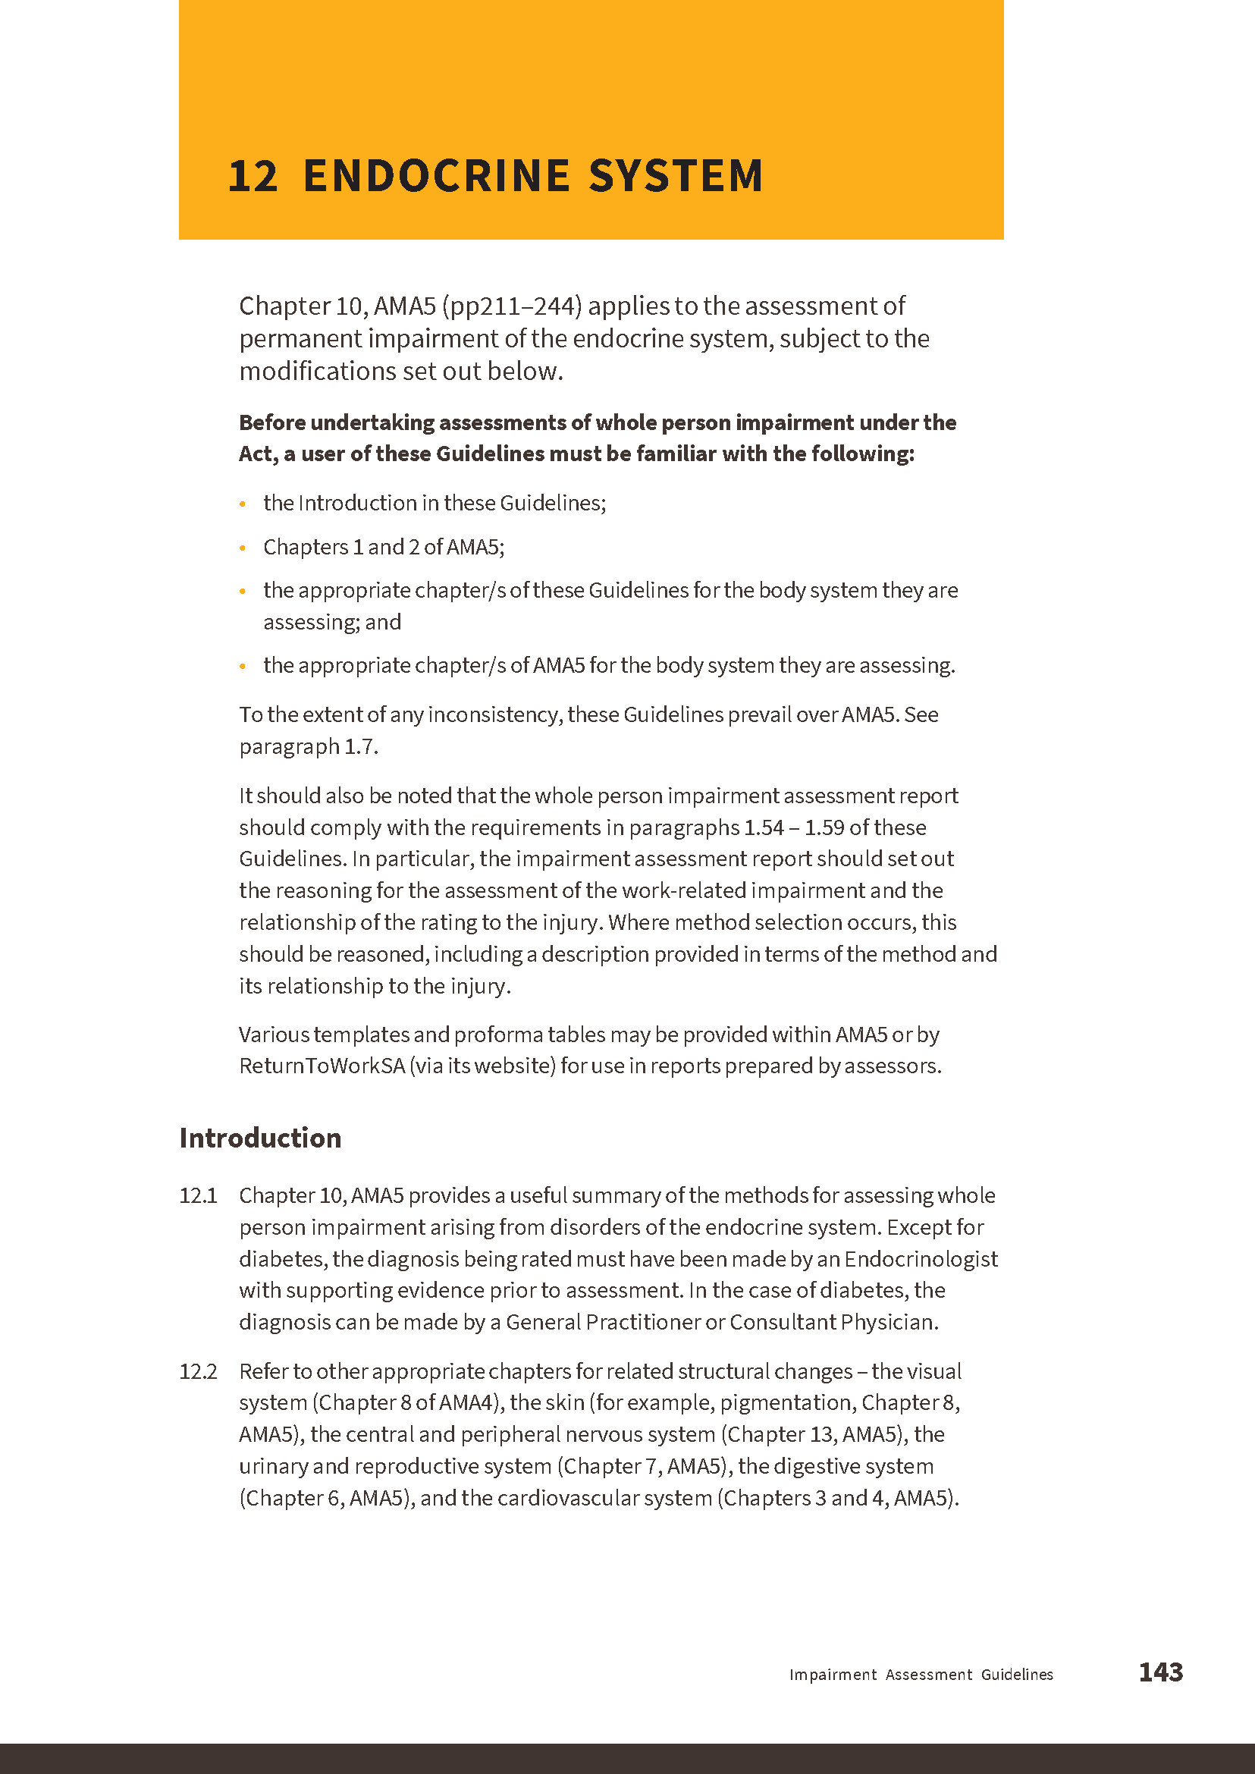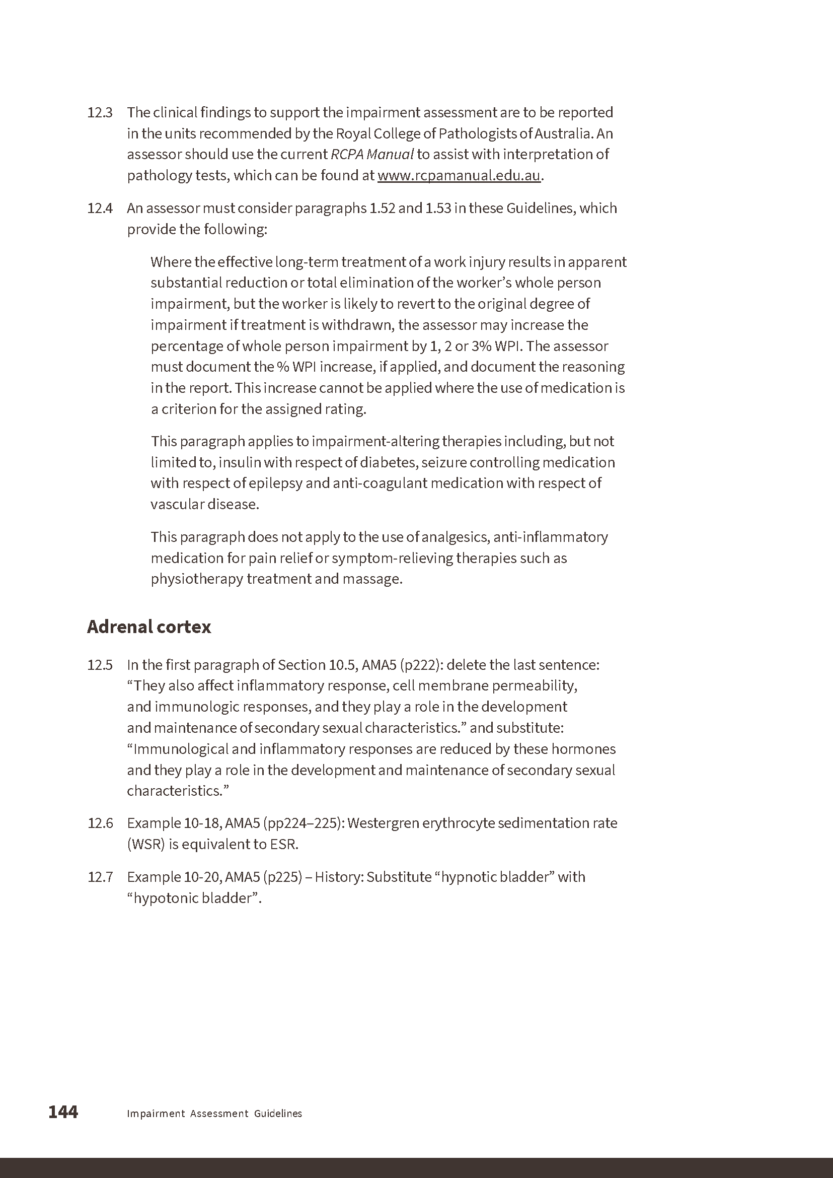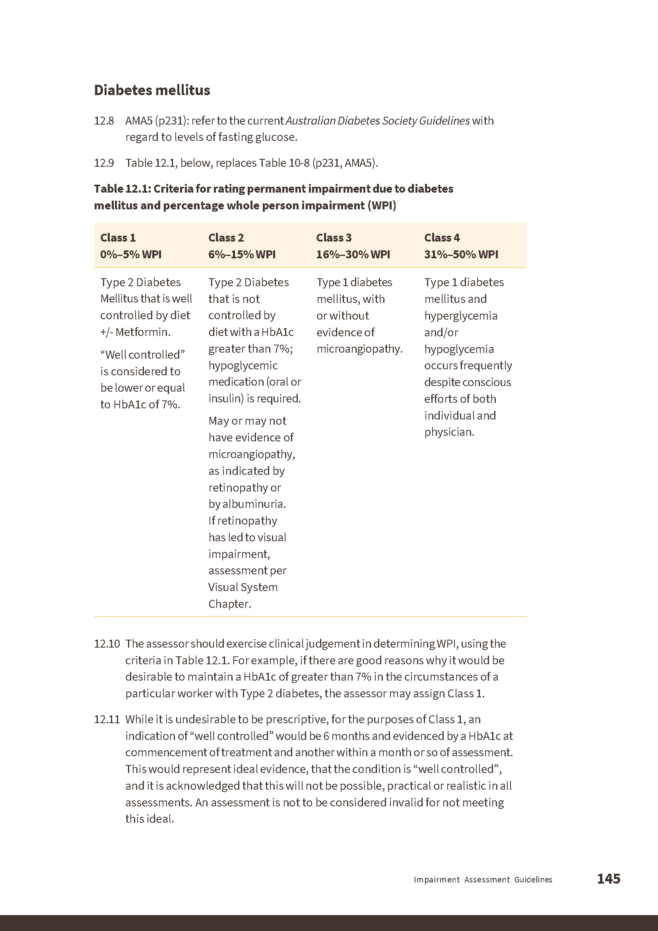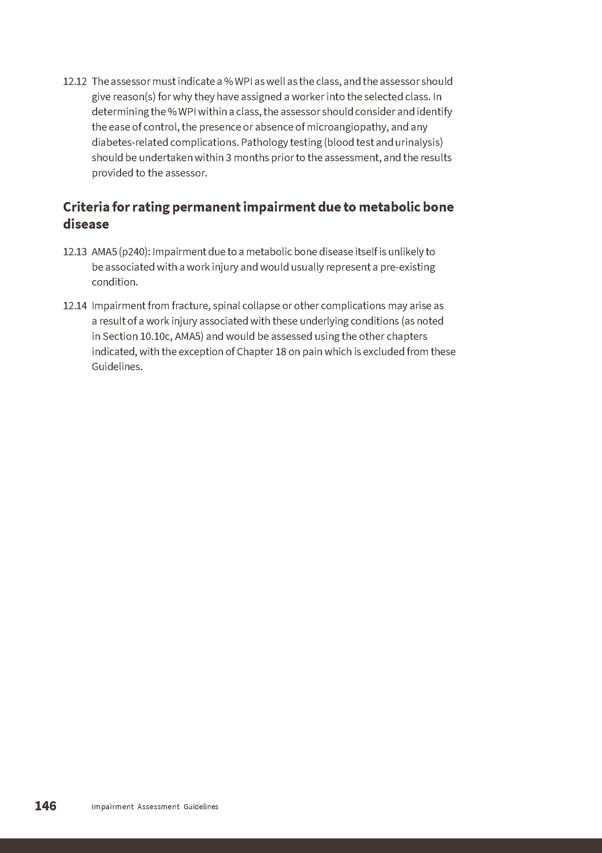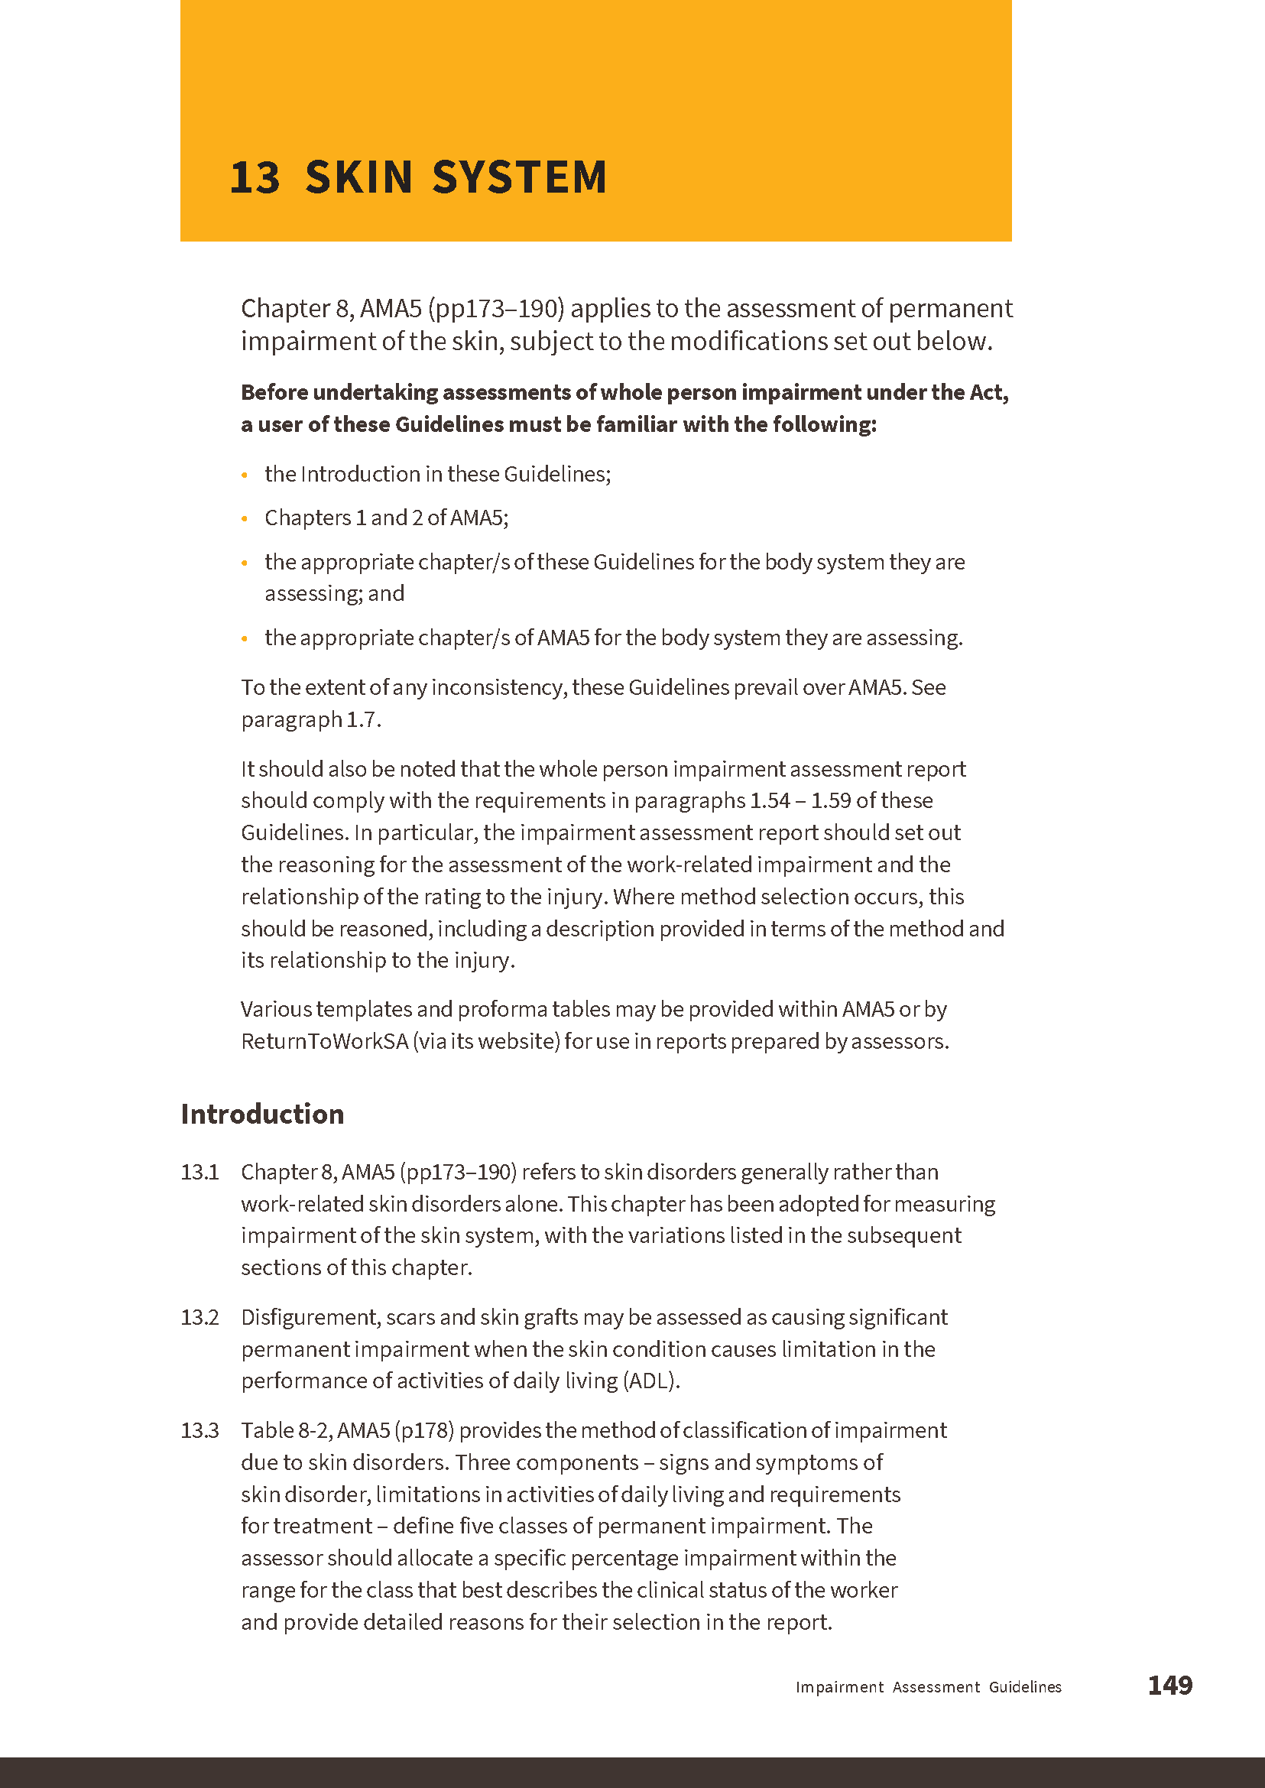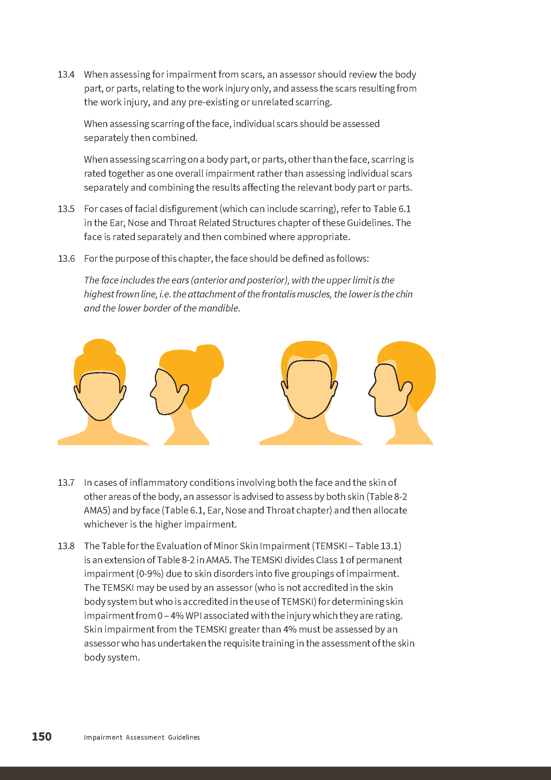

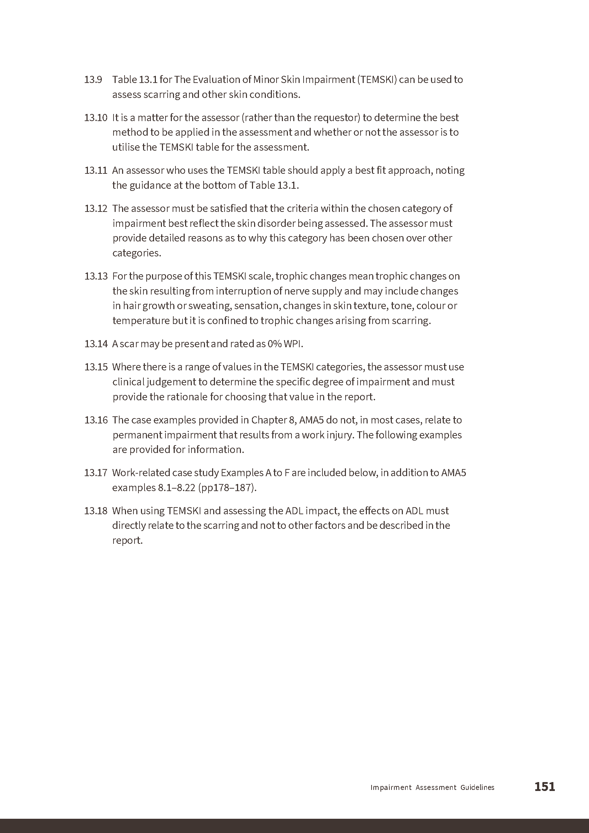

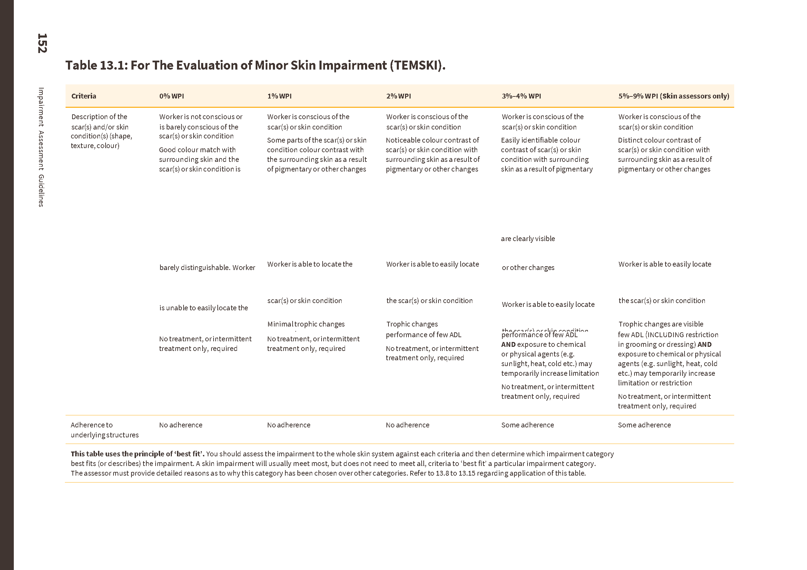

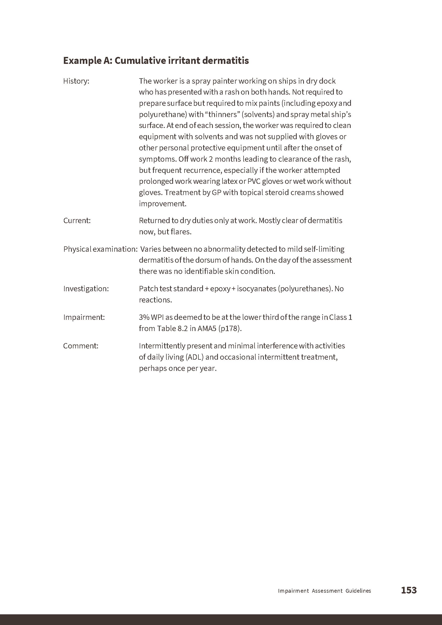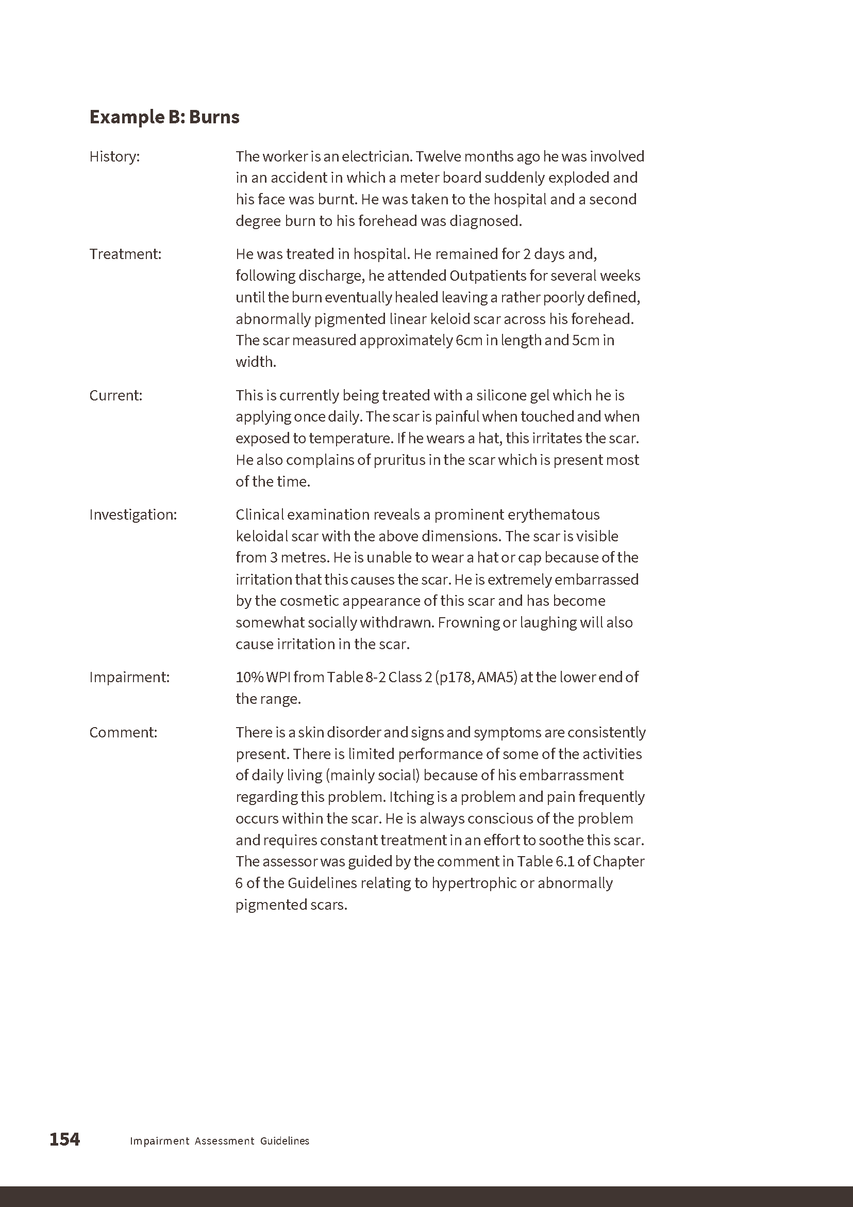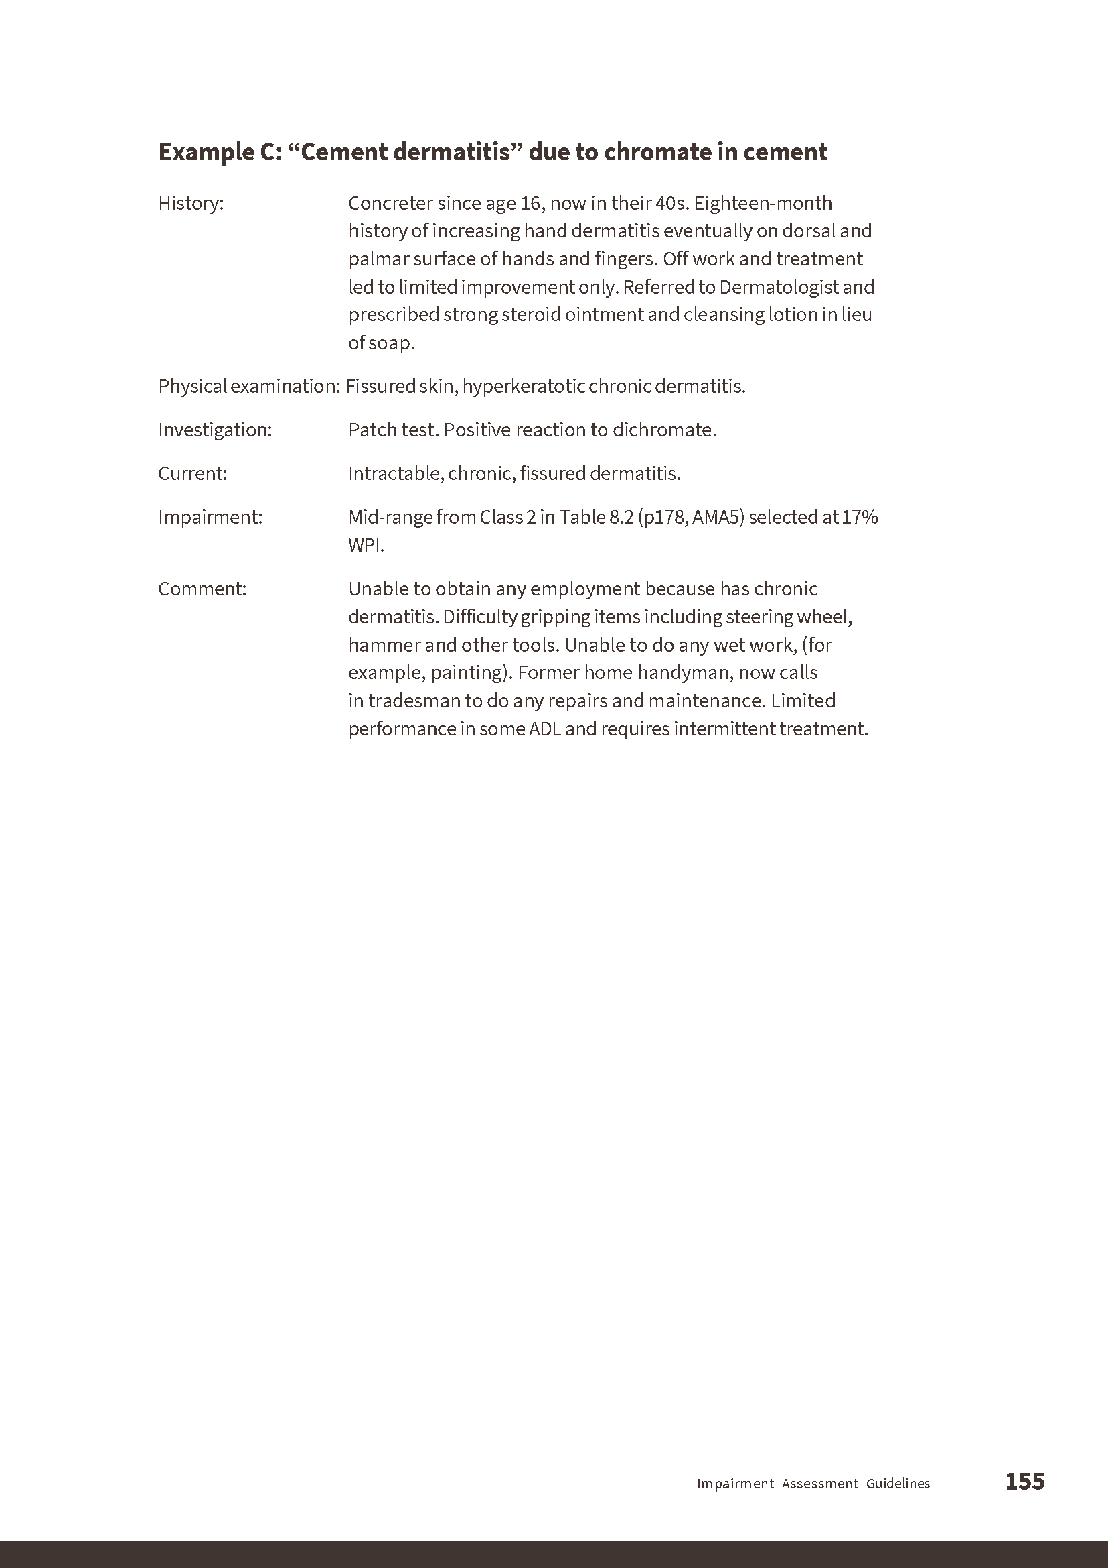

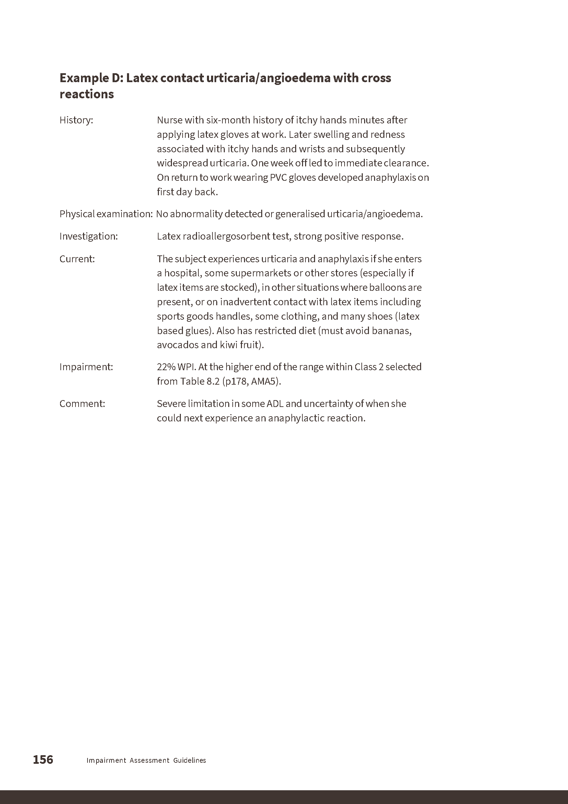

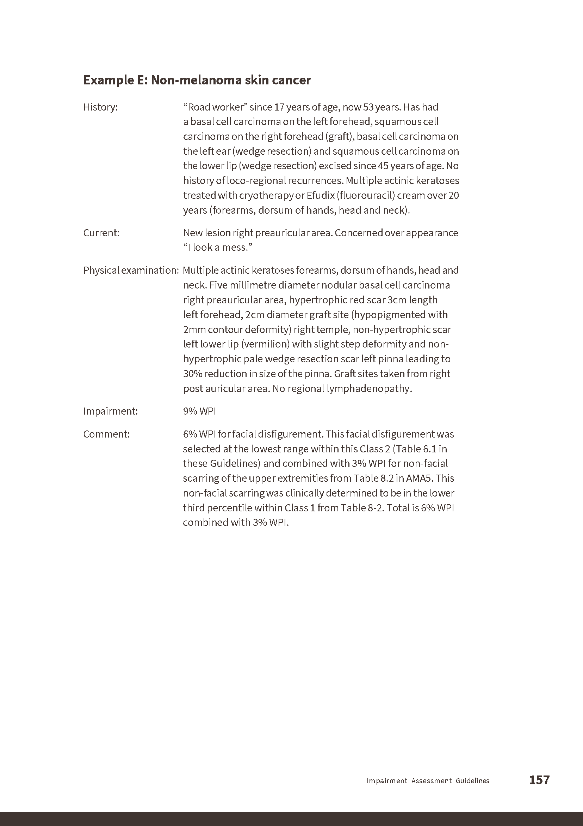

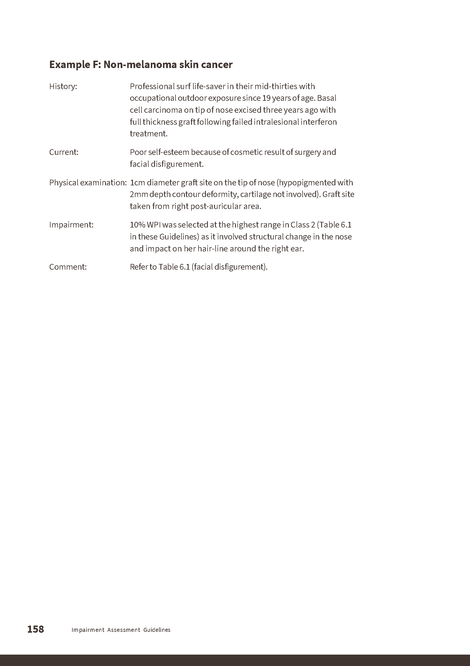

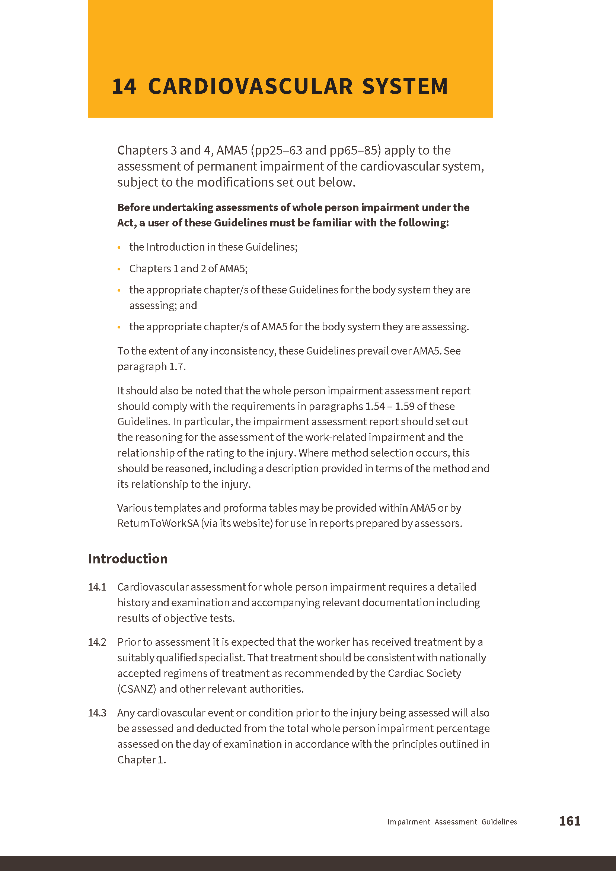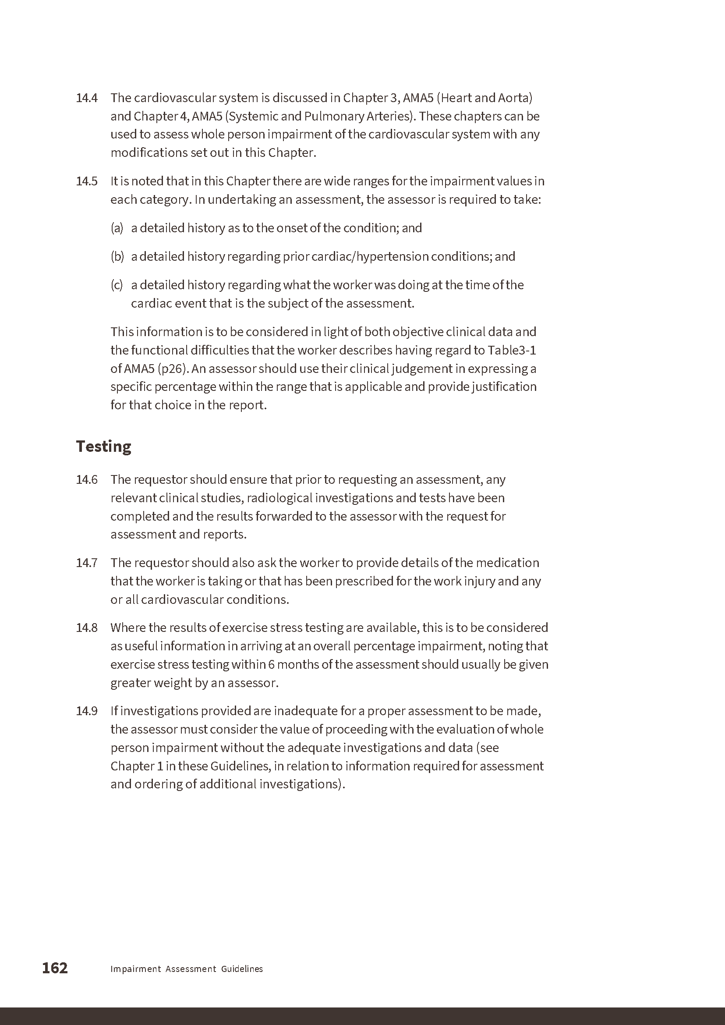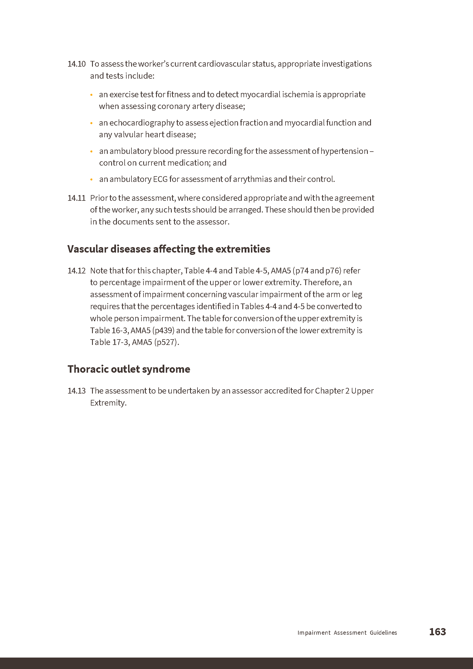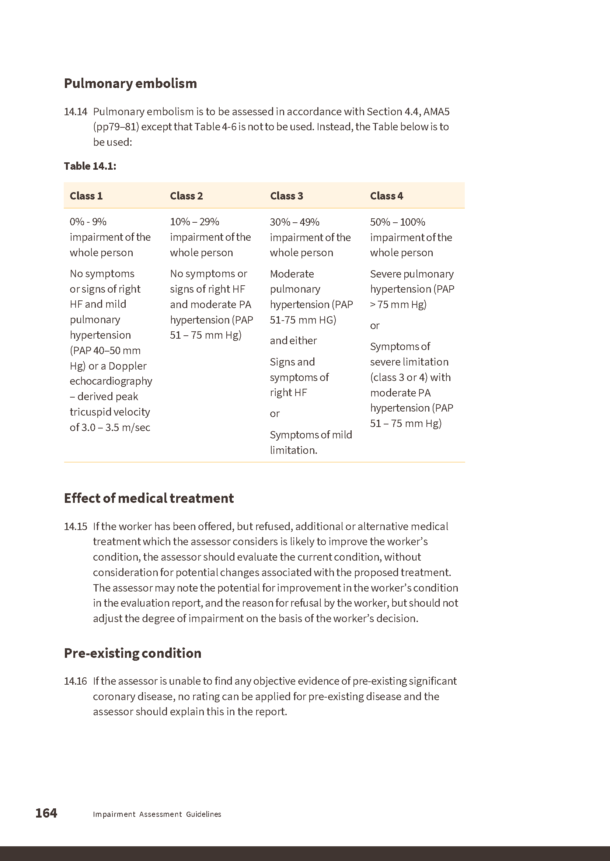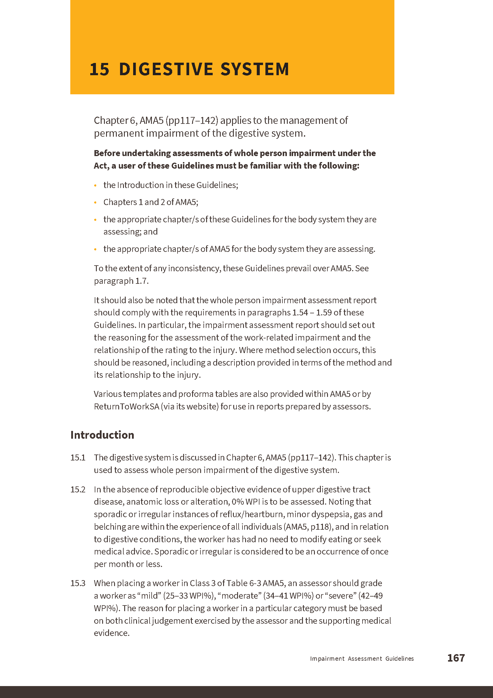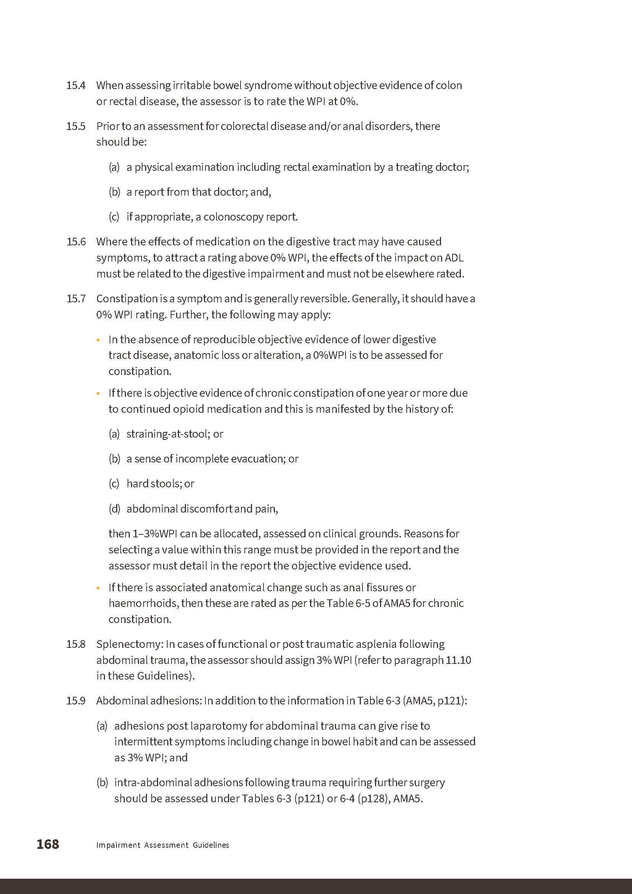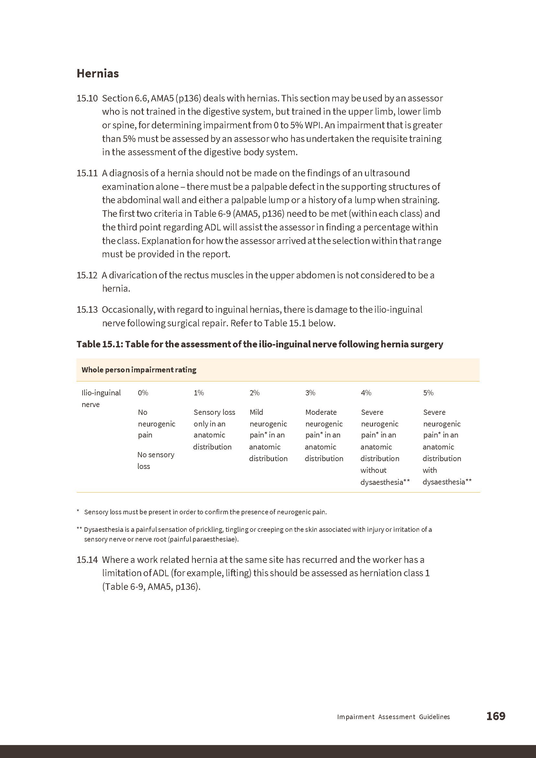

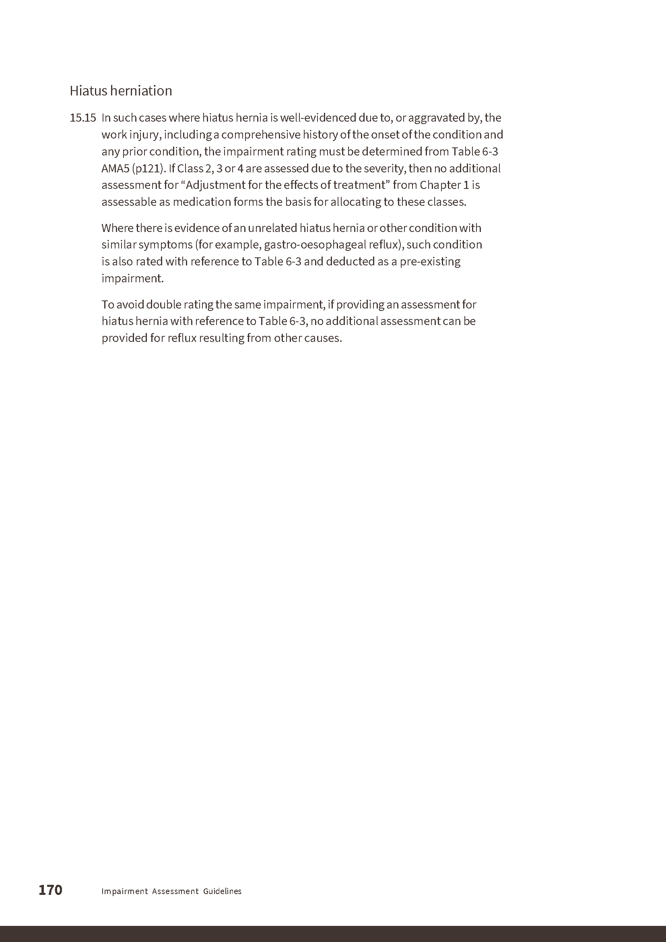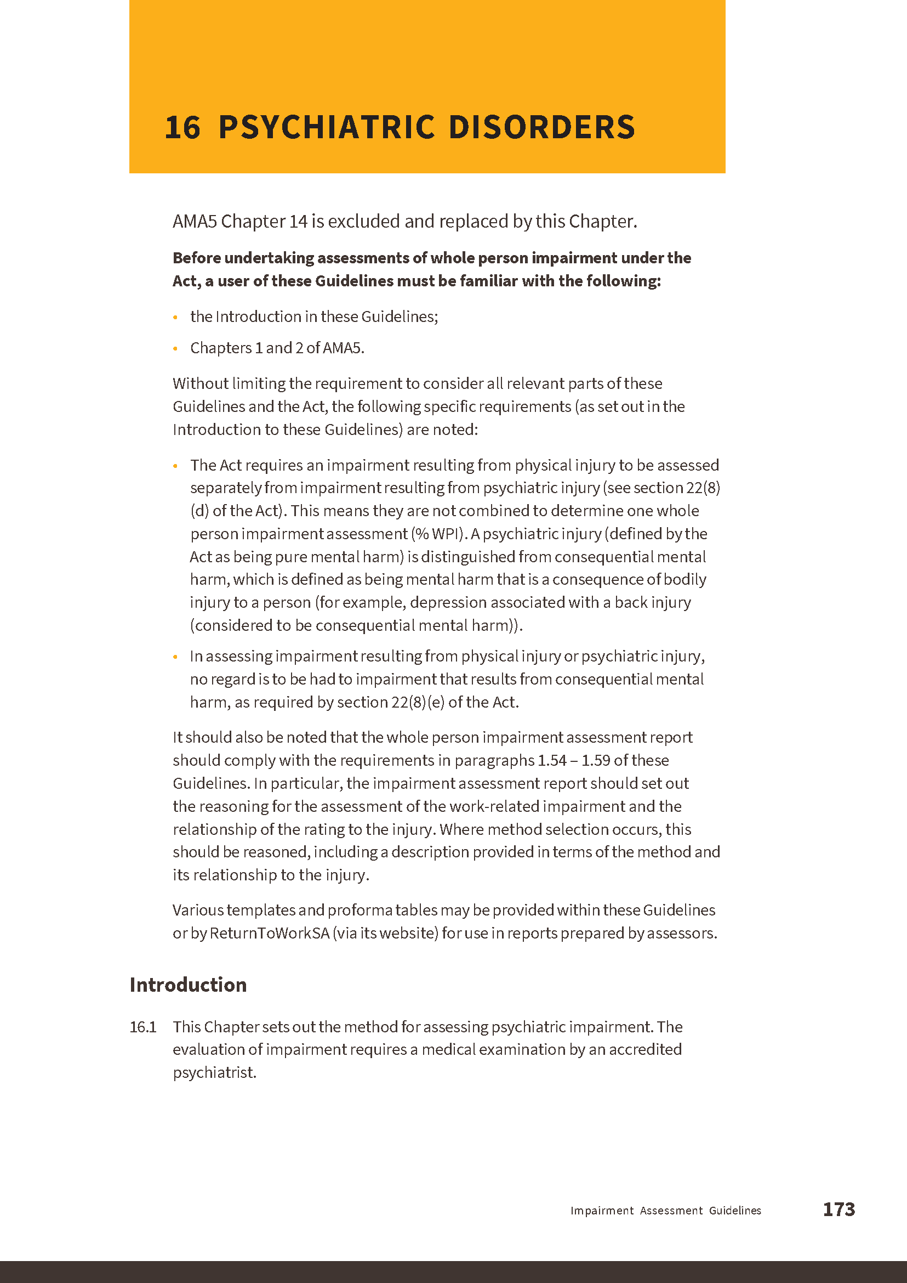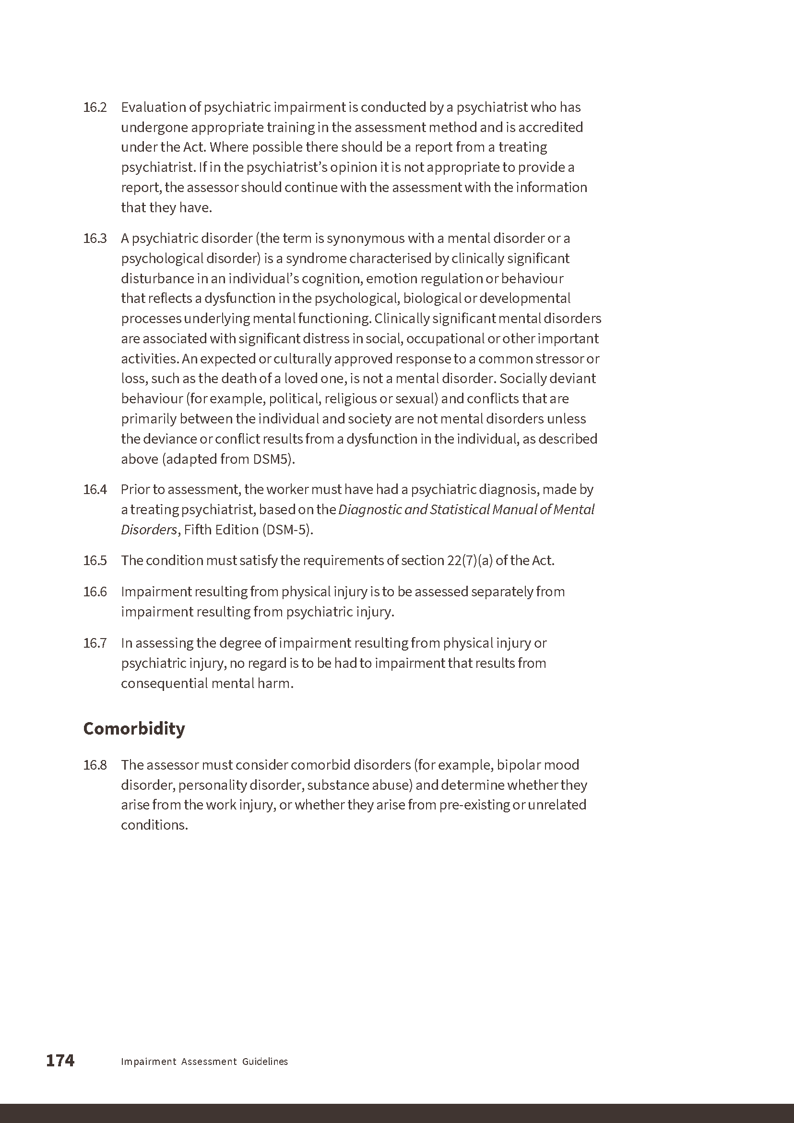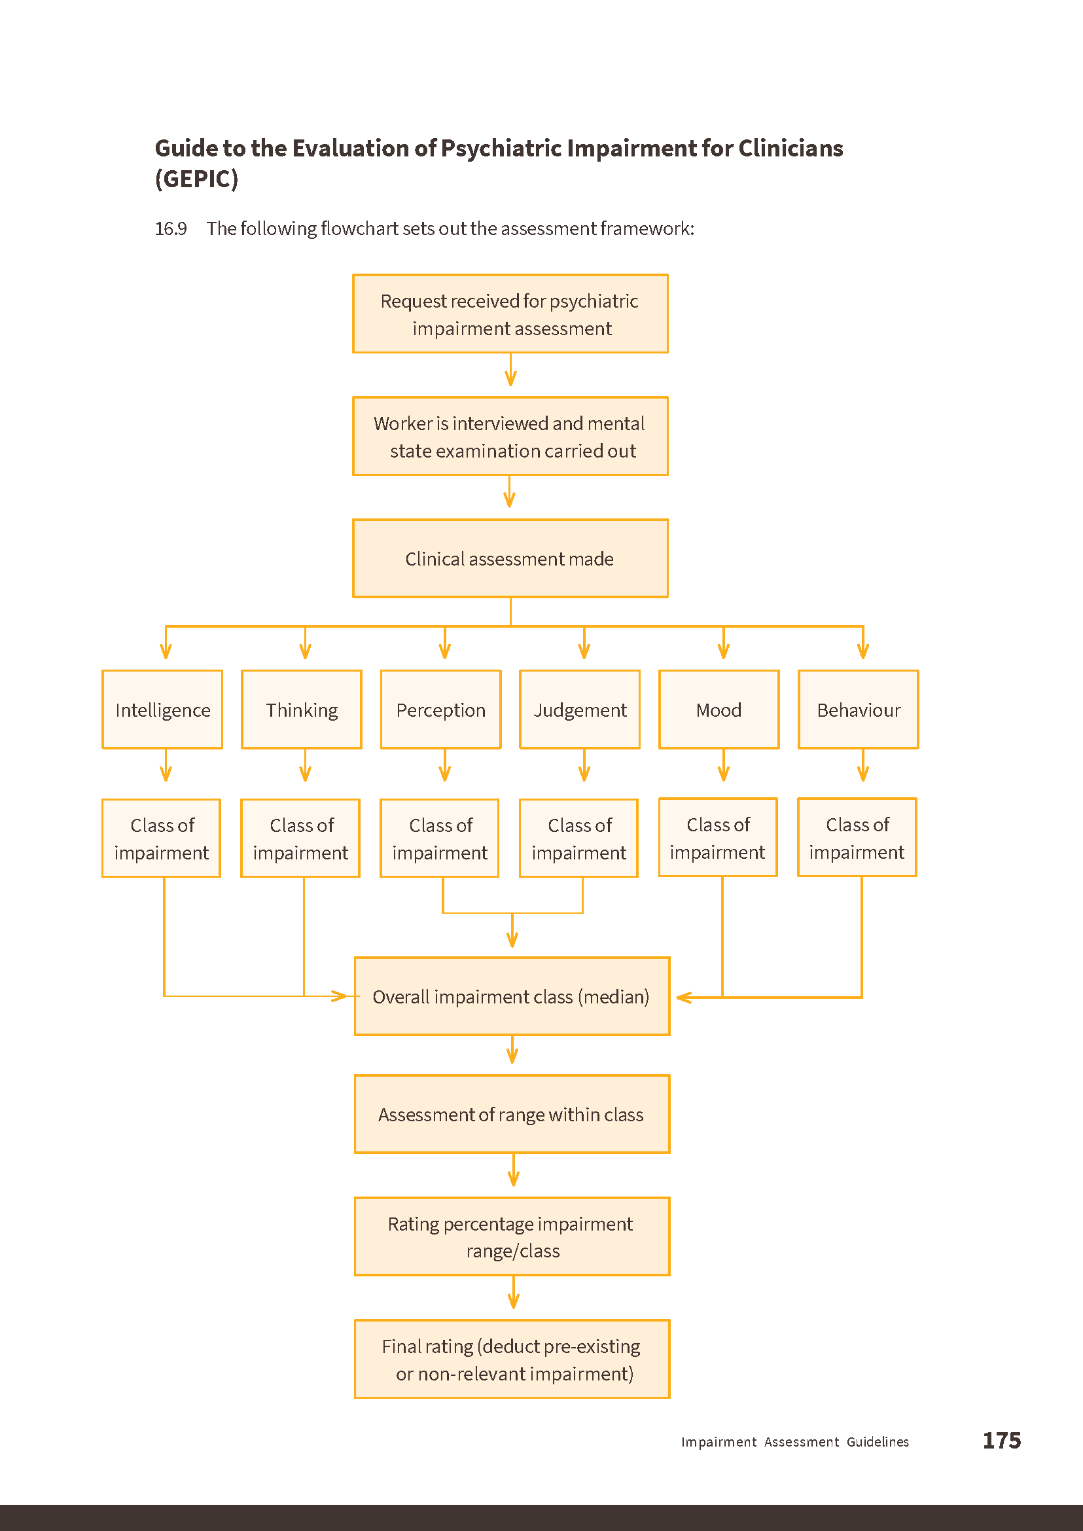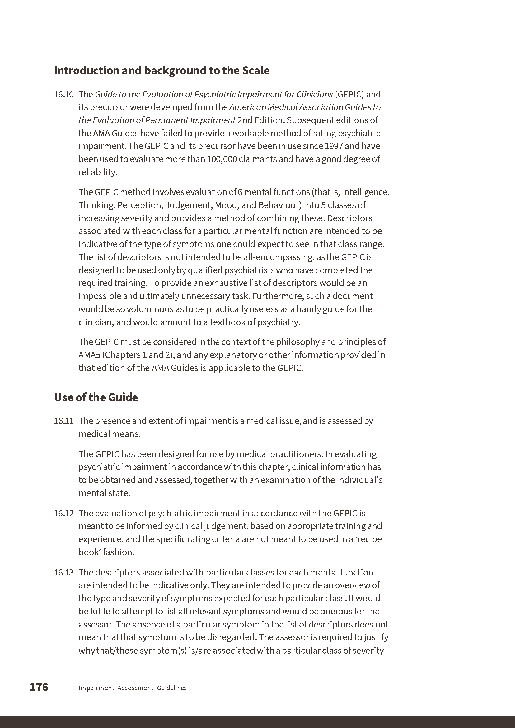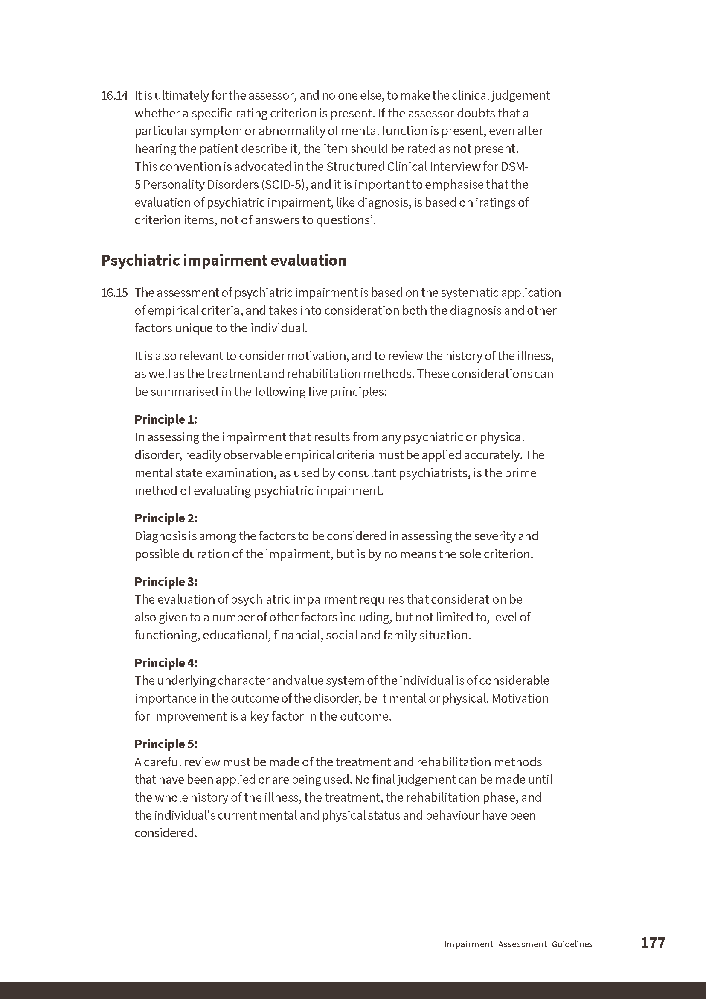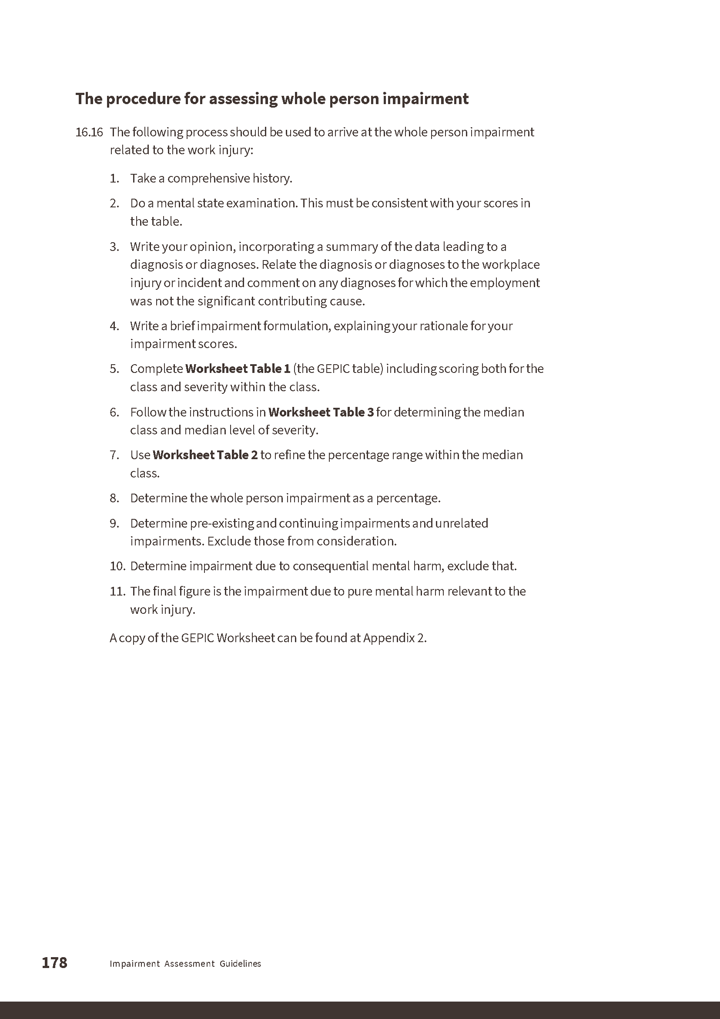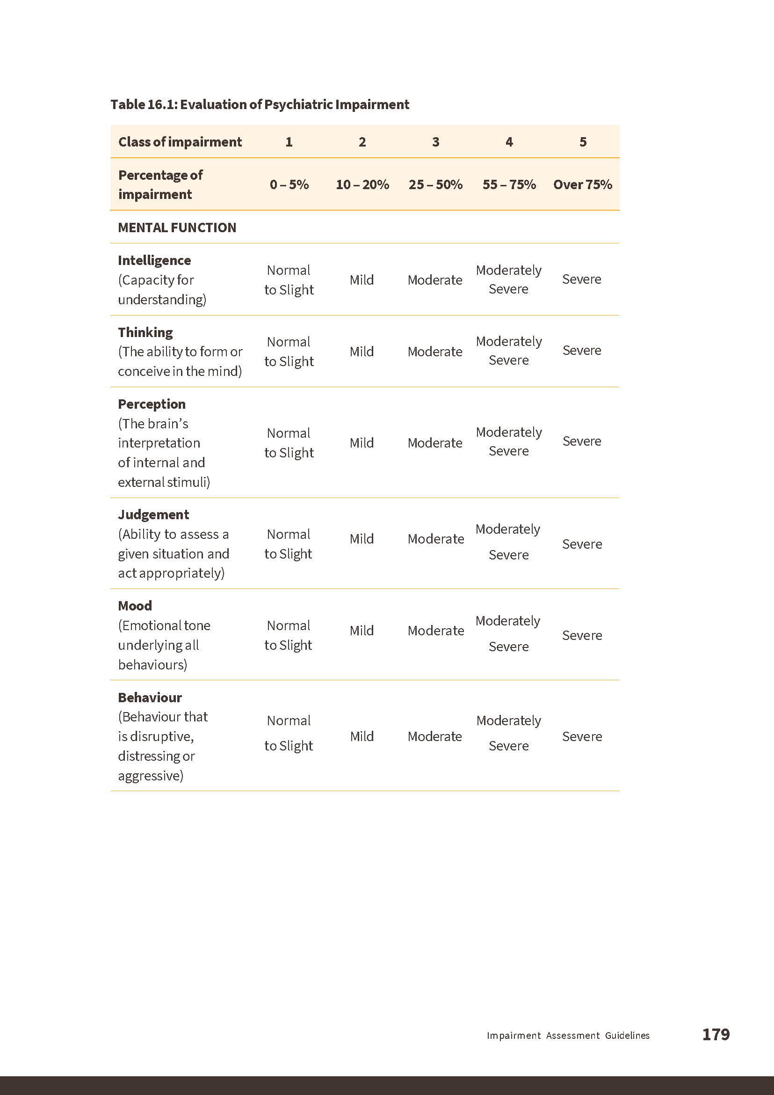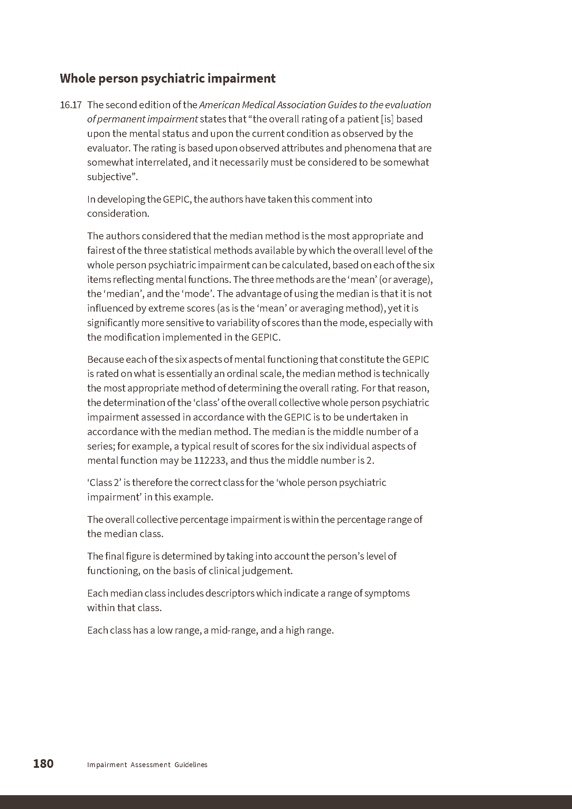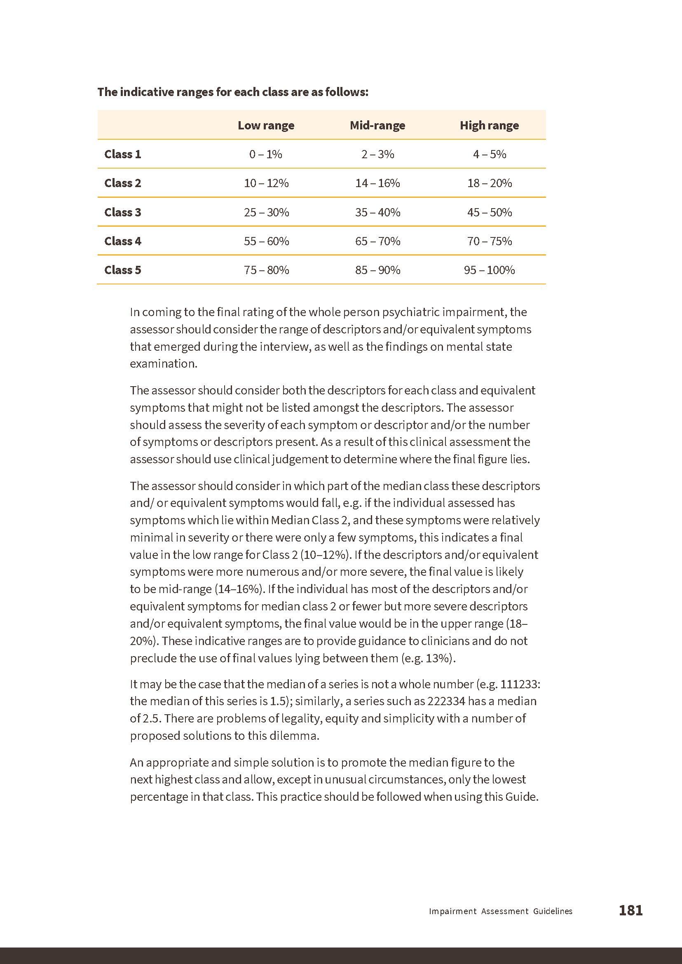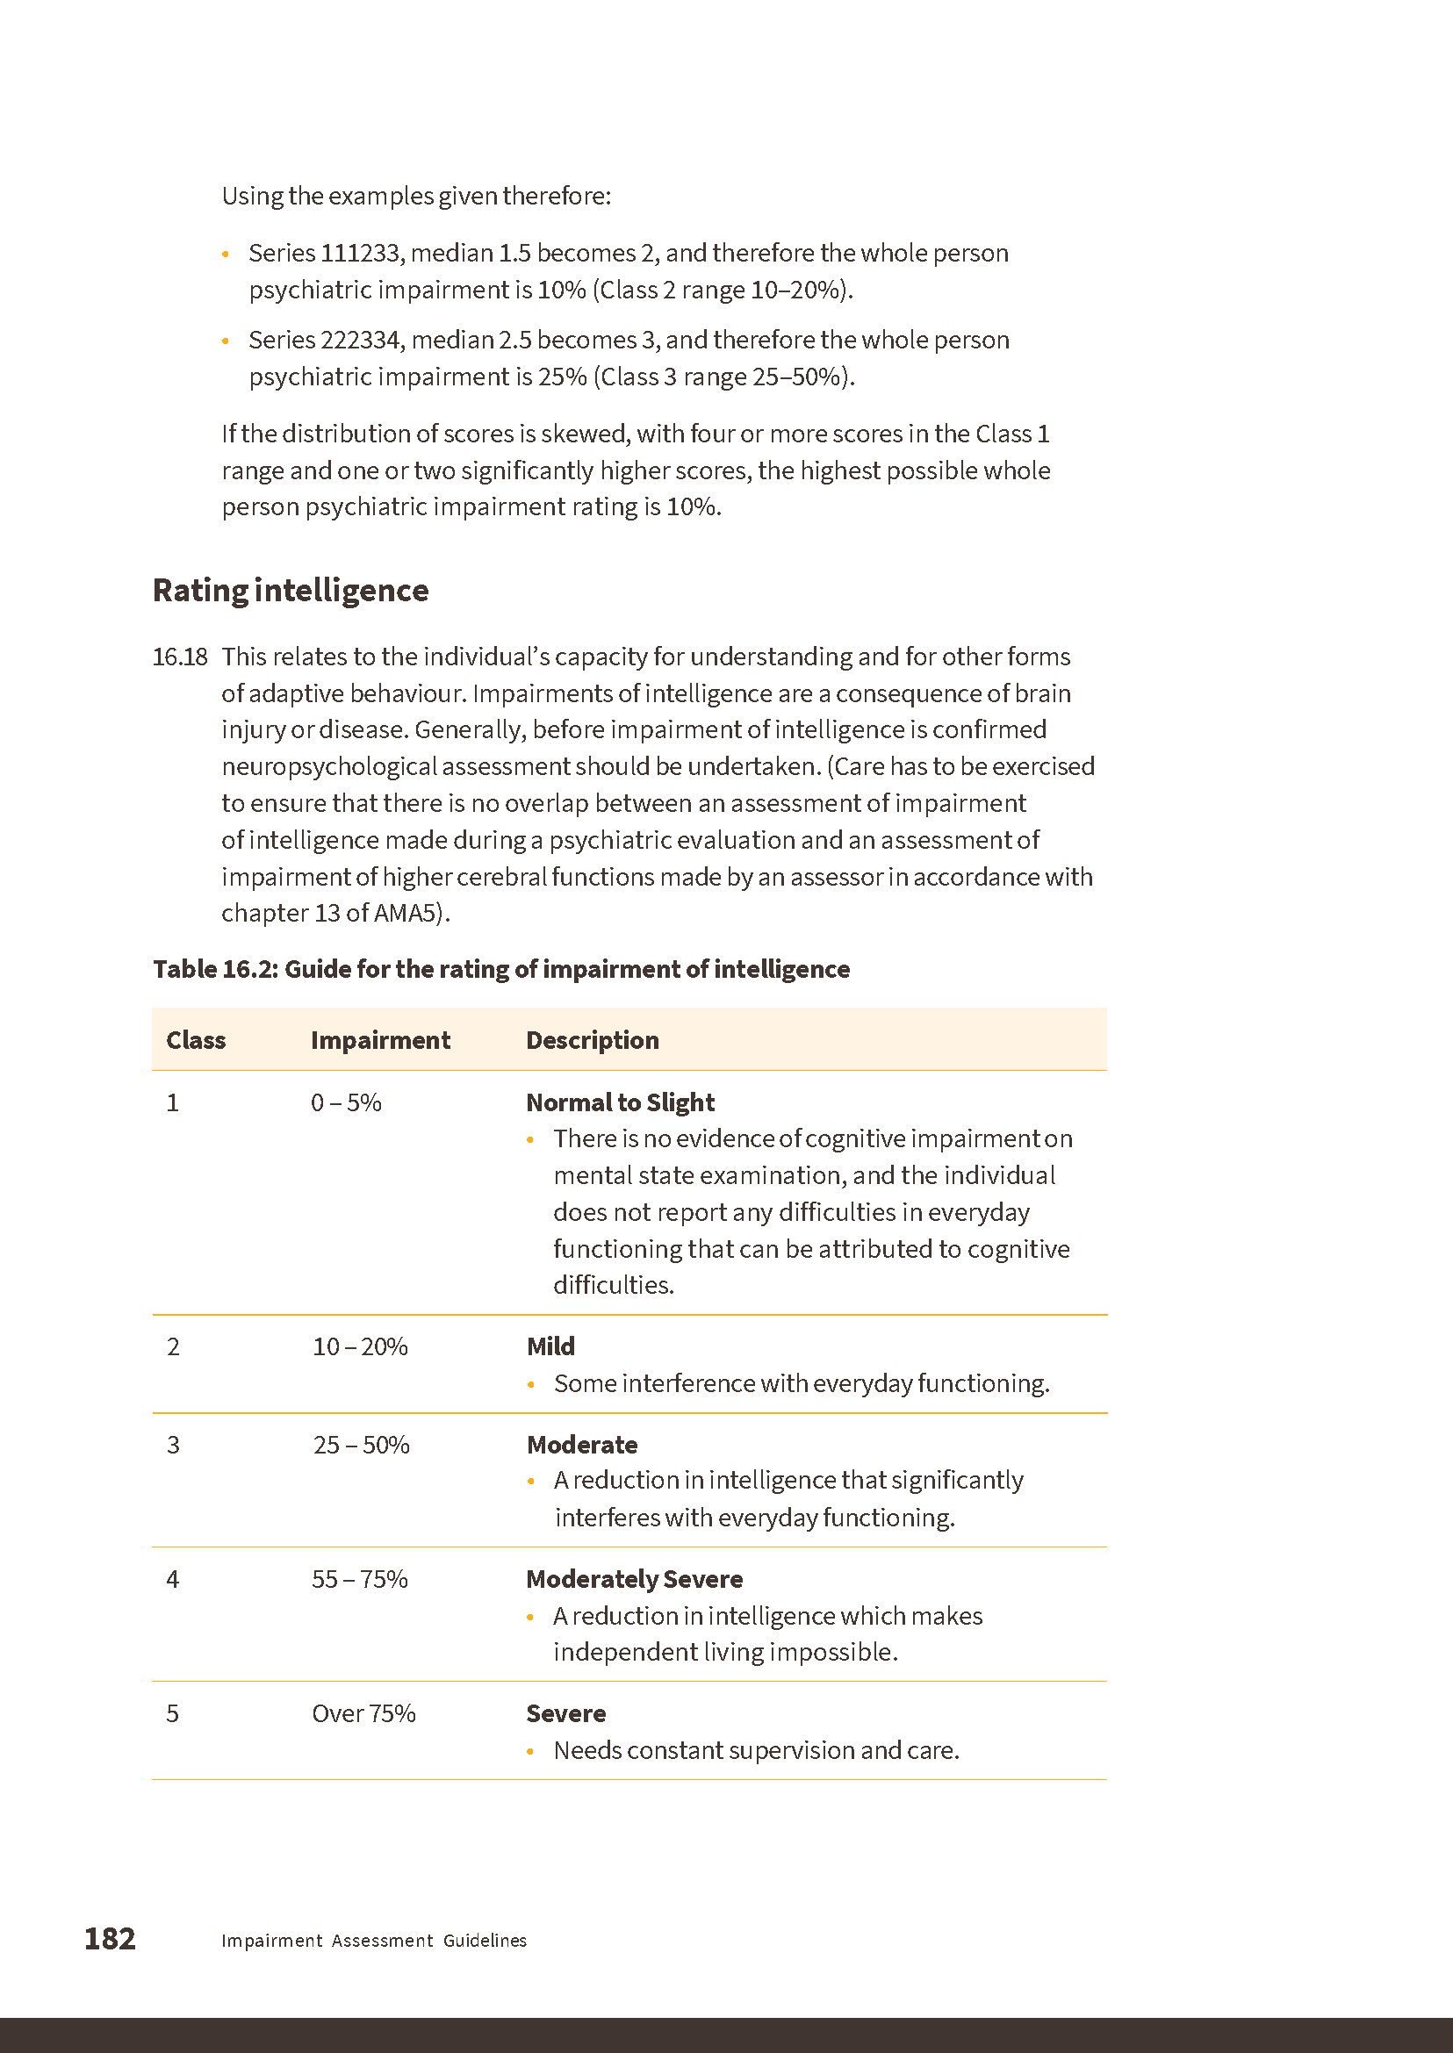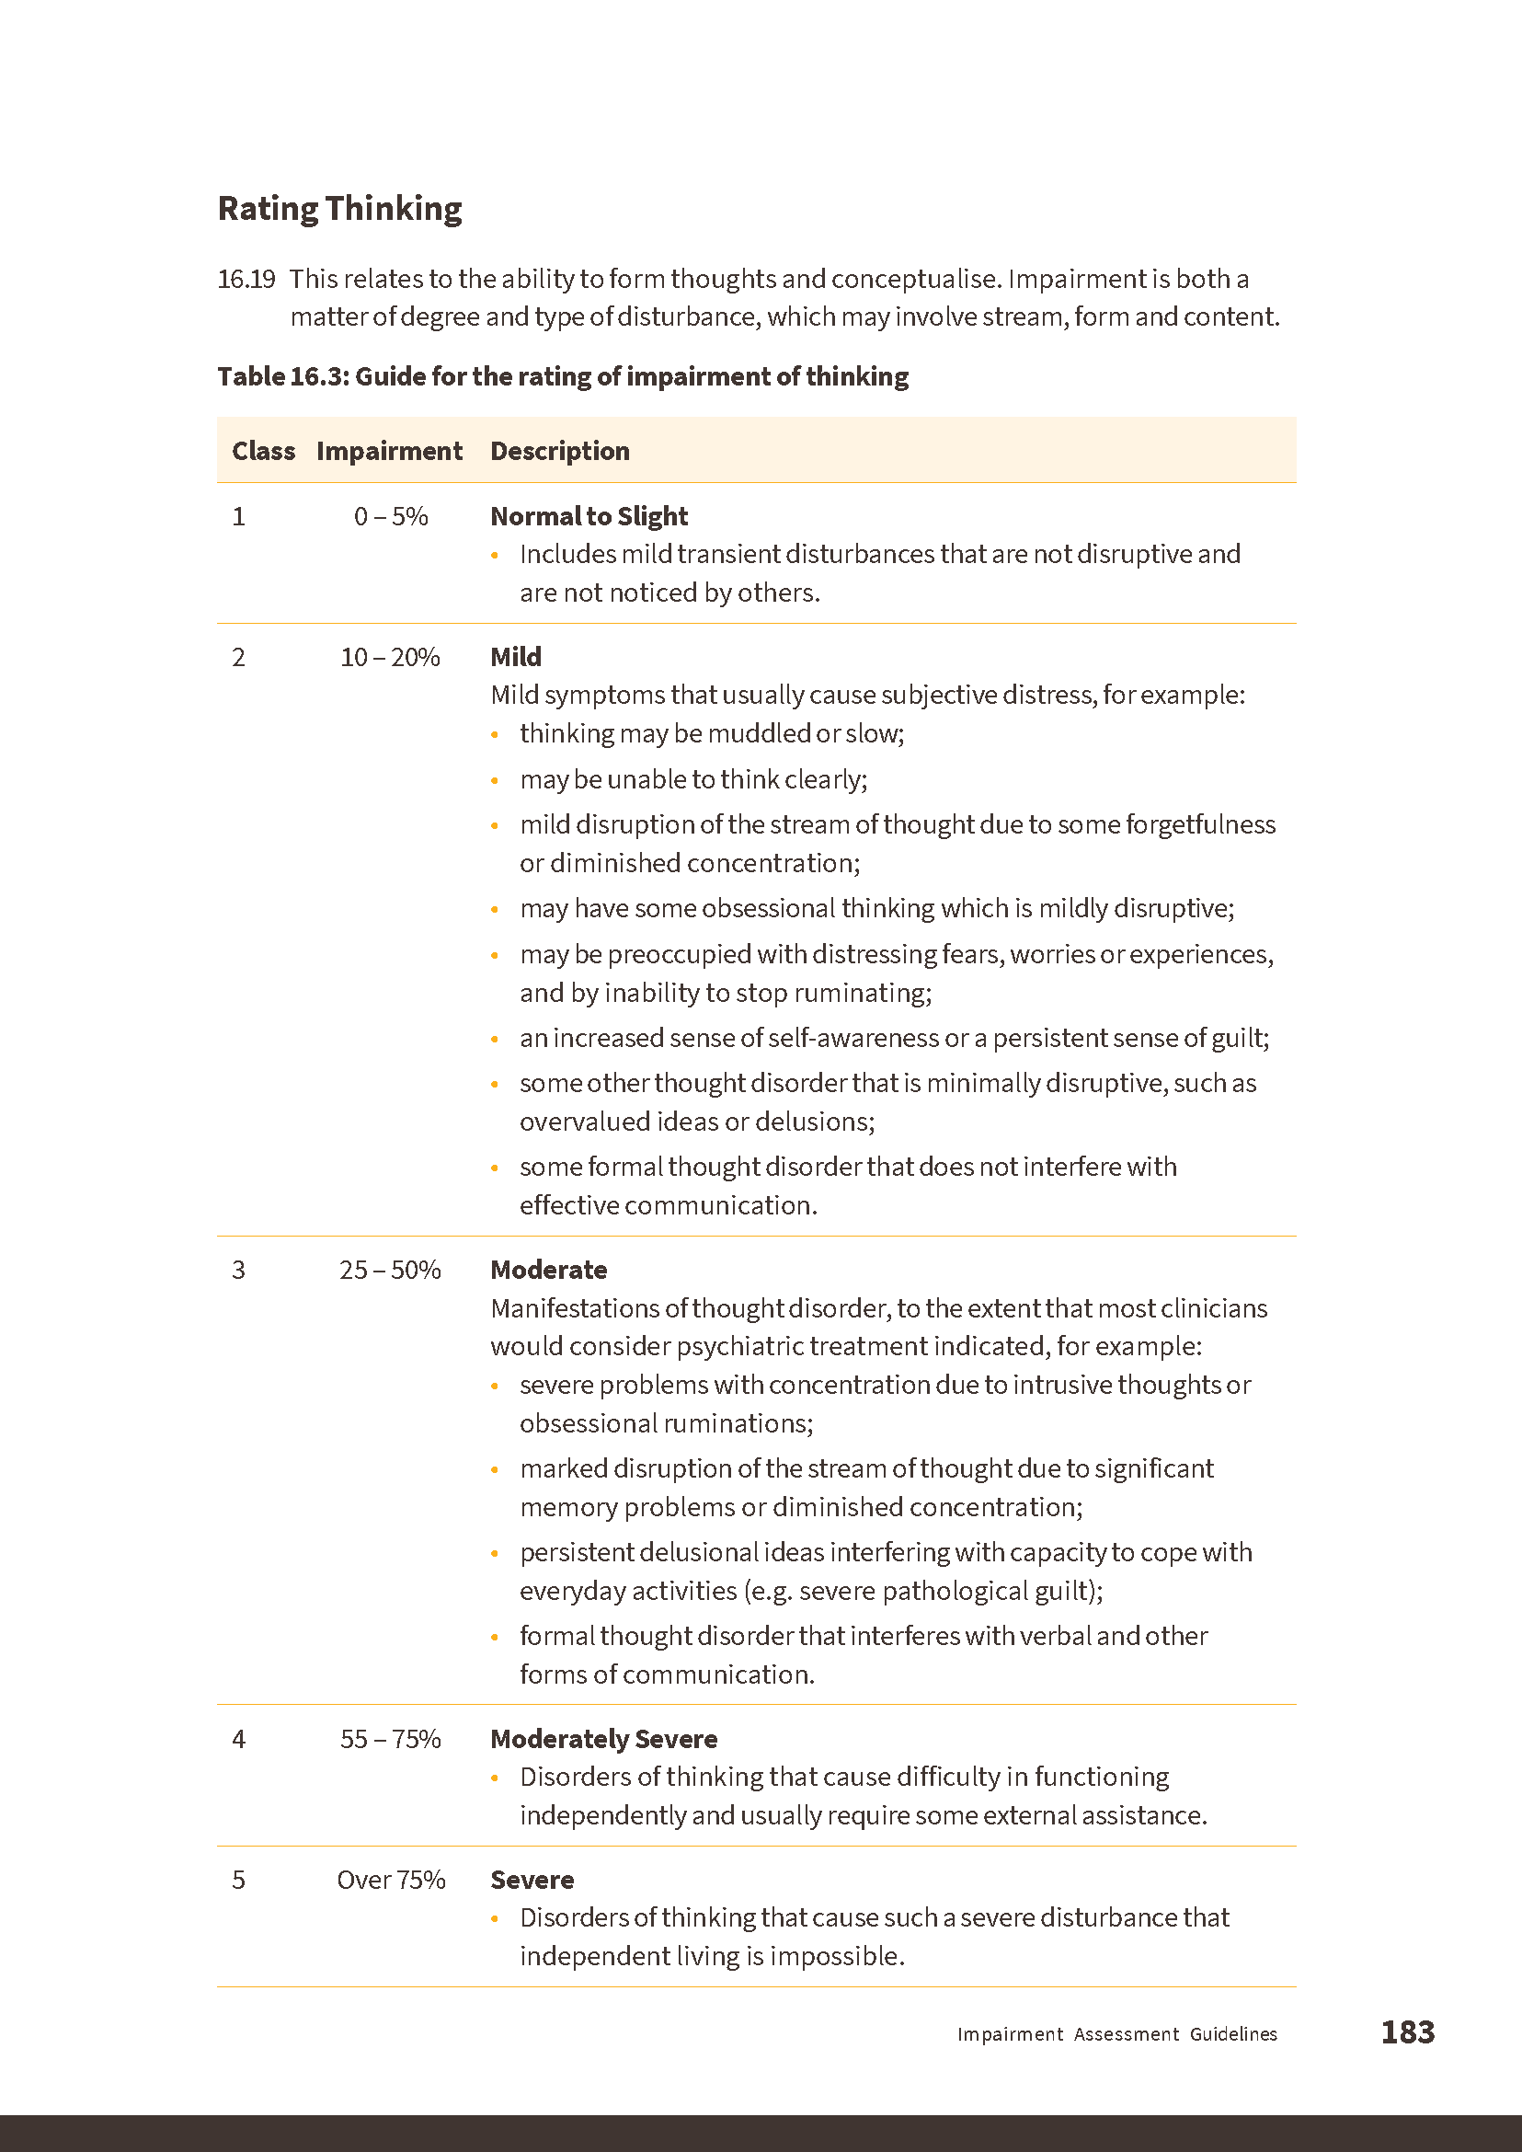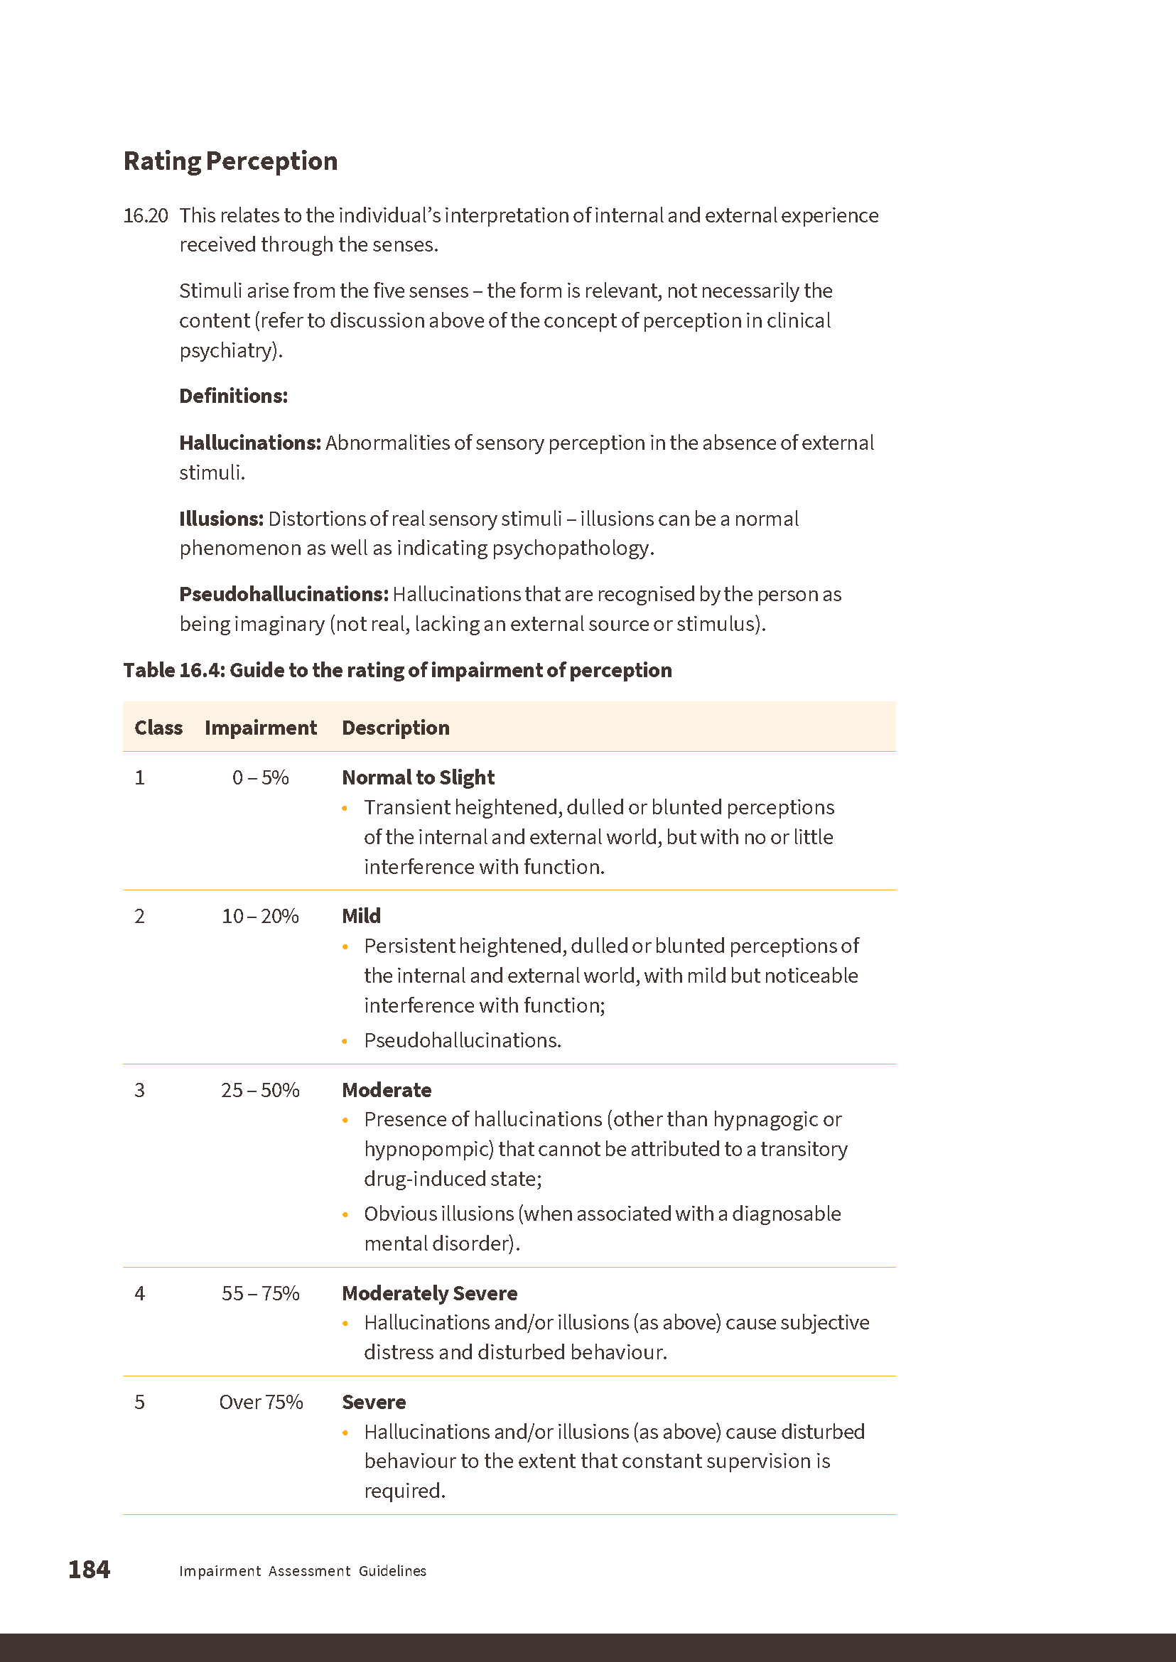

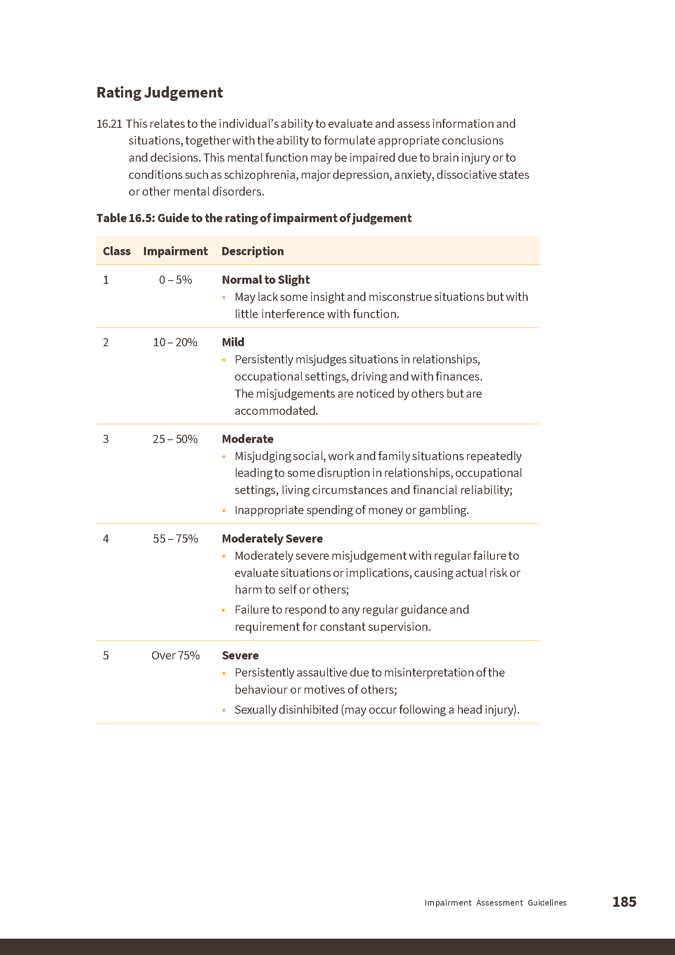

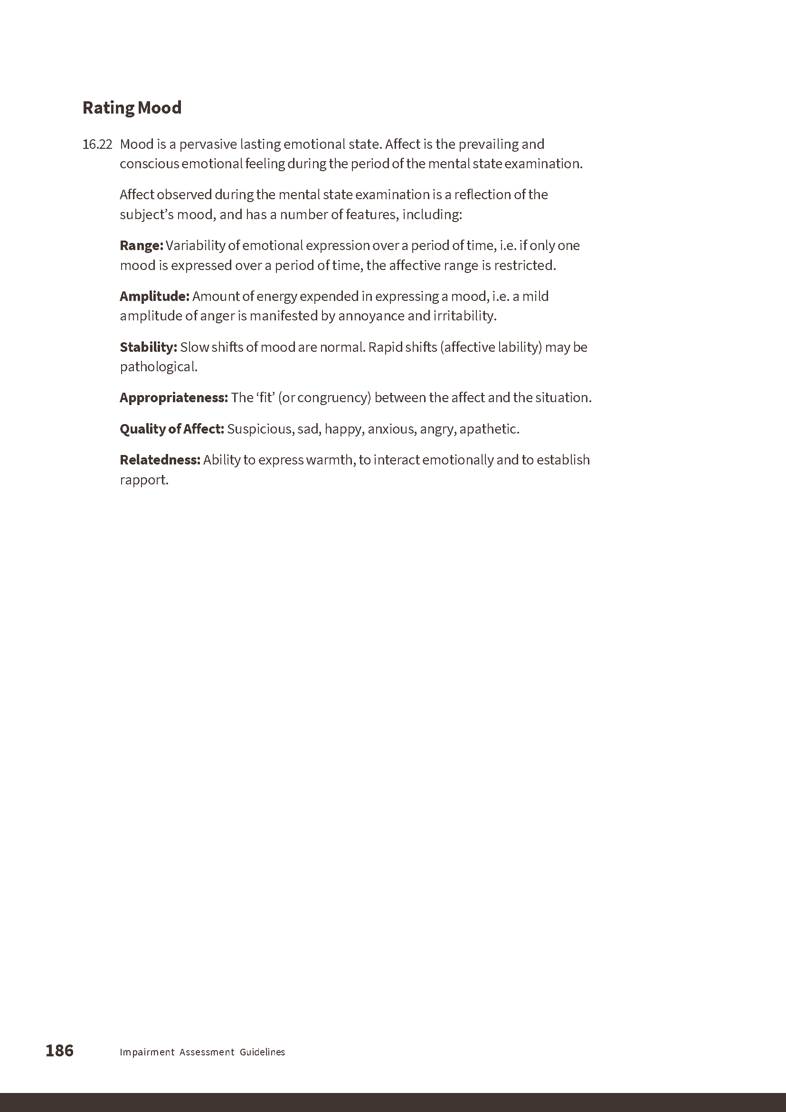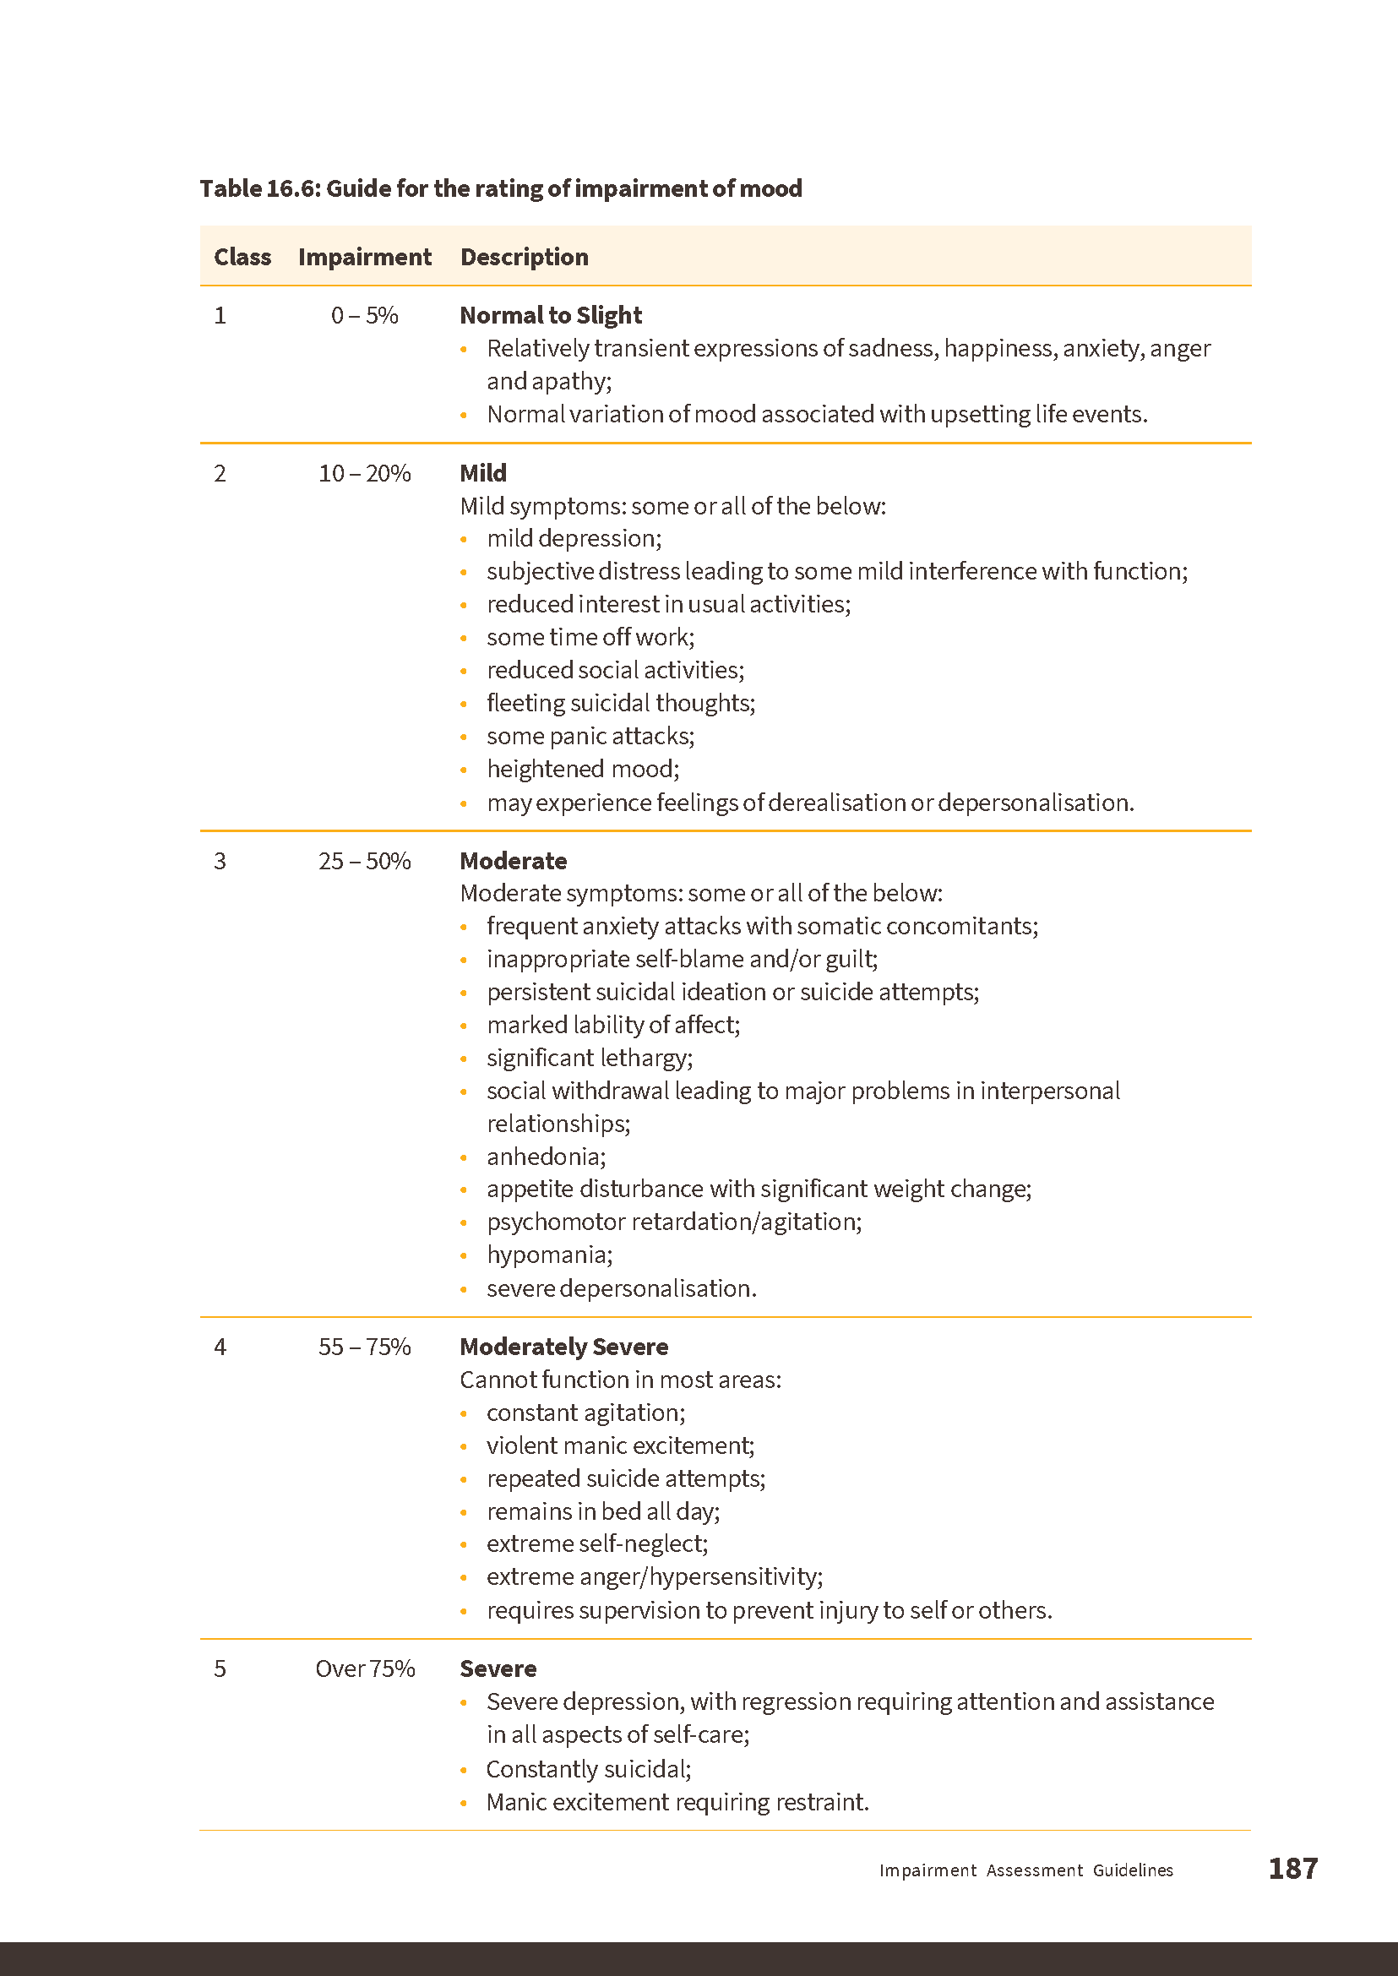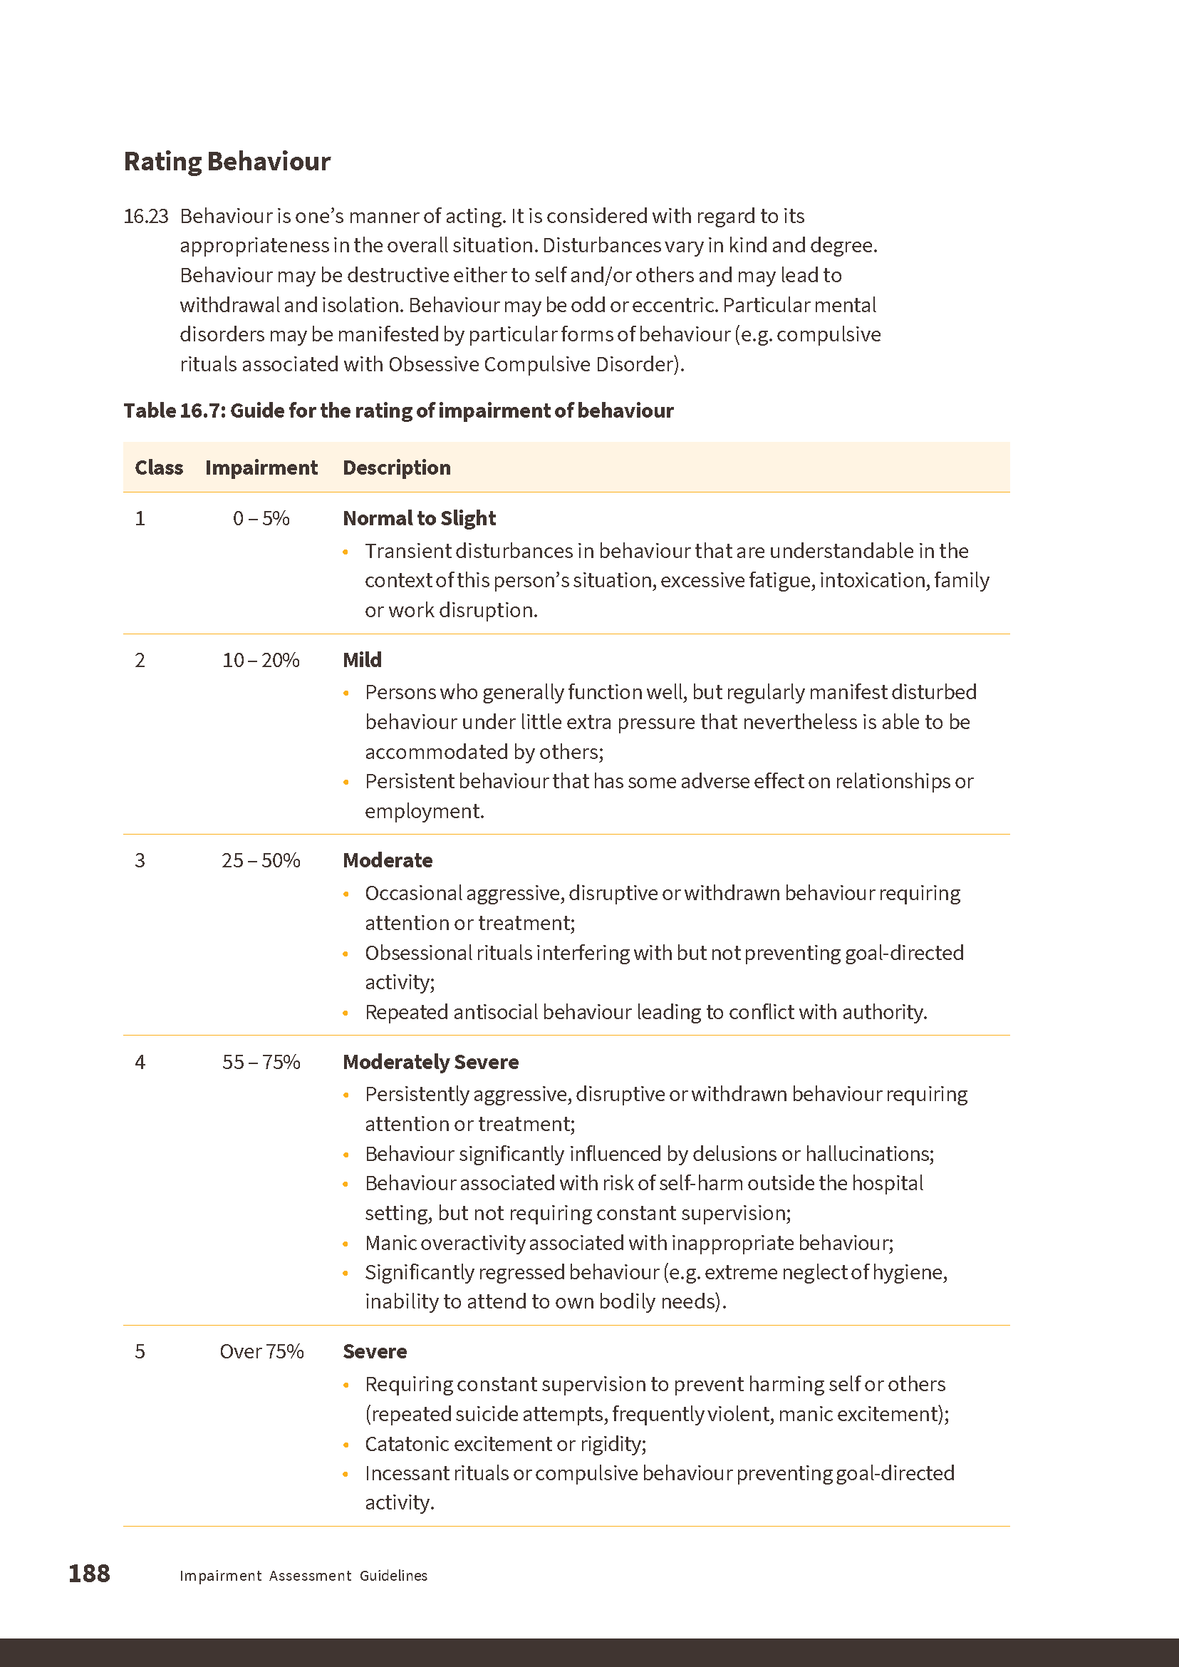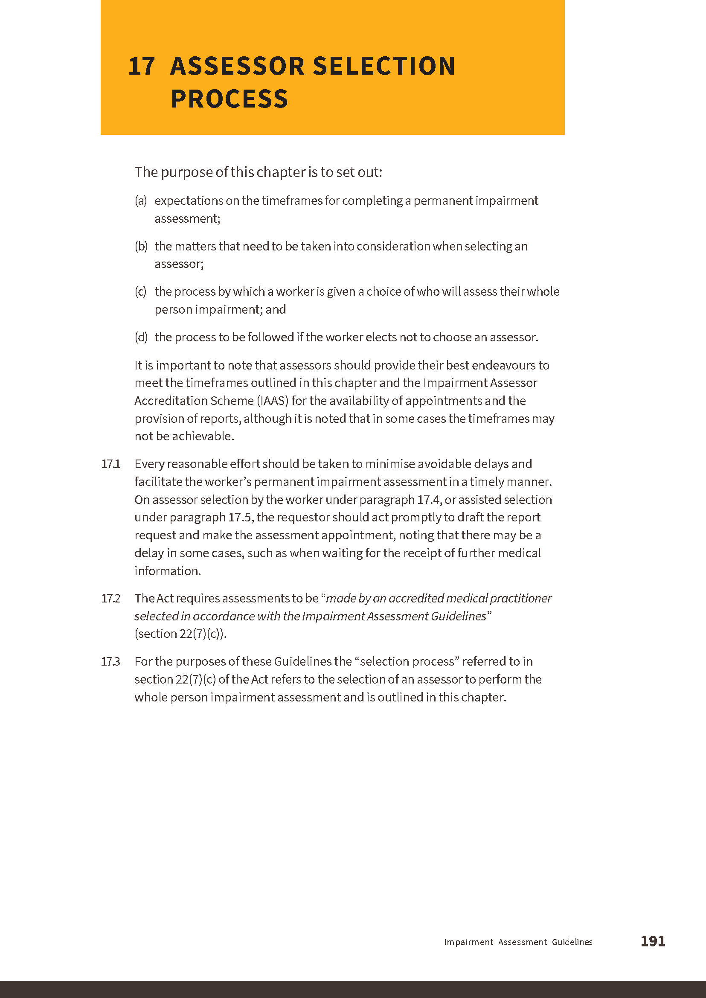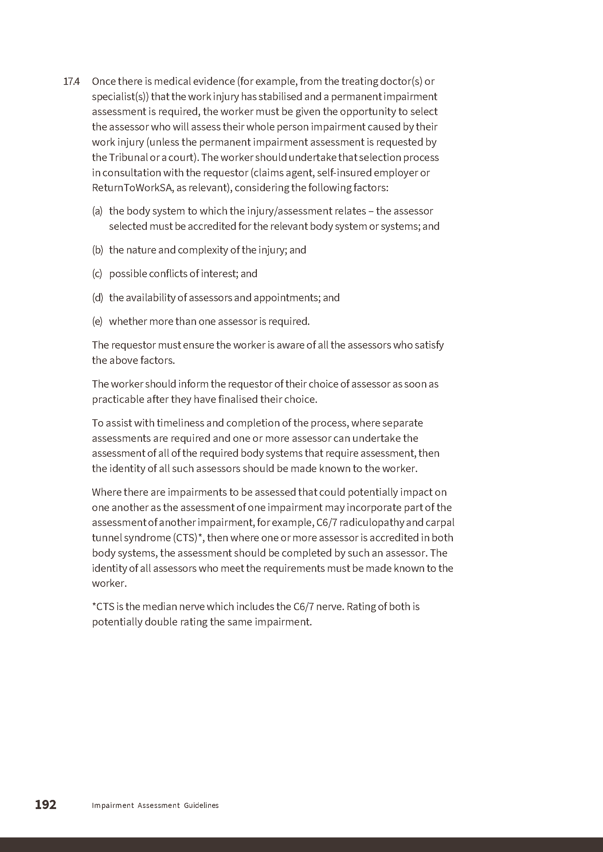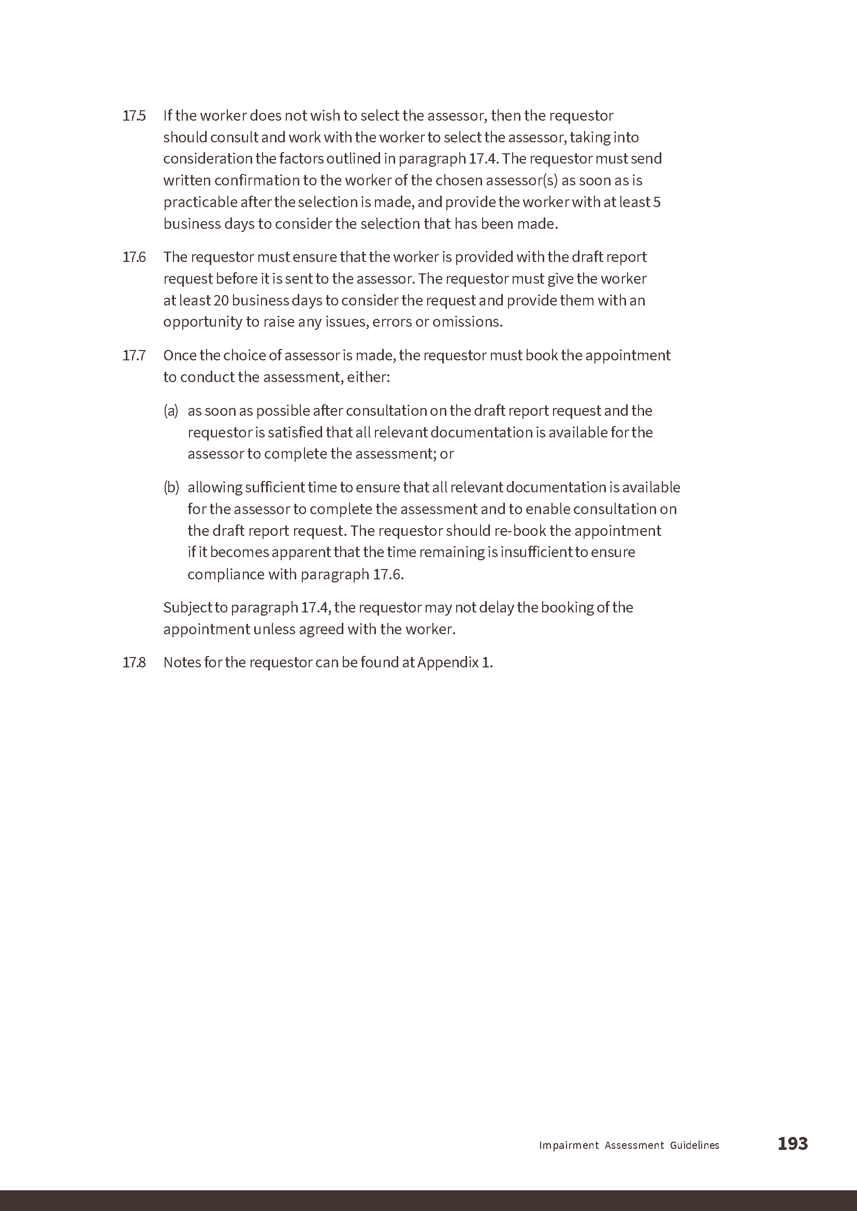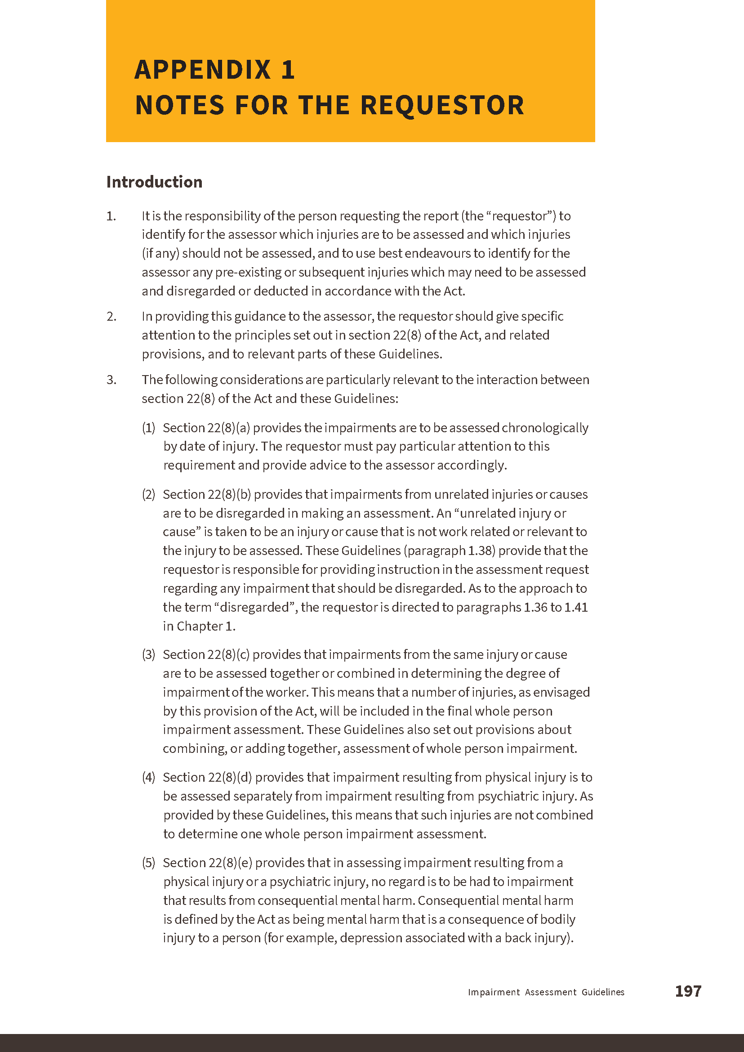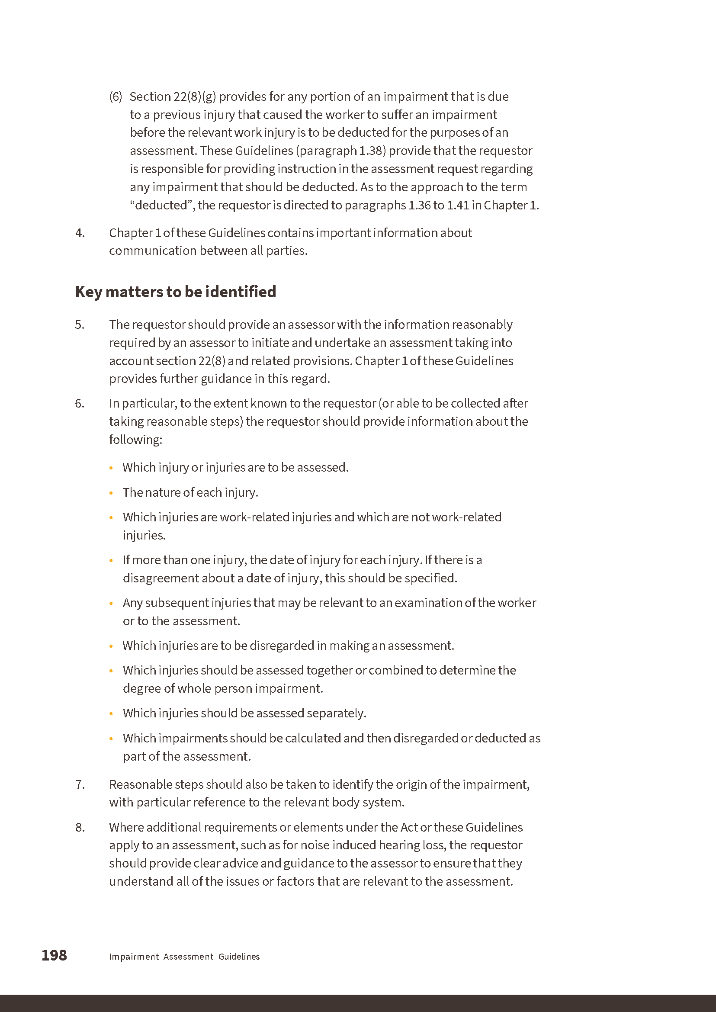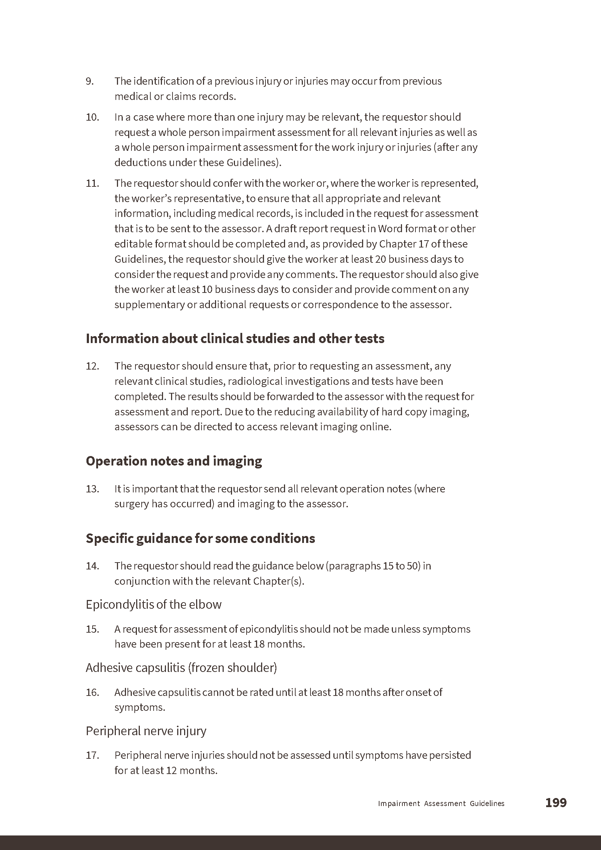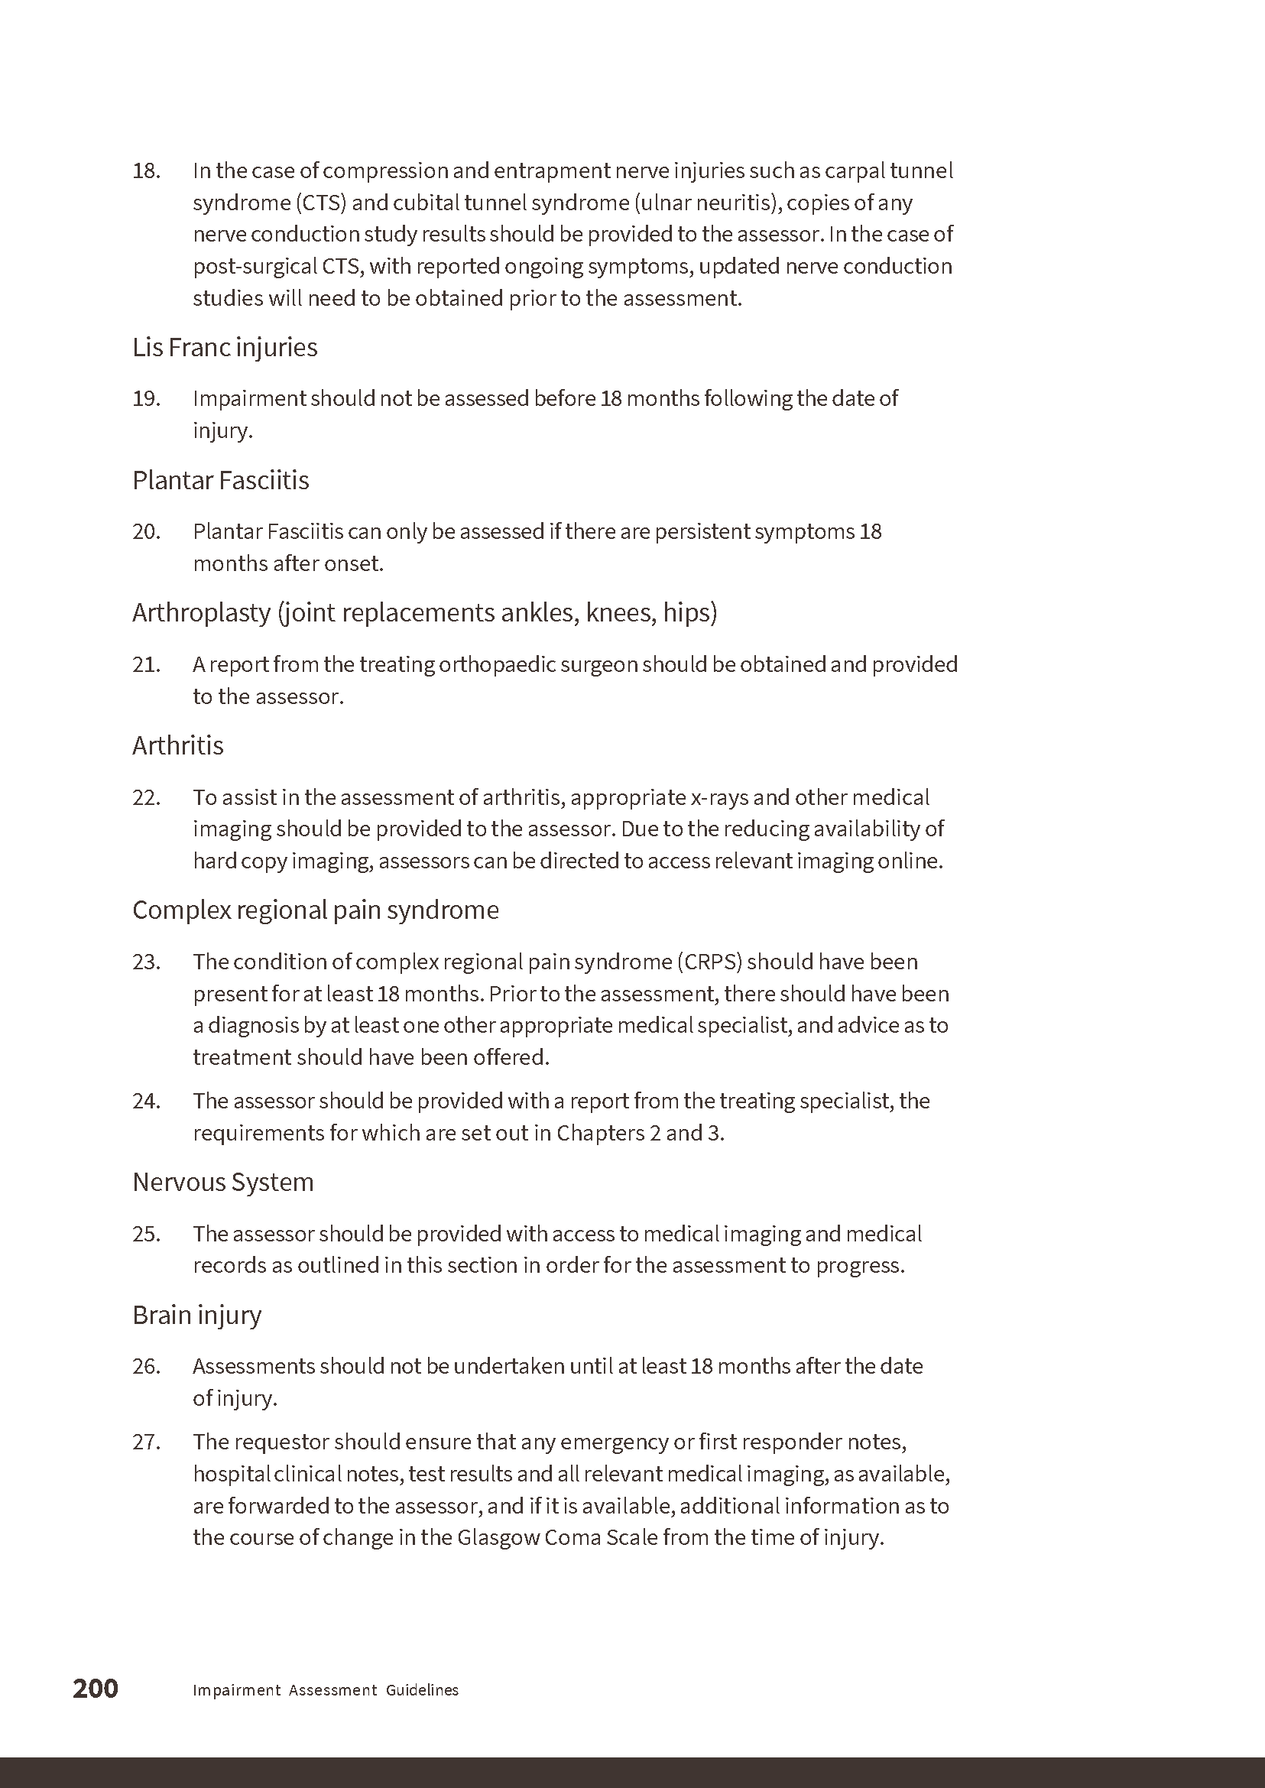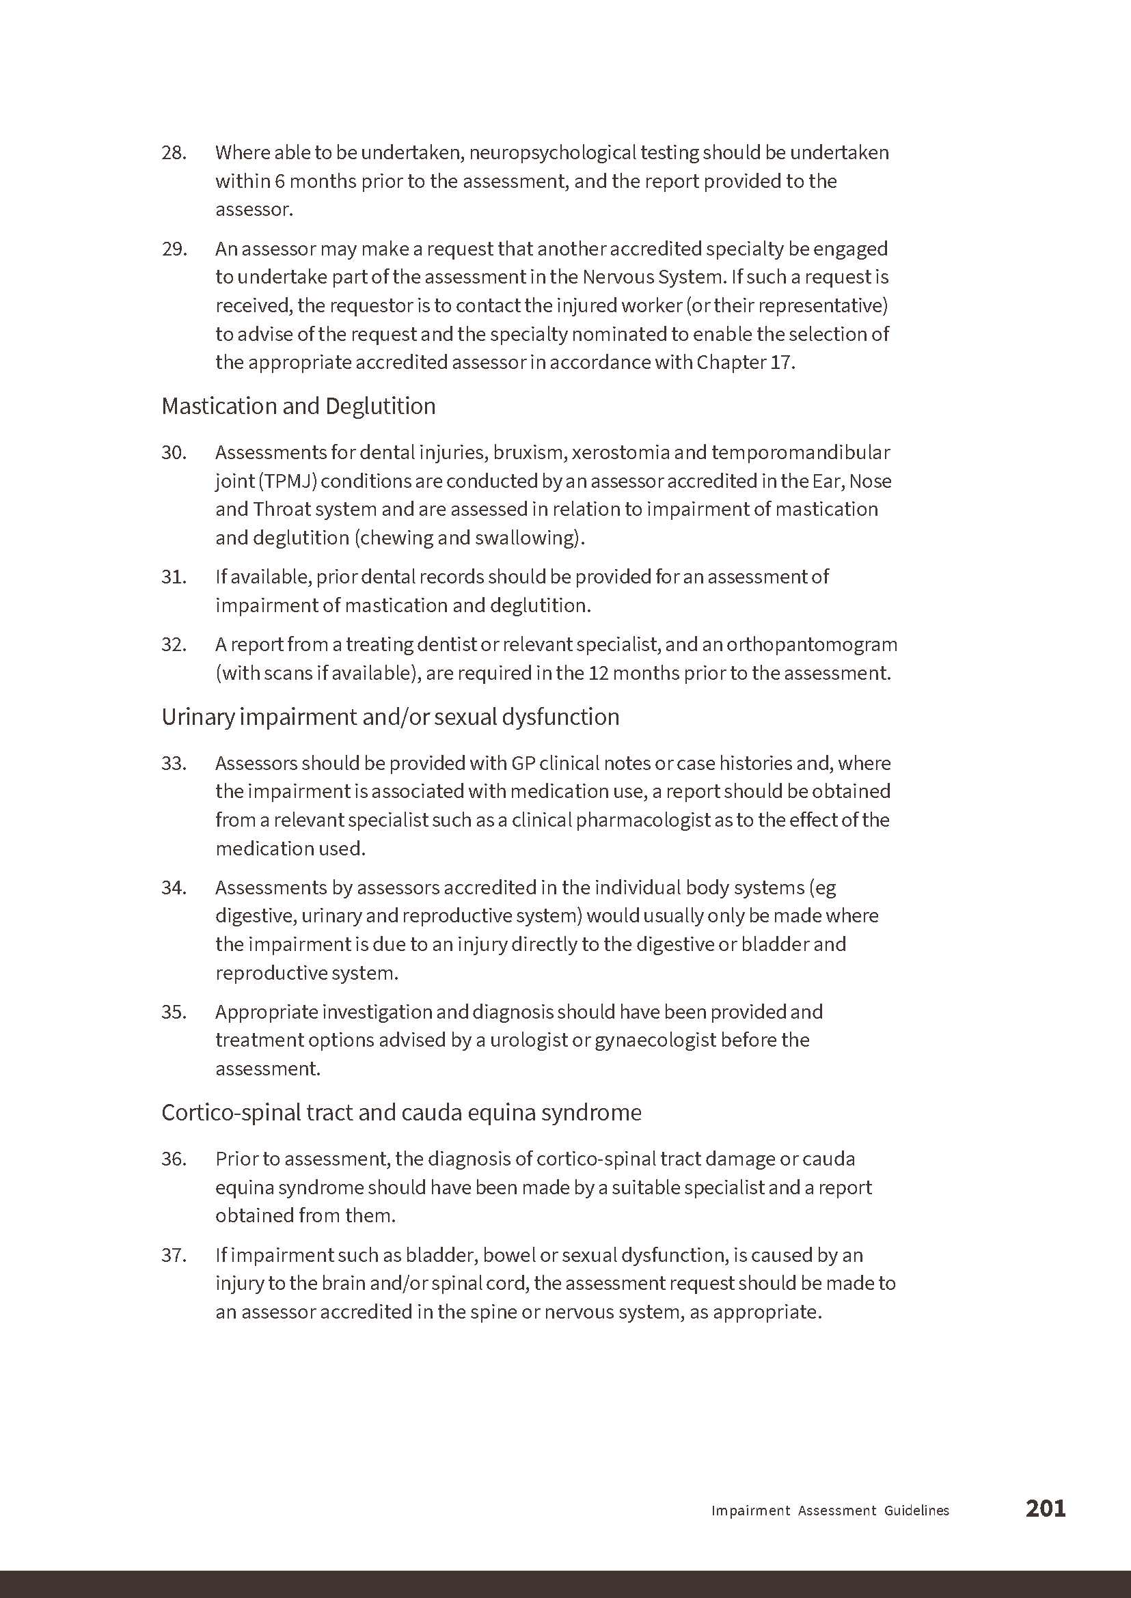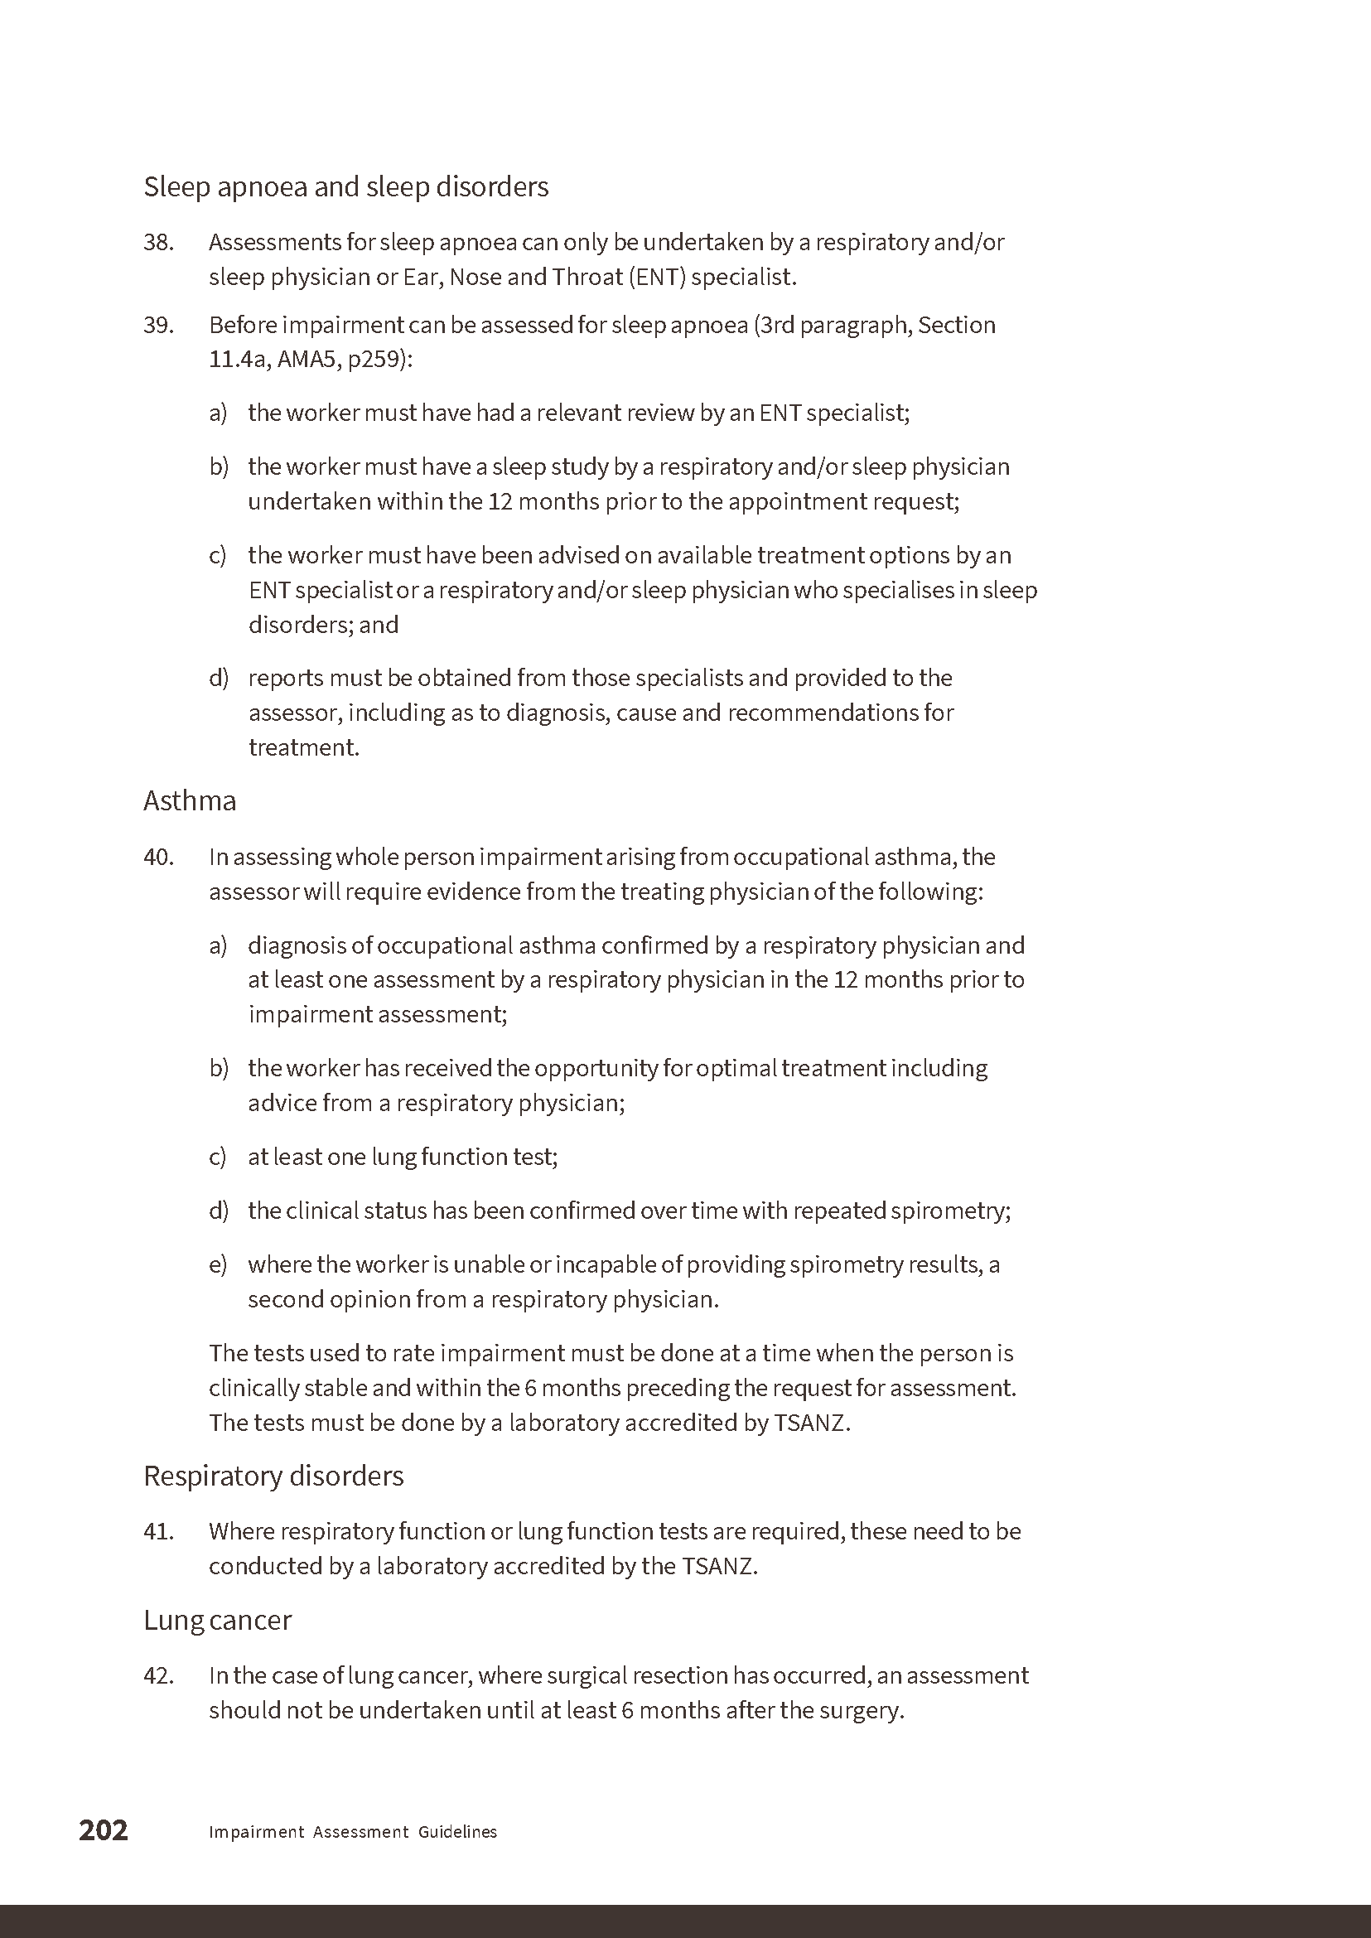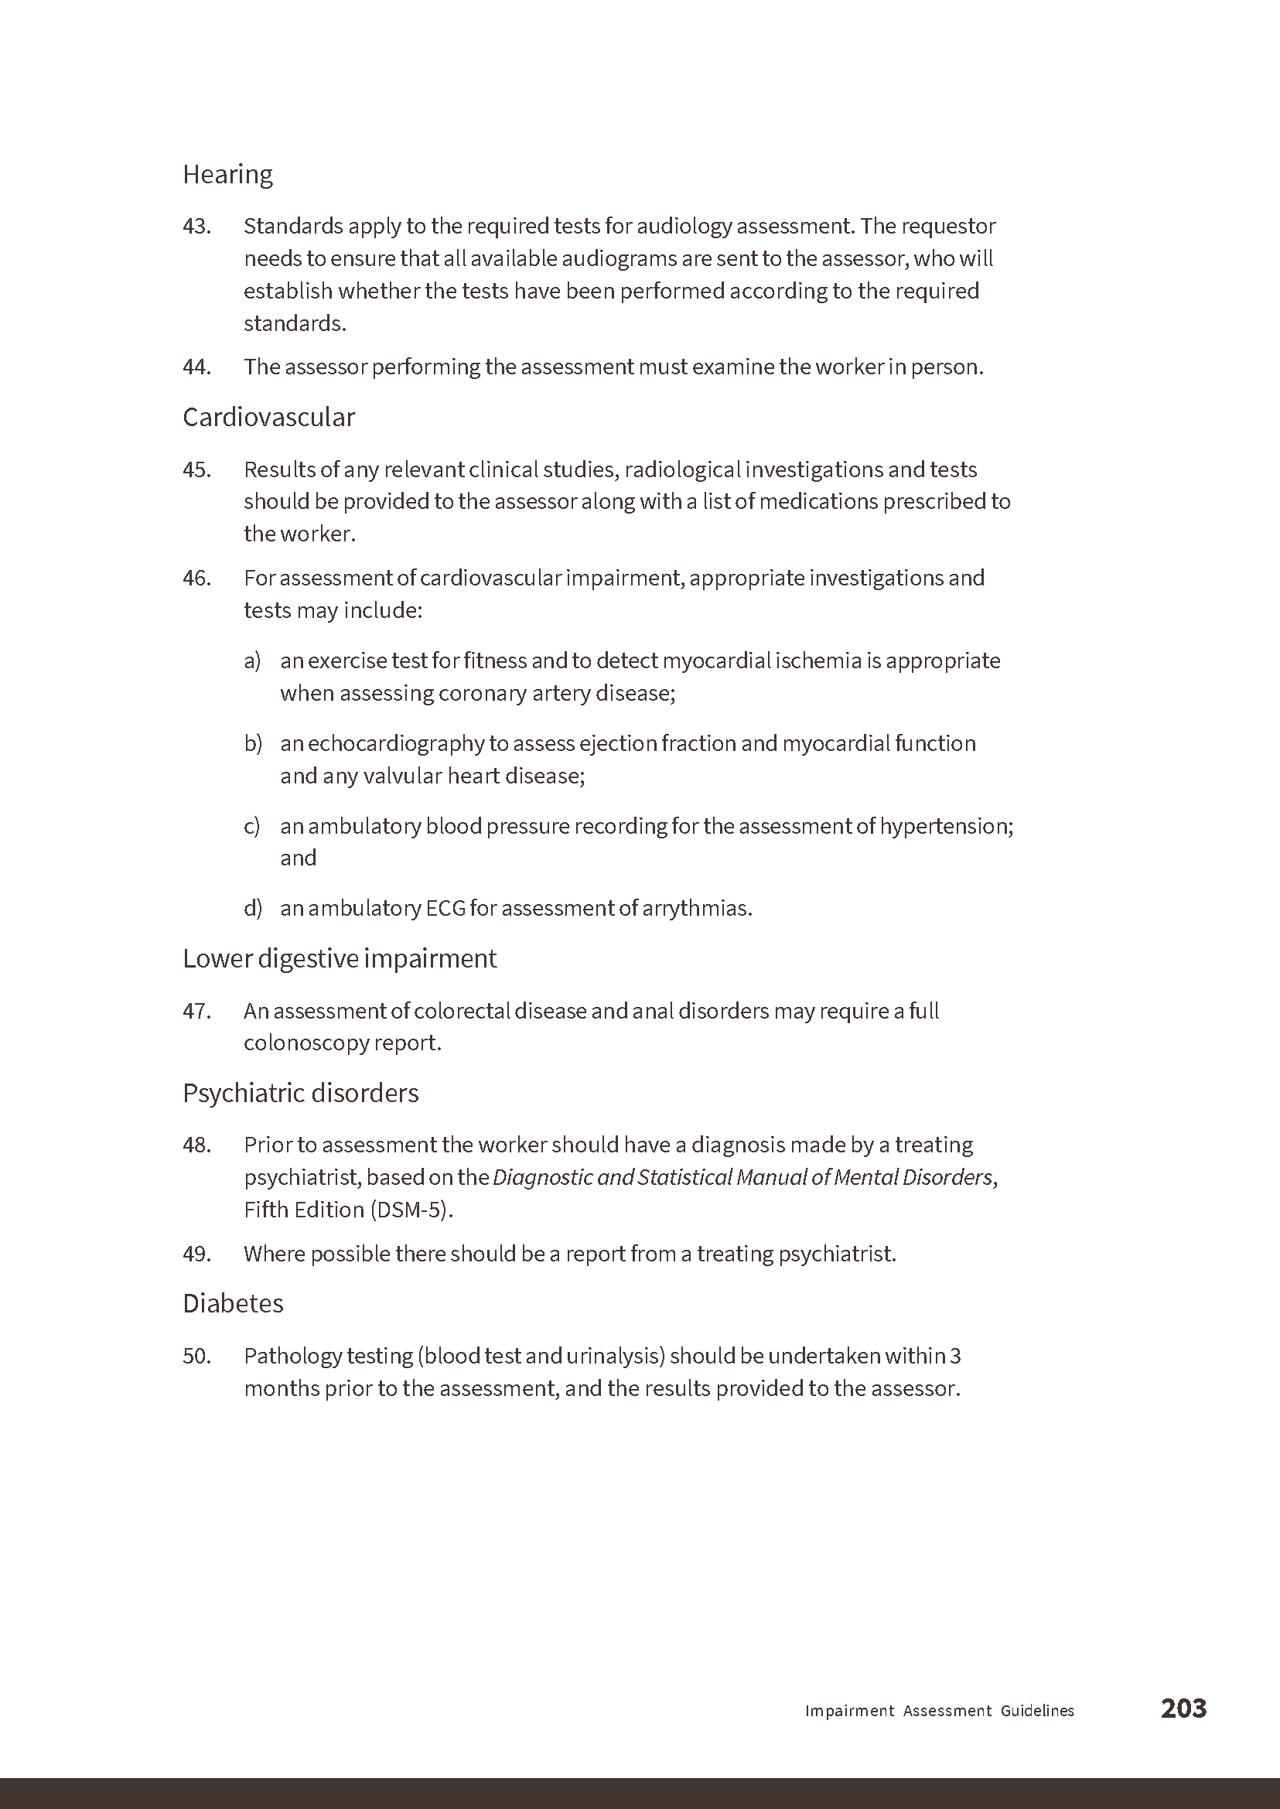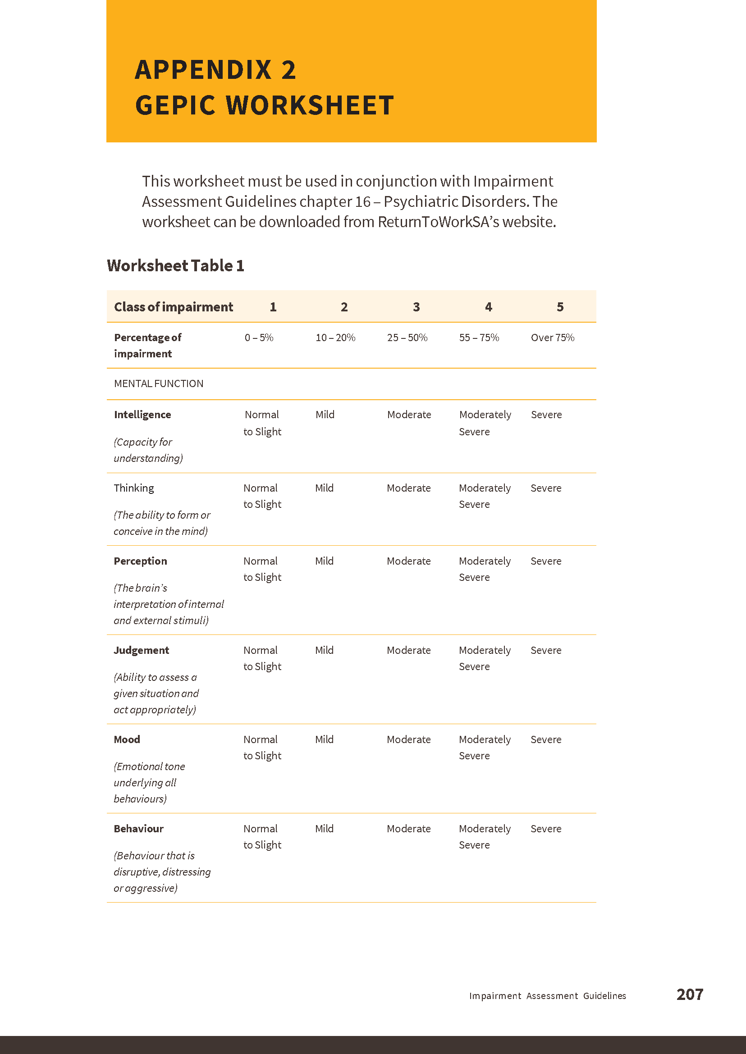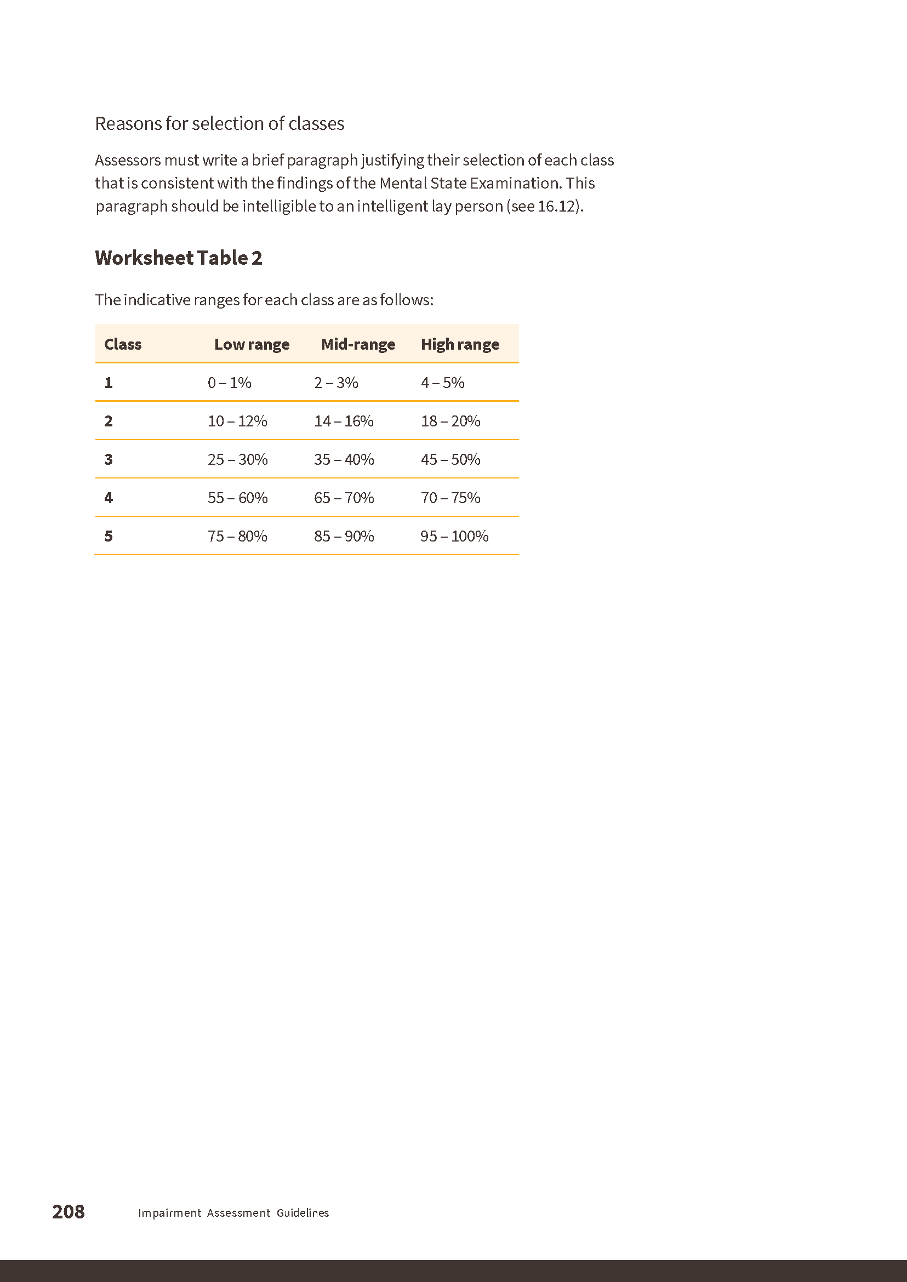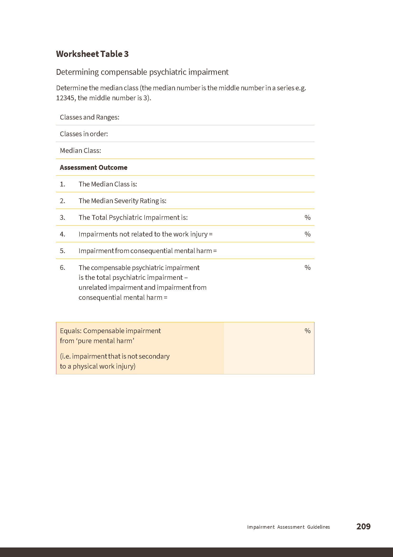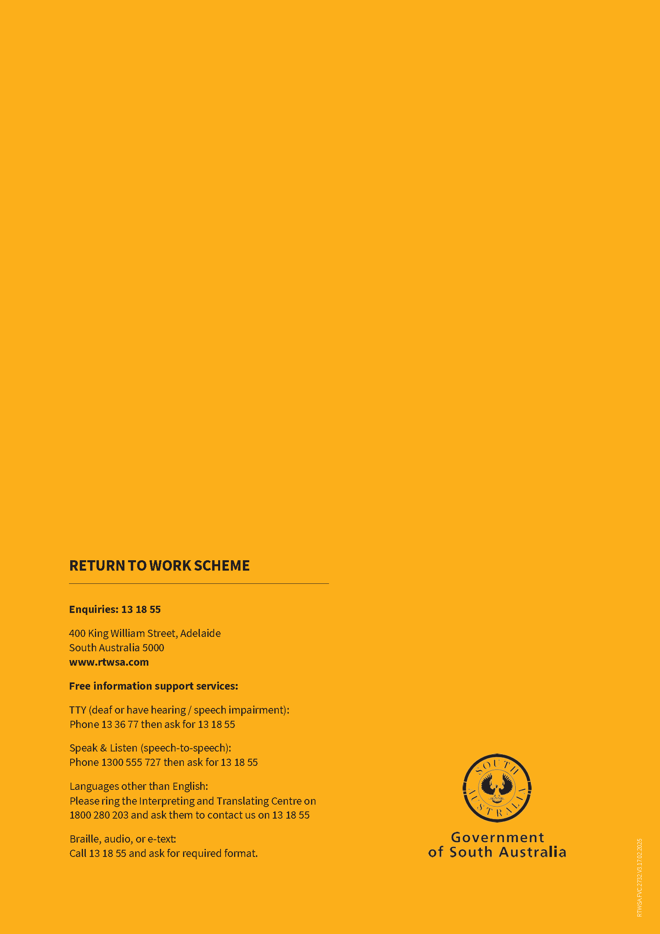

Road Traffic Act 1961
Authorisation to Operate Breath Analysing Instruments
I, Grant Stevens, Commissioner of Police, do hereby notify that on and from 28 February 2025, the following persons were authorised by the Commissioner of Police to operate breath analysing instruments as defined in and for the purposes of the:
• Road Traffic Act 1961;
• Harbors and Navigation Act 1993;
• Security and Investigation Industry Act 1995; and
• Rail Safety National Law (South Australia) Act 2012.
PD Number | Officer Name
12228 | ANDERSON, Esteban Duran
77096 | ARBON, William Xavier
14516 | DAVIS-MATTNER, Paxton Grace
49407 | GOLDSMITH, Andrew Ian
14681 | HAMLYN, Emma Jane
12369 | HARTLEY, Sarah Grace
14818 | HERBERT, Zara Kate
13877 | MENZIES, Ella Jade
13886 | POTTER, Lachlan Jacques
14688 | ROWE, Nicholas Bradley
12368 | SCOTT, Rhys Maynard
14226 | WHITLOCK, Aaron John
Dated: 13 March 2025
Grant Stevens
Commissioner of Police
Reference: 2025-0001

South Australian Housing Trust Regulations 2010
Regulation 4
Determination of Criteria for the Purposes of Affordable Housing
1. Application
This Notice applies to:
(1) assessment of applications for development approval under the PDI Act; and
(2) policies under the Planning and Design Code pursuant to the PDI Act.
2. Determination of Criteria
(1) Land or a dwelling that is the subject of an application or policy to which this Notice applies will fall within the concept of affordable housing for the purposes of Regulation 4 of the Regulations if the developer/owner of the land or dwelling has a Legally Enforceable Obligation in place to ensure:
(a) that the land or dwelling is offered for sale to an Eligible Home Buyer at or below the Price (subject to any increase to the Price approved under paragraph 2(2)) and that the offer is listed on the HomeSeeker SA website; or
(b) that the land or dwelling will be sold to an Eligible Rental Provider for the purpose of that Eligible Rental Provider making the land or dwelling available for affordable lease or rent; or
(c) where the relevant developer/owner is an Eligible Rental Provider, that the land or dwelling will be provided for affordable lease or rent by that Eligible Rental Provider,
or the Minister otherwise determines, in the Minister’s absolute discretion, that the land or dwelling constitutes affordable housing for the purposes of Regulation 4 of the Regulations.
(2) Where the land or dwelling:
(a) has features which make it more energy efficient and environmentally sustainable; or
(b) is on a small allotment within close proximity to public transport; or
(c) is offered for sale in conjunction with a financing product that increases an Eligible Home Buyer’s purchasing capacity as outlined in the industry guidelines published from time to time by the Department for Housing and Urban Development,
(each, a “designated feature”), the developer/owner may seek approval from the Chief Executive of the Department for Housing and Urban Development, or their delegate, to increase the Price by up to 10% with respect to that land or dwelling, and up to 15% where two or more designated features have been satisfied in relation to the land or dwelling.
3. Definitions
For the purposes of this Notice:
(1) “Eligible Home Buyer” means a person:
(a) who satisfies the eligibility criteria to buy a home through HomeSeeker SA (which eligibility criteria are set out on the HomeSeeker SA website accessible at https://homeseeker.sa.gov.au/ and as updated from time to time); or
(b) who is otherwise assessed as being eligible by the Chief Executive of the Department for Housing and Urban Development, or their delegate.

(2) “Eligible Rental Provider” means:
(a) the South Australian Housing Trust; or
(b) a community housing provider (however described) that is registered under a law of, or under a scheme administered by, a State or Territory of the Commonwealth of Australia, including the Community Housing Providers National Law set out in Schedule 1 of the Community Housing Providers (National Law) (South Australia) Act 2013 (SA); or
(c) a person (natural or corporate) approved to provide affordable rental under the ‘National Rental Affordability Scheme’; or
(d) a person (natural or corporate) subject to an affordable housing facilitation agreement with a Minister, or an instrumentality of the Crown in right of the State of South Australia; or
(e) any class of persons, declared from time to time by the Minister.
(3) “HomeSeeker SA” means the state government initiative by that name which is administered by the Department for Housing and Urban Development for the purpose of helping more South Australians buy or rent an affordable property, and which is described on the HomeSeeker SA website accessible at https://homeseeker.sa.gov.au/.
(4) “Legally Enforceable Obligation” includes:
(a) a legally binding agreement entered into between the developer/owner and a Minister, instrumentality of the Crown in right of the State of South Australia or Council (constituted under the Local Government Act 1999 (SA)), and in the case of a Land Management Agreement (as defined in the PDI Act) registered against the relevant instrument of title;
(b) a condition imposed by a relevant authority (as defined in the PDI Act) in relation to a development that it consents to or approves under the PDI Act; and
(c) any other form of legally enforceable obligation approved by the Minister.
(5) “Minister” means the Minister responsible for administering the South Australian Housing Trust Act 1995 (SA).
(6) “PDI Act” means the Planning, Development and Infrastructure Act 2016 (SA).
(7) “Price” means:
Affordability Indicators (March 2025) | Greater Adelaide* | Rest of State**
Dwelling or house and land purchase price (inclusive of GST) | $517,000 | $398,000
Land purchase price (inclusive of GST) | $232,650 | $179,100
* Greater Adelaide means: Greater Adelaide Planning Region as defined in Figure 1.1 The 30 Year Plan for Greater Adelaide 2017 Update, a volume of the South Australian Planning Strategy.
** Rest of State means: all areas in the State of South Australia excluding Greater Adelaide.
(8) “Regulations” means the South Australian Housing Trust Regulations 2010 under the South Australian Housing Trust Act 1995 (SA).
Dated: 4 March 2025
Hon Nick Champion MP
Minister for Housing and Urban Development

Local Government Instruments

City of Playford
Change of Road Name
Pursuant to Section 219(1) of the Local Government Act 1999 under delegation, notice is hereby given that the name of a road in Stage 1 of the Mandorla Estate, as detailed in Deposited Plan 135380, previously recorded as Monterey Crescent, is hereby changed to Rhea Crescent.
This renaming is in accordance with the approved plan of division DA 292/D036/21 and will take effect on 5 April 2025.
Dated: 13 March 2025
Matt Dineen
Senior Manager, Development Services

City of Tea Tree Gully
Supplementary Election of Councillor for Pedare Ward—Election Results
Conducted on Wednesday, 5 March 2025
Formal Ballot Papers—2,582
Informal Ballot Papers—24
Quota—1,292
Candidates | First Preference Votes | Elected/Excluded
DEAN, Jamie | 222 | Excluded
WARNER, Bradley | 417 | Excluded
WYLD, Damian | 658
MOORE, Sam | 332 | Excluded
PROLETA, Donna | 511 | Elected
BARBARO, Paul | 374 | Excluded
MILHENCH, Brian | 68 | Excluded
Dated: 13 March 2025
Mick Sherry
Returning Officer

City of Unley
Supplementary Election of Councillor for Goodwood Ward—Election Results
Conducted on Tuesday, 4 March 2025
Formal Ballot Papers—1,174
Informal Ballot Papers—3
Quota—588
Candidates | First Preference Votes | Elected/Excluded
ESDAILE, Louisa | 284
ROACH, Tony | 347 | Elected
POTOCZKY, Kirsten | 97 | Excluded
MCNALLY, Joshua | 69 | Excluded
WADE, Tori | 190 | Excluded
WRIGHT, Emma | 135 | Excluded
TIPPER, Denise | 52 | Excluded
Dated: 13 March 2025
Mick Sherry
Returning Officer

City of West Torrens
Assignment of Name for Un-named Road
Notice is hereby given that the City of West Torrens at its meeting held on 18 February 2025 resolved pursuant to Section 219 of the
Local Government Act 1999 to adopt Little Winwood Street as the name of the previously un-named public road in Thebarton (as detailed on map below) taking effect from 18 February 2025.
Notice is hereby given that the City of West Torrens at its meeting held on 18 February 2025 resolved pursuant to Section 219 of the
Local Government Act 1999 to adopt Queen Street as the name of the previously un-named public road in Thebarton (as detailed on map below) taking effect from 18 February 2025.
Dated: 13 March 2025
Angelo Catinari
Chief Executive Officer

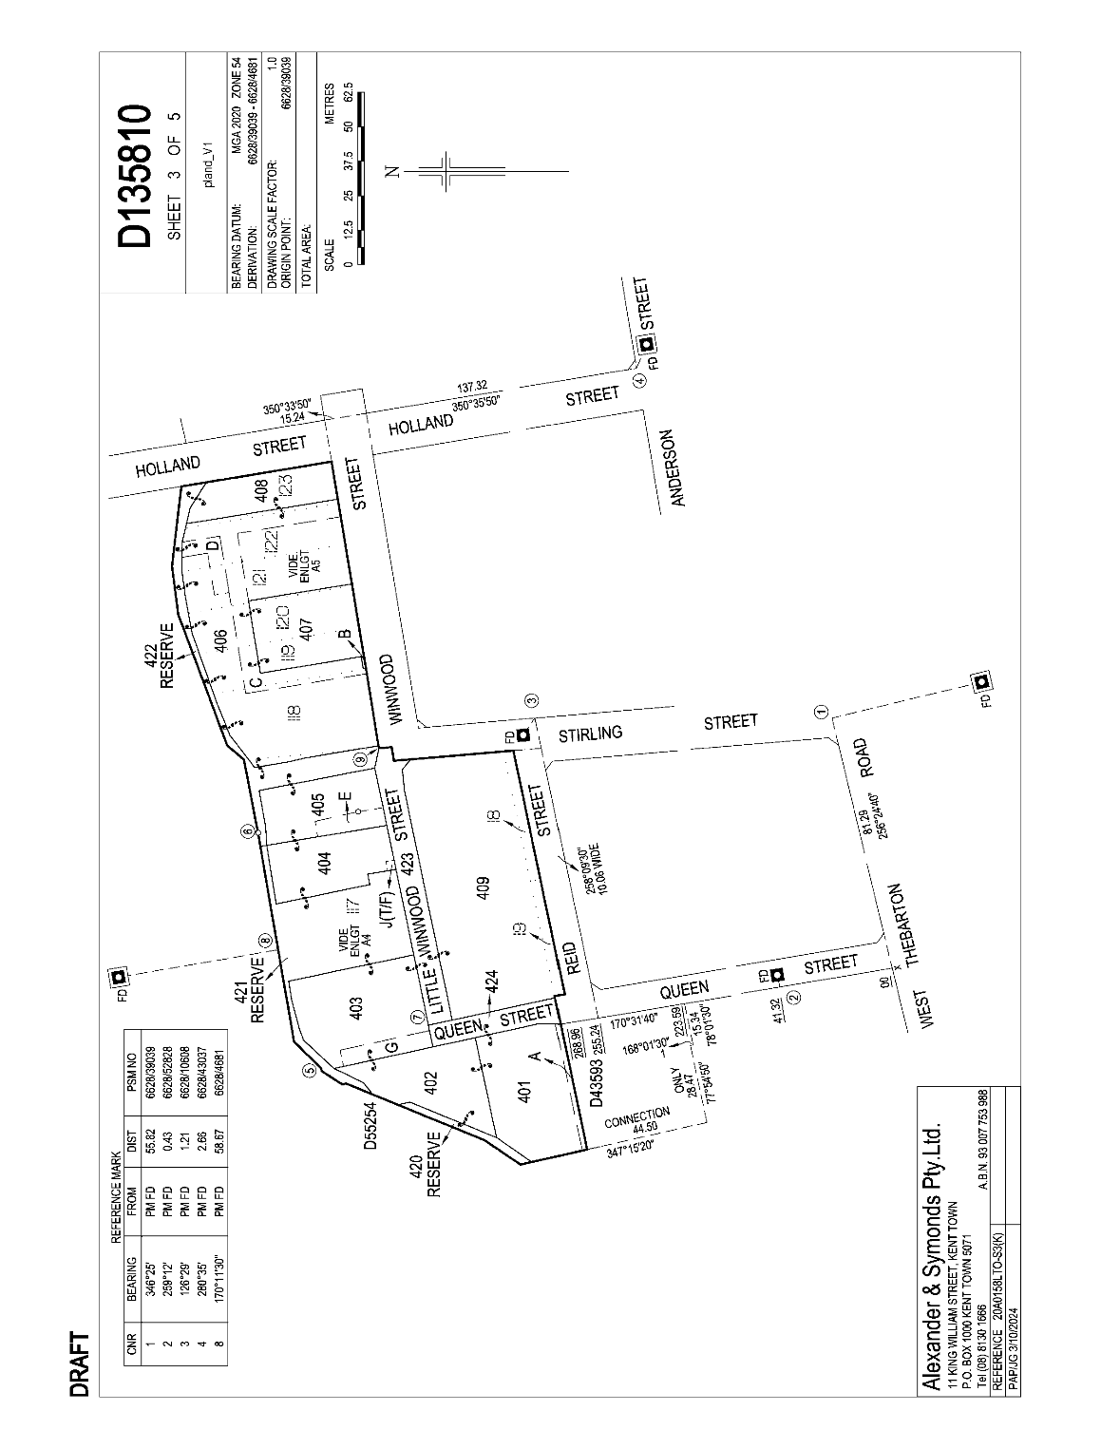

Light Regional Council
Resignation of Mayor
Notice is hereby given in accordance with Section 54(6) of the Local Government Act 1999, that a vacancy has occurred in the office of Mayor, due to a resignation of Mayor Bill O’Brien, effective 19 March 2025.
Dated: 4 March 2025
Richard Dodson
Chief Executive Officer

Northern Areas Council
Review of Representation
Notice is hereby given that the Northern Areas Council has reviewed its composition and elector representation arrangements in accordance with the requirements of Section 12 of the Local Government Act 1999 (the Act).
Pursuant to Section 12(13)(a) of the Act, the Electoral Commissioner has issued a certificate that the review undertaken by Council satisfies the requirements of Section 12 of the Act.
The following arrangements will therefore take effect from polling day of the next periodic Local Government election:
• The principal member of the Council shall be a Mayor elected by the electors for the area.
• The Council area will not be divided into wards (i.e. wards will be abolished).
• The future elected body of Council will comprise the Mayor and eight (8) area councillors, all of whom will represent the whole of the Council area and shall be elected by the community at a council-wide election.
Dated: 13 March 2025
Peter Ward
Acting Chief Executive Officer

Wudinna District Council
Local Government Act 1999
Adoption of Community Management Plans
Notice is hereby given pursuant to Section 197(3) of the Local Government Act 1999 that the Wudinna District Council, at its Ordinary Meeting dated 18 February 2025, resolved to adopt the following Community Land Management Plans:
Public Parks
• Wudinna Apex Park and Adjacent Grassed Area
• Wudinna Standley Park
• Yumburra Park—via Yaninee
• Kyancutta Polkdinney Park
Sports Grounds
• Minnipa War Memorial Oval
• Yaninee Sports Ground
• Warramboo Sports Ground
• Pygery Sports Ground
Recreation Reserves (Natural Features)
• Pildappa Rock—via Minnipa
• Tcharkulda Hill—via Minnipa
• Mount Wudinna—via Wudinna
• Polda Rock—via Wudinna
• Koongawa-Waddikee Rock
• Ucontitchie Hill—via Kyancutta
Sporting and Recreational Club Facilities
• Wudinna Swimming Pool
• Wudinna Bowling Club
• Le Hunte Pony Club—Wudinna
• Le Hunte Karting Club—Pygery
Community Halls
• Wudinna & Districts Memorial Hall
• Warramboo Hall
Public Cemeteries
• Wudinna Cemetery
• Yaninee Cemetery
• Minnipa Cemetery
• Kyancutta Cemetery
• Warramboo Cemetery
Public Toilets on Community Land
• Minnipa Hall Toilets
• Warramboo Public Toilets
Community Agricultural Land
• Parklands—S 92 Hundred of Yaninee
• Parklands—S 112 and 113 Hundred of Minnipa
• Minnipa Aerodrome S 98 and 110 Hundred of Minnipa
• Parklands—S 106 Hundred of Warramboo
• Recreation Area—S 33 Hundred of Koongawa
Miscellaneous Land
• Wudinna Showgrounds and Sports Ground
• Wudinna Senior Citizens Club
• Lot 103—Burton Tce, Wudinna
The Community Land Management Plans are available on Council’s website www.wudinna.sa.gov.au and a printed copy available for public inspection at Wudinna District Council, 11 Burton Tce, Wudinna.
Dated: 7 March 2025
Kristy Davis
Chief Executive Officer

Public Notices

National Electricity Law
Notice of Final Rules and Determinations
The Australian Energy Market Commission (AEMC) gives notice under the National Electricity Law as follows:
Under ss 102, 102A and 103, the making of the National Electricity Amendment (Improving the cost recovery arrangements for transmission non-network options) Rule 2025 No. 2 (Ref. ERC0391) and related final determination. All provisions commence on 13 March 2025.
Under ss 102 and 103, the making of the National Electricity Amendment (Amendment to frequency performance payment cost recovery) Rule 2025 No. 3 (Ref. ERC0405) and related final determination. Provisions commence as follows: Schedule 1 of this Rule commences operation on 8 June 2025, immediately after the National Electricity Amendment (Primary frequency response incentive arrangements) Rule 2022. Schedule 2 of this Rule commences operation on 20 March 2025.
Documents referred to above are available on the AEMC’s website and are available for inspection at the AEMC’s office.
Australian Energy Market Commission
Level 15, 60 Castlereagh St
Sydney NSW 2000
Telephone: (02) 8296 7800
www.aemc.gov.au
Dated: 13 March 2025

Sale of Property
Warrant of Sale
Auction Date: Friday, 28 March 2025 at 11:00am
Location: 10 Florian Street, Christie Downs, South Australia
Notice is hereby given that on the above date at the time and place stated, by virtue of the Warrant of Sale issued out of the Magistrates Court of South Australia, Action No. 013811 of 2022 directed to the Sheriff of South Australia in an action wherein Johanna May Trautwein is the Plaintiff and Robert Peter Gawel is the Defendant, I, Leslie Turner, Sheriff of the State of South Australia, will by my auctioneers, Harcourts Adelaide, make sale of the estate, right, title or interest whatsoever it may be of the defendant, Robert Peter Gawel the registered proprietor of an estate in fee simple in the following:
That piece of land situated in the area named Christie Downs, being 10 Florian Street, Christie Downs, Hundred of Adelaide, being the property comprised in Certificate of Title Register Book Volume 5396 Folio 500.
Further particulars from the auctioneers:
Bobbie Kang
Harcourts Adelaide City
3 & 4/69-79 Gilbert Street,
Adelaide SA 5000
Telephone: (08) 7230 8228
Dated: 13 March 2025
Leslie Turner
Sheriff

Notice Submission

The South Australian Government Gazette is published each Thursday afternoon.
Notices must be emailed by 4 p.m. Tuesday, the week of publication.
Submissions are formatted per the gazette style and a proof will be supplied prior to publication, along with a quote if applicable. Please allow one day for processing notices.
Alterations to the proof must be returned by 4 p.m. Wednesday.

Gazette notices must be submitted as Word files, in the following format:
• Title—the governing legislation
• Subtitle—a summary of the notice content
• Body—structured text, which can include numbered lists, tables, and images
• Date—day, month, and year of authorisation
• Signature block—name, role, and department/organisation authorising the notice

Please provide the following information in your email:
• Date of intended publication
• Contact details of the person responsible for the notice content
• Name and organisation to be charged for the publication—Local Council and Public notices only
• Purchase order, if required—Local Council and Public notices only

Email: governmentgazettesa@sa.gov.au
Phone: (08) 7133 3552
Website: www.governmentgazette.sa.gov.au

All instruments appearing in this gazette are to be considered official, and obeyed as such

Printed and published weekly by authority of T. Foresto, Government Printer, South Australia
$8.80 per issue (plus postage), $443.00 per annual subscription—GST inclusive
Online publications: www.governmentgazette.sa.gov.au

