No. 13 p. 253

**THE SOUTH AUSTRALIAN**

**GOVERNMENT GAZETTE**

**Published by Authority**

Adelaide, Thursday, 6 March 2025

**Contents**

Governor’s Instruments

Appointments, Resignations and General Matters 254

Proclamations—

[Criminal Law Consolidation (Section 20A) Amendment  
Act (Commencement) Proclamation 2025 256](#_Toc192097783)

[Youth Court (Designation and Classification  
of Magistrate) Proclamation 2025 256](#_Toc192097784)

State Government Instruments

Adelaide Dolphin Sanctuary Act 2005 257

Building Work Contractors Act 1995 257

Explosives Act 1936 257

First Nations Voice Act 2023 257

Fisheries Management (Prawn Fisheries) Regulations 2017 258

Fisheries Management Act 2007 260

Housing Improvement Act 2016 262

Land Acquisition Act 1969 263

Remuneration Tribunal, The 264

Retail and Commercial Leases Act 1995 266

Retirement Villages Act 2016 266

Roads (Opening and Closing) Act 1991 266

Local Government Instruments

City of Tea Tree Gully 267

Kangaroo Island Council 267

District Council of Streaky Bay 268

Public Notices

Employment Agents Registration Act 1993 282

National Electricity Law 282

# Governor’s Instruments

## Appointments, Resignations and General Matters

Department of the Premier and Cabinet

Adelaide, 6 March 2025

Her Excellency the Governor in Executive Council has been pleased to appoint the undermentioned to the Infrastructure SA Board, pursuant to the provisions of the Infrastructure SA Act 2018:

Member: from 6 March 2025 until 5 March 2028

Robert Louis Rigby Rust

By command,

Peter Bryden Malinauskas, MP

Premier

DPC25/007CS

Department of the Premier and Cabinet

Adelaide, 6 March 2025

Her Excellency the Governor in Executive Council has been pleased to appoint David Cameron Lovell as an Auxiliary Judge of the Supreme Court of South Australia for a term commencing on 6 March 2025 and expiring on 30 June 2025, it being a condition of appointment that the powers and jurisdictions of office should be exercised only during the time or times the actual duties are being undertaken, but at no other time throughout the period of appointment - pursuant to section 3(1) of the Judicial Administration (Auxiliary Appointments and Powers) Act 1988.

By command,

Peter Bryden Malinauskas, MP

Premier

AGO0034-25CS

Department of the Premier and Cabinet

Adelaide, 6 March 2025

Her Excellency the Governor in Executive Council has been pleased to appoint David Hamilton Bruce McLeod as an Auxiliary Magistrate of the Magistrates Court of South Australia for a term commencing on 6 March 2025 and expiring on 30 June 2025, it being a condition of appointment that the powers and jurisdictions of office should be exercised only during the time or times the actual duties are being undertaken, but at no other time throughout the period of appointment - pursuant to section 3(1) of the Judicial Administration (Auxiliary Appointments and Powers) Act 1988.

By command,

Peter Bryden Malinauskas, MP

Premier

AGO0034-25CS

Department of the Premier and Cabinet

Adelaide, 6 March 2025

Her Excellency the Governor in Executive Council has been pleased to appoint Julie-Anne Penman Burgess as Chief Executive of the South Australian Housing Trust for a term of five years from 28 April 2025 until 27 April 2030 - pursuant to section 68 of the Constitution Act 1934.

By command,

Peter Bryden Malinauskas, MP

Premier

25MHCS05579

Department of the Premier and Cabinet

Adelaide, 6 March 2025

Her Excellency the Governor in Executive Council has been pleased to appoint Vanessa Jane Burrows as the Director of the Office for Public Integrity, for a term of three years commencing on 6 March 2025 and expiring on 5 March 2028 - pursuant to section 18 of the Independent Commission Against Corruption Act 2012.

By command,

Peter Bryden Malinauskas, MP

Premier

AGO0040-25CS

Department of the Premier and Cabinet

Adelaide, 6 March 2025

Her Excellency the Governor in Executive Council has revoked the appointment of Damien Guy Walker and Leigh Dillon Todd as Clerks of Executive Council effective from 6 March 2025 - pursuant to the Letters Patent, section 41 of the Legislation Interpretation Act 2021 and section 68 of the Constitution Act 1934.

By command,

Peter Bryden Malinauskas, MP

Premier

DPC25/005CS

Department of the Premier and Cabinet

Adelaide, 6 March 2025

Her Excellency the Governor in Executive Council has been pleased to appoint Richard John Persse as a Clerk of Executive Council commencing on 6 March 2025 - pursuant to the Letters Patent and section 68 of the Constitution Act 1934.

By command,

Peter Bryden Malinauskas, MP

Premier

DPC25/005CS

Department of the Premier and Cabinet

Adelaide, 6 March 2025

Her Excellency the Governor in Executive Council has amended the terms and conditions of appointment for Penelope Ann Croser, State Courts Administrator, effective from 6 March 2025 until her term expires on 14 June 2029 - pursuant to section 16 of the Courts Administration Act 1993.

By command,

Peter Bryden Malinauskas, MP

Premier

AGO0020-25CS

## Proclamations

South Australia

### Criminal Law Consolidation (Section 20A) Amendment Act (Commencement) Proclamation 2025

**1—Short title**

This proclamation may be cited as the *Criminal Law Consolidation (Section 20A) Amendment Act (Commencement) Proclamation 2025*.

**2—Commencement of Act**

The [*Criminal Law Consolidation (Section 20A) Amendment Act 2024*](http://www.legislation.sa.gov.au/index.aspx?action=legref&type=act&legtitle=Criminal%20Law%20Consolidation%20(Section%2020A)%20Amendment%20Act%202024) (No 54 of 2024) comes into operation on 1 May 2025.

**Made by the Governor**

with the advice and consent of the Executive Council

on 6 March 2025

South Australia

### Youth Court (Designation and Classification of Magistrate) Proclamation 2025

under section 9 of the *Youth Court Act 1993*

**1—Short title**

This proclamation may be cited as the *Youth Court (Designation and Classification of Magistrate) Proclamation 2025*.

**2—Commencement**

This proclamation comes into operation on the day on which it is made.

**3—Designation and classification of magistrate**

The auxiliary magistrate named in Schedule 1 is—

(a) designated as a magistrate of the Youth Court of South Australia; and

(b) classified as a member of the Court's ancillary judiciary.

**Schedule 1—Magistrate of the Court**

David Hamilton Bruce McLeod

**Made by the Governor**

with the advice and consent of the Executive Council

on 6 March 2025

# State Government Instruments

## Adelaide Dolphin Sanctuary Act 2005

*Adoption of Adelaide Dolphin Sanctuary Management Plan*

I, Susan Close, Minister for Climate, Environment and Water, (being the Minister of the Crown to whom the administration of the  
*Adelaide Dolphin Sanctuary Act 2005* is for the time being committed), pursuant to Section 11(3) of the *Adelaide Dolphin Sanctuary Act 2005*, hereby adopt the Adelaide Dolphin Sanctuary Management Plan.

Dated: 15 January 2025

Hon Susan Close MP

Deputy Premier

Minister for Climate, Environment and Water

## Building Work Contractors Act 1995

*Exemption*

Take notice that, pursuant to Section 45 of the *Building Work Contractors Act 1995*, I, Emily Sims as a delegate for the Minister for Consumer and Business Affairs, do hereby exempt the licensee named in Schedule 1 from the application of Division 3 of Part 5 of the above Act in relation to domestic building work described in Schedule 2 and subject to the conditions specified in Schedule 3.

Schedule 1

STEPHEN MARK LUCAS (BLD 54527)

Schedule 2

Construction of a single storey detached dwelling at Allotment 103, Deposited Plan 111252, being a portion of the land described in Certificate of Title Volume 6165, Folio 738, more commonly known as 40 Needlebush Drive, Chiton SA 5211.

Schedule 3

1. This exemption is limited to domestic building work personally performed by the licensee in relation to the building work described in Schedule 2.

2. This exemption does not apply to any domestic building work the licensee contracts to another building work contractor, for which that contractor is required by law to hold building indemnity insurance.

3. That the licensee does not transfer his interest in the land prior to five years from the date of completion of the building work the subject of this exemption, without the prior authorisation of Consumer and Business Services (CBS). Before giving such authorisation, CBS may require the licensee to take any reasonable steps to protect the future purchaser(s) of the property, including but not limited to:

• Providing evidence that an adequate policy of building indemnity insurance is in force to cover the balance of the five-year period from the date of completion of the building work the subject of this exemption;

• Providing evidence of an independent expert inspection of the building work the subject of this exemption;

• Making an independent expert report available to prospective purchasers of the property;

• Giving prospective purchasers of the property notice of the absence of a policy of building indemnity insurance.

Dated: 1 March 2025

Emily Sims

Delegate for the Minister for Consumer and Business Affairs

## Explosives Act 1936

*Appointment of Inspectors of Explosives*

I, Kyam Joseph Maher, Minister for Industrial Relations and Public Sector in and for the State of South Australia, hereby appoint the following person as an Inspector of explosives for the purposes of the *Explosives Act 1936* pursuant to Section 9(1) of that Act:

• Lachlan Barry REEKS

Dated: 3 February 2025

Hon Kyam Maher MLC

Minister for Industrial Relations and Public Sector

## First Nations Voice Act 2023

2025 SA Local First Nations Voice Supplementary Election

**Region 1 Kumangka Warrarna Wangkanthi (Central)**

This supplementary election is for Aboriginal and Torres Strait Islander people enrolled on the State electoral roll in Region 1—Kumangka Warrarna Wangkanthi (Central).

Polling day is Saturday, 15 March 2025.

Early Voting Centres will be open from Tuesday, 11 March to Friday, 14 March 2025, 9:00am-5:00pm.

Locations for early voting include:

• **Adelaide CBD** ECSA, 6/60 Light Square

• **Port Adelaide** Tauondi College, 1 Lipson Street

Five polling booths will be open across Region 1—Kumangka Warrarna Wangkanthi (Central) on Saturday, 15 March 2025, from 8:00am-6:00pm. Locations include:

• **Adelaide CBD** ECSA, 6/60 Light Square

• **Port Adelaide** Tauondi College, 1 Lipson Street

• **Christie Downs** Wardli Youth Centre, 13 McKinna Road

• **Elizabeth** Playford Civic Centre, 10 Playford Boulevard

• **Lightsview** Wiltja Aṉangu Secondary College, 111-125 Folland Avenue

More information:

Telephone: 1300 655 232

Visit: [savoiceelection.sa.gov.au](https://savoiceelection.sa.gov.au/)

Dated: 5 March 2025

Mick Sherry

Returning Officer

## Fisheries Management (Prawn Fisheries) Regulations 2017

Variation on Prohibition of Fishing Activities in the Spencer Gulf Prawn Fishery

Take note that pursuant to Regulation 10 of the *Fisheries Management (Prawn Fisheries) Regulations 2017*, the notice dated 19 September 2024 published on page 3811 of the *South Australian Government Gazette* on 26 September 2024 prohibiting fishing activities in the Spencer Gulf Prawn Fishery, is hereby varied such that it will not be unlawful for a person fishing pursuant to a Spencer Gulf Prawn Fishery licence to use prawn trawl nets in the areas specified in Schedule 1, during the period specified in Schedule 2, and under the conditions specified in Schedule 3

Schedule 1

The waters of the Spencer Gulf Prawn Fishery:

(a) Except the Northern closure area, which is defined as the area north of the following index points:

1. 33°49.00S 137°40.60E East Shore

2. 33°42.50S 137°30.20E

3. 33°46.40S 137°29.30E

4. 33°48.50S 137°33.20E

5. 33°53.60S 137°27.40E

6. 33°50.00S 137°21.00E

7. 33°54.90S 137°08.70E

8. 33°56.50S 137°09.80E

9. 33°55.30S 137°13.00E

10. 33°58.00S 137°14.60E

11. 34°14.20S 136°59.00E

12. 34°14.20S 136°55.00E

13. 34°22.30S 136°51.40E

14. 34°22.30S 136°46.00E

15. 34°31.50S 136°41.90E

16. 34°34.00S 136°39.80E

17. 34°34.00S 136°34.20E

18. 34°06.70S 136°47.00E

19. 34°04.10S 136°43.60E

20. 34°00.80S 136°49.40E

21. 33°57.20S 136°45.50E

22. 33°53.70S 136°51.80E

23. 33°48.70S 136°47.30E West Shore

Points 1-2, 3-4, 5-6, 7-8, 9-10, 11-12, 13-14, 16-17, 18-19, 20-21 & 22-23 are designated east-west lines.

(b) Except the Arno closure area, which is defined as the waters contained within the following index points:

1. 33°59.00S 136°42.24E

2. 33°59.60S 136°42.60E

3. 34°00.70S 136°40.60E

4. 34°00.10S 136°40.10E

(c) Except the Wardang closure area, which is defined as the waters contained within the following index points:

1. 34°10.00S 137°28.00E

2. 34°21.00S 137°12.00E

3. 34°45.00S 137°15.00E

4. 34°48.53S 137°09.45E

5. 34°48.53S 137°06.00E

6. 34°50.75S 137°06.00E

7. 34°54.00S 137°01.00E

(d) Except the Corny closure area, which is defined as the waters contained within following closure index points:

1. 34°27.00S 136°53.00E

2. 34°27.00S 137°02.00E

3. 34°35.00S 136°56.00E

4. 34°48.60S 136°52.00E

5. 34°54.00S 136°52.00E

6. 34°54.00S 136°48.50E

7. 34°49.50S 136°48.50E

8. 34°49.50S 136°40.50E

9. 34°39.50S 136°40.50E

Then back to point 1

(e) Except the Illusions Park closure area, which is defined as the waters contained within the following closure index points:

1. 33°28.80S 137°32.20E

2. 33°28.30S 137°33.20E

3. 33°28.85S 137°33.50E

4. 33°29.40S 137°32.50E

Then back to point 1

(f) Except the Jurassic Park closure area, which is defined as the waters contained within the following closure index points:

1. 33°54.90S 137°17.60E

2. 33°54.40S 137°19.40E

3. 33°54.70S 137°19.60E

4. 33°55.20S 137°17.80E

Then back to point 1

(g) Except the Estelle Star closure area, which is defined as the waters contained within the following closure index points:

1. 33°58.80S 136°49.80E

2. 33°58.20S 136°51.00E

3. 33°59.10S 136°51.70E

4. 33°59.80S 136°50.40E

Then back to point 1

Schedule 2

Commencing at sunset on 01 March 2025 and ending at sunrise on 10 March 2025

Schedule 3

1. The coordinates in Schedule 1 are defined as degrees decimal minutes and are based on the World Geodetic System 1984 (WGS 84).

2. No fishing activity may be undertaken between the prescribed times of sunrise and sunset for Adelaide (as published in the *South Australian Government Gazette* pursuant to the requirements of the *Proof of Sunrise and Sunset Act 1923*) during the period specified in Schedule 2.

3. Fishing must cease:

(a) in the fishing area known as Northern & Inshore Wallaroo (the ‘Mid/North Gulf’ area, as described on page 40 of the Management Plan for the South Australian Commercial Spencer Gulf Prawn Fishery October 2020) if the average catch per vessel, per night (based on the best information available to the committee at sea) drops below 600kg; and

(b) in the fishing area known as Southern Wallaroo & North End (the ‘Mid/North Gulf’ area as described on page 40 of the Management Plan for the South Australian Commercial Spencer Gulf Prawn Fishery October 2020) if the average catch per vessel, per night (based on the best information available to the committee at sea) drops below 500kg; and

(c) in the fishing area known as the ‘Southern Gulf’ area (as described on page 40 of the Management Plan for the South Australian Commercial Spencer Gulf Prawn Fishery October 2020) if the average catch per vessel over two consecutive nights (based on the best information available to the committee at sea) falls below 350kg.

4. Based on the best information available from the fleet, fishing must cease in an area in the Mid/North Gulf if the average prawn bucket count exceeds 240 prawns per 7kg; or in an area in the Southern Gulf if the average prawn bucket count exceeds 260 prawns per 7kg.

5. No fishing activity may occur without the authorisation of Coordinator at Sea, Ashley Lukin, or other nominated Coordinator at Sea appointed by the Spencer Gulf and West Coast Prawn Association.

6. The authorisation of the Coordinator at Sea must be in writing, signed and record the day, date, and permitted fishing area within the waters of Schedule 1 in the form of a notice sent to the fishing fleet or vary an earlier authorisation issued by the Coordinator at Sea.

7. The Coordinator at Sea must cause a copy of any authorisation for fishing activity or variation of same, made under this notice to be emailed to the Prawn Fisheries Manager immediately after it is made.

8. The Spencer Gulf and West Coast Prawn Association must keep records of all authorisations issued pursuant to this notice.

Dated: 1 March 2025

Ashley Lukin

Coordinator at Sea, Spencer Gulf and West Coast Prawn Association Inc.

Delegate of the Minister for Primary Industries and Regional Development

## Fisheries Management Act 2007

Section 79

Revocation

Take note that the notice dated 31 May 2024 titled “*Temporary Prohibition on the Taking of Marine Benthic Animals in Specified Waters of SE—Port MacDonnell to Nene Valley*” made under Section 79 of the *Fisheries Management Act 2007*, published in the *South Australian Government Gazette*, dated 31 May 2024, being the third notice on page 1330 is hereby revoked.

Dated: 5 March 2025

Professor Gavin Begg

Executive Director

Fisheries and Aquaculture

Delegate of the Minister for Primary Industries and Regional Development

FISHERIES MANAGEMENT ACT 2007

Section 79

Temporary Prohibition on the Take and Possession of Abalone—  
Waters of Southern Zone Abalone Fishery

Pursuant to Section 79 of the *Fisheries Management Act 2007*, I Professor Gavin Begg, Executive Director Fisheries and Aquaculture, delegate of the Minister for Primary Industries and Regional Development, hereby declare that it shall be unlawful for any person to engage in the act of, or an act preparatory to or otherwise involved in, the fishing activities specified in Schedule 1, or to have possession or control of abalone within the area described in Schedule 2 during the period specified in Schedule 3.

Schedule 1

• The taking of abalone by any means within the waters of the Southern Zone Abalone Fishery as defined in the *Fisheries Management (Abalone Fisheries) Regulations 2017*—being waters adjacent to South Australia east of the meridian of longitude 139° East (GDA 2020); or

Schedule 2

• The possession of abalone within the waters of the Southern Zone Abalone Fishery as defined in the *Fisheries Management (Abalone Fisheries) Regulations 2017*—being waters adjacent to South Australia east of the meridian of longitude 139° East (GDA 2020) including the area landward to the high water mark.

Schedule 3

From 17:00 hours 6 March 2025 to 12:00 hours 5 March 2026 unless varied or revoked earlier.

Dated: 5 March 2025

Professor Gavin Begg

Executive Director

Fisheries and Aquaculture

Delegate of the Minister for Primary Industries and Regional Development

Fisheries Management Act 2007

Section 115

Exemption Number ME9903307

Take notice that pursuant to Section 115 of the *Fisheries Management Act 2007*, I Professor Gavin Begg, Executive Director Fisheries and Aquaculture, delegate to the Minister for Primary Industries and Regional Development, hereby exempt Dr Sylvia Zukowski of Aquasave—Nature Glenelg Trust, 16 Anglesea Road, Victor Harbor, South Australia 5211 (the ‘exemption holder’), or a person acting as their agent, from Sections 70 and 71(2) of the *Fisheries Management Act 2007*; and Regulation 5(a) and Clauses 39, 40, 41, 42, 43, 44, 45, 46, 47, 48, 49, 50, 51, 52, 56, 57, 63, 74, 75, 82, 90, 93, 94, 95, 96, 99 and 116 of Schedule 6 of the *Fisheries Management (General) Regulations 2017*, but only insofar as the exemption holder may engage in the surveying of aquatic resources from waters specified in Schedule 1, using the gear specified in Schedule 2 (the ‘exempted activity’), subject to the conditions specified in Schedule 3 from 25 October 2024 until 24 October 2025 unless otherwise varied or revoked earlier.

Schedule 1

Inland, estuarine and coastal waters of the State excluding Aquatic Reserves, Marine Park sanctuary zones and restricted access zones (unless authorised under the *Marine Parks Act 2007*).

Schedule 2

• 5 x seine nets (maximum length of 25m, minimum mesh size of 2mm)

• 24 x fyke nets (maximum wing span of 7m, minimum mesh size of 2mm)

• 40 x munyana nets (minimum 10cm entrance, minimum mesh size of 12mm with opening at the top no less than 20cm in diameter)

• 20 x hoop nets (1m diameter, minimum 2mm mesh, maximum 38mm entrance diameter)

• 1 x backpack electrofisher (Smith-Root LR24)

• 1 x boat electrofisher (Smith-Root 5.0kW GPP)

• 5 x cockle rake (800x300mm, minimum mesh size 12mm)

• 20 x bait trap (maximum 400mm x 300mm, minimum 2mm mesh)

• 2 x dip nets (400mm gape, 3mm mesh)

• 20 x pyramid traps.

Schedule 3

1. The exemption holder will be deemed responsible for the conduct of all persons conducting the activities under this notice. Any person conducting activities as an agent under this exemption must be provided with a copy of this notice, which they must sign as an indication that they have read and understand the conditions of the exemption.

2. Fish surveyed pursuant to this notice must be returned to the water as soon as reasonably practicable on completion of scientific evaluation.

3. Excluding protected species, up to ten (10) fish may be retained for the purpose of identification pursuant to this notice.

4. All noxious fish collected during the exempted activity must be destroyed and disposed of appropriately.

5. The specimens collected are for scientific and research purposes only and must not be sold.

6. The following persons are authorised to act as agents under this Ministerial exemption (ME9903307):

• Dr Nick Whiterod • Peter Unmack • Bryan Haywood

• Dr Mike Hammer • Dr Lauren Brown • Jonathan Tuck

• Emma Vanderzon • Dr Lachlan Farrington • Dr Scott Wedderburn

• Dr Paul Drummond • Scott Huntley • Dr Maiko Lutz

• Cory Young • Howard Brandenburg • Andrew Rethus

• Lauren Creasey

7. The exemption holder must operate electrofishing devices listed under this exemption in accordance with the *Australian Code of Electrofishing Practice 1997*, to the extent that it relates to the exempted activity.

8. Munyana nets used must have an opening at the top of at least 20cm at the narrowest part and must be removed from the water and inspected at periods not exceeding 2 hours.

9. Before conducting the exempted activity, the exemption holder must contact the Department of Primary Industries and Regions (PIRSA) FISHWATCH on 1800 065 522 and answer a series of questions about the exempted activity and be able to provide information about the area and time of the exempted activity, the vehicles and/or boats involved, the number of agents undertaking the exempted activity and other related issues.

10. The exemption holder must provide a report in writing detailing the outcomes of the research and the collection of organisms pursuant to this notice to the Executive Director PIRSA Fisheries and Aquaculture, (GPO Box 1625, Adelaide SA 5001) within 2 weeks of completion of the last activity to occur under this notice or within 2 weeks of the expiry of this notice, whichever occurs first, giving the following details:

• the date and location of sampling;

• the number of and types of nets used;

• the description of all species collected (fish, invertebrates, turtles) for purposes of identification;

• the number of each species collected.

11. While engaging in the exempted activity, the exemption holder or a person acting as their agent must be in possession of a copy of this notice. Such notice must be produced to a Fisheries Officer if requested.

12. The exemption holder must not contravene or fail to comply with the *Fisheries Management Act 2007* or any regulations made under that Act, except where specifically exempted by this notice or any other notice issued under that Act.

This notice does not purport to override the provisions or operation of any other Act including, but not limited to, the *Marine Parks Act 2007*, *National Parks and Wildlife Act 1972*, and *River Murray Act 2003*. The exemption holder and their agents must comply with any relevant regulations, permits, requirements and directions.

Dated: 2 September 2024

Professor Gavin Begg

Executive Director

Fisheries and Aquaculture

Delegate of the Minister for Primary Industries and Regional Development

Fisheries Management Act 2007

Section 115

Ministerial Exemption ME9903365

Take notice that pursuant to Section 115 of the *Fisheries Management Act 2007*, Dr Gretchen Grammer of the South Australian Research and Development Institute (SARDI), 2 Hamra Avenue, West Beach SA 5024 (the ‘exemption holders’), and her nominated agents, are exempt from Section 71(1)(b) and 71(2) of the *Fisheries Management Act 2007*, within the waters specified in Schedule 1, but only insofar as they may undertake the research activities specified in Schedule 2 (the ‘exempted activity’), subject to the conditions set out in Schedule 3, from 5 March 2025 until 4 March 2026 inclusive, unless varied or revoked earlier.

Schedule 1

Waters of South Australia, excluding the Adelaide Dolphin Sanctuary, Sanctuary and Restricted Access zones of any marine park unless authorised under the *Marine Parks Act 2007* and aquatic reserves unless otherwise authorised under the *Fisheries Management Act 2007*.

Schedule 2

1. Up to two surface or demersal longlines, of no more than 2km and up to 100 individual leaders, containing stainless-steel wire traces with up to 16/0 tuna circle hooks.

2. Up to four drumlines, containing stainless-steel wire traces with up to 20/0 stainless-steel circle hooks.

3. The tagging and/or sampling of free-swimming and/or temporarily restrained White Sharks (*Carcharodon carcharias*) with an accelerometer package and/or acoustic tag and/or satellite tag using a modified spear gun or deployment pole or alternative standard tag attachment methods as described in the *CMAR Code of Practice for Tagging Marine Animals*.

4. The collection of tissue and/or blood samples from free-swimming or temporarily restrained White Sharks using a single rubber speargun with a biopsy probe tip or using a biopsy punch and syringe.

Schedule 3

1. The exemption holder will be deemed responsible for the conduct of all persons conducting the exempted activities under this notice. Any person conducting activities under this exemption must be provided with a copy of this notice, which they must have signed as an indication that they have read and understand the conditions under it.

2. The exemption holders or nominated agents may take tissue and blood samples from a maximum of 50 White Sharks during the term of this notice.

3. The exemption holders or nominated agents may tag a maximum of 20 White Sharks during the term of this notice.

4. No shark may be taken from the water under this exemption.

5. Should a shark be restrained, fresh saltwater must be flushed through the gills of the individual and follow current best practice available at the time of sampling and/or tagging.

6. For the purposes of this notice, the following persons are the nominated agents of the exemption holder:

• Dr Michael Drew, SARDI—Aquatic and Livestock Sciences

• Dr Jeremy Bussell, SARDI—Aquatic and Livestock Sciences

• Dr Joshua Dennis, SARDI—Aquatic and Livestock Sciences

7. At least 1 hour before conducting the exempted activity, the exemption holders or nominated agents must contact the Department of Primary Industries and Regions (PIRSA) Fishwatch on 1800 065 522 and answer a series of questions about the exempted activity. The exemption holders are required to have a copy of the exemption at the time of making the call and be able to provide information about the area and time of the exempted activity, the vehicles and/or boats involved, the number of agents undertaking the exempted activity and other related questions.

8. While engaging in the exempted activity, the exemption holders and nominated agents must be in possession of a signed copy of this notice and carry their identification card issued by SARDI. Such notice and identification must be produced to a PIRSA Fisheries Officer immediately upon request.

9. The exemption holders or agents must not contravene or fail to comply with the *Fisheries Management Act 2007* or any Regulations made under that Act, except where specifically exempted by this notice.

This notice does not purport to override the provisions or operation of any other Act including, but not limited to, the *Marine Parks Act 2007*. The exemption holders and his agents must comply with any relevant regulations, permits, requirements and directions from the Department for Environment and Water when undertaking activities within a marine park.

Dated: 4 March 2025

Professor Gavin Begg

Executive Director

Fisheries and Aquaculture

Delegate of the Minister for Primary Industries and Regional Development

## Housing Improvement Act 2016

Rent Control

In the exercise of the powers conferred by the *Housing Improvement Act 2016*, the Delegate of the Minister for Housing and Urban Development hereby fixes the maximum rental amount per week that shall be payable subject to Section 55 of the *Residential Tenancies Act 1995*, in respect of each premises described in the following table. The amount shown in the said table shall come into force on the date of this publication in the Gazette.

|  |  |  |  |
| --- | --- | --- | --- |
| **Address of Premises** | **Allotment Section** | **Certificate of Title  Volume/Folio** | **Maximum Rental per week payable** |
| 3 Davies Terrace, Nailsworth SA 5083 | Allotments 5 & 12 Deposited Plan 1025  Hundred of Yatala | CT5778/320, CT5849/307 | $275.00 |
| Unit 3/27 Euston Terrace, Croydon SA 5008 | Allotment 51 Filed Plan 115863  Hundred of Croydon | CT5752/437 | $0.00 |

Dated: 6 March 2025

Craig Thompson

Housing Regulator and Registrar

Housing Safety Authority

Delegate of the Minister for Housing and Urban Development

HOUSING IMPROVEMENT ACT 2016

Rent Control Revocations

In the exercise of the powers conferred by the *Housing Improvement Act 2016*, the Delegate of the Minister for Housing and Urban Development hereby revokes the maximum rental amount per week that shall be payable subject to Section 55 of the *Residential Tenancies Act 1995*, in respect of each premises described in the following table.

|  |  |  |
| --- | --- | --- |
| **Address of Premises** | **Allotment  Section** | **Certificate of Title  Volume Folio** |
| 79 Moldavia Walk, Osborne SA 5017 | Allotment 16 Filed Plan 5068 Hundred of Port Adelaide | CT5684/485 |

Dated: 6 March 2025

Craig Thompson

Housing Regulator and Registrar

Housing Safety Authority

Delegate of the Minister for Housing and Urban Development

## Land Acquisition Act 1969

Section 16

Form 5—Notice of Acquisition

**1. Notice of acquisition**

The Commissioner of Highways (the Authority), of 83 Pirie Street, Adelaide SA 5000, acquires the following interests in the following land:

Comprising an estate in fee simple in that piece of land being portion of Allotment 71 in Deposited Plan 82876 comprised in Certificate of Title Volume 6114 Folio 298, being the whole of the land identified as Allotment 54 in D136272 lodged in the Lands Titles Office, subject only to the easement(s) over the land marked ‘A’ on D82876 for sewerage purposes to the South Australian Water Corporation (TG 8886418)

This notice is given under Section 16 of the *Land Acquisition Act 1969*.

**2. Compensation**

A person who has or had an interest consisting of native title or an alienable interest in the land that is divested or diminished by the acquisition or the enjoyment of which is adversely affected by the acquisition who does not receive an offer of compensation from the Authority may apply to the Authority for compensation.

**2A. Payment of professional costs relating to acquisition (Section 26B)**

If you are the owner in fee simple of the land to which this notice relates, you may be entitled to a payment of up to $10,000 from the Authority for use towards the payment of professional costs in relation to the acquisition of the land.

Professional costs include legal costs, valuation costs and any other costs prescribed by the *Land Acquisition Regulations 2019*.

**3. Inquiries**

Inquiries should be directed to: Petrula Pettas

GPO Box 1533

Adelaide SA 5001

Telephone: 0439 743 183

Dated: 3 March 2025

The Common Seal of the COMMISSIONER OF HIGHWAYS was hereto affixed by authority of the Commissioner in the presence of:

Rocco Caruso

Director, Property Acquisition

(Authorised Officer)

Department for Infrastructure and Transport

File Reference: 2024/06039/01

LAND ACQUISITION ACT 1969

Section 16

*Form 5—Notice of Acquisition*

**1. Notice of acquisition**

The Commissioner of Highways (the Authority), of 83 Pirie Street, Adelaide SA 5000, acquires the following interests in the following land:

Comprising an unencumbered estate in fee simple in that piece of land being the whole of Allotment 107 Deposited Plan 48219 comprised in Certificate of Title Volume 5533 Folio 573.

This notice is given under Section 16 of the *Land Acquisition Act 1969*.

**2. Compensation**

A person who has or had an interest consisting of native title or an alienable interest in the land that is divested or diminished by the acquisition or the enjoyment of which is adversely affected by the acquisition who does not receive an offer of compensation from the Authority may apply to the Authority for compensation.

**2A. Payment of professional costs relating to acquisition (Section 26B)**

If you are the owner in fee simple of the land to which this notice relates, you may be entitled to a payment of up to $10,000 from the Authority for use towards the payment of professional costs in relation to the acquisition of the land.

Professional costs include legal costs, valuation costs and any other costs prescribed by the *Land Acquisition Regulations 2019.*

**3. Inquiries**

Inquiries should be directed to: Daniel Tuk

GPO Box 1533

Adelaide SA 5001

Telephone: (08) 7133 2479

Dated: 3 March 2025

The Common Seal of the COMMISSIONER OF HIGHWAYS was hereto affixed by authority of the Commissioner in the presence of:

Rocco Caruso

Director, Property Acquisition

(Authorised Officer)

Department for Infrastructure and Transport

File Reference: 2024/06920/01

## The Remuneration Tribunal

Report No. 1 of 2025

*2025 Review of Remuneration of the Electoral Districts Boundaries Commission*

**Introduction**

1. The Remuneration Tribunal (**Tribunal**) has jurisdiction under Section 14 of the *Remuneration Act 1990* (**Act**) and Section 78(7) of the *Constitution Act 1934* (**Constitution Act**), to determine the remuneration payable to the members of the Electoral Districts Boundaries Commission (**Commission**), other than the chair.

2. The Constitution Act provides for the establishment of an Electoral Districts Boundaries Commission to review and carry out periodic redistribution of the boundaries of the State’s House of Assembly electoral districts. The Commission has perpetual succession and the powers and functions of a Royal Commission.

**Background**

3. The Commission conducts boundary reviews on a four-yearly basis. Hence, Determinations in relation to this matter are made by the Tribunal on a four-yearly basis, following the completion of the Commission’s official report. Previously, Determinations have prescribed a one-off payment of remuneration for all purposes in relation to the work performed by the Commission.

4. The previous Determination made by the Tribunal under Section 78(7) of the Constitution Act was in 2021, whereby the Tribunal determined remuneration of $20,103 each for the Electoral Commissioner and the Surveyor-General. The operative date of that Determination was 11 March 2021.

**Legislative Provisions**

5. Section 78(7) of the Constitution Act, from which the Tribunal sources its jurisdiction in relation to members of the Commission, is set out as follows:

***“78—The Commission***

*(1)* There *shall be a Commission by the name of the Electoral Districts Boundaries Commission constituted of the following members:*

*(a) the Chairman of the Commission who shall be a Judge of the Supreme Court appointed by the Chief Justice to be Chairman of the Commission; and*

*(b) the Electoral Commissioner or a person appointed pursuant to subsection (3) of this Section; and*

*(c) the Surveyor-General or a person appointed pursuant to subsection (4) of this Section.*

*(2) The Judge appointed by the Chief Justice under subsection (1) of this Section should be the most senior puisne Judge who is available to undertake the duties of Chairman of the Commission.*

*(3) If there is no Electoral Commissioner, or the Electoral Commissioner is for any reason unable to act as a member of the Commission, then, subject to subsection (5) of this Section, the Chief Justice shall appoint as a member of the Commission, for such term as the Chief Justice considers expedient, a person who, in the opinion of the Chief Justice, has wide knowledge of, and experience in, electoral matters.*

*(4) If there is no Surveyor-General, or the Surveyor-General is for any reason unable to act as a member of the Commission, then, subject to subsection (5) of this Section, the Chief Justice shall appoint as a member of the Commission, for such term as the Chief Justice considers expedient a person who, in the opinion of the Chief Justice, has wide knowledge of, and experience in, surveying.*

*(5) Where the Chairman is for the time being acting in the office of the Chief Justice any appointment to the Commission under subsection (3) or subsection (4) of this Section shall be made by the puisne judge next in order of seniority after the Chairman.*

*(6) A member appointed under subsection (3) or subsection (4) of this Section, may by instrument in writing addressed to the Governor resign the member’s office.*

*(7) The members of the Commission (other than the Chairman) are entitled to remuneration determined by the Remuneration Tribunal.”*

6. As presently constituted, the Commission is comprised of:

|  |  |
| --- | --- |
| **Office Held** | **Office Holder** |
| Chair | The Hon. Justice Anne Bampton (Supreme Court Judge appointed by the Chief Justice) |
| Member | Mr Michael Sherry (Electoral Commissioner) |
| Member | Mr Bradley Slape (Surveyor-General) |

7. The Tribunal notes that its jurisdiction under Section 78(7) of the Constitution Act is limited and specific. It is not permissible for the Tribunal to make a Determination of remuneration for the Chair of the Commission. The statutory role assigned to the Tribunal is to determine an appropriate amount of remuneration for the two members of the Commission (the Electoral Commissioner and Surveyor-General).

**The Review Process**

8. Section 10(2) of the Act provides that prior to the making of a Determination, the Tribunal must allow an affected person, or persons of an affected class, a reasonable opportunity to make submissions orally or in writing to the Tribunal.

9. Section 10(4) provides that the Minister responsible for the Act may intervene, personally or by counsel or other representative, in proceedings before the Tribunal for the purpose of introducing evidence, or making submissions, on any question relevant to the public interest.

10. On 30 January 2025, in accordance with Section 10(2) and 10(4) of the Act, the Tribunal wrote to and invited submissions by 13 February 2025 in respect of this review from:

(a) Members of the Electoral Districts Boundaries Commission

(b) The Honourable Premier of South Australia—as the Minister responsible for the Act who may make submissions or introduce evidence in the public interest

11. The Tribunal also placed a notice on its website from 30 January 2025 inviting submissions from affected persons by 13 February 2025.

**Submissions**

12. On 29 January 2025, the Honourable Justice Bampton wrote to the Tribunal advising the following:

• Having regard to the statutory provisions, requested the Tribunal determine the remuneration for the Electoral Commissioner and the Surveyor-General being the other members of the Commission.

• The Electoral Commissioner and Surveyor-General discharged their statutory duties under the Constitution Act in addition to both their substantive statutory roles.

• The Commission held public hearings on 6 February 2024 and 12 June 2024 and spent a duration of approximately 15.25 hours at 12 meetings between the period 8 November 2023 and 31 October 2024.

• Significant time was spent reading transcripts of the hearings, which included 14 representations, and 21 submissions received by the Commission. The Commission also obtained and had considerable regard to a report from a historian regarding Edward Charles Frome’s (Surveyor-General of South Australia 1839-1849) involvement in the O’Halloran expedition and the retributive actions taken against Aboriginal people following the Maria Massacre in 1840.

• In determining a monetary amount of remuneration, requested that the Tribunal take into consideration the significant contributions of the Electoral Commissioner and the Surveyor-General having regard to the nature of the Commission’s work in developing the electoral geography as the foundation of South Australia’s representative democracy.

13. On 13 February 2025, the Electoral Commissioner and Surveyor-General provided a joint submission, which can be summarised as follows:

• In undertaking an electoral distribution, the Commission must ensure that the number of electors comprised in each electoral district must not (as at the relevant date) vary from the electoral quota by more than + or – 10%. The electoral quota is the nearest integral number of obtained by dividing the total number of electors for the House of Assembly (as at the relevant date) by the number of electoral districts into which the State is divided as at the first polling day for which the order it to be effective.

• The work of the current Commission commenced in October 2023 and substantively concluded on 12 December 2024 when the final order was published.

• Two public hearings were held, 21 written submissions received and oral submissions were made by eight parties. The Commission met on 12 occasions.

• Of note, the Commissioner received a submission to change the name of the District of Frome (names after Edward Charles Frome, the South Australian Surveyor-General from 1839-1949) due to historical accounts of the Surveyor-General’s involvement in retributive actions taken against Aboriginal peoples. The Commission spent considerable effort on this sensitive matter, including accessing and reviewing historical South Australian Government Gazettes, requesting and considering reports from a historian and a Professor of Law at the University of South Australia.

• The Commission renamed one electoral district and made boundary changes to 16 electoral districts which will affect approximately 38,894 South Australian electors.

• The statutory obligation placed upon each member requires them to operate at a very senior level and possibly significantly higher than their substantive level.

• The public position under which the Commission is viewed, scrutinized and judged needs to be given full consideration.

• The three-member Commission is headed by the Chair, with the other two Commissioners carrying an equal responsibility and workload whilst bringing their own expertise to the Commission’s work.

• That any assessment acknowledges that each member was required to maintain their base workload in addition to their obligations as members of the Commission.

• That each member expended many hours outside of normal working hours.

• That the length of service with respect to the work of the Commission will endure for a period of at least 12 months.

• The Constitution Act clearly establishes that the members of the Commission (other than the Chair) are entitled to remuneration regardless of the fact that they are already in receipt of salaries as part of their substantive roles.

**Considerations**

14. The Tribunal continues to accept that the statutory powers and responsibilities exercised by the Commission members are foundational to the State’s democracy.

15. The Tribunal notes the submission of the Chair of the Commission as well as the joint submission of the Electoral Commissioner and Surveyor-General. The Tribunal has considered the final report of the Commission issued on 12 December 2024, which outlines the proceedings for the purpose of electoral redistribution. The final report also outlines the material and consideration of the Commission in relation to the request to rename the electoral district of Frome.

**Conclusion**

16. In determining an appropriate amount of remuneration for the 2024 Commission, the Tribunal has decided to apply an increase to the amount of remuneration previously payable to the 2020 Commission, having regard to increases provided to the Statutory Office Holders within its jurisdiction, as well as the proceedings of the electoral redistribution.

17. Accordingly, the Tribunal will issue a Determination which provides for a one-off lump sum payment of $24,156, for the work performed by the 2024 Commission, noting the payment is payable to each member of the Commission, other than the Chair.

**Operative Date**

18. The operative date of the accompanying Determination shall be 28 February 2025.

Dated: 27 February 2025

Matthew O’Callaghan

President

Donny Walford

Member

Mark Young

Member

The Remuneration Tribunal

Determination No. 1 of 2025

Electoral Districts Boundaries Commission

**Scope**

1. This Determination applies to the Members of the Electoral Districts Boundaries Commission, other than the Chair.

**Determination**

2. Having regard to the work performed by the members of the 2024 Electoral Districts Boundaries Commission, the Electoral Commissioner (Mr Michael Sherry) and the Surveyor-General (Mr Bradley Slape) shall each be entitled to be paid remuneration at the rate of $24,156.

3. The above remuneration shall be paid as a lump sum one-off payment for all purposes.

**Operative Date**

4. This Determination shall operate on and from 28 February 2025.

Dated: 27 February 2025

Matthew O’Callaghan

President

Donny Walford

Member

Mark Young

Member

## Retail and Commercial Leases Act 1995

*Exemption*

Pursuant to Section 77(2) of the *Retail and Commercial Leases Act 1995* (SA) I, Nerissa Kilvert, Small Business Commissioner for the State of South Australia, exempt the lease agreement between West Beach Trust and DG SA Driving Range Pty Ltd (ACN 140 428 495), in relation to portion of the land in Certificate of Title Volume 6244 Folio 784.

Dated:13 February 2025

Nerissa Kilvert

Small Business Commissioner

## Retirement Villages Act 2016

Section 59(1)

*Voluntary Termination of Retirement Village Scheme*

Take notice that I, Nat Cook, Minister for Seniors and Ageing Well, pursuant to Section 59(1) of the *Retirement Villages Act 2016*, hereby terminate the Austin Court retirement village scheme situated at 26 Hill Street, Victor Harbor, SA 5211 and comprising all of the land and improvements in Certificate of Title Register Book Volume 5535 Folio 393. I do so being satisfied for the purposes of Section 59(2) of the Act that there are no retirement village residents in occupation. The termination will take effect on the day upon which the retirement village endorsement is cancelled.

Dated: 23 February 2025

Nat Cook

Minister for Seniors and Ageing Well

## Roads (Opening and Closing) Act 1991

Section 24

**NOTICE OF CONFIRMATION OF  
ROAD PROCESS ORDER**

*Road Closure—Portion of Pedare Park Road, Woodside*

By Road Process Order made on 2 September 2024, the Adelaide Hills Council ordered that:

1. Portion of the Allotment 5 in Filed Plan 156740, Woodside, Hundred of Onkaparinga, more particularly delineated and numbered ‘1’ in Preliminary Plan 22/0043 be opened as road.

2. Portion of Pedare Park Road, Woodside, situated adjoining Allotment 10 in Filed Plan 156745, Hundred of Onkaparinga, more particularly delineated and lettered ‘A’ in Preliminary Plan 22/0043 be closed.

3. Transfer the whole of the land subject to closure to Katherine Emma Pettigrew in accordance with the Agreement for Transfer dated 28 March 2024 entered into between the Adelaide Hills Council and Katherine Emma Pettigrew.

On 18 February 2025 that order was confirmed by the Minister for Planning conditionally upon the deposit by the Registrar-General of Deposited Plan 135615 being the authority for the new boundaries.

Pursuant to Section 24(5) of the *Roads (Opening and Closing) Act 1991*, NOTICE of the Order referred to above and its confirmation is hereby given.

Dated: 6 March 2025

B. J. SLAPE

Surveyor-General

2022/16745/01

# Local Government Instruments

## City of Tea Tree Gully

Local Government Act 1999

*Adoption of Community Land Management Plans—Various Locations*

Notice is hereby provided pursuant to Section 197(3) of the *Local Government Act 1999*, that at its ordinary meeting held on 11 February 2025, Council resolved to adopt community land management plans for the following sites within the City of Tea Tree Gully, revoking previous community land management plans:

• Balmoral Reserve, Dernancourt

• Bentley Reserve, Holden Hill

• Civic Park, Modbury

• Deakin Reserve, Hope Valley

• Golden Grove Hockey Field, Golden Grove

• Jubilee Reserve, Wynn Vale

• Minor Parks, City-wide

• Natural Areas, City-wide

• O-Bahn Linear Park, Dernancourt, Holden Hill, Hope Valley, Modbury

• River Torrens Linear Park, Dernancourt—Highbury

• Robertson Reserve, Redwood Park

• Tolley Reserve, Hope Valley

• Tree Screens, City-wide

• Whinnen Reserve, St Agnes

The community land management plans may be viewed at the Council’s website <https://www.teatreegully.sa.gov.au/council/council-documents>.

Dated: 6 March 2025

Ryan McMahon

Chief Executive Officer

## Kangaroo Island Council

Review of Representation

Notice is hereby given that the Kangaroo Island Council has reviewed its composition and elector representation arrangements in accordance with the requirements of Section 12 of the *Local Government Act 1999* (the Act).

Pursuant to Section 12(13)(a) of the Act, the Electoral Commissioner has issued a certificate that the review undertaken by Council satisfies the requirements of Section 12 of the Act.

The following arrangements will therefore take effect from polling day of the next periodic Local Government election:

• The principal member of the Council shall be a Mayor elected by the electors for the area.

• The Council area will not be divided into wards.

• The future elected body of Council will comprise the Mayor and nine (9) area councillors, all of whom will represent the whole of the Council area and shall be elected by the community at a council-wide election.

Dated: 6 March 2025

Daryl Buckingham

Chief Executive Officer

## District Council of Streaky Bay

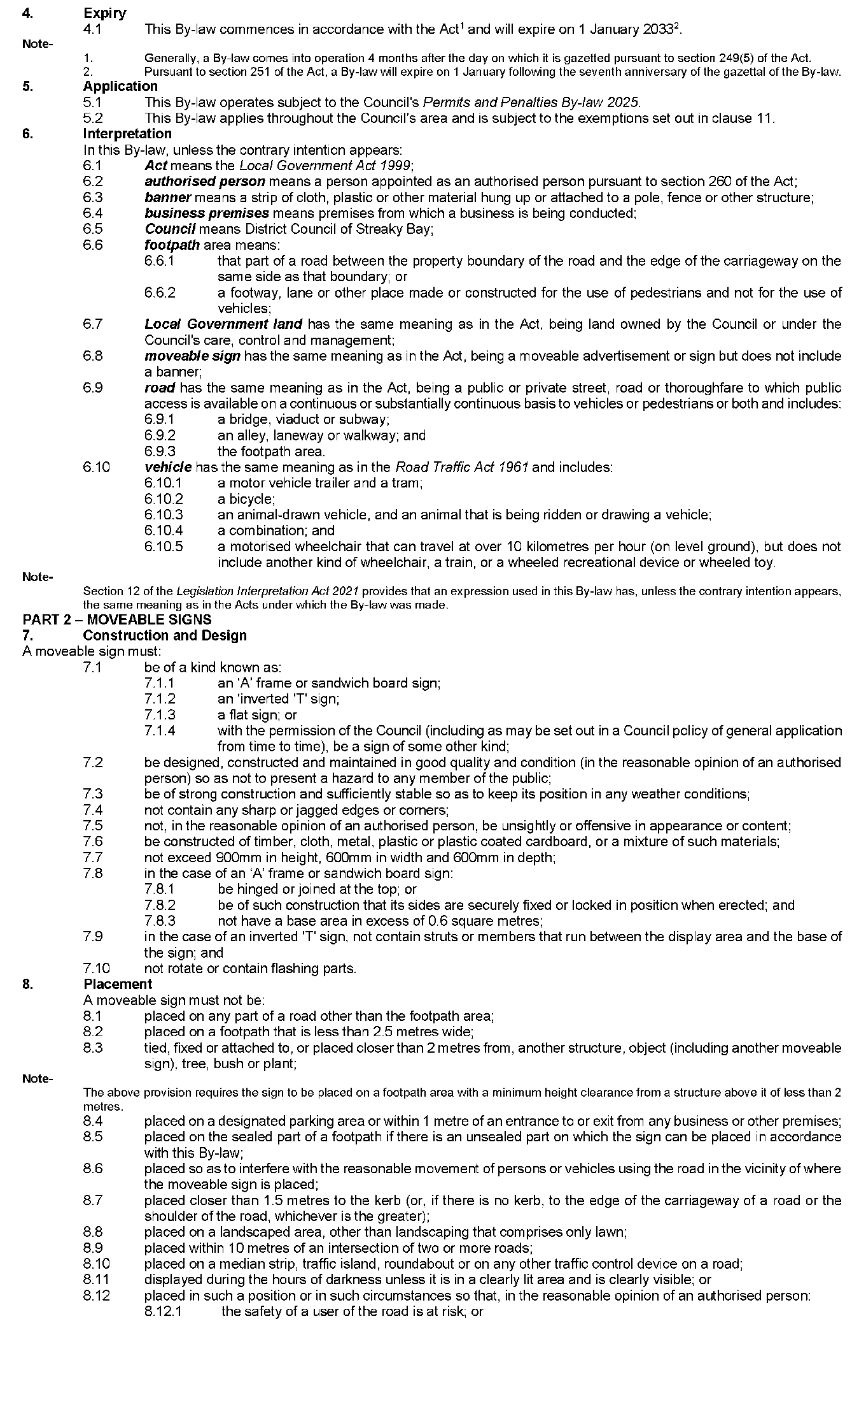

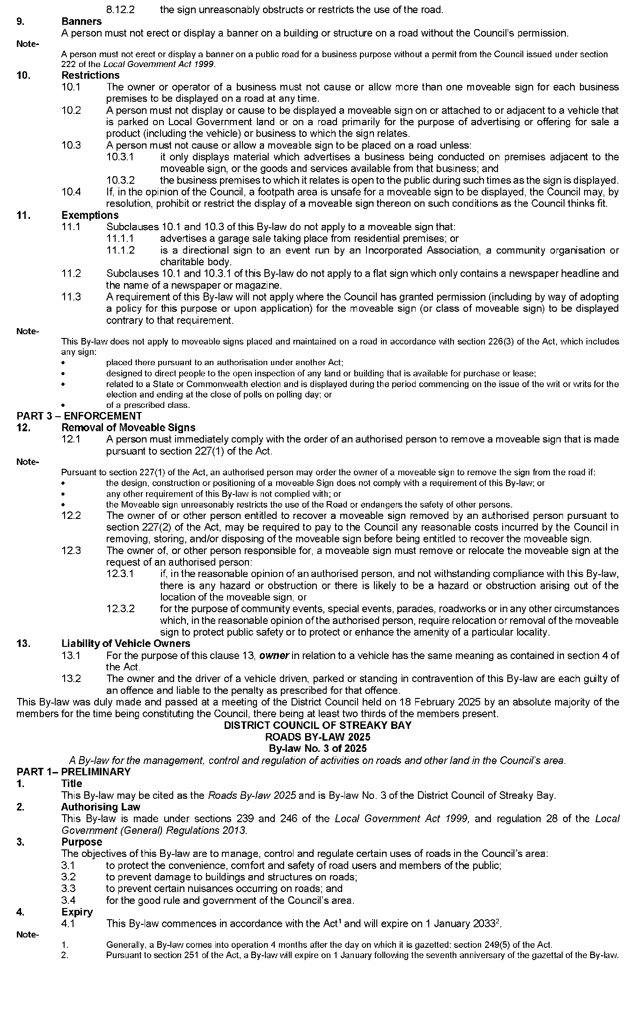

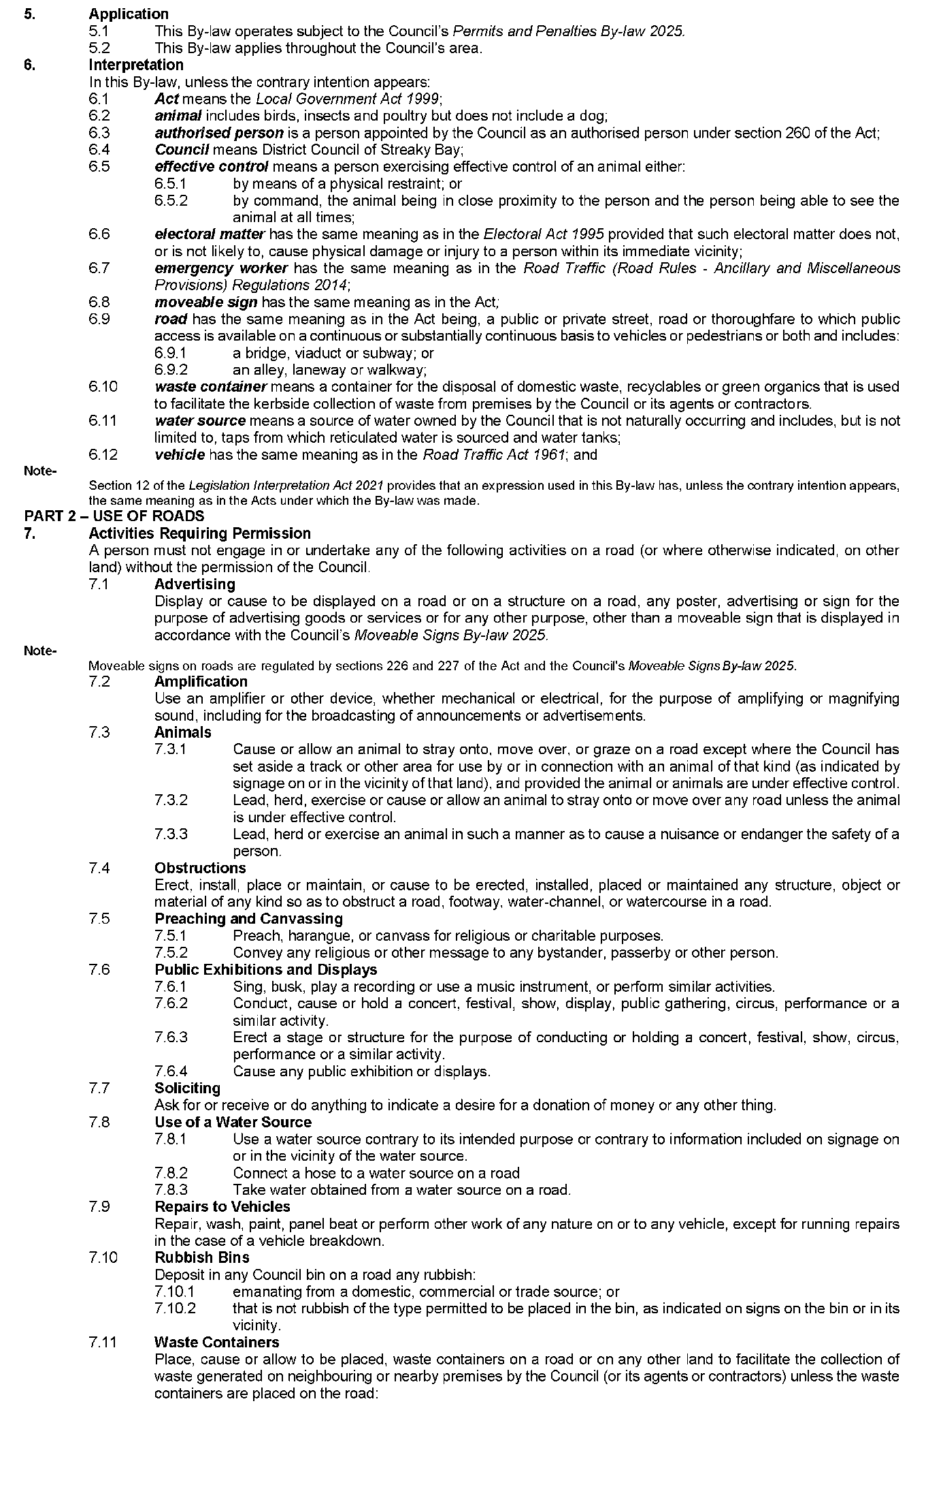

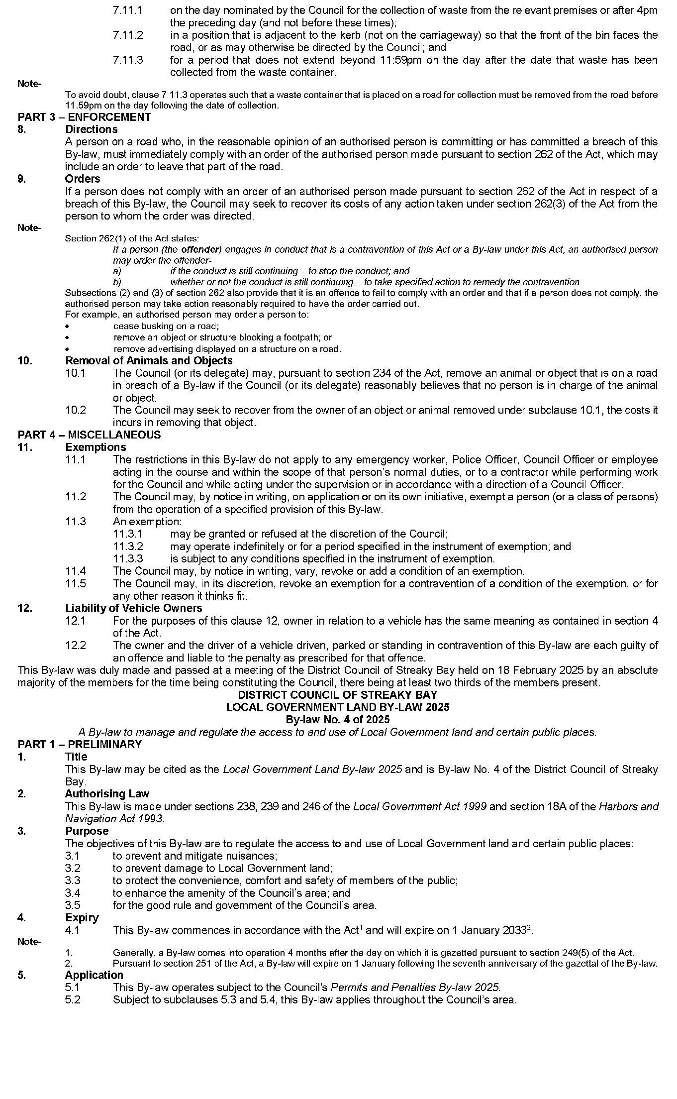

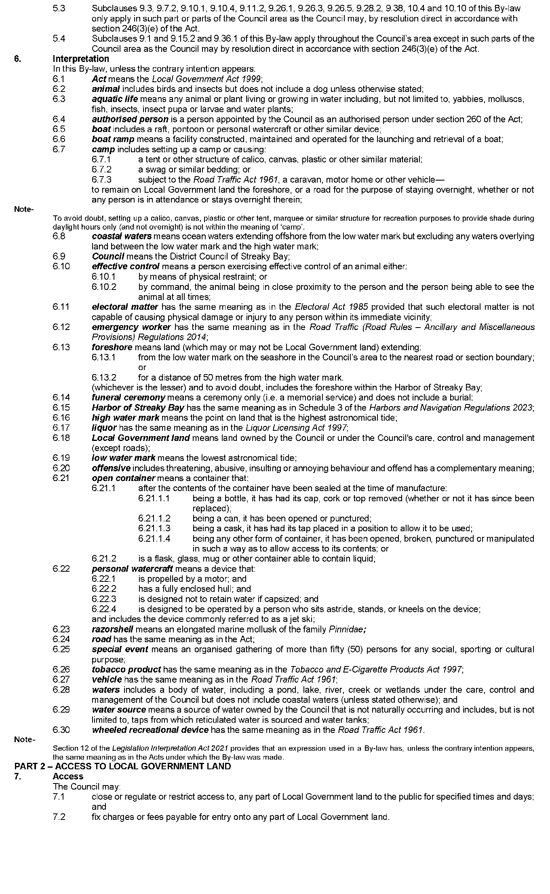

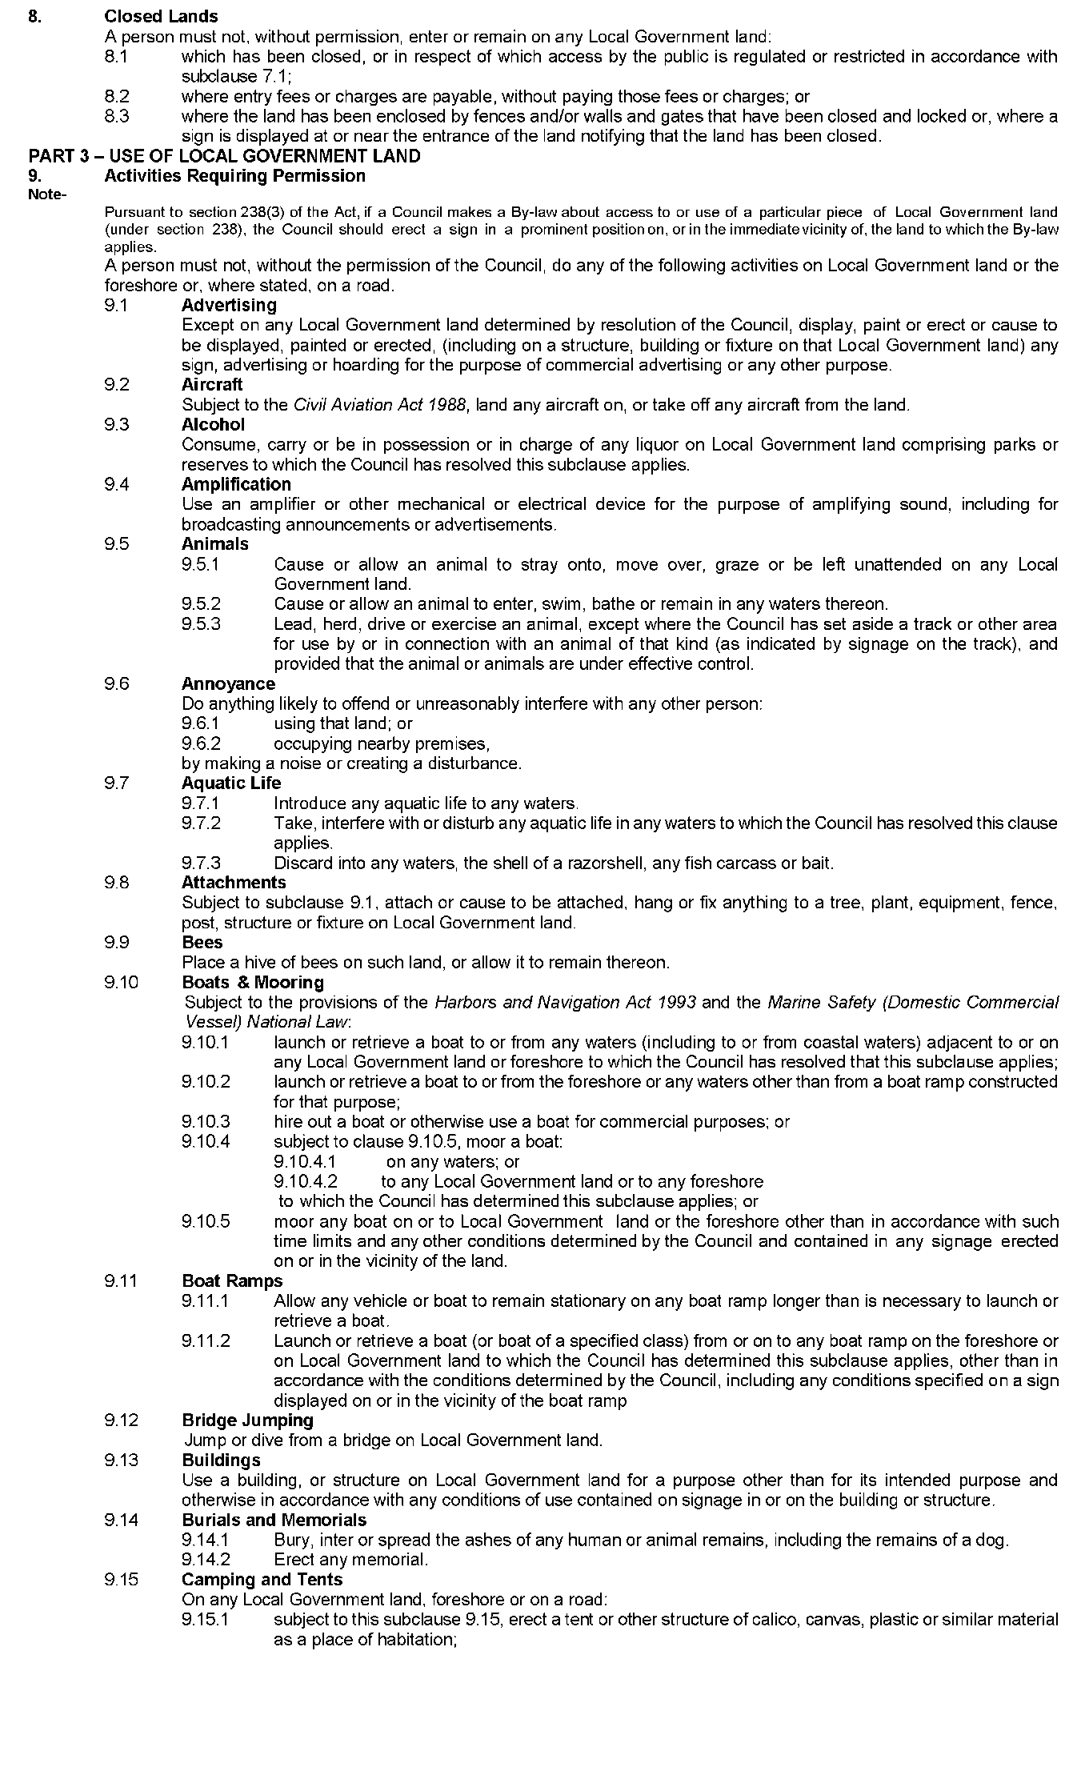

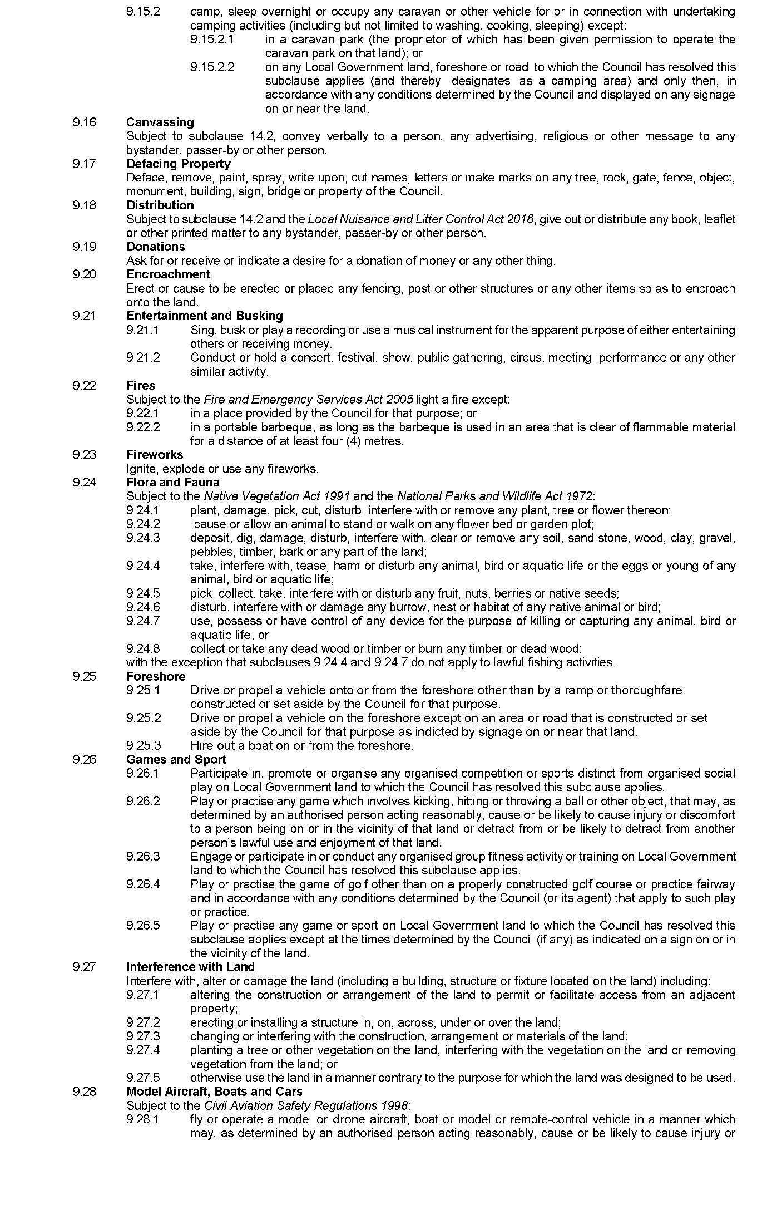

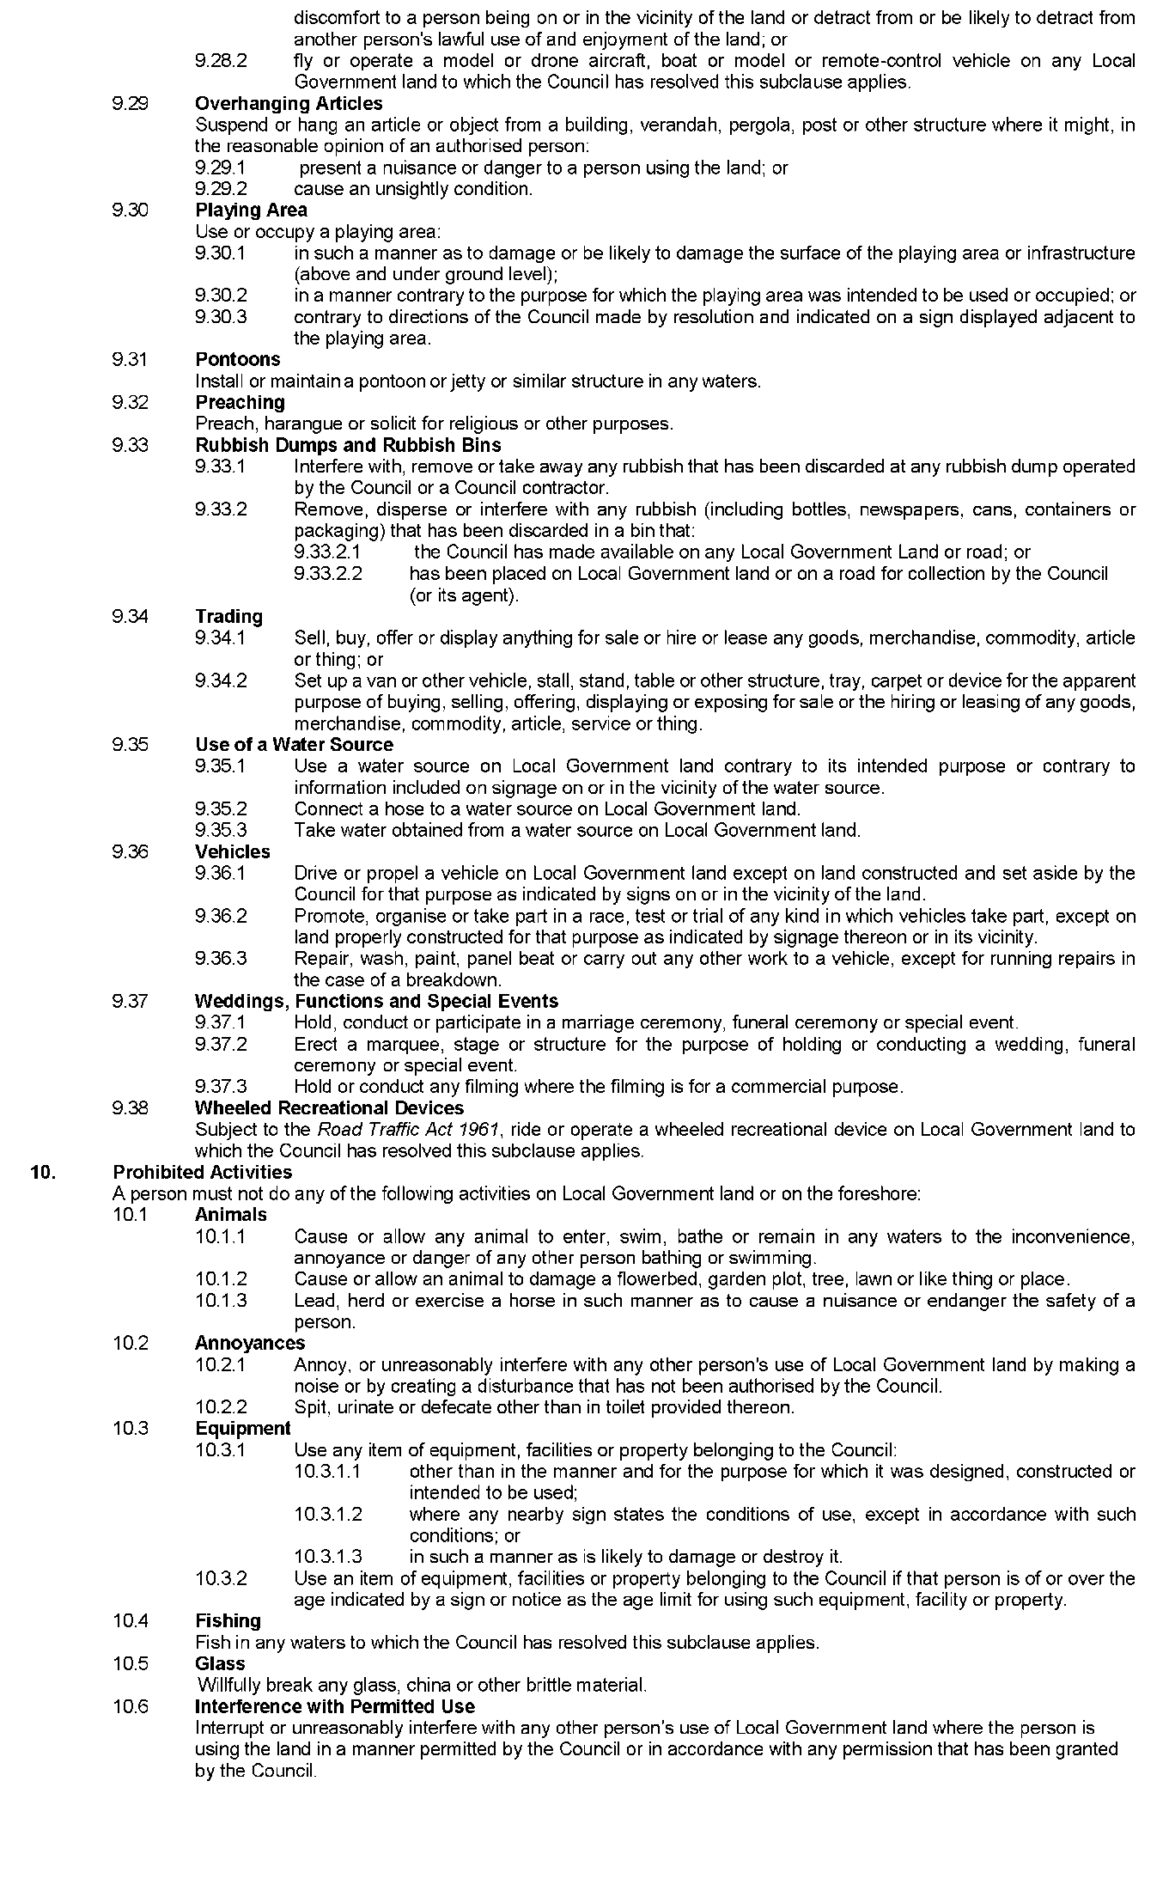

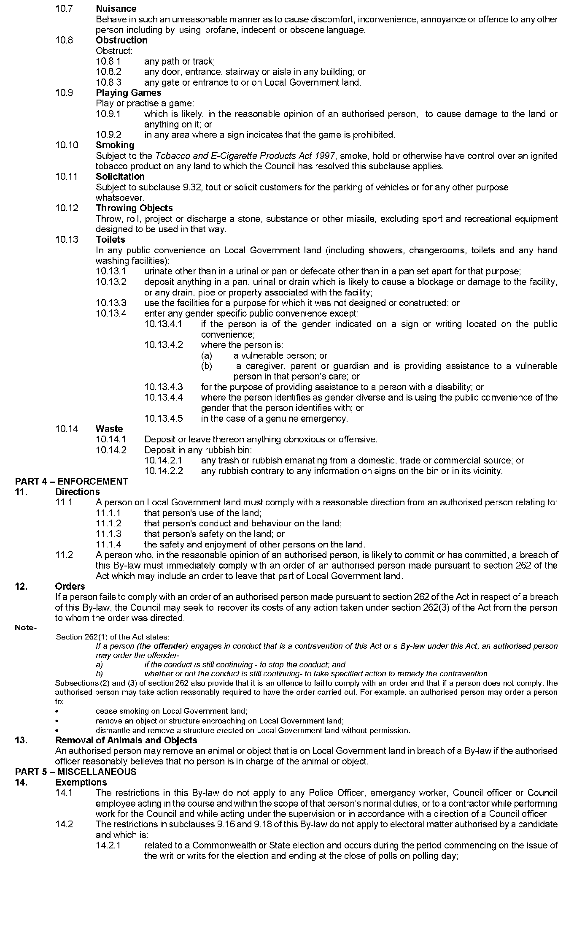

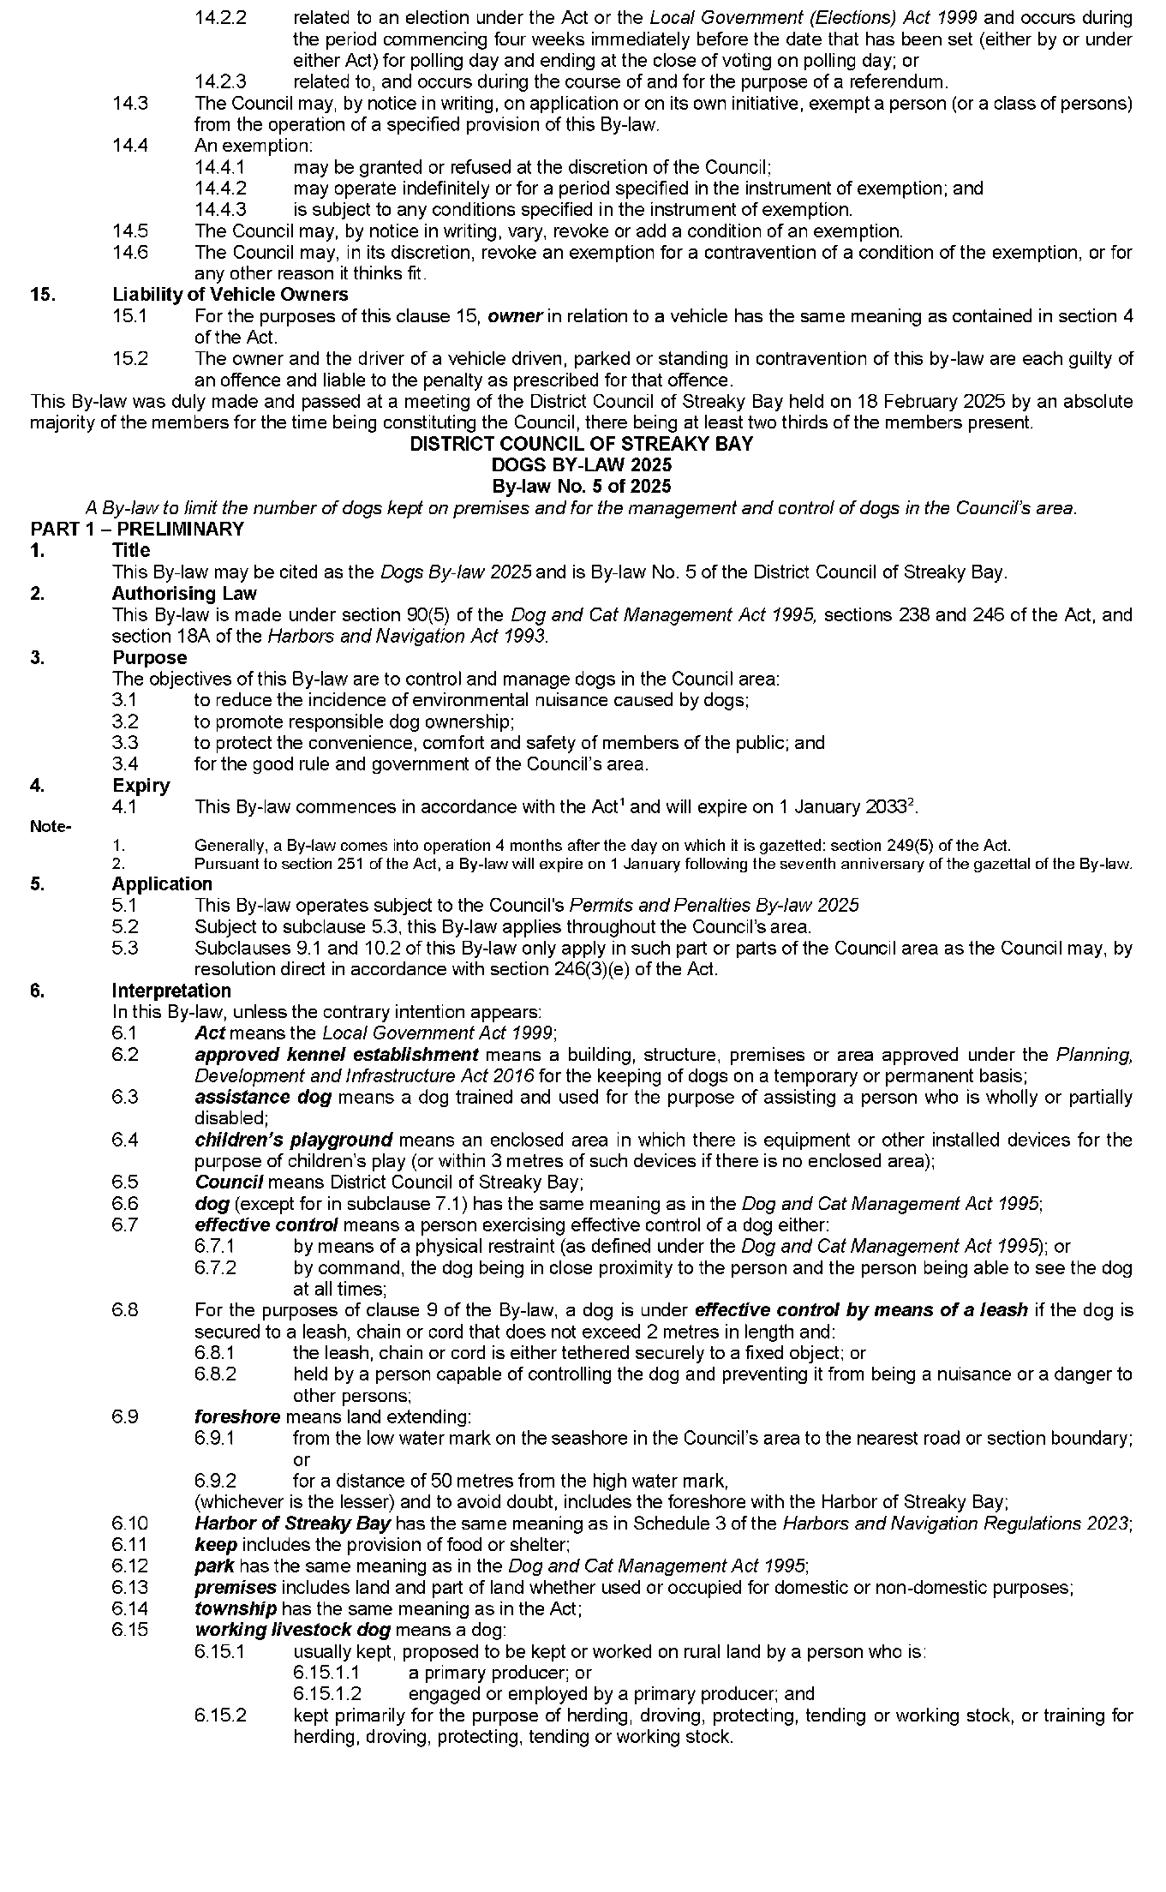

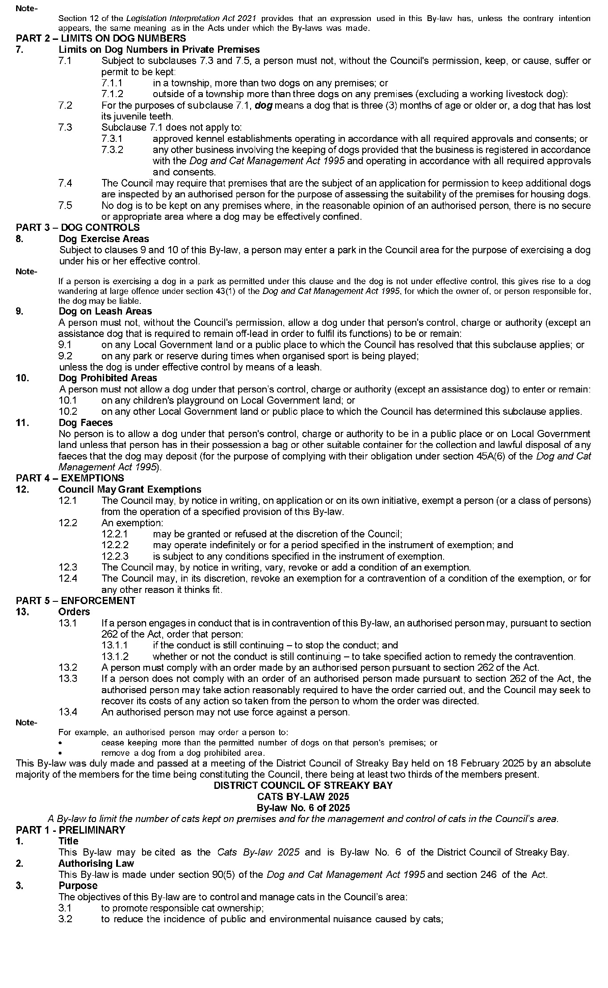

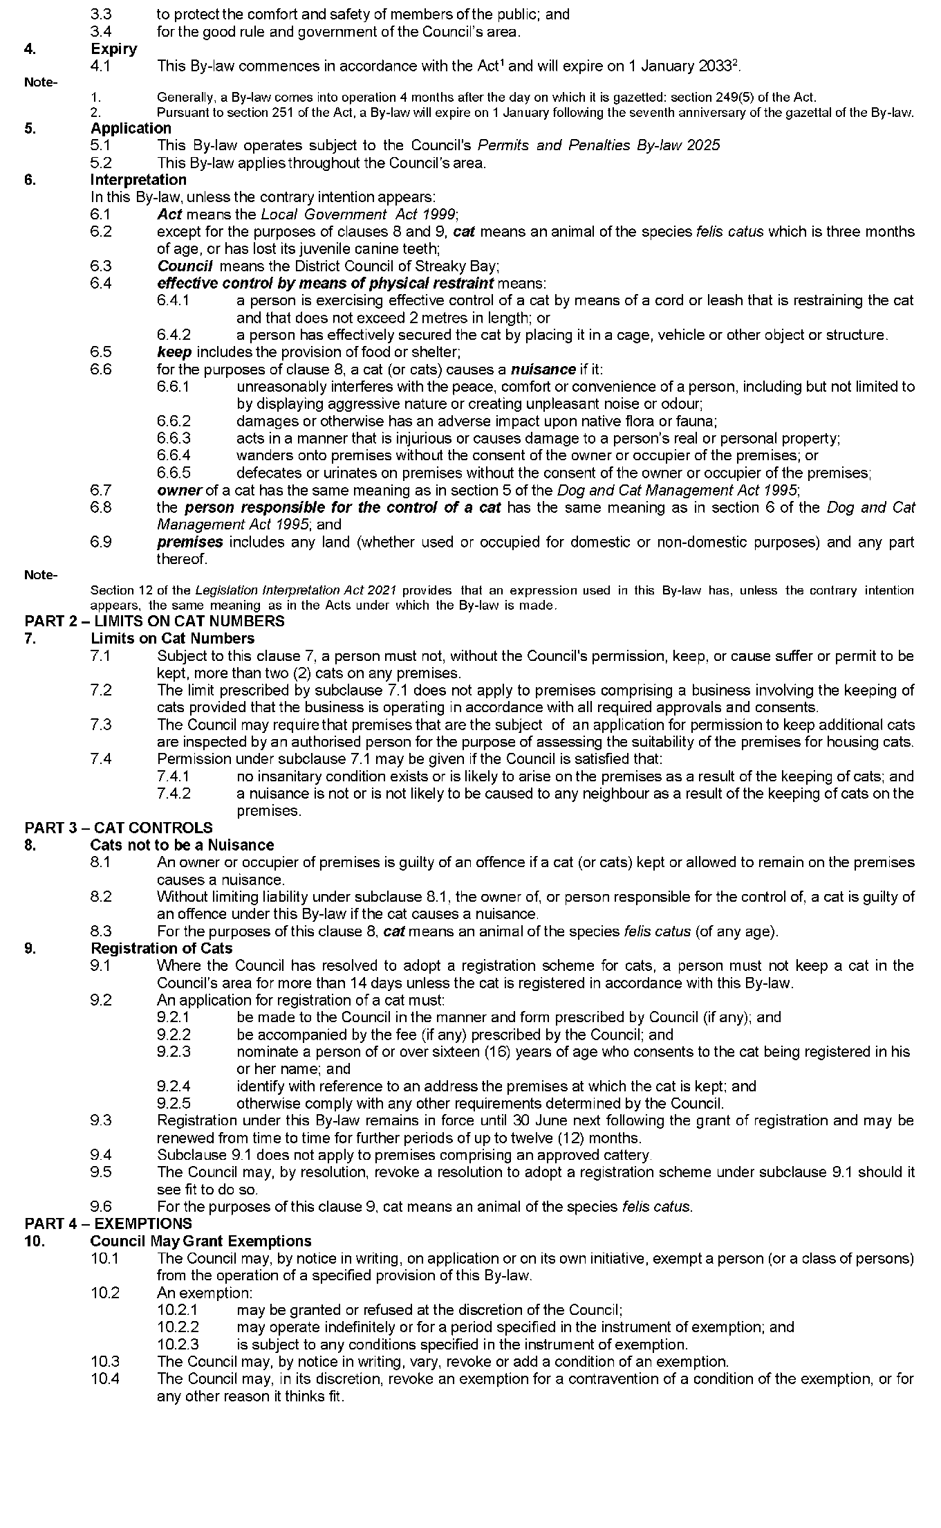

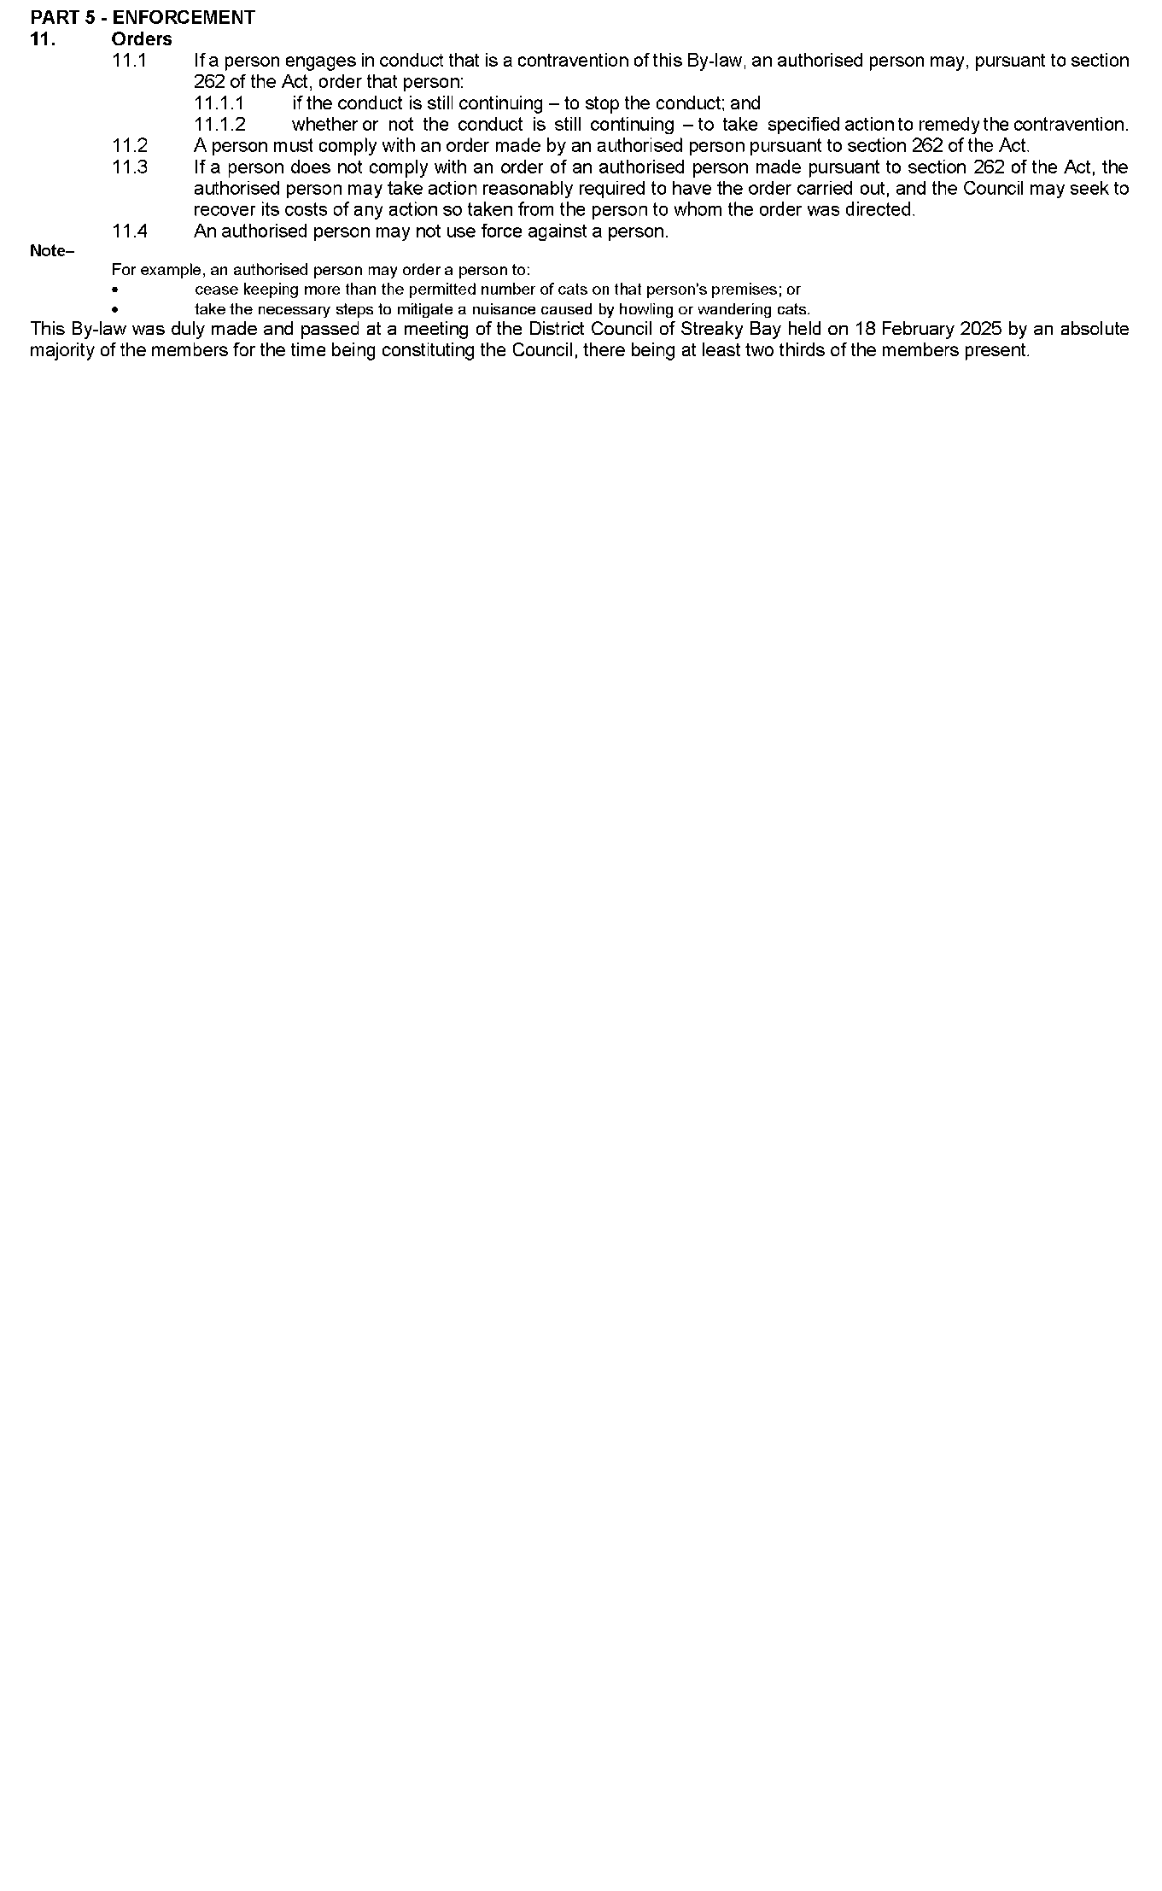Dated: 6 March 2025

Penny Williams

General Manager, Prosperity

# Public Notices

## Employment Agents Registration Act 1993

Notice of Application

Skillstream Australia Pty Ltd, hereby gives notice of its intention to apply for a license under the *Employment Agents Registration Act 1993*.

Any person may object to the application by lodging a notice of objection in writing within 10 days of the date of publication of this notice to the:

Director, SafeWork SA

GPO Box 465

Adelaide SA 5001

Dated: 6 March 2025

Herbert L. Legaspi

for and on behalf of the Applicant

## National Electricity Law

Notice of Extension for Making Final Determination

The Australian Energy Market Commission (AEMC) gives notice under the National Electricity Law as follows:

Under s 107, the time for the making of the final determination on the *Improving the NEM access standards* - *Package 1* (Ref. ERC0393) proposal has been extended to **22 May 2025**.

Documents referred to above are available on the [AEMC’s website](https://www.aemc.gov.au) and are available for inspection at the AEMC’s office.

Australian Energy Market Commission

Level 15, 60 Castlereagh St

Sydney NSW 2000

Telephone: (02) 8296 7800

[www.aemc.gov.au](http://www.aemc.gov.au)

Dated: 6 March 2025

**Notice Submission**

The South Australian Government Gazette is published each Thursday afternoon.

Notices must be emailed by 4 p.m. Tuesday, the week of publication.

Submissions are formatted per the gazette style and a proof will be supplied prior to publication, along with a quote if applicable. Please allow one day for processing notices.

Alterations to the proof must be returned by 4 p.m. Wednesday.

**Gazette notices must be submitted as Word files, in the following format:**

• Title—the governing legislation

• Subtitle—a summary of the notice content

• Body—structured text, which can include numbered lists, tables, and images

• Date—day, month, and year of authorisation

• Signature block—name, role, and department/organisation authorising the notice

**Please provide the following information in your email:**

• Date of intended publication

• Contact details of the person responsible for the notice content

• Name and organisation to be charged for the publication—Local Council and Public notices only

• Purchase order, if required—Local Council and Public notices only

Email: [governmentgazettesa@sa.gov.au](mailto:governmentgazettesa@sa.gov.au)

Phone: (08) 7133 3552

Website: [www.governmentgazette.sa.gov.au](http://www.governmentgazette.sa.gov.au)

**All instruments appearing in this gazette are to be considered official, and obeyed as such**

Printed and published weekly by authority of T. Foresto, Government Printer, South Australia

$8.80 per issue (plus postage), $443.00 per annual subscription—GST inclusive

Online publications: [www.governmentgazette.sa.gov.au](http://www.governmentgazette.sa.gov.au)