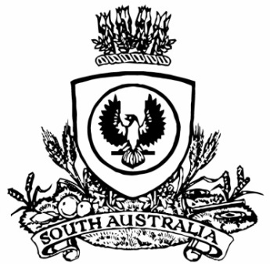**SUPPLEMENTARY GAZETTE**

**THE SOUTH AUSTRALIAN**

**GOVERNMENT GAZETTE**

**Published by Authority**

Adelaide, Wednesday, 19 February 2025

Governor’s Instrument

Act

Department of the Premier and Cabinet

Adelaide, 19 February 2025

Her Excellency the Governor directs it to be notified for general information that she has in the name and on behalf of His Majesty The King, this day assented to the undermentioned Bill passed by the Legislative Council and House of Assembly in Parliament assembled, viz.:

No. 6 of 2025—Whyalla Steel Works (Charge on Property) Amendment Bill 2025

An Act to amend the Whyalla Steel Works Act 1958

By command,

Peter Bryden Malinauskas, MP

Premier