No. 34 p. 849
THE SOUTH AUSTRALIAN
GOVERNMENT GAZETTE
Published by Authority

Adelaide, Thursday, 16 May 2024

Contents

Governor’s Instruments
Acts 851
Appointments, Resignations and General Matters 851
Lobbyists Act 2015 852
Regulations—
Fines Enforcement and Debt Recovery (Prescribed
Amounts) Amendment Regulations 2024—
No. 25 of 2024 853
Mining (Rental Fees) Amendment Regulations 2024—
No. 26 of 2024 855
Single-use and Other Plastic Products (Waste
Avoidance) (Prohibited Plastic Products)
Amendment Regulations 2024—No. 27 of 2024 857
Expiation of Offences (Fees) Amendment
Regulations 2024—No. 28 of 2024 868
Victims of Crime (Fund and Levy) Amendment Regulations 2024—No. 29 of 2024 869
Private Parking Areas (Expiation Fees) Amendment Regulations 2024—No. 30 of 2024 870
Harbors and Navigation (Fees) Amendment
Regulations 2024—No. 31 of 2024 872
Road Traffic (Miscellaneous) (Fees) Amendment Regulations 2024—No. 32 of 2024 878
Road Traffic (Miscellaneous) (Expiation Fees)
Amendment Regulations 2024—No. 33 of 2024 880
Motor Vehicles (Expiation Fees) Amendment
Regulations 2024—No. 34 of 2024 904
Heavy Vehicle National Law (South Australia)
(Expiation Fees) Amendment Regulations 2024—
No. 35 of 2024 909
Planning, Development and Infrastructure (General)
(Regulated and Significant Trees) Amendment Regulations 2024—No. 36 of 2024 919
Environment Protection (Fees) Amendment
Regulations 2024—No. 37 of 2024 923
State Government Instruments
Aboriginal Heritage Act 1988 926
Administration and Probate Act 1919 927
Adoption Act 1988 927
Aged and Infirm Persons’ Property Act 1940 929
Associations Incorporation Act 1985 930
Authorised Betting Operations Act 2000 932
Births, Deaths and Marriages Registration Act 1996 933
Boxing and Martial Arts Act 2000 934
Building Work Contractors Act 1995 934
Burial and Cremation Act 2013 937
Child Safety (Prohibited Persons) Act 2016 937
Child Sex Offenders Registration Act 2006 938
Community Titles Act 1996 939
Controlled Substances Act 1984 942
Conveyancers Act 1994 946
Co-operatives National Law (South Australia) Act 2013 947
Coroners Act 2003 953
Criminal Law (Clamping, Impounding and Forfeiture
of Vehicles) Act 2007 954
Dangerous Substances Act 1979 955
Department of Human Services 958
Disability Inclusion Act 2018 959
District Court Act 1991 960
Emergency Services Funding Act 1998 964
Employment Agents Registration Act 1993 964
Energy Resources Act 2000 965
Environment, Resources and Development Court Act 1993 966

Evidence Act 1929 968
Explosives Act 1936 969
Fair Work Act 1994 971
Fines Enforcement and Debt Recovery Act 2017 972
Fire and Emergency Services Act 2005 973
Firearms Act 2015 975
Fisheries Management Act 2007 976
Food Act 2001 980
Freedom of Information Act 1991 981
Gaming Machines Act 1992 982
Guardianship and Administration Act 1993 984
Harbors and Navigation Act 1993 984
Health Care Act 2008 985
Heavy Vehicle National Law (South Australia) Act 2013 1095
Highways Act 1926 1098
Housing Improvement Act 2016 1099
Hydroponics Industry Control Act 2009 1100
Justices of the Peace Act 2005 1101
Labour Hire Licensing Act 2017 1102
Land Acquisition Act 1969 1103
Land Agents Act 1994 1105
Land and Business (Sale and Conveyancing) Act 1994 1107
Land Tax Act 1936 1109
Legal Practitioners Act 1981 1110
Liquor Licensing Act 1997 1111
Livestock Act 1997 1122
Local Government (Elections) Act 1999 1123
Lotteries Act 2019 1124
Magistrates Court Act 1991 1126
Motor Vehicle Accidents (Lifetime Support Scheme)
Act 2013 1130
Motor Vehicles Act 1959 1130
Opal Mining Act 1995 1132
Partnership Act 1891 1133
Passenger Transport Act 1994 1134
Passenger Transport Regulations 2009 1138
Petroleum and Geothermal Energy Act 2000 1140
Petroleum Products Regulation Act 1995 1142
Planning, Development and Infrastructure Act 2016 1143
Plant Health Act 2009 1153
Plumbers, Gas Fitters and Electricians Act 1995 1155
Police Act 1998 1157
Primary Produce (Food Safety Schemes) Act 2004 1158
Public Trustee Act 1995 1163
Radiation Protection and Control Act 2021 1165
Real Property Act 1886 1169
Registration of Deeds Act 1935 1174
Relationships Register Act 2016 1175
Retirement Villages Act 2016 1176
Roads (Opening and Closing) Act 1991 1177
SACE Board of South Australia Act 1983 1178
Safe Drinking Water Fees Act 2011 1180
Second-hand Vehicle Dealers Act 1995 1181
Security and Investigation Industry Act 1995 1182
Sheriff’s Act 1978 1183
South Australian Civil and Administrative Tribunal
Act 2013 1185
South Australian Public Health Act 2011 1187
South Australian Skills Act 2008 1189
State Records Act 1997 1190
Strata Titles Act 1988 1192
Summary Offences Act 1953 1193
Supported Residential Facilities Act 1992 1194
Supreme Court Act 1935 1196
Tobacco and E-Cigarette Products Act 1997 1201
Unregulated Fees and Charges 1202
Valuation of Land Act 1971 1203
Work Health and Safety Act 2012 1205
Worker’s Liens Act 1893 1207
Youth Court Act 1993 1208
Local Government Instruments
City of Port Adelaide Enfield 1210
Mid Murray Council 1210
Yorke Peninsula Council 1210
Public Notices
National Electricity Law 1211

Governor’s Instruments

Acts
Department of the Premier and Cabinet
Adelaide, 16 May 2024
Her Excellency the Governor directs it to be notified for general information that she has in the name and on behalf of His Majesty The King, this day assented to the undermentioned Bills passed by the Legislative Council and House of Assembly in Parliament assembled, viz.:
No. 13 of 2024—AUKUS (Land Acquisition) Bill 2024
An Act to facilitate the AUKUS submarine project by providing for the acquisition of certain land
No. 14 of 2024—Bail (Conditions) Amendment Bill 2024
An Act to amend the Bail Act 1985
No. 15 of 2024—Controlled Substances (Destruction of Seized Property) Amendment Bill 2024
An Act to amend the Controlled Substances Act 1984
By command,
Kyam Joseph Maher, MLC
For Premier

Appointments, Resignations and General Matters
Department of the Premier and Cabinet
Adelaide, 16 May 2024
Her Excellency the Governor in Executive Council has been pleased to appoint the undermentioned to the Libraries Board of South Australia, pursuant to the provisions of the Libraries Act 1982:
Member: from 16 May 2024 until 15 May 2027
Bridget Maria Mather
By command,
Kyam Joseph Maher, MLC
For Premier
24ART0010CS

Department of the Premier and Cabinet
Adelaide, 16 May 2024
Her Excellency the Governor in Executive Council has been pleased to appoint the people listed as Commissioners of the South Australian Employment Tribunal for the terms specified - pursuant to the provisions of the South Australian Employment Tribunal Act 2014:
Darryl Sydney Willson on a full-time basis from 1 June 2024 until 31 May 2029
Katherine Margaret Sullivan on a part-time basis from 11 July 2024 until 10 July 2029
Marion Ruth Williams on a full-time basis from 11 July 2024 until 10 July 2029
Gina Nardone on a sessional basis from 15 June 2024 until 14 June 2029
By command,
Kyam Joseph Maher, MLC
For Premier
AGO0055-24CS

Department of the Premier and Cabinet
Adelaide, 16 May 2024
Her Excellency the Governor in Executive Council has directed that, upon his retirement, a cash payment be made to His Honour Judge Simon Stretton, a Judge of the District Court of South Australia, in lieu of his unused leave entitlement - pursuant to section 13H(2) of the Supreme Court Act 1935 and section 14(1) of the District Court Act 1991.
By command,
Kyam Joseph Maher, MLC
For Premier
AGO0082-24CS

Lobbyists Act 2015
Instrument of Delegation
The delegation notice approved on 22 March 2016 and published in the South Australian Government Gazette on 1 April 2016 (No.19, pg.1112) is revoked.
Pursuant to Section 16 of the Lobbyists Act 2015, I hereby delegate to the person holding or acting in the position of Director, Cabinet Office, Department of the Premier and Cabinet, position number M02476, the functions and powers assigned to me under the following sections of the Lobbyists Act 2015 and regulations under the Lobbyists Regulations 2016, effective from the date of this notice:
• subsection 7(1)
• subsection 7(2)
• section 8
• subsection 9(5)
• subsection 10(3)
• subsection 10(4)
• section 11
• section 12(2), and
• regulation 5.
Dated: 30 April 2024
Damien Walker
Chief Executive
Department of the Premier and Cabinet

Regulations
South Australia

Fines Enforcement and Debt Recovery (Prescribed Amounts) Amendment Regulations 2024
under the Fines Enforcement and Debt Recovery Act 2017

Contents
Part 1—Preliminary
1 Short title
2 Commencement
Part 2—Amendment of Fines Enforcement and Debt Recovery Regulations 2018
3 Amendment of regulation 6—Amounts unpaid or unrecovered for more than certain period (section 14 of Act)
4 Amendment of regulation 19—Amounts unpaid or unrecovered for more than certain period (section 26 of Act)

Part 1—Preliminary
1—Short title
These regulations may be cited as the Fines Enforcement and Debt Recovery (Prescribed Amounts) Amendment Regulations 2024.
2—Commencement
These regulations come into operation on 1 July 2024.
Part 2—Amendment of Fines Enforcement and Debt Recovery Regulations 2018
3—Amendment of regulation 6—Amounts unpaid or unrecovered for more than certain period (section 14 of Act)
(1) Regulation 6(1)—delete "$117" and substitute:
$121
(2) Regulation 6(2)—delete "$215" and substitute:
$221
4—Amendment of regulation 19—Amounts unpaid or unrecovered for more than certain period (section 26 of Act)
(1) Regulation 19(1)—delete "$117" and substitute:
$121
(2) Regulation 19(2)—delete "$215" and substitute:
$221
Editorial note—
As required by section 10AA(2) of the Legislative Instruments Act 1978, the Minister has certified that, in the Minister's opinion, it is necessary or appropriate that these regulations come into operation as set out in these regulations.
Made by the Governor
with the advice and consent of the Executive Council
on 16 May 2024
No 25 of 2024

South Australia

Mining (Rental Fees) Amendment Regulations 2024
under the Mining Act 1971

Contents
Part 1—Preliminary
1 Short title
2 Commencement
Part 2—Amendment of Mining Regulations 2020
3 Substitution of Schedule 2
Schedule 2—Rental

Part 1—Preliminary
1—Short title
These regulations may be cited as the Mining (Rental Fees) Amendment Regulations 2024.
2—Commencement
These regulations come into operation on 1 July 2024.
Part 2—Amendment of Mining Regulations 2020
3—Substitution of Schedule 2
Schedule 2—delete the Schedule and substitute:
Schedule 2—Rental

1 | Mining lease | $293.00 or $78.00 for each hectare or part of a hectare in the area of the lease, whichever is the greater
2 | Mining lease—extractives | $248.00 or $64.50 for each hectare or part of a hectare in the area of the lease, whichever is the greater
3 | Retention lease—
 | (a) if the retention lease authorises the carrying out of only exploration operations under the lease—
 | (i) if the lease is granted for a term of less than 5 years (or an aggregate term of 5 years); or | $1 090.00 or $25.25 per km2 in the area of the lease, whichever is the greater
 | (ii) if the term or aggregate term of the lease has reached the period of 5 years from the grant date, and the lease is renewed for a period of less than 5 years (or an aggregate term of 5 years); or | $293.00 or $39.50 for each hectare or part of a hectare in the area of the lease, whichever is the greater
 | (iii) if the term or aggregate term of the lease has reached the period of 10 years from the grant date, and the lease is renewed for a further period or periods; or | $293.00 or $114.00 for each hectare or part of a hectare in the area of the lease, whichever is the greater
 | (b) in any other case | $293.00 or $39.50 for each hectare or part of a hectare in the area of the lease, whichever is the greater
4 | Miscellaneous purposes licence | $293.00 or $78.00 for each hectare or part of a hectare in the area of the licence, whichever is the greater
Editorial note—
As required by section 10AA(2) of the Legislative Instruments Act 1978, the Minister has certified that, in the Minister's opinion, it is necessary or appropriate that these regulations come into operation as set out in these regulations.
Made by the Governor
with the advice and consent of the Executive Council
on 16 May 2024
No 26 of 2024

South Australia

Single-use and Other Plastic Products (Waste Avoidance) (Prohibited Plastic Products) Amendment Regulations 2024
under the Single-use and Other Plastic Products (Waste Avoidance) Act 2020

Contents
Part 1—Preliminary
1 Short title
2 Commencement
Part 2—Amendment of Single-use and Other Plastic Products (Waste Avoidance) Regulations 2021 commencing on 1 September 2024
3 Amendment of regulation 3—Interpretation
4 Amendment of regulation 3A—Definition of prohibited plastic product (section 6(1)(h) of Act)—inclusions
5 Insertion of regulation 10
10 Exemption for plastic shopping bags—charitable organisations
Part 3—Amendment of Single-use and Other Plastic Products (Waste Avoidance) Regulations 2021 commencing on 1 September 2025
6 Amendment of regulation 3—Interpretation
7 Amendment of regulation 3A—Definition of prohibited plastic product (section 6(1)(h) of Act)—inclusions
8 Repeal of regulation 4
Part 4—Amendment of Single-use and Other Plastic Products (Waste Avoidance) Regulations 2021 commencing on 1 March 2026
9 Amendment of regulation 3—Interpretation

Part 1—Preliminary
1—Short title
These regulations may be cited as the Single-use and Other Plastic Products (Waste Avoidance) (Prohibited Plastic Products) Amendment Regulations 2024.
2—Commencement
(1) Subject to this regulation, these regulations come into operation on 1 September 2024.
(2) Part 3 comes into operation on 1 September 2025.
(3) Part 4 comes into operation on 1 March 2026.
Part 2—Amendment of Single-use and Other Plastic Products (Waste Avoidance) Regulations 2021 commencing on 1 September 2024
3—Amendment of regulation 3—Interpretation
(1) Regulation 3—after the definition of Act insert:
AS 4736-2006 means Australian Standard AS 4736-2006 (Biodegradable plastics—Biodegradable plastics suitable for composting and other microbial treatment) as in force from time to time;
AS 5810-2010 means Australian Standard AS 5810-2010 (Biodegradable plastics—Biodegradable plastics suitable for home composting) as in force from time to time;
authorised certifier means a person approved by the Minister as an authorised certifier for the purposes of these regulations;
balloon stick means a stick designed or intended to be attached to an inflated balloon and includes a stick with a cup, base or other attachment device that forms part of the stick;
balloon tie means—
(a) a device that is designed or intended to be attached to a balloon to seal the balloon; or
(b) a cup, base or other attachment device that is designed or intended to attach a balloon to a balloon stick or ribbon,
but does not include—
(c) a ribbon; or
(d) garland tape;
beverage plug means a plug, stopper or similar device designed or intended to be inserted into the lid of a beverage cup to prevent spillage or leakage from the lid;
(2) Regulation 3—after the definition of care facility insert:
catering platter means a food container that is designed or intended to be used to contain multiple serves of food for the purposes of catering at a function or event, and includes any lid for the container (whether separate or attached to the container);
certified as compostable—see subregulation (2);
(3) Regulation 3—after the definition of designated person insert:
expanded polystyrene food or beverage container means a container, and includes any lid for the container, made, in whole or in part, of expanded polystyrene that is designed or intended to be used for the retail sale of food or beverages, but does not include—
(a) an expanded polystyrene cup, bowl, plate or clamshell container; or
Note—
See section 6(1) of the Act.
(b) an expanded polystyrene food tray; or
(c) a cooler box, or a lid for a cooler box, made, in whole or in part, of expanded polystyrene that is designed or intended to be used as packaging for perishable food products for the purposes of delivery to a customer by, or on behalf of, a retailer; or
(d) a container, or a lid for a container, made, in whole or in part, of expanded polystyrene that is designed or intended to be used for the transport of perishable food products from 1 business (the first business) to a second business (where that business is not a retail customer of the first business); or
(e) before 1 September 2025—an expanded polystyrene food or beverage container that forms part of the packaging of a relevant food or beverage product;
expanded polystyrene food tray means a tray made, in whole or in part, of expanded polystyrene that is designed or intended to be used for the packaging of meat, poultry, fish, vegetables, fruit or other food products for retail sale;
fish includes crustaceans and molluscs;
food bag tag means a rigid tag designed or intended to hold closed a bread bag or other food product bag, but does not include—
(a) a twist tie or cable tie; or
(b) before 1 September 2029—a plastic food bag tag used to hold closed a bag of potatoes or carrots weighing 2 kg or more;
garland tape means flexible tape with small holes designed or intended to allow multiple balloons to be placed together to create a decoration;
home compostable, in relation to a plastic product, means that the product complies with AS 5810-2010;
industrially compostable, in relation to a plastic product, means that the product complies with AS 4736-2006;
(4) Regulation 3—after the definition of pizza saver insert:
plastic barrier bag means a plastic bag without handles that—
(a) is designed or intended to be used to contain or protect unpackaged fresh fruit or vegetables, nuts or confectionery; or
(b) is used by a retail customer as additional protection from leakages for pre-packaged meat, poultry, fish, herbs or flowers,
but does not include a plastic bag that is certified as compostable provided that—
(c) in the case of a bag that is home compostable—it is clearly labelled as, or otherwise marked in a manner that indicates that it is, home compostable, or both home compostable and industrially compostable; or
(d) in the case of a bag that is industrially compostable, but not home compostable—it is clearly labelled as, or otherwise marked in a manner that indicates that it is, industrially compostable;
plastic confetti means a product comprised of pieces of plastic that are designed or intended to be thrown or projected into the air or otherwise scattered for decorative, festive or celebratory purposes and includes—
(a) such a product that is enclosed in a balloon (whether for decoration or for release by popping the balloon); and
(b) plastic streamers that are designed or intended to be thrown or projected into the air,
but does not include—
(c) sequins, diamantes, beads or glitter; or
(d) a product designed or intended to be used as a craft product; or
(e) confetti that is designed or intended to be permanently contained within, or form a permanent part of, another product (other than a single-use product) for decorative purposes;
plastic shopping bag means a plastic bag that—
(a) has handles; and
(b) is used as a means of carrying goods purchased from a retailer,
but does not include—
(c) a plastic bag that constitutes, or forms an integral part of, the packaging in which goods are sealed prior to sale; or
(d) an unsealed plastic bag that is the packaging in which perishable food is offered for sale; or
(e) a shopping bag that is made, in whole or in part, of 1 or more of the following fabrics:
(i) nylon;
(ii) polyester;
(iii) woven polypropylene;
(iv) non-woven polypropylene if—
(A) the bag has sewn, rather than heat-welded, seams; and
(B) the fabric has a minimum weight of 90 g/m² measured as a single layer of fabric; or
(f) a plastic bag that is certified as compostable provided that—
(i) in the case of a bag that is home compostable—it is clearly labelled as, or otherwise marked in a manner that indicates that it is, home compostable, or both home compostable and industrially compostable; or
(ii) in the case of a bag that is industrially compostable, but not home compostable—it is clearly labelled as, or otherwise marked in a manner that indicates that it is, industrially compostable;
(5) Regulation 3—after the definition of plastic-stemmed cotton bud insert:
premises means any land, building or structure including a moveable building or structure or any vehicle (within the meaning of the Road Traffic Act 1961);
(6) Regulation 3—after prescribed business insert:
prescribed food container means a single-use plastic food container, including a cup (other than a single-use plastic beverage cup), bowl, tray or other food container, whether or not it has, or is designed or intended to have, a lid (whether separate or attached) that is used—
(a) for the retail sale of ready-to-eat food; or
(b) to hold a condiment that is—
(i) provided to be used with ready-to-eat food; and
(ii) packaged in the container on the retail premises at which the ready-to-eat food is sold,
but does not include—
(c) an expanded polystyrene cup, bowl, plate or clamshell container; or
Note—
See section 6(1) of the Act.
(d) an expanded polystyrene food or beverage container or an expanded polystyrene food tray; or
(e) a single-use plastic catering platter; or
(f) a single-use plastic food container that is certified as compostable; or
(g) before 1 September 2029—a single-use plastic food container comprised of a transparent square or rectangular food container with a detachable transparent lid, both of which are made wholly from polypropylene or polyethylene terephthalate;
prescribed food container lid means a single-use plastic lid or cover designed or intended to be fitted onto a prescribed food container (whether separate or attached to the container) and includes plastic film intended to seal the top of a prescribed food container, but does not include—
(a) a paper or cardboard lid lined or coated with plastic that is designed or intended to be used with an aluminium foil food container used for ready-to-eat food; or
(b) a single-use plastic lid that is certified as compostable;
ready-to-eat food means food that is—
(a) prepared or packaged on retail premises at the request or order of a customer; or
(b) prepared fresh and pre-packaged on the day, or shortly before the day, on which it is intended to be offered for retail sale,
and is ready to be eaten without further cooking, heating, defrosting, washing or other preparation and is ordinarily intended to be eaten at the site of sale or shortly after at another place;
(7) Regulation 3, definition of relevant food or beverage product—after "single-serve" insert:
prior to its sale, supply or distribution to a retailer for retail sale or supply
(8) Regulation 3—after the definition of relevant food or beverage product insert:
single-use plastic beverage cup means a single-use plastic cup designed or intended to hold a beverage, but does not include—
(a) an expanded polystyrene cup; or
Note—
See section 6(1)(d) of the Act.
(b) a single-use plastic beverage cup that is certified as compostable;
single-use plastic beverage cup lid means a single-use plastic lid designed or intended to be fitted onto a beverage cup and includes plastic film intended to seal the entire top of a beverage cup, but does not include a single-use plastic lid for a beverage cup if the lid is certified as compostable;
(9) Regulation 3, definition of single-use plastic bowl—after paragraph (b) insert:
(ba) a prescribed food container that is a bowl; or
(10) Regulation 3, definition of single-use plastic bowl, (d)—after "plastic" insert:
that is not certified as compostable
(11) Regulation 3, definition of single-use plastic bowl—after paragraph (d) insert:
or
(e) a single-use plastic bowl that is certified as compostable;
(12) Regulation 3—after its present contents as amended by this regulation (now to be designated as subregulation (1)) insert:
(2) For the purposes of these regulations, a plastic product is certified as compostable if—
(a) —
(i) the plastic product has been assessed and tested by an authorised certifier and the authorised certifier has issued a certificate verifying that the product complies with AS 4736-2006 or AS 5810-2010; and
(ii) the certificate's period of validity has not expired; or
(b) until the determination date—the plastic product is the subject of an application for its certification in accordance with AS 4736-2006 or AS 5810-2010 that is made to an authorised certifier before 1 March 2026, but has not been determined before that date (and, in the case of a plastic shopping bag or a plastic barrier bag, the labelling requirements in paragraph (f) of the definition of plastic shopping bag or paragraphs (c) and (d) of the definition of plastic barrier bag (as the case requires) do not apply until the determination date); or
(c) until 1 March 2026 (other than in the case of a plastic shopping bag or a plastic barrier bag)—the plastic product has, before that date—
(i) a current and valid certification in accordance with—
(A) ASTM D6400-23 (Standard Specification for Labeling of Plastics Designed to be Aerobically Composted in Municipal or Industrial Facilities); or
(B) EN 13432 (Packaging—Requirements for packaging recoverable through composting and biodegradation—Test scheme and evaluation criteria for the final acceptance of packaging); or
(ii) a current and valid TUV OK compost INDUSTRIAL or TUV OK compost HOME certification.
(3) For the purposes of subregulation (2), the determination date, in respect of a plastic product, is the date on which the application for the product's certification in accordance with AS 4736-2006 or AS 5810-2010 is determined, withdrawn or otherwise finalised.
(4) For the purposes of the definition of authorised certifier, the Minister may, by notice in the Gazette—
(a) approve a person as an authorised certifier for the purposes of these regulations; or
(b) revoke an approval under paragraph (a).
4—Amendment of regulation 3A—Definition of prohibited plastic product (section 6(1)(h) of Act)—inclusions
Regulation 3A—after paragraph (d) insert:
(e) a plastic shopping bag;
(f) a plastic barrier bag;
(g) a single-use plastic beverage cup;
(h) a single-use plastic beverage cup lid;
(i) a single-use plastic beverage plug;
(j) an expanded polystyrene food tray;
(k) an expanded polystyrene food or beverage container;
(l) a prescribed food container;
(m) a prescribed food container lid;
(n) plastic confetti;
(o) a plastic balloon stick;
(p) a plastic balloon tie;
(q) a single-use plastic food bag tag.
5—Insertion of regulation 10
After regulation 9 insert:
10—Exemption for plastic shopping bags—charitable organisations
(1) Pursuant to section 16(1) of the Act, a person is exempt from section 7(1) of the Act in respect of the supply or distribution of plastic shopping bags if—
(a) the person is, or is acting on behalf of, a charitable organisation; and
(b) the bags were donated to the organisation; and
(c) the person supplies or distributes the bags (as the case may be) to another person for the purposes of carrying goods purchased from, or otherwise supplied by, the organisation at a thrift shop or other charitable retail outlet run by the organisation.
(2) This regulation expires on 31 August 2027.
Part 3—Amendment of Single-use and Other Plastic Products (Waste Avoidance) Regulations 2021 commencing on 1 September 2025
6—Amendment of regulation 3—Interpretation
(1) Regulation 3(1), definition of plastic barrier bag, (a)—delete "or confectionery" and substitute:
, confectionery, dairy products, meat, poultry or fish
(2) Regulation 3(1)—after the definition of plastic confetti insert:
plastic produce sticker means a plastic sticker designed or intended to be applied directly onto the surface of a fruit or vegetable, but does not include a sticker that is certified as compostable or a sticker that is, or is to be, applied to a fruit or vegetable that is to be sold, supplied or distributed to a person outside this State;
(3) Regulation 3(1)—after the definition of plastic-stemmed cotton bud insert:
pre-filled soy sauce container means a container of soy sauce—
(a) with a capacity of 30 ml or less; and
(b) that has a lid, cap or stopper; and
(c) is filled prior to its sale, supply or distribution to a retailer for retail sale or supply;
Example—
Fish-shaped plastic soy sauce containers.
(4) Regulation 3(2)(b)—after "the plastic product" insert:
(other than a plastic produce sticker)
(5) Regulation 3(2)(c)—delete "or a plastic barrier bag" and substitute:
, a plastic barrier bag or a plastic produce sticker
(6) Regulation 3(2)—after paragraph (c) insert:
or
(d) until the determination date—the plastic product is a plastic produce sticker that is the subject of an application for its certification in accordance with AS 4736-2006 or AS 5810-2010 that is made to an authorised certifier before 1 September 2028, but has not been determined before that date; or
(e) until 1 September 2028—the plastic product is a plastic produce sticker that has, before that date—
(i) a current and valid certification in accordance with—
(A) ASTM D6400-23 (Standard Specification for Labeling of Plastics Designed to be Aerobically Composted in Municipal or Industrial Facilities); or
(B) EN 13432 (Packaging—Requirements for packaging recoverable through composting and biodegradation—Test scheme and evaluation criteria for the final acceptance of packaging); or
(ii) a current and valid TUV OK compost INDUSTRIAL or TUV OK compost HOME certification.
7—Amendment of regulation 3A—Definition of prohibited plastic product (section 6(1)(h) of Act)—inclusions
Regulation 3A—after paragraph (q) insert:
(r) a plastic produce sticker;
(s) a pre-filled soy sauce container.
8—Repeal of regulation 4
Regulation 4—delete the regulation
Part 4—Amendment of Single-use and Other Plastic Products (Waste Avoidance) Regulations 2021 commencing on 1 March 2026
9—Amendment of regulation 3—Interpretation
(1) Regulation 3(1), definition of prescribed food container, (f)—delete "compostable; or" and substitute:
compostable provided that—
(i) in the case of a container with a capacity of 60 ml or more that is home compostable—it is clearly labelled as, or otherwise marked in a manner that indicates that it is, home compostable, or both home compostable and industrially compostable; or
(ii) in the case of a container with a capacity of 60 ml or more that is industrially compostable, but not home compostable—it is clearly labelled as, or otherwise marked in a manner that indicates that it is, industrially compostable; or
(2) Regulation 3(1), definition of prescribed food container lid, (b)—delete "compostable;" and substitute:
compostable provided that—
(i) in the case of a lid with a diameter of 70 mm or more that is home compostable—it is clearly labelled as, or otherwise marked in a manner that indicates that it is, home compostable, or both home compostable and industrially compostable; or
(ii) in the case of a lid with a diameter of 70 mm or more that is industrially compostable, but not home compostable—it is clearly labelled as, or otherwise marked in a manner that indicates that it is, industrially compostable;
(3) Regulation 3(1), definition of single-use plastic beverage cup, (b)—delete "compostable;" and substitute:
compostable provided that—
(i) in the case of a beverage cup with a capacity of 60 ml or more that is home compostable—it is clearly labelled as, or otherwise marked in a manner that indicates that it is, home compostable, or both home compostable and industrially compostable; or
(ii) in the case of a beverage cup with a capacity of 60 ml or more that is industrially compostable, but not home compostable—it is clearly labelled as, or otherwise marked in a manner that indicates that it is, industrially compostable;
(4) Regulation 3(1), definition of single-use plastic beverage cup lid—delete "compostable;" and substitute:
compostable provided that—
(i) in the case of a beverage cup lid with a diameter of 70 mm or more that is home compostable—it is clearly labelled as, or otherwise marked in a manner that indicates that it is, home compostable, or both home compostable and industrially compostable; or
(ii) in the case of a beverage cup lid with a diameter of 70 mm or more that is industrially compostable, but not home compostable—it is clearly labelled as, or otherwise marked in a manner that indicates that it is, industrially compostable;
(5) Regulation 3(1), definition of single-use plastic bowl, (e)—delete "compostable;" and substitute:
compostable provided that—
(i) in the case of a bowl that is home compostable—it is clearly labelled as, or otherwise marked in a manner that indicates that it is, home compostable, or both home compostable and industrially compostable; or
(ii) in the case of a bowl that is industrially compostable, but not home compostable—it is clearly labelled as, or otherwise marked in a manner that indicates that it is, industrially compostable;
Editorial note—
As required by section 10AA(2) of the Legislative Instruments Act 1978, the Minister has certified that, in the Minister's opinion, it is necessary or appropriate that these regulations come into operation as set out in these regulations.
Made by the Governor
with the advice and consent of the Executive Council
on 16 May 2024
No 27 of 2024

South Australia

Expiation of Offences (Fees) Amendment Regulations 2024
under the Expiation of Offences Act 1996

Contents
Part 1—Preliminary
1 Short title
2 Commencement
Part 2—Amendment of Expiation of Offences Regulations 2011
3 Amendment of regulation 5—Reminder notices
4 Amendment of regulation 6—Expiation enforcement warning notices

Part 1—Preliminary
1—Short title
These regulations may be cited as the Expiation of Offences (Fees) Amendment Regulations 2024.
2—Commencement
These regulations come into operation on 1 July 2024.
Part 2—Amendment of Expiation of Offences Regulations 2011
3—Amendment of regulation 5—Reminder notices
Regulation 5(a)—delete "$71.00" and substitute:
$73.00
4—Amendment of regulation 6—Expiation enforcement warning notices
Regulation 6(a)—delete "$64.00" and substitute:
$66.00
Editorial note—
As required by section 10AA(2) of the Legislative Instruments Act 1978, the Minister has certified that, in the Minister's opinion, it is necessary or appropriate that these regulations come into operation as set out in these regulations.
Made by the Governor
with the advice and consent of the Executive Council
on 16 May 2024
No 28 of 2024

South Australia

Victims of Crime (Fund and Levy) Amendment Regulations 2024
under the Victims of Crime Act 2001

Contents
Part 1—Preliminary
1 Short title
2 Commencement
Part 2—Amendment of Victims of Crime (Fund and Levy) Regulations 2018
3 Amendment of Schedule 1—Victims of Crime Levy

Part 1—Preliminary
1—Short title
These regulations may be cited as the Victims of Crime (Fund and Levy) Amendment Regulations 2024.
2—Commencement
These regulations come into operation on 1 July 2024.
Part 2—Amendment of Victims of Crime (Fund and Levy) Regulations 2018
3—Amendment of Schedule 1—Victims of Crime Levy
(1) Schedule 1, clause 1(a)(i) delete "$99" and substitute:
$102
(2) Schedule 1, clause 1(a)(ii) delete "$262" and substitute:
$270
(3) Schedule 1, clause 1(b) delete "$424" and substitute:
$437
Editorial note—
As required by section 10AA(2) of the Legislative Instruments Act 1978, the Minister has certified that, in the Minister's opinion, it is necessary or appropriate that these regulations come into operation as set out in these regulations.
Made by the Governor
with the advice and consent of the Executive Council
on 16 May 2024
No 29 of 2024

South Australia

Private Parking Areas (Expiation Fees) Amendment Regulations 2024
under the Private Parking Areas Act 1986

Contents
Part 1—Preliminary
1 Short title
2 Commencement
Part 2—Amendment of Private Parking Areas Regulations 2014
3 Amendment of regulation 7—Purpose other than parking
4 Amendment of regulation 8—Damage to signs etc
5 Amendment of regulation 10—Owner and driver guilty of offence
6 Amendment of regulation 11—Further offence each hour
7 Amendment of regulation 15—Expiation of offences against Act

Part 1—Preliminary
1—Short title
These regulations may be cited as the Private Parking Areas (Expiation Fees) Amendment Regulations 2024.
2—Commencement
These regulations come into operation on 1 July 2024.
Part 2—Amendment of Private Parking Areas Regulations 2014
3—Amendment of regulation 7—Purpose other than parking
Regulation 7, expiation fee—delete "$60" and substitute:
$62
4—Amendment of regulation 8—Damage to signs etc
Regulation 8, expiation fee—delete "$110" and substitute:
$113
5—Amendment of regulation 10—Owner and driver guilty of offence
Regulation 10, expiation fee—delete paragraphs (a) to (d) (inclusive) of the expiation fee and substitute:
(a) for an alleged contravention of regulation 4(1)(a)—$61;
(b) for an alleged contravention of regulation 4(1)(b)—$74;

(c) for an alleged contravention of regulation 5—$96;
(d) for an alleged contravention of regulation 6—$94.
6—Amendment of regulation 11—Further offence each hour
Regulation 11, expiation fee—delete "$59" and substitute:
$61
7—Amendment of regulation 15—Expiation of offences against Act
Regulation 15, table—delete the table and substitute:

Section | Expiation Fee
section 8(1) | $114
section 8(2) | $446
section 8(3) | $77
section 8(4) | $81
section 8(5) | $79
section 8(6) | $63
Editorial note—
As required by section 10AA(2) of the Legislative Instruments Act 1978, the Minister has certified that, in the Minister's opinion, it is necessary or appropriate that these regulations come into operation as set out in these regulations.
Made by the Governor
with the advice and consent of the Executive Council
on 16 May 2024
No 30 of 2024

South Australia

Harbors and Navigation (Fees) Amendment Regulations 2024
under the Harbors and Navigation Act 1993

Contents
Part 1—Preliminary
1 Short title
2 Commencement
Part 2—Amendment of Harbors and Navigation Regulations 2023
3 Amendment of Schedule 11—Fees and levies
4 Facilities levy
5 Fees
Part 3—Transitional provision
4 Transitional provision

Part 1—Preliminary
1—Short title
These regulations may be cited as the Harbors and Navigation (Fees) Amendment Regulations 2024.
2—Commencement
These regulations come into operation on the day on which they are made.
Part 2—Amendment of Harbors and Navigation Regulations 2023
3—Amendment of Schedule 11—Fees and levies
Schedule 14, clauses 4 and 5—delete clauses 4 and 5 and substitute:
4—Facilities levy
(1) The amount of a facilities levy set out in this clause is the amount payable if registration of the vessel is for a 12 month period.
(2) If a vessel is registered for a period other than 12 months, a pro rata adjustment is to be made to the amount of the facilities levy set out in this clause by applying the proportion that the number of months in the period of registration bears to 12 months and then rounding the amount up to the nearest dollar.

Levies relating to Part 15
Facilities levy for recreational vessel comprised of personal watercraft | $42.00
Facilities levy for any other vessel, according to its length as follows:
(a) if the vessel is not more than 3.1 m | nil
(b) if the vessel is more than 3.1 m but not more than 3.5 m | $42.00
(c) if the vessel is more than 3.5 m but not more than 5 m | $62.00
(d) if the vessel is more than 5 m but not more than 6 m | $75.00
(e) if the vessel is more than 6 m but not more than 7 m | $92.00
(f) if the vessel is more than 7 m but not more than 8 m | $102.00
(g) if the vessel is more than 8 m but not more than 9 m | $112.00
(h) if the vessel is more than 9 m but not more than 10 m | $126.00
(i) if the vessel is more than 10 m but not more than 11 m | $140.00
(j) if the vessel is more than 11 m but not more than 12 m | $152.00
(k) if the vessel is more than 12 m but not more than 13 m | $165.00
(l) if the vessel is more than 13 m but not more than 14 m | $177.00
(m) if the vessel is more than 14 m but not more than 15 m | $187.00
(n) if the vessel is more than 15 m but not more than 16 m | $202.00
(o) if the vessel is more than 16 m but not more than 17 m | $217.00
(p) if the vessel is more than 17 m but not more than 18 m | $227.00
(q) if the vessel is more than 18 m but not more than 19 m | $239.00
(r) if the vessel is more than 19 m but not more than 20 m | $254.00
(s) if the vessel is more than 20 m | $315.00

5—Fees

Fees relating to Part 7
Application for pilotage exemption certificate | $762.00
Application for renewal of pilotage exemption certificate | $379.00
Issue of replacement pilotage exemption certificate | $71.00
Fees relating to Part 9
Written examination (whether first or subsequent attempt)—
(a) for boat operator's licence | $52.00
(b) for special permit | $23.00
Practical test for special permit | nil
Issue of boat operator's licence—
(a) if applicant has held special permit | $20.00
(b) in any other case | $49.00
Issue of special permit | $20.00
Application for exemption from requirement to hold boat operator's licence | nil
Application for endorsement of boat operator's licence | nil
Application for recognition of qualification under law of some other place as equivalent to boat operator's licence | nil
Issue of replacement boat operator's licence or special permit | $20.00
Fees relating to Part 11
Application for registration of vessel  Note—  Personal watercraft and vessels up to 7 m may be registered for 6 or 12 months but vessels more than 7 m may only be registered for 12 months—see regulation 81(8).  (a) for a personal watercraft— | 6 months/12 months
• initial registration | $208.00/$413.00
• renewal of registration | $190.00/$379.00
• renewal of registration in different name | $212.00/$401.00
(b) for any other vessel—according to its length as follows:
(i) if the vessel is not more than 3.5 m—
• initial registration | $28.00/$55.00
• renewal of registration | $9.00/$20.00
• renewal of registration in different name | $35.00/$45.00
(ii) if the vessel is more than 3.5 m but not more than 6 m—
• initial registration | $50.00/$102.00
• renewal of registration | $36.00/$68.00
• renewal of registration in different name | $56.00/$93.00
(iii) if the vessel is more than 6 m but not more than 7 m—
• initial registration | $112.00/$222.00
• renewal of registration | $96.00/$187.00
• renewal of registration in different name | $116.00/$212.00
(iv) if the vessel is more than 7 m but not more than 10 m—
• initial registration | not applicable/$222.00
• renewal of registration | not applicable/$187.00
• renewal of registration in different name | not applicable/$212.00
(v) if the vessel is more than 10 m but not more than 15 m—
• initial registration | not applicable/$316.00
• renewal of registration | not applicable/$286.00
• renewal of registration in different name | not applicable/$308.00
(vi) if the vessel is more than 15 m but not more than 20 m—
• initial registration | not applicable/$413.00
• renewal of registration | not applicable/$379.00
• renewal of registration in different name | not applicable/$401.00
(vii) if the vessel is more than 20 m—
• initial registration | not applicable/$476.00
• renewal of registration | not applicable/$445.00
• renewal of registration in different name | not applicable/$465.00
Application for exemption from requirement for vessel to be registered | nil
Trade plates—
(a) application for initial issue | $100.00
(b) application for subsequent issue | $68.00
(c) issue of replacement certificate or label | $20.00
(d) surrender of trade plates | $20.00
Application for assignment of new identification mark | $20.00
Application for transfer of registration of vessel | $20.00
Issue of replacement certificate of registration | $20.00
Application for cancellation of registration | $20.00
Application for appointment as boat code agent | $187.00
Application for further term of appointment as boat code agent | $150.00
Application for approval as boat code examiner | $96.00
Application for further term of approval as boat code examiner | $48.00
Set of 20 HIN plates | $147.00
Pad of 50 interim boat code certificates | $42.00
Duplicate copy of boat code certificate | $20.00
Fees relating to Part 14
Application for permit to moor vessel in boat haven—
(a) North Arm Boat Haven
(i) annual permit—
• fishing vessel 9 m and over in length | $99.00 per metre
• fishing vessel less than 9 m in length | $132.00 per metre
• tender vessel | $99.00 per metre
• the above is subject to the following maximum fees:
• fishing vessel and 2 tender vessels | $642.00
• fishing vessel and 3 tender vessels | $725.00
• other vessels 12 m or more in length | $246.00 per metre
• other vessels less than 12 m in length | $2 963.00
(ii) temporary permit (1 week or part of a week) | $90.00
(b) Port MacDonnell Boat Haven
(i) annual permit | $132.00 per metre
(ii) temporary permit (24 hours) | $6.00
Part 3—Transitional provision
4—Transitional provision
(1) The fees prescribed in respect of an application for registration (and any facilities levy payable on the registration) by Schedule 11 of the Harbors and Navigation Regulations 2023, as amended by these regulations, apply where the relevant registration is to take effect on or after 1 July 2024.
(2) All other fees prescribed by Schedule 11 of the Harbors and Navigation Regulations 2023, as amended by these regulations, apply from 1 July 2024.
(3) Despite regulation 3 of these regulations—
(a) the fees prescribed in respect of an application for registration (and any facilities levy payable on the registration) by Schedule 11 of the Harbors and Navigation Regulations 2023, as in force immediately before the commencement of these regulations, continue to apply where the relevant registration is to take effect before 1 July 2024; and
(b) all other fees prescribed by Schedule 11 of the Harbors and Navigation Regulations 2023, as in force immediately before the commencement of these regulations, continue to apply until 1 July 2024.
Editorial note—
As required by section 10AA(2) of the Legislative Instruments Act 1978, the Minister has certified that, in the Minister's opinion, it is necessary or appropriate that these regulations come into operation as set out in these regulations.
Made by the Governor
with the advice and consent of the Executive Council
on 16 May 2024
No 31 of 2024

South Australia

Road Traffic (Miscellaneous) (Fees) Amendment Regulations 2024
under the Road Traffic Act 1961

Contents
Part 1—Preliminary
1 Short title
2 Commencement
Part 2—Amendment of Road Traffic (Miscellaneous) Regulations 2014
3 Amendment of Schedule 3—Fees

Part 1—Preliminary
1—Short title
These regulations may be cited as the Road Traffic (Miscellaneous) (Fees) Amendment Regulations 2024.
2—Commencement
These regulations come into operation on 1 July 2024.
Part 2—Amendment of Road Traffic (Miscellaneous) Regulations 2014
3—Amendment of Schedule 3—Fees
(1) Schedule 3, clause 1(2), table—delete the table and substitute:

 | Type of vehicle and inspection |  | Fee
1. | Heavy vehicles and buses
 | (1) | Inspection of a motor vehicle (other than a bus) | $294
 | (2) | Inspection of—
 |  | (a) a converter dolly | $99
 |  | (b) a trailer other than a converter dolly | $198
 | (3) | Inspection of a bus | $294
 | (4) | Further inspection of a vehicle | $99
2. | Vehicles other than heavy vehicles or buses
 | (1) | Inspection of a vehicle for the purposes of an exemption under section 163AA of the Act or regulation 71 | $294
 | (2) | Inspection of a vehicle for the purposes of section 139(1)(c) of the Motor Vehicles Act 1959 | $294
 | (3) | Inspection of LPG-converted vehicle for the purposes of the Dangerous Substances Act 1979 | $294
 | (4) | Any other inspection of a vehicle | $198
 | (5) | Further inspection of a vehicle | $99
(2) Schedule 3, clause 1(3)—delete "28" and substitute:
29
(3) Schedule 3, clause 1(4)—delete "66" and substitute:
68
(4) Schedule 3, clause 2(2)(a)—delete "94" and substitute:
97
(5) Schedule 3, clause 2(2)(b)(i)—delete "61" and substitute:
63
(6) Schedule 3, clause 2(2)(b)(ii)—delete "314" and substitute:
323
Editorial note—
As required by section 10AA(2) of the Legislative Instruments Act 1978, the Minister has certified that, in the Minister's opinion, it is necessary or appropriate that these regulations come into operation as set out in these regulations.
Made by the Governor
with the advice and consent of the Executive Council
on 16 May 2024
No 32 of 2024

South Australia

Road Traffic (Miscellaneous) (Expiation Fees) Amendment Regulations 2024
under the Road Traffic Act 1961

Contents
Part 1—Preliminary
1 Short title
2 Commencement
Part 2—Amendment of Road Traffic (Miscellaneous) Regulations 2014
3 Substitution of Schedule 4
Schedule 4—Expiation of offences
Part 1—Preliminary
1 Expiation of alleged offences
2 Photographic detection devices
3 Expiation fee for certain offences at average speed camera locations
4 Expiation fee for certain Road Rules contraventions within 100 metres of Safe-T-Cam photographic detection device
5 Lesser expiation fee if motor vehicle not involved
6 Prescribed roads—offences against section 45A of Act involving road trains
Part 2—Offences against the Road Traffic Act 1961
Part 3—Offences against the Australian Road Rules
Part 4—Offences against the Road Traffic (Miscellaneous) Regulations 2014
Part 5—Offences against the Road Traffic (Road Rules—Ancillary and Miscellaneous Provisions) Regulations 2014

Part 1—Preliminary
1—Short title
These regulations may be cited as the Road Traffic (Miscellaneous) (Expiation Fees) Amendment Regulations 2024.
2—Commencement
These regulations come into operation on 1 July 2024.
Part 2—Amendment of Road Traffic (Miscellaneous) Regulations 2014
3—Substitution of Schedule 4
Schedule 4—delete the Schedule and substitute:
Schedule 4—Expiation of offences
Part 1—Preliminary
1—Expiation of alleged offences
(1) The expiation fees set out in this Schedule are fixed for alleged offences against the Act or the rules or regulations specified in this Schedule.
(2) Text set out in italic type under a heading in this Schedule commencing with the words "Description of offence" is a description for convenience purposes only and is not to be taken to define the offence for which a particular amount is fixed as the expiation fee.
2—Photographic detection devices
The expiation fee for an alleged offence against section 79B(2) of the Act constituted of being the owner of a vehicle that appears from evidence obtained through the operation of a photographic detection device to have been involved in the commission of an expiable offence is the same as the expiation fee payable for that expiable offence.
3—Expiation fee for certain offences at average speed camera locations
Despite any other provision of this Schedule, the expiation fee for—
(a) an alleged offence constituted of a contravention of or failure to comply with—
(i) rule 132(2) of the Australian Road Rules (Keeping to the left of the centre of a road or the dividing line); or
(ii) rule 150(1) of the Australian Road Rules (Driving on or across a continuous white edge line); or
(b) an alleged offence against section 164A(1) of the Road Traffic Act 1961 constituted of a contravention of or failure to comply with section 110 of the Act (Driving on sealed surface),
is $1 104 if the contravention or failure to comply takes place within 100 metres of a stub line at an average speed camera location.

4—Expiation fee for certain Road Rules contraventions within 100 metres of Safe-T-Cam photographic detection device
Despite any other provision of this Schedule, the expiation fee for an alleged offence constituted of contravention by the driver of a heavy vehicle of any of the following provisions of the Australian Road Rules is $677 if the contravention takes place within 100 metres of a Safe-T-Cam photographic detection device:
(a) rule 95(1) (Emergency stopping lane only signs);
(b) rule 126 (Keeping a safe distance behind vehicles);
(c) rule 127(1) (Keeping a minimum distance between long vehicles);
(d) rule 132(2) (Keeping to the left of the centre of a road or the dividing line);
(e) rule 146(1) (Driving within a single marked lane or line of traffic);
(f) rule 147 (Moving from one marked lane to another marked lane across a continuous line separating the lanes);
(g) rule 150(1) (Driving on or across a continuous white edge line);
(h) rule 215(1) (Using lights when driving at night or in hazardous weather conditions).
5—Lesser expiation fee if motor vehicle not involved
(1) Despite the fees fixed in the tables in this Schedule, the expiation fee is $68 for an alleged offence (other than an offence referred to in subclause (2)) constituted of—
(a) driving, towing, stopping or parking a vehicle other than a motor vehicle; or
(b) travelling in or on a wheeled recreational device or wheeled toy.
(2) Subclause (1) does not apply in the case of—
(a) an offence constituted of failing to comply with the lawful directions of a person; or
(b) an offence constituted of driving, towing, stopping, parking or travelling in or on, an electric personal transporter; or
(c) an offence against section 164A(1) of the Act comprising a contravention of or failure to comply with section 99B(1), 162C(1), 162C(2) or 162C(2a) of the Act; or
(d) an offence against rule 240(1), 240(2), 241(1), 244(2), 244B, 244C, 254(2), 256(1), 256(2) or 256(3) of the Australian Road Rules.

6—Prescribed roads—offences against section 45A of Act involving road trains
(1) For the purposes of determining the expiation fee for an offence against section 45A of the Act, a road train is driven on a prescribed road if it is driven on a length of road with a prescribed speed limit (road trains) of 90 kilometres per hour or more.
(2) In this clause—
prescribed speed limit (road trains) means a prescribed speed limit (road trains) imposed under regulation 8(4) of the Road Traffic (Road Rules—Ancillary and Miscellaneous Provisions) Regulations 2014.
Note—
Different penalties apply in respect of road trains being driven on prescribed roads—see the item relating to offences against section 45A in Part 2 of this Schedule.
Part 2—Offences against the Road Traffic Act 1961

Section | Description of offence against Road Traffic Act 1961 |  | Fee
21(1a) | Placing speed limit sign on road without relevant authorisation in contravention of section 20(3) or closing portion of prescribed road without roadworks permit in contravention of section 20(5) |  | $1 376
21(3) | Holder of approval or roadworks permit failing to comply with condition of approval or permit relating to signs or other traffic control devices used in connection with work area or work site |  | $1 376
40H(5) | Engaging in conduct in contravention of direction of authorised officer or police officer to stop vehicle, or not move it, or not interfere with vehicle or its equipment or load—
 | (a) if direction relates to heavy vehicle |  | $805
 | (b) if direction relates to light vehicle |  | $333
40I(2) | Engaging in conduct in contravention of direction of authorised officer or police officer to move vehicle to specified location—
 | (a) if direction relates to heavy vehicle |  | $805
 | (b) if direction relates to light vehicle |  | $333
40J(3) | Engaging in conduct in contravention of direction of authorised officer or police officer to move light vehicle or do anything else reasonably required by officer to avoid causing harm or obstruction |  | $333
40K(5) | Engaging in conduct in contravention of direction of authorised officer or police officer to vacate or not occupy driver's seat, or to leave or not enter vehicle—
 | (a) if direction relates to heavy vehicle |  | $805
 | (b) if direction relates to light vehicle |  | $333
40V(4) | Person subject to direction contravening or failing to comply with section—
 | contravention specified in section 40V(4)(b)(i) |  | $891
40W(4) | Engaging in conduct in contravention of direction of authorised officer or police officer to produce records, devices or other things |  | $891
40X(3) | Person subject to direction contravening or failing to comply with section—
 | contravention specified in section 40X(3)(b)(i) |  | $805
40Y(5) | Engaging in conduct in contravention of direction of authorised officer or police officer to provide assistance to officer to enable effective exercise of officer's powers |  | $805
45A | Driving at speed exceeding applicable speed limit by 45 kph or more—
 | (a) if vehicle being driven is a road train being driven on a prescribed road  Note—  See clause 6 of this Schedule. |  | $1 970
 | (b) in any other case |  | $1 895
45C(1) | Driver of truck or bus on prescribed road exceeding the speed limit by 10 kph or more |  | $1 186
45C(2) | Driver of truck or bus on prescribed road failing to engage low gear |  | $1 186
47B(1) | Driving whilst having prescribed concentration of alcohol in blood—
 | contravention involving less than 0.08 grams of alcohol in 100 millilitres of blood |  | $849
47BA(1) | Driving with prescribed drug in oral fluid or blood |  | $849
47BA(1a) | Engaging in conduct involving motor vehicle that constitutes offence against section 47BA(1) while child under age of 16 years is present in or on that motor vehicle |  | $849
86A(3) | Failing to obtain ticket from parking ticket-vending machine where no fee payable |  | $63
91(3) | Person subject to direction or request of ferry operator failing to comply with section—
 | failure to comply other than by giving false information |  | $402
110C(2) | Selling or offering for sale for use on roads motor vehicle or trailer not bearing vehicle identification plate for that vehicle or trailer—
 | offence not committed in course of trade or business |  | $328
110C(3) | Driving motor vehicle or trailer not bearing vehicle identification plate for that vehicle or trailer |  | $328
117(1) | Light vehicle in breach of light vehicle standards or maintenance requirement driven on road—being driver of vehicle |  | $500
118(1) | Light vehicle in breach of light vehicle standards or maintenance requirement driven on road—being operator of vehicle |  | $500
123 | Light vehicle not complying with light vehicle mass, dimension or load restraint requirement driven on road—being driver of vehicle—
 | (a) exceeding a mass limit by less than 50% |  | $269
 | (b) exceeding a mass limit by 50% or more |  | $537
 | (c) contravening a dimension or load restraint requirement |  | $269
124(1) | Light vehicle not complying with light vehicle mass, dimension or load restraint requirement driven on road—being operator of vehicle—
 | (a) exceeding a mass limit by less than 50% |  | $269
 | (b) exceeding a mass limit by 50% or more |  | $537
 | (c) contravening a dimension or load restraint requirement |  | $269
146(3) | Engaging in conduct in contravention of direction of authorised officer to driver or operator of light vehicle to rectify specified breaches of light vehicle mass, dimension or load restraint requirement, or move vehicle to specified location and not proceed from there until breaches are rectified |  | $333
146(8) | Engaging in conduct in contravention of condition of authorisation granted by authorised officer to driver of light vehicle authorising vehicle to continue journey |  | $333
164A(1) | Contravening or failing to comply with provision of Act  Contravention of or failure to comply with—
 | s 33(9) | Failing to comply with direction of police officer | $333
 | s 53B(1) | Selling radar detector or jammer or storing or offering radar detector or jammer for sale | $514
 | s 82(1) | Speeding while passing school bus
 |  | Exceeding the speed limit while passing a school bus—
 |  | by less than 10 kph | $202
 |  | by 10 kph or more but less than 20 kph | $455
 |  | by 20 kph or more but less than 30 kph | $926
 |  | by 30 kph or more | $1 684
 | s 83(1)(a) | Speeding in emergency service speed zone
 |  | Exceeding 25 kph in emergency service speed zone—
 |  | by less than 10 kph | $202
 |  | by 10 kph or more but less than 20 kph | $455
 |  | by 20 kph or more but less than 30 kph | $926
 |  | by 30 kph or more | $1 684
 | s 85(2) | Leaving stationary vehicle in prohibited area near Parliament House etc without authority | $149
 | s 87 | Walking without due care or attention etc | $59
 | s 95 | Riding on vehicle without consent of driver | $125
 | s 99A | Bicycle rider riding on footpath or other road-related area failing to give warning to pedestrians etc | $68
 | s 99B(1) | Riding wheeled recreational device or wheeled toy on road without due care or attention etc
 |  | where riding a wheeled recreational device on a road that is—  • a one-way road with 2 or more marked lanes (other than bicycle lanes); or  • a two-way road with 2 or more marked lanes (other than bicycle lanes), on either side of the road, for vehicles travelling in the same direction; or  • a road on which the speed limit is greater than 60 kph | $455
 |  | in any other case | $68
 | s 99B(2) | Riding wheeled recreational device or wheeled toy on footpath or other road-related area abreast of another vehicle etc | $68
 | s 99B(3) | Riding wheeled recreational device or wheeled toy on footpath or other road-related area without giving warning to pedestrians etc | $68
 | s 107(1) | Driving, drawing, hauling, dragging over road any implement, sledge etc | $291
 | s 107(2) | Removing or interfering with road infrastructure, or damaging road infrastructure other than by reasonable use | $291
 | s 108(1) | Depositing certain articles or materials on road | $280
 | s 110 | Failing to keep whole of vehicle on sealed surface when driving on sealed road | $125
 | s 145(3) | Failing to comply with direction of police officer or authorised officer to stop light vehicle or produce light vehicle for examination | $333
 | s 145(5f) | Defacing, altering, obscuring or removing defective vehicle label affixed to light vehicle | $500
 | s 145(6) | Driving, selling etc light vehicle contrary to terms of defect notice | $716
 | s 161A(1) | Driving light vehicle to which section 161A applies without Ministerial approval
 |  | (a) where vehicle being driven is a bicycle that has an auxiliary motor comprised (in whole or in part) of an internal combustion engine | $449
 |  | (b) in any other case | $361
 | s 162C(1) | Riding wheeled recreational device or wheeled toy without wearing safety helmet complying with regulations and properly adjusted and securely fastened | $125
 | s 162C(2) | Riding wheeled recreational device or wheeled toy on which is carried child under 16 years not wearing safety helmet complying with regulations and properly adjusted and securely fastened | $125
 | s 162C(2a) | Parent or other person having custody or care of child under 16 years causing or permitting child to ride or be carried on wheeled recreational device or wheeled toy without wearing safety helmet complying with regulations and properly adjusted and securely fastened | $119
167(1) | Causing or permitting another person to commit an offence against Act or regulations—
 | causing or permitting commission of expiable offence |  | the expiation fee prescribed for the expiable offence
174B | Further offence for continued parking contravention |  | $61
Part 3—Offences against the Australian Road Rules

Rule | Description of offence against Australian Road Rules | Fee
20 | Speeding
 | Exceeding applicable speed limit on length of road—
 | by less than 10 kph | $202
 | by 10 kph or more but less than 20 kph | $455
 | by 20 kph or more but less than 30 kph | $926
 | by 30 kph or more | $1 684
27(1) | Failing to keep left when starting left turn (from other than multi-lane road) | $387
28(1) | Failing to keep within left lane when starting left turn on multi-lane road | $387
28(1A) | Failing to use slip lane when starting left turn on multi-lane road | $387
28(2A) | Bicycle rider starting left turn on multi-lane road from incorrect position in bicycle storage area | $68
29(1) | Failing to make left turn as indicated by turn line | $387
31(1) | Starting right turn incorrectly (from other than multi-lane road) | $387
32(1) | Failing to keep within right lane when starting right turn (on multi-lane road) | $387
32(2A) | Bicycle rider starting right turn on multi-lane road from incorrect position in bicycle storage area | $68
33(1) | Making right turn at intersection incorrectly | $387
34(1) | Making hook turn at "hook turn only" sign incorrectly | $349
35(2) | Bicycle rider making hook turn at intersection with no "hook turn only" sign etc incorrectly | $68
36 | Bicycle rider making hook turn contrary to "no hook turn by bicycles" sign | $68
37 | Starting U-turn without clear view etc | $464
38(1) | Failing to give way when making U-turn | $464
39(1) | Making U-turn contrary to "no U-turn" sign at break in dividing strip | $436
39(2) | Making U-turn contrary to "no U-turn" sign on length of road | $436
40 | Making U-turn at intersection with traffic lights and no "U-turn permitted" sign | $436
41 | Making U-turn at intersection without traffic lights where "no U-turn" sign | $436
42 | Starting U-turn at intersection from incorrect position | $464
43 | Making a U-turn at children's crossing, level crossing, marked foot crossing or pedestrian crossing without a U-turn permitted sign | $436
43A | Making a U-turn at a place with traffic lights where road and road-related area intersect without a U-turn permitted sign | $436
46(1) | Failing to give left change of direction signal before turning left | $380
46(4) | Failing to stop giving left change of direction signal after turning left | $254
48(1) | Failing to give right change of direction signal before turning right | $380
48(4) | Failing to stop giving right change of direction signal after turning right | $254
51 | Using direction indicator lights when not permitted | $254
53(1) | Failing to give stop signal before stopping or suddenly slowing | $380
53(2) | Failing to give sufficient warning of stopping | $380
53(3) | Failing to give stop signal while slowing | $380
56(1) | Failing to stop for red traffic light | $556
56(2) | Failing to stop for red traffic arrow | $556
57(1) | Failing to stop for yellow traffic light | $556
57(2) | Failing to stop for yellow traffic arrow | $556
57(3) | Failing to leave intersection showing yellow traffic light or arrow | $556
59(1) | Proceeding through red traffic light | $556
60 | Proceeding through red traffic arrow | $556
60A(1) | Proceeding through bicycle storage area before red traffic light | $436
60A(2) | Proceeding through bicycle storage area before red traffic arrow | $436
61(2) | Failing to stop at intersection when traffic lights or arrows change to yellow or red | $556
61(5) | Failing to leave intersection when traffic lights or arrows change to yellow or red | $556
62(1) | Failing to give way when turning at intersection with traffic lights | $514
63(2) | Failing to give way at intersection with traffic lights not operating or only partly operating—where traffic light-stop sign | $514
63(3) | Failing to give way at intersection with traffic lights not operating or only partly operating—where no traffic light-stop sign | $514
64 | Failing to give way at flashing yellow traffic arrow at intersection | $514
65(2) | Failing to give way at marked foot crossing (except at intersection) with flashing yellow traffic light | $489
66(1) | Failing to stop for twin red lights (except at level crossing) | $125
66(4) | Proceeding after stopping for twin red lights (except at level crossing) | $125
67(1) | Failing to stop and give way at "stop" sign or stop line at intersection without traffic lights | $514
68(1) | Failing to stop and give way at "stop" sign or stop line at other place | $436
69(1) | Failing to give way at "give way" sign or give way line at intersection (except roundabout) | $514
70 | Failing to give way at "give way" sign at bridge or length of narrow road | $514
71(1) | Failing to give way at "give way" sign or give way line at other place | $436
72(1) | Failing to give way at intersection (except T-intersection or roundabout) | $514
73(1) | Failing to give way at T-intersection | $514
74(1) | Failing to give way when entering road from road-related area or adjacent land | $464
75(1) | Failing to give way when entering road-related area or adjacent land from road | $464
76(1) | Moving into path of tram travelling in tram lane etc | $254
76(2) | Failing to move out of path of tram travelling in tram lane etc | $254
77(1) | Failing to give way to bus | $254
78(1) | Moving into path of police or emergency vehicle | $514
78(2) | Failing to move out of path of police or emergency vehicle | $514
79(1) | Failing to give way to police or emergency vehicle | $514
80(2) | Failing to stop at children's crossing | $514
80(3) | Failing to obey hand-held "stop" sign at children's crossing | $436
80(4) | Proceeding while pedestrian or bicycle rider on or entering children's crossing | $514
81(2) | Failing to give way at pedestrian crossing | $489
82 | Overtaking or passing vehicle at children's crossing or pedestrian crossing | $489
83 | Failing to give way to pedestrian in shared zone | $406
84(1) | Failing to give way when driving through break in dividing strip | $464
85 | Failing to give way on painted island | $436
86(1) | Failing to give way in median turning bays | $464
87(1) | Failing to give way when moving from side of road | $419
87(3) | Failing to give way when moving from median strip parking area | $419
88(1) | Failing to turn left at intersection with "left turn only" sign | $436
88(2) | Failing to turn left when in left lane at intersection with "left lane must turn left" sign | $436
89(1) | Failing to turn right at intersection with "right turn only" sign | $436
89(2) | Failing to turn right when in right lane at intersection with "right lane must turn right" sign | $436
90 | Turning at intersection with "no turns" sign | $436
91(1) | Turning left at intersection or other place with "no left turn" sign | $436
91(2) | Turning at intersection or other place with "no right turn" sign | $436
92(1) | Failing to drive in direction indicated by traffic lane arrows | $436
93(1) | Driving or overtaking on bridge or length of road where "no overtaking or passing" sign applies | $436
94 | Overtaking on bridge with "no overtaking on bridge" sign | $436
95(1) | Driving in emergency stopping lane | $436
96(1) | Stopping on area of road marked with "keep clear" marking | $436
97(1) | Driving on length of road where "road access" sign applies | $436
98(1) | Driving in wrong direction on length of road where "one-way" sign applies | $514
99(1) | Failing to drive to left of "keep left" sign | $436
99(2) | Failing to drive to right of "keep right" sign | $436
100 | Driving past "no entry" sign | $436
101(1) | Failing to stop before hand-held "stop" sign | $436
101(2) | Proceeding after stopping for hand-held "stop" sign | $436
101A(1) | Driving on safety ramp or arrester bed | $436
102(1) | Driving past "clearance" or "low clearance" sign | $436
103(1) | Driving past "bridge load limit (gross mass)" or "gross load limit" sign—vehicle exceeding gross mass indicated by sign | $436
103(2) | Driving past "bridge load limit (mass per axle group)" sign—vehicle axle group carrying mass exceeding mass indicated by sign | $436
104(1) | Driving past "no trucks" sign—vehicle GVM exceeding permitted mass | $436
104(2) | Driving truck past "no trucks" sign—vehicle or combination exceeding permitted length | $436
104(3) | Driving truck past "no trucks" sign where no mass or length indicated | $436
105 | Failing to enter area indicated by "trucks must enter" sign | $436
106(1) | Driving bus past "no buses" sign—bus exceeding mass indicated by sign | $436
106(2) | Driving bus past "no buses" sign—bus exceeding length indicated by sign | $436
106(3) | Driving bus past "no buses" sign where no mass or length indicated | $436
107 | Failing to enter area indicated by "buses must enter" sign | $436
108(1) | Failing to drive truck or bus in low gear on length of road where "trucks and buses low gear" sign applies | $436
111(1) | Failing to enter roundabout from multi-lane road or road with 2 or more lines of traffic travelling in same direction correctly | $436
112(2) | Failing to give required left change of direction signal before entering roundabout | $380
112(3) | Failing to continue left change of direction signal while in roundabout | $380
113(2) | Failing to give required right change of direction signal before entering roundabout | $380
113(3) | Failing to continue right change of direction signal while in roundabout | $380
114(1) | Failing to give way when entering roundabout | $514
114(2) | Failing to give way to tram when driving in roundabout | $514
115(1) | Failing to drive in roundabout to left of central traffic island | $514
116 | Failing to obey traffic lane arrows when driving in or leaving roundabout | $436
117(1) | Failing to give left change of direction signal when changing marked lanes or lines of traffic in roundabout | $380
117(2) | Failing to give right change of direction signal when changing marked lanes or lines of traffic in roundabout | $380
118(1) | Failing to give left change of direction signal when leaving roundabout | $380
118(2) | Failing to stop left change of direction signal after leaving roundabout | $380
119 | Failing to give way by rider of bicycle or animal to vehicle leaving roundabout | $68
121 | Failing to stop and give way at "stop" sign at level crossing | $556
122 | Failing to give way at "give way" sign or give way line at level crossing | $556
123 | Entering level crossing when train or tram is approaching etc | $556
124 | Failing to leave level crossing as soon as safe to do so | $556
125(1) | Unreasonably obstructing path of other driver or pedestrian | $140
126 | Failing to keep safe distance behind other vehicles | $402
127(1) | Failing to keep required minimum distance behind long vehicle | $291
128 | Entering blocked intersection | $296
128A(1) | Entering blocked crossing | $296
129(1) | Failing to keep to far left side of road | $366
130(2) | Driving in right lane on certain multi-lane roads | $310
131(1) | Failing to keep to left of oncoming vehicles | $406
132(1) | Failing to keep to left of centre of road | $464
132(2) | Failing to keep to left of dividing line | $464
132(2A) | Making U-turn across certain dividing lines | $464
135(1) | Failing to keep to left of median strip | $386
136 | Driving in wrong direction on one-way service road | $386
137(1) | Failing to keep off dividing strip | $291
138(1) | Failing to keep off painted island | $310
140 | Overtaking when not safe to do so | $366
141(1) | Driver overtaking to left of other vehicle | $402
141(2) | Bicycle rider overtaking to left of vehicle turning left | $68
142(1) | Overtaking to right of vehicle turning right | $419
143(1) | Passing or overtaking to left of turning left vehicle displaying "do not overtake turning vehicle" sign | $249
143(1A) | Passing or overtaking to left of vehicle displaying "do not overtake turning vehicle" sign | $249
143(2) | Passing or overtaking to right of turning right vehicle displaying "do not overtake turning vehicle" sign | $249
144 | Failing to keep safe distance when overtaking | $366
145 | Increasing speed while being overtaken | $364
146(1) | Failing to drive within single marked lane | $310
146(2) | Failing to drive within single line of traffic | $310
147(1) | Moving from one marked lane to another marked lane across continuous line | $310
148(1) | Failing to give way when moving from one marked lane to another marked lane | $400
148(2) | Failing to give way when moving from one line of traffic to another line of traffic | $400
148A | Failing to give way when diverging left or right within marked lane | $400
149 | Failing to give way when lines of traffic merge into single line of traffic | $400
150(1) | Driving on or across continuous white edge line | $125
151(1) | Riding motor bike or bicycle alongside more than 1 other rider on non multi-lane road | $125
151(2) | Riding motor bike or bicycle alongside more than 1 other rider in marked lane | $125
151(4) | Riding motor bike or bicycle more than 1.5 metres from another rider | $125
151A(2) | Rider of motor bike engaging in unlawful lane filtering | $455
152(1) | Driving in marked lane to which overhead lane control device applies—failing to comply with rule | $436
153(1) | Driving in bicycle lane | $319
154(1) | Driving in bus lane | $319
154A(1) | Driving in bus only lane | $319
154A(3) | Driving across bus only lane | $319
154A(5) | Turning at intersection immediately after bus only lane—failing to comply with rule | $319
155(1) | Driving in tram lane | $319
155A(1) | Driving in tramway | $319
156(1) | Driving in transit lane | $319
157(1) | Driving in truck lane | $319
159(1) | Driving in marked lane required to be used by particular kinds of vehicles | $319
160(2) | Passing or overtaking to right of tram not at or near far left side of road | $402
160(3) | Passing or overtaking left turning etc tram not at or near far left side of road | $402
161(2) | Passing or overtaking to left of tram at or near the left side of road | $402
161(3) | Passing or overtaking tram turning right or giving right change of direction signal | $402
162(1) | Driving past safety zone | $514
163(1) | Driving past rear of stopped tram at tram stop | $514
164(1) | Failing to stop when tram stops at tram stop | $514
164A(1) | Failing to stay stopped if tram stops alongside at tram stop | $514
167 | Stopping where "no stopping" sign applies | $114
168(1) | Stopping where "no parking" sign applies | $96
169 | Stopping on road with continuous yellow edge line | $116
170(1) | Stopping in intersection | $114
170(2) | Stopping within 20 metres of intersection with traffic lights | $114
170(3) | Stopping within 10 metres of intersection without traffic lights | $116
171(1) | Stopping on or near children's crossing | $114
172(1) | Stopping on or near pedestrian crossing (except at intersection) | $114
173(1) | Stopping on or near marked foot crossing (except at intersection) | $114
174(2) | Stopping on or near bicycle crossing (except at intersection) | $114
175(1) | Stopping on or near level crossing | $114
176(1) | Stopping on clearway | $319
177(1) | Stopping on freeway | $319
178 | Stopping in emergency stopping lane | $319
179(1) | Stopping in loading zone | $81
179(2) | Stopping in loading zone—exceeding time in loading zone | $81
180(1) | Stopping in truck zone | $77
181(1) | Stopping in works zone | $77
182(1) | Stopping in taxi zone | $158
183(1) | Stopping in bus zone | $158
184(1) | Stopping in minibus zone | $114
185(1) | Stopping in permit zone | $77
186(1) | Stopping in mail zone | $77
187(1) | Stopping in bus lane, transit lane or truck lane | $319
187(2) | Stopping in bicycle lane | $321
187(3) | Stopping in tram lane or tramway or on tram tracks | $319
187(4) | Stopping in bus only lane | $319
188 | Stopping in shared zone | $77
189(1) | Double parking | $114
190(1) | Stopping in or near safety zone | $77
191 | Stopping near obstruction | $140
192(1) | Stopping on bridge, causeway, ramp or similar structure | $114
192(2) | Stopping in tunnel or underpass | $140
193(1) | Stopping on crest or curve outside built-up area | $140
194(1) | Stopping near fire hydrant etc | $96
195(1) | Stopping at or near bus stop | $114
196(1) | Stopping at or near tram stop | $114
197(1) | Stopping on path, dividing strip or nature strip | $116
197(1A) | Stopping on painted island | $114
197(1B) | Stopping on traffic island | $114
198(1) | Obstructing access to and from footpath ramp etc | $94
198(2) | Obstructing access to and from driveway etc | $96
199(1) | Stopping near postbox | $114
200(1) | Stopping heavy or long vehicle on road outside built-up area except on shoulder of road | $140
200(2) | Stopping heavy or long vehicle on road in built-up area for longer than permitted time | $140
201 | Stopping on road with "bicycle parking" sign | $77
202 | Stopping on road with "motor bike parking" sign | $77
203(1) | Stopping in parking area for people with disabilities | $446
203A | Stopping in slip lane | $114
203B(1) | Stopping in parking area for electric-powered vehicles | $77
203C(1) | Stopping in parking area for charging of electric-powered vehicles | $114
205(1) | Parking for longer than indicated where "permissive parking" sign applies | $63
207(2) | Failing to pay fee etc for parking where fees payable | $63
208(1) | Failing to park on road (except in median strip parking area) in accordance with rule—parallel parking | $81
208A(1) | Failing to park in road-related area (except in median strip parking area) in accordance with rule—parallel parking | $77
209(2) | Failing to park in median strip parking area in accordance with rule—parallel parking | $77
210(1) | Failing to park in accordance with rule—angle parking | $77
211(2) | Parking where there are parking bays—failing to park vehicle wholly within parking bay | $61
211(3) | Parking where there are parking bays—failing to park long or wide vehicle in minimum number of parking bays needed to park vehicle | $61
212(1) | Entering or leaving median strip parking area—contrary to sign | $140
212(2) | Entering or leaving median strip parking area—failing to drive forward | $140
215(1) | Failing to use lights when driving at night or in hazardous weather conditions | $291
216(1) | Failing to use lights when towing vehicle at night or in hazardous weather conditions | $167
217(1) | Using fog lights when not driving in fog or other hazardous weather conditions | $291
218(1) | Using headlights on high-beam | $291
219 | Using lights to dazzle other road users | $291
220(1) | Stopping vehicle on road at night—failing to operate lights | $291
221 | Using hazard warning lights | $156
223 | Riding animal-drawn vehicle at night or in hazardous weather conditions—failing to operate lights | $68
224 | Using horn or similar warning device | $221
225(1) | Driving vehicle with radar detector or similar device in or on vehicle or trailer | $514
225(2) | Having possession of radar detector or similar device while travelling in or on vehicle or trailer | $514
226(1) | Driving heavy vehicle not equipped with portable warning triangles | $125
226(2) | Failing to produce warning triangles on demand | $125
227(2) | Failing to use portable warning triangles in accordance with rule—vehicle stopped or fallen load where speed limit is 80 kph or more | $125
227(3) | Failing to use portable warning triangles in accordance with rule—vehicle stopped or fallen load where speed limit is less than 80 kph | $125
228 | Pedestrian passing "no pedestrians" sign | $59
229 | Pedestrian on road to which "road access" sign applies | $59
230(1) | Failing to cross road in accordance with rule | $59
231(1) | Failing to cross road with pedestrian lights in accordance with rule | $59
232(1) | Failing to cross road at traffic lights without pedestrian lights in accordance with rule | $59
233(1) | Crossing road to get on tram—crossing before tram stops at tram stop | $59
233(2) | Crossing road from tram—failing to comply with rule | $59
234(1) | Crossing road near crossing for pedestrians | $59
234(2) | Pedestrian staying on crossing longer than necessary to cross road | $59
235(1) | Crossing level crossing | $59
235(2) | Crossing level crossing while warning lights flashing etc | $59
235(2A) | Failing to finish crossing level crossing in accordance with rule if warning lights start flashing etc | $59
235A(2) | Crossing pedestrian level crossing while there is a red pedestrian light | $59
235A(3) | Failing to finish crossing pedestrian level crossing in accordance with rule if red pedestrian light appears | $59
236(1) | Pedestrian causing traffic hazard | $59
236(2) | Pedestrian causing obstruction | $59
236(4) | Pedestrian selling articles or conducting other activities on road | $125
236(5) | Driver or passenger buying article or service from person on road | $125
237(1) | Getting on or into moving vehicle | $220
238(1) | Pedestrian travelling along road—failing to use footpath | $59
238(2) | Pedestrian travelling along road—failing to keep to side or face approaching traffic or walking abreast | $59
239(1) | Pedestrian on bicycle path or separated footpath | $59
239(3) | Pedestrian on bicycle path or separated footpath—failing to keep out of path of bicycle etc | $59
239A | Travelling in or on wheeled recreational device or wheeled toy past "no wheeled recreational devices or toys" sign | $68
240(1) | Travelling in or on wheeled recreational device or wheeled toy on certain types of roads
 | where travel in or on a wheeled recreational device in contravention of subrule (1) on a road that is—  • a one-way road with 2 or more marked lanes (other than bicycle lanes); or  • a two-way road with 2 or more marked lanes (other than bicycle lanes), on either side of the road, for vehicles travelling in the same direction; or  • a road on which the speed limit is greater than 60 kph | $455
 | in any other case | $68
240(2) | Travelling in or on wheeled recreational device on declared roads or at night or during certain times
 | where travel in or on a wheeled recreational device in contravention of subrule (2) on a road that is—  • a one-way road with 2 or more marked lanes (other than bicycle lanes); or  • a two-way road with 2 or more marked lanes (other than bicycle lanes), on either side of the road, for vehicles travelling in the same direction; or  • a road on which the speed limit is greater than 60 kph | $455
 | in any other case | $68
240(3) | Travelling in or on wheeled toy on declared roads or during certain times | $68
241(1) | Travelling in or on wheeled recreational device or wheeled toy on road—failing to keep to left or travelling abreast
 | where travel in or on a wheeled recreational device in contravention of subrule (1) on a road that is—  • a one-way road with 2 or more marked lanes (other than bicycle lanes); or  • a two-way road with 2 or more marked lanes (other than bicycle lanes), on either side of the road, for vehicles travelling in the same direction; or  • a road on which the speed limit is greater than 60 kph | $455
 | in any other case | $68
242(1) | Travelling in or on wheeled recreational device or wheeled toy on footpath or shared path—failing to keep left or give way | $68
243(1) | Travelling on rollerblades etc on separated footpath designated for pedestrians | $68
243(2) | Travelling on rollerblades etc on bicycle path etc—failing to keep out of path of bicycle | $68
244(1) | Travelling in or on wheeled recreational device or wheeled toy that is being towed by vehicle | $68
244(2) | Travelling in or on wheeled recreational device or wheeled toy while holding onto moving vehicle | $125
244(3) | Travelling in or on wheeled recreational device or wheeled toy too close to rear of moving motor vehicle | $68
244B | Travelling on motorised scooter—failing to wear approved bicycle helmet | $125
244C | Travelling on motorised scooter on road or road-related area | $125
245 | Riding bicycle not in accordance with rule | $68
246(1) | Carrying on bicycle more persons than bicycle designed to carry | $68
246(2) | Passenger on bicycle—passenger failing to sit in passenger seat | $68
246(3) | Riding bicycle with passenger not sitting in passenger seat | $68
247(1) | Failing to ride in bicycle lane on road | $68
247A(1) | Bicycle rider failing to enter bicycle storage area correctly at intersection with red traffic light or arrow | $68
247B(1) | Bicycle rider failing to give way when entering bicycle storage area | $68
247B(2) | Bicycle rider in bicycle storage area on multi-lane road failing to give way to motor vehicles in certain lanes when traffic lights are green or yellow | $68
248(1) | Riding bicycle on crossing—failing to cross in accordance with rule | $68
249 | Riding bicycle on separated footpath designated for pedestrians | $68
250(2) | Riding bicycle on footpath or shared path—failing to keep to left or give way | $68
251 | Riding bicycle on bicycle path etc—failing to keep to left of oncoming bicycle riders on path | $68
252(1) | Riding bicycle where "no bicycles" sign or no bicycles road marking applies | $68
253 | Bicycle rider causing traffic hazard | $68
254(1) | Bicycle being towed—riding towed bicycle | $68
254(2) | Bicycle rider holding onto moving vehicle | $125
255 | Riding bicycle too close to rear of motor vehicle | $68
256(1) | Riding bicycle—rider failing to wear approved bicycle helmet | $125
256(2) | Passenger on bicycle—passenger failing to wear approved bicycle helmet | $125
256(3) | Riding bicycle with passenger not wearing approved bicycle helmet | $125
257(1) | Riding with person on bicycle trailer | $68
258 | Riding bicycle not equipped with brake or warning device | $68
259 | Riding bicycle at night or in hazardous weather conditions without displaying lights etc | $68
260(1) | Bicycle rider crossing contrary to red bicycle crossing light | $68
261(1) | Bicycle rider crossing contrary to yellow bicycle crossing light | $68
262(1) | Bicycle rider crossing at an intersection or other place with bicycle crossing lights and traffic lights—failing to cross in accordance with rule | $68
264 | Failing to wear approved seatbelt, and be seated, in accordance with rule—driver | $435
265(1) | Failing to wear approved seatbelt, and be seated, in accordance with rule—passenger 16 years old, or older | $435
265(3) | Failing to ensure passengers 16 years old or older are wearing approved seatbelts, and are seated, in accordance with rule—
 | failure in relation to 1 such passenger | $435
 | failure in relation to more than 1 such passenger | $514
266(1) | Failing to ensure passengers under 16 years old are restrained and seated in accordance with rule—
 | failure in relation to 1 such passenger | $435
 | failure in relation to more than 1 such passenger | $514
268(1) | Travelling in or on part of motor vehicle not designed primarily for carriage of passengers or goods | $435
268(2) | Travelling in or on part of motor vehicle designed primarily for carriage of goods unless enclosed and seatbelts fitted | $435
268(3) | Travelling in or on motor vehicle with part of body outside window or door | $221
268(4) | Driving motor vehicle with part of passenger's body outside window or door | $221
268(4A) | Driving motor vehicle with passenger in or on part of vehicle not designed primarily for carriage of passengers or goods | $435
268(4B) | Driving motor vehicle with passenger in or on part of vehicle designed primarily for carriage of goods unless enclosed and seatbelts fitted | $435
269(1) | Getting off or out of moving vehicle | $220
269(3) | Creating hazard by opening door of vehicle, leaving door open etc | $220
269(4) | Driving bus while doors not closed | $402
270(1) | Riding motor bike without wearing approved helmet or with passenger not wearing approved helmet | $337
270(2) | Passenger on motor bike failing to wear approved helmet | $337
271(1) | Riding on motor bike—rider failing to ride in correct position | $161
271(2) | Riding on motor bike—passenger failing to ride in correct position | $161
271(3) | Riding on motor bike—rider riding with passenger not riding correctly | $161
271(4) | Riding on motor bike—riding with more than 1 passenger (excluding passenger in sidecar or on seat other than pillion seat) | $161
271(5) | Riding on motor bike—riding with more than permitted number of passengers in sidecar or on seat | $161
271(5A) | Riding on motor bike—riding with passenger under 8 years old not in sidecar | $161
271(5B) | Riding on motor bike—passenger in sidecar failing to be seated safely | $161
271(5C) | Riding on motor bike—riding with passenger in sidecar not seated safely | $161
272 | Passenger interfering with driver's control of vehicle etc | $402
274 | Failing to stop for red T light—tram driver | $556
275 | Failing to stop for yellow T light—tram driver | $556
277 | Proceeding after stopping for a red or yellow T light—tram driver | $556
279(2) | Proceeding when white T light or white traffic arrow no longer showing—tram driver proceeding before entering intersection | $556
279(3) | Proceeding when white T light or white traffic arrow no longer showing—tram driver failing to leave intersection | $556
281 | Failing to stop for red B light—bus driver | $556
282 | Failing to stop for yellow B light—bus driver | $556
284 | Proceeding after stopping for red or yellow B light—bus driver | $556
286(2) | Proceeding when white B light or white traffic arrow no longer showing—bus driver proceeding before entering intersection | $556
286(3) | Proceeding when white B light or white traffic arrow no longer showing—bus driver failing to leave intersection | $556
288(1) | Driving on path | $296
288(4) | Driving on path—failing to give way | $291
289(1) | Driving on nature strip | $291
289(2) | Driving on nature strip—failing to give way | $291
290 | Driving on traffic island | $291
291 | Making unnecessary noise or smoke while starting or driving | $248
292(1) | Driving or towing vehicle carrying insecure or overhanging load | $428
292A(1) | Driving or towing vehicle carrying load without required load restraint system | $428
293(2) | Failing to remove from road things fallen from vehicle while driving | $280
294(1) | Towing vehicle without keeping control of vehicle being towed | $167
294(2) | Towing trailer without keeping control of trailer | $167
295(1) | Motor vehicle towing another vehicle with towline not in accordance with rule | $167
296(1) | Reversing vehicle when not safe to do so | $514
296(2) | Reversing vehicle further than reasonably necessary | $310
297(1) | Driving vehicle without having proper control of vehicle | $221
297(1A) | Driving vehicle with person or animal in lap | $221
297(2) | Driving motor vehicle without clear view of road etc | $221
297(3) | Riding motor bike with animal between rider and handlebars or in other position that interferes with control of motor bike etc | $221
298 | Driving motor vehicle towing trailer with person in trailer | $289
299(1) | Driving vehicle with TV or VDU in operation in vehicle | $125
300(1) | Using mobile phone while driving vehicle | $556
300A | Interfering with or interrupting funeral procession | $125
301(1) | Driver of motor vehicle leading animal | $125
301(2) | Passenger in or on motor vehicle leading animal | $125
301(3) | Rider of bicycle leading animal | $68
302 | Rider of animal on footpath or nature strip failing to give way to pedestrian | $68
303(1) | Riding animal alongside more than 1 other rider on non multi-lane road | $68
303(2) | Riding animal alongside another rider in marked lane | $68
303(4) | Riding animal alongside another rider more than 1.5 metres from other rider | $68
304(1) | Failing to obey direction of police officer or authorised person | $351
Part 4—Offences against the Road Traffic (Miscellaneous) Regulations 2014

Regulation | Description of offence against Road Traffic (Miscellaneous) Regulations 2014 | Fee
39 | Evasive action in relation to average speed camera | $1 104
40(1) | Heavy vehicles and minimum allowable travel time | $677
42 | Evasive action in relation to Safe-T-Cam photographic detection device | $677
49(8) | Selling, or offering for sale, for use in motor vehicle seat belt or part of seat belt not complying with requirements of regulation or removed from vehicle in which previously used | $458
51(2) | Selling, or offering for sale, for use by motor bike rider or passenger helmet not complying with standard | $458
51(4) | Selling, or offering for sale, for use by bicycle rider helmet not meeting requirement | $458
52(2) | Selling, or offering for sale, for use by rider of wheeled recreational device or wheeled toy helmet not meeting requirement | $458
53(2) | Driving or towing on road light vehicle not complying with requirements of regulation—vehicle altered from original specifications | $119
56(1) | Bicycle rider towing vehicle other than bicycle trailer complying with regulation or towing more than 1 vehicle | $68
64(2) | Driving or towing vehicle on certain roads while transporting dangerous substance | $361
65(2) | Light vehicle towing prohibited number of vehicles | $361
66(1) | Parking in certain public places
 | parking in City of Adelaide Park Lands | $168
 | parking in other public place | $77
67(3) | Contravening notice prohibiting fishing or other specified activities from specified bridge or causeway | $125
68(1) | Failing to ensure dog does not enter or remain on certain bicycle paths | $264
Part 5—Offences against the Road Traffic (Road Rules—Ancillary and Miscellaneous Provisions) Regulations 2014

Regulation | Description of offence against Road Traffic (Road Rules—Ancillary and Miscellaneous Provisions) Regulations 2014 | Fee
8(1) | Speeding while driving road train
 | Exceeding a prescribed speed limit (road trains)—
 | by less than 10 kph | $537
 | by 10 kph or more but less than 20 kph | $691
 | by 20 kph or more but less than 30 kph | $1 063
 | by 30 kph or more | $1 895
8(2) | Speeding while driving road train
 | Exceeding 40 kph speed limit—
 | by less than 10 kph | $202
 | by 10 kph or more but less than 20 kph | $455
 | by 20 kph or more but less than 30 kph | $926
 | by 30 kph or more | $1 684
8A(1) | Speeding while driving on beach
 | Exceeding a prescribed speed limit (beaches)—
 | by less than 10 kph | $202
 | by 10 kph or more but less than 20 kph | $455
 | by 20 kph or more but less than 30 kph | $926
 | by 30 kph or more | $1 684
11A(1) | Driver of motor vehicle failing to pass rider of bicycle at a sufficient distance from the bicycle | $366
27(1) | Crossing to or from tram stop other than at crossing for pedestrians if within 20 metres of crossing or if tram has stopped | $59
30(1) | Operator of electric personal transporter failing to provide adequate instruction or reasonable supervision | $377
30(2) | Operator of electric personal transporter causing or permitting person under 12 years, or person without safety helmet complying with regulation and properly adjusted and securely fastened, to ride or be carried on the transporter | $125
30A(2) | Riding or being carried on electric personal transporter without wearing safety helmet complying with regulation and properly adjusted and securely fastened | $125
30A(3)(a) | Riding electric personal transporter at a speed exceeding 15 kph | $209
30A(4) | Riding electric personal transporter without due care or attention etc | $125
30A(5) | Riding electric personal transporter without having proper control of the transporter | $125
30A(6) | Rider of electric personal transporter causing or permitting another person to ride or be carried on the transporter at the same time | $125
30A(7) | Person in possession or control of electric personal transporter causing or permitting person under 12 years to ride or be carried on the transporter | $125
30A(8) | Riding electric personal transporter within 2 metres of motor vehicle continuously for more than 200 metres | $68
30A(9) | Riding electric personal transporter on footpath or other road-related area abreast of another wheeled recreational device etc | $68
30A(10) | Riding electric personal transporter on footpath or other road-related area without giving warning to pedestrians etc | $68
30A(11) | Riding electric personal transporter on crossing—failing to comply with regulation | $68
30A(12) | Riding electric personal transporter at night or in hazardous weather conditions without displaying lights etc | $68
44(1) | Learner or P1 driver using mobile phone while driving vehicle | $556
Editorial note—
As required by section 10AA(2) of the Legislative Instruments Act 1978, the Minister has certified that, in the Minister's opinion, it is necessary or appropriate that these regulations come into operation as set out in these regulations.
Made by the Governor
with the advice and consent of the Executive Council
on 16 May 2024
No 33 of 2024

South Australia

Motor Vehicles (Expiation Fees) Amendment Regulations 2024
under the Motor Vehicles Act 1959

Contents
Part 1—Preliminary
1 Short title
2 Commencement
Part 2—Amendment of Motor Vehicles Regulations 2010
3 Substitution of Schedule 5
Schedule 5—Expiation Fees
1 Offences against Motor Vehicles Act 1959
2 Offences against these regulations

Part 1—Preliminary
1—Short title
These regulations may be cited as the Motor Vehicles (Expiation Fees) Amendment Regulations 2024.
2—Commencement
These regulations come into operation on 1 July 2024.
Part 2—Amendment of Motor Vehicles Regulations 2010
3—Substitution of Schedule 5
Schedule 5—delete the Schedule and substitute:
Schedule 5—Expiation Fees
1—Offences against Motor Vehicles Act 1959

Section | Description of offence against Motor Vehicles Act 1959 | Fee
9(1) | Driving unregistered motor vehicle on road or causing unregistered motor vehicle to stand on road | $471
9(3) | Being owner of unregistered motor vehicle driven or found standing on road | $471
16(9) | Driving motor vehicle without carrying permit under section 16 of Act | $165
16(11) | Contravening condition of permit under section 16 of Act | $136
43A(3) | Causing or permitting unregistered heavy vehicle to be driven on road | $471
43A(7) | Failing to carry temporary configuration certificate in vehicle or to produce it for inspection by police officer or authorised officer | $66
47(1) | Driving, or causing to stand, motor vehicle not bearing number plates | $831
47(1a) | Being registered owner or registered operator of motor vehicle driven, or caused to stand, in contravention of section 47(1) of Act | $831
47A(7) | Driving motor vehicle to which is attached number plates in respect of which a declaration under section 47A(2) of Act has been made without relevant agreement under section 47A(4) | $831
47B(2) | Selling or supplying number plates without approval of Minister | $831
47C(3) | Failing to comply with direction of Registrar under section 47C(2) of Act | $377
47D(1)(a) | Driving, or causing to stand, motor vehicle to which is attached number plate bearing number other than number allotted to vehicle | $831
47D(1)(b) | Driving, or causing to stand, motor vehicle to which is attached number plate altered, defaced, mutilated or added to | $831
47D(1)(c) | Driving, or causing to stand, motor vehicle to which is attached colourable imitation of number plate | $831
47D(1)(d) | Without lawful excuse, having in possession number plate or article resembling number plate | $831
47D(2) | Being registered owner or registered operator of motor vehicle driven, or caused to stand, in contravention of section 47D(1)(a), (b) or (c) of Act | $831
56 | Failing to comply with requirements of section on transfer of ownership of motor vehicle—
 | failing to lodge notice of transfer of ownership of motor vehicle within 14 days after transfer in accordance with section 56(b)(ii) where application for cancellation of registration has not been made in accordance with section 56(a) | $314
66(2) | If motor vehicle to which trade plates are affixed is driven other than for a prescribed purpose stated in application for issue of the plates, being driver or person to whom plates were issued | $161
71B(2) | Failure by person to whom replacement number plate, trade plate or prescribed document issued to return found or recovered original plate or document to Registrar | $161
72A(2) | Acting as qualified supervising driver while having prescribed concentration of alcohol in blood or prescribed drug in oral fluid or blood | $328
74(1) | Driving motor vehicle without currently holding appropriate licence or learner's permit | $569
75A(14) | Contravening condition of learner's permit | $428
75A(15)(a) | Holder of learner's permit driving motor bike on road while no L plate affixed to bike in accordance with regulations | $428
75A(15)(b) | Holder of learner's permit driving motor vehicle (other than motor bike) on road while L plates not affixed to vehicle in accordance with regulations—
 | only 1 L plate affixed to vehicle in accordance with regulations | $248
 | no L plates affixed to vehicle in accordance with regulations | $428
75A(20) | Holder of prescribed learner's permit driving motor bike between midnight and 5.00 a.m. | $428
75A(24) | Holder of learner's permit driving motor bike on road carrying person on motor bike | $428
75A(25) | Holder of learner's permit driving motor bike on road towing vehicle by use of motor bike | $428
75B(1) | Holder of restricted motor bike learner's permit driving motor bike on road (other than in prescribed circumstances) | $428
81(4) | Contravening condition endorsed on licence or permit under section 81 of Act | $438
81A(9) | Contravening condition of provisional licence | $428
81A(13) | Holder of P1 or P2 licence under the age of 25 years driving high powered vehicle | $428
81A(15)(a) | Holder of P1 licence driving motor bike on road while no P plate affixed to bike in accordance with regulations | $428
81A(15)(b) | Holder of P1 licence driving motor vehicle (other than motor bike) on road while P plates not affixed to vehicle in accordance with regulations—
 | only 1 P plate affixed to vehicle in accordance with regulations | $248
 | no P plates affixed to vehicle in accordance with regulations | $428
81A(16) | Holder of P1 licence under the age of 25 years driving between midnight and 5.00 a.m. without being accompanied by a person acting as qualified supervising driver | $428
81A(18) | Holder of P1 licence under the age of 25 years driving with 2 or more peer passengers in the vehicle without carrying person acting as qualified supervising driver | $428
81AB(5) | Contravening condition of probationary licence | $438
81AC(3) | Contravening condition of prescribed motor bike licence referred to in section 81AC(2) of Act | $849
81B(3) | Failing to comply with requirement made by Registrar
 | failure to attend lecture | $140
96(1) | Failing to produce licence or learner's permit on request of police officer | $234
97A(3) | Failing to carry or produce licence while driving under section 97A of Act | $234
98AAA(1) | Failing to carry or produce licence while driving heavy vehicle | $234
98AAB | Failing to carry or produce probationary licence, provisional licence or learner's permit while driving | $234
102(1) | Driving uninsured motor vehicle on road or causing uninsured motor vehicle to stand on road | $870
102(2) | Being owner of uninsured motor vehicle driven or found standing on road | $870
136(1) | Failing to notify Registrar of change of name or residence of natural person who is registered owner or registered operator of motor vehicle or holds licence or learner's permit | $231
136(2) | Failing to notify Registrar of change of name or principal place of business of natural person who holds trade plates | $231
136(2a) | Failing to notify Registrar of change of principal place of business of body corporate that is registered owner or registered operator of motor vehicle or holds trade plates | $231
136(2b) | Failing to notify Registrar of change of garage address of motor vehicle | $231
136(2c) | Failing to notify Registrar of change of registered operator of motor vehicle | $231
136(2d) | Failing to notify Registrar of change of postal address | $231
143(1) | Causing or permitting another person to do or omit to do anything in contravention of Act or regulations
 | causing or permitting commission of expiable offence | the expiation fee prescribed for the expiable offence
2—Offences against these regulations

Regulation | Description of offence against these regulations | Fee
36(1) | Driving motor vehicle on road while number plate or trade plate obscured or distorted by device or substance | $569
36(4) | Driving motor vehicle on road while number plate on bike rack obscured or distorted by device or substance | $569
55E | Failing to carry or produce certificate of exemption while driving a high powered vehicle | $255
74(7) | Contravening or failing to comply with requirements of regulation concerning written-off vehicle notices or notification
 | alleged offence not committed in the course of a trade or business | $380
75(1) | Driving written-off vehicle to or from place other than place specified in regulation
 | alleged offence not committed in the course of a trade or business | $380
Editorial note—
As required by section 10AA(2) of the Legislative Instruments Act 1978, the Minister has certified that, in the Minister's opinion, it is necessary or appropriate that these regulations come into operation as set out in these regulations.
Made by the Governor
with the advice and consent of the Executive Council
on 16 May 2024
No 34 of 2024

South Australia

Heavy Vehicle National Law (South Australia) (Expiation Fees) Amendment Regulations 2024
under the Heavy Vehicle National Law (South Australia) Act 2013

Contents
Part 1—Preliminary
1 Short title
2 Commencement
Part 2—Amendment of Heavy Vehicle National Law (South Australia) (Expiation Fees) Regulations 2013
3 Substitution of Schedule 1
Schedule 1—Offences, prescribed offences and expiation fees
Part 1—Offences against the local application provisions of the Act
Part 2—Prescribed offences against the Heavy Vehicle National Law (South Australia)
Division 1—Prescribed offences for purposes of section 591 of the Law
Division 2—Prescribed offences peculiar to South Australia
Part 3—Prescribed offences against the Heavy Vehicle (Mass, Dimension and Loading) National Regulation (South Australia)
Part 4—Prescribed offences against the Heavy Vehicle (Fatigue Management) National Regulation (South Australia)

Part 1—Preliminary
1—Short title
These regulations may be cited as the Heavy Vehicle National Law (South Australia) (Expiation Fees) Amendment Regulations 2024.
2—Commencement
These regulations come into operation on 1 July 2024.

Part 2—Amendment of Heavy Vehicle National Law (South Australia) (Expiation Fees) Regulations 2013
3—Substitution of Schedule 1
Schedule 1—delete the Schedule and substitute:
Schedule 1—Offences, prescribed offences and expiation fees
Part 1—Offences against the local application provisions of the Act

Section | Description of offence | Fee
19(2) | Failure to comply with a direction given under section 19(1) | $600
21(1) | Sale or other disposal of a heavy vehicle in respect of which a vehicle defect notice is in force | $300
Part 2—Prescribed offences against the Heavy Vehicle National Law (South Australia)
Division 1—Prescribed offences for purposes of section 591 of the Law

Section | Description of offence | Fee
25A(1) | Failure of driver of PBS vehicle to keep a copy of PBS vehicle approval in driver's possession while driving the vehicle | $398
25A(2) | Failure of relevant party to ensure that driver complies with section 25A(1) | $398
60(1) | Using, or permitting the use of, a heavy vehicle that contravenes a heavy vehicle standard—
 | (a) if the heavy vehicle standard relates to a speed limiter | $800
 | (b) in any other case | $398
79(2) | Failure to comply with notice to return vehicle standards exemption (permit) to Regulator within specified period | $530
81(1) | Contravening a condition of a vehicle standards exemption | $530
81(2) | Using, or permitting the use of, a heavy vehicle that contravenes a condition of a vehicle standards exemption | $530
81(3) | Using or permitting the use of a heavy vehicle in a way that contravenes a condition of a vehicle standards exemption | $530
82(2) | Failure of driver to comply with condition under vehicle standards exemption (notice) to keep relevant document in driver's possession | $398
82(3) | Failure of relevant party to ensure driver complies with section 82(2) | $398
83(1) | Failure of driver to keep a copy of vehicle standards exemption (permit) in driver's possession | $398
83(2) | Failure of driver to return copy of vehicle standards exemption (permit) to relevant party when driver stops working | $398
83(3) | Failure of relevant party to ensure driver complies with section 83(2) | $398
85(1) | Modifying a heavy vehicle without approval by approved vehicle examiner or Regulator | $398
85(2) | Using or permitting the use of a heavy vehicle that has been modified without approval by approved vehicle examiner or Regulator | $398
86(2) | Failure of approved vehicle examiner to give approved certificate and ensure plate or label is fitted or affixed to vehicle | $398
87A(1) | Tampering with plate or label fitted to or affixed to a heavy vehicle under section 86(2) or 87(3) | $398
89(1) | Using or permitting the use of an unsafe heavy vehicle | $800
90(1) | Using or permitting the use of a heavy vehicle not fitted with emission control system for each relevant emission | $398
90(2) | Using or permitting the use of emission control system that is not operating in accordance with manufacturer's design | $398
90(3) | Using or permitting the use of an emission control system resulting in a failure to comply with heavy vehicle standard | $398
92(2) | Using or permitting the use of a heavy vehicle displaying a warning sign where the sign is not required to be displayed | $398
96(1) | Failure of person who drives, or permits another person to drive, a heavy vehicle to ensure vehicle, components and load comply with mass requirements—
 | (a) for a minor risk breach | $530
 | (b) for a substantial risk breach | $800
102(1)(a) | Failure of person who drives, or permits another person to drive, a heavy vehicle to ensure vehicle, components and load comply with dimension requirements where vehicle does not have goods or passengers in it | $398
102(1)(b) | Failure of person who drives, or permits another person to drive, a heavy vehicle to ensure vehicle, components and load comply with dimension requirements where vehicle has goods or passengers in it—
 | (a) for a minor risk breach | $398
 | (b) for a substantial risk breach | $666
109(2) | Using or permitting the use of a heavy vehicle without fixing the required flag or light to back of the load | $398
111(1) | Failure of person who drives, or permits another person to drive, a heavy vehicle to ensure vehicle, components and load comply with loading requirements—
 | (a) for a minor risk breach | $398
 | (b) for a substantial risk breach | $666
129(1) | Driver or operator of heavy vehicle contravening a condition of a mass or dimension exemption | $800
129(2) | Using or permitting the use of a heavy vehicle that contravenes a condition of a mass or dimension exemption | $800
129(3) | Using or permitting the use of a heavy vehicle in a way that contravenes a condition of a mass or dimension exemption | $800
130(2) | Failure of driver of pilot or escort vehicle to comply with conditions of a mass or dimension exemption | $800
131(1) | Failure of driver of a pilot vehicle to ensure that the accompanying heavy vehicle is not contravening a condition of exemption | $800
132(2) | Failure of driver of class 1 or class 3 heavy vehicle to comply with condition under mass or dimension exemption (notice) to keep relevant document in driver's possession | $398
132(3) | Failure of relevant party to ensure driver complies with section 132(2) | $398
133(1) | Failure of driver of a class 1 or class 3 heavy vehicle to keep a copy of a mass or dimension exemption (permit) in driver's possession | $398
133(2) | Failure of driver of a class 1 or class 3 heavy vehicle to return copy of mass or dimension exemption (permit) to relevant party when driver stops working | $530
133(3) | Failure of relevant party to ensure driver complies with section 133(1) | $398
134(1) | Displaying a heavy vehicle warning sign on a heavy vehicle not being used under a dimension exemption | $398
134(2) | Displaying a pilot vehicle warning sign on a vehicle not being used as a pilot vehicle for a heavy vehicle being used under a dimension exemption | $398
137 | Using or permitting the use of a class 2 heavy vehicle other than in accordance with a class 2 heavy vehicle authorisation | $800
150(1) | Driver or operator of a class 2 heavy vehicle contravening a condition of a class 2 heavy vehicle authorisation | $800
151(2) | Failure of driver of a class 2 heavy vehicle to comply with a condition of a class 2 heavy vehicle authorisation (notice) to keep relevant document in driver's possession | $398
151(3) | Failure of relevant party to ensure driver complies with section 151(2) | $398
152(1) | Failure of driver of a class 2 heavy vehicle to keep copy of class 2 heavy vehicle authorisation (permit) in driver's possession | $398
152(2) | Failure of driver to return copy of class 2 heavy vehicle authorisation (permit) to relevant party | $530
152(3) | Failure of relevant party to ensure driver complies with section 152(1) | $398
153A(1) | Using or permitting the use of a restricted access vehicle on a road other than one on which the vehicle is allowed to be used under an applicable mass or dimension authority | $800
181(3) | Failure to comply with notice requiring return of permit for mass or dimension authority to Regulator within specified time | $530
184(1) | Driving a heavy vehicle while towing more than 1 other vehicle other than as permitted by section 184(2) | $398
185(1) | Using or permitting the use of a trailer not securely coupled to the vehicle in front of it in a heavy combination | $800
185(2) | Using or permitting the use of incompatible or improperly connected components of a coupling in a heavy combination | $800
190(1) | Failure of responsible entity to ensure operator or driver of a heavy vehicle does not transport freight container without a complying container weight declaration | $800
191(1) | Failure of operator of a heavy vehicle to ensure vehicle's driver does not transport freight container without a complying container weight declaration | $800
191(3) | Failure of operator of a heavy vehicle to ensure freight container is not given to carrier unless carrier has been provided with complying container weight declaration or prescribed particulars | $800
192(1) | Driving a heavy vehicle loaded with freight container without a complying container weight declaration for the container | $800
192(2) | Failure of driver of a heavy vehicle to keep the complying container weight declaration in or about the vehicle and in a way readily available to an authorised officer | $398
250(1) | Failure of solo driver of a fatigue-regulated heavy vehicle to comply with standard hours—
 | (a) for a minor risk breach | $530
 | (b) for a substantial risk breach | $800
 | (c) for a severe risk breach | $1 331
251(1) | Failure of two-up driver of a fatigue-regulated heavy vehicle to comply with standard hours—
 | (a) for a minor risk breach | $530
 | (b) for a substantial risk breach | $800
 | (c) for a severe risk breach | $1 331
254(1) | Failure of solo driver of a fatigue-regulated heavy vehicle to comply with BFM hours—
 | (a) for a minor risk breach | $530
 | (b) for a substantial risk breach | $800
 | (c) for a severe risk breach | $1 331
256(1) | Failure of two-up driver of a fatigue-regulated heavy vehicle to comply with BFM hours—
 | (a) for a minor risk breach | $530
 | (b) for a substantial risk breach | $800
 | (c) for a severe risk breach | $1 331
258(1) | Failure of driver of fatigue-regulated heavy vehicle to comply with AFM hours—
 | (a) for a minor risk breach | $530
 | (b) for a substantial risk breach | $800
260(1) | Failure of driver of fatigue-regulated heavy vehicle to comply with exemption hours—
 | (a) for a minor risk breach | $530
 | (b) for a substantial risk breach | $800
263(1) | Failure of driver of fatigue-regulated heavy vehicle to comply with change of work and rest hours option requirements | $530
284(2) | Failure to comply with notice to return work and rest hours exemption (permit) to Regulator within specified period | $800
286(1) | Failure to comply with a condition of a work and rest hours exemption | $800
287(2) | Failure of driver of fatigue-regulated heavy vehicle operating under a work and rest hours exemption (notice) to keep a relevant document in driver's possession | $398
287(3) | Failure of relevant party to ensure driver complies with section 287(2) | $398
288(1) | Failure of driver of a fatigue-regulated heavy vehicle to keep a copy of work and rest hours exemption (permit) in the driver's possession | $398
288(2) | Failure of driver of a fatigue-regulated heavy vehicle to return copy of work and rest hours exemption (permit) to relevant party in certain circumstances | $530
288(3) | Failure of relevant party to ensure driver complies with section 288(1) | $398
293(1) | Failure of driver of a fatigue-regulated heavy vehicle to keep a work diary, record required information and keep the diary in the driver's possession | $800
296(1) | Failure of driver to record required information in work diary in the manner and at the time prescribed by the national regulations | $200
297(2) | Failure of driver to record required information immediately after starting work on a day | $800
298(1) | Failure of driver of a fatigue-regulated heavy vehicle to record the odometer reading as required by the national regulations | $200
299 | Failure of two-up driver to provide details prescribed by the national regulations as requested by the other driver | $398
301 | Failure of driver to comply with requirements for recording information in written work diary | $200
302 | Failure of driver to comply with requirements for recording information in electronic work diary | $200
303 | Failure of driver to record time in work diary according to the time zone of driver's base location | $200
305(1) | Failure of driver of fatigue-regulated heavy vehicle to record required information in supplementary record | $800
305(2) | Failure to comply with requirements for recording information in supplementary record not in electronic form | $398
305(3) | Failure of driver to record time in supplementary record according to the time zone of driver's base location | $200
306 | Failure of driver of fatigue-regulated heavy vehicle to notify the Regulator within 2 business days in the approved form when a written work diary has been filled up, destroyed, lost or stolen | $398
307(2) | Failure of driver to notify the Regulator within 2 business days in the approved form when an electronic work diary has been filled up, destroyed, lost or stolen or is not in working order | $398
307(3) | Failure of driver to ensure electronic work diary is examined and brought into working order within period required by Regulator | $398
308(1) | Failure of driver to comply with the requirements when an old work diary is found or returned | $398
309(2) | Failure to inform the driver's record keeper within 2 business days of becoming aware of a matter specified in section 309(1) | $398
310(2) | Failure to inform the driver's record keeper within 2 business days of becoming aware of matters specified in section 310(1) | $800
312(3) | Failure of record keeper to notify the Regulator within 2 business days of destroyed, lost or stolen electronic work diary | $800
319(1) | Failure of record keeper to comply with requirements specified in section 319(1) | $800
319A(2) | Failure of driver to record information specified in section 319(1)(a)(iii) to (vi) within 24 hours or provide information specified in section 319(1) to record keeper within 21 days | $398
321(1) | Failure of record keeper to comply with requirements specified in section 321(1) | $800
321(3) | Failure of record keeper to record information required if driver is operating under BFM or AFM hours | $800
322(2) | Failure of driver to give copy of work diary entry or supplementary record to each record keeper within 21 days | $398
323(2) | Failure of driver to give new record keeper a copy of information recorded in a work diary relating to the 28 day period before the change to the new record keeper | $398
324(2) | Failure of record keeper to give driver who stops using the electronic work diary a copy of information recorded in the diary for each day the driver was using the diary | $398
324A(2) | Failure of record keeper to give the driver a copy of the record or make the record available etc | $200
341(1) | Failure of record keeper to keep records required under Division 3 for 3 years after specified day | $800
341(2) | Failure of record keeper to keep records required under Division 9 or Division 10 for specified period | $800
341(3) | Failure of record keeper to ensure record (or copy) is readily available to an authorised officer at the record location | $398
341(4) | Failure of driver who is his or her own record keeper to ensure record (or copy) is readily available to an authorised officer at the record location | $398
341(5) | Failure of record keeper to ensure record (or copy) is readable, reasonably capable of being understood and capable of being used as evidence | $800
341(7) | Failure of record keeper to ensure information recorded in an electronic work diary is maintained so as to comply with the Regulator's conditions and manufacturer's instructions | $200
354(3) | Failure of holder of an electronic recording system approval to comply with a direction of the Regulator | $800
354(5) | Failure of a person to whom a notice has been given of amended conditions of an electronic recording system approval to give a copy of the notice to each person supplied by that person with an electronic recording system or a device forming part of the system | $800
355(2) | Failure of holder of approval of an electronic recording system that constitutes a part or the whole of an electronic work diary to remove any electronic message on the system's visual display within the period required by the Regulator | $800
355(4) | Failure of holder of an approval to comply with a direction of the Regulator | $800
355(6) | Failure of person to whom a notice that the approval has been cancelled to give a notice to each other person to whom the person has supplied an electronic recording system the subject of the approval that the approval has been cancelled | $800
373(2) | Failure to comply with notice requiring return of work diary exemption (permit) to Regulator | $800
375 | Contravention of a condition of a work diary exemption | $800
376(2) | Failure of driver of a fatigue-regulated heavy vehicle to comply with a condition under a work diary exemption (notice) to keep relevant document in driver's possession | $398
376(3) | Failure of relevant party to ensure driver complies with section 376(2) | $398
377 | Failure of a driver of a fatigue-regulated heavy vehicle to keep a copy of work diary exemption (permit) in the driver's possession | $398
392(2) | Failure to comply with notice requiring return of fatigue record keeping exemption (permit) to Regulator | $800
395 | Contravention of a condition of a fatigue record keeping exemption | $800
396(2) | Failure of owner of a fatigue-regulated heavy vehicle to maintain odometer in accordance with requirements prescribed by the national regulations | $800
399(2) | Driving or permitting a person to drive a fatigue-regulated heavy vehicle without complying with section 398 | $800
466(2a) | Operator must attach the accreditation label for a relevant vehicle in a way that the label is readable from the outside; and is not obscured, defaced or otherwise not legible | $398
466(2b) | A person must not drive a relevant vehicle if the vehicle's accreditation label is not attached to the vehicle; or, is attached to the vehicle in a way that the label is wholly or partly obscured, defaced or otherwise not legible | $398
467 | Failure of holder of BFM or AFM accreditation to comply with accreditation conditions | $800
468(1) | Failure of driver operating under BFM accreditation or AFM accreditation to keep certain documents in driver's possession | $398
468(3) | Failure of operator to ensure driver complies with section 468(1) | $398
469(2) | Failure of driver operating under a BFM accreditation or AFM accreditation to return document to operator as soon as reasonably practicable | $530
470(3) | Failure of operator to inform driver operating under AFM accreditation of the AFM hours applying under the accreditation | $800
470(8) | Failure of operator to comply with a requirement under section 470(7) | $398
471(2) | Failure of operator to give notice to driver or scheduler of amendment, suspension or cessation of heavy vehicle accreditation | $800
471(3) | Failure of driver to return to the operator any document relevant to the notice given to the driver by the operator for the purposes of section 468(1) | $530
476(2) | Failure to return accreditation certificate to Regulator within specified period | $800
488 | Failure to return identity card to Regulator within specified period | $530
513(4) | Failure to comply with a direction given under section 513(1) | $800
514(3) | Failure to comply with a direction given under section 514(1) | $800
516(3) | Failure to comply with a direction given under section 516(1) | $800
517(4) | Failure to comply with a direction given under section 517(2) | $800
522(5) | Failure to produce a heavy vehicle for inspection at the place and time stated in the notice | $800
524(5) | Failure to comply with a direction given under section 524(2) or (3) | $800
526(4) | Failure of driver of a heavy vehicle who is not the operator of the vehicle to give vehicle defect notice to operator as soon as practicable within 14 days after notice issued | $398
528(3) | Removing or defacing a defective vehicle label attached to a heavy vehicle | $398
529 | Using or permitting the use of a heavy vehicle in contravention of a vehicle defect notice—
 | (a) for a major defect notice or minor defect notice | $800
 | (b) for a self-clearing defect notice | $398
531(4) | Failure of person who is not the operator of a heavy vehicle who is given notice of an amendment or withdrawal, to give the notice to the operator as soon as reasonably practicable | $398
533(7) | Failure to comply with a direction given under section 533 | $1 331
534(5) | Failure to comply with a direction given under section 534 | $1 331
567(4) | Failure to comply with a requirement made under section 567(2) or (3) | $398
568(3) | Failure to comply with a requirement made under section 568(2)—
 | (a) if the requirement is for the driver to produce the driver's driver licence under subsection (2)(a) | $800
 | (b) if the requirement is for the driver to produce a document, device or other thing under subsection (2)(b) | An amount equal to 10% of the amount of the maximum penalty for an offence of failing to keep the document, device or other thing in the driver's possession
568(7) | Failure to comply with a requirement given under section 568(6) | $398
569(2) | Failure to comply with a requirement made under section 569(1) | $800
569(7) | Failure to comply with a requirement made under section 569(6) | $398

Division 2—Prescribed offences peculiar to South Australia

Section | Description of offence | Fee
322(4) | Failure of record keeper to ensure driver complies with section 322(2) | $398
577(4) | Failure to comply with a requirement made under section 577(1) or (2) | $1 331
Part 3—Prescribed offences against the Heavy Vehicle (Mass, Dimension and Loading) National Regulation (South Australia)

Regulation | Description of offence | Fee
16(2) | Using or permitting the use of HML heavy vehicle under higher mass limits in an area or on a route to which the HML declaration applies where vehicle is neither equipped for monitoring by an approved intelligent transport system nor covered by an intelligent access agreement | $398
28 | Driver or operator of HML heavy vehicle contravening a condition of HML permit | $398
34(2) | Failure to comply with a notice to return HML permit | $530
Part 4—Prescribed offences against the Heavy Vehicle (Fatigue Management) National Regulation (South Australia)

Regulation | Description of offence | Fee
18A(1) | Failure of driver on changing from 1 form of work diary to another to record certain information in compliance with subsection (2) | $200
Editorial note—
As required by section 10AA(2) of the Legislative Instruments Act 1978, the Minister has certified that, in the Minister's opinion, it is necessary or appropriate that these regulations come into operation as set out in these regulations.
Made by the Governor
with the advice and consent of the Executive Council
on 16 May 2024
No 35 of 2024

South Australia

Planning, Development and Infrastructure (General) (Regulated and Significant Trees) Amendment Regulations 2024
under the Planning, Development and Infrastructure Act 2016

Contents
Part 1—Preliminary
1 Short title
2 Commencement
Part 2—Amendment of Planning, Development and Infrastructure (General) Regulations 2017
3 Amendment of regulation 3F—Regulated and significant trees
4 Insertion of regulation 18A
18A Planning and Design Code—significant trees
5 Amendment of regulation 59—Regulated and significant trees
6 Amendment of Schedule 4—Exclusions from definition of development—general
7 Amendment of Schedule 13—State agency development exempt from approval
Schedule 1—Transitional provision
1 Transitional provision

Part 1—Preliminary
1—Short title
These regulations may be cited as the Planning, Development and Infrastructure (General) (Regulated and Significant Trees) Amendment Regulations 2024.
2—Commencement
These regulations come into operation on the day on which they are made.
Part 2—Amendment of Planning, Development and Infrastructure (General) Regulations 2017
3—Amendment of regulation 3F—Regulated and significant trees
(1) Regulation 3F(1)—delete "2 m" wherever occurring and substitute in each case:
1 m
(2) Regulation 3F(1)—delete "625 mm" and substitute:
310 mm

(3) Regulation 3F(2)(a)—delete "3 m" wherever occurring and substitute in each case:
2 m
(4) Regulation 3F(4)(a)—delete "10 m" and substitute:
3 m
(5) Regulation 3F(4)(a)—after the entry relating to "Agonis flexuosa (Willow Myrtle)" insert:
Angophora (any tree of the genus)
Corymbia (any tree of the genus)
(6) Regulation 3F(4)(b)—delete paragraph (b) and substitute:
(b) to a tree of a species designated (from time to time) by the Minister by notice published on the SA planning portal; or
(7) Regulation 3F—after subregulation (4) insert:
(4a) A notice under subregulation (4)(b) designating a species of tree—
(a) may be of general or limited application; and
(b) without limiting paragraph (a), may make different provision in relation to a species of tree according to the location of the tree, the circumstances or any other specified factor.
(8) Regulation 3F(6)—after paragraph (b) insert:
and
(c) that is undertaken at least 5 years after pruning of a kind referred to in this subregulation was last undertaken in relation to the tree,
4—Insertion of regulation 18A
Before regulation 19 insert:
18A—Planning and Design Code—significant trees
For the purposes of section 68(1)(a)(iv) and (b)(iv) of the Act, a prescribed criterion is that the significant tree or stand of trees (as the case requires) makes a significant contribution to the urban tree canopy of the local area.
5—Amendment of regulation 59—Regulated and significant trees
(1) Regulation 59(2)(a)—delete "specified under regulation 3F(4)(b)" and substitute:
designated under regulation 3F(4)(b) (insofar as the designation of that species of tree applies to the location of the development)
(2) Regulation 59(2)(b)—delete "10 m" and substitute:
3 m
6—Amendment of Schedule 4—Exclusions from definition of development—general
(1) Schedule 4, clause 18(1)(a)—delete paragraph (a) and substitute:
(a) subject to this clause, the tree is on land on which development for the purposes of the provision of social infrastructure is being, or is to be, carried out by or on behalf of the relevant Minister (the relevant land); or
(2) Schedule 4, clause 18—after subclause (1) insert:
(1a) The following conditions are prescribed in respect of the exclusion under subclause (1)(a) insofar as the tree-damaging activity constitutes the killing, destruction or removal of a regulated tree:
(a) the relevant Minister must—
(i) ensure the prescribed number of trees are planted and maintained on the relevant land, or on adjacent land or other land within the area of the council in which the relevant land is situated, to replace the regulated tree (with the cost of planting to be the responsibility of the relevant Minister and the cost of maintenance to be the responsibility of the owner of the land); or
(ii) if the relevant Minister considers that it is not practicable for replacement trees to be planted in accordance with subparagraph (i)—ensure an amount calculated in accordance with a fee notice made for the purposes of the Act is made into the relevant fund in lieu of planting 1 or more replacement trees under subparagraph (i);
(b) any replacement trees must satisfy the following criteria:
(i) the trees are not trees within a species designated under regulation 3F(4)(b) (insofar as the designation of that species of tree applies to the location of the tree-damaging activity);
(ii) the trees are not planted within 3 m of an existing dwelling or an existing in-ground swimming pool.
(1b) For the purposes of subclause (1a)(a)(i), the prescribed number of trees is—
(a) if the tree-damaging activity is in relation to a regulated tree—2 trees to replace the regulated tree; or
(b) if the tree-damaging activity is in relation to a significant tree—3 trees to replace the significant tree.
(3) Schedule 4, clause 18(2)—after "subclause (1)(b)" insert:
and (1a)(b)(ii)
(4) Schedule 4, clause 18(2)—after "dwelling" wherever occurring insert:
or swimming pool
(5) Schedule 4, clause 18—after subclause (2) insert:
(3) In this clause—
relevant fund has the same meaning as in section 127(7) of the Act;
relevant Minister means the Minister responsible for the administration of the Highways Act 1926;

social infrastructure means buildings or areas that facilitate the delivery of social services by a government or other service provider (whether a fee is charged for the service or not);
social services includes health services, disability services, aged care, childcare, education, justice and emergency services, arts and culture, sport and recreation, social housing and any other service provided for community benefit.
7—Amendment of Schedule 13—State agency development exempt from approval
Schedule 13, clause 2(1)(w)(ii)—delete subparagraph (ii) and substitute:
(ii) that—
(A) is on any land on which a road is located or is proposed to be built or widened; and
(B) is undertaken by or with the written authority of the Commissioner for Highways; or
Schedule 1—Transitional provision
1—Transitional provision
The amendments effected by these regulations do not apply in relation to any activity that is—
(a) undertaken for the purposes of a development that is the subject of—
(i) an application for development authorisation under the Planning, Development and Infrastructure Act 2016 lodged before the commencement of this clause; or
(ii) a development authorisation under the Planning, Development and Infrastructure Act 2016 granted before the commencement of this clause,
if the activity is undertaken after development authorisation is granted and before the day falling 12 months after the commencement of this clause; or
(b) undertaken by or on behalf of the South Australian Housing Trust for the purposes of a development, or in connection with the demolition of a dwelling or residential flat building, before 1 January 2027 (regardless of whether the application for development authorisation is lodged, or development authorisation is granted, in respect of the development before or after the commencement of this clause).
Editorial note—
As required by section 10AA(2) of the Legislative Instruments Act 1978, the Minister has certified that, in the Minister's opinion, it is necessary or appropriate that these regulations come into operation as set out in these regulations.
Made by the Governor
with the advice and consent of the Executive Council
on 16 May 2024
No 36 of 2024

South Australia

Environment Protection (Fees) Amendment Regulations 2024
under the Environment Protection Act 1993

Contents
Part 1—Preliminary
1 Short title
2 Commencement
Part 2—Amendment of Environment Protection Regulations 2023
3 Amendment of Schedule 4—Fees and levy

Part 1—Preliminary
1—Short title
These regulations may be cited as the Environment Protection (Fees) Amendment Regulations 2024.
2—Commencement
These regulations come into operation on 1 July 2024.
Part 2—Amendment of Environment Protection Regulations 2023
3—Amendment of Schedule 4—Fees and levy
(1) Schedule 4, Part 1, clause 1(a)(i)—delete "$77.50" and substitute:
$80.00
(2) Schedule 4, Part 1, clause 1(a)(iii)—delete "$7.65" and substitute:
$7.90
(3) Schedule 4, Part 1, clause 1(a)(iv)—delete "$19.20" and substitute:
$19.80
(4) Schedule 4, Part 1, clause 1(b)—delete "$23.80" and substitute:
$24.50
(5) Schedule 4, Part 1, clause 2, table, item 3(a), third column—delete "$584.00" and substitute:
$602.00
(6) Schedule 4, Part 1, clause 2, table, item 3(b), third column—delete "$5 998.00" and substitute:
$6 178.00

(7) Schedule 4, Part 1, clause 2, table, item 3(c), third column—delete "$3 471.00" and substitute:
$3 575.00
(8) Schedule 4, Part 1, clause 2, table, item 3(d), third column—delete "$77.50" and substitute:
$80.00
(9) Schedule 4, Part 1, clause 2, table, item 5(a), third column—delete "$6.10" and substitute:
$6.30
(10) Schedule 4, Part 1, clause 2, table, item 5(b), third column—delete "$2.20" and substitute:
$2.25
(11) Schedule 4, Part 2, clause 3(1)—delete subclause (1) and substitute:
(1) Pursuant to section 113 of the Act (but subject to Part 6 of these regulations and this clause), the prescribed levy payable by the holder of a licence to conduct a waste disposal depot in respect of waste received at the depot is—

(a) for solid waste—
(i) in the case of a licence holder that is a council that has made an election under regulation 82 (per tonne of solid waste disposed of at the depot) | $80.50
(ii) in the case of the holder of a licence to conduct a landfill depot or incineration depot (not being a licence holder referred to in subparagraph (I)) (per tonne of designated solid waste disposed of, used or handled at the depot)—
(A) if the depot is situated outside of metropolitan Adelaide and the waste has been brought to the depot by or on behalf of premises where the waste was generated situated outside of metropolitan Adelaide | $80.50
(B) if the depot is situated within metropolitan Adelaide and the waste has been brought to the depot by or on behalf of a council the area of which lies wholly outside of metropolitan Adelaide | $80.50
(C) in any other case | $161.00
(b) for liquid waste (per kilolitre disposed of at the depot) | $43.75

Editorial note—
As required by section 10AA(2) of the Legislative Instruments Act 1978, the Minister has certified that, in the Minister's opinion, it is necessary or appropriate that these regulations come into operation as set out in these regulations.
Made by the Governor
with the advice and consent of the Executive Council
on 16 May 2024
No 37 of 2024

State Government Instruments

Aboriginal Heritage Act 1988
South Australia
Aboriginal Heritage (Fees) Notice 2024
under the Aboriginal Heritage Act 1988
1—Short title
This notice may be cited as the Aboriginal Heritage (Fees) Notice 2024.
Note—
This is a fee notice made in accordance with the Legislation (Fees) Act 2019.
2—Commencement
This notice has effect on 1 July 2024.
3—Interpretation
In this notice, unless the contrary intention appears—
Act means the Aboriginal Heritage Act 1988.
4—Fees
The fees set out in Schedule 1 are prescribed for the purposes of the Act.
Schedule 1—Fees

Application for approval of local heritage agreement under Section 19I of Act | $308.00
Application for approval of agreement under Section 19M of Act | $308.00
Application for search of Register of Aboriginal Sites and Objects—
(a) for a basic search | $30.50
(b) for an extended search | $91.50 per hour or part thereof
Application for authority under Section 21 of Act (where accompanying local  heritage agreement) | Nil
Application for authority under Section 21 of Act (where no accompanying local heritage agreement) | $308.00
Application for authority under Section 23 of Act (where accompanying local  heritage agreement) | Nil
Application for authority under Section 23 of Act (where no accompanying local heritage agreement) | $308.00
Application for authority under Section 29 of Act | Nil
Application for authority under Section 35 of Act | $308.00
Signed by the Minister for Aboriginal Affairs
On 16 May 2024

Administration and Probate Act 1919
South Australia
Administration and Probate (Fees) Notice 2024
under the Administration and Probate Act 1919
1—Short title
This notice may be cited as the Administration and Probate (Fees) Notice 2024.
Note—
This is a fee notice made in accordance with the Legislation (Fees) Act 2019.
2—Commencement
This notice has effect on 1 July 2024.
3—Interpretation
In this notice, unless the contrary intention appears—
Act means the Administration and Probate Act 1919.
4—Fees
The fees set out in Schedule 1 are prescribed for the purposes of the Act and are payable
to the Public Trustee.
Schedule 1—Fees

1 | The fee payable by an administrator for examination of a statement and account lodged with the Public Trustee under Section 56 of the Act (per hour or part of an hour) | $269.00
Made by the Attorney-General
On 16 May 2024

Adoption Act 1988
South Australia
Adoption (Fees) Notice 2024
under the Adoption Act 1988
1—Short title
This notice may be cited as the Adoption (Fees) Notice 2024.
Note—
This is a fee notice made in accordance with the Legislation (Fees) Act 2019.
2—Commencement
This notice has effect on 1 July 2024.
3—Interpretation
In this notice, unless the contrary intention appears—
Act means the Adoption Act 1988;
regulations means the Adoption (General) Regulations 2018.
4—Fees
The fees set out in Schedule 1 are prescribed for the purposes of the Act and the regulations and are payable to the Chief Executive.
Schedule 1—Fees

Part 1—Fees in respect of adoption through Prospective Adoptive Parents Register other than overseas subregister
1 | Expression of interest under the regulations (other than expression of interest in adopting child that would involve registration on overseas subregister)—
 | (a) standard fee | $688
 | (b) reduced fee | $443
2 | Application for registration as a prospective adoptive parent (other than in relation to registration on overseas subregister)—
 | (a) standard fee | $907
 | (b) reduced fee | $499
 | (The fee includes participation in certain workshops and seminars.)
3 | Preparation of an assessment report by the Chief Executive under the regulations with respect to an application for registration (other than in relation to registration on overseas subregister)—
 | (a) standard fee | $885
 | (b) reduced fee | $448
4 | On selection of an applicant (other than from overseas subregister) for an adoption order under the regulations | $440
Part 2—Fees in respect of adoption through overseas subregister
5 | Expression of interest under the regulations in adopting child that would involve registration on overseas subregister—
 | (a) standard fee | $1062
 | (b) reduced fee | $794
6 | Application for registration as a prospective adoptive parent in respect of application seeking registration on overseas subregister—
 | (a) standard fee | $1326
 | (b) reduced fee | $1105
 | (The fee includes participation in certain workshops and seminars.)
7 | Preparation of an assessment report by the Chief Executive under the regulations in respect of application seeking registration on overseas subregister—
 | (a) standard fee | $3981
 | (b) reduced fee | $3316
8 | On preparation of file for lodging with relevant authority of overseas country | $3537
9 | On selection of an applicant from the overseas subregister for an adoption order for a particular child under the regulations—
 | (a) for first child to be placed for adoption | $4600
 | (b) for second or subsequent child to be placed for adoption | $4422
 | (The fee includes the preparation of up to 4 reports after placement of child in accordance with requirements of overseas country.)
10 | Preparation of report after placement of child in accordance with requirements of overseas country (in addition to the 4 reports included in fee under item 9) (for each additional report.) | $229
Part 3—Other fees
11 | On lodgement of an application for transfer of registration under the regulations | $370
12 | On lodgement of an application for conversion of registration under the regulations | $602
13 | For preparation of an assessment report by the Chief Executive following an application for conversion of registration under the regulations | $602
14 | For all functions associated with consent to adoption and, where necessary, the preparation of a report under section 22(1) of the Act prior to an application to the Court for an order for adoption of a child by a person other than a person selected as an applicant for an adoption order from the register—
 | (a) if the application for an adoption order is to relate to only 1 child | $493
 | (b) if the application for an adoption order is to relate to more than 1 child | $493 for the first child and $126 for each additional child named in the application
The reduced fee is payable if the person has previously been the subject of an assessment report under the regulations or a report, prepared by an agency outside this State, that, in the opinion of the Chief Executive, corresponds to an assessment report under the regulations.
Made by the Minister for Child Protection
On 24 April 2024

Aged and Infirm Persons’ Property Act 1940
South Australia
Aged and Infirm Persons’ Property Act (Fees) Notice 2024
under the Aged and Infirm Persons’ Property Act 1940
1—Short title
This notice may be cited as the Aged and Infirm Persons’ Property Act (Fees) Notice 2024.
Note—
This is a fee notice made in accordance with the Legislation (Fees) Act 2019.
2—Commencement
This notice has effect on 1 July 2024.
3—Interpretation
In this notice, unless the contrary intention appears—
Act means the Aged and Infirm Persons’ Property Act 1940.
4—Fees
The fees set out in Schedule 1 are prescribed for the purposes of the Act and are payable
to the Public Trustee.
Schedule 1—Fees

1 | The fee payable by a manager for the services rendered by the Public Trustee in respect of the estate for the purposes of Section 20(1) of the Act (per hour or part of an hour) | $269.00
Made by the Attorney-General
On 16 May 2024

Associations Incorporation Act 1985
South Australia
Associations Incorporation (Fees) Notice 2024
under the Associations Incorporation Act 1985
1—Short title
This notice may be cited as the Associations Incorporation (Fees) Notice 2024.
Note—
This is a fee notice made in accordance with the Legislation (Fees) Act 2019.
2—Commencement
This notice has effect on 1 July 2024.
3—Interpretation
In this notice, unless the contrary intention appears—
Act means the Associations Incorporation Act 1985.
4—Fees
The fees set out in Schedule 1 are prescribed for the purposes of the Act.

Schedule 1—Fees

1 | For inspection under section 6(2) of the Act of documents lodged by or in relation to an association | $33.75
2 | For the supply of an uncertified copy of, or extract from, a document held by the Commission in relation to an association (in addition to the fee payable under clause 1)—
 | (a) in the case of rules of an association or a periodic return of a prescribed association | $26.75
 | (b) in any other case | $7.60
3 | For the supply of a certified copy of, or extract from, a document held by the Commission in relation to an association (in addition to the fee payable under clause 1)—
 | (a) in the case of rules of an association or a periodic return of a prescribed association | $54.00
 | (b) in any other case | $33.75
4 | On lodging an application to the Commission (not being an application for which a fee is specified elsewhere in this Schedule) to exercise any of the powers conferred on the Commission by the Act, or by those provisions of the Corporations Act 2001 of the Commonwealth applied by the Act to an association | $83.50
5 | On lodging an application to the Minister to exercise any powers conferred on the Minister by the Act | $83.50
6 | On lodging an application for incorporation under section 19 of the Act | $246.00
7 | On lodging an application for amalgamation under section 22 of the Act | $246.00
8 | On lodging an application to register an alteration to rules under section 24 of the Act (including an application to alter the name of an association) | $83.50
9 | For the approval of the Commission of an auditor under section 35(2)(b) of the Act | $117.00
10 | On lodging a periodic return under section 36 of the Act | $117.00
11 | On submitting to the Commission for examination a draft explanatory statement prior to its registration under the provisions of the Corporations Act 2001 of the Commonwealth applied under section 40A of the Act | $246.00
12 | On lodging an application for the approval of the Commission for extension of period under section 41C(4)(a) of the Act | $87.50
13 | For consent of the Commission under section 43(1a) of the Act to distribute surplus assets of an association on winding up among members of the association | $117.00
14 | On lodging an application to deregister an association under section 43A(1) of the Act | $174.00
15 | On making a request of the Commission under section 43A(5) of the Act (in addition to the fee payable under clause 14) | $117.00
16 | On lodging an application to the Commission to exercise the powers conferred by section 44A or 46 of the Act | $117.00
17 | For an act done by the Commission—
 | (a) representing a defunct association or its liquidator under section 44A of the Act | $117.00
 | (b) under section 46 of the Act | $117.00
18 | On lodging an application to the Commission to exercise the power conferred by section 53 of the Act | $117.00
19 | On lodging an application to reserve a name under section 53A(1) of the Act | $174.00
20 | On the late lodgment of a document (in addition to any lodgment fee provided by any other clause for the lodging of that document)—
 | (a) if lodged within 1 month after the prescribed time | $45.75
 | (b) if lodged more than 1 month but within 3 months after the prescribed time | $93.50
 | (c) if lodged more than 3 months after the prescribed time | $200.00
21 | For the production by the Commission, pursuant to a subpoena, of a document held by it in relation to an association—
 | (a) for the first 2 pages or part of 2 pages | $33.75
 | (b) for each additional 2 pages or part of 2 pages | $2.10
22 | For any act that the Commission is required or authorised to do on the request of a person and for which a fee is not prescribed by any other clause | $46.25
Signed by the Minister for Consumer and Business Affairs
On 26 April 2024

Associations Incorporation Act 1985
Section 43A
Deregistration of Associations
Notice is hereby given that the Corporate Affairs Commission approves the applications for deregistration received from the associations named below pursuant to Section 43A of the Associations Incorporation Act 1985 (SA). Deregistration takes effect on the date of publication of this notice.
R.A.O.B. Wallaroo Lodge, No.41 Incorporated A1050
The Commonwealth Clydesdale Horse Society South Australia Incorporated A9108
South Australian Novell Users’ Group Incorporated A20672
Northern Knights Volleyball Club Incorporated A40942
Barossa District Ladies Probus Club Incorporated A22988
Pineview Residents Association Incorporated A10983
North East Slimmers Incorporated A42219
Dare2dream Foundation Incorporated A41185
Adelaide Lutheran Netball Club Incorporated A39015
Eynesbury Senior College Incorporated A23328
Port Lincoln Anglers Club Incorporated A5453
Global Communities For Peace Incorporated A42896
The Early Settlers Historical Club of Tea Tree Gully Incorporated A36651
Given under the seal of the Commission at Adelaide, this 15th day of May 2024.
Amy Wragg
Team Leader, Lotteries & Associations
A Delegate of the Corporate Affairs Commission

Authorised Betting Operations Act 2000
South Australia
Authorised Betting Operations (Fees) Notice 2024
under the Authorised Betting Operations Act 2000
1—Short title
This notice may be cited as the Authorised Betting Operations (Fees) Notice 2024.
Note—
This is a fee notice made in accordance with the Legislation (Fees) Act 2019.
2—Commencement
This notice has effect on 1 July 2024.
3—Fees
The fees set out in Schedule 1 are—
(a) prescribed for the purposes of the Authorised Betting Operations Act 2000; and
(b) payable to the Commissioner.
Schedule 1—Fees

1 | Application for grant of bookmaker's licence | $323.00
2 | Application for renewal of bookmaker's licence | $214.00
3 | Application for grant or renewal of agent's licence | $62.50
4 | Application for variation of a condition of a licence under Part 3 of the Authorised Betting Operations Act 2000 | $107.00
Signed by the Minister for Consumer and Business Affairs
On 26 April 2024

Births, Deaths and Marriages Registration Act 1996
South Australia
Births, Deaths and Marriages Registration (Fees) Notice 2024
under the Births, Deaths and Marriages Registration Act 1996
1—Short title
This notice may be cited as the Births, Deaths and Marriages Registration (Fees) Notice 2024.
Note—
This is a fee notice made in accordance with the Legislation (Fees) Act 2019.
2—Commencement
This notice has effect on 1 July 2024.
3—Interpretation
In this notice, unless the contrary intention appears—
Act means the Births, Deaths and Marriages Registration Act 1996.
4—Fees
The fees set out in Schedule 1 are prescribed for the purposes of the Act.

Schedule 1—Fees

1 | Application to register change of adult’s or child’s name (Section 24 or 25 of Act) | $235.00
2 | Application to register change of name under another law or by order of a court or tribunal (Section 27(2) of Act) | $62.50
3 | Application to register change of sex or gender identity (Section 29I or 29J of Act) | $62.50
4 | Application for identity acknowledgment certificate (Section 29O or 29P of Act) | $62.50
5 | Application for correction of entry in Register (Section 42 of Act) | $62.50
6 | Application for search of entries made in Register about a particular registrable event within a 10 year period or part of a 10 year period (Sections 44 and 46 of Act)—
 | (a) inclusive of issue of standard certificate on completion of search | $62.50
 | (b) inclusive of issue of death certificate extract package on completion of search | $93.50
 | (c) inclusive of issue of commemorative certificate package on completion of search | $88.00
 | (d) inclusive of issue of digital historical record on completion of search | $31.25
7 | Additional fee for giving priority to an application under Clause 6(a) | $47.00
Signed by the Minister for Consumer and Business Affairs
On 26 April 2024

Boxing and Martial Arts Act 2000
Schedule of Boxing and Martial Arts Unregulated Fees and Charges
Effective from 1 July 2024
Boxing and Martial Arts
THE Boxing and Martial Arts Act 2000 was introduced to regulate professional or public boxing and martial arts events; to promote safety in Boxing and Martial Arts; and for other purposes within the Boxing and Martial Arts (Combat Sport) sector. The Boxing and Martial Arts Regulations 2015 carries out the intentions of the Act. These Regulations introduced registration fees for contestants, promoters and trainers and the charges for 2024-25 are:
Category | GST Exempt | Fee Charge  2024-25
Trainer’s Registration Fee | Subject to GST | $63.50
Promoter’s Application Fee | Subject to GST | $510.00
Contestant Registration fee | Subject to GST | $127.00
Where noted the fees are inclusive of GST.
Dated: 28 April 2024
Hon Katrine Hildyard MP
Minister for Recreation, Sport and Racing

Building Work Contractors Act 1995
South Australia
Building Work Contractors (Fees) Notice 2024
under the Building Work Contractors Act 1995
1—Short title
This notice may be cited as the Building Work Contractors (Fees) Notice 2024.
Note—
This is a fee notice made in accordance with the Legislation (Fees) Act 2019.
2—Commencement
This notice has effect on 1 July 2024.
3—Interpretation
In this notice, unless the contrary intention appears—
Act means the Building Work Contractors Act 1995.
4—Fees
The fees set out in Schedule 1 are prescribed for the purposes of the Act.
Schedule 1—Fees

1 | Application fee for licence (Section 8(1)(b) of the Act) | $258.00
2 | Licence fee—payable before the granting of a licence under Part 2 of the Act—
 | (a) for a natural person for the following kinds of building work (as described in Schedule 2 Part 3):
 | (i) any building work | $553.00
 | (ii) light commercial/industrial and residential building work | $553.00
 | (iii) residential building work | $553.00
 | (iv) other specified building work | $286.00
 | (b) for a body corporate for the following kinds of building work (as described in Schedule 2 Part 3):
 | (i) any building work | $1 220.00
 | (ii) light commercial/industrial and residential building work | $1 220.00
 | (iii) residential building work | $1 220.00
 | (iv) other specified building work | $628.00
 | If the period between the grant of the licence and the next date for payment of a fee under Section 11 of the Act is less than or more than 12 months, a pro rata adjustment is to be made to the amount of the additional fee by applying the proportion that the length of that period bears to 12 months.
3 | Periodic fee for licence (Section 11(2)(a) of the Act)—
 | (a) for a natural person for the following kinds of building work (as described in Schedule 2 Part 3):
 | (i) any building work | $553.00
 | (ii) light commercial/industrial and residential building work | $553.00
 | (iii) residential building work | $553.00
 | (iv) other specified building work | $286.00
 | (b) for a body corporate for the following kinds of building work (as described in Schedule 2 Part 3):
 | (i) any building work | $1 220.00
 | (ii) light commercial/industrial and residential building work | $1 220.00
 | (iii) residential building work | $1 220.00
 | (iv) other specified building work | $628.00
 | If the period between a date for payment of a fee under Section 11 of the Act and the next date for payment of the fee under that section (as nominated by the Commissioner) is less than or more than 12 months, a pro rata adjustment is to be made to the amount of the fee by applying the proportion that the length of that period bears to 12 months.
5 | Application fee to impose, vary or revoke a licence condition (Section 7(2) of the Act) | $200.00
6 | Application fee for registration (Section 15(1)(b) of the Act) | $258.00
7 | Registration fee—payable before registration under Part 3 of the Act | $246.00
 | If the period between the grant of the registration and the next date for payment of a fee under Section 18 of the Act is less than or more than 12 months, a pro rata adjustment is to be made to the amount of the additional fee by applying the proportion that the length of that period bears to 12 months.
8 | Periodic fee for registration (Section 18(2)(a) of the Act) | $246.00
 | If the period between a date for payment of a fee under Section 18 of the Act and the next date for payment of the fee under that section (as nominated by the Commissioner) is less than or more than 12 months, a pro rata adjustment is to be made to the amount of the fee by applying the proportion that the length of that period bears to 12 months.
10 | Application fee to impose, vary or revoke a condition of registration (Section 13(2) of the Act) | $200.00
11 | Application fee for approval as a building work supervisor in relation to a building work contractor's business (Section 19(3)(b) of the Act) | $156.00
12 | Application fee for exemption (Section 45(1) of the Act) | $130.00
13 | Fee for replacement of licence or certificate of registration | $33.75
Signed by the Minister for Consumer and Business Affairs
On 26 April 2024

Building Work Contractors Act 1995
Exemption
Take notice that, pursuant to Section 45 of the Building Work Contractors Act 1995, I, Rita McPhail as a delegate for the Minister for Consumer and Business Affairs, do hereby exempt the licensee named in Schedule 1 from the application of Division 3 of Part 5 of the above Act in relation to domestic building work described in Schedule 2 and subject to the conditions specified in Schedule 3.
Schedule 1
GUY VANDEPEER (BLD 327762)
Schedule 2
Construction of a shed and verandah addition to an existing residential dwelling at Allotment 23 Deposit Plan 1904 being a portion of the land described in Certificate of Title Volume 5655 Folio 608, more commonly known as 18a Filsell St, Thebarton SA 5031.
Schedule 3
1. This exemption is limited to domestic building work personally performed by the licensee in relation to the building work described in Schedule 2.
2. This exemption does not apply to any domestic building work the licensee contracts to another building work contractor, for which that contractor is required by law to hold building indemnity insurance.
3. That the licensee does not transfer his interest in the land prior to five years from the date of completion of the building work the subject of this exemption, without the prior authorisation of Consumer and Business Services (CBS). Before giving such authorisation, CBS may require the licensee to take any reasonable steps to protect the future purchaser(s) of the property, including but not limited to:
• Providing evidence that an adequate policy of building indemnity insurance is in force to cover the balance of the five-year period from the date of completion of the building work the subject of this exemption;
• Providing evidence of an independent expert inspection of the building work the subject of this exemption;
• Making an independent expert report available to prospective purchasers of the property;
• Giving prospective purchasers of the property notice of the absence of a policy of building indemnity insurance.
Dated: 13 May 2024
Rita McPhail
Director, Customer and Transformation
Delegate for the Minister for Consumer and Business Affairs

Burial and Cremation Act 2013
South Australia
Burial and Cremation (Fees) Notice 2024
under the Burial and Cremation Act 2013
1—Short title
This notice may be cited as the Burial and Cremation (Fees) Notice 2024.
2—Commencement
This notice has effect on 1 July 2024.
Note—
This is a fee notice made in accordance with the Legislation (Fees) Act 2019.
3—Interpretation
In this notice, unless the contrary intention appears—
Act means the Burial and Cremation Act 2013.
4—Fees
The fees set out in Schedule 1 are prescribed for the purposes of the Act.
Schedule 1—Fees

Cremation permits
Application for cremation permit (Section 10(4) of the Act)—
(a) if the application is accompanied by documents as required by Section 10(5) of the Act or as referred to in Section 10(6)(a) of the Act | $62.50
(b) in any other case | $125.00
Signed by the Attorney-General
On 16 May 2024

Child Safety (Prohibited Persons) Act 2016
South Australia
Child Safety (Prohibited Persons) (Fees) Notice 2024
under the Child Safety (Prohibited Persons) Act 2016
1—Short title
This notice may be cited as the Child Safety (Prohibited Persons) (Fees) Notice 2024.
Note—
This is a fee notice made in accordance with the Legislation (Fees) Act 2019.
2—Commencement
This notice has effect on 1 July 2024.
3—Interpretation
In this notice, unless the contrary intention appears—
Act means the Child Safety (Prohibited Persons) Act 2016.
4—Fees
(1) For the purposes of the Act, the fees set out in Schedule 1 are prescribed.
(2) The Minister or the Registrar may waive or remit the whole or any part of a fee payable under the Act.
Schedule 1—Fees

Application for working with children check—general | $117.00
Application for working with children check—tertiary student placement | $64.50
Application for working with children check—volunteers | No fee
Application for additional working with children check (all categories) | $117.00
Application for revocation of prohibition notice | $117.00
Prescribed fee under Section 33A(1) of Act | $117.00
Made by the Minister for Human Services
On 1 April 2024

Child Sex Offenders Registration Act 2006
South Australia
Child Sex Offenders Registration (Fees) Notice 2024
under the Child Sex Offenders Registration Act 2006
1—Short title
This notice may be cited as the Child Sex Offenders Registration (Fees) Notice 2024.
2—Commencement
This notice has effect on 1 July 2024.
Note—
This is a fee notice made in accordance with the Legislation (Fees) Act 2019.
3—Interpretation
In this notice, unless the contrary intention appears—
Act means the Child Sex Offenders Registration Act 2006.
4—Fees
The fees set out in Schedule 1 are prescribed for the purposes of the Act.
Schedule 1—Fees

1 | For an application for a declaration under Part 5A of the Act  (Section 66D(1)(b) of the Act) | $206.00
Signed by the Attorney-General
On 16 May 2024

Commonwealth Marriage Act 1961
Consumer and Business Services
Fees Payable for Marriage Services Provided by Births, Deaths and Marriages Registration Office
I, ANDREA MICHAELS, Minister for Consumer and Business Affairs, hereby give notice that the fees set out below will be charged by Consumer and Business Services for marriage services at the Births, Deaths and Marriages Registration Office:
Lodgement Fee $138.00
Solemnisation Fee $235.00
These charges are inclusive of GST and will come into operation from 1 July 2024.
In this notice:
Marriage has the same meaning as that under the Commonwealth Marriage Act 1961, defined as the union of 2 people to the exclusion of all others, voluntarily entered into for life.
Lodgement means notice to be given under Section 42 of the Commonwealth Marriage Act 1961.
Dated: 16 May 2024
Andrea Michaels MP
Minister for Small and Family Business
Minister for Consumer and Business Affairs
Minister for Arts

Community Titles Act 1996
South Australia
Community Titles (Fees) Notice 2024
under the Community Titles Act 1996
1—Short title
This notice may be cited as the Community Titles (Fees) Notice 2024.
Note—
This is a fee notice made in accordance with the Legislation (Fees) Act 2019.
2—Commencement
This notice has effect on 1 July 2024.
3—Interpretation
In this notice, unless the contrary intention appears—
Act means the Community Titles Act 1996;
regulations means the Community Titles Regulations 2011.
4—Fees
The fees set out in Schedule 1 are prescribed for the purposes of the Act and the regulations.
Schedule 1—Fees

1 | Examination of plan to be lodged with application under Act before application is lodged (Section 144 of Act)—
 | (a) for application for division of land by plan of community division (Section 14 of Act)—
 | (i) if there are 5 lots or less | $580.00
 | (ii) if there are more than 5 lots | $1,156.00
 | (b) for any other application | $580.00
2 | Application for division of land by plan of community division (Section 14 of Act)—
 | (a) for examination of application | $482.00
 | (b) for examination of plan of community division not subject to prior approval under Section 144 of Act—
 | (i) if there are 5 lots or less | $580.00
 | (ii) if there are more than 5 lots | $1,156.00
 | (c) for deposit of plan of community division | $177.00
 | (d) for each lot requiring issue of certificate of title | $105.00
 | (e) for filing of scheme description | $192.00
 | (f) for filing of by-laws | $192.00
 | (g) for filing of development contract | $192.00
3 | Application to amend schedule of lot entitlements (Section 21 of Act) | $192.00
4 | Filing of copy of certified scheme description as amended (Section 31 of Act) | $192.00
5 | Filing of certified copy of by-laws as varied (Section 39 of Act) | $192.00
6 | Maximum fee for purchase from corporation of copy of by-laws (Section 44 of Act) | $58.50
7 | Fee for purchase from Registrar-General of copy of by-laws filed with plan of community division (Section 44 of Act) | $12.70
8 | Filing of certified copy of development contract as varied or agreement to terminate development contract (Section 50 of Act) | $192.00
9 | Maximum fee for purchase from corporation of copy of development contract (Section 51 of Act) | $58.50
10 | Fee for purchase from Registrar-General of copy of development contract filed with plan of community division (Section 51 of Act) | $12.70
11 | Application for amendment of deposited community plan (Section 52 of Act)—
 | (a) for examination of application | $365.00
 | (b) for examination of plan to be substituted or sheets of plan to be substituted or added if plan not subject to prior approval under Section 144 of Act | $580.00
 | (c) for each lot requiring issue of certificate of title | $105.00
 | (d) for filing of amended scheme description | $192.00
12 | Application for division of development lot in pursuance of development contract and consequential amendment of community plan (Section 58 of Act)—
 | (a) for examination of application | $365.00
 | (b) for examination of plan to be substituted or sheets of plan to be substituted or added if plan not subject to prior approval under Section 144 of Act | $580.00
 | (c) for each lot requiring issue of certificate of title | $105.00
13 | Application for amalgamation of deposited community plans (Section 60 of Act)—
 | (a) for examination of application | $365.00
 | (b) for examination of plan of community division not subject to prior approval under Section 144 | $580.00
 | (c) for deposit of plan of community division | $177.00
 | (d) for each lot requiring issue of certificate of title | $105.00
 | (e) for filing of scheme description | $192.00
 | (f) for filing of by-laws | $192.00
14 | Application for cancellation of deposited community plan (Sections 64 and 65 of Act)—
 | (a) for examination of application | $365.00
 | (b) if application is for cancellation of primary plan—
 | (i) for examination of plan that delineates outer boundaries of primary parcel | $580.00
 | (ii) for filing of plan | $177.00
 | (c) for each certificate of title to be issued | $105.00
15 | Application to note Court order for cancellation of community plan (Sections 64 and 67 of Act)—
 | (a) for noting the order | $365.00
 | (b) if application is for cancellation of primary plan—
 | (i) for examination of plan that delineates outer boundaries of primary parcel | $580.00
 | (ii) for filing of plan | $177.00
 | (c) for each certificate of title to be issued | $105.00
16 | Filing of notice of appointment, removal or replacement of administrator  (Section 100 of Act) | $192.00
17 | Filing of resolution to elect to use Act (Schedule Clause 2) | $192.00
18 | Submission of outer boundary plan—
 | (a) for examination of plan | $1,156.00
 | (b) for filing of plan | $177.00
19 | Fee for re-examination of plan when amended after approval for deposit is given | $177.00
20 | Lodgement of any other document required by Act | $192.00
Signed by the Minister for Consumer and Business Affairs
On 26 April 2024

Controlled Substances Act 1984
South Australia
Controlled Substances (Pesticides) (Fees) Notice 2024
under the Controlled Substances Act 1984
1—Short title
This notice may be cited as the Controlled Substances (Pesticides) (Fees) Notice 2024.
2—Commencement
This notice has effect on 1 July 2024.
Note—
This is a fee notice made in accordance with the Legislation (Fees) Act 2019.
3—Fees
The fees set out in Schedule 1 are prescribed for the purposes of the Controlled Substances (Pesticides) Regulations 2017.
Schedule 1—Fees

1 | On application for the issue or renewal of a pest controller’s licence—
 | (a) for 1 year | $394.00
 | (b) for 3 years | $1 182.00
2 | On application for the issue or renewal of a full pest management technician’s licence—
 | (a) for 1 year | $97.50
 | (b) for 3 years | $293.00
3 | On application for the issue of a limited pest management technician’s licence | $97.50
4 | On application for an extension of the term of a limited pest management  technician’s licence | $38.00
Made by the Minister for Health and Wellbeing
Chris Picton MP
On 1 May 2024

Controlled Substances Act 1984
South Australia
Controlled Substances (Poppy Cultivation) (Fees) Notice 2024
under the Controlled Substances Act 1984
1—Short title
This notice may be cited as the Controlled Substances (Poppy Cultivation) (Fees) Notice 2024.
2—Commencement
This notice has effect on 1 July 2024.
Note—
This is a fee notice made in accordance with the Legislation (Fees) Act 2019.
3—Interpretation
In this notice, unless the contrary intention appears—
Act means the Controlled Substances Act 1984.
4—Fees
The fees set out in Schedule 1—
(a) are prescribed for the purposes of Part 4A of the Act; and
(b) are payable to the Chief Executive.
Schedule 1—Fees

1 | On application for—
 | (a) the issue of a poppy cultivation licence | $2 147
 | (b) the renewal of a poppy cultivation licence | $1 773
 | (c) the amendment of a poppy cultivation licence—
 | (i) if the amendment relates to the specified premises described in  the licence | $1 276
 | (ii) in any other case | $244
2 | On application for—
 | (a) the issue of a poppy processing licence | $2 405
 | (b) the renewal of a poppy processing licence | $1 662
 | (c) the amendment of a poppy processing licence—
 | (i) if the amendment relates to the specified premises described in  the licence | $1 534
 | (ii) in any other case | $244
3 | For a probity check by SAPOL—
 | (a) of a natural person plus all associates of that person | $244
 | (b) of a partner in a partnership plus all associates of that partner | $244
 | (c) of a trustee of a trust plus all associates of that trustee | $244
 | (d) of a director of a body corporate plus all associates of that director | $244
 | (e) of any number of associates of a natural person, partner, trustee or director | $244
4 | For the recovery of compliance or administrative costs—
 | (a) related to a poppy cultivation licence (per year) | $1 118
 | (b) related to a poppy processing licence (per year) | $15 337
5 | For any inspection under Part 4A of the Act (other than an inspection carried out as part of the process of determining an application for the issue, renewal or amendment of a licence)—a fee of $172 per hour, charged in blocks of $17.20 per each 6 minutes
6 | For taking or removing for examination samples of, or from, or specimens of, soil, any alkaloid poppy or poppy straw, or any other plant or crop—a fee of $172 per hour, charged in blocks of $17.20 per each 6 minutes
7 | For travel by an inspector (to and from the inspector's office) for the purposes of carrying out the activities specified in item 5 or 6—a fee of $172 per hour, charged in blocks of $17.20 per each 6 minutes
Made by
The Minister for Health and Wellbeing
On 16 May 2024
The Minister for Primary Industries and Regional Development
On 16 May 2024

Controlled Substances Act 1984
Fees and Charges
I, the Hon Christopher (Chris) James Picton, Minister for Health and Wellbeing, hereby give notice pursuant to Section 55 of the Controlled Substances Act 1984 (the Act), of the following fees to apply for licences issued under the Act:
These charges will operate from 1 July 2024 to 30 June 2025.
1. Annual fee for manufacturers licence—
(a) for a manufacturer who manufactures only Schedule 1 poisons No fee
(b) for a manufacturer who manufactures Schedule 2 poisons $352.00
(c) for a manufacturer who manufactures Schedule 3 poisons $352.00
(d) for a manufacturer who manufactures Schedule 4 poisons $352.00
(e) for a manufacturer who manufactures Schedule 7 poisons $352.00
(f) for a manufacturer who manufactures drugs of dependence $459.00
Note—
The maximum cumulative annual fee is—
• for a manufacturer of poisons other than drugs of dependence—$1172.00
• for a manufacturer of drugs of dependence—$1468.00
2. Annual fee for wholesale dealers licence—
(a) for a wholesaler who sells only Schedule 1 poisons No fee
(b) for a wholesaler who sells Schedule 2 poisons $116.00
(c) for a wholesaler who sells Schedule 3 poisons $116.00
(d) for a wholesaler who sells Schedule 4 poisons $235.00
(e) for a wholesaler who sells Schedule 7 poisons $235.00
(f) for a wholesaler who sells drugs of dependence $459.00
Note—
The maximum cumulative annual fee is—
• for a wholesaler who sells poisons other than drugs of dependence—$589.00
• for a wholesaler who sells drugs of dependence—$898.00
3. Annual fee for retail sellers licence $235.00
4. Annual fee for medicine sellers licence $54.00
5. Annual fee for licence to supply, possess or administer—
(a) S4 drugs (other than drugs of dependence) (Section 18) $116.00
(b) drugs of dependence or equipment (Section 31) $116.00
Note—
The maximum cumulative fee for a licence to supply or administer S4 drugs and drugs of dependence is $158.00
6. Annual fee for licence to possess Schedule F poisons $175.00
Dated: 13 May 2024
Hon Chris Picton MP
Minister for Health and Wellbeing

Conveyancers Act 1994
South Australia
Conveyancers (Fees) Notice 2024
under the Conveyancers Act 1994
1—Short title
This notice may be cited as the Conveyancers (Fees) Notice 2024.
Note—
This is a fee notice made in accordance with the Legislation (Fees) Act 2019.
2—Commencement
This notice has effect on 1 July 2024.
3—Interpretation
In this notice, unless the contrary intention appears—
Act means the Conveyancers Act 1994.
4—Fees
The fees set out in Schedule 1 are prescribed for the purposes of the Act.
Schedule 1—Fees

1 | Application fee for registration (Section 6(1)(b) of the Act) | $365.00
2 | Registration fee—payable before registration under Part 2 of the Act—
 | (a) for a natural person | $447.00
 | (b) for a body corporate | $673.00
 | If the period between the grant of the registration and the next date for payment of a fee under Section 8 of the Act is less than or more than 12 months, a pro rata adjustment is to be made to the amount of the additional fee by applying the proportion that the length of that period bears to 12 months.
3 | Annual fee (Section 8(2)(a) of the Act)—
 | (a) for a natural person | $447.00
 | (b) for a body corporate | $673.00
 | If the period between a date for payment of a fee under Section 8 of the Act and the next date for payment of the fee under that section (as nominated by the Commissioner) is less than or more than 12 months, a pro rata adjustment is to be made to the amount of the fee by applying the proportion that the length of that period bears to 12 months.
6 | Fee for replacement of certificate of registration | $33.75
Signed by the Minister for Consumer and Business Affairs
On 26 April 2024

Co-operatives National Law (South Australia) Act 2013
South Australia
Co-operatives (South Australia) (Fees) Notice 2024
under the Co-operatives National Law (South Australia) Act 2013
1—Short title
This notice may be cited as the Co-operatives (South Australia) (Fees) Notice 2024.
2—Commencement
This notice has effect on 1 July 2024.
Note—
This is a fee notice made in accordance with the Legislation (Fees) Act 2019.
3—Interpretation
(1) In this notice, unless the contrary intention appears—
Act means the Co-operatives National Law (South Australia) Act 2013;
CNL (SA) or the Law means the Co-operatives National Law (South Australia);
CNR (SA) means the Co-operatives National Regulations (South Australia).
(2) Terms used in this notice and also in the CNL (SA) have the same meanings as they have in the CNL (SA).
4—Fees
(1) For the purposes of a provision specified in Column 2 of Schedule 1, the prescribed fee is the amount specified in Column 4 of that Schedule in relation to the matter described in Column 3 of that Schedule.
(2) Fees for anything done by or in relation to the Registrar under provisions of the Corporations Act as applied under the CNL (SA) that is not otherwise provided for in Schedule 1 are to be the same as the fees for chargeable matters under the Corporations (Fees) Act 2001 of the Commonwealth and the regulations under that Act.
Schedule 1—Fees

Column 1 | Column 2 | Column 3 | Column 4
Item | Provision | Subject | Fee
1 | CNL (SA) s 26(1)(b)(ii) | Application for registration of proposed co-operative—draft formation disclosure statement required under CNL (SA) s 23 | $473.00
2 | CNL (SA) s 26(1)(b)(ii) | Application for registration of proposed co-operative—draft formation disclosure statement not required under CNL (SA) s 23 | $238.00
3 | CNL (SA) s 31(b)(ii) | Application for registration of existing corporation—draft formation disclosure statement required under CNL (SA) s 23 | $473.00
4 | CNL (SA) s 31(b)(ii) | Application for registration of existing corporation—draft formation disclosure statement not required under CNL (SA) s 23 | $238.00
5 | CNL (SA) s 37(b)(ii) | Issue of duplicate certificate of registration | $59.00
6 | CNL (SA) s 60 | Application for Registrar’s prior approval of certain rule amendments | $117.00
7 | CNL (SA) s 63(2) | Application for registration of rule amendment, other than where pre-approved under CNL (SA) s 60—per rule (maximum of  $185.00 per lodgement)  Plus fee for late lodgement— | $18.50
 |  | (a) within first 28 days after due date | $68.00
 |  | (b) after first 28 days after due date | $215.00
8 | CNL (SA) s 63(4) | Application for issue of certificate of registration of rule amendment | $59.00
9 | CNL (SA) s 71(1) | Application for exemption from any or all provisions of Division 2 of Part 2.4 of CNL (SA) | $473.00
10 | CNL (SA) s 82(3)(a) | Application for registration of disclosure statement for compulsory share take up | $473.00
11 | CNL (SA) s 119(5) | Application to extend period for carrying on business with too few members | $473.00
12 | CNL (SA) s 152(3) | Application for determination of a member’s eligibility to vote on an active membership resolution | $238.00
13 | CNL (SA) s 171 | Application for exemption of co-operative from any or all provisions of Division 5 of Part 2.6 of CNL (SA) (former member entitlements) | $473.00
14 | CNL (SA) s 213(1)(d) | Application for approval to keep register at  another office | $59.00
15 | CNL (SA) s 220(7) | Use of “co-operative”, “co-op” etc—application  for exemption by Registrar (Regulation 5 of the  Co-operatives (South Australia) Regulations 2015) | $473.00
16 | CNL (SA) s 221(1) | Application to approve omission of “Limited” or “Ltd” in name | $59.00
17 | CNL (SA) s 222(e) | Application to approve abbreviation or elaboration of name | $59.00
18 | CNL (SA) s 224 | Application to approve change of name | $59.00
19 | CNL (SA) s 225(2) | Restriction on use of “co-operative”, “co-op” etc—application for exemption by Registrar (Regulation 6 of the Co-operatives (South Australia) Regulations 2015) | $59.00
20 | CNL (SA) s 226(4) | Lodgement of notice of change of address  Fee for late lodgement— | nil
 |  | (a) within first 28 days after due date | $68.00
 |  | (b) after first 28 days after due date | $215.00
21 | CNL (SA) s 226(6) | Application for exemption for a small co-operative or class of small co-operatives from CNL (SA) s 226(3) requirement for a notice about the name of a co-operative and its registered office | $117.00
22 | CNL (SA) s 233(2) | Application by member for review of voting entitlement | $473.00
23 | CNL (SA) s 243(2)(c)(ii) | Filing fee for registration of special resolution—  per resolution (maximum of $297.00 per lodgement)  Plus fee for late lodgement— | $59.00
 |  | (a) within first 28 days after due date | $68.00
 |  | (b) after first 28 days after due date | $215.00
24 | CNL (SA) s 244(3) | Application for certificate of registration of special resolution | $59.00
25 | CNL (SA) s 248(3) | Application for approval of disclosure statement for special postal ballot | $473.00
26 | CNL (SA) s 289 | Lodgement of annual financial reports by large co-operative  Plus fee for late lodgement— | $117.00
 |  | (a) within first 28 days after due date | $68.00
 |  | (b) after first 28 days after due date | $215.00
27 | CNL (SA) s 290 | Lodgement of half yearly reports by co-operative that is a disclosing entity  Fee for late lodgement— | nil
 |  | (a) within first 28 days after due date | $68.00
 |  | (b) after first 28 days after due date | $215.00
28 | CNL (SA) s 293 | Lodgement of annual return by small co-operative  Plus fee for late lodgement— | $117.00
 |  | (a) within first 28 days after due date | $68.00
 |  | (b) after first 28 days after due date | $215.00
29 | CNL (SA) s 316(1) | Application for exemption of certain persons (in relation to a co-operative) from all or specified requirements of “target provisions” | $473.00
30 | CNL (SA) s 317(1) | Application for exemption of certain persons (in respect of a class of co-operatives) from all or specified requirements of “target provisions” | $473.00
31 | CNL (SA) s 319(1) | Application for exemption of certain persons from all or specified requirements of “target provisions” | $473.00
32 | CNL (SA) s 320(1) | Application for exemption of certain persons (in respect of classes of audit firms or audit companies) from all or specified requirements of “target provisions” | $473.00
33 | CNL (SA) s 322 | Application for exemption from a provision of CNR (SA) made under Part 3.3 (Financial reports and audit) of CNL (SA) | $473.00
34 | CNL (SA) s 337 | Lodgement of disclosure documents for issue of securities other than an issue of securities under CNL (SA) s 338 | $3 346.00
35 | CNL (SA) s 337 | Application for exemption or modification of disclosure provisions under Chapter 6D of Corporations Act (as applied) | $473.00
36 | CNL (SA) s 338(3) | Application for approval of disclosure statement for issue of non-share securities to members or employees of co-operative | $473.00
37 | CNL (SA) s 343(3)(a) | Application for approval of disclosure statement for compulsory loan from members to co-operative | $473.00
38 | CNL (SA) s 343(10) | Application for exemption from all or specified provisions of CNL (SA) s 343 (requirements for compulsory loans from members to co-operative) | $473.00
39 | CNL (SA) s 350(1)(b) and (c) | Application for approval of the statement and terms of issue of CCUs | $473.00
40 | CNL (SA) s 359(3) | Application for exemption from a provision of CNL (SA) s 248 and s 359 (requirements in respect of disposal or acquisition of significant assets) | $473.00
41 | CNL (SA) s 363(2) | Application to permit a higher maximum level of share interest than 20% in particular co-operative | $473.00
42 | CNL (SA) s 372(1) | Application by an individual from the restrictions on share interests, relevant interests etc | $473.00
43 | CNL (SA) s 374(1)(b) | Application for approval of share offers provided for in CNL (SA) s 373 that may result in structural change of co-operative | $473.00
44 | CNL (SA) s 376(5) | Application to extend time permitted for board to consider a share offer of the kind specified in CNL (SA) s 373(1) | $117.00
45 | CNL (SA) s 380(1) | Application for exemption from a provision of Division 2 of Part 3.5 and s 248 of CNL (SA) (requirements for share offers under Division 2 of Part 3.5 of CNL (SA)) | $473.00
46 | CNL (SA) s 396(2) | Application for consent to merger or transfer of engagements by way of board approval | $117.00
47 | CNL (SA) s 397(2) | Application for approval of disclosure statement for purposes of a merger or transfer of engagements | $473.00
48 | CNL (SA) s 397(4) | Application for exemption of co-operative from complying with CNL (SA) s 397 in relation to disclosure statement about a merger or transfer  of engagements | $473.00
49 | CNL (SA) s 398(1) | Application for approval of merger or transfer  of engagements | $473.00
50 | CNL (SA) s 404(4) | Application for exemption from a provision of CNL (SA) s 248 and s 404 (requirements for transfer of incorporation) | $473.00
51 | CNL (SA) s 416(1)(a) | Application for Registrar’s permission to  shorten notice | $117.00
52 | CNL (SA) s 418(1)(f) | Application for direction exempting from disqualification from administering compromise  or arrangement | $473.00
53 | CNL (SA) s 424(1)(b) | Application for Registrar’s statement of no objection to compromise or arrangement | $473.00
54 | CNL (SA) s 425(4) | Lodgement of Supreme Court order with Registrar relating to compromise or arrangement  Plus fee for late lodgement— | $59.00
 |  | (a) within first 28 days after due date | $68.00
 |  | (b) after first 28 days after due date | $215.00
55 | CNL (SA) s 428(1) | Application for Registrar’s approval of explanatory statement for compromise or arrangement | $1 178.00
56 | CNL (SA) s 445(3) | Application for exemption from a provision of CNL (SA) s 248 or s 445 (requirements for voluntary winding up) | $473.00
57 | CNL (SA) s 453 | Application to Registrar to exercise powers in respect of property of a deregistered co-operative | $464.00
58 | CNL (SA) s 476(2)(a) | Application to local Registrar to consent to merger or transfer of engagements occurring as a result of approval by special resolution or decision by the board—merger between local and participating co-operatives | $117.00
59 | CNL (SA) s 477(2) | Application for approval by appropriate Registrar of disclosure statement for merger or transfer of engagements—local and participating co-operatives | $473.00
60 | CNL (SA) s 477(4) | Application to appropriate Registrar for exemption from requirements of CNL (SA) s 477 applying to a merger or transfer of engagements—local and participating co-operatives | $473.00
61 | CNL (SA) s 478(1) | Application for approval of merger or transfer of engagements—local and participating co-operatives | $473.00
62 | CNL (SA) s 531(1)(a) | Application to Registrar for special meeting | $473.00
63 | CNL (SA) s 531(1)(b) | Application to Registrar for inquiry | $1 178.00
64 | CNL (SA) s 588(1) | Application to Registrar for a certificate stating that a thing had or had not been done within a specified period or by a specified date | $117.00
65 | CNL (SA) s 588(2) | Application to Registrar for a certificate stating that requirements of the Law had or had not been complied with or had been complied with at a specified date or within a specified period | $117.00
66 | CNL (SA) s 588(3) | Application to Registrar for a certificate stating that on a specified date a body was not or had ceased to be registered as a co-operative under the Law | $59.00
67 | CNL (SA) s 601(1)(a) | Inspection of register of co-operatives | $33.75
68 | CNL (SA) s 601(1)(b) | Inspection of documents kept by Registrar relating to a co-operative and prescribed by the  National Regulations | $33.75
69 | CNL (SA) s 601(1)(c) | Extract from register of co-operatives inspected under CNL (SA) s 601(1)(a)—
 |  | first page | $7.60
 |  | each additional page | $2.10
70 | CNL (SA) s 601(1)(d) | Certified copy of document that may be inspected under CNL (SA) s 601(1)(b)—
 |  | first page | $33.75
 |  | each additional page | $2.10
71 | CNL (SA) s 601(1)(e) | Copy of document that may be inspected under CNL (SA) s 601(1)(b)—
 |  | first page | $7.60
 |  | each additional page | $2.10
72 | CNL (SA) s 609(1) | Application for extension or shortening of time | $117.00
73 | CNL (SA) s 611(2)(c)(iii) | Application for permission to give notice to members by newspaper | $117.00
74 | CNR (SA) reg 1.4(5) | Application by co-operative for declaration that it is a small co-operative for a particular financial year | $336.00
Signed by the Attorney-General
On 16 May 2024

Coroners Act 2003
South Australia
Coroners (Fees) Notice 2024
under the Coroners Act 2003
1—Short title
This notice may be cited as the Coroners (Fees) Notice 2024.
Note—
This is a fee notice made in accordance with the Legislation (Fees) Act 2019.
2—Commencement
This notice has effect on 1 July 2024.
3—Interpretation
In this notice, unless the contrary intention appears—
Act means the Coroners Act 2003.
4—Fees
The fees set out in Schedule 1 are prescribed for the purposes of the Act.
Schedule 1—Fees

Fees under Section 37 of the Act
1 | For each application to inspect a record or any other documentary or evidentiary material | $28.75
2 | For a copy of the transcript of evidence, or the findings and any recommendations of the Court, or an order made by the Court—
 | (a) in electronic form | $9.80 per page
 | (b) in hard-copy form | $12.50 per page
Note—
1 copy will be supplied to a person who appears before the Court under Section 20 of the Act free of charge in electronic form or hard-copy form, as specified by the person.
3 | For a copy of any other document | $5.80 per page
Made by the Attorney-General
On 16 May 2024

Criminal Law (Clamping, Impounding and Forfeiture of Vehicles) Act 2007
South Australia
Criminal Law (Clamping, Impounding and Forfeiture of Vehicles) (Fees) Notice 2024
under the Criminal Law (Clamping, Impounding and Forfeiture of Vehicles) Act 2007
1—Short title
This notice may be cited as the Criminal Law (Clamping, Impounding and Forfeiture of Vehicles) (Fees) Notice 2024.
Note—
This is a fee notice made in accordance with the Legislation (Fees) Act 2019.
2—Commencement
This notice has effect on 1 July 2024.
3—Interpretation
In this notice, unless the contrary intention appears—
Act means the Criminal Law (Clamping, Impounding and Forfeiture of Vehicles) Act 2007.
4—Fees
The fees set out in Schedule 1 are prescribed for the purposes of the Act.
Schedule 1—Fees

Fees payable to Commissioner in relation to impounding of a motor vehicle (Section 9 of Act)
1 | Administration fee (to be charged once only in relation to the impounding of a particular motor vehicle in relation to a particular offence) | $107.00
2 | Fee for transportation of vehicle to storage facility | $341.00
3 | Vehicle storage fee | $28.50 per day (or part thereof) during which the vehicle is impounded or remains uncollected*
Fees payable to Commissioner in relation to clamping of a motor vehicle (Section 9 of Act)
4 | Administration fee (to be charged once only in relation to the clamping of a particular motor vehicle in relation to a particular offence) | $45.50
5 | Fee for attending to attach clamps to motor vehicle | $107.00 plus a fee of $1.30 per kilometre travelled to and from the location at which the clamps are attached
6 | Fee for attending to remove clamps from motor vehicle | $107.00 plus a fee of $1.30 per kilometre travelled to and from the location at which the clamps are removed
Fees payable to Commissioner in relation to destruction of a motor vehicle (Section 9 of Act)
7 | Destruction Fee | $352.00
Fees payable to Sheriff in relation to impounding or forfeiture of motor vehicle (Section 12(1)(b) of Act)
8 | Administration fee (to be charged once only in relation to the impounding or forfeiture of a particular motor vehicle in relation to a particular offence) | $85.00
9 | Seizure fee | $117.00
10 | Fee for transportation of vehicle to storage facility | $341.00
11 | Vehicle storage fee (for impounded vehicles only) | $28.50 per day (or part thereof) during which the vehicle is impounded or remains uncollected*
* | If a person entitled to custody of an impounded motor vehicle has, after the end of the impounding period and during ordinary business hours, applied to the relevant authority for release of the motor vehicle and has attended to collect the vehicle in accordance with any instructions of the relevant authority, no vehicle storage fee is payable in respect of any day occurring after the date of that application.
Made by the Attorney-General
On 16 May 2024

Dangerous Substances Act 1979
South Australia
Dangerous Substances (Dangerous Goods Transport)
(Fees) Notice 2024
under the Dangerous Substances Act 1979
1—Short title
This notice may be cited as the Dangerous Substances (Dangerous Goods Transport)
(Fees) Notice 2024.
Note—
This is a fee notice made in accordance with the Legislation (Fees) Act 2019.
2—Commencement
This notice has effect on 1 July 2024.
3—Interpretation
In this notice, unless the contrary intention appears—
Act means the Dangerous Substances Act 1979.
4—Fees
The fees set out in Schedule 1 are prescribed for the purposes of the Act.
Schedule 1—Fees

1 | Application for dangerous goods driver licence or for renewal of dangerous goods driver licence—
 | (a) for a period of 1 year or less | $31.25
 | (b) for a period of more than 1 year but not more than 2 years | $63.00
 | (c) for a period of more than 2 years | $93.50
2 | Application for dangerous goods vehicle licence or for renewal of dangerous goods vehicle licence—
 | (a) for a period of 1 year or less | $187.00
 | (b) for a period of more than 1 year but not more than 2 years | $379.00
 | (c) for a period of more than 2 years | $567.00
3 | Application for determination under regulations or for variation of determination | $409.00
4 | Application for approval under regulations or for variation of approval | $409.00
5 | Application for exemption under Section 36 of Act | $409.00
6 | Replacement licence, label, approval or exemption if lost, defaced or stolen | $31.25
Signed by the Minister for Industrial Relations and Public Sector
On 16 May 2024

Dangerous Substances Act 1979
South Australia
Dangerous Substances (Fees) Notice 2024
under the Dangerous Substances Act 1979
1—Short title
This notice may be cited as the Dangerous Substances (Fees) Notice 2024.
Note—
This is a fee notice made in accordance with the Legislation (Fees) Act 2019.
2—Commencement
This notice has effect on 1 July 2024.
3—Interpretation
In these regulations, unless the contrary intention appears—
Act means the Dangerous Substances Act 1979.
4—Fees
The fees specified in Schedule 1 are prescribed for the purposes of the Act and are
payable to the Director.
Schedule 1—Fees

1 | Annual fee for a licence or renewal of a licence to keep—
 | (a) liquefied petroleum gas (Class 2)—for each licensed premises in which the aggregate capacity of tanks, packaging and cylinders—
 | (i) exceeds 560 litres (water capacity) but does not exceed 20 kilolitres | $232.00
 | (ii) exceeds 20 kilolitres (water capacity) but does not exceed 100 kilolitres | $656.00
 | (iii) exceeds 100 kilolitres (water capacity) | $1 062.00
 | (b) flammable liquids (Class 3)—for each licensed premises in which the aggregate capacity of tanks, packaging and cylinders—
 | (i) exceeds 120 litres but does not exceed 1 kilolitre | $121.00
 | (ii) exceeds 1 kilolitre but does not exceed 25 kilolitres | $232.00
 | (iii) exceeds 25 kilolitres but does not exceed 250 kilolitres | $570.00
 | (iv) exceeds 250 kilolitres but does not exceed 2 500 kilolitres | $1 949.00
 | (v) exceeds 2 500 kilolitres but does not exceed 10 000 kilolitres | $6 554.00
 | (vi) exceeds 10 000 kilolitres | $10 782.00
(c) Class 6 or 8 substances—for each licensed premises, where the sum of
the maximum volume in litres and mass in kilograms of Class 6 or 8 substances that may be kept in the premises under the licence—
 | (i) does not exceed 1 000 | $121.00
 | (ii) exceeds 1 000 but does not exceed 25 000 | $232.00
 | (iii) exceeds 25 000 but does not exceed 250 000 | $570.00
 | (iv) exceeds 250 000 but does not exceed 2 500 000 | $1 949.00
 | (v) exceeds 2 500 000 | $6 554.00
Note—
For the purposes of calculating fees, the water capacity of a 45 kilogram liquefied petroleum gas cylinder must be taken to be 109 litres.
 | If a licence is to be issued or renewed for a term of more than 1 year, the fee prescribed by this clause must be multiplied by the number of whole years in the term of the licence.
 | If a licence is to be issued or renewed for a term of less than 1 year, the fee is a proportion of the fee prescribed by this clause, being the proportion that the number of whole months in the term of the licence bears to 12.
2 | Fee for a permit, renewal of a permit or the issue of a duplicate permit | $133.00
3 | Fee for the issue of a compliance plate to the holder of a permit | $13.30
4 | Fee for the issue of a blank certificate of compliance to the holder of a permit | $5.35
5 | In respect of an application lodged by or on behalf of a Minister of the Crown | no fee
Signed by the Minister for Industrial Relations and Public Sector
On 16 May 2024

Department of Human Services
Disability Services/Accommodation Services
Notice by the Minister For Human Services
Fees Payable for Services Provided by Disability Services/Accommodation Services
THE fees set out in the table below will be charged by Disability Services/Accommodation Services for services specified in the table where the services are provided to compensable disability clients:
The Chief Executive of the department may waive payment of, or remit, the whole or any part of a fee payable under this notice.
Table of Fees (ex GST)
1. Disability Services/Accommodation Services—
Fee for campus based or residential accommodation—per day or part day $575.00
2. Disability Services/Accommodation Services—
Fee for arrangement or co-ordination of access of client to disability services—
per hour or part hour $45.50
3. Disability Services/Accommodation Services—
Fee for preparation of report on access of client to disability services
(for purpose of compensation or legal proceedings)—per report $464.00
4. In addition, where transportation is provided or arranged by Disability Services/Accommodation Services, an
additional fee equal to the cost of providing or arranging for the provision of that transportation is payable.
Non-compensable disability clients provided with a supported accommodation service by Disability Services/Accommodation Services are charged a percentage of their Disability Support Pension. The rate charged depends on the type of supported accommodation provided. Fees are increased twice yearly in line with Disability Support Pension increases.
In this notice:
Department means the Department of Human Services.
Disability Services/Accommodation Services means the business units within the Disability Services division of the Department of Human Services.
Compensable client means a client receiving services who is, or may be, entitled to payment, or has received payment, by way of compensation in respect of the injury, illness or disease for which the client is receiving those services.
Day means 24 hours (whether a continuous period or in aggregate); and
Client means a person to whom services or care is provided.
This notice will come into operation on 1 July 2024.
Dated: 8 April 2024
Hon Nat Cook MP
Minister For Human Services

Department of Human Services
Notice by the Minister for Human Services
Fees Payable for Services Provided by the Screening Unit
THE fees set out in the table below will be charged by the Department of Human Services for services specified in the table as provided by the Department of Human Services’ Screening Unit.
The Chief Executive of the department may waive payment of, or remit, the whole or any part of a fee payable under this notice.
Table of Fees (ex GST)
1. Screening Unit—employed individual
- Fee for screening assessment for:
• Vulnerable Person-Related Employment Screening $98.50
• Aged Care Sector Employment Screening $98.50
• General Employment Probity Screening $98.50
2. Screening Unit—student individual
- Fee for screening assessment $64.50
This notice will come into operation on 1 July 2024.
Dated: 8 April 2024
Hon Nat Cook MP
Minister for Human Services

Disability Inclusion Act 2018
South Australia
Disability Inclusion (NDIS Worker Check) (Fees)
Notice 2024
under the Disability Inclusion Act 2018
1—Short title
This notice may be cited as the Disability Inclusion (NDIS Worker Check) (Fees)
Notice 2024.
Note—
This is a fee notice made in accordance with the Legislation (Fees) Act 2019.
2—Commencement
This notice has effect on 1 July 2024.
3—Interpretation
In this notice—
Act means the Disability Inclusion Act 2018.
4—Fees
(1) For the purposes of the Act, the fees set out in Schedule 1 are prescribed.
(2) The Minister or the Registrar may waive or remit the whole or any part of a fee
payable under the Act.
Schedule 1—Fees
Application for NDIS worker check clearance (volunteer) | No fee
Application for NDIS worker check clearance (tertiary student) | $64.50
Application for NDIS worker check clearance (other) | $117.00
Fee payable where volunteer undertakes paid employment  where the clearance will remain in force for 12 months or less | $23.60
Fee payable where volunteer undertakes paid employment  where the clearance will remain in force for more than 12 months but not more than 2 years | $46.75
Fee payable where volunteer undertakes paid employment  where the clearance will remain in force for more than 2 years but not more than 3 years | $70.50
Fee payable where volunteer undertakes paid employment  where the clearance will remain in force for more than 3 years but not more than 4 years | $93.50
Fee payable where volunteer undertakes paid employment  where the clearance will remain in force for more than 4 years but not more than 5 years | $117.00
Made by the Minister for Human Services
On 1 April 2024

District Court Act 1991
South Australia
District Court (Fees) Notice 2024
under the District Court Act 1991
1—Short title
This notice may be cited as the District Court (Fees) Notice 2024.
Note—
This is a fee notice made in accordance with the Legislation (Fees) Act 2019.
2—Commencement
This notice has effect on 1 July 2024.
3—Interpretation
In this notice, unless the contrary intention appears—
Act means the District Court Act 1991;
ADD means the Administrative and Disciplinary Division of the Court;
corporation has the same meaning as in the Corporations Act 2001 of the Commonwealth;
National Credit Code means the National Credit Code in Schedule 1 of the National Consumer Credit Protection Act 2009 of the Commonwealth;
not-for-profit organisation means a corporation that is not for the purpose of trading or securing a pecuniary profit for its members from its transactions;
prescribed corporation means a corporation other than—
(a) a small business; or
(b) a not-for-profit organisation;
small business means a corporation that—
(a) has less than 20 full-time equivalent employees; and
(b) is not a subsidiary of a corporation that has 20 or more full-time employees;
subsidiary has the same meaning as in the Corporations Act 2001 of the Commonwealth.
4—Fees
The fees set out in Schedule 1 are prescribed for the purposes of the Act and are payable to the Court in relation to—
(a) in the case of Part 1 of that Schedule—proceedings in the Civil Division; and
(b) in the case of Part 2 of that Schedule—proceedings in the Criminal Injuries Division; and
(c) in the case of Part 3 of that Schedule—proceedings in the Criminal Division; and
(d) in the case of Part 4 of that Schedule—proceedings under the Fair Work Act 2009 of the Commonwealth.
Schedule 1—Fees
Part 1—Fees in Civil Division

1 | On filing a final notice of claim—
 | (a) in the case of a notice of claim filed using the Electronic System | $26.00
 | (b) in any other case | $62.50
2 | On filing an application for discovery of documents before the commencement of a proceeding—
 | (a) for a prescribed corporation | $274.00
 | (b) for any other person | $196.00
3 | On filing a document to commence a proceeding in the District Court—
 | (a) in the case where a fee has previously been paid for filing an application for discovery of documents relating to the subject-matter of the proceeding—
 | (i) for a prescribed corporation | $1 867.00
 | (ii) for any other person | $1 324.00
 | (b) in any other case—
 | (i) for a prescribed corporation | $2 141.00
 | (ii) for any other person | $1 520.00
4 | On transferring a proceeding commenced in the Magistrates Court to  the Court—
 | (a) in the case of a prescribed corporation | $2 141.00 less the fees already paid in respect of the proceeding in the Magistrates Court
 | (b) in any other case | $1 520.00 less the fees already paid in respect of the proceeding in the Magistrates Court
5 | On filing an application under the National Credit Code | $300.00
6 | On filing a cross action in the nature of a counter claim or third party claim—
 | (a) for a prescribed corporation | $2 141.00
 | (b) for any other person | $1 520.00
7 | On transferring a cross action in the nature of a counter claim or third party claim commenced in the Magistrates Court to the Court—
 | (a) in the case of a prescribed corporation | $2 141.00 less the fees already paid in respect of the cross action in the Magistrates Court
 | (b) in any other case | $1 520.00 less the fees already paid in respect of the cross action in the Magistrates Court
8 | On setting a date for trial—
 | (a) for a prescribed corporation | $2 141.00
 | (b) for any other person | $1 520.00
9 | On filing a notice of appeal or notice of cross appeal to the Court constituted of a Judge (other than a notice of appeal to the ADD)—
 | (a) for a prescribed corporation | $2 141.00
 | (b) for any other person | $1 520.00
10 | On filing or lodging an application, notice or other document that does not relate to a proceeding for which a fee has been paid under any of the preceding clauses—
 | (a) for a prescribed corporation | $275.00
 | (b) for any other person | $196.00
11 | For sealing a certificate or certifying under seal that a document is a true copy | $90.50
12 | For each request to search and/or inspect a record of the Court | $28.75
13 | For an unsealed copy of the record of the Court | $28.75
14 | For a sealed copy of the record of the Court | $90.50
15 | For copy of evidence—
 | (a) per page in electronic form | $9.80
 | (b) per page in hard-copy form | $12.50
16 | For copy of reasons for judgment—per page  Note—  1 copy will be supplied to a party to the proceeding free of charge. | $9.80
17 | For copy of any other document—per page | $5.80
18 | For production of transcript at request of a party where the Court does not require the transcript—per page | $19.70
19 | Trial fee—for each day or part of a day on which the trial is heard by  the Court
 | (a) for a prescribed corporation | $2 141.00
 | (b) for any other person | $1 520.00
20 | Suitors' Fund—on interest collected on funds in Court or credited to an account, payable on transfer of interest out of the fund or account or at  such earlier time or times as required by the Court
 | (a) if the interest is $10.00 or less | no fee
 | (b) in any other case | 3% of amount  of interest
21 | Taxation of costs—
 | (a) on filing a claim for costs in an existing proceeding | $90.50
 | (b) on filing an originating application for taxation of legal costs | $90.50
 | (c) for taxing an itemised claim for costs | 5% of amount  allowed on taxation  (to nearest dollar)
22 | For opening Registry (or Registry remaining open) after hours for urgent execution of process—for each hour or part of an hour | $466.00
23 | For opening Court (or Court remaining open) after hours for urgent hearing—for each hour or part of an hour | $1 402.00
Part 2—Fees in Criminal Injuries Division

1 | On filing a document by which a proceeding is commenced—
 | (a) for a prescribed corporation | $275.00
 | (b) for any other person | $196.00
2 | For each request to search and/or inspect a record of the Court | $28.75
3 | For an unsealed copy of the record of the Court | $28.75
4 | For a sealed copy of the record of the Court | $90.50
Note—
No fee is payable under Clauses 2, 3 or 4 for a request made in respect of a record relating to criminal proceedings by or on behalf of the defendant or the victim of the offence that is the subject of those proceedings.
5 | For copy of evidence—
 | (a) per page in electronic form | $9.80
 | (b) per page in hard-copy form | $12.50
6 | For copy of reasons for judgment—per page  Note—  1 copy will be supplied to a party to the proceeding free  of charge. | $9.80
7 | For copy of any other document—per page | $5.80
8 | For production of transcript at request of a party where the Court does not require the transcript—per page | $19.70
9 | Taxation of costs—
 | (a) on filing a claim for costs in an existing proceeding | $90.50
 | (b) on filing an originating application for taxation of legal costs | $90.50
 | (c) for taxing an itemised claim for costs | 5% of amount allowed on taxation (to nearest dollar)
10 | For opening Registry (or Registry remaining open) after hours for urgent execution of process—per hour or part of an hour | $466.00
11 | For opening Court (or Court remaining open) after hours for urgent hearing—per hour or part of an hour | $1 402.00
Part 3—Fees in Criminal Division

1 | For each request to search and/or inspect a record of the Court | $28.75
2 | For an unsealed copy of the record of the Court | $28.75
3 | For a sealed copy of the record of the Court | $90.50
Note—
No fee is payable under Clauses 1, 2 or 3 for a request made in respect of a record relating to criminal proceedings by or on
behalf of the defendant or the victim of the offence that is
the subject of those proceedings.
4 | For sealing a certificate or certifying under seal that a document is a true copy | $90.50
5 | For copy of evidence—
 | (a) per page in electronic form | $9.80
 | (b) per page in hard-copy form | $12.50
6 | For copy of reasons for judgment—per page  Note—  1 copy will be supplied to a party to the proceeding free of charge. | $9.80
7 | For copy of any other document—per page | $5.80
Part 4—Fee in Commonwealth Fair Work Act 2009 jurisdiction

1 | An application in relation to the jurisdiction of the Court under the Fair Work Act 2009 of the Commonwealth | no fee
Made by the Attorney-General
On 16 May 2024

Emergency Services Funding Act 1998
Section 14
Fees
I, Stephen Mulligan MP, Treasurer, set the fee pursuant to Section 14 of the Emergency Services Funding Act 1998 at $18.90:
• to inspect the Assessment Book during ordinary office hours; or
• for a copy of an entry made in the Assessment Book;
commencing on 1 July 2024.
Dated: 22 April 2024
Hon. Stephen Mullighan MP
Treasurer

Employment Agents Registration Act 1993
South Australia
Employment Agents Registration (Fees) Notice 2024
under the Employment Agents Registration Act 1993
1—Short title
This notice may be cited as the Employment Agents Registration (Fees) Notice 2024.
Note—
This is a fee notice made in accordance with the Legislation (Fees) Act 2019.
2—Commencement
This notice has effect on 1 July 2024.

3—Interpretation
In this notice, unless the contrary intention appears—
Act means the Employment Agents Registration Act 1993.
4—Fees
The fees set out in Schedule 1 are prescribed for the purposes of the Act.
Schedule 1—Fees

1 | Application for licence (Section 7(1)(d) of Act) | $18.10
2 | Application for renewal of licence (Section 9(1)(c) of Act) | $18.10
3 | Late application fee (Section 9(3) of Act) | $18.10
Signed by the Minister for Industrial Relations and Public Sector
On 16 May 2024

Energy Resources Act 2000
Suspension of Petroleum Exploration Licences—PELs 112 and 444
Pursuant to Section 90 of the Energy Resources Act 2000, notice is hereby given that the abovementioned Petroleum Exploration Licences have been suspended for the period from 9 February 2024 to 30 September 2024 inclusive, pursuant to delegated powers dated 27 November 2023.
The expiry date of PEL 112 is now determined to be 4 March 2026.
The expiry date of PEL 444 is now determined to be 6 March 2027.
Dated: 8 May 2024
Benjamin Zammit
Executive Director
Regulation and Compliance Division
Department for Energy and Mining
Delegate of the Minister for Energy and Mining

Energy Resources Act 2000
Suspension of Petroleum Exploration Licence—PEL 677
Petroleum Retention Licences—PRLs 50, 51, 52, 53, 54, 55, 56, 57, 58, 59,
60, 61, 62, 63, 64, 65, 66, 67, 68, 69, 70, 71, 72, 74, 75, 124 and 248
Pursuant to Section 90 of the Energy Resources Act 2000, notice is hereby given that the abovementioned licences have been suspended for the period from 9 February 2024 to 30 September 2024 inclusive, pursuant to delegated powers dated 27 November 2023.
The expiry date of PEL 677 is now determined to be 23 November 2028.
The expiry date of PRLs 50, 58, 59, 67, 68, 69, 70, 71, 72 and 74 is now determined to be 23 March 2025.
The expiry date of PRLs 51, 52, 53, 54, 55, 56, 57, 60, 61, 62, 63, 64, 65 and 66 is now determined to be 24 September 2026.
The expiry date of PRL 75 is now determined to be 24 September 2025.
The expiry date of PRL 124 is now determined to be 26 July 2025.
The expiry date of PRL 248 is now determined to be 14 September 2025.
Dated: 8 May 2024
Benjamin Zammit
Executive Director
Regulation and Compliance Division
Department for Energy and Mining
Delegate of the Minister for Energy and Mining

Environment, Resources and Development Court Act 1993
South Australia
Environment, Resources and Development Court
(Fees) Notice 2024
under the Environment, Resources and Development Court Act 1993
1—Short title
This notice may be cited as the Environment, Resources and Development Court
(Fees) Notice 2024
Note—
This is a fee notice made in accordance with the Legislation (Fees) Act 2019.
2—Commencement
This notice has effect on 1 July 2024.
3—Interpretation
In this notice, unless the contrary intention appears—
Act means the Environment, Resources and Development Court Act 1993.
4—Fees
(1) The fees set out in Schedule 1 are prescribed for the purposes of the Act and are payable
to the Court in relation to—
(a) in the case of Part 1 of that Schedule—proceedings in the general jurisdiction; and
(b) in the case of Part 2 of that Schedule—proceedings involving a native title question.
Schedule 1—Fees
Part 1—Fees in general jurisdiction

1 | On filing or lodging any application or initiating any appeal or other proceedings, other than—  (a) an interlocutory application under the rules of the Court; or | $284.00
 | (b) an application that relates to a building dispute to which Section 86(5) of the Development Act 1993 applies; or
 | (c) an application to the Court for a consent judgment
2 | On an application by a party to proceedings for the issue of a summons | $59.00
3 | Court fee payable by an applicant where the application relates to a building dispute to which Section 86(5) of the Development Act 1993 applies | $467.00
4 | Court fee payable by the applicant or appellant if a matter proceeds to a hearing | $311.00
5 | For each request to inspect any material under Section 47(1) of the Act | $28.75
6 | For a copy of a transcript of evidence
 | (a) per page in electronic form | $9.80
 | (b) per page in hard-copy form | $12.50
7 | Except where clause 8 applies, for a copy of any documentary material admitted into evidence—per page | $9.80
8 | For a copy of any photograph, map, plan or other document which is  greater than A4 in size | $9.80 per page, or the actual cost of copying (whichever is greater)
9 | For a copy of any decision or order given or made by the Court—per page | $9.80
Note—
A party to proceedings is entitled to 1 copy of any decision or order given or made by the Court without charge.
10 | For a copy of any other document for which a fee has not been fixed under any other clause—per page | $5.80
11 | For opening Registry (or Registry remaining open) after hours for urgent execution of process—for each hour or part of an hour | $156.00
Part 2—Fees in proceedings involving native title

1—Applications or notices commencing proceedings
 | On filing or lodging an application or initiating an appeal commencing proceedings involving a native title question other than a request for mediation | $859.00
Examples—
(a) an application for registration of a claim to native title in land
(b) an application for a native title declaration
(c) an application for variation or revocation of a native title declaration
(d) an application for a summary determination authorising mining operations on native title land (including under the expedited procedure)
(e) an appeal against a decision of the Minister to prohibit registration of a native title mining agreement
(f) an application for a determination of the Court made under an Act authorising a person to enter native title land and carry out operations on the land or to acquire native title land
(g) an application for review of compensation provisions of determination following native title declaration.
2—Other applications
 | On filing or lodging any other application in proceedings involving a native title question | $59.00
3—Inspection and copies of evidentiary material
 | (a) for each request to inspect material under Section 47(1) of the Act | $28.75
 | (b) for a copy of a transcript of evidence, documentary material admitted into evidence, or a decision or order of the Court supplied under Section 47(3) of the Act—
 | (i) per A4 page (or smaller) in electronic form | $9.80
 | (ii) per A4 page (or smaller) in hard-copy form | $12.50
 | (iii) per page that is greater in size than A4 in electronic form | $9.80
 | (iv) per page that is greater in size than A4 in hard-copy form | $12.50 or the actual cost of copying (whichever is greater)
 | (c) for a copy of any other document for which a fee has not been charged under paragraph (b)—per page | $5.80
Note—
A party to proceedings is entitled to 1 copy of any decision or order given or made by the Court without charge.
4—Opening Registry after hours
 | For opening a Registry, or a Registry remaining open, after hours for urgent execution of process—for each hour or part of an hour | $156.00
Made by the Attorney-General
On 16 May 2024

Evidence Act 1929
South Australia
Evidence (Fees) Notice 2024
under the Evidence Act 1929
1—Short title
This notice may be cited as the Evidence (Fees) Notice 2024
Note—
This is a fee notice made in accordance with the Legislation (Fees) Act 2019.
2—Commencement
This notice has effect on 1 July 2024.
3—Interpretation
In this notice, unless the contrary intention appears—
Act means the Evidence Act 1929.
4—Fees
The fees set out in Schedule 1 are prescribed for the purposes of the Act and are payable to the Registrar.
Schedule 1—Fees

1 | Fee payable in respect of an authorised news media representative (Section 69A of Act) | $761.00
Made by the Attorney-General
On 16 May 2024

Explosives Act 1936
South Australia
Explosives (Fees) Notice 2024
under the Explosives Act 1936
1—Short title
This notice may be cited as the Explosives (Fees) Notice 2024.
Note—
This is a fee notice made in accordance with the Legislation (Fees) Act 2019.
2—Commencement
This notice has effect on 1 July 2024.
3—Interpretation
In this notice, unless the contrary intention appears—
Act means the Explosives Act 1936.
4—Fees
The fees set out in Schedule 1 are prescribed for the purposes of the Act, the
Explosives Regulations 2011, the Explosives (Fireworks) Regulations 2016
and the Explosives (Security Sensitive Substances) Regulations 2006.
Schedule 1—Fees
Part 1—Fees relating to Explosives Regulations 2011

1—Classification of explosives (Part 2)
 | Fee for—
 | (a) application for classification of explosive | $218.00
 | (b) amendment of classification of explosive | $123.00
2—Licensing of factories (Part 3)
 | Licence fee for a factory to manufacture explosives | $400.00
3—Licence to mix and use Ammonium Nitrate mixture (Part 4)
 | Licence to mix and use Ammonium Nitrate mixture of Classification Code 1.1D—
 | (a) for 1 place only | $73.50
 | (b) for more than 1 place | $184.00
4—Licence to carry explosives (Part 7)
 | Licence fee for a carrier to carry—
 | (a) up to 60 kg of explosives | $46.00
 | (b) up to 265 kg of explosives | $73.50
 | (c) up to 1 000 kg of explosives | $80.50
 | (d) over 1 000 kg of explosives | $233.00
5—Licence to store on premises (Part 10)
Licence fee for storing explosives on premises in which the quantity of explosives
to be stored—
 | (a) does not exceed 30 kg | $73.50
 | (b) exceeds 30 kg but does not exceed 60 kg | $133.00
6—Licensing of magazines (Part 11)
(1) | Licence fee for portable magazine in which the quantity of explosive to be stored—
 | (a) does not exceed 60 kg | $161.00
 | (b) exceeds 60 kg but does not exceed 1 000 kg | $467.00
 | (c) exceeds 1 000 kg | $812.00
(2) | Licence fee for any other magazine in which the quantity of explosive to be stored—
 | (a) does not exceed 1 000 kg | $233.00
 | (b) exceeds 1 000 kg | $404.00
7—Licence to import explosives (Part 13)
 | Licence fee to import explosives—
 | (a) of classification code 1.2G, 1.3G, 1.4G or 1.4S | $80.50
 | (b) of another classification code | $133.00
8—Inspection or testing of explosives
 | Fee for—
 | (a) examination of fuse | $48.50
 | (b) examination of detonator | $48.50
 | (c) physical examination of firework or firework composition | $48.50
 | (d) liquefaction test | $48.50
 | (e) exudation test | $48.50
 | (f) heat test | $48.50
9—Blaster’s licence (Part 14A)
 | (a) Fee for application for blaster’s licence | $89.00
 | (b) Fee for application for renewal of blaster’s licence | $89.00
Part 2—Fees relating to Explosives (Fireworks) Regulations 2016

Applications under regulation 34—
(a) for grant or renewal of a pyrotechnician’s licence (Part 3 Division 1) | $293.00
(b) for grant or renewal of a pyrotechnic displays business licence (Part 3 Division 2) | $197.00
(c) for grant of an exempt display permit (Part 3 Division 3) | $39.50
(d) for grant or renewal of a pyrotechnic sales business licence (Part 4) | $197.00
Part 3—Fees relating to Explosives (Security Sensitive Substances) Regulations 2006

Applications under Regulation 27—
(a) for grant or renewal of a licence or permit (regardless of the number of licences or permits to be granted to the applicant, or held by the applicant to be renewed,  at the same time) | $77.50
(b) for variation of a licence or permit | $77.50
Signed by the Minister for Industrial Relations and Public Sector
On 16 May 2024

Fair Work Act 1994
South Australia
Fair Work (Representation) (Fees) Notice 2024
under the Fair Work Act 1994
1—Short title
This notice may be cited as the Fair Work (Representation) (Fees) Notice 2024.
Note—
This is a fee notice made in accordance with the Legislation (Fees) Act 2019.
2—Commencement
This notice has effect on 1 July 2024.
3—Fees
The fees set out in Schedule 1 are—
(a) prescribed for the purposes of the Fair Work Act 1994; and
(b) payable to SAET.
Schedule 1—Fees

1 | On lodging an application for registration as a registered agent—for each year  of registration | $290.00
2 | Renewal fee (during the continuation of registration as a registered agent)—for each year of registration | $290.00
Signed by the Minister for Industrial Relations and Public Sector
On 16 May 2024

Fines Enforcement and Debt Recovery Act 2017
South Australia
Fines Enforcement and Debt Recovery (Fees) Notice 2024
under the Fines Enforcement and Debt Recovery Act 2017
1—Short title
This notice may be cited as the Fines Enforcement and Debt Recovery (Fees) Notice 2024.
Note—
This is a fee notice made in accordance with the Legislation (Fees) Act 2019.
2—Commencement
This notice has effect on 1 July 2024.
3—Interpretation
In this notice, unless the contrary intention appears—
Act means the Fines Enforcement and Debt Recovery Act 2017.
4—Fees
The fees set out in Schedule 1 are prescribed for the purposes of the Act.
Schedule 1—Fees

1 | Fee payable by issuing authority under Section 9(2) of the Act | 23.40
2 | Fee payable by debtor under Section 15(1) of the Act | 23.40
3 | Reminder notice fee under Section 18(3) of the Act | 65.00
4 | Fee payable by alleged offender under Section 20(1) of the Act | 23.40
5 | Fee payable by issuing authority under Section 22(2) of the Act | 23.40
6 | Fee payable on application under Section 22(5)(b)(i) of the Act | 29.25
7 | Fee payable by debtor or alleged offender under Section 38(5) of the Act | 23.40
8 | Fee payable by debtor or alleged offender under Section 39(7) of the Act | 23.40
9 | Fee payable by debtor or alleged offender under Section 40(5) of the Act | 23.40
Made by the Treasurer
Hon. Stephen Mullighan MP
On 22 April 2024

Fire and Emergency Services Act 2005
South Australia
Fire and Emergency Services (Fees) Notice 2024
under the Fire and Emergency Services Act 2005
1—Short title
This notice may be cited as the Fire and Emergency Services (Fees) Notice 2024.
Note—
This is a fee notice made in accordance with the Legislation (Fees) Act 2019.
2—Commencement
This notice has effect on the day on 1 July 2024.
3—Interpretation
In this notice, unless the contrary intention appears—
Act means the Fire and Emergency Services Act 2005.
4—Fees
(1) The fees set out in Schedule 1 are prescribed for the purposes of the Act and payable
to SAMFS.
(2) The fees set out in Schedule 2 are prescribed for the purposes of the Act and payable
to SACFS.
Schedule 1—Fees—SAMFS

1 | Fee for fire alarm monitoring—
 | (a) in relation to the primary alarm system | $795.00
 | plus
 | (b) in relation to each subsequent alarm input | $323.00 per system
2 | Fee for attending in response to a false alarm (with the following classifications of premises or places being determined by SAMFS)—
 | (a) A Class | $994.00
 | (b) B Class | $711.00
 | (c) C Class | $508.00
3 | Fees for fire safety services—
 | (a) new alarm connection fee | $159.00
 | (b) smoke testing—per hour | $171.00
 | (c) on-site inspections—per hour | $171.00
 | (d) plan appraisals/meetings—per hour | $171.00
 | (e) land agent searches—process fee | $56.00
 | (f) land agent—document fee—per page | $5.00
 | (g) fire report copies—per set | $140.00
 | (h) installed fire system test/inspection—
 | (i) per subject matter expert—per hour | $171.00
 | (ii) per building compliance unit—per hour | $171.00
 | (iii) per fire appliance—per hour | $218.00
 | (iv) per station officer—per hour | $87.00
 | (v) per fire-fighter/general hand—per hour | $65.00
4 | Fee for the emergency response vessel—per hour | $529.00
5 | Salvage/fire watch—
 | (a) per fire appliance—per hour | $218.00
 | (b) per station officer—per hour | $87.00
 | (c) per fire-fighter—per hour | $65.00
 | (d) equipment hire—per hour | $13.00
6 | Meals for fire safety services and salvage/fire watch will be  in accordance with Commissioner’s Standard
Schedule 2—Fees—SACFS

1 | Fee for fire alarm monitoring—
 | (a) in relation to the primary alarm system | $795.00
 | plus
 | (b) in relation to each subsequent alarm input | $323.00 per system
2 | Fee for attending in response to a false alarm (with the following classifications of premises or places being determined by SACFS)—
 | (a) A Class (very high risk premises or place) | $994.00
 | (b) B Class (high risk premises or place) | $711.00
 | (c) C Class (significant, medium and low risk premises or place) | $508.00
3 | Fees for fire safety services—
 | (a) new alarm connection fee | $159.00
 | (b) smoke testing—per hour | $171.00
 | (c) on-site inspections—per hour | $171.00
 | (d) plan appraisals/meetings—per hour | $171.00
 | (e) fire report copies—per set | $140.00
 | (f) installed fire system or hydrant system test/inspection—
 | (i) per subject matter expert—per hour | $171.00
 | (ii) per flow test unit—per hour | $171.00
 | (iii) per fire appliance—per hour | $218.00
Made by the Minister for Police, Emergency Services and Correctional Services
On 8 May 2024

Firearms Act 2015
South Australia
Firearms (Fees) Notice 2024
under the Firearms Act 2015
1—Short title
This notice may be cited as the Firearms (Fees) Notice 2024.
Note—
This is a fee notice made in accordance with the Legislation (Fees) Act 2019.
2—Commencement
This notice has effect on 1 July 2024.
3—Interpretation
(1) In this notice, unless the contrary intention appears—
Act means the Firearms Act 2015.
(2) Unless the contrary intention appears, words and expressions used in this notice have the same respective meanings as in the Act or the Firearms Regulations 2017.
4—Fees
The fees set out in Schedule 1 are prescribed for the purposes of the Act and the Firearms Regulations 2017.
Schedule 1—Fees

1 | Application for grant or renewal of firearms licence (other than a category 11 (dealer) licence)—
 | (a) if term of licence does not exceed 1 year | $113
 | (b) if term of licence exceeds 1 year but does not exceed 3 years | $294
 | (c) if term of licence exceeds 3 years but does not exceed 5 years | $467
Note—
Subject to the fees otherwise specified in items 2 and 3 of this table, one application fee for the grant or renewal of a licence may be payable in respect of an application that involves more than one category of licence (other than an application for a licence authorising the purpose of collecting, or collecting and displaying, firearms—see Section 12(4) of the Act). However, a separate application will be required (and separate fee payable) in respect of each category of licence where the term for which the licence is to be issued is not the same (as determined in accordance with Section 17 of the Act).
2 | Application for grant or renewal of category 11 (dealer) licence authorising dealing in firearms or firearms and ammunition—
 | (a) if term of licence does not exceed 1 year | $582
 | (b) if term of licence exceeds 1 year but does not exceed 3 years | $1 693
 | (c) if term of licence exceeds 3 years but does not exceed 5 years | $2 810
3 | Application for grant or renewal of category 11 (dealer) licence that authorises dealing in ammunition only—
 | (a) if term of licence does not exceed 1 year | $172
 | (b) if term of licence exceeds 1 year but does not exceed 3 years | $467
 | (c) if term of licence exceeds 3 years but does not exceed 5 years | $764
4 | Application for variation of licence | $67
5 | Application for licence to replace licence lost, stolen or destroyed | $67
6 | Application for approval of person as a company’s principal or secondary nominee | $67
7 | Application for registration of firearm in name of owner of firearm | $45
8 | Application for certificate of registration to replace certificate lost, stolen or destroyed | $45
9 | Application for permit to possess ammunition | $45
10 | Fee to witness the transfer of a firearm under Regulation 51(5) of the Firearms Regulations 2017 | $35
 | However, if a firearm is registered in the name of the owner immediately after the transfer of the firearm is witnessed by a police officer, the witnessing fee is not payable.
11 | Application for international visitor permit | $45
12 | Application for foreign theatrical armourer permit | $45
13 | Application for foreign firearms dealer permit | $45
14 | Application for firearm refurbishment permit | $45
15 | Application for recognition of firearms club | $674
16 | Application for recognition of commercial range operator | $674
17 | Application for recognition of paint-ball operator | $674
18 | Application for accreditation or renewal of accreditation as an accredited  paint-ball employee | $45
19 | Administrative fee on late renewal of licence | $48
Made by the Minister for Police, Emergency Services and Correctional Services
On 2 May 2024

Fisheries Management Act 2007
South Australia
Fisheries Management (General Fees) Notice 2024
under the Fisheries Management Act 2007
1—Short title
This notice may be cited as the Fisheries Management (General Fees) Notice 2024.
Note—
This is a fee notice made in accordance with the Legislation (Fees) Act 2019.
2—Commencement
This notice has effect on 1 July 2024.
3—Interpretation
In this notice, unless the contrary intention appears—
Act means the Fisheries Management Act 2007;
eligible person—
(a) in the case of a person applying for registration as a fish processor—means the holder of a fishery authority or an aquaculture licence who applies for registration as a fish processor for the sole purpose of processing aquatic resources taken under the fishery authority or farmed under the aquaculture licence (as the case may be) for sale to a person who—
(i) is an unregistered fish processor; and
(ii) carries on a business in the course of which aquatic resources are sold or supplied as a meal or part of a meal directly to the public;
(b) in the case of a registered fish processor—means the holder of a fishery authority or an aquaculture licence who only processes aquatic resources taken under the fishery authority or farmed under the aquaculture licence (as the case may be) for sale to a person who—
(i) is an unregistered fish processor; and
(ii) carries on a business in the course of which aquatic resources are sold or supplied as a meal or part of a meal directly to the public.
4—Fees
The Fees set out in Schedule 1 are prescribed for the purposes of the Act and the regulations under the Act, as set out in the Schedule.
Schedule 1—Fees
Part 1—Commercial fishing—fishery permit application and
annual fees

Application fees payable by an applicant for the issue of a fishery permit (Section 54(1)(c) of Act)
1 | For a permit in respect of the Miscellaneous Broodstock and Seedstock Fishery | $470.00
2 | For a permit in respect of the Miscellaneous Developmental Fishery | $5 795.00
3 | For a permit in respect of the Miscellaneous Research Fishery | $470.00
Annual fees payable by the holder of a fishery permit (Section 56(5)(a) of Act)
4 | For a permit in respect of the Miscellaneous Developmental Fishery | $2 682.00

Part 2—Commercial fishing—miscellaneous fees

1 | On application for consent to the transfer of a fishery authority | $529.00
2 | On application to vary the registration of a boat used under a fishery authority other than an application to remove all boats from a Charter Boat fishery licence | $143.00
3 | On application to vary the registration of a boat under a Charter Boat fishery Licence to remove all boats | No Fee
4 | On application to vary the registration of a master | $143.00
5 | On application to vary a quota entitlement under a fishery authority | $177.00
6 | On application to vary a rock lobster pot entitlement under a licence in respect of the Northern Zone Rock Lobster Fishery or Southern Zone Rock Lobster Fishery  The fee fixed by this clause is not payable if an application to vary a rock lobster pot entitlement under a licence in respect of the Northern Zone Rock Lobster Fishery or Southern Zone Rock Lobster Fishery is made at the same time as an application to vary a giant crab or rock lobster quota entitlement under the licence | $177.00
7 | On application for registration of an additional boat under a fishery authority | $143.00
8 | On application for—
 | (a) notation of an interest in a fishery authority on the register of authorities | $231.00
 | (b) removal from the register of authorities of such a notation | $231.00
Part 3—Processing fees
Division 1—Fish processor registration application and annual fees

Registration fees payable by an applicant for registration as a fish processor (Section 64(1)(d) of Act)
1 | On application for registration as a fish processor made by an eligible person | $231.00
2 | On application for registration as a fish processor made by a person other than an eligible person—
 | (a) base fee | $1 328.00
 | (b) additional fee—
 | (i) if the applicant proposes to process abalone (Haliotis spp) under  the registration | $1 722.00
 | (ii) if the applicant proposes to process King Prawn (Merlicertus latisulcatus) under the registration | $1 722.00
 | (iii) if the applicant proposes to process Southern Rock Lobster  (Jasus edwardsii) under the registration | $1 722.00
 | If registration is to be granted for a period of less than 12 months, the fee payable is a proportion of the fee set out above, being the proportion that the number of complete months in the term of registration bears to 12.
Annual fees payable by a registered fish processor (Section 66(2)(a) of Act)
3 | Annual fee payable by a fish processor who is an eligible person | $231.00
4 | Annual fee payable by a fish processor who is not an eligible person—
 | (a) base fee | $1 328.00
 | (b) additional fee—
 | (i) if the fish processor processes abalone (Haliotis spp) under the registration | $1 722.00
 | (ii) if the fish processor processes King Prawn (Merlicertus latisulcatus) under the registration | $1 722.00
 | (iii) if the fish processor processes Southern Rock Lobster (Jasus edwardsii) under the registration | $1 722.00
Division 2—Miscellaneous fees

5 | On application by a registered fish processor to have additional premises, places, boats or vehicles specified in the certificate of registration | $40.75
Part 4—Recreational fishing fees

Application fees payable by an applicant for registration under the Fisheries Management (General) Regulations 2017 of a device to be used for recreational fishing
1 | On application for registration of a mesh net to be used by a person for recreational fishing—
 | (a) in the case of a mesh net for use in the waters of Lake George | $186.00
 | (b) in the case of a mesh net for use in any other waters—
 | (i) if the applicant produces evidence to the satisfaction of the Minister that the applicant is entitled, as the holder of a pensioner entitlement card issued under an Act or law of the Commonwealth, to travel on public transport in this State at reduced fares (for each year in the term of the registration) | $26.75
 | (ii) in any other case (for each year in the term of the registration) | $54.00
 | No fee is payable where the Minister registers a mesh net for a period of less than 1 year for the purpose of achieving a common expiry date for the registration of that mesh net and the registration of any other mesh net owned by the same person.
2 | On application for registration of a rock lobster pot to be used by a person for recreational fishing—
 | (a) for registration of 1 rock lobster pot | $88.50
 | (b) for registration of 2 rock lobster pots | $245.00
3 | On application for the issue of a replacement tag for a rock lobster pot, or a mesh net for use in the waters of Lake George, registered for recreational fishing | $35.75
Part 5—Miscellaneous fees

1 | On application for a permit under Part 6 Division 1 of the Act | $143.00
2 | On application for an exemption or a variation of an exemption under Section 115 of the Act | $177.00
3 | On application for the issue of a duplicate authority under Section 68 of the Act | $35.75
Made by the Minister for Primary Industries and Regional Development
On 16 May 2024

Food Act 2001
South Australia
Food (Fees) Notice 2024
under the Food Act 2001
1—Short title
This notice may be cited as the Food (Fees) Notice 2024.
Note—
This is a fee notice made in accordance with the Legislation (Fees) Act 2019.
2—Commencement
This notice has effect on 1 July 2024.
3—Interpretation
In these regulations, unless the contrary intention appears—
Act means the Food Act 2001;
regulations means the Food Regulations 2017.
4—Fees
The fees specified in Schedule 1 are prescribed for the purposes of the Act and
the regulations.
Schedule 1—Fees

1 | Application for approval of food safety auditors (Section 73(3)(b) of Act)
 | (a) in the case of a Public Service employee employed for the purpose of carrying out the functions of a food safety auditor | no fee
 | (b) in any other case | $191.00
2 | Inspection fee (Regulation 13)—the reasonable costs incurred in carrying out the inspection, but not exceeding—
 | (a) in the case of a small business | $144.00
 | (b) in any other case | $361.00
Made by the Minister for Health and Wellbeing
Chris Picton MP
On 1 May 2024

Freedom of Information Act 1991
South Australia
Freedom of Information (Fees) Notice 2024
under the Freedom of Information Act 1991
1—Short title
This notice may be cited as the Freedom of Information (Fees) Notice 2024.
Note—
This is a fee notice made in accordance with the Legislation (Fees) Act 2019.
2—Commencement
This notice has effect on 1 July 2024.
3—Interpretation
In this notice, unless the contrary intention appears—
Act means the Freedom of Information Act 1991.
4—Fees
The fees set out in Schedule 1 are prescribed for the purposes of the Act.
Schedule 1—Fees

1 |  | On application for access to an agency’s document (Section 13(c)) | $42.00
2 | (1) | For dealing with an application for access to an agency’s document and in respect of the giving of access to the document (Section 19(1)(b) and (c))—
 |  | (a) in the case of a document that contains information concerning the personal affairs of the applicant—
 |  | (i) for up to the first 2 hours spent by the agency in dealing with the application and giving access | no charge
 |  | (ii) for each subsequent 15 minutes so spent by the agency | $15.90
 |  | (b) in any other case—for each 15 minutes so spent by the agency | $15.90
 | (2) | In addition to the fees specified in subclause (1), the following fees are payable in respect of the giving of access to an agency’s document:
 |  | (a) where access is to be given in the form of a photocopy of the document (per page) | $0.25
 |  | (b) where access is to be given in the form of a written transcript of words recorded or contained in the document (per page) | $9.35
 |  | (c) where access is to be given in the form of a copy of a photograph, x-ray, DVD or other medium in or on which information is recorded or stored | the actual cost incurred by the agency in producing the copy

Note—
If the applicant requires that a document be posted or delivered, the applicant must pay the actual costs incurred by the agency in posting or delivering the document.
3 |  | On application for review by an agency of a determination made by the agency under Part 3 of the Act (Section 29(2)(b)) | $42.00
Signed by the Attorney-General
On 16 May 2024

Gaming Machines Act 1992
South Australia
Gaming Machines (Fees) Notice 2024
under the Gaming Machines Act 1992
1—Short title
This notice may be cited as the Gaming Machines (Fees) Notice 2024.
Note—
This is a fee notice made in accordance with the Legislation (Fees) Act 2019.
2—Commencement
This notice has effect on 1 July 2024.
3—Interpretation
In this notice, unless the contrary intention appears—
Act means the Gaming Machines Act 1992.
4—Fees
The fees set out in Schedule 1 are prescribed for the purposes of the Act.
Schedule 1—Fees

1 | Application for a gaming machine licence, gaming machine dealer's licence or gaming machine service licence | $708.00
2 | Application for the gaming machine monitor licence | $708.00
3 | Application for consent to the transfer of a gaming machine licence | $708.00
4 | Application for approval of a person as a gaming machine technician | $165.00
5 | Application for approval of a person to assume a position of authority in body corporate—
 | (a) if the person is the subject of an approval of the Commissioner in force under Section 38 of the Act | No fee
 | (b) if an approval referred to in paragraph (a) is not in force but the person is the subject of an approval of the Commissioner in force under Section 71 of the Liquor Licensing Act 1997 | $14.00
 | (c) in any other case | $165.00
6 | Application for approval of a gaming machine | $708.00
7 | Application for approval of a game | $708.00
8 | Application for approval of gaming tokens | $708.00
9 | Application for approval to manufacture gaming tokens | $708.00
10 | Application for grant of a designated application | $155.00
11 | Application for approval of an agreement or arrangement (Section 68(2) of Act) | $708.00
12 | Application to vary licence conditions (other than a condition relating to number of gaming machines on licensed premises) | $155.00
13 | Application to vary a licence condition relating to the reduction to number of gaming machines on licensed premises | No fee
14 | For the issue of an identification badge | $25.75
15 | Application for approval of a facial recognition system under Section 40D of the Act | $1 346.00
16 | Application for variation of an approved facial recognition system | $155.00
17 | Application for approval of training courses under Section 40B of the Act | $708.00
18 | Application for variation of approval of training course | $155.00
19 | Application for exemption from provision of code of practice | $155.00
20 | Application for amalgamation of club licence | $155.00
21 | Application to vary a licence condition relating to the increase to number of gaming machines on licensed premises | $708.00
22 | Application for exemption from cash facilities limitations | $155.00
23 | Application for approval of systems to be operated in connection with gaming machines under Section 40A of the Act | $708.00
24 | Application for variation of approved systems to be operated in connection with gaming machines | $155.00
25 | Application for approval as an industry body under Section 40C of the Act | $708.00
26 | Application for removal of a gaming machine licence | $708.00
27 | Application for conversion of a temporary licence into an ordinary licence | $708.00
Signed by the Minister for Consumer and Business Affairs
On 26 April 2024

Gaming Machines Act 1992
Notice Pursuant to Section 86A of the Gaming Machines Act 1992
I, Andrea Michaels, Minister for Consumer and Business Affairs, hereby give notice to holders of a gaming machine licence that pursuant to Section 86A of the Gaming Machines Act 1992 an amount of $31.50 per gaming machine entitlement held in respect of the licensed premises is payable as the recoverable administration costs for the designated financial year commencing on 1 July 2024 and ending on 30 June 2025.
Dated: 8 May 2024
Hon Andrea Michaels MP
Minister for Consumer and Business Affairs

Guardianship and Administration Act 1993
South Australia
Guardianship and Administration (Fees) Notice 2024
under the Guardianship and Administration Act 1993
1—Short title
This notice may be cited as the Guardianship and Administration (Fees) Notice 2024.
Note—
This is a fee notice made in accordance with the Legislation (Fees) Act 2019.
2—Commencement
This notice has effect on 1 July 2024.
3—Interpretation
In this notice, unless the contrary intention appears—
Act means the Guardianship and Administration Act 1993.
4—Fees
The fees set out in Schedule 1 are prescribed for the purposes of the Act and are payable
to the Public Trustee.
Schedule 1—Fees

1 | The fee payable by an administrator of a protected person's estate for examination of a statement of the accounts of an estate and preparation of a report for the Tribunal by the Public Trustee for the purposes of Section 44 of the Act (per hour or part of an hour) | $269.00
Made by the Attorney-General
On 16 May 2024

Harbors and Navigation Act 1993
Fishing Industry Facilities Schedule of Fees and Charges Pursuant to Section 31
Effective from 1 July 2024
Fees for storage, slipping, straddle carrier use and boat movements in boat yards at Port MacDonnell, Beachport and Kingscote are charged to recover some of the costs associated with the operation and administration of these facilities.
All of the fees and charges listed below are inclusive of GST.
Port MacDonnell Boat Yard
A boat yard fee is to be charged at the Port MacDonnell boat yard for all boats or trailers as follows:
• $914.00 per boat or trailer for 12 months, or
• $229.00 per boat or trailer per month or part thereof.
The fee entitles recipients to boat or trailer storage and unlimited use of the dirty work area for the period paid.
Beachport Boat Yard
A boat yard fee is to be charged at the Beachport boat yard for all boats at $5 243 per boat for one year or part thereof. This fee entitles the recipient to boat storage, 4 slippages, 4 yard shifts using the straddle carrier and unlimited use of the dirty work area for one year.
A casual boat storage fee is to be charged at the Beachport boat yard for all boats at $788.00 per month or part thereof.
A casual slipping fee (up to two hours) is to be charged at the Beachport boat yard for all boats at $493.00.
A casual yard shift fee is to be charged for use of the straddle carrier to move a boat in one operation within the boat yard for all boats at $325.00.
Additional to the above and only when applicable, an after-hours yard shift fee or an after-hours slipping fee of $180.00 may apply.
Dated: 29 April 2024
Hon Anastasios Koutsantonis MP
Minister for Infrastructure and Transport

Harbors and Navigation Act 1993
Schedule of Shipping Charges Pursuant to Section 31
Effective from 1 July 2024
Marine Facilities Ferry Services Charge
The Marine Facilities Ferry Services Charge (GST inclusive) is to apply to all ferry service using the Minister’s marine (Port) facilities and assets of Cape Jervis, Penneshaw, Kingscote and American River, unless otherwise stated. The Marine Facilities Services Charge will apply for each of the named harbors/ports used by a ferry operator.
Passengers departing from or arriving at Cape Jervis, Kingscote, Penneshaw and American River: $0.17728 per passenger.
Vehicles (irrespective of size and including prime-mover, motorcycle or equivalent but not including a bicycle): $1.60 per vehicle per departure or arrival.
Trailers/caravans: $1.60 per trailer/caravan per departure or arrival.
Freight: $2.14 per lineal metre of the semi-trailer per trip.
Boat mooring fee: $87.71 per boat per day (or part thereof).
Dated: 29 April 2024
Hon Anastasios Koutsantonis MP
Minister for Infrastructure and Transport

Harbors and Navigation Act 1993
Schedule of Shipping Charges Pursuant to Section 31
Effective from 1 July 2024
Navigation Services Charge
The Navigation Services Charge is to recover the costs of providing navigation aids to commercial shipping using the State’s indentured ports of Port Bonython and Whyalla. This will be a charge to boats on the basis of the number of times the boat enters State waters from outside those waters and proceeds to an indentured or private port in the State.
Note: Other charging arrangements have been made and apply to the ports of Ardrossan, Klein Point, Port Adelaide, Port Giles, Port Lincoln, Port Pirie, Thevenard and Wallaroo.
The base charge (GST inclusive) to be applied is $1 870.00 + $0.20590 per gross tonnage (GT) per trading voyage within South Australian waters.
The base charge will be reduced by 25% for each subsequent call of the commercial boat after the first call and within six months of the first call, (i.e. 100% of base charge for first call; 75% for second call within six months of the first call; 50% for the third call; 25% for the fourth call). No Navigation Services Charge will be payable for the fifth call and any subsequent call, provided they occur within six months of the first call.
Alternatively, an option of a one-off, up-front payment of 2.3 times the base charge for unlimited calls by the one commercial boat in a six month period is available. Application must be made prior to the entry of the boat into South Australian waters.
Harbor Services Charge (Applied at Port Bonython Only)
The Harbor Services Charge is to recover the costs of servicing boats in port and at berths.
The base charge (GST inclusive) to be applied is $5 027.00 + $0.00934 per gross tonnage (GT) of the boat per hour at berth.
Dated: 29 April 2024
Hon Anastasios Koutsantonis MP
Minister for Infrastructure and Transport

Health Care Act 2008
Fees and Charges
I, Chris Picton, Minister for Health and Wellbeing, hereby give notice pursuant to Section 59 of the Health Care Act 2008, of the following fees to apply for ambulance services:
These charges will operate from 1 July 2024 to 30 June 2025.
Emergency 1 call out fee $1,171.00
Emergency 2 call out fee (Inter-health non-life-threatening) $843.00
Non-Emergency Fee $262.00
Per Km Charge $6.70
SAAS Incidental Services (Treat No Transport) $262.00
SAAS Incidental Services (Treat No Transport) concession $130.00
These charges will be GST-free where the service is in the course of treatment of a patient who pays for the supply of the ambulance service. GST may be charged in addition to the above amounts in circumstances where the Commissioner of Taxation has ruled that the services are not GST-free, for example, for services contracted by a hospital.
Dated: 13 May 2024
Hon Chris Picton MP
Minister for Health and Wellbeing

Health Care Act 2008
Fees and Charges
I, Chris Picton, Minister for Health and Wellbeing, hereby give notice pursuant to the Health Care Act 2008, of the following fees to apply for the purpose of private hospital licensing:
These charges will operate from 1 July 2024 to 30 June 2025.
Licence application fee (Section 80 (2)) $11,011.00
Fee for grant of licence (Section 81 (3)) $11,011.00
Variation of licence/conditions of licence fee (Section 82(4)(b)) $2,752.00
Annual licence fee (1-25 beds) (Section 84 (2)) $3,028.00
Annual licence fee (26-50 beds) (Section 84 (2)) $3,853.00
Annual licence fee (51-100 beds) (Section 84 (2)) $5,505.00
Annual licence fee (101-150 beds) (Section 84 (2)) $7,156.00
Annual licence fee (151-200 beds) (Section 84 (2)) $8,809.00
Annual licence fee (>200 beds) (Section 84 (2)) $12,112.00
Application fee for transfer of licence (Section 85 (2)) $2,752.00
Application for alteration/extension of licenced premises (Section 99A(1)) $3,853.00
Application to change services provided (Section 99A(1)) $2,752.00
Additional inspection of premises fee (Section 99A(1)) $2,752.00
Dated: 13 May 2024
Hon Chris Picton MP
Minister for Health and Wellbeing

Health Care Act 2008
Fees and Charges
I, Chris Picton, Minister for Health and Wellbeing, hereby give notice pursuant to the Health Care Act 2008, of the following fees to apply for the purpose of private day procedure centre licensing:
These charges will operate from 1 July 2024 to 30 June 2025.
Licence application fee (Section 89C (2)(c)) $5,505.00
Fee for grant of licence (Section 89C (3)) $5,505.00
Annual licence fee (Section 89F (2)(a)) $1,651.00
Application fee for transfer of licence (Section 89G (2)(c)) $1,651.00
Variation of licence/conditions of licence fee (Section 99A(1)) $1,651.00
Application for alteration/extension of licenced premises (Section 99A(1)) $3,853.00
Application to change services provided (Section 99A(1)) $1,651.00
Additional inspection of premises fee (Section 99A(1)) $1,651.00
Dated: 13 May 2024
Hon Chris Picton MP
Minister for Health and Wellbeing

Health Care Act 2008
Fees and Charges
I, Chris Picton, Minister for Health and Wellbeing, hereby give notice pursuant to the Health Care Act 2008, of the following fee to apply for the application of a non-emergency ambulance licence:
These charges will operate from 1 July 2024 to 30 June 2025.
Licence application fee (Section 58) $2,752.00
Fee for grant of licence (Section 99A(1)) $2,752.00
Variation of licence fee (Section 99A(1)) $799.00
Variation of licence conditions fee (Section 99A(1)) $1,651.00
Renewal of licence fee (0-9 vehicles) (Section 99A(1)) $2,202.00
Renewal of licence fee (10+ vehicles) (Section 99A(1)) $3,303.00
Dated: 13 May 2024
Hon Chris Picton MP
Minister for Health and Wellbeing

Health Care Act 2008
Fees and Charges
I, Chris Picton, Minister for Health and Wellbeing, pursuant to Section 44 of the Health Care Act 2008, hereby set the fees listed in Columns 3 to 12 to be charged by the incorporated hospitals listed in Column 1, for public car parking by the public health service sites listed in Column 2 of Schedule 1 of this Notice.
These charges will operate from 1 July 2024 until I make a further Notice under Section 44 of the Act.
Schedule 1
Column | Column | Column | Column | Column | Column | Column | Column | Column | Column | Column | Column
1 | 2 | 3 | 4 | 5 | 6 | 7 | 8 | 9 | 10 | 11 | 12
Incorporated Hospital | Health Site | Fee payable for parking  0-1 hour | Fee payable for parking  1-2 hours | Fee payable  for parking  2-3 hours | Fee payable for parking  3-4 hours | Fee payable for parking  4-5 hours | Fee payable for parking  5-6 hours | Fee payable for parking  6-7 hours | Fee payable for parking  7-8 hours | Fee payable for parking over 8 hours | Fee payable for parking weekly
Central Adelaide Local Health Network Incorporated | The Queen Elizabeth Hospital  (multi-storey) | $3.00 | $7.00 | $9.00 | $11.00 | $13.00 | $14.00 | $15.00 | $17.00 | $18.00 | $53.00
Central Adelaide Local Health Network Incorporated | Royal Adelaide Hospital | $6.00 | $9.00 | $19.00 | $25.00 | $27.00 | $33.00 | $33.00 | $33.00 | $33.00 | $53.00
Northern Adelaide Local Health Network Incorporated | Lyell McEwin Hospital  (multi-storey) | $3.00 | $7.00 | $9.00 | $11.00 | $13.00 | $14.00 | $15.00 | $17.00 | $18.00 | $53.00
Women’s and Children’s Health Network Incorporated | Women’s and Children’s Hospital (medical centre carpark—weekday) | $6.00 | $9.00 | $11.00 | $13.00 | $14.00 | $19.00 | $19.00 | $19.00 | $19.00 | $45.00
Women’s and Children’s Health Network Incorporated | Women’s and Children’s Hospital (medical centre carpark-weekend) | $6.00 | $9.00 | $11.00 | $13.00 | $14.00 | $15.00 | $15.00 | $15.00 | $15.00 | N/A
Southern Adelaide Local Health Network Incorporated | Flinders Medical Centre (multi-storey) | $3.00 | $7.00 | $9.00 | $11.00 | $13.00 | $14.00 | $15.00 | $17.00 | $18.00 | $53.00
I, Chris Picton, Minister for Health and Wellbeing, pursuant to Section 44 of the Health Care Act 2008, do hereby set the fees listed in Columns 3 to 14 to be charged by the incorporated hospitals listed in Column 1, for public car parking by the public health service sites listed in Column 2 of Schedule 2 of this Notice.
These charges will operate from 1 July 2023 until I make a further Notice under Section 44 of the Act.
Schedule 2
Other (Including Non Multi-Storey) Car Parks
Column | Column | Column | Column | Column | Column | Column | Column | Column | Column | Column | Column | Column | Column
1 | 2 | 3 | 4 | 5 | 6 | 7 | 8 | 9 | 10 | 11 | 12 | 13 | 14
Incorporated Hospital | Health Site | Fee payable for parking  0-1 hours | Fee payable for parking  1-2 hours | Fee payable for parking  2-3 hours | Fee payable for parking  3-4 hours | Fee payable for parking  4-5 hours | Fee payable for parking  5-6 hours | Fee payable for parking  6-7 hours | Fee payable for parking  7-8 hours | Fee payable for parking  8-9 hours | Fee  payable  for  parking  9-10 hours | Fee  payable for  parking  >10 hours  (all day) | Fee  payable  for  parking weekly
Central Adelaide Local Health Network Incorporated | The Queen Elizabeth Hospital  (at grade) | Free | Free | $3.00 | $7.00 | $9.00 | $11.00 | $13.00 | $14.00 | $15.00 | $17.00 | $18.00 | $53.00
Central Adelaide Local Health Network Incorporated | Hampstead  (at grade) | Free | Free | $3.00 | $7.00 | $9.00 | $11.00 | $13.00 | $14.00 | $15.00 | $17.00 | $18.00 | $53.00
Northern Adelaide Local Health Network Incorporated | Lyell McEwin Hospital  (at grade) | Free | Free | $3.00 | $7.00 | $9.00 | $11.00 | $13.00 | $14.00 | $15.00 | $17.00 | $18.00 | $53.00
Northern Adelaide Local Health Network Incorporated | Modbury  (at grade) | Free | Free | $3.00 | $7.00 | $9.00 | $11.00 | $13.00 | $14.00 | $15.00 | $17.00 | $18.00 | $53.00
Southern Adelaide Local Health Network Incorporated | Noarlunga  (at grade) | Free | Free | $3.00 | $7.00 | $9.00 | $11.00 | $13.00 | $14.00 | $15.00 | $17.00 | $18.00 | $53.00
Women’s and Children’s Health Network Incorporated | Women’s and Children’s Hospital—Rogerson  Car Park | Flat fee $19.00 |  |  |  |  |  |  |  |  |  |  | N/A
Dated: 13 May 2024
Hon Chris Picton MP
Minister for Health and Wellbeing

Health Care Act 2008
Fees and Charges
I, Chris Picton, Minister for Health and Wellbeing, hereby give notice pursuant to Section 44 of the Health Care Act 2008, of the fees in the list attached to apply to compensable patients or patients who are not Medicare patients:
These fees will operate from 1 July 2024 until I make a further Notice under Section 44 of the Act.
Dated: 13 May 2024
Hon Chris Picton MP
Minister for Health and Wellbeing

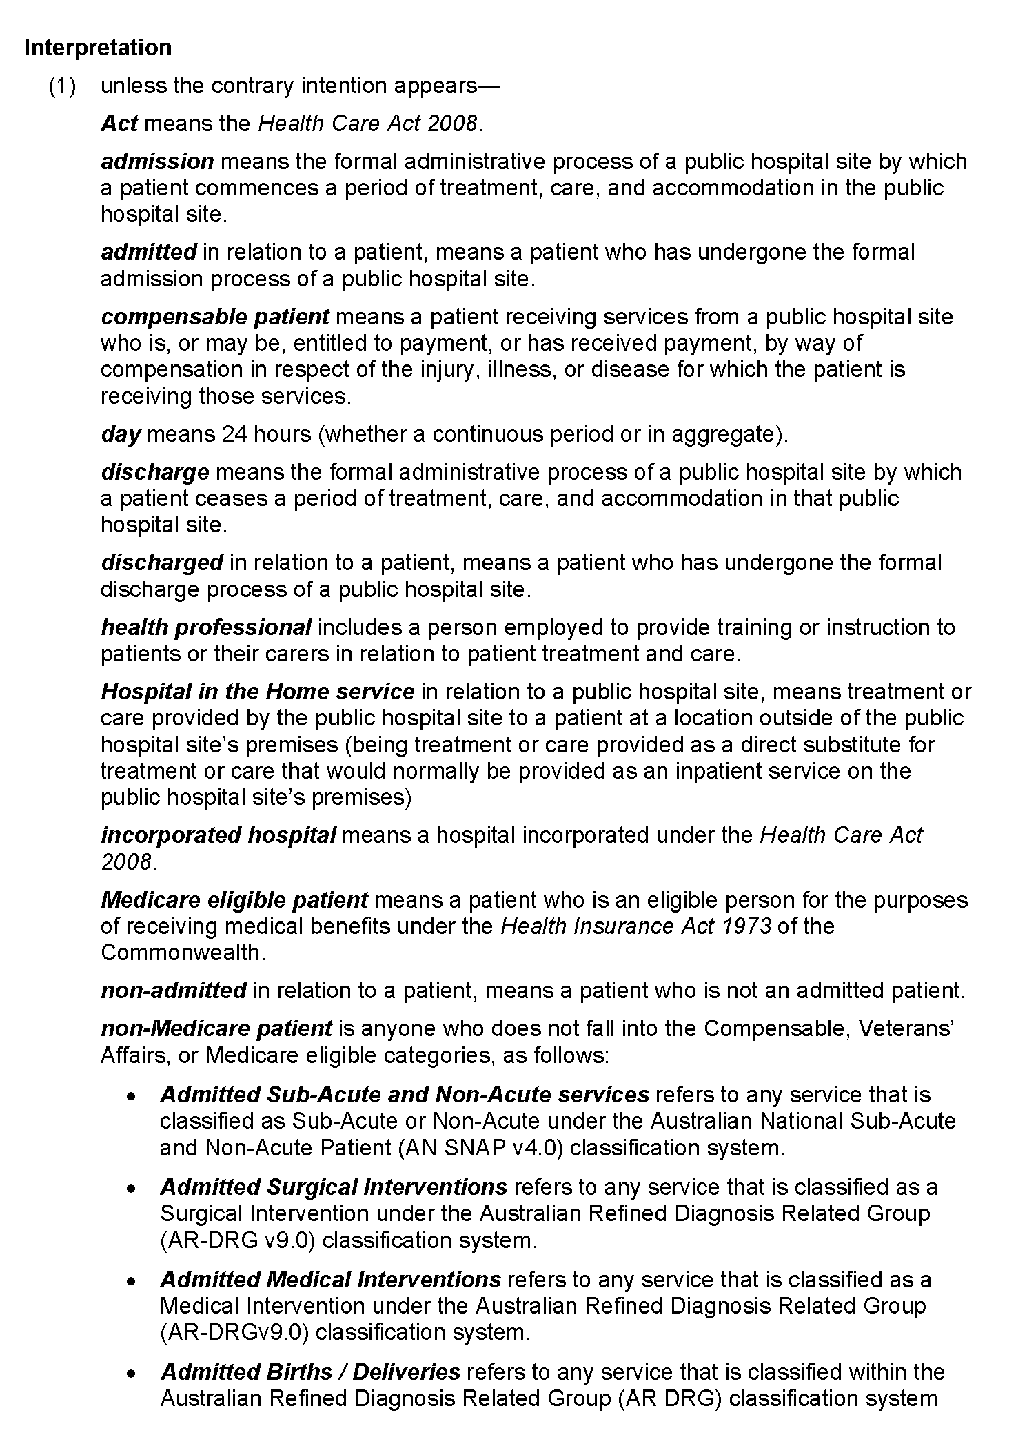

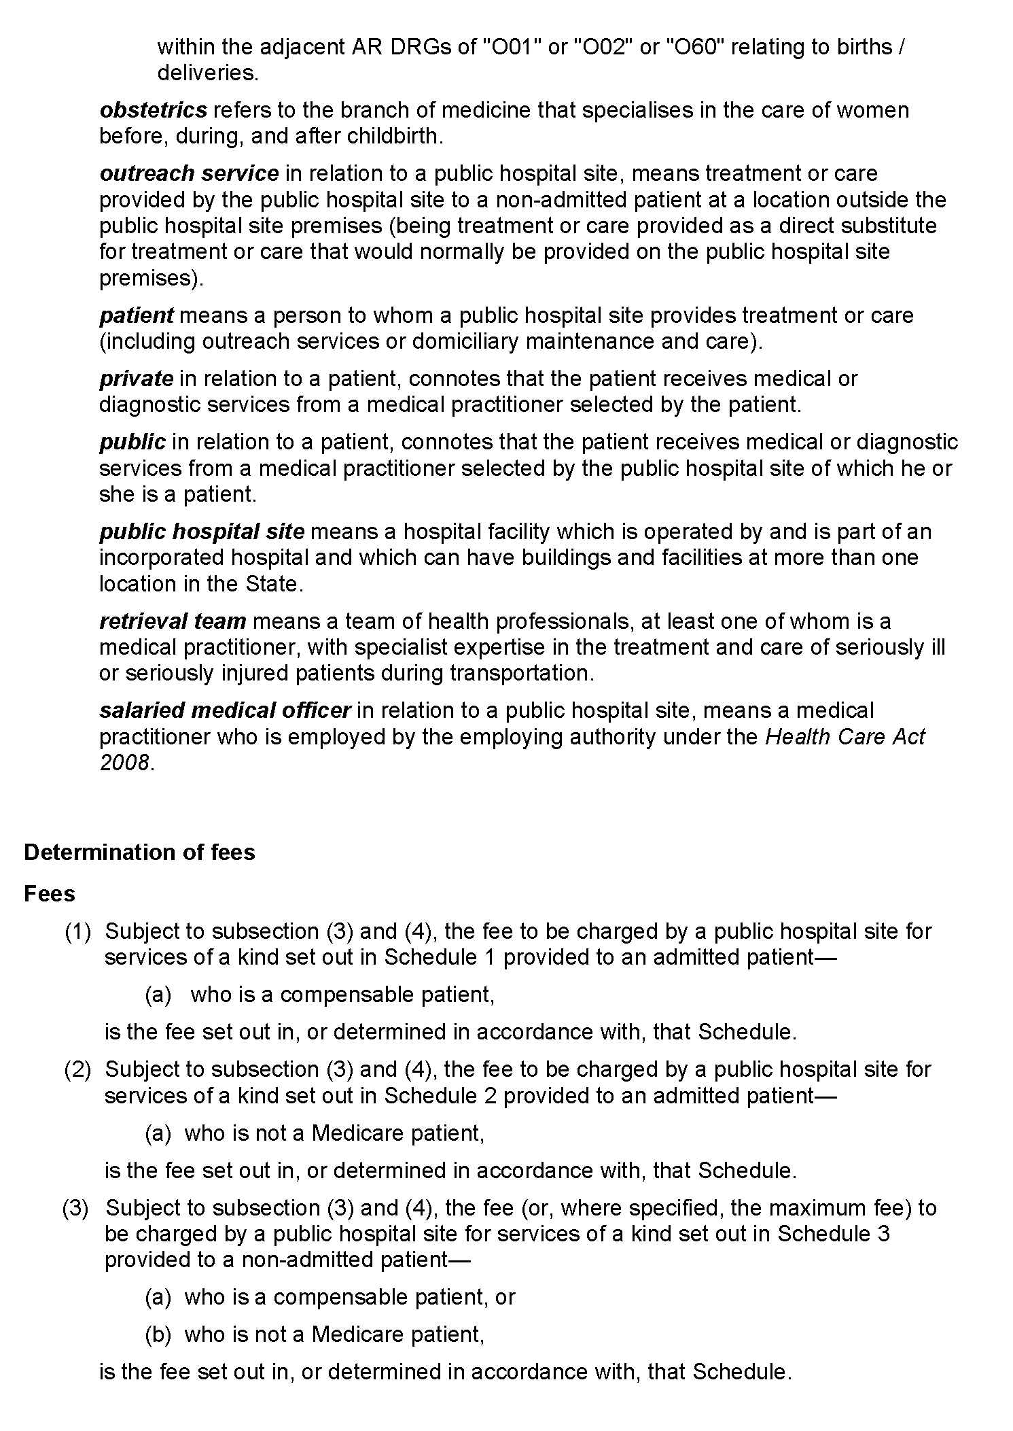

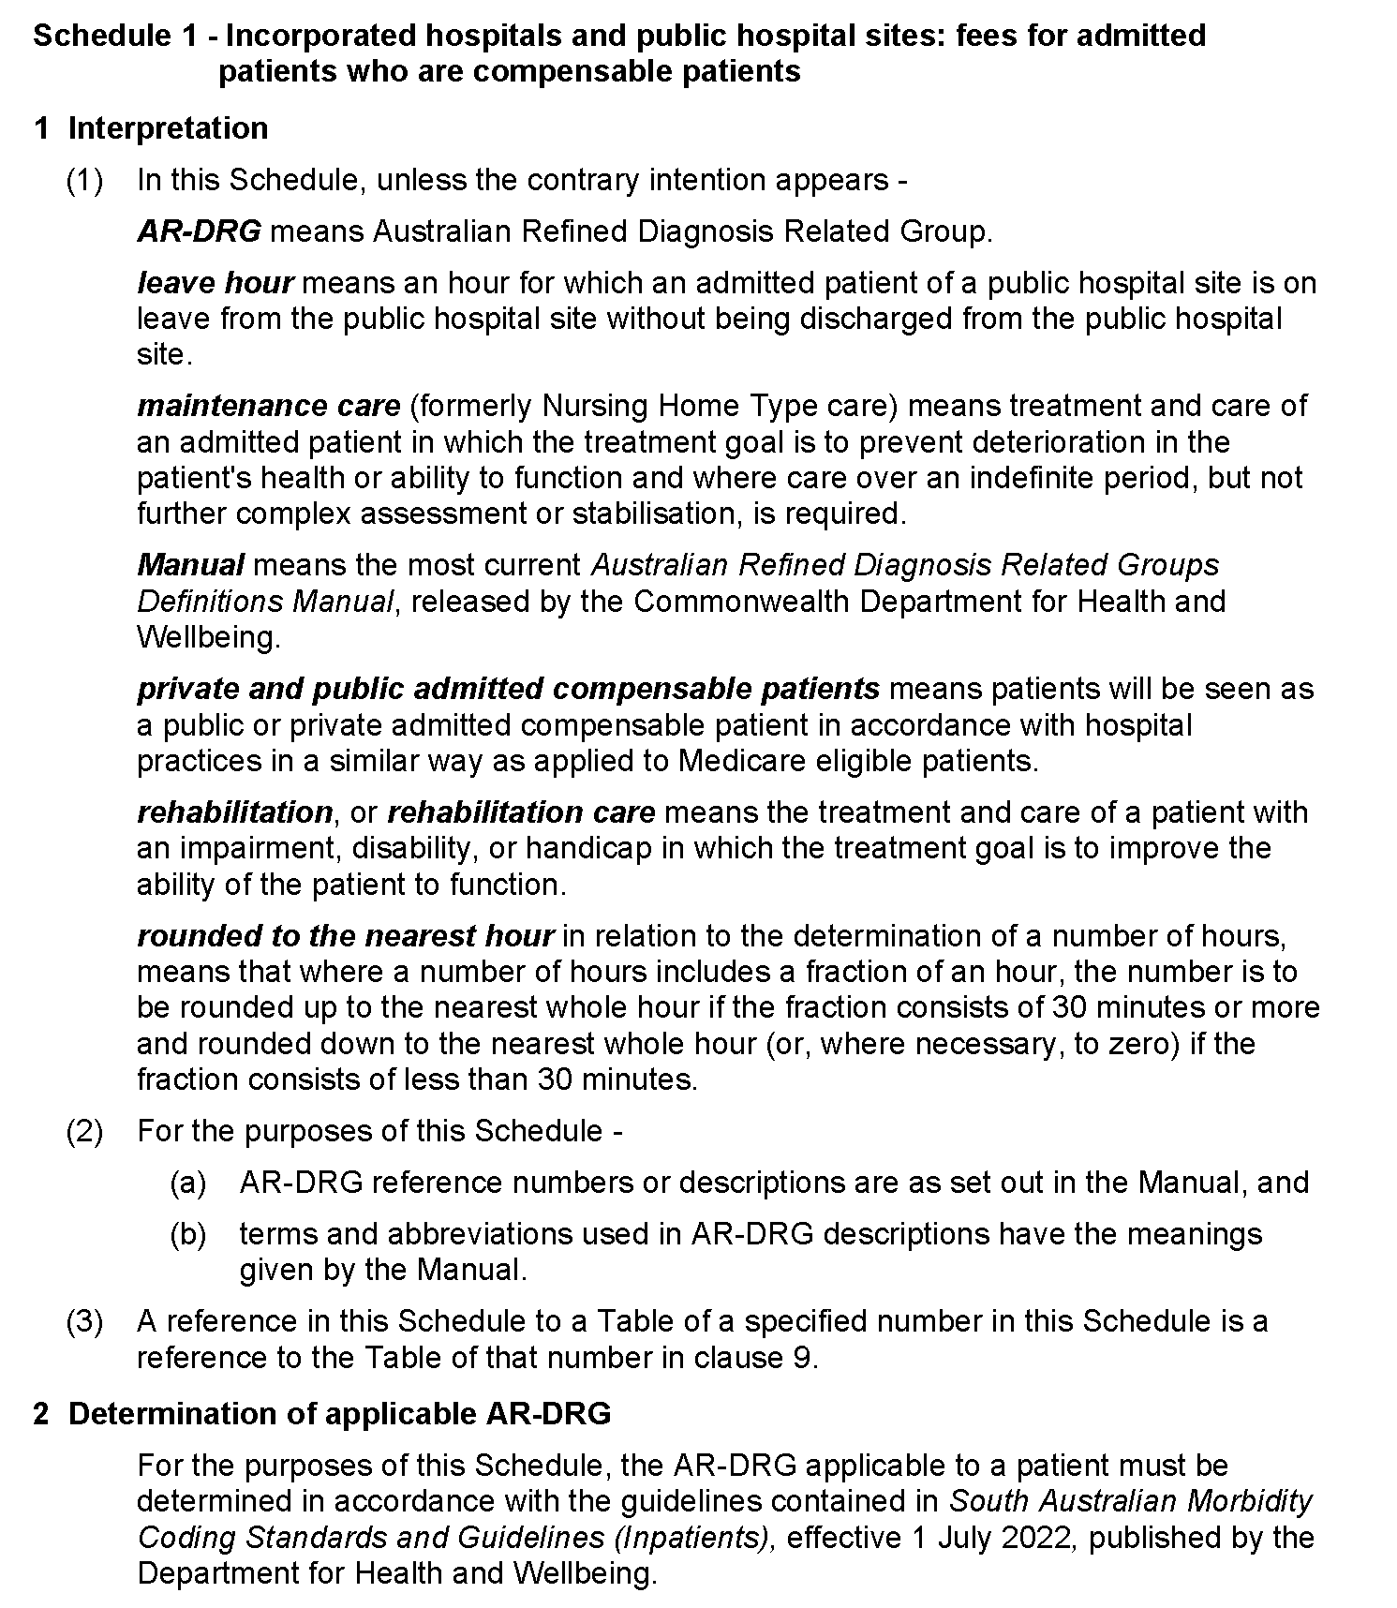
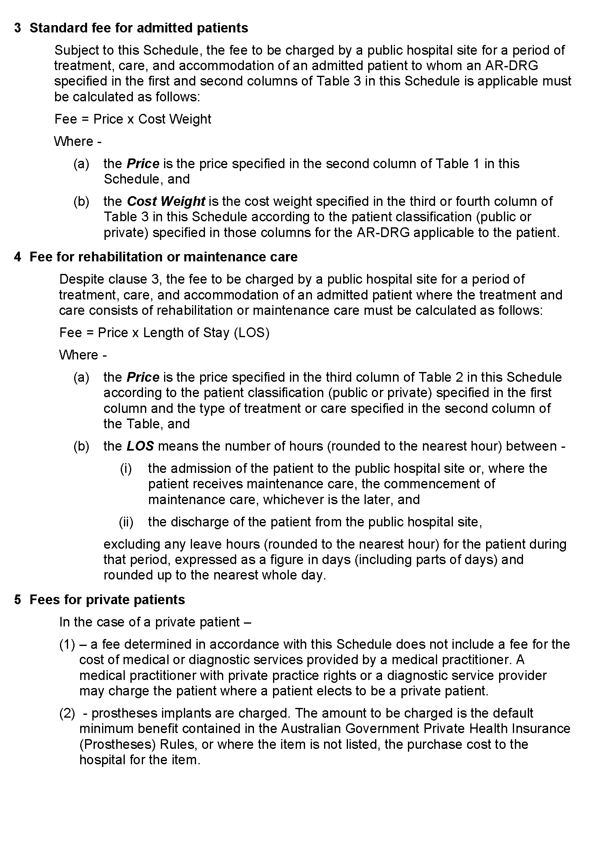

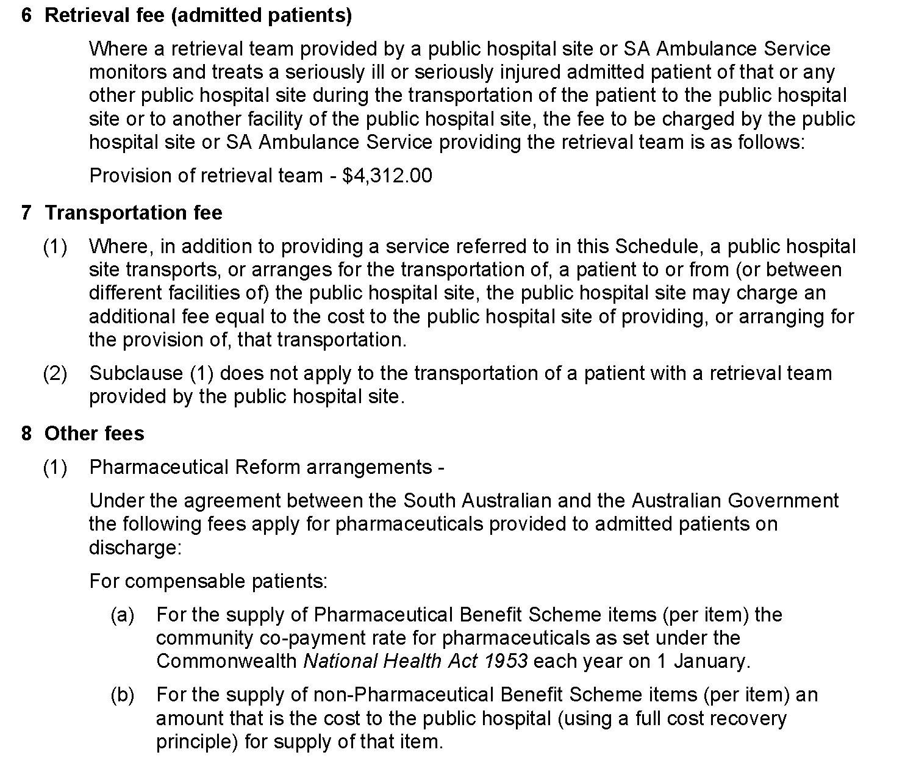

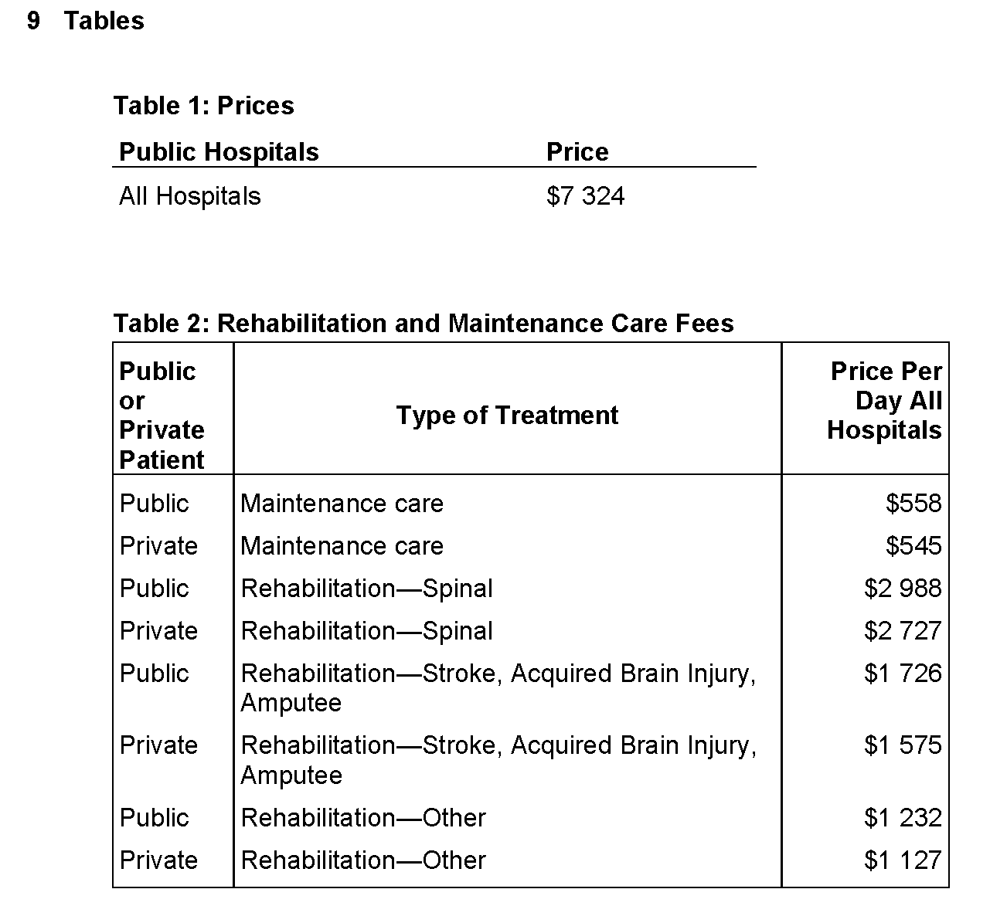

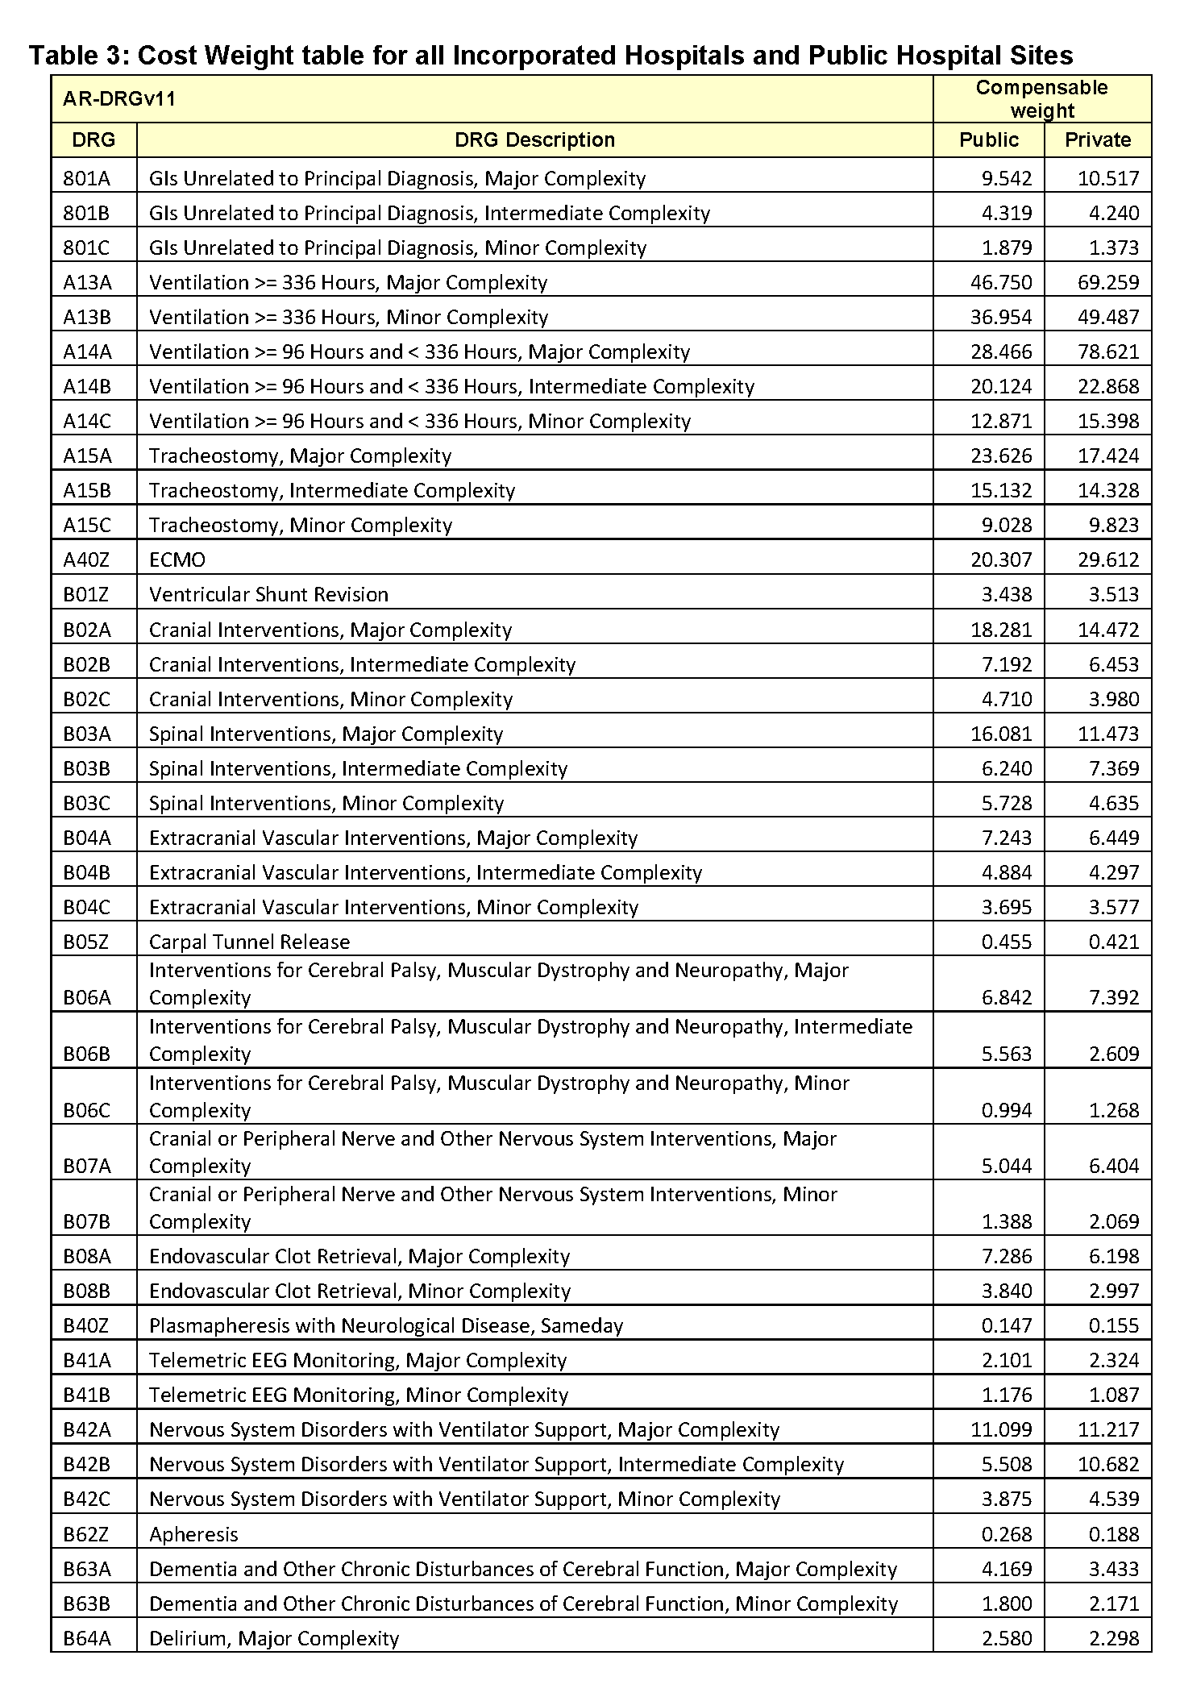
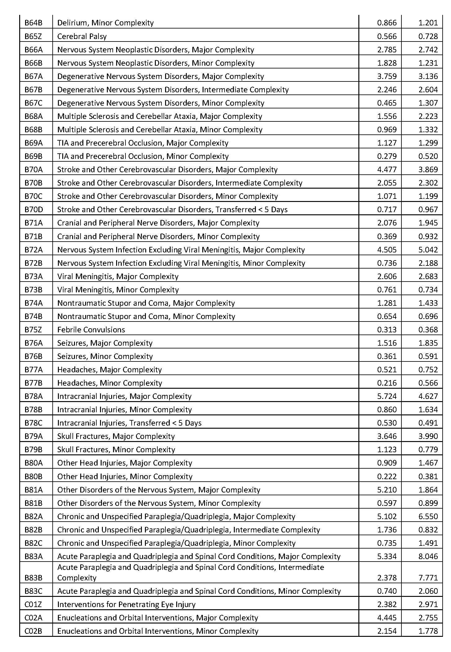
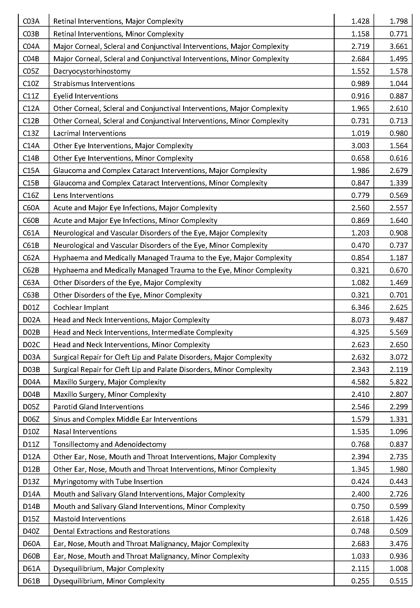

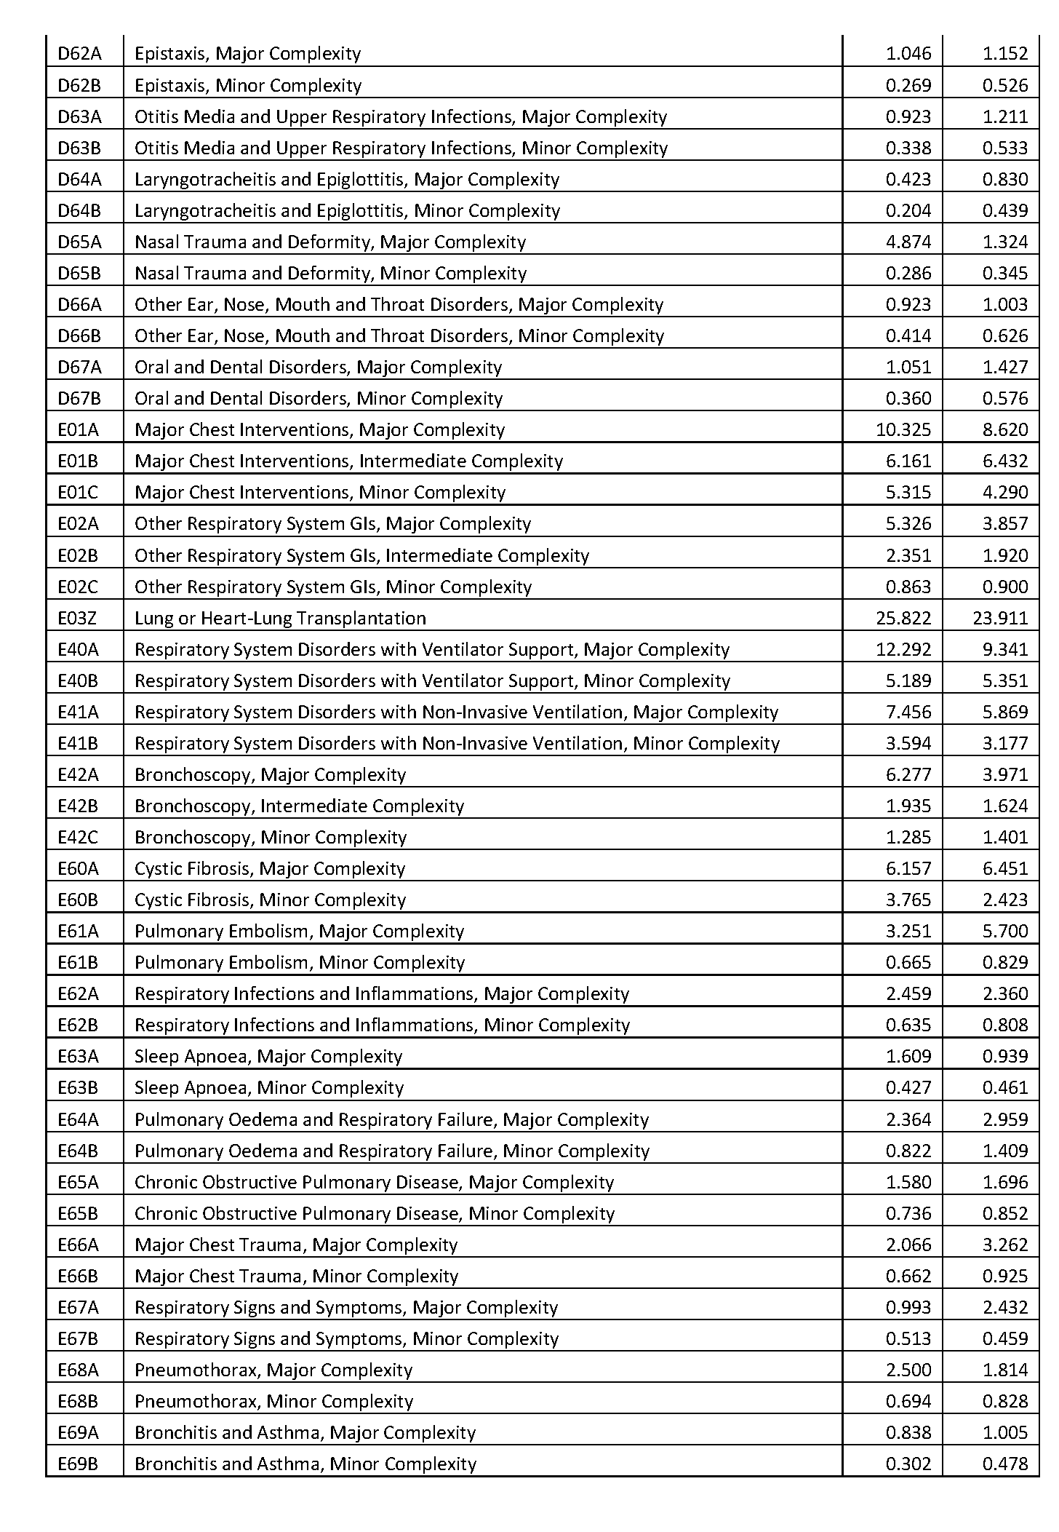
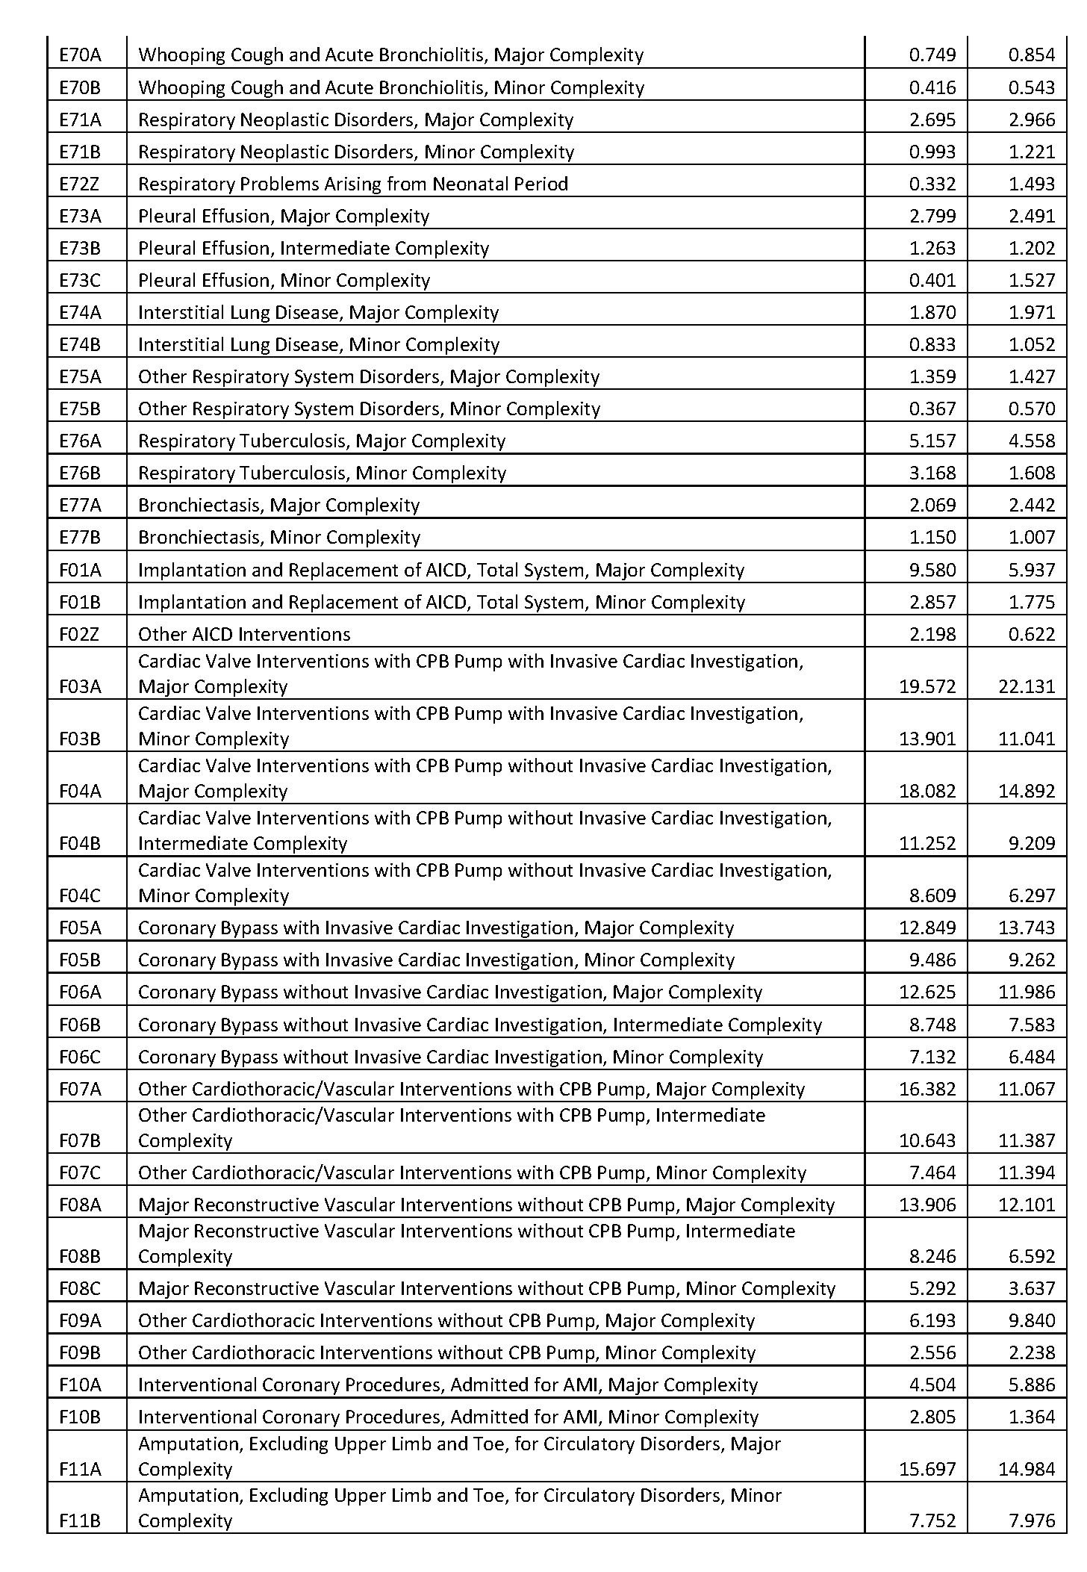
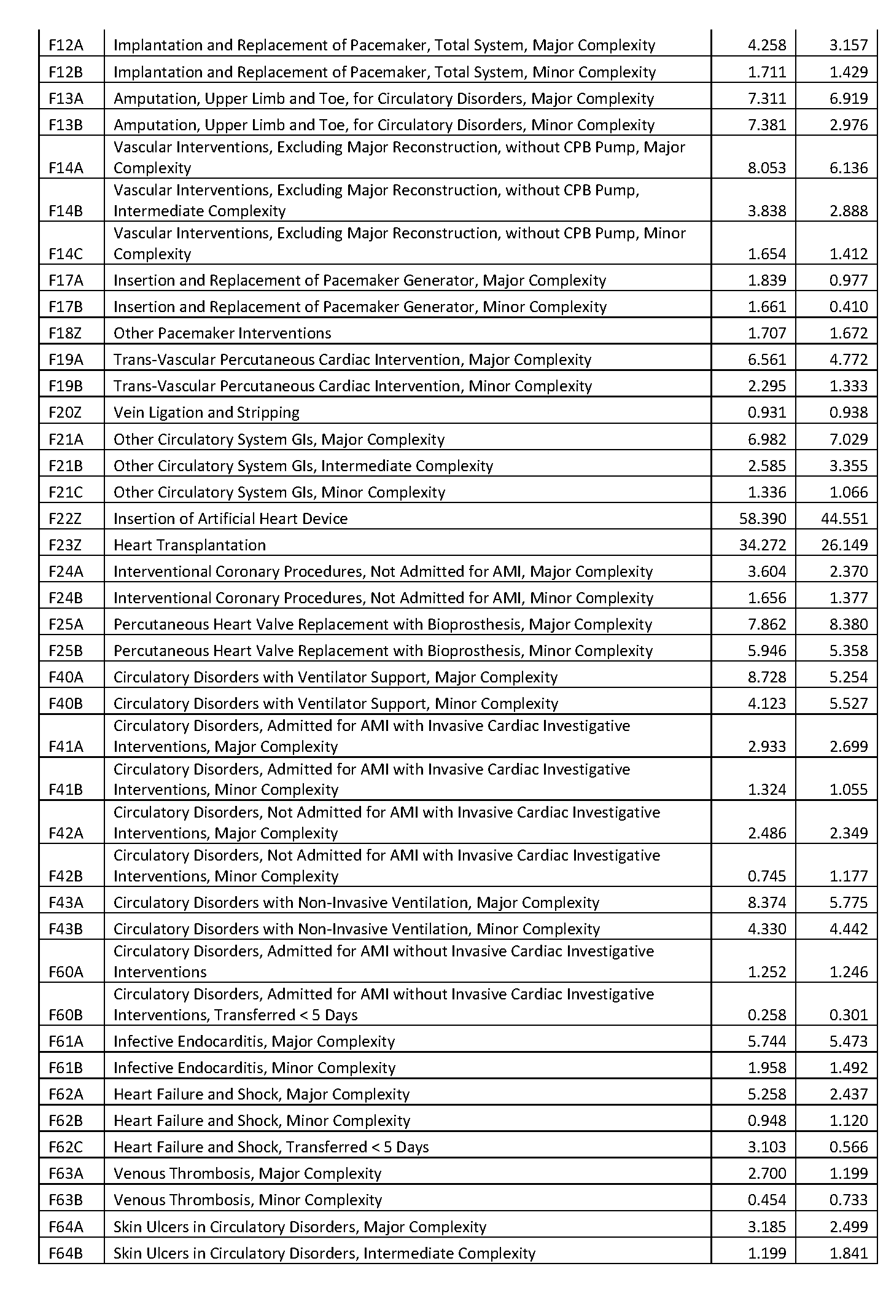
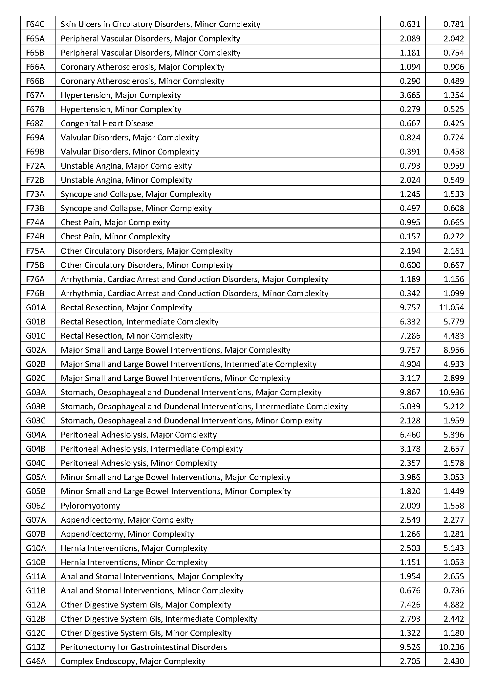
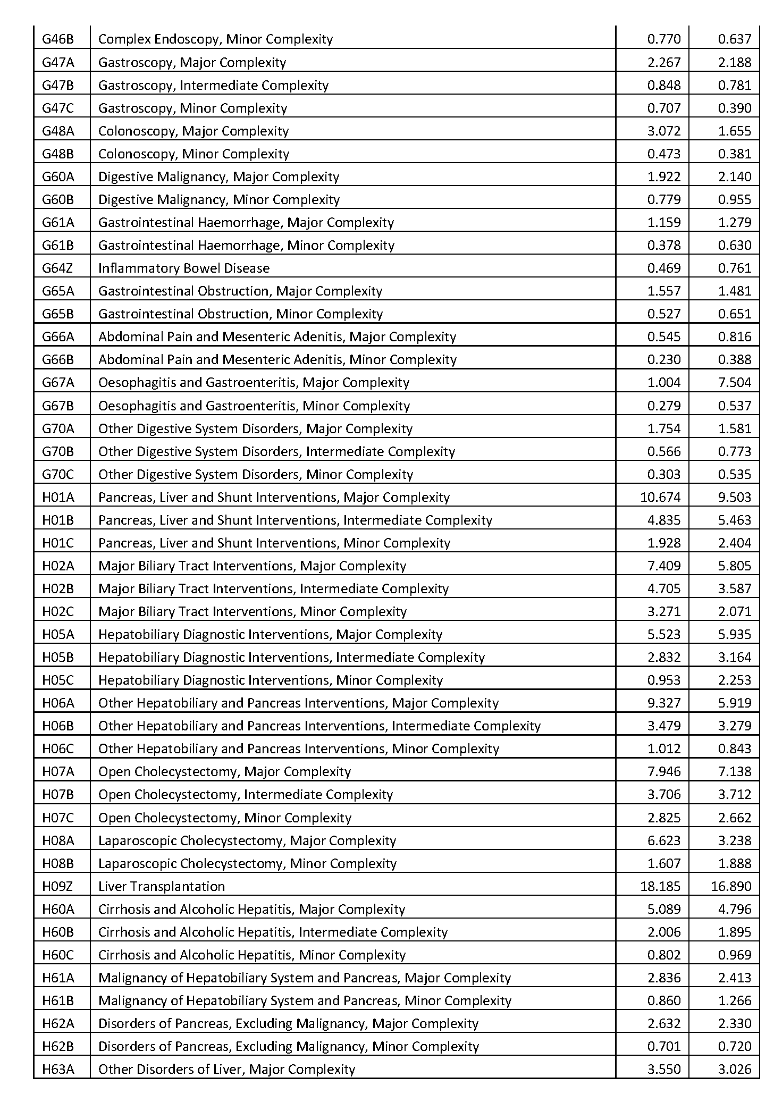
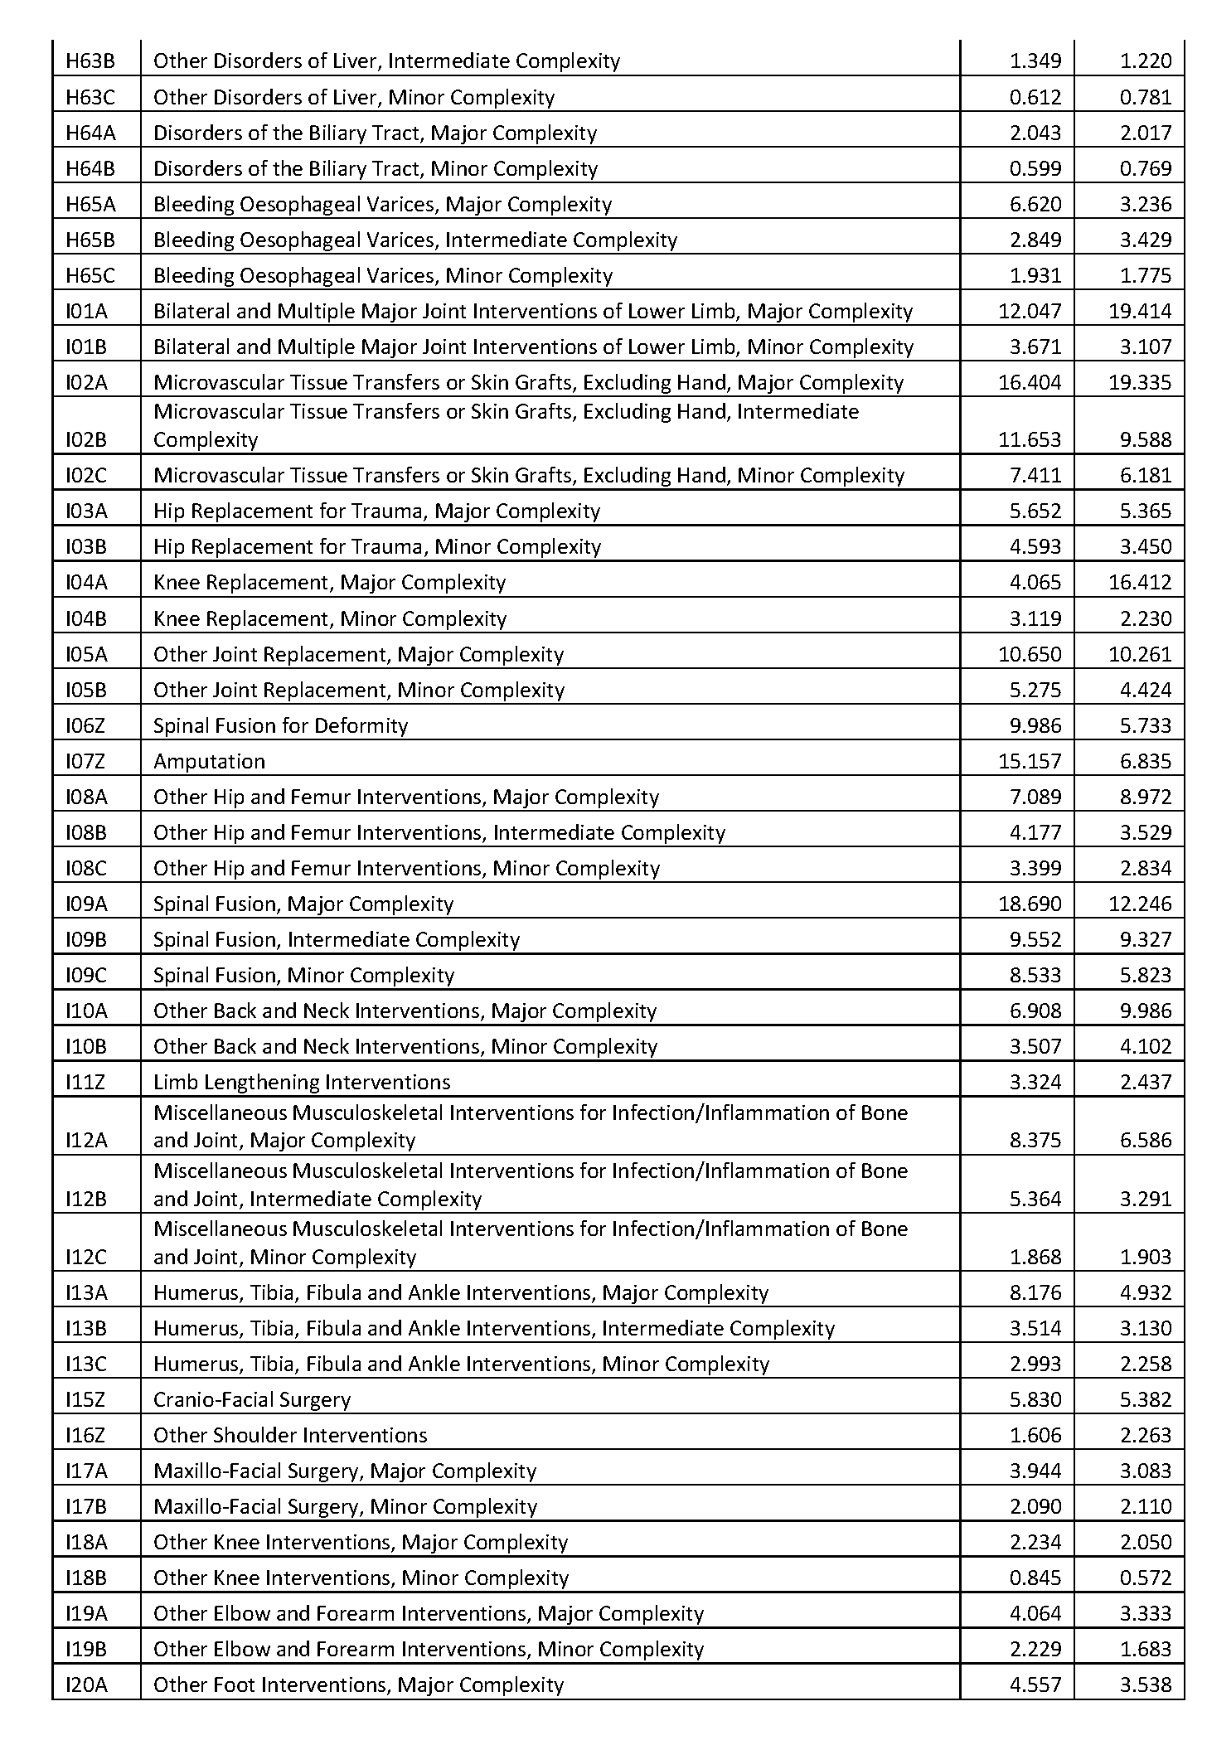
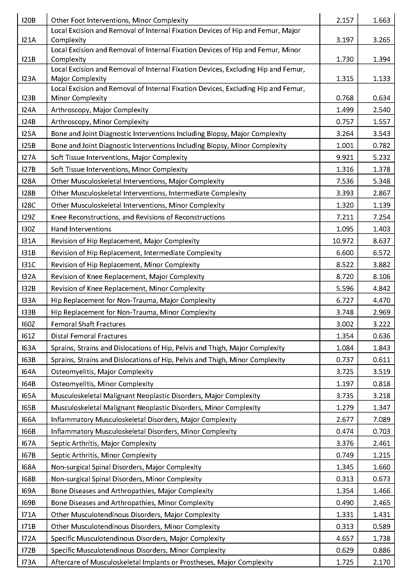
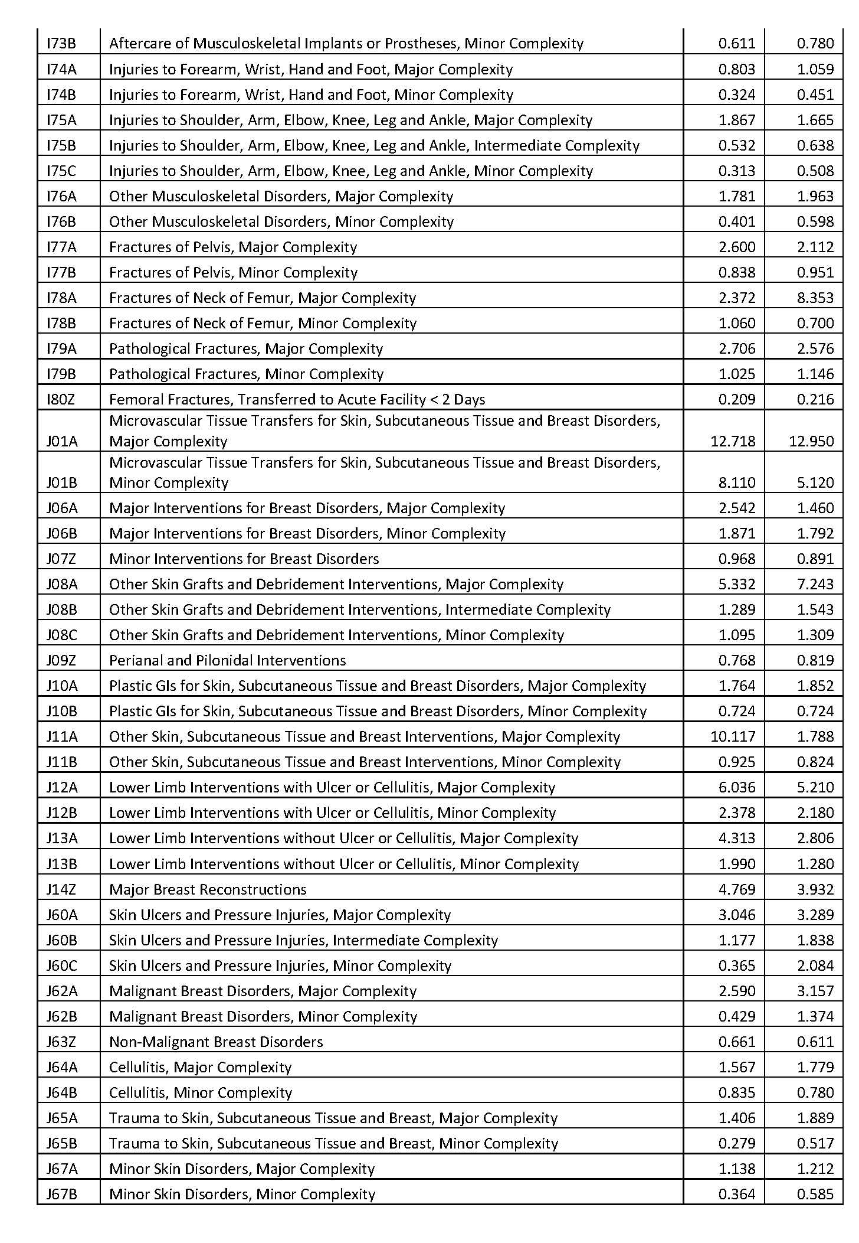
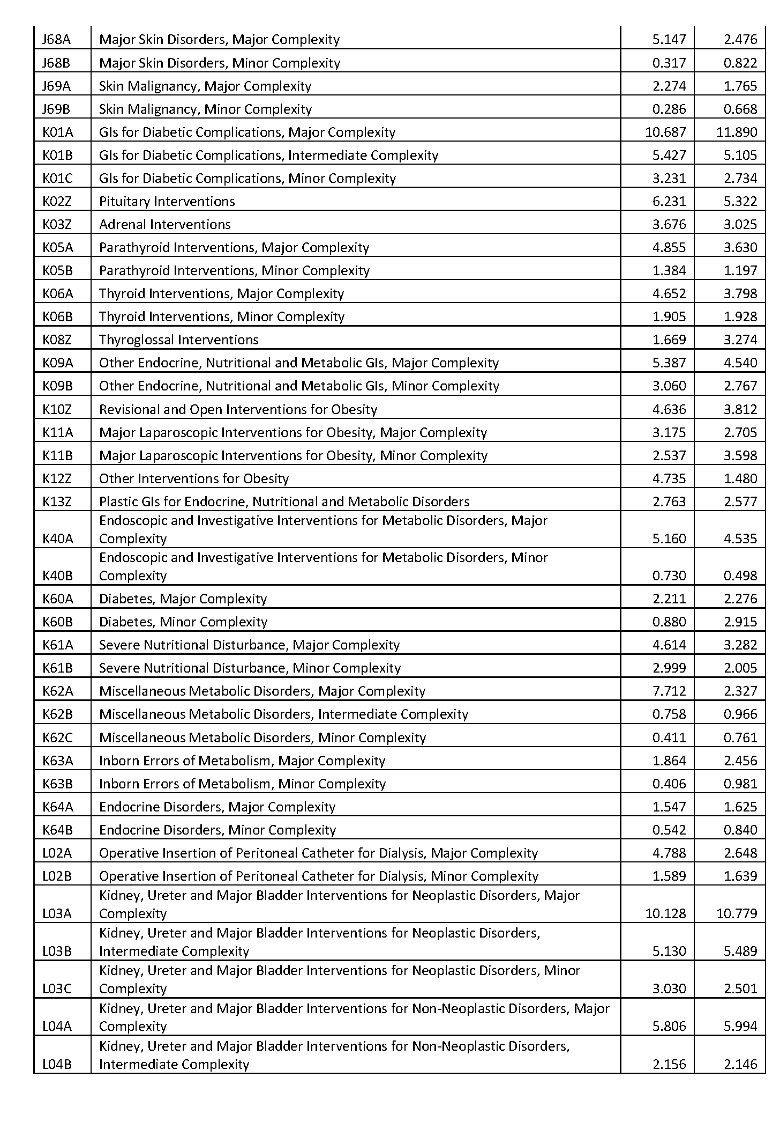
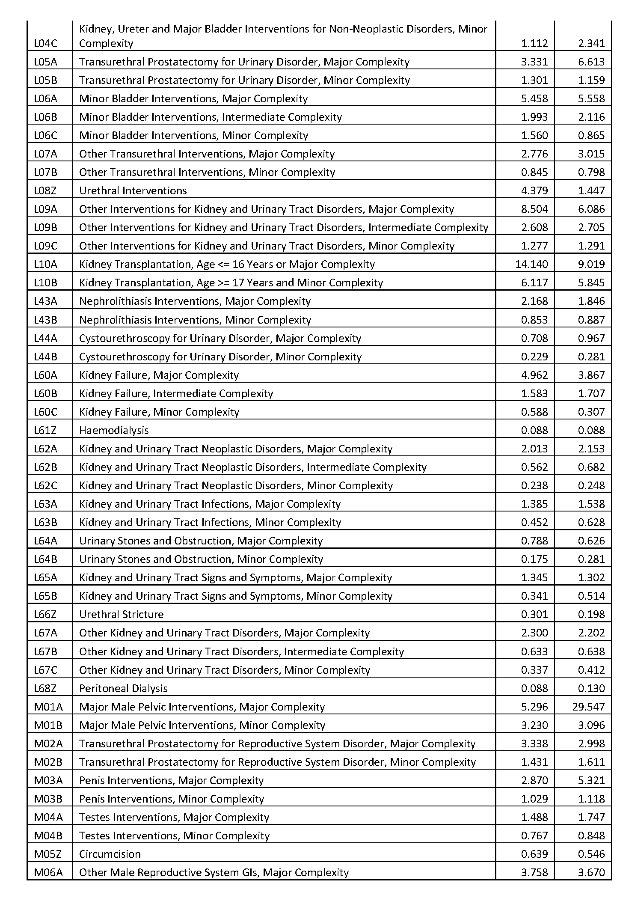
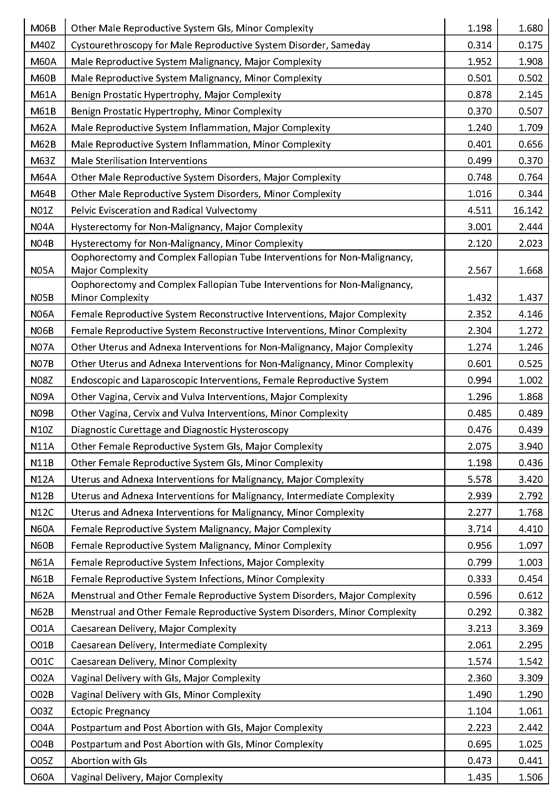
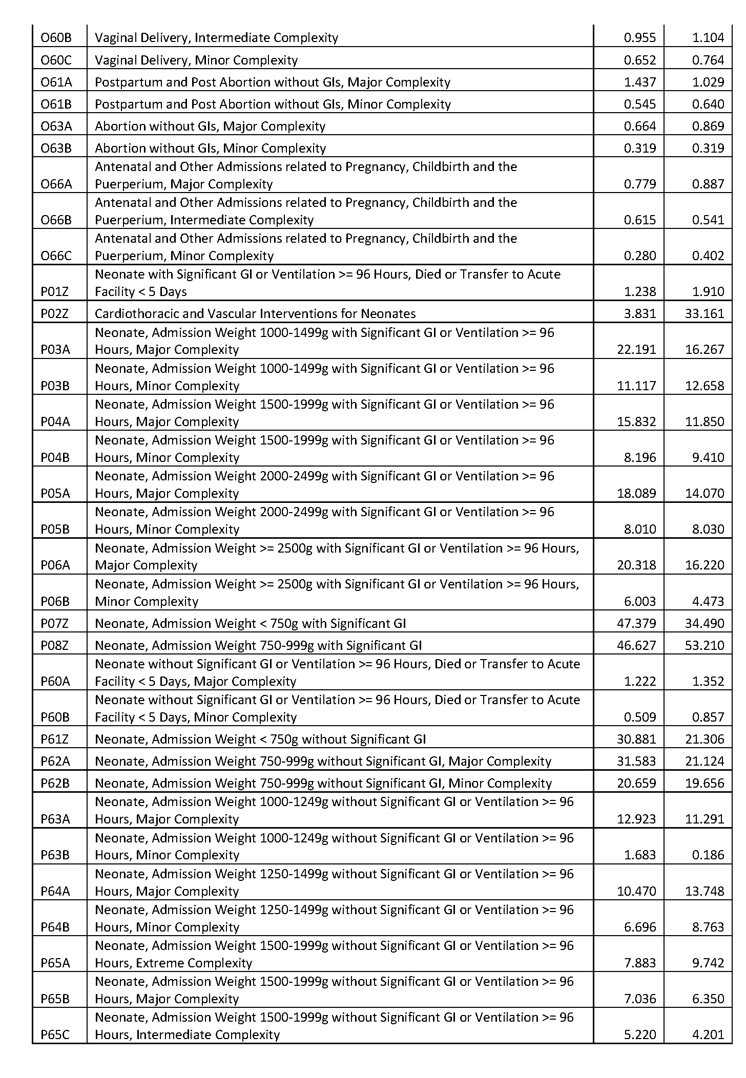
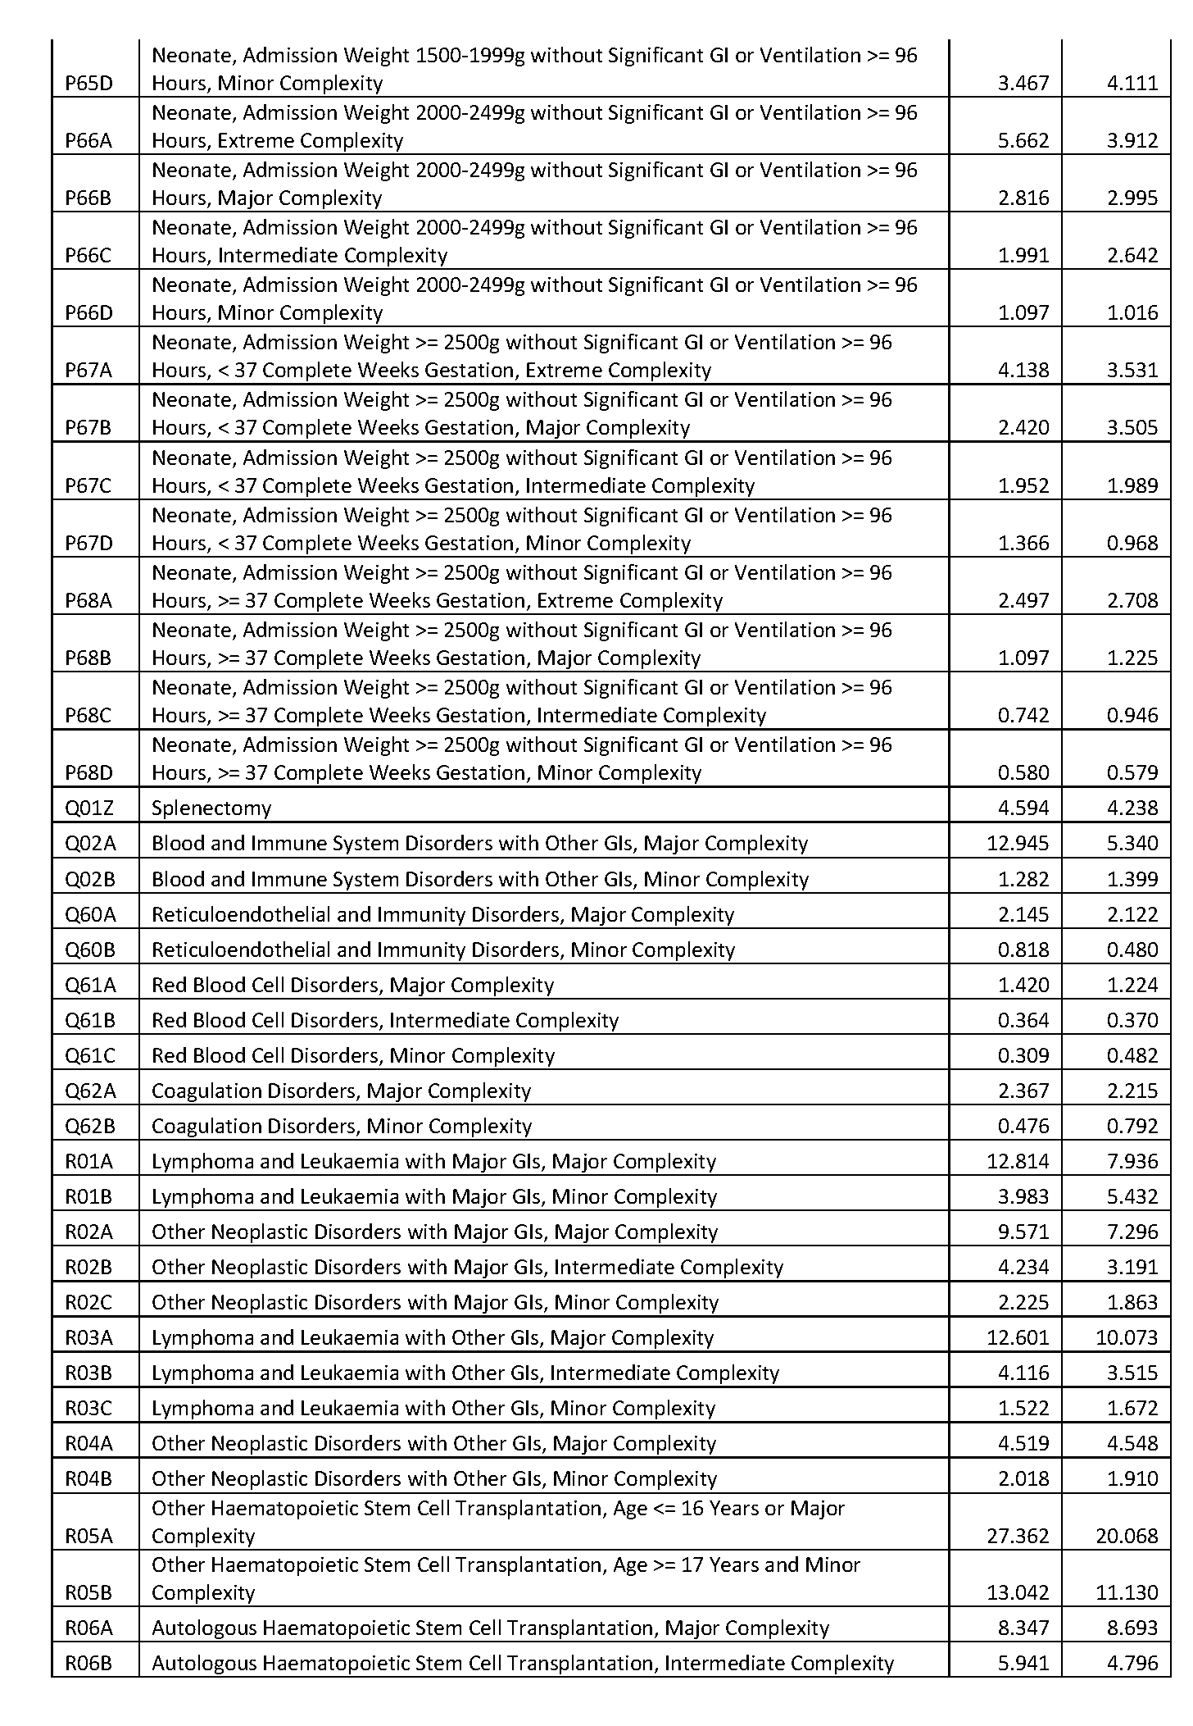
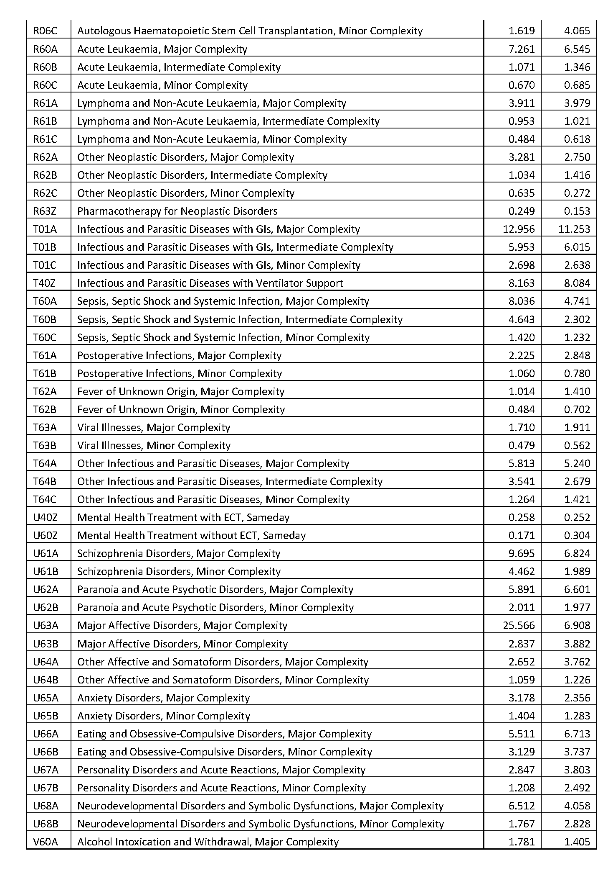
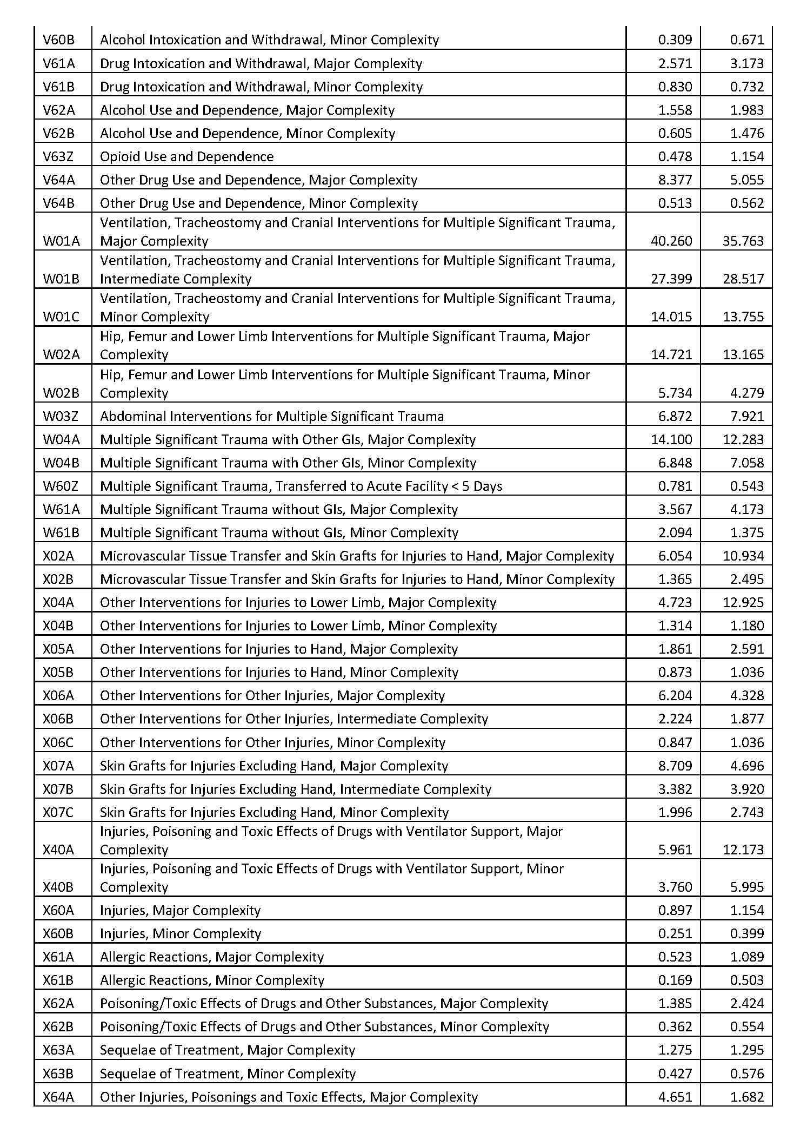
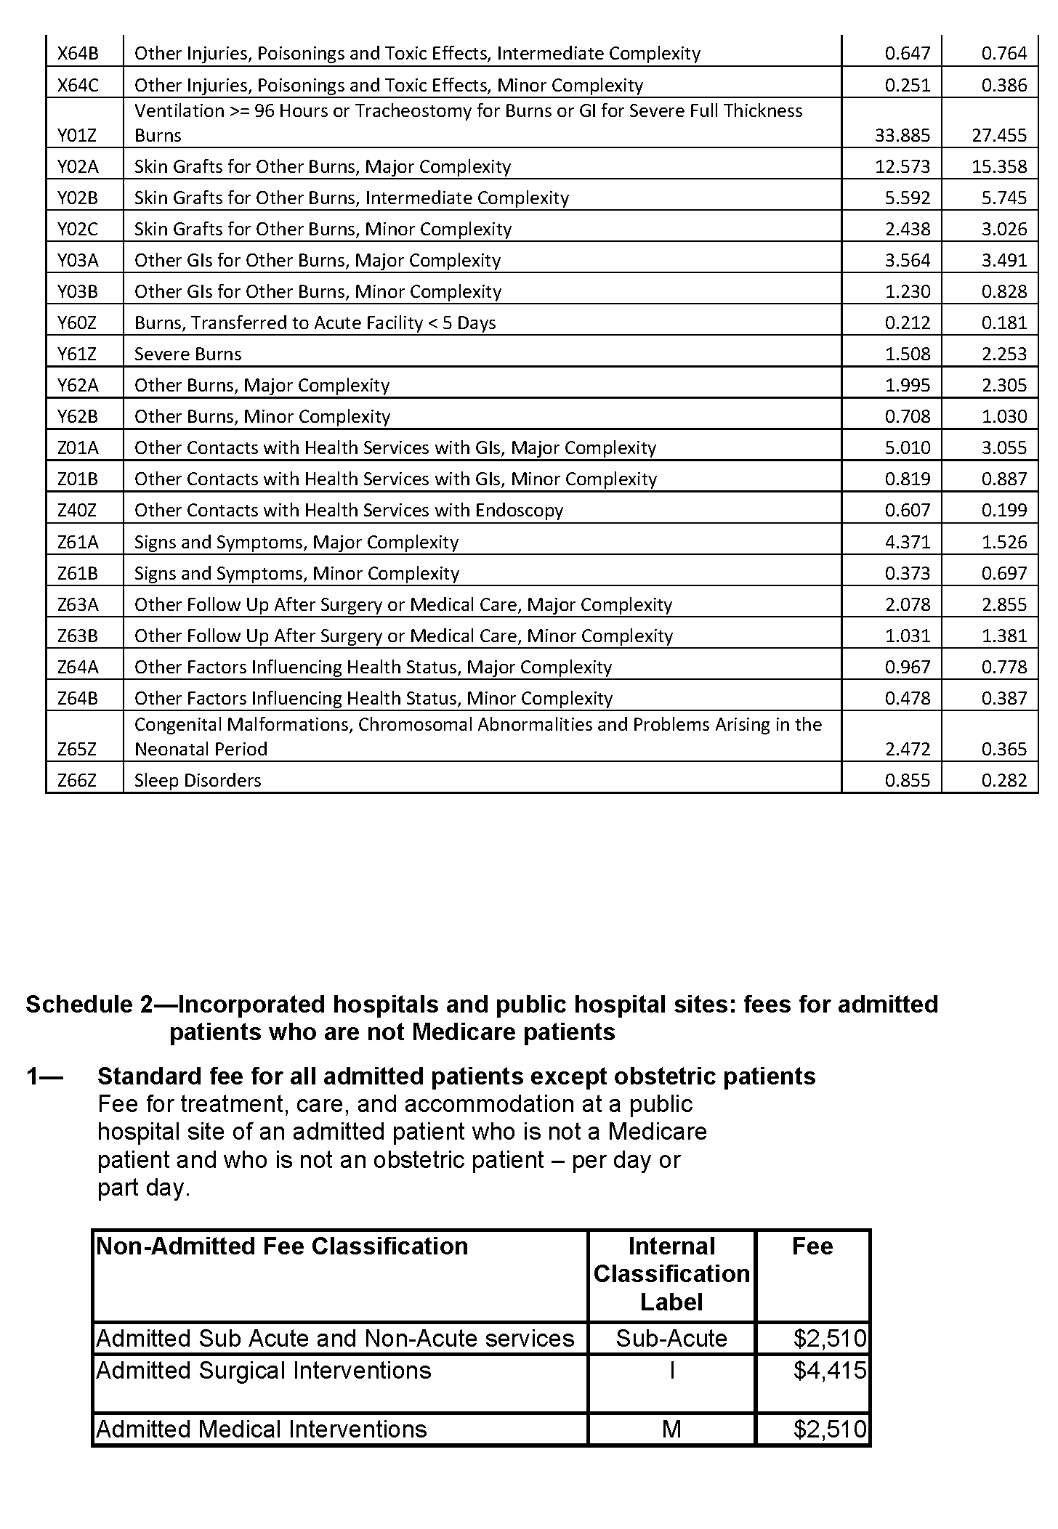
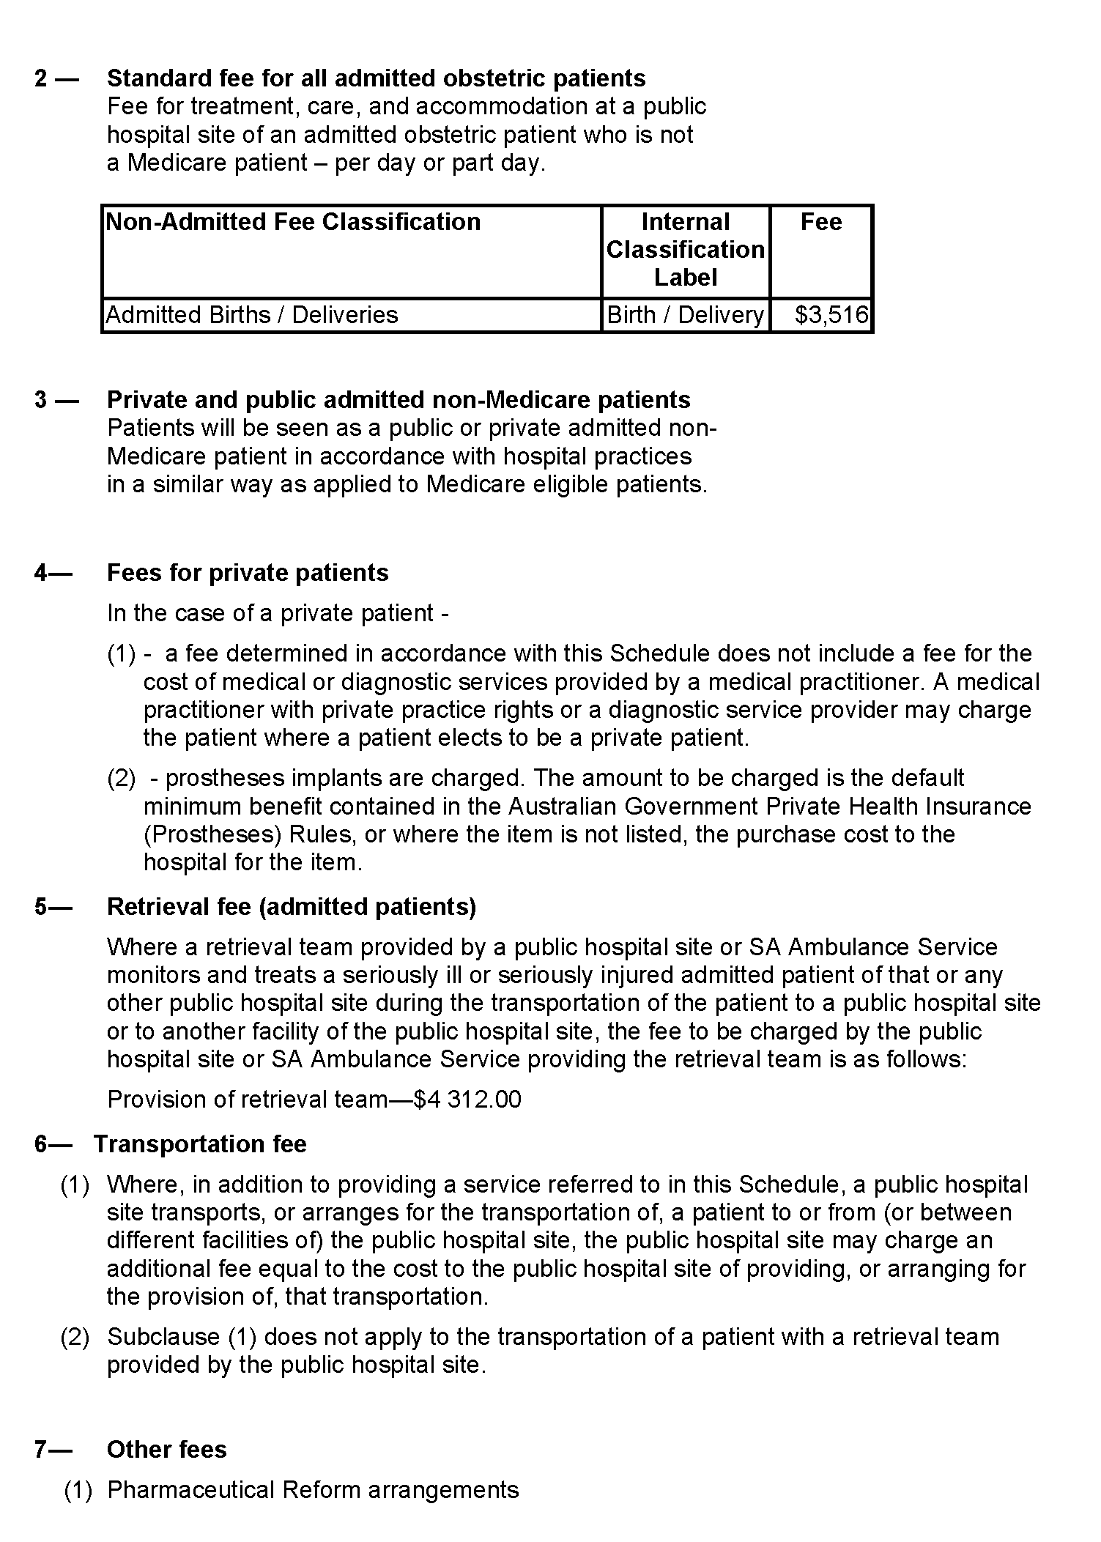

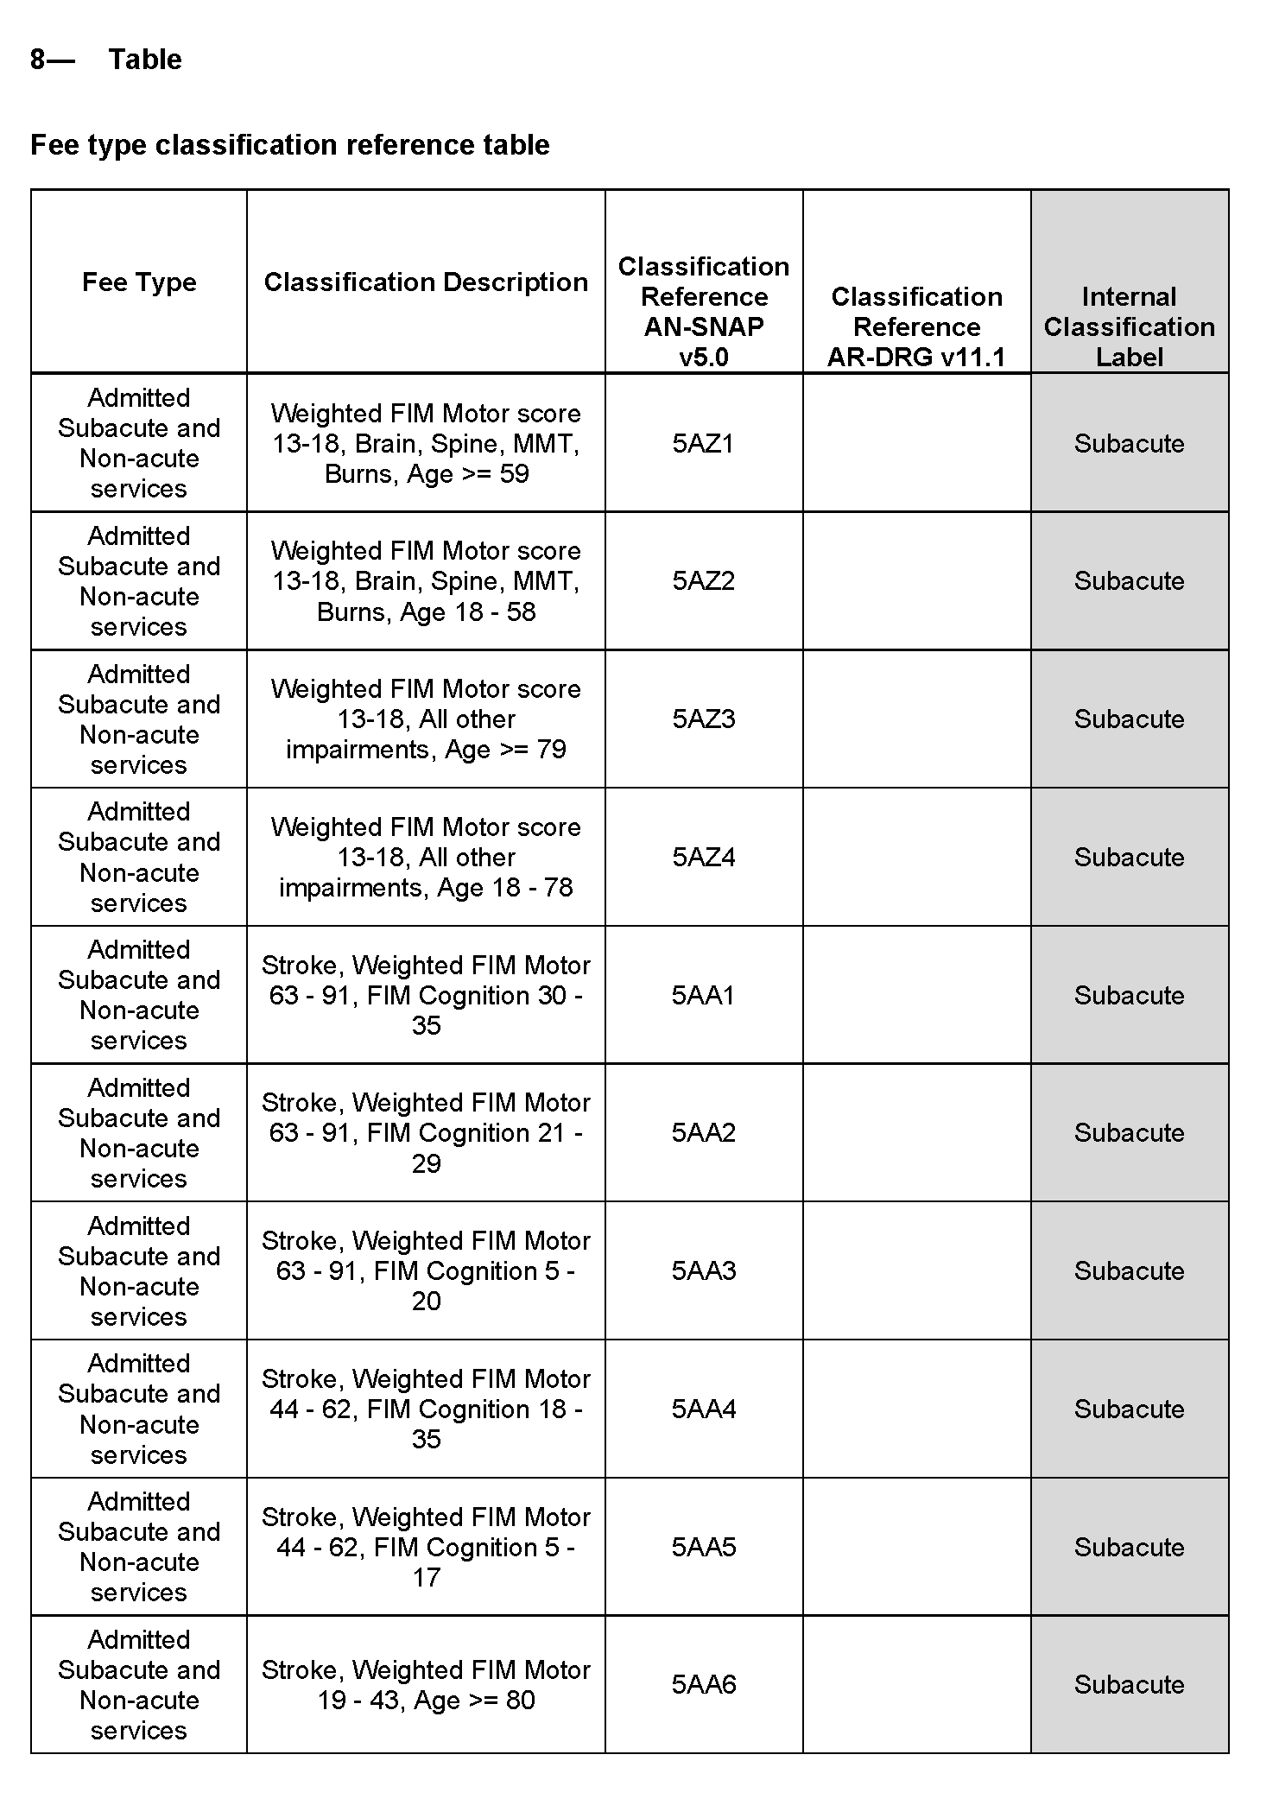

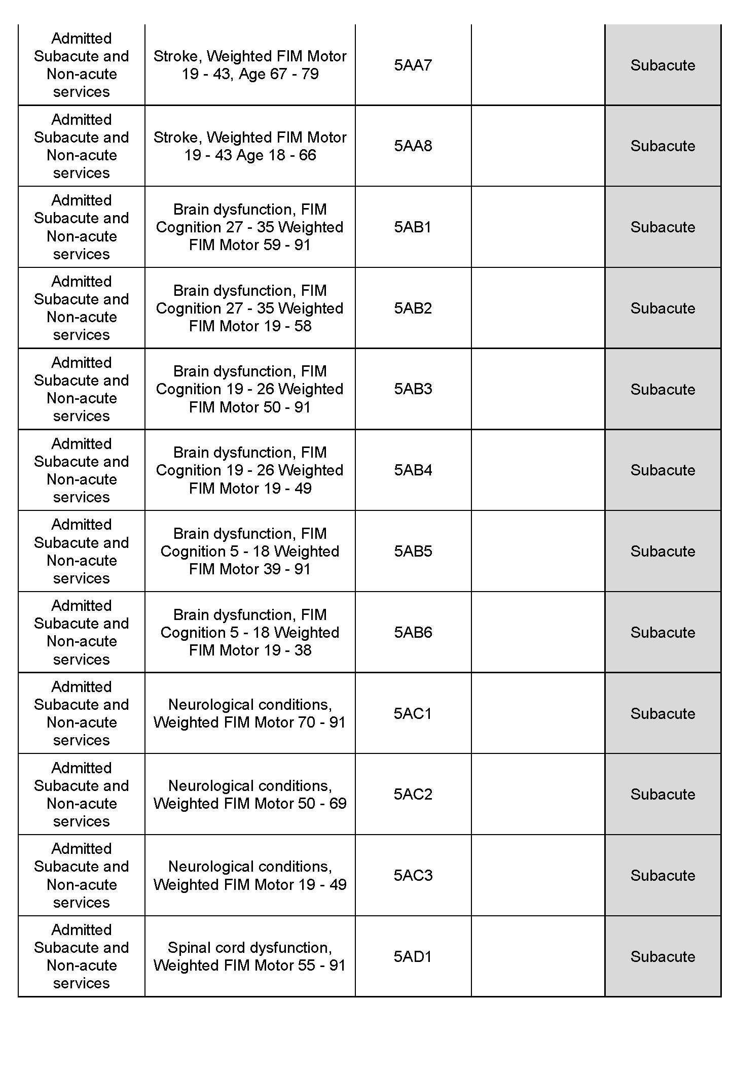
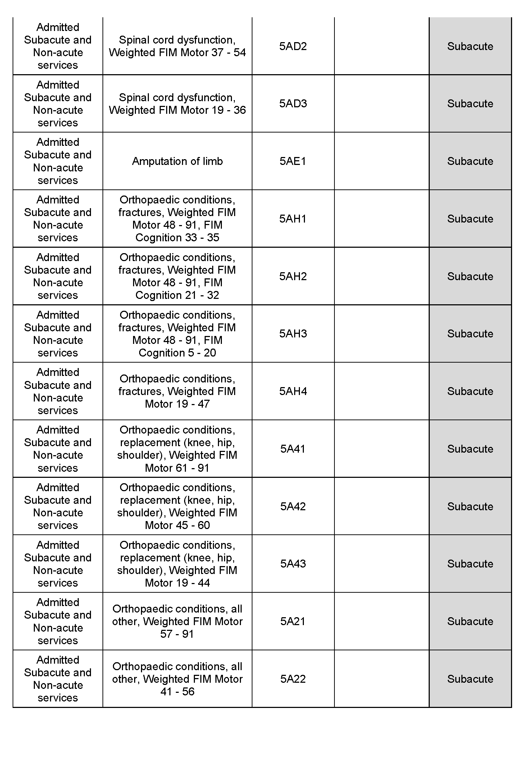
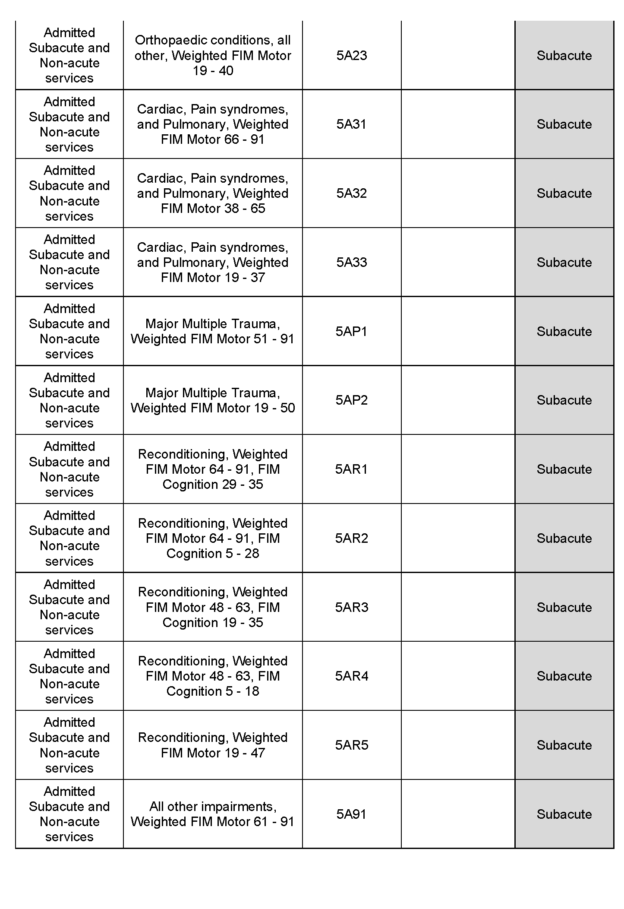
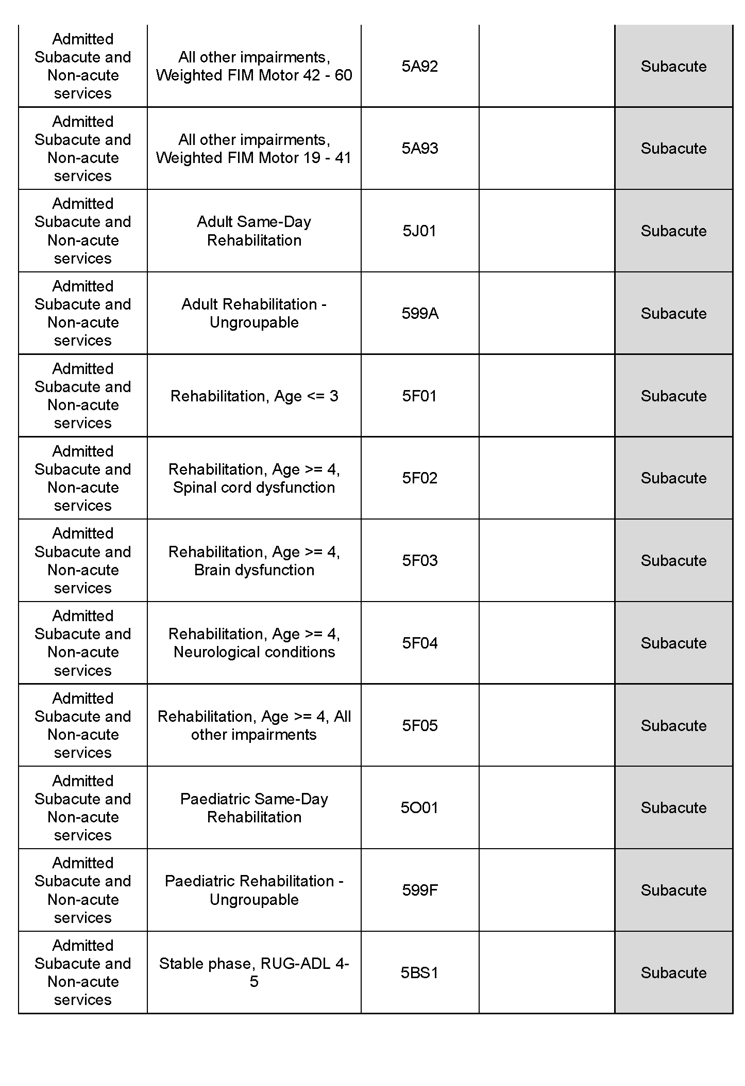
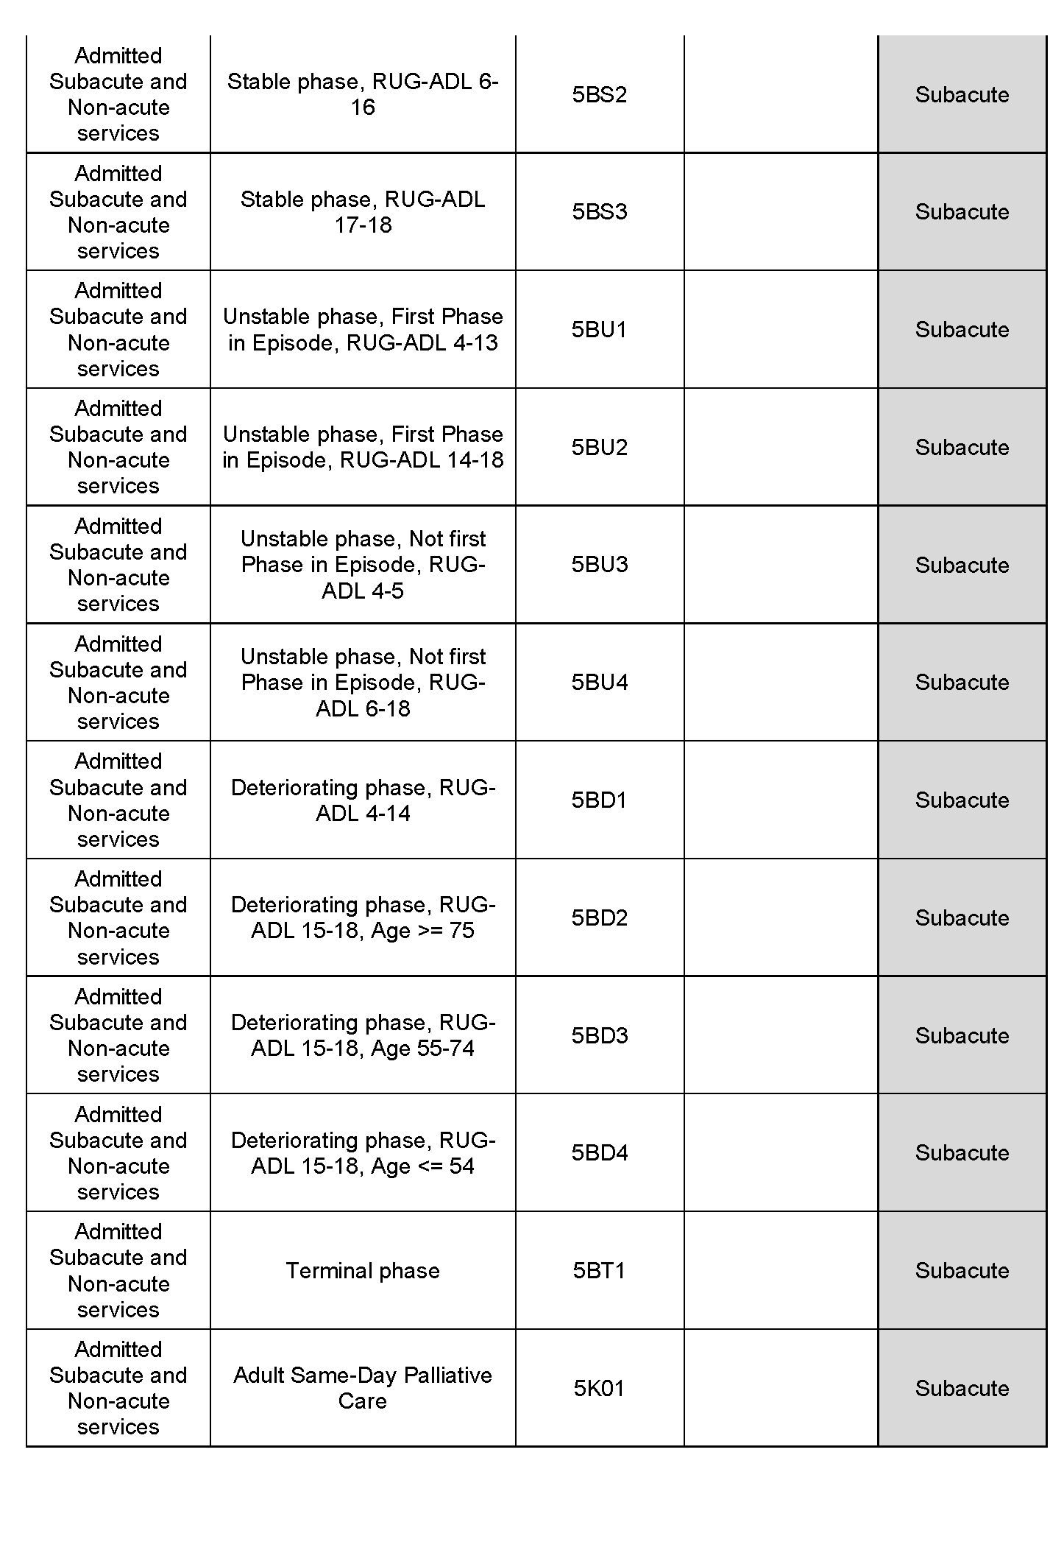
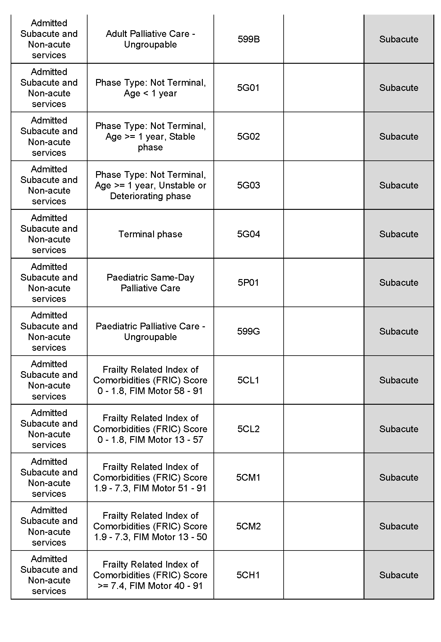
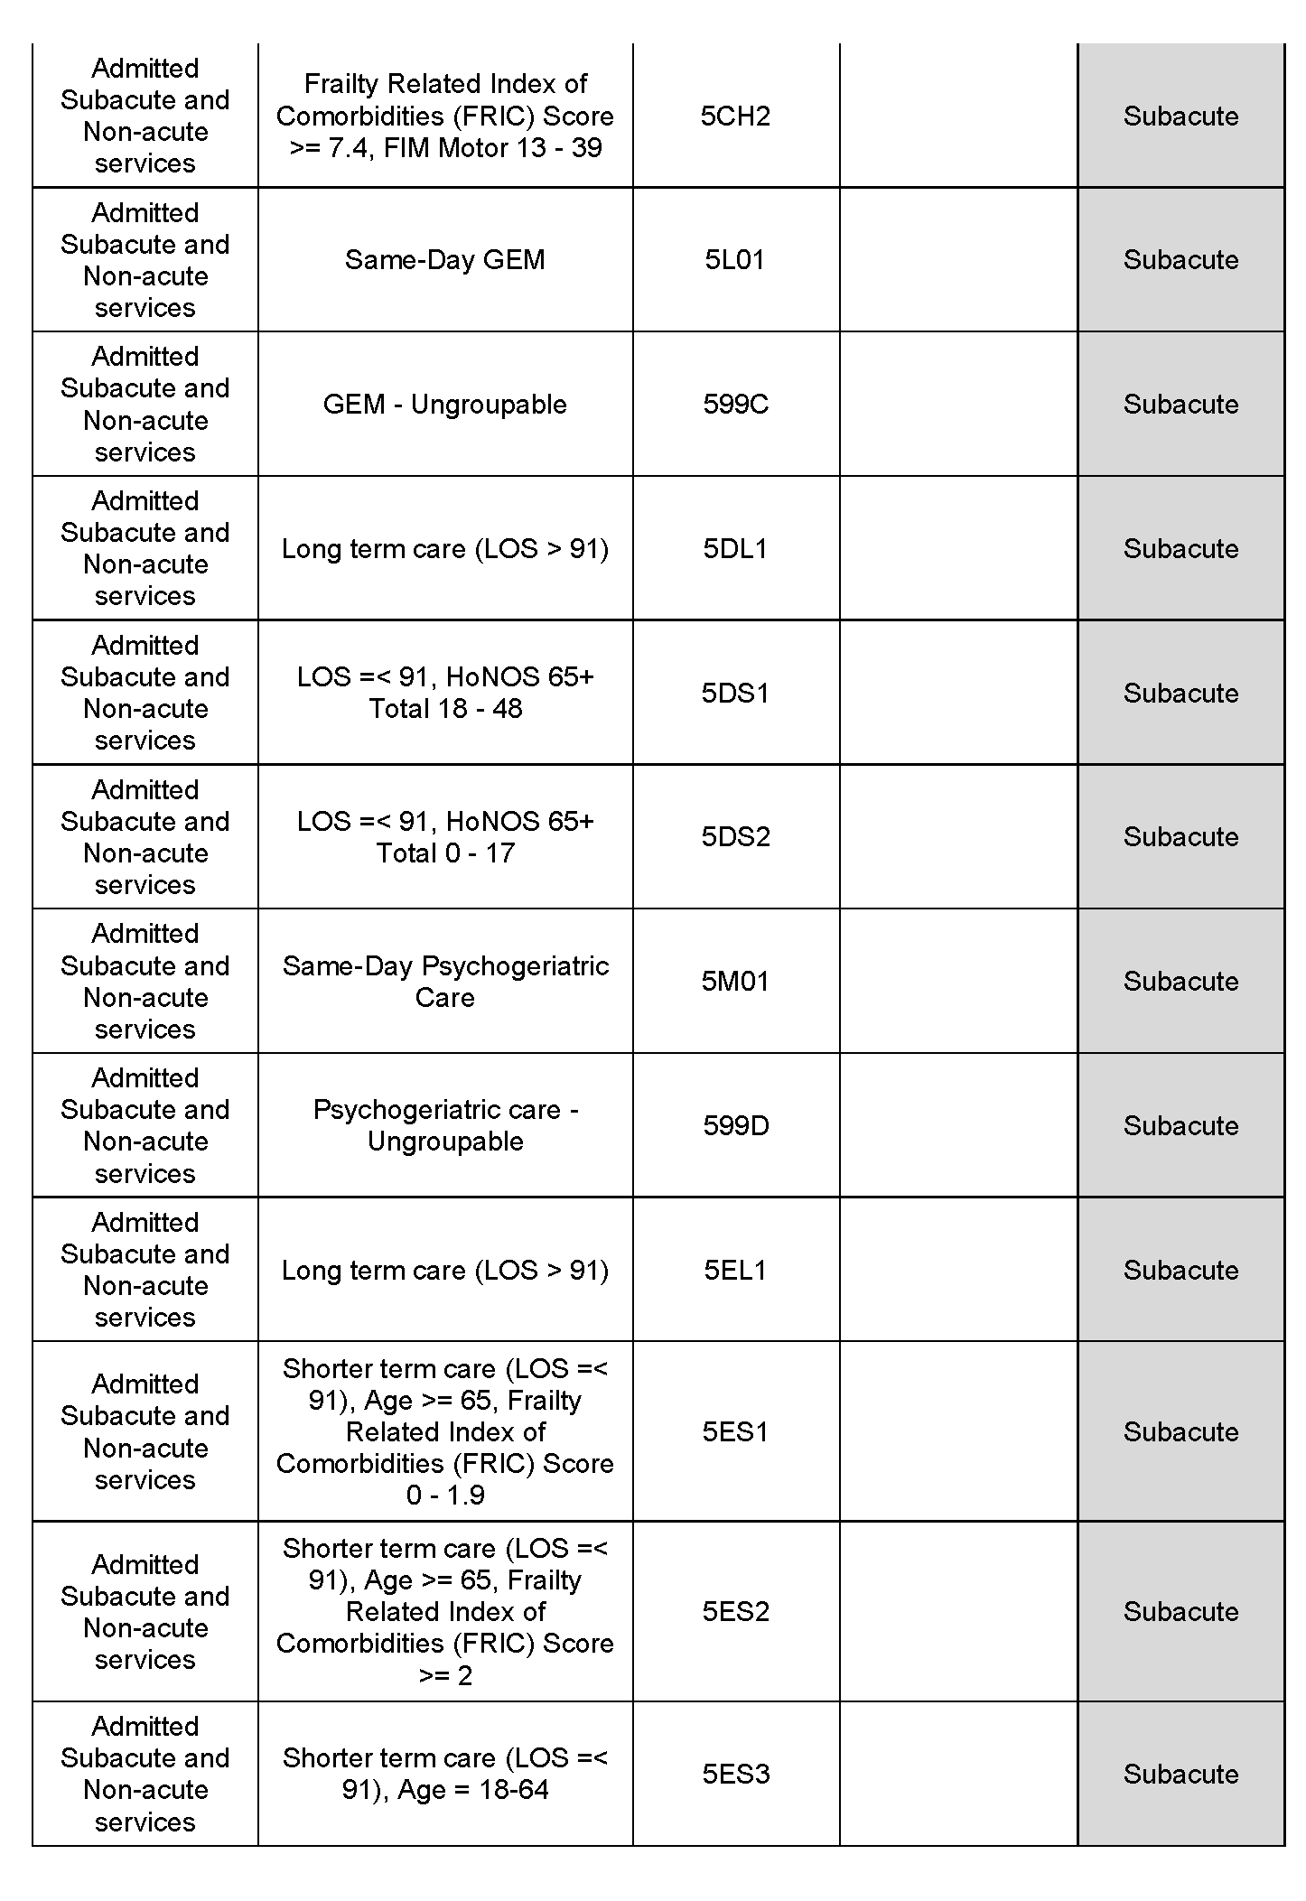
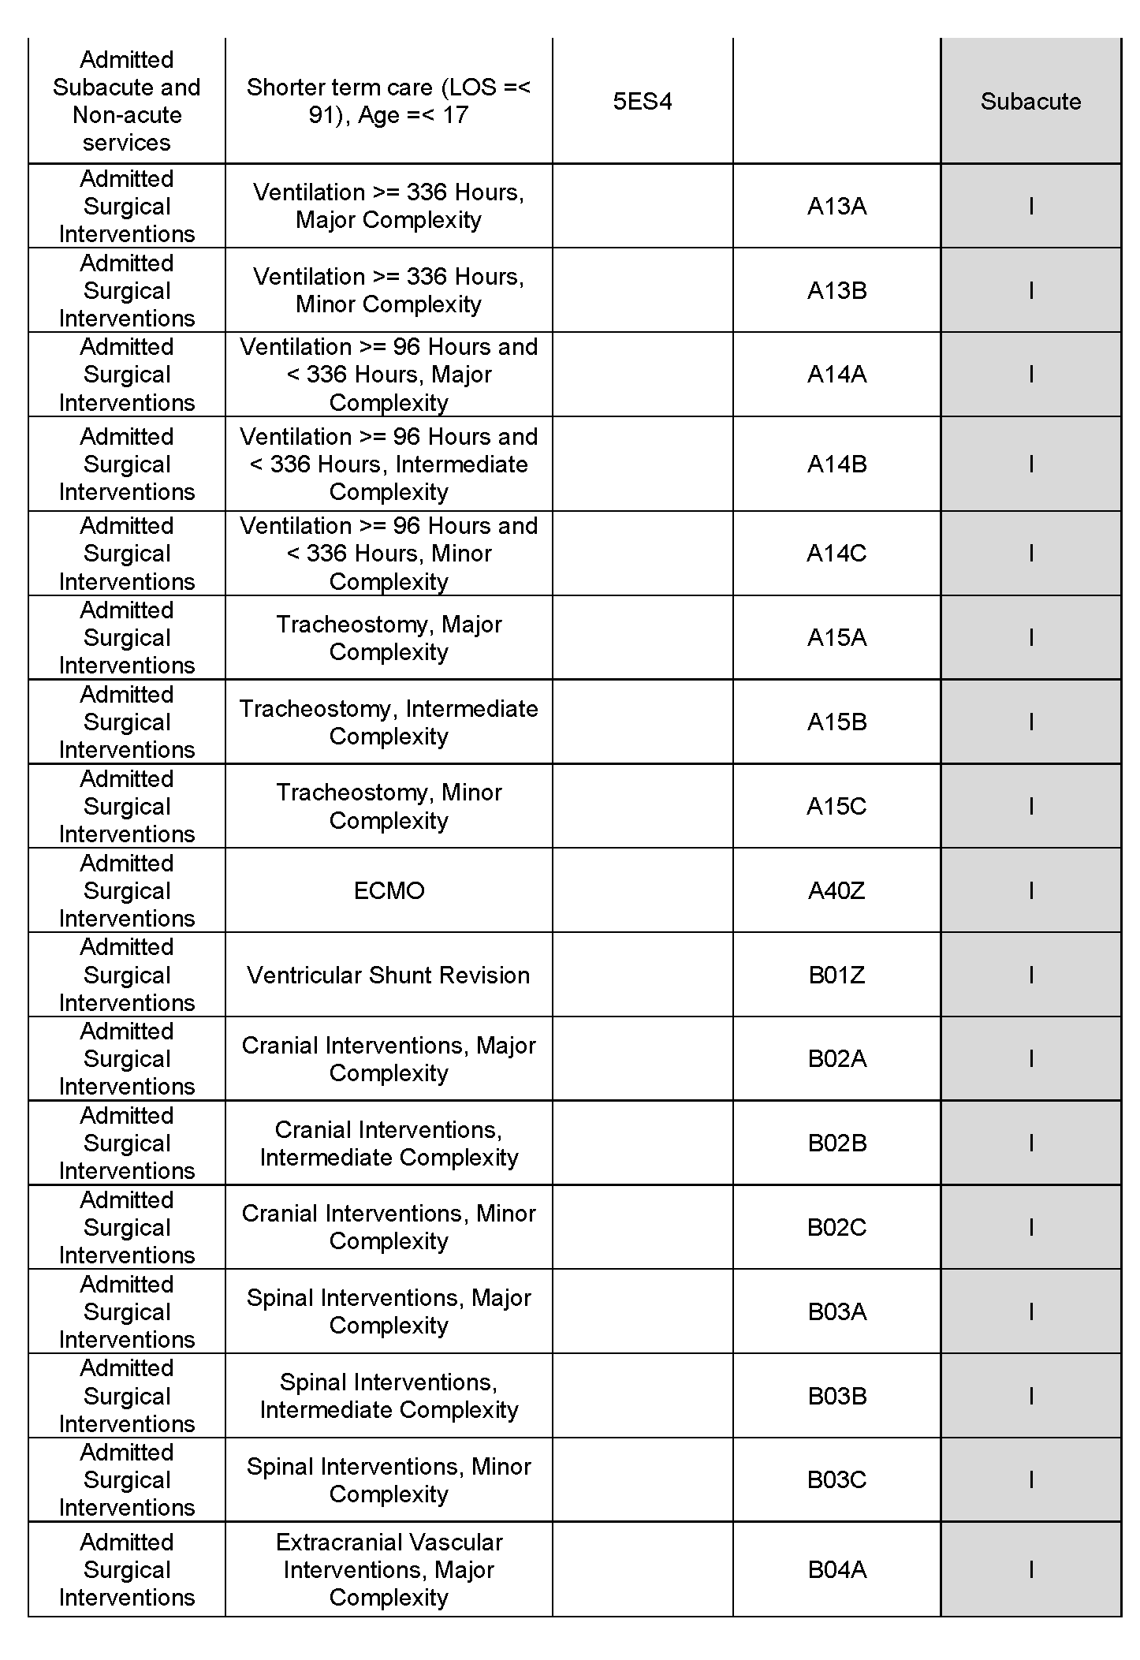
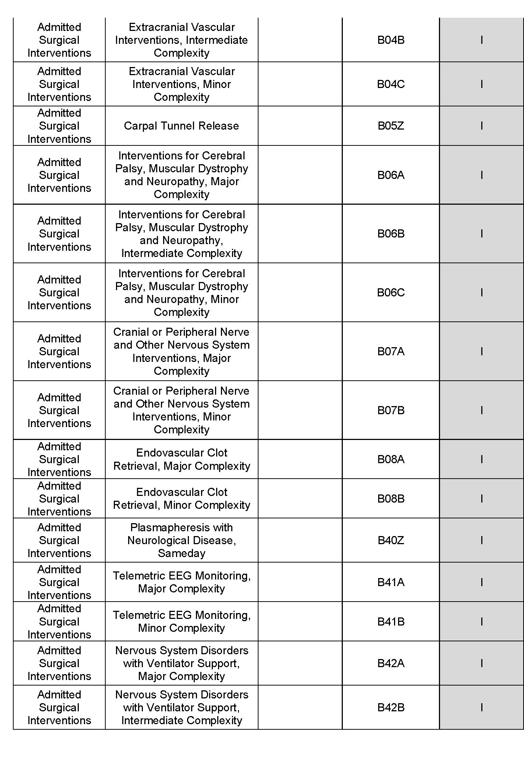
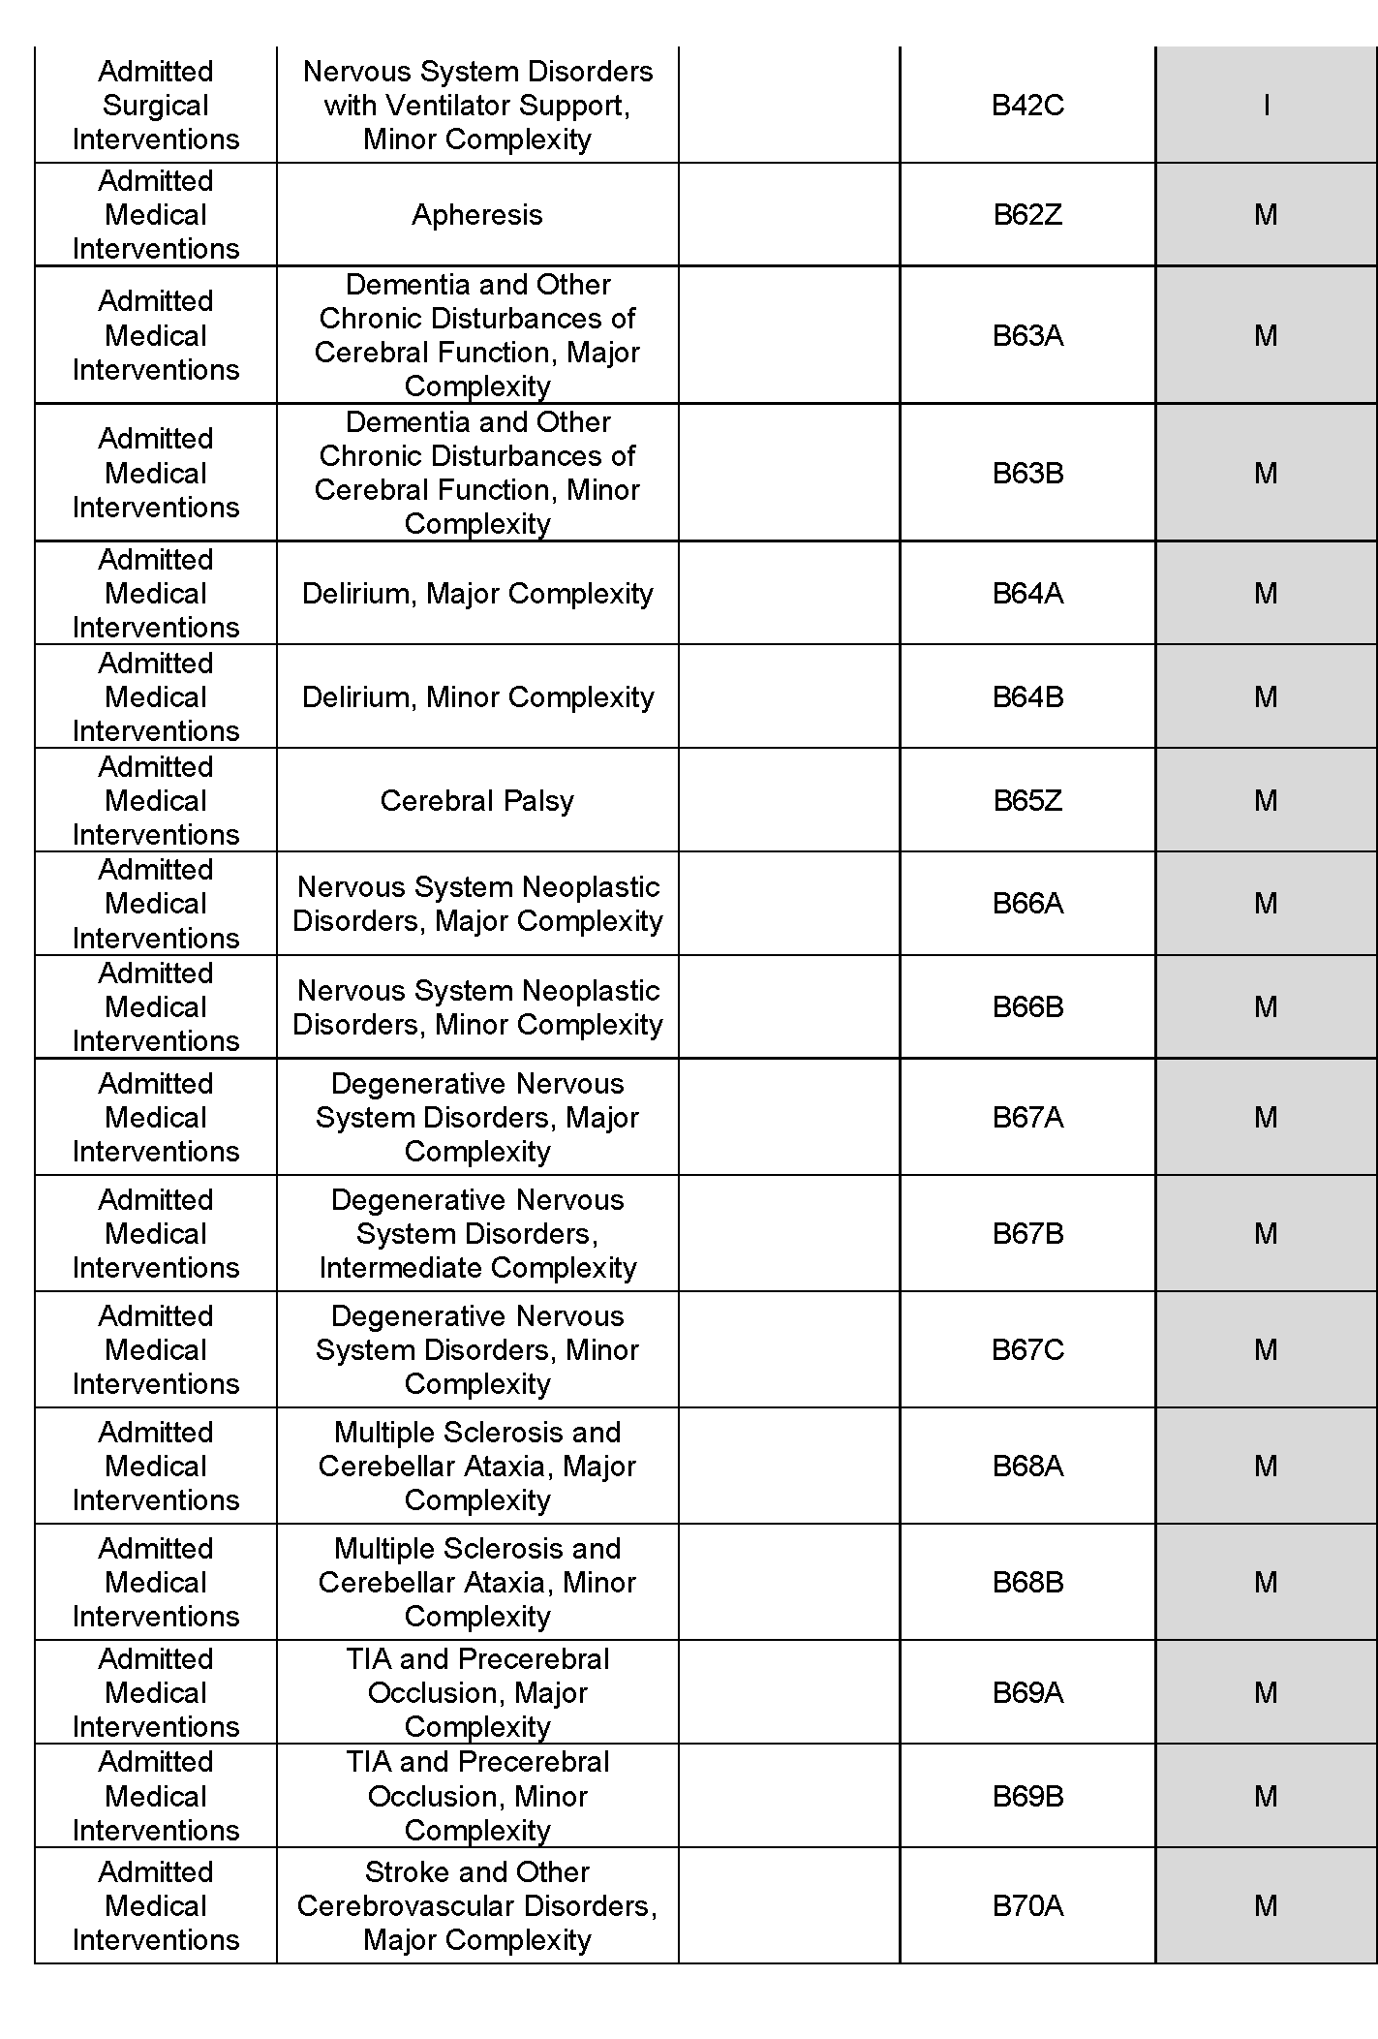
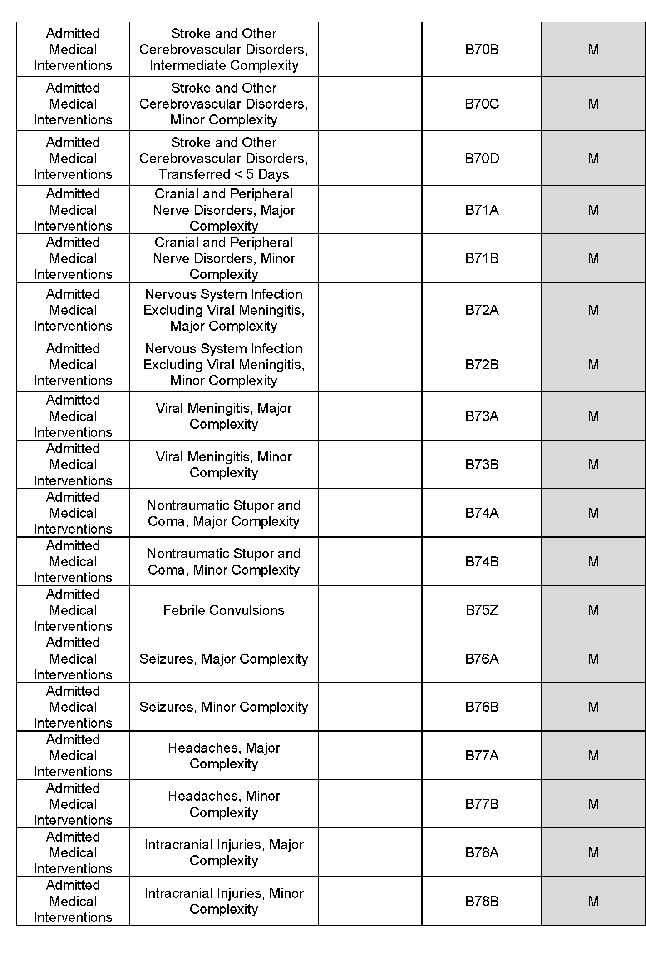
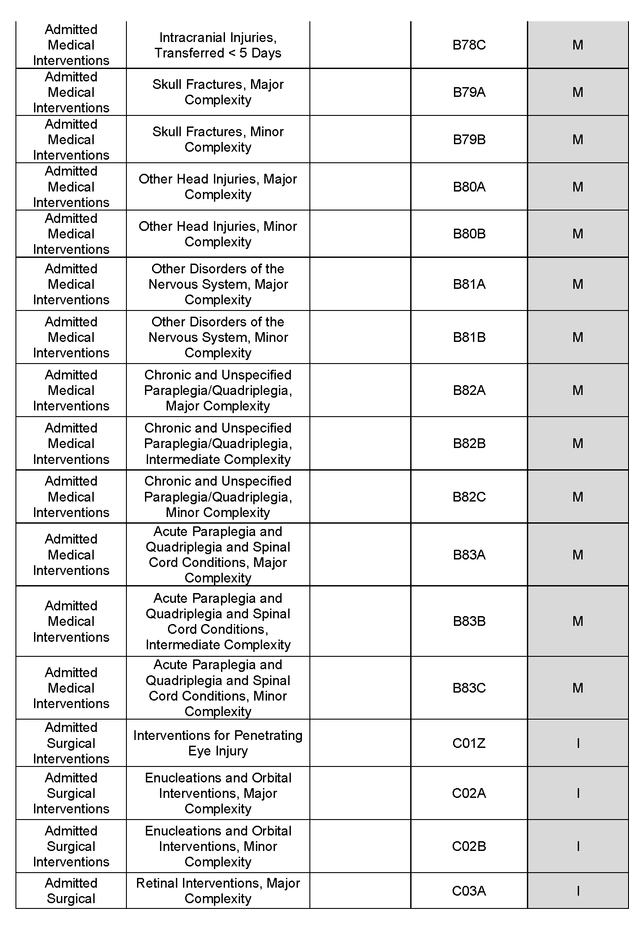
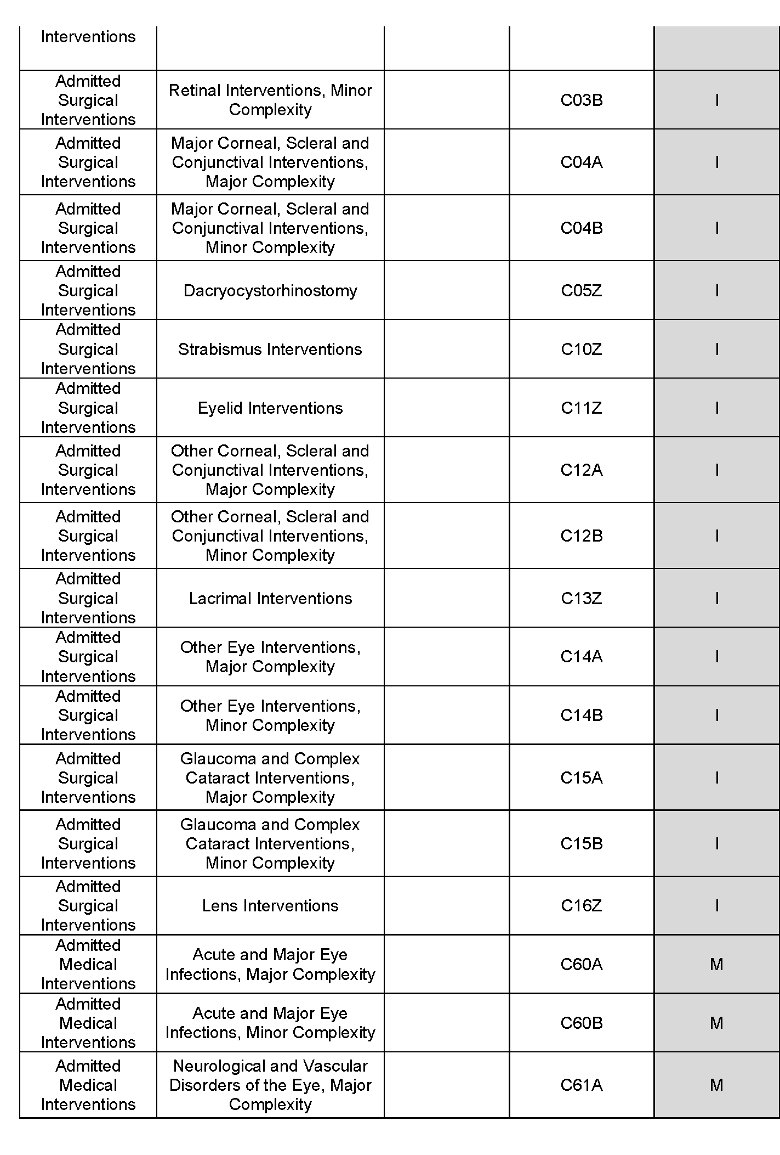
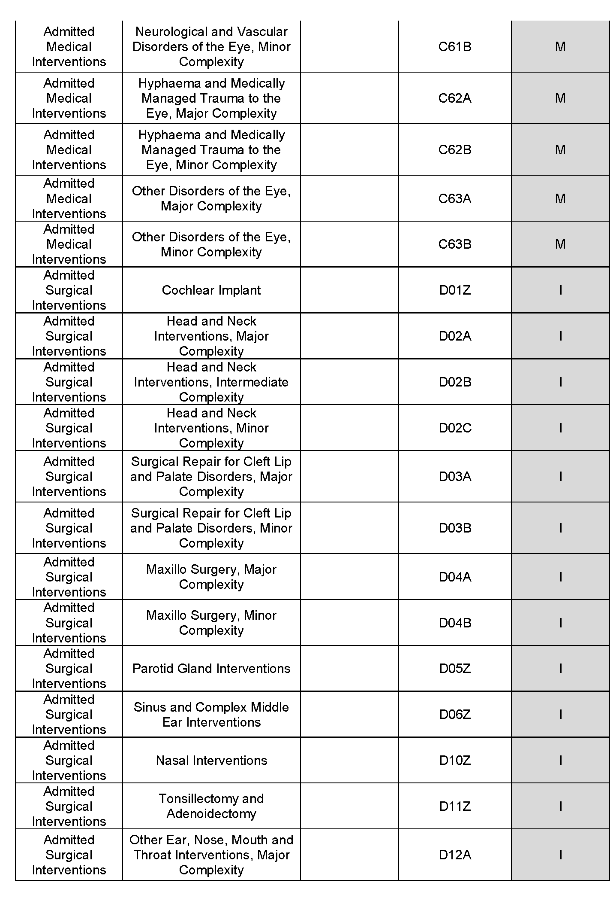
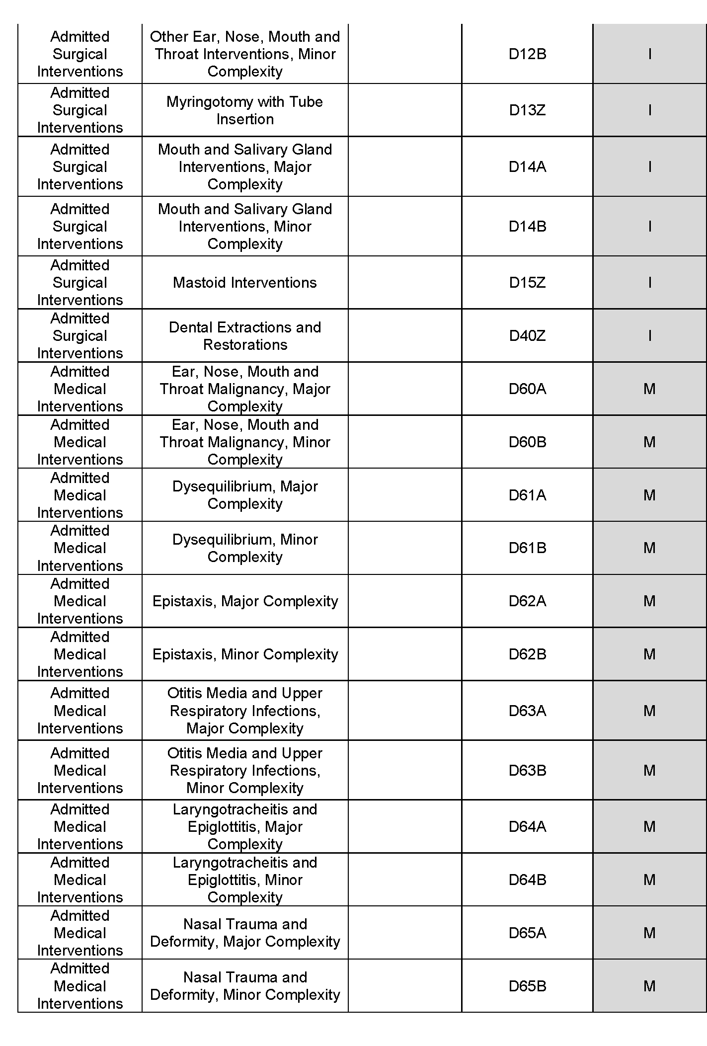
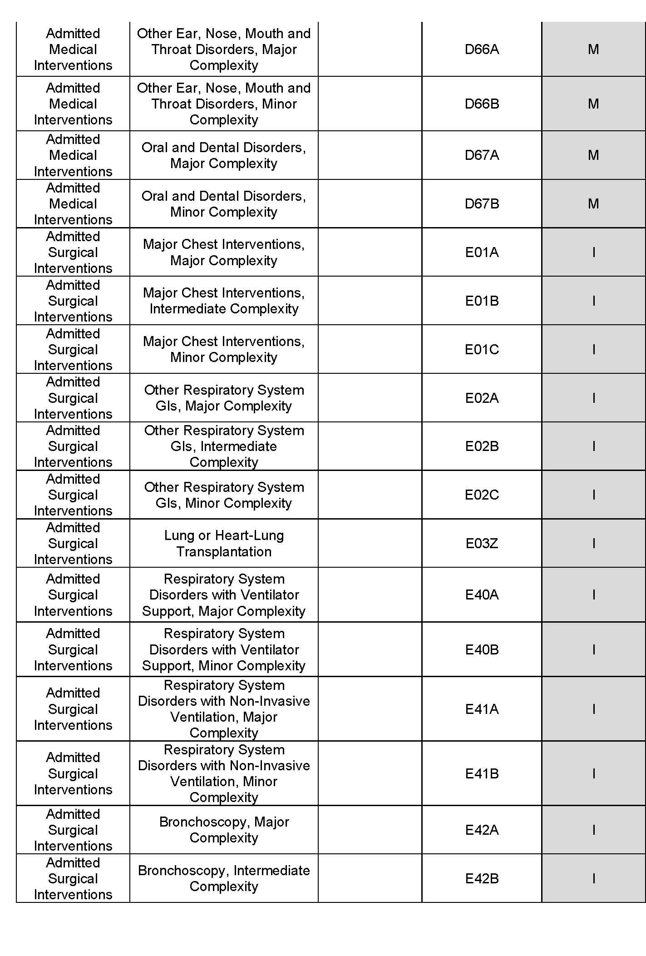

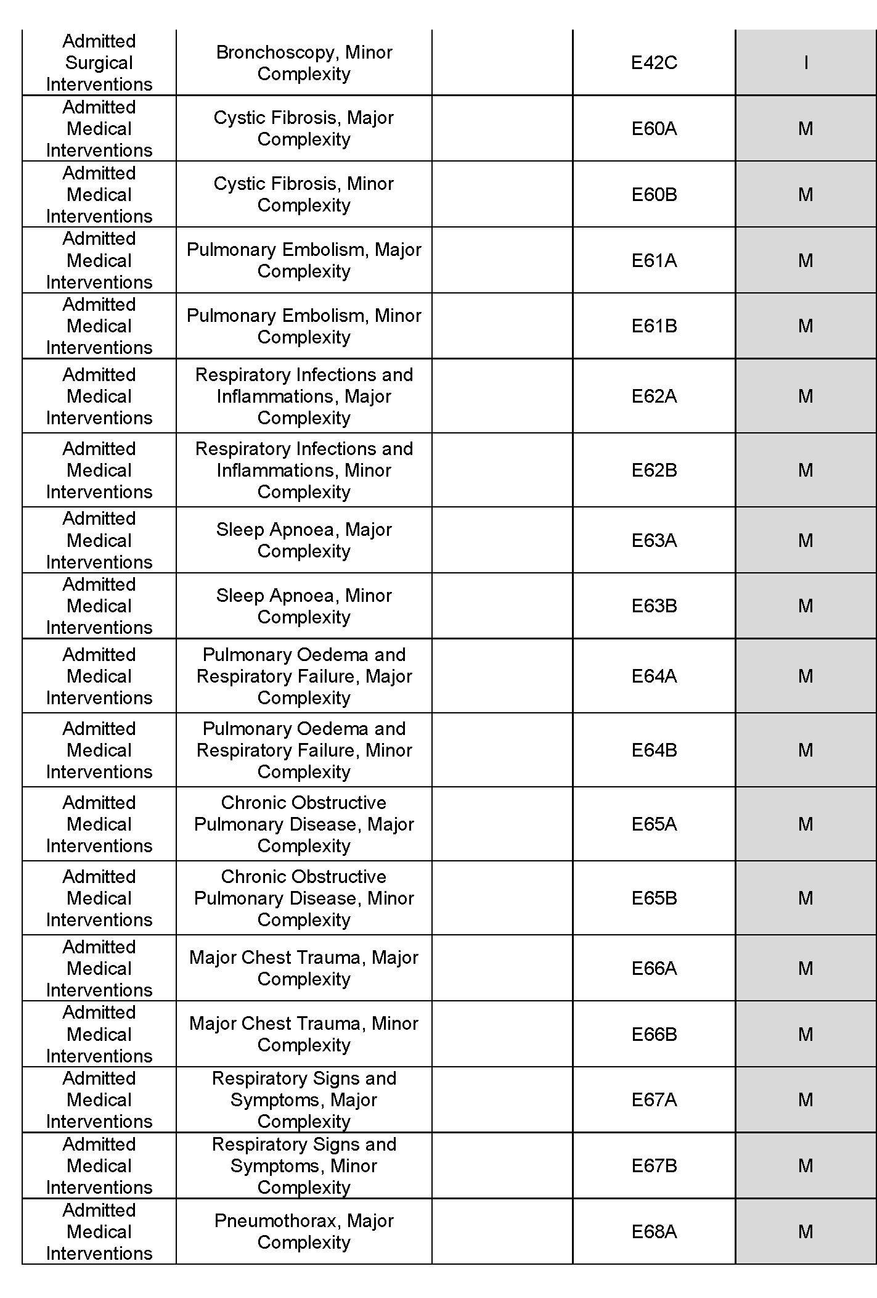
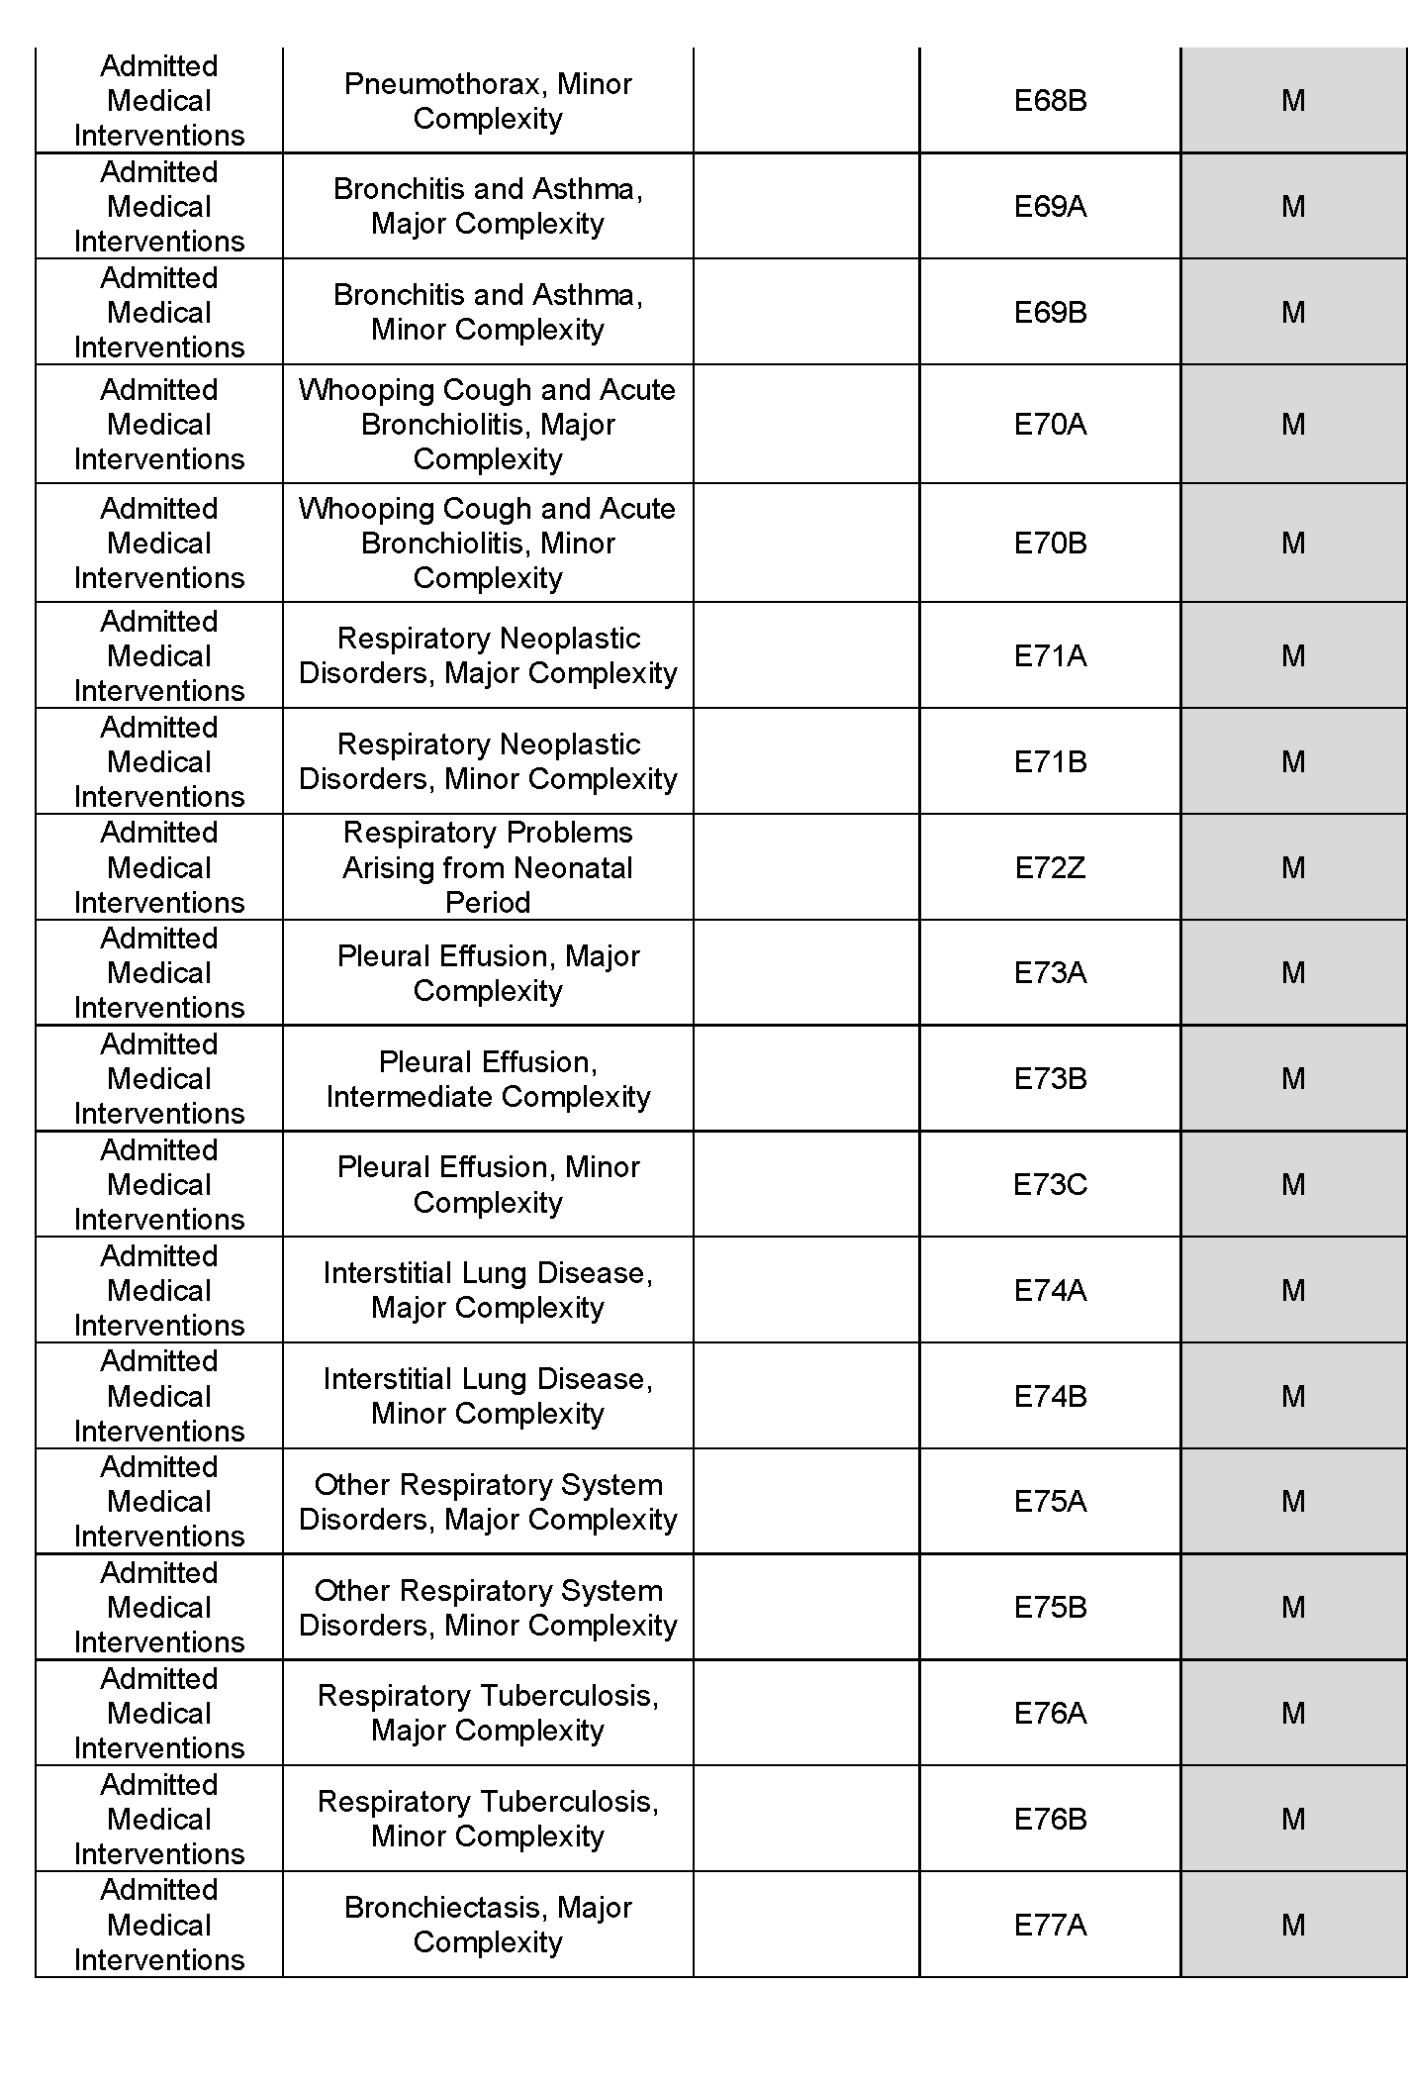

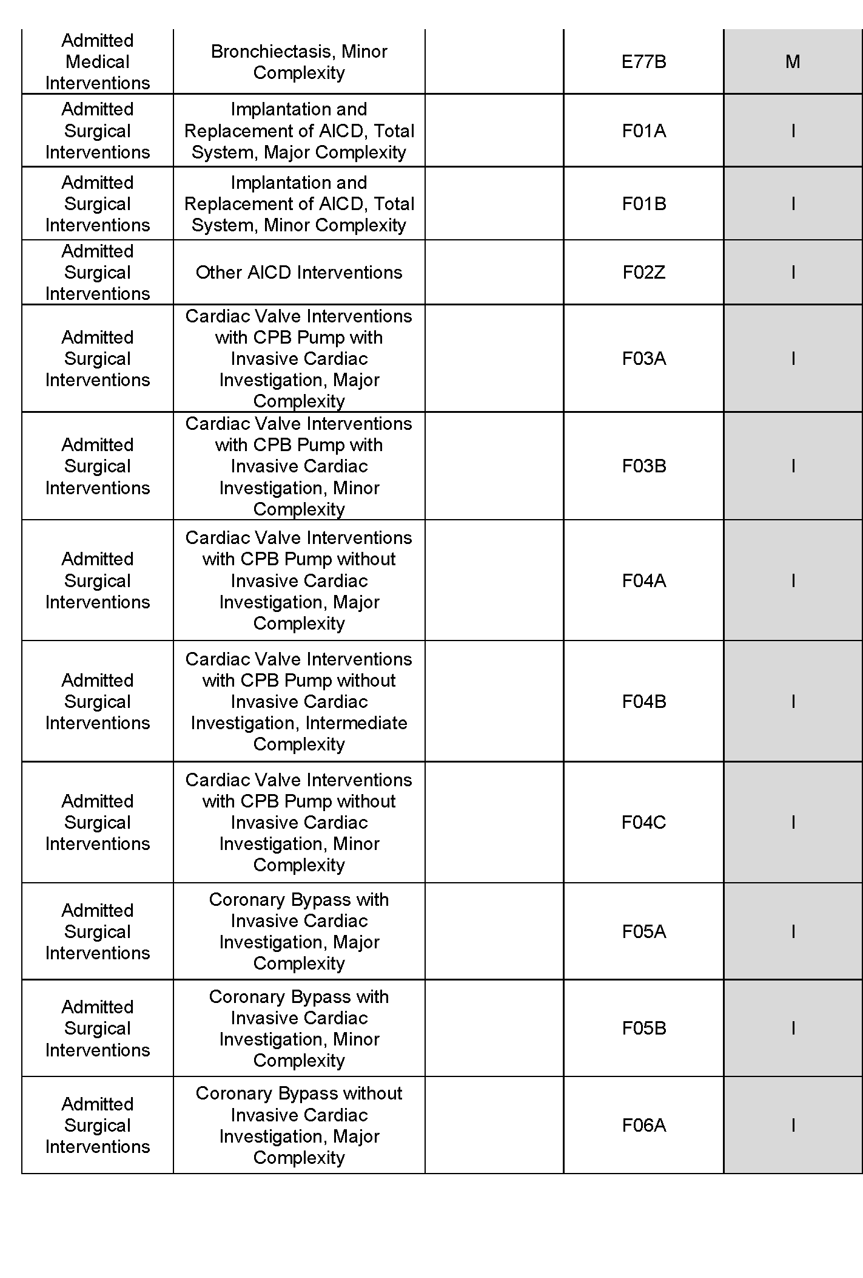

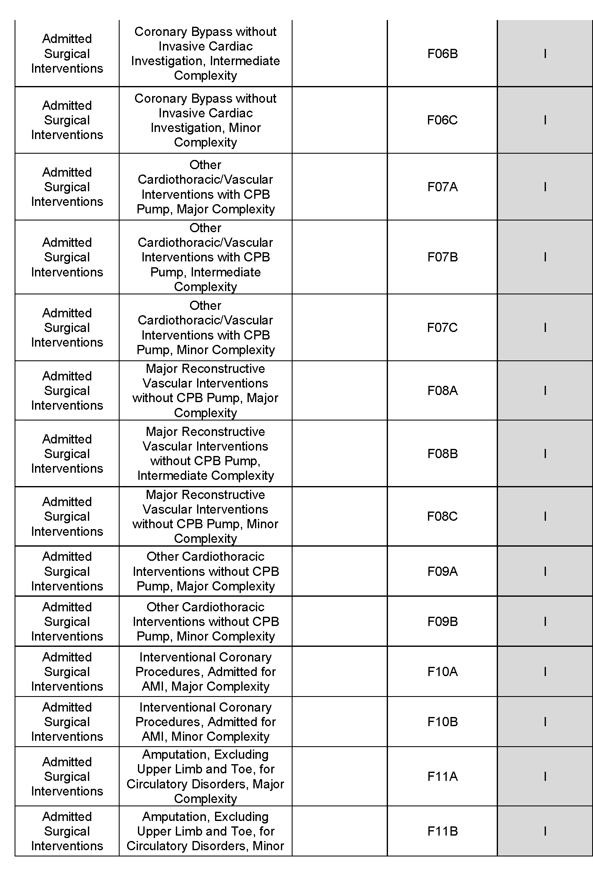
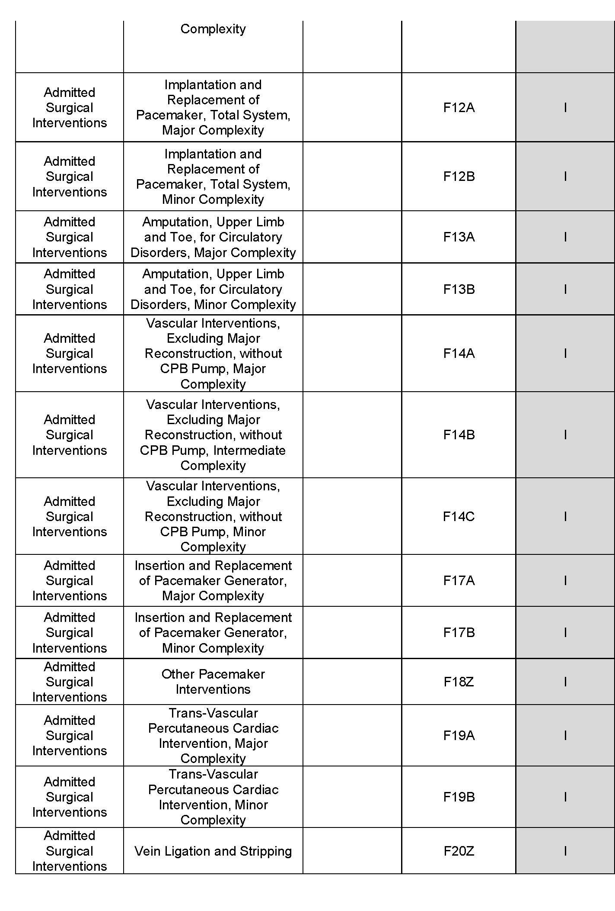
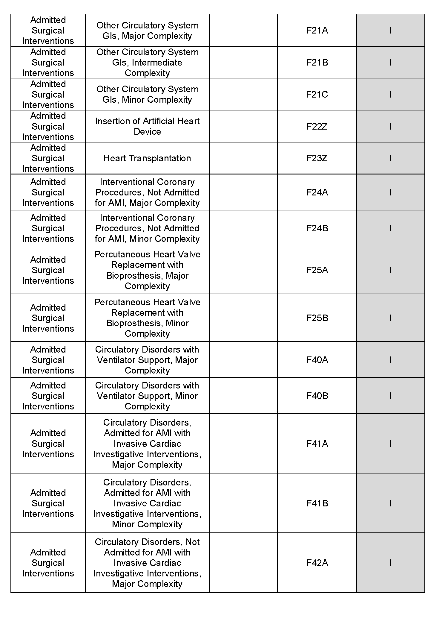

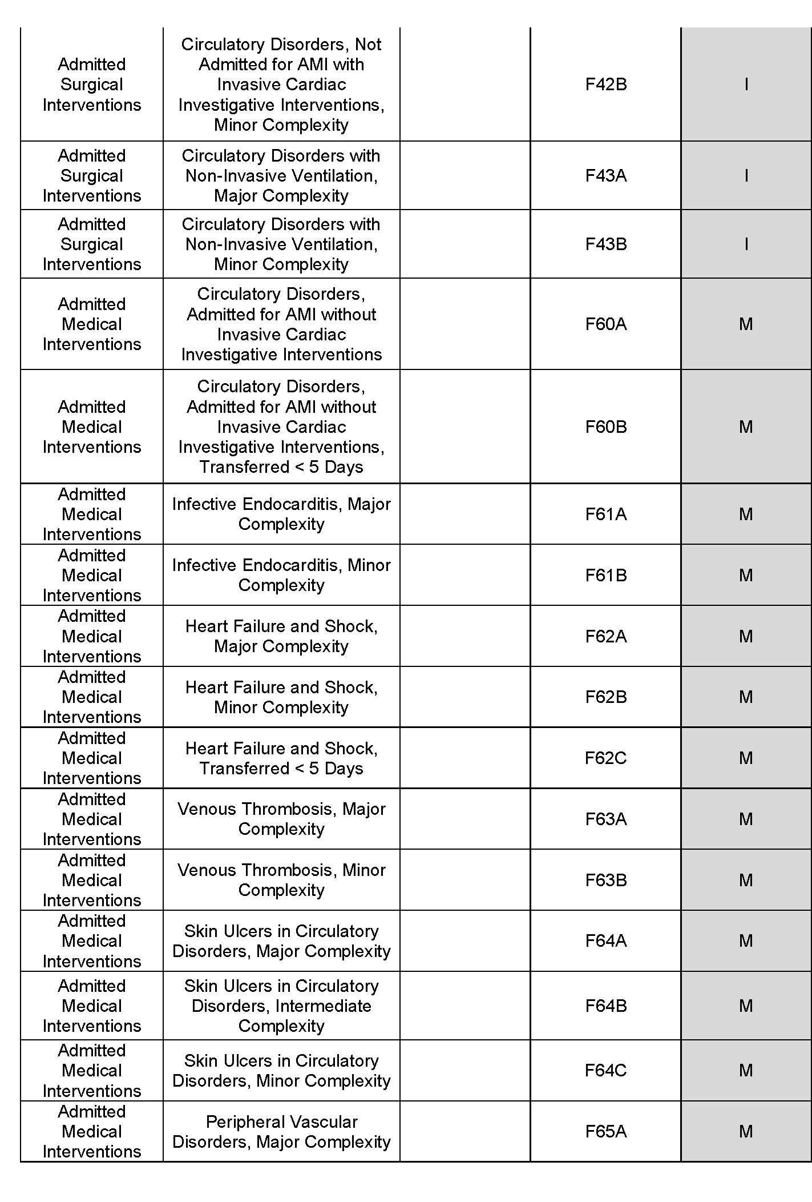
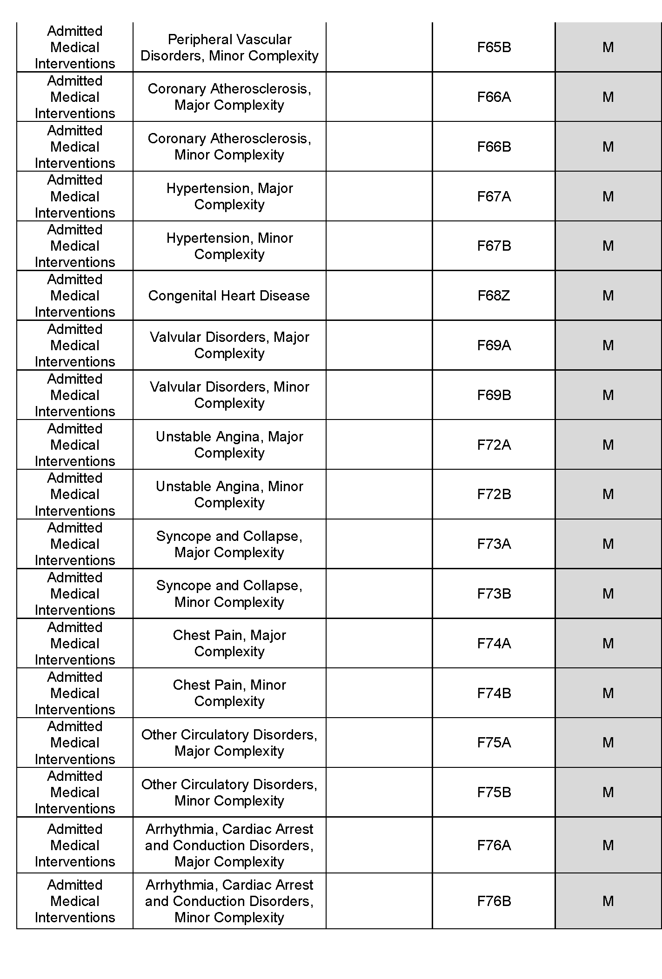

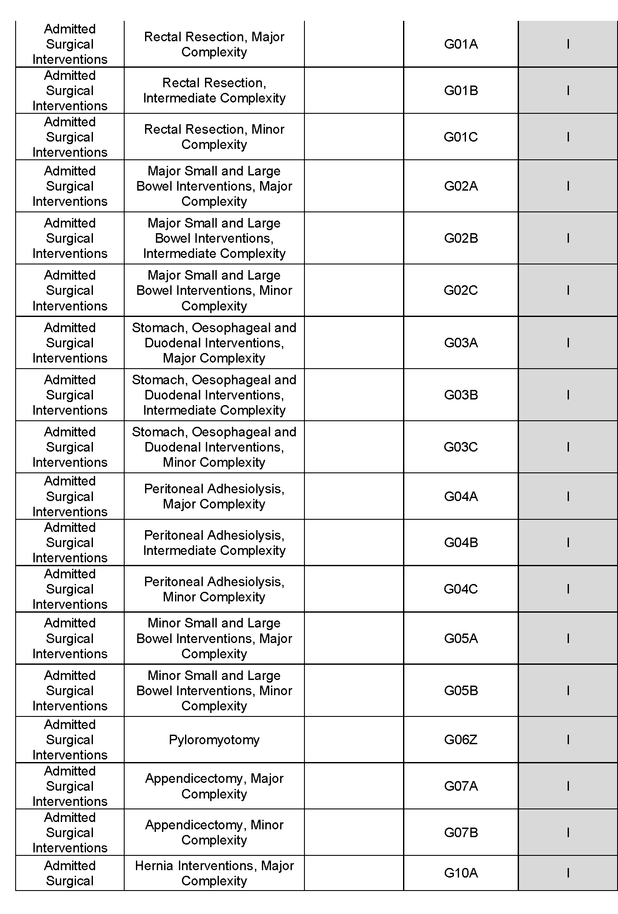
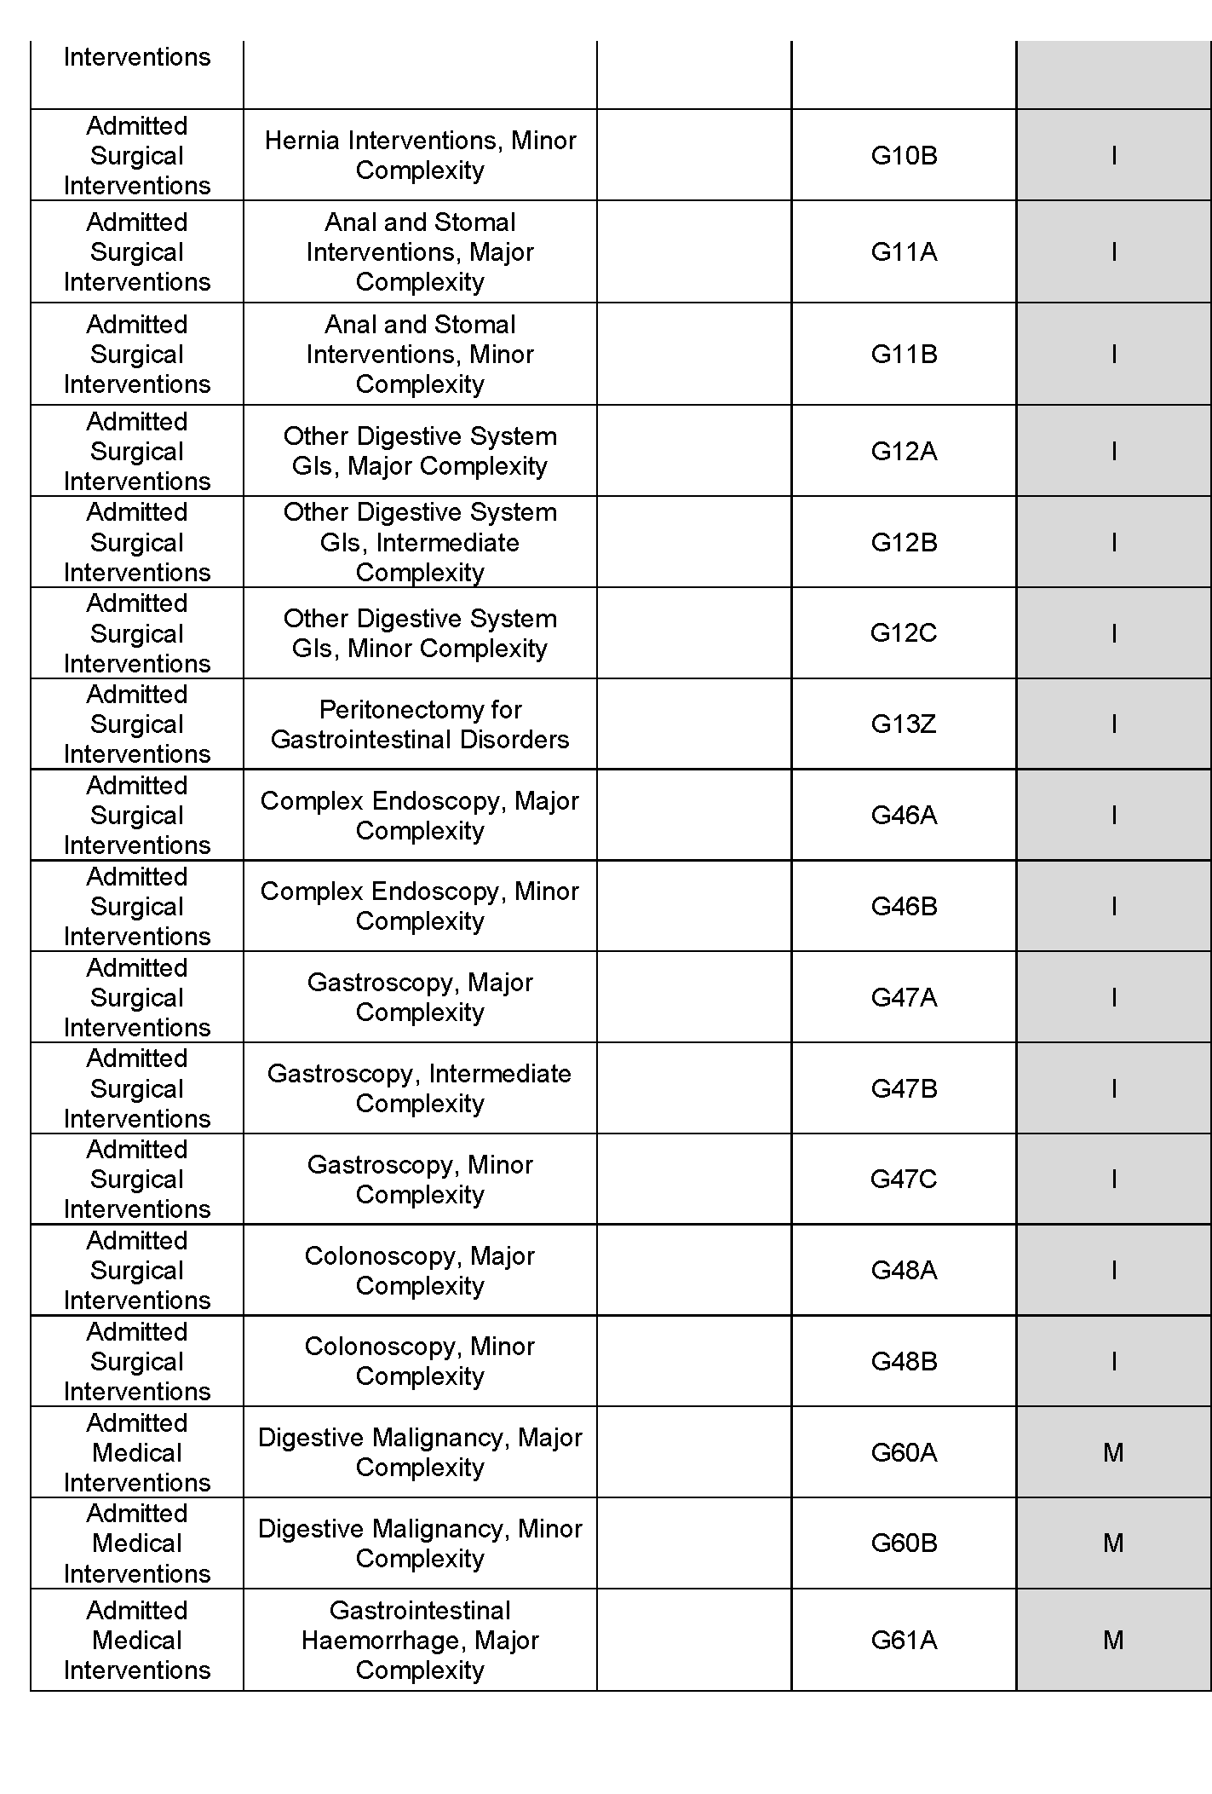

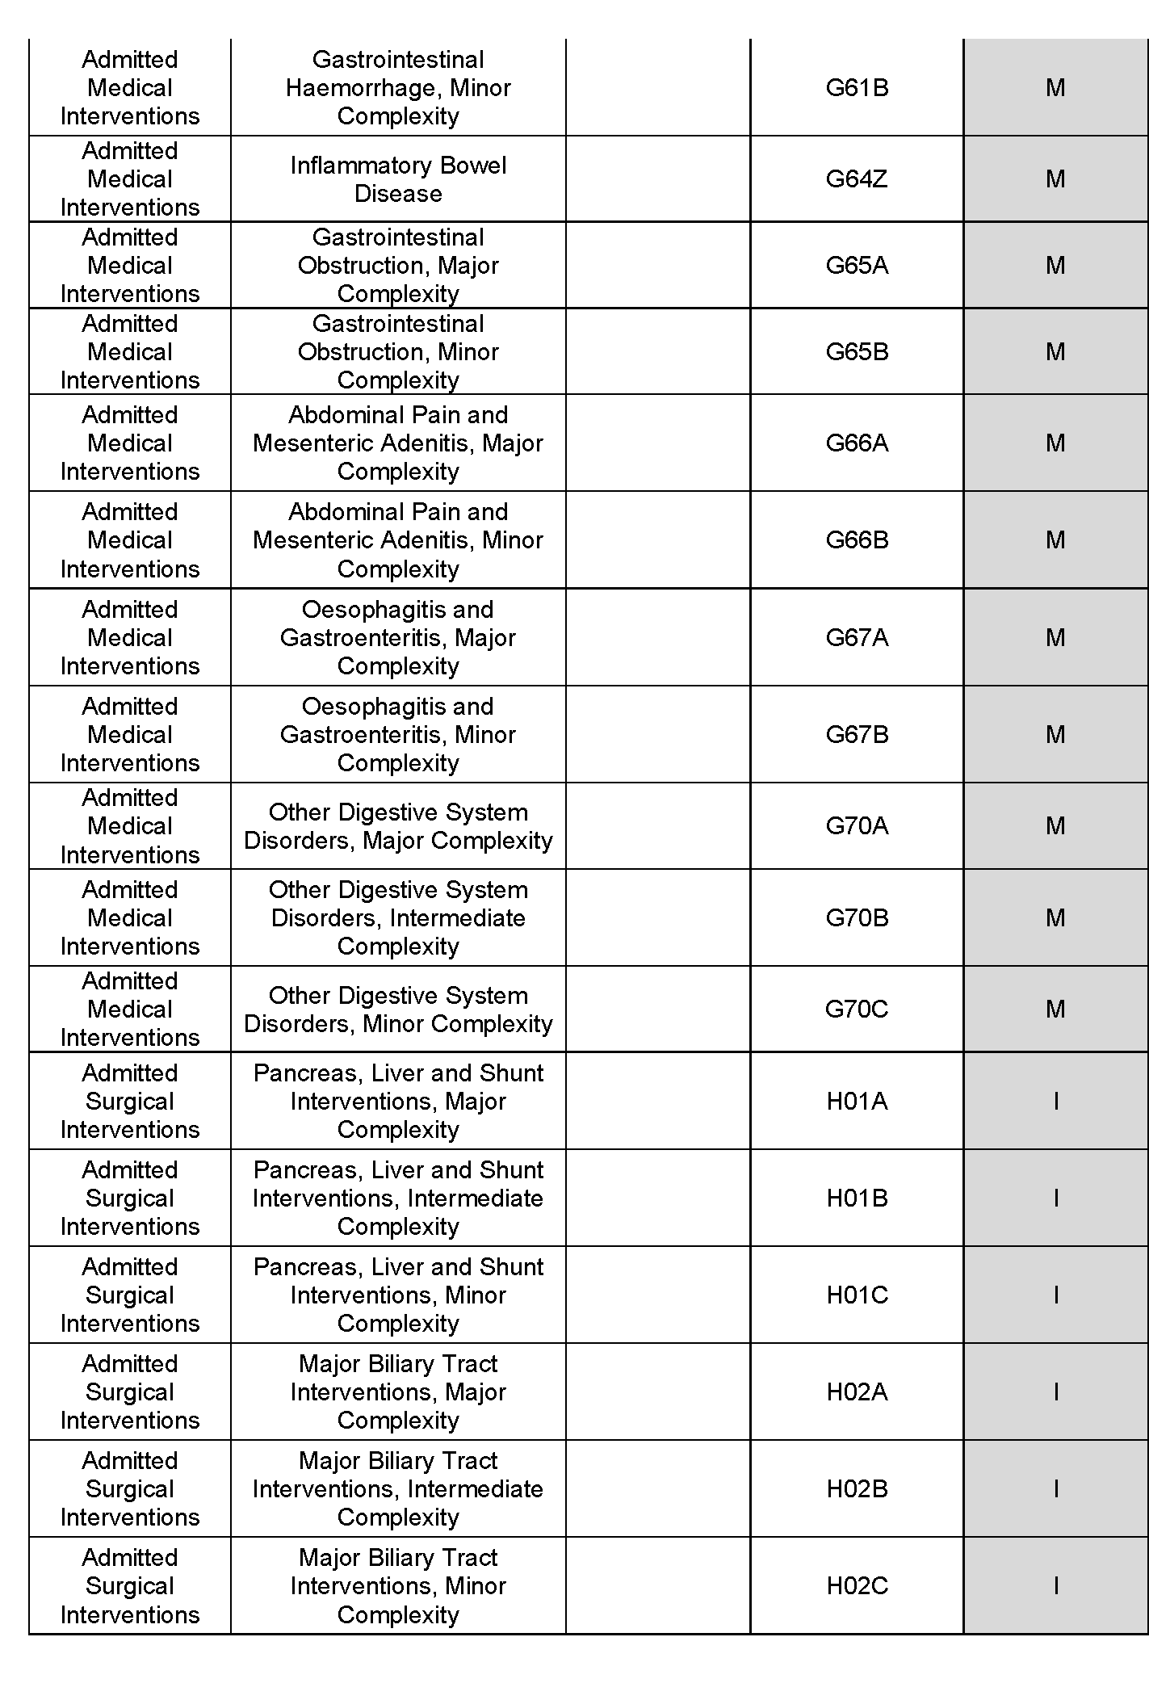
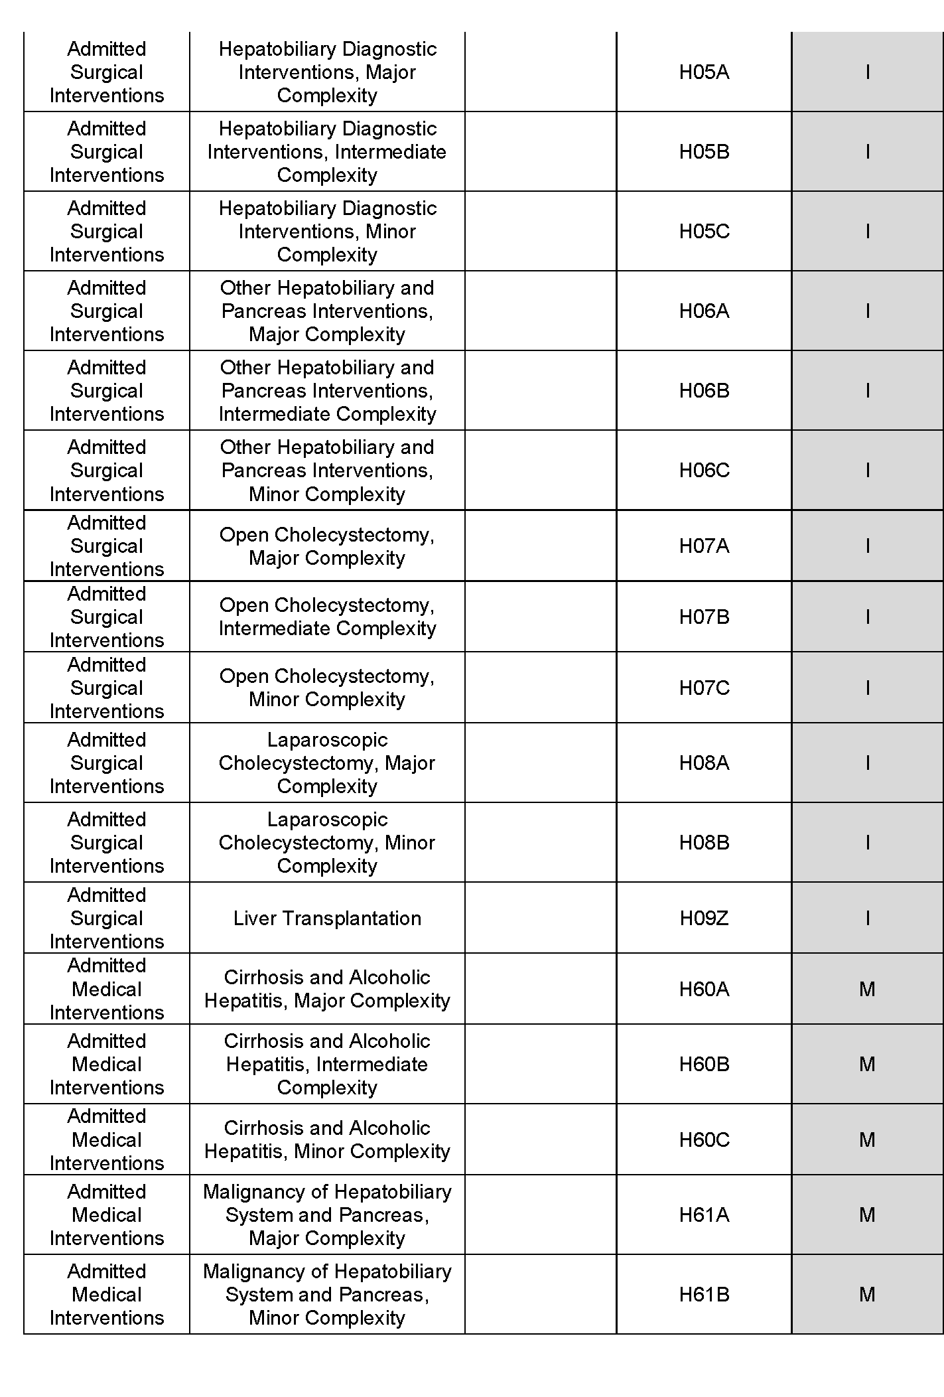

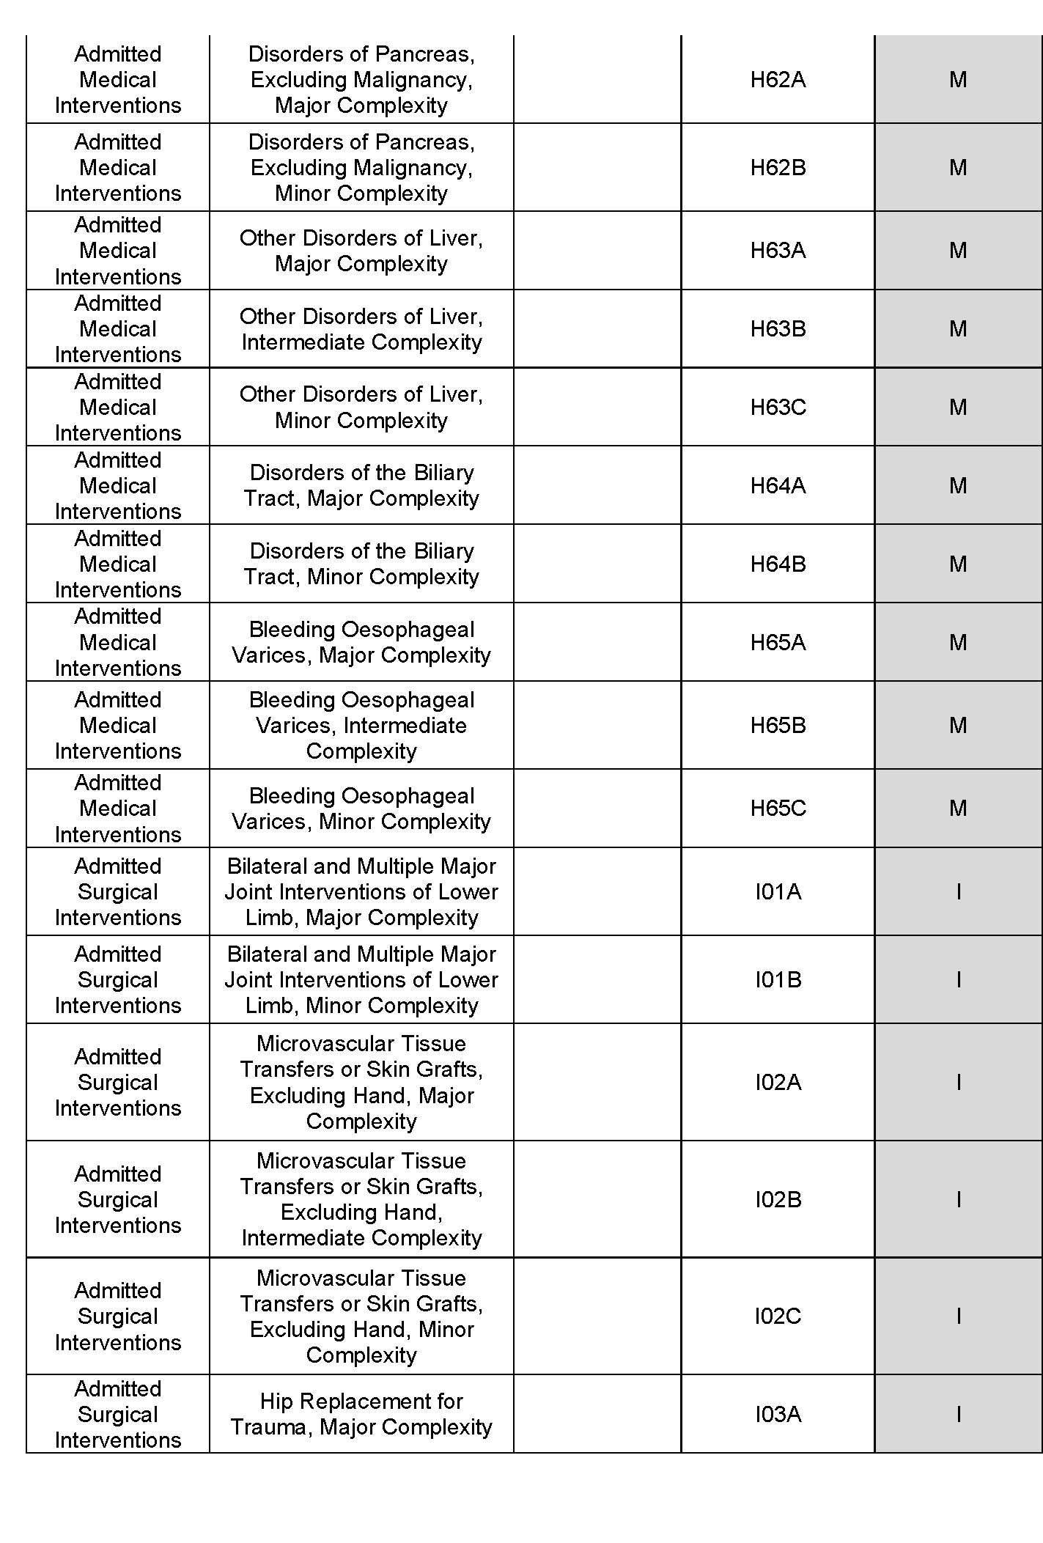

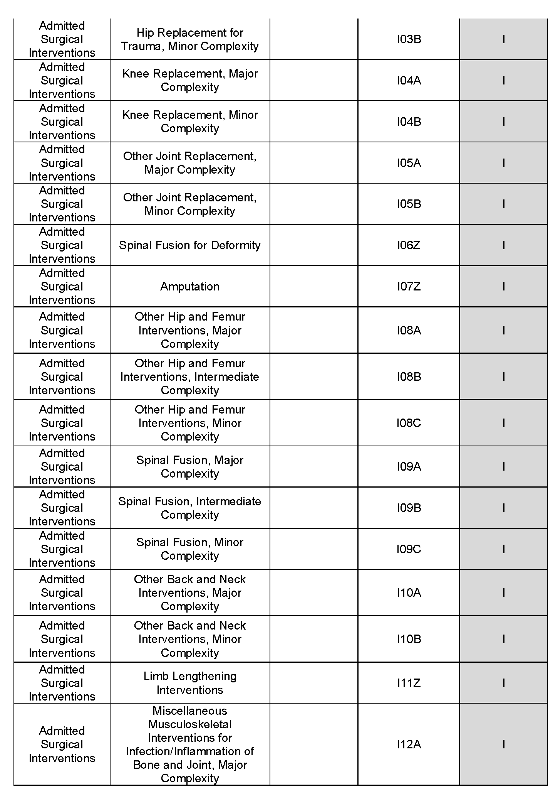
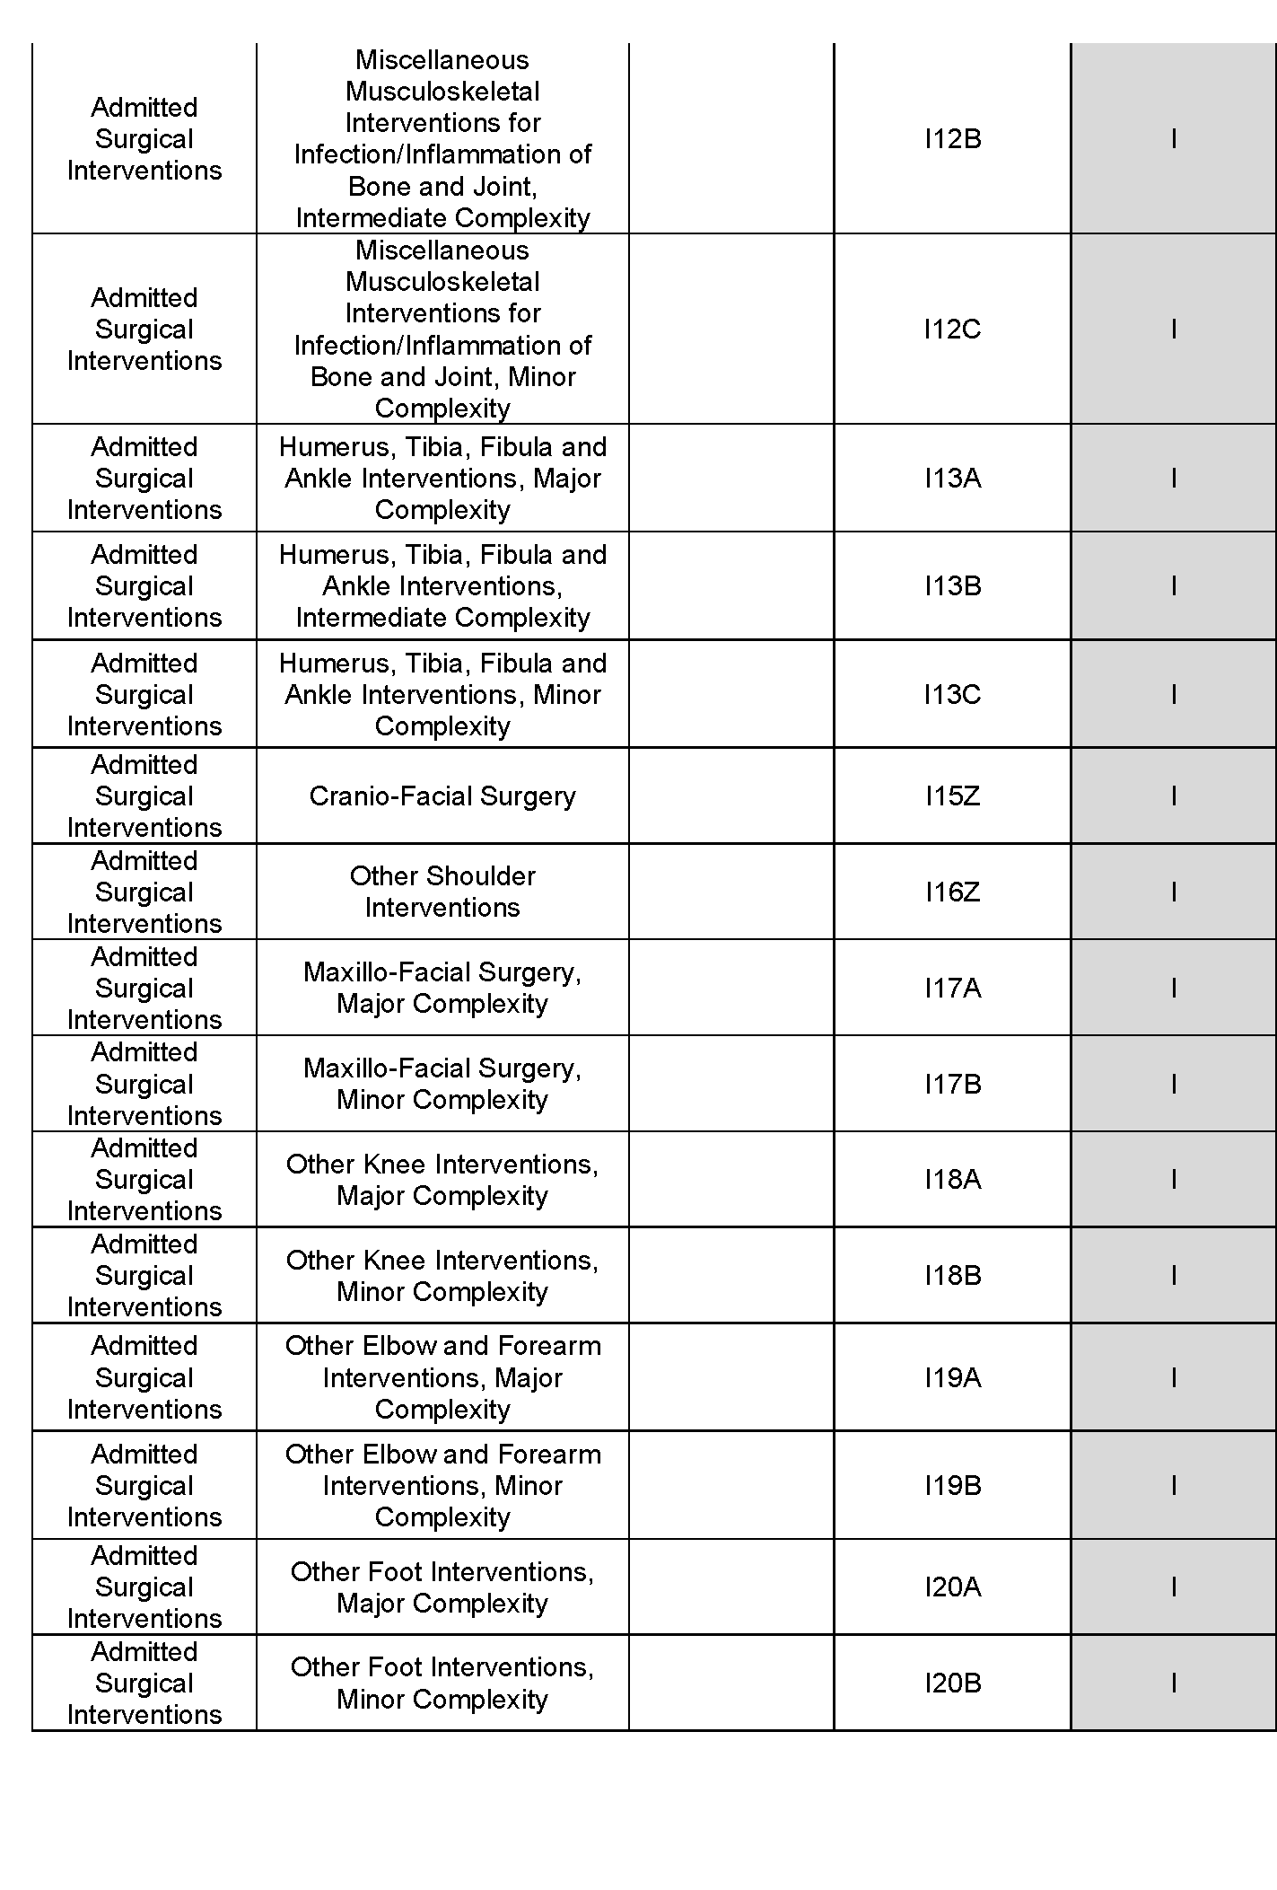

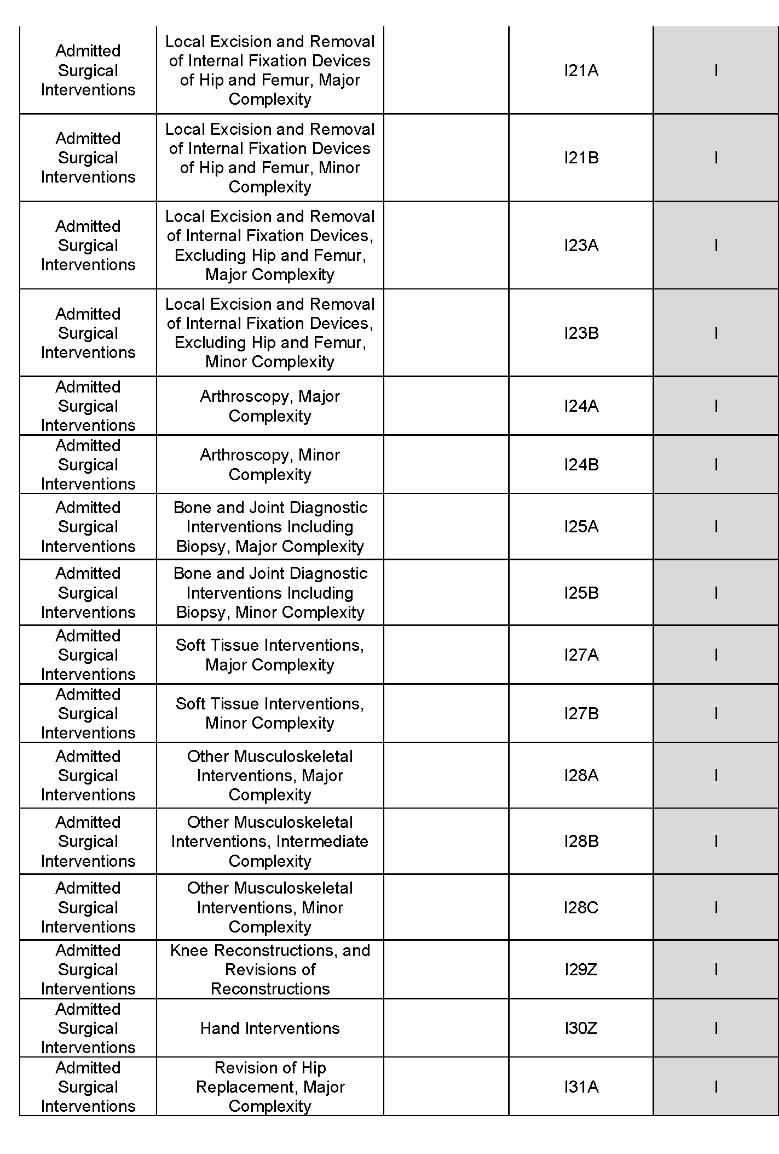
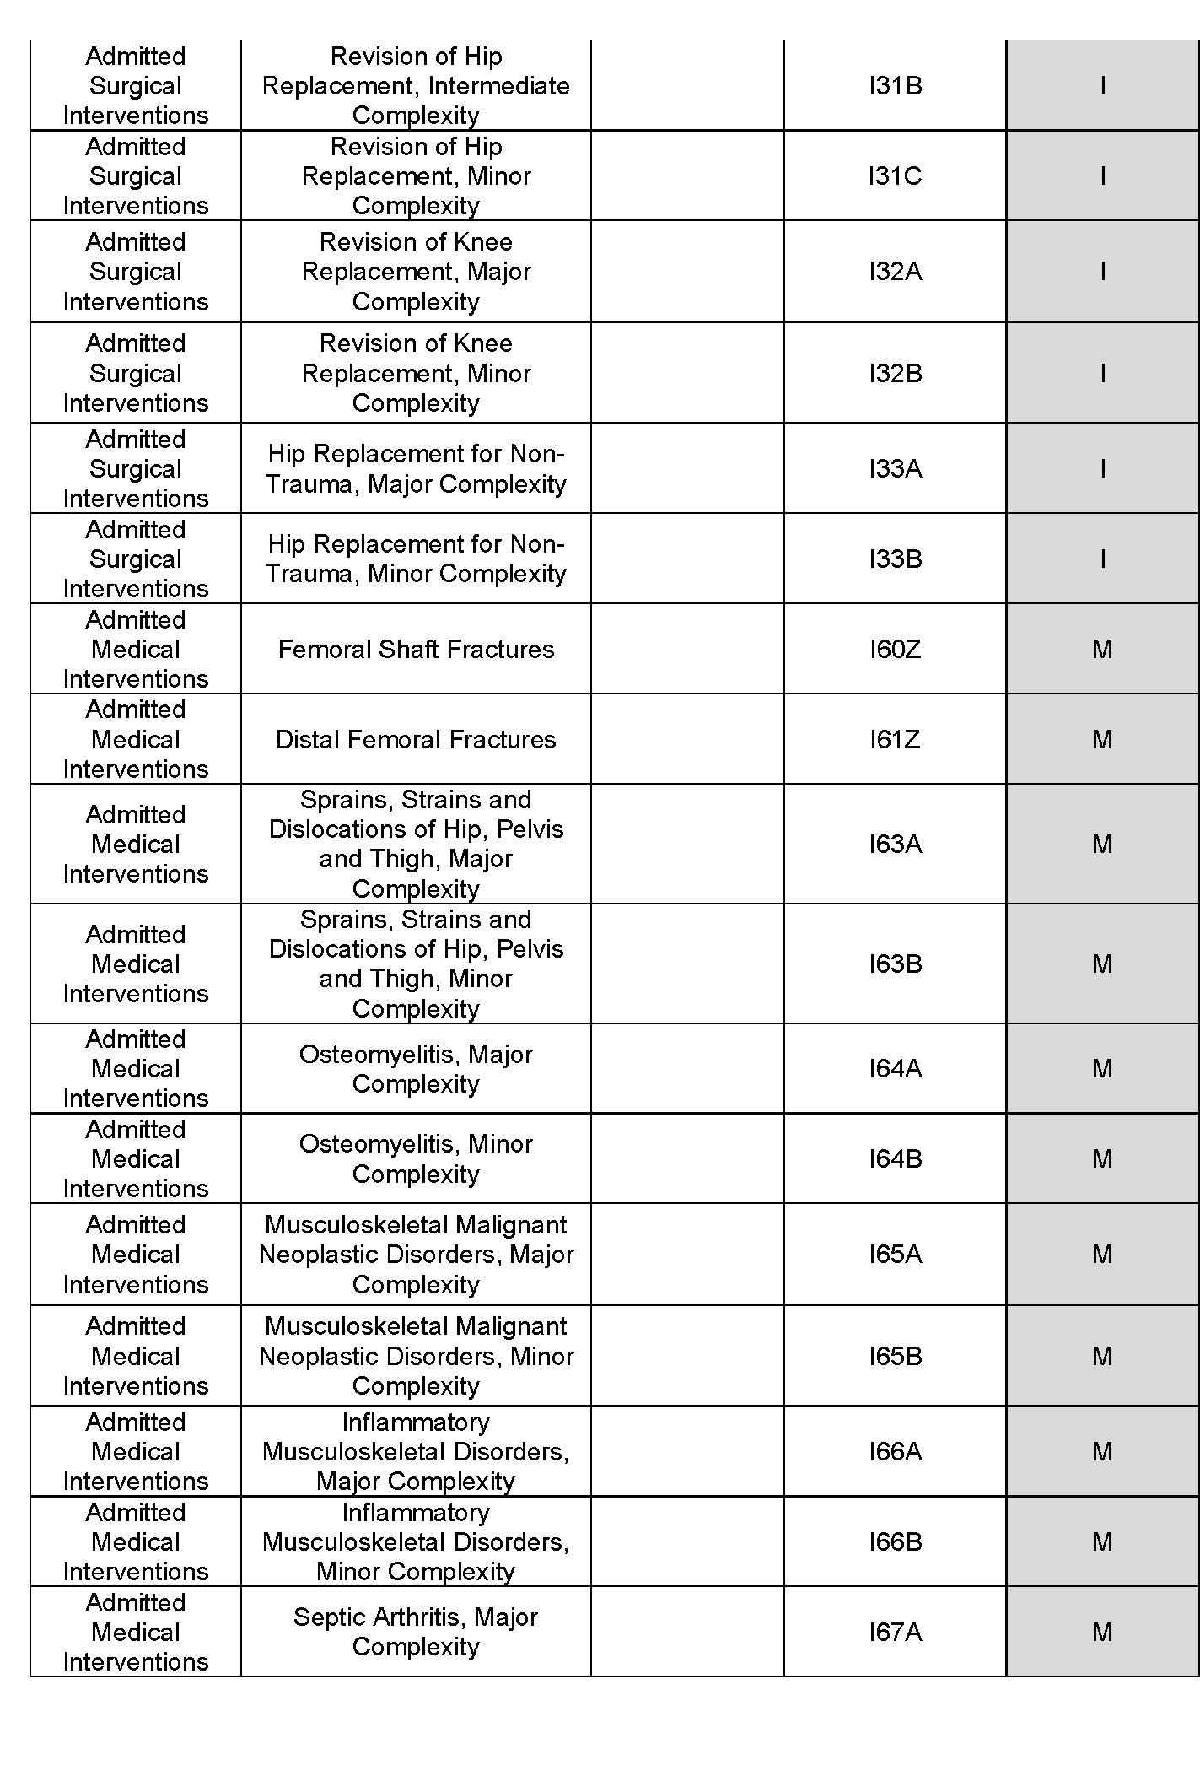

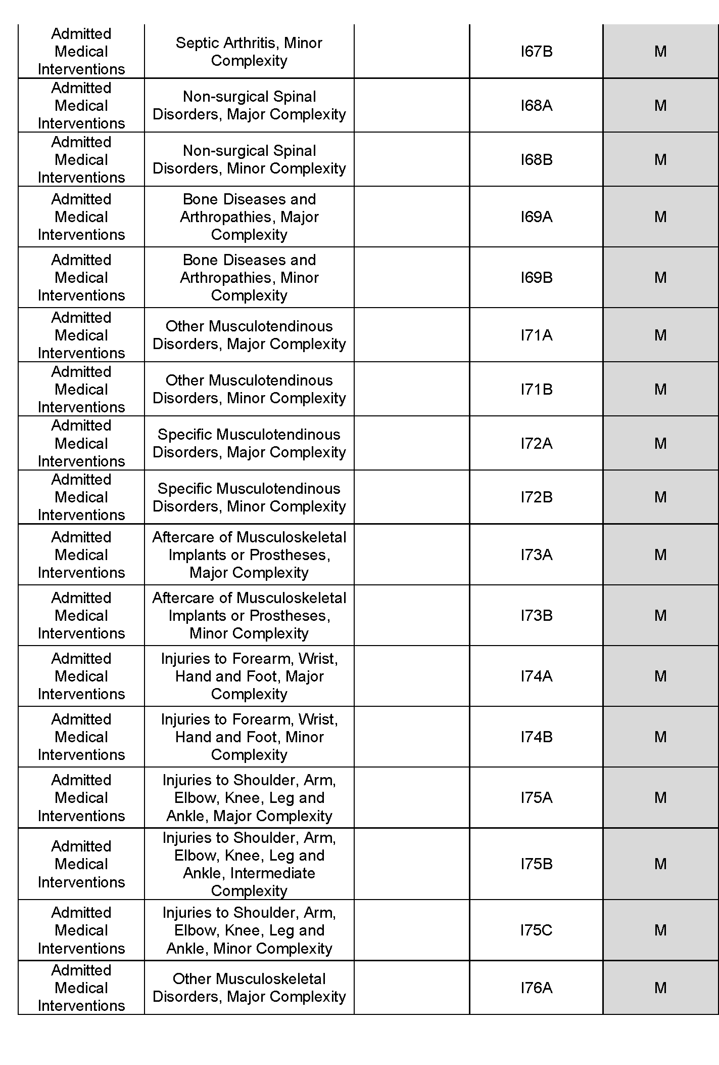

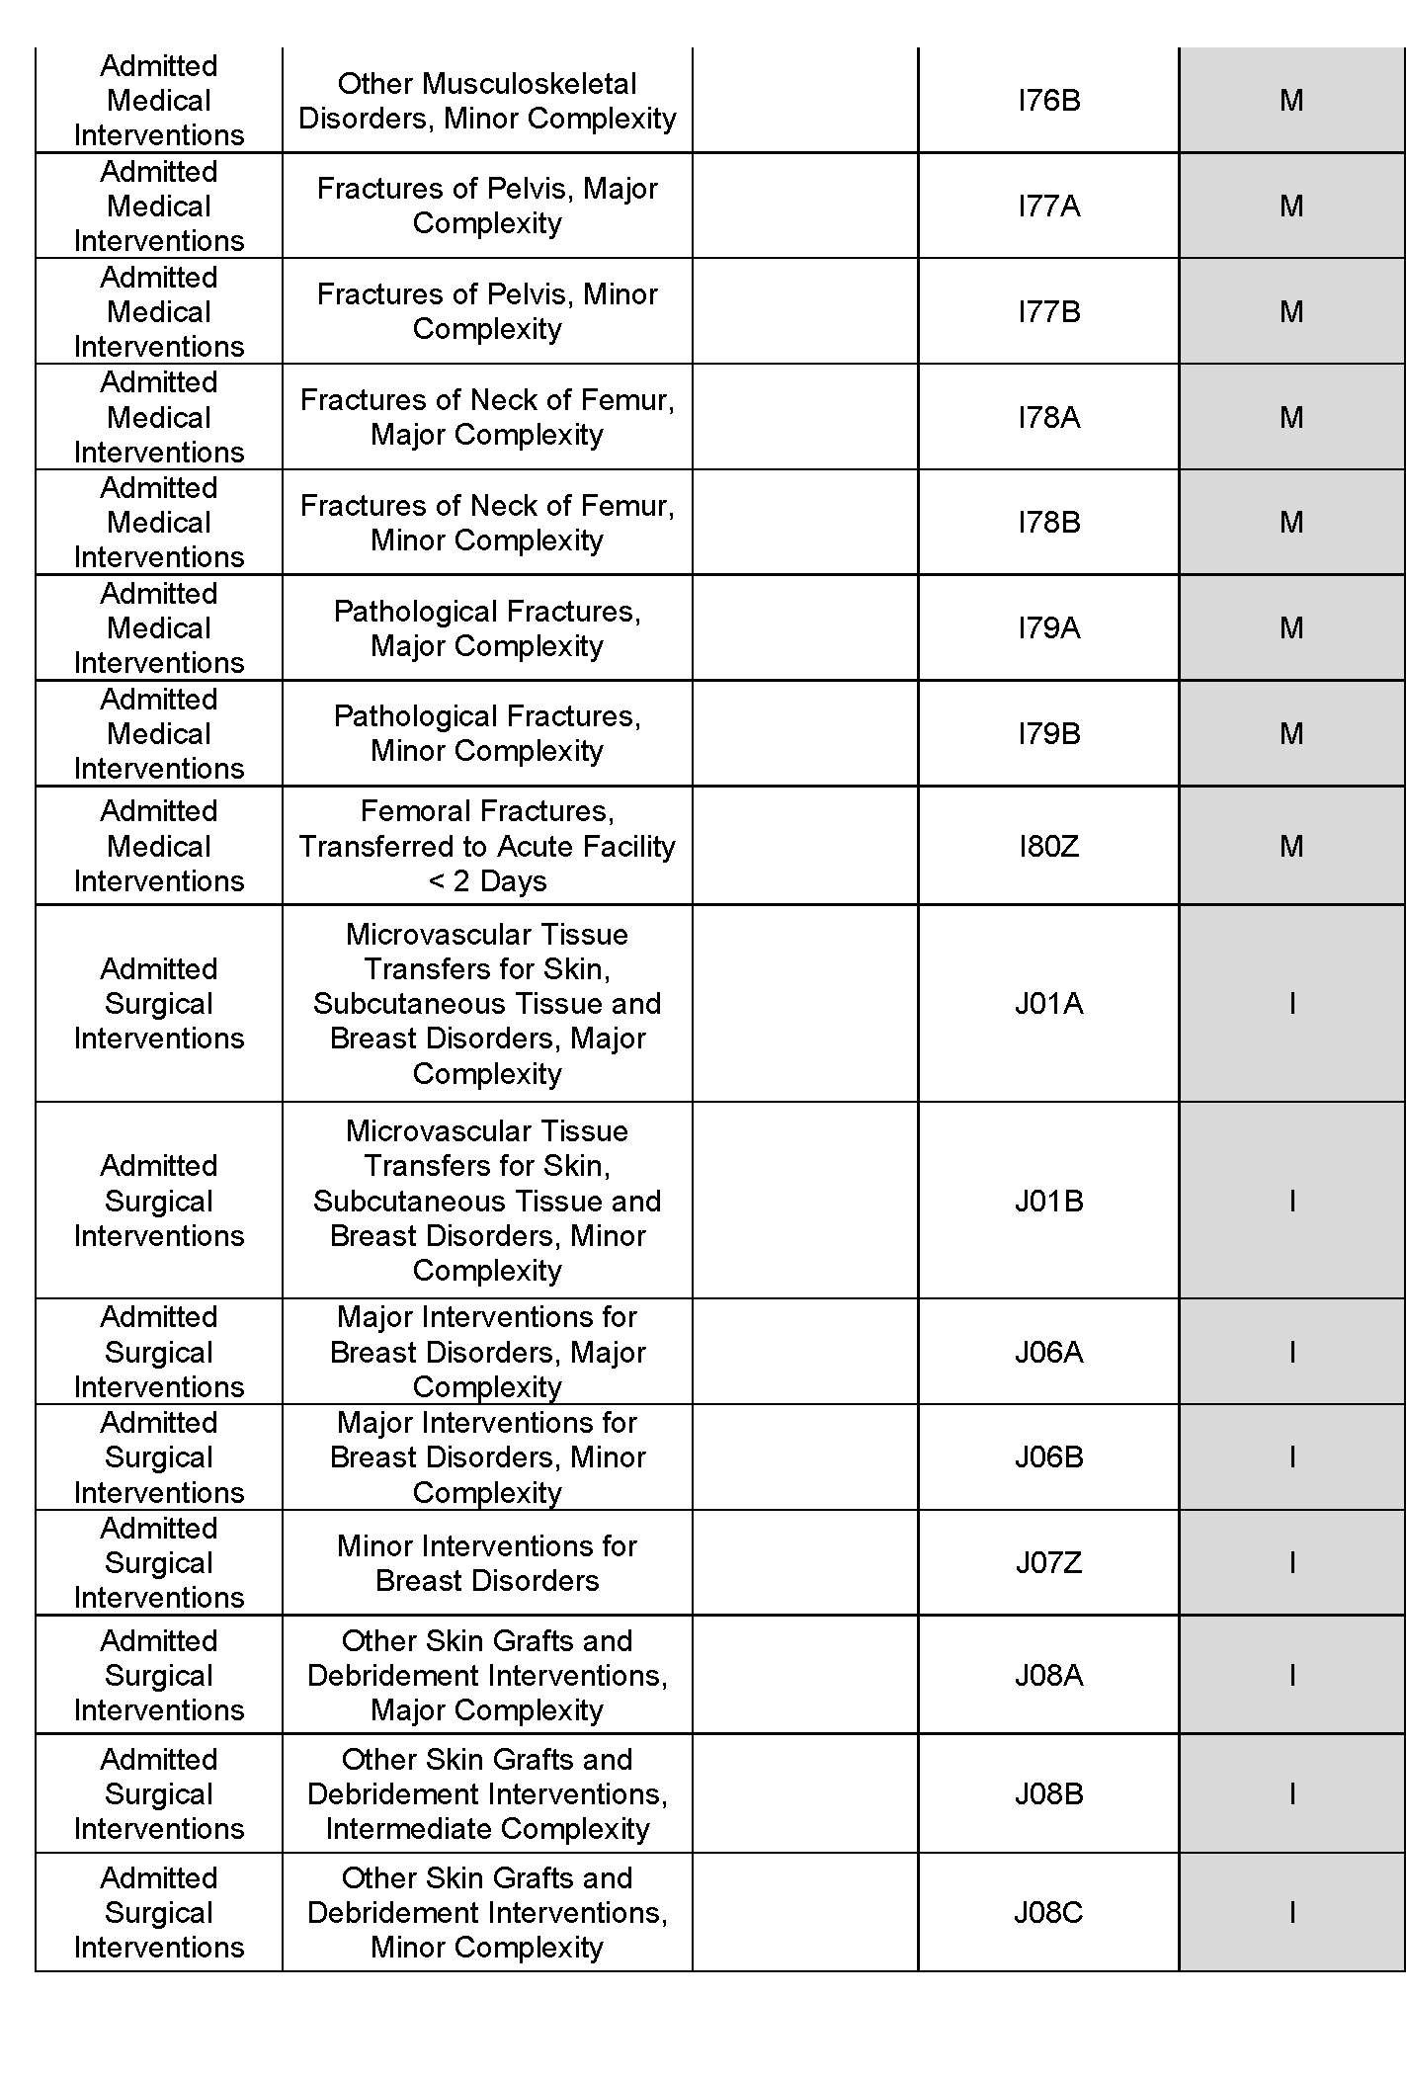

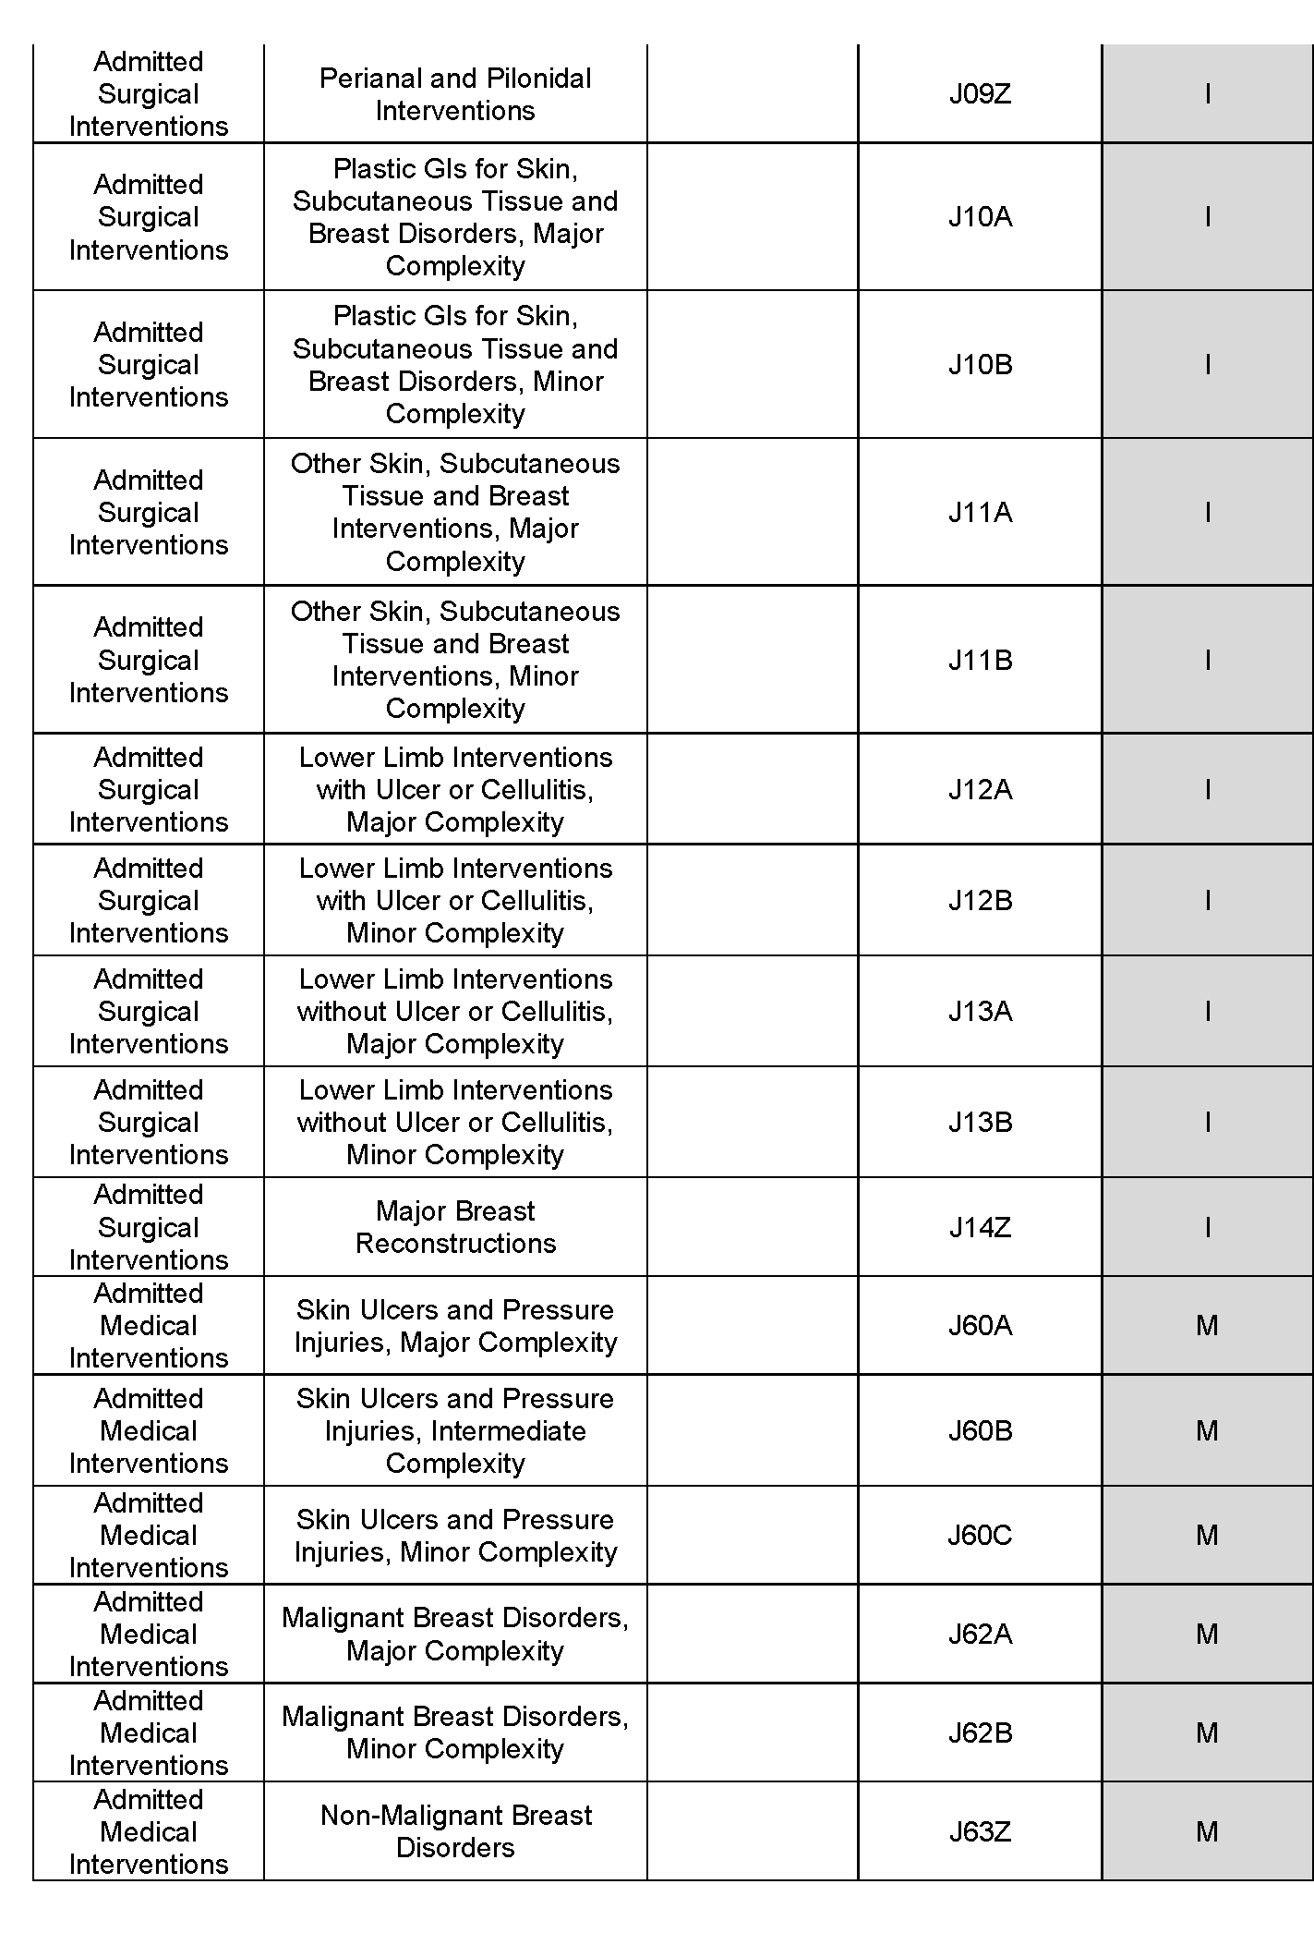
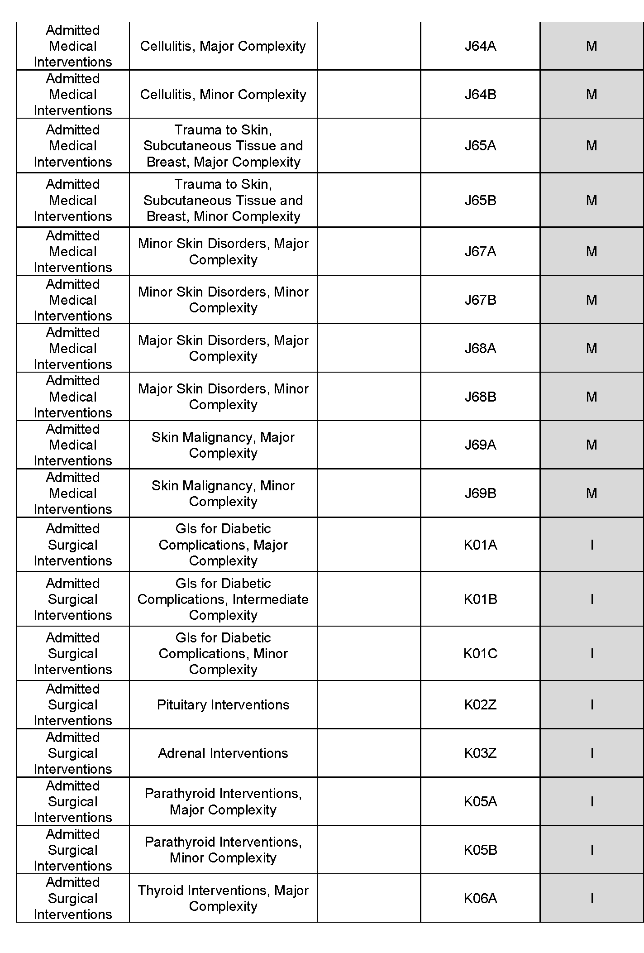
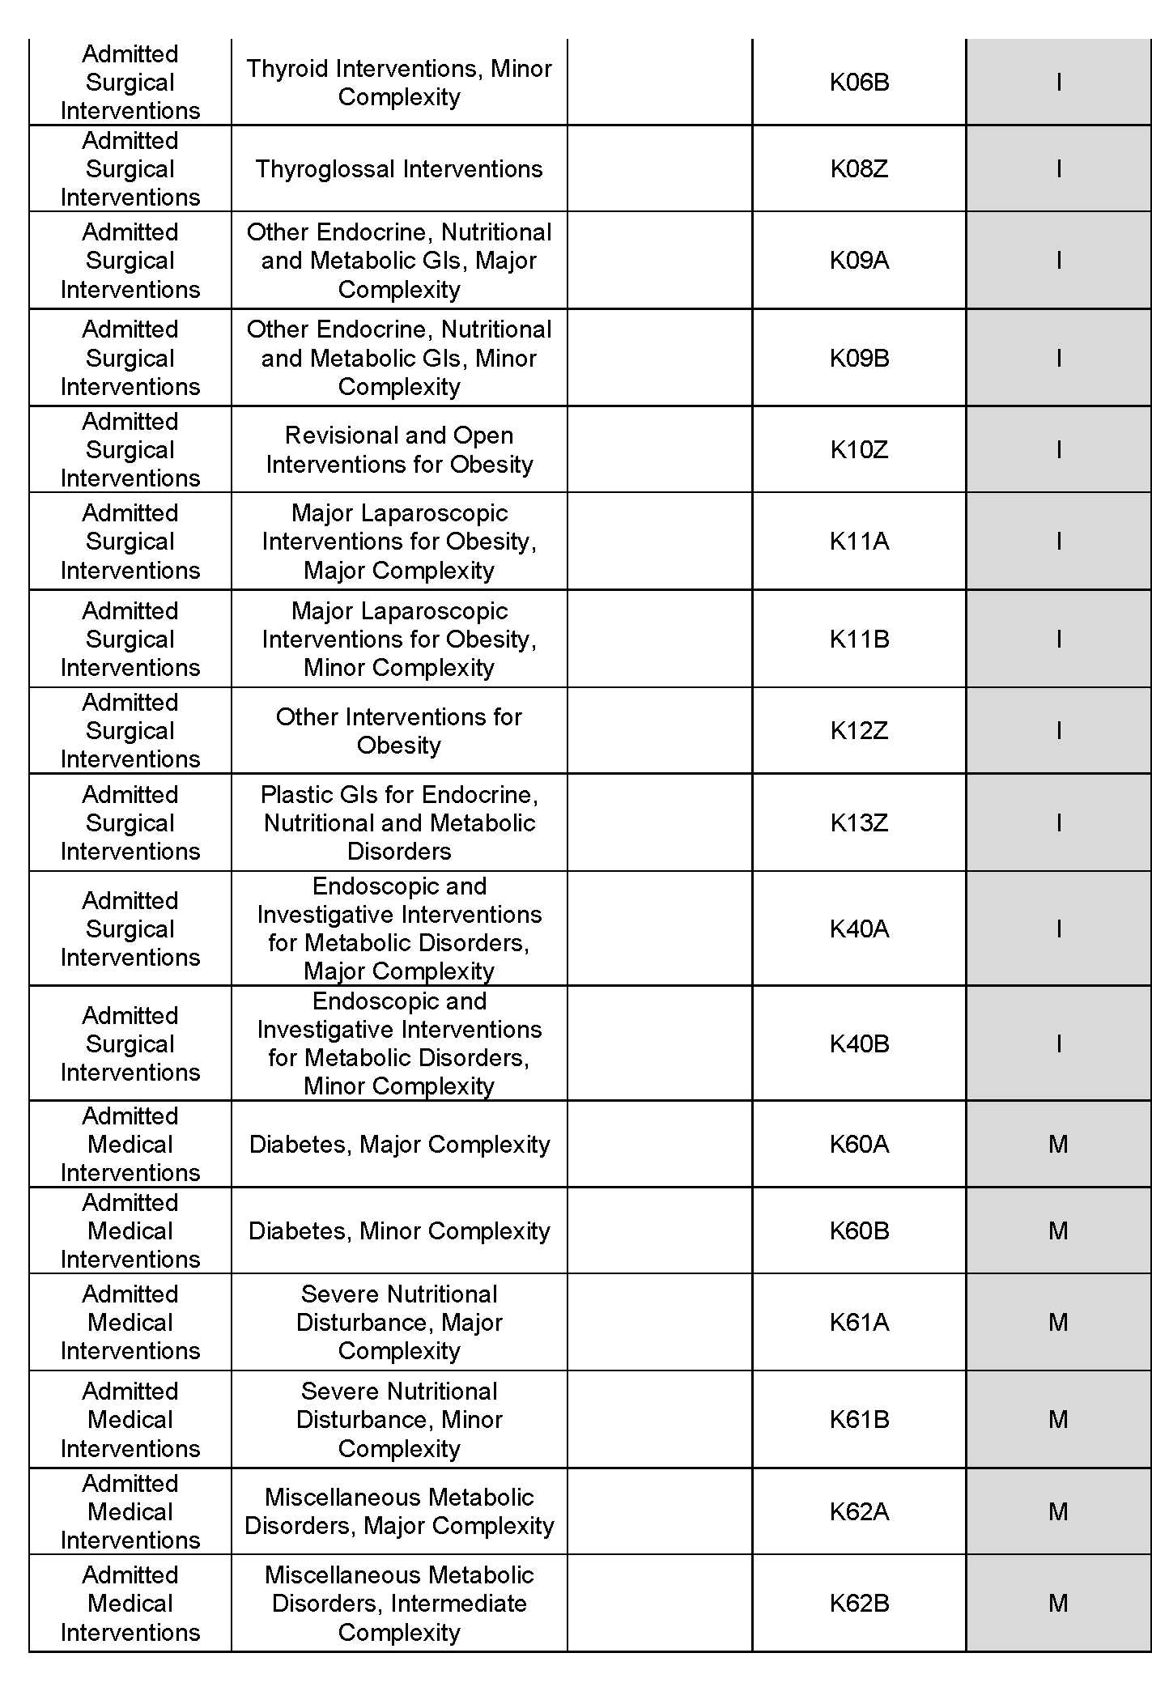
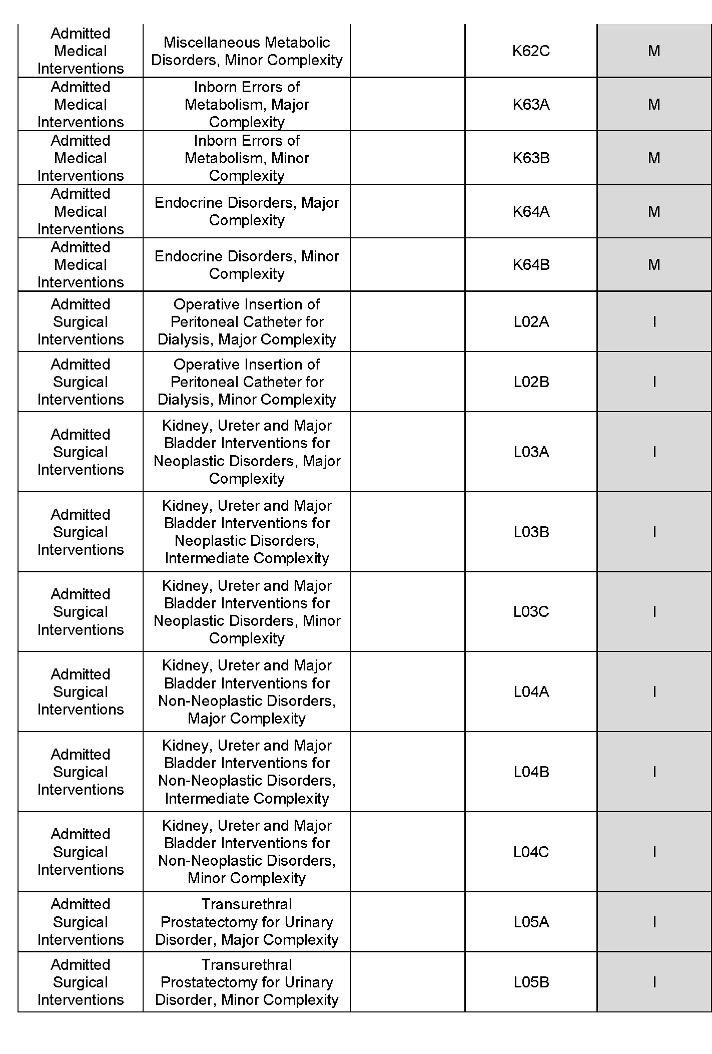
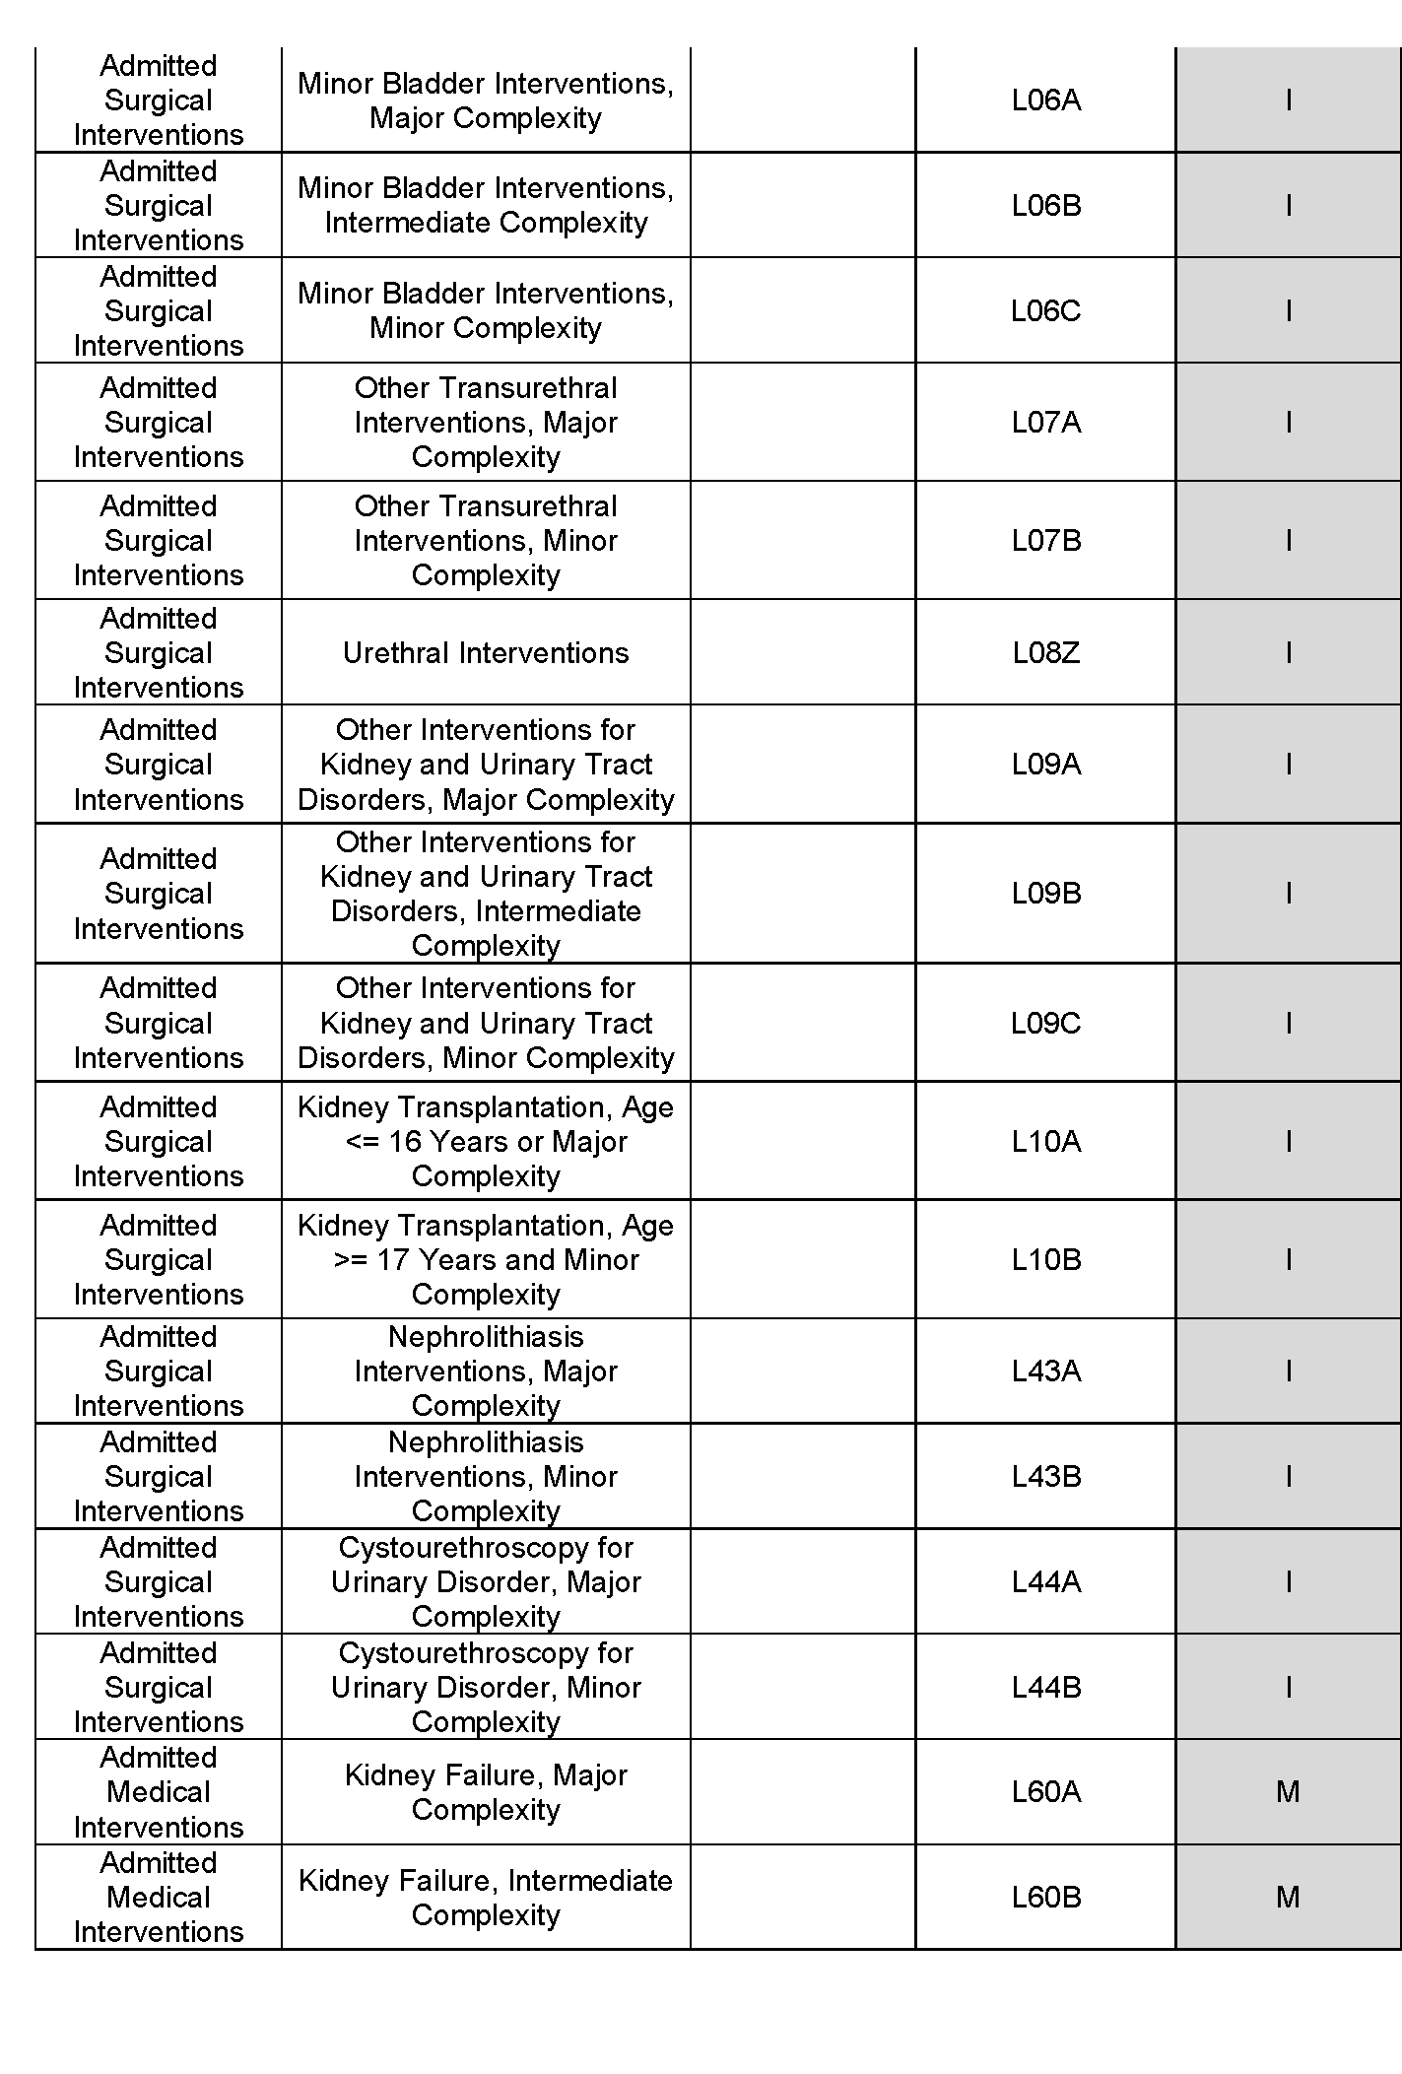

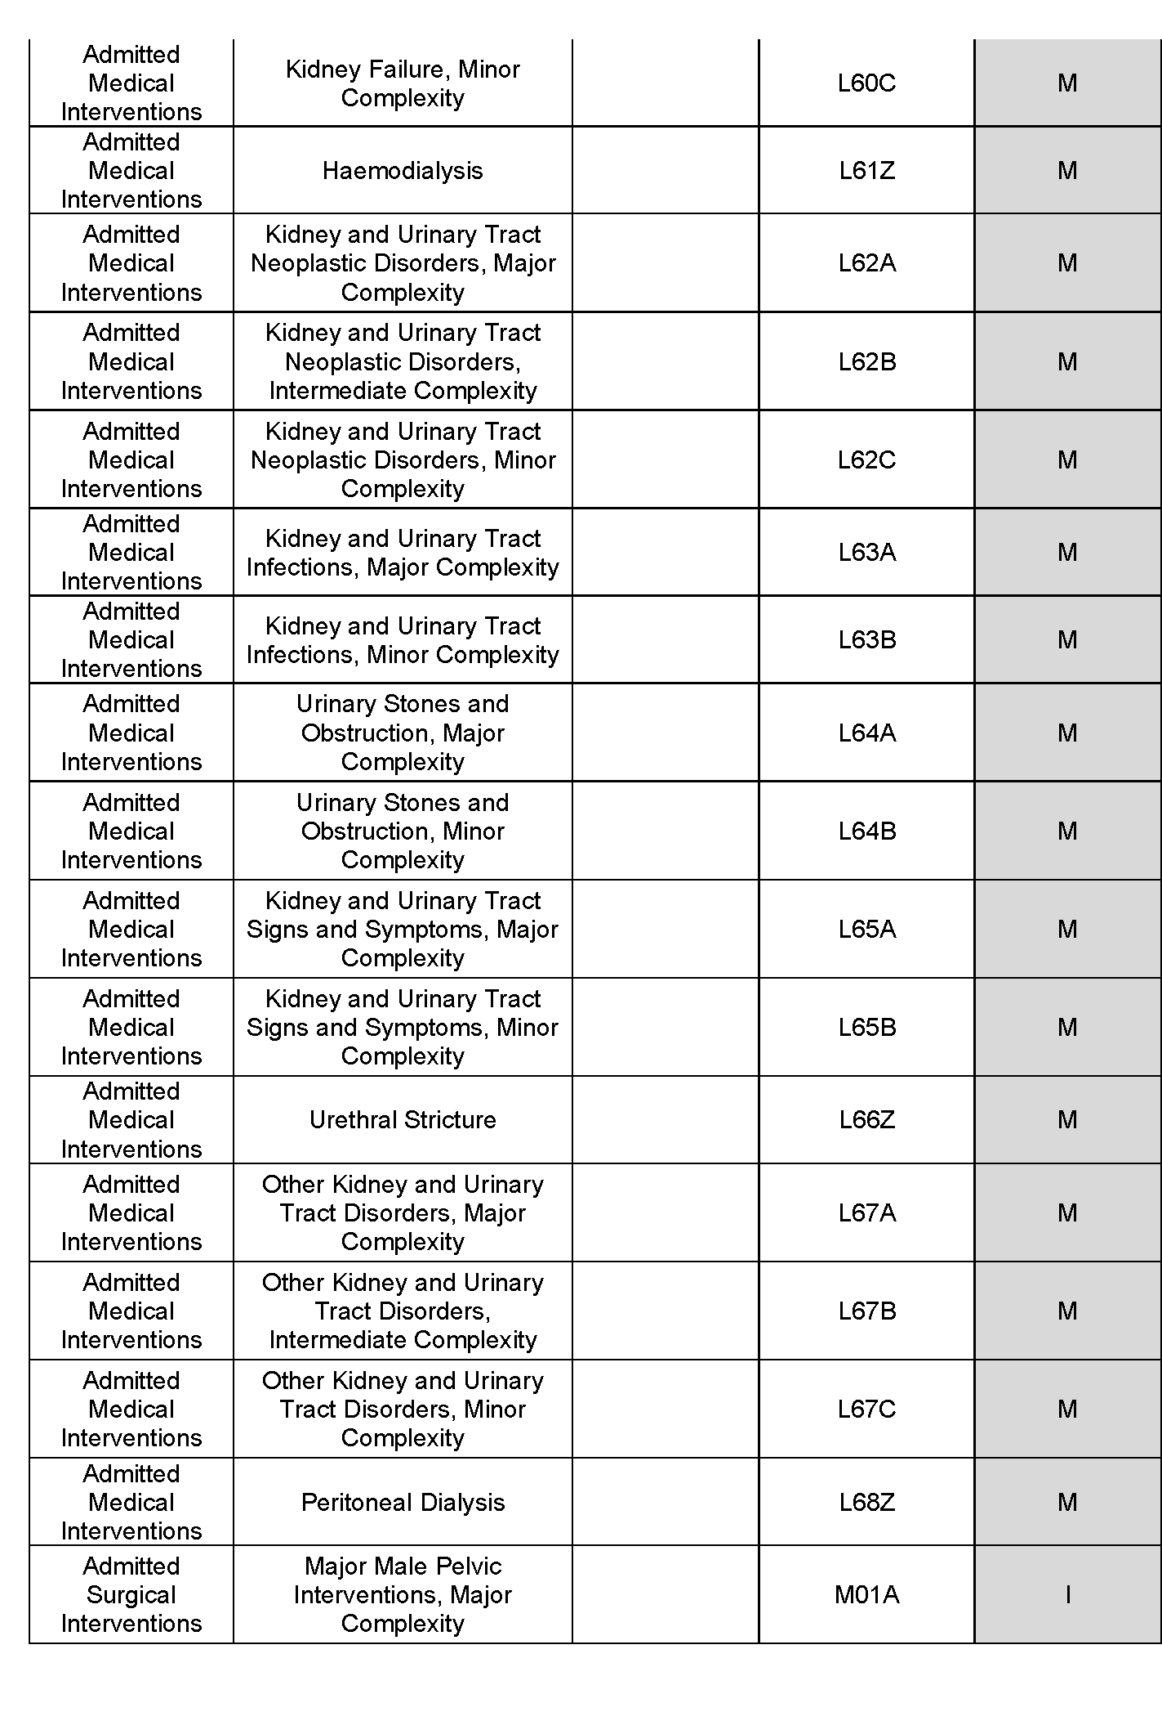

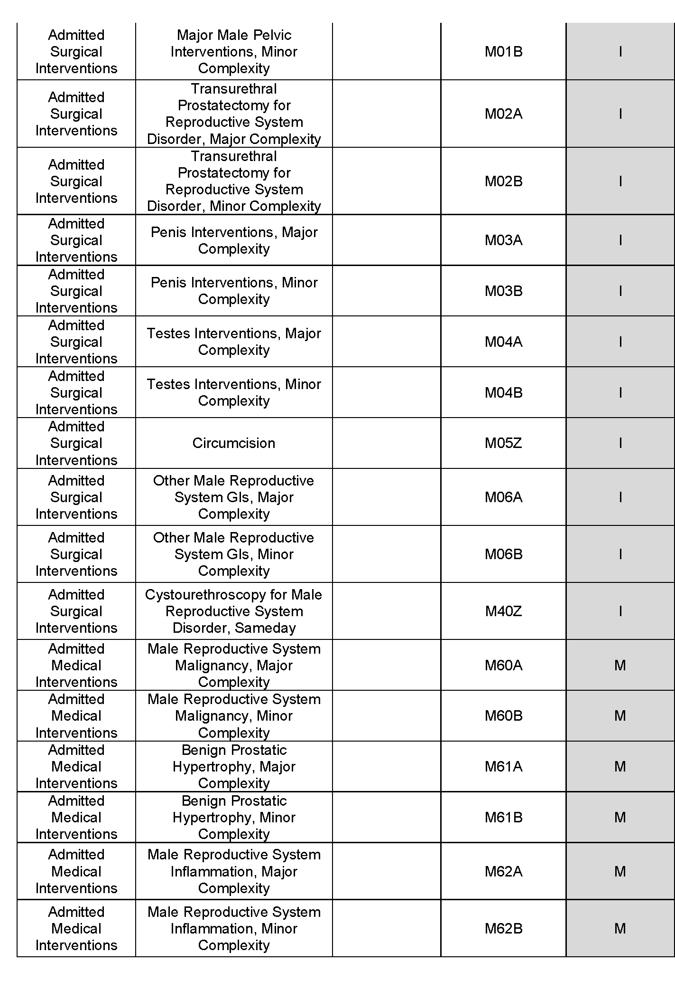

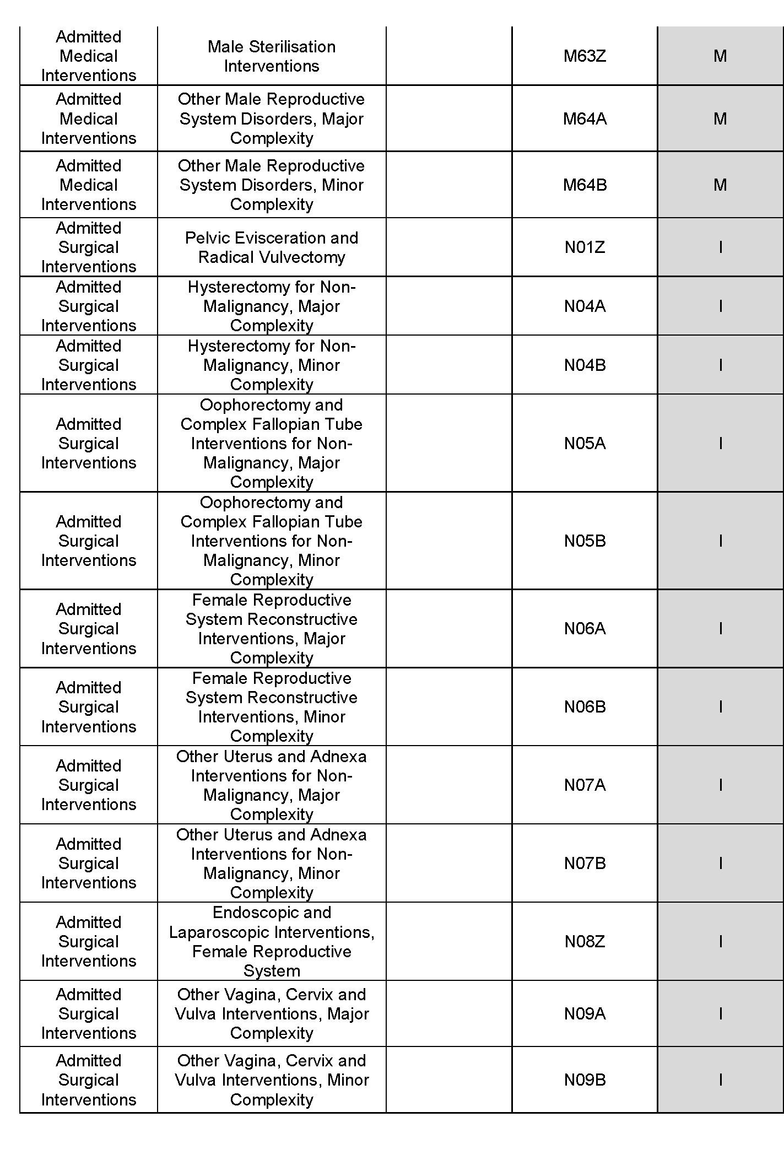
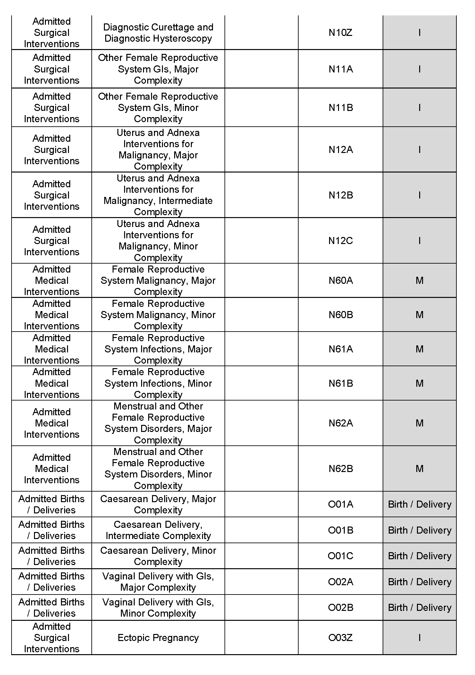

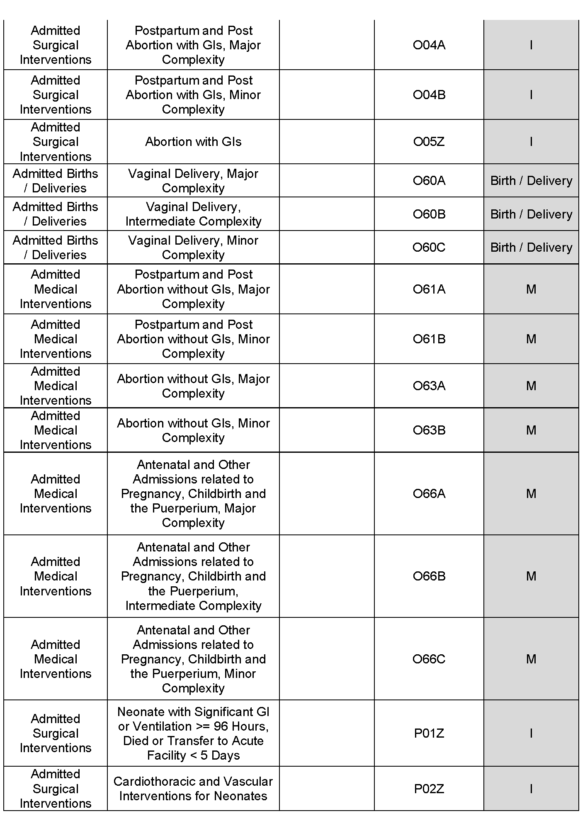

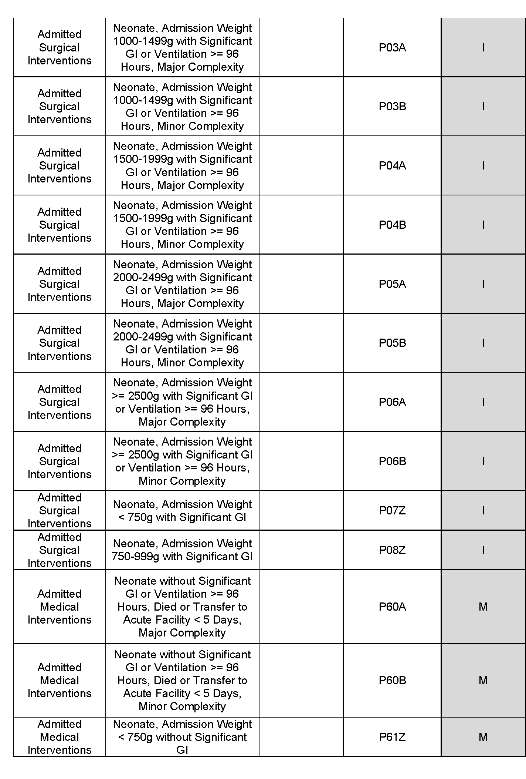

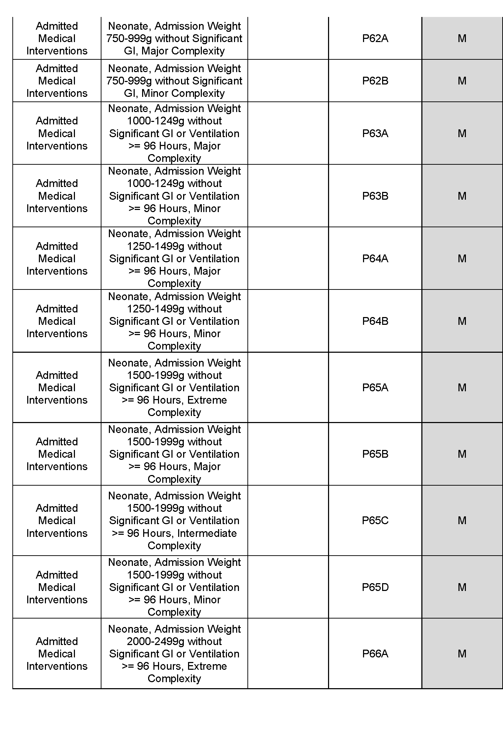

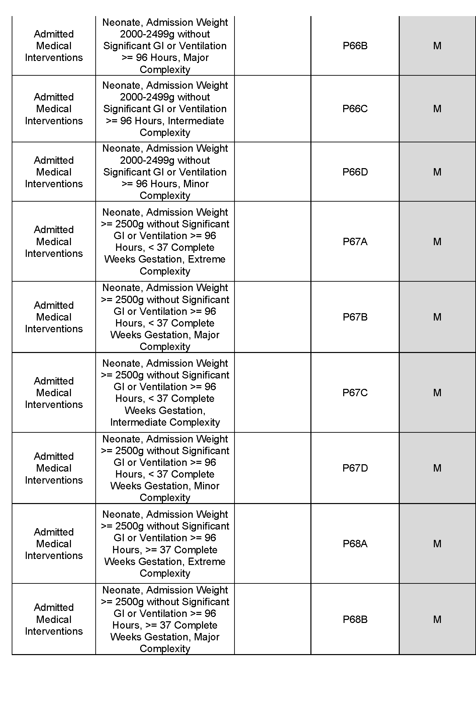

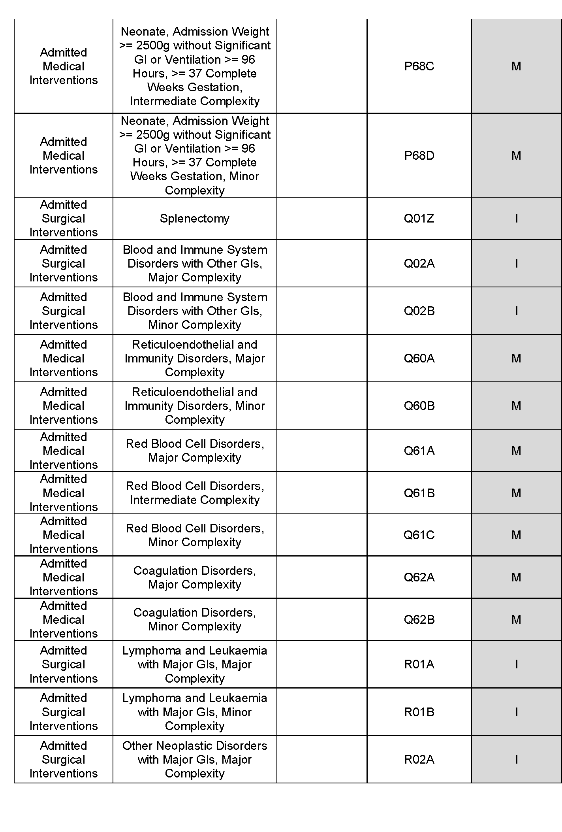

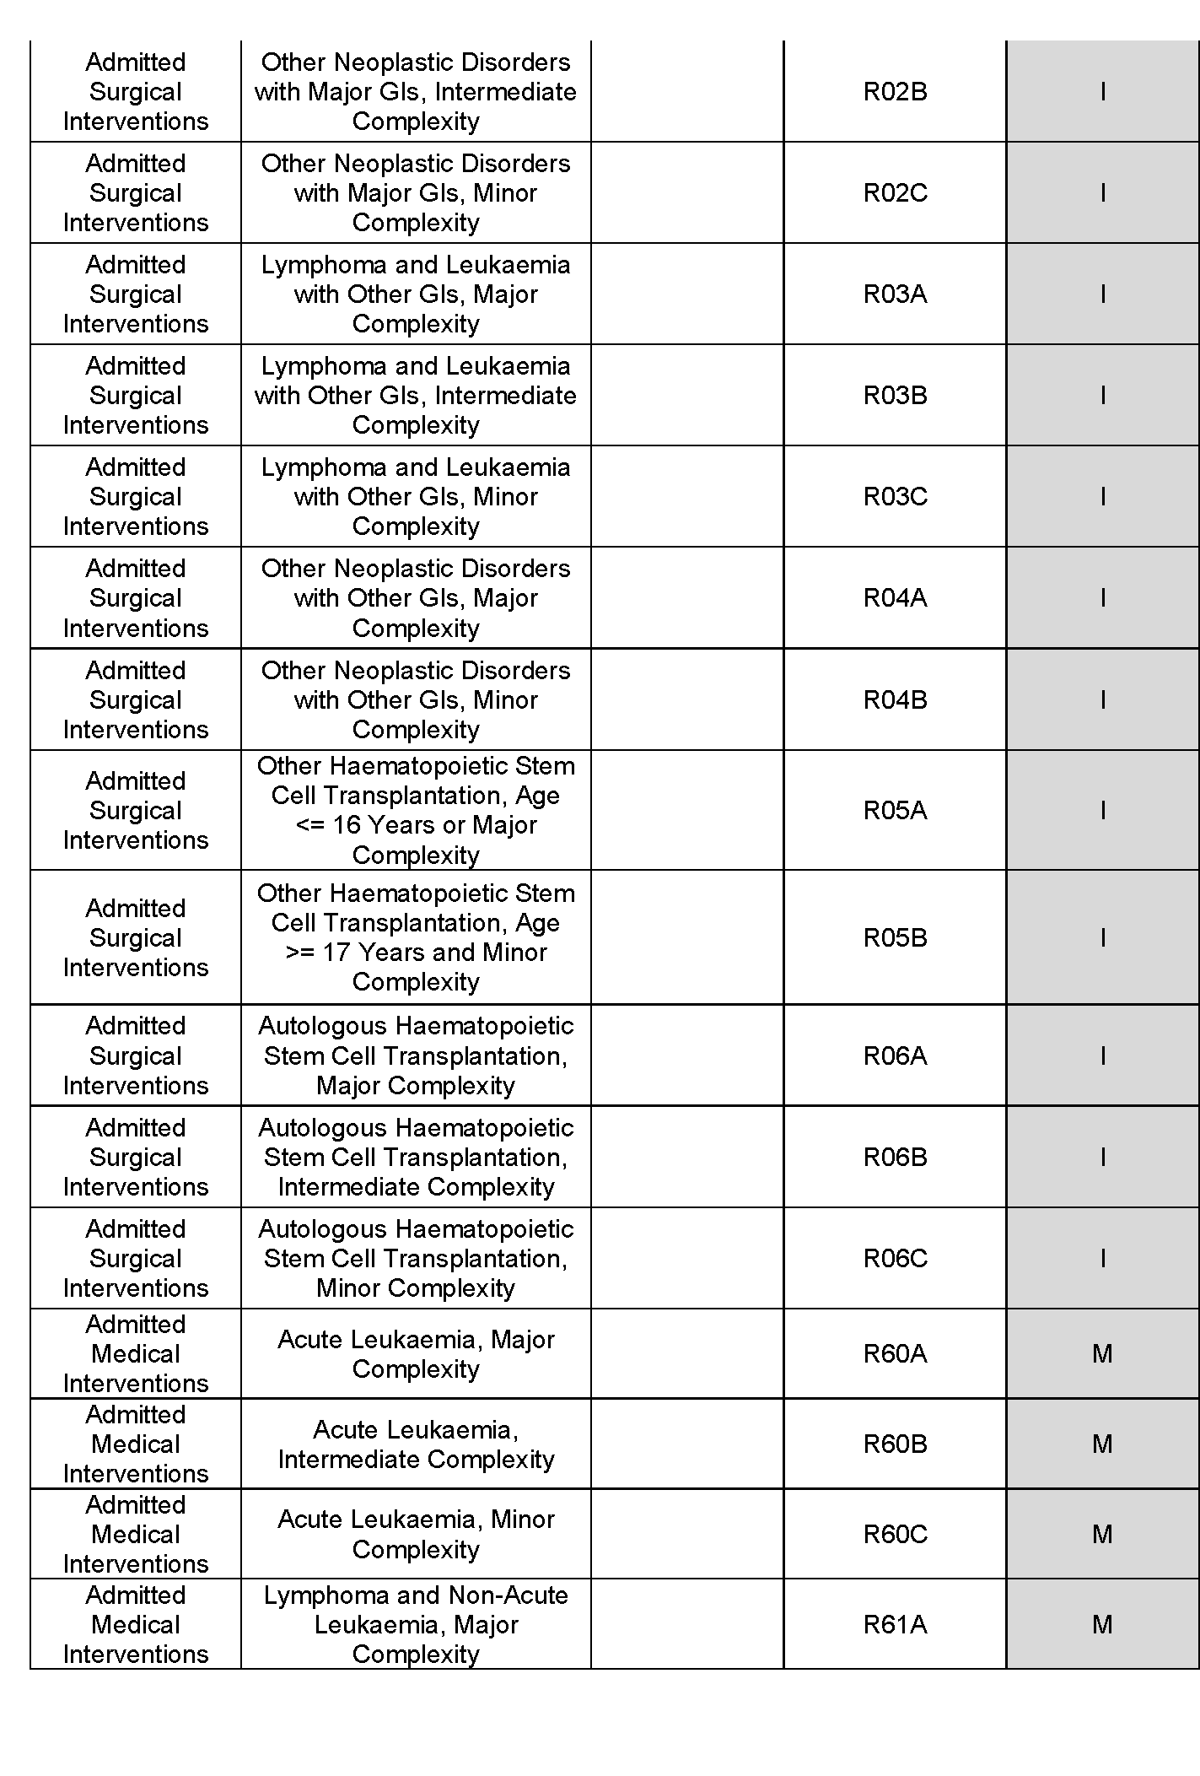

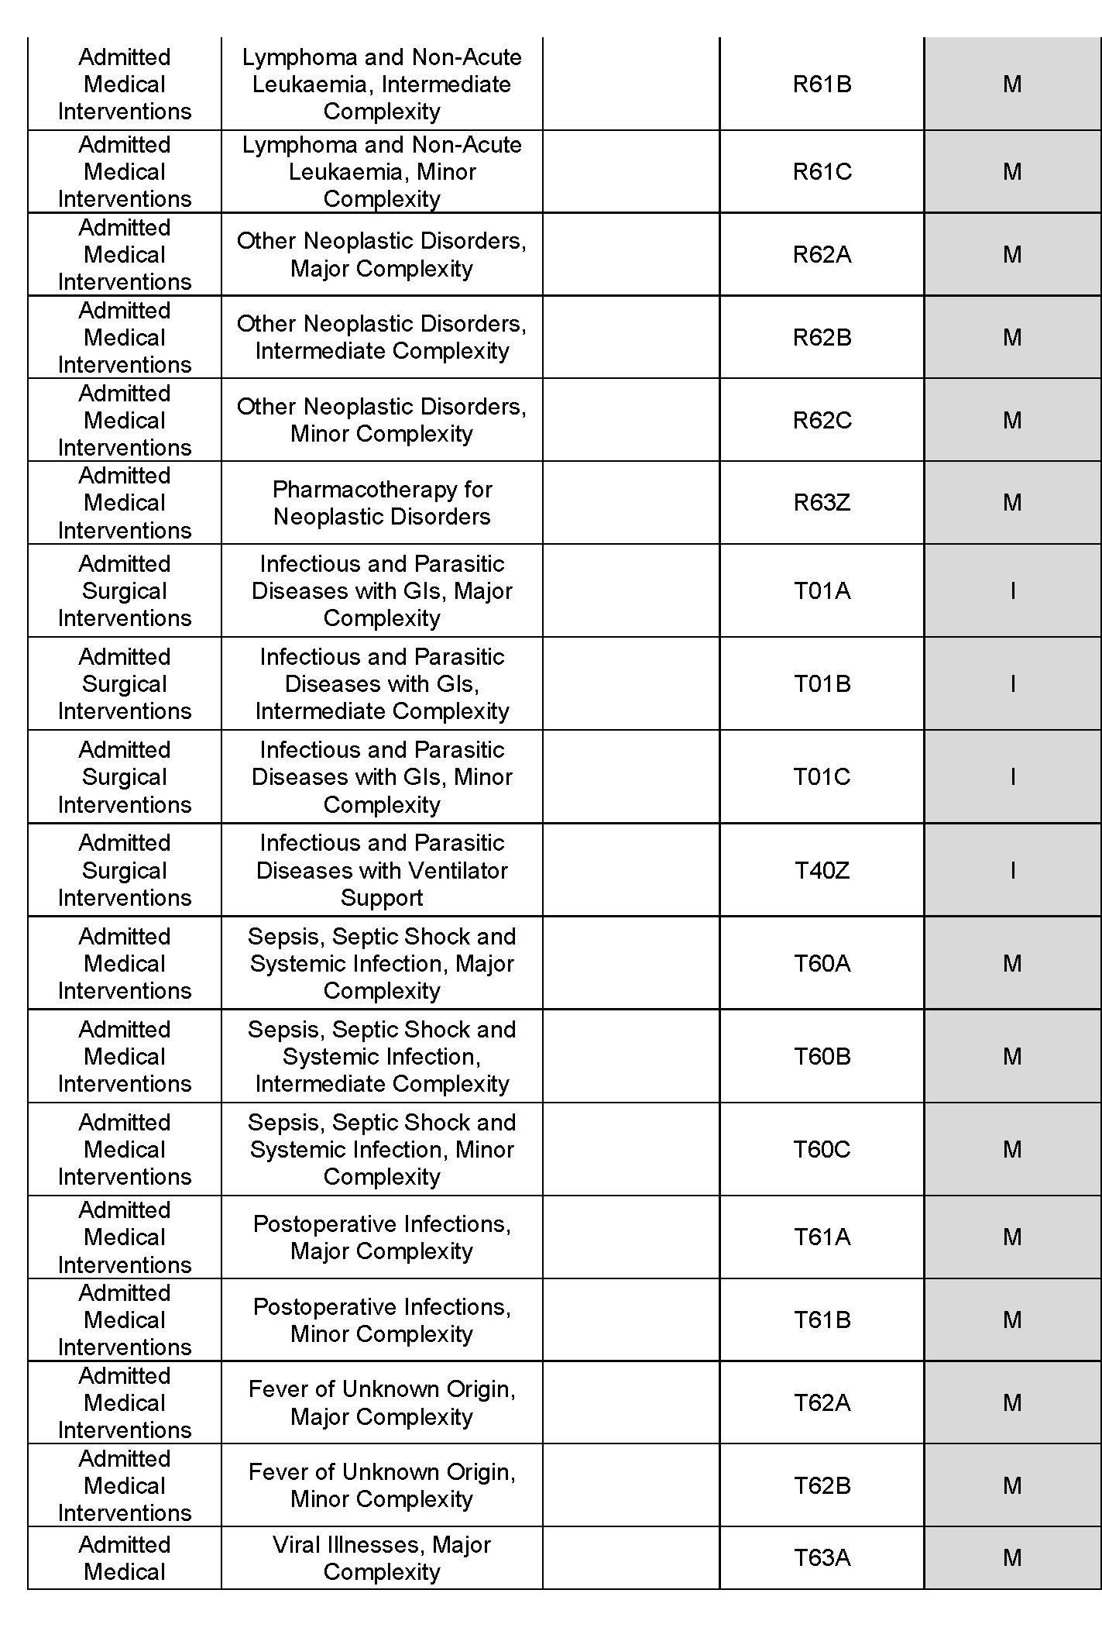
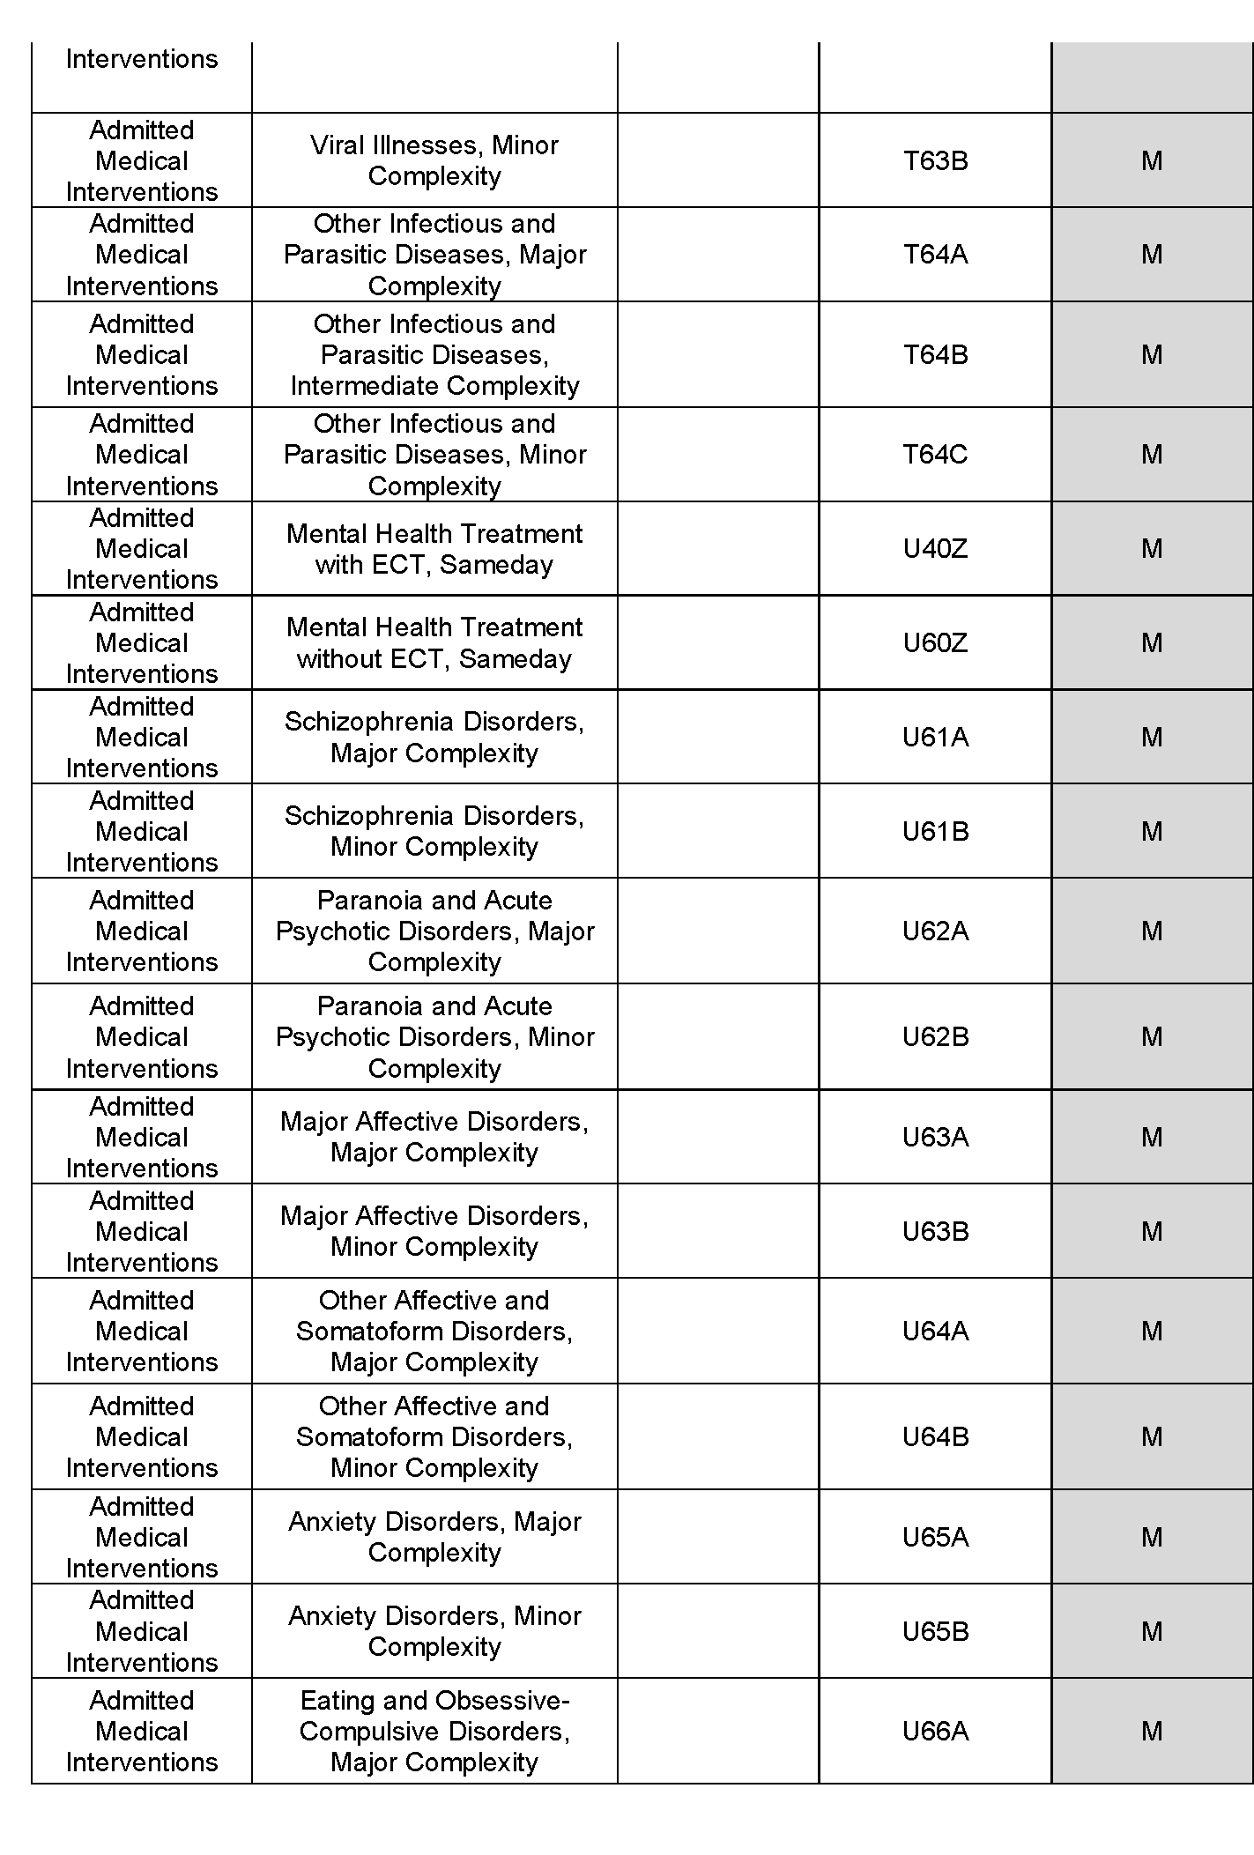
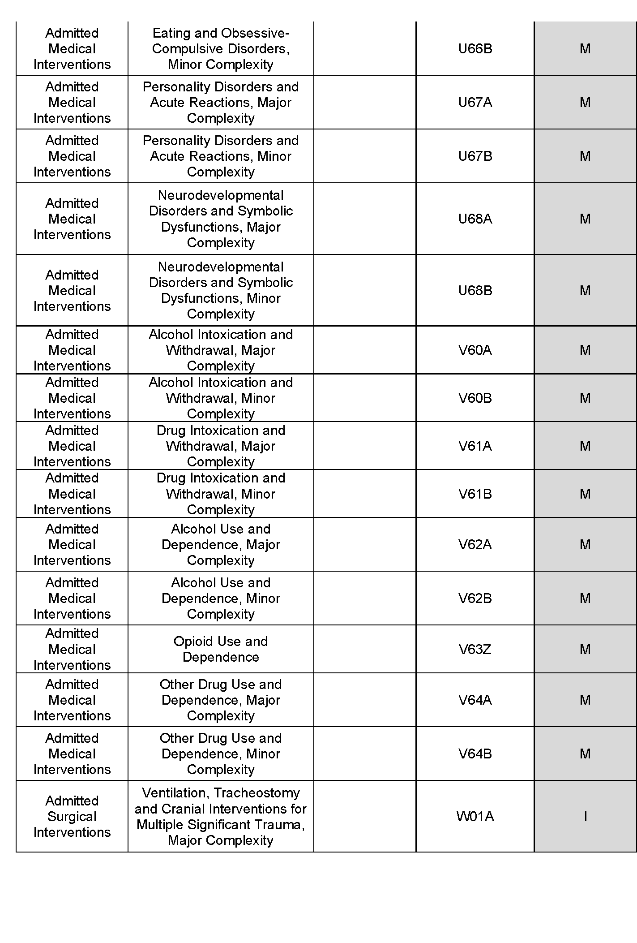

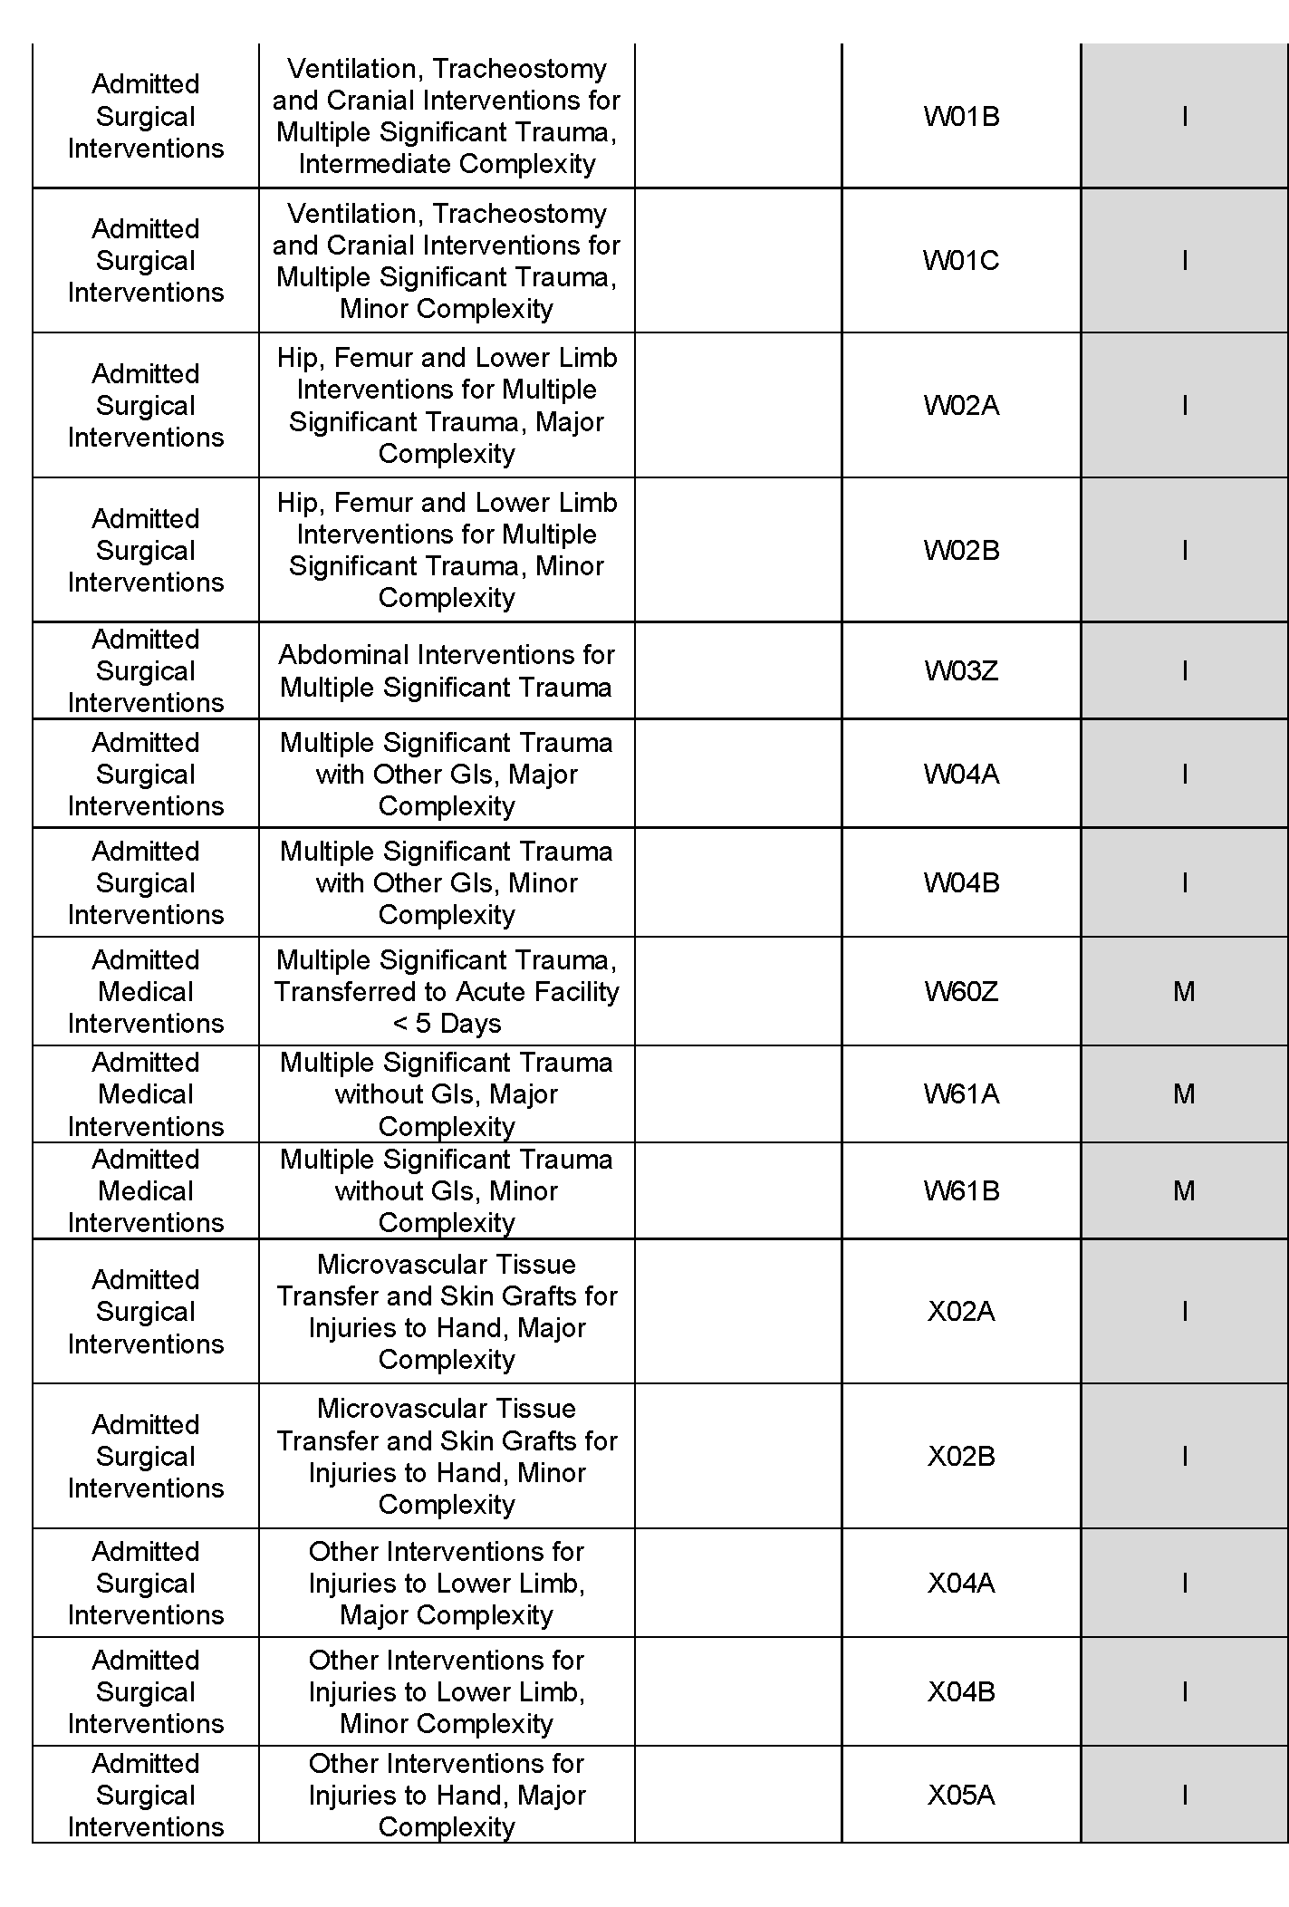
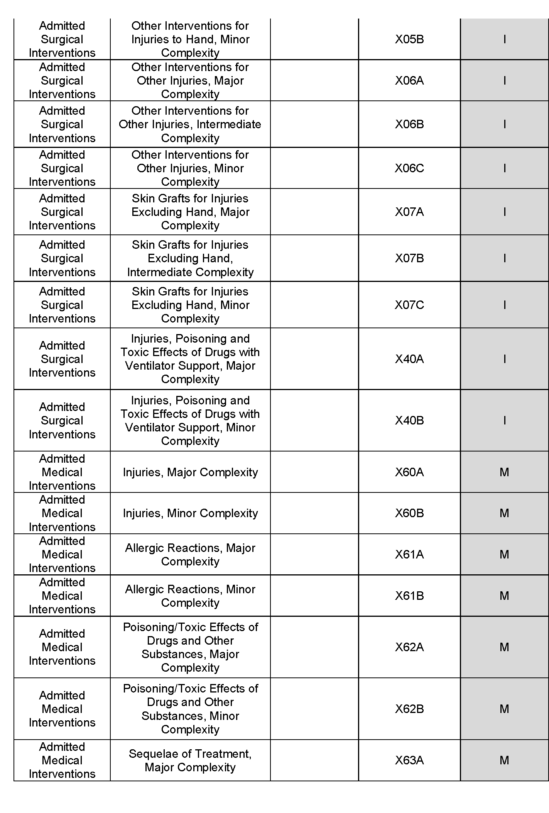
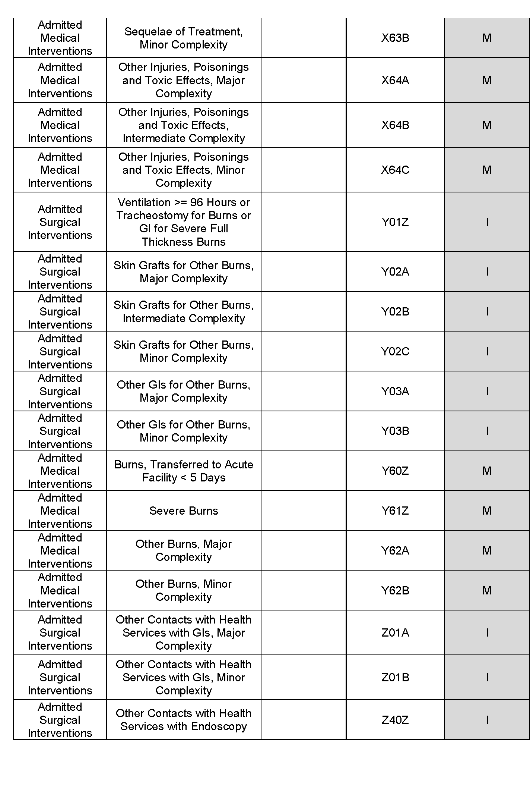

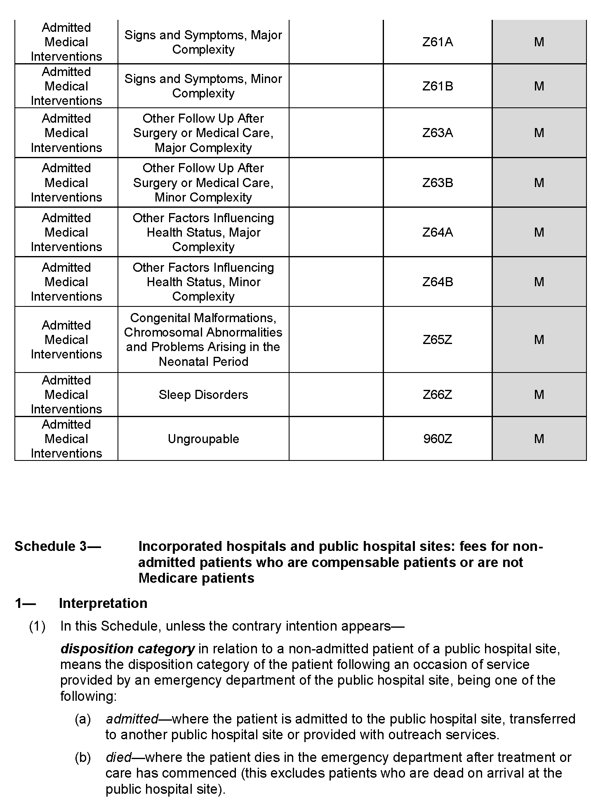

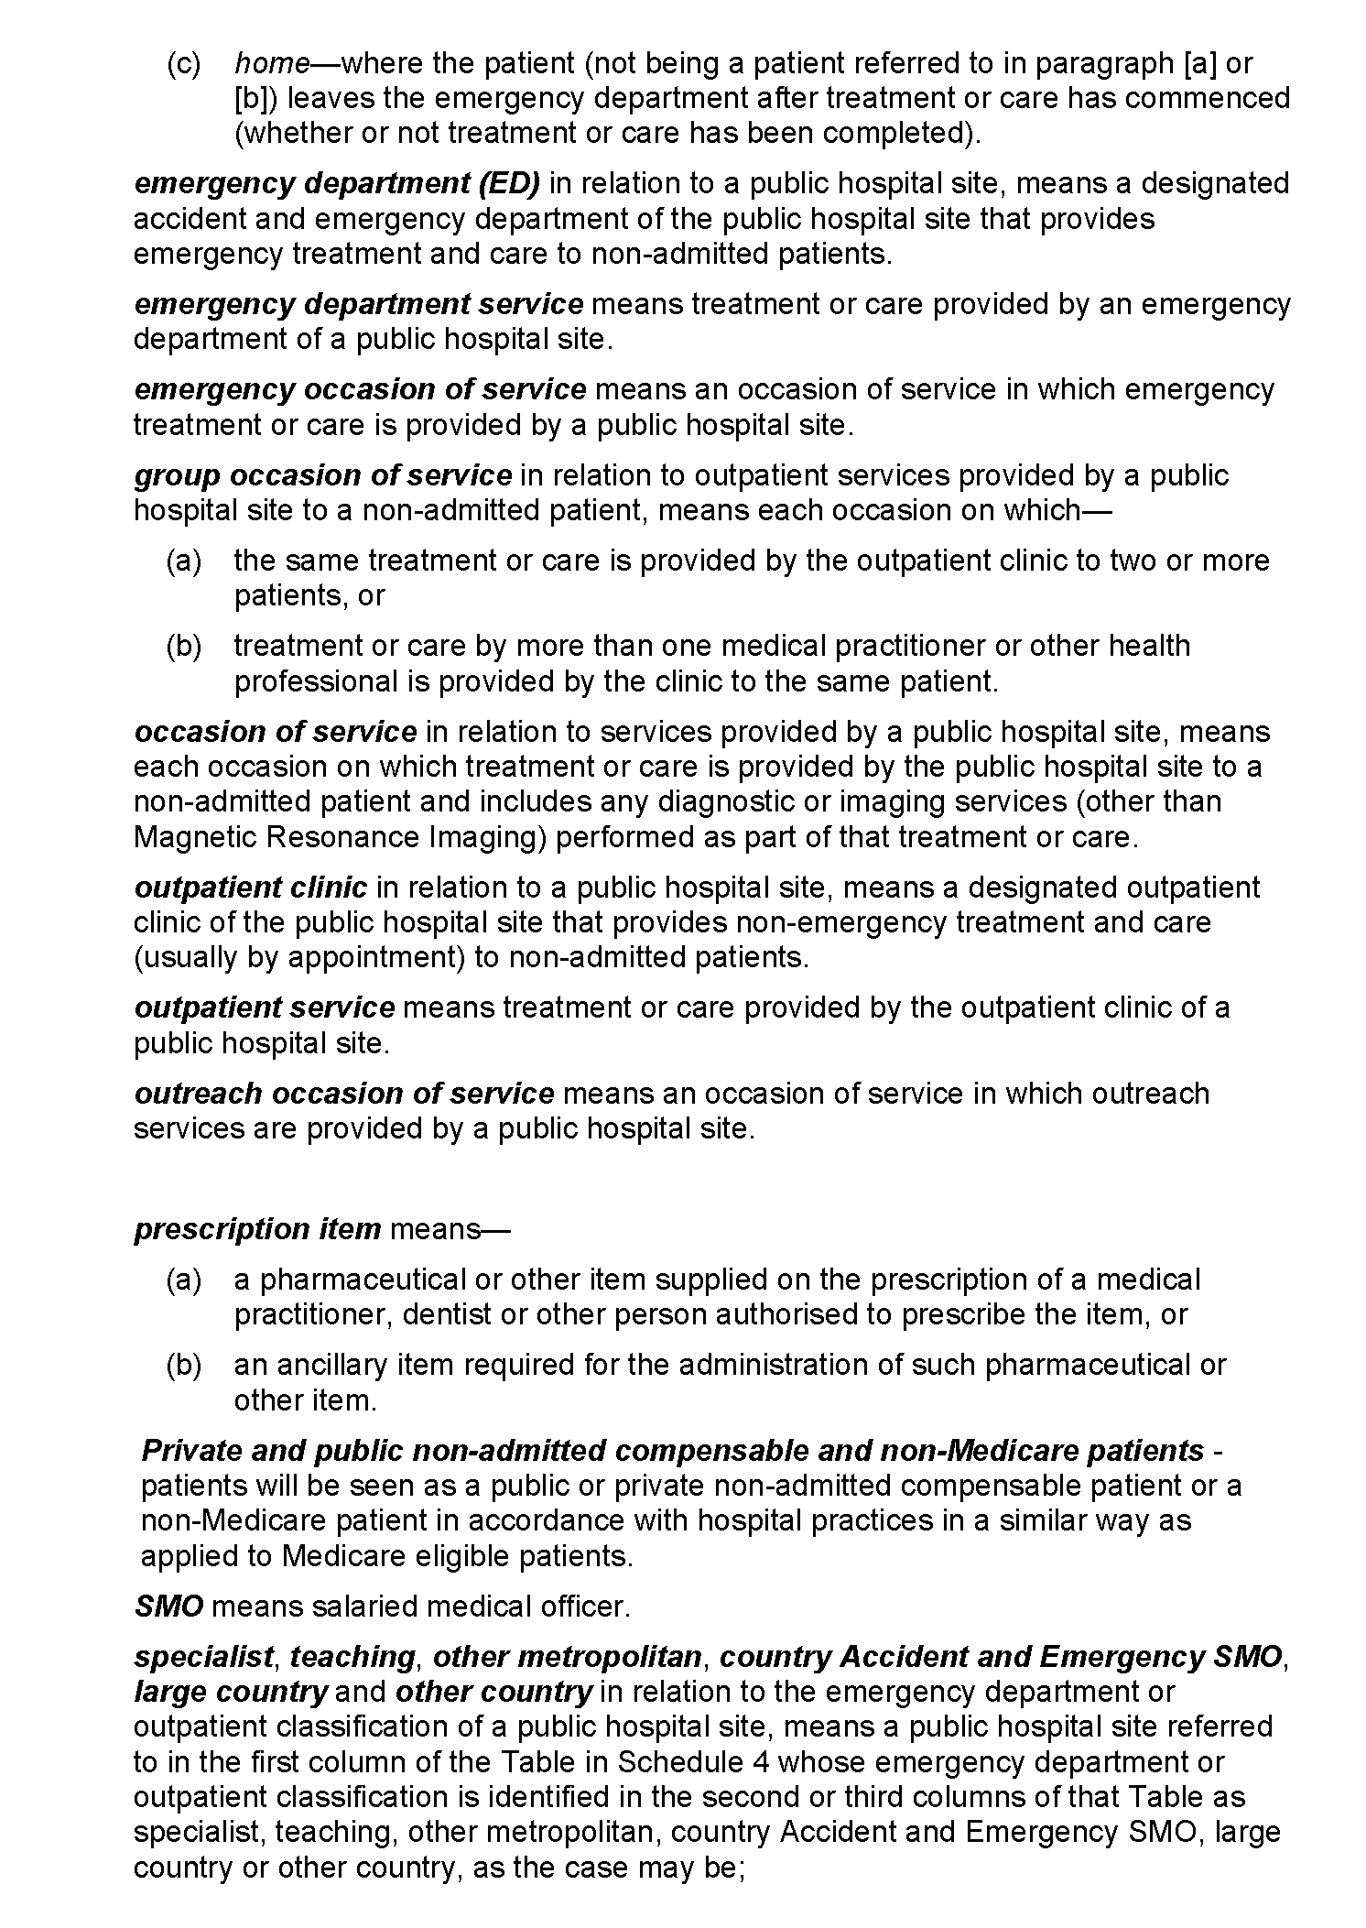

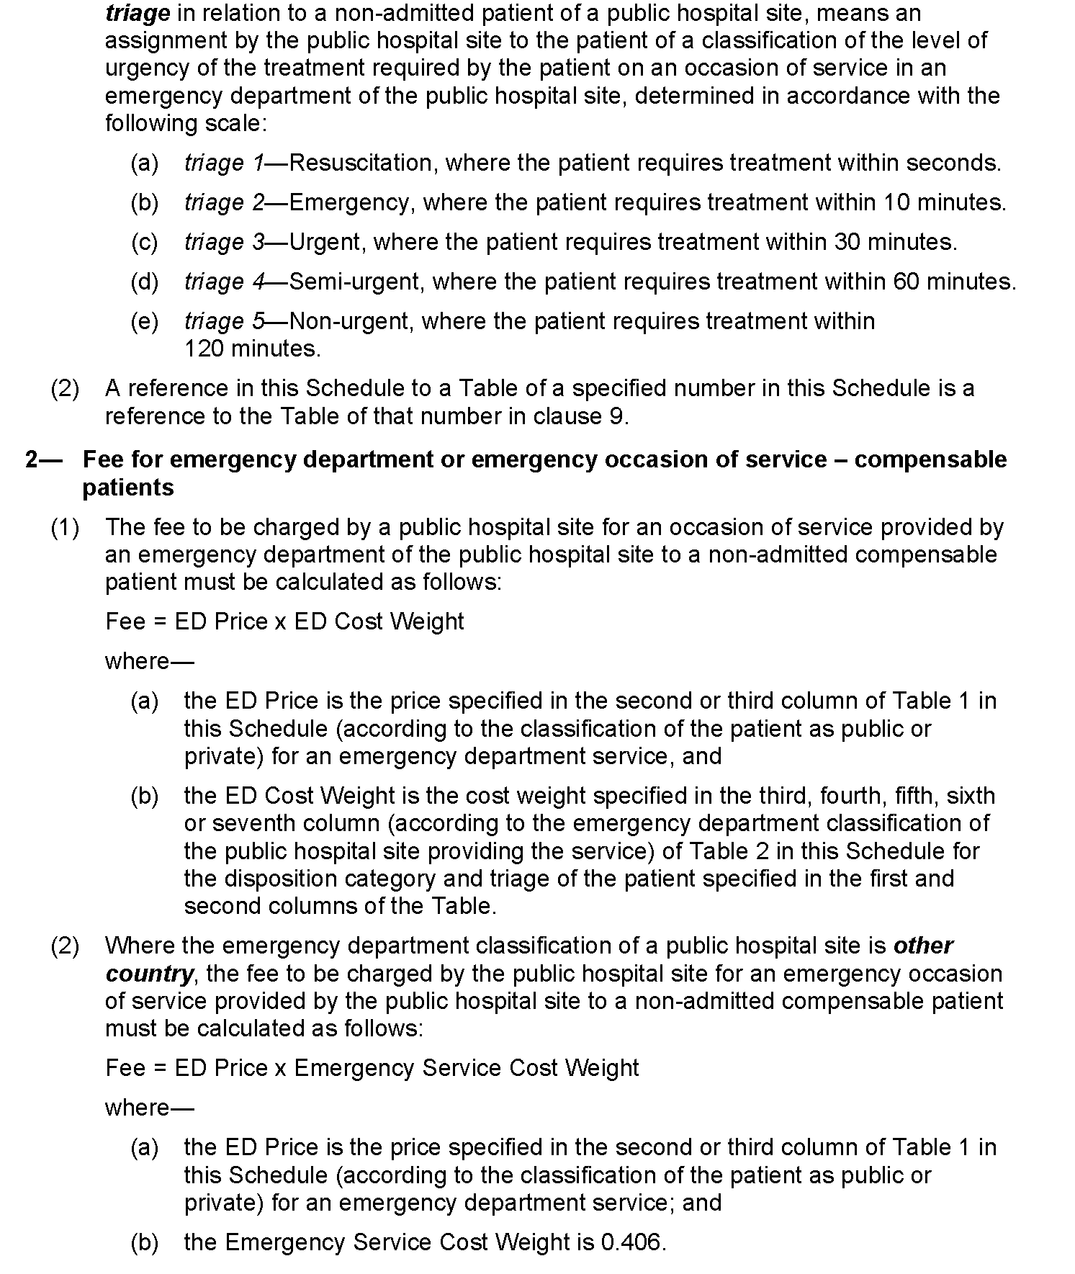

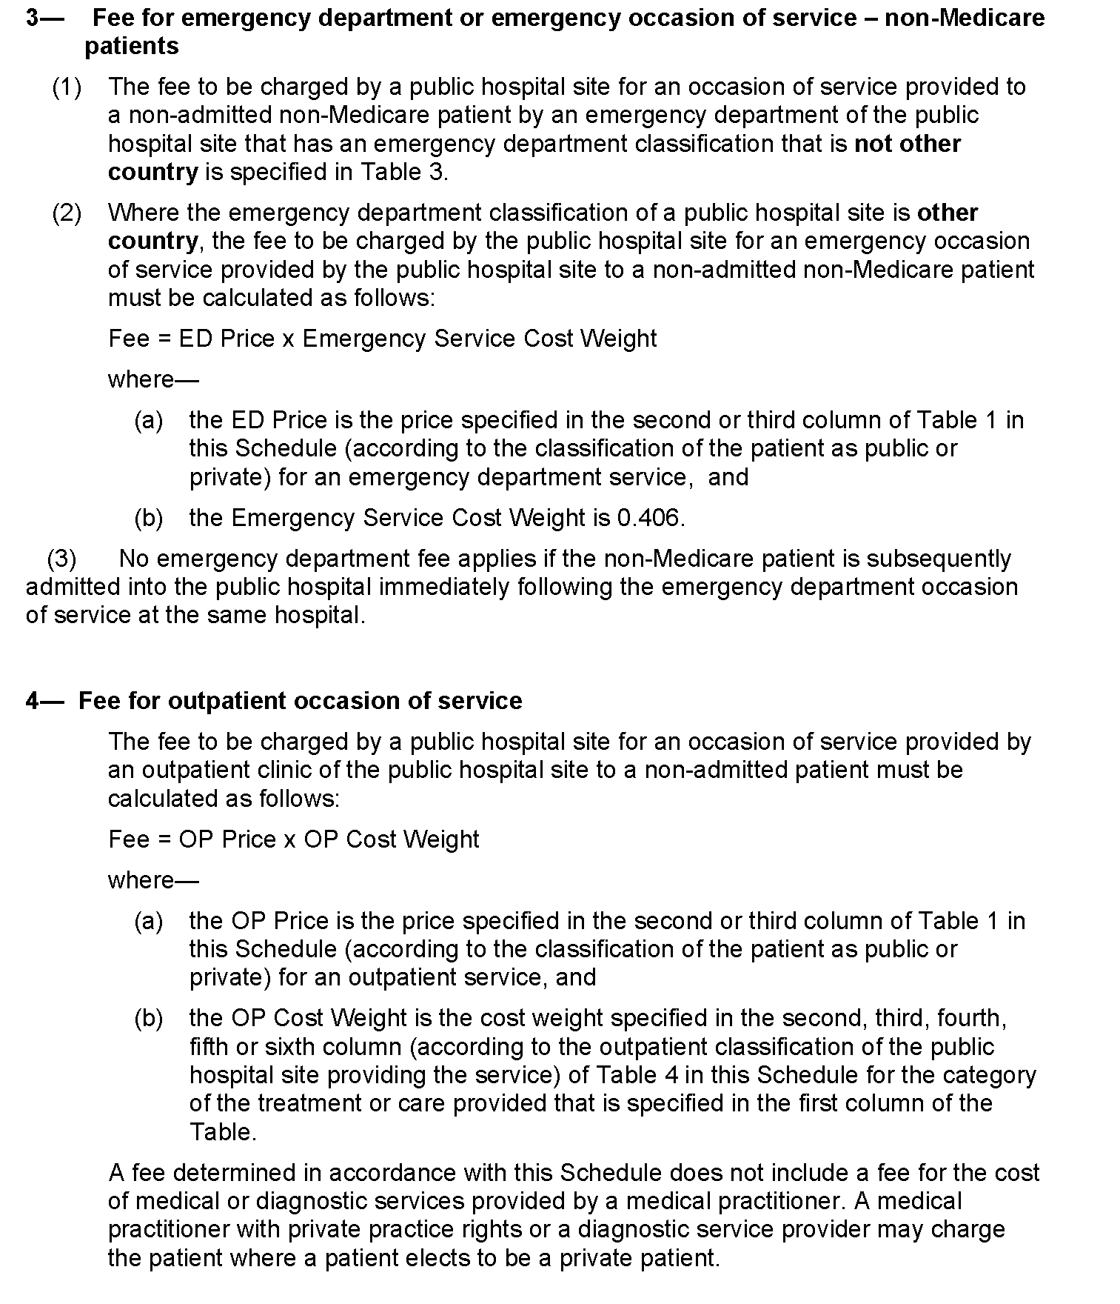

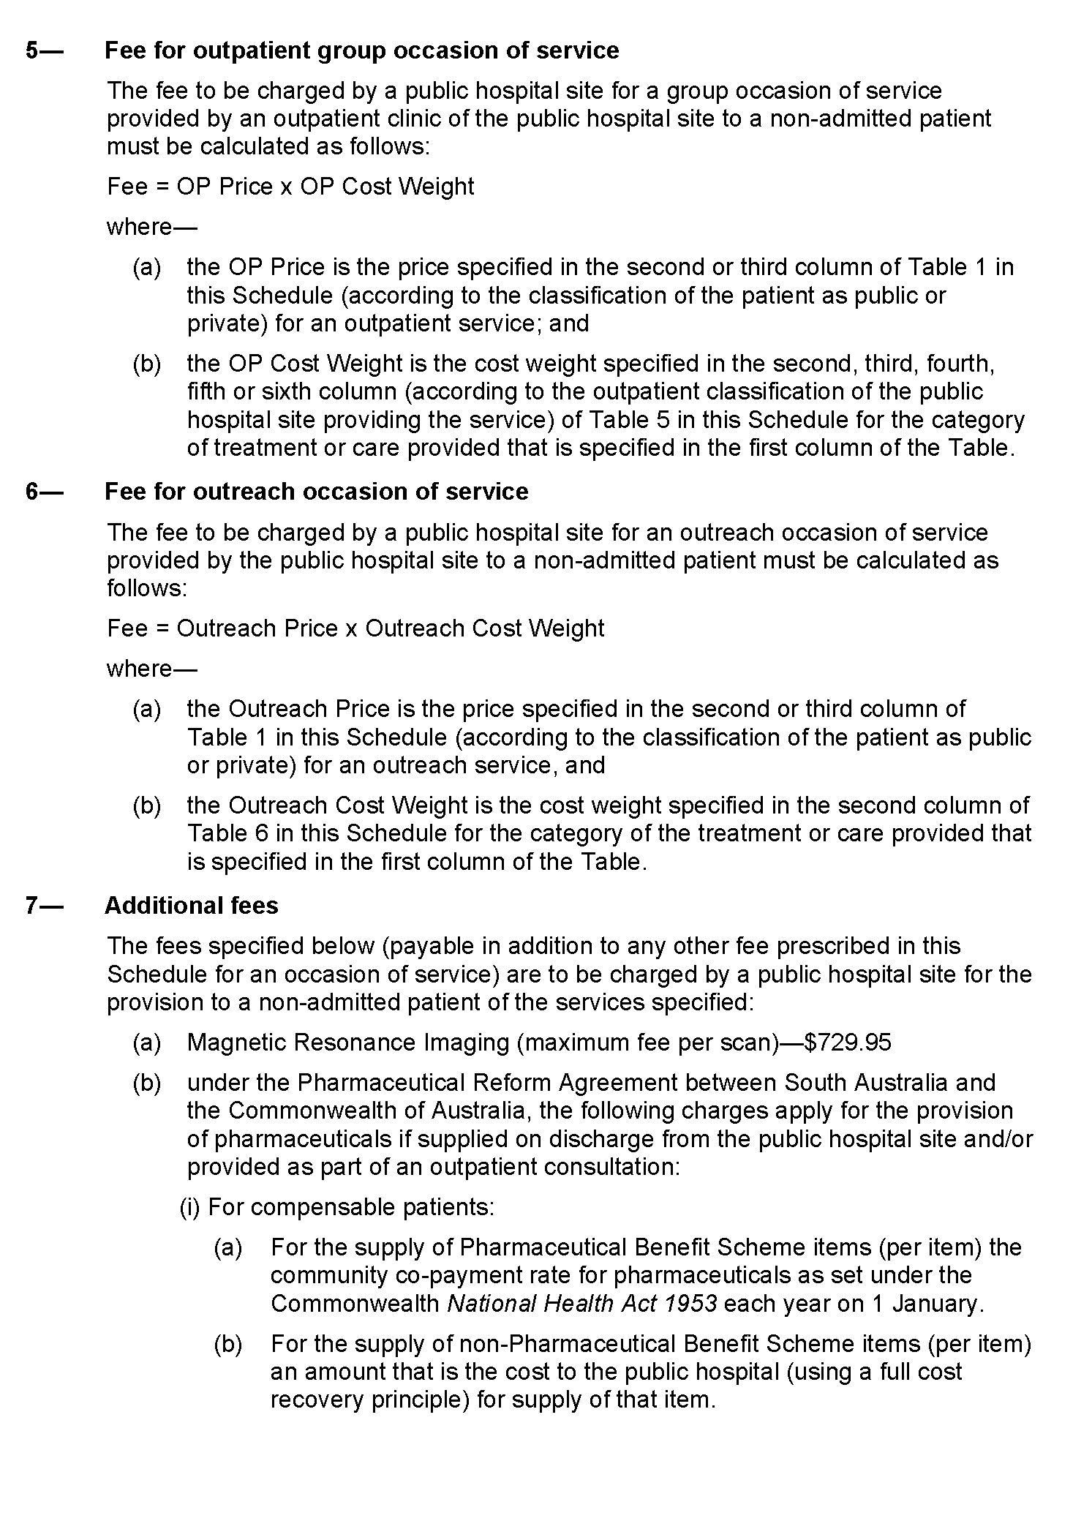

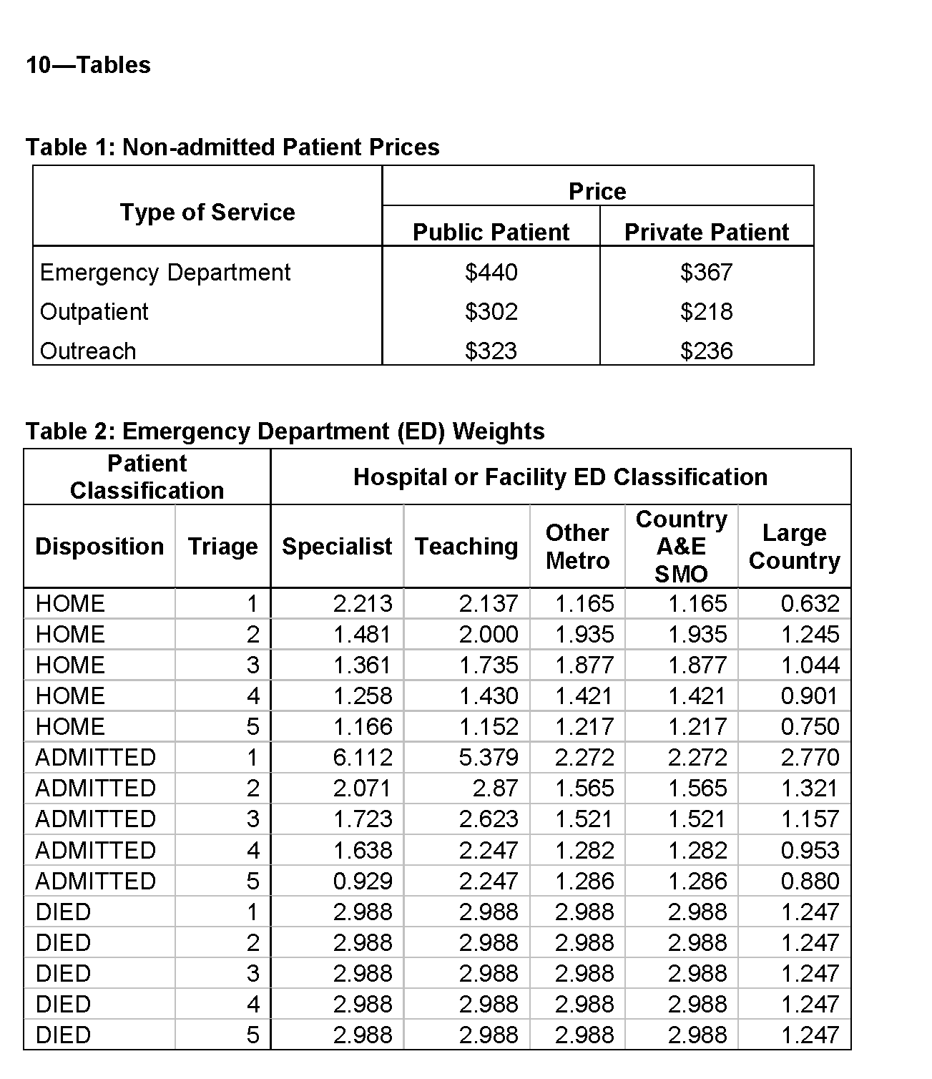

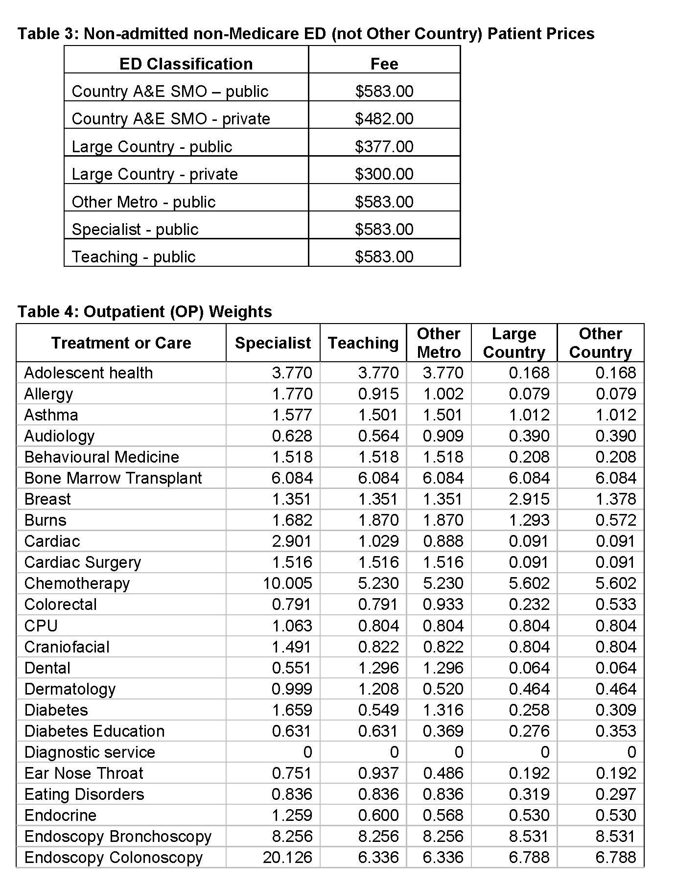

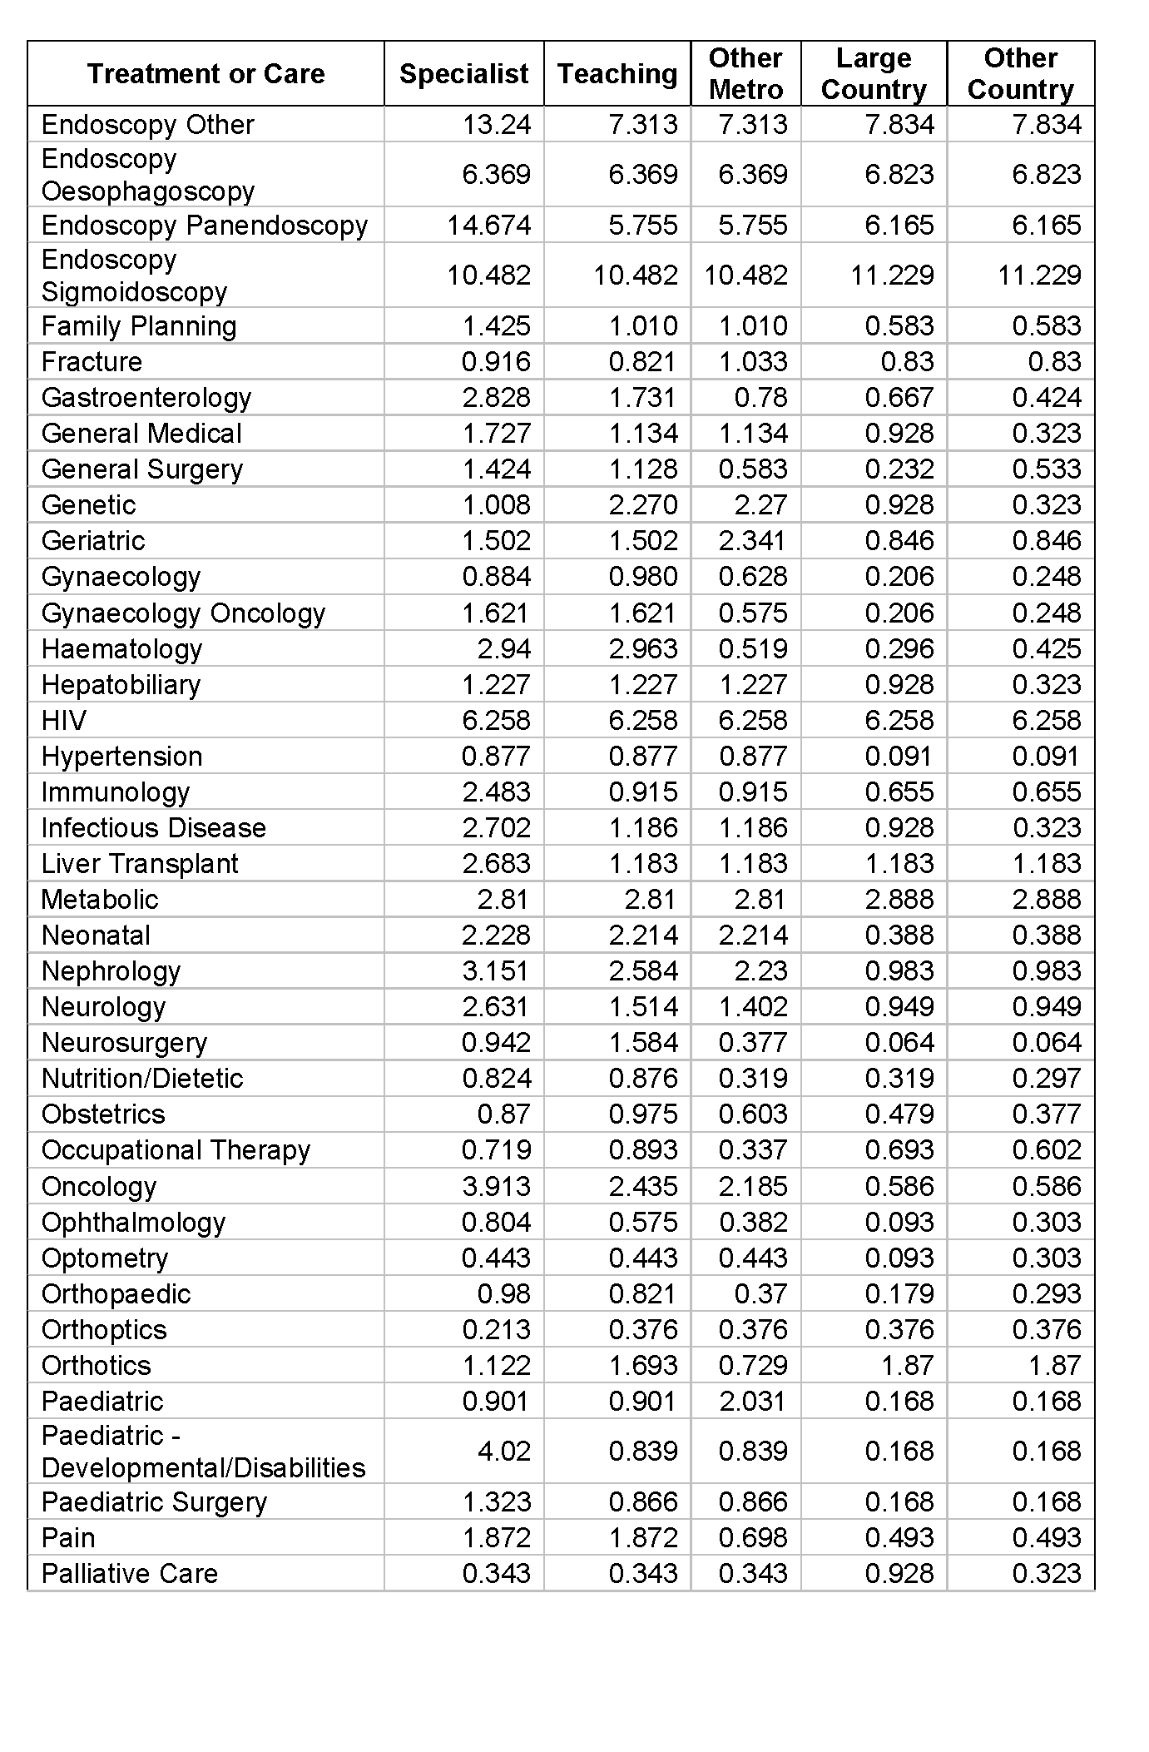

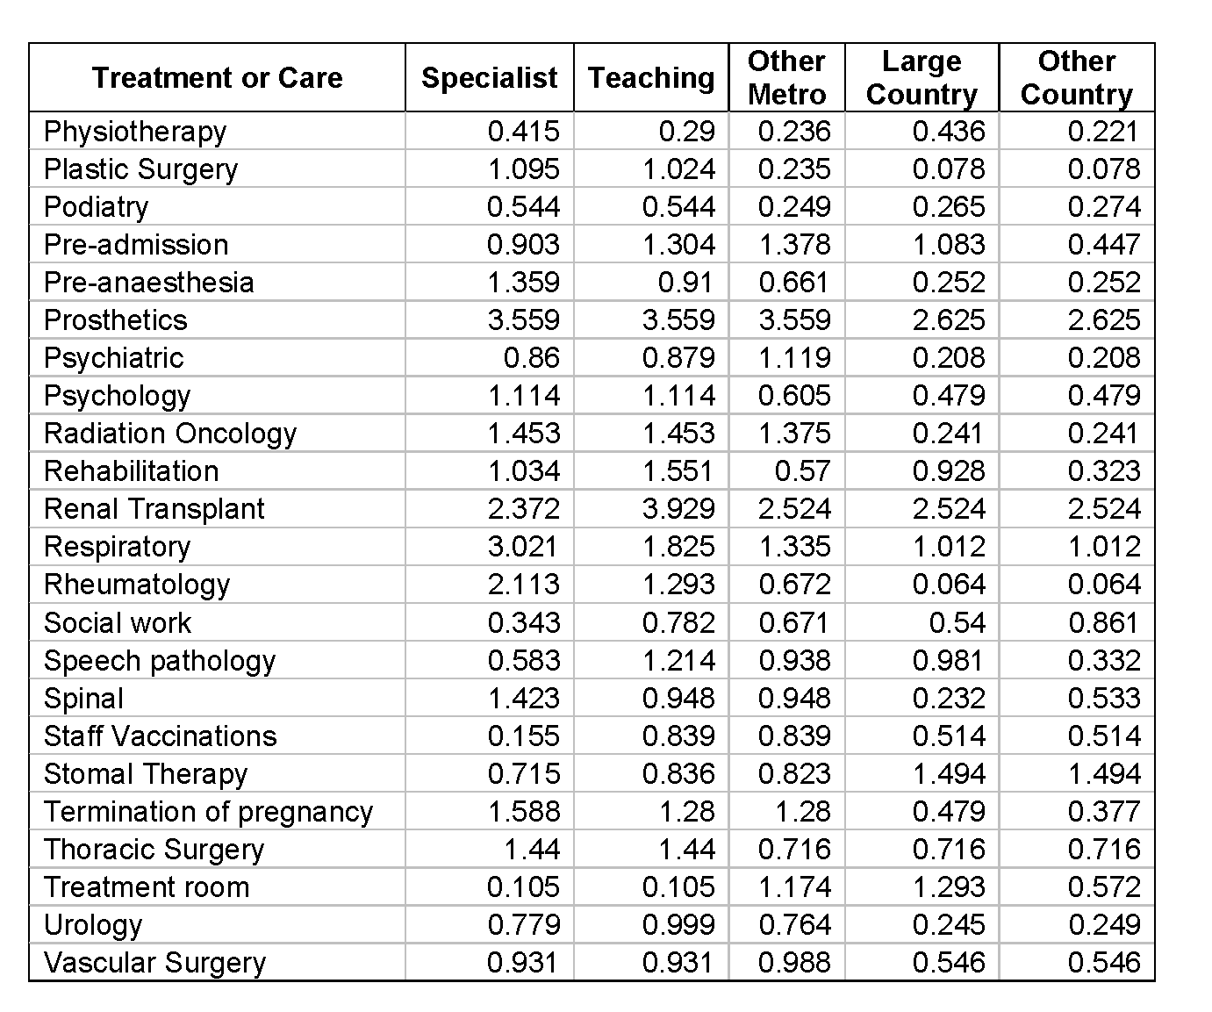

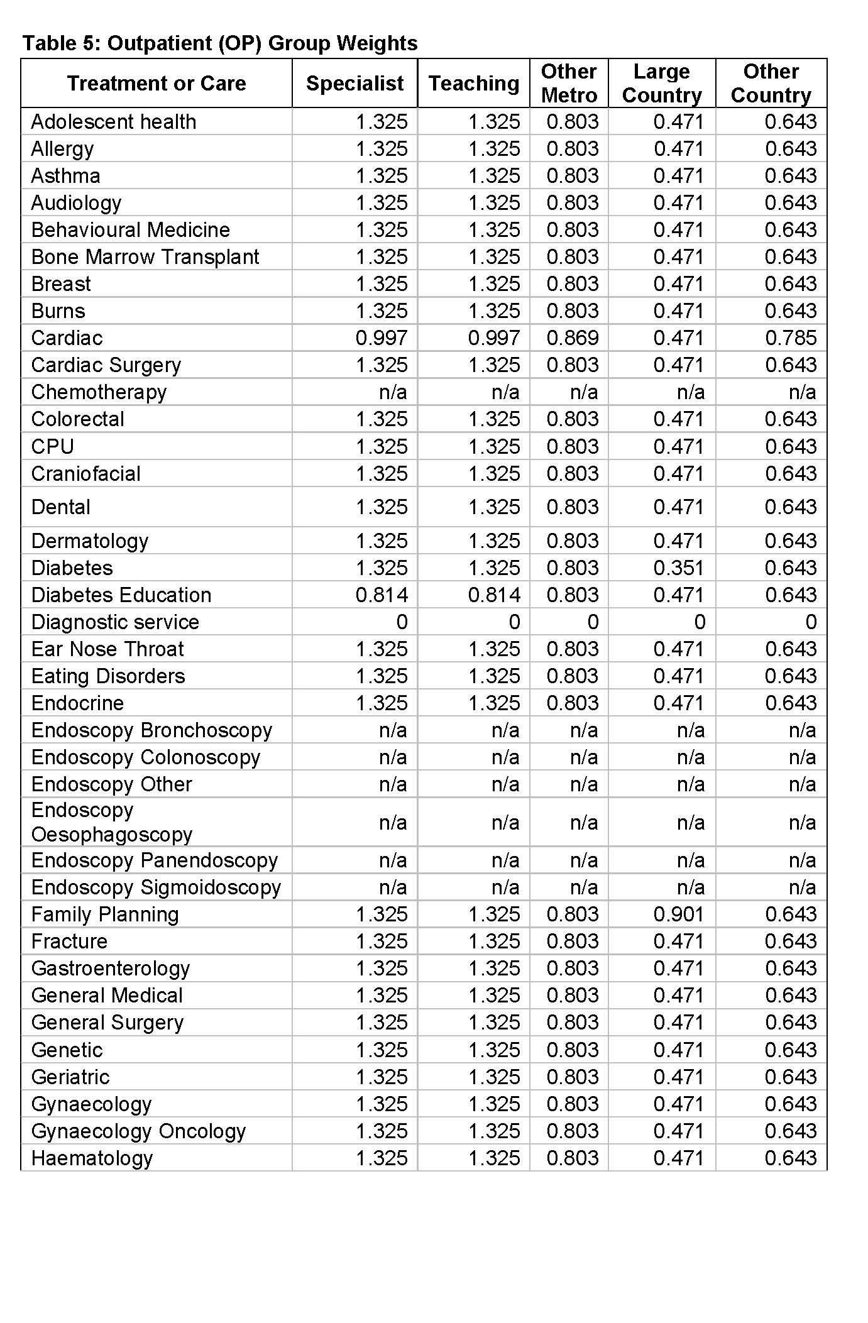

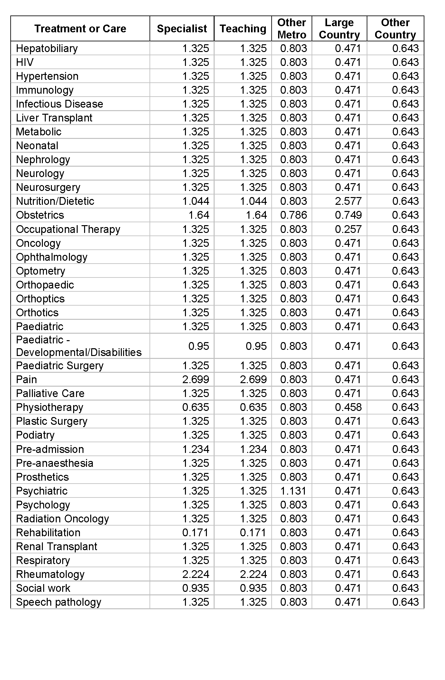

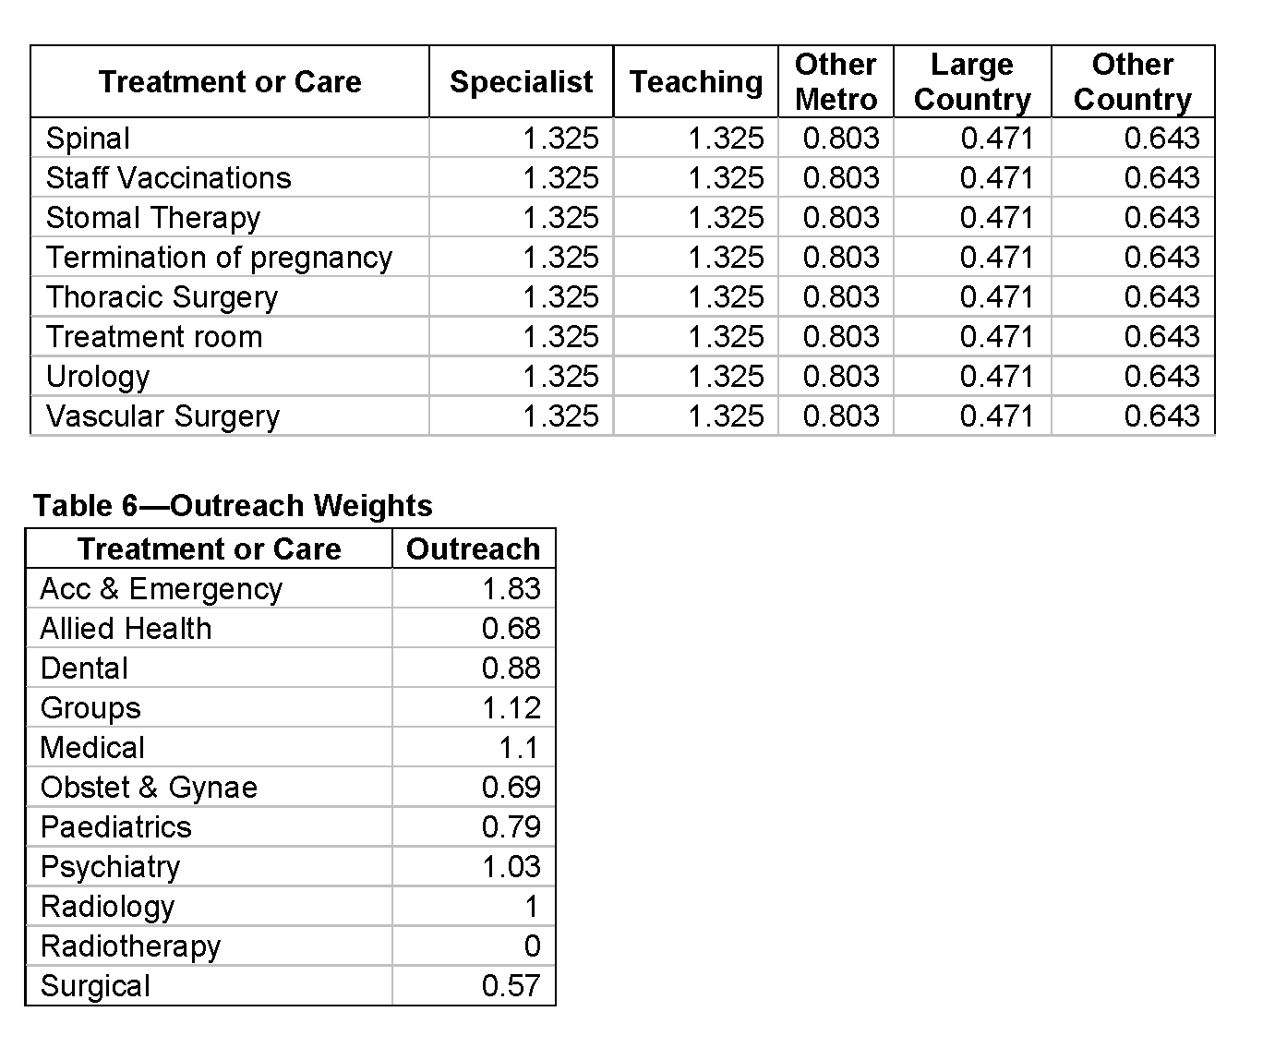

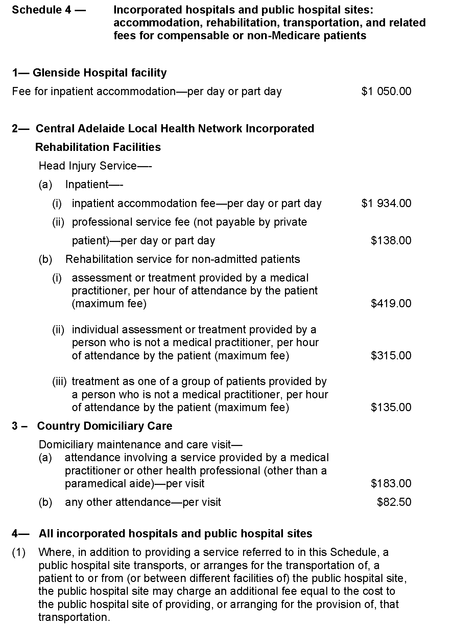

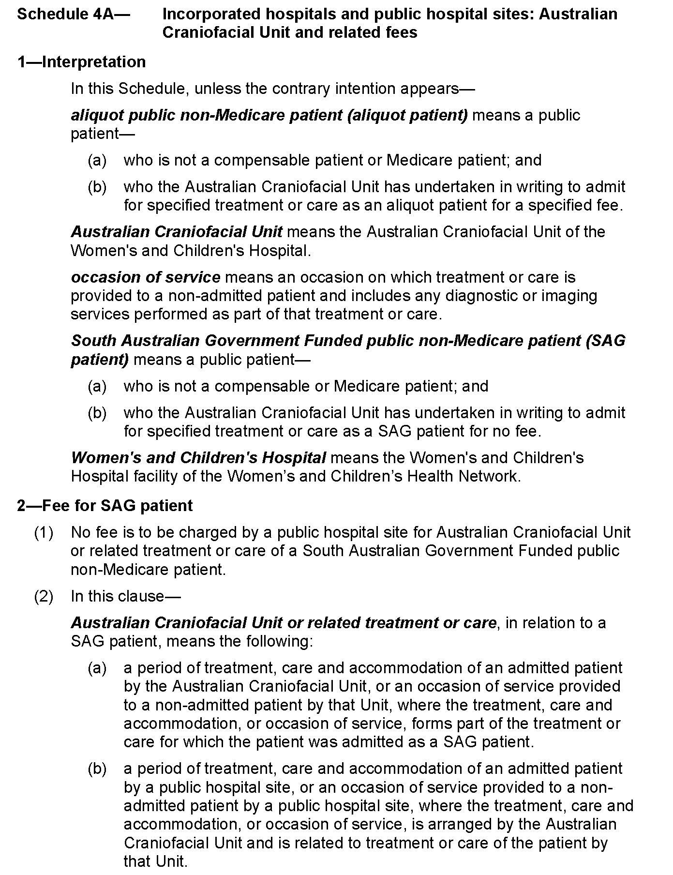

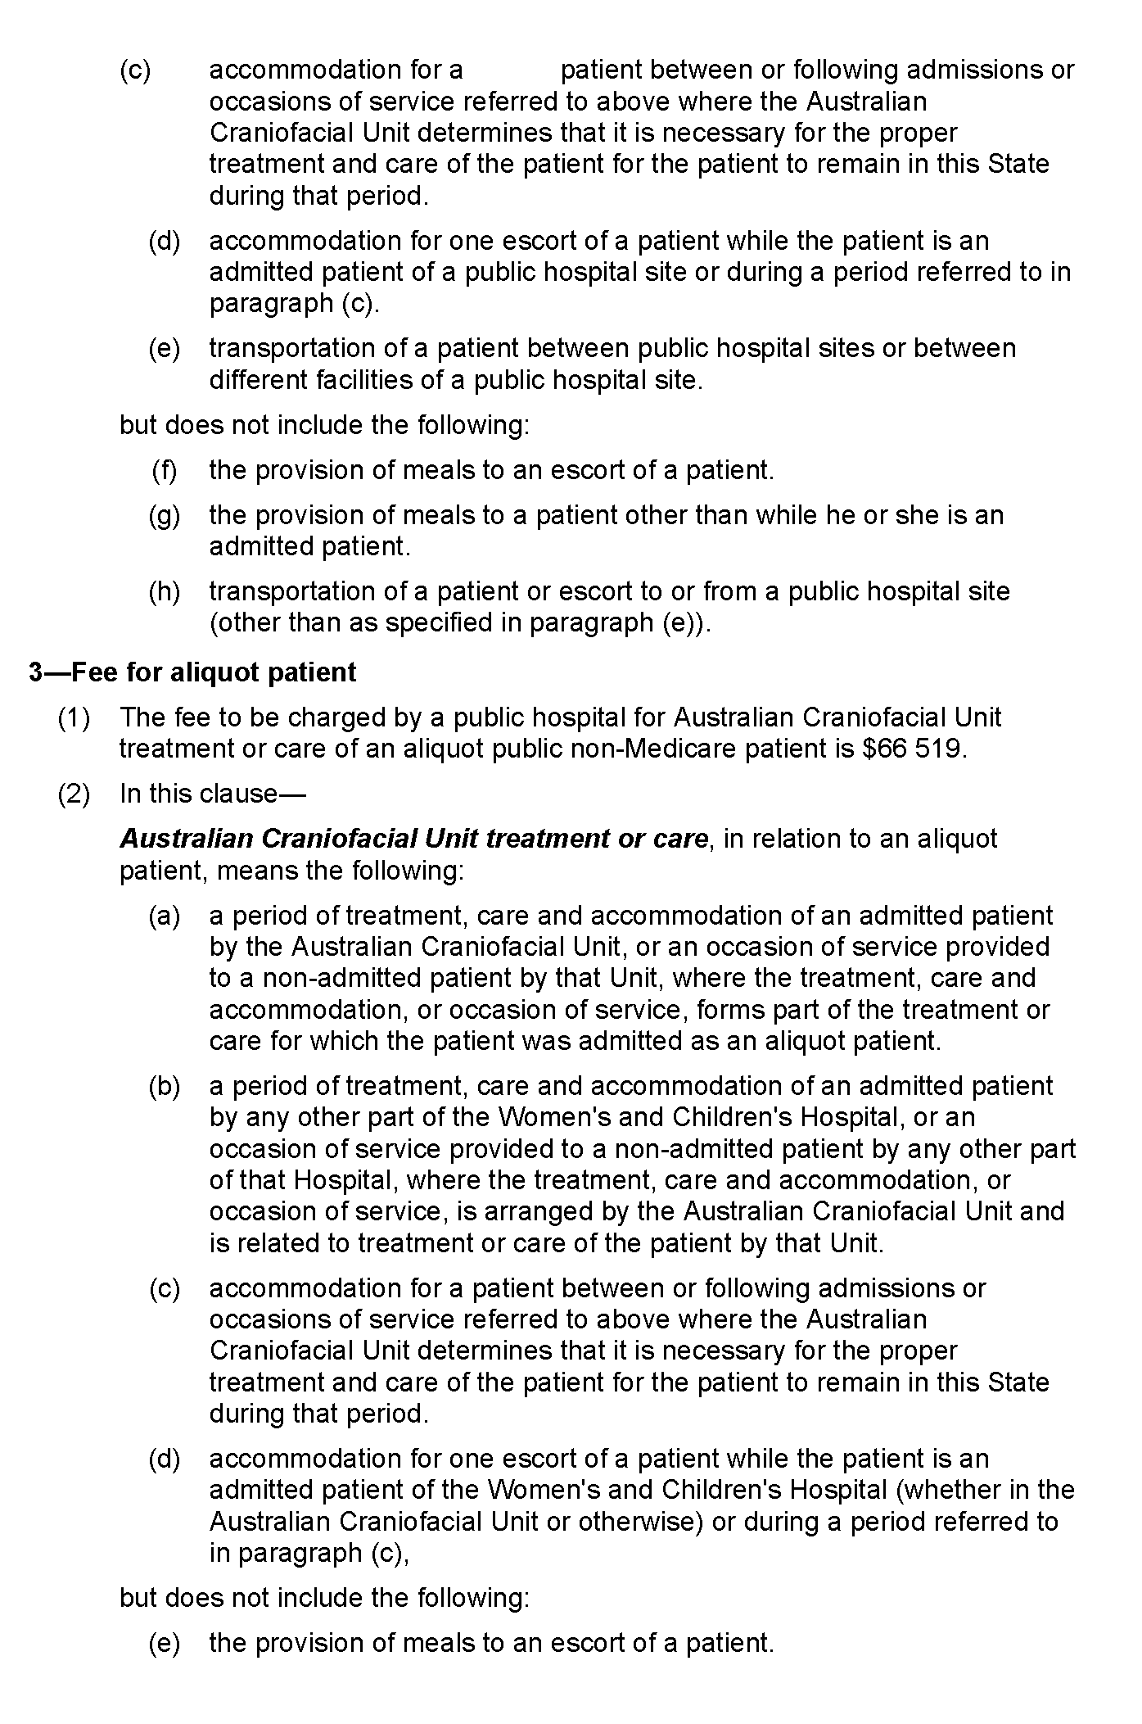

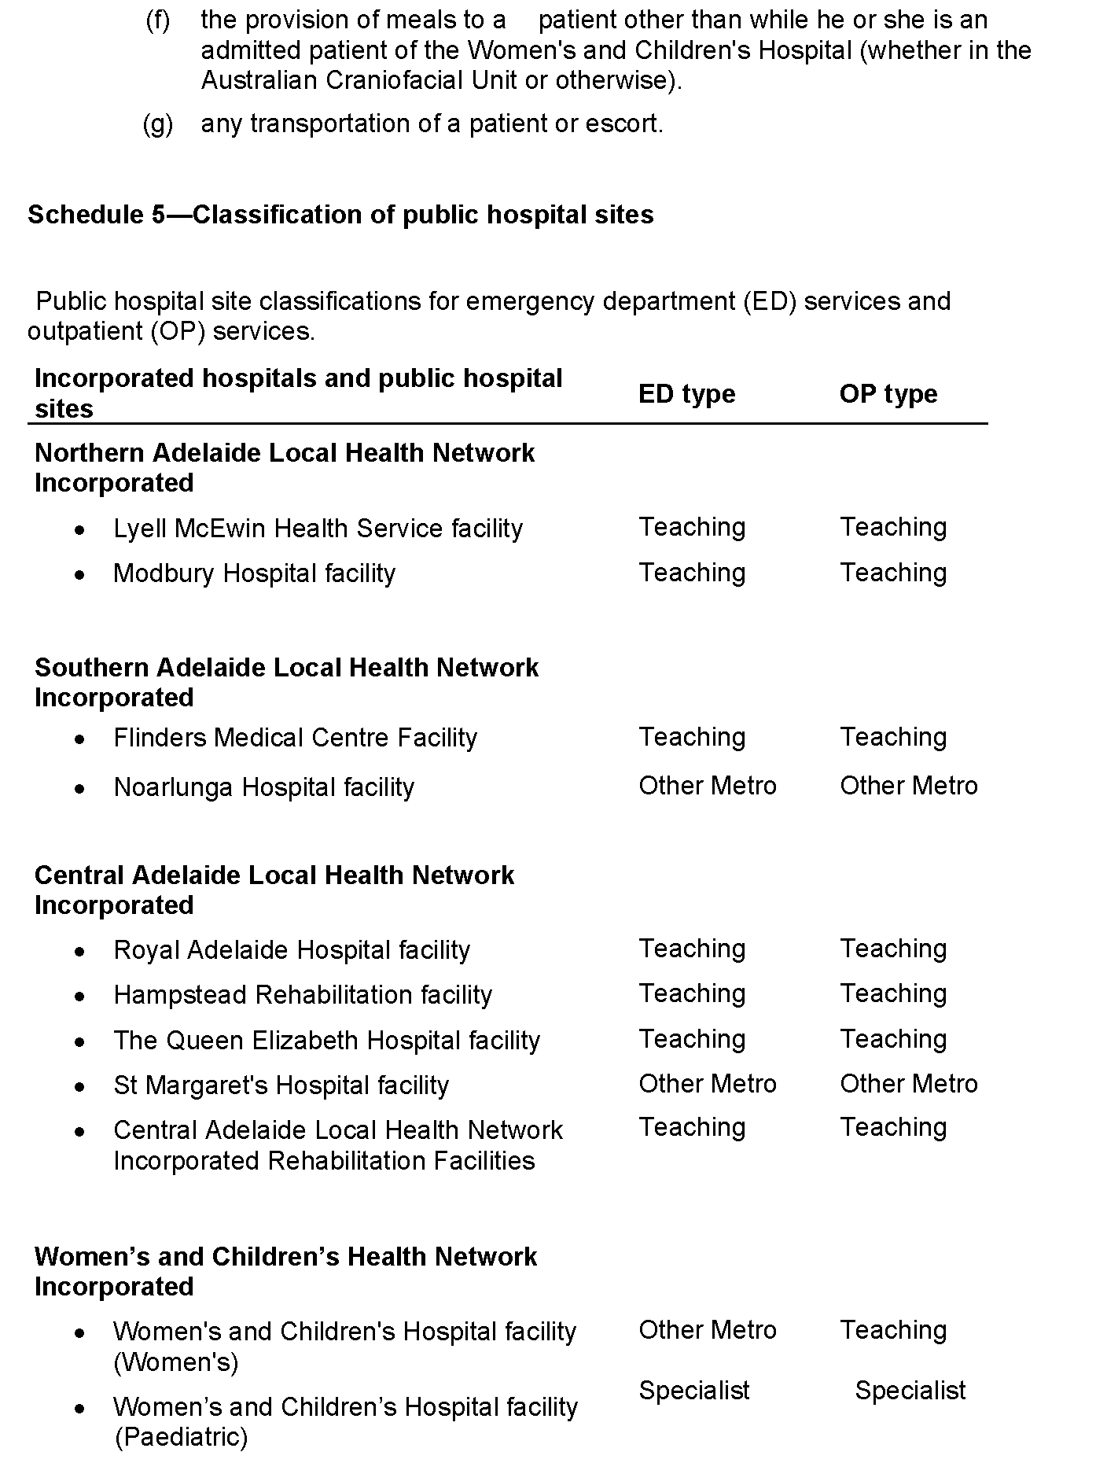

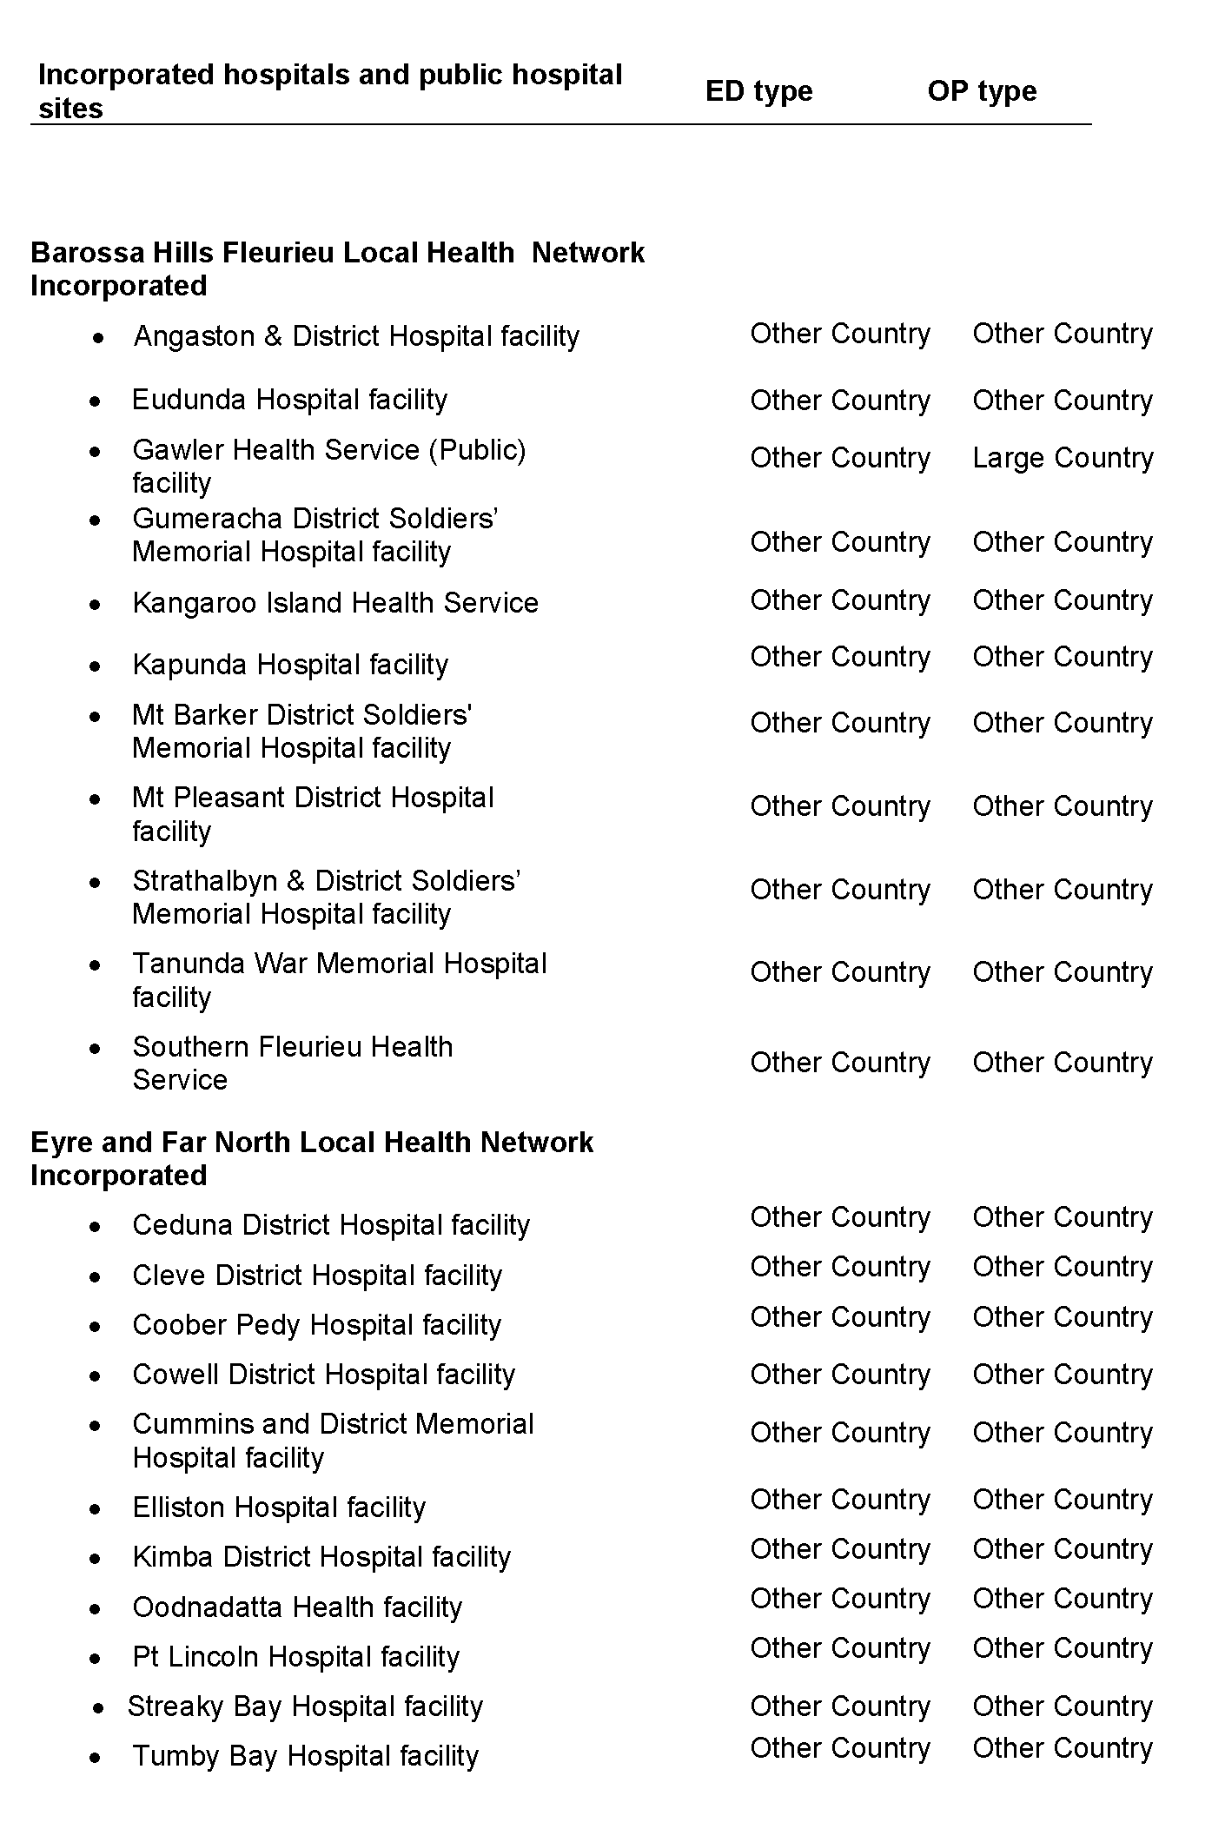

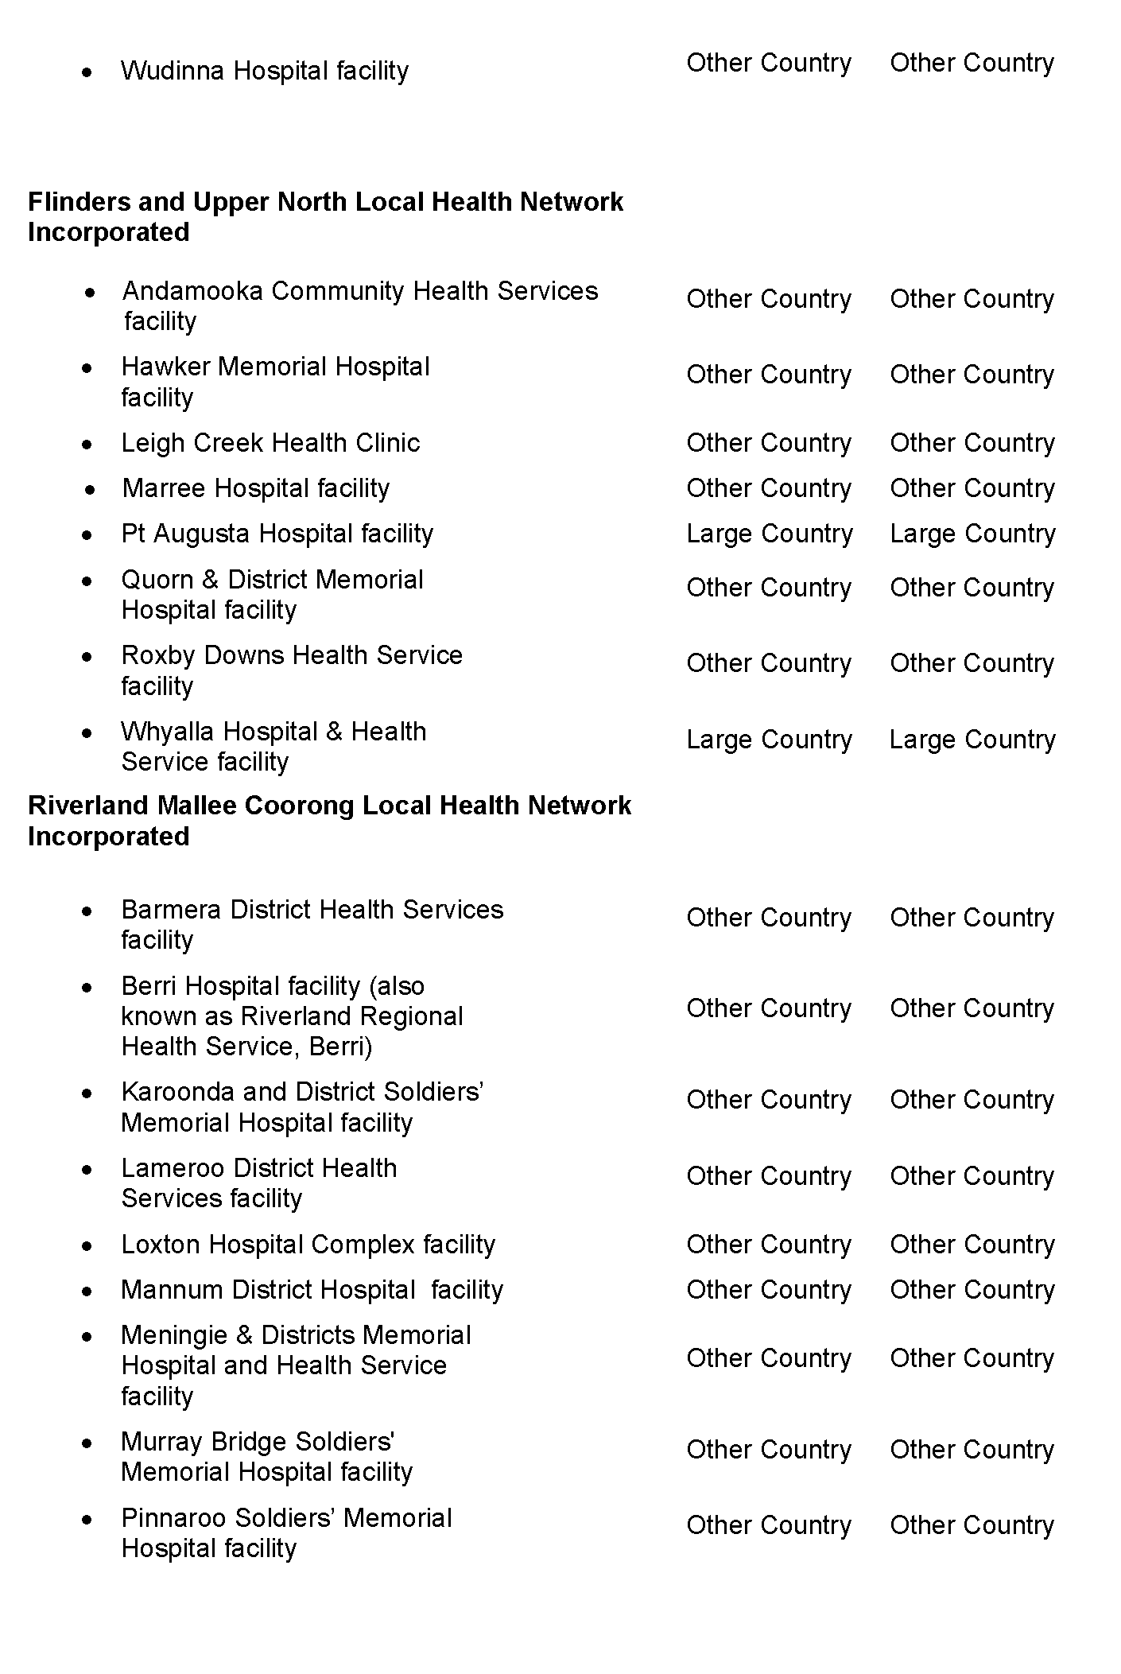

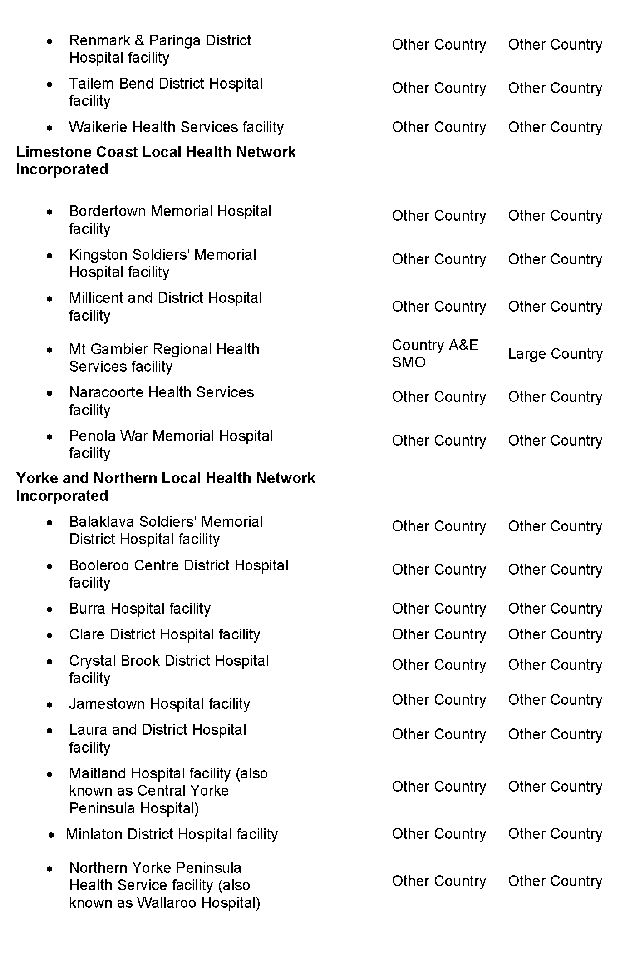

Heavy Vehicle National Law (South Australia) Act 2013
South Australia
Heavy Vehicle National Law (South Australia) (Fees) Notice 2024
under the Heavy Vehicle National Law (South Australia) Act 2013
1—Short title
This notice may be cited as the Heavy Vehicle National Law (South Australia) (Fees) Notice 2024.
Note—
This is a fee notice made in accordance with the Legislation (Fees) Act 2019. Under Section 4(3) of that Act, this notice revokes the Heavy Vehicle National Law (South Australia) (Fees) Notice 2023, as published in the Government Gazette on 18 May 2023 (p 1133).
2—Commencement
This notice has effect on 1 July 2024.
3—Interpretation
In this notice, unless the contrary intention appears—
Act means the Heavy Vehicle National Law (South Australia) Act 2013;
further inspection of a heavy vehicle means an inspection of the vehicle undertaken to determine if matters identified by a previous inspection have been addressed;
Law means the Heavy Vehicle National Law (South Australia);
Metropolitan Adelaide means Metropolitan Adelaide as defined by GRO Plan 639/93;
route assessment—see Schedule 1, item 9;
Transport Department means the administrative unit of the Public Service that is responsible for assisting a Minister in the administration of the Act.
4—Fees
(1) The fees set out in Schedule 1 are prescribed for the purposes of the Act, and are payable to the person or body as set out in the Schedule.
(2) A fee payable for booking an inspection must be paid when the booking is made.
(3) A fee payable for an inspection or route assessment must be paid prior to the inspection
or assessment.
(4) If a heavy vehicle is a heavy combination, a fee is payable for an inspection of each component vehicle of the combination.
(5) If more than 1 fee becomes payable for an inspection under Schedule 1 (other than an inspection for the purposes of a route assessment), only the higher or highest fee (as the
case may be) need be paid.
Example—
If a heavy vehicle is required to be inspected for a mass and dimension authority and for the purposes of a modification or defect clearance, only the higher fee is payable.
(6) If, as a result of a heavy vehicle being required to be inspected for the purposes of both the Law and the Road Traffic Act 1961, an inspection fee becomes payable under both Schedule 1 and the Road Traffic (Miscellaneous) Regulations 2014, only the higher of the fees need be paid to either the Transport Department or the Central Inspection Authority (as the case may be).
Example—
If a bus is required to be inspected for the purpose of carrying passengers under Section 163D of the Road Traffic Act 1961 and for the purposes of a defect clearance, only the higher fee is payable.
Schedule 1—Fees

 | Description |  |  | Fee
1 | Fee payable to the Transport Department in relation to the grant, amendment, cancellation or suspension of a mass or dimension authority, or vehicle standards exemption
 | (1) | for an inspection of a heavy vehicle (other than a trailer) |  | $392.00
 | (2) | for an inspection of a trailer (other than a converter dolly) |  | $198.00
 | (3) | for an inspection of a converter dolly |  | $99.00
 | (4) | for a further inspection of any vehicle referred to in a preceding subitem |  | $99.00
 | (5) | for inspecting a special purpose vehicle at premises (within Metropolitan Adelaide) specified by the operator of the vehicle on the request of the operator—in addition to any relevant fee referred to in a preceding subitem |  | $102.00
 | (6) | for booking an inspection or further inspection |  | $29.00
2 | Fee payable to the Transport Department in relation to compliance with a condition of a vehicle standards exemption, or mass or dimension authority
 | (1) | for an inspection of a heavy vehicle (other than a trailer) |  | $392.00
 | (2) | for an inspection of a trailer (other than a converter dolly) |  | $198.00
 | (3) | for an inspection of a converter dolly |  | $99.00
 | (4) | for a further inspection of any vehicle referred to in a preceding subitem |  | $99.00
 | (5) | for booking an inspection or further inspection |  | $29.00
3 | Fee payable to the Transport Department in relation to the approval by the Regulator of a vehicle modification (Section 87 of the Law)
 | (1) | for an inspection of a heavy vehicle (other than a trailer) |  | $294.00
 | (2) | for an inspection of a trailer (other than a converter dolly) |  | $198.00
 | (3) | for an inspection of a converter dolly |  | $99.00
 | (4) | for a further inspection of any vehicle referred to in a preceding subitem |  | $99.00
 | (5) | for booking an inspection or further inspection |  | $29.00
4 | Fee payable to the Transport Department—  • in relation to heavy vehicle standards; or  • to ensure the condition of a heavy vehicle, and any of its components or equipment, does not make use of the vehicle unsafe or endanger public safety
 | (1) | for an inspection of a heavy vehicle (other than a trailer) |  | $294.00
 | (2) | for an inspection of a trailer (other than a converter dolly) |  | $198.00
 | (3) | for an inspection of a converter dolly |  | $99.00
 | (4) | for a further inspection of any vehicle referred to in a preceding subitem |  | $99.00
 | (5) | for booking an inspection or further inspection |  | $29.00
5 | Fee payable to the Transport Department in relation to maintenance management accreditation (including the determination of an application for such accreditation (Section 459 of the Law))
 | (1) | if the heavy vehicle is nominated to be used in a class 1, 2 or 3  heavy combination—
 |  | (a) | for an inspection of a heavy vehicle (other than a trailer) | $392.00
 |  | (b) | for an inspection of a trailer (other than a converter dolly) | $198.00
 |  | (c) | for an inspection of a converter dolly | $99.00
 |  | (d) | for a further inspection of any vehicle referred to in a preceding subsubitem | $99.00
 |  | (e) | for booking an inspection or further inspection | $29.00
 | (2) | in any other case—
 |  | (a) | for an inspection of a heavy vehicle (other than a trailer) | $294.00
 |  | (b) | for an inspection of a trailer (other than a converter dolly) | $198.00
 |  | (c) | for an inspection of a converter dolly | $99.00
 |  | (d) | for a further inspection of any vehicle referred to in a preceding subsubitem | $99.00
 |  | (e) | for booking an inspection or further inspection | $29.00
6 | Fee payable to the Transport Department for an inspection required by notice under Section 522 of the Law in relation to any purpose not otherwise covered under this Schedule—
 | (1) | for an inspection of a heavy vehicle (other than a trailer) |  | $294.00
 | (2) | for an inspection of a trailer (other than a converter dolly) |  | $198.00
 | (3) | for an inspection of a converter dolly |  | $99.00
 | (4) | for a further inspection of any vehicle referred to in a preceding subitem |  | $99.00
 | (5) | for booking an inspection or further inspection |  | $29.00
7 | Fee payable to the Transport Department in relation to clearing a major defect notice or a minor defect notice (Section 530 of the Law)
 | (1) | for an inspection of a heavy vehicle (other than a trailer) |  | $294.00
 | (2) | for an inspection of a trailer (other than a converter dolly) |  | $198.00
 | (3) | for an inspection of a converter dolly |  | $99.00
 | (4) | for a further inspection of any vehicle referred to in a preceding subitem |  | $99.00
 | (5) | for booking an inspection or further inspection |  | $29.00
8 | Fee payable to SA Police in relation to clearing a major defect notice or a minor defect notice (Section 530 of the Law)
 |  | for a police officer at a police station inspecting a heavy vehicle and certifying that the required repairs have been made to the vehicle to stop the vehicle from being a defective heavy vehicle |  | $68.00
9 | Fee payable to a road manager (Section 159 of the Law)
 |  | for a route assessment required for the road manager to decide whether or not to give consent for a mass or dimension exemption (permit) or class 2 heavy vehicle authorisation (permit) involving (for example) the inspection of a heavy vehicle, the assessment of plans, maps or specifications, the survey or inspection of proposed routes, the examination of bridges or other transport infrastructure, the determination of road work or other work required to enable  the use of a proposed route, the consideration of any conditions  that may be applicable to the permit, etc |  | the fee  payable is the reasonable  cost of  providing the assessment
Made by the Minister for Infrastructure and Transport
On 30 April 2024

Highways Act 1926
Section 26(3)
Grosvenor Street, Glandore
I, Wayne Buckerfield, delegate of the Commissioner of Highways, with the approval of the Minister for Transport and pursuant to my delegated powers under Section 12A of the Highways Act 1926, do hereby give notice that I will undertake the care, control and management of Grosvenor Street, Glandore, contained within the boundaries of the City of West Torrens until further notice.
Dated: 13 May 2024
Wayne Buckerfield
Delegate of the Commissioner of Highways

Housing Improvement Act 2016
South Australia
Housing Improvement (Fees) Notice 2024
under the Housing Improvement Act 2016
1—Short title
This notice may be cited as the Housing Improvement (Fees) Notice 2024.
Note—
This is a fee notice made in accordance with the Legislation (Fees) Act 2019.
2—Commencement
This notice has effect on 1 July 2024.
3—Interpretation
In this notice, unless the contrary intention appears—
Act means the Housing Improvement Act 2016.
Regulations means the Housing Improvement Regulations 2017.
4—Fees
The fees set out in Schedule 1 are prescribed for the purposes of the Act and the regulations.
Schedule 1—Fees

1 | Recovery of costs and expenses incurred by Minister (Section 18(2) of Act)—
 | (a) for the registration of a housing assessment order, housing improvement order or housing demolition order in relation to land—
 | (i) for the first entry made by the Registrar-General in registering the order | $434.00
 | (ii) for each subsequent entry made by the Registrar-General in registering the order | $121.00
(b) for the cancellation of registration of a housing assessment order, housing improvement order or housing demolition order in
relation to land—
 | (i) for the first endorsement made by the Registrar-General in cancelling the registration of the order | $314.00
 | (ii) for each subsequent endorsement made by the Registrar-General in cancelling the registration of the order | $24.10
2 | A copy of part of the register (Section 46(6) of Act) | $42.00
3 | Fee for the purposes of Schedule 2 Clause 2(2)(b) of the regulations | $42.00
Signed by the Minister for Housing and Urban Development
On 1 May 2024

Housing Improvement Act 2016
Rent Control
In the exercise of the powers conferred by the Housing Improvement Act 2016, the Delegate of the Minister for Housing and Urban Development hereby fixes the maximum rental amount per week that shall be payable subject to Section 55 of the Residential Tenancies Act 1995, in respect of each premises described in the following table. The amount shown in the said table shall come into force on the date of this publication in the Gazette.
Address of Premises | Allotment Section | Certificate of Title  Volume/Folio | Maximum Rental per week payable
17 Tennyson Street, Clearview SA 5085 | Allotment 49, Deposited Plan 4672, Hundred of Yatala | CT5602/692 | $0.00
19 Ellen Street, Moonta SA 5558 | Allotment 330, Filed Plan 198511, Hundred of Wallaroo | CT5449/641 | $0.00
Dated: 16 May 2024
Craig Thompson
Housing Regulator and Registrar
Housing Safety Authority
Delegate of the Minister for Housing and Urban Development

Housing Improvement Act 2016
Rent Control Revocations
In the exercise of the powers conferred by the Housing Improvement Act 2016, the Delegate of the Minister for Housing and Urban Development hereby revokes the maximum rental amount per week that shall be payable subject to Section 55 of the Residential Tenancies Act 1995, in respect of each premises described in the following table.
Address of Premises | Allotment Section | Certificate of Title  Volume/Folio
44 Frederick Street, Maylands, SA 5069 | Allotment 92, Filed Plan 134843, Hundred of Adelaide | CT5412/362
Dated: 16 May 2024
Craig Thompson
Housing Regulator and Registrar
Housing Safety Authority
Delegate of the Minister for Housing and Urban Development

Hydroponics Industry Control Act 2009
South Australia
Hydroponics Industry Control (Fees) Notice 2024
under the Hydroponics Industry Control Act 2009
1—Short title
This notice may be cited as the Hydroponics Industry Control (Fees) Notice 2024.
Note—
This is a fee notice made in accordance with the Legislation (Fees) Act 2019.
2—Commencement
This notice has effect on 1 July 2024.
3—Interpretation
In this notice, unless the contrary intention appears—
Act means the Hydroponics Industry Control Act 2009.
4—Fees
The fees set out in Schedule 1 are prescribed for the purposes of the Act.
Schedule 1—Fees

1 | Application for hydroponic equipment dealer’s licence—
 | (a) if the applicant is a body corporate | $928
 | (b) if the applicant is a natural person | $573
2 | Application for approval as hydroponics industry employee | $573
3 | Annual fee for licence holders—
 | (a) if the licence holder is a body corporate | $1 017
 | (b) if the licence holder is a natural person | $779
4 | Annual fee for approved person | $373
5 | Penalty for default (Regulation 14(5)) | $215
Made by the Minister for Police, Emergency Services and Correctional Services
On 2 May 2024

Justices of the Peace Act 2005
Section 4
Notice of Appointment of Justices of the Peace for South Australia
by the Acting Commissioner for Consumer Affairs
I, Fraser W. Stroud, Commissioner for Consumer Affairs, delegate of the Attorney-General, pursuant to Section 4 of the Justices of the Peace Act 2005, do hereby appoint the people listed as Justices of the Peace for South Australia as set out below. It being a condition of appointment that the Justices of the Peace must take the oaths required of a justice under the Oaths Act 1936 and return the oaths of office form to Justice of the Peace Services within three months after the date of appointment.
For a period of ten years for a term commencing on 4 June 2024 and expiring on 3 June 2034:
Angelo Christopher Jude ZERELLA
Nathaniel James WINTER
Kirstie Skye THOMPSON
Sandra THELNING
Sofia Gianina Lee SY
Daniel Dusan SLADOJEVIC
Harvinder SINGH
Poonam SHARMA
James Ashley ROCK
Bernadette READING
Natasha Lee RAYSON
Mitchel Caven PATTISON
Julian David NUSKE
Shahrukh NAZ
James MIDDAP
Stephen James MASTERS
Emily Anne LOVEGROVE
Katherine KROLLIG
Rajesh Babu JAMMULA
Kerri Ellen I’ANSON
Pamela Christina HEINRICH
Hannah HAINS
Peter James GOODRICH
Sally Ann GOODE
Eleni DEMOURTZIDIS
Simone Jorja CAMERON
Mallika BHARDWAJ
Jamie BEAUMONT
Linda Maria BEARD
Dated: 14 May 2024
Fraser W. Stroud
Commissioner for Consumer Affairs
Delegate of the Attorney-General

Labour Hire Licensing Act 2017
South Australia
Labour Hire Licensing (Fees) Notice 2024
under the Labour Hire Licensing Act 2017
1—Short title
This notice may be cited as the Labour Hire Licensing (Fees) Notice 2024.
Note—
This is a fee notice made in accordance with the Legislation (Fees) Act 2019.
2—Commencement
This notice has effect on 1 July 2024.
3—Interpretation
In this notice, unless the contrary intention appears—
Act means the Labour Hire Licensing Act 2017.
4—Fees
The fees set out in Schedule 1 are prescribed for the purposes of the Act.
Schedule 1—Fees

1 | Application for licence (Section 15(2)(d)) | $674.00 plus—  (a) if the applicant for the licence is a  natural person—$270.00  (b) if the applicant for the licence is a  body corporate—$1,471.00
2 | Periodic fee (Section 20(2)(a)) | (a) if the holder of the licence is a  natural person—$270.00  (b) if the holder of the licence is a  body corporate—$1,471.00
3 | Application to change responsible person (Section 28(2)(b)) | $147.00
4 | On notice of substitute responsible person for limited period (Section 29(3)) | $147.00
Signed by the Minister for Consumer and Business Affairs
On 26 April 2024

Land Acquisition Act 1969
Section 16
Form 5—Notice of Acquisition
1. Notice of acquisition
The Commissioner of Highways (the Authority), of 83 Pirie Street, Adelaide SA 5000, acquires the following interests in the following land:
Comprising an unencumbered estate in fee simple in that piece of land being the whole of Allotment 202 in Deposited Plan 34545 comprised in Certificate of Title Volume 5107 Folio 561.
This notice is given under Section 16 of the Land Acquisition Act 1969.
2. Compensation
A person who has or had an interest consisting of native title or an alienable interest in the land that is divested or diminished by the acquisition or the enjoyment of which is adversely affected by the acquisition who does not receive an offer of compensation from the Authority may apply to the Authority for compensation.
2A. Payment of professional costs relating to acquisition (Section 26B)
If you are the owner in fee simple of the land to which this notice relates, you may be entitled to a payment of up to $10,000 from the Authority for use towards the payment of professional costs in relation to the acquisition of the land.
Professional costs include legal costs, valuation costs and any other costs prescribed by the Land Acquisition Regulations 2019.
3. Inquiries
Inquiries should be directed to: Petrula Pettas
GPO Box 1533
Adelaide SA 5001
Telephone: (08) 7133 2457
Dated: 10 May 2024
The Common Seal of the COMMISSIONER OF HIGHWAYS was hereto affixed by authority of the Commissioner in the presence of:
Rocco Caruso
Director Property Acquisition
(Authorised Officer)
Department for Infrastructure and Transport
File Reference: 2022/02740/01

Land Acquisition Act 1969
Section 16
Form 5—Notice of Acquisition
1. Notice of acquisition
The Commissioner of Highways (the Authority), of 83 Pirie Street, Adelaide SA 5000, acquires the following interests in the following land:
Comprising an unencumbered estate in fee simple in that piece of land being portion of Allotment 201 in Deposited Plan 36169 comprised in Certificate of Title Volume 5683 Folio 2 and being the whole of the land identified as Allotment 439 in D132281 lodged in the Lands Titles Office.
This notice is given under Section 16 of the Land Acquisition Act 1969.
2. Compensation
A person who has or had an interest consisting of native title or an alienable interest in the land that is divested or diminished by the acquisition or the enjoyment of which is adversely affected by the acquisition who does not receive an offer of compensation from the Authority may apply to the Authority for compensation.
2A. Payment of professional costs relating to acquisition (Section 26B)
If you are the owner in fee simple of the land to which this notice relates, you may be entitled to a payment of up to $10,000 from the Authority for use towards the payment of professional costs in relation to the acquisition of the land.
Professional costs include legal costs, valuation costs and any other costs prescribed by the Land Acquisition Regulations 2019.
3. Inquiries
Inquiries should be directed to: Philip Cheffirs
GPO Box 1533
Adelaide SA 5001
Telephone: (08) 7133 2395
Dated: 14 May 2024
The Common Seal of the COMMISSIONER OF HIGHWAYS was hereto affixed by authority of the Commissioner in the presence of:
Rocco Caruso
Director, Property Acquisition
(Authorised Officer)
Department for Infrastructure and Transport
File Reference: 2022/09507/01

Land Acquisition Act 1969
Section 16
Form 5—Notice of Acquisition
1. Notice of acquisition
The Commissioner of Highways (the Authority), of 83 Pirie Street, Adelaide SA 5000, acquires the following interests in the following land:
Comprising an unencumbered estate in fee simple in that piece of land being the whole of Allotment 229 in Filed Plan 19501 comprised in Certificate of Title Volume 5397 Folio 393.
This notice is given under Section 16 of the Land Acquisition Act 1969.
2. Compensation
A person who has or had an interest consisting of native title or an alienable interest in the land that is divested or diminished by the acquisition or the enjoyment of which is adversely affected by the acquisition who does not receive an offer of compensation from the Authority may apply to the Authority for compensation.
2A. Payment of professional costs relating to acquisition (Section 26B)
If you are the owner in fee simple of the land to which this notice relates, you may be entitled to a payment of up to $10,000 from the Authority for use towards the payment of professional costs in relation to the acquisition of the land.
Professional costs include legal costs, valuation costs and any other costs prescribed by the Land Acquisition Regulations 2019.
3. Inquiries
Inquiries should be directed to: Daniel Tuk
GPO Box 1533
Adelaide SA 5001
Telephone: (08) 7133 2479
Dated: 14 May 2024
The Common Seal of the COMMISSIONER OF HIGHWAYS was hereto affixed by authority of the Commissioner in the presence of:
Rocco Caruso
Director, Property Acquisition
(Authorised Officer)
Department for Infrastructure and Transport
File Reference: 2022/11132/01

Land Acquisition Act 1969
Section 16
Form 5—Notice of Acquisition
1. Notice of acquisition
The Commissioner of Highways (the Authority), of 83 Pirie Street, Adelaide SA 5000, acquires the following interests in the following land:
Comprising an unencumbered estate in fee simple in that piece of land being portion of Section 937 in Hundred of Pirie comprised in Certificate of Title Volume 5962 Folio 757, and being the whole of the land identified as Allotment 100 in D134248 lodged in the Lands Titles Office.
This notice is given under Section 16 of the Land Acquisition Act 1969.
2. Compensation
A person who has or had an interest consisting of native title or an alienable interest in the land that is divested or diminished by the acquisition or the enjoyment of which is adversely affected by the acquisition who does not receive an offer of compensation from the Authority may apply to the Authority for compensation.
2A. Payment of professional costs relating to acquisition (Section 26B)
If you are the owner in fee simple of the land to which this notice relates, you may be entitled to a payment of up to $10,000 from the Authority for use towards the payment of professional costs in relation to the acquisition of the land.
Professional costs include legal costs, valuation costs and any other costs prescribed by the Land Acquisition Regulations 2019.
3. Inquiries
Inquiries should be directed to: Philip Cheffirs
GPO Box 1533
Adelaide SA 5001
Telephone: (08) 7133 2395
Dated: 14 May 2024
The Common Seal of the COMMISSIONER OF HIGHWAYS was hereto affixed by authority of the Commissioner in the presence of:
Rocco Caruso
Director, Property Acquisition
(Authorised Officer)
Department for Infrastructure and Transport
File Reference: 2023/06475/01

Land Acquisition Act 1969
Section 16
Form 5—Notice of Acquisition
1. Notice of acquisition
The Commissioner of Highways (the Authority), of 83 Pirie Street, Adelaide SA 5000, acquires the following interests in the following land:
Comprising an unencumbered estate in fee simple in that piece of land being the whole of Allotment 101 in Filed Plan 19717 comprised in Certificates of Title Volume 6226 Folio 171, 172 and 173.
This notice is given under Section 16 of the Land Acquisition Act 1969.
2. Compensation
A person who has or had an interest consisting of native title or an alienable interest in the land that is divested or diminished by the acquisition or the enjoyment of which is adversely affected by the acquisition who does not receive an offer of compensation from the Authority may apply to the Authority for compensation.
2A. Payment of professional costs relating to acquisition (Section 26B)
If you are the owner in fee simple of the land to which this notice relates, you may be entitled to a payment of up to $10,000 from the Authority for use towards the payment of professional costs in relation to the acquisition of the land.
Professional costs include legal costs, valuation costs and any other costs prescribed by the Land Acquisition Regulations 2019.
3. Inquiries
Inquiries should be directed to: Petrula Pettas
GPO Box 1533
Adelaide SA 5001
Telephone: (08) 7133 2457
Dated: 14 May 2024
The Common Seal of the COMMISSIONER OF HIGHWAYS was hereto affixed by authority of the Commissioner in the presence of:
Rocco Caruso
Director, Property Acquisition
(Authorised Officer)
Department for Infrastructure and Transport
File Reference: 2022/02967/01

Land Agents Act 1994
South Australia
Land Agents (Fees) Notice 2024
under the Land Agents Act 1994
1—Short title
This notice may be cited as the Land Agents (Fees) Notice 2024.
Note—
This is a fee notice made in accordance with the Legislation (Fees) Act 2019.
2—Commencement
This notice has effect on 1 July 2024.
3—Interpretation
In this notice, unless the contrary intention appears—
Act means the Land Agents Act 1994.
4—Fees
The fees set out in Schedule 1 are prescribed for the purposes of the Act.

Schedule 1—Fees

1 | Application fee for registration (Section 7 of Act)—
 | (a) as an agent | $365.00
 | (b) as an agent and auctioneer | $365.00
 | (c) as a sales representative | $365.00
 | (d) as a sales representative and auctioneer | $365.00
 | (da) as a sales representative and property manager | $365.00
 | (db) as a sales representative, auctioneer and property manager | $365.00
 | (dc) as a property manager | $365.00
 | (dd) as a property manager and the applicant holds registration as a sales representative | $145.00
 | (e) as an auctioneer | $145.00
2 | Registration fee (payable on grant of registration under Part 2 of Act)—
 | (a) for an agent who is a natural person | $447.00
 | (b) for an agent that is a body corporate | $673.00
 | (c) for a sales representative | $286.00
 | (d) for a sales representative and a property manager | $286.00
 | (e) for a property manager | $240.00
 | If the period between the grant of the registration and the next date for payment of a fee under Section 9 of the Act is less than or more than 12 months, a pro rata adjustment is to be made to the amount of the additional fee by applying the proportion that the length of that period bears to 12 months.
3 | Application for variation or revocation of condition of registration (Section 8B of Act) | $155.00
3a | Application for variation or revocation of condition of registration (Section 8BB of Act) | $155.00
4 | Annual fee (Section 9 of Act)—
 | (a) for an agent who is a natural person | $447.00
 | (b) for an agent that is a body corporate | $673.00
 | (c) for a sales representative | $286.00
 | (d) for a sales representative who is also registered as a property manager | $286.00
 | (e) for a property manager | $240.00
 | If the period between a date for payment of a fee under Section 9 of the Act and the next date for payment of the fee under that section (as nominated by the Commissioner) is less than or more than 12 months, a pro rata adjustment is to be made to the amount of the fee by applying the proportion that the length of that period bears to 12 months.
7 | Fee for replacement of registration card | $33.75
Signed by the Minister for Consumer and Business Affairs
On 26 April 2024

Land and Business (Sale and Conveyancing) Act 1994
South Australia
Land and Business (Sale and Conveyancing) (Fees) Notice 2024
under the Land and Business (Sale and Conveyancing) Act 1994
1—Short title
This notice may be cited as the Land and Business (Sale and Conveyancing) (Fees) Notice 2024.
Note—
This is a fee notice made in accordance with the Legislation (Fees) Act 2019.
2—Commencement
This notice has effect on 1 July 2024.
3—Interpretation
In this notice, unless the contrary intention appears—
Act means the Land and Business (Sale and Conveyancing) Act 1994.
4—Fees
The fees set out in Schedule 1 are prescribed for the purposes of the Act and are payable to a council, or a statutory authority or prescribed body, as specified in the Schedule.
Schedule 1—Contracts for sale of land or businesses—fees

1—Fees payable to councils
 | For a council search report to be provided by a council—
 | (a) for particulars in the report—
 | (i) in relation to 1 strata unit | $28.50
 | (ii) in relation to 2 strata units on the same strata plan | $57.00
 | (iii) in relation to 3 or more strata units on the same strata plan | $85.50
 | (iv) for each certificate of title to land under the Real Property Act 1886, or Crown lease, in respect of which particulars are to be provided—
 | (A) if the applicant requests that the particulars be provided within 24 hours after receipt of the request | $42.75
 | (B) in any other case | $28.50
 | (b) for documentary material in the report—the actual cost incurred by the council in producing a copy of the document.
2—Fees payable to statutory authorities or prescribed bodies
(1) | For particulars and documentary material to be provided by a statutory authority or prescribed body (other than where particulars are to be provided for the purposes of a property interest report)—
 | (a) for particulars—
 | (i) in relation to 1 strata unit | $21.60
 | (ii) in relation to 2 strata units on the same strata plan | $40.25
 | (iii) in relation to 3 or more strata units on the same strata plan | $61.00
 | (iv) in any other case—in relation to each certificate of title to land under the Real Property Act 1886, or Crown lease, in respect of which particulars are to be provided | $21.60
 | (b) for documentary material—the actual cost incurred by the statutory authority or prescribed body in producing a copy of the document.
(2) | For a property interest report or update—
 | (a) for a property interest report to be provided by the Department in relation to a certificate of title to land under the Real Property Act 1886 or a Crown lease | $355.00
 | (b) for an update of such a report (where the application is made not more than 90 days after the original report was issued) to be provided by the Department. | $177.00
(3) | For a property interest report or update for a related title—
 | (a) for a property interest report to be provided by the Department in relation to a related title | $54.00
 | (b) for an update of such a report (where the application is made not more than 90 days after the original report was issued) to be provided by the Department. | $13.50
3—Interpretation
 | In this Schedule—
 | council search report means a report by a council (whether or not wholly or partially in electronic form) that provides particulars and documentary material under the Act or the regulations under the Act for the purposes of the preparation of a vendor's statement in relation to land;
 | Crown lease means a leasehold interest granted by the Crown under an Act;
 | Department means the Department for Trade and Investment;
prescribed body means a body prescribed for the purposes of Section 12(2) of the Act;
Note—
See Regulation 16 of the Land and Business (Sale and Conveyancing) Regulations 2010.
property interest report means a report (whether or not wholly or partially in the form of an annotated version of Form 1 or Form 2 as set out in Schedule 1 of the Land and Business (Sale and Conveyancing) Regulations 2010, and whether or not wholly or partially in electronic form) produced by the Department for the purposes of the preparation of a vendor's statement in relation to land, that includes—
(a) particulars and documentary material provided by the Department under the Act or regulations under the Act for the purposes of the preparation of the statement; and
(b) a search copy of the certificate of title to the land or, in the case of a Crown lease, a copy of the lease;
related title means a certificate of title to, or a Crown lease of, land that—
(a) is contiguous with, and owned or held pursuant to a Crown lease by the same person as, land in relation to which a property interest report is to be provided by the Department; and
(b) is valued by the Valuer-General under the Valuation of Land Act 1971 conjointly with, and is to be sold at the same time as, the land in relation to which the property interest report is to be provided;
 | strata unit includes a community lot (or development lot) and strata plan includes a community plan.
Note—
The fees payable to a strata corporation or a community corporation for the provision of information are prescribed under the Strata Titles Act 1988 and the Community Titles Act 1996, respectively.

Signed by the Minister for Consumer and Business Affairs
On 26 April 2024

Land Tax Act 1936
South Australia
Land Tax (Fees) Notice 2024
under the Land Tax Act 1936
1—Short title
This notice may be cited as the Land Tax (Fees) Notice 2024.
2—Commencement
This notice has effect on 1 July 2024.
Note—
This is a fee notice made in accordance with the Legislation (Fees) Act 2019.
3—Interpretation
In this notice, unless the contrary intention appears—
Act means the Land Tax Act 1936.
4—Fees
The fees specified in Schedule 1 are prescribed for the purposes of the Act.
Schedule 1—Fees

1 | For a certificate under Section 23 of the Act showing the amount of tax payable in respect of land | $40.25
Made by the Treasurer
Hon. Stephen Mullighan MP
On 22 April 2024

Legal Practitioners Act 1981
South Australia
Legal Practitioners (Fees) Notice 2024
under the Legal Practitioners Act 1981
1—Short title
This notice may be cited as the Legal Practitioners (Fees) Notice 2024.
Note—
This is a fee notice made in accordance with the Legislation (Fees) Act 2019.
2—Commencement
This notice has effect on the day on which it is made.
3—Interpretation
In these regulations, unless the contrary intention appears—
Act means the Legal Practitioners Act 1981.
4—Fees
The Fees specified in Schedule 1 are prescribed for the purposes of the Act.
Schedule 1—Fees

1 | For the issue or renewal of a practising certificate (other than a volunteer practising certificate)—
 | (a) for more than 6 months | $723 fee  $227 levy
 | (b) for 6 months or less | $405 fee  $114 levy
2 | Fee for the issue or renewal of a volunteer practising certificate  (see LPEAC Rule 3B: category D practising certificate) | $103 fee  $47 levy
3 | Fee to accompany written notice provided under Section 23D of the Act | $32.50
4 | Fee to accompany written notice provided under Schedule 1 Clause 4 of the Act | $32.50
Signed by the Attorney-General
On 16 May 2024

Liquor Licensing Act 1997
South Australia
Liquor Licensing (Fees) Notice 2024
under the Liquor Licensing Act 1997
1—Short title
This notice may be cited as the Liquor Licensing (Fees) Notice 2024.
Note—
This is a fee notice made in accordance with the Legislation (Fees) Act 2019.
2—Commencement
This notice has effect on 1 July 2024.
3—Interpretation
(1) In this notice, unless the contrary intention appears—
Act means the Liquor Licensing Act 1997;
class 1 event—an event authorised under a short term licence is a class 1 event if—
(a) the maximum capacity of the licensed premises authorised under the licence for the event is a number of persons not exceeding 200 persons at any one time; and
(b) the sale or supply of liquor past midnight is not authorised under the licence for the event; and
(c) the event is to last 1 day or less; and
(d) no part of the licensed premises or area adjacent to the licensed premises is used for the purpose of providing prescribed entertainment;
class 2 event—an event authorised under a short term licence is a class 2 event—
(a) if—
(i) the maximum capacity of the licensed premises authorised under the licence for the event is a number of persons not exceeding 1 200 persons at any one time; and
(ii) the sale or supply of liquor past 2 am is not authorised under the licence for the event; and
(iii) no part of the licensed premises or area adjacent to the licensed premises is used for the purpose of providing prescribed entertainment; or
(b) if the conditions of the licence in respect of the event only authorise the sale of liquor by direct sales transactions (regardless of the authorised trading hours under the licence); or
(c) if, in the opinion of the Commissioner, the nature of the event is such that the event should be regarded as a class 2 event;

class 3 event—an event authorised under a short term licence is a class 3 event if—
(a) the maximum capacity of the licensed premises authorised under the licence for the event is a number of persons exceeding 1 200 persons at any one time; or
(b) the sale or supply of liquor past 2 am is authorised for the event; or
(c) a part of the licensed premises or area adjacent to the licensed premises is used for the purpose of providing prescribed entertainment; or
(d) the Commissioner determines on other grounds that the nature of the event has required or will require the devotion of significant resources for the purposes of the administration or enforcement of the Act in relation to the event;
day—the Commissioner may, in relation to an event authorised under a short term licence, specify on the licence each period (of up to 24 hours) that constitutes a day of the event;
event includes an occasion;
5 year short term licence—a short term licence granted for a term of 5 years is a 5 year
short term licence;
short term licence includes a 5 year short term licence.
(2) For the purposes of this notice—
(a) a licence authorises the sale or supply of liquor past midnight if it authorises the sale or supply of liquor immediately before and immediately after midnight on any 1 or more days (disregarding sale or supply to a resident on licensed premises); and
(b) a licence authorises the sale or supply of liquor past 2 am if it authorises the sale or supply of liquor immediately before and immediately after 2 am on any 1 or more days (disregarding sale or supply to a resident on licensed premises); and
(c) a licence authorises the sale or supply of liquor past 3 am if it authorises the sale or supply of liquor immediately before and immediately after 3 am on any 1 or more days (disregarding sale or supply to a resident on licensed premises); and
(d) a licence authorises the sale or supply of liquor past 4 am if it authorises the sale or supply of liquor immediately before and immediately after 4 am on any 1 or more days (disregarding sale or supply to a resident on licensed premises); and
(e) a licence authorises the sale or supply of liquor past 5 am if it authorises the sale or supply of liquor immediately before and immediately after 5 am on any 1 or more days (disregarding sale or supply to a resident on licensed premises).
(3) For the purposes of this notice, the maximum capacity of licensed premises is the number of persons that must not be exceeded at the licensed premises as stated under the licence (disregarding residents in areas of the premises not accessible to other members of the public (such as bedrooms and other accommodation areas)).
4—Fees
The fees set out in Schedule 1 are prescribed for the purposes of the Act.

Schedule 1—Fees

1 | Application for the grant of a licence other than a short term licence |  | $708.00
1A | Application for the grant of an interstate direct sales licence |  | $107.00
2 | Application for the grant of a short term licence (other than a 5 year short term licence) if it is to be granted to the holder of a licence (other than a short term licence) and the licensed premises of the short term licence comprise the whole or a part of the licensed premises of the other licence held by the licensee—
 | (a) where the application is made within the prescribed time |  | $107.00
 | (b) where the application is not made within the prescribed time—the fee determined in accordance with paragraph (a) of this item plus a late fee of $107.00
3 | Application for the grant of a short term licence (other than a short term licence to which item 2 applies or a 5 year short term licence)—
 | (a) where the application is made within the prescribed time—
 | (i) if the licence is sought for a class 1 event |  | $107.00
 | (ii) if the licence is sought for a class 2 event—
 | (A) if the conditions of the licence only authorise the sale of liquor by direct sales transactions |  | $107.00
 | (B) in any other case |  | $227.00
 | (iii) if the licence is sought for a class 3 event |  | $708.00
 | (b) where the application is not made within the prescribed time—the fee determined in accordance with paragraph (a) of this item plus a late fee of—
 | (i) if the licence is sought for a class 1 event |  | $107.00
 | (ii) if the licence is sought for a class 2 event—
 | (A) in the case of a licence that only authorises the sale of liquor by direct sales transactions |  | $107.00
 | (B) in any other case |  | $227.00
 | (iii) if the licence is sought for a class 3 event |  | $708.00
However, no fee is payable under item 2 or 3 for an application for the grant of a short term licence if—
(a) the licence is sought for a class 1 or 2 event; and
(b) the applicant is an incorporated association under the Associations Incorporation Act 1985 or an entity registered under the Australian Charities and Not-for-profits Commission Act 2012 of the Commonwealth,
but if such an application is not made within the prescribed time, the late fee under item 2(b) or 3(b)(i) or (ii) (as the case requires) is payable in respect of the application.
 | For the purposes of items 2 and 3, the prescribed time, in relation to an application, is the time prescribed under Section 51(1)(c) of the Act (see the Liquor Licensing (General) Regulations 2012) as the time within which the application must be made.
4 | Event fee in relation to an event endorsed on a short term licence (other than a 5 year short term licence)—
 | (a) if the event endorsed is a class 1 event—no fee is payable
 | (b) if the event endorsed is a class 2 event—
 | (i) if the conditions of the licence only authorise the sale of liquor by direct sales transactions—an amount of $11.40 is payable in respect of each day of the event
 | (ii) in any other case—an amount equal to the sum of the base amount and the capacity amount is payable in respect of each day of the event
 | (c) if the event endorsed is a class 3 event—an amount equal to the sum of the base amount, the capacity amount and the trading hours amount is payable in respect of each day of the event
5 | Application for the grant of a 5 year short term licence—
 | (a) an application fee of |  | $708.00
 | and
 | (b) an endorsement fee for the endorsement by the licensing authority of the first event on the licence—
 | (i) for the endorsement of a class 1 event |  | $53.50
 | (ii) for the endorsement of a class 2 event |  | $113.00
 | (iii) for the endorsement of a class 3 event |  | $353.00
 | (c) an event fee in relation to the endorsement by the licensing authority of the first event on the licence—
 | (i) if the event endorsed is a class 1 event—no fee is payable
 | (ii) if the event endorsed is a class 2 event—an amount equal to the sum of the base amount and the capacity amount is payable in respect of each day of the event
 | (iii) if the event endorsed is a class 3 event—an amount comprised of the sum of the base amount, the capacity amount and the trading hours amount is payable in respect of each day of the event
6 | The following fees are payable for each subsequent event endorsed by the licensing authority on a 5 year short term licence in accordance with the conditions of  the licence:
 | (a) an endorsement fee for the endorsement of the event on the licence—
 | (i) for the endorsement of a class 1 event |  | $53.50
 | (ii) for the endorsement of a class 2 event |  | $113.00
 | (iii) for the endorsement of a class 3 event |  | $353.00
 | (b) an event fee in relation to the event—
 | (i) if the event endorsed is a class 1 event—no fee is payable
 | (ii) if the event endorsed is a class 2 event—an amount equal to the sum of the base amount and the capacity amount is payable in respect of each day of the event
 | (iii) if the event endorsed is a class 3 event—an amount comprised of the sum of the base amount, the capacity amount and the trading hours amount is payable in respect of each day of the event
7 | If the fees under item 6 payable in accordance with the conditions of the licence are not paid within the time before the commencement of the event specified by those conditions, the following additional amount is payable:
 | (a) if the event to be endorsed on the licence is a class 1 event |  | $53.50
 | (b) if the event to be endorsed on the licence is a class 2 event |  | $113.00
 | (c) if the event to be endorsed on the licence is a class 3 event |  | $353.00
8 | For the purposes of items 4(b)(ii) and (c), 5(c), and 6(b)—
 | (a) the base amount is— |  | $114.00
 | and
 | (b) the capacity amount is—
 | (i) if the maximum capacity of the licensed premises does not exceed 500 |  | nil
 | (ii) if the maximum capacity of the licensed premises exceeds 500 but does not exceed 1 000 |  | $28.50
 | (iii) if the maximum capacity of the licensed premises exceeds 1 000 but does not exceed 5 000 |  | $57.00
 | (iv) if the maximum capacity of the licensed premises exceeds 5 000 but does not exceed 10 000 |  | $85.50
 | (v) if the maximum capacity of the licensed premises exceeds 10 000 |  | $114.00
 | and
 | (c) the trading hours amount is—
 | (i) if the sale or supply of liquor past 2 am is authorised for the event but the sale or supply of liquor past 3 am is not authorised |  | $22.90
 | (ii) if the sale or supply of liquor past 3 am is authorised for the event but the sale or supply of liquor past 4 am is not authorised |  | $68.00
 | (iii) if the sale or supply of liquor past 4am is authorised for the event but the sale or supply of liquor past 5 am is not authorised |  | $166.00
 | (iv) if the licence authorises the sale or supply of liquor past 5 am |  | $333.00
9 | Application for the grant of a designated application under Section 53A of the Act |  | $155.00
10 | Application for removal of a licence |  | $708.00
11 | Application for transfer of a licence |  | $708.00
12 | Application for—
 | (a) approval of an alteration or proposed alteration to licensed premises |  | $155.00
 | (b) redefinition of licensed premises as defined in the licence |  | $155.00
13 | Application by holder of a club licence for endorsement of club event endorsement or club transport endorsement on licence (an application may relate to up to 5 such endorsements) |  | $155.00
14 | Application for exemption under Section 38(6) of the Act |  | $155.00
15 | Application by holder of liquor production and sales licence for approval of production outlet, retail outlet or wholesale outlet under Section 39(2) of the Act |  | $155.00
16 | Application by holder of liquor production and sales licence for production outlet, retail outlet or wholesale outlet to be removed under Section 62A of the Act |  | $155.00
17 | Application by holder of a liquor production and sales licence for additional licensed premises to be shared in accordance with Section 39(3) of the Act  (a collective outlet) |  | $155.00
18 | Application by holder of a liquor production and sales licence for endorsement of production and sales event endorsement on licence (an application may relate to  up to 5 such endorsements) |  | $155.00
19 | Application for amalgamation of a club licence under Section 65A of the Act |  | $155.00
20 | Application for authorisation to sell liquor in an area adjacent to licensed premises |  | $155.00
21 | Application for a variation of trading hours or for the imposition, variation or revocation of a condition of a licence—
 | (a) in relation to a short term licence |  | $55.00
 | (b) in relation to a club licence |  | $243.00
 | (c) in any other case |  | $708.00
22 | Application for—
 | (a) approval of a person or persons as a responsible person or persons under the Act |  | $155.00
 | (b) exemption under Section 97(2) of the Act |  | $155.00
23 | Application for approval of the assumption by a person of a position of authority in the trust or corporate entity that holds the licence
 | (a) if the person is the subject of an approval of the Commissioner in force under Section 38 of the Gaming Machines Act 1992 in relation to the licence under that Act that authorises operations under the Gaming Machines Act 1992 at the licensed premises (under the Liquor Licensing Act 1997) |  | no fee
 | (b) in any other case |  | $155.00
24 | Application for an approval, permission or temporary licence under Section 73 of the Act |  | $155.00
25 | Application for conversion of a temporary licence into an ordinary licence |  | $708.00
26 | Application for consent of the licensing authority to use part of the licensed premises or area adjacent to the licensed premises for the purpose of providing prescribed entertainment |  | $708.00
28 | Application for approval of an agreement or arrangement under Section 99(2) of the Act |  | $155.00
29 | Application for approval of employment of minor on licensed premises under Section 107(2) of the Act |  | $155.00
30 | Application for exemption from provision of code of practice |  | $155.00
31 | Annual fee for a general and hotel licence—the annual fee is the sum of—
 | (a) the base amount of |  | $142.00
 | and
 | (b) the capacity amount as follows:
 | (i) if the maximum capacity of the licensed premises does not exceed 200 |  | nil
 | (ii) if the maximum capacity of the licensed premises exceeds 200 but does not exceed 400 |  | $35.50
 | (iii) if the maximum capacity of the licensed premises exceeds 400 but does not exceed 800 |  | $71.00
 | (iv) if the maximum capacity of the licensed premises exceeds 800 but does not exceed 1 200 |  | $106.50
 | (v) if the maximum capacity of the licensed premises exceeds 1 200 |  | $142.00
 | and
 | (c) the trading hours amount
 | and
 | (d) —
 | (i) if the prescribed entertainment amount applies —the prescribed entertainment amount; and
 | (ii) if the prescribed area amount applies—the prescribed area amount; and
 | (iii) if the consumption off premises amount applies—the consumption off premises amount; and
 | (iv) if the bottle shop amount applies—the bottle shop amount
32 | Annual fee for an on premises licence where the licensed premises are a public conveyance—the annual fee is the sum of
 | (a) the base amount of |  | $428.00
 | and
 | (b) if the prescribed entertainment amount applies —the prescribed entertainment amount
33 | Annual fee for any other on premises licence—the annual fee is the sum of—
 | (a) the base amount of |  | $486.00
 | and
 | (b) the capacity amount of the following:
 | (i) if the maximum capacity of the licensed premises does not exceed 200 |  | nil
 | (ii) if the maximum capacity of the licensed premises exceeds 200 but does not exceed 400 |  | $121.50
 | (iii) if the maximum capacity of the licensed premises exceeds 400 but does not exceed 800 |  | $243.00
 | (iv) if the maximum capacity of the licensed premises exceeds 800 but does not exceed 1 200 |  | $364.50
 | (v) if the maximum capacity of the licensed premises exceeds 1 200 |  | $486.00
 | and
 | (c) the trading hours amount
 | and
 | (d) —
 | (i) if the prescribed entertainment amount applies —the prescribed entertainment amount; and
 | (ii) if the prescribed area amount applies—the prescribed area amount
34 | Annual fee for a restaurant and catering licence or a residential licence—the annual fee is the sum of—
 | (a) the base amount of |  | $428.00
 | and
 | (b) if the prescribed entertainment amount applies—the prescribed entertainment amount
35 | Annual fee for a club licence—the annual fee is the sum of—
 | (a) the base amount of |  | $142.00
 | and
 | (b) the capacity amount of the following:
 | (i) if the maximum capacity of the licensed premises does not exceed 800 |  | nil
 | (ii) if the maximum capacity of the licensed premises exceeds 800 but does not exceed 1 200 |  | $106.50
 | (iii) if the maximum capacity of the licensed premises exceeds 1 200 |  | $142.00
 | and
 | (c) the trading hours amount
 | and
 | (d) —
 | (i) if the prescribed entertainment amount applies—the prescribed entertainment amount; and
 | (ii) if the consumption off premises amount applies—the consumption off premises amount; and
 | (iii) if the endorsement amount applies—the endorsement amount
36 | Annual fee for a small venue licence—the annual fee is the sum of—
 | (a) the base amount of |  | $486.00
 | and
 | (b) if the prescribed entertainment amount applies—the prescribed entertainment amount
37 | Annual fee for a category 1 liquor production and sales licence—the annual fee is the sum of—
 | (a) the base amount of |  | $86.00
 | and
 | (b) —
 | (i) if the prescribed entertainment amount applies—the prescribed entertainment amount; and
 | (ii) if the consumption off premises amount applies—the consumption off premises amount; and
 | (iii) if the endorsement amount applies—the endorsement amount
 | In this item—
 | category 1 liquor production and sales licence means a liquor production and sales licence that only authorises the licensee to do the following:
 | (a) to supply liquor for consumption by way of sample on the licensed premises;
 | (b) to sell the licensee’s product on the licensed premises for consumption off the licensed premises;
 | (c) to sell the licensee’s product by direct sales transactions.
38 | Annual fee for a category 2 liquor production and sales licence—the annual fee is the sum of—
 | (a) the base amount of |  | $229.00
 | and
 | (b) the capacity amount of the following:
 | (i) if the maximum capacity of the licensed premises does not exceed 200 |  | nil
 | (ii) if the maximum capacity of the licensed premises exceeds 200 but does not exceed 400 |  | $57.25
 | (iii) if the maximum capacity of the licensed premises exceeds 400 but does not exceed 800 |  | $114.50
 | (iv) if the maximum capacity of the licensed premises exceeds 800 but does not exceed 1 200 |  | $171.75
 | (v) if the maximum capacity of the licensed premises exceeds 1 200 |  | $229.00
 | and
 | (c) the trading hours amount
 | and
 | (d) —
 | (i) if the prescribed entertainment amount applies—the prescribed entertainment amount; and
 | (ii) if the consumption off premises amount applies—the consumption off premises amount; and
 | (iii) if the prescribed area amount applies—the prescribed area amount; and
 | (iv) if the endorsement amount applies—the endorsement amount
 | In this item—
 | category 2 liquor production and sales licence means a liquor production and sales licence that is not a category 1 liquor production and sales licence and that only authorises the licensee—
 | (a) to sell the licensee’s product—
 | (i) on the licensed premises for consumption on or off the licensed premises; and
 | (ii) by direct sales transactions; and
 | (b) to sell liquor (including the licensee’s product) for consumption on the licensed premises—
 | (i) to persons attending a function where food is provided by the licensee; and
 | (ii) with or ancillary to a meal provided by the licensee; and
 | (iii) to a person seated at a table.
39 | Annual fee for any other liquor production and sales licence—the annual fee is the sum of—
 | (a) the base amount of |  | $572.00
 | and
 | (b) the capacity amount of the following:
 | (i) if the maximum capacity of the licensed premises does not exceed 200 |  | nil
 | (ii) if the maximum capacity of the licensed premises exceeds 200 but does not exceed 400 |  | $143.00
 | (iii) if the maximum capacity of the licensed premises exceeds 400 but does not exceed 800 |  | $286.00
 | (iv) if the maximum capacity of the licensed premises exceeds 800 but does not exceed 1 200 |  | $429.00
 | (v) if the maximum capacity of the licensed premises exceeds 1 200 |  | $572.00
 | and
 | (c) the trading hours amount
 | and
 | (d) —
 | (i) if the prescribed entertainment amount applies—the prescribed entertainment amount; and
 | (ii) if the consumption off premises amount applies—the consumption off premises amount; and
 | (iii) if the prescribed area amount applies—the prescribed area amount; and
 | (iv) if the endorsement amount applies—the endorsement amount
40 | Annual fee for a packaged liquor sales licence—the annual fee is the sum of—
 | (a) the base amount of—
 | (i) if the licence only authorises the licensee to sell liquor through direct sales transactions |  | $2 057.00
 | (ii) if the licence is not of a kind referred to in (i) and the licensee—
 | (A) is subject to an exemption from the condition under Section 38(3) of the Act and holds less than 6 packaged liquor sales licences under the Act |  | $961.00
 | (B) holds less than 6 packaged liquor sales licences under the Act |  | $3 200.00
 | (C) holds more than 6 but not more than 10 packaged liquor sales licences under the Act |  | $4 345.00
 | (D) holds 11 or more packaged liquor sales licences under the Act |  | $7 889.00
 | and
 | (b) if the prescribed entertainment amount applies—the prescribed entertainment amount
40A | Annual fee for an interstate direct sales licence | $142.00
41 | For the purposes of items 31 to 40 (inclusive) (relating to annual fees for licences)—
 | (a) the trading hours amount is as follows:
 | (i) if the licence does not authorise the sale or supply of liquor past 2 am |  | nil
 | (ii) if the licence authorises the sale or supply of liquor past 2 am but does not authorise the sale or supply of liquor past 3 am |  | $2 288.00
 | (iii) if the licence authorises the sale or supply of liquor past 3 am but does not authorise the sale or supply of liquor past 4 am |  | $6 860.00
 | (iv) if the licence authorises the sale or supply of liquor past 4 am but does not authorise the sale or supply of liquor past 5 am |  | $17 150.00
 | (v) if the licence authorises the sale or supply of liquor past 5 am |  | $34 298.00
 | (b) —
 | (i) the prescribed entertainment amount applies if a part of the licensed premises or area adjacent to the licensed premises is used for the purpose of providing prescribed entertainment; and
 | (ii) the prescribed entertainment amount is |  | $572.00
 | (c) —
 | (i) the consumption off premises amount applies if the licence authorises the sale of liquor to persons (other than a resident) for consumption off the licensed premises; and
 | (ii) the consumption off premises amount is |  | $343.00
 | (d) —
 | (i) the prescribed area amount applies if the Commissioner is satisfied that Hindley St is the street address of the licensed premises; and
 | (ii) the prescribed area amount is |  | $572.00
42 | For the purposes of the item relating to the annual fee for a general and hotel licencee, the bottle shop amount applies (in addition to the consumption off premises amount) if—
 | (a) the licence authorises the sale (on a specified part of the licensed premises) of packaged liquor from a facility commonly known as a “bottle shop”, “drive-in” or “drive through”; and
 | (b) the bottle shop amount is |  | $1 029.00
43 | For the purposes of the items relating to the annual fee for a club licence and a liquor production and sales licence (including a category 1 or 2 liquor production and sales licence)—  (a) the endorsement amount applies if—
 | (i) in the case of a club licence—the licence includes a club event endorsement or a club transport endorsement; and
 | (ii) in the case of a liquor production and sales licence—the licence includes a production and sales event endorsement; and
 | (b) the endorsement amount is—
 | (i) if the licence is endorsed with not more than 5 endorsements |  | nil
 | (ii) if the licence is endorsed with more than 5 but not more than 10 endorsements |  | $297.00
 | (iii) if the licence is endorsed with more than 10 but not more than 15 endorsements |  | $572.00
 | (iv) if the licence is endorsed with more than 15 endorsements |  | $1 601.00
44 | Annual fee for a suspended licence of a kind referred to in Regulation 7E of the Liquor Licensing (General) Regulations 2012 |  | $142.00
Signed by the Minister for Consumer and Business Affairs
On 26 April 2024

Livestock Act 1997
South Australia
Livestock (Fees) Notice 2024
under the Livestock Act 1997
1—Short title
This notice may be cited as the Livestock (Fees) Notice 2024.
2—Commencement
This notice has effect on 1 July 2024.
Note—
This is a fee notice made in accordance with the Legislation (Fees) Act 2019.
3—Interpretation
In this notice, unless the contrary intention appears—
Act means the Livestock Act 1997.
4—Fees
The fees specified in Schedule 1 are prescribed for the purposes of the Act and the Livestock Regulations 2013.
Schedule 1—Fees

1 | Application for registration or renewal of registration under Section 17 of the Act as a beekeeper | $51.00
No fee is payable under item 1 if—
(a) the beekeeper keeps less than 5 hives; or
(b) the bees are kept for the purposes of instruction in an educational institution approved by the Chief Inspector.

2 | Application for registration or renewal of registration under Section 17 of the Act as a deer keeper | $102.00
 | If the term for which registration is to be granted or renewed is less than or more than 24 months, a pro rata adjustment is to be made to the amount of the fee under item 1 or 2 by applying the proportion that the number of whole months in the term bears to 24 months.
No registration fee is payable under item 2 if—
(a) the application is accompanied by an application for the allocation or renewal of a PIC for the land where the deer are or are to be kept; and
(b) the proposed term of registration is no longer than the proposed term for which the PIC will be current; and
(c) a fee is payable for the application for the allocation or renewal of the PIC that is not less than the fee that would be payable for registration apart from this provision.
3 | Application for registration or renewal of registration of an artificial  breeding centre | $88.50
4 | Fee for inspection of an artificial breeding centre | $147.00 per hour plus a fee of $0.90 per kilometre travelled to and from the location of the artificial breeding centre
5 | Application for registration or renewal of registration authorising an artificial breeding procedure  (The same fee applies in relation to an applicant for, or for renewal of, registration authorising more than 1 category of artificial breeding procedure). | $88.50
6 | Application for registration or renewal of registration of a diagnostic laboratory | $553.00
7 | Late application fee for renewal of registration | $53.00
8 | Replacement certificate of registration | $44.50
9 | Application for allocation or renewal of identification code—for each code | $102.00
 | If the term for which the code is to be allocated or renewed is less than or more than 24 months, a pro rata adjustment is to be made to the amount of the fee under item 9 by applying the proportion that the number of whole months in the term bears to 24 months.
10 | Late application fee for renewal of PIC | $53.00
11 | For an extract from the register of identification codes comprised of a PIC or associated pig tattoo code and related details—
 | (a) for each PIC | $45.50
 | (b) to a maximum of | $244.00
Made by the Minister for Primary Industries and Regional Development
On 16 May 2024

Local Government (Elections) Act 1999
District Council of Lower Eyre Peninsula
Supplementary Election of Area Councillor
Call for Nominations
Nominations open on Thursday, 23 May 2024 and close at 12 noon, Thursday, 6 June 2024. Candidates must submit a profile of not more than 1,000 characters with their nomination and may also provide a photograph, predominantly head and shoulders, taken within the previous 12 months.
More information about nominating, including the candidate handbook that outlines the criteria and requirements for nominating, can be accessed at ecsa.sa.gov.au or by phoning 1300 655 232.
Nominate online at: ecsa.sa.gov.au.
ECSA are holding an online briefing session for intending candidates at 6pm on Thursday, 23 May 2024. Register online at ecsa.sa.gov.au.
Dated: 16 May 2024
Mick Sherry
Returning Officer

Local Government (Elections) Act 1999
Wakefield Regional Council
Close of Roll for Supplementary Election
Due to the resignation of a member of the council, a supplementary election will be necessary to fill the vacancy of Councillor in North Ward.
The voters roll for this supplementary election will close at 5pm on Friday, 31 May 2024.
You are entitled to vote in the election if you are enrolled on the State electoral roll for the council ward. If you have recently turned 18 or changed your residential or postal address, you must complete an electoral enrolment form available online at www.ecsa.sa.gov.au.
If you are not eligible to enrol on the State electoral roll you may still be entitled to enrol to vote if you own or occupy a property in the council ward. Contact the council to find out how.
Nominations to fill the vacancy will open on Thursday, 27 June 2024 and will be received until 12 noon on Thursday, 11 July 2024.
The election will be conducted entirely by post with the return of ballot material to reach the Returning Officer no later than 12 noon on polling day, Monday, 26 August 2024.
Dated: 16 May 2024
Mick Sherry
Returning Officer

Local Government (Elections) Act 1999
District Council of Yankalilla
Supplementary Election of Councillor for Light Ward
Call for Nominations
Nominations open on Thursday, 23 May 2024 and close at 12 noon, Thursday, 6 June 2024. Candidates must submit a profile of not more than 1,000 characters with their nomination and may also provide a photograph, predominantly head and shoulders, taken within the previous 12 months.
More information about nominating, including the candidate handbook that outlines the criteria and requirements for nominating, can be accessed at ecsa.sa.gov.au or by phoning 1300 655 232.
Nominate online at: ecsa.sa.gov.au.
ECSA are holding an online briefing session for intending candidates at 6pm on Thursday, 23 May 2024. Register online at ecsa.sa.gov.au.
Dated: 16 May 2024
Mick Sherry
Returning Officer

Lotteries Act 2019
South Australia
Lotteries (Fees) Notice 2024
under the Lotteries Act 2019
1—Short title
This notice may be cited as the Lotteries (Fees) Notice 2024.
Note—
This is a fee notice made in accordance with the Legislation (Fees) Act 2019.
2—Commencement
This notice has effect on 1 July 2024.
3—Interpretation
In this notice, unless the contrary intention appears—
Act means the Lotteries Act 2019.

4—Fees
The fees set out in Schedule 1 are prescribed for the purposes of the Act.
Schedule 1—Fees

1 | Application for lottery licence | $10.70
2 | Application for trade promotion lottery licence—standard fee calculated on the basis of the total value of all prizes in the lottery as follows:
 | (a) for a total value of not more than $10 000 | $245.00
 | (b) for a total value of more than $10 000 but not more than $50 000 | $900.00
 | (c) for a total value of more than $50 000 but not more than $100 000 | $1 575.00
 | (d) for a total value of more than $100 000 but not more than $200 000 | $2 701.00
 | (e) for a total value of more than $200 000 | $4 952.00
 | However, if the terms of the lottery provide for allocation of prizes among a number of States or Territories of the Commonwealth, the fee is to be calculated on the basis of the total value of only those prizes that are capable of being awarded to winners in this State.
3 | If an application for a trade promotion lottery licence requests that the licence be granted 5 business days or less from the day on which the application is received by the Minister—fee calculated on the basis of the total value of all prizes in the lottery as follows:
 | (a) for a total value of not more than $10 000 | $491.00
 | (b) for a total value of more than $10 000 but not more than $50 000 | $1 804.00
 | (c) for a total value of more than $50 000 but not more than $100 000 | $3 144.00
 | (d) for a total value of more than $100 000 but not more than $200 000 | $5 399.00
 | (e) for a total value of more than $200 000 | $9 906.00
 | However, if the terms of the lottery provide for allocation of prizes among a number of States or Territories of the Commonwealth, the fee is to be calculated on the basis of the total value of only those prizes that are capable of being awarded to winners in this State.
4 | Application by holder of trade promotion lottery licence to Minister for variation of terms of lottery to which licence applies | $81.00
5 | Application for grant of supplier’s licence | $2 275.00
6 | Application for renewal of supplier’s licence | $226.00
Signed by the Minister for Consumer and Business Affairs
On 16 May 2024

Magistrates Court Act 1991
South Australia
Magistrates Court (Fees) Notice 2024
under the Magistrates Court Act 1991
1—Short title
This notice may be cited as the Magistrates Court (Fees) Notice 2024
Note—
This is a fee notice made in accordance with the Legislation (Fees) Act 2019.
2—Commencement
This notice has effect on 1 July 2024.
3—Interpretation
In this notice, unless the contrary intention appears—
Act means the Magistrates Court Act 1991;
corporation has the same meaning as in the Corporations Act 2001 of the Commonwealth;
not-for-profit organisation means a corporation that is not for the purpose of trading or securing a pecuniary profit for its members from its transactions;
prescribed corporation means a corporation other than—
(a) a small business; or
(b) a not-for-profit organisation;
small business means a corporation that—
(a) has less than 20 full-time equivalent employees; and
(b) is not a subsidiary of a corporation that has 20 or more full-time employees;
subsidiary has the same meaning as in the Corporations Act 2001 of the Commonwealth.
4—Fees
The fees set out in Schedule 1 are prescribed for the purposes of the Act and are payable to the Court in relation to—
(a) in the case of Part 1 of that Schedule—
(i) proceedings in the Civil (General Claims) Division; or
(ii) proceedings in the Civil (Minor Claims) Division; or
(iii) proceedings in the Civil (Consumer and Business) Division; and
(b) in the case of Part 2 of that Schedule—proceedings in the Criminal Division; and
(c) in the case of Part 3 of that Schedule—proceedings in the Petty Sessions Division; and
(d) in the case of Part 4 of that Schedule—proceedings under the Fair Work Act 2009 of the Commonwealth.
Schedule 1—Fees
Part 1—Fees in Civil (General Claims) Division and Civil
(Minor Claims) Division

1 | On filing a final notice of claim—
 | (a) in the case of a notice of claim filed using the Electronic System | $26.00
 | (b) in any other case | $62.50
2 | On filing a minor civil action | $175.00
3 | On filing a cross action in the nature of a counter claim or a third party claim in a minor civil action | $175.00
4 | On filing a document to commence any other proceeding under the Magistrates Court Act 1991—
 | (a) where the claim is not for money—
 | (i) in the case of a prescribed corporation | $647.00
 | (ii) in any other case | $381.00
(b) where the amount claimed, or the value of the property the
subject of the proceeding, exceeds $12 000.00 but does not exceed $25 000.00—
 | (i) in the case of a prescribed corporation | $647.00
 | (ii) in any other case | $381.00
(c) where the amount claimed, or the value of the property the
subject of the proceeding, exceeds $25 000.00 but does not exceed $50 000.00—
 | (i) in the case of a prescribed corporation | $921.00
 | (ii) in any other case | $490.00
(d) where the amount claimed, or the value of the property the
subject of the proceeding, exceeds $50 000.00—
 | (i) in the case of a prescribed corporation | $1 349.00
 | (ii) in any other case | $921.00
5 | On filing a cross action in the nature of a counter claim or third party  claim in any other proceeding under the Magistrates Court Act 1991—
 | (a) where the claim is not for money—
 | (i) in the case of a prescribed corporation | $647.00
 | (ii) in any other case | $381.00
(b) where the amount claimed, or the value of the property the
subject of the proceeding, exceeds $12 000.00 but does not exceed $25 000.00—
 | (i) in the case of a prescribed corporation | $647.00
 | (ii) in any other case | $381.00
(c) where the amount claimed, or the value of the property the
subject of the proceeding, exceeds $25 000.00 but does not exceed $50 000.00—
 | (i) in the case of a prescribed corporation | $921.00
 | (ii) in any other case | $490.00
(d) where the amount claimed, or the value of the property the
subject of the proceeding, exceeds $50 000.00—
 | (i) in the case of a prescribed corporation | $1 349.00
 | (ii) in any other case | $921.00
6 | For issuing and administering an investigation or examination summons under the Magistrates Court Act 1991 | $66.50
7 | On commencement of a proceeding under any other Act  Note—  No fee is payable under this clause for a private application for an intervention order, pursuant to Clause 22. | $175.00
8 | On filing a cross action in the nature of a counter claim or a third party claim in any proceeding under any other Act | $175.00
9 | On setting a date for trial—
 | (a) for a minor civil action—
 | (i) where the amount claimed does not exceed $4 000.00 | $244.00
 | (ii) in any other case | $735.00
 | (b) for any other proceeding under the Magistrates Court Act 1991—
 | (i) in the case of a prescribed corporation | $1 227.00
 | (ii) in any other case | $921.00
10 | For publishing an advertisement | actual costs reasonably incurred
11 | For each request to search and/or inspect a record of the Court | $28.75
12 | For an unsealed copy of the record of the Court | $28.75
13 | For a sealed copy of the record of the Court | $90.50
14 | For copy of evidence—
 | (a) per page in electronic form | $9.80
 | (b) per page in hard-copy form | $12.50
15 | For copy of reasons for judgment—per page  Note—  1 copy will be supplied to a party to the proceeding free of charge. | $9.80
16 | For copy of any other document—per page | $5.80
17 | For production of transcript at request of a party where the Court does not require the transcript—per page | $19.70
18 | Suitors’ Fund—on interest collected on funds in Court or credited to an account, payable on transfer of interest out of the fund or account or at such earlier time or times as required by the Court—
 | (a) if the interest is $10.00 or less | no fee
 | (b) in any other case | 3% of amount of interest
19 | Taxation of costs: on lodging a claim for costs in an existing proceeding (other than in a minor civil action) | $90.50
20 | For opening Registry (or Registry remaining open) after hours for urgent execution of process—for each hour or part of an hour | $466.00
21 | For opening Court (or Court remaining open) after hours for urgent hearing—for each hour or part of an hour | $1 402.00
22 | For a private application for an intervention order under Section 20 of the Intervention Orders (Prevention of Abuse) Act 2009, where domestic abuse is alleged | No fee
Part 2—Fees in Criminal Division

1 | On commencement of proceedings for summary applications, summary offences, minor indictable offences or indictable offences | $328.00 plus  if the information alleges more than 1 offence—$59.00
2 | For each request to search and/or inspect a record of the Court | $28.75
3 | For an unsealed copy of the record of the Court | $28.75
4 | For a sealed copy of the record of the Court | $90.50
Note—
No fee is payable under clauses 2, 3 or 4 for a request made in respect of a record relating to criminal proceedings by or on behalf of the defendant or the victim of the offence that is the subject of those proceedings.
5 | For copy of evidence—
 | (a) per page in electronic form | $9.80
 | (b) per page in hard-copy form | $12.50
6 | For copy of reasons for judgment—per page  Note—  1 copy will be supplied to a party to the proceeding free of charge. | $9.80
7 | For copy of any other document—per page | $5.80
8 | For production of transcript at request of a party where the Court does not require the transcript—per page | $19.70
Part 3—Fee in Petty Sessions Division

1 | On an application under Section 23 of the Fines Enforcement and Debt Recovery Act 2017 for a review of a decision to refuse to revoke an enforcement determination | $66.50
Part 4—Fee in Commonwealth Fair Work Act 2009 jurisdiction

1 | On an application in relation to the jurisdiction of the Court under the Fair Work Act 2009 of the Commonwealth | no fee
Made by the Attorney-General
On 16 May 2024

Motor Vehicle Accidents (Lifetime Support Scheme) Act 2013
2024–25 Lifetime Support Scheme Fund Levy Schedule
Pursuant to Section 44 of the Motor Vehicle Accidents (Lifetime Support Scheme) Act 2013, I, Stephen Mullighan, Treasurer, having determined, after consultation with the Lifetime Support Authority, the scheme for the LSS Fund Levy, hereby give notice that the amounts in the Schedule below are payable by all persons who apply for any of the following under the Motor Vehicles Act 1959 from 1 July 2024 to 30 June 2025:
(a) the registration of a motor vehicle;
(b) an exemption from registration in respect of a motor vehicle;
(c) a permit in respect of a motor vehicle.
Dated: 16 May 2024
Hon Stephen Mullighan MP
Treasurer

Schedule
Levy Class | Vehicle Description | District | 1 Month  $ | 3 Months  $ | 6 Months  $ | 9 Months  $ | Annual  $
A | Private or business passenger vehicles | 1 | 11.87 | 35.60 | 71.20 | 106.79 | 142.39
B | Private or business passenger vehicles | 2 | 9.40 | 28.21 | 56.42 | 84.63 | 112.84
C | Goods carrying vehicles—light | 1 | 13.99 | 41.98 | 83.96 | 125.94 | 167.92
D | Goods carrying vehicles—light | 2 | 8.40 | 25.19 | 50.37 | 75.56 | 100.75
E | Taxis | 1 | 47.56 | 142.68 | 285.36 | 428.05 | 570.73
F | Taxis | 2 | 21.94 | 65.83 | 131.66 | 197.49 | 263.32
G | Hire and drive yourself vehicles | 1 and 2 | 20.15 | 60.45 | 120.90 | 181.35 | 241.80
H | Public passenger vehicles—no fare | 1 and 2 | 11.75 | 35.26 | 70.52 | 105.79 | 141.05
I | Public passenger vehicles—small | 1 and 2 | 16.79 | 50.37 | 100.75 | 151.12 | 201.50
J | Public passenger vehicles—medium | 1 | 27.99 | 83.96 | 167.92 | 251.87 | 335.83
K | Public passenger vehicles—large | 1 | 47.02 | 141.05 | 282.10 | 423.15 | 564.20
L | Public municipal omnibuses | 1 and 2 | 145.53 | 436.58 | 873.16 | 1,309.74 | 1,746.32
M | Goods carrying vehicles- medium | 1 | 19.03 | 57.09 | 114.18 | 171.27 | 228.36
N | Goods carrying vehicles—heavy | 1 and 2 | 44.78 | 134.33 | 268.66 | 403.00 | 537.33
O | Goods carrying vehicles—primary | 1 | 8.40 | 25.19 | 50.37 | 75.56 | 100.75
P | Small motorcycles  (not exceeding 250cc) | 1 and 2 | 2.80 | 8.40 | 16.79 | 25.19 | 33.58
Q | Large motorcycles  (exceeding 250cc) | 1 and 2 | 7.28 | 21.83 | 43.66 | 65.49 | 87.32
R | Tractors and other farm vehicles | 1 and 2 | 1.23 | 3.69 | 7.39 | 11.08 | 14.78
S | Historic left hand drive vehicles | 1 and 2 | 2.80 | 8.40 | 16.79 | 25.19 | 33.58
T | Special purpose vehicles | 1 | 5.60 | 16.79 | 33.58 | 50.37 | 67.17
U | Car carrier extension | 1 and 2 | 8.40 | 25.19 | 50.37 | 75.56 | 100.75
V | Goods carrying vehicles—primary | 2 | 6.16 | 18.47 | 36.94 | 55.41 | 73.88
W | Public passenger vehicles—medium | 2 | 14.55 | 43.66 | 87.32 | 130.97 | 174.63
X | Public passenger vehicles—large | 2 | 21.27 | 63.81 | 127.62 | 191.42 | 255.23
Y | Goods carrying vehicles—medium | 2 | 12.87 | 38.62 | 77.24 | 115.86 | 154.48
Z | Special purpose vehicles | 2 | 4.48 | 13.43 | 26.87 | 40.30 | 53.73
AA | Rideshare vehicles | 1 and 2 | 16.79 | 50.37 | 100.75 | 151.12 | 201.50
Permit | Unregistered vehicle permits |  | 0.67 | 2.00 | 2.00 | 2.00 | 2.00
Trailers | Trailers | 1 and 2 | 0.00 | 0.00 | 0.00 | 0.00 | 0.00

Motor Vehicles Act 1959
South Australia
Motor Vehicles (Accident Towing Roster Scheme) (Fees) Notice 2024
under the Motor Vehicles Act 1959
1—Short title
This notice may be cited as the Motor Vehicles (Accident Towing Roster Scheme) (Fees) Notice 2024.
2—Commencement
This notice has effect on 1 July 2024.
Note—
This is a fee notice made in accordance with the Legislation (Fees) Act 2019. Under Section 4(3) of that Act, this notice revokes the Motor Vehicles (Accident Towing Roster Scheme) (Fees) Notice 2023, as published in the Government Gazette on 18 May 2023 (p 1167).
3—Interpretation
In this notice, unless the contrary intention appears—
Act means the Motor Vehicles Act 1959.
4—Fees
The fees set out in Schedule 1—
(a) are prescribed for the purposes of the Act and the Motor Vehicles (Accident Towing Roster Scheme) Regulations 2015; and
(b) are payable to the Registrar.
Schedule 1—Fees

 | Description | Fee
 | Towtruck certificates
1 | On application for a towtruck certificate | $74.00
2 | For a practical test for a towtruck certificate | $75.00
3 | For a towtruck certificate—
 | (a) when the holder will be proceeding to and attending at the scene of an accident | $218.00 per year
 | (b) when the holder will not be proceeding to or attending at the scene of an accident | $109.00 per year
4 | For a temporary towtruck certificate | $74.00
5 | For a duplicate towtruck certificate | $74.00
 | Accident towing roster scheme
6 | On application for the first position on a roster | $612.00
7 | On application for renewal of each position on a roster | $362.00
8 | On late application for renewal of a position on a roster | $306.00
9 | On application for re-inclusion on a roster | $612.00
 | Books of forms
10 | For authority to tow forms (book of 10) | $270.00
11 | For direction to remove vehicle forms (book of 20) | $13.00
12 | For quotation to repair vehicle contract forms (book of 80) | $13.00
13 | For storage notice forms (book of 20) | $13.00
Made by the Minister for Infrastructure and Transport
On 30 April 2024

Opal Mining Act 1995
South Australia
Opal Mining (Fees) Notice 2024
under the Opal Mining Act 1995
1—Short title
This notice may be cited as the Opal Mining (Fees) Notice 2024.
2—Commencement
This notice has effect on 1 July 2024.
Note—
This is a fee notice made in accordance with the Legislation (Fees) Act 2019.
3—Interpretation
In this notice, unless the contrary intention appears—
Act means the Opal Mining Act 1995;
extra large precious stones claim means a precious stones claim with an area exceeding 5 000 m2 (but not exceeding 20 000 m2);
large precious stones claim means a precious stones claim with an area exceeding 2 500 m2 but not exceeding 5 000 m2;
small precious stones claim means a precious stones claim with an area of 2 500 m2 or less.
4—Fees
The fees set out in Schedule 1 are prescribed for the purposes of the Act.
Schedule 1—Fees

1 | Application for the issue or renewal of a precious stones prospecting permit | $102.00
2 | Application for the issue of a duplicate precious stones prospecting permit | $20.10
3 | Application for the issue of—
 | (a) a set of identification plates (other than the first set of plates) | $10.90
 | (b) a replacement identification plate | $8.55
4 | Application for the registration of—
 | (a) a small precious stones claim | $59.50
 | (b) a large precious stones claim | $119.00
 | (c) an extra large precious stones claim | $180.00
 | (d) an opal development lease | $143.00
5 | Application for the renewal of the registration of—
 | (a) a small precious stones claim | $180.00
 | (b) a large precious stones claim | $361.00
 | (c) an extra large precious stones claim | $541.00
6 | Lodgement or withdrawal of a caveat | $90.50
7 | Lodgement of a bond | Nil
8 | Submission for registration of an opal mining cooperation agreement | $112.00
9 | Lodgement for registration of—
 | (a) a native title mining agreement | $239.00
 | (b) a native title mining determination | $239.00
10 | Inspection of the Mining Register | $55.00
11 | Extraction of a precious stones claim report | $8.65
12 | Application for an exemption from the obligation to comply with a provision of the Act | $119.00
13 | Recovery of a post stored at an office of the Mining Registrar | $29.00
14 | Application for an exemption from the requirement to remove posts | $13.60
15 | Registration of any other document | $20.20
Made by the Minister for Energy and Mining
On 1 May 2024

Partnership Act 1891
South Australia
Partnership (Fees) Notice 2024
under the Partnership Act 1891
1—Short title
This notice may be cited as the Partnership (Fees) Notice 2024.
Note—
This is a fee notice made in accordance with the Legislation (Fees) Act 2019.
2—Commencement
This notice has effect on 1 July 2024.
3—Interpretation
In this notice, unless the contrary intention appears—
Act means the Partnership Act 1891.
4—Fees
The fees set out in Schedule 1 are prescribed for the purposes of the Act and are payable
to the Commission.

Schedule 1—Fees

1 | Application for registration of limited partnership (Section 52(1) of Act) | $238.00
2 | Application for registration of incorporated limited partnership (Section 52(1) of Act) | $537.00
3 | Inspection of Register (Section 54(3) of Act) | $33.75
4 | Copy (whether certified or not) of information in the Register (Section 54(3) of Act)—
 | (a) for first page | $33.75
 | (b) for each additional page | $2.10
5 | Notification of change in registered particulars (Section 55(1) of Act) | $47.50
6 | Late notification of change in registered particulars (Section 55 of Act)—
 | (a) if lodged not more than 1 month late | $46.25
 | (b) if lodged more than 1 month late but not more than 3 months late | $93.50
 | (c) if lodged more than 3 months late | $200.00
7 | Issue, on application, of certificate as to formation and registered particulars of limited partnership or incorporated limited partnership (Section 56(2) of Act)—
 | (a) for first page | $38.00
 | (b) for each additional page | $2.10
8 | Lodging copy of document evidencing incorporated limited partnership’s status under Venture Capital Act 2002 (Commonwealth) or Income Tax Assessment Act 1936 (Commonwealth) (Section 71E(1) or (2) of Act) | $47.50
9 | Notification by incorporated limited partnership of revocation or cessation (Section 71E(3) or (4) of Act) | $26.75
10 | Application for extension or exemption (Section 81 of Act) | $113.00
Signed by the Attorney-General
On 16 May 2024

Passenger Transport Act 1994
South Australia
Passenger Transport (Fees) Notice 2024
under the Passenger Transport Act 1994
1—Short title
This notice may be cited as the Passenger Transport (Fees) Notice 2024.
Note—
This is a fee notice made in accordance with the Legislation (Fees) Act 2019. Under Section 4(3) of that Act, this notice revokes the Passenger Transport (Fees) Notice 2023, as published in the Government Gazette on 18 May 2023 (p 1180).

2—Commencement
This notice has effect from the day on which it is published in the Gazette.
3—Interpretation
In this notice, unless the contrary intention appears—
Act means the Passenger Transport Act 1994;
regulations means the Passenger Transport Regulations 2009;
revoked notice means the Passenger Transport (Fees) Notice 2023, as published in the Government Gazette on 18 May 2023 (p 1180).
4—Fees
The fees set out in Schedule 1 are prescribed for the purposes of the Act and the regulations.
5—Transitional provision
(1) The fees prescribed in respect of—
(a) the issue or renewal of an accreditation under Part 4 of the Act; or
(b) a period for which an accreditation is held under that Part (a periodical fee); or
(c) the issue or renewal of a licence under Part 6 of the Act; or
(d) the grant or renewal of a consent under Section 49 of the Act,
by Schedule 1 of this notice apply where the issue, grant or renewal takes effect, or the period commences, on or after 1 July 2024.
(2) All other fees prescribed by Schedule 1 of this notice apply from 1 July 2024.
(3) Despite Clause 4—
(a) the fees prescribed in respect of—
(i) the issue or renewal of an accreditation under Part 4 of the Act; or
(ii) a period for which an accreditation is held under that Part (a periodical fee); or
(iii) the issue or renewal of a licence under Part 6 of the Act; or
(iv) the grant or renewal of a consent under Section 49 of the Act,
by Schedule 1 of the revoked notice, as in force immediately before the commencement of this notice, continue to apply where the issue, grant or renewal is to take effect, or the period is to commence, before 1 July 2024; and
(b) all other fees prescribed by Schedule 1 of the revoked notice, as in force immediately before the commencement of this notice, continue to apply until 1 July 2024.

Schedule 1—Fees

 | Description | Fee
1 | Application fee for an accreditation under the Act—
 | (a) in respect of an accreditation under Part 4 Division 1—
 | (i) unless (ii) or (iii) applies | $534.00
 | (ii) in the case of a Small Passenger Vehicle (Traditional) Accreditation, a Small Passenger Vehicle (Special Purpose) Accreditation, a Small Passenger Vehicle (Non-Metropolitan) Accreditation or a Country Taxi Accreditation | $534.00 plus $107.00 for each vehicle that will initially be used for the purposes of a service operated under the accreditation
 | (iii) in the case of a Small Passenger Vehicle (Metropolitan) Accreditation | $534.00 plus $107.00 for each vehicle that will initially be used for the purposes of a service operated under the accreditation
 | (b) in respect of an accreditation under Part 4 Division 2 | nil
 | (c) in respect of an accreditation under Part 4 Division 3 | $1 187.00
2 | Periodical fee payable under Section 33(1)(b) of the Act—for each prescribed period (see Regulations 10(1) and 16(1) of the regulations)—
 | (a) in respect of an accreditation under Part 4 Division 1—
 | (i) unless (ii) or (iii) applies | $534.00
 | (ii) in the case of a Small Passenger Vehicle (Traditional) Accreditation, a Small Passenger Vehicle (Special Purpose) Accreditation, a Small Passenger Vehicle (Non-Metropolitan) Accreditation or a Country Taxi Accreditation | $534.00 plus $107.00 for each vehicle used (or available for use) for the purposes of a service operated under the accreditation (as at the end of the relevant period)
 | (iii) in the case of a Small Passenger Vehicle (Metropolitan) Accreditation | $534.00 plus $107.00 for each vehicle used (or available for use) for the purposes of a service operated under the accreditation (as at the end of the relevant period)
 | (b) in respect of an accreditation under Part 4 Division 3 | $1 187.00
3 | Penalty for a default under Section 33(2) of the Act | $70.00
4 | Renewal fee under Section 34 of the Act—
 | (a) in respect of an accreditation under Part 4 Division 1—
 | (i) unless (ii) or (iii) applies | $534.00
 | (ii) in the case of a Small Passenger Vehicle (Traditional) Accreditation, a Small Passenger Vehicle (Special Purpose) Accreditation, a Small Passenger Vehicle (Non-Metropolitan) Accreditation or a Country Taxi Accreditation | $534.00 plus $107.00 for each vehicle used (or available for use) for the purposes of a service operated under the accreditation at the time of renewal
 | (iii) in the case of a Small Passenger Vehicle (Metropolitan) Accreditation | $534.00 plus $107.00 for each vehicle used (or available for use) for the purposes of a service operated under the accreditation at the time of renewal
 | (b) in respect of an accreditation under Part 4 Division 2 | nil
 | (c) in respect of an accreditation under Part 4 Division 3 | $1 187.00
5 | Application to vary an accreditation under Part 4 Division 2 | nil
6 | Notification to the Minister of—
 | (a) the introduction of a vehicle to a service—
 | (i) unless (ii) or (iii) applies | $24.00
 | (ii) in the case of a vehicle used for the purposes of a service operated under a Small Passenger Vehicle (Traditional) Accreditation, a Small Passenger Vehicle (Special Purpose) Accreditation, a Small Passenger Vehicle (Non-Metropolitan) Accreditation or a Country Taxi Accreditation | $107.00 per vehicle
 | (iii) in the case of a vehicle used for the purposes of a service operated under a Small Passenger Vehicle (Metropolitan) Accreditation | $107.00 per vehicle
 | However, if a vehicle is introduced to a service operated under an accreditation referred to in subparagraph (ii) or (iii) during a prescribed period for that accreditation under Regulation 10 of the regulations the fee payable under subparagraph (ii) or (iii) may be adjusted on a pro rata basis by applying the proportion that the number of months that are left to run to the end of that prescribed period bears to 12 months (on the basis that parts of a month count as a full month)
 | (b) the withdrawal of a vehicle from a service | $24.00
7 | Application fee for a licence under Part 6 of the Act—
 | (a) in respect of a special vehicle licence | $107.00
 | (b) in respect of any other kind of licence | $107.00
8 | Renewal fee under Part 6 of the Act | $107.00
9 | Application fee for the consent of the Minister under Section 49 of the Act | $116.00
10 | Application fee for consent to the substitution of another vehicle for a licensed taxi | $48.00
11 | Fee for issue of a duplicate of an accreditation or licence that has been lost etc | $72.00
12 | Prescribed fee under Section 54 of the Act—
 | (a) for a first inspection | $118.00
 | (b) for a subsequent inspection (if necessary) | $90.00
13 | Tender fee for the purposes of Schedule 2 of the regulations | $48.00
Made by the Minister for Infrastructure and Transport
On 30 April 2024

Passenger Transport Regulations 2009
Determination of Fares and Charges for Regular Passenger Services within Metropolitan Adelaide
PURSUANT to Regulation 149(1)(a) and (1)(b) of the Passenger Transport Regulations 2009 (the Regulations), I have determined that the fares and charges to be paid by passengers on a regular passenger service are the fares and charges set out in Schedule 1 below.
This Determination replaces the Determination of Fares and Charges for Regular Passenger Services Within Metropolitan Adelaide made under the Regulations and published in the Government Gazette on 18 May 2023 (pp. 1183-1185), as varied by the Determination of Fares and Charges for Regular Passenger Services Within Metropolitan Adelaide—Variation Notice made under the Regulations and published in the Government Gazette on 15 February 2024 (p. 169).
These fares and charges will be effective from 1 July 2024.
Dated: 29 April 2024
Hon Anastasios Koutsantonis MP
Minister For Infrastructure And Transport

Schedule 1
1. Interpretation
In this determination, unless the contrary intention appears—
concession fare (concession) means a fare for a passenger who holds a valid travel concession card or tertiary student identification card.
off-peak means:
• Monday to Friday between 9.01am to 3.00pm; and
• all day Sunday and public holidays.
peak means all times other than off-peak times.
regular fare (regular) means a fare for a passenger who is not eligible for a concession fare.
student fare (student) means a fare for:
• a passenger who holds a valid secondary student identification card; or
• a child from the age of 5 years and under 15 years.
2. Purchase of a Metrocard
Regular | Concession | Student
$5.00 | $3.50 | $3.50
In addition to the cost of a Metrocard, a minimum recharge amount of $5.00 applies when purchasing a Metrocard, unless a fare in item 3 or 4 below is loaded onto the Metrocard instead.
3. Paper Singletrip
Peak |  |  | Off-peak
Regular | Concession | Student | Regular | Concession | Student
$6.40 | $3.20 | $3.20 | $4.30 | $1.50 | $1.50
A Paper Singletrip can be used to transfer to any bus, tram or train service within 2 hours of first validation at no additional charge.
Paper Singletrips are available for purchase from Mobile Ticket Vending Machines onboard trains and trams and from the InfoCentre and Ticket Vending Machines within the Adelaide Railway Station.
Paper Singletrip fares can also be loaded onto a Metrocard. If a Metrocard is required, then a person must pay for the cost of the Metrocard (see item 2 above) in addition to the relevant Paper Singletrip fare.

4. Daytrip
Regular | Concession | Student
$12.10 | $6.10 | $6.10
Provides unlimited travel on any bus, train or tram services until 4:00am on the following day.
Paper Daytrips are available for purchase from Mobile Ticket Vending Machines onboard trains and trams and from the InfoCentre and Ticket Vending Machines within the Adelaide Railway Station.
Daytrip fares can also be loaded onto a Metrocard. If a Metrocard is required, then a person must pay for the cost of the Metrocard (see item 2 above) in addition to the relevant Daytrip fare.
Two children under 15 years of age travel free at all times on weekends, public holidays or South Australian school holidays when accompanied by an adult using a Daytrip.
5. Metrocard fare
Peak |  |  | Off-peak
Regular | Concession | Student | Regular | Concession | Student
$4.40 | $2.15 | $1.55 | $2.50 | $1.25 | $1.25
A Metrocard fare can be used to transfer to any bus, tram or train service within 2 hours of first validation at no additional charge.
6. Tap and Pay Ticket
Peak | Off-peak
$4.40 | $2.50
Only available for Regular fares.
A Tap and Pay Ticket is available by tapping an acceptable credit/debit card, or linked digital device, on a smart validator on a tram or bus.
Tap and Pay Ticket fares are aggregated daily and charged to the credit/debit card used to travel, or to the credit/debit card linked to the digital device used to travel.
A credit/debit card, or linked digital device, used to purchase a Tap and Pay Ticket can be used to transfer to any tram or bus service within 2 hours of first purchasing the fare, at no additional charge. To transfer, tap this credit/debit card, or linked digital device, on a smart validator on the next service(s).
7. 28-Day Pass
Regular | Concession | Student
$115.50 | $57.80 | $28.60
Provides unlimited travel on all Adelaide Metro services for 28 consecutive days.
A 28-Day Pass is loaded onto a Metrocard. If a Metrocard is required, then a person must pay the cost of the Metrocard (see item 2 above) in addition to the cost of the relevant 28-Day Pass.
8. 14-Day Pass
Regular | Concession | Student
$69.60 | $34.70 | $17.40
Provides unlimited travel on all Adelaide Metro services for 14 consecutive days.
A 14-Day Pass is loaded onto a Metrocard. If a Metrocard is required, then a person must pay the cost of the Metrocard (see item 2 above) in addition to the cost of the relevant 14-Day Pass.
9. Visitor Pass (3 days) Metrocard
$28.00
Provides unlimited travel on all Adelaide Metro services for 3 consecutive days.
10. Cruise Ship Daytrip Metrocard
Regular | Concession
$10.00 | $5.00
Provides unlimited travel on any bus, train or tram services until 4:00am on the following day.
Two children under 15 years of age travel free at all times when accompanied by an adult using a Cruise Ship Daytrip Metrocard.
The Cruise Ship Daytrip Metrocard is only available to cruise ship passengers with a valid cruise ship identification.
The Cruise Ship Daytrip Metrocard is only sold at the Adelaide Metro Outlet at the Outer Harbor Railway Station and the InfoCentre within the Adelaide Railway Station.
11. Primary School groups
Unlimited travel on all Adelaide Metro services for an organised school group on a planned school excursion, including for up to 4 adults (Monday to Friday only).
No charge for travel commencing between 9.30am and 3.00pm and only available with an approved group booking.

12. South Australian Seniors card holders
South Australian Seniors cards are provided by the Office for Ageing Well at no charge.
Holders of a valid South Australian Seniors card travel for free at all times on any journey.
Holders of a valid South Australian Seniors card must validate their Seniors card on every journey.
13. Bicycle and Surfboard travel on trains
Bicycles and surfboards may be carried free on train services at the following times:
• Monday to Friday—9.01am to 3.00pm and 6.01pm until last service, when space is available.
• Saturday, Sunday and public holidays—all day, when space is available.
At all other times a person, apart from the holder of a valid South Australian Seniors card, travelling with a bicycle or surfboard on a train must purchase a Concession fare for the bicycle or surfboard, in addition to the applicable fare for themselves.
Holders of a valid South Australian Seniors card may carry a bicycle or surfboard on a train for free at all times, when space is available.
14. Special Vehicles
• Class 3 Special Vehicle
• Class 6 Special Vehicle
Fare as determined. Regular fare only (no concessions available).
Ticket Type is Zone.
15. QR Code Ticket
Peak |  |  | Off-peak
Regular | Concession | Student | Regular | Concession | Student
$4.40 | $2.15 | $1.55 | $2.50 | $1.25 | $1.25
Can be used to transfer to any bus, tram or train service within 2 hours of activation at no additional charge.
Daytrip
Regular | Concession | Student
$12.10 | $6.10 | $6.10
Visitor Pass (3 days)
$28.00
A QR Code Ticket is available via the Adelaide Metro Buy & Go app.
A QR Code Ticket must be validated by holding a linked digital device near a validator until the validator validates the QR Code Ticket. Any time period associated with the fare type purchased (for example, transfers at no additional charge within a 2-hour period) will commence on activation of the QR Code Ticket and not on first validation. Multiple fares for persons travelling together on the same journey can be combined into one QR Code Ticket (up to five fares can be combined).

Petroleum and Geothermal Energy Act 2000
South Australia
Petroleum and Geothermal Energy (Fees) Notice 2024
under the Petroleum and Geothermal Energy Act 2000
1—Short title
This notice may be cited as the Petroleum and Geothermal Energy (Fees) Notice 2024.
2—Commencement
This notice has effect on 1 July 2024.
Note—
This is a fee notice made in accordance with the Legislation (Fees) Act 2019.
3—Interpretation
In this notice, unless the contrary intention appears—
Act means the Petroleum and Geothermal Energy Act 2000.
4—Fees
The fees set out in Schedule 1 are prescribed for the purposes of the Act.
Schedule 1—Fees

Part 1—Application fees
1 | Application for a licence under the Act | $5 329.00
2 | Application for the renewal of a licence under the Act | $2 666.00
3 | Application to vary or revoke a discretionary condition of a licence | $2 666.00
4 | Application for the approval of the Minister to vary a work program | $2 666.00
5 | Application to convert a production licence into a retention licence | $2 666.00
6 | Application for the authorisation of the Minister to alter or modify a pipeline | $2 666.00
7 | Application to the Minister to consolidate adjacent licence areas, or to divide a licence area | $2 666.00
8 | Application to the Minister to suspend a licence for a specified period | $2 666.00
9 | Application to the Minister for the approval and registration of a registrable dealing | $2 666.00
10 | Application to have access to material included in the commercial register | $267.00
Part 2—Annual licence fees (Section 78 of Act)
11 | Preliminary survey licence | $4 507.00 or $1.80 per km2 of the total licence area, whichever is the greater
12 | Speculative survey licence | $4 507.00 or $1.80 per km2 of the total licence area, whichever is the greater
13 | Exploration licence—
 | (a) in relation to the first term of the licence | $4 507.00 or $1.80 per km2 of the total licence area, whichever is the greater
 | (b) in relation to a licence granted on terms under which the licence is renewable for 1 further term—in relation to the second term | $4 507.00 or $2.50 per km2 of the licence area during the second term, whichever is the greater
 | (c) in relation to a licence granted on terms under which the licence is renewable for 2 further terms—
 | (i) in relation to the second term | $4 507.00 or $2.15 per km2 of the licence area during the second term, whichever is the greater
 | (ii) in relation to the third term | $4 507.00 or $4.00 per km2 of the licence area during the third term, whichever is the greater
 | (d) in relation to a licence granted on terms under which the licence is renewable for 3 further terms—
 | (i) in relation to the second term | $4 507.00 or $2.05 per km2 of the licence area during the second term, whichever is the greater
 | (ii) in relation to the third term | $4 507.00 or $2.50 per km2 of the licence area during the third term, whichever is the greater
 | (iii) in relation to the fourth term | $4 507.00 or $5.10 per km2 of the licence area during the fourth term, whichever is the greater
14 | Retention licence—
 | (a) in relation to a petroleum retention licence | $4 507.00 or $542.00 per km2 of the total licence area, whichever is the greater
 | (b) in relation to a geothermal retention licence or a gas storage retention licence | $4 507.00 or $196.00 per km2 of the total licence area, whichever is the greater
15 | Production licence—
 | (a) in relation to a petroleum production licence | $4 507.00 or $829.00 per km2 of the total licence area, whichever is the greater
 | (b) in relation to a geothermal production licence or a gas storage licence | $4 507.00 or $196.00 per km2 of the total licence area, whichever is the greater
16 | Pipeline licence | $4 507.00 or $454.00 per km, whichever is the greater
17 | Associated activities licence—
 | (a) in relation to a licence to which Section 57(1)(a) of the Act applies | $4 507.00 or $2 255.00 per km2 of  the total licence area, whichever  is the greater
 | (b) in relation to a licence to which Section 57(1)(b) of the Act applies | $4 507.00
18 | Special facilities licence | $4 507.00 or $2 407.00 per km2 of  the total licence area, whichever  is the greater
Made by the Minister for Energy and Mining
On 1 May 2024

Petroleum Products Regulation Act 1995
South Australia
Petroleum Products (Fees) Notice 2024
under the Petroleum Products Regulation Act 1995
1—Short title
This notice may be cited as the Petroleum Products (Fees) Notice 2024.
2—Commencement
This notice has effect on 1 July 2024.
Note—
This is a fee notice made in accordance with the Legislation (Fees) Act 2019.
3—Interpretation
In this notice, unless the contrary intention appears—
Act means the Petroleum Products Regulation Act 1995.
4—Fees
(1) The fees set out in Schedule 1 are prescribed for the purposes of Section 13(3) of the Act.
(2) No fee is payable for the issue of a licence to, or for the renewal of a licence by, a Minister of the Crown in right of this State.
Schedule 1—Fees

1 | For the issue or renewal of a retail licence—for each premises from which petroleum products are authorised to be sold | $311.00
Made by the Treasurer
Hon. Stephen Mullighan MP
On 22 April 2024

Planning, Development and Infrastructure Act 2016
South Australia
Planning, Development and Infrastructure (Fees) Notice (No 3) 2024
under the Planning, Development and Infrastructure Act 2016
1—Short title
This notice may be cited as the Planning, Development and Infrastructure (Fees) Notice 2024.
Note—
This is a fee notice made in accordance with the Legislation (Fees) Act 2019.
2—Commencement
This notice has effect on the date of publication in the Gazette.
3—Interpretation
(1) In this notice, unless the contrary intention appears—
Act means the Planning, Development and Infrastructure Act 2016;
allotment does not include an allotment for road or open space requirements;
development cost does not include any fit-out costs;
regulations means the following:
(a) the Planning, Development and Infrastructure (Accredited Professionals) Regulations 2019;
(b) the Planning, Development and Infrastructure (Fees, Charges and Contributions) Regulations 2019;
(c) the Planning, Development and Infrastructure (General) Regulations 2017.
(2) Words and expressions used in the regulations and in this fee notice have the same respective meanings in this notice as they have in the regulations.
(3) Subclause (2) does not apply to the extent that the context or subject matter otherwise indicates or requires.
4—Fees payable
(1) The fees set out in Schedule 1 are prescribed for the purposes of the Act and the regulations and are payable as specified in that Schedule.
(2) A fee set out in Schedule 1 item 8 is payable to the body specified in relation to the fee.
(3) Subject to subclauses (4) and (5), if an application, matter or circumstance falls within more than 1 item under Schedule 1, then the fee under each such item applies and those fees in total will be payable.
(4) If planning consent is sought for development comprising more than 1 element—
(a) a fee is not payable under Schedule 1 item 6 for each element of the development; and
(b) the fee payable under Schedule 1 item 6 is the highest fee applying to a single element of the development; and
(c) if the relevant fee is based on the total development cost, the fee payable will be based on the total cost of all elements of the development.
(5) If an application for planning consent must be referred to the same body under more than 1 item of Schedule 9 of the Planning, Development and Infrastructure (General) Regulations 2017, then only 1 prescribed fee under Schedule 1 item 8 is payable with respect to the referral of the application to that body.
(6) A reference in subclause (5) to a prescribed fee extends to a prescribed fee that, although payable, was waived (in whole or in part) by a relevant authority.
(7) Subject to subclause (8) if a lodgement fee has been paid in respect of an application for planning consent or building consent for a development, no lodgement fee is payable for any other consents related to that application or for the issue of the final development approval in respect of that development.
(8) If a lodgement fee has been paid in respect of an application under the repealed Act, a lodgement fee under this notice is payable in respect of the first application for consent related to the application under the repealed Act that is lodged electronically via the
SA planning portal.

5—Assessment requirements—water and sewerage
(1) A prescribed fee under Schedule 1 item 27 is payable to the South Australian Water Corporation or any other water industry entity identified for the purposes of Section 102(1)(c)(iii) and (1)(d)(vii) of the Act.
(2) The prescribed fee is payable by the person who makes the application to divide the land.
6—Applications relating to certain electricity infrastructure—issue of certificate by Technical Regulator
The prescribed fee under Schedule 1 item 32 is payable to the Technical Regulator for the issue of a certificate required by the Planning, Development and Infrastructure (General) Regulations 2017 to accompany an application in respect of a proposed development for the purposes of the provision of electricity generating plant with a generating capacity of more than 5 MW that is to be connected to the State’s power system.
Schedule 1—Fees
Part 1—Fees under Planning, Development and Infrastructure (Accredited Professionals) Regulations 2019
The following fees are payable for the purposes of the Planning, Development and Infrastructure (Accredited Professionals) Regulations 2019:

1 | Application to the accreditation authority for accreditation under the Planning, Development and Infrastructure (Accredited Professionals) Regulations 2019, other than where item 2 Applies—
 | (a) in the case of an application for accreditation as an accredited professional—planning level 1; and | $827.00
 | (b) in any other case | $610.00
2 | Application to the accreditation authority for accreditation under the Planning, Development and Infrastructure (Accredited Professionals) Regulations 2019 where the person is a member of a professional association or body recognised by the Chief Executive for the purposes of Regulation 16(2)(a) of the Planning, Development and Infrastructure (Accredited Professionals) Regulations 2019 and the person is applying as a member of that association or body for a corresponding level of accreditation under Regulation 16(2)(a)(ii) of those regulations | $294.00
3 | Application to the accreditation authority under Regulation 19 of the Planning, Development and Infrastructure (Accredited Professionals) Regulations 2019 | $196.00
4 | Late application fee under Regulation 19(3) of the Planning, Development and Infrastructure (Accredited Professionals) Regulations 2019 | $65.00

Part 2—Fees relating to development assessment
The following fees are payable in relation to development assessment under the Act (including in connection with the Planning, Development and Infrastructure (General) Regulations 2017):
5 | Application for outline consent, planning consent or building consent  (the base amount)—
 | (a) a lodgement fee
 | (i) if the total development cost is no more than $10 000 | $90.00
 | (ii) if the total development cost is greater than $10 000 and no more than $50 000 | $144.00
 | (iii) if the total development cost is greater than $50 000 and no more than $100 000 | $162.00
 | (iv) if the total development cost is greater than $100 000 and no more than $300 000 | $171.00
 | (v) if the total development cost is greater than $300 000 and no more than $500 000 | $180.00
 | (vi) if the total development cost is greater than $500 000 and no more than $700 000 | $414.00
 | (vii) if the total development cost is greater than $700 000 and no more than $1 000 000 | $720.00
 | (viii) if the total development cost is greater than  $1 000 000 and no more than $5 000 000 | $1,620.00
 | (ix) if the total development cost is greater than  $5 000 000 and no more than $10 000 000 | $2,160.00
 | (x) if the total development cost is greater than  $10 000 000; and | $2,970.00
 | (b) if the application is lodged at the principal office of the relevant authority—a processing fee | $87.00
5a | Application for outline consent under Section 120 of the Act | $6,000.00
6 | Application for planning consent—
 | (a) if the proposed development is to be assessed as deemed-to-satisfy development under Section 106 of the Act—
 | (i) if the total development cost is no more than $10 000 | $138.00
 | (ii) in any other case | $228.00
 | (b) if the proposed development is to be assessed on its merits under Section 107 of the Act | $272.00 or 0.125% of  the total development  cost up to a maximum of $200 000, whichever is the greater
 | (c) if the proposed development is restricted development under Section 108(1)(a) of the Act
 | (i) if the proposed development is the division of land | $534.00
 | (ii) in any other case | 0.25% of the total development cost up to a maximum of $300 000
 | (d) if the applicant applies for a review of the decision under Section 110(15) of the Act | $556.00
 | (e) if the proposed development is to be assessed as impact assessed development under Section 111 of the Act—
 | (i) if the proposed development is declared as being impact assessed development by the Minister | $1,906.00 plus 0.25% of the total development cost up to a maximum of $500 000
 | (ii) in any other case | 0.25% of the total development cost up to a maximum of $500 000
7 | Application for planning consent that must be notified—
 | (a) if Section 107(3)(a) applies | $272.00
 | (b) if Section 110(2)(a) applies | $272.00
7a | Application for outline consent that must be notified | $272.00
8 | Application for outline consent or planning consent that must be referred to 1 or more prescribed bodies under Schedule 9 of the Planning, Development and Infrastructure (General) Regulations 2017—
 | (a) for referral to the Commissioner of Highways—
 | (i) if the proposed development involves a change in the use of land | $434.00
 | (ii) if the proposed development involves the division of land | $434.00
 | (b) for referral to the Environment Protection Authority  (i) non-licensable  (ii) licensable  (iii) site contamination | $807.00  $1,816.00  $1,494.00
 | (c) for referral to the Minister responsible for the administration of the Heritage Places Act 1993 | $434.00
 | (d) for referral to the Minister responsible for the administration of the River Murray Act 2003 | $434.00
 | (e) for referral to the Relevant authority under the Landscape South Australia Act 2019 | $434.00
 | (f) for referral to the Chief Executive of the Department of the Minister responsible for the administration of the Landscape South Australia Act 2019 | $434.00
 | (g) for referral to the Coast Protection Board | $434.00
 | (h) for referral to the Minister responsible for the administration of the Historic Shipwrecks Act 1981 | $434.00
 | (i) for referral to the Commonwealth Minister responsible for the administration of the Underwater Cultural Heritage Act 2018  of the Commonwealth | $434.00
 | (j) for referral to the Native Vegetation Council | $696.00
 | (k) for referral to the Government Architect or Associate Government Architect | $530.00
 | (l) for referral to Minister responsible for the administration of the South Australian Housing Trust Act 1995 | $262.00 plus $163.00  per stage
 | (m) for referral to the Minister responsible for the administration of the Aquaculture Act 2001 | $450.00
 | (n) for referral to the South Australian Country Fire Service | $434.00
 | (o) for referral to Chief Executive of the Department of the Minister responsible for the administration of the Petroleum and Geothermal Energy Act 2000 | $356.00
 | (p) for referral to the Minister responsible for the administration of the Mining Acts | $356.00
 | (q) for referral to the Technical Regulator | $182.00
 | (r) for referral to the Airport-operator company for the relevant airport within the meaning of the Airports Act 1996 of the Commonwealth or, if there is no airport-operator company, Secretary of the Department of the Minister responsible for the administration of the Airports Act 1996 of the Commonwealth | $434.00
9 | Application for building consent (a building assessment fee)—
 | (a) for a Class 1 building under the Building Code | $490.00 or 0.25% of the total development cost, whichever is the greater
 | (b) for a Class 10 building under the Building Code | $141.00 or 0.25% of the total development cost, whichever is the greater
 | (c) for any other class of building under the Building Code—
 | (i) if the total development cost is no more than $20 000 | $730.00
 | (ii) if the total development cost is greater than $20 000 and no more than $200 000 | $730.00 plus 0.4% of  the amount determined by subtracting $20 000 from the total development cost
 | (iii) if the total development cost is greater than $200 000 and no more than $1 000 000 | $1,513.00 plus 0.25% of the amount determined by subtracting $200 000 from the total development cost
 | (iv) if the total development cost is greater than $1 000 000 | $3,692.00 plus 0.15% of the amount determined by subtracting $1 000 000 from the total development cost
10 | Application for building consent (a compliance fee)—
 | (a) for a Class 1 building under the Building Code or a swimming pool or swimming pool safety features | $262.00
 | (b) for a Class 1 building under the Building Code if the building comprises multiple dwellings | $262.00 for each dwelling
 | (c) for a Class 10 building under the Building Code—
 | (i) if the total development cost is no more than $10 000 | no fee
 | (ii) if the total development cost is greater than $10 000 | $87.00
 | (d) for any other class of building under the Building Code | Once per building—$262.00 or 0.075%  of the total development cost up to a maximum of $2,724.00, whichever is the greater
11 | Application for building consent for the demolition of a building | $158.00
12 | Application for the concurrence of the Commission under Section 118(2)(a) of the Act | $376.00
13 | Referral of application to the Commission for an opinion under Section 118(4) of the Act | $376.00
14 | Application for a development authorisation under Section 102(1)(c) or (d) of the Act—
 | (a) if the number of allotments resulting from the division is equal to or less than the existing number of allotments, or creates no more than 4 additional allotments and does not involve the creation of a public road | $191.00
 | (b) if the division creates more than 4 additional allotments | $191.00 plus $17.40  for each additional allotment created
 | (c) if the division involves the creation of a public road (regardless of the number of additional allotments created) | $191.00 plus $17.40  for each additional allotment created
15 | Application for final development approval in respect of HomeBuilder development (fee payable to the council for the area in which the proposed development is to be undertaken) | $128.00
16 | Advice of the Commission under Regulation 76 of the Planning, Development and Infrastructure (General) Regulations 2017  (payable by the applicant at the time of lodgement of the application) | $218.00
17 | A Certificate of Approval Fee for the purposes of Section 138 of the Act | $1,120.00
18 | Application under Section 130 or 131 of the Act (fee payable to  the Commission) | $193.00 plus 0.25% of the total development cost up to a maximum of $300 000
19 | Amount for public notice under Section 131(13)(a) of the Act  (amount payable to the Commission) | An amount determined by the Commission as being appropriate to cover its reasonable costs in giving public notice of the application under Section 131(13)(a)  of the Act
20 | Application for a variation of a development authorisation previously given that is minor in nature | $138.00
21 | Application to assessment panel for review of a prescribed matter under Section 202(1)(b)(i)(A) of the Act | $556.00

Part 3—Fees relating to building activity and use
The following fees are payable in relation to building activity and use (including in connection with the Planning, Development and Infrastructure (General) Regulations 2017):
22 | Issue of a certificate relating to essential safety provisions under Regulation 94 of the Planning, Development and Infrastructure  (General) Regulations 2017 | $262.00
23 | Application for assignment of a classification to a building or a change  in the classification of a building under Section 151 of the Act | $184.00
24 | Application for a certificate of occupancy under Section 152 of the Act | $54.50
Part 4—Funds and off-set schemes
The following fees are payable in relation to funds and off-set schemes:
25 | Rates of contribution under Section 198(1)(d), (2)(c) or (8) of the Act—
 | (a) where the land to be divided is within Greater Adelaide | $8,453.00 for each new allotment or strata lot delineated by the relevant plan that does not exceed 1 hectare in area
 | (b) where the land to be divided is within any other part of  South Australia | $3,394.00 for each new allotment or strata lot delineated by the relevant plan that does not exceed 1 hectare in area
26 | Rates of contribution for the purposes of Section 199(1) of the Act—
 | (a) where the prescribed building is within Greater Adelaide | $8,453.00 for each apartment or allotment delineated by the  relevant plan
 | (b) where the prescribed building is within any other part of  South Australia | $3,394.00 for each apartment or allotment delineated by the  relevant plan

Part 5—Other fees
The following fees are also payable:
27 | An assessment, or the update of an assessment, under Regulation 79 of the Planning, Development and Infrastructure (General) Regulations 2017—
 | (a) in relation to an original assessment | $438.00
 | (b) in relation to an updating of the original or a subsequent assessment (including where the update is required  because of an amended plan of division) | $126.00
28 | Application for design review under Section 121 of the Act | $107.00 plus the reasonable costs of the design panel to provide advice on the application
29 | Amount for the purposes of Section 127(6) of the Act | $500.00 for each replacement tree  that is not planted
29A | Amount for the purposes of the Urban Tree Canopy Offset Scheme established under Section 197 of the Act—
 | (a) in relation to a small tree | $500.00
 | (b) in relation to a medium tree | $1,000.00
 | (c) in relation to a large tree | $1,500.00
29B | Amount for the purposes of Schedule 4, Clause 18(1a)(a)(ii) of the Planning, Development and Infrastructure (General) Regulations 2017— | $500.00 for each replacement tree  that is not planted
30 | Application for the extension of a development authorisation under Section 126(3) of the Act—
 | (a) if the development authorisation relates to development assessed as restricted development under Section 108(1)(a) of the Act or impact assessed development under Section 111 of the Act, or relates to development assessed under Section 130 or 131 of the Act | $138.00
 | (b) in any other case | $116.00
31 | Request for initiation of infrastructure scheme under Section 163(3)(b)  of the Act | $3,999.00
32 | Certificate from Technical Regulator | $438.00
33 | Application to register an agreement under Section 192 or 193 of the Act | $87.00
34 | Fee for the purposes of Section 192(7) or 193(7) of the Act | $16.20
35 | Fee for approval under Section 197(5) of the Act | $406.00
36 | Application for the approval of the Minister under Section 235 of the Act | $173.00
37 | Application for approval of building envelope plan under Regulation 19A(1) of the Planning, Development and Infrastructure (General) Regulations 2017 | $191.00 plus $17.40 for each allotment delineated under the building envelope plan
38 | Fee for consideration and publication of building envelope plan  under Regulation 19A(3) and (4) of the Planning, Development and Infrastructure (General) Regulations 2017 (payable by applicant at  the time of making application for approval of building envelope plan) | $218.00
39 | Fee for registration as a Local Design Review Administrator under the Minister’s Design Review scheme established under Section 121  of the Act | $588.00
40 | Fee for registration an Independent Design Review Administrator under the Minister’s Design Review scheme established under Section 121  of the Act | $342.00
41 | Fee for consideration of a proposal to initiate an amendment to the Planning and Design Code under Section 73(2)(b) of the Act | $5,879.00
42 | Fee for the administration and management of a proposed amendment to the Planning and Design Code, where approval of the Minister to initiate the amendment has been granted under Section 73(2)(b) of the Act:
 | (a) if the proposed amendment is determined to be simple in nature | $4,490.00
 | (b) if the proposed amendment is determined to be moderately complex in nature | $21,807.00
 | (c) if the proposed amendment is determined to be complex in nature | $30,465.00
43 | Fee for the publication of consultation of a proposed amendment of the Planning and Design Code under Section 73(2)(b) of the Act | $9,300.00
44 | Fee for the consideration by the Minister of a proposed amendment to the Planning and Design Code under Section 73(2)(b) of the Act:
 | (a) where the proposed amendment is determined to be simple  in nature | $4,489.00
 | (b) where the proposed amendment is determined to be moderately complex in nature | $21,806.00
 | (c) where the proposed amendment is determined to be complex  in nature | $30,465.00
45 | Fee for administration of implementing a code amendment adopted to by the Minister under Section 73(2)(b) of the Act | $10,476.00
46 | Fee for accredited professionals acting in a private capacity to use the  SA Planning Portal to assess development applications | $50.00 per consent assessed in the  preceding quarter
Made by the Minister for Planning
On 14 May 2024

Plant Health Act 2009
South Australia
Plant Health (Fees) Notice 2024
under the Plant Health Act 2009
1—Short title
This notice may be cited as the Plant Health (Fees) Notice 2024.
Note—
This is a fee notice made in accordance with the Legislation (Fees) Act 2019.
2—Commencement
This notice has effect on 1 July 2024.
3—Interpretation
In this notice, unless the contrary intention appears—
Act means the Plant Health Act 2009.
4—Fees
The fees set out in Schedule 1 are prescribed for the purposes of the Act.
Schedule 1—Fees

1 | In this Schedule—
 | (a) inspection includes a survey inspection;
 | (b) survey inspection means an inspection by an inspector of a growing crop to determine if the crop is free from pests;
 | (c) if a charge for a service or time taken to travel to or from the site of an audit or inspection is expressed as an amount per hour—
 | (i) a charge is payable for services provided or travelling time for less than or more than an hour (with a minimum charge payable for 15 minutes for services provided or travelling time); and
 | (ii) the amount payable is to be determined by multiplying the amount per hour by the proportion that the number of minutes for which the services are provided or the time is taken to travel rounded to the nearest 6 minutes bears to 60 minutes.
2 | Application fees—
 | (a) on lodging an application for accreditation authorising the carrying out of an activity at only 1 specified premises (Section 16 of the Act) | $503.00
 | (b) on lodging an application for accreditation authorising the carrying out of an activity at more than 1 specified premises (Section 16 of the Act) | $503.00 plus $503.00 for each additional premises
 | (c) on lodging an application for variation of accreditation (Section 22 of the Act)—
 | (i) if the variation is to authorise the carrying out of the activity authorised under the accreditation at additional specified premises | $503.00 for each additional premises
 | (ii) for any other variation  Note—  If more than 1 application for variation of the type referred to in subparagraph (ii) is made in any year, the fee is payable only on lodging the first  such application. | $99.00
(d) on lodging an application for registration as importer (Section 26 of the Act)—
Note—
An accredited person applying for registration is not required to pay this fee.
 | (i) if registration is restricted to the importing of diagnostic samples for testing | $72.00
 | (ii) in any other case | $198.00
 | (e) on lodging an application for variation of registration as importer (Section 30 of the Act)  Note—  An accredited person applying for variation of registration is not required to pay this fee. | $54.00
 | (f) on lodging an application for review by the Minister (Section 35 of the Act) | $54.00
3 | Annual fees—
 | (a) for a person whose accreditation authorises the carrying out of an activity at only 1 specified premises (Section 21 of the Act) | $198.00
 | (b) for a person whose accreditation authorises the carrying out of an activity at more than 1 specified premises (Section 21 of the Act) | $198.00 plus $198.00 for each additional premises
 | (c) for a registered importer (Section 29 of the Act)  Note—  A registered importer who is also an accredited person is not required to pay this fee. | $108.00
4 | Penalty for default in payment of an annual fee or lodgement of an  annual return—
 | (a) for an accredited person (Section 21 of the Act) | $99.50
 | (b) for a registered importer (Section 29 of the Act) | $54.00
5 | Fee for a book of certificates to be issued by an accredited person under the Act | $39.75
6 | Fee for issue of plant health certificate under the Act | $39.75
7 | Fees for audits and inspections—
 | (a) for an audit or inspection during ordinary business hours | $172.00 per hour
 | (b) for an audit or inspection after hours—
 | (i) on a week day | $260.00 plus $260.00 per hour
 | (ii) on a weekend or public holiday—
 | (A) if the inspection has been prearranged with the auditor or inspector | $345.00 plus $345.00 per hour
 | (B) in any other case | $432.00 plus $432.00 per hour
8 | Fees for time taken to travel to or from the site of an audit or inspection—
Notes—
1 These fees are in addition to the fees under Clause 7.
2 If, on any particular trip, more than 1 site is visited for an audit or inspection, the fees under this clause will be apportioned on an equitable basis between the persons responsible for the fees charged for the relevant audits or inspections.
 | (a) for travelling time to or from the site during ordinary business hours | $172.00 per hour
 | (b) for travelling time to or from the site after hours—
 | (i) on a week day—
 | (A) if not more than 3 hours | $260.00 per hour, up to a maximum of $689.00
 | (B) if more than 3 hours  Note—  If it takes more than 3 hours to travel to or from a site, the fee for the travelling time is set at a fixed rate. | $689.00
 | (ii) on a weekend or public holiday | $345.00 per hour
9 | Fee for disposal of plants or plant related products affected by a pest | Actual cost incurred
Made by the Minister for Primary Industries and Regional Development
On 16 May 2024

Plumbers, Gas Fitters and Electricians Act 1995
South Australia
Plumbers, Gas Fitters and Electricians (Fees) Notice 2024
under the Plumbers, Gas Fitters and Electricians Act 1995
1—Short title
This notice may be cited as the Plumbers, Gas Fitters and Electricians (Fees) Notice 2024.
Note—
This is a fee notice made in accordance with the Legislation (Fees) Act 2019.
2—Commencement
This notice has effect on 1 July 2024.

3—Interpretation
In this notice, unless the contrary intention appears—
Act means the Plumbers, Gas Fitters and Electricians Act 1995.
4—Fees
The fees set out in Schedule 1 are prescribed for the purposes of the Act.
Schedule 1—Fees

1 | Application fee for licence (Section 8(1)(b) of the Act) | $258.00
2 | Licence fee—payable before the grant of a licence under Part 2 of the Act—
 | (a) for a natural person | $473.00
 | (b) for a body corporate | $692.00
 | If the period between the grant of the licence and the next date for payment of a fee under section 11 of the Act is less than or more than 12 months, a pro rata adjustment is to be made to the amount of the additional fee by applying the proportion that the length of that period bears to 12 months.
3 | Periodic fee for licence (Section 11(2)(a) of the Act)—
 | (a) for a natural person | $473.00
 | (b) for a body corporate | $692.00
 | If the period between a date for payment of a fee under Section 11 of the Act and the next date for payment of the fee under that section (as nominated by the Commissioner) is less than or more than 12 months, a pro rata adjustment is to be made to the amount of the fee by applying the proportion that the length of that period bears to 12 months.
5 | Application fee to impose, vary or revoke a licence condition (Section 7(2) of the Act) | $156.00
6 | Application fee for registration (Section 15(1)(b) of the Act) | $258.00
7 | Registration fee—payable before the grant of registration under Part 3 of the Act | $321.00
 | If the period between the grant of the registration and the next date for payment of a fee under Section 18 of the Act is less than or more than 36 months, a pro rata adjustment is to be made to the amount of the additional fee by applying the proportion that the length of that period bears to 36 months.
8 | Periodic fee for registration (Section 18(2)(a) of the Act) | $321.00
 | If the period between a date for payment of a fee under Section 18 of the Act and the next date for payment of the fee under that section (as nominated by the Commissioner) is less than or more than 36 months, a pro rata adjustment is to be made to the amount of the fee by applying the proportion that the length of that period bears to 36 months.
10 | Application fee to impose, vary or revoke a condition of registration (Section 14(2) of the Act) | $156.00
11 | Fee for replacement of licence or certificate of registration | $33.75
Signed by the Minister for Consumer and Business Affairs
On 26 April 2024

Police Act 1998
South Australia
Police (Fees) Notice 2024
under the Police Act 1998
1—Short title
This notice may be cited as the Police (Fees) Notice 2024.
Note—
This is a fee notice made in accordance with the Legislation (Fees) Act 2019.
2—Commencement
This notice has effect on 1 July 2024.
3—Interpretation
In this notice, unless the contrary intention appears—
Act means the Police Act 1998.
4—Fees
The fees set out in Schedule 1 are prescribed for the purposes of the Act.
Schedule 1—Fees
1—Interpretation
In this Schedule—
concession cardholder means a person who is the holder of—
(a) a current card or pass that entitles the person to travel on public passenger vehicles in this State at a concession fare; or
(b) any other current concession card approved by the Minister;
facts of charge means a document providing a summary of evidence;
occurrence means—
a record of information that pertains to an event or incident, whether crime-related or not, that requires police attention, action or response; or
a record of information received or observed by police that may be of future value or infers criminal activity.
national police certificate means a certificate issued in respect of a specified person on due application following a national police check carried out in respect of the person;
volunteer means a person who acts on a voluntary basis (irrespective of whether the person receives out-of-pocket expenses).
2—Fees

1 | For a national police certificate in respect of a specified person—
 | (a) if the applicant is a natural person (other than where paragraph (b) or (c) applies) | $76.50
 | (b) if the applicant is a concession cardholder (other than where paragraph (c) applies) | $55.00
 | (c) if the applicant is a volunteer who is required to obtain a national police certificate for the purposes of volunteering | $49.00
 | (d) if application is made on behalf of a Commonwealth, State or local government agency | $76.50
 | (e) if application is made on behalf of a commercial organisation | $76.50
2 | For a report on a search of fingerprint records in respect of a  specified person | $159.00
3 | For a report on a search of fingerprint and other criminal history records in respect of a specified person | $232.00
4 | For a report about a specified person’s criminal history (other than where item 1 applies) | $86.50
5 | For a report about an occurrence—in respect of each occurrence (including a search) | $89.00
6 | For a report about a vehicle collision—in respect of each report (including a search) | $89.00
7 | For a facts of charge—in respect of each document (including a search) | $89.00
Made by the Minister for Police, Emergency Services and Correctional Services
On 2 May 2024

Primary Produce (Food Safety Schemes) Act 2004
South Australia
Primary Produce (Food Safety Schemes) (Meat) (Fees) Notice 2024
under the Primary Produce (Food Safety Schemes) Act 2004
1—Short title
This notice may be cited as the Primary Produce (Food Safety Schemes) (Meat) (Fees) Notice 2024.
2—Commencement
This notice has effect on 1 July 2024.
Note—
This is a fee notice made in accordance with the Legislation (Fees) Act 2019.
3—Interpretation
In this notice, unless the contrary intention appears—
Act means the Primary Produce (Food Safety Schemes) Act 2004.
4—Fees
The fees set out in Schedule 1 are prescribed for the purposes of the Act and the Primary Produce (Food Safety Schemes) (Meat) Regulations 2017.
Schedule 1—Fees

Monetary value of fee unit and administration fee
1 | Fee unit | $134.00
2 | Administration fee | $267.00
Application fees
3 | Application fee for accreditation (Section 13 of Act)—
 | (a) if 6 or fewer full time equivalent positions are to be held by persons engaged in processing or handling meat under the accreditation | $199.00
 | (b) in any other case | $455.00
4 | Application fee for variation of conditions of accreditation or variation of an approved food safety arrangement (Section 18 of Act)—
 | (a) if 6 or fewer full time equivalent positions are to be held by persons engaged in processing or handling meat under the accreditation | $199.00
 | (b) in any other case | $455.00
5 | Application fee for exemption from compliance with code (Regulation 11 of the Primary Produce (Food Safety Schemes) (Meat) Regulations 2017) | $455.00
Annual fees (Section 17 of Act)
6 | Annual fee for accreditation authorising a person to process or handle meat for consumption by pets only | administration fee
7 | Annual fee for accreditation authorising a person to store or transport  meat only—
 | (a) | administration fee
 | plus
 | (b) if the person is authorised to store meat | 2 fee units
 | plus
 | (c) if the person is authorised to transport meat—for each vehicle used to transport meat under the accreditation during the relevant period | 1 fee unit
Note—
If a person uses more than one semi-trailer for each prime mover used to transport meat, each additional semi-trailer is, for the purposes of item 7(c) to be regarded as a separate vehicle.
8 | Annual fee for accreditation authorising a person to process or handle kangaroos in the field—
 | (a) | administration fee
 | plus
 | (b) for each tray or rack (being a tray or rack to be attached to a vehicle used for transporting kangaroo carcasses) approved for use under the accreditation | 1 fee unit
 | plus
 | (c) for each field chiller owned or leased by the person and approved for use under the accreditation | 1 fee unit
9 | Annual fee for accreditation authorising a retail meat processor and handler to undertake further processing or handling of meat that has been lawfully produced for human consumption—
 | (a) | administration fee
 | plus
 | (b) the aggregate of the fee units applicable to the each of the following types of activity carried on by the processor or handler:
 | (i) production of smallgoods by a process involving fermentation | 1 fee unit
 | (ii) production of smallgoods by a process involving cooking  or curing | 1 fee unit
 | (iii) processing of raw meat (for example, boning, slicing, mincing or dicing of meat) or production of raw smallgoods (for example, sausages, patties or corned or pickled meat) within the ambit of the definition of meat (see Section 6 of the Act and Regulation 4 of the Primary Produce (Food Safety Schemes) (Meat) Regulations 2017) | 1 fee unit
10 | Annual fee for accreditation authorising a person to grow poultry—
 | (a) if the poultry is being grown under contract to a processing company | 1 fee unit plus $30.75 for each 1 000 m² of shed space in which the poultry is housed
 | (b) in any other case | administration fee plus 1 fee unit
11 | In any other case, the annual fee is—
 | (a) | administration fee
 | plus
 | (b) the aggregate of the fee units applicable to each of the following types of activity carried on by an accredited meat producer:
(i) slaughtering for human consumption using a
mechanised process—
 | (A) poultry only | 8 fee units
 | (B) red meat animals only | 8 fee units
 | (C) other | 11 fee units
 | (ii) slaughtering for human consumption without using a mechanised process—
 | (A) poultry only | 4 fee units
 | (B) red meat animals only | 4 fee units
 | (C) other | 7 fee units
 | (iii) slaughtering for consumption by pets | 4 fee units
 | (iv) production of smallgoods for human consumption by a process involving cooking or curing | 4 fee units
 | (v) production of smallgoods for human consumption by a process involving fermentation | 4 fee units
 | (vi) production of smallgoods for human consumption by a process not involving cooking, curing or fermentation | 4 fee units
 | (vii) further processing or handling of meat that has been lawfully produced for human consumption (other than the production of smallgoods) (eg boning, producing primal or other cuts of meat, packing meat and offal or processing or handling of field processed kangaroo carcasses) | 4 fee units
 | plus
 | (c) the fee units applicable to the highest number of full-time equivalent positions (FTEs) held by persons engaged in producing meat under the accreditation during the relevant period as follows:
 | (i) not more than 6 FTEs | 2 fee units
 | (ii) more than 6 but not more than 11 FTEs | 6 fee units
 | (iii) more than 11 but not more than 26 FTEs | 12 fee units
 | (iv) more than 26 but not more than 40 FTEs | 20 fee units
 | (v) more than 40 but not more than 60 FTEs | 30 fee units
 | (vi) more than 60 FTEs | 40 fee units
 | plus
 | (d) if the person owns or leases a field chiller used for initially refrigerating kangaroo carcasses under the accreditation, for each field chiller | 1 fee unit
12 | Despite items 6 to 11 above, the annual fee payable by an accredited meat producer who is authorised to produce meat other than for supply to the domestic Australian market and is registered in accordance with regulations under the Export Control Act 1982 of the Commonwealth is the administration fee.
Default penalty (Section 17 of Act)
13 | Penalty for default in payment of an annual fee or lodging of an annual return | $217.00
Made by the Minister for Primary Industries and Regional Development
following compliance with Section 11(4) of the Act
On 16 May 2024

Primary Produce (Food Safety Schemes) Act 2004
South Australia
Primary Produce (Food Safety Schemes) (Seafood) (Fees) Notice 2024
under the Primary Produce (Food Safety Schemes) Act 2004
1—Short title
This notice may be cited as the Primary Produce (Food Safety Schemes) (Seafood) (Fees) Notice 2024.
2—Commencement
This notice has effect on 1 July 2024.
Note—
This is a fee notice made in accordance with the Legislation (Fees) Act 2019.
3—Interpretation
In this notice, unless the contrary intention appears—
Act means the Primary Produce (Food Safety Schemes) Act 2004.
4—Fees
The fees set out in Schedule 1 are prescribed for the purposes of the Act and the
Primary Produce (Food Safety Schemes) (Seafood) Regulations 2017.
Schedule 1—Fees

Application fees
1 | Application fee for accreditation (Section 13 of Act) | $622.00
2 | Application fee for approval of a food safety arrangement other than in conjunction with an application for accreditation (Regulation 8 of the Primary Produce (Food Safety Schemes) (Seafood) Regulations 2017) | $622.00
3 | Application fee for variation of an approved food safety arrangement (Section 18 of Act) | $622.00
Annual fees (Section 17 of Act)
4 | Annual fee payable by an accredited producer who holds—
 | (a) an aquaculture licence authorising the farming in a subtidal area | $268.00 + $178.00 per hectare of the licence area
 | (b) an aquaculture licence authorising the farming in an intertidal area | $268.00 + $378.00 per hectare of the licence area
 | (c) a fishery licence authorising the taking of scallop (Family Pectinidae) | $268.00 + $329.00 per licence
 | (d) a fishery licence subject to a condition fixing a pipi quota entitlement | $558.00 + $26.75 per pipi unit under the entitlement
 | (e) a fishery licence subject to a condition fixing a vongole quota entitlement in respect of the Coffin Bay vongole fishing zone | $558.00 + $0.15 per vongole unit under the entitlement
 | (f) a fishery licence subject to a condition fixing a vongole quota entitlement in respect of the Port River vongole fishing zone | $558.00 + $26.75 per vongole unit under the entitlement
 | (g) a fishery licence subject to a condition fixing a vongole quota entitlement in respect of the West Coast vongole fishing zone | $558.00 + $9.35 per vongole unit under the entitlement
Default penalty (Section 17 of Act)
5 | Penalty for default in payment of an annual fee or lodging of an annual return | $130.00
Made by the Minister for Primary Industries and Regional Development
following compliance with Section 11(4) of the Act
On 16 May 2024

Public Trustee Act 1995
South Australia
Public Trustee (Fees) Notice 2024
under the Public Trustee Act 1995
1—Short title
This notice may be cited as the Public Trustee (Fees) Notice 2024.
Note—
This is a fee notice made in accordance with the Legislation (Fees) Act 2019.
2—Commencement
This notice has effect on 1 July 2024.
3—Interpretation
In the notice, unless the contrary intention appears—
Act means Public Trustee Act 1995.
4—Fees
The fees prescribed for the purposes of Section 45 of the Act to be charged against an estate under the control of the Public Trustee (otherwise than under Section 45 of the Administration and Probate Act 1919 are as set out in Schedule 1.
Note—
Section 45 of the Administration and Probate Act 1919 provides for the vesting of an intestate estate in the Public Trustee until administration is granted in respect of the estate.
Schedule 1—Fees
The fees set out in this Schedule are maximum fees (and the Public Trustee may determine the amount in a particular case, subject to that maximum).

1 | For the preparation of—
 | (a) a contract for the sale of estate property | $293
 | (b) a tenancy agreement | $293
 | (c) a deed | $293
2 | For the preparation of a document for the purposes of the Real Property Act 1886 (other than a document referred to in item 1) | $266
3 | For the production of a certificate of title | $226
4 | For the preparation of a certificate of interest or any other certificate | $89
5 | Annual administration and audit fee for each trust estate or fund administered by the Public Trustee | $198
6 | For undertaking work in relation to taxation (per hour, or part of an hour) | $269
7 | For the preparation of an affidavit required to satisfy the requirements of the Registrar of Probates (other than an executor’s or administrator’s oath) | $309
8 | For securing, prior to the sale of real or leasehold estate, such information as is necessary to comply with all legal requirements | $309
Note—
The fee referred to in item 8 will not be charged where an agent or auctioneer employed by the Public Trustee in connection with the sale charges agent’s commission.
9 | For replacing lost documents (per document) | $452
10 | For—
 | (a) a detailed inspection and report on a building (per hour, or part of an hour) | $201
 | (b) an inspection of any other property (per hour, or part of an hour) | $201
11 | For services in connection with processing an application for a loan that is to be secured by a mortgage over property—
 | (a) application fee | $500
 | (b) fee for valuation of property | $1000
Notes—
1 With respect to a service, or action taken, by the Public Trustee and not otherwise dealt with in this notice, a fee may be charged as agreed with the person appointing the Public Trustee or requesting the Public Trustee to perform the service or take the action.
2 In all cases, the Public Trustee’s fees are payable in addition to commission and expenses paid to auctioneers or agents, legal costs and cash disbursed for postage, advertising, surveys, valuation, travelling expenses and other disbursements properly incurred in the administration, management or control of the estate, trust, fund or property to which the charge relates.

Made by the Attorney-General
On 16 May 2024

Radiation Protection and Control Act 2021
South Australia
Radiation Protection and Control (Fees) Notice 2024
under the Radiation Protection and Control Act 2021
1—Short title
This notice may be cited as the Radiation Protection and Control (Fees) Notice 2024.
Note—
This is a fee notice made in accordance with the Legislation (Fees) Act 2019.
2—Commencement
This notice has effect on 1 July 2024.
3—Interpretation
In this notice, unless the contrary intention appears—
Act means the Radiation Protection and Control Act 2021.
4—Fees
The fees set out in Schedule 1 are prescribed for the purposes of the Act.
Schedule 1—Fees
Fees payable to the Environment Protection Authority for activities requiring a radiation management licence for testing for developmental purposes (Section 18 of the Act)
1 | Application fee |  | $4,339.00
2 | Annual fee: | operations for the mining or processing of radioactive ores not involving in situ leaching | $40,499.00
3 | Annual fee: | operations for the mining or processing of radioactive ores involving in situ leaching | $40,499.00
4 | Annual fee: | mineral sands operations | $4,339.00
5 | Annual fee: | mineral processing where a radioactive substance is generated as a  by-product | $4,339.00
Fees payable to the Environment Protection Authority for activities requiring a radiation management licence for mining or mineral processing (Section 19 of the Act)
6 | Application fee |  | $13,016.00
7 | Annual fee: | operations for the mining or processing of radioactive ores involving in situ leaching | $351,340.00
8 | Annual fee: | operations for the mining or processing of radioactive ores (other than activities involving in situ leaching) with capacity to extract or process up to 5 megatonnes of radioactive ore per year | $428,760.00
9 | Annual fee: | operations for the mining or processing of radioactive ores (other than activities involving in situ leaching) with capacity to extract or process more than 5 megatonnes but not more than 15 megatonnes of radioactive ore per year | $857,511.00
10 | Annual fee: | operations for the mining or processing of radioactive ores (other than activities involving in situ leaching) with capacity to extract or process more than 15 megatonnes of radioactive ore per year | $1,141,449.00
11 | Annual fee: | mineral sands operations | $33,262.00
12 | Annual fee: | mineral processing where a radioactive substance is generated as a  by-product | $13,016.00
Fees payable to the Environment Protection Authority for activities requiring a radiation management licence for construction, establishment, control of radiation facility
(Section 20 of the Act)
13 | Application fee: | facility containing unsealed radioactive substances resulting from  past activities | $2,503.00
14 | Annual fee: | facility containing unsealed radioactive substances resulting from  past activities | $10,022.00
15 | Application fee: | facility used for the storage or handling of radioactive substances | $1,672.00
16 | Annual fee: | facility used for the storage or handling of radioactive substances | $5,011.00
17 | Application fee: | pilot plant for developmental testing operations involving or in relation to mining or mineral processing where—  (a) the radioactive substances are not subjected to a process of chemical treatment and the amount of radioactive substance processed is less than 10 tonnes of ore per calendar month;  or  (b) the radioactive substances are subjected to a process of  chemical treatment, including leaching, dissolution, solvent extraction or ion exchange and the amount of radioactive substance involved in the operation is less than 10 tonnes of  ore per year | $1,672.00
18 | Annual fee: | pilot plant for developmental testing operations involving or in relation to mining or mineral processing where—  (a) the radioactive substances are not subjected to a process of chemical treatment and the amount of radioactive substance processed is less than 10 tonnes of ore per calendar month;  or  (b) the radioactive substances are subjected to a process of chemical treatment, including leaching, dissolution, solvent extraction or ion exchange and the amount of radioactive substance involved in the operation is less than 10 tonnes of ore per year | $5,011.00
19 | Application fee: | a facility containing a particle accelerator that has, or is capable of having, a beam energy greater than 1 megaelectron volts or is capable of producing neutrons | $32,412.00
20 | Annual fee: | a facility containing a particle accelerator that has, or is capable of having, a beam energy greater than 1 megaelectron volts or is capable of producing neutrons | $10,804.00
21 | Application fee: | facility used for the production, processing, use, storage, management and disposal of unsealed sources of radioactive substances of activity greater than 10⁶ times the exempt activity | $27,010.00
22 | Annual fee: | facility used for the production, processing, use, storage, management and disposal of unsealed sources of radioactive substances of activity greater than 10⁶ times the exempt activity | $10,804.00

Fees payable to the Environment Protection Authority for activities requiring a radiation management licence for transport of radioactive materials (Section 21 of the Act)
23 | Application fee: | for a licence to transport security enhanced radioactive sources | $2,390.00
24 | Annual fee: | for a licence to transport security enhanced radioactive sources | $554.00
25 | Application fee: | for a licence to transport of non-security enhanced radioactive sources | $1,285.00
26 | Annual fee: | for a licence to transport of non-security enhanced radioactive sources | $352.00
Fees payable to the Environment Protection Authority for activities requiring a radiation management licence for possession of radiation source (Section 22 of the Act)
27 | Application fee: | for up to 5 apparatus or sealed radioactive sources or up to 2 premises | $453.00
28 | Annual fee: | for up to 5 apparatus or sealed radioactive sources or up to 2 premises | $149.00
29 | Application fee: | for 6 to 10 apparatus or sealed radioactive sources or 3 to 5 premises | $1,285.00
30 | Annual fee: | for 6 to 10 apparatus or sealed radioactive sources or 3 to 5 premises | $352.00
31 | Application fee: | for more than 10 apparatus or sealed radioactive sources or more than  5 premises | $2,390.00
32 | Annual fee: | for more than 10 apparatus or sealed radioactive sources or more than  5 premises | $554.00
Fees payable to the Environment Protection Authority for activities requiring a radiation use licence for use or handling of radioactive materials (Section 23 of the Act)
33 | Application fee | $316.00
34 | Annual fee | $141.00
Fees payable to the Environment Protection Authority for activities requiring a radiation use licence for operation of radiation apparatus (Section 24 of the Act)
35 | Application fee | $320.00
36 | Annual fee | $141.00
Fees payable to the Environment Protection Authority for premises and radiation apparatus and sources requiring registration for premises in which unsealed radioactive materials are handled
or kept (Section 25 of the Act)
37 | Application fee | $1,558.00
38 | Annual fee | $359.00
Fees payable to the Environment Protection Authority for premises and radiation apparatus and sources requiring registration for sealed radioactive sources (Section 26 of the Act)
39 | Application fee for each sealed radioactive source | $1,558.00
40 | Annual fee for the first source | $359.00
41 | Annual fee for each additional source | $118.00

Fees payable to the Environment Protection Authority for premises and radiation apparatus
and sources requiring registration for radiation apparatus (Section 27 of the Act)
42 | Application fee for each level 1 apparatus | $602.00
43 | Annual fee for each level 1 apparatus | $286.00
44 | Application fee for each level 2 apparatus | $647.00
45 | Annual fee for each level 2 apparatus | $305.00
46 | Application fee for each level 3 apparatus | $782.00
47 | Annual fee for each level 3 apparatus | $499.00
48 | Application fee for each apparatus other than level 1,2 or 3 apparatus | $602.00
49 | Annual fee for each apparatus other than level 1,2 or 3 apparatus | $286.00
Fees payable to the Environment Protection Authority for accreditation of third-party service providers (Section 31 of the Act)
50 | Application fee for accreditation as shielding verifier | $230.00
51 | Annual fee for accreditation as shielding verifier | $71.50
52 | Application fee for accreditation as compliance tester | $311.00
53 | Annual fee for accreditation as compliance tester | $71.50
54 | Application fee for accreditation as both shielding verifier and compliance tester | $389.00
55 | Annual fee for accreditation as both shielding verifier and compliance teste | $71.50
56 | Application fee for accreditation as competency assessor | $2,267.00
57 | Annual fee for accreditation as competency assessor | $885.00
Fees payable to the Environment Protection Authority for the transfer of authorisations
(Section 40 of the Act)
58 | Application for transfer of an authorisation | Same as the application fee for the relevant authorisation
Miscellaneous fees payable to the Environment Protection Authority
59 | For a reprint of a licence or certificate of registration or accreditation | $22.75
Made by the Minister for Climate, Environment and Water
On 26 April 2024

Real Property Act 1886
South Australia
Real Property (Fees) Notice 2024
under the Real Property Act 1886
1—Short title
This notice may be cited as the Real Property (Fees) Notice 2024.
Note—
This is a fee notice made in accordance with the Legislation (Fees) Act 2019.
2—Commencement
This notice has effect on 1 July 2024.
4—Interpretation
In this notice, unless the contrary intention appears—
Act means the Real Property Act 1886.
4—Fees
The fees set out in Schedule 1 are prescribed for the purposes of the Act and are payable to the Registrar-General.
Schedule 1—Fees

1 | For the registration or entry of each instrument (irrespective of the number of folios to be endorsed)—other than any registration or entry specifically provided for | $192.00
2 | For the registration of an instrument registering a mortgage and changing name of mortgagor(s) | $370.00
3 | For registering a transfer—
 | (a) where the consideration, or the capital value of the land, (whichever is the greater)—
 | (i) does not exceed $5 000 | $192.00
 | (ii) does not exceed $20 000 | $215.00
 | (iii) does not exceed $40 000 | $236.00
 | (iv) exceeds $40 000 | $332.00
 | plus $99.00 for every $10 000 (or part of $10 000) above $50 000
 | (b) where the Commissioner of State Taxation has adjudged the transfer to be exempt from stamp duty or where no ad valorem stamp duty is payable (other than in respect of land that is qualifying land under Section 105A of the Stamp Duties Act 1923) | $192.00
 | (c) that has been assessed pursuant to Section 71CA, 71CB, 71CBA or 71CC of the Stamp Duties Act 1923 | $192.00
4 | On lodgment of a caveat under Sections 39, 80F or 223D of the Act | $192.00
5 | On lodgment of a priority notice under Section 154A of the Act | $25.50
6 | On lodgment of an application to extend the duration of a priority notice under Section 154G of the Act | $12.70
7 | On lodgment of notice of withdrawal of a priority notice under Section 154E of the Act | no fee
8 | For a search of the details of a priority notice | no fee
9 | For the deposit, or noting the revocation, of a duplicate or attested copy of a power of attorney | $192.00
10 | For the registration of an application to note a change of address | no fee
11 | For entry of a foreclosure order (exclusive of the cost of advertising in  the Gazette) | $323.00
12 | For a certified copy of—
 | (a) a certificate of title under Section 51A of the Act | $39.00
 | (b) a statement under Section 51D of the Act | $39.00
13 | Unless otherwise specified—
 | (a) (except where paragraph (b) applies) for the issue of a new certificate of title | $105.00
 | (b) for the issue of a new certificate of title on the amalgamation of allotments wholly within the Mount Lofty Catchment Area | no fee
14 | For the issue of a certificate of title—
 | (a) (limited or ordinary) on the land first being brought under the Act | no fee
 | (b) to a corporation or district council for a road, street or reserve | no fee
 | (c) to effect correction or amendment of title or for the convenience of the Lands Titles Registration Office in effecting registration or redesignation | no fee
15 | For an application for the division of land—
 | (a) where deposit of the plan of division will not vest an estate or interest in land (except a street, road, thoroughfare, reserve or other similar open space that vests in a council or other authority or reverts to the Crown or an easement that will vest in an authority or entity in accordance with Section 223LG of the Act) in any person | $192.00
 | (b) in all other cases | $482.00
Note—
Fees for the examination of the plan of division, deposit or acceptance for filing of the plan and for the issue of new certificates of title are payable under this Schedule in addition to this amount.
16 | For an application for the amalgamation of allotments—
 | (a) for the amalgamation of allotments that are wholly within the Mount Lofty Catchment Area | no fee
 | (b) for any other amalgamation of allotments | $192.00
Note—
Fees for the examination of the plan of amalgamation, deposit or acceptance for filing of the plan and for the issue of new certificates of title are payable under this Schedule in addition to this amount.
17 | For the deposit or acceptance for filing by the Registrar-General—
 | (a) of a plan of amalgamation of allotments wholly within the Mount Lofty Catchment Area | no fee
 | (b) of any other plan | $177.00
18 | Unless otherwise specified, for the examination—
 | (a) of a plan of survey certified correct by a licensed surveyor and lodged with or submitted to the Registrar-General (for freehold or Crown land)—  plus a further $580.00, payable by the surveyor, if the plan is relodged or resubmitted following rejection by the Registrar-General (however, the Registrar-General may waive or reduce the further fee if the Registrar-General considers that appropriate in a particular case having regard to the work involved in examining the relodged or resubmitted plan) | $1,156.00
 | (b) of an uncertified data plan (except a plan of a kind referred to in paragraph (c)) lodged with or submitted to the Registrar-General (for freehold or Crown land) | $580.00
 | (c) of an uncertified data plan lodged with or submitted to the Registrar-General for the amalgamation of allotments wholly within the Mount Lofty Catchment Area | no fee
 | (d) of a plan lodged with or submitted to the Registrar-General for the purposes of a lease of part of an allotment | $233.00
19 | For the examination—
 | (a) of a plan of survey certified correct by a licensed surveyor and lodged with the Registrar-General for information purposes only | no fee
 | (b) of an uncertified data plan lodged with the Registrar-General for information purposes only | no fee
 | (c) of a plan of survey certified by a licensed surveyor and lodged with the Registrar-General by the Surveyor-General | no fee
 | (d) of plans submitted under the Roads (Opening and Closing) Act 1991 | no fee
20 | Unless otherwise specified, for the deposit or acceptance for filing of any plan (for freehold or Crown land) | $177.00
21 | For the deposit or acceptance for filing of a plan prepared by the Registrar-General or under the Registrar-General’s authorisation | no fee
22 | For the withdrawal of any instrument, application or plan submitted for registration, deposit or acceptance for filing | $76.50
23 | For the withdrawal of any plan of survey certified correct by a licensed surveyor and lodged with or submitted to the Registrar-General for examination | $158.00
24 | For an application under Section 146 of the Act (exclusive of the cost of registration of the instrument of discharge) | $255.00
25 | For searching the Register Book—
 | (a) comprising a search statement from the Registrar-General’s unregistered document system, a copy of the certificate of title a check search and a historical search of the certificate of title | $34.50
 | (b) comprising a search of the electronic records of the certificate of title, the Registrar-General’s unregistered document system a check search and a historical search of the certificate of title, including access to the relevant plan image and all registered instruments and dealings recorded on that certificate of title | $42.75
26 | For a copy—
 | (a) of a registered instrument | $12.70
 | (b) of a plan deposited or accepted for filing by the Registrar-General | $13.70
 | (c) of a cancelled certificate of title | no fee
 | (d) of any instrument, entry, document or record not otherwise specifically provided for | $12.70
27 | For requesting any of the following under the South Australian Integrated Land Information System (SAILIS):
 | (a) a check search of a specified certificate of title | no fee
 | (b) the details of a specified document | no fee
 | (c) the location of a specified document or plan | no fee
 | (d) the details of a specified plan | no fee
 | (e) a list of the numbers assigned to plans lodged in respect of a specified Section of land in a Hundred | no fee
 | (f) the details of the delivery of a specified item | no fee
 | (g) the details of the delivery of documents relating to—
 | (i) a specified agent code | no fee
 | (ii) a specified delivery slip | no fee
 | (h) the details of a specified agent code | no fee
 | (i) in respect of a specified document—a search of—
 | (i) the series in which the document was lodged; and | no fee
 | (ii) any other series into which the document may, subsequently, have been moved, prior to registration of the document | no fee
 | (j) a search of the location of, and the numbers assigned to, documents lodged in a specified series | no fee
 | (k) a record of all documents lodged or registered under a specified name | no fee
 | (l) a historical search of a specified certificate of title | $2.80
28 | For advertising in the Gazette—
 | (a) an application for a foreclosure | no fee
 | (b) an application under Part 4 of the Act | no fee
 | (c) an application under Part 7A of the Act | no fee
29 | For reporting to a local government authority—
 | (a) a change of ownership of land (for each change of ownership reported) | $2.70
 | (b) a converted certificate of title (for each converted certificate of  title reported) | $2.70
 | (c) on the subdivision of land—details of— | $2.70
 | (i) cancelled certificates of title; and
 | (ii) newly created parcels of land and new certificates of title issued in respect of those parcels; and
 | (iii) the valuation assessment for each new certificate of title issued,
 | (for each valuation assessment reported)
30 | For reporting to the South Australian Water Corporation—
 | (a) a change of ownership of land (for each change of ownership reported) | $2.70
 | (b) on the subdivision of land—details of— | $2.70
 | (i) cancelled certificates of title; and
 | (ii) newly created parcels and new certificates of title issued in respect of those parcels,
 | (for each new certificate of title reported)
31 | For providing miscellaneous reports of changes of ownership of land to government agencies (other than the South Australian Water Corporation) | no fee
32 | For providing reports of Heritage Agreements to the administrative unit of the Public Service that is, under a Minister, responsible for the administration of the Heritage Places Act 1993 | no fee
33 | For reporting to SA Power Networks a change of ownership of land  (plus an additional fee of $5.75 for each change of ownership reported) | $41.25
34 | For a copy of any of the following documents under the Bills of Sale Act 1886:
 | (a) a document filed under Section 11A of the Bills of Sale Act 1886 | $12.70
 | (b) a registered bill of sale or a discharge, extension or renewal of a bill of sale | $12.70
 | (c) any other document | $12.70
35 | For a copy of a plan under the Strata Titles Act 1988 (including provision of the unit entitlement sheet) | $13.70
36 | For a copy of a plan under the Community Titles Act 1996 (including provision of the lot entitlement sheet) | $13.70
37 | For providing a lodgement support service suite in respect of electronic lodgement (known as LSS 1) consisting of— | $17.50
 | (a) supply of title data for completion of electronic document forms
 | (b) unlimited title activity checks
 | (c) unlimited lodgement verifications for lodgements which reference title
38 | For providing a lodgement support service suite in respect of electronic lodgement (known as LSS 2) consisting of— | $13.70
 | (a) supply of title data for completion of electronic document forms
 | (b) unlimited lodgement verifications, for lodgements which reference title
39 | For providing a lodgement support service suite in respect of electronic lodgement (known as LSS3) consisting of the resupply of title data for electronic documents forms if original data for the title has already been supplied | no fee
Signed by the Minister for Planning
On 1 May 2024

Registration of Deeds Act 1935
South Australia
Registration of Deeds (Fees) Notice 2024
under the Registration of Deeds Act 1935
1—Short title
This notice may be cited as the Registration of Deeds (Fees) Notice 2024.
Note—
This is a fee notice made in accordance with the Legislation (Fees) Act 2019.
2—Commencement
This notice has effect on 1 July 2024.
3—Interpretation
In this notice, unless the contrary intention appears—
Act means the Registration of Deeds Act 1935.
4—Fees
The fees set out in Schedule 1 are prescribed for the purposes of the Act and are payable to the Registrar-General of Deeds.
Schedule 1—Fees

1 | For registering—
 | (a) an instrument of conveyance, a legal or equitable mortgage or any other instrument | $177.00
 | (b) an instrument of conveyance, mortgage or other instrument that has been dated 30 years or more prior to production for registration | No fee
2 | For depositing a deed, agreement, writing, assurance, map or plan | $26.50
3 | For enrolling an instrument | $26.50
4 | For a copy of an instrument that has been registered, deposited or enrolled | $12.70
Signed by the Minister for Planning
on 1 May 2024

Relationships Register Act 2016
South Australia
Relationships Register (Fees) Notice 2024
under the Relationships Register Act 2016
1—Short title
This notice may be cited as the Relationships Register (Fees) Notice 2024.
Note—
This is a fee notice made in accordance with the Legislation (Fees) Act 2019.
2—Commencement
This notice has effect on 1 July 2024.
3—Interpretation
In this notice, unless the contrary intention appears—
Act means the Relationships Register Act 2016.
4—Fees
The fees specified in Schedule 1 are prescribed for the purposes of the Act.
Schedule 1—Fees

1 | Application to register a relationship (Section 6 of Act) | $138.00
2 | Application to revoke the registration of a relationship (Section 10 of Act) | $138.00
3 | Application for correction of entry in Register (Section 17 of Act) | $62.50
4 | Application for search of entries made in Register about a particular registered relationship within a 10 year period or part of a 10 year period (Section 19 of Act)—
 | (a) inclusive of issue of standard certificate on completion of search | $62.50
 | (b) inclusive of issue of commemorative certificate package on completion of search | $88.00
5 | Application for certificate of corresponding law registered relationship (Section 27 of Act) | $62.50
6 | Additional fee for giving priority to an application under item 4(a) | $47.00
Signed by the Attorney-General
On 16 May 2024

Retirement Villages Act 2016
South Australia
Retirement Villages (Fees) Notice 2024
under the Retirement Villages Act 2016
1—Short title
This notice may be cited as the Retirement Villages (Fees) Notice 2024.
Note—
This is a fee notice made in accordance with the Legislation (Fees) Act 2019.
2—Commencement
This notice has effect on 1 July 2024.
3—Interpretation
In this notice, unless the contrary intention appears—
Act means the Retirement Villages Act 2016.
4—Fees
The fees set out in Schedule 1 are prescribed for the purposes of the Act.
Schedule 1—Fees

1 | Application for exemption under Section 5(2) of the Act | $379.00
2 | Notification of information required for register under Section 13 of the Act in relation to a retirement village—
 | • if the retirement village comprises not more than 10 residences | $22.30
 | • if the retirement village comprises more than 10 residences but not more than 50 residences | $60.50
 | • if the retirement village comprises more than 50 residences but not more than 150 residences | $227.00
 | • if the retirement village comprises more than 150 residences but not more than 300 residences | $606.00
 | • if the retirement village comprises more than 300 residences | $761.00
3 | Notification of additional stage within a retirement village | $77.50
4 | Application for exemption under Section 26(2) of the Act | $121.00
5 | Application for authorisation under Section 57(3) of the Act | $121.00
Made by the Minister for Health and Wellbeing
Chris Picton MP
On 14 May 2024

Roads (Opening and Closing) Act 1991
South Australia
Roads (Opening and Closing) (Fees) Notice 2024
under the Roads (Opening and Closing) Act 1991
1—Short title
This notice may be cited as the Roads (Opening and Closing) (Fees) Notice 2024.
Note—
This is a fee notice made in accordance with the Legislation (Fees) Act 2019.
2—Commencement
This notice has effect on 1 July 2024.
3—Interpretation
In this notice, unless the contrary intention appears—
Act means the Roads (Opening and Closing) Act 1991.
4—Fees
The fees set out in Schedule 1 are prescribed for the purposes of the Act and are payable to the Surveyor-General.
Schedule 1—Fees

1 | On deposit with the Surveyor-General of preliminary plan and statement under Section 9 of Act | $309.00
2 | For notification of a proposed road process by the Surveyor-General under Section 10 of Act (payable, on deposit of the preliminary plan and statement,  by the council commencing the road process) | $867.00
3 | On deposit with the Surveyor-General of a survey plan under Section 20 of Act—
 | (a) examination fee—
 | (i) where the plan is an uncertified data plan | $580.00
 | (ii) where the plan is a survey plan certified by a licensed surveyor | $1,156.00
 | plus a further $580.00, payable by the surveyor, if the plan is resubmitted following rejection by the Surveyor-General. (However, the Surveyor-General may waive or reduce the further fee if the Surveyor-General considers that appropriate in a particular case having regard to the work involved in examining the resubmitted plan.)
 | (b) administration fee (payable in addition to examination fee) | $285.00
4 | On deposit of any other document with the Surveyor-General under Section 20 for which a fee is not otherwise provided in this Schedule (in addition to the fees payable in relation to the deposit of a survey plan) | $214.00 per document

5 | For notification of an order or a notice by the Surveyor-General under Section 34 or Section 37 of Act (payable prior to notification) | $214.00
6 | For the withdrawal of a document (other than a survey plan) submitted to the Surveyor-General | $76.50
7 | On application for a road width declaration by the Surveyor-General under Section 38 | $82.00
Signed by the Minister for Planning
On 1 May 2024

SACE Board of South Australia Act 1983
South Australia
SACE Board of South Australia (Fees) Notice 2024
under the SACE Board of South Australia Act 1983
1—Short title
This notice may be cited as the SACE Board of South Australia (Fees) Notice 2024.
Note—
This is a fee notice made in accordance with the Legislation (Fees) Act 2019.
2—Commencement
This notice has effect on 1 July 2024.
3—Interpretation
In this notice, unless the contrary intention appears—
Act means the SACE Board of South Australia Act 1983.
4—Fees
The fees set out in Schedule 1 are prescribed for the purposes of the Act and are payable
to the Board.
Schedule 1—Fees

1 | Student fee  For enrolment, assessment and certification of a student of an educational institution located in Australia that is not in receipt of financial assistance from the State or a full fee paying overseas student (within the meaning of the Education and Early Childhood Services (Registration and Standards) Act 2011)—
 | (a) in the case of a student enrolled at Stage 1 | $517 per student
 | (b) in the case of a student enrolled at Stage 2 | $1,138 per student
2 | Late administration fee  For late class changes and late results changes—
 | (c) after the results sheets are closed by the Board in any year | $130 per student or class
 | (d) after marking and moderation has commenced by the Board in any year | $261 per student or class
 | (e) after the date of results release set by the Board in any year | $519 per student or class
3 | Incorrect submission of assessment materials fee  For the submission of incorrect assessment materials—
 | (a) after the results sheets are closed by the Board in any year | $130 per student
 | (b) after marking and moderation has commenced by the Board in any year | $261 per student
 | (c) after the date of results release set by the Board in any year | $519 per student
4 | Clerical check fee  For checking, at the request of a student, the clerical processes and procedures involved in determining a result in a subject | $30 per subject
5 | Student assessment summary fee  For access to information about the contribution of examination marks and moderated school assessment marks to the final result of a  Year 12 level subject | $25 per subject
6 | Return of student material fee  For access of students to their assessment materials | $47 per subject
7 | Replacement fee for SACE record of results  For a replacement copy of a record of studies undertaken towards completion of the prescribed certification requirements | $50 per record
8 | Replacement fee for SACE certificate  For a replacement copy of a South Australian Certificate of Education | $50 per certificate
9 | Statement of Equivalent Qualification fee  For the assessment of an overseas qualification against the requirements of the SACE and issuing of the statement | $112 per statement
10 | Express processing fee  For the SACE Board to provide a turnaround time within 48 business hours in respect of items 7-9 above | $67 per document
11 | Special exam centre fee  For administering student examinations outside of a registered examination centre—
 | (a) SACE Board of South Australia examination interstate | $162 per subject
 | (b) SACE Board of South Australia examination overseas | $270 per subject
12 | Provision of data services fee  For the provision of customised reports and data services | $162 per hour
Made by the Minister for Education, Training and Skills
On 23 April 2024

Safe Drinking Water Fees Act 2011
South Australia
Safe Drinking Water (Fees) Notice 2024
under the Safe Drinking Water Fees Act 2011
1—Short title
This notice may be cited as the Safe Drinking Water (Fees) Notice 2024.
Note—
This is a fee notice made in accordance with the Legislation (Fees) Act 2019.
2—Commencement
This notice has effect on 1 July 2024.
3—Interpretation
In this notice, unless the contrary intention appears—
Act means the Safe Drinking Water Fees Act 2011.
4—Fees
The fees set out in Schedule 1 are prescribed for the purposes of the Act.
Schedule 1—Fees

(1) | Audit or inspection for the purpose of Part 4 of the Act conducted by a department auditor or inspector of a:  (a) Level 3 drinking water provider  (b) Level 2 drinking water provider  (c) Level 1 drinking water provider | $215.00  $431.00  $646.00
(2) | Follow-up audit or inspection for the purpose of Part 4 of the Act conducted by a department auditor or inspector. | $215.00
Made by the Minister for Health and Wellbeing
Chris Picton MP
On 1 May 2024

Second-hand Vehicle Dealers Act 1995
South Australia
Second-hand Vehicle Dealers (Fees) Notice 2024
under the Second-hand Vehicle Dealers Act 1995
1—Short title
This notice may be cited as the Second-hand Vehicle Dealers (Fees) Notice 2024.
Note—
This is a fee notice made in accordance with the Legislation (Fees) Act 2019.
2—Commencement
This notice has effect on 1 July 2024.
3—Interpretation
In this notice, unless the contrary intention appears—
Act means the Second-hand Vehicle Dealers Act 1995.
4—Fees
The fees set out in Schedule 1 are prescribed for the purposes of the Act.
Schedule 1—Fees

1 | Application fee for licence (Section 8(1)(b) of the Act) | $352.00
2 | Licence fee—payable before the granting of a licence under Part 2 Division 1 of the Act—
 | (a) for a natural person—
 | (i) for carrying on the business of buying or selling second-hand vehicles consisting only of motorcycles | $258.00
 | (ii) in any other case | $542.00
 | (b) for a body corporate—
 | (i) for carrying on the business of buying or selling second-hand vehicles consisting only of motorcycles | $377.00
 | (ii) in any other case | $815.00
 | If the period between the grant of the licence and the next date for payment of a fee under Section 11 of the Act is less than or more than 12 months, a pro rata adjustment is to be made to the amount of the additional fee by applying the proportion that the length of that period bears to 12 months.
3 | Annual fee (Section 11(2)(a) of the Act)—
 | (a) for a natural person—
 | (i) for carrying on the business of buying or selling second-hand vehicles consisting only of motorcycles | $258.00
 | (ii) in any other case | $542.00
 | (b) for a body corporate—
 | (i) for carrying on the business of buying or selling second-hand vehicles consisting only of motorcycles | $377.00
 | (ii) in any other case | $815.00
 | If the period between a date for payment of a fee under Section 11 of the Act and the next date for payment of the fee under that section (as nominated by the Commissioner) is less than or more than 12 months, a pro rata adjustment is to be made to the amount of the fee by applying the proportion that the length of that period bears to 12 months.
7 | Application fee with respect to a duty to repair a vehicle (Section 24(2) of the Act) | $66.50
8 | Fee for replacement of licence | $33.75
Signed by the Minister for Consumer and Business Affairs
On 26 April 2024

Security and Investigation Industry Act 1995
South Australia
Security and Investigation Industry (Fees) Notice 2024
under the Security and Investigation Industry Act 1995
1—Short title
This notice may be cited as the Security and Investigation Industry (Fees) Notice 2024.
Note—
This is a fee notice made in accordance with the Legislation (Fees) Act 2019.
2—Commencement
This notice has effect on 1 July 2024.
3—Interpretation
In this notice, unless the contrary intention appears—
Act means the Security and Investigation Industry Act 1995.
4—Fees
The fees set out in Schedule 1 are—
(a) prescribed for the purposes of the Act; and
(b) payable to the Commissioner.
Schedule 1—Fees

1 | Application fee for licence (Section 8(1)(b) of the Act)—
 | (a) for natural person | $600.00
 | (b) for body corporate | $971.00
2 | Licence fee—payable before the granting of a licence under Part 2 of the Act—
 | (a) for natural person—
 | (i) if licence subject to employee condition or employee (supervision condition) | $389.00
 | (ii) in the case of a security industry trainers licence | $389.00
 | (iii) in any other case | $817.00
 | (b) for body corporate | $1 066.00
 | If the period between the grant of the licence and the next date for payment of a fee under Section 7C of the Act is less than or more than 12 months, a pro rata adjustment is to be made to the amount of the additional fee by applying the proportion that the length of that period bears to 12 months.
3 | Annual fee (Section 7C(1)(a) of the Act)—
 | (a) for natural person—
 | (i) if licence subject to employee condition or employee (supervision condition) | $389.00
 | (ii) in the case of a security industry trainer | $389.00
 | (iii) in any other case | $817.00
 | (b) for body corporate | $1 066.00
 | If the period between a date for payment of a fee under Section 7C of the Act and the next date for payment of the fee under that section (as nominated by the Commissioner) is less than or more than 12 months, a pro rata adjustment is to be made to the amount of the fee by applying the proportion that the length of that period bears to 12 months.
5 | Application fee to impose, vary or revoke a licence condition (Section 7A(3) of the Act) | $365.00
6 | Fee for replacement of licence | $33.75
Signed by the Minister for Consumer and Business Affairs
On 26 April 2024

Sheriff’s Act 1978
South Australia
Sheriff’s (Fees) Notice 2024
under the Sheriff’s Act 1978
1—Short title
This notice may be cited as the Sheriff’s (Fees) Notice 2024
Note—
This is a fee notice made in accordance with the Legislation (Fees) Act 2019.
2—Commencement
This notice has effect on 1 July 2024.
3—Interpretation
In this notice, unless the contrary intention appears—
Act means the Sheriff’s Act 1978.
4—Fees
The fees set out in Schedule 1 are prescribed for the purposes of the Act and are payable to the Sheriff.
Schedule 1—Fees

1 | For receiving and entering a summons, notice, order or other document for service (other than in relation to proceedings in the Magistrates Court)—  per copy | $49.50
2 | For receiving and entering a warrant (including a summons when issued as a joint process) or other process of execution | $72.50
3 | For serving a summons, claim, notice, order or other document where a written report must be submitted for the preparation of an affidavit of service—  per copy | $54.50
4 | For serving a summons, claim, notice, order or other document where a written report does not have to be submitted for the preparation of an affidavit of service—per copy | $46.00
5 | For conducting inquiries as necessary before executing a warrant or other process of execution | $54.50
6 | For executing a warrant (including serving a summons when issued as a joint process) or other process of execution or making an arrest | $102.00
7 | Additional fee if, under a warrant, personal property is seized and processed for sale | $102.00 plus $57.50 for each hour or part of  an hour after the first 3 hours
8 | Allowance for travelling expenses incurred in the service of a document or execution of a process  Note—  Only 1 fee is payable where 2 or more processes are served or executed at the same time on the same person or on different persons at the same address. | $1.75 per kilometre or part of a kilometre, after 50 kilometres
9 | Poundage—
 | (a) on a warrant of sale or other process of execution (other than on a warrant of possession enforced against real property), calculated on the amount realised on sale or, if not sold, on the value of the property seized or the amount of the judgement debt, whichever is the lesser | $0.10 per dollar for the first $2 000 and $0.05 per dollar over $2 000
 | (b) on a warrant of possession enforced against real property, calculated on the annual value (within the meaning of the Valuation of Land Act 1971) of the real property seized | $0.10 per dollar for the first $2 000 and $0.05 per dollar over $2 000
10 | For sheriff’s attendance to execute an enforcement process | $57.50 per hour or part hour, after the first hour
11 | For opening the office (or the office remaining open) after hours for an urgent execution of process | $388.00 per hour or part hour
Made by the Attorney-General
On 16 May 2024

South Australian Civil and Administrative Tribunal Act 2013
South Australia
South Australian Civil and Administrative Tribunal
(Fees) Notice 2024
under the South Australian Civil and Administrative Tribunal Act 2013
1—Short title
This notice may be cited as the South Australian Civil and Administrative Tribunal
(Fees) Notice 2024.
Note—
This is a fee notice made in accordance with the Legislation (Fees) Act 2019.
2—Commencement
This notice has effect on 1 July 2024.
3—Interpretation
In this notice, unless the contrary intention appears—
Act means the South Australian Civil and Administrative Tribunal Act 2013;
corporation has the same meaning as in the Corporations Act 2001 of the Commonwealth;
not-for-profit organisation means a corporation that is not for the purpose of trading or securing a pecuniary profit for its members from its transactions;
prescribed corporation means a corporation other than—
(a) a small business; or
(b) a not-for-profit organisation;
small business means a corporation that—
(a) has less than 20 full-time equivalent employees; and
(b) is not a subsidiary of a corporation that has 20 or more full-time employees;
subsidiary has the same meaning as in the Corporations Act 2001 of the Commonwealth.
4—Fees
The fees set out in Schedule 1 are prescribed for the purposes of the Act and are payable to the Tribunal.

Schedule 1—Fees

1 | Application for the commencement of Tribunal proceedings | $87.50
2 | Referral of a matter to the Tribunal under—
 | (a) Section 29 of the Residential Parks Act 2007 | $87.50
 | (b) Section 63 of the Residential Tenancies Act 1995 | $87.50
 | (c) Section 105M of the Residential Tenancies Act 1995 | $87.50
3 | Application for an internal review of a decision of the Tribunal under Section 70 of the Act where—
 | (a) applicant is a prescribed corporation | $939.00
 | (b) applicant is any other person | $668.00
4 | Application for a review of a decision by the Tribunal under—
 | (a) Section 169 or 296 of the Local Government Act 1999
 | (b) Section 25C of the Valuation of Land Act 1971
 | where—
 | (c) applicant is a prescribed corporation | $300.00
 | (d) applicant is any other person | $240.00
5 | Application for a review of a decision by the Tribunal under Section 15 of the Lobbyists Act 2015 where—
 | (a) applicant is a prescribed corporation | $939.00
 | (b) applicant is any other person | $668.00
6 | For each request to search and inspect a record of the Tribunal | $27.75
7 | For the provision of a transcript (or part of a transcript) on request  of a person | $214.00 for first 30 minutes or less requested, plus for each additional 30 minutes or part thereof requested—$161.00
8 | Except where item 9 applies, for a copy of documentary evidence—per page | $9.10
9 | For a copy of any photograph, map, plan or other document which is greater than A4 in size | $9.10 per page, or the actual cost of copying (whichever is greater)
10 | For inspection or copy of evidence in the form of slides, film, video tape, audio tape or other form of recording—per item | $27.75
11 | For copy of reasons for decision or order—per page  Note—  A party to proceedings is entitled to 1 copy of the reasons without charge. | $9.10
12 | For a copy of any other document—per page | $5.60
13 | For inspection or copy of a video, audio or other recording of  Tribunal proceedings | $30.50
14 | For opening the Registry (or the Registry remaining open) after hours for urgent execution of process—for each hour or part of an hour | $455.00
15 | For opening the Tribunal (or the Tribunal remaining open) after hours for urgent hearing—for each hour or part of an hour | $1 370.00
Note—
No fees are payable in respect of Tribunal proceedings under the Advance Care Directives Act 2013, the Consent to Medical Treatment and Palliative Care Act 1995, the Guardianship and Administration Act 1993 or the Mental Health Act 2009, other than a request for provision of a transcript (see Regulation 14(2) of the South Australian Civil and Administrative Tribunal Regulations 2015) or an application for an internal review of a decision under Section 70 of the Act where the applicant is not a person who is the subject of the proceedings (see Regulation 14(3) of the South Australian Civil and Administrative Tribunal Regulations 2015).

Signed by the Attorney-General
On 16 May 2024

South Australian Public Health Act 2011
South Australia
South Australian Public Health (Fees) Notice 2024
under the South Australian Public Health Act 2011
1—Short title
This notice may be cited as the South Australian Public Health (Fees) Notice 2024.
Note—
This is a fee notice made in accordance with the Legislation (Fees) Act 2019.
2—Commencement
This notice has effect on 1 July 2024.
3—Interpretation
In this notice, unless the contrary intention appears—
Act means the South Australian Public Health Act 2011.
4—Fees
The fees set out in Schedule 1 are prescribed for the purposes of the Act, the South Australian Public Health (Legionella) Regulations 2013 and the South Australian
Public Health (Wastewater) Regulations 2013.
Schedule 1—Fees
Part 1—Fees relating to South Australian Public Health (Legionella) Regulations 2013

1 | On application to the relevant authority for registration of a high risk manufactured water system—
 | (a) for registration of 1 system | $45.25
 | (b) for registration of each additional system installed on the same premises | $30.25
2 | On application to the relevant authority for renewal of registration of a high risk manufactured water system (for each system) | $22.90
3 | For inspection of a high risk manufactured water system—
 | (a) for inspection of 1 system | $181.00
 | (b) for inspection of each additional system installed on the same premises | $121.00
4 | On application to the Minister for a determination or approval under the regulations | $761.00
Part 2—Fees relating to South Australian Public Health (Wastewater) Regulations 2013

1 | Application for a product approval under Regulation 16 | $576.00
2 | Application for a wastewater works approval if the relevant authority is a council under Regulation 23—
 | (a) for the installation or alteration of a temporary on-site wastewater system—
 | (i) if the system’s capacity does not exceed 10 EP | $57.50
 | (ii) if the system’s capacity exceeds 10 EP | $115.00  plus $28.25 for each 2 EP in excess of 10 EP
 | (b) for the installation or alteration of an on-site wastewater system (other than a temporary on-site wastewater system)—
 | (i) if the system’s capacity does not exceed 10 EP | $129.00
 | (ii) if the system’s capacity exceeds 10 EP | $129.00  plus $28.25 for each 2 EP in excess of 10 EP
 | (c) for the connection of an on-site wastewater system to a community wastewater management system—
 | (i) in the case of an existing on-site wastewater system | $129.00
 | (ii) in the case of a new on-site wastewater system—
 | (A) if the system’s capacity does not exceed 10 EP | $129.00
 | (B) if the system’s capacity exceeds 10 EP | $129.00  plus $28.25 for each 2 EP in excess of 10 EP
3 | Application for a wastewater works approval if the relevant authority is the Minister under Regulation 23 | $576.00
4 | Application for variation or revocation of a condition of a wastewater works approval under Regulation 25—
 | (a) if the relevant authority is a council | $129.00
 | (b) if the relevant authority is the Minister | $576.00
5 | Application for postponement of expiry of a wastewater works approval under Regulation 26 | $129.00
6 | Inspections—
 | (a) fee for an inspection in connection with an application or other matter under these regulations if the relevant authority is a council | $143.00
 | (b) fee for an inspection in connection with an application or other matter under these regulations if the relevant authority is the Minister—
 | (i) for the first inspection | nil
 | (ii) for each subsequent inspection | $226.00
Made by the Minister for Health and Wellbeing
Chris Picton MP
On 1 May 2024

South Australian Skills Act 2008
South Australia
South Australian Skills (Fees) Notice 2024
under the South Australian Skills Act 2008
1—Short title
This notice may be cited as the South Australian Skills (Fees) Notice 2024.
Note—
This is a fee notice made in accordance with the Legislation (Fees) Act 2019.
2—Commencement
This notice has effect on 1 July 2024.
3—Interpretation
In this notice, unless the contrary intention appears—
Act means the South Australian Skills Act 2008.
4—Fees
The fees set out in Schedule 1 are prescribed for the purposes of the Act.
Schedule 1—Fees
1 | Fee payable to Commission on application under Section 70A of the Act  (Section 70A(2)(c) of the Act)—
 | (a) for a first or initial assessment | $550.00
 | (b) for a competency assessment or examination | $1 101.00
 | (c) for a second or subsequent assessment | $220.00
2 | Transfer fee payable to previous employer (Section 54O(2) of the Act)—
(a) payable by a proposed employer who is a small business within the
meaning of Section 54O(6)(a) of the Act—
 | (i) for a transfer occurring in the first year of the training contract | $1 761.00
 | (ii) for a transfer occurring in the second year of the training contract | $3 524.00
 | (iii) for a transfer occurring in the third year of the training contract | $5 285.00
 | (iv) for a transfer occurring in the fourth year of the training contract | $7 046.00
(b) payable by a proposed employer who is a large business within the
meaning of Section 54O(6)(b) of the Act
 | (i) for a transfer occurring in the first year of the training contract | $2 202.00
 | (ii) for a transfer occurring in the second year of the training contract | $4 404.00
 | (iii) for a transfer occurring in the third year of the training contract | $6 606.00
 | (iv) for a transfer occurring in the fourth year of the training contract | $8 809.00
Made by the Minister for Education, Training and Skills
On 22 April 2024

State Records Act 1997
South Australia
State Records (Fees) Notice 2024
under the State Records Act 1997
1—Short title
This notice may be cited as the State Records (Fees) Notice 2024.
Note—
This is a fee notice made in accordance with the Legislation (Fees) Act 2019.
2—Commencement
This notice has effect on 1 July 2024.
3—Fees
The fees set out in Schedule 1 are prescribed for the purposes of the Act and are payable to State Records.
Schedule 1—Fees

Application fee for public access to official records
1 | Applications involving requests for copies of documents—
 | (a) for an application made in person (1 to 10 pages inclusive) | nil
 | (b) for an application made in person (more than 10 pages) | $11.10
 | (c) for an application made in writing or by telephone | $11.10
Note—
This service is only provided if specific and accurate archive reference numbers are supplied.
Copies of documents
2 | Basic paper format (per page)—
 | (a) A4 black & white (297 mm x 210 mm) | $0.80
 | (b) A4 colour (297 mm x 210 mm) | $2.05
 | (c) A3 black & white (420 mm x 297 mm) | $2.20
 | (d) A3 colour (420 mm x 297 mm) | $4.05
3 | High quality paper format (per page)—
 | (a) A3 colour (420 mm x 297 mm) | $6.90
 | (b) A2 colour (594 mm x 420 mm) | $13.80
 | (c) A1 colour (841 mm x 594 mm) | $20.90
4 | Digital format—low resolution (for example, PDF or JPEG)—
 | (a) selected pages (1 to 4 pages inclusive) | $8.00
 | (b) small item (5 to 20 pages inclusive) | $40.00
 | (c) medium item (21 to 40 pages inclusive) | $80.00
 | (d) large item (more than 40 pages) | $118.00
5 | Digital format—high resolution (for example, TIFF) (per page) | $26.75
6 | Additional fees—
 | (a) certification of copy (per page) | $0.70
 | (b) cost of CD | $2.20
Publications
7 | A little flour and a few blankets: an administrative history of Aboriginal affairs in South Australia, 1834-2000 | $33.00
8 | Aboriginal resource kit | $62.50
9 | Ancestors in archives: a guide for family historians to South Australia's government archives | $13.40
10 | Distant voices (DVD) | $51.00
11 | Guide to records relating to Aboriginal people (5 volumes)—
 | (a) printed copy (per volume) | $14.30
 | (b) CD | $39.00
Provision of advisory, processing and loans services to agencies
12 | Preparation of disposal schedules (per hour or part of hour) | $95.00
13 | Culling and sentencing of records (per hour or part of hour) | $95.00
14 | Preparation of consignment list (per 15 minutes or part of 15 minutes) | $23.80
15 | Preparation of written advice—
 | (a) per 15 minutes (or part of 15 minutes) | $23.80
 | (b) per hour | $95.00
16 | Interfiling (placing new files into boxes already held in archive)—
 | (a) per 15 minutes (or part of 15 minutes) | $23.80
 | (b) per hour | $95.00
17 | Reprocessing of transfers received requiring further work or correction—
 | (a) per 15 minutes (or part of 15 minutes) | $23.80
 | (b) per hour | $95.00
18 | Other advisory or processing services (including any research)—
 | (a) per 15 minutes (or part of 15 minutes) | $23.80
 | (b) per hour | $95.00
19 | Loans—
 | (a) identifying and locating item (including any research)—
 | (i) per 15 minutes (or part of 15 minutes) | $23.80
 | (ii) per hour | $95.00
 | (b) retrieval (per item)—
 | (i) non-urgent | $14.90
 | (ii) urgent (within 24 hours) | $20.20
 | (c) restoring original order of item before returning it to the archive—
 | (i) per 15 minutes (or part of 15 minutes) | $23.80
 | (ii) per hour | $95.00
 | (d) issue of late returns reminder (per item) | $14.90
Signed by the Attorney-General
On 16 May 2024

Strata Titles Act 1988
South Australia
Strata Titles (Fees) Notice 2024
under the Strata Titles Act 1988
1—Short title
This notice may be cited as the Strata Titles (Fees) Notice 2024.
Note—
This is a fee notice made in accordance with the Legislation (Fees) Act 2019.
2—Commencement
This notice has effect on 1 July 2024.
3—Interpretation
In this notice, unless the contrary intention appears—
Act means the Strata Titles Act 1988.
4—Fees
The fees set out in Schedule 1 are prescribed for the purposes of the Act and are payable to the Registrar-General.
Schedule 1—Fees

1 | For lodgement of an application for—
 | (a) amendment of a strata plan | $365.00
 | (b) amalgamation of 2 or more strata plans | $365.00
2 | For the examination of—
 | (a) an amendment to a strata plan | $580.00
 | (b) an amalgamation of 2 or more strata plans | $580.00
3 | For the deposit of a strata plan | $177.00
4 | For the issue of a certificate of title—
 | (a) for each unit added to a strata plan or amended by a strata plan | $105.00
 | (b) for each unit comprised in an amalgamated plan | $105.00
5 | For the amendment of a schedule of unit entitlements | $192.00
6 | Application for cancellation of a strata plan—
 | (a) for examination of application (including fees for entering necessary memorials in the Register Book) | $365.00
 | (b) for each certificate of title issued | $105.00
7 | On lodging a certified copy of a special resolution of a strata corporation amending the articles of the corporation | $192.00
8 | On lodging any other document with the Registrar-General under the Act | $192.00
9 | On giving written notice—
 | (a) of the appointment of an administrator of a strata corporation | $192.00
 | (b) of the removal or replacement of an administrator of a strata corporation | $192.00
Signed by the Minister for Consumer and Business Affairs
On 26 April 2024

Summary Offences Act 1953
South Australia
Summary Offences (Fees) Notice 2024
under the Summary Offences Act 1953
1—Short title
This notice may be cited as the Summary Offences (Fees) Notice 2024.
Note—
This is a fee notice made in accordance with the Legislation (Fees) Act 2019.
2—Commencement
This notice has effect on 1 July 2024.
3—Interpretation
In this notice, unless the contrary intention appears—
Act means the Summary Offences Act 1953.
4—Fees
The fees set out in Schedule 1 are prescribed for the purposes of the Act.
Schedule 1—Fees

1 | For an application to the Minister for an exempt person declaration under Section 21F(5)(b) of Act | $61.00
2 | For an audio tape of the soundtrack of an audio visual record of an interview with  a suspect (Section 74D of Act) | $25.00
3 | For a copy of an audio record of an interview with a suspect (Section 74D of Act) | $25.00
4 | For a copy of an audio visual record of an intimate search of a detainee  (Section 81 of Act) | $25.00
Signed by the Attorney-General
On 16 May 2024

Supported Residential Facilities Act 1992
South Australia
Supported Residential Facilities (Fees) Notice 2024
under the Supported Residential Facilities Act 1992
1—Short title
This notice may be cited as the Supported Residential Facilities (Fees) Notice 2024.
Note—
This is a fee notice made in accordance with the Legislation (Fees) Act 2019.
2—Commencement
This notice has effect on 1 July 2024.
3—Interpretation
In this notice, unless the contrary intention appears—
Act means the Supported Residential Facilities Act 1992.
4—Fees
The fees set out in Schedule 1 are prescribed for the purposes of the Act.
Schedule 1—Fees

1 | Inspection fee for inspection of premises (section 22(1)(a)(iii) of the Act)  Note—  This fee must be paid by the proprietor of the premises within 7 days after the completion of the inspection. | $226.00
2 | Application fees—  Note—  The fee for an application must be paid at the time the application is lodged.
 | (a) on lodging an application for a licence (section 24(2) of the Act) | $93.50
 | (b) on lodging an application for the renewal of a licence (section 27(1)(b) of the Act) | $93.50
 | (c) on lodging a late application for the renewal of a licence (section 27(3) of the Act)  Note—  The fee under this paragraph is in addition to the fee under paragraph (b) | $56.00
 | (d) on lodging an application for the transfer of a licence (section 30(2)(b) of the Act) | $93.50
 | (e) on lodging an application in relation to a dispute (section 43(5)(c) of the Act) | $56.00
3 | Licensing fees—
 | (a) on a decision to grant a licence  Notes—  (1) This fee must be paid within 7 days after the applicant receives written notification from the licensing authority that the application for a licence has been approved.  (2) If the term of the licence is less than 12 months, the licence fee is a proportion of the fee under this paragraph, being the proportion that the number of whole months in the period of the licence bears to 12. | $438.00
 | (b) if the term of a licence exceeds 12 months, an annual licence fee is payable on the anniversary of the granting of the licence  Notes—  (1) This fee must be paid within 7 days after the anniversary of the granting of the licence.  (2) If the licence is due to expire before the second anniversary of the granting of the licence, the annual licence fee is a proportion of the fee under this paragraph, being the proportion that the number of whole months in the period between the first anniversary of the granting of the licence and the date on which the licence is due to expire bears to 12. | $438.00
 | (c) on a decision to renew a licence  Notes—  (1) This fee must be paid within 7 days after the applicant receives written notification from the licensing authority that the application for renewal has been approved.  (2) If the term of a licence on renewal is less than 12 months, the licence fee is a proportion of the fee under this paragraph, being the proportion that the number of whole months in the period of the licence bears to 12. | $438.00
Made by the Minister for Human Services
On 1 April 2024

Supreme Court Act 1935
South Australia
Supreme Court (Fees) Notice 2024
under the Supreme Court Act 1935
1—Short title
This notice may be cited as the Supreme Court (Fees) Notice 2024
Note—
This is a fee notice made in accordance with the Legislation (Fees) Act 2019.
2—Commencement
This notice has effect on 1 July 2024.
3—Interpretation
In this notice, unless the contrary intention appears—
Act means the Supreme Court Act 1935;
corporation has the same meaning as in the Corporations Act 2001 of the Commonwealth;
not-for-profit organisation means a corporation that is not for the purpose of trading or securing a pecuniary profit for its members from its transactions;
prescribed corporation means a corporation other than—
(a) a small business; or
(b) a not-for-profit organisation;
small business means a corporation that—
(a) has less than 20 full-time equivalent employees; and
(b) is not a subsidiary of a corporation that has 20 or more full-time employees;
subsidiary has the same meaning as in the Corporations Act 2001 of the Commonwealth.
4—Fees
The fees set out in Schedule 1 are prescribed for the purposes of the Act and are payable to the Court in relation to—
(a) in the case of Part 1 of that Schedule—proceedings in the general jurisdiction
(b) in the case of Part 2 of that Schedule—proceedings in the probate jurisdiction.

Schedule 1—Fees
Part 1—Fees in general jurisdiction

1—General
1 | On filing a final notice of claim—
 | (a) in the case of a notice of claim filed using the Electronic System |  | $26.00
 | (b) in any other case |  | $62.50
2 | On filing an application for discovery of documents before the commencement of a proceeding—
 | (a) for a prescribed corporation |  | $729.00
 | (b) for any other person |  | $515.00
3 | On filing a document to commence a proceeding in the Supreme Court—
 | (a) in the case where a fee has previously been paid for filing an application for discovery of documents relating to the subject-matter of the proceeding—
 |  | (i) for a prescribed corporation | $3 551.00
 |  | (ii) for any other person | $2 516.00
 | (b) in any other case—
 |  | (i) for a prescribed corporation | $4 280.00
 |  | (ii) for any other person | $3 031.00
4 | On filing a cross action in the nature of a counter claim or third party claim—
 | (a) for a prescribed corporation |  | $4 280.00
 | (b) for any other person |  | $3 031.00
5 | On transferring a proceeding commenced in another court to the Supreme Court—
 | (a) in the case of a prescribed corporation |  | $4 280.00  less the file commencement fees already paid in respect of the proceeding in the other court
 | (b) in any other case |  | $3 031.00  less the file commencement fees already paid in respect of the proceeding in the other court
6 | On filing a notice of appeal or notice of cross appeal for which permission to appeal is required—
 | (a) for a prescribed corporation |  | $728.00
 | (b) for any other person |  | $514.00
7 | On the Court granting permission to appeal or cross appeal—
 | (a) for a prescribed corporation |  | $3 551.00
 | (b) for any other person |  | $2 516.00
8 | On filing a notice of appeal or notice of cross appeal in respect of an appeal as of right—
 | (a) for a prescribed corporation |  | $4 280.00
 | (b) for any other person |  | $3 031.00
9 | On filing a notice of appeal to the Supreme Court against a decision of the Magistrates Court pursuant to Section 42 of the Magistrates Court Act 1991 |  | $285.00
10 | On transferring a cross action in the nature of a counter claim or third party claim commenced in another court to the Supreme Court—
 | (a) in the case of a prescribed corporation |  | $4 280.00 less the fees already paid in respect of the cross action in the other court
 | (b) in any other case |  | $3 031.00 less the fees already paid in respect of the cross action in the other court
11 | On setting a date for trial—
 | (a) for a prescribed corporation |  | $4 280.00
 | (b) for any other person |  | $3 031.00
12 | On—
 | (a) filing or lodging an application, notice or other document that does not relate to a proceeding for which a fee has been paid under any of the previous clauses |  | $90.50
 | (b) sealing a certificate |  | $90.50
 | (c) certifying under seal that a document is a true copy |  | $90.50
13 | For each request to search and/or inspect a record of the Court, other than a Divorce or Matrimonial Causes record |  | $28.75
14 | For an unsealed copy of the record of the Court |  | $28.75
15 | For a sealed copy of the record of the Court |  | $90.50
Note—
No fee is payable under Clauses 13, 14 or 15 for a request made in respect of a record relating to criminal proceedings by or on behalf of the defendant or the victim of the offence that is the subject of
those proceedings.
16 | For a copy of evidence—
 | (a) per page in electronic form |  | $9.80
 | (b) per page in hard-copy form |  | $12.50
17 | For a copy of the reasons for judgment—per page  Note—  1 copy will be supplied to a party to the proceeding free of charge. |  | $9.80
18 | For a copy of a document (other than a copy of evidence)—per page |  | $5.80
19 | For production of transcript at request of a party where the Court does not require the transcript—per page |  | $19.70
20 | Trial fee—for each day or part of a day on which the trial is heard by the Court—
 | (a) for a prescribed corporation |  | $4 280.00
 | (b) for any other person |  | $3 031.00
21 | Suitors’ Fund—on interest collected on funds in Court or credited to an account, payable from time to time or prior to the payment or transfer of interest out of any fund or money in Court—
 | (a) if the interest is $10.00 or less |  | no fee
 | (b) in any other case |  | 3% of amount of interest
22 | Taxation of costs—
 | (a) on filing a claim for costs in an existing proceeding |  | $90.50
 | (b) on filing an originating application for taxation of legal costs |  | $90.50
 | (c) for taxing an itemised claim for costs |  | 5% of amount allowed on taxation (to nearest dollar)
23 | For opening the Registry (or the Registry remaining open) after hours for urgent execution of process—for each hour or part of an hour |  | $466.00
24 | For opening the Court (or the Court remaining open) after hours for urgent hearing—for each hour or part of an hour |  | $1 402.00
2—Fees payable under rules regulating admission of practitioners
25 | On application for admission or re-admission as a practitioner |  | $719.00
3—Fees to be taken in marshal’s office
26 | Receiving and entering a writ of summons, warrant of release, decree, order, commission or other instrument under the seal of the Court |  | $75.00
27 | For—
 | (a) service of a writ of summons |  | $61.50
 | (b) execution of a warrant of arrest—for each person |  | $128.00
 | but, if a writ is served and a warrant executed on a person at the same time |  | $167.00
28 | For execution of a warrant for the seizure of a ship, cargo or other goods |  | $128.00
29 | For the release of any ship, goods or person from seizure or arrest |  | $61.50
30 | For the execution of a commission of appraisement or sale |  | $128.00
31 | For the execution of any decree, order, commission or instrument other than 1 otherwise specified in this Part |  | $128.00
32 | For delivery of a ship or goods to a purchaser |  | $128.00
33 | For attending the discharge of cargo or removal of a ship or goods—payable per day or part of a day |  | $128.00
34 | For opening office (or office remaining open) after hours for urgent execution of process—payable per hour or part of an hour |  | $466.00
35 | On the gross proceeds of any ship or goods sold—
 | (a) for every $200 or part of $200, up to $20 000 |  | $25.50
 | (b) for each additional $200 or part of $200 |  | $15.60
36 | For retaining possession of a ship (with or without cargo) or of a ship’s cargo—for each day or part of a day |  | $75.00
Note—
No fee is payable under this Part for the custody and possession of property seized if it consists of money with an ADI, or goods stored in a bonded warehouse, or if it is in the custody of a customs officer or other authorised person.

Part 2—Fees in probate jurisdiction

1 | On lodging an application for a grant of probate or administration in respect of a deceased estate the gross value of which—
 | (a) is $200 000 or less | $957.00
 | (b) is more than $200 000 but less than or equal to $500 000 | $1 914.00
 | (c) is more than $500 000 but less than or equal to $1 million | $2 549.00
 | (d) is more than $1 million | $3 826.00
2 | On lodging an application for the sealing of a grant under Section 17 of the Administration and Probate Act 1919 in respect of a deceased estate the gross value of which—
 | (a) is $200 000 or less | $957.00
 | (b) is more than $200 000 but less than or equal to $500 000 | $1 914.00
 | (c) is more than $500 000 but less than or equal to $1 million | $2 549.00
 | (d) is more than $1 million | $3 826.00
3 | On lodging an application for an order under Section 9 of the Public Trustee Act 1995 in respect of a deceased estate the gross value of which—
 | (a) is $200 000 or less | $957.00
 | (b) is more than $200 000 but less than or equal to $500 000 | $1 914.00
 | (c) is more than $500 000 but less than or equal to $1 million | $2 549.00
 | (d) is more than $1 million | $3 826.00
Note—
The fees under the preceding clauses cover—
(a) photocopies required of the will or other document (if any) for the grant and record or other purposes; and
(b) preparing and sealing any probate or letters of administration, with or without the will annexed, and any order to the Public Trustee to administer; and
(c) sealing any probate or letters of administration, with or without the will annexed, exemplification or other document under Section 17 of the Administration and Probate Act 1919.
4 | For the entry or withdrawal of a caveat, or for issuing a warning to a caveat | $43.00
5 | On entering an appearance—for 1 or more persons | $75.00
6 | For issuing a citation or a subpoena | $43.00
7 | For depositing the will of a deceased person in the Registry for safe custody on renunciation of executor (inclusive fee) | $43.00
8 | For depositing the will or codicil of a living person for safe custody in the Registry under Section 13 of the Administration and Probate Act 1919 (inclusive fee) | $143.00
Note—
This fee is not payable on an application under Section 16 of the Administration and Probate Act 1919.
9 | On lodging an application, notice or other document that does not relate to a proceeding for which a fee has been paid under any of the preceding clauses | $362.00
10 | On lodging an application, notice or other document that is subsequent and related to a proceeding for which a fee under Clause 1, 2, 3 or 10 has been paid | $70.00
11 | For an unsealed copy of the record of the Court | $28.75
12 | For a sealed copy of the record of the Court | $90.50
Made by the Attorney-General
On 16 May 2024

Tobacco and E-Cigarette Products Act 1997
South Australia
Tobacco and E-Cigarette Products (Fees) Notice 2024
under the Tobacco and E-Cigarette Products Act 1997
1—Short title
This notice may be cited as the Tobacco and E-Cigarette Products (Fees) Notice 2024.
Note—
This is a fee notice made in accordance with the Legislation (Fees) Act 2019.
2—Commencement
This notice has effect on 1 July 2024.
3—Interpretation
In this notice, unless the contrary intention appears—
Act means the Tobacco and E-Cigarette Products Act 1997.
4—Fees
For the purposes of Section 10(3) of the Act, the fee payable on application for the issue
or renewal of a licence is $340.00.
Made by the Minister for Health and Wellbeing
Chris Picton MP
On 1 May 2024

Unregulated Fees and Charges
Police Service 2024-25
Description of Police Service |  |  | Fee Charge  (GST Inclusive)  2024-25  $
Aircraft Hire | Aircraft operating charges (Pilatus PC12)—  This fee includes up to 1 pilot and 1 dropmaster/dispatcher per hour or  part thereof | (GST applicable) | 2,205.00
 | Additional crew—  Pilot/dropmaster/dispatcher per hour or part thereof | (GST applicable) | 113.00
Personnel | Destruction of registration label—required to leave station | (GST applicable) | 95.00
 | Bus driver | per hour or part | 95.00
 | Deactivate firearms—inspection and certification |  | 95.00
 | Police personnel—general |  | 95.00
 | Interviews by solicitors |  | 140.00
 | (per member in presence of officer of police)
Photocopies | A4 (297mm x 210mm) | (GST applicable) | 1.40
 | A3 (420mm x 297mm) |  | 2.50
 | Postage (Up to 50 photocopies within Australia) |  | 6.00
Photographs | Black and white— | (GST applicable)
 | 12.7cm x 17.8cm (5" x 7") |  | 24.00
 | each additional print |  | 21.50
 | 20.3cm x 25.5cm (8" x 10") |  | 24.00
 | each additional print |  | 14.60
 | 40cm x 50cm (16" x 20") |  | 47.00
 | each additional print |  | 35.80
 | Colour—
 | 14cm x 18cm (5.5" x 7") |  | 33.00
 | each additional print |  | 32.00
 | 15cm x 20cm (6" x 8") |  | 47.00
 | each additional print |  | 38.50
 | 20cm x 25cm (8" x 10") |  | 47.00
 | each additional print |  | 42.80
 | 40cm x 50cm (16" x 20") |  | 71.50
 | each additional print |  | 58.00
 | Postage (up to 50 negatives, slides or prints—within Australia) |  | 6.00
Storing Private Vehicles | Collision damaged vehicles—
 | Motor cars, motorcycles, caravans or trailers— | per day
 | In open locked storage | (GST applicable) | 15.80
 | In covered locked storage | (GST applicable) | 20.30
 | Other vehicles— | per day
 | In open locked storage | (GST applicable) | 61.00
 | In covered locked storage | (GST applicable) | 69.00
Escorts | Over-dimensional loads—
 | Labour charges—
 | Provided Monday to Friday:
 | • During business hours (per police officer) or part thereof | (GST applicable) | 138.00
 | • Outside of business hours | (GST applicable) | 183.00
 | • All time exceeding 3 hours (per police officer) | (GST applicable) | 215.00
 | Provided on Saturdays, Sundays and Public Holidays
 | (per police officer)
 | • For initial 3 hours of escort (per police officer) or part thereof  for initial three hours of escort | (GST applicable) | 183.00
 | • For any subsequent hours required |  | 215.00
 | Vehicle charges per kilometre (per vehicle)— |  | 1.10
 | Late booking fee | (GST applicable) | 415.00
 | Cancellation Fee 1 | (GST applicable) | 138.00
 | Cancellation Fee 2 (within 7 days) | (GST applicable) | 415.00
 | Cancellation Fee 3 (within 24 hours) | (GST applicable) | 830.00
 | Modification Fee 1 | (GST applicable) | 138.00
 | Modification Fee 2 (within 7 days) | (GST applicable) | 415.00
 | Modification Fee 3 (within 24 hours) | (GST applicable) | 830.00
 | Escorts other than over-dimensional loads per hour (per police officer)  or part thereof | (GST applicable) | 95.00
 | Vehicle charges per kilometre (per vehicle) | (GST applicable) | 1.10
Dated: 2 May 2024
Hon Dan Cregan MP
Minister for Police, Emergency Services and Correctional Services

Unregulated Fees
Schedule of Land Services Unregulated Enquiry and Information Products
Effective from 1 July 2024
THE Registrar-General provides a guaranteed system of land titling and property information within South Australia.
The attached products offer access to information that is specifically related to land ownership across South Australia.
Dated: 1 May 2024
Hon Nick Champion MP
Minister For Planning

Annexure A
Lands Titles Office
Category | GST Exempt | 2023-24 Fee | 2024-25 Fee | $ Change
Title for Owner Name | GST Exempt | $8.90 | $9.15 | $0.25
Title Detail | GST Exempt | $11.80 | $12.20 | $0.40
Valuation Detail | GST Exempt | $11.80 | $12.20 | $0.40
Title and Valuation Detail | GST Exempt | $17.20 | $17.70 | $0.50
Building Detail | GST Exempt | $2.25 | $2.30 | $0.05
Historical Valuation Listing | GST Exempt | $11.80 | $12.20 | $0.40
Reproduction of Certificate of Title | Subject to GST | $172.00 | $177.00 | $5.00
Production of documents to Stamp Duty Office | Subject to GST | $59.00 | $61.00 | $2.00

Valuation of Land Act 1971
South Australia
Valuation of Land (Fees) Notice 2024
under the Valuation of Land Act 1971
1—Short title
This notice may be cited as the Valuation of Land (Fees) Notice 2024.
Note—
This is a fee notice made in accordance with the Legislation (Fees) Act 2019.
2—Commencement
This notice has effect on 1 July 2024.
3—Interpretation
In this notice, unless the contrary intention appears—
Act means the Valuation of Land Act 1971.
4—Fees
The fees set out in Schedule 1 are prescribed for the purposes of the Act.

Schedule 1—Fees and allowances

1—Interpretation
 | In this Schedule—
 | residential land means—
 | (a) land designated on the valuation roll as being subject to residential land use; or
 | (b) other vacant land (not exceeding 5 000 square metres) zoned for residential purposes under a Development Plan under the Development Act 1993 or the Planning and Design Code under the Planning, Development and Infrastructure Act 2016.
2—Fees
(1) | For a copy of the valuation roll (Section 21 of Act)—for each $10 000 of capital value of the land comprised in the roll for the immediate preceding general valuation calculated as at the day it came into force | 9.73 cents
(2) | On an application for a review of a valuation (Section 25B of Act)—
 | (a) of land used by the applicant solely as his or her principal place of residence | $128.00
 | (b) of any other land | $318.00
(3) | For a certified copy of, or extract from, any entry in a valuation roll (Section 32 of Act) | $48.75
3—Allowances for review of valuation under Valuation of Land Act 1971 (section 25A(8)) or Local Government Act 1999
(1) | Review not completed—if the panel member has received a copy of the application for review and submissions of the applicant and Valuer-General but the review is not completed because the review involves a question of law, the application for review is withdrawn or for some other reason approved by the Valuer-General | $108.00
(2) | Completed review—residential land
 | (a) ordinary review | $518.00
 | (b) review of medium complexity  (c) review of high complexity | $691.00  $971.00
(3) | Completed review—land other than residential land
 | (a) basic review | $691.00
 | (b) review of low complexity | $1,036.00
 | (c) review of medium complexity | $1,381.00
 | (d) review of high complexity | $1,727.00
(4) | The complexity, or level of complexity, of a review will be determined having regard to the following:
 | (a) the nature and scale of the review (including the number of hours reasonably required to conduct the review);
 | (b) the need for consultation by the valuer with an engineer, planner, surveyor or other expert.
(5) | Other allowances
 | (a) Freedom of Information Discovery | 30% of allowance
 | (b) Attendance at South Australian Civil and Administrative Tribunal | $270 per hour (capped at $1,000)
 | (c) Attendance at Supreme Court | $323 per hour (capped at $2,000)
 | (d) Other | Pre-negotiation Fee – on an exceptions basis only (where the property does not conform to the above classification) as agreed and by negotiation prior to appointment only.
Signed by the Minister for Planning
On 1 May 2024

Work Health and Safety Act 2012
South Australia
Work Health and Safety (Fees) Notice 2024
under the Work Health and Safety Act 2012
1—Short title
This notice may be cited as the Work Health and Safety (Fees) Notice 2024.
Note—
This is a fee notice made in accordance with the Legislation (Fees) Act 2019.
2—Commencement
This notice has effect on 1 July 2024.
3—Interpretation
(1) In this notice, unless the contrary intention appears—
Act means the Work Health and Safety Act 2012;
regulations means the Work Health and Safety Regulations 2012.
(2) Unless the contrary intention appears, words and expressions used in this notice have the same respective meanings as in the Act or the regulations.
4—Fees
The fees set out in Schedule 1 are prescribed for the purposes of the Act and the regulations.
Schedule 1—Fees
1—Fees

Regulation | Name | Fee
87 | Application for high risk work licence | $95.00
98 | Application for replacement licence document | $51.50
101 | Application for renewal of high risk work licence | $95.00
 | Application by high risk work licence holder for addition of new class of high risk work to the licence | $51.50
116 | Application for accreditation of assessors | $1 484.00
127 | Application for replacement of accreditation document | $138.00
130 | Application for renewal of accreditation of assessors | $1 484.00
250 | Application for registration of a plant design | $149.00
266 | Application for registration of an item of plant | $430.00
277 | Application for renewal of a registration of an item of plant | $430.00
288 | Application for replacement registration document | $138.00
492 | Application for asbestos removal licence—Class A | $28 907.00
 | Application for asbestos removal licence—Class B | $4 404.00
 | Application for asbestos assessor licence | $2 471.00
513 | Application for replacement asbestos removal licence | $138.00
 | Application for replacement asbestos assessor licence | $138.00
516 | Application for renewal of asbestos removal licence—Class A | $28 907.00
 | Application for renewal of asbestos removal licence—Class B | $4 404.00
538 | Notification by operators of certain major hazard facilities | No fee
578 | Application for major hazard facility licence
 | Tier 1 major hazard facility | $41 438.00
 | Tier 2 major hazard facility | $82 873.00
 | Tier 3 major hazard facility | $124 311.00
585A | Annual fee payable by operator of major hazard facility  (on or before each anniversary of the date on which licence was granted)
 | Tier 1 major hazard facility | $27 625.00
 | Tier 2 major hazard facility | $55 249.00
 | Tier 3 major hazard facility | $82 873.00
594(4)(b) | Application for replacement major facility licence | $278.00
596(3) | Application for renewal of major hazard facility licence
 | Tier 1 major hazard facility | $27 625.00
 | Tier 2 major hazard facility | $55 249.00
 | Tier 3 major hazard facility | $82 873.00
600(2)(b) | Application for transfer of major hazard facility licence | $278.00
601(2)(b) | Application to cancel major hazard facility licence | No fee

2—Major hazard facilities
In this Schedule—
Schedule 15 chemical has the same meaning as in the regulations;
tier 1 major hazard facility means a major hazard facility that, in relation to Schedule 15 chemicals that are stored or handled at the facility in a quantity that exceeds 10% of their threshold quantity, only conducts storage, repacking or distribution functions;
tier 2 major hazard facility means a major hazard facility that, in relation to Schedule 15 chemicals that are stored or handled at the facility in a quantity that exceeds 10% of their threshold quantity, processes the Schedule 15 chemicals into other products using processes likely to involve the following:
(a) chemical reactions;
(b) changes in the state of the Schedule 15 chemicals;
(c) operations at high or low temperatures and pressures;
tier 3 major hazard facility means a major hazard facility that, in relation to Schedule 15 chemicals that are stored or handled at the facility in a quantity that exceeds 10% of their threshold quantity, processes the Schedule 15 chemicals into other products using multiple or complex processes at high or low temperatures or pressure.
Signed by the Minister for Industrial Relations and Public Sector
On 16 May 2024

Worker’s Liens Act 1893
South Australia
Worker’s Liens (Fees) Notice 2024
under the Worker’s Liens Act 1893
1—Short title
This notice may be cited as the Worker’s Liens (Fees) Notice 2024.
Note—
This is a fee notice made in accordance with the Legislation (Fees) Act 2019.
2—Commencement
This notice has effect on 1 July 2024.
3—Interpretation
In this notice, unless the contrary intention appears—
Act means the Worker’s Liens Act 1893.

4—Fees
The fees set out in Schedule 1 are prescribed for the purposes of the Act and are payable to the Registrar-General.
Schedule 1—Fees

1 | For lodging a notice of lien (section 10(3)) | $192.00
2 | For entering a memorandum of cessation of lien (section 16) | $192.00
3 | If a notice of lien or an application to enter a memorandum of cessation of lien is withdrawn before the appropriate memorandum is entered, the fee payable  is reduced to | $76.50
Note—
A fee is payable for entering a memorandum of withdrawal of lien under the Real Property Act 1886.

Signed by the Minister for Planning
On 1 May 2024

Youth Court Act 1993
South Australia
Youth Court (Fees) Notice 2024
under the Youth Court Act 1993
1—Short title
This notice may be cited as the Youth Court (Fees) Notice 2024.
Note—
This is a fee notice made in accordance with the Legislation (Fees) Act 2019.
2—Commencement
This notice has effect on 1 July 2024.
3—Interpretation
In this notice, unless the contrary intention appears—
Act means the Youth Court Act 1993.
4—Fees
The fees set out in Schedule 1 are prescribed for the purposes of the Act and are payable
to the Court.
Schedule 1—Fees

1 | On commencement of proceedings for summary applications, summary offences, minor indictable offences or indictable offences  Note—  No fee is payable under this clause for a private application for an intervention order, pursuant to Clause 2. | $328.00 plus if the complaint  or information alleges more than 1 offence—$59.00
2 | For a private application for an intervention order under Section 20 of the Intervention Orders (Prevention of Abuse) Act 2009, where domestic abuse is alleged | No fee
3 | On application for an adoption order under the Adoption Act 1988 | $210.00
4 | For copy of evidence—
 | (a) per page in electronic form | $9.80
 | (b) per page in hard-copy form | $12.50
5 | For copy of reasons for judgment—per page  Note—  A party to proceedings is entitled to 1 copy of the reasons without charge. | $9.80
6 | For copy of any other document—per page | $5.80
7 | For production of transcript at request of a party where the Court does not require the transcript—per page | $19.70
Made by the Attorney-General
On 16 May 2024

Local Government Instruments

City of Port Adelaide Enfield
Roads (Opening and Closing) Act 1991
Road Closing—Alderney Avenue, Clearview
Notice is hereby given, pursuant to Section 10 of the Roads (Opening and Closing) Act 1991, that Council proposes to make a Road Process Order to close and merge with the adjoining landowner a portion of Alderney Avenue, Clearview adjoining allotment 1 in D90422 delineated as ‘A’ on Preliminary Plan 24/0022.
The Preliminary Plan is available for public inspection at the Civic Centre, 163 St Vincent Street, Port Adelaide, and the Adelaide Office of the Surveyor-General located at Level 10, 83 Pirie Street, Adelaide, during normal office hours, or online at www.sa.gov.au/roadsactproposals.
Any application for easement or objection must set out the full name, address and details of the submission and must be fully supported by reasons. The application for easement or objection must be made in writing to the City of Port Adelaide Enfield, PO Box 110, Port Adelaide SA 5015, within 28 days of this notice and a copy must be forwarded to the Surveyor-General at GPO Box 1815, Adelaide 5001. Where a submission is made, the applicant must be prepared to support their submission in person upon council giving notification of a meeting at which the matter will be considered. Enquiries: Ph (08) 8405 6600.
Dated: 16 May 2024
Mark Withers
Chief Executive Officer

Mid Murray Council
Local Government Act 1999
By-law No. 7—Camping and Mooring
That Council, in exercise of its powers under Section 246(3)(e) of the Local Government Act 1999 determines that the Clause 3.4.1 of Council’s Camping and Mooring By-law apply to the following areas:
1. Bolto Reserve—Allotment 47 of DP49431, Khartoum Road, Bolto, CR 5614/641
2. Bowhill—Road Reserve adjacent Weber Road, Bowhill
3. Cadell Recreation Grounds—Section 299, 81 Dalzell Road, Cadell, CT 5971/809
4. Collier Park—Part Allotment 32 of DP1648, Randell Road, Palmer, CT 5824/917
5. Graeme Claxton Reserve—Piece 17 of DP115702, Kings Riverside Drive, Cadell, CR 6209/481
6. Greenways Landing—Allotment 15 of DP54900, Greenways Shack Road, Nildottie, CR 6221/58
7. Haythorpe Reserve—Section 727, Hunter Road, Cowirra, CR 5758/27
8. Hettner Landing/Len Batten Reserve—Section 685, Cliff View Drive, Walker Flat, CR 5418/8
9. Hogwash Bend—Sections 254 and 282, Hogwash Road, Cadell, CR 5757/428
10. John S Christian Reserve—Section 487, Black Hill Road, Black Hill, CR 5757/412
11. Rhine Villa Reserve—Allotment 52, Ridley Road, Cambrai, CT 5876/610
12. Swamp Hen Reserve—Section 720, 75 Lakeside Drive, Walker Flat, CT 5434/942
13. Tenbury Hunter Reserve—Road Reserve adjacent Stott Highway and Allotment 23 of DP58704, Swan Reach, CR 6220/563
14. Towitta Park—Section 17, Towitta Road, Towitta, CT 629/42
15. Truro Oval—Allotment 218 of FP209404, Oval Road, Truro, CT 5793/692
Authorised at the Council Meeting on 16 April 2024 (Resolution C04-24/009).
Dated: 16 May 2024
Ben Scales
Chief Executive Officer

Yorke Peninsula Council
Roads (Opening and Closing) Act 1991
Road Closure—South Coast Road, Foul Bay
Notice is hereby given, pursuant to Section 10 of the Roads (Opening and Closing) Act 1991, that the Yorke Peninsula Council proposes to make a Road Process Order to close and vest in the Crown the portion of the public road adjoining Sections 36, 46, 47, 48, 49, 50, 53, 54, 55, 58, 59, 60, 61, 103, 104 in the Hundred of Coonarie, more particularly delineated and lettered ‘A’ in Preliminary Plan 24/0020.
The Preliminary Plan and Statement of Persons Affected is available for public inspection at the offices of the Yorke Peninsula Council of 8 Elizabeth Street, Maitland and the Adelaide Office of the Surveyor-General during normal office hours. The Preliminary Plan may also be viewed at www.sa.gov.au/roadsactproposals.
Any application for easement or objection must set out the full name, address and details of the submission and must be fully supported by reasons.
The application for easement or objection must be made in writing to the Yorke Peninsula Council, 8 Elizabeth Street, Maitland SA 5573 within 28 days of this notice and a copy must be forwarded to the Surveyor-General at GPO Box 1815 Adelaide SA 5001. Where an objection is made, the Council will give notification of a meeting at which the matter will be considered.
Dated: 16 May 2024
Andrew Cameron
Chief Executive Officer

Public Notices

National Electricity Law
Notice of Making of Final Rule Determination and Final Rule
The Australian Energy Market Commission (AEMC) gives notice under the National Electricity Law as follows:
Under ss 102 and 103, the making of the National Electricity Amendment (Expanding the transmission ring-fencing framework) Rule 2024 No. 11 (Ref. ERC0371) and related final determination. All provisions commence on 23 May 2024.
Documents referred to above are available on the AEMC’s website and are available for inspection at the AEMC’s office.
Australian Energy Market Commission
Level 15, 60 Castlereagh St
Sydney NSW 2000
Telephone: (02) 8296 7800
www.aemc.gov.au
Dated: 16 May 2024

Notice Submission

The South Australian Government Gazette is published each Thursday afternoon.
Notices must be emailed by 4 p.m. Tuesday, the week of publication.
Submissions are formatted per the gazette style and a proof will be supplied prior to publication, along with a quote if applicable. Please allow one day for processing notices.
Alterations to the proof must be returned by 4 p.m. Wednesday.

Gazette notices must be submitted as Word files, in the following format:
• Title—the governing legislation
• Subtitle—a summary of the notice content
• Body—structured text, which can include numbered lists, tables, and images
• Date—day, month, and year of authorisation
• Signature block—name, role, and department/organisation authorising the notice

Please provide the following information in your email:
• Date of intended publication
• Contact details of the person responsible for the notice content
• Name and organisation to be charged for the publication—Local Council and Public notices only
• Purchase order, if required—Local Council and Public notices only

Email: governmentgazettesa@sa.gov.au
Phone: (08) 7109 7760
Website: www.governmentgazette.sa.gov.au

All instruments appearing in this gazette are to be considered official, and obeyed as such

Printed and published weekly by authority of T. Foresto, Government Printer, South Australia
$8.55 per issue (plus postage), $430.00 per annual subscription—GST inclusive
Online publications: www.governmentgazette.sa.gov.au

