No. 45 p. 1819
THE SOUTH AUSTRALIAN
GOVERNMENT GAZETTE
Published by Authority

Adelaide, Thursday, 20 June 2024

Contents

Governor’s Instruments
Appointments, Resignations and General Matters 1820
Proclamations—
Fire and Emergency Services (Bushfire Management
Areas) Amendment Proclamation 2024 1822
Regulations—
Education and Early Childhood Services (Registration
and Standards) (Amendment of Education and Care
Services National Law Text) Regulations 2024—
No. 53 of 2024 1823
Administration and Probate Regulations 2024—
No.54 of 2024 1837
State Government Instruments
Administrative Arrangements Act 1994 1839
Aquaculture Act 2001 1839
Building Work Contractors Act 1995 1843
Education and Children’s Services Act 2019 1844
Fisheries Management Act 2007 1845
Harbors and Navigation Regulations 2023 1851
Highways Act 1926 1851
Housing Improvement Act 2016 1851
Justices of the Peace Act 2005 1851
Land Acquisition Act 1969 1852
Landscape South Australia Act 2019 1852
Local Government (Elections) Act 1999 1859
Passenger Transport Act 1994 1860
Passenger Transport Regulations 2009 1860
Planning, Development and Infrastructure Act 2016 1862
Roads (Opening and Closing) Act 1991 1863
Supreme Court Act 1935 1863
Survey Act 1992 1863
Transplantation and Anatomy Act 1983 1864
Local Government Instruments
City of Playford 1865
Kangaroo Island Council 1866
Public Notices
National Electricity Law 1882
National Energy Retail Law 1882
National Gas (South Australia) Act 2008 1882
National Gas Law 1883

Governor’s Instruments

Appointments, Resignations and General Matters
Department of the Premier and Cabinet
Adelaide, 20 June 2024
His Excellency the Governor’s Deputy in Executive Council has been pleased to appoint the undermentioned to the Teachers Registration Board of South Australia, pursuant to the provisions of the Teachers Registration and Standards Act 2004:
Member: from 1 July 2024 until 30 June 2027
Carolyn Edith Grantskalns
Susan Pamela Boucher
Nigel Stevenson
Peter Roy McKay
Britta Eve Jureckson
Anthony John Haskell
Tracey Lee Chapman
Claire Elizabeth Hughes
Benjamin James Sanderson
Natarsha Caitlin Ann Ikiua
Deputy Member: from 1 July 2024 until 30 June 2027
David Wayne Freeman (Deputy to Jureckson)
Marika Marlow (Deputy to Chapman)
Harrison James Modra (Deputy to Haskell)
Tristan James Kouwenhoven (Deputy to Sanderson)
Colleen Anne Maria Tomlian (Deputy to Ikiua)
Presiding Member: from 1 July 2024 until 30 June 2027
Carolyn Edith Grantskalns
Deputy Presiding Member: from 1 July 2024 until 30 June 2027
Susan Pamela Boucher
By command,
Zoe Lee Bettison, MP
For Premier
ME24/081

Department of the Premier and Cabinet
Adelaide, 20 June 2024
His Excellency the Governor’s Deputy in Executive Council has been pleased to appoint Sally Elizabeth Gooch as a Magistrates Court Judicial Registrar on a part-time basis for a term of seven years commencing on 20 June 2024 until 19 June 2031 - pursuant to section 7AB of the Magistrates Court Act 1991.
By command,
Zoe Lee Bettison, MP
For Premier
AGO0102-24CS

Department of the Premier and Cabinet
Adelaide, 20 June 2024
His Excellency the Governor’s Deputy in Executive Council has been pleased to appoint Naomi Mary Kereru as a coroner for a term commencing on 1 July 2024 and expiring on 30 September 2024 - pursuant to section 6(1) of the Coroners Act 2003.
By command,
Zoe Lee Bettison, MP
For Premier
AGO0114-24CS

Department of the Premier and Cabinet
Adelaide, 20 June 2024
His Excellency the Governor’s Deputy in Executive Council has been pleased to appoint David Llewellyn Price as the Chief Executive Officer of the Compulsory Third Party Regulator on a full-time basis for a term of three years from 6 July 2024 until 5 July 2027 - pursuant to section 8(2) of the Compulsory Third Party Insurance Regulation Act 2016.
By command,
Zoe Lee Bettison, MP
For Premier
T&F24/045CS

Department of the Premier and Cabinet
Adelaide, 20 June 2024
His Excellency the Governor’s Deputy in Executive Council has revoked the appointment of the people listed as Clerks of Executive Council effective from 20 June 2024 - pursuant to the Letters Patent, section 41 of the Legislation Interpretation Act 2021 and section 68 of the Constitution Act 1934:
Nicole Louise Berry
Jonathan Gorvett
Robyn Sonya Green
Dylan Thomas Jones
Alison Ellen Lloydd-Wright
James Hanton March
Victoria Frances Podgorski
Louise Rose Russell
By command,
Zoe Lee Bettison, MP
For Premier
DPC24-028CS

Department of the Premier and Cabinet
Adelaide, 20 June 2024
His Excellency the Governor’s Deputy in Executive Council has been pleased to appoint Patrick Danielle Pineda Imaysay and Marie Caltabiano as Clerks of Executive Council commencing on 20 June 2024 - pursuant to the Letters Patent and section 68 of the Constitution Act 1934.
By command,
Zoe Lee Bettison, MP
For Premier
DPC24-028CS

Department of the Premier and Cabinet
Adelaide, 20 June 2024
His Excellency the Governor’s Deputy in Executive Council has approved a lump sum payment to be paid to members of the Remuneration Tribunal for their work in determining remuneration for Local Government Chief Executive Officers in 2023 - pursuant to section 7 of the Remuneration Act 1990.
By command,
Zoe Lee Bettison, MP
For Premier
DPC24/034CS

Proclamations
South Australia

Fire and Emergency Services (Bushfire Management Areas) Amendment Proclamation 2024
under section 72(3) of the Fire and Emergency Services Act 2005
Part 1—Preliminary
1—Short title
This proclamation may be cited as the Fire and Emergency Services (Bushfire Management Areas) Amendment Proclamation 2024.
2—Commencement
This proclamation comes into operation on 1 July 2024.
Part 2—Amendment of Fire and Emergency Services (Bushfire Management Areas) Proclamation 2012
3—Amendment of clause 3—Division of State into Bushfire Management Areas
(1) Clause 3(1)(c)—delete "Flinders"
(2) Clause 3(1)(h)—before "Outback" insert:
Flinders and
4—Amendment of Schedule 1—Areas of bushfire management areas
(1) Clause 3, heading—delete "Flinders"
(2) Clause 3(e)—delete paragraph (e)
(3) Clause 3(i)—delete paragraph (i)
(4) Clause 3(k) to (m)—delete paragraphs (k) to (m) (inclusive)
(5) Clause 8, heading—before "Outback" insert:
Flinders and
(6) Clause 8(a)—after subparagraph (ii) insert:
(iii) The Flinders Ranges Council;
(iv) The District Council of Mount Remarkable;
(v) District Council of Orroroo/Carrieton;
(vi) District Council of Peterborough;
(vii) The Corporation of the City of Port Augusta; and
Made by the Governor's Deputy
on the recommendation of the State Bushfire Coordination Committee and with the advice and consent of the Executive Council
on 20 June 2024

Regulations
South Australia

Education and Early Childhood Services (Registration and Standards) (Amendment of Education and Care Services National Law Text) Regulations 2024
under the Education and Early Childhood Services (Registration and Standards) Act 2011

Contents
Part 1—Preliminary
1 Short title
2 Commencement
3 Interpretation
4 Amendment of Education and Care Services National Law text
Part 2—Amendment of Education and Care Services National Law text
5 Amendment of section 5—Definitions
6 Amendment of section 43—Application for service approval
7 Amendment of section 47—Determination of application
8 Amendment of section 49—Grounds for refusal
9 Insertion of section 49A
49A Additional ground for refusal in certain participating jurisdictions—mandatory approval in principle
10 Insertion of Part 4
Part 4—Approval in principle for education and care service premises located in certain types of buildings
Division 1—Application of this Part
105 Application of Part to certain participating jurisdictions only
Division 2—Application for approval in principle
106 Application for approval in principle
107 Form and timing of application
108 Regulatory Authority may seek further information
109 Determination of application for an approval in principle
110 Grant or refusal of approval in principle
111 Regulatory Authority must refuse to grant approval in principle unless satisfied of certain matters
112 Notice of decision on application for approval in principle
113 Copy of approval in principle to be provided
Division 3—Duties of approval in principle holder
114 Duty to notify Regulatory Authority of any material change
Division 4—Amendment and transfer of approval in principle
115 Amendment of approval in principle on application
116 Amendment of approval in principle by Regulatory Authority
117 Copy of amended approval in principle to be provided
118 Transfer of approval in principle
119 Transfer of approval in principle by Regulatory Authority
Division 5—Cancellation of approval in principle
120 Regulatory Authority may cancel approval in principle
121 Show cause notice before cancellation
122 Decision in relation to cancellation
Division 6—Expiry of approval in principle
123 Expiry of approval in principle
124 Approval in principle may be extended
125 Expired approval in principle may be reinstated
11 Amendment of section 190—Reviewable decision—internal review
12 Insertion of Part 15 Division 8
Division 8—Transitional provisions—Early Childhood Legislation Amendment (Premises Approval in Principle) Act 2023
340 Transitional provision—approvals in principle—applications for service approval

Part 1—Preliminary
1—Short title
These regulations may be cited as the Education and Early Childhood Services (Registration and Standards) (Amendment of Education and Care Services National Law Text) Regulations 2024.
2—Commencement
These regulations will be taken to have come into operation on the day on which Part 2 of the Early Childhood Legislation Amendment (Premises Approval in Principle) Act 2023 of Victoria came into operation.
3—Interpretation
In these regulations—
Act means the Education and Early Childhood Services (Registration and Standards) Act 2011.
4—Amendment of Education and Care Services National Law text
(1) Pursuant to section 11 of the Act, the Education and Care Services National Law text is amended as set out in Part 2 of these regulations.
(2) In these regulations, a provision referring to the amendment of a specified provision amends the provision of the Education and Care Services National Law text so specified.
Part 2—Amendment of Education and Care Services National Law text
5—Amendment of section 5—Definitions
(1) Section 5(1)—before the definition of approved education and care service insert:
approval in principle means an approval in principle granted under section 110 for a proposed education and care service premises;
approval in principle criteria means, of the national regulations that regulate the education and care service premises, those which are prescribed to be the approval in principle criteria;
approval in principle holder means—
(a) a person granted an approval in principle under section 110; or
(b) if the approval in principle is transferred to another person under section 118 or 119, that person;
(2) Section 5(1)—after the definition of infringement law insert:
mandatory approval in principle jurisdiction means a Part 4 jurisdiction in which section 49A of this Law applies;
Note—
See section 49A.
(3) Section 5(1)—after the definition of parent insert:
Part 4 building means—
(a) a building that has 3 or more storeys (including the ground level and each level of a split level); or
(b) a building of a prescribed class;
Part 4 building law, in relation to a participating jurisdiction, means a law declared by or under a law of that jurisdiction to be a Part 4 building law;
Part 4 jurisdiction means a participating jurisdiction in which Part 4 of this Law applies;
Note—
See section 105.
Part 4 planning law, in relation to a participating jurisdiction, means a law declared by or under a law of that jurisdiction to be a Part 4 planning law;
6—Amendment of section 43—Application for service approval
Section 43—at the foot of its present contents insert:
Note—
Mandatory approval in principle jurisdictions require an approved provider to hold an approval in principle under Part 4 for the education and care service premises as a precondition of service approval. See section 49A.
7—Amendment of section 47—Determination of application
Section 47(1)—after paragraph (b) insert:
(ba) any approval in principle held by the approved provider for the education and care service premises, and whether the premises were constructed, altered or repaired in accordance with the plans, drawings or specifications attached to, or described in, the approval in principle; and
Note—
The approval in principle process in Part 4 only applies to certain premises in certain participating jurisdictions. See section 105.
8—Amendment of section 49—Grounds for refusal
Section 49—after subsection (2) insert:
(3) The Regulatory Authority must not refuse to grant a service approval on the ground that the education and care service premises do not meet the approval in principle criteria if—
(a) the approved provider is an approval in principle holder for the premises; and
(b) the premises were constructed, altered or repaired in accordance with the plans, drawings or specifications attached to, or described in, the approval in principle.
Note—
The approval in principle process in Part 4 only applies to certain premises in certain participating jurisdictions. See section 105.
(4) Subsection (3) does not prevent the Regulatory Authority from refusing to grant a service approval on any other ground, including a ground set out in subsection (1)(a) or section 47(1)(b).
9—Insertion of section 49A
After section 49 insert:
49A—Additional ground for refusal in certain participating jurisdictions—mandatory approval in principle
(1) This section applies to, and in relation to, a Part 4 jurisdiction if a law of the Part 4 jurisdiction, or an instrument made under that law, specifically declares that section 49A of this Law applies.
(2) Without limiting section 49(1), the Regulatory Authority must refuse to grant a service approval if—
(a) the education and care service premises for the service (other than a family day care service) are located in a Part 4 building; and
(b) under a Part 4 planning law or Part 4 building law (or both) of the Part 4 jurisdiction, a permit or approval is or was required for the construction, alteration or repair of the premises or the development of the land; and
(c) either—
(i) the approved provider is not the approval in principle holder for the premises; or
(ii) the premises are not constructed, altered or repaired in accordance with the plans, drawings or specifications attached to, or described in, the approval in principle.
(3) Despite subsection (2), the Regulatory Authority may grant a service approval for an education and care service—
(a) if satisfied that—
(i) the service approval is required for the emergency relocation of an education and care service; and
(ii) the education and care service premises is the most suitable available premises for the education and care service; or
(b) in any other prescribed circumstances.
(4) Subsection (2) does not apply if—
(a) a service approval was previously granted for an education and care service at the premises; and
(b) since the cancellation or surrender of that service approval, there has been no further construction, alteration or repair of the premises requiring a permit or approval under a Part 4 planning law or Part 4 building law (or both) of the Part 4 jurisdiction.
10—Insertion of Part 4
After Part 3 insert:
Part 4—Approval in principle for education and care service premises located in certain types of buildings
Division 1—Application of this Part
105—Application of Part to certain participating jurisdictions only
This Part applies to, and in relation to, a participating jurisdiction if a law of the participating jurisdiction, or an instrument made under that law, specifically declares that Part 4 of this Law applies.
Division 2—Application for approval in principle
106—Application for approval in principle
(1) A person may apply to the Regulatory Authority for the approval in principle of proposed education and care service premises.
(2) An application may be made if—
(a) the premises are for an education and care service (other than a family day care service); and
(b) the premises are proposed to be located in a new or existing Part 4 building; and
(c) under a Part 4 planning law or Part 4 building law (or both) of the Part 4 jurisdiction, a permit or approval is required for the construction, alteration or repair of the proposed education and care service premises or the development of the land.
107—Form and timing of application
(1) An application for an approval in principle must—
(a) be made to the Regulatory Authority of the Part 4 jurisdiction in which the building is to be located or is located; and
(b) be in writing; and
(c) include any plan, drawing or specification as to the construction, alteration or repair of the proposed premises and building in which the premises are or will be located; and
(d) include the prescribed information; and
(e) include payment of the prescribed fee.
(2) An application for an approval in principle must be made to the Regulatory Authority within the period declared by or under a law of the Part 4 jurisdiction to be the application period.
108—Regulatory Authority may seek further information
(1) The Regulatory Authority may ask an applicant for an approval in principle to provide any further information that is reasonably required for the purpose of assessing the application.
(2) If the Regulatory Authority asks the applicant for further information under this section, the period from the making of the request until the provision of the further information is not included in the period referred to in section 110 for the Regulatory Authority to make a decision on the application.
109—Determination of application for an approval in principle
In determining an application for an approval in principle, the Regulatory Authority must have regard to—
(a) the suitability of the proposed education and care service premises and the site and location of those premises for the operation of an education and care service; and
(b) whether the proposed education and care service premises would meet the approval in principle criteria once constructed, altered or repaired; and
(c) whether the proposed education and care service premises will have direct egress to an assembly area to allow the safe evacuation of all children; and
(d) any other matter the Regulatory Authority considers relevant; and
(e) any other prescribed matters.
110—Grant or refusal of approval in principle
(1) On receiving an application under section 106, the Regulatory Authority may—
(a) subject to section 111, grant an approval in principle; or
(b) refuse to grant an approval in principle.
(2) Subject to subsection (3), the Regulatory Authority must make a decision on the application within 60 days after the Regulatory Authority receives the application.
Note—
If further information is requested under section 108(1), the period between the making of the request and the provision of the information is not included in the 60 day period.
(3) The period referred to in subsection (2) may be extended with the agreement of the applicant.
(4) The Regulatory Authority is taken to have refused to grant an approval in principle if the Regulatory Authority has not made a decision under subsection (1)—
(a) within the relevant time required under subsection (2); or
(b) within the period extended under subsection (3)—
as the case requires.
111—Regulatory Authority must refuse to grant approval in principle unless satisfied of certain matters
The Regulatory Authority must refuse to grant an approval in principle unless satisfied that—
(a) the proposed education and care service premises (once constructed, altered or repaired) and the site and location of those premises—
(i) will be suitable for the operation of an education and care service; and
(ii) will meet the approval in principle criteria; and
(b) the proposed education and care service premises will have direct egress to an assembly area to allow the safe evacuation of all children.
112—Notice of decision on application for approval in principle
The Regulatory Authority must give written notice to the applicant of a decision under section 110 and the reasons for the decision within 7 days after the decision is made.
113—Copy of approval in principle to be provided
(1) If the Regulatory Authority grants an approval in principle, the Regulatory Authority must give a copy of the approval in principle to the applicant stating—
(a) the name of the approval in principle holder; and
(b) the site and location of the building or proposed building; and
(c) the location of the proposed education and care service premises within the building or proposed building; and
(d) the date on which the approval in principle was granted; and
(e) the date on which the approval in principle expires; and
Note—
An approval in principle expires 3 years from the day it is granted. See section 123.
(f) any other prescribed matters.
(2) The copy of the approval in principle must—
(a) attach a copy of any plan, drawing or specification that is the basis of the approval in principle of the premises; or
(b) sufficiently describe any such plan, drawing or specification.
Division 3—Duties of approval in principle holder
114—Duty to notify Regulatory Authority of any material change
The approval in principle holder must notify the Regulatory Authority of any material change to—
(a) any plan, drawing or specification attached to, or described in, the approval in principle in accordance with section 113(2); or
(b) the environment surrounding the proposed education and care service premises that may affect the suitability of the premises for the operation of an education and care service.
Example—
A neighbouring building is constructed which impacts adequate natural light in the indoor spaces of the proposed premises.
Division 4—Amendment and transfer of approval in principle
115—Amendment of approval in principle on application
(1) The approval in principle holder may apply to the Regulatory Authority for an amendment of an approval in principle.
(2) The application must—
(a) be in writing; and
(b) include the prescribed information; and
(c) include payment of the prescribed fee.
(3) The Regulatory Authority may ask the applicant to provide further information that is reasonably required for the purpose of assessing the application.
(4) If the Regulatory Authority asks the applicant for further information under this section, the period from the making of the request until the provision of the further information is not included in the period referred to in subsection (5).
(5) The Regulatory Authority must make a decision on the application within 60 days after the Regulatory Authority receives the application.
(6) The Regulatory Authority must decide the application by—
(a) amending the approval in principle in the way applied for; or
(b) with the applicant's written agreement, amending the approval in principle in another way; or
(c) refusing to amend the approval in principle.
(7) An amendment cannot change the location of the proposed education and care service premises.
(8) The Regulatory Authority must give written notice of its decision to the approval in principle holder within 7 days after the decision is made.
116—Amendment of approval in principle by Regulatory Authority
(1) The Regulatory Authority may amend an approval in principle at any time without an application.
(2) The Regulatory Authority must give written notice of the amendment to the approval in principle holder and the reasons for the decision within 7 days after the decision is made.
(3) An amendment under this section has effect—
(a) 14 days after the Regulatory Authority gives notice of the amendment under subsection (2); or
(b) if another period is specified by the Regulatory Authority, at the end of that period.
117—Copy of amended approval in principle to be provided
If the Regulatory Authority amends an approval in principle under section 115 or 116, the Regulatory Authority must give an amended copy of the approval in principle to the approval in principle holder.
118—Transfer of approval in principle
(1) The approval in principle holder (transferring approval in principle holder) may transfer the approval in principle to another person (receiving approval in principle holder).
(2) A transfer takes effect on the day the Regulatory Authority receives a notice of transfer in accordance with subsection (3).
(3) A notice of transfer must—
(a) be in writing; and
(b) be signed by both the transferring approval in principle holder and the receiving approval in principle holder; and
(c) include the prescribed information; and
(d) include payment of the prescribed fee.
(4) As soon as practicable after receiving a notice of transfer, the Regulatory Authority must—
(a) amend the approval in principle to specify the name of the receiving approval in principle holder; and
(b) provide an amended copy of the approval in principle to the receiving approval in principle holder.
119—Transfer of approval in principle by Regulatory Authority
(1) The Regulatory Authority may transfer an approval in principle to another person if the Regulatory Authority becomes aware that the approval in principle holder has died or does not exist.
(2) On transferring an approval in principle, the Regulatory Authority must—
(a) amend the approval in principle to specify the name of the receiving approval in principle holder; and
(b) provide an amended copy of the approval in principle to the receiving approval in principle holder.
Division 5—Cancellation of approval in principle
120—Regulatory Authority may cancel approval in principle
The Regulatory Authority may cancel an approval in principle if the Regulatory Authority is satisfied—
(a) that the proposed education and care service premises to which the approval relates, or the site or location of those premises, is no longer suitable for the operation of an education and care service; or
(b) the proposed education and care service premises will not be constructed, altered or repaired in accordance with the plans, drawings or specifications attached to, or described in, the approval in principle.
121—Show cause notice before cancellation
If the Regulatory Authority is considering the cancellation of an approval in principle under section 120, the Regulatory Authority must first give the approval in principle holder a show cause notice stating—
(a) that the Regulatory Authority intends to cancel the approval in principle; and
(b) the reasons for the proposed cancellation; and
(c) that within 30 days after the notice is given, the holder may give the Regulatory Authority a written response to the proposed cancellation.
122—Decision in relation to cancellation
(1) After considering any written response from the approval in principle holder received within the time allowed by section 121(c), the Regulatory Authority must—
(a) cancel the approval in principle; or
(b) decide not to cancel the approval in principle.
(2) The Regulatory Authority must give the approval in principle holder written notice of the decision and the reasons for the decision within 7 days after the decision is made.
(3) The decision to cancel the approval in principle takes effect—
(a) 14 days after the Regulatory Authority gives notice of the decision; or
(b) if another period is specified by the Regulatory Authority, at the end of that period.
(4) The notice of a decision to cancel must set out the date on which the cancellation takes effect.
Division 6—Expiry of approval in principle
123—Expiry of approval in principle
(1) An approval in principle expires—
(a) on the third anniversary of the day on which the approval in principle was granted; or
(b) if the approval in principle is extended under section 124, on the day determined by the Regulatory Authority in accordance with that section.
(2) Despite subsection (1), if an application for extension is made under section 124 before the expiry of the approval in principle, the approval in principle does not expire before the application for extension is determined by the Regulatory Authority.
(3) Despite subsection (1), if an application for service approval is made before the expiry of the approval in principle, the approval in principle does not expire before the application for service approval is determined by the Regulatory Authority.
124—Approval in principle may be extended
(1) Any time before an approval in principle expires, the Regulatory Authority may extend an approval in principle—
(a) on the application of the approval in principle holder; or
(b) without an application.
(2) The Regulatory Authority may extend an approval in principle for a period no longer than 3 years after the date on which the approval in principle would otherwise expire under section 123(1)(a).
(3) An application for extension must—
(a) be in writing; and
(b) include the prescribed information; and
(c) include payment of the prescribed fee.
(4) The Regulatory Authority may ask the applicant to provide further information that is reasonably required for the purpose of assessing the application.
(5) In determining an application for extension, the Regulatory Authority—
(a) must consider whether, before the proposed new expiry date—
(i) the construction, alteration or repair of the proposed education and care service premises is likely to be completed; and
(ii) an application for a service approval is likely to be made; and

(b) may consider whether—
(i) the proposed education and care service premises is, or is being, constructed, altered or repaired in accordance with the approval in principle; and
(ii) the approval in principle has previously been extended; and
(iii) the approval in principle has previously been reinstated.
(6) After considering an application for extension, the Regulatory Authority must—
(a) decide to extend the approval in principle; or
(b) refuse to extend the approval in principle.
(7) If the Regulatory Authority decides to extend an approval in principle, the Regulatory Authority must—
(a) amend the approval in principle to specify the new date on which the approval in principle expires; and
(b) provide an amended copy of the approval in principle to the approval in principle holder.
(8) If the Regulatory Authority decides not to extend an approval in principle, the Regulatory Authority must give the approval in principle holder written notice of its decision and the reasons for the decision within 7 days after the decision is made.
125—Expired approval in principle may be reinstated
(1) If an approval in principle expires, the former approval in principle holder may apply to the Regulatory Authority for reinstatement of the approval in principle.
(2) An application for reinstatement must—
(a) be in writing; and
(b) include the prescribed information; and
(c) include payment of the prescribed fee.
(3) The application for reinstatement must be made no later than 6 months after the date on which the approval in principle expired.
(4) The Regulatory Authority may ask the applicant to provide further information that is reasonably required for the purpose of assessing the application.
(5) In determining whether to reinstate an approval in principle, the Regulatory Authority—

(a) must consider whether, within the period that the approval in principle is to be reinstated—
(i) the construction, alteration or repair of the proposed education and care service premises is likely to be completed; and
(ii) an application for a service approval is likely to be made; and
(b) may consider whether—
(i) the proposed education and care service premises is, or is being, constructed, altered or repaired in accordance with the approval in principle; and
(ii) the approval in principle has previously been extended; and
(iii) the approval in principle has previously expired and been reinstated.
(6) The Regulatory Authority must—
(a) reinstate an approval in principle; or
(b) refuse to reinstate an approval in principle.
(7) A reinstated approval in principle expires 12 months after the day on which the decision to reinstate the approval in principle is made.
(8) If the Regulatory Authority reinstates an approval in principle, the Regulatory Authority must give the approval in principle holder a copy of the reinstated approval in principle which specifies the date on which the reinstated approval in principle expires.
(9) If the Regulatory Authority refuses to reinstate an approval in principle, the Regulatory Authority must give the applicant written notice of its decision and the reasons for the decision within 7 days after the decision is made
11—Amendment of section 190—Reviewable decision—internal review
Section 190—after paragraph (f) insert:
(fa) to refuse to grant an approval in principle; or
(fb) to amend or refuse to amend an approval in principle; or
(fc) to transfer an approval in principle under section 119; or
(fd) to cancel an approval in principle; or
(fe) to refuse to extend an approval in principle; or
(ff) to refuse to reinstate an approval in principle; or

12—Insertion of Part 15 Division 8
Part 15—after Division 7 insert:
Division 8—Transitional provisions—Early Childhood Legislation Amendment (Premises Approval in Principle) Act 2023
340—Transitional provision—approvals in principle—applications for service approval
(1) This section applies if—
(a) a participating jurisdiction declares that section 49A applies to, and in relation to, that jurisdiction; and
(b) before, on or after the commencement day, a person makes an application for a service approval in respect of education and care service premises located in a Part 4 building; and
(c) before the commencement day, a permit or approval under a Part 4 planning law or Part 4 building law was issued for the premises.
(2) Despite section 49A(2)—
(a) the applicant for the service approval is not required to be an approval in principle holder for the premises; and
(b) the Regulatory Authority must not refuse to grant a service approval on the ground that the applicant is not an approval in principle holder for the premises.
(3) In this Division—
commencement day, in relation to a mandatory approval in principle jurisdiction, means the day on which section 49A is declared to come into operation in that jurisdiction.
Editorial note—
As required by section 10AA(2) of the Legislative Instruments Act 1978, the Minister has certified that, in the Minister's opinion, it is necessary or appropriate that these regulations come into operation as set out in these regulations.
Made by the Governor's Deputy
being satisfied that the amendments made by these regulations correspond, or substantially correspond, to amendments made by the Parliament of Victoria to the Education and Care Services National Law set out in the Schedule to the Education and Care Services National Law Act 2010 of Victoria and that such amendments should be made to the Education and Care Services National Law (South Australia) and with the advice and consent of the Executive Council
on 20 June 2024
No 53 of 2024

South Australia

Administration and Probate Regulations 2024
under the Administration and Probate Act 1919

Contents
1 Short title
2 Commencement
3 Interpretation
4 Fee for examination of statement and account (section 56)
5 Interest on pecuniary legacies (section 120A)
Schedule 1—Repeal of Administration and Probate Regulations 2009

1—Short title
These regulations may be cited as the Administration and Probate Regulations 2024.
2—Commencement
These regulations come into operation on the day on which they are made.
3—Interpretation
In these regulations—
Act means the Administration and Probate Act 1919.
4—Fee for examination of statement and account (section 56)
A fee prescribed for the purposes of section 56 of the Act in relation to an application by an administrator to the Public Trustee for examination of a statement and account may be paid by the administrator from the estate in relation to which the statement and account have been prepared.
5—Interest on pecuniary legacies (section 120A)
(1) For the purposes of section 120A(1) of the Act, the rate of interest per annum fixed in any financial year is—
(a) for the 6 month period commencing on 1 July—the average mid 180 day bank bill swap reference rate published by AFMA as at the first business day of the period; and
(b) for the 6 month period commencing on 1 January—the average mid 180 day bank bill swap reference rate published by AFMA as at the first business day of the period.
(2) In this regulation—
AFMA means the Australian Financial Markets Association Limited.

Schedule 1—Repeal of Administration and Probate Regulations 2009
The Administration and Probate Regulations 2009 are repealed.
Editorial note—
As required by section 10AA(2) of the Legislative Instruments Act 1978, the Minister has certified that, in the Minister's opinion, it is necessary or appropriate that these regulations come into operation as set out in these regulations.
Made by the Governor's Deputy
with the advice and consent of the Executive Council
on 20 June 2024
No 54 of 2024

State Government Instruments

Administrative Arrangements Act 1994
Section 9
Delegation
I, Christopher James Picton, Minister for Health and Wellbeing, and the Minister to whom the Tobacco and E-Cigarette Products Act 1997 is committed, pursuant to Section 9 of the Administrative Arrangements Act 1994, hereby delegate all my powers and functions under Part 1, Part 2, Part 3, Part 5, and Part 7 of the Tobacco and E-Cigarette Products Act 1997 to:
• Minister for Consumer and Business Affairs.
This instrument of delegation has effect from the day on which it is published in the Government Gazette.
Dated: 14 June 2024
Christopher James Picton
Minister for Health and Wellbeing

Aquaculture Act 2001
South Australia
Aquaculture (Fees) Notice 2024
under the Aquaculture Act 2001
1—Short title
This notice may be cited as the Aquaculture (Fees) Notice 2024.
Note—
This is a fee notice made in accordance with the Legislation (Fees) Act 2019 and revokes the Aquaculture (Fees) Notice 2023 published in the South Australian Government Gazette on 8 June 2023 p 1448.
2—Commencement
This notice has effect on 1 July 2024
3—Interpretation
In this notice, unless the contrary intention appears—
abalone means abalone (Haliotis spp.) of all species;
Act means the Aquaculture Act 2001;
finfish means all members of the classes Actinopterygii, Elasmobranchii and Myxini;
lease area means the area of a lease described on the public register under Section 80 of the Act;
licence area means the area of a licence described on the public register under Section 80 of the Act;
prescribed wild caught tuna means members of the genera Allothunnus, Auxis, Euthunnus, Katsuwonus, and Thunnus that have been taken from the wild;
sea cage means a floating farming structure used for aquaculture comprised of or incorporating a net.
4—Fees
The fees set out in Schedule 1 are prescribed for the purposes of the Act.
Schedule 1—Fees

Fees relating to aquaculture leases
1 | Application fee for variation of an aquaculture lease or its conditions (Section 25A(5) of Act)—
 | (a) for a variation consisting of or involving—
 | (i) the substitution of the lease area (within or outside of an aquaculture zone) where at least 80% of the lease area will remain the same—
 | (A) if the corresponding licence relating to the lease authorises the farming of prescribed wild caught tuna | $2,885
 | (B) in any other case | $3,840
 | (ii) the substitution of the lease area within an aquaculture zone (other than a variation of a kind referred to in subparagraph (i))—
 | (A) if the farming of prescribed wild caught tuna is a permitted class of aquaculture in the zone | $3,341
 | (B) in any other case | $4,766
 | (iii) the substitution of the lease area outside of an aquaculture zone  (other than a variation of a kind referred to in subparagraph (i)) | $5,715
 | (b) for a variation of any other kind | $1,009
2 | Application fee for consent to transfer a production lease (Section 39(2) of Act)—
 | (a) for the transfer of 1 lease | $881
 | (b) for the transfer of each additional lease if the parties involved in the transfer are the same as for the first transfer | $748
3 | Application fee for division of a production lease area into separate lease areas (Regulation 32) | $1,234
4 | Application fee for amalgamation of 2 or more production lease areas into a single lease area (Regulation 33) | $1,514
Fees relating to aquaculture licences
5 | Application fee for a corresponding licence (Section 22(2d) of Act)—
(a) in the case of a corresponding licence authorising activities other than
research within an aquaculture zone—
 | (i) administrative component | $2,906
 | (ii) advertising component | $1,820
 | (b) in the case of a corresponding licence authorising research within an aquaculture zone—
 | (i) administrative component | $4,472
 | (ii) advertising component | $1,820
 | (c) in the case of any corresponding licence outside of an aquaculture zone—
 | (i) administrative component | $4,472
 | (ii) advertising component | $1,820
6 | Application fee for a licence other than a corresponding licence (Section 49 of Act)—
 | (a) for a category A licence—
 | (i) administrative component | $3,242
 | (ii) advertising component | $1,820
 | (b) for a category B licence—
 | (i) administrative component | $3,242
 | (ii) advertising component | $1,820
 | (c) for a category C licence—
 | (i) administrative component | $5,110
 | (ii) advertising component | $1,820
 | (d) for a category D licence—
 | (i) administrative component | $5,110
 | (ii) advertising component | $1,820
7 | Application fee for renewal of an aquaculture licence other than a corresponding licence (Section 50A of Act)—
 | (a) for the renewal of 1 licence | $881
 | (b) for the renewal of each additional licence if the parties to the licence are the same as for the first renewal | $801
Note—
A corresponding licence is, under Section 22(2b) of the Act, renewed on the renewal of the relevant lease without the requirement for an application.
8 | Application fee for variation of conditions of an aquaculture licence (Section 52(6) of Act)—
 | (a) in the case of a corresponding licence—
 | (i) for a simple variation | $1,785
 | (ii) for a standard variation | $2,361
 | (iii) for a complex variation | $4,472
 | (b) in the case of a licence other than a corresponding licence—
 | (i) for a simple variation | $782
 | (ii) for a standard variation | $918
 | (iii) for a complex variation | $2,348
9 | Application fee for consent to transfer an aquaculture licence (Section 55(4) of Act)—
 | (a) in the case of a corresponding licence—
 | (i) for the transfer of 1 licence | $881
 | (ii) for the transfer of each additional licence if the parties involved in the transfer are the same as for the first transfer | $748
 | (b) in the case of a licence other than a corresponding licence—
 | (i) for the transfer of 1 licence | $881
 | (ii) for the transfer of each additional licence if the parties involved in the transfer are the same as for the first transfer | $748
10 | Application fee for consent to surrender an aquaculture licence other than a corresponding licence (Section 56(3)(c) of Act) | $690
11 | Application fee for exemption from environmental reporting requirements (Regulation 31) | $175
12 | Application fee for division of a licence area into separate licence areas (Regulation 34) | $1,186
13 | Application fee for amalgamation of 2 or more licence areas into a single licence area (Regulation 35) | $1,514
14 | Annual fee for a corresponding licence (Section 53(1) of Act) for the financial year commencing on 1 July 2024 and for each subsequent financial year—
 | (a) for an aquaculture licence to farm prescribed wild caught tuna | $45,971
 | (b) for an aquaculture licence to farm finfish other than prescribed wild caught tuna | $11,516
 | (c) for an aquaculture licence to farm abalone in a subtidal area | $14,197
 | (d) for an aquaculture licence to farm mussels in a subtidal area | $1,513
 | (e) for an aquaculture licence to farm molluscs (other than abalone and mussels) in a subtidal area | $2,597
 | (f) for an aquaculture licence to farm molluscs (including abalone, but not including oysters) in an intertidal area | $2,552
 | (g) for an aquaculture licence to farm oysters in an intertidal area where the  holder of the licence is not a school registered under Part 5 Division 2  of the Education and Early Childhood services (Registration and  Standards) Act 2011 (SA) | $601 plus $327 for each hectare (rounded to 2 decimal places) in the licence area
 | (h) For an aquaculture licence to farm oysters in an intertidal area where the  holder of the licence is a school registered under Part 5 of the Education  and Early Childhood services (Registration and Standards) Act 2011 (SA) | No fee
 | (i) for an aquaculture licence to farm algae | $9,012
 | (j) for an aquaculture licence to farm algae per hectare | $1,084
 | (k) for an aquaculture licence authorising the storage of sea cages | $2,368
 | (l) for an aquaculture licence for tourism purposes | $2,368
15 | Annual fee for a licence other than a corresponding licence (Section 53(1) of Act)  where the holder of the licence is not a school registered under Part 5 of the  Education and Early Childhood services (Registration and Standards) Act 2011 (SA) for the financial year commencing on 1 July 2023 and for each subsequent  financial year—
 | (a) for a category A licence | $1,209
 | (b) for a category B licence | $2,607
 | (c) for a category C licence | $4,741
 | (d) for a category D licence | $7,485
16 | Annual fee for a licence other than a corresponding licence (Section 53(1) of Act) where the holder of the licence is a school registered under Part 5 of the Education and Early Childhood services (Registration and Standards) Act 2011 (SA) for the financial year commencing on 1 July 2023 and for each subsequent financial year— | No fee
Miscellaneous fees
17 | Application fee for a notation on the register that a specified person has an interest in a lease or licence (Section 80(2a) of Act) | $226
Made by the Minister for Primary Industries and Regional Development
On 17 June 2024

Building Work Contractors Act 1995
Exemption
Take notice that, pursuant to Section 45 of the Building Work Contractors Act 1995, I, Rita McPhail as a delegate for the Minister for Consumer and Business Affairs, do hereby exempt the licensee named in Schedule 1 from the application of Division 3 of Part 5 of the above Act in relation to domestic building work described in Schedule 2 and subject to the conditions specified in Schedule 3.
Schedule 1
ELIAS CONSTANTINE LAMBETIS (BLD 225710)
Schedule 2
Construction of single storey detached residential dwelling at Allotment 40 Deposited Plan 2242 being a portion of the land described in Certificate of Title Volume 5522 Folio 218, more commonly known as 17 Derwent Avenue, Magill SA 5072.
Schedule 3
1. This exemption is limited to domestic building work personally performed by the licensee in relation to the building work described in Schedule 2.
2. This exemption does not apply to any domestic building work the licensee contracts to another building work contractor, for which that contractor is required by law to hold building indemnity insurance.
3. That the licensee does not transfer his interest in the land prior to five years from the date of completion of the building work the subject of this exemption, without the prior authorisation of Consumer and Business Services (CBS). Before giving such authorisation, CBS may require the licensee to take any reasonable steps to protect the future purchaser(s) of the property, including but not limited to:
• Providing evidence that an adequate policy of building indemnity insurance is in force to cover the balance of the five-year period from the date of completion of the building work the subject of this exemption;
• Providing evidence of an independent expert inspection of the building work the subject of this exemption;
• Making an independent expert report available to prospective purchasers of the property;
• Giving prospective purchasers of the property notice of the absence of a policy of building indemnity insurance.
Dated: 17 June 2024
Rita McPhail
Director, Customer and Transformation
Delegate for the Minister for Consumer and Business Affairs

Building Work Contractors Act 1995
Exemption
Take notice that, pursuant to Section 45 of the Building Work Contractors Act 1995, I, Rita McPhail as a delegate for the Minister for Consumer and Business Affairs, do hereby exempt the licensee named in Schedule 1 from the application of Division 3 of Part 5 of the above Act in relation to domestic building work described in Schedule 2 and subject to the conditions specified in Schedule 3.
Schedule 1
DANNY MCMILLAN (BLD 284448)
Schedule 2
Construction of a single storey addition to an existing residential dwelling at Lot 42 Primary Community Plan 12954 being a portion of the land described in Certificate of Title Volume 5948 Folio 231, more commonly known as 17 Kauri Parade, Seacliff SA 5049.
Schedule 3
1. This exemption is limited to domestic building work personally performed by the licensee in relation to the building work described in Schedule 2.
2. This exemption does not apply to any domestic building work the licensee contracts to another building work contractor, for which that contractor is required by law to hold building indemnity insurance.
3. That the licensee does not transfer his interest in the land prior to five years from the date of completion of the building work the subject of this exemption, without the prior authorisation of Consumer and Business Services (CBS). Before giving such authorisation, CBS may require the licensee to take any reasonable steps to protect the future purchaser(s) of the property, including but not limited to:
• Providing evidence that an adequate policy of building indemnity insurance is in force to cover the balance of the five-year period from the date of completion of the building work the subject of this exemption;
• Providing evidence of an independent expert inspection of the building work the subject of this exemption;
• Making an independent expert report available to prospective purchasers of the property;
• Giving prospective purchasers of the property notice of the absence of a policy of building indemnity insurance.
Dated: 17 June 2024
Rita McPhail
Director Customer and Transformation
Delegate for the Minister for Consumer and Business Affairs

Building Work Contractors Act 1995
Exemption
Take notice that, pursuant to Section 45 of the Building Work Contractors Act 1995, I, Rita McPhail as a delegate for the Minister for Consumer and Business Affairs, do hereby exempt the licensee named in Schedule 1 from the application of Division 3 of Part 5 of the above Act in relation to domestic building work described in Schedule 2 and subject to the conditions specified in Schedule 3.
Schedule 1
MARTIN RICHARD ROBINSON (BLD 224623)
Schedule 2
Construction of a single storey detached residential dwelling with a double carport at Allotment 30 Deposited Plan 6648 being a portion of the land described in Certificate of Title Volume 5603 Folio 982, more commonly known as 80 Investigator Avenue, Kingscote SA 5223.
Schedule 3
1. This exemption is limited to domestic building work personally performed by the licensee in relation to the building work described in Schedule 2.
2. This exemption does not apply to any domestic building work the licensee contracts to another building work contractor, for which that contractor is required by law to hold building indemnity insurance.
3. That the licensee does not transfer his interest in the land prior to five years from the date of completion of the building work the subject of this exemption, without the prior authorisation of Consumer and Business Services (CBS). Before giving such authorisation, CBS may require the licensee to take any reasonable steps to protect the future purchaser(s) of the property, including but not limited to:
• Providing evidence that an adequate policy of building indemnity insurance is in force to cover the balance of the five-year period from the date of completion of the building work the subject of this exemption;
• Providing evidence of an independent expert inspection of the building work the subject of this exemption;
• Making an independent expert report available to prospective purchasers of the property;
• Giving prospective purchasers of the property notice of the absence of a policy of building indemnity insurance.
Dated: 14 June 2024
Rita McPhail
Director Customer Service and Transformation
Delegate for the Minister for Consumer and Business Affairs

Education and Children’s Services Act 2019
South Australia
Education and Children’s Services (Fees) Notice 2024
under the Education and Children’s Services Act 2019
1—Short title
This notice may be cited as the Education and Children’s Services (Fees) Notice 2024.
Note—
This is a fee notice made in accordance with the Legislation (Fees) Act 2019.
2—Commencement
This notice has effect on 22 July 2024.
3—Interpretation
In this notice, unless the contrary intention appears—
Act means the Education and Children’s Services Act 2019;
Non-school aged child means a child who is not yet a school aged child;
School aged child means a child who has commenced primary school, or will be commencing primary school later in the same year, or a child who is of or above 6 years of age;
Rural care program means a centre-based childcare service which operates within a government preschool facility and is provided in a rural community by the Department for Education under the Act.

4—Fees
For the purposes of the Act, the fees set out in Schedule 1 are prescribed for rural care programs.
In the case of a non-school age child:
Full day session (8.00am–6.00pm) $95.00
Morning session (8.00am–1.00pm) $47.50
Afternoon session (1.00pm–6.00pm) $47.50
Before preschool session (8:00am–9:00am) $9.50
After preschool session (3.00pm–6.00pm) $28.50
Casual care $9.50 per hour
Late collection fee $10.00 per 10 minutes or part thereof
In the case of a school aged child:
Before school care (8.00am–9.00am) $7.50
After school care (3.00pm–6.00pm) $22.50
Vacation care morning (8.00am–1.00pm) $37.50
Vacation care afternoon (1.00pm–6.00pm) $37.50
Vacation care full day (8.00am–6.00pm) $75.00
Late collection fee $10.00 per 10 minutes or part thereof
Made by the Minister for Education, Training and Skills
On 23 May 2024

Fisheries Management Act 2007
South Australia
Fisheries Management (Fishery Licence and Boat and Device Registration Application and Annual Fees) Notice 2024
under the Fisheries Management Act 2007
1—Short title
This notice may be cited as the Fisheries Management (Fishery Licence and Boat and Device Registration Application and Annual Fees) Notice 2024.
Note—
This is a fee notice made in accordance with the Legislation (Fees) Act 2019 and revokes the Fisheries Management (Fishery Licence and Boat and Device Registration Application and
Annual Fees) Notice 2023 published in the South Australian Government Gazette on
20 June 2023 p. 1800.
2—Commencement
This notice has effect from the day on which it is published in the Gazette.
3—Interpretation
In this notice, unless the contrary intention appears—
Act means the Fisheries Management Act 2007.
4—Fees
The Fees set out in Schedule 1 are prescribed for the purposes of the Act, as set out in the Schedule.
Schedule 1—Fees
Part 1—Commercial fishing—fishery licence application and
annual fees

Application or annual fees payable for a fishery licence (Section 54(1)(c) and 56(5)(a) of Act)
1 | For a licence in respect of the Central Zone Abalone Fishery—
 | (a) base fee | $10,260
 | (b) additional fee for each abalone quota unit under the licence | $410
2 | For a licence in respect of the Southern Zone Abalone Fishery—
 | (a) base fee | $11,155
 | (b) additional fee for each abalone quota unit under the licence | $194
3 | For a licence in respect of the Western Zone Abalone Fishery—
 | (a) base fee | $11,908
 | (b) additional fee for each abalone quota unit under the licence | $453
4 | For a licence in respect of the Blue Crab Fishery—
 | (a) base fee | $5,529
 | (b) additional fee for each blue crab quota unit under the licence | $27.75
5 | For a licence in respect of the Charter Boat Fishery—
 | (a) base fee where the licence has a boat registered | $2,070
 | (b) base fee where the licence has no boat registered as of 3 June 2024 | no fee
6 | For a licence in respect of the Lakes and Coorong Fishery—
 | (a) base fee | $3,560
 | (b) additional fee—
 | (i) for a gill net entitlement under the licence | $2,282

 | (ii) for each gill net to be registered for use under the licence | $215
 | (iii) for a pipi quota entitlement under the licence | $8,145
 | (iv) for each pipi quota unit under the licence | $307
 | (v) for access to the aquatic resources of the Marine Scalefish Fishery | $1,786
7 | For a licence in respect of the Marine Scalefish Fishery—
 | (a) base fee | $2,536
 | (b) additional fee for each blue crab quota unit under the licence | $32.50
 | (c) additional fee for each pipi quota unit under the licence | $307
 | (d) additional fee—
 | (i) for each garfish quota unit within the Spencer Gulf and/or Gulf St Vincent Fishing Zones of the Marine Scalefish Fishery under the licence | $69
 | (ii) for each southern calamari quota unit within the Spencer Gulf and/or  Gulf St Vincent Fishing Zones of the Marine Scalefish Fishery under  the licence | $35.50
 | (iii) for each King George whiting quota unit within the Spencer Gulf and/or  Gulf St Vincent Fishing Zones of the Marine Scalefish Fishery under  the licence | $70.50
 | (iv) for each snapper quota unit within the South East Fishing Zone of the  Marine Scalefish Fishery under the licence | $25
 | (v) for each snapper quota unit within the Spencer Gulf, Gulf St Vincent and/or West Coast Fishing Zones of the Marine Scalefish Fishery under the licence | no fee
8 | For a licence in respect of the Miscellaneous Fishery with a giant crab quota entitlement—
 | (a) base fee | $7,199
 | (b) additional fee for each giant crab quota unit under the licence | $26.25
9 | For a licence in respect of the Miscellaneous Fishery without a giant crab quota entitlement—
 | (a) base fee—
 | (i) if the licence authorises the taking of aquatic resources in the Lake Eyre Basin | no fee
 | (ii) in any other case | $7,199
 | (b) additional fee if the licence authorises the taking of aquatic resources in the Lake Eyre Basin | no fee
 | (c) additional fee if a prescribed fishing activity (as defined in the Fisheries Management (Vessel Monitoring Scheme) Regulations 2017) is to be engaged in under the licence | $991
10 | For a licence in respect of the Gulf St. Vincent Prawn Fishery | $48,490
11 | For a licence in respect of the Spencer Gulf Prawn Fishery | $29,689
12 | For a licence in respect of the West Coast Prawn Fishery | $26,389
13 | For a licence in respect of the River Fishery | $200
14 | For a licence in respect of the Northern Zone Rock Lobster Fishery subject to a condition limiting the holder of the licence to the taking of southern rock lobster, octopus and giant crab and a condition authorising the holder to take, for the purpose of bait only, any aquatic  resources of a class (other than octopus or giant crab) prescribed by Schedule 1 of the  Fisheries Management (Rock Lobster Fisheries) Regulations 2017 that are incidentally  caught in rock lobster pots—
 | (a) base fee | $4,133

 | (b) additional fee for each rock lobster quota unit under the licence
 | (i) for an inner region quota unit | $19.80
 | (ii) for an outer region quota unit | $1.95
 | (c) additional fee for each giant crab quota unit under the licence | $26.25
 | (d) additional fee if the licence is subject to a condition limiting the number of giant crab that may be taken on each boat trip | $10.80
15 | For a licence in respect of the Northern Zone Rock Lobster Fishery subject to a condition limiting the holder to the taking of southern rock lobster, octopus and giant crab and limiting the holder to the taking of aquatic resources of a class (other than octopus or giant crab) prescribed by Schedule 1 of the Fisheries Management (Rock Lobster Fisheries) Regulations 2017 for the purpose of bait only—
 | (a) base fee | $4,633
 | (b) additional fee for each rock lobster quota unit under the licence
 | (i) for an inner region quota unit | $19.80
 | (ii) for an outer region quota unit | $1.95
 | (c) additional fee for each giant crab quota unit under the licence | $26.25
 | (d) additional fee if the licence is subject to a condition limiting the number of giant crab that may be taken on each boat trip | $10.80
16 | For a licence in respect of the Northern Zone Rock Lobster Fishery not subject to a condition limiting the classes of aquatic resources that may be taken or the purpose for which aquatic resources may be taken—
 | (a) base fee | $5,920
 | (b) additional fee for each rock lobster quota unit under the licence
 | (i) for an inner region quota unit | $19.80
 | (ii) for an outer region quota unit | $1.95
 | (c) additional fee for each giant crab quota unit under the licence | $26.25
 | (d) additional fee if the licence is subject to a condition limiting the number of giant crab that may be taken on each boat trip | $10.80
 | (e) additional fee for access to Marine Scalefish Fishery—
 | (i) for each garfish quota unit within the Spencer Gulf and/or Gulf St Vincent Fishing Zones of the Marine Scalefish Fishery under the licence | $69
 | (ii) for each southern calamari quota unit within the Spencer Gulf and/or  Gulf St Vincent Fishing Zones of the Marine Scalefish Fishery under  the licence | $35.50
 | (iii) for a King George whiting quota unit within the Spencer Gulf and/or  Gulf St Vincent Fishing Zones of the Marine Scalefish Fishery under  the licence | $70.50
 | (iv) for a snapper quota unit within the South East Fishing Zone of the Marine Scalefish Fishery under the licence | $25
 | (v) for a snapper quota unit within the Spencer Gulf, Gulf St Vincent and/or  West Coast Fishing Zones of the Marine Scalefish Fishery under  the licence | no fee
17 | For a licence in respect of the Southern Zone Rock Lobster Fishery subject to a condition limiting the holder of the licence to the taking of southern rock lobster, octopus and giant crab and a condition authorising the holder to take, for the purpose of bait only, any aquatic  resources of a class (other than octopus or giant crab) prescribed by Schedule 1 of the  Fisheries Management (Rock Lobster Fisheries) Regulations 2017 that are incidentally  caught in rock lobster pots—
 | (a) base fee | $8,071
 | (b) additional fee for each rock lobster pot entitlement under the licence | $187
 | (c) additional fee for each giant crab quota unit under the licence | $26.25
 | (d) additional fee if the licence is subject to a condition limiting the number of giant crab that may be taken on each boat trip | $10.80
18 | For a licence in respect of the Southern Zone Rock Lobster Fishery subject to a condition limiting the holder to the taking of southern rock lobster, octopus and giant crab and limiting the holder to the taking of aquatic resources of a class (other than octopus or giant crab) prescribed by Schedule 1 of the Fisheries Management (Rock Lobster Fisheries) Regulations 2017 for the purpose of bait only—
 | (a) base fee | $8,571
 | (b) additional fee for each rock lobster pot entitlement under the licence | $187
 | (c) additional fee for each giant crab quota unit under the licence | $26.25
 | (d) additional fee if the licence is subject to a condition limiting the number of giant crab that may be taken on each boat trip | $10.80
19 | For a licence in respect of the Southern Zone Rock Lobster Fishery not subject to a condition limiting the classes of aquatic resources that may be taken or the purpose for which aquatic resources may be taken—
 | (a) base fee | $9,858
 | (b) additional fee for each rock lobster pot entitlement under the licence | $187
 | (c) additional fee for each giant crab quota unit under the licence | $26.25
 | (d) additional fee if the licence is subject to a condition limiting the number of giant crab that may be taken on each boat trip | $10.80
 | (e) additional fee for access to Marine Scalefish Fishery—
 | (i) for each garfish quota unit within the Spencer Gulf and/or Gulf St Vincent Fishing Zones of the Marine Scalefish Fishery under the licence | $69
 | (ii) for each southern calamari quota unit within the Spencer Gulf and/or  Gulf St Vincent Fishing Zones of the Marine Scalefish Fishery under  the licence | $35.50
 | (iii) for each King George whiting quota unit within the Spencer Gulf and/or  Gulf St Vincent Fishing Zones of the Marine Scalefish Fishery under  the licence | $70.50
 | (iv) for each snapper quota unit within the South East Fishing Zone of the  Marine Scalefish Fishery under the licence | $25
 | (v) for each snapper quota unit within the Spencer Gulf, Gulf St Vincent and/or West Coast Fishing Zones of the Marine Scalefish Fishery under the licence | no fee
20 | For a licence authorising the take of Vongole—
 | (a) base fee | $3,397
 | (b) additional fee for each vongole quota unit under the licence—
 | (i) for each vongole quota unit for the Coffin Bay vongole fishing zone | $60
 | (ii) for each vongole quota unit for the Port River vongole fishing zone | no fee
 | (iii) for each vongole quota unitfor the West Coast vongole fishing zone | $47.75
21 | For a licence authorising the take of Sardine—
 | (a) base fee | $8,715
 | (b) addition fee for each sardine quota unit under the licence— | $56
Part 2—Commercial fishing—boat and device registration fees
Application or annual fees for the registration of a device under a fishery licence (Section 54(1)(c) and 56(5)(a) of Act)
1 | For registration of 1 or more swinger nets to be used under a licence in respect of the Lakes and Coorong Fishery | no fee
2 | For registration of 1 or more sand crab pots under a licence in respect of the Marine Scalefish Fishery | no fee
3 | For registration of a fish net used solely to take fish for bait provided that the bait is not for sale | no fee
Application or annual fees payable for the registration of a boat under a fishery licence (Section 54(1)(c) and 56(5)(a) of Act)
4 | For registration of a boat under a licence in respect of the Charter Boat Fishery—
 | (a) if the certificate of survey in force in respect of the boat specifies that the boat may carry up to unberthed 6 passengers | $518
 | (b) if the certificate of survey in force in respect of the boat specifies that the boat may carry up to unberthed 12 passengers | $1,035
 | (c) if the certificate of survey in force in respect of the boat specifies that the boat may carry more than unberthed 12 passengers | $2,070
Schedule 2—Transitional and saving provisions
1—Transitional and saving provisions
(1) The licence and registration application fees prescribed by Schedule 1 of this notice apply where a licence or registration is to take effect on or after 1 July 2024.
(2) The licence and registration annual fees prescribed by Schedule 1 of this notice, apply in respect of the period of 12 months commencing on 1 July 2024.
(3) Despite the fees prescribed by Schedule 1 of this notice—
(a) the licence and registration application fees prescribed by Schedule 1 Part 1 and 2 of the Fisheries Management (Fishery Licence and Boat and Device Registration Application and Annual Fees) Notice 2023, as in force immediately before this notice has effect, continue to apply where a licence or registration is to take effect before 1 July 2024.
(b) the licence and registration annual fees prescribed by Schedule 1 Part 1and 2 of the Fisheries Management (Fishery Licence and Boat and Device Registration Application and Annual Fees) Notice 2023, as in force immediately before this notice has effect, continue to apply in respect of the period of 12 months that commenced on 1 July 2023.
Made by the Minister for Primary Industries and Regional Development
On 17 June 2024

Harbors and Navigation Regulations 2023
Schedule 3—Definition of Harbor Boundaries: Port Adelaide
Schedule 4—Ports: Port Adelaide
Notice of “designated day”
I, Tom Koutsantonis, Minister for Infrastructure and Transport:
(a) specify 21 June 2024 as the designated day for the purposes of the item relating to Port Adelaide in Schedule 3 of the Harbors and Navigation Regulations 2023; and
(b) specify 21 June 2024 as the designated day for the purposes of the item relating to Port Adelaide in Schedule 4 of the Harbors and Navigation Regulations 2023.
Dated: 14 June 2024
Tom Koutsantonis
Minister for Infrastructure and Transport

Highways Act 1926
Section 26(3)
Notice by the Delegate of the Commissioner of Highways
I, Wayne Buckerfield, delegate of the Commissioner of Highways, with the approval of the Minister for Transport and pursuant to my delegated powers under Section 12A of the Highways Act 1926, do hereby give notice that I will undertake the care, control and management of Garland Street, Glandore, contained within the boundaries of the City of Marion until further notice.
Dated: 13 June 2024
Wayne Buckerfield
Delegate of the Commissioner of Highways

Housing Improvement Act 2016
Rent Control
In the exercise of the powers conferred by the Housing Improvement Act 2016, the Delegate of the Minister for Housing and Urban Development hereby fixes the maximum rental amount per week that shall be payable subject to Section 55 of the Residential Tenancies Act 1995, in respect of each premises described in the following table. The amount shown in the said table shall come into force on the date of this publication in the Gazette.
Address of Premises | Allotment Section | Certificate of Title  Volume/Folio | Maximum Rental per week payable
54 Bruce Street, Eudunda, SA 5374 | Allotment 160, Deposited Plan 624, Hundred of Neales | CT 5737/840 | $200.00
Dated: 20 June 2024
Craig Thompson
Housing Regulator and Registrar
Housing Safety Authority
Delegate of the Minister for Housing and Urban Development

Housing Improvement Act 2016
Rent Control Revocations
In the exercise of the powers conferred by the Housing Improvement Act 2016, the Delegate of the Minister for Housing and Urban Development hereby revokes the maximum rental amount per week that shall be payable subject to Section 55 of the Residential Tenancies Act 1995, in respect of each premises described in the following table.
Address of Premises | Allotment Section | Certificate of Title  Volume/Folio
23 Addison Road, Pennington SA 5013 | Allotment 11, Deposited Plan 3021, Hundred of Yatala | CT 5916/410
3 Jordan Street, Ridgehaven SA 5097 | Allotment 17, Deposited Plan 6693, Hundred of Yatala | CT 5098/566
19 Fifth Street, Wingfield SA 5013 | Allotment 236, Plan 774, Hundred of Port Adelaide | CT 6096/375
Dated: 20 June 2024
Craig Thompson
Housing Regulator and Registrar
Housing Safety Authority
Delegate of the Minister for Housing and Urban Development

Justices of the Peace Act 2005
Section 4
Notice of Appointment of Justices of the Peace for South Australia
by the Acting Commissioner for Consumer Affairs
I, Fraser W. Stroud, Commissioner for Consumer Affairs, delegate of the Attorney-General, pursuant to Section 4 of the Justices of the Peace Act 2005, do hereby appoint the people listed as Justices of the Peace for South Australia as set out below. It being a condition of appointment that the Justices of the Peace must take the oaths required of a justice under the Oaths Act 1936 and return the oaths of office form to Justice of the Peace Services within three months after the date of appointment:

For a period of ten years for a term commencing on 25 June 2024 and expiring on 24 June 2034:
Kylie Catherine TANSELL
Joshua Robert SMART
Vishalkumar Chandrakant PATEL
Rachel Dawn PARRIS
Chloe Marie NORTHCOTT
Jeff Tito MOYSE
Sandy LUONG
Rebecca Anne FIELD
Katie Marie CENTANNI
James Barry CARTER
Samantha Jane BUNYAN
Raj ARORA
Dated: 17 June 2024
Fraser W. Stroud
Commissioner for Consumer Affairs
Delegate of the Attorney-General

Land Acquisition Act 1969
Section 16
Form 5—Notice of Acquisition
1. Notice of acquisition
The Commissioner of Highways (the Authority), of 83 Pirie Street, Adelaide SA 5000, acquires the following interests in the following land:
Comprising an estate in fee simple in that piece of land being portion of Allotment 53 in Deposited Plan 41576 comprised in Certificate of Title Volume 5256 Folio 473 and being the whole of the land identified as Allotment 11 in D 134208 lodged in the Lands Titles Office subject only to Encumbrance 12410260.
This notice is given under Section 16 of the Land Acquisition Act 1969.
2. Compensation
A person who has or had an interest consisting of native title or an alienable interest in the land that is divested or diminished by the acquisition or the enjoyment of which is adversely affected by the acquisition who does not receive an offer of compensation from the Authority may apply to the Authority for compensation.
2A. Payment of professional costs relating to acquisition (Section 26B)
If you are the owner in fee simple of the land to which this notice relates, you may be entitled to a payment of up to $10,000 from the Authority for use towards the payment of professional costs in relation to the acquisition of the land.
Professional costs include legal costs, valuation costs and any other costs prescribed by the Land Acquisition Regulations 2019.
3. Inquiries
Inquiries should be directed to: Daniel Tuk
GPO Box 1533
Adelaide SA 5001
Telephone: (08) 7133 2479
Dated: 17 June 2024
The Common Seal of the COMMISSIONER OF HIGHWAYS was hereto affixed by authority of the Commissioner in the presence of:
Rocco Caruso
Director, Property Acquisition
(Authorised Officer)
Department for Infrastructure and Transport
File Reference: 2023/08082/01

Landscape South Australia Act 2019
Notice of Establishment of Water Levies for the McLaren Vale Prescribed Wells Area
Pursuant to Section 76 of the Landscape South Australia Act 2019, I, Susan Close, Minister for Climate, Environment and Water, hereby declare the following levies, payable by persons authorised by a water licence, to take or hold water from the prescribed wells within the McLaren Vale Prescribed Wells Area:
(1) A levy of 0.747 cents per kilolitre of water allocated as endorsed on the water licence.
The levy does not apply where the water is taken for domestic purposes or for the watering of stock not subject to intensive farming.
This notice has effect in relation to the financial year commencing on 1 July 2024.
Dated: 11 June 2024
Hon Susan Close MP
Minister for Climate, Environment and Water

Landscape South Australia Act 2019
Notice of Establishment of Water Levies for the Northern Adelaide Plains Prescribed Wells Area
Pursuant to Section 76 of the Landscape South Australia Act 2019, I, Susan Close, Minister for Climate, Environment and Water, hereby declare the following levies, payable by persons authorised by a water licence to take water from prescribed wells within the Northern Adelaide Plains Prescribed Wells Area:
(1) A levy of 0.747 cents per kilolitre of water allocated as endorsed on the water licence.
The levy does not apply where the water is taken for domestic purposes or for the watering of stock not subject to intensive farming.
This notice has effect in relation to the financial year commencing on 1 July 2024.
Dated: 11 June 2024
Hon Susan Close MP
Minister for Climate, Environment and Water

Landscape South Australia Act 2019
Notice of Establishment of Water Levy for the Western Mount Lofty Ranges Prescribed Water Resources Area
Pursuant to Section 76 of the Landscape South Australia Act 2019, I, Susan Close, Minister for Climate, Environment and Water, hereby declare a levy payable by persons authorised by a water licence to take or hold water from prescribed wells or watercourses in the Western Mount Lofty Ranges Prescribed Water Resources Area or to take or hold surface water in the Western Mount Lofty Ranges Prescribed Water Resources Area:
(1) A levy of 0.747 cents per kilolitre of water allocated as endorsed on the water licence.
The levy does not apply where the water is taken for domestic purposes or for the watering of stock not subject to intensive farming or by SA Water Corporation for the purpose of providing a public water supply.
This notice has effect in relation to the financial year commencing on 1 July 2024.
Dated: 11 June 2024
Hon Susan Close MP
Minister for Climate, Environment and Water

Landscape South Australia Act 2019
Notice of Establishment of Water Levy for Water Authorised Pursuant to Section 105 of the Landscape South Australia Act 2019
Pursuant to Section 76 of the Landscape South Australia Act 2019 I, Susan Close, Minister for Climate, Environment and Water, hereby declare a levy payable by persons authorised by an authorisation issued under Section 105 of the Landscape South Australia Act 2019 from the prescribed water resources of the Western Mount Lofty Ranges Prescribed Water Resources Area, the Barossa Prescribed Water Resources Area, the McLaren Vale Prescribed Wells Area and the Northern Adelaide Plains Prescribed Wells Area:
(1) A levy of 0.747 cents per kilolitre of water authorised or allocated.
The levy does not apply where the water is taken:
(i) for domestic purposes; or
(ii) for the watering of stock that are not subject to intensive farming; or
(iii) in conjunction with a released ‘dilution flow’ for environmental/water quality purposes (as specified in the conditions of the authorisation); or
(iv) for a purpose that is authorised across an entire prescribed water resource or water resource(s).
Note: in relation to (iv) above, this includes where a particular purpose is authorised under Section 105 of the Landscape South Australia Act 2019 generally either across all prescribed water resources of the state (state-wide authorisations) or across a particular water resource of the state. Such authorisations are not limited to taking water from a specified water source(s) or site(s) that is tied to a specified location(s). An example of a state-wide authorised purpose is road-making.
This notice has effect in relation to the financial year commencing on 1 July 2024.
Dated: 11 June 2024
Hon Susan Close MP
Minister for Climate, Environment and Water

Landscape South Australia Act 2019
Notice of Establishment of Water Levy for the Angas Bremer Prescribed Wells Area
Pursuant to Section 76 of the Landscape South Australia Act 2019, I, Susan Close, Minister for Climate, Environment and Water, hereby declare the following levy payable by persons authorised by a water licence to take water from prescribed wells within the Angas Bremer Prescribed Wells Area:
(1) A levy of 0.803 cents per kilolitre of water allocated as endorsed on the water licence; or
(2) A levy of $200,
whichever is the greater.
The levy does not apply where the water is taken for domestic purposes or for the watering of stock not subject to intensive farming.
This notice has effect in relation to the financial year commencing on 1 July 2024.
Dated: 11 June 2024
Hon Susan Close MP
Minister for Climate, Environment and Water

Landscape South Australia Act 2019
Notice of Establishment of Water Levy for the Eastern Mount Lofty Ranges Prescribed Water Resources Area
Pursuant to Section 76 of the Landscape South Australia Act 2019, I, Susan Close, Minister for Climate, Environment and Water, hereby declare a levy payable by persons authorised by a water licence to take water from the Eastern Mount Lofty Ranges Prescribed Water Resources Area:
(1) Subject to paragraphs (2) and (3), a levy per kilolitre of water of:
(i) 0.803 cents per kilolitre where the water allocation endorsed on the licence is specified as an annual volume in kilolitres; or
(ii) A levy of $200,
whichever is the greater (except for a water allocation endorsed on the licence as a Taking Lower Angas Bremer Allocation (LABA) (Flood) in which case paragraph (2) below applies).
(2) A levy per kilolitre for a water allocation endorsed on the licence of 0.192 cents per kilolitre of water allocated as Taking LABA (Flood).
(3) No levy will be applied where:
(i) the water allocation is endorsed on the licence as Taking LABA (Flood Delivery);
(ii) water is taken for domestic purposes; or
(iii) water is taken for the watering of stock not subject to intensive farming.
For the purpose of this Notice:
“Taking LABA (Flood)” means an allocation granted to take water sourced from a watercourse in surface water management zones 426AR026 and/or 426BR062, or that flows from these zones, and to be taken by means of a pump or flood gate for the purpose of flood irrigation.
“Taking LABA (Flood Delivery)” means an allocation granted to take water sourced from a watercourse in surface water management zones 426AR026 and/or 426BR062, or that flows from these zones, and to be taken by means of a pump or flood gate as a delivery supplement for the purpose of flood irrigation.
“Eastern Mount Lofty Ranges Prescribed Water Resources Area” means the watercourses and wells prescribed by the Natural Resources Management (Eastern Mount Lofty Ranges—Prescribed Watercourses and Surface Water Prescribed Area) Regulations 2005 and the wells prescribed by the Natural Resources Management (Eastern Mount Lofty Ranges—Prescribed Wells Area) Regulations 2005.
This notice has effect in relation to the financial year commencing on 1 July 2024.
Dated: 11 June 2024
Hon Susan Close MP
Minister for Climate, Environment and Water

Landscape South Australia Act 2019
Notice of Establishment of Water Levy for the Western Mount Lofty Ranges Prescribed Water Resources Area
Pursuant to Section 76 of the Landscape South Australia Act 2019, I, Susan Close, Minister for Climate, Environment and Water, hereby declare the following water levy, payable by SA Water Corporation which is authorised by a water licence to take surface water in the Western Mount Lofty Ranges Prescribed Water Resources Area for the purpose of providing a public water supply:
(1) A fixed charge of $1,492,420.
This notice has effect in relation to the financial year commencing on 1 July 2024.
Dated: 11 June 2024
Hon Susan Close MP
Minister for Climate, Environment and Water

Landscape South Australia Act 2019
Notice of Establishment of Water Levies for the Far North Prescribed Wells Area
Pursuant to Section 76 of the Landscape South Australia Act 2019, I, Susan Close, Minister for Climate, Environment and Water, hereby declare the following water levies, payable by persons holding a water allocation, obtained from a water access entitlement on a water licence or an authorisation issued under Section 105 of the Landscape South Australia Act 2019 from the prescribed wells within the Far North Prescribed Wells Area:
(1) A levy of 5.21 cents per kilolitre of water allocation obtained from a water access entitlement or authorised from the All Purpose Consumptive pool for the purpose of providing a public water supply;
(2) A levy of 8.09 cents per kilolitre of water allocation obtained from a water access entitlement or authorised from the All Purpose Consumptive pool to the mining, energy, gas and petroleum sector;
(3) A levy of 5.21 cents per kilolitre of water allocation obtained from a water access entitlement or authorised from the All Purpose Consumptive pool for the operation of tourist parks and associated irrigation activities;
(4) A levy of 4.49 cents per kilolitre of water allocation obtained from a water access entitlement or authorised from the All Purpose Consumptive pool for the co-production of water during gas and oil extraction.
The amount of levy payable is based on the water allocation obtained on account of the water access entitlement under the water licence, or the volume of water authorised to be taken under an authorisation issued pursuant to Section 105 of the Landscape South Australia Act 2019.

The levy does not apply where:
(5) the water allocation is obtained on account of a water access entitlement from the Stock and Domestic Consumptive Pool; or
(6) the water allocation is obtained on account of a water access entitlement from the Cultural Water Consumptive Pool; or
(7) the water allocation is obtained on account of a water access entitlement from the All Purpose Consumptive Pool for bore-fed wetlands or recreational use; or
(8) the water is authorised under Section 105 of the Landscape South Australia Act 2019 and the authorisation is listed on page 40 of the Water Allocation Plan for the Far North Prescribed Wells Area adopted on 28 February 2021.
This notice has effect in relation to the financial year commencing on 1 July 2024.
Dated: 11 June 2024
Hon Susan Close MP
Minister for Climate, Environment and Water

Landscape South Australia Act 2019
Notice of Establishment of Water Levies for the Musgrave and Southern Basins Prescribed Wells Areas
Pursuant to Section 76 of the Landscape South Australia Act 2019, I, Susan Close, Minister for Climate, Environment and Water, hereby declare the following levies payable by persons authorised by a water licence within the Musgrave and Southern Basins Prescribed Wells Areas:
(1) A levy of 5.62 cents per unit share of all consumptive pool entitlements with the description public water supply.
(2) A levy of 3.11 cents per unit share of all consumptive pool entitlements with the description taking.
(3) A levy of 5.62 cents per unit share of all consumptive pool entitlements with the description mining.
The levy does not apply where the water is taken for domestic purposes or for the watering of stock not subject to intensive farming.
This notice has effect in relation to the financial year commencing on 1 July 2024.
Dated: 11 June 2024
Hon Susan Close MP
Minister for Climate, Environment and Water

Landscape South Australia Act 2019
Notice of Establishment of Water Levy for the River Murray Prescribed Watercourse
Pursuant to Section 76 of the Landscape South Australia Act 2019, I, Susan Close, Minister for Climate, Environment and Water, hereby declare the following levies payable by persons authorised by a water licence within the River Murray Prescribed Watercourse:
(1) A levy per unit share held by the water licensee as endorsed on the water licence of:
(i) 2.493 cents per unit share of All Purpose consumptive pool (Class 2) and Metropolitan Adelaide consumptive pool (Class 6);
(ii) 0.803 cents per unit share of All Purpose consumptive pool (Class 3 and Class 5);
(iii) 0.762 cents per unit share of All Purpose consumptive pool (Class 3 -Qualco Sunlands); or
(2) A levy of $200,
whichever is the greater.
The levy does not apply where the water is taken for domestic purposes or for the watering of stock not subject to intensive farming.
This notice has effect in relation to the financial year commencing on 1 July 2024.
Dated: 11 June 2024
Hon Susan Close MP
Minister for Climate, Environment and Water

Landscape South Australia Act 2019
Notice of Establishment of Water Levies for the Mallee Prescribed Wells Area
Pursuant to Section 76 of the Landscape South Australia Act 2019, I, Susan Close, Minister for Climate, Environment and Water hereby declare the following levies payable by persons authorised by a water licence to take water from the prescribed wells in the Mallee Prescribed Wells Area:
(1) A levy per kilolitre of water allocated as endorsed on the water licence of:
(i) 2.493 cents per kilolitre of water allocated for the purpose of providing a reticulated water supply; or
(ii) 0.803 cents per kilolitre of water allocated where the water allocation on the licence is not for the purpose of providing a reticulated water supply; or
(2) A levy of $200,
whichever is the greater.
The levy does not apply where the water is taken for domestic purposes or for the watering of stock not subject to intensive farming.
This notice has effect in relation to the financial year commencing on 1 July 2024.
Dated: 11 June 2024
Hon Susan Close MP
Minister for Climate, Environment and Water

Landscape South Australia Act 2019
Notice of Establishment of Water Levy for the Peake, Roby and Sherlock Prescribed Wells Area
Pursuant to Section 76 of the Landscape South Australia Act 2019, I, Susan Close, Minister for Climate, Environment and Water, hereby declare a levy payable by persons authorised by a water licence to take water from the Peake, Roby and Sherlock Prescribed Wells Area:
(1) A levy of 0.803 cents per kilolitre of water allocated as endorsed on the water licence; or
(2) A levy of $200,
whichever is the greater.
The levy does not apply where the water is taken for domestic purposes or for the watering of stock not subject to intensive farming.
This notice has effect in relation to the financial year commencing on 1 July 2024.
Dated: 11 June 2024
Hon Susan Close MP
Minister for Climate, Environment and Water

Landscape South Australia Act 2019
Notice of Establishment of Water Levy for the Marne Saunders Prescribed Water Resources Area
Pursuant to Section 76 of the Landscape South Australia Act 2019, I, Susan Close, Minister for Climate, Environment and Water, hereby declare a levy payable by persons authorised by a water licence to take or hold water from prescribed wells or watercourses in the Marne Saunders Prescribed Water Resources Area or to take or hold surface water in the Marne Saunders Prescribed Water Resources Area:
(1) A levy of 0.803 cents per kilolitre of water allocated as endorsed on the water licence; or
(2) A levy of $200,
whichever is the greater.
The levy does not apply where the water is taken for domestic purposes or for the watering of stock not subject to intensive farming.
This notice has effect in relation to the financial year commencing on 1 July 2024.
Dated: 11 June 2024
Hon Susan Close MP
Minister for Climate, Environment and Water

Landscape South Australia Act 2019
Notice of Establishment of Water Levy for the Clare Valley Prescribed Water Resources Area
Pursuant to Section 76 of the Landscape South Australia Act 2019, I, Susan Close, Minister for Climate, Environment and Water, hereby declare the following water levies payable by persons authorised by a water licence to take or hold water from prescribed wells or watercourses in the Clare Valley Prescribed Water Resources Area or to take or hold surface water in the Clare Valley Prescribed Water Resources Area:
(1) A levy of $121.10 as a fixed amount per water licence; and
(2) A levy of 4.321 cents per kilolitre of water allocated as endorsed on the water licence.
These levies do not apply where the water is taken for domestic purposes or for the watering of stock not subject to intensive farming.
This notice has effect in relation to the financial year commencing on 1 July 2024.
Dated: 11 June 2024
Hon Susan Close MP
Minister for Climate, Environment and Water

Landscape South Australia Act 2019
Notice of Establishment of Water Levies for the Barossa Prescribed Water Resources Area
Pursuant to Section 76 of the Landscape South Australia Act 2019, I, Susan Close, Minister for Climate, Environment and Water, hereby declare the following levies, payable by persons authorised by a water licence, to take or hold water from the prescribed surface water resources, wells and watercourses within the Barossa Prescribed Water Resources Area:
(1) A levy of 0.747 cents per kilolitre of water allocated as endorsed on the water licence.
The levy does not apply where the water is taken for domestic purposes or for the watering of stock not subject to intensive farming.
This notice has effect in relation to the financial year commencing on 1 July 2024.
Dated: 11 June 2024
Hon Susan Close MP
Minister for Climate, Environment and Water

Landscape South Australia Act 2019
Notice of Establishment of Water Levies in the Lower Limestone Coast, Padthaway,
Tintinara Coonalpyn and Tatiara Prescribed Wells Areas
Pursuant to Section 76 of the Landscape South Australia Act 2019 (the Act), I, Susan Close, Minister for Climate, Environment and Water, hereby declare the following water levies payable by persons authorised by a water licence or under Section 105 of the Act to take water from the prescribed wells in the Lower Limestone Coast, Padthaway, Tintinara Coonalpyn and Tatiara Prescribed Wells Areas:
(1) A levy of $239.81 as a fixed charge per water licence; and

(2) A levy per kilolitre of water allocated as endorsed on the water licence, or authorised under Section 105 of the Act, of:
(i) 1.940 cents per kilolitre of water allocated in the Lower Limestone Coast, Padthaway and Tatiara Prescribed Wells Areas where water is allocated for the supply of water by means of reticulated systems by the SA Water Corporation established pursuant to the South Australian Water Corporation Act 1994 or where a water allocation on a water licence is specified as a public water supply;
(ii) 0.306 cents per kilolitre of water allocated or authorised in the Lower Limestone Coast, Padthaway, Tatiara and Tintinara Coonalpyn Prescribed Wells Areas where the water allocation on a water licence is an allocation other than those allocations specified in other provisions of this notice (2(i) and 2(iii) to 2(viii) below) or where the water allocation is authorised under Section 105 of the Act;
(iii) 0.405 cents per kilolitre of water allocated in the Lower Limestone Coast, Padthaway, Tatiara and Tintinara Coonalpyn Prescribed Wells Areas where the water allocation on a water licence is specified as an industrial, aquaculture, industrial-dairy, intensive animal keeping, environmental, Pulp and Paper mill operations or recreational allocation;
(iv) 0.306 cents per kilolitre of water allocated in the Lower Limestone Coast, Padthaway, Tatiara and Tintinara Coonalpyn Prescribed Wells Areas, where the water allocation on a water licence is specified as a water (holding) allocation;
(v) 0.031 cents per kilolitre of water allocated in the Lower Limestone Coast, Padthaway, Tatiara and Tintinara Coonalpyn Prescribed Wells Areas, where the water allocation from the unconfined aquifer is specified as a delivery supplement allocation;
(vi) 0.306 cents per kilolitre of water allocated in the Lower Limestone Coast, Padthaway, Tatiara and Tintinara Coonalpyn Prescribed Wells Areas, where the water allocation from the confined aquifer on a water licence is specified as a delivery supplement allocation;
(vii) 0.306 cents per kilolitre of water allocated in the Lower Limestone Coast, Padthaway, Tatiara and Tintinara Coonalpyn Prescribed Wells Areas, where the water allocation on a water licence is specified as a specialised production requirement allocation (excluding specialised production requirement-frost allocations in the Lower Limestone Coast);
(viii) 0.102 cents per kilolitre of water allocated in the Lower Limestone Coast Prescribed Wells Areas, where the water allocation is specified as a specialised production requirement frost allocation;
(ix) 0.306 cents per kilolitre of water allocated in the Lower Limestone Coast Prescribed Wells Areas, where the water allocation on a licence is specified as a forest water allocation.
The levies do not apply where the water is taken for domestic purposes or for the watering of stock not subject to intensive farming.
This notice has effect in relation to the financial year commencing on 1 July 2024.
Dated: 11 June 2024
Hon Susan Close MP
Minister for Climate, Environment and Water

Landscape South Australia Act 2019
Notice of Establishment of Water Levy for the Morambro Creek and Nyroca Channel Prescribed Water Resources
Pursuant to Section 76 of the Landscape South Australia Act 2019, I, Susan Close, Minister for Climate, Environment and Water, hereby declare the following levies payable by persons authorised by a water licence to take or hold water from the Morambro Creek and Nyroca Channel Prescribed Watercourses including Cockatoo Lake and the Prescribed Surface Water Area:
(1) A levy as endorsed on the water licence of:
(i) $26.70 per percentage share; and
(2) A levy of $239.81 as a fixed charge per water licence.
The levy does not apply where the water is taken for domestic purposes or for the watering of stock not subject to intensive farming.
This notice has effect in relation to the financial year commencing on 1 July 2024.
Dated: 11 June 2024
Hon Susan Close MP
Minister for Climate, Environment and Water

Landscape South Australia Act 2019
Notice of Establishment of Water Levies for the Central Adelaide Prescribed Wells Area
Pursuant to Section 76 of the Landscape South Australia Act 2019, I, Susan Close, Minister for Climate, Environment and Water, hereby declare the following levies, payable by persons authorised by a water licence to take water from prescribed wells within the Central Adelaide Prescribed Wells Area:
(1) A levy of 0.747 cents per kilolitre of water allocated as endorsed on the water licence.
The levy does not apply where:
(1) the water is taken for domestic purposes or for the watering of stock not subject to intensive farming; or
(2) the water is taken from the Managed Aquifer Recharge Consumptive Pool.
This notice has effect in relation to the financial year commencing on 1 July 2024.
Dated: 11 June 2024
Hon Susan Close MP
Minister for Climate, Environment and Water

Landscape South Australia Act 2019
Notice of Establishment of Water Levies for the Dry Creek Prescribed Wells Area
Pursuant to Section 76 of the Landscape South Australia Act 2019, I, Susan Close, Minister for Climate, Environment and Water, hereby declare the following levies, payable by persons authorised by a water licence to take water from prescribed wells within the Dry Creek Prescribed Wells Area:
(1) A levy of 0.747 cents per kilolitre of water allocated as endorsed on the water licence.
The levy does not apply where:
(1) the water is taken for domestic purposes or for the watering of stock not subject to intensive farming; or
(2) the water is taken from the Managed Aquifer Recharge Consumptive Pool.
This notice has effect in relation to the financial year commencing on 1 July 2024.
Dated: 11 June 2024
Hon Susan Close MP
Minister for Climate, Environment and Water

Landscape South Australia Act 2019
Section 71
Notice of Levy Payable in 2024-25 by Persons who Occupy Land Outside Council Areas
in the South Australian Arid Lands Landscape Region
Notice is hereby given pursuant to Section 71 of the Landscape South Australia Act 2019 (“the Act”) that, the annual business plan for the South Australian Arid Lands Landscape Board (“Board”) having specified an amount to be contributed by persons who occupy land outside council areas in the South Australian Arid Lands Landscape Region (“rateable land”) toward the costs of the Board performing its functions under the Act in the 2024-2025 financial year, the Board has determined and hereby declares the following levy payable by persons who occupy rateable land, based on the area occupied:
• $76.41 per rateable property <10 ha
• $267.43 per rateable property 10 ha - <100 ha
• $534.86 per rateable property 100 ha - <100,000 ha
• $916.89 per rateable property 100,000 ha
Dated: 13 June 2024
Douglas Lillecrapp
Presiding Member
South Australian Arid Lands Landscape Board

Landscape South Australia Act 2019
Notice of Volume of Water Available for Allocation from the River Murray Consumptive Pools
Pursuant to Section 121(4) of the Landscape South Australia Act 2019 (‘the Act’), I, Sue Hutchings, delegate of the Minister for Climate, Environment and Water and Minister to whom the Act is committed, hereby determine the volume of water available for allocation from each of the Consumptive Pools within the River Murray Prescribed Watercourse to water access entitlement holders for the period 1 July 2024 to 30 June 2025, as set out in Schedule 1 below:
Schedule 1
Consumptive Pool | Classes | Volume of Water Available for Allocation | Water Access Entitlement | Water Allocation Rate as % of Nominal Maximum Water Allocation Rate of 1 kL/unit share
 |  | kL | unit share | (%)
Metropolitan Adelaide | Class 6 | 130,000,000 | 130,000,000 | 100
All Purpose | Class 1 | 8,368,662 | 8,368,662 | 100
 | Class 2 | 50,000,000 | 50,000,000 | 100
 | Class 3 | 607,798,212 | 607,798,212 | 100
 | Class 5 | 5,568,841 | 5,568,841 | 100
 | Class 8 | 22,200,000 | 22,200,000 | 100
 | Sub Total | 693,935,715 | 693,935,715
Wetland | Class 9 | 38,953,915 | 38,953,915 | 100
Environmental | *Class 9 | 7,244,800 | 7,244,800 | 100
 | Total | 870,134,430 | 870,134,430
* Riverine Recovery Program
This Notice will remain in effect until 30 June 2025, unless varied earlier.
Dated: 5 June 2024
Sue Hutchings
A/Executive Director, Water and River Murray
Department for Environment and Water
Delegate of the Minister for Climate, Environment and Water

Local Government (Elections) Act 1999
City of Onkaparinga
Supplementary Election Pimpala Ward Councillor—Election Results
Conducted on Tuesday, 4 June 2024
Formal Ballot Papers—4,826
Informal Ballot Papers—35
Quota—2,414
Candidates | First Preference Votes | Elected/Excluded
MCMAHON, Simon | 733 | Excluded
DE JONGE, Rob | 658 | Excluded
NIELSEN, Mark | 550 | Excluded
SIMATOS, Alexander | 23 | Excluded
PIVNIK, Sofia | 179 | Excluded
O’BRIEN, Michael John | 917
RAYMOND, Krystal | 162 | Excluded
BROWN, Danika Rose | 216 | Excluded
KUMAR, Deepak | 134 | Excluded
CAVAIUOLO, Dominic | 24 | Excluded
DAVIS, Kim | 1,230 | Elected
Dated: 20 June 2024
Mick Sherry
Returning Officer

Local Government (Elections) Act 1999
Tatiara District Council
Supplementary Election of Area Councillor—Election Results
Conducted on Wednesday, 5 June 2024
Formal Ballot Papers—1,793
Informal Ballot Papers—9
Quota—897
Candidates | First Preference Votes | Elected/Excluded
BROWN, Debbie | 875 | Elected
GOLDING, Tiffany | 742
WENDT, Ruben | 124 | Excluded
FIELKE, Gavin | 52 | Excluded
Dated: 20 June 2024
Mick Sherry
Returning Officer

Local Government (Elections) Act 1999
Wakefield Regional Council
Supplementary Election of Councillor for North Ward—Call for Nominations
Nominations open on Thursday, 27 June 2024 and close at 12 noon, Thursday, 11 July 2024. Candidates must submit a profile of not more than 1,000 characters with their nomination and may also provide a photograph, predominantly head and shoulders, taken within the previous 12 months.
More information about nominating, including the candidate handbook that outlines the criteria and requirements for nominating, can be accessed at ecsa.sa.gov.au or by phoning 1300 655 232.
Nominate online at: ecsa.sa.gov.au.
ECSA are holding an online briefing session for intending candidates at 6pm on Thursday, 27 June 2024. Register online at ecsa.sa.gov.au.
Dated: 20 June 2024
Mick Sherry
Returning Officer

Passenger Transport Act 1994 (‘the Act’)

Passenger Transport Regulations 2009 (‘Regulations’)
Exemption
Country Taxi Service
I, the Hon Tom Koutsantonis, Minister for Infrastructure and Transport:
Pursuant to Section 5(2) of the Act hereby EXEMPT:
1. The following taxi plate numbers TAXI9150, TAXI9156, TAXI9159, TAXI9161, TAXI9162, TAXI9163, TAXI9187, TAXI9188, TAXI9189 and TAXI9192 (known as ‘Gawler Taxis’ here forth) from:
1.1. The requirement to hold Metropolitan Taxi Accreditation for the provision of a passenger transport service using a metropolitan taxi for any journey not wholly outside Metropolitan Adelaide established under Section 32(3) of the Act, for the purpose of Section 27 of the Act; and
1.2. The requirement to hold accreditation to operate a Centralised Booking Service within Metropolitan Adelaide under Section 29(1) of the Act; and
1.3. The requirement to hold a licence to provide a passenger transport service within Metropolitan Adelaide under Section 45(1) of the Act.
The effect of the above Clauses 1, 1.1., 1.2. and 1.3. is to enable Gawler Taxis to operate within the designated area in the Schedule to this Notice (known as the ‘designated area’ here forth).
Pursuant to Section 5(3) of the Act hereby REQUIRE:
2. The following taxi plate numbers TAXI9150, TAXI9156, TAXI9159, TAXI9161, TAXI9162, TAXI9163, TAXI9187, TAXI9188, TAXI9189 and TAXI9192 (known as ‘Gawler Taxis’ here forth) to:
2.1. Only rank and hail within the designated area or outside the Metropolitan Adelaide boundary.
2.2. Not completely operate within the Metropolitan Adelaide boundary, unless completely within the designated area.
2.3. Start a trip inside of the designated area and drop off outside of the designated area.
2.4. Start a trip outside of the designated area and drop off within the designated area.
2.5. Charge the metropolitan fare contained within Schedule 3 of the Regulations for journeys wholly within the designated area.
2.6. Operate as relevant providers of a point to point transport service under Schedule 2 Section 2 of the Act, and collect a levy amount of $1 (‘$1 Levy’) from persons using the service wholly within the designated area, to be paid to the Minister. The $1 Levy is for each point to point transport service transaction and is separate from the fare consideration payable by the person for the use of that service.
2.7. Submit its vehicle every 12 months for vehicle inspection by an approved vehicle inspector in accordance with metropolitan taxi standards under Regulation 138(1) of the Regulations.
2.8. Abide by the relevant South Australian Transport Subsidy Scheme (SATSS) Conditions of Use pursuant to Regulation 150A of the Regulations.
2.9. Retain its current livery until further notice or agreement.
Interpretation
Any terms defined in the Act and the Regulations have the same meaning in this instrument.
This exemption will take effect from the date published in the South Australian Government Gazette and will remain in force for 2 years from its execution or until varied or revoked by a subsequent notice issued pursuant to Section 5(4) of the Act.
Dated: 13 June 2024
Hon Tom Koutsantonis MP
Minister for Infrastructure and Transport

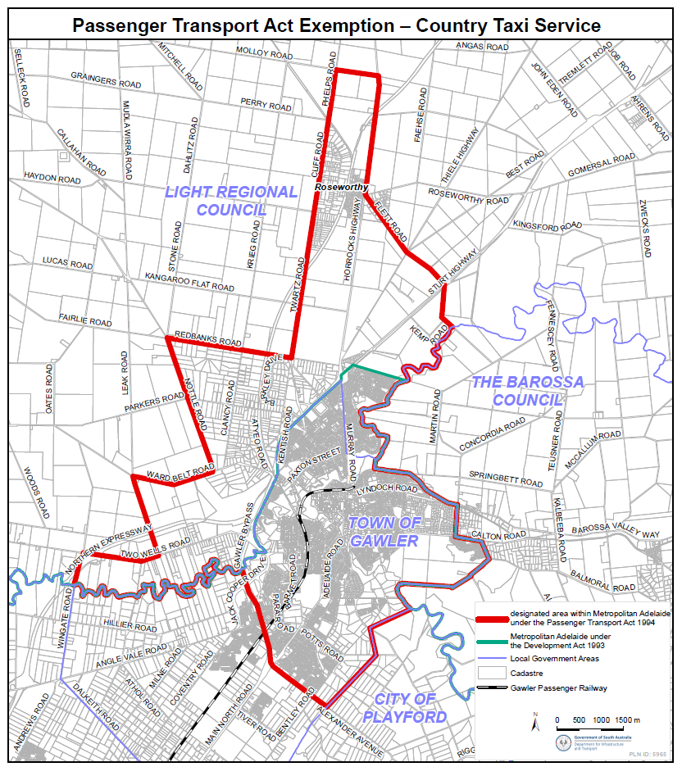
Schedule

Planning, Development and Infrastructure Act 2016
Section 76
Amendment to the Planning and Design Code
Preamble
It is necessary to amend the Planning and Design Code (the Code) in operation at 6 June 2024 (Version 2024.10) in order to make changes of form relating to the Code’s spatial layers and their relationship with land parcels. NOTE: There are no changes to the application of zone, subzone or overlay boundaries and their relationship with affected parcels or the intent of policy application as a result of this amendment.
1. Pursuant to Section 76 of the Planning, Development and Infrastructure Act 2016 (the Act), I hereby amend the Code in order to make changes of form (without altering the effect of underlying policy), correct errors and make operational amendments as follows:
(a) Undertake minor alterations to the geometry of the spatial layers and data in the Code to maintain the current relationship between the parcel boundaries and Code data as a result of the following:
(i) New plans of division deposited in the Land Titles Office between 29 May 2024 and 11 June 2024 affecting the following spatial and data layers in the Code:
A. Zones and subzones
B. Technical and Numeric Variations
• Building Heights (Levels)
• Building Heights (Metres)
• Interface Height
• Minimum Frontage
• Minimum Site Area
• Minimum Primary Street Setback
• Minimum Side Boundary Setback
• Future Local Road Widening Setback
• Site Coverage
C. Overlays
• Affordable Housing
• Airport Building Heights (Regulated)
• Character Area
• Coastal Areas
• Defence Aviation Area
• Design
• Environment and Food Production Area
• Hazards (Bushfire—High Risk)
• Hazards (Bushfire—Medium Risk)
• Hazards (Bushfire—General Risk)
• Hazards (Bushfire—Urban Interface)
• Hazards (Bushfire—Regional)
• Hazards (Bushfire—Outback)
• Heritage Adjacency
• Historic Area
• Limited Land Division
• Local Heritage Place
• Scenic Quality
• State Heritage Area
• State Heritage Place
• Stormwater Management
• Urban Tree Canopy
(b) In Part 13 of the Code—Table of Amendments, update the publication date, Code version number, amendment type and summary of amendments within the ‘Table of Planning and Design Code Amendments’ to reflect the amendments to the Code as described in this Notice.
2. Pursuant to Section 76(5)(a) of the Act, I further specify that the amendments to the Code as described in this Notice will take effect upon the date those amendments are published on the SA planning portal.
Dated: 18 June 2024
Greg Van Gaans
Director, Land and Built Environment
Department for Trade and Investment
Delegate of the Minister for Planning

Roads (Opening and Closing) Act 1991
Section 24
NOTICE OF CONFIRMATION OF
ROAD PROCESS ORDER
Road Closure—Portions of North Terrace, Gladstone
By Road Process Order made on 16 April 2024, the Northern Areas Council ordered that:
1. Portions of North Terrace, Gladstone, situated adjoining Section 457 in Deposited Plan 134396, Hundred of Booyoolie, more particularly delineated and lettered ‘A’ and ‘B’ in Preliminary Plan 23/0024 be closed.
2. Issue a Certificate of Title to The Catholic Diocese of Port Pirie Inc. (ABN: 75 019 756 963) for the whole of the land subject to closure lettered ‘A’ in accordance with the Application for Document of Title dated 10 April 2024.
3. Issue a Certificate of Title to Northern Areas Council for the whole of the land subject to closure lettered ‘B’ in accordance with the Application for Document of Title dated 16 April 2024.
4. The following easements are to be granted over portions of the land subject to closure:
Grant to the Northern Areas Council an easement for drainage purposes over the land marked ‘B’ in Deposited Plan 134396.
Grant to the South Australian Water Corporation an easement for water supply purposes over the land marked ‘A’ in Deposited Plan 134396.
On 12 June 2024 that order was confirmed by the Minister for Planning conditionally upon the deposit by the Registrar-General of Deposited Plan 134396 being the authority for the new boundaries.
Pursuant to Section 24 of the Roads (Opening and Closing) Act 1991, notice of the order referred to above and its confirmation is hereby given.
Dated: 20 June 2024
B. J. Slape
Surveyor-General
2023/06980/01

Supreme Court Act 1935
Vexatious Litigant
In the Supreme Court of South Australia
In the Civil Jurisdiction
No. CIV 010182 of 2021
File Document Number—88
BETWEEN: Attorney-General (Applicant) and Francis Thomas McDonald, Rhoda Louse McDonald (Respondent).
Judgment
Judicial Officer: | The Honourable Justice Bampton
Date of Application: | 7 September 2021
Date of Judgment: | 24 May 2024
Date of Order: | 24 May 2024
Appearances: | B Garnaut for the Applicant
 | Respondents in person
The Court orders that:
1. The Attorney-General’s application (FDN 1) is granted.
2. Each of Francis Thomas McDonald and Rhoda Louise McDonald has persistently instituted vexatious proceedings.
3. Pursuant to Section 39(1)(a) of the Supreme Court Act 1935 (SA):
(a) each of Francis Thomas McDonald and Rhoda Louise McDonald is prohibited from instituting further proceedings in a prescribed court without permission of the Supreme Court; and
(b) the proceedings already instituted by each or both of Francis Thomas McDonald and Rhoda Louise McDonald are permanently stayed.
Dated: 13 June 2024
Leah McLay
Registrar of the Supreme Court

Survey Act 1992
Fees and Levies Received by the Institution of Surveyors, Australia, South Australia Division Inc.
It is hereby notified that the below fees and charges to be levied by the Institution of Surveyors, Australia, South Australia Division Inc. for the 2024-25 financial year have been approved by Hon Nick Champion MP, Minister for Planning.
Inspection of Register $14.70
First Registration or Licence and Renewal of Registration or Licence $209.55
Late Renewal Charge and Issue of Duplicate Certificate of Registration or Licence $97.60
Plan Levy on lodgement of survey plans $145.85
Dated: 18 June 2024
J. Oddy
Registrar
Institution of Surveyors, Australia, South Australia Division Inc.

Transplantation and Anatomy Act 1983 (SA)
Section 33, Part 6
Instrument of Authorisation
Pursuant to Section 33(2) of the of the Transplantation and Anatomy Act 1983 (“the Act”), I hereby authorise the establishment of a school of anatomy for the teaching and study of anatomy and for the carrying on of the practice of anatomy, within the South Australian Health and Medical Research Institute, being a prescribed institution pursuant to Section 33(1) of the Act.
This authorisation is for the use of pre-prepared cadaveric material for imaging and for the conduct of surgical anatomy training workshops, including using robotic surgical techniques within the South Australian Health and Medical Research Institute’s Preclinical, Imaging and Research Laboratories located at 101 Blacks Road, Gilles Plains, South Australia.
This authorisation operates from 1 July 2024 and has effect until 31 December 2025.
This authorisation may be varied or revoked by the Minister for Health and Wellbeing at any time.
Dated: 18 June 2024
Hon Chris Picton
Minister for Health and Wellbeing

Local Government Instruments

City of Playford
Change of Road Name
Notice is hereby given that pursuant to Section 219(1) of the Local Government Act 1999, under delegation, Council has renamed a portion of the road Lot 8019 previously known as Casuarina Way and portion of the road Lot 8023 previously known as Rivergum Close within DP134464 as part of the Eyre Land Division—Eyre. The portion of the road segment 8019 in DP134464 will now be changed to Bottlebrush Road, requiring an amendment to the addressing of Lots 1420 to 1425. The portion of road Lot 8023 previously known as Rivergum Close will now be changed to Casuarina Way, requiring an amendment to the addressing of Lots 1401-1407 and Lots 1441-1446.
These road names changes will come into effect from 4 July 2024.
Dated: 20 June 2024
Surya Prakash
Manager, Engineering Services

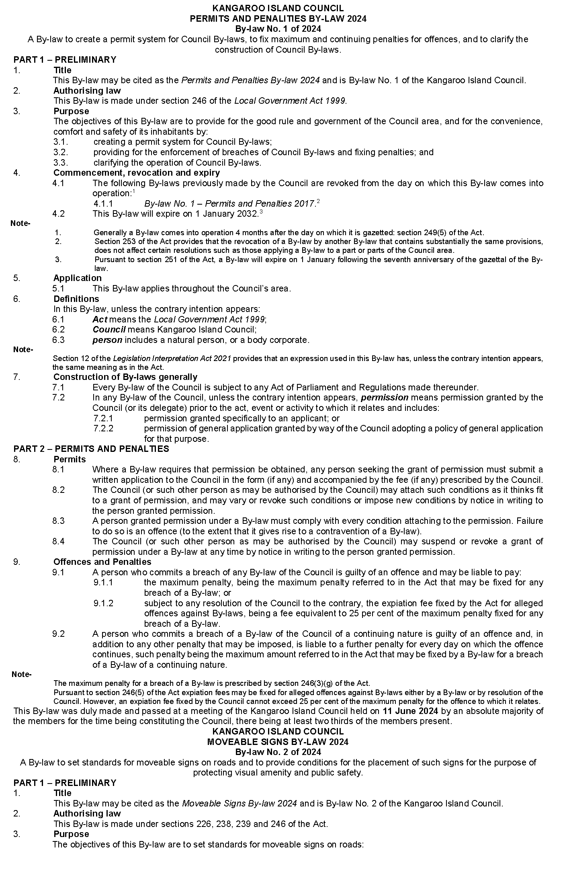
Kangaroo Island Council

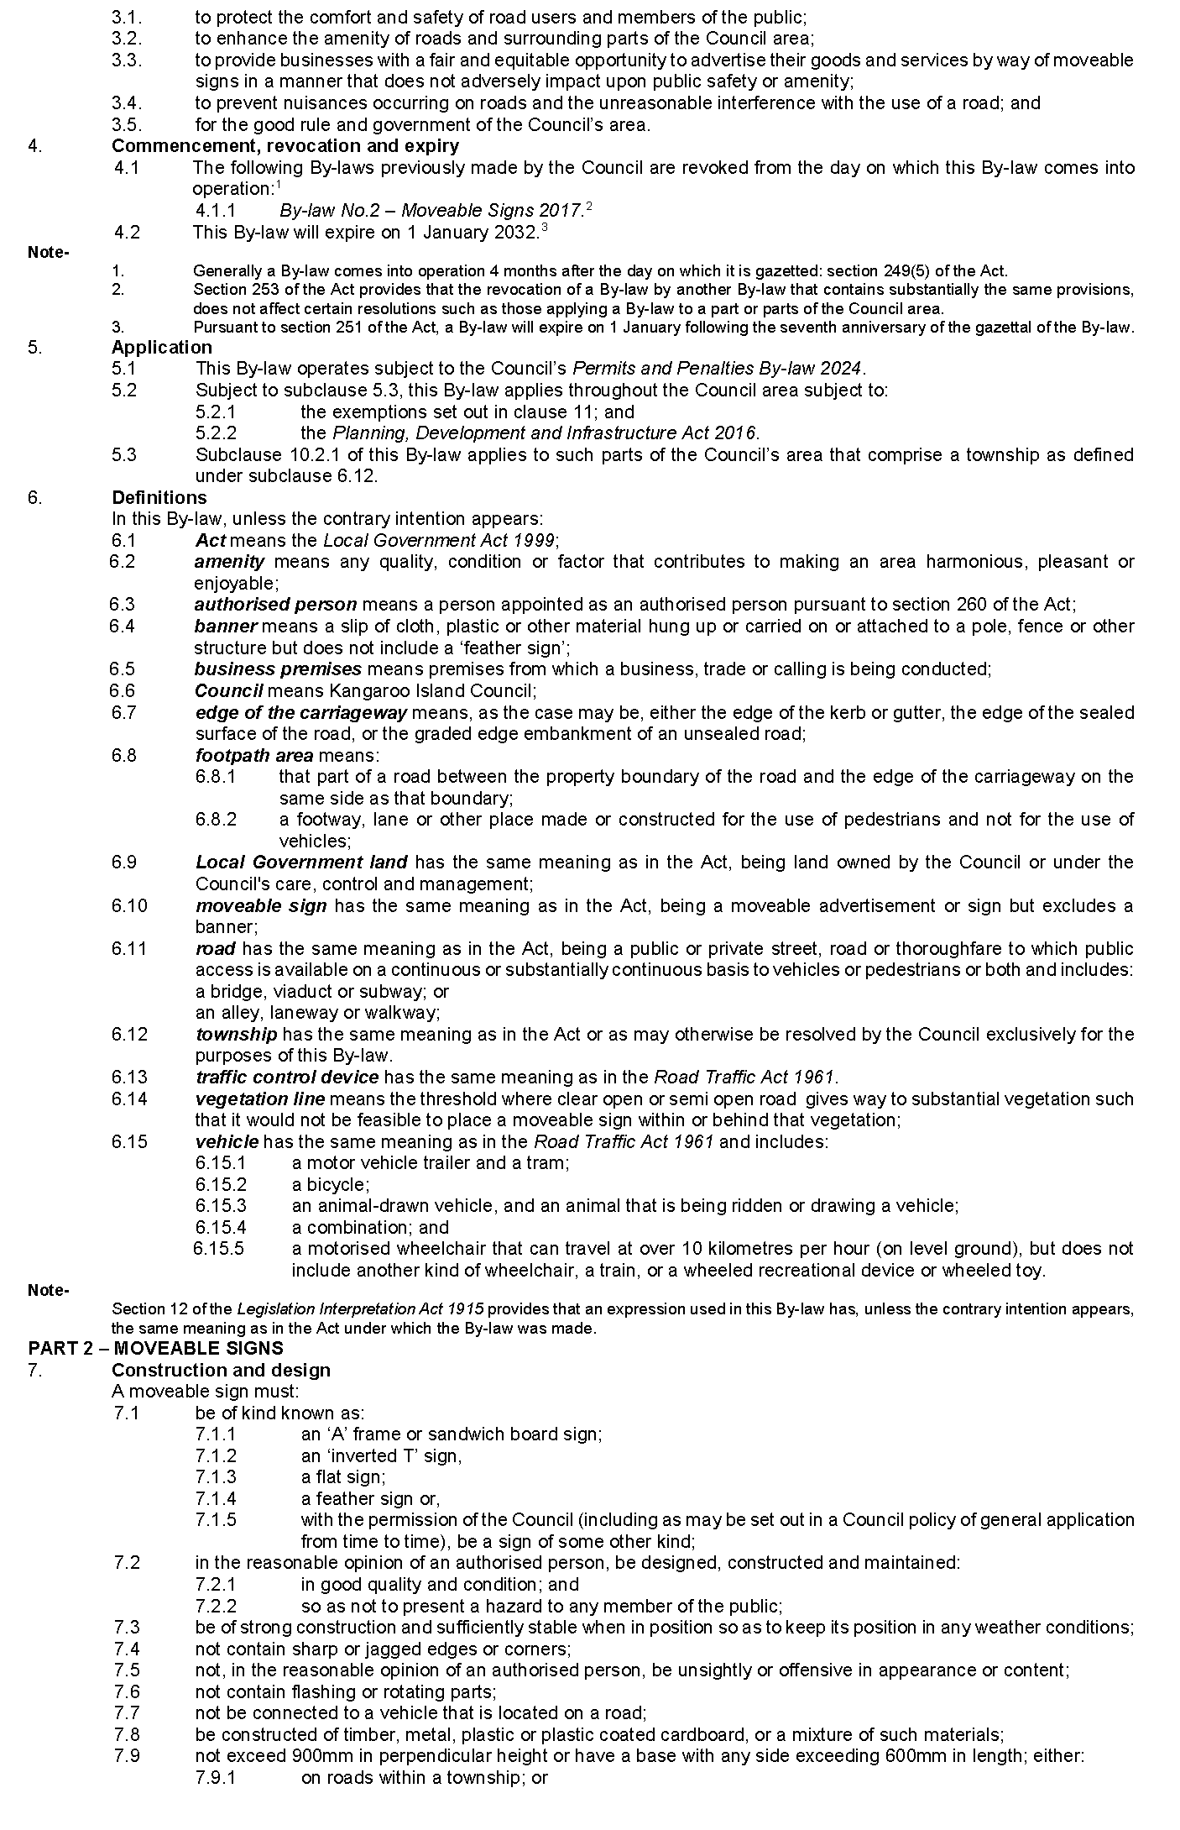
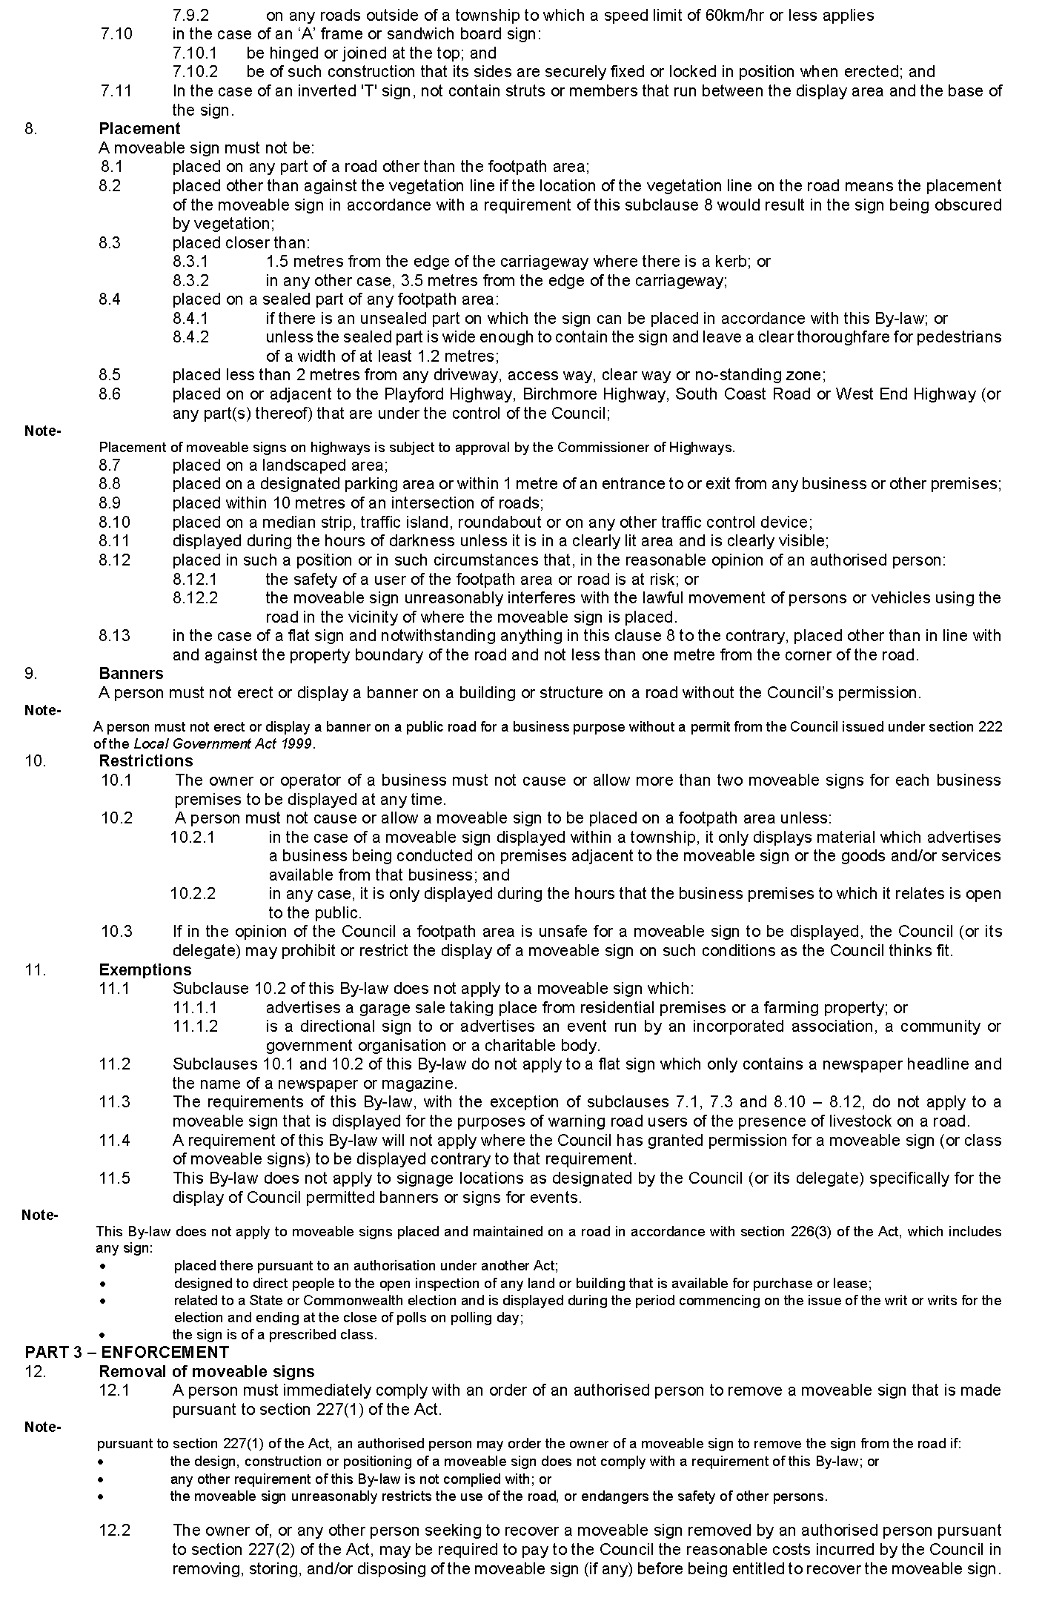
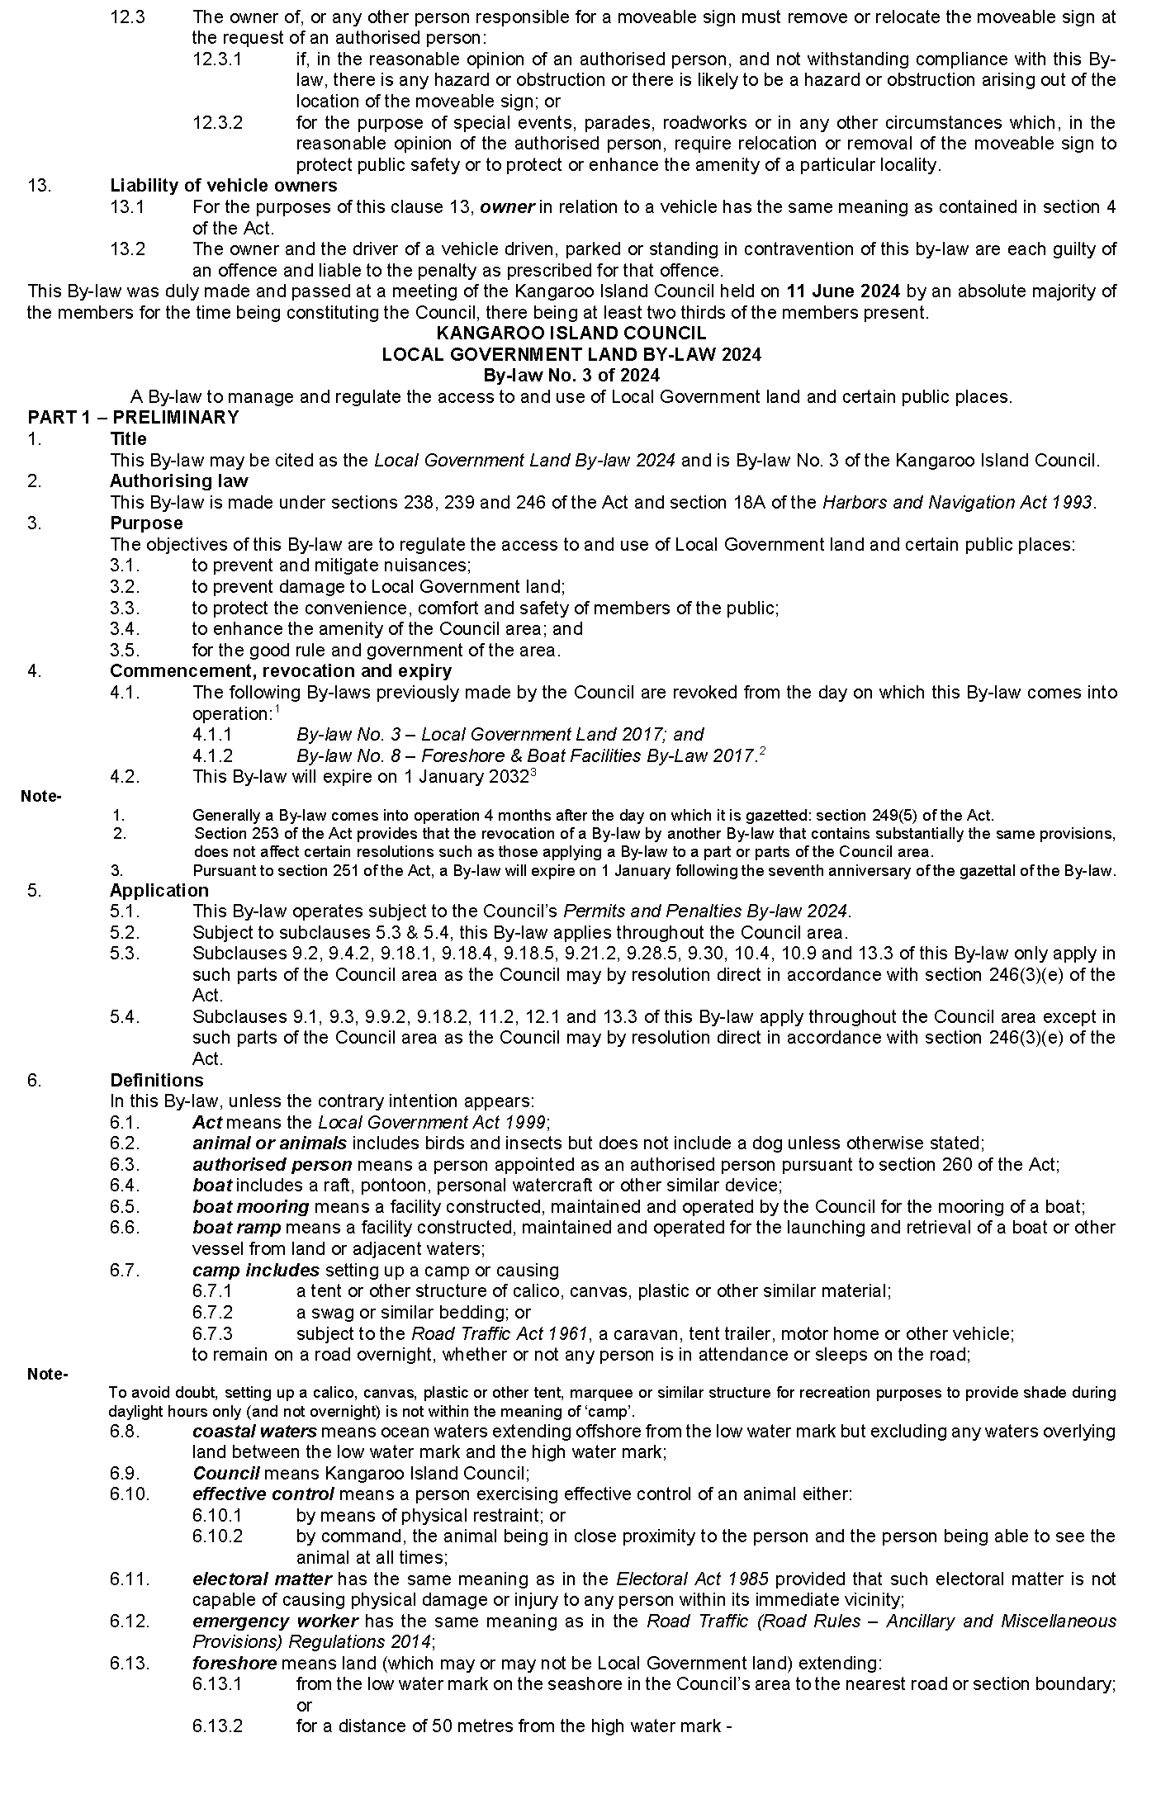
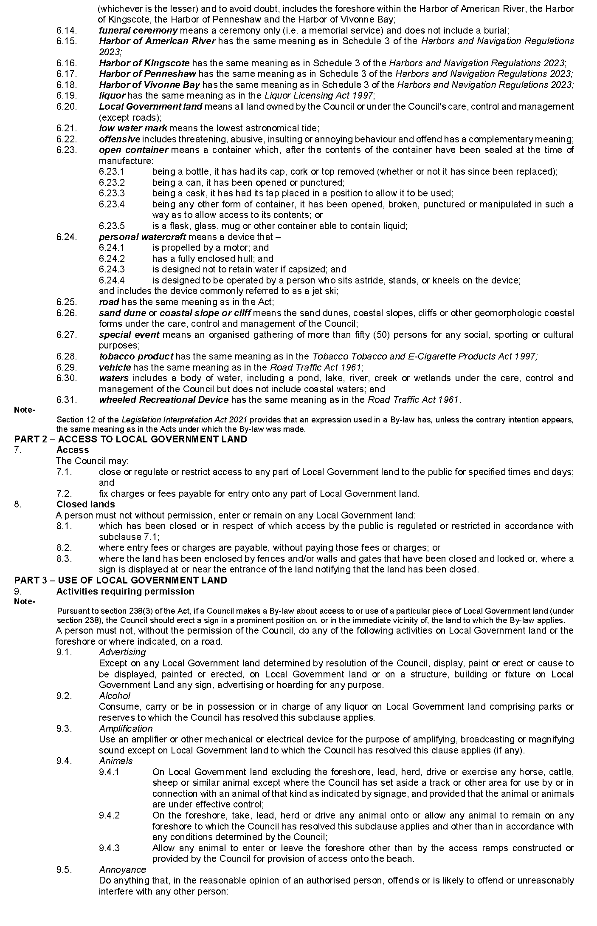
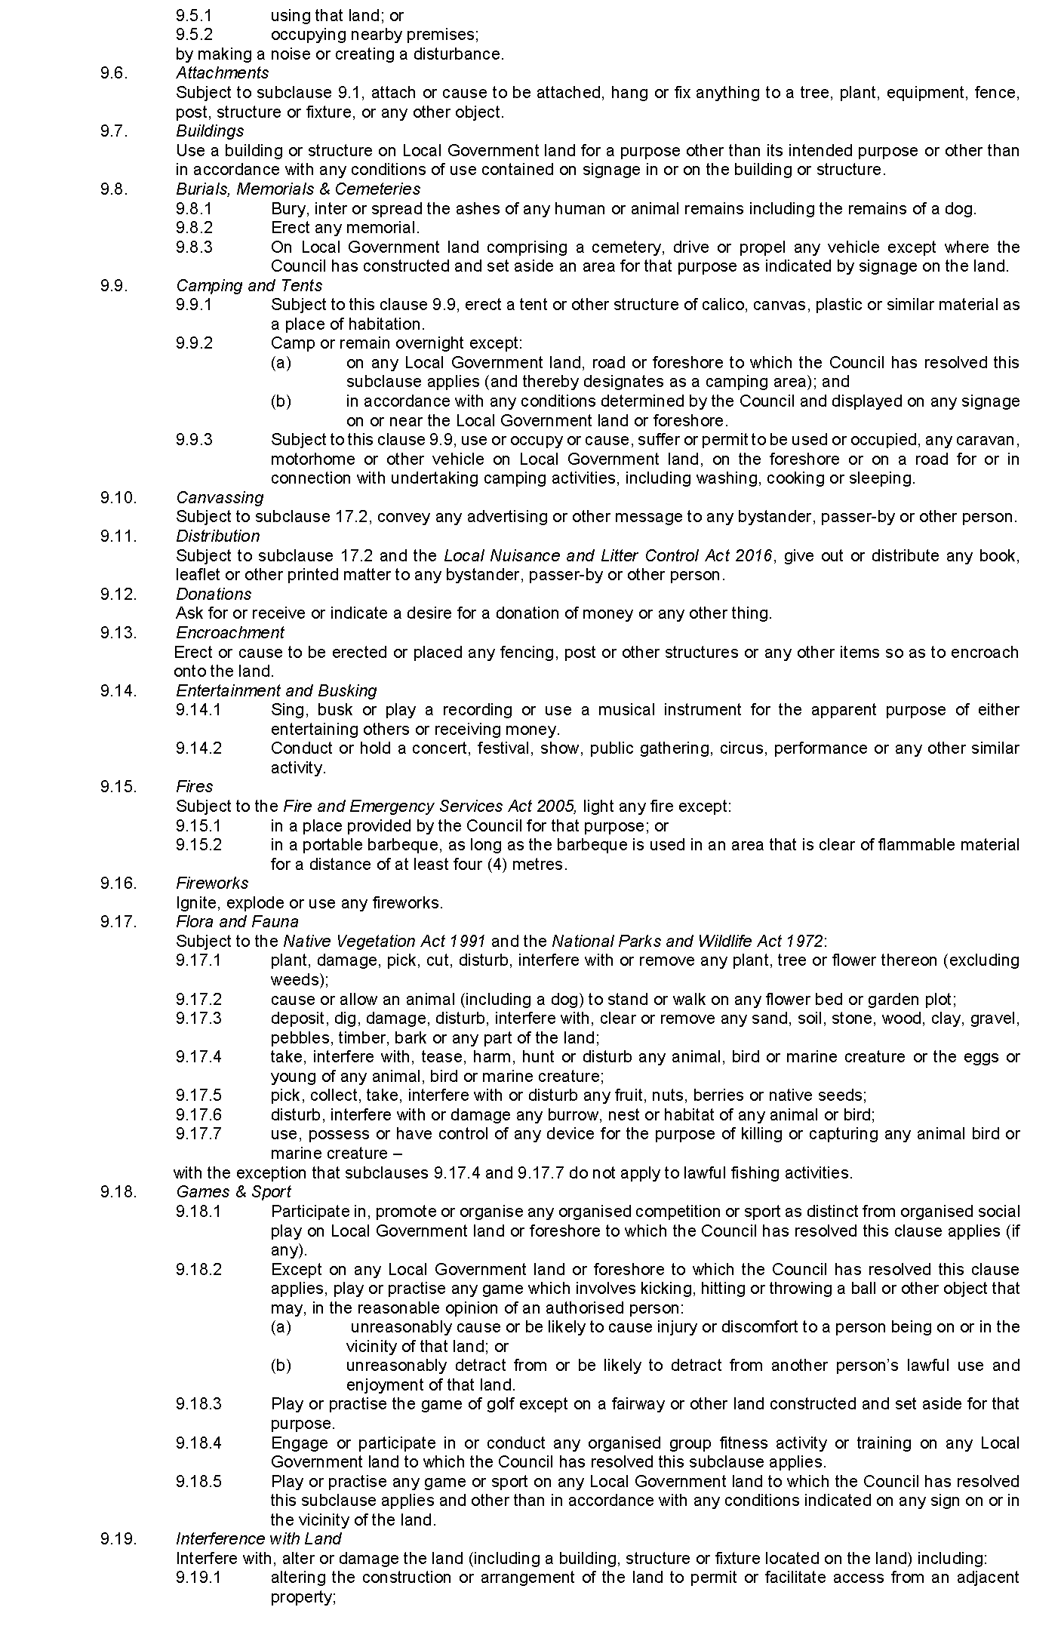
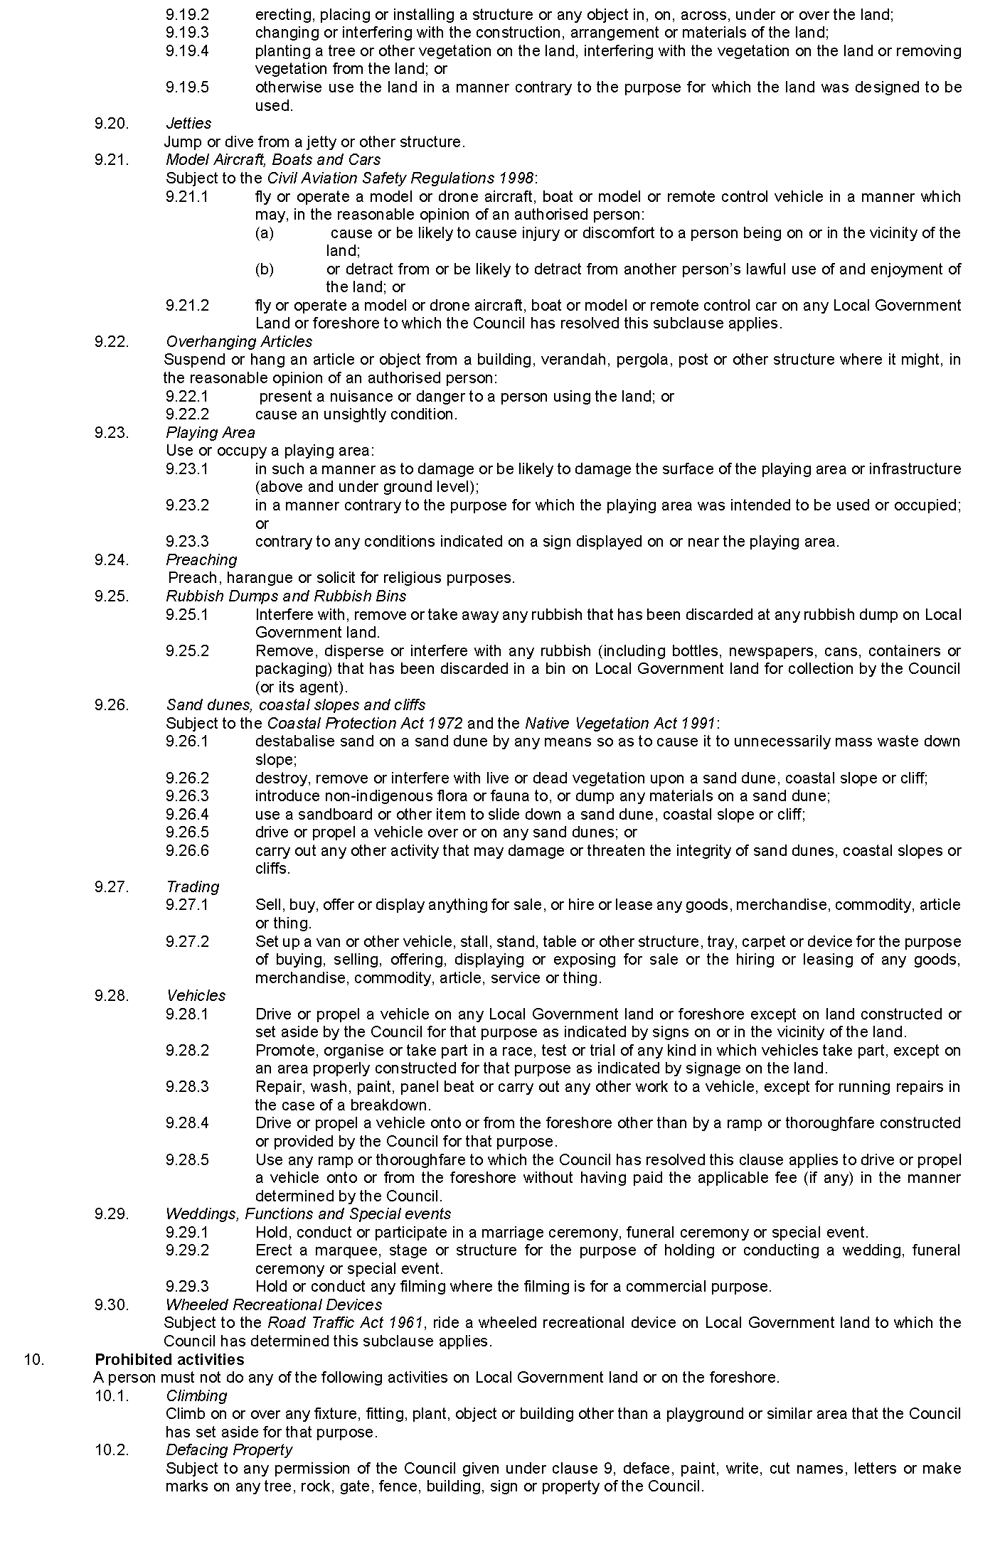
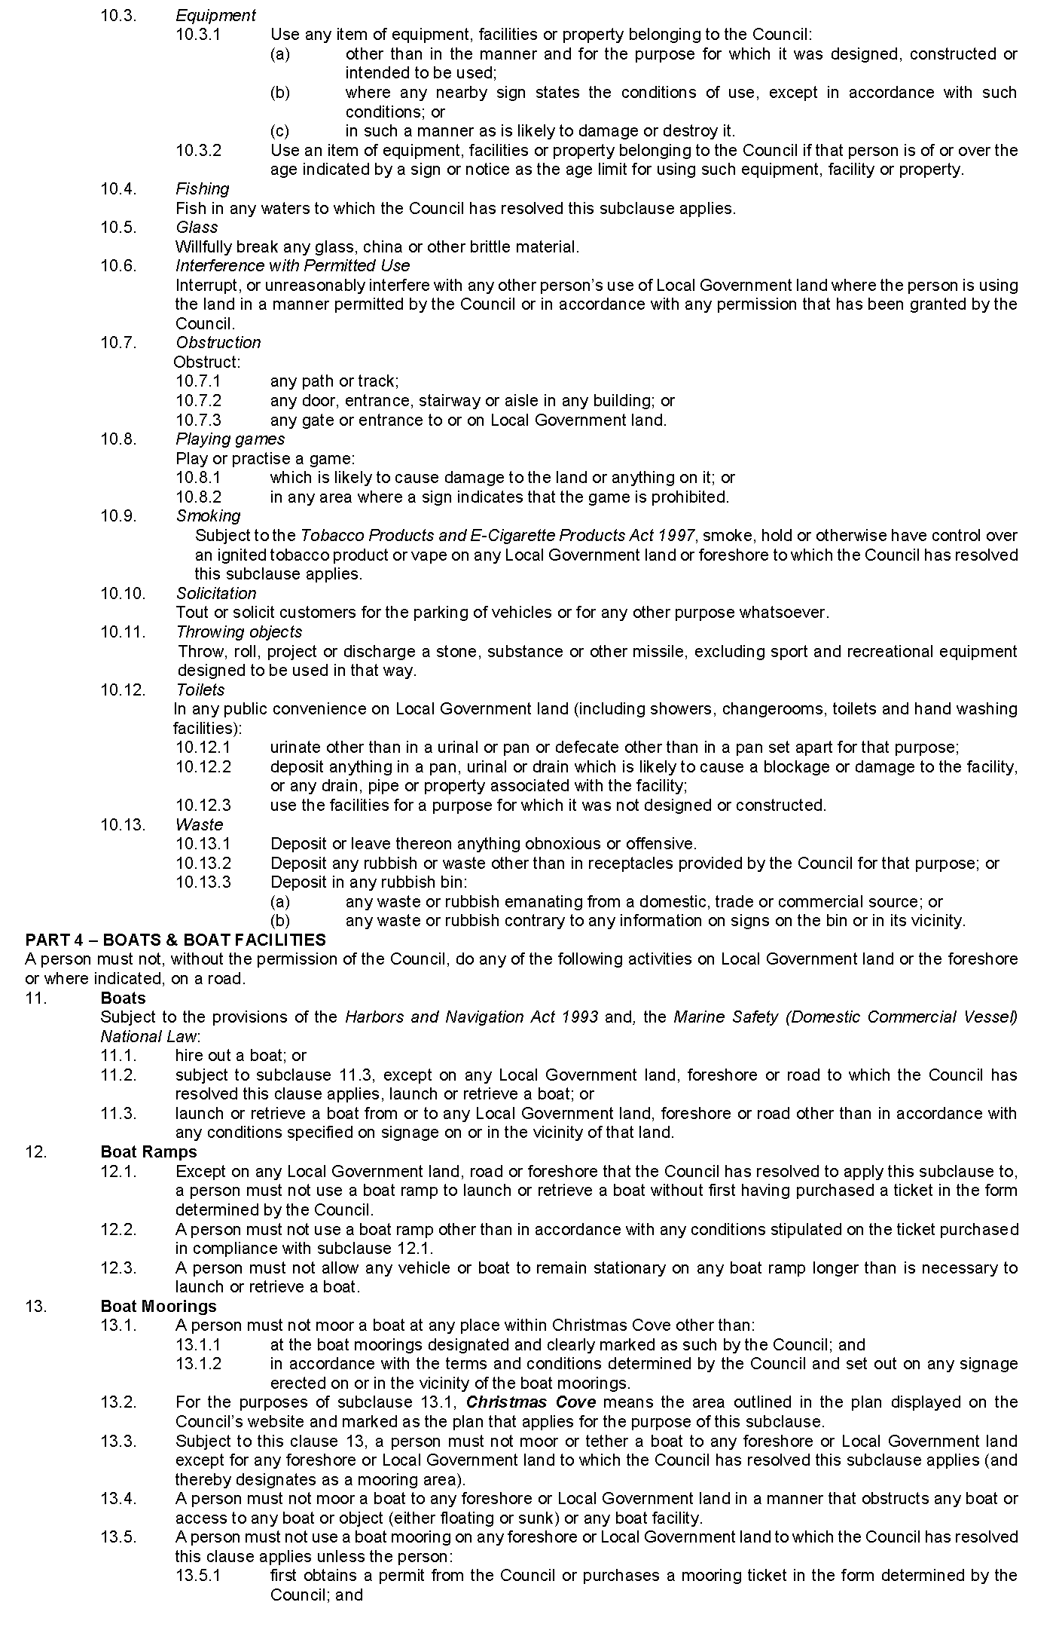
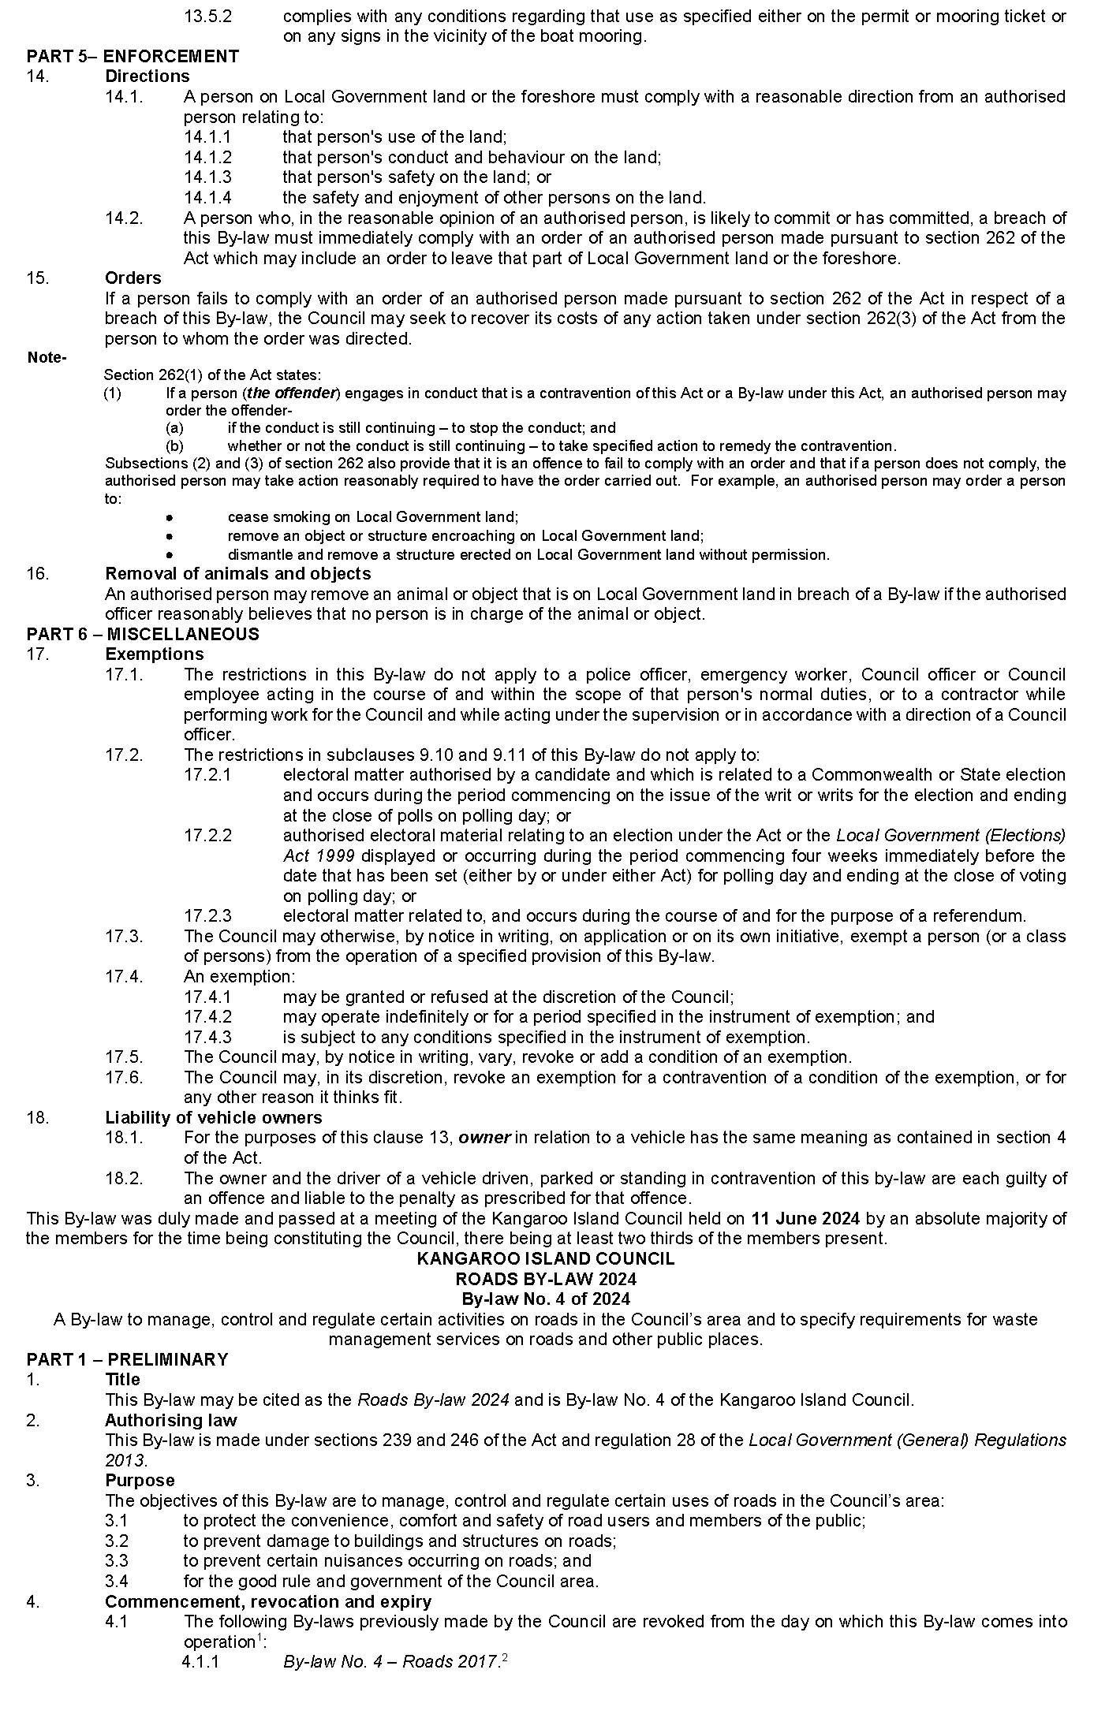
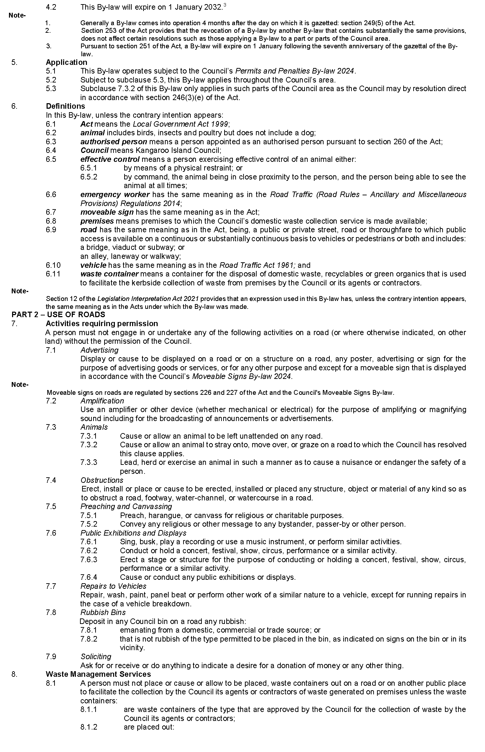
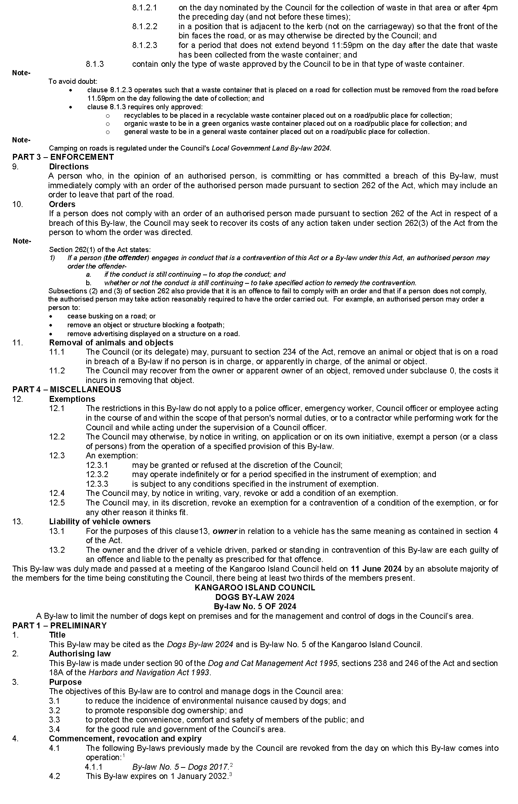
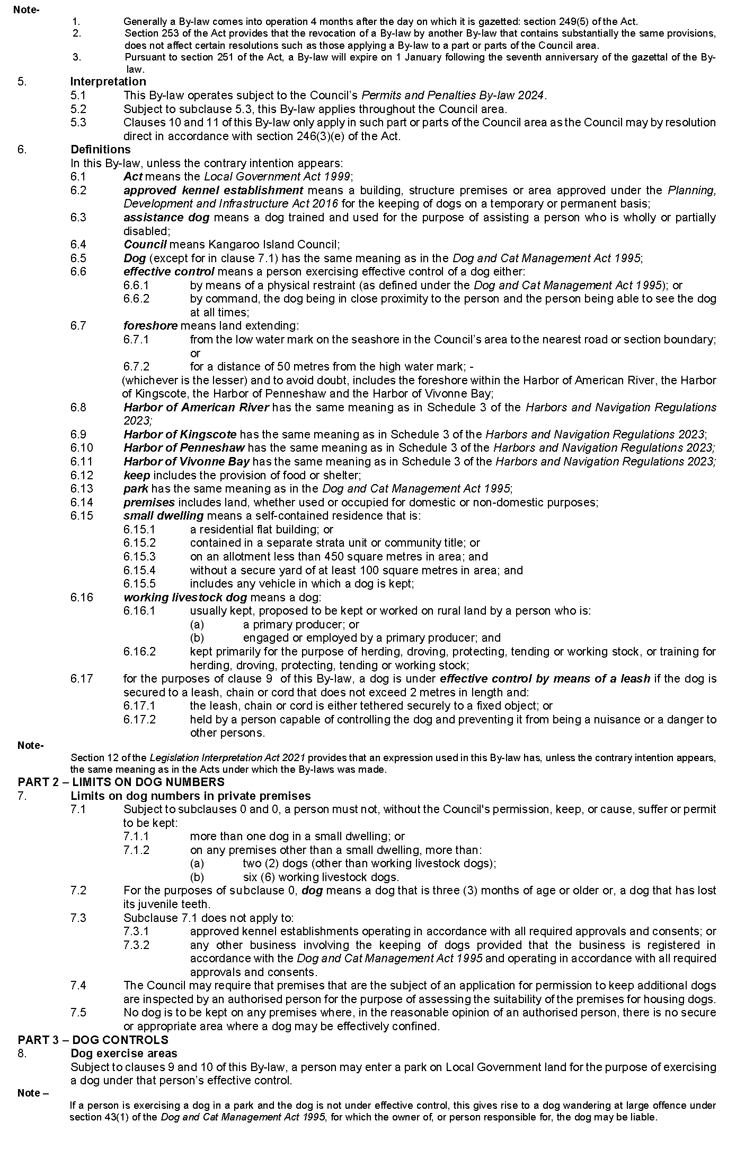
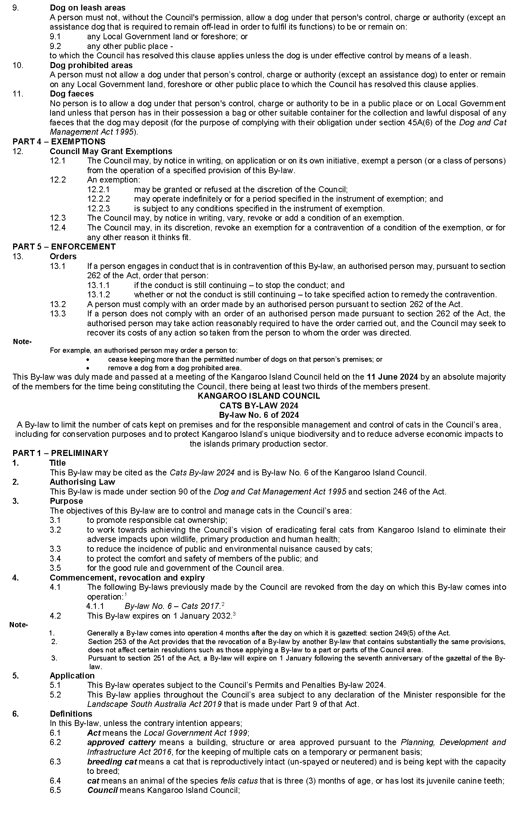
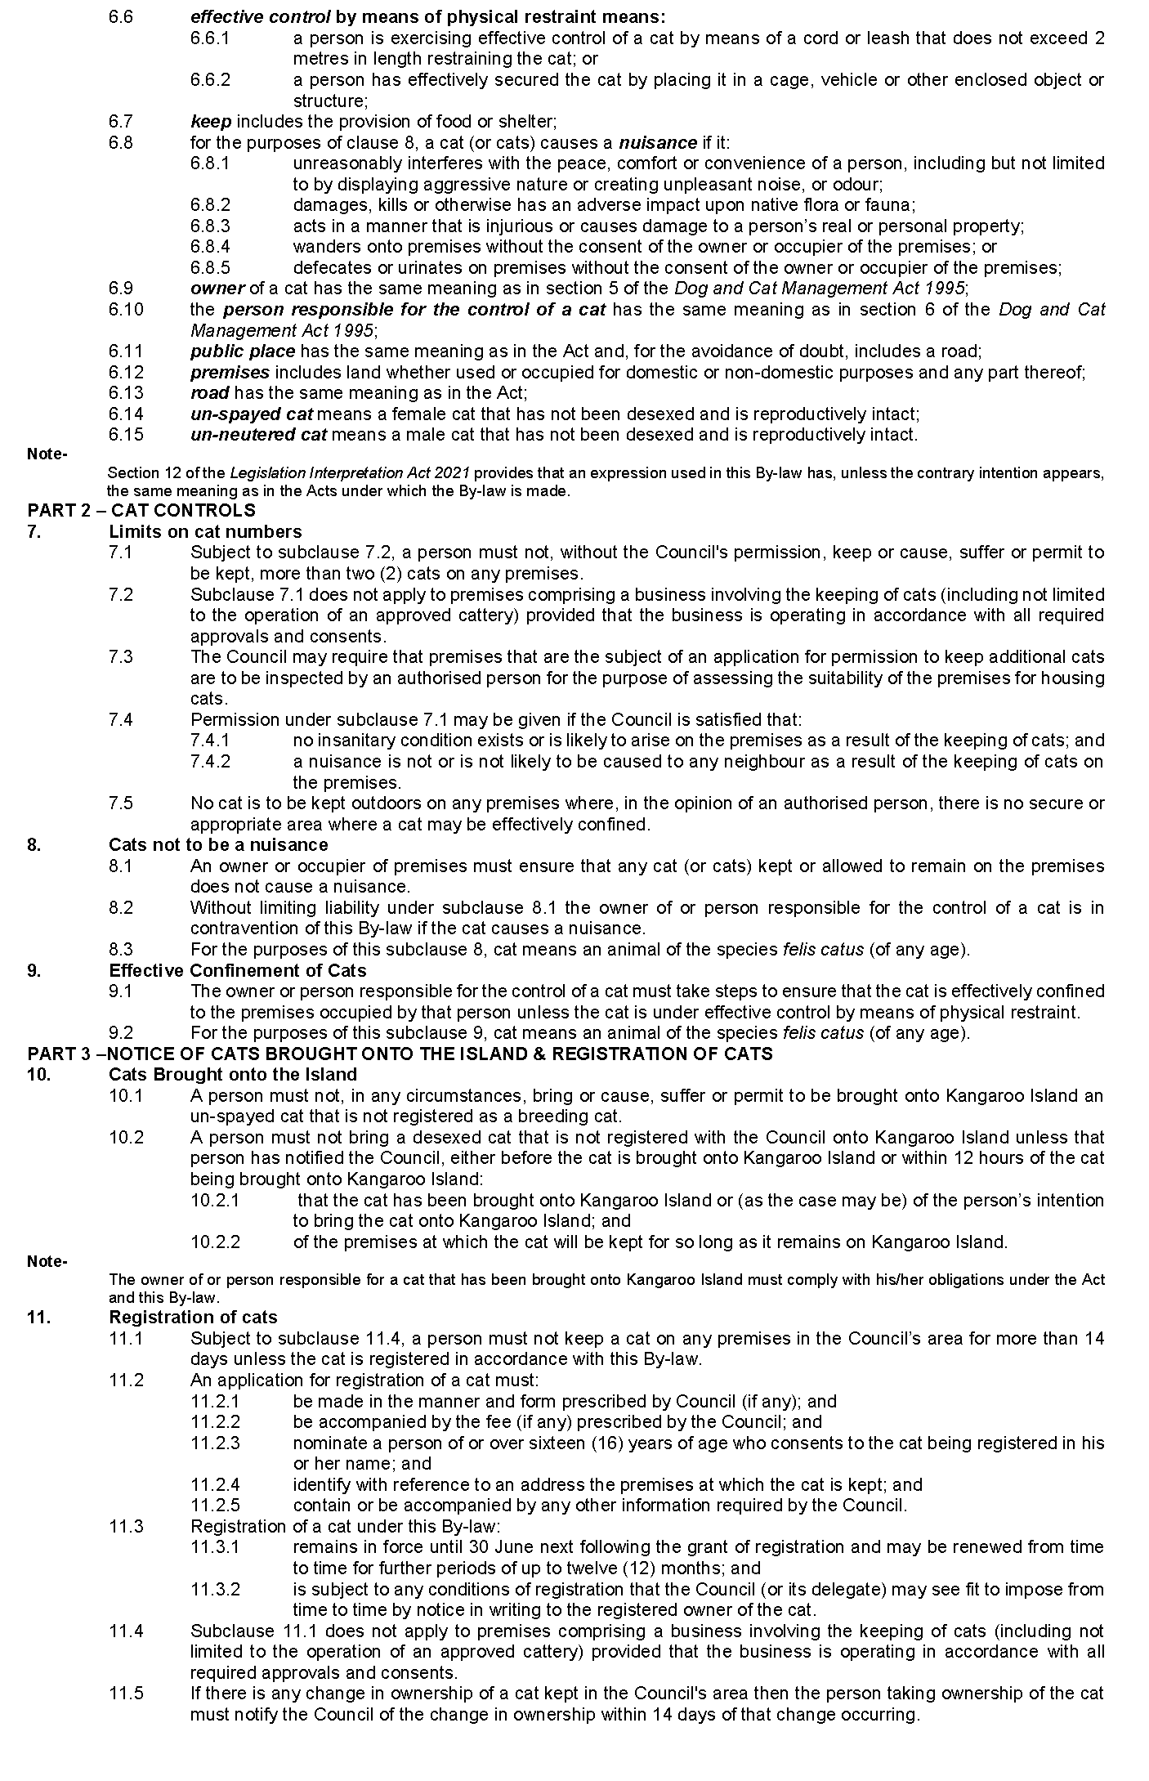
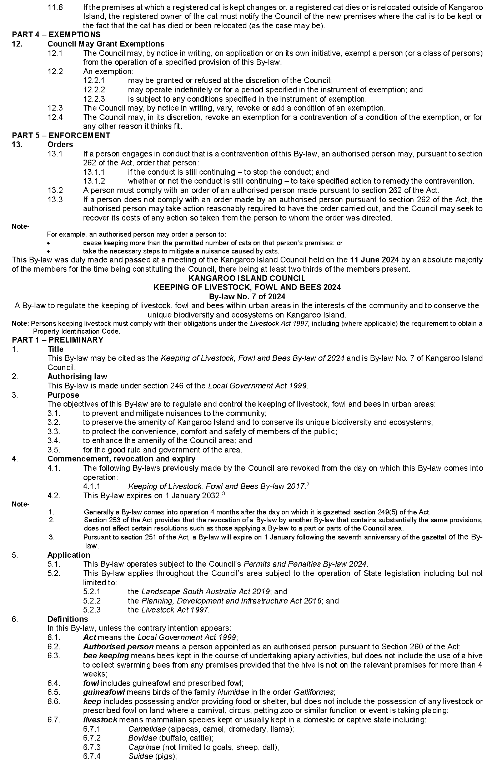
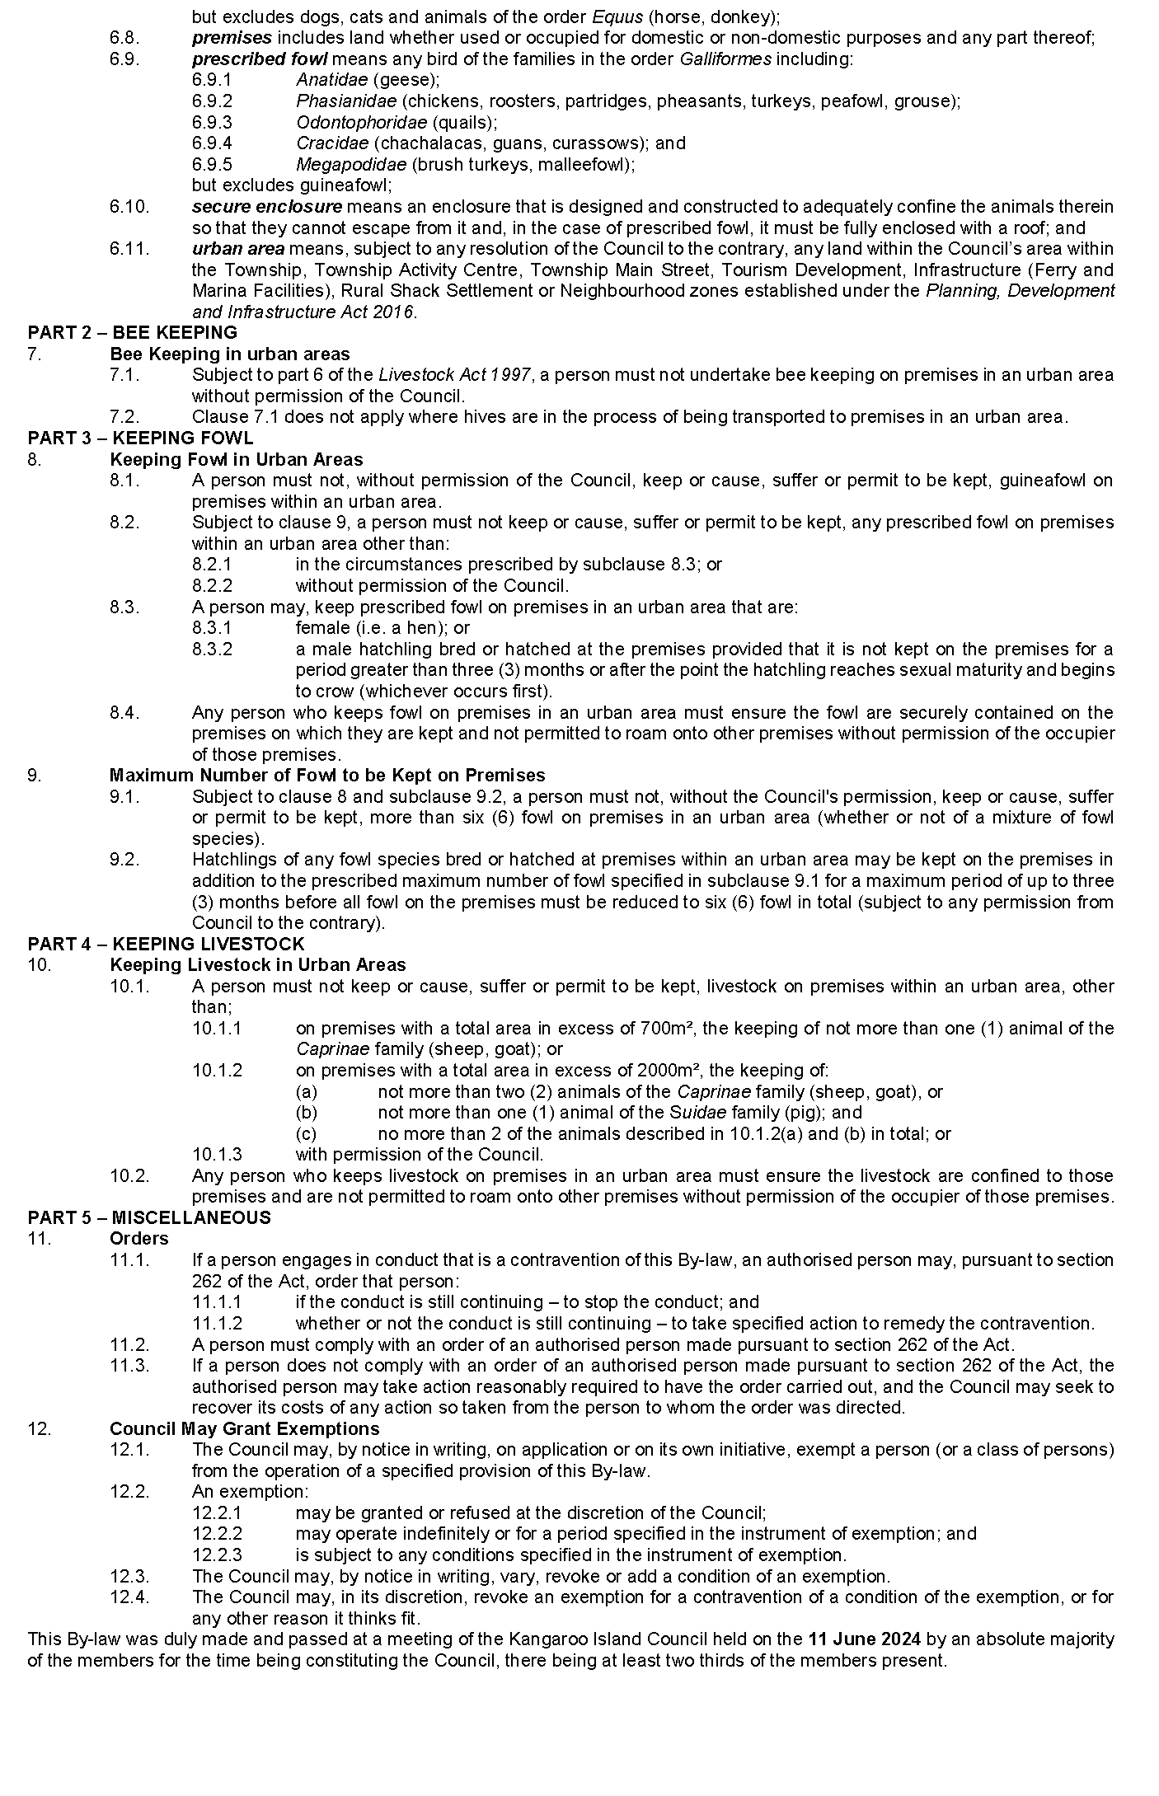

Public Notices

National Electricity Law
Notice of Extension for Final Determination
Notice of Making of Draft Rule Determination and Draft Rule
Notices of Initiation for Rule Change Request
The Australian Energy Market Commission (AEMC) gives notice under the National Electricity Law as follows:
Under s 107, the time for the making of the final determination on the Unlocking CER benefits through flexible trading (Ref. ERC0346) proposal has been extended to 15 August 2024.
Under s 99, the making of a draft determination and related draft rule on the Providing flexibility in the allocation of interconnector costs proposal (Ref. ERC0383). Submissions must be received by 1 August 2024.
Under s 95, The Honourable Chris Bowen MP, Minister for Climate Change and Energy has requested the Clarifying cyber security roles and responsibilities (Ref. ERC0388) proposal. The proposal seeks to clarify AEMO’s role and responsibilities in protecting the National Electricity Market (NEM) against cyber security incidents. Submissions must be received by 18 July 2024.
Under s 95, The Honourable Chris Bowen, Minister for Climate Change and Energy has requested the Better integrating gas into the ISP (Ref. ERC0395) proposal. The proposal seeks to require the Australian Energy Market Operator to expand its consideration of gas market conditions when developing the Integrated System Plan. Submissions must be received by 18 July 2024.
Under s 95, The Honourable Chris Bowen, Minister for Climate Change and Energy has requested the Improving consideration of demand-side factors in the ISP (Ref. ERC0396) proposal. The proposal seeks to expand the Australian Energy Market Operator’s analysis of the uptake and availability of consumer energy resources and distributed resources when developing the Integrated System Plan. Submissions must be received by 18 July 2024.
Under s 95, The Honourable Chris Bowen, Minister for Climate Change and Energy has requested the Better integrating community sentiment into the ISP (Ref. ERC0397) proposal. The proposal seeks to require the Australian Energy Market Operator to consider community sentiment earlier in the development of the Integrated System Plan. Submissions must be received by 18 July 2024.
Submissions can be made via the AEMC’s website. Before making a submission, please review the AEMC’s privacy statement on its website, and consider the AEMC’s Tips for making a submission. The AEMC publishes all submissions on its website, subject to confidentiality.
Documents referred to above are available on the AEMC’s website and are available for inspection at the AEMC’s office.
Australian Energy Market Commission
Level 15, 60 Castlereagh St
Sydney NSW 2000
Telephone: (02) 8296 7800
www.aemc.gov.au
Dated: 20 June 2024

National Energy Retail Law
Notice of Extension of Final Determination
The Australian Energy Market Commission (AEMC) gives notice under the National Energy Retail Law as follows:
Under s 266, the time for the making of the final determination on the Unlocking CER benefits through flexible trading (Ref. RRC0045) proposal has been extended to 15 August 2024.
Documents referred to above are available on the AEMC’s website and are available for inspection at the AEMC’s office.
Australian Energy Market Commission
Level 15, 60 Castlereagh St
Sydney NSW 2000
Telephone: (02) 8296 7800
www.aemc.gov.au
Dated: 20 June 2024

National Gas (South Australia) Act 2008
Notice of Making General Regulatory Information Order
Notice is hereby given that the Australian Energy Regulator (AER) has, pursuant to Section 48(1)(b) of the National Gas Law, made a general regulatory information order which applies to the following specified classes of regulated service providers of gas pipelines:
• service providers of scheme and non-scheme pipeline services provided by a transmission pipeline, and
• service providers of scheme and non-scheme pipeline services provided by a distribution pipeline.
The general regulatory information order was published by the AER on 7 June 2024 and takes effect on 1 July 2024.
The AER’s decision to make the general regulatory information order (Annual Compliance Order for gas pipeline service providers) has been published on the AER’s website (www.aer.gov.au) and is available for inspection at AER office locations listed on the AER’s website. Queries may be directed to the AER on 1300 585 165 or via email at AERGasNetworksCompliance@aer.gov.au.
Dated: 20 June 2024
Anthea Harris
Chief Executive Officer

National Gas Law
Notice of Initiation for Rule Change Request
The Australian Energy Market Commission (AEMC) gives notice under the National Gas Law as follows:
Under s 303, The Honourable Chris Bowen, Minister for Climate Change and Energy has requested the Better integrating gas into the ISP (Ref. GRC0073) proposal. The proposal seeks to require the Australian Energy Market Operator to expand its consideration of gas market conditions when developing the Integrated System Plan. Submissions must be received by 18 July 2024.
Submissions can be made via the AEMC’s website. Before making a submission, please review the AEMC’s privacy statement on its website, and consider the AEMC’s Tips for making a submission. The AEMC publishes all submissions on its website, subject to confidentiality.
Documents referred to above are available on the AEMC’s website and are available for inspection at the AEMC’s office.
Australian Energy Market Commission
Level 15, 60 Castlereagh St
Sydney NSW 2000
Telephone: (02) 8296 7800
www.aemc.gov.au
Dated: 20 June 2024

Notice Submission

The South Australian Government Gazette is published each Thursday afternoon.
Notices must be emailed by 4 p.m. Tuesday, the week of publication.
Submissions are formatted per the gazette style and a proof will be supplied prior to publication, along with a quote if applicable. Please allow one day for processing notices.
Alterations to the proof must be returned by 4 p.m. Wednesday.

Gazette notices must be submitted as Word files, in the following format:
• Title—the governing legislation
• Subtitle—a summary of the notice content
• Body—structured text, which can include numbered lists, tables, and images
• Date—day, month, and year of authorisation
• Signature block—name, role, and department/organisation authorising the notice

Please provide the following information in your email:
• Date of intended publication
• Contact details of the person responsible for the notice content
• Name and organisation to be charged for the publication—Local Council and Public notices only
• Purchase order, if required—Local Council and Public notices only

Email: governmentgazettesa@sa.gov.au
Phone: (08) 7109 7760
Website: www.governmentgazette.sa.gov.au

All instruments appearing in this gazette are to be considered official, and obeyed as such

Printed and published weekly by authority of T. Foresto, Government Printer, South Australia
$8.55 per issue (plus postage), $430.00 per annual subscription—GST inclusive
Online publications: www.governmentgazette.sa.gov.au

