
No. 81 p. 5015
THE SOUTH AUSTRALIAN
GOVERNMENT GAZETTE
Published by Authority

Adelaide, Thursday, 19 December 2024

Contents

Rules of Court
Lotteries (Saturday X Lotto) Rules 5016
State Government Instruments
Associations Incorporation Act 1985 5022
Births, Deaths and Marriages Registration Act 1996—
Republished 5022
Electricity Act 1996 5023
Gas Act 1997 5023
Energy Resources Act 2000 5026
Fisheries Management Act 2007 5027
Housing Improvement Act 2016 5027
Justices of the Peace Act 2005 5028
Landscape South Australia Act 2019 5028
Livestock Act 1997 5030
Livestock Regulations 2013 5035
Major Events Act 2013 5036
Mental Health Act 2009 5057
Motor Vehicles Act 1959 5057
National Parks and Wildlife Act 1972 5071
Passenger Transport Regulations 2024 5072
Planning, Development and Infrastructure Act 2016 5075
Planning, Development and Infrastructure (General)
Regulations 2017 5076
Proof of Sunrise and Sunset Act 1923—Erratum 5079
Public Corporations Act 1993 5080
Remuneration Tribunal, The 5080
Retail and Commercial Leases Act 1995 5097
Road Traffic Act 1961 5098
South Australian Skills Act 2008 5099
Summary Offences Act 1953 5100
Water Industry Act 2012 5101
Local Government Instruments
City of Adelaide 5102
City of Playford 5102
City of Prospect 5102
Copper Coast Council 5102
District Council of Kimba 5103
Lower Eyre Council 5103
District Council of Yankalilla 5107
Public Notices
Anglican Church of Australia 5108
National Electricity Law 5108
National Energy Retail Law 5108
National Gas Law 5109

Rules of Court
State Lotteries Act 1966

Lotteries (Saturday X Lotto) Rules
1. Preliminary
1.1 These Rules may be cited as the Lotteries (Saturday X Lotto) Amendment Rules 2024 (No. 2).
1.2 The Lotteries (Saturday X Lotto) Rules made under the State Lotteries Act 1966 and published in the Government Gazette on 9 May 2024 are herein after referred to as the "Principal Rules".
1.3 The Principal Rules are hereby amended effective from 18 May 2025 and these Rules will take effect immediately thereafter, except as provided in these Rules.
2. Amendment of Rules
2.1 Rule 6.2 of the Principal Rules is replaced by the following:
“When using a coupon, QuickPick entries can be played by marking the appropriate ‘top up games’ box or the ‘top up selection’ box (if this option is available) and will be limited to such number of games for an ordinary entry, and subject to Rule 3.4, such number of any type of system/pick entry as the Master Agent determines.”
Dated: 10 December 2024
The Common Seal of the Lotteries Commission of South Australia was affixed pursuant to a resolution of the Commissioner,
Phuong Chau
Commissioner
Approved,
Hon Stephen Mullighan MP
Treasurer

State Lotteries Act 1966
Lotteries (Saturday X lotto) Rules
This consolidation includes amendments as at 18 May 2025.
It is provided for convenient reference only and regard should be had to the full text of the Lottery Rules
and amendments as published in the South Australian Government Gazette from time to time.
Arrangement
1. Preliminary
1.1. Citation
1.2. Commencement
1.3. Lotteries (General) Rules
1.4. Application
2. Interpretation
2.1. Definitions
3. Ordinary Entry
3.1. Creation
3.2. Participation of ordinary entry
3.3. Minimum number of games
3.4. Maximum number of games
3.5. Advance entry
3.6. Methods of requesting entry
3.7. Marking a coupon
4. Multi-Week Entry
4.1. Creation
4.2. Rules governing ordinary entries apply
5. System/Pick Entry
5.1. Creation
5.2. Methods of requesting entry
5.3. Marking a coupon
5.4. Picks 4 and 5
5.5. Formula for picks 4 or 5
5.6. Creating pick 4 entry
5.7. Creating pick 5 entry
5.8. Formula for systems 7 to 20
5.9. Maximum number of system/pick entries on coupon
5.10. Multi-week system/pick entry
5.11. Price of system/pick entry

6. QuickPick Entry
6.1. Creation
6.2. Limitations when using a coupon
6.3. Generation of entry
7. Supervision of Draw
7.1. Supervision and finality of draw
7.2. Announcement of prize pool
8. Determination of Winning Numbers
8.1. Draw number
8.2. Drawing equipment
8.3. Balls to be drawn
8.4. Winning numbers and supplementary numbers
8.5. Prize divisions
9. Publication of Results
9.1. Publication
9.2. Content
10. Prize Pool Structure
10.1. Single prize
10.2. Creation of prize pool
10.3. Aggregation of prize pool
10.4. Distribution between divisions
10.5. Apportionment between winners in a division
10.6. Notification of change in prize pool distribution
10.7. Allocation where no winner in divisions 2 to 5
10.8. Allocation where no winner in division 6
10.9. Rounding out
11. Prize Reserve Fund
11.1. Creation
11.2. Distribution
11.3. Agreement with Bloc members
11.4. Assignment
12. Jackpots
12.1. Creation
12.2. Augmentation of Division 1
13. Prize Claims
13.1. Division 1
13.2. Other than Division 1
13.3. Lodgement of claim
13.4. Requirements for lodgement of claim
13.5. SALC’s discretion
14. Ticket Checkers
14.1. Location
14.2. Use
14.3. Validation of ticket
15. Special Draw
15.1. Division 1
Schedule
Date of commencement
1. Preliminary
1.1. These Rules may be cited as the Lotteries (Saturday X Lotto) Rules.
1.2. These Rules will come into operation on the date specified in the Schedule to these Rules.
1.3. These Rules are to be read in conjunction with and are subject to the Lotteries (General) Rules.
1.4. These Rules apply only to the lottery known as “X Lotto” as played on a Saturday or such other day as determined by the Bloc members.
2. Interpretation
2.1. In these Rules and in each part of these Rules unless the contrary intention appears:
“Bloc members” means the parties from time to time to the Bloc Agreement entered into by SALC with other lottery operators for the promotion, conduct and sale of tickets in inter alia the game drawn generally each Saturday night on a joint basis with a common winning number determination and a declaration of common dividends based on the equal participation of all players in the aggregated prize pool;
“claim period” means the period commencing at midnight on the day of determination of the draw results (“relevant day”) and ending on the 14th day thereafter;
“drawing equipment” means equipment operated by the Bloc members for ascertaining the winning numbers;
“QuickPick entry” means a nomination made by a player indicating that the player wishes to make a QuickPick selection in accordance with Rule 6 of these Rules;
“Special Draw” means a Saturday X Lotto draw with a guaranteed Division 1 prize for a maximum number of winners conducted in accordance with Rule 15;
“X Lotto” means a lottery drawn on a Saturday or such other day or days as the Bloc members determine in which a player is required to forecast 6 numbers to be drawn from the range of numbers 1 to 45 inclusive.
3. Ordinary Entry
3.1. To create an ordinary entry, a player must forecast or cause to be forecast 6 numbers.
3.2. An ordinary entry will provide participation for the number of games selected and paid for in one (1) draw only.
3.3. The minimum number of games that must be completed will be four (4) or such number as otherwise determined by the Master Agent.
3.4. There will be a limit to the maximum number of games that can be played, including that in any one draw:
3.4.1. the Master Agent may decline to issue more than 1,000 entries to a player; and
3.4.2. a player can be issued with no more than 201,000 equivalent games.
3.5. A player may request that an entry be issued in advance of a current draw. The maximum number of advance draws in which an entry can be issued will be notified to players by the Master Agent, following determination by SALC.
3.6. Subject to Rule 6, a player may enter a draw by:
3.6.1. submitting a coupon provided for that purpose from time to time by the Master Agent, together with an Easiplay Club membership card if applicable; or
3.6.2. making a verbal or electronic request at the selling point, together with providing an Easiplay Club membership card if applicable.
3.7. In the case of a coupon:
3.7.1. a player’s forecast must be marked with a cross mark in the centre of the square, a vertical mark in the centre of the square or such other mark as the Master Agent determines. No other mark will be accepted. All marks on a coupon must be legible and if a coupon cannot be read by a selling point terminal, it will be rejected. A coupon must not be marked in red.
3.7.2. the relevant “system/pick” box must be left blank.
3.7.3. a player who marks a “top up games” box will be taken to have authorised the selling point terminal operator to generate a random forecast of a sufficient quantity of numbers to complete the game, the coupon or the nominated number of games, as the case may be.
3.7.4. if a player marks more than the specified number of squares in any game, a ticket will not issue until the player has either nominated the number(s) to be deleted or nominated a system/pick entry. The player may be required to complete another coupon.
3.7.5. if a player marks fewer than the specified number of squares in any game and does not mark the relevant “top up games” box, a ticket will not issue until the player has either nominated the number(s) to be added or nominated a top up games entry or a system/pick entry.
4. Multi-Week Entry
4.1. A player may enter their number forecasts for a series of consecutive draws by marking the appropriate square in the “multi-week” box on a coupon or by verbally or electronically requesting such an entry at the selling point. The maximum number of consecutive draws that may be entered in this way will be notified to players by the Master Agent following determination by SALC.
4.2. The Rules governing ordinary entries will apply to every multi-week entry.
5. System/Pick Entry
5.1. A player may create a system/pick entry by forecasting or causing to be forecast 4, 5 or from 7 to 20 numbers, rather than the 6 to be forecast in the case of an ordinary entry.
5.2. In the case of a coupon, a system/pick entry must be completed by marking the relevant “system/pick” box and forecasting or causing to be forecast the quantity of numbers corresponding to the system/pick to be entered by the player. (Thus, to play system 7, 7 numbers are forecast; to play system 8, 8 numbers are forecast and so on to a maximum of 20 numbers forecast to play a system 20 entry.) In all other instances, a system/pick entry is created by verbally or electronically requesting such an entry at the selling point. Ordinary and system/pick entry participation will be accepted if completed on the same coupon and more than one system/pick entry type can be played on the one coupon.
5.3. In the case of a coupon, if more numbers are marked in any game than the requested system/pick requires, a ticket will not issue until the player has nominated the number(s) to be deleted. If fewer numbers are marked in any game than the requested system/pick requires and the relevant “top up games” box is not marked, a ticket will not issue until the player has either nominated the number(s) to be added or selected a top up games entry.
5.4. Picks 4 and 5 are entries in which the quantity of numbers forecast is less than 6 numbers.
5.5. A pick 4 or 5 entry will be equivalent to playing a certain number of separate games of 6 numbers as determined by the following formula:
(45 – P)! | (where P = pick number)
39! x (6-P)!
5.6. A player who seeks to participate in a pick 4 entry must forecast or cause to be forecast any 4 numbers. These 4 numbers will be combined with all combinations of 2 numbers from the remaining unforecast numbers. This pick entry will be equivalent to playing 820 games of 6 numbers.

5.7. A player who seeks to participate in a pick 5 entry must forecast or cause to be forecast any 5 numbers. These 5 numbers will be combined with each of the remaining unforecast numbers in turn. This pick entry will be equivalent to playing 40 games of 6 numbers.
5.8. A player who seeks to participate in a system 7 to 20 entry inclusive must forecast or cause to be forecast the quantity of numbers according to the system number to be played. These numbers will be combined with one another in all possible combinations of 6 numbers. This system entry will be equivalent to playing a certain number of separate games of 6 numbers as determined by the following formula:
S! | (where S = system number)
6! x (S-6)!
5.9. Subject to Rule 3.4, a player may enter up to 18 games of any type of system/pick entry on the one coupon or such other number as the Master Agent determines.
5.10. A system/pick entry may be entered for multi-week participation, in which case the Rules relating to multi-week and QuickPick entries will also apply.
5.11. The price of a system/pick entry will be as determined by the Master Agent from time to time.
6. QuickPick Entry
6.1. A player can play by means of a QuickPick nomination at the selling point whereby the selling point terminal will process the information nominated by the player to generate a forecast of the type nominated by the player. Such entries will be limited to such number of games for an ordinary entry, and subject to Rule 3.4, such number of any type of system or pick entry, as the Master Agent determines.
6.2. When using a coupon, QuickPick entries can be played by marking the appropriate ‘top up games’ box or the ‘top up selection’ box (if this option is available) and will be limited to such number of games for an ordinary entry, and subject to Rule 3.4, such number of any type of system/pick entry as the Master Agent determines.
6.3. The QuickPick forecast will be generated by the selling point terminal, and the generated selections will be deemed to be those selections nominated by the player as if they were marked on a coupon by the player in accordance with these Rules.
7. Supervision of Draw
7.1. The selection of winning numbers and supplementary numbers will be conducted in such manner as agreed by the Bloc members and:
7.1.1. should be conducted and supervised in accordance with the requirements of the relevant regulatory body for the State in which the draw is conducted; and
7.1.2. will be final for the purpose of determining the prize winners in that draw.
7.2. The total amount of the prize pool will be announced at each draw.
8. Determination of Winning Numbers
8.1. Each draw will be identified by a number.
8.2. Each draw will be conducted using drawing equipment agreed by the Bloc members.
8.3. For each draw, the Bloc members will cause 8 numbered balls to be drawn from the drawing equipment.
8.4. The first 6 balls drawn will be the winning numbers and the final 2 balls will be the supplementary numbers.
8.5. There will be 6 prize winning divisions in each draw:
Division 1—player(s) who correctly forecast the 6 winning numbers in any one game.
Division 2—player(s) who correctly forecast any 5 of the 6 winning numbers and either one of the supplementary numbers in any one game.
Division 3—player(s) who correctly forecast any 5 of the 6 winning numbers in any one game.
Division 4—player(s) who correctly forecast any 4 of the 6 winning numbers in any one game.
Division 5—player(s) who correctly forecast any 3 of the 6 winning numbers and either or both of the supplementary numbers in any one game.
Division 6—player(s) who correctly forecast any 3 of the 6 winning numbers in any one game.
9. Publication of Results
9.1. The Master Agent will publish the results of each draw as soon as practicable after each draw.
9.2. The information published may include:
9.2.1. the winning numbers;
9.2.2. the amount of the prize pool allocated to each division;
9.2.3. the number of prize winners or provisional prize winners in each division;
9.2.4. the value or provisional value of each prize in each division;
9.2.5. the dates when prizes will be paid;
9.2.6. the date the claim period expires; and
9.2.7. the guaranteed or estimated Division 1 prize pool in the next draw.
10. Prize Pool Structure
10.1. Only one prize can be won by any one ordinary entry in a game.
10.2. 60% of the total entry fees received for each draw (or such greater amount as SALC determines in consultation with Bloc members) will be allocated as the prize pool.
10.3. Each of the Bloc members must contribute the same percentage of the total entry fees received by them into the prize pool.

10.4. The total prize pool will be distributed between the prize divisions in accordance with the determination of SALC, after consultation with the Bloc members.
10.5. The prize money allocated to each division will be apportioned in equal shares between the winners in that division.
10.6. Any variation to the prize divisions or the prize pool distributions between the prize divisions, as determined by SALC, will be advised to players by way of the Master Agent’s website and at all selling points, at least fourteen (14) days prior to their operational date.
10.7. If there is no winner in any of Divisions 2, 3, 4 or 5 of any draw, the prize money allocated to that division will be added to the prize money allocated to the next lower division in which there is a winner.
10.8. If there is no winner in Division 6 of any draw, the prize money allocated to that division will be added to the Prize Reserve Fund.
10.9. Notwithstanding any other Rule, the Master Agent may, at its discretion round out the amount of any prize other than a Division 1 prize to the nearest five cents above or below the actual prize otherwise payable. The resulting surplus or deficit will be added to or deducted from the Division 1 prize pool.
11. Prize Reserve Fund
11.1. From time to time, SALC may set aside a proportion of the total amount received from entry fees to any draw and, in respect of that draw, the distribution of prizes will be reduced pro rata in all prize winning divisions. The amount set aside will be accumulated by SALC to constitute a pool called the Prize Reserve Fund.
11.2. The Prize Reserve Fund will be applied from time to time for or towards the payment of any of the following:
11.2.1. prizes in respect of missed prize entries for lotteries conducted by SALC through its Master Agent;
11.2.2. additional or increased prizes in subsequent lotteries conducted by SALC through its Master Agent;
in such amount(s) and to such player(s) as SALC in its absolute discretion determines.
11.3. The amounts to be set aside and the amounts to be distributed must be agreed with the Bloc members.
11.4. In the event that the game of X Lotto as played on a Saturday is replaced, enhanced, renamed or otherwise varied, the Prize Reserve Fund as constituted by this Rule 11 shall be assigned to the game replacing, enhancing, renaming or otherwise varying the game of X Lotto as played on a Saturday.
12. Jackpots
12.1. If there is no Division 1 prize winner, that portion of the prize pool that would have been payable to a single Division 1 winner in that draw will be added to or jackpotted with the Division 1 prize money in the next draw, except in the case of a Special Draw in which case Rule 15.1.3 will apply. This jackpotting will continue for no more than 4 consecutive draws. If there is no Division 1 prize winner in the next (or 5th) consecutive draw, the total amount of the jackpot and the Division 1 prize that would have been payable to a single winner in that 5th draw will be added to the prize money allocated to the next lower division in which there is a winner.
12.2. If the Master Agent guarantees a minimum prize payout in Division 1 of any draw, the amount by which the Master Agent has augmented the portion of the prize pool allocated to Division 1 in that draw will not be taken into account in determining the amount of any jackpot subsequently paid in respect of that division.
13. Prize Claims
13.1. In the case of a Division 1 prize:
13.1.1. prize money will be distributed after the claim period has elapsed;
13.1.2. claims lodged with the Master Agent within the claim period and determined by the central computer system to be prize winning tickets and any tickets subsequently identified as prize winning tickets will share equally in the prize pool available to winners in their respective division;
13.1.3. any player who claims to be entitled to a prize won on a printed ticket must lodge a claim at Head Office; and
13.1.4. prizes payable on an electronic ticket will be paid electronically in accordance with the terms upon which the electronic ticket was issued, following the elapsing of the claim period.
13.2. In the case of prizes other than a Division 1 prize:
13.2.1. prizes payable on a printed ticket will be paid as soon as practicable after the draw either at Head Office or an Agent’s place of business upon presentation of the printed ticket, or as otherwise determined by the Master Agent, subject to these Rules;
13.2.2. prizes payable on an electronic ticket will be paid electronically in accordance with the terms upon which the electronic ticket was issued, as soon as practicable after the draw; and
13.2.3. if a printed or electronic ticket includes a game that has won a prize in Division 2 or a lower division in addition to a Division 1 prize then the lower division prize will not be paid until the Division 1 prize is payable.
13.3. Any player who claims to be entitled to a prize but:
13.3.1. whose ticket has not been identified by the central computer system as a prize winning ticket;
13.3.2. considers that their ticket has been incorrectly evaluated; or
13.3.3. has not obtained confirmation that their ticket has won a prize after its evaluation by the central computer system,
must lodge a claim with the Master Agent in the case of a printed ticket and with the provider of the electronic ticket in the case of an electronic ticket.
13.4. A claim under Rule 13.1.3 or 13.3:
13.4.1. may be lodged with the Master Agent either personally or by registered mail;
13.4.2. must reach the Master Agent within 12 months of the relevant day; and
13.4.3. must be accompanied by the printed ticket in respect of which the claim is made, clearly endorsed with the claimant’s full name and address, and/or proof of purchase.
13.5. SALC:
13.5.1. will not be obliged to recognise any claim not identified as a prize winning ticket by the central computer system and not lodged within 12 months of the relevant day; and
13.5.2. may in its absolute discretion accept or refuse to accept any claim in whole or in part.
14. Ticket Checkers
14.1. Ticket checkers are located at all selling points except an internet site and are linked to the central computer system via the selling point terminal.
14.2. A player can obtain the prize status of a printed ticket by inserting the bar code of each printed ticket into the scanning device.
14.3. A prize winning ticket must be identified by the central computer system as a prize winning ticket before payment of the prize is made.
15. Special Draw
15.1. The Master Agent may, from time to time declare a Saturday X Lotto draw to be a Special Draw with a guaranteed Division 1 prize for a maximum number of winners as determined by the Master Agent prior to the conduct of the declared draw. The following provisions will apply:
15.1.1. If the total number of Division 1 prize winners is less than or equal to the maximum number of winners as determined by the Master Agent, then each prize winner will receive a guaranteed Division 1 prize.
15.1.2. If the total number of Division 1 prize winners is greater than the maximum number of winners as determined by the Master Agent, then the total of all guaranteed Division 1 prizes will be apportioned in equal shares between the winners in accordance with Rule 10.5.
15.1.3. If there is no Division 1 prize winner in a Special Draw, the portion of the prize pool that would have been payable to Division 1 in the Special Draw will be added to the Prize Reserve Fund and applied in accordance with Rule 11.2.
15.1.4. If the total of all Division 1 prizes payable in a Special Draw is less than the Division 1 prize pool, then the balance of the Division 1 prize pool that has not been won in the Special Draw will be added to the Prize Reserve Fund and applied in accordance with Rule 11.2.
Schedule
Date of operation of these Rules: 18 May 2025
© The Crown in right of the State of South Australia 2025

State Government Instruments

Associations Incorporation Act 1985
Section 42(2)
Dissolution of Association
Whereas the Corporate Affairs Commission (the Commission) pursuant to Section 42(1) of the Associations Incorporation Act 1985 (the Act) is of the opinion that the undertaking or operations of ROYAL AUTOMOBILE ASSOCIATION OF SOUTH AUSTRALIA INCORPORATED (the Association) being an incorporated association under the Act are being carried on, or would more appropriately be carried on by a Company Limited by Guarantee incorporated under the Corporations Act 2001 (Cth) and whereas the Commission was on 20 November 2024 requested by the Association to transfer its undertaking to ROYAL AUTOMOBILE ASSOCIATION OF SOUTH AUSTRALIA LIMITED (Australian Company Number 677 371 274), the Commission pursuant to Section 42(2) of the Act does hereby order that on 1 July 2025, the Association will be dissolved, the property of the Association becomes the property of ROYAL AUTOMOBILE ASSOCIATION OF SOUTH AUSTRALIA LIMITED and the rights and liabilities of the Association become the rights and liabilities of ROYAL AUTOMOBILE ASSOCIATION OF SOUTH AUSTRALIA LIMITED.
Given under the seal of the Commission at Adelaide.
Dated: 12 December 2024
Kirsty Lawrence
Delegate of the Corporate Affairs Commission

Associations Incorporation Act 1985
Section 42(2)
Dissolution of Association
Whereas the Corporate Affairs Commission (the Commission) pursuant to Section 42(1) of the Associations Incorporation Act 1985 (the Act) is of the opinion that the undertaking or operations of THE AUSTRALIAN ASSOCIATION OF MATHEMATICS TEACHERS INCORPORATED (the Association) being an incorporated association under the Act are being carried on, or would more appropriately be carried on by a Company Limited by Guarantee incorporated under the Corporations Act 2001 (Cth) and whereas the Commission was on 10 December 2024 requested by the Association to transfer its undertaking to THE AUSTRALIAN ASSOCIATION OF MATHEMATICS TEACHERS LTD (Australian Company Number 682 307 875), the Commission pursuant to Section 42(2) of the Act does hereby order that on 1 January 2025, the Association will be dissolved, the property of the Association becomes the property of THE AUSTRALIAN ASSOCIATION OF MATHEMATICS TEACHERS LTD and the rights and liabilities of the Association become the rights and liabilities of THE AUSTRALIAN ASSOCIATION OF MATHEMATICS TEACHERS LTD.
Given under the seal of the Commission at Adelaide.
Dated: 12 December 2024.
Kirsty Lawrence
Delegate of the Corporate Affairs Commission

[Republished]
The notice published in the South Australian Government Gazette No. 79, dated 12 December 2024, on page 4704, under the heading
Births, Deaths and Marriages Registration Act 1996, was published with an error and should be replaced with the following:

Births, Deaths and Marriages Registration Act 1996
South Australia
Births, Deaths and Marriages Registration (Fees) Notice 2025
under the Births, Deaths and Marriages Registration Act 1996
1—Short title
This notice may be cited as the Births, Deaths and Marriages Registration (Fees) Notice 2025.
Note—
This is a fee notice made in accordance with the Legislation (Fees) Act 2019.
2—Commencement
This notice has effect on 1 January 2025.

3—Interpretation
In this notice, unless the contrary intention appears—
Act means the Births, Deaths and Marriages Registration Act 1996.
4—Fees
The fees set out in Schedule 1 are prescribed for the purposes of the Act.
Schedule 1—Fees

1 | Application to register change of name under another law or by order of a court or tribunal (Section 27(2) of Act) | $67.50
2 | Application to register change of sex or gender identity (Section 29I or 29J of Act) | $67.50
3 | Application for identity acknowledgment certificate (Section 29O or 29P of Act) | $67.50
4 | Application for correction of entry in Register (Section 42 of Act) | $67.50
5 | Application for search of entries made in Register about a particular registrable event within a 10-year period or part of a 10 year period (Sections 44 and 46 of Act)—
 | (a) inclusive of issue of standard certificate on completion of search | $67.50
 | (b) inclusive of issue of death certificate extract package on completion of search | $98.50
 | (c) inclusive of issue of commemorative certificate package on completion of search | $93.00
 | (d) inclusive of issue of digital historical record on completion of search | $36.25
Signed by the Minister for Consumer and Business Affairs
On 4 December 2024

Electricity Act 1996

Gas Act 1997
Retailer Energy Productivity Scheme
Maximum Energy Credit—Ministerial Notice
Pursuant to Regulations 30(7) and 30(8) of the Electricity (General) Regulations 2012 under the Electricity Act 1996, and Regulations 24(7) and 24(8) of the Gas Regulations 2012 under the Gas Act 1997, I set the following maximum energy credit that a retailer may apply to have taken into account in determining whether the retailer has met a target that applies to the retailer in the subsequent year.
2026—20% of the retailer’s 2025 Priority Group Energy Productivity Target
Dated: 16 December 2024
Hon Tom Koutsantonis MP
Minister for Energy and Mining

ELECTRICITY ACT 1996
GAS ACT 1997
Retailer Energy Productivity Scheme
Minimum Specifications for Energy Productivity Activities
Pursuant to Regulation 28(5) of the Electricity (General) Regulations 2012 under the Electricity Act 1996, and Regulation 22(5) of the Gas Regulations 2012 under the Gas Act 1997, I revoke the Ministerial Notice—Replace or Upgrade Water Heater; Residential and Small Energy Consuming Customers Only, Activity No. WH1 in the South Australian Government Gazette No. 3 dated 18 January 2024 on pages 45-46.
Pursuant to Regulation 28 of the Electricity (General) Regulations 2012 and Regulation 22 of the Gas Regulations 2012, I determine the activities within the following document to be an energy productivity activity for the purposes of Part 4 of the Electricity (General) Regulations 2012 and Part 4 of the Gas Regulations 2012.
This notice will take effect on 19 December 2024.
Tom Koutsantonis
Minister for Energy and Mining

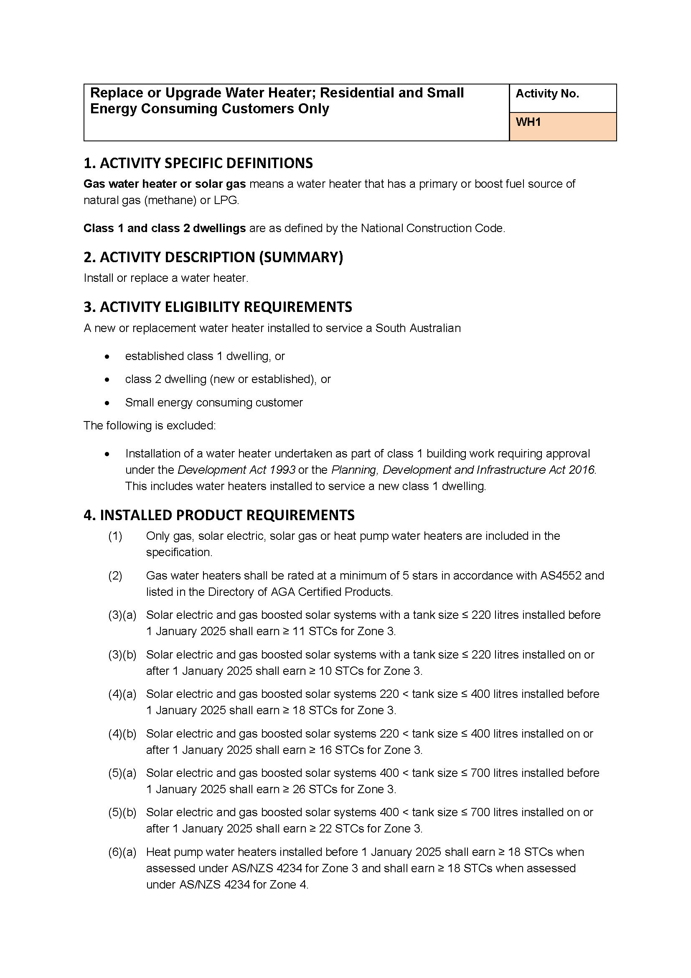
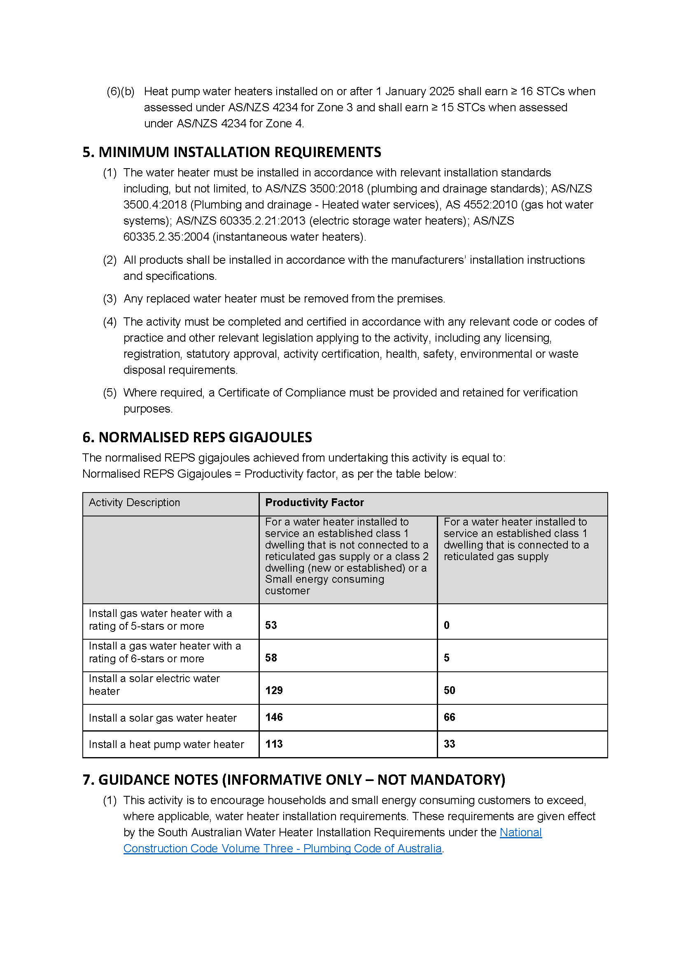

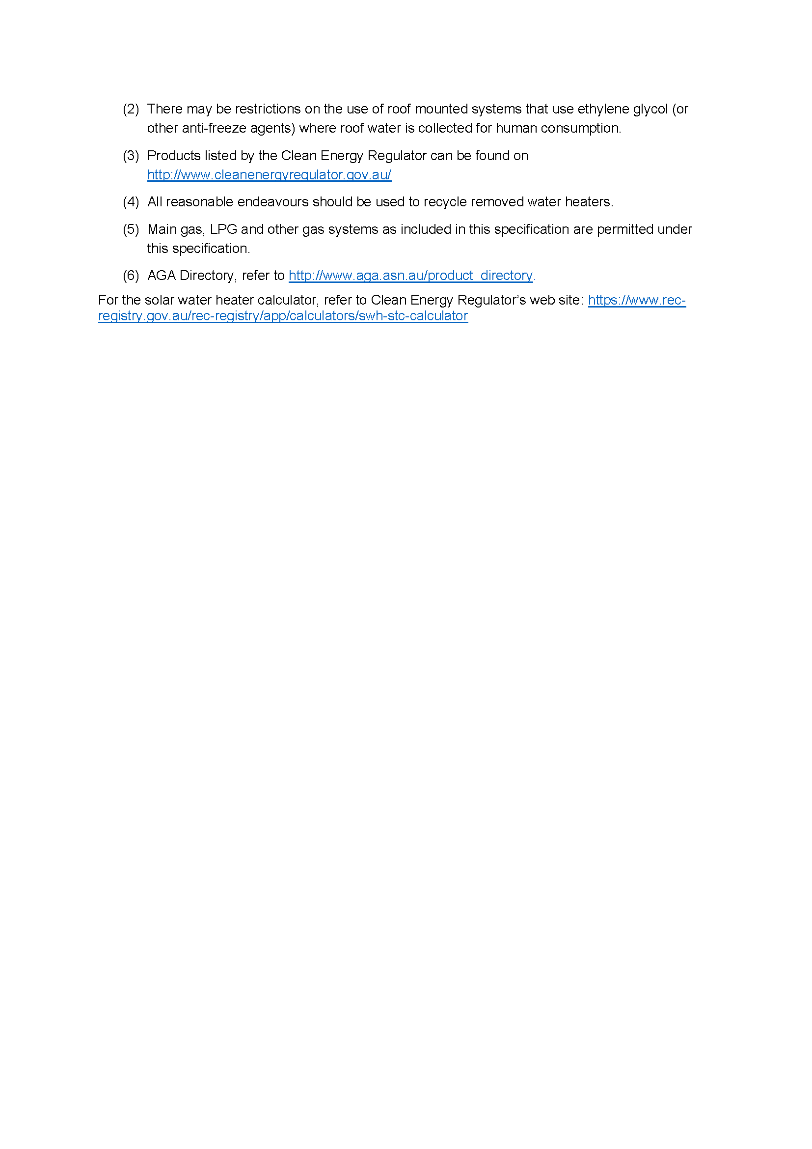

Energy Resources Act 2000
Variation of Pipeline Licence—PL 7
Notice is hereby given that under the provisions of the Energy Resources Act 2000, pursuant to delegated powers dated 19 August 2024, the conditions of the abovementioned Pipeline Licence held by East Australian Pipeline Pty Limited have been varied.
Details of the variation of Pipeline Licence PL 7 are available for viewing on the Licence Register at the Department for Energy and Mining’s website via the following link:
https://www.energymining.sa.gov.au/industry/energy-resources/licensing-and-land-access/onshore-licensing/registers
Dated: 12 December 2024
Benjamin Zammit
Executive Director
Regulation and Compliance Division
Department for Energy and Mining
Delegate of the Minister for Energy and Mining

Energy Resources Act 2000
Variation of Pipeline Licence—PL 8
Notice is hereby given that under the provisions of the Energy Resources Act 2000, pursuant to delegated powers dated 19 August 2024, the conditions of the abovementioned Pipeline Licence held by Gorodok Pty Ltd have been varied.
Details of the variation of Pipeline Licence PL 8 are available for viewing on the Licence Register at the Department for Energy and Mining’s website via the following link:
https://www.energymining.sa.gov.au/industry/energy-resources/licensing-and-land-access/onshore-licensing/registers
Dated: 12 December 2024
Benjamin Zammit
Executive Director
Regulation and Compliance Division
Department for Energy and Mining
Delegate of the Minister for Energy and Mining

Energy Resources Act 2000
Variation of Pipeline Licence—PL 18
Notice is hereby given that under the provisions of the Energy Resources Act 2000, pursuant to delegated powers dated 19 August 2024, the conditions of the abovementioned Pipeline Licence held by APA (SWQP) Pty Limited have been varied.
Details of the variation of Pipeline Licence PL 18 are available for viewing on the Licence Register at the Department for Energy and Mining’s website via the following link:
https://www.energymining.sa.gov.au/industry/energy-resources/licensing-and-land-access/onshore-licensing/registers
Date: 12 December 2024
Benjamin Zammit
Executive Director
Regulation and Compliance Division
Department for Energy and Mining
Delegate of the Minister for Energy and Mining

Fisheries Management Act 2007
Section 115
Ministerial Exemption: ME9903354
Take notice that pursuant to Section 115 of the Fisheries Management Act 2007, Mr Robert Brandle of the National Parks and Wildlife Service, 9 Mackay Street, Port Augusta SA 5700 (the ‘exemption holder’), is exempt from Sections 70 and 71 of the Fisheries Management Act 2007 and Regulation 5(a) and Clause 42, of Schedule 6 of the Fisheries Management (General) Regulations 2017 but only insofar as the exemption holder or nominated agents may engage in the take and sampling of Flinders Ranges Purple-Spotted Gudgeon (Morgunda clivicola) from the waters described in Schedule 1, using the gear specified in Schedule 2 (the ‘exempted activity’), subject to the conditions set out in Schedule 3, for a 12 month period from the day after this permit is signed, unless varied or revoked earlier.
Schedule 1
• Spring Creek, a tributary of the Bunyeroo Creek, Ikara-Flinders National Park
• Pungka Pudanha Spring, Hookina Creek, Yappala Indigenous Protected Area
Schedule 2
• Twenty (20) mesh box-style fish traps (280 x 280 x 400 or 600mm) baited with manufactured cat food
• Four (4) hand held dip nets with 300mm diameter hoop or smaller square net.
Schedule 3
1. The exemption holder must not cause or permit the use of more than two (2) hand held dab nets by any one person at any one time whilst undertaking the exempted activity.
2. A total of 100 whole Flinders Ranges Purple-Spotted Gudgeon (Morgunda clivicola) measuring less than 30mm in total length, may be retained under this exemption.
3. Samples may be collected and retained from Flinders Ranges Purple-Spotted Gudgeon (Morgunda clivicola) measuring 30mm or greater in total length where these fish are released as soon as practicable after sample collection into the waters where they were collected.
4. The specimens collected by the exemption holder are for research purposes only and must not be sold.
5. The permit holder must contact the Department of Primary Industries and Regions (PIRSA) Fisheries and Aquaculture, Manager, Aquatic Animal Health Unit on (08) 8429 2100 to notify any unusually high mortalities or outbreak of any disease (suspected or confirmed) in fish held pursuant to this permit.
6. Other than the fish that may be retained under this exemption all native fish taken pursuant to the exempted activity must be returned to the water at the site of capture.
7. All non-native species of fish caught during the exempted activity must be humanely euthanised and disposed of appropriately.
8. At least 1 hour before the commencement of fishing activities under this exemption, the Department must be informed by telephone on 1800 065 522 of the following information:
(a) the name of the person making the telephone call; and
(b) the date on which, and the time at which, the fishing activities are to be engaged in; and
(c) the location at which the fishing activities are to be engaged in; and
(d) the number of the exemption under which the fishing activities are to be engaged in; and
(e) the name of the holder of the exemption; and
(f) if nominated agent is to be engaged in the fishing activities—the name of the nominated agent.
9. While engaging in the exempted activity, the exemption holder or nominated agents must be in possession of a copy of this notice. Such notice must be produced to a Fisheries Officer if requested.
10. The exemption holder must not contravene or fail to comply with the Fisheries Management Act 2007 or any regulations made under that Act, except where specifically exempted by this notice.
This notice does not purport to override the provisions or operation of any other Act including but not limited to the National Parks and Wildlife Act 1972.
Dated: 11 December 2024
Professor Gavin Begg
Executive Director, Fisheries and Aquaculture
Delegate of the Minister for Primary Industries and Regional Development

Housing Improvement Act 2016
Rent Control
In the exercise of the powers conferred by the Housing Improvement Act 2016, the Delegate of the Minister for Housing and Urban Development hereby fixes the maximum rental amount per week that shall be payable subject to Section 55 of the Residential Tenancies Act 1995, in respect of each premises described in the following table. The amount shown in the said table shall come into force on the date of this publication in the Gazette.
Address of Premises | Allotment Section | Certificate of Title  Volume/Folio | Maximum Rental per week payable
10/36 Kenilworth Road, Parkside SA 5063 (Unit 10) | Strata Plan 11284 Hundred of Adelaide | CT5027/225 | $0.00
16 Darling Street, Sturt SA 5047 | Allotment 38 Deposited Plan 5100 Hundred of Noarlunga | CT5322/478 | $0.00
Dated: 19 December 2024
Craig Thompson
Housing Regulator and Registrar
Housing Safety Authority
Delegate of the Minister for Housing and Urban Development

HOUSING IMPROVEMENT ACT 2016
Rent Control Revocations
In the exercise of the powers conferred by the Housing Improvement Act 2016, the Delegate of the Minister for Housing and Urban Development hereby revokes the maximum rental amount per week that shall be payable subject to Section 55 of the Residential Tenancies Act 1995, in respect of each premises described in the following table.
Address of Premises | Allotment Section | Certificate of Title  Volume/Folio
340 Nelshaby Road, Napperby SA 5540 (AKA Lot 589) | Allotment 589 Filed Plan 188721 Hundred of Napperby | CT5407/498
18 Oakley Street, Adelaide SA 5000 | Allotment 20 Filed Plan 48447 Hundred of Adelaide | CT241/183,  CT5662/44, CT5978/508
23 Marine Terrace, Rosewater SA 5013 | Allotment 9 Filed Plan 107419 Hundred of Port Adelaide | CT5181/868
Dated: 19 December 2024
Craig Thompson
Housing Regulator and Registrar
Housing Safety Authority
Delegate of the Minister for Housing and Urban Development

Justices of the Peace Act 2005
Section 4
Notice of Appointment of Justices of the Peace for South Australia
by the Commissioner for Consumer Affairs
I, Stephanie Halliday, Commissioner for Consumer Affairs, delegate of the Attorney-General, pursuant to Section 4 of the Justices of the Peace Act 2005, do hereby appoint the people listed as Justices of the Peace for South Australia as set out below.
For a period of ten years for a term commencing on 22 January 2025 and expiring on 21 January 2035:
Janine Deidre WARREN
Mark John TAYLOR
Baljit SINGH
James Hamblyn ROLFE
Graham John PAYNE
Leonie Irene MACROW
Siaw-Lin LIAW
Robert William KENT
Joe Ziad HASSAN
Craig William HASLAM
Ronald John GREEN
Kate Emily FALLON
Godfrey Mark Wynne CODY
Craig Andrew CHAPMAN
Gary Malcolm CAMPBELL
Richard James BRIGHT
Vanessa Florence BOULLY
Michael Harvie BLEBY
Andrew Jonathan BITTER
David Lindsay BEATON
Catherine Ellinor BATTERSBY
Michael Kenneth BAMPTON
Mira BABIC
Jillian Heather ASHBY
Colleen Mary ANDREW
Giuseppe ALLEGRETTI
Dated: 17 December 2024
Stephanie Halliday
Acting Commissioner for Consumer Affairs
Delegate of the Attorney-General

Landscape South Australia Act 2019
Declaration of Penalty in Relation to the Unauthorised or Unlawful Taking of Water
Notice is hereby given pursuant to Section 88 of the Landscape South Australia Act 2019 (the Act), I, Sue Hutchings, delegate of the Minister for Climate, Environment and Water to whom the Act is committed, hereby declare that the following penalties are payable in relation to the unauthorised or unlawful taking of water during the consumption period that corresponds to the accounting period 1 July 2024 to 30 June 2025 inclusive:
1. Where a person who is the holder of a water allocation (other than a water allocation pursuant to an authorisation under Section 105 of the Act) takes water from a prescribed water resource listed in Column 1 of the table in Schedule 1 to this notice, which is in excess of the amount available under the allocation, the penalty declared pursuant to Section 88(1)(a) is the corresponding rate in Column 2 of the table in Schedule 1 per kilolitre of water taken in excess of the amount available under the allocation, as determined or assessed to have been taken in accordance with Section 79 of the Act.
2. Where a person who is the holder of a water allocation pursuant to an authorisation under Section 105 of the Act takes water from a prescribed water resource listed in column one of the table in Schedule 2 to this notice, which is in excess of the amount available under the allocation, the penalty declared pursuant to Section 88(1)(a) is the corresponding rate in column two of the table in Schedule 2 per kilolitre of water taken in excess of the amount available under the allocation, as determined or assessed to have been taken in accordance with Section 79 of the Act.
3. Where a person takes water from a prescribed water resource in column one of the table in Schedule 1 to this notice and is not authorised under Section 105 or as part of a water allocation to take that water, and so acts in contravention of the Act, the penalty declared under Section 88(1)(e) is the corresponding rate in column three of the table in Schedule 1 per kilolitre of water taken, as determined or assessed to have been taken in accordance with Section 79 of the Act.
4. Where a person takes water from a prescribed water resource described in column one of the table in Schedule 1 to this notice in contravention of a notice under Section 109 of the Act, the penalty declared under Section 88(1)(f) is the corresponding rate in column three of the table in Schedule 1 per kilolitre of water taken in excess of the amount authorised for take, as determined or assessed to have been taken in accordance with Section 79 of the Act.
5. Where a person may be subject to more than one penalty under Section 88 in respect of the same conduct, the penalty that is the greater shall be imposed.
In this notice:
‘the Northern Adelaide Plains Prescribed Wells Area’ means the area declared to be the Northern Adelaide Plains Proclaimed Region by proclamation under Section 41 of the Water Resources Act 1976 (see Government Gazette 13 May 1976 page 2459), and as further declared by regulation under Section 125 of the Natural Resources Management Act 2004 (see Government Gazette 22 July 2004, p. 2600);
‘the Central Adelaide Prescribed Wells Area’ means the area which includes the wells declared by regulation under Section 125 of the Natural Resources Management Act 2004 (Natural Resources Management (Central Adelaide—Prescribed Wells Area) Regulations 2007) (see Government Gazette 7 June 2007, pp.2573-2574);
‘the Dry Creek Prescribed Wells Area’ means the area declared to be the Dry Creek Proclaimed Wells Area by proclamation under Section 33(2) of the Water Resources Act 1990 (see Government Gazette 11 July 1996 p. 76, and as further varied by Government Gazette 28 November 1996, p. 1747)’;
‘the Angas-Bremer Prescribed Wells Area’ means the area declared to be the Angas-Bremer Proclaimed Region by proclamation under Section 41 of the Water Resources Act 1976 (see Government Gazette 23 October 1980 p. 1192);
‘the Peake, Roby and Sherlock Prescribed Wells Area’ means the area declared by regulation under Section 125 of the Natural Resources Management Act 2004 (Natural Resources Management (Peake, Roby and Sherlock Prescribed Wells Area) Regulations 2005)
(see Government Gazette 27 October 2005 p. 3836);
‘the Marne Saunders Prescribed Water Resources Area’ means the area declared by regulation under Section 125 of the Natural Resources Management Act 2004 (see Government Gazette 20 March 2003, p. 1111);
‘the Clare Valley Prescribed Water Resources Area’ means the area declared by regulation to be the Clare Valley Prescribed Wells Area and Watercourses under Section 8 of the Water Resources Act 1997 (see Government Gazette 25 July 1996 p.171) and the area declared by regulation to be the Clare Valley Prescribed Surface Water Area under Section 8 of the Water Resources Act 1997 (see Government Gazette 28 October 1999 p.2127);
‘the Mallee Prescribed Wells Area’ means the area declared to be the Mallee Prescribed Wells Area by proclamation under Section 41 of the Water Resources Act 1976 (See Government Gazette 28 July 1983, page 205 and varied on 9 January 1986, page 19) and as further declared by regulation under Section 125 of the Natural Resources Management Act 2004 (see Government Gazette 27 October 2005, p. 3833);
‘the Southern Basins Prescribed Wells Area’ means the area declared to be the Southern Basins Proclaimed Region by proclamation under Section 41 of the Water Resources Act 1976 (see Government Gazette 12 March 1987 p. 596);
‘the Musgrave Prescribed Wells Area’ means the area declared to be the Musgrave Proclaimed Region by proclamation under Section 41 of the Water Resources Act 1976 (see Government Gazette 12 March 1987 p. 596);
‘the Far North Prescribed Wells Area’ means the area declared to be the Far North Prescribed Wells Area by regulation under Section 8 of the Water Resources Act 1997 (see Government Gazette 27 March 2003 p. 1250);
‘the Barossa Prescribed Water Resources Area’ means the area declared by regulation under Section 8 of the Water Resources Act 1997 (see Government Gazette 19 May 2005, p. 1295);
‘the McLaren Vale Prescribed Wells Area’ means the area gazetted on 7 January 1999 page 13, under the provisions of the
Water Resources Act 1997;
‘the Western Mount Lofty Ranges Prescribed Water Resources Area’ means that area which includes:
the watercourses declared by regulation under Section 125 of the Natural Resources Management Act 2004 (Natural Resources Management (Western Mount Lofty Ranges—Prescribed Watercourses) Regulations 2005) (see Government Gazette 20 October 2005, pp. 3791-3792); and
the wells declared by regulation under Section 125 of the Natural Resources Management Act 2004 (Natural Resources Management (Western Mont Lofty Ranges—Prescribed Wells Area) Regulations 2005) (see Government Gazette 20 October 2005, pp.3793-3794); and
the surface water area declared by regulation under Section 125 of the Natural Resources Management Act 2004 (Natural Resources Management (Western Mount Lofty Ranges—Surface Water Prescribed Area) Regulation 2005) (see Government Gazette 20 October 2005, pp. 3795-3796);
‘the Eastern Mount Lofty Ranges Prescribed Resources Area’ means that area which includes:
the watercourses and surface water area declared by regulation under Section 125 of the Natural Resources Management Act 2004 (Natural Resources Management (Eastern Mount Lofty Ranges—Prescribed Watercourses and Surface Water Prescribed Area) Regulations 2005) (see Government Gazette 8 September 2005, pp.3292-3293); and
the wells declared by regulation under Section 125 of the Natural Resources Management Act 2004 (Natural Resources Management (Eastern Mount Lofty Ranges—Prescribed Wells Area) Regulations 2005) (see Government Gazette 8 September 2005, pp.3294-3295).

‘the Morambro Creek Prescribed Watercourse and Prescribed Surface Water Area’ means that area which includes:
the watercourse declared by regulation under Section 8 of the Water Resources Act 1997 (Water Resources (Morambro Creek) Regulations 2001) (see Government Gazette 12 April 2001, p.1605); and
the surface water prescribed area declared by regulation under Section 8 of the Water Resources Act 1997 (Water Resources (Surface Water Prescribed Area—Morambro Catchment) Regulations 2001).
‘the Lower Limestone Coast Prescribed Wells Area’ means the area declared by regulation under Section 8 of Water Resource Act 1997 (see Government Gazette 2 December 2004, p. 4462-4464);
‘the Padthaway Prescribed Wells Area’ means the area declared by proclamation under Section 25 of the Water Resources Act 1976
(see Government Gazette 13 May 1976, p. 2459);
‘the Tatiara Prescribed Wells Area’ means the area declared to be the Tatiara Prescribed Area by proclamation under Section 41 of the Water Resources Act 1976 (See Government Gazette 12 July 1984, p. 134) and further revoked and varied (see Government Gazette
30 January 1986, p. 206);
‘the Tintinara-Coonalpyn Prescribed Wells Area’ means the area prescribed under Section 8 of the Water Resource Act 1997
(Water Resources (Tintinara Coonalpyn Prescribed Wells Area) Regulations 2000) (see Government Gazette 2 November 2000, p.2933).
Schedule 1
Penalties for unauthorised or unlawful take from a prescribed water resource 2024-2025:
Column 1 | Column 2 | Column 3
Angas Bremer Prescribed Wells Area | $0.69/kL | $0.92/kL
Barossa Prescribed Water Resources Area | $2.25/kL | $3.00/kL
Clare Valley Prescribed Water Resources Area | $0.69/kL | $0.92/kL
Dry Creek Prescribed Wells Area | $0.69/kL | $0.92/kL
Eastern Mt Lofty Ranges Prescribed Water Resources Area | $1.20/kL | $1.60/kL
Far North Prescribed Wells Area | $0.69/kL | $0.92/kL
Lower Limestone Coast Prescribed Wells Area | $1.20/kL | $1.60/kL
Mallee Prescribed Wells Area | $1.44/kL | $1.92/kL
Marne Saunders Prescribed Water Resources Area | $0.69/kL | $0.92/kL
McLaren Vale Prescribed Wells Area | $3.90/kL | $5.20/kL
Morambro Creek Prescribed Watercourse and Prescribed Surface Water Area | $0.69/kL | $0.92/kL
Musgrave Prescribed Wells Area | $0.69/kL | $0.92/kL
Northern Adelaide Plains Prescribed Wells Area | $4.85/kL | $6.46/kL
Padthaway Prescribed Wells Area | $0.69/kL | $0.92/kL
Peake, Roby and Sherlock Prescribed Wells Area | $0.69/kL | $0.92/kL
Southern Basins Prescribed Wells Area | $0.69/kL | $0.92/kL
Tatiara Prescribed Wells Area | $0.69/kL | $0.92/kL
Tintinara Coonalpyn Prescribed Wells Area | $0.69/kL | $0.92/kL
Western Mt Lofty Ranges Prescribed Water Resources Area | $0.97/kL | $1.30/kL
Unit of measure kL is the abbreviation of kilolitre
Schedule 2
Penalties for unauthorised take from a prescribed water resource, taken in association with an authorisation pursuant to Section 105 of the Act:
Column 1 | Column 2
Central Adelaide Prescribed Wells Area | $0.69/kL
Western Mount Lofty Ranges Prescribed Water Resources Area | $1.50/kL
Unit of measure kL is the abbreviation of kilolitre
Dated: 16 December 2024
Sue Hutchings
Executive Director, Water and River Murray
Department for Environment and Water
Delegate of the Minister for Climate, Environment and Water

Livestock Act 1997
Section 4
Notifiable Diseases
Pursuant to Section 87 of the Livestock Act 1997, I, Christopher James Etherton, Chief Inspector of Stock, delegate of the Minister for Primary Industries and Regional Development, revoke the notice entitled Notifiable Diseases pursuant to Section 4 of the Livestock Act 1997 on 14 November 2024, published 21 November 2024 on page 4230 of the South Australian Government Gazette.
Pursuant to Section 4 of the Livestock Act 1997, I declare to be notifiable diseases those diseases listed as exotic diseases and report only diseases plus the following diseases:
Notifiable Diseases
Species | Disease, infections, and infestations
Bees | Melissococcus pluton (European foulbrood)
 | Paenibacillus larvae (American foulbrood)
Aquatic species | Abalone herpesvirus (Haliotid herpesvirus-1)
 | Aeromonas salmonicida—atypical strains
 | Aphanomyces invadans (epizootic ulcerative syndrome)
 | Batrachochytrium dendrobatidis
 | Bonamia exitiosa
 | Epizootic haematopoietic necrosis virus
 | Ostreid herpesvirus-1
 | Perkinsus olseni
 | Betanodavirus
Other livestock species | Aino virus
 | Akabane virus
 | Anaplasma marginale (bovine anaplasmosis)
 | Babesia bovis, B. bigemina or B. divergens (bovine babesiosis)
 | Bovine ephemeral fever
 | Bovine leukaemia virus (enzootic bovine leucosis)
 | Brucella suis
 | Burkholderia pseudomallei (melioidosis)
 | Chlamydophilia pecorum (sporadic bovine encephalomyelitis)
 | Taenia saginata (cysticercus bovis)
 | Ehrlichia canis (ehrlichiosis)
 | Escherichia coli (verotoxigenic strains)
 | Equine herpes virus-1 (EHV-1)
 | Equine infectious anaemia virus
 | Equine arteritis virus
 | Infectious laryngotracheitis virus
 | Listeria monocytogenes (listeriosis)
 | Mycobacterium avium (avian tuberculosis) in birds
 | Salmonella Pullorum (pullorum disease)
Exotic Diseases
Species | Diseases, Infections, and Infestations
Bees | Acarapis woodi (acariasis tracheal mite)
 | Acute bee paralysis virus
 | Braula coeca (bee louse)
 | Tropilaelaps clareae or T. mercedesae (tropilaelaps mite)
 | Varroa destructor or V. jacobsoni (varroosis)
Aquatic species | Acute hepatopancreatic necrosis disease
 | Aeromonas salmonicida subsp. salmonicida (furunculosis)
 | Aphanomyces astaci (crayfish plague)
 | Baculoviral midgut gland necrosis virus
 | Batrachochytrium salamandrivorans
 | Boccardia knoxi
 | Bonamia ostreae
 | Decapod iridescent virus 1
 | Edwardsiella ictaluri (enteric septicaemia of catfish)
 | Enterocytozoon hepatopenaei
 | Gill-associated virus
 | Gyrodactylus salaris
 | Haplosporidium costale or H. nelsoni (haplosporidiosis)
 | Hepatobacter penaei (necrotising hepatopancreatitis)
 | Infectious salmon anaemia virus
 | Infectious haematopoietic necrosis virus
 | Infectious hypodermal and haematopoietic necrosis virus
 | Infectious myonecrosis virus
 | Infectious pancreatic necrosis virus
 | Infectious spleen and kidney necrosis virus
 | Koi herpesvirus (Cyprinid herpesvirus 3)
 | Macrobrachium rosenbergii nodavirus (white tail disease)
 | Marteilia refringens
 | Marteilia sydneyi
 | Marteilioides chungmuensis
 | Mikrocytos mackini
 | Mollusc iridoviroses
 | Monodon slow growth syndrome
 | Myxobolus cerebralis (whirling disease)
 | Oncorhynchus masou virus disease
 | Perkinsus marinus
 | Piscirickettsia salmonis (piscirickettsiosis)
 | Ranavirus species
 | Red sea bream iridovirus
 | Renibacterium salmoninarum (bacterial kidney disease)
 | Salmonid alphavirus
 | Scale drop disease virus
 | Singapore grouper iridovirus (ranavirus)
 | Spawner-isolated mortality virus
 | Spring viraemia of carp virus
 | Taura syndrome virus
 | Tilapia lake virus disease
 | Turbot reddish body iridovirus
 | Viral haemorrhagic septicaemia virus
 | White spot syndrome virus
 | White sturgeon iridoviral disease
 | Xenohaliotis californiensis
 | Yellow head virus genotype 1
 | Yersinia ruckeri—Hagerman strain (enteric redmouth disease)
Other livestock species | African horse sickness virus
 | African swine fever virus
 | Alcelaphine herpesvirus-1 (malignant catarrhal fever, wildebeest-associated)
 | Anatid herpesvirus-1
 | Aujeszky’s disease virus (pseudorabies virus)
 | Australian bat lyssavirus
 | Avian bornavirus (proventricular dilatation syndrome)
 | Avian metapneumovirus (turkey rhinotracheitis)
 | Babesia caballi, B. equi or Theileria equi (equine piroplasmosis)
 | Bacillus anthracis (anthrax)
 | Bluetongue (clinical disease)
 | Borrelia burgdorferi (Lyme disease)
 | Borna disease virus
 | Bovine virus diarrhoea virus (type 2)
 | Brucella abortus
 | Brucella canis
 | Brucella melitensis
 | Bungowannah virus
 | Burkholderia mallei (glanders)
 | Camelpox virus
 | Chlamydophila abortus (enzootic abortion of ewes / ovine chlamydiosis)
 | Classical swine fever virus
 | Chrysomya bezziana (Old World screwworm fly)
 | Cochliomyia hominivorax (New World screwworm fly)
 | Contagious agalactia (clinical disease)
 | Cowpox virus
 | Crimean-Congo haemorrhagic fever virus
 | Devil facial tumour disease
 | Duck virus hepatitis
 | Echinococcus multilocularis
 | Ehrlichia ruminantium (heartwater)
 | Elaphostrongylus cervi
 | Encephalitis virus (tick borne)
 | Epizootic haemorrhagic disease (clinical disease)
 | Equine encephalomyelitis viruses (Eastern, Western or Venezuelan)
 | Equine encephalosis virus
 | Equine influenza virus
 | Fasciola gigantica
 | Foot and mouth disease virus
 | Francisella tularensis (tularaemia)
 | Getah virus
 | Haematobia irritans exigua (buffalo fly)
 | Haemorrhagic septicaemia (Pasturella multocida serotypes 6:b and 6:e)
 | Hantaan river virus
 | Hendra virus
 | Histoplasma farciminosum (epizootic lymphangitis)
 | Infectious bursal disease virus (very virulent and exotic antigenic variant forms)
 | Influenza A viruses in birds and swine
 | Jembrana disease virus
 | Leptospirosis interrogans serovar Canicola
 | Louping ill virus
 | Lumpy skin disease virus
 | Leishmania spp.
 | Maedi-visna virus
 | Middle East respiratory syndrome coronavirus
 | Menangle virus
 | Mycobacterium bovis
 | Mycobacterium caprae
 | Mycobacterium tuberculosis
 | Mycoplasma capricolum subsp. capripneumoniae (contagious caprine pleuropneumonia)
 | Mycoplasma iowae
 | Mycoplasma mycoides subsp. mycoides SC (contagious bovine pleuropneumonia)
 | Nairobi sheep disease virus
 | Neorickettsia risticii (Potomac fever)
 | Newcastle disease virus (virulent)
 | Nipah virus
 | Peste des petits ruminants virus
 | Pseudogymnoascus destructans in bats (white nose syndrome)
 | Taenia solium (Porcine cysticercosis)
 | Porcine epidemic diarrhoea virus
 | Porcine reproductive and respiratory syndrome virus
 | Post-weaning multi-systemic wasting syndrome
 | Psoroptes ovis (sheep scab)
 | Pulmonary adenomatosis (Jaagsiekte)
 | Rabies virus
 | Rhipicephalus australis (cattle tick)
 | Rift Valley fever virus
 | Rinderpest virus
 | Salmonella abortus-equi
 | Salmonella abortus-ovis
 | Salmonella Enteritidis in poultry
 | Salmonella Gallinarum (fowl typhoid)
 | Senecavirus A (Seneca Valley virus)
 | Sheep pox virus or goat pox virus
 | Shope’s fibroma virus
 | Swine vesicular disease virus
 | Taylorella equigenitalis (contagious equine metritis)
 | Taenia multiceps, T. serialis, T. brauni, and T. glomeratus (causing infestation with Coenurus cerebralis)
 | Teschovirus encephalomyelitis
 | Theileria annulata (Mediterranean theilerosis)
 | Theileria parva (East Coast fever)
 | Transmissible gastroenteritis coronavirus
 | Transmissible spongiform encephalopathies (bovine spongiform encephalopathy, chronic wasting disease feline
 | spongiform encephalopathy, scrapie)
 | Trichinella spp.
 | Trypanosomosis cruzi (Chagas disease)
 | Trypanosoma equiperdum (dourine)
 | Trypanosoma evansi (surra)
 | Trypanosomosis (tsetse fly associated)
 | Vesicular exanthema of swine virus
 | Vesicular stomatitis virus
 | Warble-fly (warble-fly myiasis)
 | Wesselsbron virus
 | West Nile Virus (clinical disease)
Report Only Diseases
Diseases, Infections, and Infestations
Footrot (Dichelobacter nodosus) (in sheep and in goats only)
Japanese encephalitis virus
Paratuberculosis (Johne’s disease)
Streptococcus equi equi (strangles)
Virulent pigeon paramyxovirus
This notice will come into force on 1 January 2025 and will remain in force unless amended or revoked by a subsequent notice.
Dated: 16 December 2024
Christopher James Etherton
Chief Inspector of Stock
Delegate of the Minister for Primary Industries and Regional Development

LIVESTOCK ACT 1997
Section 37
Requirements for the Control or Eradication of Footrot (Dichelobacter nodosus)
Pursuant to Section 37 of the Livestock Act 1997 (Act) and for the purposes of controlling or eradicating footrot, I Christopher James Etherton, Chief Inspector of Stock and delegate of the Minster for Primary Industries and Regional Development impose the following requirements:
1. the requirements listed in Schedule 1, which apply generally throughout the State;
2. the requirement that a person must not undertake an activity listed in Schedule 2 Column A unless it is undertaken in accordance with the requirements listed in Schedule 2 Column B for that activity.
Schedule 1
Activities Within the State
1. If a person knows or has reason to suspect that livestock owned by or under his or her control are affected with footrot, the person must take all reasonable measures to control or eradicate the footrot.
2. A person must not do an act intending that, or being recklessly indifferent as to whether, livestock become affected or further affected with footrot.
3. A person must not, without the approval of the Chief Inspector, bring footrot into the State or cause footrot to be brought into the State.

Schedule 2
Activities Subject to Requirements
Column A | Column B
Activity | Requirements
- The movement of livestock affected or suspected of being affected with footrot | Livestock affected or suspected of being affected with footrot must not be moved within the State without the approval of the Chief Inspector, unless:  (a) the livestock are moved within a holding;  (b) the livestock are moved directly from the source property to the receiving property without movement through a saleyard, transit or spelling facility, or any other interim property and a prescribed prior notice is provided by the consignor to the consignee prior to the finalisation of any sale and the movement being commenced; or  (c) the livestock are moved to the Mount Gambier Regional Livestock Exchange or the Naracoorte Regional Livestock Exchange saleyards and the consignor has provided an accurately completed National Sheep Health Declaration declaring that the livestock are affected or suspected of being affected with footrot.
- The sale of livestock affected or suspected of being affected with footrot through a livestock saleyard | Livestock affected or suspected of being affected with footrot must not be sold through a livestock saleyard without the approval of the Chief Inspector unless:  (a) the saleyard is either the Mount Gambier Regional Livestock Exchange or the Naracoorte Regional Livestock Exchange; and  (b) a prescribed warning statement is displayed in a prominent position at the saleyard; and  (c) a prescribed warning statement is placed on the National Sheep Health Declaration for any consignment sold or transited through the saleyard.
Definitions
In this notice:
consignor includes a stock agent acting on behalf of the vendor.
footrot (Dichelobacter nodosus) is a disease that has been declared to be a notifiable disease [in relation to sheep and goats] pursuant to Section 4(1)(a) of the Act and designated as a notifiable (report only) disease pursuant to Section 4(2)(a) of the Act.
holding has the same meaning as in the Act and means lands contiguous to each other, or separated only by a road, railway or watercourse, and worked as one property.
livestock affected with footrot means livestock that are suffering from or affected with the disease and includes sheep or goats in respect of which:
(a) clinical lesions consistent with footrot have been identified by a veterinarian or a PIRSA Inspector; or
(b) a positive laboratory test for footrot has been returned.
livestock saleyard has the same meaning as in the Livestock Regulations 2013 (Regulations) and includes any place where the public sale of livestock is conducted.
livestock suspected of being affected with footrot includes livestock that:
(a) within the past 12 months, have been:
(i) pastured or kept together with other livestock on the same holding; or
(ii) transported with other livestock in the same vehicle, vessel or aircraft; or
(iii) kept together with other livestock in the same group; and
(b) those other livestock are affected with footrot, or there is reason to suspect that the other livestock are affected with footrot.
National Sheep Health Declaration means the sheep health statement approved by the Chief Inspector for the purposes of the Regulations.
prescribed prior notice means a written notice accurately identifying the footrot status of the livestock in one or more of the following:
(a) a National Sheep Health Declaration;
(b) a sales agreement between the vendor and purchaser; or
(c) a declaration on an online livestock selling platform.
prescribed warning statement means the following written statement:
This saleyard accepts livestock affected or suspected of being affected with footrot and purchasers must be aware of the risks associated with purchasing livestock that may be affected with footrot.
stock agent has the same meaning as in the Regulations and, in relation to a vendor or purchaser of livestock, means a person who, for fee or reward, arranges for the sale or purchase of the livestock on behalf of the vendor or purchaser.
This Notice will come into force on 1 January 2025 and will remain in force until 31 December 2029 unless amended or revoked by a subsequent Notice.
Dated: 16 December 2024
Christopher James Etherton
Chief Inspector of Stock
Delegate of the Minister for Primary Industries and Regional Development

Livestock Act 1997

Livestock Regulations 2013
Regulation 3A(1)(b)
Chief Inspector of Stock Requirements for Capture of a Harvested Rangeland Goat
Pursuant to Regulation 3A(1)(b) of the Livestock Regulations 2013, I, Christopher James Etherton, Chief Inspector of Stock, hereby determine the following requirement for the capture of a harvested rangeland goat:
• the goat must not have been born as a result of a managed breeding program.
Definitions
In this Notice:
Harvested Rangeland Goat has the same meaning as the Livestock Regulations 2013.
This notice comes into effect 1 January 2025.
Dated: 17 December 2024
Christopher James Etherton
Chief Inspector of Stock

Livestock Act 1997
Livestock Regulations 2013
Regulation 3(1)
Chief Inspector of Stock—Vendor Declaration, National Vendor Declaration,
Sheep Health Statement and NLIS Database Manager
Pursuant to Section 87 of the Livestock Act 1997, I Christopher James Etherton, Chief Inspector of Stock, revoke the notice made by the Chief Inspector of Stock pursuant to Regulation 3(1) of the Livestock Regulations 2013 on 22 October 2021 and published on 4 November 2021 in the South Australian Government Gazette.
Pursuant to Regulation 3(1) of the Livestock Regulations 2013, I Christopher James Etherton, Chief Inspector of Stock:
1. Approve each of the following forms as a vendor declaration:
(a) in respect of cattle (except bobby calves) consigned to a destination land, other than an EU accredited facility, the National Vendor Declaration (Cattle) and Waybill published by Integrity Systems Company Limited (“ISC”) from time to time;
(b) in respect of cattle (except bobby calves) consigned from an EU accredited facility, the European Union Vendor Declaration (Cattle) and Waybill published by ISC from time to time;
(c) in respect of bobby calves, the National Vendor Declaration (Bobby Calves) and Waybill published by ISC from time to time;
(d) in respect of sheep and lambs, the National Vendor Declaration (Sheep and Lambs) and Waybill published by ISC from time to time; and
(e) in respect of farmed goats, the National Vendor Declaration (Goats) and Waybill published by ISC from time to time; and
(f) in respect of harvested rangeland goats, the National Vendor Declaration (Harvested Rangeland Goats) and Waybill published by ISC from time to time.
2. Designate each vendor declaration approved for livestock of the kind referred to in paragraph (1) above, as a national vendor declaration for livestock of that kind, for the purposes of the Regulations.
3. Approve the National Sheep Health Declaration, as published on the Farm Biosecurity website from time to time, as the sheep health statement.
4. Designate the person who manages and administers the NLIS Database from time to time, namely the Administrator under the Terms of Use for the National Livestock Identification System Database as the NLIS database manager for the purposes of the regulations.
Definitions:
destination land has the same meaning as the Livestock Regulations 2013.
Farm Biosecurity website means the website maintained by Animal Health Australia and Plant Health Australia at:
https://www.farmbiosecurity.com.au
Farmed goats has the same meaning as the Livestock Regulations 2013.
Harvested rangeland goat has the same meaning as the Livestock Regulations 2013.
Terms of Use for the National Livestock Identification System Database means edition 1.26 published on 10 July 2024 and as amended from time to time.
NLIS has the same meaning as the Livestock Regulations 2013.
This notice comes into effect 1 January 2025.
Dated: 17 December 2024
Christopher James Etherton
Chief Inspector of Stock

Major Events Act 2013
Section 6B
Declaration of a Major Event
Pursuant to Section 6B of the Major Events Act 2013, I, Hon. Zoe Bettison MP, Minister for Tourism declare the 2025 Repco Adelaide Motorsport Festival held from Friday, 7 March to Sunday, 9 March 2025 to be declared a major event.
By virtue of the provisions of the Major Events Act 2013, I do hereby:
1. Declare the 2025 Repco Adelaide Motorsport Festival to be a major event.
2. Specify the period of the event, for which the declaration of the major event is in force is from 5:00am on Friday, 7 March to 11:59pm on Sunday, 9 March 2025.
3. Declare the major event venues to be the areas as shown as ‘Major Event Venue’ in descriptions and maps specifically covering Gouger Street between Mill Street and Morphett Street, Wakefield Road between East Terrace and Dequetteville Terrace, and Park 16 (Victoria Park/Pakapakanthi).
4. Declare the controlled areas to be any public place or a part of a public place that is within 250 metres of the boundary of the major event venues, as shown as the ‘Declared Controlled Area’ on the map.
5. Designate Massive Events Corp P/L (ABN 55 984 494 841) to be the event organisers for the event.
6. Declare that the following provisions of Part 3 of the Act apply to the event, the event site and the declared controlled area for the event:
(a) Section 8
(b) Section 10
(c) Section 11
(d) Section 12
(e) Section 13
(f) Section 14

7. Being satisfied that the title “Repco Adelaide Motorsport Festival” and the logo as it appears below are sufficiently connected with the identity and conduct of the major event, and that the event has commercial arrangements that are likely to be adversely affected by unauthorised use of the title and logo, I hereby declare, pursuant to Section 14(1) of the Act, that “Repco Adelaide Motorsport Festival” is an official title and the logo as it appears below is an official logo in respect of the event.

Dated: 11 December 2024
Hon Zoe Bettison MP
Minister for Tourism

Maps of Controlled Areas
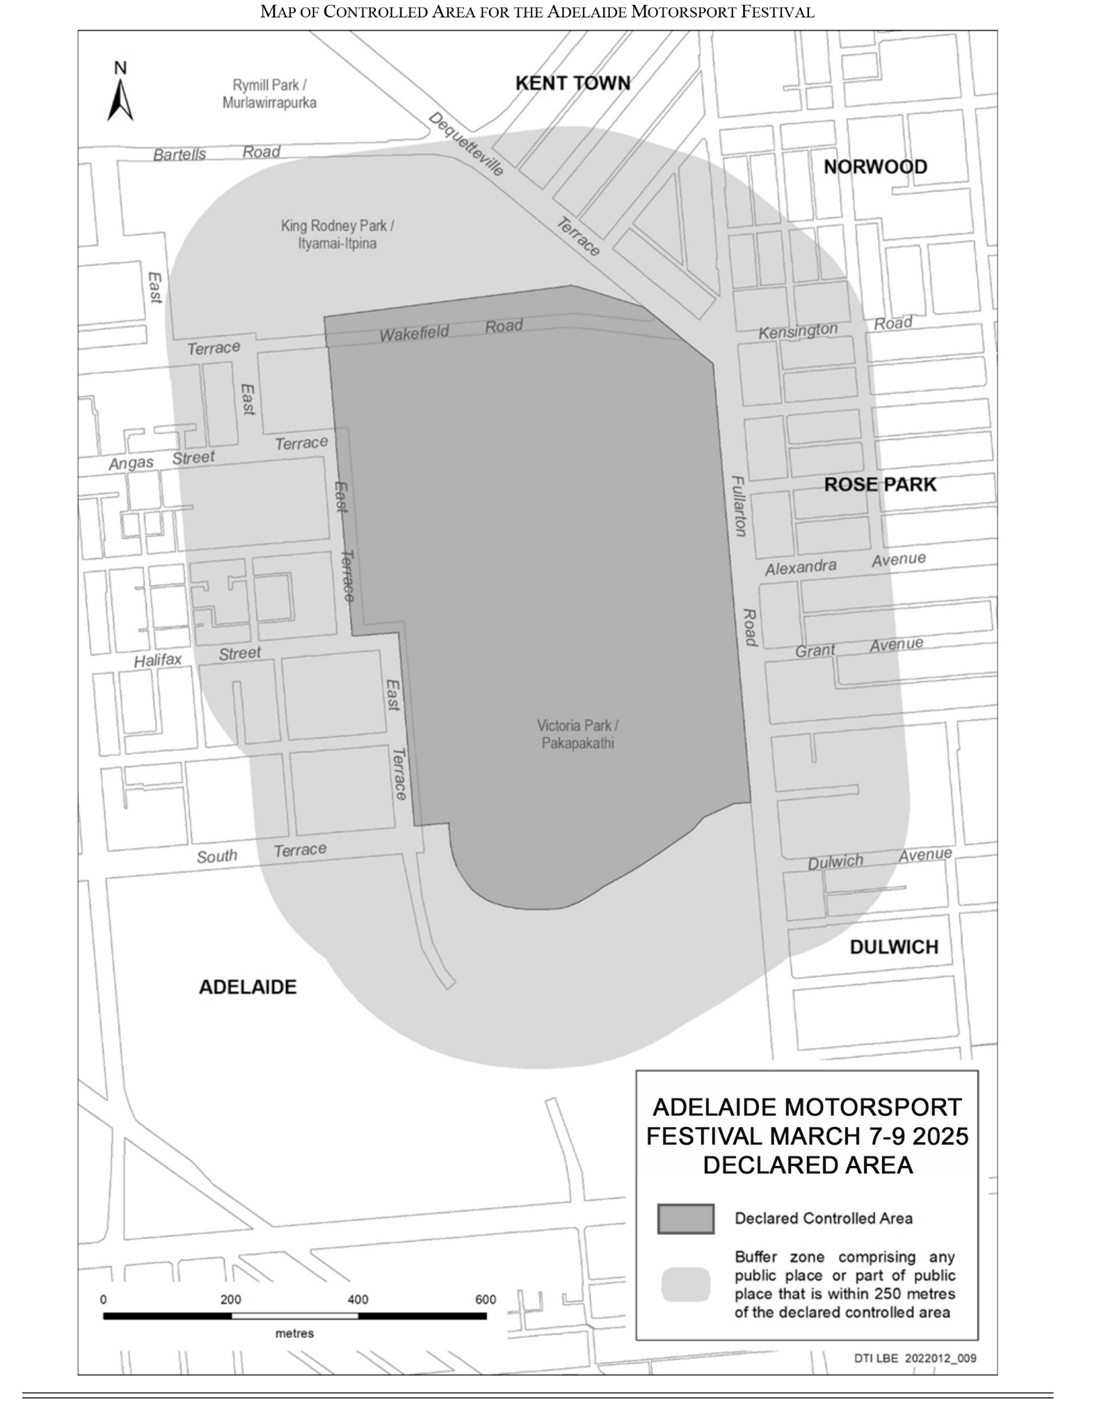
2025 Repco Adelaide Motorsport Festival

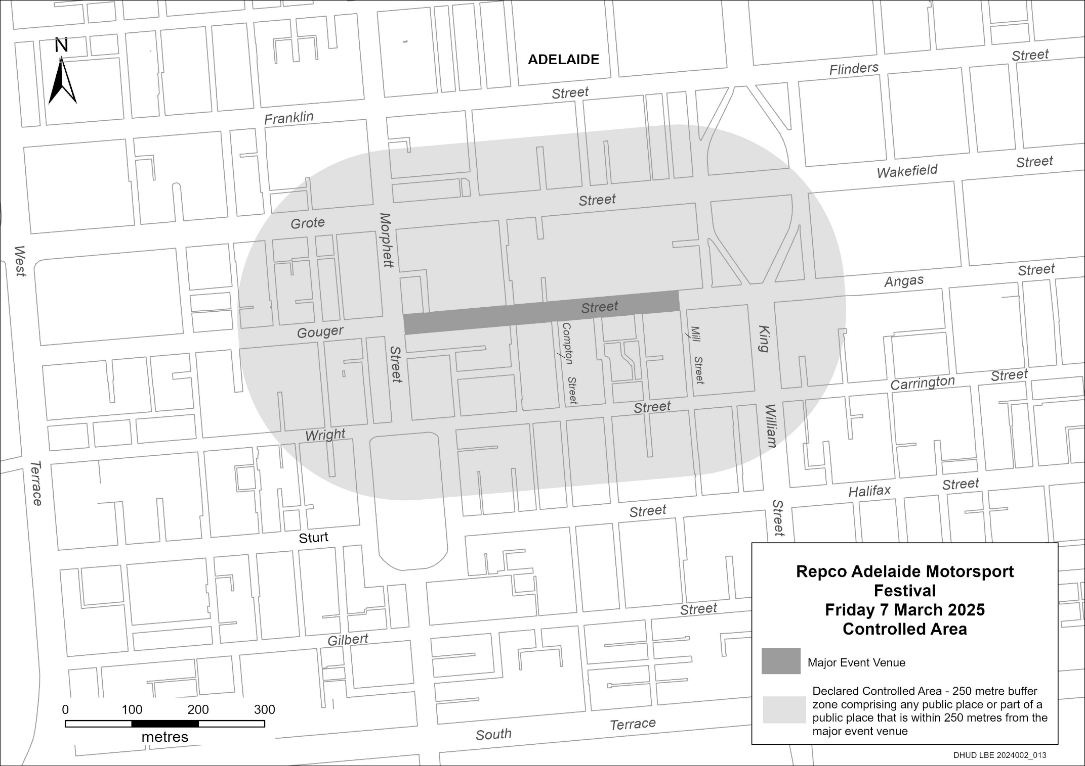

MAJOR EVENTS ACT 2013
Section 6b
Declaration of a Major Event
Pursuant to Section 6B of the Major Events Act 2013, I, Hon. Zoe Bettison MP, Minister for Tourism declare the 2025 Santos Tour Down Under to be held from 17 to 26 January 2025 to be declared a major event.
By virtue of the provisions of the Major Events Act 2013, I do hereby:
1. Specify the period of the event, for which the declaration of the major event is in force is Friday, 17 January to Sunday, 26 January 2025.
• Please note, on Saturday, 25 January 2025 from midnight to 11:59pm, authority to enforce the Major Event Act at Adelaide Oval and the surrounding areas is under the auspice of Cricket Australia.
2. Declare the 2025 Santos Tour Down Under and its associated events officially organised by the event organiser to be a major event:
The Santos Tour Down Under comprises:
• Villawood Men’s Classic
• Schwalbe Women’s One Day Classic
• Three days of women’s competition racing, namely:
◦ Ziptrak Women’s Stage 1
◦ Health Partners Women’s Stage 2
◦ Hyundai Women’s Stage 3
• Six days of men’s competition racing, namely:
◦ Ziptrak Men’s Stage 1
◦ Health Partners Men’s Stage 2
◦ efex Men’s Stage 3
◦ Hahn Men’s Stage 4
◦ Think! Road Safety Men’s Stage 5
◦ Schwalbe Men’s Stage 6

• The associated events officially organised by the event organiser, namely:
◦ City of Adelaide Tour Village
◦ Health Partners Family Day
◦ Health Partners Family Ride
◦ Team Presentation
◦ Detours
◦ Hillside Social at Willunga Hill
◦ Hillside Social at Montefiore Hill
◦ Breakaway Zones
◦ Race Day Presentation Podiums
◦ Carpark Climb presented by Wilson Parking
◦ Legends Night dinner presented by Telstra
3. Declare the major event venues to be the women’s race routes, men’s race routes, Men’s Classic race route, Carpark Climb venue and Tour Village, and the controlled areas to be any public place or part of a public place that is within 250 metres from the boundary of the major event venues.
4. Designate the South Australian Tourism Commission (ABN 80 485 623 691) to be the event organisers for the event.
5. Declare that the following provisions of Part 3 of the Act apply to the event, the event site and the declared controlled area for the event:
(a) Section 8
(b) Section 10
(c) Section 11
(d) Section 12
(e) Section 13
(f) Section 14
6. Being satisfied that the title “Santos Tour Down Under” and the logo as it appears below are sufficiently connected with the identity and conduct of the major event, and that the event has commercial arrangements that are likely to be adversely affected by unauthorised use of the title and logo, I hereby declare, pursuant to Section 14(1) of the Act, that “Santos Tour Down Under” is an official title and the logo as it appears below is an official logo in respect of the event.

Dated: 17 December 2024
Hon Zoe Bettison MP
Minister for Tourism

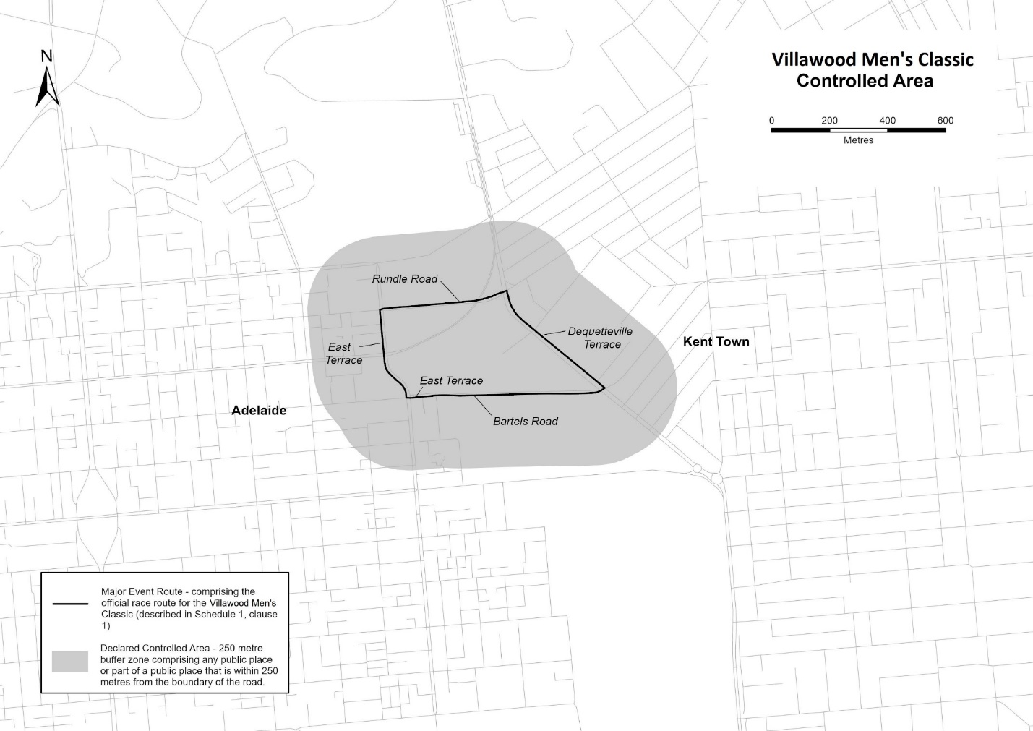
Map of Controlled Areas for the Santos Tour Down Under

Description of official race route for Villawood Men’s Classic
The official race route for the Villawood Men’s Classic (Adelaide) comprises the portion of road commencing in Adelaide at the intersection of Bartels Road and East Terrace, then westerly along East Terrace to its intersection with East Terrace, then generally north-westerly along East Terrace to its intersection with Rundle Road, then generally easterly along Rundle Road to its intersection with Dequetteville Terrace, then south-easterly along Dequetteville Terrace to its intersection with Bartels Road, then westerly along Bartels Road to the place of commencement.

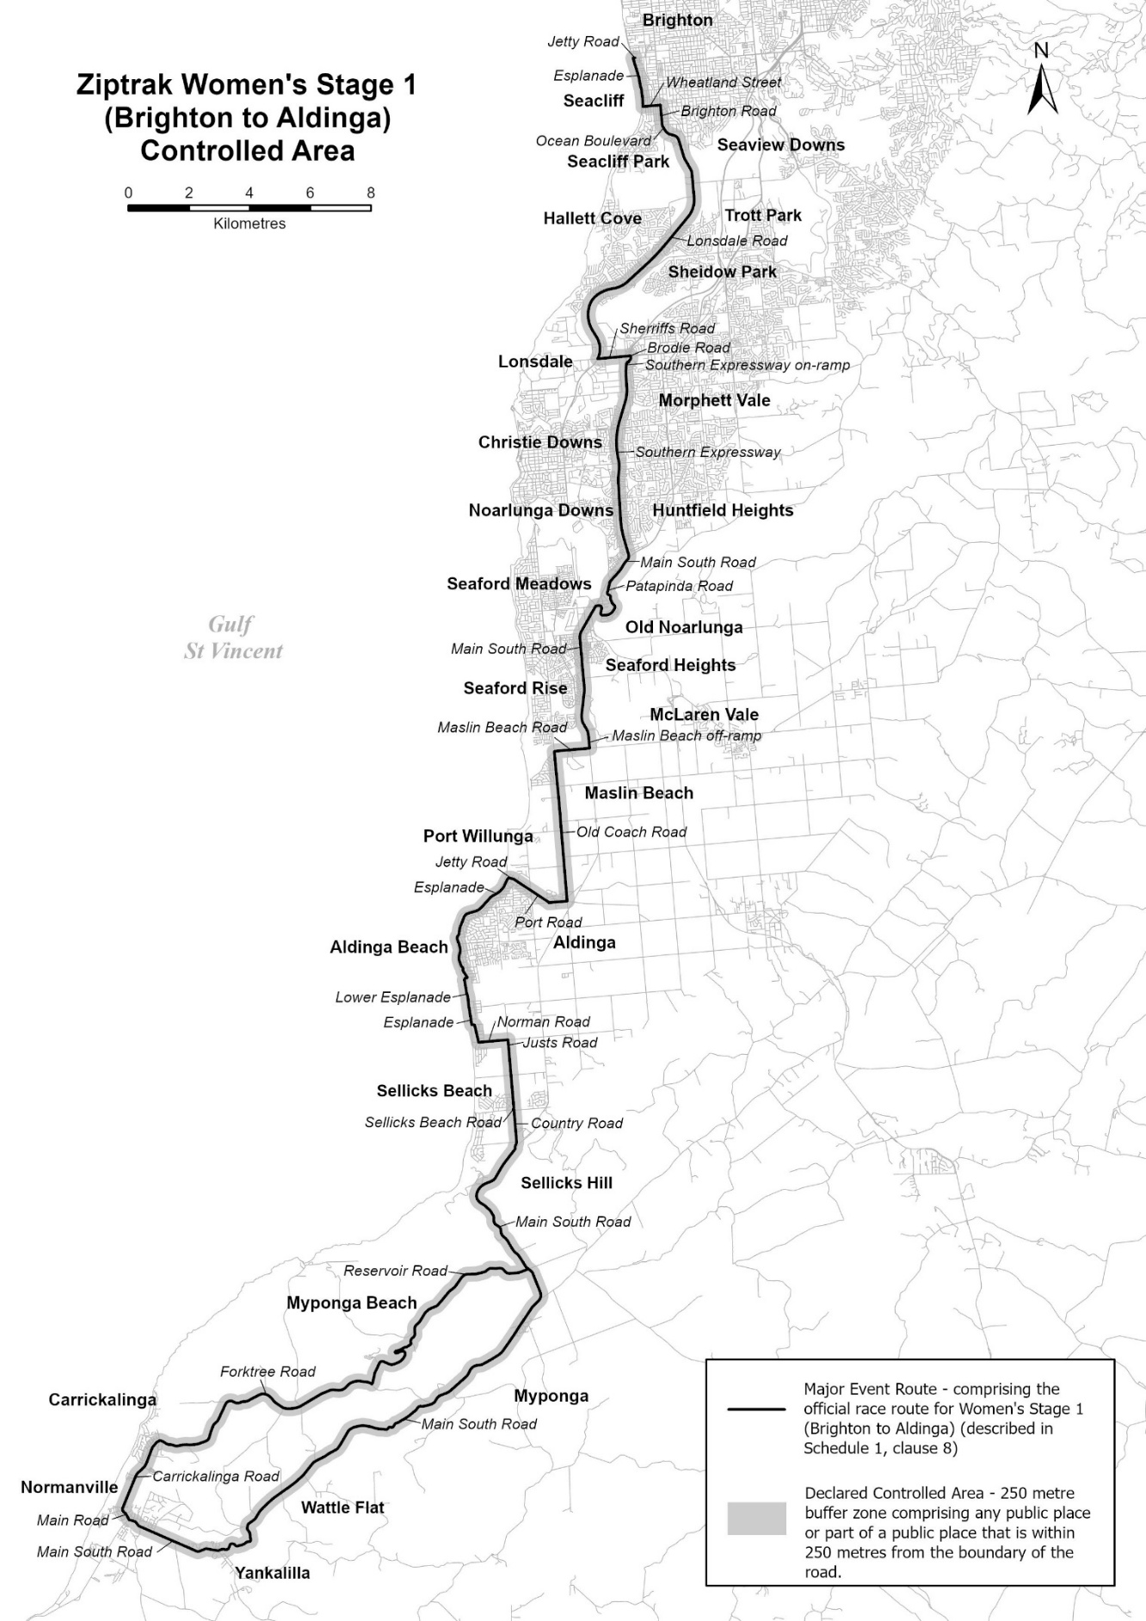
Description of official race route for Ziptrak Women’s Stage 1 (Brighton to Aldinga Beach)
The official race route for Ziptrak Women’s Stage 1 (Brighton to Aldinga Beach) comprises the portion of road commencing at the intersection of Twining Lane and Jetty Road in Brighton, then westerly along Jetty Road to its intersection with Esplanade, then generally south-easterly, southerly along Esplanade to its intersection with Wheatland Street, then easterly along Wheatland Road to its intersection with Brighton Road, then southerly along Brighton Road until it becomes Ocean Boulevard in Seacliff Park, then generally south-easterly and southerly along Ocean Boulevard until its intersection with Lonsdale Road in Trott Park, then southerly, generally south-westerly, and generally southerly to its intersection with Sherriffs Road in Lonsdale, then easterly along Sherriffs Road until its intersection with Brodie Road in Morphett Vale, then generally southerly, generally south-westerly along Brodie Road, then onto the Southern Expressway on-ramp, then continue south-westerly until it becomes the Southern Expressway, then generally southerly, along the Southern Expressway to its intersection with Main South Road in Onkaparinga Heights, then south-westerly along Main South Road to its intersection with Patapinda Road, then south-westerly, generally southerly, generally south-easterly, generally south-westerly, generally westerly, generally northerly and westerly along Patapinda Road to its intersection Main South Road in Old Noarlunga, then south-westerly and generally southerly along Main South Road, then south-easterly along the Southern Expressway off-ramp McLaren Vale to its intersection with Maslin Beach Road, then westerly, along Maslin Beach Road to its intersection with Old Coach Road, then southerly along Old Coach Road to its intersection with Port Road in Aldinga, then westerly and north-westerly along Port Road until it becomes Jetty Road in Port Willunga, then generally westerly to its intersection with Esplanade, then generally south-westerly, generally southerly and generally south-easterly along Esplanade to its intersection with Lower Esplanade in Aldinga Beach, then westerly, and southerly along the Lower Esplanade until it becomes Esplanade, then southerly, easterly and south-easterly to its intersection with Norman Road, then easterly along Norman Road to its intersection with Justs Road, then southerly along Justs Road to its intersection with Sellicks Beach Road in Sellicks Beach, then easterly along Sellicks Beach Road to its intersection with Country Road, then generally southerly along Country Road to its intersection with Main South Road in Sellicks Hill, then generally south-westerly, generally southerly and generally south-easterly along Main South Road to its intersection with Reservoir Road in Myponga, then generally westerly, south-westerly, north-easterly and south-westerly along Reservoir Road to its intersection with Forktree Road in Wattle Flat, then generally westerly and generally south-westerly, along Forktree Road to its intersection with Carrickalinga Road, then generally south-westerly along Carrickalinga Road to its intersection with Main Road in Normanville, then generally south-easterly along Main Road to its intersection with Main South Road, then generally south-easterly, generally north-easterly and north-westerly along Main South Road to its intersection with Reservoir Road, in Sellicks Hill.

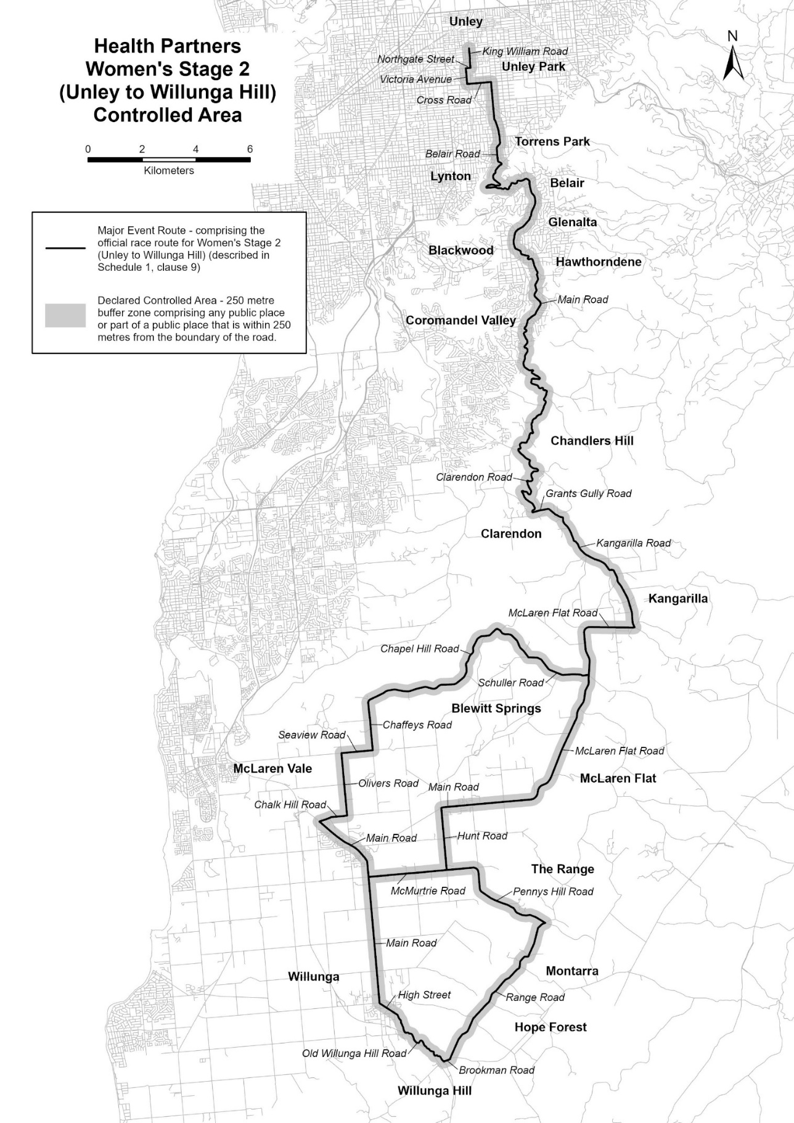
Description of official race route for Health Partners Women’s Stage 2 (Unley to Willunga Hill)
The official race route for Health Partners Women’s Stage 2 (Unley to Willunga Hill) comprises—
(a) the portion of road commencing at the intersection of Walter Street with King William Road in Hyde Park, then generally southerly along King William Road to its intersection with Northgate Street in Unley Park, then westerly along Northgate Street to its intersection with Victoria Avenue, then southerly along Victoria Avenue to its intersection with Cross Road, then generally easterly, to its intersection with Belair Road then generally southerly, generally south-easterly, generally south-westerly, south-easterly, generally westerly, generally easterly and generally north-easterly along Belair Road to its intersection with Main Road in Belair, then generally southerly, generally south-westerly, generally southerly, generally south-easterly, and generally south-westerly along Main Road to its intersection with Clarendon Road, then generally south-easterly, generally south-westerly and generally south-easterly along Clarendon Road to its intersection with Grants Gully Road, then easterly, and south-easterly along Grants Gully Road until it becomes Kangarilla Road in Clarendon, then generally south-easterly along Kangarilla Road to its intersection with McLaren Flat Road, in Kangarilla, then westerly, and generally southerly, along McLaren Flat Road to its intersection with Schuller Road, then esterly and generally north-westerly along Schuller Road to its intersection with Chapel Hill Road in Blewitt Springs, then, generally south-westerly and westerly along Chapel Hill Road to its intersection with Chaffeys Road in McLaren Vale, then generally southerly along Chaffeys Road to its intersection with Seaview Road, then westerly along Seaview Road to its intersection with Olivers Road, then southerly along Olivers Road to its intersection with Chalk Hill Road, then westerly, generally south-westerly along Chalk Hill Road to its intersection with Main Road, then generally south-easterly, southerly along Main Road to its intersection with McMurtrie Road, then easterly along McMurtrie Road to its intersection with Hunt Road, then northerly along Hunt Road to its intersection with Main Road in McLaren Flat, then, generally easterly along Main Road until it becomes McLaren Flat Road, then generally easterly and north-easterly to its intersection with Schuller Road in Kangarilla.
(b) the portion of road commencing at the intersection of McMurtrie Road and Main Road in McLaren Vale, then southerly along Main Road to its intersection with High Street in Willunga, then south-easterly along High Street until it becomes Old Willunga Hill Road, then generally south-easterly, along Old Willunga Hill Road to its intersection with Brookman Road, then north-easterly along Brookman Road to its intersection with Range Road, then generally north-easterly, along Range Road to its intersection with Pennys Hill Road, then generally north-westerly, and northerly along Pennys Hill Road until it becomes McMurtrie Road in McLaren Vale.

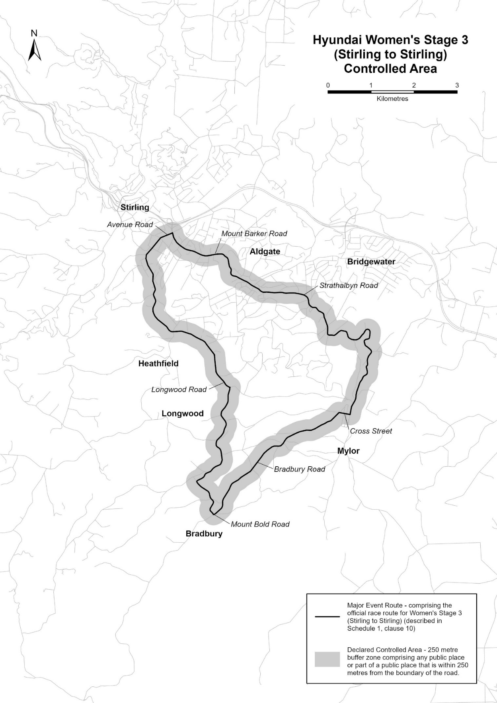
Description of official race route for Hyundai Women’s Stage 3 (Stirling to Stirling)
The official race route for Hyundai Women’s Stage 3 (Stirling to Stirling) comprises the portion of road commencing at the intersection of Garrod Crescent and Mount Barker Road in Stirling, then generally north-westerly along Mount Barker Road to its intersection with Avenue Road, then generally south-westerly, along Avenue Road to its intersection with Longwood Road, then generally southerly, generally
south-easterly, generally southerly, south-westerly and generally south-easterly, along Longwood Road to its intersection with Mount Bold Road in Bradbury, then north-easterly along Mount Bold Road until its intersection with Bradbury Road, then generally north-easterly, along Bradbury Road to its intersection with Cross Street in Mylor, then easterly along Cross Street to its intersection with Strathalbyn Road, then generally north-easterly, north-westerly, generally north-easterly, generally south-westerly, generally north-westerly, westerly and generally
north-westerly along Strathalbyn Road to its intersection with Mount Barker Road in Aldgate, then generally north-westerly, and generally westerly along Mount Barker Road to is intersection with Garrod Crescent to the point of commencement.

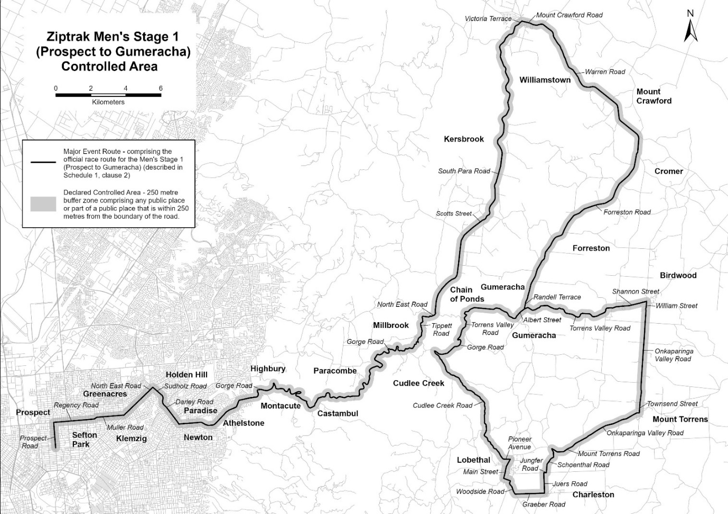
Description of official race route for Ziptrak Men’s Stage 1 (Prospect to Gumeracha)
The official race route for Ziptrak Men’s Stage 1 (Prospect to Gumeracha) commencing at the intersection of Kintore Avenue and Prospect Road, Prospect, then generally northerly along Prospect Road to its intersection with Regency Road, then generally easterly, along Regency Road to its intersection with Muller Road in Manningham, then generally easterly along Muller Road to its intersection with North East Road in Greenacres, then north-easterly along North East Road to its intersection with Sudholz Road in Holden Hill, then generally south-easterly, and southerly along Sudholz Road until it becomes Darley Road in Paradise, south-easterly to its intersection with Gorge Road, then generally easterly, south-easterly, generally north-easterly, northerly, generally south-easterly and generally north-easterly, along Gorge Road to its intersection with Tippett Road in Cudlee Creek, then generally north-easterly, north-westerly, generally northerly, and easterly along Tippett Road to its intersection with North East Road in Chain of Ponds, then generally north-easterly, along North East Road to its intersection with South Para Road, then north-easterly, and northerly along South Para Road until it becomes Scott Street in Kersbrook, then north-easterly along Scott Street until it becomes South Para Road, then generally north-easterly, generally northerly, and north-easterly along South Para Road until is becomes Victoria Terrace in Williamstown, then north-easterly along Victoria Terrace until its intersection with Mount Crawford Road, then generally north-easterly, along Mount Crawford Road until it becomes Warren Road, then south-easterly, easterly, south-easterly, and southerly along Warren Road to its intersection with Forreston Road in Mount Crawford, then south-westerly, along Forreston Road to its intersection with Randell Terrace in Gumeracha, then south-westerly along Randell Terrace to its intersection with Albert Street, then
south-westerly, westerly, and north-westerly along Albert Street until it becomes Torrens Valley Road, then generally north-westerly, westerly, south-westerly, and south-easterly along Torrens Valley Road to its intersection with Gorge Road in Chain of Ponds, then generally southerly, south-westerly, easterly, southerly, south-westerly and north-westerly along Gorge Road to its intersection with Cudlee Creek Road in Cudlee Creek, then south-easterly, generally southerly, and south-easterly along Cudlee Creek Road until its becomes Pioneer Avenue in Lobethal, then easterly and along Pioneer Avenue to its intersection with Main Street, then south-westerly along main Street to its intersection with Woodside Road, then south-easterly, generally southerly, south-easterly along Woodside Road to its intersection with Graeber Road, then easterly along Graber Road to its intersection with Juers Road in Charleston, then northerly along Juers Road to its intersection with Jungfer Road, then easterly along Jungfer Road to its intersection with Schoenthal Road, then northerly, north easterly, and north-westerly along Schoenthal Road to its intersection with Mount Torrens Road, then south-easterly, easterly, north-easterly along Mount Torrens Road to its intersection with Onkaparinga Valley Road in Mount Torrens, then north-easterly, easterly along Onkaparinga Valley Road to its intersection with Townsend Street, then northerly along Townsend Street to its intersection with Onkaparinga Valley Road, then northerly along Onkaparinga Valley Road, until it becomes William Street in Birdwood, then northerly along William Street to its intersection with Shannon Street, then generally south-westerly along Shannon Street until it becomes Torrens Valley Road, then generally south-westerly, generally westerly and north-westerly along Torrens Valley Road until it becomes Albert Street in Gumeracha, then south-westerly along Albert Street to its intersection with Randell Terrace in Gumeracha.

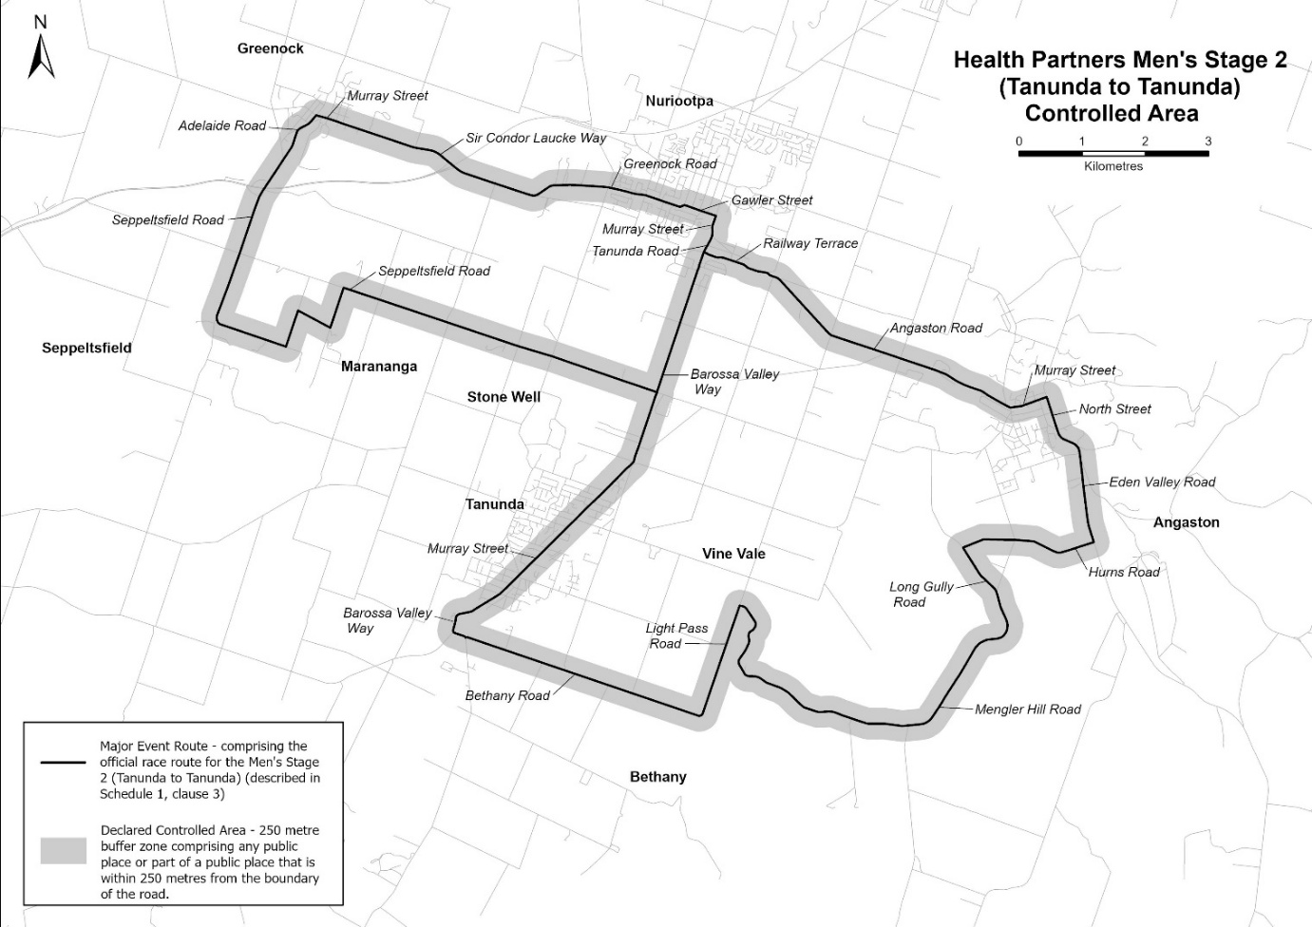
Description of official race route for Health Partners Men’s Stage 2 (Tanunda to Tanunda)
The official race route for Health Partners Men’s Stage 2 (Tanunda to Tanunda) comprises—
- the portion of road commencing at the intersection of Murray Street and Elizabeth Street in Tanunda, then south-westerly along Murray Street until it becomes Barossa Valley Road, then southerly, south-easterly along Barossa Valley Road to its intersection with Bethany Road, then south-easterly to its intersection with Light Pass Road in Bethany, then north-easterly to its intersection with Mengler Hill Road in Vine Vale, then generally south-easterly , generally southerly, generally south-easterly, north-easterly, and north-westerly along Mengler Hill Road to its intersection with Long Gully Road in Angaston, then north-westerly along Long Gully Road to its intersection with Hurns Road, then generally easterly and south-easterly to its intersection with Eden Valley Road, then north-westerly along Eden Valley Road to its intersection with North Street, then generally north-westerly along North Street to its intersection with Murray Street, then south-westerly, north-westerly along Murray Street until it becomes Angaston Road, then north-westerly along Angaston Road to its intersection with Railway Terrace in Nuriootpa, then generally north-westerly along Railway Terrace to its intersection with Tanunda Road, then generally north-easterly along Tanunda Road until it becomes Murray Street, then north-easterly along Murray Street to its intersection with Gawler Street, then north-westerly along Gawler Street to its intersection with Greenock Road, then south-westerly and generally north-westerly, along Greenock Road to its intersection with Sir Condor Laucke Way, then south-westerly, generally north-westerly along Sir Condor Laucke Way until it becomes Murray Street in Greenock, then north-westerly along Murray Street to its intersection with Adelaide Road, then generally south-westerly along Adelaide Road to its intersection with Seppeltsfield Road, then south-westerly, south-easterly, north-easterly, south-easterly, north-easterly, and south-easterly along Seppeltsfield Road to its intersection with Barossa Valley Way in Tanunda, then south-westerly along Barossa Valley Way until its intersection with Murray Street, then south-westerly along Murray Street to its intersection with Elizabeth Street in Tanunda, and
- the portion of the road commencing at the intersection of Railway Terrace and Barossa Valley Way in Nuriootpa, then south-westerly along Barossa Valley Way, until its intersection with Seppeltsfield Road.
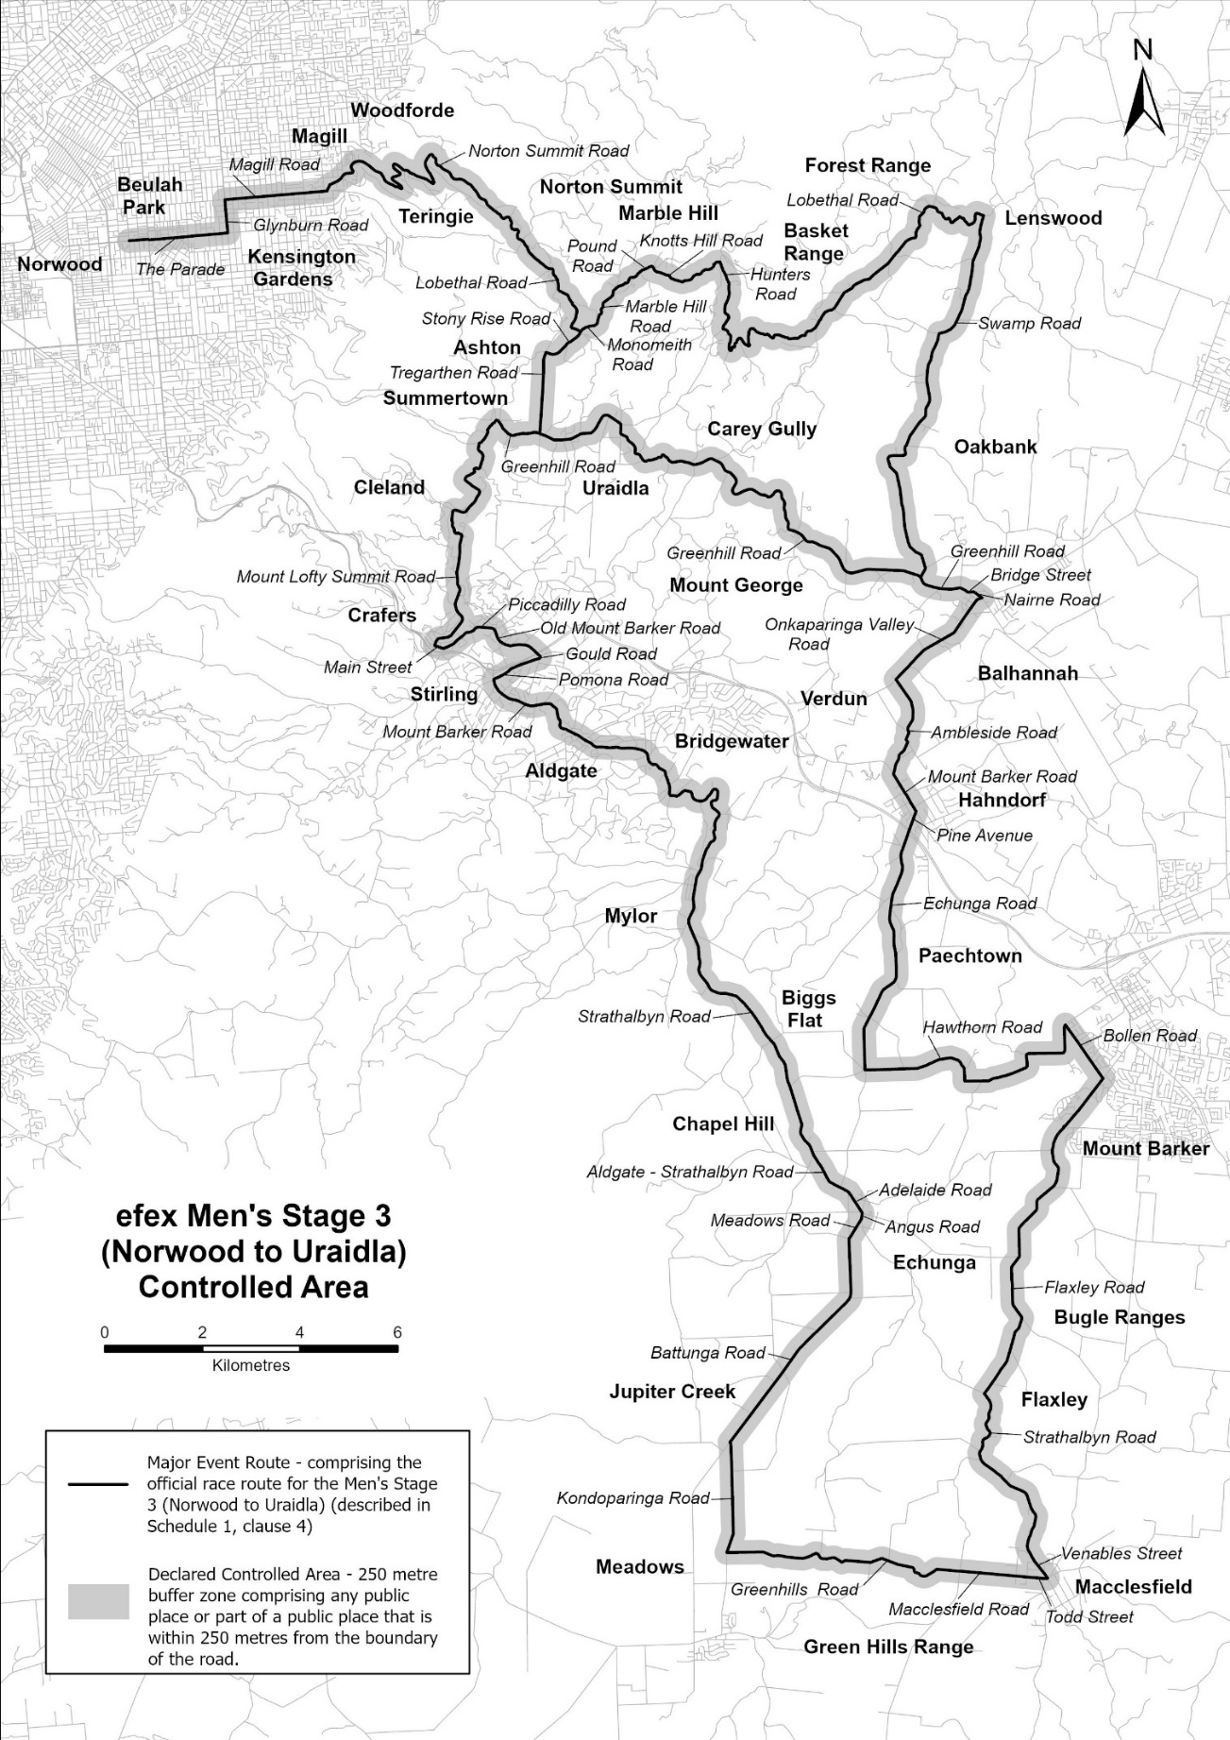
Description of official race route for efex Men’s Stage 3 (Norwood to Uraidla)
The official race route for efex Men’s Stage 3 (Norwood to Uraidla) comprises—
(a) the portion of road commencing at the intersection of The Parade and George Street, in Norwood, then easterly along The Parade to its intersection with Glynburn Road, then northerly along Glynburn Road to its intersection with Magill Road in Kensington Gardens, then easterly along Magill Road until its intersection with Norton Summit Road in Magill, then generally north-easterly, south-easterly, generally northerly, south-easterly, generally northerly and south-easterly along Norton Summit Road until it becomes Lobethal Road in Norton Summit, then generally south-easterly along Lobethal Road to its intersection with Stony Rise Road in Ashton, then generally south-westerly and westerly along Stony Rise Road until its intersection with Tregarthen Road in Ashton, then southerly along Tregarthen Road until its intersection with Greenhill Road in Summertown, then westerly, north-westerly and generally south-westerly along Greenhill Road to its intersection with Mount Lofty Summit Road, then generally southerly, generally south-westerly, south-easterly, south-westerly, generally southerly and south-westerly along Mount Lofty Summit Road to its intersection with Main Street in Crafers, then south-easterly along Main Street to its intersection with Piccadilly Road, then north-easterly and easterly along Piccadilly Road to its intersection with Old Mount Barker Road, then generally south-easterly along Old Mount Barker Road to its intersection with Gould Road in Stirling, then south-westerly along Gould Road to its intersection with Pomona Road, then south-westerly along Pomona to its intersection with Mount Barker Road in Stirling, then south-easterly, easterly and generally south-easterly along Mount Barker Road to its intersection with Strathalbyn Road in Aldgate, then south-easterly, easterly, generally south-easterly, generally easterly, north-easterly, generally southerly, south-westerly and generally south-easterly along Strathalbyn Road until it becomes Aldgate-Strathalbyn Road in Echunga, then south-easterly along Aldgate-Strathalbyn Road until it becomes Adelaide Road, then south-easterly along Adelaide Road to its intersection with Angas Road, then south-westerly along Angas Road to its intersection with Meadows Road, then south-westerly along Meadows Road to its intersection with Battunga Road, then southerly and south-westerly along Battunga Road to its intersection with Kondoparinga Road in Meadows, then generally southerly along Kondoparinga Road to its intersection with Greenhills Road, then generally easterly along Greenhills Road to its intersection with Macclesfield Road in Macclesfield, then easterly along Macclesfield Road to its intersection with Todd Street, then easterly along Todd Street to its intersection with Venables Street, then north-westerly along Venables Street to its intersection with Strathalbyn Road, then north-westerly, generally northerly, north-westerly and generally northerly along Strathalbyn Road to its intersection with Flaxley Road in Flaxley, then north-easterly, generally northerly, and generally north-easterly along Flaxley Road to its intersection with Bollen Road in Mount Barker, then north-westerly along Bollen Road to its intersection with Hawthorn Road in Mount Barker, then southerly, westerly, southerly, generally south-westerly, northerly and generally westerly along Hawthorn Road to its intersection with Echunga Road in Echunga, then northerly, north-easterly, generally northerly and north-easterly along Echunga Road to its intersection with Pine Avenue in Paechtown, then north-easterly along Pine Avenue to its intersection with Mount Barker Road in Hahndorf, then north-westerly until its intersection with Ambleside Road in Hahndorf, then north-easterly and north-westerly along Ambleside Road to its intersection with Onkaparinga Valley Road, then north-easterly along Onkaparinga Valley Road to its intersection with Nairne Road in Balhannah, then north-westerly along Nairne Road to its intersection with Bridge Street in Balhannah, then westerly along Bridge Street to its intersection with Greenhill Road, then generally north-westerly along Greenhill Road to its intersection with Swamp Road, then north-easterly, north-westerly, easterly, generally north-easterly, Swamp Road to its intersection with Lobethal Road in Lenswood, then westerly, southerly, generally north-westerly, generally south-westerly, westerly, southerly, north-westerly, south-westerly and generally north-westerly along Lobethal Road to its intersection with Hunters Road in Basket Range, then generally northerly, generally north-westerly along Hunters Road to its intersection with Knotts Hill Road, then generally south-westerly, and generally north-westerly along Knotts Hill Road to its intersection with Pound Road in Marble Hill, then south-westerly along Pound Road to its intersection with Marble Hill Road in Ashton, then generally south-westerly along Marble Hill Road to its intersection with Monomeith Road, then generally south-westerly along Monomeith Road until its intersection with Stony Rise Road; and
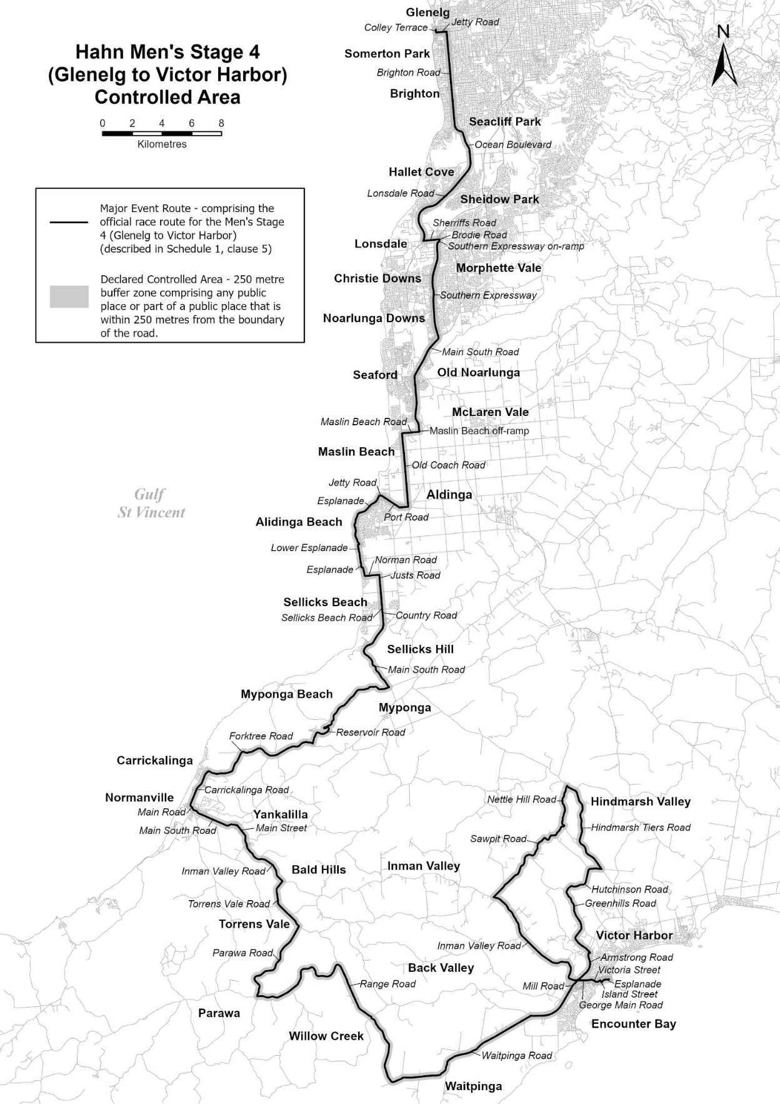
(b) the portion of road commencing at the intersection of Tregarthen Road with Greenhill Road in Summertown, then generally easterly, north-easterly, generally south-easterly generally easterly, and generally south-easterly along Green Hill Road to its intersection with Swamp Road in Balhannah.
Description of official race route for Hahn Men’s Stage 4 (Glenelg to Victor Harbor)
The official race route for Hahn Men’s Stage 4 (Glenelg to Victor Harbor) comprises the portion of road commencing at the intersection of Colley Terrace in Glenelg, then southerly along Colley Terrace until its intersection with Jetty Road, then easterly along Jetty Road to its intersection with Brighton Road, then southerly along Brighton Road until it becomes Ocean Boulevard in Seacliff Park, then generally south-easterly and generally southerly to its intersection with Lonsdale Road in Trott Park, then southerly, generally south-westerly and generally southerly to its intersection with Sherriffs Road in Lonsdale, then easterly along Sherriffs Road, to its intersection with Brodie Road in Morphett Vale, then generally south-westerly along Brodie Road to the Southern Expressway on-ramp, then south-westerly until it becomes the Southern Expressway, then generally southerly, along the Southern Expressway to its intersection with Main South Road in Onkaparinga Heights, then south-westerly, and generally southerly along Main South Road, onto the Maslin Beach off- ramp, in Seaford Rise, then southerly to its intersection with Maslin Beach Road, then westerly along Maslin Beach Road to its intersection with Old Coach Road, then southerly along Old Coach Road to its intersection with Port Road in Aldinga, then westerly and north-westerly along Port Road until it becomes Jetty Road in Port Willunga, then generally westerly to its intersection with Esplanade, then generally south-westerly, generally southerly and generally south-easterly along Esplanade to its intersection with Lower Esplanade in Aldinga Beach, then westerly, and southerly along the Lower Esplanade until it becomes Esplanade, then southerly, easterly and south-easterly to its intersection with Norman Road, then easterly along Norman Road to its intersection with Justs Road, then southerly along Justs Road to its intersection with Sellicks Beach Road in Sellicks Beach, then easterly along Sellicks Beach Road to its intersection with Country Road, then generally southerly along Country Road to its intersection with Main South Road in Sellicks Hill, then generally south-westerly, generally southerly and generally south-easterly along Main South Road to its intersection with Reservoir Road in Myponga, then generally westerly, south-westerly, north-easterly and south-westerly along Reservoir Road to its intersection with Forktree Road in Wattle Flat, then generally westerly and generally south-westerly, along Forktree Road to its intersection with Carrickalinga Road, then generally south-westerly along Carrickalinga Road to its intersection with Main Road in Normanville, then generally south-easterly along Main Road to its intersection with Main South Road, then generally south-easterly, and generally north-easterly along Main South Road to its intersection with Main Street, then generally south-easterly until it becomes Inman Valley Road, then generally south-easterly along Inman Valley Road to its intersection with Torrens Vale Road in Bald Hills, then south-westerly, southerly and south-easterly along Torrens Vale Road to its intersection with Parawa Road in Torrens Vale, then south-westerly, generally southerly, along Parawa Road to its intersection with Range Road in Parawa, then easterly, generally north-easterly, generally easterly, north-easterly, and south-easterly, along Range Road to its intersection with Waitpinga Road in Willow Creek, then generally south-easterly, southerly, generally north-easterly, easterly and north-easterly along Waitpinga Road until it becomes Mill Road in Waitpinga, then generally north-easterly along Mill Road to its intersection with Inman Valley Road, then westerly, northerly, and generally northerly-westerly, along Inman Valley Road to its intersection with Sawpit Road, then generally north-easterly, along Sawpit Road to its intersection with Nettle Hill Road in Hindmarsh Valley, then north-westerly, generally northerly and north-easterly along Nettle Hill Road to its intersection with Hindmarsh Tiers Road, then south-easterly, generally southerly and generally south-easterly along Hindmarsh Tiers Road to its intersection with Hutchinson Road, then westerly, and generally south-westerly, along Hutchinson Road to its intersection with Greenhill Road, then generally south-easterly, generally south-westerly and south-easterly along Greenhill Road to its intersection with Armstrong Road in Victor Harbor, then north-westerly, generally southerly and south-westerly along Armstrong Road to the Victor Harbor turn-off to its intersection with George Main Road, then generally easterly and generally south-easterly along George Main Road until it becomes Victoria Street, then north-easterly along Victoria Street to its intersection with Island Street, then south-easterly along Island Street to its intersection with Esplanade, then north-easterly and easterly along Esplanade to its intersection with Albert Place in Victor Harbor.

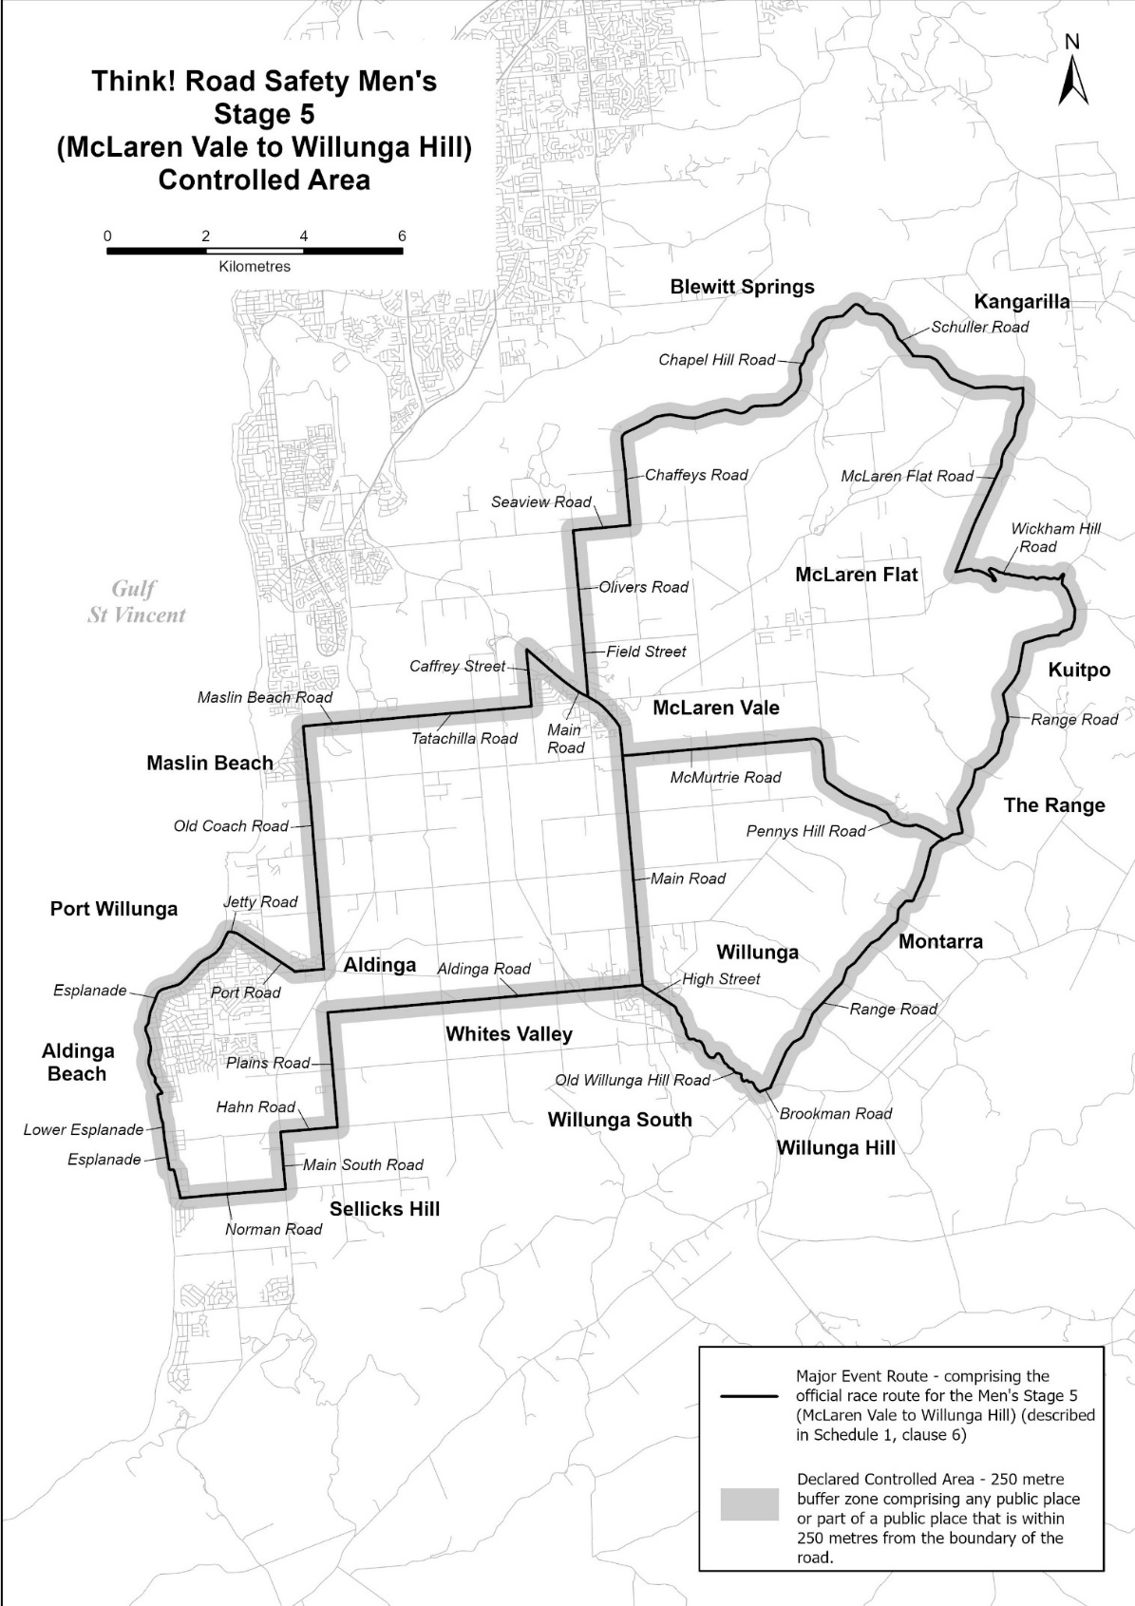

Description of official race route for Think! Road Safety Men’s Stage 5 (McLaren Vale to Willunga Hill)
The official race route for Think! Road Safety Men’s Stage 5 (McLaren Vale to Willunga Hill) comprises—
(a) the portion of road commencing at the intersection of main Road and Field Street in McLaren Vale, then northerly along Field Street until it becomes Olivers Road, then northerly along Olivers Road until its intersection with Seaview Road, then easterly along Seaview Road to its intersection with Chaffeys Road, then northerly along Chaffeys Road to its intersection with Chapel Hill Road, then generally easterly, generally north-easterly, and generally south-easterly to its intersection with Schuller Road in Blewitt Springs, then generally south-easterly and easterly along Schuller Road to its intersection with McLaren Flat Road in Kangarilla, then generally south-westerly along McLaren Flat Road to its intersection with Wickham Hill Road in McLaren Flat, then generally easterly, generally south-easterly, generally north-westerly, generally easterly and generally southerly along Wickham Hill Road to its intersection with Range Road, then generally southerly, generally westerly, generally south-westerly, south-easterly and generally south westerly to its intersection with Brookman Road in Willunga, then south-westerly along Brookman Road to its intersection with Old Willunga Hill Road, then generally north-westerly along Old Willunga Hill Road until it becomes High Street, then north-westerly along High Street to its intersection with Aldinga Road, then westerly along Aldinga Road to its intersection with Plains Road in Aldinga, then southerly along Plains Road to its intersection with Hahn Road in Sellicks Hill then westerly along Hahn Road to its intersection with Main South Road, then southerly along Main South Road to its intersection with Norman Road in Aldinga Beach, then westerly along Norman Road to its intersection with Esplanade, then northerly, westerly and generally northerly along Esplanade to its intersection with Lower Esplanade, then generally northerly and easterly along Lower Esplanade to its intersection with Esplanade, then generally north-westerly and generally north-easterly along Esplanade to its intersection with Jetty Road in Port Willunga, then generally easterly along Jetty Road to its intersection with Port Road, then south-easterly and easterly along Port Road to its intersection with Old Coach Road in Aldinga, then northerly along Old Coach Road to its intersection with Maslin Beach Road in Maslin Beach, then easterly along Maslin Beach Road until it becomes Tatachilla Road, then easterly along Tatachilla Road to its intersection with Caffrey Street in McLaren Vale, then northerly along Caffrey Street to its intersection with Main Road, then south-westerly along Main Road to its intersection with Field Street; and
(b) the portion of road commencing at the intersection of Field Street and Main Road in McLaren Vale, then south-easterly and southerly along Main Road to its intersection with Aldinga Road in Willunga; and
(c) the portion of the road commencing at the intersection of Range Road and Pennys Hill Road in The Range, then generally
north-westerly, northerly and westerly to its intersection with Main Road in McLaren Vale.

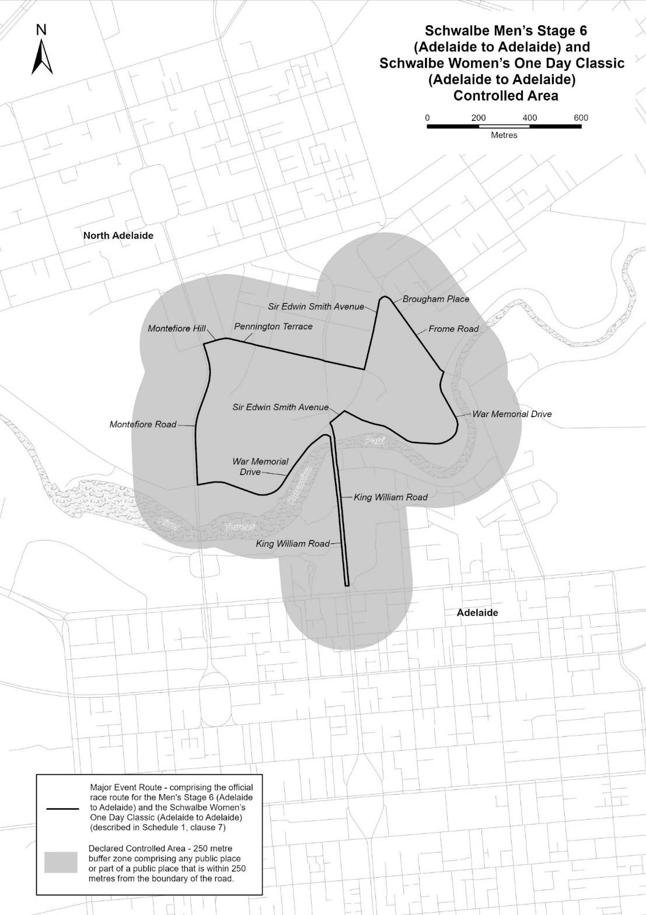
Description of official race route for Schwalbe Men’s Stage 6 (Adelaide to Adelaide)
and Schwalbe Women’s One Day Classic (Adelaide to Adelaide)
The official race route for the Schwalbe Men’s Stage 6 and the Women’s One Day Classic (Adelaide to Adelaide) comprises the portion of King William Road in North Adelaide at its intersection with Victoria Drive, then southerly along King William Road, to a point on King William Road, approximately 25 metres north of North Terrace, then westerly across King William Road, and then northerly along King William Road to its intersection with War Memorial Drive, then south-westerly, north-westerly and westerly along War memorial Drive to its intersection with Montefiore Road, then generally northerly along Montefiore Road to its intersection with Montefiore Hill, then easterly along Montefiore Hill to its intersection with Pennington Terrace, then south-easterly along Pennington Terrace to its intersection with Sir Edwin Smith Avenue, then north-easterly along Sir Edwin Smith Avenue, to its intersection with Brougham Place, then south-easterly along Brougham Place until it becomes Frome Road, then south-easterly along Frome Road to its intersection with War Memorial Drive, then south-westerly, south-easterly, south-westerly, westerly and north-westerly along War Memorial Drive to its intersection with Sir Edwin Smith Avenue, then south-westerly along Sir Edwin Smith Avenue until its intersection with King William Road, then southerly along King William Road to the point of commencement.
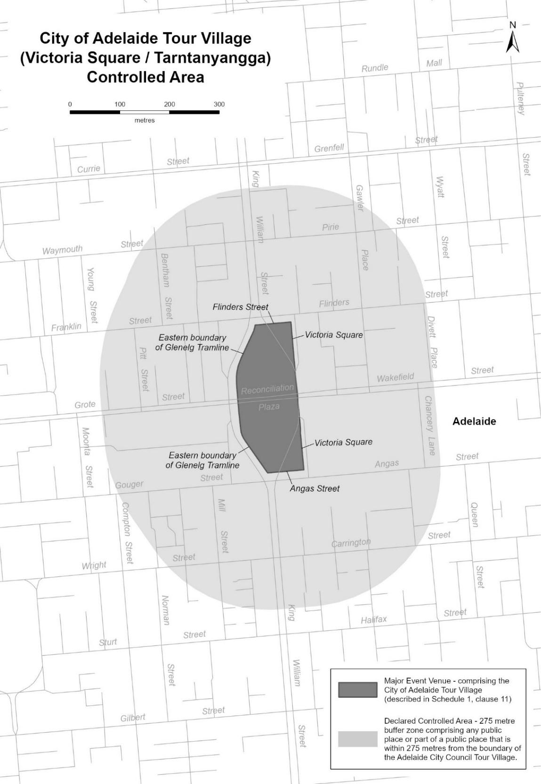
Description of City of Adelaide Tour Village
The City of Adelaide Tour Village comprises the area in Victoria Square / Tarntanyangga in Adelaide bounded as follows: commencing at the point at which the eastern boundary of the Glenelg Tramline intersects the southern boundary of Franklin Street, then easterly along the southern boundary of Franklin Street to its intersection with the western boundary of the portion of road (running generally north to south) known as Victoria Square, then southerly along that boundary to its south-eastern-most point, then southerly in a straight line across Wakefield Street to the north-eastern-most point on the western boundary of the portion of road (running generally north to south) known as Victoria Square, then southerly along that boundary to its intersection with the northern boundary of Angas Street, then westerly along the northern boundary of Angas Street to its intersection with the eastern boundary of the Glenelg Tramline, then generally north-westerly and northerly along the eastern boundary of the Glenelg Tramline to its intersection with the southern boundary of Reconciliation Plaza, then northerly in a straight line across Reconciliation Plaza to the intersection of the northern boundary of Reconciliation Plaza with the eastern boundary of the Glenelg Tramline, then northerly and generally north-easterly along the eastern boundary of the Glenelg Tramline to the point of commencement.
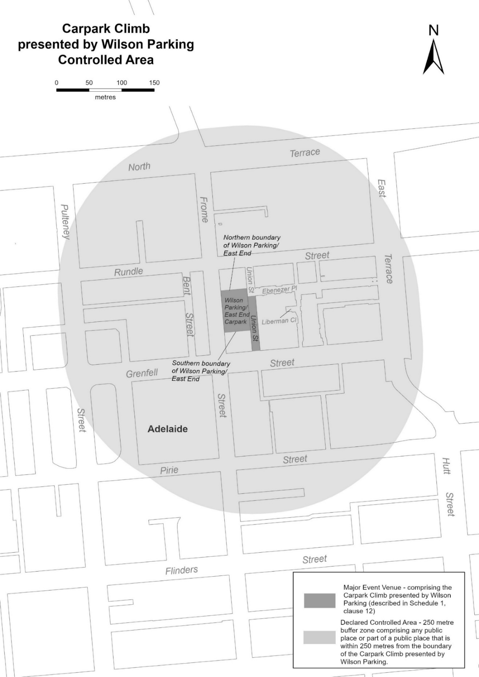
Description of Carpark Climb presented by Wilson Parking, Adelaide
The Carpark Climb presented by Wilson Parking, Adelaide, commences at an intersection of the western boundary of Union Street and Grenfell Street, then northerly along the western boundary of Union Street till its intersection with the Southern boundary of the Wilson Carpark, then westerly along the southern boundary of the Wilson Carpark until its intersection with Frome Street, then generally northernly along the eastern boundary of Frome Street until its intersection with the northern boundary of the Wilson Carpark, then easternly along the Northern boundary of Wilson Parking until its intersection with Union Street, then generally southernly along the eastern boundary of Union Street, until its intersection with the westerly production of the southern boundary of Ebenezer Place, then easterly, following the westerly production of Ebenezer Place across Union Street to the eastern boundary of Union Street, then southernly until its intersection with Grenfell Street, then generally westerly along Grenfell Street until its intersection with Union Street, point of commencement.

Mental Health Act 2009
Authorised Mental Health Professional
Notice is hereby given in accordance with Section 94(1) of the Mental Health Act 2009, that the Chief Psychiatrist has determined the following person as an Authorised Mental Health Professional:
Lorraine Smitham
Vanessa Browne
A person’s determination as an Authorised Mental Health Professional expires three years after the commencement date. The Chief Psychiatrist make vary or revoke this determination at any time.
Dated: 17 December 2024
Dr John Brayley
Chief Psychiatrist

Motor Vehicles Act 1959
South Australia
Motor Vehicles (Approval of Motor Bikes and Motor Trikes) Notice 2024 No 3
under the Motor Vehicles Act 1959
1—Short title
This notice may be cited as the Motor Vehicles (Approval of Motor Bikes and Motor Trikes) Notice 2024.
2—Commencement
This notice will come into operation on the date of publication in this Gazette.
3—Approved motor bikes and motor trikes
For the purposes of Schedules 2 and 3 of the Motor Vehicles Regulations 2010 and the transitional provisions of the Motor Vehicles Variation Regulations 2005 (No 233 of 2005), the motor bikes and motor trikes specified in Schedule 1 are approved.
Schedule 1—Approved motor bikes and motor trikes
The following are approved:
• All motor bikes and motor trikes built before December 1960 with an engine capacity not exceeding 660ml.
• All motor bikes and motor trikes with an engine capacity not exceeding 260 milliliters and a power to weight ratio not exceeding 150 kilowatts per tonne, except the following:
Suzuki RGV250
Kawasaki KR250 (KR-1 and KR1s models)
Honda NSR250
Yamaha TZR250
Aprilia RS250
• All motor bikes and motor trikes with electric powered engines, with a power output not in excess of 25kw.
Motor bikes and Motor trikes with electric powered engines listed in the table below are approved:
MAKE | MODEL | VARIANT NAME | YEAR(S) | CAPACITY
BRAAAP | MotoE | 5000w | 2022-current | Electric
 | MotoE | 8000w | 2022-current | Electric
 | MotoE | 10000w | 2022-current | Electric
EVOKE | URBAN S |  | 2020-current | Electric
 | URBAN CLASSIC |  | 2020-current | Electric
FONZARELLI | 125 | 125 | 2014-2015 | Electric
KAWASAKI | NX011A | NR011A (Ninja e-1)  NX011A (Ninja e-1) | 2023 | Electric
KYBURZ | DXP | KYBURZ | 2017 | Electric
ZERO | DS | Zero DS | Unit 2015 | Electric
 | S | Zero S | Until 2015 | Electric
Motor trikes with an engine capacity not less than 261ml and not exceeding 660ml listed in the table below are approved:
MAKE | MODEL | VARIANT NAME | YEAR(S) | CAPACITY
BRP | Can am Ryker | Rotax 600 ACE | 2018 | 599
GILERA | FUOCO 500 | FUOCO 500 | 2007-13 | 493
LAMBRETTA | All model | Lambretta | pre 2008 | under 660
OZ TRIKE | FUN 500 | FUN 500 | pre 2008 | 500
METROPOLIS | AA | 2018 | 399 | METROPOLIS
PGO | All models | All models under 220 | All | 220
PIAGGIO | All Models | All models | 2010-17 | under 350
Motor bikes with an engine capacity not less than 261ml and not exceeding 660ml listed in the table below are approved:
MAKE | MODEL | VARIANT NAME | YEAR(S) | CAPACITY
AJP | PR7 | PR7 | 2017-19 | 600
AJS | MODEL 18 | MODEL 18 | pre 1963 | 497
 | MODEL 20 | MODEL 20 | 1955-61 | 498
APRILIA | KV | RS 660 LAMS & Tuono 660 LAMS | 2020-on | 659
 | Moto 6.5 | Moto 6.5 | 1998-99 | 649
 | M35 | SR MAX 300 | 2012 | 278
 | PEGASO 650 | DUAL SPORTS | 1994-01 | 652
 | PEGASO 650 | OUTBACK | 2000-01 | 652
 | PEGASO 650 | Factory 650 | 2007-08 | 660
 | PEGASO 650 I.E. | OUTBACK | 2001-02 | 652
 | PEGASO 650 I.E. | DUAL SPORTS | 2001-06 | 652
 | SCARABEO 300 | VRG | 2009 | 278
 | SCARABEO 400 | SCARABEO 400 | 2007 | 399
 | SCARABEO 500 | SCARABEO 500 | 2007-08 | 460
 | SPORTCITY300 | SPORTCITY300 | 2010-12 | 300
 | STRADA 650 | ROAD | 2006-08 | 659
 | STRADA 650 | TRAIL | 2006-08 | 659
 | VP (RXV 450) | VPV-VPT-VPH 18.3kW | 2006-10 | 449
 | VP (RXV 550) | VPZ- VPX- VPL 20kW | 2006-10 | 553
 | VS (SXV 450) | SXV 450 (VSR-VSH) 14kW | 2006-08 | 449
 | VS (SXV 550) | SXV 550 (VSS-VSL) 14.5kW | 2006-08 | 553
 | XC | Tuareg 660 (LAMS) | 2022-on | 659
ASIAWING | LD450 | ODES MCF450 | 2011-13 | 449
ATK | 605 | 605 | 1995 | 598
BENELLI | LEON | Leoncino, Leoncino Trail | 2018-on | 500
 | VELVET DUSK | Velvet 400 Dusk, Velvet Touring 400 | 2002-06 | 383
 | P10 | BN 302 | 2015 on | 300
 | P16 | TRK 502X | 2018 on | 500
 | P18 | LEONCINO 500 | 2017 on | 500
 | P18 | LEONCINO 500 TRAIL | 2018 on | 500
 | P18  P16 | BENELLI  TRK502 | 2017  2017 | 500  500
 | P25 | GT600 RESTRICTED | 2014-15 | 600
 | P25 | BN 600 RESTRICTED | 2013-on | 600
 | P36 | 502C | 2019 | 500
 | VELVET DUSK | VELVET DUSK | 2003-05 | 383
BETA | BETA | FUPA RR E3 | 2018 | 293
 | BMA RR | RR350 15 | 2018 | 349
 | BMA RR | RR390 16 | 2018 | 386
 | BMA RR | RR430 17 | 2018 | 431
 | BMA RR | RR480 18 | 2018 | 478
 | FUPA E5 | E5 00 | 2015 | 293
 | FUPA E5 | E8/03 | 2016-on | 293
 | FUPA RR E3 | RR 2T 300 | 2012-on | 293
 | FUPA RR E3 | RR350 20 & RR350 15 | 2016-on | 349
 | FUPA RR E3 | RR390 31 & RR390 16 | 2016-on | 386
 | FUPA RR E3 | RR430 32 & RR430 17 | 2016-on | 431
 | FUPA RR E3 | RR480 33 & RR480 18 | 2016-on | 478
 | RR E3 | RR350 | 2011-on | 349
 | RR E3 | RR400 | 2010-14 | 398
 | RR E3 | RR450 | 2010-14 | 449
 | RR E3 | RR520 | 2010-11 | 498
 | RR300 2T | RR300 2T | 2018-on | 293
 | RR350 4T | RR350 4T | 2019-on | 349
 | RR390 4T | RR390 4T | 2019-on | 386
 | RR430 4T | RR430 4T | 2019-on | 431
 | RR450 | RR450 | 2000-08 | 448
 | RR480 4T | RR480 4T | 2019-on | 478
 | RR525 | RR525 | 2000-08 | 510
 | XTRAINER 300 2T | XTRAINER 300 2T | 2019-on | 293
BMW | C400X | 0C09/C400X | 2018-on | 350
 | C400GT | 0C06, C400GT | 2018-on | 350
 | C650 | C600 SPORT | ALL | 647
 | C650 | C650 GT/Sport | All | 647
 | F650 | FUNDURO | 1995-00 | 652
 | F650 | G650 GS | 2009-2016 | 652
 | F650 | G650 GS Sertao | 2012-2016 | 652
 | F650CS | SCARVER | 2002-06 | 652
 | F650CS | SE ROAD | 2004-06 | 652
 | F650GS | DAKAR | 2000-08 | 652
 | F650GS | F650GS | 2000-10 | 652
 | F650ST | F650ST | 1998 | 652
 | G 450 X | G 450 X | 2008-10 | 450
 | G310 | G310R-0G01 | 2016-on | 313
 | G310GS | G310GS-0G02 | 2016-on | 313
 | G650GS | Sertao | All | 650
 | R45 | R45 | All | 453
 | R50 | R50 | All | 499
 | R60 | R60 | 1960-78 | 590
 | R65 | R65 | 1978-88 | 650
 | R65LS | R65LS | 1981-86 | 650
 | R69 | R69S | 1961-67 | 600
BOLWELL | LM25W | FIRENZE | 2009 | 263
BOLLINI | All models | All models under 250 | All | 250
BRAAAP | Moto4 | Moto Range, Cruiser 400 | 2021-on | 400
 | ST | 450 | 2016-on | 450
 | ST400 | Shadow | 2022-on | 367
BSA | A50 | A50 | 1964-70 | 500
 | A65 | A65 | 1966-69 | 650
 | A7 | A7 | 1961 | 500
 | B40 | B40 | 1969 | 350
 | B44 | B44 | 1967-71 | 440
 | B50 | B50 | 1971 | 495
 | B50SS GOLDSTAR | B50SS GOLDSTAR | 1971 | 498
 | GOLD STAR | GOLD STAR | 1938-63 | 500
 | LIGHTNING | LIGHTNING | 1964 | 654
 | SPITFIRE MKIII | SPITFIRE MKIII | 1967 | 650
 | THUNDERBOLT | THUNDERBOLT | 1968 | 499
BUELL | Blast | STREET FIGHTER | 2002-07 | 491
BUG | SEE KYMCO
BULTACO | ALPINA | ALPINA | 1974 | 350
 | FRONTERA | FRONTERA | 1974 | 360
 | SHERPA | SHERPA | 1974 | 350
CAGIVA | 360WR | 360WR | 1998-02 | 348
 | 410TE | 410TE | 1996 | 399
 | 610TEE | 610TEE | 1998 | 576
 | 650 ALAZZURA | 650 ALAZZURA | 1984-88 | 650
 | 650 ELFANT | 650 ELFANT | 1985-88 | 650
 | CANYON 500 | DUAL SPORTS | 1999-06 | 498
 | CANYON 600 | DUAL SPORTS | 1996-98 | 601
 | RIVER 600 | RIVER 600 | 1995-98 | 601
 | W16 600 | W16 600 | 1995-97 | 601
CAN-AM | CAN-AM RYKER | ROTAX 600 ACE | 2019-on | 599
CCM | GP Series | GP450-1(A1 30kW) | 2015-16 | 450
 | GP Series | GP450-2(A1 30kW) | 2015-16 | 450
CFMOTO | CF300-7F | 300CL-X | 2023-on | 292
 | CF 400-6F | 450SR | 2022-on | 449
 | CF 650 | CF650NK-LAM | 2012-on | 649
 | CF 650 | CF650TK-LAM | 2013-17 | 649
 | CF 650 | 650NK-LAM | 2016-18 | 649
 | CF 650 | 650MT | 2016-on | 649
 | CF 650 | 650GT | 2019-on | 649
 | CF 650 (400NK) | 400NK | 2016-17 | 400
CHANGJIANG | CJ650B with sidecar | Nomad, Tourer | 2023-on | 649
COSSCK | 650 | Ural | 1974 | 649
DERBI | MULHACEN | MULHACEN | 2008 | 659
 | RAMBLA | RA 300 | 2010 | 278
DNEPR | K650 | K650 | 1972 | 650
 | K650 | K650 DNEPR | 1967-74 | 650
 | MT9 | MT9 | 1974 | 650
DUCATI | 400 MONSTER | 400 MONSTER | 2002 | 398
 | 400 SIE | 400 S I E monster |  | 398
 | 400 SS JUNIOR | 400 SS | 1989-96 | 398
 | 400SS | 400SS | 1992-95 | 398
 | 500 DESMO | 500 Sport Desmo | 1977-83 | 497
 | 500GTL | 500GTL | 1975-77 | 497
 | 500SL | PANTAH | 1984 | 499
 | 600 MONSTER | 600 MONSTER | 1994-01 | 583
 | 600 MONSTER | DARK | 1998-01 | 583
 | 600 S | 600 SUPERSPORT | 1994-97 | 583
 | 600M | 600M | 1994-01 | 583
 | 600SL | PANTAH | 1980-84 | 583
 | 600SS | 600SS | 1994-98 | 583
 | 620 MONSTER LITE | M620 LITE | 2003-07 | 618
 | 620 MULTISTRADA LITE | MTS620 24.5Kw | 2005-07 | 618
 | 659 Monster | Monster 659 | All | 659
 | DM 350 | 350 | pre 85 | 350
 | DM 450 | 450 | pre 85 | 448
 | DM450 | DM450 | 1972 | 450
 | DM500 | DM500 | 1981-84 | 498
 | F3 | 350 F3 | 1986-1989 | 349
 | F4 | 400 F4 | 1986 | 400
 | KA (Scrambler) | 00AA Sixty2 | 2015-on | 399
 | M4 | M620ie LITE | 2003-04 | 620
 | M5 | Monster 659 | 2011 | 659
 | MD | 02AU | 2017 | 659
ELSTAR SHINERAY | XY400 | CAFÉ RACER | 2018 | 397
 | XY400 | CAFÉ RACER F | 2018 | 397
 | XY400 | CLASSIC C | 2018 | 397
 | XY400 | SCRAMBLER C | 2018 | 397
 | XY400 | WB400 & WB400c | 2015-17 | 397
ENFIELD | BULLET | CLASSIC | 1993-08 | 499
 | BULLET | DELUXE | 1993-08 | 499
 | BULLET | ELECTRA ROAD | 2006-08 | 499
 | BULLET 350 | DELUXE | 1988-01 | 346
 | BULLET 350 | SUPERSTAR | 1988-95 | 346
 | BULLET 350 | CLASSIC | 1993-01 | 346
 | BULLET 500 | 500 | 1995-08 | 499
 | BULLET 65 | ROAD | 2003-04 | 499
 | LIGHTNING | ROAD | 2000-08 | 499
 | MILITARY | ROAD | 2002-08 | 499
 | TAURUS | DIESEL | 2001 | 325
FANTIC | CA50 | Flat Track | 2020-on | 449
 | CA50 | Scrambler | 2020-on | 449
 | CA50 | Rally | 2020-on | 449
 | TZ | EC300 | 2011-12 | 300
 | TZ | Gas Gas EC30 | 2012 | 300
GAS-GAS | 4E | EC 30 | 2017 | 299
 | 4E | EC25 | 2017 | 299
 | 4E (IPA 48807) | EC 30 | 2018 | 299
 | CONTACT ES | 280 ES | 2018 | 272
 | EC ENDURO | EC30 | 2016-17 | 299
 | EC Series | EC300 | 2001-on | 293
 | EC Series | EC350F | 2021-on | 350
 | EC400 | FSE ENDURO | 2002-03 | 399
 | EC450 | FSE ENDURO | 2003-05 | 449
 | EC450 | FSE SUPERMOTARD | 2003-08 | 449
 | EC450 | FSR ENDURO | 2006-12 | 449
 | FS 400 | FS40A | 2006 | 398
 | FS 450 | FS45 | 2006 | 443
 | FS 500 | FS50 (503) | 2006-2009 | 503
 | FSE 400 | 400 | 2002 | 398
 | FSE 450 | 450 | 2003-08 | 398
 | PAMPERA | 320 TRAIL | 1998-02 | 333
 | PAMPERA | 400 TRAIL | 2006-08 | 399
 | PAMPERA | 450 | 2007-09 | 443
 | SM400 | SUPERMOTARD | 2003-08 | 399
 | SM450 | SUPERMOTARD | 2003-08 | 443
 | TT300 | EC300 | 1998-08 | 295
GILERA | NEXUS 500 | NEXUS 500 | 2003-08 | 460
HARLEY DAVIDSON | LWZ Series | X350 | 2023-on | 353
 | LWZ Series | X500 | 2023-on | 500
 | SS350 | Sprint | 69-1974 | 350
 | XGS SERIES | Street 500 -XG500 16MY | 2014-15 | 494
 | XGS SERIES | Street 500 | 2015-on | 494
HONDA | 600V TRANSALP | 600V | 1988 | 583
 | BROS400 | BROS400 | 1988 | 399
 | C70 | DREAM | pre 1970 | 305
 | CB300 (FA) | CB300FA | 2014-18 | 286
 | CB300R | CBF300NA | 2018-on | 286
 | CB350 | CB350 | 1969-72 | 348
 | CB350F | CB350F | 1972-74 | 325
 | CB360 | CB360 | 1973-76 | 360
 | CB400 | CB400 | 1981 -2014 | 395
 | CB400 ABS | CB400 ABS | 2008 - 2016 | 399
 | CB400F | CB400F | 1975-77 | 408
 | CB400N | CB400N | 1981 | 395
 | CB400T | CB400T | 1977 | 408
 | CB450 | CB450 | 1967-75 | 450
 | CB500 FOUR | CB500-FOUR K,K1,K2 | 1971-73 | 498
 | CB500 TWIN | CB500T | 1974-78 | 498
 | CB500F | CB500FA/F | 2012-on | 471
 | CB500X | CB500XA | 2013-on | 471
 | CB550 | CB550 | 1974-78 | 544
 | CB650 | CB650 | All | 650
 | CB650F | CB650FA-LTD-16ym | 2015-2017 | 649
 | CBR300R | CBR300R | 2014-16 | 286
 | CBR300R | CBR300RA | 2014-18 | 286
 | CBR500R | CBR500RA | 2012-on | 471
 | CBR650F | CBR650F LAMS (CBR650FL) | 2015-2019 | 649
 | CBR650R | CBR650R | 2019-on | 649
 | CBX550 | CBX550F | 1982-85 | 572
 | CJ360 | CJ360 | 1976 | 356
 | CL450 | CL450 | 1965-77 | 444
 | CL500A | CL500 | 2023-on | 471
 | CMX500 | CMX500 | 2016-on | 471
 | CMX500A | CMX500A | 2016-20 | 471
 | CRF300 | CRF300 Rally | 2020-on | 286
 | CRF300 | CRF300L | 2020-on | 286
 | CRF400R | CRF400R | 2013 | 399
 | CRF450L | CRF450L | 2018-on | 449
 | CRF450L | CRF450L2019YM | 2018-on | 449
 | CRF450X | CRF450X | 2005-09 | 449
 | CX500 | CX500 | 1977-82 | 495
 | DEAUVILLE | NT650V | 2000-07 | 647
 | FJS400A | SW-T400 | 2009 | 399
 | Fortza 300 | NSS300 Forza | All | 279
 | FT500 | FT500 | 1982-84 | 498
 | FTS600D | SILVERWING | 2006-08 | 582
 | GB400 | GB400 | All | 399
 | GB500 | GB500 TT | 1975-91 | 498
 | GL400 | GL400 | 1985 | 396
 | NF02 | SH300 | 2009 | 279
 | NSS300 | NSS300 Forza | 2013-on | 279
 | NSS350 | NSS350 Forza | 2020-on | 330
 | NT400 | NT400 | 1989-92 | 400
 | NT650V | DEAUVILLE | 2003-07 | 647
 | NTV650 | REVERE | 1989-92 | 647
 | NX650 | DOMINATOR | 1988-00 | 644
 | OBI RVF400 VFR400 | OBI RVF400 Otobai import model only | All | 400
 | REVERE | REVERE | 1990 | 647
 | SL350 | SL350 | 1972 | 348
 | Steed | steed | 2002 | 398
 | VT400 | VT 400 | All | 398
 | VT400C | SHADOW | All | 399
 | VT500 | VT500 | 1983-87 | 491
 | VT600C | VT600C | 1993-00 | 583
 | VT600C | SHADOW VLX | 1988-2008 | 583
 | XBR500 | XBR500 | 1986-89 | 499
 | XBR500SH | XBR500 | 1986-89 | 499
 | XL350 | XL350 | 1984-87 | 339
 | XL500 | XL500 | 1979-84 | 498
 | XL600R | XL600R | 1984-87 | 589
 | XL600RMG | XL600RMG | 1986-88 | 591
 | XL600VH | TRANSALP | 1987-89 | 583
 | XL650 | TRANSALP | 2005 | 647
 | XL650V | TRANSALP | 2002-08 | 647
 | XR350 | XR350 | 1983 | 339
 | XR350R | XR350R | 1983-84 | 339
 | XR350R | XR350R | 1985-86 | 353
 | XR400 | XR400 | 1996-08 | 397
 | XR400 MOTARD | XR400M | 1996-08 | 397
 | XR400R | XR400R | 1996-08 | 397
 | XR500R | XR500R | 1983-84 | 498
 | XR600R | XR600R | 1985-00 | 591
 | XR650L | XR650L/ XR650R | 2001-06 | 644
 | XR650R | XR650R Kss and Mss (only) | 2004-05 | 649
 | XR650R | XR650R (Australian version only) | 1999-2001 | 649
HUNTER | DD350E-2 | BOBBER | 2011-13 | 320
 | DD350E-6C | DAYTONA | 2010-13 | 320
 | DD350E-6C | SPYDER | 2010-13 | 320
HUSABERG | FE01 | FE450 MY05 (Ab) | 2004 | 449
 | FE01 | FS650 MY05 (Db) | 2004 | 628
 | FE350 | ENDURO | All | 350
 | FE400 | ENDURO | All | 399
 | FE450 | ENDURO | 2008-14 | 449
 | FE501 | ENDURO | 2012-14 | 510
 | FE501E | ENDURO | 1997-12 | 501
 | FE570 | ENDURO | 2008-10 | 565
 | FE600E | ENDURO | 1997-00 | 595
 | FE650E | ENDURO | 2004-08 | 628
 | FE650E | ENDURO | 2000-04 | 644
 | FS450 | SUPERMOTARD | 2008-10 | 449
 | FS450E | ENDURO | 2004 | 449
 | FS570 | SUPERMOTARD | 2009-10 | 565
 | FS650C/E | SUPERMOTARD | 2004-08 | 628
 | FS650E | SUPERMOTARD | 2002-04 | 644
 | TE300 | TE Series | 2010-14 | 293
HUSQVARNA | 300WR | WR300 | 2008-12 | 298
 | 310TE | TE310 A3 | 2009-13 | 303
 | 310TE | TE310 A2 | 2008-10 | 298
 | 350TE | TE350 | 1995 | 349
 | 400SM | SUPERMOTARD | 2002-04 | 400
 | 400TE | ENDURO | 2000-01 | 400
 | 410TE | ENDURO | 1998-00 | 400
 | 410TE | ENDURO | 1994-97 | 415
 | 450SM/R/RR | SUPERMOTARD | 2003-08 | 449
 | 450TC | MOTOCROSS | 2001-08 | 449
 | 450TE | ENDURO | 2001-10 | 449
 | 450TE-IE | ENDURO | 2007-08 | 449
 | 450TXC | TRAIL | 2007-08 | 449
 | 510SM | SUPERMOTARD | 2006-10 | 501
 | 510TC | MOTOCROSS | 2004-07 | 501
 | 510TE | ENDURO | 1986-2008 | 510
 | 510TE-IE | TE510IE | 2008 | 510
 | 570TE | 570TE(RP) | 2000 | 577
 | 610SM | SUPERMOTARD | 2000-08 | 577
 | A6 SMR 449 | A600AB | 2010-12 | 450
 | A6 SMR 511 | A601AB | 2010-12 | 478
 | A6 SMR 511 | A602AB | 2012 | 478
 | A6 TE 449 | A600AATE449 | 2010-13 | 450
 | A6 TE 511 | A601AATE511 | 2010-13 | 478
 | A8 | 0H11B 35kW | 2013 | 652
 | AE430 | ENDURO | 1986-88 | 430
 | FE | FE350 | 2014-on | 350
 | FE | FE450 | 2014 on | 449
 | FE | FE450 | 2016-on | 450
 | FE | FE501 | 2014 on | 501
 | FE | FE501 | 2016-on | 510
 | Pilen Series | VP 401 | 2018-on | 373
 | Pilen Series | SP 401 | 2018-on | 373
 | SMR449 | SMR449 | 2011 | 449.6
 | SMR511 | SMR511 | 2012 | 447.5
 | SMS630 | A401AB SMS630 | 2010-on | 600
 | TE | TE300 | 2014 on | 298
 | TE | TE300 | 2016-17 | 293
 | TE449 | Enduro 2014 | 2013 | 449.6
 | TE510 (A2) | Enduro 2013 | 2006-2013 | 477.5
 | TE610 | TE610(RP), dual sports | 2000 on | 577
 | TE630 | A401AA TE630 | 2010-on | 600
 | TR650 | TR650 Terra | 2013 | 652
 | TR650 Strada | 0H11F 35kW | 2013-on | 652
 | TR650 Terra | 0H11B 35kW and 0H11D 35kW | 2013-on | 652
 | WR260 | ENDURO | 1990-91 | 260
 | WR300 | ENDURO | 2010-13 | 293
 | WR360 | ENDURO | 1991-03 | 349
 | WR400 | ENDURO | 1984-88 | 396
 | WR430 | ENDURO | 1988 | 430
HYOSUNG | GT650 EFI | GT650EFI Lams | All | 647
 | GT650R EFI | GT650R EFI Learner | All | 647
 | GV650C/S | Lams model | All | 647
INDIAN | VELO | VELO | 1969 | 500
JAWA | 350 | 350 | 1974 | 350
 | 634 ROAD | 634 ROAD | 1984-85 | 343
 | 638 ROAD | 638 ROAD | 1985-86 | 343
JONWAY | MALIBU | MALIBU 320 | 2012 | 320
KAWASAKI | EL450A | EL450A L, EL450B L, Eliminator, Eliminator SE | 2023-on | 451
 | EN400 | Vulcan | 1986 | 400
 | EN450 | 450LTD | 1985-87 | 454
 | EN500 | Vulcan | 1990-02 | 500
 | EN650B | Vulcan S ABS/ABS L | 2014-current | 649
 | EN650B | EN650E ABS L 1&2 | 2016-17 | 649
 | EN650C | VULCAN S, VULCAN S L | 2016-on | 649
 | ER300B | ER300B (Z300 ABS) | 2015-on | 296
 | ER-5 | ER500 | 1999-06 | 498
 | ER-650C | ER-6nL | 2009 | 649
 | ER-650C | ER-6nL ABS | 2009-11 | 649
 | ER650F | ER-6nl ABS learner model | 2012-2016 | 649
 | ER650H | ER650H LAMS (Z650L) | 2016-17 | 649
 | ER650H | ER659K LAM (Z650L) | 2019-on | 649
 | ER650H | ER650M LAMS (Z650RS) | 2021-on | 649
 | ER650H | ER650R L | 2023-on | 649
 | ER650H | ER650S L | 2021-on | 649
 | EX300A (Ninja 300) | EX300B Ninja/ special (A&B) | 2012-18 | 296
 | EX300B | EX300B | 2015-on | 296
 | EX400 | GPX 400R | 1987-94 | 399
 | EX400G | Ninja 400 & EX400G | 2018 - on | 399
 | EX400G | KAWASAKI | 2018 | 399
 | EX400G | Z400 and ER400G | 2019 | 399
 | EX400G | Ninja 500 & Z500 | 2024-on | 451
 | EX650F | Ninja 650L (2012) | 2012 | 649
 | EX650K | EX650S L | 2021-on | 649
 | EX650K (LAMS) | Ninja 650 L | 2016-on | 649
 | GPZ550 | GPZ550 | 1981-90 | 553
 | GT550 | Z550 | 1984-88 | 553
 | KL600 | KLR600 | 1984-87 | 564
 | KL650 | KLR650 | 1987-99 | 651
 | KL650E | KLR650 | 2013-2017 | 651
 | KLE300C | KLE300C VERSYS-X 300 | 2017-on | 295
 | KLE500 | DUAL SPORTS | 1992-08 | 498
 | KLE500 | KLE500 | 1992-2008 | 498
 | KLE650F | Versys 650L ABS | 2014-on | 649
 | KLE650F | KLE650F ABS L & ABS L MY17 | 2016-on | 649
 | KLE650F | KLE650H L | 2021-on | 649
 | KLR600 | KL600 | 1984-87 | 564
 | KLR650E | KL650E | 1987-2012 | 651
 | KLX300R | KLX300R | 1996-04 | 292
 | KLX400 | KLX400 | 2003 | 400
 | KLX450R | KLX450R | 2007-on | 449
 | KLX650 | KLX650 | 1989-95 | 651
 | KLX650R | ENDURO | 1993-04 | 651
 | KZ400 | KZ400 | 1974-84 | 398
 | KZ440 | KZ440 | 1985 | 443
 | KZ500 | KZ500 | 1979 | 497
 | KZ550 | KZ550 | 1986 | 547
 | LE650D | Versys 650L ABS | 2010 | 649
 | LE650D | Versys 650L ABS | 2011-on | 649
 | LTD440 | LTD440 | 1982 | 443
 | LX400 | LX400 Eliminator | 1989 | 398
 | Ninja 650 | Ninja 650RL ABS | 2009-11 | 649
 | Ninja 650 | Ninja 650L ABS | 2011-16 | 649
 | Ninja 650 L model | Ninja 650RL | 2009 | 649
 | S2 | S2 | 1972 | 346
 | S3 | S3 | 1974 | 400
 | W400 | EJ400AE | 2006-09 | 399
 | Z400B2 | KZ400B2 | 1979 | 398
 | Z400D | KZ400D | 1975 | 398
 | Z500 | Z500 | 1980 | 498
 | ZR550 | ZEPHYR | 1991-99 | 553
 | ZZR400 | ZZR400 | 1991 | 399
 | ZZR400 | ZZR400 | 1992 | 399
KTM | 2T-EXC | 300 EXC | 2012-2017 | 293
 | 300 exc | 300exc | All | 300
 | 300EXC | ENDURO | 1984-2011 | 293
 | 300EXC-E | ENDURO | 2007-08 | 293
 | 300GS | ENDURO | 1990-95 | 280
 | 350EXC Special-R | ENDURO | 2005-06 | 350
 | 350EXC-F | ENDURO | 2011-on | 347
 | 360EXC | ENDURO | 1996-98 | 360
 | 380EXC | ENDURO | 2000 | 368
 | 390 Duke | 390 Duke | All | 390
 | 400EXC | ENDURO | 2008-11 | 393
 | 400GS | ENDURO | 1993-99 | 400
 | 400SC | 400SC | 1996-98 | 400
 | 400TE | 400TE | 2001 | 400
 | 450EXC | ENDURO | 2002-07 | 448
 | 450EXC | ENDURO | 2005-11 | 449
 | 450EXC | ENDURO | 2011-on | 449
 | 4T-EXC RACING | 350 EXC-F | 2012-on | 350
 | 4T-EXC RACING | 450 EXC | 2012-on | 449
 | 4T-EXC RACING | 500 EXC | 2012-on | 510
 | 500EXC | ENDURO | 2011-on | 510
 | 500GS | ENDURO | 1984-91 | 553
 | 510EXC | ENDURO | 1999-02 | 510
 | 520EXC | ENDURO | 2000-02 | 510
 | 525EXC | ENDURO | 2002-05 | 510
 | 525EXC-R | ENDURO | 2005-07 | 510
 | 530EXC | ENDURO | 2008-11 | 510
 | 600 ENDURO | ENDURO | 1987-93 | 553
 | 600 ENDURO INCAS | ENDURO | 1989-90 | 553
 | 625SMC | 625SMC | 2004 | 609
 | 640 4T -EGS | 640 LC4-EMY04 | 2004-05 | 625
 | 640 4T -EGS | 640 LC4-MY05 | 2004-05 | 625
 | 660 SMC | 4T-EGS | 2004 | 654
 | Adventure | 390 Adventure | 2020-on | 373
 | Freeride | Freeride (MY12 on) | 2012 | 350
 | IS DUKE | 390 DUKE (C3) | 2013 | 373
 | IS RC | RC 390 | 2016-on | 373
 | Rally | 450 RALLY | 2017-on | 449
 | Rally | 690 RALLY | 2017 | 654
 | RC390 | RC390 | all | 390
KYMCO | AGILITY 300 | T4 (300) | 2020 | 276
 | AK Series | AK 550 | 2017-on | 550
 | DT Series | DT X360/E70000 | 2021-on | 321
 | V2 | Downtown 350i (V200010, V20020, V20030, V23010-V23000, C71100)) | 2015-on | 321
 | XCITING S 400 | D62001 & D62000 | 2019-on | 400
 | X-Town | KS60A (300i) | 2016-on | 276
LAMBRETTA | All model | Lambretta | pre 2008 | under 660
LARO | DD350E-6C | Pro Street 350 | 2011 | 320
 | SPT series | SPT350 | 2011 | 320
LAVERDA | 500 | 500 | 1979 | 497
LIFAN | All model | All models | 2009-10 | under 300
LIFENG | Regal Raptor | CRUISER 350 | 2011 | 320
MAICO | Enduro | 500E | 1984-88 | 488
MATCHLESS | G12 | G12 | pre 1966 | 646
 | G80 | HARRIS | 1988-90 | 494
 | G80 | G80 | pre 1963 | 497
MBK | FALCONE | YAMAHA XT660R/X | 2005-08 | 660
MONTESA | COTA 330 | TRIAL | 1985-86 | 328
 | COTA 335 | TRIAL | 1986-88 | 327
 | COTA 348T | TRIAL | 1984-87 | 305
 | COTA 350 | TRIAL | 1984-85 | 349
MOTO GUZZI | 350 GT | 350 GT | 1992 | 350
 | Falcone | Falcone | 1972 | 498
 | V35 | V35 | 1977-90 | 346
 | V50 | V50 | 1977-79 | 490
 | V50 | Monza | 1980-85 | 490
 | V65 | V65 | 1982-94 | 643
 | V65 | Lario | 1984-89 | 643
MOTO MORINI | 3.5 ROAD | 3.5 ROAD | 1984-85 | 344
 | 350 SPORT | 350 SPORT | 1974-85 | 344
 | 500 CAMEL | TRAIL | 1984-86 | 479
 | 500 SEI | 500 SEI | 1984-85 | 479
 | 500 STRADA | 500 STRADA | 1977-85 | 479
MUZ | BAGHIRA | ENDURO | 1999-02 | 660
 | MASTIFF | SUPERMOTARD | 1999-02 | 660
 | SKORPION | REPLICA | 1998-02 | 660
 | SKORPION | SPORT | 1998-02 | 660
 | SKORPION | TRAVELLER | 1998-02 | 660
 | SKORPION | TOUR | 1998-02 | 660
MV AGUSTA | 350 | 350 | 1972-76 | 349
NORTON | 650SS | 650SS | 1961-68 | 650
 | ES2 | ES2 | pre 1963 | 490
 | MANX | MANX | All | Under 660
 | MODEL 50 | MODEL 50 | 1933-63 | 348
 | MODEL 88 | DOMINATOR | pre 1966 | 497
 | NAVIGATOR | NAVIGATOR | 1964 | 350
PANTHER | MODEL 100 | 600 | pre 1963 | 598
 | MODEL 120 | 650 | pre 1966 | 645
PEUGEOT | GEOPOLIS | AEAA | 2007-08 | 399
 | METROPOLIS | AA | 2018-on | 399
 | SATELIS | AEAA | 2007-08 | 399
 | SATELIS | AFAA | 2007-08 | 493
PIAGGIO | All Models | All models | 2010-17 | under 350
 | PSI M59 (MP3 400) | M59101 (400ie RL) | 2006-08 | 399
 | PSI M52 | M52101 XEVO 400ie | 2006-08 | 399
QJ MOTORCYCLES | BJ60 | BJ60 | All | 600
 | P25 | BJ600 | All | 600
RICKMAN | 650 | Triumph | 1964 | 649
RIEJU | MR5E | MR300 ENDURO | 2020-on | 293
 | MR5E | MR300 ENDURO PRO | 2020-on | 293
RIYA | RY300T (RY) | RY300T | 2012-15 | 288
ROYAL ALLOY | GP300 | GP300 | 2020-on | 278
ROYAL ENFIELD | All models | All models under 660 | till 2014 | under 660
 | CLASSIC | Classic 350 | 2016-on | 349
 | CNEX | CNEG | 2018-on | 648
 | CNEX | CNEH | 2018-on | 648
 | CNEX | CNEG (CONTINENTAL GT 650) | 2018-on | 648
 | CNEX | CNEH (INTERCEPTOR GT 650) | 2018-on | 648
 | CNEX | Super Meteor 650 | 2023-on | 648
 | CNEX | Super Meteor 650 Touring | 2023-on | 648
 | D4A5C | Himalayan | 2016-on | 411
 | D4A5C EFI | Himalayan | 2016-on | 411
 | GUERRILLA | 450 G1 | 2024-on | 450
 | HIMALAYAN 450 | G1 | 2024-on | 452
 | HUNTER | Hunter 350 | 2022-on | 349
 | J1 | Bullet 350 | 2023-on | 349
 | Meteor | Meteor 350 | 2020-on | 349
 | UMI BULLET | U3S | 2015-19 | 346
 | UMI BULLET | BULLET 500 CKE | 2015-19 | 499
 | UMI CONTINENTAL | CONTINENTAL GT | 2015 | 535
RS HONDA | XR400M | MOTARD | 2005-08 | 397
RUDGE WHITWORTH | 650 | Rudge | pre 1961 | 650
SHERCO | S4 | ENDURO 450 | 2007-2010 | 448
 | S4 | ENDURO 510 | 2007-2010 | 510
 | S4 | ENDURO 300 | 2010 | 290
 | S6 | 300 2ST | 2014-on | 293
 | S6 | 300 4ST | 2015-on | 303
 | S6 | 450 4ST | 2015-on | 449
 | S6 | 480ST | 2021-on | 479
 | S6 | 500 4ST | 2018-on | 510
SUZUKI | AN400 | AN 400 | 2004-on | 400
 | AN400 | BURGMAN | 2008-18 | 400
 | AN400 | AN400 | 2008-18 | 400
 | AN650 | BURGMAN | 2008-18 | 638
 | Burgman | Burgman 400ABS (AN400A) | 2014-on | 400
 | DL650 | DL650 AUE & DL650X AUE | 2016-20 | 645
 | DL650AUE | V Strom | 2014-on | 645
 | DL650XAUE | V-Strom 650 XT learner approved | 2015-on | 645
 | DR350 | All | 1991-98 | 349
 | DR400 | DR400 | 1999 | 400
 | DR500 | All | 1981-84 | 498
 | DR600R | DR600R | 1985-90 | 598
 | DR650 | All | 1990-08 | 644
 | DR650SE | DR650SE | 1995-on | 644
 | DR-Z400E | DR-Z400E | All | 398
 | DR-Z400E | DR-Z400 (2006 MY~) | All | 398
 | DR-Z400E | DR-Z400 | All
 | DR-Z400S | DR-Z400S | 2005-14 | 398
 | DR-Z400SM | DR-Z400SM | 2005-on | 398
 | GN400 | GN400 | 1980-81 | 400
 | GR650 | All | 1983-88 | 651
 | GS400 | GS400 | 1976-82 | 400
 | GS450 | All | 1981-89 | 450
 | GS500 | GS500 | 2000-13 | 487
 | GS500E | GS500E | 1976-99 | 492
 | GS500F | GS500F | 2003-13 | 487
 | GS550 | All | 1977-82 | 549
 | GSR400 | GSR400 | 2006-08 | 398
 | GSX400 | F | 1981-04 | 398
 | GSX400 | E | 1981-84 | 398
 | GSX650F | GSX650 /FU | 2008-12 | 656
 | GT380 | GT380 | 1973-78 | 380
 | GT500 | GT500 | 1976-78 | 500
 | GT550 | GT550 | 1973-78 | 550
 | KATANA 550 | KATANA 550 | 1981-83 | 550
 | LS650 | Boulevard S40 | 2015-on | 652
 | LS650 | SAVAGE | 1986-89 | 652
 | LS650 | LS650 | 2018 | 652
 | PE400 | PE400 | 1980-81 | 400
 | RE5 | ROTARY | 1974 | 500
 | RMX450  (market name RMX450Z) | RMX450 | 2014-15 | 449
 | SFV650U | SFV650U | 2009-17 | 645
 | SP370 | ENDURO | 1978 | 370
 | SV650-3 | SV650 UA | 2015-2017 | 645
 | SV650S LAMS | SV650SU LAMs Gladdius | 2008/2013 | 645
 | SVF650  (Market name-Gladius) | SVF650 U/UA | 2009-2014 | 645
 | T500 | T500 | 1970-74 | 500
 | TS400 | TS400 | 1976 | 400
 | XF650 | FREEWIND | 1997-01 | 644
SWM | A1 | 01/AA and 01/AB | 2015-2017 | 600
 | A2 | 01/AA | 2016 | 300
 | A2 | 03/AA and 03/AB | 2016 | 500
 | A3 | 00-01-02 | 2016 | 445
 | B3 | Silver Vase, Gran Milano | 2019-20 | 445
SYM | All Models | All models under 400 | 2008-12 | 400
 | LN | GTS 300i Sport | 2015-16 | 278
 | LX | MaxSYM 400i | 2012-on | 399
TGB | All Models | All models under 300 | 2012 | 300
TM | 3002T | ENDURO | 2010 | 297
 | 300E | ENDURO | 2000-08 | 294
 | 400E | ENDURO | 2002-03 | 400
 | 4504T | ENDURO | 2010 | 450
 | 450E | ENDURO | 2003-08 | 449
 | 450MX | 450MX | 2008 | 449
 | 5304T | ENDURO | 2010 | 528
 | 530E | ENDURO | 2003-08 | 528
 | 530MX | 530MX | 2008 | 528
TRIUMPH | 21 | 21 | 1963 | 350
 | DAYTONA 500 | DAYTONA 500 | 1970 | 490
 | HD Series | HD418MY | 2017 | 660
 | L Series | TRIDENT 660 | 2020-on | 660
 | L Series | TIGER SPORT 660 | 2022-on | 660
 | Street triple | LAMs Street Triple 659 L67Ls7 | 2014-on | 659
 | T010 | Speed 400 | 2023-on | 398
 | T010 | Scrambler 400 X | 2023-on | 398
 | T100 | TIGER | pre-1970 | 498
 | T120 | BONNEVILLE | 1959-1974 | 649
 | TR5 | TROPHY | 1969 | 449
 | TR6 | TROPHY | 1961 - 73 | 649
 | TR7 | TIGER | 1971 | 649
 | TRIBSA | TRIBSA | 1960-70 | 650
UBCO | 2018 2X2 | UBCO | 2018
URAL | DNEPR | DNIEPNER | 1974 | 650
 | K650 | K650 | 1967-74 | 650
 | MT9 | MT9 | 1974 | 650
 | THRUXTON | THRUXTON | 1965-67 | 499
VESPA | All Models | All models | until 1/09/2013 | 50-300
 | GTS 300 | GTS 300 (Super/Sport/Super Sport/Tech) | 2008-on | 278
 | GTV 300 | MD3109 | All | 278
 | PSI M45 | M45200 300 S/SS | 2016-on | 278
 | PSI M45 | M45202 300 ABS | 2018-on | 278
 | PSI M45 | M45710 300 S/SS | 2018-on | 278
 | PSI M45 | M45715 300 S/TECH | 2019-on | 278
 | PSI M45 | M45710 300 | 2018 | 278
 | PSI M45 | M45719 GTS 300 SS HPE | 2020-on | 278
 | PSI M45 | M45724 GTS 300 SG | 2020-on | 278
 | PSI M45 | M45200 300 S/SS | 2016-on | 278
 | PSI M45 | M45202 300 ABS | 2018-on | 278
 | PSI M45 | M45710 300 S/SS | 2018-on | 278
 | PSI MA3 | MA330 300 E4 (GTS/SUPER/SS) | 2016-17 | 278
VOR | 400 ENDURO | 400 ENDURO | 2000 | 399
 | 450 ENDURO | 450 ENDURO | 2002 | 450
 | 500 ENDURO | 500 ENDURO | 2001 | 503
 | 530 ENDURO | 530 ENDURO | 2001 | 530
 | VOR ENDURO | 400SM | 2000-01 | 399
 | VOR ENDURO | 500SM | 2000-01 | 503
XINGYUE | XY400Y | XY400Y | 2008-09 | 400
YAMAHA | CZD300 (X-Max300) | CZD300-A | 2016-on | 292
 | DT400 | DT400 | 1976-77 | 400
 | FZ600 | FZ600 | All | 600
 | FZ6R | FZ6R | All | 600
 | IT426 | IT426 | 1987 | 426
 | IT465 | IT465 | 1987 | 465
 | IT490 | IT490 | 1983 | 490
 | MT 07 | MT07 LAMS, MTN660-A | 2015-on | 655
 | MT 07 | MT07, MTN660 | 2015-on | 655
 | MT-03 | MT03 | 2011 on | 660
 | MT-07 | MT-07 LAMs | 2015-on | 655
 | MTM660 | XSR700 | 2016-on | 655
 | MTN320 | MTN320-A | All | 321
 | MTT660-A | RM 161 | 2016-17 | 655
 | MX400 | MX400 | 1976 | 400
 | RD350 | RD350 | to 1975 | 350
 | RD400 | RD400 | 1976 | 398
 | RT2 | RT2 | 1970 | 360
 | RT350 | RT350 | 1972 | 347
 | SR400 | SR400 | All | 400
 | SR500 | SR500 | 1978-1981 | 499
 | SRX400 | SRX400 | 1985-90 | 400
 | SRX600 | SRX600 | 1986-96 | 608
 | SZR660 | SZR660 | 1997 | 659
 | T MAX | Tmax 530 | All | 530
 | Tenere | Tener | All | 660
 | Tricity 300 (MWD300) | Tricity 300 (MWD300) | 2020-on | 292
 | TT350 | TT350 | 1986-01 | 346
 | TT500 | TT500 | 1975 | 500
 | TT600 | TT600 | All | 595
 | TT600E | TT600E | All | 595
 | TT600R | TT600R | All | 595
 | TX650 | TX650 | 1976 | 653
 | WR400F | WR400F | 1998 - 2000 | 399
 | WR426F | Belgarda import ONLY | 2001 | 426
 | WR450F | WR450F | All | 450
 | WR450F | WR450F (2GC) | All | 449
 | XJ550 | XJ550 | 1981-82 | 528
 | XJ6 | XJ6FL/NL (25kW & 35kW) | All | 600
 | XJ6 | XJ6SL (25kW) | All | 600
 | XJR400 | ZJR400 | 1999 | 400
 | XJR400 | 4HM | 2003 | 399
 | XP500 | XP500 | All | 499
 | XP500 | XP500 | All | 530
 | XS360 | XS360 | All | 359
 | XS400 | XS400 | All | 391
 | XS650 | XS650 | 1972-1984 | 653
 | XSR700 | RM131 | 2015-17 | 655
 | XT350 | XT350 | All | 346
 | XT500 | XT500 | All | 499
 | XT550 | XT550 | All | 552
 | XT600 | XT600 | All | 590
 | XT660R | XT660R | All | 659
 | XT660X | XT660X | All | 659
 | XT660Z T N R | XT660Z | All | 660
 | XTZ660 | XT660Z Tenere | All | 659
 | XV400 | XV400 Virago | 1983 | 399
 | XV535 | XV535 Virago | All | 535
 | XVS400 | XVS400 Dragstar | 2001-08 | 399
 | XVS650A/custom | XVS650 custom and classic | All | 649
 | XZ400 | XZ400 | 1982 | 399
 | XZ550 | XZ550 | 1982-83 | 550
 | YP400 | MAJESTY | All | 395
 | YZF R3 | YZF R3A | All | 321
 | YZF320-A | YZF320-A | 2022-on | 321
 | YZF660 |  | 2021-on | 649
ZHEJIANG | HT300T | Base | 2015 | 275
An approved motor bike and motor trike must:
• Be the standard model and variant as specified on the above list; and
• Not be modified in any way that increases its power-to-weight ratio.
Schedule 2—Revocation
The Motor Vehicles (Approval of Motor Bikes and Motor Trikes) Notice 2024 No 2 made on
24 October 2024.
(Gazette no.71, p.3988) is revoked.
Dated: 12 December 2024
Stuart Gilbert
Deputy Registrar of Motor Vehicles

Motor Vehicles Act 1959
South Australia
Motor Vehicles (Conditional Registration—Revocation of Motor Vehicle Club) Notice 2024—Moto Italia SA Incorporated
under the Motor Vehicles Act 1959
1—Short title
This notice may be cited as the Motor Vehicles (Conditional Registration—Revocation of Motor Vehicle Club) Notice 2024—Moto Italia SA Incorporated.
2—Commencement
This notice takes effect 28 days from the date that it is published in the Gazette.

3—Interpretation
In this notice—
Act means the Motor Vehicles Act 1959;
Conditional Registration Scheme or Scheme means the scheme for conditional registration of historic, prescribed left hand drive and street rod motor vehicles under Section 25 of the Act and Regulations 15 and 16 of the Motor Vehicles Regulations 2010;
Department means the Department for Infrastructure and Transport;
Registrar means the Registrar of Motor Vehicles;
Regulations means the Motor Vehicles Regulations 2010.
4—Revocation
The Registrar’s recognition of the motor vehicle club detailed below:
Moto Italia SA Inc
for the Conditional Registration Scheme, which was published by notice in the Gazette dated 22 February 2024 (p 212), is hereby revoked further to
Regulation 16(3)(c)(ii) of the Regulations.
Made by the Deputy Registrar of Motor Vehicles
Delegate of the Registrar of Motor Vehicles
On 11 December 2024

Motor Vehicles Act 1959
South Australia
Motor Vehicles (Conditional Registration—Recognition of Motor Vehicle Clubs) Notice 2024—Road Knights Hot Rod & Custom Club Incorporated
under the Motor Vehicles Act 1959
1—Short title
This notice may be cited as the Motor Vehicles (Conditional Registration—Recognition of Motor Vehicle Clubs) Notice 2024—Road Knights Hot Rod & Custom Club Incorporated.
2—Commencement
This notice takes effect from the date it is published in the Gazette.
3—Interpretation
In this notice—
Act means the Motor Vehicles Act 1959;

Code of Practice means the ‘Code of Practice—Conditional Registration Scheme for Historic, Individually Constructed, Left-Hand Drive and Street Rod Vehicles’ published by the Department for Infrastructure and Transport;
Conditional Registration Scheme or Scheme means the scheme for conditional registration of historic, individually constructed, left hand drive, street rod and vehicles under Section 25 of the Act and Regulations 15 and 16 of the Motor Vehicles Regulations 2010;
Department means the Department for Infrastructure and Transport;
Federation means the Federation of Historic Motoring Clubs SA Incorporated;
MR334 form means an ‘Approval for Registration of Vehicle on the Club Registration Scheme (MR334)’;
Prescribed log book means a log book in a form approved by the Registrar;
Registrar means the Registrar of Motor Vehicles;
Regulations means the Motor Vehicles Regulations 2010.
4—Recognition of motor vehicles clubs
The motor vehicle clubs specified in Schedule 1 are, subject to the conditions set out in Clause 5, recognised for the purposes of Regulation 16 of the Regulations.
5—Conditions of recognition
A motor vehicle club specified in Schedule 1 must comply with the following conditions:
(a) the club must maintain a constitution approved by the Registrar;
(b) the club must nominate and have members authorised by the Registrar (authorised persons). The club’s authorised person(s) are responsible for approving applicants and motor vehicles for registration under the Scheme. This includes confirming that Scheme applicants are financial members of a club; any other details as required by the Registrar on the MR334 form; and to inspect members’ vehicles when requested to do so by the Registrar;
(c) the club must issue a prescribed log book to club members for each of their vehicles to record vehicle use;
(d) the club must cancel a member’s prescribed log book when a member resigns, must ensure that a statutory declaration is provided when a member’s log book is lost or destroyed, must keep details of members’ prescribed log book return sheets and forward copies of the same to the Registrar or Federation annually as required;
(e) the club must create and maintain records detailing all its financial members, its authorised persons, all vehicles for which an MR334 form has been issued, all statutory declarations received and prescribed log books issued and returned to the club;
(f) the club must keep records for a period of 5 years from the date of the document and these records must include all duplicate MR334 forms, all records of motor vehicle inspections undertaken in accordance with paragraph (b), all statutory declarations provided by members for the purposes of paragraphs (d), all prescribed log books issued by reference to their serial number, the member’s name and the vehicle for which it was issued, and to make all such records available for inspection or provide copies of the records at the request of the Registrar for audit purposes;
(g) the club must ensure, as far as practicable, that all members comply with the Code of Practice;
(h) the club, as far as practicable, must report to the Registrar or the Federation details of members and motor vehicles not complying with the conditions and criteria set out in the Code of Practice for the Scheme;
(i) the club must provide to the Registrar, within 2 months after the end of the club’s financial year, an annual report detailing members from that financial year with vehicles registered under the Scheme who are no longer financial members of the club;
(j) the club must notify the Registrar, in writing, within 14 days of resolution to cease operation as a club and must provide the club records specified in paragraph (f) to the Registrar within 14 days of its dissolution.
Note—
Under regulation 16(3)(c) of the Motor Vehicles Regulations 2010, the Registrar may, by notice in the Gazette, withdraw the recognition of a motor vehicle club if satisfied that the club has contravened or failed to comply with a condition applying to its recognition by the Registrar, or if there is other good cause to withdraw the recognition.
Schedule 1—Recognised motor vehicle clubs
Historic, individually constructed, left-hand drive and street rod vehicles motor vehicle clubs
Road Knights Hot Rod & Custom Club Incorporated
Made by the Deputy Registrar of Motor Vehicles
On 5 December 2024

National Parks and Wildlife Act 1972
Martindale Hall Conservation Park Management Plan 2024
I, Susan Close, Minister for Climate, Environment and Water, hereby give notice under the provisions of Section 38 of the National Parks and Wildlife Act 1972 that, on 16 December 2024, I adopted a plan of management for Martindale Hall Conservation Park.
Copies of the plan may be obtained from:
• https://www.environment.sa.gov.au/topics/park-management/statewide-park-strategies/park-management-plans
• Department for Environment and Water Customer Service Centre, ground floor, 81-95 Waymouth Street, Adelaide SA 5000
Dated: 16 December 2024
Hon Susan Close MP
Minister for Climate, Environment and Water

National Parks and Wildlife Act 1972
Parks of Eastern Kangaroo Island Management Plan
I, Susan Close, Minister for Climate, Environment and Water, hereby give notice under the provisions of Section 38 of the National Parks and Wildlife Act 1972 that, on 11 December 2024, I adopted a plan of management for Baudin Conservation Park, Beatrice Islet Conservation Park, Busby Islet Conservation Park, Cape Willoughby Conservation Park, Cygnet Estuary Conservation Park, Dudley Conservation Park, Lashmar Conservation Park, Lesueur Conservation Park, Nepean Bay Conservation Park, Pelican Lagoon Conservation Park, and Simpson Conservation Park.
Copies of the plan may be obtained from:
• https://www.environment.sa.gov.au/topics/park-management/statewide-park-strategies/park-management-plans
• Department for Environment and Water Customer Service Centre, ground floor, 81-95 Waymouth Street, Adelaide SA 5000
• Kingscote National Parks and Wildlife Service Office, 37 Dauncey Street, Kingscote SA 5223
Dated: 12 December 2024
Hon Susan Close
Minister for Climate, Environment and Water

Passenger Transport Regulations 2024
Regulation 155(1)
Concession Cards—Health Care Card—Adelaide Metro Regular Passenger Services
Pursuant to Regulation 155(1) of the Passenger Transport Regulations 2024, I, the Hon Anastasios Koutsantonis MP, Minister for Infrastructure and Transport, in the State of South Australia, do hereby determine the card referred to in Schedule 1 as a concession card providing transport concessions (as detailed) on all Adelaide Metro Regular passenger services.
This determination:
• will take effect from 1 January 2025 and will remain in force until varied or revoked by a subsequent notice; and
• is not intended to revoke any previous determinations under Regulation 155(1) of the Passenger Transport Regulations 2024 or any previous determinations under Regulation 149(1) of the Passenger Transport Regulations 2009.
Schedule 1

HEALTH CARE CARD Issued by Services Australia, Australian Government
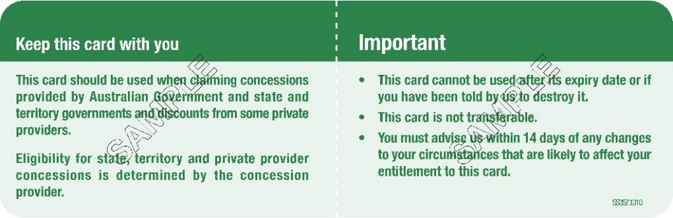
Front of Physical Card
Back of Physical Card
The holder of a Health Care Card, that is the person to whom Services Australia issued the card, is entitled to concession fare travel on all Adelaide Metro bus, train and tram services.
The entitlement to concession fare travel does not extend to persons listed on a Health Care Card as a partner or a dependent.
In this Schedule:
Health Care Card means a physical Health Care Card issues by Services Australia, a digital Health Care Card displayed using the myGov app on a linked digital device, or a digital Health Care Card displayed using the Express Plus Centrelink app on a linked digital device.
myGov app is the digital application with the title “myGov” that is made available by Services Australia and that can be downloaded from the Apple App Store or from the Google Play Store.
Express Plus Centrelink app is the digital application with the title “Express Plus Centrelink” that is made available by Services Australia and that can be downloaded from the Apple App Store or from the Google Play Store.
Dated: 6 December 2024
Hon Anastasios Koutsantonis MP
Minister for Infrastructure and Transport

PASSENGER TRANSPORT REGULATIONS 2024
Regulation 155(1)
Concession Cards—Health Care Card—Provincial City and State Government
Contracted Regional Bus Services throughout South Australia
Pursuant to Regulation 155(1) of the Passenger Transport Regulations 2024, I, the Hon Anastasios Koutsantonis MP, Minister for Infrastructure and Transport, in the State of South Australia, do hereby determine the card referred to in Schedule 1 as a concession card providing transport concessions (as detailed) on all Provincial City and State Government Contracted Regional Bus Services throughout South Australia.
This determination:
• will take effect from 1 January 2025 and will remain in force until varied or revoked by a subsequent notice; and
• is not intended to revoke any previous determinations under Regulation 155(1) of the Passenger Transport Regulations 2024 or any previous determinations under Regulation 149(1) of the Passenger Transport Regulations 2009.
Schedule 1
HEALTH CARE CARD issued by Services Australia, Australian Government
Front of Physical Card
Back of Physical Card
The holder of a Health Care Card, that is the person to whom Services Australia issued the card, is entitled to concession fare travel on all Provincial City and State Government Contracted Regional Bus Services throughout South Australia.
The entitlement to concession fare travel does not extend to persons listed on a Health Care Card as a partner or a dependent.
In this Schedule:
Health Care Card means a physical Health Care Card issues by Services Australia, a digital Health Care Card displayed using the myGov app on a linked digital device, or a digital Health Care Card displayed using the Express Plus Centrelink app on a linked digital device.
myGov app is the digital application with the title “myGov” that is made available by Services Australia and that can be downloaded from the Apple App Store or from the Google Play Store.
Express Plus Centrelink app is the digital application with the title “Express Plus Centrelink” that is made available by Services Australia and that can be downloaded from the Apple App Store or from the Google Play Store.
Dated: 6 December 2024
Hon Anastasios Koutsantonis MP
Minister for Infrastructure and Transport

Passenger Transport Regulations 2024
Schedule 2
Lifting Fee Determination—Christmas Day 2024
1. Lifting Fee Determination
I, Anastasios Koutsantonis, Minister for Infrastructure and Transport further to my powers in the Passenger Transport Regulations 2024 (‘Regulations’) hereby DETERMINE pursuant to Clause 1(5) of Schedule 2 of the Regulations that a lifting fee of $50 plus GST will be paid by the Department for Infrastructure and Transport (the Department) in relation to access taxi transport journeys provided on 25 December 2024, Christmas Day, where all of the following requirements concerning the journey are satisfied.
1.1. Requirements
The following requirements must be met, being that the journey:
• involves the carriage of a person using a wheelchair, scooter or large (ride-on) mobility aide (regardless of whether they hold a SATSS Member ID Card or non-SATSS Access Taxi Card issued by the Department);
• is taken in a taxi operating under a special licence (i.e. an Access Taxi);
• is booked through the contracted Access Taxi Centralised Booking Service;
• is taken on 25 December 2024, Christmas Day, after 12:01am and before 11:59pm.
1.2. Taxi-meter
The taxi has a taxi-meter that:
• is programmed and approved to apply the lifting fee;
• is programmed such that the waiting time calculation does not commence prior to 7 minutes and 31 seconds elapsing or, upon the vehicle travelling 100 metres or more (whichever occurs first), following activation of the meter;

• only applies the lifting fee if the lifting fee function/tariff selection is automated and activated by the contracted Access Taxi Centralised Booking Service, or as otherwise approved;
• does not include the lifting fee as part of the fare component to be paid in full or part by the passenger or display the lifting fee in such a manner as to imply the passenger is liable for any payment of the lifting fee;
• may record the lifting fees on the taxi-meter totals for a shift or other appropriate time period; and
• may display the lifting fee on the face of the taxi-meter, but where it does so, it must indicate a lifting fee applies to the trip and is paid by the Government of South Australia.
1.3. Tariffs—Schedule 2, Clause 1 of the Regulations
• Tariff 1 and Tariff 2 as set out in Clause 1 of Schedule 2 of the Regulations must be used for calculating the legal fare.
• For ease of meter programming and audit purposes, the lifting fee together with the legal fare payable on Tariff 1 and Tariff 2 in Clause 1 of Schedule 2 to the Regulations, may be respectively displayed on the taxi-meter and in records as Tariff 5 and Tariff 6. In all other respects, Tariff 5 and Tariff 6 will be taken to be respectively Tariff 1 and Tariff 2 for the purposes of determining and charging the legal fare.
1.4. General
• In accordance with Regulations 26 and 27 of the Regulations, the holder of an accreditation under Part 4 of the Act must, if required by me, provide information relevant to, or associated with, the payment of the lifting fee.
• Accredited drivers of taxi services providing services to eligible persons must ensure that the journey complies with the requirements set out in paragraph 1.2 above.
• Eligible Persons who are access taxi passengers falling within paragraph 1.1. above and who are transported on 25 December 2024, Christmas Day, are not required to present a card to accredited drivers of taxi services for scanning.
2. Conditions of Use
2.1. Conditions of Use for Eligible Persons
• On 25 December 2024, Christmas Day, an Eligible Person is not required to hold a SATSS Member ID Card or non-SATSS Access Taxi Card issued by the Department.
2.2. Conditions of Use for Drivers and Operators
• A driver must have the ‘SATSS mobile application’ installed on their mobile device.
• A driver must have the Suburban Partner application installed on their mobile device.
• The driver and Centralised Booking Services must record the full name of the passenger when using the Suburban partner application. The Centralised Booking Services must provide access to the Department for Infrastructure and Transport, to journey data for review.
Commencement and Operation
2.3. This determination does not vary or revoke any other determinations made under Regulation 150A and/or Schedule 3 Clause 1(5) of the Passenger Transport Regulations 2009 and Regulation 157 and/or Schedule 2 Clause 1(5) of the Regulations including, but not limited to, determinations concerning lifting fees and the South Australian Transport Subsidy Scheme (SATSS) except for the period between 12:01am and 11:59 pm on 25 December 2024, Christmas Day.
2.4. This determination takes effect from the day that it is published in the South Australian Government Gazette and applies only for journeys taken between 12:01am and 11:59pm on 25 December 2024, Christmas Day.
3. Interpretation
In this instrument:
• Terms defined in the Passenger Transport Act 1994 and Passenger Transport Regulations 2024 (the Regulations) have the same meaning unless defined otherwise in this determination.
• ‘Access Taxi’ means a passenger transport vehicle licenced under Section 45 of the Act and Regulation 35(1)(c) of the Regulations to carry persons who use wheelchairs, scooters, or other large (ride-on) mobility aides.
• ‘Accredited driver’ means a person who is accredited under section 28 of the Act, who drives an Access Taxi.
• ‘Access CBS’ means the centralised booking service contracted by the Minister and accredited under the Act to co-ordinate and allocate or assign bookings for Access Taxis.
• ‘Eligible person’ is a person who is a person using a wheelchair, scooter or large (ride-on) mobility aide, (regardless of whether they hold a SATSS Member ID Card or non-SATSS Access Taxi Card issued by the Department);
• ‘Eligible trip’ is a trip booked through the Access CBS for the transport of an eligible person.
• ‘Non-SATSS Access Taxi Card’ means a non-transferable identification card with a unique barcode issued by the Department to an eligible person (and does not include a SATSS Member ID Card).
• ‘SATSS’ means the South Australian Transport Subsidy Scheme.
• ‘SATSS Member ID Card’ means a non-transferable identification card issued to a SATSS member which contains a photograph of the member and a unique barcode which has been determined by the Minister.
Dated: 17 December 2024
Hon Anastasios Koutsantonis MP
Minister for Infrastructure and Transport

Planning, Development and Infrastructure Act 2016
Section 76
Amendment to the Planning and Design Code
Preamble
It is necessary to amend the Planning and Design Code (the Code) in operation at 5 December 2024 (Version 2024.22) in order to make changes of form relating to the Code’s spatial layers and their relationship with land parcels. NOTE: There are no changes to the application of zone, subzone or overlay boundaries and their relationship with affected parcels or the intent of policy application as a result of this amendment.
1. Pursuant to Section 76 of the Planning, Development and Infrastructure Act 2016 (the Act), I hereby amend the Code in order to make changes of form (without altering the effect of underlying policy), correct errors and make operational amendments as follows:
(a) Undertake minor alterations to the geometry of the spatial layers and data in the Code to maintain the current relationship between the parcel boundaries and Code data as a result of the following:
(i) New plans of division deposited in the Land Titles Office between 27 November 2024 and 10 December 2024 affecting the following spatial and data layers in the Code:
A. Zones and subzones
B. Technical and Numeric Variations
• Building Heights (Levels)
• Building Heights (Metres)
• Concept Plan
• Minimum Frontage
• Minimum Site Area
C. Overlays
• Affordable Housing
• Coastal Areas
• Hazards (Bushfire—High Risk)
• Hazards (Bushfire—Medium Risk)
• Hazards (Bushfire—General Risk)
• Hazards (Bushfire—Urban Interface)
• Hazards (Bushfire—Regional)
• Hazards (Bushfire—Outback)
• Heritage Adjacency
• Historic Area
• Local Heritage Place
• Noise and Air Emissions
• River Murray Flood Plain Protection Area
• State Heritage Place
• Stormwater Management
• Urban Tree Canopy
(ii) Improved spatial data for existing land parcels in the following locations (as described in Column A) that affect data layers in the Code (as shown in Column B):
Location (Column A) | Layers (Column B)
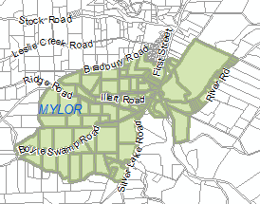  Mylor | Zones  Overlays  - Environment Food Production Area  - Hazards (Bushfire—High Risk)  - Heritage Adjacency  - Limited Land Division  - Local Heritage Place  - Scenic Quality  - Urban Transport Routes
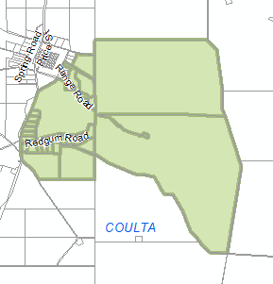  Coulta | Overlays  - Hazards (Bushfire—General)  - Hazards (Bushfire—High)  - Hazards (Bushfire—Medium)  - Key Outback and Rural Routes
(b) In Part 13 of the Code—Table of Amendments, update the publication date, Code version number, amendment type and summary of amendments within the ‘Table of Planning and Design Code Amendments’ to reflect the amendments to the Code as described in this Notice.
2. Pursuant to Section 76(5)(a) of the Act, I further specify that the amendments to the Code as described in this Notice will take effect upon the date those amendments are published on the SA planning portal.
Dated: 13 December 2024
Greg Van Gaans
Director, Geospatial, Data Science and Analytics,
Department for Housing and Urban Development
Delegate of the Minister for Planning

Planning, Development and Infrastructure (General) Regulations 2017
Schedule 8 Clause 4 (1)(J)
Designation of Buildings and Building Products
Preamble
1. Pursuant to Schedule 8 Clause 4(1)(j) of the Planning, Development and Infrastructure (General) Regulations 2017 (the Regulations), the Minister may publish a notice to designate a building or class of building, or a building product or kind of building product.
2. A designated building or designated building product are defined in a notice published by the Minister in the Government Gazette for the purposes of Clause 4(1)(j) of Schedule 8.
Notice
I, Jodie Evans, Director, Building, as delegate of the Minister for Planning, give notice for the purposes of Clause 4(1)(j) of Schedule 8 of the Regulations, with the following set out in Notice A—Designated Building Products attached to this Notice:
• The classes of buildings designated for the purposes of Clause 4(1)(j)(i) of Schedule 8 of the Regulations;
• The use of a building product for the purposes of Clause 4(1)(j)(ii) of Schedule 8 of the Regulations; and
• The details required by the Minister relating to the use of any building product for the purposes of Clause 4(1)(j) of Schedule 8 of the Regulations.
This Notice commences on the day on which it is published, and it replaces all previous Notices made for the purposes of Clause 4(1)(j) of Schedule 8 of the Regulations.
Dated: 19 December 2024
Jodie Evans
Director, Building
Planning and Land Use Services
Delegate of the Minister for Planning

Notice A—Designated Building Products
Section 119(1)(c) of the Planning, Development and Infrastructure Act 2016
Schedule 8, Clause 4(1)(j) of the Planning, Development and Infrastructure (General) Regulations 2017
Designated building
For the purposes of Schedule 8, Clause 4(1)(j)(i) of the Planning, Development and Infrastructure (General) Regulations 2017 a designated building is a building with a Building Code classification of:
(a) Class 2, 3, or 9 consisting of two or more storeys, or
(b) Class 5, 6, 7 or 8 consisting of three or more storeys.
Designated building product
For the purposes of Schedule 8, Clause 4(1)(j)(ii) of the Planning, Development and Infrastructure (General) Regulations 2017 a designated building product is a building product that consists of a metal panel or lining formed with an aluminium, or similar thin metal sheet material, with any type of core material.
Details relating to the designated building product
For the purposes of Schedule 8 of the Planning, Development and Infrastructure (General) Regulations 2017, the following information must be submitted with an application for building rules consent for building work that involves the installation or alteration of this designated building product on this designated building:
(a) Details of each designated building product used, including:
• Product name,
• Product exterior and core material composition,
• Proposed location/s of the product on the building, and
• Proposed installation/fixing method/s.
(b) Completed Attachment A of this Notice for any designated building product that forms part of a Performance Solution (as defined by the Building Code).

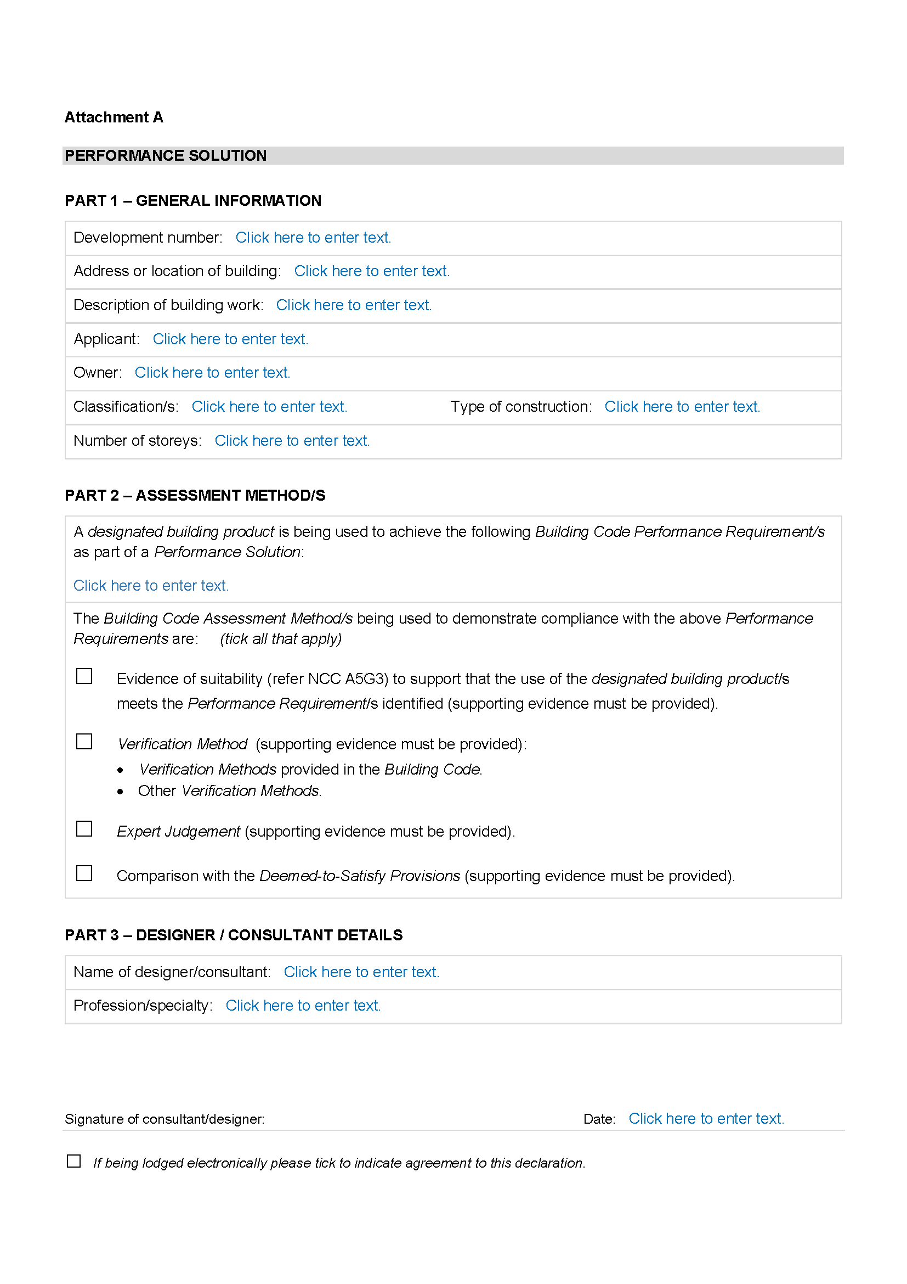
Attachment A

Proof of Sunrise and Sunset Act 1923
Erratum
Almanac for January, February, March 2025
In the South Australian Government Gazette No. 79 dated 12 December 2024, on page 4809, the Schedule showed some incorrect times, the notice should read as follows:
Pursuant to the requirements of the Proof of Sunrise and Sunset Act 1923, I Jon William Whelan, Chief Executive, Department for Infrastructure and Transport, at the direction of the Minister for Infrastructure and Transport, publish in the Schedule hereto an almanac setting out the times of sunrise and sunset on every day for the three calendar months January, February and March 2025.
Dated: 3 December 2024
Jon William Whelan
Chief Executive
Department for Infrastructure and Transport

Schedule
Sunrise and Sunset Times for Adelaide 2025
Latitude: South 34° 56′ Longitude: East 138° 36′
GMT+9.50 hours (Daylight saving GMT+l0.5 hours)
 |  | January |  |  |  |  |  | February |  |  |  |  |  | March
 |  | Rise |  |  | Set |  |  | Rise |  |  | Set |  |  | Rise |  |  | Set
Date |  | hr | min |  | hr | min |  | hr | min |  | hr | min |  | hr | min |  | hr | min
1 |  | 06 | 05 |  | 20 | 32 |  | 06 | 35 |  | 20 | 23 |  | 07 | 02 |  | 19 | 53
2 |  | 06 | 06 |  | 20 | 33 |  | 06 | 36 |  | 20 | 22 |  | 07 | 03 |  | 19 | 52
3 |  | 06 | 07 |  | 20 | 33 |  | 06 | 37 |  | 20 | 21 |  | 07 | 04 |  | 19 | 50
4 |  | 06 | 08 |  | 20 | 33 |  | 06 | 38 |  | 20 | 20 |  | 07 | 05 |  | 19 | 49
5 |  | 06 | 09 |  | 20 | 33 |  | 06 | 39 |  | 20 | 20 |  | 07 | 06 |  | 19 | 48
6 |  | 06 | 09 |  | 20 | 33 |  | 06 | 40 |  | 20 | 19 |  | 07 | 07 |  | 19 | 47
7 |  | 06 | 10 |  | 20 | 33 |  | 06 | 41 |  | 20 | 18 |  | 07 | 08 |  | 19 | 45
8 |  | 06 | 11 |  | 20 | 33 |  | 06 | 42 |  | 20 | 17 |  | 07 | 09 |  | 19 | 44
9 |  | 06 | 12 |  | 20 | 33 |  | 06 | 43 |  | 20 | 16 |  | 07 | 09 |  | 19 | 43
10 |  | 06 | 13 |  | 20 | 33 |  | 06 | 44 |  | 20 | 15 |  | 07 | 10 |  | 19 | 41
11 |  | 06 | 14 |  | 20 | 33 |  | 06 | 45 |  | 20 | 14 |  | 07 | 11 |  | 19 | 40
12 |  | 06 | 15 |  | 20 | 32 |  | 06 | 46 |  | 20 | 13 |  | 07 | 12 |  | 19 | 38
13 |  | 06 | 16 |  | 20 | 32 |  | 06 | 47 |  | 20 | 12 |  | 07 | 13 |  | 19 | 37
14 |  | 06 | 17 |  | 20 | 32 |  | 06 | 48 |  | 20 | 11 |  | 07 | 14 |  | 19 | 36
15 |  | 06 | 18 |  | 20 | 32 |  | 06 | 49 |  | 20 | 10 |  | 07 | 14 |  | 19 | 34
16 |  | 06 | 19 |  | 20 | 32 |  | 06 | 50 |  | 20 | 09 |  | 07 | 15 |  | 19 | 33
17 |  | 06 | 20 |  | 20 | 31 |  | 06 | 51 |  | 20 | 08 |  | 07 | 16 |  | 19 | 31
18 |  | 06 | 21 |  | 20 | 31 |  | 06 | 52 |  | 20 | 06 |  | 07 | 17 |  | 19 | 30
19 |  | 06 | 22 |  | 20 | 30 |  | 06 | 53 |  | 20 | 05 |  | 07 | 18 |  | 19 | 29
20 |  | 06 | 23 |  | 20 | 30 |  | 06 | 54 |  | 20 | 04 |  | 07 | 19 |  | 19 | 27
21 |  | 06 | 24 |  | 20 | 30 |  | 06 | 55 |  | 20 | 03 |  | 07 | 19 |  | 19 | 26
22 |  | 06 | 25 |  | 20 | 29 |  | 06 | 56 |  | 20 | 02 |  | 07 | 20 |  | 19 | 25
23 |  | 06 | 26 |  | 20 | 29 |  | 06 | 57 |  | 20 | 01 |  | 07 | 21 |  | 19 | 23
24 |  | 06 | 27 |  | 20 | 28 |  | 06 | 58 |  | 19 | 59 |  | 07 | 22 |  | 19 | 22
25 |  | 06 | 28 |  | 20 | 28 |  | 06 | 59 |  | 19 | 58 |  | 07 | 23 |  | 19 | 20
26 |  | 06 | 29 |  | 20 | 27 |  | 07 | 00 |  | 19 | 57 |  | 07 | 23 |  | 19 | 19
27 |  | 06 | 30 |  | 20 | 26 |  | 07 | 01 |  | 19 | 56 |  | 07 | 24 |  | 19 | 18
28 |  | 06 | 31 |  | 20 | 26 |  | 07 | 01 |  | 19 | 54 |  | 07 | 25 |  | 19 | 16
29 |  | 06 | 32 |  | 20 | 25 |  |  |  |  |  |  |  | 07 | 26 |  | 19 | 15
30 |  | 06 | 33 |  | 20 | 24 |  |  |  |  |  |  |  | 07 | 26 |  | 19 | 13
31 |  | 06 | 34 |  | 20 | 24 |  |  |  |  |  |  |  | 07 | 27 |  | 19 | 12
*NOTE: Daylight Saving Time is subject to change.
Sunrise and Sunset times calculated on 20/11/24. Certified correct: A. Dolman, 20 November 2024

Public Corporations Act 1993
Section 6
Direction to the South Australian Water Corporation
Background:
1. Pursuant to Section 6 of the Public Corporations Act 1993, and Sections 6 and 7(2)(f) of the South Australian Water Corporation Act 1994, the South Australian Water Corporation (SA Water) is subject to control and direction by its Minister, and has the functions conferred on it by its Minister.
2. The South Australian Water Corporation Act 1994 is committed to the Minister for Housing Infrastructure (the Minister) as per Gazettal notice dated 15 April 2024, p.683.
3. Pursuant to Section 32 of the Water Industry Act 2012 (SA), Cape Jaffa Anchorage Essential Services (CJAES) wrote to the Essential Services Commission of South Australia to surrender its retail licence for the provision of sewerage and non-drinking water services to residential and non-residential customers, with an effective surrender date of 31 October 2022.
4. The Minister previously considered it appropriate to direct SA Water to temporarily take over the existing operations of CJAES.
5. The Minister now considers a new direction is appropriate to extend the timeframe for SA Water’s temporary takeover of existing operations at Cape Jaffa to allow more time to confirm and transition to long term arrangements for water and sewerage services.
Direction:
6. I, Nick Champion, Minister for Housing Infrastructure, direct SA Water under section 6 of the Public Corporations Act 1993 to use best endeavours to:
(i) secure all access rights and approvals necessary to continue SA Water’s temporary operation of non-drinking water and sewerage services at Cape Jaffa, to ensure continued operation to customers (as defined by the Water Industry Act 2012) at Cape Jaffa Marina until 30 June 2026;
(ii) work with the Department for Environment and Water to confirm all land and other assets that would be required for SA Water to continue the temporary operation of non-drinking water and sewerage services at Cape Jaffa until 30 June 2026;
(iii) take ownership of all land and other assets required to continue SA Water’s temporary operation of non-drinking water and sewerage services at Cape Jaffa, for nil consideration, by no later than 30 June 2025;
(iv) provide a retail service to customers at Cape Jaffa Marina, with all charges to be based on the charges of CJAES as at 1 July 2024 (see Attachment 1), to be indexed and published in the South Australian Government Gazette.
7. For the avoidance of doubt and to the extent of any inconsistency, this direction overrides any other previous direction to SA Water under Section 6 of the Public Corporations Act 1993—with respect to Cape Jaffa customers.
8. This direction may be revoked at any time.
Dated: 19 December 2024
Hon Nick Champion MP
Minister for Housing Infrastructure

Attachment 1
Prices for Customers at Cape Jaffa Marina as at 1 July 2024
Fee Name | Fee¹
Non-drinking water
Supply fee | $399.00 per annum payable quarterly (GST free)
Flat rate tariff | $3.14 per kL (GST free)
Sewerage
Sewer access fee | The higher of:  • 37.125 cents per $1000 of property value per quarter², or  • minimum access fee of $159.90 (GST free)
¹ Fee quoted for 2024-25. Fees for 2025-26 to be indexed and published in the South Australian Government Gazette prior to 1 July 2025.
² Property value is set by the Valuer General.

The Remuneration Tribunal
Report No. 12 of 2024
2024 Review of Salary of the Governor of South Australia
Introduction
1. The Remuneration Tribunal (Tribunal) has jurisdiction under Section 14 of the Remuneration Act 1990 (SA) (Act) and Section 73 of the Constitution Act 1934 (SA) (Constitution Act), to determine the rate of salary payable to Her Excellency the Governor of South Australia (the Governor).
2. As explained in this report, the Tribunal has decided to increase the Governor’s remuneration consistent with the median salary for State Governors. The Tribunal has issued an accompanying Determination, which applies from 1 February 2025.

Background
3. In late 2021, the Tribunal undertook a review of the salary of the Governor. As part of that review, it considered it necessary to establish a sustainable basis for the remuneration of the Governor.
4. It noted that it did not consider it appropriate or necessary to undertake a traditional work value assessment of the duties of the Governor, given those functions are enshrined in our constitution and democratic system.
5. Having undertaken an interjurisdictional comparison, the Tribunal observed that the salary at that time was materially lower than the median salary of Governor’s in other Australian jurisdictions. It noted that if the anomaly was not addressed, there was the potential to indicate a lessor role for the Governor of South Australia.
6. In Report 15 of 2023 the Tribunal adopted a consistent approach and confirmed its view that the Governor of South Australia should be remunerated at a level comparable to that of Governors in other States.
The Review Process
7. On 14 November 2024, in accordance with Section 10(2) and 10(4) of the Act, the Tribunal wrote to and invited submissions by 29 November 2024 in respect of this review from:
(a) Her Excellency the Governor of South Australia
(b) The Honourable Premier of South Australia—as the Minister responsible for the Act who may make submissions or introduce evidence in the public interest
8. The Tribunal also placed a notice on its website from 14 November 2024 inviting submissions from affected persons by 29 November 2024.
9. On 18 November 2024, the Official Secretary to the Governor wrote to the Tribunal advising that the Governor did not intend to make a submission in relation to the Tribunal’s review of the Governor’s salary, leaving the matter to the discretion of the Tribunal.
10. On 21 November 2024, the Premier’s representative confirmed that the Premier did not intend to make a submission.
11. No other submissions were received by the Tribunal in relation to this review.
Consideration and Conclusion
12. Consistent with the remarks made in 2021, the Tribunal continues to be of the view that the role of the Governor of South Australia should be regarded as comparable to that of Governors in other States. This approach recognises the significant importance of this unique role within the State.
13. A departure from this approach would once again establish a significant difference in the remuneration payable to this and future Governors, and most likely lead to future very substantial remuneration adjustments.
14. As such, the Tribunal has considered the below data in relation to the salaries of Governors in other jurisdictions.
Salaries of Governors in Other Jurisdictions
Jurisdiction* | Governor Salary  Per Annum | Relevant Authority
QLD | $522,225 | Act of Parliament
WA | $504,475 | Independent Tribunal
CTH** | $709,017 | Act of Parliament
TAS | $583,645 | Act of Parliament
VIC | $517,650 | Act of Parliament
NSW*** | $521,720 | Independent Tribunal
Median Salary ex SA | $521,720
Average Salary ex SA | $529,943
SA | $495,754 | Independent Tribunal
* NT and ACT have not been included as there is no office of Governor in those jurisdictions.
** The Australian Constitution prevents the salary of the Governor-General from being altered during an incumbent’s time in office. For the purpose of this review, the Governor-General of the Commonwealth of Australia’s salary has been excluded from the median calculation.
*** Clause 5A of the Statutory and Other Offices Remuneration (Judicial and Other Office Holders) Regulation 2013 states that the NSW Remuneration Tribunal is not to make a determination that has the effect of awarding an increase in remuneration that takes effect before 1 July 2025.
15. Accordingly, the Tribunal has decided to increase the salary of the Governor to $521,720 per annum, which is the median amount, excluding South Australia for State Governors.
16. An accompanying Determination has been issued and will take effect from 1 February 2025.
Dated: 12 December 2024
Matthew O’Callaghan
President
Donny Walford
Member
Mark Young
Member

The Remuneration Tribunal
Determination No. 12 of 2024
Salary of the Governor of South Australia
Determination
1. Pursuant to Section 73 of the Constitution Act 1934 (SA), the Remuneration Tribunal hereby determines that the salary of the Governor of South Australia shall be $521,720.
2. This Determination operates from 1 February 2025.
Dated: 12 December 2024
Matthew O’Callaghan
President
Donny Walford
Member
Mark Young
Member

THE REMUNERATION TRIBUNAL
Report No. 13 of 2024
Overseas Accommodation and Daily Allowance
Pacific Judicial Conference—Chief Justice Kourakis
Introduction
1. On 15 November 2024, the Remuneration Tribunal (Tribunal) received an application and submission from the Honourable Chris Kourakis, Chief Justice of the Supreme Court of South Australia. The Chief Justice requested the Tribunal make a Determination setting an overseas accommodation and daily allowance for his attendance at the Pacific Judicial Conference being held in Auckland between 9 and 12 February 2025. The Chief Justice advised he would be arriving in Auckland on 8 February and departing 13 February 2025.
2. This specific Determination has been sought, as the Tribunal’s existing Determination for the payment of accommodation and meal allowances does not cover international travel. In recent years, the Tribunal’s practice has been to instead make specific Determinations for international travel.
The Review Process
3. Section 10(2) of the Remuneration Act 1990 (SA) (Act) provides that prior to the Tribunal making a Determination affecting the remuneration of a particular person, or persons of a particular class, the Tribunal must allow that person, or the persons of that class, a reasonable opportunity to make submissions orally or in writing to the Tribunal.
4. Section 10(4) of the Act provides that the Honourable Premier of South Australia, as the Minister responsible for the Act, may intervene, personally or by counsel or other representative, in proceedings before the Tribunal for the purpose of introducing evidence, or making submissions, on any question relevant to the public interest.
5. On 21 November 2024, the Tribunal wrote to the Premier and the Judicial Remuneration Coordinating Committee (JRCC), to invite submissions by 5 December 2024 on this application.
6. The Tribunal also advertised its intention to consider this application on its website from 21 November 2024.
7. On 21 November 2024, the JRCC confirmed that it supports the application.
8. On 5 December 2024, the Premier’s representative confirmed that the Premier did not intend to provide any submissions in respect of this application.
9. No other submissions were received.
Consideration and Conclusion
10. Chief Justice Kourakis’ application can be summarised as follows:
• On 18 October 2024, the Chief Justice was invited by the Chief Justice of New Zealand to attend the Pacific Judicial Conference in Auckland, New Zealand. The theme of the conference is Strengthening the Institution of the Judiciary.
• He wishes to claim an appropriate daily allowance and reimbursement for accommodation between 8 and 13 February 2025.
• The conference is held from 9 to 12 February 2025.
• Consistent with the Commonwealth Remuneration Tribunal (Official Travel) Determination 2024, he seeks a daily allowance set by reference to the most recent Australian Taxation Office determination (TD2024/3) concerning reasonable meals and incidentals, and reimbursement for accommodation which is of a standard reasonably equivalent to that provided to him in Australia for official duties.
• Tables 8 and 9 of TD2024/3 are relevant, with the daily allowance being A$340 per day.
• Reimbursement will be sought for accommodation at a reasonable cost at a hotel near the conference.
11. Attached to the submission, the Chief Justice provided a copy of the invitation from the Chief Justice of New Zealand and the conference program.
12. The Tribunal recognises the necessity for judicial officers to travel internationally in the course of their official duties, noting that such travel has been, however, infrequent. Consistent with past practice, the Tribunal remains of the view that individual applications may be made for the determination of overseas travel entitlements according to the unique circumstances of each instance of travel.
13. In circumstances where a judicial officer is travelling and has access to airport lounges or is provided with meals as part of a long-haul flight, the Tribunal is of the view that a daily allowance should not be sought and is not payable.

14. The Tribunal is also satisfied that the Commonwealth Remuneration Tribunal (Official Travel) Determination 2024 continues to set a reasonable basis for determining an appropriate overseas daily allowance for meals and incidentals and entitlement to accommodation for this trip.
15. The Tribunal considers that accommodation and daily allowance provisions are appropriately payable to Chief Justice Kourakis between 8 and 12 February 2025. An accompanying Determination reflects the Tribunal’s decision.
Operative Date
16. The accompanying Determination will operate from 15 November 2024, being the date, the application was received.
Dated: 17 December 2024
Matthew O’Callaghan
President
Donny Walford
Member
Mark Young
Member

THE REMUNERATION TRIBUNAL
Determination No. 13 of 2024
Overseas Accommodation and Daily Allowance
Pacific Judicial Conference—Chief Justice Kourakis
Scope of Determination
1. This Determination applies to the Honourable Chris Kourakis, Chief Justice of the Supreme Court of South Australia.
Determination
2. Chief Justice Kourakis will be entitled to the following, in respect of his attendance at the Pacific Judicial Conference being held in Auckland from 8-12 February 2025:
(a) a daily allowance of A $340 set by reference to the most recent Australian Taxation Office determination (TD2024/3) concerning reasonable meals and incidentals. This will be for 5 days;
(b) reimbursement for his accommodation directly associated with his attendance at the conference, provided the reimbursement does not exceed the costs of accommodation of a standard reasonably equivalent to that provided to him in Australia for official duties.
Date of Operation
3. This Determination will operate from 15 November 2024.
Dated: 17 December 2024
Matthew O’Callaghan
President
Donny Walford
Member
Mark Young
Member

The Remuneration Tribunal
Report No. 14 of 2024
2024 Review of Salary Sacrifice Arrangements for Judges, Court Officers and Statutory Officers
Introduction
1. The Remuneration Tribunal (Tribunal) has conducted a review of Determination 10 of 2022 which provides for salary sacrifice arrangements for Judges, Court Officers and Statutory Officers covered by the determination.
2. As explained in this report, the Tribunal has issued a new determination, superseding Determination 10 of 2022, as the Tribunal has been advised that the normal public sector arrangements apply equally to Judges, Court Officers and Statutory Officers.
3. Nevertheless, the Tribunal has determined the operative date of the new determination will be 1 February 2025, to enable any affected person to make submissions to it in the event that there are differences between Determination 10 of 2022 and the South Australian Government Salary Sacrifice Arrangement (SAGSSA) Principal Agreement, which have not been brought to the Tribunal’s attention.
The Review Process
4. On 19 September 2024, in accordance with Sections 10(2) and 10(4) of the Remuneration Act 1990 (SA) (Act), the Tribunal wrote to and invited submissions by 3 October 2024 in respect of this review from:
(a) the Honourable Premier of South Australia—as the Minister responsible for the Act who may make submissions or introduce evidence in the public interest
(b) the Judicial Remuneration Coordinating Committee (JRCC)
(c) members of the judiciary and relevant office holders covered by Determination 10 of 2022
(d) the Office of the Commissioner for Public Sector Employment
5. The Tribunal also placed a notice on its website from 19 September 2024 inviting submissions from affected persons by 3 October 2024.
6. On 19 September 2024, the Auditor-General confirmed that he would not be making a submission on this occasion.
7. On 23 September 2024, the Electoral Commissioner confirmed that he would not be making a submission on this occasion.

8. On 3 October 2024, the Premier’s representative confirmed that the Premier did not intend to make a submission
9. The JRCC provided a written submission on 3 October 2024, on behalf of:
(a) the Chief Justice, Judges and Associate Judges of the Supreme Court;
(b) the Chief Judge, Judges and Associate Judges of the District Court;
(c) the Judges and Magistrates of the South Australian Employment Tribunal;
(d) the Chief Magistrate and the Magistrates of the Magistrates Court;
(e) the State Coroner and Deputy State Coroners;
(f) the Commissioners of the Environment, Resources and Development Court; and
(g) the President and Deputy Presidents of the South Australian Employment Tribunal.
10. The JRCC submitted that the Tribunal should review the determination of the salary sacrifice arrangements in the usual way and otherwise make a determination that reflects the terms of Determination 10 of 2022.
11. The Office of the Commissioner for Public Sector Employment (OCPSE) provided a written submission on 3 October 2024.
12. In summary, the OCPSE submitted that:
• The Tribunal should remove Schedules 1, 2 and 3 of Determination 10 of 2022 and include relevant officer holders under the South Australian Government Salary Sacrifice Arrangement (SAGSSA) Principal Agreement, noting that the SAGSSA Principal Agreement covers whole of government participation.
• The Tribunal should remove all references to the salary sacrifice of Superannuation to a private fund or Triple S Scheme.
• The Tribunal should remove all references to the Administration fee.
• The Tribunal should support the renumbering of the Benefit Items to align with that in the SAGSSA Principal Agreement.
13. The JRCC did not oppose the submission made by the OCPSE.
Consideration and Conclusion
14. On 18 and 25 November 2024, the Tribunal met with the SAGSSA Project Manager of OCPSE together with representatives from Crown and the Premier’s office. The SAGSSA Project Manager advised the Tribunal that the SAGSSA Principal Agreement for the public sector contains the same benefits as provided for in the Tribunal’s Determination 10 of 2022.
15. The Tribunal was provided with advice that a side-by-side comparison of the benefit items available in Determination 10 of 2022 and the SAGSSA Principal Agreement showed that with the exception of one change that was effective at the commencement of the SAGSSA Principal Agreement, there are no differences. The exception being that salary sacrifice of superannuation is no longer administered by the salary sacrifice provider (Smartsalary) and is now managed by the relevant employer’s payroll team or provider.
16. The Premier’s representative also advised that in view of the amendments to the determination being administrative only, there is no objection to the Tribunal issuing a new determination in the terms being proposed.
17. Accordingly, the Tribunal is of the view that duplicating the arrangement by way of a Tribunal determination is unnecessary, provided that there is indeed no difference.
18. As such, the Tribunal has determined to issue a new determination with an operative date of 1 February 2025.
19. The operative date is intended to provide affected persons with the opportunity to raise any issues or concerns with the Tribunal by way of submission prior to 1 February 2025.
Dated: 17 December 2024
Matthew O’Callaghan
President
Donny Walford
Member
Mark Young
Member

The Remuneration Tribunal
Determination No. 14 of 2024
Salary Sacrifice Arrangements for Judges, Court Officers and Statutory Officers
Scope of Determination
1. This Determination applies to Judges, Court Officers and Statutory Officers.
Interpretation
2. In this Determination:
“Court Officer” means any of the following:
The State Coroner;
The Commissioners of the Environment, Resources and Development Court.
“Judges” means any of the following members of the judiciary:
the Chief Justice of the Supreme Court;
the President of the Court of Appeal;
the Puisne Judges of the Court of Appeal;
the Puisne Judges of the Supreme Court;

the President of the South Australian Employment Tribunal;
the Deputy Presidents of the South Australian Employment Tribunal;
the Judges of the Environment, Resources and Development Court;
the Judges of the South Australian Employment Tribunal;
the Chief Judge of the District Court;
the other District Court Judges;
the Chief Magistrate;
the Magistrates of the South Australian Employment Tribunal;
the other Magistrates;
the Associate Justices of the Supreme Court; and
the Associate Judges of the District Court.
“Office Holder” means any of the Judges, Court Officers, or Statutory Officers.
“SAGSSA Principal Agreement” means the South Australian Government Salary Sacrifice Arrangement Principal Agreement.
“Statutory Officers” means any of the following statutory office holders:
The Auditor-General;
The Electoral Commissioner;
The Deputy Electoral Commissioner; and
The Health and Community Services Complaints Commissioner.
Salary Sacrifice Arrangements
3. The salary sacrifice arrangement provided in the SAGSSA Principal Agreement is to apply to an Office Holder, covered by this Determination.
Date of Operation
4. This Determination comes into operation on and from 1 February 2025 and shall remain in force until further Determination by the Tribunal.
Dated: 17 December 2024
Matthew O’Callaghan
President
Donny Walford
Member
Mark Young
Member

THE REMUNERATION TRIBUNAL
Report No. 15 of 2024
2024 Review of Conveyance Allowances—Judges, Court Officers and Statutory Officers
Introduction
1. The Remuneration Tribunal (Tribunal) has conducted a review of Determination 14 of 2023 which sets conveyance allowances and related entitlements for members of the judiciary and office holders listed in Section 13 of the Remuneration Act 1990 (SA) (Act), and certain other office holders as conferred under Section 14 of the Act.
2. As explained in this report, in previous years the Tribunal has had regard to fluctuations in prices set by the South Australian Government Financing Authority and the range of vehicles available without excess charges depending on the level of allowance. The Tribunal has continued to have regard to such factors and as a result has determined to increase the allowances by 4.75%.
3. The Tribunal has issued an accompanying Determination, which applies from 1 January 2025.
The Review Process
4. On 19 September 2024, in accordance with Sections 10(2) and 10(4) of the Act, the Tribunal wrote to and invited submissions by
3 October 2024 in respect of this review from:
(a) the Honourable Premier of South Australia—as the Minister responsible for the Act who may make submissions or introduce evidence in the public interest
(b) the Judicial Remuneration Coordinating Committee (JRCC)
(c) members of the judiciary and relevant office holders
5. The Tribunal also placed a notice on its website from 19 August 2024 inviting submissions from affected persons by 3 October 2024.
6. The Tribunal raised with affected parties the apparent difference in the conveyance allowance arrangements between the Federal and State systems particularly where, under the State system, if an office holder elects to have a vehicle that requires a contribution that is a lesser amount than the allowance they then receive the remainder of that allowance.
7. On 19 September 2024, the Auditor-General confirmed that he would not be making a submission on this occasion.
8. On 23 September 2024, the Electoral Commissioner confirmed that he would not be making a submission on this occasion.
9. On 3 October 2024, the Premier’s representative confirmed that the Premier did not intend to make a submission.
10. The JRCC provided a written submission on 3 October 2024, on behalf of:
(a) the Chief Justice, Judges and Associate Judges of the Supreme Court;
(b) the Chief Judge, Judges and Associate Judges of the District Court;

(c) the Judges and Magistrates of the South Australian Employment Tribunal;
(d) the Chief Magistrate and the Magistrates of the Magistrates Court;
(e) the State Coroner and Deputy Coroner;
(f) the Commissioners of the Environment, Resources and Development Court; and
(g) the President and Deputy Presidents of the South Australian Employment Tribunal.
11. The JRCC’s submission detailed observations of the Federal system, noting similarities and differences and concluded this was a matter for the Tribunal to consider.
12. No other submissions were received.
Other Jurisdictions
13. Consideration has been given to the entitlements provided to judicial officers in other jurisdictions.
14. The Commonwealth Remuneration Tribunal determination provides for the reimbursement of private vehicle running costs up to a prescribed limit, or the provision of a private plated vehicle that is not a luxury car leased in accordance with the FVS Policy. The value of the entitlement may not be taken as cash, except to the extent that reimbursement is claimed. Furthermore, while the Chief Justice of the High Court has an entitlement to these arrangements in addition to Commonwealth car with driver services, other judges with an entitlement to Commonwealth car with driver services can only receive a private plated vehicle or the reimbursement of private vehicle running costs if they forgo their entitlement to those services.
15. The Northern Territory Remuneration Tribunal determination provides an entitlement for a Local Court Judge to be provided with a 4-cylinder motor vehicle with private number plates to use for official duties, so long as the model is one provided within a specified list.
16. The New South Wales Remuneration Tribunal 2024 determination provides for a conveyance allowance. The history of the conveyance allowance is provided for in their 2003 special determination and 2005 special determination. In particular, the purpose of the conveyance allowance is to replace a former scheme that provided an amount to Supreme Court Judges to compensate for motor vehicles provided to Federal Court Judges. Judicial Officers may, but are not obliged, to use the conveyance allowance towards the cost of leasing a motor vehicle through the State Government’s leasing scheme.
17. In Victoria, Judges of the Supreme Court, Country Court and Chief Magistrate are to be provided with a motor vehicle in accordance with the Judicial Car Scheme set out in the Department of Justice Fleet Management Policies and Guidelines 2001, or any other Departmental policy that is adopted from time to time and are required to contribute $837 per annum towards the running costs of the vehicle. These judicial officers are also provided with a driver. By way of certificate issued 14 February 2008, Magistrates are entitled to a car allowance of $9,060 per annum, adjusted annually in accordance with CPI, with the allowance included in the salary for magistrates for superannuation purposes. Magistrates can also access the Department of Justice Fleet Management Policies and Guidelines 2001, or any other Departmental policy that is adopted from time to time and are able to offset the cost of a car provided through such policy.
18. In Western Australia Judges and Magistrates are provided with a Government owned vehicle with an annual whole of life cost for the vehicle up to a prescribed limit. It appears that judicial officers cannot take the cash value of the allowance if the vehicle selected is less than the allowance.
Consideration And Conclusion
19. Having considered the submission of the JRCC and schemes within other jurisdictions, the Tribunal is concerned that if Judges, Court Officers, and Statutory Officers elect to access a vehicle which has a substantially lower cost than the allocated allowance, this may amount to the substantial remainder of the allowance being paid to the office holder.
20. The Tribunal has adopted the position that the intention of the conveyance allowance was to provide Judges, Court Officers, and Statutory Officers with access to vehicles appropriate to their position, through the Judicial Vehicle Scheme. As far as the Tribunal can ascertain, the conveyance allowance is not intended to be provided to office holders covered by the determination in the event that they do not elect to be provided with a vehicle or elect for a vehicle that is at a lesser amount than the applicable conveyance allowance.
21. Furthermore, the Tribunal is concerned that while some Judges, Court Officers and Statutory Officers may be able to access electric vehicles, which involves significantly less contribution costs, others who are required to undertake substantial country travel, cannot practically access these vehicles.
22. Accordingly, the Tribunal proposes to progressively implement a restriction to the effect that if a Judge, Court Officer, or Statutory Officer covered by the determination selects a vehicle which attracts a lower cost, the remnant component of the allowance remains unspent and is not payable to them. The Tribunal proposes that this change will progressively take effect as Judges, Court Officers and Statutory Officers replace their current vehicles. The Tribunal invites comment on this proposal by no later than 28 February 2025. Confirmation of the Tribunal’s position will then be issued.
23. Given reviews occur on an annual basis, the Tribunal has determined that consideration of any increase to the current conveyance allowances is still necessary. In this regard, the Tribunal has considered the approach adopted in previous years where regard has been given to fluctuations in prices set by the South Australian Government Financing Authority and the range of vehicles available without excess charges depending on the level of allowance. The Tribunal has continued to have regard to such factors and as a result has determined to increase the allowances by 4.75 %.
24. An accompanying Determination has been issued and will operate from 1 January 2025.
Dated: 17 December 2024
Matthew O’Callaghan
President
Donny Walford
Member
Mark Young
Member

THE REMUNERATION TRIBUNAL
Determination No. 15 of 2024
Conveyance Allowances—Judges, Court Officers and Statutory Officers
Determination
1. Interpretation
1.1. In this Determination, unless the contrary appears:
“Court Officer” means Commissioners of the Environment, Resources and Development Court;
“Executives” means persons appointed to an executive position under the Public Sector Act 2009 (SA);
“Judges” means any of the following members of the judiciary:
the Chief Justice of the Supreme Court;
the President of the Court of Appeal;
the Judges of the Court of Appeal;
the Puisne Judges of the Supreme Court;
the President of the South Australian Employment Tribunal;
the Deputy Presidents of the South Australian Employment Tribunal;
the Judges of the Environment, Resources and Development Court;
the Judges of the South Australian Employment Tribunal;
the Chief Judge of the District Court;
the other District Court Judges;
the Chief Magistrate (as a Judge of the District Court);
the Magistrates of the South Australian Employment Tribunal;
the other Magistrates;
the Associate Justices of the Supreme Court;
the Associate Judges of the District Court;
the State Coroner; and
the Deputy State Coroner.
“Registrar” means the "Registrar” within the meaning of the South Australian Employment Tribunal Act 2014 (SA).
“Relevant authority” means:
(a) the State Courts Administrator in relation to Judges and Court Officers;
(b) the Registrar in relation to the presidential members of the South Australian Employment Tribunal; and
(c) the Manager Fleet, South Australian Government Financing Authority in relation to other Statutory Officers.
“Retirement” bears the same meaning as in the Judges’ Pensions Act 1971, the Superannuation Act 1988 and the Southern State Superannuation Act 2009.
“Resignation” bears the same meaning as in the Judges’ Pensions Act 1971, the Superannuation Act 1988, and the Southern State Superannuation Act 2009.
“Statutory Officers” means any of the following statutory office holders:
the Auditor-General;
the Electoral Commissioner;
the Deputy Electoral Commissioner; and
the Health and Community Services Complaints Commissioner.
1.2. For the purposes of this Determination, “salary” bears the same meaning as in the Judges’ Pensions Act 1971, Southern State Superannuation Act 2009, and in the Superannuation Act 1988, to the intent and effect that any amount paid by way of conveyance allowance is not “salary”, and that any abatement or reduction of salary in accordance with this Determination will not affect the determination of entitlements or obligations pursuant to those Acts.
2. Conveyance Allowances
2.1. Amount of Allowances
Subject to the conditions set out in this Determination, Judges, Court Officers and Statutory Officers are entitled to receive a conveyance allowance payable fortnightly at an annual rate as follows:
2.1.1 For:
the Chief Justice of the Supreme Court;
the President of the Court of Appeal;
the Judges of the Court of Appeal;
Judges of the Supreme Court;
the Chief Judge of the District Court;
the President of the South Australian Employment Tribunal; and
the Auditor-General;
an amount of $19,356.

2.1.2 For:
Judges of the District Court;
the Chief Magistrate;
Judges of the South Australian Employment Tribunal;
Judges of the Environment, Resources and Development Court;
Associate Justices of the Supreme Court;
the Electoral Commissioner; and
the Health and Community Services Complaints Commissioner;
an amount of $18,659.
2.1.3 For:
Magistrates;
Associate Judges of the District Court;
the State Coroner;
the Deputy State Coroner;
Magistrates of the South Australian Employment Tribunal;
Deputy President of the South Australian Civil and Administrative Tribunal, appointed under Section 14(1)(b) of the SACAT Act 2013.
Commissioners of the Environment, Resources and Development Court; and
the Deputy Electoral Commissioner;
an amount of $17,247.
2.2. Part Time Appointees
Where a person to whom this Determination applies is appointed on a part time basis, that person is entitled to receive a conveyance allowance at a pro rata amount of the relevant allowance in clause 2.1, based on the number of ordinary hours worked as a proportion of the full time equivalent.
2.3. Temporary Appointees
Where a person who is not provided with a vehicle in their substantive position is appointed on a temporary basis to act as a Judge, Court Officer or Statutory Officer, that person is entitled after the expiration of the first calendar month of service to receive a conveyance allowance in accordance with clause 2.1.
2.4. Use of Taxis and Private Vehicles
2.4.1. Judges and Court Officers
A Judge or Court Officer is not entitled to use a government fleet vehicle allocated to the Courts Administration Authority, or to engage taxis or hire car at the expense of the State Courts Administrator, or to seek the payment of any additional allowance for the use of a private vehicle, whether for official or unofficial purposes unless:
(a) it has been certified by the State Courts Administrator that it was inefficient or not cost effective for the Judge or Court Officer to use the vehicle available for their official and private use; or
(b) it has been certified by the State Courts Administrator that the vehicle available for the Judge or Court Officer’s official and private use cannot travel safely to a designated location; or
(c) such use or engagement is consistent with a general direction given by the Chief Judicial Officer of the relevant Court, or in the case of Court Officers, the presiding officer of the relevant Tribunal, as to the circumstances where the vehicle available for official and private use, need not be used by reason of efficiency and cost effectiveness.
For the presidential members of the South Australian Employment Tribunal, the Registrar is the relevant approval authority.
An example of circumstances where such certification or general directions may be given is for journeys to and from the airport, where it may be more efficient or cost effective to use a taxi.
2.4.2. Statutory Officers
A Statutory Officer must not engage a taxi or hire car, and is not entitled to the payment of any additional allowance for the use of a private vehicle, whether for official or unofficial purposes, unless it is inefficient or not cost effective to use the vehicle available for the Statutory Officer’s official and private use.
2.4.3. Amount of Reimbursement
Where any person subject to this Determination is seeking payment of an additional allowance to cover the use of a private motor vehicle for official purposes, reimbursement of the cost will be made, calculated at the rate per kilometre at a rate equating to that pursuant to the SA Public Sector Salaried Employees Interim Award.
3. Vehicles Available Through the South Australian Government Financing Authority for Official and Private Use
3.1. Selection of Vehicle
Persons who are subject to this Determination are entitled, in accordance with the conditions specified herein, to elect to have allocated to them a motor vehicle of any model and type from the Judicial Vehicle Schedule compiled by the South Australian Government Financing Authority, as varied from time to time. Notice of the selected motor vehicle should be made in writing as follows:
• by Judges and Court Officers to the State Courts Administrator;
• by members of the South Australian Employment Tribunal to the Registrar, including members who are Statutory Officers; and
• by other Statutory Officers to the Manager Fleet, South Australian Government Financing Authority.
The annual charge payable for each vehicle, determined by the South Australian Government Financing Authority is set out in the Judicial Vehicle Schedule compiled by the South Australian Government Financing Authority.

3.2. Temporary Appointees
Persons appointed on a temporary basis to act as a Judge, Court Officer or Statutory Officer are not entitled to make an election under clause 3.1.
3.3. Charges for Use of Vehicles
The annual amount payable by a Judge, Court Officer or Statutory Officer for the use of a selected vehicle is the amount set out in the South Australian Government Financing Authority Judicial Vehicle Schedule adjacent to the description of the type of vehicle.
Where a person to whom this Determination applies is appointed on a part time basis, and elects pursuant to clause 3.1 to have a motor vehicle, the charge payable by that person pursuant to clause 3.4 shall be an amount determined by the South Australian Government Financing Authority, which may be greater than the standard charge to a full time officer to appropriately reflect the proportionately greater private use of such a motor vehicle.
3.4. Payment of Vehicle Charges
If a Judge, Court Officer or Statutory Officer makes an election under clause 3.1 and a vehicle is supplied in accordance with that election, then the salary and allowances otherwise payable to the Judge, Court Officer or Statutory Officer must be abated and reduced so as to offset the charges for the use of the vehicle for the period during which the Judge, Court Officer or Statutory Officer has the use of the vehicle.
3.5. New Models or Types
3.5.1. If a new type of vehicle, or a new model of a type specified in the Schedules becomes available for selection in terms of 3.1 after the date of election but before the placement of a binding order, the Judge, Court Officer, or Statutory Officer is entitled to withdraw the original election and elect to take the new model or type of vehicle.
3.5.2. The annual charge payable for a new model or new type of vehicle is that amount determined by the South Australian Government Financing Authority as the annual charge for private use of the vehicle. The annual charge takes into account the following:
• purchase price and depreciation;
• fuel, maintenance, insurance roadside assistance, registration costs and interest rates; (operating costs are calculated on the basis of an average of 70% private usage and 30% business usage);
• Goods and Services Tax (GST);
• Fringe Benefits Tax (FBT) based on an attributed business rate of 20,000 kilometres per year; and
• the vehicle being retained for 3 years or 60,000 kilometres travelled, whichever first occurs.
3.5.3. If a model or type of vehicle selected by a Judge, Court Officer or Statutory Officer becomes unavailable before the placement of a binding order, the Judge, Court Officer or Statutory Officer must be advised accordingly and allowed to make a further election under clause 3.1.
3.5.4. If a model becomes unavailable after the date of placement of a binding order and a later or better model vehicle is supplied, any Judge, Court Officer or Statutory Officer who has selected the unavailable vehicle is liable only to pay the annual charge for the vehicle as selected, and not the charge payable for the vehicle as supplied.
3.6. Accessories
The Judge, Court Officer or Statutory Officer may choose to have manufacturer approved accessories fitted to the vehicle. The full cost of the accessories and the expense of having them fitted (including any tax incurred) is payable by the Judge, Court Officer or Statutory Officer. When the vehicle is due for return the Judge, Court Officer or Statutory Officer may have personally-installed accessories removed from the vehicle, providing the Judge, Court Officer or Statutory Officer meets the full cost of restoring the vehicle to the same condition as if the accessories had not been fitted. No compensation will be paid if options are left on the vehicle unless agreed by the relevant authority.
Standard options such as mud flaps, floor mats, cargo barriers (where fitted) may not be removed from the vehicle. Tow bars must not be reinstalled on another vehicle.
The non-fitment of standard features requires that the Judge, Court Officer or Statutory Officer undertakes a comprehensive risk assessment prior to requesting approval from the relevant authority under clause 3.1.
The fitment of non-standard vehicle options fitted requires that the Judge, Court Officer or Statutory Officer seeks documented advice or engineering certificates (as required) to support the decision and to cover any additional costs incurred for registering or re-registering the vehicle in relation to the new specifications. The Judge, Court Officer or Statutory Officer is required to undertake a comprehensive risk assessment prior to requesting approval to fit non-standard vehicle options from the relevant authority under clause 3.1.
3.7. Retention of Vehicle
Having made an election and receiving the vehicle, the Judge, Court Officer or Statutory Officer must keep the vehicle for a period equivalent to the period determined from time to time by the South Australian Government Financing Authority as the period for the replacement of vehicles provided.
At the conclusion of that period the Judge, Court Officer or Statutory Officer will be entitled to make a new election, or, if they do not make an election, to be paid the allowance.
3.8. Conditions of Use
The vehicle will be fully maintained, serviced and insured by the relevant authority under clause 3.1.
The vehicle will be made available at or near the place of duty of the Judge, Court Officer, or Statutory Officer and the vehicle will be available for private and official use, subject to the following:
3.8.1. The Judge, Court Officer, or Statutory Officer must make the vehicle available for official use (including for official use by the Judge, Court Officer, or Statutory Officer) at all times whilst the vehicle is parked at or near the usual place of work of the Judge, Court Officer, or Statutory Officer, and the Judge, Court Officer or Statutory Officer, does not require the vehicle for private use.

3.8.2 The Judge, Court Officer, or Statutory Officer will be authorised by the relevant authority to refuel the vehicle provided the vehicle is fuelled or recharged in accordance with any requirements specified by the South Australian Government Financing Authority, which may include requirements that the vehicle be fuelled using a particular brand of motor fuel and that it be only fuelled in South Australia. (If fuelled otherwise than in accordance with those requirements, it will be at the cost of the Judge, Court Officer, or Statutory Officer).
3.8.3. The Judge, Court Officer, or Statutory Officer must make the vehicle available as required by the relevant authority for the purposes of the maintenance and repair of the vehicle and must deliver the vehicle to such place as the relevant authority may specify for that purpose.
3.8.4. The relevant authority will ensure that Judges, Court Officers and Statutory Officers are insured (which may be pursuant to Government “self-insurance”) in respect of compulsory third party liability, third party property damage and any property damage to the vehicle and will hold the Judge, Court Officer, or Statutory Officer harmless in respect of any such property damage.
The Judge, Court Officer, or Statutory Officer is responsible for making their own arrangements for insurance in respect of personal items within the vehicle and any towed items (e.g. trailers and caravans). The Judge, Court Officer, or Statutory Officer must comply with any requirements of the insurance policy of which the member is aware or should have been made aware of.
3.8.5. The Judge, Court Officer or Statutory Officer will be responsible for any driving or parking fines for offences incurred.
3.8.6. The vehicle is available to the Judge, Court Officer or Statutory Officer while on leave. Where the Judge, Court Officer or Statutory Officer is absent from duty for a period greater than 7 days then the Judge, Court Officer, or Statutory Officer will be responsible for fuelling the vehicle until returning to duty.
3.8.7. Vehicles may be driven interstate during periods of leave and there is no limit to privately travelled kilometres. Fuel and recharging charges for private interstate trips are entirely the personal responsibility of the Judge, Court Officer, or Statutory Officer.
3.9. Special Conditions of Use
Notwithstanding anything else in this Determination:
3.9.1. where any damage is the result of a wilful or deliberate act of any person, the relevant authority may take such action as they think is fit to recover the cost of such damage;
3.9.2. the insurance and discharges are not applicable if the driver is under the influence of drugs and/or alcohol;
3.9.3. the insurance and discharges are not applicable if the insurance has been brought to the attention of the Judge, Court Officer or Statutory Officer and is avoided by an action of the driver of the vehicle; and
3.9.4. where the insurance policy contains an excess clause, then the Judge, Court Officer or Statutory Officer will be liable to repay the relevant authority the amount of that excess (or any part thereof) in the event that it becomes payable by reason of the driver of the vehicle being blameworthy for any of the damage giving rise to a claim on the policy when the vehicle is being used other than for official use.
3.10. Care of Vehicle
The Judge, Court Officer or Statutory Officer is responsible for ensuring that reasonable care is taken of the vehicle. Off street parking at the home of the person concerned is to be used if available and reasonable steps are to be taken to ensure its security. Where any damage to a vehicle supplied to a:
3.10.1. Judge or Court Officer is, in the opinion of the Courts Administration Council, the consequence of a serious breach of the obligations imposed by this clause, the Judge, or Court Officer must, on demand, pay the Courts Administration Authority the proper cost of rectification of such damage;
3.10.2. Statutory Officer is, in the opinion of the Manager Fleet, South Australian Government Financing Authority, the consequence of a serious breach of the obligations imposed by this clause, the Statutory Officer concerned must, on demand, pay to the South Australian Government Financing Authority the proper cost of rectification of such damage; and
3.10.3. Presidential member of the South Australian Employment Tribunal is, in the opinion of the Registrar, the consequence of a serious breach of the obligations imposed by this clause, the Member concerned must, on demand, pay to the Tribunal the proper cost of rectification of such damage.
3.11. Additional Drivers
The vehicle may be driven by any other Government employee who requires the vehicle for official use.
Judges, Court Officers, and Statutory Officers, must nominate to the relevant authority the names of any persons to use the vehicle at times when it is not required to be available for official use and, subject to the control and direction of the Judge, Court Officer or Statutory Officer, such persons will be authorised to use the vehicle upon such nomination.
Approval is required from the relevant authority for the vehicle to be driven by holders of any form of provisional licence or learner’s permit. Approval is also required if any other category of person not otherwise mentioned, is to drive the vehicle.
3.12. Right to Purchase
At any time during the 12 months immediately preceding the date of his or her retirement or resignation, a Judge, Court Officer, or Statutory Officer may, by notice in writing to the relevant authority, elect to purchase the vehicle then allocated to him or her as at the date of his or her retirement or resignation or at the end of the lease period. After such notification has been given, the relevant authority must take such steps as are necessary to ensure that it can sell the vehicle to the member.
3.13 No Changeover
A Judge, Court Officer or Statutory Officer who makes an election under clause 3.12 shall not be permitted or required to hand a vehicle in for normally scheduled changeover where that changeover would occur between the date of election and the date of retirement/resignation/end of lease period.

3.14 Conditions of Purchase
The conditions in relation to a purchase made following an election under clause 3.12 shall be:
3.14.1 The price will be the fair market value, as determined by the South Australian Government Financing Authority, for such a vehicle sold without any statutory warranty.
3.14.2 The price will be agreed between the Manager Fleet, South Australian Government Financing Authority, and the Judge, Court Officer or Statutory Officer, with due regard being had to prices generally recovered for such vehicles at the South Australian Government Financing Authority public motor vehicle auctions.
3.14.3 Failing such agreement, the price will be determined by an independent valuer agreed by the parties. Where the prospective retiree/resignee is a:
3.14.3.1. Judge or Court Officer, any fee payable to such a valuer shall be borne in equal shares by the prospective retiree/resignee and the State Courts Administrator;
3.14.3.2. Statutory Officer, any fee payable to such a valuer shall be borne in equal shares with half payable by the respective retiree/resignee and the other half being payable from funds appropriated to pay expenses associated with the statutory office held by the retiree/resignee; and
3.14.3.3. Presidential member of the South Australian Employment Tribunal, any fee payable to such a valuer shall be borne in equal shares by the prospective retiree/resignee and the Registrar.
3.14.4 The purchase of the vehicle will be directly from SAFA’s agent for Vehicle Disposal Management (VDM) services.
3.14.5 The price shall be payable to SAFA’s VDM agent in full on, or prior to, the date of retirement/resignation of the Judge, Court Officer or Statutory Officer.
3.14.6 Vehicles are sold without motor vehicle registration, or registration plates. It is the responsibility of the purchaser to make their own arrangements for the registration of the vehicle, and to affix new registration plates to the vehicle.
3.14.7 From the sale date, all liabilities such as registration, insurance, fuel management and ongoing servicing requirements will become the responsibility of the new owner.
4. Date of Operation
4.1 This Determination operates from 1 January 2025. It supersedes Determination 14 of 2023.
4.2 If a Judge, Court Officer or Statutory Officer currently has the use of a vehicle pursuant to a previous Determination of the Remuneration Tribunal, the conveyance allowance and annual charge payable under the previous Determination will continue to apply. Clause 2 of this Determination will have no effect until that Judge, Court Officer or Statutory Officer takes delivery of a vehicle pursuant to this Determination, or elects not to receive a vehicle.
Dated: 17 December 2024
Matthew O’Callaghan
President
Donny Walford
Member
Mark Young
Member

The Remuneration Tribunal
Report No. 16 of 2024
2024 Review of Accommodation Reimbursement and Allowances for Country Members of Parliament
Introduction
1. The Remuneration Tribunal (Tribunal) has reviewed Determination 9 of 2023, which provides for eligible members of Parliament to claim allowances or reimbursements for accommodation costs from commercial accommodation, a second residence accommodation payment or non-commercial accommodation in Metropolitan Adelaide.
2. As explained in this report, the Tribunal has determined to increase the commercial accommodation reimbursement by 2.4%, the second residence accommodation payment by 3.2% and the non-commercial accommodation payment to $92 per night. The Tribunal has issued an accompanying determination, which applies from 1 January 2025.
Background
3. The country members accommodation determination exists to facilitate journeys of an official nature from a country member's principal place of residence to Adelaide. The determination operates such that country members are not disadvantaged for fully and properly carrying out their official parliamentary, electoral, community or ministerial duties in Adelaide.
4. The Tribunal’s Report 9 of 2020 contains extensive information about the history of the country members accommodation reimbursement/allowance.
5. In its December 2023 Report, the Tribunal detailed amendments to the reimbursements and allowances to simplify and expedite the payment process. It changed the distance allowance calculation, introduced a streamlined reporting arrangement and introduced a new category of accommodation reimbursement relating to non-commercial accommodation. Other reimbursement rates were increased to recognise inflationary pressures.
The Review Process
6. On 22 October 2024, in accordance with Sections 10(2) and 10(4) of the Remuneration Act 1990 (SA) (Act), the Tribunal wrote to and invited submissions by 5 November 2024 in respect of this review from:
(a) The Honourable Premier of South Australia—as the Minister responsible for the Act who may make submissions or introduce evidence on any question relevant to the public interest;

(b) Members of Parliament;
(c) The Treasurer;
(d) The independent Commissioner Against Corruption (ICAC);
7. The Tribunal also advertised its intention to review this, and other determinations applicable to Members of Parliament, on its website from 22 October 2024. Submissions were also invited by 5 November 2024.
8. On 1 November 2024, the Premier advised that he did not intend to make a submission on this matter.
9. On 4 November 2024, the Acting Independent Commissioner Against Corruption also advised that he did not intend to make a submission on this matter.
Opposition Members Submission
10. On 12 November 2024, after an extension was granted, a written submission was received from Opposition Members.
11. Opposition Members reiterated their 2023 submission and sought the opportunity to make oral submissions. Joshua Teague MP and David Basham MP appeared on behalf of Opposition Members on 11 December 2024.
12. In summary, Opposition Members submitted the following:
• the core nature of a Country Member of Parliament’s representation, require that they attend Parliament. That is fundamental to the role of a Member of Parliament and is distinct from ad hoc travel;
• the determination should be on the basis of a principle-based approach, rather than codifying criteria and, secondly, that the Tribunal should adopt the recommendations and observations of the ICAC set out in the Commissioner’s letters dated 14 July 2021 and
29 June 2022 respectively;
• the current regime ought to be replaced with an annual allowance. Such a model would eliminate uncertainty and would add transparency of remuneration of Members of Parliament;
• the process to seek reimbursement is administratively burdensome. In some instances, the actual expense amount is not reimbursed to Members of Parliament in that expenditure components, such as bank credit card fees are not reimbursed;
• if the Tribunal was minded to introduce an allowance, as a starting point, the Tribunal could consider the number of sitting days and determine an allowance amount to be set by a commercial benchmark. Whether the Member then decided to stay in commercial accommodation, purchase a house in Adelaide or arrange other accommodation should simply be a matter for the Member who is accountable to their electors;
• in terms of the current system the uptake of non-commercial accommodation would be evident in the online reports published by Parliament, however, they were unaware of Members of Parliament using this option.
Consideration
13. The Tribunal remains committed to a system that has a significant level of accountability and does not consider changes to the 2022 approach are warranted at this time. The Tribunal notes that Opposition Members have suggested a principle-based approach together with an annual allowance but have not satisfied the Tribunal about how such an allowance should be appropriately founded.
14. The Tribunal has noted the submission of Opposition Members that in some instances the actual amount expended is not reimbursed. For the avoidance of doubt, the Tribunal clarifies that the determination requires the actual amount spent on accommodation, within the various categories, up to the prescribed amount to be reimbursed, which includes any charges applied as a result of the method of payment selected by the Member of Parliament and/or any other accommodation associated expenses.
15. The Tribunal has reviewed the determination amounts in the context of the following data on cost increases.
16. The Consumer Price Index (All groups Adelaide) shows the following percentage changes from the corresponding quarters of previous years:
(i) 4.8% for December 2023
(ii) 4.3% for March 2024
(iii) 4.5% for June 2024
(iv) 3.2% for September 2024
17. The Tribunal has also had regard to the Australian Taxation Office Taxation Determinations TD2023/3 and TD2024/3, which respectively set for taxation purposes reasonable accommodation, meal and incidental expenses for the 2023-24 and 2024-25 income years. The Tribunal has noted there was an overall increase of 2.2% to 2.63% for the daily total (which includes accommodation, meals, and incidentals). The Tribunal has also taken note of interest rate movements.
Conclusion
18. Having regard to these factors, the Tribunal has decided to increase the commercial accommodation reimbursement amount by 2.4%, the second residence accommodation payment by 3.2% and non-commercial accommodation to $92.
19. The increases will apply from 1 January 2025.
Dated: 17 December 2024
Matthew O’Callaghan
President
Donny Walford
Member
Mark Young
Member

The Remuneration Tribunal
Determination No. 16 of 2024
Accommodation Reimbursement and Allowances for Country Members of Parliament
Scope of Determination
1. This Determination applies to Members of Parliament who meet the eligibility criteria for a Part A or Part B accommodation reimbursement or allowance.
Purpose
2. The purpose of this Determination is to provide a mechanism for Country Members of Parliament who meet the eligibility criteria to make a claim for expenditure incurred when staying in Metropolitan Adelaide for the primary purpose of performing either parliamentary, electoral, community or ministerial duties.
Interpretation
3. In this Determination, unless the contrary appears:
“Actual Expenditure” means an amount of money spent by a Member of Parliament.
“Clerk of the House” means a person who holds the office of, or is acting in the office of, either the Clerk of the Legislative Council or the Clerk of the House of Assembly.
“Commercial Accommodation” means short term (not permanent) accommodation in a commercial establishment such as a hotel, motel, serviced apartment, Airbnb or similar platform and must be a genuine arms-length commercial transaction.
“Community Duties” means any activities of the Member of Parliament in connection with their duty to be actively involved in community affairs, including attendance at community events and functions.
“Electoral Duties” means any activities of the Member of Parliament that support or serve their constituents. This includes the Member of Parliament’s duty to represent and assist their constituents in dealings with governmental and other public agencies and authorities.
“Member of Parliament” means a Member of the Parliament of South Australia, either of the Legislative Council or the House of Assembly.
“Metropolitan Adelaide” bears the same meaning as defined in the Development Act 1993 (SA).
“Ministerial Duties” means activities undertaken by a Member of Parliament in relation to their role as a Minister.
“Non-commercial Accommodation” means accommodation with family or friends.
“Parliamentary Duties” means any activities that relate directly to a Member of Parliament’s role as a Member of Parliament. This includes duties in connection with sittings of Parliament or sittings as a Member on parliamentary committees.
“Party Political Duties” means activities of the Member of Parliament in connection with both their political party and their own, or another Member of Parliament’s, membership of the Parliament.
“Principal Place of Residence” means the Member of Parliament’s home residence where the Member of Parliament is enrolled to vote on the electoral roll.
“Second Residence” means a residence where a Member of Parliament resides other than the Member of Parliament’s principal place of residence. The second residence must be owned by the Member of Parliament and/or the Member of Parliament’s spouse, or the Member of Parliament and/or the Member of Parliament’s spouse must have a rental agreement for the second residence for a period of six months or more.
“Spouse” means a person with whom a Member of Parliament is married or is in a registered relationship under the Relationships Register Act 2016 (SA).
“Tribunal” means the Remuneration Tribunal of South Australia established by the Remuneration Act 1990 (SA).
Part A—Greater Than 75kms From Parliament House
4. Commercial Accommodation Reimbursement
4.1. A Member of Parliament:
4.1.1. whose principal place of residence is greater than 75kms by road from Parliament House (by the most direct route); and
4.1.2. who has a requirement to stay in Metropolitan Adelaide overnight for the primary purpose of performing either parliamentary, electoral, community or ministerial duties (but not for the primary purpose of party political duties); and
4.1.3. who has incurred actual expenditure for staying overnight in commercial accommodation within Metropolitan Adelaide
is, upon complying with the requirements in Part C, entitled to be reimbursed for the actual amount paid for commercial accommodation up to a maximum amount of $252 per night.
5. Second Residence Payment
5.1. A Member of Parliament:
5.1.1. whose principal place of residence is greater than 75kms by road from Parliament House (by the most direct route); and
5.1.2. who has a requirement to stay in Metropolitan Adelaide overnight for the primary purpose of performing either parliamentary, electoral, community or ministerial duties (but not for the primary purpose of party political duties); and
5.1.3. who has incurred actual expenditure for staying overnight at a second residence in Metropolitan Adelaide
is, upon complying with the requirements in Part C, entitled to a payment of $209 per night.

6. Non-commercial Accommodation Allowance
6.1. A Member of Parliament:
6.1.1. whose principal place of residence is greater than 75kms by road from Parliament House (by the most direct route); and
6.1.2. who has a requirement to stay in Metropolitan Adelaide overnight for the primary purpose of performing either parliamentary, electoral, community or ministerial duties (but not for the primary purpose of party political duties)
is, upon complying with the requirements in Part C, entitled to an allowance of $92 per night.
7. Part A Claim Limit
7.1. A Member of Parliament may claim up to 135 nights, per financial year, for any Part A claims, or combination of Part A claims, made within a financial year.
7.2. If a Member is not a Member of Parliament for a whole financial year, the maximum number of nights per financial year available under Part A shall be reduced on a pro-rata basis, based on the number of days served as a Member of Parliament in the relevant financial year, as a proportion of the total number of days in that financial year. The pro-rata amount shall be rounded to the nearest whole number.
Part B—Less Than 75km From Parliament House
8. Commercial Accommodation Reimbursement
8.1. A Member of Parliament:
8.1.1. whose principal place of residence is less than 75kms by road from Parliament House (by the most direct route), but is outside of Metropolitan Adelaide; and
8.1.2. who has a requirement to stay in Metropolitan Adelaide overnight for the primary purpose of performing either parliamentary, electoral, community or ministerial duties (but not for the primary purpose of party political duties); and
8.1.3. who has incurred actual expenditure for staying overnight in commercial accommodation within Metropolitan Adelaide
is, upon complying with the requirements in Part C, entitled to be reimbursed for the actual amount paid for commercial accommodation up to a maximum amount of $252 per night.
9. Part B Claim Limit
9.1. A Member of Parliament may claim up to 15 nights, per financial year, for Part B claims.
9.2. If a Member is not a Member of Parliament for a whole financial year, the maximum number of nights per financial year available under Part B shall be reduced on a pro-rata basis, based on the number of days served as a Member of Parliament in the relevant financial year, as a proportion of the total number of days in that financial year. The pro-rata amount shall be rounded to the nearest whole number.
Part C—Evidence Requirements
10. Commercial Accommodation Reimbursement
10.1. To receive a commercial accommodation reimbursement, under Part A or Part B, a Member of Parliament must provide to the Clerk of the House:
10.1.1. a signed statutory declaration stating the suburb, town or nearest town as appropriate of the Member of Parliament’s principal place of residence and confirming it is greater than 75kms from Parliament House (by the most direct route) for Part A or less than 75kms from Parliament House but outside Metropolitan Adelaide (by the most direct route) for Part B; and
10.1.2. a receipt as evidence of the amount of actual expenditure for each night of commercial accommodation; and
10.1.3. a claim form confirming any relevant particulars that the Clerk of the House deems necessary to ensure compliance with this Determination.
11. Second Residence Payment
11.1. To receive a second residence payment, under Part A, a Member of Parliament must provide the Clerk of the House with a signed statutory declaration confirming:
11.1.1. a second residence is maintained by the Member of Parliament in Metropolitan Adelaide; and
11.1.2. the suburb, town or nearest town as appropriate of the second residence; and
11.1.3. the suburb, town or nearest town as appropriate of the Member of Parliament’s principal place of residence and confirming it is greater than 75kms from Parliament House (by the most direct route); and
11.1.4. a certificate of title evidencing the Member of Parliament and/or the Member of Parliament’s spouse as the registered owner and confirming their principal place of residence or second residence is not commercially rented out; or
11.1.5. a rental agreement evidencing the Member of Parliament and/or the Member of Parliament’s spouse as the tenant of the second residence.
11.2. A Member of Parliament must provide a claim form confirming any relevant particulars that the Clerk of the House deems necessary to ensure compliance with this Determination.
12. Non-commercial Accommodation Allowance
12.1. To receive a non-commercial accommodation allowance, under Part A, a Member of Parliament must provide to the Clerk of the House:
12.1.1. a signed statutory declaration stating the suburb, town or nearest town as appropriate of the Member of Parliament’s principal place of residence and confirming it is greater than 75kms from Parliament House (by the most direct route); and
12.1.2. a claim form confirming any relevant particulars that the Clerk of the House deems necessary to ensure compliance with this Determination.

13. Change of Circumstances
13.1. If a Member of Parliament has provided a statutory declaration in relation to their principal place of residence or second residence and their circumstances change, then the Member of Parliament is responsible for notifying the Clerk of the House, by way of signed statutory declaration, of a change of circumstances within 30 days of such change occurring.
13.2. A change of circumstances includes establishing, changing or ceasing to maintain a second residence.
13.3. For the avoidance of doubt, there is no entitlement to a second residence payment or other claim under this Determination from the date eligibility ceases.
Date of Operation
14. This Determination operates from 1 January 2025. It supersedes Determination 9 of 2023.
Dated: 17 December 2024
Matthew O’Callaghan
President
Donny Walford
Member
Mark Young
Member

The Remuneration Tribunal
Report No. 17 of 2024
Application for exemption to the financial year cap of fees for Deputy Board Member Mr Greg May for the year 2024-25
Introduction
1. On 14 November 2024, the Remuneration Tribunal (Tribunal) received an application and submission from the Presiding Member of the Parole Board of South Australia, Frances Nelson KC, for an exemption to the financial year cap for fees to Deputy Board Member, Mr Greg May, for the year 2024-2025.
2. Allowances for Members of the Parole Board of South Australia are currently contained in Determination 6 of 2024. Mr May as a Deputy Member of the Parole Board receives a sessional rate of $1,661 per session, with a maximum amount of $49,772 per financial year.
3. As explained in this report, the Tribunal has decided to exempt Mr May from the application of the cap for the remainder of the 2024-2025 financial year.
The Review Process
4. Section 10(2) of the Remuneration Act 1990 (SA) (Act) provides that prior to the Tribunal making a Determination affecting the remuneration of a particular person, or persons of a particular class, the Tribunal must allow that person, or the persons of that class, a reasonable opportunity to make submissions orally or in writing to the Tribunal.
5. Section 10(4) of the Act provides that the Honourable Premier of South Australia, as the Minister responsible for the Act, may intervene, personally or by counsel or other representative, in proceedings before the Tribunal for the purpose of introducing evidence, or making submissions, on any question relevant to the public interest.
6. On 21 November 2024, the Tribunal wrote to the Premier, Minister for Police, Emergency Services and Correctional Services and Deputy Board Member, Mr Greg May, to invite submissions by 5 December 2024 on this application.
7. The Tribunal also advertised its intention to consider this application on its website from 21 November 2024.
8. On 21 November 2024, Deputy Board Member, Mr Greg May, confirmed that he supports the application and wishes to not make any further submissions.
9. On 4 December 2024, the Minister for Police, Emergency Services and Correctional Service’s representative confirmed that the Minister did not intend to provide any submissions in respect of this application.
10. On 5 December 2024, the Premier’s representative confirmed that the Premier did not intend to provide any submissions in respect of this application.
11. No other submissions were received.
Consideration and Conclusion
12. The Presiding Member of the Parole Board’s application can be summarised as follows:
• An exemption is requested from the financial year cap of fees with respect to Deputy Board Member Mr Greg May for the year 2024-2025;
• Due to circumstances beyond their control, the Parole Board is currently operating one full Board member down for an entire year. One member, Mr Kyprianou was not reappointed as of 2 June 2024;
• The Board member appointed to replace Mr Kyprianou, Mr Tony Shillabeer, does not commence until 2 July 2025;
• As a Deputy Board Member, Mr May is paid at a sessional rate as per Determination 14 of 2022¹. The determination, at the time the application was made, caps Mr May’s yearly payable rate at $46,238;
• For the period 1 July 2024, to October 2024, Mr May attended 14 meetings and received $22,456 in total payments;
• Mr May is further scheduled between October and the end of December 2024 to another 8 meetings, $12,832 in total payments.
• By the end of December 2024 Mr May will have been paid $35,288 for 22 meetings;
• If Mr May’s annual board fee cap remains at $46,238, that leaves $10,950—which, at $1,604 per meeting, is just under 7 meetings for 6 months to the end of June 2025;
• Given that one full member position is unoccupied and so not being paid for, the Parole Board anticipates no negative budgetary impact;
• If an exemption is unable to be provided, the Parole Board will be required to cancel several meetings resulting in delay of interviews and processing of parole applications and potentially leading to extended periods of incarceration, creating pressure on the prison system’s capacity to accommodate prisoners.
13. Attached to the submission, the Presiding Member provided a copy of Government Gazette No. 37 and Minutes forming enclosure to Shared Services South Australia (SSA).
14. The cap on fees for Deputy Board Members operates to recognise that these persons are generally utilised as substitutes when Parole Board Members are not available rather than as ongoing Members. The rate for Deputy Board Members has been set to recognise the normal casual nature of their involvement.
15. The Tribunal recognises the necessity for the Parole Board to be able to access sufficient Members to attend its scheduled regular hearings, noting that a shortage of Members mean that the Parole Board will be required to cancel several meetings resulting in delay of interviews and processing of parole applications.
16. Given the exceptional circumstances provided for in the application, the Tribunal considers it necessary to exempt Mr May from the financial year cap provided for in clause 5.2 of Determination 6 of 2024 to cover the vacancies in the schedule of meetings for 2025 up until the end of the financial year, noting that a new Parole Board Member will commence on 2 July 2025.
Operative Day
17. The Determination will operate from 1 January 2025 and will cease to operate 30 June 2025.
¹ Note the application was made before the Tribunal issued Determination 6 of 2024 on 19 November 2024.
Dated: 17 December 2024
Matthew O’Callaghan
President
Donny Walford
Member
Mark Young
Member

The Remuneration Tribunal
Determination No. 17 of 2024
Exemption to the Financial Year Cap of Fees for Deputy Board Member Mr Greg May for the Year 2024-25
Scope of Determination
1. This Determination applies to Mr Greg May, Deputy Board Member of the Parole Board of South Australia.
Exemption
2. Mr Greg May, Deputy Parole Board Member of South Australia is exempt from the financial year cap in Clause 5.2 of Determination 6 of 2024 from 1 July 2024 to 30 June 2025.
Dated: 17 December 2024
Matthew O’Callaghan
President
Donny Walford
Member
Mark Young
Member

THE REMUNERATION TRIBUNAL
Report No. 18 of 2024
2024 Review of Minimum and Maximum Remuneration for
the City of Holdfast Bay Council Local Government Chief Executive Officer
Introduction
1. On 11 September 2024, the Remuneration Tribunal (Tribunal) received an application from the City of Holdfast Bay Council requesting the Tribunal move the City of Holdfast Bay from band 4 ($319,280 - $358,550) to band 3 ($357,760 - $388,253). The current bandings are provided for in Determination 4 of 2024, where the Tribunal recently, on 9 September 2024, provided a 2% increase to the maximum of each band set by the Tribunal.
2. Council’s application was made on the basis that the Chief Executive Officer (CEO) of the City of Holdfast Bay had recently retired and therefore Council was about to undertake a recruitment process to attract, appoint and remunerate a new CEO.
3. For the reasons provided within this report, the Tribunal has determined to take into account the information provided by Council as part of its broader review being conducted for all Local Government CEOs.
Legislative Provisions
4. Section 14 of the Remuneration Act 1990 (SA) (Act) provides that the Tribunal has jurisdiction to determine the remuneration, or a specified part of the remuneration, payable in respect of certain offices, if such jurisdiction is conferred upon the Tribunal by any other Act or by the Governor by proclamation.
5. Section 99A of the Local Government Act 1999 (SA) (LG Act) confers jurisdiction upon the Tribunal to determine the minimum and maximum remuneration that may be paid or provided to CEOs of Councils constituted under the LG Act.

The Review Process
6. The City of Holdfast Bay’s application can be summarised as follows:
• The CEO of Council has retired and therefore a recruitment process is required.
• Council considers the current remuneration band may deter some candidates from applying, with the majority of metropolitan Councils at band 4 or above.
• The City of Holdfast Bay has unique factors such as owning an aged care facility, for which the CEO has responsibility. The facility has seen significant growth over the past few years with an approximate 300% increase in budgeted revenue now exceeding $49 million and increases in staffing levels to approximately 500 employees. This has resulted in a consolidated budgeted revenue position of the Council of more than $106 million.
• An independent expert remuneration specialist was engaged who, based on industry benchmarks, assessed the CEO role as being in the order of $423,000.
• Without responsibility for the aged care facility, the expert remuneration specialist advised that the remuneration would be within the current band, being band 4.
7. On 18 September 2024, the Tribunal requested further information from the Council. In particular, information relating to the organisational structure of the aged care facility and specific information concerning the responsibilities of the CEO in this regard. The Tribunal also sought information as to the recruitment timelines.
8. On 16 October 2024, the Council provided further information.
9. The Tribunal then invited the City of Holdfast Bay to meet. On 12 November 2024, the Tribunal met with Deputy Mayor, Susan Lonie and General Manager, Strategy and Corporate Sharon Wachtel. Council provided an update as to the recruitment process and undertook to provide further information in relation to the aged care facility.
10. That information was provided on 19 November 2024.
11. Section 10(2) of the Act provides that prior to the Tribunal making a Determination affecting the remuneration of a particular person, or persons of a particular class, the Tribunal must allow that person, or the persons of that class, a reasonable opportunity to make submissions orally or in writing to the Tribunal.
12. Section 10(4) of the Act provides that the Honourable Premier of South Australia, as the Minister responsible for the Act, may intervene, personally or by counsel or other representative, in proceedings before the Tribunal for the purpose of introducing evidence, or making submissions, on any question relevant to the public interest.
13. On 2 December 2024, the Tribunal wrote to the Premier, the Minister for Local Government as Minister responsible for the LG Act and the CEO of the Local Government Association, to invite submissions by 9 December 2024 on this application.
14. The Tribunal also advertised its intention to consider this application on its website from 2 December 2024.
15. On 10 December 2024, the Premier’s representative confirmed that a submission would not be made.
16. The Tribunal notes the media advice that a CEO has been appointed.
17. No other submissions were received.
Consideration and Conclusion
18. The Tribunal is in the process of completing an extensive review of the Local Government CEO minimum and maximum remuneration amounts and anticipates issuing a Report in this respect soon.
19. The Tribunal will consider the information provided by the City of Holdfast Bay as part of the extensive review and has therefore determined that no increase should be provided ahead of the general review.
Dated: 17 December 2024
Matthew O’Callaghan
President
Donny Walford
Member
Mark Young
Member

Retail and Commercial Leases Act 1995
Exemption
Pursuant to Section 77(2) of the Retail and Commercial Leases Act 1995 (SA) I, Nerissa Kilvert, Small Business Commissioner for the State of South Australia, exempt the lease agreement between The Trust Company (Australia) Ltd (ACN 000 000 993) as custodian for CH Cork Pty Ltd (ACN 633 898 478) as trustee for CQE Childcare Trust No. 1 and Edge Early Learning South Australia Pty Ltd
(ACN 647 929 048), in relation to the whole of the land in Certificate of Title Volume 5954 Folio 914, Allotment 5 in Filed Plan 21331 in the Area Named Angle Vale, Hundred of Munno Para, located at 143-145 Angle Vale Road, Angle Vale, South Australia.
Dated: 13 December 2024
Nerissa Kilvert
Small Business Commissioner

Road Traffic Act 1961
South Australia
Road Traffic (Exemption for Left-Hand Drive Vehicles for Inspection) Light Vehicle Notice 2024
under Section 163AA of the Road Traffic Act 1961
1. Operation
This Notice comes into operation on the day on which it is published in the South Australian Government Gazette.
2. Interpretation
In this Notice—
Act means the Road Traffic Act 1961;
left hand drive vehicle means a light vehicle that has its steering wheel on the left of the longitudinal axis of the vehicle;
light vehicle means a motor vehicle with a gross vehicle mass of 4.5 tonnes or less;
Minister means the Minister to whom the administration of the Act is committed;
MV Act means the Motor Vehicles Act 1959;
road means an area that is open to or used by the public and is developed for, or has as one of its main uses, the driving of motor vehicles;
Rules means the Road Traffic (Light Vehicle Standards) Rules 2018;
special purpose vehicle has the same meaning as in the Motor Vehicles (National Heavy Vehicles Registration Fees) Regulations 2008;
Transport Department inspection station means an inspection station managed by the Department for Infrastructure and Transport or a South Australia Police station.
3. Exemption
In accordance with the powers under Section 163AA of the Act, I hereby EXEMPT the following class of vehicles, being left hand drive vehicles, from Rule 26 (Steering) of the Rules subject to the conditions specified in 4 below.

4. Conditions
4.1 This exemption only operates if:
(a) the vehicle is not a special purpose vehicle; and
(b) the vehicle is subject to an unregistered vehicle permit under the MV Act for the day of travel; or
(c) the vehicle is registered under the MV Act; or
(d) the vehicle is bearing and is authorised to bear trade plates under the MV Act.
4.2 This exemption operates only on the day, and only during the time, that the vehicle is being driven to or from a Transport Department inspection station for the purposes of an inspection of the vehicle under the Act (including Regulations made under the Act) and/or the MV Act (including Regulations made under that Act).
4.3 The travel on roads for the purposes of condition 4.2 may only take place during official daylight hours and the travel to and from the place of inspection must be via the shortest practicable route.
4.4 Left hand and right hand exterior mirrors must be fitted to the vehicle and, by themselves or in conjunction with an interior mirror, must provide the driver with an unobstructed view to the rear.
4.5 The vehicle’s headlights must be fitted with a dipping device to deflect the light projected from the headlight downwards, or downwards and to the left.
4.6 This exemption does not derogate from any other duty or requirement imposed by or under the Act or the MV Act concerning the vehicle.
5. Revocation
This Notice may be revoked by the Minister or their delegate by written notice at any time.
6. Execution
Dated: 18 December 2024
Hon Tom Koutsantonis MP
Minister for Infrastructure and Transport

South Australian Skills Act 2008
Part 4—Apprenticeships, Traineeships and Training Contracts
Pursuant to the provision of the South Australian Skills Act 2008, the South Australian Skills Commission (SASC) gives notice that determines the following Declared Vocations published in the Government Gazette No. 87 on 22 December 2022, have been revoked.
*Trade/ #Declared Vocation/ Other Occupation | Qualification Code | Qualification Title | Nominal Term of Training Contract | Probationary Period | Supervision Level Rating
Aged Care Worker # | CHC43021 | Certificate IV in Ageing Support | 24 | 60 | High
Community Worker # | CHC43021 | Certificate IV in Ageing Support | 24 | 60 | High
Disability Worker # | CHC43021 | Certificate IV in Ageing Support | 24 | 60 | Medium
Dated: 19 December 2024
John Evangelista
Director, Traineeship and Apprenticeship Services
South Australian Skills Commission

SOUTH AUSTRALIAN SKILLS ACT 2008
Part 4—Apprenticeships, Traineeships and Training Contracts
Pursuant to the provision of the South Australian Skills Act 2008, the South Australian Skills Commission (SASC) gives notice that determines the following qualification and training contract conditions for Trades or Declared Vocations, in addition to those published in past Gazette notices.
*Trade/#Declared Vocation/Other Occupation | Qualification Code | Qualification Title | Nominal Term of Training Contract | Probationary Period | Supervision Level Rating
Marine Engine Driver Grade 2 # | MAR30824 | Certificate III in Maritime Operations  (Marine Engine Driver Grade 2  Near Coastal) | 24 | 60 | High
Master 5 Skipper Grade 3 # | MAR30924 | Certificate III in Maritime Operations | 24 | 60 | High
Dated: 19 December 2024
John Evangelista
Director, Traineeship and Apprenticeship Services
South Australian Skills Commission

Summary Offences Act 1953
Declared Public Precincts
Ministerial Determination
I, Kyam Maher, Attorney-General in the State of South Australia, being the Minister responsible for the administration of Part 14B—Declared Public Precincts of the Summary Offences Act 1953, DO HEREBY DETERMINE pursuant to the provisions of Section 66 of the said Act that the area contained within the following boundaries:
• Southern boundary of Pier Street taking a straight line west to the low tide shoreline of the Gulf St. Vincent;
• Low tide shoreline of the Gulf St. Vincent to the most northern point at low tide of the breakwater;
• The most northern point at low tide of the breakwater, to the southwest corner of the Holdfast Shores Marina (inclusive of Holdfast Promenade Plaza), the boundary of the southern end of the marina extending east to Anzac Highway (northern boundary) then extending east on Anzac Highway (northern boundary) to eastern boundary of Brighton Road;
• Eastern boundary of Brighton Road to southern boundary of Pier Street;
• Tram Stop 15, including the northern boundary of Dunbar Terrace to Service Road, south across the tram tracks 40 metres east of Brighton Road, to the southern side of Maxwell Terrace up to the intersection with Fortrose Street;
will be declared a public precinct for a period of 12 hours from 6.00pm on 31 December 2024 to 6.00am on 1 January 2025.
References to boundaries identified by streets, roads, or terraces for the purpose of this declaration will be taken to mean and include the area up to the applicable building or fence lines, or the imagined projection thereof, on the relevant boundary.
I am satisfied that there is, during the period specified in this declaration, a reasonable likelihood of conduct posing a risk to public order and safety in the area specified.
I am satisfied that the inclusion of each public place in the area is reasonable having regard to that identified risk.
Dated: 19 December 2024
Kyam Maher
Attorney-General

Glenelg Declared Public Precinct
Declared Public Precinct GLENELG, as per the below defined map is bordered by:
• Southern boundary of Pier Street taking a straight line west to the low tide shoreline of the Gulf St. Vincent.
• Low tide shoreline of the Gulf St. Vincent to the most northern point at low tide of the breakwater.
• The most northern point at low tide of the breakwater, to the southwest corner of the Holdfast Shores Marina (inclusive of Holdfast Promenade Plaza), the boundary of the southern end of the marina extending east to Anzac Highway (northern boundary) then extending east on Anzac Highway (northern boundary) to eastern boundary of Brighton Road.
• Eastern boundary of Brighton Road to southern boundary of Pier Street.
• Tram Stop 15, including the northern boundary of Dunbar Terrace to Service Road, south across the tram tracks 40 metres east of Brighton Road, to the southern side of Maxwell Terrace up to the intersection with Fortrose Street.

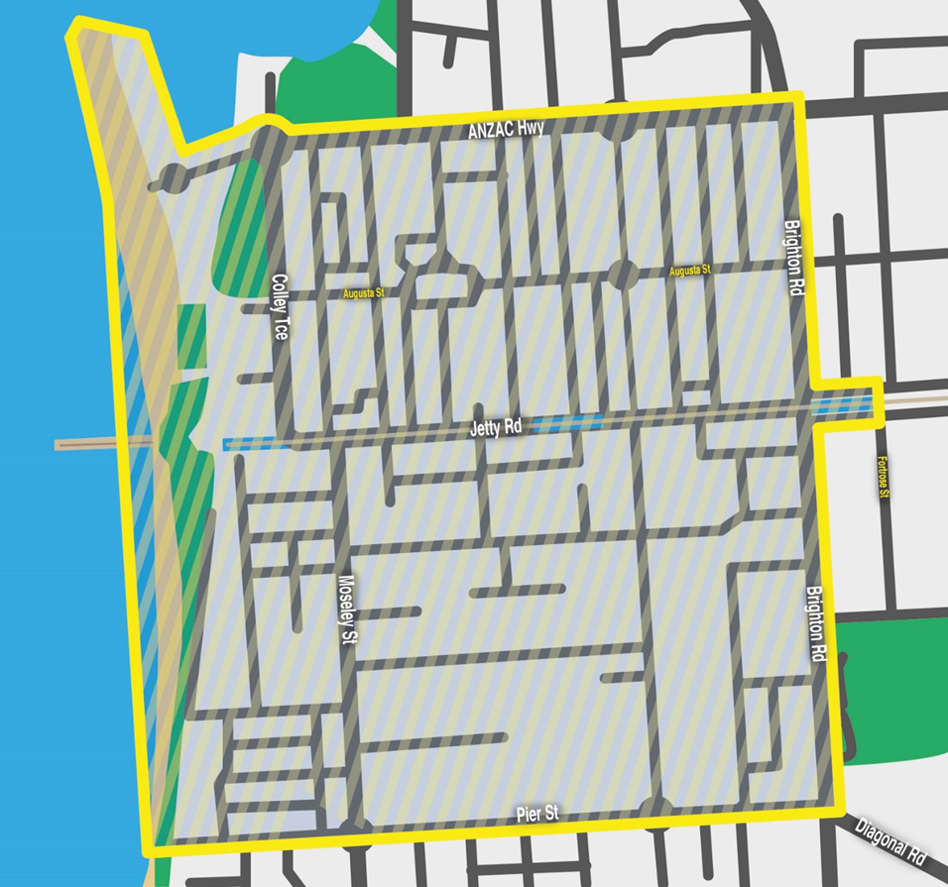

Water Industry Act 2012
South Australian Water Corporation
Fees and Charges
Pursuant to Section 36 of the Water Industry Act 2012 the following charges for water, sewerage and associated services apply. These charges are fixed for the period 11 July 2024 to 30 June 2025.
Pursuant to the Water Industry Regulations 2012 (Regulations 38) and Government Gazette 6 June 2013, SA Water may levy an availability charge despite the fact that the land is not connected to SA Water’s infrastructure. All charges for sewerage services are based on the property valuation of the land. Property values are set annually by the Valuer-General for the next financial year.
Water Fees and Charges
Cape Jaffa Water Supply Area
Description | Charge
Availability Charge (Fixed Charge) | $99.75 per quarter
Water use charge | $3.14 per kilolitre
Scales for Calculation of Sewerage Charge
Quarterly sewerage charges (fixed charges) are based on the greater of the minimum charge or property-based charge (if not otherwise specified in this Gazette).
Property Based Charge: Scale | Minimum Quarterly Fixed Charge
$0.37125 per $1,000 of capital value | $159.90
Dated: 18 December 2024
D. Ryan
Chief Executive
South Australian Water Corporation

Local Government Instruments

City of Adelaide
Local Government Act 1999
Assigning of Road Name / Changing of Road Name
Notice is hereby given, pursuant to Section 219(4) of the Local Government Act 1999, that on 26 November 2024 Council:
1. Approved the name ‘The Angels Lane’ to the unnamed private road Lettered ‘A’ and ‘C’ on Filed Plan 16026 (which said private road commences at 125 Hindley Street, runs in a southerly direction for approximately 32 metres and then turns and runs in a westerly direction for approximately 120 metres whereupon it meets Morphett Street).
2. Approved changing the name of the public road currently known as ‘The Angels Lane’ to ‘Gallerie Lane’.
Dated: 3 December 2024
Michael Sedgman
Chief Executive Officer

City of Playford
Change of Road Name
Pursuant to Section 219 of the Local Government Act 1999 and under delegated authority, notice is hereby given that the name of a road in Stage 6H of the Playford Alive Estate, as detailed in Deposited Plan 133705, previously recorded as Bursaria Avenue (Road Segment 9145), is hereby changed to Duffield Avenue.
This renaming is in accordance with the approved plan of division DA 292/G052/21 and will take effect on 2 January 2025.
Dated: 19 December 2024
Matt Dineen
Senior Manager, Development Services

City of Prospect
Local Government Act 1999
Assignment of Name to Public Place
Notice is hereby given that, pursuant to Section 219(1) of the Local Government Act 1999 and at its meeting of 10 December 2024, the Council resolved to assign the dual name “Louisa Da Costa Park/Mukanthi Yurntu” to the public place comprising the ‘pocket park’ reserve located along the portion of the road corridor bordering the intersection of Main North Road and Nottage Terrace.
Further information regarding the Council’s decision can be obtained from the Council’s offices and on its website at www.prospect.sa.gov.au
Dated: 19 December 2024
C. White
Chief Executive Officer

Copper Coast Council
Review of Elector Representation
Notice is hereby given that the Copper Coast Council is undertaking a review to determine whether a change of arrangements are required in respect to elector representation, to ensure that the electors of the area are being adequately and fairly represented.
Pursuant to the provisions of Section 12 (7) of the Local Government Act 1999, notice is hereby given that Council has prepared a Representation Report which sets out the elector representation proposal that Council believes should be carried into effect at the next Local Government elections in November 2026 and examines the advantages and disadvantages of the various options available, in regard to the composition and structure of Council and the division of the Council area into wards.
A copy of the Representation Report is available on Council’s website (www.coppercoast.sa.gov.au), or can be inspected and/or purchased at the principal Council Office, 51 Taylor Street, Kadina.
Written submissions are invited from interested persons and should be directed to the Chief Executive Officer, PO Box 396, Kadina 5554 or emailed to info@coppercoast.sa.gov.au, by close of business on Friday, 31 January 2025. Council’s Public Comment Submission Form (also available on the Council’s website) can be utilised.
Further information regarding the elector representation review can be obtained by contacting Katrina Borlace, Director Corporate and Community Services on (08) 8828 1200 or by emailing info@coppercoast.sa.gov.au
Dated: 19 December 2024
D. Strong
Chief Executive Officer

District Council of Kimba
Change of Meeting Date
Notice is hereby given that the District Council of Kimba resolved at its meeting held on 11 December 2024, to change the scheduled January 2025 Council Meeting from Wednesday, 8 January 2025 commencing at 2 pm to Wednesday, 15 January 2025 commencing at 2 pm.
Dated: 19 December 2024
Deb Larwood
Chief Executive Officer

Lower Eyre Council
Liquor Licensing (Dry Areas) Notice 2024
Liquor Licensing Act 1997—Section 131(1a)
1. Short Title
This notice may be cited as the Liquor Licensing (Dry Areas) Notice 2024.
2. Commencement
This notice comes into operation on 31 December 2024.
3. Interpretation
(1) In this notice:
principal notice means the Liquor Licensing (Dry Areas) Notice 2015 published in the Gazette on 5.1.15, as in force from time to time.
(2) Clause 3 of the principal notice applies to this notice as if it were the principal notice.
4. Consumption etc of Liquor Prohibited in Dry Areas
(1) Pursuant to Section 131 of the Act, the consumption and possession of liquor in the area described in the Schedule is prohibited in accordance with the provisions of the Schedule.
(2) The prohibition has effect during the periods specified in the Schedule.
(3) The prohibition does not extend to private land in the area described in the Schedule.
(4) Unless the contrary intention appears, the prohibition of the possession of liquor in the area does not extend to—
(a) a person who is genuinely passing through the area if:
(i) the liquor is in the original container in which it was purchased from licensed premises; and
(ii) the container has not been opened; or
(b) a person who has possession of the liquor in the course of carrying on a business or in the course of his or her employment by another person in the course of carrying on a business; or
(c) a person who is permanently or temporarily residing at premises within the area or on the boundary of the area and who enters the area solely for the purpose of passing through it to enter those premises or who enters the area from those premises for the purpose of leaving the area.
Schedule—Coffin Bay Area 1
1. Extent of Prohibition
The consumption of liquor is prohibited and the possession of liquor is prohibited.
2. Period of Prohibition
From 9pm on 31 December 2024 to 8am on 1 January 2025.
3. Description of Area
The public area in and adjacent to the town of Coffin Bay bounded as follows:
Commencing at the point at which the prolongation in a straight line of the northern boundary of Section 665 Hd of Lake Wangary intersects the low water mark of Coffin Bay, then generally northerly, easterly, southerly, south-easterly and north-easterly along the low water mark to the point at which it is intersected by the prolongation in a straight line of the western boundary of Section 131 Hd of Lake Wangary, then southerly along that prolongation and boundary of Section 131 to the northern boundary of Lot 57 DP 54186, then generally south-westerly and south-easterly along the northern and south-western boundaries of Lot 57 to the point at which the south-western boundary is intersected by the prolongation in a straight line of the north-western boundary of Section 273 Hd of Lake Wangary, then south-westerly along that prolongation and boundary of Section 273 to the point at which it meets the eastern boundary of Section 295 Hd of Lake Wangary, then south-westerly, north-westerly, north-easterly and north-westerly along the north-eastern and northern boundaries of Section 295 to the western boundary of the Section, then southerly along the western boundaries of Section 295, Lots 212 and 211 of DP 71703, Lot 101 of DP 56785 and Lot 6 DP 25759 to the northern boundary of Section 665 Hd of Lake Wangary, then generally westerly, north-westerly, northerly and westerly along the northern boundary of that Section to the point at which it meets the eastern boundary of Section 667 Hd of Lake Wangary, then westerly along the northern boundary of Section 667, the northern boundary of Section 665 Hd of Lake Wangary and the prolongation in a straight line of the northern boundary of Section 665 to the point of commencement. The area includes the whole of any jetty, boat ramp or other structure that projects below the low water mark from within the area described above (as well as any area beneath such a structure).

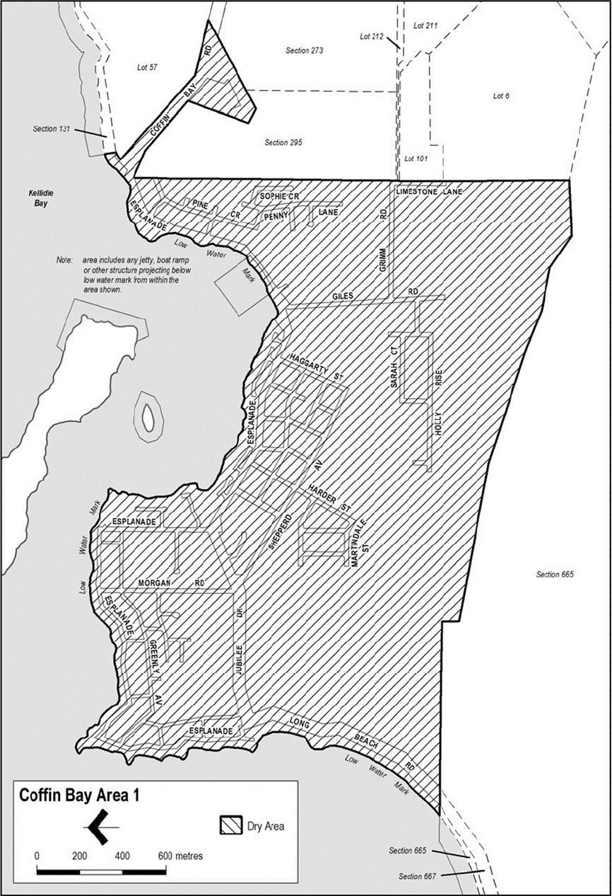
Made by the Lower Eyre Council.
Dated: 12 December 2024
Delfina Lanzilli
Chief Executive Officer

LOWER EYRE Council
Liquor Licensing Act 1997—Section 131(1a)
Liquor Licensing (Dry Areas) Notice 2024
1. Short Title
This notice may be cited as the Liquor Licensing (Dry Areas) Notice 2023.
2. Commencement
This notice comes into operation on 31 December 2024.
3. Interpretation
(1) In this notice:
principal notice means the Liquor Licensing (Dry Areas) Notice 2015 published in the Gazette on 5.1.15, as in force from time to time.
(2) Clause 3 of the principal notice applies to this notice as if it were the principal notice.
4. Consumption etc of Liquor Prohibited in Dry Areas
(1) Pursuant to Section 131 of the Act, the consumption and possession of liquor in the area described in the Schedule is prohibited in accordance with the provisions of the Schedule.
(2) The prohibition has effect during the periods specified in the Schedule.
(3) The prohibition does not extend to private land in the area described in the Schedule.
(4) Unless the contrary intention appears, the prohibition of the possession of liquor in the area does not extend to:
(a) a person who is genuinely passing through the area if:
(i) the liquor is in the original container in which it was purchased from licensed premises; and
(ii) the container has not been opened; or
(b) a person who has possession of the liquor in the course of carrying on a business or in the course of his or her employment by another person in the course of carrying on a business; or
(c) a person who is permanently or temporarily residing at premises within the area or on the boundary of the area and who enters the area solely for the purpose of passing through it to enter those premises or who enters the area from those premises for the purpose of leaving the area.
Schedule—Cummins Area 1
1. Extent of Prohibition
The consumption of liquor is prohibited and the possession of liquor is prohibited.
2. Period of Prohibition
From 9pm on 31 December 2024 to 8am on 1 January 2025.
3. Description of Area
The public area in Cummins bounded as follows:
All in the Hundred of Cummins and within an area as defined as commencing at northwest corner of Allotment 99 in FP 180131 and extending northwards in line with the western boundary of this allotment to a point on the northern boundary of Warrow Road, then heading eastwards and following the boundary of Allotment 550 in DP 66791 until the north corner of Allotment 22 in DP 79231, then heading eastwards across Bratten Way to follow the southern boundary, then the eastern boundary of Allotment 71 in DP 94689 to a point in line with the northern boundary of Section 80, then heading eastwards across the Tod Highway to follow northern and then eastern boundary of Section 80, then heading roughly southeast to the nearest corner of Section 30, then heading eastwards along the northern boundary of Section 30 until reaching a point in line with the northeast corner of Allotment 601 in DP 87427, then heading southwest and following the boundary of Allotment 600 in DP 87427 until the southern corner of Allotment 24 in DP 50626, then heading to a point on the southern boundary of Tumby Bay Road in line with the southeast boundary of Allotment 24 in DP 50626, then heading northwest nd following the southern boundary of Bratten Way up to the northwest corner of Allotment 149 in FP 180181 and then following, in a southerly direction the western boundary of Allotments 10, 11 and 12 in DP 95966 and Allotment 52 in DP 53199 until the southwest corner of Allotment 802 in FP 209177, then heading westwards along and in line with the southern boundary of Allotment 802 in FP 209177 until the western boundary of the Tod Highway, then heading north and following the boundary of Allotment 111 in DP 67442 until, and then following the eastern boundary of Allotment 11 in DP 85166 until the commencement point being the northwest corner of Allotment 99 in FP 180131.

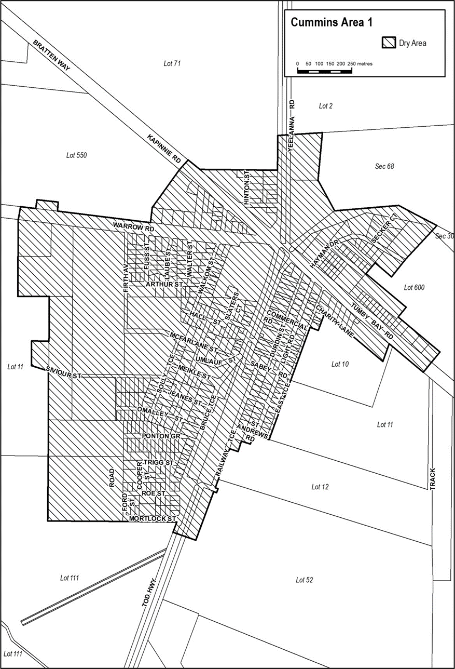
Made by the Lower Eyre Council.
Dated: 12 December 2024
Delfina Lanzilli
Chief Executive Officer

District Council of Yankalilla
Representation Review
Notice is hereby given that the District Council of Yankalilla (the Council) is undertaking a review to determine whether a change of arrangements is required with respect to the Council’s elector representation. The purpose of the review is to ensure that electors of the Council are being adequately and fairly represented.
Pursuant to Section 12(7) of the Local Government Act 1999 (the Act), notice is hereby given that Council has prepared a Representation Report that:
• examines the advantages and disadvantages available to Council in regard to its future composition and structure, in particular whether the number of members should be reduced, and the question whether the council area should be divided into wards; and
• sets out the proposal that the Council considers should be carried into effect at the next Local Government elections scheduled in 2026.
In accordance with Section 12(2) and 12(6) of the Act, the Representation Report also examines and set out a proposal to change the name of the Council to ‘Fleurieu Coast Council’.
A copy of the Representation Report is available on the Council’s community engagement hub at https://www.yoursayyankalilla.com.au or a hard copy can be obtained from the Council Office located at 1 Charles Street, Yankalilla SA.
Written submissions are invited from interested persons. Submissions can be made as follows and will be accepted between 19 December 2024 to 31 January 2025 inclusive.
• Online at: https://www.yoursayyankalilla.com.au
• Addressed to the Chief Executive Officer and delivered in person to 1 Charles Street, Yankalilla SA or via post to PO Box 9, Yankalilla SA 5203
• Emailed to: participate@yankalilla.sa.gov.au
Submissions can also be made at Council’s Australia Day event, to be held at the Village Green, Normanville SA from 9:00am-11:00am on 26 January 2025.
Further information regarding the review can be obtained from Council’s website or by contacting Michyla Lewis on tel. 08 8558 0200.
Dated: 19 December 2024
Nathan Cunningham
Chief Executive Officer

Public Notices

Anglican Church of Australia
Alteration of the Constitution
Notice is hereby given under Section 67(2) of the Constitution of the Anglican Church of Australia that whereas on 13 May 2022 the General Synod of the Anglican Church of Australia duly made:
• Canon No. 7 of 2022 being the Constitution Amendment (Mandatory Suspension) Canon 2022 to alter the Constitution of the Anglican Church of Australia in order to implement recommendation 16.52 of the Royal Commission into Institutional Responses to Child Sexual Abuse relating to the mandatory suspension of persons in ministry who are subject to a plausible complaint of child sexual abuse; and
• Canon No.8 of 2022 being the Constitution Amendment (Mandatory Deposition) Canon 2022 to alter the Constitution of the Anglican Church of Australia in order to implement recommendation 16.56 of the Royal Commission into Institutional Responses to Child Sexual Abuse relating to the mandatory deposition of persons in religious ministry who are convicted of an offence relating to child sexual abuse.
And whereas on 3 December 2024 the President of the General Synod, the Most Rev’d Geoffrey Smith, Archbishop of Adelaide and Metropolitan of the Province of South Australia, determined that there is no condition remaining to which the coming of the Canons into effect is subject.
The said President determined that the said Canons shall come into effect on 10 March 2025.
Dated: 11 December 2024
Anne Hywood
General Secretary
General Synod
Anglican Church of Australia

National Electricity Law
Notice of Final Determinations and Final Rules
Notice of Extension for Making a Draft Determination
The Australian Energy Market Commission (AEMC) gives notice under the National Electricity Law as follows:
Under ss 102, 102A and 103, the making of the National Electricity Amendment (Integrating price-responsive resources into the NEM) Rule 2024 No. 24 (Ref. ERC0352) and related final determination. Provisions of this Rule commence as follows: schedule 1 commences operation on 23 May 2027, schedule 2 commences operation on 31 March 2026, schedule 3 commences operation on 1 January 2026, schedule 4 commences operation on 23 May 2027 and schedule 5 commences operation on 19 December 2024.
Under ss 102, 102A and 103, the making of the National Electricity Amendment (Better integration of gas and community sentiment into the ISP) Rule 2024 No. 25 (Ref. ERC0395) and related final determination. All provisions commence on 19 December 2024.
Under ss 102, 102A and 103, the making of the National Electricity Amendment (Improving consideration of demand-side factors in the ISP) Rule 2024 No. 26 (Ref. ERC0396) and related final determination. All provisions commence on 19 December 2024.
Under s 107, the time for making the draft determination on the Allowing AEMO to accept cash as credit support (Ref. ERC0403) proposal has been extended to 3 April 2025.
Documents referred to above are available on the AEMC’s website and are available for inspection at the AEMC’s office.
Australian Energy Market Commission
Level 15, 60 Castlereagh St
Sydney NSW 2000
19 December 2024
Telephone: (02) 8296 7800
www.aemc.gov.au
Dated:19 December 2024

National Energy Retail Law
Notice of Final Determination
The Australian Energy Market Commission (AEMC) gives notice under the National Energy Retail Law as follows:
Under s 259, the making of the final determination on the Integrating price-responsive resources into the NEM (Ref. RRC0051) proposal. No retail rule was made.
Documents referred to above are available on the AEMC’s website and are available for inspection at the AEMC’s office.
Australian Energy Market Commission
Level 15, 60 Castlereagh St
Sydney NSW 2000
Telephone: (02) 8296 7800
www.aemc.gov.au
Dated: 19 December 2024

National Gas Law
Notice of Final Determination and Final Rule
The Australian Energy Market Commission (AEMC) gives notice under the National Gas Law as follows:
Under ss 311, 312 and 313, the making of the National Gas Amendment (Better integration of gas and community sentiment into the ISP) Rule 2024 No. 7 (Ref. GRC0073) and related final determination. All provisions commence on 19 December 2024.
Documents referred to above are available on the AEMC’s website and are available for inspection at the AEMC’s office.
Australian Energy Market Commission
Level 15, 60 Castlereagh St
Sydney NSW 2000
Telephone: (02) 8296 7800
www.aemc.gov.au
Dated: 19 December 2024

Notice Submission

The South Australian Government Gazette is published each Thursday afternoon.
Notices must be emailed by 4 p.m. Tuesday, the week of publication.
Submissions are formatted per the gazette style and a proof will be supplied prior to publication, along with a quote if applicable. Please allow one day for processing notices.
Alterations to the proof must be returned by 4 p.m. Wednesday.

Gazette notices must be submitted as Word files, in the following format:
• Title—the governing legislation
• Subtitle—a summary of the notice content
• Body—structured text, which can include numbered lists, tables, and images
• Date—day, month, and year of authorisation
• Signature block—name, role, and department/organisation authorising the notice

Please provide the following information in your email:
• Date of intended publication
• Contact details of the person responsible for the notice content
• Name and organisation to be charged for the publication—Local Council and Public notices only
• Purchase order, if required—Local Council and Public notices only

Email: governmentgazettesa@sa.gov.au
Phone: (08) 7133 3552
Website: www.governmentgazette.sa.gov.au

All instruments appearing in this gazette are to be considered official, and obeyed as such

Printed and published weekly by authority of T. Foresto, Government Printer, South Australia
$8.80 per issue (plus postage), $443.00 per annual subscription—GST inclusive
Online publications: www.governmentgazette.sa.gov.au

