
No. 79 p. 4603
THE SOUTH AUSTRALIAN
GOVERNMENT GAZETTE
Published by Authority

Adelaide, Thursday, 12 December 2024

Contents

Governor’s Instruments
Appointments, Resignations and General Matters 4604
Proclamations—
Government Financing Authority (Declaration of
Semi-Government Authority) Proclamation 2024 4609
National Parks and Wildlife (Thidna Conservation
Park) Proclamation 2024 4610
Public Finance and Audit (Declaration of
Semi-Government Authority) Proclamation 2024 4610
South Australian Civil and Administrative Tribunal (Designation of Magistrates as Members of Tribunal) Proclamation 2024 4611
Youth Court (Designation and Classification of
Magistrates) Proclamation 2024 4612
Regulations—
Livestock (Electronic Identification of Sheep and
Goats) Amendment Regulations 2024—
No. 118 of 2024 4613
Fisheries Management (General) (Miscellaneous)
Amendment Regulations 2024—No. 119 of 2024 4642
Fisheries Management (Marine Scalefish Fishery)
(Carriage of Devices on Registered Boat)
Amendment Regulations 2024—
No. 120 of 2024 4652
Fisheries Management (Sardine Fishery) (Quota
Entitlement) Amendment Regulations 2024—
No. 121 of 2024 4653
Fisheries Management (Rock Lobster Fisheries)
(Miscellaneous) Amendment Regulations 2024—
No. 122 of 2024 4655
Fisheries Management (Demerit Points) (Miscellaneous) Amendment Regulations 2024—No. 123 of 2024 4658
Fisheries Management (Sardine Fishery) (Fishing
Zones) Amendment Regulations 2024—
No. 124 of 2024 4662
Fisheries Management (Vessel Monitoring Scheme)
(Sardine Fishery Zones) Amendment
Regulations 2024—No. 125 of 2024 4666
Single-use and Other Plastic Products (Waste Avoidance)
(Food Containers) Amendment Regulations 2024—
No. 126 of 2024 4667
Automated External Defibrillators (Public Access) Regulations 2024—No. 127 of 2024 4669
Rules of Court
Joint Criminal (No 5) Amending Rules 2024 4673
Uniform Special Statutory (No 4) Amending Rules 2024 4699
State Government Instruments
Administrative Arrangements Act 1994 4703
Births, Deaths and Marriages Registration Act 1996 4704
Coast Protection Act 1972 4705
Constitution Act 1934 4707
Crown Land Management Regulations 2024 4784
Energy Resources Act 2000 4786
Fisheries Management Act 2007 4787
Highways Act 1926 4788
Housing Improvement Act 2016 4789
Land Acquisition Act 1969 4790
Passenger Transport Act 1994 4790
Passenger Transport Regulations 2024 4790
Pastoral Land Management and Conservation Act 1989 4791
Planning, Development and Infrastructure Act 2016 4792
Proof of Sunrise and Sunset Act 1923 4809
Retail and Commercial Leases Act 1995 4809
Retirement Villages Act 2016 4810
Return to Work Act 2014 4810
Tobacco and E-Cigarette Products Act 1997 4811
Wilderness Protection Act 1992 4811
Local Government Instruments
Port Adelaide and Enfield Council 4812
City of Salisbury 4812
City of Victor Harbor 4812
District Council of Orroroo Carrieton 4813
District Council of Tumby Bay 4813
Public Notices
National Electricity Law 4816

Governor’s Instruments

Appointments, Resignations and General Matters
Department of the Premier and Cabinet
Adelaide, 12 December 2024
Her Excellency the Governor in Executive Council has been pleased to appoint the Honourable Chief Justice Christopher John Kourakis as Governor’s Deputy of South Australia from 12.00pm on Monday, 6 January 2025 until 11.59pm on Monday, 6 January 2025.
By command,
Dr Susan Elizabeth Close, MP
For Premier

Department of the Premier and Cabinet
Adelaide, 12 December 2024
Her Excellency the Governor in Executive Council has been pleased to appoint the Honourable Andrea Michaels MP, as Acting Treasurer and Acting Minister for Defence and Space Industries, from 11 January 2025 until 20 January 2025 inclusive, during the absence of the Honourable Stephen Campbell Mullighan MP.
By command,
Dr Susan Elizabeth Close, MP
For Premier
T&F24/097CS

Department of the Premier and Cabinet
Adelaide, 12 December 2024
Her Excellency the Governor in Executive Council has been pleased to appoint the Honourable Dr Susan Elizabeth Close MP, as Acting Minister for Trade and Investment, Acting Minister for Local Government and Acting Minister for Veterans’ Affairs, from 16 December 2024 until 20 December 2024 inclusive, during the absence of the Honourable Joseph Karl Szakacs MP.
By command,
Dr Susan Elizabeth Close, MP
For Premier
24MTI007CS

Department of the Premier and Cabinet
Adelaide, 12 December 2024
Her Excellency the Governor in Executive Council has been pleased to appoint the Honourable Anastasios Koutsantonis MP as Acting Deputy Premier from 31 December 2024 until 14 January 2025 inclusive, during the absence of the Honourable Dr Susan Elizabeth Close MP.
By command,
Dr Susan Elizabeth Close, MP
For Premier
DPC24/060CS

Department of the Premier and Cabinet
Adelaide, 12 December 2024
Her Excellency the Governor in Executive Council has been pleased to appoint the Honourable Daniel Roy Cregan MP as Acting Minister for Climate, Environment and Water, Acting Minister for Industry, Innovation and Science and Acting Minister for Workforce and Population Strategy from 31 December 2024 until 14 January 2025 inclusive, during the absence of the Honourable Dr Susan Elizabeth Close MP.
By command,
Dr Susan Elizabeth Close, MP
For Premier
DPC24/060CS

Department of the Premier and Cabinet
Adelaide, 12 December 2024
Her Excellency the Governor in Executive Council has been pleased to appoint the Honourable Blair Ingram Boyer MP as Acting Minister for Aboriginal Affairs, Acting Attorney-General and Acting Minister for Industrial Relations and Public Sector from 4 January 2025 until 14 January 2025 inclusive, during the absence of the Honourable Kyam Joseph Maher MLC.
By command,
Dr Susan Elizabeth Close, MP
For Premier
DPC24/060CS

Department of the Premier and Cabinet
Adelaide, 12 December 2024
Her Excellency the Governor in Executive Council has been pleased to appoint the Honourable Clare Michele Scriven MLC as Acting Minister for Tourism and Acting Minister for Multicultural Affairs from 2 January 2025 until 8 January 2025 inclusive, during the absence of the Honourable Zoe Lee Bettison MP.
By command,
Dr Susan Elizabeth Close, MP
For Premier
DPC24/060CS

Department of the Premier and Cabinet
Adelaide, 12 December 2024
Her Excellency the Governor in Executive Council has been pleased to appoint the Honourable Zoe Lee Bettison MP as Acting Minister for Health and Wellbeing from 13 January 2025 until 17 January 2025 inclusive, during the absence of the Honourable Christopher James Picton MP.
By command,
Dr Susan Elizabeth Close, MP
For Premier
DPC24/060CS

Department of the Premier and Cabinet
Adelaide, 12 December 2024
Her Excellency the Governor in Executive Council has been pleased to appoint the Honourable Katrine Anne Hildyard MP as Acting Minister for Human Services and Acting Minister for Seniors and Ageing Well from 29 December 2024 until 11 January 2025 inclusive, during the absence of the Honourable Natalie Fleur Cook MP.
By command,
Dr Susan Elizabeth Close, MP
For Premier
DPC24/060CS

Department of the Premier and Cabinet
Adelaide, 12 December 2024
Her Excellency the Governor in Executive Council has been pleased to appoint the Honourable Zoe Lee Bettison MP as Acting Minister for Primary Industries and Regional Development and Acting Minister for Forest Industries from 9 January 2025 until 23 January 2025 inclusive, during the absence of the Honourable Clare Michele Scriven MLC.
By command,
Dr Susan Elizabeth Close, MP
For Premier
DPC24/060CS

Department of the Premier and Cabinet
Adelaide, 12 December 2024
Her Excellency the Governor in Executive Council has been pleased to appoint the Honourable Joseph Karl Szakacs MP as Acting Minister for Education, Training and Skills from 24 December 2024 until 3 January 2025 inclusive, during the absence of the Honourable Blair Ingram Boyer MP.
By command,
Dr Susan Elizabeth Close, MP
For Premier
DPC24/060CS

Department of the Premier and Cabinet
Adelaide, 12 December 2024
Her Excellency the Governor in Executive Council has been pleased to appoint the Honourable Blair Ingram Boyer MP as Acting Minister for Trade and Investment, Acting Minister for Local Government and Acting Minister for Veterans’ Affairs from 6 January 2025 until 12 January 2025 inclusive, during the absence of the Honourable Joseph Karl Szakacs MP.
By command,
Dr Susan Elizabeth Close, MP
For Premier
DPC24/060CS

Department of the Premier and Cabinet
Adelaide, 12 December 2024
Her Excellency the Governor in Executive Council has been pleased to appoint Patrick James Clarke Hill, Elizabeth Ann Ferris and John Frederick Clover to the office of Magistrate, effective from 20 January 2025 - pursuant to section 5 of the Magistrates Act 1983.
By command,
Dr Susan Elizabeth Close, MP
For Premier
AGO0257-24CS

Department of the Premier and Cabinet
Adelaide, 12 December 2024
Her Excellency the Governor in Executive Council has been pleased to appoint Barbara Ellen Johns as the Deputy President of the South Australian Civil and Administrative Tribunal for a term of five years, commencing on 19 January 2025 and expiring on 18 January 2030 - pursuant to the provisions of the South Australian Civil and Administrative Tribunal Act 2013.
By command,
Dr Susan Elizabeth Close, MP
For Premier
AGO0256-24CS

Department of the Premier and Cabinet
Adelaide, 12 December 2024
Her Excellency the Governor in Executive Council has been pleased to appoint Snezana Savic as Deputy Registrar of the South Australian Civil and Administrative Tribunal for a term of two years, commencing on 30 January 2025 and expiring on 29 January 2027 - pursuant to the provisions of the South Australian Civil and Administrative Tribunal Act 2013.
By command,
Dr Susan Elizabeth Close, MP
For Premier
AGO0256-24CS

Department of the Premier and Cabinet
Adelaide, 12 December 2024
Her Excellency the Governor in Executive Council has been pleased to appoint Cinzia Aglieco as a Judicial Registrar of the Magistrates Court on a part-time basis, for a term of seven years commencing on 12 December 2024 and expiring on 11 December 2031 - pursuant to section 7AB of the Magistrates Court Act 1991.
By command,
Dr Susan Elizabeth Close, MP
For Premier
AGO0256-24CS

Department of the Premier and Cabinet
Adelaide, 12 December 2024
Her Excellency the Governor in Executive Council has been pleased to appoint Emma Michelle Townsend as the Independent Commissioner Against Corruption, for a term of five years commencing on 3 February 2025 and expiring on 2 February 2030 - pursuant to section 8 of the Independent Commission Against Corruption Act 2012.
By command,
Dr Susan Elizabeth Close, MP
For Premier
AGO0263-24CS

Department of the Premier and Cabinet
Adelaide, 12 December 2024
Her Excellency the Governor in Executive Council has been pleased to appoint Emma Michelle Townsend as the Director of the Office of Public Integrity, for a term of five years commencing on 7 January 2025 and expiring on 6 January 2030 - pursuant to section 18 of the Independent Commission Against Corruption Act 2012.
By command,
Dr Susan Elizabeth Close, MP
For Premier
AGO0263-24CS

Department of the Premier and Cabinet
Adelaide, 12 December 2024
Her Excellency the Governor in Executive Council has been pleased to appoint Vanessa Jane Burrows as the Acting Director of the Office of Public Integrity for a term commencing on 2 January 2025 and expiring on 31 January 2025 - pursuant to section 18 of the Independent Commission Against Corruption Act 2012.
By command,
Dr Susan Elizabeth Close, MP
For Premier
AGO0263-24CS

Department of the Premier and Cabinet
Adelaide, 12 December 2024
Her Excellency the Governor in Executive Council has been pleased to appoint Vanessa Jane Burrows as the Acting Director of the Office of Public Integrity for a term commencing on 3 February 2025 and expiring on 2 May 2025 - pursuant to section 18 of the Independent Commission Against Corruption Act 2012.
By command,
Dr Susan Elizabeth Close, MP
For Premier
AGO0263-24CS

Department of the Premier and Cabinet
Adelaide, 12 December 2024
Her Excellency the Governor in Executive Council has been pleased to appoint Michael Thomas Boylan KC as the Judicial Conduct Commissioner, for a term of three years commencing on 7 January 2025 and expiring on 6 January 2028 - pursuant to section 7 of the Judicial Conduct Commissioner Act 2015.
By command,
Dr Susan Elizabeth Close, MP
For Premier
AGO0249-24CS

Department of the Premier and Cabinet
Adelaide, 12 December 2024
Her Excellency the Governor in Executive Council has been pleased to appoint the undermentioned as Deputy Rail Commissioners - pursuant to section 5 of the Rail Commissioner Act 2009:
Andrew John Excell for a term of five years commencing on 13 December 2024 and expiring on 12 December 2029 or until he ceases to hold the positions of Deputy Chief Executive, Department for Infrastructure and Transport and Executive Director, Transport Strategy and Planning, Department for Infrastructure and Transport, or a position that corresponds with either of these positions, whichever is earlier.
Robert Murray Stopp for a term of five years commencing on 13 December 2024 and expiring on 12 December 2029 or until he ceases to hold the position of Executive Director, Public Transport South Australia, Department for Infrastructure and Transport, or a position that corresponds with that position, whichever is earlier.
Simon Paul Morony for a term of five years commencing on 13 December 2024 and expiring on 12 December 2029 or until he ceases to hold the position of Executive Director, Infrastructure Delivery, Department for Infrastructure and Transport, or a position that corresponds with that position, whichever is earlier.
By command,
Dr Susan Elizabeth Close, MP
For Premier
24MIT0048CS

Department of the Premier and Cabinet
Adelaide, 12 December 2024
Her Excellency the Governor in Executive Council has been pleased to appoint Jennifer Caruso as a member of the Local First Nations Voice for Region 1 - Central, commencing on 12 December 2024 until the next election - pursuant to section 14(4) of the First Nations Voice Act 2023.
By command,
Dr Susan Elizabeth Close, MP
For Premier
AGO0261-24CS

Department of the Premier and Cabinet
Adelaide, 12 December 2024
Her Excellency the Governor in Executive Council has been pleased to appoint Joy Makepeace as a member of the Local First Nations Voice for Region 6 - Yorke and Mid-North, commencing on 12 December 2024 until the next election - pursuant to section 14(4) of the First Nations Voice Act 2023.
By command,
Dr Susan Elizabeth Close, MP
For Premier
AGO0261-24CS

Department of the Premier and Cabinet
Adelaide, 12 December 2024
Her Excellency the Governor in Executive Council has been pleased to appoint the undermentioned as Community Visitors for a term of three years commencing on 12 December 2024 and expiring on 11 December 2027 - pursuant to the Mental Health Act 2009:
Briony Therese Lia
Eimear Caitlin Muir-Cochrane
Helen Jones
Kathryn Joy McPhee
By command,
Dr Susan Elizabeth Close, MP
For Premier
HEAC-2024-00055

Department of the Premier and Cabinet
Adelaide, 12 December 2024
Her Excellency the Governor in Executive Council has been pleased to appoint the undermentioned to the Police Disciplinary Tribunal, pursuant to the provisions of the Police Complaints and Discipline Act 2016:
Panel Member: from 20 January 2025
Patrick James Clarke Hill
Elizabeth Ann Ferris
John Frederick Clover
By command,
Dr Susan Elizabeth Close, MP
For Premier
AGO0257-24CS

Department of the Premier and Cabinet
Adelaide, 12 December 2024
Her Excellency the Governor in Executive Council has been pleased to appoint the undermentioned to the Construction Industry Training Board, pursuant to the provisions of the Construction Industry Training Fund Act 1993:
Member: from 20 December 2024 until 19 December 2027
John Clifford Chapman
Mardi Ann Conduit
Erin Elizabeth Hennessy
William Wreford Frogley
Rebecca Louise Pickering
Chelsea Jane West
Member: from 20 December 2024 until 19 December 2026
Cameron Joel Baker
Stephen Charles Knight
Kelly Margaret Fitzpatrick
Stuart Thomas William Gordon
Gary Edward Henderson
Cassie Marie Manser
Presiding Member: from 20 December 2024 until 19 December 2027
John Clifford Chapman
By command,
Dr Susan Elizabeth Close, MP
For Premier
ME24/122

Proclamations
South Australia

Government Financing Authority (Declaration of Semi-Government Authority) Proclamation 2024
under section 4 of the Government Financing Authority Act 1982
1—Short title
This proclamation may be cited as the Government Financing Authority (Declaration of Semi-Government Authority) Proclamation 2024.
2—Commencement
This proclamation comes into operation on the day on which it is made.
3—Declaration of semi-government authority
The Community Services Sector Long Service Leave Board is declared to be a semi-government authority for the purposes of the Government Financing Authority Act 1982.
Made by the Governor
with the advice and consent of the Executive Council
on 12 December 2024

South Australia

National Parks and Wildlife (Thidna Conservation Park) Proclamation 2024
under section 30(2) of the National Parks and Wildlife Act 1972
1—Short title
This proclamation may be cited as the National Parks and Wildlife (Thidna Conservation Park) Proclamation 2024.
2—Commencement
This proclamation comes into operation on the day on which it is made.
3—Alteration of boundaries of Thidna Conservation Park
The boundaries of the Thidna Conservation Park are altered by adding to the Park the following Crown land:
Allotment 100 in Deposited Plan 117307, Hundred of Carribie, County of Fergusson.
Made by the Governor
with the advice and consent of the Executive Council
on 12 December 2024

South Australia

Public Finance and Audit (Declaration of Semi-Government Authority) Proclamation 2024
under section 17 of the Public Finance and Audit Act 1987
1—Short title
This proclamation may be cited as the Public Finance and Audit (Declaration of Semi-Government Authority) Proclamation 2024.
2—Commencement
This proclamation comes into operation on the day on which it is made.
3—Declaration of semi-government authority
The Community Services Sector Long Service Leave Board is declared to be a semi-government authority for the purposes of the Public Finance and Audit Act 1987.
Made by the Governor
with the advice and consent of the Executive Council
on 12 December 2024
South Australia

South Australian Civil and Administrative Tribunal (Designation of Magistrates as Members of Tribunal) Proclamation 2024
under section 18 of the South Australian Civil and Administrative Tribunal Act 2013
1—Short title
This proclamation may be cited as the South Australian Civil and Administrative Tribunal (Designation of Magistrates as Members of Tribunal) Proclamation 2024.
2—Commencement
This proclamation comes into operation on 20 January 2025.
3—Designation of magistrates as members of Tribunal
The following magistrates holding office under the Magistrates Act 1983 are designated as members of the South Australian Civil and Administrative Tribunal:
Patrick James Clarke Hill
Elizabeth Ann Ferris
John Frederick Clover
Made by the Governor
on the recommendation of the Attorney-General after consultation by the Attorney-General with the President of the South Australian Civil and Administrative Tribunal and the Chief Magistrate and with the advice and consent of the Executive Council
on 12 December 2024

South Australia

Youth Court (Designation and Classification of Magistrates) Proclamation 2024
under section 9 of the Youth Court Act 1993
1—Short title
This proclamation may be cited as the Youth Court (Designation and Classification of Magistrates) Proclamation 2024.
2—Commencement
This proclamation comes into operation on 20 January 2025.
3—Designation and classification of magistrates
The magistrates named in Schedule 1 are—
(a) designated as magistrates of the Youth Court of South Australia; and
(b) classified as members of the Court's ancillary judiciary.
Schedule 1—Magistrates of the Court
Patrick James Clarke Hill
Elizabeth Ann Ferris
John Frederick Clover
Made by the Governor
with the advice and consent of the Executive Council
on 12 December 2024

Regulations
South Australia

Livestock (Electronic Identification of Sheep and Goats) Amendment Regulations 2024
under the Livestock Act 1997

Contents
Part 1—Preliminary
1 Short title
2 Commencement
Part 2—Amendment of Livestock Regulations 2013
3 Amendment of regulation 3—Interpretation
4 Insertion of regulation 3A
3A Harvested rangeland goats
5 Amendment of regulation 58—Register of PICs and pig tattoo codes
6 Amendment of heading to Part 11 Division 1
7 Amendment of regulation 60—Application of Division
8 Amendment of regulation 61—PIDs
9 Amendment of regulation 62—Movement documentation
10 Amendment of regulation 63—NLIS notification before removal of animals from land of pasture
11 Amendment of regulation 64—NLIS notification after animals moved to different land of pasture
12 Amendment of regulation 66—NLIS notification of animals consigned to livestock saleyard for sale
13 Amendment of regulation 69—NLIS notification when animals slaughtered
14 Insertion of Part 11 Division 1A
Division 1A—Electronic identification of sheep and farmed goats
Subdivision 1—Preliminary
71A Application of Division
71B Interpretation
71C Movements of animals to be recorded etc in respect of each animal
Subdivision 2—Electronic identification devices
71D Sheep and farmed goats born before 1 January 2025 to continue to comply with existing provisions
71E Sheep and farmed goats born on or after 1 January 2025 to be identified with eID
71F All sheep and farmed goats to be identified with eID before leaving property from 1 January 2027
71G Animals at livestock saleyards and abattoirs must have eID
Subdivision 3—Movement documentation
71H Movement documentation
71I Animals at livestock saleyards and abattoirs must have movement documentation
Subdivision 4—NLIS notification of movements of sheep and farmed goats
71J NLIS notification before removal of animals from land of pasture
71K NLIS notification after animals moved to different land of pasture
71L NLIS notification of animals consigned to livestock saleyard for sale
71M NLIS notification after animals moved for special event
71N NLIS notification where animals moved to animal holding area
71O NLIS notification when animals slaughtered

Subdivision 5—Harvested rangeland goats
71P Chief Inspector may authorise person to operate goat depot
71Q Offence to operate goat depot unless authorised
71R Movement documentation
71S Harvested rangeland goats at abattoirs must have movement documentation
71T NLIS notification before removal of harvested rangeland goats from goat depot
71V NLIS notification after harvested rangeland goats moved to goat depot or abattoir
71W NLIS notification when harvested rangeland goats slaughtered
Subdivision 6—Miscellaneous
71X Identification of animal at abattoir must be possible until fitness for human consumption assessed
71Y False or misleading statements under this Division
15 Amendment of regulation 74—Removal of livestock in contravention of this Part
16 Amendment or regulation 75—Types of devices
17 Amendment or regulation 76—Authorisation of manufacturers and recyclers
18 Amendment or regulation 77—Supply of tags and devices
19 Amendment of regulation 78—Animal must not have more than 1 PID
20 Insertion of regulation 78A
78A No other form of electronic identification to be fitted to sheep or farmed goats
21 Amendment of regulation 79—PIDs and tags must bear correct information
22 Amendment of regulation 80—Removal and disposal of PIDs
23 Amendment of regulation 81—Replacement of lost devices other than at livestock saleyards
24 Amendment of regulation 82—Offence to alter or deface tags and devices
25 Amendment of regulation 83—Signing of vendor declaration

Part 1—Preliminary
1—Short title
These regulations may be cited as the Livestock (Electronic Identification of Sheep and Goats) Amendment Regulations 2024.
2—Commencement
These regulations come into operation on 1 January 2025.
Part 2—Amendment of Livestock Regulations 2013
3—Amendment of regulation 3—Interpretation
(1) Regulation 3(1), definition of animal holding area—delete the definition and substitute:
animal holding area—
(a) includes a holding yard, assembly point or transit centre; and
(b) does not include a goat depot;
(2) Regulation 3(1), definition of authorised manufacturer—delete "or PIDs" wherever occurring and substitute:
, PIDs or eIDs
(3) Regulation 3(1), definition of authorised recycler—after "PIDs" wherever occurring insert:
or eIDs

(4) Regulation 3(1)—after the definition of destination land insert:
electronic identification device or eID means a device containing a microchip for the permanent identification of sheep or goats obtained from an authorised manufacturer or an authorised recycler or a person authorised under a corresponding law to manufacture or recycle such devices or through an ordering system approved under a corresponding law;
farmed goat means a goat that is kept in a domestic or captive state but does not include a harvested rangeland goat;
Note—
However, a harvested rangeland goat becomes a farmed goat in certain circumstances—see regulation 3A(3).
(5) Regulation 3(1)—after the definition of foundation insert:
goat depot means a place at which harvested rangeland goats are aggregated before their sale or slaughter (not being a place on the property at which the goats are captured);
harvested rangeland goat—see regulation 3A;
(6) Regulation 3(1), definition of non-functioning PID—delete the definition and substitute:
non-function PID or non-functioning eID means, in relation to an electronic PID or an eID, means an electronic PID or eID that fails to provide a reading when scanned;
(7) Regulation 3(1), definition of prescribed movement details—delete ", sheep or goats"
(8) Regulation 3(1), definition of unmanaged goat—delete the definition
(9) Regulation 3(2)—delete ", sheep or goats" first occurring
(10) Regulation 3(2)(a)—delete ", and the type of animals (that is, whether cattle, sheep or goats)"
(11) Regulation 3(2)(f)—delete paragraph (f) and substitute:
(f) the number or code on each animal's PID.
(12) Regulation 3(3)—after paragraph (b) insert:
(ba) a sheep or farmed goat will not be regarded as being pastured on land if—
(i) the animal is held at an animal holding area as part of a consignment of such animals; and
(ii) the consignment leaves the animal holding area not more than 7 days after arrival; and
(iii) there is no change in the consignment of which the animal forms part (other than a change resulting from the death of an animal);
(13) Regulation 3(3)—after paragraph (d) insert:
(da) a requirement to provide to a person, or notify a person of, details comprised of a number or code on an eID will be satisfied if the number or code generated when the eID is scanned is provided;

4—Insertion of regulation 3A
After regulation 3 insert:
3A—Harvested rangeland goats
(1) For the purposes of these regulations, a reference to a harvested rangeland goat will be taken to be a reference to a goat—
(a) that is captured from a wild state (however described); and
(b) the capture of which satisfies any requirements determined by the Chief Inspector by notice in the Gazette for the purposes of this paragraph.
(2) Without limiting the requirements that may be determined by the Chief Inspector under subregulation (1)(b), such requirements may include—
(a) a requirement that a goat be captured, or not be captured, in a specified part of the State; or
(b) a requirement that a goat was not born as part of a managed breeding program.
(3) However, a goat ceases to be a harvested rangeland goat, and will be taken to be a farmed goat, if any of the following occurs:
(a) the goat is held at the place at which it was captured from a wild state for more than 42 days;
(b) the goat is moved from the place at which it was captured from a wild state to anywhere other than a goat depot or abattoir;
(c) the goat is held at a goat depot for a period of more than 10 days;
(d) the goat is moved from a goat depot to a place (including, to avoid doubt, to another goat depot) other than an abattoir;
(e) the goat is subjected to animal husbandry practices (however described) at any point following its capture from a wild state;
(f) the goat is provided with any form of veterinary treatment following its capture from a wild state.
5—Amendment of regulation 58—Register of PICs and pig tattoo codes
Regulation 58(4)(c)—delete paragraph (c) and substitute:
(c) to a regional landscape board for the purposes of the performance of functions under the Landscape South Australia Act 2019 relating to the containment of livestock; or
6—Amendment of heading to Part 11 Division 1
Heading to Part 11 Division 1—delete ", sheep and goats"

7—Amendment of regulation 60—Application of Division
(1) Regulation 60—delete ", sheep and goats"
(2) Regulation 60—after its present contents insert:
Note—
This Division, as in force immediately before the commencement of the Livestock (Electronic Identification of Sheep and Goats) Amendment Regulations 2024, may continue to apply to certain sheep and goats born before 1 January 2025—see regulation 71B.
8—Amendment of regulation 61—PIDs
(1) Regulation 61(1)(b)—delete paragraph (b)
(2) Regulation 61(3)—delete subregulation (3)
9—Amendment of regulation 62—Movement documentation
(1) Regulation 62(1)(b)—delete paragraph (b)
(2) Regulation 62(6), definition of prescribed details, (a)—delete "(that is, whether cattle, sheep or goats)"
(3) Regulation 62(6), definition of prescribed details, (f)(i) and (ii)—delete subparagraphs (i) and (ii)
10—Amendment of regulation 63—NLIS notification before removal of animals from land of pasture
Regulation 63(c)—delete paragraph (c)
11—Amendment of regulation 64—NLIS notification after animals moved to different land of pasture
(1) Regulation 64(1)(a)(ii)—delete subparagraph (ii)
(2) Regulation 64(1)(b)(ii)(E)—delete subsubparagraph (E)
(3) Regulation 64(1)(d)(iv)(A)—delete subsubparagraph (A)
12—Amendment of regulation 66—NLIS notification of animals consigned to livestock saleyard for sale
Regulation 66(1)(b)(ii)(B)—delete subsubparagraph (B)
13—Amendment of regulation 69—NLIS notification when animals slaughtered
Regulation 69(1)(b)(ii)—delete subparagraph (ii)

14—Insertion of Part 11 Division 1A
After regulation 71 insert:
Division 1A—Electronic identification of sheep and farmed goats
Subdivision 1—Preliminary
71A—Application of Division
Except where a provision expressly provides otherwise, this Division applies only to sheep and farmed goats.
71B—Interpretation
In this Division—
prescribed movement details means—
(a) in relation to sheep or farmed goats—
(i) the number of animals and the type of animals (that is, sheep or farmed goats) being moved; and
(ii) the number or code of each animal's eID; and
(iii) the serial number of the national vendor declaration (if any) accompanying the animals during their movement; and
(iv) the date on which the animals are being moved; and
(v) the identification code of the land of dispatch; and
(vi) the identification code of the destination land;
(b) in relation to harvested rangeland goats—
(i) the number of animals being moved; and
(ii) the serial number of the national vendor declaration accompanying the animals during their movement; and
(iii) the identification code of the land of dispatch; and
(iv) the identification code of the destination land; and
(v) —
(A) in the case where the animals are moved to a goat depot—the date on which the animals are being moved; or
(B) in the case where the animals are moved to an abattoir—the date on which the animals are slaughtered.

71C—Movements of animals to be recorded etc in respect of each animal
Except where a particular provision of this Division provides otherwise, the movements of sheep and farmed goats are, for the purposes of this Division, to be recorded and provided on the basis of the movements of each individual animal.
Note—
Previously, movements were recorded on a visual, or flock, basis.
Subdivision 2—Electronic identification devices
71D—Sheep and farmed goats born before 1 January 2025 to continue to comply with existing provisions
(1) This regulation applies to—
(a) sheep and farmed goats born before 1 January 2025; and
(b) in the case of farmed goats that were harvested rangeland goats—goats captured from a wild state before 1 January 2025.
Note—
See regulation 3A(3) for when harvested rangeland goats become farmed goats.
(2) Subject to this regulation, each sheep or farmed goat to which this regulation applies must either—
(a) be identified with a PID in accordance with Part 11 Division 1 (as in force immediately before the commencement of this regulation); or
(b) be identified with an eID in accordance with regulation 71E.
(3) Subject to subregulation (4), in the case where a sheep or farmed goat to which this regulation applies is identified with a PID, Part 11 Division 1 (as in force immediately before the commencement of this regulation) will be taken to continue apply in relation to the sheep or farmed goat as if it had not been amended by the Livestock (Electronic Identification) Amendment Regulations 2024.
Note—
Consequently, this Division does not apply in relation to those animals.
(4) In the case where a sheep or farmed goat to which this regulation applies is identified with an eID (including an animal to which both a PID and an eID is attached)—
(a) subregulation (3) will cease to apply in relation to the sheep or farmed goat; and
(b) this Division will apply in relation to the sheep or farmed goat.

71E—Sheep and farmed goats born on or after 1 January 2025 to be identified with eID
(1) This regulation applies to—
(a) sheep and farmed goats born on or after 1 January 2025; and
(b) in the case of farmed goats that were harvested rangeland goats—goats captured from a wild state on or after 1 January 2025.
Note—
See regulation 3A(3) for when harvested rangeland goats become farmed goats.
(2) Each sheep or farmed goat to which this regulation applies must be identified with an eID in accordance with this regulation.
(3) For the purposes of this Division, a sheep or farmed goat will not be taken to be identified with an eID unless—
(a) in the case of a sheep—an eID is attached to an ear of the sheep in accordance with any instructions of the manufacturer of the eID; or
(b) in the case of a farmed goat—
(i) an eID is attached to an ear of the goat in accordance with the instructions of the manufacturer of the eID; or
(ii) an eID consisting of a hock band is attached to a hock of the goat in accordance with any instructions of the manufacturer of the eID.
(4) The owner or person responsible for the management of a sheep or farmed goat to which this regulation applies must not bring the animal into the State or remove the animal from land on which it has been pastured unless the animal is identified with an eID.
Maximum penalty: $5 000.
Expiation fee: $315.
(5) To avoid doubt, nothing in this regulation prevents—
(a) a sheep or farmed goat born before 1 January 2025 from being identified with an eID; or
(b) a visual management tag from being applied to a sheep or farmed goat to which this regulation applies.
71F—All sheep and farmed goats to be identified with eID before leaving property from 1 January 2027
From 1 January 2027 onwards, the owner or person responsible for the management of a sheep or farmed goat must not bring the animal into the State or remove the animal from land on which it has been pastured unless the animal is identified with an eID.
Maximum penalty: $5 000.
Expiation fee: $315.

71G—Animals at livestock saleyards and abattoirs must have eID
(1) If a sheep or farmed goat at a livestock saleyard or abattoir is not identified with an eID, the owner and the person responsible for the management of the animal immediately before its movement to the saleyard or abattoir are each guilty of an offence.
Maximum penalty: $5 000.
Expiation fee: $315.
(2) If, at a livestock saleyard, a sheep or farmed goat that is not identified with an eID is sold, the saleyard operator, the stock agent acting on behalf of the vendor and the person responsible for the management of the animal at the saleyard are each guilty of an offence.
Maximum penalty: $5 000.
Expiation fee: $315.
(3) If, at an abattoir, a sheep or farmed goat animal that is not identified with an eID is slaughtered, the operator of the abattoir and the person responsible for the management or slaughter of the animal are each guilty of an offence.
Maximum penalty: $5 000.
Expiation fee: $315.
(4) However, no offence is committed under subregulation (3) if the operator of the abattoir notifies an inspector, before the slaughter, of the omission and of as many prescribed movement details relating to the movement of the sheep or farmed goat to the abattoir as may be reasonably ascertained in the circumstances.
(5) If a sheep or farmed goat at a livestock saleyard bears a non-functioning eID, the operator of the saleyard or a stock agent may cause the animal to be identified with a replacement eID bearing the identification code of the saleyard.
(6) Before a sheep or farmed goat that is not identified with an eID, or bears a non-functioning eID, is removed from a livestock saleyard—
(a) the operator of the saleyard or a stock agent must, if the animal is not identified with an eID, cause the animal to be identified with a replacement eID bearing the identification code of the saleyard; and
(b) the operator of the saleyard must notify the NLIS database manager of—
(i) the prescribed movement details relating to the movement of the animal to the saleyard (including, in the case of a non-functioning eID, the number or code on that eID); and
(ii) the number or code on any replacement eID.
Maximum penalty: $5 000.
Expiation fee: $315.

(7) If an animal is identified with a replacement eID under subregulation (5) or (6), the saleyard operator or stock agent must make, and keep for at least 2 years, a written record of—
(a) the prescribed movement details relating to the movement of the animal to the saleyard; and
(b) the name of the person responsible for causing the animal to be identified with the replacement eID; and
(c) the date on which the eID was attached or inserted; and
(d) the name of the vendor of the animal.
Maximum penalty: $5 000.
Expiation fee: $315.
Subdivision 3—Movement documentation
71H—Movement documentation
(1) For the purposes of this Division, movement documentation, in relation to sheep or farmed goats being moved, must, subject to this regulation, comprise—
(a) either—
(i) a copy of the vendor declaration completed in relation to the animals; or
(ii) a document containing—
(A) the prescribed details in relation to the animals; and
(B) the name and signature of the person completing the document; and
(b) in the case of sheep other than sheep consigned direct from a livestock saleyard outside the State to an abattoir in the State for slaughter—a sheep health statement.
(2) In the case where sheep or farmed goats arrive at an animal holding area, the vendor declaration, or the documents referred to in subregulation (1)(a)(ii), (as the case requires) in relation to the animals must also include the PIC of the animal holding area.
(3) The owner or person responsible for the management of sheep or farmed goats that are brought into this State or removed from land on which they have been pastured (the consignor), is guilty of an offence unless movement documentation that complies with this regulation in relation to the animals—
(a) accompanies the animals during their movement; and

(b) is provided to a person (the consignee) as follows:
(i) if the animals are brought into the State or removed for the purposes of sale by a stock agent—to the stock agent;
(ii) if the animals are brought into the State or removed for the purposes of direct sale to a purchaser—to the purchaser or the person responsible for the management of the animals following the sale;
(iii) if the animals are brought into the State or removed for the purposes of their movement to an abattoir or prescribed premises—
(A) to the person responsible for the management of the animals following their movement; and
(B) to the operator of the abattoir or prescribed premises;
(iv) in any other case—to the person responsible for the management of the animals following their movement.
Maximum penalty: $5 000.
Expiation fee: $315.
(4) If animals at a livestock saleyard are sold by a stock agent, a copy of the movement documentation, or a document containing the prescribed movement details, relating to the movement of the animals to the saleyard must be provided by the agent to a person (the consignee) as follows:
(a) if the animals are to be consigned direct to an abattoir for slaughter—
(i) to the person responsible for the management of the animals at the abattoir; and
(ii) to the operator of the abattoir,
by the end of the day of sale;
(b) in any other case—to the purchaser or the person responsible for the management of the animals following the sale within 2 days after the sale.
Maximum penalty: $5 000.
Expiation fee: $315.
(5) Without limitation, a stock agent will be taken to have complied with subregulation (4) if, within the period specified, the agent has—
(a) uploaded the copy of the documentation to the NLIS database; and
(b) notified the consignee of that upload.

(6) Records of documentation under this regulation must be kept as follows:
(a) a consignor must keep a copy of the movement documentation relating to the consignment for at least 7 years;
(b) a consignee (other than the operator of an abattoir or the person in charge of a special event) must keep a copy of the movement documentation relating to the consignment for at least 7 years;
(c) a consignee who is the operator of an abattoir or the person in charge of a special event must keep a copy of the movement documentation relating to the consignment for at least 2 years.
Maximum penalty: $5 000.
Expiation fee: $315.
(7) In this regulation—
prescribed details, in relation to animals being moved, means—
(a) the number and type of animals (that is, sheep or farmed goats) being moved; and
(b) the breed, gender and approximate age of the animals; and
(c) the date on which the animals are being moved; and
(d) the identification code of the land of dispatch; and
(e) the identification code of the destination land (or the address or a description of the location of that land); and
(f) the serial number of the national vendor declaration (if any) accompanying the animals during their movement; and
(g) the date on which the documentation is completed.
71I—Animals at livestock saleyards and abattoirs must have movement documentation
(1) If, at a livestock saleyard, a sheep or farmed goat in respect of which movement documentation relating to the movement of the animal to the saleyard has not been provided as required under regulation 71H is sold, the saleyard operator, the stock agent acting on behalf of the vendor and the person responsible for the management of the animal at the saleyard are each guilty of an offence.
Maximum penalty: $5 000.
Expiation fee: $315.
(2) If, at an abattoir, a sheep or farmed goat in respect of which—
(a) in the case of an animal that was moved direct to the abattoir from land on which it was pastured—movement documentation relating to the movement of the animal to the abattoir has not been provided as required under regulation 71H(3); or

(b) in the case of an animal that was moved direct to the abattoir from a livestock saleyard to which it was consigned for sale and kept for a period not exceeding 7 days—documentation relating to the movement of the animal to the saleyard has not been provided as required under regulation 71H(4),
is slaughtered, the operator of the abattoir and the person responsible for the management or slaughter of the animal are each guilty of an offence.
Maximum penalty: $5 000.
Expiation fee: $315.
(3) However, no offence is committed under subregulation (2) if the operator of the abattoir notifies an inspector, before the slaughter, of the omission and of as many prescribed movement details relating to the movement of the sheep or farmed goat to the abattoir as may be reasonably ascertained in the circumstances.
Subdivision 4—NLIS notification of movements of sheep and farmed goats
71J—NLIS notification before removal of animals from land of pasture
If a sheep or farmed goat is pastured on land (other than land on which it was bred), the owner or person responsible for the management of the animal must not remove the animal from that land unless the NLIS database manager has been notified of—
(a) the number or code on the animal's eID; and
(b) the identification code of the land.
Maximum penalty: $5 000.
Expiation fee: $315.
71K—NLIS notification after animals moved to different land of pasture
(1) Subject to this regulation, if a sheep or farmed goat is removed from land on which it has been pastured (the land of dispatch) and pastured on other land (the destination land), the following provisions apply:
(a) if the land of dispatch is land or premises other than prescribed premises or a port for live export, the owner or person responsible for the management of the animal after its arrival at the destination land must notify the NLIS database manager of the prescribed movement details relating to the movement of the animal to the destination land within 2 days after the arrival of the animal at the destination land, or before the animal is removed from the destination land, whichever occurs earlier;

(b) if the destination land is prescribed premises (other than prescribed premises of a kind contemplated by regulation 71M or 71N), the operator of the prescribed premises must notify the NLIS database manager, within 2 days after the arrival of the animal at the premises, of—
(i) in the case of prescribed premises comprised of a pound—
(A) the date of impoundment; and
(B) the identification code of the pound; and
(C) the identification code of the land on which the animal was last pastured, or, if that code is not known, the identification code approved by the Chief Inspector for use in the circumstances as a default code; and
(D) the number or code on each animal's eID including, in the case of an animal that arrived at the pound without being identified with an eID, the number or code of the replacement eID attached to the animal at the pound; and
(E) the total number of animals in the consignment (including the animal); and
(ii) in any other case—
(A) the prescribed movement details relating to the movement of the animal to the prescribed premises; and
(B) the date of arrival of the animal at the prescribed premises;
(c) if the land of dispatch is prescribed premises other than an animal feedlot and the destination land is land or premises other than a port for live export, the operator of the prescribed premises must notify the NLIS database manager, within 2 days after the removal of the animal from the prescribed premises, of the prescribed movement details relating to the movement of the animal to the destination land;
(d) if the land of dispatch is a live export depot and the destination land is a port for live export, the operator of the depot must, within 2 days after the removal of the animal from the depot, notify the NLIS database manager of—
(i) the date of removal of the animal; and
(ii) the identification code of the depot; and
(iii) the identification code of the port; and
(iv) the number or code on each animal's eID.

Maximum penalty: $5 000.
Expiation fee: $315.
(2) The owner or person responsible for the management of an animal after its arrival at prescribed premises must provide the operator of the premises with information necessary for that person to comply with subregulation (1)(b).
Maximum penalty: $5 000.
Expiation fee: $315.
(3) The owner or person responsible for the management of an animal after its removal from prescribed premises must provide the operator of the premises with information necessary for that person to comply with subregulation (1)(c) or (1)(d).
Maximum penalty: $5 000.
Expiation fee: $315.
(4) If the owner or person responsible for the management of an animal becomes aware that information provided to the operator of prescribed premises or the NLIS database manager in respect of the animal under this regulation is inaccurate or incomplete or that the animal was not moved direct to the destination contemplated at the time the information was provided, the person must, as soon as practicable, notify the NLIS database manager of the correct or complete information.
Maximum penalty: $5 000.
Expiation fee: $315.
(5) It is not a defence to a charge of an offence under this regulation comprised of a failure to notify the NLIS database manager of the identification code of destination land to establish that an identification code had not previously been allotted to the land.
(6) For the purposes of this regulation, if an animal is removed from land of dispatch and unloaded at any other land or premises (including a livestock saleyard) during transit, that other land or premises will be taken to be the destination land.
71L—NLIS notification of animals consigned to livestock saleyard for sale
(1) The following provisions apply in relation to sheep and farmed goats consigned to a livestock saleyard for sale:
(a) by the end of each day on which animals are offered for sale at the saleyard, the operator of the saleyard must notify the NLIS database manager—
(i) for each animal that arrives at the saleyard and is sold at the saleyard on that day, of—
(A) the prescribed movement details relating to the movement of the animal to the saleyard; and

(B) the date of the sale; and
(ii) for each animal that arrives at the saleyard but is not sold at the saleyard on that day, of—
(A) the prescribed movement details relating to the movement of the animal to the saleyard; and
(B) the date of the arrival; and
(C) in addition, in the case of an animal that was dead on arrival—the identification code approved by the Chief Inspector for use in the circumstances as a default deceased code;
(b) the operator of the saleyard must, for each animal sold at the saleyard, update the entry in the database for the animal with details as follows:
(i) if, by the end of the day of sale of the animal, the operator is aware of the destination land for the animal, the operator must—
(A) if the destination land is an abattoir—by the end of that day; or
(B) in any other case—within 2 days after the sale,
update the entry with the identification code of that land and the total number of animals in the consignment (including the animal) that are to be or have been moved direct to that land;
(ii) if, by the end of the day of sale of the animal, the operator is not aware of the destination land for the animal, the operator must, within 2 days after the sale, update the entry with—
(A) the identification code of the stock agent acting on behalf of the purchaser of the animal, or, if no such agent was used, the stock agent acting on behalf of the vendor of the animal; and
(B) the total number of animals in the consignment (including the animal) that are to be or have been moved direct to the destination land;
(c) if the operator of the saleyard updates the entry in the database for an animal with the identification code of a stock agent under paragraph (b)(ii)(A), the operator must ensure that the stock agent is aware that their identification code has been used for that purpose;

(d) before, or as soon as practicable (and, in any event, within 2 days) after, an animal that has not been sold at the saleyard is removed from the saleyard, the operator of the saleyard must update the entry in the database for that animal with the identification code of the destination land for the animal;
(e) before, or as soon as practicable (and, in any event, within 2 days) after an animal that has died at the saleyard is disposed of at the saleyard or removed from the saleyard, the operator of the saleyard must update the entry in the database for that animal with the identification code approved by the Chief Inspector for use in the circumstances as a default deceased code;
(f) if the operator of the saleyard becomes aware that information provided to the NLIS database manager is inaccurate or incomplete through an omission or error made by the operator, the operator must, as soon as practicable, provide the correct or complete information.
Maximum penalty: $5 000.
Expiation fee: $315.
(2) A person (whether or not a stock agent) who offers a sheep or farmed goat for sale at a livestock saleyard must provide the operator of the saleyard with information necessary for the operator to comply with subregulation (1).
Maximum penalty: $5 000.
Expiation fee: $315.
(3) A person (whether or not a stock agent) who purchases a sheep or farmed goat at a livestock saleyard must comply with the following provisions:
(a) if the destination land for the animal has been determined before the end of the day of the purchase, the person must, on that day, notify the operator of the saleyard of the identification code of that land;
(b) if the destination land for the animal has not been determined before the end of the day of the purchase, the person must, on that day, notify the operator of the saleyard of the identification code of the stock agent acting on behalf of the purchaser, or, if no such agent was used, the stock agent acting on behalf of the vendor.
Maximum penalty: $5 000.
Expiation fee: $315.

(4) If a person notifies the saleyard operator of the identification code of destination land under subregulation (3)(a), the agent must, as soon as practicable (and, in any event, within 2 days) after that notification, give written notice to the purchaser of the animal setting out details of the identification code provided.
Maximum penalty: $5 000.
Expiation fee: $315.
Note—
The notice may be included on an invoice.
(5) If a person notifies the saleyard operator of the identification code of a stock agent under subregulation (3)(b), the person must ensure that the stock agent is aware that their identification code has been used for that purpose.
Maximum penalty: $5 000.
Expiation fee: $315.
(6) A stock agent whose identification code has been provided to the saleyard operator under subregulation (3)(b) must, before, or as soon as practicable (and, in any event, within 2 days) after, the sheep or farmed goat is removed from the saleyard, notify the NLIS database manager of the identification code of the destination land for the animal.
Maximum penalty: $5 000.
Expiation fee: $315.
(7) If a stock agent notifies the NLIS database manager of the identification code of destination land under subregulation (6), the agent must, as soon as practicable (and, in any event, within 2 days) after that notification, give written notice to the purchaser of the sheep or farmed goat setting out details of the identification code provided.
Maximum penalty: $5 000.
Expiation fee: $315.
Note—
The notice may be included on an invoice.
(8) It is not a defence to a charge of an offence against subregulation (3) to establish that an identification code had not previously been allocated in respect of the land or person concerned.
(9) A person selling or purchasing a sheep or farmed goat through a stock agent must provide the stock agent with information necessary for the stock agent to comply with this regulation.
Maximum penalty: $5 000.
Expiation fee: $315.

(10) If the purchaser of a sheep or farmed goat becomes aware that information provided to the operator of a livestock saleyard or the NLIS database manager in respect of the animal under this regulation is inaccurate or incomplete or that an animal was not moved direct to the destination land contemplated at the time the information was provided, the purchaser must, as soon as practicable, notify the NLIS database manager of the correct or complete information.
Maximum penalty: $5 000.
Expiation fee: $315.
(11) For the purposes of this regulation, until 30 June 2025—
(a) a reference in this regulation to the prescribed movement details in relation to an animal will be taken to be a reference to the prescribed movement details of the animal within the meaning of regulation 3(2) (as in force immediately before the commencement of this regulation); and
(b) a reference in this regulation to "2 days" (other than in subregulation (6)) will be taken to be a reference to 2 working days; and
(c) a reference in subregulation (6) to "2 days" will be taken to be a reference to 7 working days,
and this subregulation expires on 1 July 2025.
71M—NLIS notification after animals moved for special event
(1) Subject to this regulation, if a sheep or farmed goat is removed from land on which it has been pastured (the land of dispatch) and held on prescribed premises for the purposes of a special event before their direct return to the land of dispatch, the operator of the prescribed premises must notify the NLIS database manager, within 2 days after the arrival of the animal at the premises, of—
(a) the date of the animal's arrival at the prescribed premises; and
(b) the date or dates on which the animals are present at the special event; and
(c) the number and type of animals (that is, sheep or farmed goats) being moved; and
(d) the number or code on each animal's eID; and
(e) the identification code of the prescribed premises.
Maximum penalty: $5 000.
Expiation fee: $315.

(2) The owner or person responsible for the management of a sheep or farmed goat after its arrival at prescribed premises must provide the operator of the premises with information necessary for that person to comply with subregulation (1).
Maximum penalty: $5 000.
Expiation fee: $315.
(3) If the owner or person responsible for the management of a sheep or farmed goat becomes aware that information provided to the operator of prescribed premises or the NLIS database manager in respect of the animal under this regulation is inaccurate or incomplete or that the animal was not moved direct to the destination contemplated at the time the information was provided, the person must, as soon as practicable, notify the NLIS database manager of the correct or complete information.
Maximum penalty: $5 000.
Expiation fee: $315.
(4) It is not a defence to a charge of an offence under this regulation comprised of a failure to notify the NLIS database manager of the identification code of prescribed premises to establish that an identification code had not previously been allotted to the relevant land.
(5) For the purposes of this regulation, if a sheep or farmed goat is removed from land of dispatch and unloaded at any other land or premises (including a livestock saleyard) during transit, that other land or premises will be taken to be the destination land.
(6) However, subregulation (5) does not apply to the unloading of sheep or farmed goats at an animal holding area in accordance with regulation 71N.
71N—NLIS notification where animals moved to animal holding area
(1) Subject to this regulation, if a sheep or farmed goat is removed from land on which it has been pastured (the land of dispatch) and held in an animal holding area, the operator of the animal holding area must notify the NLIS database manager, within 2 days after the arrival of the animal at the animal holding area, of—
(a) the date of the animal's arrival at the animal holding area; and
(b) the number and type of animals (that is, sheep or farmed goats) being moved; and
(c) the number or code on each animal's eID; and
(d) the identification code of the animal holding area; and
(e) in the case of an animal that was dead on arrival—the identification code approved by the Chief Inspector for use in the circumstances as a default deceased code.
Maximum penalty: $5 000.
Expiation fee: $315.

(2) The owner or person responsible for the management of a sheep or farmed goat after its arrival at an animal holding area must provide the operator of the premises with information necessary for that person to comply with subregulation (1).
Maximum penalty: $5 000.
Expiation fee: $315.
(3) If a sheep or farmed goat dies at animal holding area, the operator of the animal holding area must as soon as practicable (and, in any event, within 2 days) update the entry in the database for that animal with—
(a) the prescribed movement details relating to the movement of the animal to the animal holding area; and
(b) the identification code approved by the Chief Inspector for use in the circumstances as a default deceased code.
Maximum penalty: $5 000.
Expiation fee: $315.
(4) If—
(a) a sheep or farmed goat remains at an animal holding area for a period of more than 7 days; or
(b) there is a change in the sheep or farmed goats comprising the consignment,
then—
(c) the operator of the animal holding area must as soon as practicable (and, in any event, within 2 days) notify the NLIS database manager of the prescribed movement details relating to the movement of the animal to the animal holding area; and
(d) the animal holding area will be taken to be the destination land.
Maximum penalty: $5 000.
Expiation fee: $315.
(5) If the owner or person responsible for the management of a sheep or farmed goat becomes aware that information provided to the operator of an animal holding area or the NLIS database manager in respect of the animal under this regulation is inaccurate or incomplete or that the animal was not moved direct to the destination contemplated at the time the information was provided, the person must, as soon as practicable, notify the NLIS database manager of the correct or complete information.
Maximum penalty: $5 000.
Expiation fee: $315.
(6) It is not a defence to a charge of an offence under this regulation comprised of a failure to notify the NLIS database manager of the identification code of an animal holding area to establish that an identification code had not previously been allotted to the animal holding area.

(7) For the purposes of this regulation, if an animal is removed from land of dispatch and unloaded at any other land or premises (including a livestock saleyard) during transit, that other land or premises will be taken to be the destination land.
71O—NLIS notification when animals slaughtered
(1) The operator of an abattoir must, within 2 days after slaughtering a sheep or farmed goat, notify the NLIS database manager of—
(a) the date of slaughter of the animal; and
(b) —
(i) if the animal was moved direct to the abattoir from land on which it was pastured—the prescribed movement details relating to the movement of the animal to the abattoir; or
(ii) if the animal was moved direct to the abattoir from a livestock saleyard to which it had been consigned for sale and at which it had been kept for a period not exceeding 7 days—
(A) the type of animal; and
(B) the total number of animals in the consignment to the abattoir (including the animal); and
(C) the identification code of the saleyard.
Maximum penalty: $5 000.
Expiation fee: $315.
(2) The operator of an abattoir must keep a written record of the details referred to in subregulation (1) (other than those details required to be kept by the operator under regulation 71H(6)) for at least 2 years.
Maximum penalty: $5 000.
Expiation fee: $315.
(3) The owner or person responsible for the management of a sheep or farmed goat at an abattoir must provide the operator of the abattoir with information necessary for the operator to comply with subregulation (1).
Maximum penalty: $5 000.
Expiation fee: $315.

Subdivision 5—Harvested rangeland goats
71P—Chief Inspector may authorise person to operate goat depot
(1) The Chief Inspector may, on application, authorise a person to operate a goat depot.
(2) An application under subregulation (1) must—
(a) be made to the Chief Inspector; and
(b) be in the form and contain or be accompanied by the information required by the Chief Inspector.
(3) A person must not contravene or fail to comply with a condition of an authorisation.
Maximum penalty: $10 000.
Expiation fee: $315.
71Q—Offence to operate goat depot unless authorised
A person must not operate a goat depot unless the person is authorised to do so by the Chief Inspector.
Maximum penalty: $10 000.
Expiation fee: $315.
71R—Movement documentation
(1) For the purposes of this Division, movement documentation, in relation to harvested rangeland goats being moved, must comprise a copy of the vendor declaration completed in relation to the animals.
(2) The owner or person responsible for the management of harvested rangeland goats that are captured from a wild state and moved to a goat depot (the consignor) is guilty of an offence unless movement documentation that complies with subregulation (1) in relation to the animals—
(a) accompanies the animals during their movement; and
(b) is provided to the operator of the goat depot (the consignee).
Maximum penalty: $5 000.
Expiation fee: $315.

(3) The owner or person responsible for the management of harvested rangeland goats that are captured from a wild state and moved to an abattoir (the consignor) is guilty of an offence unless movement documentation that complies with subregulation (1) in relation to the animals—
(a) accompanies the animals during their movement; and
(b) is provided to the operator of the abattoir (the consignee).
Maximum penalty: $5 000.
Expiation fee: $315.
(4) The owner or person responsible for the management of harvested rangeland goats that are brought into this State or removed from a goat depot and moved to an abattoir (the consignor) is guilty of an offence unless movement documentation that complies with subregulation (1) in relation to the animals—
(a) accompanies the animals during their movement; and
(b) is provided to the operator of the abattoir (the consignee).
Maximum penalty: $5 000.
Expiation fee: $315.
(5) Records of documentation under this regulation must be kept as follows:
(a) a consignor must keep a copy of the movement documentation relating to the consignment for at least 7 years;
(b) a consignee must keep a copy of the movement documentation relating to the consignment for at least 2 years.
Maximum penalty: $5 000.
Expiation fee: $315.
71S—Harvested rangeland goats at abattoirs must have movement documentation
(1) If, at an abattoir, a harvested rangeland goat that was moved to the abattoir from the place at which the goat was captured from a wild state or a goat depot is slaughtered and the movement documentation relating to the movement of the animal to the abattoir has not been provided as required under regulation 71R(3) or (4) (as the case requires), the operator of the abattoir and the person responsible for the management or slaughter of the animal are each guilty of an offence.
Maximum penalty: $5 000.
Expiation fee: $315.
(2) However, no offence is committed under subregulation (1) if the operator of the abattoir notifies an inspector, before the slaughter, of the omission and of as many prescribed movement details relating to the movement of the harvested rangeland goat to the abattoir as may be reasonably ascertained in the circumstances.

71T—NLIS notification before removal of harvested rangeland goats from goat depot
If a harvested rangeland goat is held at a goat depot, the owner or person responsible for the management of the animal must not remove the animal from that goat depot unless the NLIS database manager has been notified of the identification code of the goat depot.
Maximum penalty: $5 000.
Expiation fee: $315.
71V—NLIS notification after harvested rangeland goats moved to goat depot or abattoir
(1) Subject to this regulation, if a harvested rangeland goat is captured from a wild state and moved to a goat depot, the operator of the goat depot must notify the NLIS database manager of the prescribed movement details relating to the movement of the animal within 2 days after the arrival of the animal at the goat depot.
Maximum penalty: $5 000.
Expiation fee: $315.
(2) Subject to this regulation, if a harvested rangeland goat is captured from a wild state, or removed from a goat depot, and moved to an abattoir, the operator of the abattoir must notify the NLIS database manager of the prescribed movement details relating to the movement of the animal to the abattoir within 2 days after the arrival of the animal at the abattoir.
Maximum penalty: $5 000.
Expiation fee: $315.
(3) If the operator of a goat depot or abattoir (as the case requires) becomes aware that information provided under this regulation is inaccurate or incomplete or that the animal was not moved direct to the abattoir contemplated at the time the information was provided, the person must, as soon as practicable, notify the NLIS database manager of the correct or complete information.
Maximum penalty: $5 000.
Expiation fee: $315.
(4) It is not a defence to a charge of an offence under this regulation comprised of a failure to notify the NLIS database manager of the identification code of a goat depot or abattoir to establish that an identification code had not previously been allotted to the goat depot or abattoir.
(5) For the purposes of this regulation, if a harvested rangeland goat is removed from a goat depot and unloaded at any other land or premises (including a livestock saleyard) during transit, that other land or premises will be taken to be the destination land.

71W—NLIS notification when harvested rangeland goats slaughtered
(1) The operator of an abattoir must, within 2 days after slaughtering a harvested rangeland goat, notify the NLIS database manager of the prescribed movement details relating to the movement of the animal to the abattoir.
Maximum penalty: $5 000.
Expiation fee: $315.
(2) The operator of an abattoir must keep a written record of the details referred to in subregulation (1) (other than those details required to be kept by the operator under regulation 71R(5)) for at least 2 years.
Maximum penalty: $5 000.
Expiation fee: $315.
(3) The owner or person responsible for the management of a harvested rangeland goat at an abattoir must provide the operator of the abattoir with information necessary for the operator to comply with subregulation (1).
Maximum penalty: $5 000.
Expiation fee: $315.
Subdivision 6—Miscellaneous
71X—Identification of animal at abattoir must be possible until fitness for human consumption assessed
The operator of an abattoir must ensure that the abattoir has in place post-slaughter procedures approved by the Chief Inspector that will enable the determination, at any time until an assessment is made of the fitness for human consumption of the carcass of a sheep, farmed goat or harvested rangeland goat, of—
(a) in the case of an animal that was moved direct to the abattoir from land on which it was pastured—the prescribed movement details relating to the movement of the animal to the abattoir; or
(b) in the case of an animal that was moved direct to the abattoir from a livestock saleyard to which it had been consigned for sale and at which it was kept for a period not exceeding 7 days—the prescribed movement details relating to the movement of the animal to the saleyard.
Maximum penalty: $5 000.
Expiation fee: $315.

71Y—False or misleading statements under this Division
A person must not make a statement that is false or misleading in a material particular (whether by reason of the inclusion or omission of any particular) in any details required to be provided under this Division.
Maximum penalty/expiation fee:
(a) If the person made the statement knowing that it was false or misleading:
Maximum penalty—$10 000.
(b) In any other case:
Maximum penalty—$5 000.
Expiation fee—$315.
15—Amendment of regulation 74—Removal of livestock in contravention of this Part
Regulation 74)1)(a)(ii)—after "PIDs" insert:
or eIDs (as the case requires)
16—Amendment or regulation 75—Types of devices
Regulation 75—after "PID" insert:
or eID (as the case requires)
17—Amendment or regulation 76—Authorisation of manufacturers and recyclers
(1) Regulation 76(a)—delete "or PIDs" and substitute:
, PIDs or eIDs
(2) Regulation 76(b)—after "PIDs" insert:
or eIDs
18—Amendment or regulation 77—Supply of tags and devices
Regulation 77—delete "or PIDs" and substitute:
, PIDs or eIDs
19—Amendment of regulation 78—Animal must not have more than 1 PID
(1) Heading to regulation 78—after "PID" insert:
or eID
(2) Regulation 78—after subregulation (1) insert:
(1a) A person must not attach to or insert in a sheep or farmed goat an eID if the animal already has an eID attached to it.
Maximum penalty: $2 500.
Expiation fee: $210.

(3) Regulation 78(2)—after "of a" insert:
PID that is a
(4) Regulation 78—after subregulation (2) insert:
(3) This regulation does not apply to the attachment of an eID (whether a breeder or post-breeder device) to an animal as a replacement for any non-functioning eID.
20—Insertion of regulation 78A
After regulation 78 insert:
78A—No other form of electronic identification to be fitted to sheep or farmed goats
(1) The owner or person responsible for the management of a sheep or farmed goat that is identified with an eID must, before removing the animal from land on which it is pastured, remove any other device (not being an eID) containing a microchip that is attached to or inserted in the animal.
(2) The owner or person responsible for the management of a sheep or farmed goat that is identified with an eID must not attach to or insert in the animal any other device containing a microchip.
(3) A person who contravenes subregulation (1) or (2) is guilty of an offence.
Maximum penalty: $5 000.
Expiation fee: $315.
(4) Subregulations (1) and (2) apply in relation to a device whether the device is functioning or non-functioning.
21—Amendment of regulation 79—PIDs and tags must bear correct information
(1) Heading to regulation 79—after "PIDs" insert:
, eIDs
(2) Regulation 79(1)—after "PID" wherever occurring insert:
, eID
(3) Regulation 79(2)—after "PID" wherever occurring insert:
or eID
22—Amendment of regulation 80—Removal and disposal of PIDs
(1) Heading to regulation 80—after "PIDs" insert:
and eIDs
(2) Regulation 80(1)—after "PID" insert:
or eID

(3) Regulation 80(2)(b)—after "PID" wherever occurring insert:
or eID
(4) Regulation 80(2)—after paragraph (b) insert:
or
(c) the removal of a PID in accordance with regulation 78A(1).
(5) Regulation 80(3)—after "PIDs" insert:
and eIDs
(6) Regulation 80(4)—after "PID" wherever occurring insert:
or eID
23—Amendment of regulation 81—Replacement of lost devices other than at livestock saleyards
(1) Regulation 81(1)(a)—after "PID" insert:
or eID
(2) Regulation 81(1)(c)—after "PID" wherever occurring insert:
or eID
(3) Regulation 81(3)—after "PID" insert:
or eID
24—Amendment of regulation 82—Offence to alter or deface tags and devices
Regulation 82—delete "or PID" and substitute:
, PID or eID
25—Amendment of regulation 83—Signing of vendor declaration
Regulation 83—after its present contents (now to be designated as subregulation (1)) insert:
(2) However, subregulation (1) does not apply in relation to a vendor declaration relating to harvested rangeland goats.
Editorial note—
As required by section 10AA(2) of the Legislative Instruments Act 1978, the Minister has certified that, in the Minister's opinion, it is necessary or appropriate that these regulations come into operation as set out in these regulations.
Made by the Governor
with the advice and consent of the Executive Council
on 12 December 2024
No 118 of 2024

South Australia

Fisheries Management (General) (Miscellaneous) Amendment Regulations 2024
under the Fisheries Management Act 2007

Contents
Part 1—Preliminary
1 Short title
2 Commencement
Part 2—Amendment of Fisheries Management (General) Regulations 2017
3 Amendment of regulation 3—Interpretation
4 Amendment of regulation 5—Classes of fishing activities prescribed for purposes of section 70 of Act
5 Amendment of regulation 8—Possession of Pipi in vehicles carrying 3 or more persons
6 Insertion of regulation 8A
8A Possession or control of Black Bream in or near waters of Lakes and Coorong during closed season
7 Amendment of regulation 23B—Taking of Murray Cod in certain waters
8 Amendment of regulation 24—Berleying
9 Amendment of regulation 26—Requirement to remove anchors etc from nets removed from Lakes and Coorong Fishery
10 Amendment of regulation 30—Minister's determinations
11 Amendment of regulation 32—Expiation of alleged offences
12 Amendment of Schedule 5—Protected species
13 Amendment of Schedule 6—Classes of fishing activities prescribed for purposes of section 70 of Act
14 Amendment of Schedule 7—Areas in which use of fish nets is prohibited under section 70 of Act
15 Amendment of Schedule 8—Prescribed quantities
16 Amendment of Schedule 11—Expiation fees

Part 1—Preliminary
1—Short title
These regulations may be cited as the Fisheries Management (General) (Miscellaneous) Amendment Regulations 2024.
2—Commencement
These regulations come into operation on 1 January 2025.

Part 2—Amendment of Fisheries Management (General) Regulations 2017
3—Amendment of regulation 3—Interpretation
(1) Regulation 3(1), definition of Coorong coastal waters—delete "from" and substitute:
adjacent to South Australia between
(2) Regulation 3(1), definition of inland waters—after "fresh waters" insert:
other than the waters of a prescribed reservoir
(3) Regulation 3(1), after the definition of Lakes Albert and Alexandrina insert:
Lakes and Coorong means the waters of the Coorong, Lakes Albert and Alexandrina and the Coorong coastal waters;
(4) Regulation 3(1), definition of Lakes and Coorong Fishery—delete "Fisheries Management (Lakes and Coorong Fishery) Regulations 2009" and substitute:
Fisheries Management (Lakes and Coorong Fishery) Regulations 2024
(5) Regulation 3(1)—after the definition of prawn trawl net insert:
prescribed reservoir means the following bodies of water:
(a) Aroona Dam;
(b) Beetaloo Reservoir;
(c) Bundaleer Reservoir;
(d) Happy Valley Reservoir;
(e) Myponga Reservoir;
(f) South Para Reservoir;
(g) Warren Reservoir;
(h) any other reservoir or dam specified by the Minister by notice in the Gazette for the purposes of this definition;
4—Amendment of regulation 5—Classes of fishing activities prescribed for purposes of section 70 of Act
Regulation 5(b)—after subparagraph (ii) insert:
or
(iii) by using a fish net in any waters of the State specified in Schedule 7 Part 3 other than—
(A) a purse seine net used by the holder of a licence in respect of the Marine Scalefish Fishery, registered for use under that licence, for the purpose of taking Salmon provided that—
• no other device registered for use under the licence is in use; and
• the waters in which it is being used are 10 m or more in depth; or

(B) a sardine net used by the holder of a licence in respect of the Sardine Fishery, registered for use under that licence, for the purpose of taking Australian Sardine (Sardinops sagax) or Australian Anchovy (Engraulis australis) provided that—
• only 1 such sardine net is in use; and
• the waters in which it is being used are 10 metres or more in depth.
5—Amendment of regulation 8—Possession of Pipi in vehicles carrying 3 or more persons
Regulation 8(2)(c)—delete "900" and substitute:
990
6—Insertion of regulation 8A
After regulation 8 insert:
8A—Possession or control of Black Bream in or near waters of Lakes and Coorong during closed season
If a person—
(a) is in, or within 50 metres of, the waters of the Lakes and Coorong; and
(b) has possession or control of 1 or more Black Bream (Acanthopagrus butcheri) during the period commencing 1 August in any year and ending on 31 January of the following year,
the person is guilty of an offence.
Maximum penalty:
(a) for a first offence—$10 000;
(b) for a second or subsequent offence—$20 000.
Expiation fee: $315.
7—Amendment of regulation 23B—Taking of Murray Cod in certain waters
Regulation 23B—delete "the River Murray proper and" and substitute:
a prescribed reservoir, the River Murray proper or
8—Amendment of regulation 24—Berleying
(1) Regulation 24, heading—delete "Berleying" and substitute:
Restrictions on use of certain berley and bait
(2) Regulation 24—after subregulation (3) insert:
(3a) A person must not use abalone of any species, or any part of an abalone of any species, as bait or berley in any waters of the State.
Maximum penalty: $2 500.
Expiation fee: $210.

9—Amendment of regulation 26—Requirement to remove anchors etc from nets removed from Lakes and Coorong Fishery
Regulation 26(2)—delete subregulation (2)
10—Amendment of regulation 30—Minister's determinations
Regulation 30(6)—delete subregulation (6) and substitute:
(6) This regulation does not apply in relation to a determination made for the purposes of—
(a) regulation 22; or
(b) paragraph (b) of the definition of designated distance in Schedule 6 clause 101(2).
(7) Subregulations (3)(b) and (4) do not apply in relation to a determination made for the purposes of regulation 23A, 23B, 23C, 23E or 23F.
11—Amendment of regulation 32—Expiation of alleged offences
Regulation 32(2)—after paragraph (b) insert:
or
(c) by using a fish net in any waters of the State specified in Schedule 7 Part 3 other than—
(i) a purse seine net used by the holder of a licence in respect of the Marine Scalefish Fishery, registered for use under that licence, for the purpose of taking Salmon provided that—
(A) no other device registered for use under the licence is in use; and
(B) the waters in which it is being used are 10 m or more in depth; or
(ii) a sardine net used by the holder of a licence in respect of the Sardine Fishery, registered for use under that licence, for the purpose of taking Australian Sardine (Sardinops sagax) or Australian Anchovy (Engraulis australis) provided that—
(A) only 1 such sardine net is in use; and
(B) the waters in which it is being used are 10 metres or more in depth,
12—Amendment of Schedule 5—Protected species
Schedule 5, item relating to Silver Perch (Bidyanus bidyanus)—after "(Bidyanus bidyanus)" insert:
in the waters of the State other than the waters of a prescribed reservoir

13—Amendment of Schedule 6—Classes of fishing activities prescribed for purposes of section 70 of Act
(1) Schedule 6, Part 1, clause 6—after "drum net" insert:
, pyramid net
(2) Schedule 6, Part 1, clause 9(1)—delete "Fisheries Management (Lakes and Coorong Fishery) Regulations 2009" and substitute:
Fisheries Management (Lakes and Coorong Fishery) Regulations 2024
(3) Schedule 6, Part 1, clause 9(2)—delete subclause (2)
(4) Schedule 6, Part 1, clause 18(1)(a)—delete paragraph (a) and substitute:
(a) by using, in waters less than 100 metres in depth, a rock lobster pot that—
(i) is not fitted with a metal rod that is securely fastened to the centroid of the base of the pot and extends perpendicular to a height not less than level with the base of the neck of the pot; or
(ii) does not have a rigid frame rectangular or square in shape with 2 opposing sides opening to not more than 135 millimetres that is securely attached to the inner or outer cove mouth opening of the pot; or
(iii) does not have a rigid frame circular in shape opening to not more than 150 millimetres in diameter securely attached to the inner or outer cove mouth opening of the pot; or
(5) Schedule 6, Part 1, clause 18(2)—delete subclause (2) and substitute:
(2) A rock lobster pot must—
(a) —
(i) weigh not more than 40 kilograms; and
(ii) be not more than 61 centimetres high; and
(iii) be not more than 122 centimetres wide at its base; and
(iv) have its cove mouth at the top; and
(v) be attached by a line to a buoy that complies with regulation 13; or
(b) —
(i) be of a rectangular cuboid shape; and
(ii) be not more than 45 centimetres in height; and
(iii) not have a base with a diagonal measurement of more than 130 centimetres; and
(iv) have its cove mouth at the top; and
(v) be attached to a buoy that complies with regulation 13.

(6) Schedule 6, Part 1, clause 38(1)—delete "Fisheries Management (Lakes and Coorong Fishery) Regulations 2009" and substitute:
Fisheries Management (Lakes and Coorong Fishery) Regulations 2024
(7) Schedule 6, Part 1, clause 38(2)—delete subclause (2)
(8) Schedule 6, Part 2, clause 54(1)(b)—delete paragraph (b) and substitute:
(b) by using, in waters less than 100 metres in depth, a rock lobster pot that—
(i) is not fitted with a metal rod that is securely fastened to the centroid of the base of the pot and extends perpendicular to a height not less than level with the base of the neck of the pot; or
(ii) has a rigid frame, rectangular or square in shape, with 2 opposing sides opening to not more than 135 millimetres that is securely attached to the inner or outer cove mouth opening of the pot; or
(iii) has a rigid frame, circular in shape, opening to not more than 150 millimetres in diameter that is securely attached to the inner or outer cove mouth opening of the pot.
(9) Schedule 6, Part 2, clause 63(2), table, item relating to Golden Perch (Macquaria ambigua)—after "The waters of the State" insert:
other than the waters of a prescribed reservoir
(10) Schedule 6, Part 2, clause 65(1), table, item relating to The waters of the State east of longitude 136° East—delete "300" and substitute:
330
(11) Schedule 6, Part 2, clause 65(1), table—after the item relating to Large Mulloway (Argyrosomus japonicus) insert:

The waters of a prescribed reservoir | Golden Perch (Macquaria ambigua) | 2
The waters of a prescribed reservoir | Silver Perch (Bidyanus bidyanus) | 2
The waters of a prescribed reservoir | Rainbow Trout (Oncorhynchus mykiss) | 2
(12) Schedule 6, Part 3—after clause 74 insert:
74A—Taking of fish in waters of prescribed reservoir other than by using rod and line or hand line
The taking of fish in the waters of a prescribed reservoir by using a device other than—
(a) a rod and line; or
(b) a hand line.

(13) Schedule 6, Part 3, clause 101—delete the clause and substitute:
101—Use of mesh net as set net in Murray lakes, Murray Mouth and Coorong
(1) The taking of fish by using a mesh net as a set net in the waters within the designated distance of each side of the Goolwa, Mundoo, Boundary Creek, Ewe Island and Tauwitchere Barrages.
(2) In this clause—
designated distance means—
(a) 300 metres; or
(b) such other distance determined by the Minister by notice in the Gazette.
(14) Schedule 6, Part 3, clause 113(2)—delete "or more than 35 centimetres in length"
(15) Schedule 6, Part 3, clause 120, table—after the item relating to Bream (Acanthopagrus spp) insert:

Black Bream (Acanthopagrus butcheri) | The waters of the Lakes and Coorong | The period commencing on 1 August in any year and ending on the following 31 January of the subsequent year.
(16) Schedule 6, Part 3—after clause 126 insert:
126A—Use of certain fish hooks and devices in certain waters within Adelaide Dolphin Sanctuary
(1) The taking of fish by any person—
(a) using—
(i) a fishing hook size exceeding 56 millimetres in length; or
(ii) a fishing hook with a gape exceeding 23 millimetres; or
(b) using—
(i) a hand line; or
(ii) a rod and line,
within 50 metres of a dolphin that is visible to the person,
in the waters within the Adelaide Dolphin Sanctuary contained within the area south-eastwards of the line commencing at a point longitude 138° 30' 05.41" East, latitude 34° 45' 47.64" South near Pelican Point in the Hundred of Port Adelaide, thence north-westerly to a point longitude 138° 31' 26.56" East, latitude 34° 44' 54.04" South, being a point on the southern breakwater at St Kilda, continuing north-westerly on a straight line along the said breakwater to a point longitude 138° 31' 56.19" East, latitude 34° 44' 41.27" South being a point on the said breakwater that intersects with the mean high water mark, continuing generally easterly along the said mean high water mark to a point longitude 138° 32' 16.59" East, latitude 34° 44' 35.11" South near Mangrove Street, St Kilda.
(2) In this clause—
Adelaide Dolphin Sanctuary means the sanctuary of that name established under the Adelaide Dolphin Sanctuary Act 2005;
dolphin means any dolphin of the genus—
(a) Tursiops; or
(b) Delphinus;
gape of a fishing hook means the distance from the tip of the point of the hook to the inside of the shaft.
14—Amendment of Schedule 7—Areas in which use of fish nets is prohibited under section 70 of Act
(1) Schedule 7, Part 1, items relating to Coffin Bay and Port Lincoln—delete the items
(2) Schedule 7, Part 1, item relating to Price—delete "near 34°16′23.71″ South, 138°01′21.94″ East (Mangrove Point)" and substitute:
located at 34°16′14.16″ South, 138°01′10.68″ East, including all waters of Wills Creek and the waters of its anabranches and tributaries
(3) Schedule 7, Part 1, item relating to Murray Mouth—delete the item and substitute:
Murray Mouth
The waters of the Murray Mouth.
(4) Schedule 7—after Part 2 insert:
Part 3—Areas in which use of nets other than purse seine nets or sardine nets by certain licensed persons is prohibited
Coffin Bay
The waters of or near Coffin Bay contained within and bounded by a line commencing at Mean High Water Springs closest to 34°25′44.79″ South, 135°12′22.76″ East (Point Sir Isaac), then easterly to the location on Mean High Water Springs closest to 34°25′06.20″ South, 135°21′31.68″ East (Frenchman Bluff), then beginning southerly following the line of Mean High Water Springs to the point of commencement.
Port Lincoln
The waters of or near Port Lincoln contained within and bounded by a line commencing at Mean High Water Springs closest to 34°32′37.80″ South, 136°05′20.72″ East (Point Bolingbroke), then south-westerly to the location on Mean High Water Springs closest to 34°43′31.30″ South, 135°59′43.10″ East (Cape Donington), then beginning westerly following the line of Mean High Water Springs to the point of commencement.

15—Amendment of Schedule 8—Prescribed quantities
Schedule 8, table, item relating to Pipi (Donax spp)—delete "1 200" and substitute:
1 320
16—Amendment of Schedule 11—Expiation fees
(1) Schedule 11, table—after the entry relating to clause 65(1) of Schedule 6 regarding taking Large Mulloway insert:

65(1) | Taking Golden Perch within waters of a prescribed reservoir (recreational bag limit)—exceeding limit:
 | • by 1 Golden Perch | $250
 | • by 2 Golden Perch | $375
 | • by 3 Golden Perch | $500
 | • by more than 3 Golden Perch | $625
65(1) | Taking Silver Perch within waters of a prescribed reservoir (recreational bag limit)—exceeding limit:
 | • by 1 Silver Perch | $250
 | • by 2 Silver Perch | $375
 | • by 3 Silver Perch | $500
 | • by more than 3 Silver Perch | $625
65(1) | Taking Rainbow Trout within waters of a prescribed reservoir (recreational bag limit)—exceeding limit:
 | • by 1 Rainbow Trout | $250
 | • by 2 Rainbow Trout | $375
 | • by 3 Rainbow Trout | $500
 | • by more than 3 Rainbow Trout | $625
(2) Schedule 11, table—after the entry relating to clause 74 of Schedule 6 insert:

74A | Taking fish in waters of a prescribe reservoir using a device other than a rod and line or a hand line | $250
(3) Schedule 11, table, entry relating to clause 113(2) of Schedule 6—delete "or oversize"
(4) Schedule 11, table, entry relating to clause 120 of Schedule 6—after "Bream" insert:
(Acanthopagrus spp) (in certain waters of Onkaparinga River)

(5) Schedule 11, table, entry relating to clause 120 of Schedule 6—before the item relating to taking Razorfish insert:

 | • taking Black Bream (in the waters of the Lakes and Coorong) | $375
(6) Schedule 11, table—after the entry relating to clause 126 of Schedule 6 insert:

126A | Taking fish using certain hooks, or using certain devices within 50 metres of a dolphin, in certain waters within the Adelaide Dolphin Sanctuary | $375
Editorial note—
As required by section 10AA(2) of the Legislative Instruments Act 1978, the Minister has certified that, in the Minister's opinion, it is necessary or appropriate that these regulations come into operation as set out in these regulations.
Made by the Governor
with the advice and consent of the Executive Council
on 12 December 2024
No 119 of 2024

South Australia

Fisheries Management (Marine Scalefish Fishery) (Carriage of Devices on Registered Boat) Amendment Regulations 2024
under the Fisheries Management Act 2007

Contents
Part 1—Preliminary
1 Short title
2 Commencement
Part 2—Amendment of Fisheries Management (Marine Scalefish Fishery) Regulations 2017
3 Repeal of regulation 22

Part 1—Preliminary
1—Short title
These regulations may be cited as the Fisheries Management (Marine Scalefish Fishery) (Carriage of Devices on Registered Boat) Amendment Regulations 2024.
2—Commencement
These regulations come into operation on 1 January 2025.
Part 2—Amendment of Fisheries Management (Marine Scalefish Fishery) Regulations 2017
3—Repeal of regulation 22
Regulation 22—delete the regulation
Editorial note—
As required by section 10AA(2) of the Legislative Instruments Act 1978, the Minister has certified that, in the Minister's opinion, it is necessary or appropriate that these regulations come into operation as set out in these regulations.
Made by the Governor
with the advice and consent of the Executive Council
on 12 December 2024
No 120 of 2024

South Australia

Fisheries Management (Sardine Fishery) (Quota Entitlement) Amendment Regulations 2024
under the Fisheries Management Act 2007

Contents
Part 1—Preliminary
1 Short title
2 Commencement
Part 2—Amendment of Fisheries Management (Sardine Fishery) Regulations 2021
3 Amendment of regulation 9—Individual sardine catch quota system

Part 1—Preliminary
1—Short title
These regulations may be cited as the Fisheries Management (Sardine Fishery) (Quota Entitlement) Amendment Regulations 2024.
2—Commencement
These regulations come into operation on 1 January 2025.
Part 2—Amendment of Fisheries Management (Sardine Fishery) Regulations 2021
3—Amendment of regulation 9—Individual sardine catch quota system
Regulation 9(3)(d)—delete paragraph (d) and substitute:
(d) the Minister may, not more than twice during a quota period, vary the conditions of all licences in respect of the fishery so as to increase the sardine quota entitlements under the licences on a proportionate basis according to the proportion that the number of sardine units allocated to a licence in respect of the same sardine fishing zone bears to the total number of units under all licences for that fishing zone at the commencement of the quota period;

Editorial note—
As required by section 10AA(2) of the Legislative Instruments Act 1978, the Minister has certified that, in the Minister's opinion, it is necessary or appropriate that these regulations come into operation as set out in these regulations.
Made by the Governor
with the advice and consent of the Executive Council
on 12 December 2024
No 121 of 2024

South Australia

Fisheries Management (Rock Lobster Fisheries) (Miscellaneous) Amendment Regulations 2024
under the Fisheries Management Act 2007

Contents
Part 1—Preliminary
1 Short title
2 Commencement
Part 2—Amendment of Fisheries Management (Rock Lobster Fisheries) Regulations 2017
3 Amendment of regulation 15—Individual rock lobster catch quota system—Northern Zone
4 Amendment of regulation 16—Individual rock lobster catch quota system—Southern Zone
5 Amendment of regulation 20—Disposal of rock lobster and giant crab
6 Amendment of Schedule 1—Aquatic resources prescribed for rock lobster fisheries

Part 1—Preliminary
1—Short title
These regulations may be cited as the Fisheries Management (Rock Lobster Fisheries) (Miscellaneous) Amendment Regulations 2024.
2—Commencement
These regulations come into operation on 1 January 2025.
Part 2—Amendment of Fisheries Management (Rock Lobster Fisheries) Regulations 2017
3—Amendment of regulation 15—Individual rock lobster catch quota system—Northern Zone
(1) Regulation 15(1), definitions of quota period 2019-2020, quota period 2020-2021, quota period 2021-2022 and quota period 2022-2023—delete the definitions
(2) Regulation 15(3)(ab) and (ac)—delete paragraphs (ab) and (ac)
(3) Regulation 15(3a) and (3b)—delete subregulations (3a) and (3b)

(4) Regulation 15(4)—delete subregulation (4) and substitute:
(4) For the purposes of—
(a) subregulation (3)(b)(i) and (ii); and
(b) subregulation (3)(c)(i) and (ii),
any increase in the quota entitlement under a licence applying during a first quota period as a result of a variation of the quota entitlement under the licence previously made under subregulation (3)(b)(i) or (ii) must be disregarded.
4—Amendment of regulation 16—Individual rock lobster catch quota system—Southern Zone
(1) Regulation 16(1), definition of quota period—delete the definition and substitute:
quota period—a quota period for the fishery means—
(a) the period that commenced on 1 September 2024 and ends on 31 August 2025; or
(b) the period of 12 months commencing on 1 September 2025 or on 1 September in any subsequent year;
(2) Regulation 16(1), definitions of quota period 2020-2021 and quota period 2021-2022—delete the definitions
(3) Regulation 16(3)(ac)—delete paragraph (ac)
(4) Regulation 16(3a)—delete subregulation (3a) and substitute:
(3a) For the purposes of—
(a) subregulation (3)(b)(i) and (ii); and
(b) subregulation (3)(c)(i) and (ii),
any increase in the quota entitlement under a licence applying during a first quota period as a result of a variation of the quota entitlement under the licence previously made under subregulation (3)(b)(i) or (ii) must be disregarded.
5—Amendment of regulation 20—Disposal of rock lobster and giant crab
Regulation 20(2)—delete subregulation (2) and substitute:
(2) If a rock lobster is found to be dead when it is landed, the holder of the licence may retain the dead landed rock lobster for a non-commercial purpose, provided that there are no more than 2 such rock lobster at any time on the boat on which they are landed and—
(a) in the case of the holder of a licence in respect of the Northern Zone Rock Lobster Fishery—the total number of such rock lobster retained by the holder of the licence—
(i) in the period that commences on the day on which this subregulation comes into operation and ends on 31 August 2025; or
(ii) in the quota period for the fishery (within the meaning of regulation 15(1)) commencing on 1 September 2025 or on 1 September in any subsequent year,
does not exceed 30; or
(b) in the case of the holder of a licence in respect of the Southern Zone Rock Lobster Fishery—the total number of such rock lobster retained by the holder of the licence—
(i) in the period that commences on the day on which this subregulation comes into operation and ends on 31 August 2025; or
(ii) in the quota period for the fishery (within the meaning of regulation 16(1)) commencing on 1 September 2025 or on 1 September in any subsequent year,
does not exceed 30.
6—Amendment of Schedule 1—Aquatic resources prescribed for rock lobster fisheries
Schedule 1 Part 1—before "Giant Crab (Pseudocarcinus gigas)" insert:
Eastern Rock Lobster (Sagmariasus verreauxi)
Editorial note—
As required by section 10AA(2) of the Legislative Instruments Act 1978, the Minister has certified that, in the Minister's opinion, it is necessary or appropriate that these regulations come into operation as set out in these regulations.
Made by the Governor
with the advice and consent of the Executive Council
on 12 December 2024
No 122 of 2024

South Australia

Fisheries Management (Demerit Points) (Miscellaneous) Amendment Regulations 2024
under the Fisheries Management Act 2007

Contents
Part 1—Preliminary
1 Short title
2 Commencement
Part 2—Amendment of Fisheries Management (Demerit Points) Regulations 2017
3 Amendment of Schedule 1—Demerit point offences and demerit points

Part 1—Preliminary
1—Short title
These regulations may be cited as the Fisheries Management (Demerit Points) (Miscellaneous) Amendment Regulations 2024.
2—Commencement
These regulations come into operation on 1 January 2025.
Part 2—Amendment of Fisheries Management (Demerit Points) Regulations 2017
3—Amendment of Schedule 1—Demerit point offences and demerit points
(1) Schedule 1, Part 1, clause 2, table—after the item relating to clause 65(1) of Schedule 6 of the Fisheries Management (General) Regulations 2017 regarding taking Large Mulloway insert:

65(1) | Taking Golden Perch within waters of a prescribed reservoir (recreational bag limit)—exceeding limit:
 | (a) if the offence is expiated—
 | (i) by 1 Golden Perch | 10
 | (ii) by 2 Golden Perch | 15
 | (iii) by 3 Golden Perch | 20
 | (iv) by more than 3 Golden Perch | 25
 | (b) in any other case—
 | (i) first offence | 60
 | (ii) second offence | 80
 | (iii) third or subsequent offence | 100
65(1) | Taking Silver Perch within waters of a prescribed reservoir (recreational bag limit)—exceeding limit:
 | (a) if the offence is expiated—
 | (i) by 1 Silver Perch | 10
 | (ii) by 2 Silver Perch | 15
 | (iii) by 3 Silver Perch | 20
 | (iv) by more than 3 Silver Perch | 25
 | (b) in any other case—
 | (i) first offence | 60
 | (ii) second offence | 80
 | (iii) third or subsequent offence | 100
65(1) | Taking Rainbow Trout within waters of a prescribed reservoir (recreational bag limit)—exceeding limit:
 | (a) if the offence is expiated—
 | (i) by 1 Rainbow Trout | 10
 | (ii) by 2 Rainbow Trout | 15
 | (iii) by 3 Rainbow Trout | 20
 | (iv) by more than 3 Rainbow Trout | 25
 | (b) in any other case—
 | (i) first offence | 60
 | (ii) second offence | 80
 | (iii) third or subsequent offence | 100
(2) Schedule 1, Part 1, clause 2, table—after the item relating to clause 74 of Schedule 6 of the Fisheries Management (General) Regulations 2017 insert:

74A | Taking fish in waters of a prescribe reservoir using a device other than a rod and line or a hand line
 | (a) if the offence is expiated | 15
 | (b) in any other case—
 | (i) first offence | 45
 | (ii) second offence | 60
 | (iii) third or subsequent offence | 75
(3) Schedule 1, Part 1, clause 2, table, item relating to clause 113(2) of Schedule 6 of the Fisheries Management (General) Regulations 2017—delete "or oversize"
(4) Schedule 1, Part 1, clause 2, table, first item relating to clause 120 of Schedule 6 of the Fisheries Management (General) Regulations 2017, (a)(ii)—after "Bream" insert:
(Acanthopagrus spp) (in certain waters of Onkaparinga River)

(5) Schedule 1, Part 1, clause 2, table, first item relating to clause 120 of Schedule 6 of the Fisheries Management (General) Regulations 2017, (a)—after subparagraph (ii) insert:

(iia) in the case of taking Black Bream (in the waters of the Lakes and Coorong) | 15
(6) Schedule 1, Part 1, clause 2, table, second item relating to clause 120 of Schedule 6 of the Fisheries Management (General) Regulations 2017, (a)(ii)—after "Bream" insert:
(Acanthopagrus spp) (in certain waters of Onkaparinga River)
(7) Schedule 1, Part 1, clause 2, table, second item relating to clause 120 of Schedule 6 of the Fisheries Management (General) Regulations 2017, (a)—after subparagraph (ii) insert:

(iia) in the case of taking Black Bream (in the waters of the Lakes and Coorong) | 15
(8) Schedule 1, Part 1, clause 2, table—after the item relating to clause 126 of Schedule 6 of the Fisheries Management (General) Regulations 2017 insert:

126A | Taking fish using certain hooks, or using certain devices within 50 metres of a dolphin, in certain waters within Adelaide Dolphin Sanctuary
 | (a) if the offence is expiated | 20
 | (b) in any other case—
 | (i) first offence | 60
 | (ii) second offence | 80
 | (iii) third or subsequent offence | 100
(9) Schedule 1, Part 1, clause 3, table—after the item relating to Part 2 insert:

Part 3 | Engaging in a fishing activity of a prescribed class—taking fish by using a fish net in any of the waters of the State specified in Schedule 7 Part 3 of the Fisheries Management (General) Regulations 2017 other than a purse seine net used by the holder of a licence in respect of the Marine Scalefish Fishery registered for use under that licence for the purpose of taking Salmon while no other registered device is being used and the waters in which it is being used are 10 metres or more in depth, or a sardine net used by the holder of a licence in respect of the Sardine Fishery registered for use under that licence for the purpose of taking Australian Sardine or Australian Anchovy while only 1 such net is in use and the waters in which it is being used are 10 metres or more in depth:
 | (a) if the offence is expiated | 20
 | (b) in any other case—
 | (i) first offence | 60
 | (ii) second offence | 80
 | (iii) third or subsequent offence | 100

(10) Schedule 1, Part 2, clause 8, table, item relating to regulation 8(2) of the Fisheries Management (General) Regulations 2017—delete "900" and substitute:
990
(11) Schedule 1, Part 2, clause 8, table—after the item relating to regulation 8(2) of the Fisheries Management (General) Regulations 2017 insert:

8A(1) | Person in, or within prescribed distance of, waters of the Lakes and Coorong in possession or control of 1 or more Black Bream during closed season—
 | (a) if the offence is expiated | 15
 | (b) in any other case—
 | (i) first offence | 45
 | (ii) second offence | 60
 | (iii) third or subsequent offence | 75
(12) Schedule 1, Part 2, clause 8, table—after the item referring to regulation 24(3) of the Fisheries Management (General) Regulations 2017 insert:

24(3a) | Using abalone or any part of an abalone as bait or berley in waters of the State—
 | (a) if the offence is expiated | 15
 | (b) in any other case—
 | (i) first offence | 45
 | (ii) second offence | 60
 | (iii) third or subsequent offence | 75
(13) Schedule 1, Part 2, clause 10, table, item relating to regulation 22(2) of the Fisheries Management (Marine Scalefish Fishery) Regulations 2017—delete the item
Editorial note—
As required by section 10AA(2) of the Legislative Instruments Act 1978, the Minister has certified that, in the Minister's opinion, it is necessary or appropriate that these regulations come into operation as set out in these regulations.
Made by the Governor
with the advice and consent of the Executive Council
on 12 December 2024
No 123 of 2024

South Australia

Fisheries Management (Sardine Fishery) (Fishing Zones) Amendment Regulations 2024
under the Fisheries Management Act 2007

Contents
Part 1—Preliminary
1 Short title
2 Commencement
Part 2—Amendment of Fisheries Management (Sardine Fishery) Regulations 2021
3 Amendment of regulation 3—Interpretation
4 Amendment of regulation 4—Constitution of fishery
5 Amendment of regulation 9—Individual sardine catch quota system
Schedule 1—Transitional provision etc
1 Interpretation
2 Transitional provision etc

Part 1—Preliminary
1—Short title
These regulations may be cited as the Fisheries Management (Sardine Fishery) (Fishing Zones) Amendment Regulations 2024.
2—Commencement
These regulations come into operation on 1 January 2025.

Part 2—Amendment of Fisheries Management (Sardine Fishery) Regulations 2021
3—Amendment of regulation 3—Interpretation
(1) Regulation 3(1), definition of Gulfs Zone—delete the definition and substitute:
Gulf St. Vincent Zone means the waters of Gulf St. Vincent and surrounding waters contained within and bounded by a line commencing at Mean High Water Springs closest to 35°14'11.18" South, 137°10'0.03" East in the vicinity of Marion Bay on Yorke Peninsula, then beginning north-easterly following the line of Mean High Water Springs to the location closest to 34°54'59.95" South, 137°47'53.92" East (Stansbury) then south-easterly along the geodesic to the intersection of the coast line of mainland Australia at the Mean High Water Springs at the point closest to 35°09'59.83" South, 138°28'03.57" East in the vicinity of Onkaparinga Head then south-westerly to the location closest to 35°36'21.55" South, 138°5'45.63" East (near Cape Jervis, Fleurieu Peninsula), then south-westerly to Mean High Water Springs closest to 35°43'1.15" South, 137°56'31.23" East (near Penneshaw, Kangaroo Island), then beginning westerly following the line of Mean High Water Springs to the location closest to 35°37'54.52" South, 137°10'0.03" East, then northerly to the point of commencement;
(2) Regulation 3(1), definition of Outside Zone—delete "Gulfs Zone" and substitute:
Gulf St. Vincent Zone or the Spencer Gulf Zone
(3) Regulation 3(1), definition of sardine fishing zone—delete the definition and substitute:
sardine fishing zone means—
(a) the Gulf St. Vincent Zone; or
(b) the Spencer Gulf Zone; or
(c) the Outside Zone;
(4) Regulation 3(1)—before the definition of unit entitlement insert:
Spencer Gulf Zone means the waters of Spencer Gulf and surrounding waters contained within and bounded by a line commencing at Mean High Water Springs closest to 34°56'41.95" South, 135°37'30.03" East (near Cape Carnot, Eyre Peninsula), then beginning easterly following the line of Mean High Water Springs to a point closest to 35°14'11.18" South, 137°10'0.03" East in the vicinity of Marion Bay on Yorke Peninsula, heading south to its intersection with Kangaroo Island, then beginning westerly following the line of Mean High Water Springs to the location closest to 35°52'59.95" South, 136°32'8.19" East (near Vennachar Point, Kangaroo Island), then westerly to 35°52'59.95" South, 135°37'30.03" East, then northerly to the point of commencement;

4—Amendment of regulation 4—Constitution of fishery
Regulation 4(2)—delete "Gulfs Zone" and substitute:
Gulf St. Vincent Zone, the Spencer Gulf Zone
5—Amendment of regulation 9—Individual sardine catch quota system
(1) Regulation 9(1)—after the definition of following quota period insert:
Gulfs Zone means the Gulfs Zone as defined by regulation 3(1), as in force immediately before 1 January 2025.
(2) Regulation 9(3)—after paragraph (a) insert:
(b) on the commencement of the quota period commencing on 1 January 2025, the Minister must, in respect of each licence in respect of the fishery that was, immediately before the commencement of that quota period, allocated sardine units in respect of the Gulfs Zone, allocate—
(a) a number of sardine units in respect of the Spencer Gulf Zone equal to the number of sardine units allocated to the licence immediately before the commencement of that quota period in respect of the Gulfs Zone; and
(b) a number of sardine units in respect of the Gulf St. Vincent Zone equal to the number of sardine units allocated to the licence immediately before the commencement of that quota period in respect of the Gulfs Zone,
disregarding any variation of that unit entitlement in respect of the Gulfs Zone during the quota period ending 31 December 2024 that was expressed to apply only for, or for the balance of, that quota period;
Schedule 1—Transitional provision etc
1—Interpretation
In this Schedule—
Gulfs Zone means the Gulfs Zone as defined by regulation 3(1) of the principal regulations, as in force immediately before 1 January 2025;
principal regulations means the Fisheries Management (Sardine Fishery) Regulations 2021;
Spencer Gulf Zone has the same meaning as in the principal regulations.

2—Transitional provision etc
(1) If the Minister may, in respect of the total catch of sardines taken by the holder of a licence in respect of the sardine fishery subject to a condition fixing a sardine quota entitlement in respect of the Gulfs Zone during the quota period ending on 31 December 2024, have varied the conditions of that licence pursuant to regulation 9(3)(f) of the principal regulations so as to increase the sardine quota entitlement under the licence in respect of the Gulfs Zone for the quota period commencing on 1 January 2025, the Minister may instead vary the conditions of that licence so as to increase the sardine quota entitlement under the licence in respect of the Spencer Gulf Zone for that quota period by an amount equal to that by which the sardine quota entitlement under the licence may have been increased in respect of the Gulfs Zone.
(2) If the Minister may, in respect of the total catch of sardines taken by the holder of a licence in respect of the sardine fishery subject to a condition fixing a sardine quota entitlement in respect of the Gulfs Zone during the quota period ending on 31 December 2024, have varied the conditions of that licence pursuant to regulation 9(3)(g) of the principal regulations so as to decrease the sardine quota entitlement under the licence in respect of the Gulfs Zone for the quota period commencing on 1 January 2025, the Minister may instead vary the conditions of that licence so as to decrease the sardine quota entitlement under the licence in respect of the Spencer Gulf Zone for that quota period by an amount equal to that by which the sardine quota entitlement under the licence may have been decreased in respect of the Gulfs Zone.
Editorial note—
As required by section 10AA(2) of the Legislative Instruments Act 1978, the Minister has certified that, in the Minister's opinion, it is necessary or appropriate that these regulations come into operation as set out in these regulations.
Made by the Governor
with the advice and consent of the Executive Council
on 12 December 2024
No 124 of 2024

South Australia

Fisheries Management (Vessel Monitoring Scheme) (Sardine Fishery Zones) Amendment Regulations 2024
under the Fisheries Management Act 2007

Contents
Part 1—Preliminary
1 Short title
2 Commencement
Part 2—Amendment of Fisheries Management (Vessel Monitoring Scheme) Regulations 2017
3 Amendment of regulation 3—Interpretation

Part 1—Preliminary
1—Short title
These regulations may be cited as the Fisheries Management (Vessel Monitoring Scheme) (Sardine Fishery Zones) Amendment Regulations 2024.
2—Commencement
These regulations come into operation on 1 January 2025.
Part 2—Amendment of Fisheries Management (Vessel Monitoring Scheme) Regulations 2017
3—Amendment of regulation 3—Interpretation
(1) Regulation 3(1), definition of prescribed fishing activity, (ca)—delete "Gulfs Zone" and substitute:
Gulf St. Vincent Zone, the Spencer Gulf Zone
(2) Regulation 3(2)(ba)—delete "Gulfs Zone" and substitute:
Gulf St. Vincent Zone, Spencer Gulf Zone
Editorial note—
As required by section 10AA(2) of the Legislative Instruments Act 1978, the Minister has certified that, in the Minister's opinion, it is necessary or appropriate that these regulations come into operation as set out in these regulations.
Made by the Governor
with the advice and consent of the Executive Council
on 12 December 2024
No 125 of 2024

South Australia

Single-use and Other Plastic Products (Waste Avoidance) (Food Containers) Amendment Regulations 2024
under the Single-use and Other Plastic Products (Waste Avoidance) Act 2020

Contents
Part 1—Preliminary
1 Short title
2 Commencement
Part 2—Amendment of Single-use and Other Plastic Products (Waste Avoidance) Regulations 2021
3 Amendment of regulation 3—Interpretation

Part 1—Preliminary
1—Short title
These regulations may be cited as the Single-use and Other Plastic Products (Waste Avoidance) (Food Containers) Amendment Regulations 2024.
2—Commencement
These regulations come into operation on the day on which they are made.
Part 2—Amendment of Single-use and Other Plastic Products (Waste Avoidance) Regulations 2021
3—Amendment of regulation 3—Interpretation
(1) Regulation 3(1), definition of expanded polystyrene food or beverage container—after paragraph (e) insert:
or
(f) before 1 September 2029—an expanded polystyrene food container that has an expanded polystyrene lid (whether separate or attached to the container) that is designed or intended to be used for the retail sale of ice cream, gelati, frozen yoghurt or other similar frozen dessert that is packaged on the retail premises at the request or order of a customer;

(2) Regulation 3(1), definition of prescribed food container—after paragraph (g) insert:
or
(h) before 1 September 2029—a single-use plastic bowl—
(i) made wholly from polypropylene; and
(ii) that has a lid (whether separate or attached to the container) made wholly from polypropylene; and
(iii) that is used for the retail sale of soup or other foods comprised of a substantial amount of liquid intended to be provided to a customer at a temperature of above 60°C;
(3) Regulation 3(1), definition of single-use plastic bowl—after paragraph (ba) insert:
(bb) before 1 September 2029—a single-use plastic bowl of a kind referred to in paragraph (h) of the definition of prescribed food container; or
Editorial note—
As required by section 10AA(2) of the Legislative Instruments Act 1978, the Minister has certified that, in the Minister's opinion, it is necessary or appropriate that these regulations come into operation as set out in these regulations.
Made by the Governor
with the advice and consent of the Executive Council
on 12 December 2024
No 126 of 2024

South Australia

Automated External Defibrillators (Public Access) Regulations 2024
under the Automated External Defibrillators (Public Access) Act 2022

Contents
1 Short title
2 Commencement
3 Interpretation
4 Definition of public building or facility
5 Relevant authority for prescribed vehicle
6 Relevant facility—prescribed distance
7 Calculating floor area
8 Prescribed sporting facility
9 Application of Act—hospital or other medical facility
10 Maximum number of Automated External Defibrillators required to be installed
11 Definition of relevant designated building or facility or prescribed building
12 Exemptions—vehicles
13 Placement and accessibility of Automated External Defibrillators
14 Installation of Automated External Defibrillators

1—Short title
These regulations may be cited as the Automated External Defibrillators (Public Access) Regulations 2024.
2—Commencement
These regulations come into operation on the day on which section 3 of the Automated External Defibrillators (Public Access) Act 2022 comes into operation.
3—Interpretation
In these regulations—
Act means the Automated External Defibrillators (Public Access) Act 2022;
publicly accessible floor area has the same meaning as in section 7 of the Act.
4—Definition of public building or facility
(1) For the purposes of paragraph (e) of the definition of public building or facility in section 3(1) of the Act, a place of worship is prescribed.
(2) For the purposes of paragraph (g) of the definition of public building or facility in section 3(1) of the Act, a carpark (whether indoor or outdoor) is excluded from the ambit of that definition.
(3) In this regulation—
place of worship means a building or facility the primary purpose of which is to be a place for an organised group of people to gather to worship or undertake other religious activities.

5—Relevant authority for prescribed vehicle
For the purposes of the definition of relevant authority for a prescribed vehicle in section 3(1) of the Act, the following entities are prescribed:
(a) in the case of a train or tram—the owner of the train or tram (as the case may be);
(b) in the case of a public bus—the registered owner of the bus.
6—Relevant facility—prescribed distance
For the purposes of paragraph (a) of the definition of relevant facility in section 3(1) of the Act, the prescribed distance is 100 m.
7—Calculating floor area
(1) For the purposes of section 3(4)(a) of the Act, the method for calculating the floor area of a building or facility is—
(a) for the purposes of determining whether a building or facility is a relevant building or relevant facility, or the floor area of a building referred to in section 5(a) of the Act after the completion of the construction or major works—calculating the sum of each relevant area of the building or facility; or
(b) for the purposes of determining the publicly accessible floor area of a building or facility for the purposes of section 7 of the Act—calculating the sum of each relevant area of the building or facility that constitutes publicly accessible floor area.
(2) In this regulation—
relevant area means—
(a) in the case of a building (whether a relevant building or otherwise)—
(i) internal floor space within the exterior walls of the building, including rooms, stairs, toilets, lifts, lift shafts and columns; and
(ii) any external balcony or rooftop terrace; or
(b) subject to paragraph (c), in the case of a facility (whether a relevant facility or otherwise)—the relevant area of any buildings of the facility as determined in accordance with paragraph (a), but does not include an outdoor swimming pool or other external areas of a building, or between buildings, of the facility (including gardens, pathways and driveways); or
(c) in the case of a facility (whether a relevant facility or otherwise) that is a single enclosed (whether fully or partially) structure—any area within the perimeter of the facility.
8—Prescribed sporting facility
(1) For the purposes of section 4(b) of the Act, a building or facility the primary purpose of which is to be a place where a sport is played, or an activity for health or wellbeing purposes that involves physical exertion takes place, is a prescribed sporting facility.
(2) A prescribed sporting facility does not include a building or facility (or a building that is part of a facility) referred to in section 4(c) to (k) (inclusive) of the Act.

9—Application of Act—hospital or other medical facility
(1) For the purposes of section 6A(1)(a) of the Act, the following requirements are prescribed in relation to a hospital or other medical facility:
(a) a medical practitioner, a registered nurse or a paramedic is on site at the hospital or facility at all times during the opening hours of the hospital or facility;
(b) a defibrillator is available at the hospital or facility for use by staff of the hospital or facility.
(2) A facility that provides residential care within the meaning of the Aged Care Act 1997 of the Commonwealth will be taken not to be a medical facility for the purposes of section 6A(1)(a) of the Act.
(3) In this regulation—
defibrillator means a medical apparatus which uses an electric shock to restore normal heart rhythm and includes an Automated External Defibrillator.
10—Maximum number of Automated External Defibrillators required to be installed
For the purposes of section 7(1)(c) of the Act, the maximum number of Automated External Defibrillators required to be installed is—
(a) in the case of a building or facility with a publicly accessible floor area of or exceeding 12 000 m² but less than 37 000 m²—10; or
(b) in the case of a building or facility with a publicly accessible floor area of or exceeding 37 000 m² but less than 50 000 m²—12; or
(c) in the case of a building or facility with a publicly accessible floor area of or exceeding 50 000 m² but less than 77 000 m²—15; or
(d) in the case of a building or facility with a publicly accessible floor area of or exceeding 77 000 m² but less than 100 000 m²—18; or
(e) in the case of a building or facility with a publicly accessible floor area of or exceeding 100 000 m² but less than 115 000 m²—20; or
(f) in the case of a building or facility with a publicly accessible floor area of or exceeding 115 000 m² but less than 130 000 m²—25; or
(g) in the case of a building or facility with a publicly accessible floor area of or exceeding 130 000 m²—30.
11—Definition of relevant designated building or facility or prescribed building
For the purposes of the definition of relevant designated building or facility or prescribed building in section 7(3) of the Act, a school is excluded from the ambit of that definition.
12—Exemptions—vehicles
In accordance with section 17(2)(a) of the Act, the following classes of vehicles are exempt from the application of the Act:
(a) aircraft used for the purposes of firefighting;
(b) trains that carry freight but no passengers.

13—Placement and accessibility of Automated External Defibrillators
(1) For the purposes of section 17(2)(ab) of the Act, and subject to subregulation (3), the following requirements are prescribed in relation to an Automated External Defibrillator installed in accordance with the Act:
(a) in the case of an Automated External Defibrillator installed in a building or facility—the Automated External Defibrillator must be accessible to the public;
(b) in any case—the Automated External Defibrillator must not be installed in a cabinet, container or other structure in a manner that prevents immediate access to the Automated External Defibrillator in an emergency (such as a cabinet, container or other structure that requires a key or access code to be opened).
(2) For the purposes of subregulation (1)(a), an Automated External Defibrillator will be taken to be accessible to the public if a member of the public may request access to it.
(3) The requirement in subregulation (1)(a) does not apply to an Automated External Defibrillator installed in a facility that provides residential care within the meaning of the Aged Care Act 1997 of the Commonwealth.
14—Installation of Automated External Defibrillators
(1) For the purposes of section 17(2)(ac) of the Act, the following constitutes installation of an Automated External Defibrillator for the purposes of the Act:
(a) in the case of an Automated External Defibrillator in a building or facility—placement of the Automated External Defibrillator in the building or facility (whether behind a reception desk or otherwise) provided that it remains in the same location at all times, other than when it is in use;
(b) in the case of an Automated External Defibrillator in a vehicle—placement of the Automated External Defibrillator in the vehicle.
(2) Nothing in subregulation (1)(a) prevents the owner of a building or facility from moving an Automated External Defibrillator to an alternative permanent location if the owner considers that it is necessary or appropriate to do so.
(3) For the purposes of subregulation (1)(a), an Automated External Defibrillator will be taken to be in use if it is being used to treat a cardiac arrest or if it is being transported for that purpose or because it is suspected that it may need to be used for that purpose.
Editorial note—
As required by section 10AA(2) of the Legislative Instruments Act 1978, the Minister has certified that, in the Minister's opinion, it is necessary or appropriate that these regulations come into operation as set out in these regulations.
Made by the Governor
with the advice and consent of the Executive Council
on 12 December 2024
No 127 of 2024

Rules of Court
Supreme Court Act 1935
District Court Act 1991
Magistrates Court Act 1991
Youth Court Act 1993
South Australia

Joint Criminal (No 5) Amending Rules 2024
By virtue and in pursuance of the Supreme Court Act 1935, the District Court Act 1991, the Environment, Resources and Development Court Act 1993, the Magistrates Court Act 1991 and the Youth Court Act 1993, and all other enabling powers, we, the Chief Justice of the Supreme Court, the Chief Judge of the District Court, the Senior Judge of the Environment, Resources and Development Court, the Acting Chief Magistrate of the Magistrates Court, and the Judge of the Youth Court make the following Joint Criminal (No 5) Amending Rules 2024.
1. These Rules may be cited as the Joint Criminal (No 5) Amending Rules 2024.
2. The amendments made by these rules come into effect on the later of—
(a) 16 December 2024; or
(b) the date of their publication in the Gazette.
3. In these Rules, the commencement date means the date on which these rules come into effect under rule 2.
4. The Joint Criminal Rules 2022 (“the Rules”) are amended as set out below.
5. Rule 41.6 is deleted and substituted as follows:
41.6—Orders relating to bail
(1) A record of outcome containing orders relating to bail must be in the prescribed form.
Prescribed form—
Form 24 Record of Outcome—Order
(2) If the Court makes a direction under section 11A of the Bail Act that a defendant or youth surrender any firearm, ammunition or firearm part, a written direction in the prescribed form must be given to the defendant or youth before they are released from custody.
Prescribed form—
Form 28 Direction to Surrender Firearms and Ammunition
(3) If the terms of bail require a defendant or youth to surrender their passport to a Registrar, not to apply for a new passport and not to approach any point of international departure, the Court may direct the Principal Registrar or a Registrar to cause a request to be sent to the Minister for Foreign Affairs to refuse to issue an Australian passport in the prescribed form.
Prescribed form—
Form 29 Request to the Minister for Foreign Affairs to Refuse to Issue Australian Passport
(4) If the prosecution applies for review of a decision by the Court to release a defendant or youth on bail and an order is made under section 16 of the Bail Act that the release be deferred, the Principal Registrar must cause to be issued a notice of stay of release on application for review in the prescribed form to the Sheriff and the Chief Executive.
Prescribed form—
Form 30 Notice of Order for Stay of Release on Application for Review

6. In Schedule 2, Form 25—Bail Agreement is deleted and substituted as follows:
Form 25

To be inserted by Court
Case Number:

Date Filed:

FDN:

BAIL AGREEMENT
Bail Act 1985 s 6
[SUPREME/DISTRICT/MAGISTRATES/YOUTH] Select one COURT OF SOUTH AUSTRALIA
CRIMINAL JURISDICTION

[FULL NAME]
Informant/R
v
[FULL NAME]
Defendant/Youth
Defendant/Youth
 | Full Name
Address
 | Street Address (including unit or level number and name of property if required)
 | City/town/suburb | State |  | Postcode | Country
 | Email address
Date of Birth/Licence No
 | Date of Birth |  | Driver’s Licence no
Phone Details
 | Type (eg. Home; work; mobile) - Number |  | Another number

Bail Agreement
I, the [Defendant/Youth] of the above address, having been
 charged with the [offence/offences] listed in the Information dated [date],
 convicted of the [offence/offences] [being count/counts [number(s)]] listed in the Information dated [date],
agree to obey all the bail rules listed in this agreement.
I understand that if I do not appear when required, or if I do not obey the bail rules—
I may be arrested by the police with or without a warrant; and
I may have to pay any money that I have agreed to pay to the Court if I break this agreement; and
I may be convicted of an offence against the Bail Act 1985 and may be sent to prison for up to 2 years or fined up to $10,000.
Rules (Conditions)
General
 | 1. | I must be of good behaviour and obey the conditions of this Bail Agreement.
 | 2. | I must pay to the Court $[amount] if I break any terms or conditions of this Bail Agreement.
 | 3. | I must provide security by personally depositing cash with the Court in the amount of $[amount] to secure payment of a financial penalty as promised by me if I break any terms or conditions of this Bail Agreement.
 | 4. | I must come to Court  a. [on date, at time, at location, in court]  b. and at any other time when called on.  I must stay at Court until my matter has been heard unless a Court Officer tells me not to be in Court.  I understand the hearings I must attend include Court hearings about sentencing, appeals, and reviews of Court decisions.
Supervision
 | 5. |  | Adult Only I must be supervised by a Community Corrections Officer (‘my Supervising Officer’) for the term of this Bail Agreement and I must obey their lawful directions.
 | 6. |  | [BLANK]
 | 7. |  | Youth Only I must be supervised by a Department of Human Services (Youth Justice) Officer (‘my Supervising Officer’) for the term of this Bail Agreement and I must obey their lawful directions.
 | 8. |  | [BLANK]
 | 9. |  | I must be supervised by a Treatment Intervention Court case manager (‘my Supervising Officer’) for the term of this Bail Agreement and I must obey their lawful directions.
 | 10. |  | [BLANK]
 | 11. |  | default selected if Youth not selected, default Port Adelaide if bail accommodation support program selected I must report [within 2 working days of signing this Bail Agreement/immediately] to the offices of the Community Corrections Centre at [location] unless, within that period, I receive a notice from the Chief Executive of the Department for Correctional Services to the contrary.
 | 12. |  | Adult Only I must report immediately to the offices of the Courts Unit of the Department for Correctional Services.
 | 13. |  | Youth Only I must report immediately to the Officer from the Department of Human Services (Youth Justice) present in Court.
 | 14. |  | Adult Only I must report [within 2 working days of signing this Bail Agreement/immediately] to my Supervising Officer in person at [location] or by telephone on [insert correct phone number] unless, within that period, I receive a notice from the Chief Executive of the Department for Correctional Services to the contrary.
 | 15. |  | Youth Only I must report [within 2 working days of signing this Bail Agreement/immediately] to my Supervising Officer by telephone on 1800 621 425 unless, within that period, I receive a notice from the Chief Executive of the Department of Human Services to the contrary.
 | 16. |  | Adult Only I must report to the police at [police station location] police station between [time] and [time] every [reporting day(s)] starting on [date].
 | 17. |  | Youth Only I must go to school on every normal school day unless I have legal reason not to be there (eg being sick).
 | 18. |  | My Supervising Officer, or a delegate of that Officer, is authorised to reveal that I am subject to this Bail Agreement to any person if it is reasonably necessary to confirm employment (work) or compliance with any condition of this Bail Agreement.
Travel
 | 19. |  | default selected if no supervision condition selected I must not leave South Australia for any reason without the permission of a Judge or Magistrate.
 | 20. |  | default selected if supervision condition selected I must not leave South Australia for any reason without the written permission of the Chief Executive of the Department [for Correctional Services/of Human Services] or nominee
 | 21. |  | I can leave South Australia to travel to [location] between [date] and [date], both dates inclusive. I must report to [location] by no later than [time] on [date].
 | 22. |  | I must give up any passport I have to the Registrar of the [Court] at [location] and must not apply for a new passport.
 | 23. |  | I must not enter any point of international departure such as an airport or seaport.
Firearms
 | 24. |  | mandatory unless cogent reasons and no undue risk I must not possess a firearm (gun of any sort), ammunition or any firearm part.
 | 25. |  | mandatory unless cogent reasons and no undue risk I must submit to such tests (including testing without notice) for gunshot residue as may be reasonably required by a member of the South Australian Police.
 | 26. |  | I must hand in any firearm, ammunition or any firearm part owned or possessed by me as soon as I possibly can at the [location] Police Station.
Home Detention
 | 27. |  | Adult Only I must live at [address] and stay there while on bail. I must not leave at any time except for:  a. necessary medical or dental treatment;  b. avoiding or reducing a serious risk of death or injury (whether to me or some other person);  c. going to remunerated (paid) employment at such times and places as approved from time to time by my Supervising Officer;  d. going to a place to undergo assessment or treatment (or both) relating to my mental or physical condition as approved or directed by my Supervising Officer;  e. going to an intervention program as approved or directed by my Supervising Officer;  f. going to any other course of education, training or instruction, or other activity as approved or directed by my Supervising Officer;  g. any other reason approved or directed by my Supervising Officer.
 | 28. |  | Mandatory if serious and organised crime suspect I must reside at [address] and remain at that place of residence while on bail, not leaving it except for one of the following purposes  A. necessary medical or dental treatment for me  B. averting or minimising a serious risk of death or injury (whether to me or some other person)  C. any other purpose approved by the Chief Executive of the Department [for Correctional Services/of Human Services].

 | 29. | accommodation support program selected I must live at the Bail Support Accommodation Program Facility, 77 Thomas Place, Port Adelaide 5013 and stay there while on bail. I must not leave at any time except for:  a. necessary medical or dental treatment;  b. avoiding or reducing a serious risk of death or injury (whether to me or some other person);  c. going to remunerated (paid) employment at such times and places as approved from time to time by my Supervising Officer;  d. going to a place to undergo assessment or treatment (or both) relating to my mental or physical condition as approved or directed by my Supervising Officer;  e. going to an intervention program as approved or directed by my Supervising Officer;  f. going to any other course of education, training or instruction, or other activity as approved or directed by my Supervising Officer;  g. any other reason approved or directed by my Supervising Officer.
 | 30. | Youth only I must live at [address] and stay there while on Bail. I must not leave at any time except for:  a. remunerated (paid) employment;  b. necessary medical or dental treatment;  c. going to school, work, or training or any other activity as required by the Court or as approved or directed by my Supervising Officer.
 | 31. | I must not leave the court building or my current institution until I have been fitted with an electronic transmitter.
 | 32. | When I am released from court, I must go straight to [address], so I can have an electronic transmitter fitted and when I get there, I must contact the Home Detention Unit of the Department [for Correctional Services/of Human Services] by telephone on [1300 796 199/1800 814 914].
 | 33. | When I am released from court, I must go straight to the offices of the Department [for Correctional Services/of Human Services] at [location] and I must report to my Supervising Officer so I can have an electronic transmitter fitted and then go straight to [address].

 | 34. | mandatory if serious and organised crime suspect When I am released from Court:  a. I agree to be fitted with a device of a kind approved by the Chief Executive of the Department [for Correctional Services/of Human Services] for the purpose of monitoring compliance with the previous conditions and to comply with all reasonable directions of the Chief Executive Officer in relation to the device  b. I must wear the electronic transmitter and obey the Department [for Correctional Services/of Human Services] rules of electronic monitoring, including charging the transmitter daily, for the term of this Bail Agreement.  c. I must always be contactable by mobile telephone following words default selected if class 1 or class 2 offence or serious and organised crime suspect selected [that does not provide access to the internet]. I must give my contact details to my Supervising Officer so they can use it to get in touch with me at all times while I am electronically monitored.  d. I must not do any water related sport or activity at any time unless this has been approved beforehand by my Supervising Officer.  e. I must come to an entrance to the required address at the request of my Supervising Officer [or a Police Officer]. I understand that I can only be away from the house for reasons that are allowed in this Bail Agreement.  f. I must answer any calls or text messages from my Supervising Officer straight away on the mobile phone number I have given.  g. I must comply with any direction given by my Supervising Officer.
 | 35. | I give permission for the Department [for Correctional Services/of Human Services] to tell other people that I am under a home detention condition of Bail if that is needed to check my employment (work) or that I am obeying my Bail Agreement conditions.
 | 36. | If an emergency requires me to move to another address:  a. I must not move until I have obtained the permission of my Supervising Officer; and  b. I must apply to the Court for a variation of the conditions of this Bail Agreement within 2 working days; and  c. the conditions of this Agreement will continue to apply as though the new address were specified in this Agreement.
Residence (place of living)
 | 37. | I must live at [address]
 | 38. | Adult only I must live at the Bail Support Accommodation Program Facility at 77 Thomas Place, Port Adelaide SA 5013.
 | 39. | I must live where my Supervising Officer directs.
 | 40. | Youth Only I must live where [my Supervising Officer/the Department for Child Protection] directs, at first with [name].
 | 41. | I must stay at the required address between the hours of [time] and [time] and I must be at an entrance to that address if asked to by my Supervising Officer or a Police Officer, unless absent:  a. for emergency medical or dental treatment, to avoid or reduce a serious risk of death or injury to myself or another or for any other reason approved by my Supervising Officer;  b. in line with the terms and conditions of this Bail Agreement.
 | 42. | Youth only I must stay at the required address between the hours of [time] and [time] and I must be at an entrance to that address if asked to by my Supervising Officer or a Police Officer, unless absent:  a. for emergency medical or dental treatment, to avoid or reduce a serious risk of death or injury to myself or another or for any other reason approved by my Supervising Officer;  b. in line with the terms and conditions of this Bail Agreement;  c. in the company of [name/an adult approved by my Supervising Officer].
 | 43. | While a resident at the Bail Accommodation Support Program (‘BASP’), I must obey all lawful directions of BASP staff. I must not assault, threaten, harass or intimidate any BASP staff or person living there.
 | 44. | default selected if general residential condition selected If an emergency requires me to move to another address:  a. I must not move until I have obtained the permission of my Supervising Officer; and  b. I must apply to the Court for a variation of the conditions of this Bail Agreement within 2 working days; and  c. the conditions of this Agreement will continue to apply as though the new address were specified in this Bail Agreement.
 | 45. | I must not live at [address(es)].
 | 46. | I must not live with [name(s)].
Monitoring
 | 47. | When I am released from Court, I:  a. default selected must go straight to [address], so I can have an electronic transmitter fitted following text displayed if address is home address rather than Department address and when I get there, I must contact the Home Detention Unit of the Department [for Correctional Services/of Human Services] by telephone on [1300 796 199/1800 814 914];  b. youth only must remain in custody pending the availability of an electronic monitoring device;  c. must wear the electronic transmitter and obey the Department [for Correctional Services/of Human Services] rules of electronic monitoring, including charging the transmitter daily, for the term of this Bail Agreement.  d. must always be contactable by mobile telephone following words default selected if class 1 or class 2 offence or serious and organised crime suspect selected [that does not provide access to the internet]. I must give my contact details to my Supervising Officer so they can use it to get in touch with me at all times while electronically monitored.  e. must not do any water related sport or activity at any time unless this has been approved beforehand by my Supervising Officer.  f. must answer straight away to any calls or text messages from the Department [for Correctional Services/of Human Services] on the mobile phone number I have given.
Programs
 | 48. | I must go to an assessment at [Owenia House/Child and Adolescent Mental Health Service] as directed by my Supervising Officer. I must do what is asked of me, including taking part in treatment that is advised after the assessment.
 | 49. | Adult Only I must  a. contact the CAA Intervention Program Manager by telephone on 08 8204 8815 within 2 working days to book an assessment interview with the CAA Senior Clinical Assessment and Liaison Officer (Abuse Prevention Program) and I must turn up to the appointment; and  b. if assessed as suitable, go to and complete an Abuse Prevention Program that the CAA Intervention Program Manager says is suitable.
 | 50. | I must go to an assessment and, if assessed as suitable, go to and complete any:  a. psychiatric, psychological or medical assessment, treatment, counselling, or therapy programs, including for drug abuse;  b. educational, vocational or recreational programs;  c. intervention program;  d. programs and projects,  that my Supervising Officer reasonably directs.
 | 51. | Adult Only I must pay [amount in dollars or percentage of cost] towards the cost of [any course or treatment/specify courses or treatments] required to be undertaken by me under the condition[s] above.

Communication
 | 52. | Mandatory if serious and organized crime suspect I must not communicate with any person other than [specify person or class].
 | 53. | mandatory if serious and organised crime suspect I must not possess (have) any telephone, mobile phone, computer or other telecommunication device except [specify device(s)] and I must only use permitted device(s) for communication reasons.
 | 54. | I must not:  a. possess (have) or use any device that lets me communicate with any other person on the internet or freely browse or search on the internet except [specify device(s)] and unless I have permission beforehand from my Supervising Officer;  b. use the internet, or attempt to use the internet, directly or indirectly, except for the purpose of banking, employment, education, or essential Australian government services, including public transport; or  c. use any social media, networking or chat based applications on the internet or any electronic devices.
Association
 | 55. | I must not go near or stay near a child or person under the age of [number] years unless I am with a person approved by my Supervising Officer. I must sign all required forms and obey the directions of my Supervising Officer about the choice and approval of the approved person.
 | 56. | I must not go or stay within [500 metres (half a kilometre)/other distance] of any school, kindergarten or childcare centre.
 | 57. | I must not directly or indirectly approach, communicate with, contact, or go or stay within [number] metres of [person(s) and/or class(es) of persons]. Contact is only permitted at a court or tribunal hearing where the defendant is a party to or a witness in the proceeding. If I am under the supervision of a Supervising Officer, contact is permitted if I have permission beforehand from, and comply with the conditions imposed by, my Supervising Officer.
 | 58. | I must not go or stay within [number] metres of the boundary of any place where [name] may live or work.
 | 59. | I must not [go to [location] [or] go or stay within the area [description of area, including boundaries]]. If I am under the supervision of a Supervising Officer, I may go or stay within that area if I have permission beforehand from, and comply with the conditions imposed by, my Supervising Officer.
 | 60. | mandatory if class 1 or class 2 offence unless cogent reasons and no risk to children I must not do any child related work and I must not apply for child related work except [specify exception(s)].
 | 61. | I must not assault, harass, threaten or intimidate [name].
 | 62. | I must obey the terms of any active Intervention Order.
Employment
 | 63. | I must tell my Supervising Officer of any change of employment within 2 working days of the change.
Drugs and Alcohol
 | 64. | I must not use  a. alcohol  b. any drug that is not prescribed by a doctor registered in South Australia or legally available in another way, and then only at the prescribed or recommended dosage  c. [other]  and I must have any tests that are needed to check if I am obeying these orders as directed by my Supervising Officer. I must sign all needed forms and obey all of the testing procedures.
 | 65. | I must not drive, or sit in the driver’s seat of, a motor vehicle while any alcohol or any other drug is in my blood or oral fluid (saliva), unless the drug was prescribed by a doctor or is available in some other legal way.
Driver’s Licence
 | 66. | I must not drive, or sit in the driver’s seat of a motor vehicle, [unless I hold a current driver’s licence].
Other Conditions
 | 67. | I must not be released from custody until appropriate transport is arranged to facilitate my immediate transportation to [nominated place/address].
 | 68. | [other conditions] provision for multiple additional conditions
Guarantee
 | 69. | I must give the Court a written guarantee from [name, address, date of birth], in terms acceptable to the Court, in the sum of $[amount] that they know me and they are confident that I will obey the conditions of this Bail Agreement.
 | 70. | I must give the Court a written guarantee from a person acceptable to the Court, in terms acceptable to the Court, in the sum of $[amount] that they know me and they are confident that I will obey the conditions of this Bail Agreement.
 | 71. | I must obtain security from the Guarantor by depositing cash with the Court in the amount of $[amount] to secure payment of a financial penalty by the Guarantor as promised by the Guarantor if I break any terms or conditions of this Bail Agreement.

Youth Aboriginal Community Court Adelaide Conditions
 | 72. | I must be supervised by a Youth Aboriginal Community Court Adelaide (‘YACCA’) Coordinator for the term of this Bail Agreement and I must obey their lawful directions.
 | 73. | I must go to an assessment at the Youth Court as directed by my YACCA Coordinator.
 | 74. | I must go to and complete any YACCA related activities that my YACCA Coordinator reasonably directs.

[Defendant/Youth]

I agree to this bail agreement. I have been provided with a copy of this Bail Agreement.
…………………………………………
Signature of [Defendant/Youth]
…………………………………………
Name printed
Witness
………………………………………………
Signature of authorised witness
witness must be the Judicial Officer granting bail, the registrar or deputy registrar of a Court, a justice of the peace, a police officer of or above the rank of sergeant or the responsible officer for a police station, the manager of a training centre if the Defendant/Youth is in a training centre, the person in charge of a prison if the Defendant/Youth is in a prison, or a delegate of any of these persons or any other person or class of persons specified by the Court
………………………………………….
Printed name and title of witness (if not Judicial Officer granting bail) stamp here if applicable
………………………….
Date

1. In Schedule 2, Form 25A—Bail Agreement Variation is deleted and substituted as follows:
Form 25A

To be inserted by Court
Case Number:

Date Filed:

FDN:

BAIL AGREEMENT VARIATION
Bail Act 1985 s 6
[SUPREME/DISTRICT/MAGISTRATES/YOUTH] Select one COURT OF SOUTH AUSTRALIA
CRIMINAL JURISDICTION

[FULL NAME]
Informant/R
v
[FULL NAME]
Defendant/Youth
Defendant/Youth
 | Full Name
Address
 | Street Address (including unit or level number and name of property if required)
 | City/town/suburb | State |  | Postcode | Country
 | Email address
Date of Birth/Licence No
 | Date of Birth |  | Driver’s Licence no
Phone Details
 | Type (eg. Home; work; mobile) - Number |  | Another number

Bail Agreement
I, the [Defendant/Youth] of the above address, having been
 charged with the [offence/offences] listed in the Information dated [date],
 convicted of the [offence/offences] [being count/counts [number(s)]] listed in the Information dated [date],
agree to obey all the bail rules listed in this agreement.
I understand that if I do not appear when required, or if I do not obey the bail rules—
I may be arrested by the police with or without a warrant; and
I may have to pay any money that I have agreed to pay to the Court if I break this agreement; and
I may be convicted of an offence against the Bail Act 1985 and may be sent to prison for up to 2 years or fined up to $10,000.
Rules (Conditions)
General
 | 1. | I must be of good behaviour and obey the conditions of this Bail Agreement.
 | 2. | I must pay to the Court $[amount] if I break any terms or conditions of this Bail Agreement.
 | 3. | I must provide security by personally depositing cash with the Court in the amount of $[amount] to secure payment of a financial penalty as promised by me if I break any terms or conditions of this Bail Agreement.
 | 4. | I must come to Court  c. [on date, at time, at location, in court]  d. and at any other time when called on.  I must stay at Court until my matter has been heard unless a Court Officer tells me not to be in Court.  I understand the hearings I must attend include Court hearings about sentencing, appeals, and reviews of Court decisions.

Supervision
 |  | 5. | Adult Only I must be supervised by a Community Corrections Officer (‘my Supervising Officer’) for the term of this Bail Agreement and I must obey their lawful directions.
 |  | 6. | [BLANK]
 |  | 7. | Youth Only I must be supervised by a Department of Human Services (Youth Justice) Officer (‘my Supervising Officer’) for the term of this Bail Agreement and I must obey their lawful directions.
 |  | 8. | [BLANK]
 |  | 9. | I must be supervised by a Treatment Intervention Court case manager (‘my Supervising Officer’) for the term of this Bail Agreement and I must obey their lawful directions.
 |  | 10. | [BLANK]
 | 11. |  | default selected if Youth not selected, default Port Adelaide if bail accommodation support program selected I must report [within 2 working days of signing this Bail Agreement/immediately] to the offices of the Community Corrections Centre at [location] unless, within that period, I receive a notice from the Chief Executive of the Department for Correctional Services to the contrary.
 | 12. |  | Adult Only I must report immediately to the offices of the Courts Unit of the Department for Correctional Services.
 | 13. |  | Youth Only I must report immediately to the Officer from the Department of Human Services (Youth Justice) present in Court.
 | 14. |  | Adult Only I must report [within 2 working days of signing this Bail Agreement/immediately] to my Supervising Officer in person at [location] or by telephone on [insert correct phone number] unless, within that period, I receive a notice from the Chief Executive of the Department for Correctional Services to the contrary.
 | 15. |  | Youth Only I must report [within 2 working days of signing this Bail Agreement/immediately] to my Supervising Officer by telephone on 1800 621 425 unless, within that period, I receive a notice from the Chief Executive of the Department of Human Services to the contrary.
 | 16. |  | Adult Only I must report to the police at [police station location] police station between [time] and [time] every [reporting day(s)] starting on [date].
 | 17. |  | Youth Only I must go to school on every normal school day unless I have legal reason not to be there (eg being sick).
 | 18. |  | My Supervising Officer, or a delegate of that Officer, is authorised to reveal that I am subject to this Bail Agreement to any person if it is reasonably necessary to confirm employment (work) or compliance with any condition of this Bail Agreement.
Travel
 | 19. |  | default selected if no supervision condition selected I must not leave South Australia for any reason without the permission of a Judge or Magistrate.
 | 20. |  | default selected if supervision condition selected I must not leave South Australia for any reason without the written permission of the Chief Executive of the Department [for Correctional Services/of Human Services] or nominee
 | 21. |  | I can leave South Australia to travel to [location] between [date] and [date], both dates inclusive. I must report to [location] by no later than [time] on [date].
 | 22. |  | I must give up any passport I have to the Registrar of the [Court] at [location] and must not apply for a new passport.
 | 23. |  | I must not enter any point of international departure such as an airport or seaport.
Firearms
 | 24. |  | mandatory unless cogent reasons and no undue risk I must not possess a firearm (gun of any sort), ammunition or any firearm part.
 | 25. |  | mandatory unless cogent reasons and no undue risk I must submit to such tests (including testing without notice) for gunshot residue as may be reasonably required by a member of the South Australian Police.
 | 26. |  | I must hand in any firearm, ammunition or any firearm part owned or possessed by me as soon as I possibly can at the [location] Police Station.
Home Detention
 | 27. |  | Adult Only I must live at [address] and stay there while on bail. I must not leave at any time except for:  h. necessary medical or dental treatment;  i. avoiding or reducing a serious risk of death or injury (whether to me or some other person);  j. going to remunerated (paid) employment at such times and places as approved from time to time by my Supervising Officer;  k. going to a place to undergo assessment or treatment (or both) relating to my mental or physical condition as approved or directed by my Supervising Officer;  l. going to an intervention program as approved or directed by my Supervising Officer;  m. going to any other course of education, training or instruction, or other activity as approved or directed by my Supervising Officer;  n. any other reason approved or directed by my Supervising Officer.

 | 28. | Mandatory if serious and organised crime suspect I must reside at [address] and remain at that place of residence while on bail, not leaving it except for one of the following purposes:  D. necessary medical or dental treatment for me  E. averting or minimising a serious risk of death or injury (whether to me or some other person)  F. any other purpose approved by the Chief Executive of the Department [for Correctional Services/of Human Services].
 | 29. | accommodation support program selected I must live at the Bail Support Accommodation Program Facility, 77 Thomas Place, Port Adelaide 5013 and stay there while on bail. I must not leave at any time except for:  h. necessary medical or dental treatment;  i. avoiding or reducing a serious risk of death or injury (whether to me or some other person);  j. going to remunerated (paid) employment at such times and places as approved from time to time by my Supervising Officer;  k. going to a place to undergo assessment or treatment (or both) relating to my mental or physical condition as approved or directed by my Supervising Officer;  l. going to an intervention program as approved or directed by my Supervising Officer;  m. going to any other course of education, training or instruction, or other activity as approved or directed by my Supervising Officer;  n. any other reason approved or directed by my Supervising Officer.
 | 30. | Youth only I must live at [address] and stay there while on Bail. I must not leave at any time except for:  d. remunerated (paid) employment;  e. necessary medical or dental treatment;  f. going to school, work, or training or any other activity as required by the Court or as approved or directed by my Supervising Officer.
 | 31. | I must not leave the court building or my current institution until I have been fitted with an electronic transmitter.
 | 32. | When I am released from court, I must go straight to [address], so I can have an electronic transmitter fitted and when I get there, I must contact the Home Detention Unit of the Department [for Correctional Services/of Human Services] by telephone on [1300 796 199/1800 814 914].
 | 33. | When I am released from court, I must go straight to the offices of the Department [for Correctional Services/of Human Services] at [location] and I must report to my Supervising Officer so I can have an electronic transmitter fitted and then go straight to [address].
 | 34. | mandatory if serious and organised crime suspect When I am released from Court:  h. I agree to be fitted with a device of a kind approved by the Chief Executive of the Department [for Correctional Services/of Human Services] for the purpose of monitoring compliance with the previous conditions and to comply with all reasonable directions of the Chief Executive Officer in relation to the device.  i. I must wear the electronic transmitter and obey the Department [for Correctional Services/of Human Services] rules of electronic monitoring, including charging the transmitter daily, for the term of this Bail Agreement.  j. I must always be contactable by mobile telephone following words default selected if class 1 or class 2 offence or serious and organised crime suspect selected [that does not provide access to the internet]. I must give my contact details to my Supervising Officer so they can use it to get in touch with me at all times while I am electronically monitored.  k. I must not do any water related sport or activity at any time unless this has been approved beforehand by my Supervising Officer.  l. I must come to an entrance to the required address at the request of my Supervising Officer [or a Police Officer]. I understand that I can only be away from the house for reasons that are allowed in this Bail Agreement.  m. I must answer any calls or text messages from my Supervising Officer straight away on the mobile phone number I have given.  n. I must comply with any direction given by my Supervising Officer.
 | 35. | I give permission for the Department [for Correctional Services/of Human Services] to tell other people that I am under a home detention condition of Bail if that is needed to check my employment (work) or that I am obeying my Bail Agreement conditions.
 | 36. | If an emergency requires me to move to another address:  d. I must not move until I have obtained the permission of my Supervising Officer; and  e. I must apply to the Court for a variation of the conditions of this Bail Agreement within 2 working days; and  f. the conditions of this Agreement will continue to apply as though the new address were specified in this Agreement.

Residence (place of living)
 | 37. | I must live at [address]
 | 38. | Adult only I must live at the Bail Support Accommodation Program Facility at 77 Thomas Place, Port Adelaide SA 5013.
 | 39. | I must live where my Supervising Officer directs.
 | 40. | Youth Only I must live where [my Supervising Officer/the Department for Child Protection] directs, at first with [name].
 | 41. | I must stay at the required address between the hours of [time] and [time] and I must be at an entrance to that address if asked to by my Supervising Officer or a Police Officer, unless absent:  c. for emergency medical or dental treatment, to avoid or reduce a serious risk of death or injury to myself or another or for any other reason approved by my Supervising Officer;  d. in line with the terms and conditions of this Bail Agreement.
 | 42. | Youth only I must stay at the required address between the hours of [time] and [time] and I must be at an entrance to that address if asked to by my Supervising Officer or a Police Officer, unless absent:  d. for emergency medical or dental treatment, to avoid or reduce a serious risk of death or injury to myself or another or for any other reason approved by my Supervising Officer;  e. in line with the terms and conditions of this Bail Agreement;  f. in the company of [name/an adult approved by my Supervising Officer].
 | 43. | While a resident at the Bail Accommodation Support Program (‘BASP’), I must obey all lawful directions of BASP staff. I must not assault, threaten, harass or intimidate any BASP staff or person living there.
 | 44. | default selected if general residential condition selected If an emergency requires me to move to another address:  d. I must not move until I have obtained the permission of my Supervising Officer; and  e. I must apply to the Court for a variation of the conditions of this Bail Agreement within 2 working days; and  f. the conditions of this Agreement will continue to apply as though the new address were specified in this Bail Agreement.
 | 45. | I must not live at [address(es)].
 | 46. | I must not live with [name(s)].

Monitoring
 | 47. | When I am released from Court, I:  g. default selected must go straight to [address], so I can have an electronic transmitter fitted following text displayed if address is home address rather than Department address and when I get there, I must contact the Home Detention Unit of the Department [for Correctional Services/of Human Services] by telephone on [1300 796 199/1800 814 914];  h. youth only must remain in custody pending the availability of an electronic monitoring device;  i. must wear the electronic transmitter and obey the Department [for Correctional Services/of Human Services] rules of electronic monitoring, including charging the transmitter daily, for the term of this Bail Agreement.  j. must always be contactable by mobile telephone following words default selected if class 1 or class 2 offence or serious and organised crime suspect selected [that does not provide access to the internet]. I must give my contact details to my Supervising Officer so they can use it to get in touch with me at all times while electronically monitored.  k. must not do any water related sport or activity at any time unless this has been approved beforehand by my Supervising Officer.  l. must answer straight away to any calls or text messages from the Department [for Correctional Services/of Human Services] on the mobile phone number I have given.
Programs
 | 48. | I must go to an assessment at [Owenia House/Child and Adolescent Mental Health Service] as directed by my Supervising Officer. I must do what is asked of me, including taking part in treatment that is advised after the assessment.
 | 49. | Adult Only I must  c. contact the CAA Intervention Program Manager by telephone on 08 8204 8815 within 2 working days to book an assessment interview with the CAA Senior Clinical Assessment and Liaison Officer (Abuse Prevention Program) and I must turn up to the appointment; and  d. if assessed as suitable, go to and complete an Abuse Prevention Program that the CAA Intervention Program Manager says is suitable.

 | 50. | I must go to an assessment and, if assessed as suitable, go to and complete any:  e. psychiatric, psychological or medical assessment, treatment, counselling, or therapy programs, including for drug abuse;  f. educational, vocational or recreational programs;  g. intervention program;  h. programs and projects,  that my Supervising Officer reasonably directs.
 | 51. | Adult Only I must pay [amount in dollars or percentage of cost] towards the cost of [any course or treatment/specify courses or treatments] required to be undertaken by me under the condition[s] above.
Communication
 | 52. | Mandatory if serious and organized crime suspect I must not communicate with any person other than [specify person or class].
 | 53. | mandatory if serious and organised crime suspect I must not possess (have) any telephone, mobile phone, computer or other telecommunication device except [specify device(s)] and I must only use permitted device(s) for communication reasons.
 | 54. | I must not:  d. possess (have) or use any device that lets me communicate with any other person on the internet or freely browse or search on the internet except [specify device(s)] and unless I have permission beforehand from my Supervising Officer;  e. use the internet, or attempt to use the internet, directly or indirectly, except for the purpose of banking, employment, education, or essential Australian government services, including public transport; or  f. use any social media, networking or chat based applications on the internet or any electronic devices.
Association
 | 55. | I must not go near or stay near a child or person under the age of [number] years unless I am with a person approved by my Supervising Officer. I must sign all required forms and obey the directions of my Supervising Officer about the choice and approval of the approved person.
 | 56. | I must not go or stay within [500 metres (half a kilometre)/other distance] of any school, kindergarten or childcare centre.

 | 57. | I must not directly or indirectly approach, communicate with, contact, or go or stay within [number] metres of [person(s) and/or class(es) of persons]. Contact is only permitted at a court or tribunal hearing where the defendant is a party to or a witness in the proceeding. If I am under the supervision of a Supervising Officer, contact is permitted if I have permission beforehand from, and comply with the conditions imposed by, my Supervising Officer.
 | 58. | I must not go or stay within [number] metres of the boundary of any place where [name] may live or work.
 | 59. | I must not [go to [location] [or] go or stay within the area [description of area, including boundaries]]. If I am under the supervision of a Supervising Officer, I may go or stay within that area if I have permission beforehand from, and comply with the conditions imposed by, my Supervising Officer.
 | 60. | mandatory if class 1 or class 2 offence unless cogent reasons and no risk to children I must not do any child related work and I must not apply for child related work except [specify exception(s)].
 | 61. | I must not assault, harass, threaten or intimidate [name].
 | 62. | I must obey the terms of any active Intervention Order.
Employment
 | 63. | I must tell my Supervising Officer of any change of employment within 2 working days of the change.
Drugs and Alcohol
 | 64. | I must not use:  d. Alcohol  e. any drug that is not prescribed by a doctor registered in South Australia or legally available in another way, and then only at the prescribed or recommended dosage  f. [other].  and I must have any tests that are needed to check if I am obeying these orders as directed by my Supervising Officer. I must sign all needed forms and obey all of the testing procedures.
 | 65. | I must not drive, or sit in the driver’s seat of, a motor vehicle while any alcohol or any other drug is in my blood or oral fluid (saliva), unless the drug was prescribed by a doctor or is available in some other legal way.

Driver’s Licence
 | 66. | I must not drive, or sit in the driver’s seat of a motor vehicle, [unless I hold a current driver’s licence].
Other Conditions
 | 67. | I must not be released from custody until appropriate transport is arranged to facilitate my immediate transportation to [nominated place/address].
 | 68. | [other conditions] provision for multiple additional conditions
Guarantee
 | 69. | I must give the Court a written guarantee from [name, address, date of birth], in terms acceptable to the Court, in the sum of $[amount] that they know me and they are confident that I will obey the conditions of this Bail Agreement.
 | 70. | I must give the Court a written guarantee from a person acceptable to the Court, in terms acceptable to the Court, in the sum of $[amount] that they know me and they are confident that I will obey the conditions of this Bail Agreement.
 | 71. | I must obtain security from the Guarantor by depositing cash with the Court in the amount of $[amount] to secure payment of a financial penalty by the Guarantor as promised by the Guarantor if I break any terms or conditions of this Bail Agreement.
Youth Aboriginal Community Court Adelaide Conditions
 | 72. | I must be supervised by a Youth Aboriginal Community Court Adelaide (‘YACCA’) Coordinator for the term of this Bail Agreement and I must obey their lawful directions.
 | 73. | I must go to an assessment at the Youth Court as directed by my YACCA Coordinator.
 | 74. | I must go to and complete any YACCA related activities that my YACCA Coordinator reasonably directs.

[Defendant/Youth]

I agree to this bail agreement. I have been provided with a copy of this Bail Agreement.
…………………………………………
Signature of [Defendant/Youth]
…………………………………………
Name printed
Witness
………………………………………………
Signature of authorised witness
witness must be the Judicial Officer granting bail, the registrar or deputy registrar of a Court, a justice of the peace, a police officer of or above the rank of sergeant or the responsible officer for a police station, the manager of a training centre if the Defendant/Youth is in a training centre, the person in charge of a prison if the Defendant/Youth is in a prison, or a delegate of any of these persons or any other person or class of persons specified by the Court
………………………………………….
Printed name and title of witness (if not Judicial Officer granting bail) stamp here if applicable
………………………….
Date

2. In Schedule 2, Form 28—Direction to Surrender Firearms and Ammunition is deleted and substituted as follows:
Form 28
To be inserted by Court
Case Number:

Date Signed:

FDN:

DIRECTION TO SURRENDER FIREARMS AND AMMUNITION
Bail Act 1985 s 11A
[SUPREME/DISTRICT/MAGISTRATES/YOUTH] Select one COURT OF SOUTH AUSTRALIA
CRIMINAL JURISDICTION

[FULL NAME]
Informant/R
v
[FULL NAME]
Defendant/Youth
To the [Defendant/Youth] [full name], having been granted bail subject to the conditions stipulated in the Bail Agreement dated [date].
Pursuant to section 11A(1) of the Bail Act 1985, I direct you to surrender any firearm, ammunition, or firearm part owned by you or in your possession forthwith to [specify location of police station].
…………………………………………
Signature of Judicial Officer
[title and name]

[date and time]
Acknowledgement by [Defendant/Youth]

I have been provided with a copy of this Direction and understand it.

…………………………………………
Signature of [Defendant/Youth]

…………………………………………
Name printed

Witness

………………………………………………
Signature of authorised witness
witness must be the Judicial Officer, the registrar or deputy registrar of a Court, a justice of the peace, a police officer of or above the rank of sergeant or the responsible officer for a police station, the manager of a training centre if the [Defendant/Youth] is in a training centre, the person in charge of a prison if the [Defendant/Youth] is in a prison, or a delegate of any of these persons or any other person or class of persons specified by the Court

next item not displayed if witness is Judicial Officer granting bail

………………………………………….
Printed name and title of witness stamp here if applicable

………………………….
Date

In accordance with the Supreme Court Act 1935, the District Court Act 1991 and the Magistrates Court Act 1991, and all other enabling powers, the Joint Criminal (No 5) Amending Rules 2024 have been made—
• as rules of the Supreme Court by 3 or more Judges of the Supreme Court; and
• as rules of the District Court by the Chief Judge and 2 or more other Judges of that Court; and
• as rules of the Magistrates Court by the Acting Chief Magistrate and 2 or more other Magistrates; and
• as rules of the Youth Court by the Judge and the magistrates who are members of the principal judiciary of that Court,
and such rules will apply to and in relation to the Court in accordance with their terms.
Dated: 3 December 2024.
Chief Justice Kourakis
Chief Judge Evans
Acting Chief Magistrate Duncan
Judge Eldridge

Supreme Court Act 1935
District Court Act 1991
Magistrates Court Act 1991
Youth Court Act 1993
South Australia

Uniform Special Statutory (No 4) Amending Rules 2024
By virtue and in pursuance of the Supreme Court Act 1935, the District Court Act 1991, the Magistrates Court Act 1991 and the Youth Court Act 1993, and all other enabling powers, we, the Chief Justice of the Supreme Court, the Chief Judge of the District Court, the Acting Chief Magistrate of the Magistrates Court, and the Judge of the Youth Court make the following Uniform Special Statutory (No 4) Amending Rules 2024.
1. These Rules may be cited as the Uniform Special Statutory (No 4) Amending Rules 2024.
2. The amendments made by these rules come into effect on the later of:
(a) 16 December 2024; or
(b) the date of their publication in the Gazette.
3. In these Rules, the commencement date means the date on which these rules come into effect under rule 2.
4. The Uniform Special Statutory Rules 2022 (“the Rules”) are amended as follows.
5. The definitions of detention order and supervision order in rule 166.2 are deleted and substituted as follows:
166.2—Definitions
In this Part:
Code means the Criminal Code enacted by the Criminal Code Act 1995 (Cth);
detention order means a community safety detention order made under section 395.12 of the Code;
supervision order means a community safety supervision order made under section 395.13 of the Code.
6. In Schedule 1, Form 1OS – Interim Intervention Order Proposed Terms is deleted and substituted as follows:
Form 1OS

PROPOSED INTERIM INTERVENTION ORDER TERMS
(Part of Intervention Order Application)
Interim Intervention Order Terms Requested
General
 | 1. | The Respondent must not assault, threaten, harass or intimidate the protected person[s].
 | 2. | The Respondent must not damage or interfere with property belonging to the protected person or the premises where the protected person[s] stay[s], reside[s] or work[s].
 | 3. | The Respondent must not take possession of personal property belonging to the protected person[s] or the following specified property reasonably needed by the protected person: [specified property].
 | 4. | The Respondent must not be in possession of the following weapon[s] or article[s]: [weapon/article].

Firearms
 | 5. | default selected Any firearm (e.g. guns), ammunition or part of a firearm in the possession of the Respondent and any licence or permit held by the Respondent authorising possession of a firearm, ammunition or part of a firearm must be surrendered (handed in) immediately to the Registrar of Firearms.
 | 6. | default selected For so long as this Order remains in force, any licence or permit held by the Respondent authorising possession of a firearm (e.g. guns), ammunition or part of a firearm is suspended and the Respondent is disqualified from holding or obtaining a licence or permit authorising possession of a firearm, ammunition or part of a firearm. The Respondent is prohibited from possessing a firearm, ammunition or part of a firearm in the course of his or her employment.
Contact
 | 7. | The Respondent must not contact or communicate with the protected person[s] either directly or in any way (including telephone, SMS messages, in writing, email or any other social media etc)  BUT contact is permitted:  a. at any court or tribunal hearing where the Respondent is a party to the proceeding or a witness;  b. through a solicitor or police;  c. in accordance with an order of a court exercising jurisdiction under the Family Law Act 1975  d. at a family dispute resolution conference or family counselling under the Family Law Act 1975, a family conference under the Young Offenders Act 1993, a family group conference convened under section 22 of the Children and Young People (Safety) Act 2017 or at a mediation;  e. in accordance with a Parenting Plan under section 63C of the Family Law Act 1975 consented to by the protected person after this Order;  f. by SMS [and email] [and other means of communication] to facilitate access to child[ren] and to exchange information as to the welfare of the child/ren;  g. [other].

 | 8. | The Respondent must vacate the premises at [address] forthwith upon service of this Order and not return to those premises unless this term is varied or removed by the Court.
 | 9. | The Respondent is permitted to attend at the protected person[s] residence once in the presence of and at a time organised by a police officer to collect personal property not affected by this Order.
 | 10. | The Respondent must not publish on the internet or by any electronic means any material about the protected person[s].
Vicinity
 | 11. | The Respondent must not follow or keep the protected person[s] under surveillance including tracking by GPS or otherwise.
 | 12. | The Respondent must not go or stay within [number] metres of the protected person[s] unless permitted by other conditions of this Order.
 | 13. | The Respondent must not go or stay within [number] metres of any boundary of where the protected person[s] stay[s], reside[s] or work[s].
 | 14. | The Respondent must not go or stay within [number] metres of the boundary of the following location[s]: [address] provision for multiple
 | 15. | The Respondent must not go or stay within [number] metres of the boundary of any education or care facility attended by the protected person[s] including specifically the following: [address] provision for multiple
Other conditions
 | 16. | The Respondent must not cause, allow or encourage another person to do anything forbidden by this Order.
 | 17. | only available if jurisdiction ‘Magistrates Court’ The Respondent must contact the Intervention Program Manager at 8204 8815 within 2 business days and make and attend an appointment for assessment, and if assessed as suitable undertake any intervention program as ordered by the Court.
 | 18. | The Respondent must surrender [description of weapons or articles] to [person or authority] by [date].
 | 19. | The Respondent must return [description of personal property] to [name of protected person] by [date].
 | 20. | The Respondent must allow [name of protected person] to [recover/have access to/make use of] personal property, namely [description of personal property] and allow the person to be accompanied by [a police officer/other specified person] while doing so.
 | 21. | provision for multiple [other conditions]

In accordance with the Supreme Court Act 1935, the District Court Act 1991 and the Magistrates Court Act 1991, and all other enabling powers, the Uniform Special Statutory (No 4) Amending Rules 2024 have been made:
• as rules of the Supreme Court by 3 or more Judges of the Supreme Court; and
• as rules of the District Court by the Chief Judge and 2 or more other Judges of that Court; and
• as rules of the Magistrates Court by the Acting Chief Magistrate and 2 or more other Magistrates; and
• as rules of the Youth Court by the Judge and the magistrates who are members of the principal judiciary of that Court,
and such rules will apply to and in relation to the Court in accordance with their terms.
Dated: 3 December 2024.
Chief Justice Kourakis
Chief Judge Evans
Acting Chief Magistrate Duncan
Judge Eldridge

State Government Instruments

Administrative Arrangements Act 1994
Section 9
Delegation—Tobacco and E-Cigarette Products Act 1997 and Related Matters
I, Hon Chris Picton MP, Minister for Health and Wellbeing, and the Minister to whom the Tobacco and E-Cigarette Products Act 1997 (the TEP Act) is committed, pursuant to Section 9 of the Administrative Arrangements Act 1994 and to the extent necessary under Section 38(1) of the Legislation Interpretation Act 2021, hereby:
1. declare that this instrument takes effect on 13 December 2024;
2. delegate, to the Minister for Consumer and Business Affairs, the functions and powers described in Schedules 1 and 2 to this Instrument;
3. delegate, to the Minister for Consumer and Business Affairs, the power in Section 72(1) of the TEP Act to delegate powers and functions under the Act to any person or body, subject to the condition that the power in Section 72(1) is not to be used to delegate functions and powers which are not delegated to the Minister for Consumer and Business Affairs by paragraph 2 and Schedule 1 of this instrument;
4. declare that the delegation of powers and functions in paragraphs 2 and 3 of this instrument is intended to delegate powers and functions under the provisions referenced as in force of the date of this instrument, and as amended from time to time; and
5. revoke the previous instrument of delegation regarding my functions and powers under the TEP Act, published in the Gazette on 28 November 2024.
Dated: 6 December 2024
Hon Chris Picton MP
Minister for Health and Wellbeing

Schedule 1
Description | Provision/s | Functions and Powers Delegated
Tobacco and E-Cigarette Products Act 1997
Licences | Part 2 | All of my functions and powers
Investigations | Part 5
Controlled purchase operations | Part 6
Closure orders | Part 6AA
Disciplinary action against holder of licence | Part 6A
Review | Part 6B
Register | s 73
Minister may require verification of information | s 76
Enforceable voluntary undertakings | s 76A
Criminal intelligence | s 77
Disclosure of information | s 78(2)(c) | disclose, give access to or use, or authorise a person to disclose, give access to or use, information necessary for administering, monitoring or enforcing compliance with the Act or a designated Act; or necessary for the administration or enforcement of another Act or law, if the disclosure, access or use is necessary to lessen or prevent a serious risk to public health or safety or to otherwise protect the public interest
 | 78(3) | exclude information before information obtained in the course of the administration of this Act is disclosed
Evidence | s 85 | All of my functions and powers
Fees | s 87(6) | waive, reduce or refund a prescribed fee payable by a person under the Act
Tobacco and E-Cigarette Products Regulations 2019
Conditions of wholesale licence | reg 3B | All of my functions and powers
Annual return | reg 3BA
Prescribed notice | reg 4
Seized property and forfeiture | reg 25
Analysis | reg 27
Evidentiary provisions | reg 28

Schedule 2
Description | Provision/s | Functions and Powers Delegated
Tobacco and E-Cigarette Products (E-Cigarette and Other Reforms) Amendment Act 2024
Saving and transitional provisions | Sch 1 | All of my functions and powers
Legislation (Fees) Act 2019
Relevant authority may prescribe fees by fee notice | s 4 | All of my functions and powers as relevant authority under the TEP Act

Births, Deaths and Marriages Registration Act 1996
South Australia
Births, Deaths and Marriages Registration (Fees) Notice 2025
under the Births, Deaths and Marriages Registration Act 1996
1—Short title
This notice may be cited as the Births, Deaths and Marriages Registration (Fees) Notice 2025.
Note—
This is a fee notice made in accordance with the Legislation (Fees) Act 2019.
2—Commencement
This notice has effect on 1 January 2025.
3—Interpretation
In this notice, unless the contrary intention appears—
Act means the Births, Deaths and Marriages Registration Act 1996.
4—Fees
The fees set out in Schedule 1 are prescribed for the purposes of the Act.

Schedule 1—Fees

1 | Application to register change of name under another law or by order of a court or tribunal (Section 27(2) of Act) | $67.50
2 | Application to register change of sex or gender identity (Section 29I or 29J of Act) | $67.50
3 | Application for identity acknowledgment certificate (Section 29O or 29P of Act) | $67.50
4 | Application for correction of entry in Register (Section 42 of Act) | $67.50
5 | Application for search of entries made in Register about a particular registrable event within a 10-year period or part of a 10 year period (Sections 44 and 46 of Act)—
 | (a) inclusive of issue of standard certificate on completion of search | $67.50
 | (b) inclusive of issue of death certificate extract package on completion of search | $98.50
 | (c) inclusive of issue of commemorative certificate package on completion of search | $93.50
 | (d) inclusive of issue of digital historical record on completion of search | $36.25
Signed by the Minister for Consumer and Business Affairs
On 4 December 2024

Coast Protection Act 1972
Section 34
Restricted Area
Wauraltee Beach
Take notice that, pursuant to Section 34 of the Coast Protection Act 1972, I, Susan Close, the Minister for Climate, Environment and Water, hereby declare the land defined in The Schedule to be a restricted area for the purposes of that section.
The following restrictions and prohibitions apply:
1. The presence of a caravan, tent trailer, motor home or other camping vehicle within the restricted area is prohibited.
2. Within the restricted area, a person must not camp or sleep overnight. Camp includes setting up a camp or causing: a tent or other structure of calico, canvas, plastic or similar material; a swag or similar bedding; or a caravan, tent trailer, motor home or other camping vehicle; to remain on land overnight, whether or not any person is in attendance or sleeping on the land.
The prohibitions and restrictions within the restricted area do not apply to:
(a) a person acting in the course of an emergency; or
(b) an Aboriginal person acting in accordance with native title rights; or
(c) a person exercising official powers or functions under an Act (whether of the State or of the Commonwealth)
(d) a person exercising rights under a lease, licence or right of way
Effective Date: 3 February 2025 until otherwise modified or revoked.
Susan Close
Minister for Climate, Environment and Water

The Schedule
Section 288 in the Hundred of Wauraltee, and adjacent (unparcellated) land to low watermark, bounded by the northern and southern boundaries of that section.
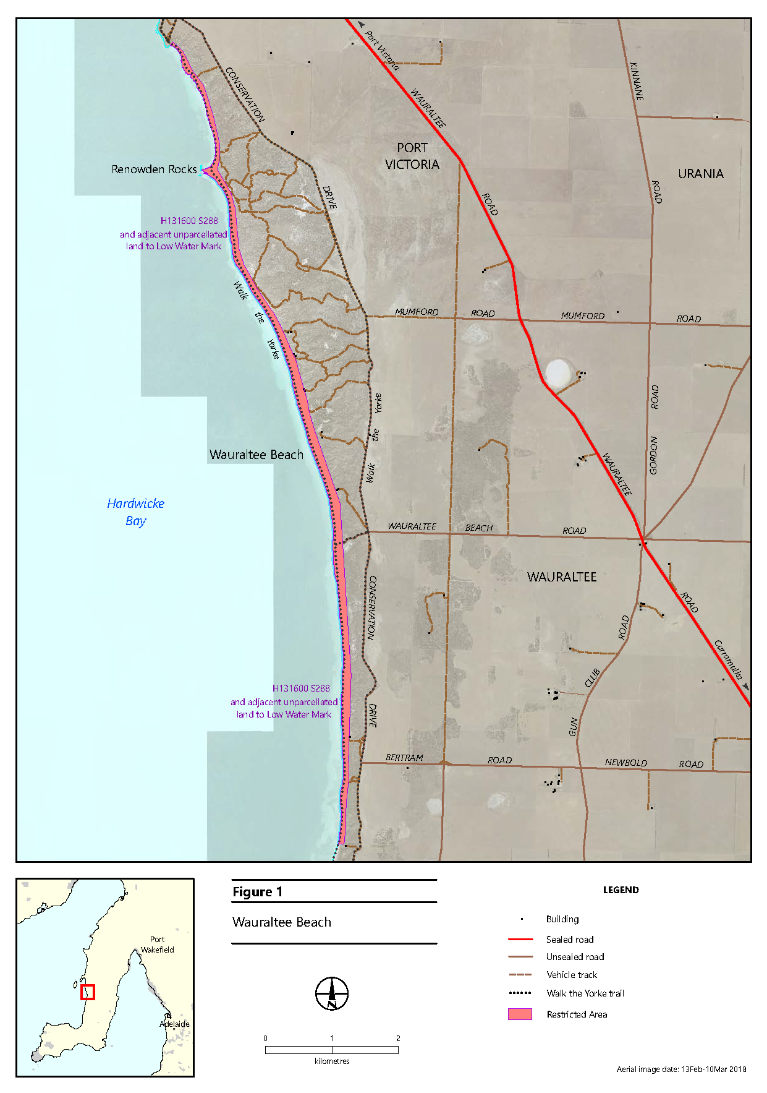
The extent of the restricted areas along the coast is shown in the map below:

Constitution Act 1934
Order Making an Electoral Redistribution
Notice is hereby given pursuant to Section 86 of the Constitution Act 1934, that the Electoral Districts Boundaries Commission has caused an order to be published making an electoral redistribution of the State’s 47 House of Assembly electoral districts.
Any elector, as defined under Section 4 of the Electoral Act 1985, or the registered officer of any political party registered under Part 6 of the Electoral Act 1985, has a right to appeal against this order within 1 month of the publication in the Gazette being Thursday, 12 December 2024.
Dated: 12 December 2024
David Gully
Secretary
Electoral Districts Boundaries Commission

South Australia
Report of the Electoral Districts Boundaries Commission 2024
CONTENTS
Order of the Commission
2024 Electoral Redistribution—Statewide
2024 Electoral Redistribution—Outer Metropolitan Region
2024 Electoral Redistribution—Metropolitan Region
Preliminary
Appointment of Chairperson
Application for recusal of Justice Stanley
Recusal
Appointment of Justice Bampton
Present members of the Commission
Commencement of the Commission’s proceedings for the purpose of making an electoral redistribution
The Legislation
The statutory redistribution criteria
The 2020 electoral redistribution and the 2022 election results
The Relevant Date
The Electoral Quota
Methodology of the Commission
Calculation of the elector to population ratio
Representations and Submissions Before the Commission
Representations received before the publication of the draft report
Submissions received following the publication of the draft report
Impact of the 2024 Electoral Redistribution
Naming of the Electoral Districts
Playford
Frome
Dr Krichauff’s report
Records in the South Australian Gazette
Colonial response to the hanging of the Milmendjeri men
Professor Watson’s submission
The Commission’s ecision
Proposals for commemorative naming
Acknowledgements
The Schedule

Order of the Commission
Pursuant to Part 5 of the Constitution Act 1934 (SA), the Electoral Districts Boundaries Commission now makes and publishes an order making an electoral redistribution, namely, the redistribution delineated and described in the district plans contained in the schedule to this order. The names of the electoral districts appear above each plan. The relationship of the electoral districts to one another is delineated in the three rack plans numbered 1511, 1512 and 1513 which are deposited with the Surveyor-General, Adelaide. Any inconsistencies between the rack plans and the district plans are to be resolved in favour of the district plans.
The Electoral Districts Boundaries Commission declares that the relevant date for the purpose of Section 77 of the Constitution Act 1934 (SA) is 30 June 2024. The total number of electors on the electoral roll on that day was 1,288,896, such that the electoral quota for each of the 47 House of Assembly electoral districts is 27,423.
Any elector or registered political party has a right to appeal against this order to the Court of Appeal within one month of its publication in accordance with Section 86 of the Constitution Act 1934 (SA).
This order shall be published in the Gazette.
Made at Adelaide this 12th day of December 2024 by the Electoral Districts Boundaries Commission.
The Honourable Justice A. E. Bampton

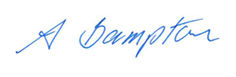
Chair
Mr M. Sherry
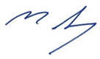
Member
Mr B. Slape
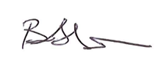
Member
Mr D. Gully

Secretary

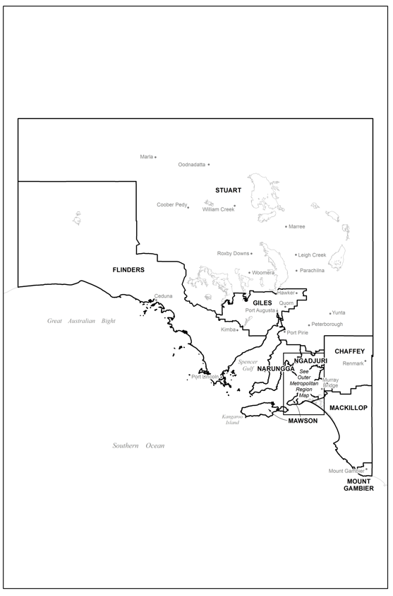
2024 Electoral Redistribution—Statewide

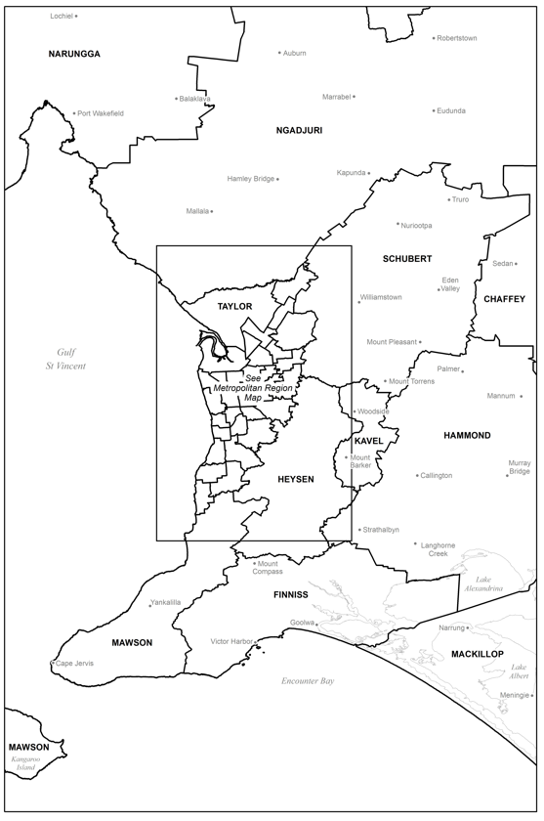
2024 Electoral Redistribution—Outer Metropolitan Region

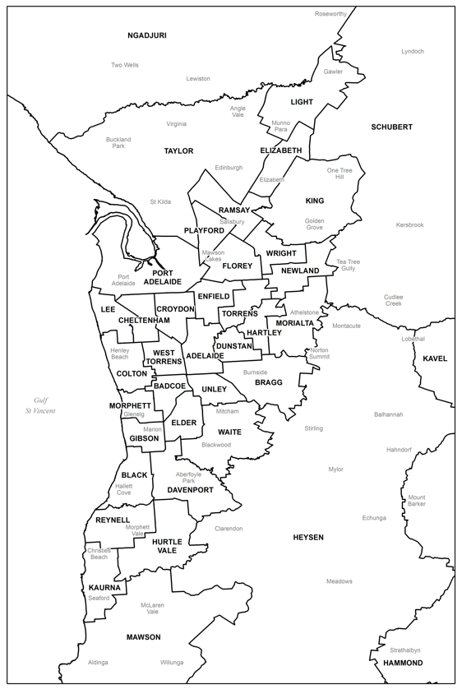
2024 Electoral Redistribution—Metropolitan Region

Report of the Electoral Districts Boundaries Commission 2024
Preliminary
The Electoral Districts Boundaries Commission (“the Commission”) was established by an amendment to the Constitution Act 1934 (SA) (“the Constitution Act”) in 1975. The Commission is a permanent and independent body. Its statutory members are a Judge of the Supreme Court, the Electoral Commissioner, and the Surveyor-General.
It is the task of the Commission to redraw the boundaries of each House of Assembly electoral district (“electoral district”) whenever an occasion prescribed by Section 82(2) of the Constitution Act arises (“electoral redistribution”). The usual occasion is following the holding of a general House of Assembly election. The Commission is required to commence proceedings for the purpose of making an electoral redistribution within 24 months after each polling day and to complete the proceedings with all due diligence.
Appointment of Chairperson
By notice published in the South Australian Government Gazette on 19 October 2023, the Honourable Chief Justice appointed the Honourable Justice Tim Stanley to be the Chairman of the Commission with the appointment to take effect from 30 October 2023.
Application for recusal of Justice Stanley
Upon that appointment, the Liberal Party of South Australia (South Australian Division) (“the Liberal Party”) made an oral application during a hearing on 9 November 2023 for Justice Stanley to recuse himself from performing the function of Chairman by reason of apprehended bias (“the recusal application”), which was said to arise from his Honour’s historical association with the Australian Labor Party (SA Branch) (“the Labor Party”). In November 2023, advertisements were published in The Advertiser and the Sunday Mail and notice was given to the 13 registered officers of the parties registered in South Australia, as well as the Australian Democrats (SA Division) (“the Democrats”), inviting submissions on the recusal application. The form of the advertisement and the dates on which it was published in The Advertiser and the Sunday Mail are set out in Appendix 1 to this report.
The recusal application was heard by Justice Stanley, without the other members of the Commission, during a public hearing on 5 December 2023. In his reasons for declining to recuse himself delivered on 19 December 2023, his Honour said he did not consider that a fair-minded lay observer might draw any logical connection between the factors relied on by the Liberal Party in support of its application and an apprehended deviation from resolving the questions which the work of the Commission requires to be decided on their merits, given the effluxion of time since he had any involvement with the Labor Party. His Honour also considered that a fair-minded lay observer would appreciate that for the past 12 years he had discharged the duties of a judge. His Honour reasoned a fair-minded lay observer would understand that a judge’s training, tradition, and the judicial oath to do right to all manner of people according to law without fear or favour, affection or ill-will, required him to discard the irrelevant, the immaterial and the prejudicial. Accordingly, his Honour was not persuaded that a fair-minded lay observer might reasonably apprehend that he might not bring an impartial mind to the resolution of the questions the Commission would be required to decide and therefore dismissed the application.
Justice Stanley’s judgment for refusing the recusal application can be found on the Commission’s website.
Recusal
After dismissing the recusal application, Justice Stanley, as detailed in his second judgment on recusal, became aware that a close, personal friend, whom he had known for 50 years, is one of two directors and shareholders of ALP Holdings Pty Ltd, the corporate entity which holds the Labor Party’s property and assets. His Honour explained that each elected member of the Labor Party pays a levy to the party to fund its operations and administration. Accordingly, decisions concerning the drawing of electoral boundaries which may affect the number of Labor Party candidates elected to the House of Assembly at a State election may affect the Labor Party’s funding and, ultimately, its property and assets. In those circumstances, his Honour considered that a fair-minded lay observer, aware of his existing association with one of the two directors and shareholders of ALP Holdings Pty Ltd, might consider that he might not bring an impartial mind to the drawing of electoral boundaries which could indirectly affect the property and assets of the Labor Party. His Honour considered, unlike the matters that formed the basis of the recusal application, this friendship was not a historical matter. As a result, his Honour recused himself on the basis of apprehended bias on 27 December 2023.
Justice Stanley’s judgment recusing himself can also be found on the Commission’s website.
Appointment of Justice Bampton
Following Justice Stanley’s recusal, the Chief Justice appointed the Honourable Justice Anne Bampton, the most senior puisne Judge available to undertake the duties of Chairperson of the Commission, pursuant to Section 78(1) of the Constitution Act, with the appointment to take effect from 5 January 2024.
Present members of the Commission
In addition to Justice Bampton, Chairperson, the present members of the Commission are the Electoral Commissioner, Mr Mick Sherry, and the Surveyor-General, Mr Bradley Slape.
Commencement of the Commission’s proceedings for the purpose of making an electoral redistribution
A general election for the House of Assembly took place on 19 March 2022 (“the 2022 election”). The Commission commenced its present proceedings in February 2024, having published an advertisement in January 2024 in The Advertiser and other metropolitan and regional newspapers, inviting representations from interested persons in relation to the electoral redistribution. The form of the advertisement and a list of all the newspapers in which it was published, with the respective publication dates, are set out in Appendix 2.
The persons or bodies from whom the Commission received written representations are listed in Appendix 3. All were given the opportunity to appear before the Commission, in person or by counsel or other representative, and to give or call oral evidence. The Commission held the public hearings listed in Appendix 4 in the Supreme Court complex, 1 Gouger Street, Adelaide. Appendix 4 also details the name of the witness called before the Commission and the names of persons and bodies who made oral submissions. A list of all exhibits received by the Commission is set out in Appendix 5.
During the hearings, the Commission had the valuable assistance of Mr T A Besanko who was instructed by the Commission, as well as Mr T Duggan KC and Mr J Teague MP for the Liberal Party, Mr B Doyle KC and Mr A Tisato for the Labor Party, and Mr P Black for the Democrats.
During the ongoing work of the Commission, the public has had access, via the Commission’s website, to the representations lodged, transcript of the public hearings, and exhibits received by the Commission, as well as advance notice of future hearings. General information about the Commission, relevant legislation, and previous reports and exhibits dating back to 2003 have also been available for viewing. Exhibits referred to in this report but not reproduced as appendices may be viewed on the website at www.edbc.sa.gov.au.

The Legislation
The statutory redistribution criteria
Section 77 of the Constitution Act governs the basis of an electoral redistribution:
77—Basis of redistribution
(1) Whenever an electoral redistribution is made, the redistribution shall be made upon the principle that the number of electors comprised in each electoral district must not (as at the relevant date) vary from the electoral quota by more than the permissible tolerance.
(2) In this section—
electoral quota means the nearest integral number obtained by dividing the total number of electors for the House of Assembly (as at the relevant date) by the number of electoral districts into which the State is to be divided as at the first polling day for which the order is to be effective;
permissible tolerance means a tolerance of ten per centum;
the relevant date means a date specified in an order as the relevant date, being a date falling not earlier than six months before the date of the order.
Section 82 prescribes when the Commission must commence proceedings for the purpose of making an electoral redistribution and Section 83 prescribes the criteria to which the Commission must have regard:
83—Criteria
(2) In making an electoral redistribution, the Commission must have regard, as far as practicable, to—
(a) the desirability of making the electoral redistribution so as to reflect communities of interest of an economic, social, regional or other kind;
(b) the population of each proposed electoral district;
(c) the topography of areas within which new electoral boundaries will be drawn;
(d) the feasibility of communication between electors affected by the redistribution and their parliamentary representative in the House of Assembly;
(e) the nature of substantial demographic changes that the Commission considers likely to take place in proposed electoral districts between the conclusion of its present proceedings and the date of the expiry of the present term of the House of Assembly,
and may have regard to any other matters it thinks relevant.
As detailed in the 2020 report of the Commission (“the 2020 report”), the Constitution Act was amended by the Constitution (One Vote One Value) Amendment Act 2017 (SA) (“the Amendment Act”). The Amendment Act removed Sections 83(1) and 83(3) and added Section 83A. As the Commission noted in the 2020 report, Section 83A does not impose any obligation or requirement on the Commission and is not relevant to this electoral redistribution.
Following the removal of Sections 83(1) and 83(3), Sections 77 and 83(2) were left as the critical provisions governing an electoral redistribution. The Full Court, in Martin v Electoral Districts Boundaries Commission (“Martin”), interpreted and ascribed meaning to Sections 77 and 83(2). The Commission determined in the 2020 report that Sections 77 and 83(2) continued to bear the meanings ascribed to them by the Court in Martin notwithstanding the passage of the Amendment Act and, further, that the Commission is bound to undertake the electoral redistribution in accordance with those Sections as interpreted by the Court.
The 2020 Electoral Redistribution and the 2022 Election Results
Prior to the 2022 election, the House of Assembly was comprised of 22 Liberal Party members, 19 Labor Party members and six independent members, namely, Mr Bell MP (the Member for Mount Gambier), the Honourable Geoffrey Brock MP (the Member for Frome), Mr Ellis MP (the Member for Narungga), Ms Bedford MP (the Member for Florey), the Honourable Daniel Cregan MP (the Member for Kavel), and Mr Duluk MP (the Member for Waite).
The 2020 electoral redistribution resulted in 27 electoral districts notionally on the Liberal Party side of the swing-to-lose pendulum (the swing-to-lose pendulum is explained in the following section of this report) compared with 20 electoral districts on the Labor Party side. Florey remained a notionally Labor Party electoral district, while Mount Gambier and Frome, remaining as notional Liberal electoral districts, were joined by Waite following the departure of Mr Duluk from the Liberal Party in February 2020. Subsequently, Narungga and Kavel also became notional Liberal Party electoral districts following the departures of Mr Ellis and Mr Cregan from the Liberal Party in February 2021 and October 2021 respectively. The pendulum demonstrated that if the Labor Party achieved 50.1 percent of the two-party preferred vote, representing a uniform swing of two percent in its favour, it would have been able to win 24 electoral districts and form government by gaining the electoral districts of Newland, Adelaide, King, and Elder.
The 2020 report also included a pendulum which assumed a 50:50 vote, resulting in 24 electoral districts on the Liberal Party side as against 23 electoral districts on the Labor Party side (Appendix 16 to the 2020 report). The most marginal electoral districts were Elder on the Liberal Party side, with a swing-to-lose figure of 0.1 percent, as well as King and Adelaide on the Labor Party side, both of which had a swing-to-lose figure of 1.1 percent.
Appendix 6 contains a comparison of projected electors at the time of the 2020 report against actual enrolments at the time of the 2022 election.
At the 2022 election, the Labor Party won 27 electoral districts and the Liberal Party won 16 electoral districts, with the result that the Labor Party was able to form government in its own right. The electoral districts of Kavel, Mount Gambier, and Narungga were retained by their sitting members, Mr Cregan, Mr Bell, and Mr Ellis respectively, who had each contested their electoral districts as independents. Mr Brock (the sitting Member for Frome) was elected to the electoral district of Stuart. Defeats were suffered by Mr Duluk and Ms Bedford (the Member for Florey), who contested the electoral district of Newland.
Overall, the swing away from the Liberal Party was not uniform. The Labor Party won 54.6 percent of the notional two-party preferred vote while the Liberal Party won 45.4 percent, representing a statewide swing of 6.5 percent in favour of the Labor Party.
Appendix 7 is the swing-to-lose pendulum depicting the outcomes following the 2022 election.
By-elections for the electoral districts of Bragg, Dunstan and Black were held on 9 July 2022, 6 April 2024 and 16 November 2024 respectively. The electoral district of Bragg was won by a Liberal Party candidate and the Labor Party won the electoral districts of Dunstan and Black, resulting in two electoral district changes in the Labor Party’s favour.
In July 2023, Mr McBride MP, who had retained the electoral district of MacKillop in the 2022 election, suspended his Liberal Party membership and took up a position on the crossbench.
The Relevant Date
The Commission must specify a relevant date for the purpose of defining the electoral quota under Section 77 of the Constitution Act. It must be a date falling not earlier than six months before the date of the Commission’s final order. It is necessary for this purpose to have regard to the Commission’s likely timetable, and also to the state of the joint electoral roll that is used by the Australian Electoral Commission and the Electoral Commission of South Australia within the relevant period. The electoral redistribution is made on the basis that the relevant date is 30 June 2024.
The Electoral Quota
The State’s enrolled elector population on the relevant date was 1,288,896. The electoral quota, which is the basis of any electoral redistribution, is obtained by dividing the total number of electors as at the relevant date by the number of electoral districts to the nearest integral number. The electoral quota for this electoral redistribution is therefore 27,423.
The elector numbers for any electoral district must not diverge from the electoral quota by more than 10 percent as at the relevant date. However, the Commission is also required by Section 83(2)(e) of the Constitution Act to have regard to the substantial demographic changes that are likely to take place in the proposed electoral districts before the expiry of the present term of the House of Assembly.
Demographic changes which are expected to occur between the relevant date and the period within which the next election will take place were the subject of evidence given by Mr Chris Rudd (Manager Analytics and Forecasting, Department for Trade and Investment). The Commission accepts Mr Rudd’s evidence.
The Commission has also considered the population projected on 30 June 2026, being the nearest available date to March 2026 when the next election is due, which is estimated to be 1,328,188. On that basis, the projected electoral quota is 28,259. These figures appear in Appendix 8.
Methodology of the Commission
The Commission, as it did in the 2020 report, considers that the desirability of achieving numerical equality between electoral districts as at the relevant date and on election day is a relevant factor in this electoral redistribution, but not to the exclusion of those matters identified in Section 83(2)(a) to (e) of the Constitution Act. Further, the Commission, for the reasons set out in the 2020 report, also considers it appropriate to have regard to the principle of electoral fairness and the existing boundaries. The Commission has approached its task by adopting the following methodology.
First, as the existing boundaries were drawn by the Commission in the 2020 report in accordance with the matters identified in Section 83(2) of the Constitution Act, the Commission considers the existing boundaries, together with the principle of minimal disturbance, are relevant and an appropriate starting point.
Second, the Commission has ensured that all electoral districts were kept within a 10 percent tolerance as at the relevant date, as required by Section 77 of the Constitution Act. Further, to give effect to the desirability of achieving numerical equality between electoral districts, the Commission has approached its task in this electoral redistribution by trying, where possible, to achieve electoral districts with electoral quota variances of less than five to seven percent.
Third, the Commission set all electoral districts within the 10 percent tolerance at election day based on its projections.
Fourth, the Commission has had regard to the mandatory relevant considerations contained in Sections 83(2)(a) to (e) of the Constitution Act and has sought to give effect to those considerations to the extent possible having regard to the requirements of Section 77.
Fifth, the Commission has, consistently with the approach adopted by the Commission in its 2020 report, had regard to what has been referred to as the “swing-to-lose pendulum” to determine the extent to which the proposed boundaries achieve statewide electoral fairness. The pendulum is used as a tool to assess political fairness. It is prepared by comparing the total votes from the previous election between the two final candidates in each electoral district. Where this contest is not between Labor Party and Liberal Party candidates, a notional outcome is derived by undertaking a re-throw of the ballot papers between the Labor Party and Liberal Party candidates in each electoral district. In accordance with this methodology, the outcome (or notional outcome) of each electoral district from the last election is reflected by its placement on either the Liberal Party or Labor Party side of the pendulum. As the Commission did in the 2020 report, we agree with the observations made in the 2016 report of the Commission that:
… the use of the swing-to-lose pendulum is familiar to those with an interest in the work of the Commission. That familiarity has been assumed for the purposes of this Report. The pendulum is a tool available to the Commission, but its limitations must be acknowledged. … They include that swings are not uniform and that it is not possible to estimate accurately numbers of swinging voters, that it is not possible to assess precisely the impact of movement of boundaries and that the greater the number of voters moved in or out of a district, the greater the “error” will be.
Calculation of the elector to population ratio
The Commission adopted the methodology identified by the Commission in its 2020 report for calculating the elector to population ratio based upon Statistical Area Level 2 (“SA2”) population projections. SA2 are the smallest geographical areas for which the Australian Bureau of Statistics (“ABS”) publishes annual population estimates. These areas are designed to represent communities that interact together socially and economically and typically have a population range of 3,000 to 25,000 people. The methodology adopted involves a process of aggregating the projected 18+ population data and enrolled elector data to each of the 172 separate SA2s across the State. That process is considered to provide a finer grain assessment for calculating the ratio of electors to population at an SA2 level.
The application of the SA2 elector ratio to the projected 18+ population for each concordant Statistical Area Level 1 (“SA1”) provides a more geographically specific estimate of enrolled electors as most SA1s have a population of 200 to 800 people. The resulting SA1 elector estimates can then be aggregated by electoral district to provide the number of projected electors for each existing and proposed electoral district.
These projections are guided by demographic trends and contemporary information relating to residential development activity that is likely to drive population growth across Greater Adelaide to June 2026. In regional South Australia, analysis of recent population changes coupled with information about key economic developments is used to inform the projection process.
Demographic evidence was heard from Mr Rudd during a public hearing held by the Commission on 6 February 2024. Exhibit 10, “Demographic trends and projections for the Electoral Districts Boundaries Commission 2022-2026”, tendered during Mr Rudd’s evidence, was prepared by the Department for Trade and Investment and outlines the projected population of each electoral district.
Due to unforeseen influences that may affect the future size and distribution of the population, the Commission acknowledges that there is need for caution when using projections. However, pursuant to Section 83(2) of the Constitution Act, it is required to have regard to likely demographic changes when conducting the electoral redistribution and it anticipates that the above approach will lead to more accurate projections.
Representations and Submissions Before the Commission
Representations received before the publication of the draft report
The Commission acknowledges the written representations it has received. Following receipt of written representations, the Commission held a further public hearing on 12 June 2024 during which the Commission heard oral submissions made by Mr Peake OAM, Mr Fulbrook MP (the Member for Playford), the Labor Party, the Liberal Party, and the Democrats. The following discussion provides an overview of the representations made to the Commission.
The Commission received a representation from the Electoral Reform Society which advocated for multi-member electorates. However, as the Commission has stated in previous reports, the Commission does not have the power to make such a change in an electoral redistribution.
The Australian Greens (SA Greens) (“the Greens”) proposed that Heysen “[shift] to encompass parts of the ‘peri-urban’ hills face, while exporting the outer regions of the current Heysen electorate into surrounding areas that better align as communities of interest”. The proposed peri-urban areas included “portions of the Hills community of Waite and Bragg”. The Commission is of the view that this representation did not adequately account for flow-on effects to other electoral districts.
Additionally, accepting that the Commission is entitled, although not required, to take fairness into account in making an electoral redistribution, the Greens proposed that the Commission should view fairness considerations “through a multi-party lens”. It was submitted that “any application of ‘fairness’ should be broadened to reflect ‘multi-partisanism’ and [recognise] that we are not simply a two-party system”. The Commission notes that the pendulums in Appendices 7, 13, and 14 are no more than a depiction of the alignment of electoral districts to the Liberal Party and Labor Party based on the most recent election results, including on a notional basis where the electoral district is held by a candidate not aligned with either party.
The electoral districts of Giles, Kaurna, Kavel and Taylor were identified as being outside of the projected electoral quota tolerance on 30 June 2026. The Democrats submitted that “None of those four electorates are geographically proximate to each other. Increasing numbers in electorates below quota and decreasing numbers in electorates above quota will have flow-on effects in neighbouring electorates”.
The continuing decline in the number of projected electors as against the electoral quota in the electoral districts of Flinders, Giles and Stuart was also acknowledged. This is exacerbated by two of Stuart’s neighbouring electoral districts, Narungga and Chaffey, also being projected to be well below the electoral quota. The Democrats submitted that it was “inevitable that the inexorable clockwise movement of the electoral boundaries in the West, far North and mid North of the State must continue (at least unless the State Parliament were to amend s 27 of the Constitution Act to increase the number of members of the House of Assembly)—and that movement must occur in the present redistribution”. The Democrats also suggested the Commission should be wary of setting electoral district boundaries at the outer bounds of the permissible tolerance, “other than to give effect to the mandatory criteria in [Section] 82(2)”, given the possible volatility of population projections.
The Liberal Party submitted that the Commission should have regard to statewide electoral fairness and “the desirability of minimising the disturbance to the existing boundaries”. It was further submitted that “in affording a fair contest it will be necessary to adjust the boundaries so that there is a group of electoral districts which are in play and which will change hands on an incremental basis in the event of a change in voter sentiment”.
The Liberal Party emphasised that the proposals in its representation were necessarily of a provisional nature as the relevant date data was not yet available. The Liberal Party representation refers to a projected electoral quota calculated by reference to the current and projected enrolment and voting data contained in exhibits 13B and 13C. The Commission notes that the boundary changes proposed by the Liberal Party would result in the four country electoral districts of Flinders, Giles, Narungga, and Stuart being significantly below the projected electoral quota at -8.4 percent,-9.7 percent, -7.2 percent, and -7.8 percent respectively. Further, boundary changes proposed by the Liberal Party would result in eight metropolitan electoral districts having a projected electoral quota variance of at or outside ±7.0 percent, namely Croydon (+8.1 percent), Florey (+9.3 percent), Gibson (-8.2 percent), Light (+7.0 percent), Ramsay (+7.7 percent), Reynell (+8.2 percent), Taylor (+7.4 percent), and Unley (+7.2 percent). Overall, the Liberal Party’s proposals would result in 12 of the 47 electoral districts being at or above ±7.0 percent of the projected electoral quota.
In assessing the 2022 election result, the Labor Party submitted that the Commission’s 2020 electoral redistribution produced an “appropriate result” from a statewide electoral fairness perspective, given that “the party that won the [two-party preferred] State-wide vote secured at least 24 [electoral districts]”. The Labor Party nevertheless said that there was “a slight bias of 0.4% or 0.5% in favour of the Liberal Party”. The Labor Party explained, by reference to the five most marginal Labor Party electoral districts on the 2022 election pendulum, that if the 2022 election were recontested and the Liberal Party obtained a uniform statewide two-party preferred swing of 4.2 percent, the Liberal Party would secure 24 electoral districts, thereby allowing it to form government with only 49.6 percent of the statewide vote.
The Labor Party acknowledged that the “actual and projected elector numbers for this redistribution appear to offer the Commission a genuine choice between making minimal change to the existing electoral boundaries and making more significant change to establish more sustainable boundaries for the medium to longer term”. While an approach of minimal disturbance is available to the Commission, the Labor Party representation proposed “more substantial change, by altering the northern-most regional [electoral] districts of the State (Flinders, Giles and Stuart) so they are no longer under-quota”. It was also submitted that Port Augusta should be reunited.
Submissions received following the publication of the draft report
The Commission published its draft report on 15 August 2024 and published a notice on the same day in The Advertiser inviting submissions from interested persons about the draft report. The form of the advertisement is set out in Appendix 9.
The Commission received 21 written submissions. The authors of these submissions and the date on which they were received by the Commission are set out in Appendix 10. The Commission determined that each written submission could be considered without the need for a further public hearing.
A significant number of submissions related to the Commission’s proposed boundary changes in metropolitan areas, particularly the alteration to the boundary between Croydon and West Torrens. Further, a number of submissions proposed changes in the southern beachside electoral districts of Reynell, Black, Gibson and Morphett.

The draft report proposed relocating the suburb of Bowden and a portion of the suburb of Brompton from Croydon into West Torrens to balance electoral quota variances between those electoral districts. Twelve submissions, in addition to the Labor Party submission, raised concerns with this proposed change and highlighted the shared history and strong community links between Bowden and Brompton. The Member for Croydon, the Honourable Peter Malinauskas MP, submitted that the proposed change would “undermine the deep and long-standing connection between the suburbs of Bowden and Brompton, which function as a unified community”.
The Commission in its draft report also proposed addressing the electoral quota variance in Kaurna by moving electors into the neighbouring district of Reynell, then moving further electors through Black, then into Gibson. Electors would finally be moved into Morphett, which is projected to have an electoral quota variance of -6.6 percent on 30 June 2026 if its boundaries are not changed.
The Commission received submissions following the publication of the draft report raising concerns with this proposal, including from the Liberal Party and the Labor Party, namely with the relocation of the suburb of Old Reynella from Reynell into Black, the suburb of South Brighton from Black into Gibson and part of the suburb of Somerton Park from Gibson into Morphett. The Commission notes the Labor Party’s submission that the southern boundary of Morphett has been altered by each electoral redistribution since at least 2003.
Having considered the submissions described above, as well as the principle of minimal disturbance, the Commission has determined to retain the boundaries set in the 2020 electoral redistribution in respect of five electoral districts, being Croydon and West Torrens, and the southern beachside electoral districts of Black, Gibson and Morphett. While this results in projected electoral quota variances for these electoral districts ranging from -6.6 percent (Morphett) to +8.1 percent (Croydon) on 30 June 2026, the Commission notes that these electoral districts have electoral quota variances of -5.7 percent and +3.8 percent respectively as at the relevant date such that they remain well within the ±10 percent tolerance. The Commission may need to address the boundaries of these electoral districts in the next electoral redistribution.
The Commission is mindful that implementing alternative alterations to those proposed in the draft report would result in changes being made without them having been the subject of submissions. However, to offset the movement of the suburb of Christie Downs into Reynell from Kaurna, the Commission has determined to relocate a small portion of the suburb of Morphett Vale from Reynell into Hurtle Vale. These electoral districts consequently have an electoral quota variance of +1.0 percent (Kaurna), +6.2 percent (Hurtle Vale), and +1.4 percent (Reynell) as at the relevant date. The Commission notes that these districts are projected to have electoral quota variances of +1.3 percent (Kaurna), +3.5 percent (Hurtle Vale), and +1.0 percent (Reynell) on 30 June 2026.
Three submissions addressed the inclusion of the suburb of Hewett in the electoral district of Frome. While the Liberal Party submitted that this proposed boundary change would create a hybrid rural-suburban electoral district, the Labor Party proposed also including part of the suburb of Willaston in Frome. The Commission has determined not to depart from the boundary delineated in the draft report having regard to the boundary between the Local Government Areas of the Light Regional Council (which includes the suburb of Hewett) and the Town of Gawler.
A submission was also received by the Commission from Mr Sam Telfer MP, the Member for Flinders, regarding the proposal in the draft report to include the Aṉangu Pitjantjatjara Yankunytjatjara Lands (“APY Lands”) within the electoral district of Flinders. The submission raised concerns with the distance the Member for Flinders would be required to travel between the electoral district’s “several disparate population centres of… reasonable size” and the APY Lands to visit the area in person, noting that the latter remains without reliable telecommunications access. Mr Telfer also highlighted the shared community of interest between Coober Pedy (which is located in the electoral district of Stuart), Port Augusta and the APY Lands including because the APY Lands are “serviced by a combination of Coober Pedy, Port Augusta, Alice Springs and Adelaide”. Finally, the submission pointed to the “permanent disconnect” between the communities living in the APY Lands and those living in the adjoining Maralinga Tjarutja Council, which is headquartered and accesses services in Ceduna.
The Commission also notes the submission received from the Port Augusta City Council, which similarly highlighted the movement of people between the APY Lands to Coober Pedy and Port Augusta, the provision of services to the APY Lands and the Flinders Ranges by Port Augusta and the tourism trails that connect Port Augusta to the Flinders Ranges and APY Lands.
Mr Telfer’s submission attached a letter from Far West Community Partnerships, a partnership of the five Aboriginal communities in the far west region of South Australia: Ceduna, Koonibba, Scotdesco, Yalata, and Oak Valley (Maralinga). The letter raises a concern that including the APY Lands in the electoral district of Flinders would “contribute to a reduction in representation and visitation to the existing areas and unique communities already in [Flinders]”.
The Commission has determined to retain the boundaries of the electoral district of Flinders set in the 2020 electoral redistribution, resulting in an electoral quota variance of -5.2 percent as at the relevant date and a projected electoral quota variance of -8.0 percent on 30 June 2026. However, given the reunification of Port Augusta within the electoral district of Giles, and having regard to the association between the APY Lands and Coober Pedy, the Commission has determined to relocate the APY Lands to the electoral district of Stuart.
Impact of the 2024 Electoral Redistribution
The Commission notes, given the 2020 electoral redistribution and the outcome of the 2022 election, it is possible to achieve minimal disturbance in this electoral redistribution. The only electoral district outside the allowable electoral quota tolerance as at the relevant date was Taylor at +12.6 percent, which was projected to have an electoral quota variance of +18.6 percent on 30 June 2026. Five additional electoral districts were projected to have a variance to electoral quota at or above ±8.0 percent on 30 June 2026: Croydon (+8.1 percent), Flinders (-8.0 percent), Giles (-10.1 percent), Kaurna (+10.0 percent), and Kavel (+10.0 percent).
Although the Commission had proposed in its draft report to change the boundaries of Flinders, Black, Croydon, Gibson, Morphett, and West Torrens, the Commission has, for reasons already stated in this report, determined to retain the boundaries of these electoral districts set in the 2020 electoral redistribution. To address the significant projected electoral quota variances in respect of the other identified electoral districts, with associated flow-on adjustments to neighbouring electoral districts, the Commission has made changes to 16 electoral districts, being approximately one third of the 47 electoral districts. As explained above, it has also had regard to the principle of electoral fairness.
Appendix 11 summarises the boundary changes and their impact on electors. It identifies the 31 districts with no boundary changes. The 16 districts with boundary changes are shown with the number of current electors affected by the proposed changes, which is in the order of 38,894. This is compared with 222,000 electors moved as a result of the 2020 electoral redistribution.
Appendix 12 sets out the present and projected enrolments for each electoral district after the 2024 electoral redistribution. The Commission has achieved an outcome where only five electoral districts have a projected variance to quota of greater than ± 5.0 percent.

Appendix 13 represents, in the form of the swing-to-lose pendulum, the political consequences of the 2024 electoral redistribution. Apportioning the 2022 election Labor/Liberal two-party preferred figures to the 2026 projected elector population results in a 55.0 percent Labor Party to 45.0 percent Liberal Party outcome. On that basis, the Liberal Party should expect to win 24 electoral districts and form government if it achieves a uniform 5.1 percent swing.
Appendix 14 illustrates the electoral district allocation based on a 50:50 split of the two-party preferred vote on the basis of the 2024 electoral redistribution. On that basis, the Labor Party would win 24 electoral districts and the Liberal Party would win 23 electoral districts. The Commission notes that, while the 50:50 split places 24 electoral districts on the Labor Party side of the pendulum, the most marginal electoral district of Newland at 0.1 percent reflects a margin of approximately 28 votes. As set out above, Newland would become a Liberal Party electoral district if a 5.1 percent swing were achieved in favour of the Liberal Party.
The Commission does not consider that it should attempt to deliver a predicted outcome with a greater level of precision than that currently estimated based on the results from the 2022 election.
Naming of the Electoral Districts
Playford
The Commission received written and oral submissions from Mr Fulbrook (the Member for Playford) requesting that the electoral district of Playford be renamed to reduce confusion with the Local Government Area, the City of Playford, which is in the near vicinity, but presently not situated in the electoral district of Playford. Mr Fulbrook gave an example of the confusion when his office received 30 calls on one day from City of Playford ratepayers concerning a proposed 6.5 percent increase in council rates. Mr Fulbrook made it clear that he was not advocating for the Commission to cease using the name Playford as an electoral district, but rather that the name be used for an electoral district in another location, like the present electoral district of Taylor.
The electoral district of Playford is named after the former Premier of South Australia, Sir Thomas Playford. It was first created in 1969, and first contested in the 1970 State election. Whilst the boundaries of the electoral district have changed since that time, its name has not. The City of Playford was formed approximately 18 years later, by the merging of the former City of Elizabeth and City of Munno Para in 1997.
Whilst it acknowledges that there appears to have been, and may be, some confusion on the part of certain ratepayers within the City of Playford regarding which electoral district they are in, as has been reported by Mr Fulbrook, the Commission is not minded to rename the electoral district of Playford. This is so for a number of reasons. First, the electoral district has borne the name of Playford for over 50 years and the City of Playford was created approximately 18 years after the creation of the electoral district. Secondly, without expressing any view about how future redistributions should occur, there is a possibility that some or all of the City of Playford is brought into the electoral district of Playford at some point, as a consequence of a future redistribution. Thirdly, switching the name of the electoral district with that of another nearby electoral district, like the electoral district of Taylor, may not alleviate the confusion to any material degree, and, in any event, may generate a different kind of confusion, whereby electors presently in Playford and the electoral district whose name would be swapped with Playford fail to learn of or understand the fact of the name swap.
Frome
The Commission also received a representation from the Honourable Reggie Martin MLC advocating for the renaming of the electoral district of Frome. The electoral district is named after the third Surveyor-General of South Australia, General Edward Charles Frome (“the Surveyor-General”).
Whilst Mr Martin acknowledged that the Surveyor-General’s name has been associated with various South Australian electoral districts since 1884, he expressed concerns about its continued use due to historical accounts of the Surveyor-General’s involvement in retributive actions taken against Aboriginal peoples in the Coorong area following what has been referred to as the “Maria Massacre”. Mr Andrew Peake OAM also provided a written representation and made oral submissions during the public hearing of the Commission on 12 June 2024. Mr Peake expressed a contrary view to that of Mr Martin with respect to the Surveyor-General’s involvement in and responsibility for these retributive actions. Mr Peake also suggested the reintroduction of an electorate named Peake after Archibald Henry Peake, who held the office of Premier of the State on three occasions, including during World War I.
The Commission considered it appropriate, given the representations and submissions regarding the name of Frome, to seek further information from Dr Skye Krichauff, a historian specialising in South Australian colonial history and cross-cultural relations between Aboriginal peoples and colonists. Dr Krichauff’s report, “A short history [of] Edward Charles Frome (Surveyor-General of South Australia, 1839-1849) and an investigation into his involvement in the O’Halloran Expedition and the burning of an Aboriginal encampment on the Coorong in 1840”, was received by the Commission as exhibit 20A.
Dr Krichauff’s report
Dr Krichauff states at the commencement of her report that in its preparation she has drawn extensively on primary sources. She describes that upon hearing news of the killing of survivors of the Maria shipwreck, Governor Gawler instructed the assistant surveyor, William Pullen, to investigate. Dr Krichauff states that upon receiving Pullen’s report (“the Pullen report”), Governor Gawler called South Australia’s governing council (“the Council”) to meet on 12 August 1840:
…and laid [the Pullen report] before them. The Council was comprised of the Governor, Acting Colonial Secretary, Advocate General, Surveyor General, [and] Assistant Commissioner. On this occasion, Judge Cooper was requested to attend. The Judge and the Advocate General declared the crimes were beyond the reach of ordinary British law.
(Footnotes omitted)
Dr Krichauff describes that on 14 August 1840, Governor Gawler instructed the Police Commissioner, Major O’Halloran, to proceed to “the Elbow of the Goolwa” with a party, including 12 mounted police, Captain Nixon, and Inspector Tolmer. Dr Krichauff annexes to her report a copy of Governor Gawler’s handwritten instruction to Major O’Halloran and a transcript which details that the object of the expedition was:
… to apprehend, and bring to summary justice, the ringleaders in the murder, or any of the murderers (in all not to exceed three) of eight or more white persons …
To this end, your first object should be if possible to make prisoners the whole number congregated with the murderers.
It is of very great importance that if possible in effecting this portion of the duty, no blood should be shed or violence shown or encountered.
The future effect of the expedition on the minds and conduct of the natives will certainly be much more beneficial if the murderers are captured without bloodshed.
This however will probably be the most difficult part of your duty and if in the execution of it you are really compelled to abandon temperate measures and to resort to those of extreme force against the whole tribe you will not be held blamable [sic]. Your duty is to capture the murderers and this object must be effected, if they fall within your reach.
…
When to our own thorough conviction you shall have identified any number not exceeding three of the actual murderers, you will distinctly point out such men and require the deliberate opinions of Mr Pullen, Captain Nixon, and the Encounter Bay blacks, concerning their guilt, and you will make a note by names of those opinions as to guilty or not guilty for the information of the Governor.
You will however act upon your own single deliberate judgement.
Should your mind become satisfied of the guilt as to actual participation in the murder of any number not exceeding three, you will if possible move the whole tribe in your power to the spot at which the murder was committed. You will there explain to the blacks the nature of your conduct and the orders you have received from the Governor, and you will deliberately and formally cause sentence of death to be executed by shooting or hanging upon the convicted murderers not exceeding three as above described.
(Emphasis in original)
Pursuant to Governor Gawler’s instruction, Major O’Halloran’s expedition started for Goolwa on 17 August 1840. In his first report to Governor Gawler dated 26 August 1840, Major O’Halloran recorded that two culprits were identified and captured and that he investigated the murders before passing the sentence of death. On 25 August 1840, two Milmendjeri men (also referred to as Milmenrura men) were executed by hanging.
Dr Krichauff states in her report that the hanging of the Milmendjeri men was controversial and that Governor Gawler defended his actions before the Council on 15 September 1840. She refers to the opinion of the Law Officers of the Crown (“the Attorney-General and Solicitor-General of England”) that Governor Gawler and Major O’Halloran were guilty of murder. The Commission will return to the opinion of the Attorney-General and Solicitor-General of England later in this report.
Dr Krichauff details in her report that historical evidence indicates that the Surveyor-General was in Adelaide and was not a member of Major O’Halloran’s expedition to the Coorong. She points out that he was not named in the list of men in Governor Gawler’s instruction, nor was he named in either of Major O’Halloran’s reports, Inspector Tolmer’s account of the expedition or in any other firsthand account.
Dr Krichauff refers to the Surveyor-General’s subsequent expedition to the Coorong as recorded in the Surveyor-General’s handwritten report to Governor Gawler dated 15 October 1840, as well as sketches, paintings, and drawings made in his 1840 sketchbook. Dr Krichauff reports that the Surveyor-General’s expedition to the Coorong occurred between 24 September and 14 October 1840, during which he travelled along the shore of the Coorong and recorded that he did not meet any Aboriginal people, although he saw some Aboriginal people in the distance on the other side of the Coorong. He also saw the bodies of the men who were “hung for the recent murder of the passengers of the Maria”.
Dr Krichauff refers to the Surveyor-General having made several sketches of his expedition from Salt Creek to the Murray Mouth, including the sketches titled “Native Village on the Coorong deserted by the Milmenrura tribe after the murder of the crew of the Maria, burnt by me, Oct. 40” and ““Pilgaru”—two natives hung for murder”.
Dr Krichauff concludes her report stating, inter alia, “Surveyor General Edward Charles Frome did not accompany O’Halloran or play any role in this expedition. He was in Adelaide at the time. … Frome was not responsible for the death of any Milmenrura or, as far as I have been able to determine, any other Aboriginal people. He was however responsible for burning an Aboriginal village”.
Records in the South Australian Gazette
The Commission considered it important to have close regard to matters recorded in the South Australian Gazette consequent on the Pullen report of the killing of the survivors of the shipwreck. Dr Krichauff’s report footnotes the gazette of 13 August 1840 which the Commission notes records the following:
Wednesday, August 12, 1840.
The Council met at 12 o’clock by special summons, present—
His Excellency the Governor
The Acting Colonial Secretary
The Advocate General
The Surveyor General
The Assistant Commissioner
His Honor the Judge attended at the request of the Governor and Members of Council.
The recent murder of eight Europeans by the Aborigines on the sea-coast to the south-eastward of Lake Alexandrina, and the measures necessary to be taken by the Government with reference thereto were taken into consideration.
The gazette records that Governor Gawler directed that the Pullen report be inserted into the gazette for public information. Prior to the insertion of the Pullen report, the gazette records:
The Government will immediately take active measures for further investigating this case, in order, if possible, to discover the individuals by whom the murder was committed.
The South Australian Gazette of 17 September 1840 records further detail about the meeting of the Council on 12 August 1840. Under the heading “Journal of the proceedings of the Council”, it is recorded:
Adelaide, Sept. 15, 1840
The Council met at 10 o’clock. Present—
His Excellency the Governor
The Acting Colonial Secretary
The Advocate General
The Surveyor General
The Assistant Commissioner

The minutes of the last meeting were read and confirmed.
His Excellency read the following minute on the recent murder committed by the aborigines on the Coorong, in the month of August, 1840:
On the 12th of August last I laid before a Council specially assembled for the purpose, the reports which had been forwarded to me concerning the murder of several Europeans by the natives near the coast to the south-east of Encounter Bay. His Honor the Judge who attended by particular request, and all the members present, including the Advocate General, declared their opinions that the crimes in question were beyond the reach of the ordinary British law.
…
His Honor having withdrawn, the members of the Council concurred with me in opinion, that, notorious as the district referred to had been for its crimes, and brutal and unprovoked as had been most evidently the recent murders, it was imperative that retribution should be inflicted. …
Governor Gawler’s minute records that as the alleged crimes were “[b]eyond the limits of ordinary British justice, there remained for [Governor Gawler], in conformity with usage in Great Britain, the course of … proceeding on the principles of martial law. This course [he] adopted”. Governor Gawler explains in the minute that “the proclamation of martial law was omitted with the unanimous advice and concurrence of the members of the Council; but in other respects the proceeding was regulated on strict principles of martial justice”.
The gazette also records that Governor Gawler laid before the Council the instructions he had given to Major O’Halloran and which Major O’Halloran had acted upon. It is not clear whether the members of the Council were aware of the terms of the instructions prior to the meeting of Council on 15 September 1840. The minute in the gazette describes that Major O’Halloran was expressly charged to:
… make prisoners if possible without bloodshed—to select the guilty persons from among them—to try them in the most formal manner—to obtain the opinions of the gentlemen who accompanied the party and of the friendly natives present—and then, if the proof of guilt were sufficient, to pass sentence and proceed to formal execution.
The Commission notes that the handwritten instructions given to Major O’Halloran, as quoted at page 19 of this report, differ from the instructions described in the minute.
Governor Gawler’s minute records that he also laid before the Council on 15 September 1840 the minutes of the investigation conducted by Major O’Halloran. The gazette records that the Advocate General, with the permission of Governor Gawler, entered remarks into the gazette endorsing the retributive actions taken on Governor Gawler’s instruction.
Colonial response to the hanging of the Milmendjeri men
In the article referred to by Mr Martin in his representation, ‘The “Coorong Massacre”: Martial Law and the Aborigines at first settlement’, Stephen Lendrum states Major O’Halloran:
… could not have begun to realise what he was to face on his return to Adelaide. Over the following few months he and Gawler were to be subjected to severe and damaging criticism; criticism which seems to have contributed to an early end to Gawler’s commission as Governor. They were both about to become the centre of a debate as to the legality of the procedure adopted to try the two Milmenrura Aborigines, which was to reach a climax with the declaration by the Colonial Department that the hanging was an act of murder and that all those who had taken part were guilty of this crime.
The Commission notes, by reference to Mr Lendrum’s article, the Colonial Department in England requested the Attorney-General and Solicitor-General of England to provide their opinion regarding the hanging of the Milmendjeri men. The opinion provided by the Attorney-General and Solicitor-General of England was that:
… the murders with which the Aborigines were charged having been committed within the limits of the province defined under the authority of an Act of Parliament the Aborigines might have been brought to trial for them in the ordinary legal tribunals of the colony; that the summary execution of the supposed murderers was contrary to law; that the legal character of the act is murder,—Major O’Halloran and those who were present assisting him being guilty as principals and Governor Gawler being guilty as an accessory before the fact; and that they can only be indemnified by Act of Parliament, or by a Pardon under the Great Seal.
Professor Watson’s submission
The Commission also sought the assistance of Aboriginal Affairs and Reconciliation and was referred to Professor Irene Watson, a Professor of Law at the University of South Australia. In her submission, received by the Commission as exhibit 21A, Professor Watson said she is connected to the Coorong and the South-East region as a traditional owner belonging to the Tanganekald, Meintangk, Potaruwutj, and Bunganditj First Nations. Her apical ancestors Jimmy Gibson, Katherine Gibson and Kitty Russell are significant Elders who have been used in the process of constructing the “Ngarriindjeri” native title claim and the South-East First Nations native title claim. Professor Watson’s ancestors and family have an ancient connection to the “Maria Creek” and her mother Noeline (Gibson) Casey was born in 1936 on land adjacent to the Maria Creek, Kingston.
Professor Watson reports that she had had an opportunity to consider Dr Krichauff’s report and is very familiar with the archival research which informed it. Professor Watson reports that she had previously engaged and directed Dr Krichauff as a research assistant in respect of her work on her Australian Research Council project and to gather archival records about the Coorong massacres in relation to the Maria shipwreck.
Professor Watson states that the Surveyor-General’s burning of a Milmendjeri village is evidenced by his sketch and its caption. Professor Watson refers to references in Dr Krichauff’s report regarding reports of the Surveyor-General’s instructions to treat Aboriginal people without violent intent and the need to record Aboriginal languages. Professor Watson queries whether these accounts justify leaving Frome as the name of an electoral district, or whether there is enough doubt created by his sketch and its narrative to make the change.
Professor Watson, while suggesting that renaming the electoral district after an Aboriginal person or a pre-colonial Aboriginal First Nation would be a symbolic acknowledgement, stated that the change of name is of small consequence in the context of the ongoing impact of colonialism.

The Commission’s decision
The Commission acknowledges the contribution and assistance of Dr Krichauff and Professor Watson.
The Commission has determined that the electoral district of Frome should be renamed having regard to the following matters.
Whilst the Surveyor-General did not accompany Major O’Halloran on his expedition, the South Australian Gazette records he was present as a member of Council at the meeting on 12 August 1840 when the Government’s response to the Pullen report was discussed. By reference to the record in the gazette on 17 September 1840, the members of the Council present at the meeting on 12 August 1840 concurred with Governor Gawler “that notorious as the district referred to had been for its crimes, and brutal and unprovoked as had been most evidently the recent murders, it was imperative that retribution should be inflicted”. The gazette also records that Governor Gawler proceeded on the principles of martial law and that the proclamation of it was omitted with the unanimous advice and concurrence of the members of the Council.
The Commission notes that the execution of the two Milmendjeri men was controversial and was the subject of intense (although not universal) criticism in colonial South Australia and England, including by the Adelaide newspaper, The South Australian Register. The Commission also notes that the Attorney-General and Solicitor-General of England provided an opinion to the effect that Major O’Halloran, and those who assisted him on his expedition, had carried out acts of murder and that Governor Gawler was guilty as an accessory before the fact. Governor Gawler and Major O’Halloran were never charged, but it appears that the controversy led to an early end to Governor Gawler’s commission.
Having regard to the Surveyor-General’s recorded concurrence with Governor Gawler on the matters detailed above during the Council meeting of 12 August 1840, in combination with his admission of burning the camp “… deserted by the Milmenrura tribe after the murder of the crew of the Maria”, the Commission regards the name of Frome as unsuitable for a House of Assembly electoral district in the Parliament of South Australia.
The Commission considered it appropriate to use an Aboriginal name or word to rename the electoral district of Frome. To that end, the Commission invited the comment of Aboriginal organisations who may have a connection with the area encompassed by the electoral district of Frome. Enquiries were made of the Aboriginal Lands Trust, Ngadjuri Nation Aboriginal Corporation, Kaurna Yerta Aboriginal Corporation RNTBC, River Murray and Mallee Aboriginal Corporation, Mannum Aboriginal Community Association Inc, and First Peoples of the River Murray Mallee Region #2 as to whether they would support “Ngadjuri” or alternatively the word “Cowie” as a new name for the electoral district of Frome.
“Ngadjuri”, pronounced ‘Na-dju-ri’, means “we people” and refers to the Ngadjuri people, whose traditional lands cover the mid north region of South Australia.
In July 2023, the Ngadjuri people were recognised as native title holders over an area of more than 15,000 square kilometres, encompassing approximately 50% of the electoral district of Frome including the towns Hilltown, Clare, Mintaro, Watervale, Auburn, Waterloo, Saddleworth, Rhynie, Riverton, Marrabel, Tarlee, Freeling, Kapunda, Eudunda, and Robertstown.
“Cowie” means “water” in the Ngadjuri language and appears frequently as a suffix in Ngadjuri-based nomenclature.
The Commission received responses from the Aboriginal Lands Trust and the Ngadjuri Nation Aboriginal Corporation. Both responses strongly supported the use of the name “Ngadjuri”.
Accordingly, the Commission has decided to rename the electoral district of Frome as the electoral district of Ngadjuri.
Proposals for commemorative naming
The Commission received a number of representations and heard submissions regarding the commemorative naming of electoral districts following the recent deaths of Mr Raymond Steele Hall and Ms Lowitja O’Donoghue AC CBE DSG. While the preliminary view of the Commission is that the names O’Donoghue and Hall are appropriate for an electoral district, the current practice of the Surveyor-General when considering names for places under the Geographical Names Act 1991 (SA) is that a person should be deceased for at least one year before their name is considered commemoratively for a geographical place. To achieve consistency and uphold the principles underpinning the Surveyor-General’s current practice, the Commission has determined to follow this practice for the purpose of this redistribution.
The Commission also received representations regarding the commemorative naming of electoral districts in honour of Miss Elizabeth Hanretty MBE, Dr John Bannon AO and Dr David Tonkin AO. The Commission is of the view that each of these names may be appropriate for an electoral district in a future electoral redistribution.
Acknowledgements
The Commission records its gratitude to Mr David Gully (the Commission Secretary), Ms Jo-Anne Ragless, (Lead Analyst, Analytics and Forecasting, Department for Housing and Urban Development), Mr Jason Phillips (Team Leader, Spatial Planning, Department for Housing and Urban Development) the staff of the Electoral Commission of South Australia and the Department for Housing and Urban Development, Ms Sarah Schonfeldt (the Chairperson’s Judicial Assistant), Ms Olivia Bradley (the Chairperson’s Associate), and Mr Tom Besanko (Counsel assisting the Commission).
We also thank the staff of the Courts Administration Authority for facilitating, and providing courtrooms and transcript for, the Commission’s hearings. The Commission again thanks those persons who provided written representations and submissions or who gave evidence or presented argument at the public hearings.

The Schedule
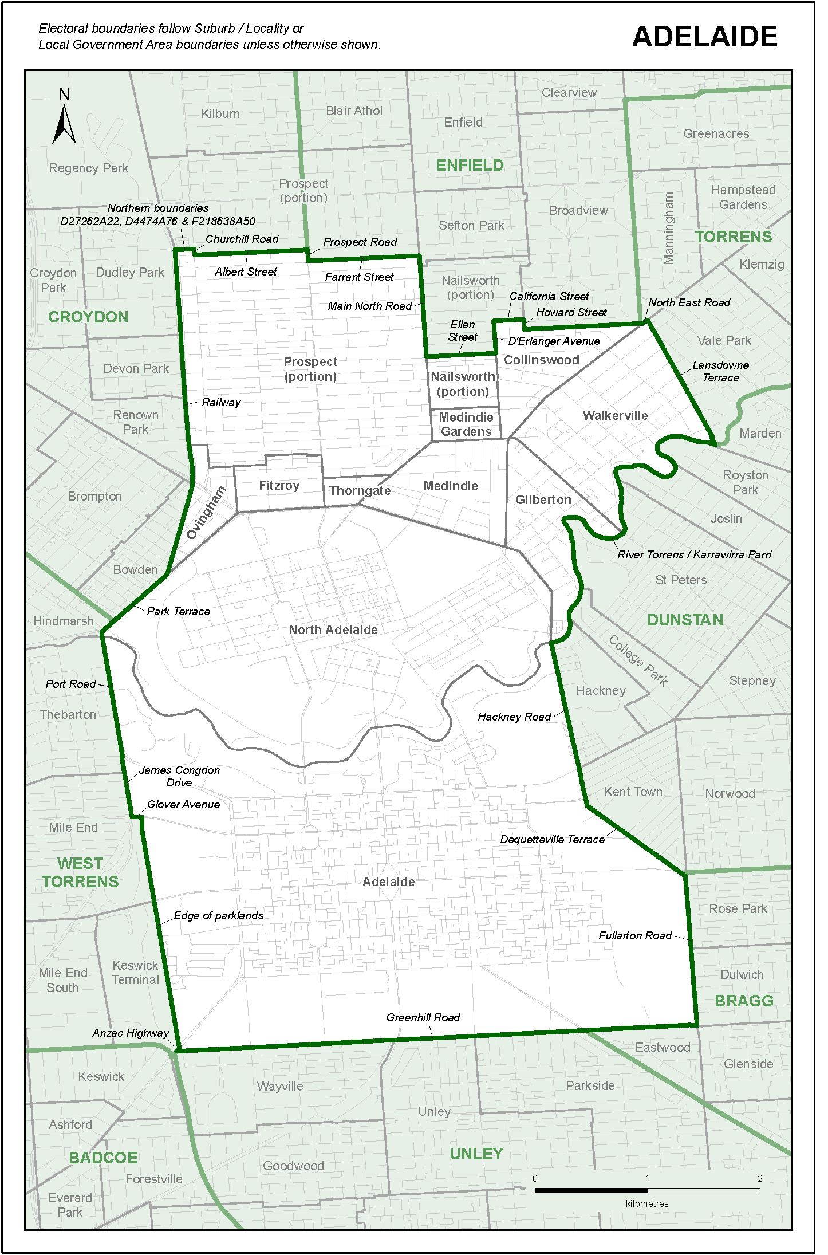
The district plans of the 47 House of Assembly electoral districts which follow in this schedule and are named, delineated, and described therein, define the boundaries of the electoral districts consequent upon this electoral redistribution.

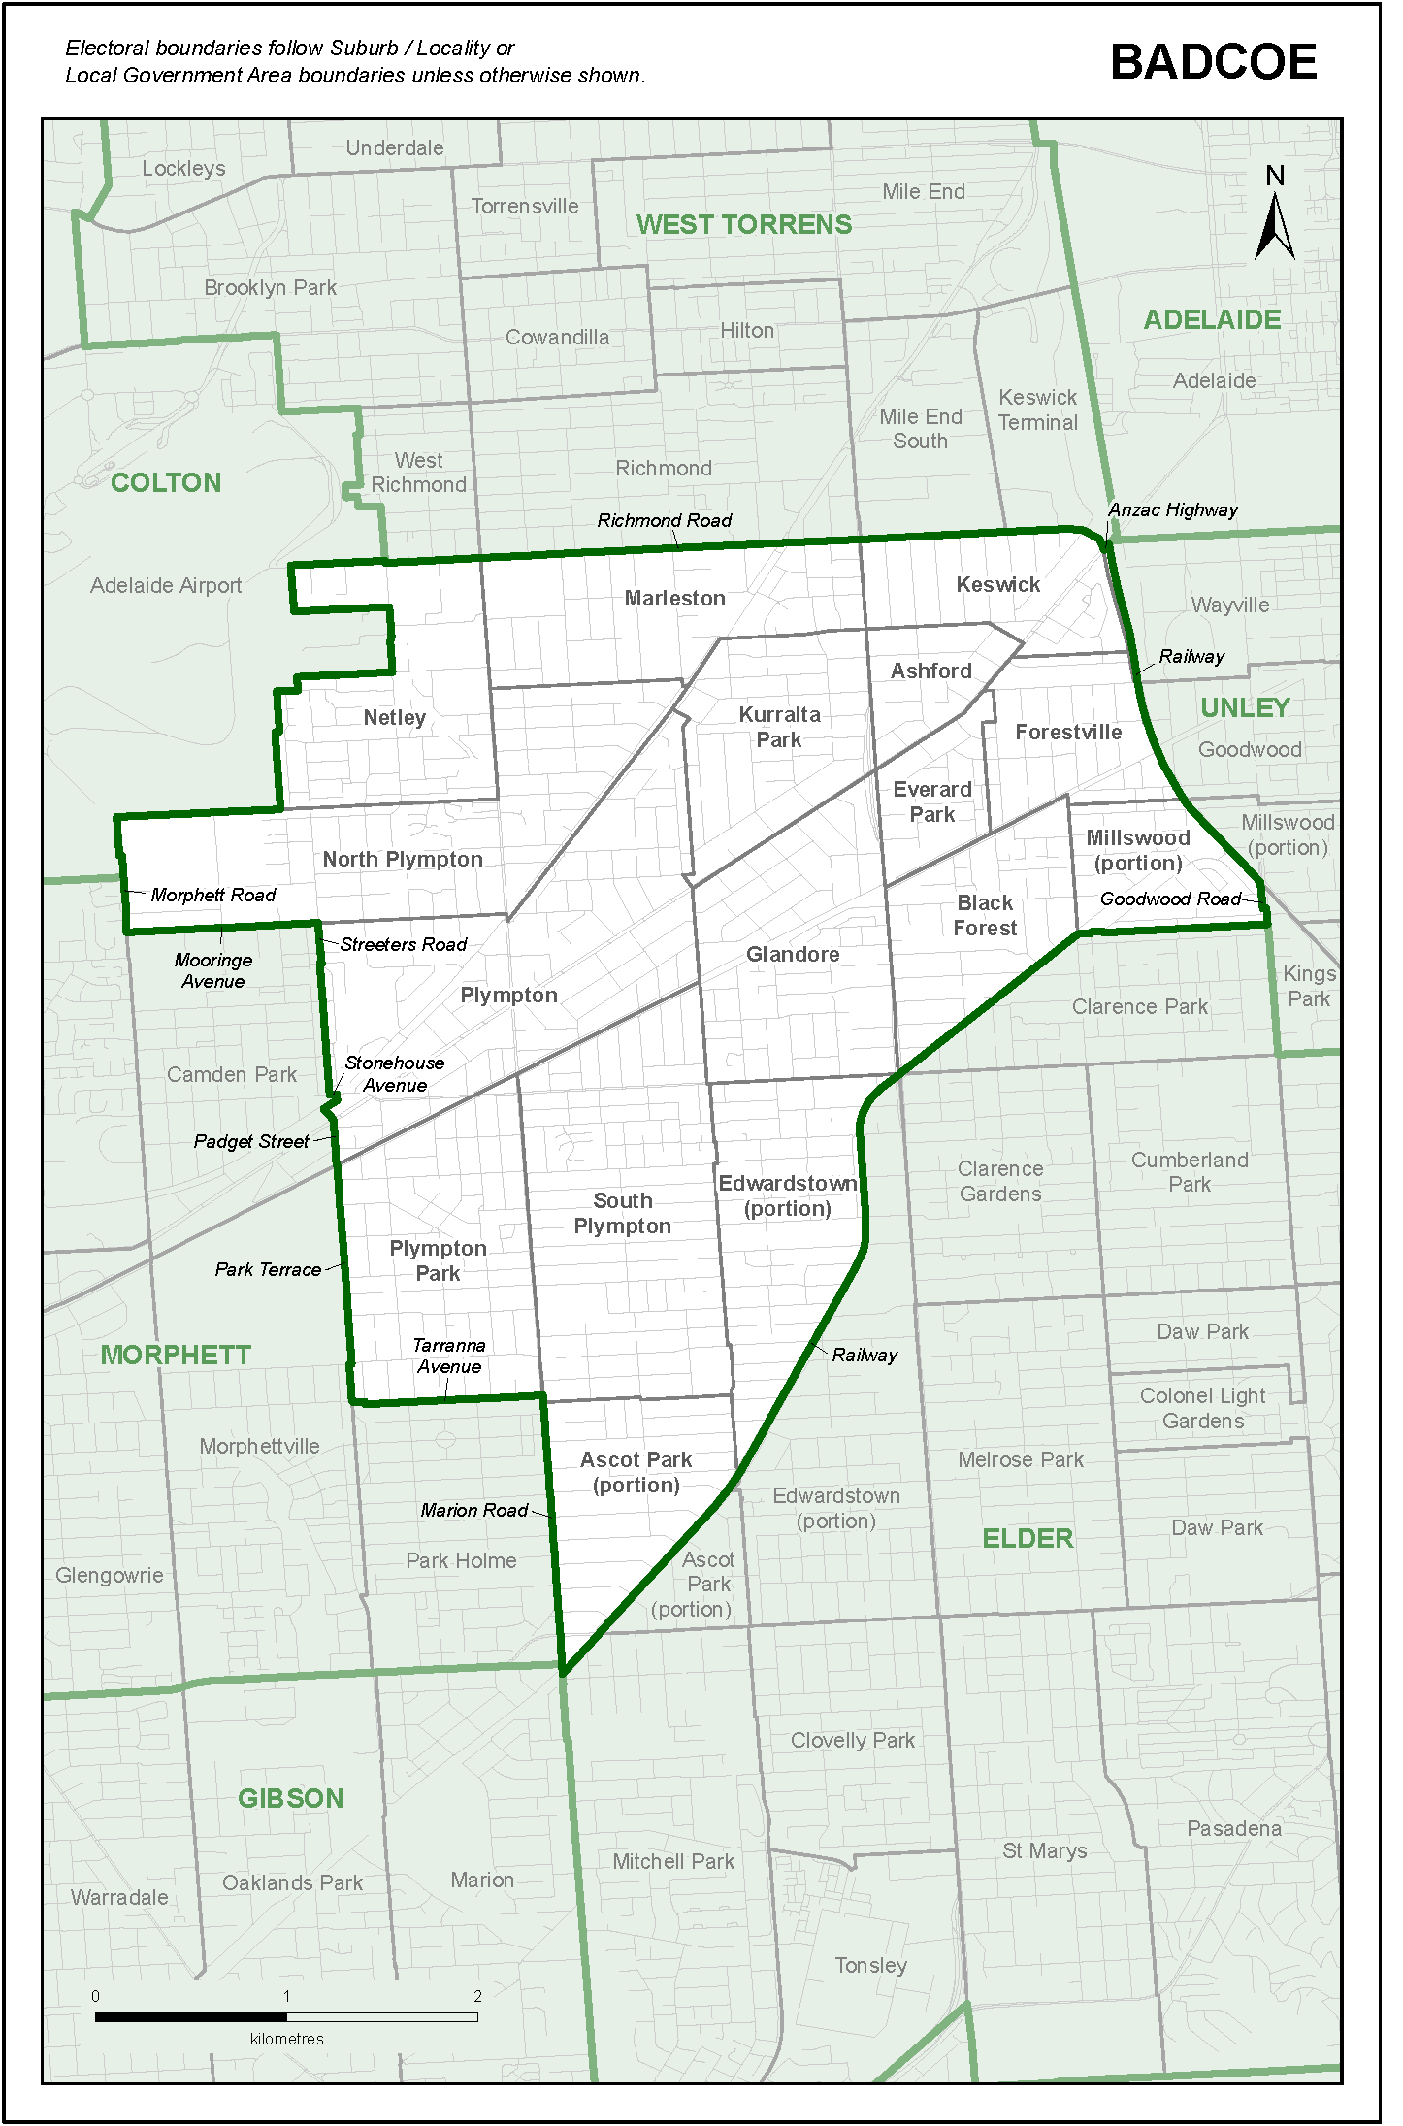
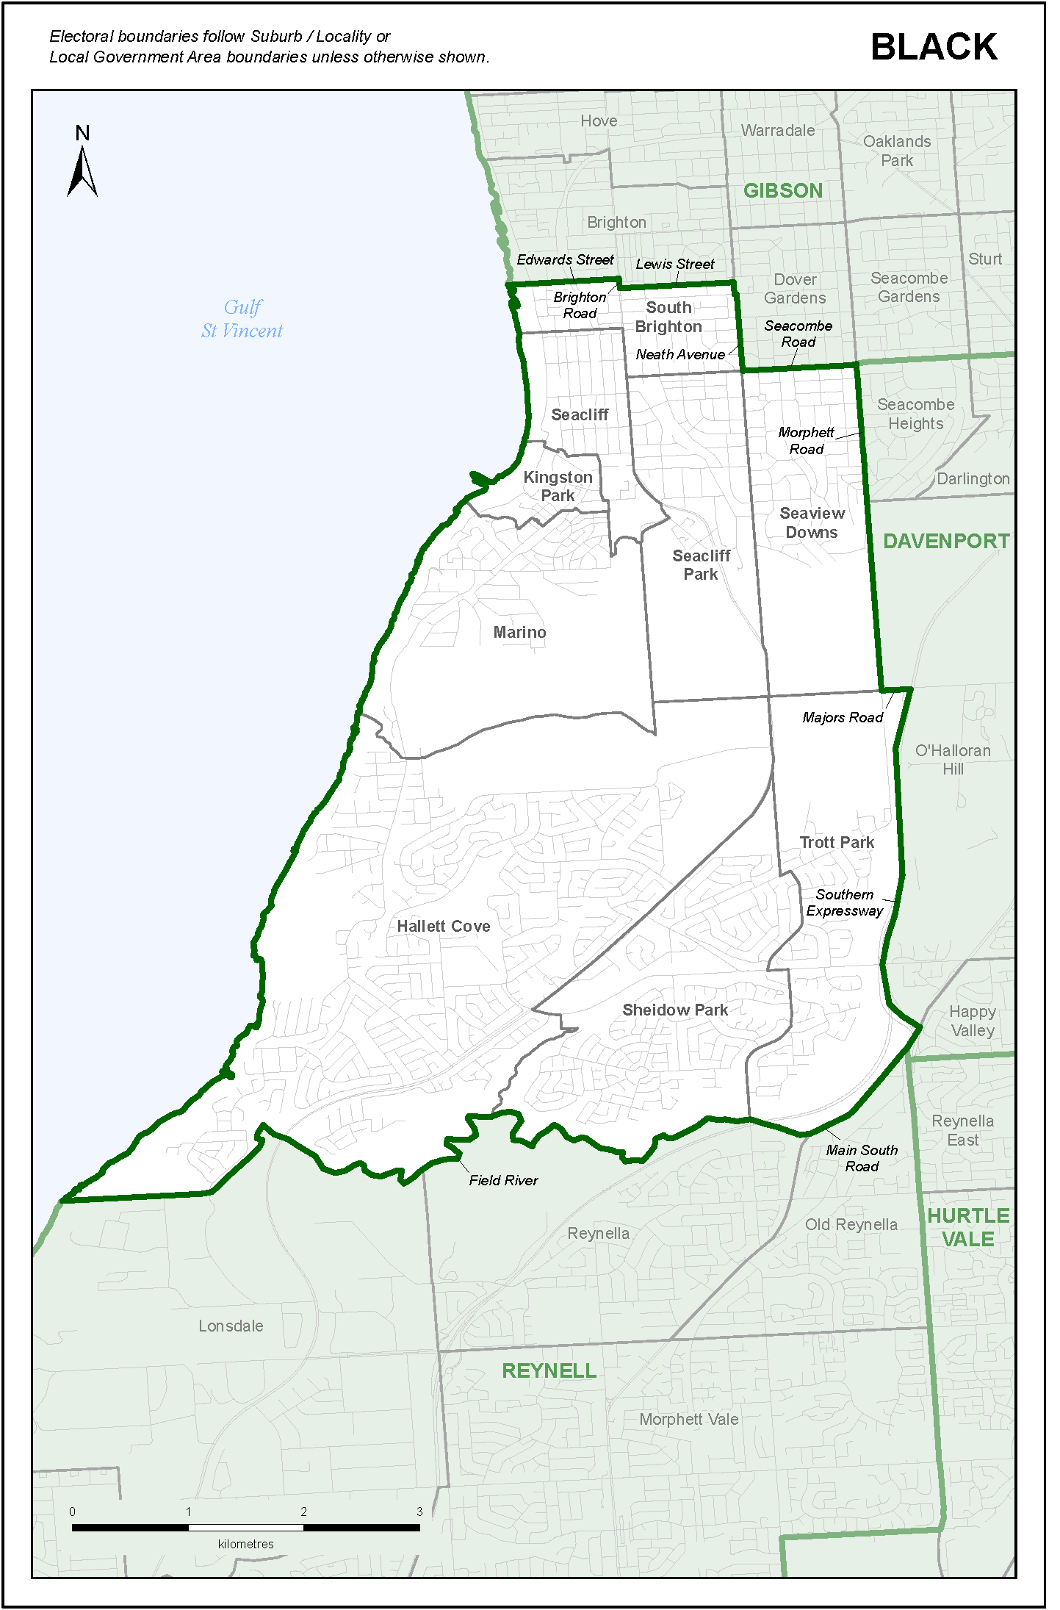
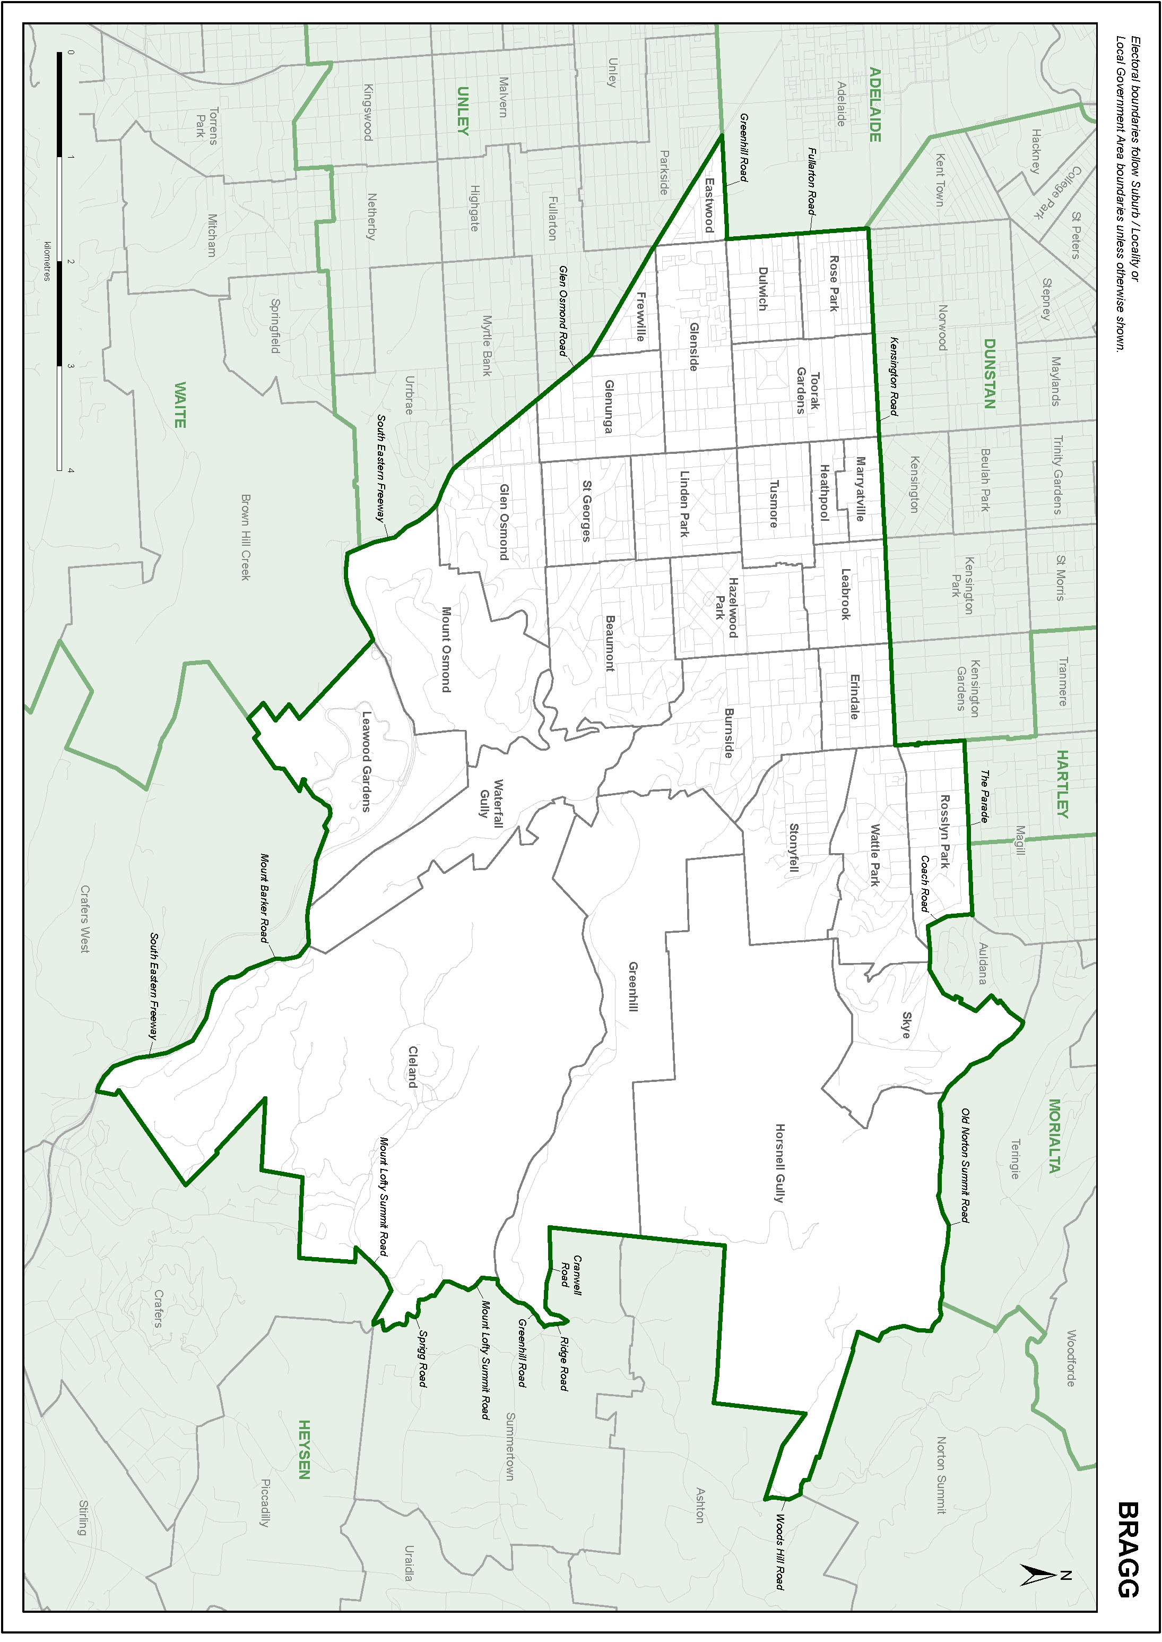
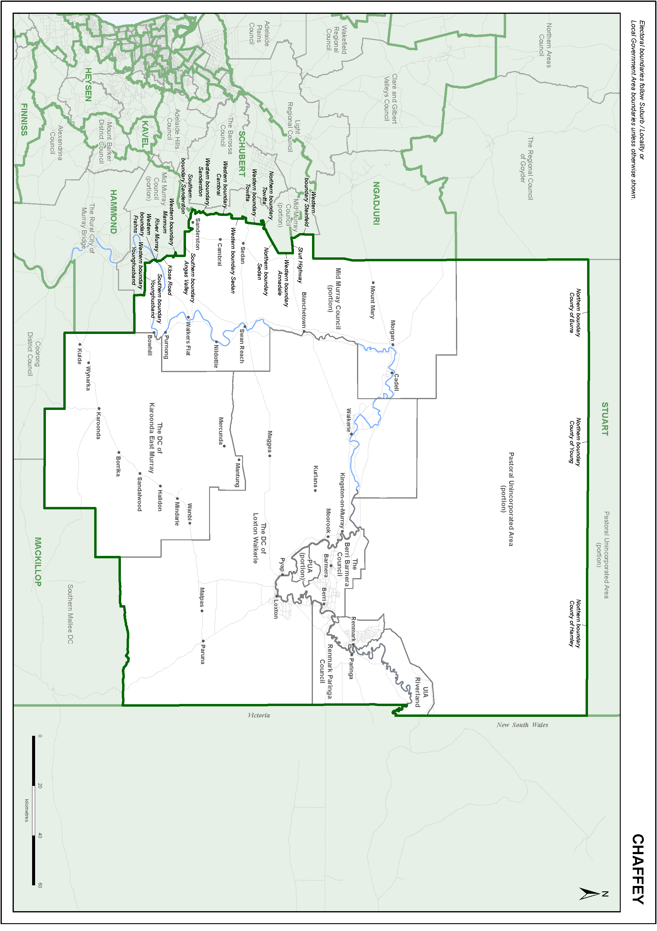
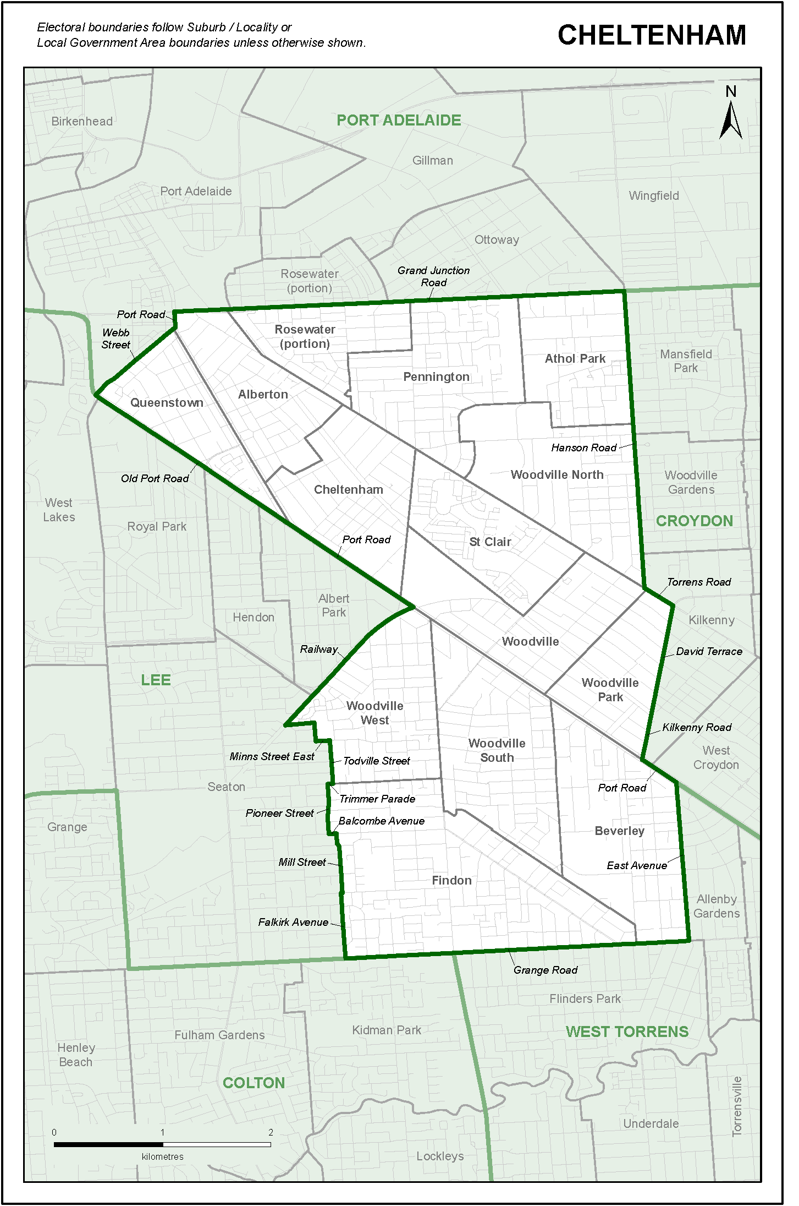
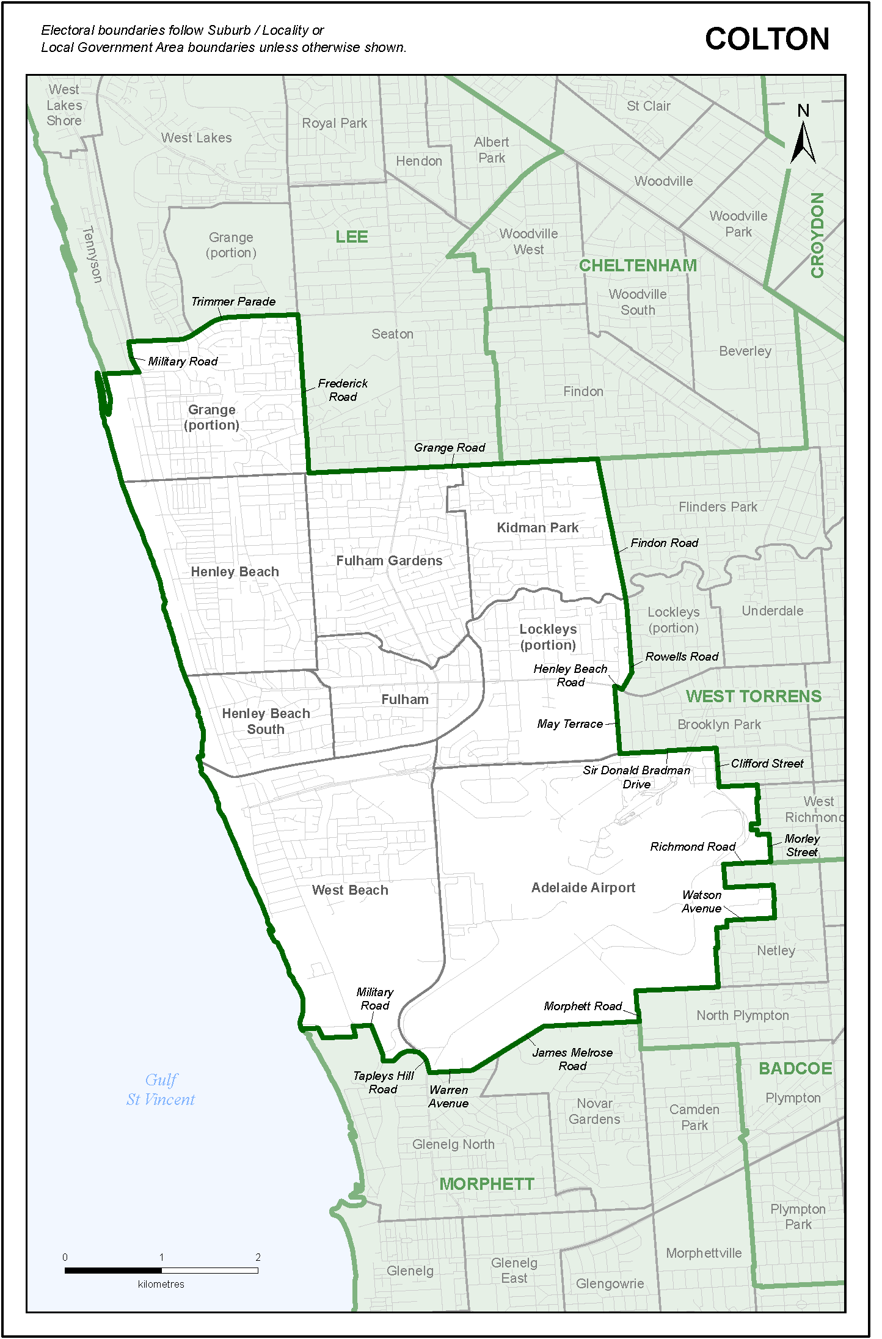
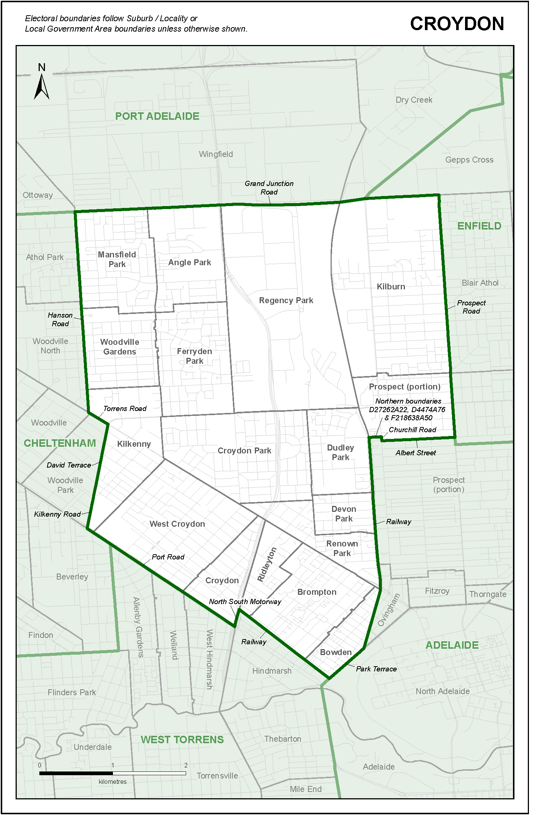
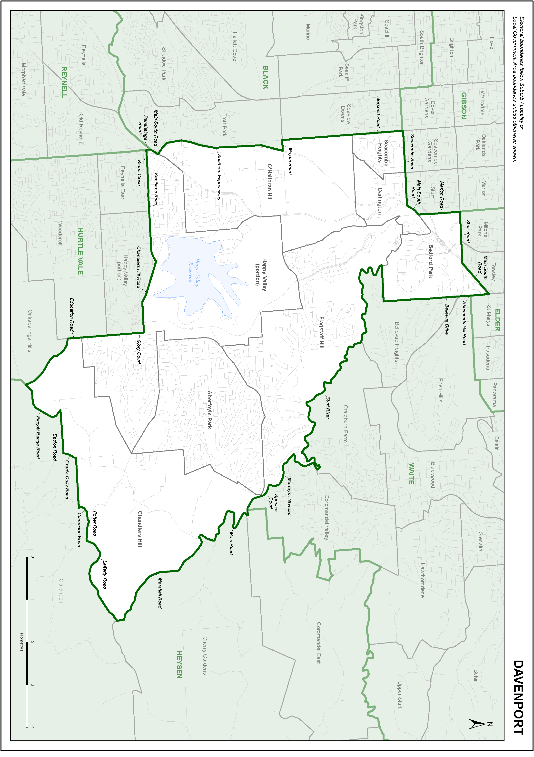
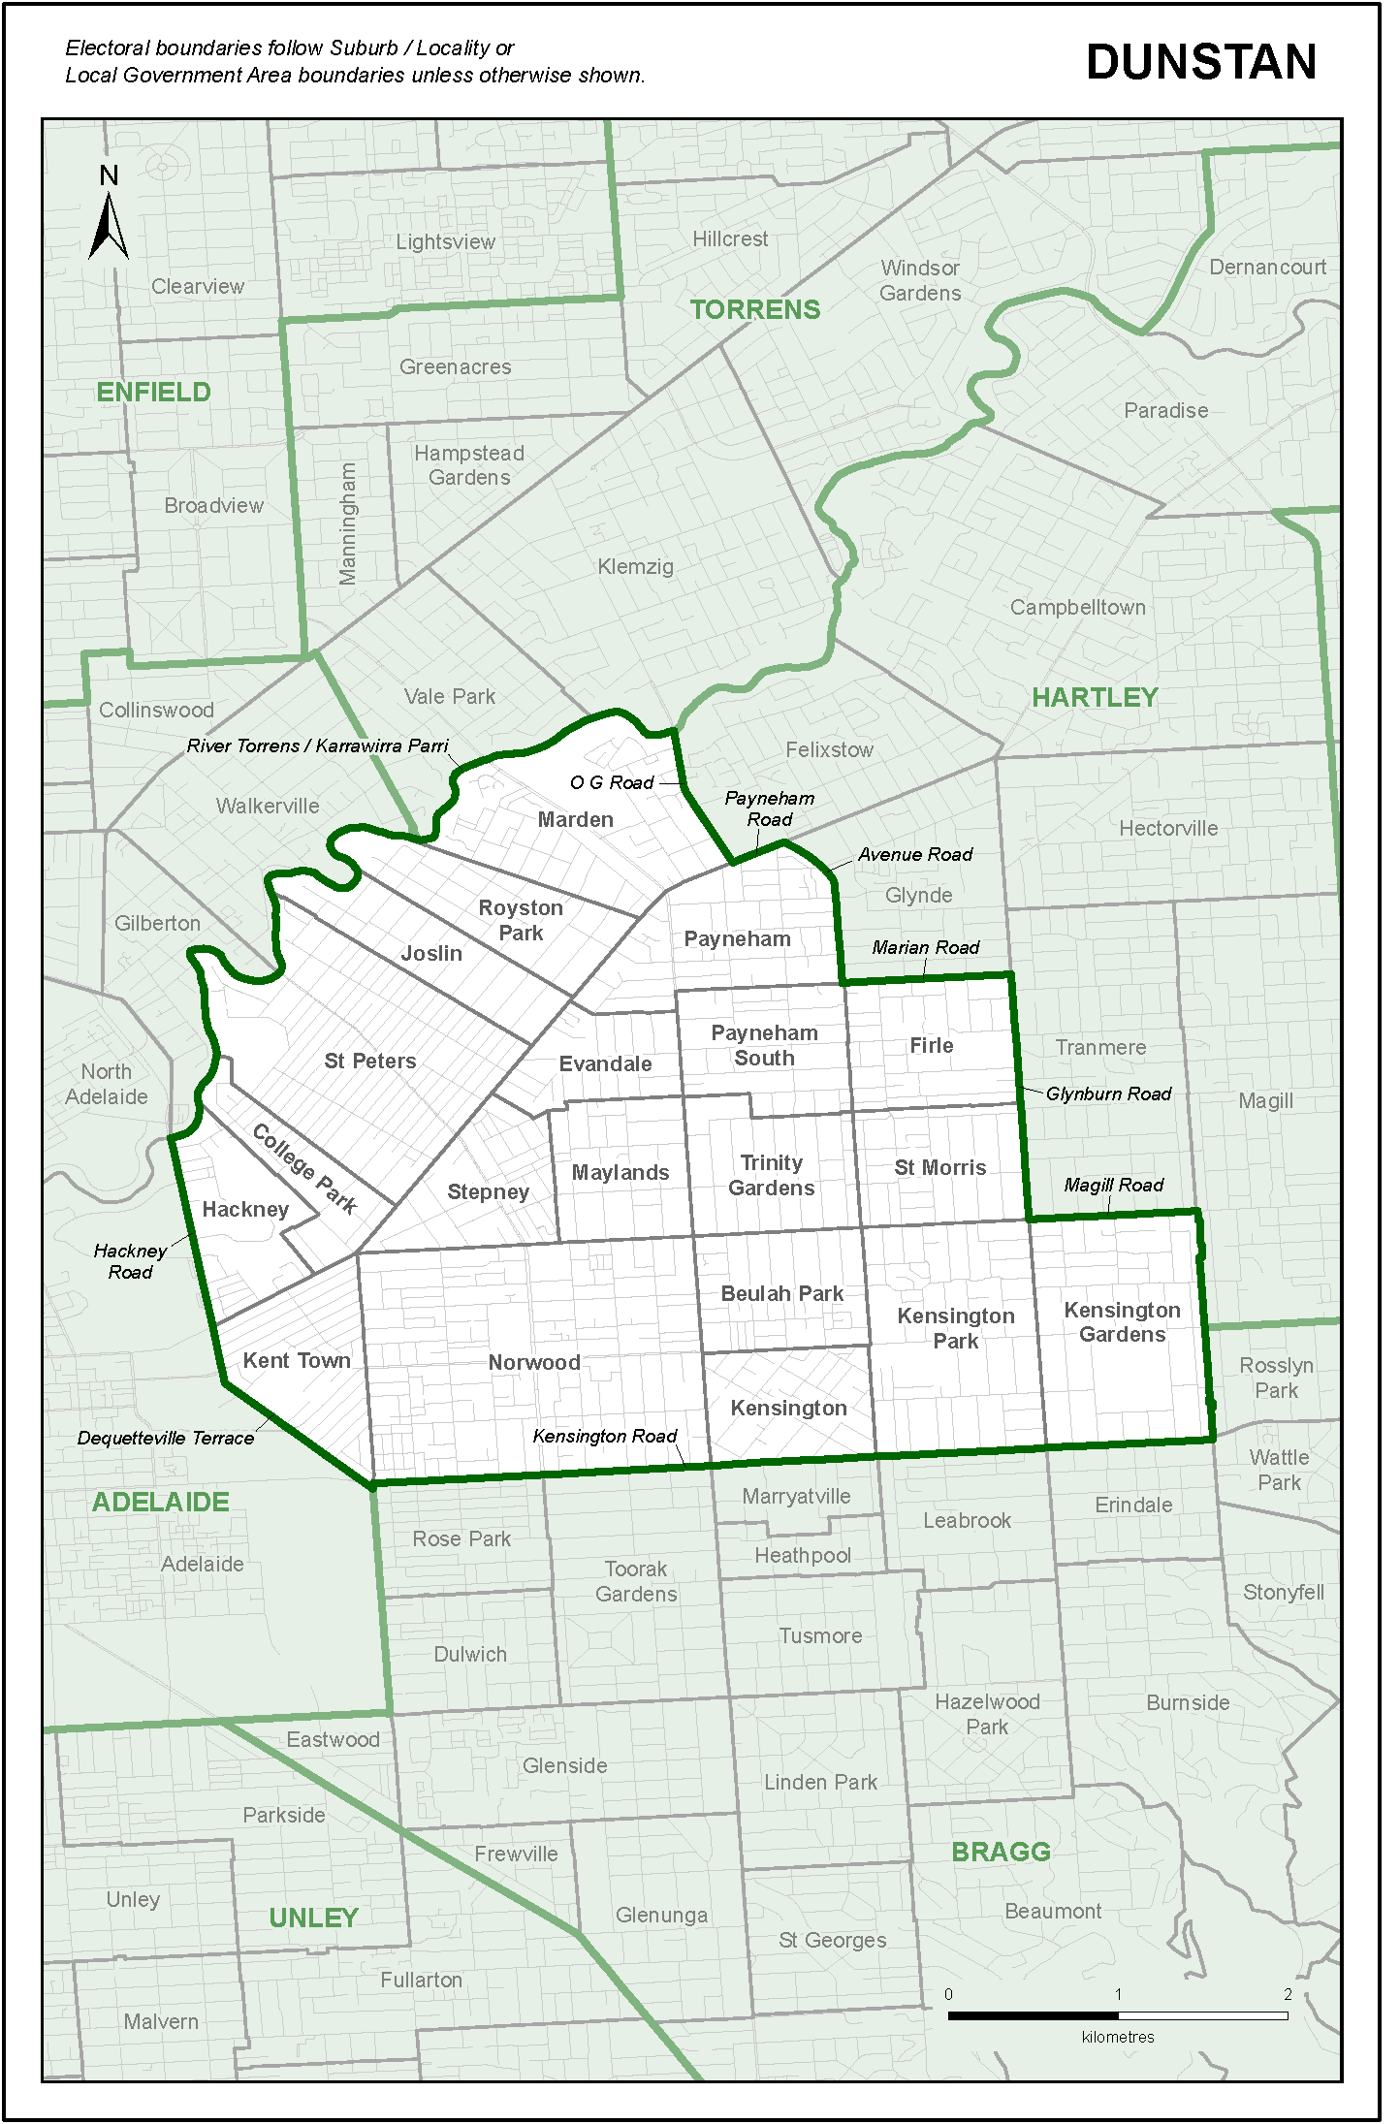
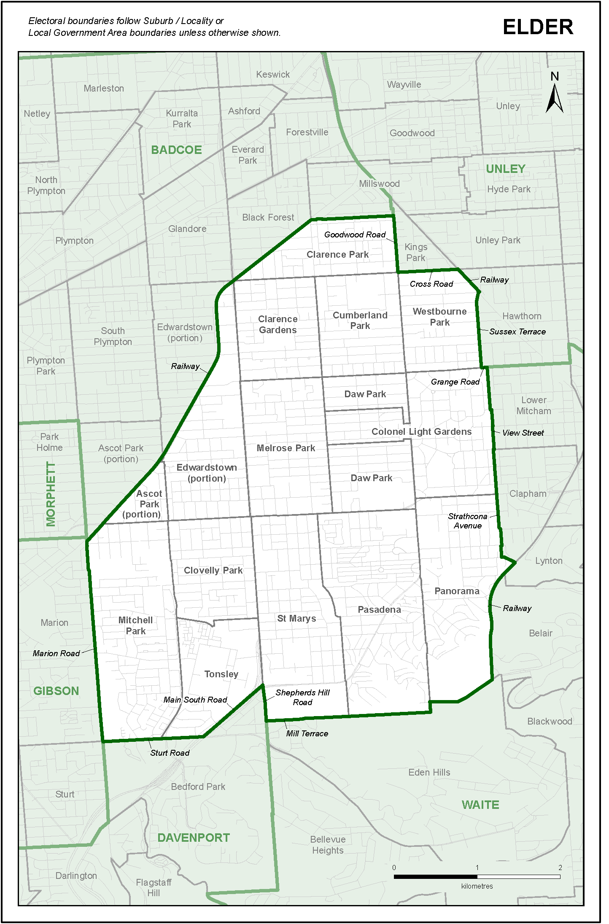
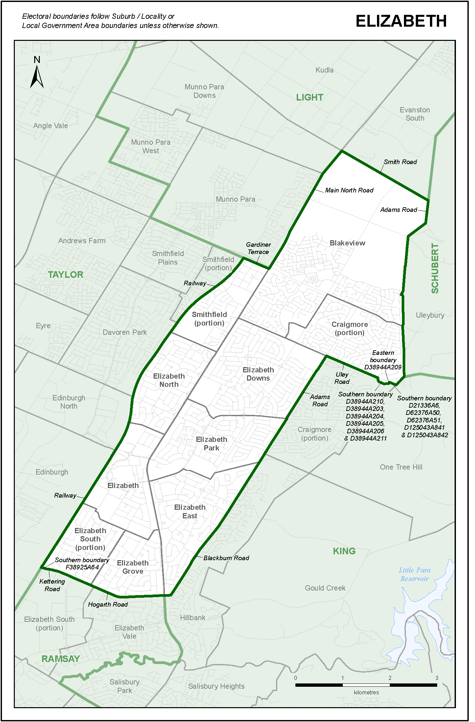
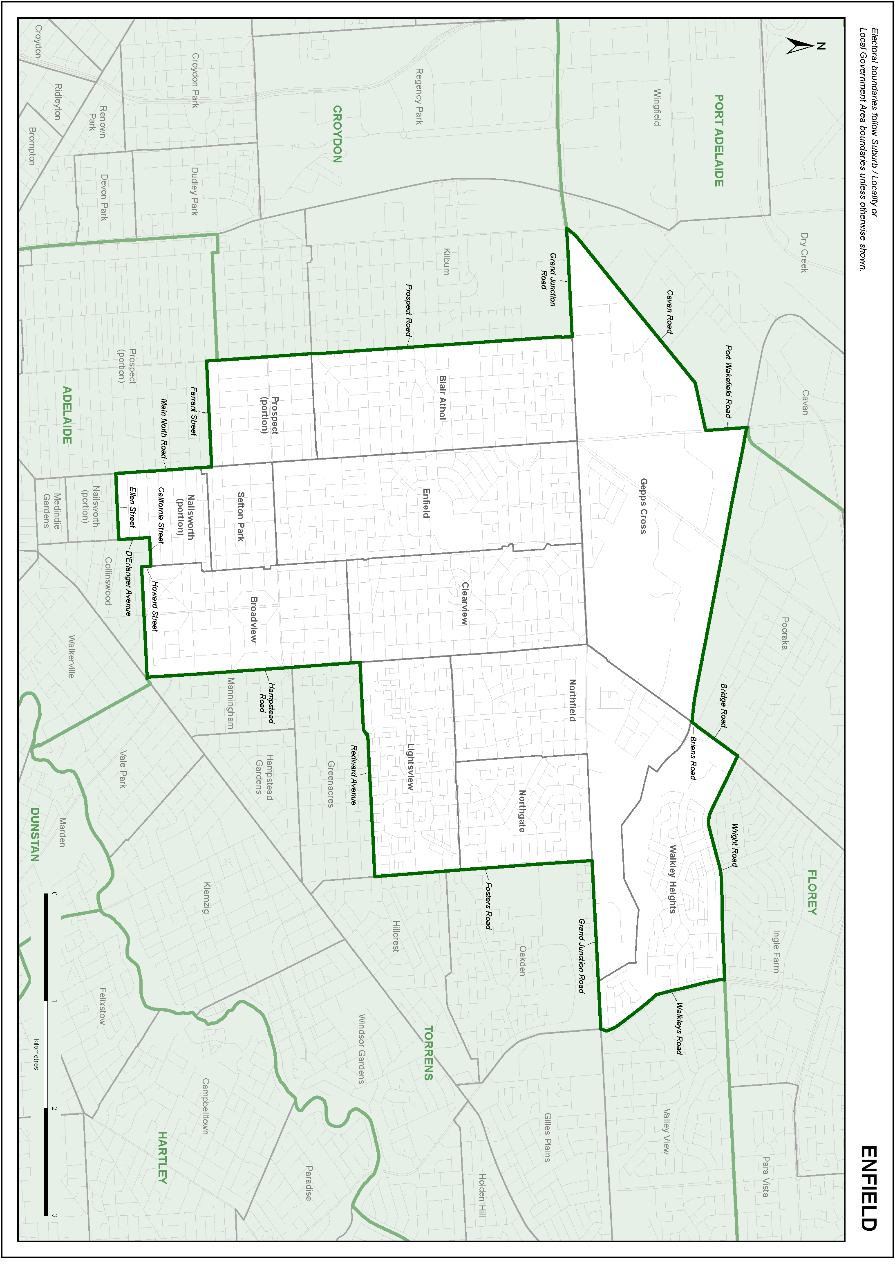
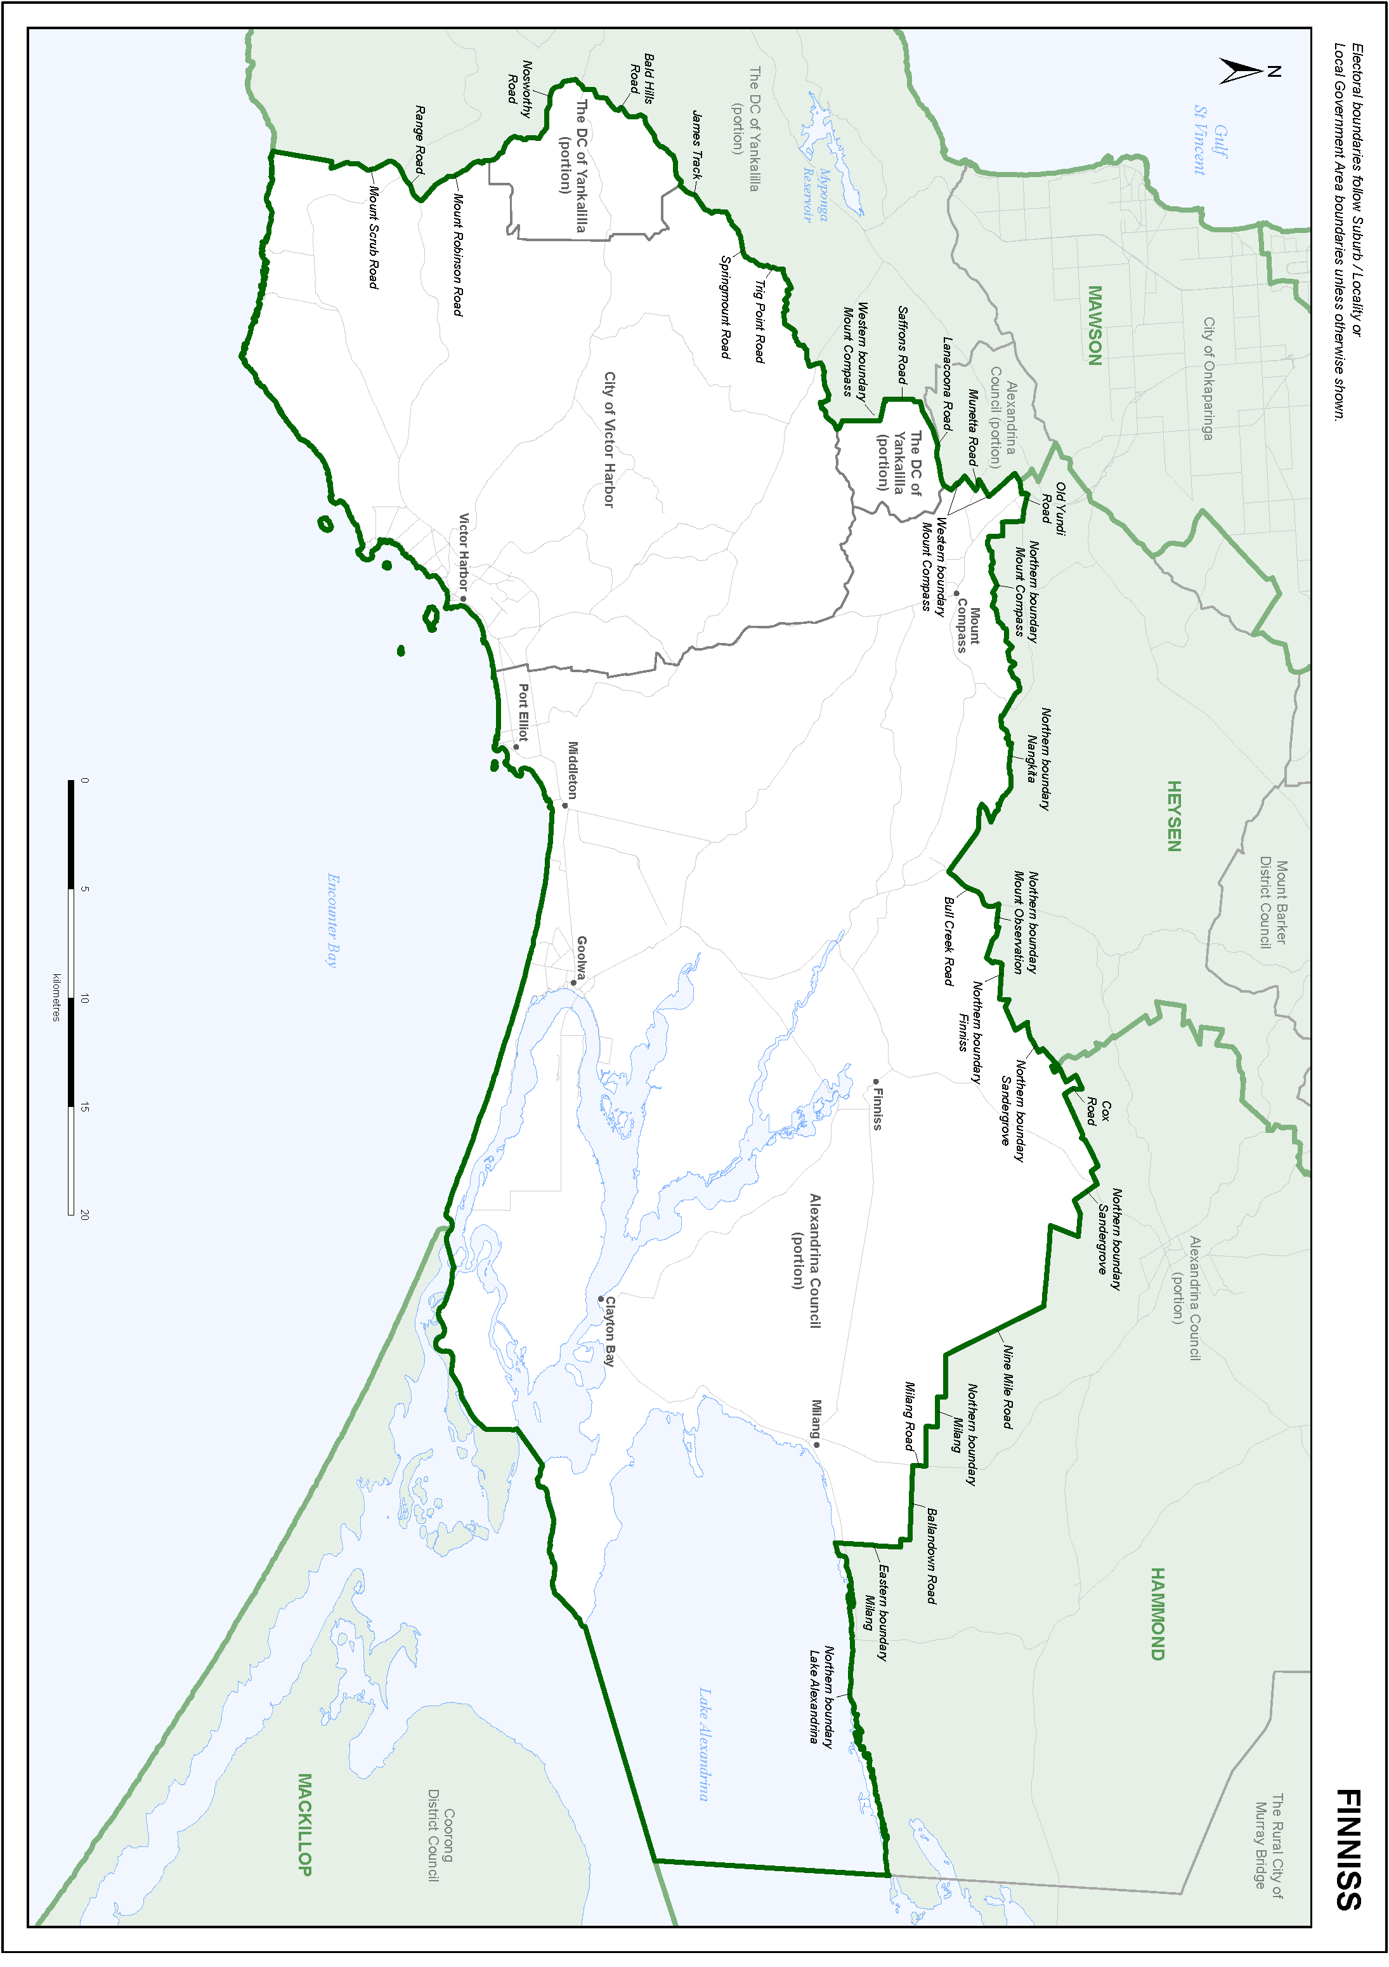
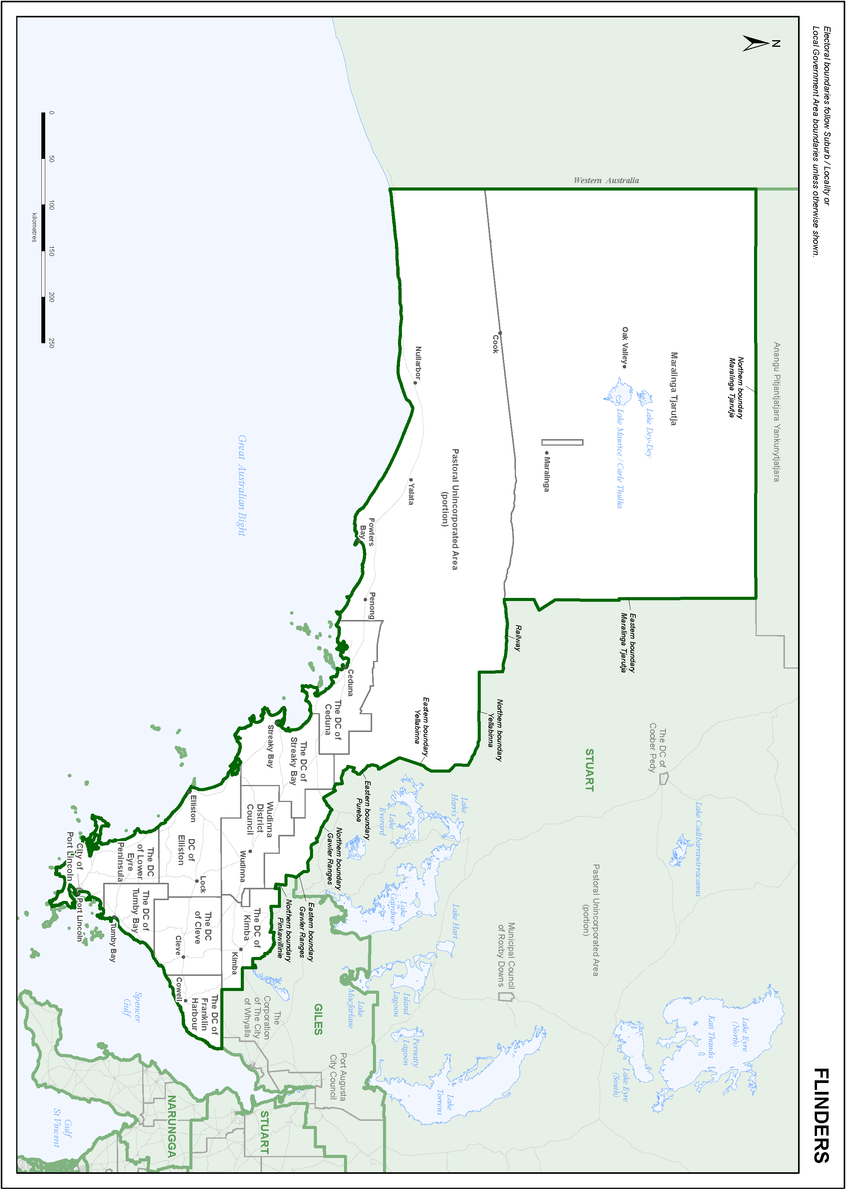
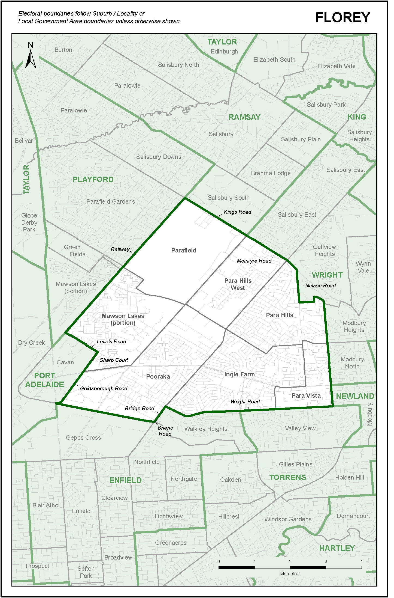
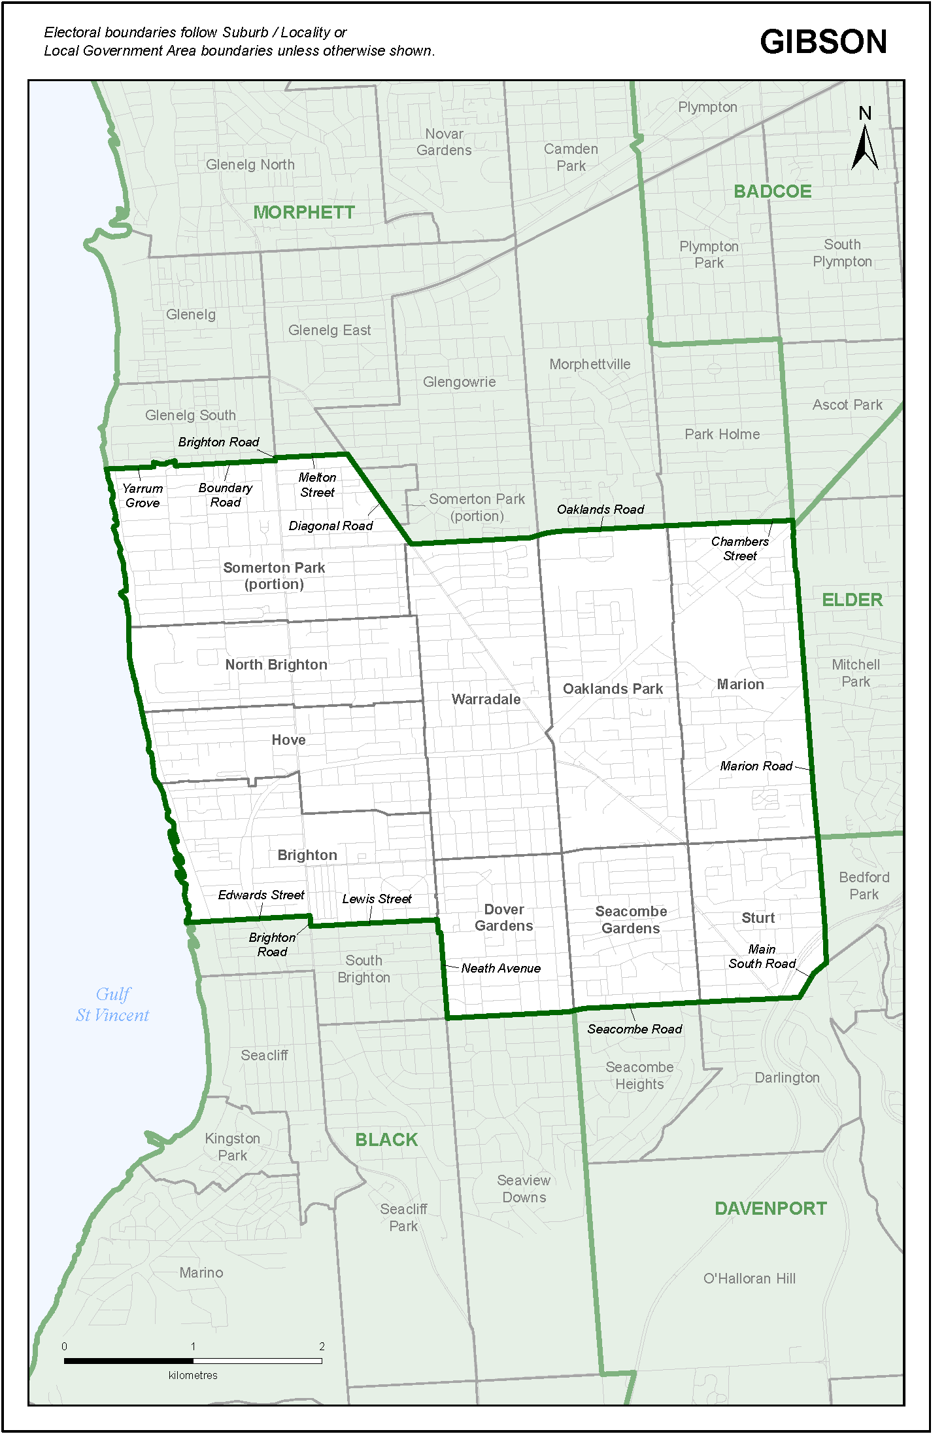
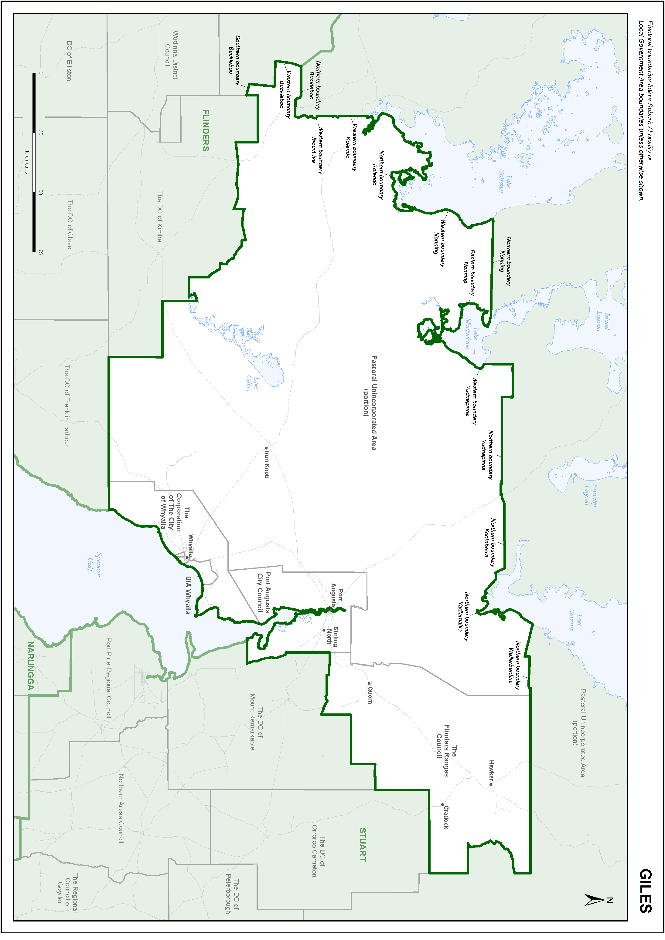
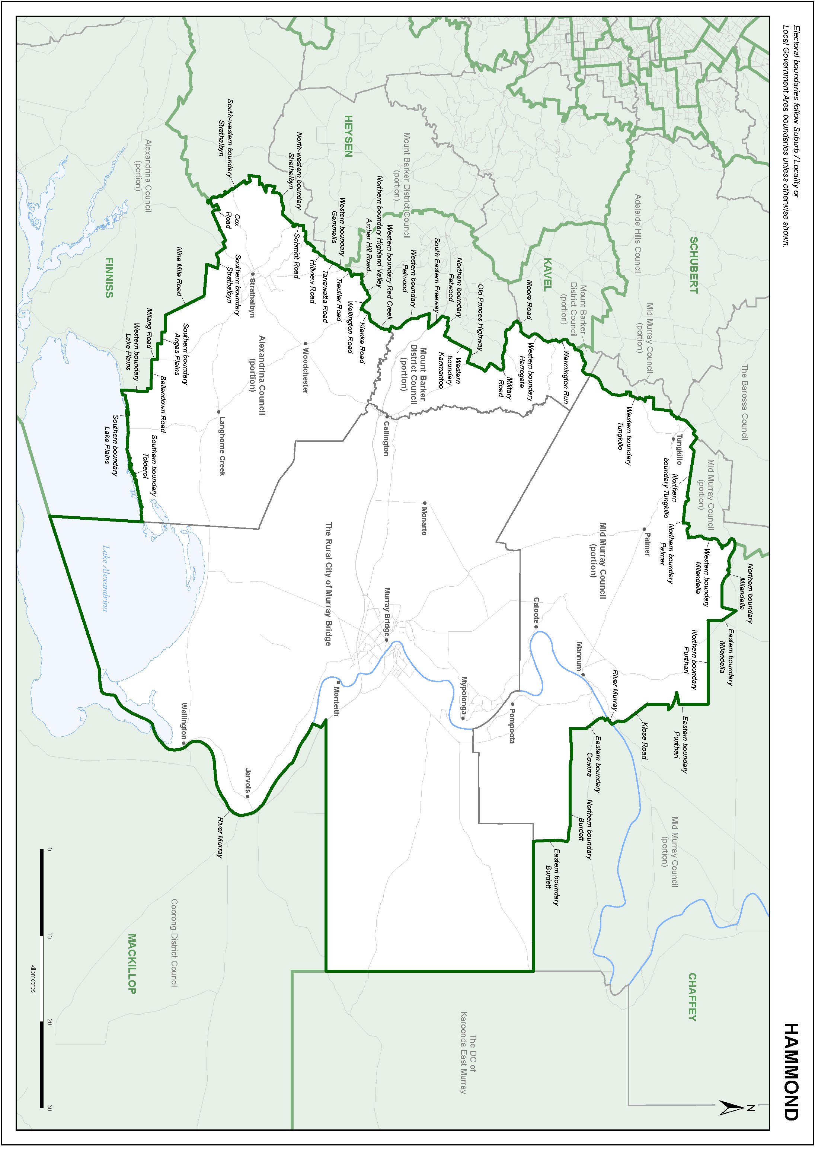
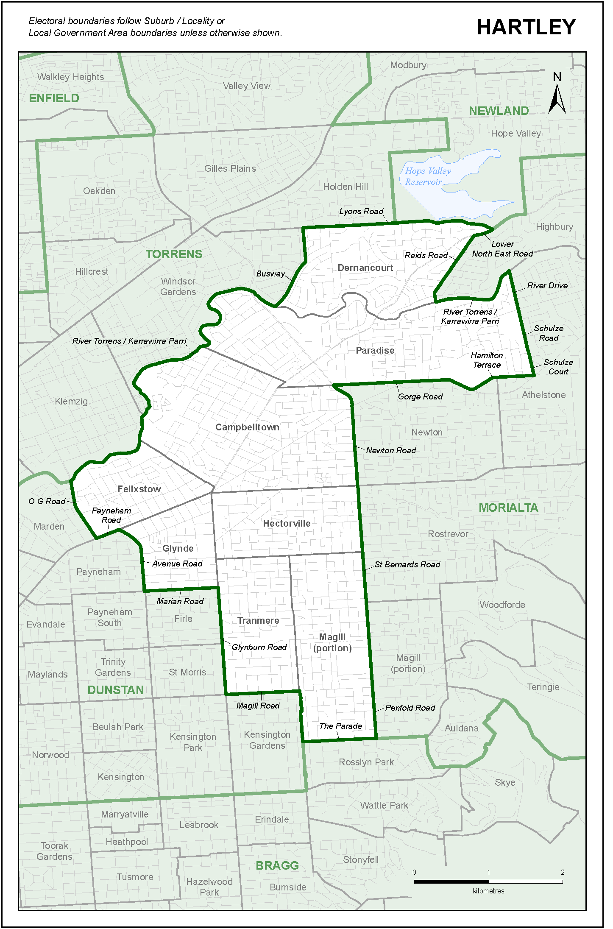
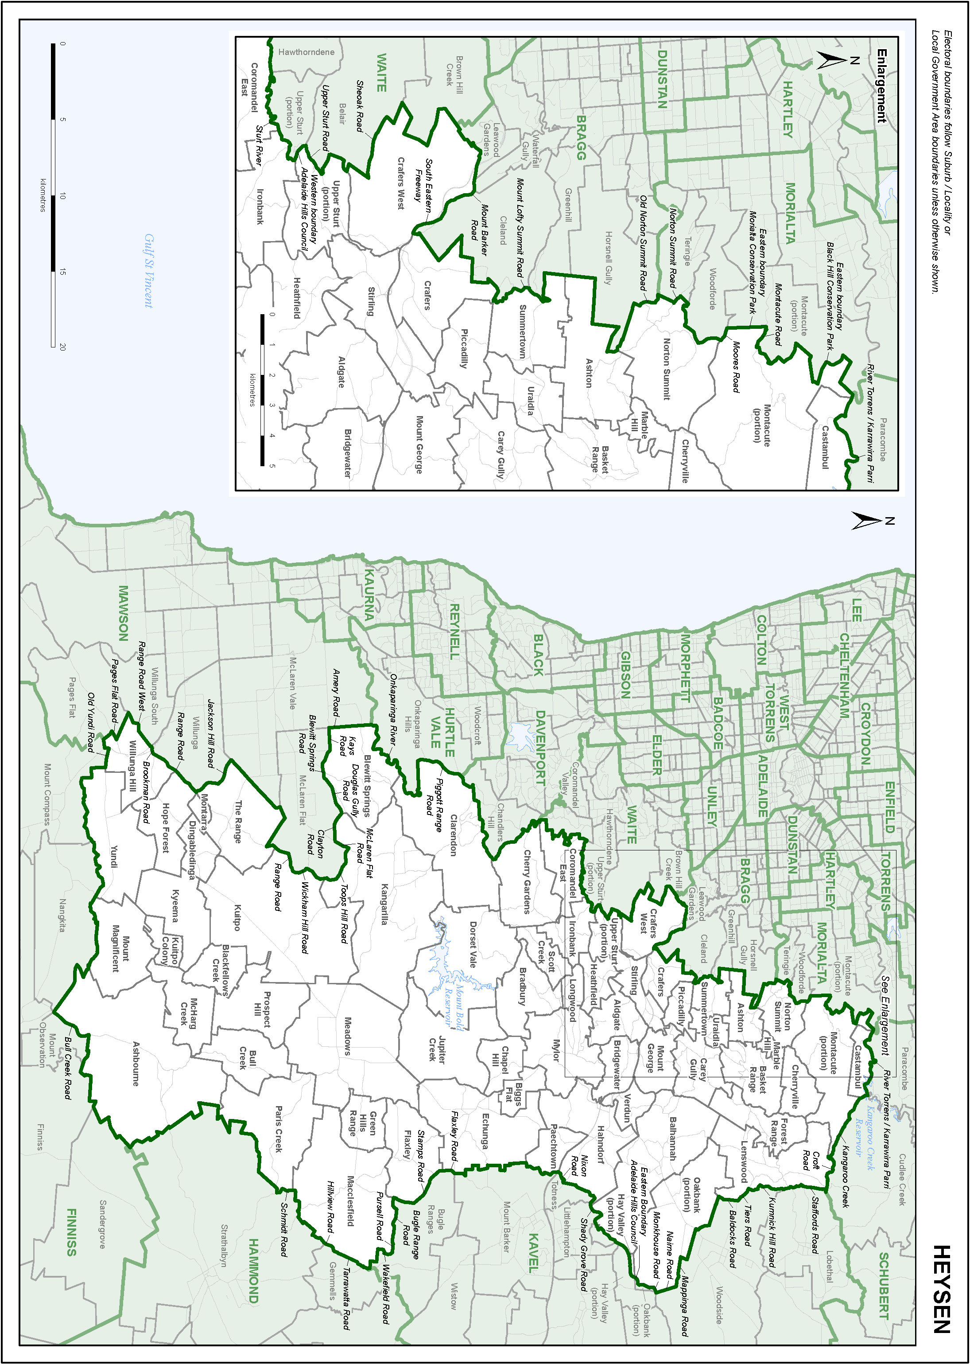
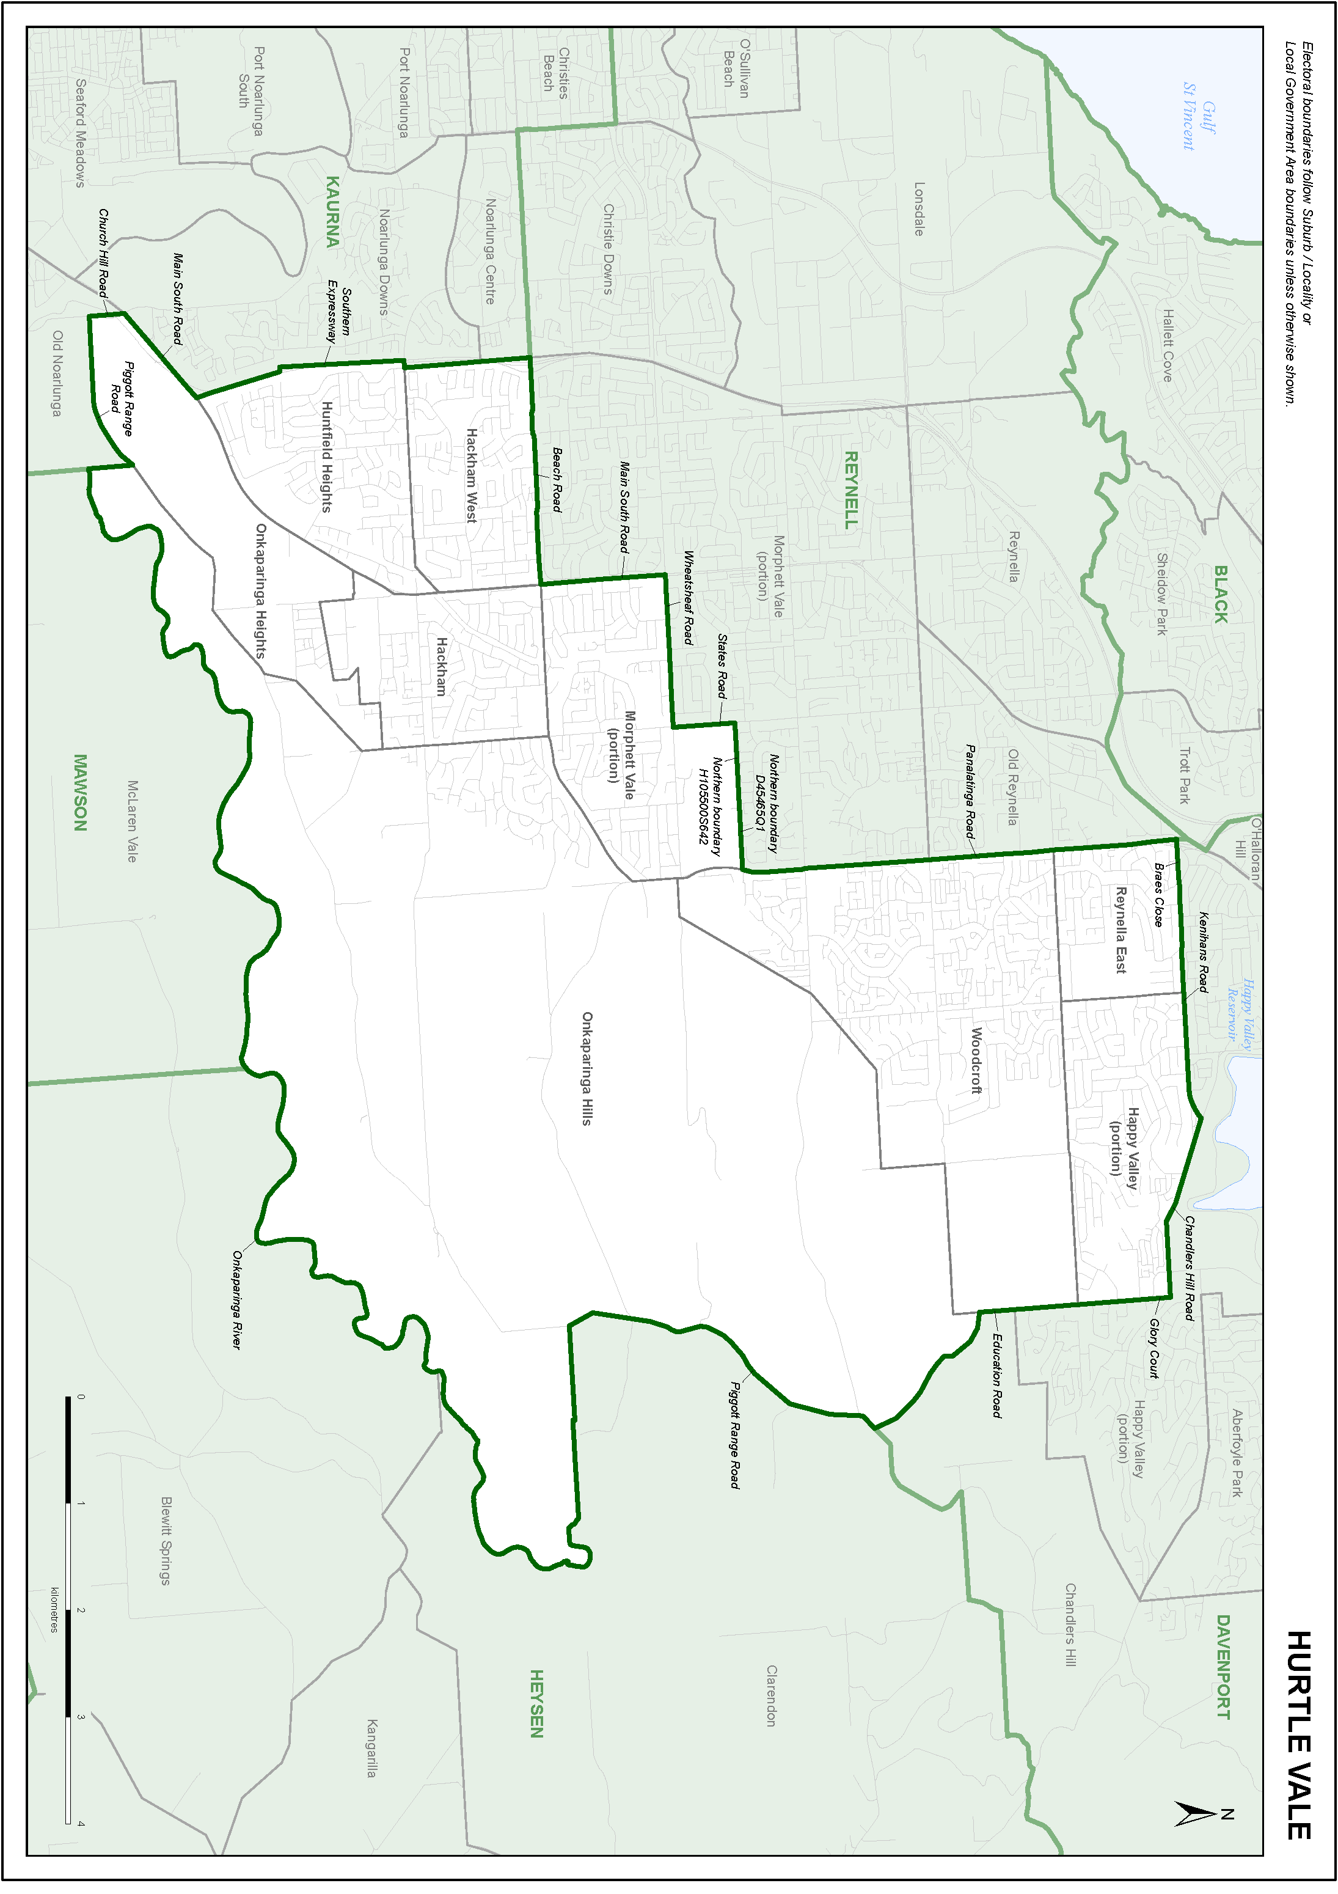
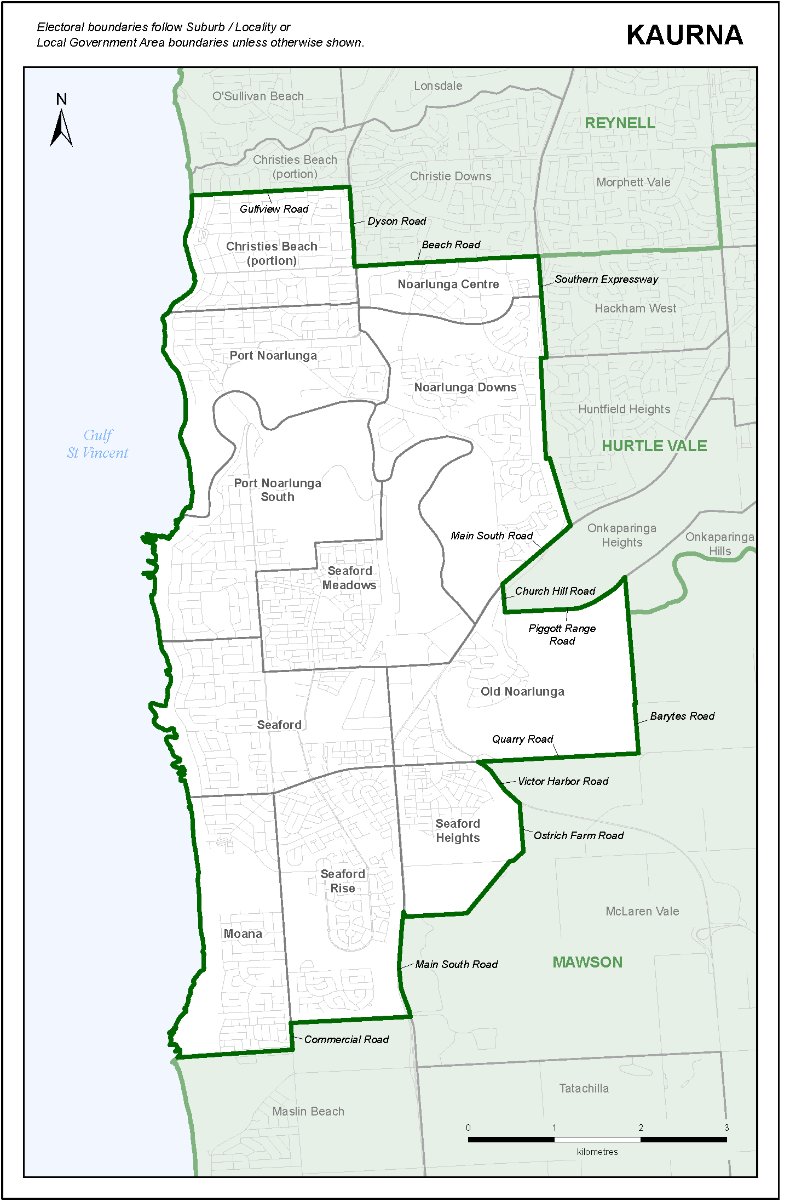
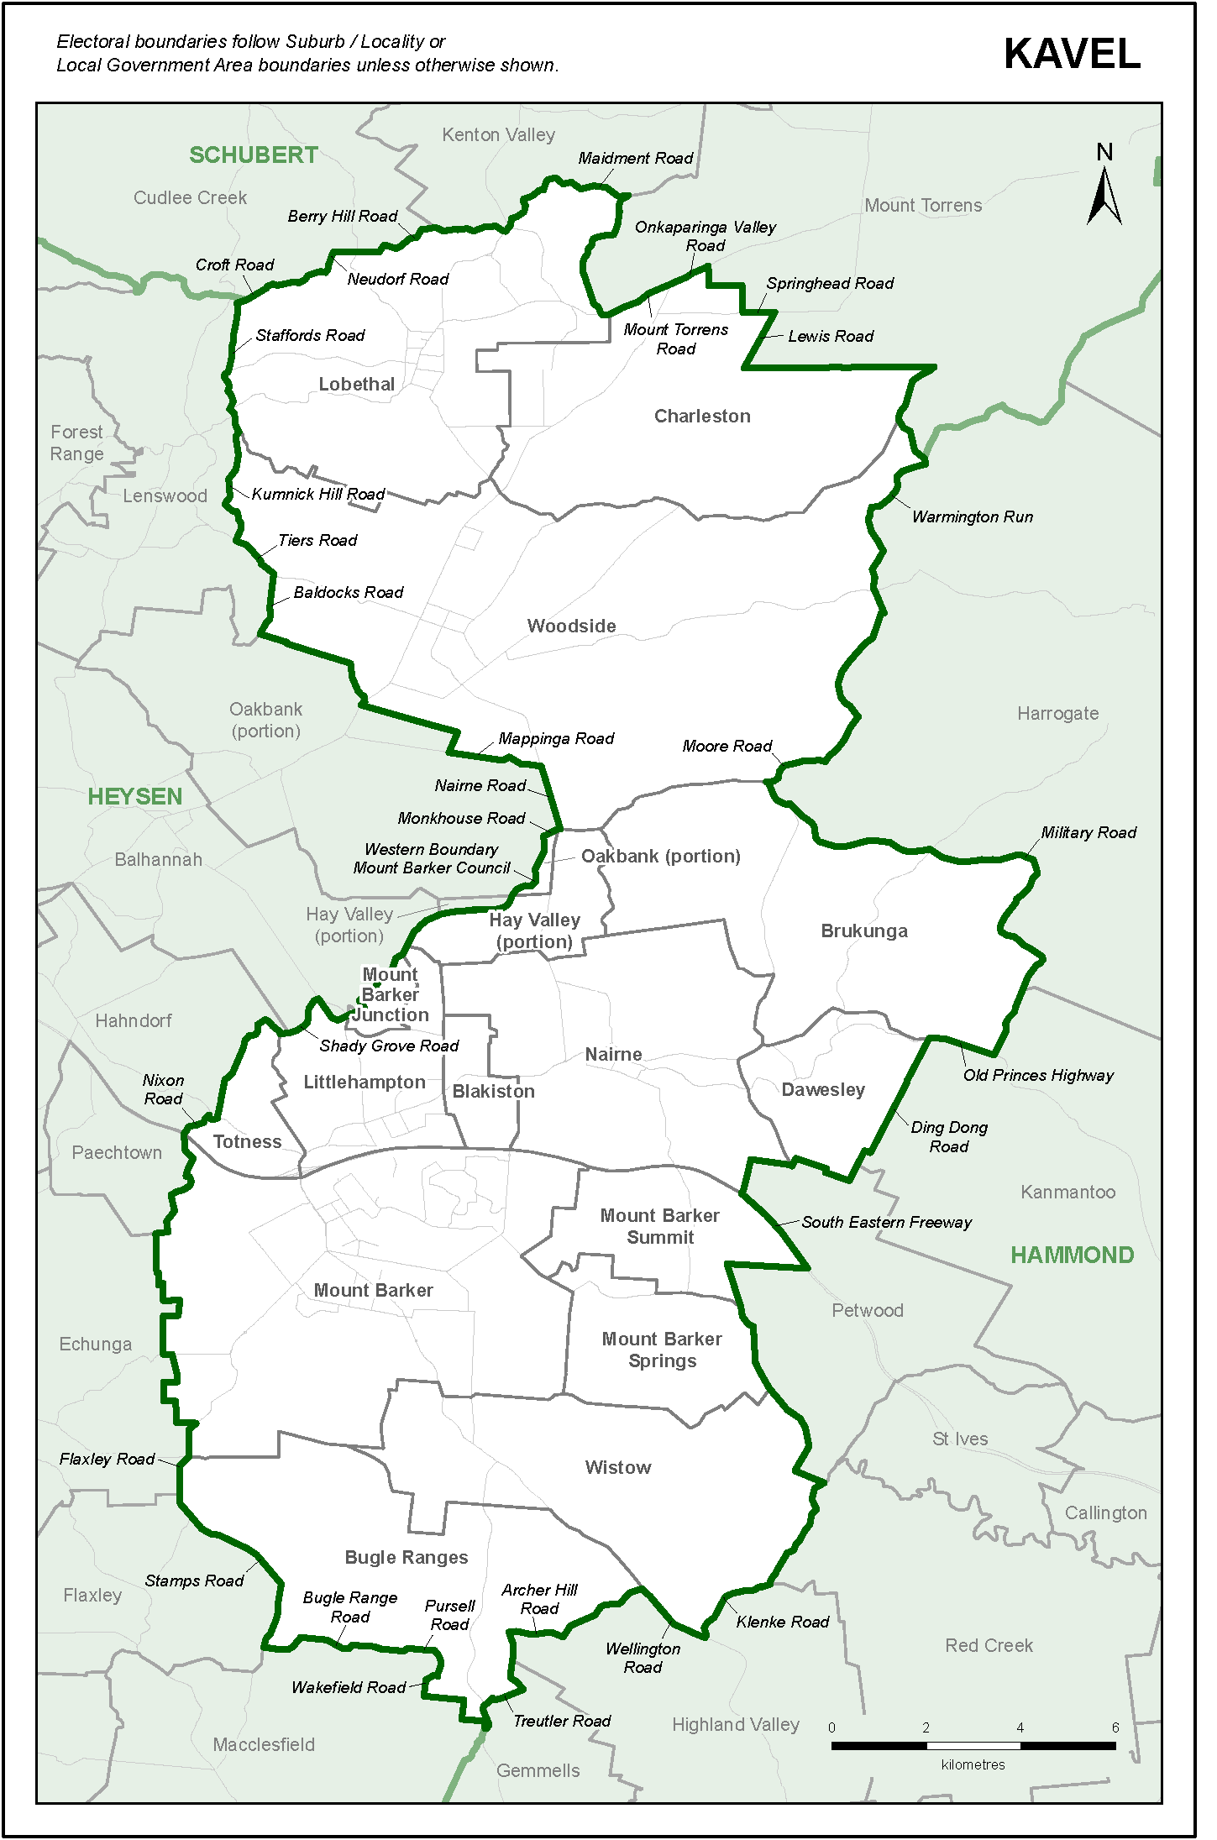
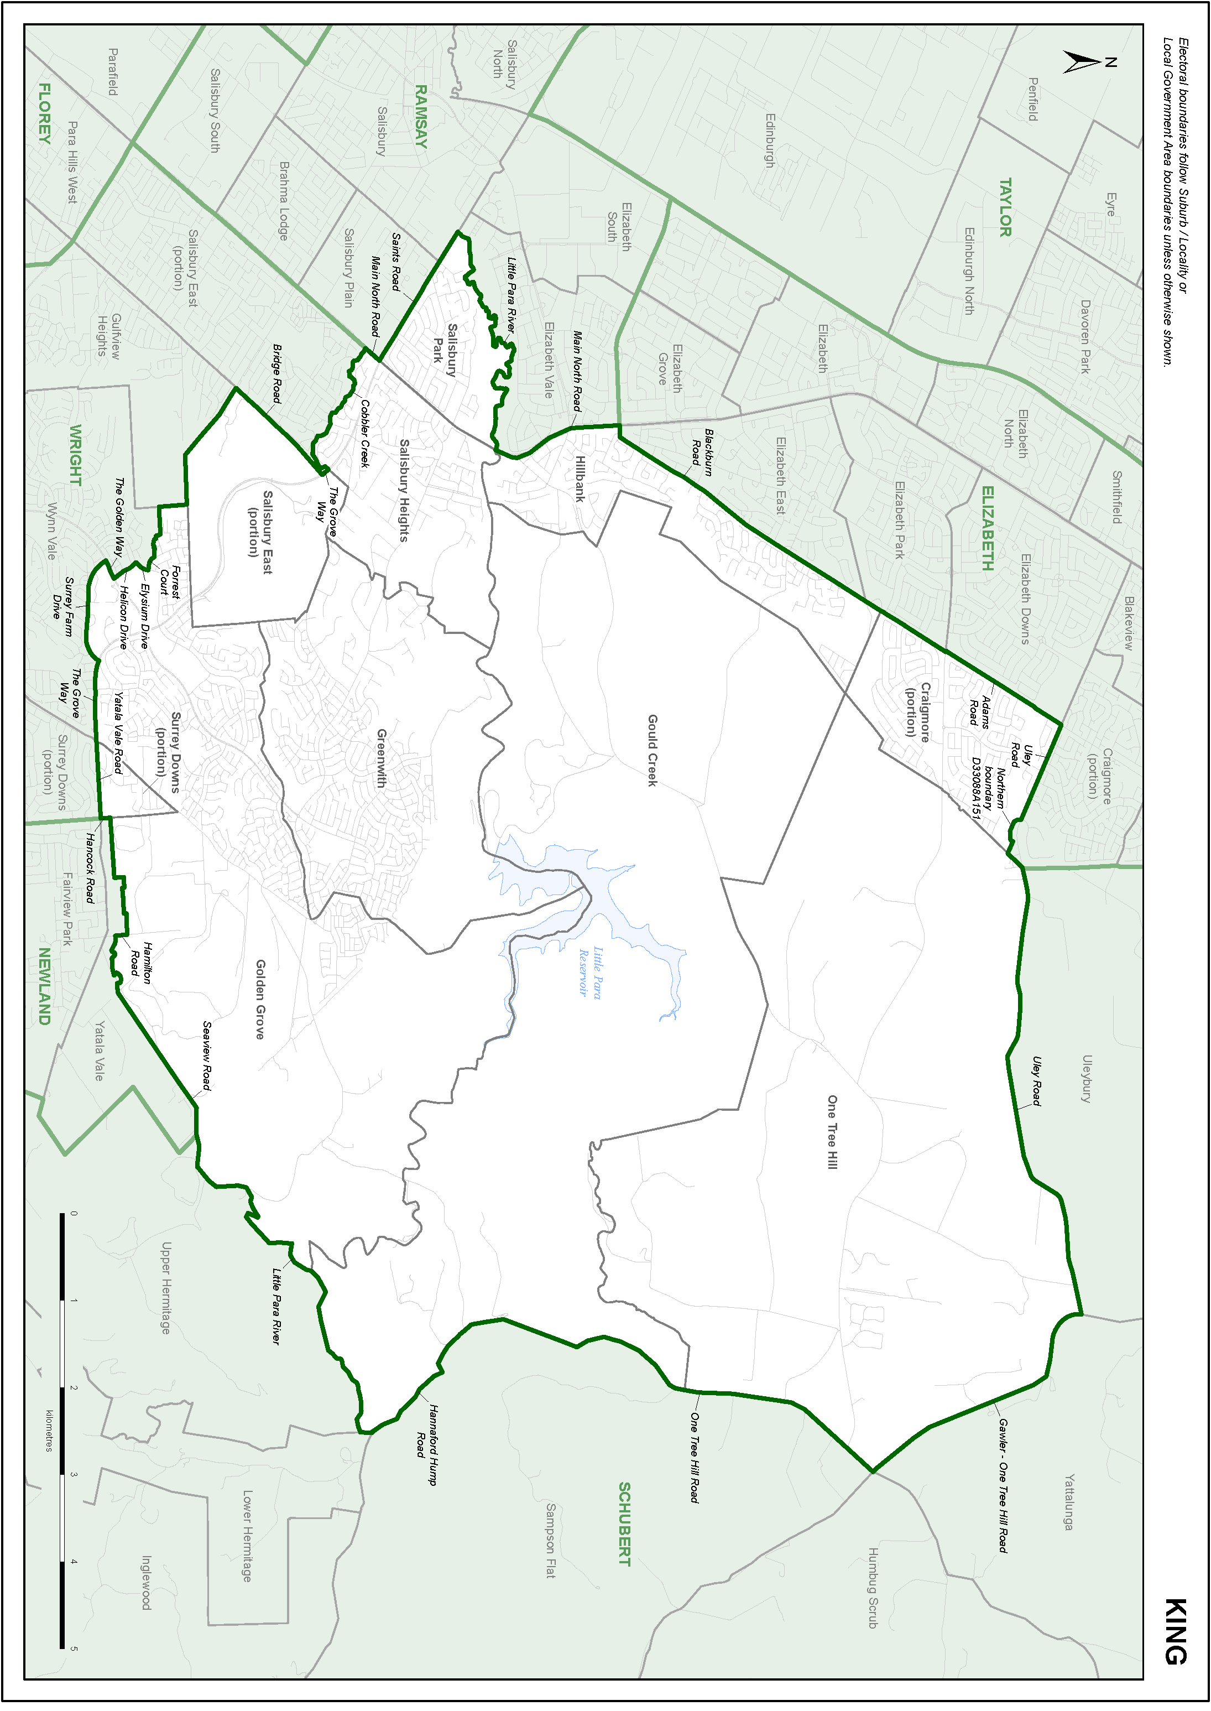
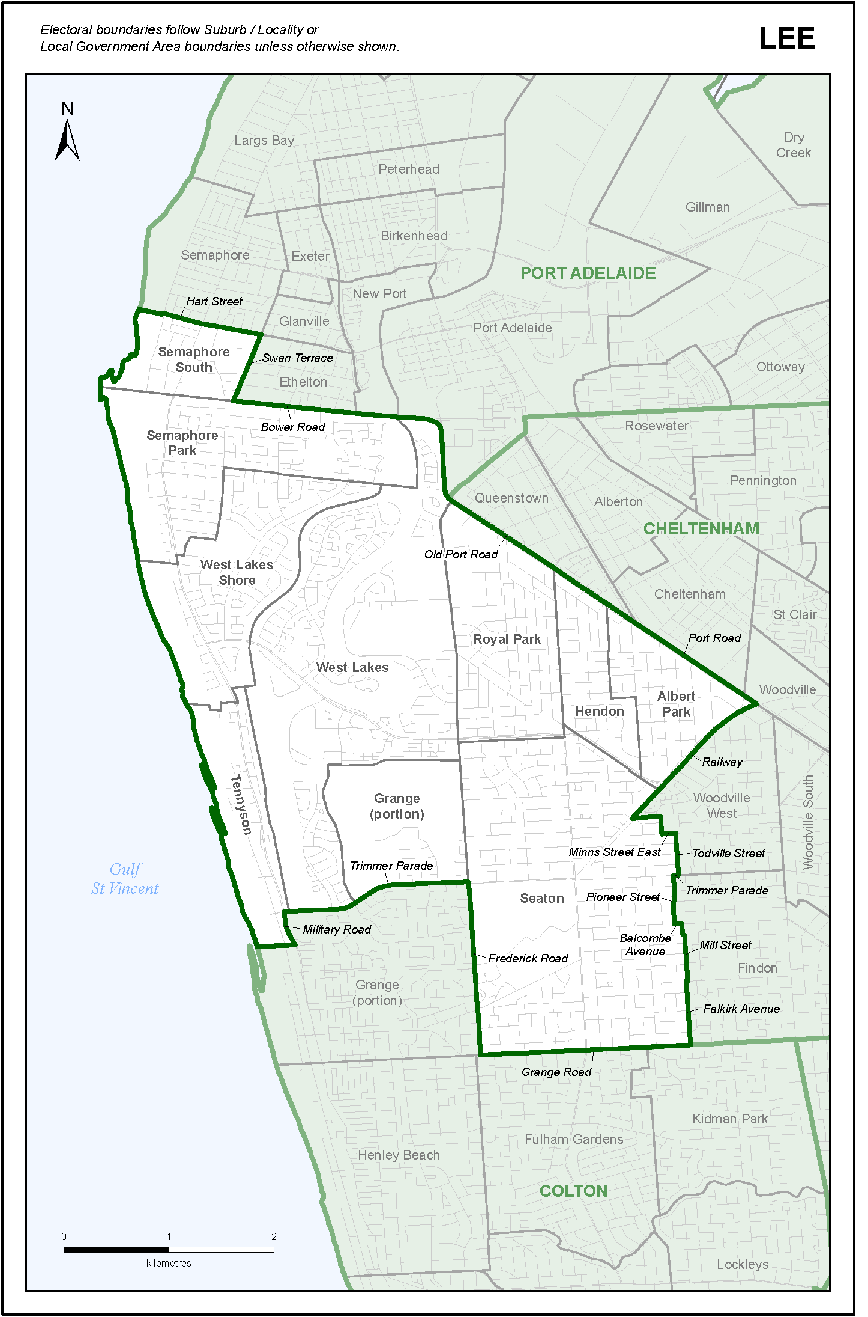
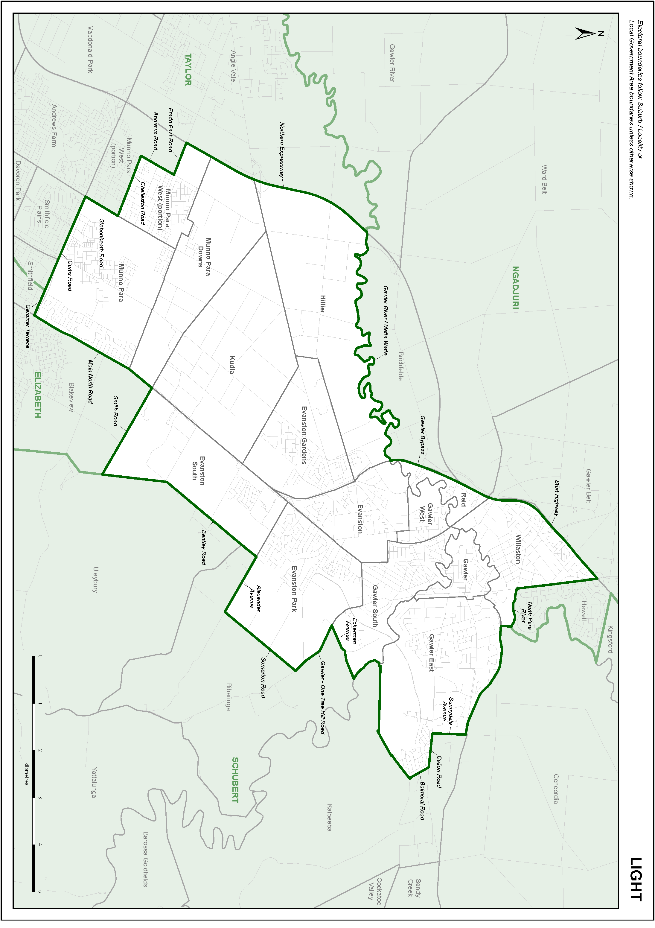
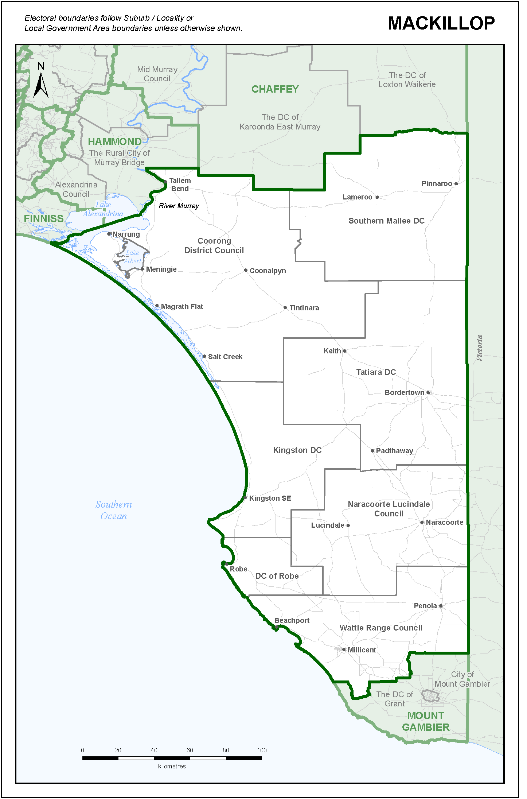
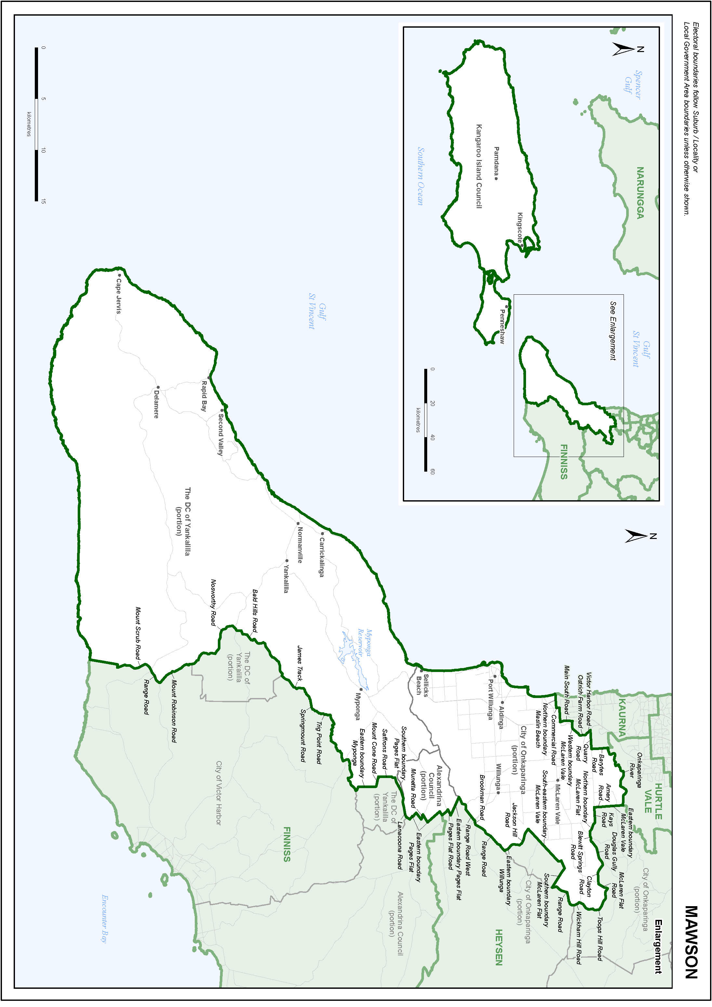
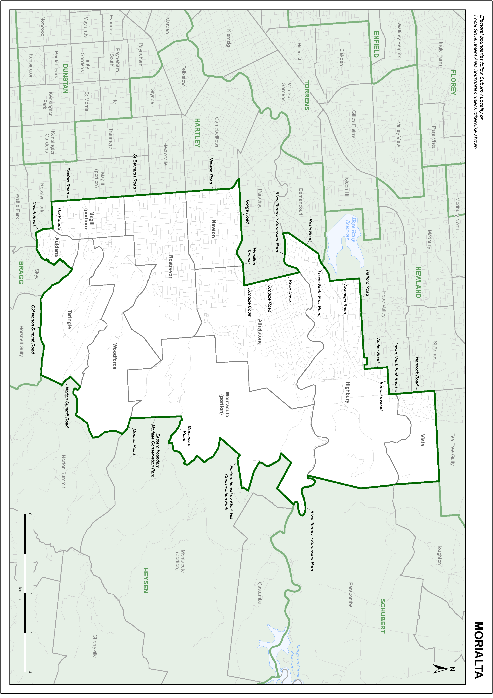
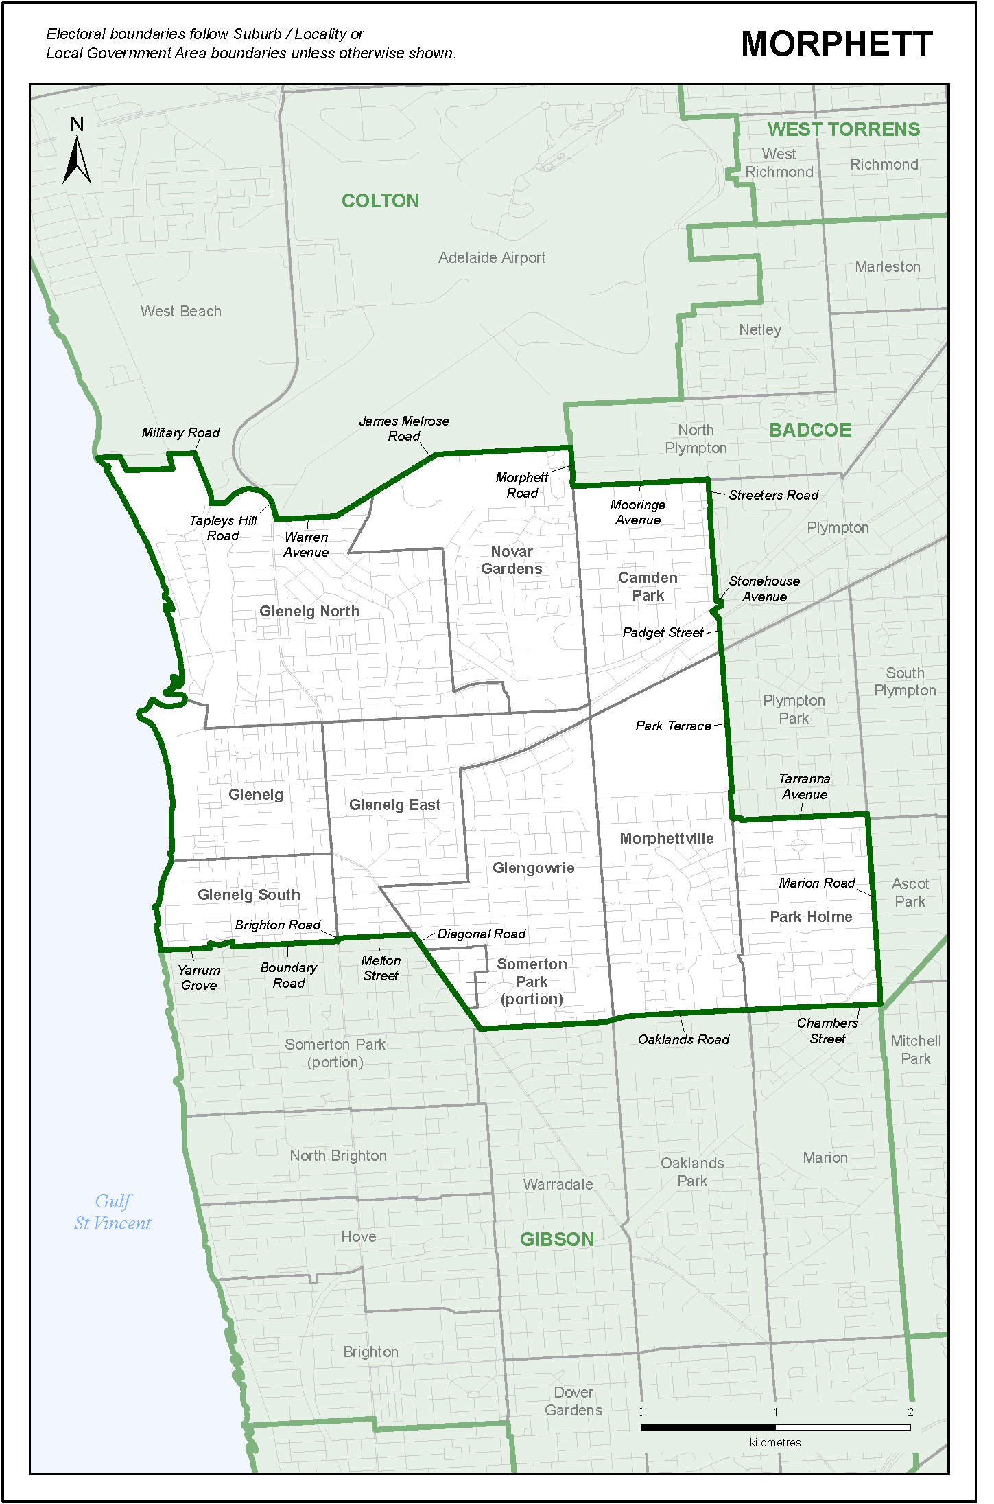
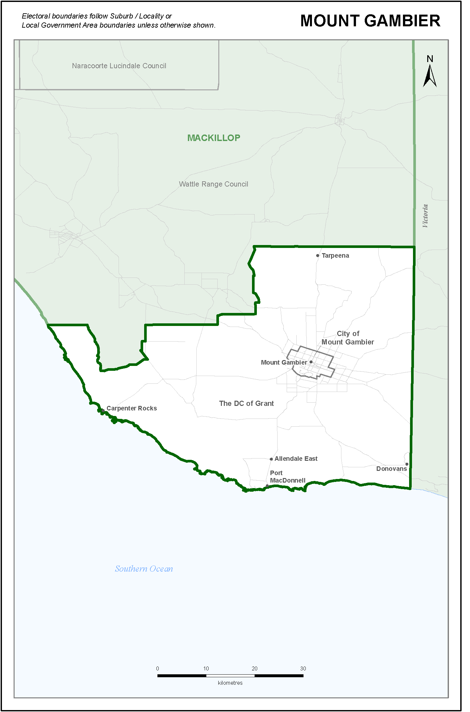
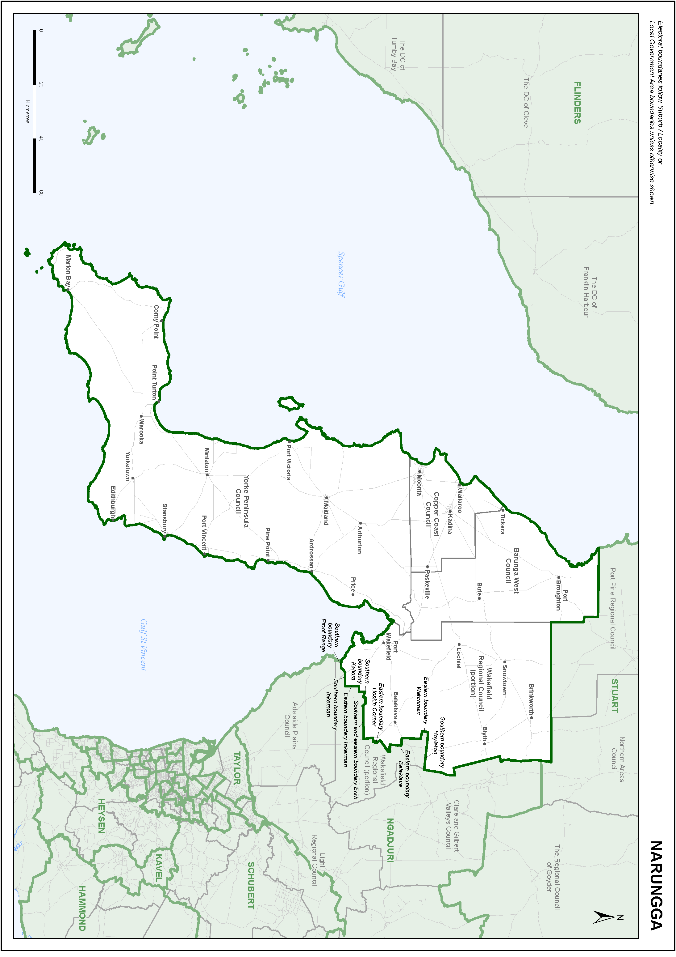
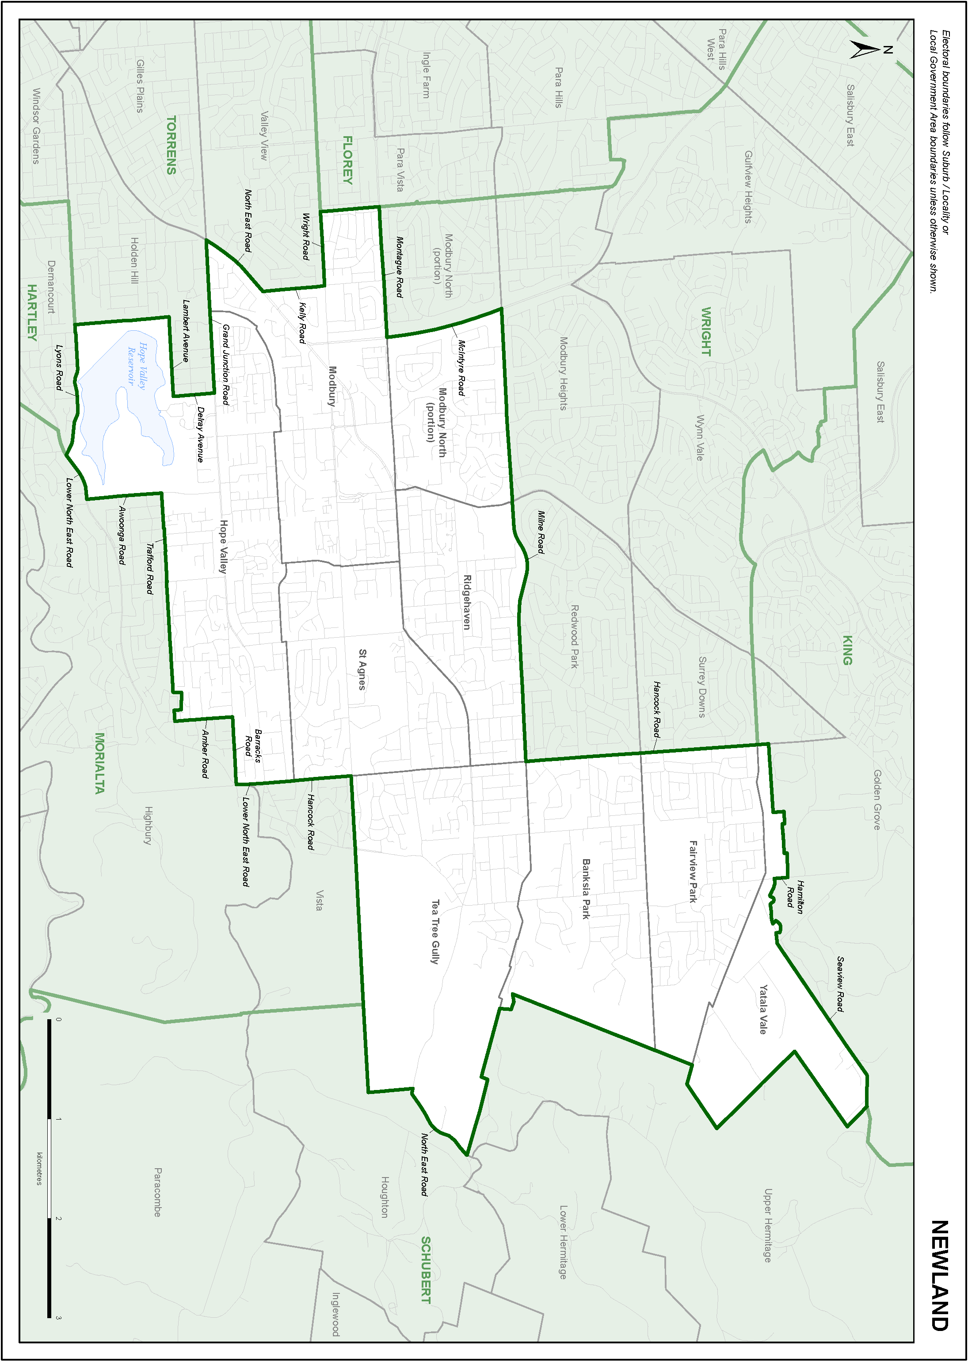
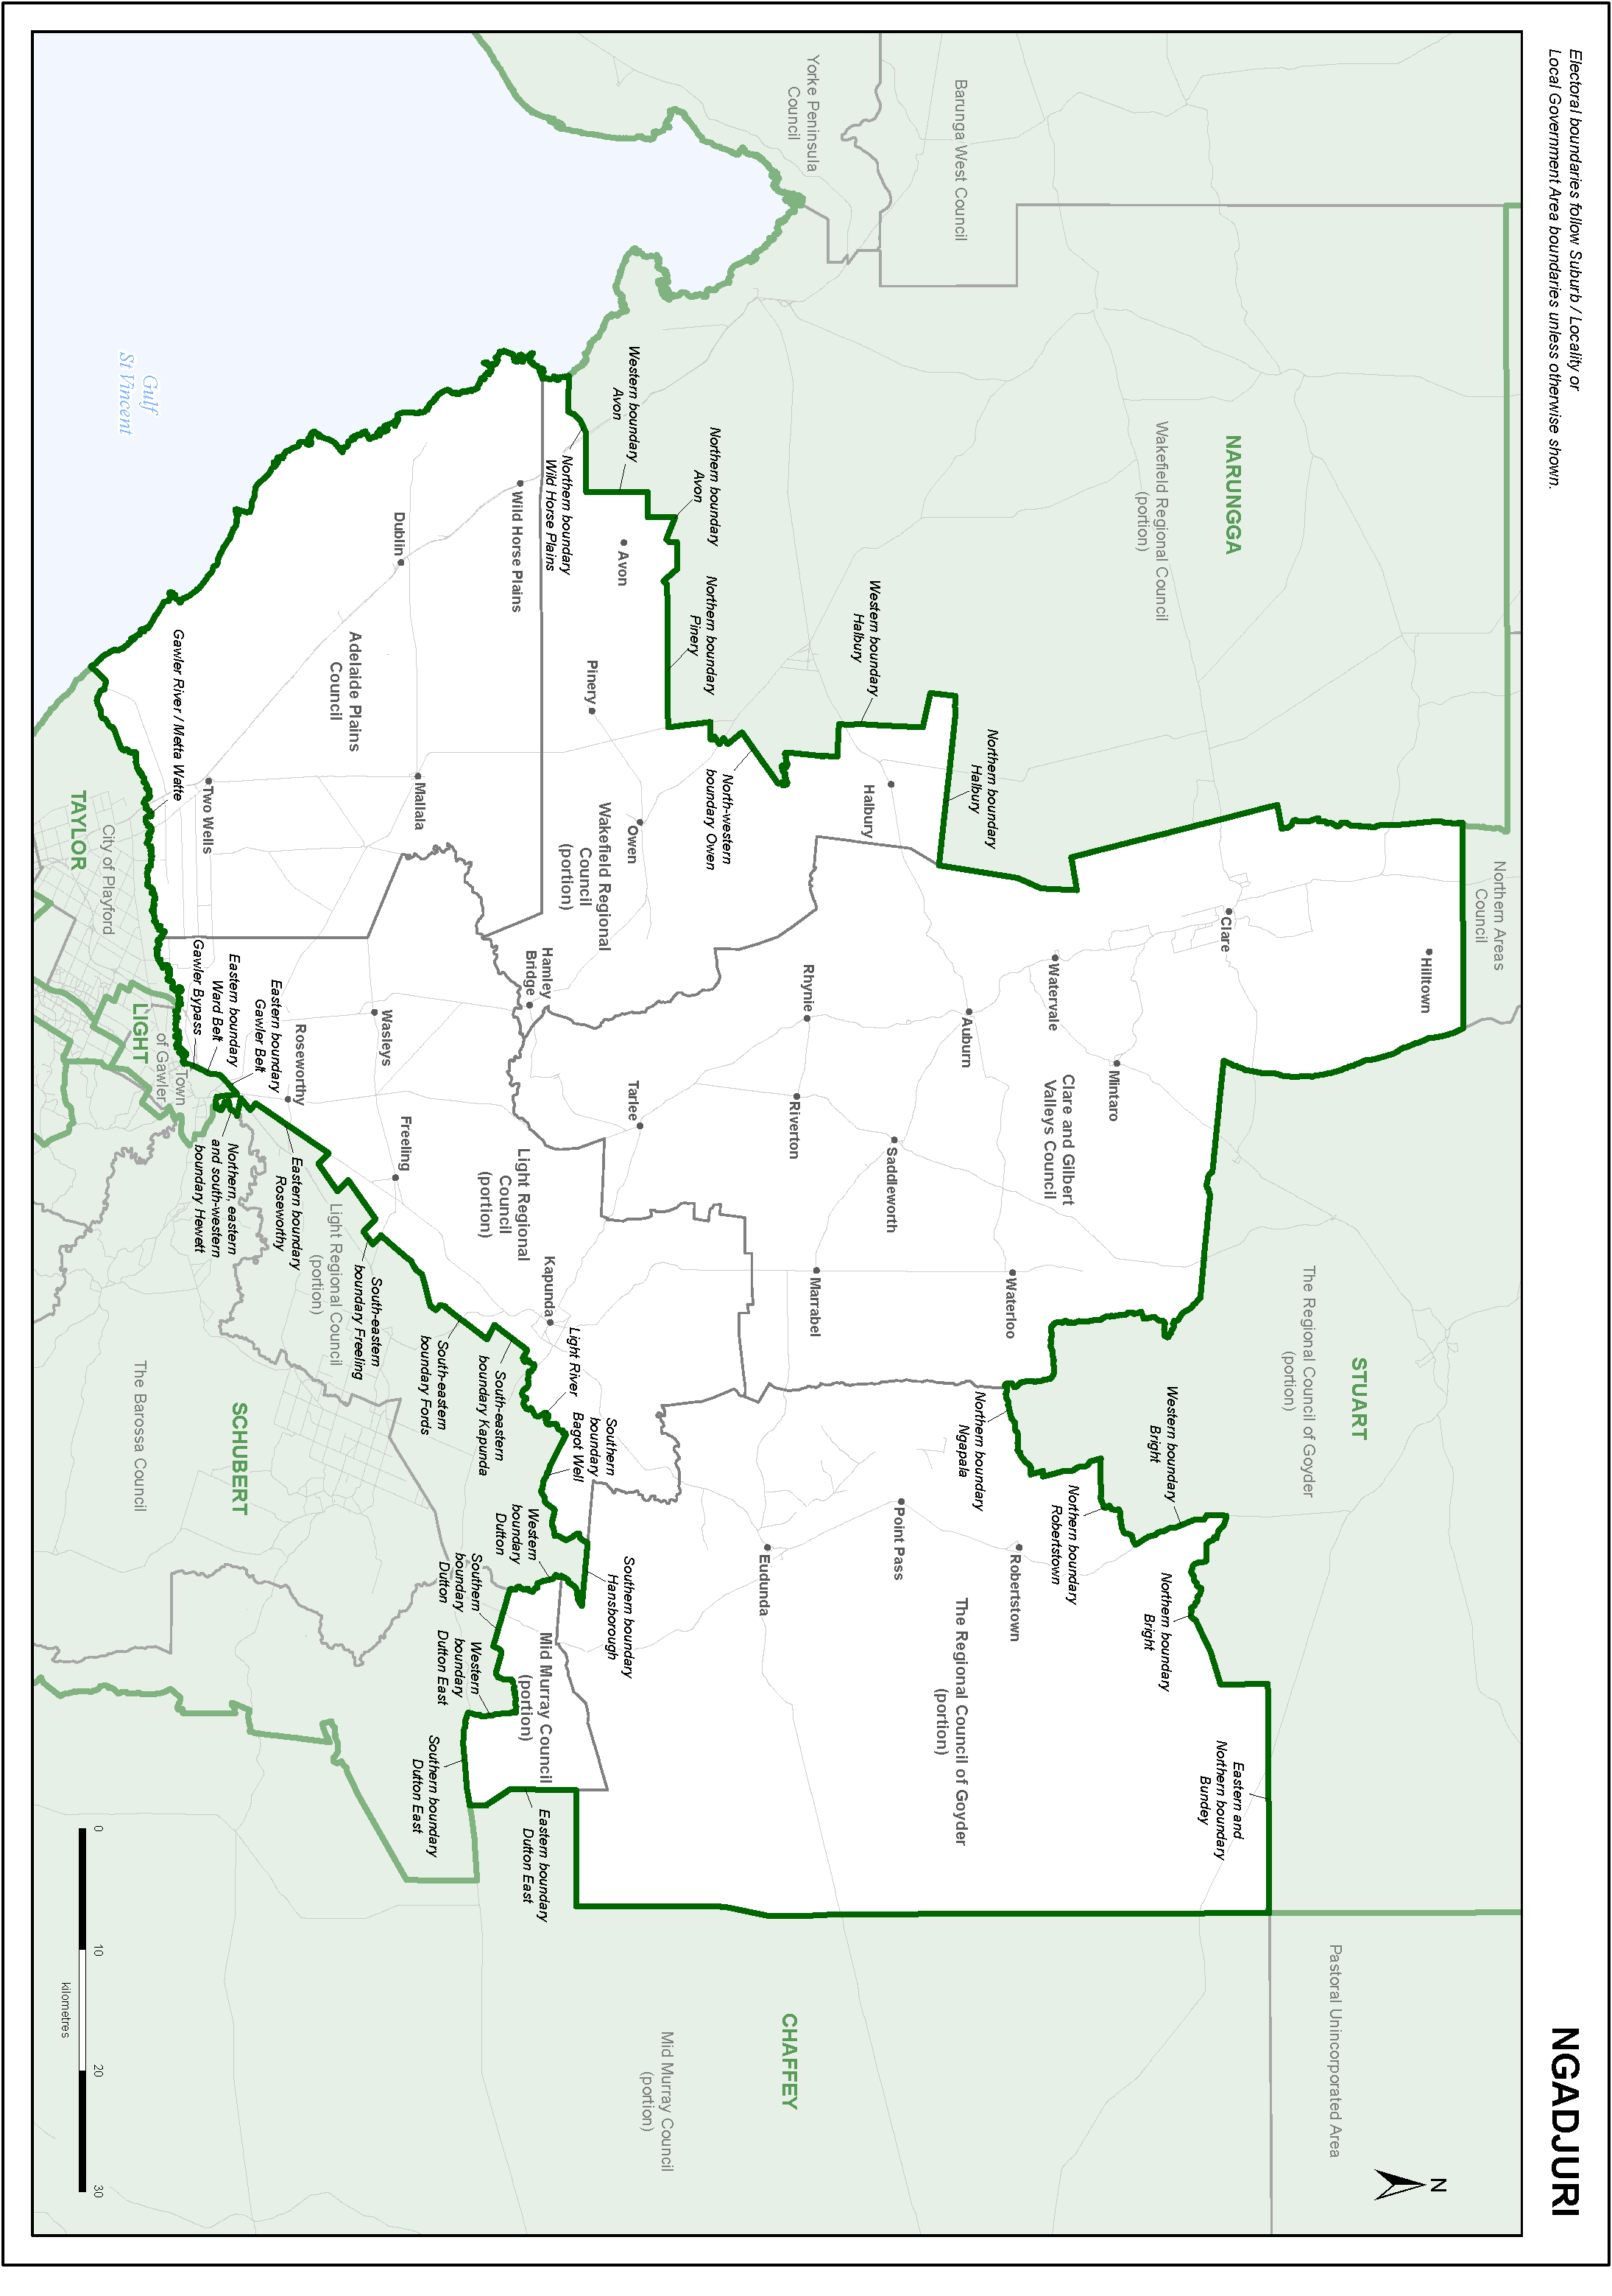
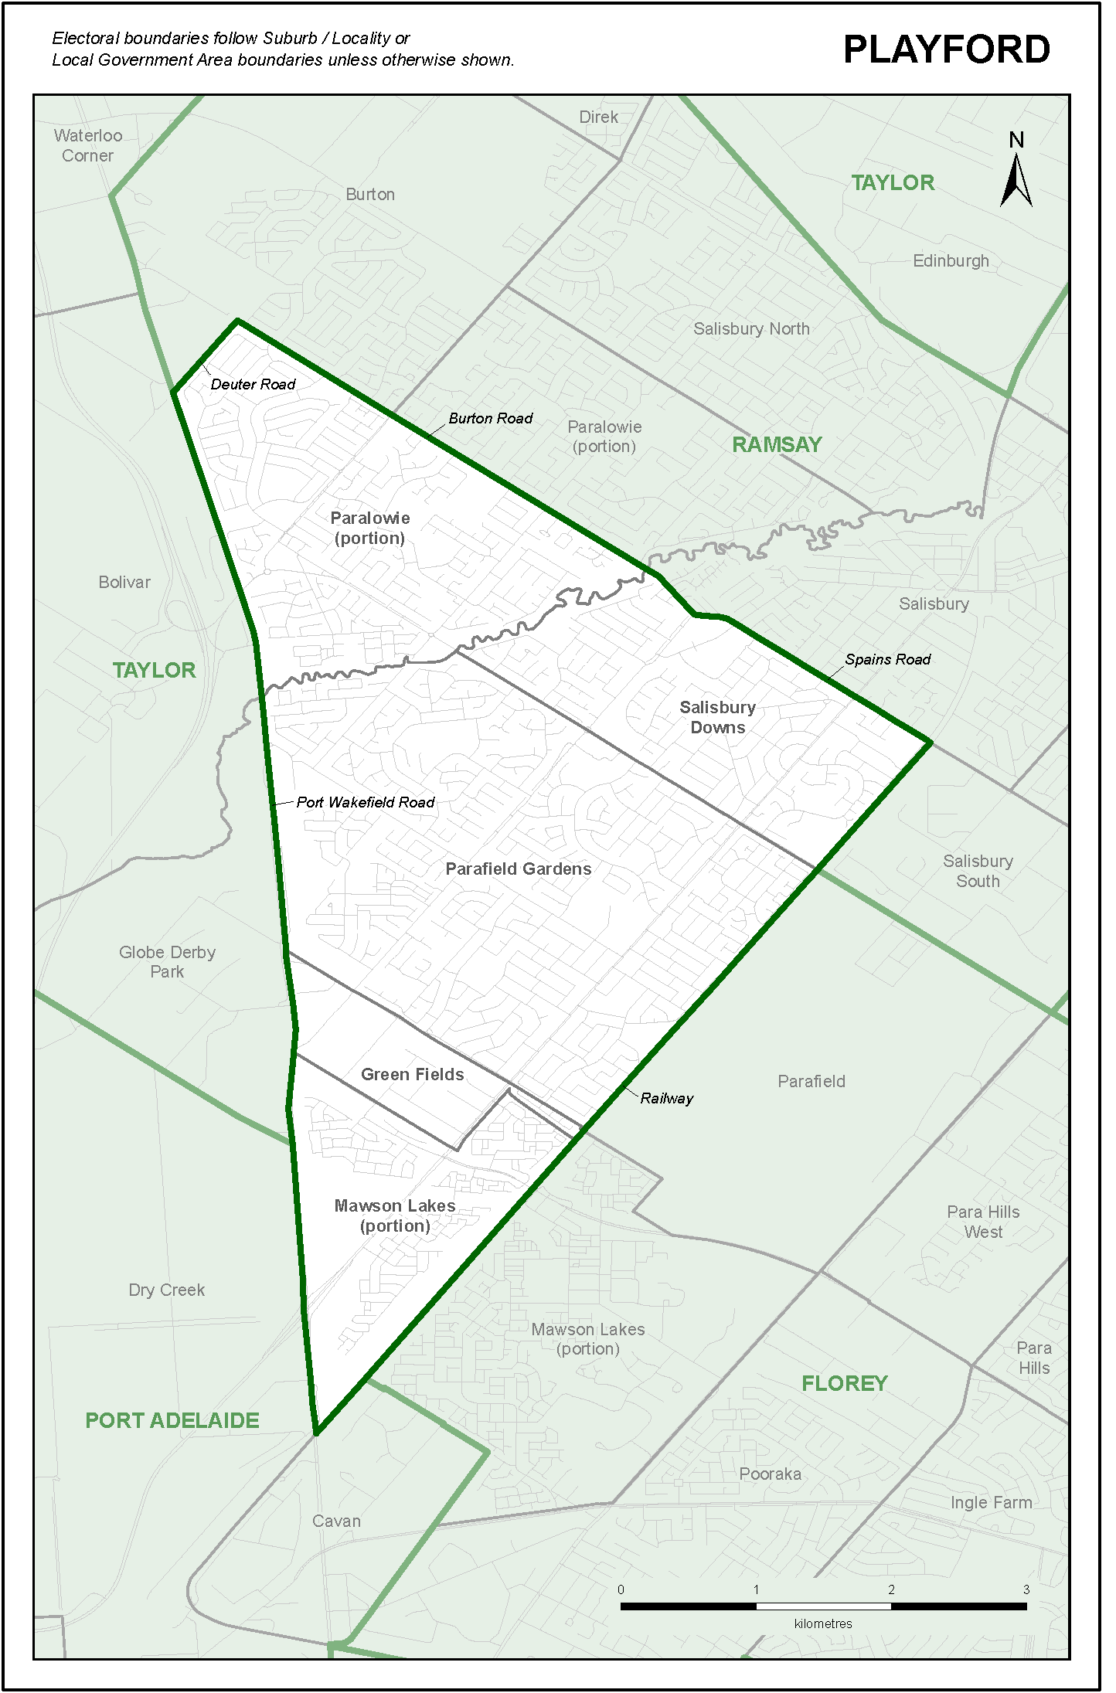
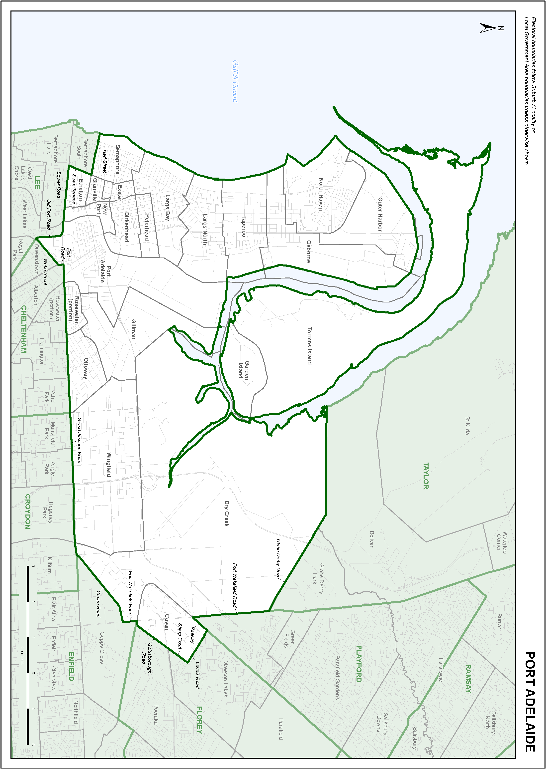
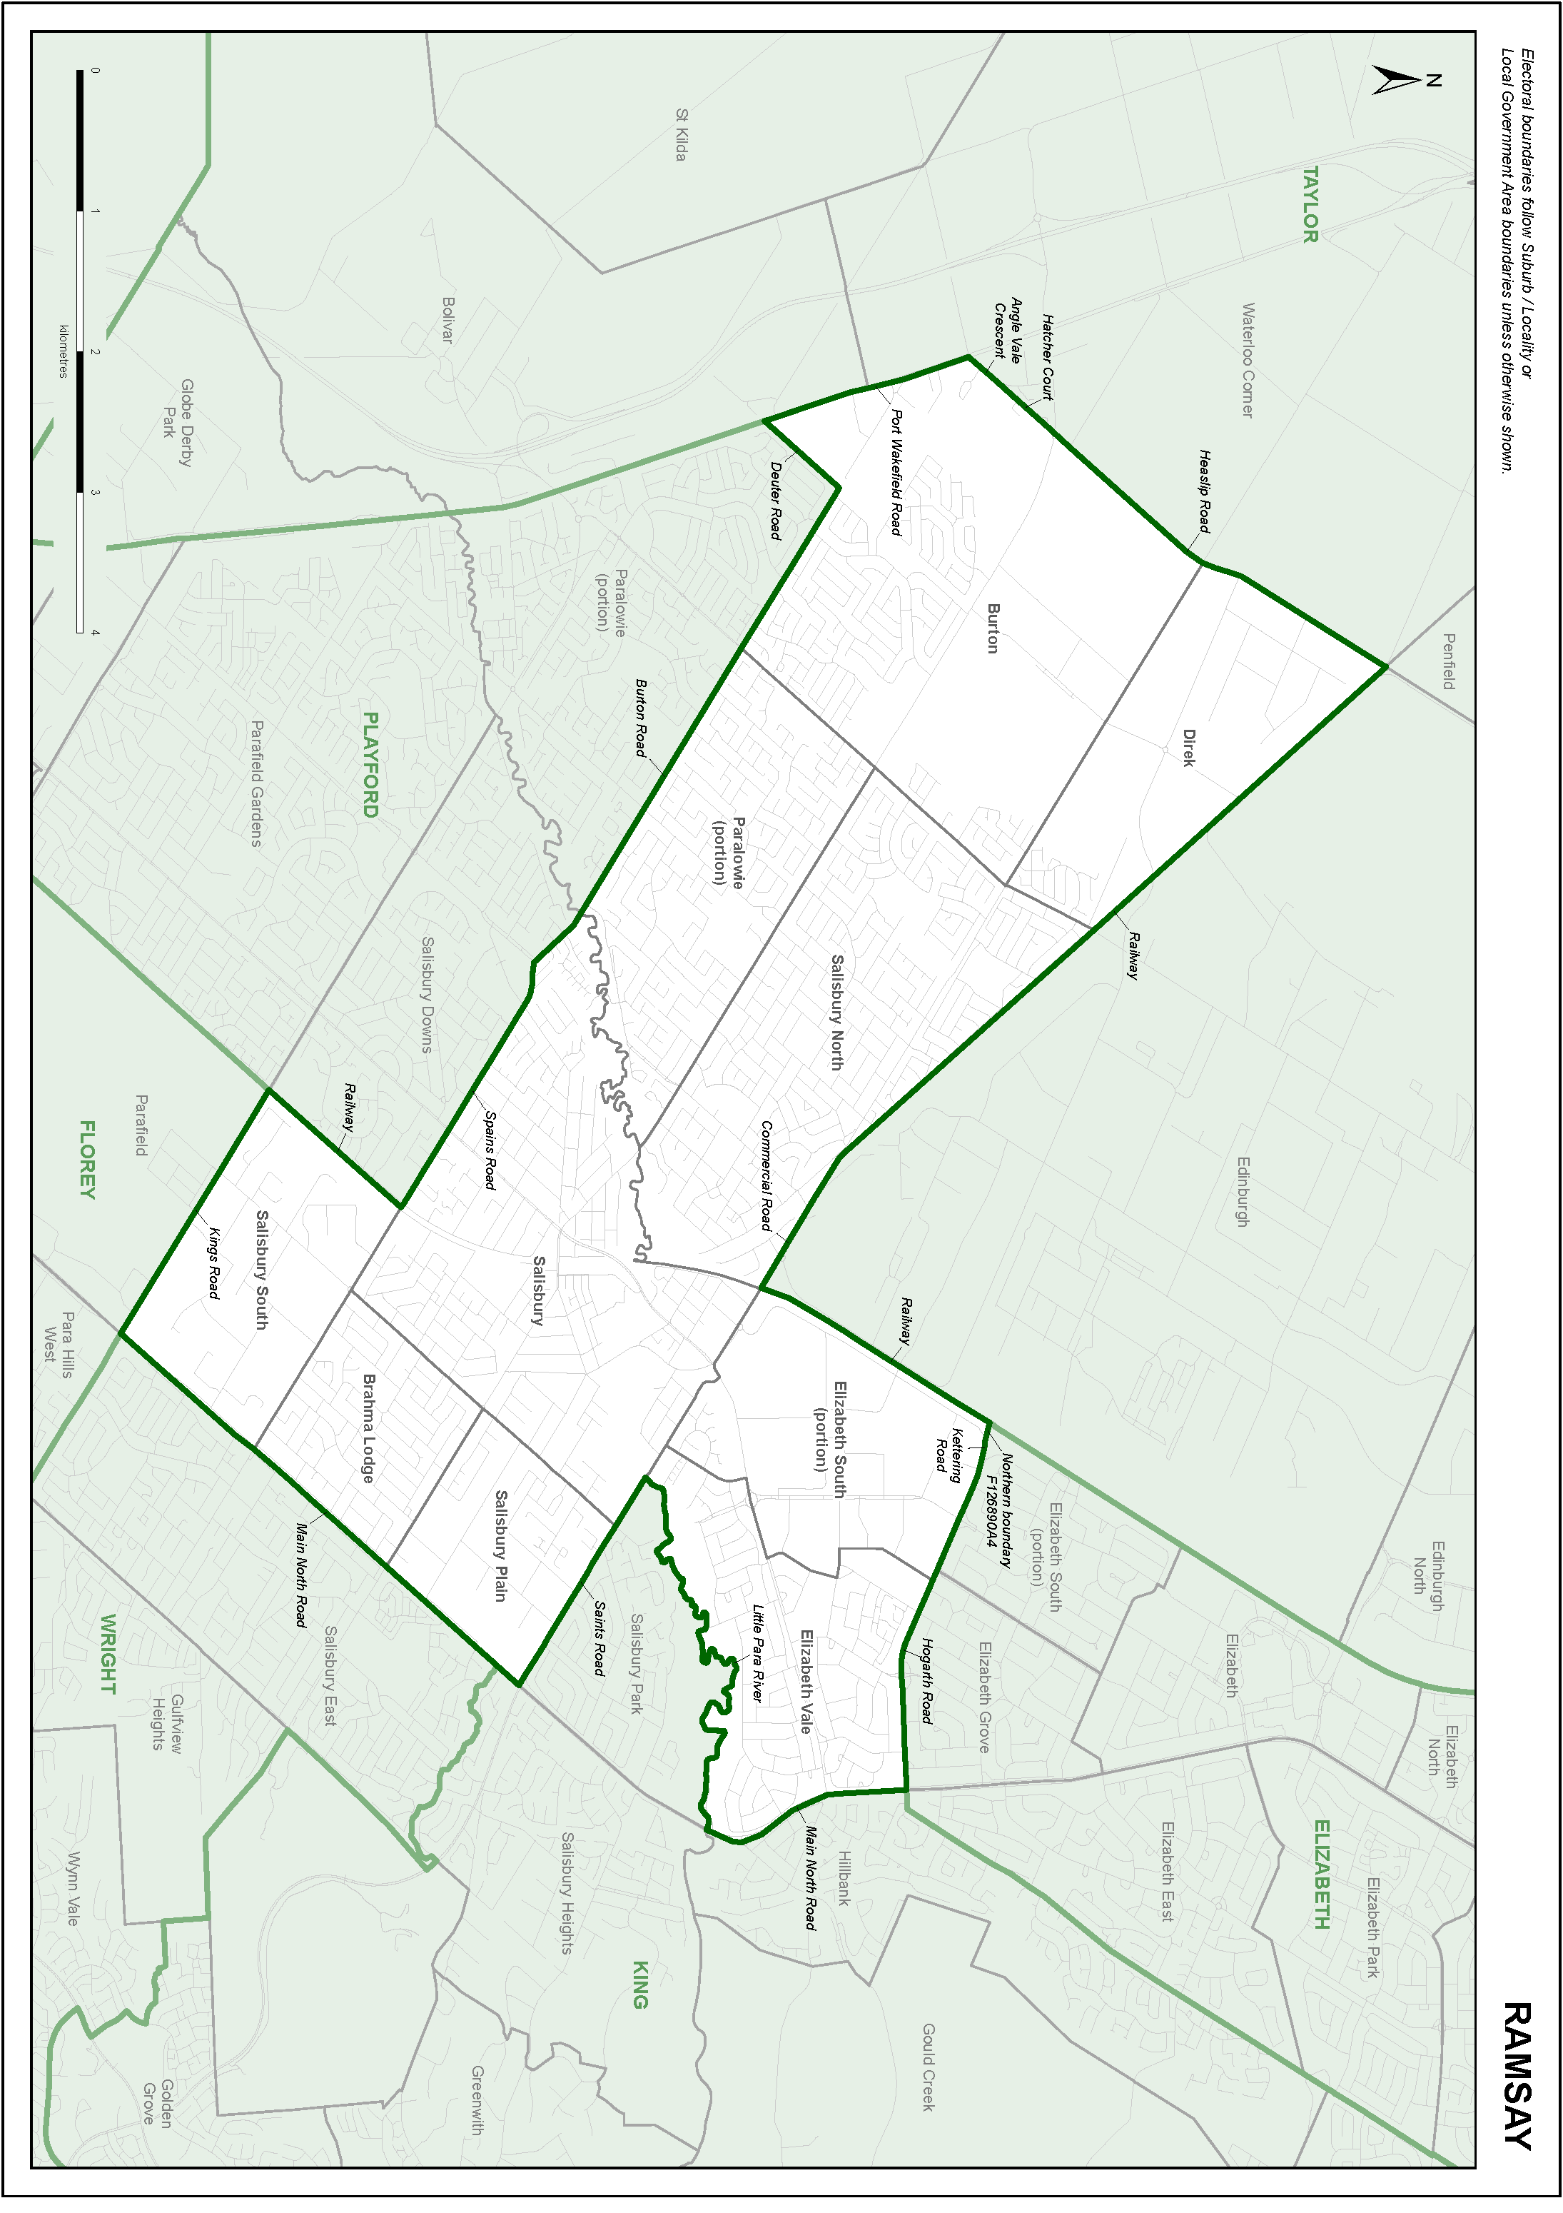
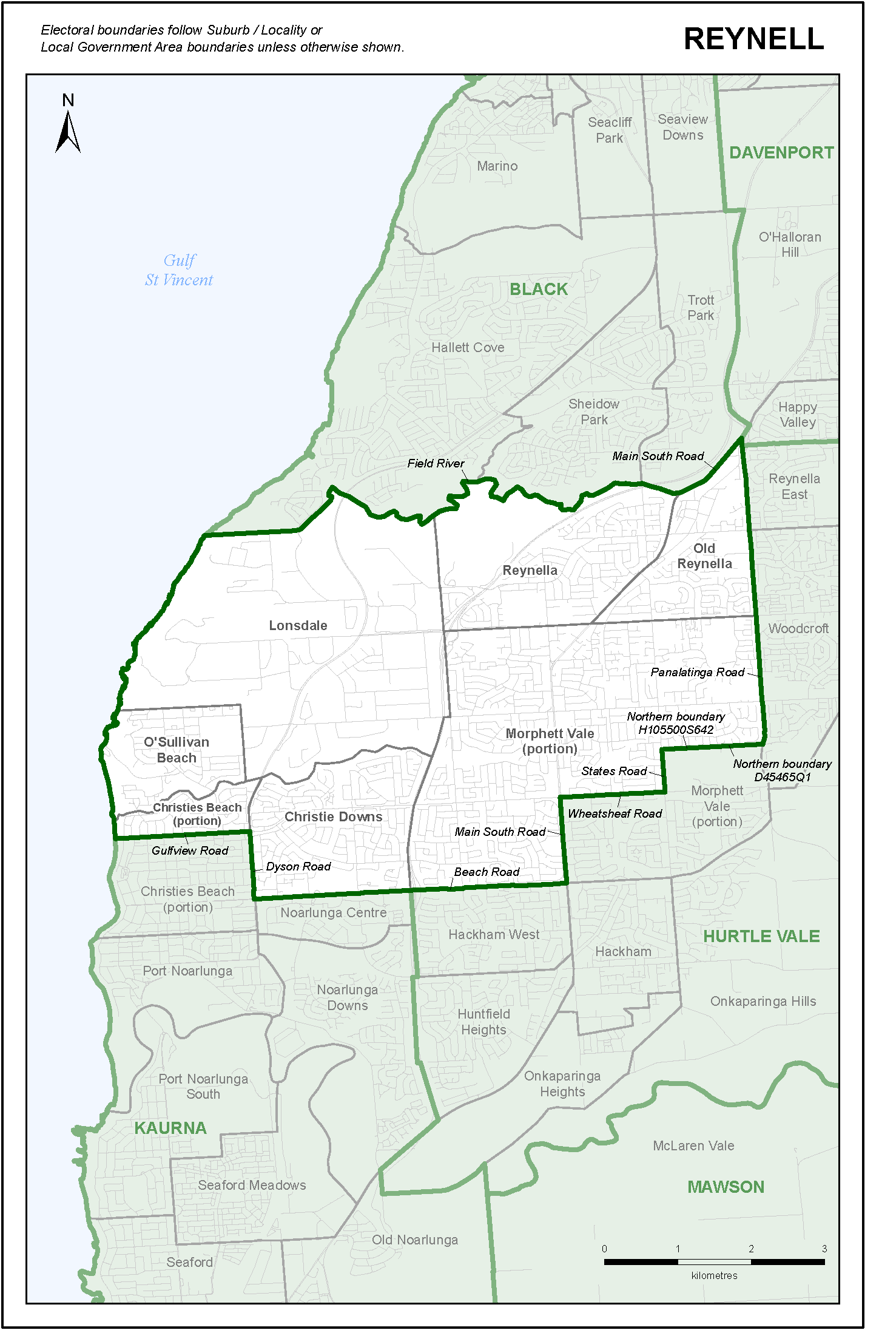
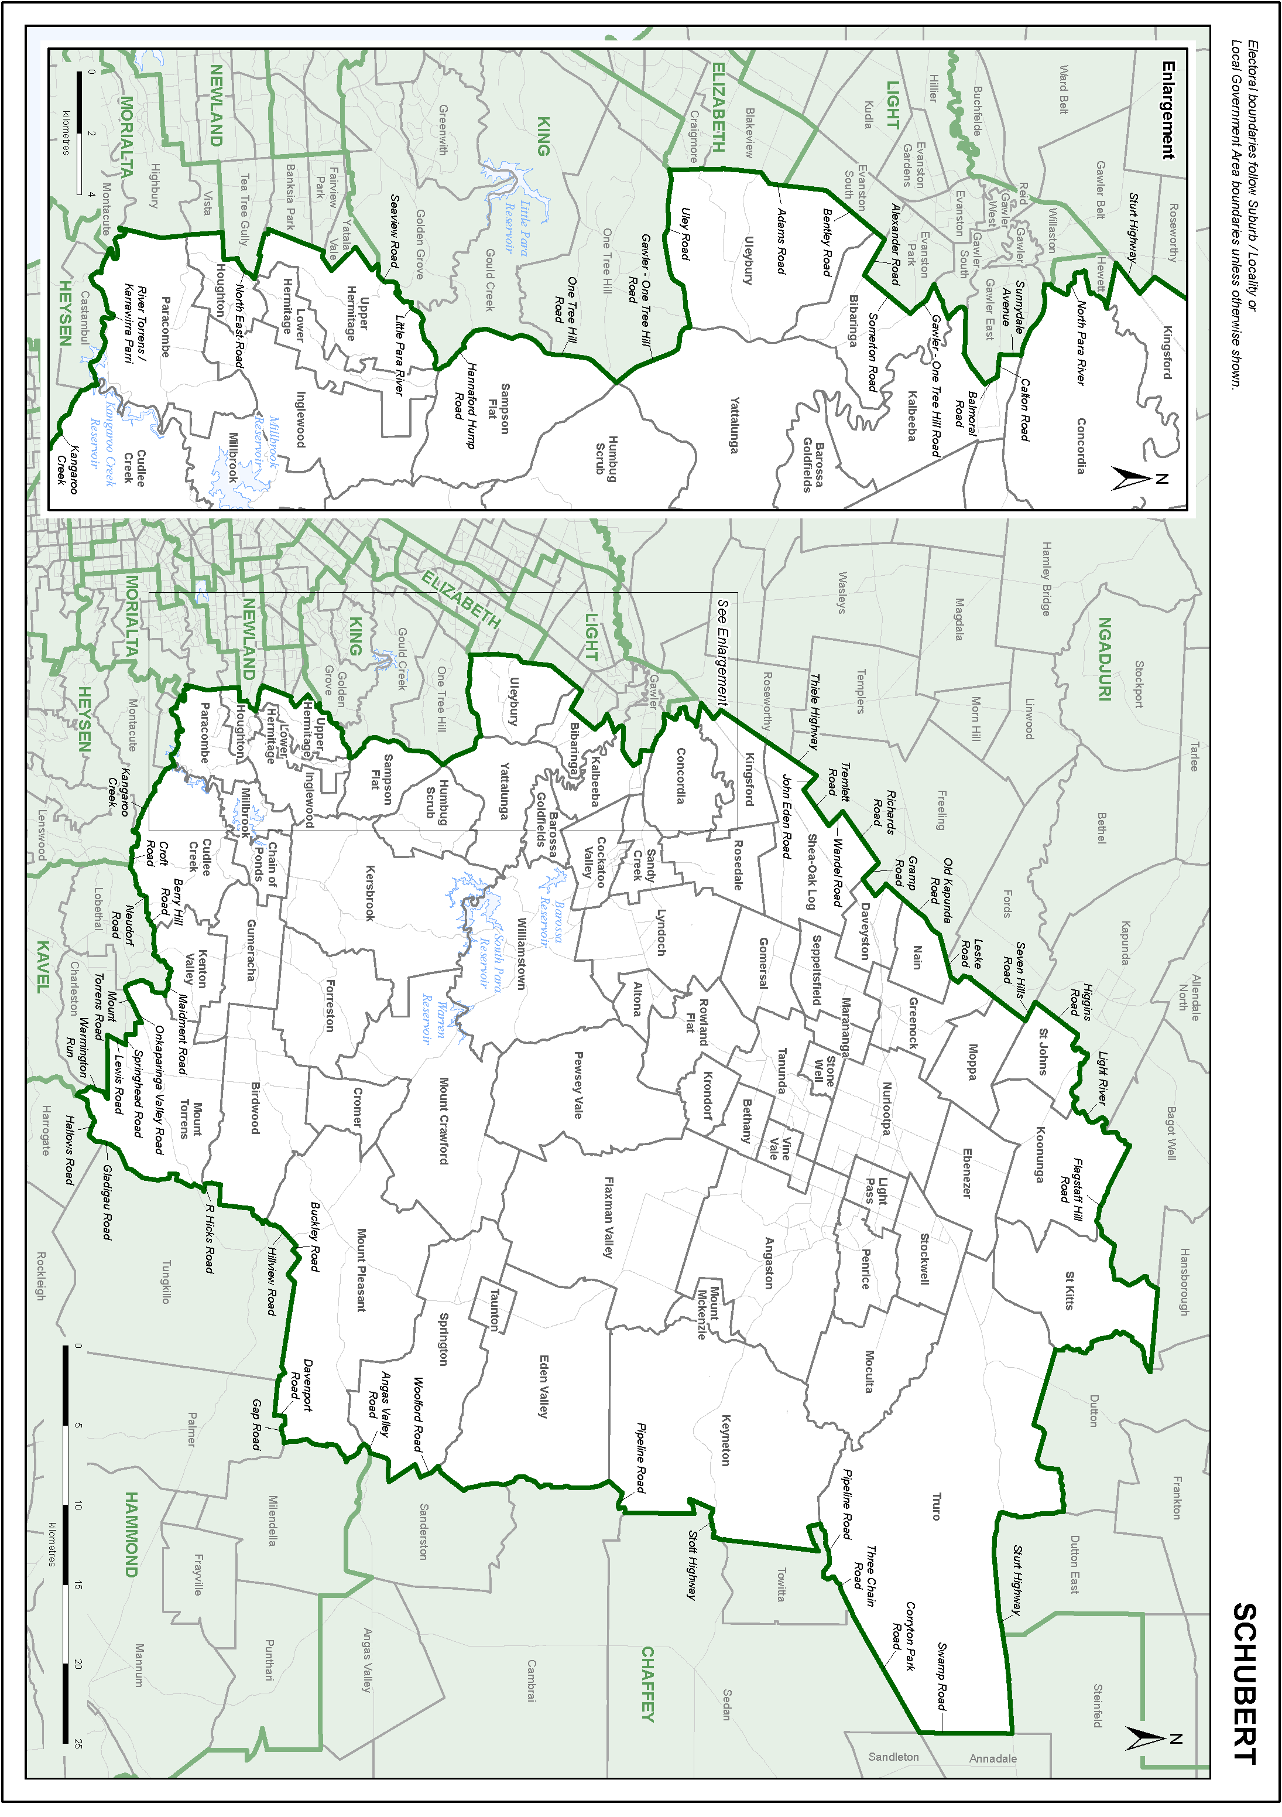
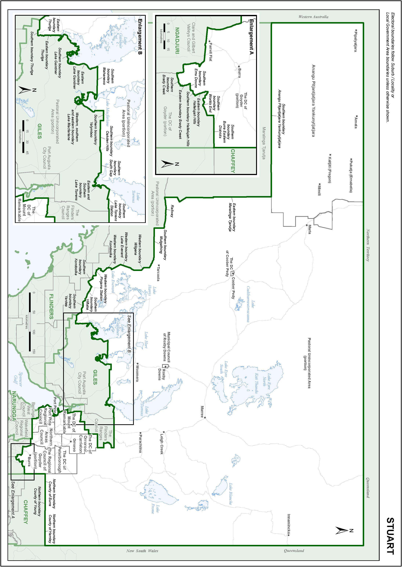
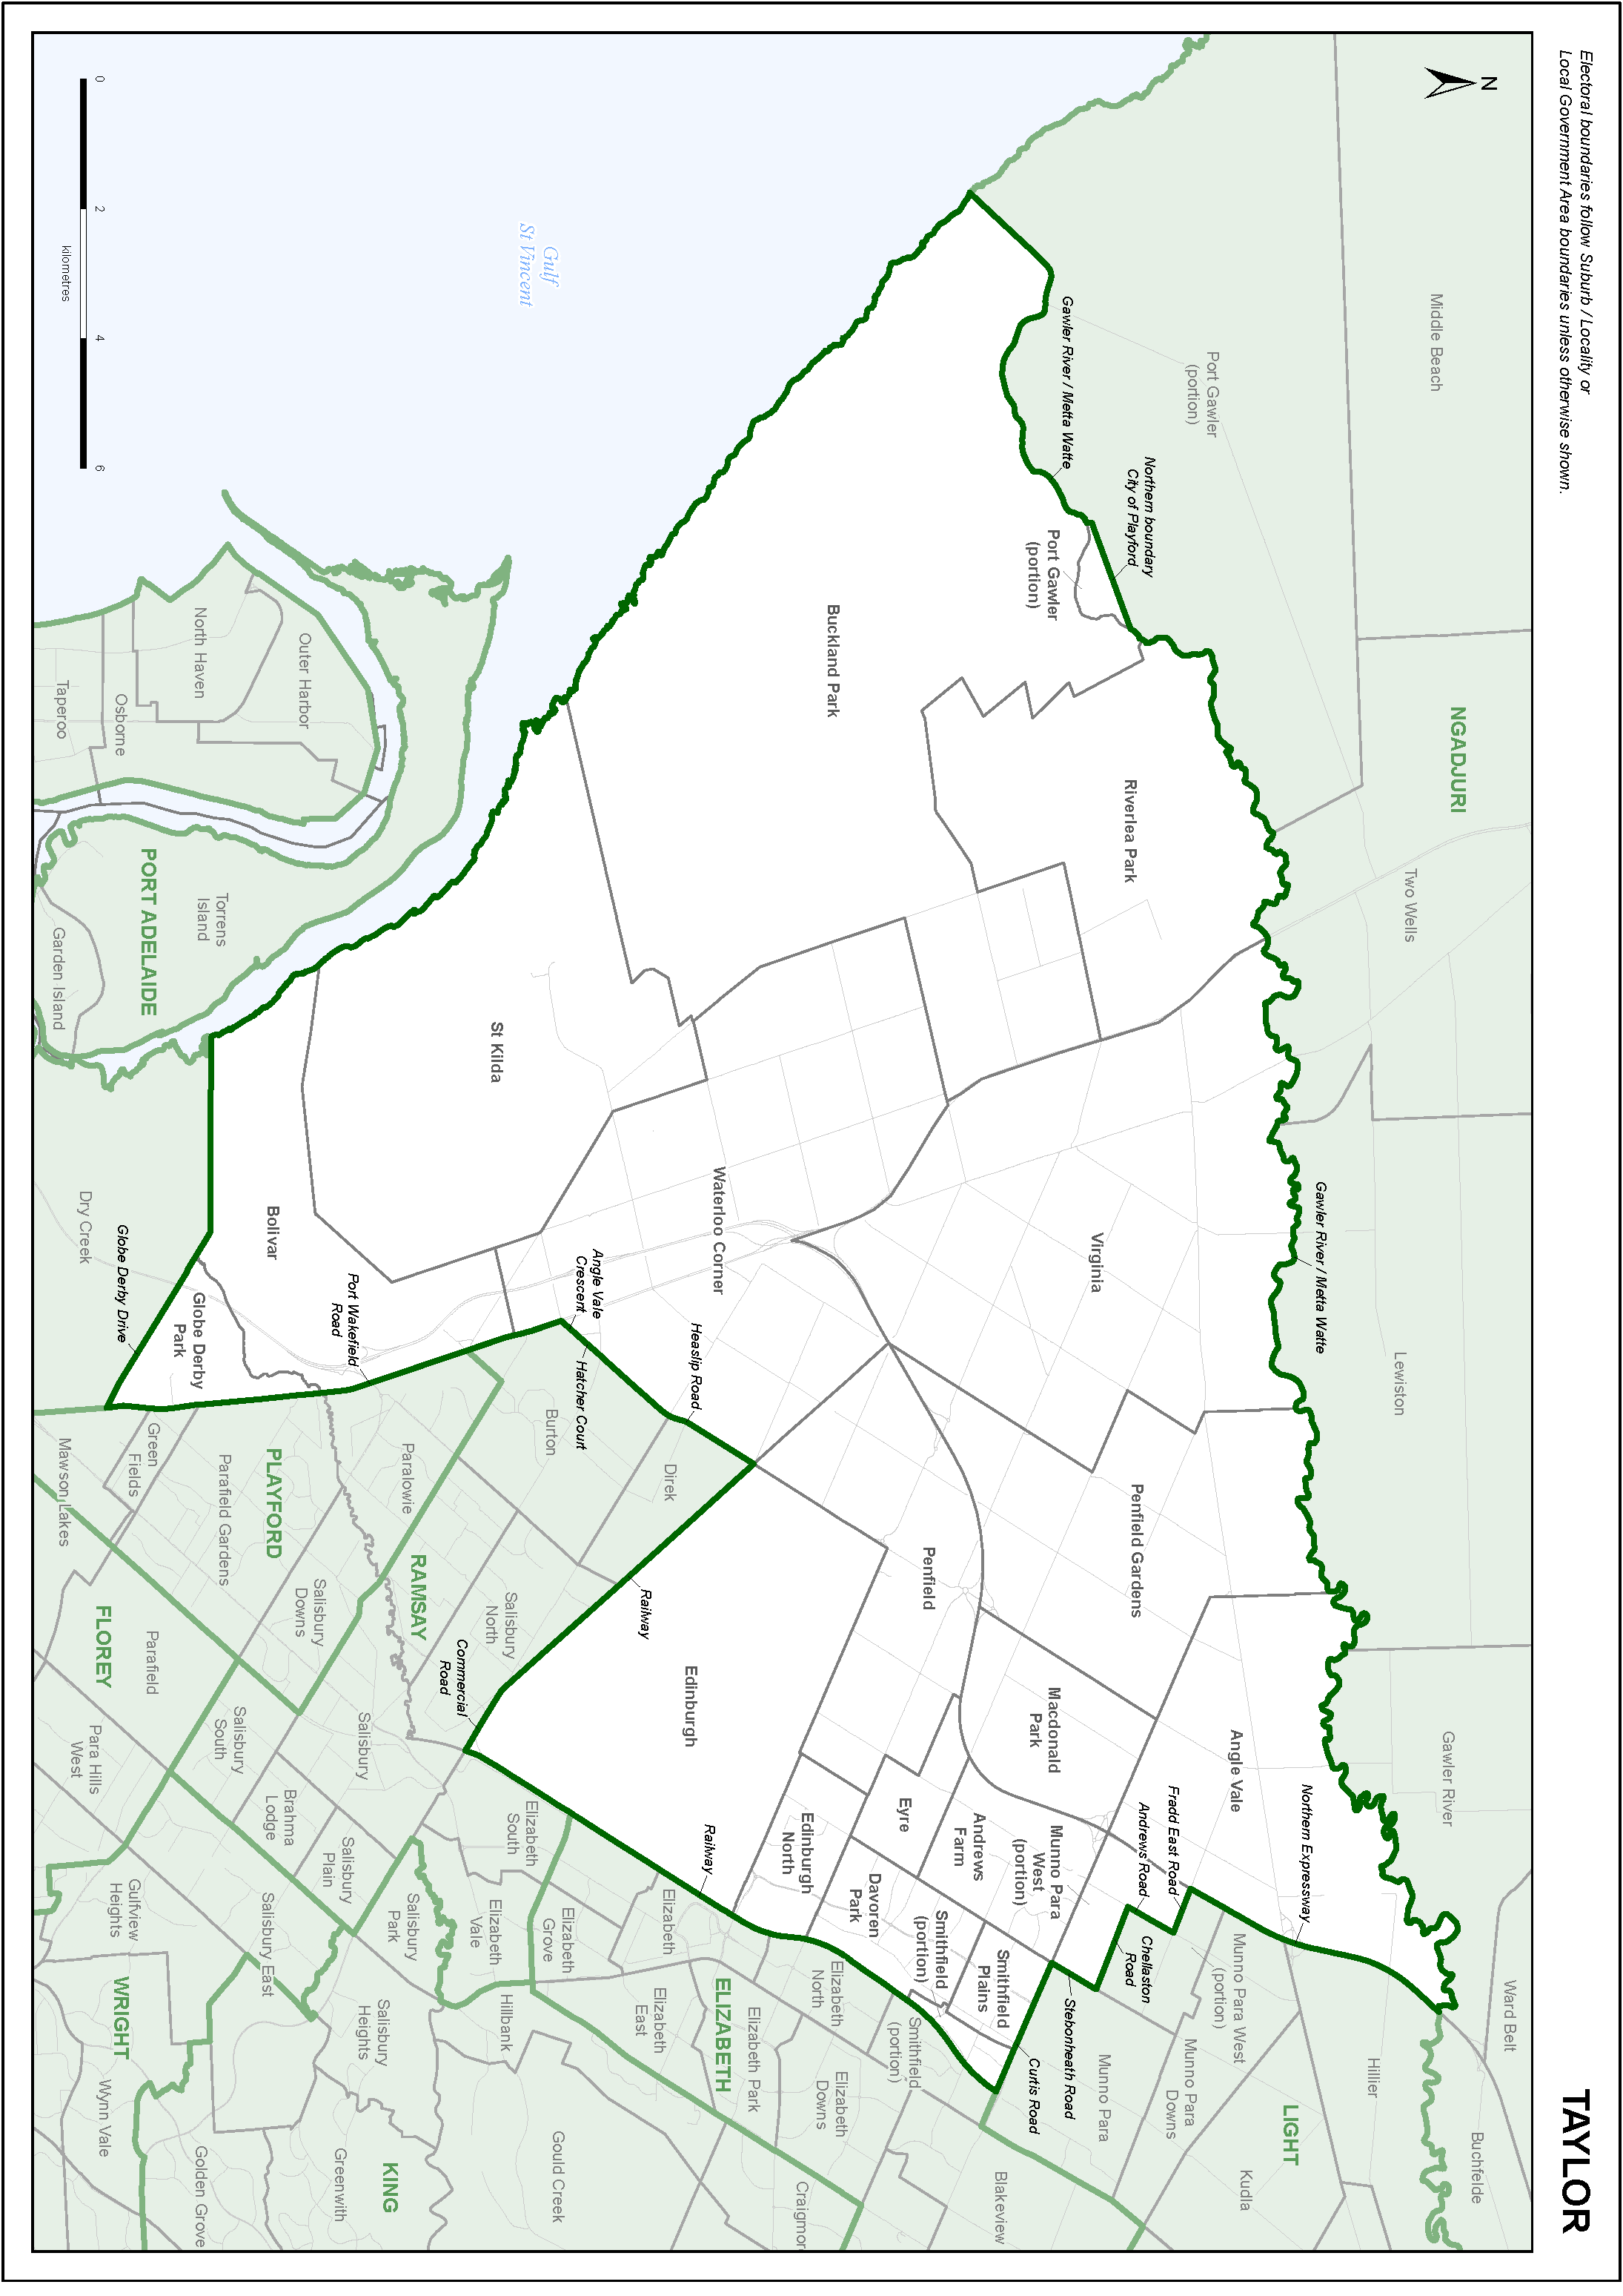
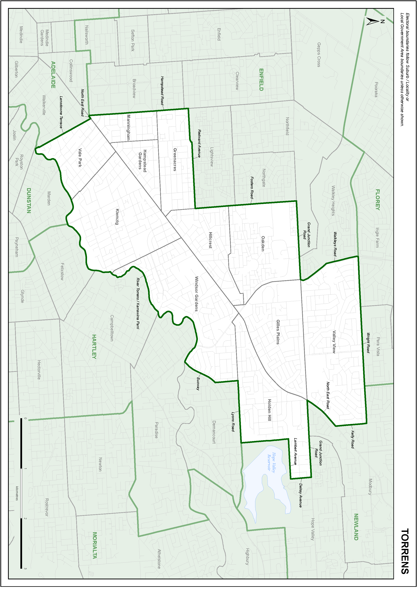
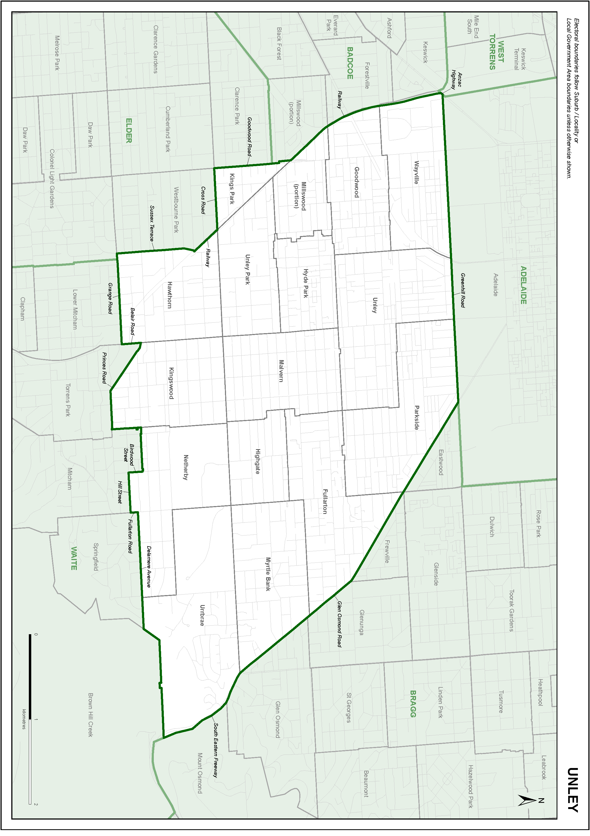
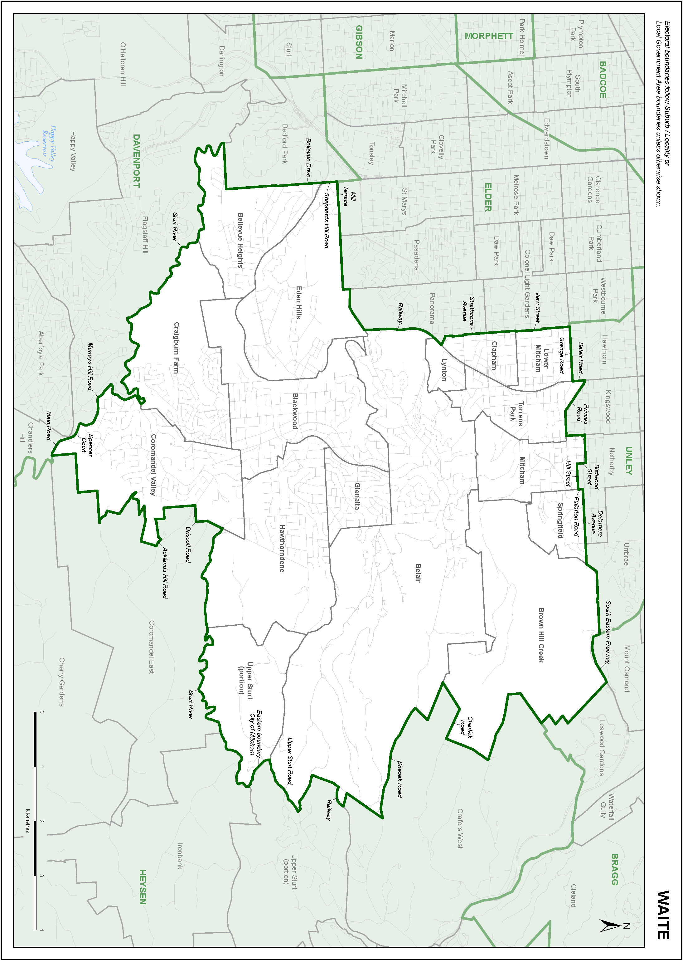
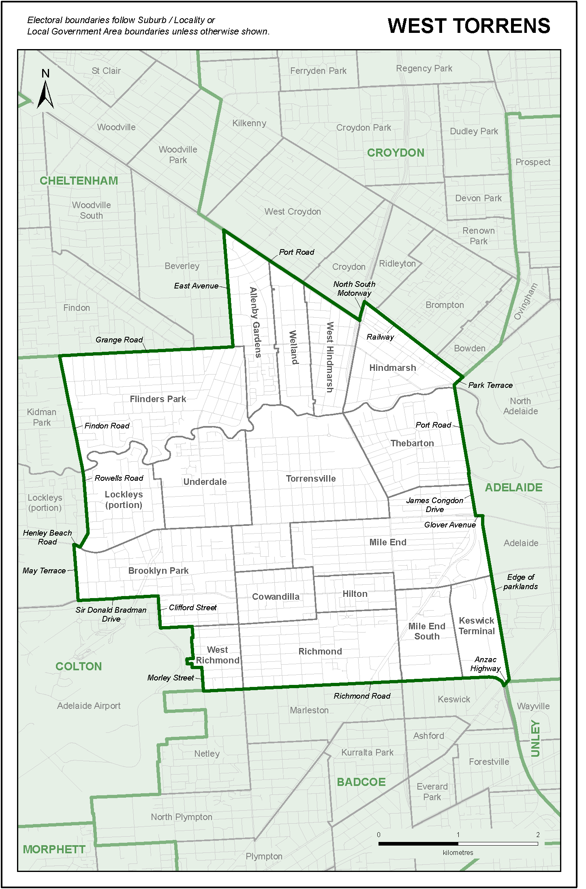
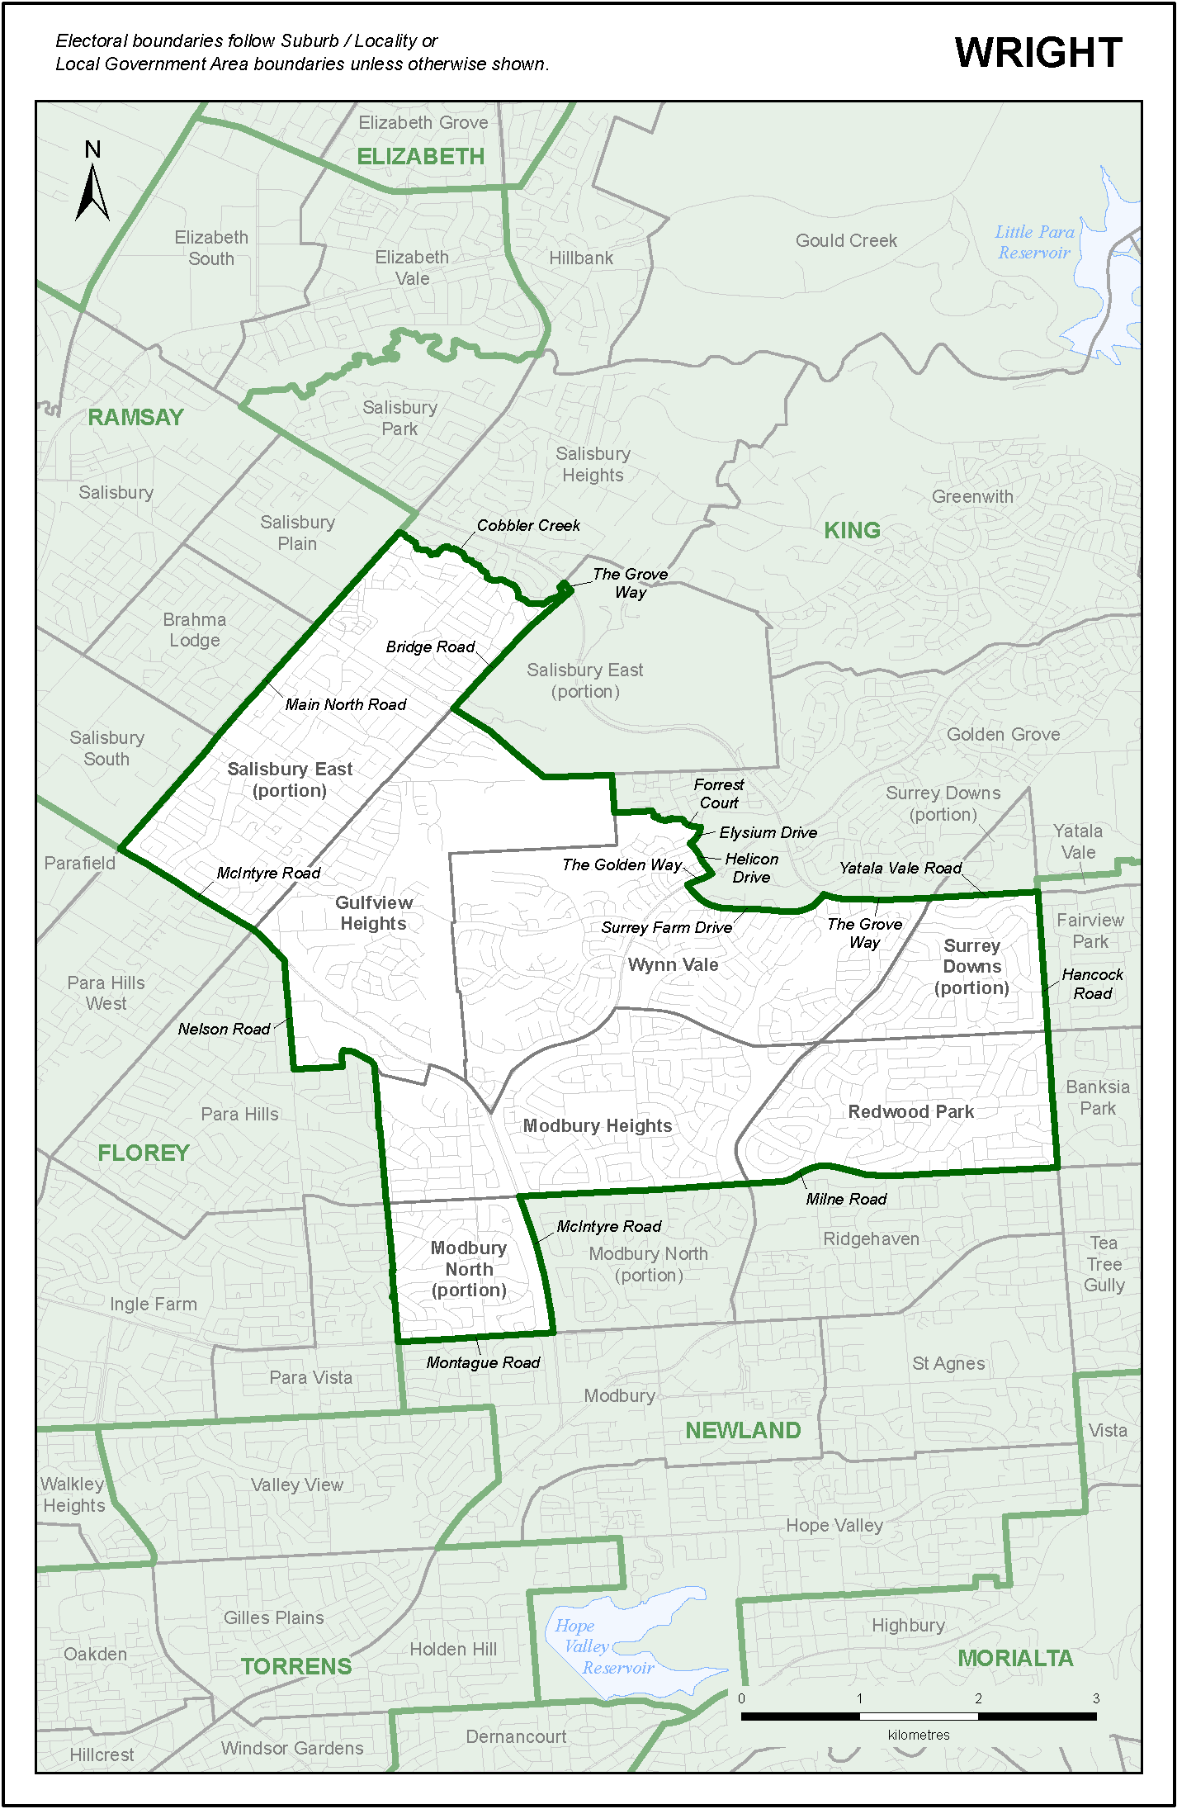

Index to Appendices
1. Public notice inviting submissions on recusal of Chairperson
2. Public notice inviting representations on electoral redistribution
3. Written representations received by the Commission
4. Public hearings held in Adelaide
5. Exhibits received by the Commission
6. Comparison of projected electors at the time of the 2020 report against actual enrolments at the time of the 2022 election
7. Swing-to-lose figures based on the 2022 election
8. Present and projected enrolments before the 2024 electoral redistribution
9. Public notice inviting submissions about the draft report
10. Written submissions received by the Commission about the draft report
11. Summary of impact of boundary changes on electors
12. Present and projected enrolments after the 2024 electoral redistribution
13. Swing-to-lose figures based on the 2024 electoral redistribution
14. Electoral districts allocation based on 50:50 vote following the 2024 electoral redistribution

Appendix 1
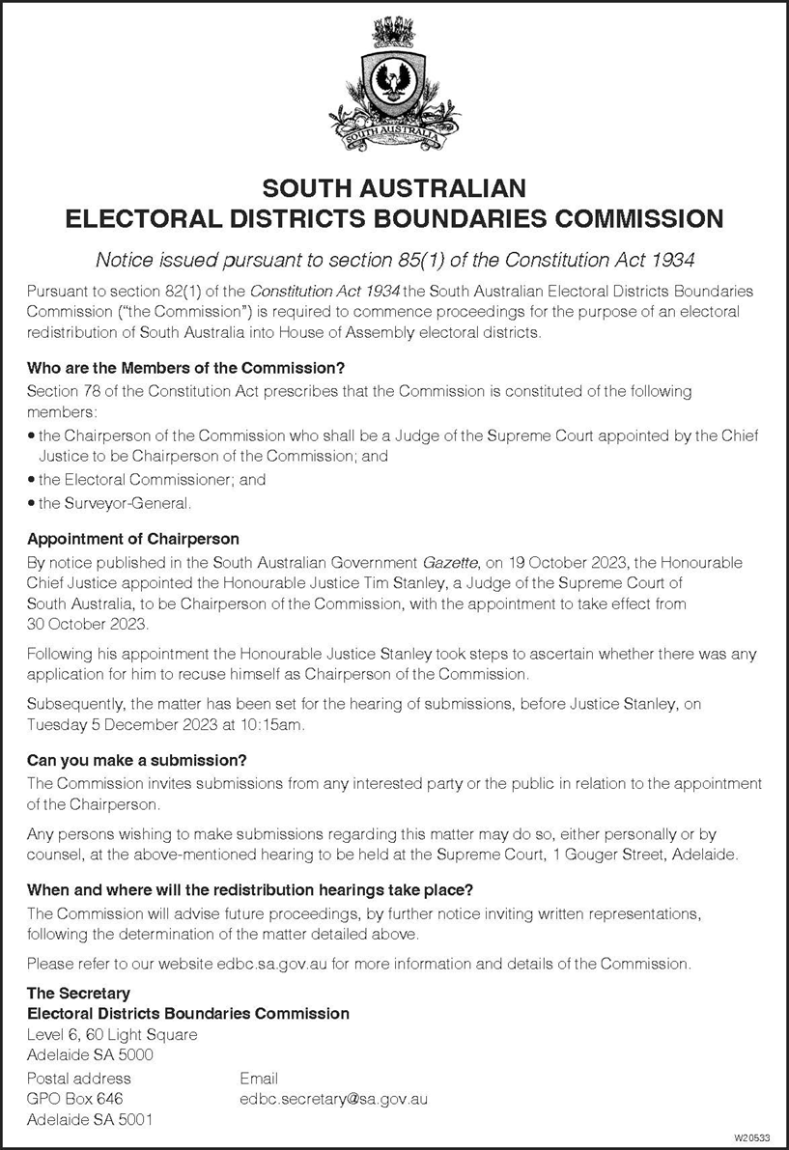
Public Notice Inviting Submissions on Recusal of Chairperson

List of Newspapers in which the Public Notice was Published
Metropolitan Newspapers Date of Publication
Adelaide Advertiser 25 November 2023
Adelaide Sunday Mail 26 November 2023

Appendix 2
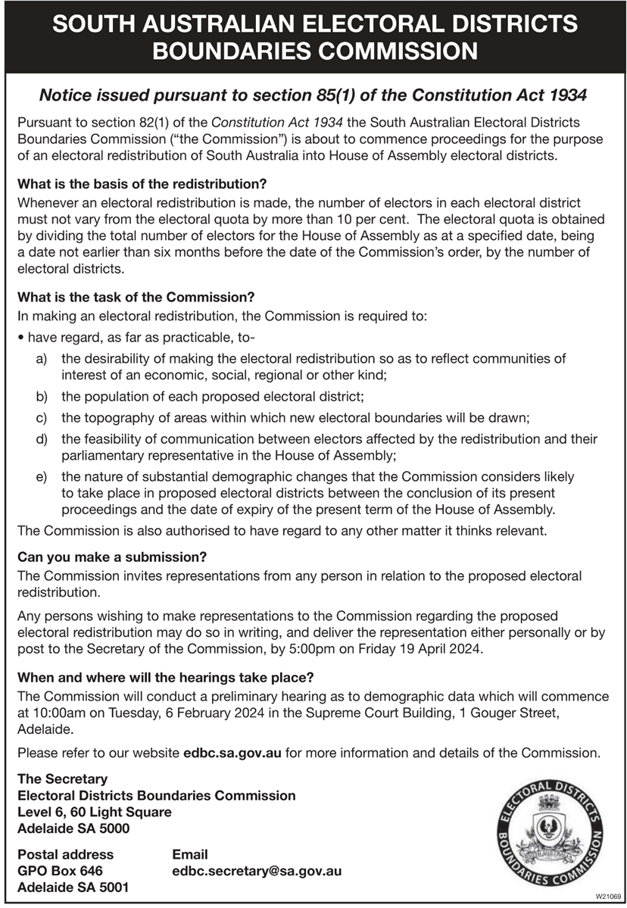
Public Notice Inviting Representations on Electoral Redistribution

List of Newspapers in which the Public Notice was Published
Newspaper | Date of Publication
Metropolitan Newspapers
Adelaide Advertiser
20 January 2024
Adelaide Sunday Mail | 21 January 2024
The Weekend Australian | 20 January 2024
Country Newspapers
Bordertown Chronicle | 24 January 2024
Eyre Peninsula Advocate | 25 January 2024
Fleurieu Sun | 25 January 2024
Koori Mail | 31 January 2024
Limestone Coast Today | 24 January 2024
Mount Barker Courier | 24 January 2024
Mount Gambier Times | 24 January 2024
Murray Pioneer—Renmark | 24 January 2024
Murray Valley Standard | 25 January 2024
Naracoorte News | 24 January 2024
Penola Pennant | 24 January 2024
Pinnaroo Border Times | 24 January 2024
Port Lincoln Times | 25 January 2024
Port Pirie Recorder | 25 January 2024
South Eastern Times | 24 January 2024
Strathalbyn Southern Argus | 25 January 2024
The Border Watch—Mt Gambier | 24 January 2024
The Bunyip—Gawler | 24 January 2024
The Kangaroo Island Islander | 25 January 2024
The Leader—Angaston | 24 January 2024
The Plains Producer | 24 January 2024
The SE Voice | 25 January 2024
The Transcontinental Port Augusta | 25 January 2024
The Victor Harbor Times | 23 January 2024
Whyalla News | 25 January 2024
Yorke Peninsula Country Times | 23 January 2024

Appendix 3
Written Representations Received by the Commission
Author of Representation | Date Received
Mr K Horsnell | 25 January 2024
Mr A Peake OAM | 18 February 2024
Mr D Hall | 16 April 2024
Mr J Fulbrook MP | 17 April 2024
Hon R Martin MLC | 17 April 2024
Mr J Taggart | 17 April 2024
The Electoral Reform Society of South Australia | 18 April 2024
Mr M Pratt | 18 April 2024
Mr J Photakis | 19 April 2024
The Greens | 19 April 2024
Australian Democrats (SA Division) Inc | 19 April 2024
Liberal Party of Australia (SA Division) | 19 April 2024
Australian Labor Party (SA Branch) | 19 April 2024
Mr A Foley | 20 April 2024

Appendix 4
Public Hearings Held in Adelaide
9 November 2023 | Recusal Application Preliminary Hearing
5 December 2023 | Recusal Application Hearing
6 February 2024 | Commission Public Hearing
12 June 2024 | Commission Public Hearing
Witness Called Before the Commission
6 February 2024 | Christopher Ian Rudd
Persons and Bodies who Made Oral Submissions
Recusal Application
9 November 2023 | Liberal Party (SA Division)
 | Represented by Mr T Duggan KC and Mr J Teague
5 December 2023 | Liberal Party (SA Division)
 | Represented by Mr T Duggan KC and Mr J Teague
 | Australian Labor Party (SA Branch)
 | Represented by Mr B Doyle KC and Mr A Tisato
 | Australian Democrats (SA Division) Inc
 | Represented by Mr P Black
Electoral Redistribution Proceeding
6 February 2024 | Liberal Party (SA Division)
 | Represented by Mr T Duggan KC and Mr J Teague
 | Australian Labor Party (SA Branch)
 | Represented by Mr B Doyle KC and Mr A Tisato
 | Australian Democrats (SA Division) Inc
 | Represented by Mr P Black
12 June 2024 | Liberal Party (SA Division)
 | Represented by Mr J Teague
 | Australian Labor Party (SA Branch)
 | Represented by Mr B Doyle KC and Mr A Tisato
 | Australian Democrats (SA Division) Inc
 | Represented by Mr P Black
 | Mr A Peake OAM
 | Mr J Fulbrook MP

Appendix 5
Exhibits Received by the Commission
1 | Copy page number 3515 of South Australian Government Gazette of 19 October 2023 giving notice of appointment of the Chairman of the Commission
2 | Notice calling for submissions on recusal of Chairperson published 25 November 2023
3 | Judgment on recusal of Chairperson
4 | Judgment on recusal of Chairperson (No 2)
5 | Copy page number 26 of South Australian Government Gazette of 11 January 2024 giving notice of appointment of the Chairman of the Commission
6A | Notice of hearing to address demographic data and to invite written representations on boundary proposals
6B | List of newspapers in which the advertisement referred to as exhibit 6A was published
7 | Brochure explaining the composition, role and function of the Commission, criteria for redistribution and other matters
8 | Document setting out two-party preferred pendulum, swing-to-lose figures for the 2022 election
9 | Document containing comparison of 2022 actual enrolments versus 2020 projections, dated January 2024
10 | Report titled Demographic trends and projections for the Electoral Districts Boundaries Commission, 2022-2026 prepared by the Department for Trade and Investment
11A | Curriculum vitae of Christopher Ian Rudd
11B | Curriculum vitae of Jo-Anne Emma Ragless
11C | Curriculum vitae of Deborah Jane Burrows
11D | Curriculum vitae of Dr Thomas Guy Wilson—Consulting Demographer
12 | Calculation of electors to population ratio—30 June 2022
13A | Explanation of data fields used in the enrolment and voting data spreadsheet
13B | Enrolment and voting data spreadsheet
13C | Summary of enrolment and voting data by electoral district
14A | Email from Mr Peake OAM dated 12 May 2024
14B | Written outline of oral submissions of Mr Peake OAM
15 | Labor Party written outline of oral submissions for hearing on 12 June 2024
16 | Electoral roll as at 31 May 2024 tendered by the Labor Party
17A | Explanation of data fields used in the enrolment and voting data spreadsheet as at the relevant date
17B | Enrolment and voting data spreadsheet as at the relevant date
17C | Summary of enrolment and voting data by electoral district as at the relevant date
18 | Notice calling for written submissions following release of the draft report
19A | Explanation of data fields used in the enrolment and voting data spreadsheet for draft boundaries
19B | Enrolment and voting data spreadsheet for draft boundaries
19C | Summary of enrolment and voting data by electoral district for draft boundaries
20A | Report of Dr Krichauff “A short history [of] Edward Charles Frome (Surveyor General of South Australia, 1839-1849) and an investigation into his involvement in the O’Halloran Expedition and the burning of an Aboriginal encampment on the Coorong in 1840”
20B | Appendices to Dr Krichauff’s report
20C | Curriculum vitae of Dr Skye Krichauff
21A | Submission of Prof Irene Watson on proposal for renaming the electoral district of Frome
21B | Curriculum vitae of Prof Irene Watson
21C | Paper titled “Colonial Logic and The Coorong Massacres” provided by Prof Irene Watson

Appendix 6
Comparison of Projected Electors at the Time of the 2020 Report
Against Actual Enrolments at the Time of the 2022 Election
District | Projected Electors |  | Actual Enrolments |  | Enrolment Variance
 | 30/06/2022 | % Quota Variance | 19/03/2022 | % Quota Variance
ADELAIDE | 26382 | -0.2 | 27331 | +1.4 | 949
BADCOE | 26599 | +0.7 | 27481 | +2.0 | 882
BLACK | 26497 | +0.3 | 26437 | -1.9 | -60
BRAGG | 26015 | -1.6 | 26709 | -0.9 | 694
CHAFFEY | 25957 | -1.8 | 25807 | -4.2 | -150
CHELTENHAM | 26636 | +0.8 | 27621 | +2.5 | 985
COLTON | 26997 | +2.2 | 28379 | +5.3 | 1382
CROYDON | 27915 | +5.6 | 28182 | +4.6 | 267
DAVENPORT | 27198 | +2.9 | 26835 | -0.4 | -363
DUNSTAN | 26724 | +1.1 | 27269 | +1.2 | 545
ELDER | 27461 | +3.9 | 27757 | +3.0 | 296
ELIZABETH | 27534 | +4.2 | 27717 | +2.8 | 183
ENFIELD | 26674 | +0.9 | 27240 | +1.1 | 566
FINNISS | 26441 | +0.1 | 27086 | +0.5 | 645
FLINDERS | 24370 | -7.8 | 25108 | -6.8 | 738
FLOREY | 26293 | -0.5 | 26361 | -2.2 | 68
FROME | 26590 | +0.6 | 26915 | -0.1 | 325
GIBSON | 27238 | +3.1 | 28207 | +4.7 | 969
GILES | 24838 | -6.0 | 24966 | -7.4 | 128
HAMMOND | 26049 | -1.4 | 26584 | -1.4 | 535
HARTLEY | 25826 | -2.3 | 26158 | -2.9 | 332
HEYSEN | 25526 | -3.4 | 26049 | -3.3 | 523
HURTLE VALE | 25789 | -2.4 | 26506 | -1.7 | 717
KAURNA | 27621 | +4.5 | 28845 | +7.0 | 1224
KAVEL | 25804 | -2.4 | 27164 | +0.8 | 1360
KING | 26652 | +0.9 | 27193 | +0.9 | 541
LEE | 25388 | -3.9 | 25846 | -4.1 | 458
LIGHT | 26823 | +1.5 | 26719 | -0.9 | -104
MACKILLOP | 27301 | +3.3 | 27214 | +1.0 | -87
MAWSON | 27331 | +3.4 | 27500 | +2.0 | 169
MORIALTA | 26005 | -1.6 | 26680 | -1.0 | 675
MORPHETT | 25101 | -5.0 | 26221 | -2.7 | 1120
MOUNT GAMBIER | 25703 | -2.7 | 25597 | -5.0 | -106
NARUNGGA | 24708 | -6.5 | 25098 | -6.9 | 390
NEWLAND | 26999 | +2.2 | 26866 | -0.3 | -133
PLAYFORD | 25443 | -3.7 | 26660 | -1.1 | 1217
PORT ADELAIDE | 27547 | +4.2 | 28354 | +5.2 | 807
RAMSAY | 27250 | +3.1 | 27821 | +3.2 | 571
REYNELL | 26220 | -0.8 | 27175 | +0.8 | 955
SCHUBERT | 26953 | +2.0 | 27424 | +1.8 | 471
STUART | 25776 | -2.5 | 25266 | -6.3 | -510
TAYLOR | 26734 | +1.2 | 27752 | +3.0 | 1018
TORRENS | 26912 | +1.8 | 28173 | +4.5 | 1261
UNLEY | 26913 | +1.8 | 27592 | +2.4 | 679
WAITE | 27057 | +2.4 | 27857 | +3.4 | 800
WEST TORRENS | 25677 | -2.8 | 26327 | -2.3 | 650
WRIGHT | 26532 | +0.4 | 26670 | -1.0 | 138
Total | 1241999 |  | 1266719 |  | 24720
Quota | 26426 |  | 26951
 |  |  |  |  | January 2024

Appendix 7
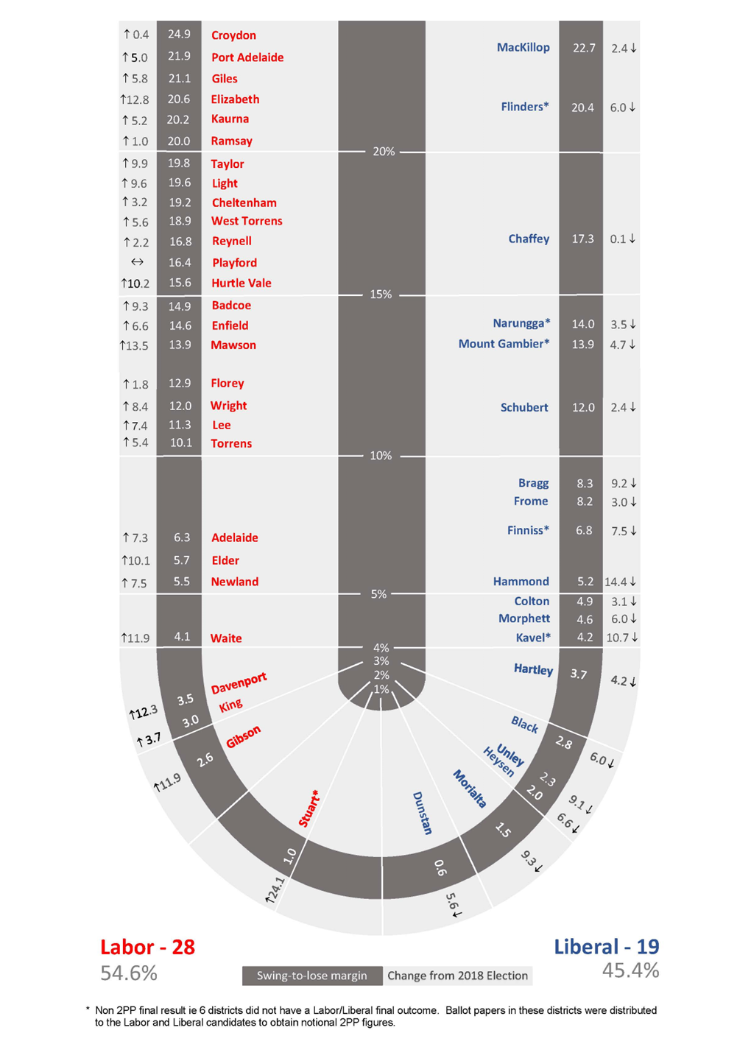
Swing-to-lose Figures Based on the 2022 Election

Appendix 8
Present and Projected Enrolments Before the 2024 Electoral Redistribution
District | Relevant Date |  | Projected Date |  | Enrolment Variance
 | 30/06/2024 | % Quota Variance | 30/06/2026 | % Quota Variance
ADELAIDE | 27671 | +0.9 | 29036 | +2.7 | 1365
BADCOE | 27122 | -1.1 | 28893 | +2.2 | 1771
BLACK | 26506 | -3.3 | 26917 | -4.7 | 411
BRAGG | 26494 | -3.4 | 27529 | -2.6 | 1035
CHAFFEY | 26068 | -4.9 | 26507 | -6.2 | 439
CHELTENHAM | 28281 | +3.1 | 29055 | +2.8 | 774
COLTON | 28327 | +3.3 | 28746 | +1.7 | 419
CROYDON | 28455 | +3.8 | 30555 | +8.1 | 2100
DAVENPORT | 26958 | -1.7 | 27996 | -0.9 | 1038
DUNSTAN | 26833 | -2.2 | 28499 | +0.8 | 1666
ELDER | 27521 | +0.4 | 28843 | +2.1 | 1322
ELIZABETH | 28304 | +3.2 | 28402 | +0.5 | 98
ENFIELD | 27585 | +0.6 | 28746 | +1.7 | 1161
FINNISS | 28080 | +2.4 | 29078 | +2.9 | 998
FLINDERS | 26001 | -5.2 | 26007 | -8.0 | 6
FLOREY | 26310 | -4.1 | 27949 | -1.1 | 1639
FROME | 28656 | +4.5 | 28861 | +2.1 | 205
GIBSON | 28138 | +2.6 | 28862 | +2.1 | 724
GILES | 25550 | -6.8 | 25398 | -10.1 | -152
HAMMOND | 27923 | +1.8 | 28166 | -0.3 | 243
HARTLEY | 26277 | -4.2 | 28089 | -0.6 | 1812
HEYSEN | 26714 | -2.6 | 26890 | -4.8 | 176
HURTLE VALE | 27079 | -1.3 | 27230 | -3.6 | 151
KAURNA | 30038 | +9.5 | 31087 | +10.0 | 1049
KAVEL | 29401 | +7.2 | 31085 | +10.0 | 1684
KING | 27459 | +0.1 | 27626 | -2.2 | 167
LEE | 25969 | -5.3 | 27320 | -3.3 | 1351
LIGHT | 28890 | +5.3 | 30244 | +7.0 | 1354
MACKILLOP | 27601 | +0.6 | 27927 | -1.2 | 326
MAWSON | 28322 | +3.3 | 29219 | +3.4 | 897
MORIALTA | 26839 | -2.1 | 27466 | -2.8 | 627
MORPHETT | 25853 | -5.7 | 26390 | -6.6 | 537
MOUNT GAMBIER | 26134 | -4.7 | 26693 | -5.5 | 559
NARUNGGA | 26036 | -5.1 | 26223 | -7.2 | 187
NEWLAND | 26675 | -2.7 | 27821 | -1.5 | 1146
PLAYFORD | 26759 | -2.4 | 27396 | -3.1 | 637
PORT ADELAIDE | 28837 | +5.2 | 29986 | +6.1 | 1149
RAMSAY | 28351 | +3.4 | 28986 | +2.6 | 635
REYNELL | 27500 | +0.3 | 28121 | -0.5 | 621
SCHUBERT | 28681 | +4.6 | 28990 | +2.6 | 309
STUART | 25546 | -6.8 | 26055 | -7.8 | 509
TAYLOR | 30875 | +12.6 | 33517 | +18.6 | 2642
TORRENS | 28161 | +2.7 | 29266 | +3.6 | 1105
UNLEY | 27334 | -0.3 | 28367 | +0.4 | 1033
WAITE | 28122 | +2.5 | 27849 | -1.5 | -273
WEST TORRENS | 25971 | -5.3 | 27127 | -4.0 | 1156
WRIGHT | 26689 | -2.7 | 27173 | -3.8 | 484
Total | 1288896 |  | 1328188 |  | 39292
Quota | 27423 |  | 28259
 |  |  |  |  | July 2024

Appendix 9
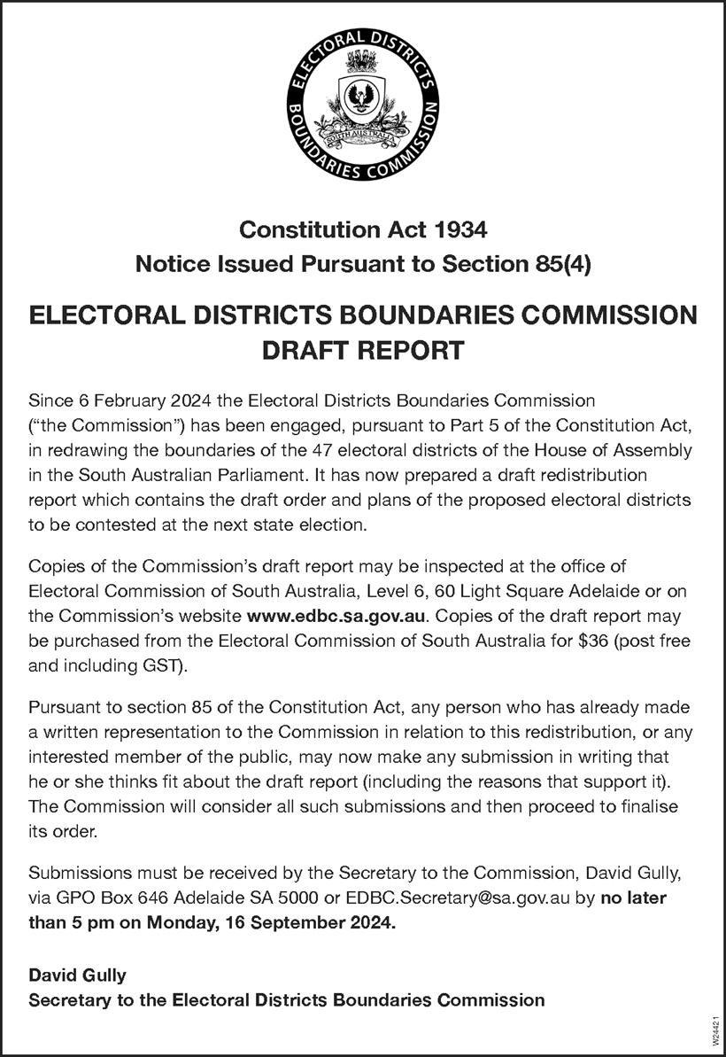
Public Notice Calling for Submissions About the Draft Report

Appendix 10
Written Submissions Received by the Commission About the Draft Report
Author of Submission Date Received
Mr M Gordon 25 August 2024
Ms J Hallewas 26 August 2024
Port Augusta City Council 30 August 2024
Port Pirie Regional Council 11 September 2024
Ms C Jaeschke 11 September 2024
Ms C Burgess 15 September 2024
Ms A Russell 15 September 2024
Ms R Hannaford 15 September 2024
Dr S Sutton 16 September 2024
Mr D Billing 16 September 2024
Mr S Telfer MP 16 September 2024
M & G Luccon 16 September 2024
Mr M Smiljanic 16 September 2024
Mr P Konings 16 September 2024
Mr P Alexandrides 16 September 2024
Mr C Auricht 16 September 2024
Mr W Cheffirs 16 September 2024
Australian Labor Party (SA Branch) 16 September 2024
Liberal Party of Australia (SA Division) 16 September 2024
Hon P Malinauskas MP 16 September 2024
Ms F Bedford 16 September 2024

Appendix 11
Summary of Impact of Boundary Changes on Electors
District | Before  Redistribution |  | Transfers/Comments |  | Change | After  Redistribution
 | Electors | Quota |  |  |  | Electors | Quota
Adelaide | 27671 | +0.9% | No Change |  |  | 27671 | +0.9%
Badcoe | 27122 | -1.1% | No Change |  |  | 27122 | -1.1%
Black | 26506 | -3.3% | No Change |  |  | 26506 | -3.3%
Bragg | 26494 | -3.4% | No Change |  |  | 26494 | -3.4%
Chaffey | 26068 | -4.9% | No Change |  |  | 26068 | -4.9%
Cheltenham | 28281 | +3.1% | No Change |  |  | 28281 | +3.1%
Colton | 28327 | +3.3% | No Change |  |  | 28327 | +3.3%
Croydon | 28455 | +3.8% | No Change |  |  | 28455 | +3.8%
Davenport | 26958 | -1.7% | No Change |  |  | 26958 | -1.7%
Dunstan | 26833 | -2.2% | No Change |  |  | 26833 | -2.2%
Elder | 27521 | +0.4% | No Change |  |  | 27521 | +0.4%
Elizabeth | 28304 | +3.2% | From Taylor | - The suburb of Elizabeth North and portion of the suburb of Smithfield | +3485
 |  |  | Into King | - Portion of the suburb of Craigmore | -3749 | 28040 | +2.2%
Enfield | 27585 | +0.6% | No Change |  |  | 27585 | +0.6%
Finniss | 28080 | +2.4% | No Change |  |  | 28080 | +2.4%
Flinders | 26001 | -5.2% | No Change |  |  | 26001 | -5.2%
Florey | 26310 | -4.1% | No Change |  |  | 26310 | -4.1%
Gibson | 28138 | +2.6% | No Change |  |  | 28138 | +2.6%
Giles | 25550 | -6.8% | From Stuart | - The remainder of Port Augusta City Council | +6495
 |  |  | Into Stuart | - The localities of Coober Pedy, Roxby Downs Andamooka and Oodnadatta and the APY Lands | -5091 | 26954 | -1.7%
Hammond | 27923 | +1.8% | No Change |  |  | 27923 | +1.8%
Hartley | 26277 | -4.2% | No Change |  |  | 26277 | -4.2%
Heysen | 26714 | -2.6% | From Kavel | - The localities of Forest Range, Lenswood, Balhannah and Oakbank | +2584 | 29298 | +6.8%
Hurtle Vale | 27079 | -1.3% | From Reynell | - Portion of the suburb of Morphett Vale | +2032 | 29111 | +6.2%
Kaurna | 30038 | +9.5% | Into Reynell | - The suburb of Christie Downs | -2341 | 27697 | +1.0%
Kavel | 29401 | +7.2% | Into Heysen | - The localities of Forest Range, Lenswood, Balhannah and Oakbank | -2584 | 26817 | -2.2%
King | 27459 | +0.1% | From Elizabeth | - Portion of the suburb of Craigmore | +3749
 |  |  | Into Wright | - Portion of the suburb of Salisbury East | -1835 | 29373 | +7.1%
Lee | 25969 | -5.3% | From  Port Adelaide | - The suburb of Semaphore South | +788 | 26757 | -2.4%
Light | 28890 | +5.3% | From Taylor | - Portion of the suburb of Munno Para West | +1774
 |  |  | Into Ngadjuri | - North of Gawler River incorporating the localities of Ward Belt, Gawler River, Gawler Belt, Buchfelde and Hewett | -3166 | 27498 | +0.3%
MacKillop | 27601 | +0.6% | No Change |  |  | 27601 | +0.6%
Mawson | 28322 | +3.3% | No Change |  |  | 28322 | +3.3%
Morialta | 26839 | -2.1% | No Change |  |  | 26839 | -2.1%
Morphett | 25853 | -5.7% | No Change |  |  | 25853 | -5.7%
Mount Gambier | 26134 | -4.7% | No Change |  |  | 26134 | -4.7%
Narungga | 26036 | -5.1% | From Ngadjuri | - The localities of Watchman, Balaklava, Dalkey, Hoskin Corner and Erith | +1653
 |  |  | Into Stuart | - The localities of Redhill, Koolinga and Collinsfield | -1792 | 27427 | 0.0%
Newland | 26675 | -2.7% | No Change |  |  | 26675 | -2.7%

District | Before  Redistribution |  | Transfers/Comments |  | Change | After  Redistribution
 | Electors | Quota |  |  |  | Electors | Quota
Ngadjuri | 28656 | +4.5% | From Light | - North of Gawler River incorporating the localities of Ward Belt, Gawler River, Gawler Belt, Buchfelde and Hewett | +3166 | 26530 | -3.3%
 |  |  | Into Stuart | - The remainder of Northern Areas Council incorporating the localities of Jamestown and Spalding and portion of The Regional Council of Goyder incorporating the localities of Hallett, Burra and Farrell Flat | -3639
Playford | 26759 | -2.4% | No Change |  |  | 26759 | -2.4%
Port Adelaide | 28837 | +5.2% | Into Lee | - The suburb of Semaphore South | -788 | 28049 | +2.3%
Ramsay | 28351 | +3.4% | No Change |  |  | 28351 | +3.4%
Reynell | 27500 | +0.3% | From Kaurna | - The suburb of Christie Downs | +2341
 |  |  | Into Hurtle Vale | - Portion of the suburb of Morphett Vale | -2032 | 27809 | +1.4%
Schubert | 28681 | +4.6% | No Change |  |  | 28681 | +4.6%
Stuart | 25546 | -6.8% | From Ngadjuri | - The remainder of Northern Areas Council incorporating the localities of Jamestown and Spalding and portion of The Regional Council of Goyder incorporating the localities of Hallett, Burra and Farrell Flat | +3639

Appendix 12
Present and Projected Enrolments After the 2024 Electoral Redistribution
District | Relevant Date |  | Projected Date |  | Enrolment Variance
 | 30/06/2024 | % Quota Variance | 30/06/2026 | % Quota Variance
ADELAIDE | 27671 | +0.9 | 29036 | +2.7 | 1365
BADCOE | 27122 | -1.1 | 28893 | +2.2 | 1771
BLACK | 26506 | -3.3 | 26917 | -4.7 | 411
BRAGG | 26494 | -3.4 | 27529 | -2.6 | 1035
CHAFFEY | 26068 | -4.9 | 26507 | -6.2 | 439
CHELTENHAM | 28281 | +3.1 | 29055 | +2.8 | 774
COLTON | 28327 | +3.3 | 28746 | +1.7 | 419
CROYDON | 28455 | +3.8 | 30555 | +8.1 | 2100
DAVENPORT | 26958 | -1.7 | 27996 | -0.9 | 1038
DUNSTAN | 26833 | -2.2 | 28499 | +0.8 | 1666
ELDER | 27521 | +0.4 | 28843 | +2.1 | 1322
ELIZABETH | 28040 | +2.2 | 28295 | +0.1 | 255
ENFIELD | 27585 | +0.6 | 28746 | +1.7 | 1161
FINNISS | 28080 | +2.4 | 29078 | +2.9 | 998
FLINDERS | 26001 | -5.2 | 26007 | -8.0 | 6
FLOREY | 26310 | -4.1 | 27949 | -1.1 | 1639
GIBSON | 28138 | +2.6 | 28862 | +2.1 | 724
GILES | 26954 | -1.7 | 27265 | -3.5 | 311
HAMMOND | 27923 | +1.8 | 28166 | -0.3 | 243
HARTLEY | 26277 | -4.2 | 28089 | -0.6 | 1812
HEYSEN | 29298 | +6.8 | 29431 | +4.1 | 133
HURTLE VALE | 29111 | +6.2 | 29248 | +3.5 | 137
KAURNA | 27697 | +1.0 | 28638 | +1.3 | 941
KAVEL | 26817 | -2.2 | 28544 | +1.0 | 1727
KING | 29373 | +7.1 | 29476 | +4.3 | 103
LEE | 26757 | -2.4 | 28130 | -0.5 | 1373
LIGHT | 27498 | +0.3 | 28624 | +1.3 | 1126
MACKILLOP | 27601 | +0.6 | 27927 | -1.2 | 326
MAWSON | 28322 | +3.3 | 29219 | +3.4 | 897
MORIALTA | 26839 | -2.1 | 27466 | -2.8 | 627
MORPHETT | 25853 | -5.7 | 26390 | -6.6 | 537
MOUNT GAMBIER | 26134 | -4.7 | 26693 | -5.5 | 559
NARUNGGA | 27427 | +0.0 | 27564 | -2.5 | 137
NEWLAND | 26675 | -2.7 | 27821 | -1.5 | 1146
NGADJURI | 26530 | -3.3 | 27047 | -4.3 | 517
PLAYFORD | 26759 | -2.4 | 27396 | -3.1 | 637
PORT ADELAIDE | 28049 | +2.3 | 29176 | +3.2 | 1127
RAMSAY | 28351 | +3.4 | 28986 | +2.6 | 635
REYNELL | 27809 | +1.4 | 28552 | +1.0 | 743
SCHUBERT | 28681 | +4.6 | 28990 | +2.6 | 309
STUART | 28043 | +2.3 | 27955 | -1.1 | -88
TAYLOR | 25616 | -6.6 | 28203 | -0.2 | 2587
TORRENS | 28161 | +2.7 | 29266 | +3.6 | 1105
UNLEY | 27334 | -0.3 | 28367 | +0.4 | 1033
WAITE | 28122 | +2.5 | 27849 | -1.5 | -273
WEST TORRENS | 25971 | -5.3 | 27127 | -4.0 | 1156
WRIGHT | 28524 | +4.0 | 29070 | +2.9 | 546
Total | 1288896 |  | 1328188 |  | 39292
Quota | 27423 |  | 28259
 |  |  |  |  | November 2024

Appendix 13
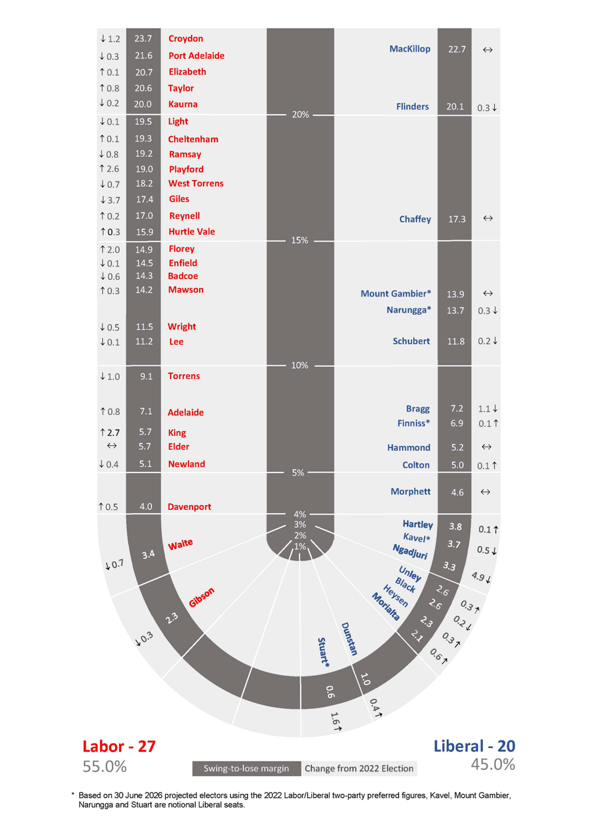
Swing-to-lose Figures Based on the 2024 Electoral Redistribution

Appendix 14
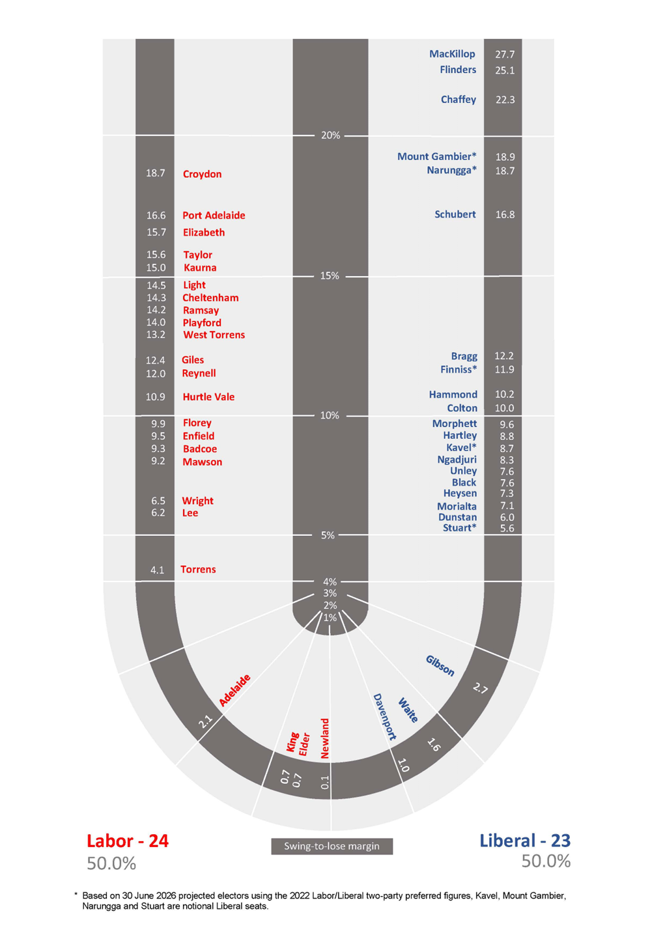
Electoral Districts Allocation Based on 50:50 Vote
Following the 2024 Electoral Redistribution

Crown Land Management Regulations 2024
Regulation 10
Prohibition and Restriction of Specified Activities on Designated Unalienated Crown Land
Wauraltee Beach
Take notice that, pursuant to Regulation 10 of the Crown Land Management Regulations 2024, I, Susan Close, the Minister for Climate, Environment and Water, hereby designate the land defined in The Schedule to be subject to the following restrictions, prohibitions and conditions;
1. It is prohibited for a person to bring onto the designated area a caravan, tent trailer, motor home or other camping vehicle.
2. Within the designated area, a person must not camp or sleep overnight on the land. Camp includes setting up a camp, or causing: a tent or other structure of calico, canvas, plastic or similar material; a swag or similar bedding; or a caravan, tent trailer, motor home or other camping vehicle; to remain on land overnight, whether or not any person is in attendance or sleeping on the land.
The prohibitions, restrictions and conditions within the restricted area do not apply to:
(a) a person acting in the course of an emergency; or
(b) an Aboriginal person acting in accordance with native title rights and interests; or
(c) a person exercising official powers or functions under an Act (whether of the State or of the Commonwealth)
(d) a person exercising rights under a lease, licence or right of way
(e) a person acting in accordance with a right granted under the Crown Land Management Act 2009
Effective Date: 3 February 2025 until otherwise modified or revoked.
Susan Close
Minister for Climate, Environment and Water

The Schedule
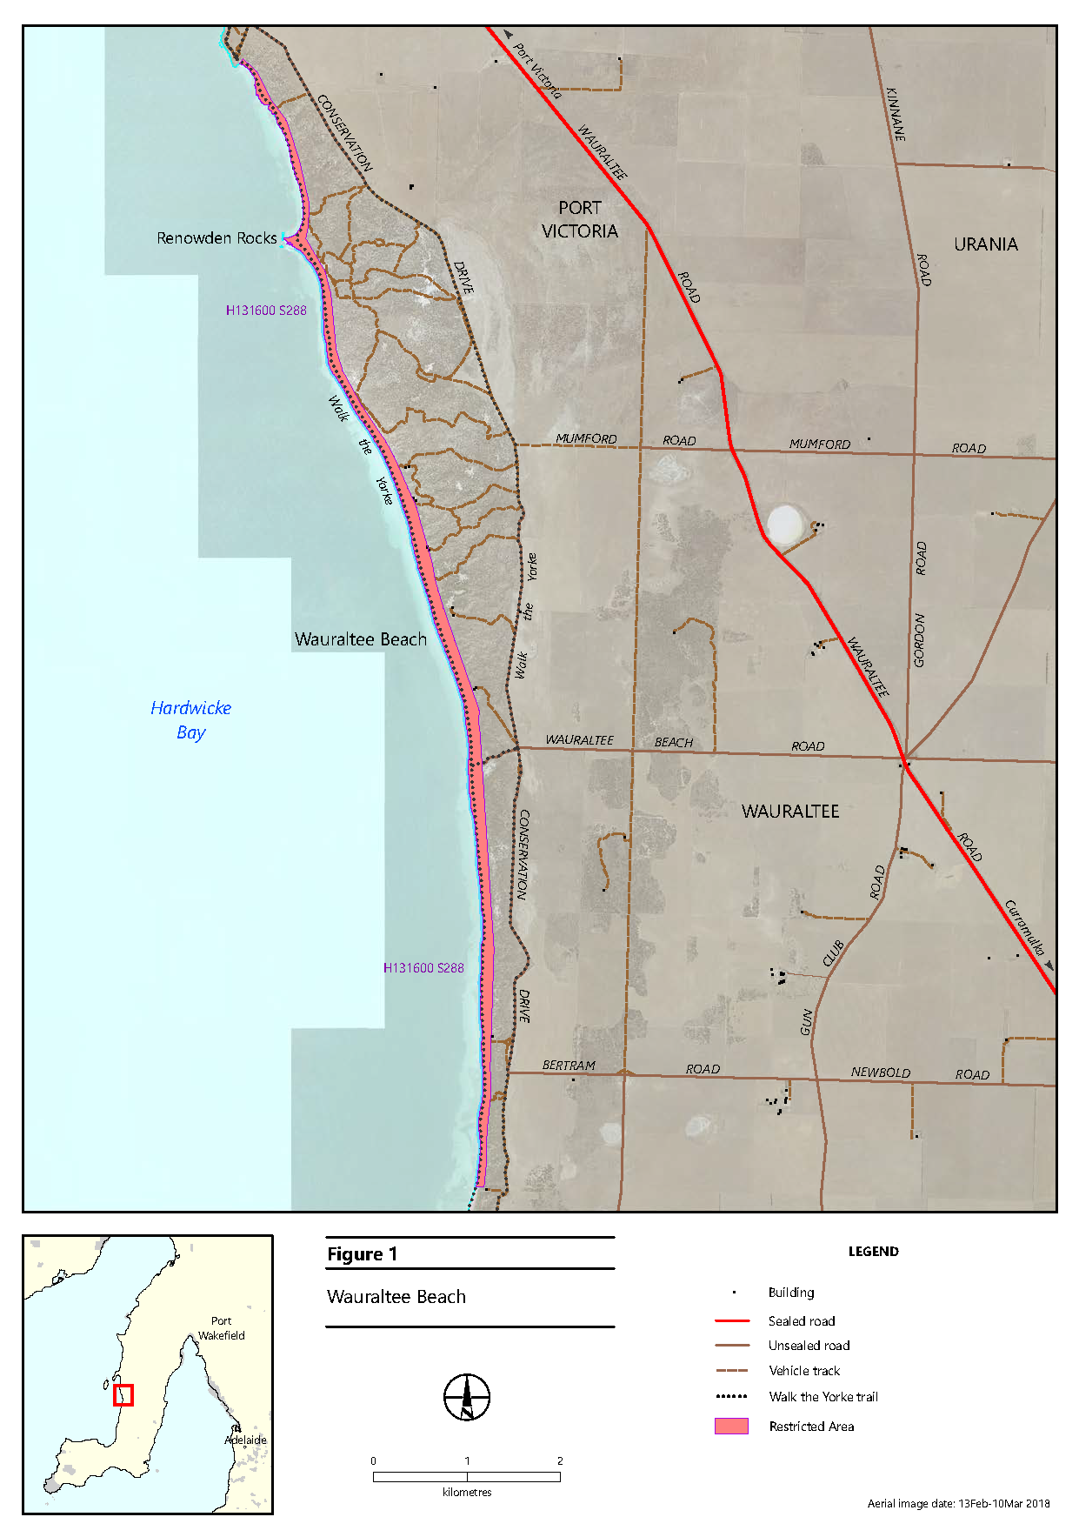
Section 288 in the Hundred of Wauraltee

Energy Resources Act 2000
Grant of Petroleum Production Licence—PPL 280
Associated Activities Licence—AAL 321
Notice is hereby given that the undermentioned Petroleum Production Licence and Associated Activities Licence have been granted with effect from 3 December 2024, under the provisions of the Energy Resources Act 2000, pursuant to delegated powers dated 19 August 2024.
No. of Licence | Licensees | Locality | Area in km² | Reference
PPL 280 | Beach Energy Limited  Great Artesian Oil and Gas Pty Ltd  Drillsearch Gas Pty Limited | Cooper Basin | 13.71 | MER-2024/0173
AAL 321 | Beach Energy Limited  Great Artesian Oil and Gas Pty Ltd  Drillsearch Gas Pty Limited | Cooper Basin | 0.247 | MER-2024/0172
Description of Area
PPL 280
All that part of the State of South Australia, bounded as follows:
Commencing at a point being the intersection of latitude 27°56'25"S GDA94, and longitude 139°39′20″E GDA94, thence east to longitude 139°40'45"E GDA94, south to latitude 27°56′50″S GDA94, east to longitude 139°40′55″E GDA94, south to latitude 27°57′15″S GDA94, east to longitude 139°41′10″E GDA94, south to latitude 27°57′55″S GDA94, east to longitude 139°41′25″E GDA94, south to latitude 27°58′45″S GDA94, west to longitude 139°40′00″E AGD66, north to latitude 27°58′40″S GDA94, west to longitude 139°39′50″E GDA94, north to latitude 27°58′25″S GDA94, west to longitude 139°38′45″E GDA94, north to latitude 27°57′45″S GDA94, east to longitude 139°39′05″E GDA94, north to latitude 27°57′25″S GDA94, east to longitude 139°39′15″E GDA94, north to latitude 27°57′00″S GDA94, east to longitude 139°39′20″E GDA94,
and north to the point of commencement.
AREA: 13.71 square kilometres approximately.
AAL 321
All that part of the State of South Australia, bounded as follows:
All coordinates GDA2020, Zone 54
Area 1
Easting Northing
370764.11mE 6906250.31mN
370935.17mE 6906111.24mN
371158.21mE 6905953.24mN
370992.00mE 6905951.46mN
370891.60mE 6906021.67mN
370865.23mE 6906042.18mN
370765.48mE 6906123.50mN
370764.11mE 6906250.31mN
Area 2
371177.37mE 6905939.68mN
371237.87mE 6905896.82mN
371529.38mE 6905617.03mN
372090.55mE 6905162.21mN
372242.43mE 6905154.49mN
372402.63mE 6905168.13mN
372388.98mE 6904903.53mN
372061.48mE 6904871.48mN
372043.68mE 6904999.64mN
372023.51mE 6905088.63mN
371466.77mE 6905537.93mN
371207.49mE 6905791.35mN
371213.35mE 6905811.85mN
371211.89mE 6905826.51mN
371200.17mE 6905841.16mN
371188.45mE 6905847.02mN
371178.35mE 6905847.86mN
371177.37mE 6905939.68mN
AREA: 0.247 square kilometres approximately
Dated: 3 December 2024
Benjamin Zammit
Executive Director
Regulation and Compliance Division
Department for Energy and Mining
Delegate of the Minister for Energy and Mining

Fisheries Management Act 2007
Section 79
Shark and Ray Fishing Arrangements
Temporary Prohibition of Fishing Activity
Pursuant to Section 79 of the Fisheries Management Act 2007, I Professor Gavin Begg, Executive Director Fisheries and Aquaculture, delegate of the Minister for Primary Industries and Regional Development, hereby declare that it will be unlawful for any person to engage in the class of fishing activities specified in Schedule 1 during the period specified in Schedule 2.
Schedule 1
1. The taking or possession of the following species by any person:
(a) Whitefin Swellshark (Cephaloscyllium albipinnum)
(b) Oceanic Whitetip Shark (Carcharhinus longimanus)
(c) Green Sawfish (Pristis zijsron)
(d) Greeneye Spurdog (Squalus chloroculus)
(e) Southern Dogfish (Centrophorus uyato)
(f) Basking Shark (Cetorhinus maximus)
(g) Grey Nurse Shark (Carcharias taurus)
(h) All stingaree species of genus Urolophus
(i) All skate species of genus Dipturus or Dentiraja.
2. The taking by an unlicensed person, other than a person fishing on a lawful charter, in any one day of more than one (1) combined of any of the following species:
(a) Common Thresher (Alopias vulpinus)
(b) Broadnose Sevengill Shark (Notorynchus cepedianus)
(c) Hammerhead Shark (Sphyrna zygaena)
(d) Smooth Stingray (Bathytoshia brevicaudata)
(e) Black Stingray (Bathytoshia lata)
(f) Bigeye Thresher (Alopias superciliosus)
(g) Bronze Whaler (Carcharhinus brachyurus)
(h) Dusky Whaler (Carcharhinus obscurus)
(i) Shortfin Mako (Isurus oxyrinchus)
(j) Melbourne Skate (Spiniraga whitleyi)
(k) School Shark (Galeorhinus galeus).
3. The taking from a boat carrying three (3) or more unlicenced persons, other than a boat engaged in lawful charter boat fishing or undertaking a lawful fishing activity of a class constituted as a fishery, in any one day, of more than three (3) combined of any of the species listed at condition 2.
4. The taking by an unlicensed person, other than a person fishing on a lawful charter, in any one day of more than two (2) combined of any species of sharks, rays or skates not listed at conditions 1 or 2 or listed as a protected species.
5. The taking from a boat carrying three (3) or more unlicenced persons, other than a boat engaged in lawful charter boat fishing undertaking a lawful fishing activity of a class constituted as a fishery, in any one day, of more than six (6) combined of any species of sharks, rays, or skates not listed at conditions 1 or 2 or listed as a protected species.
6. The taking by any person fishing on a lawful charter, in any one trip, of more than one (1) combined of any of the following species:
(a) Common Thresher (Alopias vulpinus)
(b) Broadnose Sevengill Shark (Notorynchus cepedianus)
(c) Hammerhead Shark (Sphyrna zygaena)
(d) Smooth Stingray (Bathytoshia brevicaudata)
(e) Black Stingray (Bathytoshia lata)
(f) Bigeye Thresher (Alopias superciliosus)
(g) Bronze Whaler (Carcharhinus brachyurus)
(h) Dusky Whaler (Carcharhinus obscurus)
(i) Shortfin Mako (Isurus oxyrinchus)
(j) Melbourne Skate (Spiniraga whitleyi)
(k) School Shark (Galeorhinus galeus).
7. The taking by any person fishing on a lawful charter, in any one trip, of more than one (1) combined of any species of sharks, rays or skates not listed at condition 1 or 6 or listed as a protected species.

8. The taking by an unlicensed person of:
(a) Smooth Stingray (Bathytoshia brevicaudata), Black Stingray (Bathythoshia lata) or Southern Eagle Ray (Myliobatis tenuicaudatus) of greater than 100cm disc width; or
(b) Southern Fiddler Ray (Trygonorrhina dumerilii) or Western Shovelnose Ray (Aptychotrema vincentiana) of greater than 80 cm total length.
9. Failure to immediately return a fish, that is not of a noxious aquatic species, to the water with the least possible injury or damage, unless the person is lawfully retaining that fish.
Schedule 2
00:01 hours 16 December 2024 until 23:59 hours on 15 December 2025.
For the purpose of this notice:
Disc width—means the distance across the width from one wing tip to the other.
In any one day—means during the period commencing at midnight and ending at the midnight next following.
Non-noxious aquatic resource—means any species of aquatic resource not declared by the Minister by notice in the Gazette to be a noxious species for the purposes of the Fisheries Management Act 2007.
Protected species—means a species of aquatic resource declared by the Fisheries Management (General) Regulations 2017 to be a protected species for the purposes of the Fisheries Management Act 2007.
Sharks, Rays or Skates—means any species of the Class Elasmobranchii.
Taking—means the act of taking or act preparatory to taking.
Total length—means the distance from tip of the nose to the end of the tail.
Dated: 7 December 2024
Professor Gavin Begg
Executive Director
Fisheries and Aquaculture
Delegate of the Minister for Primary Industries and Regions

Fisheries Management Act 2007
Section 115
Variation—Ministerial Exemption ME9903336
Take notice that pursuant to Section 115 of the Fisheries Management Act 2007 (the Act), Ministerial exemption ME9903336 provided to
Mr Thomas Sankey Robinson of Goolwa Pipi Co Pty Ltd, 50 Hill Street Port Elliot (the ‘exemption holder’), dated 1 October 2024 and published in the South Australian Government Gazette dated 31 October 2024, on page 4075 is hereby varied by deleting Schedule 1 and inserting the following:
Schedule 1
The following persons are nominated agents of the exemption holder:
Nominated Agent | Licence Number
Alistair Scott-Young | L27 | L08
Steven Jones | L27 | L08
Jacob Jones | L27 | L08
Clinton Walker | L27 | L08
Darren Hoad | L45 | -
Matt Hoad | L45 | -
Jayce Stephenson | L45 | -
Dated: 6 December 2024
Professor Gavin Begg
Executive Director
Fisheries and Aquaculture
Delegate of the Minister for Primary Industries and Regional Development

Highways Act 1926
Section 26(3)
Care, Control and Management of Local Road
I, Jon William Whelan, Commissioner of Highways, with the approval of the Minister for Infrastructure and Transport do hereby give notice that I will undertake the care, control and management of the following local road, within the boundaries of the City of Marion until further notice, in association with the North-South Corridor, River Torrens to Darlington Project.
• Nottingham Crescent
The extent of works is identified on the attached plan and is scheduled to commence December 2024.
Dated: 11 December 2024
Jon William Whelan
Commissioner of Highways

Highways Act 1926
Section 26(3)
Care, Control and Management of Local Road
I, Jon William Whelan, Commissioner of Highways, with the approval of the Minister for Infrastructure and Transport do hereby give notice that I will undertake the care, control and management of the following local roads, within the boundaries of the City of Unley until further notice, in association with the North-South Corridor, River Torrens to Darlington Project.
• Norman Terrace
• Aroha Terrace
The extent of works is identified on the attached plan and is scheduled to commence December 2024.
Dated: 11 December 2024
Jon William Whelan
Commissioner of Highways

Highways Act 1926
Section 26(3)
Care, Control and Management of Local Road
I, Jon William Whelan, Commissioner of Highways, with the approval of the Minister for Infrastructure and Transport do hereby give notice that I will undertake the care, control and management of the following local road, within the boundaries of the City of West Torrens until further notice, in association with the North-South Corridor, River Torrens to Darlington Project.
• Glengyle Terrace
The extent of works is identified on the attached plan and is scheduled to commence December 2024.
Dated: 11 December 2024
Jon William Whelan
Commissioner of Highways

Housing Improvement Act 2016
Rent Control
In the exercise of the powers conferred by the Housing Improvement Act 2016, the Delegate of the Minister for Housing and Urban Development hereby fixes the maximum rental amount per week that shall be payable subject to Section 55 of the Residential Tenancies Act 1995, in respect of each premises described in the following table. The amount shown in the said table shall come into force on the date of this publication in the Gazette.
Address of Premises | Allotment Section | Certificate of Title  Volume/Folio | Maximum Rental per week payable
Unit 5/4 Para Road, Evanston SA 5116 | Unit 5 Strata Plan 12931 Hundred of Munno Para | CT6087/185 | $160.00
Dated:12 December 2024
Craig Thompson
Housing Regulator and Registrar
Housing Safety Authority
Delegate of the Minister for Housing and Urban Development

Housing Improvement Act 2016
Rent Control Revocations
In the exercise of the powers conferred by the Housing Improvement Act 2016, the Delegate of the Minister for Housing and Urban Development hereby revokes the maximum rental amount per week that shall be payable subject to Section 55 of the Residential Tenancies Act 1995, in respect of each premises described in the following table.
Address of Premises | Allotment Section | Certificate of Title  Volume/Folio
8 Murray Street, Callington SA 5254 | Allotment 218 Filed Plan 4078 Hundred of Kanmantoo | CT5501/134
13 Edson Crescent, Littlehampton SA 5250 | Allotment 61 Deposited Plan 33098 Hundred of Macclesfield | CT6124/289
Dated 12 December 2024
Craig Thompson
Housing Regulator and Registrar
Housing Safety Authority
Delegate of the Minister for Housing and Urban Development

Land Acquisition Act 1969
Section 16
Form 5—Notice of Acquisition
1. Notice of acquisition
The Commissioner of Highways (the Authority), of 83 Pirie Street, Adelaide SA 5000, acquires the following interests in the following land:
A free and unrestricted right and liberty in gross over portion of Allotment 1037 in Deposited Plan 33417 comprised in Certificate of Title Volume 6146 Folio 574, more particularly being that area marked “F” in the plan FX260516 lodged in the Lands Titles Office (the Land), for the Authority and its agents, employees, workers, licensees and invitees at any time with or without vehicles, plant, equipment and materials to:
(a) construct a new traffic signal controlled left turn lane to replace the existing turn left slip lane, remove the existing intervening traffic island and infill from the replacement turn left lane to the existing footpath of the existing Road on the Land (described for that purpose in this notice); and
(b) maintain, inspect, alter, repair and replace the Road infrastructure in an ongoing manner;
(c) break the surface of, dig, open up and use the Land for any of those purposes.
This notice is given under Section 16 of the Land Acquisition Act 1969.
2. Compensation
A person who has or had an interest consisting of native title or an alienable interest in the land that is divested or diminished by the acquisition or the enjoyment of which is adversely affected by the acquisition who does not receive an offer of compensation from the Authority may apply to the Authority for compensation.
2A. Payment of professional costs relating to acquisition (Section 26B)
If you are the owner in fee simple of the land to which this notice relates, you may be entitled to a payment of up to $10,000 from the Authority for use towards the payment of professional costs in relation to the acquisition of the land.
Professional costs include legal costs, valuation costs and any other costs prescribed by the Land Acquisition Regulations 2019.
3. Inquiries
Inquiries should be directed to: Daniel Tuk
GPO Box 1533
Adelaide SA 5001
Telephone: (08) 7133 2479
Dated: 10 December 2024
The Common Seal of the COMMISSIONER OF HIGHWAYS was hereto affixed by authority of the Commissioner in the presence of:
Rocco Caruso
Director, Property Acquisition
(Authorised Officer)
Department for Infrastructure and Transport
DIT 2023/04089/01

Passenger Transport Act 1994 (‘The Act’)

Passenger Transport Regulations 2024 (‘Regulations’)
Exemption
Small Passenger Vehicle Special Purpose
I, the Hon Anastasios Koutsantonis, Minister for Infrastructure and Transport:
1. Pursuant to Section 5(2) of the Act hereby EXEMPT vehicle attached to number plate 1365SV from the requirements under Regulation 141(1) and Regulation 13(1)(q)(iii).
2. Pursuant to Section 5(3) of the Act hereby REQUIRE number plate 1365SV:
2.1. Can not transfer, affix or attach number plate 1365SV onto another vehicle, while this exemption remains in force.
Interpretation
Any terms defined in the Act and the Regulations have the same meaning in this instrument.
The ‘attached vehicle’, is the vehicle attached to number plate 1365SV as of 17 July 2024.
This exemption will take effect from the date published in the South Australian Government Gazette and will remain in force for 2 years from its execution.
This exemption may be varied or revoked by a subsequent notice issued pursuant to Section 5(4) of the Act.
Dated: 10 December 2024
Hon Anastasios Koutsantonis MP
Minister for Infrastructure and Transport

Passenger Transport Act 1994 (‘the Act’)
Passenger Transport Regulations 2024 (‘Regulations’)
Exemption
Small Passenger Vehicle Special Purpose
I, the Hon Anastasios Koutsantonis, Minister for Infrastructure and Transport:
1. Pursuant to Section 5(2) of the Act hereby EXEMPT vehicle attached to number plate 1658SV from the requirements under Regulation 141(1).
2. Pursuant to Section 5(3) of the Act hereby REQUIRE number plate 1658SV:
2.1. Can not transfer, affix or attach number plate 1658SV onto another vehicle, while this exemption remains in force.
Interpretation
Any terms defined in the Act and the Regulations have the same meaning in this instrument.
The ‘attached vehicle’, is the vehicle attached to number plate 1658SV as of 3 November 2024.
This exemption will take effect from the date published in the South Australian Government Gazette and will remain in force for 2 years from its execution.
This exemption may be varied or revoked by a subsequent notice issued pursuant to Section 5(4) of the Act.
Dated: 10 December 2024
Hon Anastasios Koutsantonis MP
Minister for Infrastructure and Transport

Pastoral Land Management and Conservation Act 1989
Public Access Route Closure December 2024
Notice of Intent to Temporarily Close Public Access Route Number 2, Named Level Post Bay
Notice is hereby given of the intent to temporarily close the Level Post Bay Public Access Route from Muloorina to Kati Thanda-Lake Eyre National Park, 5 December 2024 until further notice, pursuant to Section 45(7) of the Pastoral Land Management and Conservation Act 1989. Notification of the re-opening of the Public Access Route will be provided on the Department for Infrastructure and Transport’s Outback Road Warnings website at https://www.dit.sa.gov.au/OutbackRoads/outback_road_warnings/special_notices.
Notice of Intent to Temporarily Close Public Access Route Number 12, named Old Peake Telegraph
Notice is hereby given of the intent to temporarily close the Old Peake Telegraph Public Access Route from the turn off on the Oodnadatta Track to the Freeling Springs carpark and the Old Peake ruins, from 5 December 2024 until further notice, pursuant to Section 45(7) of the Pastoral Land Management and Conservation Act 1989. Notification of the re-opening of the Public Access Route will be provided on the Department for Infrastructure and Transport’s Outback Road Warnings website at:
https://www.dit.sa.gov.au/OutbackRoads/outback_road_warnings/special_notices
Notice of Intent to Temporarily Close Public Access Route Number 1,4 Named Strangway Springs
Notice is hereby given of the intent to temporarily close the Strangway Springs Public Access Route from T-junction on Oodnadatta Track to the Stile at carpark, from 5 December 2024 until further notice, pursuant to Section 45(7) of the Pastoral Land Management and Conservation Act 1989. Notification of the re-opening of the Public Access Route will be provided on the Department for Infrastructure and Transport’s Outback Road Warnings website at https://www.dit.sa.gov.au/OutbackRoads/outback_road_warnings/special_notices.
Notice of Intent to Temporarily Close Public Access Route Number 18, Named Lake Cadibarrawirracanna
Notice is hereby given of the intent to temporarily close the Lake Cadibarrawirracanna Public Access Route from William Creek Road turn off to the lookout, from 5 December 2024 until further notice, pursuant to Section 45 (7) of the Pastoral Land Management and Conservation Act 1989. Notification of the re-opening of the Public Access Route will be provided on the Department for Infrastructure and Transport’s Outback Road Warnings website at https://www.dit.sa.gov.au/OutbackRoads/outback_road_warnings/special_notices.
Notice of Intent to Temporarily Close Public Access Route Number 20, named Beresford Bore
Notice is hereby given of the intent to temporarily close the Strangway Springs Public Access Route from Beresford Bore Public Access Route from the Oodnadatta track turn off to Beresford Bore Ruins, from 5 December 2024 until further notice, pursuant to Section 45(7) of the Pastoral Land Management and Conservation Act 1989. Notification of the re-opening of the Public Access Route will be provided on the Department for Infrastructure and Transport’s Outback Road Warnings website at:
https://www.dit.sa.gov.au/OutbackRoads/outback_road_warnings/special_notices
Dated: 4 December 2024
Mark May
Pastoral Board Delegate
Program Leader, Pastoral Operations
Department for Environment and Water

Planning, Development and Infrastructure Act 2016
Section 80
Alterations to the Building Rules—Ministerial Building Standards
Preamble
1. The Planning, Development and Infrastructure Act 2016 (the Act) defines the Building Rules as meaning (amongst other things) the Building Code, being the Building Code of Australia published by the Australian Building Codes Board from time to time, and Ministerial building standards published by the Minister under the Act.
2. Under Section 80(1) of the Act, the Minister may, after consultation with the State Planning Commission (the Commission), publish Ministerial building standards that:
(a) relate to any aspect of building work (including the regulation, control, restriction or prohibition of building work);
(b) relate to any aspect of the design, construction, quality, safety, health, amenity, sustainability, adaptive re-use or maintenance of buildings; or
(c) modify the Building Code as it applies under the Act (including pursuant to Section 79(1)(b)).
3. Under Section 80(4) of the Act, the Minister may, after consultation with the Commission, vary or revoke a Ministerial building standard.
4. Pursuant to Section 80 of the Act, notice of publishing, varying, or revoking a Ministerial building standard must be placed in the Government Gazette before they can take effect.
Notice
Pursuant to Section 80(1) of the Act, I, Jodie Evans, Director, Building, give notice, having consulted with the Commission, that the following Ministerial building standard that modifies the Building Code (including further modifications to modifications that are made under Section 79(1)(a) of the Act) has been varied and is to commence from the date of this notice:
Ministerial Building Standard MBS 007—Modifications to the Building Code of Australia (Amendment 3) dated 10 December 2024 as published on the PlanSA portal.
Dated: 10 December 2024
Jodie Evans
Director, Building
Planning and Land Use Services
As Delegate of the Minister for Planning

Ministerial Building Standard MBS 007
Modifications to the Building Code of Australia—December 2024
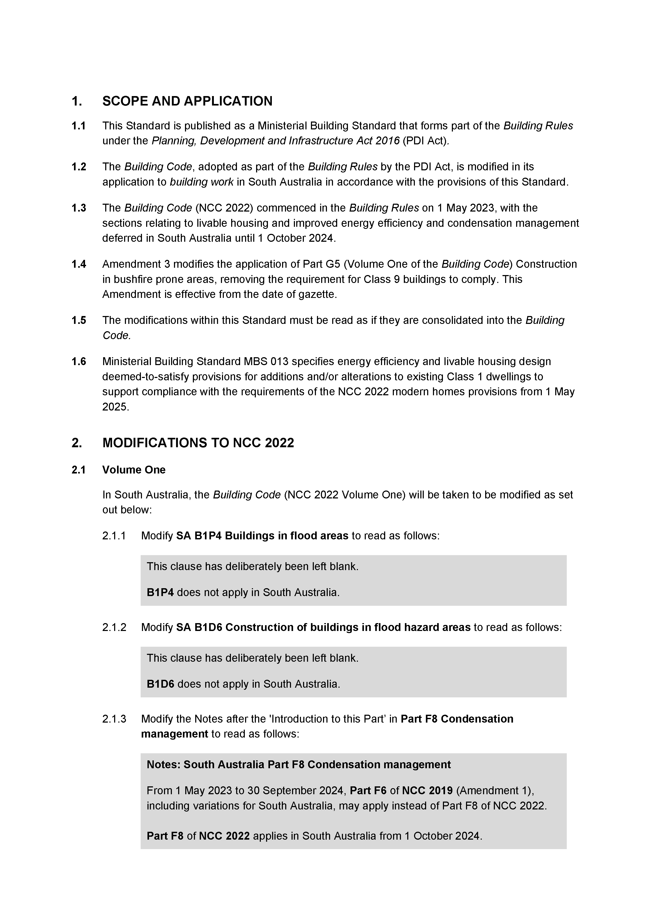
Published by the Minister for Planning

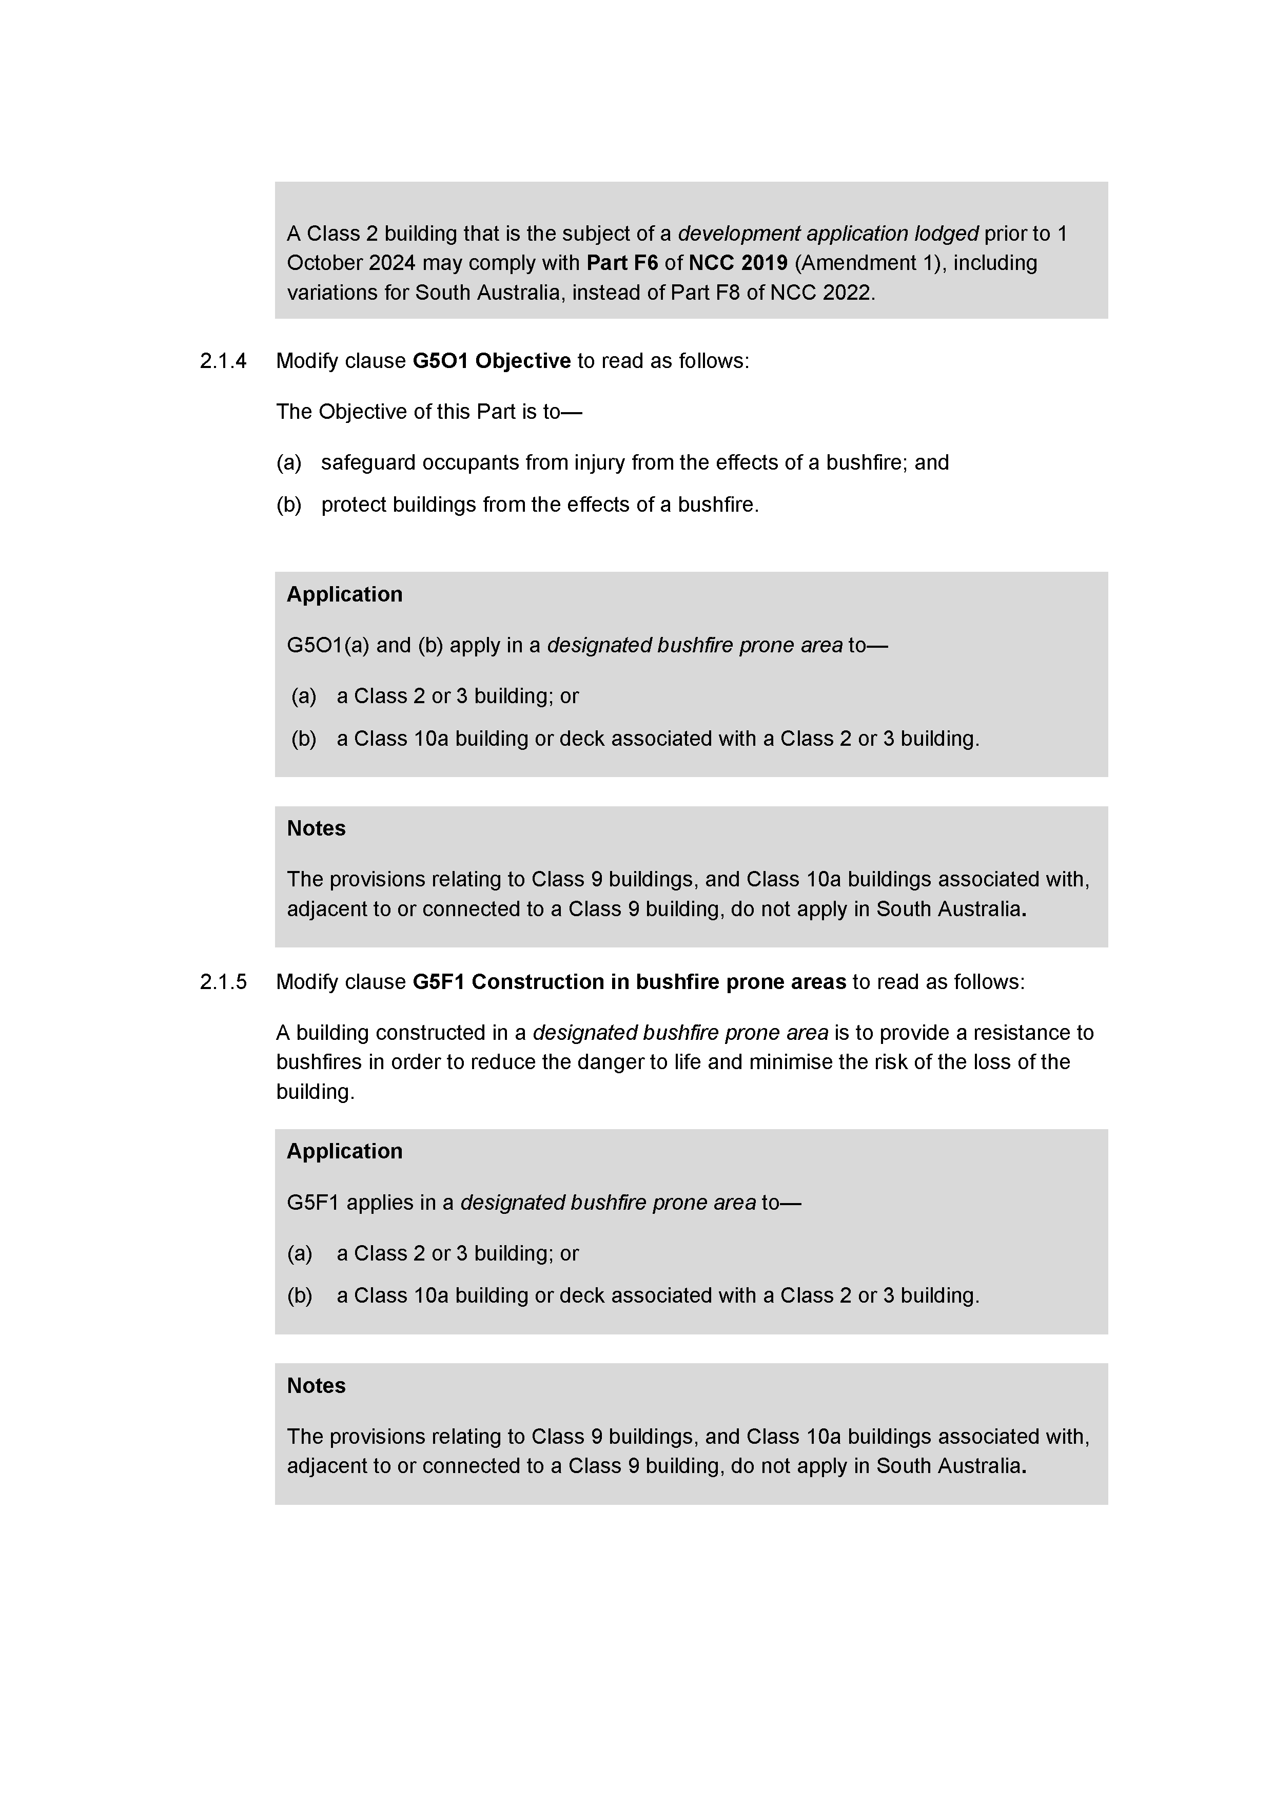

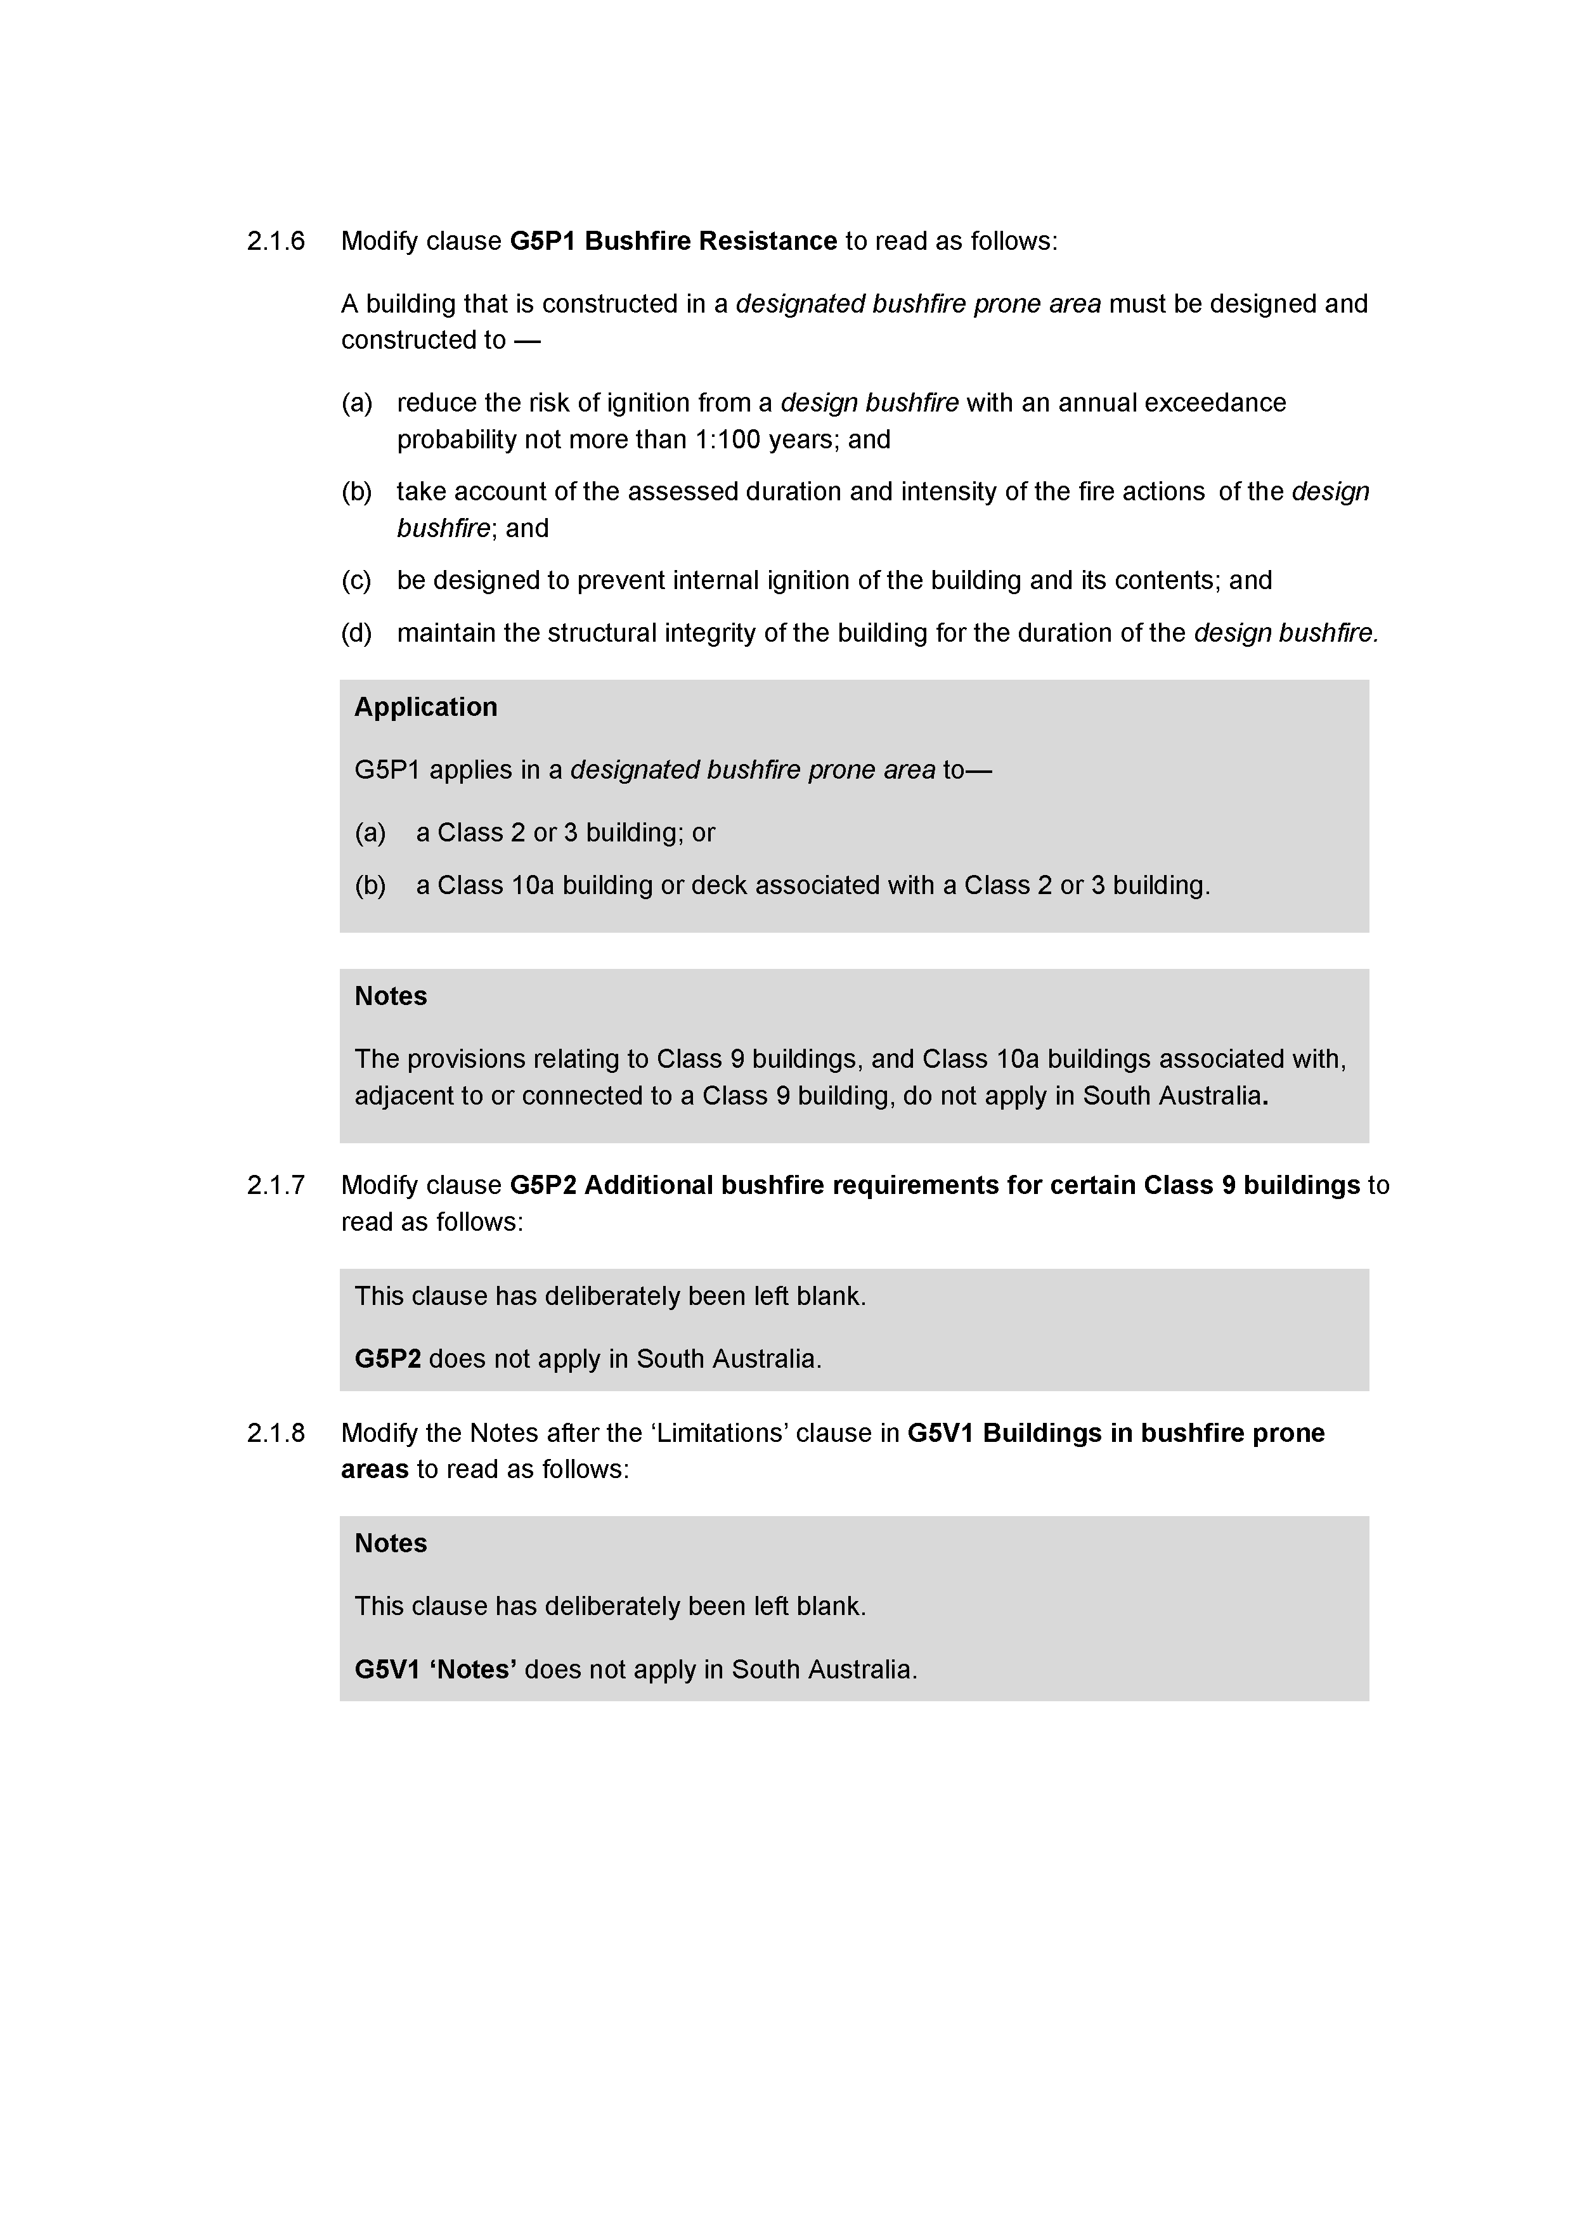

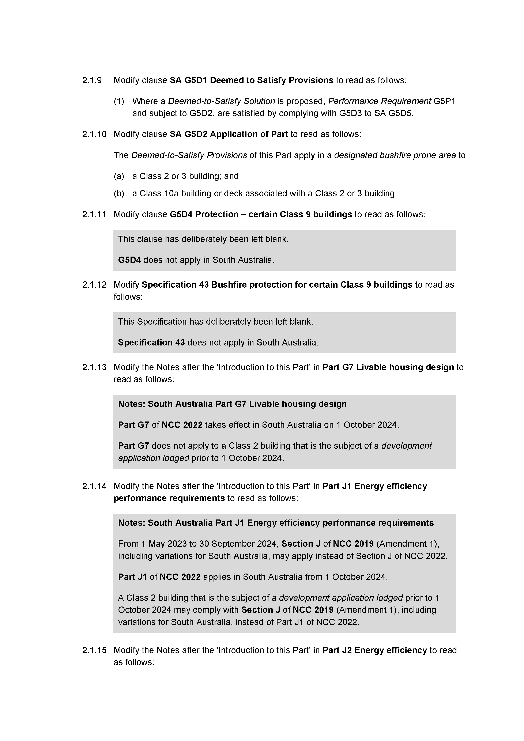

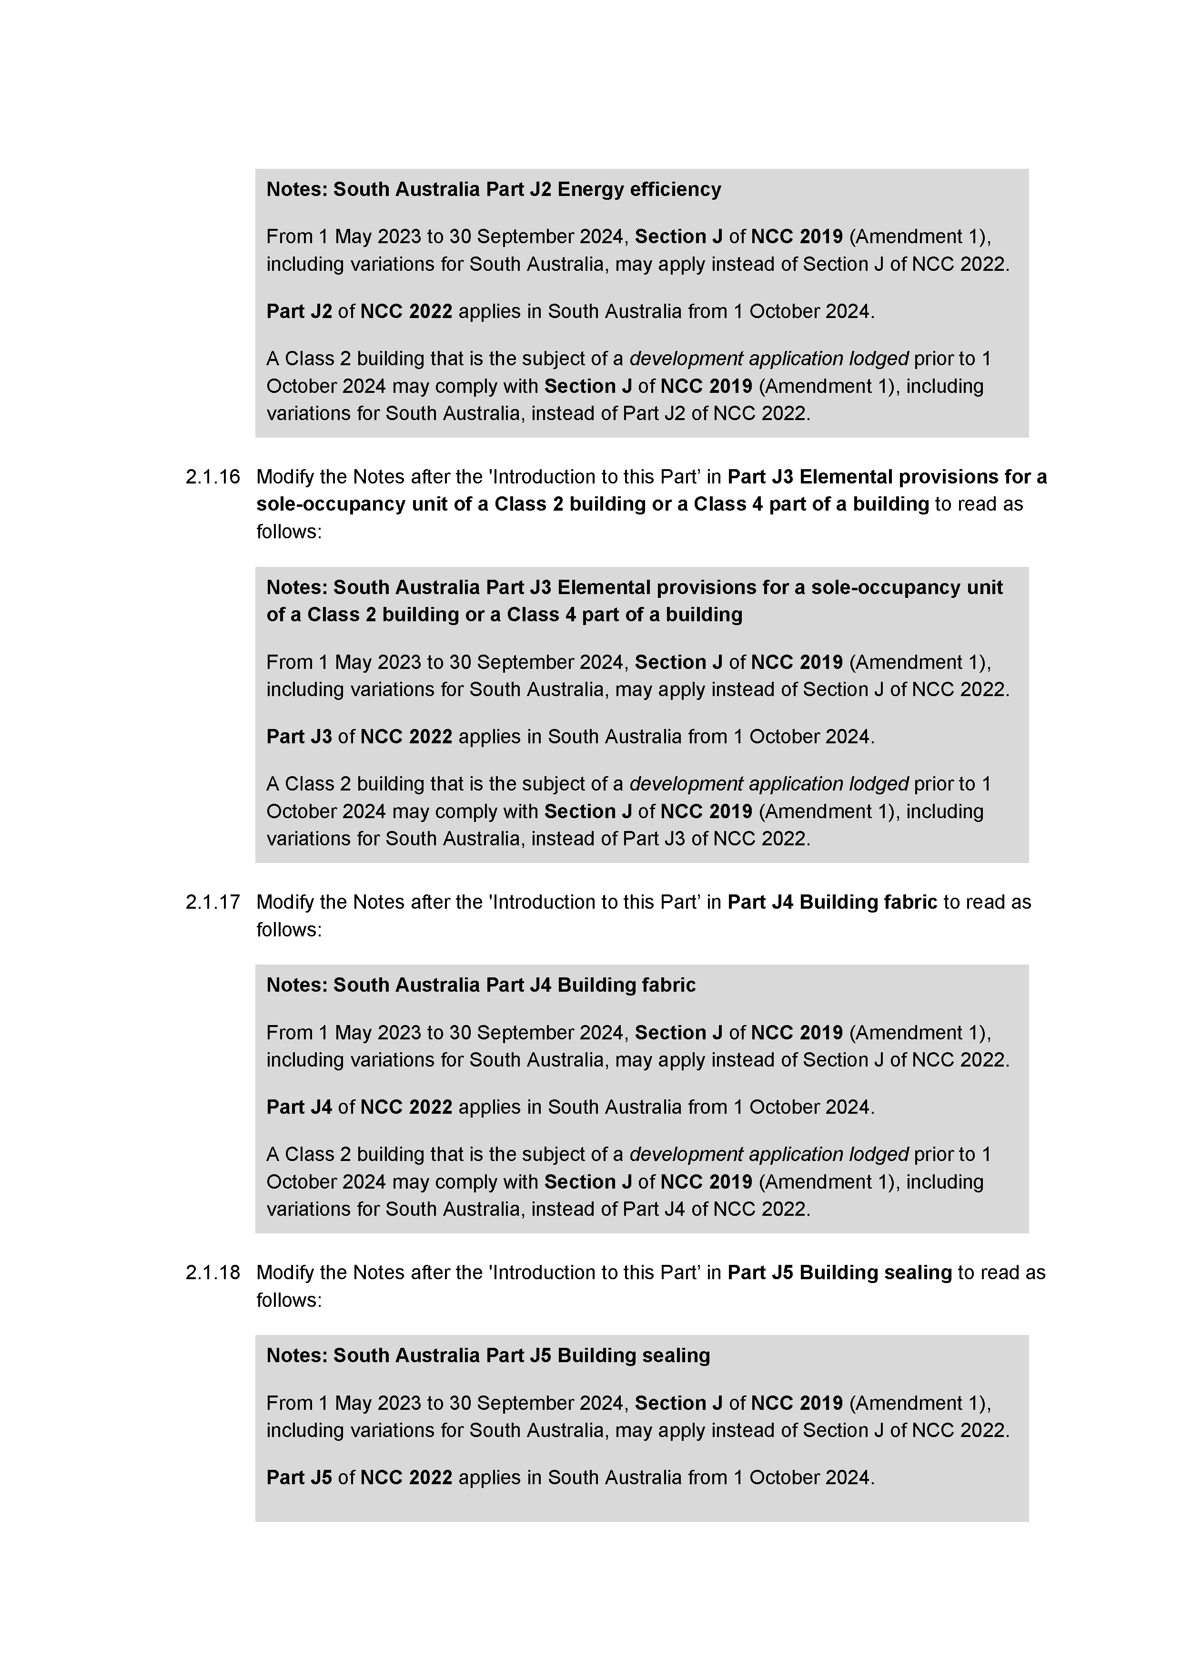

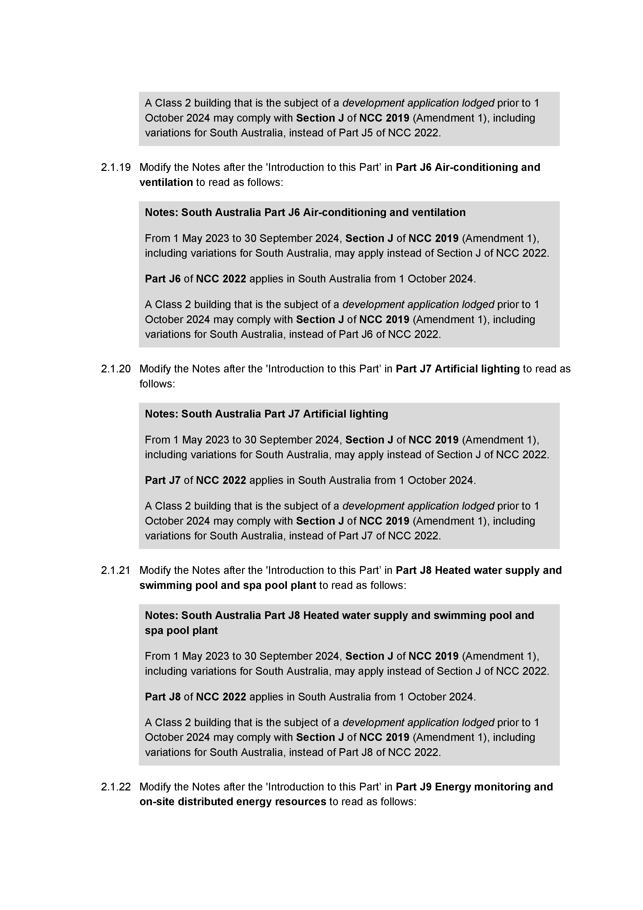

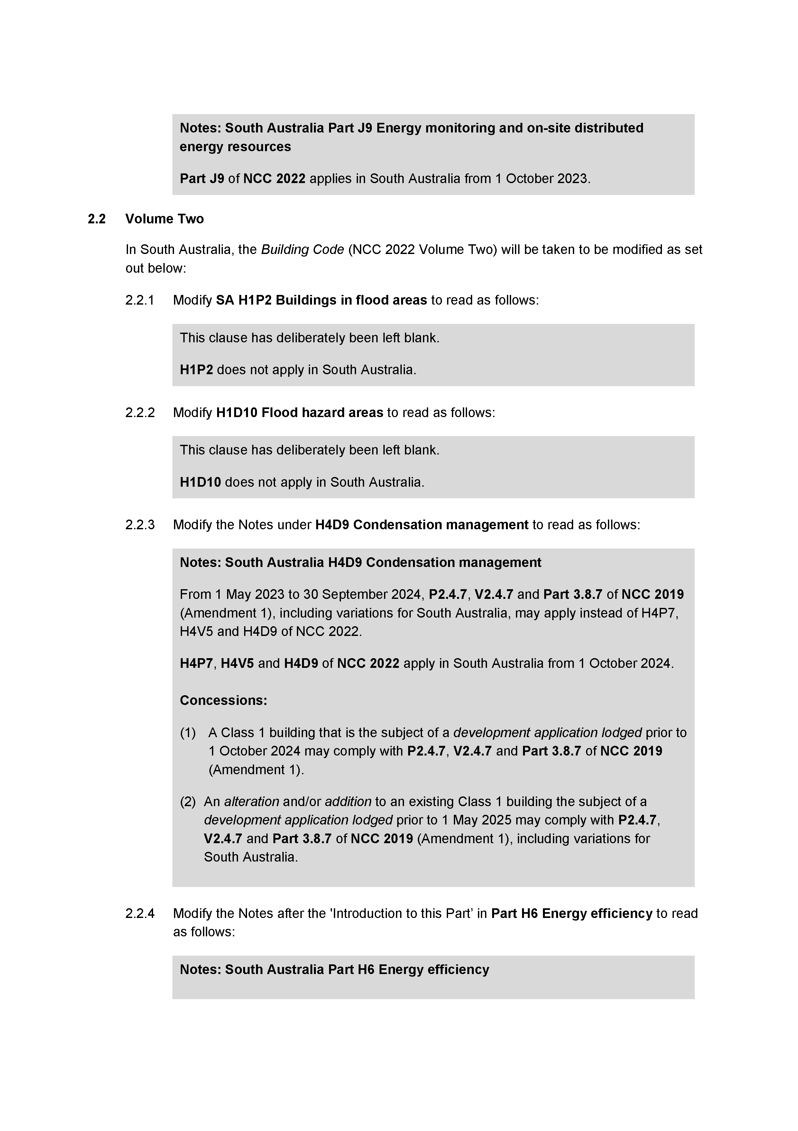

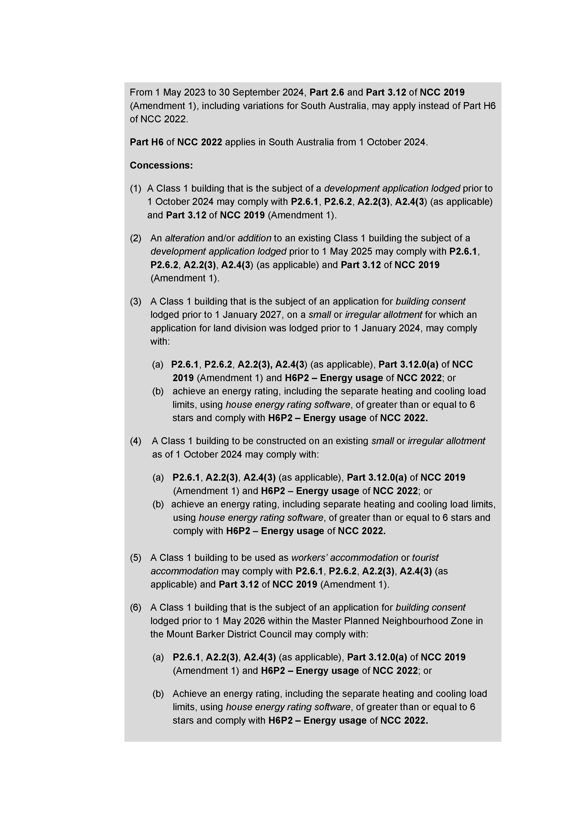

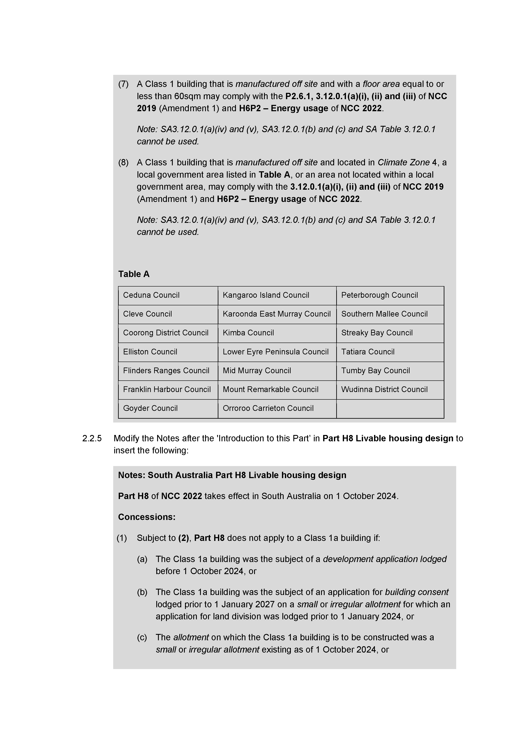

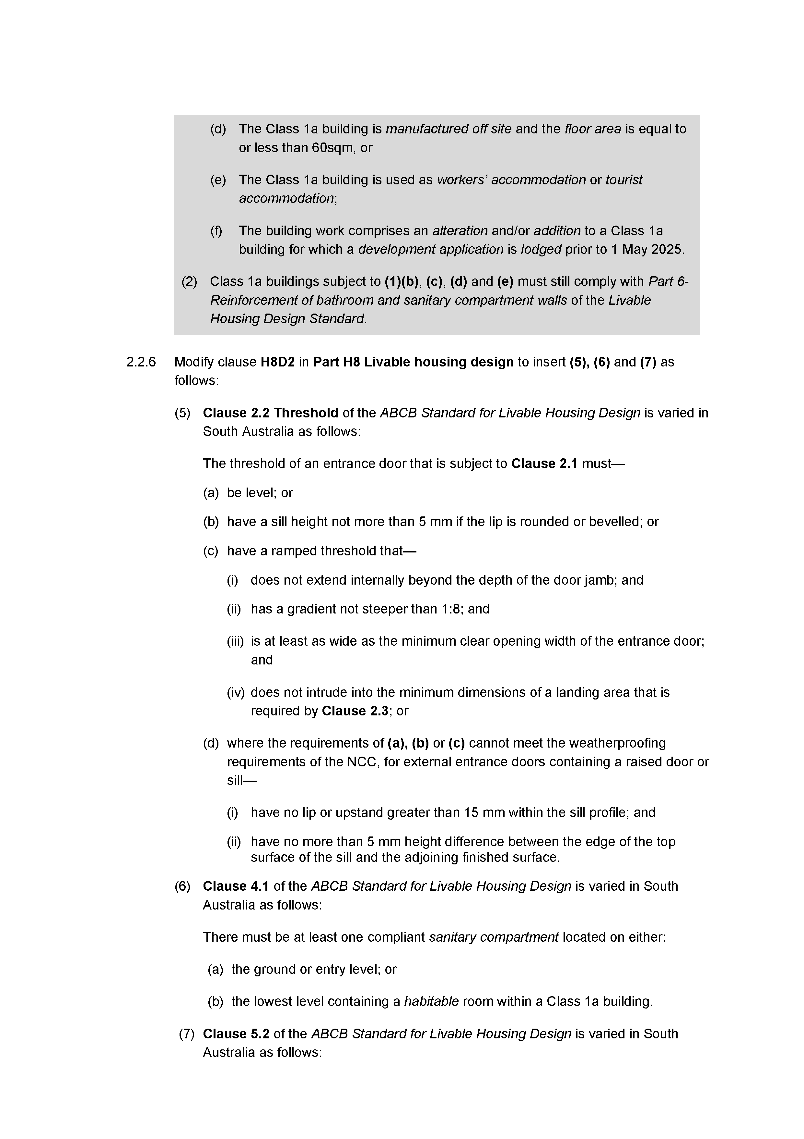

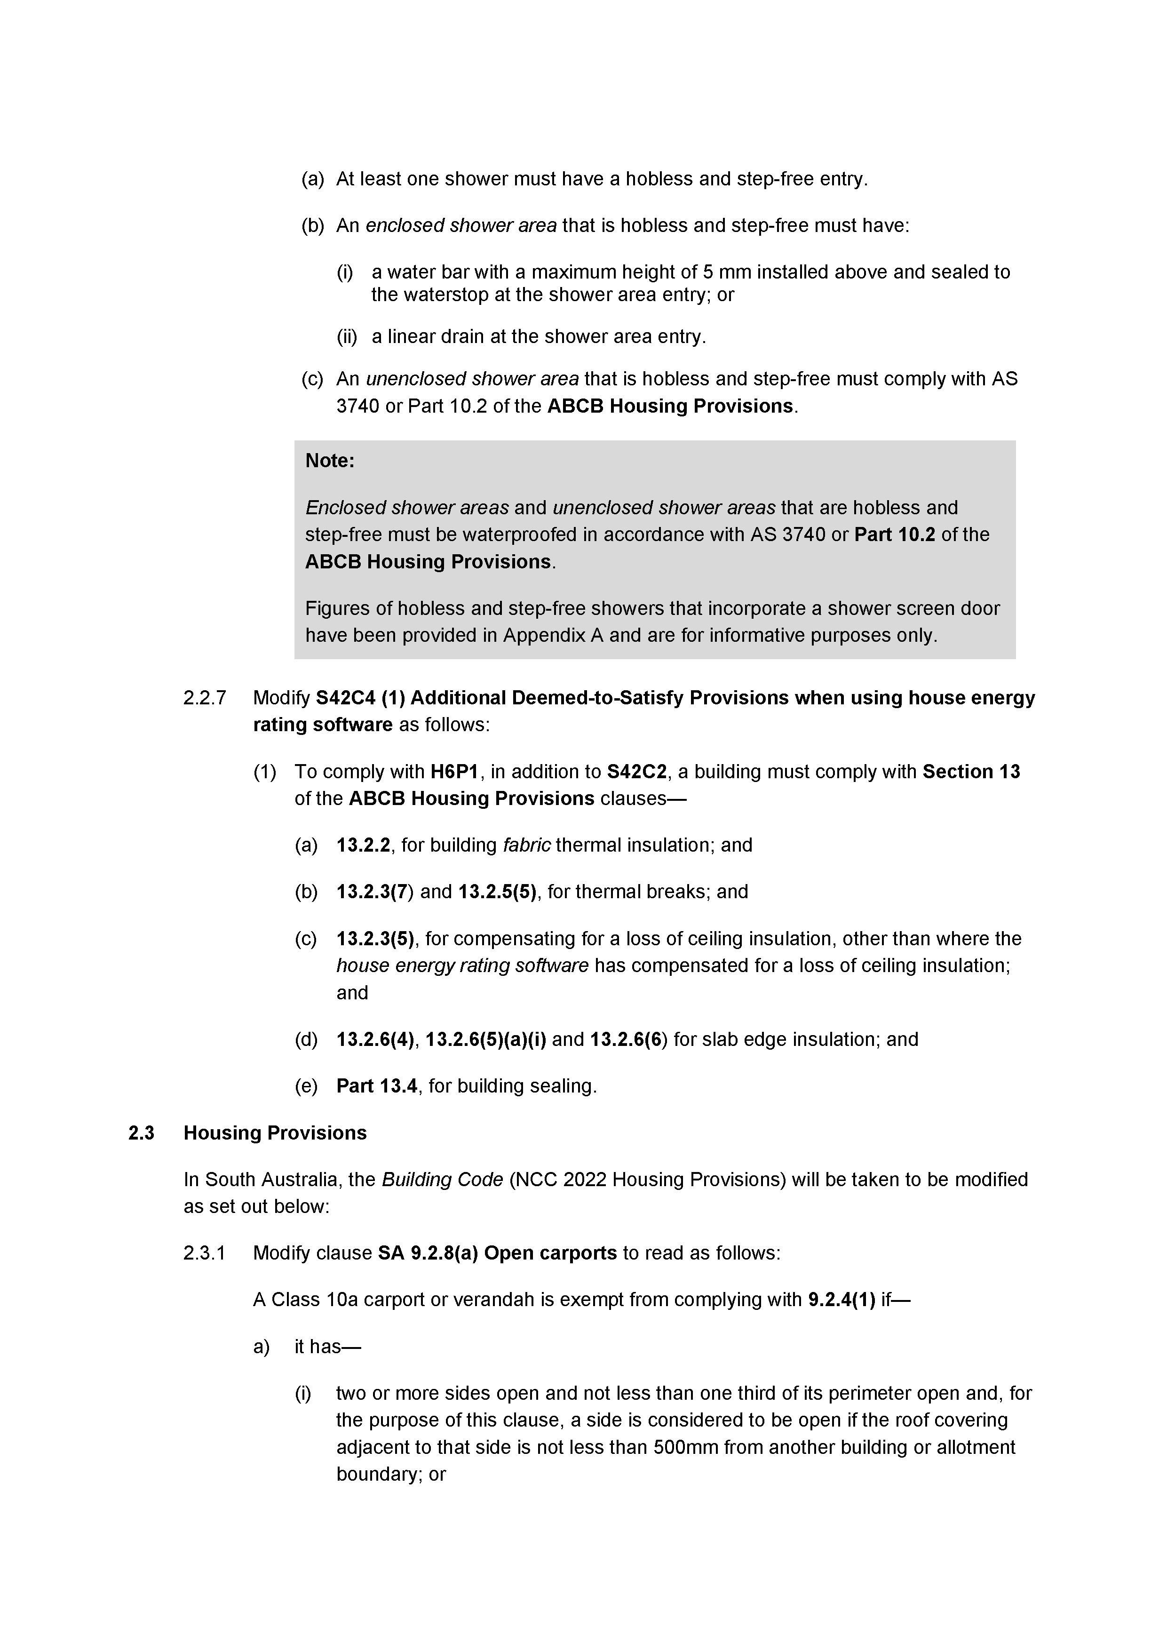

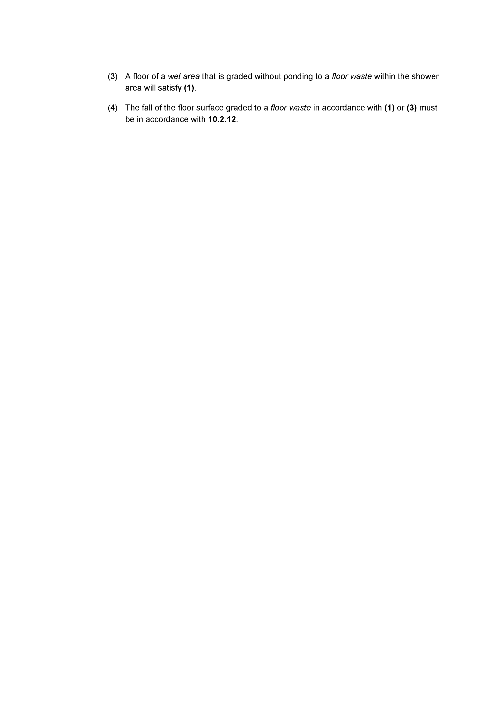
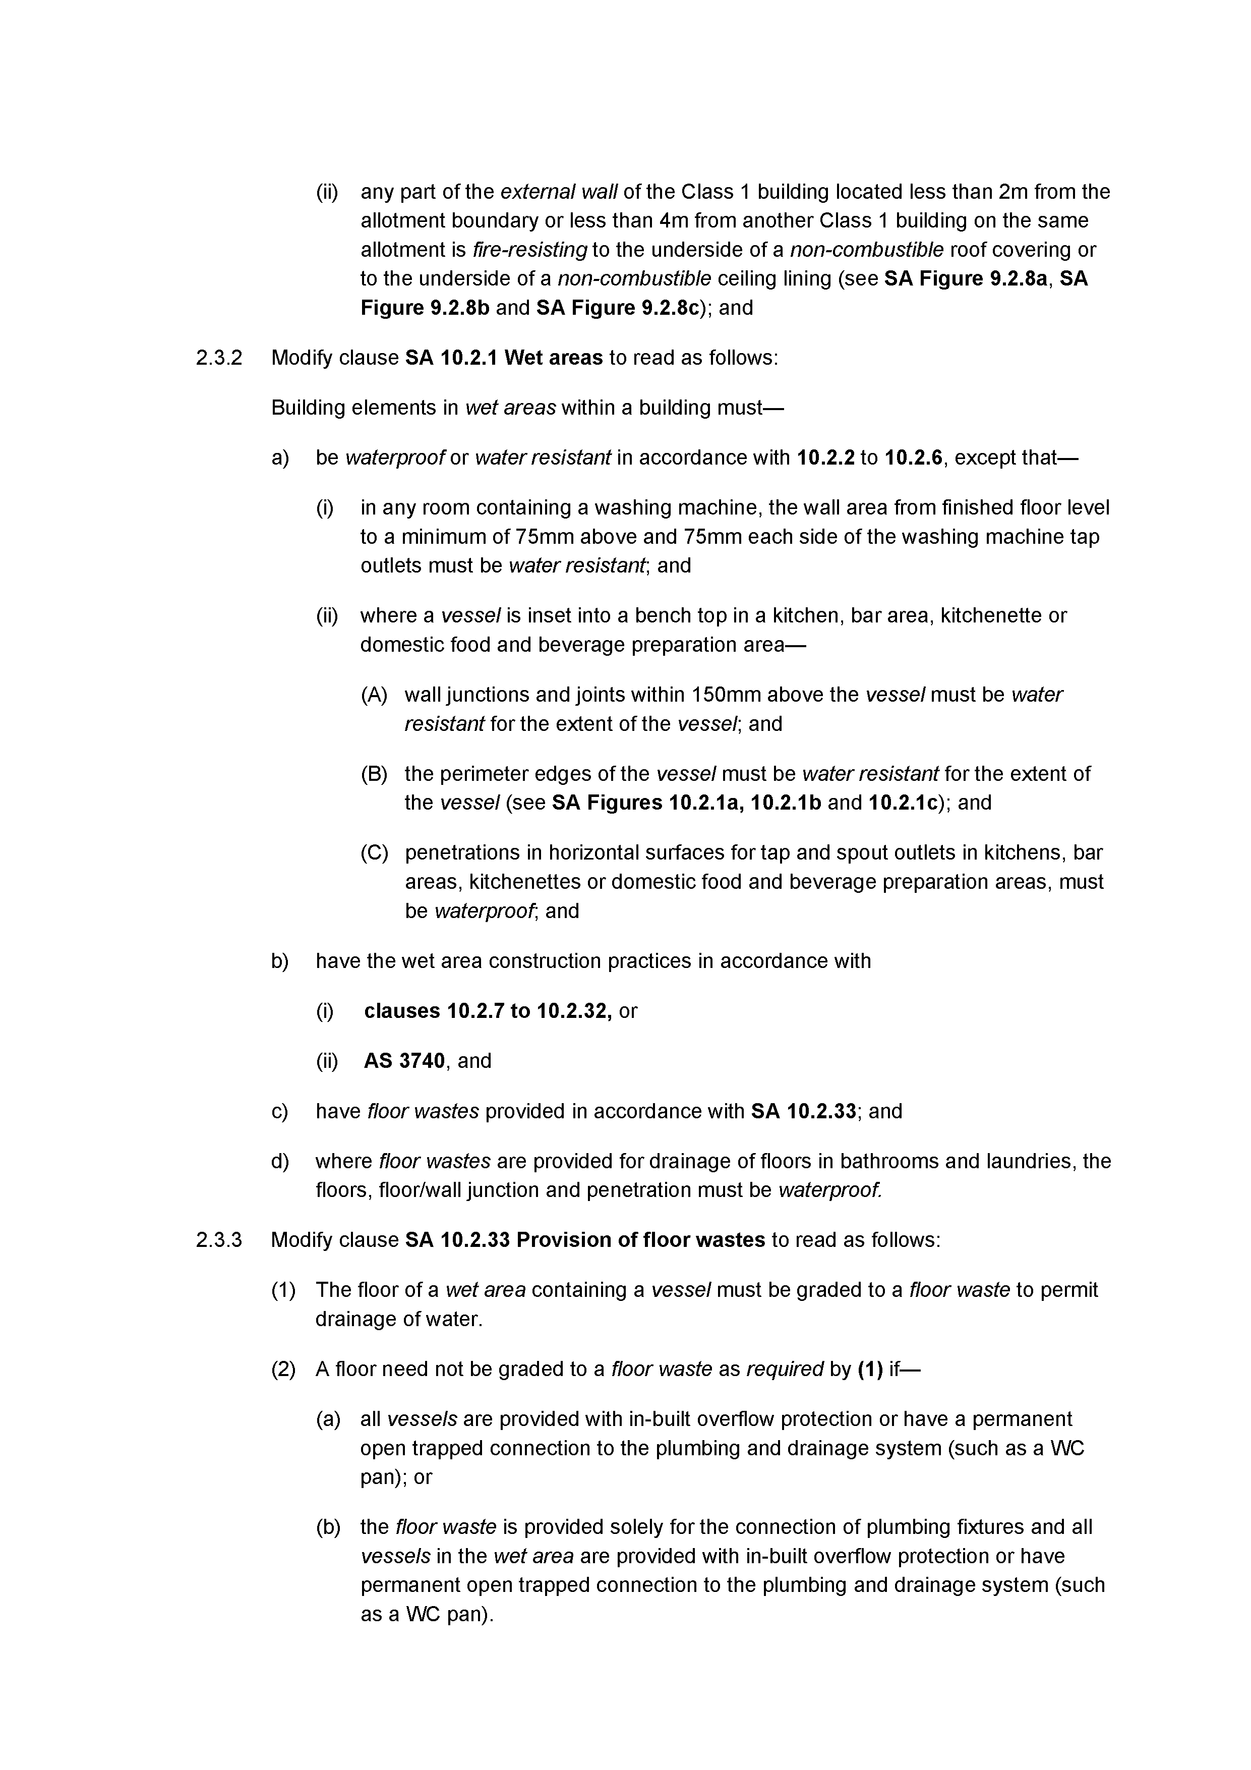

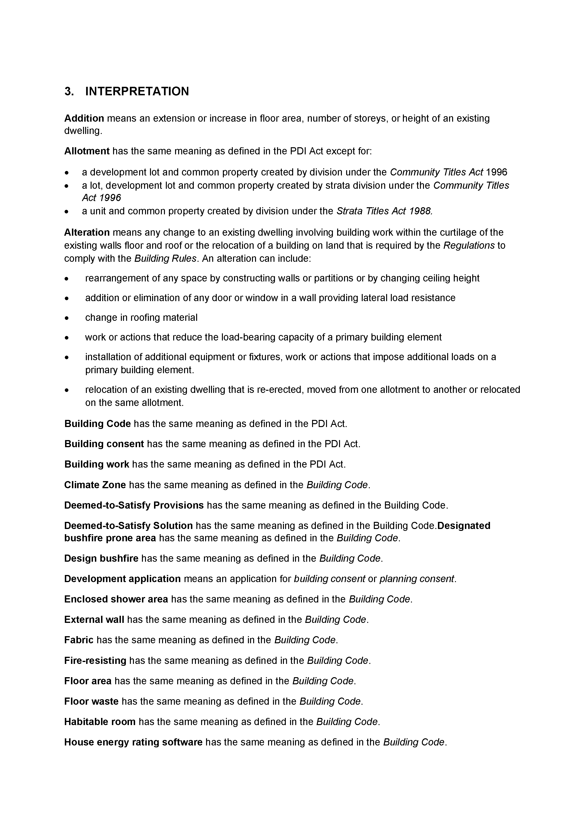

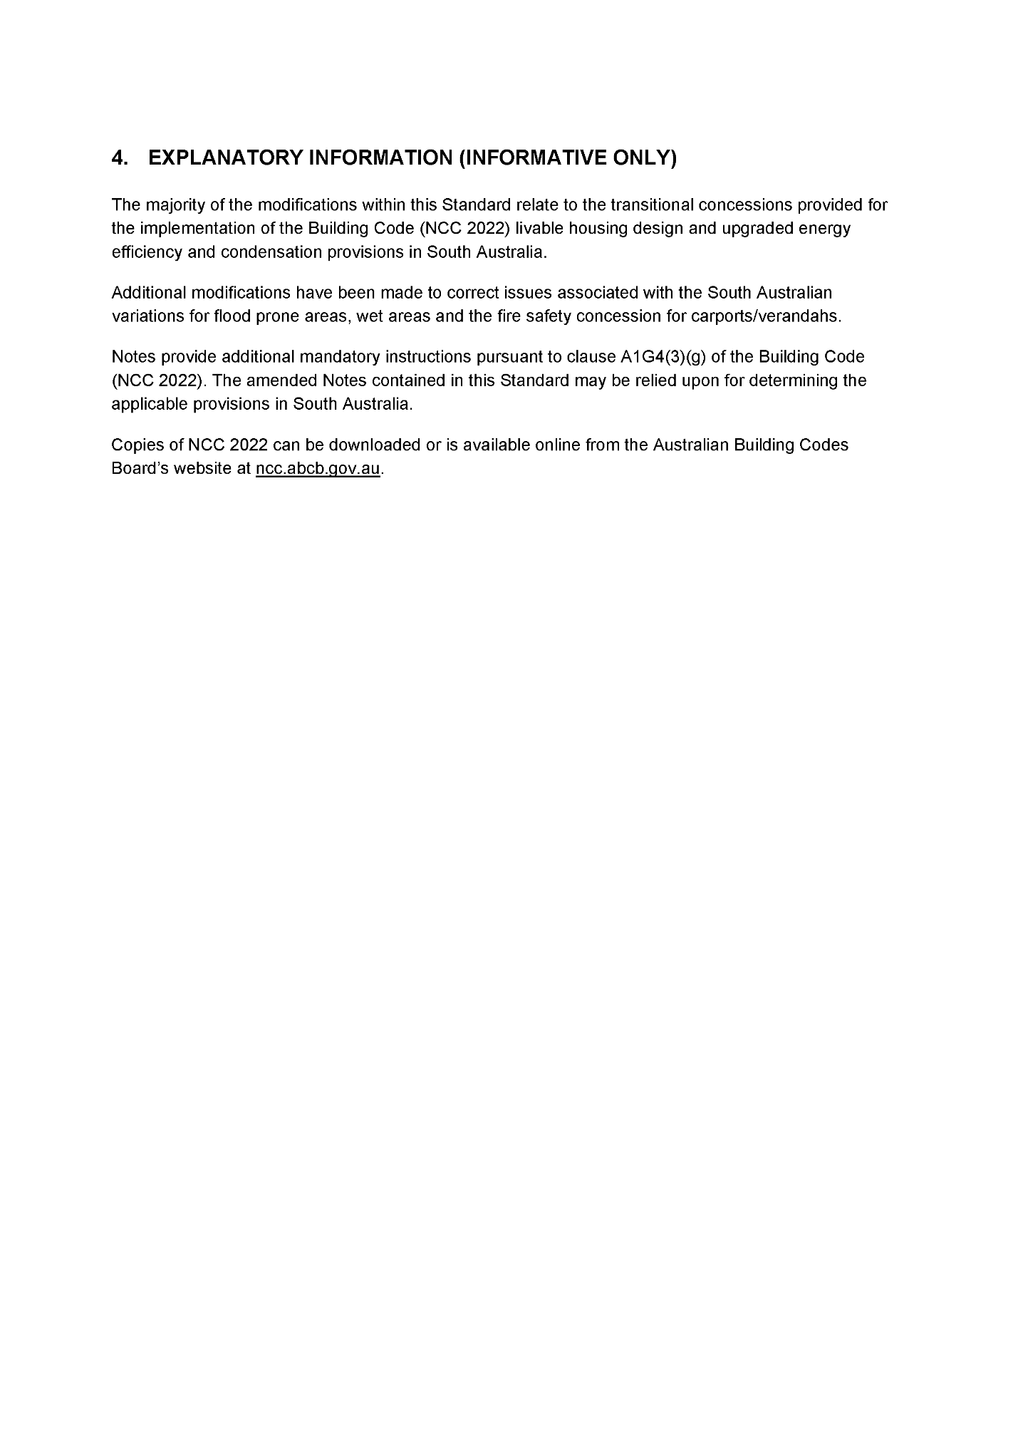
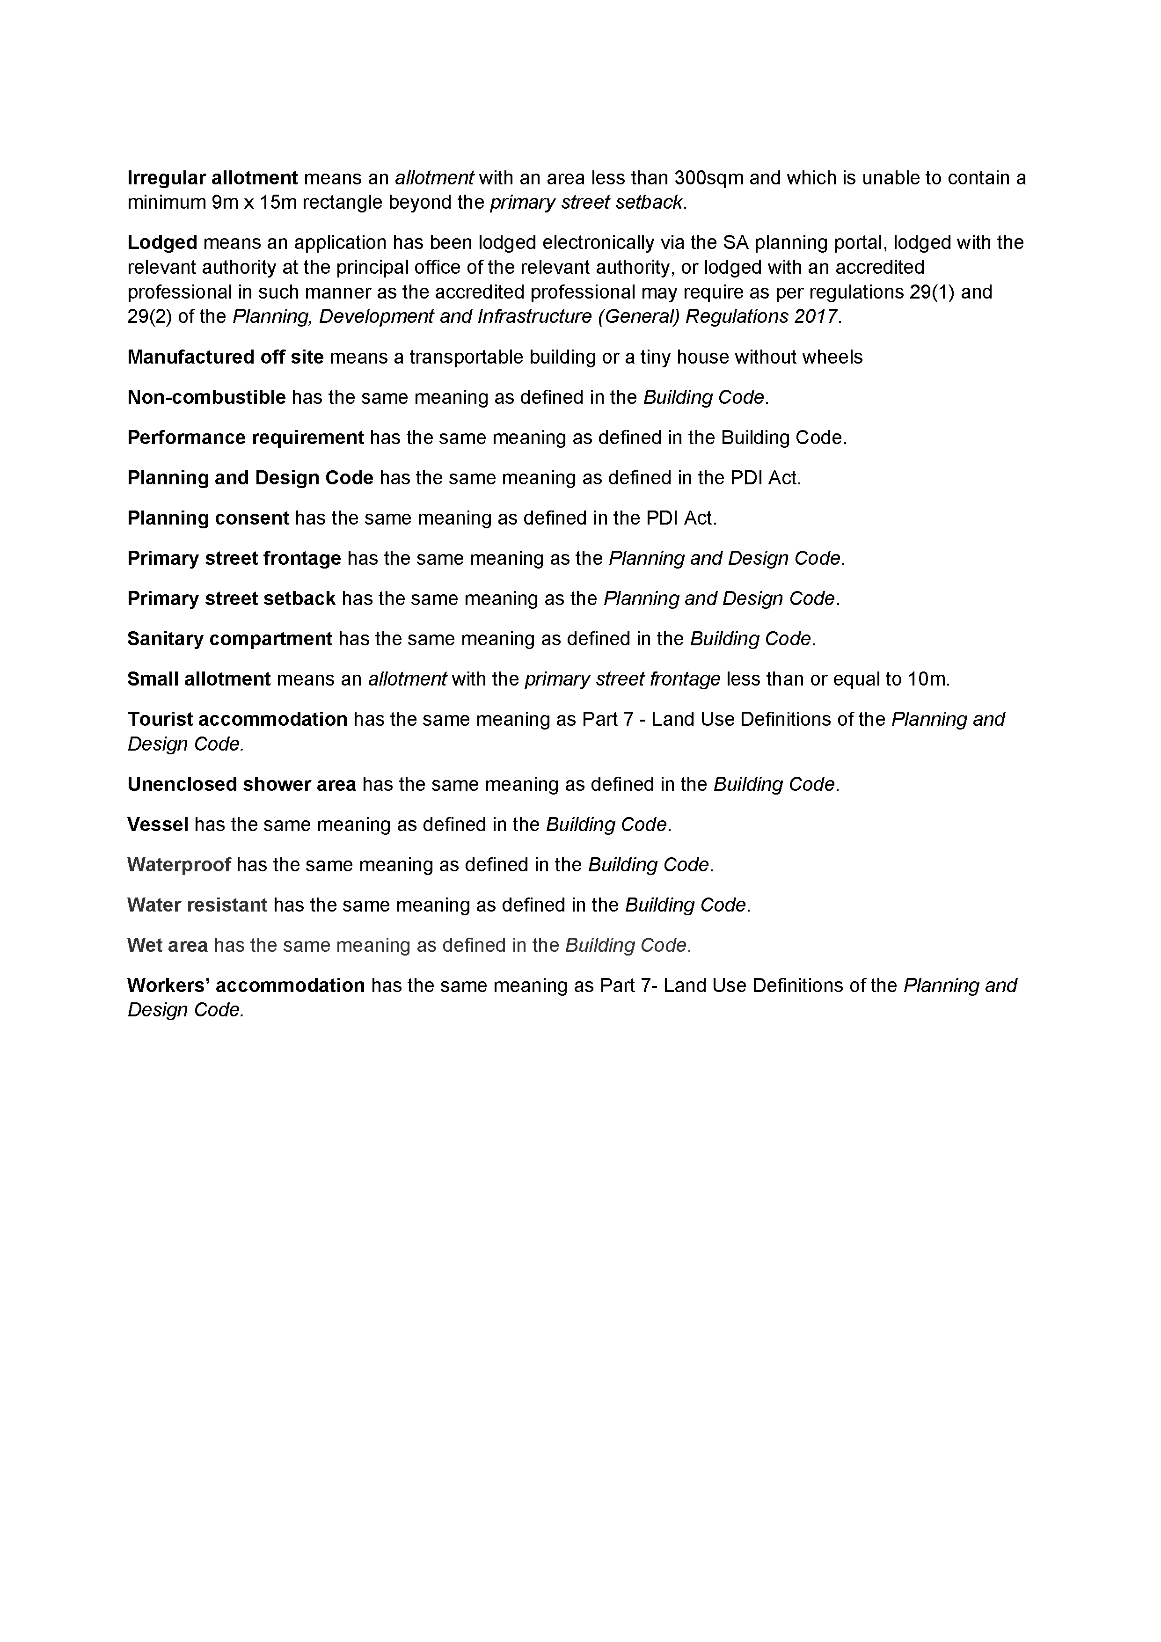

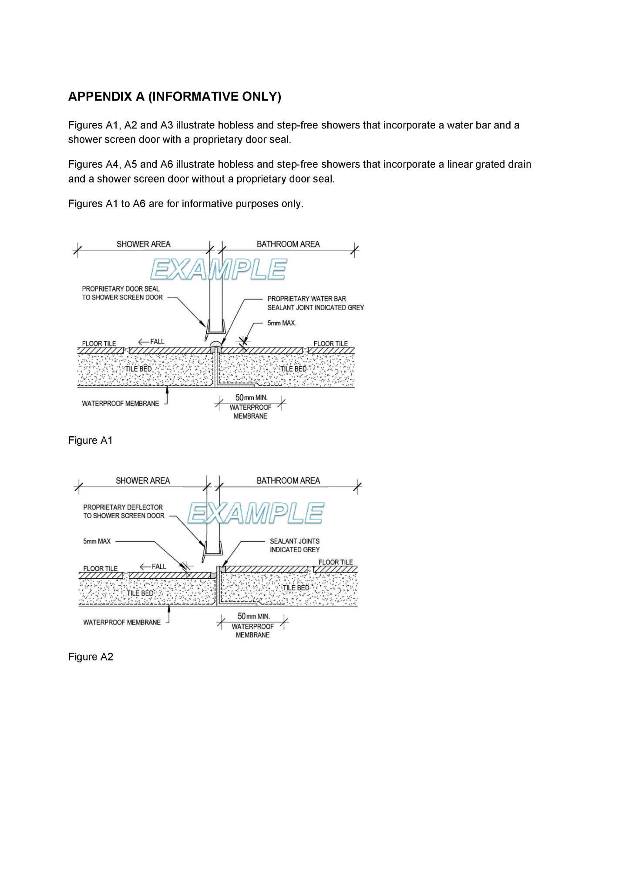
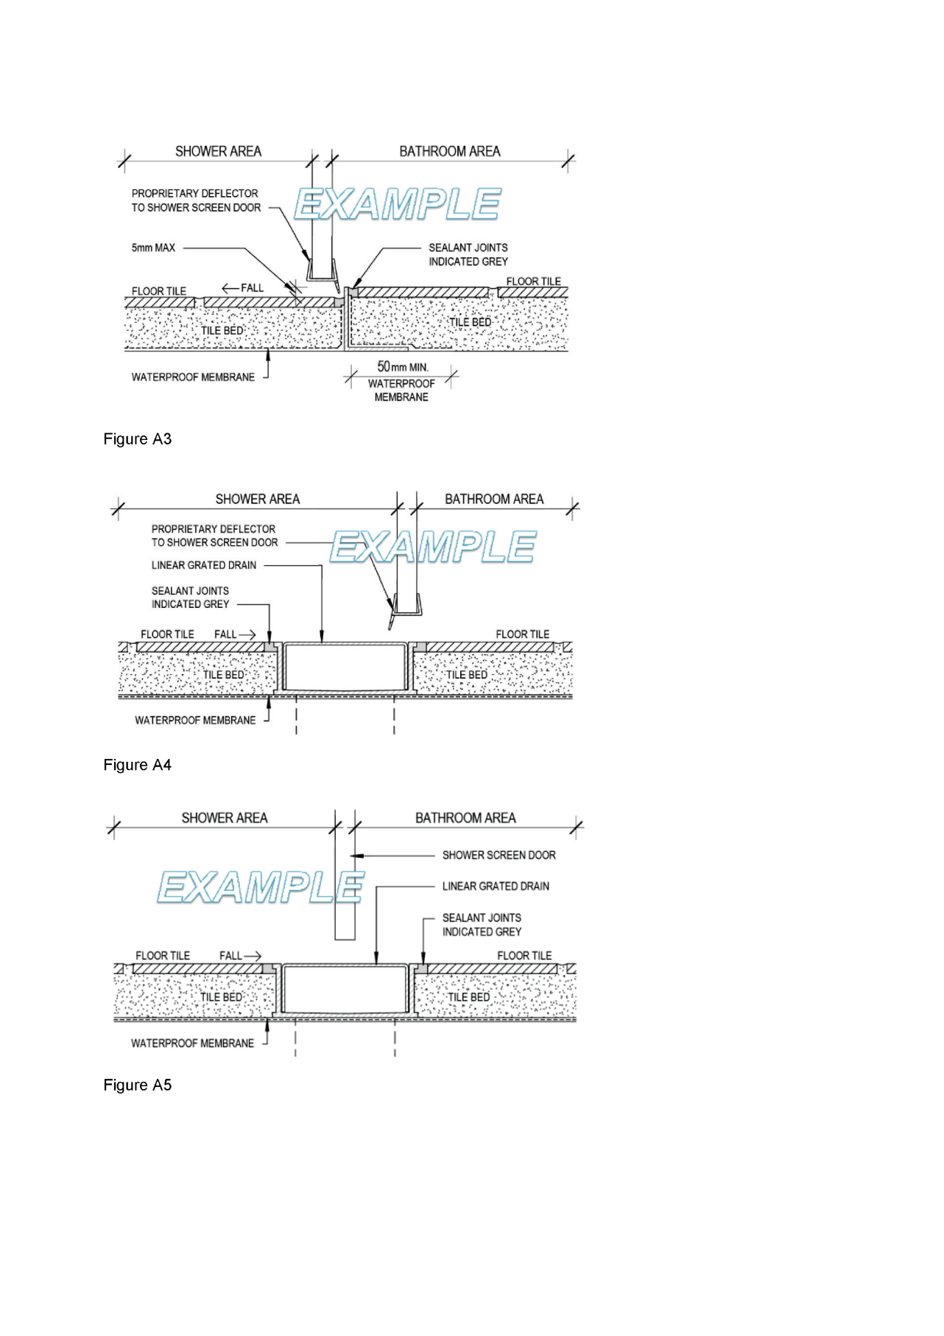
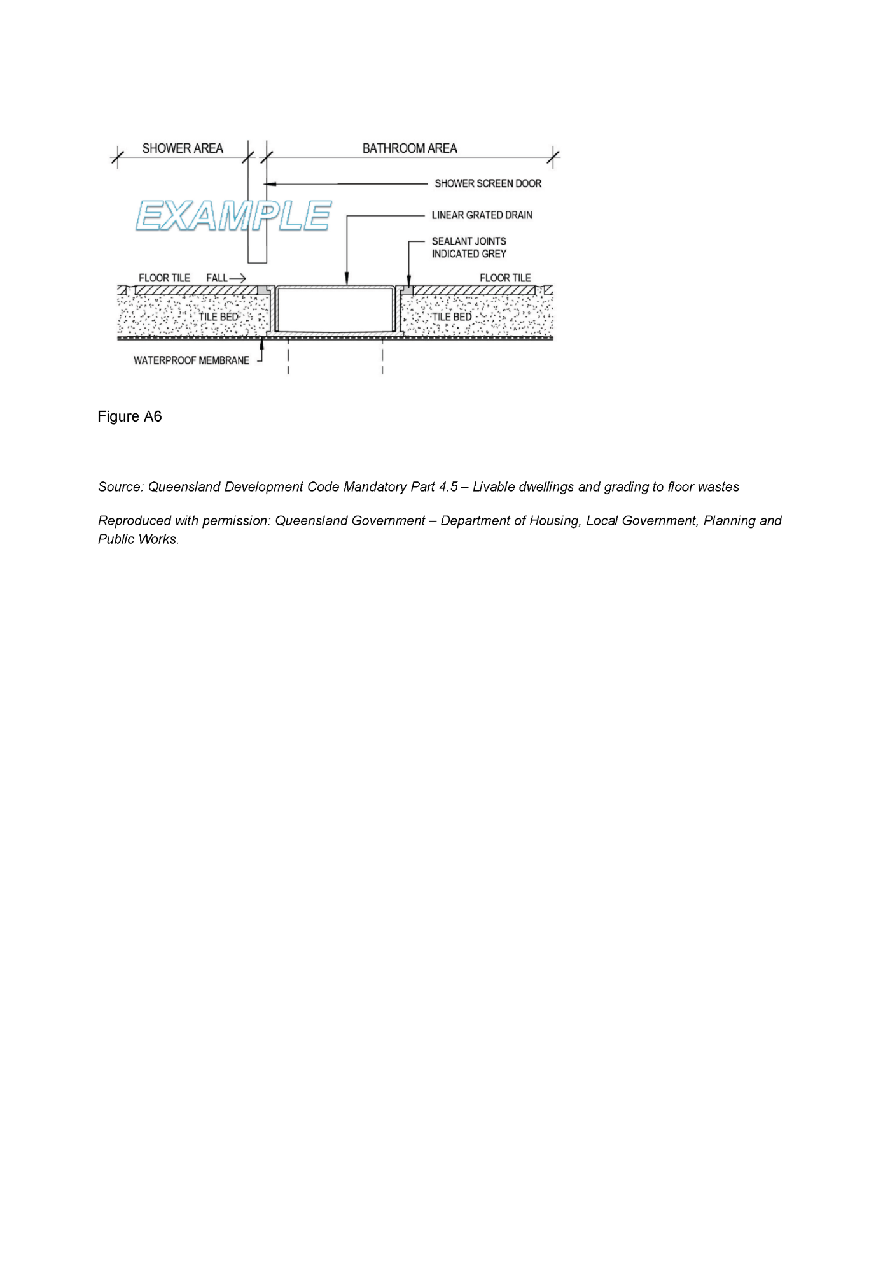

Proof of Sunrise and Sunset Act 1923
Almanac for January, February, March 2025
Pursuant to the requirements of the Proof of Sunrise and Sunset Act 1923, I Jon William Whelan, Chief Executive, Department for Infrastructure and Transport, at the direction of the Minister for Infrastructure and Transport, publish in the Schedule hereto an almanac setting out the times of sunrise and sunset on every day for the three calendar months January, February and March 2025.
Dated: 3 December 2024
Jon William Whelan
Chief Executive
Department for Infrastructure and Transport

Schedule
Sunrise and Sunset Times for Adelaide 2025
Latitude: South 34° 56′ Longitude: East 138° 36′
GMT+9.50 hours (Daylight saving GMT+l0.5 hours)
 |  | January |  |  |  |  |  | February |  |  |  |  |  | March
 |  | Rise |  |  | Set |  |  | Rise |  |  | Set |  |  | Rise |  |  | Set
Date |  | hr | min |  | hr | min |  | hr | min |  | hr | min |  | hr | min |  | hr | min
1 |  | 06 | 05 |  | 20 | 32 |  | 06 | 35 |  | 20 | 23 |  | 07 | 02 |  | 19 | 53
2 |  | 06 | 06 |  | 20 | 33 |  | 06 | 36 |  | 20 | 22 |  | 07 | 03 |  | 19 | 52
3 |  | 06 | 07 |  | 20 | 33 |  | 06 | 37 |  | 20 | 21 |  | 07 | 04 |  | 19 | 50
4 |  | 06 | 08 |  | 20 | 33 |  | 06 | 38 |  | 20 | 20 |  | 07 | 05 |  | 19 | 49
5 |  | 06 | 09 |  | 20 | 33 |  | 06 | 39 |  | 20 | 20 |  | 07 | 06 |  | 19 | 48
6 |  | 06 | 09 |  | 20 | 33 |  | 06 | 40 |  | 20 | 19 |  | 07 | 07 |  | 19 | 47
7 |  | 06 | 10 |  | 20 | 33 |  | 06 | 41 |  | 20 | 18 |  | 07 | 08 |  | 19 | 45
8 |  | 06 | 11 |  | 20 | 33 |  | 06 | 42 |  | 20 | 17 |  | 07 | 09 |  | 19 | 44
9 |  | 06 | 12 |  | 20 | 33 |  | 06 | 43 |  | 20 | 16 |  | 07 | 09 |  | 19 | 43
10 |  | 06 | 13 |  | 20 | 33 |  | 06 | 44 |  | 20 | 15 |  | 07 | 10 |  | 19 | 41
11 |  | 06 | 14 |  | 20 | 33 |  | 06 | 45 |  | 20 | 14 |  | 07 | 11 |  | 19 | 40
12 |  | 06 | 15 |  | 20 | 32 |  | 06 | 46 |  | 20 | 13 |  | 07 | 12 |  | 19 | 38
13 |  | 06 | 16 |  | 20 | 32 |  | 06 | 47 |  | 20 | 12 |  | 07 | 13 |  | 19 | 37
14 |  | 06 | 17 |  | 20 | 32 |  | 06 | 48 |  | 20 | 11 |  | 07 | 14 |  | 19 | 36
15 |  | 06 | 18 |  | 20 | 32 |  | 06 | 49 |  | 20 | 10 |  | 07 | 14 |  | 19 | 34
16 |  | 06 | 19 |  | 20 | 32 |  | 06 | 50 |  | 20 | 09 |  | 07 | 15 |  | 19 | 33
17 |  | 06 | 20 |  | 20 | 31 |  | 06 | 51 |  | 20 | 08 |  | 07 | 16 |  | 19 | 31
18 |  | 06 | 21 |  | 20 | 31 |  | 06 | 52 |  | 20 | 06 |  | 07 | 17 |  | 19 | 30
19 |  | 06 | 22 |  | 20 | 30 |  | 06 | 53 |  | 20 | 05 |  | 07 | 18 |  | 19 | 29
20 |  | 06 | 23 |  | 20 | 30 |  | 06 | 54 |  | 20 | 04 |  | 07 | 19 |  | 19 | 27
21 |  | 06 | 24 |  | 20 | 30 |  | 06 | 55 |  | 20 | 03 |  | 07 | 19 |  | 19 | 26
22 |  | 06 | 25 |  | 20 | 29 |  | 06 | 56 |  | 20 | 02 |  | 07 | 20 |  | 19 | 25
23 |  | 06 | 26 |  | 20 | 29 |  | 06 | 57 |  | 20 | 01 |  | 07 | 21 |  | 19 | 23
24 |  | 06 | 27 |  | 20 | 28 |  | 06 | 58 |  | 19 | 59 |  | 07 | 22 |  | 19 | 22
25 |  | 06 | 28 |  | 20 | 28 |  | 06 | 59 |  | 19 | 58 |  | 07 | 23 |  | 19 | 20
26 |  | 06 | 29 |  | 20 | 27 |  | 07 | 00 |  | 19 | 57 |  | 07 | 23 |  | 19 | 19
27 |  | 06 | 30 |  | 20 | 26 |  | 07 | 01 |  | 19 | 56 |  | 07 | 24 |  | 19 | 18
28 |  | 06 | 31 |  | 20 | 26 |  | 07 | 01 |  | 19 | 54 |  | 07 | 25 |  | 19 | 16
29 |  | 06 | 32 |  | 20 | 25 |  | 07 | 26 |  | 19 | 15
30 |  | 06 | 33 |  | 20 | 24 |  | 07 | 26 |  | 19 | 13
31 |  | 06 | 34 |  | 20 | 24 |  | 07 | 27 |  | 19 | 12
*NOTE: Daylight Saving Time is subject to change.
Sunrise and Sunset times calculated on 20/11/24. Certified correct: A. Dolman, 20 November 2024

Retail and Commercial Leases Act 1995
Exemption
Pursuant to Section 77(2) of the Retail and Commercial Leases Act 1995 (SA) I, Nerissa Kilvert, Small Business Commissioner for the State of South Australia, exempt the lease agreement between the Minister for Police, Emergency Services and Correctional Services and ABC Community Hub Inc, from Section 13 of the Act, in relation to portion of the land in Certificate of Title Volume 5394 Folio 981 (premises), located at Gawler River Road, Willaston, South Australia.
Dated: 27 November 2024
Nerissa Kilvert
Small Business Commissioner

Retirement Villages Act 2016
Section 5
Notice of Exemption
Take Notice that I, Chris Picton, Minister for Health and Wellbeing, pursuant to section 5(2) of the Retirement Villages Act 2016 (the Act), hereby exempt the operator specified in Schedule 1 (the Authority) from Sections 22(c), 33(1)(b), 33(6)(a), 33(7)(a), 34(8), 38(1), 39(1) and 40(4) of the Act in relation to the retirement villages specified in Schedule 2.
Schedule 1
James Brown Memorial Trust (t/as Kalyra)
Schedule 2
(a) Kalyra McLaren Vale Village
(b) Aldersey Grove Estate
This exemption is subject to the following conditions:
1. The Authority must, at least 10 business days before a person enters into a residence contract, give the person a copy of the financial statement presented at the last annual meeting of each of the retirement villages specified in Schedule 2 and a copy of the meeting minutes of the last two annual meetings of residents at each of the retirement villages specified in Schedule 2. This condition will cease to have effect if and once the Authority can provide the person consolidated information of both retirement villages specified in Schedule 2.
2. An annual meeting must be held at which the residents of the retirement villages specified in Schedule 2 will be able to attend.
3. The annual meeting required in condition 2 must be held and run as if it were a meeting held in accordance with Section 33 of the Act.
4. The exemption from Sections 33(7)(a) and 40(4) of the Act applies only to the standard of information (“Information”) as prescribed by Regulation 10 of the Retirement Villages Regulations 2017 that is required to be provided to residents pursuant to Sections 33(6)(a)
and 40(1) of the Act.
5. Information may be prepared in a consolidated format for the retirement villages specified in Schedule 2 operated by the Authority and need not specifically relate to the site at which the relevant resident or residents reside.
6. The Authority shall not impose a special levy on residents unless authorised by special resolution passed at a consolidated meeting at which all residents will be able to attend.
7. A residents’ committee elected will be taken to be the residents’ committee for the purposes of Section 38(1) of the Act and Section 39(1)(a) of the Act.
Dated: 6 December 2024
Hon Chris Picton MP
Minister for Health and Wellbeing

Retirement Villages Act 2016
Section 59(1)
Voluntary Termination of Retirement Village Scheme
Take notice that I, Chris Picton, Minister for Health and Wellbeing, pursuant to Section 59(1) of the Retirement Villages Act 2016, hereby terminate the Poinsettia Village retirement village scheme situated at Pybus Street, Port Augusta SA 5700 and comprising all of the land and improvements in Certificate of Title Register Book Volume 5696 Folio 235. I do so being satisfied for the purposes of Section 59(2) of the Act that all residents of the retirement village agree to the termination. The termination will take effect on the day upon which the retirement village endorsement is cancelled.
Dated: 7 December 2024
Chris Picton
Minister for Health and Wellbeing

Return to Work Act 2014
Travel Allowance Notice 2025
Preamble
Section 33(8) of the Return to Work Act 2014 (the Act) states that:
If a worker travels in a private vehicle to or from any place for the purpose of receiving medical services, hospitalisation or approved recovery/return to work services, and the travel is reasonably necessary in the circumstances of the case, the worker is entitled to a travel allowance at rates fixed by a scale published by the Minister under this section.
Notice
I Declare that the rate for travel allowance in 2025 is hereby fixed for the purposes of Section 33(8) of the Act at 0.564 cents per kilometre, and this notice supersedes all previous notices of the travel allowance rate published under Section 33(8) of the Act.
This Notice is effective for travel on or after 1 January 2025.
Dated: 5 December 2024
Hon Kyam Maher MLC
Minister for Industrial Relations and Public Sector

Tobacco and E-Cigarette Products Act 1997
South Australia
Tobacco and E-Cigarette Products (Fees) (No 2) Notice 2024
under the Tobacco and E-Cigarette Products Act 1997
1—Short title
This notice may be cited as the Tobacco and E-Cigarette Products (Fees) (No 2) Notice 2024.
Note—
This is a fee notice made in accordance with the Legislation (Fees) Act 2019.
2—Commencement
This notice has effect on 13 December 2024.
3—Interpretation
In this notice, unless the contrary intention appears—
Act means the Tobacco and E-Cigarette Products Act 1997.
4—Fees
The fees set out in Schedule 1 are prescribed for the purposes of Sections 7(2) and 11(1) of the Act.
Schedule 1—Fees
1 | Application or annual renewal for a retail tobacco licence. | $340.00
2 | Application or annual renewal for a wholesale tobacco licence. | $650.00
Made by the Minister for Health and Wellbeing
On 2 December 2024

Wilderness Protection Act 1992
Nuyts Archipelago and Investigator Group Wilderness Protection Areas Management Plan 2024
I, Susan Close, Minister for Climate, Environment and Water, hereby give notice under the provisions of Section 31 of the Wilderness Protection Act 1992 that, on 3 December 2024, I adopted a plan of management for Nuyts Archipelago Wilderness Protection Area and Investigator Group Wilderness Protection Area.
Copies of the plan may be obtained from:
- https://www.environment.sa.gov.au/topics/park-management/statewide-park-strategies/park-management-plans
- Department for Environment and Water Customer Service Centre, ground floor, 81-95 Waymouth Street, Adelaide SA 5000
- Ceduna National Parks and Wildlife Service Office, 50B McKenzie St, Ceduna SA 5690
- Port Lincoln National Parks and Wildlife Service Office, 86 Tasman Terrace, Port Lincoln SA 5606
Dated: 3 December 2024
Hon Susan Close MP
Minister for Climate, Environment and Water

Local Government Instruments

Port Adelaide and Enfield Council
Local Government Act 1999
Change of Name of Public Place
Notice is hereby given pursuant to Section 219(1) of the Local Government Act 1999 of the change of public place of the whole of land known as Certificate of Title Volume 6241 Folio 434 formerly known as “Largs North Reserve”, to “Ray Guscott Reserve”.
Name change of reserve to take effect from 12 December 2024.
M. Withers
Chief Executive Officer

City of Salisbury
Local Government Act 1999
Proposal to Lease Community Land
Notice is hereby given that at a meeting held on 25 November 2024, pursuant to Section 202 of the Local Government Act 1999, the Council of the City of Salisbury resolved to seek public comment on a proposal to lease portion of the land located at 400 Bridge Road, Para Hills West also known as The Paddocks Centre, identified as Allotment 92 in Deposited Plan 11000, for commercial purposes to Waveconn for a period of up to 30 years.
Any person is entitled to object to the proposed lease. Such objections must set out the full name and address of the person making the objection and must be fully supported by reasons.
Council invites written submissions on the proposal which are to be received by close of business on 16 January 2025 and addressed to the Chief Executive Officer, City of Salisbury, PO Box 8, Salisbury SA 5108.
Any further information can be obtained by viewing the Have Your Say section on the City of Salisbury’s public website www.salisbury.sa.gov.au/council/haveyoursay or from Emma Robinson, on (08) 8406 8216 or by email at erobinson@salisbury.sa.gov.au
Dated: 12 December 2024
John Harry
Chief Executive Officer

City of Salisbury
Local Government Act 1999
Proposal to Lease Community Land
Notice is hereby given that at a meeting held on 25 November 2024, pursuant to Section 202 of the Local Government Act 1999, the Council of the City of Salisbury resolved to seek public comment on a proposal to enter into a Joint Use Agreement for portion of the land located at 133-167 Mawson Lakes Boulevard also known as Mobara Park, Mawson Lakes identified as Allotment 852 in Deposited Plan 65657, to allow the Mawson Lakes School to use this area as playing fields between the hours of 8:30am – 4:00pm Monday to Friday for a period of up to 10 years.
Any person is entitled to object to the proposed lease. Such objections must set out the full name and address of the person making the objection and must be fully supported by reasons.
Council invites written submissions on the proposal which are to be received by close of business 16 January 2025 and addressed to the Chief Executive Officer, City of Salisbury, PO Box 8, Salisbury SA 5108.
Any further information can be obtained by viewing the Have Your Say section on the City of Salisbury’s public website www.salisbury.sa.gov.au/Council/have-your-say or from Emma Robinson, on (08) 8406 8216 or by email at erobinson@salisbury.sa.gov.au
Dated: 12 December 2024
John Harry
Chief Executive Officer

City of Victor Harbor
Local Government Act 1999
Naming of Roads
The City of Victor Harbor hereby gives notice pursuant to Section 219(1) of the Local Government Act 1999, and in accordance with the Council’s Resolution OC3882024 of 25 November 2024, that the unnamed roads, as part of Oceane Land Division Stage 1B-1 and Stage 1B-2 be named Oceane Boulevard, Oceane Place and Riverside Close.
A copy of this notice and further information can be obtained from the Council’s offices at 1 Bay Road, Victor Harbor SA 5211, during ordinary business hours or on the Council’s website at www.victor.sa.gov.au.
Dated: 12 December 2024
Victoria MacKirdy
Chief Executive Officer

District Council of Orroroo Carrieton
Adoption of Policy
Notice is hereby given pursuant to Section 219(7) of the Local Government Act 1999, that the District Council of Orroroo Carrieton its Ordinary Council meeting on 27 November 2024 resolved to adopt the Naming of Roads, Reserves and Public Places Policy.
The adopted Naming of Roads, Reserves and Public Places Policy can be viewed at www.orroroo.sa.gov.au.
Dated: 12 December 2024
Henry Inat
Acting Chief Executive Officer

District Council of Tumby Bay
Liquor Licensing Act 1997—Section 131(1ab)
Liquor Licensing (Dry Areas) Notice 2024
1. Short title
This notice may be cited as the Liquor Licensing (Dry Areas) Notice 2024.
2. Commencement
This notice comes into operation on 31 December 2024.
3. Interpretation
(1) In this notice—
principal notice means the Liquor Licensing (Dry Areas) Notice 2015 published in the Gazette on 5 January 2015, as in force from time to time.
(2) Clause 3 of the principal notice applies to this notice as if it were the principal notice.
4. Consumption etc of liquor prohibited in dry areas
(1) Pursuant to Section 131 of the Act, the consumption and possession of liquor in the area described in the Schedule is prohibited in accordance with the provisions of the Schedule.
(2) The prohibition has effect during the periods specified in the Schedule.
(3) The prohibition does not extend to private land in the area described in the Schedule.
(4) Unless the contrary intention appears, the prohibition of the possession of liquor in the area does not extend to—
(a) a person who is genuinely passing through the place if—
(i) the liquor is in the original container in which it was purchased from licensed premises; and
(ii) the container has not been opened; or
(b) a person who has possession of the liquor in the course of carrying on a business or in the course of their employment by another person in the course of carrying on a business; or
(c) a person who is permanently or temporarily residing at premises near the public place and who enters the public place solely for the purpose of passing through it to enter those premises or who enters the public place from those premises for the purpose of leaving the place; or
(d) a person who possesses or consumes the liquor for sacramental or other similar religious purposes

Schedule—Port Neill Area 1
- Extent of prohibition
The consumption of liquor is prohibited and the possession of liquor is prohibited.
- Period of prohibition
From 10.30pm on 31 December 2024 to 8am on 1 January 2025.
- Description of area
Port Neill Area 1
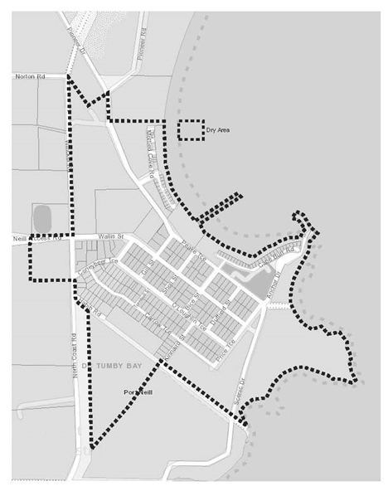
The area in and adjacent to Port Neill bounded as follows: commencing at the point at which the prolongation in a straight line of the south-western boundary of Section 194 Hundred of Dixson intersects the low water mark on the western side of Spencer Gulf, then north-westerly along that prolongation and boundary of Section 194 to the western boundary of the Section, then in a straight line by the shortest route to the point at which the eastern boundary of Section 195 Hundred of Dixson meets the south-western boundary of that Section, then north-westerly along the south-western boundary of Section 195 to the north-western boundary of the Section (the south-eastern boundary of Kinnaird Street), then in a straight line by the shortest route to the eastern corner of Lot 55 of DP 80902, then south-westerly along the south-eastern boundary of Lot 55 to the eastern boundary of North Coast Road, then northerly, north-westerly and northerly along that boundary of North Coast Road to the point at which it meets the northern boundary of Coneybeer Terrace, then in a straight line by the shortest route across North Coast Road to the western boundary of North Coast Road, then due west in a straight line for 200 metres, then due north in a straight line to the northern boundary of Section 54 Hundred of Dixson (the southern boundary of the Port Neill Access Road), then easterly along that boundary of Section 54 and the prolongation in a straight line of that boundary to the eastern boundary of North Coast Road, then northerly along that boundary of North Coast Road to the point at which it meets the northern boundary of Section 120 Hundred of Dixson, then south-easterly, north-easterly and southerly along the northern and eastern boundaries of Section 120 to the point at which the eastern boundary of the Section is intersected by the prolongation in a straight line of the northern boundary of Section 136 Hundred of Dixson, then easterly along that prolongation and boundary of Section 136, and the prolongation in a straight line of that boundary, to the low water mark on the western side of Spencer Gulf, then generally south-easterly, easterly, southwesterly, easterly, southerly and south-westerly along the low water mark to the point of commencement. The area includes any jetty, wharf, boat ramp, breakwater or other structure projecting below low water mark from within the area described above, as well as any area beneath such a structure.

Schedule—Tumby Bay Area 1
- Extent of prohibition
The consumption of liquor is prohibited and the possession of liquor is prohibited.
- Period of prohibition
From 10.30pm on 31 December 2024 to 8am on 1 January 2025.
- Description of area
Tumby Bay Area 1
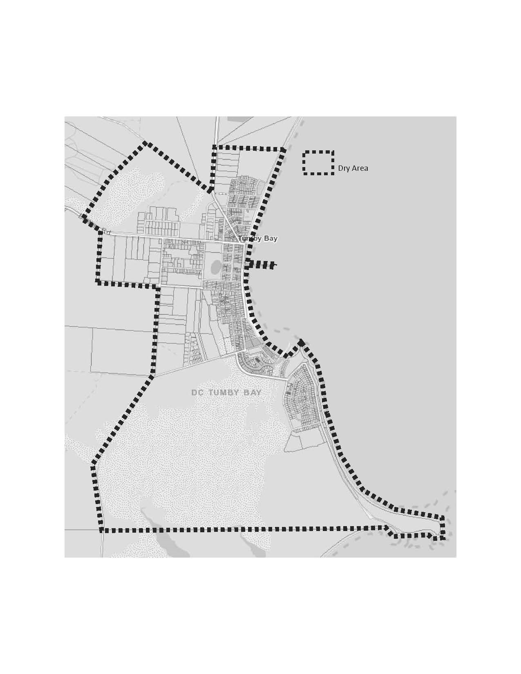
The area in and adjacent to Tumby Bay bounded as follows: commencing at the point at which the prolongation in a straight line of the northern boundary of Section 353 Hundred of Hutchison intersects the low water mark of Tumby Bay, then generally southerly, easterly, south-easterly, southerly and westerly along the low water mark to the point at which it is intersected by the prolongation in a straight line of the northern boundary of Section 355 Hundred of Hutchison, then westerly along that prolongation and northern boundary of Section 355 and the southern boundary of Piece 501 DP 85629 to the point at which the southern boundary of Piece 501 meets the eastern boundary of Thuruna Road, then generally northerly, north-easterly and northerly along that eastern boundary of Thuruna Road to the point at which it intersects the northern boundary of Dutton Terrace, then westerly and northerly along that boundary of Dutton Terrace to the point at which it meets the southern boundary of Bratten Way, then in a straight line by the shortest route (across Bratten Way) to the southern boundary of Lot 65 DP 59150, then generally north-westerly, north-easterly and south-easterly along the south-western, north-western and north-eastern boundaries of Lot 65 to the point at which the north-eastern boundary of Lot 65 is intersected by the prolongation in a straight line of the western boundary of Lot 101 DP 78505, then northerly along that prolongation and boundary of Lot 101 to the northern boundary of the Lot, then easterly along the northern boundaries of Lot 101, Section 817 Hundred of Hutchison and Section 353 Hundred of Hutchison and the prolongation in a straight line of the northern boundary of Section 353 to the point of commencement. The area includes the whole of any wharf, jetty, boat ramp, breakwater or other structure extending below low water mark from within the area described above, as well as any area beneath such a structure.
Dated: 4 December 2024
Dion Watson
Acting Chief Executive Officer

Public Notices

National Electricity Law
Notice of Final Rules
Notice of Draft Determination and Draft Rule
The Australian Energy Market Commission (AEMC) gives notice under the National Electricity Law as follows:
Under ss 102, 102A and 103, the making of the National Electricity Amendment (Shortening the settlement cycle) Rule 2024 No. 22 (Ref. ERC0384) and related final determination. Provisions commence as follows: Schedule 1 will commence on 9 August 2026 and Schedule 2 will commence on 19 December 2024.
Under ss 102 and 103, the making of the National Electricity Amendment (Cyber security roles and responsibilities) Rule 2024 No. 23 (Ref. ERC0388) and related final determination. All provisions commence on 12 December 2024.
Under s 99, the making of a draft determination and related draft Rule on the Inter-regional settlements residue arrangements for transmission loops proposal (Ref. ERC0386). Written requests for a pre-determination hearing must be received by 19 December 2024. Submissions must be received by 30 January 2025.
Submissions can be made via the AEMC’s website. Before making a submission, please review the AEMC’s privacy statement on its website, and consider the AEMC’s Tips for making a submission. The AEMC publishes all submissions on its website, subject to confidentiality.
Written requests should be sent to submissions@aemc.gov.au and cite the reference in the title. Before sending a request, please review the AEMC’s privacy statement on its website.
Documents referred to above are available on the AEMC’s website and are available for inspection at the AEMC’s office.
Australian Energy Market Commission
Level 15, 60 Castlereagh St
Sydney NSW 2000
Telephone: (02) 8296 7800
www.aemc.gov.au
Dated: 12 December 2024

Notice Submission

The South Australian Government Gazette is published each Thursday afternoon.
Notices must be emailed by 4 p.m. Tuesday, the week of publication.
Submissions are formatted per the gazette style and a proof will be supplied prior to publication, along with a quote if applicable. Please allow one day for processing notices.
Alterations to the proof must be returned by 4 p.m. Wednesday.

Gazette notices must be submitted as Word files, in the following format:
• Title—the governing legislation
• Subtitle—a summary of the notice content
• Body—structured text, which can include numbered lists, tables, and images
• Date—day, month, and year of authorisation
• Signature block—name, role, and department/organisation authorising the notice

Please provide the following information in your email:
• Date of intended publication
• Contact details of the person responsible for the notice content
• Name and organisation to be charged for the publication—Local Council and Public notices only
• Purchase order, if required—Local Council and Public notices only

Email: governmentgazettesa@sa.gov.au
Phone: (08) 7133 3552
Website: www.governmentgazette.sa.gov.au

All instruments appearing in this gazette are to be considered official, and obeyed as such

Printed and published weekly by authority of T. Foresto, Government Printer, South Australia
$8.80 per issue (plus postage), $443.00 per annual subscription—GST inclusive
Online publications: www.governmentgazette.sa.gov.au

(2017) 127 SASR 362.
(1977) 6(1) Adelaide Law Review 27.

