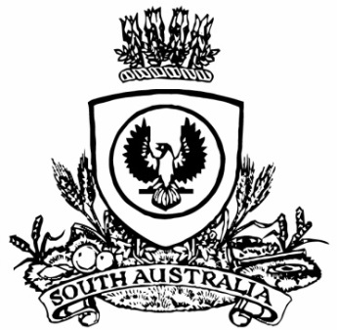**SUPPLEMENTARY GAZETTE**

**THE SOUTH AUSTRALIAN**

**GOVERNMENT GAZETTE**

**Published by Authority**

Adelaide, Monday, 26 August 2024

Governor’s Instrument

Letters Patent Constituting the Office of Governor

*Assumption of the Administration of the State by an Administrator*

Take notice that, having been notified the Governor of the State of South Australia will assume the role of Administrator of the Commonwealth, I have requested the Honourable Chief Justice Christopher John Kourakis assume the administration of the State, from the time the Governor’s appointment as Administrator of the Commonwealth begins on Monday, 26 August 2024 until this ceases on Monday, 2 September 2024, pursuant to the Letters Patent constituting the Office of Governor made on 14 February 1986, as amended by the Governor of the State of South Australia by Order in Council on 25 October 2001 and 29 June 2023.

Dated: 26 August 2024

Peter Malinauskas

Premier