
THE SOUTH AUSTRALIAN
GOVERNMENT GAZETTE
Published by Authority

Adelaide, Thursday, 12 July 2018

Contents

Acts Assented To 2784
Appointments, Resignations, Etc. 2784
Associations Incorporation Act 1985—Notice 2785
Corporations and District Councils—Notices 2828
Development Act 1993—Notices 2785
Fisheries Management Act 2007—Notice 2813
Fisheries Management (Prawn Fisheries)
Regulations 2017—Notice 2813
Genetically Modified Crops Management Act 2004—
Notice 2814
Health Care Act 2008—Notice 2814
Housing Improvement Act 2016—Notices 2815
Justices of the Peace Act 2005—Notices 2815
Liquor Licensing Act 1997—Notices 2816
Mining Act 1971—Notices 2823
National Parks and Wildlife Act 1972—Notices 2825
National Parks and Wildlife (National Parks)
Regulations 2016—Notice 2825
Petroleum and Geothermal Energy Act 2000—Notices 2826
Retail and Commercial Leases Act 1995—Notice 2827
Trustee Act 1936—Administration of Estates 2851
Wilderness Protection Act 1992—Notice 2827

Department of the Premier and Cabinet
Adelaide, 12 July 2018
His Excellency the Governor directs it to be notified for general information that he has in the name and on behalf of Her Majesty The Queen, this day assented to the undermentioned Acts passed by the Legislative Council and House of Assembly in Parliament assembled, viz.:
No. 4 of 2018—Criminal Law Consolidation (Dishonest Communication with Children) Amendment Act 2018.
An Act to amend the Criminal Law Consolidation Act 1935
No. 5 of 2018—Statutes Amendment (SACAT Federal Diversity Jurisdiction) Act 2018.
An Act to amend the Magistrates Court Act 1991 and the South Australian Civil and Administrative Tribunal Act 2013
By command,
Daniel Cornelis van Holst Pellekaan, MP
for Acting Premier

Department of the Premier and Cabinet
Adelaide, 12 July 2018
His Excellency the Governor in Executive Council has been pleased to appoint the undermentioned to the Architectural Practice Board of South Australia, pursuant to the provisions of the Architectural Practice Act 2009:
Member: from 12 July 2018 until 11 July 2021
Dimitty Andersen
Kirsteen Mackay
Kymberley Alissa Lawrence
By command,
Daniel Cornelis van Holst Pellekaan, MP
for Acting Premier
MPL18/005CS

Department of the Premier and Cabinet
Adelaide, 12 July 2018
His Excellency the Governor in Executive Council has been pleased to appoint the undermentioned to the Aquaculture Tenure Allocation Board, pursuant to the provisions of the Aquaculture Act 2001:
Member: from 12 July 2018 until 11 July 2021
Kate Ngaire Shierlaw
Alexander Cameron Thamm
Catherine Jane Sayer
By command,
Daniel Cornelis van Holst Pellekaan, MP
for Acting Premier
MPI18/0011 CS

Department of the Premier and Cabinet
Adelaide, 12 July 2018
His Excellency the Governor in Executive Council has been pleased to appoint Professor Brenda Wilson as Governor’s Deputy of South Australia for the period from 12:00am on Sunday, 15 July 2018 until 12:00am on Wednesday, 18 July 2018.
By command,
Daniel Cornelis van Holst Pellekaan, MP
for Acting Premier

Department of the Premier and Cabinet
Adelaide, 12 July 2018
His Excellency the Governor in Executive Council has been pleased to appoint the Honourable Daniel Cornelis van Holst Pellekaan, MP, Minister for Energy and Mining to be also Acting Minister for Trade, Tourism and Investment for the period from 15 July 2018 to 21 July 2018 inclusive, during the absence of the Honourable David Wickham Ridgway, MLC.
By command,
Daniel Cornelis van Holst Pellekaan, MP
for Acting Premier
18TTICS/00007

Department of the Premier and Cabinet
Adelaide, 12 July 2018
His Excellency the Governor in Executive Council has been pleased to appoint Barbara Ellen Johns to act in the office of Magistrate on an auxiliary basis, for a period commencing on 12 July 2018 and expiring on 30 June 2019, it being a condition of appointment that the powers and jurisdictions of the office should only be exercised during the time or times the actual duties are being undertaken, but at no other time throughout the period of appointment - pursuant to the Judicial Administration (Auxiliary Appointments and Powers) Act 1988.
By command,
Daniel Cornelis van Holst Pellekaan, MP
for Acting Premier
AGO0082-18CS

Department of the Premier and Cabinet
Adelaide, 12 July 2018
His Excellency the Governor in Executive Council has been pleased to appoint Roger James Thomas to the position of Commissioner for Aboriginal Engagement for a period commencing on 12 July 2018 and expiring on 27 February 2020 - pursuant to section 68 of the Constitution Act 1934.
By command,
Daniel Cornelis van Holst Pellekaan, MP
for Acting Premier
DPC18/037CS

Department of the Premier and Cabinet
Adelaide, 5 July 2018
His Excellency the Governor directs it to be notified that he has been pleased to approve the retention of the title ‘Honourable’ by:
Mr Jay Weatherill MP, Mr John Rau MP, Mr Anastasious (Tom) Koutsantonis MP, Mr Leon Bignell MP, Mr Geoffrey Brock MP, Ms Zoe Bettison MP and Mr Stephen Mullighan MP.
By command,
Steven Spence Marshall
Premier
DPC16/3594

Department of the Premier and Cabinet
Adelaide, 5 July 2018
His Excellency the Governor directs it to be notified that he has been pleased to approve the retention of the title ‘Honourable’ by:
Mr John Gazzola.
By command,
Steven Spence Marshall
Premier
DPC18/1832

ASSOCIATIONS INCORPORATION ACT 1985
Order Pursuant to Section 42(2)
Dissolution of Association
WHEREAS the CORPORATE AFFAIRS COMMISSION (“the Commission’) pursuant to section 42(1) of the Associations Incorporation Act 1985 (“the Act”) is of the opinion that the undertaking or operations THE LUTHERAN LAYPEOPLE’S LEAGUE OF AUSTRALIA INCORPORATED (“the Association”) being an incorporated association under the Act are being carried on, or would more appropriately be carried on by a company limited by guarantee incorporated under the Corporations Act 2001 (Cth) AND WHEREAS the Commission was on 2nd May 2018 requested by the Association to transfer its undertaking to company LUTHERAN LAYPEOPLE’S LEAGUE OF AUSTRALIA LIMITED (Australian Company Number 627 336 707), the Commission pursuant to section 42(2) of the Act DOES HEREBY ORDER that on 13th July 2018, the Association will be dissolved, the property of the Association becomes the property of LUTHERAN LAYPEOPLE’S LEAGUE OF AUSTRALIA LIMITED and the rights and liabilities of the Association become the rights and liabilities of LUTHERAN LAYPEOPLE’S LEAGUE OF AUSTRALIA LIMITED.
Given under the seal of the Commission at Adelaide
Dated: 10 July 2018
Rosalba Aloi
A delegate of the Corporate Affairs Commission

DEVELOPMENT ACT 1993
Section 29
Amendment to the Lower Eyre Peninsula Council Development Plan
Preamble
It is necessary to amend the Lower Eyre Peninsula Council Development Plan (the Plan) dated 28 February 2017.
PURSUANT to section 29 (2)(b)(i) and Section 29(2)(b)(ii) of the Development Act 1993, I—
- Amend the Plan as follows:
- Amend Coastal Settlement Zone Principle of Development Control 5 by deleting the words ‘other than Tulka’.
- Replace Coastal Settlement Zone PDC 6 with the contents of ATTACHMENT A.
- Within the Coastal Settlement Zone delete the fourth row of the table in PDC 12.
- Within the Coffin Bay Policy Area 1 of the Coastal Settlement Zone:
    - delete ‘or 50 percent of the allotment (whichever is greater)’ from PDC 3(d)
    - replace the third row of the table in Principle of Development Control 6, with the contents of ATTACHMENT B.
- Within the Coastal Settlement Zone non-complying table:
- replace the listing for ‘dwelling’ in the non-complying table with the contents of ATTACHMENT C.
- replace part d for ‘land division’ in the non-complying table with the contents of ATTACHMENT D
- delete part (b) for the land use ‘Outbuilding’
- delete ‘and Shelley Beach Kellidie Bay Policy Area 2 and where the outbuilding is contained within a combined building footprint (inclusive of carports, balconies, roof patios, verandas, decks and dwellings) that does not exceed 190 square metres or 50 per cent of the allotment (whichever is greater)’ from part (c)
- Within the Mixed Use (Point Boston) Zone, replace the table in Principle of Development Control 22(c) with the contents of ATTACHMENT E.
- In the Non-complying table of the Mixed Use (Point Boston) Zone, replace the row for ‘land division’ with the contents of ATTACHMENT F.
- In Primary Production Zone PDC 12(d) replace the words ‘500 hectares’ with ‘200 hectares’.
- In the Complying Development section of the Primary Production Zone insert the contents of ATTACHMENT G before ‘farming’.
- Delete the row ‘Community Centre’ from the Non-complying Table of the Primary Production Zone.
- Replace the ‘Land division’ row in the Non-complying table in the Primary Production Zone with the contents of ATTACHMENT H
- Within the Rural Living Zone replace the sixth row of the table in Principle of Development Control 6 with the contents of ATTACHMENT I
- Within the Rural Living Zone replace the first row of the table in Principle of Development Control 7 with the contents of ATTACHMENT J
- Within the Settlement Zone delete the first row of the table for Complying Development.
- In the Water Protection Zone, delete the words ‘Provided it is sited more than 50 metres from any public road or road allotment boundary’ from the first row of the table for Complying Development.
- Within the Water Protection Zone non-complying table:
- delete the row that contains “Dwelling’
- add the following land uses in alphabetical order into the table: ‘Multiple dwelling’, ‘Residential flat building’, ‘Row dwelling’ and ‘Semi-detached dwelling’.
- Replace ‘Bushfire Protection Area – BPA Map LEP/15’ with the contents of ATTACHMENT K.
- Fix the day on which this notice is published in the Gazette as the day on which the section 29 Amendment will come into operation.
Dated: 6 July 2018
Sally Smith
General Manager, Investment Management
Development Division
Department of Planning, Transport and Infrastructure
as Delegate of Stefan Knoll, Minister for Planning

Attachment A
6 Sheds, garages and other freestanding outbuildings should have external walls constructed of pre-treated colour coated metal, masonry, timber or compressed fibre cement.
Attachment B
Maximum wall height (from natural ground level) | 2.7 metres
Attachment C
Except a dwelling that satisfies one of the following:
(a) will not result in more than one dwelling on an allotment
(b) it is located within the Coffin Bay Policy Area 1 and it satisfies all of the following:
(i) it will not result in more than one dwelling on an allotment
(ii) the total floor area for all buildings (inclusive of carports and outbuildings) does not exceed 190 square metres
(iii) the total building height does not exceed 5 metres
(c) it is in the form of tourist accommodation and it is located within Coffin Bay township.
Attachment D
(d) it is located within the Shelley Beach Kellidie Bay Policy Area 2 and it achieves one of the following:
(i) all resulting allotments are at least 800 square metres and are connected to the Community Wastewater Management System;
(iii) it is for the purpose of creating a road reserve or public reserve;
(iv) it is an adjustment of allotment boundaries where no new allotments are created partly or wholly within the zone.
Attachment E
Parameter | Value
Maximum combined floor area for sheds, garages and outbuildings on the allotment | 36 square metres
Maximum building height (from natural ground level) | 3.3 metres
Maximum wall height (from natural ground level) | 2.7 metres
Attachment F
Land division | Except where it is for a boundary realignment where no additional allotments are created or it is located in one of the following precincts:  - Precinct 15 Residential East  - Precinct 16 Residential North  - Precinct 17 Residential West,  - Precinct 18 Residential South,  - Precinct 19 Tourist Accommodation  - Precinct 20 Land-based Aquaculture.
Attachment G
- Farm buildings that:
- are sited more than 50 metres from any public road or allotment boundary
- have a total floor area of 500 square metres or less
Attachment H
Land division | Except where it is for a boundary realignment or where it achieves one of the following:  (a) allotments of at least 200 hectares  (b) to create an allotment for one of the following (i)-(iv):  (i) of at least 1 hectare to excise one of two habitable dwellings (each built or under construction before 13 June 1985) from an existing allotment  (ii) of at least 1 hectare for the purposes of processing, display, or sale of locally grown produce  (iii) of at least 10 hectares for the purposes of horticulture  (iv) for the purposes of accommodating a dwelling ancillary to farming, occupied by one of the following:  (A) an employee of the farm  (B) the owner of the farm for the owner’s retirement.
Attachment I
Maximum building height (from natural ground level) | 8 metres
Attachment J
Maximum combined floor area for all sheds, garages and outbuildings on the allotment | 180 square metres
Maximum building height (from natural ground level) | 6 metres
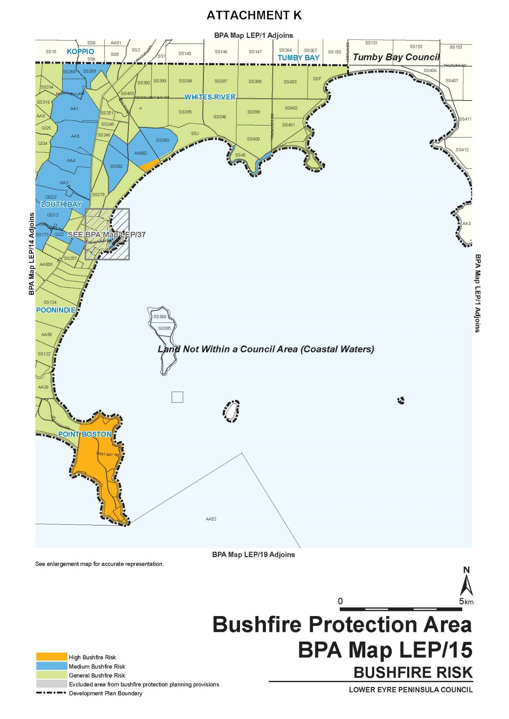

DEVELOPMENT ACT 1993
Section 29
Amendment to the West Torrens Council Development Plan
Preamble
It is necessary to amend the West Torrens Council Development Plan (the Plan) dated 6 February 2018.
PURSUANT to Section 29 (2)(b)(i), (2)(b)(ii) and (3)(c)(ii) of the Development Act 1993, I —
  - Amend the reference to ‘Table WeTo/6 – Off –Street Vehicle Parking Requirements for Urban Corridor Zone’ in the listing for ‘Office’ in ‘Table WeTo/1 – Conditions for Complying Development’, to ‘Table WeTo/6 – Off –Street Vehicle Parking Requirements for Designated Areas’.
  - Replace ‘Table WeTo/3 – Contributory Items’ with the contents of ‘ATTACHMENT A’.
This will result in the removal of the following items from ‘Table WeTo/3 – Contributory Items’:
Property Address | Description of Contributory Item | Certificate of Title | DPLG ID
14 WAINHOUSE ST TORRENSVILLE | Dwelling | CT 5959/672  CT 5959/669  CT 5959/670  CT 5959/671 | 21240
66 HENLEY BEACH RD MILE END | Shops and Office | CT 5452/945 | 21802
37A MILNER ROAD RICHMOND | Dwelling | CT 5971/14  CT 5971/15 | 21612
1A MARTIN AVENUE RICHMOND | Dwelling | CT 6031/72  CT 6058/6 | 21617
RICHMOND |  | CT 5841/525 | 21668
RICHMOND |  | CT 5841/525 | 21670
RICHMOND |  | CT 5841/525 | 21671
RICHMOND |  | CT 5841/525 | 21673
RICHMOND |  | CT 5989/394  CT 5989/394 | 21675
RICHMOND |  | CT 5989/393  CT 5989/393 | 21661
RICHMOND |  | CT 5989/393  CT 5989/393 | 21662
RICHMOND |  | CT 5841/525 | 21674
RICHMOND |  | CT 5841/525 | 21672
RICHMOND |  | CT 5841/525 | 21669
RICHMOND |  | CT 5841/525 | 21667
RICHMOND |  | CT 5841/525 | 21666
RICHMOND |  | CT 5989/393  CT 5989/393 | 21623
RICHMOND |  | CT 5989/395 | 21680
  - Replace ‘Table WeTo/4 – Local Heritage Places’ with the contents of ‘ATTACHMENT B’.
  - Replace the following overlay maps with the contents of ‘ATTACHMENT C’:
- Overlay Map WeTo /5—Heritage
- Overlay Map WeTo /7—Heritage
- Overlay Map WeTo /9—Heritage.
  - Remove the following map references from the ‘Map Reference Table’:
Zone Maps
Zone Name | Map Numbers
Community Zone | WeTo/6
Policy Area Maps
Policy Area Name | Map Numbers
Arterial Roads Policy Area 1 | WeTo/4
District Commercial Policy Area 2 | WeTo/5, WeTo/13
Recreation Policy Area 5 | WeTo/6, WeTo/10
Precinct Maps
Precinct Name | Map Numbers
Precinct 1 Intersection | WeTo/13
  - Include the following map references from the ‘Map Reference Table’:
Zone Maps
Zone Name | Map Numbers
Commercial Zone | WeTo/14
Policy Area Maps
Policy Area Name | Map Numbers
Medium Density Policy Area 19 | WeTo/4, WeTo/5
Precinct Maps
Precinct Name | Map Numbers
Precinct 2 Richmond Road | WeTo/9
Overlay Maps
Issue | Map Numbers
Strategic Transport Routes | WeTo/10
  - Fix the day on which this notice is published in the Gazette as the day on which the section 29 Amendment will come into operation.
Dated: 6 July 2018
Sally Smith
General Manager, Planning and Development
Development Division
Department of Planning, Transport and Infrastructure
as Delegate of Stephan Knoll, Minister for Planning

Attachment A
Table WeTo/3 - Contributory Items
Property Address | Description of Contributory Item | Certificate of Title | DPLG ID
4 ELSTON Street BROOKLYN PARK | Dwelling | CT 5775/64 | 21597
6 ELSTON Street BROOKLYN PARK | Dwelling | CT 5629/905 | 21599
7 ELSTON Street BROOKLYN PARK | Dwelling | CT 5783/426 | 21596
8 ELSTON Street BROOKLYN PARK | Dwelling | CT 5281/978 | 21601
9 ELSTON Street BROOKLYN PARK | Dwelling | CT 6020/917 | 21598
10 ELSTON Street BROOKLYN PARK | Dwelling | CT 5713/306 | 21603
11 ELSTON Street BROOKLYN PARK | Dwelling | CT 5773/673 | 21600
12 ELSTON Street BROOKLYN PARK | Dwelling | CT 5704/313 | 21604
13 ELSTON Street BROOKLYN PARK | Dwelling | CT 5283/566 | 21602
14 ELSTON Street BROOKLYN PARK | Dwelling | CT 5081/811 | 21606
17 ELSTON Street BROOKLYN PARK | Dwelling | CT 5488/59 | 21605
21 ELSTON Street BROOKLYN PARK | Dwelling | CT 5277/988 | 21607
22 ELSTON Street BROOKLYN PARK | Dwelling | CT 5275/110 | 21609
23 ELSTON Street BROOKLYN PARK | Dwelling | CT 5238/9 | 21608
24 ELSTON Street BROOKLYN PARK | Dwelling | CT 5694/725 | 21610
26 ELSTON Street BROOKLYN PARK | Dwelling | CT 5257/655 | 21611
2 BALLARA Street MILE END | Dwelling | CT 5871/612 | 21446
2A BALLARA Street MILE END | Dwelling | CT 5871/624 | 21447
4A BALLARA Street MILE END | Dwelling | CT 5874/324 | 21448
6 BALLARA Street MILE END | Dwelling | CT 6051/205 | 21449
6A BALLARA Street MILE END | Dwelling | CT 6051/206 | 21450
8A BALLARA Street MILE END | Dwelling | CT 5776/465 | 21451
10 & 10A BALLARA Street MILE END | Dwelling | CT 5003/443  CT 5003/444  CT 5003/445 | 21452
12 BALLARA Street MILE END | Dwelling | CT 5127/363 | 21453
14 & 14A BALLARA Street MILE END | Dwelling | CT 5553/852  CT 5874/323 | 21454
16 BALLARA Street MILE END | Dwelling | CT 5830/804 | 21401
18 BALLARA Street MILE END | Dwelling | CT 5866/168 | 21400
20 BALLARA Street MILE END | Dwelling | CT 5548/12 | 21399
22 BALLARA Street MILE END | Dwelling | CT 5526/966 | 21398
24 BALLARA Street MILE END | Dwelling | CT 5840/631 | 21397
26 BALLARA Street MILE END | Dwelling | CT 5724/76 | 21462
28 BALLARA Street MILE END | Dwelling | CT 5532/785 | 21461
30 BALLARA Street MILE END | Dwelling | CT 5529/849 | 21460
1/1 & 2/1A CLAREMONT Street MILE END | Dwelling | CT 5026/393  CT 5026/394  CT 5026/395 | 21458
2 CLAREMONT Street MILE END | Dwelling | CT 5683/187 | 21404
3A CLAREMONT Street MILE END | Dwelling | CT 5826/873 | 21457
4 CLAREMONT Street MILE END | Dwelling | CT 5739/576 | 21403
5 & 5A CLAREMONT Street MILE END | Dwelling | CT 5392/525  CT 5871/622 | 21456
6 CLAREMONT Street MILE END | Dwelling | CT 5119/287 | 21402
7 & 7A CLAREMONT Street MILE END | Dwelling | CT 5724/68  CT 5892/436 | 21455
1 CUMING Street MILE END | Dwelling | CT 5279/811 | 21378
3 CUMING Street MILE END | Dwelling | CT 5281/840 | 21377
5 CUMING Street MILE END | Dwelling | CT 5731/859 | 21376
7 CUMING Street MILE END | Dwelling | CT 5814/766 | 21375
8 & 8A CUMING Street MILE END | Dwelling | CT 5071/33 | 21367
1/ 9 CUMING Street MILE END | Dwelling | CT 5005/311 | 21374
10 CUMING Street MILE END | Dwelling | CT 5071/34 | 21366
12 & 12A CUMING Street MILE END | Dwelling | CT 5071/35 | 21365
13 CUMING Street MILE END | Dwelling | CT 5658/796 | 21373
14 CUMING Street MILE END | Dwelling | CT 5126/399 | 21364
15 CUMING Street MILE END | Dwelling | CT 5521/234 | 21372
16 CUMING Street MILE END | Dwelling | CT 5804/282 | 21363
17 CUMING Street MILE END | Dwelling | CT 5665/275 | 21371
18 CUMING Street MILE END | Dwelling | CT 5900/720 | 21362
19 CUMING Street MILE END | Dwelling | CT 5476/755 | 21370
20 CUMING Street MILE END | Dwelling | CT 5283/456 | 21361
21 CUMING Street MILE END | Dwelling | CT 5582/680 | 21369
22 CUMING Street MILE END | Dwelling | CT 5719/122 | 21360
23 CUMING Street MILE END | Dwelling | CT 6057/2 | 21368
24 CUMING Street MILE END | Dwelling | CT 5658/800 | 21359
25 CUMING Street MILE END | Dwelling | CT 5273/676 | 21574
25A CUMING Street MILE END | Dwelling | CT 5802/160 | 21575
26 CUMING Street MILE END | Dwelling | CT 5577/775 | 21358
27 CUMING Street MILE END | Dwelling | CT 5556/424 | 21576
28 & 28A CUMING Street MILE END | Dwelling | CT 5818/721  CT 5818/722 | 21357
29 CUMING Street MILE END | Dwelling | CT 5755/453 | 21577
30 & 30A CUMING Street MILE END | Dwelling | CT 5235/211  CT 5857/879 | 21356
31 CUMING Street MILE END | Dwelling | CT 5716/681 | 21578
33 CUMING Street MILE END | Dwelling | CT 5996/260 | 21579
34 CUMING Street MILE END | Dwelling | CT 5722/966 | 21726
35 & 35B CUMING Street MILE END | Dwelling | CT 5825/748 | 21581
1/36 & 2/36 CUMING Street MILE END | Dwelling | CT 5172/16  CT 5172/17  CT 5172/18 | 21725
37 CUMING Street MILE END | Dwelling | CT 5814/667 | 21580
39 CUMING Street MILE END | Dwelling | CT 5818/886 | 21582
40 CUMING Street MILE END | Dwelling | CT 5678/407 | 21724
41 CUMING Street MILE END | Dwelling | CT 5377/63 | 21583
42 CUMING Street MILE END | Dwelling | CT 6104/534  CT 6104/536 | 21723
43 CUMING Street MILE END | Dwelling | CT 5660/494 | 21584
44 CUMING Street MILE END | Dwelling | CT 5805/436 | 21722
45 CUMING Street MILE END | Dwelling | CT 5790/75 | 21585
46 CUMING Street MILE END | Dwelling | CT 5394/509 | 21721
47 CUMING Street MILE END | Dwelling | CT 5781/980 | 21586
48 CUMING Street MILE END | Dwelling | CT 5819/351 | 21720
49 CUMING Street MILE END | Dwelling | CT 5668/64 | 21587
50 CUMING Street MILE END | Dwelling | CT 5472/45 | 21719
51 CUMING Street MILE END | Dwelling | CT 5628/656 | 21588
52 & 52A CUMING Street MILE END | Dwelling | CT 5672/879 | 21718
53 CUMING Street MILE END | Dwelling | CT 5218/94 | 21589
54 & 54A CUMING Street MILE END | Dwelling | CT 5196/211  CT 5841/324 | 21716
55 CUMING Street MILE END | Dwelling | CT 5813/138 | 21590
1/56A & 2/56 CUMING Street MILE END | Dwelling | CT 5016/72  CT 5016/73  CT 5016/74 | 21715
57 CUMING Street MILE END | Dwelling | CT 5480/984 | 21591
58 CUMING Street MILE END | Dwelling | CT 5812/757 | 21714
59 CUMING Street MILE END | Dwelling | CT 5983/350 | 21592
60 CUMING Street MILE END | Dwelling | CT 5135/55 | 21713
61 CUMING Street MILE END | Dwelling | CT 5246/248 | 21593
62 CUMING Street MILE END | Dwelling | CT 5794/701 | 21712
62A CUMING Street MILE END | Dwelling | CT 5434/680 | 21711
63 CUMING Street MILE END | Dwelling | CT 5387/480 | 21594
64 CUMING Street MILE END | Dwelling | CT 5717/28 | 21710
65 CUMING Street MILE END | Dwelling | CT 5546/181 | 21694
66 CUMING Street MILE END | Dwelling | CT 5797/533 | 21709
67 CUMING Street MILE END | Dwelling | CT 5543/884 | 21695
68 CUMING Street MILE END | Dwelling | CT 5389/48 | 21708
70 CUMING Street MILE END | Dwelling | CT 5697/615 | 21707
72 CUMING Street MILE END | Dwelling | CT 6113/68 | 21706
74 CUMING Street MILE END | Dwelling | CT 5531/123 | 21705
76 CUMING Street MILE END | Dwelling | CT 5817/945 | 21704
78 CUMING Street MILE END | Dwelling | CT 5176/153 | 21703
80 CUMING Street MILE END | Dwelling | CT 5553/260 | 21702
82 CUMING Street MILE END | Dwelling | CT 5931/387 | 21701
2 & 2A DEW Street MILE END | Dwelling | CT 5748/601  CT 5748/602 | 21508
4 & 4A DEW Street MILE END | Dwelling | CT 5973/143  CT 5973/144 | 21507
6 DEW Street MILE END | Dwelling | CT 5144/556 | 21506
8 & 8A DEW Street MILE END | Dwelling | CT 5027/39  CT 5027/40  CT 5027/41 | 21505
10 & 10A DEW Street MILE END | Dwelling | CT 5124/687  CT 5288/606 | 21504
1 GLADSTONE Road MILE END | Dwelling | CT 5779/442 | 21355
2 GLADSTONE Road MILE END | Dwelling | CT 5496/242 | 21334
2A GLADSTONE Road MILE END | Dwelling | CT 5198/585 | 21333
3 GLADSTONE Road MILE END | Dwelling | CT 5779/441 | 21354
4 GLADSTONE Road MILE END | Dwelling | CT 5178/342 | 21332
4A GLADSTONE Road MILE END | Dwelling | CT 5159/59 | 21331
5 GLADSTONE Road MILE END | Dwelling | CT 5665/674 | 21353
6 GLADSTONE Road MILE END | Dwelling | CT 5690/770 | 21330
7 GLADSTONE Road MILE END | Dwelling | CT 5316/832 | 21352
8 GLADSTONE Road MILE END | Dwelling | CT 5139/857 | 21329
8A GLADSTONE Road MILE END | Dwelling | CT 5510/593 | 21328
9 GLADSTONE Road MILE END | Dwelling | CT 5071/18 | 21351
10 GLADSTONE Road MILE END | Dwelling | CT 5319/870 | 21327
11 GLADSTONE Road MILE END | Dwelling | CT 5071/17 | 21350
12 GLADSTONE Road MILE END | Dwelling | CT 5839/359 | 21326
13 GLADSTONE Road MILE END | Dwelling | CT 5714/718 | 21349
14 GLADSTONE Road MILE END | Dwelling | CT 5508/430 | 21325
14A GLADSTONE Road MILE END | Dwelling | CT 5839/358 | 21324
15 GLADSTONE Road MILE END | Dwelling | CT 5071/16 | 21348
16 Gladstone Road MILE END | Dwelling | CT 5644/968  CT 5644/971 | 21323
17 GLADSTONE Road MILE END | Dwelling | CT 5071/15 | 21347
18 GLADSTONE Road MILE END | Dwelling | CT 5427/660 | 21322
19 GLADSTONE Road MILE END | Dwelling | CT 5470/913 | 21346
20 GLADSTONE Road MILE END | Dwelling | CT 5567/446 | 21321
21 GLADSTONE Road MILE END | Dwelling | CT 5813/46 | 21345
22 GLADSTONE Road MILE END | Dwelling | CT 5344/844 | 21320
23 GLADSTONE Road MILE END | Dwelling | CT 5505/415 | 21344
1&2/ 24 GLADSTONE Road MILE END | Dwelling | CT 5025/738  CT 5025/739 | 21319
25 GLADSTONE Road MILE END | Dwelling | CT 6053/96 | 21343
27 GLADSTONE Road MILE END | Dwelling | CT 5304/799 | 21342
29 GLADSTONE Road MILE END | Dwelling | CT 5799/257 | 21341
30 GLADSTONE Road MILE END | Dwelling | CT 5658/333 | 21767
31 GLADSTONE Road MILE END | Dwelling | CT 5720/86 | 21340
33 GLADSTONE Road MILE END | Dwelling | CT 5799/259 | 21339
1/ 34 GLADSTONE Road MILE END | Dwelling | CT 5000/926 | 21766
35-35A GLADSTONE Road MILE END | Dwelling | CT 5837/743 | 21338
36 GLADSTONE Road MILE END | Dwelling | CT 5717/539 | 21765
36A GLADSTONE Road MILE END | Dwelling | CT 5646/207 | 21764
38 GLADSTONE Road MILE END | Dwelling | CT 6156/508 | 21763
39 GLADSTONE Road MILE END | Shop | CT 5893/575 | 21748
40 GLADSTONE Road MILE END | Dwelling | CT 5490/336 | 21762
41 GLADSTONE Road MILE END | Dwelling | CT 5775/493 | 21746
42 & 42A GLADSTONE Road MILE END | Dwelling | CT 5376/542  CT 5376/543 | 21761
43 GLADSTONE Road MILE END | Dwelling | CT 5867/777 | 21745
45-45A GLADSTONE Road MILE END | Dwelling | CT 5210/910 | 21744
47 GLADSTONE Road MILE END | Dwelling | CT 5199/149 | 21743
48 GLADSTONE Road MILE END | Dwelling | CT 5704/532 | 21760
49 GLADSTONE Road MILE END | Dwelling | CT 5908/827 | 21742
50 GLADSTONE Road MILE END | Dwelling | CT 5803/866 | 21759
50A GLADSTONE Road MILE END | Dwelling | CT 5258/942 | 21758
53 GLADSTONE Road MILE END | Dwelling | CT 5657/408 | 21741
54 GLADSTONE Road MILE END | Dwelling | CT 6056/199 | 21757
55 GLADSTONE Road MILE END | Dwelling | CT 5291/487 | 21740
2/ 57 & 57A GLADSTONE Road MILE END | Dwelling | CT 5037/127  CT 5037/129  CT 5867/447 | 21739
58 GLADSTONE Road MILE END | Dwelling | CT 5813/921 | 21756
58A GLADSTONE Road MILE END | Dwelling | CT 5364/246 | 21755
59 & 59A GLADSTONE Road MILE END | Dwelling | CT 5018/523  CT 5018/524  CT 5018/525 | 21738
61 GLADSTONE Road MILE END | Dwelling | CT 5797/492 | 21737
62 GLADSTONE Road MILE END | Dwelling | CT 5173/505 | 21754
62A GLADSTONE Road MILE END | Dwelling | CT 5302/61 | 21753
65 GLADSTONE Road MILE END | Dwelling | CT 5546/677 | 21736
67 GLADSTONE Road MILE END | Dwelling | CT 5805/104 | 21735
69 GLADSTONE Road MILE END | Dwelling | CT 5292/104 | 21734
71 GLADSTONE Road MILE END | Dwelling | CT 5281/380 | 21733
75 GLADSTONE Road MILE END | Dwelling | CT 5135/123  CT 5135/125 | 21732
77 GLADSTONE Road MILE END | Dwelling | CT 5292/763 | 21731
79 GLADSTONE Road MILE END | Dwelling | CT 5810/580 | 21730
81 & 81A GLADSTONE Road MILE END | Dwelling | CT 6013/410  CT 6013/411 | 21729
83 & 83A GLADSTONE Road MILE END | Dwelling | CT 5153/703  CT 6064/664 | 21728
85 & 87 GLADSTONE Road MILE END | Dwelling | CT 5974/305  CT 5974/306 | 21727
34 HENLEY BEACH Road MILE END | Shops | CT 5225/163 | 21810
36 HENLEY BEACH Road MILE END | Shop | CT 5365/802 | 21809
40 HENLEY BEACH Road MILE END | Shop | CT 5221/224 | 21808
42 HENLEY BEACH Road MILE END | Shop | CT 5882/170 | 21807
44 HENLEY BEACH Road MILE END | Shop | CT 5514/551 | 21806
50-60 HENLEY BEACH Road MILE END | Shops | CT 5225/682  CT 5309/298 | 21804
62-62A HENLEY BEACH Road MILE END | Shops and Office | CT 5339/775 | 21803
1-4/ 68 & 70 HENLEY BEACH Road MILE END | Shop | CT 5875/176  CT 5875/177  CT 5875/178  CT 5875/179 | 21801
72 HENLEY BEACH Road MILE END | Shop | CT 5239/425 | 21800
3 HUGHES Street MILE END | Dwelling | CT 5786/303 | 21311
4 HUGHES Street MILE END | Dwelling | CT 5355/857 | 21554
5 HUGHES Street MILE END | Dwelling | CT 5319/860 | 21310
6 HUGHES Street MILE END | Dwelling | CT 5511/407 | 21553
7 HUGHES Street MILE END | Dwelling | CT 5319/859 | 21309
8 & 8A HUGHES Street MILE END | Dwelling | CT 6150/474  CT 6150/475  CT 6150/476 | 21552
9 HUGHES Street MILE END | Dwelling | CT 5378/252 | 21308
10 HUGHES Street MILE END | Dwelling | CT 5256/39 | 21551
11-11A HUGHES Street MILE END | Dwelling | CT 5319/858 | 21307
12 HUGHES Street MILE END | Dwelling | CT 5113/962 | 21550
13 HUGHES Street MILE END | Dwelling | CT 5327/210 | 21306
14A HUGHES Street MILE END | Dwelling | CT 5506/603 | 21549
16 HUGHES Street MILE END | Community | CT 5506/602 | 21548
17 HUGHES Street MILE END | Dwelling | CT 5813/825 | 21305
18 HUGHES Street MILE END | Dwelling | CT 5824/219 | 21547
19 HUGHES Street MILE END | Dwelling | CT 5830/501 | 21304
20 HUGHES Street MILE END | Dwelling | CT 5814/661 | 21546
21 HUGHES Street MILE END | Dwelling | CT 5839/356 | 21303
22 & 24 HUGHES Street MILE END | Dwelling | CT 6014/148 | 21544
23 HUGHES Street MILE END | Dwelling | CT 5566/801 | 21302
25 HUGHES Street MILE END | Dwelling | CT 5775/543 | 21301
26 HUGHES Street MILE END | Dwelling | CT 5875/809 | 21543
27 HUGHES Street MILE END | Dwelling | CT 5775/545 | 21300
28 HUGHES Street MILE END | Dwelling | CT 5875/811 | 21542
29 HUGHES Street MILE END | Dwelling | CT 5442/347 | 21299
30 & 30A HUGHES Street MILE END | Dwelling | CT 5825/934  CT 5864/566 | 21541
31 HUGHES Street MILE END | Dwelling | CT 6155/925 | 21298
32 & 32A HUGHES Street MILE END | Dwelling | CT 5509/293  CT 5672/137 | 21540
33A HUGHES Street MILE END | Dwelling | CT 5476/14 | 21561
34 HUGHES Street MILE END | Dwelling | CT 5898/135 | 21539
35 HUGHES Street MILE END | Dwelling | CT 5475/735 | 21560
36 HUGHES Street MILE END | Dwelling | CT 5839/355 | 21538
37 HUGHES Street MILE END | Dwelling | CT 5935/585  CT 5935/588 | 21559
38 HUGHES Street MILE END | Dwelling | CT 5362/751 | 21537
39 HUGHES Street MILE END | Dwelling | CT 5671/421 | 21558
40 HUGHES Street MILE END | Dwelling | CT 5786/301 | 21536
41 HUGHES Street MILE END | Dwelling | CT 5649/930 | 21557
42 & 42A HUGHES Street MILE END | Dwelling | CT 5235/436  CT 5864/567 | 21535
43 HUGHES Street MILE END | Dwelling | CT 5117/351 | 21556
46 HUGHES Street MILE END | Dwelling | CT 5065/750 | 21531
1-2/ 47 HUGHES Street MILE END | Dwelling | CT 5026/459  CT 5026/460  CT 5026/461 | 21774
48 HUGHES Street MILE END | Dwelling | CT 5141/306 | 21530
49 HUGHES Street MILE END | Dwelling | CT 5859/698 | 21775
1/ 50 & 52 HUGHES Street MILE END | Dwelling | CT 5038/212  CT 5038/214  CT 5859/198 | 21529
51 HUGHES Street MILE END | Dwelling | CT 5392/732 | 21776
53 HUGHES Street MILE END | Dwelling | CT 5762/389 | 21777
54 HUGHES Street MILE END | Dwelling | CT 5823/830 | 21528
55 HUGHES Street MILE END | Dwelling | CT 5584/988 | 21778
56 HUGHES Street MILE END | Dwelling | CT 5820/465 | 21527
57 HUGHES Street MILE END | Dwelling | CT 5201/810 | 21779
58 HUGHES Street MILE END | Dwelling | CT 5402/299 | 21526
59 HUGHES Street MILE END | Dwelling | CT 5647/916 | 21780
60 HUGHES Street MILE END | Dwelling | CT 5811/733 | 21525
61 HUGHES Street MILE END | Dwelling | CT 6123/943 | 21781
62 HUGHES Street MILE END | Dwelling | CT 5926/3 | 21524
63 HUGHES Street MILE END | Dwelling | CT 5324/172 | 21782
64 HUGHES Street MILE END | Dwelling | CT 6027/604  CT 6027/606 | 21523
65-65A HUGHES Street MILE END | Dwelling | CT 5837/277 | 21783
67 HUGHES Street MILE END | Dwelling | CT 5780/4 | 21784
68 HUGHES Street MILE END | Dwelling | CT 5582/703 | 21522
71 HUGHES Street MILE END | Dwelling | CT 6164/230  CT 6164/233 | 21785
72 HUGHES Street MILE END | Dwelling | CT 5838/463 | 21521
73 HUGHES Street MILE END | Dwelling | CT 5378/916  CT 5378/997 | 21786
75 HUGHES Street MILE END | Dwelling | CT 5378/917 | 21787
80 HUGHES Street MILE END | Dwelling | CT 5297/412 | 21520
81 HUGHES Street MILE END | Dwelling | CT 5280/951 | 21788
83 HUGHES Street MILE END | Dwelling | CT 5925/878 | 21789
1 JUNCTION Street MILE END | Dwelling | CT 5589/905 | 21812
2 JUNCTION Street MILE END | Dwelling | CT 5100/685 | 21813
3 JUNCTION Street MILE END | Dwelling | CT 6106/446 | 21814
4 JUNCTION Street MILE END | Dwelling | CT 5192/942 | 21815
5 JUNCTION Street MILE END | Dwelling | CT 5233/658 | 21816
6 JUNCTION Street MILE END | Dwelling | CT 5138/94 | 21817
7 JUNCTION Street MILE END | Dwelling | CT 5713/912 | 21818
8 JUNCTION Street MILE END | Dwelling | CT 5094/539 | 21819
1 KING Street MILE END | Dwelling | CT 5372/200 | 21430
1A KING Street MILE END | Dwelling | CT 5880/499 | 21396
3 KING Street MILE END | Dwelling | CT 5164/956 | 21395
4 KING Street MILE END | Dwelling | CT 5778/523 | 21389
5 KING Street MILE END | Dwelling | CT 5164/957 | 21394
8A KING Street MILE END | Dwelling | CT 5786/823 | 21388
10 KING Street MILE END | Dwelling | CT 5558/490 | 21387
12 KING Street MILE END | Dwelling | CT 5787/645 | 21386
14 & 14A KING Street MILE END | Dwelling | CT 5862/965  CT 5862/968 | 21384
15 KING Street MILE END | Dwelling | CT 5633/946 | 21445
16 & 16A KING Street MILE END | Dwelling | CT 5862/973  CT 5862/975 | 21382
17 KING Street MILE END | Dwelling | CT 5900/470 | 21444
18 KING Street MILE END | Dwelling | CT 6111/971 | 21381
19 KING Street MILE END | Dwelling | CT 5404/616 | 21443
20 KING Street MILE END | Dwelling | CT 5713/916 | 21380
21 KING Street MILE END | Dwelling | CT 5392/787 | 21442
23 KING Street MILE END | Dwelling | CT 5810/545 | 21441
25 & 25A KING Street MILE END | Dwelling | CT 5846/413  CT 5846/414 | 21440
26 KING Street MILE END | Dwelling | CT 5887/848 | 21567
27 KING Street MILE END | Dwelling | CT 5824/39 | 21439
28 KING Street MILE END | Dwelling | CT 5638/470 | 21566
29 KING Street MILE END | Dwelling | CT 5892/437 | 21438
30 KING Street MILE END | Dwelling | CT 5763/913 | 21565
31 & 31A KING Street MILE END | Dwelling | CT 5892/438  CT 5892/439 | 21437
32A & 32B KING Street MILE END | Dwelling | CT 5018/467  CT 5018/468  CT 5018/469 | 21564
33A KING Street MILE END | Dwelling | CT 5335/27 | 21436
34 KING Street MILE END | Dwelling | CT 5658/379 | 21563
1/ 35 & 35A KING Street MILE END | Dwelling | CT 5202/718  CT 5202/719  CT 5335/28 | 21435
36 KING Street MILE END | Dwelling | CT 5795/86 | 21562
37 KING Street MILE END | Dwelling | CT 5892/435 | 21434
38 KING Street MILE END | Dwelling | CT 5512/292 | 21429
39 KING Street MILE END | Dwelling | CT 5211/23 | 21433
40 KING Street MILE END | Dwelling | CT 5802/345 | 21428
41 KING Street MILE END | Dwelling | CT 5816/266 | 21432
42 KING Street MILE END | Dwelling | CT 5886/683 | 21427
43 KING Street MILE END | Dwelling | CT 5853/88 | 21431
44 KING Street MILE END | Dwelling | CT 5793/469 | 21426
45 KING Street MILE END | Dwelling | CT 5334/638 | 21405
46 KING Street MILE END | Dwelling | CT 5515/653 | 21425
47 KING Street MILE END | Dwelling | CT 5739/760 | 21406
48 KING Street MILE END | Dwelling | CT 5578/94 | 21424
49 KING Street MILE END | Dwelling | CT 5792/226 | 21407
50 KING Street MILE END | Dwelling | CT 5316/362 | 21423
51 KING Street MILE END | Dwelling | CT 5418/579 | 21408
52 KING Street MILE END | Dwelling | CT 5723/894 | 21422
53 KING Street MILE END | Dwelling | CT 5773/791 | 21409
54 & 54A KING Street MILE END | Dwelling | CT 6065/820  CT 6065/821  CT 6065/822 | 21421
55 KING Street MILE END | Dwelling | CT 5771/101 | 21410
56 KING Street MILE END | Dwelling | CT 5167/790 | 21420
58 KING Street MILE END | Dwelling | CT 5983/351 | 21419
60 KING Street MILE END | Dwelling | CT 5346/584 | 21418
61 KING Street MILE END | Dwelling | CT 5673/320 | 21411
62A-62D KING Street MILE END | Dwelling | CT 5201/772 | 21417
64 KING Street MILE END | Dwelling | CT 5466/557 | 21416
66 KING Street MILE END | Dwelling | CT 5803/849 | 21415
1 PARKER Street MILE END | Dwelling | CT 5748/337 | 21513
2 PARKER Street MILE END | Dwelling | CT 5102/555 | 21519
3 PARKER Street MILE END | Dwelling | CT 5435/74 | 21512
4 PARKER Street MILE END | Dwelling | CT 5704/943 | 21518
5 PARKER Street MILE END | Dwelling | CT 5283/558 | 21511
6 PARKER Street MILE END | Dwelling | CT 5544/779 | 21517
7 PARKER Street MILE END | Dwelling | CT 5748/321 | 21510
8 PARKER Street MILE END | Dwelling | CT 5707/768 | 21516
10 PARKER Street MILE END | Dwelling | CT 5557/104 | 21515
6-10 RAILWAY Terrace MILE END | Dwelling | CT 5124/414  CT 5124/415 | 21555
12 RAILWAY Terrace MILE END | Dwelling | CT 5108/322  CT 5786/304 | 21312
14 RAILWAY Terrace MILE END | Dwelling | CT 5501/71 | 21313
16 RAILWAY Terrace MILE END | Dwelling | CT 5313/340 | 21314
18 RAILWAY Terrace MILE END | Dwelling | CT 5839/357 | 21337
20 RAILWAY Terrace MILE END | Dwelling | CT 5284/536 | 21336
22 RAILWAY Terrace MILE END | Dwelling | CT 5786/296 | 21335
28 RAILWAY Terrace MILE END | Dwelling | CT 5351/80 | 21379
30 RAILWAY Terrace MILE END | Dwelling | CT 5889/778 | 21393
32 RAILWAY Terrace MILE END | Dwelling | CT 5164/972 | 21392
34 RAILWAY Terrace MILE END | Dwelling | CT 5164/971 | 21391
36 RAILWAY Terrace MILE END | Dwelling | CT 5878/354 | 21390
34 ROSE Street MILE END | Dwelling | CT 5141/578 | 21514
37A ROSE Street MILE END | Dwelling | CT 5869/141 | 21509
1 & 1A VICTORIA Street MILE END | Dwelling | CT 5028/47  CT 5028/48  CT 5028/49 | 21811
4 VICTORIA Street MILE END | Dwelling | CT 5188/558 | 21534
6 VICTORIA Street MILE END | Dwelling | CT 5747/604 | 21533
8 VICTORIA Street MILE END | Dwelling | CT 5813/152 | 21532
10 VICTORIA Street MILE END | Dwelling | CT 5343/277 | 21773
12 VICTORIA Street MILE END | Dwelling | CT 5883/859 | 21772
14 VICTORIA Street MILE END | Dwelling | CT 5561/153 | 21771
15 VICTORIA Street MILE END | Dwelling | CT 5497/182 | 21315
16 VICTORIA Street MILE END | Dwelling | CT 5837/278 | 21770
17 VICTORIA Street MILE END | Dwelling | CT 5355/832 | 21316
17A VICTORIA Street MILE END | Dwelling | CT 5554/417 | 21317
18 VICTORIA Street MILE END | Dwelling | CT 5558/383 | 21769
19 VICTORIA Street MILE END | Dwelling | CT 5786/297 | 21318
20 VICTORIA Street MILE END | Dwelling | CT 5826/146 | 21768
22 VICTORIA Street MILE END | Dwelling | CT 5874/686 | 21747
24 VICTORIA Street MILE END | Dwelling | CT 5874/768 | 21573
24A VICTORIA Street MILE END | Dwelling | CT 5874/789 | 21572
26 & 26A VICTORIA Street MILE END | Dwelling | CT 6059/459 | 21571
 |  | CT 6059/460
28 VICTORIA Street MILE END | Dwelling | CT 5874/769 | 21570
28A VICTORIA Street MILE END | Dwelling | CT 5124/376 | 21569
1/ 30 & 30A VICTORIA Street MILE END | Dwelling | CT 5049/507  CT 5049/508  CT 5049/509 | 21568
8 ALBERT Street RICHMOND | Dwelling | CT 6031/109 | 21680
21 Albert Street RICHMOND | Dwelling | CT 6037/622 | 26033
23 ALBERT Street RICHMOND | Dwelling | CT 6037/623 | 21626
24 & 26 ALBERT Street RICHMOND | Dwelling | CT 6031/62  CT 6031/63 | 21625
25 & 27 ALBERT Street RICHMOND | Dwelling | CT 6037/624  CT 6037/625 | 21677
28 ALBERT Street RICHMOND | Dwelling | CT 6031/61 | 21624
30 ALBERT Street RICHMOND | Dwelling | CT 6031/60 | 21676
8 & 10 DAVENPORT Terrace RICHMOND | Dwelling | CT 6031/67  CT 6031/68 | 21619
12 & 14 DAVENPORT Terrace RICHMOND | Dwelling | CT 6031/70  CT 6031/71 | 21618
16 & 18 DAVENPORT Terrace RICHMOND | Dwelling | CT 6117/857  CT 6117/858 | 21616
20 & 22 DAVENPORT Terrace RICHMOND | Dwelling | CT 6117/861  CT 6117/862 | 21615
24 & 26 DAVENPORT Terrace RICHMOND | Dwelling | CT 6117/865  CT 6117/866 | 21614
1 & 3 MARTIN Avenue RICHMOND | Dwelling | CT 6031/73  CT 6031/74 | 21617
5 & 7 MARTIN Avenue RICHMOND | Dwelling | CT 6058/5  CT 6058/6 | 21627
6 & 8 MARTIN Avenue RICHMOND | Dwelling | CT 6037/614  CT 6037/615 | 21663
9 & 11 MARTIN Avenue RICHMOND | Dwelling | CT 6058/3  CT 6058/4 | 21664
13 & 15 MARTIN Avenue RICHMOND | Dwelling | CT 6058/1  CT 6058/2 | 21678
14 & 16 MARTIN Avenue RICHMOND | Dwelling | CT 6031/64  CT 6031/65 | 21665
17 & 19 MARTIN Avenue RICHMOND | Dwelling | CT 6037/96  CT 6037/97 | 21679
33 MILNER Road RICHMOND | Dwelling | CT 6117/869 | 21670
35 MILNER Road RICHMOND | Dwelling | CT 6117/871 | 21613
37 MILNER Road RICHMOND | Dwelling | CT 6117/872 | 21612
39 & 41 MILNER Road RICHMOND | Dwelling | CT 6037/600  CT 6037/601 | 21622
43 MILNER Road RICHMOND | Dwelling | CT 6037/599 | 21621
45 Milner Road RICHMOND | Dwelling | CT 6037/597 | 26032
47 MILNER Road RICHMOND | Dwelling | CT 6037/596 | 21668
1 ASHLEY Street TORRENSVILLE | Dwelling | CT 5546/676 | 21167
3 ASHLEY Street TORRENSVILLE | Dwelling | CT 5787/337 | 21168
5 ASHLEY Street TORRENSVILLE | Dwelling | CT 5704/277 | 21169
7 ASHLEY Street TORRENSVILLE | Dwelling | CT 5785/966 | 21170
9 ASHLEY Street TORRENSVILLE | Dwelling | CT 5785/965 | 21171
11 ASHLEY Street TORRENSVILLE | Dwelling | CT 5785/964 | 21172
13 ASHLEY Street TORRENSVILLE | Dwelling | CT 5830/140 | 21466
2 CARLTON Parade TORRENSVILLE | Dwelling | CT 5813/461 | 21156
4 CARLTON Parade TORRENSVILLE | Dwelling | CT 5815/864 | 21155
6 CARLTON Parade TORRENSVILLE | Dwelling | CT 5856/215 | 21154
8 CARLTON Parade TORRENSVILLE | Dwelling | CT 5856/220 | 21153
10 CARLTON Parade TORRENSVILLE | Dwelling | CT 5820/797 | 21152
14 CARLTON Parade TORRENSVILLE | Dwelling | CT 5439/45 | 21138
15A CARLTON Parade TORRENSVILLE | Dwelling | CT 5147/187 | 21243
16 CARLTON Parade TORRENSVILLE | Dwelling | CT 5797/398 | 21137
18 CARLTON Parade TORRENSVILLE | Dwelling | CT 5743/875 | 21136
20 CARLTON Parade TORRENSVILLE | Dwelling | CT 5781/684 | 21135
22 CARLTON Parade TORRENSVILLE | Dwelling | CT 5682/159 | 21134
24 CARLTON Parade TORRENSVILLE | Dwelling | CT 5729/957 | 21260
26 CARLTON Parade TORRENSVILLE | Dwelling | CT 5797/412 | 21261
28 CARLTON Parade TORRENSVILLE | Dwelling | CT 5832/644 | 21262
30 CARLTON Parade TORRENSVILLE | Dwelling | CT 5895/872 | 21263
32 CARLTON Parade TORRENSVILLE | Dwelling | CT 5545/280 | 21264
34 CARLTON Parade TORRENSVILLE | Dwelling | CT 5160/981 | 21265
36 CARLTON Parade TORRENSVILLE | Dwelling | CT 5779/514 | 21279
1A DANBY Street TORRENSVILLE | Dwelling | CT 5700/472 | 21908
3 DANBY Street TORRENSVILLE | Dwelling | CT 5455/6 | 21907
4 DANBY Street TORRENSVILLE | Dwelling | CT 5287/980 | 21912
5 DANBY Street TORRENSVILLE | Dwelling | CT 5108/225 | 21906
6 DANBY Street TORRENSVILLE | Club | CT 5722/895 | 21911
7 DANBY Street TORRENSVILLE | Dwelling | CT 5193/557 | 21905
8 DANBY Street TORRENSVILLE | Club | CT 5547/977 | 21910
9 DANBY Street TORRENSVILLE | Dwelling | CT 5732/317 | 21904
10 DANBY Street TORRENSVILLE | Dwelling | CT 5700/85 | 21909
11 DANBY Street TORRENSVILLE | Dwelling | CT 5766/488 | 21231
12 DANBY Street TORRENSVILLE | Dwelling | CT 5546/673 | 21227
13 DANBY Street TORRENSVILLE | Dwelling | CT 6008/343 | 21230
15 DANBY Street TORRENSVILLE | Dwelling | CT 5563/94 | 21229
17 DANBY Street TORRENSVILLE | Dwelling | CT 5167/631 | 21228
19 DANBY Street TORRENSVILLE | Dwelling | CT 5553/102 | 21151
20 DANBY Street TORRENSVILLE | Dwelling | CT 5119/762 | 21210
21 DANBY Street TORRENSVILLE | Dwelling | CT 5109/129 | 21149
22 DANBY Street TORRENSVILLE | Dwelling | CT 5119/947 | 21209
23 DANBY Street TORRENSVILLE | Dwelling | CT 5515/900 | 21147
24 DANBY Street TORRENSVILLE | Dwelling | CT 5119/946 | 21208
25 DANBY Street TORRENSVILLE | Dwelling | CT 5211/820 | 21144
26 DANBY Street TORRENSVILLE | Dwelling | CT 5118/179 | 21207
27 DANBY Street TORRENSVILLE | Dwelling | CT 5773/157 | 21142
28 DANBY Street TORRENSVILLE | Dwelling | CT 5118/351 | 21206
30 DANBY Street TORRENSVILLE | Dwelling | CT 5118/173 | 21205
31 DANBY Street TORRENSVILLE | Dwelling | CT 5818/989 | 21164
32 DANBY Street TORRENSVILLE | Dwelling | CT 5118/353 | 21204
33 DANBY Street TORRENSVILLE | Dwelling | CT 5408/303 | 21165
34 DANBY Street TORRENSVILLE | Dwelling | CT 5119/944  CT 5119/945 | 21203
35 DANBY Street TORRENSVILLE | Dwelling | CT 5783/789 | 21463
36 DANBY Street TORRENSVILLE | Dwelling | CT 5119/777 | 21202
37 DANBY Street TORRENSVILLE | Dwelling | CT 5560/390 | 21464
38 DANBY Street TORRENSVILLE | Dwelling | CT 5119/943 | 21201
39 DANBY Street TORRENSVILLE | Dwelling | CT 5802/327 | 21465
40 DANBY Street TORRENSVILLE | Dwelling | CT 5119/766 | 21200
42 DANBY Street TORRENSVILLE | Dwelling | CT 5119/795 | 21199
44 DANBY Street TORRENSVILLE | Dwelling | CT 5119/807 | 21198
46 DANBY Street TORRENSVILLE | Dwelling | CT 6079/392  CT 6079/393 | 21185
46A DANBY Street TORRENSVILLE | Dwelling | CT 5596/991 | 21184
48 DANBY Street TORRENSVILLE | Dwelling | CT 5756/887 | 21183
50 DANBY Street TORRENSVILLE | Dwelling | CT 5786/281 | 21182
52 DANBY Street TORRENSVILLE | Dwelling | CT 5786/280 | 21181
54 DANBY Street TORRENSVILLE | Dwelling | CT 5656/755 | 21180
56 DANBY Street TORRENSVILLE | Dwelling | CT 5786/659 | 21179
58 DANBY Street TORRENSVILLE | Dwelling | CT 5791/71 | 21178
60 DANBY Street TORRENSVILLE | Dwelling | CT 5546/227 | 21177
62 DANBY Street TORRENSVILLE | Dwelling | CT 6110/951 | 21176
64 DANBY Street TORRENSVILLE | Dwelling | CT 5785/967 | 21175
66 DANBY Street TORRENSVILLE | Dwelling | CT 5787/863 | 21174
68 DANBY Street TORRENSVILLE | Dwelling | CT 5785/963 | 21173
168 HENLEY BEACH Road TORRENSVILLE | Shops | CT 5312/864 | 21797
170 HENLEY BEACH Road TORRENSVILLE | Shops | CT 5304/775  CT 5304/776  CT 5304/783 | 21795
174 HENLEY BEACH Road TORRENSVILLE | Shop and Office | CT 5108/661 | 21794
178 HENLEY BEACH Road TORRENSVILLE | Shop | CT 5108/659 | 21793
192 & 192B HENLEY BEACH Road TORRENSVILLE | Shops | CT 5580/707  CT 5739/737 | 21798
200 HENLEY BEACH Road TORRENSVILLE | Shop | CT 5360/845 | 21799
1 HUNTRISS Street TORRENSVILLE | Dwelling | CT 5406/789 | 21882
2 HUNTRISS Street TORRENSVILLE | Dwelling | CT 5763/895 | 21895
3 HUNTRISS Street TORRENSVILLE | Dwelling | CT 5797/521 | 21883
4 HUNTRISS Street TORRENSVILLE | Dwelling | CT 5790/93 | 21891
5 HUNTRISS Street TORRENSVILLE | Dwelling | CT 5797/520 | 21884
6 HUNTRISS Street TORRENSVILLE | Dwelling | CT 5609/300 | 21890
8 HUNTRISS Street TORRENSVILLE | Dwelling | CT 5790/94 | 21889
9 & 11 HUNTRISS Street TORRENSVILLE | Dwelling | CT 5002/983  CT 5002/984  CT 5002/986 | 21885
10 HUNTRISS Street TORRENSVILLE | Dwelling | CT 5305/855 | 21888
12 HUNTRISS Street TORRENSVILLE | Dwelling | CT 5752/293 | 21887
14 HUNTRISS Street TORRENSVILLE | Dwelling | CT 5856/368 | 21247
15 & 15A HUNTRISS Street TORRENSVILLE | Dwelling | CT 5437/806 | 21278
15B HUNTRISS Street TORRENSVILLE | Dwelling | CT 6002/92 | 21276
1/16 & 2/18 HUNTRISS Street TORRENSVILLE | Dwelling | CT 5005/928  CT 5005/929 | 21246
17 HUNTRISS Street TORRENSVILLE | Dwelling | CT 5405/577 | 21275
20 & 22 HUNTRISS Street TORRENSVILLE | Dwelling | CT 5300/760  CT 5398/804 | 21245
21 HUNTRISS Street TORRENSVILLE | Dwelling | CT 5721/756 | 21274
23 HUNTRISS Street TORRENSVILLE | Dwelling | CT 5814/67 | 21273
25 HUNTRISS Street TORRENSVILLE | Dwelling | CT 5352/606 | 21277
26 HUNTRISS Street TORRENSVILLE | Shop and Dwelling | CT 5814/192 | 21244
28 HUNTRISS Street TORRENSVILLE | Dwelling | CT 5840/283 | 21266
29 HUNTRISS Street TORRENSVILLE | Dwelling | CT 5831/886 | 21503
30 HUNTRISS Street TORRENSVILLE | Dwelling | CT 5881/822 | 21267
31 HUNTRISS Street TORRENSVILLE | Dwelling | CT 5104/921 | 21502
32 HUNTRISS Street TORRENSVILLE | Dwelling | CT 5116/476 | 21268
33 HUNTRISS Street TORRENSVILLE | Dwelling | CT 5294/164 | 21501
34 HUNTRISS Street TORRENSVILLE | Dwelling | CT 5349/501 | 21269
35 HUNTRISS Street TORRENSVILLE | Dwelling | CT 5892/381 | 21500
36 HUNTRISS Street TORRENSVILLE | Dwelling | CT 5840/3 | 21270
37 HUNTRISS Street TORRENSVILLE | Dwelling | CT 6068/805 | 21499
38 HUNTRISS Street TORRENSVILLE | Dwelling | CT 5806/773 | 21271
39 HUNTRISS Street TORRENSVILLE | Dwelling | CT 5758/921 | 21498
40 & 42 HUNTRISS Street TORRENSVILLE | Dwelling | CT 5578/347  CT 5578/348 | 21272
41 HUNTRISS Street TORRENSVILLE | Dwelling | CT 5247/181 | 21497
44 HUNTRISS Street TORRENSVILLE | Dwelling | CT 5075/378 | 21485
45 HUNTRISS Street TORRENSVILLE | Dwelling | CT 5783/639 | 21496
46 HUNTRISS Street TORRENSVILLE | Dwelling | CT 5814/948 | 21486
47 HUNTRISS Street TORRENSVILLE | Dwelling | CT 5539/624 | 21495
48 & 1/50 HUNTRISS Street TORRENSVILLE | Dwelling | CT 5014/873  CT 5014/875  CT 5958/984 | 21487
52 HUNTRISS Street TORRENSVILLE | Dwelling | CT 5386/287 | 21488
54 HUNTRISS Street TORRENSVILLE | Dwelling | CT 5839/125 | 21489
56 HUNTRISS Street TORRENSVILLE | Dwelling | CT 5561/626 | 21490
58 HUNTRISS Street TORRENSVILLE | Dwelling | CT 5461/508 | 21491
60 HUNTRISS Street TORRENSVILLE | Dwelling | CT 5876/107 | 21492
62 HUNTRISS Street TORRENSVILLE | Dwelling | CT 5406/817 | 21493
64 HUNTRISS Street TORRENSVILLE | Dwelling | CT 5310/618 | 21494
2 NORTH Parade TORRENSVILLE | Dwelling | CT 5152/754 | 21188
4 NORTH Parade TORRENSVILLE | Dwelling | CT 5448/278 | 21187
1-2/ 6 NORTH Parade TORRENSVILLE | Dwelling | CT 5193/494  CT 5193/495 | 21186
8 NORTH Parade TORRENSVILLE | Dwelling | CT 5769/365 | 21157
10 NORTH Parade TORRENSVILLE | Dwelling | CT 5813/723 | 21158
12 NORTH Parade TORRENSVILLE | Dwelling | CT 5815/453 | 21159
14 NORTH Parade TORRENSVILLE | Dwelling | CT 5815/450 | 21160
16 NORTH Parade TORRENSVILLE | Dwelling | CT 5815/451 | 21161
18 NORTH Parade TORRENSVILLE | Dwelling | CT 5512/282 | 21941
20 NORTH Parade TORRENSVILLE | Dwelling | CT 5524/900 | 21162
21 NORTH Parade TORRENSVILLE | Dwelling | CT 5142/511 | 21253
23 NORTH Parade TORRENSVILLE | Dwelling | CT 5485/708 | 21252
24 NORTH Parade TORRENSVILLE | Dwelling | CT 5202/961 | 21480
26 NORTH Parade TORRENSVILLE | Dwelling | CT 5838/4 | 21481
28 NORTH Parade TORRENSVILLE | Dwelling | CT 5356/342 | 21482
30 NORTH Parade TORRENSVILLE | Dwelling | CT 5495/428 | 21483
32 NORTH Parade TORRENSVILLE | Dwelling | CT 5892/33 | 21484
1 NORTHCOTE Street TORRENSVILLE | Office | CT 5087/638 | 21899
1A NORTHCOTE Street TORRENSVILLE | Office | CT 5761/14 | 21898
2 NORTHCOTE Street TORRENSVILLE | Dwelling | CT 6058/857 | 21903
6 NORTHCOTE Street TORRENSVILLE | Dwelling | CT 5811/702 | 21902
7 NORTHCOTE Street TORRENSVILLE | Dwelling | CT 5808/540 | 21897
8 NORTHCOTE Street TORRENSVILLE | Dwelling | CT 5704/570 | 21901
9 NORTHCOTE Street TORRENSVILLE | Dwelling | CT 5338/297 | 21239
10 NORTHCOTE Street TORRENSVILLE | Dwelling | CT 5559/23 | 21900
11 NORTHCOTE Street TORRENSVILLE | Dwelling | CT 5780/965 | 21238
12 NORTHCOTE Street TORRENSVILLE | Dwelling | CT 6168/626  CT 6168/628 | 21235
13 NORTHCOTE Street TORRENSVILLE | Dwelling | CT 5780/738 | 21237
14 NORTHCOTE Street TORRENSVILLE | Dwelling | CT 5548/373 | 21234
15 NORTHCOTE Street TORRENSVILLE | Dwelling | CT 5074/772 | 21236
16 NORTHCOTE Street TORRENSVILLE | Dwelling | CT 6004/761  CT 6004/763 | 21233
17 NORTHCOTE Street TORRENSVILLE | Dwelling | CT 5365/316 | 21133
18 NORTHCOTE Street TORRENSVILLE | Dwelling | CT 5810/328 | 21232
19 NORTHCOTE Street TORRENSVILLE | Dwelling | CT 5857/875 | 21296
20 NORTHCOTE Street TORRENSVILLE | Dwelling | CT 5232/871 | 21150
21 NORTHCOTE Street TORRENSVILLE | Dwelling | CT 5850/535 | 21294
22 NORTHCOTE Street TORRENSVILLE | Dwelling | CT 5198/236 | 21148
23 NORTHCOTE Street TORRENSVILLE | Dwelling | CT 5614/488 | 21292
24 NORTHCOTE Street TORRENSVILLE | Dwelling | CT 5274/381 | 21146
25 NORTHCOTE Street TORRENSVILLE | Dwelling | CT 5898/884 | 21290
26 NORTHCOTE Street TORRENSVILLE | Dwelling | CT 5494/809 | 21145
27 NORTHCOTE Street TORRENSVILLE | Dwelling | CT 5821/398 | 21288
28 NORTHCOTE Street TORRENSVILLE | Dwelling | CT 5606/489 | 21143
29 NORTHCOTE Street TORRENSVILLE | Dwelling | CT 5855/780 | 21287
30 NORTHCOTE Street TORRENSVILLE | Dwelling | CT 5856/439 | 21141
32 NORTHCOTE Street TORRENSVILLE | Dwelling | CT 5856/375 | 21140
33 NORTHCOTE Street TORRENSVILLE | Dwelling | CT 5883/877 | 21283
34 NORTHCOTE Street TORRENSVILLE | Dwelling | CT 5856/372 | 21139
35 NORTHCOTE Street TORRENSVILLE | Dwelling | CT 5448/745 | 21281
94 SOUTH Road TORRENSVILLE | Dwelling | CT 5158/721 | 21166
116-118 SOUTH Road TORRENSVILLE | Office and Dwelling | CT 5771/143 | 21223
154 SOUTH Road TORRENSVILLE | Office and Dwelling | CT 5848/479 | 21913
156 & 158 SOUTH Road TORRENSVILLE | Office and Dwelling | CT 6151/604  CT 6161/603 | 21914
160 SOUTH Road TORRENSVILLE | Dwelling | CT 5575/282 | 21915
162 SOUTH Road TORRENSVILLE | Office and Dwelling | CT 5749/298 | 21916
164 SOUTH Road TORRENSVILLE | Office | CT 5789/676  CT 5802/36 | 21917
5 WAINHOUSE Street TORRENSVILLE | Dwelling | CT 6084/926  CT 6084/927 | 21894
7 WAINHOUSE Street TORRENSVILLE | Dwelling | CT 5789/459 | 21893
9 WAINHOUSE Street TORRENSVILLE | Dwelling | CT 5780/625 | 21892
11 WAINHOUSE Street TORRENSVILLE | Dwelling | CT 5225/787 | 21248
12 WAINHOUSE Street TORRENSVILLE | Office | CT 5355/912 | 21896
13 WAINHOUSE Street TORRENSVILLE | Dwelling | CT 5515/237 | 21249
15 WAINHOUSE Street TORRENSVILLE | Dwelling | CT 5843/5 | 21250
16 WAINHOUSE Street TORRENSVILLE | Dwelling | CT 6037/728 | 21241
17 WAINHOUSE Street TORRENSVILLE | Dwelling | CT 5135/713 | 21251
19 WAINHOUSE Street TORRENSVILLE | Dwelling | CT 5821/403 | 21259
20 WAINHOUSE Street TORRENSVILLE | Dwelling | CT 6037/727 | 21242
21 WAINHOUSE Street TORRENSVILLE | Dwelling | CT 5846/25 | 21258
22 WAINHOUSE Street TORRENSVILLE | Dwelling | CT 5547/525 | 21297
23 WAINHOUSE Street TORRENSVILLE | Dwelling | CT 5547/906 | 21257
24 WAINHOUSE Street TORRENSVILLE | Dwelling | CT 5871/212 | 21295
25 WAINHOUSE Street TORRENSVILLE | Dwelling | CT 5547/578 | 21256
26 WAINHOUSE Street TORRENSVILLE | Dwelling | CT 5895/880 | 21293
27 WAINHOUSE Street TORRENSVILLE | Dwelling | CT 5545/166 | 21255
28 WAINHOUSE Street TORRENSVILLE | Dwelling | CT 5895/632 | 21291
29 WAINHOUSE Street TORRENSVILLE | Dwelling | CT 5803/658 | 21254
30 WAINHOUSE Street TORRENSVILLE | Dwelling | CT 5928/964 | 21289
31 WAINHOUSE Street TORRENSVILLE | Dwelling | CT 5164/89 | 21479
32 WAINHOUSE Street TORRENSVILLE | Dwelling | CT 5871/421 | 21286
33 WAINHOUSE Street TORRENSVILLE | Dwelling | CT 5285/324 | 21478
34 WAINHOUSE Street TORRENSVILLE | Dwelling | CT 5896/422 | 21285
36 WAINHOUSE Street TORRENSVILLE | Dwelling | CT 5876/843 | 21284
37 WAINHOUSE Street TORRENSVILLE | Dwelling | CT 5558/956 | 21477
38 WAINHOUSE Street TORRENSVILLE | Dwelling | CT 5845/131 | 21282
39 WAINHOUSE Street TORRENSVILLE | Dwelling | CT 5803/884 | 21476
40 WAINHOUSE Street TORRENSVILLE | Dwelling | CT 5896/448 | 21280
41 WAINHOUSE Street TORRENSVILLE | Dwelling | CT 5546/718 | 21475
42 WAINHOUSE Street TORRENSVILLE | Dwelling | CT 5813/984 | 21163
45 WAINHOUSE Street TORRENSVILLE | Dwelling | CT 5769/277 | 21474
47 WAINHOUSE Street TORRENSVILLE | Dwelling | CT 5376/6 | 21473
49 WAINHOUSE Street TORRENSVILLE | Dwelling | CT 5547/492 | 21472
52 WAINHOUSE Street TORRENSVILLE | Dwelling | CT 5623/1 | 21471
54 WAINHOUSE Street TORRENSVILLE | Dwelling | CT 5795/809 | 21470
56 WAINHOUSE Street TORRENSVILLE | Dwelling | CT 5764/151 | 21469
58 WAINHOUSE Street TORRENSVILLE | Dwelling | CT 5780/396 | 21468
60 WAINHOUSE Street TORRENSVILLE | Dwelling | CT 5780/395 | 21467

Attachment B
Table WeTo/4 - Local Heritage Places
Property Address | Description and/or  Extent of Listed Place | Lot No. or Part Sec | Plan No. | Certificate of Title | Section 23(4)  Criteria | DPLG ID
85-87 Anzac Highway ASHFORD | Ashford House School & Fence; Extent of 1882 residence including pillared front portico, front verandahs, bay windows, face stone and brickwork, slate roof, moulded chimneys, cast iron verandah balustrading and all other original architectural details. Front fence with 4 masonry pillars, masonry and cast iron fence sections, and cast iron double gates. Remaining garden elements including 2 mature Port Jackson figs (Ficus benjamina) 1998 Heritage Survey Ref AS01 | 700 | F10556 | CT 5841/495 | a c d e f | 21070
85-87 Anzac Highway ASHFORD | Tree- Gum Tree Stump (rear of Ashford House); Extent and remains of gum tree stump 1998 Heritage Survey Ref AS02 | 700 | F10556 | CT 5841/495 | a e f | 21071
12 Tyson Street ASHFORD | Mature Oak (Querbcus robur) Tree; Tree formed original part of Ashford House gardens 2003 Heritage Review Ref Page 3 | 83 | D3108 | CT 5642/65 | a e f | 21120
27-29 Elston Street BROOKLYN PARK | Lockleys Junior Primary School; External form and original detailing of the 1915 school building including brick coped gable ends, tall face red brick chimneys and other original detailing. Later extensions and additions do not form part of the listing. 1998 Heritage Survey Ref. BP02 | 31  32  33  34  35  49  50  51  52  53 | D1898  D1898  D1898  D1898  D1898  D1898  D1898  D1898  D1898  D1898 | CT 5551/685  CT 5551/685  CT 5551/685  CT 5551/685  CT 5551/685  CT 5551/685  CT 5551/685  CT 5551/685  CT 5551/685  CT 5551/685 | a c d | 21073
23 Lipsett Terrace BROOKLYN PARK | St John Bosco Parish Centre; External form and detailing of the circa 1910 former residence including masonry walls, timber joinery, return verandah and gabled roof form. Additions to the rear (north) of the property are not included in the listing. 1998 Heritage Survey Ref. BP01 | 148 | D1127 | CT 6109/525 | a c | 21072
31-47 Lipsett Terrace BROOKLYN PARK | Former Salesian College buildings; 1890 structures including chapel and hall constructed in red brick with masonry and timber detailing. 2003 Heritage Review Ref. Page 10 | 212 | F5731 | CT 5559/87 | a c d e | 21115
112-120 Marion Road BROOKLYN PARK | Former West Torrens Council Chambers; Extent of earliest sections of building including rendered mouldings to window and door openings and parapeted frontages to Marion Road, and masonry sections of buildings behind including early chimneys, walls and other original elements. Later additions and extensions do not form part of the listing. 1998 Heritage Survey Ref. BP04 | 76 | F144404 | CT 5861/944 | a c d | 21075
44-50 Marshall Terrace BROOKLYN PARK | House; Overall external original form and detailing of circa 1880s residence including sandstone and bluestone walls with rendered window and door dressings, double gable form, timber door and window joinery and moulded eaves brackets and window head detail. 1998 Heritage Survey Ref. BP05 | 109  110 | D1127  D1127 | CT 5795/828  CT 5795/829 | a d | 21076
5-7 May Terrace BROOKLYN PARK | Brooklyn Park Uniting Church; Overall external form and original detailing of 1913 church including gable end detailing, arch headed windows and face red brick walls. Later extensions and additions do not form part of the listing. 1998 Heritage Survey Ref. BP03 | 100 | D17646 | CT 5698/832 | a c | 21074
407 Anzac Highway CAMDEN PARK | House & Coach House; External form and detailing of residence fronting Anzac Highway and external form and detailing of two storeyed building along rear boundary of property. 1998 Heritage Survey Ref CP01 | 50 | F7052 | CT 5828/5 | a d | 21077
1-35 Jenkins Street (corner Brooker Terrace) COWANDILLA | Former Cowandilla Junior Primary School; U' shaped form of painted brick former school building including timber window and door joinery, and gable ventilated to roof form. 1998 Heritage Survey Ref. CO01 | 12 | D57875 | CT 5861/581 | a d | 21078
180-184 Sir Donald Bradman Drive COWANDILLA | Shops; Painted masonry shops with projecting parapet detail and remaining original shopfront elements. 1998 Heritage Survey Ref. HI04 | 3 | F106772 | CT 5177/612 | a c | 21079
17-21 Davenport Terrace HILTON | Row Houses; External form and original materials and detailing of row of single storey masonry row houses. Later front porch additions and asbestos roof tiles are not included in the listing. 1998 Heritage Survey Ref. HI05 | 82 | F145110 | CT 5851/339 | a b d | 21080
81-85 Davenport Terrace (also known as 165-171 Sir Donald Bradman Drive) HILTON | Memorial Gardens and Cross; Stone memorial and plinth. 1998 Heritage Survey Ref. HI02 | 714 | F211500 | CT 2437/129 | a c d f | 21082
143-145 Sir Donald Bradman Drive HILTON | Theatre 62 (former Baptist Church & Hilton Soldier's Memorial Hall); Former 1872 Baptist Church with alterations and adjacent memorial hall (former Soldier's Memorial Institute). 1998 Heritage Survey Ref. HI01 | 28  9  4 | F145156  D639  D3002 | CT 5776/128  CT 5792/740  CT 5832/7 | a c | 21081
45 Farnham Road KESWICK | House 'Alpine'; The overall form and detailing of the circa 1890 residence including face stone front elevation, brickwork, pediment, balustrading to parapet, verandah and verandah balustrade. 2003 Heritage Survey Ref. KE02 | 55 | F19512 | CT 5438/104 | a d | 21084
419-433 South Road KESWICK | Richmond Primary School; Original 1898 red brick school building fronting South Road including gable end detailing, verandah form and other original detailing. 2003 Heritage Survey Ref. KE04 | 450  451 | D1288  D1288 | CT 5837/916  CT 5837/916 | a c d | 21085
41-47 Surrey Road KESWICK | Former Keswick Child Health Centre; Circa 1940 red brick domestic scaled building, including terracotta tiled roof, brick pillared verandah and concrete window hoods. The later infill mesh panels to doors and windows and window shade blind are not included. 2003 Heritage Survey Ref. KE05 | 421 | D1288 | CT 5812/597 | a c | 21086
2-4 Anthus Street LOCKLEYS | Dwelling; External form and detailing of 1883 bluestone residence including verandas, gable end detailing and timber door and joinery. 2003 Heritage Review Ref Page 3 | 4 | F11111 | CT 5086/130 | a d e | 21116
2 Cross Street LOCKLEYS | Dwelling; External form and detailing of 1911 house including face stone and render walls, strapped timber gable end and roof gables, verandah form and timber detailing. 2003 Heritage Review Ref. Page 14 | 93 | F120312 | CT 5804/569 | a d | 21119
10 & 10A Cross Street LOCKLEYS | Attached Dwellings; External form and detailing of the pair of c1908 residences including masonry construction, projecting gables and central verandah, and red face brick chimney. 2003 Heritage Review Ref. Page 17 | 1  2  CP | S6804  S6804  S6804 | CT 5015/345  CT 5015/346  CT 5015/347 | a d | 21123
362 Henley Beach Road LOCKLEYS | Soldier's Memorial Centre (now Odeon Cinema); External form and detailing of original memorial hall, particularly the elevation to Henley Beach Road. Later extensions and additions do not form part of the listing. 1998 Heritage Survey Ref. LO02 | 36 | F124330 | CT 5842/983 | a c e | 21088
382 Henley Beach Road LOCKLEYS | House; Overall form and external detailing of circa 1910 residence including masonry walls with rendered trim, distinctive conical corner tower and return verandah. 1998 Heritage Survey Ref. LO03 | 25 | F124319 | CT 5424/851 | a d | 21089
4 Rowells Road LOCKLEYS | House "Billilla"; Extent and original detailing of bluestone residence including unpainted stone and brickwork, gable ended rear bay, brick chimneys. 1998 Heritage Survey Ref. LO05 | 100 | D52986 | CT 5710/319 | a d e | 21090
46-48 Torrens Avenue LOCKLEYS | House; Overall external form and detailing of face bluestone residence with brick trim, timber gable end and verandah detailing. Later extensions to the north do not form part of the listing. 1998 Heritage Survey Ref. LO06 | 96 | F120415 | CT 5811/318 | a d | 21091
1 Elm Avenue MILE END | Dwelling; External form and details of c1920 houses. 1996 Heritage Survey Ref. Pages 78 & 79 | 1 | D2422 | CT 5192/119 | a d | 9103
3 Elm Avenue MILE END | Dwelling; External form and details of c1920 houses. 1996 Heritage Survey Ref. Pages 78 & 80 | 2 | D2422 | CT 5618/501 | a d | 9104
5 Elm Avenue MILE END | Dwelling; External form and details of c1920 houses. 1996 Heritage Survey Ref. Pages 78 & 80 | 3 | D2422 | CT 5408/926 | a d | 9105
7 Elm Avenue MILE END | Dwelling; External form and details of c1920 houses. 1996 Heritage Survey Ref. Pages 78 & 80 | 4 | D2422 | CT 5719/489 | a d | 9106
8 Elm Avenue MILE END | Dwelling; External form and details of c1920 houses. 1996 Heritage Survey Ref. Pages 78 & 81 | 64 | F144292 | CT 5587/642 | a d | 9107
9 Elm Avenue MILE END | Dwelling; External form and details of c1920 houses. 1996 Heritage Survey Ref. Pages 78 & 81 | 5 | D2422 | CT 5559/254 | a d | 9108
10 Elm Avenue MILE END | Dwelling; External form and details of c1920 houses. 1996 Heritage Survey Ref. Pages 78 & 81 | 65 | F144293 | CT 5380/922 | a d | 9109
16 Falcon Avenue MILE END | St James Anglican Church; External form, details and materials of 1901 Church. 1996 Heritage Survey Ref. Pages 82-83 | 2 | D27292 | CT 5159/851 | a c d | 9110
6-8 Henley Street 11-19 Elm Avenue MILE END | Offices; Former MTT Converter Station. External form, details and materials of 1910 structure (excluding front office addition) 1996 Heritage Survey Ref. Page 92 | 13  15  6  8  11  17  19 | C24490  C24490  C24490  C24490  C24490  C24490  C24490  C24490 | CT 6007/583  CT 6007/584  CT 6007/585  CT 6007/586  CT 6007/587  CT 6007/588  CT 6007/589  CT 6007/590 | a d | 9114
28-32 Henley Beach Road MILE END | Mile End Hotel; External form, details and materials of the original two storey section of hotel. 1996 Heritage Survey Ref. Pages 84-85 | 1 | F103915 | CT 5140/590 | a b f | 9111
147 Henley Beach Road MILE END | Former dwelling; External form, details and materials of front section of house. 1996 Heritage Survey Ref. Pages 88-89 | 398  535  536 | D1285  D42283  D42283 | CT 5293/899  CT 5293/899  CT 5293/899 | a d f | 9112
173 Henley Beach Road MILE END | Former service station; External form, details and original materials of front section of building. 1996 Heritage Survey Ref. Page 90 | 526  524 | D42051  D42052 | CT 6126/302  CT 6162/303 | a d | 9113
19 James Congdon Drive MILE END | Former International Harvester LTD Showroom; External form, details and materials of two storey frontage. 1996 Heritage Survey Ref. Pages 76-77 | 14  22 | F119833  F119841 | CT 5224/126  CT 5224/127 | a d | 9102
200 South Road MILE END | Holder Memorial Church; External form, details and materials of 1914-15 church. 1996 Heritage Survey Ref. Page 96-97 | 732 | D34701 | CT 5104/806 | a c d f | 9116
12a Victoria Street MILE END | Mile End Baptist Church; External form, details and materials of both the 1908 and 1912 sections of the church. Excluding rear hall. 1996 Heritage Survey Ref. Page 98 | 132 | D1099 | CT 5316/477 | a c | 9117
47-49 London Road MILE END SOUTH | Former Charlick's Mill; Multi storey brick mill complex and single storey brick section fronting London Road. Later corrugated iron and concrete sections are not included. 1998 Heritage Survey Ref. MS02 | 120 | F19721 | CT 5902/321 | a c d | 21095
328 Marion Road NETLEY | House 'Carlyle'; Circa 1900 residence including face stone walls, strapped gable ends, expansive roof form, brick chimneys, return verandah with timber posts and bracketing, and rear castellated wall sections. 1998 Heritage Survey Ref. NE01 | 301 | D91273 | CT 6113/204 | a d | 21097
Birdwood Terrace McArthur Avenue NORTH PLYMPTON | Former Railway Corridor; Extent of open land of former railway reserve 1998 Heritage Survey Ref PL02 | 120 | F6137 | CT 5868/745 | a c f | 21098
327-329 Marion Road NORTH PLYMPTON | House 'Kandahar'; Extent of 1906 residence including picked random coursed sandstone, asymmetric form, tower, bay windows, cast iron verandah posts and trim. 1998 Heritage Survey Ref. PL07 | 26 | F7197 | CT 5825/472 | a c d | 21099
333 Marion Road NORTH PLYMPTON | House and Gates 'Bucklands'; Extent of 2 storey mansion including face bluestone, brick projecting prominent front chimney, 2 storey verandah with cast iron and timber trim, cast iron posts, and significant mature trees including Bunya Pines and Figs.Note - under redevelopment at Jan. 2004 gate posts have been removed, rear section including conservatory may have been demolished. 1998 Heritage Survey Ref. PL08 | 28 | F7197 | CT 5681/664 | a d | 21100
336 Marion Road NORTH PLYMPTON | House 'The Pines'; Remaining section of 1880 residence including recessed entrance porch and arcaded entrance elements, window detailing and plasterwork. Elements of the garden including mature Moreton Bay fig driveway from Marion Road. 1998 Heritage Survey Ref. PL09 | 16 | F17584 | CT 5705/154 | a d e | 21101
353 Marion Road NORTH PLYMPTON | House 'Nesfield'; Extent of substantial 1892 residence including face stone and brickwork, substantial tower with arched entrance, castellated front bay, circular access stair to tower and other detailing. Listing includes the boundary fence of brick pillars and plinth and cast iron railing. 1998 Heritage Survey Ref. PL10 | 27 | F7395 | CT 5498/947 | a d e f | 21102
354 Marion Road NORTH PLYMPTON | House; Circa 1880s symmetrically fronted residence with return verandah, gabled entrance porch, cast iron verandah posts and detailing, and moulded masonry chimneys. 1998 Heritage Survey Ref. PL11 | 10 | D89930 | CT 6100/800 | a d e | 21103
457-489 Anzac Highway NOVAR GARDENS | Avenue of River Red Gums (Eucalyptus camaldulensis); Retention of two rows of trees planted in avenue formation that formerly lined the driveway from Anzac Highway into Cummins House. 2003 Heritage Review Ref. Page 7 | 2 | F34937 | CT 5203/102 | a e f | 21121
457-489 Anzac Highway NOVAR GARDENS | Olive Grove (Olea europa); Retention of rows of mature olive trees originally part of the Cummins house garden. 2003 Heritage Review Ref. Page 7 | 2 | F34937 | CT 5203/102 | a e f | 21122
11-13 Clayton Avenue PLYMPTON | Anglican Church of the Good Shepherd; 1920s sections of red brick church with terracotta tiled roof, original detailing and square tower. Excluding later additions. 1998 Heritage Survey Ref PL04 | 10  11 | D2693  D2693 | CT 5849/475  CT 5849/476 | a c d f | 21105
30 Long Street PLYMPTON | Multi-use hall (Hayhurst RSL Hall); Face bluestone 1902 hall with brick quoins, original window dressings and strapped gable infill. The later red brick addition to the front is not included in the listing. 1998 Heritage Survey Ref. PL05 | 233  209 | F21483  F21483 | CT 5083/878  CT 5083/879 | a c | 21106
20 Owen Street PLYMPTON | Plympton Primary School; Including 1880s bluestone school building and 1950s red brick separate structure. 1998 Heritage Survey Ref. PL03 | 216 | F779 | CT 5785/646 | a c d | 21108
68 Brooker Terrace RICHMOND | St Aloysius Catholic Church; External form and detailing of 1933 red brick church including simple roof form and projecting northern bay with coping detail and eastern porch. 1998 Heritage Survey Ref RI01 | 27 | D2051 | CT 5853/268 | a c | 21109
71 Kingston Avenue RICHMOND | House; External form and detailing of circa 1910 bluestone house including bull-nose return verandah. 1998 Heritage Survey Ref. RI02 | 11 | F144939 | CT 5642/714 | a b d | 21110
32 Chapel Street THEBARTON | Dwelling; External form and original detailing of circa 1860 cottage 1996 Heritage Survey Ref Pages 47 - 48 | 26 | F6527 | CT 5681/819 | a d | 9089
41 Chapel Street THEBARTON | Dwelling; External form and materials of circa 1850 cottage 1996 Heritage Survey Ref Pages 47 - 48 | 67 | F6527 | CT 5680/297 | a b d | 9090
39 George Street THEBARTON | Wheatsheaf Hotel; External form, details and material of 1919 hotel. 1996 Heritage Survey Ref. Pages 57-58 | 1 | D17651 | CT 5698/502 | a c d | 9078
65-67 George Street THEBARTON | St Nicholas Greek Orthodox Church; External form, details and materials of 1959 church. 1996 Heritage Survey Ref. Pages 59 | 3 | D60043 | CT 5878/474 | a d | 9079
116 George Street THEBARTON | Former St John the Baptist School; External form, details and materials of 1939 frontage. 1996 Heritage Survey Ref. Page 60 | 129  130  131 | F199611  F199611  F199611 | CT 6144/335  CT 6144/335  CT 6144/335 | a d | 9080
12 & 12A Kintore Street THEBARTON | Dwelling; External form of c1865 cottage. 1996 Heritage Survey - refer to Thebarton Village Page 47 | 1  2  CP | S14483  S14483  S14483 | CT 5877/228  CT 5877/229  CT 5877/230 | a d | 9091
28 Kintore Street THEBARTON | Dwelling; External form, detailing and original elements of c1866 cottage. 1996 Heritage Survey - refer to Thebarton Village Page 47 | 181 | F6531 | CT 5634/240 | a d | 9092
30 Kintore Street THEBARTON | Dwelling; External form, gable detailing and other original materials of the c1850 cottage. 1996 Heritage Survey - refer to Thebarton Village Page 47 | 182 | F6531 | CT 5107/827 | a d | 9093
38 Kintore Street THEBARTON | Dwelling; External form, detailing and elements to gable ends and verandah of c1872 cottage. 1996 Heritage Survey - refer to Thebarton Village Page 47 | 50 | F54653 | CT 6072/994 | a d | 9094
42 Kintore Street THEBARTON | Dwelling; External form and detailing, particularly verandah and chimneys of c1866 cottage. 1996 Heritage Survey - refer to Thebarton Village Page 47 | 187 | F6531 | CT 5508/996 | a d | 9095
72 Kintore Street THEBARTON | Dwelling; Original external form of c1880 cottage. 1996 Heritage Survey - refer to Thebarton Village Page 47 | 10 | F37588 | CT 5354/226 | a d | 9096
114 Kintore Street THEBARTON | Kilmara Primary School convent and chapel; External form, details and materials of 1869 chapel, 1883 church and 1885 school building. 1996 Heritage Survey - Pages 64-65 | 22 | D1234 | CT 6054/373 | a c e f | 9082
57 Light Terrace THEBARTON | Former butcher's shop and dwelling; External form and detailing of 1891 shop original detailing of 1840s dwelling behind. Added after Review of 1996 Heritage Survey | 107 | F17429 | CT 5483/169 | a c d | 9097
61 Light Terrace THEBARTON | Dwelling; External form and materials of c1876 cottage. Added after Review of 1996 Heritage Survey | 9 | F6527 | CT 5071/137 | a d | 9098
63 Light Terrace THEBARTON | Dwelling; External form and original details (not including current verandah) of 1852 cottage. Added after Review of 1996 Heritage Survey | 8 | F6527 | CT 5661/999 | a d | 9099
47-49 Maria Street THEBARTON | Semi-detached dwellings; Original external form of attached c1868 cottages. 1996 Heritage Survey - refer to Thebarton Village Page 47-49 | 170 | F6531 | CT 5238/185 | a d e | 9129
51 Maria Street THEBARTON | Dwelling; External form, materials and details of this c1868 cottage. 1996 Heritage Survey - refer to Thebarton Village Page 47-49 | 169 | F6531 | CT 5235/989 | a d e | 9100
53-55 Maria Street THEBARTON | Dwelling; External form and original detailing of c1868 attached cottages. 1996 Heritage Survey - refer to Thebarton Village Page 32-33 | 167  168 | F6531  F6531 | CT 5783/801  CT 5783/801 | a d e | 9101
64 Maria Street THEBARTON | Dwelling: Barbara Hanrahan's Studio; External form, details and materials of 1920s house, excluding the side garden allotment. 1996 Heritage Survey Ref. Page 66 | 147 | F6531 | CT 5214/763 | c e | 9083
107 Port Road THEBARTON | Southwark Brewery Gardens; Garden strip to River Torrens. 1996 Heritage Survey Ref. Pages 67-68 | 383  380  381  382  391  2  384  385  386  387  388  389  390 | D1038  D1038  D1038  D1038  D1038  F103751  D1038  D1038  D1038  D1038  D1038  D1038  D1038 | CT 5137/205  CT 5137/368  CT 5137/368  CT 5137/368  CT 5137/383  CT 5137/753  CT 5138/158  CT 5138/158  CT 5138/158  CT 5138/158  CT 5138/158  CT 5138/158  CT 5977/935 | a c f | 9084
107 Port Road THEBARTON | Plaque: Site of Colonel Light's Cottage; Attached to wall of warehouse. Plaque only 1996 Heritage Survey Ref Page 54 | 2 | D64225 | CT 5941/298 | e | 9077
107 Port Road THEBARTON | Electric Supply Company Transformer; External form, details and materials of building housing transformer. 1996 Heritage Survey Ref. Page 61 | 2 | D64225 | CT 5941/298 | a d | 9135
32 Queen Street (previously listed as 26-32 Stirling Street) THEBARTON | Alaska Towers (former Alaska Ice Cream Factory); External form of 1920's structure from Fauldings use of site. 1996 Heritage Survey Ref Pages 72-75 | 20  21 | D683  D683 | CT 5213/487  CT 5400/30 | a c d f | 21066
51-57 South Road THEBARTON | West Thebarton Hotel; External form of 1880s hotel. 1996 Heritage Survey Ref. Page 46 | 1 | F14586 | CT 5166/967 | a c | 9085
125-133 South Road THEBARTON | Former Town Hall; Original external form, details and materials of 1885 Town Hall which remain. 1996 Heritage Survey Ref. Pages 70-71 | 212  213  62 | D88290  D88290  F119781 | CT 6096/161  CT 6096/161  CT 6096/161 | a c | 9086
125-133 South Road THEBARTON | Girl Guide and Scout Hall; External form, details and materials of 1939 hall 1996 Heritage Survey Ref Page 53 | 25 | D1357 | CT 5838/327 | c | 9076
135 South Road THEBARTON | Former Thebarton Court House and Police Station; External form, details and materials of the rendered masonry 1940 frontage to South Road and George Street. Added after Review of 1996 Heritage Survey | 1 | D1234 | CT 6054/361 | a c d | 9088
141 South Road THEBARTON | Queen of Angels Church; External form, details and materials of 1916 church. 1996 Heritage Survey Ref. Pages 62-63 | 23  24  25  26 | D1234  D1234  D1234  D1234 | CT 6054/375  CT 6054/375  CT 6054/375  CT 6054/375 | a c d f | 9081
35-37 Stirling Street THEBARTON | University of Adelaide, Thebarton Campus - Factory Building (former Amdel Warehouse), Compound Building (former Caretakers Residence/Office), Hedge House Building (former Laboratories), former Boiler House and Chimney; External form of 1920s structures from Fauldings use of site. 1996 Heritage Survey Ref. Pages 72-75 | 117  19  18 | D19274  D683  D683 | CT 5110/939  CT 5110/939  CT 5110/940 | a c d f | 9087
38 Ashley Street TORRENSVILLE | Grandstand, Thebarton Soldiers' Memorial Oval.; 1921 Grandstand including overall form, seating and access steps. 1996 Heritage Survey Ref Pages 99-101 | 12 | D14796 | CT 5092/344 | a c d | 9119
40 Ashley Street TORRENSVILLE | Thebarton Senior College (former Technical School); External form, details and materials of section of building fronting Ashley Street. 1996 Heritage Survey Ref Pages 102-104 | 18 | F26399 | CT 5384/552 | a c d | 9120
86 Ashley Street TORRENSVILLE | House (Albert Villa); External form, details and materials of 1890's section of house. 1996 Heritage Survey ref Pages 105-106 | 42 | F123336 | CT 5410/518 | a d e | 9121
1/31 & 2/31 Carlton Parade TORRENSVILLE | Attached Dwelling (former Congregational Church); External form, details and materials of the 1935 church 1996 Heritage Survey Ref Pages 107-108 | 1  2 | C22743  C22743 | CT 5935/15  CT 5935/16 | a c d | 9122
40-42 Carlton Parade TORRENSVILLE | Former Fire Station; External form, details and materials of 1917 Fire Station 1996 Heritage Survey Ref Pages 109-111 | 111  110 | D1771  D1771 | CT 5349/52  CT 5349/53 | a c d | 9123
114 Henley Beach Road TORRENSVILLE | Mile End Church of Christ; External form, details and materials of both church buildings. 1996 Heritage Survey Ref. Pages 114-115 | 7 | F122901 | CT 5845/732 | a c | 9118
180 Henley Beach Road TORRENSVILLE | The Royal Hotel; External form of hotel based on 1880s structure. 1996 Heritage Survey Ref. Pages 16-117 | 102  103 | D618  D618 | CT 5139/14  CT 5139/14 | a c | 9125
184-188 Henley Beach Road TORRENSVILLE | RW Fielder & Son District Centre; External form, details and materials of 1936 corner section of shop. 1996 Heritage Survey Ref. Page 118 | 503 | D35862 | CT 5105/444 | a d | 9126
194 Henley Beach Road TORRENSVILLE | Pan Aracadian Hall; External form, details and materials of the frontage to street. 1996 Heritage Survey Ref. Pages 119-120 | 56 | F122850 | CT 5778/802 | a c | 9127
8A Jervois Street TORRENSVILLE | Druids Hall; External form, details and materials of stone frontage to Jervois Street. 1996 Heritage Survey Ref. Pages 121-122 | 60 | D618 | CT 6157/474 | a c d | 9128
68 Meyer Street TORRENSVILLE | Dwelling; External form, original details and materials of circa 1900 residence including front bay drum window, stone front elements, brick rear sections and complex roof form. 2004 Heritage Review | 68 | D89567 | CT 6098/307 | a d e | 21124
49 Hardys Road UNDERDALE | Outbuilding; External form, original details and materials of single storey stone and brick outbuilding. 2004 Heritage Review | 63 | F123157 | CT 5720/413 | a e | 21125
264 Henley Beach Road UNDERDALE | House 'Roseneath'; External form and original detailing of large circa 1880 residence including face stone walls, verandah with cast iron columns, circular turret, arched porch entrance and other original details. 1998 Heritage Survey Ref. UN01 | 7 | F131915 | CT 5662/83 | a d | 21113
103 Holbrooks Road UNDERDALE | Former Holbrook's Winery; Overall form of remnant cellar buildings including local field stone walls, brick coping with gable ends and red brick detailing to quoins and other openings. 1998 Heritage Survey Ref. UN02 | 461 | D72682 | CT 5981/562 | a b d | 21114
Anzac Highway road reserve, VARIOUS SUBURBS | Avenue of Claret Ash Trees (Fraxinus raywoodii); Extends through the suburbs of Ashford, Keswick, Kurralta Park, Plympton, Camden Park and Novar Gardens 2003 Heritage Review Ref Page 3 |  |  | RR | a e f | 21126
364A Marion Road (corner Mooringe Avenue) | All Saints Uniting Church (former Methodist Church); Extent of 1856 rendered hall form church (including the bell tower) but excluding the later front porch and rear additions. 1998 Heritage Survey Ref. PL12 | 58  59  60 | F6523  F6523  F6523 | CT 5487/139  CT 5487/25  CT 5831/605 | a c d | 21104

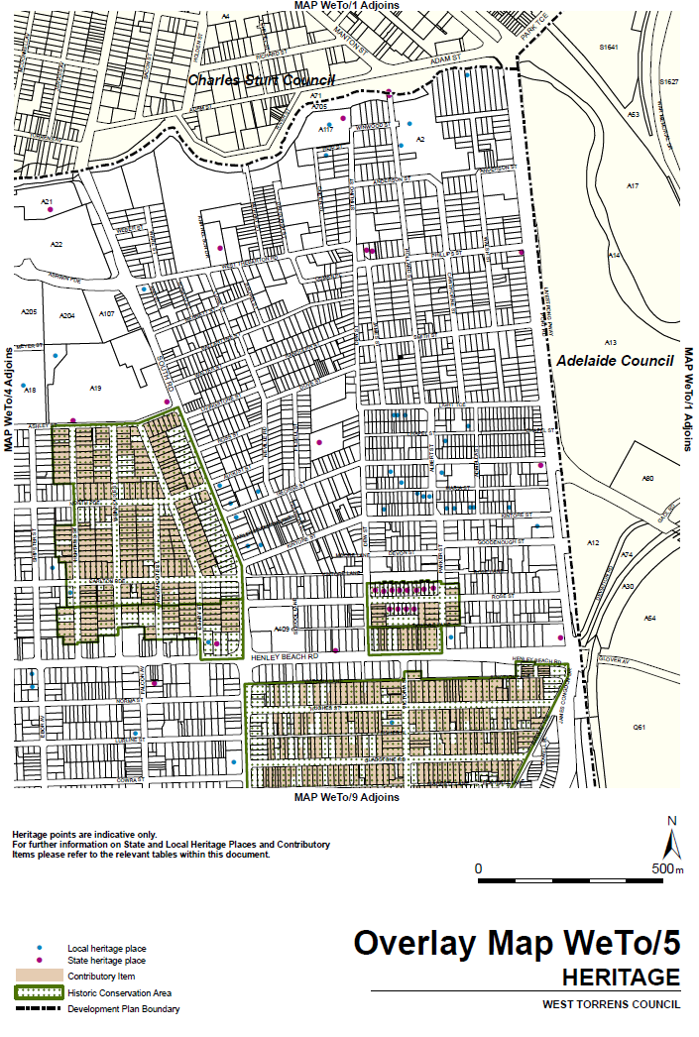
Attachment C
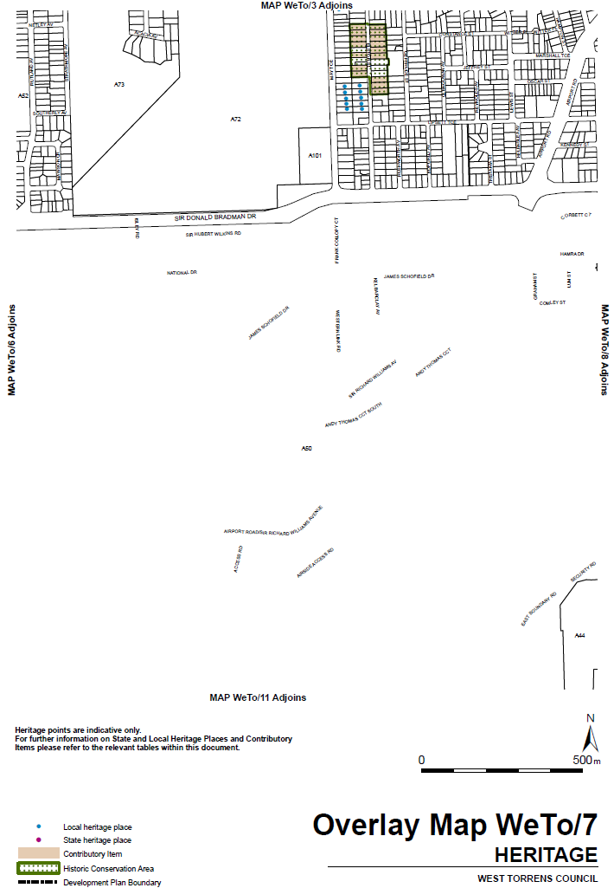
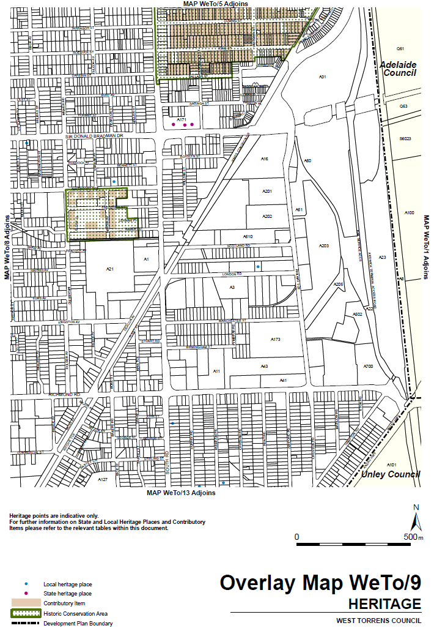

FISHERIES MANAGEMENT ACT 2007
Section 115
Ministerial Exemption ME9903001
Exemption for SARDI Employees and Specified Affiliates
TAKE NOTICE that pursuant to section 115 of the Fisheries Management Act 2007, the Research Chief, Aquatic Sciences and scientists and technical staff employed in the administrative unit of Primary Industries and Regions SA who are substantively employed in the Aquatic Sciences division of South Australian Research and Development Institute (SARDI) and Specified Affiliates of SARDI (as defined below) (hereinafter referred to as the “exemption holder”), are exempt from Sections 52, 70, 71, 73, 74(1)(b) and 79 of the Fisheries Management Act 2007, (the 'exempted activity'), subject to the conditions specified in Schedule 1, from 5 July 2018 until 30 June 2019, unless varied or revoked earlier.
Schedule 1
- Activities undertaken under this notice may only be for the purposes of the research projects listed in Table 1 of the minute provided to the Executive Director of Fisheries and Aquaculture on 1 June 2018 or for the purposes directly related to the administration of the Fisheries Management Act 2007.
- Research done pursuant to this notice may be undertaken within all waters of the State excluding:
- sanctuary and restricted access zones of marine parks (unless otherwise authorised under the Marine Parks Act 2007).
- Aquatic reserves (unless otherwise authorised under the Fisheries Management Act 2007)
- The exemption holder may take any species of fish using any type of device, other than explosives, from the waters of the State as described in clause 1 of this notice.
- The exemption holder, whilst engaged in activities pursuant to this exemption, must carry an identification card issued by SARDI.
- The exemption holder must advise the Executive Director, Fisheries and Aquaculture of any proposed activities and the dates when they will be undertaken, in writing, before commencing an activity that would, but for this exemption notice, be in contradiction of a temporary closure made under section 79 of the Fisheries Management Act 2007.
- At least 1 hour before conducting the exempted activity, the exemption holder must contact PIRSA FISHWATCH on 1800 065 522 and answer a series of questions about the exempted activity. The exemption holder will need to have a copy of this notice in their possession at the time of making the call, and be able to provide information about the area and time of the exempted activity, the vehicles and/or boats involved, and other related issues.
- The exemption holder may take cockle species (Order Veneroida) from the waters of the Adelaide Dolphin Sanctuary as part of FRDC project “Mud cockle (Katelysia spp.) stock enhancement/restoration: practical implementation and policy evaluation”, but only where those waters are also the waters of the Port River Cockle Fishing Zone as defined in the Fisheries Management Act 2007. Collected cockle specimens once taken away from the collection site cannot be released back into any waters of the State (unless otherwise authorised under the Fisheries Management Act 2007
- Before commencing the permitted activity in the Adelaide Dolphin Sanctuary, the exemption holder must provide notification of intended dates and times of the activity to one of the following:
- Verity Gibbs Manager, Adelaide Dolphin Sanctuary: verity.gibbs@sa.gov.au
- Jon Emmett Regional Coordinator Marine Parks: jon.emmett@sa.gov.au
- While engaging in the exempted activity, the exemption holder must be in possession of a copy of this exemption. Such exemption must be produced to a PIRSA Fisheries Officer if requested.
- The exemption holder must not contravene or fail to comply with the Fisheries Management Act 2007 or any regulations made under that Act, except where specifically exempted by this notice.
- In this exemption Specified Affiliates of SARDI means commercial fishing licence holders, independent contractors, research students, volunteers, and other affiliates provided the following additional conditions are met:
- The affiliates are at all times in the presence of, and under the direct supervision, of an exemption holder while undertaking the exempted activity;
- At least 1 clear business day (the “consideration period”) prior to undertaking the exempted activity the Research Chief of SARDI Aquatic Sciences (or his delegate) notifies the Executive Director Fisheries and Aquaculture (or his delegate) in writing of the names of the affiliates together with any other identifying information about the affiliates that may be specifically required from time to time;
- No objection is taken to the affiliates nominated by SARDI during the consideration period (with any such objection being communicated to the Research Chief of SARDI Aquatic Sciences or his delegate during the consideration period).
For the purpose of this instrument the delegate of the Executive Director Fisheries and Aquaculture is:
Mr Lambertus López
Manager Legal and Legislative Programs
Email: lambertus.lopez@sa.gov.au
This notice does not purport to override the provisions or operation of any other Act including but not limited to the Adelaide Dolphin Sanctuary Act 2005, Marine Parks Act 2007 or the River Murray Act 2003.
Dated: 4 July 2018
Sean Sloan
Executive Director
Fisheries and Aquaculture
Delegate of the Minister for Primary Industries and Regional Development

FISHERIES MANAGEMENT (PRAWN FISHERIES) REGULATIONS 2017
Fishing Run for the West Coast Prawn Fishery
TAKE notice that pursuant to regulation 10 of the Fisheries Management (Prawn Fisheries) Regulations 2017, the notice dated 27 February 2018 on page 1092 of the South Australian Government Gazette of 6 March 2018 prohibiting fishing activities in the West Coast Prawn Fishery is HEREBY varied such that it will not be unlawful for a person fishing pursuant to a West Coast Prawn Fishery licence to use prawn trawl nets in the areas specified in Schedule 1, during the period specified in Schedule 2, and under the conditions specified in Schedule 3.
Schedule 1
The waters of the West Coast Prawn Fishery.
Schedule 2
Commencing at sunset on 6 July 2018 and ending at sunrise on 20 July 2018.
Schedule 3
- Each licence holder must ensure that a representative sample of catch (a ‘bucket count’) is taken at least 3 times per night during the fishing activity.
- Each ‘bucket count’ sample must be accurately weighed to 7kg where possible and the total number of prawns contained in the bucket must be recorded on the daily catch and effort return.
- Fishing must cease if one of the following limits is reached:
  - A total of 14 nights of fishing are completed
  - The average catch per vessel, per night (for all 3 vessels) drops below 300 kg for two consecutive nights
  - The average ‘bucket count’ for all vessels exceeds 270 prawns per bucket on any single fishing night in the Ceduna area
  - The average ‘bucket count’ for all vessels exceeds 240 prawns per bucket on any single fishing night in the Coffin Bay area
  - The average ‘bucket count’ for all vessels exceeds 240 prawns per bucket on any single fishing night in the Venus Bay area.
- The fleet must nominate a licence holder to provide a daily update by telephone or SMS message to the Prawn Fishery Manager on 0477 396 367, to report the average prawn catch and the average prawn ‘bucket count’ for all vessels operating in the fishery.
- No fishing activity may be undertaken after the expiration of 30 minutes from the prescribed time of sunrise and no fishing activity may be undertaken before the prescribed time of sunset for Adelaide (as published in the South Australian Government Gazette pursuant to the requirements of the Proof of Sunrise and Sunset Act 1923) during the period specified in Schedule 2.
Dated: 6 July 2018
Steve Shanks
Prawn Fisheries Manager
Delegate of the Minister for Primary Industries and Regional Development

GENETICALLY MODIFIED CROPS MANAGEMENT ACT 2004
Revocation of Exemptions
PURSUANT to Section 6 (5) (a) of the Genetically Modified Crops Management Act 2004 (‘the Act’), I, Tim Whetstone, Minister for Primary Industries and Regional Development, revoke the following exemptions issued under the Act:
(1) Exemption issued to the University of Adelaide pursuant to Section 6 (2) (a) (i) of the Act dated 28 July 2010.
Dated: 5 July 2018
Tim Whetstone
Minister for Primary Industries and Regional Development

HEALTH CARE ACT 2008
Notice of Amendment
TAKE NOTICE that, pursuant to section 17(7) of the Health Care Act 2008, I, STEPHEN WADE, Minister for Health and Wellbeing, do hereby make the following variations to the constitution of the South Coast Health Advisory Council Incorporated (the constitution):
- Change the name of the Health Advisory Council from South Coast Health Advisory Council to Southern Fleurieu Health Advisory Council to better reflect the area covered by the health service.
- Change the name of the South Coast District Hospital to the Southern Fleurieu Health Service to reflect the incorporation of Community Health and Hospital services.
- 22.1 Amend to read:
In the case of the appointment of such a Member to the Advisory Council, at least 6 weeks before the first and each subsequent Annual General Meeting at which such a Member is to be appointed, the Advisory Council will by written notice request the Southern Fleurieu Area Councils to nominate to the Advisory Council 2 persons in total to be considered for appointment under this clause.
- 22.3 Amend to read:
The Advisory Council will select one of the nominees for appointment pursuant to this clause. In the event that no nominations are received from the Southern Fleurieu Area Councils by the date requested by the Advisory Council, then the Advisory Council will appoint a suitable person to be that Member
- In Part 5 (Definitions) of the constitution, change the following definitions to read:
“Community” is a collective term referring to persons who live in the Local Area as defined in this Constitution or who live outside of the Local Area but who use or may use services provided by or associated with the Southern Fleurieu Health Service sites of Country Health SA Hospital Incorporated, a hospital incorporated under the Health Care Act 2008.
“Southern Fleurieu Area Councils” means the local government area of the City of Victor Harbor, Yankalilla District Council and Alexandrina Council (Coastal Wards).
“Southern Fleurieu Health Service sites of Country Health SA Hospital Incorporated” includes the sites from which health services are or were provided by the hospital incorporated under the South Australian Health Commission Act 1976 as South Coast District Hospital Incorporated together with such additional sites from which health services may be provided to persons who live in the Community as may from time to time be determined by Country Health SA Hospital Incorporated.
Dated: 7 July 2018
Hon Stephen Wade
Minister for Health and Wellbeing

HOUSING IMPROVEMENT ACT 2016
Section 25
Rent Control
In the exercise of the powers conferred by the Housing Improvement Act 2016, I hereby fix the maximum rental per week which shall be payable subject to Section 55 of the Residential Tenancies Act 1995, in respect of each house described in the following table. The amount shown in the said table shall come into force on the date of this publication in the Gazette.
Address of Premises | Allotment  Section | Certificate of Title  Volume/Folio | Maximum Rental  per week payable
14 Kings Avenue, Burnside SA 5066 | Allotment 141 Deposited Plan 18641 | CT5146/668 | $0.00  Unfit for Human Habitation
37 Jane Place, Tanunda SA 5352 | Allotment 110 Filed Plan 36577 Hundred of Moorooroo | CT5315/100 | $0.00  Unfit for Human Habitation
16 Adelaide Street, Kalangadoo SA 5278 | Allotment 62 Town of Kalangadoo Hundred of Grey | CT5775/984 | $0.00  Unfit for Human Habitation
Dated: 12 July 2018
John Herrmann
Housing Regulator and Registrar
Office of Housing Regulation, Housing SA
Delegate of Minister for Human Services

HOUSING IMPROVEMENT ACT 2016
Section 25
Rent Control Revocations
I am satisfied that each of the houses described hereunder has ceased to be unsafe or unsuitable for human habitation for the purposes of the Housing Improvement Act 2016, notice is hereby given that, in exercise of the powers conferred by the said Act, the Minister for Human Services Delegate does hereby revoke the said Rent Control in respect of each property.
Address of Premises | Allotment  Section | Certificate of Title  Volume/Folio
3/ 34 Riddoch Street, PENOLA SA 5277 | Allotment 101 Deposited Plan 92670  Hundred of Penola | CT5194/377, CT6127/966
58 Nineteenth Street, Renmark SA 5341 | Allotment 162 Filed Plan 18511  Renmark Irrigation District | CT5157/824
94 John Lewis Drive, Port Broughton SA 5522 | Lot 100 Primary Community Plan 40289 Hundred of Mundoora | CT6174/187
Dated: 12 July 2018
John Herrmann
Housing Regulator and Registrar
Office of Housing Regulation, Housing SA
Delegate of Minister for Human Services

Justices of the Peace Act 2005
Section 4
Notice of Appointment of Justices of the Peace for South Australia
Notice by the Commissioner for Consumer Affairs
I, Dini Soulio, Commissioner for Consumer Affairs, delegate of the Attorney-General, pursuant to section 4 of the Justices of the Peace Act 2005, do hereby appoint the people listed as Justices of the Peace for South Australia as set out below for a period of ten years commencing from 23 July 2018 and expiring on 22 July 2028 it being a condition of appointment that the Justices of the Peace must take the oaths required of a justice under the Oaths Act 1936 and return the oaths of office form to Justice of the Peace Services within three months after the date of appointment:
Daniel Roy CREGAN
Stacey Jane FRANKLIN
Alexander Thomas GLOVER
Leanne Faye HADELER
Andrew William HAMDEN
Loretta Ann KAHMANN
Theresa Diane KINGSTON
Michele LANGFORD
Nicholas Paul LATTY
Jung Eun LEE
Michael John MCMAHON
Robin Dennis MITCHELL
Elizabeth Anne NEIL
Thien Ngoc NGUYEN
Carolyn Louise PIPER
Beatrice Salvatrice Paola RUGARI
Sharon Fay RYAN
Graeme Iain SMITH
Michelle Joy STENING
Zoe Jane THWAITES
Dated: 3 July 2018
Dini Soulio
Commissioner for Consumer Affairs
Delegate of the Attorney-General

JUSTICES OF THE PEACE ACT 2005
Section 10(2)
Notice to Revoke the Suspension from Office
Notice by the Commissioner for Consumer Affairs
I, Dini Soulio, Commissioner for Consumer Affairs, delegate of the Attorney-General, pursuant to section 10(2) of the Justices of the Peace Act 2005, do hereby revoke the suspension of Mary Lou Williams from the office of Justice of the Peace for South Australia effective from the date of this notice.
Dated: 3 July 2018
Dini Soulio
Commissioner for Consumer Affairs
Delegate of the Attorney-General

South Australia
Liquor Licensing (Dry Areas) Notice 2018
under section 131(1) of the Liquor Licensing Act 1997
1—Short title
This notice may be cited as the Liquor Licensing (Dry Areas) Notice 2018.

2—Commencement
This notice comes into operation once this Notice has been published in the Government Gazette.

3—Interpretation
(1) In this notice—
principal notice means the Liquor Licensing (Dry Areas) Notice 2015 published in the Gazette on 5.1.15, as in force from time to time.
(2) Clause 3 of the principal notice applies to this notice as if it were the principal notice.

4—Consumption etc of liquor prohibited in dry areas
(1) Pursuant to section 131 of the Act, the consumption and possession of liquor in the area described in the Schedule is prohibited in accordance with the provisions of the Schedule.
(2) The prohibition has effect during the periods specified in the Schedule.
(3) The prohibition does not extend to private land in the area described in the Schedule.
(4) Unless the contrary intention appears, the prohibition of the possession of liquor in the area does not extend to—
(a) a person who is genuinely passing through the area if—
(i) the liquor is in the original container in which it was purchased from licensed premises; and
(ii) the container has not been opened; or
(b) a person who has possession of the liquor in the course of carrying on a business or in the course of his or her employment by another person in the course of carrying on a business; or
(c) a person who is permanently or temporarily residing at premises within the area or on the boundary of the area and who enters the area solely for the purpose of passing through it to enter those premises or who enters the area from those premises for the purpose of leaving the area.
(5) The Schedule is in substitution for Schedule—Port Lincoln Area 1 in the principal notice.

Schedule—Port Lincoln Area 1
1—Extent of prohibition
The consumption of liquor is prohibited and the possession of liquor is prohibited.

2—Period of prohibition
Continuous provided that where -
- an event of historic, cultural, traditional or major community significance or showcasing local and/or regional produce and culture or promoting tourism is held within the area; and
- the consumption and possession of liquor within the area (or a defined portion of the area) are authorized for a specified period during the event by the City of Port Lincoln,
the prohibition does not apply in the area (or defined portion of the area) during that specified period.

3—Description of area
The area in Port Lincoln bounded as follows: commencing at the point at which the prolongation in a straight line of the northern boundary of Lot 2 FP 3800 intersects the low water mark on the western side of the Spencer Gulf, then generally southerly and south-easterly along the low water mark to the western side of the Town Jetty, then around the outer boundary of the Jetty back to the low water mark in the eastern side of the Jetty, then south-easterly, easterly, northerly and easterly along the low water mark to its intersection with the prolongation in a straight line of the eastern boundary of Lot 60 DP 53037, then southerly along that prolongation to the northern boundary of Lot 60, then generally westerly, southerly and westerly along that boundary of Lot 60 to the point at which the boundary of Lot 60 meets the eastern boundary of Porter street, then generally south-westerly along that boundary of Porter street to its intersection with the southern boundary of Liverpool Street, then north-westerly along that boundary of Liverpool Street and the southern boundary of Hallett Place to the eastern boundary of New West Road, then south-westerly along that boundary of New West Road to it intersection with the prolongation in a straight line of the western boundary of Tennyson Terrace, then generally north-westerly along that prolongation and boundary of Tennyson Terrace and the western boundary of Gloucester terrace to the point at which that western boundary of Gloucester Terrace intersects the prolongation in a straight line of the northern boundary of Bishop Street, then north-easterly along that prolongation and boundary of Bishop Street to the eastern boundary of Lot 87 FP 105569, then generally north-westerly and northerly along the eastern boundary of Lot 8 and the eastern boundaries of the adjoining allotments (including the eastern and boundary of Walker Street) to the point at which the eastern boundary of Lot 2 FP 3800 meets the northern boundary of that Lot, then along the prolongation in a straight line of the northern boundary of Lot 2 to the point of commencement.

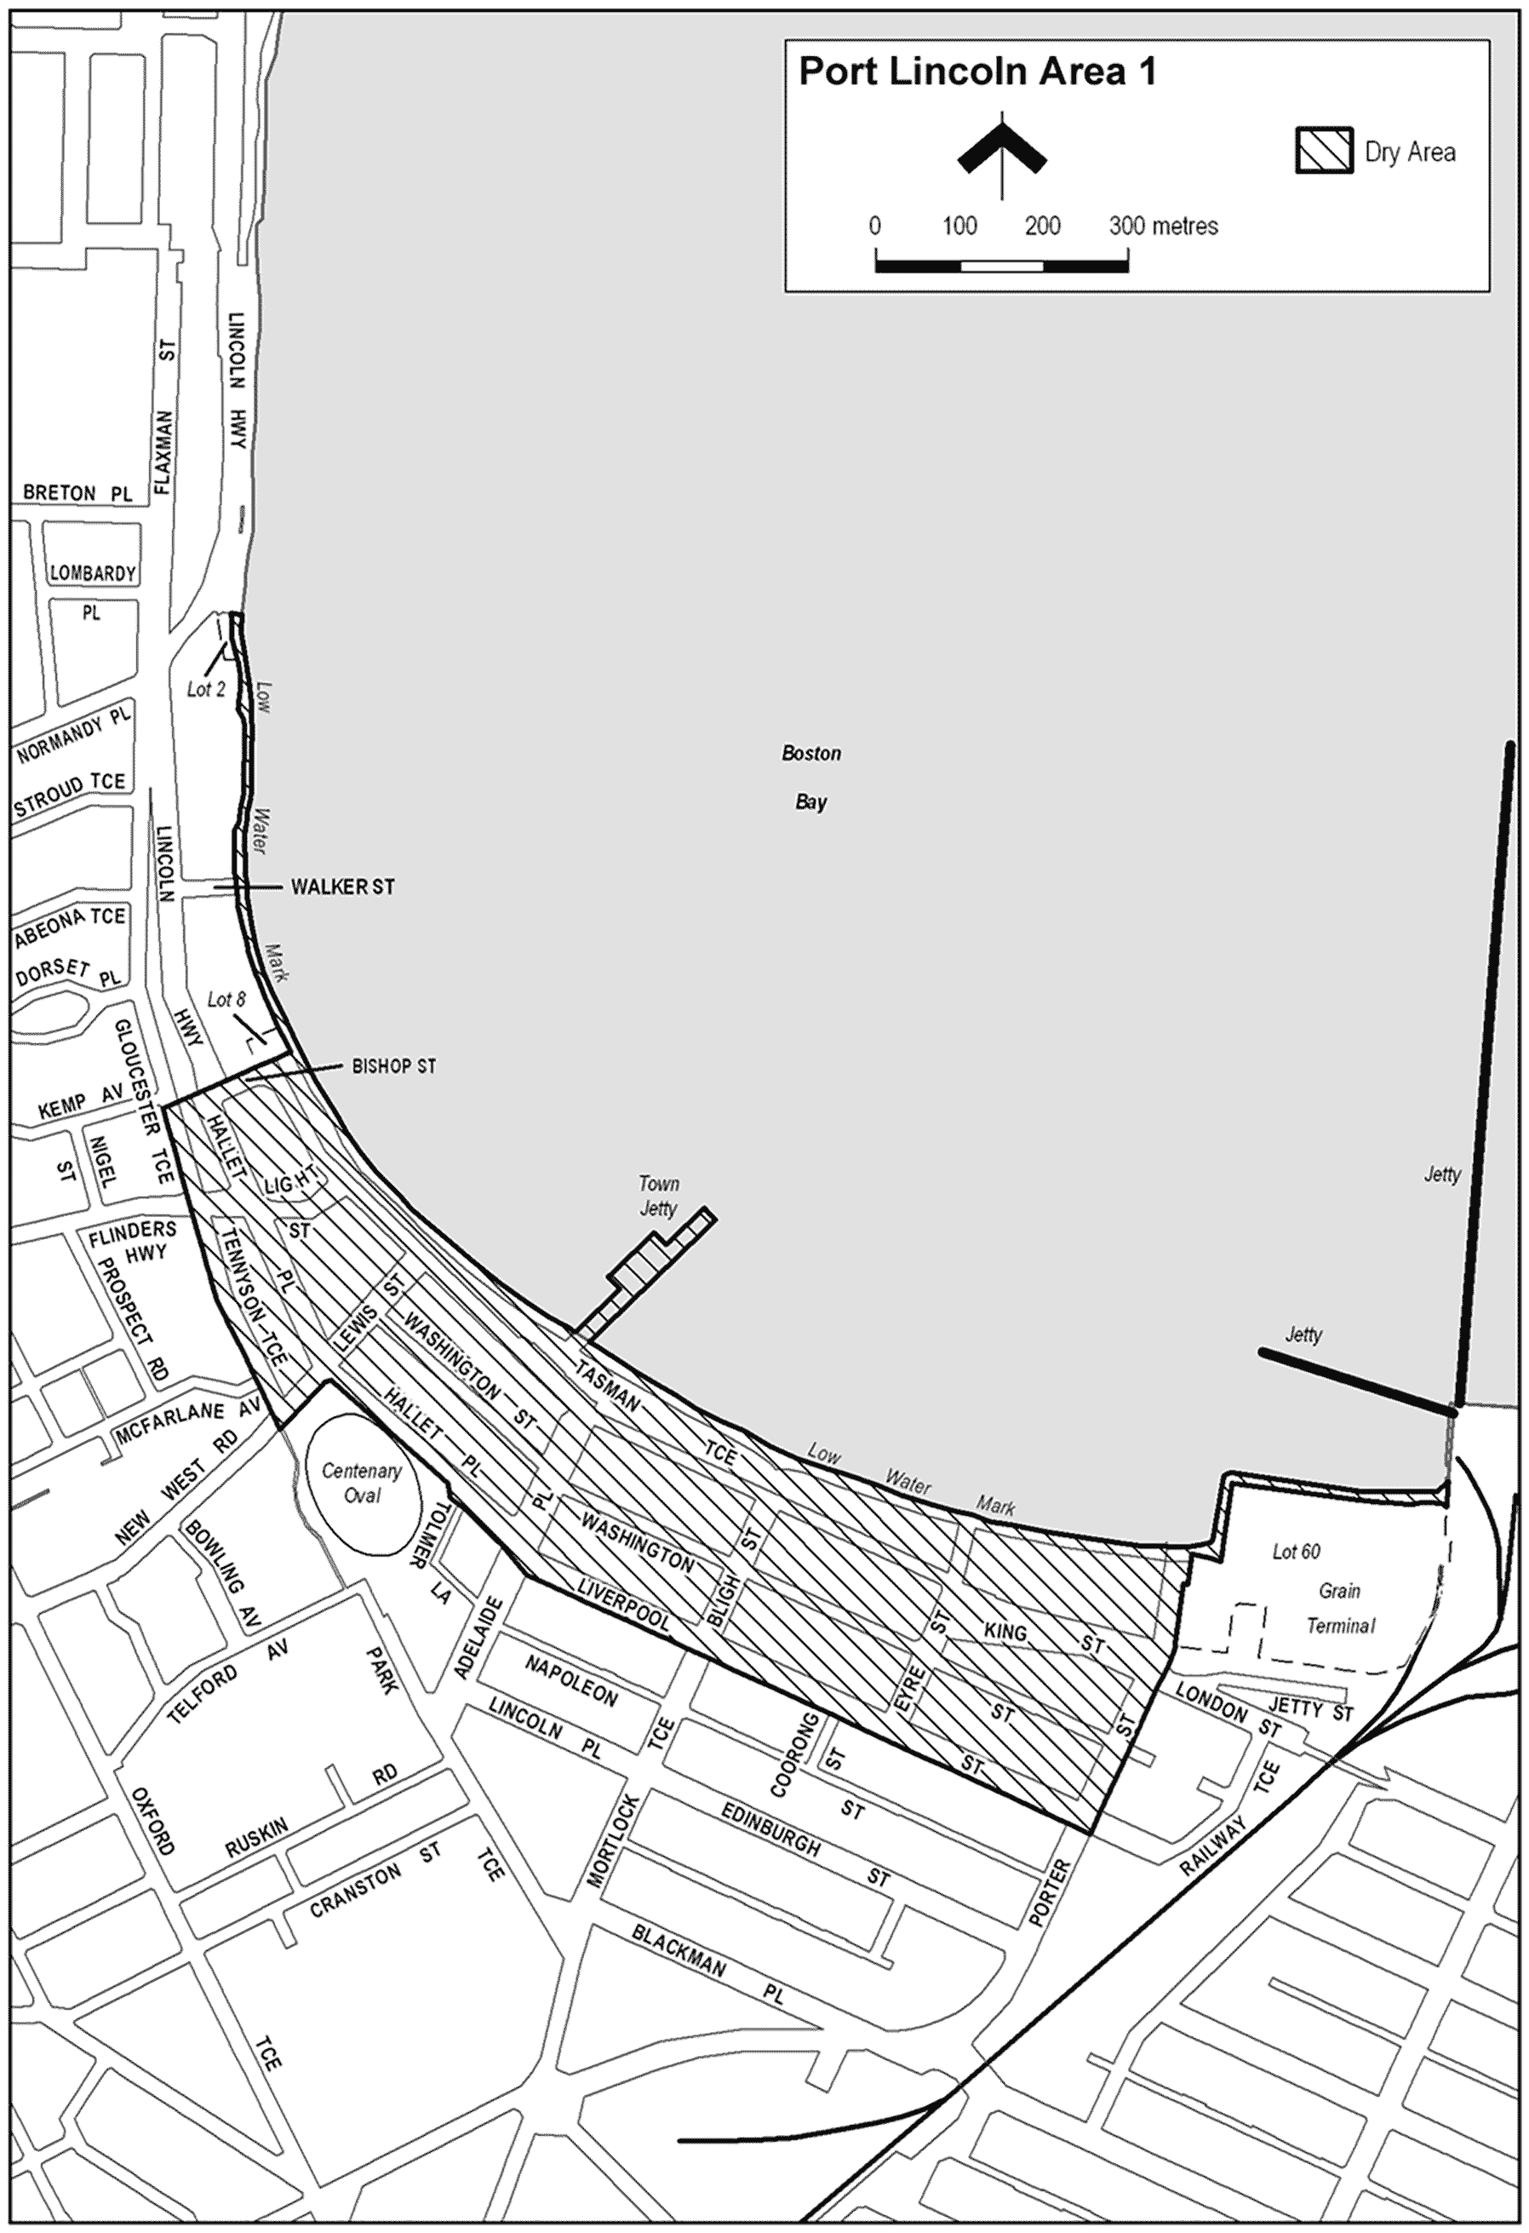

Made by the Attorney General
on 30 June 2018

South Australia
Liquor Licensing (Dry Areas) Notice 2018
under section 131(1a) of the Liquor Licensing Act 1997

1—Short title
This notice may be cited as the Liquor Licensing (Dry Areas) Notice 2018.
2—Commencement
This notice comes into operation on 26 January 2019.
3—Interpretation
(1) In this notice—
principal notice means the Liquor Licensing (Dry Areas) Notice 2015 published in the Gazette on 5.1.15, as in force from time to time.
(2) Clause 3 of the principal notice applies to this notice as if it were the principal notice.

4—Consumption etc of liquor prohibited in dry areas
(1) Pursuant to section 131 of the Act, the consumption and possession of liquor in the area described in the Schedule is prohibited in accordance with the provisions of the Schedule.
(2) The prohibition has effect during the periods specified in the Schedule.
(3) The prohibition does not extend to private land in the area described in the Schedule.
(4) Unless the contrary intention appears, the prohibition of the possession of liquor in the area does not extend to—
(a) a person who is genuinely passing through the area if—
(i) the liquor is in the original container in which it was purchased from licensed premises; and
(ii) the container has not been opened; or
(b) a person who has possession of the liquor in the course of carrying on a business or in the course of his or her employment by another person in the course of carrying on a business; or
(c) a person who is permanently or temporarily residing at premises within the area or on the boundary of the area and who enters the area solely for the purpose of passing through it to enter those premises or who enters the area from those premises for the purpose of leaving the area.
(5) The Schedule is in substitution for Schedule—Wilmington Area 1 in the principal notice.
Schedule—Wilmington Area 1

1—Extent of prohibition
The consumption of liquor is prohibited and the possession of liquor is prohibited.
2—Period of prohibition
From 12 noon on 26 January 2019 to 12 noon on 27 January 2019.
3—Description of area
The area in and adjacent to Wilmington bounded as follows: commencing at the intersection of the south-western boundary of Maria Terrace and the south-eastern boundary of Cudmore Terrace (at the south-eastern corner of Section 536 Hundred of Willochra), then travelling generally north-westerly along the western boundary of Maria Terrace until it intersects the southern boundary of Section 3 Hundred of Willochra, then north-easterly along that boundary until it intersects the south-western boundary of Oval Road, then generally north-westerly along that western boundary of Oval Road to the point at which the prolongation in a straight line of Oval Road intersects the northern boundary of Horrocks Pass Road, then easterly along that northern boundary of Horrocks Pass Road to the point at which the northern boundary of Horrocks Pass Road meets the south-western boundary of Gunyah Road, then north-westerly along the western boundary of Gunyah Road to the point at which it is intersected by the prolongation in a straight line of the north-western boundary of Beautiful Valley Road, then north-easterly along the northern boundary of Beautiful Valley Road to the south-western boundary of Section 716 Hundred of Willochra, then south-easterly along the prolongation in a straight line of that boundary of Section 716 to the south-eastern boundary of Horrocks Highway, then south-westerly along that boundary of Horrocks Highway to the point at which it intersects the north-eastern boundary of Alexis Road, then south-easterly along the eastern boundary of Alexis Road to the point at which it is intersected by the prolongation in a straight line of the south-eastern boundary of Gogler Road, then travelling south-westerly along the southern boundary and thence north-westerly along the western boundary of Gogler Road to a point where it intersects with the south-eastern boundary of Parkville Avenue, then in a south westerly direction along the southern boundary of Parkville Avenue to a point where the prolongation in a straight line of that boundary meets the intersection of the south-western boundary of Wilds Way and western boundary of Horrocks Highway, then north-westerly along the western boundary of Horrocks Highway until it intersects with the southern boundary of Cudmore Terrace, then south westerly along that boundary to the point of commencement.
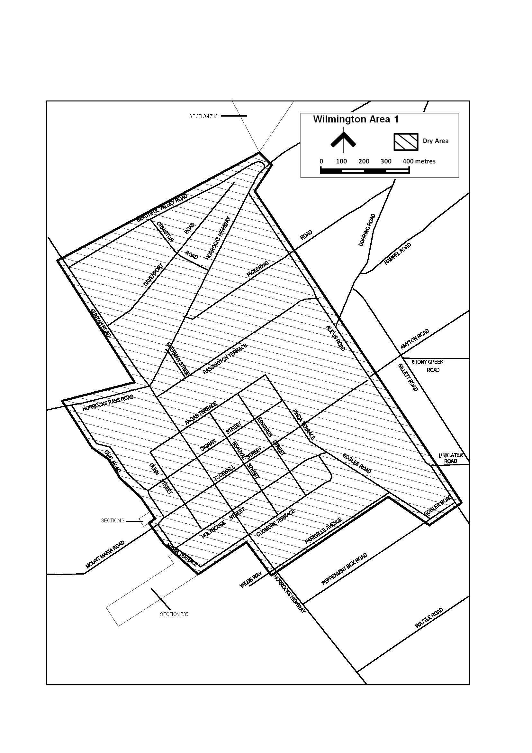
Made by the Liquor and Gambling Commissioner
on 6 July 2018

Mining Act 1971
Notice pursuant to Section 28(5) of the Mining Act 1971
Notice is hereby given in accordance with Section 28(5) of the Mining Act 1971 that the delegate of the Minister for Energy and Mining intends to grant Exploration Licences over the areas described below.
Applicant: Quantum Graphite Operations Pty Ltd (Subject to Deed of Company Arrangement)
Location: Uley Area – approx. 25 km southwest of Port Lincoln
Term: Two years
Area in km²: 76
Reference number: 2016/00097
Applicant: BRRS Mining Pty Ltd
Location: Yarrah area – approx. 35 km northwest of Port Augusta
Pastoral Leases: Yadlamalka, Wilkatana
Term: One year
Area in km²: 279
Reference number: 2018/00100
Applicant: Macallum Group Ltd
Location: Allandale Station area – approx. 30 km southeast of Oodnadatta
Pastoral Leases: Allandale
Term: One year
Area in km²: 601
Reference number: 2018/00104
Applicant: Macallum Group Ltd
Location: Macumba area – approx. 210 km northeast of Coober Pedy
Pastoral Leases: Macumba, Allandale
Term: One year
Area in km²: 735
Reference number: 2018/00106
Applicant: Vectorex Pty Ltd
Location: Mosquito Hill area – approx. 55 km south-southeast of Adelaide
Term: One year
Area in km²: 78
Reference number: 2018/00107
Applicant: Petratherm Limited
Location: Mitchellville area – approx. 20 km northeast of Cowell
Term: One year
Area in km²: 243
Reference number: 2018/00108
Plans and co-ordinates can be found on the Department for Energy and Mining website:
http://energymining.sa.gov.au/minerals/exploration/public_notices or by contacting Mineral Tenements on 08 8429 2572.
Community information on mineral exploration licence processes and requirements under the Mining Act 1971 is available from: http://energymining.sa.gov.au/minerals/land_access/community_information or hard copy on request to Mineral Tenements.
J Martin
Mining Registrar
Department for Energy and Mining
Delegate of the Minister for Energy and Mining

MINING ACT 1971
Notice pursuant to Section 29 (1a) and 29 (5) (b) (ii) of the Mining Act 1971
NOTICE is hereby given that the notice under the Mining Act 1971 (the Act) published on 28th November 2017 in the South Australian Government Gazette at page 4734, is varied in respect of land referred to in the Schedule.
Notice is further hereby given that:
- Pursuant to subsection 29 (1a) of the Act no applications may be made for corresponding licences over land identified in Columns 1, 2, 3 and 6 of the Schedule during the succeeding period listed in Column 4 of the Schedule.
- Applications for corresponding licences may be made during the period listed in Column 5 of the Schedule and during that period, pursuant to subsection 29 (5) (b) (ii) of the Act, subsection 29 (4) of the Act will not apply in relation to any such applications. (See Note 1).
- Plans and coordinates for the land identified in Columns 1, 2, 3 and 6 of the Schedule can be obtained at the Department for Energy and Mining (DEM) Minerals website http://www.minerals.energymining.sa.gov.au/exploration/public_notices or by phoning Mineral Tenements on (08) 8463 3103.
- This Notice becomes effective on 12 July 2018.
The Schedule
Column 1  ERA No | Column 2  Locality | Column 3  Area (km²) | Column 4  Moratorium Period | Column 5  Application Open Dates | Column 6  Specific criteria
995 | Waurea area - approx 165 km NE of Streaky Bay | 978 | 04/02/2018 to 02/09/2018 | 03/09/2018 to 07/09/2018 | -
Dated: 12 July 2018
M Spikin
A/General Manager Mineral Tenements
Mining Registrar
Delegate of the Minister for Energy and Mining
NOTE 1: The effect of this notice is that:
- No applications for a corresponding licence may be made during the succeeding period.
- The succeeding period will always expire on a Sunday. From the immediately following Monday to the immediately following Friday, applications for a corresponding licence may be made (the application week).
- Applications made in the application week will not be dealt with under subsection 29(4) i.e., on a first come first served basis, but under subsection 29(6) i.e., on a merits basis.
- If no applications are made in the application week, the land in question will cease to be subject to the notice and any applications for an exploration licence made after that time will be dealt with under subsection 29(4).

MINING ACT 1971
Notice pursuant to Section 29 (1a) and 29 (5) (b) (ii) of the Mining Act 1971
NOTICE is hereby given that the notice under the Mining Act 1971 (the Act) published on 28th November 2017 in the South Australian Government Gazette at page 4735, is varied in respect of land referred to in the Schedule.
Notice is further hereby given that:
- Pursuant to subsection 29 (1a) of the Act no applications may be made for corresponding licences over land identified in Columns 1, 2, 3 and 6 of the Schedule during the succeeding period listed in Column 4 of the Schedule.
- Applications for corresponding licences may be made during the period listed in Column 5 of the Schedule and during that period, pursuant to subsection 29 (5) (b) (ii) of the Act, subsection 29 (4) of the Act will not apply in relation to any such applications. (See Note 1).
- Plans and coordinates for the land identified in Columns 1, 2, 3 and 6 of the Schedule can be obtained at the Department for Energy and Mining (DEM) Minerals website http://www.energymining.sa.gov.au/exploration/public_notices or by phoning Mineral Tenements on (08) 8463 3103.
- This Notice becomes effective on 12 July 2018.
The Schedule
Column 1  ERA No | Column 2  Locality | Column 3  Area (km²) | Column 4  Moratorium Period | Column 5  Application Open Dates | Column 6  Specific criteria
996 | Hallet area – approx. 50 km north of Burra | 103 | 22/05/2018 to 02/09/2018 | 03/09/2018 to 07/09/2018 | -
Dated: 12 July 2018
M Spikin
A/General Manager Mineral Tenements
Mining Registrar
Delegate of the Minister for Energy and Mining
NOTE 1: The effect of this notice is that:
- No applications for a corresponding licence may be made during the succeeding period.
- The succeeding period will always expire on a Sunday. From the immediately following Monday to the immediately following Friday, applications for a corresponding licence may be made (the application week).
- Applications made in the application week will not be dealt with under subsection 29(4) i.e., on a first come first served basis, but under subsection 29(6) i.e., on a merits basis.
- If no applications are made in the application week, the land in question will cease to be subject to the notice and any applications for an exploration licence made after that time will be dealt with under subsection 29(4).

MINING ACT 1971
Section 73G
Notice is hereby given in accordance with Section 73G of the Mining Act 1971 and Regulation 81 of the Mining Regulations 2011, that a mine operations plan for the undermentioned private mine has been received.
Proprietor: Craiglee Pty Ltd
Private Mine: PM 122 – Manoora Freestone Quarry
Location: Section 310, Hundred of Saddleworth
Area: 34 hectares
Purpose: Recovery of Construction Materials (Sandstone)
Reference: 1972/01353
To arrange inspection of the mine operations plan draft objectives and criteria please phone the Department for Energy and Mining on 8429 2572.
A copy of the mine operations plan draft objectives and criteria has been provided to the Clare & Gilbert Valleys Council and an electronic copy can be found on the Department for Energy and Mining website:
http://minerals.dem.sa.gov.au/mining/public_notices_mining
Written submissions in relation to the draft objectives and criteria are invited to be received at the Department for Energy and Mining, Mining Regulation, Attn: Business Support Officer, GPO Box 320 ADELAIDE 5001 or dem.miningregrehab@sa.gov.au no later than 15 August 2018.
When you make a written submission, that submission becomes a public record. Your submission will be provided to the applicant and may be made available for public inspection.
Greg Marshall
Director Mining Regulation
Department for Energy and Mining
Delegate of the Director of Mines

NATIONAL PARKS AND WILDLIFE ACT 1972
Innamincka Regional Reserve Management Plan
I, David Speirs, Minister for Environment and Water, hereby give notice under the provisions of section 38 of the National Parks and Wildlife Act 1972 that, on 5 June 2018 I adopted a plan of management for Innamincka Regional Reserve.
The plan may be inspected or obtained at the following locations:
- Department for Environment and Water (DEW) website - http://www.environment.sa.gov.au/parkmanagementplans
- Natural Resources Centre, Adelaide - Ground floor, 81-95 Waymouth Street, Adelaide SA 5000
- Natural Resources Centre SA Arid Lands - Level 1, 9 Mackay Street, Port Augusta SA 5700
David Speirs MP
Minister for Environment and Water

NATIONAL PARKS AND WILDLIFE ACT 1972
Tallaringa Conservation Park Management Plan
I, David Speirs, Minister for Environment and Water, hereby give notice under the provisions of section 38 of the National Parks and Wildlife Act 1972 that, on 4 June 2018, I adopted a plan of management for Tallaringa Conservation Park.
The plan may be inspected or obtained at the following locations:
- Department for Environment and Water (DEW) website - http://www.environment.sa.gov.au/parkmanagementplans.
- Natural Resources Centre, Adelaide - Ground floor, 81-95 Waymouth Street, Adelaide SA 5000
- Natural Resources Centre, Alinytjara Wilurara - 50B McKenzie Street, Ceduna, SA, 5690
David Speirs MP
Minister for Environment and Water

National Parks and Wildlife (National Parks) Regulations 2016
Cycling within Reserves
PURSUANT of Regulations 9 and 10(1) of the National Parks and Wildlife (National Parks) Regulations 2016, I John Erwin Schutz, Director of National Parks and Wildlife, hereby grant permission for the riding of bicycles on the designated tracks and trails within Anstey Hill Recreation Park proclaimed under the National Parks and Wildlife Act 1972.
Designated trails are shown in the map below:
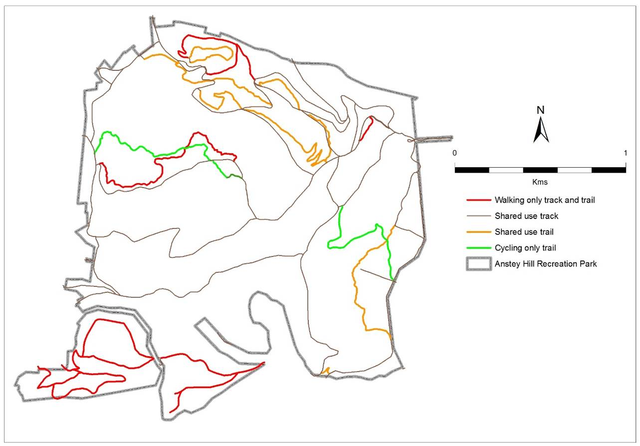
Dated: 22 January 2018
J. E. Schutz
Director of National Parks and Wildlife

Petroleum and Geothermal Energy Act 2000
Delegation under Section 7(1a)
I, ROBERT IVAN LUCAS, Treasurer in the State of South Australia, under Section 7 (1a) of the Act, do hereby delegate to the persons who, from time to time hold, occupy or perform the following positions:
- Chief Executive, the Department for Energy and Mining.
- Executive Director, Energy Resources Division, the Department for Energy and Mining
- Deputy Executive Director Energy Resources & Commercial, Energy Resources Division, the Department for Energy and Mining
Those Ministerial powers or functions pursuant to the following Sections:
Petroleum and Geothermal Energy Act — sections 43, and 44
All previous instruments of delegation relating to these sections are hereby revoked, pursuant to section 7(1a) (b) of the Act.
Dated: 25 June 2018
Robert Ivan Lucas
Treasurer

Petroleum and Geothermal Energy Act 2000
Delegation under Section 7(1)(a)
I, Hon Dan van Holst Pellekaan MP, Minister for Energy and Mining in the State of South Australia, under Section 7 (1)(a) of the Act, do hereby delegate with effect from 1 July 2018, to the persons who, from time to time hold, occupy or perform the following positions, Ministerial powers or functions pursuant to the following Sections and Regulations and the power of sub-delegation pursuant to Section 7(2) of the Act:
- To the Chief Executive, Department for Energy and Mining.
- To the Executive Director, Energy Resources Division, Department for Energy and Mining.
Petroleum and Geothermal Energy Act 2000 — all sections except: 35(2), 49(1), 49(2), 52, 55(1), 55(3), 55(6), 55(7), 55(9), 111(2), 125(4), 126(1), 126(4), 127(1), 127(2) and 127(3).
Regulations under the Petroleum and Geothermal Energy Act 2000 – all regulations.
The previous instrument of delegation, published in the South Australian Government Gazette on 11 April 2017 (page 1042) is hereby revoked with effect from 1 July 2018 pursuant to Section 7(1)(b) of the Act.
Dated: 29 June 2018
Hon Dan van Holst Pellekaan MP
Minister for Energy and Mining

Petroleum and Geothermal Energy Act 2000
Sub-delegation under Section 7(2)
I, BARRY A. GOLDSTEIN, Executive Director, Energy Resources Division, Department for Energy and Mining in the State of South Australia, do hereby sub-delegate to the persons who hold, occupy or perform the positions indicated below within the Energy Resources Division, Ministerial powers or functions pursuant to the following Sections and Regulations, delegated to me by instrument dated 29 June 2018 and effective 1 July 2018:
Petroleum and Geothermal Energy Act 2000:
Director, Engineering Operations sections expressly and only for engineering and geophysical operations sections 27(2), 74(3), 74(4), 86(4), 88(1) and 134 (expressly and only for the purpose of exercising powers under the regulations listed below).
Director, Geoscience and Exploration section 134 (expressly and only for the purpose of exercising powers under the regulations listed below).
General Manager, Licensing and Legislation section 134 (expressly and only for the purpose of exercising powers under the regulations listed below).
Petroleum and Geothermal Energy Regulations 2013:
Director, Engineering Operations regulations:
24(1), 30(4), 30(6), 31(5), 33(1), 33(3)(e), 33(6), 41(1), 42(1), 43(1), 44(1), 45(1), 46(3), 46(4) and 47(1).
Director, Geoscience and Exploration, regulations:
25(2)(b), 33(1), 33(3)(e), 33(6), 38(2)(b), 39(1), 40(1), 45(1), 47(1), 48(1), 48(3) and 49(4).
General Manager, Licensing and Legislation, regulations:
33(1), 33(3)(e), 33(6) and 47(1).
These sub-delegations are to be exercised in accordance with the published Petroleum and Geothermal Energy Act compliance Policy available at: https://sarigbasis.pir.sa.gov.au/WebtopEw/ws/samref/sarig1/wcir/Record?r=0&m=1&w=catno=2040182
The previous instrument of sub-delegation dated 3 April 2017 and published in the South Australian Government Gazette dated 11 April 2017, is hereby revoked pursuant to section 7(1)(b) of the Act with effect from 2 July 2018.
Dated: 2 July 2018
Barry A. Goldstein
Executive Director
Energy Resources Division
Department for Energy and Mining
Delegate of the Minister for Energy and Mining

RETAIL AND COMMERCIAL LEASES ACT 1995
Exemption under Section 77
I, David Gregory Pisoni, Minister for Industry and Skills, do hereby exempt the retail shop lease described below from section 30 of the Retail and Commercial Leases Act 1995, provided that this exemption shall lapse if Shahin Enterprises Pty Ltd ACN 008 150 543 ceases to be the lessee under the said lease.
Land Leased | Commencement Date of Lease | Current Lessor | Current Lessee
Certificate of Title Volume 6129 Folio 19 | 20 August 2000 | Seaford Mobil Pty Ltd ACN 132 583 601 | Shahin Enterprises Pty Ltd ACN 008 150 543
Dated: 2 July 2018
The Hon David Pisoni
Minister for Industry and Skills

WILDERNESS PROTECTION ACT 1992
Public Submissions - Proposal to Proclaim an Addition to the Cape Torrens Wilderness Protection Area
I, DAVID SPEIRS, Minister for Environment and Water, hereby give notice under the provisions of section 22(6)(e) of the Wilderness Protection Act 1992, that the public submissions regarding the proposal to proclaim an addition to the Cape Torrens Wilderness Protection Area are now available for public viewing.
The land to be added to the wilderness protection area is Allotment 1 in Deposited Plan 23502, Hundred of Borda.
Copies of the submissions may be viewed at or obtained from the offices of the Department for Environment, Water and Natural Resources at:
- Natural Resource Centre - Adelaide, Ground Floor, 81-95 Waymouth Street, Adelaide, S.A. 5000.
- Natural Resource Centre - Kingscote, 37 Dauncey Street, Kingscote, S.A., 5223.
Or by contacting Elspeth Young, Coordinator, Protected Area System, Protected Areas Unit, Department for Environment and Water at elspeth.young@sa.gov.au.
Dated: 25 June 2018
David Speirs MP
Minister for Environment and Water

CAMPBELLTOWN CITY COUNCIL
Adoption of Valuations and Declaration of Rates
NOTICE is hereby given that at its meeting held on 3 July 2018, the Corporation of the City of Campbelltown for the financial year ending 30 June 2019 resolved:
Adoption of Valuation
To adopt for rating purposes the most recent valuations supplied by the Valuer-General of the capital value of land within the Council’s area totalling $12 815 775 200.
Declaration of General Rate for the Year 2018-2019
To declare a general rate of 0.300049 cents for each dollar of the assessed capital value of rateable land within the Council’s area.
Minimum Rate
To fix a minimum amount payable by way of general rates of $959 in respect of rateable land within the Council’s area.
Declaration of Separate Rate for the Year 2018-2019
To declare a separate rate of 0.193814 cents for each dollar of the assessed capital value of rateable property with an address along the eastern side of Lower North East Road (between Downer Avenue and Hambledon Road) with the aim of raising $25 050 to recover the construction and maintenance costs for the toilet facility at 6A Denmead Avenue, Campbelltown.
Natural Resources Management Levy
To declare a separate rate of 0.009737 cents in the dollar on the capital value of all rateable land within the Council’s area to reimburse the Council for amounts contributed to the Adelaide and Mount Lofty Ranges Natural Resources Management Board.
P Di Iulio
Chief Executive Officer

CITY OF MARION
Adoption of Valuations and Declaration of Rates
Notice is hereby given that on 26 June 2018 the Council of the City of Marion, pursuant to the provisions of the Local Government Act 1999, for the year ending 30 June 2019:
Adoption of Valuations
- adopted the capital valuations to apply in its area for rating purposes for the 2018-2019 financial year as supplied by the Valuer-General totalling $21,032,242,140.
Declaration of Rates
- declared differential general rates in the dollar based on capital value as follows:
- 0.343301 cents in the dollar on rateable land of Category 1 – Residential, Category 7 – Primary Production and Category 9 – Other.
- 0.635107 cents in the dollar on rateable land of Category 2 – Commercial Shop, Category 3 – Commercial Office, Category 4 – Commercial Other.
- 0.583612 cents in the dollar on rateable land of Category 5 – Industrial Light, Category 6 – Industrial Other.
- 0.686602 cents in the dollar on rateable land of Category 8 – Vacant Land.
- resolved that the minimum amount payable by way of general rates in respect of rateable land within the area for the year ending 30 June 2019 be $1,040.00; and
- declared a Separate Rate of 0.009892 cents in the dollar on all rateable land within the Adelaide and Mount Lofty Ranges Natural Resources Management Board Area within the area.
The Council resolved that rates will be payable in four equal or approximately equal instalments, and that the due dates for those instalments will be 3 September 2018, 3 December 2018, 1 March 2019 and 3 June 2019.
Adrian Skull
Chief Executive

CITY OF NORWOOD PAYNEHAM & ST PETERS
Adoption of Valuation and Declaration of Rates
NOTICE is hereby given that the Council of the Corporation of the City of Norwood Payneham & St Peters, at a meeting held on 2 July 2018 and for the 2018-2019 financial year:
(1) adopted, for rating purposes and effective from 1 July 2018, the Valuer-General’s valuation of capital values in the Council area totalling $14,311,353,700;
(2) declared differential general rates on rateable land within its area as follows:
- for residential land use, 0.22187 cents in the dollar on the capital value of the land subject to the rate; and
- for Commercial (Shop), Commercial (Office), Commercial (Other), Industrial (Light), Industrial (Other), Primary Production, Vacant Land and Other land uses, 0.26625 cents in the dollar on the capital value of the land subject to the rate;
(3) fixed a minimum amount payable by way of general rates of $982 in respect of all rateable land within its area;
(4) declared a separate rate of 0.00934 cents in the dollar on the capital value of rateable land in its area within the area of the Adelaide and Mount Lofty Ranges Natural Resources Management Board to recover the levy payable to the Board; and
(5) declared a differential separate rate of 0.0540 cents in the dollar on the capital value of all land classified as Category 2 – Commercial Shop, Category 3 - Commercial Office, Category 4 – Commercial Other and Category 5 – Industrial Light within the area defined to constitute the 'Parade Precinct' for these purposes.
Dated: 5 July 2018
M. Barone
Chief Executive Officer

City of Onkaparinga
Adoption of Valuations and Declaration of Rates for 2018-19
Notice is given that at its meeting held on 3 July 2018 the Council, for the financial year ending 30 June 2019:
Adoption of Valuation
adopted for rating purposes the Valuer-General's valuation of capital value being $30,113,654,080 effective from 1 July 2018.
Declaration of General Rates
- declared differential general rates according to land use, as follows:
- 0.304544 cents in the dollar on rateable land of category (a) (Residential) use
- 0.433761 cents in the dollar on rateable land of categories (b),(c),(d), (Commercial - Shop , Office and Other) and (e) and (f) (Industrial - Light and Other) uses
- 0.321987 cents in the dollar on rateable land of category (g) (Primary Production) use
- 0.433643 cents in the dollar on rateable land of category (h) (Vacant Land) use and
- 0.377554 cents in the dollar on rateable land of category (i) (Other) use; and
- imposed a fixed charge of $475.
Declaration of Separate Rates – Natural Resources Management Levies
declared separate rates as follows:
- 0.010046 cents in the dollar on all rateable land in the council’s area in the region of the Adelaide and Mt Lofty Ranges Natural Resources Management Board and
- 0.022212 cents in the dollar on all rateable land in the council’s area in the region of the SA Murray-Darling Basin Natural Resources Management Board.
Service Charges
- imposed a community wastewater management annual service charge of:
- $851 per unit on each occupied allotment; and
- $851 per unit on each vacant allotment; and
- the increase in the CWMS service charge required to achieve full cost recovery pricing for 2018-19 be partially offset with a $119 service charge rebate per unit pursuant to Section 166(1)(m)(ii) of the Act.
- imposed an annual service charge to recover the costs incurred by council for the disposal and treatment of major trade waste. This service charge to be calculated on either a per kilolitre basis or an annual amount (as negotiated with the customer). The service charge will be inclusive of:
- the cost of service provision (based on the nature and the level of usage of the service), return on assets, allowance for unquantifiable risk, plus other regulatory requirements.
Payment of Rates
Resolved that the above rates and charges will fall due on the following days:
1 September 2018
1 December 2018
1 March 2019
1 June 2019
Mark Dowd
Chief Executive Officer

City of Playford
Resignation of a Councillor
Notice is given in accordance with Section 54 (6) of the Local Government Act 1999 that vacancy has occurred in Ward 1, due to the resignation of Councillor Carol Muzyk effective from 30 June 2018.
Dated: 27 June 2018
Sam Green
Acting Chief Executive Officer

Port Augusta City Council
Adoption of Valuation and Declaration of Rates
NOTICE is hereby given that the Corporation of the City of Port Augusta at a meeting held on 5th July 2018 resolved for the 2018/2019 financial year as follows:
Adoption of Valuation
Adopted the valuations of the Valuer-General of site values for all land in the area of the Council which amounts in total to the value of $609,448,000 and which represents the sum of all properties set forth in the assessment records of the Council for the 2018/2019 financial year and hereby specifies the 5th day of July 2018 as the day upon which the adoption of such valuations of the Valuer-General shall become the valuations of the Council.
Declaration of Rates
- Declared differential general rates according to the locality and the use of the land based upon the site value of the land on all rateable land within the area of the Council as follows:
- In the area of the City zoned in the Development Plan as Residential, Residential (Davenport), Highway Services, Bulky Goods, Residential Stables, Neighbourhood Centre, Urban Coastal, District Centre, Local Centre, Industry, Airport, Recreation:
- 2.9959 cents in the dollar on rateable land with a land use category of (a), (h) & (i);
- 4.7934 cents in the dollar on all rateable land with a land use category of (b), (c), (d), (e) & (f); and
- 0.7789 cents in the dollar for all rateable land with a land use category of (g).
- In the area of the City zoned in the Development Plan as Public Purposes, Defence, Conservation, Rural Living, Coastal Conservation, Primary Industry:
- 2.0672 cents in the dollar on rateable land with a land use category of (a) and (i).
- 4.7934 cents in the dollar on all rateable land with a land use category of (b), (c), (d), (e) & (f).
- 0.7789 cents in the dollar for all rateable land within a land use category of (g).
- 1.0785 cents in the dollar for all rateable land within a land use category of (h).
- In the area of the City zoned in the Development Plan as Coastal Holiday Settlement:
- 0.9587 cents in the dollar on all rateable land with a land use category of (a), (b), (c), (d), (e) & (f)
- 0.7789 cents in the dollar on all rateable land with a land use category of (g).
- 1.0785 cents in the dollar on all rateable land with a land use category of (h).
- 2.9959 cents in the dollar on all rateable land with a land use category of (i).
- In all other areas not specifically referred to in sub-paragraphs (a), (b) and (c) above, 2.9959 cents in the dollar on all other rateable land irrespective of its land use category.
- Fixed a minimum amount payable by way of rates of $1,305.00 in respect to all rateable land in its area.
- Imposed an annual service charge of $450 per unit for all vacant and occupied properties to which effluent drainage disposal services is made available within the City of Port Augusta for the 2018/2019 financial year in the Willsden, Augusta Park, Hospital Road, Zanuckville, Conwaytown, Transcontinental Estate and Stirling North Community Waste Water Management Schemes.
- Imposed:
- An annual service charge of $224 for the purpose of a kerbside waste collection and recycling service for all occupied properties within the City of Port Augusta (with the exception of the Commissariat Point and Blanche Harbor Coastal home localities and Miranda Township) to which the service is provided or made available in the 2018/2019 financial year.
- An annual service charge of $112 for the purpose of mixed bin waste collection service to all residential properties within the Commissariat Point and Blanche Harbor Coastal Home localities and Miranda Township to which the service is provided or made available in the 2018/2019 financial year.
- In order to reimburse the Council for amounts contributed to the Northern & Yorke Natural Resources Management Board for the financial year 2018/2019 totalling $273,931, declared a separate rate based on a fixed charge of $36.30 on all rateable properties within the area of the Council.
J. Banks
Chief Executive Officer

CITY OF PORT LINCOLN
Adoption of Valuations and Declaration of Rates 2018-2019
Notice is hereby given that at its meeting on 18 June 2018, the City of Port Lincoln Council resolved for the year ending 30 June 2019 as follows:
- to adopt (effective from 1 July 2018) the valuations made by the Valuer-General of Site Values of all land within the area of the Council valued at $1,140,472,500 that are to apply for rating purposes;
- to declare:
- a General Rate of 0.7400 cents in the dollar; and
- a Fixed Charge of $435.00 in respect of all rateable land;
- to declare a Waste Annual Service Charge of $256.75 based on the nature of the service;
- to declare a Recycling Annual Service Charge of $53.40 based on the nature of the service (excludes vacant land and marina berths);
- to declare a separate rate based on a fixed charge, which will be determined by the land use as follows:
  - $75.60 fixed charge for Residential, Other and Vacant Land;
  - $113.40 fixed charge for Commercial and Industrial Land;
  - $151.20 fixed charge for Primary Producers;
on all rateable land within the Council area and the area of the Eyre Peninsula Natural Resources Management Board in order to reimburse the Council the amount contributed to the Eyre Peninsula Natural Resources Management Board.
S. Rufus
Chief Executive Officer

CITY OF PROSPECT
Adoption of Valuation and Declaration of Rates 2018-2019
NOTICE is hereby given that City of Prospect, at a meeting of Council held on 26 June 2018 for the year ending 30 June 2019 resolved as follows:
Adoption of Valuations
That the Council of the City of Prospect, pursuant to Section 167 (2) (a) of the Local Government Act 1999, adopts valuations of capital value made by the Valuer-General in relation to the area of the Council on 1 July 2018 and specifies that the total of the values that are to apply within the area for rating purposes for the year ending 30 June 2019 is $5 980 736 700.
Declaration of Differential General Rates
That the Council of the City of Prospect, pursuant to Sections 152 (1) (a), 153 (1) (b) and 156 (1) (c) of the Local Government Act 1999, hereby declares differential general rates on rateable land within the area, which rates vary by reference to the uses of land designated by Regulation 14 of the Local Government (General) Regulations 2013.
(a) Residential: A rate of 0.306640 cents in the dollar on the capital value of such rateable land.
(b) Commercial—Shop: A rate of 0.631026 cents in the dollar on the capital value of such rateable land.
(c) Commercial—Office: A rate of 0.631026 cents in the dollar on the capital value of such rateable land.
(d) Commercial—Other: A rate of 0.631026 cents in the dollar on the capital value of such rateable land.
(e) Industry—Light: A rate of 0.631026 cents in the dollar on the capital value of such rateable land.
(f) Industry—Other: A rate of 0.631026 cents in the dollar on the capital value of such rateable land.
(g) Primary Production: A rate of 0.631026 cents in the dollar on the capital value of such rateable land.
(h) Vacant Land (Residential Planning Zone): A rate of 0.383300 cents in the dollar on the capital value of such rateable land.
(i) Vacant Land (Non-Residential Planning Zone): A rate of 0.788783 cents in the dollar on the capital value of such rateable land.
(j) Other: A rate of 0.631026 cents in the dollar on the capital value of such rateable land.
Declaration of a Minimum Amount
That the Council of the City of Prospect, pursuant to Section 158 (1) (a) of the Local Government Act 1999, hereby fixes, in respect of the year ending 30 June 2019 a minimum amount of $1 200 that shall be payable by way of general rates on rateable land within the Council’s area.
Declaration of a Separate Rate (Prospect Village Heart Marketing Fund)
City of Prospect, pursuant to Sections 154 and 154 (2) (c) of the Local Government Act 1999, hereby declares separate rate by fixed charge of $99 on rateable land within Land Uses of 2, 3, 4, 5, 6 and 9 within the High Street Development Zone (Zone H) on Prospect Road, Prospect South Australia.
Declaration of a Separate Rate (Natural Resources Management Levy)
That pursuant to Section 95 of the Natural Resources Management Act 2004 and Section 154 of the Local Government Act 1999, Council, in order to reimburse to the Council the amount contributed to the Adelaide and Mount Lofty Ranges Natural Resources Management Board Levy of $564 966, declares for the year ending 30 June 2019 a separate rate of 0.009673 cents in the dollar on the capital valuation of all rateable properties within the area of the City of Prospect.
Payment of Rates
Notice is hereby given that pursuant to Section 181 of the Local Government Act 1999, the rates shall be payable in four equal or approximately equal instalments due and payable on 3 September 2018, 3 December 2018, 1 March 2019 and 3 June 2019.
C. Hart
Chief Executive Officer

CITY OF SALISBURY
Adoption of Valuations & Declaration of Rates
NOTICE is given that the City of Salisbury at a meeting held on Monday 25 June 2018,
1. Adopted the Valuer-General's valuation of rateable capital values, being $21,814,344,360, for the year ending 30 June 2019. The valuation shall, from 25 June 2018, become and be the valuation of the Council for rating purposes.
2. Declared differential general rates on property within its area for the financial year ending on the 30 June 2019, which rates shall vary by reference to the use of the rateable property in accordance with Regulation 14 of the Local Government (General) Regulations 2013 as follows:-
(a) In respect of rateable land which is used for "Commercial – Shop”, “Commercial – Office”, “Commercial – Other”, "Industrial - Light", “Industrial – Other”, “Marina Berth” Land uses, a Differential General Rate of 0.6419 cents in the dollar for the assessed capital value of such land.
(b) In respect of rateable land which is used for "Vacant Land" Land use, a Differential General Rate of 0.5569 cents in the dollar for the assessed capital value of such land.
(c) In respect of all other rateable land in the area used for purposes other than as stated in paragraph (a) and (b) hereof, a Differential General Rate of 0.4284 cents in the dollar on the assessed capital value of such land.
3. Fixed a Minimum amount of $987 which shall be payable by way of rates on any one assessment within the municipality in respect of the year ending 30 June 2019.
4. Declared the following differential separate rates in accordance with Section 154 of the Local Government Act 1999, for the year ending 30 June 2019.
Salisbury Business Association Separate Rate
A separate rate of 0.066116 cents in the dollar on the capital value of rateable land in the council area known as Salisbury Business Association area in respect of land use classified as Commercial Shop, Commercial Office and Commercial Other.
The purpose of this separate rate is to provide a fund to promote and enhance business viability, profitability trade and commerce in that part of the Council's area, which is the subject of the separate rate.
Globe Derby Separate Rate
A separate rate of $100.00 for each share of common land being 1 share for each allotment numbered Lots 1-23 & Lots 26-32 of DP9830, 1 share for each allotment numbered Lots 50-51 DP18972, 1 share for each allotment numbered Lots 33-34 & Lots 38-64 of DP9831, 1 share for allotment numbered lot 2 of FP14624, and 1 share in total for Lots 1 on FP14624 and 37 on DP9831 combined of portion of Section 3070 of Hundred of Port Adelaide (laid out as Bolivar).
The purpose of this separate rate is to provide a fund to the Globe Derby Community Club for the purpose of maintaining the common land, being Lot 65 in Deposited Plan No. 9832.
Adelaide and Mount Lofty Ranges Natural Resources Management Board Separate Rate
A separate rate of 0.009790 cents in the dollar on the capital valuation of all rateable properties within the area of the City of Salisbury.
The purpose of this separate rate is to reimburse to Council the amount contributed to the Adelaide and Mount Lofty Ranges Natural Resources Management Board as required under Section 95 of the Natural Water Resources Management Act 2004.
Dated: 25 June 2018
J Harry
Chief Executive Officer

CITY OF UNLEY
Adoption of Valuations and Declaration of Rates
NOTICE is hereby given that the Corporation of the City of Unley at a meeting on 25 June 2018 for the financial year ending 30 June 2019 resolved as follows:
Adoption of Valuations
Adopt for rating purposes the Government assessment of capital value being $14,534,176,840 as detailed in the valuation roll prepared by the Valuer-General in relation to the Council area and specified 1 July 2018 as the day as and from which the valuations shall become and be the valuations of the Council.
Declaration of Rates
Declared differential general rates, based upon the capital value of the land as follows:
(a) in respect to rateable land which is categorised as Residential, a differential general rate of 0.002459 rate in the dollar;
(b) in respect to rateable land which is categorised as Commercial-Shop, Industry-Light, Industry-Other, Primary Production, Vacant Land and Other, a differential general rate of 0.004959 rate in the dollar; and
(c) in respect to rateable land which is categorised as Commercial-Office and Commercial-Other, a differential general rate of 0.005968 rate in the dollar.
Fix a minimum amount payable by way of general rates at $805.
A separate rate of 0.00009594 rate in the dollar as the Natural Resource Management Levy in accordance with the requirements of the Natural Resources Management Act 2004.
Differential Separate rates as follows:
- in that part of the Council’s area comprising rateable land with an Unley Road address, a differential separate rate of 0.0003523 rate in the dollar, capped at $2,000 in respect of land uses: Commercial-Shop, Commercial-Office and Commercial-Other.
- in that part of the Council’s area comprising rateable land with a Goodwood Road address and situated between Mitchell Street/Arundel Avenue to the south and Leader Street/Parsons Street to the North, a differential separate rate of 0.001372 rate in the dollar, capped at $2,000 in respect of land uses: Commercial-Shop, Commercial-Office and Commercial-Other.
- in that part of the Council’s area comprising rateable land with a King William Road address and situated between Greenhill Road and Commercial Road, a differential separate rate of 0.001957 rate in the dollar capped at $2,000 in respect of land use: Commercial-Shop.
- in that part of the Council’s area comprising rateable land along Fullarton Road between Cross Road and Fisher Street, a fixed charge of $250 in respect of land uses: Commercial-Shop, Commercial-Office and Commercial-Other.
P. Tsokas
Chief Executive Officer

CITY OF VICTOR HARBOR
Adoption of Valuation and Declaration of Rates
NOTICE is hereby given that at the Special Meeting on 2 July 2018 the City of Victor Harbor resolved for the financial year ending 30 June 2019:
Adoption of Valuation
To adopt the most recent capital valuations provided by the Valuer General for land within the Council area, totaling $4,137,400,100 for rating purposes for the year ending 30 June 2019.
Declaration of Differential General Rates
To declare differential general rates as follows:
- 0.4349 cents in the dollar on rateable land of Category 1 (Residential) and Category 9 (Other)
- 0.5654 cents in the dollar on rateable land of Category 2 (Commercial-Shop), Category 3 (Commercial-Office) and Category 4 (Commercial-Other)
- 0.5001 cents in the dollar of rateable land of Category 5 (Industry – Light) and Category 6 (Industry-Other)
- 0.3914 cents in the dollar of rateable land of Category 7 (Primary Production)
- 0.6524 cents in the dollar of rateable land of Category 8 (Vacant Land)
Fixed Charge
To impose a fixed charge of $350 on each separate piece of rateable land within the area of the Council.
Separate Rate – NRM Levy
To declare the following separate rates:
- 0.01011 cents in the dollar on all rateable land in the area of the Council and the Adelaide and Mount Lofty Ranges Natural Resource Management Board.
- 0.02565 cents in the dollar on all rateable land in the area of the council and the SA Murray Darling Basin Natural Resource Management Board.
Victoria MacKirdy
Chief Executive Officer

CITY OF WEST TORRENS
Adoption of Valuations and Declaration of Rates
Notice is hereby given that the Council in exercise of the powers contained in Chapters 8, 9 and 10 of the Local Government Act 1999 and the Natural Resources Management Act, 2004:
1. Adoption of Valuations
At a meeting held on 3 July 2018, adopted for rating purposes, for the year ended 30 June 2019, the capital valuations of the Valuer-General of all property within the Council area, totalling $17,369,552,580.
2. Declaration of Rates
At a meeting held on 3 July 2018:
(i) Declared differential general rates in the dollar based on capital values as follows:
(a) 0.243890 cents in the dollar on rateable land use of the permissible differing category (a);
(b) 0.624894 cents in the dollar on any rateable land of the permissible differing categories (b) to (i) inclusive.
(ii) Declared a minimum amount payable by way of general rates on rateable land in its area of $909.00.
(iii) Declared a separate rate on rateable land within the Council area of 0.009555 cents in the dollar based on capital values, as a contribution to the Adelaide and Mt Lofty Ranges Natural Resources Management Board.
Terry Buss
Chief Executive Officer

TOWN OF GAWLER
Adoption of Valuation and Declaration of Rates 2018-2019
- NOTICE is hereby given that pursuant to Section 167 (2) (a) of the Local Government Act 1999, the Town of Gawler, at its meeting held on Tuesday, 26 June 2018 and for the fiscal year ending 30 June 2019, adopted, for rating purposes, the most recent valuations of the Valuer-General available to Council, of the capital value of land within the area of the Council totalling $3,778,532,820.
Declaration of General Rates
- That having taken into account the general principles of rating outlined in Section 150 of the Local Government Act 1999 and the requirements of Section 153 (2) of the Local Government Act 1999, pursuant to Sections 153 (1) (b) and 156 (1) (a) of the Local Government Act 1999 and Regulation 14 (1) of the Local Government (General) Regulations 2013 the following Differential General Rates be declared in respect of all rateable land in the Council’s area for the financial year ending 30 June 2019 varying on the basis of the use of the land:
(a) Residential—0.50230 cents in the dollar.
(b) Commercial (Shop)—1.09906 cents in the dollar.
(c) Commercial (Office)—1.09906 cents in the dollar.
(d) Commercial (Other)—1.09906 cents in the dollar.
(e) Industry (Light)—1.09906 cents in the dollar.
(f) Industry (Other)—1.09906 cents in the dollar.
(g) Primary Production—0.50230 cents in the dollar.
(h) Vacant Land—0.75345 cents in the dollar.
(i) Other—0.50230 cents in the dollar.
- That pursuant to Section 158 (1) (a) of the Local Government Act 1999, for the financial year ending 30 June 2019, a minimum amount payable by way of rates of $977 be fixed in respect of all rateable land in the Council’s area.
Service Charges
- That pursuant to Section 155 of the Local Government Act 1999, for the financial year ending 30 June 2019, an annual waste management service charge of $186 based on the nature of the service be imposed on all occupied land in the Council’s area (excluding Primary production properties with no, or minimal, built form) to which the Council provides or makes available the prescribed service of waste collection, treatment and disposal.
Business Development and Marketing Separate Rates
- That pursuant to Section 154 of the Local Government Act 1999, for the financial year ending 30 June 2019, Council declares a separate differential rate of 0.065889 cents in the dollar for business development and marketing in respect of all rateable land within the hatched area A defined within Attachment 2 of the Declaration of Rates report to the 26 June 2018 Council Meeting, and to which the following land uses have been attributed—Category 2 (Commercial—Shop), Category 3 (Commercial—Office), Category 4 (Commercial—Other), Category 5 (Industry—Light) and Category 6 (Industry—Other).
- That pursuant to Section 154 of the Local Government Act 1999, for the financial year ending 30 June 2019, Council declares a separate differential rate of 0.036038 cents in the dollar for business development in respect of all rateable land within the Gawler township excluding the hatched area A defined within Attachment 2 of the Declaration of Rates report to the 26 June 2018 Council Meeting, and to which the following land uses have been attributed: Category 2 (Commercial—Shop), Category 3 (Commercial—Office), Category 4 (Commercial—Other), Category 5 (Industry—Light) and Category 6 (Industry—Other).
Natural Resources Management Levy
- That pursuant to Section 95 of the Natural Resources Management Act 2004 and Section 154 of the Local Government Act 1999, for the financial year ending 30 June 2019, in order to reimburse to the Council the amount of $361,432 to be contributed to the Adelaide and Mount Lofty Ranges Natural Resources Management Board, a separate rate of 0.009781 cents in the dollar based upon the capital value of land is declared on all rateable land in the Council’s area and within the Adelaide and Mount Lofty Ranges Natural Resources Management Board area.
Separate Rate – Gawler East Transport Infrastructure
- That pursuant to Section 154 (2) (b) of the Local Government Act 1999, for the financial year ending 30 June 2019, a proportional separate rate be declared on the following land parcels for the purpose of securing developer contributions towards construction of the Gawler East Link Road and associated deferred infrastructure activities, which will be of direct benefit to the land and occupiers of the land:
Assessment No. | Proportional Basis (developable land –hectares) | Infrastructure Charge per developable land (per hectare) $ | Total $
Development Area – Springwood Communities:
140744 | 45.677 | 38,119.72 | 1,741,194.45
40868 | 22.745 | 38,119.72 | 867,033.03
144467 | 29.021 | 38,119.72 | 1,106,272.39
144475 | 21.701 | 38,119.72 | 827,236.04
Development Area – Other Future Developers:
144572 | 1.601 | 66,467.84 | 106,415.01
144564 | 1.42 | 66,467.84 | 94,384.33
144556 | 2.1 | 66,467.84 | 139,582.46
68584 | 1 | 66,467.84 | 66,467.84
68576 | 1 | 66,467.84 | 66,467.84
68802 | 1.73 | 66,467.84 | 114,989.36
68827 | 3.26 | 66,467.84 | 216,685.16
68819 | 5.49 | 66,467.84 | 364,908.44
68568 | 1.31 | 66,467.84 | 87,072.87
88222 | 1.58 | 66,467.84 | 105,019.19
79776 | 1.38 | 66,467.84 | 91,725.62
67312 | 4.17 | 66,467.84 | 277,170.89
67337 | 1.61 | 66,467.84 | 107,013.22
67345 | 1 | 66,467.84 | 66,467.84
67434 | 1.25 | 66,467.84 | 83,084.80
71893 | 1.58 | 66,467.84 | 105,019.19
144653 | 2.103 | 66,467.84 | 139,781.87
144661 | 1.047 | 66,467.84 | 69.591.83
67078 | 1.96 | 66,467.84 | 130,276.97
70808 | 1.81 | 66,467.84 | 120,306.79
67086 | 3.87 | 66,467.84 | 257,230.54
68535 | 0.53 | 66,467.84 | 35,227.96
67191 | 2.45 | 66,467.84 | 162,846.21
67183 | 2.1 | 66,467.84 | 139,582.46
67175 | 1.05 | 66,467.84 | 69,791.23
133348 | 0.65 | 66,467.84 | 43,204.10
144491 | 3.2 | 66,467.84 | 212,697.09
67159 | 1.55 | 66,467.84 | 103,025.15
67142 | 0.59 | 66,467.84 | 39,216.03
5262 | 1.13 | 66,467.84 | 75,108.66
Separate Rate – Gawler East Community Infrastructure
- That pursuant to Section 154 (2) (b) of the Local Government Act 1999, for the financial year ending 30 June 2019, a proportional separate rate be declared on the following land parcels for the purpose of securing developer contributions towards community infrastructure activities, which will be of direct benefit to the land and occupiers of the land:
Assessment No. | Proportional Basis (developable land – hectares) | Infrastructure Charge per developable land (per hectare) $ | Total $
Development Area – Springwood Communities:
140744 | 45.677 | 25,460.42 | 1,162,955.60
40868 | 22.745 | 25,460.42 | 579,097.25
144467 | 29.021 | 25,460.42 | 738,886.85
144475 | 21.701 | 25,460.42 | 552,516.57
Development Area – Other Future Developers:
144572 | 1.601 | 35,381.10 | 56,645.14
144564 | 1.42 | 35,381.10 | 50,241.16
144556 | 2.1 | 35,381.10 | 74,300.31
68584 | 1 | 35,381.10 | 35,381.10
68576 | 1 | 35,381.10 | 35,381.10
68802 | 1.73 | 35,381.10 | 61,209.30
68827 | 3.26 | 35,381.10 | 115,342.39
68819 | 5.49 | 35,381.10 | 194,242.24
68568 | 1.31 | 35,381.10 | 46,349.24
88222 | 1.58 | 35,381.10 | 55,902.14
79776 | 1.38 | 35,381.10 | 48,825.92
67312 | 4.17 | 35,381.10 | 147,539.19
67337 | 1.61 | 35,381.10 | 56,963.57
67345 | 1 | 35,381.10 | 35,381.10
67434 | 1.25 | 35,381.10 | 44,226.38
71893 | 1.58 | 35,381.10 | 55,902.14
144653 | 2.103 | 35,381.10 | 74,406.45
144661 | 1.047 | 35,381.10 | 37,044.01
67078 | 1.96 | 35,381.10 | 69,346.96
70808 | 1.81 | 35,381.10 | 64,039.79
67086 | 3.87 | 35,381.10 | 136,924.86
68535 | 0.53 | 35,381.10 | 18,751.98
67191 | 2.45 | 35,381.10 | 86,683.70
67183 | 2.1 | 35,381.10 | 74,300.31
67175 | 1.05 | 35,381.10 | 37,150.16
133348 | 0.65 | 35,381.10 | 22,997.72
144491 | 3.2 | 35,381.10 | 113,219.52
67159 | 1.55 | 35,381.10 | 54,840.71
67142 | 0.59 | 35,381.10 | 20,874.85
5262 | 1.13 | 35,381.10 | 39,980.64
Separate Rate – Gawler East Traffic Interventions
- That pursuant to Section 154 (2) (b) of the Local Government Act 1999, for the financial year ending 30 June 2019, a proportional separate rate be declared on the following land parcels for the purpose of securing developer contributions towards Gawler East traffic interventions infrastructure activities, which will be of direct benefit to the land and occupiers of the land:
Assessment No. | Proportional Basis (developable land –hectares) | Infrastructure Charge per developable land (per hectare) $ | Total $
Development Area – Springwood Communities:
140744 | 45.677 | 53,188.89 | 2,429,508.93
40868 | 22.745 | 53,188.89 | 1,209,781.30
144467 | 29.021 | 53,188.89 | 1,543,594.78
144475 | 21.701 | 53,188.89 | 1,154,252.10
Development Area – Other Future Developers:
144572 | 1.601 | 14,756.67 | 23,625.43
144564 | 1.42 | 14,756.67 | 20,954.47
144556 | 2.1 | 14,756.67 | 30,989.01
68584 | 1 | 14,756.67 | 14,756.67
68576 | 1 | 14,756.67 | 14,756.67
68802 | 1.73 | 14,756.67 | 25,529.04
68827 | 3.26 | 14,756.67 | 48,106.74
68819 | 5.49 | 14,756.67 | 81,014.12
68568 | 1.31 | 14,756.67 | 19,331.24
88222 | 1.58 | 14,756.67 | 23,315.54
79776 | 1.38 | 14,756.67 | 20,364.20
67312 | 4.17 | 14,756.67 | 61,535.31
67337 | 1.61 | 14,756.67 | 23,758.24
67345 | 1 | 14,756.67 | 14,756.67
67434 | 1.25 | 14,756.67 | 18,445.84
71893 | 1.58 | 14,756.67 | 23,315.54
144653 | 2.103 | 14,756.67 | 31,033.28
144661 | 1.047 | 14,756.67 | 15,450.23
67078 | 1.96 | 14,756.67 | 28,923.07
70808 | 1.81 | 14,756.67 | 26,709.57
67086 | 3.87 | 14,756.67 | 57,108.31
68535 | 0.53 | 14,756.67 | 7,821.04
67191 | 2.45 | 14,756.67 | 36,153.84
67183 | 2.1 | 14,756.67 | 30,989.01
67175 | 1.05 | 14,756.67 | 15,494.50
133348 | 0.65 | 14,756.67 | 9,591.84
144491 | 3.2 | 14,756.67 | 47,221.34
67159 | 1.55 | 14,756.67 | 22,872.84
67142 | 0.59 | 14,756.67 | 8,706.44
5262 | 1.13 | 14,756.67 | 16,675.04
Residential Rates Cap
- That pursuant to Section 153 (3) of the Local Government Act 1999, the Council will (upon application from the principal ratepayer) fix a maximum increase in General rates to be charged on any rateable land that constitutes the principal place of residence of the principal ratepayer as follows:
- 10% - for self-funded retirees or those ratepayers whose primary income source is fixed government benefits
- 20% - for all other ratepayers
Where the increase is as a result of significant valuation movements except where:
(a) significant capital improvements have been made to the property; or
(b) the basis for rating or rebates has changed from the previous year; or
(c) new building work and/or development activity has occurred on the land; or
(d) changes in land use, wholly or partially have occurred; or
(e) changes in zoning have occurred; or
(f) the ownership of the rateable property has changed from the previous year; or
(g) the property is no longer the principal place of residence of the principal ratepayer; or
(h) a correction has been made to a previously undervalued property by the Valuer-General; or
(i) the property is owned by a company or incorporated body.
Alteration of General Rates for Commercial and Industrial Properties
- Pursuant to Section 158 (1) (b) of the Local Government Act 1999, Council will alter the amount of General rates otherwise payable in respect of any rateable land use of Category 2 (Commercial – Shop), Category 3 (Commercial – Office), Category 4 (Commercial – Other), Category 5 (Industry – Light) and Category 6 (Industry – Other) as follows:
Property Valuation $ | General Rate | Rebate % | Effective Net General Rate
0-499 999 | 0.0109906 | 40 | 0.00659436
500,000-749,999 | 0.0109906 | 35 | 0.00714390
750,000-999,999 | 0.0109906 | 30 | 0.00769342
1,000,000-1,499,999 | 0.0109906 | 25 | 0.00824300
1,500,000-1,999,999 | 0.0109906 | 15 | 0.00934200
2,000,000-4,999,999 | 0.0109906 | 7.5 | 0.01016630
5,000,000+ | 0.0109906 | — | 0.01099060
Withholding of Discretionary General Rate Rebate for Commercial Properties in the Town Centre in a State of Neglect
- Taking into consideration the determining factors outlined in Section 3.10 of the Strategic Rating Policy, Council not withhold any Discretionary Rate Rebates provided to commercial properties (pursuant to Section 158 (1) (b) of the Local Government Act 1999), on the basis that Council has deemed that no commercial properties are currently in a state of neglect which detracts significantly from the amenity of their locality.
Payment of Rates
- That pursuant to Section 181 (2) of the Local Government Act 1999, Council determines that all rates and service charges will be payable in four equal or approximately equal instalments, falling due on 3 September 2018, 3 December 2018, 1 March 2019 and 3 June 2019.
H. Inat
Chief Executive Officer

TOWN OF GAWLER
Town Centre Carparking Fund
PURSUANT to Section 50A of the Development Act 1993, notice is hereby given to determine the contribution amounts which apply to the Town Centre Carparking Fund for the 2018/2019 Financial Year.
Details of the Fund are as follows:
Name of Fund: Town Centre Carparking Fund.
Designated Area: Town Centre Historic (Conservation) Zone of the Gawler (CT) Development Plan consolidated 20 February 2018, incorporating the Light Town Centre Historic (Conservation) Policy Area and the Gawler South Town Centre Historic (Conservation) Policy Area.
Contribution Rates (per carpark) for the 2018/2019 Financial Year in Town Centre Historic (Conservation) Zone are as follows:
- Light Town Centre Historic (Conservation) Policy Area: $7,456.00; and
- Gawler South Town Centre Historic (Conservation) Policy Area: $5,577.00.
Henry Inat
Chief Executive Officer

ADELAIDE HILLS COUNCIL
Adoption of Valuation and Declaration of Rates 2018-2019
NOTICE is given that at the meeting held on 26th June 2018 the Council for the financial year ending 30 June 2019 resolved as follows:
Determination of Valuation – 2018-2019
To adopt for rating purposes the most recent valuations of the State Valuation Office of the capital value of land within the Council’s area, amounting to $10,000,439,900.
Declaration of General Rates
- To declare general rates based upon the capital value:
- On rateable land with a category of Residential, Primary Production, Vacant Land and Other, a rate of 0.2421 cents in the dollar; and
- On rateable land with a category of Commercial-Shop, Commercial-Office, Commercial-Other, Industry-Light and Industry-Other, a rate of 0.2784 cents in the dollar.
- To declare a fixed charge of $634 in respect of all rateable land.
Declaration of a Separate Rate – Natural Resources Management Levy
To declare the following separate rates based upon the capital value.
- 0.01014 cents in the dollar on all rateable land in the Council’s area and in the area of the Adelaide and Mt Lofty Natural Resource Management Board;
- 0.02536 cents in the dollar on all rateable land in the Council’s area and in the area of the SA Murray-Darling Basin Natural Resource Management Board.
Service Charges
To impose annual service charges of $823 for occupied land and $578 for vacant land based on the nature of the service and the level of usage of the service where the Council provides or makes available the following prescribed services:
- the Woodside Community Wastewater Management Systems;
- the Woodside Extension Community Wastewater Management Systems;
- the Birdwood and Mt Torrens township Community Wastewater Management Systems:
- the Kersbrook township Community Wastewater Management Systems ;
- the Charleston township Community Wastewater Management Systems;
- the Verdun township Community Wastewater Management Systems;
- the Mt Lofty Ward Community Wastewater Management Systems;
Declaration of a Separate Rate – Stirling Business
- To declare a separate rate within the precinct known as the District Centre (Stirling) Zone excluding land with the land use category of Residential and otherwise government owned land, of 0.0876 cents in the dollar based on the capital value of the land, and
- To fix a minimum amount payable by way of this separate rate of $240, and
- To fix the amount that would otherwise be payable by way of this separate rate at a maximum amount of $2,145.
A. Aitken
Chief Executive Officer

ALEXANDRINA COUNCIL
Adoption of Valuations and Declaration of Rates
NOTICE is hereby given that the Alexandrina Council at its meeting held on 2 July 2018, for the financial year ending 30 June 2019, in exercise of the powers contained in Chapter 8 and 10 of the Local Government Act 1999, resolved as follows:
Adoption of Valuations
That pursuant to Section 167 (2)(a) of the Local Government Act 1999, the Council adopts the most recent valuations of capital value made by the Valuer-General for rating purposes for the year ending 30 June 2019. The total valuations for the area aggregate $7,427,226,720 of which $7,227,108,150 is the valuation of rateable land.
Declaration of Rates
That pursuant to Sections 153 (1)(b) and 156 (1)(a) of the Act declares that the following differential general rates on rateable land within the Council area, based on capital value of the land and by reference to land use as categorised within Regulation 14(1) of the Local Government (General) Regulations 2013:
- In respect of rateable land which is categorised by Land Use Category 1 (Residential), Category 2 (Commercial - Shops), Category 3 (Commercial - Office), Category 4 (Commercial - Other), Category 5 (Industry - Light), Category 6 (Industry - Other), Category 8 (Vacant Land), Category 9 (Other),
a differential general rate of 0.3943 cents in the dollar.
- In respect of rateable land which is categorised by Land Use Category 7 (Primary Production),
a differential general rate of 0.3273 cents in the dollar.
- Determine that the maximum increase in the general rate to be charged on rateable land in its area that constitutes the principal place of residence of a principal ratepayer shall be 12%, and any amount over 12% be remitted.
Fixed Charge
Pursuant to Sections 151 and 152 (1)(c) of the Local Government Act, a fixed charge of $360 be imposed on each separate piece of rateable land within the Council area.
Declaration of Separate Rates – Natural Resources Management Levy Valuations
In exercise of the powers contained in Section 95 of the Natural Resources Management Act 2004 and Section 154 of the Local Government Act 1999, and in order to reimburse to Council, the amount contributed to:
- The Adelaide and Mount Lofty Ranges Natural Resources Management Board, being $177,527 a separate rate of 0.0100 cents in the dollar, based on rateable land in the Council area within the area of the Board, the capital value of which comprises $1,769,021,720.
- The SA Murray-Darling Basin Natural Resources Management Board, being $1,350,816 a separate rate of 0.0247 cents in the dollar, based on rateable land in the Council area within the area of the Board, the capital value of which comprises $5,458,086,430.
Rate Rebates
Pursuant to Section 44 of the Local Government Act 1999, delegates its power to the Chief Executive or his nominee to determine applications and to grant a discretionary rebate of rates in accordance to Section 166 of the Local Government Act 1999.
Pursuant to Chapter 10; Division 5 of the Local Government Act 1999, adopt the Rating Policy as presented, noting that for the 2018-2019 financial year that all other rateable land (excluding the principal place of residence) within its area shall be limited to a maximum rate increase of 50%, and any amount over 50% will be remitted upon application within the relevant conditions.
Service Charges
Pursuant to Section 155 (2) of the Local Government Act 1999, the Council declares the following service charges for all properties serviced by these schemes for the year ended 30 June 2019 as follows:
- Common Effluent Service Charges:
  - Occupied unit - $555.
  - Vacant unit - $415.
- Water Schemes:
  - Finniss Water Scheme
An access charge of $235 for properties connected to the Scheme with an additional charge of $3.37 per kilolitre for consumption.
Payment of Rates
That pursuant to Section 181 (2) of the Local Government Act 1999, Council declares that all rates for the year ending 30 June 2019 are payable by quarterly instalments on the 1st day of the month of September 2018, December 2018, March 2019 and June 2019.
Dated: 4 July 2018
Glenn Rappensberg
Chief Executive Officer

THE BAROSSA COUNCIL
Adoption of Valuation and Declaration of Rates and Charges
1. Adoption of Valuation
Notice is hereby given that at its special meeting held on 27 June 2018 and in relation to the 2018/2019 Financial Year, Council, in accordance with Section 167(2)(a) of the Local Government Act 1999, adopts for rating purposes the Valuer-General’s most recent valuations available to the Council of the Capital Value in relation to the area of the Council, which specifies that the total of the values that are to apply within the area is $5,184,619,740 of which $ 5,071,168,889 is rateable.
2. Declaration of Differential General Rates
That Council, pursuant to Sections 152(1)(c)(i),153(1)(b) and156(1)(a) of the Local Government Act 1999, declares the following differential general rates on rateable land within its area for the year ending 30th June 2019, based upon the capital value of the land which rates vary by reference to land use categories as per Regulation 14 of the Local Government (General) Regulations 2013 as follows:
(1) Category (a) use (Residential), a rate of 0.003482 in the dollar;
(2) Category (b) use (Commercial – Shop), category (c) use (Commercial – Office) and category (d) use (Commercial – Other), a rate of 0.005474 in the dollar;
(3) Category (e) use (Industry – Light), a rate of 0.005652 in the dollar;
(4) Category (f) use (Industry – Other), a rate of 0.01616 in the dollar;
(5) Category (g) use (Primary Production), a rate of 0.003378 in the dollar;
(6) Category (h) use (Vacant Land), a rate of 0.006359 in the dollar;
(7) Category (i) use (Other), a rate of 0.005813 in the dollar;
3. Fixed Charge
That Council, pursuant to Section 152 (1)(c)(ii) of the Local Government Act 1999, declare a fixed charge of $342.00 on each separately valued piece of rateable land within the Council area for the year ending 30th June 2019.
4. Waste Collection Service Charge
That Council, pursuant to Section 155 of the Local Government Act 1999, and in order to provide the service of waste collection in those parts of the Council’s area described in (3) below, impose the following service charges by reference to the nature and/or level of usage of the service, for the year ending 30th June 2019:
(1) Non-recyclable Waste Collection
(a) An annual service charge of $106.00 for 140L collection receptacles;
(b) An annual service charge of $133.00 for 240L collection receptacles;
except in instances where, subject to written application to and the approval of the Council, residential households with six or more permanent residents or a special medical condition may receive a 240L receptacle at the same service charge for a 140L receptacle.
(2) Recyclable Waste Collection
(a) An annual service charge of $50.00 for 240L collection receptacle
(b) An annual service charge of $59.00 for 240L Green Organic Waste collection receptacle
(3) Parts of Council Area
All Service Entitled Properties in the Designated Waste Collection Areas and along the Approved Waste Collection route as identified in the Waste Management Services Policy
5. Community Wastewater Management Systems (CWMS) Rate and Service Charge
That Council, pursuant to Section 155 of the Local Government Act 1999, impose a service rate and service charge for the year ending 30th June 2019, in the following areas to which Council makes available a Community Wastewater Management System (CWMS):
1. Lyndoch, Mount Pleasant, Nuriootpa, Penrice, Stockwell,Tanunda and Williamstown – Residential & Vacant Land Properties
(a) An annual service charge of $330 for occupied residential rateable and non-rateable land;
(b) An annual service charge of $105 on each assessment of vacant rateable and non-rateable land.
2. Lyndoch, Mount Pleasant, Nuriootpa, Penrice, Stockwell, Tanunda and Williamstown – Non-Residential & Non-Vacant Land Properties
A service rate of 0.001183 in the dollar of the capital value of occupied non-residential rateable land.
3. Springton – Residential & Vacant Land Properties
(a) An annual service charge of $575 (including a capital repayment contribution of $245) on assessments of occupied residential rateable land and non-rateable land;
(b) An annual service charge of $245 on assessments of occupied non-rateable land;
(c) An annual service charge of $60 on each assessment of vacant rateable and non-rateable land.
4. Springton – Non-Residential & Non-Vacant Land Properties
(a) A service rate of 0.001183 in the dollar of the capital value of occupied non-residential rateable land.
(b) An annual service charge of $245.00 on assessments of occupied non- rateable land;
6. Natural Resources Management Levies
That Council, in exercise of the powers contained in Section 154 of the Local Government Act 1999, for the year ending 30th June 2019:
(1) and in order to reimburse the Council for the amount contributed to the Adelaide and Mount Lofty Ranges Natural Resources Management Board, a levy in the nature of a separate rate of 0.0000968 in the dollar of the capital value of land, be declared on all rateable land in the Council’s area in the area of that Board in accordance with Section 95 of the Natural Resources Management Act 2004; and
(2) in order to reimburse the Council for the amount contributed to the SA Murray-Darling Basin Natural Resources Management Board, a levy in the nature of a separate rate of 0.0002476 in the dollar of the Capital Value of land, be declared on all rateable land in the Council’s area in the area of that Board in accordance with Section 95 of the Natural Resources Management Act 2004.
7. Payment of Rates
(1) Pursuant to Section 181(1) and (2) of the Local Government Act 1999, all rates and charges will be payable in four quarterly instalments due on 11 September 2018, 4 December 2018, 5 March 2019 and 4 June 2019; provided that in cases where the initial account requiring payment of rates is not sent at least 30 days prior to these dates, or an amended account is required to be sent, authority to fix the date by which rates must be paid in respect of those assessments affected is hereby delegated pursuant to Section 44 of the Act, to the Chief Executive Officer;
(2) Pursuant to Section 44 of the Local Government Act 1999, the Chief Executive Officer be delegated power under Section 181(4)(b) of the Act to enter into agreements with ratepayers relating to the payment of rates in any case where the Chief Executive Officer thinks it necessary or desirable to do so;
8. RESIDENTIAL RATES CAP
That Council, pursuant to Section 153(3) and (4) of the Local Government Act 1999, has determined to fix a maximum increase in general rates levied upon a category 1 land use (Residential) property, for the year ending 30th June 2019 which constitutes the principal place of residence of a principal ratepayer at:
(a) 7.5% over and above the general rates levied for the 2017/2018 financial year (for those eligible for a State Government concession on their Council rates including those in receipt of the Cost of Living Concession) or;
(b) 15% over and above the general rates levied for the 2017/2018 financial year (for all other such ratepayers), provided that:
(c) the property has been the principal place of residence of the principal ratepayer since at least 1 July 2017, and;
(d) the property has not been subject to improvements with a value of more than $20,000 since 1 July 2017.
Martin McCarthy
Chief Executive Officer

CLARE & GILBERT VALLEYS COUNCIL
Adoption of Valuation & Declaration of Rates
Notice is hereby given that the Clare & Gilbert Valleys Council at a Special Council Meeting held on 25 June 2018, resolved as follows for the year ending 30 June 2019:
- Adopted for rating purposes the capital valuations made by the Valuer General within Council’s area totalling $2,758,312,800.
- Declared differential general rates based upon the use of the land as follows:
  - Residential, Vacant Land and Other: 0.4900 cents in the dollar;
  - Commercial (Shop), Commercial (Office) and Commercial (Other): 0.6615 cents in the dollar;
  - Industry (Light) and Industry (Other): 0.6615 cents in the dollar;
  - Primary Production: 0.3185 cents in the dollar.
- Fix a minimum amount of $700.00 payable by way of general rates.
- Imposed annual service charges based on the level of usage of the service in respect of land to which it provides or makes available Community Wastewater Management System services at $380.00 per unit in respect of all land serviced by either the Clare Scheme, Riverton Scheme or Saddleworth Scheme.
- Imposed an annual service charge of $190.00 based on the nature of the service within the towns and/or designated collection areas of Clare, Riverton, Saddleworth, Mintaro, Sevenhill, Auburn, Watervale, Manoora, Rhynie, Marrabel, Stockport, Tarlee, Waterloo, Armagh and Golfview Heights.
- Declared a separate rate of 0.0186 cents in the dollar in order to reimburse the Council the amount contributed to the Northern & Yorke Natural Resources Management Board being $504,572.
Dr Helen Macdonald
Chief Executive Officer

COORONG DISTRICT COUNCIL
Adoption of Valuations and Declarations of Rates
NOTICE is hereby given that at the ordinary Council meeting held on Tuesday, 26 June 2018, the Coorong District Council passed the following resolutions for the financial year ended 30 June 2019:
Adoption of Valuations
To adopt for rating purposes the most recent capital valuations of the Valuer General totalling $1,541,360,800.
Declaration of General Rates and Separate Rates
To declare general rates as follows:
- A fixed charge of $360 in respect to each rateable assessment.
- Differential general rates on the capital value and locality of all rateable land within the Bulk Handling Zone as described in Council’s Development Plan as consolidated 13 February 2014 at 1.2234 cents in the dollar.
- Differential general rates on the capital value and locality of all rateable land outside the Bulk Handling Zone according to its land use as follows:
  - 0.4293 cents in the dollar in respect of land with the land use of Residential;
  - 0.4293 cents in the dollar in respect of land with the land use of Commercial-Shop, Commercial-Office, Commercial-Other;
  - 0.4293 cents in the dollar in respect of land with the land use of Industry-Light, Industry-Other;
  - 0.4293 cents in the dollar in respect of land with the land use of Other;
  - 0.3734 cents in the dollar in respect of land with the land use of Primary Production; and
  - 0.5151 cents in the dollar in respect of land with the land use of Vacant Land.
- A separate rate per property of 0.0259054 cents in the dollar on the capital value of all rateable land within that part of the Council area that is within the area of the SA Murray Darling Basin Natural Resource Management Board.
- A differential separate rate per property on all rateable land within that part of the Council area that is within the area of the South East Natural Resource Management Board with the following land uses.
  - $72.75 per rateable property with the land use of Residential, Vacant & Other;
  - $109.33 per rateable property with the land use of Commercial – Shop, Office or Other;
  - $173.91 per rateable property with the land use of Industrial – Light or Other; and
  - $335.66 per rateable property with the land use of Primary Production.
To impose annual service charges as follows:
- Community Wastewater Management Systems (CWMS):
Tailem Bend, Meningie, Tintinara and Wellington East:
- $605 per occupied unit;
- $605 per vacant allotments.
- On each assessment of rateable and non-rateable land to which the Council makes available a water supply service in the areas of Wellington East and Peake:
- A supply charge of $235 per property;
- A usage charge of $0.60 per kilolitre used.
- $325 on each eligible assessment of rateable and non-rateable land within the kerbside collection boundary to which the Council makes available a Kerbside Waste Management Service.
Declaration of Payment of Rates
Rates are payable in four equal or approximately equal instalments on:
- 11 September 2018;
- 11 December 2018;
- 11 March 2019; and
- 11 June 2019.
V. Cammell
Chief Executive Officer

COPPER COAST COUNCIL
Adoption of Valuation and Declaration of Rates
NOTICE is hereby given that the Copper Coast Council, at its Meeting held on Wednesday, 4th July 2018, resolved for the year ending 30 June 2019 as follows:
Adoption of Valuations
To adopt the most recent valuations of the Valuer-General available to the Council, of the capital value of land within the Council’s area totalling $3,612,188,960 and of which $3,475,138,586 is the total valuation of rateable land.
Adoption of Rates
1. To declare the following differential general rates varying according to the use of the land:
i. with a land use designated as Category (a) - Residential, a rate of 0.2722 cents in the dollar;
ii. with a land use designated as Category (b) - Commercial—Shop, Category (c) - Commercial—Office or Category (d) – Commercial-Other, a rate of 0.5982 cents in the dollar;
iii. with a land use designated as Category (e) – Industry-Light, a rate of 0.6205 cents in the dollar;
iv. with a land use designated as Category (g) - Primary Production, a rate of 0.2353 cents in the dollar;
v. with a land use designated as Category (h) - Vacant Land, a rate of 0.4607 cents in the dollar;
vi. with a land use designated as Category (i) - Other (any other land use not referred to in a previous category), a rate of 0.3068 cents in the dollar; and
vii. with a land use designated as Marina Berths, a rate of 0.5982 cents in the dollar.
2. To impose an amount of $588 as a fixed charge as part of the general rates in respect of each separate piece of rateable land in the area of the Council.
3. To declare a separate rate of a fixed amount of $712 in respect of each separate piece of rateable land in that part of the Council area known as “The Dunes” to partly fund the activity of the maintenance of the Port Hughes Golf Course.
4. To declare a differential separate rate of 0.04195 cents in the dollar with a minimum amount of $50.00 being payable in respect of each separate piece of rateable land (excluding land with a residential land use) in that part of the Council area known as Kadina Central Business District for the activity which is the ‘revitalisation project’.
5. To declare a separate rate of a proportional amount of $195 per linear metre of shop front in respect of each separate piece of rateable land in that part of the Council area known as Owen Terrace Business District for the activity which is the ‘verandah project’.
6. To declare a separate rate of a fixed amount of $265 in respect to each allotment per certificate of title for properties in that part of the Council area adjoining the Riley Cove Community Corporations 20692 internal roads to fund the activity of the replacement of the road seal, pavement and kerbing (internal road maintenance).
7. To declare a separate rate of a fixed amount of $195 in respect of each property allotment per certificate of title for properties adjoining Moyle Street, New Town for a 50% contribution towards the activity of upgrading Moyle Street.
8. To declare a separate rate of a fixed amount of $164 in respect of each property allotment per certificate of title for properties adjoining Olive Parade, New Town for a 50% contribution towards the activity of kerbing for Olive Parade.
Adoption of Community Wastewater Management Scheme Annual Service Charges
To impose an annual service charge based on the nature of the service and the level of usage of the service of $518 per property unit in respect of all land to which the Council provides or makes available the Community Wastewater Management scheme.
Adoption of NRM Levy
To declare a separate rate of 0.0181 cents in the dollar based on the capital value of all rateable land within the Council area and the area of the Northern and Yorke Natural Resources Management Board in order to reimburse the Council the amount of $625,318 payable to the Northern and Yorke Natural Resources Management Board.
Wade Della Torre
Acting Chief Executive Officer

KINGSTON DISTRICT COUNCIL
Local Government Act 1999
Proposed Revocation of Community Land Classification
Pursuant to Section 194 of the Local Government Act 1999, the Kingston District Council wishes to notify the community that it proposes to revoke the Community Land Classification of the whole of the following Council owned property, known as Allotment 41 Venn Terrace, Kingston SE (Subject Land):
- Undeveloped Reserve – Allotment 41 in Deposited Plan 10631, Certificate of Title Volume 5553 Folio 39, Kingston SE SA 5275
The revocation of the community land classification is proposed as the Subject Land is surplus to Council’s requirements and has been identified as under utilised.
A copy of the Community Consultation Report is available on Council's website (www.kingstondc.sa.gov.au), or a copy can be obtained at the Council offices, 29 Holland Street, Kingston SE SA 5275.
Written submissions are invited from interested persons and must be received by 5.00pm Wednesday 8 August 2018. Submissions are to be directed to the Kingston District Council, PO Box 321, Kingston SE 5275, or emailed to rates@kingstondc.sa.gov.au.
Information regarding the Community Consultation Report can be obtained by contacting Chelsea Burns, Senior Property Officer, at the Council office on 8767 2033.
Andrew MacDonald
Chief Executive Officer

MOUNT BARKER DISTRICT COUNCIL
Adoption of Valuations and Declaration of Rates
NOTICE is hereby given that at its meeting held on 2 July 2018, the Council declared as follows for the year ending 30 June 2019:
Adoption of Valuation
That the most recent valuation of the Valuer-General available to the Council of the Capital Value of land within the Council’s area totalling $7 312 448 480.
Declaration of Differential General Rates
Differential rates be declared for the financial year ending 30 June 2019 on the assessed capital value of all rateable land and according to the use of the land and its locality within the area of the Council as follows:
(1) All residential land within the zone of Primary Production: 0.373647 cents in the dollar
(2) All other land within the Council area according to its land use as follows:
Residential (Category (a)): 0.415163 cents in the dollar;
Commercial (Categories (b), (c) and (d)): 0.415163 cents in the dollar;
Industry (Categories (e) and (f)): 0.415163 cents in the dollar;
Vacant Land (Category (h)): 0.415163 cents in the dollar;
Other (Category (i)): 0.415163 cents in the dollar;
Primary Production (Category (g)): 0.348737 cents in the dollar.
Minimum Rate
A minimum amount payable by way of general rates of $735 be fixed in respect of rateable land in the Council’s area.
Maximum Increase
A maximum increase in the general rate to be charged on rateable land that constitutes the principal place of residence of a principal ratepayer subject to the ratepayer meeting the Council’s prescribed eligibility criteria being where the amount of any maximum increase in the general rate is greater than 12.5% or the Principal Ratepayer holds a State Concession Card and is eligible for the maximum pensioner concession and, the amount of any maximum increase in the general rate is greater than 4%. Conditions apply in accordance with Section 153 (4) of Local Government Act 1999 and Council’s Annual Business Plan 2018-2019.
Payment of Rates—Instalment Due Dates
All rates are payable in four instalments payable on 7 September 2018, 7 December 2018, 1 March 2019 and 7 June 2019 of the financial year for which the rates are declared.
Declaration of Service Charges
Community Wastewater Management Systems
An annual service charge of $495 per unit based on the level of usage for the financial year ending 30 June 2019 for any common effluent drainage scheme authorised by the Minister.
Wastewater Sewer Systems
An annual service charge of $605 based upon the nature of the prescribed service of a sewerage scheme per property/ connection for the financial year ending 30 June 2019.
Council provides a rebate of $110 per property/connection for Brukunga assessments connected to the Sewer System to provide relief against what would otherwise amount to a substantial increase in the service charge.
Refuse Charge
An annual service charge based on the nature of the service for the financial year ending 30 June 2019 for the collection of kerbside waste and recycling in respect of all land:
(1) Within any area designated as ‘township’ of $193;
(2) Outside any area designated as ‘township’ but within the prescribed collection area of $163.
(3) For Council owned properties where a refuse service is provided a service charge of $163 (one weekly MGB Kerbside waste collection of two bins for each service charge)
Primary Production
Properties classified as Primary Production where no dwelling exists are exempt under Council’s Kerbside Waste and Recycling Collection Service Policy for the refuse charge and consequently no service (or associated refuse charge) applies to these properties.
Premises classified as exempt from the kerbside collection service due to inaccessibility or similar reasoning by Council will not be required to pay the annual service charge and therefore will not receive a kerbside collection service.
Conditions apply to Schools, multiple Tenancies, Commercial and Industrial Bin Provision and Replacement and Council owned properties (refer Kerbside Waste and Recycling Collection Service Policy for definitions).
Meadows Non-Potable Water Charge
An annual service charge of $359 for the Meadows non-potable water service based on the nature of the service for the financial year ending 30 June 2019.
Recycled Water Charge
An annual service charge of $54 for Meadows recycled water service based on the nature of the service for the financial year ending 30 June 2019.
Declaration of Separate Rates
Hahndorf Separate Rate
A differential separate rate of 0.188446 cents in the dollar on all rateable land within the area defined within the Township of Hahndorf on Land uses—Category (b) (Commercial—Shop), Category (c) (Commercial—Office), Category (d) (Commercial—Other), Category (e) (Industry—Light), Category (f) (Industry—Other) and Category (h) (Vacant Land), with any land with a value that results in a separate rate liability in excess of $2,500 being capped at a maximum amount payable of $2,500 under Section 158 (1) (b) of the Local Government Act 1999.
Mount Barker Regional Town Centre Separate Rate
A differential separate rate of 0.041495 cents in the dollar on all rateable land within Mount Barker Regional Town Centre Zone as described in the Development Plan with the Land Uses—Category (b) (Commercial—Shop), Category (c) (Commercial—Office), Category (d) (Commercial—Other), Category (e) (Industry—Light), Category (f) (Industry—Other) and Category (h) (Vacant Land) under Section 158 (1) (b) of the Local Government Act 1999.
Developer Contribution Separate Rate
A separate rate on each of the development sites listed below:
Hawthorn Road—CT 5888/156 Allotment 98, DP 60057
Hawthorn Road—CT 6181/339 Allotment 69, FP 159946
Fiora Court-CT6200/287 Piece 2004 DP116794
Fiora Court-CT6200/287 Piece 2005 DP116794
Fiora Court-CT6200/287 Piece 2006 DP116794
Matthew Road—CT 6121/666 Piece 301, DP 84858
Princes Highway—CT 6121/666 Piece 302, DP 84858
Parr Street—CT 6121/665 Allotment 303, DP 84858,
of an amount comprising a fixed charge for the purpose of securing the construction of infrastructure works located directly adjacent or within or near to the development site being works of particular benefit to the land and to the occupiers of the land that is the subject of the proposed development and to visitors to that part of the Council area.
Transport Infrastructure MDPA Area
A separate rate of a proportionate amount of $62,632 per hectare on rateable land within the defined MDPA Area which separate rate is the primary mechanism to raise funds to meet the costs of the activity of the required transport infrastructure to support and service the MDPA Area for the benefit of the land the subject of the separate rate and also to the occupiers of the land within the MDPA Area.
These separate rates are subject to the Infrastructure Contributions—Separate Rate Relief Policy.
Wastewater (Sewer) Infrastructure Mount Barker MDPA Area
A separate rate of a fixed charge of $7,960 per new allotment on all rateable land within the defined MDPA Area (excepting land parcels in Nairne being Lot 2 DP 83527 CT 6064/932; Lot 4 FP 157339 CT 5385/949 and Lot 3 FP 157338 CT 5520/779 and that portion contained within the MDPA Lot 1 DP 83527 CT 6077/952) the purpose of which is to fund the activity of essential infrastructure works to meet Wastewater needs and being of particular benefit to the land and to the occupiers of the land to which the separate rate applies.
These separate rates are subject to the Infrastructure Contributions—Separate Rate Relief Policy.
Wastewater (CWMS) Infrastructure Nairne MDPA Area
A separate rate of a fixed charge of $5,363 per new allotment on all rateable land within the defined Nairne MDPA Area namely land parcels in Nairne being Lot 2 DP 83527 CT 6064/932, Lot 4 FP 157339 CT 5385/949 and Lot 3 FP 157338 CT 5520/779 and that portion contained within the MDPA Lot 1 DP83527 CT 6077/952 the purpose of which is to fund the activity of essential infrastructure works to meet Wastewater needs and being of particular benefit to the land and to the occupiers of the land to which the separate rate applies.
These separate rates are subject to the Infrastructure Contributions—Separate Rate Relief Policy.
Recreation, Sport and Community Infrastructure Mount Barker MDPA Area
A separate rate of a fixed charge of $1,743 per new allotment on all rateable land within the defined MDPA Area (excepting land parcels in Nairne being Lot 2 DP 83527 CT 6064/932, Lot 4 FP 157339 CT 5385/949 and Lot 3 FP 157338 CT: 5520/779 and that portion contained within the MDPA Lot 1 DP 83527 CT 6077/952) the purpose of which is to contribute to the activity of recreation, sport and community infrastructure that will be of direct benefit to land within the MDPA Area and to occupiers of that land.
These separate rates are subject to the Infrastructure Contributions—Separate Rate Relief Policy.
Recreation, Sport and Community Infrastructure Nairne MDPA Area
A separate rate of a fixed charge of $1,471 per new allotment on all rateable land within the defined Nairne MDPA Area namely land parcels in Nairne being LOT: 2 DP: 83527 CT: 6064/932, Lot 4 FP 157339 CT 5385/949 and Lot 3 FP 157338 CT 5520/779 and that portion contained within the MDPA Lot 1 DP 83527 CT 6077/952 the purpose of which is to contribute to the activity of recreation, sport and community infrastructure that will be of direct benefit to land within the MDPA Area and to occupiers of that land.
These separate rates are subject to the Infrastructure Contributions—Separate Rate Relief Policy.
Western Sector Community Open Space Land Acquisition
A separate rate of fixed charges the purpose of which is to provide security to recover the total cost to Council of the purchase of Lot 503, Bollen Road, Mount Barker for the purposes of community open space, that will be of direct benefit to the specified land within the Western Sector of the MDPA Area and to occupiers of that land.
Pce 1003&1004 DP115191 CT 6189/333-$267,139
Pce 1010&1011 DP117835 CT 6205/205-$951,373
Lot 1009 DP115865 CT 6193/972—$424,206.
These separate rates are subject to the Infrastructure Contributions—Separate Rate Relief Policy.
Bluestone Indirect Infrastructure
A separate rate of fixed charges the purpose of which is to provide the required security for remaining Bluestone commitments for indirect infrastructure obligations to Council being works of particular benefit to the land and to the occupiers of the land that is the subject of the proposed development and to visitors to that part of the Council area.
$
Lot 2204 DP93399 CT6138/492 (.723 ha) 76,477
Lot 7205 DP112861 CT6175/281 (4.735 ha) 500,647
Lot 7206 DP112861 CT6175/282 (4.257 ha) 440,591
Lot 7202 DP112861 CT6175/278 (3.276 ha) 346,382
These separate rates are subject to the Infrastructure Contributions—Separate Rate Relief Policy.
MDPA Wastewater Commitment
A separate rate of fixed charges the purpose of which is as a replacement mechanism for the existing Wastewater (Sewer) Infrastructure MDPA Mount Barker Area Separate Rate where the developer has executed a Wastewater Commitment Deed with Council and requested the use of this mechanism to provide security commensurate with the amount specified in their Wastewater Commitment Deed.
$
CT6193/972 30 Kidman Road Lot 1009 DP115865 601,685
CT6193/977 32 Kidman Road Lot 5 DP49619 711,663
CT6148/279 41 Bollen Road Lot 502 DP94946 1,035,146
CT6205/205 Newenham Pararde Pce1010&1011, DP117835 1,151,612
CT6206/137 82B Martin Road Lot 4104 DP118186 1,035,200
CT5974/333 239 Wellington Road Lot 31 DP17656 336,422
CT6198/367 Amblemead Drive Lot 801 DP116710 329,964
CT5776/473 191 Paech Road Lot 30 FP160107 795,769
CT6189/333 Rainbird Dr Pce 1003&1004, DP115191 517,574
CT6081/652 Wellington Road Lot 52 DP31944 1,106,324
CT5907/827 Wellington Road Lot 53 DP31944 1,106,324
CT5907/825 187 Paech Road Lot 51 DP31944 1,475,098
CT6205/286 186 Fidler Lane Pce 1007&1008, DP118115 1,636,833
CT6207/974 Wellington Road Pce 7209&7219 DP118484 4,468,319
CT6181/339 15 Hawthorn Road Lot 69 FP159946 817,476
CT5221/453 250 Old Mt Barker Rd Lot 2 FP125337 388,166
CT5626/645 226 Flaxley Rd Lot 3 DP15155 549,901
CT5782/528 17 Kidman Rd Lot 4 DP21714 161,736
CT6076/789 Martin Rd Sec 2889 HP150600 1,482,772
CT5607/944 269 Flaxley Rd Sec 2893 HP150600 1,588,684
CT6165/943 52 Beneva Road Lot 6 DP49619 905,720
CT6172/78 209 Wellington Rd Lot 3 DP83903 360,462
CT6191/746 Sims Rd Lot 500 DP115905 1,066,968
These separate rates are subject to the Infrastructure Contributions—Separate Rate Relief Policy
Littlehampton Development Sites Infrastructure Contributions
These separate rates are subject to the Infrastructure Contributions—Separate Rate Relief Policy
Littlehampton Direct Infrastructure
A Separate Rate of a fixed charge of $388,442 on allotment 97 FP 157332 CT 5826/809, the separate rate will ensure that the beneficiaries of development, as a result of the rezoning of land initiated by Council in 2006, contribute to the necessary additional specific and critical infrastructure, and existing ratepayers will be protected from excessive increases in general rates to fund such additional infrastructure.
Littlehampton In-direct Infrastructure
A Separate Rate of fixed charges the purpose of which is to ensure the beneficiaries of development as a result of the rezoning of land initiated by Council in 2006, contribute to the necessary additional specific and critical infrastructure, and existing ratepayers will be protected from excessive increases in general rates to fund such additional infrastructure.
Lot 101 DP62247 CT 5902/341 - $131,133
Lot 102 DP62247 CT 5902/342 - $131,133
Natural Resource Management Levy
A separate rate of 0.009698 cents in the dollar be declared on the value of rateable land in the area of the Adelaide and Mount Lofty Ranges Natural Resources Management Board.
A separate rate of 0.023724 cents in the dollar be declared on the value of rateable land in the area of the SA Murray-Darling Basin Natural Resources Management Board.
A. Stuart
Chief Executive Officer

Port Pirie Regional Council
Adoption of Valuation and Declaration of Rates 2018/19
Notice is hereby given that the Port Pirie Regional Council, at its meeting held on 2 July 2018, in exercise of the powers contained in Chapter 10 of the Local Government Act 1999 and for the year ending 30 June 2019 resolved as follows:
Adoption of Valuations
Adopted for rating purposes, the Valuer General’s valuation of capital value of land within the area of the Council totalling $2,439,014,780.
Declaration of Rates
Declared differential rates, based on the capital value of the land and by reference to the following land uses:
- Category (a) – Residential and Category (i) - Other, a differential general rate of 0.402 cents in the dollar;
- Category (b) – Commercial Shop, Category (c) – Commercial Office, Category (d) – Commercial Other and Category (e) – Industry Other, differential general rate of 0.804 cents in the dollar;
- Category (f) – Industry Other (Nyrstar), a differential general rate of 4.875 cents in the dollar;
- Category (g) – Primary Production, a differential general rate of 0.321 cents in the dollar;
- Category (h) – Vacant Land, a differential general rate of 0.804 cents in the dollar;
Annual Service Charge - Community Wastewater Management System
Imposed a service charge on both rateable and non-rateable land to which it provides or makes available a community wastewater management system and for that service charge to vary on the basis of land being occupied or unoccupied as follows.
- Crystal Brook occupied $189 per service
- Crystal Brook unoccupied $142 per service
- Napperby occupied $442 per service
- Napperby unoccupied $331 per service
Annual Service Charge – Waste Management
Imposed a service charge of $230 on all residential properties within the Council area to which it provides the prescribed service of waste collection, and to apply the sliding scale provided for in regulation 13 of the Local Government (General) Regulations 2013 as prescribed.
Separate Rate – Natural Resource Management Levy
Declared a differential separate rate of 0.0181 cents in the dollar on all rateable properties located within the area of the Council, to recover amounts payable to the Northern & Yorke Natural Resource Management Board.
Fixed Charge
Imposed a fixed charge of $490 on rateable land within the area of the Council.
P Ackland
Chief Executive Officer

PORT PIRIE REGIONAL COUNCIL
Township Boundaries – Burning Permits
NOTICE is hereby given that the Port Pirie Regional Council has determined Township Boundaries for the purposes of the Environment Protection (Air Quality) Policy 2016.
Pursuant to the provisions of Section 4 of the Local Government Act 1999 and Council resolution dated 27 June 2018, notice is here given to proclaim the local towns of Crystal Brook, Koolunga, Napperby, Port Pirie, and Redhill. The boundaries of which are shown on Rack Plans 1289, 1448 to 1451 respectively, deposited in the Office of the Surveyor-General.
Copies of the plans can be viewed at the Council Offices, 115 Ellen Street Port Pirie, or at the Office of the Surveyor-General, 101 Grenfell Street, Adelaide and can also be viewed on Council’s website (www.pirie.sa.gov.au).
Peter Ackland
Chief Executive Officer

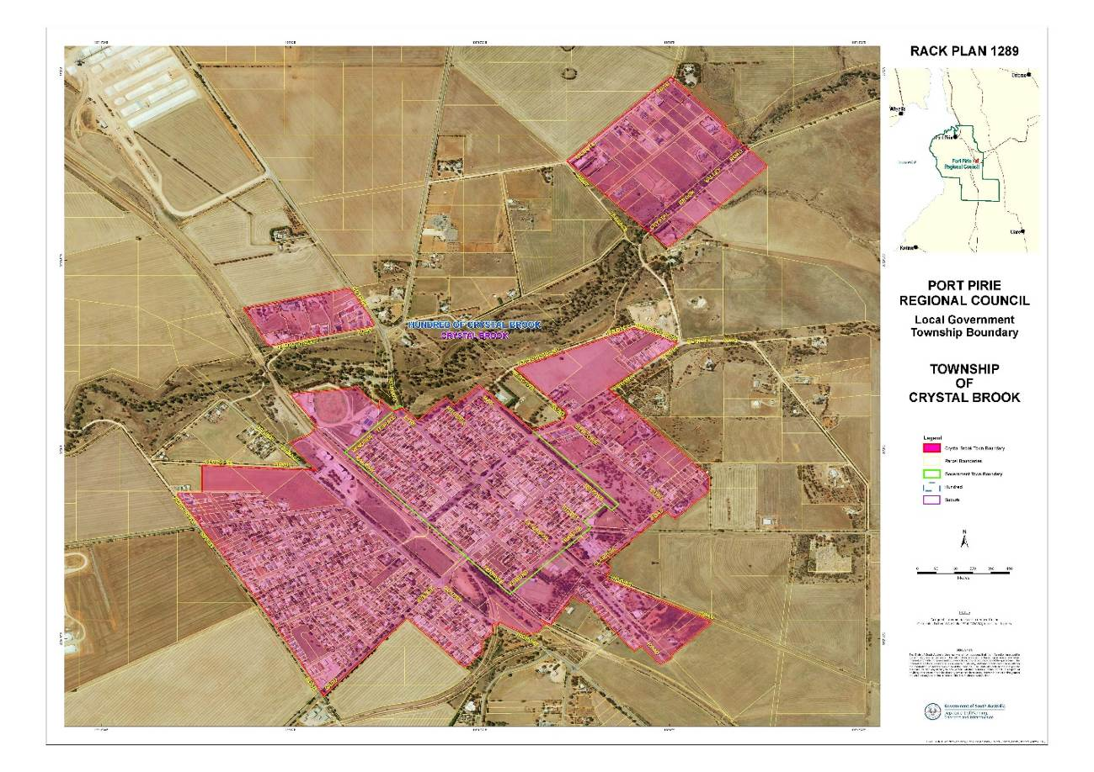
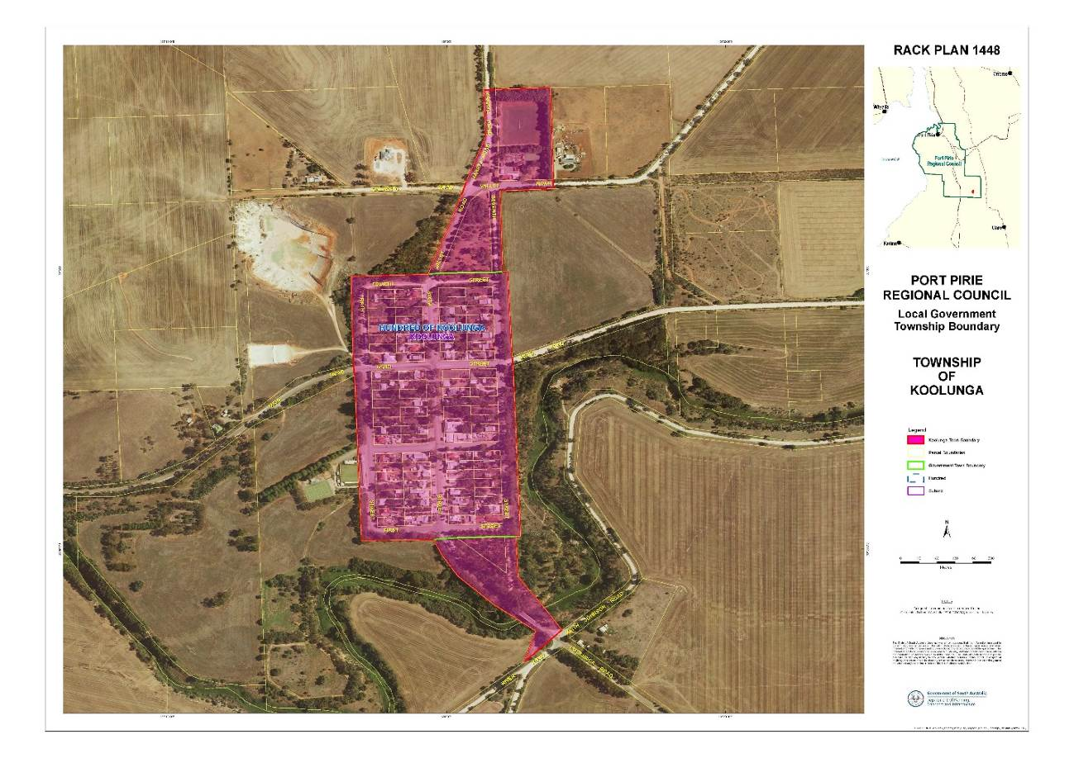
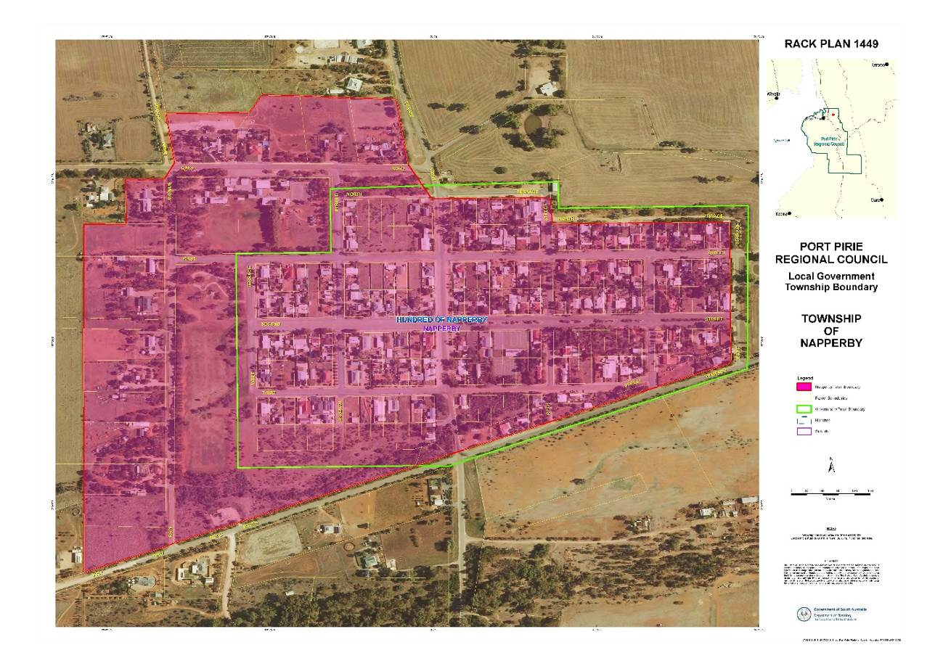
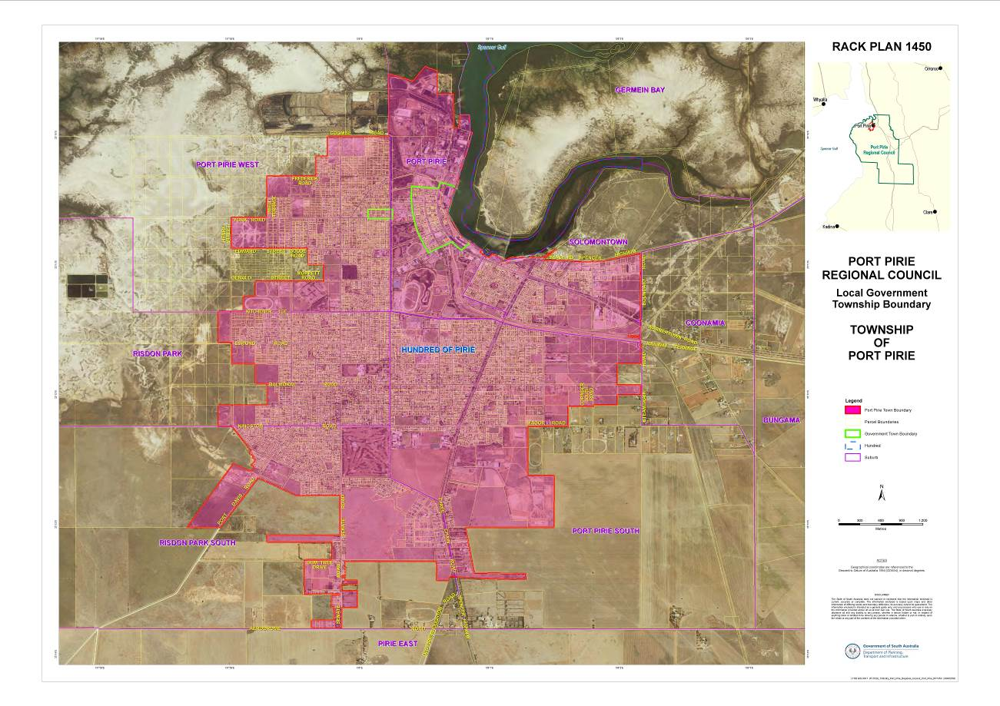
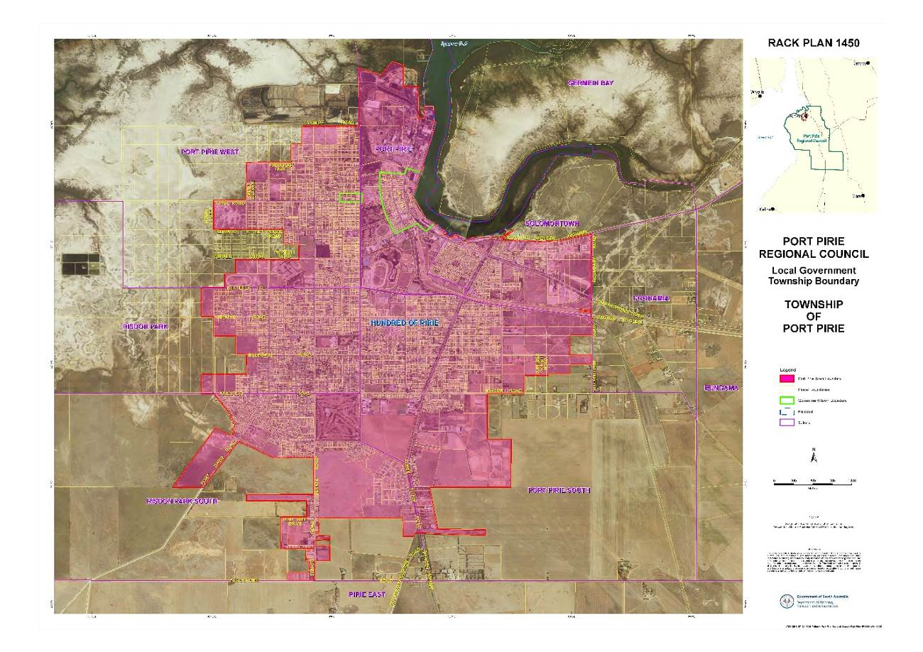
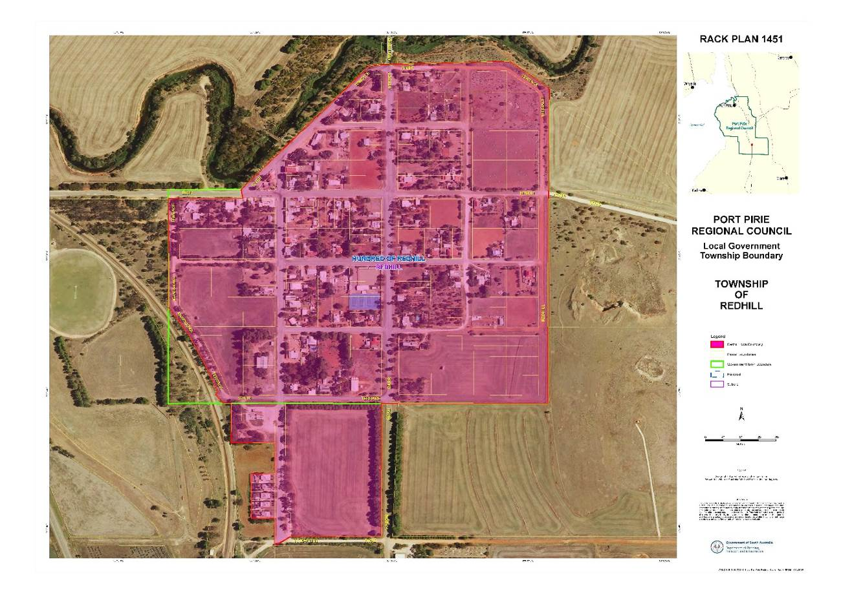

DISTRICT COUNCIL OF ROBE
Adoption of Valuation and Declaration of Rates 2018-2019
Notice is hereby given that the District Council of Robe, at a meeting held on 4 July 2018 and in relation to the financial year ending 30 June 2019, adopted the 2018-2019 Annual Business Plan and Budget and resolved to:-
- Adopt for rating purposes, the capital valuations of the Valuer-General totalling $1,134,033,740.
- Declare a single General Rate of 0.3424 cents in the dollar on the assessed Capital Values of all rateable land in its area.
- Grant a rebate to rateable assessments in accordance with the criteria prescribed in the Council’s “Rating Policy”, so that for those eligible assessments, there is not an increase of more than 10% in respect of the liability for general rates for the financial year ending 30 June 2019.
- Impose an annual service charge of $302.00 for the Garbage and Recycling Collection Service based on the level of usage of the service, on all land to which Council provides or makes available the prescribed service.
- Impose an annual service charge of $162.00 for the Garbage Collection Service based on the level of usage of the service, on all land within the Boatswains Point area to which Council provides or makes available the prescribed service.
- Impose an annual service charge based on the nature and level of usage of the service and varying according to whether the land is vacant or occupied on all land to which Council provides or makes available the prescribed services for the collection, treatment or disposal of waste known as Community Waste Water Management System in respect of all land serviced by these schemes as follows:
-Occupied $521.00 per property unit
-Unoccupied $419.00 per property unit
- Declare a minimum amount payable by way of general rates in respect of any one piece of rateable land in the amount of $684.00.
- Declare a separate rate based on a fixed charge amount that depends upon the use of the land to recover the contribution to the South East Natural Resources Management Board as follows:
- Residential, Vacant & Other $72.50
- Commercial $110.00
- Industrial $174.00
- Primary Production $336.00
Roger Sweetman
Chief Executive Officer

MUNICIPAL COUNCIL OF ROXBY DOWNS
Adoption of Valuation and Declaration of Rates 2018-2019
PURSUANT to Section 12(6)(b) of the Roxby Downs (Indenture Ratification) Act 1982 and Section I67(2)(a) of the Local Government Act 1999 the most recent valuations of the Valuer-General available to the Council of the capital value of land within the Council’s area are adopted, totalling $509,034,100.00
Fixed Charge
Pursuant to section 152(l)(c) of the Local Government Act 1999 a fixed charge of $680.00 is imposed in respect of each separate piece of rateable land in the Council area.
Differential General Rates
Pursuant to Sections 152(l)(c), 153(1)(b) and 156(l)(a) of the Local Government Act 1999 Differential General Rates arc declared in accordance with the use of the land in accordance with the differentiating factors specified at Regulation 14 of the Local Government (General) Regulations 2013 as follows:-
- Residential - a differential rate of 0.6100 cents in the dollar on the capital value of such land
- Commercial Shops - a differential rate of 1.6683 cents in the dollar on the capital value of such land
- Commercial Office - a differential rate of 1.7474 cents in the dollar on the capital value of such land
- Commercial Other - a differential rate of 1.67023 cents in the dollar on the capital value of such land
- Industrial Light - a differential rate of 1.3926 cents in the dollar on the capital value of such land
- Industrial Other - a differential rate of 1.4282 cents in the dollar on the capital value of such land
- Other - a differential rate of 1.1915 cents in the dollar on capital value of such land
- Vacant Land - a differential rate of 1.2096 cents in the dollar on the capital value of such land.
Service Charges
Pursuant to section 155 of the Local Government Act 1999 a service charge of $458.00 is imposed upon each separate piece of rateable land to which the Council makes available a service for the collection, treatment, recycling and disposal of domestic waste (excluding organics), on the basis that the sliding scale provided for in Regulation 13 of the Local Government (General) Regulations 2013 will be applied to reduce the service charge payable, as prescribed.
In accordance with section 155(3)(b) of the Local Government Act 1999 and Regulation 12(4)(a) of the Local Government (General) Regulations 2013, this service charge will only apply to land of the Residential category.
In accordance with Clause 29(5) of the Schedule to the Roxby Downs (Indenture Ratification) Act 1982, this service charge is fixed having regard to the reasonable costs incurred or likely to be incurred in providing such services and to charges paid by other industrial users and country area consumers respectively in the State and includes all such allowances, discounts and subsidies as may from time to time be granted or given to such users and consumers.
Separate Rate - NRM Levy
Pursuant to section 95 of the Natural Resources Management Act 2004 and section 154 of the Local Government Act 1999, a separate rate (fixed charge) of $60.70 is declared on all rateable land in the Council area to raise the amount of $113,509.00 on behalf of the SA Arid Lands Natural Resources Management Board.
No Minimum Rate
The Council does not fix a minimum rate pursuant to Section 158(l)(a) of the Local Government Act 1999 for the 2018/2019 financial year.
Rate Capping Rebate
A rebate of differential general rates for the 2018/2019 financial year may be granted to the Principal Ratepayer of any assessment under Section 166(1)(1) of the Local Government Act 1999, on application to the Council, conditions apply.
In general terms, the amount of rebate will be the positive difference (if any) between: (a) the amount of differential general rates imposed for the 2018/2019 financial year in respect of that assessment: and (b) the amount of differential general rates imposed for the 2017/2018 financial year in respect of that assessment plus 5%.
The precise amount of the rebate will be calculated in accordance with the Municipal Rating Policy. Applications for this rebate must be made in the form prescribed in the Municipal Rating Policy.
Due Dates for Payment of Rates
In accordance with Section 181 of the Local Government Act 1999, the 2018/2019 General Rates (Fixed Charge and Differential Rate), Service Charge and Separate Rate shall be due in four (4) equal or approximately equal instalments payable on 17 September 2018, 17 December 2018, 18 March 2019 and 17 June 2019.
Rateability and Approvals under Roxby Downs (Indenture Ratification) Act 1982
It is noted that:
- Any land excluded from rating pursuant to clause 29(1) of the Schedule to the Roxby Downs (Indenture Ratification) Act 1982 is in accordance with Section 147(2)(h) of the Local Government Act 1999, not rateable land,
- The rates resolved herein are operative with the agreement of the Joint Venturers under clause 29(3)(a) of the Schedule to the Roxby Downs (Indenture Ratification) Act 1982.
- No rates or charges adopted herein are discriminatory to the Joint Venturers.
- The budget adopted herein attracts the operation of clause 29(3)(b) of the Schedule to the Roxby Downs (Indenture Ratification) Act 1982 with the approval of the State and the Joint Venturers.
Dated: 27 June 2018
R. D. Blight
Chief Executive

Southern Mallee District Council
Adoption of Valuation and Declaration of Rates
Notice is hereby given that the Southern Mallee District Council at the meeting held on Wednesday 20 June 2018, resolved as follows;
Adoption of Valuation
The rates assessed on rateable property in the area of the Council will be based on the capital value of the land and pursuant to Section 167 of the Local Government Act 1999, the Council determines, for the 2018 2019 financial year, that the most recent assessment of valuations of land in the Council area, as prepared by the Valuer-General, be adopted for rating purposes and the Council specifies 1 July 2018 as the date from which these assessments will become the valuations of the Council
The assessed capital value of rateable properties is $469,604,600 within a total valuation of $489,330,200 less non rateable properties
Declaration of Rates – General Rate
Pursuant to Sections 153 and 156 of the Local Government Act 1999, the Council for the year ending 30 June 2019, declares the following differential rates of;
0.008450 in the dollar on the capital value of rateable land within the townships of Parrakie, Geranium, Lameroo, Parilla and Pinnaroo, and
0.007400 in the dollar of the capital value of all other rateable land in the Council area
Service Charges - Community Wastewater Management Scheme
As set out in Section 155 of the Local Government Act 1999, the Council imposes an annual service charge on each piece of occupied land of $595.00 and on each piece of vacant land of $297.00 to which the prescribed service [Community Wastewater Management Scheme] is available
Maximum Increase
Pursuant to Section 153 of the Local Government Act 1999 the Council has determined for the 2018 2019 financial year to not fix a maximum increase in the general rate on any rateable land constituting the principal place of residence of a principal ratepayer
Minimum Rates
Pursuant to Section 158 of the Local Government Act 1999, the Council declares a minimum amount payable by way of general rates of $560 in respect of all rateable properties within its area
Rate Rebates 2018 2019
As set out in Division 5 of the Local Government Act 1999, the Council in reliance upon section 166 [1] [ m ] [ ii ] of the Act grants rebates of rates to achieve the following effects;
That a maximum rate of $420 be applied to any vacant unused land.
Pursuant to Section 166(1)(l)(ii) of the Local Government Act 1999 the Council grant Discretionary Rebates of Rates for the purposes of providing relief against what would otherwise amount to a substantial change in rates payable by a ratepayer due to rapid changes in valuations where;
The general rate on properties would have increased by more than 12% from the previous year.
Discount for Early Payment of Rates
That the Council provide a discount of 2.5% only on the general rates for any ratepayer, who pays their rates in full by the 3 September 2018
Natural Resource Management Levy
Pursuant to Section 95 of the Natural Resource Management Act 2004 and Section 154 of the Local Government Act 1999, in order to reimburse the Council the amount of $109,140 contributed to the SA Murray Darling Basin Natural Resource Management Board for the year ending 30 June 2019, a separate rate of 0.02325 in the dollar be declared on all rateable land in the Council's area within the board area
Mobile Garbage Bin Collection and Disposal Service Charge
As set out in Section 155 of the Local Government Act 1999, the Council imposes an annual service charge against each rateable and non-rateable piece of land within the collection area in line with the Council’s Mobile Garbage Bin Collection Service Policy of $230.00 per annum and $170.00 per annum for each additional Mobile Garbage Bin Collection
Payment of Rates - Instalment Dates
Pursuant to Section 181 of the Local Government Act 1999, the Council declares that the Council rates for the financial year ending 30 June 2019 shall be payable in four equal instalments with instalments falling due on 3 September 2018, 3 December 2018, 4 March 2019 and 3 June 2019
Dated: 20 June 2018
Peter Bond
Acting Chief Executive Officer

TATIARA DISTRICT COUNCIL
Adoption of Valuations and Declaration of Rates
NOTICE is hereby given that the Tatiara District Council at its Special Meeting held on 3 July 2018 resolved the following:
Adoption of Valuations
To adopt for rating purposes the most recent valuations of the Valuer-General available to the Council of the capital values of land within the Council area, totaling $1,834,864,320, comprising $1,802,455,700 in respect of rateable land and $32,408,620 in respect of non-rateable land.
Declaration of Differential General Rates
To declare differential general rates on rateable land within the Council area according to the locality and the use of the land as follows:
- in the area of the Council zoned in the Council’s Development Plan consolidated 24 October 2013 as Residential, Town Centre, Commercial, Bulk Handling, Caravan and Tourist Park, Industry, Township and Community Zones:
1.1 0.6042 cents in the dollar on all rateable land with land use Categories (a), (b), (c), (d), (e), (f), (h) and (i);
1.2 0.4028 cents in the dollar on all rateable land with land use Category (g).
- in the area of the Council zoned in the Council’s Development Plan consolidated 24 October 2013 as Rural Living:
2.1 0.48336 cents in the dollar on all rateable land with land use Category (a);
2.2 0.6042 cents in the dollar on all rateable land with land use Categories (b), (c), (d), (e), (f) and (i);
2.3 0.4028 cents in the dollar on all rateable land with land use Categories (g) and (h).
- in the area of the Council zoned in the Council’s Development Plan consolidated 24 October 2013 as Primary Industry, Conservation, Deferred Urban and Water Protection:
3.1 0.4028 cents in the dollar on all rateable land with land use Categories (g) and (h);
3.2 0.48336 cents in the dollar on all rateable land with land use Categories (a), (b), (c), (d), (e), (f) and (i).
Minimum Rate
To fix a minimum amount of $560.00 shall be payable by way of general rates on rateable land within the Council area.
Natural Resources Management Levy
To declare a separate rate based on a fixed charge on rateable land in the area of the Council and in the area of the Board of:
- $74.60 in respect of rateable land with land use Categories (a), (h) & (i)
- $115.50 in respect of rateable land with land use Categories (b), (c) & (d)
- $174.00 in respect of rateable land with land use Categories (e) & (f)
- $337.00 in respect of rateable land with land use Categories (g)
Community Wastewater Management Schemes
To impose service charges on all land within its area to which Council provides or makes available the Community Wastewater Management System varying according to whether the land is vacant or occupied:
Bordertown CWMS | Vacant Land | $180.00
 | Occupied Land | $340.00
Keith CWMS | Vacant Land | $180.00
 | Occupied Land | $340.00
Mundulla CWMS | Vacant Land | $180.00
 | Occupied Land | $340.00
Wolseley CWMS | Vacant Land | $180.00
 | Occupied Land | $340.00
Waste Management and Recycling Collection Annual/Service Charge
To declare an annual service charge of $300.00 based on the nature of the service in respect of all land to which it provides or makes available the service of a 3 bin Garbage, Green Waste and Recycling Collection Service.
A Champness
Chief Executive Officer

YORKE PENINSULA COUNCIL
Adoption of Valuations and Declaration of Rates 2018-2019
NOTICE is hereby given that at meetings of the Yorke Peninsula Council held on 27 June 2018 and 11 July 2018, the Council resolved for the financial year ending 30 June 2019, as follows:
Adoption of Valuations
To adopt for rating purposes the most recent valuations of the Valuer-General available to the Council of the capital value of land within the Council’s area totalling $6 043 441 300, comprising $167 823 482 in respect of non-rateable land and $5 875 617 818 in respect of rateable land.
Declaration of Differential General Rates
To declare differential general rates on rateable land within the Council area as follows:
- on land of category (g) use (primary production), a rate of 0.1729 cents in the dollar; and
- on all other land a rate of 0.2780 cents in the dollar; and
- to impose a fixed charge component of the general rate of $410.
Adoption of Community Wastewater Management Scheme Annual Service Charges
To impose service charges on each assessment of rateable and non-rateable land in the following areas to which land the Council makes available a Community Wastewater Management System:
Per Unit
$
Maitland and Tiddy Widdy Beach areas:
- occupied land 495
- vacant land 368
Ardrossan, Balgowan, Black Point, Edithburgh, Point Turton, Port Vincent,
Port Victoria, Stansbury, Sultana Point and Yorketown areas:
- occupied land 495
- vacant land 368
Bluff Beach, Chinaman Wells, Foul Bay, Hardwicke Bay, Port Julia and Rogues Point areas:
- occupied land 495
- vacant land 368
Adoption of Water Supply Schemes Annual Service Charges
To impose service charges on each assessment of rateable and non-rateable land in the following areas to which land the Council provides or makes available a water supply service:
$
Balgowan area 199
Black Point area 199
Hardwicke Bay area 199
Adoption of Waste Collection and Recycling Annual Service Charges
To impose an annual service charge based on the nature and level of usage of the service on both rateable and non-rateable land to which the Council provides the prescribed service of waste collection (the Waste Collection and Recycling Service) as follows:
- $210 for a two bin service; and
- $262 for a three bin service.
Declaration of Separate Rate
To declare a separate rate of 0.01782 cents in the dollar on all rateable land in the area of the Council to raise the amount of approximately $1 046 756 (inclusive of rebates of approximately $5,594) with $1 040 840 payable to the Northern and Yorke Natural Resources Management Board.
A. Cameron
Chief Executive Officer

Trustee Act 1936
Public Trustee
Estates of Deceased Persons
In the matter of the estates of the undermentioned deceased persons:
BURGESS Ian Lloyd late of 108 Gulfview Road Goolwa Beach of no occupation who died 11 March 2017
CAVENETT Mark David late of 27 Charnock Street Largs North of no occupation who died 7 March 2018
CORPE Anne Priscilla late of 122 Esplanade Semaphore of no occupation who died 10 December 2017
FIELD Lorna Tasma late of 4 Kangaroo Thorn Road Trott Park Retired Technical Librarian who died 26 March 2018
GOOLD Michael James late of 156 Glynburn Road Tranmere of no occupation who died 14 September 2017
HARRIS James William late of 11 Hughes Street Mile End Retired Rigger who died 18 March 2018
JOHNSTON Raymond late of 323 Sir Donald Bradman Drive Brooklyn Park Retired Company Director who died 3 March 2018
JONES Malcolm late of 6 Pridham Boulevard Aldinga Beach of no occupation who died 4 June 2017
KUCZMA Wladyslaw late of 156 Main North Road Prospect Retired Labourer who died 6 March 2018
LONSDALE Carol Irene late of 5 Bradford Court Enfield of no occupation who died 19 February 2018
MALYCHA Neil Francis late of 6 Durdin Road Elizabeth Vale Retired Maintenance Worker who died 9 March 2018
McMAHON Valerie Joan late of 37 Blamey Road Elizabeth East of no occupation who died 18 May 2017
RIEDL Anna late of 42 - 60 Halsey Road Elizabeth East of no occupation who died 22 January 2018
ROSS James Pattison late of 1A Warrego Crescent Linden Park Retired Public Servant who died 19 April 2018
Notice is hereby given pursuant to the Trustee Act 1936, the Inheritance (Family Provision) Act 1972 and the Family Relationships Act 1975 that all creditors, beneficiaries, and other persons having claims against the said estates are required to send, in writing, to the office of Public Trustee at GPO Box 1338, Adelaide, 5001, full particulars and proof of such claims, on or before the 10 August 2018 otherwise they will be excluded from the distribution of the said estate; and notice is also hereby given that all persons indebted to the said estates are required to pay the amount of their debts to the Public Trustee or proceedings will be taken for the recovery thereof; and all persons having any property belonging to the said estates are forthwith to deliver same to the Public Trustee.
Dated: 12 July 2018
N S Rantanen
Acting Public Trustee

Notice Submission

Notices for publication must be submitted before 4 p.m. Tuesday, the week of intended gazettal.
Proofs of formatted content are supplied for all notice submissions. Alterations must be returned before 4 p.m. Wednesday.
The SA Government Gazette is compiled and published each Thursday. Requests to withdraw submitted notices must be received before 10 a.m. on the day of publication.

Gazette notices should be emailed as Word files—and signed PDF files if applicable—
in the following format:
- Title (name of the governing legislation/department/organisation)
- Subtitle (description of notice)
- A structured body of text
- Date of authorisation
- Name, position, and department/organisation of the authorising person

Please provide the following information in your email:
- Date of intended gazettal
- Details that may impact on publication of the notice
- Email address and phone number of the person authorising the submission
- Name of the person and organisation to be charged for the notice, if applicable
- Request for a quote, if required
- Purchase order, if required

Email: governmentgazettesa@sa.gov.au
Phone: (08) 8207 1025
Website: www.governmentgazette.sa.gov.au

Printed and published weekly by authority of T. Lancaster, Government Printer, South Australia
$7.35 per issue (plus postage), $370.00 per annual subscription—GST inclusive
Online publications: www.governmentgazette.sa.gov.au

